National Aged Care Quality Indicator Program (QI Program) Manual – Part A


September 2026

National Aged Care Quality Indicator Program Manual - Part A
This publication is published by the Australian Government Department of Health, Disability and Ageing as a manual to administer the National Aged Care Quality Indicator Program (QI Program).
Copyright Notice
© 2026 Commonwealth of Australia as represented by the Department of Health, Disability and Ageing, except for the text in respect of pressure injuries in Chapter 8 which includes material from the International Statistical Classification of Diseases and Related Health Problems, Tenth Revision, Australian Modification reproduced under licence from the Independent Hospital Pricing Authority.
This work is copyright. You may copy, print, download, display and reproduce the whole or part of this work in unaltered form for your own personal use or, if you are part of an organisation, for internal use within your organisation, but only if you or your organisation:
- do not use the copy or reproduction for any commercial purpose, and
- retain this copyright notice and disclaimer as part of that copy or reproduction.
Apart from rights as permitted by the Copyright Act 1968 (Cth), or allowed by this copyright notice, all other rights are reserved, including (but not limited to) all commercial rights. Unauthorised use of a copy or reproduction is strictly prohibited.
This licence does not cover, and there is no permission given for, use of the Commonwealth Coat of Arms or any logos and trademarks (including the logo of the Department of Health, Disability and Ageing) contained within this publication.
The intellectual property rights contained within the Quality of Care Experience Aged Care Consumers (QCE-ACC) and Quality of Life Aged Care Consumers (QOL-ACC) materials and tools are owned by Flinders University and have been licensed to the Department of Health, Disability and Ageing. Modification or alteration of these tools (including but not limited to the questions and scoring methodology) is strictly prohibited.
Disclaimer
The information in this manual does not constitute, and must not be relied upon as, medical or clinical advice. Any medical questions must be referred to, and obtained from, an independent medical or clinical adviser.
Assistance
For further assistance, please contact the My Aged Care provider and assessor helpline on 1800 836 799. The helpline is available between 8am and 8pm Monday to Friday, and between 10am and 2pm on Saturday local time across Australia, except for public holidays.
Acknowledgements
The Commonwealth would like to acknowledge the work undertaken by the Victorian Department of Health from 2006 to 2021 which assisted the Commonwealth to establish the National Aged Care Quality Indicator Program.

Contents
1 Introduction to the National Aged Care Quality Indicator Program 4
2 Quality indicators in the QI Program 5
3 Quality indicator data submission 9
4 Data recording templates 10
5 Measurement and assessment – data collection for quality indicators 10
6 Record keeping 10
7 Definitions 11
8 Pressure injuries 12
9 Restrictive practices 19
10 Unplanned weight loss - significant 23
11 Unplanned weight loss – consecutive 28
12 Falls and major injury 33
13 Medication management – polypharmacy 37
14 Medication management – antipsychotics 40
15 Activities of daily living 43
16 Incontinence care 47
17 Hospitalisation 52
18 Workforce 55
19 Consumer experience 60
20 Quality of life 66
21 Enrolled nursing (EN): Proportion of EN care minutes and Proportion of Nursing care minutes 72
22 Allied health: Allied health care minutes 76
23 Allied health: recommended services received 80
24 Lifestyle officers 86
Appendix A 88
Appendix B 90
Appendix C 99
Appendix D 117

Introduction to the National Aged Care Quality Indicator Program
Participation in the National Aged Care Quality Indicator Program (QI Program) has been a requirement for all registered providers (providers) of approved residential care homes (aged care homes) since 1 July 2019. The QI Program requires quarterly reporting against 14 quality indicators across crucial areas of care – pressure injuries, restrictive practices, unplanned weight loss, falls and major injury, medication management, activities of daily living, incontinence care, hospitalisation, workforce, consumer experience, quality of life, enrolled nursing, allied health and lifestyle officers.

QI Program objectives
The objectives of the QI Program are:
- for registered providers to have robust, valid data to measure and monitor their performance, and support continuous quality improvement in the care they provide to individuals accessing funded aged care services;
- to give older people in Australia, residents and the community transparent information about quality in aged care to assist decision making; and
- for government to have system-level measures of quality in aged care and an evidence base to inform policy and regulation.
FIGURE 1: SUMMARY OF QI PROGRAM OBJECTIVES
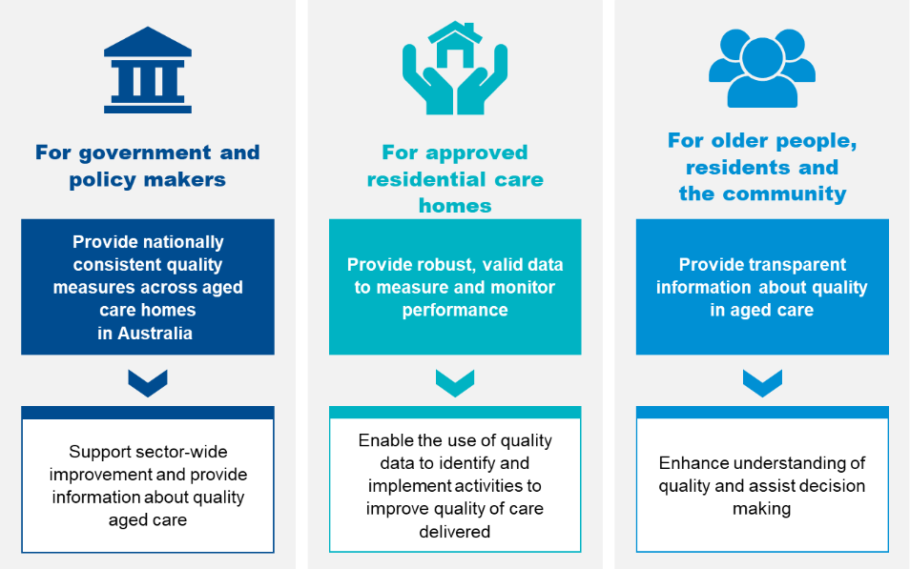

Quality indicators in the QI Program
The QI Program requires the collection and reporting of quality indicators that relate to important aspects of quality of care across 14 crucial areas of care. Data for each quality indicator is collected through measurements and assessments within each of the categories set out in
Figure 2. Information is then compiled, derived and is provided to the Secretary of the Australian Government Department of Health, Disability and Ageing (System Governor), or the System Governor’s delegate, in accordance with the Aged Care Act 2024 (the Act).
The System Governor is responsible for QI Program compliance.
All registered providers of approved residential care homes must collect data across the 14 quality indicators, in accordance with section 166 of the Aged Care Rules (the Rules). Further information can also be found below in Figure 2.
Pursuant to section 166-340 of the Rules, a registered provider must give the System Governor a quarterly financial report for each quarter of a financial year.

FIGURE 2: SUMMARY OF QI PROGRAM QUALITY INDICATORS
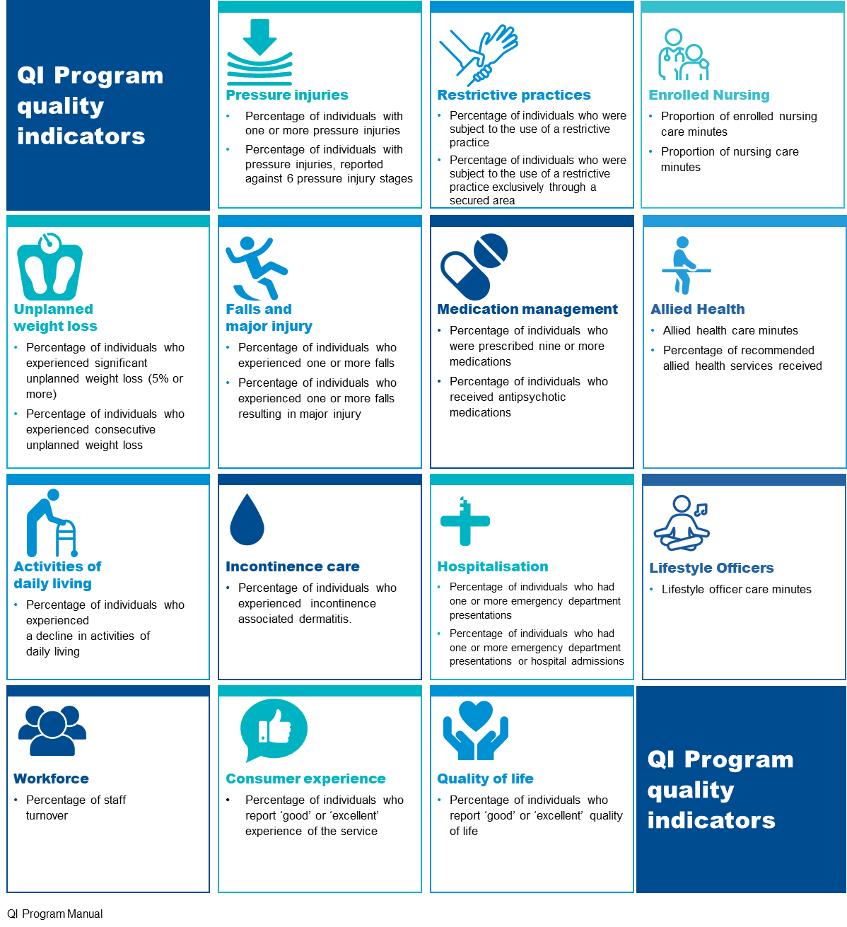

Value for quality indicators
For each of the quality indicators, excluding the workforce, enrolled nursing, allied health and lifestyle officers quality indicators, the percentage value is derived using the following formula:
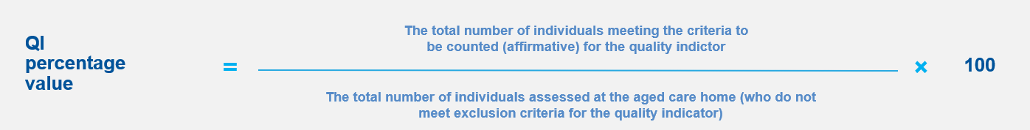

For the workforce quality indicator, the percentage value is derived using the following formula:
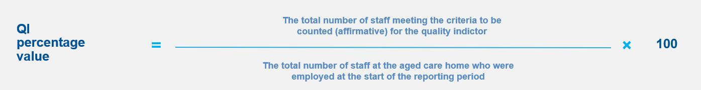

For the recommended allied health services received data point of the allied health quality indicator, the percentage value is derived using the following formula:
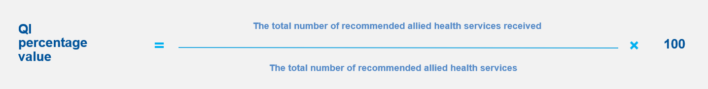

For the enrolled nursing quality indicator, the percentage value is derived using the following formulas:
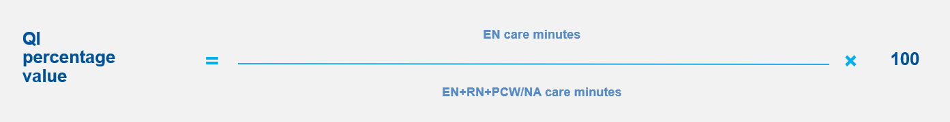
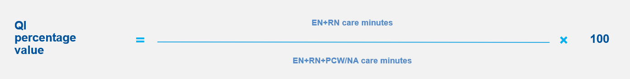

For allied health and lifestyle officers care minutes data points, the proportion values are derived using the following formulas:
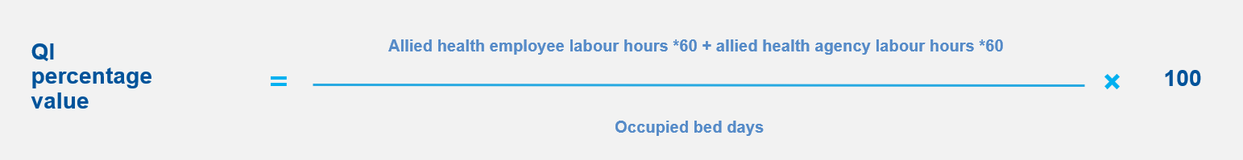
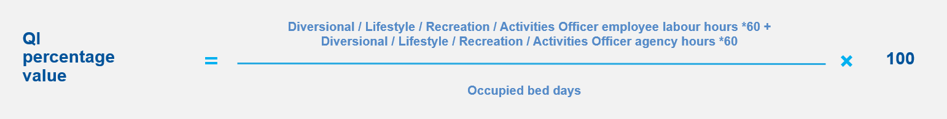
Further information on deriving quality indicator values is in the QI Program Quick Reference Guides.

How information for the QI Program will be collected and managed
The QI Program involves specific methods for collecting, recording, submitting, and interpreting information about the quality indicators. In accordance with the Act, aged care homes must collect data consistently using the methods prescribed in section 166 of the Rules.
Registered providers must record and submit their quality indicator data for pressure injuries, restrictive practices, unplanned weight loss, falls and major injury, medication management, activities of daily living, incontinence care, hospitalisation, workforce, consumer experience, quality of life and the recommended allied health services received data point no later than the 21st day of the month after the end of each quarter (reporting period) into the Government Provider Management System (GPMS). Further information on QI data submission is outlined in sections 8 to 24 of this Manual.
The Department of Health, Disability and Ageing (department) will extract data submitted through the Quarterly Financial Report (QFR) and undertake calculations to populate the enrolled nursing, lifestyle officers and allied health care minutes data points. Please see the QFR webpage for more information on the QFR requirements. As QFR and QI reporting timeframes do not align, there may be a delay in QFR data extraction into the Quality Indicators application in GPMS.
GPMS establishes a modern system to give registered providers, government, and older people in Australia access to up-to-date information on the quality and safety of aged care homes. The GPMS Quality Indicators Application supports submission of quarterly data as required by the QI Program.
GPMS will:
- Allow registered providers to self-manage, view, and maintain their records with the government
- Support provider reporting requirements
- Improve information sharing between the aged care and healthcare systems to deliver the right care the first time
- Provide the functionality to submit data using a bulk upload function to make the reporting process streamlined, allowing data for multiple aged care homes to be consolidated and uploaded simultaneously.

Quality indicator data submission
Pursuant to paragraph 166(1)(a) of the Act, registered providers of residential aged care must give a report (the quality indicators report) on the quality indicators provided in Subdivision C of the Rules to the System Governor each reporting period. To avoid doubt, if any individuals are excluded for any reason under Subdivision C, a registered provider is required to include information about the exclusion of those individuals in the report where required.
Pursuant to section 166-115 of the Rules, for the purposes of subsection 166(4) of the Act, the reporting period for a quality indicators report given to the System Governor is a quarter, being a period of 3 months, beginning at the start of a financial year; and a registered provider must give a quality indicators report to the System Governor within 21 days after the end of the reporting period.
Pursuant to section 166-112 of the Rules, for the purposes of paragraph166(5)(a) of the Act, registered providers must collect data for quality indicators each reporting period and enter it via GPMS in order to make the information available to the System Governor, unless otherwise agreed by the department (for example, if another organisation is being engaged to do so).
Registered providers must submit quality indicator data for pressure injuries, restrictive practices, unplanned weight loss, falls and major injury, medication management, activities of daily living, incontinence care, hospitalisation, workforce, consumer experience, quality of life and recommended allied health services received data point into GPMS within 21 days after the end of each reporting period.
The department will extract data submitted through the QFR and undertake calculations for the enrolled nursing, lifestyle officers and allied health care minutes data points. As QFR and QI reporting timeframes do not align, there may be a delay in QFR data extraction into the QI Program app in GPMS. The extracted and calculated data from the QFR will display in GPMS only once the provider has completed their initial QFR submission.
Further guidance relating to quality indicator data submission is available in the GPMS User Guide: Quality Indicators application.
FIGURE 3: DATES FOR SUBMISSION OF QUALITY INDICATOR DATA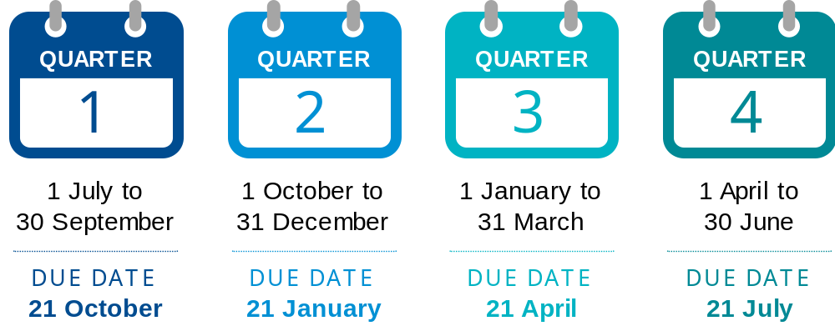
QFR DUE DATE | QFR DUE DATE | QFR DUE DATE | QFR DUE DATE
4 November | 14 February | 5 May | 4 August

Data recording templates
A data recording template is available for each quality indicator, to automatically calculate and summarise the quality indicator data to enter and submit as part of the quality indicators report through the GPMS Quality Indicator application. QI Program Data Recording Templates are available on the QI Program Resources page on the Department’s website. Instructions on how to use the data recording template are provided within the templates.

Measurement and assessment – data collection for quality indicators
Pursuant to section 166-112 of the Rules, registered providers must make measurements or other assessments that are relevant to indicating the quality of residential care. Information from existing data sets (e.g. incident reporting systems) must not be used where information has been collected differently to what is described in the Rules.
Pursuant to section 166-340 of the Rules, a registered provider must give the System Governor a quarterly financial report for each quarter of a financial year.

Record keeping
A registered provider must give the quality indicators report provided in section 166-110 of the Rules to the System Governor each reporting period. A registered provider must, in accordance with paragraph 154(a) of the Act, keep and retain the quality indicators report, and records relating to the collection and measurements of quality indicators; in written or electronic form, for seven years starting on the day the record is made or received. A registered provider may be required to comply with other Commonwealth, State or Territory laws in relation to the retention of records.

Definitions
The definitions ascribed to the terms below are intended to apply for the purposes of the QI Program.
TABLE 1: QI PROGRAM DEFINITIONS
Term | Definition
Individuals/Residents | Individuals accessing funded aged care services (previously referred to as care recipients)
Aged care home | Approved residential care home
Reporting period/Quarter | The reporting period for a quality indicators report given to the System Governor is a quarter, being a period of three months, beginning at the start of a financial year. A registered provider must give a quality indicators report to the System Governor within 21 days after the end of the reporting period.
Assessment period | The period of time where registered providers are required to collect and record data for each quality indicator. For some quality indicators, this involves retrospective audit and for others it involves a point in time observation assessment.
Collection period | The period of time where approved residential care homes are required to collect data for specific quality indicators within the reporting period.
System Governor | The Secretary of the Department of Health, Disability and Ageing
Collection date | The day on which the individual’s data is to be captured, for each quality indicator reporting period.
Exclusions | Individuals who, on the basis of meeting stipulated criteria, are no longer eligible to be included in the total counts for each quality indicator. Consequently, exclusions are deducted from the population assessed for the quality indicator and the resulting percentage value reported.  Where multiple exclusion reasons apply to any individual who is excluded from being assessed for a quality indicator, the primary reason should be applied and reported. Secondary reasons are not required to be reported.  The exception to this definition is an exclusion for the incontinence care quality indicator. Individuals who did not have incontinence, are not eligible to be included in the population assessed for incontinence associated dermatitis. However, these individuals do continue to be included in the total count assessed for the incontinence care quality indicator.

Pressure injuries

Overview of pressure injuries
A pressure injury is an injury of the skin and/or underlying tissue, usually over a bony prominence, caused by unrelieved pressure, friction or shearing. Pressure injuries are potentially life threatening, decrease the resident’s quality of life, and are expensive to manage. Regular monitoring for pressure injuries is important because pressure injuries may develop rapidly and are a painful, costly, and often preventable complication.
Registered providers must collect and report on pressure injury data each reporting period, according to the requirements set out in section 166-120 of the Rules.
The ICD-10 Australian Modified (AM) pressure injury classification system outlined in the Prevention and Treatment of Pressure Ulcers/Injuries: Clinical Practice Guideline 2019 is the pressure injury classification system used for the purposes of the QI Program.

TABLE 2: PRESSURE INJURIES QUALITY INDICATOR OVERVIEW
  Percentage of individuals with pressure injuries, reported against six pressure injury stages | Collection  - A single observation assessment for each individual, around the same time every reporting period
Quality indicator reporting
- Individuals with one or more pressure injuries
- Individuals with one or more pressure injuries measured and reported against each of the six pressure injury stages:
- Stage 1 Pressure Injury
- Stage 2 Pressure Injury
- Stage 3 Pressure Injury
- Stage 4 Pressure Injury
- Unstageable Pressure Injury
- Suspected Deep Tissue Pressure Injury.
Additional reporting
- Individuals assessed for pressure injuries
- Individuals with one or more pressure injuries acquired outside the aged care home during the reporting period; and
- Individuals with one or more pressure injuries acquired outside the aged care home during the reporting period, measured and reported against each of the six pressure injury stages:
- Stage 1 Pressure Injury
- Stage 2 Pressure Injury
- Stage 3 Pressure Injury
- Stage 4 Pressure Injury
- Unstageable Pressure Injury
- Suspected Deep Tissue Pressure Injury.
Note: Individuals with one or more pressure injuries that were acquired outside of the aged care home during the reporting period must be reported under additional reporting, and as part of the total number of individuals with one or more pressure injuries.
Exclusions
- Individuals who withheld consent to undergo an observational assessment for pressure injuries throughout the reporting period
- Individuals who were absent from accessing funded aged care services throughout the reporting period.

Key terms for pressure injuries
A pressure injury is an injury of the skin and/or underlying tissue, usually over a bony prominence, caused by unrelieved pressure, friction or shearing.
The ICD 10 Australian Modified (AM) pressure injury classification system outlined in the Prevention and Treatment of Pressure Ulcers/Injuries: Clinical Practice Guideline 2019 includes the following six pressure injury stages:
TABLE 3: STAGES OF PRESSURE INJURIES
STAGE 1 PRESSURE INJURY
Intact skin with non-blanchable redness of a localised area usually over a bony prominence. Darkly pigmented skin may not have visible blanching; its colour may differ from the surrounding areas. The area may be painful, firm, soft, warmer or cooler as compared to adjacent tissue.
STAGE 2 PRESSURE INJURY
Partial thickness loss of dermis presenting as a shallow open ulcer with a red/pink wound bed, without slough. May also present as an intact or open/ruptured serum-filled blister.
STAGE 3 PRESSURE INJURY
Full thickness tissue loss. Subcutaneous fat may be visible, but bone, tendon or muscle are not exposed. Slough may be present but does not obscure the depth of tissue loss.
STAGE 4 PRESSURE INJURY
Full thickness tissue loss with exposed bone, tendon or muscle. Slough or eschar may be present on some parts of the wound bed. Often include undermining and tunnelling. The depth of a stage 4 pressure injury varies by anatomical location.
UNSTAGEABLE PRESSURE INJURY
Full thickness skin and tissue loss in which the base of the injury is covered by sough (yellow, tan, grey, green or brown) and/or eschar (tan, brown or black) in the wound bed. Until enough slough or eschar is removed to expose the base of the wound, the stage cannot be determined. Excludes pressure injury reclassified to stage 3 or 4 after exposure/debridement.
SUSPECTED DEEP TISSUE PRESSURE INJURY
Purple or maroon localised area of discoloured intact skin or blood-filled blister due to damage of underlying soft tissue from pressure and/or shear. The area may be preceded by tissue that is painful, firm, mushy, boggy, warmer or cooler as compared to adjacent tissue. Deep tissue injury may be difficult to detect in individuals with dark skin tones. Evolution may include a thin blister over a dark wound bed. The wound may further evolve and become covered by thin eschar. Evolution may be rapid, exposing additional layers of tissue even with optimal treatment. Excludes pressure injury reclassification to stage 1 to 4 after exposure/debridement.

Measurements and assessments for pressure injuries
The purpose of assessing an individual through the process set out below is to collect data relating to the pressure injuries quality indicator.
Pursuant to section 166-120 of the Rules, registered providers must make assessments and measurements of pressure injuries that are relevant to indicating the quality of residential care in accordance with the requirements listed below.
- Identify a date once every reporting period to assess each individual residing at the aged care home for pressure injuries. This assessment should be on or around the same time each reporting period.
- Inform individuals about the proposed observational assessment and ensure consent is sought from each individual before the assessment takes place.
Note: This should be completed as part of the individual’s routine personal care (e.g. bathing and toileting).
- Record the individuals excluded because of withholding consent to undergo an observational assessment for pressure injuries throughout the reporting period.
- Record the individuals excluded because of an absence from accessing funded aged care services throughout the reporting period (e.g. the individual was hospitalised for the entire reporting period).
- Conduct a full-body observation assessment of each individual residing at the aged care home during the reporting period to assess for the presence of pressure injuries. Where possible, do this as part of the individual’s routine personal care.
- Record each individual with one or more pressure injuries.
Note: All instances of pressure injuries must be recorded at this step, irrespective of where they were acquired. The same pressure injury on a resident should be counted towards the QI across multiple quarters if it remains present.
- Record each individual with one or more pressure injuries against each of the six stages under the ICD-10-AM (2019) pressure injury classification system:
- Stage 1 Pressure Injury
- Stage 2 Pressure Injury
- Stage 3 Pressure Injury
- Stage 4 Pressure Injury
- Unstageable Pressure Injury
- Suspected Deep Tissue Pressure Injury.
Note: The individual may have more than one pressure injury. In this case all pressure injuries must be assessed and the presence of a pressure injury at each stage (one or more) must then be recorded against each of the six stages.
- Record each individual with one or more pressure injuries acquired outside of the aged care home during the reporting period (e.g. acquired during a hospital stay or pressure injuries present on newly arrived individuals).
Note: Residents with pressure injuries acquired outside of the aged care home in previous reporting periods should be included as part of the total number of individuals with one or more pressure injuries, not in ‘additional reporting’.
- Record each individual with one or more pressure injuries that were acquired outside of the aged care home during the reporting period (e.g. acquired during a hospital stay, or pressure injuries present on newly arrived individuals), against each of the six stages under the ICD-10-AM (2019) pressure injury classification system:
- Stage 1 Pressure Injury
- Stage 2 Pressure Injury
- Stage 3 Pressure Injury
- Stage 4 Pressure Injury
- Unstageable Pressure Injury
- Suspected Deep Tissue Pressure Injury.
Note: The resident may have more than one pressure injury acquired outside the aged care home during the reporting period. In this case all pressure injuries acquired outside the aged care home during the reporting period must be assessed and the presence of a pressure injury at each stage (one or more) must then be recorded against each of the six stages. These must be reported under ‘additional reporting’, and as part of the total number of individuals with one or more pressure injuries.

Inclusions for pressure injuries
All individuals must be assessed for pressure injuries except those listed in 8.3.2. Exclusions for pressure injuries.

Exclusions for pressure injuries
Individuals that:
- withheld consent to undergo an observational assessment for pressure injuries throughout the reporting period; or
- were absent from the aged care home throughout the reporting period;
are excluded from assessment for pressure injuries but are reported under additional reporting requirements.

Data reporting for pressure injuries
Pursuant to section 166-120 of the Rules, registered providers must compile or otherwise derive information from these measurements and assessments of pressure injuries that is relevant to indicating the quality of residential care.
As per sections 166-112(2) and (3) of the Rules, registered providers must ensure that the information reported from the measurements and assessments does not contain personal information (within the meaning of the Privacy Act 1988) about any of the individuals accessing funded aged care services.
TABLE 4 REQUIREMENTS FOR DATA REPORTING ON PRESSURE INJURIES
1 | Number of individuals assessed for pressure injuries.  Note: All individuals must be assessed for pressure injuries except those listed in 8.3.2. Exclusions for pressure injuries.
2 | Number of individuals excluded because of withholding consent to undergo an observational assessment for pressure injuries throughout the reporting period.
3 | Number of individuals excluded because of an absence from accessing funded aged care services throughout the reporting period.
4 | Number of individuals that have one or more pressure injuries.  Note: This is the total number of individuals with one or more pressure injuries, including those acquired outside of the aged care home.
5 | Number of individuals that have one or more pressure injuries measured and reported against each of the six pressure injury sub-categories.  Note: The individual may have more than one pressure injury. In this case all pressure injuries must be assessed and the presence of a pressure injury at each stage (one or more) must then be recorded against each of the six sub-categories.
6 | Number of individuals that have one or more pressure injuries acquired outside of the approved residential care home during the reporting period.
7 | Number of individuals that have one or more pressure injuries acquired outside of the approved residential care home during the reporting period, with each injury measured and reported against each of the six pressure injury sub-categories.  Note: The individual may have more than one pressure injury acquired outside the approved residential care home. In this case all pressure injuries acquired outside the approved residential care home must be assessed and the presence of a pressure injury at each stage (one or more) must then be recorded against each of the six sub-categories.

How to report pressure injuries
Pursuant to section 166-110 of the Rules, registered providers must submit the quality indicators report into GPMS in order to make the information available to the System Governor.
Registered providers must consult with a suitably qualified health practitioner if there is uncertainty about the presence or stage of a pressure injury.

Additional resources for pressure injuries
More information and resources related to pressure injuries are available at www.health.gov.au and in QI Program Manual - Part B.

Restrictive practices

Overview of restrictive practices
Section 17 of the Act defines restrictive practices as any practice or intervention that has the effect of restricting the rights or freedom of movement of an individual.
The QI Program restrictive practices quality indicator measures and reports data relating to all restrictive practices, excluding chemical restraint. This includes physical restraint, mechanical restraint, environmental restraint and seclusion.
Registered providers must collect and report on restrictive practices data each reporting period, according to the requirements set out in section 166-125 of the Rules.
 | Section 17-5 of the Rules sets out specific requirements for the use of any restrictive practice in residential care settings.  Registered providers must satisfy requirements relating to the use of a restrictive practice in relation to an individual, as set out in the Rules.
TABLE 5: RESTRICTIVE PRACTICES QUALITY INDICATOR OVERVIEW
  Percentage of individuals who were subject to the use of a restrictive practice  Percentage of individuals who were subject to the use of a restrictive practice exclusively through the use of a secure area | Collection  - A single three-day record review for each individual on a selected collection date every reporting period (this three-day period is the collection period)
Quality indicator reporting
- Individuals who were subject to the use of a restrictive practice (other than chemical restraint)
Additional reporting
- Individuals were assessed for the use of restrictive practices (other than chemical restraint)
- Individuals who were subject to the use of a restrictive practice (other than chemical restraint) exclusively through the use of a secure area
- Collection date
Exclusions
- Individuals who were absent from accessing funded aged care services throughout the collection period

Key terms for restrictive practices
For the purposes of the QI Program, restrictive practices includes all forms of restrictive practice, excluding chemical restraint, as follows:
- mechanical restraint is a practice or intervention that is, or that involves, the use of a device to prevent, restrict or subdue an individual’s movement for the primary purpose of influencing the individual’s behaviour, but does not include the use of a device for therapeutic or non-behavioural purposes in relation to the individual
- physical restraint is a practice or intervention that:
- is or involves, the use of physical force to prevent, restrict or subdue movement of an individual’s body, or part of an individual’s body, for the primary purpose of influencing the individual’s behaviour; but
- does not include the use of a hands-on technique in a reflexive way to guide or redirect the individual away from potential harm or injury if it is consistent with what could reasonably be considered to be the exercise of care towards the individual.
- environmental restraint is a practice or intervention that restricts, or that involves restricting, an individual’s free access to all parts of the individual’s environment (including items and activities as well as, common grounds outside the aged care home) for the primary purpose of influencing the individual’s behaviour. Locked/coded doors (including the front door) are considered a restrictive practice if they prevent an individual from accessing a part of their environment or limit their movements. The individual’s environment is taken to include the person’s room, any common areas within the home, and common grounds outside the home. While coded doors are commonly used within aged care homes for the safety of individuals, they are a restrictive practice if an individual cannot leave freely. If an aged care home provides door codes to individuals who are able to remember them, and can leave the aged care home without assistance, this would not be considered an environmental restraint.
- seclusion is a practice or intervention that is, or that involves, the sole confinement of an individual in a room or a physical space at any hour of the day or night where:
- voluntary exit is prevented or not facilitated; or
- it is implied that voluntary exit is not permitted; or
for the primary purpose of influencing the individual’s behaviour.
For the purposes of the QI Program, restraint through the use of a secure area includes only environmental restraint, as defined above.
All listed forms of restrictive practice, including instances the individual or their representative instigate or request the restrictive practice, are considered restrictive practices for the purposes of the QI Program.

Measurements and assessments for restrictive practices
The purpose of assessing an individual through the process set out below is to collect data relating to the restrictive practices quality indicator.
Pursuant to section 166-125 of the Rules, registered providers must make assessments and measurements of restrictive practices that are relevant to indicating the quality of residential care in accordance with the requirements listed below.
- Identify and record a collection date (DD/MM/YYYY), which is to take place during the reporting period. The date must be varied between reporting periods and unpredictable to staff directly involved in the care of an individual. The collection period will include the selected collection date and the two days before – this must be the same three days for all individuals at the aged care home.
- Record the individuals whose records are assessed for restrictive practices (other than chemical restraint).
- Record the individuals excluded because of an absence from accessing funded aged care services throughout the collection period (e.g. the individual was hospitalised for the entire three-day collection period).
- Review individual records and assess whether each individual was subject to the use of a restrictive practice (other than chemical restraint) on any occasion during the collection period. This will be based on the existing records of individuals during the three-day collection period, noting that it is a legal requirement that aged care homes document all incidences of restrictive practices (see section 162-20(b) of the Rules).
Note: Restrictive practices (other than chemical restraint) must be recorded, even if an individual or their representative have provided consent to the use of the restrictive practice.
- Record whether each individual was subject to the use of restrictive practices other than chemical restraint (once or more and including the use of secure areas) on any occasion during the three-day collection period.
- Of the individuals subject to the use of a restrictive practice (other than chemical restraint) during the three-day collection period recorded in Step 5 above, record whether the restrictive practice was exclusively through the use of a secure area.
Note: It may not be feasible to conduct the record audit for all individuals on a single day. The review may be spread out over several days, however the review of individual records must always be as they were on the identified collection date at the aged care home.

Inclusions for restrictive practices
All individuals must be assessed for restrictive practices except those listed in 9.3.2. Exclusions for restrictive practices.

Exclusions for restrictive practices
Individuals who were absent from accessing funded aged care services for the entire three-day collection period, are excluded from assessment for restrictive practices, but are reported under additional reporting requirements.

Data reporting for restrictive practices
Pursuant to section 166-125 of the Rules, registered providers must compile or otherwise derive information from these measurements and assessments that is relevant to indicating the quality of residential care.
As per sections 166-112(2) and (3) of the Rules, registered providers must ensure that the information reported from the measurements and assessments does not contain personal information (within the meaning of the Privacy Act 1988) about any of the individuals accessing funded aged care services.
TABLE 6: REQUIREMENTS FOR DATA REPORTING ON RESTRICTIVE PRACTICES
1 | The collection date in the reporting period.
2 | Number of individuals whose records were assessed for the use of restrictive practices other than chemical restraint throughout the collection period.  Note: All individuals must be assessed for restrictive practices except those listed in 9.3.2. Exclusions for restrictive practices.
3 | Number of individuals excluded because of an absence from accessing funded aged care services throughout the collection period.
4 | Number of individuals subjected to the use of a restrictive practice other than chemical restraint on any occasion throughout the collection period.  Note: The individual may be subjected to one or more restrictive practices, including through a secure area.
5 | Number of individuals subjected to the use of restrictive practices other than chemical restraint on any occasion throughout the collection period only in a secure area.

How to report restrictive practices
Pursuant to section 166-110 of the Rules, registered providers must submit the quality indicators report into GPMS in order to make the information available to the System Governor.

Additional resources for restrictive practices
More information and resources related to restrictive practices are available at www.health.gov.au and in QI Program Manual - Part B.

Unplanned weight loss - significant
Unplanned weight loss is the result of deficiency in a person’s dietary intake relative to their needs and may be a symptom or consequence of disease. The unplanned weight loss quality indicator is reported against:
- significant unplanned weight loss (this Section), and
- consecutive unplanned weight loss (see Section 11 of this Manual).
Registered providers are required to collect and record data for each category.

Overview of significant unplanned weight loss
Significant unplanned weight loss is defined as weight loss equal to or greater than 5% over a three-month period. Regular monitoring for significant unplanned weight loss is important because many causes of weight loss can be addressed if detected early.
Registered providers must collect and report on significant unplanned weight loss data each reporting period, according to the requirements set out in section 166-130 of the Rules.
TABLE 7: SIGNIFICANT UNPLANNED WEIGHT LOSS QUALITY INDICATOR OVERVIEW
  Percentage of individuals who experienced significant unplanned weight loss (5% or more) | Collection  - The weight of each individual is collected in the last month (finishing weight) of the reporting period and compared to their weight record in the last month of the previous reporting period (previous weight) to determine percentage of weight loss
Quality indicator reporting
- Individuals who experienced significant unplanned weight loss (5% or more)
Additional reporting
- Individuals who were assessed for significant unplanned weight loss
Exclusions
- Individuals who withheld consent to be weighed on the finishing weight collection date
- Individuals who are receiving end-of-life care
- Individuals who did not have the required weights recorded (e.g. previous and/or finishing weight) including comments that explain why any weights were not recorded

Key terms for significant unplanned weight loss
Significant unplanned weight loss is weight loss equal to or greater than 5% over a three-month period. Registered providers can determine this by comparing the previous weight (finishing weight from the previous reporting period) and the finishing weight from the current reporting period. Both weights must be available to give this result.
Note: If an individual has a written record from a medical doctor or dietitian, which includes intentional weight loss (for example, body fat or fluid), this weight loss will not be counted as unplanned weight loss. Where no such record exists, all weight loss must be considered unplanned regardless of the body size or any other characteristic of the individual.
Previous weight is the weight recorded for each individual in the final month of the previous reporting period. The previous weight for significant and consecutive unplanned weight loss is the same weight measurement collected at the same time, in the final month of the previous reporting period.
Finishing weight is the final weight recorded for each individual, recorded in the final month of the current reporting period. The finishing weight for significant and consecutive unplanned weight loss is the same weight measurement collected at the same time, in the final month of the current reporting period.
For the purposes of the QI Program, end-of-life care is the terminal phase of life. This is where death is imminent and likely to occur within three months. This is sometimes referred to as actively dying.

Measurements and assessments for significant unplanned weight loss
The purpose of assessing an individual through the process set out below is to collect data relating to the significant unplanned weight loss quality indicator.
Pursuant to section 166-130 of the Rules, registered providers must make assessments and measurements of unplanned weight loss that are relevant to indicating the quality of residential care in accordance with the requirements listed below.
Note: Previous weights and finishing weights may have already been recorded for each individual as part of assessments and measurements made for consecutive unplanned weight loss. The previous weights and finishing weights can be used for significant unplanned weight loss and do not need to be collected again.
- Using the aged care home’s weight records, identify each individual’s previous weight (finishing weight from the previous reporting period).
- In the final month of the current reporting period, collect and record the finishing weight for each individual residing at the aged care home, using a calibrated scale.
Note: Always request the consent of each individual to assess their body weight before making the assessment. If they withhold consent to be assessed for their finishing weight, record this (see Step 3).
Note: Weigh individuals at or around the same time each month.
Note: Weigh individuals at around the same time of the day and wearing clothing of a similar weight (e.g. a single layer without coats or shoes).
- Record the individual/s excluded because they withheld consent to be weighed on the finishing weight collection date.
- Record the individual/s excluded because they are receiving end-of-life care.
- Record the individual/s excluded because they did not have the required weights recorded (e.g. previous and/or finishing weight). Include comments as to why the weights were not recorded (e.g. the individual was hospitalised).
- For each individual who provided their consent, compare their finishing weight from the current reporting period with their previous weight (finishing weight from the previous reporting period) and calculate the percentage of weight loss (formula provided below). The percentage of unplanned weight loss can be calculated using an automated template or the following formula:
Note: Individuals who have a written strategy and/or ongoing records relating to planned weight loss are not counted as unplanned weight loss.

Inclusions for significant unplanned weight loss
All individuals must be assessed for significant unplanned weight loss except those listed in 10.3.2. Exclusions for significant unplanned weight loss.

Exclusions for significant unplanned weight loss
Individuals who:
- withhold consent to be weighed on the finishing weight collection date; or
- are receiving end-of-life care; or
- do not have the required weights recorded (e.g. previous and/or finishing weight)
are excluded from assessments for significant unplanned weight loss but are reported under additional reporting requirements.
Note: Individuals residing at the aged care home who did not have a previous weight recorded (finishing weight for the previous reporting period), must have a finishing weight collected and recorded using a calibrated scale, in the final month of the current reporting period through the process set out above.

Data reporting for significant unplanned weight loss
Pursuant to section 166-130 of the Rules, registered providers must compile or otherwise derive information from these measurements and assessments that is relevant to indicating the quality of residential care.
Registered providers must compile or derive information in accordance with the requirements below. As per sections 166-112(2) and (3) of the Rules, registered providers must ensure that the information compiled or derived from the measurements and assessments must not be personal information (within the meaning of the Privacy Act 1988) about any of the individuals accessing funded aged care services.
TABLE 8: SIGNIFICANT UNPLANNED WEIGHT LOSS QUALITY INDICATOR OVERVIEW
1 | Number of individuals assessed for significant unplanned weight loss.  Note: All individuals must be assessed for significant unplanned weight loss except those listed in 10.3.2. Exclusions for significant unplanned weight loss.
2 | Number of individuals excluded because they withheld consent to be weighed on the finishing weight collection date.
3 | Number of individuals excluded because they are receiving end-of-life care.
4 | Number of individuals excluded because they did not have the required weights recorded (e.g. previous and/or finishing weights). Include comments as to why the weights were not recorded.
5 | Number of individuals that experienced a 5% or higher decrease in weight between the finishing weight and the previous weight (significant unplanned weight loss).  Note: Remember individuals who have a written strategy and/or ongoing record relating to planned weight loss are not counted as having unplanned weight loss.

How to report significant unplanned weight loss
Pursuant to section 166-110 of the Rules, registered providers must submit the quality indicators report into GPMS in order to make the information available to the System Governor.
In giving information relating to significant unplanned weight loss to the System Governor pursuant to section 166-130 of the Rules, registered providers must note individuals who were excluded because they did not have a finishing weight recorded for the current or previous reporting period, including the reason why the weights were not recorded, in the comments section in GPMS. Registered providers must ensure that the information compiled or derived in accordance with these requirements does not contain personal information about any of the individuals.

Additional resources for significant unplanned weight loss
More information and resources related to significant unplanned weight loss are available at www.health.gov.au and in QI Program Manual - Part B.
IMPORTANT NOTE
All unplanned and unexpected weight loss must be investigated promptly, and appropriate treatment commenced.
If a resident cannot be weighed, it is still good practice to monitor them using alternative means such as mid-arm or calf circumference. This ensures changes are identified and appropriate strategies put in place.

Unplanned weight loss – consecutive
Unplanned weight loss is the result of deficiency in a person’s dietary intake relative to their needs and may be a symptom or consequence of disease. The unplanned weight loss quality indicator is reported against:
- significant unplanned weight loss (see Section 10 of this Manual), and
- consecutive unplanned weight loss (this Section).
Registered providers are required to collect and record data for each category.

Overview of consecutive unplanned weight loss
Consecutive unplanned weight loss is weight loss of any amount every month over three consecutive months of the reporting period. Consecutive unplanned weight loss should not be dismissed as a natural aged-related change. The detection of consecutive unplanned weight loss may be an early indicator of a symptom or consequence of disease and can be addressed if detected early.
Registered providers must collect and report on consecutive unplanned weight loss data each reporting period, according to the requirements set out in section 166-130 of the Rules.
TABLE 9: CONSECUTIVE UNPLANNED WEIGHT LOSS QUALITY INDICATOR OVERVIEW
Percentage of individuals who experienced consecutive unplanned weight loss | Collection  - Three monthly weights are collected for each individual every reporting period and are compared against each other, as well as the finishing weight from the previous reporting period (previous weight), to determine consecutive unplanned weight loss
Quality indicator reporting
- Individuals who experienced consecutive unplanned weight loss of any amount over three consecutive months of a reporting period
Additional reporting
- Individuals assessed for consecutive unplanned weight loss
Exclusions
- Individuals who withheld consent to be weighed on any weight collection date
- Individuals who are receiving end-of-life care
- Individuals who did not have the required weights recorded (e.g. previous, starting, middle and/or finishing weights), including comments that explain why any weights were not recorded

Key terms for consecutive unplanned weight loss
Consecutive unplanned weight loss is weight loss of any amount every month over three consecutive months of the reporting period. This can only be determined if the individual is weighed on all three occasions within the reporting period, and at the end of the previous reporting period (previous weight).
Note: If an individual has a written record from a medical doctor or dietitian, which includes planned weight loss (e.g. body fat or fluid), this weight loss will not be counted as unplanned weight loss. Where no such record exists, all weight loss must be considered unplanned regardless of the body size or any other characteristic of the individual.
Previous weight is the weight recorded for each individual, in the final month of the previous reporting period. The previous weight for significant and consecutive unplanned weight loss is the same weight measurement collected at the same time, in the final month of the previous reporting period.
Starting weight is the weight recorded for each individual, in the first month of the reporting period.
Middle weight is the mid-reporting period weight recorded for each individual, recorded in the second month of the reporting period.
Finishing weight is the final weight recorded for each individual, recorded in the final month of the current reporting period. The finishing weight for significant and consecutive unplanned weight loss is the same weight measurement collected at the same time, in the final month of the current reporting period.
For the purposes of the QI Program, end-of-life care is the terminal phase of life, where death is imminent and likely to occur within three months. This is sometimes referred to as actively dying.

Measurements and assessments for consecutive unplanned weight loss
The purpose of assessing an individual through the process set out below is to collect data relating to the consecutive unplanned weight loss quality indicator.
Pursuant to section 166-130 of the Rules, registered providers must make assessments and measurements of unplanned weight loss that are relevant to indicating the quality of residential care in accordance with the requirements listed below.
Note: Previous weights and finishing weights may have already been recorded for each individual as part of assessments and measurements made for significant unplanned weight loss. The previous weights and finishing weights can be used for consecutive unplanned weight loss and do not need to be collected again.
- Using the aged care home’s weight records, identify each individual’s previous weight (finishing weight from the previous reporting period).
- In the first month of the reporting period, collect and record the starting weight of each individual residing at the aged care home, using a calibrated scale.
Note: Always request the consent of individuals to assess their body weight before making the assessment. If they withhold consent to be assessed for either a starting, middle or finishing weight, record this (see Step 6).
Note: Weigh individuals at or around the same time each month.
Note: Weigh individuals at around the same time of the day and wearing clothing of a similar weight (e.g. a single layer without coats or shoes).
- In the second month of the reporting period, collect and record the middle weight of each individual residing at the aged care home, using a calibrated scale.
- In the third and final month of the current reporting period, collect and record the finishing weight for each individual residing at the aged care home, using a calibrated scale.
- Record the individuals excluded because they are receiving end-of-life care.
- Record the individuals excluded because they did not have any of the required weights recorded (e.g. previous, starting, middle and/or finishing weights). Include comments as to why the weights were not recorded (e.g. the individual entered the aged care home during the reporting period).
- For each individual who provided consent, compare the previous, starting, middle, and finishing weights to determine if there has been weight loss in every month over three consecutive months of the reporting period.

Inclusions for consecutive unplanned weight loss
All individuals must be assessed for unplanned weight loss except those listed in 11.3.2. Exclusions for consecutive unplanned weight loss.

Exclusions for consecutive unplanned weight loss
Individuals who:
- withhold consent to be weighed on any weight collection dates; or
- are receiving end-of-life care; or
- do not have the required weights recorded (e.g. previous, starting, middle and/or finishing weights)
are excluded from assessments for consecutive weight loss but are reported under additional reporting requirements.
Note: Individuals residing at the aged care home who did not have a previous weight recorded (finishing weight for the previous reporting period), must have a finishing weight collected and recorded using a calibrated scale in the final month of the current reporting period quarter through the process set out above.

Data reporting for consecutive unplanned weight loss
For the purposes of section 166-130 of the Rules, registered providers must compile or otherwise derive information from these measurements and assessments that is relevant to indicating the quality of residential care.
As per sections 166-112(2) and (3) of the Rules, registered providers must ensure that the information reported from the measurements and assessments does not contain personal information (within the meaning of the Privacy Act 1988) about any of the individuals accessing funded aged care services.
Table 10: REQUIREMENTS FOR DATA REPORTING ON CONSECUTIVE UNPLANNED WEIGHT LOSS
1 | Number of individuals assessed for consecutive unplanned weight loss.  Note: All individuals must be assessed for unplanned weight loss except those listed in 11.3.2. Exclusions for consecutive unplanned weight loss.
2 | Number of individuals excluded because they withheld consent to be weighed on any weight collection date
3 | Number of individuals excluded because they are receiving end-of-life care.
4 | Number of individuals excluded because any of the required weights (previous, starting, middle and/or finishing) were not recorded. Include comments as to why the weights were not recorded.
5 | Number of individuals that experienced any decrease in weight between the previous weight, starting weight, middle weight and finishing weight.

How to report consecutive unplanned weight loss
Pursuant to section 166-110 of the Rules, registered providers must submit the quality indicators report into GPMS in order to make the information available to the System Governor.
In giving information relating to consecutive unplanned weight loss to the System Governor pursuant to section 166-130 of the Rules, registered providers must note individuals who were excluded because they did not have a previous, starting, middle, and/or finishing weight recorded, including the reason why the weights were not recorded, in the comments section in GPMS. Registered providers must ensure that the information compiled or derived in accordance with these requirements does not contain personal information about any of the individuals.

Additional resources for consecutive unplanned weight loss
More information and resources related to consecutive unplanned weight loss are available at www.health.gov.au and in QI Program Manual - Part B.
IMPORTANT NOTE
Any unplanned and unexpected weight loss must be investigated promptly and appropriate treatment commenced.
If a resident cannot be weighed, it is still good practice to monitor them using alternative means such as mid-arm or calf circumference. This ensures changes are identified and appropriate strategies put in place.

Falls and major injury

Overview of falls and major injury
A fall is an event that results in a person coming to rest inadvertently on the ground or floor or other lower level. This includes onto crash mats and from low beds.
- A fall resulting in major injury is a fall that meets this definition and results in one or more of the following: bone fractures, joint dislocations, closed head injuries with altered consciousness and/or subdural haematoma.
While not all falls (with and without injury) can be prevented, the evidence suggests that fall rates can be reduced with interventions such as standard and individualised fall prevention strategies, physiotherapy, medication reviews and occupational therapy, among others. Dignity of risk should also be promoted consistently with resident choice and control. It is critical to routinely screen for falls risk and to monitor the outcomes of falls prevention programs and interventions.
Registered providers must collect and report on falls and major injury data each reporting period, according to the requirements set out in section 166-135 of the Rules.
TABLE 11: FALLS AND MAJOR INJURY QUALITY INDICATOR OVERVIEW
  Percentage of individuals who experienced one or more falls  Percentage of individuals who experienced one or more falls resulting in major injury | Collection  - A single review of the care records of each individual for the entire reporting period
Quality indicator reporting
- Individuals who experienced one or more falls at the aged care home during the reporting period
- Individuals who experienced one or more falls at the aged care home resulting in major injury during the reporting period
Additional reporting
- Individuals assessed for falls and major injury
Exclusions
- Individuals who were absent from accessing funded aged care services throughout the reporting period

Key terms for falls and major injury
For the purposes of the QI Program, a fall is defined as an event that results in a person coming to rest inadvertently on the ground or floor or other lower level. This includes falls from a low bed and onto a crash mat.
A fall resulting in major injury is a fall that meets the definition above and results in one or more of the following:
- bone fractures;
- joint dislocations;
- closed head injuries with altered consciousness; and/or
- subdural haematoma.
Falls resulting in major injury that occur while an individual is away from the aged care home and not under direct supervision of staff are not included.

Measurements and assessments for falls and major injury
The purpose of assessing an individual through the process set out below is to collect data relating to the falls and major injury quality indicator.
Pursuant to section 166-135 of the Rules, registered providers must make assessments and measurements of falls and major injury that are relevant to indicating the quality of residential care in accordance with the requirements listed below.
- The collection date must take place in the 21 days after the end of the reporting period, in order to review records for the entire reporting period.
- Record the individuals whose records are reviewed for the reporting period, to assess for falls, and falls resulting in major injury. All individuals residing at the aged care home during the reporting period should be included.
- Record the individuals excluded because of an absence from accessing funded aged care services throughout the reporting period (e.g. the individual was hospitalised for the entire reporting period).
- Record whether each individual experienced one or more falls at the aged care home during the reporting period.
Note: Individuals who only experienced a fall or fall resulting in major injury that occurred while the individual was away from the aged care home and not under direct supervision of staff are excluded from these counts.
- Record whether each individual experienced one or more falls at the aged care home, resulting in major injury, during the reporting period.

Inclusions for falls and major injury
All individuals must be assessed for falls and major injury except those listed in 12.3.2. Exclusions for falls and major injury.

Exclusions for falls and major injury
Individuals who were absent from accessing funded aged care services throughout the reporting period, are excluded from assessment for falls and major injury, but are reported under additional reporting requirements.
Note: Falls resulting in major injury that occurred while the individual was away from the aged care home and not under direct supervision of staff are not included for the purposes of assessment or reporting.

Data reporting for falls and major injury
Pursuant to section 166-135 of the Rules, registered providers must compile or otherwise derive information from these measurements and assessments that is relevant to indicating the quality of residential care.
As per sections 166-112(2) and (3) of the Rules, registered providers must ensure that the information reported from the measurements and assessments does not contain personal information (within the meaning of the Privacy Act 1988) about any of the individuals accessing funded aged care services.
TABLE 12: REQUIREMENTS FOR DATA REPORTING ON FALLS AND MAJOR INJURY
1 | Number of individuals whose records were assessed for falls and falls resulting in major injury.  Note: All individuals must be assessed for falls and major injury except those listed in 12.3.2. Exclusions for falls and major injury.
2 | Number of individuals excluded because of an absence from accessing funded aged care services at the approved residential care home throughout the reporting period.
3 | Number of individuals who experienced one or more falls at the approved residential care home during the reporting period.
4 | Number of individuals who experienced one or more falls at the approved residential care home resulting in major injury during the reporting period.

How to report falls and major injury
Pursuant to section 166-110 of the Rules, registered providers must submit the quality indicators report into GPMS in order to make the information available to the System Governor.

Additional resources for falls and major injury
More information and resources related to falls and major injury are available at www.health.gov.au and in QI Program Manual - Part B.

Medication management – polypharmacy
Medication management plays a critical role in achieving quality of care for older people. The medication management quality indicator is reported against:
- medication management – polypharmacy (this section), and
- medication management – antipsychotics (see Section 14 of this Manual).
Registered providers are required to collect and record data for each category.

Overview of polypharmacy
Polypharmacy is defined as the prescription of nine or more medications to an individual. Regular monitoring of polypharmacy is important because polypharmacy has been associated with reduced quality of life and harms such as adverse drug events, falls, cognitive decline, and hospitalisation.
Registered providers must collect and report on polypharmacy data each reporting period, according to the requirements set out in section 166-140 of the Rules.
TABLE 13: MEDICATION MANAGEMENT – POLYPHARMACY QUALITY INDICATOR OVERVIEW
  Percentage of individuals who were prescribed nine or more medications | Collection  - A single review of medication charts and/or administration records for each individual on a selected collection date every reporting period
Quality indicator reporting
- Individuals who were prescribed nine or more medications
Additional reporting
- Individuals assessed for polypharmacy
- Collection date in the reporting period
Exclusions
- Individuals admitted in hospital on the collection date

Key terms for polypharmacy
For the purposes of the QI Program, medication is defined as a chemical substance given with the intention of preventing, diagnosing, curing, controlling or alleviating disease or otherwise enhancing the physical and/or mental welfare of people. For the purpose of the QI Program, it includes prescription and non-prescription medicines, irrespective of the administered route.
For the purposes of the QI Program, polypharmacy is defined as the prescription of nine or more medications to an individual.
For the purposes of the QI Program, any medication with an active ingredient is counted in the polypharmacy quality indicator, except for those listed below which must not be included in the count of medications:
- Lotions, creams or ointments used in skin and wound care;
- Dietary supplements, including those containing vitamins;
- Short-term medications, such as antibiotics or temporary eye drops; and
- PRN medications.
Different dosages of the same medicine must not be counted as different medications.

Measurements and assessments for polypharmacy
The purpose of assessing an individual through the process set out below is to collect data relating to the polypharmacy quality indicator.
Pursuant to section 166-140 of the Rules, registered providers must make assessments and measurements of medication management that are relevant to indicating the quality of residential care in accordance with the requirements listed below.
- Identify and record a collection date (DD/MM/YYYY) for the reporting period.
- Record the individuals whose medication charts and/or administration records are reviewed to assess for polypharmacy. All individuals residing at the aged care home on the collection date must be included in the assessment.
Note: The audit for polypharmacy will be completed using each individual’s medication charts and/or administration records as they are on the identified collection date.
- Record the individuals excluded because they were not assessed due to hospital admission on the collection date.
- Review each individual’s medication chart and/or administration records as on the collection date and record whether each individual was prescribed nine or more medications.
Note: It may not be feasible to conduct the medication chart/administration record audit for all individuals on a single day. The review may be spread out over several days however, the review of medication charts and/or administration records must always be as they were on the identified collection date.

Inclusions for polypharmacy
All individuals must be assessed for medication management except those listed in 13.3.2. Exclusions for polypharmacy.

Exclusions for polypharmacy
Individuals who were admitted in hospital on the collection date, are excluded from assessment for polypharmacy, but are reported under additional reporting requirements.

Data reporting for polypharmacy
Pursuant to section 166-140 of the Rules, registered providers must compile or otherwise derive information from these measurements and assessments that is relevant to indicating the quality of residential care.
As per sections 166-112(2) and (3) of the Rules, registered providers must ensure that the information reported from the measurements and assessments does not contain personal information (within the meaning of the Privacy Act 1988) about any of the individuals accessing funded aged care services.
TABLE 14: REQUIREMENTS FOR DATA REPORTING ON POLYPHARMACY
1 | The collection date in the reporting period.
2 | Number of individuals assessed for polypharmacy.  Note: All individuals must be assessed for polypharmacy except those listed in 13.3.2. Exclusions for polypharmacy.
3 | Number of individuals excluded because they were admitted in hospital on the collection date.
4 | Number of individuals prescribed nine or more medications based on a review of their medication chart and/or administration record taken on the collection date.

How to report polypharmacy
Pursuant to section 166-110 of the Rules, registered providers must submit the quality indicator data into GPMS in order to make the information available to the System Governor.

Additional resources for polypharmacy
More information and resources related to polypharmacy are available at www.health.gov.au and in QI Program Manual - Part B.

Medication management – antipsychotics
Medication management plays a critical role in achieving quality of care for older people. The medication management quality indicator is reported against:
- medication management – polypharmacy (see Section 13 of this Manual), and
- medication management – antipsychotics (this section).
Registered providers are required to collect and record data for each category.

Overview of antipsychotics
Antipsychotics are medications prescribed for the treatment of a diagnosed condition of psychosis. Regular monitoring of the use of antipsychotics is important because use of certain medication classes, such as antipsychotics, has been shown to be associated with poor health outcomes. Registered providers must collect and report on antipsychotic usage data each reporting period, according to the requirements set out in section 166-140 of the Rules.
TABLE 15: MEDICATION MANAGEMENT – ANTIPSYCHOTICS QUALITY INDICATOR OVERVIEW
Percentage of individuals who received antipsychotic medications | Collection  - A seven-day medication chart and/or administration record review for each individual every reporting period
Quality indicator reporting
- Individuals who received an antipsychotic medication
Additional reporting
- Individuals assessed for antipsychotic medications
- Individuals who received an antipsychotic medication for a medically diagnosed condition of psychosis
- Collection date in the reporting period
Exclusions
- Individuals who were admitted in hospital for at least six days prior to the collection date (entire seven-day assessment period).

Key terms for antipsychotics
For the purposes of the QI Program, medication is defined as a chemical substance given with the intention of preventing, diagnosing, curing, controlling or alleviating disease or otherwise enhancing the physical and/or mental welfare of people. For the purpose of the QI Program, it includes prescription and non-prescription medicines irrespective of the administered route.
Diagnosed by a medical doctor, psychosis is characterised by symptoms such as delusions, hallucinations, and perceptual disturbances, and by the severe disruption of ordinary behaviours (adapted from the ICD-10-AM, 2017).
Disorders where there may be a diagnosed condition of psychosis include: schizophrenia bipolar disorder, Huntington’s chorea, delusions and hallucinations. End-of-life care recipients may also experience psychosis.
A non-exhaustive list of antipsychotic medications is available in QI Program Manual - Part B.

Measurements and assessments for antipsychotics
The purpose of assessing an individual through the process set out below is to collect data relating to the antipsychotics quality indicator.
Pursuant to section 166-140 of the Rules, registered providers must make assessments and measurements of medication management that are relevant to indicating the quality of residential care in accordance with the requirements listed below.
- Identify and record a collection date (DD/MM/YYYY) during the reporting period – between the second week and end of the reporting period. The collection date and the six days prior will be the collection period for which all individual medication charts and administration records are reviewed for antipsychotic medications.
Note: The collection date must be varied between reporting periods and must not be identified to, or conducted by, staff directly involved in the care of individuals accessing funded aged care services.
- Record the individuals whose medication charts and/or administration records are reviewed to assess for receipt of antipsychotic medications over the seven-day collection period. All individuals residing at the aged care home during the seven-day collection period must be included in the assessment.
- Record the individuals excluded because they were admitted in hospital for at least the 6 days prior to the collection date (the entire seven-day collection period).
- Review each individual’s medication charts and/or administration records of the seven-day collection period and record whether each individual received an antipsychotic medication. This includes PRN (‘as needed’) medications.
- Of those individuals who received an antipsychotic medication in Step 4, also record whether the individual has a medically diagnosed condition of psychosis by performing a review of their medical records.
Note: It may not be feasible to conduct the medication chart/administration record audit for all individuals on a single day. The review may be spread out over several days however, the review of medication charts and/or administration records must always be as they were on the identified collection date.

Inclusions for antipsychotics
All individuals must be assessed for medication management except those listed in 14.3.2. Exclusions for antipsychotics.

Exclusions for antipsychotics
Individuals who were admitted in hospital for at least 6 days prior to the collection date, are excluded from assessment for antipsychotics, but are reported under additional reporting requirements.

Data reporting for antipsychotics
Pursuant to section 166-140 of the Rules, registered providers must compile or otherwise derive information from these measurements and assessments that is relevant to indicating the quality of residential care.
As per sections 166-112(2) and (3) of the Rules, registered providers must ensure that the information reported from the measurements and assessments does not contain personal information (within the meaning of the Privacy Act 1988) about any of the individuals accessing funded aged care services.
TABLE 16: REQUIREMENTS FOR DATA REPORTING ON ANTIPSYCHOTICS
1 | The collection date in the reporting period¹.
2 | Number of individuals assessed for antipsychotic medications.  Note: All individuals must be assessed for medication management except those listed in 14.3.2. Exclusions for antipsychotics.
3 | Number of individuals excluded because they were admitted in hospital for at least 6 days prior to the collection date.
4 | Number of individuals that received an antipsychotic medication based on the review of the individual’s medication chart and/or administration record on the collection date.
5 | Number of individuals that received an antipsychotic medication for a medically diagnosed condition of psychosis based on a review of the individual’s medication chart and/or administration record on the collection date.
¹Note: the assessment period includes the 6 days prior to the collection date.

How to report antipsychotics
Pursuant to section 166-110 of the Rules, registered providers must submit the quality indicators report into GPMS in order to make the information available to the System Governor.

Additional resources for antipsychotics
More information and resources related to antipsychotics are available at www.health.gov.au and in QI Program Manual - Part B.

Activities of daily living

Overview of activities of daily living
Activities of daily living (ADLs) can be used to measure people’s ability to move and care for themselves. These include management of grooming and personal hygiene, dressing, going to the toilet and eating. ADLs are important to maintain independence, health status and quality of life. Aged care homes can assist residents to actively participate in these activities to improve or maintain function or slow the rate of decline.
The Barthel Index of Activities of Daily Living (ADL assessment) is the assessment tool used for the purposes of the QI Program, included in Appendix A.
Registered providers must collect and report on activities of daily living data each reporting period, according to the requirements set out in section 166-145 of the Rules.
TABLE 17: ACTIVITIES OF DAILY LIVING QUALITY INDICATOR OVERVIEW
  Percentage of individuals who experienced a decline in activities of daily living | Collection  - A single assessment of each individual is completed around the same time every reporting period and compared to their ADL assessment total score in the previous reporting period to determine decline
Quality indicator reporting
- Individuals who experienced a decline in their ADL assessment total score of one or more points
Additional reporting
- Individuals assessed for ADL function
- Individuals with an ADL assessment total score of zero in the previous reporting period
Exclusions
- Individuals who are receiving end-of-life care
- Individuals who were absent from accessing funded aged care services throughout the entire reporting period
- Individuals who did not have an ADL assessment total score recorded for the previous reporting period including comments that explain why the previous assessment was not recorded

Key terms for activities of daily living
The Barthel Index of Activities of Daily Living assessment tool (included in Appendix A) is comprised of 10 items. For each item, choose the statement most closely corresponding to a resident’s current level of ability. The score for each statement is added together to give the ADL assessment total score.
For the purposes of the QI Program, decline in ADLs is defined as a decline in ADL assessment total score of one or more points. This is determined by comparing the ADL assessment total score from the previous reporting period and the ADL assessment total score from the current reporting period. Both ADL assessment total scores must be available to provide this result.
For the purposes of the QI Program, end-of-life care is the terminal phase of life, where death is imminent and likely to occur within three months. This is sometimes referred to as actively dying.

Measurements and assessments for activities of daily living
The purpose of assessing an individual through the process set out below is to collect data relating to the ADL quality indicator.
Pursuant to section 166-145 of the Rules, registered providers must make assessments and measurements that are relevant to indicating the quality of residential care in accordance with the requirements listed below.
- Using the aged care home’s care records, identify each individual’s ADL assessment total score from the previous reporting period.
- Around the same time each reporting period, conduct an ADL assessment for each individual by completing all questions in the Barthel Index of Activities of Daily Living assessment tool, included in Appendix A.
Note: Barthel Index of Activities of Daily Living scoring is based on the individual’s actual performance over the previous 24–48 hours, noting longer periods will be relevant for some items (e.g. bowel and bladder).
Note: An individual’s performance for each of the ten items is established using the best available evidence. This can include using existing knowledge of the individual obtained through routine personal care, asking the individual, referring to care records or by direct observation.
- Record the individuals excluded because they were receiving end-of-life care.
- Record the individuals excluded because of an absence from the aged care home throughout the reporting period (e.g. the individual was hospitalised for the entire reporting period).
- Record the individuals excluded because an assessment of ADL was not recorded for the previous reporting period. Include comments as to why the previous assessment was not recorded (e.g. the individual was hospitalised for the entire previous reporting period).
- Record the individuals with an ADL assessment total score of zero in the previous reporting period.
- Record the ADL assessment total score for each individual.
- For each individual, compare the previous reporting period ADL assessment total score with the current reporting period ADL assessment total score, to determine if the individual experienced a decline of one or more points.
- Record the number of individuals who experienced a decline in ADL assessment total score by one or more points.

Inclusions for activities of daily living
All individuals at the aged care home must be assessed for ADL function, except for those listed in 15.3.2 Exclusions for activities of daily living.

Exclusions for activities of daily living
Individuals who:
- were receiving end-of-life care for the entire reporting period; or
- were absent from the aged care home throughout the reporting period; or
- did not have an ADL assessment total score recorded for the previous reporting period
are excluded from the assessment for ADLs, but are reported under additional reporting requirements.
Note: Individuals residing at the aged care home who did not have an ADL assessment total score recorded for the previous reporting period, must have an ADL assessment conducted in the current reporting period, through the process set out above.

Data reporting for activities of daily living
Pursuant to section 166-145 of the Rules, registered providers must compile or otherwise derive information from these measurements and assessments that is relevant to indicating the quality of residential care.
Registered providers must compile or derive information in accordance with the requirements below. As per sections 166-112(2) and (3) of the Rules, registered providers must ensure that the information compiled or derived from the measurements and assessments must not be personal information (within the meaning of the Privacy Act 1988) about any of the individuals accessing funded aged care services.
TABLE 18: REQUIREMENTS FOR DATA REPORTING ON ACTIVITIES OF DAILY LIVING
1 | Number of individuals assessed for ADL function.  Note: All individuals must be assessed for ADL function, except for those listed in 15.3.2 Exclusions for activities of daily living.
2 | Number of individuals excluded because they are receiving end-of-life care.
3 | Number of individuals excluded because of an absence from accessing funded aged care services throughout the reporting period.
4 | Number of individuals excluded because an assessment for ADL function was not recorded for the previous reporting period. Include comments as to why any such previous assessment was not recorded.
5 | Number of individuals assessed for ADL function and received a total score of zero in the previous reporting period.
6 | Number of individuals that were assessed for ADL function and experienced a decline in the total score by one or more points.

How to report activities of daily living
Pursuant to section 166-110 of the Rules, registered providers must submit the quality indicators report into GPMS in order to make the information available to the System Governor.
In giving information relating to activities of daily living to the System Governor pursuant to section 166-145 of the Rules, registered providers must note individuals who were excluded because they did not have a previous ADL assessment total score recorded in the previous reporting period, including the reason why the previous assessment was not recorded, in the comments section in GPMS. Registered providers must ensure that the information compiled or derived in accordance with these requirements does not contain personal information about any of the individuals.

Additional resources for activities of daily living
More information and resources related to ADLs are included in Appendix A, and are available at www.health.gov.au and in QI Program Manual - Part B.

Incontinence care

Overview of incontinence care
Continence is the ability to control the bladder and bowel. Incontinence is the loss of bladder and bowel control, which can impact independence, health and quality of life. Homes can ensure residents have access to the right treatments and support to assist bladder and bowel control.
Incontinence associated dermatitis (IAD) is common in aged care homes. There are several risk factors for the development of IAD, including incontinence of urine, faeces (or both), pre-existing skin conditions, poor mobility, and inability to maintain personal hygiene.
The Ghent Global IAD Categorisation Tool is the assessment tool used for the purposes of the QI Program, included in Appendix B.
Registered providers of aged care homes must collect and report on incontinence care data each reporting period, according to the requirements set out in section 166-150 of the Rules.
TABLE 19: INCONTINENCE CARE QUALITY INDICATOR OVERVIEW
  Percentage of individuals who experienced incontinence associated dermatitis | Collection  - A single assessment for each individual, around the same time every reporting period as part of routine care
Quality indicator reporting
- Individuals who have incontinence and IAD
- Individuals who have incontinence and IAD measured and reported against each of the four sub-categories:
- 1A: Persistent redness without clinical signs of infection
- 1B: Persistent redness with clinical signs of infection
- 2A: Skin loss without clinical signs of infection
- 2B: Skin loss with clinical signs of infection.
Additional reporting
- Individuals assessed for incontinence care
- Individuals with incontinence
Exclusions for incontinence care
- Individuals who were absent from accessing funded aged care services throughout the reporting period
Exclusions for IAD assessment
- Individuals who did not have incontinence

Key terms for incontinence care
For the purposes of the QI Program, incontinence is any accidental or involuntary loss of urine from the bladder (urinary incontinence) or faeces from the bowel (faecal incontinence). Incontinence can range in severity from a small leak to complete loss of bladder or bowel control.
For the purposes of the QI Program, an individual has incontinence if urinary incontinence occurs more than once a day or faecal incontinence more than once a week.
For the purposes of the QI Program, an individual has incontinence if they require urinary catheters for passing urine.
Incontinence associated dermatitis (IAD) is defined in the Ghent Global IAD Categorisation Tool as a specific type of irritant contact dermatitis characterised by erythema and oedema of the peri-anal or genital skin. In some cases, IAD is accompanied by bullae, erosion or secondary cutaneous infection. The Ghent Global IAD Categorisation Tool includes the following IAD categories:
TABLE 20: SUB-CATEGORIES OF IAD
CATEGORY 1 PERSISTENT REDNESS
1A – Persistent redness without clinical signs of infection
1B – Persistent redness with clinical signs of infection
CATEGORY 2 SKIN LOSS
2A – Skin loss without clinical signs of infection
2B – Skin loss with clinical signs of infection.
Please refer to the Ghent Global IAD Categorisation Tool, included in Appendix B. This includes further guidance to inform clinical assessment of persistent redness, skin loss and signs of infection.
Note: IAD and pressure injuries have a number of common risk factors. IAD can be commonly misdiagnosed as a pressure injury. Differentiation between IAD and pressure injuries requires accurate assessment, including identification of the cause of the skin damage.

Measurements and assessments for incontinence care
The purpose of assessing an individual through the process set out below is to collect data relating to the incontinence care quality indicator.
Pursuant to section 166-150 of the Rules, registered providers must make assessments and measurements that are relevant to indicating the quality of residential care in accordance with the requirements listed below.
- Identify a date once every reporting period to assess each individual residing at the aged care home for incontinence as part of routine care. This assessment should occur on or around the same time each reporting period.
Note: It may not be feasible to assess all individuals on a single day. The review may be spread out over several days to ensure all individuals residing at the aged care home during the reporting period are included. Providers should seek consent from each individual prior to completing an assessment for incontinence.
- Record the individuals excluded because of an absence from accessing funded aged care services throughout the reporting period (e.g. the individual was hospitalised for the entire reporting period).
- Record the individuals excluded from IAD assessment because they did not have incontinence.
Note: Incontinence related care and skin integrity should be monitored as part of the individual’s routine personal care (e.g. bathing and toileting). Providers should seek consent from each individual with incontinence prior to completing an assessment for IAD.
- Record each individual who had incontinence.
- For each individual recorded at Step 4 with incontinence, record if they experienced IAD.
Note: IAD should be monitored as part of the individual’s routine personal care (e.g. bathing and toileting).
- Record each individual with incontinence who experienced IAD against each of the four sub-categories in the Ghent Global IAD Categorisation Tool:
- 1A: Persistent redness without clinical signs of infection
- 1B: Persistent redness with clinical signs of infection
- 2A: Skin loss without clinical signs of infection
- 2B: Skin loss with clinical signs of infection.
Note: An IAD assessment should be conducted by staff who understand the Ghent Global IAD Categorisation Tool and have the necessary skills and experience to do so accurately and safely. It may be appropriate for personal care workers to observe for signs of redness or skin loss during routine personal care for residents and if identified, escalate to appropriately trained staff for further assessment. Registered providers must consult with a suitably qualified health practitioner if there is uncertainty about the presence or severity of IAD.
Note: All instances of IAD must be recorded at this step, irrespective of where it was acquired.

Inclusions for incontinence care
All individuals must be assessed for incontinence care except for those listed in 16.3.2 Exclusions for incontinence care.

Exclusions for incontinence care
Individuals who were absent from the aged care home throughout the reporting period, are excluded from the assessment for incontinence care, but are reported under additional reporting requirements.

Exclusions for IAD assessment
Individuals who did not have incontinence, are excluded from the assessment for IAD, but are reported under additional reporting requirements.

Data reporting for incontinence care
Pursuant to section 166-150 of the Rules, registered providers must compile or otherwise derive information from these measurements and assessments that is relevant to indicating the quality of residential care.
As per sections 166-112(2) and (3) of the Rules, registered providers must ensure that the information reported from the measurements and assessments does not contain personal information (within the meaning of the Privacy Act 1988) about any of the individuals accessing funded aged care services.
TABLE 21: REQUIREMENTS FOR DATA REPORTING ON INCONTINENCE CARE
1 | Number of individuals assessed for incontinence care.  Note: All individuals must be assessed for incontinence care except for those listed in 16.3.2 Exclusions for incontinence care.
2 | Number of individuals excluded because of an absence from accessing funded aged care services throughout the reporting period.
3 | Number of individuals excluded from an IAD assessment because they did not have incontinence.
4 | Number of individuals that have incontinence.
5 | Number of individuals that have incontinence and IAD.
6 | Number of individuals that have incontinence and IAD measured and reported against the following Ghent Global IAD Categorisation Tool sub-categories:  - 1A: Persistent redness without clinical signs of infection  - 1B: Persistent redness with clinical signs of infection  - 2A: Skin loss without clinical signs of infection  - 2B: Skin loss with clinical signs of infection.

Note: The number of individuals that have incontinence and IAD (requirement 5) should not be more than the number of individuals that have incontinence and IAD reported against the Ghent Global IAD Categorisation Tool sub-categories (requirement 6).

16.5 How to report incontinence care
Pursuant to section 166-110 of the Rules, registered providers must submit the quality indicator data into GPMS in order to make the information available to the System Governor.
Registered providers must consult with a suitably qualified health practitioner if there is uncertainty about the presence or severity of incontinence associated dermatitis.

Additional resources for incontinence care
More information and resources related to incontinence care are included in Appendix B, and are available at www.health.gov.au and in QI Program Manual - Part B.

Hospitalisation

Overview of hospitalisation
Many emergency department presentations or admissions to hospital are potentially preventable if people have timely access to appropriate healthcare services. Excessive transfers of residents to the emergency department may indicate poor care quality and access.
Registered providers of aged care homes must collect and report on hospitalisation data each reporting period, according to the requirements set out in section 166-155 of the Rules.
TABLE 22: HOSPITALISATION QUALITY INDICATOR OVERVIEW
  Percentage of individuals who had one or more emergency department presentations  Percentage of individuals who had one or more emergency department presentations or hospital admissions | Collection  - A single review of the care records for each individual for the entire reporting period
Quality indicator reporting
- Individuals who had one or more emergency department presentations during the reporting period
- Individuals who had one or more emergency department presentations or hospital admissions during the reporting period
Additional reporting
- Individuals assessed for hospitalisation
Exclusions
- Individuals who were absent from accessing funded aged care services throughout the reporting period

Key terms for hospitalisation
For the purposes of the QI Program, an emergency department presentation occurs when an individual presents to an emergency department or urgent care centre. This includes all emergency department presentations occurring in person, or via a technology enabled platform (e.g. telehealth or virtual).
For the purposes of the QI Program, a hospital admission occurs when an individual is accepted by a hospital inpatient speciality service for ongoing management. This includes all hospital admissions, planned or unplanned, of any length (e.g. same day or overnight), occurring in any location (e.g. hospital or hospital in the home).
Medical appointments at a hospital are not reported as part of the hospitalisation quality indicator. Therefore, individuals attending hospital for medical appointments, for example, dialysis three times a week or monthly appointments for chemotherapy, are not included in the reporting for this quality indicator.
It is important to note, if an individual is admitted in hospital after the medial appointment, they should be included in the additional reporting requirements for the hospitalisation quality indicator.

Measurements and assessments for hospitalisation
The purpose of assessing an individual through the process set out below is to collect data relating to the hospitalisation quality indicator.
Pursuant to section 166-155 of the Rules, registered providers must make assessments and measurements relevant to indicating the quality of residential care in accordance with the requirements listed below.
- The collection date must take place in the 21 days after the end of the reporting period, in order to review records for the entire reporting period.
- Record the individuals whose records are reviewed to assess for hospitalisation for the reporting period. All individuals residing at the aged care home during the reporting period should be included.
- Record the individuals excluded because of an absence from accessing funded aged care services throughout the reporting period (e.g. the individual was hospitalised for the entire reporting period).
- Record the individuals with one or more emergency department presentations during the reporting period.
- Record the individuals with one or more emergency department presentations or hospital admissions during the reporting period.

Inclusions for hospitalisation
All individuals must be assessed for hospitalisation except those listed in 17.3.2 Exclusions for hospitalisation.

Exclusions for hospitalisation
Individuals who were absent from accessing funded aged care services throughout the reporting period are excluded from the assessment for hospitalisation, but are reported under additional reporting requirements.

Data reporting for hospitalisation
Pursuant to section 166-155 of the Rules, registered providers must compile or otherwise derive information from these measurements and assessments that is relevant to indicating the quality of residential care.
As per sections 166-112(2) and (3) of the Rules, registered providers must ensure that the information reported from the measurements and assessments does not contain personal information (within the meaning of the Privacy Act 1988) about any of the individuals accessing funded aged care services.
TABLE 23: REQUIREMENTS FOR DATA REPORTING ON HOSPITALISATION
1 | Number of individuals assessed for hospitalisation.  Note: All individuals must be assessed for hospitalisation except those listed in 17.3.2 Exclusions for hospitalisation.
2 | Number of individuals excluded because of an absence from accessing funded aged care services throughout the reporting period.
3 | Number of individuals that had one or more emergency department presentations during the reporting period.
4 | Number of individuals that had one or more emergency department presentations or hospital admissions during the reporting period.

Note: The number of individuals that had one or more emergency department presentations (requirement 3) should not be more than the number of individuals that had one or more emergency department presentations or hospital admissions (requirement 4).

How to report hospitalisation
Pursuant to section 166-110 of the Rules, registered providers must submit the quality indicator data into GPMS in order to make the information available to the System Governor.

Additional resources for hospitalisation
More information and resources related to hospitalisation are available at www.health.gov.au and in QI Program Manual - Part B.

Workforce

Overview of workforce
The aged care workforce is critical to providing quality services to meet the needs of older people in Australia. There are well established links between the capacity of aged care staff and the quality of care provided. Many older people in Australia, their families and representatives have reported that continuity of care is the critical element for wellbeing in residential aged care.
Registered providers must collect and report on workforce data each reporting period (quarter), according to the requirements set out in section 166-160 of the Rules.
TABLE 24: WORKFORCE QUALITY INDICATOR OVERVIEW
  Percentage of staff turnover | Collection  - A single review of staff records
Quality Indicator Reporting
- Staff who were employed at the start of the reporting period (quarter) as:
- service managers
- nurse practitioners or registered nurses
- enrolled nurses
- personal care workers or nursing assistants.
- Staff who stopped working during the reporting period as:
- service managers
- nurse practitioners or registered nurses
- enrolled nurses
- personal care workers or nursing assistants.
Additional reporting
- Staff who worked any hours during the previous reporting period as:
- service managers
- nurse practitioners or registered nurses
- enrolled nurses
- personal care workers or nursing assistants.

Key terms for workforce
For the purposes of the QI Program, staff are considered employed when they have worked at least 120 hours in the previous reporting period.
Note: All staff that meet this definition are included, irrespective of the type of employment (e.g. this includes permanent, part-time, casual, contractors, and agency staff).
For the purposes of the QI Program, staff who stopped working refers to staff members who have a period of at least 60 consecutive days in the current reporting period in which they have not worked at the aged care home.
The definition of employed at the start of the current reporting period for the purposes of the QI program data collection is: ‘worked at least 120 hours at the aged care home in the previous reporting period’.
Therefore, a staff member who has worked no hours in the current reporting period but worked at least 120 hours in the previous reporting period, meets the definition of employed at the start of the current reporting period, as well as the definition for staff who stopped working.
Service managers are staff who manage the operations of an aged care home. This includes leading staff teams to ensure the provision of quality care, in line with the strengthened aged care quality standards.
Nurse practitioners are registered as nurse practitioners with the Nursing and Midwifery Board of Australia and have completed approved education to be recognised as a nurse practitioner by Services Australia.
Registered nurses are staff who have completed the prescribed education preparation, demonstrate competence to practice, and are registered under the National Law as an RN in Australia.
Enrolled nurses are staff who provide nursing care under the direct or indirect supervision of an RN. They have completed the prescribed education preparation and demonstrate competence to practice under the National Law as an EN in Australia.
Personal care workers/Nursing assistants are staff classified under Schedule B.2 in the Aged Care Award 2010 as an Aged Care employee – direct care level 1 to level 6. A provider may employ a PCW in an equivalent role in a corresponding award/enterprise agreement; or an individual contract/agreement. The primary responsibility of a PCW/ NA is to directly provide personal care services to residents under the supervision of a RN or EN.

Measurements and assessments for workforce
The purpose of assessing a staff member through the process set out below is to collect data relating to the workforce quality indicator.
Pursuant to section 166-160 of the Rules, registered providers must make assessments and measurements that are relevant to indicating the quality of residential care in accordance with the requirements listed below.
- The collection date must take place in the 21 days after the end of the current reporting period, in order to review records for the entire reporting period.
- Record the staff who worked any hours in the previous reporting period as the following:
- service managers;
- nurse practitioners or registered nurses;
- enrolled nurses; and
- personal care workers or nursing assistants.

- Record the staff who met the QI Program definition of employed as the following:
- service managers;
- nurse practitioners or registered nurses;
- enrolled nurses; and
- personal care workers or nursing assistants
at the start of the current reporting period (i.e. they worked at least 120 hours at the aged care home in the previous quarter).
Note: Refer to 18.2 Key terms for workforce for the definition of ‘employed staff’.
- For staff who were recorded under Step 3, record the staff who have stopped working during the current reporting period (i.e. they had a period of at least 60 consecutive days in the current quarter in which they did not work at the aged care home).
Note: Refer to 18.2 Key terms for workforce for the definition of ‘staff who stopped working’.
FIGURE 4: SUMMARY OF DATA COLLECTION STEPS FOR WORKFORCE
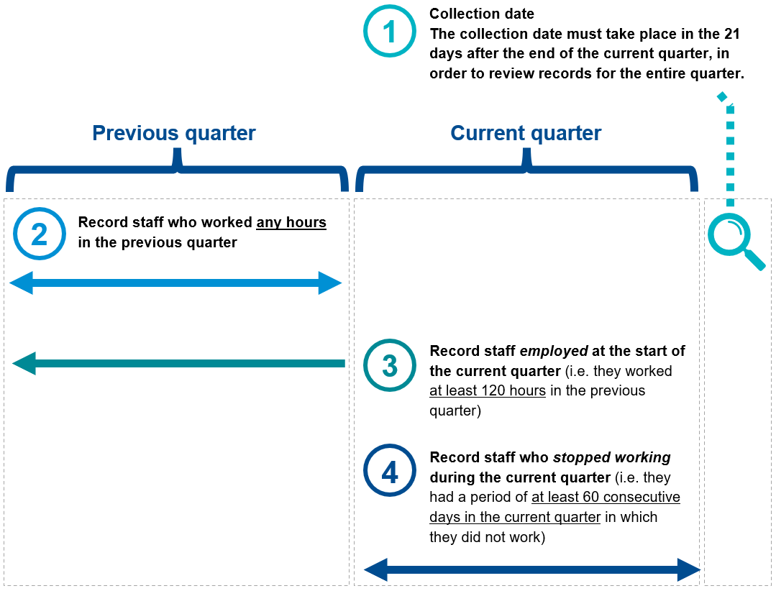
In respect of the above diagram, the collection date is within 21 days after the end of the ‘current quarter’. Therefore the ‘current quarter’ for the purposes of the workforce indicator would be the quarter that the registered provider is collecting the data for, not the quarter that the collection date falls within. For example, if the collection date was 21 July the current quarter would be Q4, 1 April to 30 June and the previous quarter would be Q3, 1 January to 31 March.

Inclusions for workforce
All staff who worked any hours as either service managers, nurse practitioners, registered nurses, enrolled nurses, personal care workers or nursing assistants at the start of the reporting period must be assessed for the workforce quality indicator.
Note: Refer to 18.2 Key terms for workforce.

Exclusions for workforce
Nil.

Data reporting for workforce
Pursuant to section 166-160 of the Rules, registered providers must compile or otherwise derive information from these measurements and assessments that is relevant to indicating the quality of residential care.
As per sections 166-112(2) and (3) of the Rules, registered providers must ensure that the information reported in accordance with these requirements does not contain personal information (within the meaning of the Privacy Act 1988) about any of the staff members.
TABLE 25: REQUIREMENTS FOR DATA REPORTING ON WORKFORCE
1 | Number of staff that have worked any number of hours as service managers in the previous reporting period.
2 | Number of staff that have worked any number of hours as nurse practitioners or registered nurses in the previous reporting period.
3 | Number of staff that have worked any number of hours as enrolled nurses in the previous reporting period.
4 | Number of staff that have worked any number of hours as personal care workers or nursing assistants in the previous reporting period.
5 | Number of staff that were employed at the start of the reporting period and have worked for at least 120 hours in the previous reporting period as service managers.
6 | Number of staff that were employed at the start of the reporting period and have worked for at least 120 hours in the previous reporting period as nurse practitioners or registered nurses.
7 | Number of staff that were employed at the start of the reporting period and have worked for at least 120 hours in the previous reporting period as enrolled nurses.
8 | Number of staff that were employed at the start of the reporting period and have worked for at least 120 hours in the previous reporting period as personal care workers or nursing assistants.
9 | Number of staff that were employed at the start of the reporting period and did not work for at least 60 consecutive days in the reporting period as service managers.
10 | Number of staff that were employed at the start of the reporting period and did not work for at least 60 consecutive days in the reporting period as nurse practitioners or registered nurses.
11 | Number of staff that were employed at the start of the reporting period and did not work for at least 60 consecutive days in the reporting period as enrolled nurses.
12 | Number of staff that were employed at the start of the reporting period and did not work for at least 60 consecutive days in the reporting period as personal care workers or nursing assistants.

How to report workforce
Pursuant to section 166-110 of the Rules, registered providers must submit the quality indicators report into GPMS in order to make the information available to the System Governor.

Additional resources for workforce
More information and resources related to workforce are available at www.health.gov.au and in
QI Program Manual - Part B.

Consumer experience

Overview of consumer experience
Consumer experience is crucial in capturing the consumer voice of older people in Australia. The Quality-of-Care Experience Aged Care Consumers © Flinders University 2022 (QCE-ACC) tool was co-designed with older people in Australia to assess important aspects of consumer experience. The QCE-ACC is comprised of six questions focused on key attributes to the quality-of-care experience — respect and dignity, supported decision-making, skills of aged care staff, impact on health and wellbeing, social relationships and community connection, and confidence in lodging complaints.
The QCE-ACC is the consumer experience assessment tool used for the purposes of the QI Program, included in Appendix C.
Registered providers must collect and report on consumer experience data each reporting period, according to the requirements set out in section 166-165 of the Rules.

TABLE 26: CONSUMER EXPERIENCE QUALITY INDICATOR OVERVIEW
  Percentage of individuals who report ‘good’ or ‘excellent’ experience of the service | Collection  - A consumer experience assessment must be offered to each individual for completion, around the same time every reporting period
Quality indicator reporting
- Individuals who undertook the consumer experience assessment (QCE-ACC) through self-completion, interviewer facilitated or proxy-completion, reported against the sub-categories:
- ‘Excellent’ (individuals who score between 22–24)
- ‘Good’ (individuals who score between 19–21)
Additional reporting
- Individuals who were offered a consumer experience assessment for completion
- Individuals who undertook the consumer experience assessment (QCE-ACC) through self-completion, interviewer facilitated or proxy-completion, reported against the sub-categories:
- ‘Moderate’ (individuals who score between 14–18)
- ‘Poor’ (individuals who score between 8–13)
- ‘Very poor’ (individuals who score between 0–7)
Exclusions
- Individuals who were absent from accessing funded aged care services throughout the reporting period
- Individuals who chose not to complete the consumer experience assessment in the reporting period.

Key terms for consumer experience
The Quality of Care Experience Aged Care Consumers© (QCE-ACC) tool asks individuals to indicate their quality of care experience by selecting the most appropriate statement using a five or six-point scale. This ranges from ‘never’ to ‘always’ for five of the six survey questions, with the question about complaints having a ‘not applicable’ option see Appendix C.
The individual’s scores for each of the six questions is added together to give a total score. The guidance provides a rescaling tool if an individual answers ‘not applicable’. In line with standard mathematical rounding conventions, rescaled scores where a ‘not applicable’ option has been selected should be rounded to the nearest whole number for categorisation purposes. If the decimal component is less than 0.5, the score is rounded down (e.g. 7.2 becomes 7) and if the decimal is 0.5 or greater, the score is rounded up (e.g. 21.6 becomes 22).
Once scored, these are then assigned to one of five categories describing overall consumer experience:
- Excellent consumer experience: where an individual scores between 22–24
- Good consumer experience: where an individual scores between 19–21
- Moderate consumer experience: where an individual scores between 14–18
- Poor consumer experience: where an individual scores between 8–13
- Very poor consumer experience: where an individual scores between 0–7.
Anonymous collection of QCE-ACC assessments is preferred and should be supported to the extent possible.
For the purposes of the QI Program, self-completion is when an individual independently completes the QCE-ACC Self-Complete Version. It is recommended the QCE-ACC is self-completed by all individuals with capacity (e.g. individuals with no or mild cognitive impairment). Registered providers are encouraged to facilitate anonymous, self-completion where possible, using the QCE-ACC Self-Complete Version.
Note: Where self-completion by an individual is not possible because they are unable to read the questions or write responses, interviewer facilitated completion is recommended (see below).
For the purposes of the QI Program, interviewer facilitated completion is when an individual requires additional assistance (e.g. support with reading the questions or writing responses) to facilitate completion using the QCE-ACC Interviewer Facilitated Version. The interviewer must not influence scoring by the individual and must use the QCE-ACC Interviewer Facilitated Version.
Note: Where self-completion and interviewer facilitated completion is not possible because an individual has moderate or severe cognitive impairment, proxy-completion is recommended (see below).
For the purposes of the QI Program, proxy-completion is when an individual is unable to answer on their own behalf (e.g. because of moderate or severe cognitive impairment) through self-completion, or through interviewer facilitated completion. The QCE-ACC Proxy Version can only be completed by a legal guardian, in accordance with section 28(2) of the Aged Care Act 2024. It is recommended that the legal guardian also be someone who knows the individual well and sees them regularly and whose power extends to making decisions relating to care and not for example, financial decisions only.
A legal guardian is someone who;
- has guardianship of the individual under a law of the Commonwealth, a State or a Territory;
- is appointed by a court, tribunal, board or panel under a law of the Commonwealth, a State or a Territory, and has power to make decisions for the individual; or
- holds an enduring power of attorney or like power granted by the individual.
The proxy respondent should answer based on their own knowledge of the individual and their experience at the time of administration using the QCE-ACC Proxy Version.

Measurements and assessments for consumer experience
The purpose of assessing an individual through the process set out below is to collect data relating to the consumer experience quality indicator.

Pursuant to section 166-165 of the Rules, registered providers must make assessments and measurements of consumer experience that are relevant to indicating the quality of residential care in accordance with the requirements listed below.

- Offer the QCE-ACC Self-Complete Version document for self-completion to all suitable individuals at the aged care home at around the same time every reporting period. The QCE-ACC Self-Complete Version can be self-completed by individuals with no or mild cognitive impairment.
- Arrange interviewer facilitated completion for all individuals requiring assistance to complete the QCE-ACC document (e.g. where the individual requires support with reading the questions or writing responses) at around the same time every reporting period using the QCE-ACC Interviewer Facilitated Version.
- Arrange proxy-completion for all individuals who cannot complete the QCE-ACC through self-completion or interviewer facilitated completion (e.g. due to moderate or severe cognitive impairment) at around the same time every reporting period using the QCE-ACC Proxy Version.
- Record the individuals that were excluded because of an absence from the aged care home throughout the reporting period.
- Record the individuals that were excluded because they chose not to complete the QCE-ACC in the reporting period.
Note: Individuals with no or mild cognitive impairment can choose not to complete the QCE-ACC by self-completion or interviewer facilitated completion. Where an individual requires a proxy (e.g. due to moderate or severe cognitive impairment) and either, the individual does not have a suitable proxy arrangement in place or the proxy does not complete the QCE-ACC, no survey can be completed.
- Record the individuals who reported consumer experience through each means of assessment of the QCE-ACC (self-completion, interviewer facilitated or proxy-completion), scored against the five sub-categories:
- ‘Excellent’ (individuals who score between 22–24)
- ‘Good’ (individuals who score between 19–21)
- ‘Moderate’ (individuals who score between 14–18)
- ‘Poor’ (individuals who score between 8–13)
- ‘Very poor’ (individuals who score between 0–7).

Inclusions for consumer experience
All individuals must be assessed for consumer experience except for those listed in 19.3.2 Exclusions for consumer experience.

Exclusions for consumer experience
Individuals who:
- were absent from accessing funded aged care services throughout the reporting period; or
- chose not to complete the consumer experience assessment in the reporting period
are excluded from assessment for consumer experience, but are reported under additional reporting requirements.

Data reporting for consumer experience
Pursuant to section 166-165 of the Rules, registered providers must compile or otherwise derive information from these measurements and assessments that is relevant to indicating the quality of residential care.
As per sections 166-112(2) and (3) of the Rules, registered providers must ensure that the information reported from the measurements and assessments does not contain personal information (within the meaning of the Privacy Act 1988) about any of the individuals accessing funded aged care services.
TABLE 27: REQUIREMENTS FOR DATA REPORTING ON CONSUMER EXPERIENCE
1 | Number of individuals offered a consumer experience assessment through the means of self-completion, interviewer facilitated or proxy-completion.  Note: All individuals must be assessed for consumer experience except for those listed in 19.3.2 Exclusions for consumer experience.
2 | Number of individuals excluded because of an absence from accessing funded aged care services throughout the reporting period.
3 | Number of individuals excluded because of choosing not to complete the consumer experience assessment in the reporting period.
4 | Number of individuals who undertook the consumer experience assessment during the reporting period and reported against the following sub-categories and means of assessment (self-completion, interviewer facilitated, or proxy-completion) for individuals in each sub-category:  - ‘Excellent’: for individuals who score between 22 and 24  - ‘Good’: for individuals who score between 19 and 21  - ‘Moderate’: for individuals who score between 14 and 18  - ‘Poor’: for individuals who score between 8 and 13  - ‘Very poor’: for individuals who score between 0 and 7.

How to report consumer experience
Pursuant to section 166-110 of the Rules, registered providers must submit the quality indicators report into GPMS in order to make the information available to the System Governor.

Additional resources for consumer experience
More information and resources related to consumer experience are included in Appendix C, and are available at www.health.gov.au and in QI Program Manual - Part B.

Quality of life

Overview of quality of life
Quality of life refers to a person’s perception of their position in life, taking into consideration their environment and their goals, expectations, standards, and concerns. It includes their emotional, physical, material, and social wellbeing.
The Quality of Life Aged Care Consumers © Flinders University 2022 (QOL-ACC) tool was co-designed with older people in Australia to assess important aspects of quality of life. The QOL-ACC is comprised of six questions focused on six key attributes of quality of life — independence, mobility, pain management, emotional wellbeing, social relationships, and leisure activities/hobbies.
The QOL-ACC is the quality of life assessment tool used for the purposes of the QI Program, included in Appendix D.
Registered providers of aged care homes must collect and report on quality of life data each reporting period, according to the requirements set out in section 166-170 of the Rules.
TABLE 28: QUALITY OF LIFE QUALITY INDICATOR OVERVIEW
  Percentage of individuals who report ‘good’ or ‘excellent’ quality of life | Collection  - A quality of life assessment must be offered to each individual for completion, around the same time every reporting period
Quality indicator reporting
- Individuals who undertook the quality of life assessment (QOL-ACC) through self-completion, interviewer facilitated or proxy-completion, reported against the sub-categories:
- ‘Excellent’ (individuals who score between 22–24)
- ‘Good’ (individuals who score between 19–21)
Additional reporting
- Individuals who were offered a quality of life assessment for completion
- Individuals who undertook the quality of life assessment (QOL-ACC) through self-completion, interviewer facilitated or proxy-completion, reported against the sub-categories:
- ‘Moderate’ (individuals who score between 14–18)
- ‘Poor’ (individuals who score between 8–13)
- ‘Very poor’ (individuals who score between 0–7)
Exclusions
- Individuals who were absent from accessing funded aged care services throughout the reporting period
- Individuals who chose not to complete the quality of life assessment in the reporting period.

Key terms for quality of life
The Quality of Life Aged Care Consumers© (QOL-ACC) tool asks individuals to indicate their quality of life by selecting the most appropriate statement using a five or six-point scale. This ranges from ‘none of the time’ to ‘all of the time’ for five survey questions, with the question about pain management having a ‘not applicable’ option, see Appendix D.
The individual’s scores for each of the six questions is added together to give a total score. The guidance provides a rescaling tool if an individual answers ‘not applicable’ to the pain management question. In line with standard mathematical rounding conventions, rescaled scores where a ‘not applicable’ option has been selected should be rounded to the nearest whole number for categorisation purposes. If the decimal component is less than 0.5, the score is rounded down (e.g. 7.2 becomes 7) and if the decimal is 0.5 or greater, the score is rounded up (e.g. 21.6 becomes 22).
Once scored, these are then assigned to one of five categories describing overall quality of life:
- Excellent quality of life: where an individual scores between 22–24
- Good quality of life: where an individual scores between 19–21
- Moderate quality of life: where an individual scores between 14–18
- Poor quality of life: where an individual scores between 8–13
- Very poor quality of life: where an individual scores between 0–7.
Anonymous collection of QOL-ACC assessments is preferred and should be supported to the extent possible.
For the purposes of the QI Program, self-completion is when an individual independently completes the QOL-ACC Self-Complete Version. It is recommended the QOL-ACC is self-completed by all individuals with capacity (e.g. individuals with no or mild cognitive impairment). Providers are encouraged to facilitate anonymous, self-completion where possible, using the QOL-ACC Self-Complete Version.
Note: Where self-completion by an individual is not possible because they are unable to read the questions or write responses, interviewer facilitated completion is recommended (see below).
For the purposes of the QI Program, interviewer facilitated completion is when an individual requires additional assistance (e.g. support with reading the questions or writing responses) to facilitate completion using the QOL-ACC Interviewer Facilitated Version. The interviewer must not influence scoring by the individual and must use the QOL-ACC Interview Facilitated Version.
Note: Where self-completion and interviewer facilitated completion is not possible because an individual has moderate or severe cognitive impairment, proxy-completion is recommended (see below).
For the purposes of the QI Program, proxy-completion is when an individual is unable to answer on their own behalf (e.g. because of moderate or severe cognitive impairment), through self-completion, or through interviewer facilitated completion. The QOL-ACC Proxy Version can only be completed by a legal guardian, in accordance with section 28(2) of the Aged Care Act 2024. It is recommended that the legal guardian also be someone who knows the individual well and sees them regularly and whose power extends to making decisions relating to care, and not for example, financial decisions only.
A legal guardian is someone who;
- has guardianship of the individual under a law of the Commonwealth, a State or a Territory;
- is appointed by a court, tribunal, board or panel under a law of the Commonwealth, a State or a Territory, and has power to make decisions for the individual; or
- holds an enduring power of attorney or like power granted by the individual.
The proxy respondent should answer based on their own knowledge of the individual and their quality of life at the time of administration using the QOL-ACC Proxy Version.

Measurements and assessments for quality of life
The purpose of assessing an individual through the process set out below is to collect data relating to the quality of life quality indicator.

Pursuant to section 166-170 of the Rules, registered providers must make assessments and measurements of quality of life that are relevant to indicating the quality of residential care in accordance with the requirements listed below.

- Offer the QOL-ACC Self-Complete Version for self-completion to all suitable individuals at the aged care home at around the same time every reporting period. The QOL-ACC Self-Complete Version can be self-completed by individuals with no or mild cognitive impairment.
- Arrange interviewer facilitated completion for all individuals requiring assistance to complete the QOL-ACC (e.g. where the individual requires support with reading the questions or writing responses) at around the same time every reporting period using the QOL-ACC Interviewer Facilitated Version.
- Arrange proxy-completion for all individuals who cannot complete the QOL-ACC through self-completion or interviewer facilitated completion (e.g. due to moderate or severe cognitive impairment) at around the same time every reporting period using the QOL-ACC Proxy Version.
- Record the individuals excluded because of an absence from accessing funded aged care services throughout the reporting period.
- Record the individuals excluded because of choosing not to complete the QOL-ACC in the reporting period.
Note: Individuals with no or mild cognitive impairment can choose not to complete the QOL-ACC by self-completion or interviewer facilitated completion. Where an individual requires a proxy (e.g. due to moderate or severe cognitive impairment) and either the individual does not have a suitable proxy arrangement in place or the proxy does not complete the QCE-ACC, no survey can be completed.
- Record the individuals who reported quality of life through each means of assessment of the QOL-ACC (self-completion, interviewer facilitated or proxy-completion), scored against the five sub-categories:
- ‘Excellent’ (individuals who score between 22–24)
- ‘Good’ (individuals who score between 19–21)
- ‘Moderate’ (individuals who score between 14–18)
- ‘Poor’ (individuals who score between 8–13)
- ‘Very poor’ (individuals who score between 0–7).

Inclusions for quality of life
All individuals must be assessed for quality of life except for those listed in 20.3.2 Exclusions for quality of life.

Exclusions for quality of life
Individuals who:
- were absent from accessing funded aged care services throughout the reporting period; or
- chose not to complete the quality of life assessment in the reporting period
are excluded from assessment for quality of life, but are reported under additional reporting requirements.

Data reporting for quality of life
Pursuant to section 166-170 of the Rules, registered providers must compile or otherwise derive information from these measurements and assessments that is relevant to indicating the quality of residential care.
As per sections 166-112(2) and (3) of the Rules, registered providers must ensure that the information reported from the measurements and assessments does not contain personal information (within the meaning of the Privacy Act 1988) about any of the individuals accessing funded aged care services.
TABLE 29: REQUIREMENTS FOR DATA REPORTING ON QUALITY OF LIFE
1 | Number of individuals that were offered a quality of life assessment during the reporting period through the means of self-completion, interviewer facilitated or proxy-completion.  Note: All individuals must be assessed for quality of life except for those listed in 20.3.2 Exclusions for quality of life.
2 | Number of individuals excluded because of an absence from accessing funded aged care services throughout the reporting period.
3 | Number of individuals excluded because of choosing not to complete the quality of life assessment in the reporting period.
4 | Number of individuals who undertook the quality of life assessment, and who reported against the following sub-categories and the means of assessment of the QOL-ACC (self-completion, interviewer facilitated or proxy-completion), for the individuals in each sub-category:  - ‘Excellent’: for individuals who score between 22 and 24  - ‘Good’: for individuals who score between 19 and 21  - ‘Moderate’: for individuals who score between 14 and 18  - ‘Poor’: for individuals who score between 8 and 13  - ‘Very poor’: for individuals who score between 0 and 7.

How to report quality of life
Pursuant to section 166-110 of the Rules, registered providers must submit the quality indicators report into GPMS in order to make the information available to the System Governor.

Additional resources for quality of life
More information and resources related to quality of life are included in Appendix D, and are available at www.health.gov.au and in QI Program Manual - Part B.

Enrolled nursing (EN): Proportion of EN care minutes and Proportion of Nursing care minutes
Nurses are essential health professionals who care for people in health and aged care settings. Nurses have the knowledge and skills to give high quality care where and when it is needed. The enrolled nursing (EN) quality indicator is reported against:
- Proportion of EN care minutes, and
- Proportion of nursing care minutes.
Providers are not required to submit data through the QI Program app on GPMS for these data points. The Department will extract the data needed to calculate these from data submitted through the Quarterly Financial Report (QFR) (see table 31 for details). This will then be pulled across to the QI Program app in GPMS and enable providers to see their enrolled nursing data alongside their other QI Program data.
The requirements for the enrolled nursing quality indicator are set out in section 166-185 of the Rules.

Overview of enrolled nursing: Proportion of EN care minutes and Proportion of nursing care minutes
TABLE 30: ENROLLED NURSING QUALITY INDICATOR OVERVIEW
  Proportion of EN care minutes (EN care minutes as a percentage of total care minutes¹)  Proportion of nursing care minutes. (RN + EN care minutes as a percentage of total care minutes) | Collection  - The Department will calculate the ‘proportion of EN care minutes’ and ‘proportion of nursing care minutes’ data point using data submitted by registered providers through the QFR
Quality indicator reporting (extracted from QFR)
- Proportion of EN care minutes per individual per day
- Proportion of nursing care minutes per individual per day¹
Additional reporting (extracted from QFR)
- RN care minutes per individual per day
- PCW/NA care minutes per individual per day
NA: nursing assistant; EN: enrolled nurse; PWC: personal care worker; RN: registered nurse
¹ Total care minutes: EN + RN + PCW + NA care minutes per individual per day.

Key terms for enrolled nursing: Proportion of EN care minutes and proportion of nursing care minutes
ENs are staff who provide nursing care under the direct or indirect supervision of an RN. They have completed the prescribed education preparation and demonstrate competence to practice under the National Law as an EN in Australia.
Registered nurses (RNs) are staff who have completed the prescribed education preparation, demonstrate competence to practice, and are registered under the National Law as an RN in Australia.
A personal care worker/nursing assistant (PCW/NA) is an employee classified under Schedule B.2 in the Aged Care Award 2010 as an Aged Care employee – direct care level 1 to level 6. A registered provider may employ a PCW in an equivalent role in a corresponding award/enterprise agreement; or an individual contract/agreement. The primary responsibility of a PCW/NA is to directly provide personal care services to residents under the supervision of a RN or EN.
The Government funds registered providers through the Australian National Aged Care Classification (AN-ACC) to have a sufficient mix of RNs, ENs and PCWs/NAs on duty at all times. This is so registered providers can provide safe and quality care to residents living at their aged care homes.

Data reporting for enrolled nursing (EN): Proportion of EN care minutes and proportion of nursing care minutes
Pursuant to section 166-340 of the Aged Care Rules (the Rules), a registered provider must give the System Governor a quarterly financial report for each quarter of a financial year.
For the purposes of obtaining this data registered providers may use the information that the registered provider gives to the System Governor under section 166-335 of the Rules.
A registered provider must include the following information on enrolled nursing with respect to direct care staff members that deliver funded aged care services:
- Enrolled nursing total number of care minutes (in hours);
- Registered nursing total number of care minutes (in hours);
- Personal care workers and nursing assistants total number of care minutes (in hours).
The department will extract data submitted under section 166-335 of the Rules and undertake calculations to reach these data points as per below. Please see the QFR webpage for more information on the QFR requirements.
As collection periods for the QFR and QI Program do not align, there may be a delay in QFR data extraction into the QI Program app in GPMS. The extracted and calculated EN quality indicator data from the QFR will display in GPMS only once the registered provider has completed their initial QFR submission.
TABLE 31: REQUIREMENTS FOR DATA REPORTING ON ENROLLED NURSING
1 | EN care minutes per individual per day
2 | Nursing care minutes per individual per day  (EN care minutes per individual per day + RN care minutes per individual per day)
3 | Total care minutes per individual per day¹.  (EN care minutes per individual per day + RN care minutes per individual per day + PCW/NA care minutes per individual per day)
¹Care minute values are calculated as:
EN care minutes per individual per day = (EN employee labour hours + EN agency hours) * 60 mins / Occupied bed days
RN care minutes per individual per day = (RN employee labour hours + RN agency hours) * 60 mins / Occupied bed days
PCW/NA care minutes per individual per day = (PCW/NA employee labour hours + PCW/NA agency hours) * 60 mins / Occupied bed days

Additional resources for enrolled nursing (EN)
More information and resources for enrolled nursing are available at www.health.gov.au and in
QI Program Manual - Part B .

Allied health: Allied health care minutes
Allied health services are critical to providing quality care to meet the needs of older people in Australia residing in residential aged care. Allied health professionals are health professionals that are not part of the medical, dental, pharmacy or nursing professions. They are university qualified practitioners with specialised expertise in preventing, diagnosing and treating a range of conditions and illnesses.
Registered providers must make a range of allied health services available to individuals under section 148 of the Act. In addition, under the Strengthened Aged Care Quality Standards (Quality Standards) the provider must ensure that individuals receive comprehensive, safe and quality clinical care services that are evidence-based, person-centred and delivered by registered health practitioners, allied health professionals, allied health assistants or nursing assistants (Outcome 5.4).
The requirements for the allied health care minutes quality indicator data point are set out in section 166-175(2) of the Rules.

Overview of allied health care minutes
Registered providers are to report the allied health quality indicator against:
- Allied health care minutes (see this Section).
- Percentage of recommended allied health services received (see Section 23 of this Manual).
Registered providers are not required to submit data through QI Program reporting for the allied health care minutes data point. The Department will extract the data needed to calculate these data points from data submitted through the QFR (see table 33 for details). This will then be pulled across to the QI Program app in GPMS and enable providers to see their allied health care minutes data alongside their other QI Program data.
TABLE 32: ALLIED HEALTH QUALITY INDICATOR OVERVIEW
  Allied health care minutes | Collection  - The Department will calculate the ‘allied health care minutes’ data point using data submitted by registered providers through the QFR
Quality indicator reporting (extracted from QFR)
- Allied health care minutes per individual per day
Additional reporting (extracted from QFR)
- Physiotherapy care minutes per individual per day
- Occupational therapy care minutes per individual per day
- Speech pathology care minutes per individual per day
- Podiatry care minutes per individual per day
- Dietetics care minutes per individual per day
- Other care minutes per individual per day
- Allied health assistant care minutes per individual per day

Key terms for allied health care minutes
For the purposes of the QI Program, allied health and therapy services delivered by an allied health professional are defined in line with the QFR:

- physiotherapist
- occupational therapist
- speech pathologist
- podiatrist
- dietitian
- allied health assistant
- other allied health professionals².

²Other allied health professionals includes the following disciplines and is defined in line with the QFR:

- art therapists
- audiologists
- exercise physiologists
- music therapists
- chiropractors
- counsellors
- osteopaths
- psychologists
- social workers
- diabetes educators

Note: Allied health assistant means a person who holds a Certificate IV in Allied Health Assistance from a registered training organisation. They must work under the supervision of allied health professionals and be subject to a delegation framework.

Data reporting for allied health care minutes

Pursuant to section 166-340 of the Aged Care Rules (the Rules), a registered provider must give the System Governor a quarterly financial report for each quarter of a financial year.
Under subsection 166-175(2) of the Rules, a quality indicators report must include the number of allied health professional labour hours (represented as minutes of care and services delivered to individuals each day) and reported separately as:
(a) allied health professional employee labour hours;
(b) allied health professional agency labour hours.
The Department will extract the data needed to calculate these data points from data submitted through the QFR (see table 33 for details). Please see the QFR webpage for more information on the QFR requirements.
As QFR and QI reporting timeframes do not align, there may be a delay in QFR data extraction into the QI Program app in GPMS. The extracted and calculated allied health data from the QFR will display in GPMS only once the registered provider has completed their initial QFR submission.
TABLE 33: REQUIREMENTS FOR DATA REPORTING ON ALLIED HEALTH CARE MINUTES
1 | Allied health care minutes per individual per day  (Allied health employee labour hours *60 + allied health agency labour hours*60) /Occupied bed days
2 | Physiotherapy care minutes per individual per day  (Physiotherapist employee labour hours*60 + Physiotherapist agency staff labour hours*60) / Occupied bed days.
3 | Occupational therapy care minutes per individual per day  (Occupational Therapist employee labour hours*60 + Occupational Therapist agency labour hours*60) / Occupied bed days.
4 | Speech pathology care minutes per individual per day  (Speech Pathologist employee labour hours*60 + Speech Pathologist agency labour hours*60) / Occupied bed days.
5 | Podiatry care minutes per individual per day  (Podiatrist labour hours*60 + Podiatrist agency labour hours*60) / Occupied bed days.
6 | Dietetics care minutes per individual per day  (Dietetic Care labour hours*60 + Dietetic Care agency labour hours*60) / Occupied bed days.
7 | Other allied health care minutes per individual per day  (Other allied health employee labour hours*60 + Other allied health agency labour hours*60) / Occupied bed days.
8 | Allied health assistant care minutes per individual per day  (Allied health assistants employee labour hours*60 + Allied health assistants agency labour hours*60) / Occupied bed days.

Additional resources for allied health care minutes
More information and resources for allied health are available at www.health.gov.au and in
QI Program Manual – Part B.

Allied health: recommended services
received
Allied health services are critical to providing quality care to meet the needs of older people in Australia. Allied health professionals are health professionals that are not part of the medical, dental, pharmacy or nursing professions. They are university qualified practitioners with specialised expertise in preventing, diagnosing and treating a range of conditions and illnesses. For the purposes of the QI Program an allied health practitioner is equivalent to an allied health professional.
Registered providers must make a range of allied health services available to individuals under section 148 of the Act. In addition, under the Strengthened Aged Care Quality Standards (Quality Standards) the provider must ensure that individuals receive comprehensive, safe and quality clinical care services that are evidence-based, person-centred and delivered by registered health practitioners, allied health professionals, allied health assistants or nursing assistants (Outcome 5.4). This includes timely and appropriate referrals to allied health professionals.

Overview of allied health - recommended services received
Registered providers are to report the allied health quality indicator against:
- Allied health care minutes (see Section 22 of the Manual).
- Percentage of recommended allied health services received (see this Section).
TABLE 34: ALLIED HEALTH QUALITY INDICATOR OVERVIEW
Percentage of recommended allied health services received | Collection  - A single review of care records for each individual. The review must be after the end of the current reporting period before data is due (the 21st day of the month after the reporting period ended).
Quality indicator reporting
- Number of allied health services recommended in care and services plan
- Number of recommended allied health services received
Additional reporting
- Number of individuals assessed for services delivered by an allied health professional
- Number of individuals excluded because they were absent from the aged care home during the reporting period
- Number of allied health services that were recommended to be delivered by an allied health professional (through a care and services plan) reported against:
- physiotherapist
- occupational therapist
- speech pathologist
- podiatrist
- dietitian
- allied health assistant
- other allied health professionals.
- Number of allied health services that were recommended to be delivered by an allied health professional (through a care and services plan) which were received reported against:
- physiotherapist
- occupational therapist
- speech pathologist
- podiatrist
- dietitian
- allied health assistant
- other allied health professionals.

Key terms for allied health - recommended services received
For the purposes of the QI Program, funded aged care services in the service type allied health and therapy services delivered by an allied health professional are defined in line with the QFR.

Under subsection 166-175(3) of the Rules, registered providers must report against each of the following subcategories:

- physiotherapist
- occupational therapist
- speech pathologist
- podiatrist.
- dietitian
- allied health assistant
- other allied health professionals³

‘Other allied health’ includes the following disciplines and is defined in line with the QFR and include the following in accordance with subsection 166-175(4) of the Rules:

- art therapists
- audiologists
- diabetes educators
- exercise physiologists
- music therapists
- chiropractors
- counsellors
- osteopaths
- psychologists
- social workers.

Note: Allied health assistant means a person who holds a Certificate IV in Allied Health Assistance from a registered training organisation. They must work under the supervision of allied health professionals and be subject to a delegation framework.
For the purposes of the QI Program, the following definitions apply:
- Recommended allied health service: any allied health service recommendation documented in an individual’s care and services plan and/or progress notes during the reporting period. This can be through a referral, an incident response (for example, after a fall), or a request from an individual or their representative. In the case of ongoing or ‘as required’ recommendations for allied health services, documentation in the care and services plan may need to be updated during each reporting period, if it is not clear that a received allied health service relates to a current recommendation.
- Received allied health service: a recommended allied health service has been received if the appointment/visit occurred and was documented during the reporting period in the individual’s care and services plan and/or progress notes. The received allied health service is counted if it involves assessment, intervention or both. This can include group therapy sessions.
- Care and services plan: care plans and associated documents which describe the current care needs, goals and preferences of individuals and include strategies for risk management and preventative care (Strengthened Aged Care Quality Standards, Outcome 3.1). They should be current and reflect the outcomes of assessments. For the purposes of the QI Program, progress notes and reports provided by allied health professionals are included.

Measurements and assessments for allied health - recommended services received
The purpose of assessing an individual through the process set out below is to collect data for the allied health - recommended services received data point.
Under section 166-175(1) of the Rules, providers must make assessments and measurements of allied health services that are relevant to indicating the quality of residential care in accordance with the requirements listed below.
- Record the individuals in the aged care home that were assessed for an allied health services recommendation during the reporting period.
- Record the individuals excluded because of an absence from the aged care home throughout the reporting period.
- Review and record each individual’s care and services plan and assess whether each individual had a recommendation for an allied health service and the allied health discipline that the recommendation was for.
- For individuals who had a recommendation for services delivered by an allied health professional during the reporting period recorded in step 3, record whether they received that service for an allied health professional by discipline.
Note: Providers only need to report services received that were recommended. For example, if the individual has a recommendation for dietetics and physiotherapy, and they receive a service for dietetics and speech pathology, you would report this as one recommended dietetics service received.
Note: Providers only need to report once per discipline. For example, if the individual receives three recommended dietitian visits and one recommended physiotherapy visit during a reporting quarter, this should be counted as: one recommended and received dietetics service, and one recommended and received physiotherapy service. Do not count multiple instances of care received from the same discipline during the reporting quarter.

Inclusions for allied health - recommended services received
All individuals must be assessed for allied health - recommended services received except those listed in 23.3.2. Exclusions for allied health - recommended services received.

Exclusions for allied health - recommended services received
Individuals who were absent from accessing funded aged care services throughout the reporting period, are excluded from assessment for allied health – recommended services received but are reported under ‘additional reporting requirements’.

Data reporting for allied health - recommended services received
Pursuant to section 166-175 of the Rules, registered providers must compile or otherwise derive information from these measurements and assessments that is relevant to indicating the quality of residential care.
As per sections 166-112(2) and (3) of the Rules, registered providers must ensure that the information reported from the measurements and assessments does not contain personal information (within the meaning of the Privacy Act 1988) about any of the individuals accessing funded aged care services.

TABLE 35: REQUIREMENTS FOR DATA REPORTING ON ALLIED HEALTH – RECOMMENDED SERVICES RECEIVED
1 | Number of individuals assessed for services delivered by an allied health professional during the reporting period.
2 | Number of individuals who were excluded because of an absence from accessing funded aged care services throughout the reporting period.
3 | Number of allied health and therapy services that were recommended to be delivered by an allied health professional through a care and services plan.
4 | Number of allied health and therapy services recommended to be delivered by a physiotherapist.
5 | Number of allied health and therapy services recommended to be delivered by an occupational therapist.
6 | Number of allied health and therapy services recommended to be delivered by a speech pathologist.
7 | Number of allied health and therapy services recommended to be delivered by a podiatrist.
8 | Number of allied health and therapy services recommended to be delivered by a dietitian.
9 | Number of allied health and therapy services recommended to be delivered by an allied health assistant.
10 | Number of allied health and therapy services recommended to be delivered by other allied health professionals.
11 | Number of allied health and therapy services that were recommended to be delivered by an allied health professional which were received.
12 | Number of allied health and therapy services that were recommended to be delivered by a physiotherapist which were received.
13 | Number of allied health and therapy services that were recommended to be delivered by an occupational therapist which were received.
14 | Number of allied health and therapy services that were recommended to be delivered by a speech pathologist which were received.
15 | Number of allied health and therapy services that were recommended to be delivered by a podiatrist which were received.
16 | Number of recommended allied health and therapy services that were recommended to be delivered by a dietitian which were received.
17 | Number of allied health and therapy services that were recommended to be delivered by an allied health assistant which were received.
18 | Number of allied health and therapy services that were recommended to be delivered by other allied health professionals which were received.

Note: The number of allied health services received should not be more than the number of recommended allied health services.

How to report allied health - recommended services received
Pursuant to section 166-110 of the Rules, registered providers must submit the quality indicators report into GPMS in order to make the information available to the System Governor.

Additional resources for allied health - recommended services received
More information and resources for allied health – recommended services received are available at www.health.gov.au and in QI Program Manual - Part B.

Lifestyle officers

Overview of lifestyle officers
Lifestyle officers typically provide support to individuals to do activities to enhance their psychological, spiritual, social and physical well-being. Under section 166-180(1) of the Rules, a lifestyle officer includes the following roles:
- diversional officer,
- recreational officer
- activities officer.
Registered providers of residential aged care are required to report the labour costs of lifestyle officers as part of the QFR.
Registered providers are to report the lifestyle officers quality indicator against:
- Lifestyle officers care minutes.
Registered providers are not required to submit data through QI Program reporting for the lifestyle officers care minutes data point. The Department will extract the data needed to calculate these data points from data submitted through the QFR (see section 24.3 for details).
TABLE 36: LIFESTYLE OFFICERS QUALITY INDICATOR OVERVIEW
  Lifestyle officers care minutes | Collection  - The Department will calculate lifestyle officers care minutes for the purposes of the QI Program from data submitted by registered providers through the QFR.
Quality indicator reporting (extracted from QFR)
- Lifestyle officers care minutes

Key terms for lifestyle officers
For the purposes of the QI Program, the lifestyle officers quality indicator will use ‘Diversional / Lifestyle / Recreation / Activities officer residential labour hours’ data submitted through the QFR.
Only Diversional / Lifestyle / Recreation / Activities officer hours relating to caring for government-funded residential aged individuals (including those receiving residential respite) funded under the Australian National Aged Care Classification (AN-ACC) model should be included. Please see the QFR webpage for more information on the QFR requirements.

Data reporting for lifestyle officers
Pursuant to section 166-340 of the Aged Care Rules (the Rules), a registered provider must give the System Governor a quarterly financial report for each quarter of a financial year.

Under subsection 166-180 of the Rules, a quality indicators report must include:
(a) the total labour hours worked in care minutes by lifestyle officers;
(b) the total labour hours worked as agency staff by lifestyle officers.
Registered providers are not required to submit data through QI Program reporting for this data point. The Department will extract the data needed to calculate these data points from data submitted through the QFR (see table 37 for details).
As QFR and QI reporting timeframes do not align, there may be a delay in QFR data extraction into the QI Program app in GPMS. The extracted and calculated allied health data from the QFR will display in GPMS only once the registered provider has completed their initial QFR submission.
TABLE 37: REQUIREMENTS FOR DATA REPORTING ON LIFESTYLE OFFICERS
1 | Lifestyle officers care minutes per individual per day⁴  (Diversional / Lifestyle / Recreation / Activities officer employee labour hours*60 + Diversional / Lifestyle / Recreation / Activities Officer agency hours*60)/ occupied bed days
⁴Lifestyle officers care minutes is calculated by - (Diversional / Lifestyle / Recreation / Activities officer employee labour hours*60 + Diversional / Lifestyle / Recreation / Activities Officer agency hours*60)/ occupied bed days.

How to report for lifestyle officers
Registered providers are to report Diversional / Lifestyle / Recreation / Activities officer (employee and agency) labour hours as well as occupied bed days for the quarter as part of the QFR. These are used to work out the lifestyle officers care minutes per individual per day. As QFR and QI reporting timeframes do not align, there may be a delay in QFR data extraction into the QI Program app in GPMS. Registered providers must submit quality indicator data for all quality indicators excluding enrolled nursing, allied health care minutes and lifestyle officers into GPMS no later than the 21st day of the month after the end of each quarter. The extracted and calculated lifestyle officers data from the QFR will display in GPMS only once the registered provider has completed their initial QFR submission.

Additional resources for lifestyle officers
More information and resources for the lifestyle officers quality indicator are available at www.health.gov.au and in QI Program Manual – Part B.

Appendix A

Barthel Index of Activities of Daily Living
Barthel Index of Activities of Daily Living is a clinical rating scale containing 10 activities of daily living items, looking at personal or self care and mobility. The items cover faecal and urinary continence, personal care, toileting, feeding, transfers, mobility, dressing, going up and down stairs and bathing.

Instructions
Barthel Index of Activities of Daily Living scoring is based on an individual’s performance or what an individual does, not as a record of an individual’s capacity or what an individual could do.
An individual’s performance is established using the best available evidence. This can include using existing knowledge of the individual obtained through routine personal care, asking the individual, referring to care records or by direct observation. Direct testing is not required.
Scoring is based on performance over the previous 24–48 hours, noting longer periods will be relevant for some items (e.g. bowel and bladder).
Scores range from 0 to 1, 2 or 3 for each activity.
Total possible scores range from 0–20, with lower scores indicating increased disability (a score less than 4 indicates total dependence).
The main aim is to establish the degree of independence from any help, physical or verbal, however minor and for whatever reason.
The need for supervision, prompting, or any external support renders the individual not independent.
Middle categories imply that the patient supplies over 50% of the effort.
The use of aids to be independent is allowed, provided the patient uses them independently.

Choose the statement that most closely corresponds to the individual's performance for each of the following 10 items. Record what an individual does, not what an individual could do.
An individual’s performance is established using the best available evidence. This can include using existing knowledge of the individual obtained through routine personal care, asking the individual, referring to care records or by direct observation. Direct testing is not required.

Bowels | Score
0. Incontinent (or needs to be given enemata)
1. Occasional accident (once per week)
2. Continent
Bladder
0. Incontinent, or catheterised and unable to manage
1. Occasional accident (max once per 24 hours)
2. Continent (for over 7 days)
Grooming
0. Needs help with personal care
1. Independent face / hair/ teeth / shaving (implements provided)
Toilet use
0. Dependent
1. Needs some help, but can do something alone
2. Independent (on and off, dressing, wiping)
Feeding
0. Unable
1. Needs help cutting, spreading butter, etc.
2. Independent (food provided within reach)
Transfer | Score
0. Unable – no sitting balance
1. Major help (one or two people, physical), can sit
2. Minor help (verbal or physical)
3. Independent
Mobility
0. Immobile
1. Wheelchair independent, including corners, etc.
2. Walks with help of one person (verbal or physical)
3. Independent (but may use aid e.g. walking stick)
Dressing
0. Dependent
1. Minor help, but can do about half unaided
2. Independent (including buttons, zips, laces, etc.)
Stairs
0. Unable
1. Needs help (verbal, physical, carrying aid)
2. Independent up and down
Bathing
0. Dependent
1. Independent (as in showers)

Scoring:
Sum the patient's scores for each item. Total possible scores range from 0–20, with lower scores indicating increased disability.
ID: __________________ Last Name: ________________ DOB: / / Date completed: / /
Collin C, Wade DT, Davies S, Horne V (1988), The Barthel ADL Index: a reliability study, International Disability Studies, vol. 10(2) p. 61–63.


Appendix B


PREFACE
Incontinence-associated dermatitis (IAD) is a specific type of irritant contact dermatitis characterized by erythema and oedema of the peri-anal or genital skin. In some cases, IAD is accompanied by bullae, erosion or secondary cutaneous infection (Gray et al., 2012). The aetiology of IAD is complex and multifactorial (Beeckman et al., 2009). Excessive skin surface moisture resulting in skin maceration, chemical, and physical irritation enhances the permeability of the skin compromising the skin barrier function (Mugita et al., 2015).
IAD prevalence and incidence figures vary by type of setting and populations. The prevalence of IAD is estimated between 5.7 and 22.8%, and the incidence of IAD between 3.4 and 50% (Gray et al., 2012). These differences may be explained by the lack of internationally agreed diagnostic criteria and the potential confusion with superficial pressure ulcers or other skin conditions (Beeckman et al., 2007). A recent Cochrane review revealed a substantial heterogeneity of reported outcomes and instruments in IAD research (Beeckman et al., 2016).
We are pleased to introduce the Ghent Global IAD Categorisation tool (GLOBIAD). The tool is the result of a two-year project involving 22 international experts and 823 clinicians from 30 countries. The GLOBIAD categorises IAD severity based on visual inspection of the affected skin areas. It aims to create an internationally agreed description of IAD severity, and to standardize the documentation of this condition in clinical practice and research.
The GLOBIAD is now available for introduction in clinical practice. We welcome any feedback and translations of the GLOBIAD in languages other than English. Please contact us via SKINT@UGent.be.
Kind regards
Dimitri Beeckman, RN, PhD
Professor of Skin Integrity and Clinical Nursing
Ghent University, University Centre for Nursing and Midwifery, Skin Integrity Research Group (SKINT), Belgium
Karen Van den Bussche, RN, MSc
PhD student
Ghent University, University Centre for Nursing and Midwifery, Skin Integrity Research Group (SKINT), Belgium
Jan Kottner, RN, PhD
Scientific Director
Charité-Universitätsmedizin Berlin, Clinical Research Center for Hair and Skin Science, Germany

HOW TO CITE THIS DOCUMENT
Beeckman D., Van den Bussche K., Alves P., Beele H., Ciprandi G., Coyer F., de Groot T., De Meyer D., Dunk A.M., Fourie A., García-Molina P., Gray M., Iblasi A., Jelnes R., Johansen E., Karadağ A., LeBlanc K., Kis Dadara Z., Long M.A., Meaume S., Pokorna A., Romanelli M., Ruppert S., Schoonhoven L., Smet S., Smith C., Steininger A., Stockmayr M., Van Damme N., Voegeli D., Van Hecke A., Verhaeghe S., Woo K. and Kottner J. The Ghent Global IAD Categori- sation Tool (GLOBIAD). Skin Integrity Research Group - Ghent University 2017. Available to download from www.UCVVGent.be
© Beeckman D. & Van den Bussche K., 2017




Category 1: Persistent redness
1A - Persistent redness without clinical signs of infection

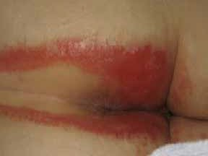
Critical criterion
- Persistent redness
A variety of tones of redness may be present.
Patients with darker skin tones, the skin may be paler or darker than normal, or purple in colour.
Additional criteria
- Marked areas or discolouration from a previous (healed) skin defect
- Shiny appearance of the skin
- Macerated skin
- Intact vesicles and/or bullae
- Skin may feel tense or swollen at palpation
- Burning, tingling, itching or pain
1B - Persistent redness with clinical signs of infection
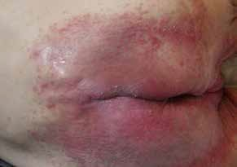

Critical criteria
Persistent redness
A variety of tones of redness may be present. Patients with darker skin tones, the skin may be paler or darker than normal, or purple in colour.
Signs of infection
Such as white scaling of the skin (suggesting a fungal infection) or satellite lesions (pustules surrounding the lesion, suggesting a Candida albicans fungal infection).
Additional criteria
Marked areas or discolouration from a previous (healed) skin defect
Shiny appearance of the skin
Macerated skin
Intact vesicles and/or bullae
The skin may feel tense or swollen at palpation
Burning, tingling, itching or pain
Category 2: Skin loss

2A - Skin loss without clinical signs of infection

Critical criterion
- Skin loss
Skin loss may present as skin erosion (may result from damaged/eroded vesicles or bullae), denudation or excoriation. The skin damage pattern may be diﬀuse.
Additional criteria Persistent redness
A variety of tones of redness may be present. Patients with darker skin tones, the skin may be paler or darker than normal, or purple in colour
- Marked areas or discolouration from a previous (healed) skin defect
- Shiny appearance of the skin
- Macerated skin
- Intact vesicles and/or bullae
- Skin may feel tense or swollen at palpation
- Burning, tingling, itching or pain
2B - Skin loss with clinical signs of infection

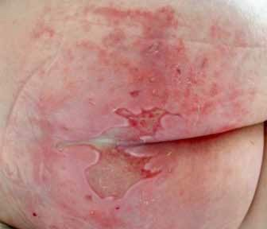
Critical criteria
- Skin loss
Skin loss may present as skin erosion (may result from damaged/
eroded vesicles or bullae), denudation or excoriation. The skin damage pattern may be diﬀuse.
- Signs of infection
Such as white scaling of the skin (suggesting a fungal infection) or satellite lesions (pustules surrounding the lesion, suggesting a Candida albicans fungal infection), slough visible in the wound bed (yellow/brown/greyish), green appearance within the wound bed (suggesting a bacterial infection with Pseudomonas aeruginosa), excessive exudate levels, purulent exudate (pus) or a shiny appearance of the wound bed.
Additional criteria
- Persistent redness
- Marked areas or discolouration from a previous (healed) skin defect
- Shiny appearance of the skin
- Macerated skin
- Intact vesicles and/or bullae
- Skin may feel tense or swollen at palpation
- Burning, tingling, itching or pain


Beeckman D, Van den Bussche K, Alves P, Beele H, Ciprandi G, Coyer F, de Groot T, De Meyer D, Dunk AM, Fourie A, García-Molina P, Gray M, Iblasi A, Jelnes R, Johansen E, Karadağ A, LeBlanc K, Kis Dadara Z, Long MA, Meaume S, Pokorna A, Romanelli M, Ruppert S, Schoonhoven L, Smet S, Smith C, Steininger A, Stockmayr M, Van Damme N, Voegeli D, Van Hecke A, Verhaeghe S, Woo K & Kottner J. The Ghent Global IAD Categorisation Tool (GLOBIAD). Skin Integrity Research Group- Ghent University 2017.
The categories do not necessarily relate to the natural history of IAD and are not intended to suggest how IAD may develop or progress. This categorisation tool may prove useful in the monitoring of IAD prevalence and incidence, and for research purposes.

CATEGORY 1: PERSISTENT REDNESS
Category 1A: Persistent redness without clinical signs of infection
Critical criterion
Persistent redness
A variety of tones of redness may be present. Patients with darker skin tones, the skin may be paler or darker than normal, or purple in colour.

Additional criteria
- Marked areas or discolouration from a previous (healed) skin defect
- Shiny appearance of the skin
- Macerated skin
- Intact vesicles and/or bullae
- Skin may feel tense or swollen at palpation
- Burning, tingling, itching or pain

Category 1B: Persistent redness with clinical signs of infection
Critical criteria
Persistent redness
A variety of tones of redness may be present. Patients with darker skin tones, the skin may be paler or darker than normal, or purple in colour.
Signs of infection
Such as white scaling of the skin (suggesting a fungal infection) or satellite lesions (pustules surrounding the lesion, suggesting a Candida albicans fungal infection).

Additional criteria
- Marked areas or discolouration from a previous (healed) skin defect
- Shiny appearance of the skin
- Macerated skin
- Intact vesicles and/or bullae
- Skin may feel tense or swollen at palpation
- Burning, tingling, itching or pain

CATEGORY 2: SKIN LOSS
Category 2A: Skin loss without clinical signs of infection
Critical criterion
Skin loss
Skin loss may present as skin erosion (may result from damaged/eroded vesicles or bullae), denudation or excoriation. The skin damage pattern may be diffuse.

Additional criteria
- Persistent redness
A variety of tones of redness may be present. Patients with darker skin tones, the skin may be paler or darker than normal, or purple in colour
- Marked areas or discolouration from a previous (healed) skin defect
- Shiny appearance of the skin
- Macerated skin
- Intact vesicles and/or bullae
- Skin may feel tense or swollen at palpation
- Burning, tingling, itching or pain


Category 2B: Skin loss with clinical signs of infection
Critical criteria
Skin loss
Skin loss may present as skin erosion (may result from damaged/eroded vesicles or bullae), denudation or excoriation. The skin damage pattern may be diffuse.
Signs of infection
Such as white scaling of the skin (suggesting a fungal infection) or satellite lesions (pustules surrounding the lesion, suggesting a Candida albicans fungal infection), slough visible in the wound bed (yellow/brown/greyish), green appearance within the wound bed (suggesting a bacterial infection with Pseudomonas aeruginosa), excessive exudate levels, purulent exudate (pus) or a shiny appearance of the wound bed.
Additional criteria

- Persistent redness
A variety of tones of redness may be present. Patients with darker skin tones, the skin may be paler or darker than normal, or purple in colour
- Marked areas or discolouration from a previous (healed) skin defect
- Shiny appearance of the skin
- Macerated skin
- Intact vesicles and/or bullae
- Skin may feel tense or swollen at palpation
- Burning, tingling, itching or pain

GLOSSARY
Bulla A circumscribed lesion > 1 cm in diameter that contains liquid (clear, serous or haemorrhagic), a large blister
Erosion Loss of either a portion of or the entire epidermis
Excoriation A loss of the epidermis and a portion of the dermis due to scratching or an exogenous injury
Maceration An appearance or surface softening due to constant wetting - frequently white
Papule An elevated, solid, palpable lesion that is ≤ 1 cm in diameter
Pustule A circumscribed lesion that contains pus
Scale A visible accumulation of keratin, forming a flat plate or flake
Swelling Enlargement due to accumulation of oedema or fluid, including blood
Vesicle A circumscribed lesion ≤ 1 cm in diameter that contains liquid (clear, serous or haemorrhagic), a small blister

REFERENCES
Beeckman D, Schoonhoven L, Fletcher J, Furtado K, Gunningberg L, Heyman H, Lindholm C, Paquay L, Verdú J and Defloor T. EPUAP classification system for pressure ulcers: European reliability study. Journal of advanced nursing 2007; 60: 682-91.
Beeckman D, Schoonhoven L, Verhaeghe S, Heyneman A, Defloor T. Prevention and treatment of incontinence-associated dermatitis: literature review. Journal of advanced nursing 2009; 65: 1141-54.
Beeckman D, Van Damme N, Schoonhoven L, Van Lancker A, Kottner J, Beele H, Gray M, Woodward S, Fader M, Van den Bussche K, Van Hecke A, De Meyer D and Verhaeghe S. Interventions for preventing and treating incontinence-associated dermatitis in adults. The Cochrane Library 2016.
Gray M, Beeckman D, Bliss DZ, Fader M, Logan S, Junkin J, Selekof J, Doughty D and Kurz P. Incontinence-associated dermatitis: a comprehensive review and update. Journal of wound, ostomy, and continence nursing : official publication of The Wound, Ostomy and Continence Nurses Society / WOCN 2012; 39: 61-74.
Mugita Y, Minematsu T, Huang L, Nakagami G, Kishi C, Ichikawa Y, Nagese T, Oe M, Noguchi H, Mori T, Abe M, Sugama J and Sanada H. Histopatho- logy of incontinence-associated skin lesions: inner tissue damage due to invasion of proteolytic enzymes and bacteria in macerated rat skin. PloS one 2015; 10: e0138117.



Appendix C
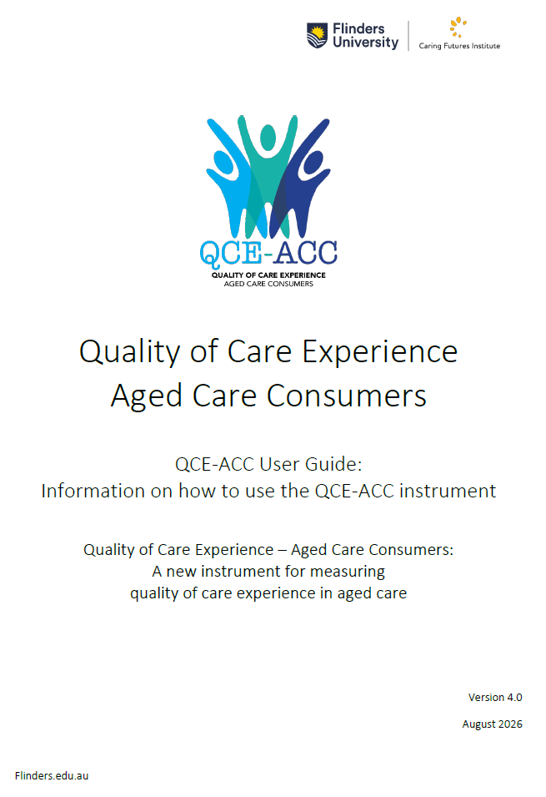

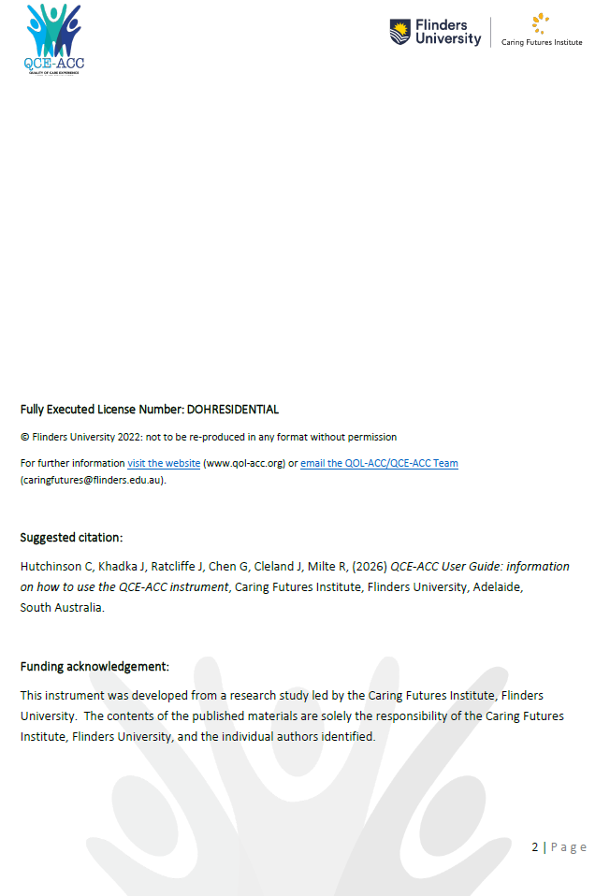
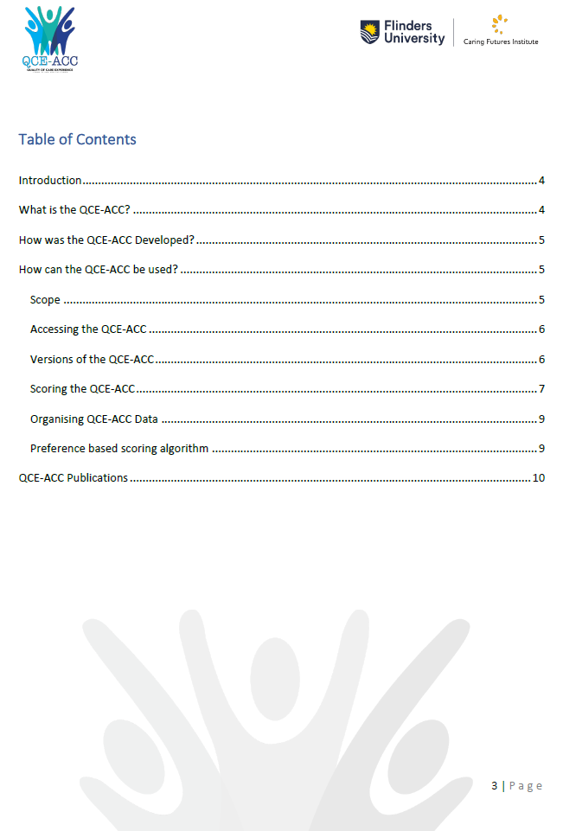

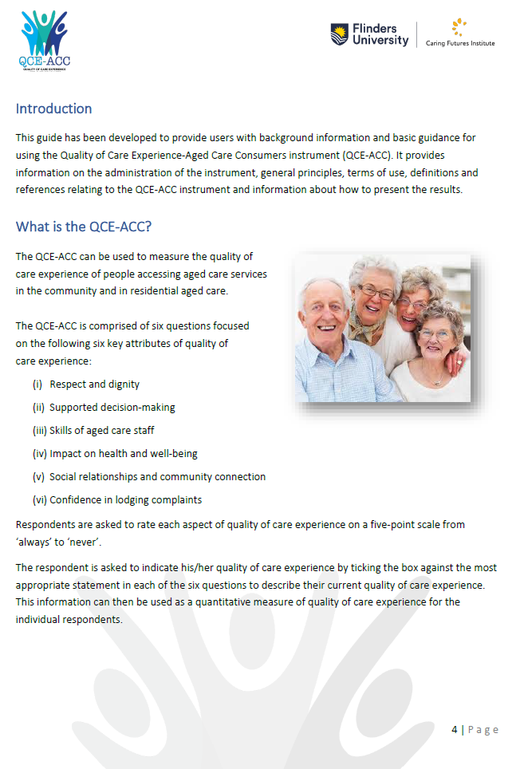

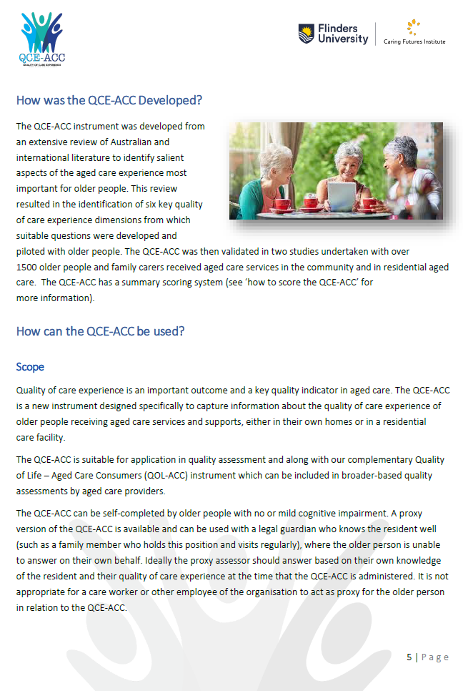

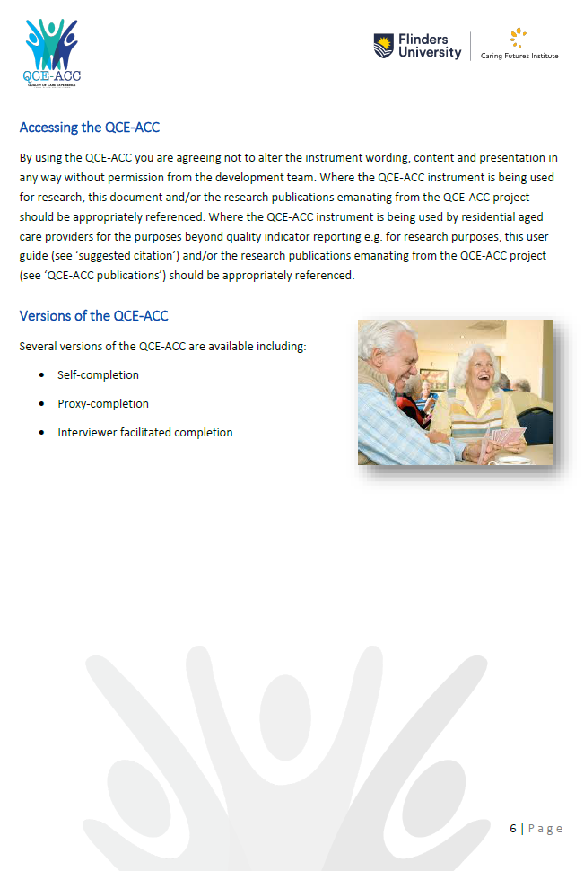

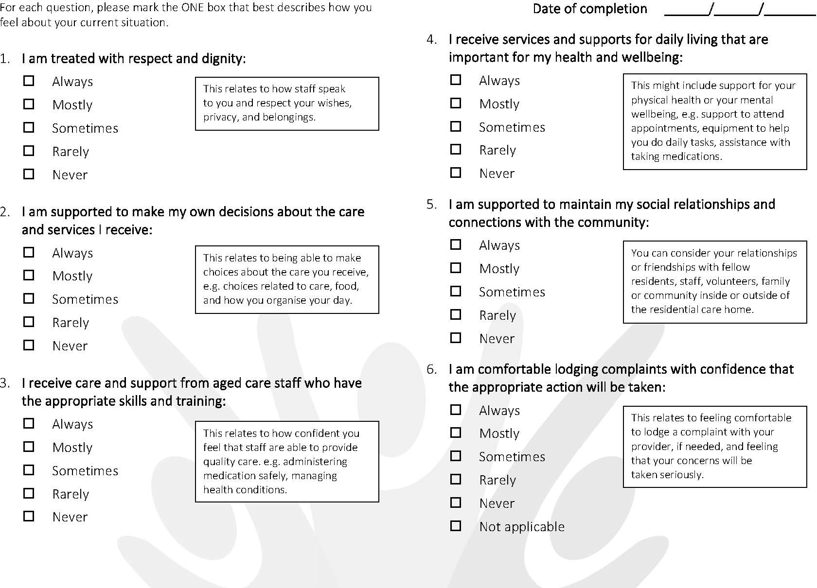
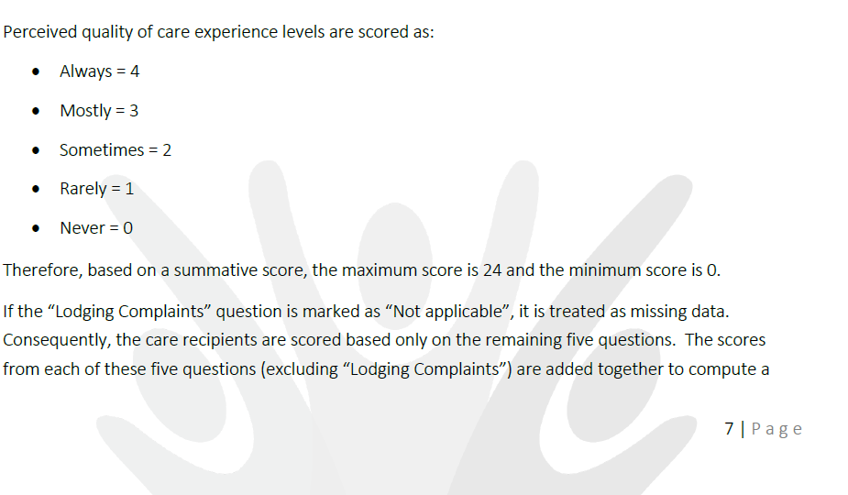

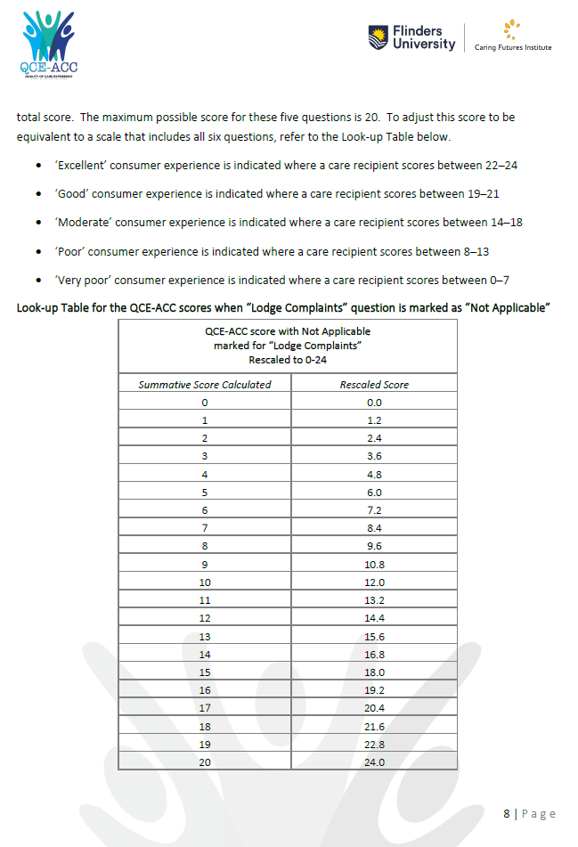

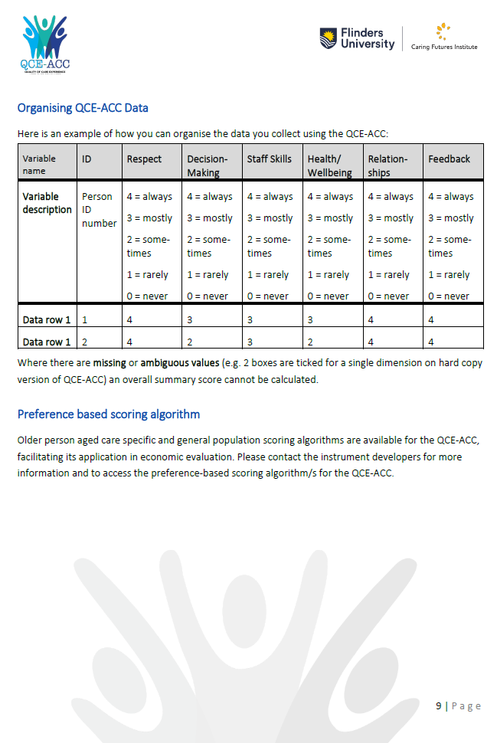
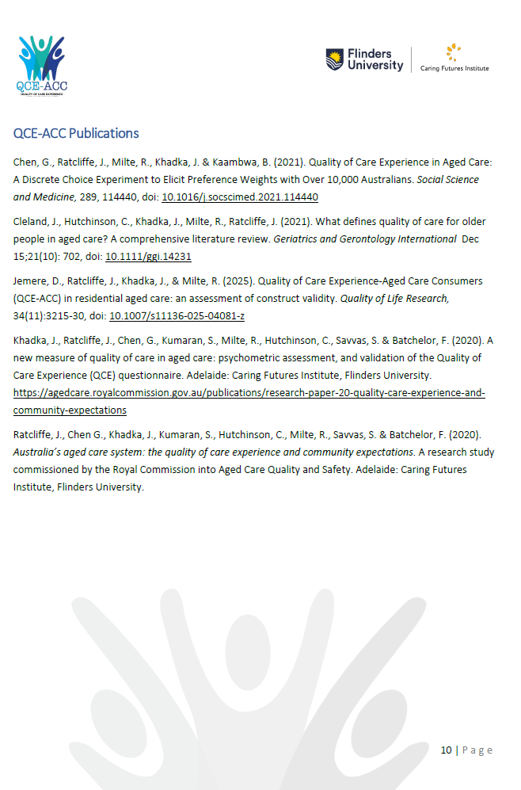
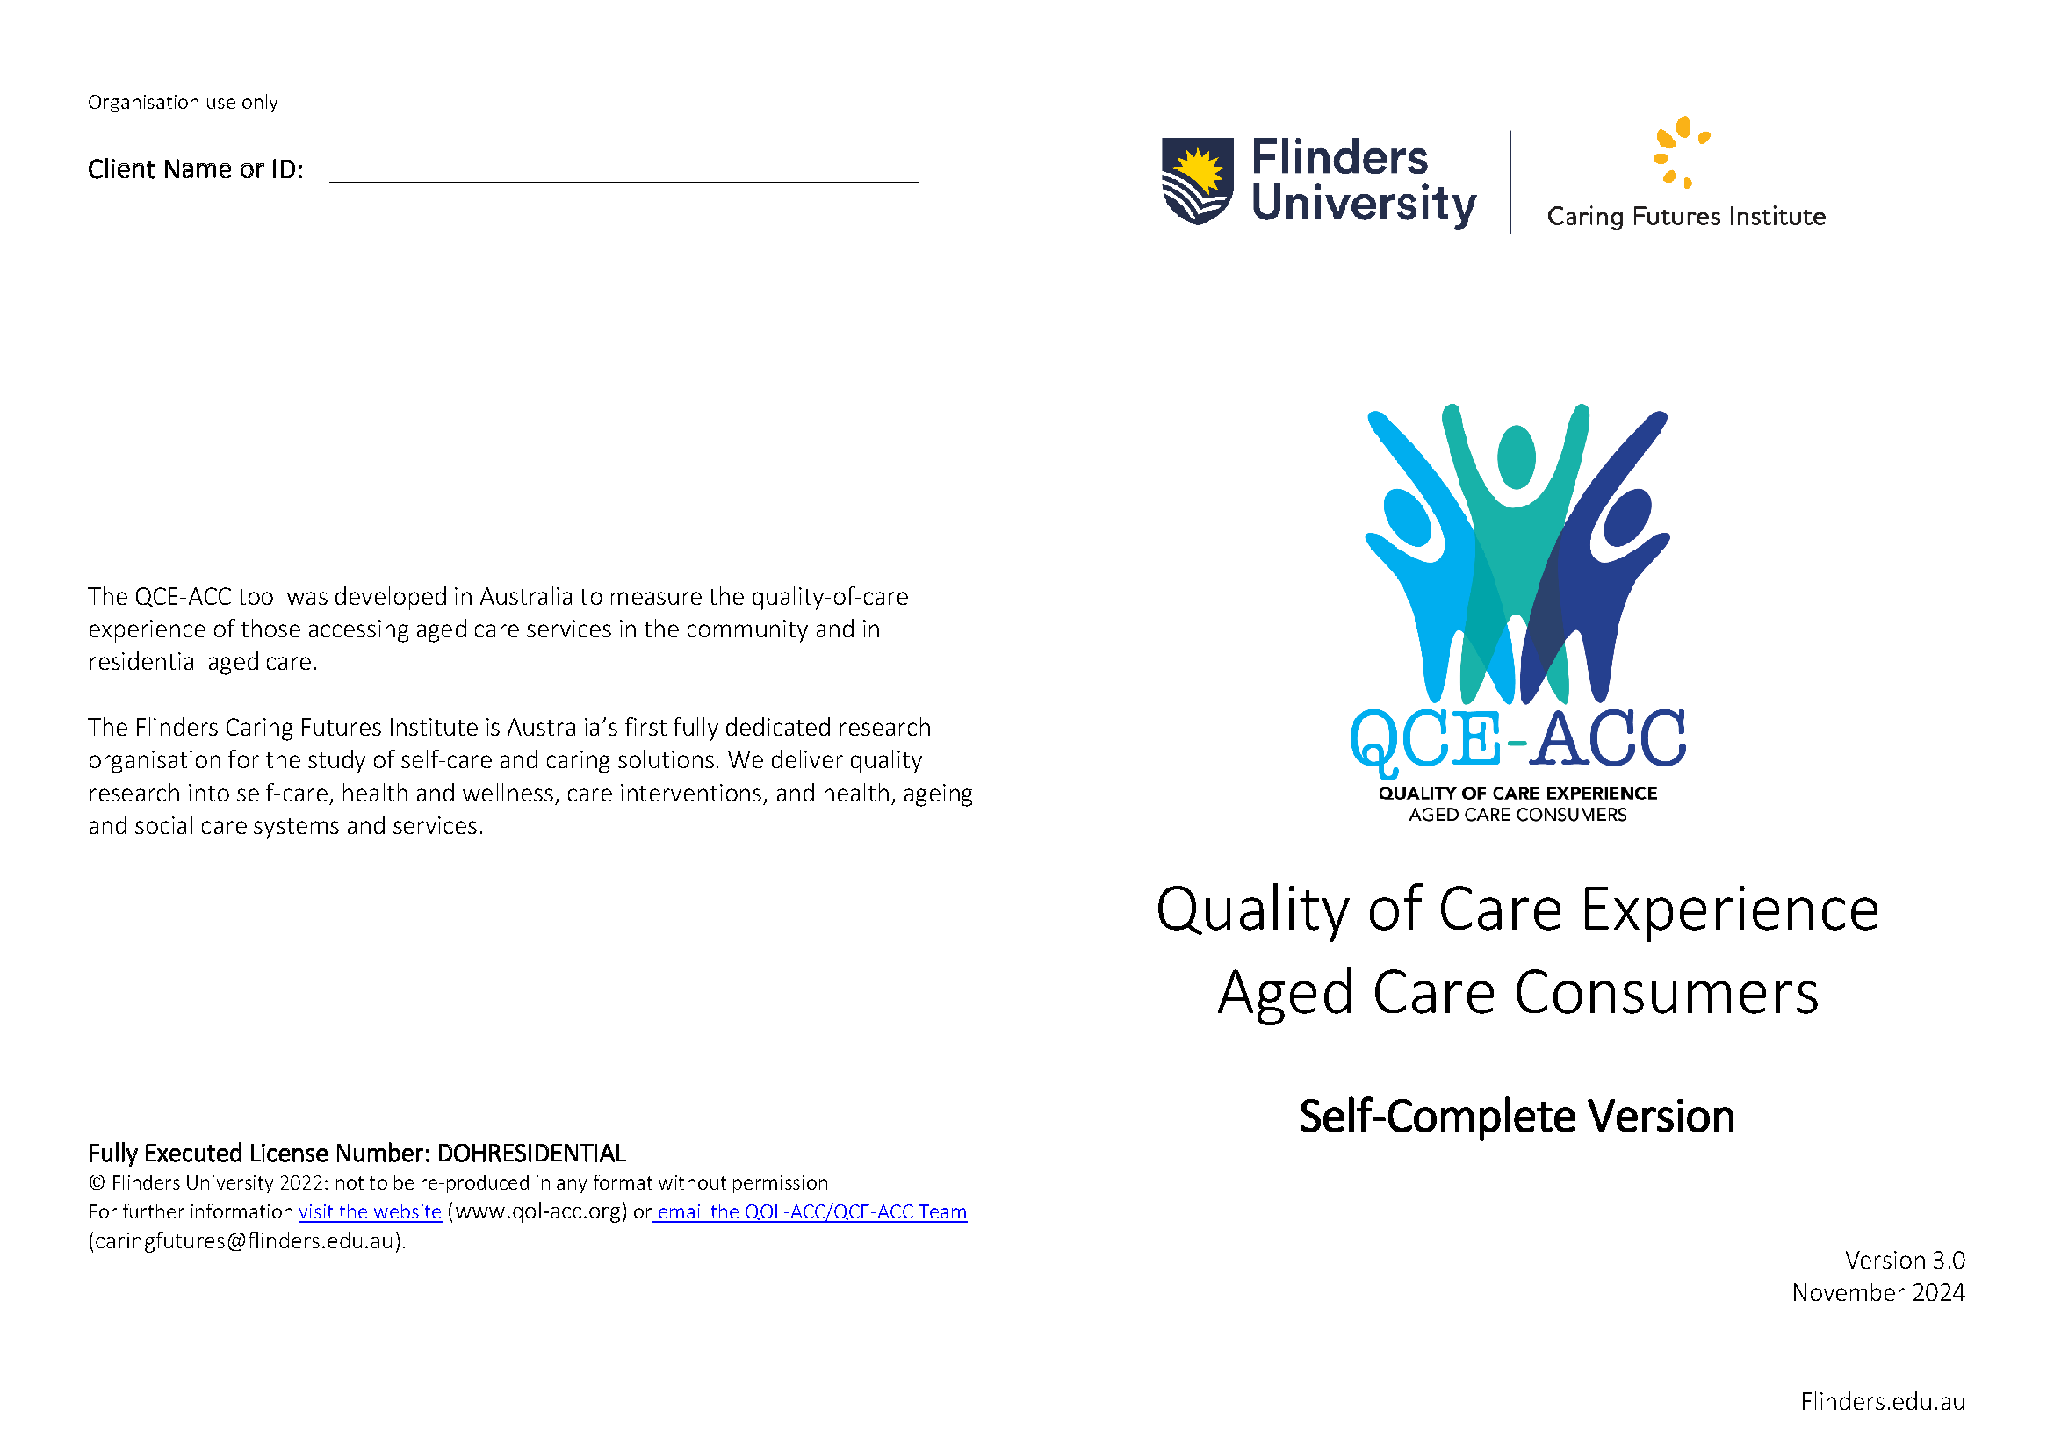
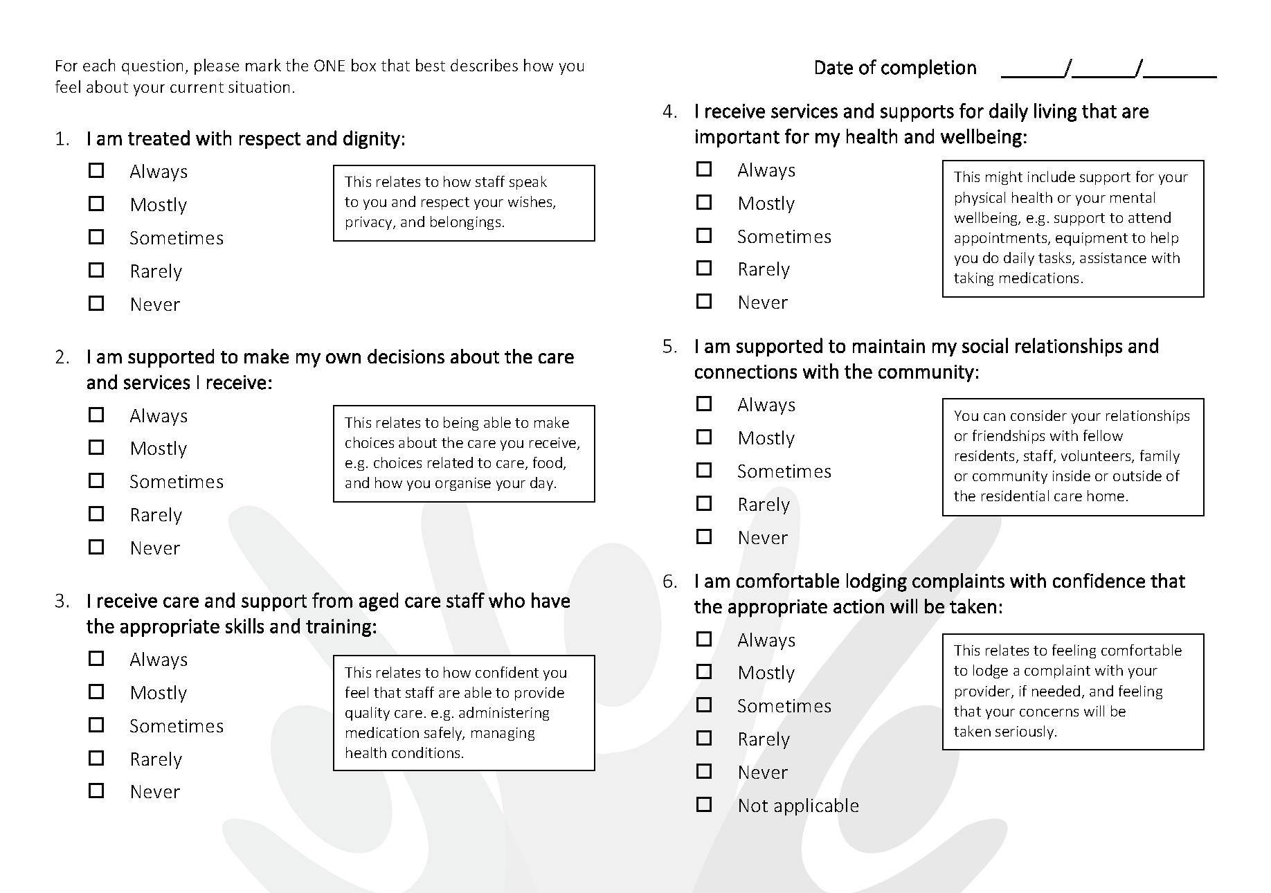

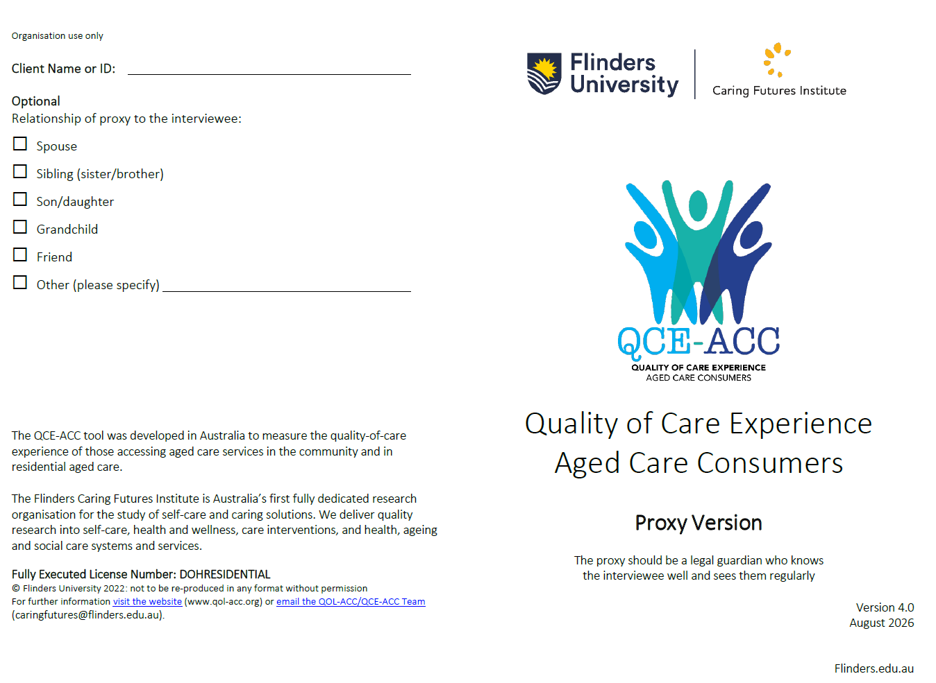

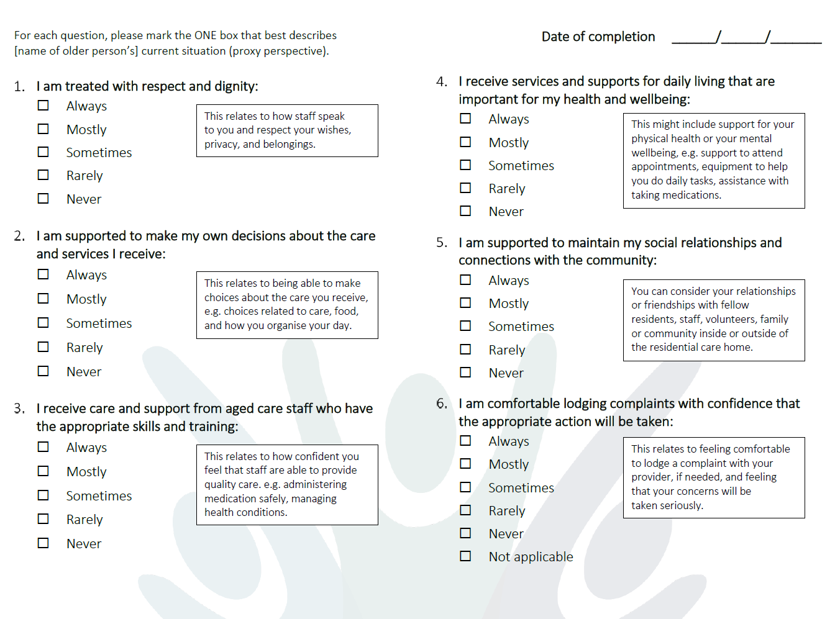

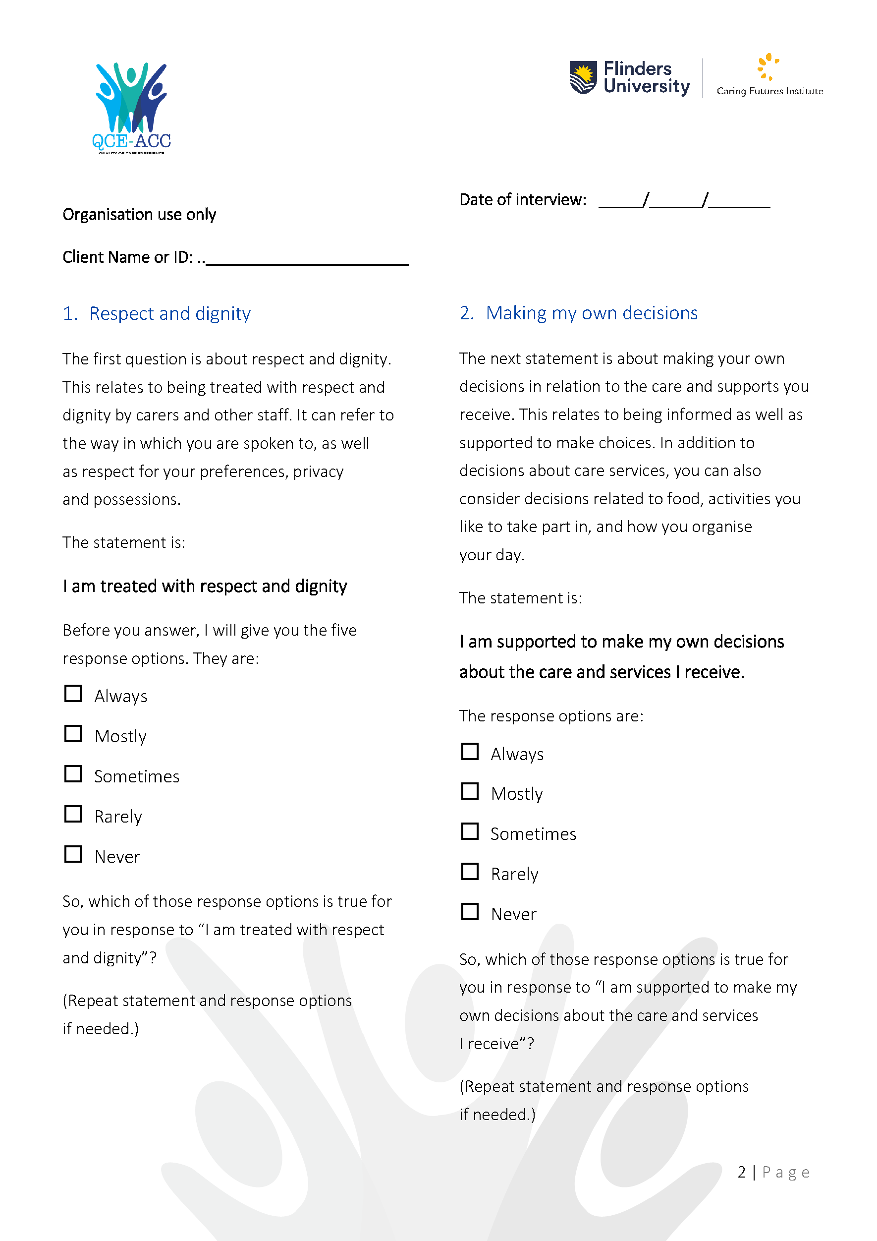
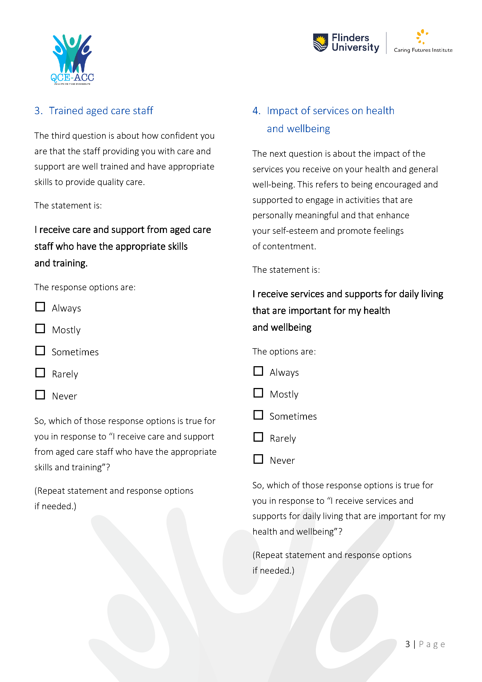
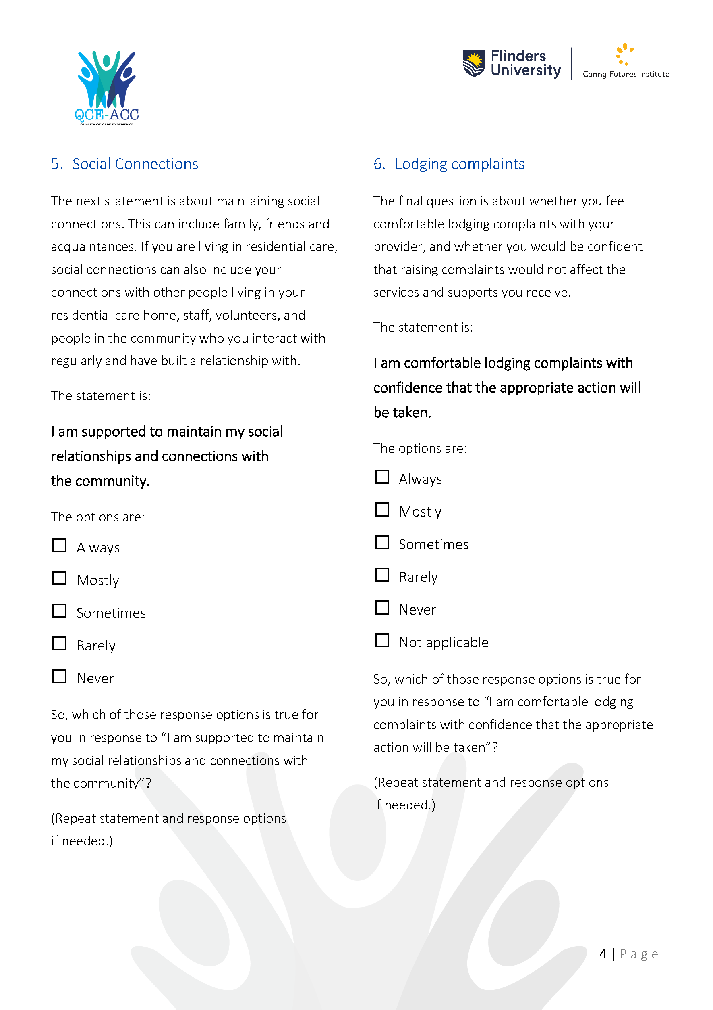

Appendix D
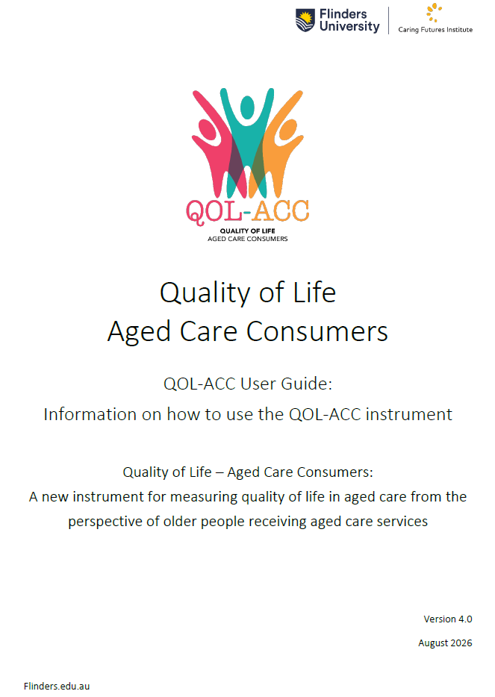

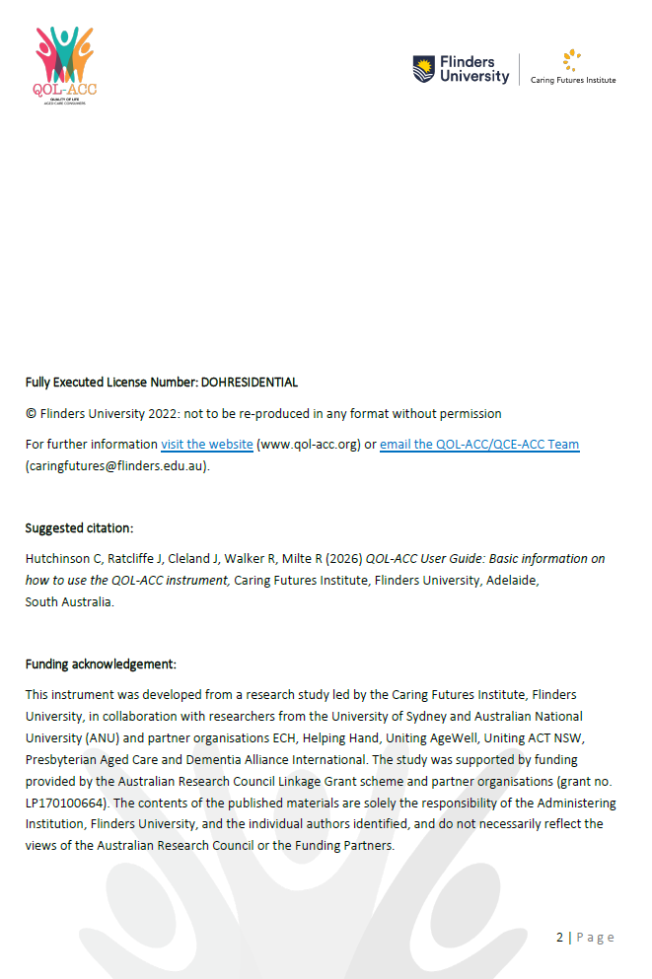
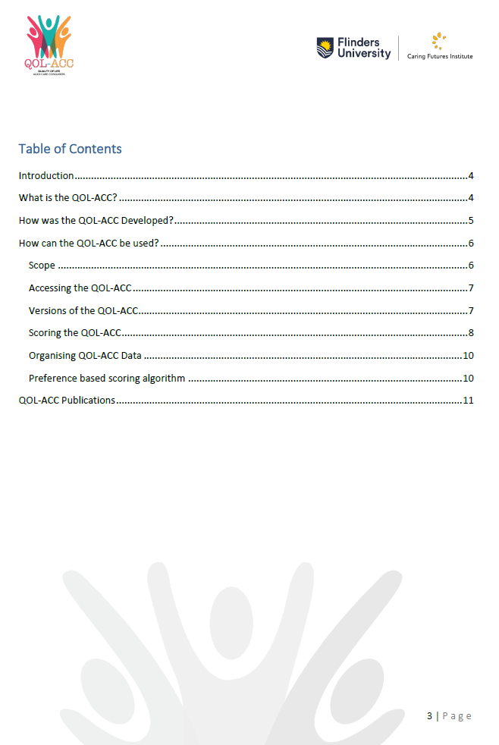

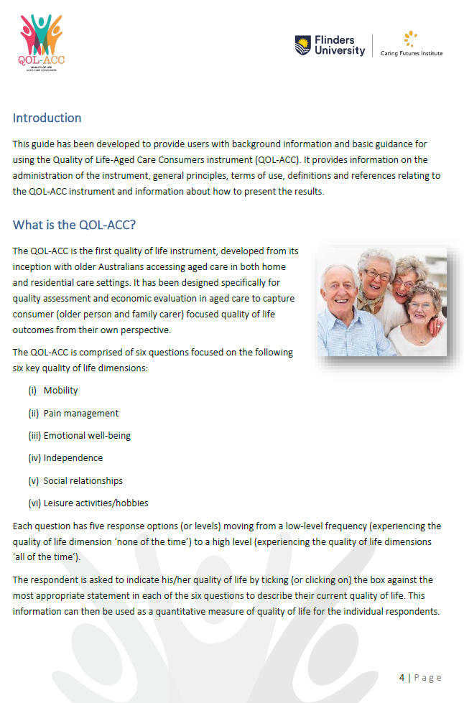
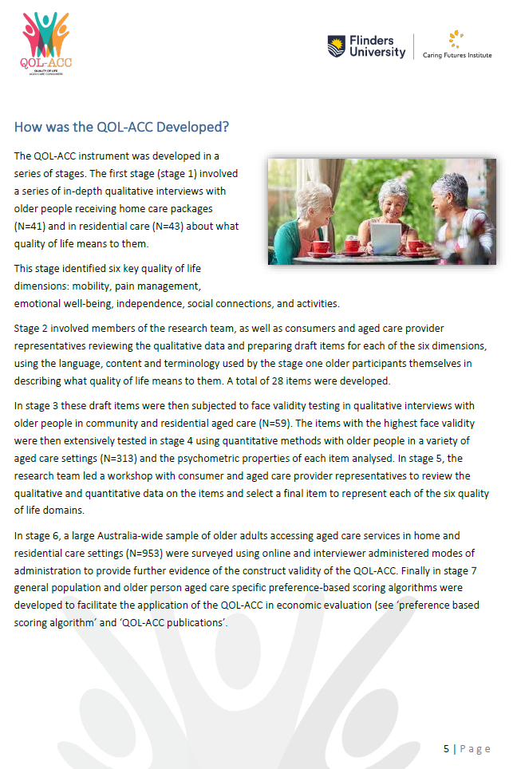

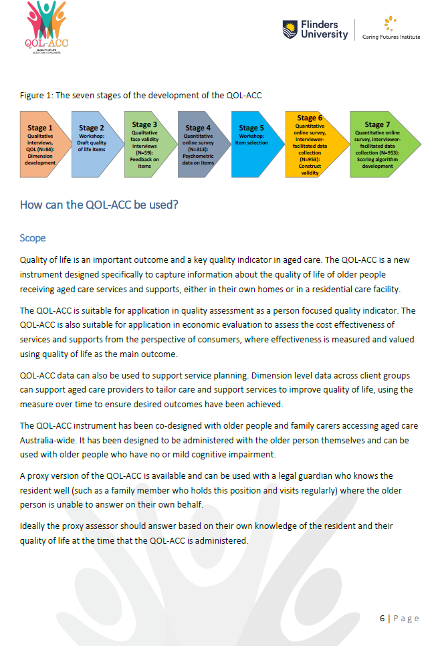

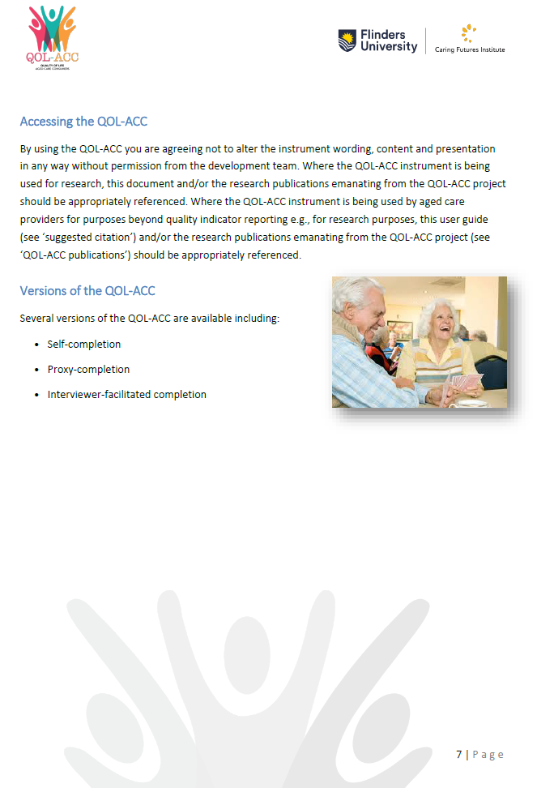

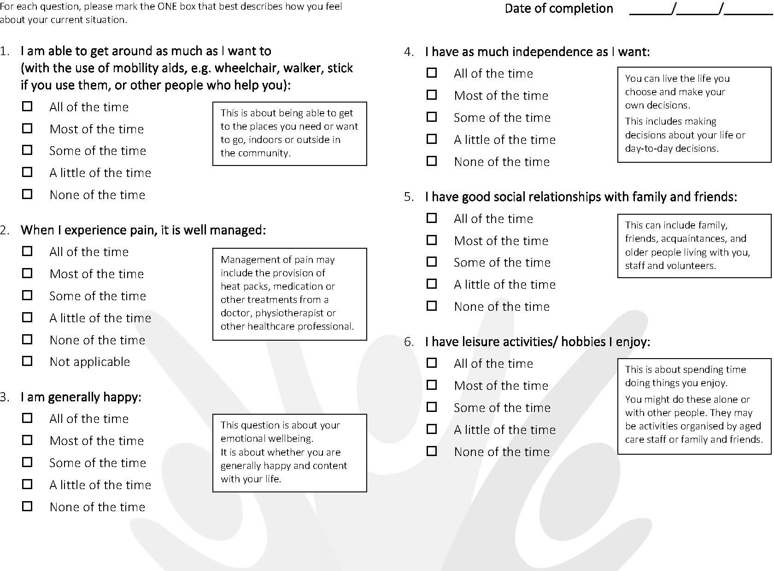

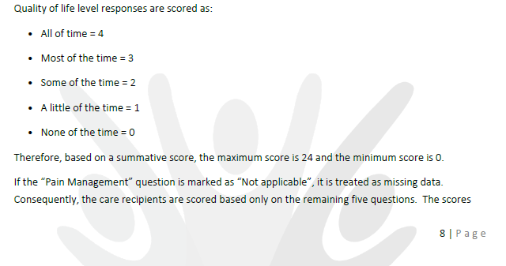

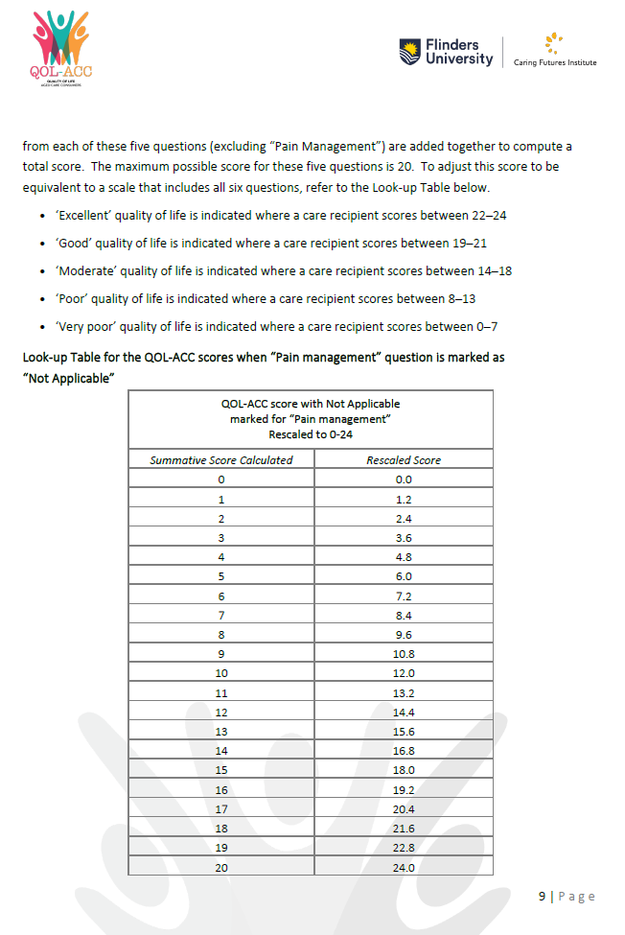

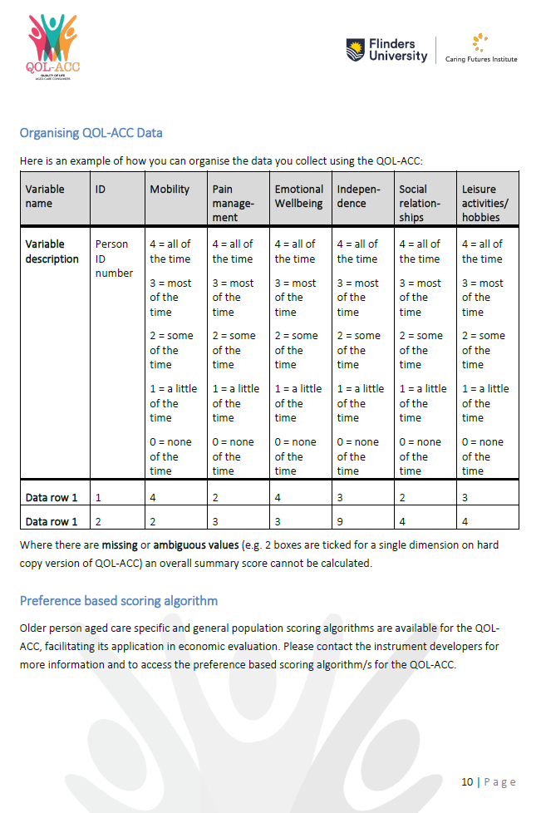

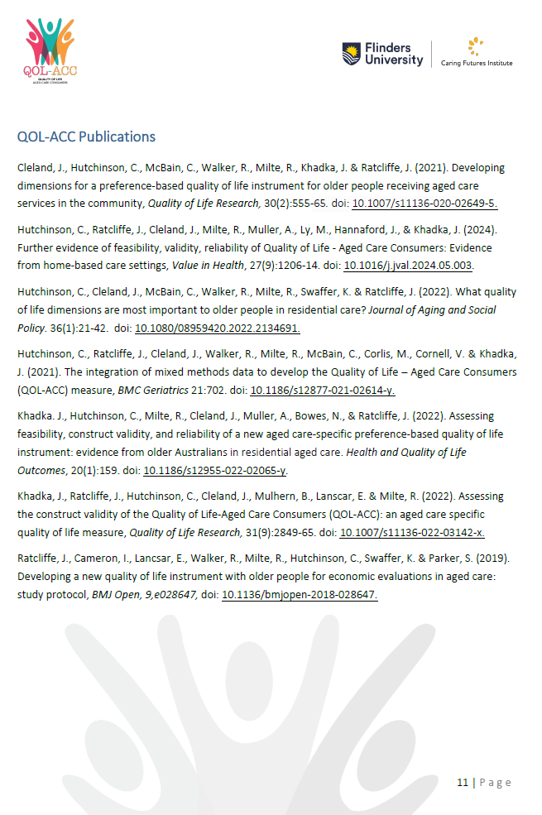

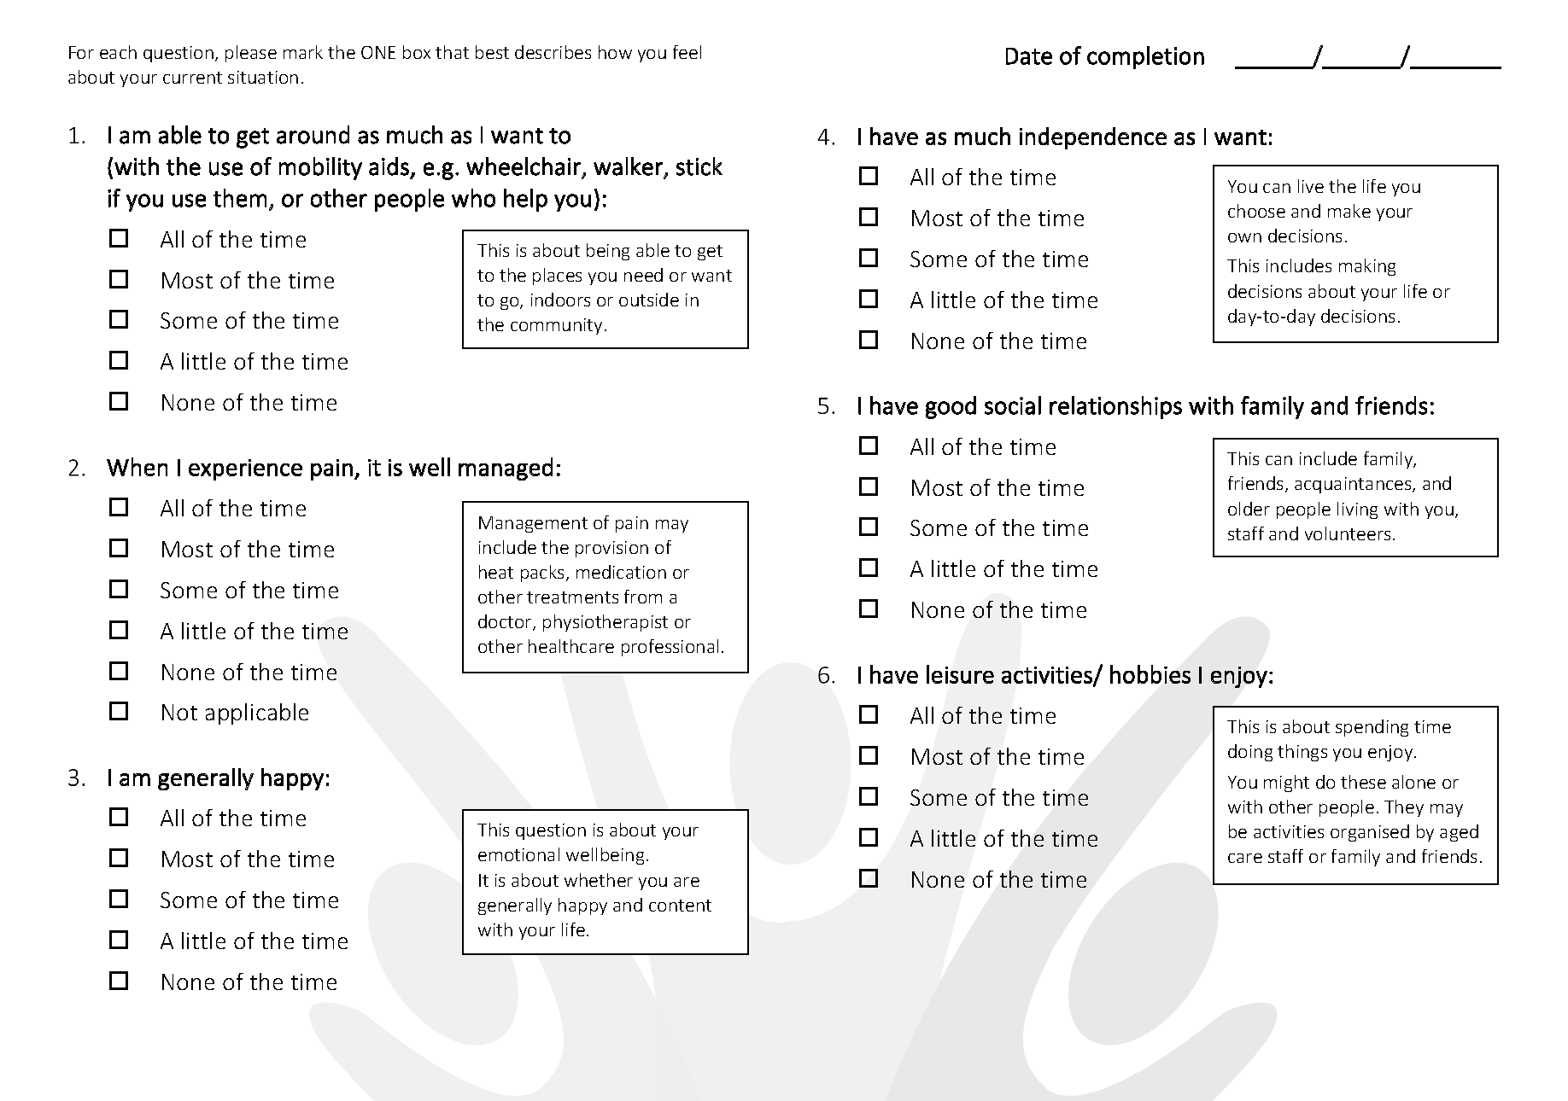

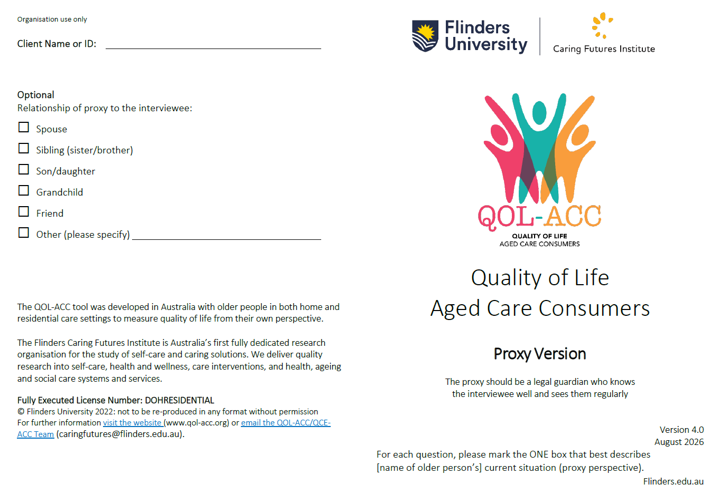
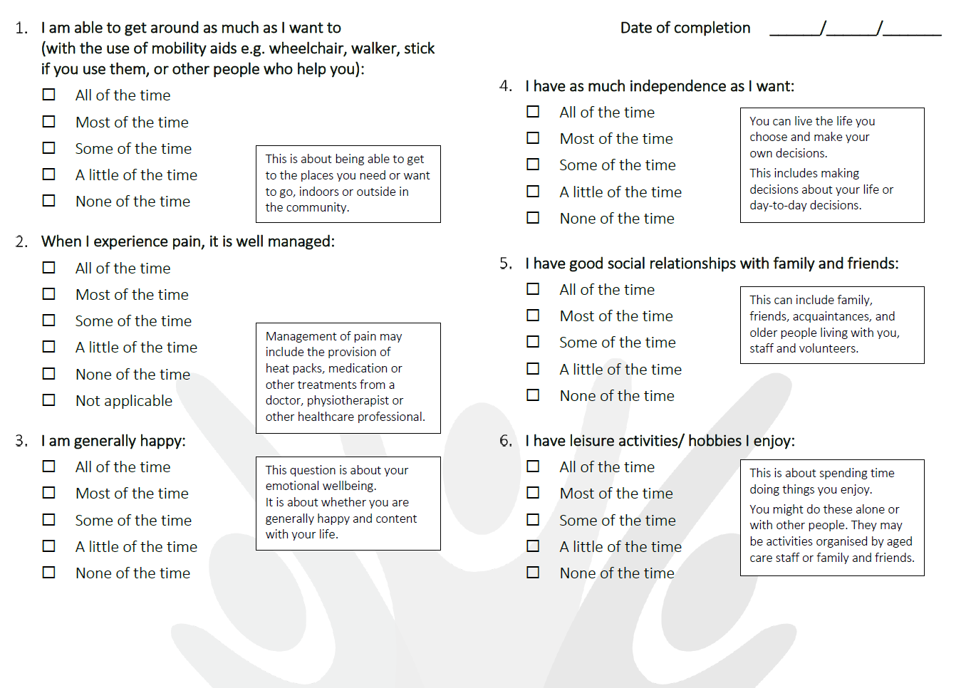
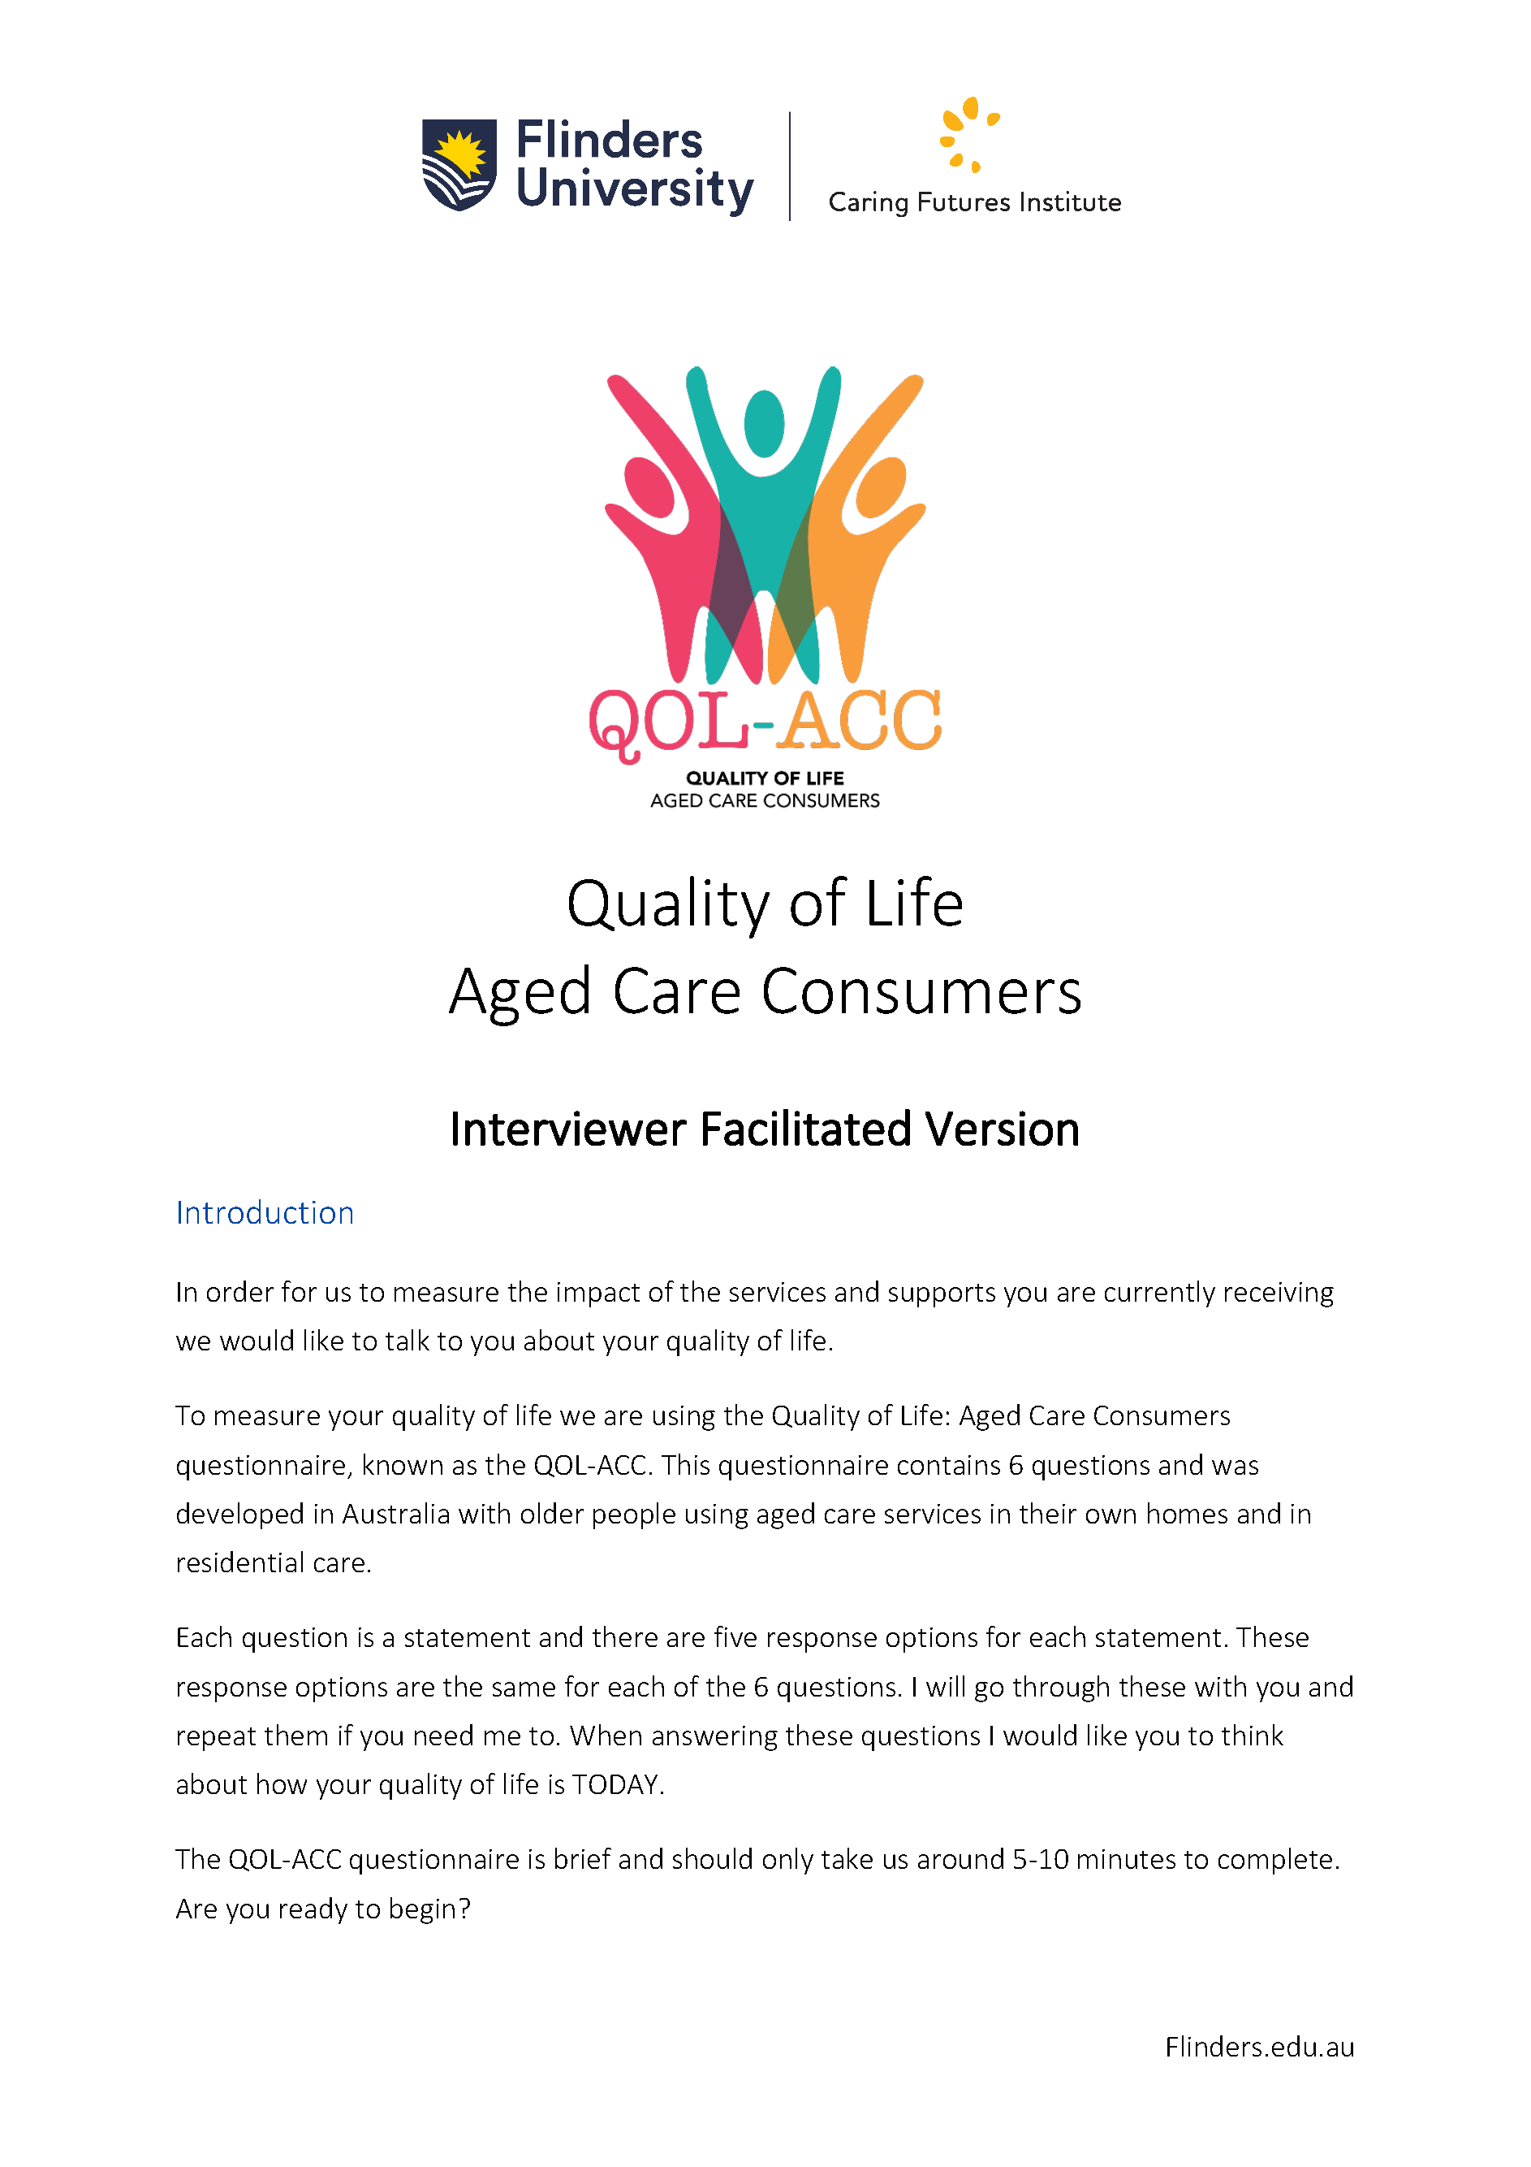

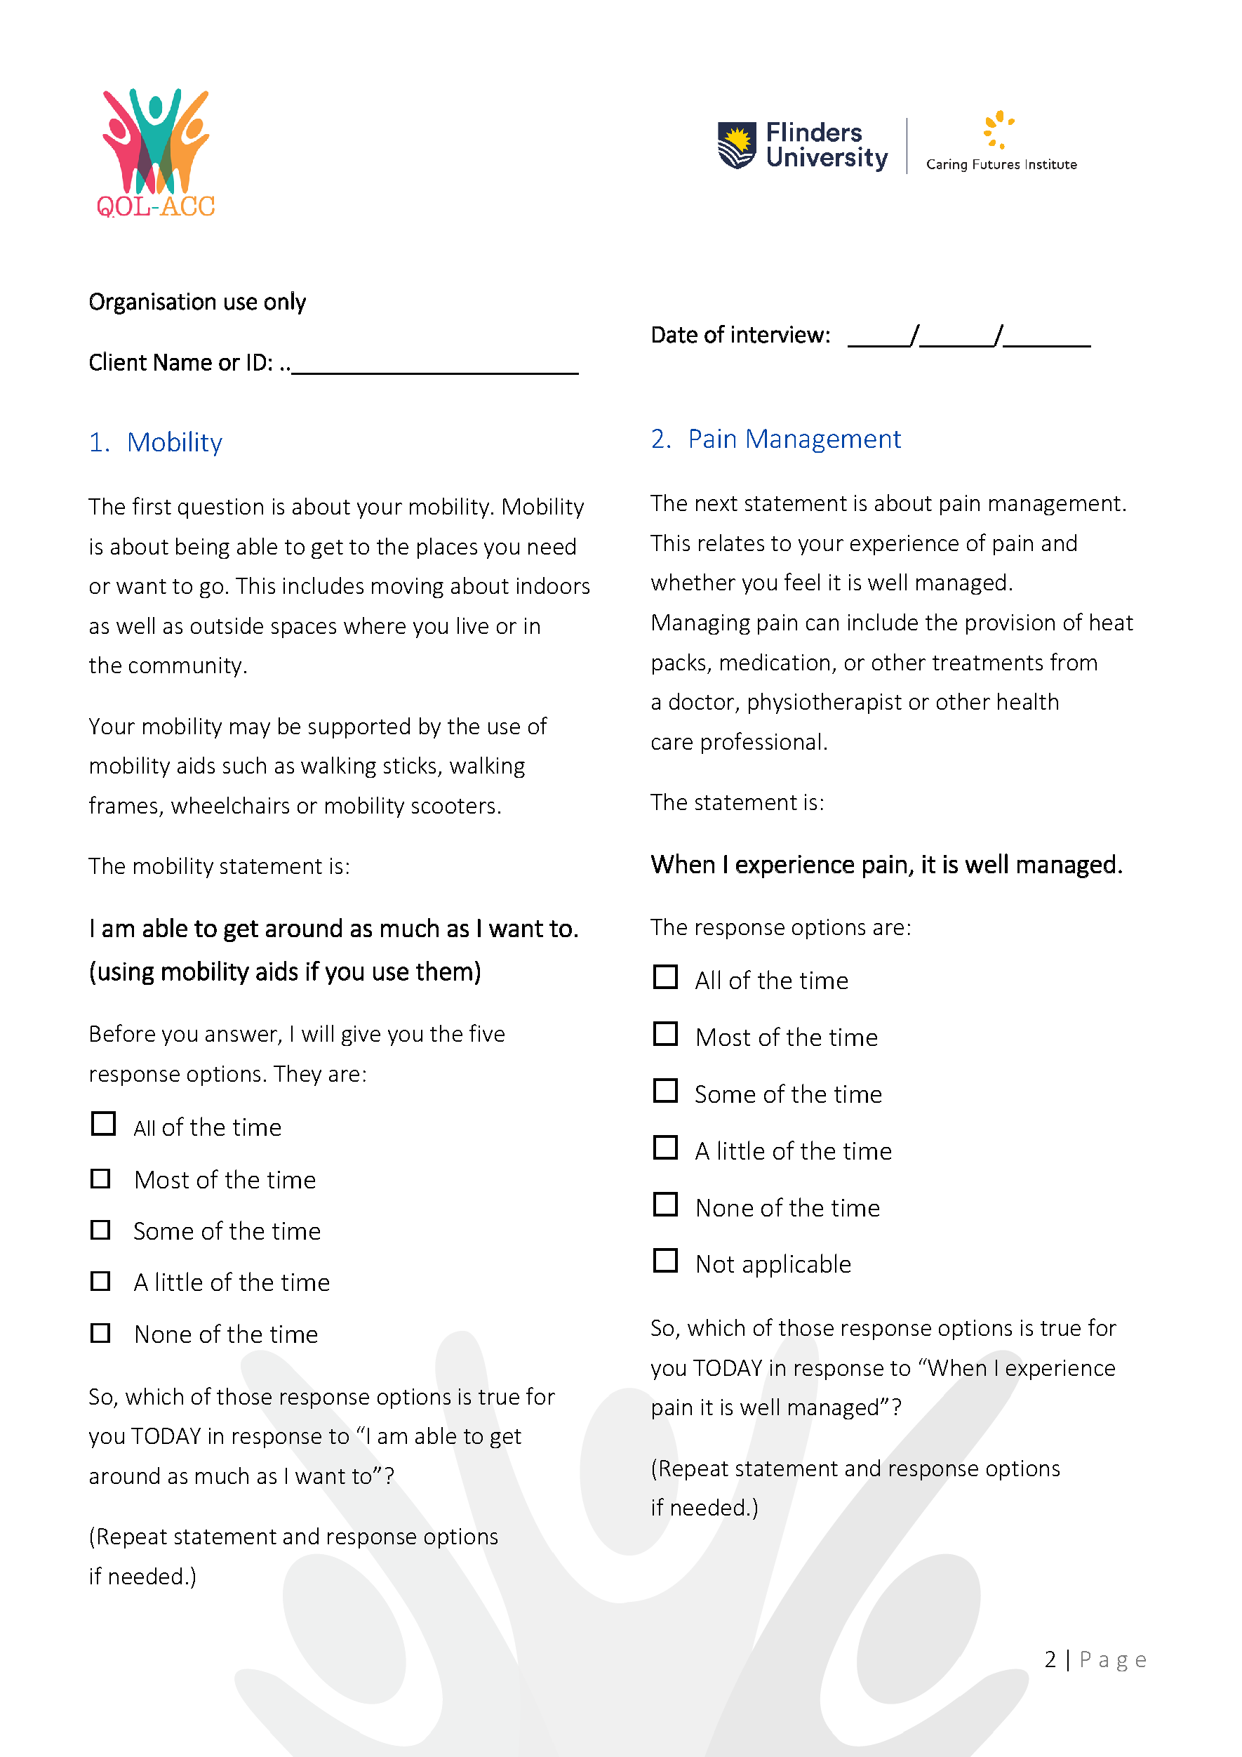
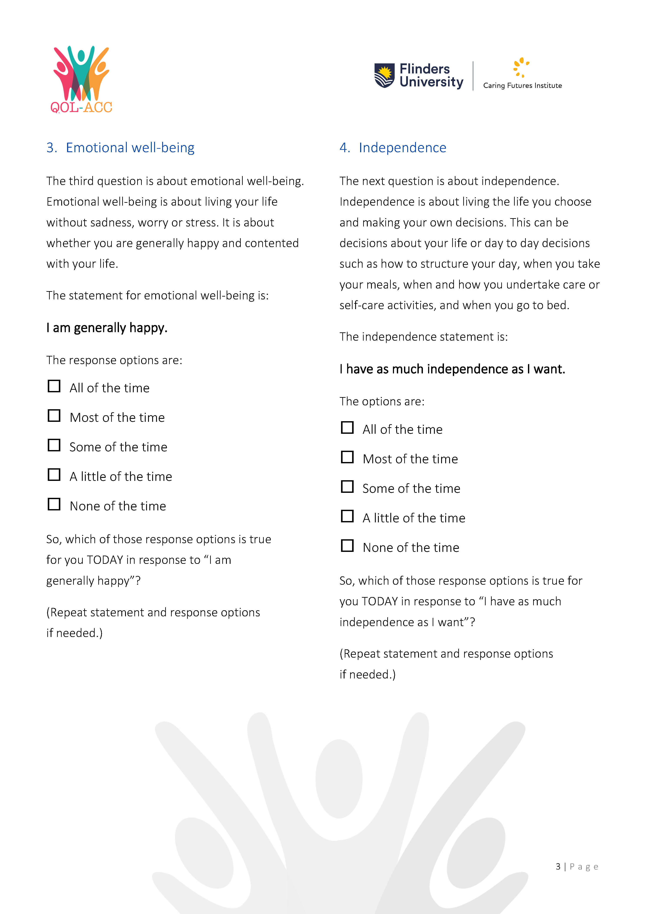
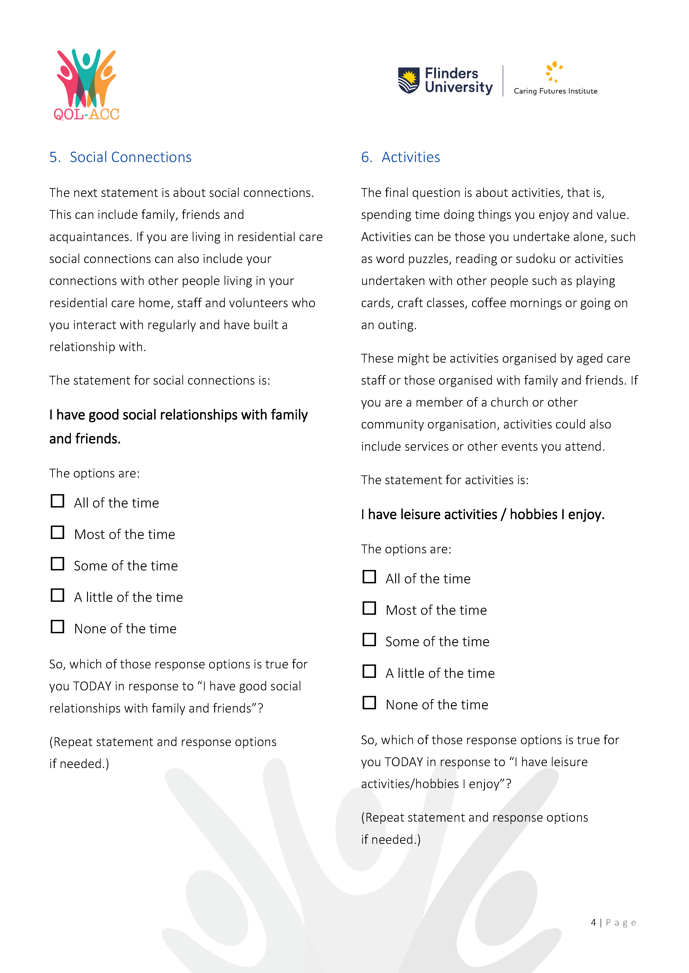
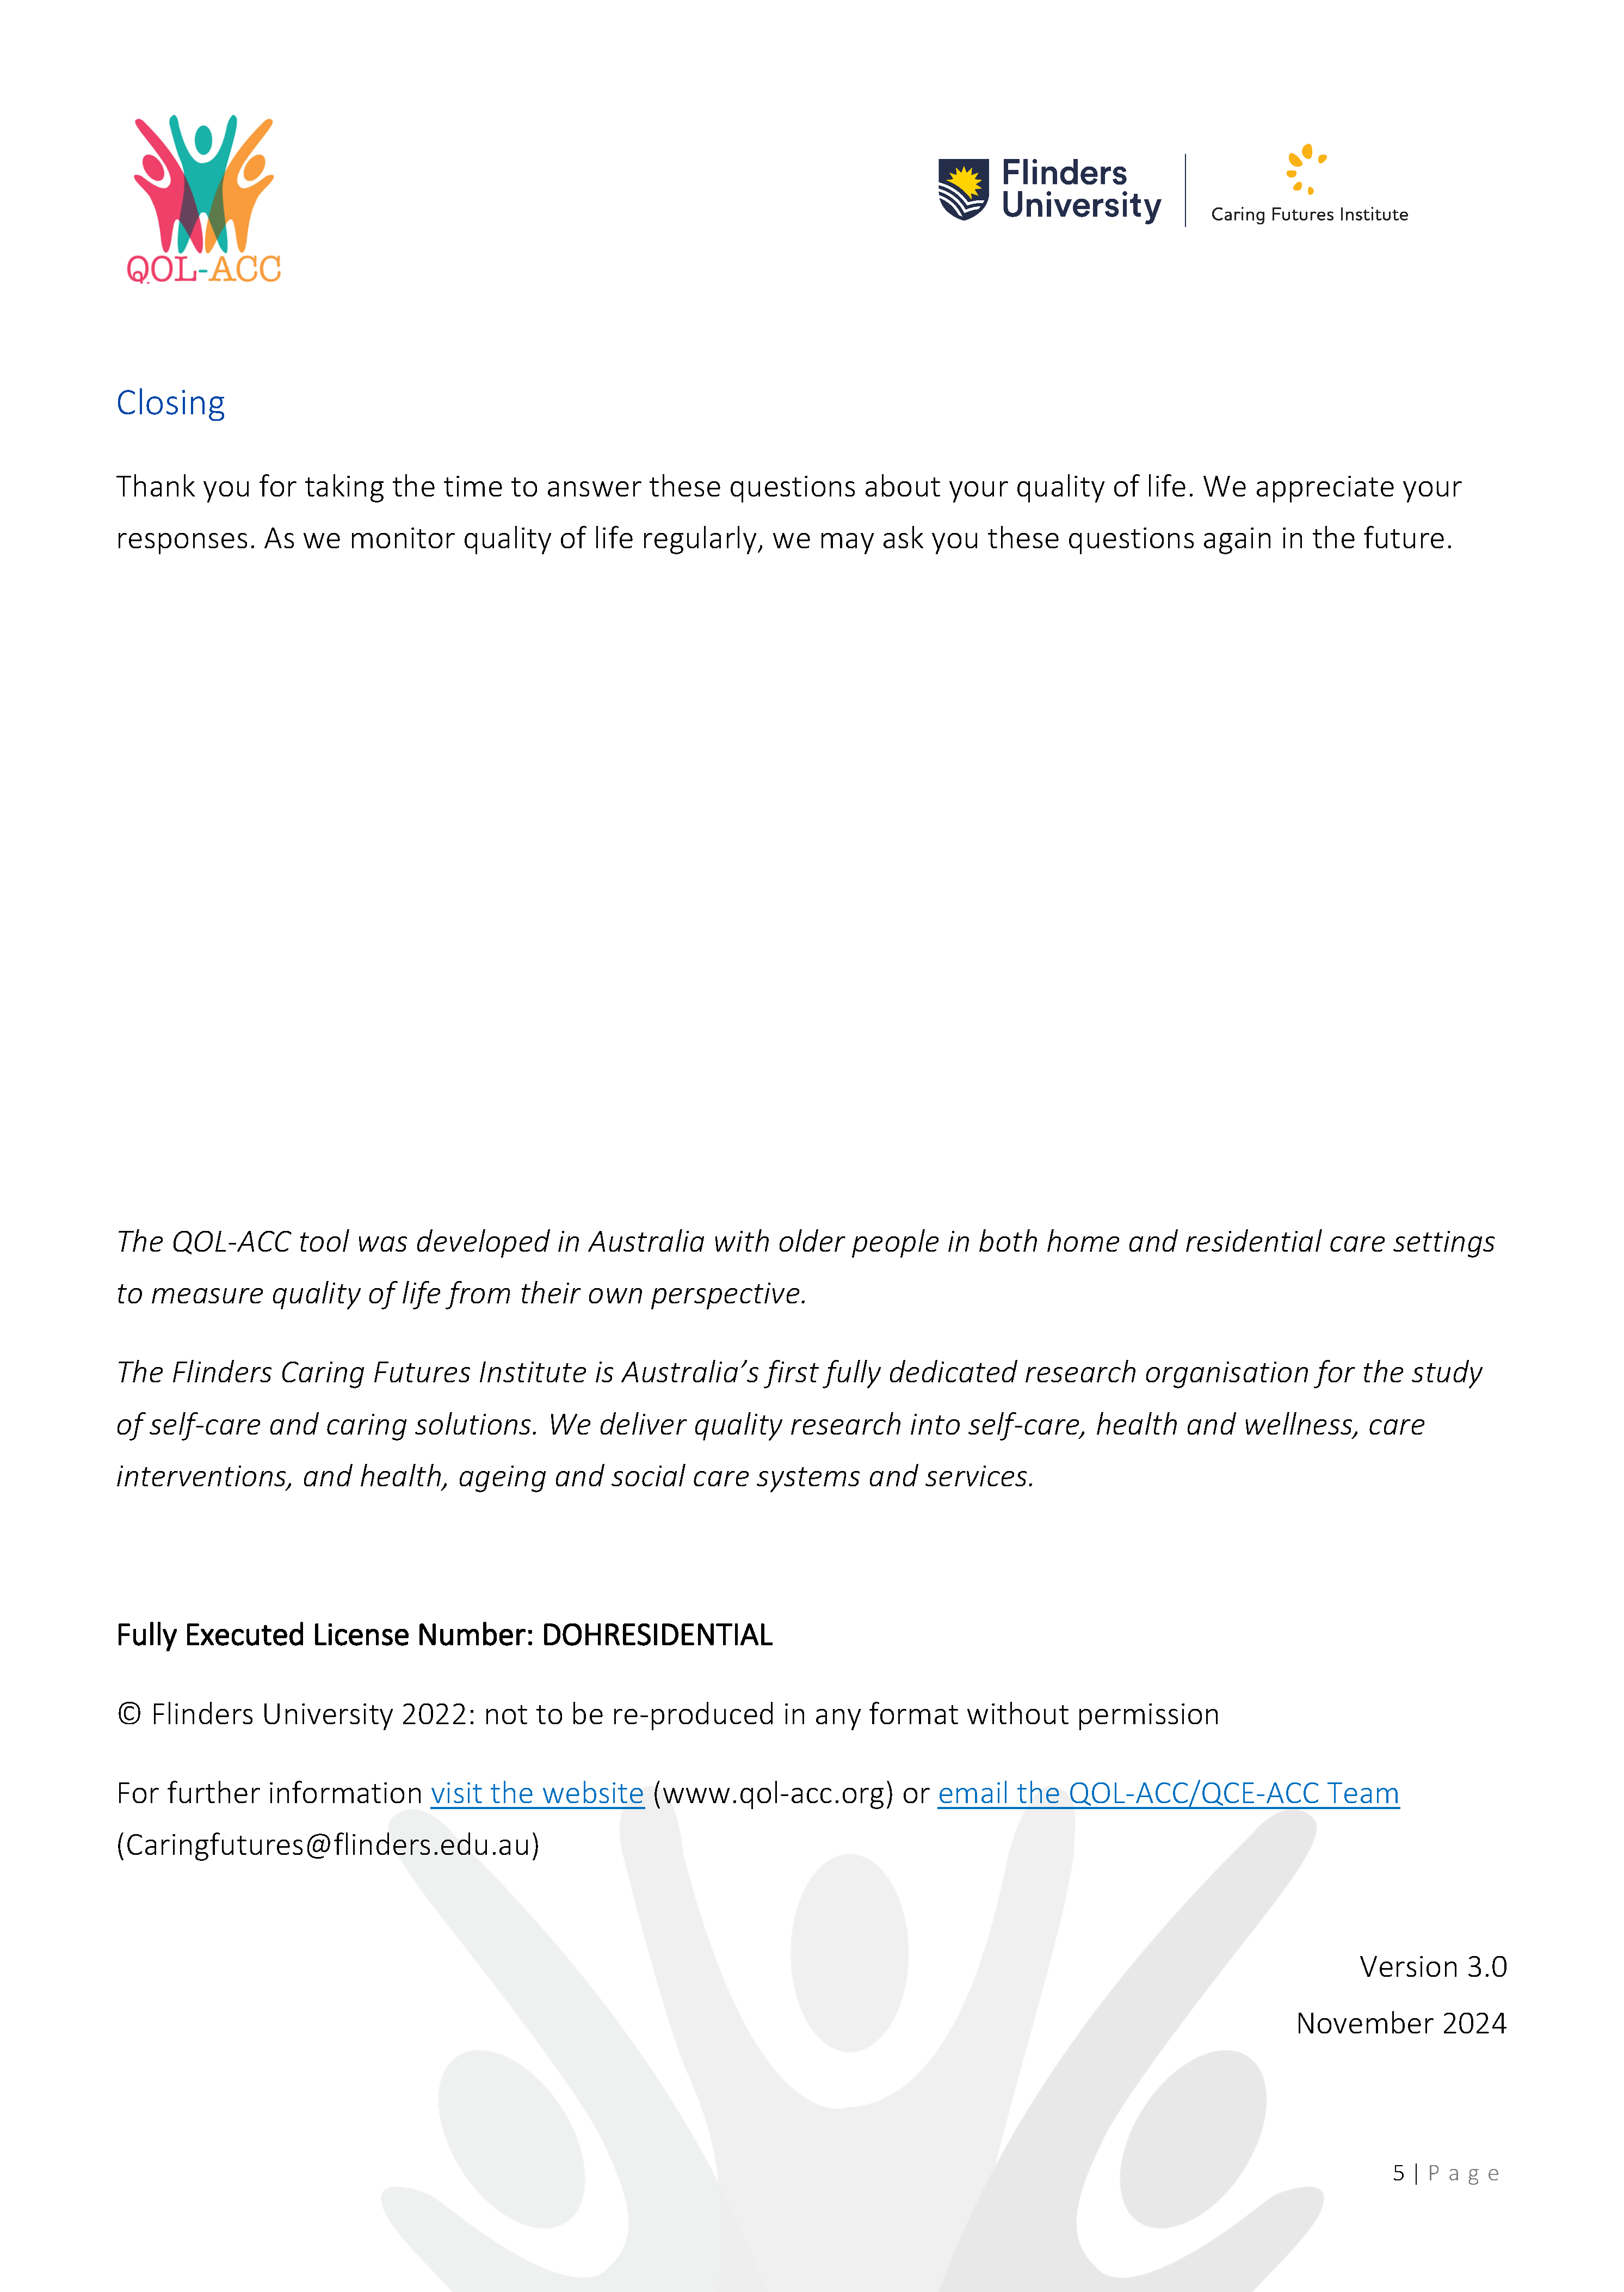

Health.gov.au
All information in this publication is correct as at September 2026

Australian Commission on Safety and Quality in Health Care (ACSQHC) (2012), Safety and Quality Improvement Guide Standard 8: Preventing and Managing Pressure Injuries, ACSQHC, Sydney.
Independent Hospital and Pricing Authority (IHPA) (2019), International Statistical Classification of Diseases and Related Health Problems, Tenth Revision, Australian Modification (ICD-10-AM), IHPA.
European Pressure Ulcer Advisory Panel (EPUAP), National Pressure Injury Advisory Panel (NPIAP) and Pan Pacific Pressure Injury Alliance (PPPIA) (2019), Prevention and Treatment of Pressure Ulcers/Injuries: Clinical Practice Guideline. The International Guideline 2019, Emily Haesler (Ed.), EPUAP/NPIAP/PPPIA.
Australian Commission on Safety and Quality in Health Care (2012), Safety and Quality Improvement Guide Standard 8: Preventing and Managing Pressure Injuries, Sydney.
Xu D, Kane R and Arling G (2019), Relationship between nursing home quality indicators and potentially preventable hospitalisation, BMJ Quality & Safety, vol. 28(7), p. 524–533.
World Health Organisation (2007), WHO global report on falls prevention in older age, WHO, France.
Xu D, Kane R, and Arling G (2019), Relationship between nursing home quality indicators and potentially preventable hospitalisation, BMJ Quality & Safety, vol. 28(7), p. 524–533.
Collin C, Wade DT, Davies S, and Horne V (1988), The Barthel ADL Index: a reliability study, International Disability Studies; vol. 10(2), p. 61–63.
Van Damme N, Van den Bussche K, De Meyer D, Van Hecke A, Verhaeghe S, and Beeckman D, (2017), Independent risk factors for the development of skin erosion due to incontinence (incontinence-associated dermatitis category 2) in nursing home residents: results from a multivariate binary regression analysis, International Wound Journal, vol. 14(5), p. 801–810.
Beeckman D, Van den Bussche K, Alves P, Beele H, Ciprandi G, Coyer F, de Groot T, De Meyer D, Dunk AM, Fourie A, García-Molina P, Gray M, Iblasi A, Jelnes R, Johansen E, Karadağ A, LeBlanc K, Kis Dadara Z, Long MA, Meaume S, Pokorna A, Romanelli M, Ruppert S, Schoonhoven L, Smet S, Smith C, Steininger A, Stockmayr M, Van Damme N, Voegeli D, Van Hecke A, Verhaeghe S, Woo K and Kottner J (2017), The Ghent Global IAD Categorisation Tool (GLOBIAD), Skin Integrity Research Group - Ghent University.
Khadka, J, Ratcliffe, J, Chen, G, Kumaran, S, Milte, R, Hutchinson, C, Savvas, S and Batchelor, F (2020), A new measure of quality of care in aged care: psychometric assessment, and validation of the Quality of Care Experience (QCE) questionnaire, Caring Futures Institute, Flinders University, Adelaide.
Cleland, J, Hutchinson, C, McBain, C, Walker, R, Milte, R, Khadka, J and Ratcliffe, J (2020), Developing dimensions for a preference-based quality of life instrument for older people receiving aged care services in the community, Quality of Life Research, p. 1–11.
Mahoney F and Barthel DW (1965), Functional evaluation: the Barthel Index, Maryland State Medical Journal, vol. 14, p. 61–65.
Wade DT and Collin C (1988), The Barthel ADL Index: a standard measure of physical disability, International Disability Studies, vol. 10(2), p.64–67.

