Assessor Portal User Guide 7 – Completing a Support Plan and Support Plan Review
This user guide is intended for aged care needs assessors who complete a support plan and/or a Support Plan Review, using the My Aged Care assessor portal.
! | Starting from 1 November 2025, the Aged Care Act 2024 and the Support at Home program came into effect with significant change to support plans in the IAT.  To ensure the right IAT is used, and triage can continue for priority referrals, any assessments in the following statuses already started prior to 1 November 2025 and in progress on 1 November 2025 must be restarted:  - Triage complete, main assessment not started  - Triage complete, main assessment in progress (includes incomplete support plan)  - Main assessment completed, awaiting delegate decision (comprehensive assessments)  For information on the Restart Assessment Process, please refer to Management of active assessments for 1 November 2025 transition – Standard Operating Procedure and Restarting In Progress Assessments for Support at Home (instructional video).  This is available from your Assessment Organisation.

! | Starting from 1 November 2025, there are changes to assessment delegations under the Aged Care Act 2024, for both Clinical and Non-clinical Assessment Delegates.  To understand Assessment Delegate changes, refer to ‘Chapter 7: Delegations and Approvals under the Act’ of My Aged Care Assessment Manual.  For CHSP only: From 29 June 2026, Home Support assessments will require delegate approval in the system, following the same process as comprehensive assessments.  Manual Delegate Approval is no longer required for Home Support assessments.  Assessors should now follow the standard system-based delegate approval process, consistent with comprehensive assessments.

Table of contents
The Support Plan 6
The Identified needs tab 6
Adding an assessment summary 7
The Goals and recommendations tab 9
Accepting the IAT Recommendation 10
Overriding the IAT Recommendation 10
Types of Recommendations 14
Linking Recommendations to Goals 14
Viewing the Recommendation after a delegate decision 16
Adding Recommendations 19
General Recommendation 19
Service Recommendation 20
No Care Type Under the Act 21
No Care Approval/No Change to Existing Care Approvals 22
Period of Linking Support 25
Period of Reablement 26
Care type for Delegate decision 27
Support at Home Recommendations 30
Adding Home Support services 30
Viewing Recommended SaH services 33
Assistive technology and Home modifications (AT-HM) Recommendations 35
Adding a Home modification Recommendation 35
Viewing Home modification Service Recommendation 37
Editing Home modification Recommendation 38
Adding an Assistive technology Recommendation 38
Viewing Assistive technology Service recommendation 41
Editing Assistive technology Recommendation 42
Adding Client Concerns and Goals 43
Linking Goals to Existing Support at Home Recommendations 46
Recording Service Frequency and Intensity 48
Support at Home - Restorative Care Pathway 49
Overriding to Restorative Care Pathway 49
Editing IAT Outcome to Restorative Care Pathway 51
Recommending Second Unit of Restorative Care Pathway 52
End-of-Life Pathway 54
Validating the End-of-Life Form 55
Overriding to End-of-Life Pathway 55
Flagging End-Of-Life to an existing SaH Restorative Care Pathway 57
Revert End-of-Life Flag 60
Overriding to End-of-Life for Transitioned Home Care Package (HCP) clients 61
Reverting to End-of-Life for Transitioned Home Care Package (HCP) clients 64
Completing the Support Plan 65
'Returned to Assessor’ status 67
Amendments to the IAT 67
Reviewing and Resubmitting the returned IAT 69
Amendments to the support plan 75
Finalising the support plan 75
Finalising a Support Plan for Support at Home classification 77
Ending a period of Reablement or linking support 78
Printing a copy of the support plan 82
Support Plan Reviews 84
Viewing a Support Plan Review 84
Starting a Support Plan Review 86
Recommending a new assessment 92
Issuing an assessment referral as a result of a Support Plan Review 96
Ad hoc Support Plan Reviews 99
Scheduling an Ad hoc Support Plan Review 100
Transferring a Support Plan Review 104
Support Plan Review for Support at Home 105
Support Plan Review for services following an End-of-Life Pathway episode 107
Revert to the previous ‘latent’ SaH classification 107
Reassessment for a new Support at Home Classification following an episode of End of Life 110

The Support Plan
The aged care client’s support plan records and identifies the client’s:
- areas of concern regarding care
- goals to address these concerns
- any recommendations for services or actions to achieve the identified goals.
The client develops their own support plan with an assessor during the face-to-face assessment.
The SUPPORT PLAN is made up of several components (tabs):
- Identified Needs
- Goals & Recommendations
- Manage Services & referrals
(Refer to My Aged Care – Assessor Portal User Guide 8 – Referring for services)
- Associated People – showing people associated with the support plan.
- Review – showing a future to review the support plan.
This guide will go into the Goals & recommendations tab in detail.

The Identified needs tab
The IDENTIFIED NEEDS tab contains a summary of the needs identified as part of the assessment that require addressing in the support plan. This also includes information of the client’s latest completed Support Plan Review if applicable.
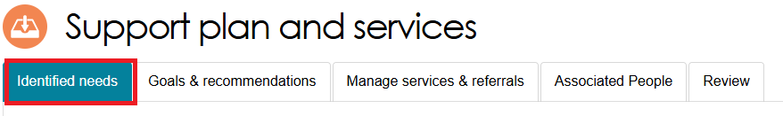
Headings in the Identified Needs tab
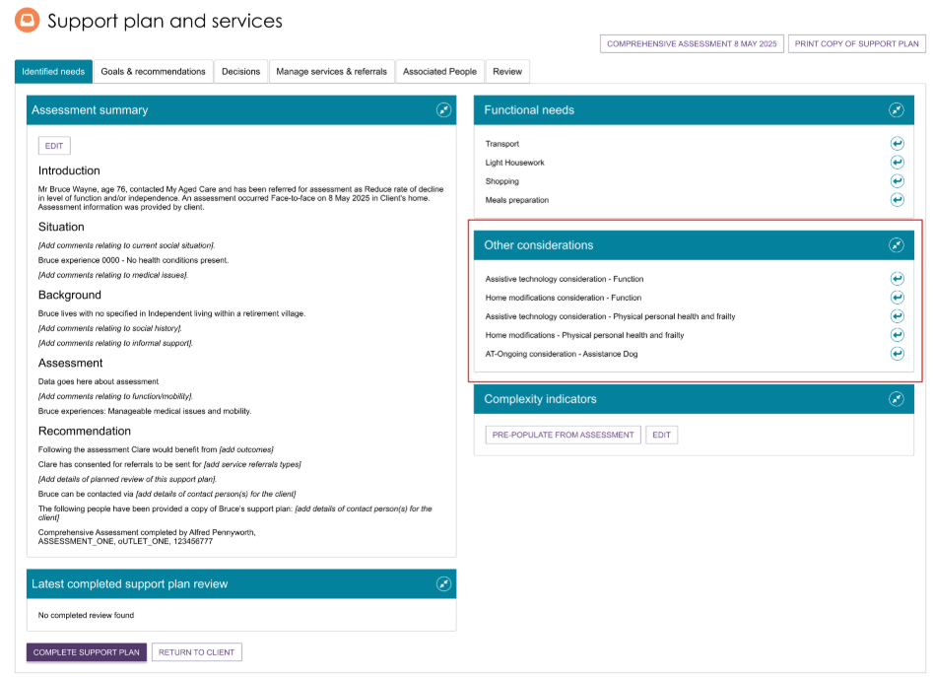

Adding an assessment summary
When completing a support plan, assessors can add an Assessment summary within the Identified needs tab.
The assessor can use Pre-Populate from Assessment button to get the assessment summary populated.
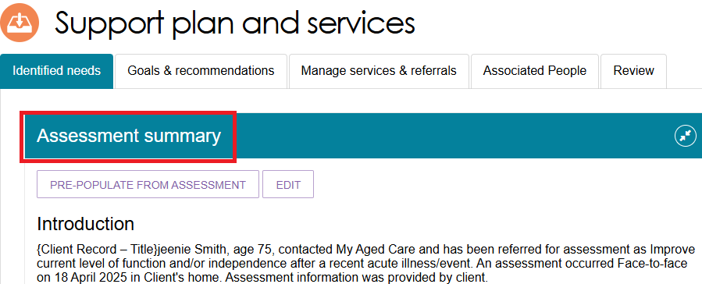
This summary appears on the printed support plan provided to the client. It can help conduct further assessments if required. It is visible to service providers who have received a referral for that client.
The assessment summary can be pre-filled based on the information an assessor records in the assessment. An icon (arrow leaving a square pointing right) will display on the fields which automatically pre-fill into the assessment summary.
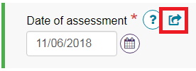
To add an assessment summary based on the information captured from the assessment, select PRE-POPULATE FROM ASSESSMENT.
Alternatively, select EDIT to edit the assessment summary without any pre-filling. This will open a blank assessment summary.
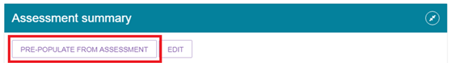
A read-only view of the assessment summary will display.
The system will populate information where it exists. If information does not exist in a field, the system will advise which field has not been populated. This will display as [field name].

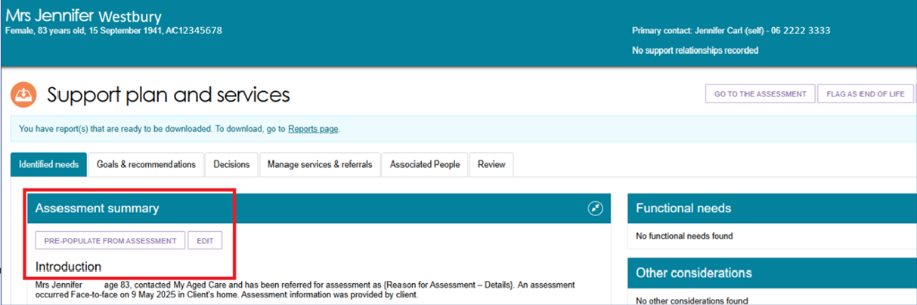
Assessors can choose to enter information in the field in the assessment; add relevant information in the assessment summary; or remove the instruction from the assessment summary. Assessors will be prompted to enter additional information that could not be populated from the assessment. This will display as [example instruction].
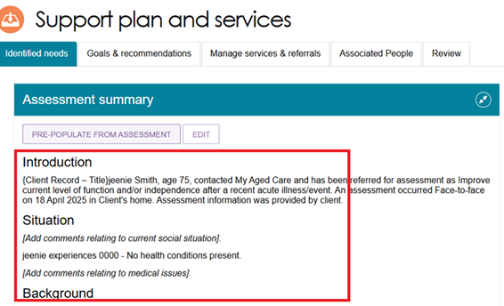
Select EDIT to start editing information in the assessment summary.
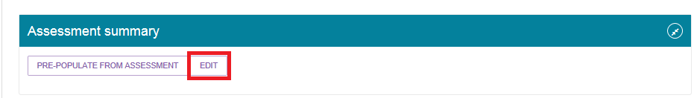
Select CONFIRM EDIT to open the editable assessment summary.
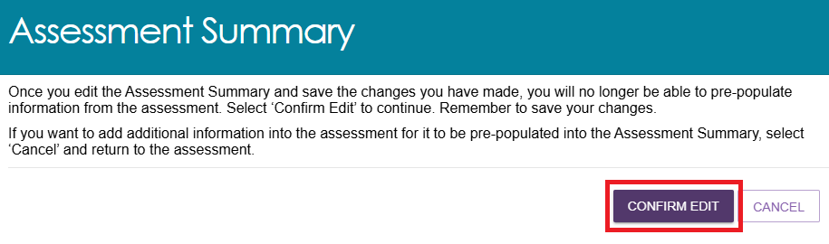
Once CONFIRM EDIT has been selected and the changes have been saved, the select Pre-populate from assessment option will no longer be available to be selected.
Once the assessment summary has been edited/updated, select SAVE to save changes. Based on the information pre-populated from the assessment, the assessment summary may exceed the 5000-character limit.
Assessors should reduce the assessment summary by removing or summarising old content.
Assessors can continue to edit the assessment summary after they have saved their changes.
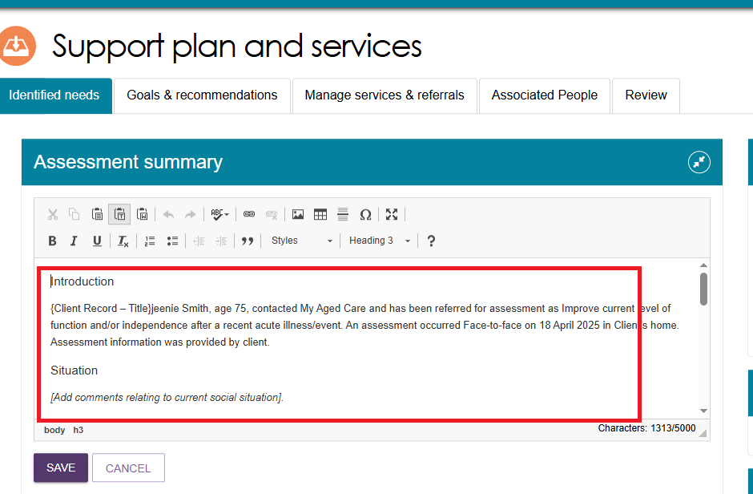
! | Ensure changes to the assessment summary are regularly saved, as auto-save does not apply to the assessment summary.

The Goals and recommendations tab
The Goals & recommendations tab is where you will record the client’s areas of concerns, goals to address their concerns, and any services or general recommendations.
Within the Goals & recommendations tab you will also be able to view the IAT outcome and the recommended classification/s. The recommendation/s is based on inputs from the assessor on the IAT assessment and the client’s current care approvals.
If applicable, more than one active approval can be displayed. For example, when a client has an active Restorative Care Pathway (RCP) classification approval, and an SaH 1-8 Classification is approved in a reassessment, both the RCP and the SaH classifications will be shown in the Goals & Recommendations tab.

Accepting the IAT Recommendation
To accept the IAT Outcome, go to the IAT Outcome and Classifications section and select ACCEPT.
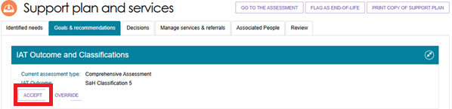

Overriding the IAT Recommendation
Refer to the other sections in this guide for Overriding to Restorative Care Pathway and Overriding to End-of-Life Pathway.
! | The IAT will allow an ongoing Support at Home Classification to be overridden to a different ongoing classification level.  However, assessors must not undertake this action and delegates must not approve assessments where this occurs.  An ongoing SaH classification outcome cannot be overridden to an ongoing lower or higher SaH classification outcome (in line with section 81-10 of the Aged Care Rules).
- To OVERRIDE a recommended classification, select the OVERRIDE button located underneath the IAT Outcome and Classifications heading.
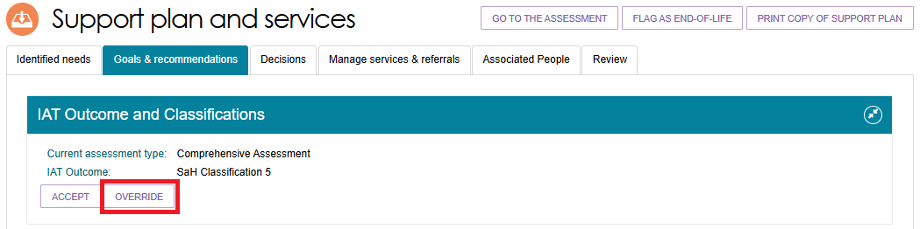
- The Override IAT Outcome pop up appears, prompting the assessor to input the new classification, the override reason and the override reason description.
The list of classifications that are allowed to be selected will depend on the initial IAT Outcome. Assessors are also only allowed to select classifications in line with the Aged Care Rules. Refer to the My Aged Care Assessment Manual for further information.
The appearance of the pop up and the drop-down options will depend on the original IAT outcome and the intended override.

Below is an example of an Override IAT outcome pop up.
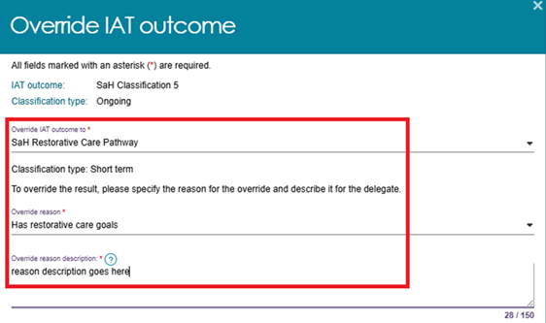
- If you are overriding to any other classification other than ‘Restorative Care Pathway’, then you will also need to choose a reason from the ‘RCP reject reason’ drop down.
(Otherwise, refer to the Overriding to Restorative Care Pathway section).
The options are: Not suitable/eligible for RCP, Seeking ongoing services, and Other.
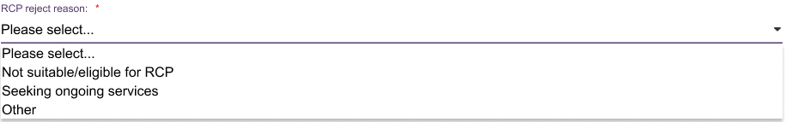
If Other was chosen, then you must also enter a description for the reject reason.
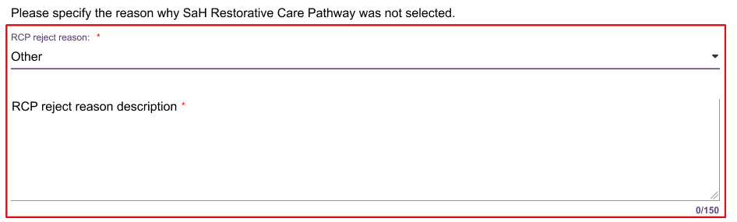
- If you have chosen a Support at Home classification for the override, then you will be asked to select the client’s preference for seeking Home support services through the Support at Home program. Select ‘Seeking services’ or ‘Not seeking services’.
An information banner may appear to remind you that ‘The client’s preference for seeking Home support services determines whether they are in the Support at Home priority system’.

- Select SAVE TO PLAN, OVERRIDE or ACCEPT once the fields are completed.
Once the classification or recommendation is accepted, a new screen will open to input all the services within each service type available for the classification, their frequency and intensity.
The image below shows an example of the Add Home Support Services page. It shows three services within the Allied Health and Therapy service type available to be chosen.
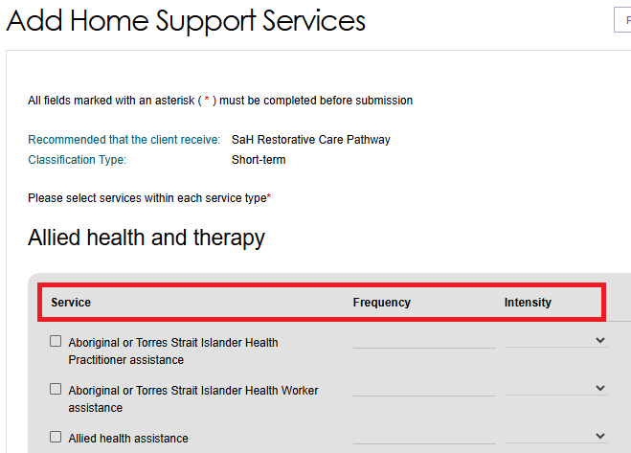
- Once all the values are entered, Select SAVE TO PLAN at the bottom of the page.
The following image shows examples of chosen transport services, with frequency and intensity recorded.
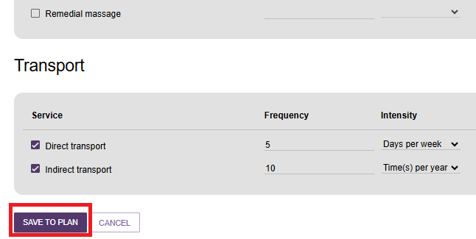
- The updated classification will be displayed on the client’s GOALS AND RECOMMENDATIONS tab.
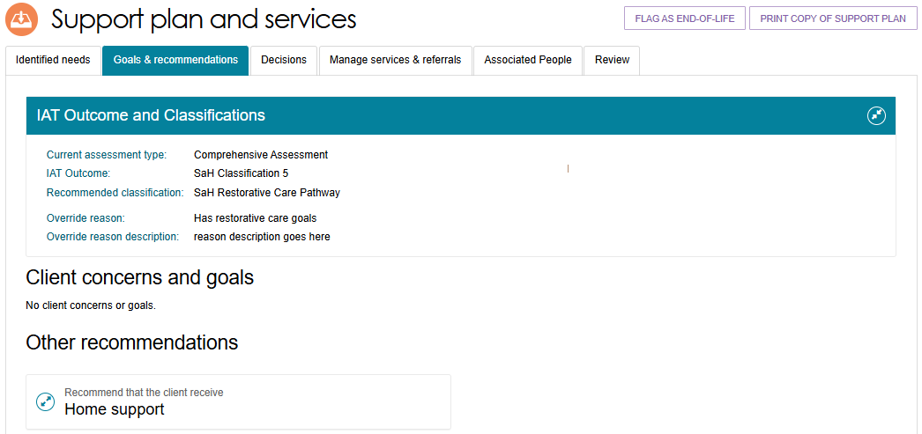
- The existing classification/s will also display on the right hand side of the updated classification, if applicable.
The below image shows an example of a client with a Transitioned HCP Classification under Support at Home, as per the Aged Care Act 2024.
This is displayed in the Existing Classification section.
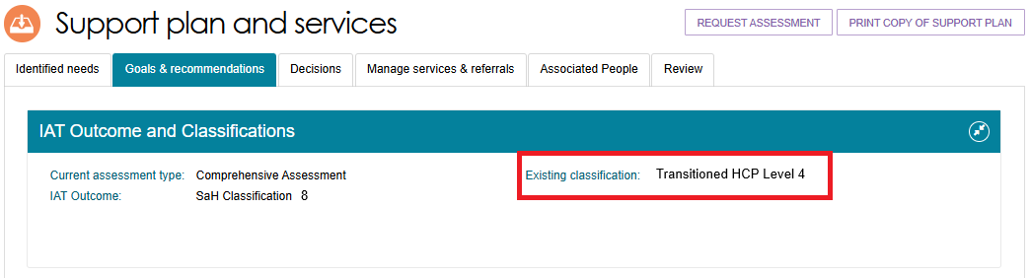
The recommendation displays for guidance only. Assessors will still need to select the service the client requires.
For clinical aged care needs assessors (clinical assessors):
- CHSP - refer to Manual Delegate Approval for CHSP – Standard Operating Procedure and instructional videos for comprehensive and home support assessments.
- Support at Home Classifications recommendation – refer to Adding Home Support services for a Support at Home Classification.
For non-clinical aged care needs assessors (non-clinical assessors), this means they should consider the following based on the IAT outcome:
- CHSP – refer to Manual Delegate Approval for CHSP – Standard Operating Procedure and instructional videos for comprehensive and home support assessments.
- Support at Home – you should consider converting the assessment to a comprehensive assessment under the supervision of a staff member who holds a clinical assessor role.

Types of Recommendations
There are seven types of recommendations that can be added or removed to a support plan following an assessment:
! | For Home Support services under the Support At Home Program, refer to Adding Home Support services for a Support at Home Classification and Assistive technology and Home modifications (AT-HM) Recommendations.
- General recommendations are non-Commonwealth funded supports that are identified by the assessor and the client and will be actioned by the client or the assessor rather than a service provider, for example: that the client sees a health practitioner, or that they join a local support group.
- Service recommendations are for adding recommendations for services to a clients support plan, such as Commonwealth Home Support Program (CHSP) services.
- Assistive technology under Support at Home program.
- Home modification under Support at Home program.
- Recommended long-term living arrangement is only applicable to comprehensive assessments. It is the most appropriate long-term living situation identified during a comprehensive assessment that can be selected from a list of accommodation settings after discussing the goals with the client and/or their supporter. This can only be recommended after a comprehensive assessment has been completed.
- Care type for Delegate decision recommendations are applicable only to comprehensive assessments where CHSP is not recommended. These recommendations relate to care types under the Aged Care Act 2024 (the Act) which require approval by a Delegate.
- Recommendations for a period of linking support are for where a client’s complex circumstances may be a barrier to accessing aged care services, and providing linking support can assist the client to access various services they require.
Recommendations for a period of reablement are for time-limited interventions that are targeted towards a client’s specific goal(s) or desired outcome to adapt to some function loss, or regain confidence and capacity to resume their activities, for example: training in a new skill, modification to a client’s home environment or having access to equipment or assistive technology.

Linking Recommendations to Goals
Recommendations can be linked to concerns and goals, or they can be added as an Other Recommendation. Further information on linking support and reablement is available in the My Aged Care Assessment Manual on the department’s website.
Recommendations can be associated to more than one goal. When adding your recommendations you can select one or more goals to associate a recommendation or unlink the recommendation from all goals.
- You can select the appropriate recommendation from the Other Recommendations section of the Goals & Recommendations tab. You can then choose to link this recommendation to a relevant goal. If you add a recommendation from the Other Recommendations section recommendation will be displayed underneath that heading.
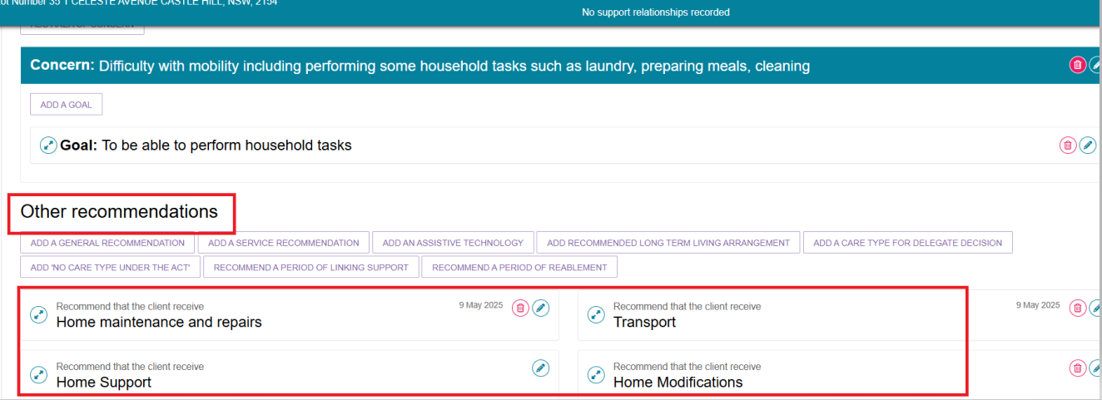
- Alternatively, you can add a recommendation directly to an area of concern and goal by selecting the arrow next to Goal and below Add to this goal on the right-hand side of the panel.
If you add a recommendation from the Add to this goal section, the recommendation will be displayed underneath the goal.
Select the arrow to the left of the goal to display the recommendation details.
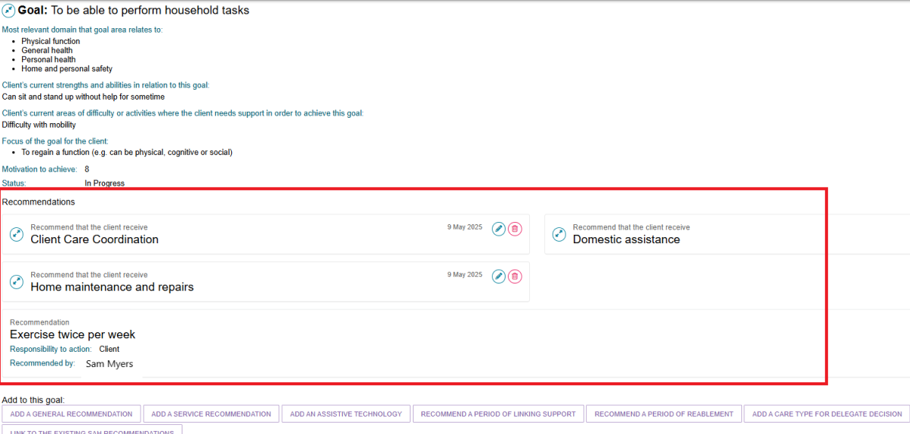

- To unlink a recommendation from the goal, select the EDIT icon (Blue Pencil) next to the recommended service under the goal and press the UNLINK THIS RECOMMENDATION FROM ALL GOALS button and select SAVE TO PLAN.
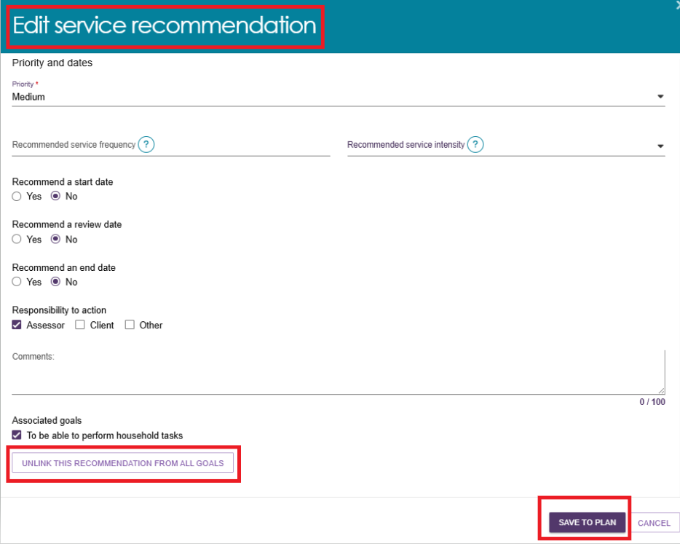

Viewing the Recommendation after a delegate decision
Once the goals and recommendations have been entered, the assessor forwards the referral to the delegate for decision-making. After the delegate completes their review, the assessor can view the outcome, including which recommended services were approved or modified. The assessor can also see if the delegate has added any new services.
To access this information, the assessor can locate the client using the Find a Client link in the Assessor Portal.
You can search for a client in the My Aged Care Assessor Portal by entering their First Name, Last Name, or Aged Care User ID in the search fields.
If the client was recently accessed, you can also select them directly from the Recently Viewed Persons section for quicker access.
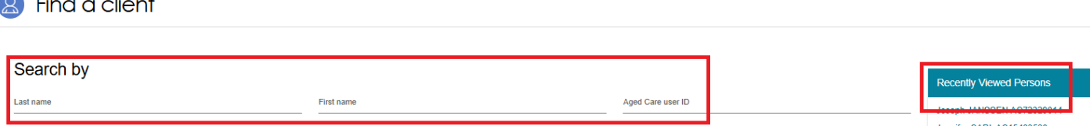
Once you are in the client record, navigate to the Plans tab and select Support Plan.
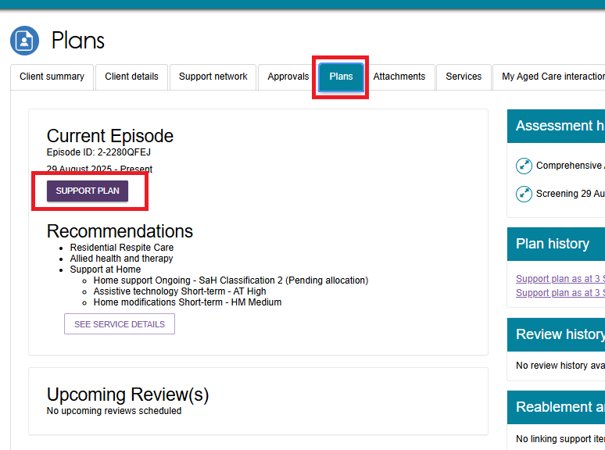
Once you are in the client's Support Plan and Services screen within the Assessor Portal, navigate to the Decisions tab to view the delegate’s decision.
This section displays the outcome of the delegate’s review, including any approved, modified, or newly recommended services.
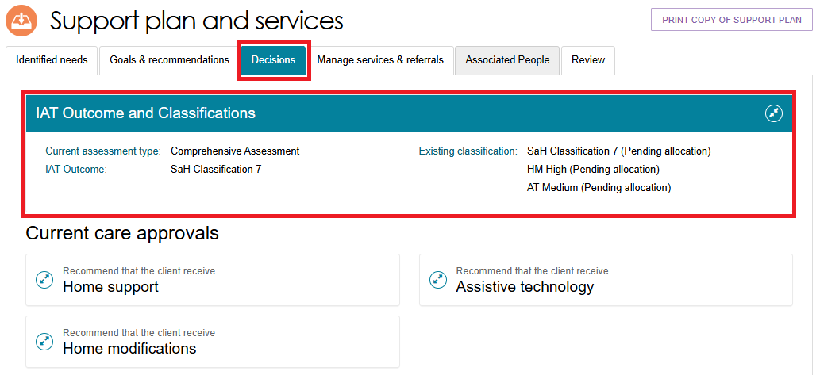

Scroll down to the Delegate Decisions and Comments section within the Decisions tab to view all decisions made by the delegate regarding the services recommended for the client.
This area provides a detailed summary of approved, modified, or newly suggested services, along with any comments or justifications provided by the delegate.
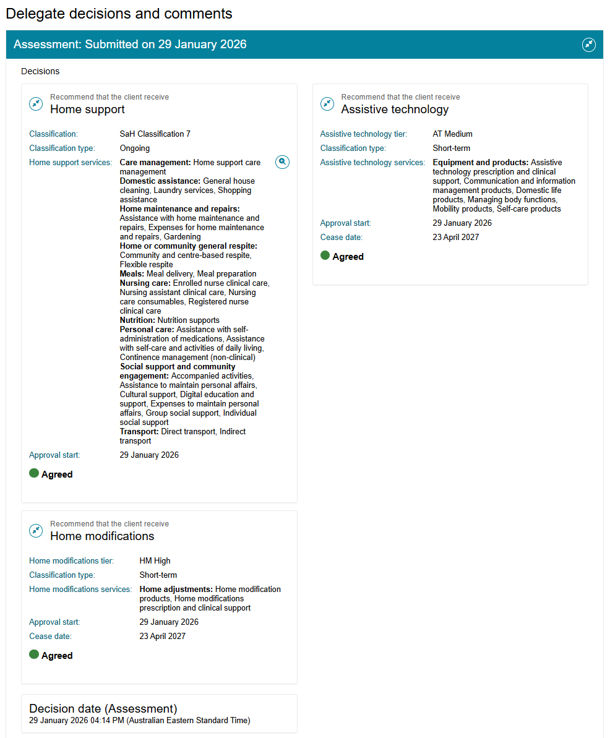

Adding Recommendations
To add a general recommendation, go to General Recommendation.
To add a service recommendation, go to Service Recommendation.
To add a Home modification, go to Adding a Home modification Recommendation.
To add an Assistive technology Service, go to Adding Assistive technology Recommendation.
To add a recommendation for a period of linking support, go to Period of Linking Support.
To add a recommendation for a period of reablement, go to Period of Reablement.
To add a recommendation for a Care type for Delegate decision, go to Care type for Delegate decision.
To add a recommendation of No Care Type Under the Act, go to No Care Type Under the Act.
To add a recommendation for No Care Approval or for No Change to Existing Care Approvals, go to No Care Approval/No Change to Existing Care Approvals.

General Recommendation
Select Add a general recommendation.
Examples of general recommendations include:
- Develop Emergency Care Plan.
- Connect with GP or other health professional.
- Gain assistance with decision making.
- Obtain a smoke alarm.
- Develop a Personal Emergency Plan.
- Investigate getting a Personal Alarm.
- When a pop-up box is displayed, enter information about the general recommendation, check the box if you are linking it to a goal and select SAVE TO PLAN.
As assessors are completing the assessment, they will be able to add general recommendations to the support plan from the assessment.
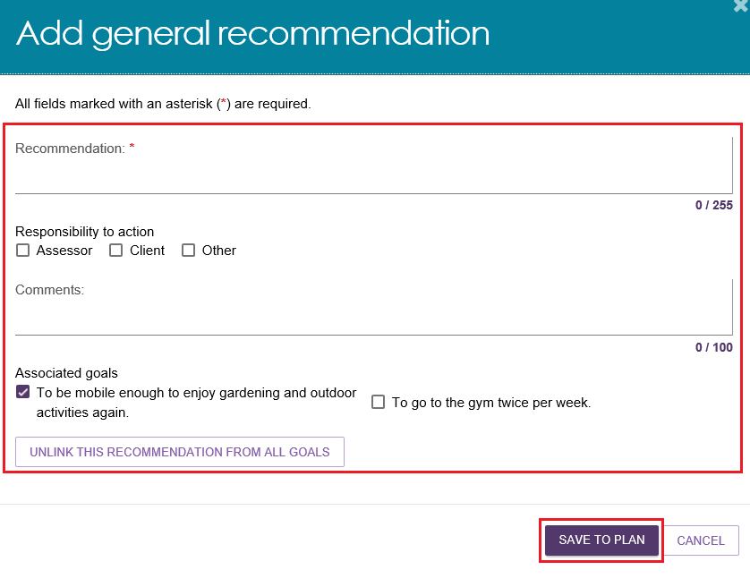
- In the assessment, the assessor can select to Add as Recommendation and this will populate in the Identified needs and Goals & recommendations tabs in the support plan.
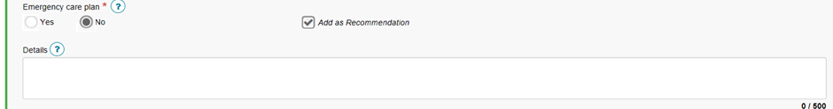

Service Recommendation
Select Add a service recommendation.
When a pop-up box is displayed, select the recommended service, complete all mandatory fields and select SAVE TO PLAN.
For more information on Support at Home Assistive technology services and Home modification services, refer to the Support at Home - Assistive technology and Home modifications (AT-HM) Recommendations section.
The priority for Support at Home service recommendations will default to the priority as calculated by the Integrated Assessment Tool.
Assessors should use the comments field to clarify the specific scope of the services that are recommended to be delivered within the Support at Home service type.
The scope of services should be linked to the identified needs from the assessment and goals referred to in the support plan, for example: unable to get to places beyond walking distance; requires transport to health clinic.
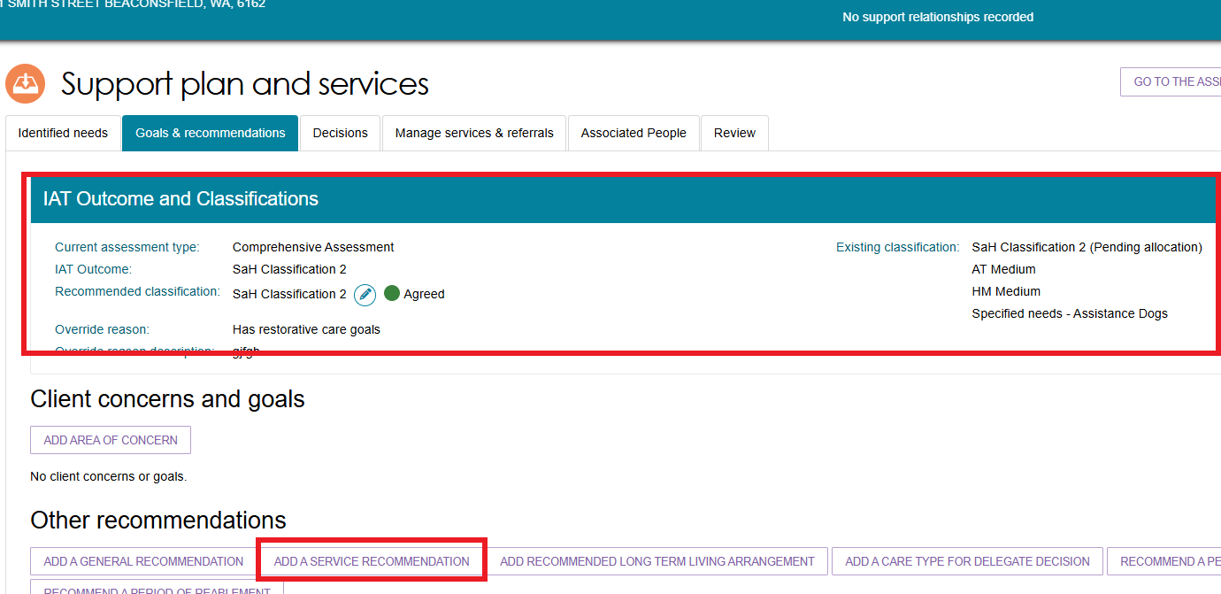

! | Transitioned Clients from MPS or NATSIFAC Program  Assessors can select Services under the MPSP and Services under the NATSIFACP as a Service Recommendation.  Transitioned clients are identified by the phrase MPSP NATSIFACP Deeming in the client summary page, and the Goals and Recommendations tab of the client record.  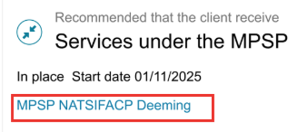  There will also be an information message reminding assessors that Client is approved to access services through a provider under MPSP or NATSIFACP.

No Care Type Under the Act
Use No Care Type Under the Act when a client has withdrawn their application for care under the Aged Care Act. This outcome does not require delegate approval. This option will display before accepting or overriding the IAT outcome.
! | This option will not appear if the Integrated Assessment Tool (IAT) algorithm recommends Support At Home (SaH) or CHSP classification and you accepted.
- Select ‘Add No Care Type Under the Act’.
This image shows an example where ‘Add No Care Type Under the Act’ is the only recommendation available to be selected (all other recommendations are greyed out) prior to accepting or overriding the IAT outcome.
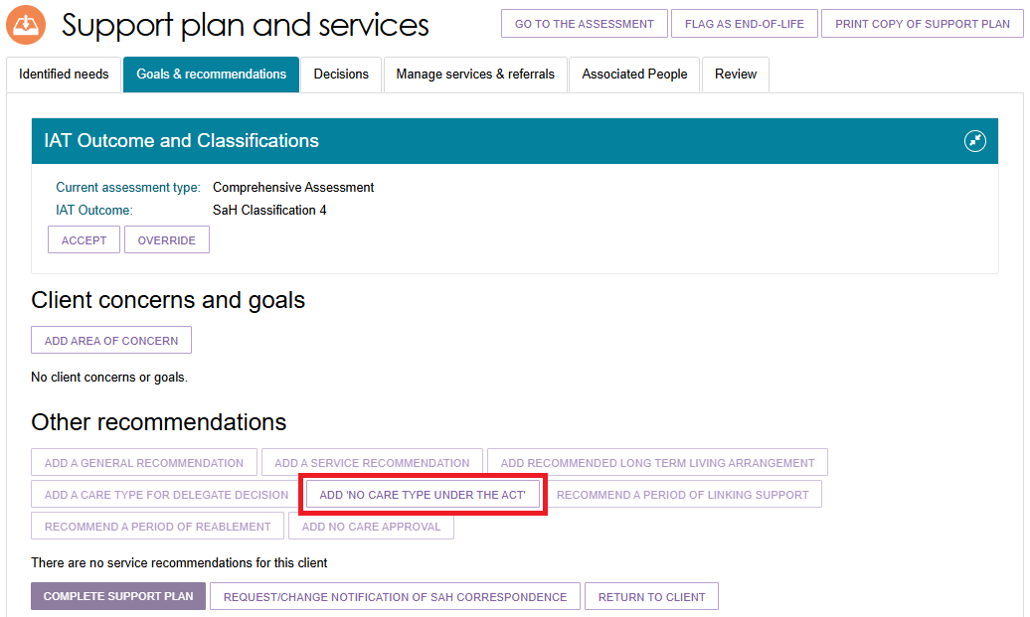
- When a pop-up box is displayed, select the reason for the recommendation that the client receives No Care Type Under the Act, enter a comment or reason if appropriate and select SAVE TO PLAN.
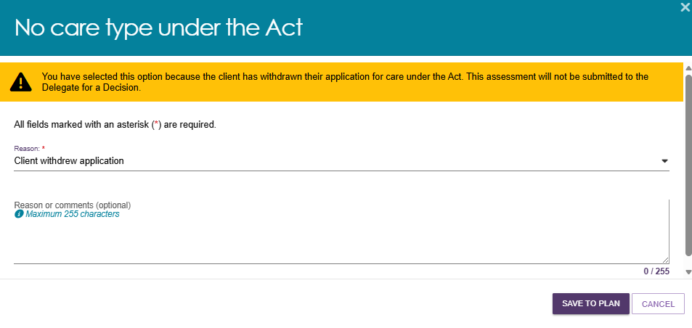
- Alternatively, if you add a recommendation from the Other recommendations section or are adding a No Care Type Under the Act recommendation, the recommendation will be displayed underneath that heading. The recommendation will not be linked to a goal.
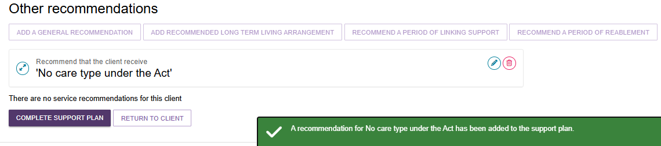

No Care Approval/No Change to Existing Care Approvals
No Care Approval and No Change to Existing Care Approvals are two special types of care type for Delegate Decision.
Comprehensive assessors and Home support assessors can add either No Care Approval or No Change to Existing Care Approvals to an IAT assessment, then submit the assessment for delegate approval before finalising the support plan.
However, these options are not available during the support period or the support plan review.
Use No Care Approval when the client has no previous approval records, has been assessed, but no services or care approvals are recommended because the IAT outcome shows the client is not eligible for CHSP or SaH based on their assessed needs. This IAT outcome must be accepted prior to selecting the option.

Use No Change to Existing Care Approvals during a reassessment where the outcome does not change the client’s existing approvals. This outcome also requires delegate approval. This option appears if the client has previous approval records.
Follow these steps to add No Care Approval or No Change to Existing Care Approvals:
- Select either NO CARE APPROVAL, or NO CHANGE TO EXISTING CARE APPROVALS, from the Other Recommendations section.
No Care Approval example
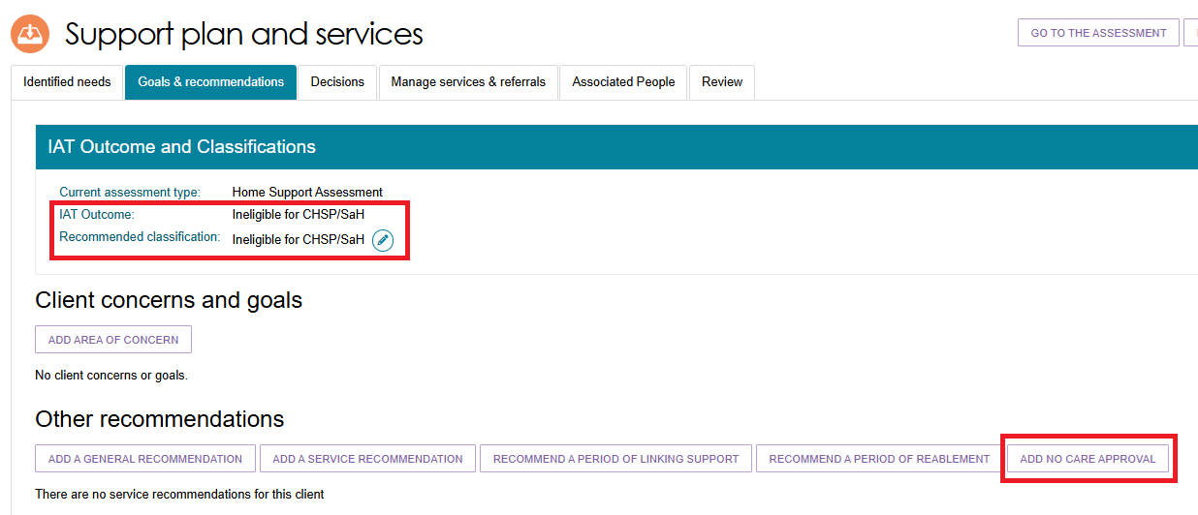
No Change to Existing Care Approvals example
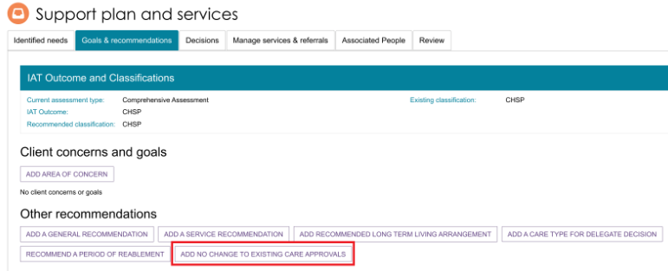
These options are also available directly from a client’s goal. The below image shows an example of adding No Care Approval in the Client Concerns and Goals section.
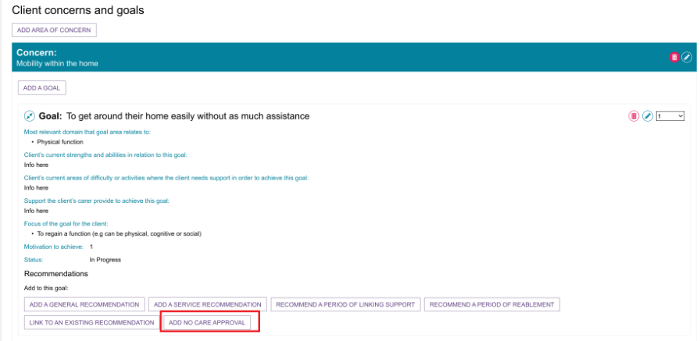
- Optionally, enter your reason or comments in the pop up, then select SAVE TO PLAN.
No Care Approval example
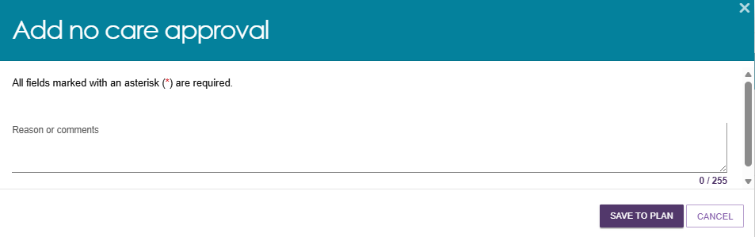
No Change to Existing Care Approvals example
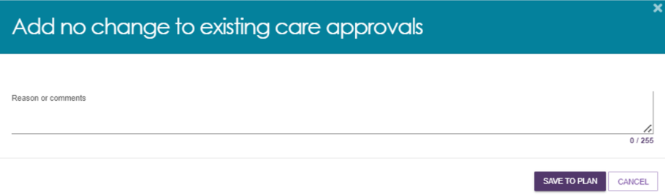
- The recommendation appears in the client’s Goals & Recommendations section of the support plan, along with a success banner ‘Your recommendation has been added’.
Delegate decision is then required.
No Care Approval example
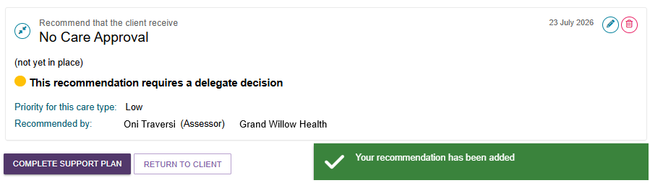
No Change to Existing Care Approvals example
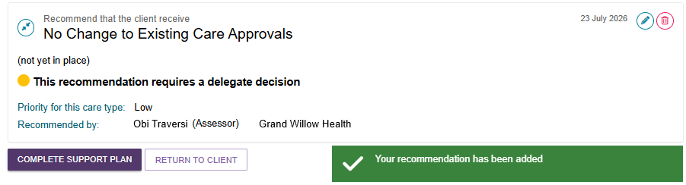
! | CHSP, MPSP or NATSIFAC in the support plan  If a client already has a CHSP, MPSP or NATSIFAC recommendation (including CHSP services added as ‘urgent’) in their support plan, assessors can complete the client’s support plan for a Comprehensive assessment, without needing to add the following recommendations:  - Add a care type for delegate decision, or  - No care approval, or  - No change to existing care approvals.  Otherwise, an error message will appear:

Period of Linking Support
Select RECOMMEND A PERIOD OF LINKING SUPPORT. In the pop-up box that will display, enter the start date for the period of linking support and the recommended end date, and select the reason for recommending linking support from the drop-down menu. Include any relevant comments and linking to any goals where applicable. Select RECOMMEND saving to the client's support plan.
During a period of linking support, extension requests for Transition Care and Residential Respite Care services can be requested and granted. Further information regarding linking support is available in the My Aged Care Assessment Manual.
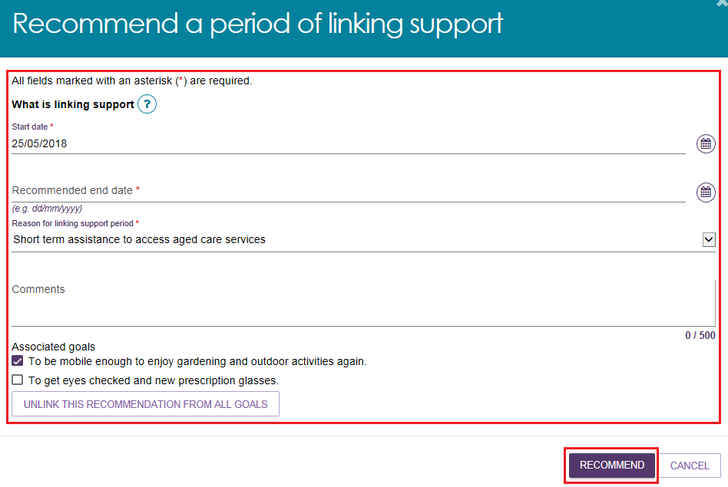

Period of Reablement
Select RECOMMEND A PERIOD OF REABLEMENT. When a pop-up box is displayed, enter the start date for the period of reablement and the recommended end date, and select the reason for recommending reablement from the drop-down menu. Enter any relevant comments and linking to any goals where applicable. Select RECOMMEND saving to the clients support plan.
During a period of reablement, extensions requests for Transition Care and Residential Respite Care services can be requested and granted.
Further information regarding reablement is available in the My Aged Care Assessment Manual.
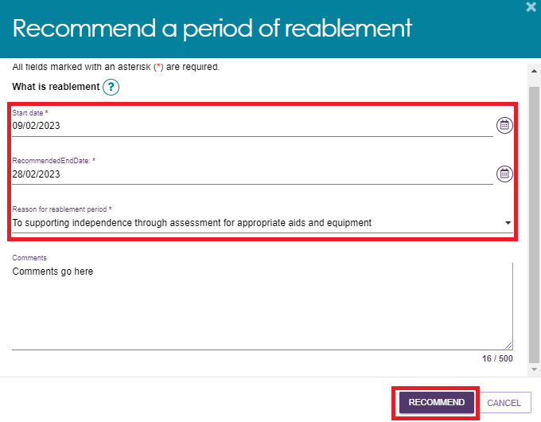

Care type for Delegate decision
- Select ADD A CARE TYPE FOR DELEGATE DECISION. This can be done either as part of a goal, or separately.
ADDING A CARE TYPE AS PART OF A GOAL
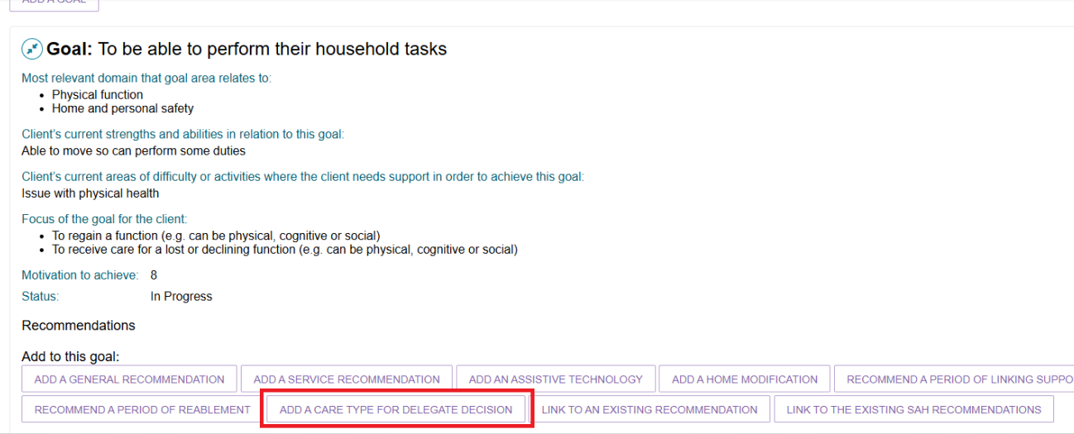
ADDING A CARE TYPE SEPARATELY
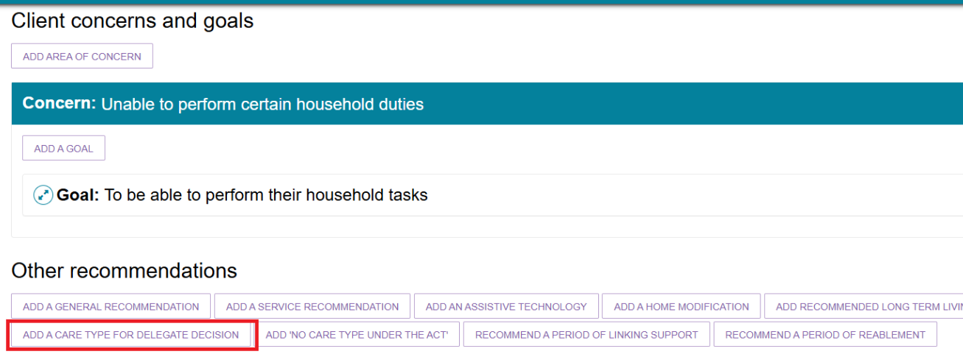
- At the pop-up, select which care type applies, enter the reason and comments, if necessary, then select SAVE TO PLAN. The care types available are: Residential permanent, Residential respite care, and Transition Care.
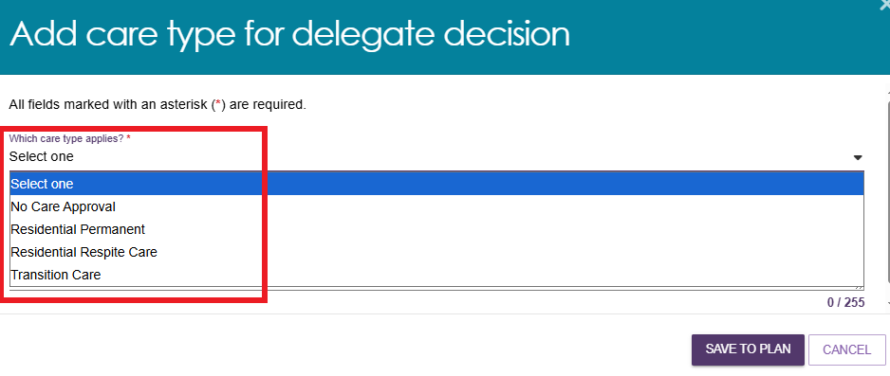
! | If a client is under the age of 65, several additional entry fields will appear to document their exceptional circumstances.
- Once the required care type is selected, the pop-up screen will expand asking for further information. The assessor will be prompted to select the priority or urgency of the selected care type.
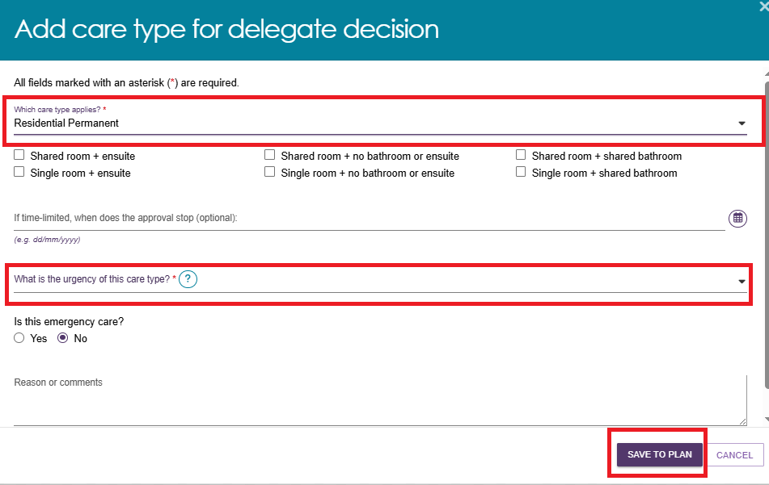
For Residential Permanent and Residential Respite Care, urgency is used.
For Residential Permanent the field is editable and needs to be selected. For Residential Respite Care the field will default to High and cannot be edited.
The Aged Care Assessment manual provides guidance on selecting level of urgency.
For Residential Respite Care, ensure that the DEMMI checkbox is ticked, and a valid reason is entered as shown in the following image.
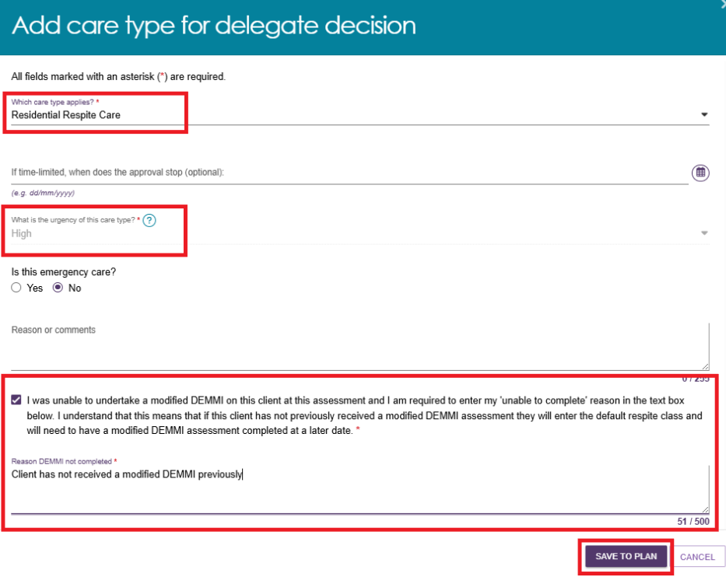
- Select SAVE TO PLAN.
! | If a client’s home address is not recorded, you will receive a warning message to update the address while performing the above step.  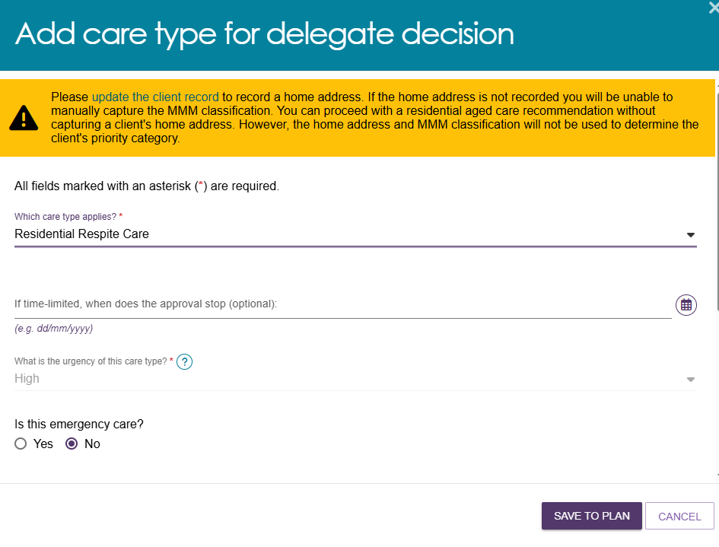

Support at Home Recommendations

Adding Home Support services
Once the clinical assessor has accepted the Support at Home classification, the assessor will be prompted to add Home Support services for the client. For each service that is recommended for the client, you will need to tick the tick box, enter a frequency and an intensity.
! | If the assessor does not select a service, the Support at Home service provider will not be permitted to provide the service to the client, which may result in a Support Plan Review to add the service to the Support at Home classification.  When assessing for Support at Home, the Support Plan allows assessors to select all relevant service types when making a recommendation. This minimises the number of Support Plan Reviews raised. The only exception is Allied Health and Therapeutic Services for Independent Living, which must be selected manually based on identified goals.

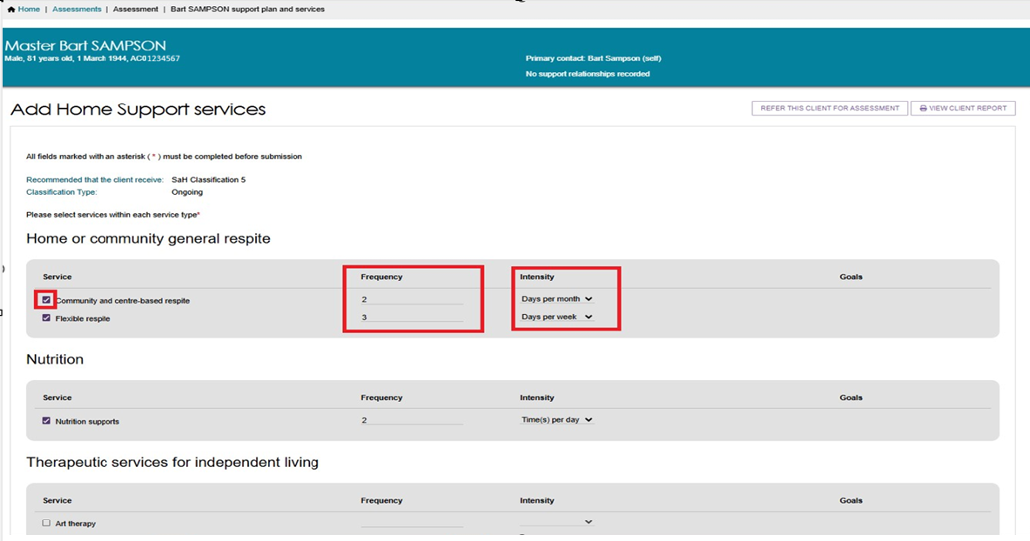
The assessor should review all recommended services to ensure that all the services that are required are either selected or deselected. Then, select the SAVE TO PLAN button.

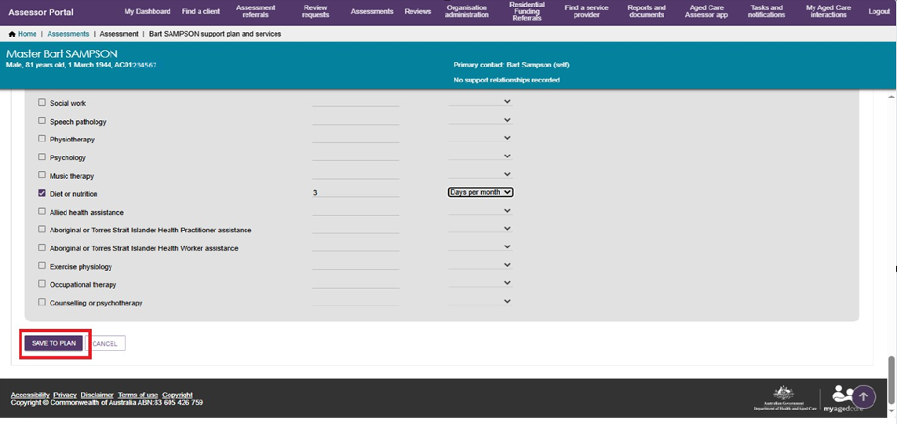
Once saved to the plan you will be redirected to the Goals & recommendations tab with a banner stating that the creation of the services to display will take up to 60 seconds to show.
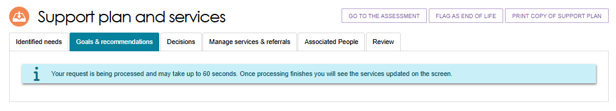
Once expanded, the assessor will be able to view the Support at Home service recommendation/s. Select the View (magnifying glass) icon to view them in detail.
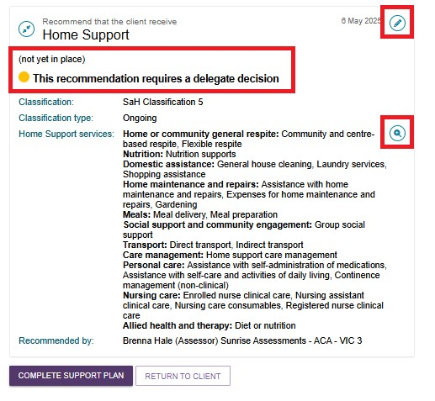
The detailed view shows the recommended service with frequency.
Show more by using the expand buttons.
To return, select the CLOSE button.
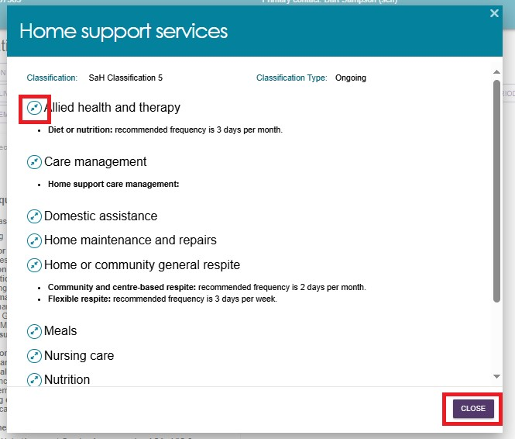
Once the assessor has completed all the required changes, select the COMPLETE SUPPORT PLAN REVIEW.

Viewing Recommended SaH services
- To view details and the statuses of a client's services recommended under their Support at Home classifications, navigate to OTHER RECOMMENDATIONS under the GOALS AND RECOMMENDATIONS tab. Select the expand icon next to the service, and then select the blue magnifier (View) icon.
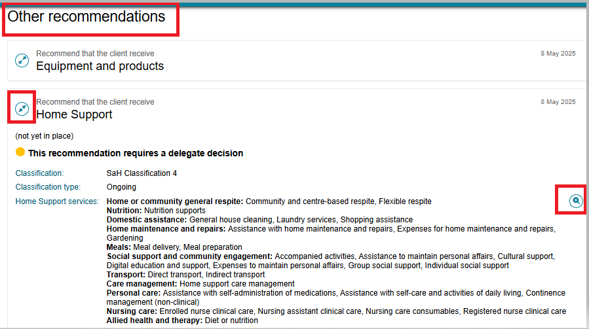
A Pop-up screen will open listing all the services recommended.
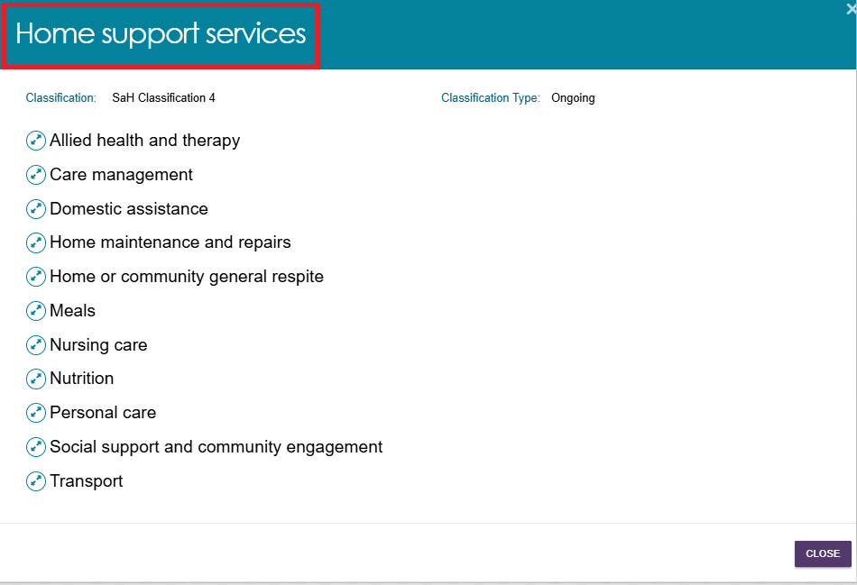
- Select the expand card icon to view the details and statuses of all the services associated.
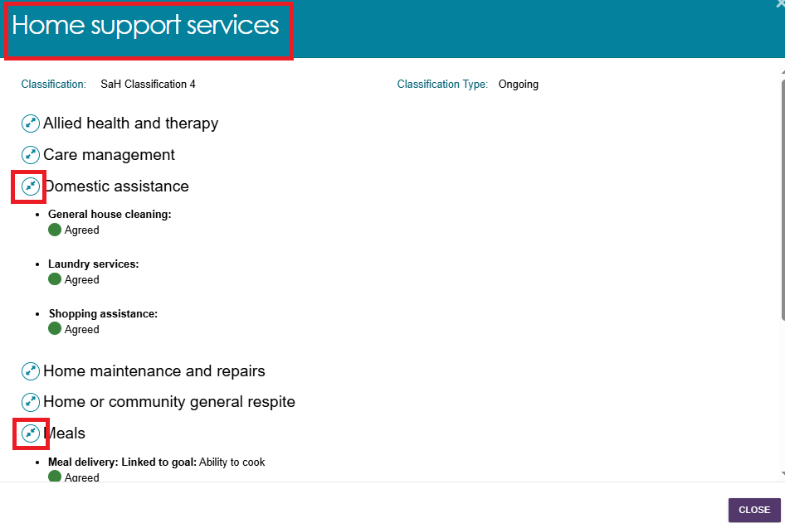

Assistive technology and Home modifications (AT-HM) Recommendations
This section outlines how to view, add and edit services offered under the Assistive technology and Home modifications (AT-HM) Services.

Adding a Home modification Recommendation
! | When considering adding/editing Home modifications care recommendations, refer to:  - Support Plan section of My Aged Care – Integrated Assessment Tool (IAT) User Guide  - Approving AT and HM under Support at Home and Approving AT and HM under CHSP sections under Chapter 8 of the My Aged Care Assessment Manual  - AT-HM Scheme Guidelines on support plan or support plan reviews for AT-HM. Assessment operation managers have access to the AT-HM tier guide document on the assessor SharePoint site. Operation managers can download and provide the template to assessors.  - Assessor workforce training.
If the client’s IAT outcome is of any Support at Home Classification, the assessor can add a Home modification recommendation during the assessment.
- Go to the client’s GOALS AND RECOMMENDATIONS tab within the Support Plan and Services screen.
If AT/HM Short-term was selected as an Other Consideration during the IAT, then there will be an information message reminding you to ‘please consider the identified needs captured in the Other Considerations section when making an AT or HM funding tier recommendation’.
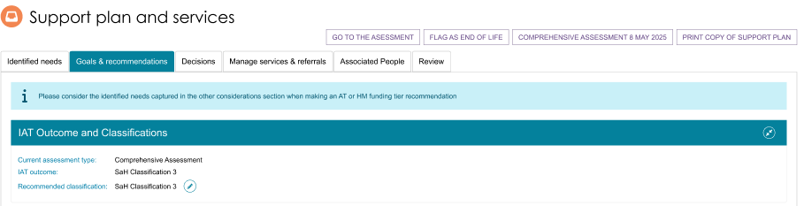

- Scroll to the OTHER RECOMMENDATIONS section. Select ADD A HOME MODIFICATION.
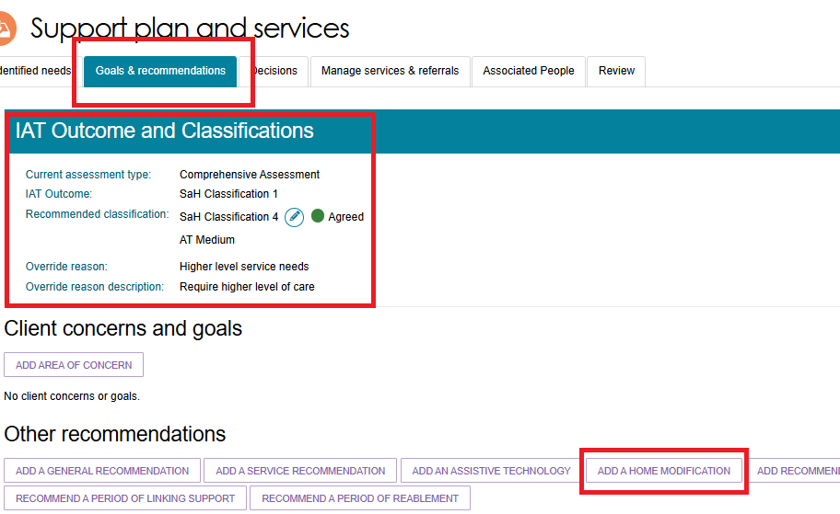
- The Add Home modifications recommendation screen will display.
Select the relevant Home modification Tier from the drop down. (available tiers are HM Low, HM Medium, HM High). The SERVICE TYPE/s will then be pre-filled. At this stage you can link goals by selecting the Edit button next to ‘Linked Goals’.
For the next question ‘The client’s preference for seeking Home modifications services through the Support at Home program is’; select Seeking services.
Then, Select SAVE TO PLAN.
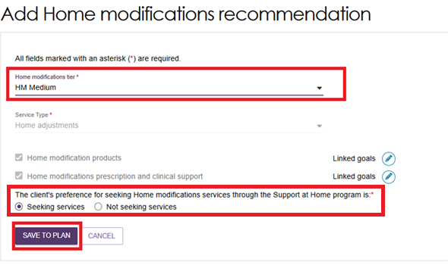
- The Home modification recommendation will then display on the client’s GOALS AND RECOMMENDATION tab under the OTHER RECOMMENDATIONS section.
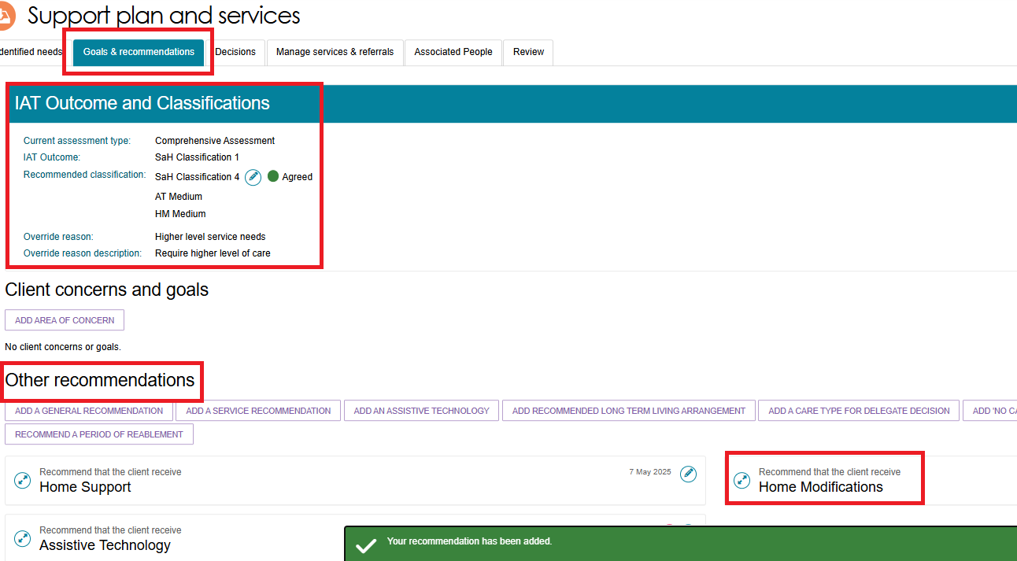

Viewing Home modification Service Recommendation
- To view the details of the Home modification Service, select the blue expand (pencil) icon next to the Home modification service under the OTHER RECOMMENDATIONS section.
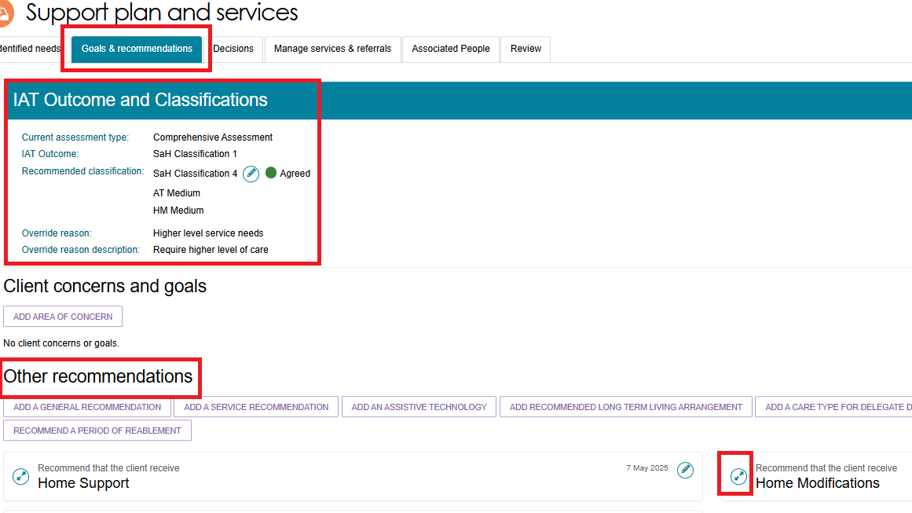
- Details about the recommended Home modification Service will be displayed.
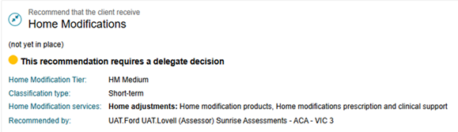

Editing Home modification Recommendation
- To edit a Home modification recommendation, select the blue pencil (edit) icon on the top right hand corner of the Home modification service.
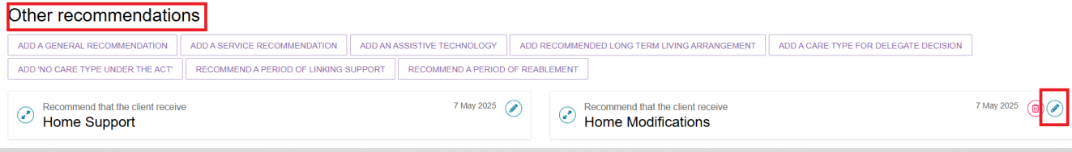
- The Editing Home modifications recommendation page displays. Apply the required changes and select SAVE TO PLAN.
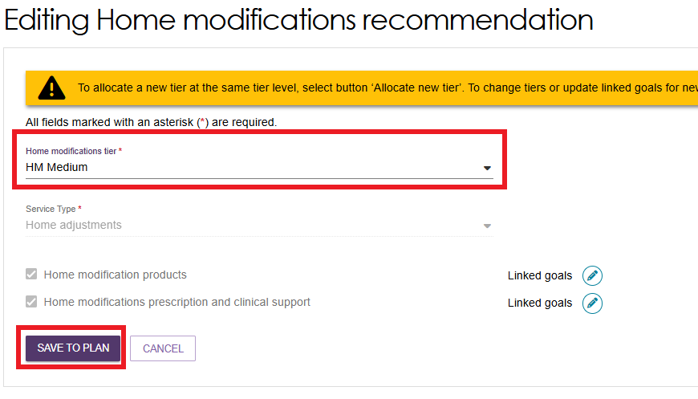

Adding an Assistive technology Recommendation
! | When considering adding/editing Assistive technology care recommendations, refer to:  - Support Plan section of My Aged Care – Integrated Assessment Tool (IAT) User Guide  - Approving AT and HM under Support at Home and Approving AT and HM under CHSP sections under Chapter 8 of the My Aged Care Assessment Manual  - AT-HM Scheme Guidelines on support plan or support plan reviews for AT-HM. Assessment operation managers have access to the AT-HM tier guide document on the assessor SharePoint site. Operation managers can download and provide the template to assessors.  - Assessor workforce training.
If the client’s IAT outcome is of any Support at Home Classification, the assessor can add an Assistive technology recommendation during the assessment.

- Go to the client’s GOALS AND RECOMMENDATIONS tab within the Support Plan and Services screen.
If AT/HM Short-term was selected as an Other Consideration during the IAT, then there will be an information message reminding you to ‘please consider the identified needs captured in the Other Considerations section when making an AT or HM funding tier recommendation’.
There may be other information messages to help you make an Assistive technology recommendation:
- Scroll to the OTHER RECOMMENDATIONS section.
Select ADD AN ASSISTIVE TECHNOLOGY.
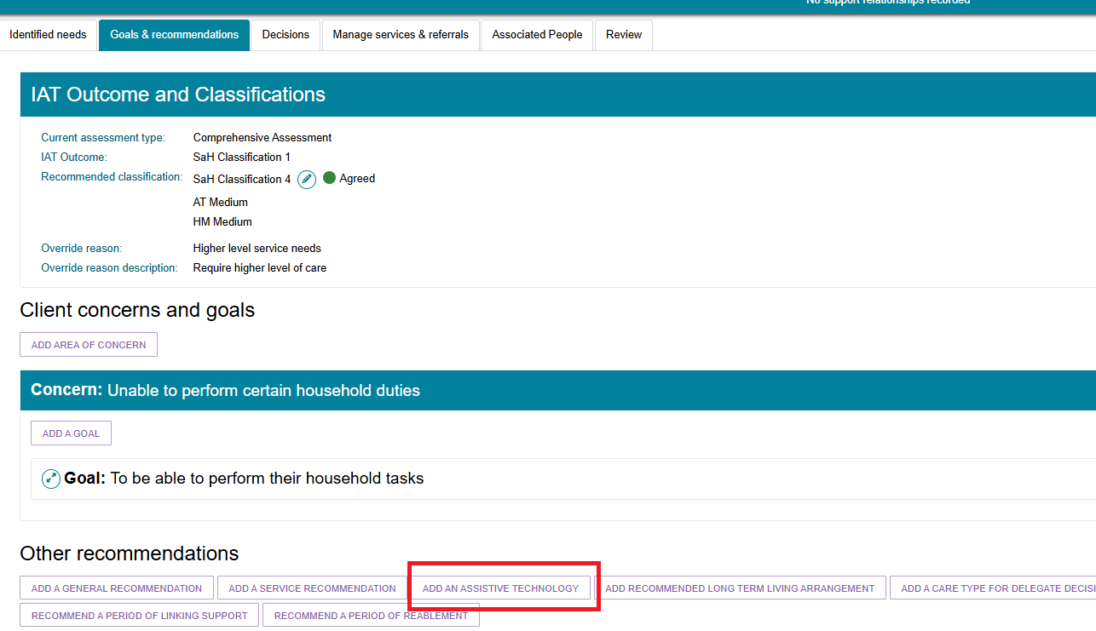
- The Add Assistive technology recommendation screen displays. Select the relevant Classification Type (ongoing or short-term) and the Specified Needs (assistance dogs) or the Assistive technology tier (AT low, AT medium or AT high) from the drop-downs.
Depending on what was chosen (and the client’s classification), some service types become automatically filled in and pre-selected.
For the next question ‘The client’s preference for seeking Home modifications services through the Support at Home program is’; select Seeking services.
Select SAVE TO PLAN.
! | Services don't display the Linked goals if the service recommendations are from a previous assessment.
Add AT recommendation - Ongoing Assistance Dogs
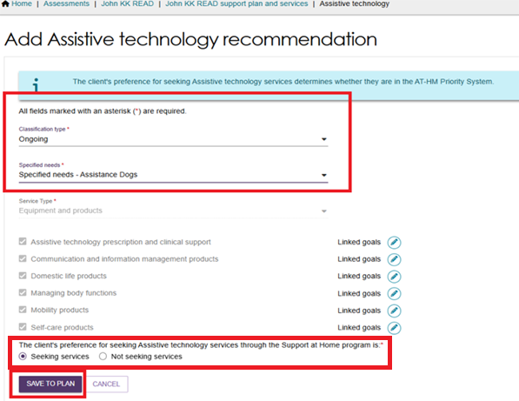
Add AT recommendation - Short Term, Medium Tier
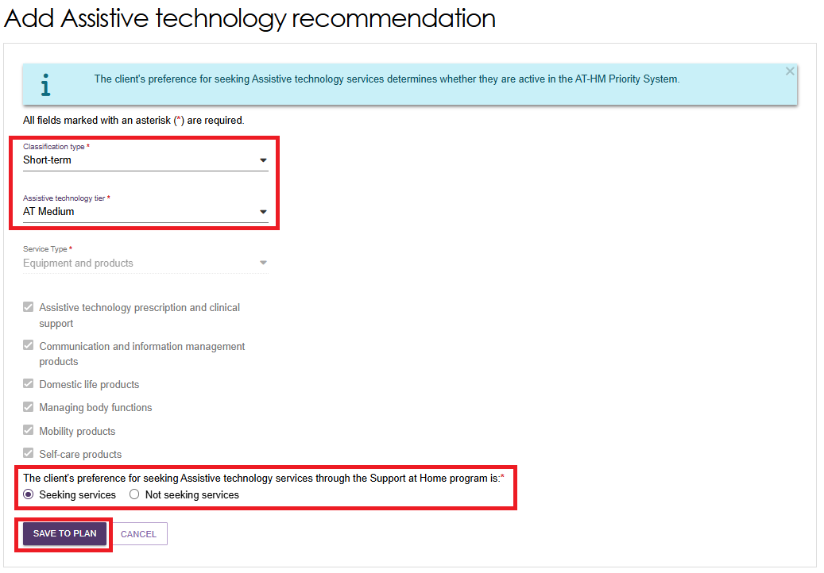

Viewing Assistive technology Service recommendation
- Once the Assistive technology recommendation is added, the changes will be displayed on the Client’s GOALS AND RECOMMENDATIONS tab under the OTHER RECOMMENDATIONS section.
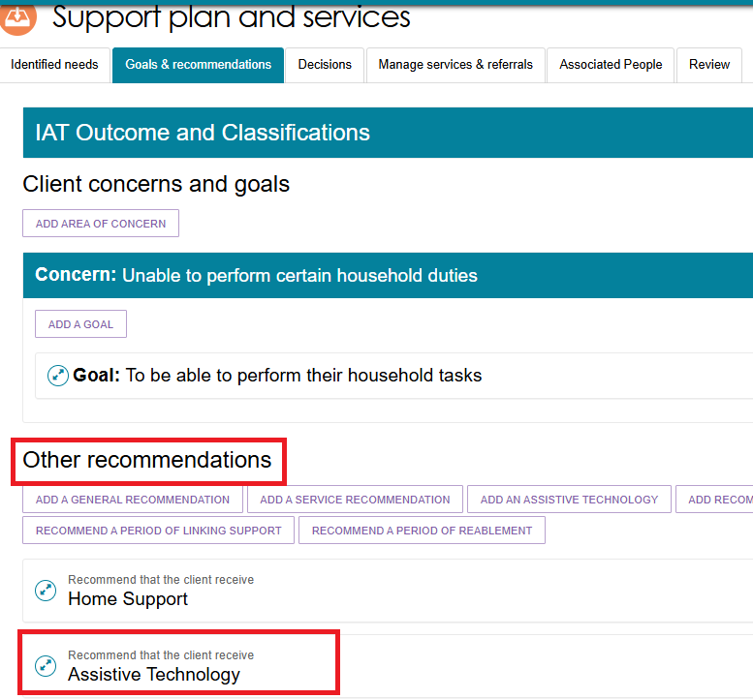
- To view the Assistive technology Services recommended, select the blue Expand icon next to ASSISTIVE TECHNOLOGY.
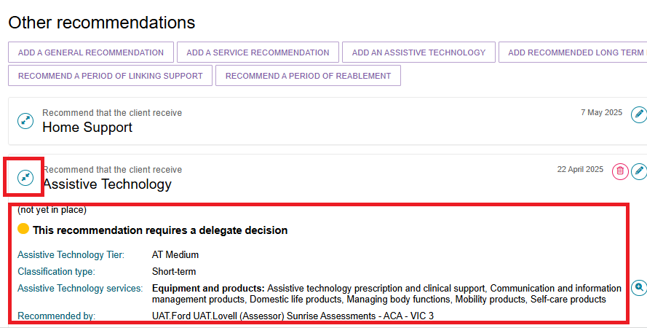

Editing Assistive technology Recommendation
- To edit an Assistive technology recommendation, select the blue Edit (pencil) icon on the top right hand corner of the Assistive technology service.
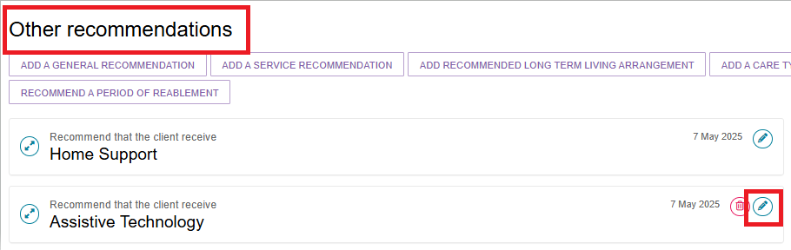
- The Editing Assistive technology recommendation page appears. Apply the required changes and select SAVE TO PLAN.
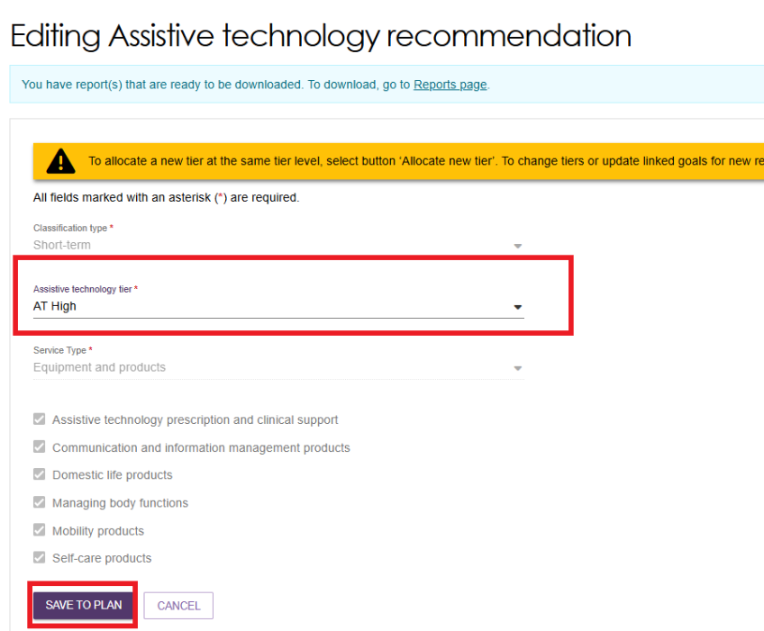

Adding Client Concerns and Goals
- From the support plan and services page select the Goals & recommendations tab.
Under the Client concerns and goals section, select ADD AREA OF CONCERN.

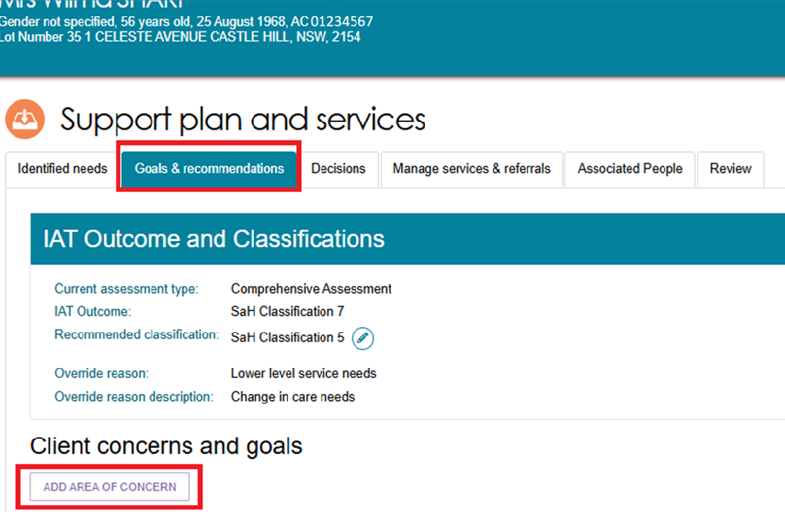
- In the pop-up box, record the area of concern, and select SAVE TO PLAN.
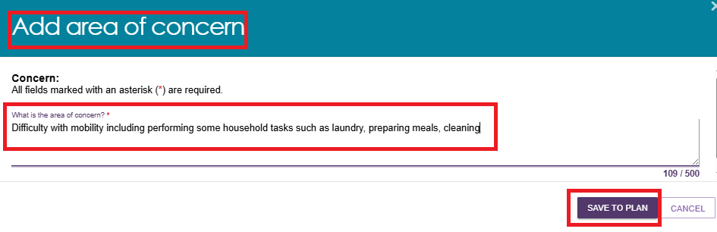
- The area of concern will appear under the Client concerns and goals section.
Select the Bin icon to delete. Select the Pencil icon to edit.
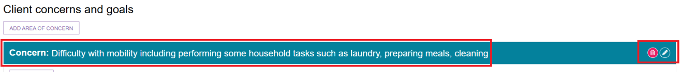
- To add a goal to the concern, select ADD A GOAL.
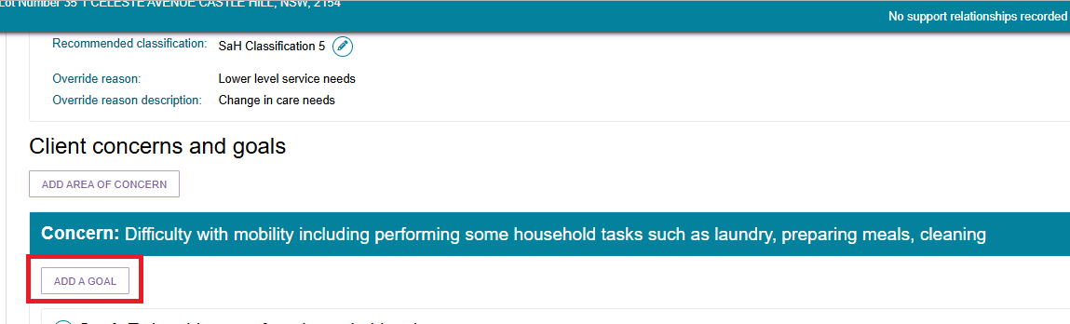

In the pop-up box, enter the goal, record the client’s motivation to achieve the goal (with 1 being least motivated to 10 being highly motivated), the status of the goal, and select SAVE TO PLAN.
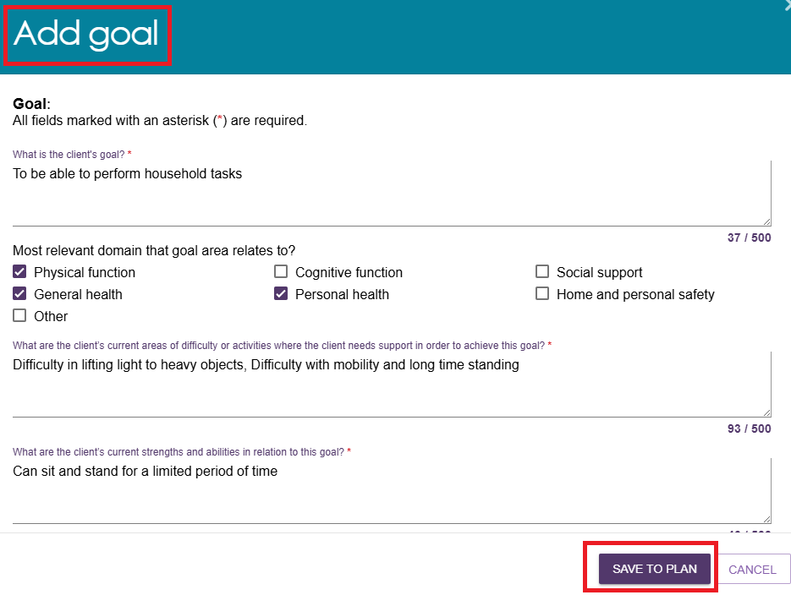
This information will appear under the associated area of concern under CLIENT CONCERNS AND GOALS.
You can edit or remove goals that may no longer be relevant to the client’s situation here, by selecting the Pencil icon or Rubbish bin icon respectively.
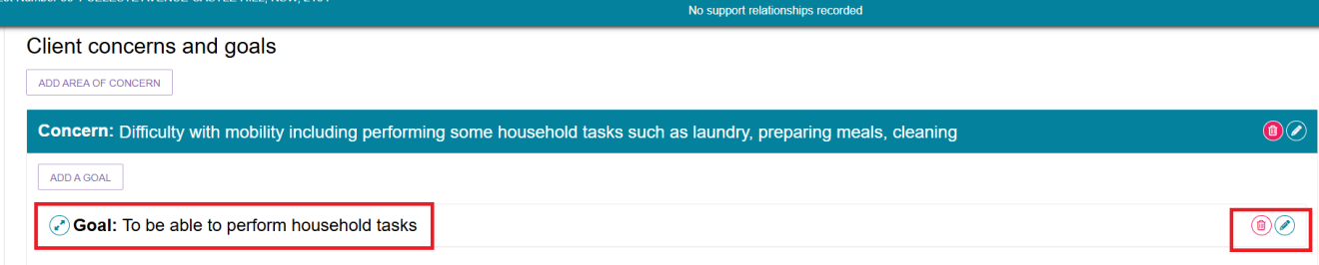
- Continue to add more concerns and goals by repeating the above step.
! | Changing the display order of multiple concerns or goals  When multiple concerns or goals have been added, you are able to change the display order by using the drop-down box at the right-hand side of the record.  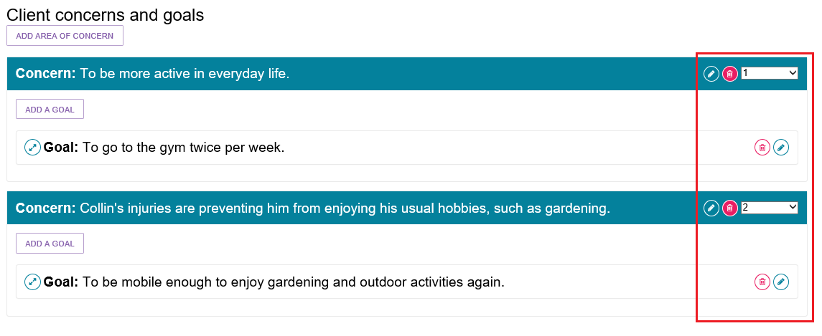
- In the Goals section, you can add service recommendations that may be relevant to assisting the client in achieving their goals.
Select the blue expand card icon next to the goal where the service needs to be added and select the relevant button.
Refer to Adding Recommendations for more information.
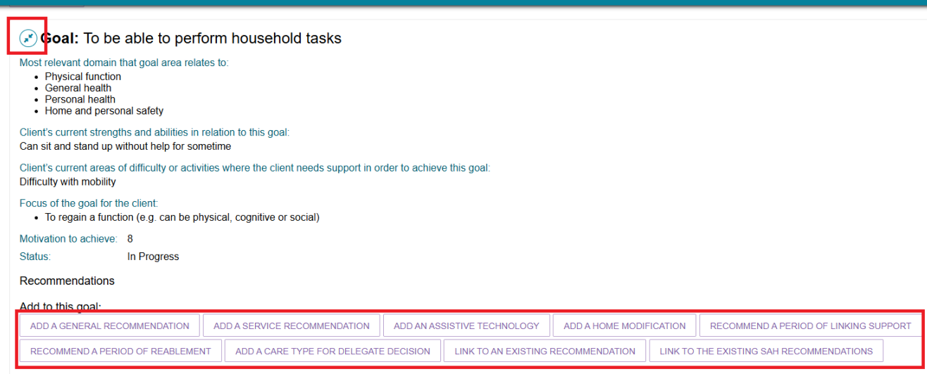

Linking Goals to Existing Support at Home Recommendations
For clients with recommended Support at Home Classifications, the assessor can link their goals defined in the support plan to the existing Support at Home service recommendations.
- From the client’s Support plan and services screen, go to the Goals & Recommendations tab. Then go to the Client concerns and goals section.
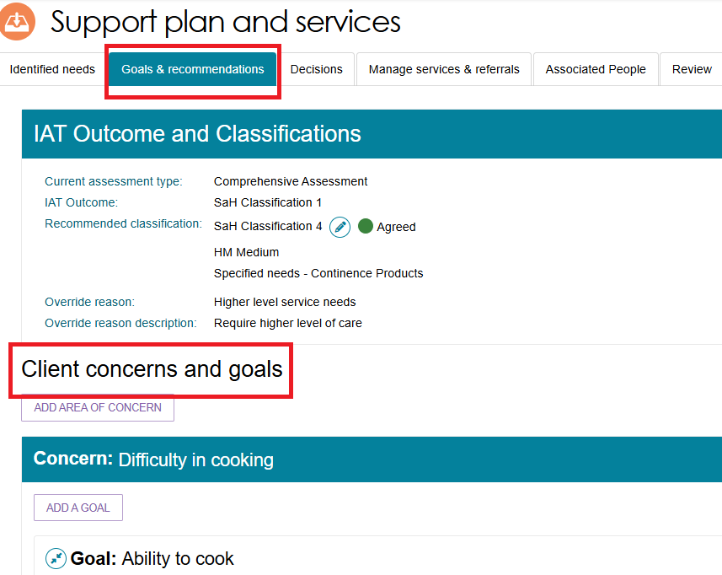
- View the client GOAL by selecting the blue expand card icon.
Then, select the LINK TO THE EXISTING SAH RECOMMENDATIONS button.
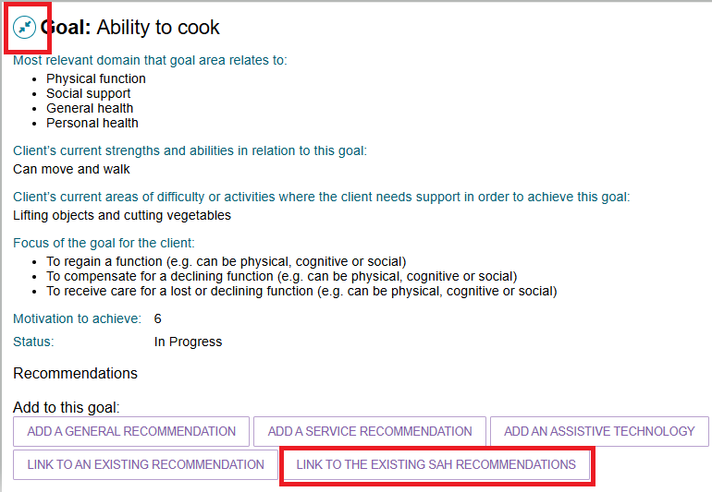
- The Link to the existing SaH recommendations screen displays.
Select a recommendation (classification) from the drop down.
Use the expand icon to expand the service type/s to be linked to this goal.
Then, tick the tickboxes next to the desired service/s.
Finally, select the SAVE TO PLAN button
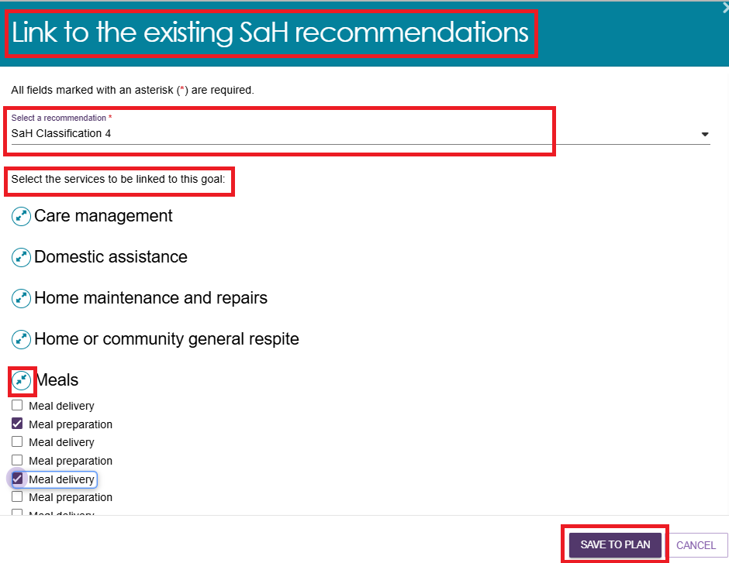

- The linked Support at Home recommendation will be displayed within the relevant client GOAL section.
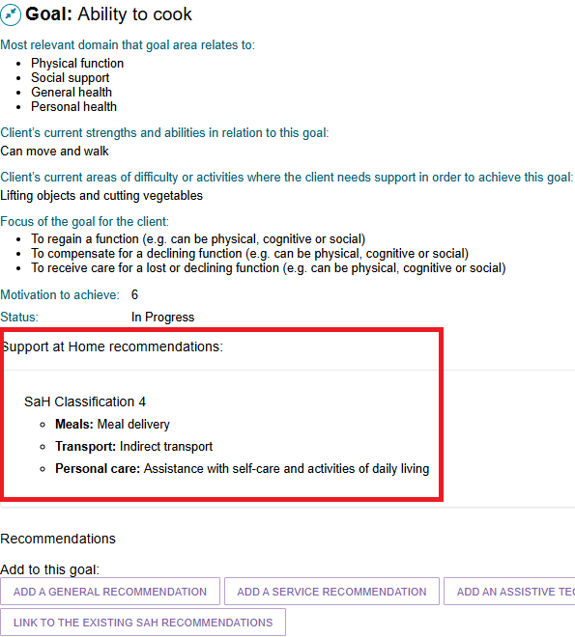

Recording Service Frequency and Intensity
Assessors can record the recommended service frequency and intensity for each service they recommend. This is not mandatory.
An assessor can record information that has been discussed with the client or information relating to a client’s preference for the intensity of service delivery. This will be provided as a guide to the service provider who will agree the frequency and intensity of services with the client.
Where a client does not wish to access a particular service at that point in time, or only requires infrequent services, you should still create the service recommendation.
The client will be able to access these services at a later date by calling the My Aged Care contact centre to facilitate the sending of electronic referrals from recommendations created in their support plan.
Entering specific information about the services required allows the provider and the contact centre to know whether a service is for a specific purpose only or for an ongoing need.
The information allows the contact centre to decide regarding whether they can make the referral or need to request a Support Plan Review from the assessment organisation.
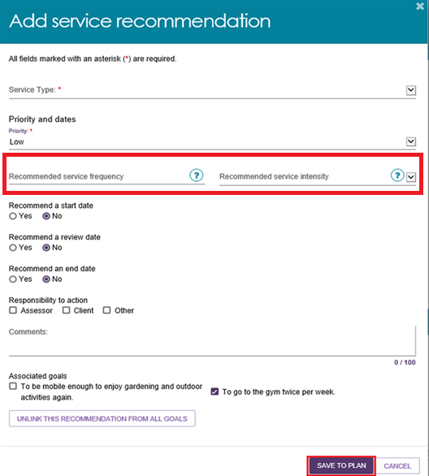

Support at Home - Restorative Care Pathway

Overriding to Restorative Care Pathway
Once a client receives an IAT outcome, the assessor can override it to Restorative Care Pathway.
  - Go to the client’s support plan section and then the Goals & Recommendations tab.
Select OVERRIDE.
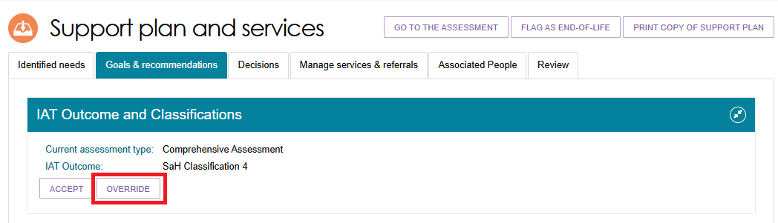

  - The Override IAT Outcome pop up appears. Select ‘Override IAT Outcome To’ as ‘SaH Restorative Care Pathway’. Select an override reason and enter a description of the reason. Finally, Select SAVE TO PLAN.
You may receive the below warning message prompting you to add recommended services again.
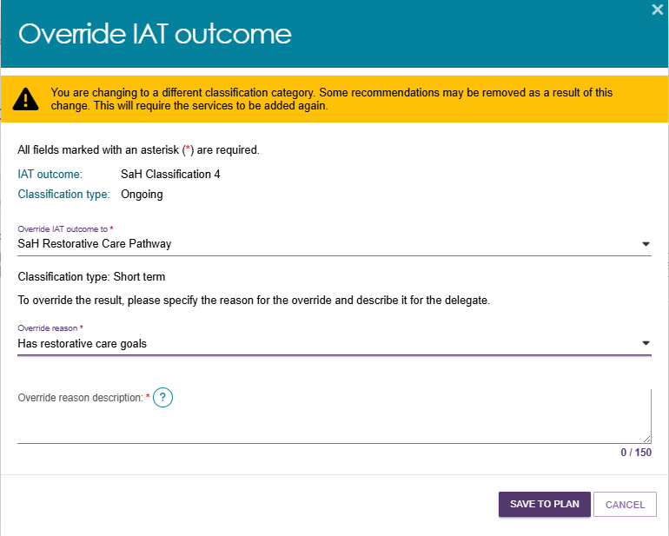
  - If the original IAT outcome was a Support at Home classification, you will be asked to review the list of Home Support services. Then, select SAVE TO PLAN.
An information banner may display: ‘Your request is being processed and may take up to 60 seconds. Once processing finishes you will see the services updated on the screen.’
  - The Goals & Recommendations page displays again. Go back to the IAT Outcome and Classification heading to view the overridden outcome.
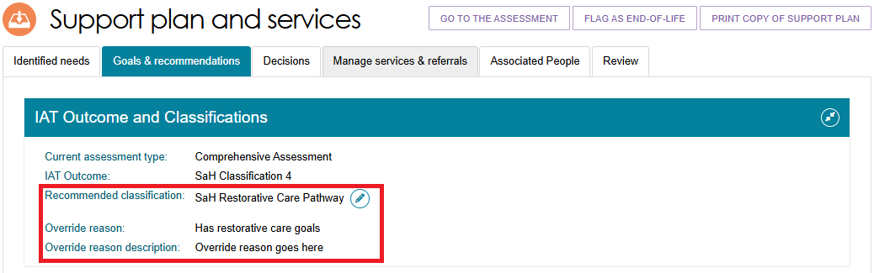
In case of the Support at Home classification, its classification now displays as ‘SaH Restorative Care Pathway’.
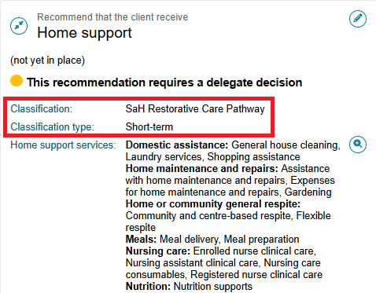
Once the classification or recommendation is accepted, a ‘Add Home Support services’ screen will open to input all the services within each service type available for the classification, their frequency and intensity.
This page will display the ‘Home support restorative care management’ service chosen as default (greyed out).
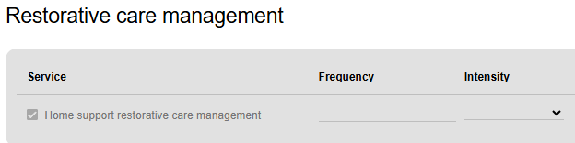

Editing IAT Outcome to Restorative Care Pathway
To edit an existing IAT Outcome to the Restorative Care Pathway:
- Go to the client’s support plan via the client record, Current Assessments or Recent Assessments tab.
- In the client’s Goals & Recommendations tab, select ‘Edit Classification’.
- The ‘Edit recommended classification’ pop up appears.
- In the ‘Override IAT outcome to’ drop down, select ‘SaH Restorative Care Pathway’. An information banner appears reminding you that adding the RCP will automatically include the AT Medium and the HM Medium classifications as well, and that you can edit or remove these recommendations if required.
- In the ‘Override reason’ drop down, select from the following:
- Has restorative care goals
- Delay/Prevent ongoing services
- Needs early intervention care
- Other.
- You must enter an explanation for the edit in the ‘Override reason description’ text box. Finally, select ‘Save to Plan’.
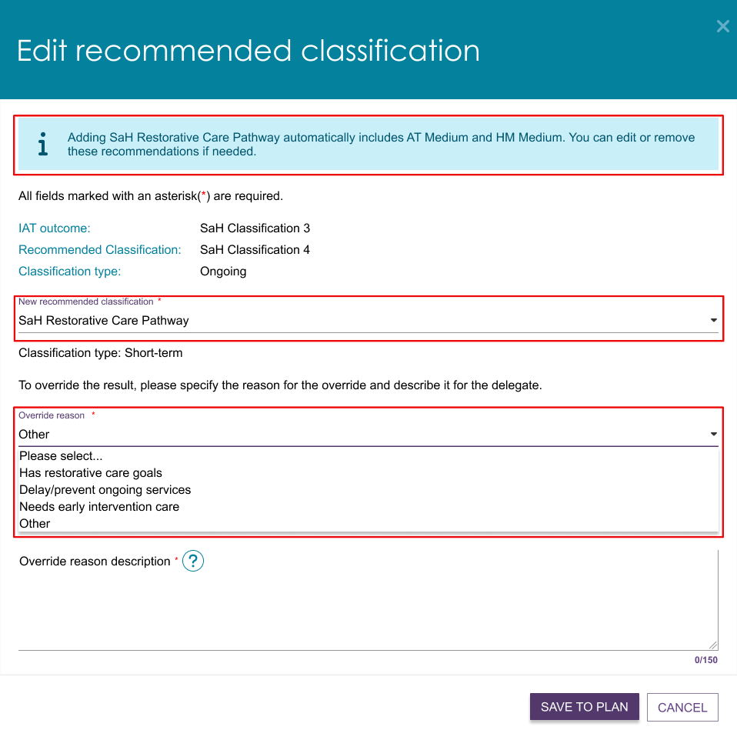

Recommending Second Unit of Restorative Care Pathway
If the client has an approved and active Support at Home (SaH) Restorative Care Pathway on the Support Plan, a second unit of Restorative Care Pathway can be requested for a client within sixteen weeks since the commencement of the Restorative Care Pathway (first unit).
Upon delegate approval of the second unit, a new Restorative Care Pathway approval will be created with an approval start date set to the date on which the delegate approved, and the approval end date is set to the same approval end date of the first unit.
! | Before recommending or approving a second unit of RCP, confirm that the client has commenced services under their first unit of RCP.  Do not approve a second unit of RCP if the client has not commenced their first RCP unit.
Once the second unit is added, the assessor can revert their decision and remove it.
- Go to the Support Plan and Services section, then to the Goals & Recommendations tab. The Existing classification under the IAT Outcome and Classifications heading should be ‘SaH Restorative Care Pathway’.
Then, select ADD SECOND UNIT OF RESTORATIVE CARE PATHWAY.
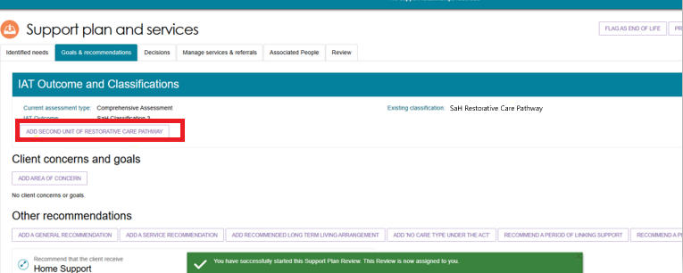
- Once the ADD SECOND UNIT OF RESTORATIVE CARE PATHWAY button is selected, a new window will open with ADD SECOND UNIT button to confirm the selection. Selecting the button will then facilitate prompts to generate the RCP – Approval of 2nd unit of funding.
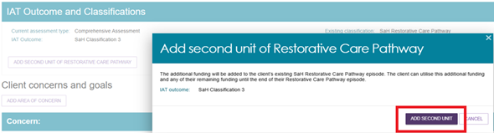
- The assessor has the option to revert their decision to recommend a second unit of restorative care pathway if the circumstances change by selecting the REMOVE SECOND UNIT OF RESTORATIVE CARE button.
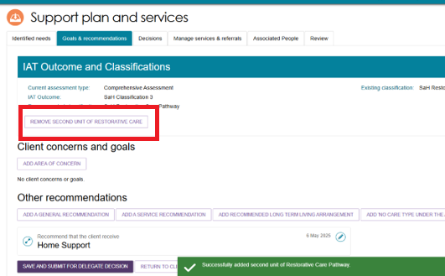

- Select Remove at the confirmation pop up.
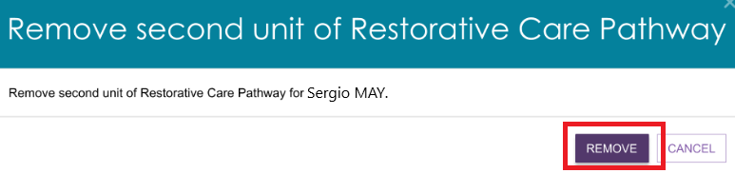

End-of-Life Pathway
This section discusses how to edit and override IAT results to include the End-of-Life (EoL) pathway. For clients starting a new Support Plan Review for services following an EoL episode, please refer to the corresponding section of Support Plan Reviews.
! | Any prospective End of Life pathway clients must be flagged as End-of-life and have their EoL form validated as per current process described in the Assessment Manual.  This can be done during the client’s assessment, in the client record, or in the support plan during Support Plan Review.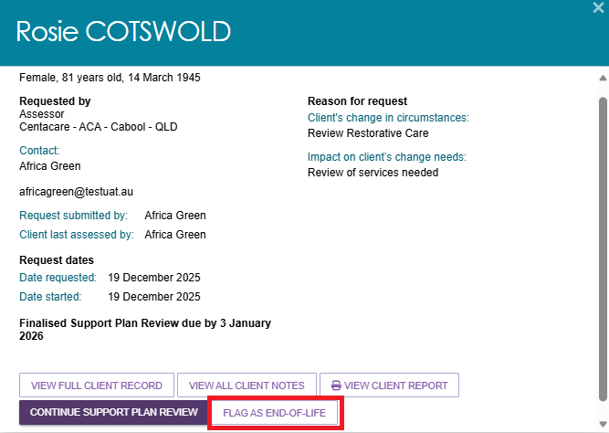

Validating the End-of-Life Form
Assessment delegates are responsible for verifying the completion of the End-of-Life Pathway form in the older person’s record when the End-of-Life Pathway has been flagged in the My Aged Care assessor portal. Reviewing the form will involve:
- Checking the individual’s details to ensure they match the record in the portal.
- Verifying the completion of all areas of the Medical Assessment section to confirm:
- The individual has a prognosis of a life expectancy of three months or less, and
- An Australian-modified Karnofsky Performance Status (AKPS) score of 40 or less.
- The medical practitioner or nurse practitioner has completed and signed the form.
An individual will not be eligible for approval for the End-of-Life Pathway if the required criteria outlined in the medical assessment section are not met.

Overriding to End-of-Life Pathway
To override an existing IAT Outcome to the End-of-life Pathway, the client needs to be flagged as EoL first.
- Go to the client’s support plan. This can be done by searching for the client, or going to the Plans tab of their client record and then selecting SUPPORT PLAN.
- Go to the Goals & Recommendations tab of the support plan, and then select the OVERRIDE TO END-OF-LIFE button. or the Edit Classification button.
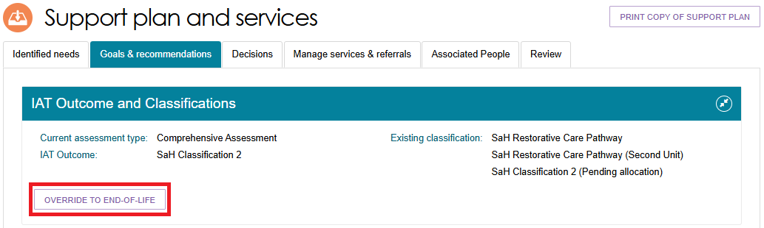
- The Override IAT Outcome pop up appears. An information banner appears to let you know that ending the EoL Pathway will automatically add the AT Medium classification into the client’s support plan.
You can edit or remove this recommendation if required. However, any Home modifications changes will be removed when overriding to EoL.
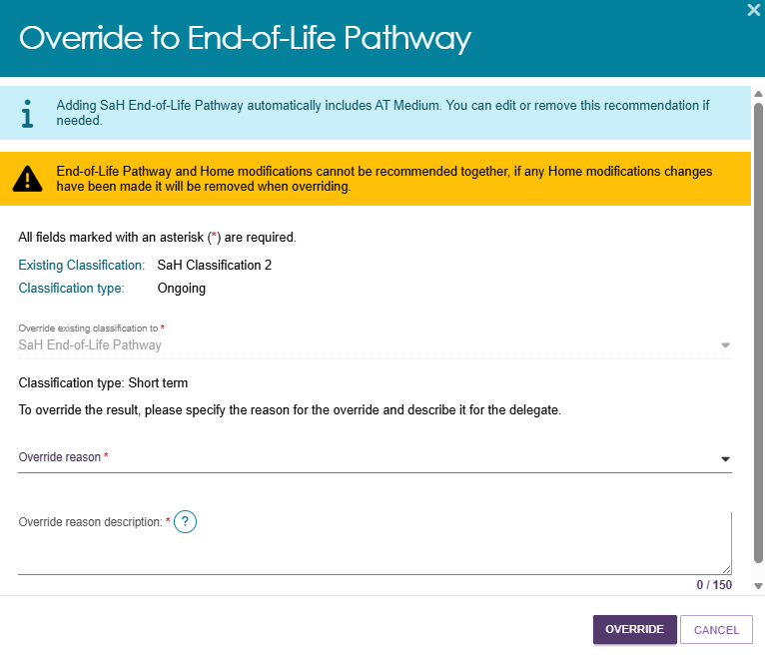
- Select the Override reason from the drop down, and enter a description underneath the drop down. Then, select OVERRIDE.
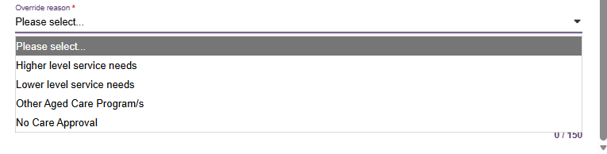
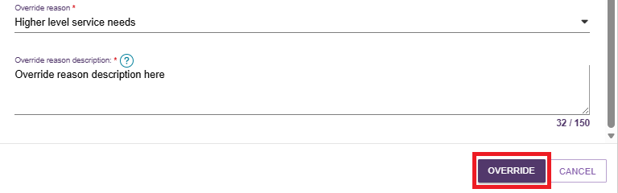

- If the override is accepted, the client’s IAT Outcome and Classifications section will show “SaH End-of-Life Pathway”, the override reason and the override reason description.
If applicable, REVERT buttons to the client’s previous classification/s may appear.
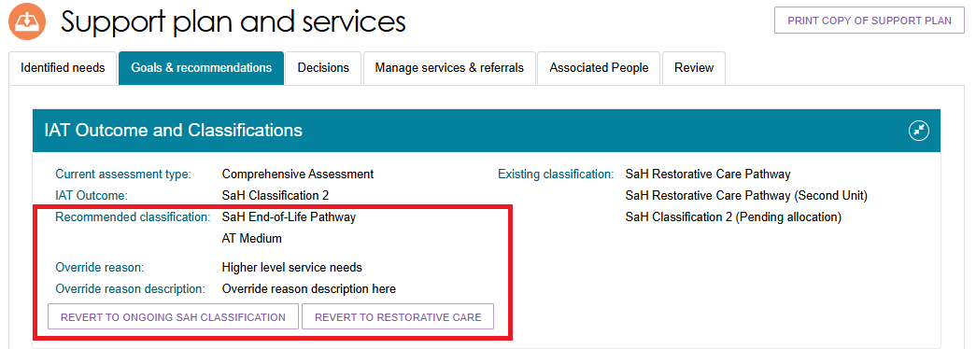
- If necessary, you will need to add or edit Home support services to match the EoL Pathway. Select the Edit (pencil) icon in the Home support section of Other Recommendations.
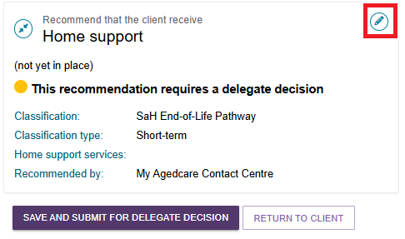

Flagging End-Of-Life to an existing SaH Restorative Care Pathway
If the review is flagged as End of Life, the assessor can set the classification to SaH End-of-Life Pathway when:
- existing classification is SaH Restorative Care Pathway
- the End-of Life Pathway form has been verified
- before submitting the Support Plan Review for delegate decision.
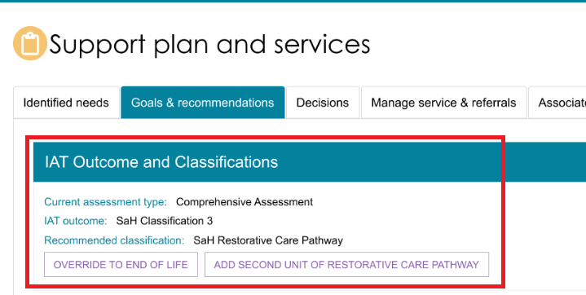

- At the client’s Goals and Recommendations tab, go to the IAT Outcome and Classifications section, and select the OVERRIDE TO END OF LIFE button.
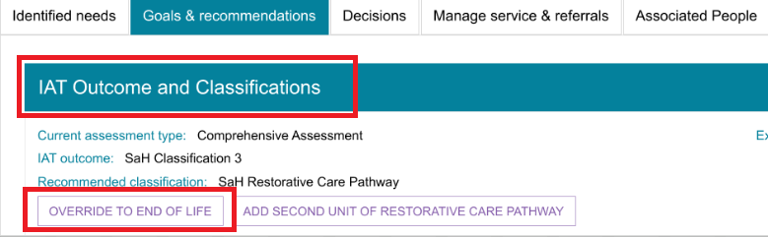
- Check for the information in the recommendations section and select COMPLETE AND FINALISE SUPPORT PLAN REVIEW button.
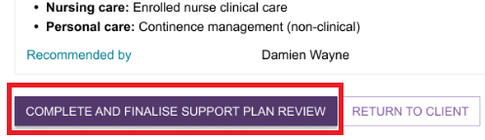
- The IAT Outcome and Classifications section will now display the recommendation classification as SaH End-Of-Life Pathway.
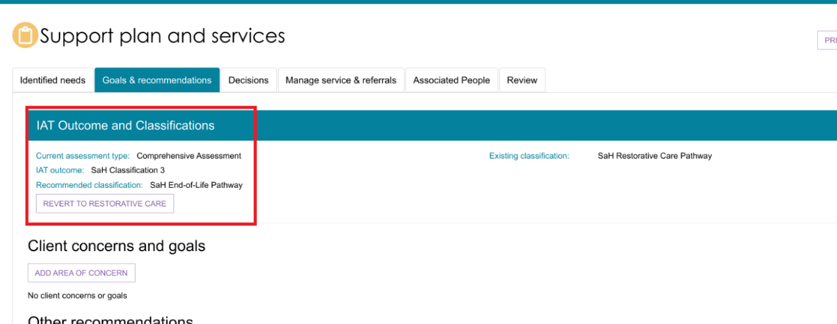
- Then, select Save and Submit for Delegate Decision.
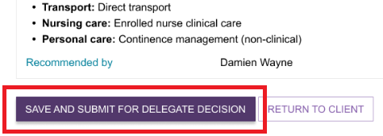
! | If there is a change of mind from the client or their supporter guardian that they do not want their assessment to be flagged as END OF LIFE, the assessor will have the ability to Revert to the ongoing classification.
- Enter the outcome of the Support Plan Review from the drop-down menu selection alongside who the plan was conducted with.
Select COMPLETE AND FINALISE SUPPORT PLAN REVIEW to finalise the Support Plan Review. The outcome details entered above cannot be edited once the Support Plan Review is complete and will appear on the client’s support plan.
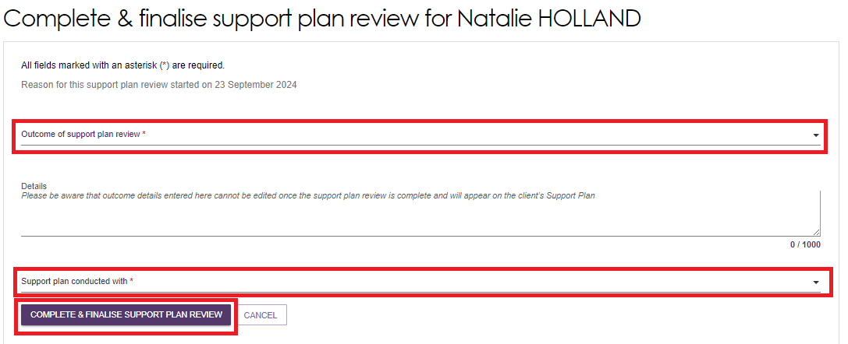
! | If a period of reablement or linking support is added to the client’s support plan during a Support Plan Review, the outcome of the review will be automatically set to Updates to the existing plan. Once the review is complete, the client’s assessment will be open for the assessor to start the support period.
! | If the outcome of the Support Plan Review is that a new assessment is required, please refer to Issuing an assessment referral as a result of a Support Plan Review.
- The Support Plan Review will be visible under the PLANS tab in the client record.
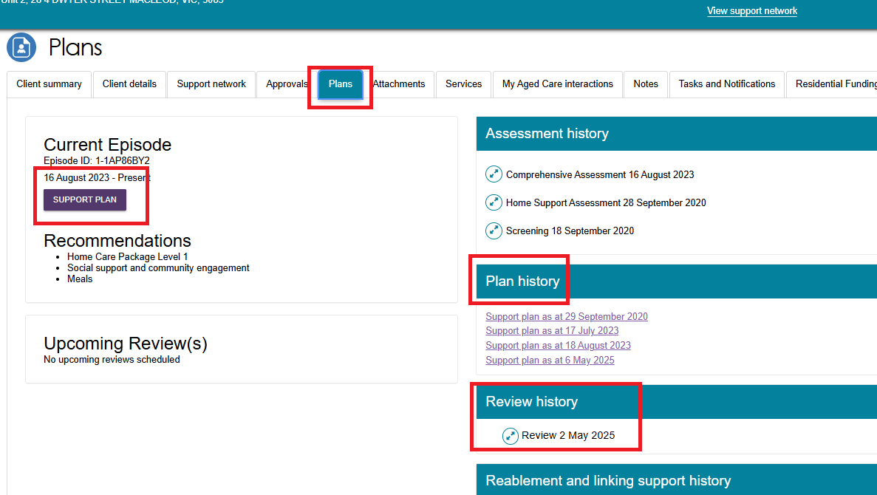

Revert End-of-Life Flag
If there is a change of mind from the client or their supporter guardian that they do not want their assessment to be flagged as END OF LIFE, the assessor will have the ability to Revert to the ongoing classification.
- Go to the client’s profile and go to the Goals and Recommendations tab.
- The IAT Outcome and Classifications page displays. It says that the recommended classification is SaH End-Of-Life Pathway. Select the button underneath to revert to the previous recommendation. The below example shows Revert to Restorative Care.
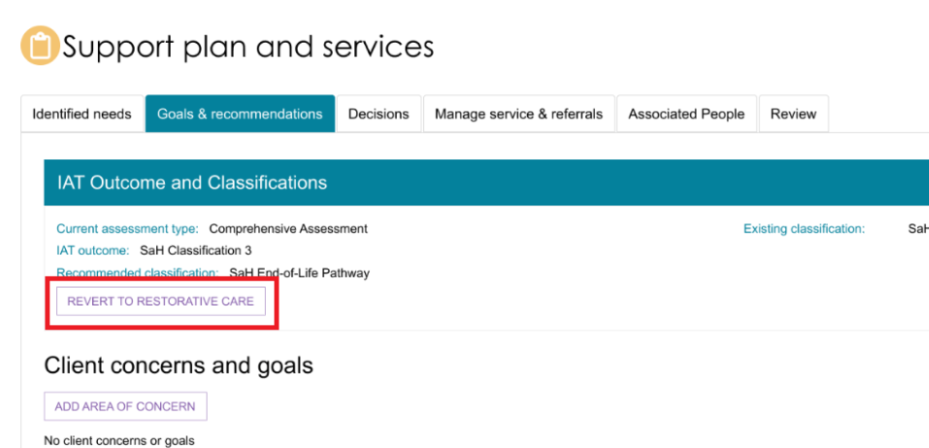
- Select Revert at the confirmation pop up.
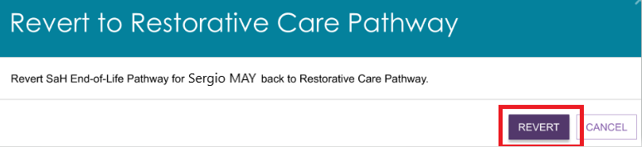
- Once confirmed, the assessor will be taken back to the reverted screen, which is the client’s GOALS AND RECOMMENDATIONS tab as shown below.
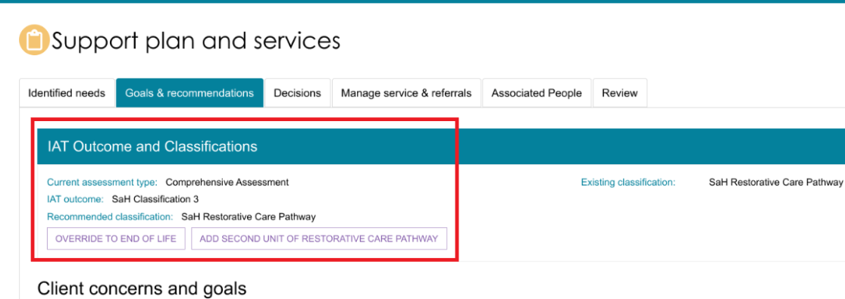

Overriding to End-of-Life for Transitioned Home Care Package (HCP) clients
Assessors can override a client's classification from Transitioned HCP Level 1–4 to SaH End-of-Life Pathway during a Support Plan Review, once the End-of-Life Pathway form has been verified. This is necessary because Transitioned clients do not have pre-created services, and tailored Home Support services must be added to meet their end-of-life care needs.
- Select the Goals & recommendation tab from the client’s profile. The Existing classification will display at the IAT Outcome and Classifications section as Transitioned HCP Level 1–4.
Select the OVERRIDE TO END OF LIFE button.
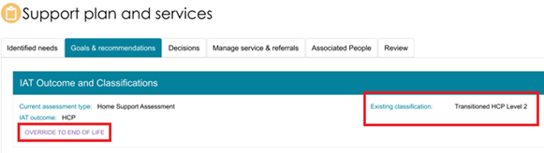
- A pop-up screen OVERRIDE TO END-OF-LIFE PATHWAY will appear prompting to enter relevant information. Upon entering the information select OVERRIDE.
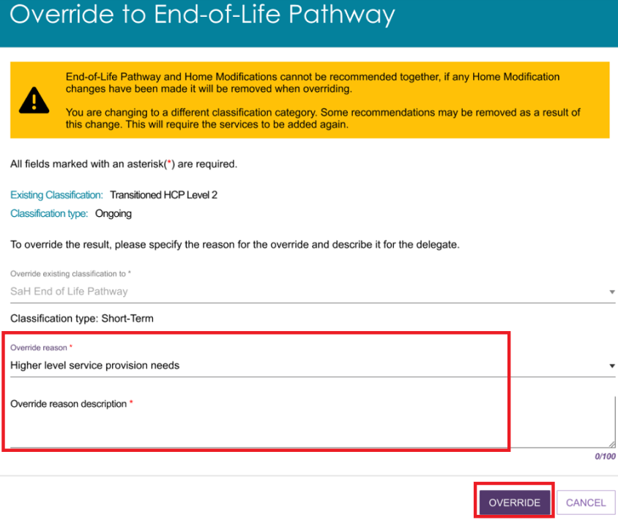

- You will be taken to the ADD HOME SUPPORT SERVICES page prompting to add the services as required.
Assessors should consider the needs of the client noting the classification approval is for the End-of-Life Pathway.
Tick the desired service/s, add a Frequency and Intensity, and link any goals.
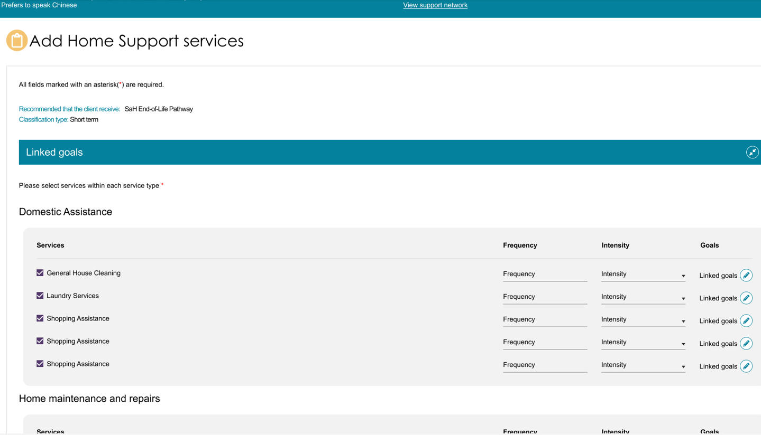
- Select SAVE TO PLAN.
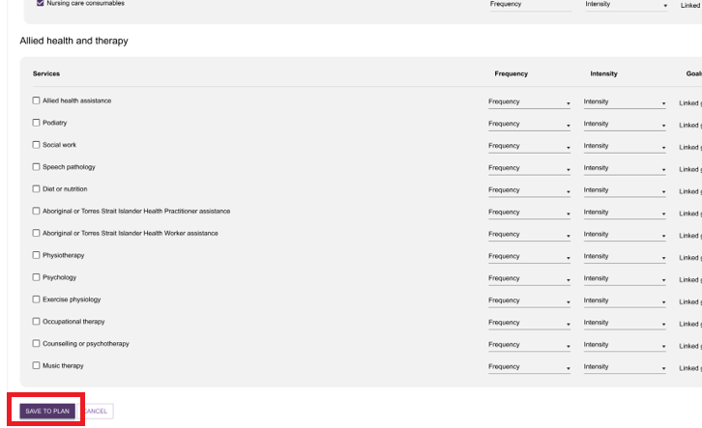

- You will be taken to the GOALS & RECOMMENDATIONS page. At this stage you can REVERT to the transitioned classification if required.
Select SAVE AND SUBMIT FOR DELEGATE DECISION.
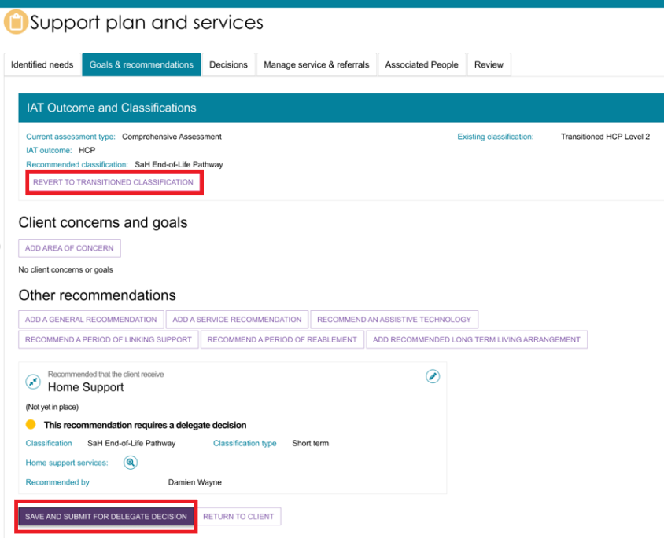
! | If a client's existing classification is SaH End-of-Life Pathway, the Assessor can override back to Transitioned HCP Level 1-4 prior to submitting the Support Plan for delegate decision.  After overriding, the assessor can also revert to SaH End-of-Life Pathway if required.  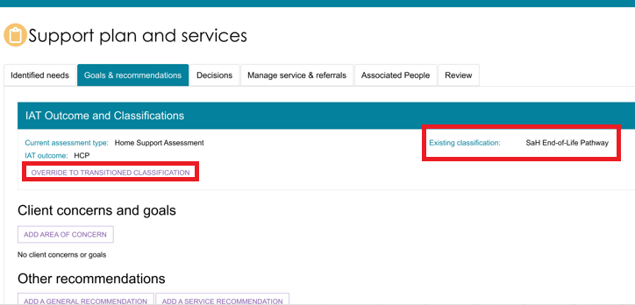

Reverting to End-of-Life for Transitioned Home Care Package (HCP) clients
Assessors will have the option to revert the Transitioned HCP classification back to End of Life, after overriding the End of Life to the Transitioned classification.
- Go to the client’s GOALS & RECOMMENDATIONS screen. The existing classification is SaH End-of-Life Pathway.
Select REVERT TO END OF LIFE.
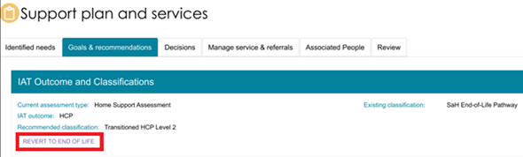
- A pop-up screen will appear prompting the user to confirm the action. Select REVERT.
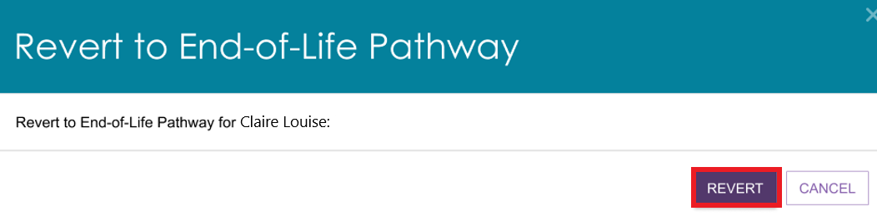
- You will be directed to the GOALS & RECOMMENDATIONS screen.

Completing the Support Plan
Follow these steps to complete the support plan:
- Confirm that you have made all service or general recommendations, and are satisfied with the client’s goals and concerns, as the support plan cannot be edited after it has been completed, except when the delegate returns the assessment to you.
- Select COMPLETE SUPPORT PLAN from any tab in the client’s support plan.
- If the client has a Support at Home classification (ongoing or short-term) but no home address or MMM (Modified Monash Model) classification, a pop-up screen will appear while performing this step prompting or reminding the assessor to record the client’s home address. The assessor can continue to complete the support plan without recording the address at this stage. Select CONTINUE TO COMPLETE SUPPORT PLAN.
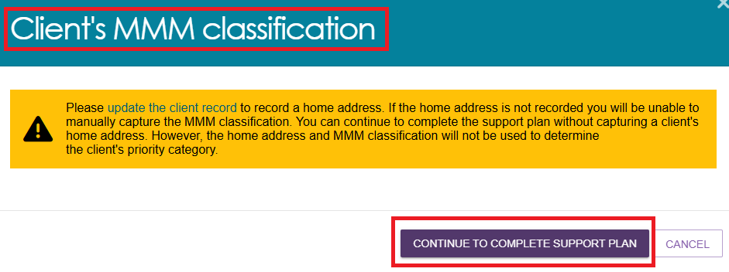
! | The following banner will be displayed if you continue to complete support plan without recording the client’s address:  “A home address is required in order to complete the assessment.”  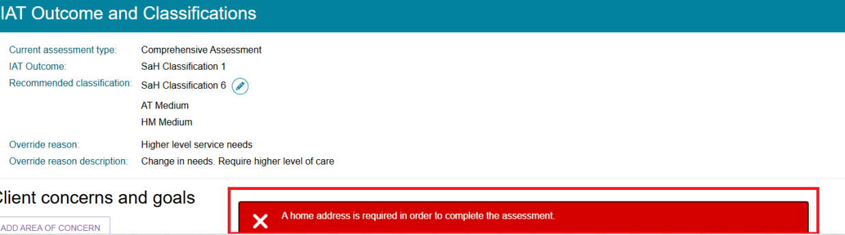
- If the client’s address is recorded but their location does not belong to any of Australia’s MMM classifications (MMM1 - MMM7), the system will prompt you to update client’s MMM classification prior to completing the support plan.
If the MMM Classification in not known, Select UNKNOWN from the dropdown menu.
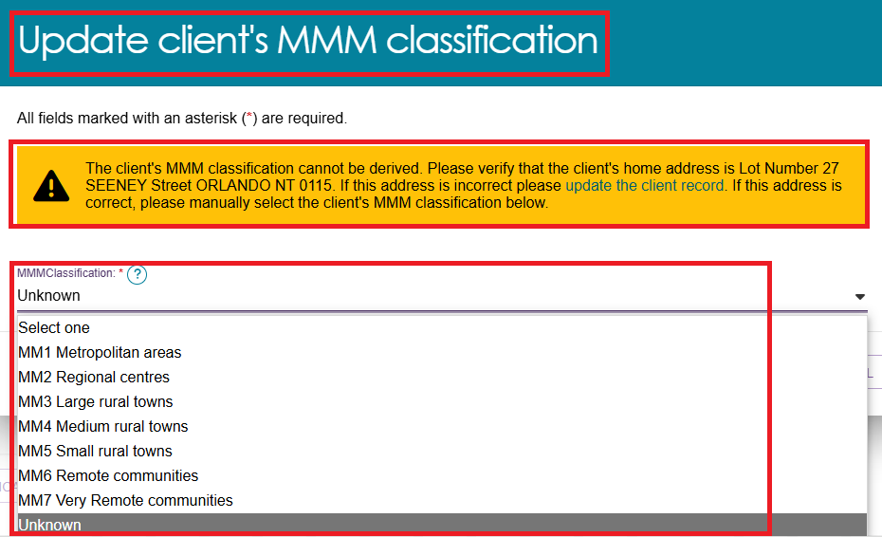
- Select SAVE TO PLAN to proceed.
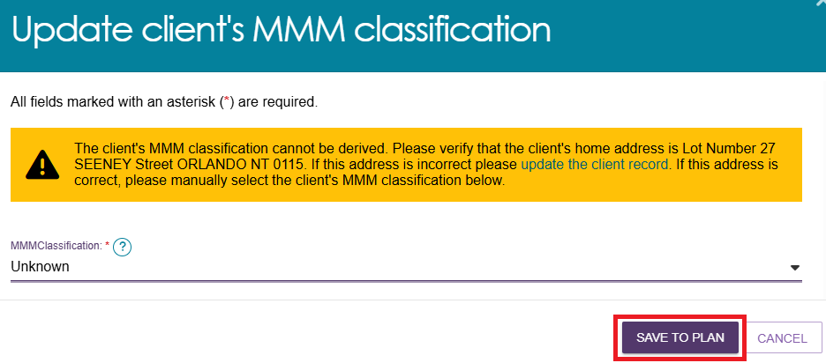
- You will be taken to the Decisions tab to submit for Delegate decision. Go to the bottom of the page and select SAVE AND SUBMIT FOR DELEGATE DECISION.

- From the pop-up tick the appropriate box and select SUBMIT.
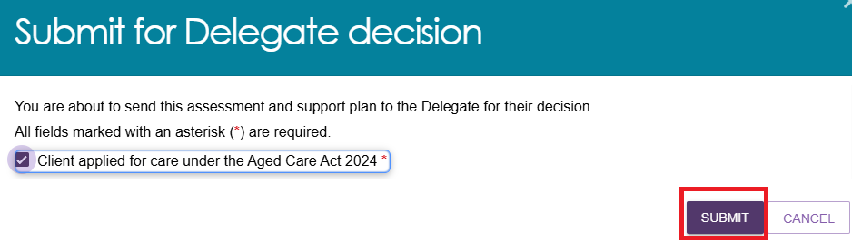
- A green banner will then display confirming the assessment and support plan has been sent to the Delegate for their decision.


'Returned to Assessor’ status
A delegate can return a Support Plan Review (or IAT assessment) to the assessor because amendments to the support plan and/or the IAT are required. It will then have a Returned to Assessor status.

Amendments to the IAT
Where the assessment delegate identifies errors in the IAT, they may return the IAT to the you to apply requested changes. The delegate can only do this once per assessment.
This request can also be viewed from the assessment tab under Returned to Assessor.
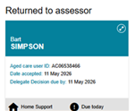
The image below shows an example of a client’s record in Card view when the client’s IAT assessment is returned. It contains:
- an information banner: ‘Delegate has requested the IAT questions to be reviewed. Please refer to the Notes to assessor to review IAT below for details on the instructions provided by the delegate
- ‘Notes to assessor to review IAT’ section, and a ‘View Details’ button, at the bottom right of the card
A Continue Assessment button at the bottom left of the card will take the assessor into the IAT to action any amendments as per instructions provided by the delegate.
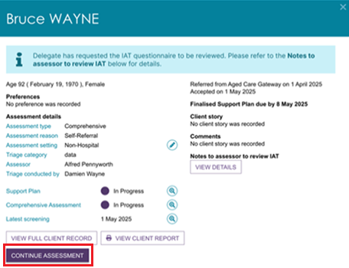
The below image shows the same information banner in the IAT Outcome and Classifications section of the client’s Support Plan and Services page, Goals & Recommendations tab. This time, select the Go to assessment button at the top right of the screen, to action any amendments as per instructions provided by the delegate.
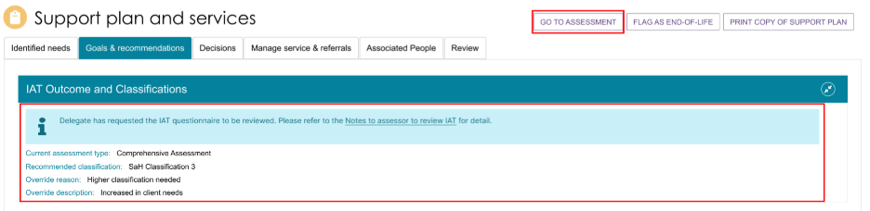
This image below shows the Notes to assessor to review IAT pop up, with example text next to each IAT topic.
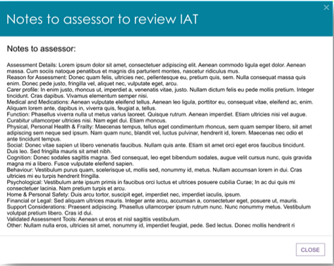

Reviewing and Resubmitting the returned IAT
Follow these steps to review the returned IAT and resubmit the assessment to the delegate.
      - Go to the Assessments tile of the Assessor Portal, then open the client’s assessment card or listing listed under the Current assessments tab, Returned to assessor section.

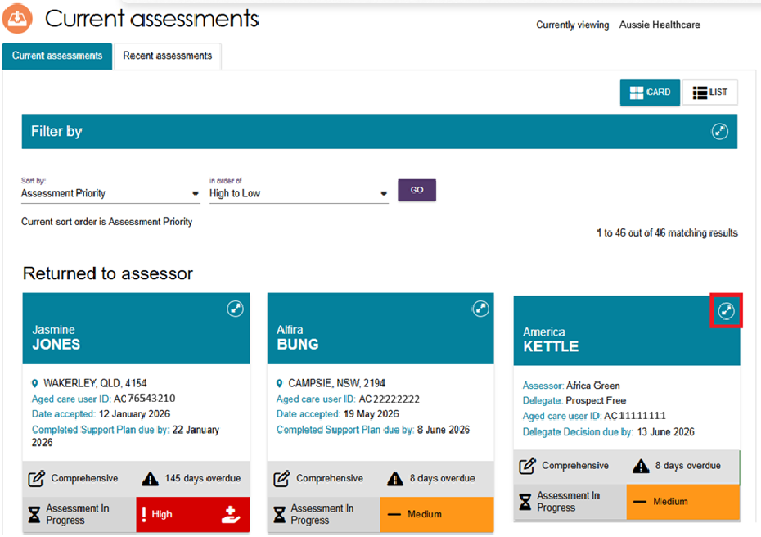
- Select View Details underneath the ‘Notes to assessor to review IAT’ section, from the client’s card or listing.

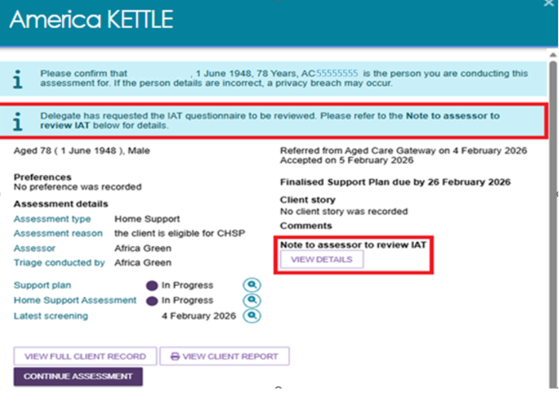
Alternatively, from the Support plan and services page, go to the Goals & Recommendations tab, then to the IAT Outcome and Classifications section. Select the Notes to assessor to review IAT link from the information banner.
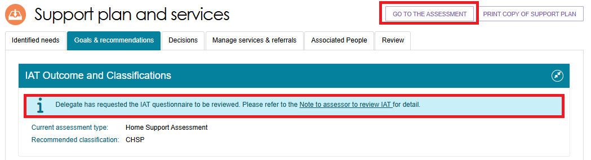
- The ‘Notes to assessor to review IAT’ pop up appears. It shows a list of the IAT topics, and the Delegate’s notes against each topic. Once the assessor receives the instructions from the delegate, they are required to action the requested changes in the relevant sections of the IAT.
These instructions direct the assessor what to amend in the IAT for resubmission.
Select Close to go back to the client’s assessment card or listing, and select Continue Assessment, or select Go To Assessment if in the Support Plan and Services page.
- The client’s IAT now appears ready for your review to action amendments as per instructions provided by the delegate.
When the IAT is returned to the assessor for amendments, all the Review checkboxes including the Page Review checkboxes on every screen, and the Goals Review button, will be cleared.
The Assessor will need to finalise the IAT again, once all the mandatory questions have been answered, including the Review checkboxes.
Once you have finalised the assessment, assessment delegates are not able to request another review of the IAT.
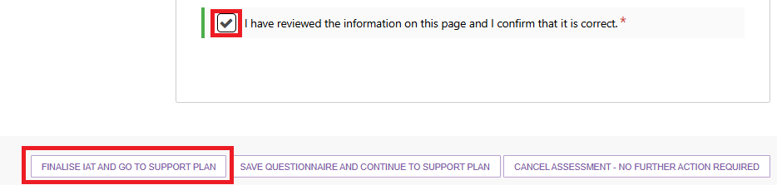
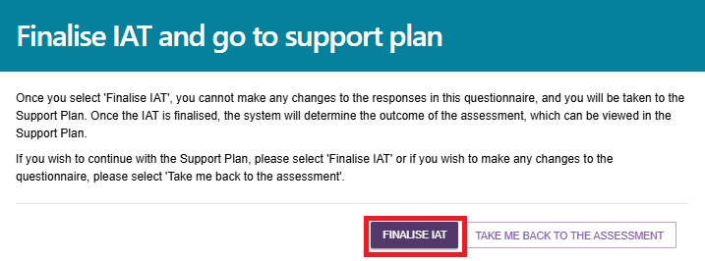
- Once the IAT is finalised (for the second time, after review), the client’s IAT Outcome may be different. An information banner may appear: ‘Please revise the Recommended Classification and Support Plan recommendations based on the new IAT Outcome’.
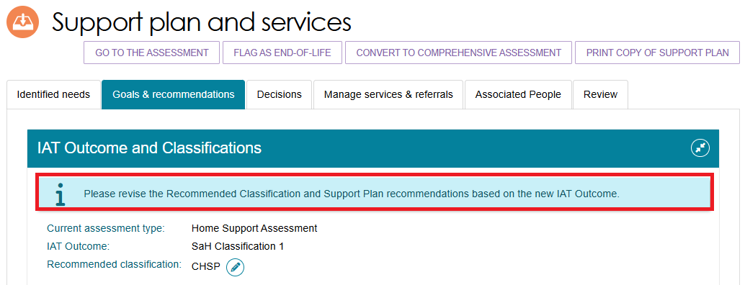
You will still be required to review all classifications and any prompts triggers (for example Restorative care pathway, Assistive technology, Home modifications). If the intention is to recommend an ongoing Home Support Classification, the assessor must ensure ‘Recommended Classification’ matches the new ‘IAT outcome’ via the edit functionality
Otherwise, you may receive a warning message:

If the IAT outcome results in a lower classification than the client’s current existing classification, please ensure the Recommended Classification is equivalent to the client's existing Classification level when recommending ongoing home support services through Support at Home or CHSP.
As per existing functionality, the assessor can override the ‘Recommended Classification’ to recommend a short-term pathway or Residential Care if required.
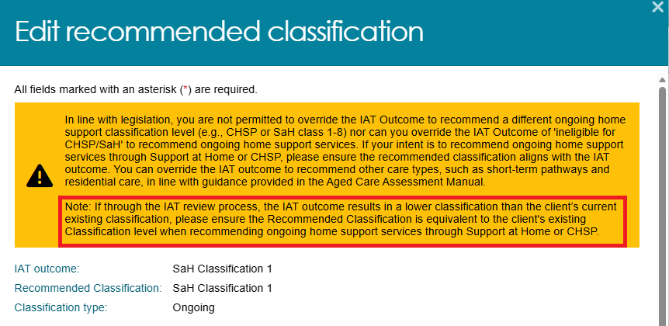

- At this stage, you may want (or need) to update the client’s support plan as well to reflect the new IAT Outcome and recommendations.
When you have finished reviewing the new IAT classification and/or the support plan, select the Complete Support Plan button.
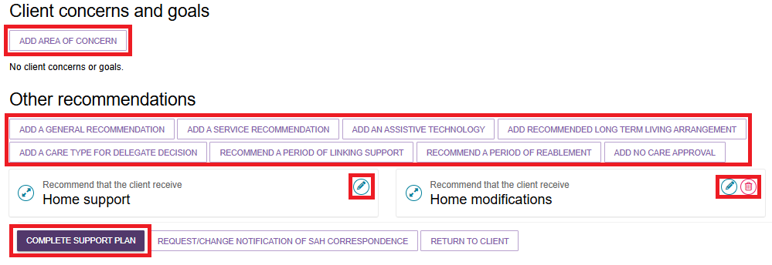
- The Note to Delegate pop up appears. You need to provide notes on what you corrected in the relevant IAT domains that the delegate asked you to review.
The Notes to Delegate text box is mandatory and has the list of IAT Domains pre-filled for your convenience. This text can be updated or removed whilst inputting your notes. Non-clinical assessors must document all clinical supervisor(s) involved throughout the assessment process.
If this text box is not completed, an error message will appear.
Finally, select CONTINUE TO COMPLETE SUPPORT PLAN.
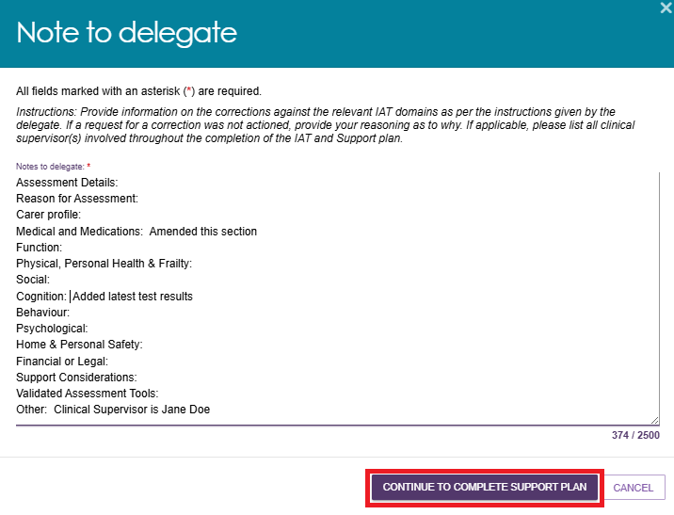

- Once you have completed the changes required or specified by the Assessment Delegate, you will be required to SAVE AND RESUBMIT FOR DELEGATE DECISION.
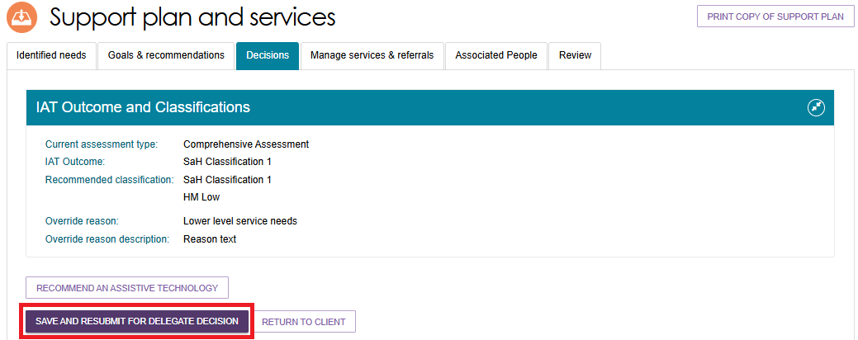
Select SUBMIT at the pop up that appears.
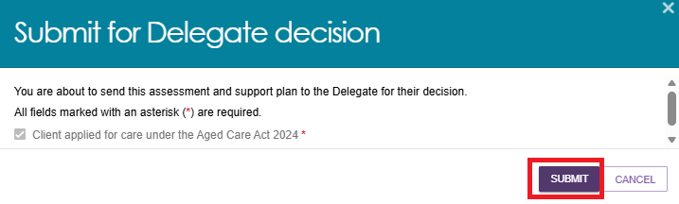
- If successful, you will receive a message banner stating that the resubmission has been successfully completed and submitted to the Assessment Delegate.
An information banner displays – ‘Assessor has reviewed the IAT questionnaire as per delegate’s request. View the Notes to delegate on the IAT review here’.
Select the here hyperlink to view both your Notes to delegate and the delegate’s notes to assessor.
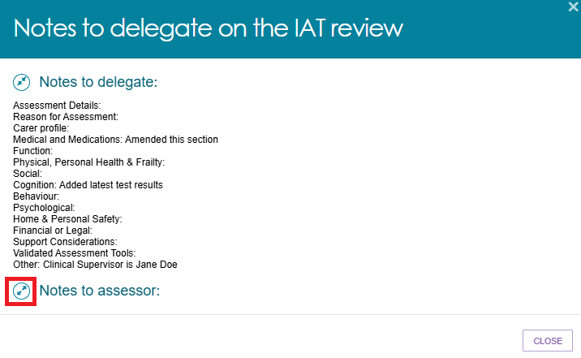

Amendments to the support plan
After the assessor has completed the IAT Assessment, completed the support plan, and submitted the recommendation/s for delegate decision, the Delegate may return the Comprehensive assessment or Home Support Assessment for amendments to the support plan.
Returned assessments will display under ‘Returned to assessor’ in the Assessment Tab.
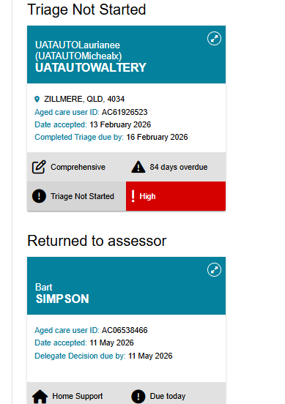
Assessors are able to amend the client’s concerns and goals, other recommendations, assessment summary and service recommendations according to the instructions provided by the delegate. For further detailed information, please refer to the Assessment Manual.

Finalising the support plan
When you have completed the assessment and the support plan, you will need to arrange referrals for the recommended service(s), before finalising the support plan.
Refer to the My Aged Care – Assessor Portal User Guide 8 – Referring for services for detailed information on this process.
! | The client’s support plan should be finalised once an effective referral(s) has been made or where the client chose not to proceed with aged care services or to manage their own referrals.  An effective referral is where:  - A referral is accepted by a service provider  - The client has accepted responsibility for managing their own referral  - The outcome of the assessment is that no further action is required by the assessor.
! | Assessors should not issue CHSP referral codes until after the Assessment Delegate has approved the recommendation.  For more information on how to issue referral codes for CHSP only, please refer to Chapter 9: Finalising the Assessment and Service Referral of My Aged Care Assessment Manual, and instructional videos for comprehensive and home support assessments.

  - From any tab in the client’s support plan, you will have the option to FINALISE SUPPORT PLAN at the bottom of the page.
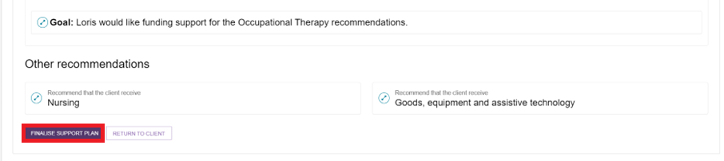
  - A pop-up box will display, and the referral status for each recommended service type will be pre-populated. Where a referral is Not Actioned, you will need to record a reason.
  - If the face-to-face assessment was conducted in a remote location, you should ensure that the Remote Assessment indicator is selected before the support plan is finalised.
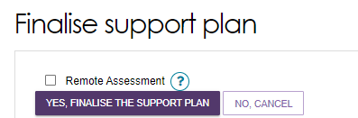
Once you have confirmed these outcomes, select YES, FINALISE THE SUPPORT PLAN.
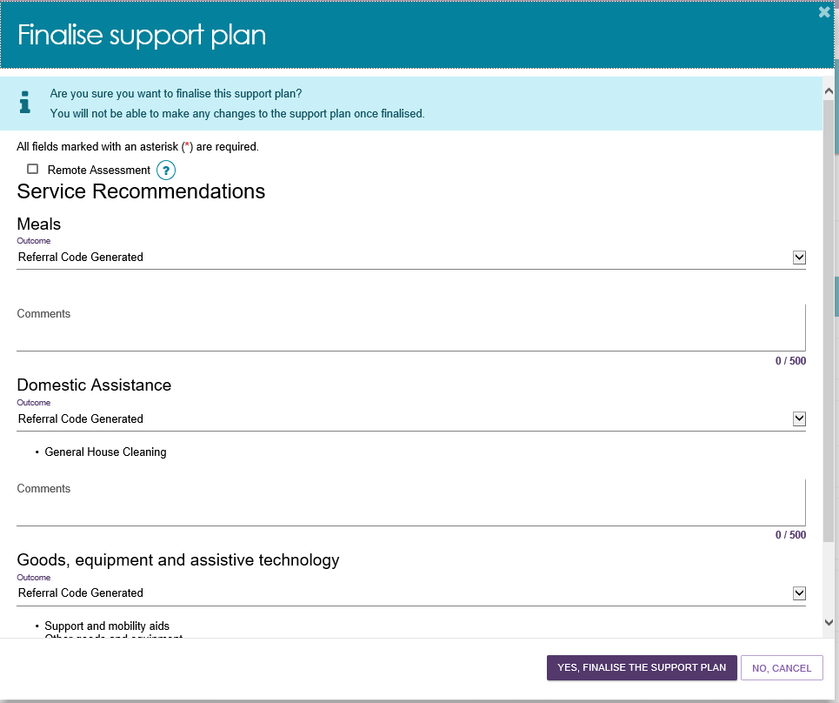
! | If you are choosing outcomes to support a client located remotely, you can choose Community-based care.  Outcome comments are required if you have chosen Not actioned or Community-based care following a remote assessment. Please provide detailed comments to support your outcome reasons.  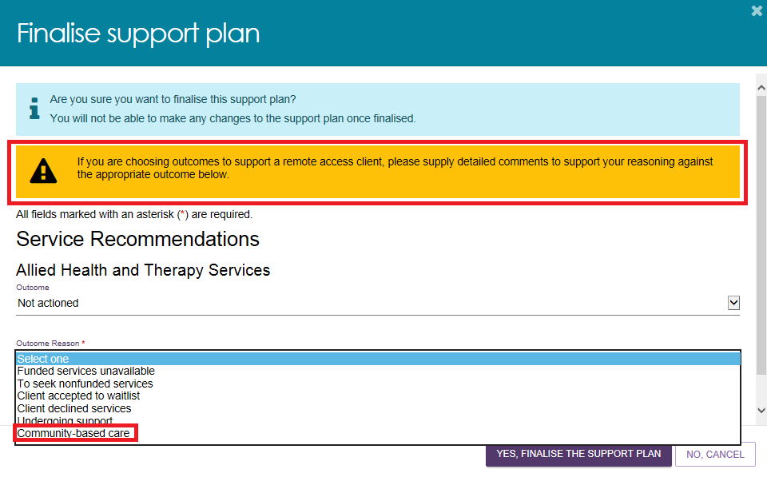
  - You will receive a confirmation message that the support plan has been finalised.

Finalising a Support Plan for Support at Home classification
Unlike other recommendations, the screen for finalising the Support Plan for clients’ recommended Support At Home classification will not include the individual services to record the outcome. It will be displayed as Support at Home.
Select YES, FINALISE THE SUPPORT PLAN.
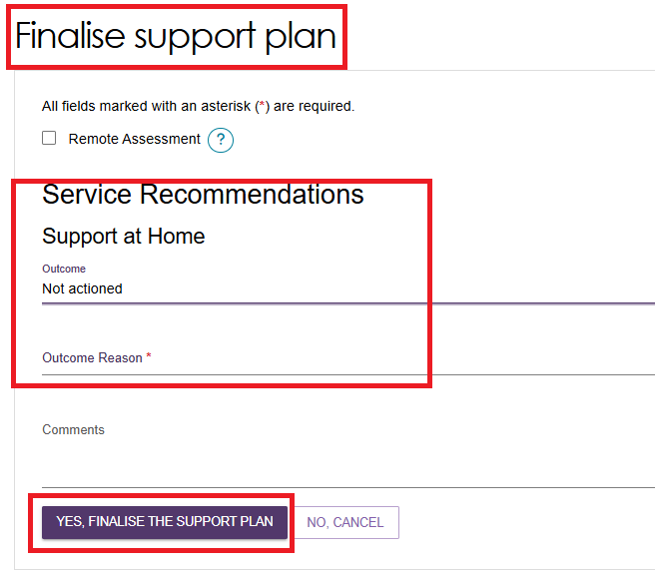

Ending a period of Reablement or linking support
Assessors can end the period of reablement or linking support, in either one of two ways.
- End each linking support and/or reablement period individually, by selecting END LINKING SUPPORT PERIOD or END REABLEMENT PERIOD on the Goals & recommendations tab of the clients Support Plan.
Assessors are required to enter the end date for the support period and the outcome.
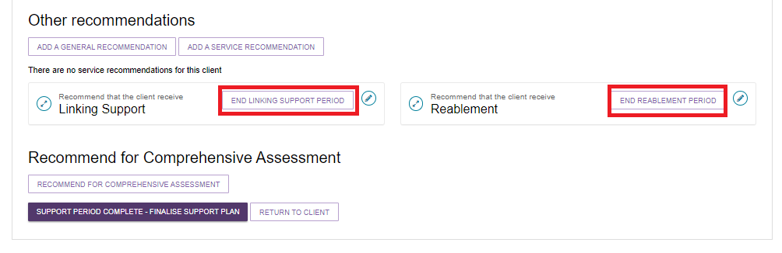
To finalise the support plan, but keep the support period open, select FINALISE SUPPORT PLAN & KEEP OPEN FOR SUPPORT PERIOD.

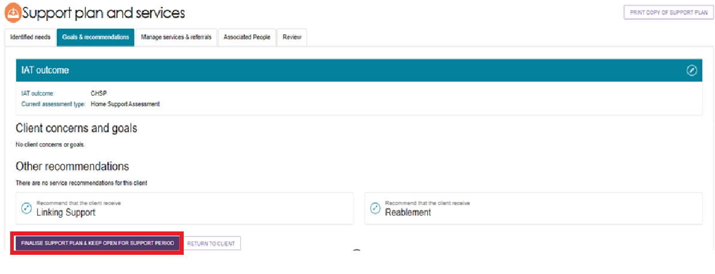
- A pop-up box will appear and ask you to finalise the support plan and keep open the support period. To finalise, select YES, FINALISE THE SUPPORT PLAN.

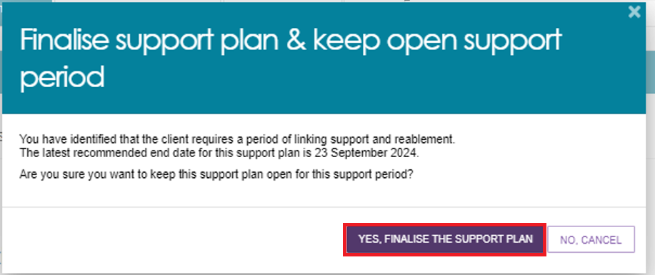
- End all linking support and/or reablement periods at the same time by selecting SUPPORT PERIOD COMPLETE – FINALISE SUPPORT PLAN on the Goals & Recommendations tab of the client’s support plan.

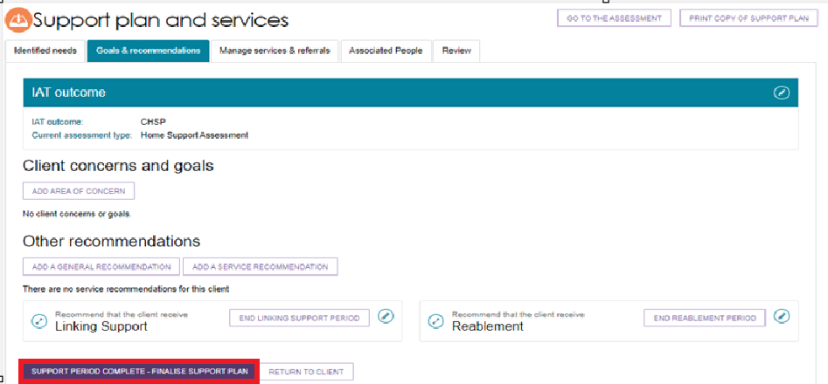
- All periods of linking support and/or reablement that have not ended will be displayed. Assessors are required to enter the end date for each support period and the outcome.
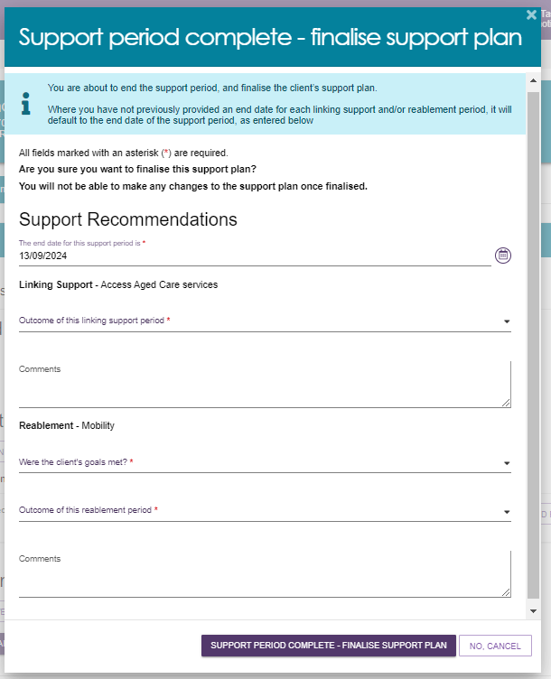

When assessors need to end the period of reablement for client they will be able to access it from the END REABLEMENT PERIOD button beside the Reablement tile under Other recommendations.
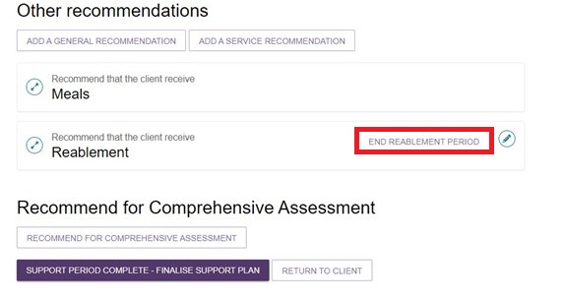
- A pop-up will appear with the title End period of reablement.
Assessors will need to answer two mandatory questions in the End period of reablement section in the assessor portal.
The first question asks whether the client’s reablement goals were met.
The second question prompts the assessor to detail outcomes by selecting from a drop-down menu.
Mandatory questions will be marked with an asterisk. Assessors should provide further information about the end of period of reablement in the comments box.
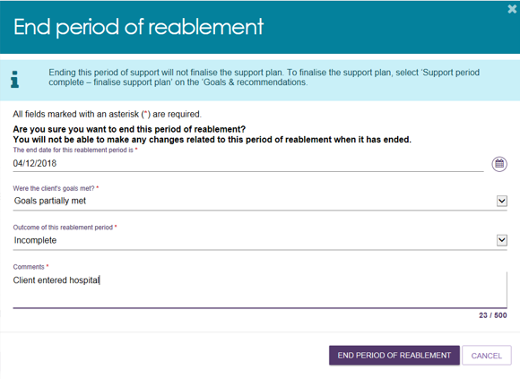
! | If a client is undergoing a period of support (linking support and/or reablement), the team leader may contact the assessor asking them to end the period of support in order to assign a Support Plan Review.  Alternatively, the assessor can request that the team leader cancel the review so the assessor can continue the period of support.

Printing a copy of the support plan
A PDF version of a client’s support plan is available to print from the assessor portal. The printed version includes the client’s: Last completed Support Plan Review (if applicable), Assessment Summary, Goals & Recommendations (including areas of concern), recommended services, a referral code where applicable, and strategies and any current care approvals.
- To print a copy of the client’s support plan, select the PRINT COPY OF SUPPORT PLAN link from the client record or support plan.
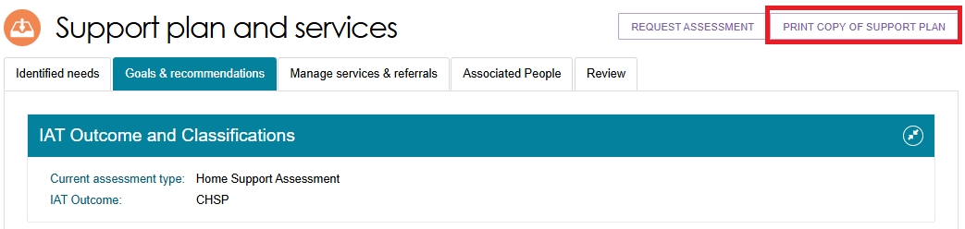
- A blue banner will appear at the bottom of the screen whilst the report is in progress. Select Reports page to navigate to the Reports and documents page.

- From the Report and documents page select View.
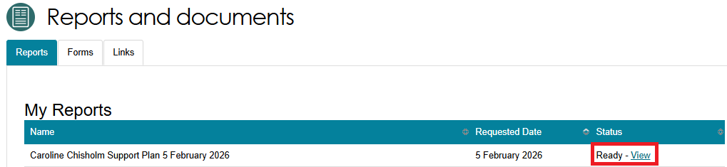
- The printer friendly version of the support plan will download. Select your printer options and select Print.

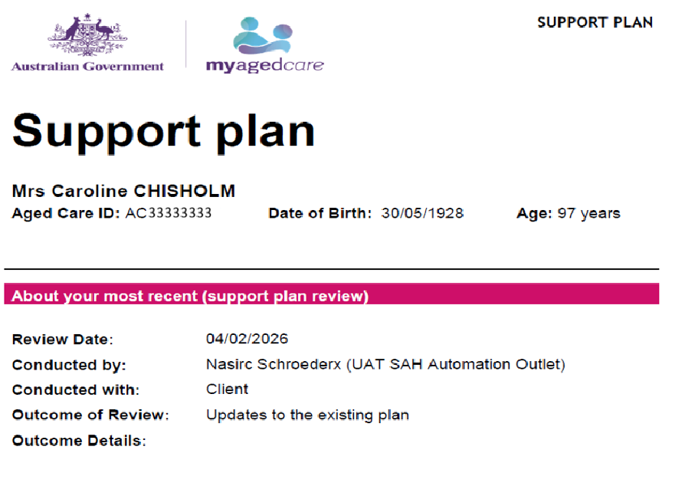
If a client already has a previous Support Plan Review completed the following section named Support Plan Review (first completed) would be displayed before the Goals and Recommendations section.
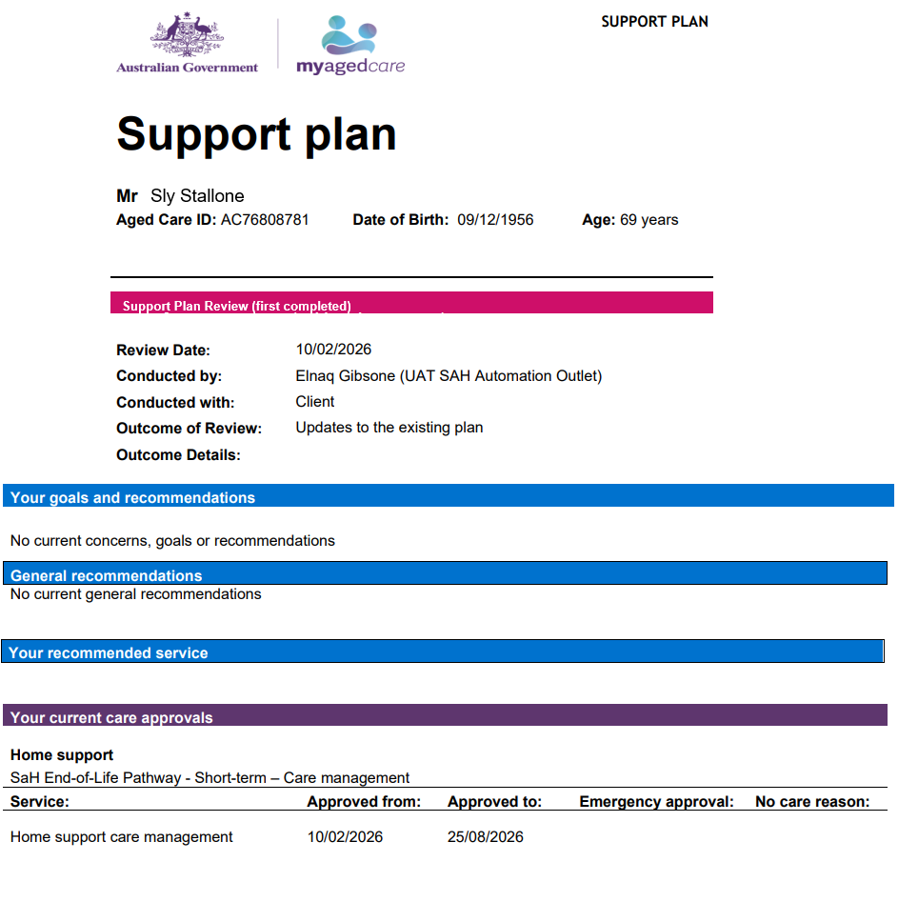

Support Plan Reviews

Viewing a Support Plan Review
- Select the Reviews tile from the homepage to view all Support Plan Reviews assigned to you.
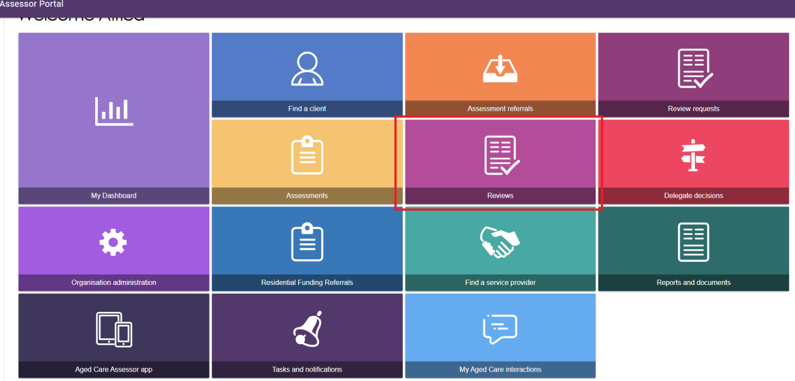

- Go to the Current reviews tab to view Support Plan Reviews assigned to you.

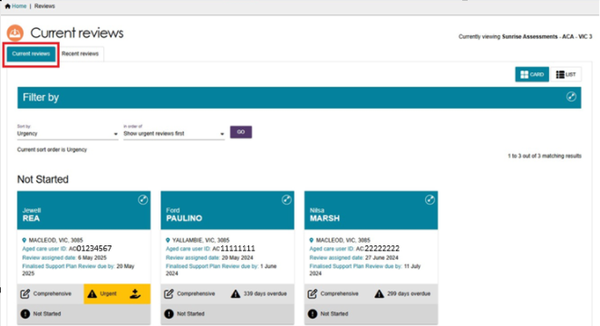
- Select the expand button on the top of the review card to see further information.
The card will also display the assessment type, urgency for the Support Plan Review to be completed and if it is currently overdue.
The following example also contains the End-of-Life Pathway symbol.
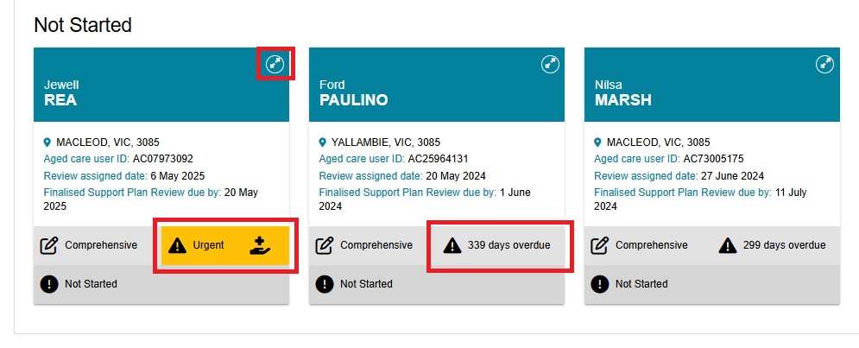
- If the request is for the End-of-Life Pathway services, select the edit (pencil) button to start verifying or adding the End-of-Life Pathway Form.
Further information on how to verify the End-of-Life Pathway Form can be found in the My Aged Care Assessment Manual.

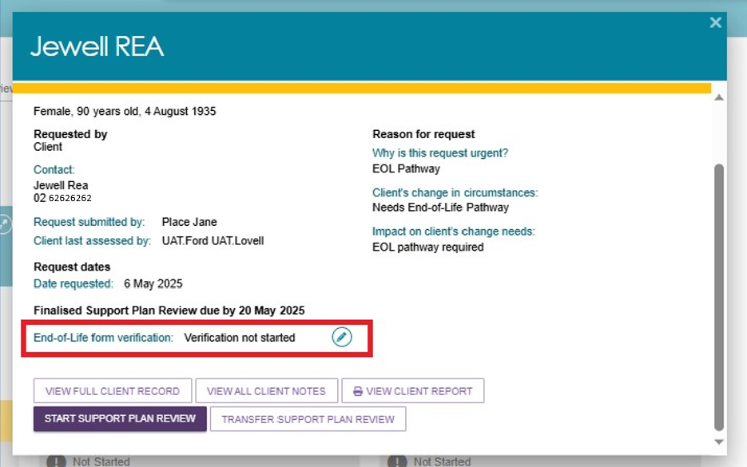

Starting a Support Plan Review
Follow these steps to start a Support Plan Review that has been assigned to you:
- Expand the client card in either card or list view. The Client Summary page displays. Select START SUPPORT PLAN REVIEW.

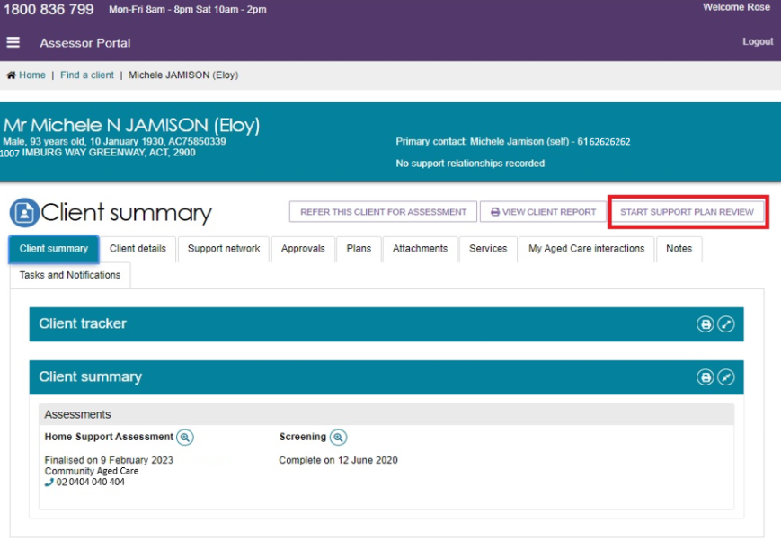
Alternatively, from the Current reviews page you can also expand the client card and select START SUPPORT PLAN REVIEW.

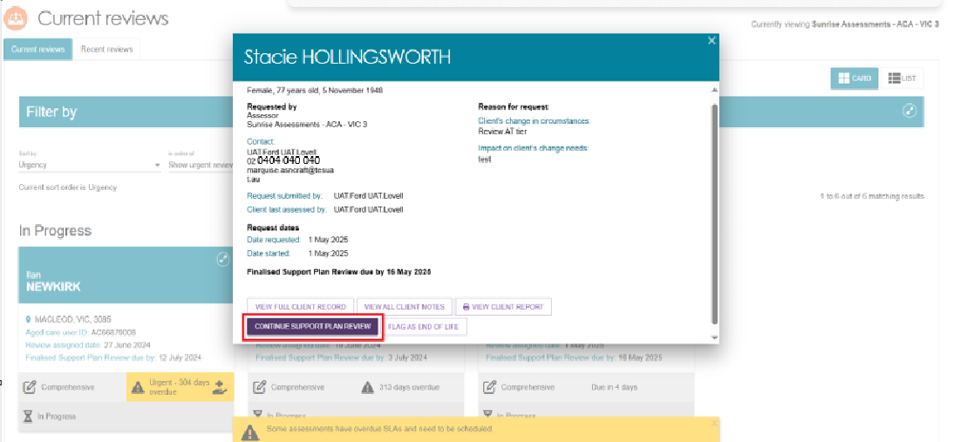
- From the Before you start the Support Plan Review pop-up select either CONTINUE TO SUPPORT PLAN REVIEW or RECOMMEND A NEW ASSESSMENT.
Select CONTINUE TO SUPPORT PLAN REVIEW to start the Support Plan Review for the client.
If the client’s circumstances have changed significantly and there is clear evidence (i.e. a letter from a GP or allied health professional) to demonstrate that they need higher level care, you can issue a referral directly for a new assessment rather than completing a Support Plan Review by selecting the button RECOMMEND A NEW ASSESSMENT.
! | There is no SPR required to extend an EoL episode from 12 weeks to 16 weeks. This process occurs automatically. Completing an SPR during a current EoL episode will end date the EoL funding immediately.

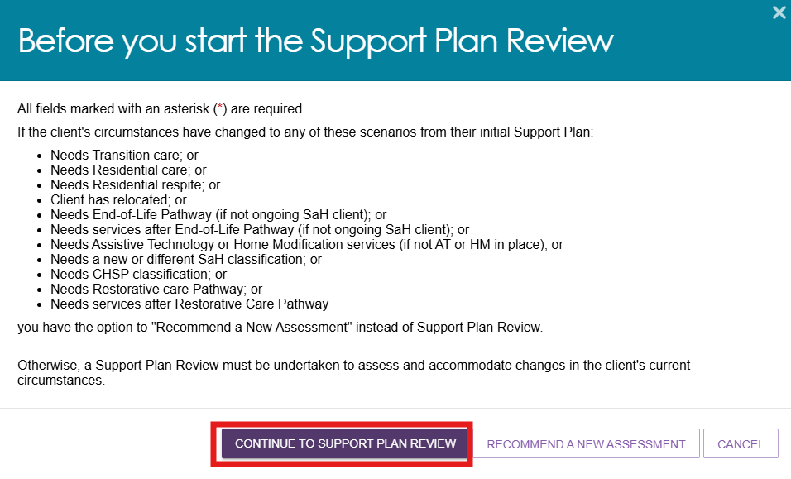

- A pop-up will display asking if the client consents to share their information with My Health Record. Select No or Yes based on the client’s response and select who this decision was made by from the drop-down menu.
If consent is provided by a supporter guardian, then their first name must be entered before proceeding.
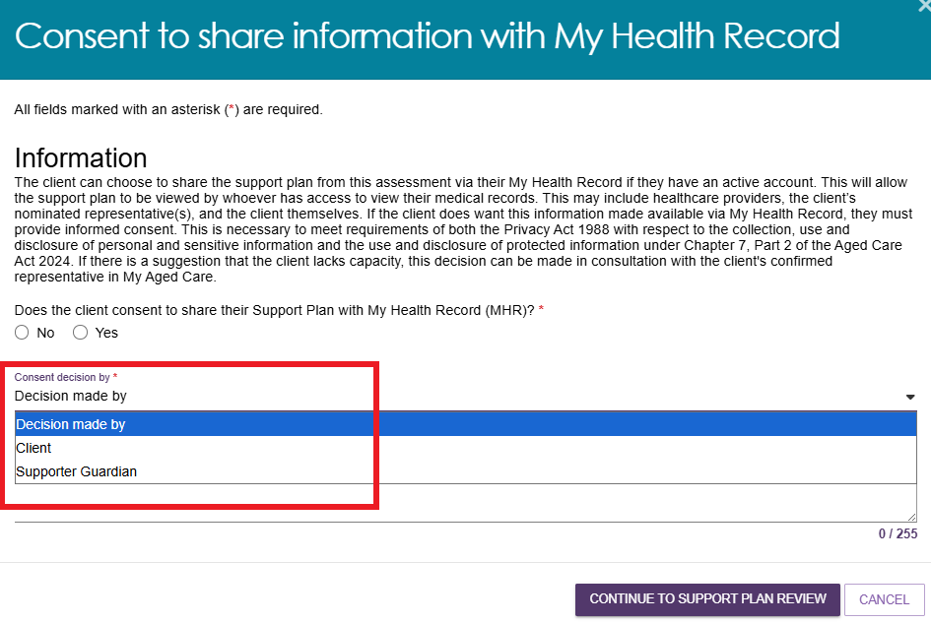
- If the client does not consent to share their support plan with My Health Record you will also be required to enter a consent denial reason before selecting CONTINUE TO SUPPORT PLAN REVIEW. If the consent is not provided by the client’s supporter guardian, their first name must be entered along with the denial reason before proceeding.
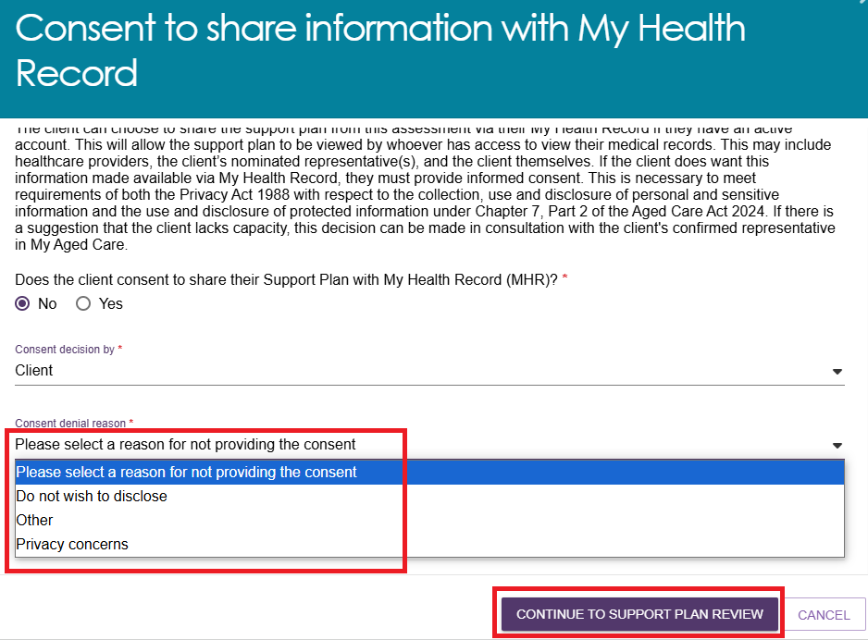
- Select CONTINUE TO SUPPORT PLAN REVIEW.
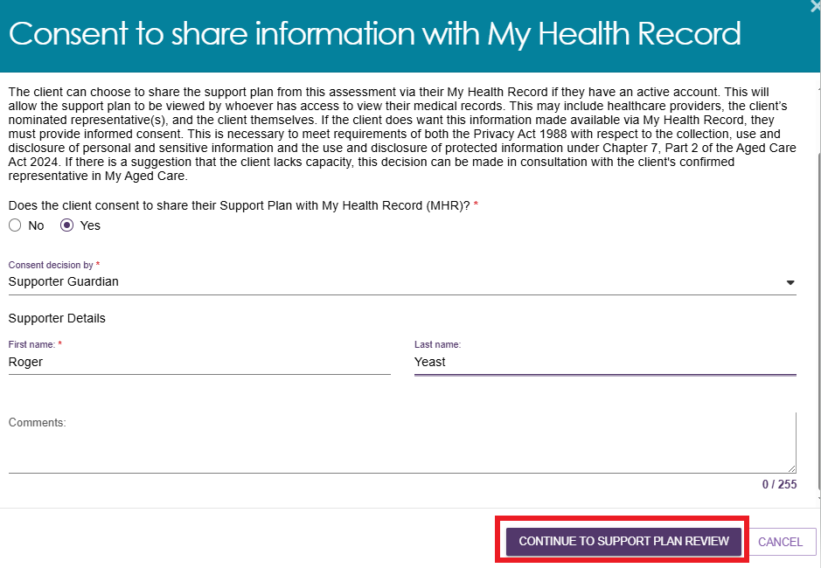
- Once a Support Plan Review has been started, an assessor will be able to make changes to information in the following sections of the client’s support plan:
- Assessment summary
- Client motivations
- Goals & recommendations (including recommendations for linking support & reablement)
- Manage services & referrals
- Associated People
- Review.
When finished, select COMPLETE & FINALISE SUPPORT PLAN REVIEW.
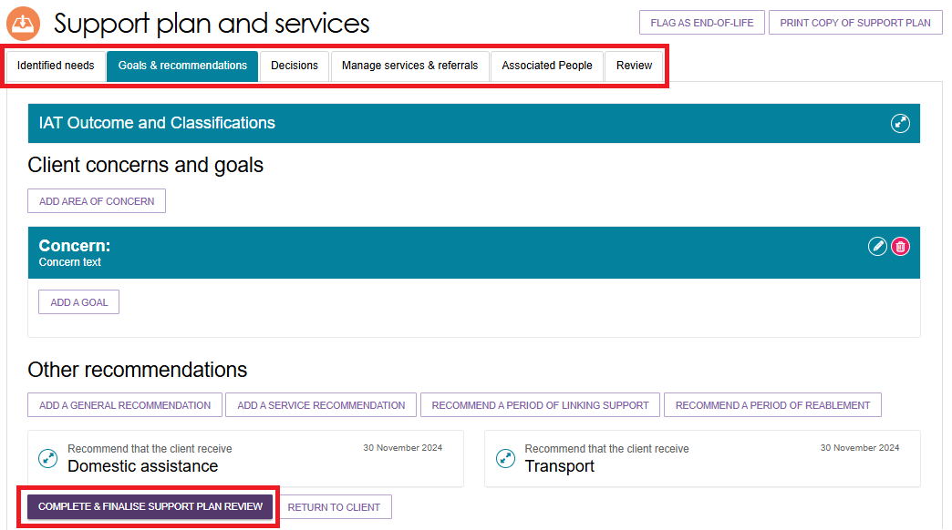
! | Previously recommended CHSP, MPS or NATSIFAC services  For clients who had CHSP, MPS and/or NATSIFAC services recommended before 23 February 2026, assessors cannot delete these services in the client’s IAT assessment during the support plan review or when the support plan is ‘Undergoing Support’. The below image shows the Goals & Recommendations section of a client’s support plan. Historical CHSP, MPS or NATSIFAC services do not have the Delete button available.  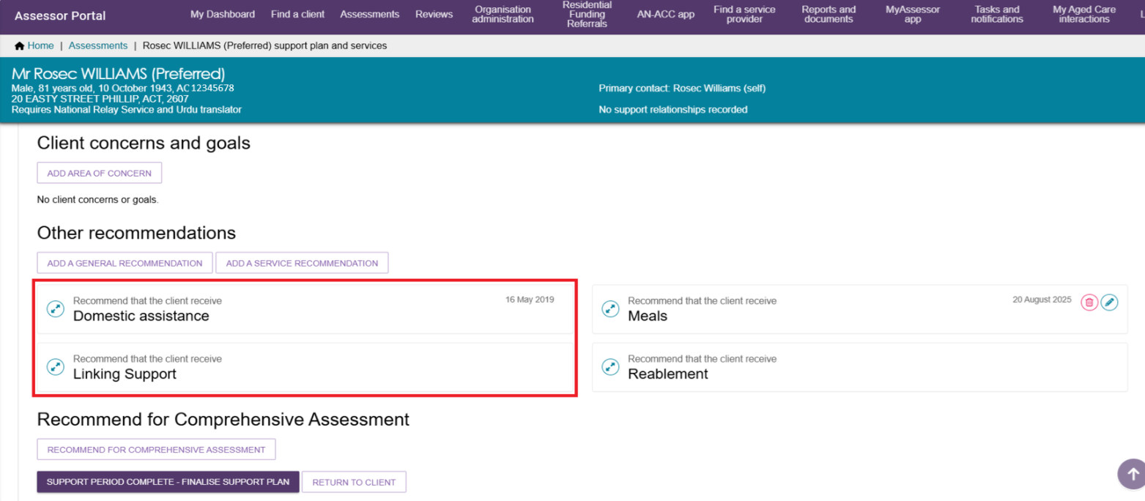
- The Complete & finalise support plan review page appears. Fill in all mandatory fields including Outcome of support plan review, and who the Support plan was conducted with Optionally for each service recommendation you can fill in the outcome and comments. Then, select COMPLETE & FINALISE SUPPORT PLAN REVIEW.
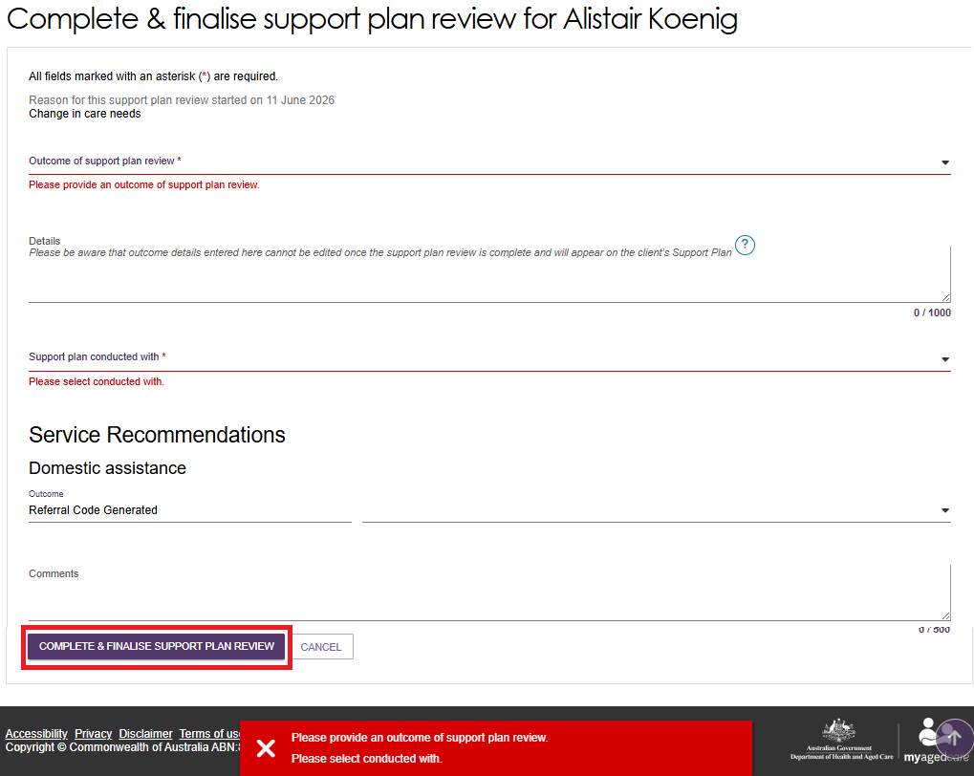
- If the SPR outcome is a reassessment, you will be prompted to enter the outcome of the review, the reason for the new assessment referral, then select an organisation of which to issue the referral. This can only be done in circumstances where a client requires one or more of the following:
- Transition care
- Residential care
- Residential respite
- Client has relocated
- End-of-Life Pathway (if not ongoing SaH client)
- Services after End-of-Life Pathway (if not ongoing SaH client)
- Assistive Technology or Home Modification services (if not AT or HM in place)
- A new or different SaH classification; or
- CHSP classification
- Restorative care Pathway
- Services after Restorative Care Pathway
! | A new assessment after the End-of-Life Pathway is only required where the person did not receive an inactive SaH classification at their initial assessment. Otherwise, continue to Support Plan Review, unless a reassessment is required to reflect changes in the person's needs or circumstances.

Recommending a new assessment
Follow these steps if the client’s circumstances have changed and it is more appropriate to issue a referral directly for a new assessment rather than completing a Support Plan Review:
      - Expand the client card in either card or list view. The Client Summary page displays. Select START SUPPORT PLAN REVIEW.

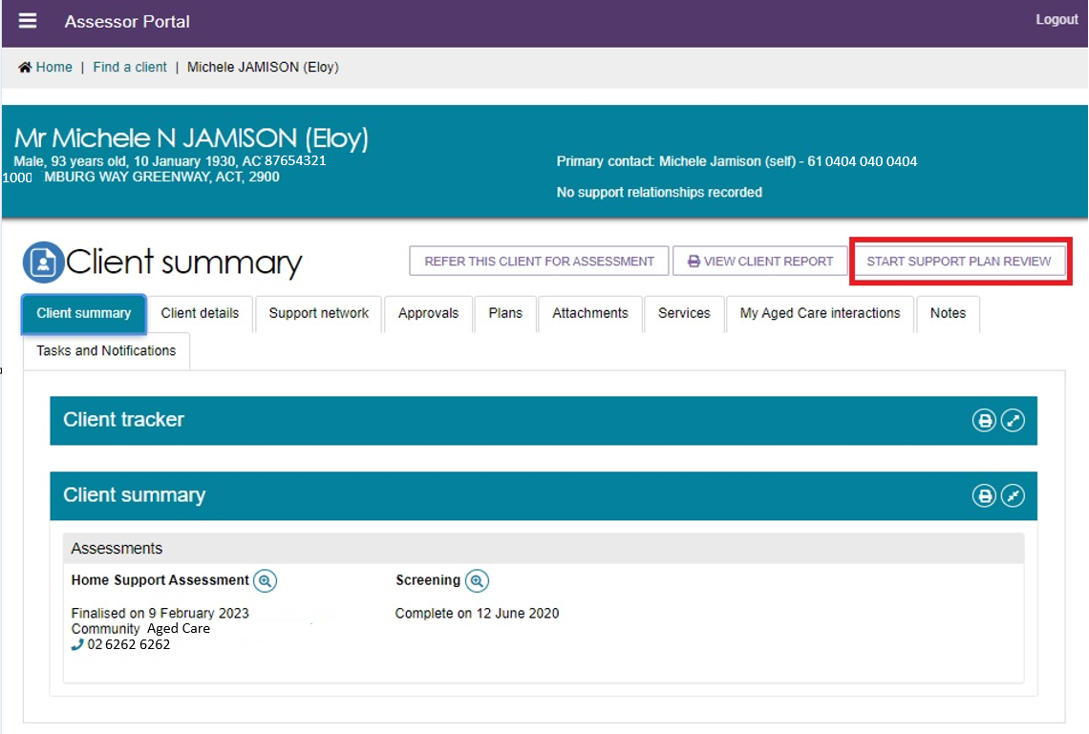
Alternatively, from the Current reviews page you can also expand the client card and select START SUPPORT PLAN REVIEW.

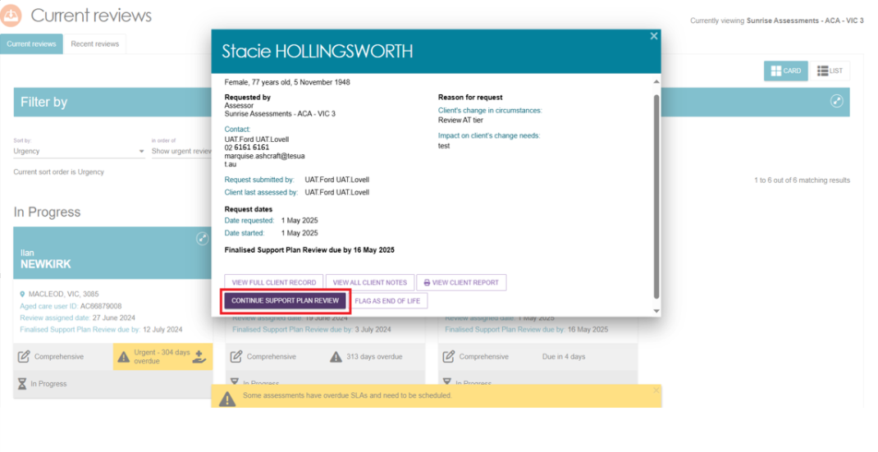
      - From the Before you start the Support Plan Review pop-up select RECOMMEND A NEW ASSESSMENT.
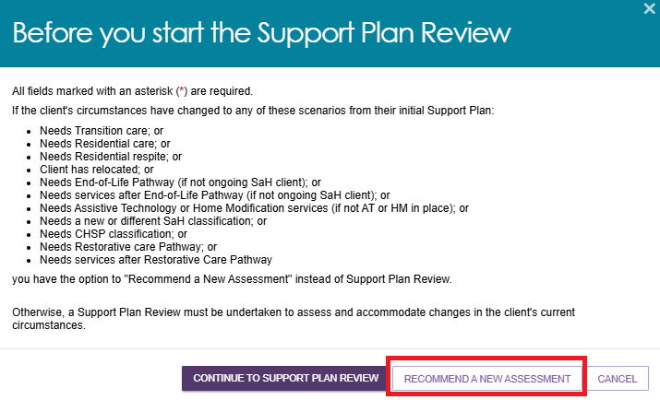

      - A pop up appears to complete or finalise the support plan review and to refer your client for assessment.
- Select the reason for the new assessment. The values available are:
- Needs Transition care
- Needs Residential care
- Needs Residential respite
- Client has relocated
- Needs End of Life pathway (not Support at Home client)
- Needs services post-End of Life pathway (only for non Support at Home clients e.g., CHSP clients)
- Needs Assistive technology or Home modification (none in place)
- Needs new or different Support at Home classification
- Needs Commonwealth Home Support Program classification
- Needs Restorative Care pathway
- Needs services post-Restorative Care pathway.
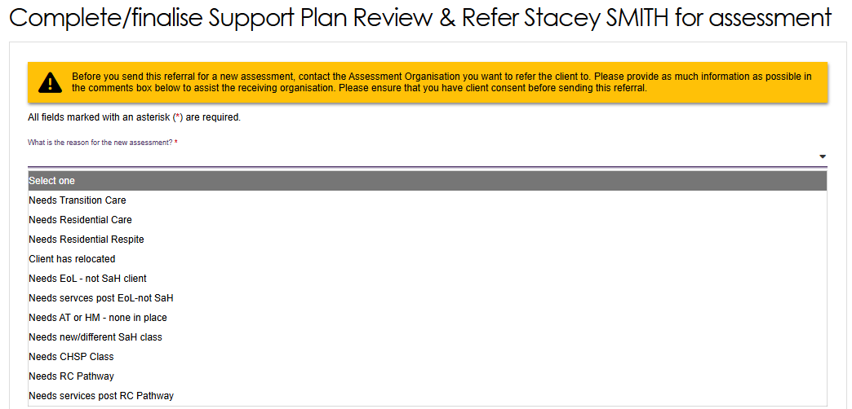
- Assign this referral to either yourself or your organisation, or another organisation.
- Choose the assessment type- Home support or Comprehensive. For Comprehensive, select the outlet.
- Select the assessment priority
- Add any comments if necessary.
- Select COMPLETE/FINALISE SUPPORT PLAN REVIEW & REFER ASSESSMENT.
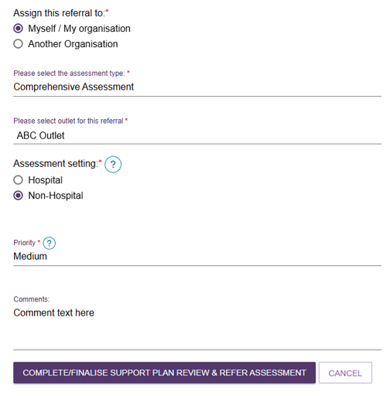

Issuing an assessment referral as a result of a Support Plan Review
When completing a Support Plan Review, an assessor can refer the client for a new assessment. This is completed during the Complete & finalise Support Plan Review page.
            - In the Complete and Finalise Support Plan Review section of the client’s support plan, select A new assessment required.
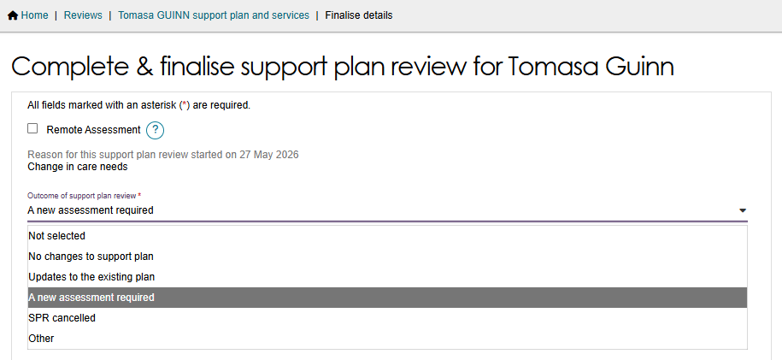
            - Complete all mandatory sections of the Complete & finalise support plan review page.

            - At the bottom of the page, you will be required to issue a new assessment referral before completing the review. You can send the assessment referral to yourself or your organisation, or to another organisation. Select the appropriate option.
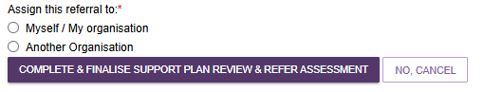
If you choose Myself / My Organisation, you will be prompted to select the assessment type, outlet for referral, assessment setting (if you’ve selected a Comprehensive Assessment) and indicate the priority of the referral. Optionally you can add comments.
Then, select COMPLETE & FINALISE SUPPORT PLAN REVIEW & REFER ASSESSMENT.
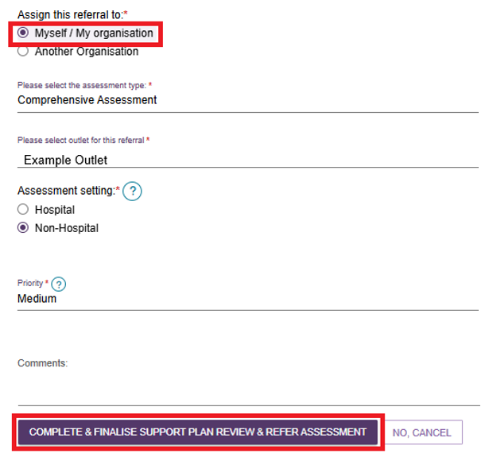

If you choose Another Organisation, you will be required to indicate the type of assessment required and the assessment setting (if Comprehensive Assessment has been selected).
Then, search for the assessment organisation’s address by either using the client’s address, or enter an alternative assessment address.
If you selected Use the client’s address, any alternative assessment addresses that the client has will be removed from the client’s profile when the referral is issued.
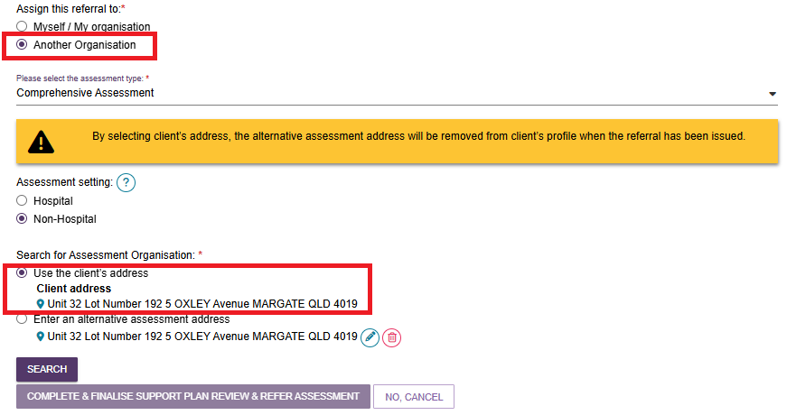
If you enter an alternative assessment address, you can use either the one displayed, or select the Pencil (Edit) button to enter a different address.
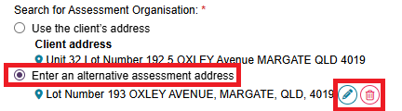
Select SEARCH, then select the desired assessment organisation.
Once you have selected an assessment organisation you will be asked to enter the priority of the assessment. Optionally you can add comments.

            - Finally, select COMPLETE & FINALISE SUPPORT PLAN REVIEW & REFER ASSESSMENT.

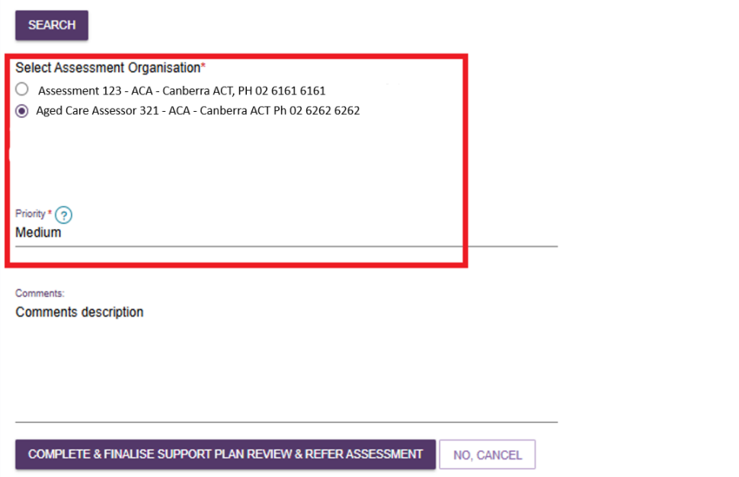
            - Upon completing the Support Plan Review, a green banner will display to confirm the referral has been issued.

The new assessment will appear under the Current assessments tab if you have assigned it to yourself or appear in the Incoming referrals queue for a team leader if assigned to My Organisation or Another Organisation.
! | All assessments, including those generated from Support Plan Reviews are required to undergo triage.  For more information refer to My Aged Care – Assessor Portal User Guide 3 – Managing referrals for assessment and support plan reviews.

Ad hoc Support Plan Reviews
You will be able to start an ad hoc Support Plan Review for any client who has been assessed by your assessment outlet, without requiring a Support Plan Review to be assigned to you. This can be done from any tab within the client record by selecting START SUPPORT PLAN REVIEW or via selecting the client card from the CURRENT REVIEWS page.
An ad hoc review will override a scheduled review. In this instance the team leader should cancel the scheduled review in their upcoming review tab if it is no longer required.

Scheduling an Ad hoc Support Plan Review
An ad hoc Support Plan Review can be scheduled by the assessor outside the usual review schedule, typically when there is a significant change in the client’s needs, health, or circumstances that affect the level or type of care they require.
  - To schedule an ad hoc Support Plan Review, navigate to the REVIEW tab under SUPPORT PLAN AND SERVICES screen.

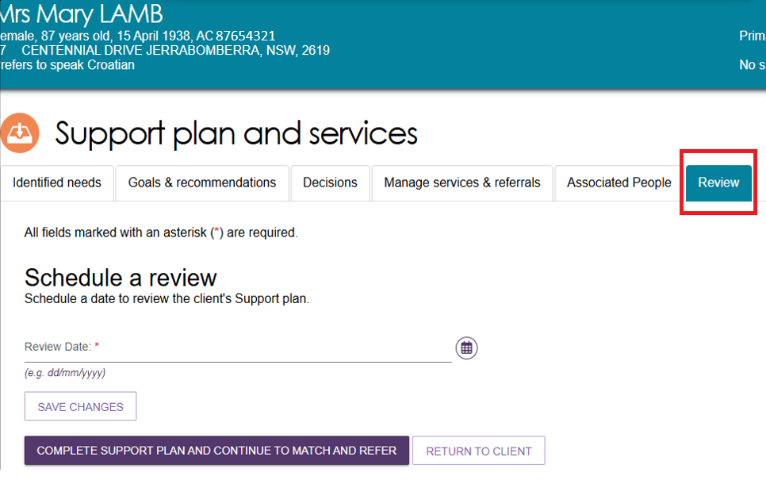
  - Select the CALENDAR icon under SCHEDULE A REVIEW, pick a future date for review and select the SAVE CHANGES button.

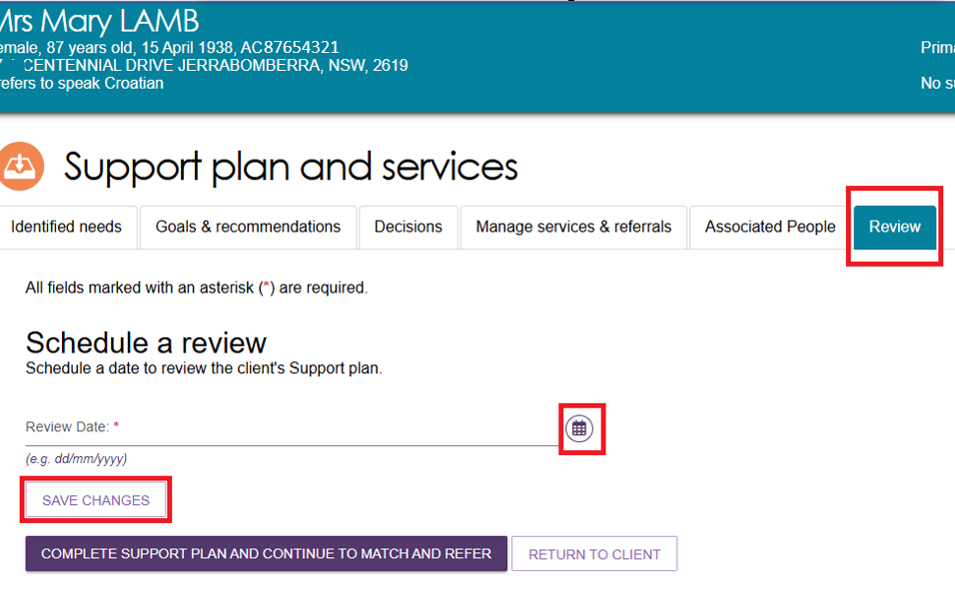

  - Select COMPLETE SUPPORT PLAN AND CONTINUE TO MATCH AND REFER.
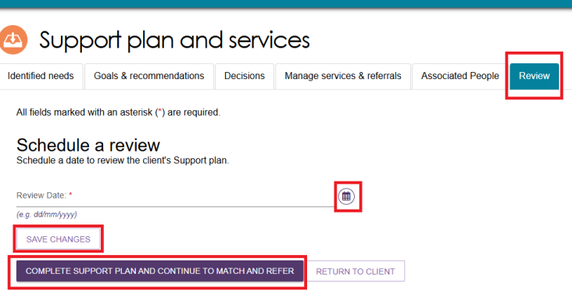
  - You will notice the START SUPPORT PLAN REVIEW button on the top right hand side of the client’s PLANS tab. Select START SUPPORT PLAN REVIEW.
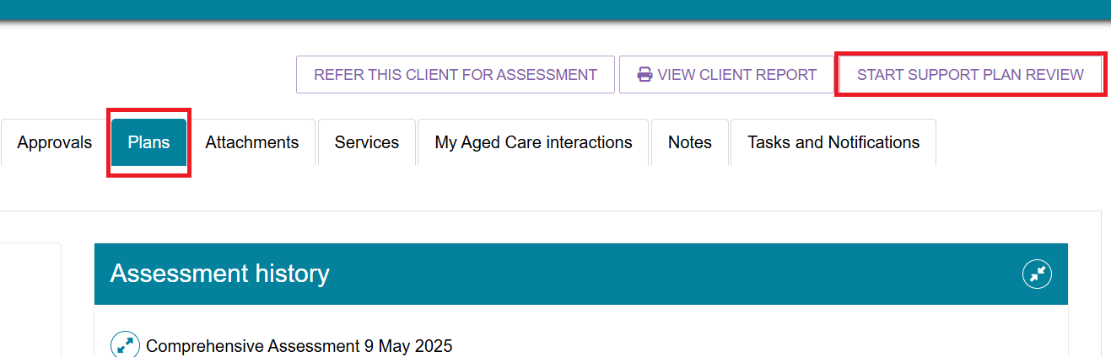
  - Select CONTINUE TO SUPPORT PLAN REVIEW button on the next screen

- This will take you to the CONSENT screen. Complete the required fields and select CONTINUE TO SUPPORT PLAN REVIEW.
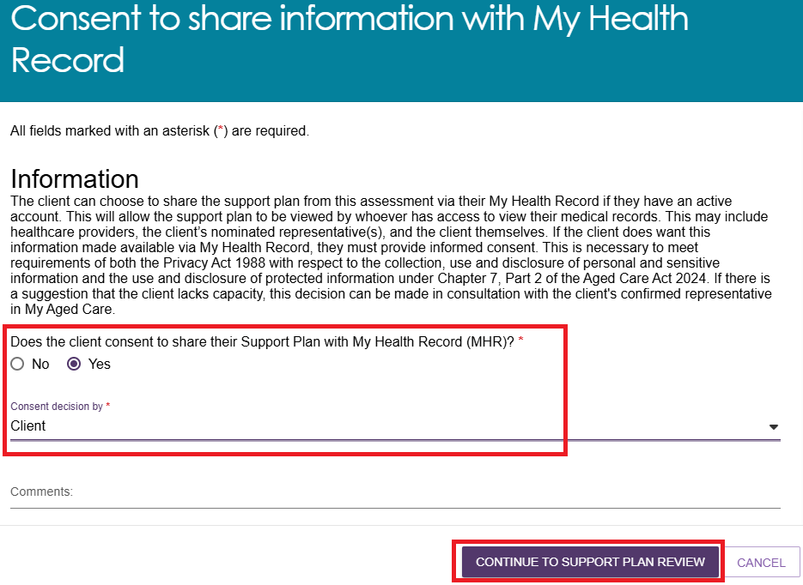
- A pop-up window will open to input the client’s change in circumstance. Select the relevant reason.
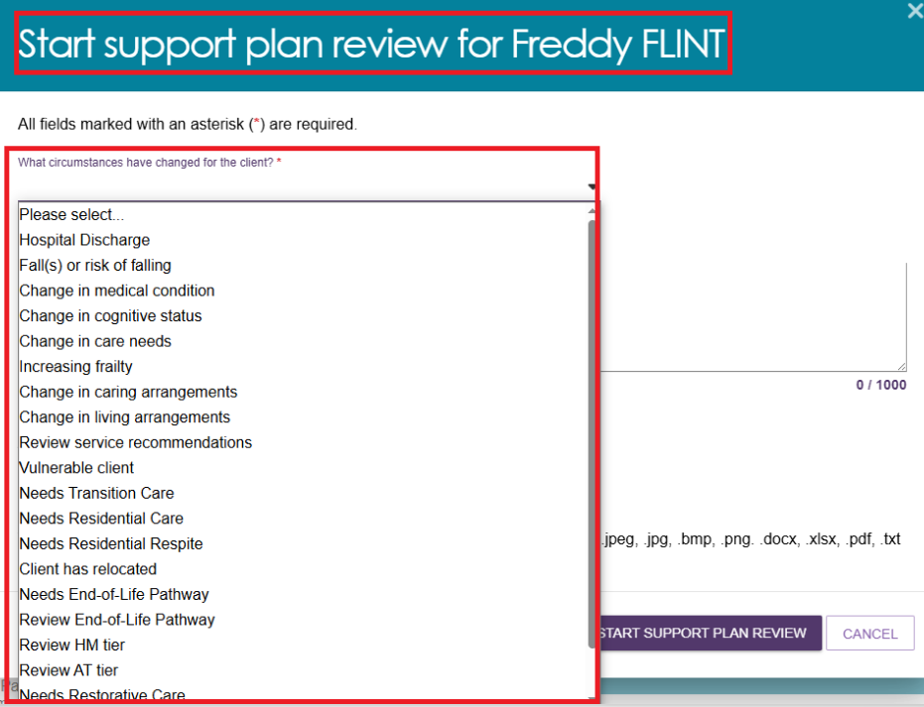

- Continue to input all the relevant information, UPLOAD any supporting documentation (such as a letter from qualified health professionals) as required and select START SUPPORT PLAN REVIEW.
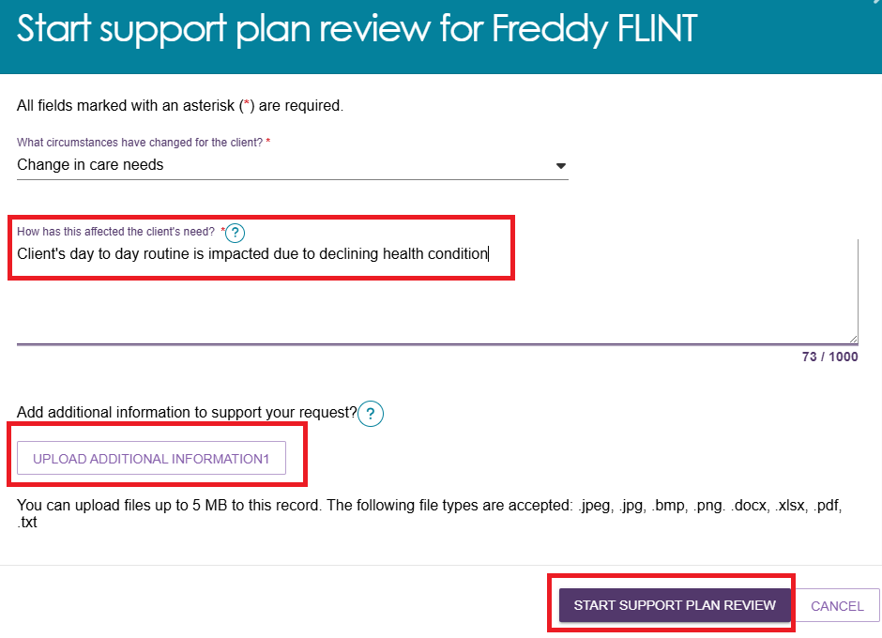

Transferring a Support Plan Review
Both assessors and team leaders can transfer Support Plan Reviews to other assessment organisations.
  - To begin transferring a Support Plan Review, go to Current reviews and select the client card you wish to transfer for the Support Plan Review. Select TRANSFER SUPPORT PLAN REVIEW.
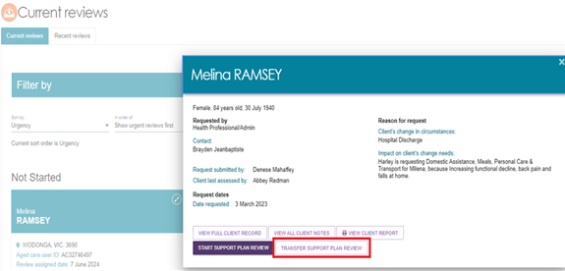
  - You will need to enter What is the reason for the transfer and search and select the Assessment Organisation which the Support Plan Review will be transferred to.
Once the reason for transfer and organisation has been selected, select TRANSFER to finalise.
A banner will display at the bottom advising you to call the assessment organisation you are referring the client to. This banner also highlights the need for client consent prior to transferring.

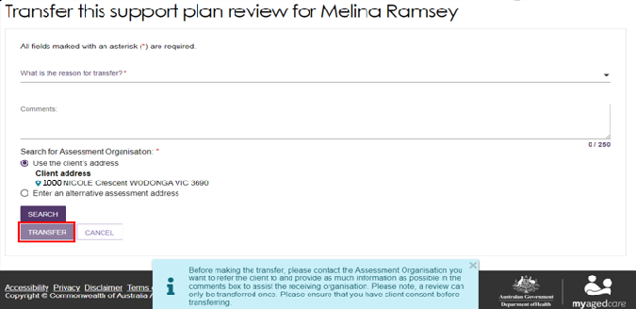
! | Support Plan Reviews can only be transferred once.

Support Plan Review for Support at Home
A Support Plan Review for Support at Home is conducted when there is a need to reassess a client’s current Support at Home services due to changes in their circumstances, goals, or care needs. This review ensures that the services being provided remain appropriate, effective, and aligned with the client’s preferences and situation.

The Goals & recommendations tab is where you will record the clients:
- areas of concern,
- goals to address their concerns,
- any services or general recommendations, and
- any care type recommendations.
Support at Home care types are delivered under the Aged Care Act 2024 (the Act). If they need a delegate decision, this can be done at Add a care type for delegate decision.

Support Plan Review for services following an End-of-Life Pathway episode
Assessors may receive a Support Plan Review (SPR) request for a client who is nearing the end of their End-of-Life pathway episode, or has outlived their End-of-Life (EoL) pathway episode and requires ongoing services.
In this situation the assessor must complete an SPR to determine the client’s current needs and recommend to either:
- revert to the previous (‘latent’) SaH classification, or
- conduct a reassessment to allow the client to access a higher ongoing Support at Home classification. (for example, they may have been approved initially for a SaH 4, then accessed EoL, and now need a SaH 8 ongoing which will better support their higher needs).
For clients in this scenario, the SPR request will typically be initiated by the service provider.
The provider will submit the request by selecting Review End-of-Life Pathway as the reason when lodging the SPR.

Revert to the previous ‘latent’ SaH classification
To revert to the previous (‘latent’) Support at Home classification:
- Open the SPR request linked to the client’s record.
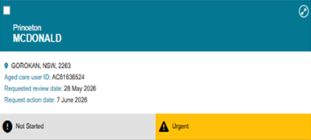

- Review the reason for the request, noting the provider has identified that the client has outlived the End-of-Life Pathway or is close to finishing their 16 weeks of services.
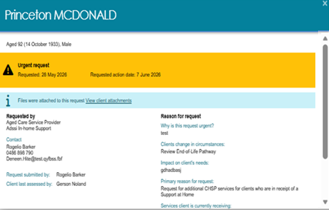
- Go to the client’s Goals & Recommendations tab of their Support plan and services page.
In the IAT Outcome and Classifications section, an Information banner displays, indicating that the client is currently on the End-of-Life Pathway and can only be recommended for a Latent or higher ongoing Support at Home classification.
Select Revert to Ongoing SAH Classification or Override to Transitioned HCP Classification.
Revert to Ongoing SAH Classification example
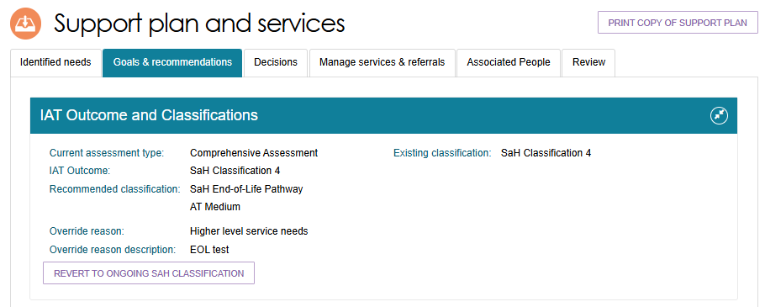

Override to Transitioned HCP Classification example
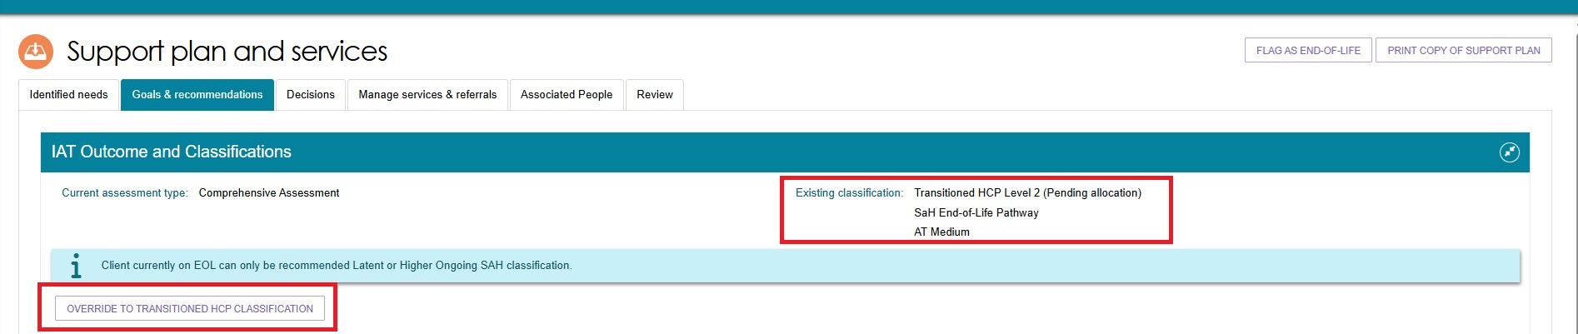
- A pop up appears to confirm the revert or the override. Select REVERT or OVERRIDE to proceed.
Revert to ongoing SAH Classification pop up example
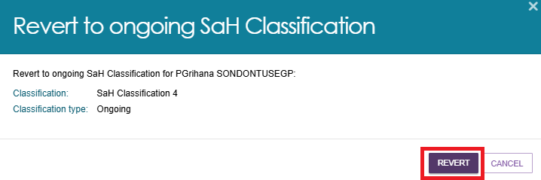
Override to Transitioned HCP Classification pop up example
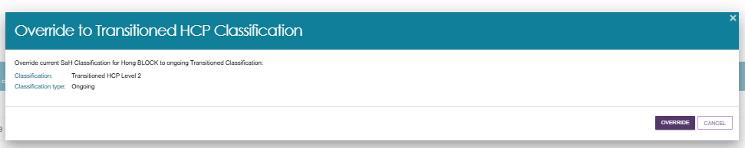
- If successful, a green banner appears at the bottom of the screen.
- Once overridden, the client’s IAT Outcome and Classifications section now shows their latest classification and the override reason of Latent Pending.
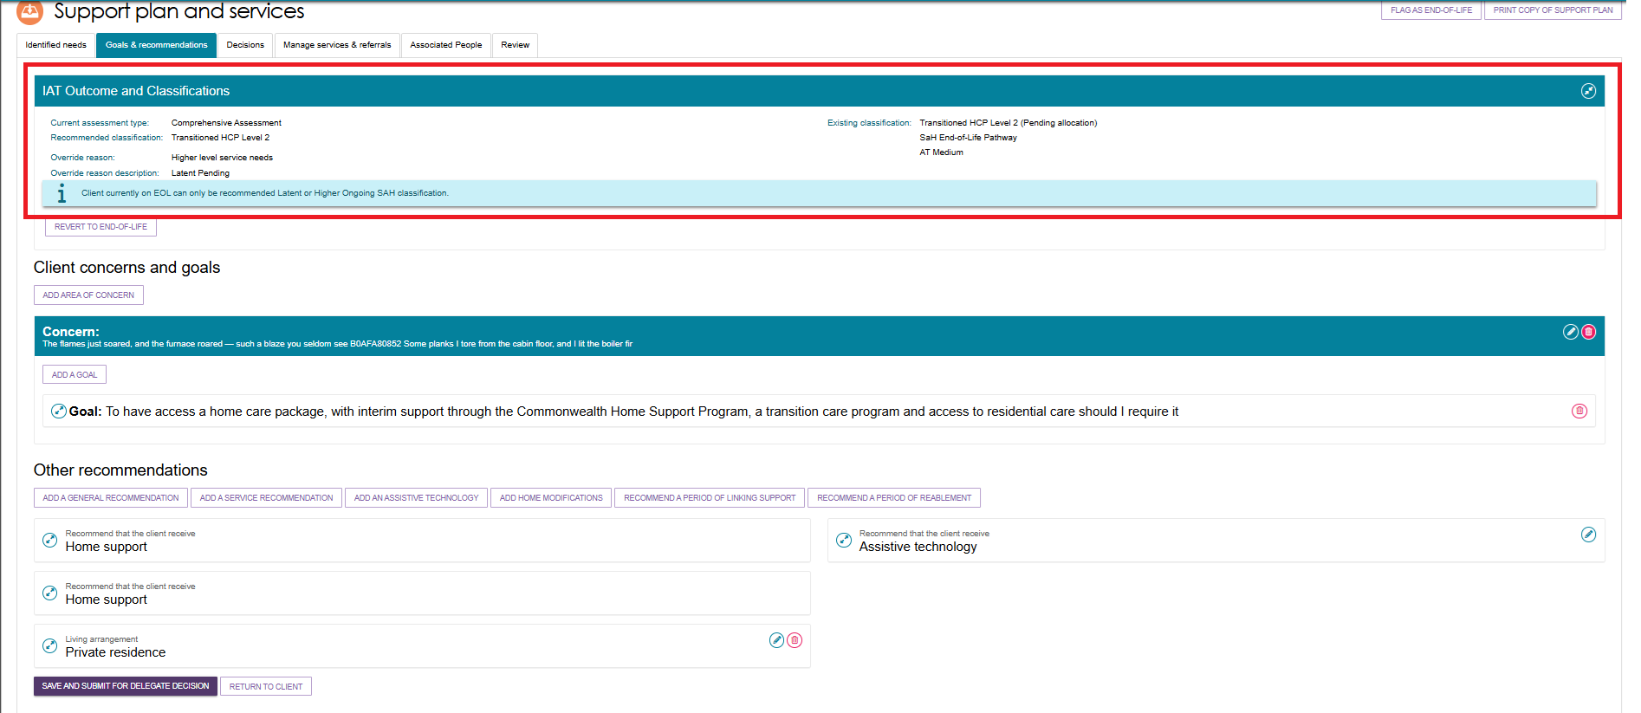

- Finalise the SPR and record the outcome in the system, transitioning the client from the End-of-Life pathway to their ‘latent’ ongoing Support at Home classification to support continuity of services.
You will be taken to the Decisions tab to submit for Delegate decision. Go to the bottom of the page and select SAVE AND SUBMIT FOR DELEGATE DECISION.
- The Submit for Delegate decision pop up appears. Confirm that the Client applied for care under the Aged Care Act 2024 by selecting the tickbox, then select SUBMIT.
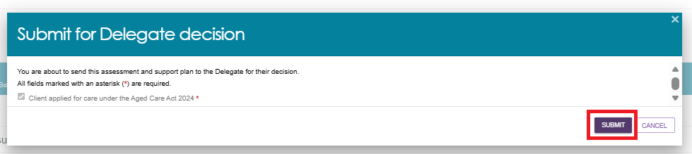
- A green banner will then display confirming the assessment and support plan has been sent to the Delegate for their decision.

Reassessment for a new Support at Home Classification following an episode of End of Life
- Go to the Plans tab of the client record, and select REQUEST A REVIEW from the top right of the screen.
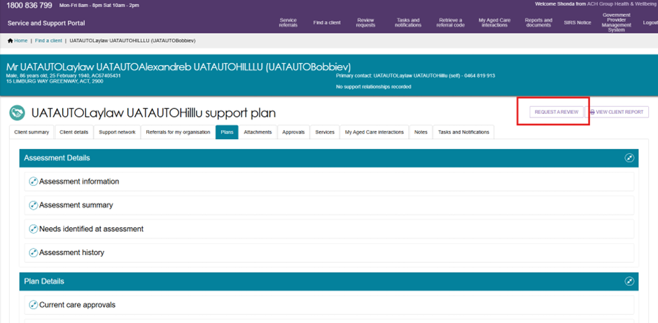

- The Request a Review page appears. Fill out all mandatory details and add any relevant documentation (such as a care plan).
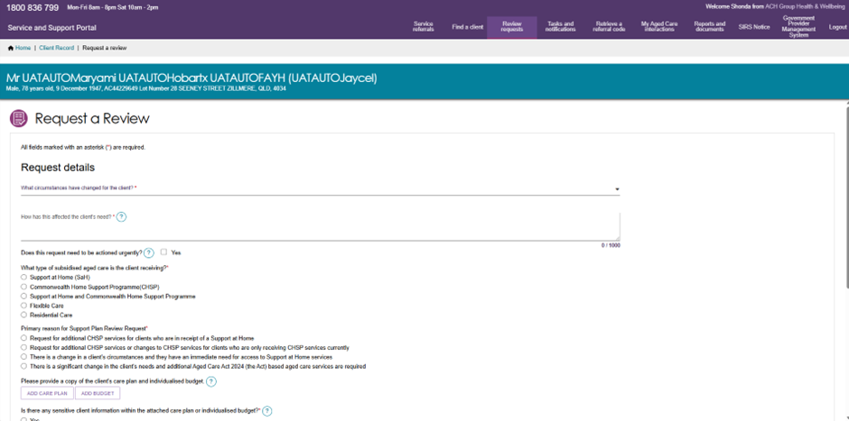
(The Team Leader will then be required to assign the assessment to a suitable assessor.)
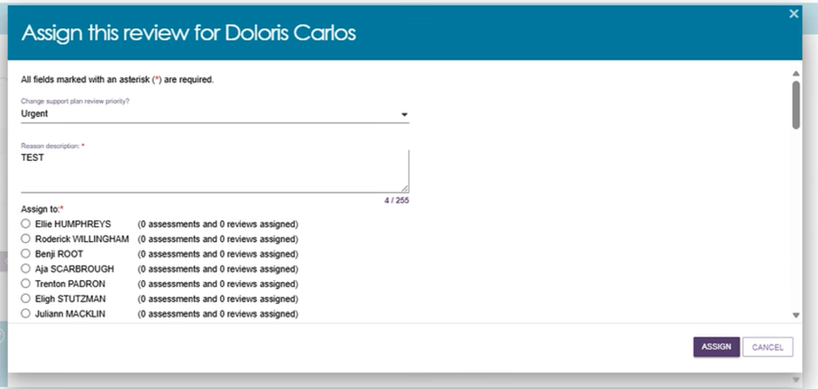

- The assessor that is assigned the assessment will need to go to the Reviews tile of the Assessor Portal home page, and then the Not Started section of the Current Reviews page, to find the client.

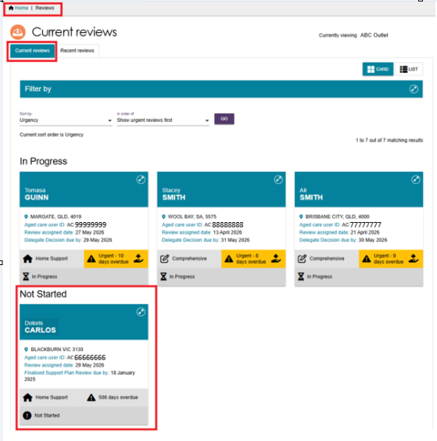
- The client’s card appears. Select START SUPPORT PLAN REVIEW.
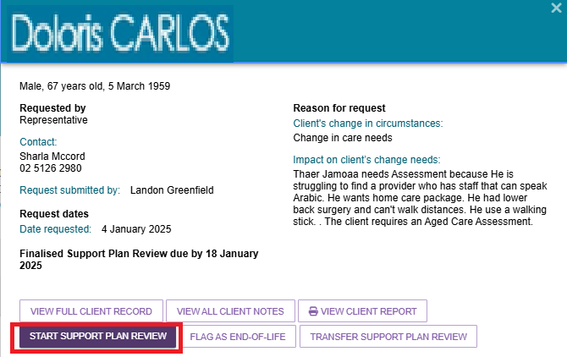

- The ‘Before you start the Support Plan Review’ pop up appears. Select RECOMMEND A NEW ASSESSMENT.
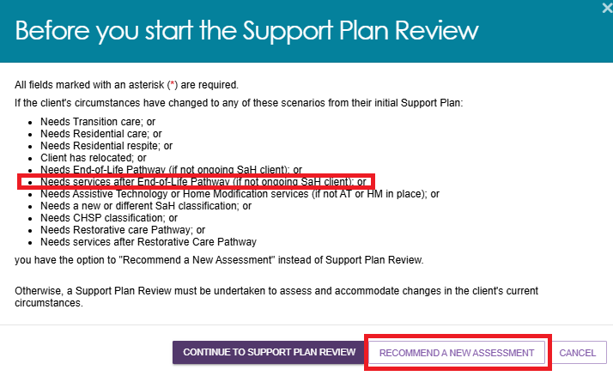
- The assessor will then press START TRIAGE and then continue to START ASSESSMENT, after Triage is completed.
Start Triage
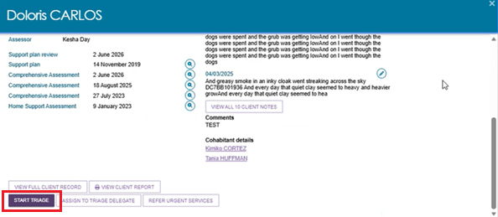

Start Assessment
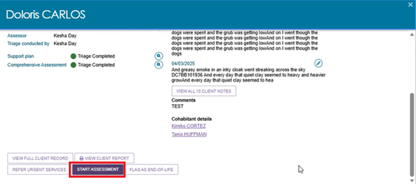
- After the assessment is finished, select FINALISE IAT.
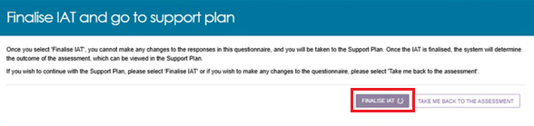
- The IAT outcome from the re-assessment will appear in the Goals & Recommendations tab. An Information message displays that the client can only be recommended their latent or a higher ongoing classification level.
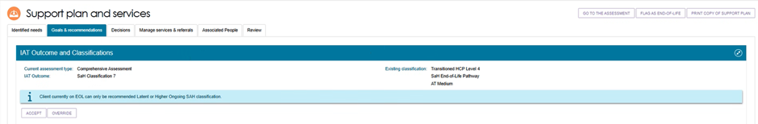
- The assessor will then accept the new SAH Classification, complete the assessment and support plan as per normal processes prior to submitting for delegation.
