(Australian Government Department of Health, 2026)
Multidisciplinary Workforce Planning:
Technical Guide
Kruk Review Recommendation 19

HEALTH WORKFORCE TASKFORCE

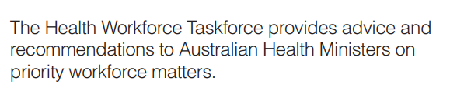

This guide was prepared on behalf of the Health Workforce Taskforce under the auspices of the Health Ministers Meeting
© Health Workforce Taskforce 2026
All rights reserved.
This material may be copied and shared for non-commercial purposes only. Distribution for profit, modification for commercial purposes, or resale of this work is not permitted.

Contents
Introduction and purpose 5
How to use this guide 6
Who this guide is for 7
Time horizons and planning assumptions 9
Key concepts and language used in this guide 10
Steps in the planning process 12
Step 1: Create the authorising environment 14
Step 2: Establish the planning context 16
Step 3: Assess current and future state population needs 22
Step 4: Consider the model of care design 26
Step 5: Assess the workforce skills and capabilities required to deliver the model of care 30
Step 6: Conduct workforce scenario modelling and option testing 35
Step 7: Conduct implementation planning 43
Appendix A: Glossary and acronyms 49
Appendix B: Step 2 templates 50
Appendix C: Step 3 templates 59
Appendix D: Step 4 templates 66
Appendix E: Step 5 templates 74
Appendix F: Step 6 templates 82
Appendix G: Step 7 templates 84

Introduction
Multidisciplinary Workforce Planning: Technical Guide

Introduction and purpose
This Technical Guide provides a practical, high‑level approach to support needs‑based, multidisciplinary workforce planning at the service level across Australia.
This guide has been developed in alignment with Recommendation 19 of the Independent Review of Australia’s Regulatory Settings Relating to Overseas Health Practitioners (the Kruk Review).
The purpose of this guide is to support workforce planners, organisation leaders and clinicians to:
- Move beyond profession-specific and FTE replacement approaches to workforce planning for multidisciplinary care delivery models.
- Design workforce models that are grounded in population needs and future focused models of care.
- Consider multidisciplinary capability, skill mix and team configurations in a structured way.
- Apply a flexible yet consistent planning approach that can be adapted to different organisation contexts, geographies and jurisdictions.
This guide builds on multidisciplinary workforce concepts such as needs-based planning, capability-driven approaches, and place-based planning, which are explained further in key concepts and language used in this guide. Workforce planners are encouraged to focus on workforce configurations that deliver safe, effective and sustainable care, while also addressing equity, cultural safety and service quality.
This guide does not prescribe a single workforce model, nor does it override jurisdictional policies, industrial arrangements or regulatory requirements. Instead, it provides a common planning approach and a set of considerations that can be applied flexibility within local governance, funding and workforce contexts.
It treats multidisciplinary workforce planning as an iterative and ongoing planning discipline, one that requires regular review and refinement to remain responsive to evolving population needs, care models and system priorities. This flexibility reflects the diversity of organisation contexts and the challenges of analysing and determining workforce supply and demand. In doing so, this guide recognises that FTE approaches will continue to be required and relevant across some contexts and settings.

How to use this guide
This Technical Guide is designed for practical application, with a focus on real-world, multidisciplinary workforce planning challenges that arise when addressing service needs across diverse Australian health contexts.
The document is structured around a seven-step planning approach:
- Create the authorising environment
- Establish the planning context
- Assess current and future state population needs
- Consider the model of care design
- Assess the workforce skills and capabilities required to deliver the model of care
- Conduct workforce scenario modelling and option testing
- Conduct implementation planning
Each step includes:
- A brief explanation of its purpose
- Key activities and planning considerations
- Guiding questions to support decision-making
- Indicative inputs and outputs
- References to tools, templates or examples where relevant.
While each step in the framework remains important and provides a structured process, some steps will more closely resemble business-as-usual or traditional activities, while others will introduce new concepts and approaches.
Throughout the document, callout boxes and prompts highlight where users should:
- Refer to their own jurisdictional policies, datasets or planning frameworks
- Engage with relevant state or territory health departments, regulators or peak bodies
- Seek local clinical, community or workforce expertise
- Note key activities required to be completed prior to proceeding with the next step.
While the steps in this guide can be read and used sequentially, it is designed to allow workforce planners to independently draw on guidance for specific steps as needed based on local priorities, organisation contexts, and available data.
 This guide is intentionally high-level. Workforce planning teams should always consult their relevant organisation or governing body to confirm current data sources, regulatory requirements and industrial arrangements.

Who this guide is for
Multidisciplinary workforce planning occurs across multiple levels of the health system, each with different roles, levers and constraints.
This Technical Guide is intended to primarily support service level (meso-level) workforce planning, where population need, models of care and workforce configuration intersect.
While the guide may also inform broader system level thinking or local operational decisions, it is not intended to replace:
- National or jurisdiction wide workforce supply modelling
- Regulatory, accreditation or industrial frameworks
- Short term operational rostering and deployment processes
Table outlines where this guide is intended to be used within the broader workforce planning landscape.
Table 1 Key workforce planning activities by system level
System level | Definition | Relevance to this guide
Macro level: National / Jurisdictional stakeholders  Includes  - Commonwealth, state and territory health departments (including central workforce policy and strategy teams)  - Regulatory and accreditation bodies  - Industrial relations agencies and workforce unions  - Peak bodies and health workforce agencies  - Primary Health Network (PHN) workforce planning and commissioning leads | Workforce planning at the macro level focuses on determining the overall size, composition, distribution and future supply of the health workforce needed to meet population level health needs at a ‘whole-of- system’ or jurisdiction level. Some of the key functions and focus areas at this level include:  - Funding models and investment settings  - Regulation, legislation and industrial arrangements  - Professional accreditation and national standards  - High level workforce supply, demand and distribution modelling  - Assessment of population level need | Provides context for understanding opportunities and constraints
Meso level: Service / Organisational stakeholders  Includes  - Service level workforce planners  - Health service executives  - Clinical service directors / discipline leaders  - Organisational planning and HR leads  - Community representatives (including health service consumers) | Workforce planning at the meso level focuses on translating population need and service priorities into a practical workforce model, including the required mix of roles, capabilities and team configurations needed to deliver models of care within an organisation. Clinicians are explicitly recognised as joint owners of the workforce model design, ensuring it directly relates to quality and safety. At this level, workforce planning must also align with and adhere to relevant national standards, regulatory frameworks and requirements established at the macro level.  Additionally, consumers should be recognised as important co-design partners in relation to workforce model design. Key functions and focus areas at this level include:  - Service level workforce planning  - Care pathway and model of care design  - Planning for multidisciplinary capability and skill mix  - Partnerships with health and care providers and local networks  - Local responses to service demand and consumer need | Primary audience
Micro level: Operational level / Individual teams and organisational units  Includes  - Unit / ward managers  - Team leaders  - Practice managers  - Shift coordinators / duty managers  - Service coordinators / program managers | Workforce planning at the micro level focuses on day-to-day and short-term deployment of the workforce, including how staff are allocated, supervised and coordinated within individual teams or service units. Key functions and focus areas at this level include:  - Regular rostering  - Daily staffing decisions  - Delegation, supervision and task allocation  - FTE allocation within teams | Engaged and informed on steps, but not primary focus

While multidisciplinary workforce planning is undertaken at the service level in this guide, workforce planners should recognise that comprehensive connected care depends on collaboration with other organisations and professions beyond the organisation. Understanding interfaces, responsibilities and points of transition is critical and should be considered throughout the planning process.

Time horizons and planning assumptions
Workforce planning decisions operate across different time horizons and levels of certainty. This Technical Guide is designed to support strategic and medium‑term multidisciplinary workforce planning, while recognising better practice approaches are dynamic, data driven and adaptive, allowing plans to evolve in response to changing contexts, community needs and external factors.
In practice, workforce planning is commonly undertaken at different time horizons, each serving a distinct purpose:
- Operational workforce planning, which focuses on immediate staffing and deployment decisions, typically over the next 3–24 months
- Strategic workforce planning, which focuses on future workforce capability, service models and system readiness over a medium‑term horizon, typically 2–5 years.
For the purposes of this guide:
- Short term planning (0-2 years): Focused on immediate service delivery pressures, workforce availability and known constraints.
- Medium term planning (3-5 years): The primary focus of this Technical Guide. This horizon supports consideration of evolving population need, changes to models of care, workforce capability development and alternative multidisciplinary team configurations.
- Long term planning (beyond 5 years): Focused on shaping future directions through scenario‑based planning. At this horizon, planning explores a range of plausible futures (for example, changes to service models, technology, workforce roles or funding settings) to support strategic thinking, adaptability and preparedness over time.
Not all steps in the approach will be applied with the same depth across all time horizons. Users should apply judgment based on:
- The purpose of the planning exercise
- The maturity of existing workforce plans
- Data availability and reliability
- The degree of uncertainty in future service demand.
Importantly, multidisciplinary workforce planning is not a one‑off activity. Consistent with better practice, plans should be dynamic and regularly reviewed and refreshed in response to evolving organisation contexts, population needs and workforce conditions. Assumptions should remain flexible and adaptive, allowing plans to shift proactively as circumstances change over time.
This guide encourages ongoing review, scenario testing and adjustment. Workforce plans should leverage data driven insights to evolve with emerging policy directions, new service models and shifting workforce and population needs, rather than relying on static long‑term forecasts.

Key concepts and language used in this guide
This Technical Guide is designed to support multidisciplinary workforce planning for the delivery of multidisciplinary care.
At its core, multidisciplinary workforce planning focuses on how different professions, roles and capabilities work together to deliver care, and how the workforce can be configured to meet population and organisation needs in an integrated way. This represents a shift away from planning each profession in isolation or simply replacing existing FTE positions, towards a more needs‑driven approach. It also recognises the constraints and opportunities inherent to the workforce that may be available to a given organisation.
To support this way of thinking, this guide draws on several key concepts that are used together throughout the document.
Table 2 Overview of key concepts used in this guide
Concept | Overview
Multidisciplinary workforce planning | An approach to workforce planning that considers how multiple professions, roles and workforce segments collectively contribute to care delivery, rather than planning individual professions separately.
Needs‑based planning | An approach that starts with population health needs and service demand and then considers the workforce capabilities and team configurations required to meet those needs, rather than beginning with existing workforce supply or historical staffing patterns.
Capability‑ and skill‑mix approaches | Planning that focuses on the skills, competencies and functions required to deliver care safely and effectively, recognising that different professions and roles may contribute similar or complementary capabilities within a multidisciplinary team.
Place‑based planning | Planning that reflects the specific geographic, cultural, workforce and organisation context of a community or region, recognising that workforce models and solutions will vary depending on local circumstances.
These concepts are not intended to be applied in isolation. In practice, multidisciplinary workforce planning involves bringing these approaches together to inform decisions about models of care, workforce model design, team composition and future capability needs.
Other key terms used throughout this guide are defined in Appendix A.
These definitions are not intended to imply uniform definitions or applications across all jurisdictions. Users should interpret and apply these concepts in ways that align with local policy settings, regulatory requirements and workforce arrangements, while remaining consistent with the overarching intent of multidisciplinary, needs‑based workforce planning.
Steps in the planning process
Multidisciplinary Workforce Planning: Technical Guide

Steps in the planning process
This Technical Guide is structured around a seven-step model designed to support service level workforce planning for multidisciplinary teams. Each step includes key activities and considerations to support a consistent approach across services, but also to enable flexibility and applicability to diverse organisation settings.
The sequence set out in this model supports organisations to assess population health needs, design integrated models of care, assess current and future workforce capability, design the workforce model and plan for sustainable implementation. However, the multidisciplinary workforce planning approach described through the seven-step model is not expected to be linear. Workforce planners should anticipate the need to revisit earlier steps as new information emerges, assumptions are tested and understanding of local requirements is refined.
Many services (especially in rural, regional and smaller settings) may lack the time, tools, analytical capability and resourcing assumed by more advanced planning models. While a needs-based approach to multidisciplinary workforce planning that is set out in this model is recommended, the Technical Guide acknowledges that fulsome adoption may not always be possible across different contexts. When undertaking the planning exercise, workforce planners should identify which steps and activities are able to be adopted in full, and which parts require a more staged and selective approach.
By offering a structured and iterative approach, this guide aims to support service level workforce planners to think beyond traditional strategies and adopt needs-based, capability driven multidisciplinary workforce planning that is consumer-centred and adaptable to local contexts. Refer to Figure 1.

Key steps and activities
The key steps and activities within this guide are outlined in the diagram below.
Figure 1 Overview of key steps and activities within this guide
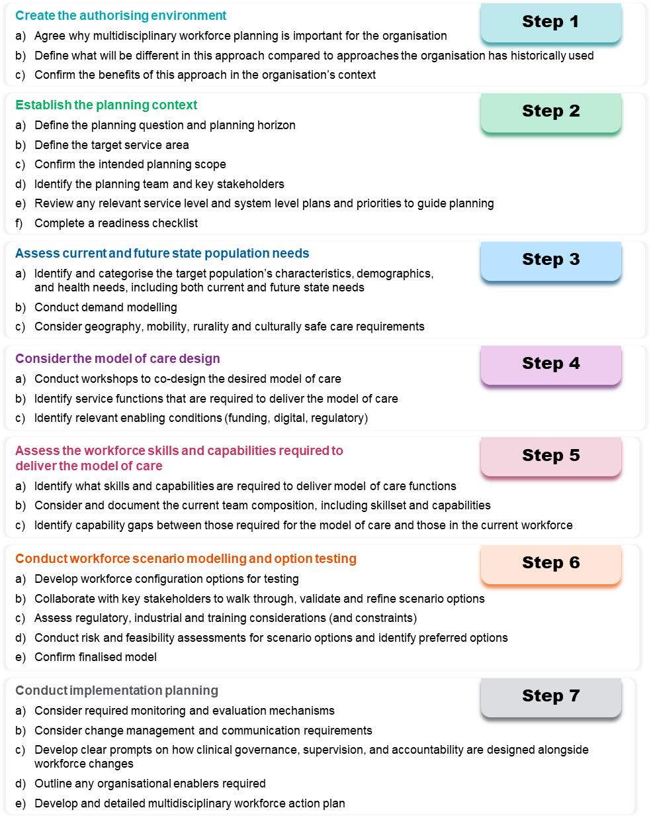


Step 1: Create the authorising environment
Securing support and buy-in from organisational leaders and senior clinicians is essential to facilitate successful multidisciplinary workforce planning.
This stage establishes the authorising environment to approach planning in a different way and builds support across the organisation. Authorisation should also include clarity on the boundaries of the workforce planning exercise, including funding, regulatory and service constraints and a shared understanding that workforce planning outputs will inform, but not override, broader system, funding and policy decisions.
To secure authorisation to commence planning the following steps should be taken:
- Determine whether a multidisciplinary approach is required: Assess whether a multidisciplinary workforce planning approach is necessary to achieve the intended service and care outcomes. Where it is required, continue with this guide. Where it is not, refer to existing workforce planning tools in place across the organisation.
- Identify decision makers: Identify the key decision makers within the organisation who have the authority to approve new workforce planning approaches.
- Build a compelling case: Clearly articulate the value of multidisciplinary workforce planning by addressing the following:
- Why this approach is important
- How it differs from standard workforce planning
- The planning situations / use cases where it is the optimal approach
- The benefits it delivers for the organisation, workforce and consumer outcomes.
- Prepare and present a proposal or discussion: Develop a tailored proposal or presentation for key stakeholders. Demonstrate how this approach supports the organisation’s goals, including flexibility, sustainability and improved care delivery.
- Secure buy-in: Identify executive sponsors and senior clinical leaders who will support each stage of the planning process and gain formal authorisation to proceed.
Below are key messages that can support the case for approval.
- Agree why multidisciplinary workforce planning is important for the organisation
Multidisciplinary workforce planning responds directly to the growing complexity of healthcare delivery and the need for integrated, team-based care to address diverse population health needs. Traditional workforce planning approaches that focus on profession specific or FTE replacement may be insufficient to meet evolving demands. This approach allows for flexible, responsive and sustainable workforce solutions that align with consumer care pathways, population health objectives and integrated models of care, while continuing to operate within constrained funding environments.
- Define what will be different in this approach compared to approaches the organisation has historically used
This approach marks a clear departure from traditional workforce planning methods by:
- Shifting from FTE replacement to needs-based planning
- Focusing on capabilities and skill mix in addition to the standard consideration of job titles, professions and headcounts
- Designing for integrated team configurations drawing on multiple professions to maximise efficiency and safety
- Leveraging technology, digital tools and automation to enable new workforce configurations, support role redesign and reduce avoidable administrative burden
- Embedding culturally safe and place-based care considerations within planning processes to address disparities and respond to community needs
- Prioritising long term strategic planning over short term reactive responses.
- Confirm the benefits of this approach in the organisation’s context
Multidisciplinary workforce planning offers: ;;;
- Improved consumer outcomes and experience through multidisciplinary team-based care
- Better alignment with population health needs addressing critical gaps in service delivery
- Greater workforce flexibility, attraction, retention and sustainability, enabling staff to work to their full scope of practice
- Enhanced equity of care provision particularly for rural and remote populations
- Culturally safe care for Aboriginal and Torres Strait Islander individuals, families and communities
- Organisational efficiencies including better task distribution, reduced duplication and new opportunities for automation and innovation.

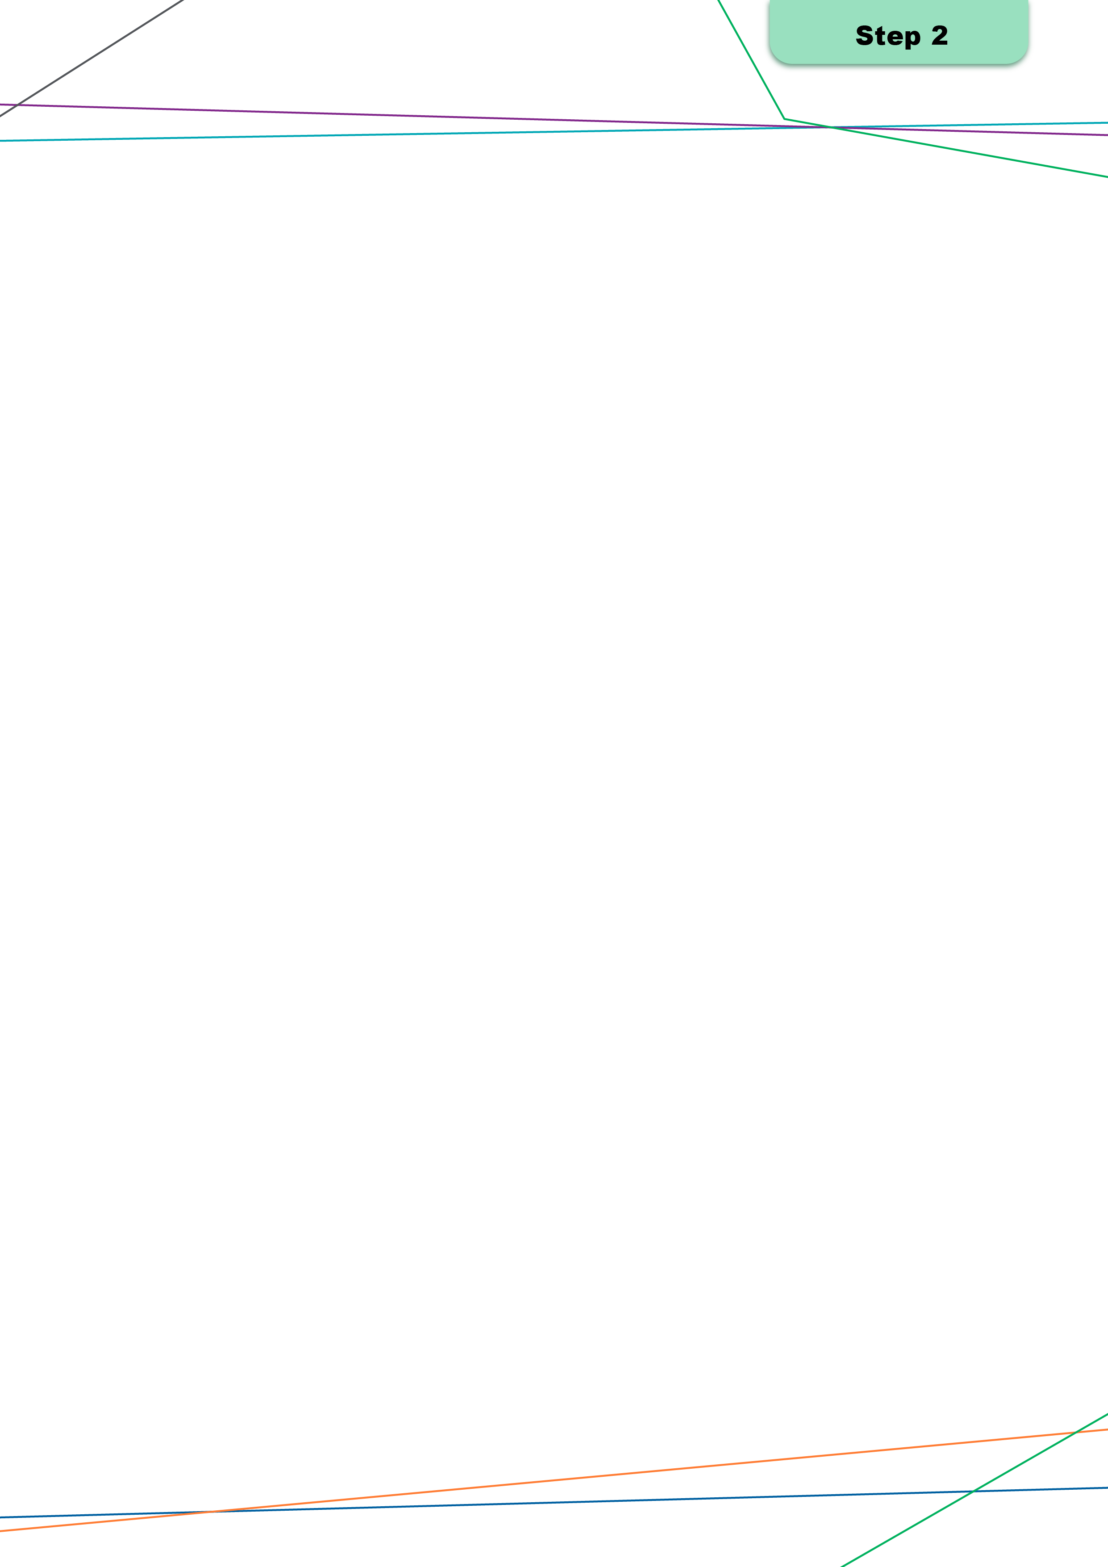
Step 2: Establish the planning context
Establishing the context involves defining the project’s purpose, scope and stakeholders. It ensures that workforce planning efforts are informed by the broader system’s goals and tailored to meet the health needs of the target population. This stage lays the groundwork for successful multidisciplinary workforce planning.

Key activities

2a) Define the planning question and planning horizon
 | Objective  Define the core question the workforce planning seeks to answer and establish the timeframe (e.g., short, medium, long-term).
 | Key questions  - What is the problem or opportunity being addressed?  - Why is multidisciplinary workforce planning needed?  - What timeframe is relevant to this situation?  - How can we capture short, medium, and long-term horizons?  - What are the agreed goals for undertaking the specific planning exercise?  - What budget parameters is the organisation working within for the planning exercise?
 | Inputs  - Workforce planning team members  - Time and resources dedicated to planning  - Current workforce planning documents/strategies/approaches  - Service level and system level directives
 | Outputs  - Clearly articulated planning question  - Agreed planning horizon
Defining the planning question is a foundational step because it clarifies why the multidisciplinary workforce planning exercise is being undertaken and what decision the output is intended to support. This step should give the planning team a shared understanding of the issue or opportunity that must be addressed across the whole care team, not just within one profession. Establishing the planning horizon helps set expectations about the scale and depth of analysis required for multidisciplinary workforce planning. Short term horizons tend to focus on immediate pressures such as access, safety, or stabilisation of key workforce groups. Medium- and long-term horizons allow for more strategic considerations, including how models of care may evolve and what capabilities will be needed across the multidisciplinary team.

2b) Define the target service area
Objective
Identify the geographic parameters of the target service area and its requirements.
Key questions
- What suburbs/cities/regions are included within the target service area?
- What is the level of service demand from consumers within the target service area? To what extent is this demand currently being met?
- Are workforce shortages or factors impacting service capacity influencing how residents currently access care?
- How is the target service area and broader service landscape expected to evolve in the short, medium and long term?
Inputs
- Geographic data mapping the defined service area
- Population/demographic data
Outputs
- Defined service area map
Defining the target service area establishes the geographic boundaries within which multidisciplinary workforce planning will occur, and identification of other service providers across the broader service landscape, to support with scope clarification for more detailed analysis. The aim of this activity is to create a shared understanding of the population the multidisciplinary workforce will be expected to support and the services currently available. It also allows early identification of factors such as cross-boundary consumer flows, travel patterns and areas of high or low service access that may influence future workforce requirements. This scoping exercise should remain high level, with the main outcome being a defined service area map and a clear description of its core characteristics, which will support further detailed analysis in Step 3, ensuring the planning team has a consistent and accurate geographic frame to support the assessment of population health needs, service demand and multidisciplinary workforce implications.
Appendix B provides a template/checklist with a range of prompts to support this activity.

2c) Confirm the intended planning scope
Objective
Confirm the output of the relevant planning activity.
Key questions
- What is the scope of the activity planning is intended for? E.g., a new facility, service re-design, community-led design
- Are there any constraints/factors to consider when planning commences? (e.g., funding)
- Are there any barriers or opportunities that have been identified which will impact this activity?
- What are the key objectives, activities, and outputs associated with this activity?
Outputs
- Confirmation of scope and parameters underpinning the planning activity
 When confirming the intended planning scope, workforce planners may already have a particular model they are working with and/or from. In this case, workforce planners should align the scope around these requirements.
Confirming the intended planning scope establishes a shared understanding of the purpose of the multidisciplinary workforce planning activity and the boundaries within which planning will proceed. This step focuses on clarifying what the planning effort is meant to address and the outputs it should generate, while identifying any constraints or conditions that may shape the work. Doing this early prevents scope drift and aims to ensure the multidisciplinary workforce planning process remains targeted, feasible and aligned with local priorities.
Workforce planners may consider:
- Why is this planning activity being undertaken?
Examples include a new facility or organisation, expansion of an existing organisation, redesign to support integrated care, community-identified needs, or recognised service gaps.
- What outcome is required?
Examples include a defined workforce requirement, a revised model of care, identification of workforce risks, or options for multidisciplinary team configuration.
- What factors could shape or limit the approach?
Examples include funding and budget considerations, regulatory constraints, infrastructure timing, data quality issues, community expectations, or system-wide constraints.
- What opportunities could influence the scope?
Examples include emerging roles, skill-mix innovation, partnership models, virtual and AI-enabled care options, or improved integration across professions.

2d) Identify the planning team and the key stakeholders
Objective
- Identify the stakeholders who are important to be involved in the planning team, and the stakeholders who should be engaged.
Key questions
- Who should be involved in the planning team? Consider:
  - Workforce planners
  - Clinicians
  - Organisational leadership and governance, and
- Which stakeholders should be engaged outside the defined team? Consider:
  - Community representatives (including consumers)
  - First Nations representatives
  - Other key stakeholders (e.g., key staffing groups involved in implementation, other service providers)
- Who should lead the planning team?
- What responsibilities will team members have and how will these be allocated across team members?
- How often will the planning team engage with stakeholders outside the defined team?
- What skills and expertise do each team member hold? Are there any gaps?
Outputs
- Planning document outlining the team structure, key stakeholders, and ways of working

Identifying the project or planning team aims to ensure the right people are involved from the outset and that the multidisciplinary workforce planning activity is grounded in appropriate clinical governance. The planning team should bring together operational, strategic, clinical and community perspectives to inform the multidisciplinary workforce planning approach. Because multidisciplinary workforce planning directly influences quality, safety and service outcomes, workforce planners should deliberately include the voices, expertise and decision-making authority from across different groups to design safe, feasible and team-based workforce options.
Appendix B outlines a stakeholder engagement plan for workforce planners to use and build out the key stakeholder roles and expectations.
When establishing the planning context, workforce planners should also consider change management processes to support the planning activity. This may include identifying staff groups to engage with and allocating organisational and clinical leaders responsibilities as champions of change.

2e) Review any relevant service level and system level plans and priorities to guide planning
Objective
- Understand the service and system level objectives and priorities and incorporate them into the planning approach.
Key questions

- How do these objectives and priorities align with our project?
- How do they differ?
- Is there opportunity to better integrate these into our project?
- What resources/sources of data are available to support this?
 | Inputs  - Existing organisation plans and strategic documents  - Local area/state/national health plans  - Policy directives and/or reform agendas  - Service level and system level performance targets  - Funding directives
Outputs
- Aligned priorities and objectives across service and system level planning
Reviewing service level and system level plans aims to ensure that the multidisciplinary workforce planning activity is aligned with broader strategic directions, policy settings and priority areas across the organisation, jurisdiction and national environment. Workforce planners should identify the key documents that influence their context, such as organisational strategies, service plans, jurisdictional workforce or health system plans, national workforce reforms and policy directives to identify where objectives converge and diverge. Reviewing these documents during this initial planning stage helps to clarify expectations, identify any dependencies and resource assumptions that may be relevant, and ensure that the multidisciplinary workforce planning activity is not undertaken in isolation.

2f) Complete a readiness checklist
Objective
- Determine the organisation’s readiness to undertake strategic workforce planning.
Key questions
- Have you discussed planning with the organisation’s leadership group? Are they aware of the time and effort commitments? Are they prepared to build support across the organisation?
- Do you understand how the objectives align with priorities in the organisation’s existing plans and strategies?
- Do you have an existing multidisciplinary workforce planning approach and does it need review?
- Are the organisation’s Divisional Operational and Business Plans up to date? Have you identified the key stakeholders, planning team, and leadership champions of change, and their roles and responsibilities?
- Do you regularly leverage current workforce data available through the relevant jurisdiction’s health department?
- Do you have processes in place to collect workforce information such as current skills, capabilities and qualifications?
- Are you ready to assess the organisation’s current and future workforce needs through an open and honest standpoint?
- Do you have current key workforce risks (operational or cultural)? What are they?
Outputs
- Checklist assessing readiness
- A detailed project plan, including a project chart/timeline breaking down the project’s scope across identified time periods.
Completing a readiness checklist helps confirm that the organisation is prepared to begin multidisciplinary workforce planning. A simple readiness check early on reduces the risk of delays and ensures the activity begins with the right foundations in place.
Appendix B provides a detailed readiness checklist which has been developed as a tool for workforce planners to use, to confirm all key inputs and outputs across the activities in Step 2 (this step) have been considered. Appendix B also provides a multidisciplinary workforce planning key data table for workforce planners to refer to.
Recognising that data maturity varies across services and professions, particularly around needs-based information, the key data table in Appendix B is intended to guide workforce planners to appropriate data sources and stewards. Workforce planners can also make note of which sources they are aware of that are not already listed and which may be of use to others.
The outputs generated across Step 2 provide the foundation for developing a project plan and an engagement plan. These plans should bring together the agreed scope, the identified planning team, expected deliverables and the indicative sequence of activities to support effective multidisciplinary workforce planning. The project plan should also consider any change management activities that should commence at this stage to support effective transition. A simple project chart or timeline helps clarify when key tasks occur, who is responsible and how engagement with stakeholders will be structured.


Step 3: Assess current and future state population needs
An agreed description of the target population, their key health needs and drivers of demand, including how these needs are expected to change over time. This step provides the foundation for subsequent workforce capability assessments, scenario testing and implementation planning.
 This step does not require sophisticated modelling or complete datasets in all cases. The level of depth applied should be proportionate to the planning purpose, data availability and decision timeframe.

Key activities

3a) Identify and categorise the target population’s characteristics, demographics, and health needs, including both current and future state needs.
 | Objective  To describe who the organisation is planning for and the key health needs that drive demand for care, including both current and anticipated future needs.
 | Key questions  - Who comprises the target population for this organisation or organisation network?  - What are the key demographic characteristics (e.g. age profile, population growth or decline)?  - What are the predominant health needs, including chronic conditions or complex care needs?  - Are there specific population groups with distinct needs (e.g. First Nations peoples, culturally and linguistically diverse communities, rural or remote populations)?  - Have these specific population groups been engaged to identify and address their distinct needs?  - How are population needs expected to change over the planning horizon?
 | Inputs  Rather than prescribing datasets, this guide encourages workforce planners to draw on multiple levels of information as appropriate.  - National level data  - State/Territory level data  - Local level data
 | Outputs  - Clear description of the target population(s)  - Summary of key health needs and demand drivers  - Agreed assumptions about future population change

 Practice insight
Local qualitative knowledge (e.g. clinician experience, community feedback) is often essential to interpret quantitative data and identify unmet or emerging needs that are not visible in administrative datasets.
This activity aims to develop a concise, decision‑focused profile of the population within the defined service area. The aim is to describe who the organisation exists to support and the key health needs that drive demand, not to produce a comprehensive epidemiological report.
Where possible use a small number of high value indicators rather than a long list of metrics that offer low benefit for decision-making. Document any known limitations (e.g. lagged data, incomplete coverage).
Workforce planners should start with the service area boundaries established in Step 2 and describe the population in terms of scale, structure and complexity. This includes population size and growth trends, age profile and the presence of priority cohorts with distinct needs, such as Aboriginal and Torres Strait Islander communities, people with disability or populations experiencing higher levels of chronic or multimorbid conditions.
The output of this activity should be:
- A clear description of the target population(s)
- The key health needs and demand drivers
- Agreed assumptions about how these needs may change over the planning horizon.

Considering the right data sources
Key data sources that workforce planners may draw on to support this step include:
- Local population profiles and projections
- Burden of disease and local health status metrics
- Service utilisation patterns
- Social determinants and community characteristics
- Rurality, geographic distribution, cultural safety needs (e.g., First Nations health needs).
See Appendix C for a population and needs description worksheet.

3b) Conduct demand modelling
Objective
- To develop an indicative view of current and future service demand that is sufficient to inform workforce planning decisions.
Key questions
- What services or activities are most relevant to the planning question?
- What are the main drivers of demand (e.g. population growth, ageing, disease prevalence, service redesign, model of care redesign)?
- What assumptions are being made about future service use?
- Where are there known uncertainties or data gaps?
- Are there any funding or budget constraints to factor into modelling?
Inputs
- Service activity data
- Population projections
- Burden of disease or prevalence estimates
- Policy or service reform assumptions
Outputs
- Indicative estimates of current and future demand
- Documented assumptions and limitations
Demand modelling in this guide is about developing an indicative view of service demand that can be used to inform the next steps, not producing a perfect forecast.
This activity develops an indicative view of current and future service demand that is sufficient to inform workforce planning decisions. Its purpose is not to create a precise forecast, but to make the relationship between population need and service demand explicit and transparent.
Workforce planners should focus first on the services, activities or care pathways that are most relevant to the planning question. Using readily available information establish a baseline view of demand. This baseline can then be adjusted using evidence‑based assumptions about future change, for example population growth, ageing, disease prevalence or planned service redesign. To inform these assumptions, workforce planners may undertake a literature and policy scan to identify relevant demand drivers, emerging trends or planned reforms likely to influence service demand over the planning horizon.
Where data quality is limited, or where workforce planning is responding to new models of care where there is no prior data available, scenario‑based thinking may be more appropriate than detailed quantitative modelling. In these cases, workforce planners should test a small number of plausible demand futures rather than defaulting to a single estimate. All assumptions should be clearly documented.
Then, translate the demand view into documented assumptions and a simple set out outputs:
- Current demand (baseline)
- Projected demand over the planning horizon
- The key uncertainties and data gaps.
See Appendix C for a detailed modelling worksheet and guide.

3c) Consider geography, mobility, rurality and culturally safe care requirements.
Objective
To ensure that population need is understood in its geographic, cultural and access context, rather than treated as a purely numerical exercise.
Key questions
- How does geography affect access to care (e.g. travel time, service distribution, extreme weather)?
- What proportion of the population accesses care locally versus outside the service area? What proportion access care from other organisations within the service area or via Telehealth services?
- Are there rural, remote or highly mobile populations that require different service approaches?
- What culturally safe care requirements must be considered, particularly for Aboriginal and Torres Strait Islander peoples?
- How might these factors affect demand, service design and workforce configuration?
Inputs
- Geographic mapping of population and services
- Consumer flow and referral data
- Community and stakeholder input
- Cultural governance or engagement frameworks
Outputs
- Understanding of geographic and access-related demand drivers
- Identification of culturally safe care considerations
- Implications for later model of care and workforce design steps
This activity aims to ensure the needs assessment reflects place and access realities, rather than relying solely on quantitative indicators without consideration of access, geography, cultural safety and organisation context.
Start by identifying the geographic and access factors that shape how people use services (travel times, service distribution, consumer flows across boundaries) and the extent to which residents access care locally versus elsewhere. For rural or remote or highly mobile populations, consider how distance, limited service availability and other workforce/organisation constraints may change both the level and the form of demand (e.g. higher reliance on outreach, networked services or virtual models). This step should result in a clear narrative on how geography and mobility are likely to affect demand patterns and service requirements over time.
Care should explicitly meet culturally safe and appropriate service delivery requirements. This includes working with local cultural governance frameworks and seeking input from the community to identify needs, even if some are not captured in formal datasets. Use available engagement insights, local knowledge and existing cultural governance frameworks to identify implications for access, service pathways and how care should be delivered to be safe and acceptable.
The output should be a short set of access and context implications for demand, service design and workforce configuration including:
- Geographic constraints/opportunities
- Consumer flow considerations
- Culturally safe care considerations
- Any design implications (e.g., outreach, transport, interpreter access, culturally safe entry points).

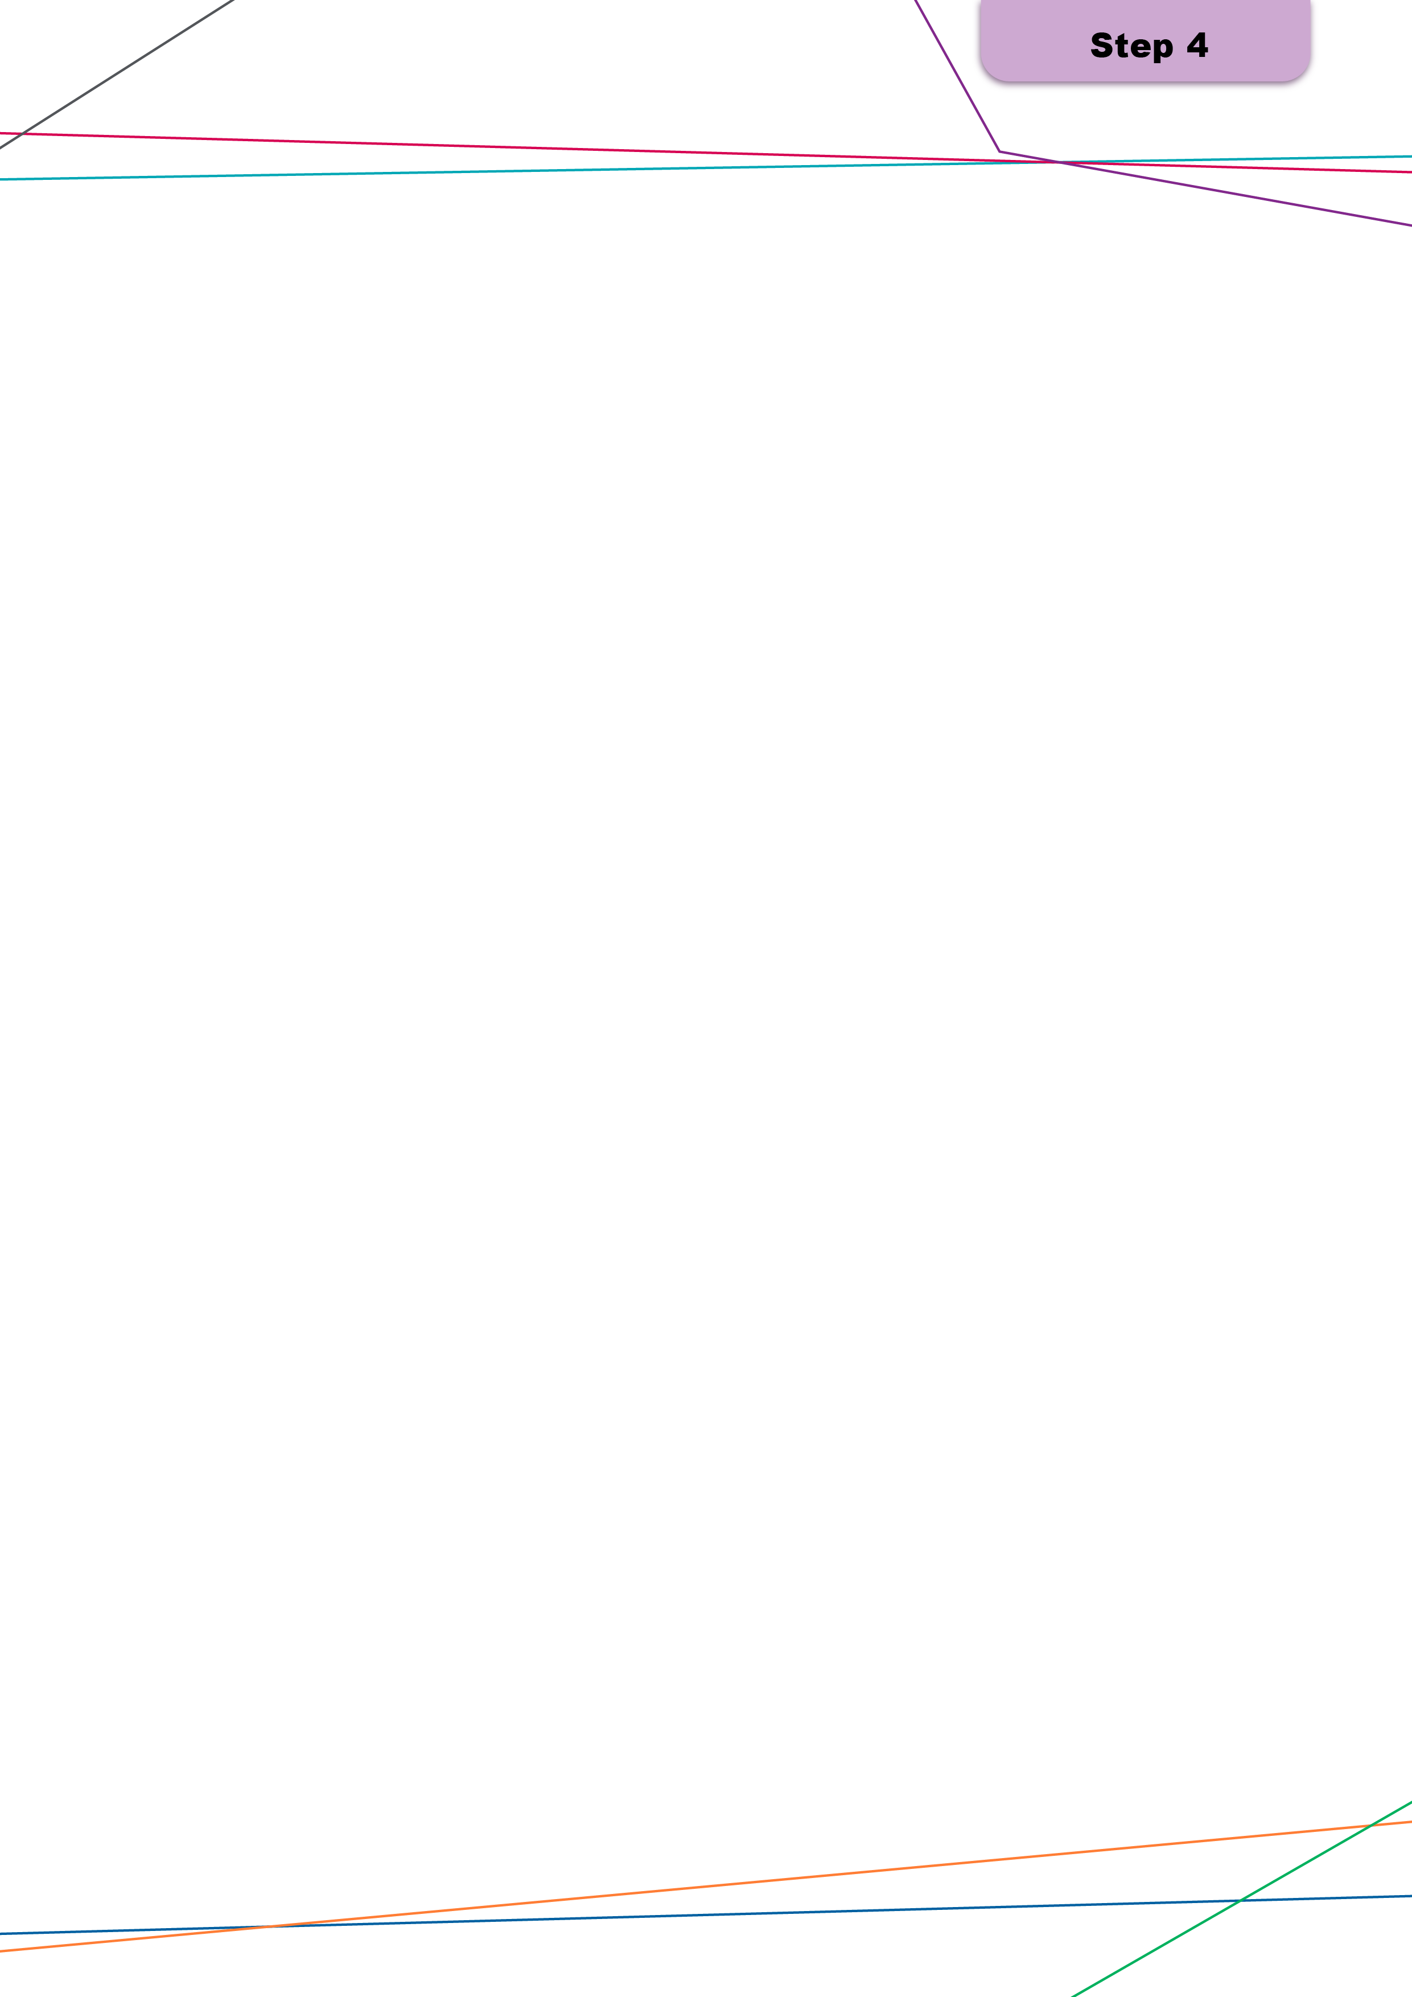
Step 4: Consider the model of care design
Effective planning requires careful consideration of the model of care that the multidisciplinary team will deliver. This involves adopting a structured and co-designed approach to determine service requirements and goals, which then informs multidisciplinary workforce planning.
 When completing this step, workforce planners should identify whether a new model of care is being created, or whether an existing one is being refreshed or reviewed. This will inform the extent to which some activities are completed or can be modified to suit a refreshed approach.

Key activities

4a) Conduct workshops to co-design the desired model of care
 | Objective  Develop a co-designed model of care through collaboration with different stakeholder groups. Account for context-specific factors into the model of care design, considering rural and remote communities, First Nations consumers, and the delivery of digital and virtual care.
 | Key questions  - Which stakeholders should be involved? Consider internal and external stakeholders.  - Is there an existing model, or is this model of care new? Consider what workforce enablement may be required (e.g. upskilling, retraining, digital enablement).  - If there’s an existing model, are there areas of duplication or gaps that need to be addressed? Consider the maturity of the existing model of care, including any implementation or workforce risks  - What services need to be delivered to meet the needs of the population as identified in Steps 2 and 3?  - How should care be experienced and delivered? Consider care pathways.  - To what extent should innovative modes of service delivery, such as virtual care and care in the home, feature in the desired model?  - How can culturally safe practices be built into in the model of care?  - Are there any context-specific factors that should be considered?
 | Inputs  - Existing model documentation  - Feedback/complaints received prior to the session  - Need, demand and activity data  - Insights from relevant community groups and representatives within the defined service area (e.g., consumers in remote communities, ACCHO representatives)  - Examples of culturally safe models of care and better practice frameworks  - Shared governance guidelines  - Digital and virtual care frameworks  - Research findings and knowledge of emerging innovative practices
 | Outputs  - A documented model of care that is tailored to context-specific needs and incorporates culturally and clinically safe care requirements  - Understanding of the nature and scope of care provided within the model that can support decisions about workforce skills, roles and team composition  - Implementation considerations for the delivery of digital, virtual, and remote care  - Understanding of organisations and stakeholders involved in delivering the model of care
The model of care developed in this activity may be new or may be an updated version of an existing model. This will be specific to the organisation’s context and priorities. It is recommended that the model of care is co-designed with relevant internal and external stakeholders, as identified in Step 2. Consider engaging clinicians, organisational leadership and governance, First Nations representatives, community members, and other key stakeholders.
The process may include the following activities:
- Identification of overarching design principles to guide the development of the model of care
- Co-design workshops to holistically capture the voices of different stakeholder groups
- Individual consultations for in-depth exploration of complex clinical aspects or matters relating to culturally safe and appropriate care
- Consideration of what treatments, supports and interventions are required to support the population need
- Understanding of the complexity of population needs and how this can vary
- Development of a proposed model of care
- Validation and testing of the model of care.
During the co-design process, workforce planners should work with stakeholders to consider how context-specific factors may influence the model of care and the services it provides. These factors will look different for each organisation and population being served. Workforce planners should consider insights from localised population and service provision data, community representatives, consumers, and clinicians, to support their understanding of the specific factors shaping the care model. The co-design process also enables workforce planners and stakeholders to consider innovation and shared governance opportunities in the model of care design, for example, virtual and digital care, care at home, and shared governance settings with other organisations that may be involved in delivering the model of care.
A framework for approaching model of care design is available in Appendix D.
Workforce planners should ensure there is proportional representation of participants in the co-design sessions, reflective of the stakeholders identified in Step 2. Workforce planners should pay particular attention to the proportion of different types of clinicians involved, to promote a balanced approach to co-design.

4b) Identify service functions that are required to deliver the model of care
Objective
- Identify the functional components of the desired model of care.
Key questions
- Which functions are required to deliver the desired model of care?
- Which functions already exist within the organisation?
- Are there any new or emerging functions requiring additional support?
Inputs
- Examples of successful multidisciplinary teams already in place at the service level
Outputs
- A defined list of functions required to deliver the model of care
Once the model of care has been finalised, workforce planners should further detail the functions needed to deliver the model. The following activities may assist in rigorously documenting all functions:
- Map the care journey from start to finish:
- At each stage of the journey, consider what functions are required, who is involved (including other organisations and professions beyond the immediate organisation), key points of transition, and the location/s where multidisciplinary care is being delivered.
- Draw on modelling completed in Step 3 to identify the core functions essential for care delivery, aligned with population need:
- Consider factors such as referrals and intake processes, assessment activities, care planning and coordination, interventions and treatments, self-management activities, and monitoring and escalation protocols.
- Test the core functions against the model of care’s key design principles or objectives:
- Assess whether each function is necessary and effective in delivering the model of care. Consider whether each function is performed reliably in the current model of care, and whether there is any duplication with other functions.
- Refine and validate the functions with stakeholders:
- Test the identified functions with stakeholders identified in Step 2 to help ensure the functions are accurate and practical.
Templates for identifying the different service functions can be found in Appendix D.

4c) Identify relevant enabling conditions (funding, digital, regulatory)
Objective
- Identify the key enablers that will underpin and facilitate implementation of the desired model of care.
Key questions
- What are the key drivers at an organisational level supporting the model?
- What are the key barriers to the model’s success?
- What are the changes that will be implemented with this model and how are you engaging with impacted stakeholders to ensure success?
- How does the existing funding model influence the model?
- How will digital systems and data be used in the model?
- What is the regulatory environment the model will operate in?
Inputs
- Existing funding model requirements and structure
- Digital and data system documentation
- System level regulatory directives
- Assessment of service level governance structures and leadership in driving multidisciplinary workforce planning
Outputs
- Understanding of how objectives and key enablers interact over different time horizons
- Framework mapping key enablers
Once the functions within the model of care are confirmed, workforce planners should work closely with health professionals across the organisation, as well as organisational leadership, to identify the enablers that are required to support the model of care. Key enablers may include governance and leadership, workforce combinations, community considerations, technology and digital systems, education and training, cultural considerations, financial and performance factors. Each factor should be considered alongside a broader change management process to support buy-in for and reduce opposition to implementation of a new model. These enablers can be mapped against a set of criteria (for example, the level of effort required to implement them, their impact on multidisciplinary care delivery, and their relevance and applicability to the service context). By mapping the key enablers, it helps workforce planners to better understand what factors influence the successful delivery of the multidisciplinary model of care and its associated functions.
A framework for identifying and mapping key enablers and constraints in multidisciplinary workforce planning is available in Appendix D.
 Challenge prompts
- What factors within the organisation’s span of control are inhibiting or enabling multidisciplinary workforce planning? Consider organisational culture, leadership and governance, training and development opportunities, technology systems, and existing policies and processes amongst other factors.
- What small changes can be made in the organisation at a service level to build support and buy-in for the desired model of care?

Step 5: Assess the workforce skills and capabilities required to deliver the model of care
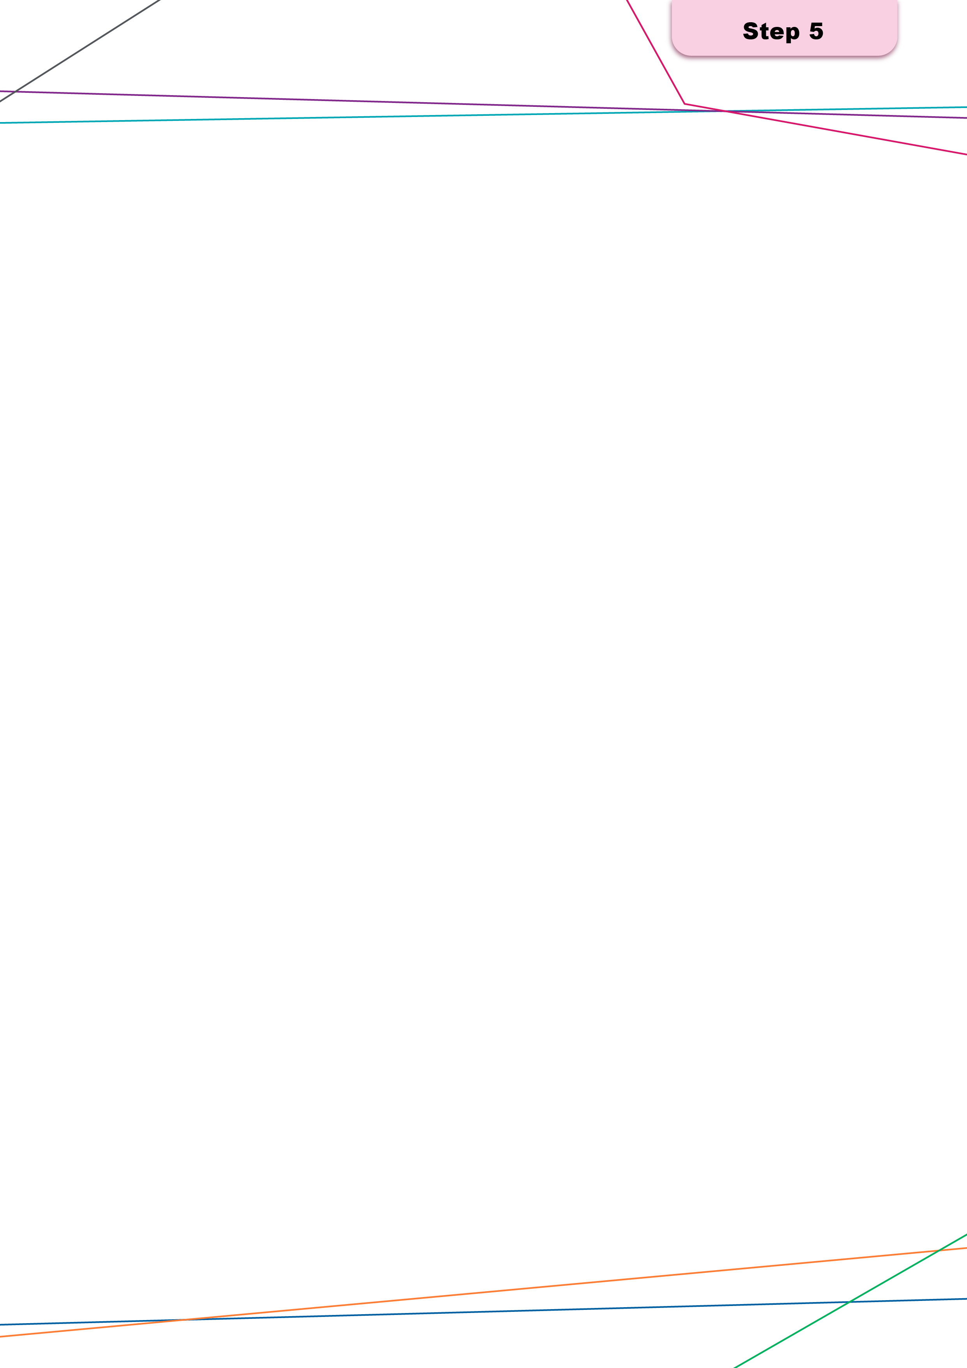
A documented current‑state workforce profile and a clear articulation of gaps and future workforce capability needs to inform workforce scenario modelling.

Key activities

5a) Identify what skills and capabilities are required to deliver model of care functions
 | Objective  To translate the service functions identified in Step 4 into a clear set of skills and capabilities required to deliver the model of care safely and effectively. This will inform mapping these skills and capabilities to professions or workforce groups and initiate the development of the skills and capability matrix.
 | Key questions  - What skills and capabilities are required for each identified function?  - What skills and capabilities are core, specialised or enabling?  - Which capabilities are required consistently versus those at specific points in the care pathway?
 | Inputs  - Desired model of care  - Defined service functions  - Clinical and workforce stakeholder input  - Relevant capability, competency or scope of practice frameworks  - Local governance, safety and cultural requirements
 | Outputs  - A defined list of required skills and capabilities aligned to service functions  - Clear description of capability requirements  - An agreed skill and capability set to form one axis of the skills and capability matrix
This activity builds directly on Step 4b, where service functions required to deliver the model of care were identified. The aim is to translate those functions into skills and capabilities required of the workforce without pre-empting which professions or roles will deliver them.
Start by listing the functions as defined in the model of care. Conduct a workshop with relevant stakeholders to determine the skills and capabilities required to deliver the model of care. For each function, ask the group to identify what the workforce needs to be able to do to deliver the function safely and effectively. Workforce planners may find it helpful to separate cohorts into high, medium, and low care complexity levels to better understand drivers of demand for different skills and capabilities across functions.
The focus should remain on identifying what skills and capabilities are required to undertake each function, rather than assigning these to professions or roles. While professional capability frameworks and existing scope of practice guidance for individual professions can be used as reference materials to sense check requirements, they should not be used to assign capabilities to specific roles at this stage. The intent is to clearly articulate what needs to be delivered not who delivers it.
The output of this activity is Matrix A, a clear, agreed list of required skills and capabilities aligned to service functions. Matrix A, along with suggested prompts to support translation of service functions into skills and capabilities, is provided in Appendix E.

5b) Consider and document the current team composition, including skillset and capabilities
Objective
To document the current workforce composition and map the skills and capabilities available within the team against the skills and capability requirements identified in Step 5a. This step will also assess whether the workforce is currently being enabled to work at full scope of practice and capability.
Key questions
- What is the workforce demographic?
- What roles and workforce groups currently comprise the team?
- How is the current workforce configured?
- What skills and capabilities do the current workforce have?
- How is the workforce distributed geographically?
- What type of health professionals are (and are not) available in the area?
Inputs
- Skills and capability requirements
- Desired model of care
- Workforce profile (roles, headcount/FTE, employment type, vacancy rates)
- Workforce movement indicators (turnover, retirements where known)
- Local context information
- Known policy, industrial and regulatory constraints (where relevant locally)
- Role descriptions, scope‑of‑practice arrangements and local protocols
Outputs
- Documented current team composition
- A populated current state skills and capability matrix
It is important to recognise that individuals holding a similar role may have differing capabilities based on specific credentials, qualifications or additional training (e.g. specialist certification) and these should be taken into account during the mapping process.
This activity focuses on understanding what the existing workforce is currently able to deliver, in alignment with the capability requirements identified in Step 5a.
Begin by mapping the current workforce composition. Identify all roles in the team, their headcount, location, employment types and their FTE. Using the capability requirements defined in Step 5a, map which roles or workforce groups are currently able to deliver each requirement, including where multiple professions or groups have the skills and capabilities to deliver a function. This forms the second axis of the skills and capability matrix.
This mapping should be informed by:
- Workforce profile data (headcount, FTE, vacancies, skill sets)
- Rosters and workload data
- Organisational service plans, business plans, operational priorities and any other documents outlining the capabilities and services each profession is able to deliver
- Clinical governance information, scope-of-practice arrangements and role delineation.
Where formal workforce capability data does not exist or is incomplete, planners may use rapid capability audit methods as interim inputs. These may include structured self‑report surveys, credential and training record reviews, or facilitated capability‑mapping workshops with clinicians and workforce leads.
Engaging directly with key stakeholders, such as clinicians, organisation leaders and workforce planners, through structured workshops can strengthen the process and ensure the matrix provides an accurate reflection of real-world practice.
Alongside capability mapping, workforce planners should examine workforce supply and sustainability factors that affect the current team, such as:
- Age profile and retirement patterns
- Turnover and recruitment trends
- Local workforce availability and pipeline issues
- Consider external system pressures (industrial arrangements, training capacity, funding settings).
Incorporating and analysing these factors helps to identify the root causes of workforce constraints, assess whether the current workforce is working to the top of their scope and provides important context for planning future capability development requirements.
Constraints to top of scope practice are not always regulatory and industrial, many are locally defined through historical practice, credentialing or workflow and should be explicitly tested rather than assumed. Where planners may encounter uncertainty or disagreement when assessing capability or constraints, the prompts in Appendix E can be used to support discussion.
The output of Step 5b is a comprehensive and validated skills and capability matrix (Matrix B), showing how existing roles and workforce groups align with the capability requirements of the model of care.
A skills and capability matrix template can be found in Appendix E.

5c) Identify capability gaps between those required for the model of care and those in the current workforce
Objective
- Compare the capability requirements with the current capability baseline to identify gaps, constraints, over‑reliance risks and capabilities that are present but not fully utilised due to scope, supervision, workflow or organisational limitations.
Key questions
- Which required capabilities are fully available today and which are missing or limited?
- Are gaps driven by workforce supply, skill mix, workflow design, supervision or enabling constraints?
- Where are staff not operating to their full scope of practice and what factors are limiting this?
- Which gaps create the highest risk to quality, safety or access?
- Can capabilities or tasks be distributed across the team to mitigate gaps?
- What types of role design, re-design or task redistribution options are feasible in the local context?
- What supervision, training or credentialing is required to support proposed changes?
- Could any identified gaps be addressed through digital tools, automation or AI enabled supports rather than additional workforce?
Inputs
- Desired model of care
- Skills and capability matrix
- Stakeholder validation
Outputs
- Gap register (capability gaps, supply gaps, configuration gaps)
- Prioritised gaps to test in Step 6 scenarios
- A set of feasible solutions for role design, redistribution or workforce reconfiguration.
- Early considerations for implementation readiness
This activity produces a clear gap register outlining shortfalls in the current workforce composition, capability and multidisciplinary team configuration. It also identifies the factors contributing to these gaps and formulates actionable solutions to address them.
Start by using the outputs from prior steps to identify current gaps. These may include missing roles, inadequate skill distribution, underrepresentation in geographically isolated communities or missing coordination roles within multidisciplinary teams.
Link critical gaps with outcomes such as restricted access, care duplication, interruption of care continuity or diminished workforce sustainability. Document the root causes of these gaps, whether linked to scope limitations, workforce shortages or organisational inefficiencies.
Once gaps are identified and prioritised, explore practical solutions to mitigate them by considering new ways to configure the workforce. Look for opportunities to:
- Enable current roles to function at their full authorised scope of practice through training, credentialing or supervision enhancements.
- Redistribute tasks across the team by leveraging overlapping capabilities or skills to address bottlenecks or underutilised capacities.
- Streamline workflows and enhance team efficiency with tools such as automation or digital solutions.
- Address workforce shortages through targeted strategies such as recruitment drives for underrepresented roles.
Before assuming that additional workforce is required, consider whether identified gaps could be partially addressed through digital tools and automation. This may include enabling administrative or coordination activities (such as referral drafting, documentation, information collation) through digital support, allowing clinical time to be redirected to care delivery.
Also consider whether limitations relate to technology or data integration (e.g. fragmented systems, manual workarounds, lack of shared records) and note these as enablers or dependencies for later implementation planning.
Document the enabling conditions (e.g., required training, supervision, credentialing, or funding adjustments) that may be required to address the key gaps. Additionally capture relevant constraints such industrial agreements and regulatory constraints that may affect implementation.
Appendix E provides a gap register template.
 Challenge prompts
Is this function performed this way because its clinically necessary or because it is historical custom?
Could this function be enabled within existing scope (with the right supervision, credentialing, workflow or tools)?
Could this function be redistributed safely to another role that already has overlapping capability?
Could this function be streamlined or supported through digital, automated or AI enabled tools, freeing clinical time? If so, which components of this function could be supported by digital enablement or automation?
Is this function a bottleneck? What is the smallest change that would relieve it without increasing clinical risk?


Step 6: Conduct workforce scenario modelling and option testing
Workforce scenario modelling, option testing, and validation brings together the analyses and activities completed in Steps 1 – 5 to produce clearly defined and agreed models. This supports multidisciplinary workforce planners to understand how the models operate in practice.
 The activities in this step are ongoing and dynamic and workforce planners should complete these activities regularly, as workforce planning contexts evolve. Workforce planners should consider completing these activities as policy directives, new data, and service models emerge.

Key activities

6a) Develop workforce configuration options for testing
 | Objective  Generate a set of plausible, needs‑based multidisciplinary workforce configurations that bring together the skills and capabilities required to deliver the model of care. These options may not be limited to utilising existing staff – the scenario testing conducted through this step will examine the relative benefits and challenges of each option. Develop criteria against which to assess each option.
 | Key questions  - What are the different multidisciplinary workforce configurations that could deliver the model of care?  - How could tasks be taken up more fully by existing roles, reallocated across the team, or supported through technology or automation to address the gaps identified in Step 5?  - What are the interdependencies across roles (for example supervision, clinical governance, cultural safety, and skill mix)?  - What assumptions must be made explicit (for example productivity expectations, technology availability, supervision capacity, regulatory considerations, requirement for recruitment activity)?  - Could this function be more appropriately delivered in another setting and/or by another organisation?  - What configurations are likely to be affordable within expected funding?  - If demand exceeds resources, what trade-offs are required?
 | Inputs  - Finalised model of care  - Data and information on population needs, demand drivers and access considerations  - Insights on local service context, cultural safety requirements and enabling conditions (for example funding, digital, regulatory)  - Skills/capability matrix, workforce supply baseline and gap register  - Future capability requirements and workforce “hypotheses”
 | Outputs  - A small set of plausible multidisciplinary workforce configuration options for further testing, as well as a high-level description of the impact of each scenario (e.g., on infrastructure, technology, care delivery setting considerations)  - Documentation of assumptions underpinning each scenario  - A set of assessment criteria to inform analysis of options in later activities
Create a set of workforce configuration options that reflect the full set of inputs produced in Steps 3, 4 and 5. The purpose is not to identify a single ‘best’ model, but to generate several feasible options that show different ways of addressing the identified workforce gaps within the agreed model of care and context.
Workforce planners should start by combining the population needs and demand drivers (Step 3), the model of care pathway, service functions and capability requirements (Step 4) and the workforce capability baseline, gap register and future capability requirements (Step 5). From the ‘workforce hypotheses’ developed in Step 5, workforce configuration scenarios developed in this step should reflect practical configurations that also consider appropriate (and realistic) enablement for existing roles to practice to their full authorised scope, redistribution of tasks across the multidisciplinary team and supporting technologies that could streamline or automate workflows.
Each workforce configuration option should clearly state the assumptions applied, such as required enabling conditions (training, digital tools, supervision availability, funding, regulatory flexibility) and any known constraints (e.g. ability to recruit if required). It is important to recognise any interdependencies between roles, so that changes in one part of the team (for example increased use of a particular role) are reflected in the configuration of others.
Once the workforce configuration options have been identified, workforce planners should develop assessment criteria to apply in later activities. The criteria are designed to assess the relative benefits and challenges of each option. Suggested criteria are:
- Legislative and regulatory constraints
- Industrial arrangements and clinical governance requirements
- Training requirements
- Funding and costs
- Risk
- Implementation feasibility.
Conducting this assessment will help workforce planners to understand which option is most practical and suitable for their context, and where adjustments may need to be made.
The output of this activity is a small number of options that differ meaningfully in how care functions are allocated across the multidisciplinary team. Each configuration is carried forward into the later Step 6 activities, where they are ‘reality tested’ against the assessment criteria also developed in this activity.
Refer to Appendix F for an assessment matrix.
Consider how technology and AI tools can streamline collation of outputs from previous activities to support scenario modelling and workforce configuration option development.

6b) Collaborate with key stakeholders to walk through, validate and refine scenario options
Objective
- Gather insights from different stakeholder groups to ensure scenarios are reasonable and reflect practical configurations.
Key questions
- Do these scenarios reflect the reality of multidisciplinary teams?
- Are there any gaps or areas where the scenarios need to be amended?
- How can any obstacles be overcome?
Inputs
- Agreed scenario options containing multidisciplinary workforce configurations
- Stakeholders from across different groups
- User-testing materials
Outputs
- Feedback on proposed scenario options
- A set of refined scenario options
Collaboration with key stakeholders is critical to testing, validating and refining the multidisciplinary workforce planning configuration options identified in the previous activity. Engage with stakeholders identified in Step 2 to conduct option walkthroughs and validate and refine the options for further analysis. Workforce planners should engage stakeholders to gain insights on the practicality and feasibility of each multidisciplinary care team option. This testing can take the form of workshops, and is designed to identify what works well, as well as any barriers and constraints on the implementation of multidisciplinary models of care in practice. These workshops provide workforce planners the opportunity to gain feedback on the practicality of each model directly from end-users. Workforce planners should review the feedback received from stakeholders during these walkthroughs and reflect the feedback into a set of refined scenario options for further regulatory, risk and feasibility analysis.

6c) Assess regulatory, industrial and training considerations (and constraints)
Objective
- Identify regulatory, training and industrial factors influencing multidisciplinary workforce planning. Also identify clinical governance requirements and initial and ongoing education and training needs to support the workforce.
Key questions
- What regulatory frameworks, industrial agreements, and training requirements are applicable to each scenario? Do they impact the scenarios’ feasibility?
- Are there any scope of practice constraints impacting collaboration? Or vice versa, are there any poor collaboration efforts impeding full scope of practice functionality?
- What additional training is required for team members to effectively deliver care in each scenario? (Including training related to new roles, workflows, digital or technology‑enabled supports including the appropriate use of AI tools and associated governance or risk requirements, where relevant)
Inputs
- Regulatory frameworks in effect in the relevant jurisdiction and nationally
- Industrial and clinical governance arrangements for relevant health professionals
- Training records and requirements
Outputs
- Understanding of how regulatory, training and industrial and clinical governance considerations influence the scenarios
- Understanding of the key enablers and barriers influencing multidisciplinary workforce teams in the organisation’s context, including factors within and outside the organisation’s control
Workforce planners should understand the broader regulatory, industrial, and training landscapes, as well as key cost drivers influencing the different scenarios identified and assess each scenario against the criteria developed in activity 6a.
 Constraints to top of scope practice are not always regulatory or industrial. Many are locally defined through historical practice, credentialing or workflow design and should be explicitly tested rather than assumed.

Legislative and regulatory requirements
Collect and review national, state and peak/industrial body legislative and regulatory documents to identify standards relevant to each member of the multidisciplinary team in each scenario. This will support workforce planners to identify and understand how standards overlap or differ, as well as any restrictions or conditions on practice. Workforce planners should engage with formalised documents held by regulatory boards, industrial and peak body associations, and jurisdictional health departments to support their understanding of which activities different team members are permitted to deliver. Workforce planners can also refer to policies and position descriptions outlined by organisations to support their understanding of the regulations applicable in their context.

Industrial agreements and clinical governance requirements
Review the clinical governance requirements and industrial instruments relevant to the different professions within the multidisciplinary team, where applicable. Industrial agreements usually take the form of an enterprise bargaining agreement or award specific to a profession in a particular jurisdiction. Clinical governance requirements help workforce planners to understand specifications around supervision, management and accountability across professions. This activity supports workforce planners to understand how industrial constraints and clinical governance requirements may impact the functioning of each scenario, for example, nurse-to-consumer ratio and supervision requirements. Workforce planners should account for these constraints when developing the final model and seek to develop mitigation strategies where required.

Training requirements
Review existing training records and competencies of the team members in each scenario to understand the current training baseline across each team. Draw on existing records alongside legislative and regulatory requirements to identify what mandatory training and/or upskilling is required to enable team members to perform the functions expected of them and within the parameters of their professional competence. Workforce planners should also account for the time, effort, and cost associated with training and upskilling required to fulfil the role combinations with the different multidisciplinary workforce planning scenarios.
Workforce planners can use the regulatory, industrial and training considerations to understand what functions each team member can complete and identify areas where functions can be assigned across the multidisciplinary team. Example questions to address these considerations include:
- Which tasks must remain with specific professions due to legal/regulatory restrictions?
- Which tasks can be reassigned with training or credentialing?
- Do any industrial constraints limit flexibility?
- What pathways exist within this model to implement new roles or redistribute tasks?
- What engagement with education providers or accreditation authorities is required to ensure accredited training pathways can support this scenario?
Useful sources for workforce planners to refer to include position descriptions at the local service level, training records, enterprise bargaining agreements, and national capability statements relating to scope of practice which are maintained by professional boards and peak and industrial bodies.

Funding and costs
Review the organisation’s funding parameters and identify the key cost drivers associated with each scenario to understand the most cost-effective options. Workforce planners should draw on available financial data relating to workforce costs and service delivery. Example questions to support the assessment of each scenario include:
- What are the key costs associated with each scenario?
- How does the use of different combinations of health professionals influence cost? How does this vary when using health professionals from different organisations?
- How do costs change over time and with different models of care?
- What is the expected revenue from each scenario?

6d) Conduct risk and feasibility assessments for scenario options and identify preferred options
Objective
- Examine the risks and feasibility of implementation for each scenario, drawing on the assessment criteria developed in previous activities and practice knowledge to identify feasible options.
Key questions
- What existing and emerging risks may apply to each scenario? What mitigation strategies can be used to manage risks?
- Which scenarios are most effective in balancing implementation, feasibility, and risk management?
Inputs
- Workforce data
- Clinical and professional knowledge
- Previous risk assessment documentation
- Stakeholder feedback and input
- Assessment criterion developed in previous activity
Outputs
- Risk and feasibility assessments for each scenario
- Risk ratings and mitigation strategies
- Identified feasible options
Risk and feasibility assessments focus on testing the practical implementation of the multidisciplinary workforce scenarios. To do so, workforce planners should combine the findings from the activities in previous steps and draw on the assessment criteria developed in activity 6a to finalise the assessment of the options identified.

Risk
When considering risk, workforce planners should consider the practical implications associated with implementation, including the availability of the health professionals included in the proposed multidisciplinary team, regulatory, training and industrial barriers, cost considerations, and the organisation’s overall readiness to commence implementation planning. This provides context for each multidisciplinary workforce planning scenario and supports the identification and mitigation of risks.
When conducting the assessment, use a typical risk matrix which assesses the likelihood of a risk occurring against its potential impact and allocate each risk an overall rating. This should be overlayed with input from clinical and organisational leaders who can apply context-specific expertise to the proposed multidisciplinary team scenarios. Example risks associated with multidisciplinary workforce planning include willingness of professionals to collaborate across scope, financial risks, cultural change, workforce supply challenges, and safety risks. For each risk identified, workforce planners should develop mitigation strategies, which should include practical steps responding to specific components of each risk.

Implementation feasibility
When considering feasibility, workforce planners should consider the level of effort required to implement each multidisciplinary team scenario versus the output and its associated benefits. Use a feasibility assessment framework to assess each scenario against a range factors. For example, operational, financial, infrastructure and delivery settings, impacts on other organisations. When completing the assessment, workforce planners should also identify the main challenges impeding feasibility and potential mitigation strategies.

Combining assessments to create an overall picture
Once all assessments have been completed for each scenario, workforce planners should combine the findings of the assessments to inform the development of a preferred model. Gather organisational leadership and key stakeholders to review the outcomes of the assessment and consider the following prompting questions:
- Which scenarios are high-risk? Is implementation possible with mitigation?
- Which scenarios are impractical?
- Which scenarios are most realistic to proceed with?

6e) Confirm finalised model
Objective
- Finalise the confirmed model based on the analyses and activities completed in previous steps.
Key questions
- Is there broad consensus in support of the identified preferred model?
- Does the model contain clear processes for use by multidisciplinary team members?
- What actions are required prior to implementation planning?
Inputs
- Outcomes of risk and feasibility assessments
- Identified preferred model
Outputs
- A finalised model ready for implementation planning.
Workforce planners should draw on the outcomes of the risk and feasibility assessments and the identified preferred model from the previous activity to finalise the multidisciplinary team model. Ensure there is consensus across the organisation in support of the final model and that organisational leaders are prepared to champion the multidisciplinary approach as the change process commences.
On completion of this activity, the multidisciplinary workforce planning activity will be complete and ready for implementation planning.
 Challenge prompts
Are there any concerns about the finalised model? How will they be managed during implementation planning?
How can organisational and clinical leaders champion change as the model is implemented?


Step 7: Conduct implementation planning
A structured and actionable implementation approach that sequences workforce changes, addresses key risks and incorporates clinical governance, communication and change management requirements. This step ensures the safe and sustainable transition to the preferred workforce model.
 Historical norms and entrenched professional cultures can be a significant barrier to workforce change. Successful implementation depends on trusted clinical leaders actively championing change and modelling new ways of working.

Key activities

7a) Consider required monitoring and evaluation mechanisms
 | Objective  - To define a set of measures and review processes that track whether implementation is progressing as intended and whether the workforce changes are supporting the model of care and service outcomes.
 | Key questions  - What does success look like for implementation and for early service outcomes?  - What small set of indicators will best show whether the new model is working?  - What data is already available through business-as-usual reporting?  - Who will review results, how often and what decisions will monitoring inform?  - How will feedback from consumers, communities and staff be captured and used?
 | Inputs  - Preferred model and implementation roadmap  - Existing performance reporting  - Workforce monitoring sources  - Stakeholder feedback mechanism
 | Outputs  - Monitoring and evaluation plan  - Agreed review schedule
Monitoring arrangements should be limited to a small number of indicators that provide confidence implementation is progressing as intended and that workforce changes are supporting the model of care. Wherever possible, workforce planners should rely on existing performance, workforce and quality reporting, supplemented only where critical gaps exist.
Early monitoring should focus on implementation fidelity, workforce capability enablement and access impacts, rather than downstream health outcomes, particularly where models are being implemented progressively or at pilot scale.
A monitoring and evaluation framework and supporting template can be found in Appendix G.

7b) Consider change management and communication requirements.
Objective
- To identify the engagement, communication and support activities required to embed workforce changes, manage impacts on staff and stakeholders and minimise implementation risk.
Key questions
- Who will be affected by the workforce changes and how?
- What concerns or risks may arise and how will they be addressed?
- What key messages are required to explain why the change is occurring and how safety and quality are maintained?
- What support is needed during transition?
- How will engagement and communication be sustained over time?
Inputs
- Implementation roadmap and action plan
- Stakeholder mapping and governance structures
- Organisational communication channels
- Identified risks and sensitivities from earlier steps
Outputs
- Change management and communication approach aligned to the implementation roadmap
- Identified change risks and mitigation strategies
Change management focuses on how workforce changes will be understood, adopted and sustained by those delivering and receiving care. Workforce planners should identify who is affected, the key messages required and how engagement will be maintained throughout implementation, using existing leadership, communication and governance structures. Addressing long-held views of traditional team roles and functions is critical to the implementation of a new model of care. Establishing respected leaders who can champion the new approach and attract support from all stakeholders is essential to ensure a seamless, safe and effective care transition.
This activity should remain tightly aligned to the implementation roadmap, ensuring communication and engagement are timed to key milestones and risks rather than treated as a standalone workstream.
Build in simple ways for staff to raise issues early during implementation. This may include brief team huddles, clear feedback channels and quick adjustment cycles.
Refer to Appendix G for a change management framework.

7c) Develop clear prompts on how clinical governance, supervision, and accountability are designed alongside workforce changes
Objective
- To ensure clinical governance, supervision and accountability arrangements are explicitly considered and aligned with workforce changes to support safe and high‑quality care.
Key questions
- What clinical governance arrangements must be in place before implementation?
- How will supervision requirements change as roles or team structures evolve?
- Where does clinical accountability sit within redesigned roles and multidisciplinary teams?
- Are any formal approvals or endorsements required prior to implementation?
- What readiness checks are needed to confirm safety and governance arrangements are in place?
Inputs
- Preferred workforce model
- Local clinical governance frameworks and scope‑of‑practice guide
- Supervision and credentialing policies
- Clinical leadership input
Outputs
- Clear governance, supervision and accountability considerations to be addressed during implementation
- Governance checkpoints integrated into the implementation roadmap
This activity aims to ensure that clinical governance, supervision and accountability considerations are explicitly addressed alongside workforce changes. Workforce planners should confirm how redesigned roles and multidisciplinary configurations align with existing governance frameworks, including supervision requirements, escalation pathways and approval processes.
The intent is not to redesign governance, but to ensure workforce changes are implementation‑ready, clinically safe and appropriately authorised before being enacted.

7d) Outline any organisational enablers required
Objective
- To identify the organisational conditions that must support implementation and to highlight gaps requiring escalation or resourcing.
Key questions
- What enabling conditions must be in place for this workforce model to work?
- What decisions, resourcing or funding are required from leadership to proceed?
- What external dependencies exist?
- What risk/s emerge if enablers are not resolved and what is the mitigation plan?
- What must be sustained long term to keep the model viable?
Inputs
- Implementation roadmap and action plan
- Identified constraints and enablers
Outputs
- List of organisational enablers required and status
- Escalation items/decisions required to proceed
Workforce planners must identify and plan for the organisational enablers required to support the successful implementation of the workforce model. These enablers will include leadership support, appropriate funding, enabling technology and infrastructure, workforce training pipelines, or regulatory and industrial approvals. Drawing on outputs from Step 2 (context and drivers), Step 5 (gap identification), and Step 6 (preferred workforce model), workforce planners should assess what conditions are essential and whether any barriers exist that could disrupt progress. In practice, this often includes protected time for training, sufficient supervision capacity and backfill or workload relief during transitions which are critical to enabling uptake of new roles or ways of working.

7e) Develop a detailed multidisciplinary workforce action plan
Objective
- To convert the preferred workforce model (from Step 6) into a clear set of actions, owners, timelines and dependencies that can be governed and tracked.
Key questions
- What are the specific actions required to implement the preferred workforce configuration?
- Who is accountable for each action (and who needs to be consulted)?
- What dependencies exist (policy, funding, digital, training, industrial, approvals)?
- What risks must be managed and what mitigations are required?
- What ‘minimum viable’ implementation could be delivered first if constraints delay full implementation?
Inputs
- Preferred workforce model and assumptions
- Gap register and capability requirements
- Known constraints and enablers
- Stakeholder feedback and endorsement requirements
Outputs
- Multidisciplinary workforce action plan
- Risk/issues log for implementation and mitigation actions
This activity focuses on converting the preferred workforce configuration into a clear set of multidisciplinary actions, responsibilities, timelines and dependencies that can be actively managed.
It brings together the outputs of the previous activities in Step 7 into a single, actionable plan. It should include an initial roadmap that sequences actions, milestones and key decision points to enable safe and staged implementation where necessary.
Where full implementation is not immediately feasible, planners should consider piloting or staging actions with clear readiness checks and decision points to confirm whether to proceed, adjust or pause. Implementation planning should also explicitly consider what existing activities will stop, reduce or shift during transition, to avoid workload stacking and implementation fatigue.
Actions should be framed around what needs to change (e.g. role redesign, new capability development, changes to deployment or coordination arrangements, recruitment drives), rather than listing activities for each profession. The aim is to maintain a multidisciplinary lens and ensure actions align directly with the agreed model of care and capability requirements.
Each action should have a clearly identified owner, indicative timeframe and key dependencies, recognising that some actions may sit outside the direct control of the planning team (e.g. training, funding approvals). Where full implementation is not immediately feasible, workforce planners should identify minimum viable or interim actions that move the system in the right direction while managing risk. The output of this activity is a concise workforce action plan that provides clarity on what will be done, by whom and in what sequence rather than a detailed project plan.
A multidisciplinary workforce action plan and a risk and issues log can be found in Appendix G.
Once the workforce plan is determined, develop a one-page summary detailing the current state, desired future state, workforce capacity or capability gaps, and actions being taken to address these gaps. Present this back to stakeholders engaged in Step 1 to ensure the authorising environment is sustained into implementation.

Appendices

Multidisciplinary Workforce Planning: Technical Guide

Appendix A: Glossary and acronyms
Table 3 Glossary Acronyms and abbreviations
Term | Definition
AI | Artificial Intelligence
Consumer | A health consumer is anyone who has used, currently uses, or will use health care services. It also includes their family and caregivers. In this guide, the term consumer is used as an inclusive term to refer to patients and service users.
Department | Victorian Department of Health
Functions | For this Technical Guide, functions are understood as the distinct activities that must be performed in order to deliver the model of care across each stage of care.
Kruk Review | The Independent Review of Australia’s Regulatory Settings Relating to Overseas Health Practitioners
Model of care | A model of care is a structured, evidence‑informed approach to organising health services that defines how care is delivered to a population to achieve agreed outcomes, including access, quality, continuity, equity and value. Models of care provide the organising logic that can align service delivery, workforce capability, funding and governance arrangements.
Organisation | An organisation in this context refers to the entity providing a health service to consumers.
PDSA | Plan-Do-Study-Act
PHN | Primary Health Network
Service | A service is the type of health care being provided by the organisation.
Skills and capabilities | Skills and capabilities describe what the workforce needs to be able to do to deliver each function safely and effectively.
Stages of care | Stages of care are a practical way to break a model of care into a small number of ‘care categories’ that describe where a patient is in their care journey. Some baseline stages are provided as a starting point and should be adapted to fit the service context, these include:  - Prevention and early intervention  - Screening and detection  - Receiving care  - Discharge  - Ongoing care and recovery.

Appendix B: Step 2 templates
This appendix contains templates referenced in the key activities outlined in Step 2.

Key data table
The below table outlines relevant data types and sources which may be useful for workforce planners, containing references to both national and jurisdictional level data sets.
Template 1 Key data table
Data elements (e.g., workforce, population, target service area) | Suggested data source / steward | Notes  Space for planning team members to make note of which sources are most useful / any other comments.
Geographic and demographic data  e.g., age profile, population growth or decline | - Australian Bureau of Statistics Census data
Population health data  e.g. burden of disease and health needs | - Data from the AIHW, e.g., data from its Australian Centre for Monitoring Population Health, and refined diagnosis related groups data  - Chronic Disease Registries  - National Health Survey  - Local services activity data sets and needs assessments
Service utilisation data and demand drivers | - Hospital data: Emergency Department presentations, admitted patient data (diagnoses, length of stay, complexity), non-admitted clinic activity  - Community and primary care data: GP visits (e.g. Medicare / MBS data), Allied health  - Waiting list and referral data  - Wait times and timeliness of service delivery  - Service gap analyses
Workforce data (beyond FTE) | - HR and payroll systems (FTE, staffing profiles)  - Credentialing and scope of practice data  - Skills and capability mapping (where available)  - Workforce distribution (e.g. rural vs metro, service-level allocation)  - Vacancy and turnover rates, including intention to leave and exit data  - Data from Ahpra’s National Health Workforce Dataset
Community characteristics  (e.g. First Nations peoples, culturally and linguistically diverse communities, rural or remote populations) | - Insights from clinicians and local community members  - Clinical outcomes (e.g. complication rates, readmissions)  - Patient-reported outcome measures (PROMs), Patient-reported experience measures (PREMs)  - Safety and quality indicators
Financial and cost data | - Activity-based costing (ABF data, service level activity and referral data)  - Information on funding available (e.g. Commonwealth vs state funding)  - Cost-effectiveness studies
Workforce pipeline and education data | - University enrolments and graduation data  - Training pipeline data (internships, registrar pathways)  - Professional development and credentialing data
Miscellaneous  e.g., capability inventories, organisation-specific data | - Relevant additional data sets that support the planning activity

Readiness Checklist
Complete the checklist below to determine your organisation’s readiness to undertake multidisciplinary workforce planning.
Where the organisation has answered ‘no’ to a question, it may indicate areas for further preparation prior to commencing multidisciplinary workforce planning.
This readiness checklist will also support workforce planners to develop a preliminary project plan, an engagement plan, and a change management plan.
Template 2 Readiness checklist
Question | Yes | No | Notes
- Have workforce planners created the authorising environment for the planning activity? (i.e., discussed and confirmed support for multidisciplinary workforce planning from organisational leadership)
- Does the organisation have an existing multidisciplinary workforce planning approach, and does it need review?
- Have workforce planners defined:
  - The planning question
  - Relevant time horizons
  - The target service area
- Have workforce planners agreed on the scope and parameters for the planning activity?
- Have workforce planners:
  - Identified stakeholders who will be involved in the planning team?
  - Identified stakeholders who will be engaged outside the defined team?
- Have workforce planners reviewed existing service and system level plans and strategies and identified any priorities and objectives that may be relevant to the planning activity?
- Can workforce planners leverage current workforce data available through the relevant jurisdiction’s health department?
- Does the organisation have processes in place to collect workforce information such as current skills, capabilities and qualifications?
- Has the organisation identified any workforce risks that need to be considered throughout the planning process? What are they?
- Is the organisation ready to assess the organisation’s current and future workforce needs through an open and honest standpoint?

When working through the key data table and readiness checklist, workforce planners may encounter instances of imperfect data, or other constraints and limitations. In this case, workforce planners should refer to Table 5 in Appendix E, which provides guidance on navigating common constraints.

Team formation prompts
To assist workforce planners, the following categories can guide team formation:
The core planning team may include:
- Workforce planners and data and analytics staff
- Clinicians
- Organisational leadership and governance
When forming the planning team, it is critical that workforce planners ensure all relevant health workforces are represented proportionately. When doing so, workforce planners should consider the representation of allied health professions and the paraprofessional workforce, where relevant. This will help support workforce planners to ensure the planning team is representative of its service and reduce dominance by any one group.
Other stakeholders engaged by the planning team may include:
- Community representatives (including consumers)
- First Nations representatives
- Other key stakeholders (e.g., key staffing groups involved in implementation, other service providers)
Members of the core planning team will have different roles and responsibilities, which may include:
- Planning lead: provides leadership for the planning activity, ensures governance, provides support and direction to other team members, and manages deliverables.
- Clinical lead(s): provides leadership around clinical safety, validates the feasibility of multidisciplinary team configurations, and provides guidance around model of care and function design.
- Workforce/analytics team members: supports the planning lead with data, projections, and modelling activities, understands the workforce composition and the organisation’s data capabilities.
- Organisational leadership: provides authorisation and permission to conduct multidisciplinary workforce planning through a different approach, champions and builds support for the change across the organisation, ensures alignment with service level plans.
Consider defining stakeholder engagement expectations
- Identify stakeholders who will be engaged by the core planning team
- Confirm the frequency and format of engagement
- Clarify decision‑making and governance roles versus advisory roles
- Identify where additional backfill funding and resourcing is needed to support clinical involvement in planning
Confirm the core planning team has the right capabilities and gaps
- Assess whether the core planning team collectively holds the necessary skills (e.g. modelling, clinical expertise across professions, community knowledge, governance and oversight)
- Identify any gaps and determine whether additional expertise or support is required

Project plan
The project plan is a structured approach to documenting the key activities, milestones, and timeline for the multidisciplinary workforce planning activity. It also provides transparency of the end-to-end process and expected effort and involvement required. Key components may include:
- Purpose: outline the objective of the multidisciplinary workforce planning activity (i.e., answering ‘why’ the organisation is doing multidisciplinary workforce planning and what it intends to achieve by doing so).
- Scope: confirm the parameters of the activity, including which aspects are relevant to the organisation (e.g., whether a new model of care is required, or whether it will involve a redesign process)
- Key activities and milestones: list all activities involved in the process relevant to the organisation’s context. These can be categorised by phases, time horizons, or by the steps outlined in this guide.
- Team members and their responsibilities: reflect the names, roles, responsibilities, and contact details of the team members involved in the core planning team. This can be in a visual diagram to reflect the working relationships and interdependencies, or a format suitable for the organisation’s context. This should also include stakeholders identified for engagement outside the planning team.
- Governance and risk management: outline governance protocols and structures which will oversee the multidisciplinary workforce planning activity. Include a high-level overview of any emerging/existing risks and their mitigation strategies.
- Timeline: develop a Gantt chart style timeline which outlines all project activities against the defined phase/time horizon.
.
Template 3 Gantt chart
The Gantt chart template below supports workforce planners with an example timeline structure.
Week commencing (date)
Week | 1 | 2 | 3 | 4 | 5 | 6 | 7 | 8 | 9 | 10 | 11 | 12 | 13 | 14 | 15 | 16 | 17 | 18
Step 1: Create the authorising environment
Agree why multidisciplinary workforce planning is important for the organisation
Define what will be different in this approach compared to approaches the organisation has historically used
Confirm the benefits of this approach in the organisation’s context
Step 2: Establish the planning context
Define the planning question and planning horizon
Confirm the intended planning scope
Identify the planning team and key stakeholders
Review any relevant service level and system level plans and priorities to guide planning
Complete a readiness checklist
Define the target service area
Step 3: Assess current and future state population needs
Identify and categorise the target population’s characteristics, demographics, and health needs, including both current and future state needs
Conduct demand modelling
Consider geography, mobility, rurality and culturally safe care requirements
Step 4: Consider the model of care design
Conduct workshops to co-design the desired model of care
Identify service functions that are required to deliver the model of care
Identify relevant enabling conditions (funding, digital, regulatory)
Step 5: Assess the workforce skills and capabilities required to deliver the model of care
Identify what skills and capabilities are required to deliver model of care functions
Consider and document the current team composition, including skillset and capabilities
Identify capability gaps between those required for the model of care and those in the current workforce
Step 6: Conduct workforce scenario modelling and option testing
Develop workforce configuration options for testing
Collaborate with key stakeholders to walk through, validate and refine scenario options
Assess regulatory, industrial and training considerations (and constraints)
Conduct risk and feasibility assessments for scenario options and identify preferred options
Confirm finalised model
Step 7: Conduct implementation planning
Consider required monitoring and evaluation mechanisms
Consider change management and communication requirements
Develop clear prompts on how clinical governance, supervision, and accountability are designed alongside workforce changes
Outline any organisational enablers required
Develop and detailed multidisciplinary workforce action plan
Governance meetings
Regular meetings

Stakeholder engagement plan
A stakeholder engagement plan outlines the approach, methods of engagement, and key messages and questions to be posed to stakeholders.
Key elements may include:
- Overview of approach: summarise the engagement approach, including a breakdown of hours allocated for engagement in each relevant activity, the number and format of sessions, and the estimated period for engagement.
- Objectives: outline the objectives of stakeholder engagement, including the different topics where the organisation is seeking input from stakeholders. This may vary for different stakeholders and should be tailored for each group.
- Key messages: develop a set of key messages to be shared with stakeholders about the multidisciplinary workforce planning activity, including the benefits, and the value of their contribution.
- Stakeholder register: capture the details of each stakeholder being engaged, including the frequency and purpose of engagement. This will be informed by the mapping template below.

Mapping template
The table below supports workforce planners to identify the specific individuals in each stakeholder group and their level of involvement in the multidisciplinary workforce planning activity.
Template 4 Stakeholder mapping template
Stakeholder group | Name, role and organisation | Contact details | Level of engagement (RACI model) | Purpose of engagement | Frequency of engagement
Workforce planners and data and analytics staff
Clinicians
Organisational leadership and governance
Community representatives (including consumers)
First Nations representatives
Other key stakeholders (e.g., key staffing groups involved in implementation, other service providers)

Responsible | Is responsible for completion of the task
Accountable | Is accountable for the successful completion of the task
Consulted | Is consulted on the task to provide detailed subject matter expertise
Informed | Is informed about the progress of the task

Appendix C: Step 3 templates
This appendix contains templates referenced in Step 3 of the Technical Guide.

Population and needs description
This template supports workforce planners to summarise the key population characteristics, priority cohorts, health needs and demand drivers relevant to the service or organisation.
Template 5 Population and needs description worksheet
Planning context | Service/organisation name
Planning context | Service area (defined in Step 2)
Planning context | Planning horizon
Planning context | Planning purpose
Population overview  Summarise only the characteristics most relevant to service demand and workforce implications | Population size and growth/decline trends
 | Age profile (including significant ageing or youth cohorts)
 | Geographic Distribution (metro, regional, rural, remote)
 | Socio-economic or access factors influencing service use
Priority population cohorts  Identify cohorts with distinct needs or access considerations | Examples may include:  - Aboriginal and Torres Strait Islander Peoples  - Culturally and linguistically diverse communities  - People with disability or complex care needs  - Older people with multiple chronic conditions  - Rural, remote or highly mobile populations
Key health needs and drivers of demand  High level summary of health needs influencing demand for care | Predominant health conditions or care needs
 | Level of complexity and multimorbidity
 | Preventative, acute, sub-acute or chronic care needs
Social or system factors influencing demand
e.g. limited alternatives, service gaps
Expected changes over the planning horizon  Identify anticipated shifts that may affect demand or workforce requirements | Demographic change (growth, ageing, migration)
 | Service or system reforms
 | Emerging models of care or delivery approaches
 | Technology or policy changes
Assumptions, data sources and limitations | Document key assumption explicitly:  - Key data sources used  - Known gaps or limitations  - Areas of uncertainty  - Judgement calls made by planners

Indicative demand modelling worksheet
This template supports workforce planners to develop an indicative view of current and future service demand to inform multidisciplinary workforce planning. It is designed to be applied proportionately, using available data and professional judgement, and to make assumptions and uncertainty explicit.

Demand modelling flow
Demand modelling at the service level is intended to establish the direction, scale and sensitivity of demand, rather than to produce precise forecasts. The overview below illustrates the recommended high‑level logic that underpins this approach.
Template 6 Demand modelling flow
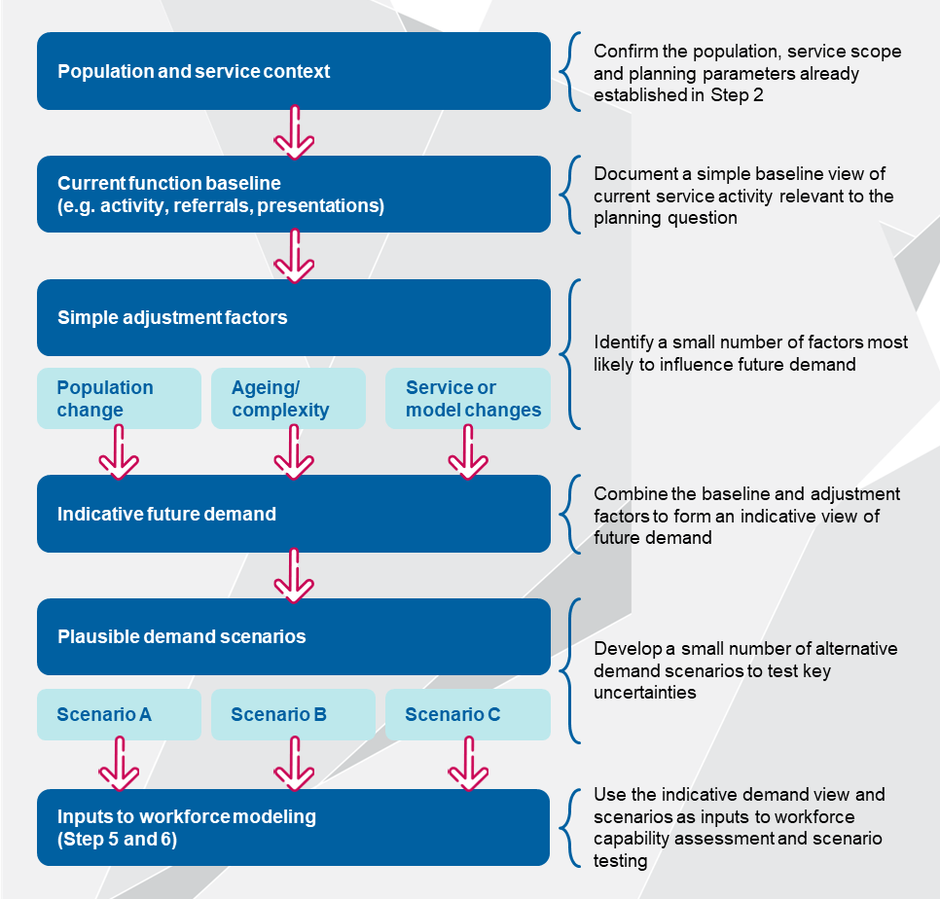
Demand modelling at the service level should not assume demand is met solely within a single organisation. Planners should consider:
Demand met by other service providers within the area
Referral, transfer and hand off points across organisations and sectors
Changes in demand that may arise from shifts in service responsibility, access arrangements or care pathways
The purpose is to understand how demand is experienced by the service not to model the entire system.

Indicative demand modelling worksheet structure
The worksheet tables below can be completed directly in this document. Where planners wish to apply calculations or test multiple scenarios more efficiently, the same structure can be copied into a spreadsheet as a working tool.

Population and service context
What to do in this section:
- Confirm the scope of modelling and how outputs will be used
- Establish consistency with decisions made in Step 2

Current function baseline
What to do in this section:
- Capture a simple, defensible baseline
- Use the best available data
Service/activity | Baseline period | Baseline volume | Unit of measure | Notes/caveats

Simple adjustment factors
What to do in this section:
- Identify a small number of factors most likely to influence demand
- Avoid listing all possible drivers and focus on those material to workforce planning
Adjustment type | Assumption | Direction of impact | Rationale/evidence | Confidence
Population change |  | Increase/decrease/shift |  | High/Med/Low
Ageing or complexity
Service or model changes
Other

Indicative future demand
What to do in this section:
- Apply agreed adjustment factors to the baseline
- Record outputs quantitatively where possible, or qualitatively where data is limited
Service / activity | Baseline demand | Indicative future demand | Net change | Assumptions applied

Plausible demand scenarios (if required)
What to do in this section:
- Use only where uncertainty is significant
- Limit to two or three scenarios that test key assumptions
- Focus on assumptions most likely to affect workplace configuration rather than minor variance
Scenario | Description | Key assumptions changed | Why this scenario is plausible
Scenario A
Scenario B
Scenario C

Worked example
Scenario | Description | Key assumptions changed | Why this scenario is plausible
Scenario A (base case) | Demand continues broadly in line with recent service activity and current delivery arrangements | - No material change in referrals or access  - Current service mix maintained | Reflects recent performance and provides a baseline for comparisons
Scenario B (demand shifts to the service) | Increased demand due to care shifting from acute or external providers into community-based services | - Earlier discharge  - Changes in referral pathways  - More care delivered in the community | Consistent with known system pressures to shift care out of hospitals and into community and primary care settings
Scenario C (higher complexity) | Similar volumes but a higher proportion of consumers require complex, coordinated care | - Ageing population  - Increased multimorbidity  - Greater time per episode of care | Aligns with observed trends in chronic disease complexity without assuming volume growth

Scenario outputs (summary)
What to do in this section:
- Summarise at a high level how demand for each service or activity differs across the base case and alternative scenarios
- Record outputs qualitatively by default, using short descriptions of the direction and relative scale of change (e.g. increase, decrease, stable, shift in mix or complexity).
- Where data supports it, include high‑level indicative figures (e.g. approximate percentage change)
Service / activity | Scenario A (base case) | Scenario B | Scenario C

Appendix D: Step 4 templates
This appendix contains templates referenced in the key activities outlined in Step 4.

Applying key model of care terms in Steps 4 and 5
The table below supports workforce planners to apply core model of care terms when undertaking the activities in Step 4 and Step 5. The purpose is to highlight how each term should be interpreted and used in practice to support consistent, needs based planning.
The considerations below are intended to help planners move from shared concepts to practical decisions, including co-design, identification of service functions and translation of functions into skills and capabilities. The frameworks and templates that follow build on these considerations to support structured testing, validation and refinement with stakeholders.
Table 4 Considerations for applying model of care concepts
Term | Considerations
Model of care | In the context of this Technical Guide, a model of care sets the overall intent and design for how care delivered, this includes:  - Focusing on defining ‘what good care looks like’ for a population or cohort  - Supporting local adaptation to reflect population need, service context and workforce capability  - Evolving dynamically in response to evidence, feedback and changing conditions  - Bridging policy intent, evidence and frontline practice to support consistent care delivery
Stages of care  (within the model of care) | For the purposes of this Technical Guide, stages of care are used to support:  - Mapping the model of care to the patient’s care journey  - Providing a flexible structure that can be adapted to different service contexts  - Allowing movement between stages, while recognising that care is not always linear  - Supporting categorisation of functions that occur across different stages of care
Functions  (what must happen at each stage) | Functions describe the work (e.g. tasks or activities) that must occur to deliver appropriate care at each stage, independent of roles or professions. Mapping functions includes:  - Identifying the tasks or activities required to deliver the model of care at each stage  - Describing what must happen, regardless of who performs the activity  - Making work visible across teams and settings  - Providing a clear basis for determining the skills and capabilities required to deliver care safely and effectively
Skills and capabilities  (what people must be able to do) | For the purposes of this Technical Guide, effective mapping of skills and capabilities to functions requires workforce planners to consider:  - Focusing descriptions on actions and abilities (e.g. assess, decide, deliver, coordinate, respond) before assigning professions, job titles or individuals  - Integrating technical skill and professional judgement required in practice  - Embedding culturally safe and person-centred practice as a core capability  - Reflecting clinical governance, supervision and accountability requirements in relation to the skills and capabilities identified  - Considering whether required skills and capabilities are realistically enabled by the technology, infrastructure and care environments in which care is delivered  - Addressing the safe and appropriate use of digital or AI‑enabled supports, including the application of professional judgement, oversight and accountability

Model of care co-design framework
Workforce planners should engage with stakeholders identified in Step 2 to co-design the model of care, using the framework outlined below. This process should draw on the shared definitions of models of care, stages of care, functions, and skills and capabilities set out earlier in this appendix to support a consistent and transparent approach.

Confirm level of influence
The figure below shows a continuum of engagement spanning from the provision of information to full ownership by stakeholders. This adapted version also incorporates a co-design approach, which is recommended for multidisciplinary workforce planning. Workforce planners can use the diagram below to identify what level of participation each stakeholder should have, as well as the key messages to be shared with different participants.
Figure 2 Spectrum of stakeholder influence
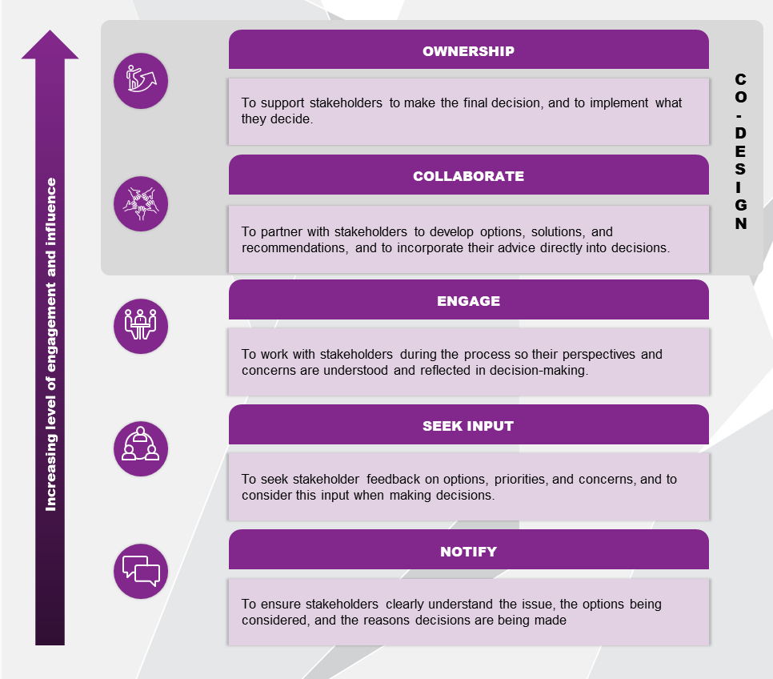

Overview of model of care design approach and outcomes
The table below provides a structure for workforce planners to use when planning the phases and activities involved in the model of care design process. The phases listed below have been adapted from existing model of care design approaches and provide an initial structure for workforce planners to draw on when conducting the model of care design process. A description of each phase is provided below, and workforce planners can adapt the titles at their own discretion. A worked example is provided below for workforce planners to refer to.
Template 7 Model of care design planning table
Phase | Description | Participants | Activities | Co-designed outcomes
Commence | - Initiate the model of care design / refresh process.
Understand | - Understand the current state data and information available on the existing model of care.
Develop | - Create the new model of care / refresh the existing approach based on collective input from stakeholders across the organisation’s ecosystem.
Finalise | - Identify implementation and adaptation support required.

Worked example
Phase | Participants | Activities | Co-designed outcomes
Commence | - Project team  - Organisational leadership and governance | - Agree on whether a new model of care is required or whether a refresh of an existing model is more suitable  - Visioning workshop | - Confirmed vision for the outcomes of the planning activity  - Agreement on approach to co-design
Understand | - Project team | - Review existing data and information, identifying gaps and areas where more information is needed | - Collective understanding of the organisation’s current state and emerging and existing better practice examples
Develop | - Project team  - Workforce planners and data and analytics staff  - Clinicians  - Organisational leadership and governance  - Community representatives (including consumers)  - First Nations representatives  - Other key stakeholders (e.g., key staffing groups involved in implementation) | - Design principles workshop and validation workshop to finalise principles  - Reviewing and synthesising relevant evidence and guidance to inform the model of care, including evidence of what works for the target population, culturally and clinically safe care considerations, and relevant policy or best‑practice guidance  - Articulating the high‑level model of care by describing the intended outcomes, the consumer care journey, and the key stages of care, at a level of detail sufficient to support subsequent identification of functions and workforce implications | - Validated design principles and the model of care
Finalise | - Project team  - Workforce planners and data and analytics staff  - Clinicians  - Organisational leadership and governance  - Community representatives (including consumers)  - First Nations representatives  - Other key stakeholders (e.g., key staffing groups involved in implementation) | - Validation and adaptation workshop to support testing and refining the model of care with clinicians, subject matter experts and community representatives to ensure it is culturally appropriate, clinically safe, and feasible to deliver within the local workforce and service context  - Confirming endorsement of the final model of care with key stakeholders prior to progressing to later steps  - Documenting the model of care | - Fit-for-purpose model of care for use in later steps

The templates provided below are designed to help workforce planners outline an indicative approach to the workshops within the ‘develop’ phase.
Template 8 Co-design workshop activity planning
Workshop | Pre-workshop activities | Proposed workshop format / duration | Indicative agenda | Required participants
Example design principles workshop | Participants provided findings from current state analysis for review  Discussion questions circulated to participants | Face-to-face workshop (half or full day) in an agreed central location. Hybrid options can be made available | Introduction and insights from current state scan (0.75 hr)  Breakout groups: Principles design and ideation (1.5 hr)*  Principles alignment and prioritisation (0.75 hr)  Playback of key concepts and draft design principles (1.5 hr) | Project team  Organisational leadership and governance
Design principles workshop
Validation workshop
Build the high-level model of care with input from subject matter experts, clinicians, and community representatives
Validation workshop
Facilitation strategies are provided below to assist workforce planners and workshop facilitators to ensure there is proportional representation of voices throughout the co-design sessions.
- Establishing housekeeping rules around appropriate behaviours at the start of the session which are applicable to all participants, regardless of profession and seniority
- Summarise findings and ask for validation from the group as a whole as the workshop is progressing, rather than only at the end.
- Directly asking questions to participants who may not have yet shared their opinions
- Actively recognising and addressing any imbalances of power, information and representation.
- Providing interactive activities for all participants to have input in, e.g. putting contributions on a sticky note against broader themes, polls and questions.
- Provide an avenue for participants to provide additional feedback after the session, e.g., via email, Microsoft forms survey

Function identification
To commence the process for identifying the functional components of the model of care, workforce planners should first map the stages of care relevant to the planning activity. While the example template below includes five different baseline stages of care, workforce planners should adapt the table according to the stages of care and functions relevant for their context, based on the patient care journey and service context for the model of care being developed.
For each stage of care, workforce planners should then identify the functions that must occur to deliver the model of care. Functions are understood as the distinct activities that must be performed, regardless of profession or role. This approach supports a clear separation between what must happen (functions) and who performs the work (roles or professions). Translating service functions into skills and capabilities is considered in step 5 of the Technical Guide and is supported by templates in Appendix E.
The below template also provides space for workforce planners to record any relevant observations, assumptions, or matters requiring further testing or validation with stakeholders to support finalisation of the functions that should be included across each stage of care.
Template 9 Function identification
Stage: Prevention and early intervention
Function | Observations, assumptions or matters for validation
Health education and promotion | e.g. Assumptions about target cohorts, links to prevention programs delivered outside the service
[Function]
[Function]
[Function]
[Function]
Stage: Screening and detection
Function | Observations, assumptions or matters for validation
Patient history and priorities | e.g. Variability in intake processes across settings
[Function]
[Function]
[Function]
[Function]
Stage: Receiving care
Function | Observations, assumptions or matters for validation
Case conferencing and culturally safe care planning | e.g. Frequency of case conferencing, involvement of external providers
[Function]
[Function]
[Function]
[Function]
Stage: Discharge
Function | Observations, assumptions or matters for validation
Discharge planning and handover | e.g. Consistency of discharge summaries, timing of referrals
[Function]
[Function]
[Function]
[Function]
Stage: Ongoing care and recovery
Function | Observations, assumptions or matters for validation
Coordination with community providers | e.g. shared care arrangements
[Function]
[Function]
[Function]
[Function]
Once functions have been identified for each stage of care and any assumptions or matters requiring validation have been documented, these templates should be used to support structured discussion with co-design stakeholders. Validated functions provide the agreed basis for identifying the skills and capabilities required to deliver the model of care and are used as direct inputs into Step 5.

Key enablers and constraints framework
This exercise supports planners to identify and test the enabling conditions required to support delivery of the model of care, with a deliberate focus on what sits within the organisation’s span of control at the service level.
The intent is not to resolve all system-level constraints at this stage but to distinguish between:
- Enabling factors that can be influenced or adjusted locally to support the model of care
- Factors that sit outside organisational control and should be noted as context or future dependency
This distinction keeps the model of care grounded, realistic and actionable while ensuring assumptions and dependencies are transparent before progressing to workforce capability assessment and scenario testing.
Template 10 Key enablers and constraints framework
Enabler category | Enabling factor | Within organisation’s span of control (yes/partial/no) | How this currently enables or constrains delivery of the model of care | Key assumptions or matters requiring validation
Governance and leadership
Workforce combinations
Community considerations
Technology and digital systems
Consumer data and information security
Infrastructure and care environments
Education and training
Cultural considerations
Financial and performance factors
Challenge prompts
What factors within the organisation’s span of control are inhibiting or enabling multidisciplinary workforce planning? Consider organisational culture, leadership and governance, training and development opportunities, technology systems, and existing policies and processes amongst other factors.
What small changes can be made in the organisation at a service level to build support and buy-in for the desired model of care?

Appendix E: Step 5 templates
This appendix contains templates referenced in the key activities outlined in Step 5.

Prompts for translating service functions into skills and capabilities
This section provides prompts to support workforce planners to consistently translate service functions identified in Step 4 into a clear set of skills and capabilities required to deliver the model of care.
The prompts are intended to support structured discussion with clinical, workforce and governance stakeholders and to reduce reliance on profession‑based assumptions.
Template 11 Prompts for translating service functions into skills and capabilities
1 | Start with the service function | For each function identified in the model of care, confirm:  - What is the intent of this function within the care pathway?  - Where does it sit (e.g. prevention, assessment, treatment, ongoing care, transition)?
2 | Ask “what skills and capabilities are required to perform the function?” | Use the following prompts to translate functions into skills and capabilities:  - What does the workforce need to be able to deliver this function safely and effectively (e.g. to assess, decide, deliver, coordinate or respond)?  - What knowledge, judgement, technical skill or relational capability is required?  - What elements require culturally safe practice, particularly for priority populations?  - Are supervision or management capabilities required to support this function effectively?  - Which capabilities are:  - Core to delivering this function?  - Specialised, required only in certain circumstances?  - Enabling, such as coordination, digital or communication capabilities?  Focus on actions and abilities, not job titles.
3 | Consider variation across the care pathway and complexity | To avoid under‑ or over‑specifying capabilities, planners should consider:  - Which capabilities are required consistently, versus at specific points in the care pathway?  - How do capability requirements change for:  - High‑complexity vs low‑complexity cohorts?  - Stable vs deteriorating conditions?  - Are different levels of proficiency required for the same capability in different contexts?
4 | Sense‑check without assigning professions | Professional capability frameworks and scope of practice guidance may be used to:  - Validate that the identified capabilities are realistic and safe  - Check alignment with regulatory or governance expectations  They should not be used at this stage to assign capabilities to professions or roles.  The intent of this activity is to articulate what needs to be delivered, not who delivers it.

Skills and Capability Matrix
The matrices below support structured mapping of required skills and capabilities required for the proposed model of care and assess how these align with the current workforce’s capabilities. They should be completed sequentially to define required capabilities, assess existing capability levels, identify constraints, and establish capability gaps.

Matrix A
This matrix is used to define which skills and capabilities are required to deliver the desired model of care, regardless of their current availability within the organisation. It focuses exclusively on identifying the ideal state from a workforce planning perspective.
The intent of Matrix A is to articulate what needs to be delivered, not who delivers it. Professional roles are considered later in the process once capability requirements are clearly understood.
How to use:
Engaging directly with key stakeholders, such as clinicians, organisation leaders and workforce planners, through structured workshops can strengthen the process and ensure the matrix provides an accurate reflection of real‑world practice.
Because multidisciplinary workforce planning directly influences quality, safety and service outcomes, planners should deliberately include the voices, expertise and decision‑making authority from across different groups to support safe, feasible and team‑based workforce configurations.
Where relevant, external partners involved in delivering care under the proposed model should also be included.
- List the agreed skills and capabilities from Step 5a across the top of the table.
- List all relevant professions or workforce groups (whether or not they currently exist within the organisation) down the left-hand column.
- Mark Yes if the workforce group or profession is expected to possess this skill or capability in the proposed model of care. Mark No if it is not relevant for the proposed delivery model.
- Add more rows/columns as needed.
- Professional capability frameworks may be used to sense‑check, but not to assign capabilities to professions at this stage.
- Do not assess capacity, resourcing or constraints in this table as this comes later in Matrix B and beyond.
Assume a generic, profession‑level scope of practice and do not consider current workforce availability at this stage.

Template 12 Skills and capability matrix A
Profession/workforce group | Skill/capability 1 | Skill/capability 2 | Skill/capability 3 | Skill/capability 4 | Skill/capability 5
Profession/ group A |  | 
Profession/ group B
Profession/ group C
Profession/ group D

Matrix B
This matrix is used to evaluate the current workforce’s ability to deliver the identified skills and capabilities from Matrix A. It focuses on understanding how existing skills and capabilities align with requirements and exploring constraints that limit their utilisation.
How to use:
- Include only for capabilities marked ‘Yes’ in Matrix A.
- Assess the extent to which your current workforce (including any external partners involved in delivering care under the proposed model) has the relevant skills or capabilities.
- Use the rating scale below consistently.
- Identify any key constraints or considerations related to governance, supervision, workflow design or capacity.

Template 13 Matrix B rating scale
Rating scale:
Well covered – capability is available at sufficient scale and routinely utilised | 
Present but under‑utilised – capability exists but is not routinely or fully used | 
Present but constrained – capability exists but is limited by scope, workflow, supervision, policy or resourcing | 
The categories “present but under‑utilised” and “present but constrained” are mutually exclusive.
Under‑utilised should be selected where the capability could be used within current scope, governance and policy settings, but is not routinely applied due to workflow design, role delineation, rostering, custom or cultural practice.
Constrained should be selected where the capability cannot be fully applied, even if willingness exists, due to limitations such as supervision requirements, credentialing, regulation, local policy or resourcing.
If both appear to apply: Select constrained and document the constraint explicitly in the “Key constraints” column.
Template 14 Skills and capability matrix B
Profession/workforce group | Skill/ capability 1 | Skill/ capability 2 | Skill/ capability 3 | Skill/ capability 4 | Skill/ capability 5 | Key constraints (for this profession) | Governance / supervision considerations
Profession/ group A
Profession/ group B
Profession/ group C

Example constraints might include: | Example governance and supervision may include
- Scope of practice limitations  - Supervision or credentialling requirements  - Workflow or credentialling requirements  - Workforce availability or headcount limitations  - Local policy, industrial or funding settings  - Training or capability maintenance requirements | - Required professional oversight  - Delegation or escalation arrangements  - Credentialing or endorsement requirements
For guidance on how to interpret, classify and work through constraints identified during Matrix B without stalling the planning process, refer to the navigating common constraints section later in this appendix.
Once both matrices are complete and validated with stakeholders:
- Review capabilities that are absent across all professions
- Review capabilities rated as under-utilised or constrained
- Identify whether constraints are:
- Regulatory/industrial
- Organisation or workflow-based
- Capability or training related
- Use this analysis to populate the capability gap register.
Constraints to top of scope practice are not always regulatory or industrial. Many are locally defined through historical practice, credentialing or workflow design and should be explicitly tested rather than assumed.

Gap register
This capability gap register consolidates gaps identified through the skills and capability in Matrix B into a single, structured view. It supports workforce planners to clearly document where required skills and capabilities are missing, constrained or insufficiently enabled within the current workforce and to prioritise these gaps for further analysis and action.
Each entry in the register should describe the gap at the level of skills or capabilities, rather than professions or roles, and record the primary factors contributing to the gap.
Where planners are capturing a large number of gaps, it may be more efficient to maintain the gap register in a spreadsheet using predefined dropdown lists (for example, for gap type, root cause category, priority and status).
Template 15 Skills and capability gap register
Gap ID | Skill or capability | Gap type (select) | Primary root cause category (select) | Impact / risk (quality, safety, access) | Priority (H/M/L) | Enabling conditions required | Constraints / dependencies | Owner | Notes
1 |  | Capability not present / Capability present but underutilised / Capability present but constrained | Supply / Skill mix / Workflow / Supervision / Credentialling / Funding / Industrial / Other
2
3

Navigating common constraints
Workforce planners are likely to encounter a range of constraints when applying a capability‑based approach in practice. The purpose of this section is not to resolve these constraints but to help planners distinguish between:
- Constraints that are likely to require system‑level change or long‑term advocacy
- Constraints that are addressable at a service or local level through leadership, governance, workflow or cultural change

Levels of influence
The level of influence helps planners to quickly determine whether a constraint is something they can act on at a service level, or whether it primarily sits outside the scope of this planning exercise and should be noted as context.
Use this classification to support discussion, not to resolve the issue immediately.
Table 5 Level of influence
Level of influence | What this typically includes | Prompt questions
Macro level (National/jurisdictional) | Legislative, regulatory or funding settings that apply broadly across the health system | - Is this defined in legislation, regulation or national funding rules?  - Would changing it require formal reform or advocacy beyond the service?
Meso-level (service/organisational) | Coordination, commissioning or infrastructure barriers across services or organisations | - Is this driven by how services interact (e.g. referral pathways, digital systems, commissioning gaps)?  - Could it be influenced through regional collaboration?
Micro level (operational level/individual teams and organisational units) | Governance, credentialing, workflow, culture or local interpretation of rules | - Is this shaped by local policy, custom, credentialing, delegation, supervision or trust?  - Could it be changed through leadership or redesign?
Adapted from The Constraint Labyrinth concept, University of Queensland

Common constraints
This table provides examples of constraints that commonly arise during capability mapping discussions. It is not intended to be exhaustive but to help planners recognise issues that may surface and name them consistently.
Table 6 Common constraints
Constraint type | Common examples
Regulatory and funding constraints | - Title‑protection approaches that restrict activities based on profession rather than capability  - Diagnostic or prescribing restrictions embedded in Medicare or jurisdictional legislation  - Fee‑for‑service funding models that privilege individual activity over team‑based care
Governance and authorisation constraints | - Internal credentialing or privileging rules more restrictive than required by law  - Conservative delegation or supervision requirements  - Unclear accountability for activities
Cultural and hierarchical constraints | - Traditional hierarchies prioritising “who” delivers care over “what” is needed  - Professional boundary protection  - Limited trust or understanding of other professions’ capabilities
Workflow and system constraints | - Fragmented referral pathways and unnecessary hand‑offs  - Inefficient handover processes
Data, digital and infrastructure constraints | - Lack of shared records across services (“digital black holes”)  - Limited visibility of capability, scope or credentialing information  - Fragmented workforce data
Workforce distribution constraints | - Maldistribution or absence of specific professions in some settings  - Under‑use of alternative or extended workforce models
Adapted from The Constraint Labyrinth concept, University of Queensland
When a constraint is identified, consider whether the issue related to:
Education: has training been completed?
Competence: is the profession or team currently able and confident in this context?
Authorisation: is the activity permitted and approved locally?
Accountability: is responsibility, escalation and oversight clear?
In many cases, planners may find that authorisation or accountability, rather than capability, is the primary blocker.

Strategies planners can use
The purpose of identifying constraints is to support structured discussion and documentation during the planning exercise. When planners feel blocked while completing the matrices, they may consider the following approaches to help progress the discussion:
- Record the constraint explicitly and continue the exercise, rather than pausing until it is resolved
- Note assumptions or contested views (e.g. ‘varies by service’, ‘requires further validation’) rather than forcing consensus
- Distinguish capability from permission, by asking whether the issue relates to skill and competence, or to authorisation, governance or custom
- Capture the constraint at the appropriate level (jurisdictional, regional or local), rather than treating all barriers as service level failures
- Park escalation issues clearly for later consideration, rather than allowing them to stall capability mapping
- Use prompts to test default assumptions, particularly where discussions revert quickly to job titles, workforce availability or historical practice
Importantly, not all constraints identified through this process can or should be addressed locally. Making this distinction explicit helps planners progress the planning task, prioritise effort and reduce frustration during the exercise.

Appendix F: Step 6 templates
This appendix contains templates referenced in the key activities outlined in Step 6.

Assessment matrix
The multicriteria analysis approach outlined in the table below supports workforce planners to ‘reality test’ the identified multidisciplinary workforce team configurations. A five-point scoring scale is used to assess and compare different considerations across the configurations identified.
Template 16 Scenario assessment matrix
Impact | Score
Strong positive impact | 5
Moderate positive impact | 4
No significant impact | 3
Moderate negative impact | 2
Strong negative impact | 1

Criteria | Assessment approach | Score | Weighting
Criteria 1: Legislative and regulatory requirements |  |  | Total score for Criteria 1 (%)
Sub-criteria 1a) | Qualitative assessment | 1 – 5 | #
Sub-criteria 1b) | Qualitative assessment | 1 – 5 | #
Criteria 2: Industrial arrangements and clinical governance requirements |  |  | Total score for Criteria 2 (%)
Sub-criteria 2a) | Qualitative assessment | 1 – 5 | #
Sub-criteria 2c) | Qualitative assessment | 1 – 5 | #
Criteria 3: Training requirements |  |  | Total score for Criteria 3 (%)
Sub-criteria 3a) | Qualitative assessment | 1 – 5 | #
Sub-criteria 3b) | Qualitative assessment | 1 – 5 | #
Criteria 4: Risks |  |  | Total score for Criteria 4 (%)
Sub-criteria 5a) | Qualitative assessment | 1 – 5 | #
Sub-criteria 5b) | Qualitative assessment | 1 – 5 | #
Criteria 5: Implementation feasibility |  |  | Total score for Criteria 5 (%)
Sub-criteria 6a) | Qualitative assessment | 1 – 5 | #
Sub-criteria 6b) | Qualitative assessment | 1 – 5 | #
Overall weighted score

Constraints to top of scope practice are not always regulatory or industrial. Many are locally defined through historical practice, credentialing or workflow design and should be explicitly tested rather than assumed. Workforce planners can factor these considerations into their assessments within the existing criterion (e.g., within Criteria 2), or can update the template and add a new criteria when completing the assessment.
A worked example assessment matrix is provided below for workforce planners to refer to.
Criteria | Assessment approach | Score | Weighting
Legislative and regulatory requirements |  |  | 20%
Alignment with jurisdictional legislation and regulation | Strong consistency with state or territory health legislation, scope of practice, registration requirements, and service delivery regulations. | 5 | 10
Alignment with national legislation and regulation | Strong alignment with national frameworks and legislation. | 5 | 10
Industrial agreements and clinical governance requirements |  |  | 20%
Alignment with industrial agreements | General consistency with enterprise agreements, relevant awards, workloads and supervision requirements, however some consultation required. | 4 | 10
Profession-specific clinical governance requirements | Adherence to profession-specific standards, credentialing, supervision arrangements, accountability, and clinical risk management obligations. | 4 | 10
Training requirements |  |  | 20%
Mandatory training requirements | Most mandatory training has been met, with minimal additional investment required. | 4 | 10
Upskilling required to fulfil roles | Minimal additional education or competency mapping required. | 4 | 10
Risks |  |  | 20%
Workforce supply | Additional resourcing required to fulfil different team compositions | 1 | 5
Safety | Increased risks to manage staff safety when travelling to remote consumers | 2 | 5
Change management risks | Moderate change management support required | 3 | 5
Funding and budget constraints | Limited flexibility within existing funding model | 2 | 5
Implementation feasibility |  |  | 20%
Level of effort versus outputs and benefits | Clear evidence of benefits outweighing implementation effort. | 5 | 10
Impact on:  - Operations  - Finance  - Infrastructure  - Delivery settings  - Other organisations | Some financial impacts because of new team composition and engagement with other organisations. | 3 | 10
Overall weighted score |  |  | 3.8

Appendix G: Step 7 templates
This appendix contains templates referenced in the key activities outlined in Step 7.

Monitoring and evaluation framework
The Plan-Do-Study-Act (PDSA) cycle is a commonly used quality improvement approach in health settings that supports rapid, small‑scale testing of change.
In this guide, PDSA is used to support monitoring and evaluation during implementation. It helps services test changes in practice, review monitoring information and make timely adjustments before changes are scaled or locked in.
Each PDSA cycle represents one monitoring cycle, focused on a specific aspect of implementation (for example, introducing a new role, testing a workflow change or enabling staff to work to intended scope).
Figure 3 PDSA cycle
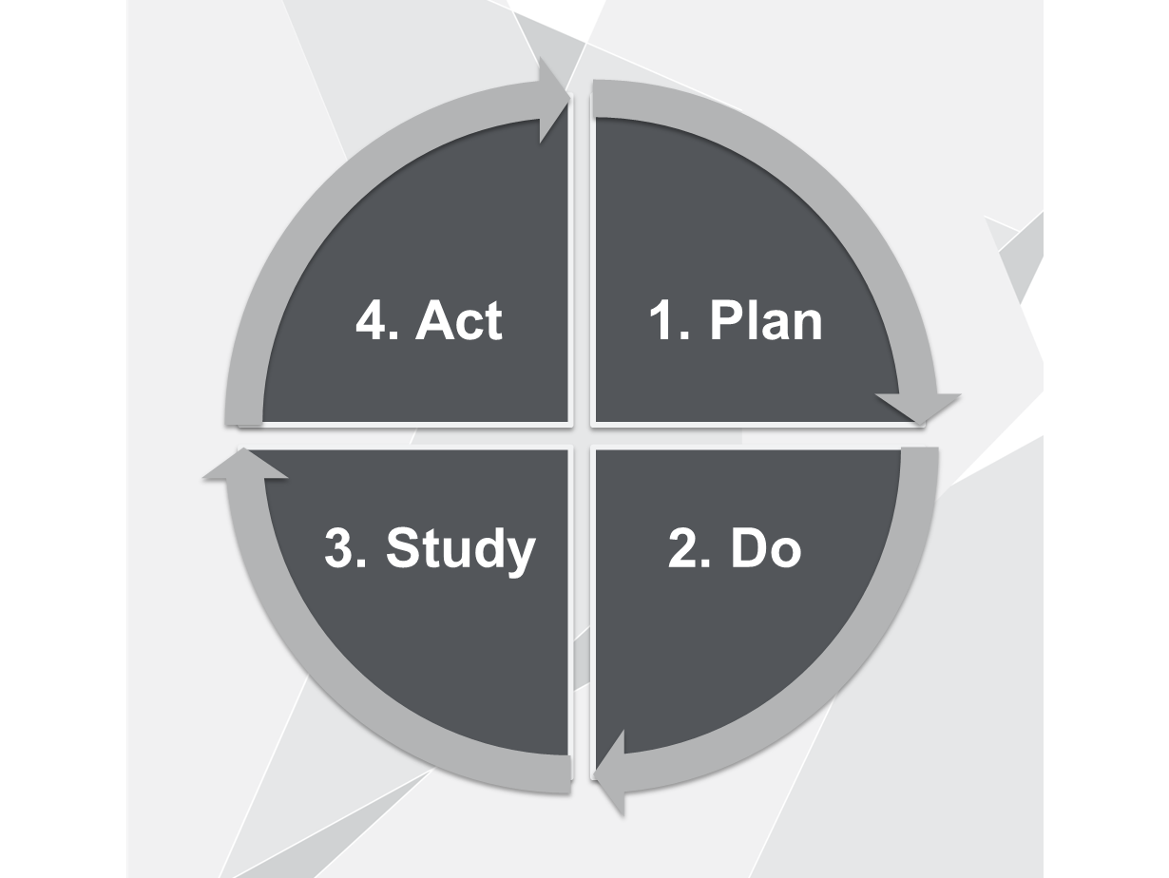

Using PDSA to support monitoring
A PDSA cycle is a short, time-limited monitoring period during which:
- Expected implementation changes are tested
- A small number of indicators are reviewed
- Decisions are made about what to do next
Multiple cycles may occur over time as implementation progresses and evolves. The table below sets out how the PDSA cycle can be used to structure monitoring activities, review evidence and guide decisions during implementation.
Table 7 PDSA cycle for monitoring and evaluation
PDSA stage | What happens at this stage
Plan: define what will be monitored | - Identify the aspect of implementation being monitored  - Clarify what success looks like  - Select a small number of indicators  - Confirm data sources, reviewers and review timing  This information is recorded in the monitoring and evaluation template.
Do: implement and observe | - Implementation proceeds as planned  - Data and feedback are collected using existing sources  - Observations are noted as changes are trialled in practice
Study: review monitoring information | - Monitoring information and feedback are reviewed  - Progress against expected outcomes is assessed  - Issues, enablers and unintended impacts are identified
Act: decide what to do next | Based on what is learned, planners decide whether to:  - Continue implementation as planned  - Refine workflows, roles or supports  - Pause or adjust the approach  - Commence a new monitoring cycle

Monitoring and evaluation template
The below template supports planners to define what will be monitored, using what data, how often and how findings will inform decisions. It is intended to be completed using existing performance, workforce and feedback mechanisms wherever possible.
Template 17 Monitoring and evaluation template
Area to monitor | What does success look like? | Indicator(s) | Data source | Review frequency | Reviewer | Decisions informed
Monitoring arrangements should be limited to a small number of indicators that provide confidence implementation is progressing as intended.
Where possible:
- Rely on existing business-as-usual reporting
- Prioritise qualitative insights and simple measures
Focus on early signals rather than downstream health outcomes

Change management framework
This framework supports workforce planners, organisational leaders and clinical leaders to plan the engagement, communication and support activities required to embed workforce changes during implementation.
Figure 4 Change management framework
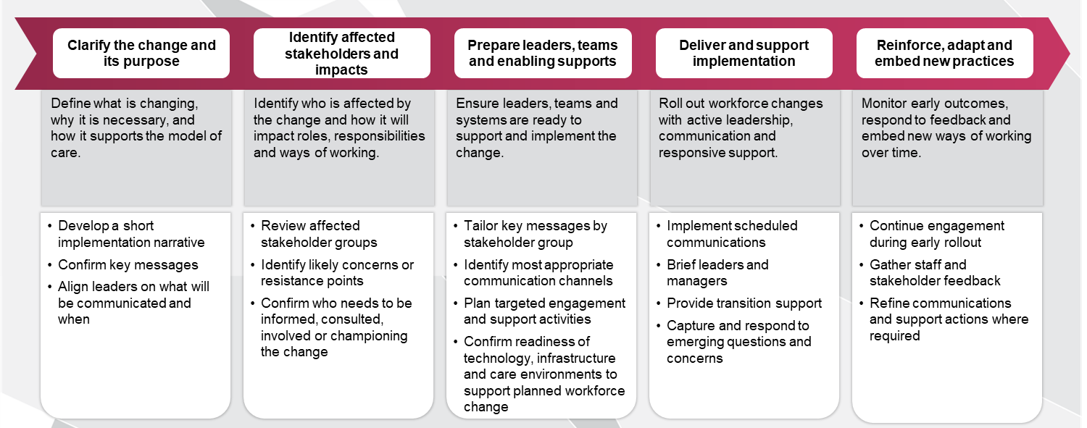

Champions of change
Successful implementation of workforce change depends on visible and credible champions who actively model and reinforce new ways of working. Champions of change play a critical role in building trust, addressing concerns and sustaining momentum during transition.
Workforce planners should identify and engage champions early, ensuring they are drawn from relevant clinical, operational and leadership groups, and that their role is clearly understood and supported.
Champions may include respected clinicians, service managers, team leaders, First Nations leaders or consumer representatives, depending on context and the nature of change.
Change impact and communication assessment template
This template supports workforce planners to capture the specific impacts of the preferred workforce model on different stakeholder groups and identify the communication and support responses required during implementation. It should build on stakeholder mapping already completed earlier in the guide.
Where workforce changes affect a large number of stakeholder groups, it may be more efficient to maintain this assessment in a spreadsheet using filters or dropdown lists (for example, for degree of impact or engagement response).
Template 18 Change impact and communication assessment
Stakeholder group | What is changing for them? | Likely impact | Degree of impact on stakeholder (Low/Medium/High) | Key message | Support/  engagement response | Owner | Status
Focus on the implementation change itself, including who is affected, what concerns may arise, what messages they need to hear and what engagement or support should be provided during transition.

Workforce action plan
This template supports workforce planners to translate the preferred multidisciplinary workforce model into a practical implementation plan with clear actions, owners, timeframes, dependencies and monitoring points. It should be used to actively manage implementation rather than as a detailed project plan.
This template incudes an example of how the action plan can be applied to the diabetes – types 2 chronic care management scenario.
For complex implementations with many actions, dependencies or phased timeframes, planners may find it useful to track the action plan in a spreadsheet with sorting and status tracking functionality.
Template 19 Workforce action plan
Action ID | What needs to change | Specific action | Lead owner | Supporting roles/  stakeholders | Timing/phase | Dependencies | Key risks/issues | Mitigation/  contingency | Milestone/  decision point | Success measure/  monitoring indicator | Status
A1 | The local workforce needs stronger capability in diabetes self-management education and behaviour change support | Develop and deliver a targeted capability uplift package for locally available staff to provide structured self-management education and behaviour change coaching | Clinical lead | Education / training lead  Nursing lead  Aboriginal and Torres Strait Islander Health Practitioner lead  Workforce planning lead | Phase 1 | Agreed capability set  Training time  Educator availability  Supervision arrangements | Training is delayed or staff cannot attend due to service pressures | Prioritise a small initial cohort and use staged training / coaching delivery | Training package approved and first cohort enrolled | Number of staff trained and assessed as able to deliver structured self-management support | Not started

Implementation roadmap template
This roadmap provides a high-level visual view of implementation across short, medium and long-term planning horizons. It is intended to complement the workforce action plan by showing when key activity areas are expected to commence, continue or become a focus
Organisations may choose to replicate this roadmap in a spreadsheet or planning tool to support sequencing, dependency management and updates over time. Where this occurs, the roadmap should still reflect the agreed short‑, medium‑ and long‑term activities captured here and remain aligned to the workforce action plan.
Template 20 Implementation roadmap
Workstream | Activity | Short term planning  (0-2 years) | Medium term planning  (3-5 years) | Long term planning  (beyond 5 years)
Endorsement and mobilisation | Activity X
Endorsement and mobilisation | Activity X
Endorsement and mobilisation | Activity X
Endorsement and mobilisation | Activity X
Endorsement and mobilisation | Activity X
Change management and communication | Activity X
Change management and communication | Activity X
Change management and communication | Activity X
Clinical governance, supervision and accountability | Activity X
Clinical governance, supervision and accountability | Activity X
Clinical governance, supervision and accountability | Activity X
Clinical governance, supervision and accountability | Activity X
Workforce capability and training | Activity X
Workforce capability and training | Activity X
Workforce capability and training | Activity X
Workforce capability and training | Activity X
Organisation enablers | Activity X
Organisation enablers | Activity X
Organisation enablers | Activity X
Organisation enablers | Activity X

Implementation risk and issues register log
This template supports workforce planners to record, monitor and escalate the risks and issues that may affect implementation of the preferred multidisciplinary workforce model. It should be maintained as a live log during implementation and reviewed regularly through the agreed governance process.
During implementation, the risk and issues register may be maintained as a live spreadsheet to support regular updates, escalation and review through governance forums.
Template 21 Implementation risk and issues register log
ID | Risk description | Impact on implementation | Likelihood | Impact | Overall rating | Owner | Mitigation/action | Status
1 | Networked / virtual specialist support for dietetics, diabetes education or podiatry is unreliable or unavailable, leaving key capability gaps unresolved | Partnership arrangements are not confirmed  Telehealth access is unreliable  External providers are not available at required frequency  Referral criteria are unclear | Medium | High | High | Service manager | Formalise partner arrangements early  Define referral / triage criteria, test telehealth processes before implementation, and track specialist access through the enabler register | Yes
2

Australian Government Department of Health and Aged Care. (2024). Unleashing the potential of our health workforce: Scope of practice review – Final report. https://www.health.gov.au/sites/default/files/2024-11/unleashing-the-potential-of-our-health-workforce-scope-of-practice-review-final-report_0.pdf
Gottlieb, K. (2013). The Nuka System of Care: improving health through ownership and relationships. International Journal of Circumpolar Health, 72(1), 21118. https://doi.org/10.3402/ijch.v72i0.21118
Meadows, D., Maclaren, J., Morton, A., & Ross, D. (2025). Determining skill mix and optimal multidisciplinary team composition: A scoping review. Healthcare management forum, 38(3), 278–285.
Birch, S., Gibson, J. & McBride, A. (2020). Opportunities for, and implications of, skill mix changes in healthcare pathways: Pay, productivity and practice variations in a needs-based planning framework Social Science & Medicine, (250) 112863, https://doi.org/10.1016/j.socscimed.2020.112863
For this Technical Guide, ‘functions’ are understood as the distinct activities that must be performed in order to deliver the model of care.
The terms listed in this glossary table have been adapted from the definitions outlined in Unleashing the Potential of our Health Workforce (2024).
Adapted from the Aged Care Quality and Safety Commission’s RACI Matrix, https://www.agedcarequality.gov.au/sites/default/files/media/topic-resource-14-raci-matrix.pdf
Note: These stages are provided as examples only. Not all models of care will include each stage. Adapt or replace with stages relevant to your context.
Institute for Healthcare Improvement. Model for improvement. Adapted from: https://www.ihi.org/library/model-for-improvement
Adapted from established change management theory, including Kotter’s model of organisational change and Bridges’ transition model. Campbell, R. J. (2008). Change management in health care. The Health Care Manager, 27(1), 23–39.

