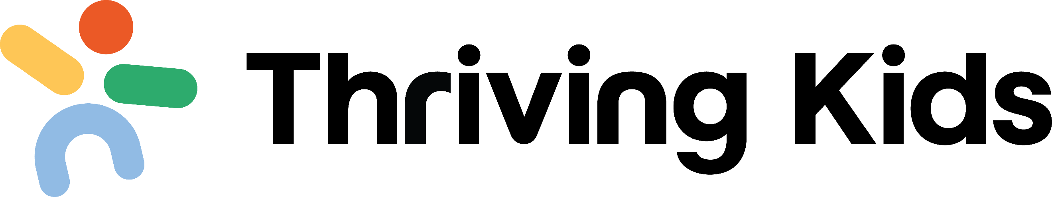Australian Government Roadmap

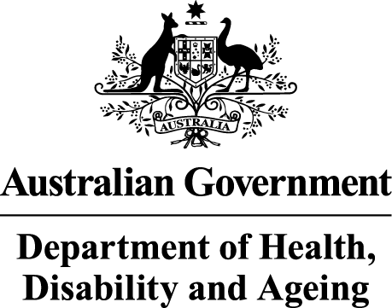 |  | The Australian Government Department of Health Disability and Ageing wrote this.  We say DHDA for short.  When you see the word we it means DHDA.
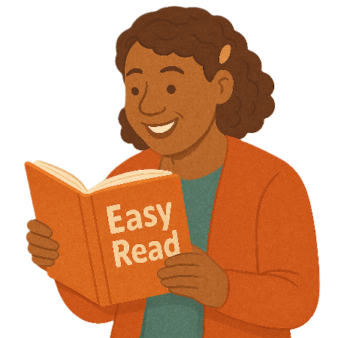 |  | We wrote this in an easy to read way.  We use pictures to explain some ideas.
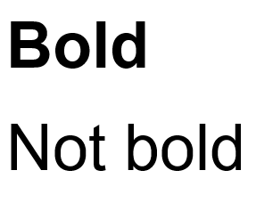 |  | We have some words in bold.  This means the letters are thicker and darker.  These are important words.
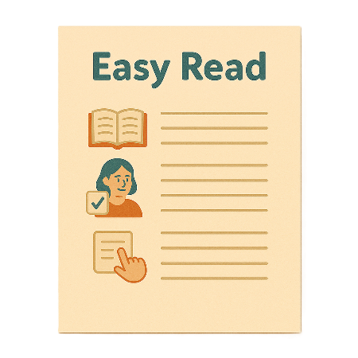 |  | This is an Easy Read summary of another document.  This means it has the most important ideas.
 |  | We can answer any questions by email.  Email us thriving.kids@health.gov.au
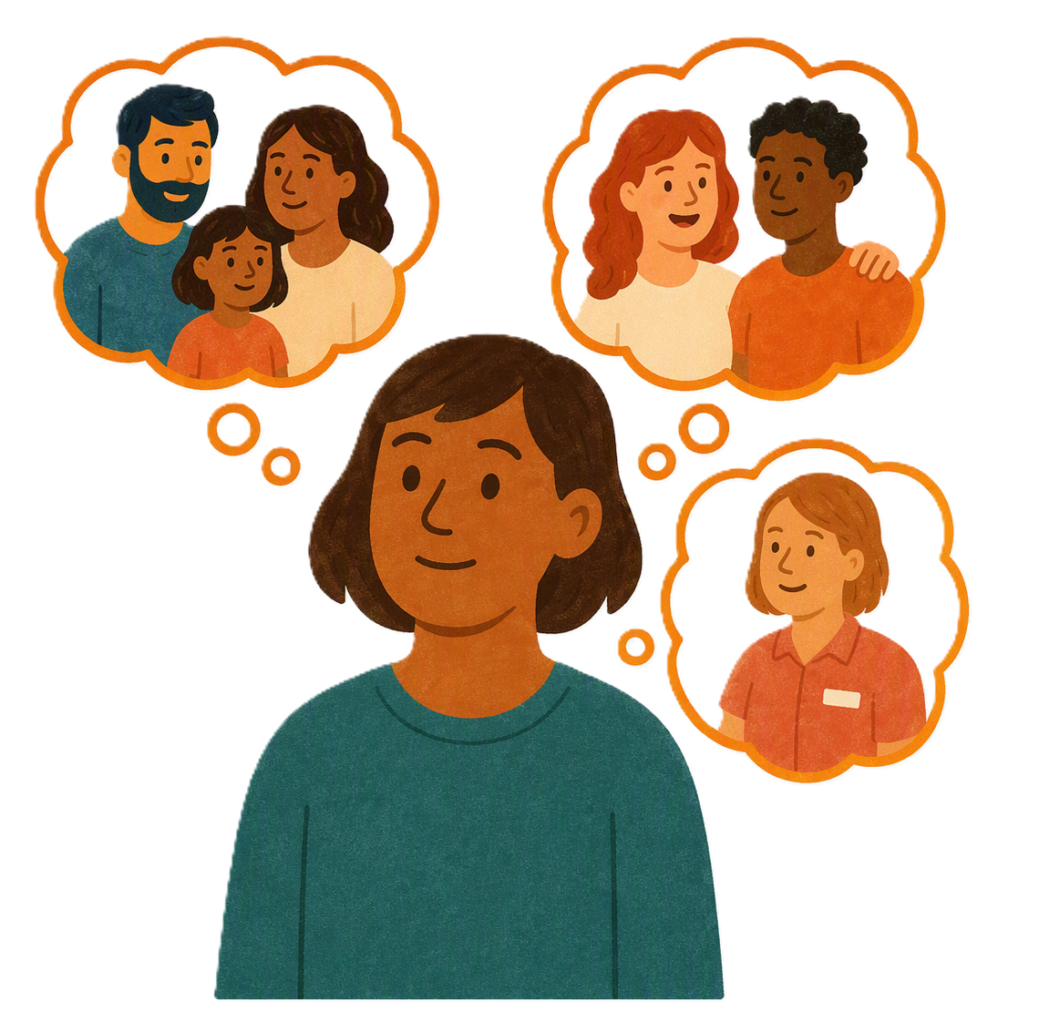 |  | You can ask for help to read this document.  You can ask  - A friend  - Family members  - A support person.
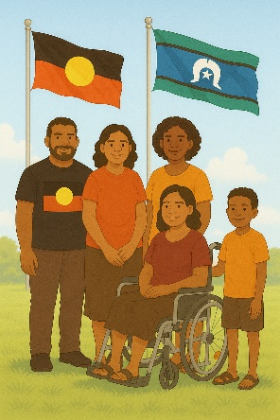 |  | We recognise Aboriginal and Torres Strait Islander people as the Traditional Owners of the land we live on.
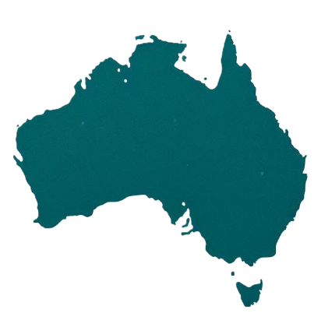 |  | They were the first people to live on and use the  - Land  - Waters.

Contents

What is Thriving Kids | 5
The Australian Government Roadmap | 7
Supports from October 2026 | 9
Supports from November 2026 | 12
Supports from early 2027 | 13
Supports from middle 2027 | 16
Supports from late 2027 | 18
Supports from 2028 | 23

What is Thriving Kids

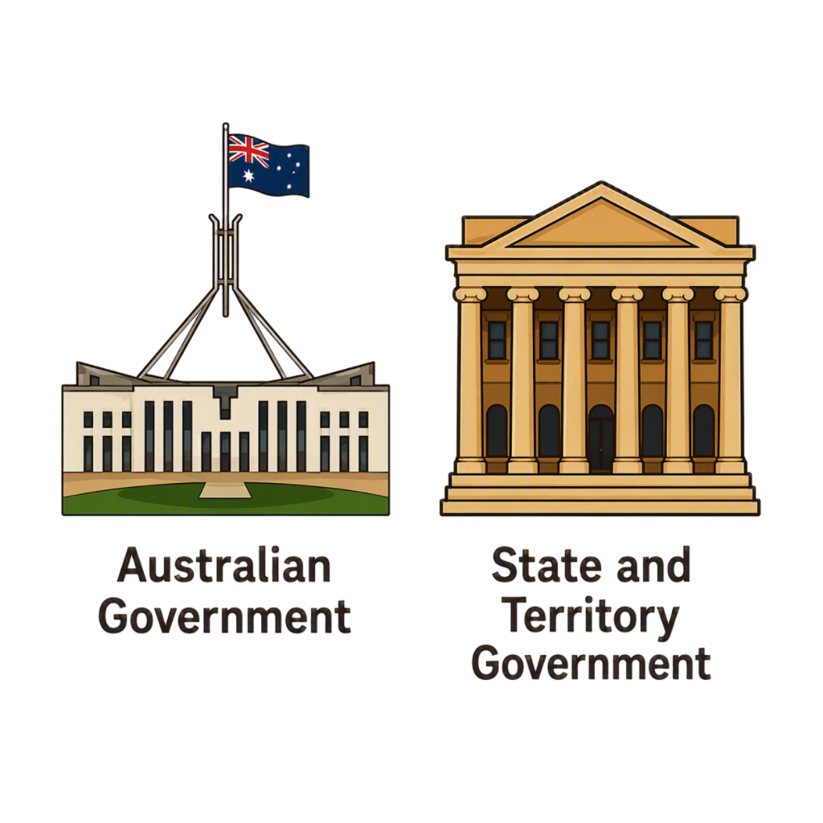 |  | All governments are working together to make Thriving Kids.  That means the  - Australian Government  - State and territory governments
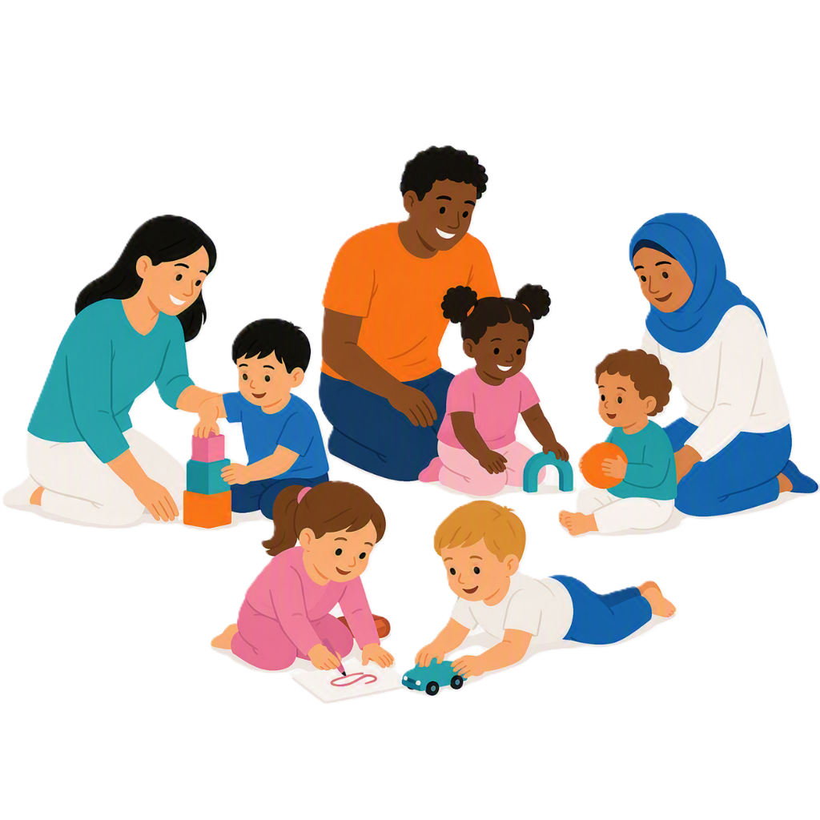 |  | Thriving Kids will have some  - New supports  - Supports now that will be expanded.  It will be different to the NDIS.
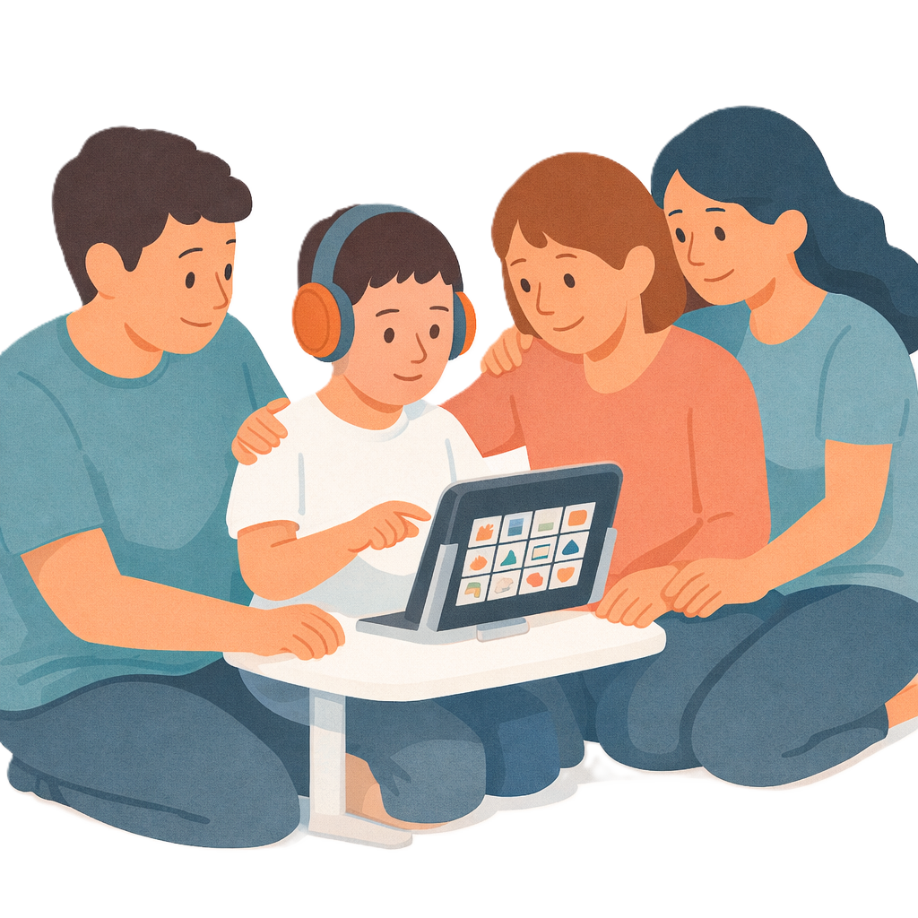 |  | It will support children who  - Are 8 years old and younger  - Have developmental delay  - Have autism  - Need some support.  It will also support families and carers.
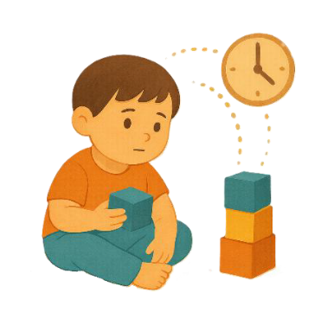 |  | Development delays are when  - Someone might be slower to develop than other people their age.  They might need extra help with  - Talking  - Moving  - Their emotions.
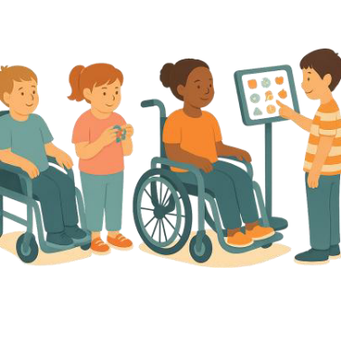 |  | Children who need lots of support can still apply for the NDIS.  Apply means you send information about  - Who you are  - Your disability  - What supports you need.  This helps us decide if you need NDIS supports.

The Australian Government Roadmap

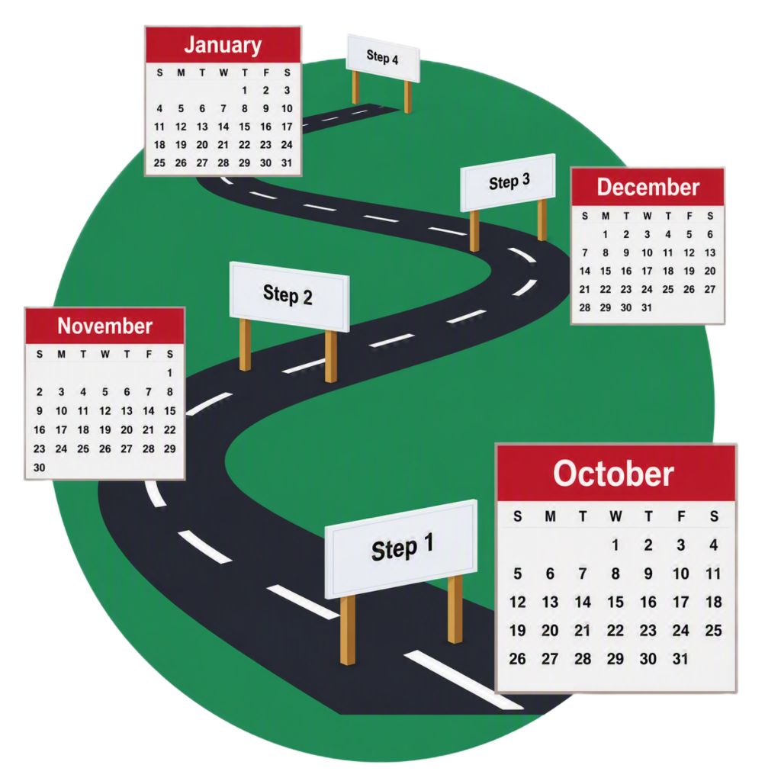 |  | The Thriving Kids Roadmap says  - What supports the Australian Government is doing for Thriving Kids  - When supports will start.
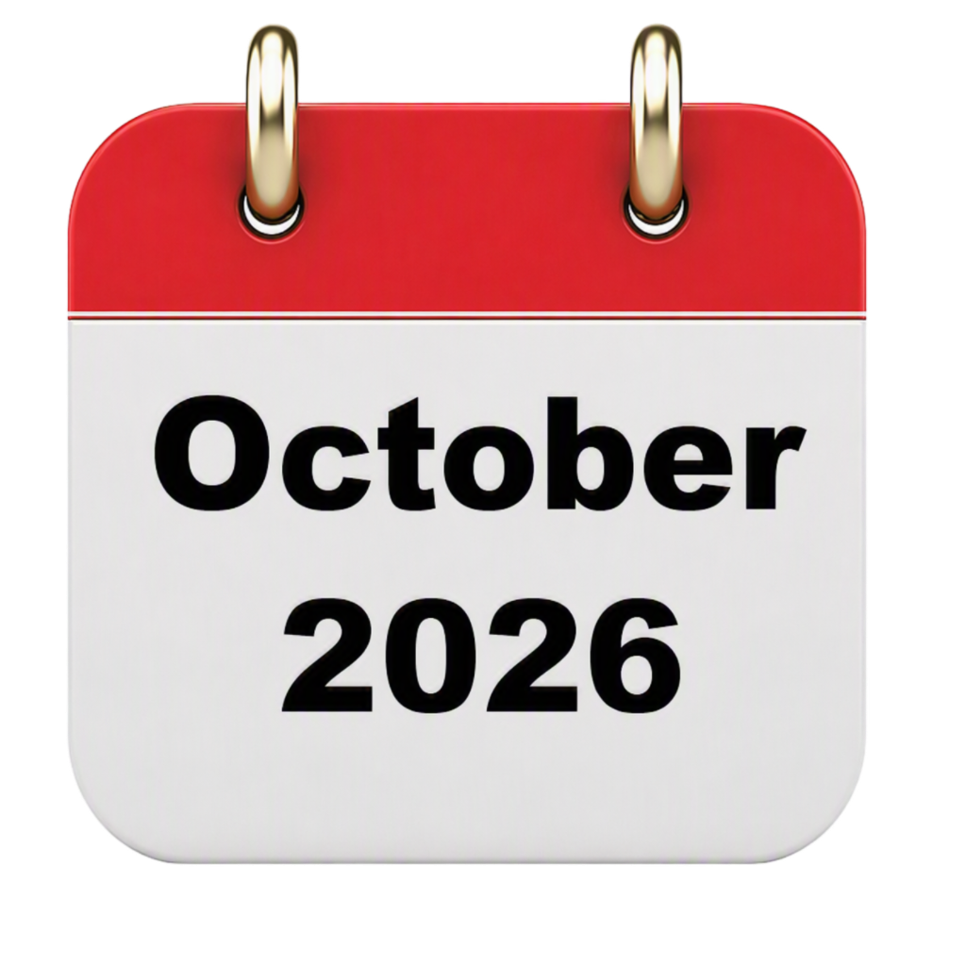 |  | Some supports started in October 2026.
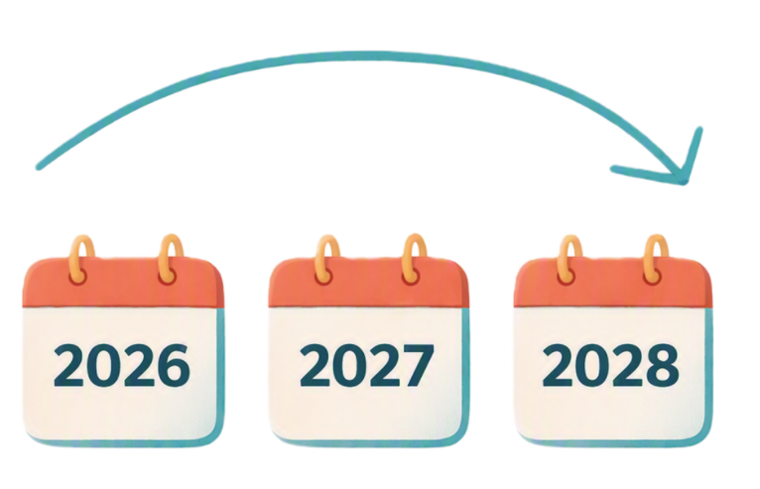 |  | More supports will start over time.  All supports will be ready by the start of 2028.
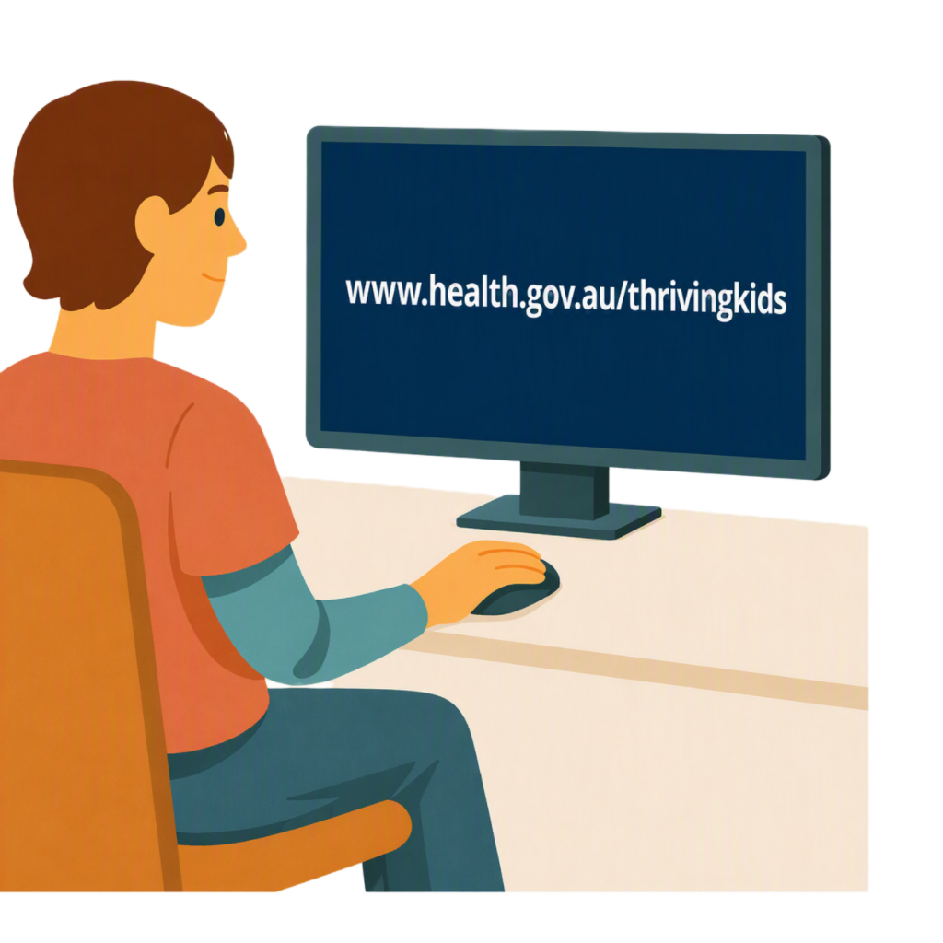 |  | Other supports are being done by state and territory governments.  To find out what supports are being done by  - Australian Government  - State and territory governments  You can go to this website  www.health.gov.au/thrivingkids  It is not in Easy Read.  It will have some Easy Reads you can look at.

Supports from October 2026

The supports starting in October 2026 are

- Information and advice about child development for

  - Families
  - Carers
  - Professionals.
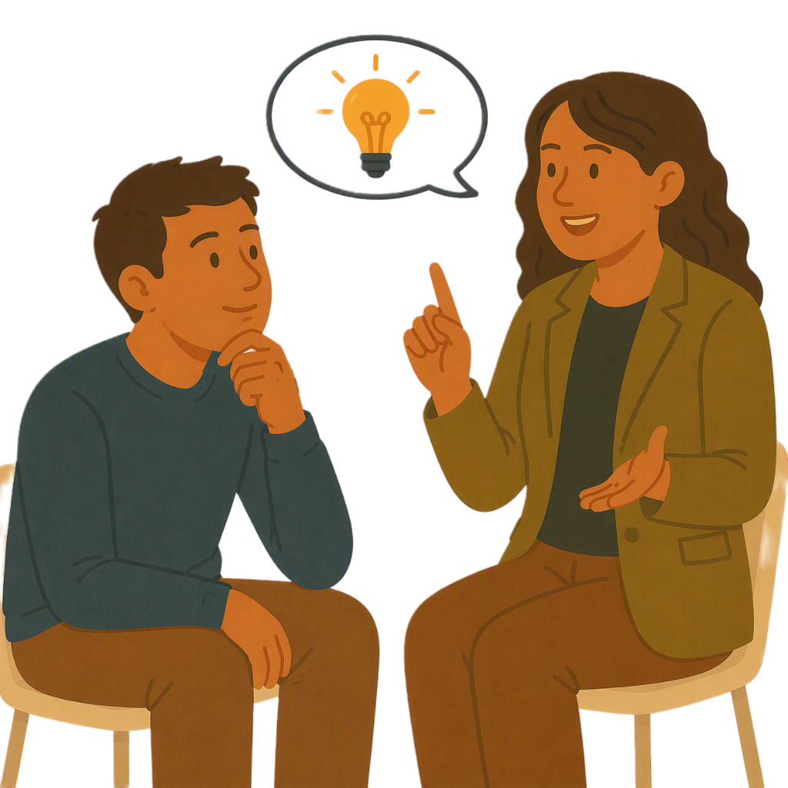 |  | Advice is ideas on how to do something.
 |  | Professionals are people who are trained to do a job like a doctor or teacher.
There is a

- Thriving Kids website

This has information about Thriving Kids.
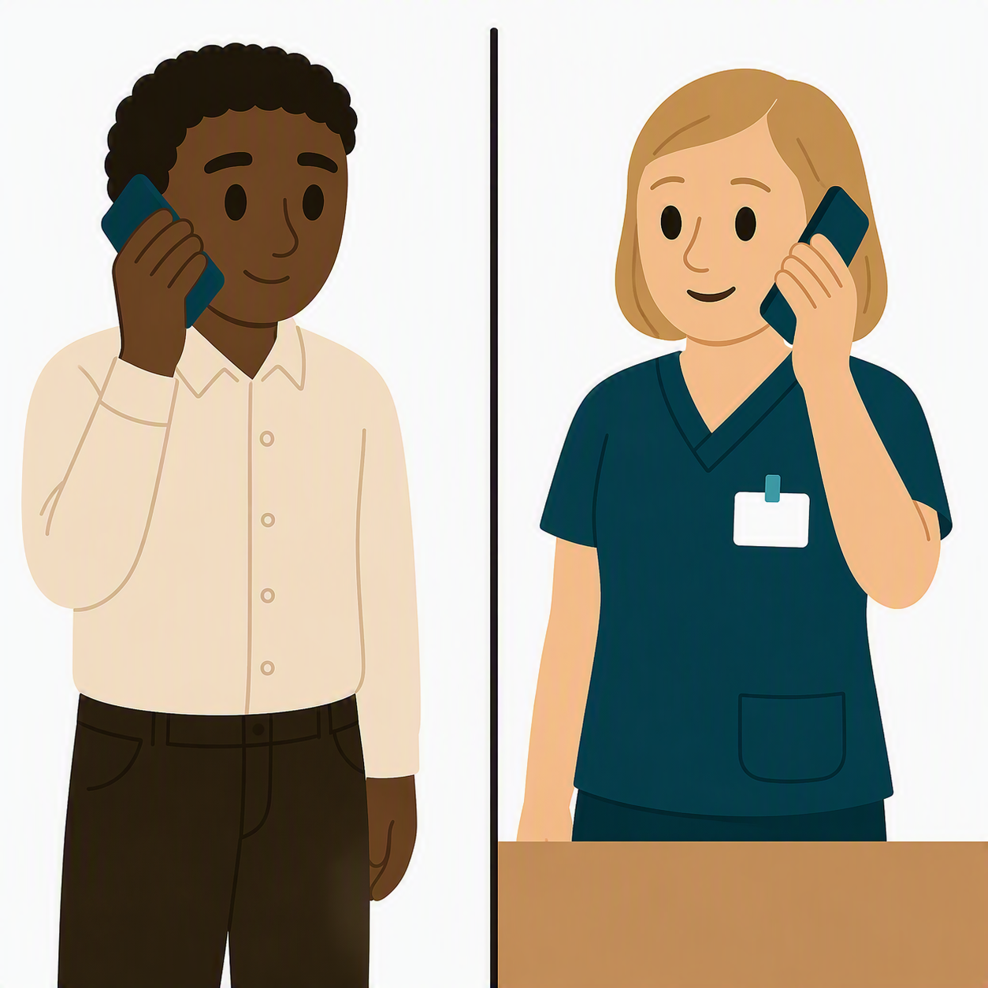 |  | - Phoneline  People can call nurses on the phone to get information and advice about child development.  The number is  1800 882 436
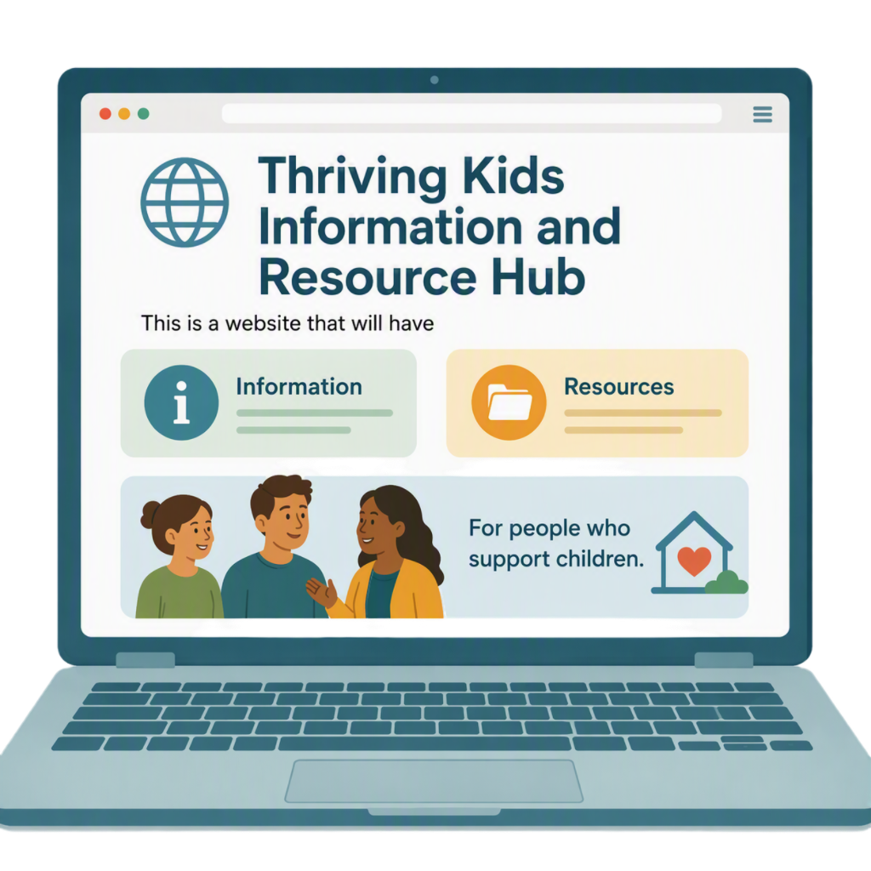 |  | - Thriving Kids Information and Resource Hub  This is a website that has  - Information  - Resources  For families and people who work with children.
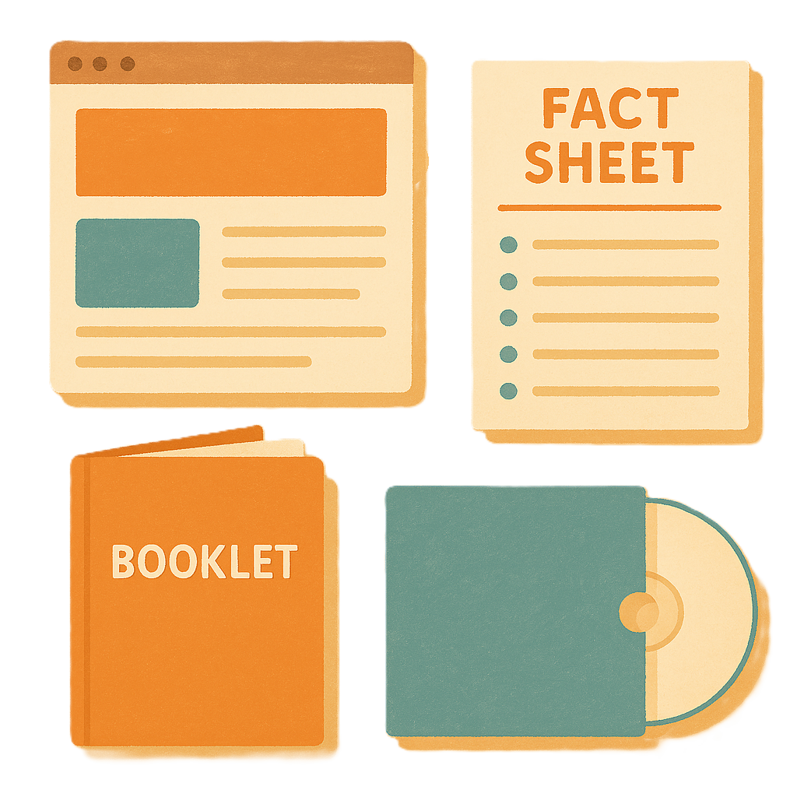 |  | Resources are information that tell someone a way to do something.
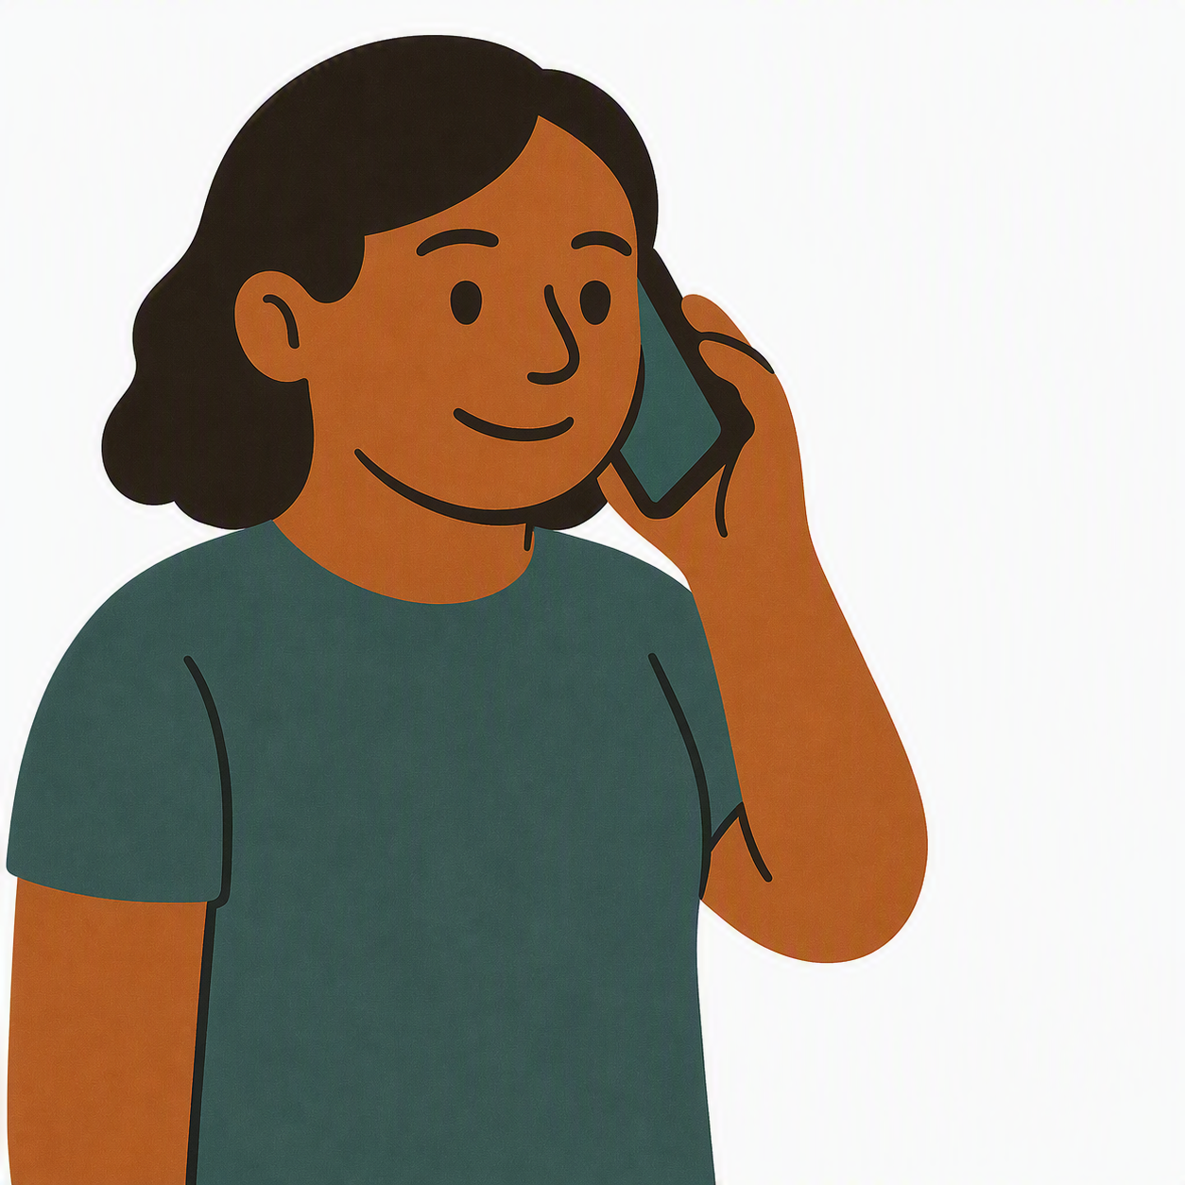 |  | - Thriving Kids Autism Helpline.  This can help families  - Get evidence informed advice about autism  - Know about different supports  - Find services.  The number is  1300 654 789
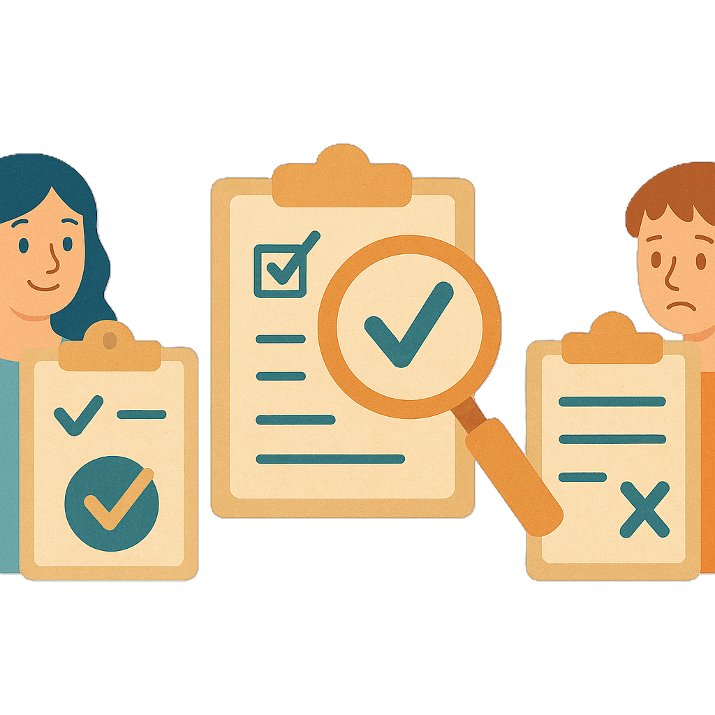 |  | Evidence is proof that something is true.  Informed advice is advice that is based on things that have worked before.

Supports from November 2026

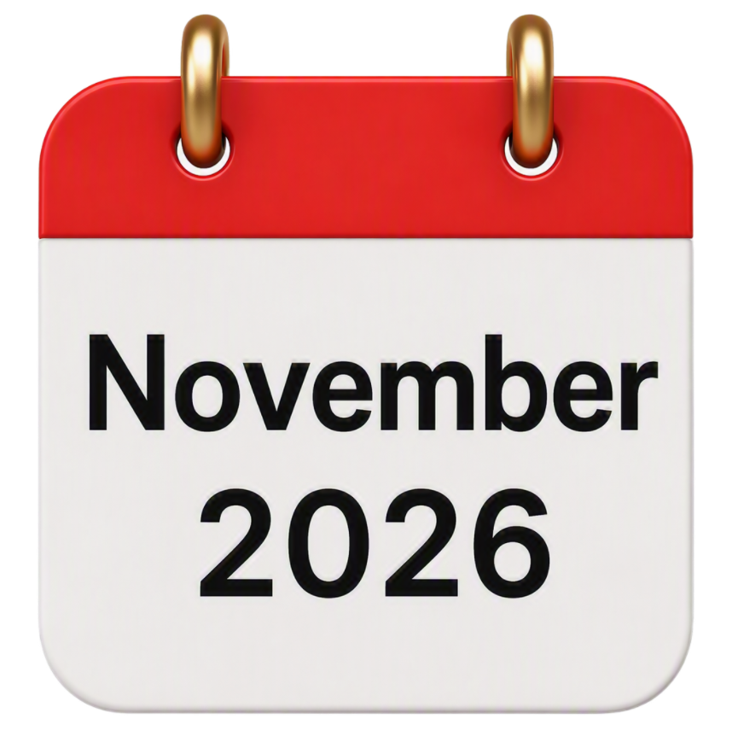 |  | The supports starting in November 2026 will be the  - Medicare Healthy Kids Check.
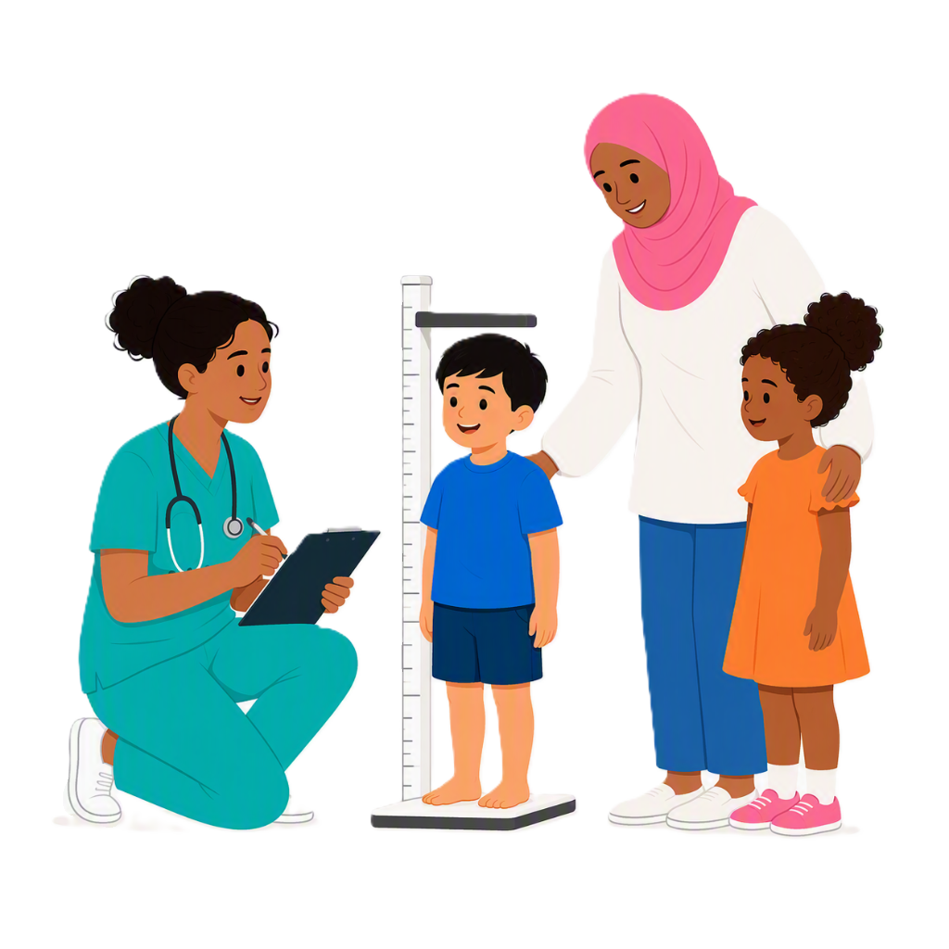 |  | This is a check for 3 year old children with a GP.  The GP will check how the child is going with their  - Health  - Development.
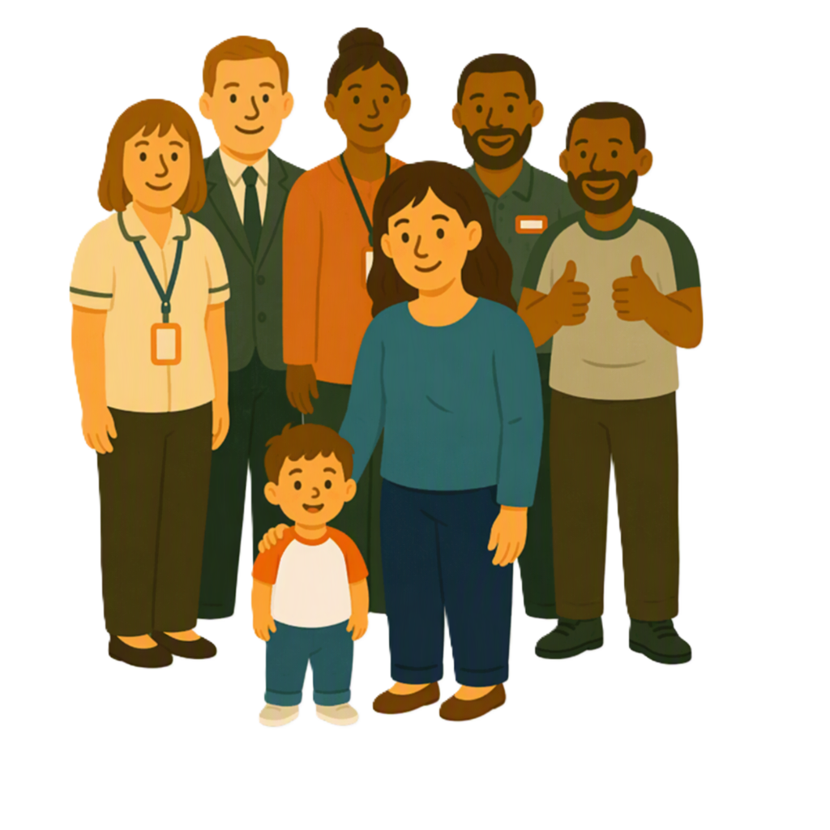 |  | This will help to see if a child needs supports.
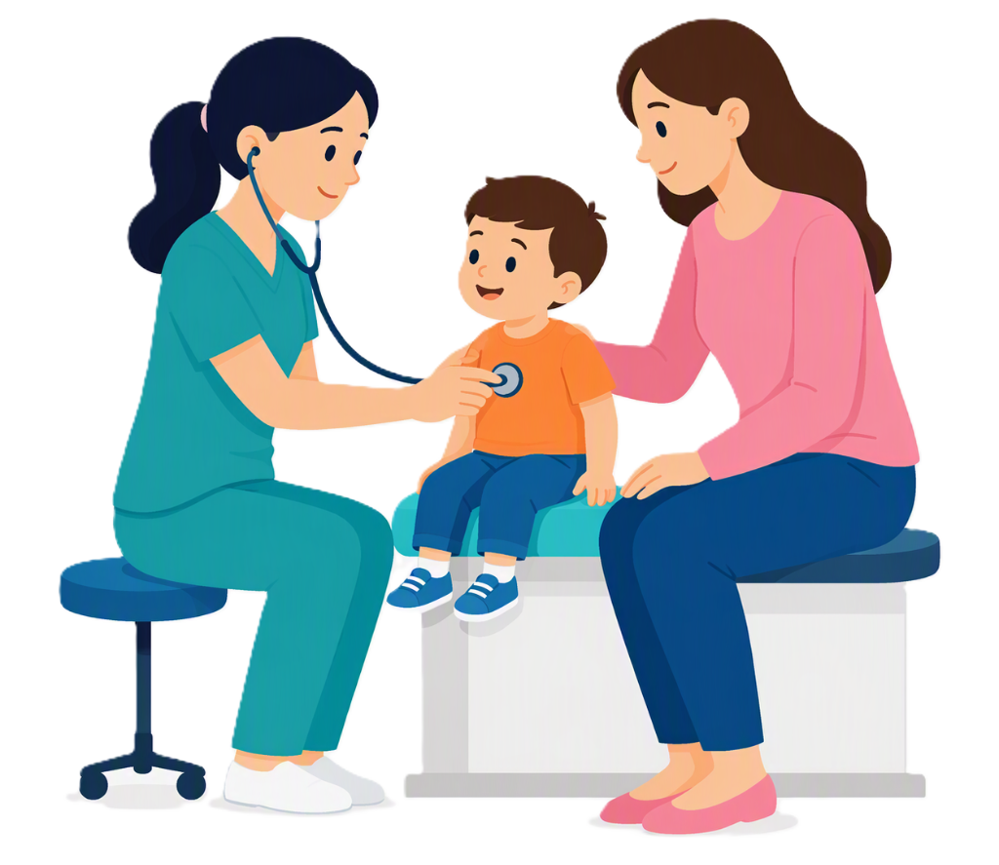 |  | Medicare supports people  - To get healthcare  - Pay less for some health services.

Supports from early 2027

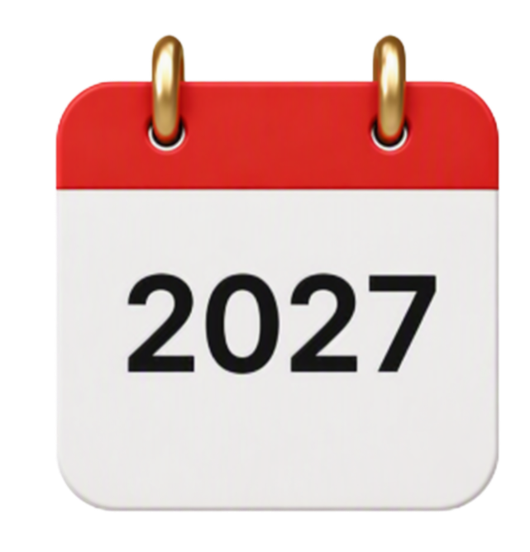 |  | The supports starting at the beginning of 2027 will support  - First Nations sector activities.
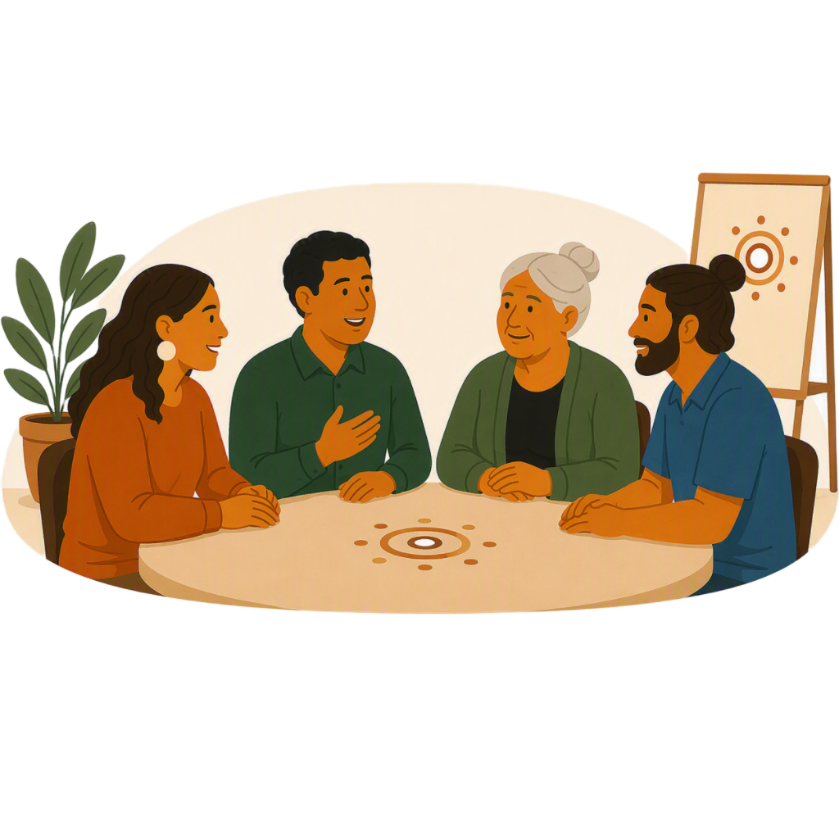 |  | The First Nations sector is organisations.  - Run by First Nations people  - Support First Nations people.
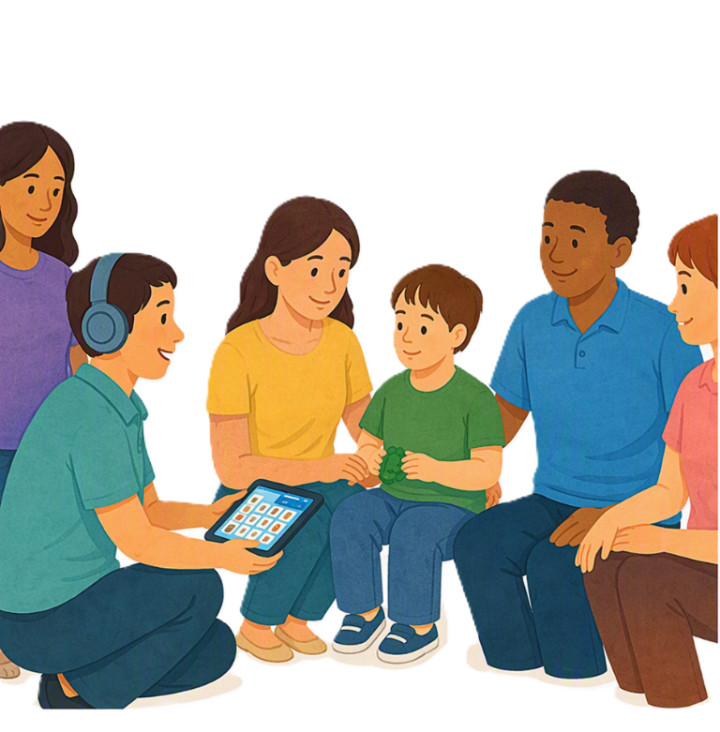 |  | Activities will focus on  - Supporting children and families in a culturally responsive way.
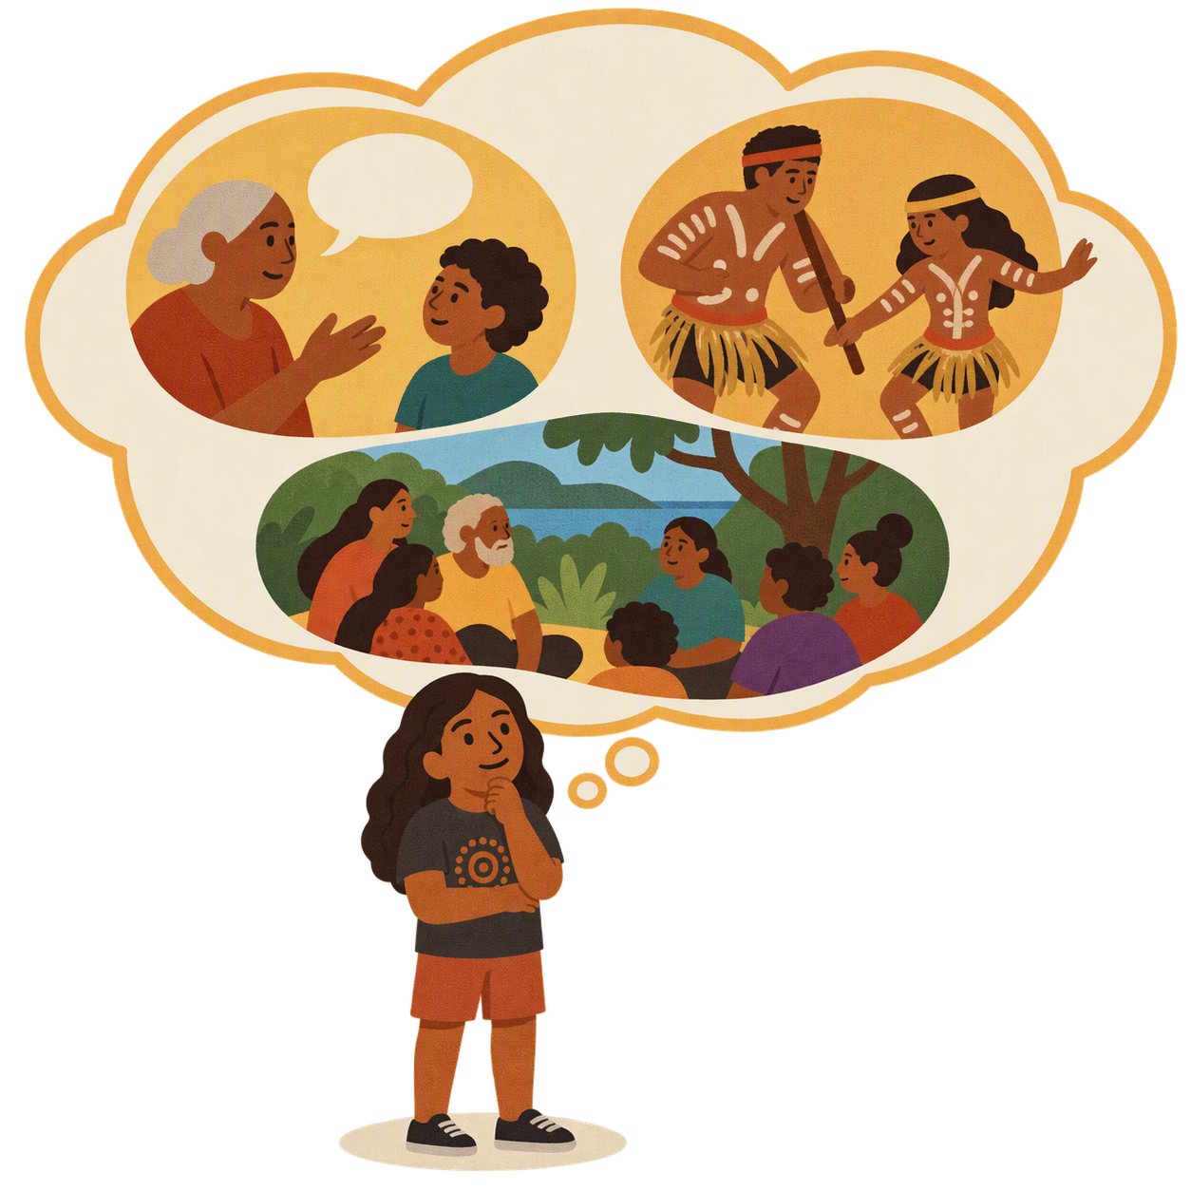 |  | Your culture is your  - Language  - Beliefs  - Traditions  - Family  - Community.
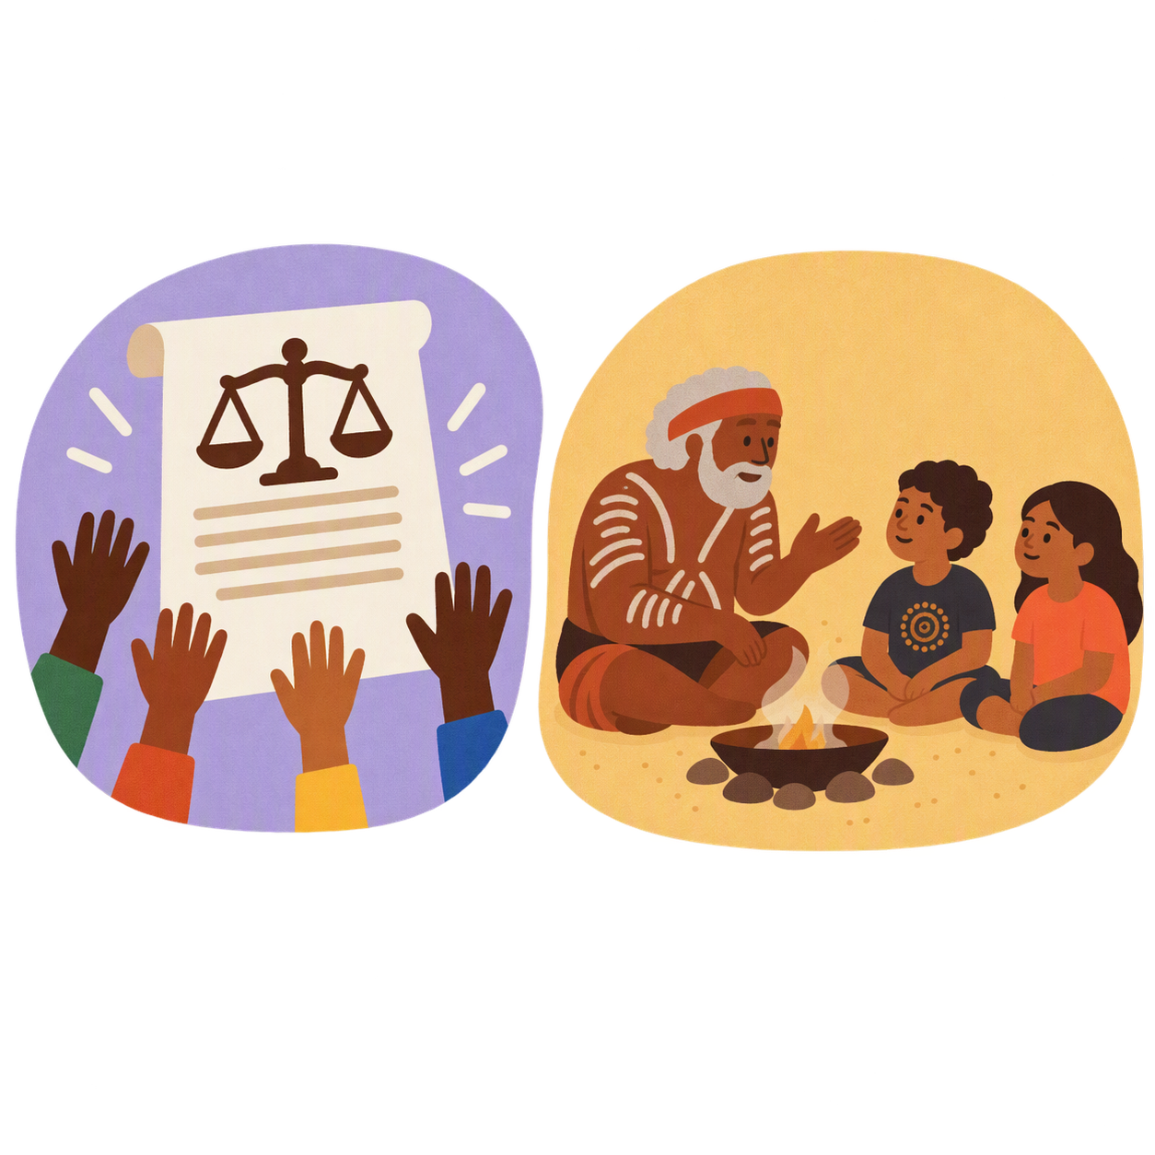 |  | Culturally responsive means respecting peoples  - Rights  - Cultures  - Traditions.  This helps people feel safe to be themselves.  It can also be called culturally safe.
 |  | - Online peer support for Autistic children and their families.  Peer support will help  - Find information  - Connect with others  - Learn ways to support your children  - Learn how to support your wellbeing.
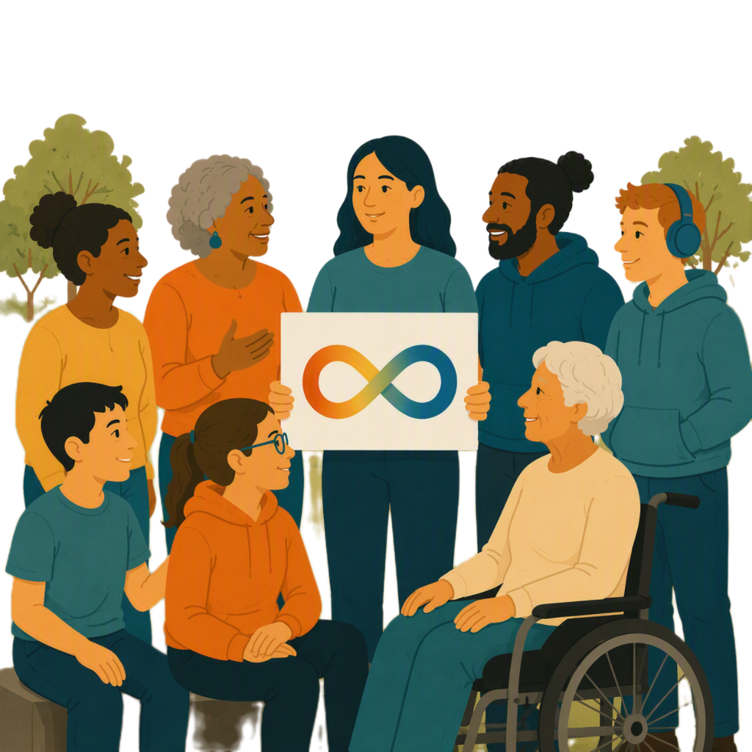 |  | - Working with the Autistic community.  This will make sure supports are working well.

Supports from middle 2027

 |  | The supports starting in the middle of 2027 will be
- Medicare Thriving Kids phoneline will be available.

This means families and health professionals can ask questions about a childs

  - Development
  - Behaviour.
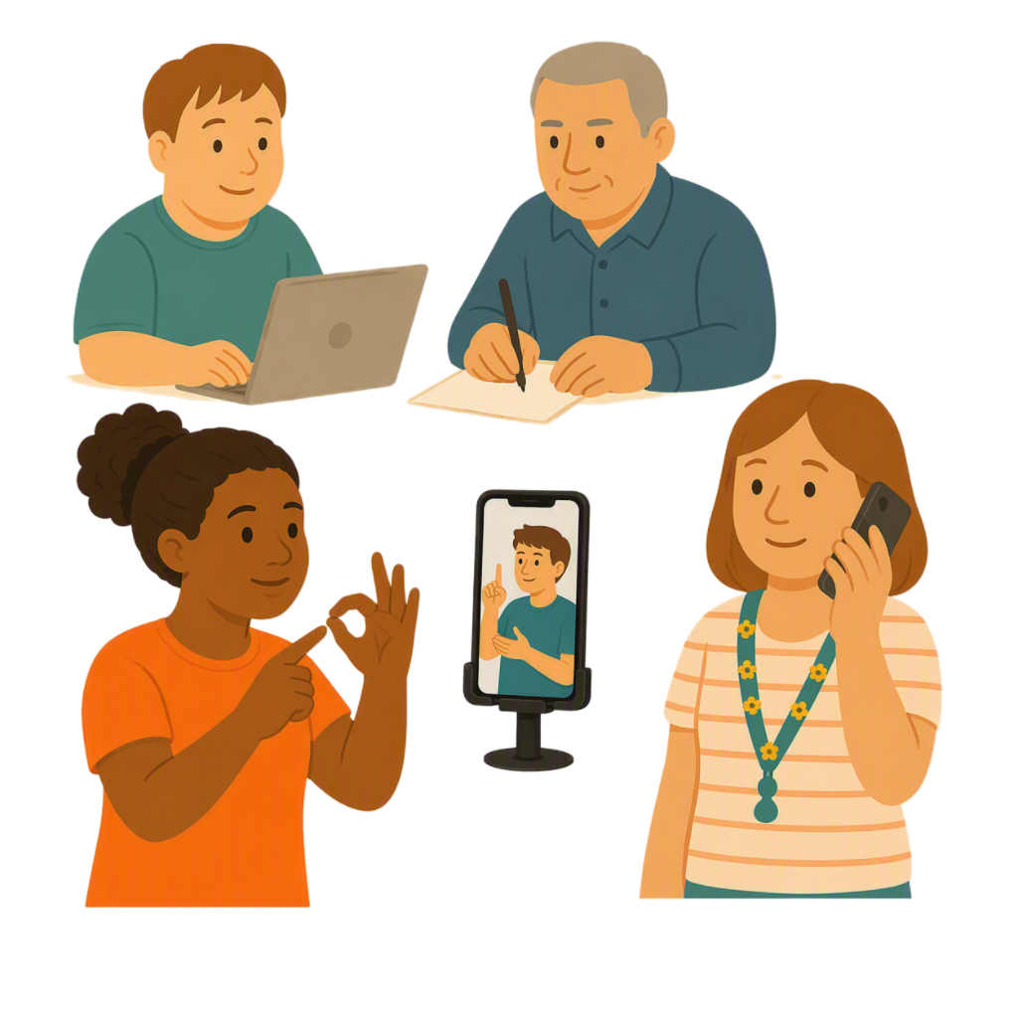 |  | Families and professionals can get support by  - Phone  - Video call.
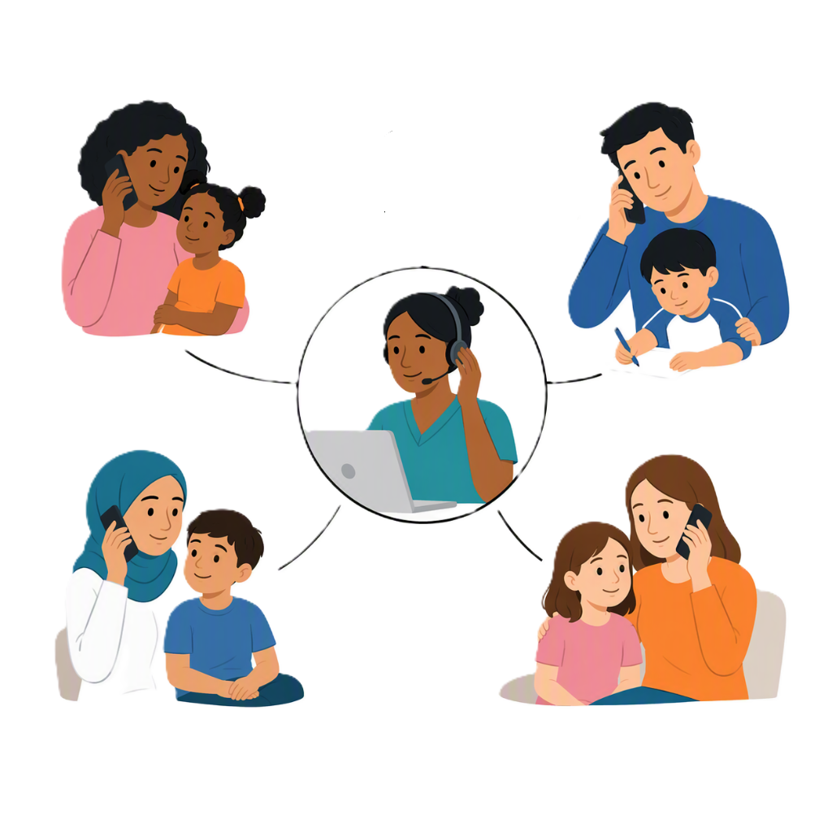 |  | Medicare Thriving Kids will share information and advice.  It will also help families find other supports if they need them.
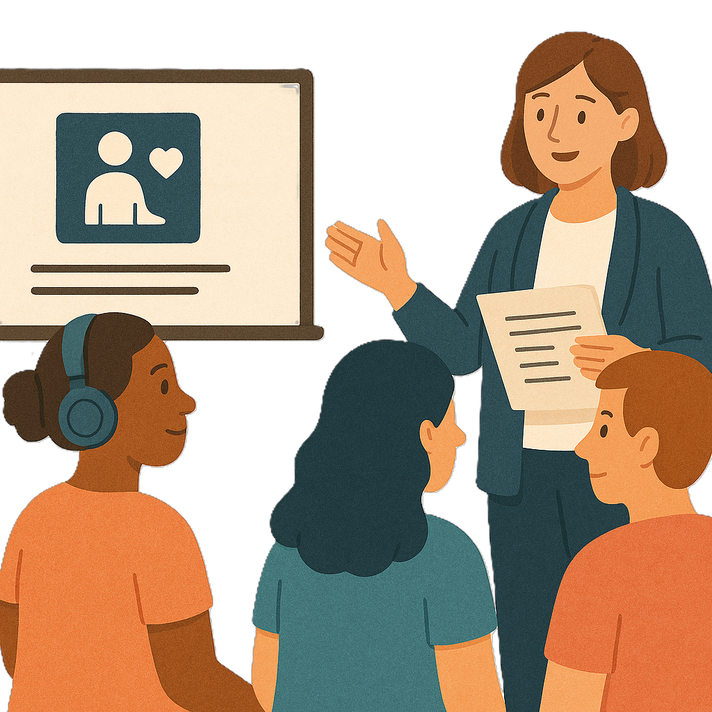 |  | There will also be training for people working with children who have  - Developmental delay  - Autism.
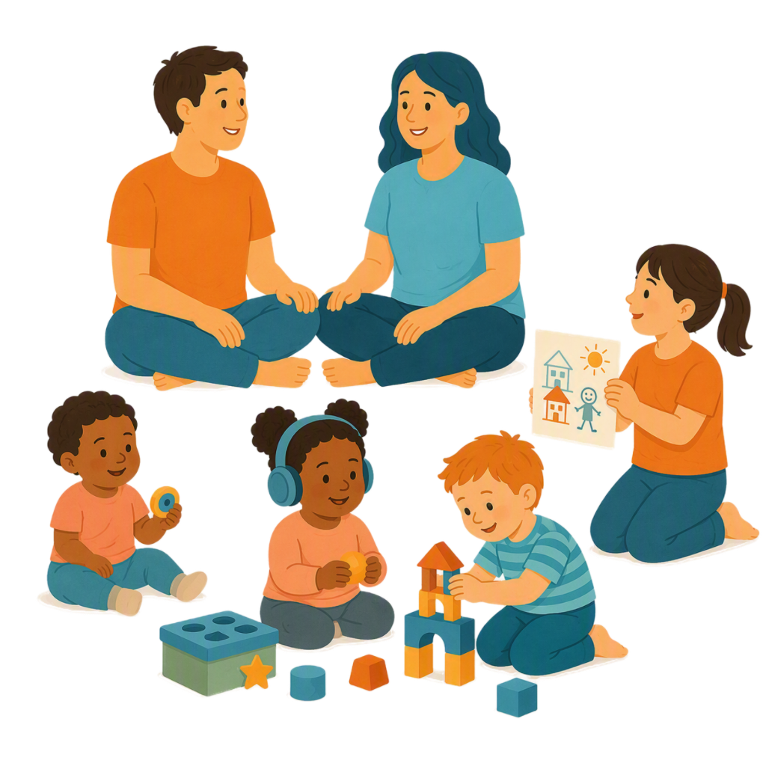 |  | This will help them support  - Children  - Families.

Supports from late 2027

 |  | The supports starting in late 2027 will be
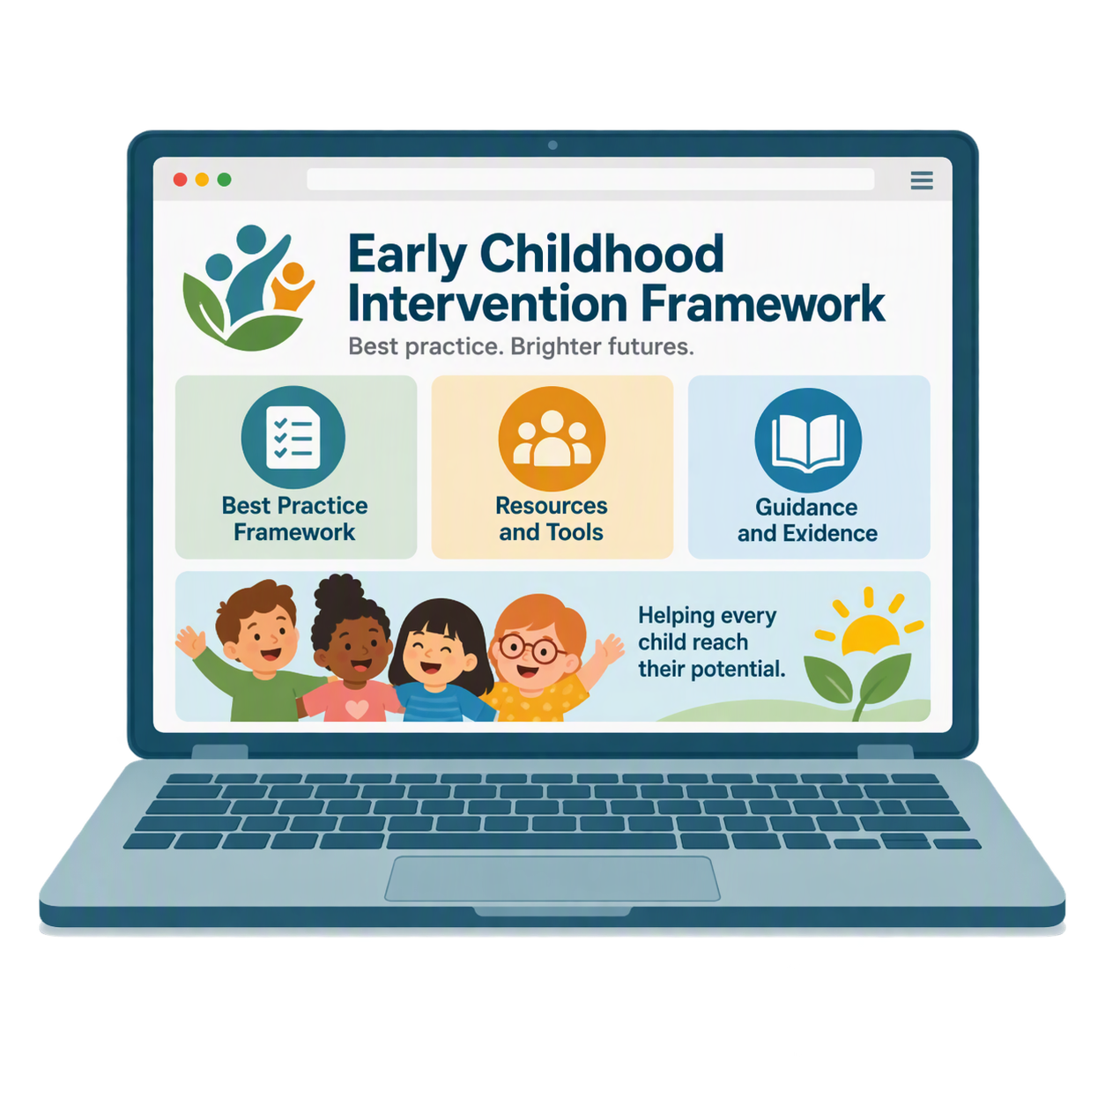 |  | - Support for using the National Best Practice Framework for Early Childhood Intervention  We will say Early Childhood Intervention Framework for short.
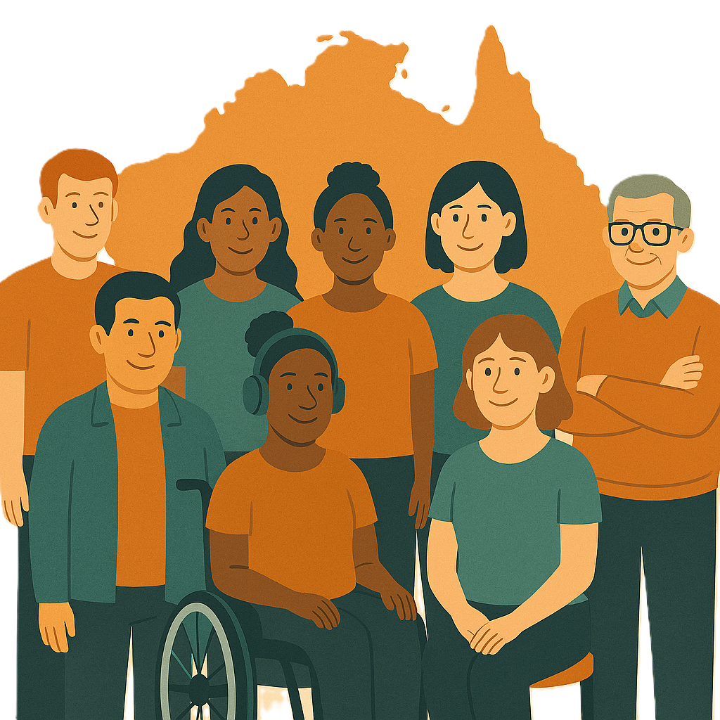 |  | National means people from across Australia.
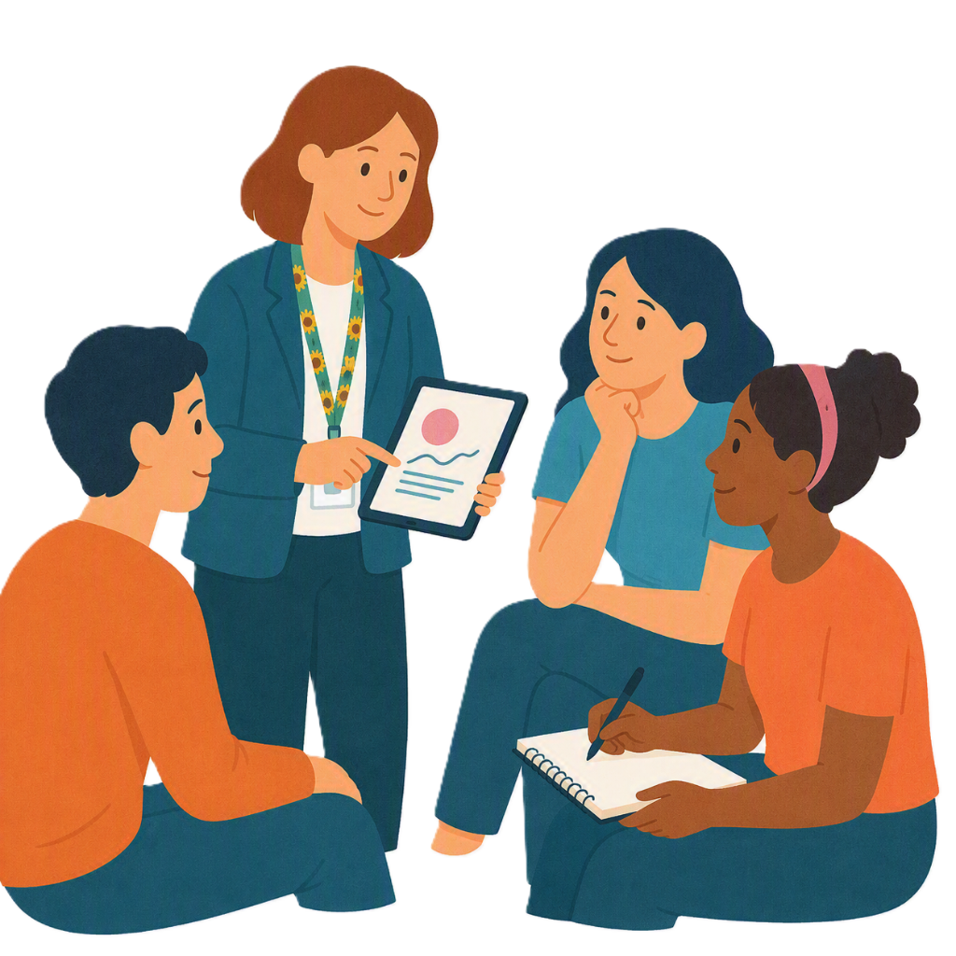 |  | Best practice is the way of doing things.  They are ways that give good results.
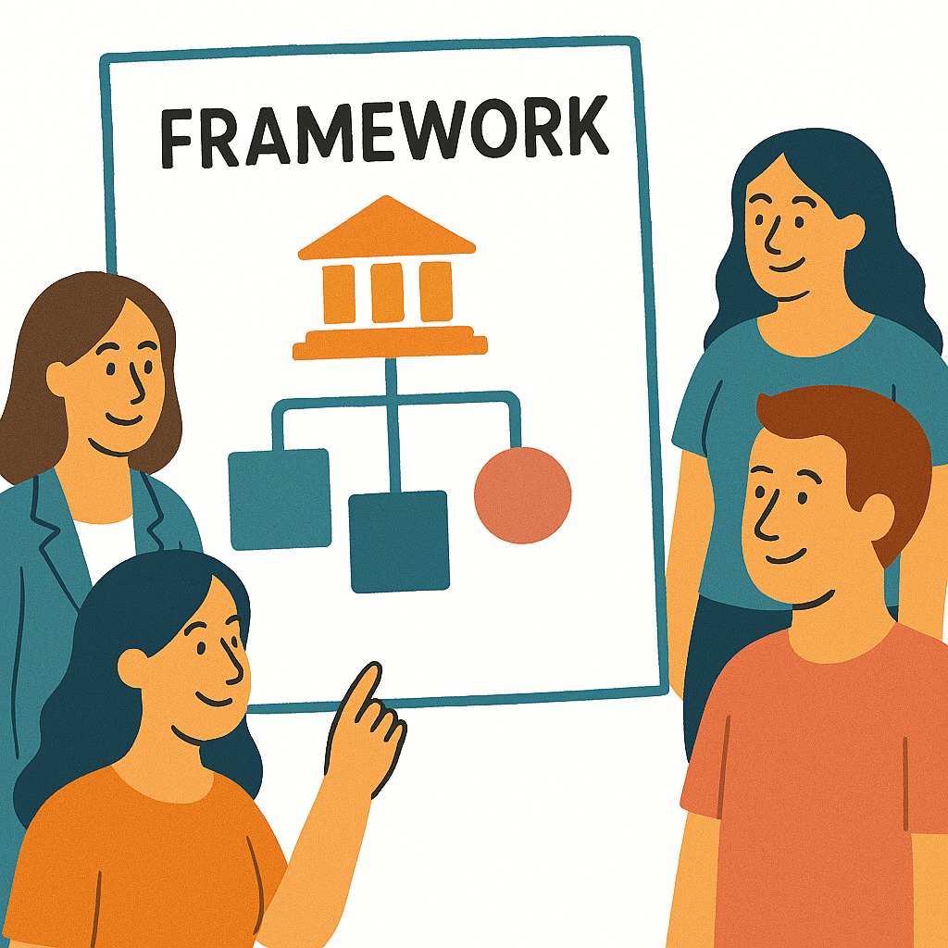 |  | A framework is how we will do something.
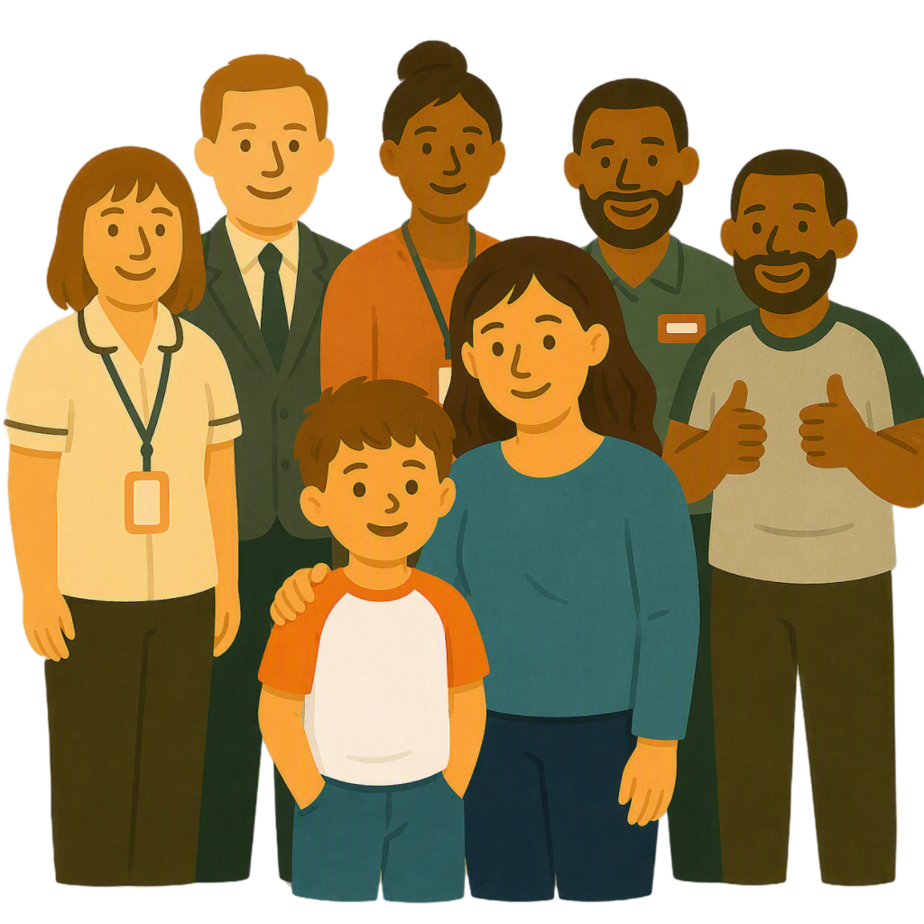 |  | The Early Childhood Intervention Framework is about good supports for children with  - Disability  - Developmental delay.
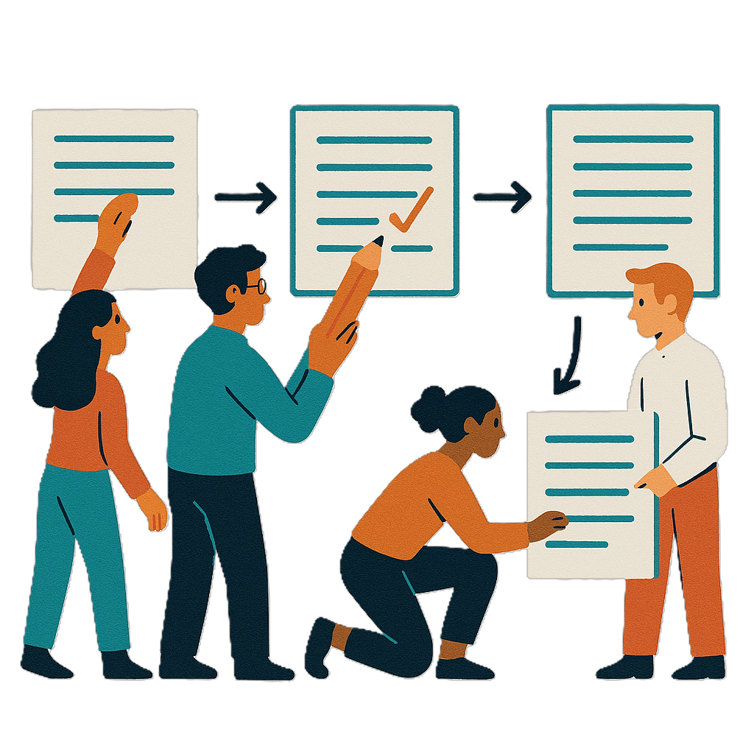 |  | An intervention is  - Different things to change to make things better.
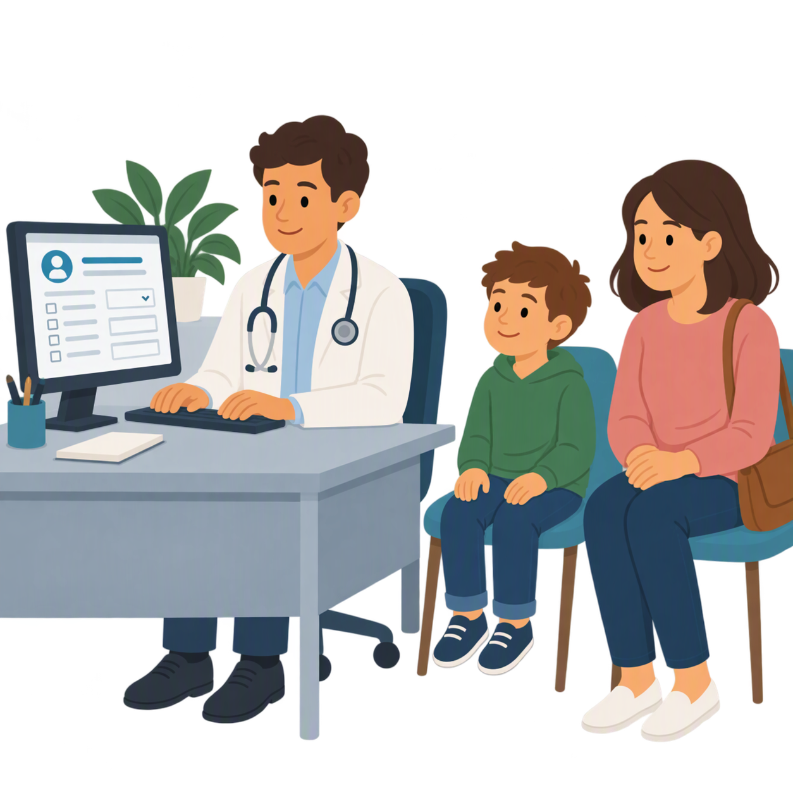 |  | - Adapted Comprehensive Health Assessment Program Tool.  We call it CHAP for short.
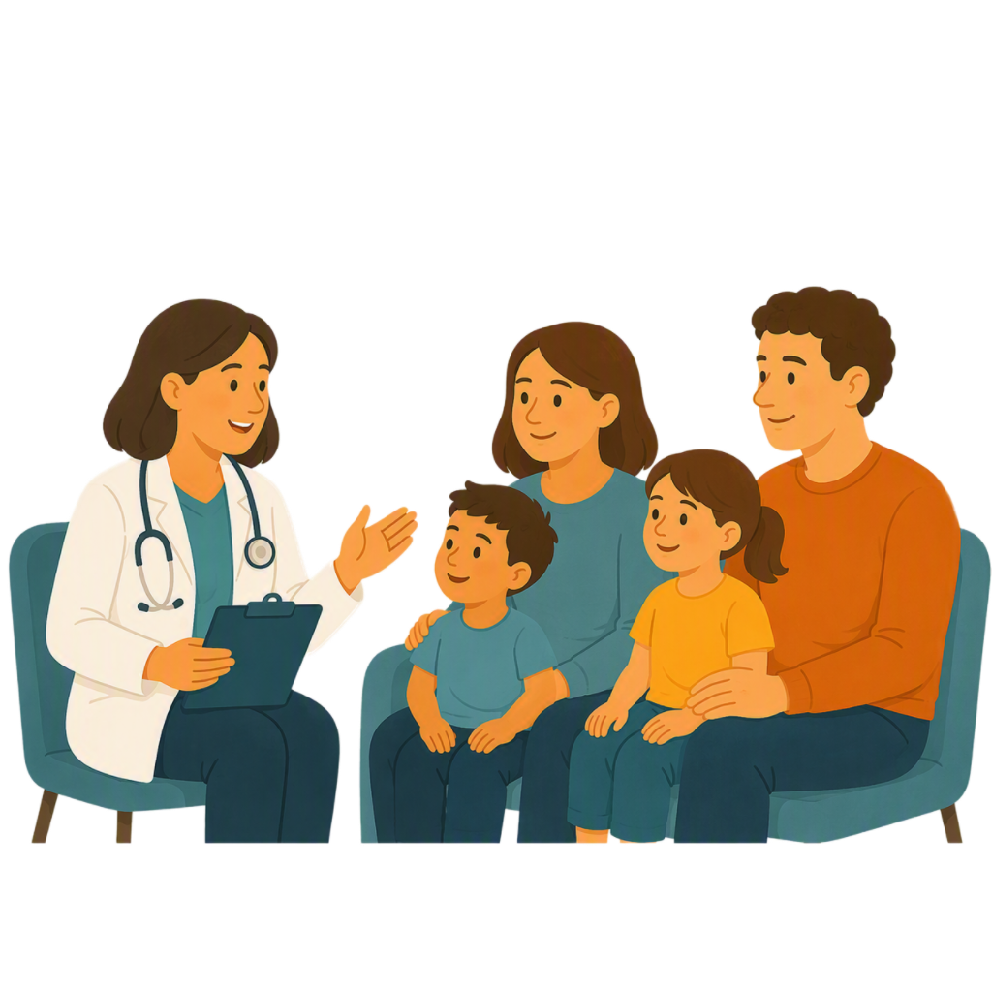 |  | The CHAP is for GPs and families who care for children  - 3 to 12 years old  - Who may have  - Developmental delay  - Developmental differences.
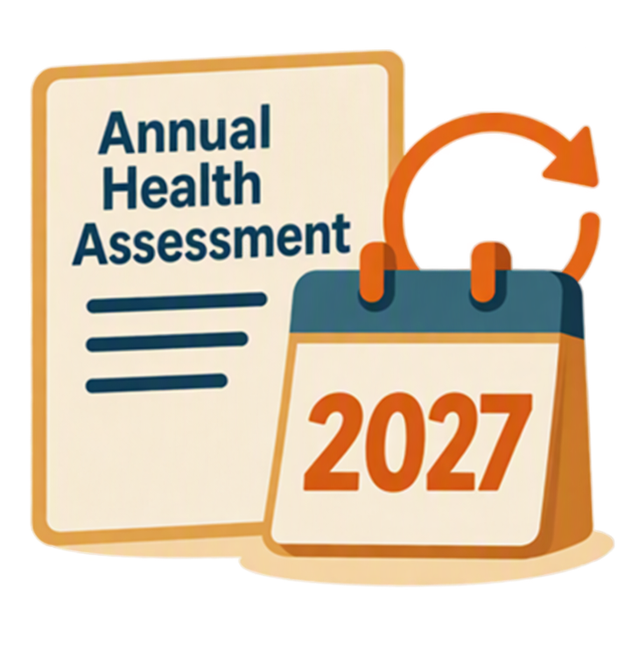 |  | It helps make annual health assessments easier.  Annual health assessments are sometimes called yearly health checks.
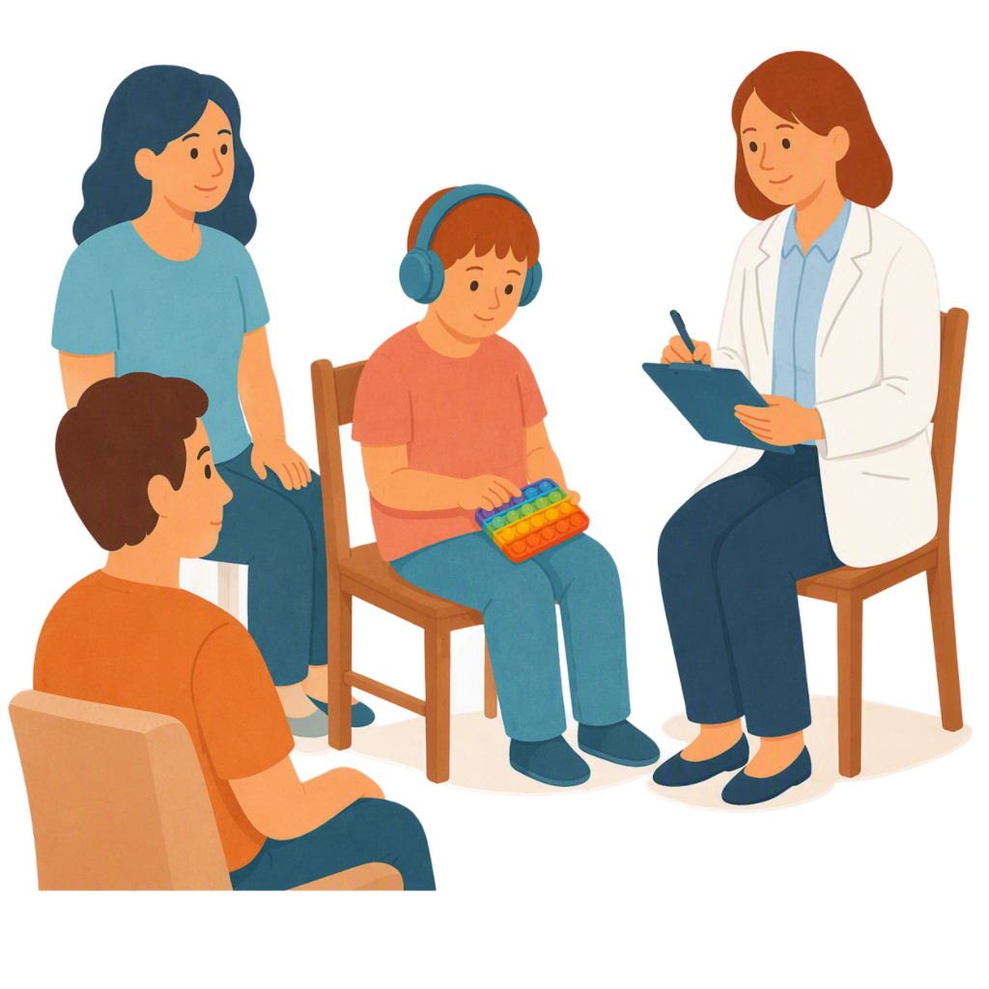 |  | They are a special appointment with your GP once a year.
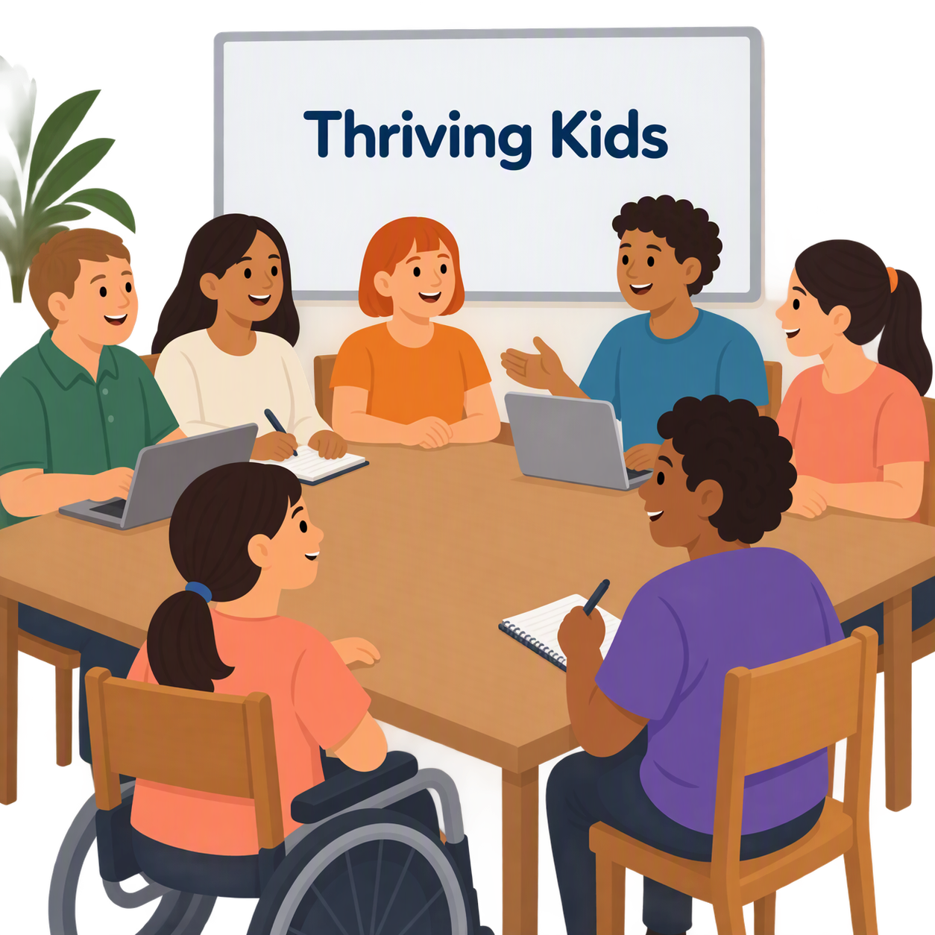 |  | There will also be  - Reporting on Thriving Kids.
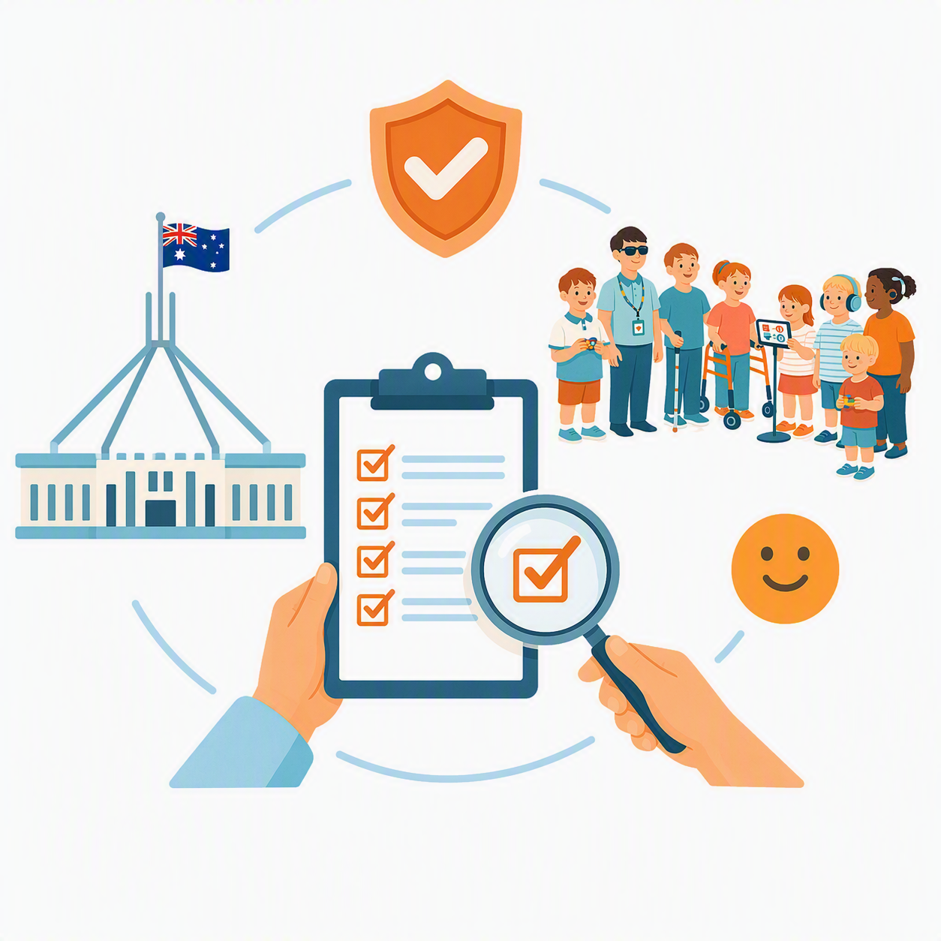 |  | Reporting means to show what has been happening.
All governments will report on their progress.

It will be part of the

- Public report each year
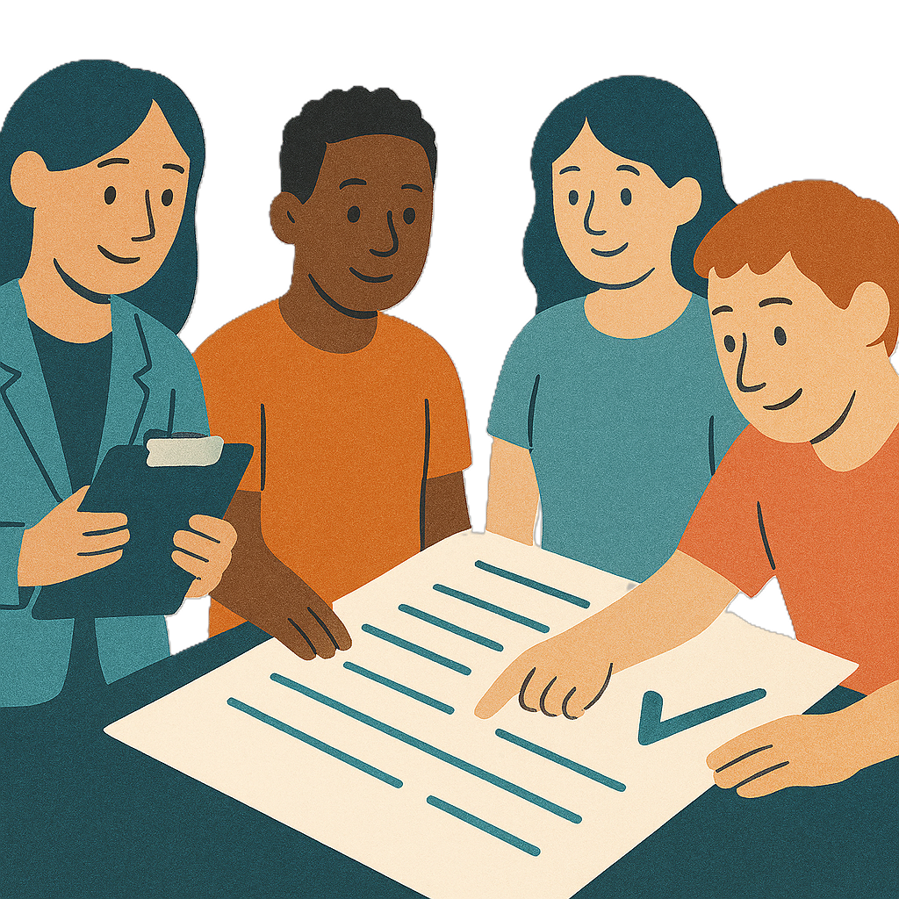 |  | The reporting will help the review of Thriving Kids in 2029.  A review is when you check what  - Works  - Needs to change.
 |  | Work will be happening to set up a  - National Digital Child Health Record.
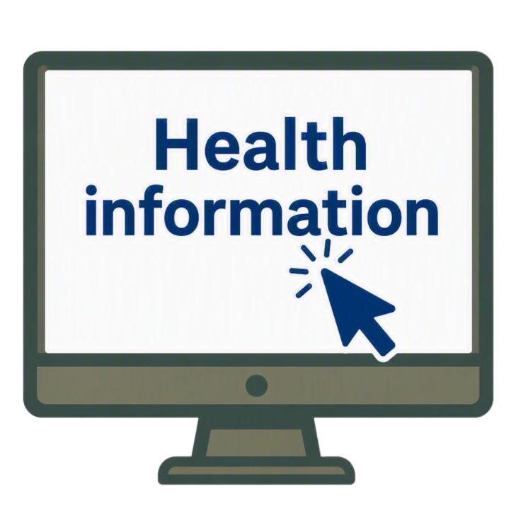 |  | This will help families find information about a childs health and development in 1 place.
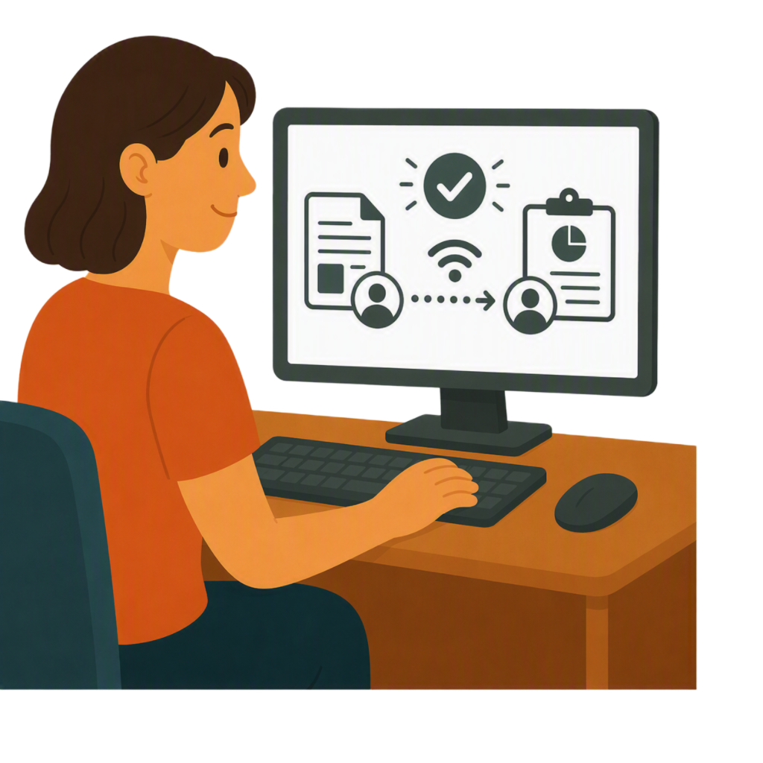 |  | It will also make it easier for professionals to  - Share  - Report  On a childs health and development.

Supports from 2028

 |  | From 1 January 2028  - Thriving Kids supports will be fully ready
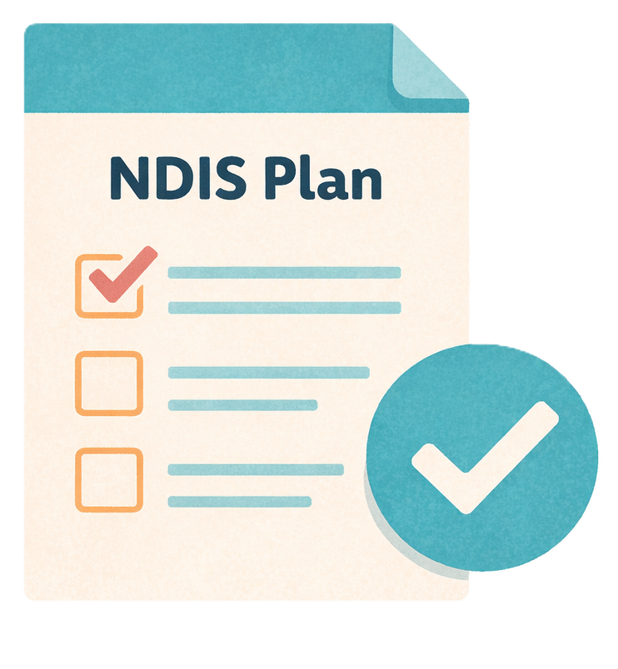 |  | - There will be changes to who can get NDIS.
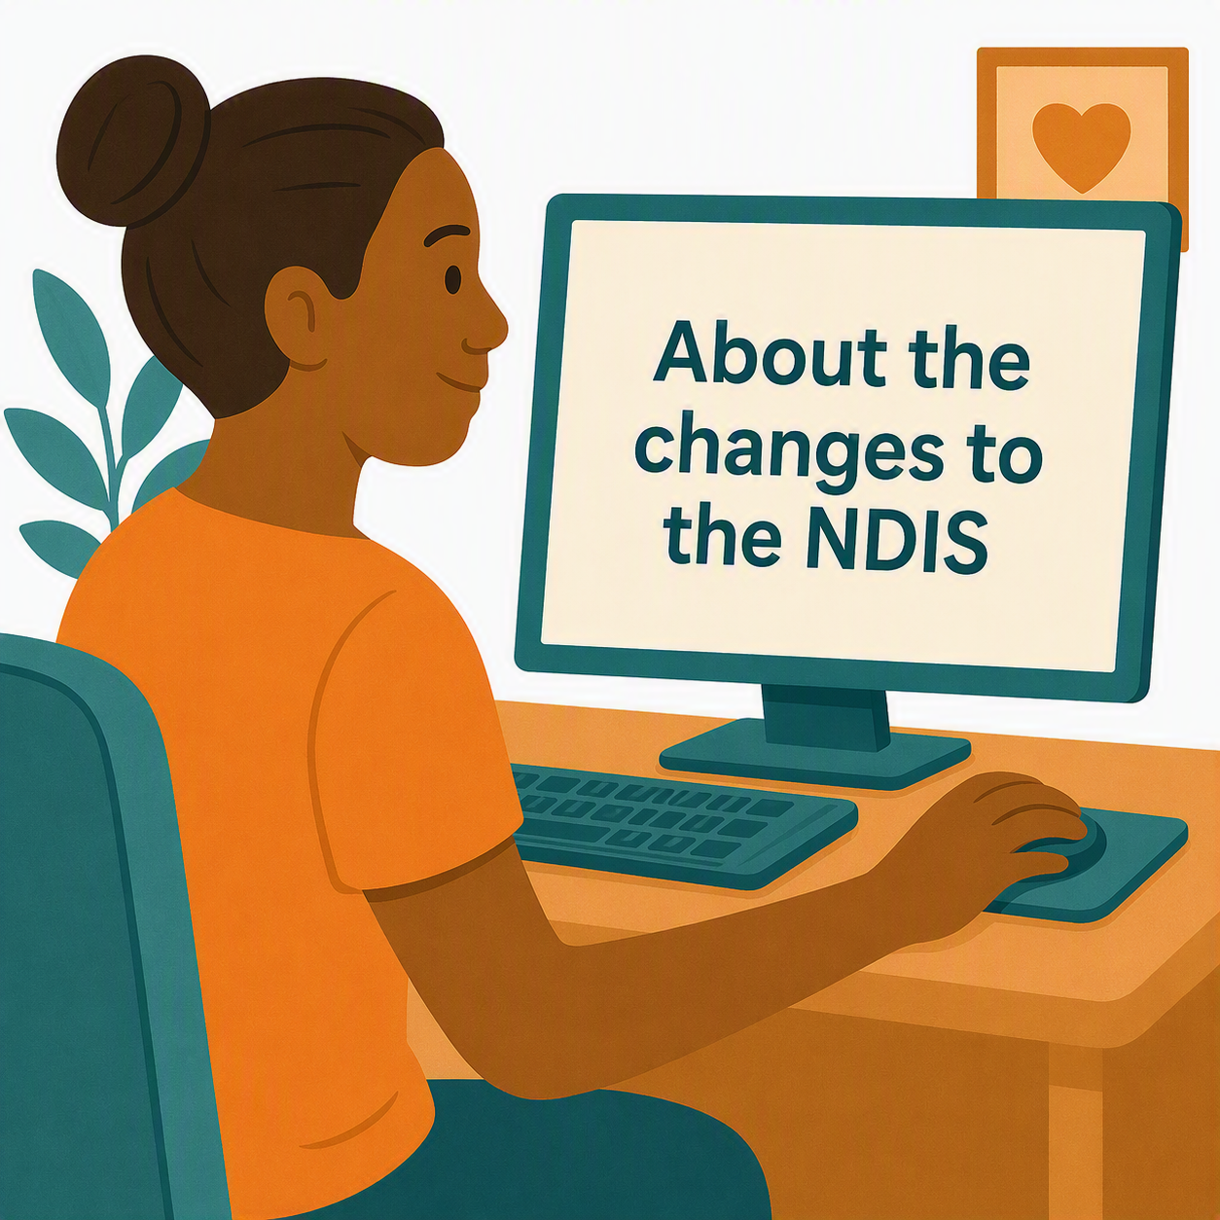 |  | To find out more about the changes you can go to this website  www.health.gov.au/our-work/ndis-legislation-changes/amendments/ndis-amendment-securing-the-ndis-for-future-generations-bill-2026/about-the-changes-to-the-ndis  It is not in Easy Read.

Some images in this Easy Read were made using AI.
You must not share or copy any of the images without permission.
September 2026.

