
Final Report – Review of nKPI and OSR
Department of Health, Disability and Ageing
1 July 2026


Nous Group acknowledges Aboriginal and Torres Strait Islander peoples as the First Australians and the Traditional Custodians of Country throughout Australia. We pay our respect to Elders past and present, who maintain their culture, Country and spiritual connection to the land, sea and community.
This artwork was developed by Marcus Lee Design to reflect Nous Group’s Reconciliation Action Plan and our aspirations for respectful and productive engagement with Aboriginal and Torres Strait Islander peoples and communities.
Disclaimer:
This is an independent report prepared by Nous Group (Nous), which has been commissioned by the Department of Health, Disability and Ageing (Client).
The analyses, opinions and conclusions contained in this report are those of Nous. This report does not constitute or contain any legal, financial, or commercial advice and should not be relied upon as such.
This report has been prepared based on information provided by the Client and by other persons as at the date of this report. Nous has relied on that information and has not independently verified or audited that information. Nous does not accept responsibility to update or revise this report.
This report may contain forward-looking statements, conclusions, and recommendations. Whilst Nous has prepared this report with care and diligence, Nous makes no representations or warranties, express or implied, regarding the completeness or accuracy of the information in this report. In particular, nothing in this report represents or guarantees future outcomes, and no representation or warranty is made to this effect.
Any use of this report by third parties is at their own risk. Nous accepts no liability or responsibility for any consequences (direct or indirect) arising from such use.
© Nous Group

Contents
1 Executive Summary 1
2 Methodology 5
2.1 Purpose and scope of this review 5
2.2 Overview of the methodological approach 6
2.3 Ethical framework and Indigenous Data Sovereignty 6
2.4 Review stages and sequencing 6
2.5 Literature and document review 7
2.6 Stakeholder engagement methodology 7
2.7 Data analysis and synthesis 7
2.8 Development of findings and recommendations 8
2.9 Limitations 8
3 Background 9
3.1 Policy landscape 9
3.2 Primary health care services 9
3.3 The nKPI and OSR data collections 11
3.4 History of the nKPIs 11
3.5 History of the OSR 12
3.6 The 2018 AIHW Review 13
4 Future landscape 16
4.1 Australia’s health systems are rapidly modernising 16
4.2 Reforms to data collection, linkage, and reporting will reshape the OSR and nKPI collections 17
4.3 Tomorrow’s system will need to build on improvements to the current system 22
5 National Key Performance Indicators (nKPIs) 25
5.1 Introduction 25
5.2 Purpose 26
5.3 Usefulness 28
5.4 Scope and content 32
5.5 Reporting burden 40
6 Online Services Report (OSR) 42
6.1 Introduction 42
6.2 Purpose of the OSR collection 44
6.3 Use of the OSR collection 45
6.4 Scope and content 47
6.5 Reporting burden 50
7 Data platforms and infrastructure 52
7.1 Introduction 52
7.2 Data Collection 53
7.3 Departmental reporting infrastructure 59
7.4 Future landscape infrastructure 66
7.5 Artificial Intelligence 71
8 Indigenous Data Sovereignty and Governance (IDS&G) 76
9 Recommendations 81
9.1 Overview of recommendations 81
9.2 Planning considerations 86

Executive Summary
This report presents the final findings and recommendations of the review of the national Key Performance Indicators (nKPIs) and the Online Services Report (OSR), commissioned by the Department of Health, Disability and Ageing (the Department). The review examines the appropriateness, usefulness, efficiency and governance of the collections, the burden they place on First Nations Primary Health Care (PHC) services, and how they can be strengthened in the context of Indigenous Data Sovereignty principles, broader national digital health reform, and the Closing the Gap Priority Reforms, in particular Priority Reform 4 relating to shared access to data and information at a regional level.
The nKPIs and the OSR were established at different times and for distinct but complementary purposes within the First Nations PHC system. The nKPIs were developed in 2010 to support continuous quality improvement (CQI) in First Nations PHC services, by providing a nationally consistent, service‑level view of key clinical activities and outcomes, alongside a secondary role in informing program monitoring and policy development. Since their introduction, the nKPIs have been refined through periodic review and stakeholder input, but their core design as a six‑monthly, aggregated, CQI‑oriented collection has remained unchanged.
The OSR has a longer history, originating in earlier service activity and organisational reporting collections from the late 1990s and later consolidated into a single annual report to support funding accountability, service profiling and system‑level understanding of the First Nations PHC sector. The OSR was designed primarily as an administrative and organisational dataset, capturing workforce, activity and service context information to inform Indigenous Australians’ Health Programme (IAHP) funding assurance, program management and national reporting. Over time, incremental changes to scope and reporting requirements have increased burden and reduced clarity of purpose, without diminishing the underlying value of the collection for its core roles, reinforcing the need to re‑establish the OSR as a focused and proportionate collection aligned to its core funding and stewardship functions.
The review draws on an extensive evidence base, including a documentation and literature review, quantitative analysis of the collections and supporting systems, and comprehensive consultation with Aboriginal Community Controlled Health Organisations (ACCHOs), other First Nations PHC services, peak bodies, government agencies, data custodians and system partners. Findings reflect consistent themes across these sources and build on the Initial Findings and Recommendations through additional analysis, sector feedback and refinement of proposed reform pathways.

The role of the nKPI and OSR in the current data environment
The review finds that the nKPI and OSR collections continue to play an important and enduring role within the First Nations PHC data ecosystem. When assessed against their original and intended purposes, the collections together provide nationally consistent, service‑level data that supports CQI, benchmarking and governance oversight through the nKPI, and funding accountability, program administration and sector‑level profiling through the OSR. Compared with many other government reporting programs, they are relatively mature, reflecting sustained investment in indicator design, cross‑vendor automation, validation processes, training and sector support.
At the same time, recognising the distinct ways in which different stakeholders use the data, the review confirms that both collections are best understood as partial and purpose‑bound instruments rather than comprehensive or standalone measures of First Nations health or service performance. Structural features of the collections, including aggregation, reporting frequency, partial population coverage and reliance on Clinical Information Systems (CIS), inherently limit the extent to which all original objectives can be realised simultaneously. These constraints reflect deliberate design choices intended to balance value, feasibility and reporting burden, rather than shortcomings in implementation. This reflects a broader, systemic issue beyond the nKPI and OSR, where digital architectures fail to accommodate the holistic models of health held by First Nations peoples.
Importantly, some perceived limitations in how data is accessed and interpreted are not solely a function of these structural features but also relate to how data is currently presented to the sector and stakeholders. For example, the configuration of Qlik Sense (Qlik) dashboards provides a relatively flat and constrained view of the data. However, this reflects design choices in reporting and visualisation, rather than inherent limitations in the underlying data or its potential use. There is therefore scope to enhance how data is presented and interrogated over time, without requiring fundamental changes to the collections themselves.
In practice, these purpose boundaries are reflected in the different uses of the data. At the service level, nKPI data primarily supports high‑level CQI, reflection, benchmarking and governance reporting, while OSR data is experienced largely as an administrative and funding‑related reporting requirement. At the sector level, organisations such as the National Aboriginal Community Controlled Health Organisation (NACCHO) and some Affiliates use aggregate outputs to support advocacy, sector monitoring and system stewardship. Within government, use is concentrated in specific departmental and program areas for funding assurance, contract management and contribution to national reporting, including analysis undertaken by data custodians such as the Australian Institute of Health and Welfare (AIHW). Understanding these distinct use cases is critical to identifying where value is generated, where reporting burden is most acutely felt, and how reciprocity can be strengthened across the system.
A central finding is that clarity of purpose and use matters more than the volume of reporting itself. Where the intended purpose of a collection is clearly articulated, aligned to how data are used, and visibly linked to value for services and the sector, reporting effort is more readily understood and accepted. Conversely, lack of transparency about downstream use undermines trust and amplifies perceptions of burden.

Findings on the nKPI collection
The nKPI collection is most effective as a high‑level CQI, benchmarking and governance tool. This aligns directly with the original intent of the nKPIs to support service‑level continuous quality improvement, reflection and oversight. Its six‑monthly, aggregated design supports reflection on trends over time and peer comparison and is particularly useful for board reporting and high‑level oversight. However, the same design features limit its usefulness for day‑to‑day clinical improvement, targeted follow‑up or real‑time decision‑making. This reflects the way the collection has evolved in practice rather than a deliberate exclusion of real‑time CQI in its original intent. At the time of its establishment, the nKPIs were expected to support CQI within services; however, over time, the emergence of more advanced CIS tools and internal analytics has enabled services to undertake timelier, patient‑level CQI through other means. In practice, PHC services rely on their own CIS‑based tools and internal analytics for operational CQI, with nKPIs providing a complementary rather than primary evidence source.
The review finds that the current nKPI set broadly aligns with many core clinical priorities relevant to IAHP‑funded PHC services, but does not reflect the full scope of holistic, culturally grounded PHC service delivery. Significant gaps remain in areas such as social and emotional wellbeing and mental health, where there is strong sector interest but no agreed, low‑burden approach to standardised collection. These gaps highlight the limits of the nKPI as a bounded CQI and governance dataset, rather than a comprehensive representation of all PHC activity. At the same time, not all existing indicators provide commensurate value, and some require refinement to improve relevance, interpretability and alignment with holistic, culturally grounded clinical practices of IAHP-funded PHC services.
The review concludes that, in the short to medium term, reform should focus on strengthening the clarity, value and usability of the existing nKPI collection, rather than expanding its scope. This reflects the broader, longer‑term direction of health data reform, which points toward greater use of interoperable, unit‑level data within CISs as part of national digital health reform, rather than incremental enhancement of existing aggregated reporting collections.
In this context, references to unit‑level data relate to changes in data structure and reporting architecture, not the introduction of whole‑of‑system person‑level data linkage or expanded surveillance of individuals. This includes clearer articulation of what the nKPIs are and are not intended to be used for; targeted refinement of indicators; optionality where indicators are not relevant to all services; and exploration of approaches that better support CQI without increasing compliance burden.
In this context, the value of significant investment in further expanding or materially redesigning the current nKPI approach is limited. Instead, the emphasis is on practical, proportionate improvements that address current pain points, minimise additional burden on PHC services, and are achievable without significant investment in time or resourcing, while progressing longer‑term reform in parallel. A future transition to unit‑level data has the potential to address many current limitations in the longer term.

Findings on the OSR collection
The OSR remains a critical funding and accountability dataset, particularly for workforce, service activity and organisational context. This is consistent with the original purpose of the OSR as an administrative and organisational collection designed to support IAHP funding assurance, service profiling and system stewardship, rather than service‑level CQI. Government stakeholders rely on OSR data to support IAHP funding assurance and program management, and system‑level analysis by data custodians such as the AIHW depend heavily on OSR workforce information.
In this role, the OSR also supports national reporting on the size, distribution and scope of the ACCHOs sector and provides baseline organisational information that assists services and funders to understand sector capacity and sustainability.
However, the OSR is widely experienced by services as higher‑burden and comparatively low‑value in its current form. Manual reporting requirements, particularly workforce and vacancy reporting, are the primary drivers of burden, and several measures do not consistently reflect contemporary PHC service models, including multidisciplinary, outreach‑based and culturally grounded care. These issues undermine the OSR’s effectiveness in fulfilling its core purposes, both for funding assurance and for sector‑level reporting, as inconsistency and reporting burden reduce confidence in the data and limit its usability. This burden is compounded by limited shared understanding of how OSR data is used for its core funding and stewardship purposes. There is also limited shared understanding of how specific OSR measures are used in policy decisions, which weakens confidence in the collection and contributes to perceptions of non‑reciprocal reporting.
The review finds limited appetite for expanding the scope of the OSR. Instead, the priority is purposeful simplification in line with the OSR’s core role in funding assurance and system‑level understanding.
The primary value of the OSR for funding assurance lies in a small set of core measures, particularly client numbers, episodes of care and clinic location, which are used by the Australian Government as inputs to understand service scale, reach and distribution. These data support high‑level funding assurance and system oversight rather than detailed analysis of service delivery models.
For the OSR’s other core purposes, including supporting organisations to understand their own scale and profile, and enabling national reporting on the size and scope of the ACCHOs sector, the focus is on making data easier to collect/report and more consistent, rather than more detailed. Accordingly, reform should prioritise removing low‑value or redundant items, reducing unnecessary granularity, clarifying definitions, and improving alignment between reporting effort and actual use. Where OSR data is relied on for funding or system oversight, clearer communication and feedback loops are essential to improve transparency and trust.

Infrastructure, governance and future directions
Both collections are underpinned by shared digital infrastructure, including the Health Data Portal and associated analytics tools. While automation and direct load deliver clear benefits, services continue to experience challenges with usability, access management, validation processes and data preparation, particularly in high‑turnover, low‑capacity organisational settings. These issues compound reporting burden and limit the value returned through dashboards and reporting tools.
The review situates these findings within a broader and rapidly evolving digital health landscape. National reforms are increasingly oriented toward interoperable, unit‑level data architectures, linkage across care settings and reuse of data for multiple purposes, consistent with Closing the Gap Priority Reform 4. Interoperable, unit‑level data architectures relate to how clinical data are structured, extracted and reused to reduce duplication and reporting burden. Data linkage across care settings and the reuse of data for multiple purposes raise additional questions about consent, linkage, access and downstream use. Progress toward this future state will be incremental and will depend in part on technical advancements beyond the sector, including CIS vendor development, broader standards adoption, and national certification frameworks.
Beyond Priority Reform 4, these directions also have important implications across the full set of Priority Reforms under Closing the Gap. Priority Reform 1, which focuses on formal partnerships and shared decision‑making, highlights the need for stronger co‑design and joint governance of data systems with Aboriginal community‑controlled organisations, ensuring that decisions about data collection, use and reform are made in genuine partnership. Priority Reform 2, which centres on strengthening the community‑controlled sector, reinforces the importance of reducing unnecessary administrative burden on ACCHOs, building sector capability in data and digital systems, and aligning data collection and governance with community‑controlled models of care. Priority Reform 3, which seeks to transform government organisations, underscores the need for government to improve transparency, consistency and accountability in how data is collected, used and shared, including clearer articulation of purpose and stronger feedback loops to services.
While this overall direction offers substantial long‑term benefits, First Nations PHC services consistently emphasised the need for caution, strong Indigenous‑led governance, and demonstrable reciprocity, particularly in relation to any reforms that extend beyond service‑level reporting toward cross‑system data linkage. This includes ensuring that future governance arrangements apply consistently to all data relating to First Nations people across the health system, including data generated in mainstream service settings, not only within community‑controlled organisations.
In this context, the future direction points toward shared data infrastructure with First Nations-led governance, building on existing platforms such as the Health Data Portal (HDP). The HDP provides an established, sector-wide foundation, with existing functionality, service familiarity and support structures that could be progressively strengthened and adapted over time, rather than replaced. Evolving toward shared infrastructure of this kind would support more coordinated reporting, improved data access, and greater sector influence over how data is governed, used and returned, consistent with Indigenous Data Sovereignty principles and the objectives of the Closing the Gap Priority Reforms. Any future data model must also ensure that data flows back to services in a form that supports direct clinical follow-up and meaningful CQI, not only upward to system users.
Over the longer term, a mature and well‑governed data environment of this kind has the potential to significantly reduce, or potentially eliminate, the need for periodic compliance‑based reporting by PHC services. However, trust, consent and control are foundational requirements, not secondary considerations, for any future data reform.

Overall implications and reform pathway
Given that the nKPI and OSR collections will remain the primary national service‑level datasets in the near term, the review concludes that reform efforts should prioritise clarity, proportionality and trust, rather than expansion of scope. This includes:
- reaffirming and clearly communicating the purpose, use and limits of each collection
- reducing reporting burden by removing or simplifying low‑value requirements
- strengthening feedback loops so services can see how their data is used and reciprocity so services can gain more benefit from the collected data
- embedding Indigenous Data Sovereignty more deeply in governance and decision‑making.
At the same time, reforms should be deliberately sequenced to avoid over‑investment in legacy approaches and to remain compatible with longer‑term system transformation. The recommendations in this report are therefore framed across three horizons: immediate improvements to current collections; foundational changes that enable more substantial reform; and transition steps that prepare the system for a future data environment that better supports self‑determination, service‑level improvement and integrated, whole‑of‑system insight.

Methodology

Purpose and scope of this review
Nous Group (Nous) was commissioned by the Department to undertake this review of the KPIs and OSR collections used across the First Nations PHC sector. The review examines whether the collections remain fit for purpose in the current policy, sector and digital health environment, and identifies opportunities to strengthen their design, governance and use over time.
The review considers how effectively the nKPI and OSR collections support accountability, continuous quality improvement and system‑level understanding, while remaining proportionate to the capacity and operating realities of First Nations PHC services. In doing so, it assesses the collections in the context of Indigenous Data Sovereignty principles, Closing the Gap commitments, and broader digital health reform.
The review focuses on a set of interrelated, system‑level issues that shape the effectiveness and sustainability of the collections.
- Clarity and coherence of purpose of the nKPI and OSR collections – This includes examining whether the intended purposes of the collections are clearly articulated, consistently understood across stakeholders, and appropriately differentiated from one another. It also considers how the collections are used in practice by First Nations PHC organisations, peak bodies, data custodians and government agencies, and whether these uses align with the original and stated purposes of the collections.
- Content and design of the collections – including the relevance, structure and internal consistency of indicators and data items. This includes consideration of the extent to which the collections reflect contemporary clinical practice, holistic and community‑controlled models of care, and priority areas for First Nations health. The review also considers the balance between national comparability and local usefulness, and the degree to which the collections support meaningful interpretation and application of data at different levels of the system.
- Governance and stewardship arrangements for the nKPI and OSR collections – This includes examining roles and responsibilities for decision‑making, mechanisms for sector involvement and advice, transparency of change processes, and alignment with Indigenous Data Sovereignty principles. Attention is given to how decisions about the evolution of the collections are made, communicated and implemented, and how trust and legitimacy are maintained across the sector.
- Digital platforms and infrastructure that support the collections – particularly the Health Data Portal and associated reporting tools. This includes examining how effectively these systems enable data submission, validation, access and use, and how their design and usability shape the overall experience and value of reporting for services and other stakeholders. The review also considers how current platforms position the collections for future reform, including interoperability, data reuse and integration with broader digital health initiatives.
- Reporting burden as a system issue – situated within the broader operating environment of First Nations PHC organisations. reporting burden is understood not simply as the effort required to gather and submit data for the nKPI and OSR collections, but as the cumulative impact of multiple, overlapping reporting obligations across funding agreements, programs, jurisdictions and systems. This includes consideration of duplication between collections, misalignment of definitions and reporting cycles, usability of reporting platforms, workforce capacity and turnover, and the extent to which reported data delivers reciprocal value back to services. The review examines how these factors interact to shape perceptions of burden, effort and value, and where opportunities may exist to streamline, align or better sequence reporting requirements.
- Future directions and reform pathways for the nKPI and OSR collections – This includes identifying options for near‑term improvements and longer‑term evolution, considering policy commitments under Closing the Gap, digital health reform, Indigenous Data Sovereignty expectations, and the capacity of the sector to absorb change. The review focuses on realistic, staged pathways that balance continuity with reform, and that support both accountability and community‑controlled health system strengthening.
The report is structured as follows. It first outlines the policy and sector context and the history of the nKPI and OSR collections. It then presents detailed findings and recommendations in relation to the nKPI, OSR, and supporting data platforms and infrastructure. Finally, it sets out implementation considerations and a forward‑looking transition pathway to support both near‑term improvements and longer‑term system reform.
The review does not seek to assess individual service performance, redesign funding models, or replace existing accountability mechanisms. Rather, it provides evidence‑based advice on how the nKPI and OSR collections can continue to meet their intended purposes while evolving in a way that is coherent, transparent and supportive of the First Nations PHC sector.
In considering future directions for the nKPI and OSR collections, the review tested a range of longer‑term data scenarios raised through consultations and the literature, including the potential role of more granular, unit‑level data and increased data linkage. These scenarios are presented in this report as aspirational reference points only. They were not assessed as implementation‑ready reforms, nor were they evaluated for feasibility, cost, timing or impact within the scope of this review. All findings and recommendations are grounded in the current operational realities of First Nations PHC services, including workforce capacity, clinical information systems, funding arrangements and reporting burden.

Overview of the methodological approach
Nous adopted a mixed‑methods, multi‑stage methodology to deliver the Five‑Year Review of the nKPI and OSR collections. The approach balanced depth of technical analysis with broad, culturally informed sector engagement to ensure findings and recommendations were evidence‑based, implementable and aligned with Indigenous Data Sovereignty principles.
The methodology was structured around four interdependent Focus Areas:
- Appropriateness, accuracy, efficiency, effectiveness and governance of current nKPI and OSR collections
- Opportunities for additional or enhanced reporting
- Effectiveness and suitability of existing data platforms and infrastructure
- Alignment with broader digital health strategies, interoperability and emerging technologies
While each Focus Area was examined in depth, the Review explicitly recognised interdependencies across data content, reporting burden, digital infrastructure, governance and policy alignment. Insights were synthesised across Focus Areas to support coherent, system‑level recommendations.

Ethical framework and Indigenous Data Sovereignty
The Review was conducted in accordance with established ethical and professional standards relevant to work involving First Nations peoples. Although formal ethics approval was not required, as engagement occurred in a professional rather than personal capacity, heightened ethical considerations were embedded throughout the methodology.
Indigenous Data Sovereignty was a foundational principle of the Review. Nous applied FAIR and CARE principles and embedded an Indigenous Data Governance lifecycle approach across project design, data collection, analysis and communication. This ensured that data was handled respectfully, securely and in ways that supported self-determination, reciprocity and sector benefit.

Review stages and sequencing
The Review was delivered across six structured stages, with distinct but connected analytical and engagement activities:
- Initial briefings and planning, including confirmation of scope, governance, stakeholders, risks and Key Lines of Enquiry
- Detailed briefings and research, including literature review, system briefings and survey design
- Broad consultation and further research, including national workshops, targeted consultations and a sector survey
- Initial findings and recommendations, including synthesis of evidence and testing of emerging insights
- Draft report development and review, including refinement of findings, recommendations and implementation considerations
- Final reporting and dissemination, including the final report, implementation plan and tailored summary products
This staged approach enabled progressive testing and validation of findings with the Department and key stakeholders, reducing the risk of misalignment and strengthening implementation feasibility.

Literature and document review
A targeted literature and document review was undertaken to establish context, identify known challenges and opportunities, and inform the development of findings and recommendations. Sources included:
- Previous nKPI and OSR reviews and supporting documentation
- Policy and strategy frameworks, including Closing the Gap, the IAHP Program Logic and national digital health strategies
- NACCHO’s Core Services and Outcomes Framework
- Data governance and Indigenous Data frameworks
- Technical documentation relating to the Health Data Portal, Qlik and data workflows
Findings from the literature review were mapped to the four Focus Areas and associated Key Lines of Enquiry and were used to inform engagement design and triangulate stakeholder perspectives.

Stakeholder engagement methodology
Stakeholder engagement was central to the Review and was designed to ensure broad, inclusive and culturally safe participation across the First Nations primary health care ecosystem. Engagement activities were tailored to stakeholder roles, expertise and availability, and aligned with agreed engagement principles.

Face‑to‑face workshops
Cross‑jurisdictional, face‑to‑face workshops were conducted with First Nations primary health care organisations, NACCHO and state and territory affiliates, and Commonwealth and state health departments.
Workshops were designed as half‑day, in-person sessions to balance depth of discussion with time burden. They explored current state challenges, future opportunities and practical considerations across all Focus Areas. Workshop outputs were captured through structured notes and synthesis templates.

Targeted consultations
Targeted consultations were undertaken with stakeholders holding specific technical, policy or system expertise. These included policy, IT and digital health teams within the Department, data custodians, advisory groups, national digital health bodies and clinical information system vendors.
Consultations were semi‑structured, aligned to relevant Focus Areas and Key Lines of Enquiry, and conducted primarily via Microsoft Teams.

National survey
A national online survey was distributed to all IAHP‑funded First Nations primary health care organisations to enable broad participation with minimal reporting burden. The survey was short, written in plain language and primarily multiple‑choice. It was designed iteratively with the Department and structured using survey logic to tailor questions.
Survey findings were analysed by organisation type, jurisdiction and remoteness and were used to complement qualitative insights and identify sector‑wide patterns.

Data analysis and synthesis
Analysis involved triangulation of qualitative and quantitative inputs, including literature, engagement findings, survey data and de‑identified nKPI and OSR datasets. Insights were synthesised within and across Focus Areas, with explicit consideration of:

- Variations by service type, jurisdiction and remoteness
- Reporting burden and workforce capacity impacts
- Technical feasibility and system constraints
- Alignment with policy, governance and digital health directions
Findings were iteratively tested with the Department and advisory stakeholders to ensure accuracy, balance and practical relevance.

Development of findings and recommendations
Findings and recommendations were developed through a structured evidence‑to‑advice process. Each recommendation was informed by multiple evidence sources, stakeholder perspectives across the sector, technical and implementation considerations, and alignment with Indigenous Data Sovereignty principles.
Recommendations were designed to be staged where appropriate and were accompanied by implementation considerations to support feasibility and sequencing.

Limitations
As with all large‑scale reviews, the methodology was subject to some limitations. These included variability in stakeholder availability, differences in data maturity across services, and reliance on de‑identified datasets. These limitations were mitigated through broad engagement, triangulation of evidence and transparent reporting of findings.

Background

Policy landscape
The nKPI and OSR collections sit within a policy environment shaped by three intersecting agendas:
- First Nations health reform
- Commonwealth funding and accountability frameworks
- National digital health and data modernisation
These agendas establish the expectations placed on service‑level data collections, while also constraining how they can realistically operate in practice.
At a system level, Commonwealth policy has long emphasised the role of culturally safe, community‑controlled primary health care as a central mechanism for improving First Nations health outcomes. Within this setting, service‑level data collections are intended to support accountability for public investment, enable oversight of funded activity, and provide a basis for monitoring system performance and improvement. The nKPI and OSR collections are embedded within this broader accountability architecture, rather than operating as standalone policy instruments.
More recently, the Closing the Gap framework has sharpened policy expectations around the way data relating to First Nations peoples and services is collected, governed and used. Priority Reform 2 focuses on strengthening the community‑controlled sector, including by reducing unnecessary administrative burden and supporting organisational capability. Priority Reform 3 emphasises the need to transform government organisations so that systems, processes and data practices better support First Nations priorities. Priority Reform 4 further highlights shared access to data and information at the regional level. These reforms reinforce the expectation that data collections should be proportionate, clearly purposeful and demonstrably beneficial to First Nations organisations and communities and not solely designed to meet government reporting needs.
In parallel, whole‑of‑system digital health and data reforms are reshaping policy expectations of health data more broadly. National strategies increasingly emphasise interoperability, reuse of data captured at the point of care, and linkage across service settings. These reforms signal a long‑term shift away from isolated, purpose‑built reporting collections toward more integrated data infrastructures capable of supporting multiple uses. While these directions are well established at a policy level, their practical implications for First Nations‑specific service‑level collections remain uncertain and will unfold over time.
Indigenous Data Sovereignty principles add a further and increasingly prominent policy dimension. There is growing recognition that data about First Nations peoples and services must be governed in ways that strengthen Indigenous authority, transparency and reciprocity. Within mandatory, funding‑linked reporting arrangements, this creates policy tension. While some degree of compliance‑based reporting is unavoidable, there is an increasing expectation that decisions about what data are collected, how they are used, and how value is returned to the sector should be more clearly articulated and more strongly informed by Indigenous‑led governance.
These policy settings frame the core challenge addressed in this review. The nKPI and OSR collections are expected to continue supporting accountability and system monitoring in the near term, while also evolving to reduce unnecessary burden, improve clarity of purpose, and align more closely with the Closing the Gap Priority Reforms, Indigenous Data Sovereignty principles, and longer‑term digital health reform. Understanding this policy context is essential for interpreting the findings of the review and for situating its recommendations within a realistic and sequenced reform pathway.

Primary health care services
First Nations PHC organisations provide culturally safe, community-controlled and accessible primary health services that are grounded in local knowledge, relationships, and First Nations ways of working. These services play a critical role in addressing long‑standing inequities in health outcomes by delivering holistic, culturally informed care and supporting continuity, trust and engagement with primary health care.
In doing so, First Nations PHC organisations strengthen access to care and improve health and wellbeing for First Nations communities, particularly in contexts where mainstream services have historically not met community needs.
First Nations PHC organisations play a key role in the delivery of comprehensive, culturally safe and accessible primary healthcare services to First Nations people. There are two categories of service type:
- ACCHOs which are governed by local Aboriginal and/or Torres Strait Islander people.
- Non-ACCHOs, which are Services not governed by First Nations communities, including government-run clinics, NGOs, and other health providers.
In 2024-25, First Nations primary health care organisations reported seeing around 456,000 First Nations clients, representing approximately 45 per cent of the estimated national First Nations population. In remote and very remote areas, coverage was substantially higher, with around three‑quarters of First Nations people accessing care through First Nations PHC organisations, reflecting the central role these services play in remote service delivery.
Core funding for First Nations PHC organisations is provided through the Indigenous Australians’ Health Programme (IAHP), which underpins a national policy approach to delivering culturally safe, community‑controlled primary health care. In 2024-25, 215 organisations reported to the Online Services Report under the IAHP, comprising 152 Aboriginal Community Controlled Health Organisations (71 per cent) and 63 non‑ACCHO providers (29 per cent) delivering culturally appropriate primary health care services.
First Nations PHC organisations receive funding from a range of sources that can be grouped into several broad categories. These include direct Commonwealth grant funding (most notably through the Indigenous Australians’ Health Programme), Commonwealth funding administered through commissioning or intermediary bodies such as Primary Health Networks (PHNs) and NACCHO, and universal activity‑based funding streams including the Medicare Benefits Schedule (MBS) and the Pharmaceutical Benefits Scheme (PBS). In addition, organisations receive funding from state and territory governments, including jurisdiction‑specific programs and service agreements.
At a system level, Australian Government and state and territory governments together fund the majority of health expenditure for First Nations people, accounting for approximately 87 per cent of total spending in 2022-23, with around 47 per cent provided by the Australian Government and 40 per cent by state and territory governments. Within this, Aboriginal Community Controlled Health Organisations and other First Nations‑specific primary health care programs funded under the Indigenous Australians’ Health Programme represent a relatively small but critical share of total expenditure, estimated at around 7 per cent, while MBS‑funded services and PBS medicines account for a further share at around 6 per cent and 5.6 per cent, respectively. The relative importance of these funding sources varies substantially by remoteness, with average health expenditure per First Nations person around 1.5 times higher in remote and very remote areas than in major cities, reflecting a greater reliance on block and grant‑based funding streams, including IAHP funding to ACCHOs, compared with a greater reliance on fee‑for‑service arrangements such as the MBS in urban and regional settings
First Nations PHC organisations, especially ACCHOs, provide comprehensive and holistic support to community members beyond merely clinical primary care services. The ACCHO sector is represented by the peak body the NACCHO. As the foundation for the Core Services and Outcomes Framework, NACCHO developed a model of community controlled comprehensive primary health care. It identifies four main domains of ACCHSs core services:
- Clinical services: Evidence-based, person-centred care provided by multidisciplinary teams to diagnose, treat, and manage health conditions across the life course in a culturally safe and integrated way.
- Governance: Community-elected leadership that sets strategy, oversees service performance, ensures cultural accountability, and guides the delivery of high-quality, community-led care.
- Community health promotion and empowerment: Community-led programs that build strength prevent illness and promote wellbeing by addressing social and cultural determinants of health through education, advocacy, and collective action beyond the clinical setting.
- Policy direction and partnerships: ACCHSs lead and influence health policy and system reform through advocacy, co-design, and strategic partnerships that advance self-determination, address social determinants, and ensure culturally informed, community-driven solutions.
ACCHO activities are extensive, encompassing not only direct client programs but also initiatives focused on workforce development and partnerships with local organisations. While clinical care remains the most frequently reported service, ACCHSs also provide a diverse array of programs such as community and cultural engagement, health promotion, drug, alcohol and addiction support, mental health services, and family support. The breadth of their activity reflects ACCHSs commitment to holistic, culturally safe care that addresses both health and the broader social determinants impacting wellbeing.

The nKPI and OSR data collections
First Nations PHC services report on a series of national nKPIs and OSR as a requirement for IAHP funding. These data sets provide inputs for stakeholders across the First Nations PHC sector to generate insights to monitor service provision and inform funding decisions and policies to improve the health and wellbeing of First Nations people. They are particularly relevant to Closing the Gap Priority Reform 2 Building the community-controlled sector and Priority Reform 4 Shared access to data and information at the regional level. These priorities emphasise the importance of community control, accountability and equitable access to data for First Nations peoples, communities and organisations.
nKPIs collect quantitative clinical data about service delivery and health outcomes of First Nations clients. They collect these data every six months. They include indicators across maternal and child health, chronic disease management and preventative health. For most conditions of interest, the nKPIs collect both number of services provided in the period, as well as whether indicators of certain conditions are within specified levels. For example, in relation to diabetes, the nKPIs collect the proportion of First Nations ‘regular clients’ with Type 2 diabetes who have had a HbA1c measurement result recorded, as well as whether that measurement result was within a ‘specified level’.
The OSR collects a combination of narrative and quantitative service level data to capture organisational insights. OSR data provides the Australian Government with annual insights into the PHC organisations across multiple areas including staffing, numbers of clients accessing services and their contacts, and episodes of care; organisation governance and accreditation; and services delivered. Overall, the OSR complements the nKPIs’ clinical focus by offering a broader view of organisation capacity and service delivery.
Data collection and reporting for nKPIs and OSR datasets are facilitated through the Department’s digital infrastructure, namely the HDP, developed and hosted by the Department. nKPI indicator values are automatically generated within CIS from patient record data captured through routine clinical service delivery and are then submitted via the HDP. OSR data are submitted through a mixture of the PHC organisation’s CIS and other manually entered records.

History of the nKPIs
The nKPIs were first referenced and later established with the dual purpose of monitoring health issues and progress in outcomes for PHC organisations’ client populations and supporting CQI activity among service providers. They were developed through a staged trial approach and refined through subsequent review.

Purpose and development
The nKPIs originated from the 2008 National Indigenous Reform Agreement (NIRA), which formed part of the broader Closing the Gap agenda. However, the NIRA did not discuss the specific purpose of the collection. Its purpose was articulated in a January 2011 discussion paper by the Office for Aboriginal and Torres Strait Islander Health (OATSIH) and expanded on in an early presentation of the Technical Working Group:
“The national KPIs are intended to:
- indicate the major health issues pertaining to a PHC organisation’s client population (especially those of maternal health, early childhood and the detection and prevention of chronic diseases)
- outline the extent to which government funded Indigenous-specific PHC organisations collect, record and review pertinent data on these issues, and
- reveal changes in health risks or outcomes that may be driven by the quality of care that government funded Indigenous-specific PHC provide to their clients.”
Like its predecessor, Healthy for Life, the nKPIs have also been expected to provide the evidence base to support CQI activities of health services. This is based on a model that allows health services to assess their present service delivery, plan changes, implement changes and then reassess their progress. The model allows for ongoing improvement over time, with the aim of improving health outcomes for clients, and allowing for improvements to specifically meet the needs identified by individual services.
In 2018, the AIHW review, described in further detail below, recognised that participants perceived a range of purposes for the collection, but it ultimately reaffirmed the nKPIs original purpose and recommend clearly articulating that purpose and obtaining relevant stakeholder endorsement:
“The purpose of the nKPIs is to improve the delivery of primary health care services, by supporting continuous quality improvement (CQI) activity among service providers. The nKPIs can also be used to support policy and service planning at the national and state/territory levels, by monitoring progress and highlighting areas for improvement.”³
As at the time of this review, this remains the stated purpose of the nKPI collection, as outlined on the Department of Health, Disability and Ageing’s online overview.
The development of the nKPIs began in 2010, informed by an AIHW examination of existing indicator sets and their relationship to frameworks including the Health Performance framework, which included Northern Territory Aboriginal Health KPIs, QAIHC Core Indicators, Healthy for Life Essential Indicators, and Australian Primary Care Collaborative.
A staged approach was used for phasing in the collection, beginning in June 2012 after an initial trial involving organisations with previous data collection experience. The nKPIs began with 90 organisations that had participated in the Healthy for Life program, a continuous quality improvement program for organisations providing care to Indigenous Australians, funded by the Australian Government. 11 indicators were included in the first collection, and all 24 were collected for the first time in the December 2017 collection.
Since the introduction of these nKPIs, indicators have been regularly updated to reflect evolving data collection needs. This includes in response to the AIHW’s 2018 review. As at the time of this review, the following key changes have been made to the indicators:
- Four indicators have been retired – PI08 (Team Care Arrangement), PI04 (Child immunisation), PI15 (Influenza immunisation), and PI17 (AUDIT-C)
- One indicator has been added – PI25 (Sexually transmissible infections)
- One indicator remains in pilot – PI26 (Child ear health check)

History of the OSR
The OSR was first established to streamline previous reports into one collection, where it had the broad purpose of profiling of Department-funded services, identifying gaps, challenges and issues affecting PHC services, and satisfying government accountability requirements (and informing funding allocations).

Purpose and development
Data related to the current OSR originated from separate collections first commencing in 1998. In 1997, the Commonwealth provided $135.8 million to First Nations primary health and substance abuse services, and the following year sent the first annual Service Activity Report (SAR) questionnaire to the PHC services receiving that funding. Drug and alcohol services and Bringing Them Home and Link Up services were added in 2007-08. In 2009, with the aim of reducing reporting burden and improving timeliness, a streamlined paper-based report was introduced to capture all 3 collections.
The combined collection became known as the OATSIH Services Reporting collection (OSR), and management of the collection was given to the AIHW. The original collection’s purpose was for:
“An administrative, service level data collection with the primary purposes of providing information to:
- profile the work of the DoH funded health services
- satisfy government accountability requirements related to the activities of services
- identify key issues affecting Indigenous primary health care services
- identify gaps in Aboriginal and Torres Strait Islander services, and
- to inform various publications and national reporting such as ‘the National Aboriginal and Torres Strait Islander Health Performance Reporting; COAG reporting and DOHA/OATSIH annual reports.³”
The reporting method changed in 2012, from paper-based to online reporting with organisations submitting data through a web-based portal, with revision of the collection in 2012-2023 including a major structural change moving to a module-based approach.
In 2018, the AIHW review, described in further detail below, reaffirmed the OSRs purpose as above, with some minor changes, to cover: profiling Department-funded services, satisfying accountability requirements, identifying service gaps and challenges, and identifying key issues affecting Indigenous health services.

The 2018 AIHW Review
In May 2018, the Department commissioned AIHW to review the nKPI and OSR collections. The AIHW Review was the first formal review since the implementation of the nKPI and OSR collections. The purpose of the review was to clarify their purpose, assess strength and limitations, and recommend improvements to reduce reporting burden and enhance stakeholder value. Extensive engagement was undertaken with 131 First Nations-specific primary health care services, national bodies (e.g. NACCHO, Royal Australian College of General Practitioners (RACGP)), government departments, committees, and software vendors. It was structured around five themes: purpose, usefulness, content, reporting burden, and future directions.

Findings
Based on the themes, the AIHW made key findings in relation to the nKPIs and OSR, which pointed to opportunities to improve clarity, relevance and utility. These are captured in Figure 1 and Figure 2 and detailed below.
The AIHW found that the purpose of both the nKPI and OSR collections could be clearer to those submitting data. The AIHW review found that the OSR and nKPI collections lack clear, distinct purposes, leading to confusion and inconsistent use. Originally designed to serve different functions, OSR for service-level data and nKPIs for clinical performance, their roles have blurred over time. A key example is workforce data: both collections report client contacts using similar definitions and data sources, but with different timeframes and disaggregation. This overlap results in duplicated reporting and uncertainty about which dataset best reflects workforce activity.
There was variation in the extent to which different stakeholders found the collections useful. The AIHW review found that the perceived usefulness of the OSR and nKPI collections varied considerably across stakeholder groups.
While national policymakers and data custodians valued the collections for informing system-level reporting and performance benchmarking, many service-level stakeholders, particularly ACCHOs, had concerns about their practical relevance. Some viewed the collections as externally driven compliance tools rather than mechanisms for local quality improvement. This disconnect was compounded by limited feedback loops, lack of visibility over how data were used, and minimal alignment with service priorities, leading some organisations to question the value of continued participation.
Figure 1 | AIHW's key findings relating to the OSR
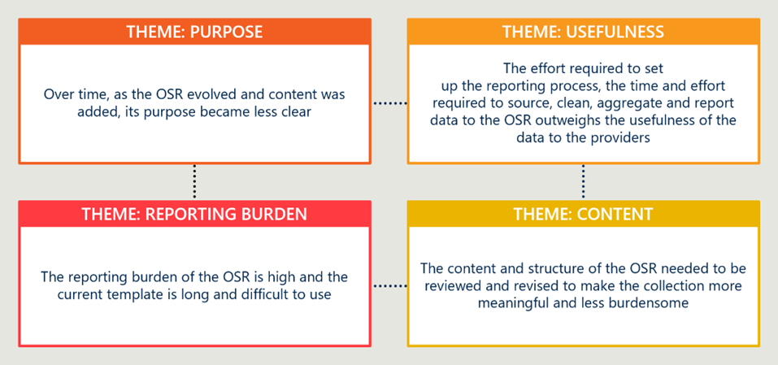
Figure 2 | AIHW's key findings relating to the nKPIs
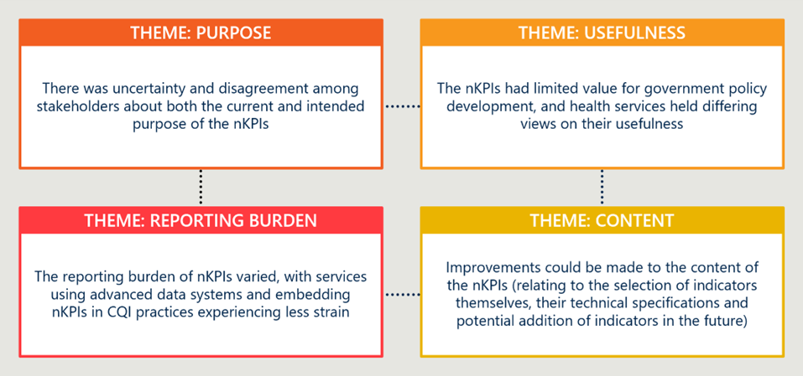
Improvements could be made to the content of the collections to ensure their relevance and continue to meet current clinical and best practice guidelines. The AIHW review emphasised the need to revise the content of both the OSR and nKPI collections to ensure they remain fit for purpose. For the OSR, stakeholders noted that current items do not adequately reflect the comprehensive and culturally safe care provided by First Nations PHCs, including areas such as community engagement, social and emotional wellbeing, and non-clinical services. For the nKPIs, several indicators were found to be misaligned with current clinical guidelines or lacking coverage of priority areas such as child health, mental health, and sexually transmitted infections.
The AIHW Review recommended a structured and transparent process for indicator development and refinement, supported by clinical and technical expertise, to ensure the collections continue to reflect best practice and evolving service delivery models.
The burden of reporting could be reduced, for example, by streamlining the OSR collection instrument, and improving training material for CIS. The AIHW Review identified several opportunities to reduce the reporting burden associated with the OSR and nKPI collections.
Stakeholders noted that the OSR instrument is overly complex, with more than 126 individual measures in some sections, many of which are not consistently used or understood. Streamlining the instrument to focus on core service-level data would reduce duplication and improve usability. In addition, the AIHW Review highlighted the need for improved training and support for CIS, particularly in relation to data extraction and indicator definitions. Enhanced guidance materials and targeted training would help services navigate technical challenges and improve data quality, while also reducing the time and effort required for reporting.

Implementation
The AIHW made 21 recommendations regarding the OSR and 12 recommendations regarding the nKPI, as well as providing a future development theme that reflected diverse stakeholder feedback. The Health Services Data Advisory Group (HS DAG) considered the recommendations and has led their implementation, which has occurred for all AIHW agreed recommendations. Updates to the collections have largely centred on the evolution of the indicators and improvement of the HDP platform.
In response to the review, several indicators were proposed, with two pilot indicators introduced, and four indicators retired. There is limited detail in the HS DAG’s communiques regarding their rationale for retiring specific indicators, however, based on the review these retirements likely reflect broader concerns around relevance, data quality, and alignment with clinical practice. The AIHW Review found that many nKPIs suffered from unclear specifications, misalignment with best practice guidelines, and burdensome reporting requirements that strained service capacity. Stakeholders questioned whether some indicators truly supported continuous quality improvement or simply added to reporting burden without meaningful utility. These criticisms, combined with a push for streamlined, clinically relevant, and locally useful data, appears to have contributed to the decision to retire these indicators.
The Health Data Portal’s OSR capability has also been refined based on the AIHW’s review. Stakeholders highlighted that the OSR instrument was overly complex with individual measures which were inconsistently applied or poorly understood. In response, a series of targeted improvements were introduced to reduce duplication, streamline reporting structures, and simplify data entry processes. The Department indicated that improvements were made to reduce duplication, streamline reporting structures, and simplify data entry.

Future landscape
Health data collection processes are shifting rapidly, driven by broader digital health reform and increasing expectations of interoperability, data reuse and system‑level insight. For the Aboriginal and Torres Strait PHC sector, this future presents both opportunities and risks. Digital systems can strengthen health equity by improving access, continuity of care and clinical decision-making, particularly in regional and remote settings. However, realising these benefits depends on systems that are designed, governed and delivered in culturally safe, community-controlled ways. While the direction of travel is becoming clearer, the pathway, timing and implications for existing collections such as the nKPI and OSR remain uncertain.

Australia’s health systems are rapidly modernising
Australia's national digital health reform agenda signals a clear and consistent direction away from siloed, limited purpose collections and toward connected systems in which data is captured once at the point of care and can be shared securely across the health system.
Australian governments and system agencies are undertaking significant modernisation programs to reform health data infrastructure and improve how primary care data is collected, linked and used. The intended developments are reflected across a range of overlapping policy and reform documents at a state and national level. Four overarching documents are guiding this process:
- The National Digital Health Strategy 2023-28 and its Strategy Delivery Roadmap, which set out the medium‑term priorities for creating a more connected, person‑centred and digitally enabled health system.
- The National Healthcare Interoperability Plan 2023-28, which establishes a national approach to data standards, identity, information sharing and system interoperability across healthcare settings.
- The Digital Health Blueprint and Action Plan 2023-2033, which articulates the Australian Government’s long‑term vision for digital health capabilities and data‑enabled system reform over the next decade.
- The Data and Digital Government Strategy, which sets whole‑of‑government direction on data reuse, digital capability, interoperability and responsible data management across public services, and provides a broader enabling framework within which health‑specific reforms are progressing.
Collectively, these documents signal a clear and consistent focus on greater data standardisation, interoperability and reuse. There is an increasing emphasis on de-identified unit-level data captured once at the point of care and reused for multiple purposes, reducing reliance on stand-alone aggregated reporting collections and establishing the foundation for potential linkage across datasets and care settings. This reflects a broader shift toward data that follows the person rather than sitting siloed within individual organisations.
The technical foundation for this reform is the adoption of Fast Healthcare Interoperability Resources (FHIR) as the national standard for health data exchange, enabling different clinical systems to share information consistently and securely across care settings. Structured clinical terminology such as SNOMED-CT ensure that data carries consistent meaning as it moves between systems.
While these documents provide a coherent strategic narrative at a national level, they also create an evolving and, at times, ambiguous reform context for existing primary care data collections. They raise questions about how current reporting arrangements will align with future platforms, standards and governance models, and how short-term improvements should be prioritised in a way that remains compatible with longer-term system reform.
The Digital Health Blueprint and Action Plan 2023-2033 sets out a staged reform timeline across three horizons: a short-term horizon (2023-25), a mid-term horizon (2025-28), and a long-term horizon (2028 onwards). For this report’s purposes, we note that the Blueprint’s original short-term horizon (2023-25) has now concluded; accordingly, from our perspective the short-term horizon should be read as until 2027, and mid-term from 2027-29, for any actions not yet taken. Long-term horizon refers to 2029 onwards.

Reforms to data collection, linkage, and reporting will reshape the OSR and nKPI collections

The emerging future landscape fundamentally changes data flow between health services and the broader system.
Australian health data collection is expected to shift from stand-alone, highly aggregated reporting toward
de-identified unit-level data that can be linked, reused and analysed across care settings. In this model, data is captured once at the point of care and then reused for multiple purposes. While data from the ACCHO sector should not move ahead of these national changes, it should also not be left behind. If realised, the anticipated future state represents a fundamental change for the nKPI and OSR collections.
In an interoperable environment, clinical data held in CIS platforms has the potential to flow continuously and automatically to a central data warehouse as de-identified unit-level records. For the reporting of clinical statistics, this shifts the burden of reporting away from services, replacing periodic extraction and manual reconciliation with automated data flows, and strengthens the quality and granularity of data available for analysis, returning richer and more contextually meaningful insights to services.
Technological integration and system interoperability also presents potential to streamline the flow of organisational information. For example, automatic data exchange between systems that were traditionally incompatible, such as health workforce management platforms and centralised data portals, could reduce manual entry and improve consistency across reporting obligations.
These represent fundamental changes in data reporting for both collections:
- Clinical data (nKPI): The nKPI is an aggregated, point-in-time collection reported every six months. Clinical data is extracted from compatible CIS platforms and loaded directly into the HDP as a pre-populated draft; services address validation flags as they arise to improve accuracy and completeness of reported data. Over time, there is potential to transition toward shared data infrastructure under First Nations‑led governance, replacing periodic snapshots and enabling more flexible reporting, including against existing indicators and against new or emerging priorities, without placing additional burden on services. This also creates the foundation for potential data linkage across the broader health system, should this be agreed.
- Organisational data (OSR): The OSR is an annual point-in-time collection. Automatic extraction from the CIS pre-populates activity data; workforce, governance and organisational data are entered manually, requiring some subjective judgement. As the broader data environment evolves toward greater automation and interoperability, there is opportunity to streamline the OSR collection, with standardised definitions to improve consistency across organisations, and extended automation through greater integration with workforce management and other administrative systems.
Figure 3 provides a high-level, illustrative representation of how data could flow between First Nations PHC services and the broader health system in a future state, informed by the direction of Australia's national digital health reform agenda and emerging developments in health data infrastructure, interoperability, and AI. The infrastructure that underpins this system and associated recommendations is described in further detail in Section 7.4.
Figure 3 | Indicative future state data flow
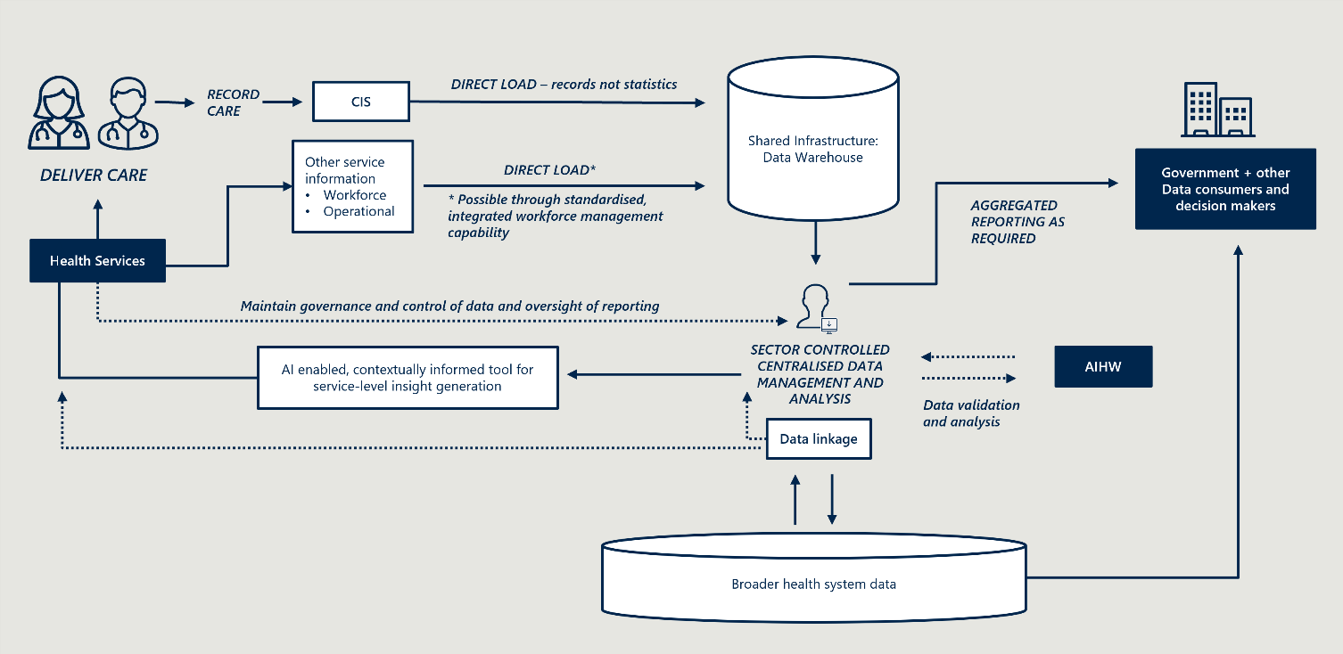

Sharing de-identified unit record data presents opportunity to enhance patient care

Reporting de-identified unit level data from ACCHSs into a centralised, shared platform with First Nations-led data governance has the potential to deliver considerable benefits against the purposes of the nKPI collection.
For population health monitoring purposes, access to de-identified unit-level data enables more flexible and responsive reporting than the current aggregated model.
Rather than being limited to a fixed set of pre-defined indicators, unit-level data can be interrogated to address new and emerging priorities, support different forms of analysis, and generate insights that reflect changing policy and service contexts, without placing additional collection burden on services. For system stakeholders, this would improve the evidence base for policy development, funding decisions and performance monitoring.
For CQI, while services already access unit-level data through their own CIS for day-to-day clinical decision-making, centralised management of de-identified unit-level data could strengthen how that data is used to inform service delivery. Bringing data together in a consistent, well-governed environment would support services to draw more meaningful insights from their data, benchmark performance against peers, and understand what the data means for local CQI activity. This is particularly relevant for services with lower data capability or capacity, who may lack the analytical resources to fully interrogate their own data independently.
However, realising these benefits requires investment in the foundations that make unit-level data reliable and meaningful. FHIR provides the technical framework for data exchange across systems, while SNOMED-CT supports more consistent recording of clinical concepts, and the Australian Core Data for Interoperability (AUCDI) defines the minimum data elements that should be captured at the point of care. Together, these standards support more consistent and interoperable capture of unit-level data. Near real-time data feeds are subject to less extensive validation than periodic aggregated submissions, meaning data quality relies heavily on the accuracy and consistency of point-of-care capture. Consistent application of shared data and terminology standards is therefore essential and will require CIS vendors to build the required technical capability to consistently apply standards such as FHIR, SNOMED-CT and AUCDI.
Critically, the storage and use of de-identified unit-level data must be underpinned by strong Indigenous-led governance, with First Nations communities and organisations holding genuine control over how their data is accessed, analysed and used, consistent with Indigenous Data Sovereignty principles.

Importantly, these governance expectations apply to all data relating to First Nations people, regardless of whether it is generated within ACCHSs or non‑ACCHO service settings. While governance arrangements may differ across contexts, consistent application of First Nations data governance principles is essential to ensure appropriate protection, control and use of all such data.
Additionally, any transition to unit-record data collection would also need to address patient consent and opt-out. Where individuals exercise their right to opt out of unit-record data sharing, the resulting dataset may be less complete than current aggregated extraction for some services or indicators. The implications of opt-out for data completeness, representativeness and analytical validity would need to be understood and managed as part of any transition design.

De-identified unit-level data establishes the foundation for clinical data linkage, enabling a more fulsome picture of patient journeys, should this be agreed by the sector.
Centralised storage of de-identified unit-level data from ACCHSs creates the technical and governance foundations for potential linkage with data from other parts of the health system. Linking ACCHSs' clinical data with data from mainstream primary care services, other ACCHSs and hospital services would provide a more complete picture of health service use and outcomes for First Nations people. Where the current nKPI collection cannot capture how individual clients move across providers or settings, linked unit-level data enables analysis at a population level, connecting care delivered across different providers and allowing insights to move beyond what a fixed indicator set can reveal. This reinforces the need for governance frameworks that operate consistently across both community‑controlled and mainstream service settings, ensuring that data relating to First Nations people is subject to appropriate oversight regardless of its source.
For population health monitoring, data linkage could support system-wide analysis that ACCHO data alone cannot provide. Connected data across primary care, hospitals and other services would enable more complete analysis of how First Nations people access care, where continuity breaks down, and how different aspects of the system interact to influence health outcomes. This shift allows insights to move beyond the performance of individual services toward an of understanding system‑wide patterns of access, continuity of care and outcomes for First Nations people. In this way, linked data strengthens the evidence base for policy development, funding decisions and service planning at a national and jurisdictional level.
For CQI at the service level, linked data would enable ACCHSs to have a complete view of their clients' care journeys beyond their own service. This would support ACCHSs to identify gaps in care pathways, support timely and targeted follow-up, prioritise outreach to priority cohorts, and improve coordination across providers. For example, enabling visibility of clinical events that the service would not otherwise know had occurred, such as hospital admissions, emergency department presentations, specialist contacts, or interactions with mainstream primary care services.
As with the transition to de-identified unit-level data collection, progress towards the adoption of shared standards, including FHIR, SNOMED-CT and AUCDI, will support the technical linkage of data and support meaningful comparison across services and settings

Data linkage developments require trust, consent and strong Indigenous governance.
Data linkage can only proceed through genuine co-design and trust-building with the sector. It must be underpinned by strong Indigenous-led governance, with benefits clearly articulated and services confident that linkage adds value that justifies the transition. This includes ensuring that governance arrangements extend beyond the community‑controlled sector to encompass data held in mainstream systems about First Nations people, with appropriate mechanisms in place to uphold Indigenous Data Sovereignty principles across the full data landscape.
Across consultations, First Nations PHC services expressed hesitancy about sharing de-identified unit-level data and broader system linkage. This hesitancy reflects a combination of factors, including concerns about appropriate access to sensitive data, privacy and consent arrangements for communities and individuals, loss of control over data interpretation, and historical misuse of health data. It also reflects the fact that such approaches are not yet widespread practice in 2026 and remain unfamiliar or untested for many services.
As the broader health system continues to undergo digital transformation, and as shared infrastructure and governance models mature, greater acceptance of data linkage approaches can reasonably be expected over time. However, services emphasised that any changes to data collection must be grounded in reciprocity, clear purpose and demonstrable benefit, with governance arrangements that actively manage risk to communities and ensure that trust, consent and control are foundational rather than assumed.
Advancing in step with broader system reform presents the strongest pathway to sustainable progress and trusted systems. Mainstream primary care is still transitioning toward unit‑level, interoperable data models that enable data linkage. Pre-emptive reform in the First Nations PHC sector risks positioning community-controlled organisations as forerunners or test cases for reforms that the broader system has not yet implemented. This approach risks concentrating costs, risks and scrutiny on the community‑controlled sector. Progressing in alignment with broader primary care reform allows trust, capability and governance maturity to develop over time, ensuring that future data models strengthen patient care and system performance while preserving community confidence and self-determination.
As shown in Figure 4, early initiatives across the sector provide insight into what culturally safe unit-level data collection and data linkage could look like in practice.
Figure 4 | Early trials and jurisdiction‑led initiatives provide insight into the future state
Early trials and jurisdiction-led initiatives provide insight into the future state,
but do not yet constitute a national model.
The NT trial demonstrates that Aboriginal-led, locally governed unit-level data can directly support CQI.
Unit record data has demonstrated potential in NT Government clinics. Stakeholders described how NT Government‑run clinics are using unit‑record data to support proactive patient outreach, continuity of care and service stability. Access to patient‑level data through a standardised dashboard (updated through automated daily uploads) enables clinics to identify cohorts requiring follow‑up, generate recall lists, and maintain continuity of care despite frequent workforce turnover and better accommodating patient movement between clinics. In these settings, unit‑record data supports operational resilience by reducing reliance on individual staff knowledge and enabling new or transient clinicians to quickly understand patient needs, treatment histories, and priority actions.
Stakeholders suggested that elements of this model could inform the future direction of PHC service data collection. This model emphasises the importance of jurisdiction‑level control under strong Aboriginal governance, with only de‑identified, aggregated information shared with the Commonwealth. This approach was seen to strengthen Data Sovereignty, enhance internal data analysis and CQI capability, while still supporting meaningful national‑level reporting. When appropriately governed, this creates significant potential benefits not only for individual health services, their patients and communities, but also for NT Health, funders, and other system stakeholders who rely on aggregated insights to inform policy, investment, and service design.
The National Primary and Acute Care Data Linkage Project indicates potential for a shared national data linkage framework.
The National Primary and Acute Care Data Linkage Project (Design Phase) (NPACDLP) is co-led by NSW Health, DoHAC and AIHW, in partnership with all state and territory health departments. The project is engaging key stakeholders, such as those from the Primary Health Network, ACCHO and NACCHO, during the consultation process to inform a blueprint for a hub-and-spoke data linkage system. The aim is to link de-identified data from general practices with other health data by leveraging existing infrastructure and successes across jurisdictions, such as the Lumos project in NSW, to provide better insights into patient journeys across the health system.
NPACDLP illustrates how a national, privacy‑preserving data linkage architecture could enable analysis of patient journeys across settings, support population‑level planning, and improve policy evaluation. This includes consideration of Indigenous participation, governance and reciprocal data sharing.
However, NPACDLP remains conceptual and pre‑implementation. It is not yet live, does not support service‑level CQI use, and excludes real‑time or clinical data sharing by design. As such, it signals the direction of travel for a national system but does not yet represent an operational national model.
The Lumos initiative demonstrates the feasibility of routine data linkage across primary and acute care settings under Indigenous data governance.
Lumos is a NSW Health data linkage initiative that connects de-identified general practice data with state hospital, emergency department and mortality datasets to map patient journeys across the health system. Lumos demonstrates the value of unit‑level, cross‑sector data linkage for understanding service utilisation, care pathways and outcomes at a population level, and has generated actionable insights for participating practices, Primary Health Networks and policymakers. Importantly, it operates under established privacy, consent and governance arrangements, showing the feasibility of large‑scale linkage of primary care data.
The design of the Aboriginal Lumos Pilot is an example of how linked data systems may involve ACCHO data with Indigenous Data Sovereignty and Governance (IDS&G) principles. The Pilot links ACCHO data within the secure Lumos environment but stored in a separate, access-controlled space, overseen by an Indigenous governance group. Participating ACCHOs retain full control over their own linked data asset and can access linked information about their clients’ interactions across the health system to support continuity of care and local planning. This service-level data is not visible across the system. The Aboriginal Lumos pilot intends to support ACCHOs access to Aboriginal data analysts and fund collaboration with Aboriginal researchers and academics to ensure communities can interpret, analyse, and apply data in ways that reflect their own priorities and knowledge systems.
However, Lumos is jurisdiction‑specific, limited to NSW, and focused on secondary use for planning and evaluation rather than real‑time clinical or national reporting. While Lumos provides a strong proof‑of‑concept for linked primary care data, it does not yet constitute a scalable national platform or a unified model for consistent cross‑jurisdictional reporting.
While early trials and initiatives like these provide insight, none are fully representative of the national future state.
Progress towards the future state will therefore need to be incremental, evidence‑led and closely aligned with developments across the wider health system, rather than pursued by the First Nations PHC sector in isolation.

Consolidated reporting infrastructure will reduce burden and strengthen data access across programs.
Health system reporting infrastructure is expected to consolidate into fewer, more integrated platforms that enable data to be submitted once and reused for multiple purposes. The current environment creates unnecessary duplication and administrative burden, as First Nations PHC services must meet overlapping reporting requirements across multiple funders and programs, each with distinct workflows, interfaces and data obligations. The nKPI and OSR are two such collections, but the challenge extends across the broader reporting landscape.
There is strong sector interest in consolidating First Nations reporting into a single platform, driven by frustration with the cumulative burden of multiple, overlapping submissions. A central reporting hub would simplify the reporting experience, reduce onboarding burden in high-turnover environments, and give services clearer visibility of what is required, when it is due, and how submissions relate to different funding and assurance obligations. This transparency would support more efficient planning and coordination of reporting tasks, reduce duplication across programs, and help services better understand how their data contributes to different system purposes. New staff would only need to learn one system and submission workflow, reducing the risk of errors. Over time, a simpler and more coherent reporting experience would reduce cumulative administrative burden and improve confidence and consistency in data submission.
Consolidating reporting through a single platform would also improve data access, governance and use for the Department and other authorised data users. Stakeholders indicated that nKPI and OSR data is under-used. A central reporting hub with clearer, more direct access to well‑governed data may lower access barriers, enabling more timely and routine use of information to inform policy understanding, program design and system‑level analysis. This could improve system‑level insight while reducing reporting demands on First Nations PHC services.
My Health Record provides an example of a consolidated national access point supported by data linkage. My Health Record is a national digital platform that brings together an individual’s key health information from multiple healthcare providers to support continuity of care. This type of shared infrastructure demonstrates how data can be captured once and reused for multiple purposes, supporting continuity of care and system‑level insight. However, workshop participants indicated that My Health Record has had limited uptake within First Nations communities. Participants cited a combination of factors, including limited perceived value for services and communities and concerns about trust, consent and downstream data use.
While consolidation has a technical dimension, the central challenge is aligning reporting requirements across programs and funders. Given the extent of development underway nationally, it would be premature to take a decision about a future central platform in advance of further national progress, reinforcing the need for caution at this stage. Different programs carry different data obligations, and consolidating these into a single platform requires agreement on what is collected, by whom, and for what purpose, before the technical solution can be determined.
The HDP has demonstrated value as a secure central submission point for current reporting requirements.
It is widely used across the sector and reflects a co‑designed approach, with established layouts, existing service familiarity, and strong support arrangements that enable services to submit and access data. The portal also provides a shared mechanism for data submission and access across stakeholders, supporting consistency and visibility of reporting. However, its legacy application architecture has presented challenges in areas such as system stability, performance, development speed and cost. Limitations in advanced analytics are also influenced by the constrained set of analytics tools currently approved for use, rather than by the HDP architecture alone. Importantly, these constraints do not necessarily preclude data reuse or broader platform integration, which are enabled through the Enterprise Data Warehouse underpinning the HDP. This suggests that the HDP provides a viable foundation that can be progressively built on as a central submission point, rather than requiring wholesale replacement in the near term.
As expectations for data reuse, interoperability and analytical capability continue to evolve, the Department will need to consider whether the HDP application layer can be incrementally modernised to meet future needs, or whether alternative approaches, including a new or complementary platform, would provide a more flexible and cost‑effective foundation over time.
Realisation of the longer-term future state as described above has implications for the role of dedicated reporting platforms. As the reporting paradigm shifts from periodic manual submissions toward continuous, automated data flows, purpose-built submission portals may become redundant for clinical data reporting.
In the short-to-medium-term, however, there is clear benefit in pursuing progressive consolidation of reporting into a single platform, reducing duplication, simplifying submission processes and improving consistency across collections. This approach supports incremental improvement within the current reporting paradigm while laying foundations for future reform.
While the longer‑term direction toward more unified reporting infrastructure is evident, the pathway, timing and end‑state remain uncertain and will depend on governance, investment sequencing and broader system readiness. In this context, while the ultimate form of future infrastructure cannot yet be determined, there is a clear opportunity to build on existing platforms such as the HDP, given their established use, familiarity across the sector and current role as a central submission point. Further discussion on the transition to improved reporting infrastructure can be found in Section 7.

Tomorrow’s system will need to build on improvements to the current system
The analysis in Section 4.2 highlights a fundamental tension facing the nKPI and OSR collections. While both collections remain useful in the current environment, they both have inherent structural incompatibilities that prevent full alignment with the expected future state of health data systems.

nKPI
The nKPI collection has inherent structural limitations as a six‑monthly, aggregated reporting mechanism, particularly in its ability to support timely analysis, flexible reporting and service‑level operational use. These limitations relate to how data are aggregated and reported, rather than to the underlying value of measuring clinical activities, interventions and outcomes themselves.
The nKPIs were intentionally designed as an aggregated, point‑in‑time collection to limit reporting burden and manage governance and privacy considerations. As such, they are well suited to high‑level benchmarking, accountability and governance, but less well suited to more dynamic or evolving information needs. This does not diminish the importance of defining, recording and analysing measures of health interventions and their results; rather, it highlights constraints in the current reporting format.
Over time, two distinct but related developments are often discussed in this context. The first is the availability of de‑identified unit‑record data within clinical systems, which enables more flexible analysis of agreed measures without changing what is being measured. Compared with aggregated collections, unit‑record data supports reporting on new or short‑term indicators, enables multiple analytical uses from a single data source, and reduces duplication, without necessarily increasing reporting burden for services. These benefits can be realised without data linkage. The second, and qualitatively different, development is the linkage of unit‑record data across datasets. Where linkage occurs under appropriate governance, additional value may be realised through longitudinal analysis, cross‑program insights and more sophisticated evaluation. Strong privacy protections and First Nations governance are essential prerequisites for any such linkage.
In the short-term, improvements to the nKPI remain necessary and justified. There is no set timeline for the transition to unit‑level data, plus a dependency on numerous external factors, and the collection will continue to play an interim role in CQI, benchmarking and accountability. Incremental improvements to the nKPI can help identify which data are genuinely used and valued by services and government, supporting a clearer pathway toward future unit‑record and, where appropriate, linked data arrangements.

OSR
For the OSR, the implications of longer‑term data reform are more uneven. Some information currently collected through the OSR, such as client counts and activity measures, is already derived directly from underlying client records within CISs, and this is expected to continue. There is no evidence of systemic data accuracy issues with these elements.
Issues raised through the review do not primarily relate to services’ ability to interpret or apply definitions, as these are largely automatically applied through CIS‑based extraction and calculation rules. Rather, feedback reflects disagreement with, or dissatisfaction about, certain definitions and how they are used for funding, assurance and system‑level purposes. Concepts such as episodes of care and census‑date counts are consistently applied within CIS environments, and the use of a defined census date for each reporting period is a well‑established and generally well‑understood feature of the collection.
As a result, opportunities for improvement are less about the availability or calculation of data, and more about whether existing concepts and definitions remain fit‑for‑purpose, clearly justified, and proportionate to their intended uses, particularly where they inform funding and assurance decisions.
In contrast, workforce and organisational characteristics are not captured through unit‑record clinical data and are not addressed through changes to clinical data systems. These measures provide essential information for funding, assurance and system understanding, and some form of service‑level administrative collection will therefore remain necessary unless equivalent information can be reliably sourced from existing central datasets. For these elements, the primary issues relate to clarity and consistency of definitions, comparability across services, and the reporting burden placed on providers, rather than data accuracy. While collection of these data is already partially automated, there are limited additional opportunities for full automation, given the nature of the information being reported.
At present, the longer‑term direction for workforce and organisational elements of the OSR is clearer than for other aspects of the data environment. These elements sit outside unit‑record clinical data and data linkage reforms and will continue to require some form of administrative reporting in the foreseeable future. The future focus for these elements of the OSR is therefore not replacement, but refinement. This includes clearer articulation of purpose, targeted review of definitions, particularly where there is persistent disagreement about whether they accurately capture service delivery and workload (for example, in relation to Episodes of Care), rather than solely issues of interpretation, incremental improvements to comparability, and continued efforts to automate collection where feasible to reduce reporting burden. These considerations are central to improving the utility and proportionality of OSR workforce and organisational reporting and reinforces the importance of aligning OSR refinements as closely as possible with longer‑term goals, while prioritising changes that alleviate known issues and reduce burden in the short term.

Supporting the transition
The review recommends the development of a full transition strategy to guide these reforms. A transition strategy is needed to clarify the interim role of each collection, sequence reforms, and guide proportionate investment while the future state continues to evolve. Any short-term refinements to the nKPI and relevant elements of the OSR collections should be assessed not only on their immediate benefit, but also on whether they contribute to, or at least remain compatible with, a longer-term transition toward unit record data and more integrated primary care data systems. This approach will help ensure that changes are proportionate to the value they generate, do not entrench legacy approaches unnecessarily, and are sequenced to build confidence, governance maturity, and system readiness over time.
Achieving this future state will require significant preconditions, including foundational work on unit‑record data collection, real‑time data use and data linkage, as well as alignment with broader digital health and data modernisation agendas. This transition must be grounded in trust and First Nations-led governance. Any evolution toward more granular, linkable or reusable data will only be viable if it is underpinned by strong Indigenous Data Sovereignty, clear consent and control mechanisms, and genuine partnership with First Nations PHC services and peak bodies. Trust and governance are therefore foundational requirements, not secondary considerations, for managing transition.
Accordingly, the recommendations that follow are framed around two parallel tracks: strengthening the value, trust and proportionality of existing collections, while enabling longer‑term system‑level work to progress toward a data model that better supports Indigenous self‑determination, real‑time use and integrated, whole‑of‑system insight.
RECOMMENDATION 1
Confirm the future vision for the collections in line with broader digital health data reform and develop a transition strategy in partnership with PHC services, NACCHO and state-based affiliates.
Consultation with relevant stakeholders across the HS DAG, the Department, and across government, including with the Australian Digital Health Agency, will help to confirm the future vision for the collection in line with broader digital health reforms.
Following this, a transition strategy should focus on strengthening and building on the current collections, while clarifying their ongoing role, identify priority transition pathways, and set out a phased roadmap that supports sector readiness while avoiding additional reporting burden. This should be undertaken within the context of broader reform, rather than solely within the nKPI and OSR context.
Within this strategy, the nKPI and relevant OSR elements should continue in the short-to-medium-term. While future‑state data collections are widely anticipated, they are not imminent and will require significant further work, including governance, infrastructure, capability and trust‑building with the sector.
In this context, there is clear value in pursuing well‑targeted medium‑term improvements to existing collections, particularly where these enhance usability, reduce burden, improve clarity or strengthen alignment with service and policy needs. At the same time, the Department should consider how proposed enhancements align with anticipated future‑state directions, to ensure that investments are proportionate, scalable and do not unintentionally constrain future reform. This approach balances practical near‑term improvement with longer‑term readiness, without deferring action in anticipation of a future state that remains some distance away and supports investment decisions that are robust across both current and future data environments.

National Key Performance Indicators (nKPIs)

Introduction

Collection overview
The nKPI collection comprises a nationally consistent set of primary health care indicators for First Nations people as outlined in Section 3.4. The indicators focus on key priority areas, including maternal and child health, preventive health, and chronic disease management (see Figure 5).
Figure 5 | nKPI major themes and respective indicators
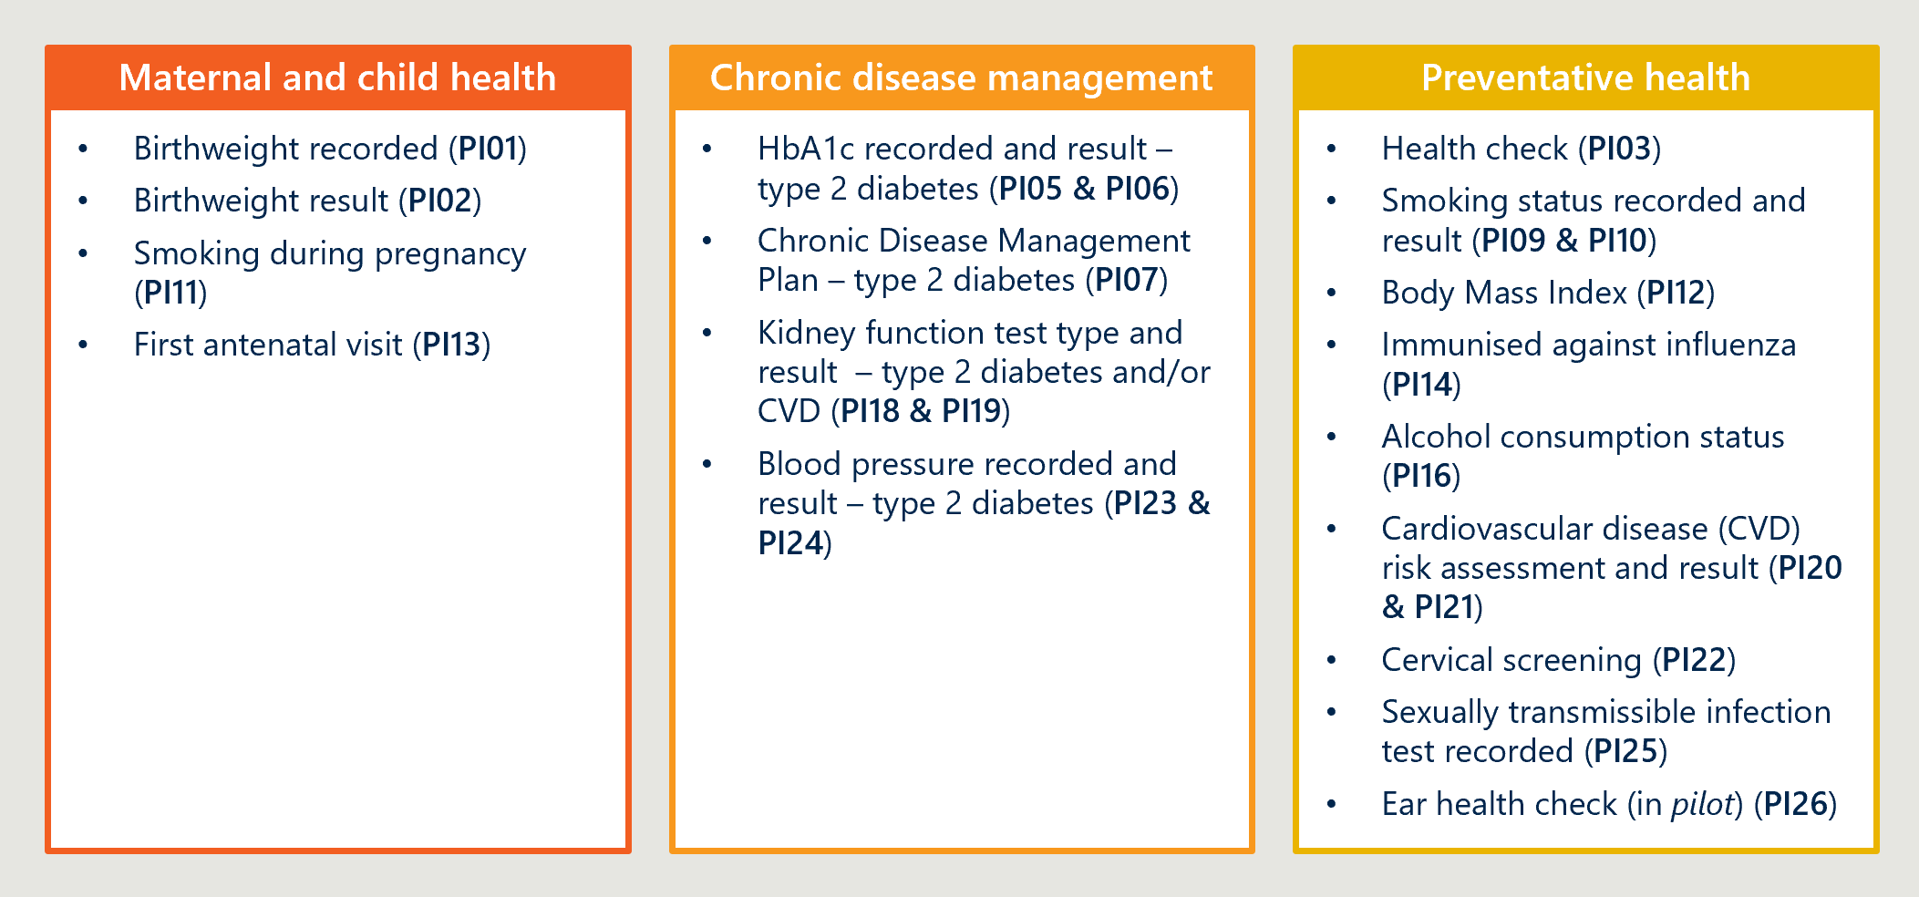
The collection monitors and assesses progress against the objectives of the National Aboriginal and Torres Strait Islander Health Plan and the health outcomes and Priority Reforms under Closing the Gap, while also supporting CQI within PHC services. Services submit nKPI data via the HDP twice annually in January and July and as of 2025, 225 services report to the nKPI collection. Reporting organisations are primarily ACCHOs, alongside a smaller number of other First Nations-focused PHC organisations. The collection has matured considerably since its establishment, with growing coverage, improving data quality, and increasing consistency across a diverse and complex service delivery environment.

Summary of findings
The review identified findings relating to the purpose, usefulness, scope and content and reporting burden of the nKPI collection:
- Purpose: The intended purpose of the nKPI collection is broadly understood across the sector as supporting high‑level CQI, benchmarking and governance reporting for IAHP‑funded PHC services. However, there is less consistent understanding of how nKPI data is used downstream, particularly for policy and planning purposes, and of the limits of what the collection can reasonably be expected to inform given its design.
- Usefulness to PHC services: The nKPI collection is most useful to PHC services as a high‑level tool for reflection, benchmarking and governance reporting. Its six‑monthly, aggregated design supports consideration of trends over time and comparison with peer services but limits its usefulness for day‑to‑day operational CQI, targeted follow‑up or real‑time clinical improvement. These limitations reflect a design that intentionally prioritised comparability and reduced reporting burden over operational granularity. In practice, services rely primarily on their own CIS‑based tools for operational CQI, where more timely and detailed information is available to support clinical decision‑making and local quality improvement; however, the extent to which services can do so varies based on CIS capability, staff data literacy and resourcing. In this context, nKPIs provide a complementary, system‑level lens, valued particularly for benchmarking, board‑level discussion and reflection on longer‑term trends, rather than a frontline improvement tool.
- Usefulness to government: The nKPI collection provides government with a nationally consistent, service‑level dataset that supports IAHP monitoring, reporting and high‑level policy analysis. However, its usefulness is inherently bounded by its scope and design. The nKPIs capture activity within IAHP‑funded services rather than the First Nations population as a whole and are therefore best suited to program‑specific monitoring and contextual policy insight rather than comprehensive population‑level planning or outcome measurement.
- Usefulness to other sector stakeholders: Use of the nKPI collection by other sector stakeholders, including research and advocacy organisations, is limited. This reflects the design and purpose of the collection, rather than a lack of interest in the underlying issues. The nKPI collection provides aggregated, service‑level data produced at six‑monthly intervals, with a primary focus on supporting high‑level CQI, governance reporting and system‑level oversight within IAHP‑funded services. As a result, it is not well suited to broader analytical, evaluative or advocacy uses that require more flexible, granular or cross‑cutting data. In practice, other sector stakeholders commonly draw on a range of alternative data sources that are better aligned to these purposes, with the nKPIs playing a limited and supplementary role.
- Scope and content: The current core indicators largely reflect the health priorities of First Nations health services; however, several important clinical and non‑clinical factors that contribute to health burden are not captured, and gaps and issues remain across the indicator set.
    - PI14 provides limited CQI and strategy and policy planning value and should be removed from the nKPI collection.
    - PI01, PI02 and PI13 should be made opt-in for PHC services that do not deliver maternal and child health services and remain part of the core set of nKPIs for services that deliver maternal and child health services.
    - PI09, PI10, PI20, PI25 and PI26 require adjustment, including the disaggregation of ‘vaping’ from tobacco smoking in PI09, PI10 and PI11.
    - PI07 should be expanded.
    - PI03, PI05, PI06, PI16 and PI22 should be maintained without change.
- Reporting burden: The reporting burden associated with the nKPI collection is generally low in isolation due to its automated extraction and submission processes. However, PHC services experience the nKPIs within a broader, high‑burden reporting environment. In this context, perceptions of burden are shaped less by the effort required to submit nKPI data and more by cumulative reporting demands and by limited visibility of how reported data is used and returned to services. Clearer articulation of purpose and stronger feedback loops would help ensure that reporting effort is proportionate to perceived value

Purpose

The nKPIs are intended to support high‑level CQI and to inform policy and strategic planning in relation to IAHP‑funded First Nations PHC services.
As discussed in Section 3.4, the nKPIs were originally established to create a clear line of sight between the activities of IAHP‑funded First Nations PHC services and national policy objectives, particularly the Closing the Gap targets for life expectancy and child mortality. In doing so, the collection was designed to support high‑level CQI within services, while also enabling policy and strategic planning at a system level. They were designed to identify priority health issues within service populations, assess whether services collect and use relevant data, and track changes in health risks and outcomes as a proxy for quality of care. These foundational purposes remain embedded in the current nKPI specifications.
These purposes have remained consistent over time, even as expectations of the collection and the broader data environment have evolved. The Department now describes the primary purpose of the nKPI as supporting CQI and improving service delivery, alongside monitoring performance to identify areas for improvement and informing policy and planning at national, state and territory levels. This articulation aligns closely with the original intent of the nKPIs as a high‑level CQI and system‑level planning tool, rather than a comprehensive or operational performance dataset.
The nKPI supports CQI through a combination of process measures, which assess whether care is delivered as intended (such as routine recording of BMI or smoking status), and outcome measures, which track changes in patient health over time.
Services are expected to use this data to monitor performance trends, benchmark against peers and jurisdictions, and assess whether CQI activities are associated with improved outcomes. These uses reflect the high‑level CQI focus of the collection, rather than real‑time or service‑specific clinical management.
At a system level, the nKPI is intended to inform policy and strategic planning by providing the Department with insight into the populations accessing IAHP‑funded services and the overall performance of the IAHP. This information is intended to support decisions about where additional programs or targeted interventions may be required to strengthen care processes and improve outcomes across the PHC system. This planning function is closely linked to the CQI purpose, translating aggregated service‑level insights into system‑level action.
While not always framed explicitly, the nKPI is also used to support accountability and transparency in the use of public funding. By providing a nationally consistent view of activity, service delivery and outcomes in IAHP‑funded services, the nKPI is intended to enable governments to demonstrate how public investment is being used, assess whether funding is supporting the delivery of intended care, and provide assurance that resources are directed to areas of need. This function sits adjacent to the CQI and planning purposes of the nKPI, without displacing the primary CQI and planning purposes of the collection, reflecting broader government expectations for stewardship, performance oversight and transparency in publicly funded health programs.

There is an opportunity to strengthen how the purpose of the nKPI is communicated and embedded across the sector.
In the previous review, AIHW recommended that the Department clearly articulate the purpose of the nKPI, obtain relevant stakeholder endorsement, and notify key stakeholders when nKPI data are used for research and/or policy purposes. Consultation findings indicate that, while some steps have been taken, these actions have not gone far enough and have not been communicated consistently across the sector. As a result, many services remain unclear about key aspects of the nKPI purpose.
There is a clear opportunity to re‑affirm and more consistently articulate the purpose of the nKPI across the sector. This includes being explicit about what the nKPI can and cannot reasonably be expected to do (as discussed in Section 6.1.2), to ensure expectations are realistic and shared. This is particularly important given that the scope of the nKPI reflects practical constraints on what can be consistently collected with low‑burden at a national level, rather than a definitive statement about what information is valuable to services or the sector. Clarifying whether the nKPI is intended to measure only a subset of clinical activity would also support better understanding of what is in and out of scope, including the extent to which holistic care is captured.
Clearer articulation of how nKPI data is used to inform policy and strategic planning, and where its contribution is necessarily limited, would help strengthen trust in the collection and increase confidence in its use. This would support a shift in perceptions away from compliance and accountability, and toward the nKPIs intended role in supporting CQI and system learning.
RECOMMENDATION 2
2A – Confirm and clearly communicate the intended purpose of the nKPI for policy and strategic planning.
Develop clear, accessible guidance materials that explain how the Department uses nKPI data for policy development, program monitoring and strategic planning. This should include practical examples of how data informs decisions and where its use is limited.
These materials should be provided to all reporting services ahead of each reporting period and made publicly available via the Department website and the HDP. Separate internal materials should also be developed to ensure consistent understanding of the purpose and use of the nKPI across departmental teams.
2B – Strengthen support for PHC services to interpret and use nKPI data for CQI.
Develop clinically informed, sector‑led guidance to support PHC services to interpret and apply nKPI information for CQI in First Nations primary health care contexts. This should focus on practical use of nKPI data alongside existing Clinical Information Systems (CIS) tools, recognising that nKPIs provide a complementary, high‑level view rather than a primary operational dataset.
Existing guidance on reporting processes, validation and use of analytics tools should continue to be maintained and updated and aligned with broader sector efforts to build data capability (including Recommendation 16).

Usefulness

nKPIs are used for high‑level monitoring and benchmarking and some services use them for targeted CQI activities.
Stakeholder consultations throughout the Review indicate that there is highly variable use of the nKPI for CQI, and perceptions of its value differed significantly across services.
Some services reported not using the nKPI for CQI at all, while most described using it intermittently to support specific or discrete CQI activities. A small number of services reported making substantial organisational changes based on nKPI insights, with these responses reported more frequently in survey data than in workshops. This variability reflects the diversity of service contexts, capabilities and information needs, and means the nKPI serves different purposes for different services.
Where used for CQI, services reported generally regarding the nKPI as a supplementary input rather than a primary evidence base. This aligns with the original design of the nKPI, which was not intended to support real‑time CQI as a primary data source. Three key limitations were consistently identified:
- While nKPI data supports benchmarking and the identification of high‑level trends, services generally report on a six-monthly basis in line with the mandatory reporting cycle, limiting usefulness for day‑to‑day or real‑time CQI. While more frequent reporting is technically feasible, it is not standard practice. Services noted that the lag makes it difficult to assess whether recent changes implemented in preceding periods have led to shifts in process or outcome measures.
- The current indicator set does not capture several important areas of primary health care practice, such as social and emotional wellbeing (SEWB) and mental health, meaning that CQI is only supported for a subset of care domains. Noting that, indicators are limited to what can be captured in structured, extractable fields from CIS platforms, which do not yet exist for priority domains such as SEWB.
- Many services already have access to the underlying patient-level data through their own CIS and analytics tools, enabling more detailed and timely analysis than is possible through aggregated nKPI reporting alone While population level insights can signal where performance has shifted, patient-level operational data is required to direct CQI efforts.
These limitations need to be considered in the context of the broader value provided by the nKPI collection. While some services can access similar underlying unit-record data through their own CISs and use this data routinely for operational CQI, others face constraints related to system capability, workforce capacity and data literacy, and therefore rely more heavily on the nKPI as a primary source of performance information. This comparative insight represents a distinct and, for some services, meaningful source of value. In addition, access to advanced analytics tools such as Power BI or Tableau is uneven across the sector, particularly among services with lower data capability; by contrast, the HDP provides a universally accessible, no‑cost reporting platform that does not require local system maintenance. As a result, the nKPI performs both an adjunct and, for some services, a more primary CQI function. However, the collection is most effective as an adjunct to locally held data, and its limitations are most pronounced for those services that rely on it as their primary CQI tool. Taken together, these features reinforce the importance of improving the value and usability of the nKPIs, particularly for services with more limited data capability, while recognising that the collection cannot substitute for service‑level operational data.
Opportunities for real-time CQI: A “two speed” nKPI model
Given the nature of nKPI reporting as described – with six-monthly reporting cycles but no appetite to increase reporting frequency – there is an opportunity to explore alternatives that enable more real-time CQI for PHC services. One such opportunity is the use of a “two-speed” model. Services’ desire for more timely insights for improvement is best understood as an appetite for faster, service-facing feedback loops rather than for more frequent validated reporting. This creates scope to introduce a two-speed model, where validation processes are reduced or removed to enable a timely, near real-time extract of nKPI insights delivered as a “CQI feed.” This would enable timely recalls and follow-up and targeted action at clinic and program level. Importantly, this would be delivered as supplementary to the retained existing six-monthly validated submission for high-level monitoring, trend reporting and peer benchmarking, which preserves the integrity, trust and purpose of the national collection.
Early investigation suggests such a model is technically feasible, as it builds on what PHC services already do in practice – many already rely on internal tools (e.g., PenCAT, CIS dashboards, Power BI) for operational CQI because those tools can generate patient lists, track recalls and support near real-time monitoring. In addition, the HDP already supports Trial submissions, which can be uploaded more frequently and are not subject to the full validation and approval workflow. Consultation feedback suggests this existing functionality could be repurposed and strengthened to form the basis of a regular, unvalidated CQI feed, rather than requiring a wholly new reporting mechanism.

Specific organisational characteristics may influence how useful the nKPI is for CQI.

Usefulness may be influenced by the size of the organisation.
Where participants in the Review’s survey chose to identify themselves and provided their client‑size band, it is possible to explore whether perceived usefulness varies by organisation size (see Figure 6 and Figure 7).
However, these findings should be treated with caution: the number of identified respondents is small and may not be representative of the broader survey cohort. Responses reflect perceptions across organisations that differ in structure, service model, and system configuration, including variation in whether data is reported at organisation or site level, differences in CIS platforms, and differing levels of direct load capability. These factors may affect the comparability of responses and how services experience the utility of nKPI data in practice.
In addition, perspectives expressed in workshops generally emphasised more often the limits in the nKPIs practical utility for day‑to‑day CQI and planning compared with internal clinical systems and more granular data sources. Limitations in extraction, variability across CIS platforms (including known constraints in some systems), and ongoing system transitions such as CIS migration can influence both data quality and perceived usefulness of reporting, particularly for collections such as the OSR where direct load capability is evolving.
Services with more than 5,000 clients generally find the nKPI more useful than services with 1,000 or fewer clients. Larger services were more likely to rate the nKPI as “very useful” across all five purposes, most strongly for tracking health outcomes and supporting CQI. This may suggest the nKPI is more readily embedded within formal performance management and governance processes in larger organisations.
By contrast, services with 1,000 or fewer clients tend to see the nKPI as “somewhat useful” rather than “very useful” across most uses. The clearest difference is in strategic planning and budgeting, where small services report no “very useful” responses at all, while larger services do. On reporting to boards and funders, small services were split, with as many rating the nKPI not useful as very useful, indicating its role in reporting is variable for these services.
Figure 6 | Use of nKPI among survey respondents with fewer than 1,000 clients
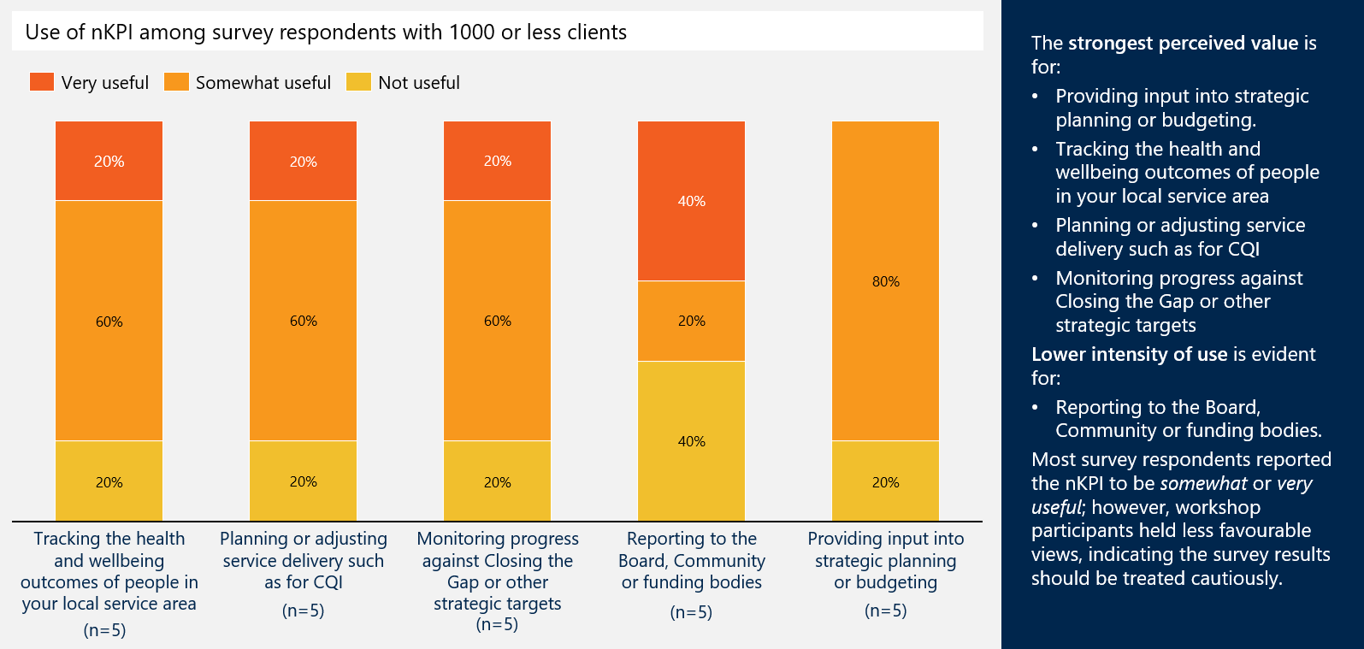
Figure 7 | Use of nKPI among survey respondents with more than 5000 clients
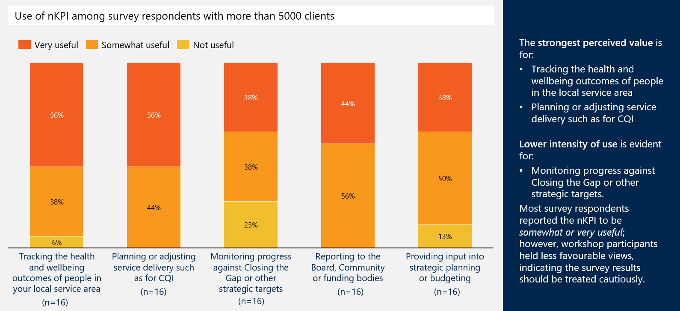

Usefulness may be influenced by data capability and service resources.
Use of the nKPI varies significantly according to organisational capability, particularly workforce capacity to access Qlik and interpret nKPI data (discussed further in Section 7.3.2). Where capability in using Qlik is limited, organisations face constraints in generating insights, reducing the practical value derived from the nKPI.
Engagement with nKPI data for CQI is further influenced by broader resourcing pressures. High workloads and staff turnover contribute to CQI activity being applied inconsistently or deprioritised, limiting the extent to which nKPI data is used systematically to inform improvement.
In some organisations, responsibility for reporting and data analytics is concentrated with a single individual rather than embedded as a shared organisational function. In cases where this arrangement has been in place for an extended period, organisational reliance on that individual has developed, with insights dependent on their capacity to interpret and disseminate findings. As a result, nKPI data and its implications do not always reach the broader workforce, constraining organisation‑wide understanding and use of the nKPI.

nKPIs are not widely used by Department or other system stakeholders to inform policy or strategic planning beyond IAHP.
From a policy and strategic planning perspective, use of the nKPI for policy and strategic planning is concentrated within IAHP‑adjacent areas and compared to the OSR, the nKPI is less utilised by the Department. Since 2014, AIHW has used nKPI data to produce a range of indicator-based reports and annual reports on primary care. A small number of stakeholders reported accessing nKPI data directly via the HDP, while others relied on AIHW publications.
As with their use for CQI, limitations of the nKPI for policy and strategic planning were consistently identified:
- The nKPI is deliberately designed to capture activity within IAHP‑funded services, but its usefulness beyond this cohort is limited. Departmental stakeholders increasingly require data that supports system‑wide and population‑level analysis, which the nKPI was never intended to provide. While this is not a failure of the nKPI, the practical consequence is that its value is largely confined to a narrow segment of the system, limiting its utility for broader planning and analysis.
- Despite being largely automated, services reported ongoing data quality and interpretability challenges with the nKPI. Errors in data population reduce confidence in the accuracy of reported results, while the absence of qualitative context limited meaningful interpretation for policy and planning. As a result, services were concerned that nKPI data does not always reflect the full picture of need, performance or capacity.
- The nKPI provides a strong view of activity within IAHP‑funded services, but it does not isolate IAHP‑funded activity alone, nor is it intended to. While IAHP funding underpins the viability of comprehensive ACCHO service delivery, services also deliver care funded through Medicare and other sources, and the proportion of funding from other sources can vary significantly across organisations.
For most services, nKPI captures a mix of IAHP and non‑IAHP‑funded activity, limiting its precision as a proxy for IAHP funding alone. In practice, most services report that there is no practical way to separate IAHP‑funded activity from activity supported by other funding sources within their clinical systems. As a result, services are generally required to report on all relevant activity, and the nKPI should be understood as reflecting total service delivery within IAHP‑funded services rather than IAHP‑specific activity. This approach supports consistency in reporting over time but limits the extent to which the collection can be used as a direct representation of IAHP‑funded activity alone.

Other First Nations Primary Health Care sector organisations report limited use of the nKPIs for research or advocacy purposes.
System stakeholders outside the Department, particularly those in the research, advocacy and First Nations health sectors, did not consider themselves consistent users of nKPI data. First Nations health peak bodies and their state and territory affiliates reported some use of nKPI data; however, it was not commonly used to inform research or advocacy activities. This reflects the scope and design of the collection. The nKPI covers a subset of PHC services, specifically those funded under the IAHP, and captures data for a subset of First Nations people accessing those services. The aggregated, service‑level nature of the data also limits its suitability for population‑wide analysis, cross‑program comparison or broader advocacy use. Use of the data varied across affiliates, reflecting differences in the number of services that elected to share their data. Affiliates also described an important enabling role, supporting services with data submission, data quality, and reporting processes.
Mainstream professional peak bodies and research organisations consulted were generally aware of the nKPI and OSR collections but reported limited use of either dataset to inform research or advocacy. For these stakeholders, the primary data gap was not service activity data, but information capturing experiences of cultural safety, racism, discrimination, and trust. They emphasised that measurement of racism should focus on hospital and other mainstream health settings rather than First Nations organisations, noting its influence on willingness to access services, quality of care received, and decisions to leave hospital early or avoid treatment altogether (see Figure 8).
Figure 8 | Quotes from other First Nations Primary Health Care sector organisations
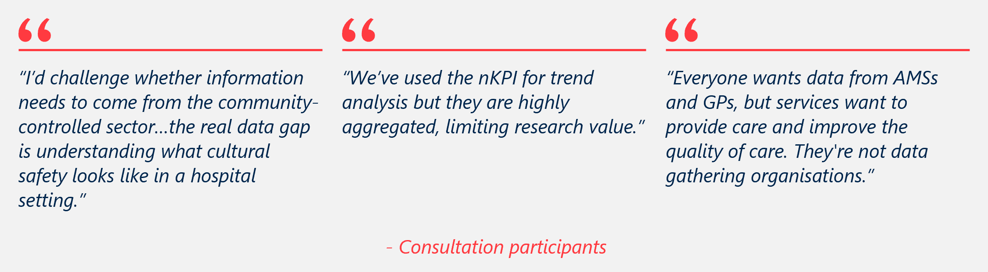

In the short term, efforts should focus on maximising the use and value of the existing nKPI, alongside ongoing consideration of how unit record data may, over time, support system‑wide improvement.
A shift to unit‑record data represents a different form of the data currently collected through the nKPI and, on its own, would not materially change the collection’s suitability for broader research or advocacy purposes. Many of the existing limitations would therefore remain, particularly those related to coverage, scope and the subset of services and First Nations people represented.
The primary value of unit‑record data lies in enabling greater flexibility, timeliness and analytical use of the same underlying information for CQI, policy and planning within the existing scope of the collection. Importantly, unit‑record data also positions the system for potential future data linkage, which would enable a more comprehensive picture of service use and outcomes for First Nations people across programs and settings. Such linkage would address some, but not all, of the current limitations. However, as outlined in Section 4, sector hesitancy reflects unresolved concerns about data use and significant practical, technical and policy barriers make such a shift unlikely in the near term. Even with linkage, important gaps would remain, including limitations in capturing experiences of racism, culturally grounded aspects of care, and social and emotional wellbeing outcomes.
Addressing these gaps will require parallel work beyond the evolution of the nKPI data architecture, as discussed in Sections 7 and 8. In this context, the most pragmatic approach is to maximise the value of the existing nKPI collection within its current design constraints, rather than introduce changes that increase reporting burden without addressing the collection’s underlying limitations.
RECOMMENDATION 3
Enhance support for day‑to‑day CQI without increasing compliance burden by introducing a two‑speed nKPI model, including a near‑real‑time, unvalidated CQI feed for service‑level improvement with minimal central validation and no qualitative inputs.
In practice, CIS remain the primary tool for day‑to‑day, patient‑level CQI, enabling services to identify and follow up individual clients. The proposed CQI feed does not replace these tools. Rather, it provides a complementary, service‑level view that enables services to track trends over time, compare performance with peers, and engage more actively with the nKPI dataset without waiting for six‑monthly validated submissions.
In this context, “near real‑time” does not necessarily imply continuous or live reporting. An indicative option could be a regular monthly data extract, subject to consultation with the sector to understand whether this frequency is both desirable and feasible within existing workflows.
While the proposed CQI feed would be explicitly unvalidated and therefore not suitable for external reporting or benchmarking, timely access to indicative data is likely to increase service engagement with the nKPIs and strengthen understanding of the trends and stories they reveal. By prioritising speed and usability over perfection, the CQI feed would support practical, day‑to‑day improvement without extending burden or expectations.

Scope and content
This review has examined the current scope and content of the nKPI having regard to the original intent of the collection, its practical operation, and the broader reporting environment in which it sits. In doing so, it considered whether existing indicators should be retained in their current form, refined, or removed, as well as whether there is a case for introducing new indicators to better reflect contemporary priorities and information needs.
Where relevant, proposed changes should follow the established process for indicator updates. Under this process, a brief is provided to HS-DAG outlining candidate changes for discussion. If agreed, the HS-DAG then establishes a Clinical and Technical Working Group to assess each change, supported by briefing papers prepared by the AIHW or Solving Health. The working group completes a detailed decision template and reports its recommendation back to HS-DAG. If endorsed, changes are actioned through updates to the vendor specifications managed by Solving Health, which in turn trigger corresponding changes to CIS platforms and, where required, the HDP.

The nKPI has gaps in priority coverage, but most core indicators continue to be highly relevant to services.
Overall, the broad nKPI categories remain well aligned with the priorities of IAHP-funded PHC services. The primary exception is maternal and child health: while widely recognised as a critical health priority, many services do not deliver maternal and child health programs, limiting the relevance and utility of these indicators for a substantial proportion of the sector. More broadly, concerns with the current core nKPI set relate less to the appropriateness of the underlying priority areas and more to issues of indicator definition, scope and recording practices. For example, smoking‑related indicators were frequently raised; however, feedback focused on the need for refinement rather than removal. Figure 9 shows the frequency with which adjustments or removals of individual nKPI indicators were suggested across workshops and surveys.
Figure 9 | Frequency of requested adjustment or removal of nKPI indicators by PHC services
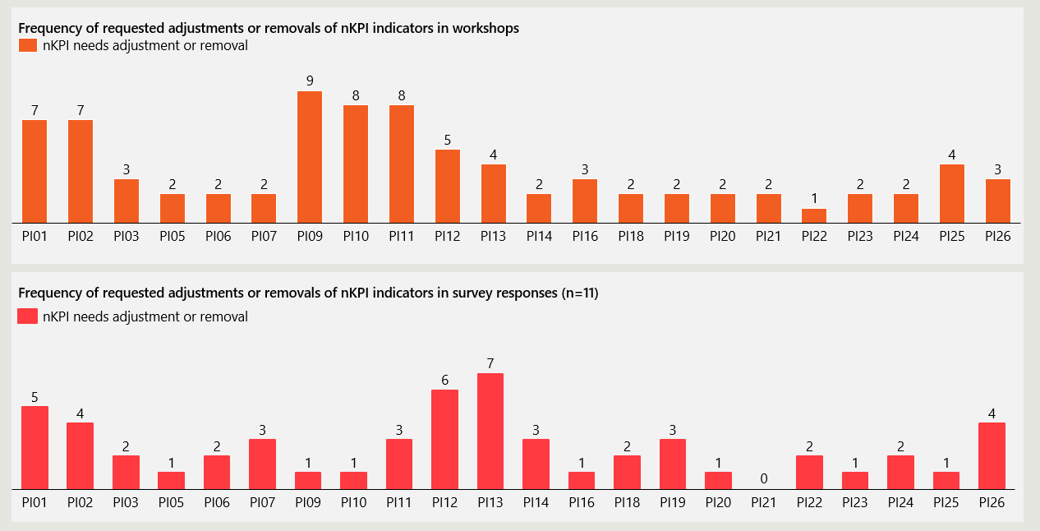
Stakeholders also identified several priority areas not currently captured by the nKPI; however, there was broad agreement that expansion should be approached cautiously. Addressing all identified gaps would require the inclusion of measures that are difficult to standardise and would materially increase reporting burden, potentially undermining the sustainability and overall value of the collection.

Maternal and child health indicators within the nKPI are beneficial where services deliver these programs, but many services do not.
PI01 (birthweight recorded), PI02 (birthweight result), PI11 (smoking during pregnancy), and PI13 (first antenatal visit) are maternal and child health indicators that align with several Closing the Gap outcome areas, including healthy birth weight (Outcome Area 2), child development (Outcome Area 3), early childhood education (Outcome Area 4), strong families and communities (Outcome Areas 8 and 13), and preventing entry into out‑of‑home care (Outcome Area 12). Supporting First Nations mothers, children and families in the early years of life, and measuring progress against these outcomes, remains an important policy objective.
However, the relevance of these indicators varies substantially across services. Many ACCHOs and other PHC services do not deliver babies and have limited involvement in antenatal care, which constrains their ability to meaningfully collect and use these indicators. In contrast, a subset of services provides antenatal and maternal care, including through dedicated Aboriginal Maternal and Child Health programs; for example, in Victoria, several ACCHOs deliver Aboriginal Maternal and Child Health services as part of structured MCH programs.
On this basis, it is recommended that PI01 (birthweight recorded), PI02 (birthweight result), and PI13 (first antenatal visit) remain mandatory indicators for services that deliver maternal and child health services only. For services that do not deliver maternal and child health services, these indicators should become opt-in, as some First Nations PHC services without a maternal and child health remit indicated interest in continuing to monitor this data. This approach would preserve the availability of maternal and child health data where services are appropriately positioned to collect it, while avoiding the imposition of low‑value reporting requirements on services without a maternal and child health remit.
PI11 (smoking during pregnancy) should remain a mandatory core indicator. Pregnant women may continue to attend their local ACCHO or PHC service regardless of whether the service delivers babies or provides antenatal care, and smoking status during pregnancy can therefore be recorded within routine primary care interactions.

Chronic disease management indicators within the nKPI are important; however, there is an overemphasis on diabetes and limited coverage of other chronic conditions.
The nKPIs place a substantial emphasis on chronic disease management, particularly type 2 diabetes.
Indicators including PI05 and PI06 (HbA1c recording and results), PI07 (chronic disease management plans for type 2 diabetes), PI18 and PI19 (kidney function testing and risk categorisation for people with type 2 diabetes and/or cardiovascular disease), and PI23 and PI24 (blood pressure recording and results for people with type 2 diabetes) collectively reflect this focus.
Effective chronic disease management is critical to improving quality of life, preventing serious complications such as stroke and organ failure, slowing disease progression, and reducing avoidable hospitalisations and long‑term healthcare costs, while supporting patient self‑management through proactive monitoring and continuity of care.
While this emphasis reflects the significant burden of chronic disease within First Nations communities, stakeholders consistently noted an over‑concentration on type 2 diabetes relative to other major chronic conditions. Diabetes mellitus accounts for approximately 12 per cent of the total chronic disease burden, whereas ischaemic heart disease represents a substantially larger share (22 per cent), followed by diseases of the liver (11 per cent), other forms of heart disease including heart failure and cardiomyopathy (6 per cent), chronic lower respiratory diseases such as chronic obstructive pulmonary disease (6 per cent), and cerebrovascular disease (5 per cent). This imbalance limits the ability of the nKPIs to provide a comprehensive view of chronic disease management across services.
To address this, it is recommended that PI07 be expanded to capture all chronic disease management plans, rather than being restricted to type 2 diabetes. While this approach would reduce the ability to disaggregate plans by specific condition at a national level, services would retain access to this detail within their own CISs. Importantly, expanding PI07 would provide a more accurate and system‑level view of chronic disease management activity without substantially increasing reporting burden. As chronic disease management plans are a standard Medicare‑billable clinical item, this information should be readily available for most services. It is also noted that cardiovascular disease is partially captured through PI20 and PI21, which measure cardiovascular disease risk assessment and results; whilst these indicators do not reflect ongoing chronic disease management activity and therefore do not substitute for a broader chronic disease management measure, they do address the burden of cardiovascular disease.

Indicators that rely on patient self-report or ambiguous definitions introduce consistency challenges.
For certain nKPI indicators, comparability is affected by variation in how consistently self-reported information is sought and how ambiguous classification decisions are applied across services. Where results depend on patient self-report, recorded values are sensitive to whether and how the question is asked. First Nations PHC organisations noted that some indicator definitions are applied differently across and within services, limiting their comparability at the national level. For example:
- Smoking indicators (PI09: smoking status recorded; PI10: smoking status result; PI11: smoking during pregnancy) are affected by ambiguous classification decisions, unclear recency rules, and reliance on patient self-report, each of which introduces variation in how the indicators are recorded across services.
- Alcohol consumption indicators (PI16: alcohol consumption status recorded; PI17 alcohol consumption status) raises similar concerns about self-report, with recorded results varying according to whether and how clinicians seek the information and what patients report.

While preventive health measures within the nKPI were broadly considered appropriate, the value of many individual indicators is limited by a need for further refinement.
PI03 (health check), PI09 and PI10 (smoking status recorded and results), PI12 (Body Mass Index), PI14 (immunised against influenza), PI16 (alcohol consumption status recorded), PI20 and PI21 (cardiovascular disease risk assessment and results), PI22 (cervical screening), PI25 (sexually transmissible infection test recorded), and PI16 (ear health check, in pilot) are classified as preventive health indicators. Collectively, these indicators capture proactive, evidence‑based activities such as screening, vaccination, and the identification of lifestyle risk factors aimed at preventing illness, enabling early detection, and supporting overall health and wellbeing. In doing so, they are intended to reduce the risk of chronic disease, improve long‑term health outcomes, and mitigate future health system costs.
There was consistent agreement that preventive health is an appropriate and important focus of the nKPI. Given the breadth of risk factors and conditions covered, suggested improvements varied across individual indicators and stakeholder groups. A common limitation across preventative health indicators is in how follow‑up care is reflected, with many indicators capturing initial screening or assessment but not measuring whether appropriate follow‑up actions occur. For example, while PI16 records alcohol consumption status, it does not capture whether individuals identified as at risk are referred to, or engage with, alcohol reduction or support programs.
While capturing this information would increase the clinical and strategic value of the indicators it would likely require new indicators to be added and doing so would significantly increase the reporting burden.
Preventative health indicators recommended for adjustment or removal are discussed further below.

Smoking status recorded and result (PI09 and PI10)
Smoking indicators were the most frequently discussed nKPIs in workshops. PHC services consistently highlighted the need for clearer definitions to support consistent data capture, particularly around scope. Stakeholders called for explicit guidance on whether vaping and marijuana use should be included, clearer recency rules to ensure smoking status reflects behaviour in the previous 12 months, and revised age groupings (e.g. under 18, 18-55, and over 55).
It is recommended that recency rules be clarified to specify a 12‑month reference period and that age groupings be revised accordingly. While capturing vaping and marijuana use was seen as important, it is recommended that vaping is disaggregated from smoking within the existing smoking indicator. AIHW data (2024) shows that vaping is most prevalent among younger people (particularly those aged 18-24) while older age groups are more likely to smoke tobacco and least likely to use e‑cigarettes. Treating vaping as distinct from tobacco smoking would improve the relevance of risk profiles and support more targeted prevention and cessation activities at the service level, consistent with AUCDI R3.

Body Mass Index (PI12)
Many PHC services questioned the relevance and cultural validity of BMI as an indicator. Stakeholders noted that BMI is both a blunt and insensitive measure, with limited CQI value at the service level and known limitations in data capture. Services reported preference for alternative measures such as waist circumference or combined height and weight, which were considered more clinically meaningful and reflective of individual and community health risk.

Immunised against influenza (PI14)
PI14 has limited value for service‑level CQI because many First Nations people receive influenza vaccinations outside PHC services, particularly through pharmacies, meaning the data does not reliably reflect service activity or performance. Although the Department previously considered using the Australian Immunisation Register and did not proceed due to insufficient clinic‑level granularity, this level of detail is not necessary for CQI purposes. As PI14 provides little actionable insight for services it should be removed from the nKPI collection. Removing PI14 would reduce unnecessary reporting effort and allow greater focus within the nKPI on areas that provide more value.

Sexually transmissible infection test recorded (PI25)
PI25 currently captures only chlamydia and/or gonorrhoea. However, notifications of syphilis, gonorrhoea and chlamydia have increased significantly since 2012, particularly among people aged 34 years and under, who experience higher rates of these infections than other age groups. In 2022, notifications of infectious syphilis in Australia reached a historic high. While HIV notification rates have steadily declined, HIV transmission remains a serious concern due to the severity and long‑term consequences of infection. On this basis, it is recommended that PI25 be expanded to include syphilis and HIV.

Ear health check (PI26)
PI26, currently in pilot and scheduled to transition out of pilot in July 2026, relates to ear health checks and includes three assessment components: (1) visual examination of the appearance of both ear canals and eardrums; (2) assessment of the movement of both eardrums; or (3) a combination of both. Assessment of eardrum movement is undertaken through tympanometry, a quick and non‑invasive diagnostic test that aligns with relevant clinical practice guidelines for ear health assessment.
PHC services reported variability in the routine availability, use, and integration of this equipment within primary care workflows. Several services noted challenges in consistently undertaking tympanometry in line with the indicator specifications, including workforce capability, time constraints, and extraction feasibility. In response, PHC services suggested refining the indicator to place greater emphasis on visual examination of the ear canal and eardrum using otoscopy, supported by tympanometry where clinically indicated and feasible. This approach was seen as more consistently achievable across services, while remaining broadly aligned with clinical practice guidelines and improving the feasibility and comparability of data extraction.
While the Ear Health Equipment Program provides ACCHSs with access to equipment such as tympanometers, feedback suggests that practical factors such as workforce capability, time constraints and workflow integration affect the extent to which this equipment is routinely used in primary care settings. This highlights the importance of ensuring the indicator design remains feasible and aligned with how ear health checks are delivered in practice, particularly as PI26 transitions out of pilot.

While there is strong appetite to expand the nKPI to include additional health priorities, many proposed additions are difficult to measure effectively and would increase reporting burden.
The current nKPIs capture only a subset of what First Nations PHC services deliver, with a strong emphasis on clinical activity aligned to a Western model of care. Core elements of PHC including SEWB, community engagement, advocacy and outreach are not reflected in the indicators. While there is a strong desire for indicators that better reflect day‑to‑day service delivery and a more holistic conception of health consistent with First Nations worldviews, stakeholders acknowledged the challenges of capturing these dimensions within current digital systems.
In this sense, the issue extends beyond the specific indicators selected; it reflects a broader tension between holistic models of health and digital architectures that are not designed to accommodate them.

Mental health and SEWB emerged as the most requested new indicators and the most significant gap in current nKPI collection.
Mental health and SEWB represent a significant and growing component of primary health care workload and unmet need, yet they are not adequately captured in current nKPI reporting. This limitation is not unique to the nKPI; at present, there are no robust mental health prevalence estimates or SEWB indicators for First Nations peoples, reflecting broader data gaps across the system. Notwithstanding these challenges, there remains a strong policy and service rationale for improving visibility of SEWB and mental health activity; however, consistent with sector feedback, this should be approached cautiously and in alignment with current development work rather than through immediate inclusion in the nKPI.
Previous attempts to establish nationally consistent mental health or SEWB indicators have repeatedly identified substantial conceptual, methodological and implementation barriers. These include the absence of a ‘gold standard’ SEWB measure, difficulty identifying instruments that are valid, reliable and feasible for routine use, and challenges integrating tools into clinical systems without creating burden. Similarly, national indicator development processes have found no single tool that captures the breadth of SEWB constructs in a culturally appropriate and clinically meaningful way, with significant risks associated with adopting imperfect measures.
Preliminary work following previous reviews explored options such as GP Mental Health Treatment Plans as a proxy indicator, recognising this as a pragmatic but partial solution while more appropriate SEWB measures are developed. However, such proxies have important limitations, including variable recording practices, partial coverage of service activity, and misalignment with holistic concepts of SEWB.
Work to define culturally safe, methodologically robust and low‑burden approaches to measuring mental health and SEWB is still underway. This includes work led by University of Western Australia (UWA) in partnership with ACCHOs (including Kimberley Aboriginal Medical Service), alongside national efforts involving the National Indigenous Australians Agency (NIAA), the Commonwealth Scientific and Industrial Research Organisation (CSIRO) and the Australian Digital Health Agency (ADHA), is progressing the development of culturally safe SEWB concepts capable of structured clinical coding and integration into CISs. This work is ongoing and developing, and while not yet mature, represents the critical pathway for any future indicator. Meaningful progress on indicators should be contingent on the maturation of this work. Until this work matures, the absence of culturally appropriate, standardised and low‑burden measures remains a significant constraint.
Commonly proposed measures have limitations and may pose risks of harm if implemented without appropriate safeguards. Commonly suggested measures, such as K10 scores and Mental Health Care Plans, have significant limitations: K10 has been raised as culturally inappropriate in some contexts, while Mental Health Care Plans are inconsistently recorded, variably followed up, and therefore unreliable as a performance measure.

More broadly, variation in service models (including clinical, counselling and outreach approaches), reliance on unstructured free‑text data, limited oversight of what is being collected, and the need for informed client consent further constrain standardisation. There are also important considerations regarding potential psychological harm or limited therapeutic value when collecting data from people who are acutely vulnerable.
Reflecting sector advice, including that there is limited value in revisiting mental health indicators until SEWB clinical coding work has progressed, immediate inclusion of a mental health or SEWB indicator in the nKPI is not recommended. However, consistent with stakeholder feedback, including the view that improved measurement remains important over time, there is a role for continued, carefully scoped exploration of options as enabling work progresses.
In the interim, elements of SEWB and mental health service activity may be more appropriately captured through the OSR, where service‑level context (such as workforce, programs and service mix) can be reported without imposing requirements for clinical comparability or benchmarking. This aligns with previous approaches where broader system data collections have supplemented the absence of a fit‑for‑purpose SEWB indicator.
Any future consideration of SEWB or mental health indicators should be explicitly framed as exploratory and CQI‑focused, with clear safeguards against system‑level performance interpretation. This includes clear articulation of when data should not be collected, how results should not be used, and how services retain control over interpretation within their own contexts.

With an eventual transition to unit-level data, expansion of the primary nKPI collection should be constrained to targeted enhancements that are feasible in the near term and clearly add value.
Services proposed a wide range of potential new indicators reflecting health priorities specific to their local communities, demonstrating a strong and legitimate desire to better capture areas of concern. However, the review found that any expansion of the nKPI must be carefully balanced against reporting burden. While the nKPI collection itself is generally regarded as relatively low burden, it operates within an already high‑burden reporting environment (discussed further in Section 5.5). Expanding the indicator set would therefore risk compounding pressure on services and undermining the long‑term sustainability of the collection.
Looking ahead, the anticipated transition to unit‑level data will fundamentally change how priorities can be addressed. Services already have some ability to interrogate patient‑level data within their CIS for day‑to‑day CQI; however, this capability varies significantly across the sector and is often constrained by workforce capacity, analytical capability and system functionality. In this context, unit‑level data is likely to provide the greatest immediate value at a system and sector level (including for the Department and sector representatives such as NACCHO and Affiliates), where it can support more flexible analysis, policy development and system planning. Over time, as capability matures and appropriate tools and supports are in place, there is potential for more consistent service‑level use of unit‑level data to complement existing CIS‑based CQI activities, reducing reliance on an increasingly large and fixed set of national indicators.
With respect to additional indicators, particularly for mental health, the usefulness of any measure is dependent on its intent, including whether it is designed to capture service activity and workload, or outcomes and prevalence. While services strongly advocate for improved mental health data, there is active work underway to define culturally safe and methodologically robust approaches to measuring mental health and social and emotional wellbeing within primary health care. This work is being supported at a national level by the NIAA, which received Budget funding to progress development in close partnership with the sector, including ACCHOs such as Kimberley Aboriginal Medical Services and Danila Dilba Health Service.
In parallel, research‑led work, driven by the UWA and Kimberley Aboriginal Medical Services (KAMS), with support from the Department through CSIRO funding, is exploring how social and emotional wellbeing concepts can be described using terminology that is meaningful to communities while also capable of structured coding and integration into existing mechanisms, including clinical information systems and the 715 health assessment. Ideally, this work would be aligned across jurisdictions and health systems, rather than confined to the First Nations primary health care context alone.

RECOMMENDATION 4
Remove nKPI indicator PI14 (immunized against influenza).
PI14 provides little actionable insight for services it should be removed from the nKPI collection.

RECOMMENDATION 5
Make PI01 (birthweight recorded), PI02 (birthweight result) and PI13 (first antenatal visit) opt-in for PHC services that do not deliver maternal and child health services.
Given the mixed service model, where not all PHC services deliver maternal and child health care, it is recommended that PI01, PI02 and PI13 be made opt‑in for services that do not deliver maternal and childcare services. Under this approach, the Department would work with PHC services to identify those that provide these services and require reporting accordingly, while services that do not deliver maternal and child health care would not be required to report against these indicators, although they may opt-in to report these indicators if desired.

RECOMMENDATION 6
Refine PI09, PI10, PI12 PI25 and PI26 to ensure they best align with contemporary clinical guidance, service delivery models, and data feasibility.
PI09 and PI10 should be retained and refined, ensuring alignment with RACGP/NACCHO guidance. This includes clearer recency rules (reflecting behaviour in the previous 12 months), appropriate age groupings, and consideration of how vaping/e‑cigarette use is captured in a clinically meaningful and feasible way.
PI12 should be refined by replacing BMI with a waist circumference-based measure, improving clinical relevance, cultural appropriateness and CQI value.
PI20 (and PI21) should be maintained pending outcomes of national work on CVD risk calculator integration and standardisation, before any refinement is considered.
PI25 should not be expanded at this stage. Further investigation is required to clarify the purpose and scope of STI-related reporting within the nKPI, including consideration of national vs regional priorities and whether additional conditions (e.g. syphilis, HIV, Hepatitis C) are appropriate for inclusion.
PI26 should transition out of pilot and be refined to align with the RACGP/NACCHO National Guide, including capturing ear health checks involving visual examination of the eardrum. Implementation should address known data capture and audiology recording limitations.

RECOMMENDATION 7
Expand PI07 to include all Chronic Disease Management Plans.
Expand PI07 to capture all Chronic Disease Management Plans (not just type 2 diabetes) to provide a more balanced and system‑level view of chronic disease management across services. This expansion should include clear specification of the eligible population (denominator), limited to clients with a defined chronic disease or condition, with nationally consistent definitions and coding agreed through the HS DAG to ensure comparability and clinical validity.

RECOMMENDATION 8
Disaggregate the smoking indicator to separately identify vaping/e‑cigarette use.
Refine the existing nKPI smoking indicator to explicitly distinguish vaping/e‑cigarette use from tobacco smoking. This would improve visibility of emerging risk behaviours, support more targeted prevention and cessation responses, and maintain the contemporary relevance of smoking‑related measures without increasing the overall indicator set.

RECOMMENDATION 9
Explore, at an appropriate future point, options for capturing a mental health and/or SEWB indicator aligned to sector‑led development of clinically coded SEWB concepts.
While mental health and SEWB represent a significant and growing component of primary health care workload, they cannot be appropriately included in the nKPI at this time due to data gaps, cultural and clinical limitations of available proxies, variability in service models, and risks of harm; further work is needed to develop a culturally appropriate, meaningful and feasible indicator before inclusion.
Consistent with sector advice, further work on indicators should be timed to align with progress in SEWB clinical coding development (including UWA‑led work) and related national data initiatives. As this work matures, there is an opportunity to revisit an indicator that is culturally appropriate, clinically meaningful and feasible, developed in partnership with the sector.

Optional indicators offer opportunity to support local and program priorities during the transition period.

Optional indicators could increase the usefulness and scope of the current nKPI.
Optional indicators could support local and program priorities by enabling services to report on dimensions aligned to community health priorities and local program activity, where they consider the value to outweigh the effort of participation. Where opt‑in measures can be derived from existing CIS data, optional indicators would not introduce additional mandatory reporting requirements and allow services to determine whether participation is appropriate for their context.
Optional indicators provide a practical pathway to expand the usefulness and responsiveness of the nKPI collection in the short to medium term, without increasing compliance requirements, while allowing flexibility to respond to diverse service models and local priorities.

Optional indicators could supplement the core national set, supporting local CQI and reducing duplication across reporting obligations.
Through the consultation process, services identified a range of additional dimensions that may represent valuable additions to the nKPI collection, some of which warrant consideration as optional indicators. Commonly identified dimensions that may be considered for a suite of optional indicators include mental health and social and emotional wellbeing, dental health, child development, respiratory conditions, and wound care.
Determining suitable optional indicators would require a dedicated piece of work to assess appropriate scope and priorities for inclusion, and to determine the feasibility of extraction and reporting. Any indicators progressed should have agreed definitions, be extractable without significant additional manual effort, and return value that clearly outweighs additional reporting effort. If optional indicators are adopted, the selection should be reassessed periodically as program requirements and sector priorities evolve, including whether current core indicators are better suited to optional status where their value varies across organisations and where retaining them as mandatory does not serve a clear national or program purpose.
If optional indicators are pursued, the operational model would need to balance flexibility with consistency. Services should elect which optional indicators to report and commit to that selection for a defined period (such as 24 months) to support meaningful trend analysis and reduce complexity. The current HDP configuration presents constraints in this regard, as indicator settings require manual adjustment.
Enabling item-level automation within the HDP and potentially allowing services to manage their own indicator elections administratively, would support the practical administration of optional indicators.
RECOMMENDATION 10
Explore the feasibility and value of introducing optional indicators to the nKPI collection to support local CQI priorities and program delivery.
The Department should explore whether optional indicators could increase the usefulness of the nKPI collection by allowing services to report on additional dimensions aligned to community health priorities, local program activity, or areas of care beyond core IAHP-funded services.
This approach aligns with sector interest in more flexible reporting that reflects the diversity of priorities across First Nations PHC services and complements NACCHO’s Core Services and Outcomes Framework. Optional indicators would provide a mechanism to support this alignment in a practical way, while maintaining a consistent core national dataset.

Reporting burden

The nKPI itself is low‑burden; however, it contributes to cumulative reporting pressure in an already high‑burden context.
Overall, the nKPI is considered a relatively low‑burden reporting requirement, particularly when compared with the OSR and other mandatory reporting obligations faced by First Nations PHC services. The nKPI collection largely relies on automated extraction of data from services’ CIS into the HDP, which minimises the need for manual data entry where systems are correctly configured.
However, additional effort arises when validation flags occur. These typically reflect issues with data entry practices, where required information is not recorded in the specific fields from which the nKPI extracts data. As a result, data may fail to pull through as expected, even if it exists elsewhere in the system. Where systems are well configured and data is entered consistently, reporting effort remains minimal. Services with limited knowledge of CIS setup requirements can spend considerable time identifying and correcting validation flags prior to submission. These issues reflect capability and system‑interface challenges rather than the intrinsic design of the nKPI collection alone. Targeted reforms, including the introduction of a two-speed nKPI model (Recommendation 3) and continued investment in sector-wide data literacy uplift (Recommendation 16), have the potential to reduce the effort associated with validation by improving data visibility, supporting earlier identification of data issues, and strengthening capability at the point of data capture.
Notwithstanding the relatively low burden of the nKPI itself, PHC services consistently reported that their overall reporting burden when considering the full suite of funding, accountability and performance reporting requirements is very high. Many services indicated that managing reporting is challenging and can detract from core service delivery, particularly during peak reporting times. In this context, reporting burden is experienced cumulatively rather than being attributable to any single collection.
While individual changes may appear minor in isolation, adding reporting burden anywhere within an already constrained system is likely to have flow‑on impacts for both data quality and more importantly service delivery. Stakeholders noted that high reporting pressure can increase the risk of errors and inconsistencies, as staff are required to complete reporting tasks alongside clinical and operational responsibilities, potentially undermining the reliability of the data collected.
Perceptions of reporting burden are shaped not only by the effort required to submit data, but by the extent to which services can see how reported data is used and returned to them in meaningful ways. Where the purpose and value of reporting are clear, burden is more readily accepted; where it is not, even low‑effort reporting can be experienced as onerous. Taken together, these findings reinforce that reporting burden is a primary design constraint for the nKPI. Maintaining low burden, avoiding duplication, and strengthening the visibility of value and feedback loops are therefore critical to the sustainability and credibility of the collection over time.

RECOMMENDATION 11
Explore opportunities to host a centralised reporting portal for funders of First Nations PHC organisations through both centralised infrastructure and alignment of overlapping data collections.
Under current arrangements, services submit data to multiple funders through separate systems with inconsistent requirements and interfaces, increasing cumulative reporting burden. This reflects both platform fragmentation and duplication across similar data collections. Addressing this requires not only a centralised submission platform, but also greater alignment of reporting requirements across government to reduce duplication.
The direct load capability of the HDP model provides a viable foundation for a centralised platform through which services could submit data once, with outputs made available to relevant funders according to agreed access arrangements. A key prerequisite is assessing whether the usability and stability issues identified in the current HDP can be adequately addressed and whether its underlying architecture can support a broader multi-funder reporting function (See Section 7 for further detail on HDP infrastructure).

Online Services Report (OSR)

Introduction

Overview of the collection
The OSR is a national data collection focused on the organisational characteristics and services provided by PHC organisations that receive IAHP funding to provide health services to First Nations people. It contains information on the activity, volume and coverage of services, regardless of the service’s funding source, provided by these organisations.
The intended purpose of the OSR (as recommended by the AIHW) is to:
- Profile the Department-funded services
- Satisfy government accountability requirements
- Identify service gaps and challenges within First Nations health services
- Identify key issues affecting Indigenous health services
In the 2024-25 reporting period, all 229 organisations in scope submitted data to the OSR, including 215 PHC organisations and 14 Maternal and Child Health (MCH) organisations. However, most reported data and associated analysis relate to the 215 PHC organisations. Of the 215 PHC organisations, 152 (71 per cent) were ACCHOs and 63 (29 per cent) were non-ACCHOs who provide First Nations-specific primary health care.
These organisations submit aggregated organisation-level data across nine sections that may be grouped broadly into three categories: Administrative, Activity Profile, and Workforce Profile data.
- Administrative data collects structured organisational information about the health service, including its Organisation Profile, such as accreditation status, its Governance, such as board composition, and its Clinic Information, such as location and opening hours.
- Activity Profile data captures the volume and nature of health services delivered, such as the number of clients seen and care services delivered, to support service profiling, highlight key issues, and inform funding model calculations and accountability measures.
- Workforce Profile data captures the composition of the organisation’s workforce, including paid, unpaid and vacant positions, to support service profiling and to identify service capability gaps, challenges, and key issues affecting health services.

Summary of findings
The review identified several findings relating to the purpose, usefulness, scope, and content of the OSR collection:
- Purpose: The intended purpose of the OSR collection is well established as providing organisational, workforce and service‑profile information to support government stewardship, funding, assurance and system‑level understanding of IAHP‑funded primary health care services. While this purpose is clear in principle, consultation findings indicate that how OSR data is used to achieve these objectives is not consistently understood across the sector, particularly by reporting services.
- Usefulness to PHC services: The OSR has limited direct usefulness for First Nations PHC services in supporting operational improvement or day‑to‑day decision‑making. Much of the information collected is already held within services’ internal systems, and aggregation through the OSR reduces timeliness and granularity.
This reflects the intended design of the collection, which is focused on organisational profiling and system‑level insight rather than service‑level improvement.
- Usefulness to government: The OSR provides government with critical contextual, organisational and workforce information that is not available through other national collections. This includes data required for funding model inputs, accountability, assurance and system oversight. However, while OSR data provides a view of the ACCHO sector and other IAHP-funded PHC services, it does not provide a comprehensive view of broader First Nations health. As a result, OSR must be interpreted alongside other sources to support policy and planning, reflecting its role as a complementary rather than comprehensive dataset.
- Usefulness to other sector stakeholders: Use of the OSR by other system stakeholders, including research, advocacy and peak bodies, is limited.
For researchers focused on population health, clinical outcomes and epidemiology, the OSR has limited relevance regardless of data quality, as it does not collect the types of individual‑level, outcome or prevalence information required for that work.
For First Nations health peak bodies and advocacy organisations, the potential value of the OSR lies primarily in what it reveals about the size, distribution, growth and workforce challenges of the ACCHO sector and other IAHP‑funded primary health care services. However, limitations in data consistency, definitional clarity and reporting burden constrain confidence in the data. In addition, the variable extent to which ACCHOs receive funding from sources outside the IAHP limits the usefulness of OSR data for drawing system‑wide conclusions about resourcing and sustainability.
Where OSR data is accessed, it is most often used selectively and contextually, rather than as a primary data source.
- Scope and content: The current scope and content of the OSR collection needs adjustment, with a number of items delivering limited value relative to the effort required to collect them. These issues relate primarily to manual collection processes, variable data quality and definitional challenges, rather than the level of detail captured.
  - Smoke‑free workplace status does not provide meaningful analytical value within the OSR and should be removed. Accreditation data should be pre‑populated, where required under funding agreements, to minimise reporting effort.
  - Workforce indicators require refinement due to inconsistent definitions, reliance on manual reporting and resulting variability in data quality, which together drive reporting burden and limit comparability across services.
  - Client count and episodes of care measures do not fully reflect the scope or intensity of services delivered by IAHP‑funded services. These measures do not capture important aspects of care such as social and emotional wellbeing activities, family and community engagement, outreach and preventive work. Episodes of care represent a collection of client contacts recorded on a single day and are derived from data already captured in CIS. However, as multiple interactions may occur within a single episode, this measure can mask variation in service intensity, particularly for services delivering multidisciplinary, team‑based or continuous care. Additional categories were suggested but are unlikely to deliver benefits proportionate to the increase in reporting burden, particularly where underlying definitional, consistency and quality issues have not been resolved.
- Reporting burden: The OSR contains substantial manual reporting components, particularly for workforce data, which contribute to a high reporting burden for services, noting that relative to the level of funding received, the reporting requirements are generally proportionate and reasonable in isolation. This burden is experienced within an already crowded reporting environment and is amplified by definitional ambiguity, workforce turnover and limited administrative capacity. It represents a significant constraint on future change and reinforces the importance of maintaining proportionality and avoiding unnecessary expansion.

Purpose of the OSR collection

The OSR is intended to support assurance, allocation and ongoing stewardship of IAHP funding, and provide organisational and workforce context to inform performance monitoring, policy development and program delivery.
For the Department, the OSR is primarily a funding, assurance and accountability collection.
It supports oversight of IAHP funding by monitoring activity, workforce and organisational characteristics that sit alongside funding arrangements, rather than providing a complete picture of service demand or performance on its own. The Department uses selected OSR measures to inform funding distribution, monitor whether funded activity is being delivered as intended, identify emerging delivery and sustainability risks, and target additional support or engagement where required. OSR outputs are also used by other stakeholders, including AIHW, NACCHO and NIAA, to describe sector capacity, highlight workforce and service pressures, and inform funding, resource allocation and policy priorities. This positions the OSR as a complementary, system‑level administrative collection that supports funding assurance and decision‑making alongside clinical datasets such as the nKPI, rather than as a standalone measure of service performance.

While the purpose of the OSR is clear in principle, consultation findings indicate that how OSR data is used to achieve this purpose is not consistently understood across the sector, particularly by PHC services.
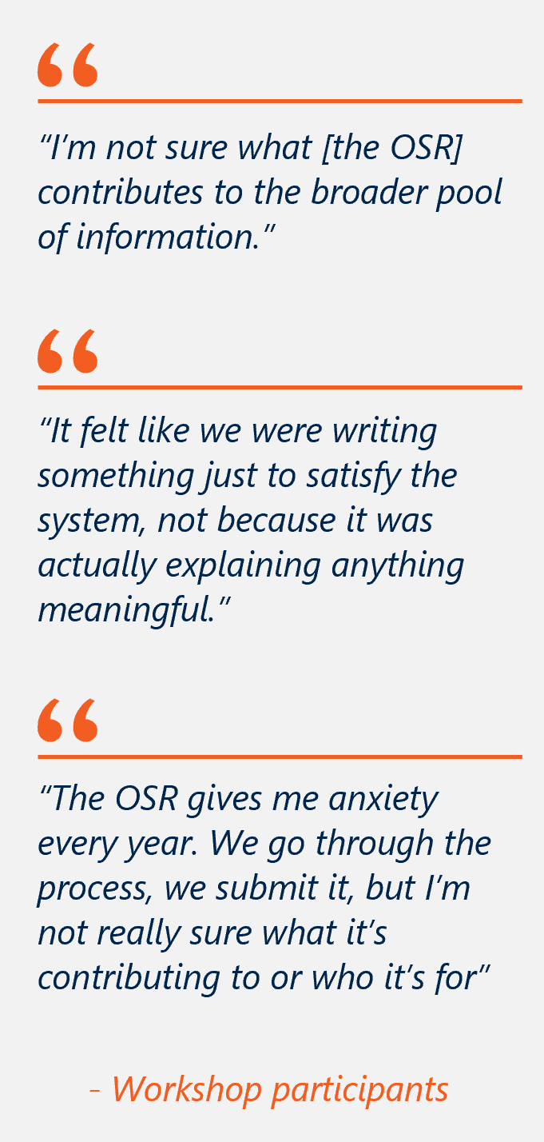
While the concept of the OSR is broadly understood, stakeholders lack clarity on how specific OSR measures are used to achieve its purposes. The Department has provided governing statements, but despite this, the practical use of the OSR data is not consistently understood. While the Department teams who directly use OSR data understand their purpose, use and limitations, this clarity is not shared across the sector, nor consistently across other departmental branches. This limits the perceived transparency around funding assurance and program management processes and contributes to uncertainty about how reported data informs decision‑making.
This lack of clarity is a persistent and well‑documented issue. The 2018 AIHW review found that the OSR does not have a clear or consistently understood purpose, with stakeholders holding differing views about what the collection is intended to achieve and how the data should be used. The review noted that the OSR was initially designed to capture service‑level activity and organisational information, but that incremental additions and overlapping requirements have blurred its function. Over time, the presence of overlapping and adjacent reporting requirements across the OSR and nKPI collections has contributed to duplication and uncertainty regarding which datasets should be used for analytical and decision‑making purposes.
PHC services predominantly view the purpose of the OSR as a compliance obligation rather than a tool for service improvement or strategic decision-making. There is broad understanding that OSR data is used for funding decisions but little understanding on how it is used for these purposes. PHC services reported limited visibility of downstream data use, which reinforces their uncertainty about the purpose of ongoing reporting and does not align with IDS&G principles.
- RECOMMENDATION 12

Confirm the intended purpose of the OSR as supporting assurance, strategic planning and policy decisions, and explain how the collection is used to achieve these purposes.
The purpose of the OSR should be re-established as to aid the assurance and allocation of IAHP funding, contextualise clinical results, and support policy development in response to identified needs.
Clear guidance materials should be developed to explain how the Department uses OSR data for these purposes. These materials should be provided to all reporting services ahead of each reporting period and made publicly available via the Department of Health, Disability and Ageing website and the Health Data Portal.
Separate internal materials should also be developed to clearly articulate the purpose and intended use of OSR data for departmental stakeholders and disseminated to all teams that use or rely on OSR data.

Use of the OSR collection

Usefulness to government
The OSR supports government stewardship of IAHP funding by providing organisational, workforce and activity information for funding assurance and program management. The OSR collection is predominantly used by the Department’s program and contract management areas for IAHP funding allocation and assurance. Government stakeholders reported using OSR data accessed directly via the HDP portal or through AIHW reports. This data used directly to inform grant evaluations, performance reporting, and broader system monitoring. Funding allocation is based on episodes of care and client numbers at both organisation and site levels.
However, the OSR does not operate as a precise or standalone proxy for IAHP‑funded activity. Some services include activity that is not funded by IAHP and activity measures like episodes of care do not provide a full picture of service activity (see Section 6.4 for details). As a result, OSR data has inherent limitations when used in isolation for funding decisions, particularly where service activity fluctuates due to changes in non‑IAHP funding streams or workforce availability. OSR data is not consistently considered alongside other contextual information, such as activity workplans. As a result, services expressed concern that policy decisions may not be informed by a holistic understanding of service activity, operating context, and delivery models.
OSR data is currently used by the Department primarily to support funding accountability and high‑level funding considerations, particularly through measures such as client numbers, episodes of care and workforce information. However, OSR data is largely reported at a whole‑of‑organisation level and captures total service activity, meaning reported volumes and patterns of activity are shaped not only by IAHP funding but also by other Commonwealth, state and territory funding sources and service‑specific delivery models.
As a result, OSR data provides an indicative signal of service scale and activity rather than a precise measure of IAHP‑funded activity, and, on its own, cannot fully explain differences in relative need, service intensity or funding adequacy across organisations. Any changes to the funding model sit outside the scope of this review.
Clarity on which measures are used to inform policy decisions has been made available in public resources, but services do not have a consistent strong understanding of this process. Increasing the accessibility and visibility this information, perhaps through a dedicated glossary or listed at the start of the report, may help reduce confusion (See OSR Recommendation 1).
The OSR is also used to identify service issues and gaps, primarily at a system and contextual level. The AIHW uses OSR data to prepare reports that contextualise nKPI results, promote sector understanding and advocate for sector support. These reports help promote understanding of service context, capacity, and regional need and are used across the Department by multiple stakeholders. Aspects such as workforce supply, vacancies, and turnover pressures are seen as critical contextual factors affecting service access, continuity of care and performance. Understanding service capacity and distribution across jurisdictions and remoteness categories further provides insight into the ability of services to meet population need.
The AIHW uses OSR data to understand these trends, identify needs, and advocate for further funding and support. The AIHW draws on OSR data to understand these trends, which may influence future funding and support decisions.
For example, collecting vacant FTE data is important in understanding unmet workforce demand, service delivery risk and system sustainability. While there are some issues with the vacancy measure (see Section 6.4), it broadly shows where services cannot be fully staffed, highlights recruitment and retention challenges and provides critical evidence to inform workforce planning and policy decisions.
Also, while OSR vacancy data are not used as a formal Closing the Gap target indicator, these data are used by the AIHW to inform Closing the Gap-related reporting, analysis and policy advice, particularly on workforce capacity and sustainability in ACCHOs. This includes data analysis and reporting for the Aboriginal and Torres Strait Islander Health Performance Framework (HPF), Tier 3 (Health system performance), specifically to inform Measure 3.22: Recruitment and retention of staff.
Inherent structural characteristics of the OSR limit its use for system‑wide strategic policy decisions. While the OSR was established to profile services, support funding accountability, and identify service gaps, challenges and key issues, the collection is not designed to operate as a standalone evidence base for large‑scale policy or investment decisions across the sector.
The OSR can signal areas of pressure or emerging issues, such as workforce shortages or service coverage gaps, but its aggregated structure, annual reporting cycle and variation in reporting practices limit the precision and reliability required for system‑level decisions, such as determining the scale or distribution of major new investments. In this sense, OSR data is better suited to informing service‑level funding assurance and contextual understanding than to underpinning broad strategic policy decisions in isolation.
For these reasons, OSR data is most appropriately used alongside other information sources, including qualitative intelligence and complementary datasets, to support policy development. These limitations reflect the design intent of the collection and the priority placed on maintaining a low reporting burden, rather than shortcomings in implementation.

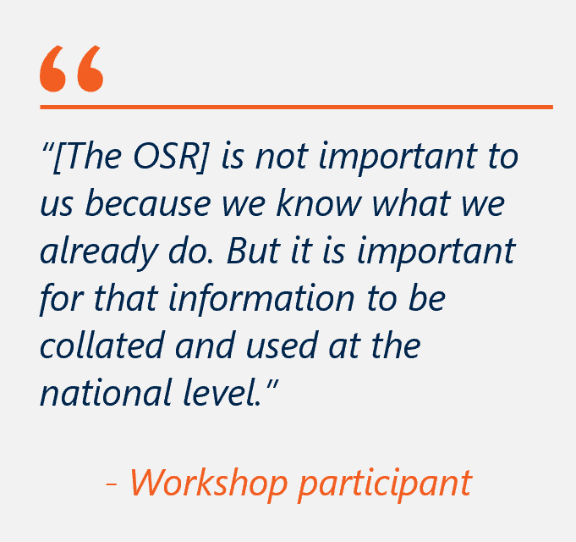
Usefulness for services
First Nations PHC services sometimes use OSR data for internal planning and organisational insights. The OSR can prompt review of workforce, service activity and client lists, particularly in services without dedicated HR or analytics systems. Some services reported using OSR snapshots to support board reporting or grant applications.
However, most workshop participants indicated that OSR data is not heavily relied upon for ongoing planning or operational decision‑making, as relevant information is already held in internal systems that are timelier and more accessible for day‑to‑day use. Survey responses were more positive than workshop discussions, though qualitative comments similarly emphasised that OSR use is largely limited to high‑level insights (see Figure 10).
This pattern of use is consistent with the intended design of the OSR. The OSR was not designed as a service‑level planning or CQI tool, but as a system‑level collection to support funding assurance, accountability and program administration.
The annual, point‑in‑time nature of the OSR further limits its usefulness for operational purposes, particularly in a context of high workforce turnover and changing service models. By the time data is submitted and analysed, it may no longer reflect current workforce composition or service capacity.
Services with more mature internal systems typically rely on those tools for planning, with the OSR playing a supplementary or reflective role. This aligns with the expected use of the OSR, and no changes are recommended to reposition it as a service‑level planning tool.
Figure 10 | Survey results on the usefulness of OSR data to PHC services
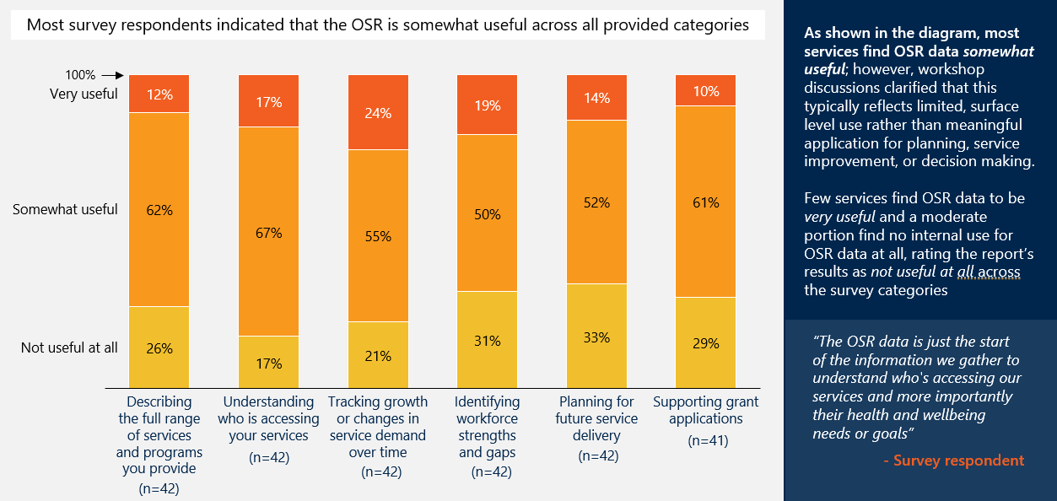

Usefulness for external stakeholders
External stakeholders reported no direct use of OSR submissions, noting that access to and use of OSR data occurs primarily through AIHW analyses and publications rather than through direct engagement with submission-level data. This reflects the intended external-facing access pathway for OSR data, with AIH W playing a central role in compiling, contextualising and validating OSR information alongside other datasets, rather than any perceived limitation in the underlying data itself. Stakeholders described using AIHW products for purposes such as sector‑wide trend analysis, high‑level monitoring, briefing and reporting, and comparative analysis across programs or service types. AIHW reporting was viewed as accessible and fit‑for‑purpose for these uses, applying consistent methods, metadata and caveats, and situating OSR data within a broader national evidence base. This aligns with the collection’s design as a system‑level dataset intended to support national analysis rather than primary research or advocacy.

Scope and content

The scope and content of the OSR require refinement.
This section examines opportunities to refine the scope and content of the OSR to improve relevance, reduce burden and better reflect contemporary service delivery. Key findings and recommendations include:
- The removal of accreditation status and smoke‑free workplace reporting measures as they provide limited analytical or assurance value. Where these data are required under funding agreements (e.g. accreditation), pre‑population should be considered to reduce reporting burden.
- Simplifying workforce reporting to reduce manual effort while retaining the data required for funding oversight and system‑level workforce analysis.
- Improving measures (episodes of care and client contacts) to better reflect holistic and multidisciplinary models of care delivered by services.
- Identified gaps in the OSR do not warrant expansion of the collection given reporting burden and feasibility considerations.

Workforce reporting is high burden with low perceived value, despite its importance to AIHW reports.
OSR workforce reporting is intended to support funding oversight, workforce planning and system‑level understanding of PHC service capacity. As highlighted in Section 6.3, AIHW sees workforce data as a crucial measure used to contextualise service deliver. However, this value is not evident to PHC services nor seen to be commensurate to the burden of reporting.
Workforce reporting was consistently identified as the most burdensome component of the OSR collection. Reporting on paid and unpaid FTE positions requires substantial manual effort. PHC services reported significant variability in how workforce roles are described and structured across organisations, including staff working across multiple roles, sites or funding streams, as well as visiting specialists, locums and community‑based workers. While consistent, well‑defined OSR workforce definitions are necessary to support comparability and data quality, this variability in local workforce descriptors makes it difficult for services to reliably map their internal workforce data to the prescribed categories. As a result, services reported spending significant time interpreting definitions and manually reconciling local workforce records to align with OSR requirements. This suggests that improvements would be best directed toward supporting greater consistency in workforce descriptors across services and refining guidance to improve mapping to OSR definitions, rather than relaxing the definitions themselves. Most PHC services were not confident that the result accurately reflected their workforce.
Vacancy reporting raised additional, and distinct, concerns. Services noted that the current point‑in‑time measure (vacancies as of 30 June) does not adequately reflect sustained workforce shortages, turnover, backfilling arrangements, or churn over the year. As a result, vacancy data can misrepresent workforce pressure at both service and system levels, limiting its usefulness for workforce planning and funding assurance.
At the same time, services questioned whether they have ready access to the information required to support more complex vacancy measures, such as vacancies over time, without significantly increasing reporting burden. Many services noted that tracking when positions were vacant across the year is not information, they are currently required to compile for OSR purposes, and that manual reconstruction would be impractical.
Some stakeholders noted that, in principle, burden could be mitigated where structured extracts from existing HR and payroll systems are feasible – for example, by identifying pay periods in which no staff were paid against a given position identifier. However, the feasibility, consistency, and maturity of such approaches vary across services and would require careful testing before any changes are implemented.
To preserve the system‑level value of workforce data while reducing or at least not increasing burden, any refinement to OSR workforce or vacancy measures should prioritise improved alignment with existing service systems, clearer guidance on interpretation, and automation where possible. Changes should only proceed where they demonstrably improve data quality and interpretability without introducing new manual reporting effort for services.
- RECOMMENDATION 13
- Refine OSR workforce reporting to improve clarity, consistency and fitness for purpose.
The Department should work in partnership with NACCHO, AIHW and the sector to refine OSR workforce categories, ensuring they accurately reflect how workforce data is used for funding assurance, service delivery, and system‑level workforce analysis. This should focus on improving alignment between OSR categories and common PHC workforce descriptors, supported by clearer mapping guidance, to reduce manual reconciliation and improve consistency and comparability across services.
This work should build on existing sector‑led efforts and ensure that any refinements maintain appropriate granularity while reducing ambiguity and improving interpretability, rather than reducing the scope of workforce reporting.

- RECOMMENDATION 14
- Assess options to improve the usefulness of OSR vacancy measures.
The Department should work with AIHW and PHC services to assess whether the current point‑in‑time vacancy measure can be refined to better reflect sustained workforce shortages and churn over the year. Any consideration of annualised vacancy measures should be explicitly contingent on feasibility, including the potential for automated or system‑derived extracts from existing HR or payroll systems. No changes should be introduced where they would increase manual reporting effort for services.

Episodes of care are not a reliable measure of service intensity, and important dimensions of PHC service delivery are not visible in current OSR activity measures.

Episodes of care are not a reliable measure of service intensity.
Episodes of care are an important assurance measure used by the Department. However, the way episodes are currently defined and counted limits their usefulness as an indicator of effort, workload or complexity of care. The Department’s Guide to the OSR Form describes an episode of care as a contact between an individual client and service, with one or more staff, to provide health care (e.g. for sickness, injury, counselling, health education, screening) within one calendar day. All contacts on the one day are treated holistically as one episode of care (p. 6). As a result, the volume, intensity and complexity of care delivered within a single episode can vary widely depending on the number of services, staff and disciplines involved.
Some services reported that relying on episodes of care in isolation risks misinterpreting effort and efficiency, as services that deliver multiple services to a client through coordinated, multidisciplinary care on a single day will record fewer episodes of care overall. The perception that this dynamic disadvantages comprehensive and efficient models of care is highly prevalent among services and is not explicitly addressed in official department communication.
Without redefining episodes of care to better reflect real workloads or ensuring they are consistently interpreted alongside client contacts and other contextual information, there is a continuing risk that assessments do not accurate represent the volume and intensity of services provided. Whilst a single episode of care definition may not be suitable across all service models, there is scope to improve how episodes of care are defined and applied to better reflect service delivery.

Current OSR activity measures do not capture the full scope of PHC service delivery.
By focusing on discrete, individual interactions, client contacts also do not adequately capture the provision of family‑centred and group‑based care. The current count explicitly excludes residential care and group sessions, such as antenatal classes, men's groups and support groups. Previous versions of the OSR included group-activity counts, however it was removed on the basis that reporting burden outweighed the value of the data collected. As a result, recorded client contacts can significantly under‑represent actual service activity, effort and impact. To be fit for purpose, client contacts would need to be revised to explicitly recognise group‑ and family‑based models of care before the measure could reliably support system‑level analysis. However, because group‑based activities are fundamentally different from one‑to‑one contacts, stakeholders suggested that they may require a separate reporting category rather than being combined with individual client contact measures. Any expansion would need to weigh the value of the data against the additional burden on services, given that group-based activities are generally not recorded in clinical records and would require additional record-keeping to be captured in the OSR.
The 2018 AIHW Review found that the OSR had expanded over time through incremental additions, contributing to reporting burden and reduced clarity of purpose. It recommended refocusing the collection on a narrower set of organisational, workforce and activity measures to support funding accountability and high‑level system understanding. As a result of this refocusing and subsequent streamlining, the OSR no longer captures many non‑clinical and community‑based aspects of service delivery, including elements related to social and emotional wellbeing and holistic models of care. While these activities remain central to how PHC services support First Nations wellbeing, their limited visibility within the current OSR framework contributes to an under‑representation of the full scope and extent of work undertaken by services. As such, any inclusion of group‑based measures would need to consist of a limited expansion of scope for client counts and be implemented as a simple numerical measure rather than a detailed new reporting requirement.
PHC services further reported confusion about what constitutes a client contact and an episode of care. Services were often unfamiliar with the terms used and noted they differed from local definitions. While the Department has provided clear definitions for each measure, greater consistency with definitions used by other funders was identified as a priority to improve reporting clarity and support data reuse.

RECOMMENDATION 15
Explore options to better reflect differences in service intensity, while maintaining the current underlying data inputs
Differences in service intensity are not currently well reflected in the OSR collection. The Department should explore opportunities to better represent these differences to inform service profiles. This should build on existing underlying data inputs, exploring further options only where material gaps remain. Any changes should be tightly scoped, proportionate and designed to avoid reintroducing complexity or reporting burden.

Additions to the OSR are not advised.
Adding OSR categories is not advised, should be approached cautiously and on a targeted basis. While there is clear sector interest in expanding the scope of reporting, any additions should be carefully assessed to ensure they address genuine gaps in capturing service activity and provide clear value relative to implementation effort.
Stakeholders identified gaps in the current OSR measures that reflect broader community needs and proposed 13 potential additions. Some proposals reflect areas where current measures do not fully capture the breadth of service delivery, particularly beyond core clinical activity.
Broad expansion of OSR categories is unlikely to be proportionate. Instead, priority should be given to refining existing measures, improving interpretation, and considering tightly scoped additions only where material gaps remain and cannot be addressed through better use of existing data.

Reporting burden
The OSR relies heavily on manual processes, increasing reporting burden in an already heavy reporting environment. The OSR, particularly workforce elements, contains significant manual data entry and reconciliation requirements. These elements require services to extract, interpret and re‑categorise information from internal systems to fit OSR definitions, often through time‑intensive manual processes. While the absolute burden of the OSR may be moderate in isolation, it adds to an already crowded reporting environment in which services are required to meet multiple, overlapping data and assurance requirements across programs and funders. For many services, this cumulative burden is felt most acutely in high‑turnover and resource‑constrained settings, where manual reporting diverts limited administrative capacity away from service delivery.
Services reported little insight into how the OSR is used, contributing to a high sense of non-reciprocal reporting burden. Across workshops there was uneven understanding on how data informs policy decisions and a sense of frustration over repeatedly reporting the same organisational needs without observing a response (e.g. a proportionate increase in funding or other assistance). This contributes to a perceived absence of reciprocity. Over time, this dynamic has reinforced a sense that OSR reporting is a one‑way process, characterised by high effort and uncertain value. As a result, the OSR is widely seen as a compliance obligation rather than a meaningful mechanism for communicating service need, contextual challenges, or areas requiring additional support. This accentuates the view of the OSR as a burden rather than a meaningful and important assurance process.
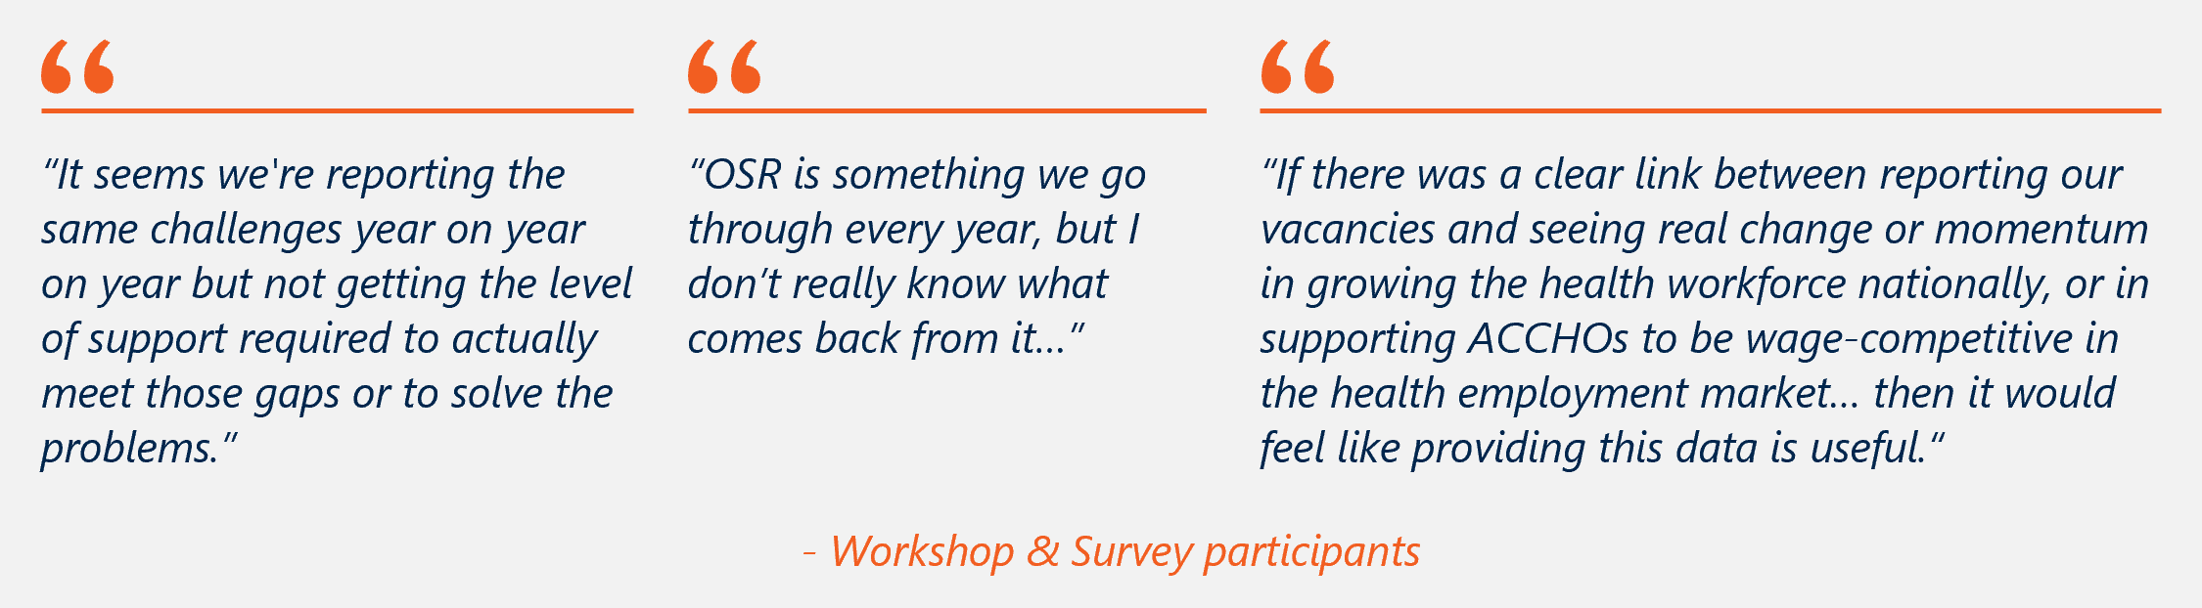

Figure 11 | Survey results – OSR reporting burden
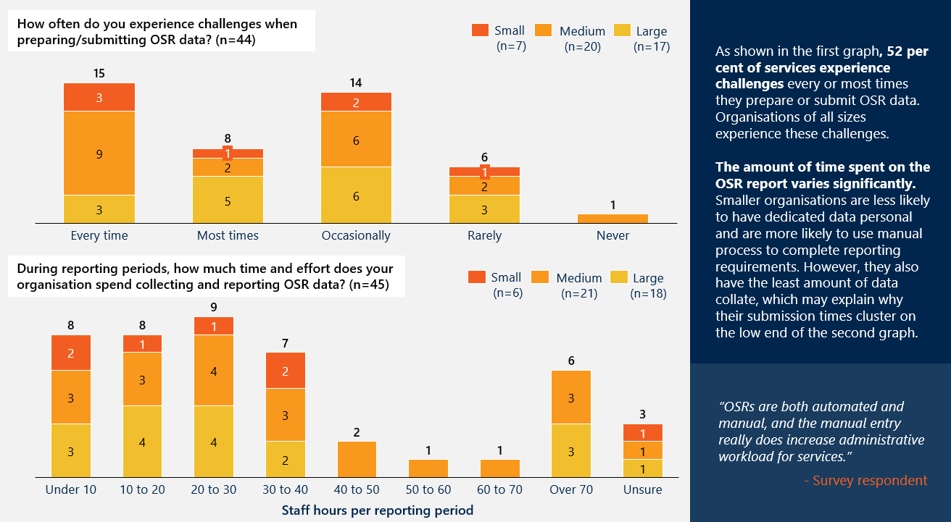

Data platforms and infrastructure

Introduction

Overview of data flow and infrastructure
The nKPI and OSR collections are underpinned by digital infrastructure provided in part by the Department, and in part by the First Nations PHC organisations, as illustrated in Figure 12. Clinical records are captured during primary health care delivery in a CIS. Reporting values are calculated within the CIS from clinical records and are generally loaded automatically into the HDP as aggregate statistics which generate a pre-populated draft submission. As clinical indicators, all nKPI data can be automatically extracted from a compatible CIS (Communicare, Medical Director, MMEx, Best Practice or PCIS), though organisations using other systems must manually input data. For OSR, the direct load populates episodes of care, client contacts, and client numbers, but workforce data, organisational profile, governance, and clinic details must be entered manually from organisational records.
As a data quality support function, automated validation checks flag mathematical anomalies (e.g. numerator exceeding its denominator) and unexpected values (e.g. results significantly higher than the previous year) for the organisation to resolve or explain. The submission then progresses through an internal review conducted within the First Nations PHC organisation to assess internal consistency and completeness before being signed off by the organisation and made available to the AIHW. The AIHW undertakes further external consistency checks across submissions, including comparisons with sector‑wide patterns and values reported by other organisations. Where additional anomalies are identified (e.g. values that are substantially higher than those reported by comparable services), the submission may be returned to the health service via the portal for amendment or further clarification.
As a result of these validation and review processes, the HDP contains multiple years of reporting data across First Nations PHC services nationally, providing a validated dataset suitable for internal and external assurance and analysis.
Through the HDP, organisations and other stakeholders can access Qlik, which provides interactive dashboards that present a service’s data against national averages, self-determined targets and comparable groups of services. The nKPI data presented in Qlik is updated almost immediately following submission. Organisations may also access and analyse their data through internal tools such as Power BI or CIS-generated reports.
The following subsections assess the infrastructure and data collection workflows that underpin this process, from initial capture through to reporting and access.
Figure 12 | nKPI and OSR data flow
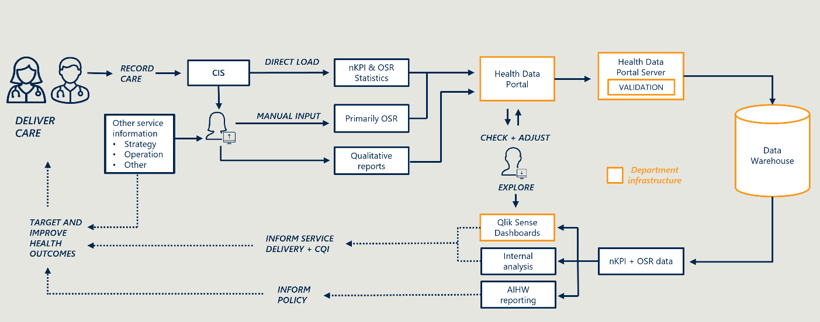

Organisations frequently report challenges with data preparation and submission.
First Nations PHC organisations frequently report challenges preparing and submitting both the nKPI and OSR collections. These challenges arise across two dimensions:
- Variation in data quality, completeness and consistency across the sector, (see Section 7.2) shaped by clinical workflows, CIS design and organisational capability at the point of capture and extraction, and subjective interpretation at clinical workflow and data submission.
- Submission and access through government infrastructure (see Section 7.3), where platform usability and access arrangements in the HDP and Qlik add to the burden on services.
As shown in Figure 13, almost all organisations responding to the survey reported experiencing challenges preparing and submitting both collections, and about half reported experiencing challenges every time or most times they submit. Small and medium organisations were more likely to report experiencing challenges every time compared to larger organisations; however, difficulties were experienced across organisations of all sizes.
Figure 13 | Frequency of challenges experienced during preparation and submission of nKPI and OSR
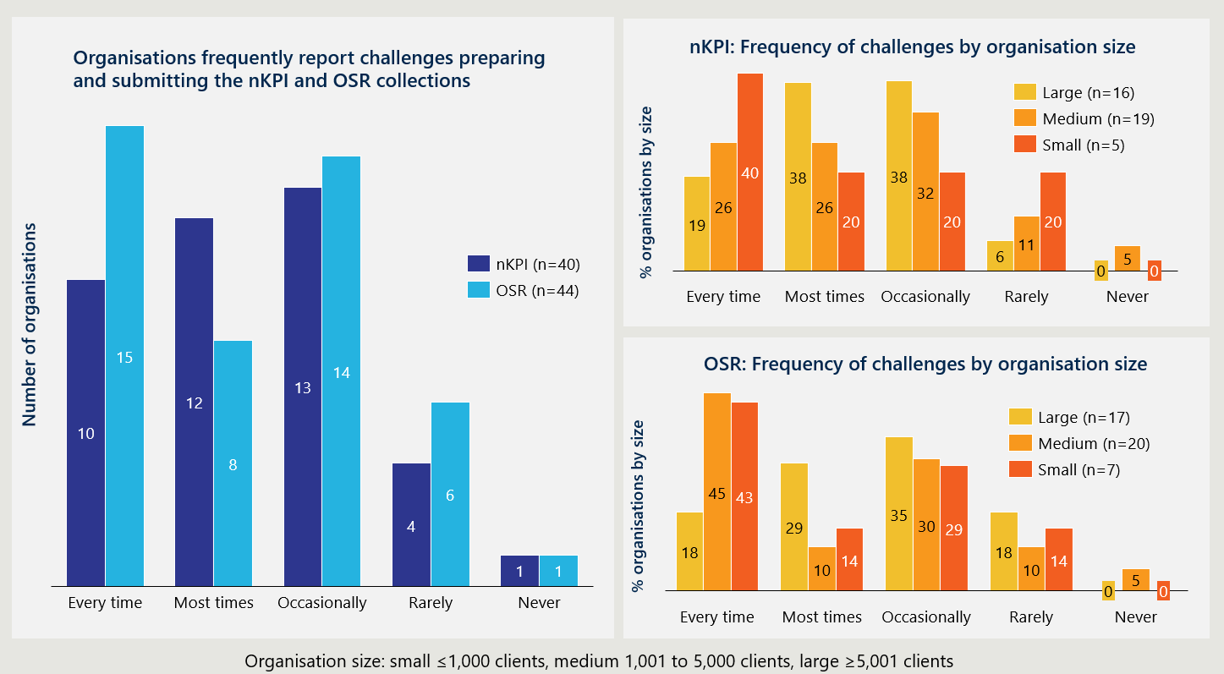

Data Collection

Data completeness at the service level

At the service level, the accuracy of reported data depends on the completeness of clinical data for reporting purposes at the point of care within the CIS, the extraction rules and definitions used to translate clinical records into reportable data fields, and the organisational capability to manage data quality through the reporting cycle. While clinical records are primarily designed to support safe and effective patient care, they are not always structured or standardised in ways that enable complete and consistent extraction for reporting purposes. These factors affect both the completeness of data for internal organisational use and the accuracy of reporting to the nKPI and OSR government collections.
As the First Nations PHC sector becomes increasingly focused on using high quality data to inform service delivery, governance and outcomes for communities, consistent with Closing the Gap Priority Reform 4, the importance of data capability at the service level is growing. The challenges described in this section relating to consistency in data capture and varied data maturity are not unique to the nKPI and OSR collections but reflect sector-wide conditions shaped by workforce transience, CIS limitations, and the operating realities of First Nations PHC services. As the sector moves toward less manually validated data flows, including more frequent CQI-oriented reporting, and the potential for automated unit-level data exchange, the quality of what is captured at the point of care will become increasingly consequential. Sustained investment in data capability in health services alongside technical and standards-based reform is therefore a requirement for progress.

Gaps in data completeness and staff capability introduce downstream reporting challenges.
The experience of challenges preparing and submitting nKPI and OSR data frequently relates to limitations in the way clinical information is captured and structured for reporting, issues arising during data extraction, staff capability, and connectivity constraints. Figure 14 shows the prevalence of specific challenges reported by surveyed organisations when preparing and submitting both the nKPI and the OSR collections.
Figure 14 | Survey reported challenges experienced preparing/submitting nKPI and OSR data
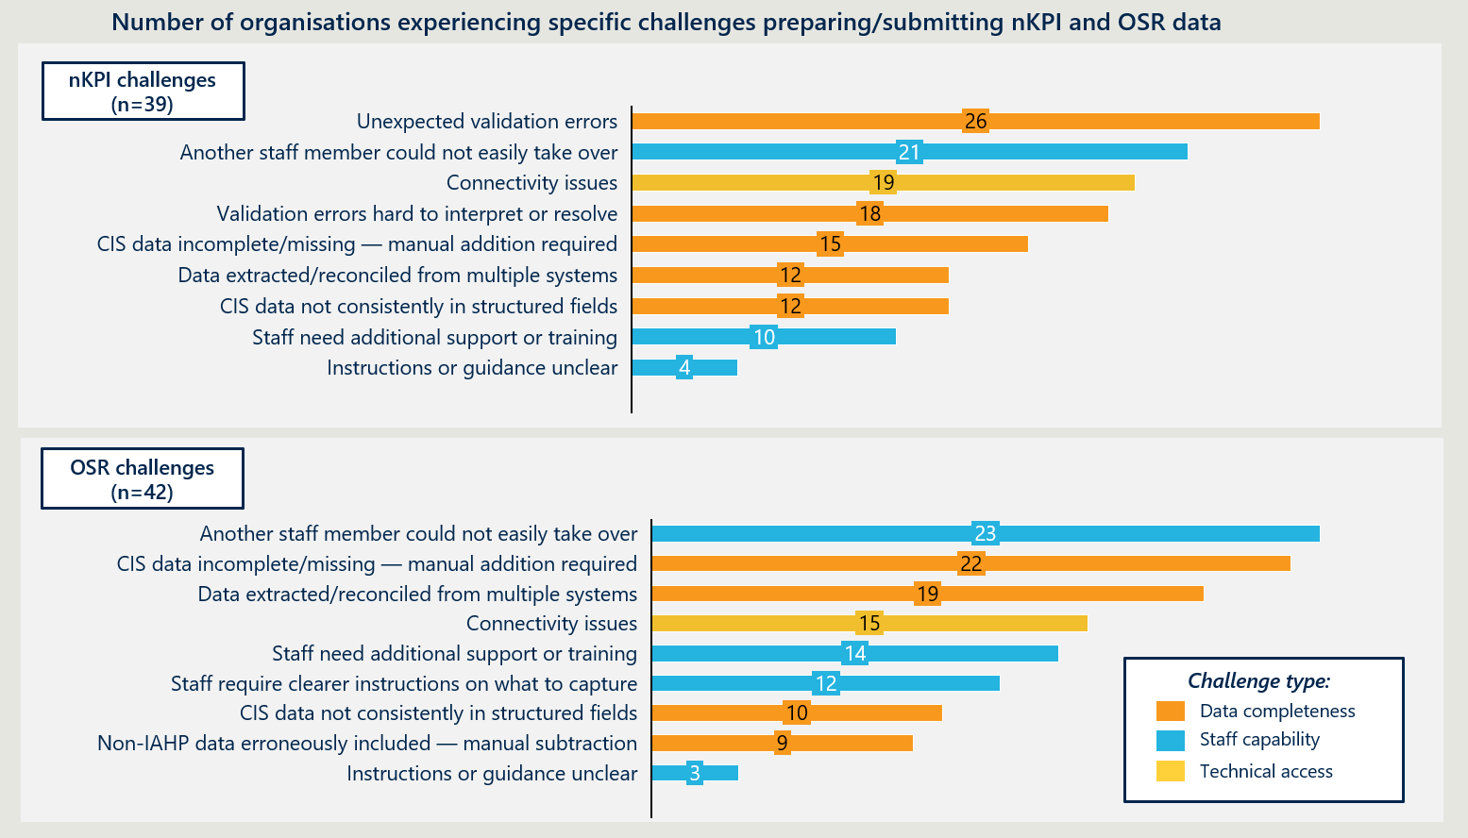
For the nKPI collection, data completeness challenges are the most prevalent. Unexpected validation errors were reported by the greatest number of organisations (26), and many organisations reported experiencing difficulty interpreting and resolving the validation flags. Where data is incomplete or has not been entered in line with extraction logic at the point of capture, automatic extraction does not eliminate manual effort. Organisations must still address quality issues after direct load, adding missing CIS data, reconciling data from multiple systems, or correcting data not captured in structured fields during care delivery.
Organisations also identified challenges associated with staff capability; reporting knowledge is frequently concentrated in individuals, with 21 organisations reporting that another staff member could not easily take over submission. Some organisations identified a need for additional training, though very few cited unclear instructions or guidance as the core problem, suggesting that support and guidance materials generally exist but are not consistently reaching the staff who need them. Connectivity issues accessing the HDP were also widely reported (19 organisations), introducing further complications during the submission process.
For the OSR collection, the submission process itself requires a degree of manual input by design, as workforce and other measures are typically sourced from non-clinical systems. Beyond this, data completeness remains a core challenge, reflecting the need to bring together information that is not routinely held within clinical information systems. Organisations commonly reported that OSR completion requires data to be extracted and reconciled across multiple non‑clinical systems, such as HR, payroll and operational records, and then manually incorporated alongside CIS‑derived activity data (19 organisations). In some cases, this reconciliation effort was further compounded by inconsistencies in how activity or workforce‑related information is captured at point‑of‑care or configured within systems.
Staff capability challenges are generally more prevalent for OSR than for nKPI, consistent with First Nations PHC staff frequently describing the OSR as the most demanding aspect of reporting. Organisational knowledge of OSR submission frequently relies on individual staff (23 organisations), and a notable proportion identified a need for additional training and support (14 organisations), and clearer guidance (12 organisations) for staff. However, clarity of guidance materials supplied was rarely cited, indicating staff need better visibility of and connection to guidance and assistance that, in most cases, is already available through the Department. Connectivity issues submitting the OSR were frequent (15 organisations), though less common for OSR compared to the nKPI, which during consultation was attributed to the availability of offline working versions that support the submission process.

Clinical workflows and infrastructure at point of care determine the completeness of clinical data.
The completeness and reliability of nKPI data are fundamentally shaped by clinical workflows and digital infrastructure at the point of care. A notable strength of the collection is its direct load functionality, which enables automated extraction from CIS to the HDP, supporting streamlined and efficient reporting. Extraction logic draws on structured data fields within the CIS, meaning what clinicians capture in coded, extractable fields directly determines what is available for reporting. Where clinicians record relevant information outside of expected fields, including in free text or progress notes, the information cannot be directly extracted for reporting. This means nKPI statistics may not fully represent service activity and may introduce burden at point of submission if services manually adjust counts, based on information captured in alternate locations.
Variation in clinical documentation practice is an inherent feature of the clinical environment and a primary source of gaps between care delivered and data reported. In health services, clinicians capture clinical data to support care delivery, not national reporting obligations. There is not necessarily a single location or structure within a CIS for recording the same clinical information, and natural variation therefore arises in how individual clinicians use structured fields to document care. Considerable work has been undertaken to build expected variation into extraction logic; however, it cannot compensate for information that is not captured in structured, coded fields. Information recorded outside the fields covered by extraction logic will not be reflected in automatically extracted nKPI data.
Additionally, First Nations PHC service staff highlighted that clinicians will regularly use free-text notes to document care, especially where structured fields are poorly aligned with clinical workflows, require subjective judgement or do not reflect the delivery of care in First Nations PHC settings. Free-text notes may support clinical practice, however, unstructured narrative input is incompatible with hard coded extraction logic, meaning clinically relevant information recorded in this way is not systematically captured in the nKPI extraction workflow.
These challenges are compounded by limitations in current CIS platforms. None of the four major CIS products in use across the sector fully accommodate the holistic, culturally grounded models of care delivered by First Nations PHC services. Even Communicare, which was originally developed for the First Nations PHC context, was identified by some services as having usability limitations that affect how consistently clinical data is captured in structured fields.
Services reported limited responsiveness from CIS vendors to enhancement requests, reflecting the relatively small market share represented by First Nations PHC services. Additionally, staff highlighted that CIS interfaces are often experienced as ‘clunky’ and difficult to use, leading clinicians to adapt their documentation practice, including using free-text entry or recording information in alternative fields. Services frequently rely on workarounds, parallel recording processes, or locally developed practices to capture information that is clinically meaningful but not well supported by system architecture. While these approaches enable care delivery, they reduce the extent to which data can be consistently structured for extraction and reporting.
Achieving consistent structured data capture across a clinical workforce is challenging given high workforce turnover and transience (including the prevalence of locum staffing) in the First Nations health sector. Services must repeatedly orient new staff to CIS configuration, data entry expectations, and indicator definitions. Locum staff may bring documentation practices from other clinical contexts that do not align with local workflows, and systematic behaviour change of individual clinicians is very difficult to sustain at the service level.
Data quality issues originating in clinical workflows are difficult to detect and resolve at the point of submission. In some cases, this manifests as validation flags that organisations find difficult to interpret and address, as reflected in survey responses above. In others, incomplete data is incorporated into the nKPI collection without correction, meaning reported results do not fully capture the extent of care delivered by services, limiting the accuracy of nKPI data for performance monitoring and quality improvement purposes.
In the near term, targeted guidance and support may support services to improve the fidelity of clinical documentation to extraction logic can uplift data quality.
However, this approach has inherent limits, as it requires ongoing effort from services and cannot fully resolve variation in documentation practice that is a natural feature of clinical environments. As explored in the following sections, future systems capability, incorporating structured clinical terminology (i.e. SNOMED-CT) and interoperability frameworks (i.e. FHIR) will offer reduced sensitivity to natural variation in clinical workflows.

External system dependencies constrain completeness for some indicators.
For a small number of nKPI indicators, data completeness depends on information generated or held outside the health service's CIS and not created directly by the clinician as part of routine clinical care. Where system integration between external providers and the CIS is limited or inconsistent, data may not flow back to the service reliably, constraining reporting completeness in ways that are outside a service's direct control.
- PI25 measures STI testing for chlamydia and gonorrhoea by counting pathology results returned from external providers. Solving Health has undertaken significant work to map the range of relevant Logical Observation Identifiers Names and Codes (LOINC) to support consistent extraction for the indicator. However, some pathology providers apply local custom codes to results rather than standard codes, meaning they are not captured in reporting unless identified and mapped in advance. Additionally, some services use point-of-care testing (POCT) for STIs, particularly remote services located far from pathology laboratories. POCT devices have not yet been integrated with CIS platforms, introducing a further source of incompleteness for PI25. This produces gaps in data completeness that cannot be resolved through changes to service-level practice, requiring manual recoding and data entry to address.
- PI22 measures cervical screening by counting clients who have had a screening test recorded within the previous five years. Where a client is screened at an external provider, the result is held in the National Cancer Screening Register. The Register is intended to support two-way information flows with clinical systems, but integration is currently limited to view-only access. Without the ability to automatically return results into CIS records, external results must be manually entered, and where this does not occur PI22 may undercount completed screenings.
For these indicators, data quality challenges are driven by external dependencies rather than service-level practice. Validation processes undertaken by Solving Health and departmental guidance partially mitigate some of these issues, though where indicators are structurally dependent on external systems, some degree of incompleteness is likely to persist. Services commonly undertake manual recoding, parallel record-keeping, or supplementary counts to compensate, absorbing effort that originates in upstream system design and data exchange limitations. Improvements in completeness depend on broader interoperability and data-sharing and coding standards arrangements, as well as technical platform developments to external databases. Expectations of completeness need to remain proportionate to the level of control services can reasonably exercise over upstream data sources.

Varied data capability influences organisational capacity to manage data quality through the reporting cycle.
Data capability varies significantly across First Nations PHC services, shaping how consistently organisations can capture, monitor, and address data quality issues before they reach the formal reporting stage. Services with stronger data maturity tend to maintain more consistent clinical data practices and identify issues as part of ongoing operations, enabling earlier resolution and greater confidence in reported outputs. The presence of dedicated data or analytics roles further strengthens this capability. While validation issues remain a common challenge in the submission of nKPI data, organisations with stronger data capability are generally better placed to identify and resolve quality issues before the submission stage, as they may pull reports and assess data quality on a more frequent basis.
For services with lower data maturity, quality issues in clinical data are more likely to go undetected until the reporting stage. Without the capability to identify root causes, First Nations PHC staff often reported resorting to manual adjustments or contextual comments to flag unexpected results rather than addressing underlying problems, limiting improvement to data quality over time. While validation is a necessary and valued component of data integrity, it can create frustration where services cannot efficiently diagnose and resolve issues. Generally, smaller organisations are more likely to have less data capability than larger organisations, though this is not uniformly the case.
The complexity of the OSR collection presents additional challenge for services given the manual effort involved in its compilation and the range of data inputs required. First Nations PHC services, especially those without embedded data capability noted compiling the submission within six-week reporting window can be a significant challenge, given the competing demands of care delivery and alignment with end-of-financial-year reporting obligations across other programs.
As noted in survey findings in Figure 14, reporting knowledge is frequently concentrated in individuals, and workforce turnover creates recurring capability gaps. Support materials exist but do not consistently reach the staff who need them. Strengthening data quality outcomes therefore requires targeted capability development and support through the reporting cycle, rather than increased validation or compliance expectations at the point of submission.
More broadly, uplifting data capability is recognised as a sector-wide priority. NACCHO is developing a National Aboriginal Community Controlled Digital Health Implementation Plan and an accompanying Workforce Digital Health Literacy Plan, which recommend sustained, sector-led investment to uplift data capability across ACCHOs, including stronger digital literacy, workforce training, culturally appropriate resources and Indigenous-led data governance. Efforts to improve data capability and quality for the nKPI and OSR should align with these broader sector initiatives, reinforcing and complementing overall data capability uplift.
RECOMMENDATION 16
Continue existing data quality support and invest in a sector-wide data literacy uplift across First Nations PHC services.
The Department already provides substantial guidance and support to help PHC services meet their nKPI and OSR reporting obligations, and maintaining these efforts is necessary while the current reporting arrangements continue. The HDP support function and affiliate-level data capability roles should be sustained to provide practical assistance with reporting and data use, particularly for organisations with lower data maturity that face competing clinical and operational demands.
Building on existing sector-led work, including NACCHO’s current initiatives in digital health will be critical to ensuring that data capability uplift aligns with other emerging national infrastructure and priorities. While the nature of support required will evolve as the sector transitions to an environment underpinned by structured clinical terminology and FHIR-enabled workflows, the quality of data will always depend on what is captured at the point of care.
A sector-wide data literacy uplift, delivered through affiliates and networks, would strengthen consistency in data capture and support effective use of data. This could include delivering data capability support and training tailored to local context, supporting improved onboarding processes for clinicians with regard to structured data capture, and assisting organisations to audit their data capture workflows and target improvements to CIS-specific data capture and management practices where required. Efforts should complement and extend existing investments and initiatives, avoiding duplication, and be co-designed with NACCHO, affiliates and First Nations PHC services.

Structured clinical terminology and interoperability frameworks are the most viable path to sustained improvement in data completeness.
Ongoing refinement of extraction logic has strengthened data completeness, though further adjustment will not resolve systematic challenges. The HDP team and Solving Health have performed an important function in improving data completeness through ongoing refinement of extraction logic, validation processes, and technical guidance to services and vendors, and this work has materially strengthened the reliability of the collections over time. Many of the data quality challenges that remain reflect natural variation and lack of standardisation in how clinical data is documented by clinicians to support care delivery. Continued incremental, reactive adjustment of extraction logic and validation rules offers limited scope to resolve this tension, and the investment required is unlikely to be proportionate to the returns.
Structured clinical terminology and interoperability frameworks will play an increasingly important role in supporting data quality. Broader adoption of SNOMED-CT and FHIR across the sector's clinical information systems represents the most viable path to sustained improvement in data quality. These standards address the underlying tension between how clinical data is documented and how reporting infrastructure is designed to extract it, in ways that continued refinement of extraction logic cannot. As these standards become more widely embedded, many of the extraction and reconciliation challenges that currently require ongoing management are likely to reduce, leading to a data environment in which clinical documentation and reporting infrastructure are more naturally aligned.
SNOMED-CT is the internationally recognised standard for clinical terminology. It assigns structured codes to clinical concepts at the point of documentation, meaning that where codes are correctly bound to extractable fields, clinical information is captured in a consistent, structured form.
Current CIS platforms across the sector use a range of clinical terminology standards. Broader adoption of SNOMED-CT would support more consistent and interoperable data capture, though its presence alone does not resolve data completeness challenges. Consistent application depends on clinicians selecting coded terms rather than free text, and on codes being bound to the correct fields for extraction. It is also important that structured clinical terminology is sufficiently flexible to reflect culturally grounded models of care, including concepts and activities that may not map readily to mainstream clinical terminology. Design features such as predictive coding prompts during clinical documentation could support more consistent use without requiring clinicians to change how they deliver care.
However, SNOMED-CT alone is not suitable for First Nations PHC services to understand their clients' needs, or for service and patient reporting, as it records individual clinical concepts in detail without grouping them into the hierarchical classification needed for counting and analysis. The AIHW has proposed coding to both SNOMED-CT and the latest International Classification of Diseases (ICD-11) as part of broader work to harmonise data for national primary health care data collection. This would also support comparison with hospital and other service data as those sectors transition to ICD-11.
FHIR is the international standard for exchanging health data between systems. Current reporting infrastructure depends on extraction logic specific to each CIS platform, requiring bespoke integration work whenever data needs to move between systems. FHIR addresses this by providing a common data model and application programming interface standard that allows different systems to share structured clinical data in a consistent, machine-readable format. Where two systems are FHIR-compatible, data can flow reliably between them with less manual intervention. For the nKPI and OSR collections, broader FHIR adoption would support more automated data exchange, reducing reliance on manual extraction and the reconciliation effort currently required. Implementation requires configuration work on both sides of any exchange, and compatibility alone does not guarantee seamless integration. CIS platforms currently vary in their level of FHIR compatibility, though vendors indicated that modernised, cloud-based platforms are intended to incorporate FHIR as a foundational feature, reflecting broader momentum toward interoperable, standards-based health data infrastructure.
These standards address genuine structural barriers, but adoption standardises data prospectively only, does not prescribe back-end database design, and does not guarantee standardised recording behaviour. Realising reporting benefits will take time, and consistent data capture will continue to depend on clinical workflow, workforce stability, and CIS usability at the point of care.
The national digital health system is evolving rapidly, with FHIR-based interoperability and structured clinical terminology set to reshape how clinical data is captured, shared, and used for reporting. Driven through legislation and the work of the ADHA, CSIRO, and the Department’s Digital Health Branch this reform will shift the sector toward a paradigm likely to be built on unit record data access, automation, and reduced reliance on service-level reporting capacity. Realising this future state requires action on both the technical and human dimensions of reform: ensuring platforms and extractors are compatible with FHIR-structured data, embedding FHIR and SNOMED-CT requirements into CIS vendor certification, and supporting ACCHOs to understand and adapt to the workflow and system changes that will follow.
RECOMMENDATION 1.1 (Transition Strategy Recommendation)
Prepare for effective use of FHIR and structured clinical terminology that will underpin the future reporting environment, ensuring infrastructure and processes are ready to transition.
The First Nations Health Division should prepare to coordinate and enable the transition to interoperable, standards-based data infrastructure for First Nations PHC organisations. This should occur through a dedicated cross-agency working group with the Digital Health Branch, ADHA, AIHW and CSIRO. The working group should track progress on national standards adoption, ensure First Nations PHC organisation-specific considerations are reflected in broader standard development and implementation sequencing. It should also work with AIHW to translate captured data into a form usable for reporting and PHC use and align systems and extractors with FHIR as vendor platforms develop. The Department should also support services to understand and prepare for the workflow and system changes that will follow.

Manual OSR reporting creates burden and introduces consistency risks.
OSR workforce data must be compiled manually from HR, payroll, and other internal records, increasing reliance on individual judgement and local knowledge. This increases reporting burden and the likelihood of errors and creates reliance on the knowledge of individual staff.
Where reporting expertise is concentrated in a small number of people, workforce transience introduces further risk to consistency and continuity. Manual compilation across multiple source systems increases the permutations through which data can be assembled, compounding variation at an aggregate level that cannot be resolved through guidance or training alone.
Direct load capability for workforce management systems would reduce reliance on manual reconciliation and individual interpretation, addressing the structural source of much of this variation, however, is not currently possible with without definitional standardisation and given the multitude of HR and workforce management platforms used across the sector.
RECOMMENDATION 17
Explore a pathway to enable automated extraction of OSR workforce data through standardisation of definitions and engagement with HR system vendors.
The Department should explore opportunities to develop and offer OSR-certified workforce management platforms to First Nations PHC services. Modelled on the nKPI CIS vendor certification approach, this would involve working with interested vendors to build direct reporting capability to the OSR, removing the manual reconciliation that currently represents the highest reporting burden in the OSR cycle. Beyond burden reduction, certification would require vendors to align their systems with OSR workforce definitions and data structures, improving consistency at the point of capture rather than at the point of reporting. Standardised digital workforce records would also support broader workforce management across a sector characterised by high transience, including continuity of care, credentialing, and risk management. Certified platforms would then be made available to the sector, offering services the opportunity to transition to workforce management systems better suited to their service and reporting needs.

Departmental reporting infrastructure

Health Data Portal (HDP)
The HDP is a secure web-based platform built on IBM WebSphere Portal that supports the submission, validation, and reporting of data for a range of Department of Health and Aged Care collections. For the nKPI and OSR collections, it serves as the primary platform through which First Nations PHC services submit data, access validation feedback, and view reported results through Qlik dashboards. Secure access to the HDP is facilitated through myID, the Australian Government's digital identity credential. Organisations also submit IAHP Activity Workplans and Reports through the HDP platform.

HDP functionality and support provide tangible value.
Despite broader functionality constraints and frustrations associated with use of the HDP for reporting, survey findings (as per Figure 15) indicate that 63 per cent of respondents identified that there are aspects of the HDP worth preserving, rising to 71 per cent among medium-sized organisations.
Figure 15 | Service perceptions of the HDP
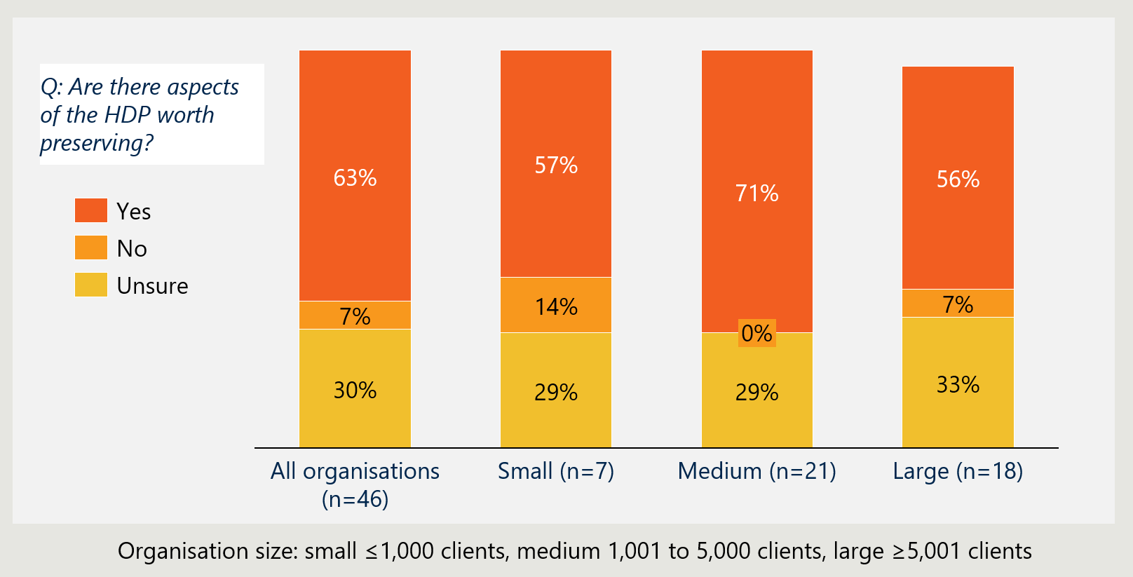
Direct load functionality substantially reduces reporting burden for nKPI and aspects of OSR. First Nations PHC organisations consistently identified the automatic extraction from CIS and direct load of statistics into the HDP as a highly valued feature of the reporting process. Where systems are appropriately configured, direct load supports consistency, reduces transcription error, and enables services to focus effort on review and validation rather than data assembly. First Nations PHC staff noted that the relative ease of nKPI submission compared to other funding reports highlighted the potential to reduce overall reporting burden if this capability were expanded across the broader reporting obligations.
As workforce and organisational data cannot be extracted automatically, First Nations PHC organisations highlighted that offline templates are a valued workaround that support collation of data outside the portal, which can then be uploaded to populate required fields. Services reported that this flexibility is particularly useful for managing complex workforce data across multiple staff types and sites and reduces frustration when using the HDP.
The HDP support team is highly valued, though the current model is unlikely to be scalable. Services consistently described the support team as timely, practical, and essential, particularly during submission windows when validation flags, workforce reporting queries, and access issues require prompt resolution. For services certain organisations lower data capability, personalised support from the HDP team is viewed as a necessarily pre-requisite for participation in the national collections. The high-intensity personalised support model is well suited to the needs of the sector, where capability varies significantly across organisations, reporting knowledge is often held by a small number of staff, and workforce turnover means that services regularly approach submission with limited institutional experience.
However, demand for support is highly concentrated within the nominal six-week submission periods, often extending by up to a month for services with the highest support needs. The volume of one-to-one assistance required is significant, and departmental stakeholders noted that the current model is unlikely to be sustainable at scale, particularly if reporting requirements are extended or changed. This reinforces the importance of maintaining low-burden collection design and investing in upstream capability and system improvements that reduce reliance on reactive support, while protecting the personalised support function that is most valued by smaller and lower-capability services.
HDP performance, stability and access arrangements shape the reporting experience.
The usability and reliability of the HDP have a direct influence on how services experience the reporting process. While the HDP delivers clear value through automation and support, services consistently identified performance, stability and access‑related issues that disrupt reporting and introduce avoidable pressure, particularly during submission windows.

Platform instability causes significant frustration and adds avoidable burden during submission windows. Services commonly reported losing data when entering narrative activity data or OSR statistics manually, requiring re-entry under time pressure. The source of data loss is difficult to attribute with certainty and may relate to network connectivity, client-side behaviour, or server-side performance, but the practical effect is consistent: additional effort, frustration, and reduced confidence in the reliability of the reporting interface. To mitigate this risk, many services draft responses offline before entering information into the HDP, reducing the intended efficiency of an online portal and shifting effort back onto services. Portal-to-server failures during upload can further disrupt submission and, while not persistent, their occurrence during time-limited reporting windows amplifies their impact. Autosave and save-in-progress functionality were consistently identified as a priority improvement, and the HDP team has confirmed that work is underway to address this. However, the HDP's legacy Java-based architecture constrains how far performance and usability can be improved without more fundamental platform change, placing practical limits on the extent to which reporting experience can be enhanced through incremental fixes alone.
Access management arrangements create recurring barriers, particularly for services with high workforce turnover. Access to the HDP requires authentication through myID, linked to an organisation through the Relationship Authorisation Manager (RAM). Authenticated access via myID is a standard entry requirement across Commonwealth platforms, though the identity strength required varies depending on data security considerations. The HDP requires only Basic identity strength, meaning users need a compatible device and a personal email address or mobile number, without identity document verification. Some First Nations PHC services reported confusion about identity document requirements, a perceived barrier that clearer service-facing communication could resolve. The more substantive challenge is RAM administration: services frequently reported difficulty identifying the correct principal authority, managing access changes as staff join and leave, and maintaining continuity of access in high-turnover environments. These challenges create multiple points of failure for services with limited administrative capacity and can delay submission where access cannot be established within reporting timeframes. The Digital ID Act 2024 requires that alternative access pathways be available for individuals who cannot or choose not to use a Digital ID, meaning the HDP cannot rely solely on myID-based arrangements going forward.

Departmental control of the HDP is not well aligned with the principles of Indigenous Data Sovereignty and Governance.
The nKPI and OSR collections are built on data contributed by First Nations PHC services about the communities they serve. Principles of IDS&G relate specifically to the rights of First Nations peoples and organisations to control the collection, ownership and application of data about their people, lands and communities, while data governance refers to the policies, processes and accountabilities governing how data is managed and used, and system governance refers to decision‑making arrangements (e.g. committees such as HS DAG) overseeing collections and priorities. These are distinct but interrelated concepts that operate across the current system.
The current model is not well aligned with the Department's IDS&G commitments. The nKPI collection was originally designed to sit with the AIHW to maintain independence from the Department. Subsequent centralisation within the Department has shifted stewardship arrangements, with data now held and managed through the HDP.
Under the current model, services are required to submit nKPI and OSR data through the HDP, which is governed by the Commonwealth. This creates a distinction between service‑level ownership of data and system‑level governance and access arrangements once data is aggregated. The Department controls the conditions under which data is held, accessed, and used, while system governance is exercised through advisory and decision‑making forums (e.g. HS DAG). While organisations can choose whether to share their data with NACCHO and affiliates, this opt-in arrangement does not constitute genuine sovereignty over how data is governed at the system-level data governance. Services described limited visibility of how submitted data informs policy decisions and expressed concern about transparency and use of data within funding and accountability contexts.
Ambitions for the future data environment present an opportunity to transition to genuine sector control. As discussed in Section 4, there is growing interest in the broader health sector to increase the granularity of data sharing, including de-identified unit record data. Realising this potential will require clear, trusted and distinct arrangements for IDS&G (rights and control), data governance (management and access), and system governance (decision‑making) that the sector has confidence in. The transition towards the future data landscape creates a natural opportunity to design those arrangements from the outset rather than retrofitting them onto existing infrastructure. First Nations organisations expressed hesitation about expanded data sharing under current arrangements, reflecting the importance of resolving the underlying governance question as part of future reform.
Transitioning the data to a sector-controlled state requires consultation, consensus, and capability investment. There is potential for custodianship to sit with a national peak body, such as NACCHO, at affiliate or network level, or with an alternative body, and determining the right approach would require genuine consultation and consensus building across the sector. The Department would also have a role in supporting the data governance and technical capability required to make any transition viable.
RECOMMENDATION 1.2 (Transition Strategy Recommendation)
Commit to transitioning toward shared data infrastructure that allows genuine sector control, underpinned by strong First Nations-led governance. The Department should make an explicit commitment to transitioning governance and custodianship of the nKPI and OSR data in a way that strengthens Indigenous Data Sovereignty, supported by fit-for-purpose data governance and system arrangements. This includes establishing clear and distinct roles for:
- Indigenous Data Sovereignty (sector control and authority over data),
- data governance (access, management and use of data), and
- system governance (decision‑making forums and oversight).
Progression to this state will require establishing consensus across the sector on the appropriate level of custodianship and governance. The Department should facilitate and resource this consensus-building process, ensuring it builds on existing governance structures and sector‑led initiatives rather than duplicating them. The appropriate model cannot be predetermined and must reflect the diversity of views and governance arrangements across the sector.

Qlik Sense (Qlik)
Effective data share-back is central to the value of the nKPI and OSR collections. The Collective Benefit principle of the CARE Principles for Indigenous Data Governance holds that First Nations PHC services should be able to derive tangible benefit from the data they contribute, including through data return that actively supports service improvement and self-determined quality improvement activity. Furthermore, Priority Reform 4 of the National Agreement on Closing the Gap commits Australian government departments to shared access to data and information at the regional level, and outlines obligation to build the capacity of First Nations organisations to collect, use and interpret data in ways that support their communities. In this context of the nKPI and OSR collections, Departmental infrastructure and resources should support First Nations PHC services to use their data to inform CQI and improve healthcare delivery for their communities.
Qlik is accessed through the HDP and is designed to enable health services to interpret and engage with their nKPI and OSR data through interactive reports and visualisations. Qlik dashboards allow organisations to view their own performance, track trends over time, and compare results against other services and national benchmarks, with the intended purpose of supporting services to identify areas for improvement and inform quality improvement activity.

Qlik is not consistently used by First Nations PHC organisations to support data analysis.
Qlik offers valued benchmarking and summary functionality, though structural constraints and variable awareness limit consistent engagement across the sector. Services engaging with Qlik highlighted that they valued the ‘Health Service Snapshot,’ as it provides a key summary of nKPI and OSR information. A smaller number of participants reported using Qlik for benchmarking and comparison against peer organisations and national averages as part of their quality assurance processes. This functionality represents valued applications of the platform and point to a clear role for Qlik or equivalent platforms within the sector's broader data ecosystem. However, a number of staff engaged during the Review's consultation indicated that they had never heard of Qlik or had not incorporated it into their organisation's analytical workflows. Staff nevertheless expressed appetite for a more robust data analytics approach, including the kinds of functionality Qlik is designed to provide, such as high-level performance summaries and benchmarking against peer organisations.

For routine monitoring and quality improvement activity, the utility of Qlik is shaped by the frequency of data collection. During consultation, Qlik was rarely described as a primary tool for day-to-day analysis of service delivery or outcomes. The nKPI and OSR data are collected every six and twelve-months respectively, which limits the currency of information available through the platform for ongoing operational analysis.
Services can submit trial data to the HDP outside of formal reporting periods, with this data flowing automatically to enrich Qlik reports; however, this is not commonly practised across the sector. Services therefore tend to rely on internal CIS-linked tools, Power BI, and Tableau for day-to-day analysis, as these platforms provide near real-time, patient-level and program-level data better suited to clinical decision-making and CQI.
Survey responses reinforce the variable use of Qlik across the sector. As shown in Figure 16, just under a third of organisations (28 per cent) primarily access their nKPI and OSR data via Qlik or the HDP, while more than half report rarely or never using the platform (29 and 26 per cent respectively).
Engagement with Qlik varies by organisational size, indicating differences in internal data capability and analytical infrastructure. Larger organisations (those reporting more than 5,000 clients) are least likely to report not using Qlik at all (12 per cent), though only 24 per cent use it as their primary analytical tool for nKPI and OSR data, with 41 per cent rarely using it and relying mainly on other sources. This suggests that larger organisations tend to have stronger data maturity and broader analytical infrastructure, with Qlik playing a complementary role alongside other platforms that support more flexible and operationally focused analysis.
Medium (1,001 to 5,000 clients) organisations report not using Qlik at the highest rate, with 42 per cent reporting they never use the platform. Among small (1,000 or fewer clients) organisations, the most common response was using Qlik as the primary means of accessing data rather than alongside other sources (57 per cent, noting the small sample size of seven). This pattern may reflect more limited access to alternative analytical infrastructure. Qlik (or an equivalent platform) therefore holds potential to play a meaningful role in supporting data engagement across the sector, particularly for organisations with less established analytical capability, though this function is not consistently realised in current practice.
Figure 16 | First Nations PHC organisations engagement with Qlik
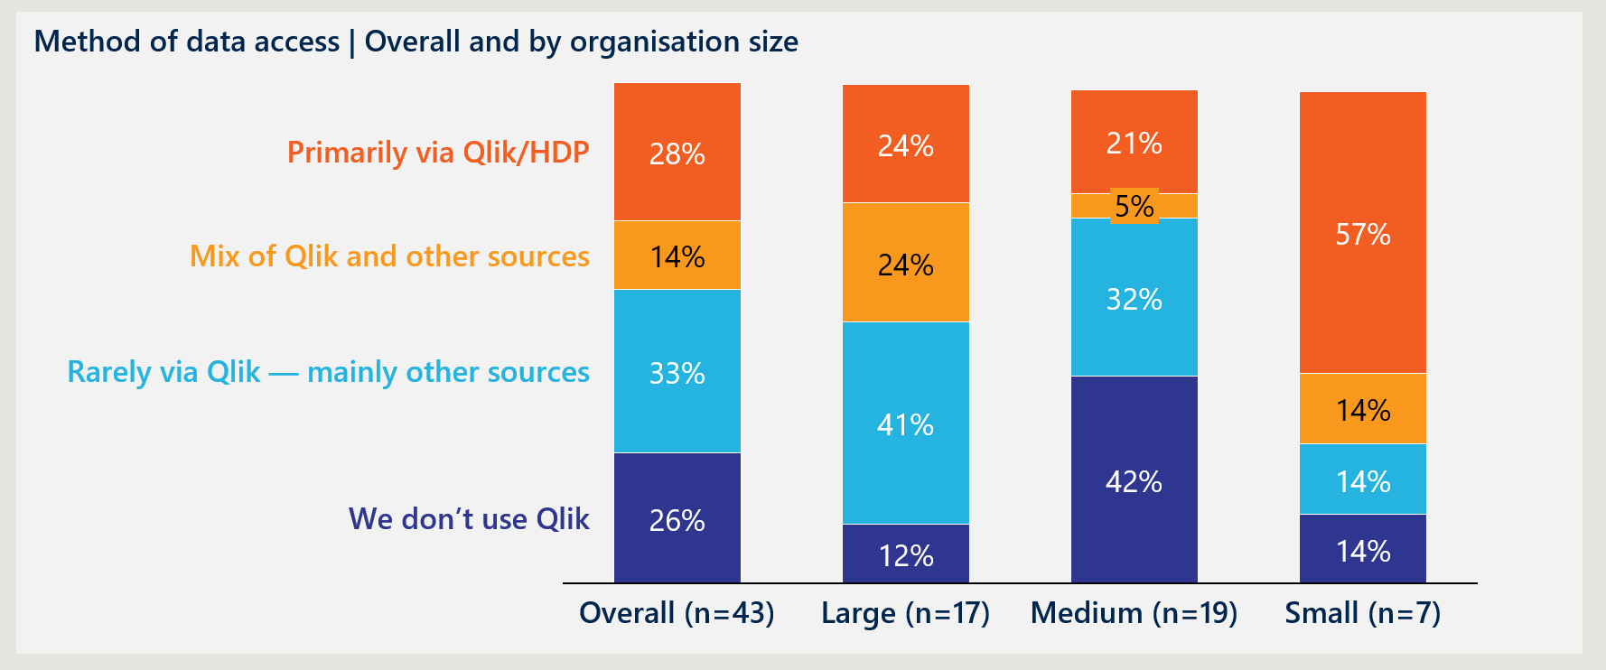
Qlik offers genuine analytical value, but its complexity limits engagement across much of the sector.
The complexity of the Qlik platform creates a barrier to access for many health services. Qlik is a highly capable analytics platform, offering flexibility and robust governance features well suited to sophisticated analysis of complex datasets. However, the platform is marketed to power users, analysts and data professionals who engage with it regularly, build familiarity with its structure, and have the time and technical capability to navigate complex queries and analysis. This does not reflect the diversity of data capability across the First Nations PHC sector, where staff often engage with data intermittently, work in environments with high staff turnover, and require fast and intuitive access to insights rather than a platform that rewards sustained investment in learning.

First Nations PHC staff consistently described Qlik as overwhelming on first use, citing complex menus, excessive detail, and slow performance. The volume of content compounds this challenge; the Qlik dashboard presents 39 reports, and navigating to relevant information requires familiarity with both the platform structure and the underlying datasets. Access to Qlik is also authenticated via the HDP, meaning the access management challenges around myID and RAM administration can present an additional barrier to users reaching the analytics environment.
Survey data indicates that where services do engage with Qlik, perceptions of the platform's content are broadly positive. Though confidence is uneven and very few organisations strongly agree with any of the following statements. As shown in Figure 17:
- Data presentation: 78 per cent of organisations agree or strongly agree that data is presented in a way that is easy to understand, with agreement higher among larger organisations (88 per cent) than medium (73 per cent) or small organisations (67 per cent).
- Support and training: Over half of organisations (56 per cent) agree or strongly agree that they have enough support and training to engage with the dashboards effectively. Half or more of small and medium organisations disagreed, while larger organisations were more confident (68 per cent agree or strongly agree).
- Data usefulness: 75 per cent agree or strongly agree that the data is useful and appropriate to their needs. Medium and large organisations are somewhat more positive, at 77 and 75 per cent respectively, compared with 67 per cent of small organisations.
These results suggest that the content Qlik delivers has genuine value that access and usability barriers are preventing many services from reaching. Targeted improvements to navigation, onboarding, and the initial user experience could meaningfully extend engagement across the sector.
Figure 17 | First Nations PHC organisations' experience of Qlik
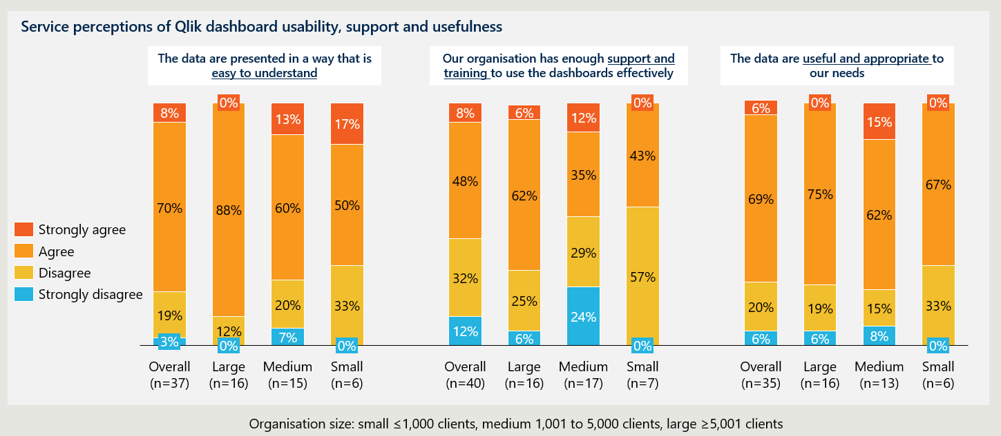

RECOMMENDATION 18
Reduce barriers to data engagement by simplifying data analytics and visualisation tools, exploring accessible alternatives, and AI-guided analytics.
The Department should simplify and improve how services engage with the data sharing and analytics tools it provides to support performance monitoring and quality improvement, through:
  - Simplifying Qlik dashboards: The Department should reduce the volume of reports presented to users by surfacing the most used and valuable reports on a simplified landing page and moving remaining reports to an advanced user area, reducing cognitive load without removing functionality for experienced users.
  - Developing Power BI dashboards as a simplified alternative to Qlik: The Department should develop Power BI dashboards as a simpler, more accessible interface through which services can view and engage with their nKPI and OSR data, presenting key high-level information in a clear and navigable format.
  - Exploring alternative, AI-enabled platforms to deliver accessible, contextually informed insights to health services: The Department should assess available AI-enabled tools that would allow services to query their data in plain language, receive contextualised summaries of their results, with potential to integrate narrative and other service information alongside the quantitative nKPI and OSR data.

Culturally appropriate system-level interpretation of data return requires narrative context and service control.
Integrating narrative and contextual insight would meaningfully strengthen how nKPI and OSR data is interpreted and used at a system level. Beyond technical simplification, the value of data returned to services is shaped by its relevance to context. First Nations PHC services consistently emphasised that cultural appropriateness is determined not only by what is collected, but by how data is interpreted and used by system‑level decision makers. As described in Sections 4.2 and 5.2, there are gaps in the way that nKPI and OSR collections capture the holistic nature of First Nations service delivery, and the contextual factors that shape performance at the community level, including workforce and recruitment pressures, community health events, and local cultural considerations.
While Qlik presents quantitative results and supports high‑level summaries and benchmarking for system users, services reported limited ability to see how their data is interpreted or contextualised once it leaves the service. This is not because services lack insight into their own performance or context. Rather, services noted that narrative and contextual information they already provide through Activity Work Plans, qualitative reports and annual reporting is not structurally integrated into how nKPI and OSR metrics are interpreted at a system level. More fundamentally, quantitative indicators alone were seen as insufficient to reflect local circumstances, cultural considerations, and service delivery realities.
Current platform architecture and indicator design limit the extent to which narrative context can inform system‑level interpretation of nKPI and OSR data. Services can currently add contextual commentary when responding to validation queries, though this offers limited analytical value, and narrative information submitted through Activity Work Plans and activity reports is not systematically reflected in Qlik outputs. Qlik's architecture constrains how far this can be addressed, as embedded content is developer-authored and static, meaning services cannot edit it to reflect local context.
Migration to Qlik Cloud would unlock Insight Advisor, an AI-enabled feature that allows users to query data in natural language and receive automated summaries, representing a near-term opportunity. However, Insight Advisor describes statistical patterns rather than conveying local or cultural meaning and would not fully address the contextual gaps services have identified. If the current platform cannot support culturally appropriate data return in a practical and scalable way, alternative approaches better aligned to sector needs should be considered and piloted with services before broader implementation. The broader opportunity for AI to support more contextually and culturally informed data return is explored further in Section 7.4, 7.5 and Recommendation 18 and 19.

Future landscape infrastructure

Broader digital health reform is driving a fundamental shift toward interoperable, integrated data systems.
Australia's national digital health reform agenda signals a clear and consistent direction away from siloed, limited purpose collections and toward connected systems in which data is captured once at the point of care and shared securely across the health system (see Section 4.2).
The adoption of FHIR is the technical foundation to enable system interoperability for data exchange across the system, with structured clinical terminology such as SNOMED-CT ensuring that data carries consistent meaning as it moves between systems. CIS vendors consulted as part of this review acknowledged this direction of travel, noting that modern platform development is increasingly oriented around FHIR-based architecture and API-enabled interoperability.

Required infrastructure capability in the future state

The emerging future state fundamentally changes data flow between health services and the broader system.
In an interoperable environment, automated flows of de-identified unit-level records from CIS platforms to a central data repository could replace periodic submission of aggregated statistics, removing the reporting cycle as a distinct burden on services. There is also opportunity to streamline the sharing of organisational data, for example through direct integration with workforce management systems, enabling more consistent and timely reporting without manual reconciliation, and supporting richer insights and analysis informed by both clinical and organisational context. Realising this shift requires embedding IDS&G principles, including consent and reciprocity, from the outset.
Figure 18 provides a high-level, illustrative representation of how data could flow between First Nations PHC services and the broader health system in a future state, informed by the direction of Australia's national digital health reform agenda and emerging developments in health data infrastructure, interoperability, and AI. The specific architecture including where shared infrastructure sits (for example, within a sector‑controlled entity such as a national peak body, a federated model across affiliates, or a hybrid model with government‑supported infrastructure), would need to be determined through co‑design. This includes consideration of whether infrastructure would hold data from both ACCHOs and non‑ACCHOs, and the governance arrangements required to ensure any model remains appropriate, equitable, and acceptable to all participating organisations.
At a conceptual level the future state represents material changes across the data lifecycle.

Data collection and extraction
Clinical data recorded during care delivery flows directly from CIS platforms into a centralised data warehouse as records rather than statistics, removing the need for periodic extraction and aggregation. Broader adoption of FHIR and structured clinical terminology standards such as SNOMED-CT reduces the sensitivity of data flows to variation in how individual clinicians document care.
There is also opportunity to build standardised direct load capability for workforce and operational data through integrated workforce management platforms, replacing the manual compilation that currently dominates OSR reporting and supporting more consistent and higher quality workforce data collection across the sector. Data quality at source remains critical and would continue to be supported through standardised data definitions, CIS configuration, and clinical workflow design.

Data storage and management
The centralised (or federated) data environment critically supports genuine sector-control over how data is governed and used. It holds clinical, workforce, and operational data, with First Nations organisations determining the conditions under which data is accessed and used, consistent with IDS&G principles.
Under any future model, roles and accountabilities for data stewardship would need to be clearly defined, including responsibility for data quality assurance, validation, curation and version control.
Existing functions currently performed by the Department, AIHW and technical partners (such as validation processes, exclusion rules, data quality checks, and support to services) would need to be explicitly maintained or transitioned within the new model. This may include:
- a central data quality function responsible for validation rules, data cleaning, and standardised processing
- ongoing technical support to services to resolve data submission issues
- clear quality standards and reporting on data completeness and reliability
- formal roles for national custodians (including AIHW) in assuring statistical quality and consistency for national reporting.
Maintaining and strengthening these functions will be critical to ensuring that gains in data quality achieved under the current model are not lost.

Data reporting
Reporting to government and funders could be automated and streamlined from the central portal. Because data is held at the unit record level, aggregate statistics for reporting can be generated on demand from the underlying data rather than relying on pre-coded extraction logic and fixed indicator definitions that may have been developed and deployed years before the report is generated. This reduces the need for rigid, pre-specified indicators, allows reporting to be adapted as policy and funding needs evolve without requiring changes to how data is captured at the point of care, and minimises reporting burden on health services.
In this model, government would continue to receive high‑quality, agreed outputs (primarily aggregated data), but there should also be clearly defined, governed pathways for trusted users to access unit record data where appropriate. This includes national data custodians such as the AIHW, who require access to unit record data to support national reporting, data linkage and system‑level analysis, consistent with broader national data reform directions.
Access arrangements would need to be tiered and governed, including:
- sector‑controlled access for service‑level and affiliate use
- approved access for national data custodians, including AIHW, to unit record data under appropriate First Nations-led governance, enabling AIHW to maintain its existing role in data quality assurance, granular analysis, indicator development and national reporting
- defined pathways for secondary use (e.g. public health research, policy analysis), subject to consent, ethics approval and Indigenous‑led governance.
For organisational data, automated reporting drawing on standardised workforce and activity data flowing directly from integrated systems would improve the timeliness and reliability of information available to government and funders while reducing manual reconciliation burden on services.

Data linkage and secondary use
First Nations-led governance and management of unit record data in shared infrastructure that allows genuine sector control could support linkage with mainstream health system data and national datasets. However, any approach to data linkage must reflect consent, cultural safety, and the right of individuals to control how their data is used. This includes recognising that some individuals may choose to access care in different settings precisely because they do not want their information linked, particularly for sensitive services such as sexual health or unplanned pregnancy.
Where primary care data is connected with hospital, emergency department, and specialist datasets, it becomes possible to examine patient journeys across the care continuum, understand how PHC investment influences downstream health system use, and generate population-level evidence to inform policy decisions in ways that current aggregated collections cannot support. As a result, linkage should be governed by clear consent, purpose limitation and opt‑out mechanisms, rather than treated as automatic or universal.
However, linkage should not be treated as automatic or universal. It must be governed by clear consent processes, purpose limitation, opt‑out mechanisms, and transparent community benefit. This extends to broader secondary use of data, including research, policy analysis, and potential interaction with national assets such as My Health Record, all of which should occur only under agreed governance arrangements.
Where data is anonymised, privacy‑preserving linkage would require more sophisticated technical approaches, such as probabilistic or cryptographic matching, to enable population‑level analysis without exposing individual identities. While technically feasible, these approaches increase complexity and reinforce the need for strong governance, transparency and Indigenous‑led decision‑making about when and how linkage is appropriate.

Insight generation and use of data.
The richness of data held in the central portal, spanning clinical, workforce, and operational information linked across care settings, creates the conditions for significant uplift in analytical capacity and more flexible, service-driven interrogation of data relevant to local priorities, reducing reliance on rigid national indicator sets.
AI enabled insights generation will reduce the analytical expertise required to access insights that are operationally meaningful and culturally appropriate.
Figure 18 | Indicative future state data flow

The future state requires infrastructure with specific functional capabilities.
The future state described above has specific implications for the platforms and infrastructure required to support it. The functional requirements below set out what capable infrastructure would need to deliver across three areas:

Data collection and extraction
The platform must support automatic, streamlined data flows from CIS platforms and workforce management systems to the central data warehouse, without manual extraction or periodic submission cycles. By reducing the need for repeated manual access and submission through central portals, automatic data flows would also reduce the frequency and impact of myID‑related access issues that currently affect some services. Data entry must be resilient to variation in clinical documentation practice, supported by consistent adoption of FHIR and SNOMED-CT across CIS platforms. This requires FHIR to be supported and consistently implemented at the CIS level, not just at the receiving platform, as interoperability depends on structured data being generated at the point of care.
Emerging uses of AI could support automated data cleaning and validation by identifying, prioritising and contextualising material data quality issues, rather than flagging every minor inconsistency. Importantly, AI‑enabled validation should reduce the technical and cognitive load on services by resolving issues upstream or presenting only high‑value exceptions for review, avoiding overly prescriptive or burdensome feedback that would increase workload. The intent is to help services move beyond technical data management tasks, so they can focus their effort on delivering care to communities. (see Section 7.5 for further details). These capabilities should complement, not replace, established data quality processes currently performed by the Department, AIHW and technical partners, and must be embedded within a clearly defined data quality assurance framework with accountable roles.
Achieving direct load capability for workforce data would require the Department to establish agreed workforce data definitions and standards, and work with HR and workforce management system vendors to build direct reporting capability to the central platform. Where systems are certified to meet these standards, manual reconciliation is removed and the consistency and completeness of workforce data captured across the sector is improved (see Recommendation 17).

Data storage and management
The platform must securely hold de-identified unit record data, governed and controlled by the sector consistent with IDS&G principles. Sector custodianship does not preclude structured access for authorised national data custodians.
Rather, the model should enable controlled, governed access to unit record data where agreed, including for national reporting, statistical production and linkage, while maintaining sector authority over conditions of use. See Recommendation 1.2 for further detail on what is required to transition toward sector-controlled data infrastructure.
The platform must also support interoperability across First Nations PHC services and, where appropriate, with mainstream health systems and national datasets to enable data linkage. Achieving this requires a sector-controlled, centralised data warehouse with FHIR-native data storage and access management capability, and established data governance frameworks that define the conditions under which linkage and external access are permitted.
Clear designation of roles within the linkage ecosystem will be required, including identifying an authorised data integration authority/authorities to undertake linkage in accordance with national standards. This may include recognised national integrating authorities (such as AIHW or the ABS), operating under sector‑approved governance arrangements.
To ensure consistency with national reform directions, including the National Primary Health Care Data Collection, infrastructure and governance arrangements should enable appropriately governed linkage between First Nations PHC data and mainstream GP data. Without such pathways, national reporting risks providing an incomplete picture of First Nations primary care use.

Data sharing and analytics
The platform should integrate clinical and organisational data, with the analytical layer designed to connect these data types in a way that generates contextually meaningful insights. This means defining how clinical outcomes, workforce data and service activity are linked, so that analysis reflects not just what health outcomes are being achieved, but the operational context in which care is being delivered.
For government and funders, the platform must generate automated aggregate reporting through a single central portal, removing the need for separate submission processes. This requires reporting logic to be built into the platform itself, drawing on the underlying unit record data rather than relying on pre-coded extraction rules. The model should also support tiered access pathways, including:
- aggregated reporting for routine government use
- governed access to unit record data for authorised national custodians (including AIHW) for statistical reporting and system‑level analysis
- approved access for linkage and research purposes under Indigenous‑led governance and ethics processes.
This ensures that government reporting needs, national statistical requirements, and sector priorities can be met concurrently, rather than requiring trade‑offs between them.
Consistent with the principle of reciprocity, the platform should ensure that the value of contributed data is returned to services through the insights it generates. To support health services across varying levels of data capability, an AI‑enabled analytics platform is required that supports plain‑language querying, contextually informed insight generation, and integration of narrative alongside quantitative outputs.
Narrative inputs could be sourced through the upload of existing documents such as annual reports, qualitative submissions or contextual commentary, allowing AI tools to derive structured insights from material that services already produce.
The use of AI introduces governance requirements that extend beyond standard data security. Strong governance frameworks would be required to define how AI tools are trained, validated and applied, ensure outputs are accurate, culturally appropriate and cannot cause harm, and prevent access to sensitive data by unauthorised users or systems.
Current infrastructure would require significant adaptation to meet future state requirements. The HDP and Qlik were designed for the current model of periodic, aggregated reporting and would require adaptation across all three functional areas to meet future state requirements. While both platforms have evolved incrementally over time, the shift toward unit record data storage, sector-controlled governance, data linkage, and AI-enabled analytics represents a more fundamental change in platform capability than incremental enhancement is likely to achieve. The HDP's legacy Java-based architecture is likely to reach functional limitations in this process, and it is not yet clear whether adaptation would be sufficient or whether new infrastructure would ultimately be required.
Resolving this question should be an early and priority action within the transition strategy set out in Recommendation 1.3.

Realising the future state requires early and sustained investment in foundational enablers.
The direction of travel toward a more interoperable, sector-led data environment is clear, though the precise architecture of the future state remains subject to ongoing reform processes at the national level and the pace at which technology and system-wide change can be introduced. Realising the benefits of digital health, including emerging technologies such as AI, depends on foundational enablers, including reliable infrastructure, digital inclusion, interoperable systems, workforce capability, cultural safety and accountable governance.
Establishing the standards, systems and workflows that underpin a more connected, sector‑led data environment takes time, but doing this work early helps services move beyond the most technically complex aspects of data management and reporting, allowing greater focus on the delivery of care to communities. Progress made now will also determine how well‑positioned the sector is to benefit from broader digital health investment as system‑wide reform accelerates.
The components of the future state are interdependent. Adoption of common standards, including FHIR and structured clinical terminology at the point of care, enables the capture of unit‑level clinical records rather than aggregated statistics. Unit‑level records, in turn, support potential data linkage, more adaptable reporting, and AI‑enabled analytics, without requiring repeated manual transformation by services.
Sector data governance and technical capability must be built in parallel. While First Nations organisations bring deep contextual, cultural and service‑level expertise, many currently lack consistent access to the technical infrastructure, workforce capability and governance support required for custodianship of linked, unit‑level datasets at scale. Building this capability over time is essential before any transition of custodial responsibility can occur.
Progress must also advance in step with broader health system reform. As discussed in Section 4, moving ahead of the broader primary care system risks concentrating the costs, risks, and scrutiny of reform on community-controlled organisations before the enabling conditions are in place across the wider system. Equally, broader system modernisation must recognise the specific needs and challenges of Aboriginal and Torres Strait Islander PHC services to ensure digital health reform does not deepen inequity. Short-term improvements to the nKPI and OSR collections must remain compatible with this longer-term trajectory, and investment decisions should be assessed against whether they contribute to or remain compatible with the future state rather than entrenching current approaches.
RECOMMENDATION 1.3 (Transition strategy recommendations)
Identify and establish the infrastructure required to support the future state data environment, including a sector-controlled platform capable of storing de-identified record-level data, linking across the broader health system, supporting automated low-burden reporting to funders, and returning rich, contextually relevant insights to services.
As part of the platform pathway determined through Recommendation 1.2, the Department should identify and progressively establish the infrastructure required to support a future state data environment for First Nations PHC.
This infrastructure should be capable of storing de-identified record-level data securely, linking across the broader health system, supporting automated low-burden reporting to multiple funders, and returning rich, contextually relevant insights to services.
Future infrastructure should be designed from the outset as shared infrastructure that allows genuine sector control, under strong First Nations-led governance, consistent with the commitment set out in Recommendation 1.2. This means engaging First Nations organisations and peak bodies in the design process and ensuring that decisions about what data is held, how it is accessed, and how insights are returned reflect the principles of IDS&G. This includes decisions about public reporting, which promotes transparency, gives clients visibility of how their data is used and informs understanding of the broader First Nations health environment. Investment in the data governance and technical capability of sector bodies should be treated as a prerequisite to infrastructure development rather than a subsequent consideration.

Artificial Intelligence

AI has potential to reduce administrative effort across the reporting lifecycle
The Australian healthcare sector is expanding its use of AI. Uptake of AI in the First Nations PHC sector is varied, with digital scribes the most common application.
When applied in a coordinated way, AI has the potential to increase clinician time for patient care, improve data quality, and accelerate the translation of data into insight. Considerable risks, feasibility complications, and safeguards must be considered before this potential can be realised. First Nations PHC organisations engaged in the Review expressed a general appetite for AI‑enhancements, particularly where it could reduce documentation burden, provided there are strong governance and privacy safeguards.
The following sections present a high-level assessment of use-cases for AI across the nKPI and OSR data lifecycle, highlighting areas for potential exploration. The discussion below is intended to inform future scoping and does not constitute a full feasibility study as a detailed analysis of costs, risks, governance arrangements, and implementation pathways as it is beyond the scope of this report.

Digital scribes can reduce documentation effort at point of care.
Ambient digital scribe technology is a key example of use of AI technology to streamline clinical workflows at point of care. Digital scribes use speech recognition and natural language processing to capture clinician-patient interactions and generate draft clinical notes for review, with the intended benefit of allowing clinicians to spend less time on manual documentation and more time on care delivery. Early evidence indicates clear reductions in documentation time, increased same‑day note closure, and reduced after‑hours work, with associated improvements in clinician experience and burnout.
Across Australian health services, digital scribe adoption is rapidly growing. The RACGP states that it expects the use of AI scribe use to grow rapidly as the technology evolved to become more accurate and efficient. Indeed, according to an RACGP poll, GP indicating they used AI scribes rose from 22 per cent in August 2024, to 40 per cent in November 2025. CIS vendors engaged in the Review identified ambient scribes as an emerging opportunity, particularly where they can be paired with existing clinical workflows.
Currently, most digital scribe technology primarily generates narrative free‑text rather than the populating structured data entry fields with information from consultation notes, meaning manual input into a CIS is required for clinical information to available for reporting purposes. If scribes progressively replace manual documentation without proactive clinical coding alongside them, the volume of structured, extractable data available for reporting may decrease rather than increase.
The use of AI scribes requires careful implementation in clinical practice, incorporating strong oversight and manual review. The RACGP identifies clinical risks including errors, omissions, and misheard terminology in generated notes; privacy risks including data breach and potential secondary use of collected data by vendors; and workflow risks including the time required to review and correct outputs. Clinicians must also ensure they seek patient consent prior to recording.

Digital scribes are typically chosen, funded and implemented internally by services, either through direct procurement by health services or via vendor‑bundled offerings within clinical information systems. There may be opportunity for the Department to support the safe adoption of AI scribes in First Nations PHC organisations by creating or facilitating access to informational materials, such as the information sheet and checklist released by AIDH.

AI offers potential to consistently transform clinical documentation into structured, extractable data suitable for nKPI and OSR reporting.
Vendors and other stakeholders with expertise in digital health highlighted emerging opportunities for AI-enabled coding and extraction tools to address data consistency issues affecting nKPI and OSR data, and reduce the manual effort associated with their correction.
Potential applications include automated identification of missing or incomplete data, assisted coding, correction of inconsistent terminology, and mapping of clinical information to standard vocabularies such as SNOMED-CT and LOINC. Additionally, large language models and other machine-learning approaches may be applied to unstructured clinical text to identify relevant entities and extract structured information, functioning as a translation layer between clinical documentation and formal reporting requirements such as the nKPI and OSR. This capability is likely to grow in relevance as AI scribe adoption increases and a greater share of clinical documentation is captured as narrative free text rather than structured data entry. Internationally, AI-assisted coding tools are increasingly commercially available,, though evidence of effective use in Australian primary care contexts is limited.
There is also potential for AI to support pre‑population of stable fields and provide intelligent prompts within clinical information systems to encourage more consistent data entry at the point of care by clinicians.
However, current tools remain imperfect and require manual oversight. Application of AI tools to improve the consistency of structured, extractable data required cautious, staged approach in which AI augments existing processes under clear governance rather than replacing established clinical judgement or reporting controls.

AI tools can also be applied to qualitative and narrative material that is currently difficult to synthesise and largely invisible in dashboards and routine collections.
Workshop participants frequently highlighted gaps in the current data environment where qualitative and narrative insights are missing but essential for meaningful interpretation, as a significant share of insight relevant to First Nations PHC sits in unstructured text rather than structured datasets. Narrative material (such as free text clinical notes, contextual explanations, and qualitative reports) captures cultural context, service models and lived experience that are largely absent from current reporting and dashboard tools. Workshop participants also noted that much of this narrative is repeatedly prepared in annual reports and other submissions. AI‑enabled synthesis could help unpack and reuse this material, reducing the need for services to restate the same contextual information across multiple reporting processes.
AI tools can help turn these narratives into structured, analysable insights for governance, policy, and quality improvements. Specifically, AI could be used to connect quantitative outcomes with qualitative feedback, surface themes in qualitative data that might be missed in manual analysis, reduce the time from data collection to actionable insights and make it easier for those with limited digital literacy to engage with data.
Two main technological approaches exist:
- Traditional Natural Language Processing (NLP) methods, including topic modelling, lexicon-based sentiment analysis, and text mining, use statistical patterns and word frequencies to categorise text. These methods are transparent, consistent, and reproducible, working well with structured or semi-structured data.
- Large Language Models (LLM) better ‘understand’ context and nuance, handle diverse conversational language, and can identify themes even when expressed in varied ways. LLMs offer significant benefits but require careful consideration of their relative opacity and the appropriateness of their use in specific contexts.
Effective workflows often combine the two approaches, using traditional NLP for initial screening and LLMs for deeper interpretation, with human validation built in. Common applications are:
- Thematic analysis, which uses NLP groups text into themes and LLMs refine or generate categories based on codebooks. AI enabled thematic analysis tags qualitative text with themes or sentiment so it can be treated as structured, quantifiable data and analysed alongside existing quantitative measures. This allows analysts to correlate themes with outcomes and easily move between numerical patterns and the underlying narratives that explain them.
- Semantic search, which allows users to query qualitative data by meaning rather than keywords, and link narrative insights to quantitative trends. This can be applied to qualitative datasets to search for specific perspectives or deployed automatically to surface relevant qualitative context in response to queries about quantitative patterns.
The Department has identified qualitative-quantitative integration as a priority area for further investigation, particularly in response to concerns from ACCHOs that quantitative metrics alone do not capture the full scope of their challenges. A practical constraint is that NLP processing cannot be performed within existing reporting platforms as there is no straightforward way to run topic modelling or sentiment analysis within Qlik or any major business intelligence platform. While robust tools exist, such as BERTopic for topic modelling and spaCy for named entity recognition and text classification, integrating their outputs into the Department's current workflows would require an additional processing step. As such, early feasibility is highest for departmental and analytical use rather than direct service-level reporting.

AI tools could also reduce the burden of narrative reporting but require centralised guidance to manage risk.
A small number of services identified that they were already using AI tools to support and refine report writing. The use of generative AI to draft summaries, trend descriptions, and explanatory narrative is increasingly common across the broader health and public sector, though routine, centrally governed use to generate official reporting narrative from nKPI and OSR data is not yet established. This reflects ongoing concerns about accuracy, traceability, and appropriate handling of sensitive information. There is potential value in a more structured, centrally supported approach, including explicit guidance to the sector. This would enable stronger risk mitigation, prevent confidential data from being processed through unmanaged open-source models, and provide safeguards against oversimplification and hallucinations. Automated outputs should be clearly positioned as draft and subject to human review, with guidance to ensure culturally appropriate framing and safe use of sensitive data.

AI-enabled conversational analytics support could reduce barriers to data engagement.
Within the First Nations PHC sector, stakeholders reported limited current use of conversational analytics or AI-guided query tools for nKPI and OSR data, reflecting wider constraints in data literacy, access, and platform usability. In the broader market, major analytics platforms are rapidly introducing conversational and natural-language query capabilities, though adoption in health settings is uneven and typically confined to organisations with mature data governance and strong controls over data access and model behaviour.
AI-enabled conversational and augmented analytics could make existing nKPI and OSR insights more accessible by enabling staff to ask questions in plain language, receive guided answers, and iteratively refine analysis without specialist analytics capability. Tools such as natural language-to-SQL translate plain-language questions into structured data queries, returning results that can be visualised and explained, and can surface explanatory context about changes in the data, supporting routine CQI and decision-making in settings with uneven data literacy (see Recommendation 18).
Feasibility depends on strong prerequisites: well-defined metric definitions, robust access controls, clear separation between CQI support and compliance or performance assessment, and technical guardrails ensuring answers are traceable to source data and cannot be mistaken for authoritative clinical advice.
RECOMMENDATION 19
Adopt AI across the data pipeline commencing with established frameworks and progressing to pilot projects.
By conducting a carefully planned and staged approach to the adoption of AI, the Department can generate improvements that are safe, appropriate and technically feasible. Establishing clear frameworks around the use of AI along the data pipeline, or coordinating with other relevant leading bodies, such as the Therapeutic Goods Administration or the Australian Health Practitioner Regulation Agency, on the adoption of frameworks (e.g. for the use of AI scribes), will establish upfront guidance and enable consistent adoption, risk management, and a shared reference point for services, vendors, government, and other stakeholders.
Progressing priority AI use cases as pilot projects will generate important system-wide improvements. Priority opportunities will reduce administrative burden and improve data quality without changing accountability settings or increasing surveillance concerns:
- Trial AI-assisted data quality prompts (e.g. missing-data detection, inconsistent coding flags, and suggested fixes) within existing submission and validation processes.
- Assess feasibility of AI-supported synthesis of free-text contextual explanations (e.g. grouping themes for analyst review), ensuring outputs remain draft and are not treated as definitive without review.
- Define success measures focused on time saved, error reduction, usability for lower-capability services, and cultural safety, with clear go/no-go decision point.

The use of AI in health data systems carries risks and considerations that require active management

AI can reduce burden and improve insight, but only if adopted with strong safeguards to manage bias, privacy, and culturally unsafe or context-blind outputs.
There is recognition that AI offers opportunities to improve efficiency, depth of insight, and analytical capability across health data systems. However, as noted by digital health experts and First Nations PHC services, these opportunities must be balanced against well‑documented risks. These include cultural safety, privacy and security risks, the potential for inaccurate or biased outputs, and impacts on the health workforce, such as deskilling or over‑reliance on automated outputs without appropriate oversight. The Department should also consider the longer-term impacts of AI on the workforce, as roles may be transformed or displaced by increasing automation.
Any attempt to adopt AI in a culturally safe way must begin from the recognition that AI models are complex socio-technical systems. Focusing narrowly on the technical capabilities of the model itself, without considering how it was developed and how it will be deployed, is a recipe for poor outcomes. AI models are fundamentally shaped by the data they are trained on. As discussed in CSIRO’s Artificial intelligence for healthcare in Australian Indigenous communities, frontier models are trained on large, Euro-centric global datasets that reflect dominant cultural assumptions and may embed biases or gaps in understanding of First Nations contexts. Equally important is how these models are deployed and applied in specific social contexts. When applied to First Nations health data (especially narrative inputs related to cultural safety, social and emotional wellbeing, or community experience), these limitations create heightened risks of misinterpretation, inappropriate abstraction, or erasure of culturally significant meaning.
Beyond operational risks, use of AI also raises ethical dilemmas. Public concern remains over the ethical use of some frontier models, given uncertainty about training data provenance and copyright. There are also concerns about the environmental impact of AI, particularly the energy intensity of large‑scale models and cloud‑based processing, reinforcing the need to be selective about use cases and to prioritise applications that deliver clear value relative to their resource footprint. To support safe and effective adoption, any future use of AI in First Nations health data systems will need to be grounded in the Australian Government’s guidance on responsible AI, as explained in the Policy for the Responsible Use of AI In Government.

This policy requires government agencies to develop a strategic approach to AI adoption, embed responsible‑AI processes across their operations, and implement risk‑based oversight throughout the AI lifecycle, including pathways for reporting and responding to AI incidents. These guardrails reinforce that AI may only be introduced where strong governance, adequate protections, and proportionate risk‑mitigation measures are in place, ensuring that efficiency gains do not come at the cost of safety, ethics, or public trust.

AI in the health sector is evolving rapidly and recommendations quickly become outdated.
New AI models, and tools are released frequently, meaning any assessment risks becoming outdated quickly. The observations detailed in this report should treated as indicative of current capability and direction, rather than fixed predictions about future solutions.
Across the Digital Health landscape, vendors are exploring and implementing AI integrated workflows and are operating in a market where AI integration is increasingly expected. However, vendors and CISs are not at a consistent stage of technical readiness, with some platforms introducing AI enabled features, while others are more constrained by legacy architecture. Systems with more mature, cloud-based infrastructure and structured data models are generally better positioned to integrate AI, while those reliant on older or on-premises architecture face greater barriers to scalable implementation.
At the same time, vendors such as Microsoft are expanding natural language querying and exploratory data analysis functions in their tools such as CoPilot. While promising, their use in health contexts requires careful attention to privacy, security, and clinical governance.
The Department has also indicated an intention to shift toward a Google enterprise data and analytics platform. Vertex AI, which is Google Cloud’s unified AI development platform, could be a viable foundation for supporting analysis of health service data. It provides access to Google’s AI models (including Gemini) and third-party models, as well as tooling for secure deployment, integration, and managed operation. Vertex AI offers the technical “hooks” needed to connect AI capabilities into existing systems; for example, Qlik may be able to integrate LLM based batch processing or interactive dashboard insights via Vertex AI connectors. However, further investigation is needed to validate this use case and assess its feasibility.
AI enabled analytical support is a rapidly evolving space within the Digital Health environment, with many emerging tools. The sector’s requirements are ultimately a simple, reliable interface that genuinely supports analysis and insight generation. Vertex AI is likely to be just one of several platforms capable of delivering this function.

Indigenous Data Sovereignty and Governance (IDS&G)
IDS&G is a critical consideration in strengthening the current nKPI and OSR collections and in shaping any longer‑term evolution of primary health care data arrangements. As discussed in Section 4, significant further work is required before more granular, reusable or interoperable data approaches could be considered, and any future direction would only be effective if it is underpinned by strong Indigenous Data Sovereignty, clear consent and control arrangements, and genuine partnership with First Nations PHC services and peak bodies. These governance expectations apply to all data relating to First Nations people, regardless of whether it is generated within ACCHOs or non‑ACCHO service settings. While governance mechanisms may differ across contexts, consistent application of IDS&G principles is essential. Importantly, the immediate opportunity lies in embedding and strengthening IDS&G within existing nKPI and OSR arrangements, while ensuring that current investments and design decisions do not constrain alignment with future, nationally agreed data directions.

Enhancing Indigenous‑led governance, strategic alignment and reciprocity would help the collections better achieve their purpose and support self‑determination and community accountability.
The compliance requirements associated with funding‑linked reporting inherently constrain the extent of self‑determination available to First Nations PHC services, as these obligations are mandatory rather than discretionary. Both the nKPI and OSR are compulsory conditions of IAHP funding, which for most services represents their primary source of income. In this context, consent to provide data cannot reasonably be considered genuinely voluntary, as services have limited practical ability to refuse, negotiate, or meaningfully restrict the data they are required to submit. These conditions sit in tension with Indigenous Data Sovereignty and the CARE Principles’ emphasis on “authority to control,” as non‑compliance would place the financial viability of services at risk.
While the nKPI and OSR are likely to remain mandatory, there are opportunities for the collections to better support Indigenous Data Sovereignty through clearer purpose‑setting, stronger Indigenous‑led governance, improved transparency about data use, and alignment of reporting investments with agreed future‑state directions, rather than premature commitment to specific technical models.

First Nations representation exists in governance, but there is a clear opportunity to strengthen Indigenous‑led oversight.
The Aboriginal and Torres Strait Islander HS DAG, co‑chaired by the Department and NACCHO, provides strategic advice on the development of the nKPI and the OSR. Membership includes representatives from KAMS, Central Australian Aboriginal Congress, the Northern Territory Government, Winnunga Nimmityjah Aboriginal Health and Community Services, the RACGP, the AIHW, and the NIAA.
Collectively, members bring deep expertise in First Nations PHC through both professional roles, and in many cases, lived experience. However, not all service representatives are Indigenous, and not all Indigenous members hold operational service delivery roles, reflecting the group’s strategic rather than operational remit. Importantly, non‑First Nations members often participate in an explicitly representative capacity, nominated by services or peak bodies and holding long‑standing, trusted relationships within the sector. These members play a critical role in representing organisational perspectives and maintaining continuity, and this form of representation should be recognised alongside considerations of Indigenous identity.
The HS DAG meets at least twice annually and formally reviews the nKPI and OSR collections every five years to ensure they remain clinically relevant, strategically aligned, and responsive to sector needs. While the group provides strategic oversight, operational responsibility sits with the Department’s First Nations Health Data team.
This separation of oversight from execution reflects good governance practice by reducing conflicts of interest and concentration of power. There is a strong case to expand or rebalance HS DAG membership to strengthen Indigenous leadership while also maintaining trusted representative voices and continuity of relationships across the sector.
This should include representation from different types of PHC services such as small and large services, and those with varying levels of data capability, alongside Indigenous representatives with cultural authority and governance expertise.
An optimal governance model combines strong Indigenous‑led oversight with diverse PHC service representation, ensuring decisions are informed by cultural authority, lived experience and on‑the‑ground operational realities. This approach would strengthen the practical application of IDS&G by ensuring that decisions about how data are defined, interpreted and used are grounded in community priorities, service realities and self‑determination, while also recognising that representation may be based on mandate, trust and accountability to services, not solely identity.
Any changes to governance composition, roles or decision‑making authority should be carefully sequenced and clearly communicated to maintain confidence among services and stakeholders. Rapid or poorly specified changes risk undermining existing trust and relationships, even where the intent is to strengthen First Nations‑led governance.

PHC services have limited control over data indicators and use, creating an immediate opportunity for improvement.
As discussed above, there are limitations in the extent to which the nKPI nor the OSR data collections reflect the cultural context or service delivery realities of PHC services. This limits the collective benefit of these collections and weakens their alignment with IDS&G principles.
While the nKPI captures some priorities that are important to First Nations people and their communities, notable gaps remain, and PHC services report limited opportunities to influence or amend indicators. Similarly, many OSR indicators are perceived as having low relevance to CQI for PHC services, reiterating a lack of control over the selection of indicators.
In relation to data use beyond the service, PHC services have limited understanding of how their data is used by the Department. This issue extends beyond the community‑controlled sector, as data relating to First Nations people is also generated and used within mainstream services, where equivalent clarity and governance expectations are required. Without clear information about the intended use of the data, PHC services are unable to exercise meaningful control over it. This highlights the need for clearer, more transparent communication to PHC services about how their data is used, so they are genuinely informed and able to engage with the process.

Heavy PHC investment in data submission is not delivering true reciprocity, weakening Indigenous Data Sovereignty.
Despite significant investment by PHC services in preparing, validating, and submitting nKPI and OSR data, the current usefulness of that data to services and data share-back arrangements do not deliver commensurate value in return. Consultations indicate that use of the nKPI for CQI is highly variable, with many services describing intermittent use to high-level CQI activities rather than as a primary evidence base, given the six-monthly, point-in-time nature of the collection. While the underlying OSR data, including service delivery statistics, workforce, and governance arrangements, informs internal planning, the OSR itself is rarely used directly by services for ongoing decision-making. Barriers to accessing and interpreting the data analytics and visualisations via Qlik, constrain services’ ability to meaningfully interpret, explain or apply their data. As a result, data submission remains largely extractive: information flows upward to system users, while the benefits returned to services are partial and uneven. This weakens reciprocity and sits in tension with IDS&G principles, which emphasise mutual benefit, control over interpretation, and the ability for communities to tell the story behind their data. Ensuring reciprocity across the full data landscape requires that all data relating to First Nations people, including data generated outside ACCHOs, is subject to governance arrangements that uphold transparency, benefit and control.

Governance arrangements must maintain strong alignment with broader digital health reform while remaining Indigenous led.
As the nKPI and OSR collections increasingly intersect with national digital health initiatives, including interoperability, data linkage and potential transitions toward more granular data, there is a growing need for governance arrangements to maintain strong connection to the broader digital health reform agenda. Decisions about the future design, scope and use of the collections will have implications beyond the immediate stewardship of the First Nations Health Data team, particularly as reforms progress at a system level.

Embedding digital health expertise within governance arrangements would support more coherent, forward‑looking decision‑making by ensuring that collection‑specific reforms are informed by, and aligned with, broader digital health infrastructure, standards and implementation timelines. This would help anticipate downstream impacts, reduce the risk of misalignment with system‑wide reform, and ensure that Indigenous‑led governance forums are meaningfully supported to engage with complex technical and reform considerations as they arise.
Importantly, strengthening this connection should complement, not dilute, Indigenous‑led governance. Ensuring access to digital health expertise alongside strong First Nations representation would enable the HS DAG to remain grounded in IDS&G, community control and sector priorities, while also being equipped to engage confidently with future reform pathways that extend beyond the collections themselves. This alignment should ensure that governance frameworks are not limited to community‑controlled data flows but extend to the full ecosystem of data relating to First Nations people across the health system.
RECOMMENDATION 20

The HS DAG and the Department should clearly articulate their respective mandates and decision‑making authority, including which decisions rest with the Department and which are the responsibility of the HS DAG, as they relate to the collections.
While the HS DAG has taken steps to improve transparency by publishing communiqués (an approach recommended in the AIHW review), these updates primarily focus on meeting outcomes and decisions, rather than clearly explaining how decisions are made and where accountability sits. Clearer articulation of the respective roles and responsibilities of the Department and the HS DAG, particularly in relation to decision‑making authority over the collections, would support stronger understanding and reinforce relationships of trust across the sector.

RECOMMENDATION 21

Adopt a staged and continuous governance approach, with formal reviews triggered by system milestones rather than a fixed review cycle and priorities identified jointly between the HS DAG and the Department.
Given the pace and uncertainty of change in the First Nations PHC data environment, particularly the anticipated shift toward unit‑level data and interoperable systems, reliance on infrequent, large‑scale reviews is increasingly misaligned with the operating context.
Instead of positioning five‑year reviews as the primary mechanism for reform, the Department and HS DAG should prioritise structured, ongoing engagement with First Nations PHC services through a standing advisory mechanism, supported by regular checkpoints focused on emerging issues, burden, data quality, and governance.
Formal, comprehensive reviews may still be appropriate at key transition points, such as the introduction of materially new data models or governance arrangements but should be triggered by system change rather than a fixed time interval. This approach enables issues to be identified and addressed earlier, supports proportionate adjustment during transition, and avoids over‑investing in legacy approaches while the future state continues to evolve.

RECOMMENDATION 22

Strengthen the connection between nKPI/OSR governance and broader digital health reform by embedding digital health expertise within governance arrangements.
As the nKPI and OSR collections increasingly intersect with national digital health reform, interoperability and unit‑level data initiatives, the Department should ensure that governance arrangements maintain a clear line of sight to the broader digital health agenda. This could be achieved by incorporating dedicated digital health expertise into the HS DAG, or through a formal standing linkage between the HS DAG and relevant digital health governance forums.
Embedding digital health capability within governance would support strategic alignment between collection‑specific decisions and system‑wide reform, help anticipate infrastructure and interoperability implications of proposed changes, and reduce the risk that nKPI and OSR reforms evolve in isolation from broader digital health architecture. Importantly, this role should complement rather than displace Indigenous‑led governance, ensuring that future‑facing technical considerations are integrated alongside IDS&G, community control and sector priorities.

RECOMMENDATION 23

The HS DAG establish a standing mechanism for First Nations PHC services to participate in and inform the group.
This approach would strengthen the HS DAG’s decision‑making by grounding strategic advice on the nKPI and OSR in current operational realities, helping to identify potential burden, feasibility issues, and unintended impacts early in the design and review process. Membership should rotate on a defined cycle. Rotating PHC representation should deliberately reflect diversity in service size, geographic context, and data capability (e.g. small and large services, urban, regional and remote settings). Rotating membership would also avoid concentration of influence, broaden sector perspectives over time, and ensure that advice remains informed by lived service experience rather than static representation.

Ongoing reflection on the nKPI and OSR collections, assessed against the Maiam Nayri Wingara principles, is essential to enable incremental improvements while broader system-level reforms are pursued.
A transition to unit‑level data would represent a significant shift in how sensitive First Nations health information is collected, stored and governed. Such a shift raises material considerations regarding perceptions of surveillance, control and ownership of data, particularly where data stewardship arrangements sit outside community‑controlled settings. Clarity of purpose emerged as a critical precondition for change, with a clear need for the Commonwealth to articulate the rationale for collecting unit‑level data, the specific uses to which it would be put, and the value that would be returned to First Nations communities.
In this context, IDS&G principles and robust governance arrangements must be embedded from the outset of any transition. As discussed in Section 4, the development of a transition strategy in partnership with PHC services and peak bodies would provide a structured pathway for evolving the nKPI and OSR collections in alignment with broader health data reform, while ensuring risks, sensitivities and governance requirements are addressed progressively rather than retrospectively.
Moving towards broader reform needs to be undertaken in tandem with the ongoing work across the system nationally, to bring First Nations data, along with other data, into the broader digital health reform (as discussed in Section 4). It moves beyond consideration of the specifics of the nKPI and OSR collections, into broader system-wide considerations for First Nations data.
While existing relationships between the First Nations Health Data team and the sector provide an important foundation, longstanding sensitivities regarding Commonwealth stewardship of First Nations data remain salient. Proceeding cautiously, in tandem with the overarching reform, strengthening trust over time, and embedding shared decision‑making are therefore essential given the scale and significance of the proposed change.
Establishing a standing mechanism for First Nations PHC services to participate in and inform the HS DAG would create a formal avenue for sector advice on unit‑level data and proposed changes. Opportunities for the HS DAG to contribute at a broader system level would also be important. While this approach would not amount to full co‑design, it would support meaningful and systematic sector input into governance and reform discussions.
RECOMMENDATION 24

Embed future evolution of the nKPI and OSR collections within whole‑of‑system First Nations data and digital health reform, supported by strengthened Indigenous‑led governance and cross‑portfolio coordination.
The Department should ensure that ongoing reflection on the nKPI and OSR collections, including consideration of any transition toward more granular or unit‑level data, is not progressed in isolation from the broader stewardship and data developments across the Department. Any such evolution should be explicitly embedded within broader, system‑wide First Nations data and digital health reform, undertaken in parallel with national reforms affecting primary health care data more broadly. This includes clearly articulating the purpose, intended uses and value proposition of any move toward unit‑level data, and ensuring alignment with the Maiam Nayri Wingara principles and IDS&G frameworks from the outset.
To support this, the Department should develop a staged transition pathway in partnership with First Nations PHC services and peak bodies, enabling risks, sensitivities and governance requirements to be addressed progressively rather than retrospectively. While existing relationships between the First Nations Health Data team and the sector provide a strong foundation, enduring sensitivities regarding Commonwealth stewardship of First Nations data require cautious, trust‑building reform. Strengthening Indigenous‑led governance and establishing standing mechanisms for First Nations PHC services to inform advisory bodies, including the HS DAG, would provide a structured avenue for systematic sector input into both collection‑specific and broader system‑level data reform.

Recommendations

Overview of recommendations
The recommendations in this review are designed to deliver a set of benefits that matter most to PHC services, the Department and other government stakeholders, and to the long-term utility and feasibility of data collection and reporting in the sector.
Collectively, they aim to improve clarity of purpose, increase the relevance and usefulness of collections for CQI, strategy and policy planning, funding assurance, and further reduce reporting burden. They also seek to strengthen and embed principles of Indigenous-led governance, ensuring data is governed, interpreted and used in culturally appropriate ways.
These improvements will see immediate action taken to improve the collections as they are, while building readiness for future reform and enhancing trust, governance, data quality and infrastructure in the First Nations PHC sector, necessary to support a transition to more integrated health data systems as the digital health environment evolves.
Given the complexity of reform in the digital health and data landscape, clear and deliberate implementation planning for all recommendations outlined in this report is critical. Importantly, effective implementation will enable the optimisation of the collections in the short term, while preparing for long-term reform.
The recommendations of the review address opportunities to improve the collections to increase their usefulness and clarity and further minimise reporting burden. These collections sit within a rapidly evolving digital health environment, where longer-term reforms may fundamentally change how primary care data is collected and used.
This review recognises that whilst there is a clear direction towards integrated unit-level data and standardised interoperable systems, there is a degree of uncertainty, and the future state is not yet fully defined. With this in mind, this review’s recommendations and their implementation can be considered in three frames: how to deliver short-term improvements; how to establish foundations that align with this more substantive reform; and how to actively prepare for the transition to a future state.
- Short-term improvements are actions that deliver immediate value and can be implemented largely within the Department’s existing authority, systems and governance. These actions focus on improving clarity of purpose, refining the scope and content of the collections to further minimise reporting burden, making necessary technical or definitional fixes, and addressing any other immediate concerns held by the sector. They are largely within the Department’s control and do not depend on broader digital health reform, system-wide change, or highly complex multi-stakeholder engagement. Together these actions provide a practical step forward to improve the collections and demonstrate responsiveness to the sector.
- Foundations for substantive reform are actions that represent more significant change – providing substantial value over the longer-term but involving greater implementation complexity. These actions are intended to improve the value and usefulness of the collections – to both the government and PHC services – while laying the groundwork for more substantive but critically important changes, such as governance reform. They are more complex to implement, requiring multi-stakeholder input, co-design and agreement, or technical complexity, and are less directly within the Department’s sole control. Taken together, these foundational actions create the conditions for sustained and substantial improvement of the collections, ensuring they are well-placed to function in a future state of digital health collection.
- Transition steps that focus on the actions required to actively prepare for the future digital health data landscape. These actions are forward-looking and exploratory, aimed at clarifying future options, testing assumptions, and identifying the conditions required for more fundamental reform to occur safely and credibly. They require detailed consideration of policy, governance, data architecture and sequencing, alongside sustained and meaningful consultation with the sector to build trust, shared understanding and readiness. Collectively, these transition steps provide a disciplined pathway for managing uncertainty, ensuring that future reform is evidence-led, Indigenous-governed, and progressed at a pace that maintains sector confidence while avoiding premature or misaligned system change.

Table 1 | Future Landscape
Future Landscape

 | # | Recommendation | Benefit
Transition steps | 1 | Confirm the future vision for the collections in line with broader digital health data reform and develop a transition strategy in partnership with PHC services, NACCHO and state-based affiliates. | Provides clarity on the position of the collections within broader digital health data reform – ensuring that all stakeholders are aligned on this vision – and strengthens readiness for future reform by embedding detail on sequencing, dependencies and decision-points into a transition strategy, enabling proportionate investment and reducing the risk of misaligned or premature change as the broader digital health environment evolves.
Transition steps | 1.1 | Prepare for effective use of FHIR and structured clinical terminology that will underpin the future reporting environment, ensuring infrastructure and processes are ready to transition. | Improves interoperability, data quality and future readiness by aligning collections with national and international data standards, reducing fragmentation across systems and supporting more efficient data reuse as the digital health environment evolves.
Transition steps | 1.2 | Commit to transitioning toward shared data infrastructure that allows genuine sector control, underpinned by strong First Nations-led governance | Strengthens trust, self-determination and long-term sustainability by signalling a clear commitment to First Nations control over data infrastructure, supporting alignment with IDS&G principles and providing a foundation for future reform.
Transition steps | 1.3 | Identify and establish the infrastructure required to support the future state data environment, including a sector-controlled platform capable of storing de-identified record-level data, linking across the broader health system, supporting automated low-burden reporting to funders, and returning rich, contextually relevant insights to services. | Builds readiness for a future digital health data environment by defining the infrastructure needed to support secure data linkage, low-burden reporting and meaningful return of value to services, while ensuring future systems are Indigenous-governed, scalable and aligned with broader health system reform.

Table 2 | Recommendations – nKPIs
National Key Performance Indicators (nKPIs)

 | # | Recommendation | Benefit
Short-medium term improvements | 2 | A. Confirm and clearly communicate the intended purpose of the nKPI policy and strategic planning.  B. Strengthen support for PHC services to interpret and use nKPI data for CQI. | Clarifying and communicating the purpose of the nKPI and strengthening support for PHC services to interpret and apply their data will primarily benefit PHC services by making clear how their data may be used to enable CQI and inform strategy and policy planning. This will strengthen trust, reduce perceptions of one-way reporting, and support more disciplined data stewardship.
Short-medium term improvements | 4 | Remove nKPI indicator PI14 (immunized against influenza). | Reduces reporting burden by removing an indicator with limited CQI value and known data capture limitations, while improving the overall relevance and focus of the nKPI indicator set.
Short-medium term improvements | 5 | Make PI01 (birthweight recorded), PI02 (birthweight result) and PI13 (first antenatal visit) opt-in for PHC services that do not deliver maternal and child health services. | Improves proportionality by removing mandatory reporting for services that do not deliver maternal and child health care, while retaining relevant indicators where services are positioned to collect and use them.
Short-medium term improvements | 6 | Refine PI09, PI10, PI12, PI25 and PI26 to ensure they best align with contemporary clinical guidance, service delivery models, and data feasibility. | Improves indicator relevance, data quality and interpretability by aligning specifications with contemporary clinical practice and service delivery models, strengthening the usefulness of the nKPI for CQI and system-level analysis.
Short-medium term improvements | 7 | Expand PI07 to include all Chronic Disease Management Plans. | Provides a more accurate and balanced view of chronic disease management activity across services, improving system-level insight while maintaining low reporting burden through use of existing, routinely captured data. Clear definition of the eligible cohort and consistent condition coding will support meaningful interpretation and comparability across services.
Short-medium term improvements | 8 | Disaggregate the smoking indicator to separately identify vaping/e‑cigarette use. | Improves the contemporary relevance of the nKPI by capturing emerging risk behaviours, supporting service-level prevention and planning while maintaining alignment with the existing indicator framework.
Short-medium term improvements | 10 | Explore the feasibility and value of introducing optional indicators to the nKPI collection to support local CQI priorities and program delivery. | Optional indicators could expand the medium-term usefulness of the nKPI by enabling services to report on dimensions aligned to local priorities or program requirements and consolidate overlapping reporting obligations across programs.
Foundations for substantive reform | 3 | Enhance support for day‑to‑day CQI without increasing compliance burden by introducing a two‑speed nKPI model, including a more frequent, unvalidated CQI feed for service‑level improvement with minimal central validation and no qualitative inputs. | Improves the practical usefulness of the nKPI for service-led CQI by enabling more timely feedback while preserving the integrity, trust and benchmarking role of the validated six-monthly submission and avoiding an expansion of compliance reporting.
Foundations for substantive reform | 9 | Explore, at an appropriate future point, options for capturing a mental health and/or SEWB indicator aligned to sector‑led development of clinically coded SEWB concepts. | Acknowledges a recognised data gap while avoiding premature indicator development, ensuring any future mental health or SEWB indicator is only considered once culturally appropriate, clinically meaningful and sector‑supported approaches are available. Aligning with sector‑led SEWB clinical coding initiatives reduces risk of harm, improves cultural safety, and supports development of an indicator that is feasible, comparable, and beneficial for CQI in the longer term.
Foundations for substantive reform | 11 | Explore opportunities to host a centralised reporting portal for funders of First Nations PHC organisations, through both centralised infrastructure and alignment of overlapping data collections. | Reduces duplication and fragmentation across reporting requirements by creating a pathway toward more coordinated reporting to multiple funders, lowering administrative burden for services while improving consistency and efficiency in how information is submitted and reused.

Table 3 | Recommendations – OSR
Online Services Report

 | # | Recommendation | Benefit
Short-term improvements | 12 | Confirm the intended purpose of the OSR as aiding assurance and allocation of funding and strategic planning and explain how the collection is used to achieve these purposes. | Clarifies how OSR data is used by the Department and where its use is limited, strengthening trust among PHC services, reducing perceptions of one-way reporting, and supporting more consistent and disciplined stewardship of the collection without increasing reporting burden.
Short-term improvements | 13 | Refine OSR workforce reporting to improve clarity, consistency and fitness for purpose. | Reduces manual reconciliation and improves comparability by aligning workforce categories with common PHC workforce descriptors, supported by clearer mapping guidance, while maintaining appropriate granularity for system-level workforce analysis.
Short-term improvements | 14 | Assess options to improve the usefulness of OSR vacancy measures. | Improves the interpretability and usefulness of vacancy data by better reflecting sustained workforce pressure over time, supporting more accurate system-level understanding without increasing reporting complexity for services.
Short-term improvements | 15 | Explore options to better reflect differences in service intensity, while maintaining the current underlying data inputs. | Improves transparency and confidence in how OSR activity data is interpreted by making differences in service intensity more visible from data already collected. This responds to a widely held sector concern that comprehensive, multidisciplinary care is understated, without introducing new reporting requirements or increasing burden on services.

Table 4 | Recommendations – Data Platforms and Infrastructure
Data Platforms and Infrastructure

 | # | Recommendation | Benefit
Short-term improvements | 16 | Continue existing data quality support and invest in a sector-wide data literacy uplift across First Nations PHC services. | Improves data quality and consistency at the point of care by building workforce data capability and strengthening CIS-specific data capture practices, reducing downstream reporting effort and increasing confidence in reported results across both current and future data environments.
Short-term improvements | 18 | Reduce barriers to data engagement by simplifying data analytics and visualisation tools, exploring accessible alternatives, and AI-guided analytics. | Improves accessibility and practical use of existing reporting outputs by making dashboards easier to navigate and interpret, supporting more consistent engagement across services with varying data capability while strengthening the value returned from existing data collections.  Identifies opportunities to improve accessibility and interpretability of data outputs for services with varying data capability, while enabling cautious, governed exploration of new analytical approaches that may reduce reliance on specialist expertise over time.

Data Platforms and Infrastructure

 | # | Recommendation | Benefit
Foundations for substantive reform | 17 | Explore a pathway to enable automated extraction of OSR workforce data through standardisation of definitions and engagement with HR system vendors. | Builds sustainable data capability closer to services by providing shared, trusted support for data quality, interpretation and use, reducing reliance on individual service capacity while improving consistency and confidence across the network.
Foundations for substantive reform | 19 | Adopt AI across the data pipeline commencing with established frameworks and progressing to pilot projects. | Achieves the benefits of AI in a way that is safe, consistent and trusted, reducing administrative and reporting burden and improving data quality without increasing surveillance or altering accountability settings. By establishing clear frameworks and testing priority use cases through pilots, the Department and services can build confidence, manage risk and generate evidence on where AI delivers genuine value before scaling adoption across the system.

Table 5 | Recommendations – Governance
Governance

 | # | Recommendation | Benefit
Short-term improvements | 20 | The HS DAG and the Department should clearly articulate their respective mandates and decision‑making authority, including which decisions rest with the Department and which are the responsibility of the HS DAG, as they relate to the collections. | Clearly articulating the respective mandates and decision-making authority of the HS DAG and the Department will reduce ambiguity, enable more timely and defensible decisions, and strengthen confidence that changes to the collections are governed through transparent and appropriate processes.
Short-term improvements | 21 | Adopt a staged and continuous governance approach, with formal reviews triggered by system milestones rather than a fixed review cycle and priorities identified jointly between the HS DAG and the Department. | Given the pace and uncertainty of change in the First Nations PHC data environment, reliance on infrequent, large‑scale reviews is increasingly misaligned with the operating context. Instead, the Department and HS DAG should prioritise structured, ongoing engagement with PHC services through a standing advisory mechanism, supported by regular checkpoints on emerging issues, burden, data quality and governance. Comprehensive reviews should be reserved for key system transition points and triggered by material change rather than a fixed cycle.
Short-term improvements | 22 | Strengthen the connection between nKPI/OSR governance and broader digital health reform by embedding digital health expertise within governance arrangements. | As the nKPI and OSR increasingly intersect with national digital health reform, governance arrangements must retain a clear line of sight to the broader digital health agenda. Incorporating digital health expertise into, or alongside, HS DAG governance would support alignment with system‑wide reform, help anticipate interoperability implications, and reduce the risk of collections evolving in isolation. This capability should complement, not displace, Indigenous‑led governance and sector priorities.

Data Platforms and Infrastructure

 | # | Recommendation | Benefit
Foundations for substantive reform | 23 | The HS DAG establish a standing mechanism for First Nations PHC services to participate in and inform the group. | Strengthens Indigenous-led governance by embedding lived service experience directly into HS DAG deliberations, improving the relevance, legitimacy and trustworthiness of decisions affecting the nKPI and OSR while supporting more reciprocal and transparent engagement with the sector.
Foundations for substantive reform | 24 | Embed future evolution of the nKPI and OSR collections within whole‑of‑system First Nations data and digital health reform, supported by strengthened Indigenous‑led governance and cross‑portfolio coordination. | Strengthening Indigenous‑led governance and establishing standing mechanisms for First Nations PHC services to inform advisory bodies, including the HS DAG, would provide a structured avenue for systematic sector input into both collection‑specific and broader system‑level data reform.

Planning considerations

Barriers to implementation
Systemic barriers will limit the extent to which recommendations deliver their intended benefits. Some barriers sit outside the Department’s direct control and may constrain impact even where recommendations are implemented as planned. The considerations below should be kept in mind when assessing progress and evaluating outcomes.
- Low data literacy will continue to constrain service’s ability to use the systems available to them. Consultations identified low data literacy as a major barrier to services data capability. The recommended simplifications will make submission steps and outputs easier to work with, but they will not remove this barrier on their own. Services will need external support to build confidence and capability before these systems are routinely and effectively used.
- Limited infrastructure and connectivity may continue to limit access to reporting systems and reduce the benefits of reform. Unreliable internet and ageing hardware can slow or prevent access to the HDP, dashboards, and cloud-based CIS functions. This increases the time and effort needed to submit reports, even when the reporting requirements are simplified. It also reduces routine use of dashboards and feedback products, which limits the recommendations’ intended benefits for CQI and decision-making. These constraints often sit outside the Department’s direct control and may persist unless addressed through broader infrastructure and service-level investment.
- The Department has limited control over CIS design and functionality, which constrains how far recommendations can improve consistency and comparability across services. This limits the ability to align CIS fields, workflows and reporting outputs with the way First Nations PHC services deliver care. The Department cannot mandate a single CIS and cannot require vendors to implement specific changes within their products. The Department can only use external incentives, and these are often weak because First Nations PHC services represent a small share of the overall CIS market.
- High workforce turnover in PHC organisations means services lose reporting knowledge as staff leave and new staff start. This reduces the impact of improved guidance because capability does not stay in place long enough to deliver consistent benefits. Services must continuously onboard new staff to local reporting processes and data practices. This responsibility sits with services rather than the Department.
- Competing priorities and time pressure can push reporting and data-use activities behind immediate service delivery needs. Staff focus on meeting deadlines rather than improving data quality or using results for CQI. This reduces the practical impact of the recommendations, even where systems and guidance are improved. It also increases the risk that reporting becomes a compliance task rather than a useful input to service planning. Training of new and existing staff is often deprioritised in favour of focusing on immediate patient care.
- Inherent suspicion about government motives may reduce willingness to engage with the transition strategy and any future data reforms. Many First Nations communities have experienced data being misused and commitments not being met.
Weak feedback loops and limited reciprocity reinforce a view that reporting is one-way and low value. This makes services cautious about adopting new data approaches, even when they are well designed. Without clear First Nations-led governance that applies Indigenous Data Sovereignty principles in practice, a radical future model is unlikely to gain buy-in.

These principles apply to all data relating to First Nations people, regardless of whether it is generated within community‑controlled or non‑community‑controlled service settings, with governance mechanisms adapted appropriately to each context.
Commonwealth of Australia (2020). National Agreement on Closing the Gap. Available at: https://www.closingthegap.gov.au/national-agreement/national-agreement-closing-the-gap.
Australian Institute of Health and Welfare (AIHW) (2026). Aboriginal and Torres Strait Islander specific primary health care: results from the OSR and nKPI collections – OSR clients (2024–25). AIHW, Australian Government. Available at: https://www.aihw.gov.au/reports/indigenous-australians/indigenous-primary-health-care-results-osr-nkpi/contents/osr-clients.
Australian Institute of Health and Welfare (AIHW) (2026). Aboriginal and Torres Strait Islander specific primary health care: results from the OSR and nKPI collections – OSR organisations (2024–25). AIHW, Australian Government. Available at: https://www.aihw.gov.au/reports/indigenous-australians/indigenous-primary-health-care-results-osr-nkpi/contents/osr-organisations.
Australian Institute of Health and Welfare (AIHW) (2024), Expenditure on Aboriginal and Torres Strait Islander health compared to need, AIHW, Canberra. Available at: https://www.indigenoushpf.gov.au/measures/3-21-health-expenditure (accessed April 2026).
Australian Institute of Health and Welfare (AIHW) (2025), Aboriginal and Torres Strait Islander Health Performance Framework: Summary report, AIHW, Canberra. Available at: https://www.indigenoushpf.gov.au/reports/summary-reports/summary-report (accessed April 2026).
NACCHO. Core Services and Outcomes Framework: The Model of Aboriginal and Torres Strait Islander Community-Controlled Comprehensive Primary Health Care. National Aboriginal Community Controlled Health Organisation, Canberra, ACT: June 2021.
Australian Government (2020). National Agreement on Closing the Gap: Priority Reforms. National Indigenous Australians Agency. Available at: https://www.closingthegap.gov.au/national-agreement/priority-reforms.
From Identifying and definitional attributes, Indigenous primary health care key performance indicators in METeOR (https://meteor.aihw.gov.au/content/index.phtml/itemId/687913 ).
National Key Performance Indicators for Aboriginal and Torres Strait Islander primary health care | Australian Government Department of Health, Disability and Ageing.
Australian Institute of Health and Welfare (AIHW) (2023). Aboriginal and Torres Strait Islander health performance framework. AIHW, Canberra. Available at: https://www.aihw.gov.au/getmedia/e44edeb2-b61f-4805-8b9f-aad0dd8dc001/aihw-ihw-225.pdf (accessed April 2026).
Australian Institute of Health and Welfare, Review of the two national Indigenous-specific primary health care data collections: OSR and nKPI, Cat. no. IHW 225, AIHW, Canberra, 2020 (accessed 5 August 2025). AIHW link.
Unless otherwise specified, references to “system‑level” use in this report relate to the First Nations Primary Health Care system, rather than the broader Australian health system.
Fast Healthcare Interoperability Resources (FHIR) is an international health data exchange standard developed by HL7 that defines how health information is structured and shared electronically, enabling different clinical and administrative systems to exchange data securely and consistently.
Systematized Nomenclature of Medicine – Clinical Terms (SNOMED‑CT) is an internationally recognised clinical terminology that provides a standardised way to code and represent clinical concepts, ensuring consistent meaning of health information across systems and settings.
The Australian Core Data for Interoperability (AUCDI) defines a nationally agreed set of core clinical data elements and data groups that should be captured within clinical information systems to support consistent, reusable and interoperable health information across the Australian health system.
Australian Government Department of Health. Sexually transmissible infections: Beforeplay – frequently asked questions. August 2025. Available at: https://www.health.gov.au/sites/default/files/2025-08/sexually-transmissible-infections-beforeplay-frequently-asked-questions.pdf.
National Aboriginal Community Controlled Health Organisation (NACCHO) (2021), Core Services and Outcomes Framework, NACCHO, Canberra.
The First Nations Mental Health and Wellbeing Study was initially conceived as a prevalence study but was constrained by the availability and quality of underlying data.
Australian Government Department of Health and Aged Care, Aboriginal and Torres Strait Islander Health – Online Services Report (OSR), accessed 16 March 2026. https://www.health.gov.au/topics/aboriginal-and-torres-strait-islander-health/reporting/osr.
AIHW (2020). Review of the two national Indigenous specific primary health care datasets The Online Services Report and the national Key Performance Indicators. Accessed March 2026 from AIHW link.
Australian Institute of Health and Welfare (AIHW) (n.d.). Online Services Report (OSR) for Aboriginal and Torres Strait Islander specific primary health care organisations, 2024–25; Quality Statement. METEOR – Metadata Online Registry. Available at: https://meteor.aihw.gov.au/content/814688 (accessed April 2026).
Department of Health, Disability and Ageing (n.d.). Guide to the Online Services Report (OSR) form in the Health Data Portal. Australian Government, Canberra. Available at: https://dataportal.health.gov.au/wps/wcm/connect/dataportal/282c4814-b605-4c01-95e4-af2d38eaff22/Guide+to+the+OSR+Form+in+the+Health+Data+Portal.pdf (accessed April 2026).
DoHAC (nd.). Indigenous Australians’ Health Programme (IAHP) Primary Health Care Funding Distribution Model – Technical Factsheet. Accessed 19 March 2026. https://www.health.gov.au/sites/default/files/2024-12/overview_and_calculation_steps_-_iahp_primary_health_care_funding_model_technical_factsheet.pdf.
As detailed in the Department’s Guide to the OSR Form in the Health Data Portal, p. 9.
PCIS is the Primary Care Information System used by the Northern Territory Health Department, primarily in remote NT health centres.
Noting that NACCHO represents the community-controlled sector and does not represent other Aboriginal Medical Services or organisation who may also receive IAHP funding.
Noting that these governance principles apply to data on First Nations people regardless of whether it is collected by a community-controlled or non-community-controlled service. In community-controlled settings, First Nations-led governance is inherent in the organisational model. In non-community-controlled settings, equivalent governance would need to be established through formal arrangements such as data sharing agreements, oversight bodies, or access protocols.
Automated, centralised reporting may make it more difficult for services to directly identify and address data quality issues at the point of care, as feedback is less visible at the service level. Mitigating this risk will require complementary mechanisms to support transparent, service‑level feedback loops alongside system‑level automation.
Probabilistic matching means linking records that don't have a common identifier by calculating the likelihood that two records refer to the same person, based on combinations of other variables such as age, location, and service type. It doesn't need a name or ID to work, but it produces matches with a degree of uncertainty.
Cryptographic matching means converting identifying information into an encrypted code before sharing it, so two datasets can be matched on the encrypted value without either party ever seeing the underlying personal information.
Duggan MJ, Gervase J, Schoenbaum A, et al (2025). Clinician Experiences With Ambient Scribe Technology to Assist With Documentation Burden and Efficiency. JAMA Netw Open. 2025;8(2):e2460637. doi:10.1001/jamanetworkopen.2024.60637; Yawen Guo, Jiayuan Wang, Di Hu, Steven Tam, Charles Gilman, Emilie Chow, Danielle Perret, Deepti Pandita, Kai Zheng (2026). Evaluating ambient artificial intelligence documentation: effects on work efficiency, documentation burden, and patient-centered care, Journal of the American Medical Informatics Association, Volume 33, Issue 2, Pages 273–282, https://doi.org/10.1093/jamia/ocaf180.
RACGP. Guidance on AI scribes. 27 October, 2025. https://www.racgp.org.au/running-a-practice/technology/artificial-intelligence-ai/artificial-intelligence-ai-scribes.
Wisbey, M (2025). GPs’ AI scribe use doubles in one year: Poll. NewsGP, RACGP. https://www1.racgp.org.au/newsgp/professional/gps-ai-scribe-use-doubles-in-one-year-poll.
RACGP. Guidance on AI scribes. 27 October, 2025. https://www.racgp.org.au/running-a-practice/technology/artificial-intelligence-ai/artificial-intelligence-ai-scribes.
Australasian Institute of Digital Health (AIDH). (2025). Information Sheet: AI scribes in healthcare workflows. https://digitalhealth.org.au/wp-content/uploads/2025/07/Implementation_AI-scribes-in-healthcare-workflows.pdf.
Dai, T., Kvedar, J. C., & Polsky, D. (2025). Policy brief: ambient AI scribes and the coding arms race. NPJ digital medicine, 8(1), 780. https://doi.org/10.1038/s41746-025-02272-z.
Avasant. Ambient AI Scribes: Streamlining Clinical Documentation for Operational Efficiency. November 2025. https://avasant.com/report/ambient-ai-scribes-streamlining-clinical-documentation-for-operational-efficiency/.
See here for Goodman, AG., Shinners, L., Mahoney, R., VACCHO, ATSICHS Brisbane, CEADH and the Australian Indigenous HealthInfoNet (2025). Artificial intelligence for healthcare in Australian Indigenous communities: Scoping project to explore relevance, CSIRO.
See here for the Policy for the responsible use of AI in government, version 2, 2025.
Australian Government Department of Health and Aged Care (DoHAC), Aboriginal and Torres Strait Islander Health Services Data Advisory Group, viewed April 2026, https://www.health.gov.au/committees-and-groups/aboriginal-and-torres-strait-islander-health-services-data-advisory-group.

