Securing the NDIS for Future Generations
NDIS Amendment
Part 1

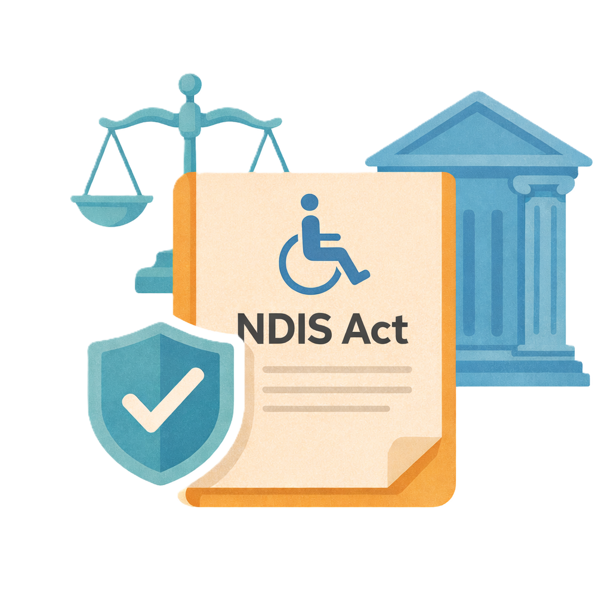
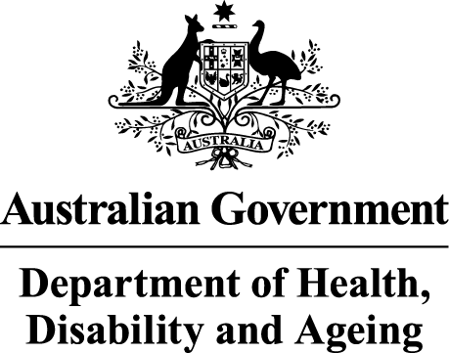 | The Australian Government Department of Health Disability and Ageing wrote this.  We say DHDA for short.  When you see the word we it means DHDA.
 | We wrote this in an easy to read way.  We use pictures to explain some ideas.
 | We have some words in bold.  This means the letters are thicker and darker.  These are important words.
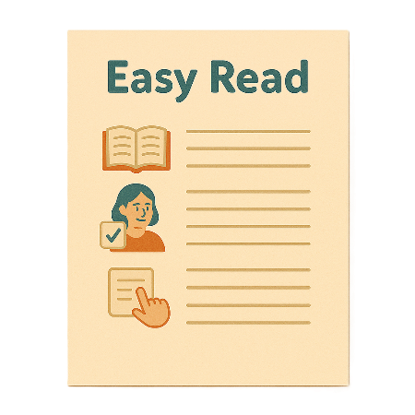 | This is an Easy Read summary of another document.  This means it has the most important ideas.
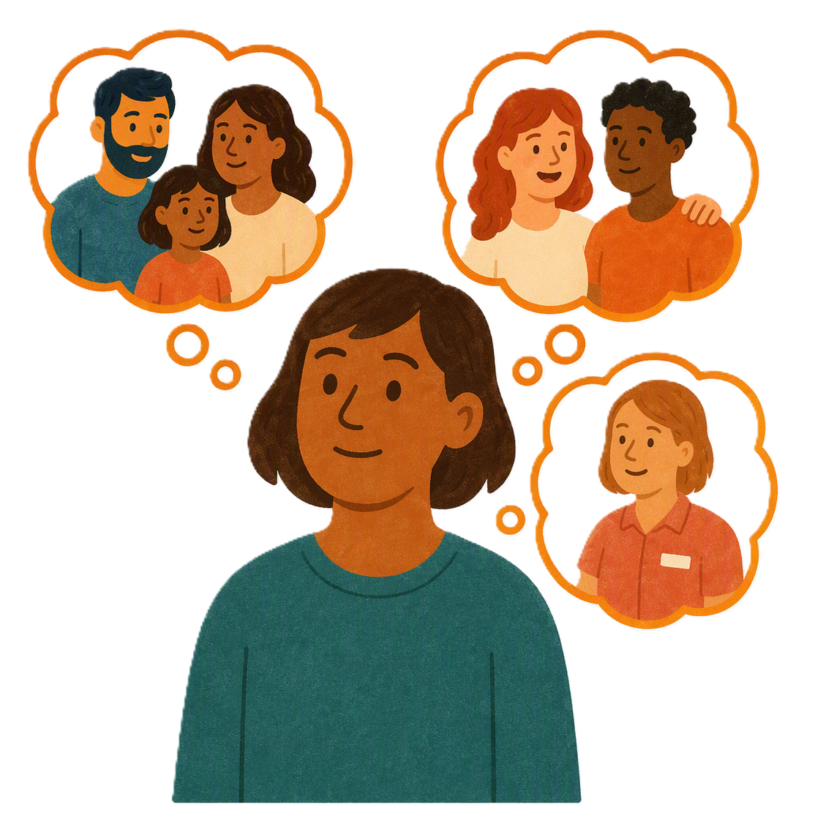 | You can ask for help to read this document.  You can ask  - A friend  - Family members  - A support person.
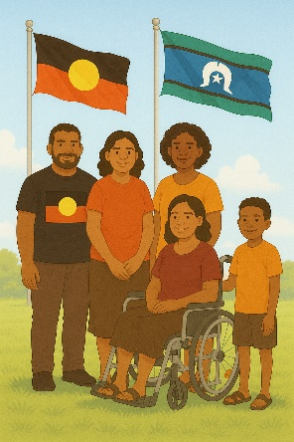 | We recognise Aboriginal and Torres Strait Islander people as the Traditional Owners of the land we live on.
 | They were the first people to live on and use the  - Land  - Waters.

Contents

Changes to NDIS laws | 5
About this document | 9
Banning kickbacks and inducements | 10
Providers not having to give documents for investigations | 14
New punishments for fraud | 18
Whistleblower protection | 22

Changes to NDIS laws

The government has made changes to the NDIS laws.

Laws are rules for how we live.
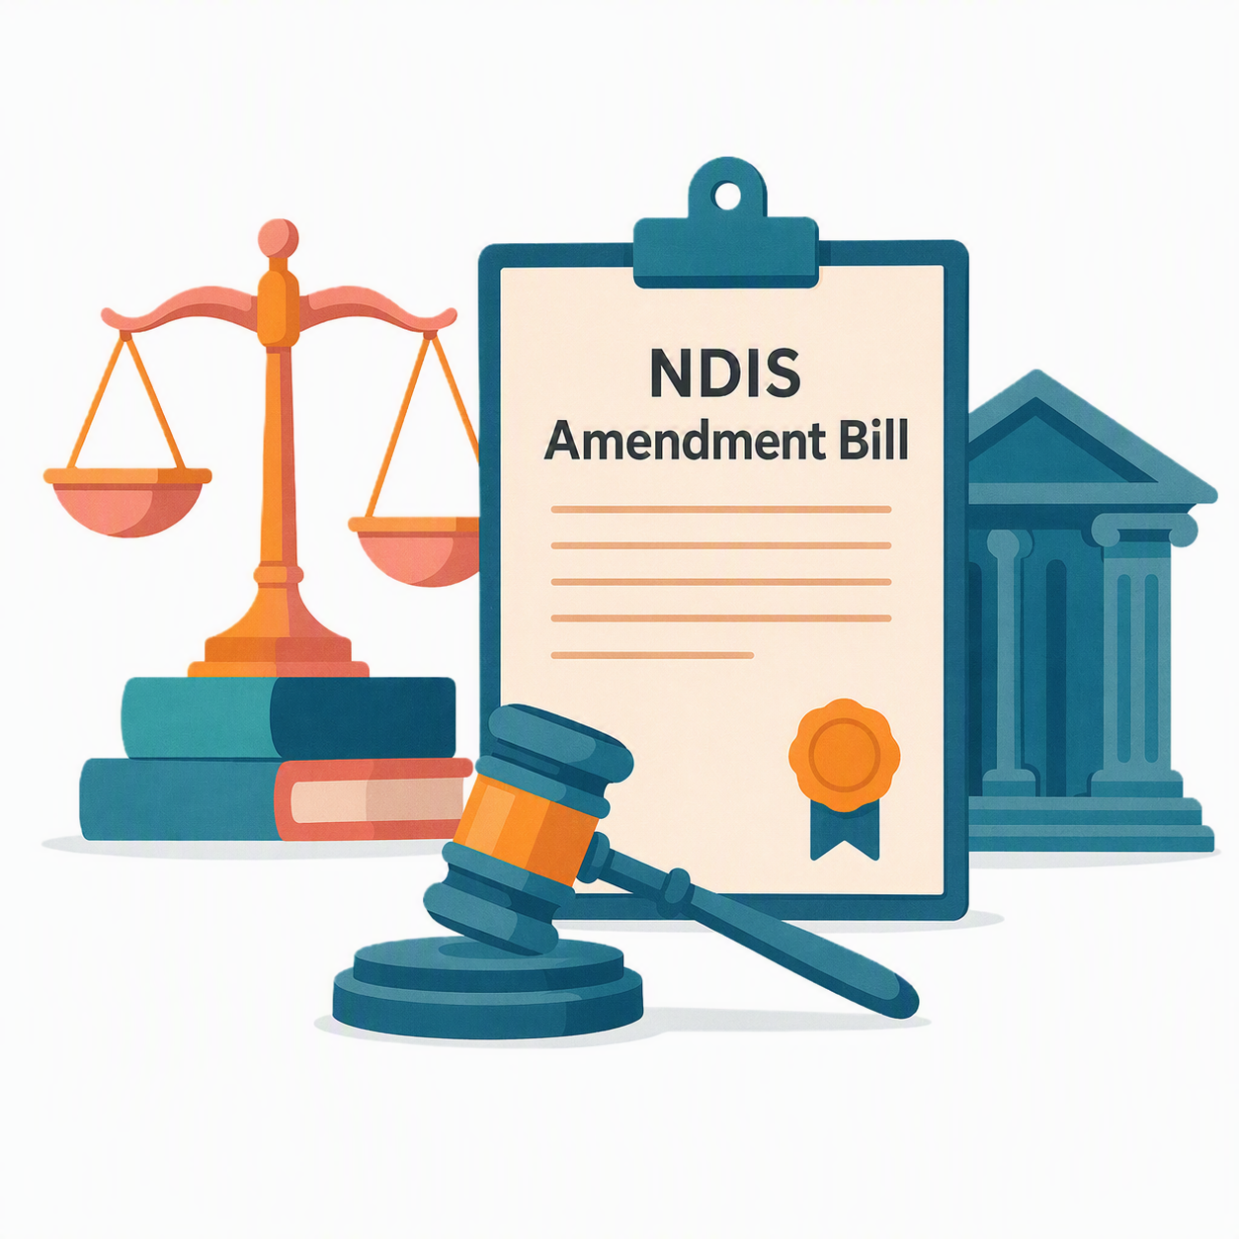 |  | To do this the Government  - Introduced the NDIS Amendment Bill 2026  A Bill is a proposed change.  It means it is not a law yet
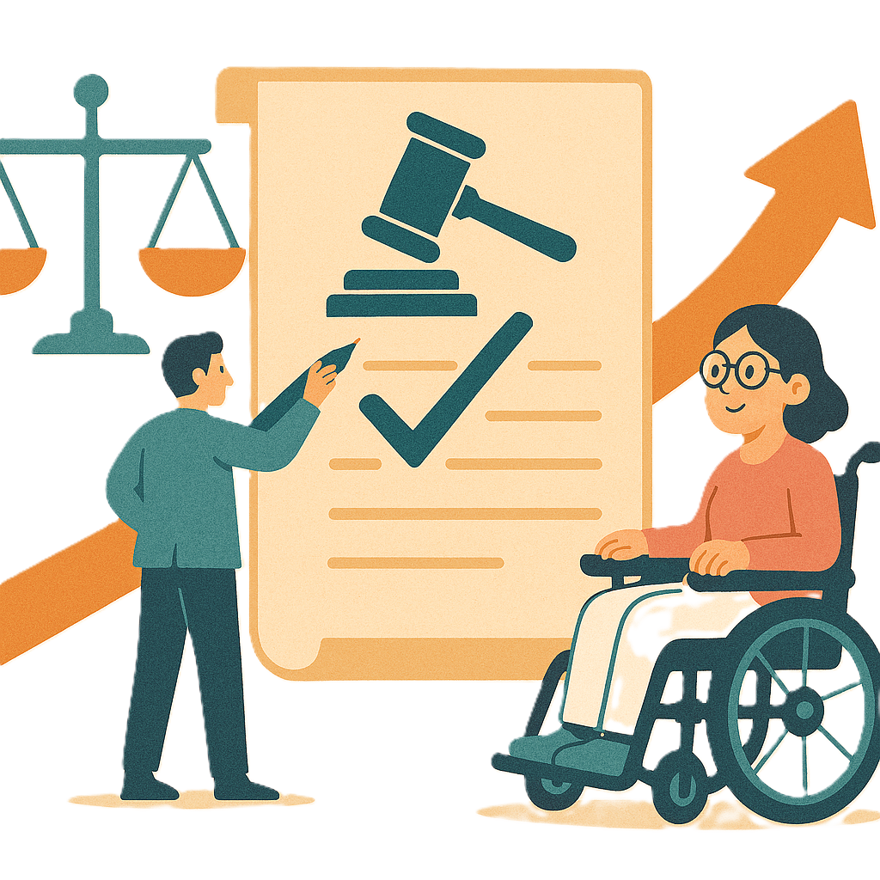 |  | Changes to the laws are called amendments.  They help laws  - Change  - Be better.
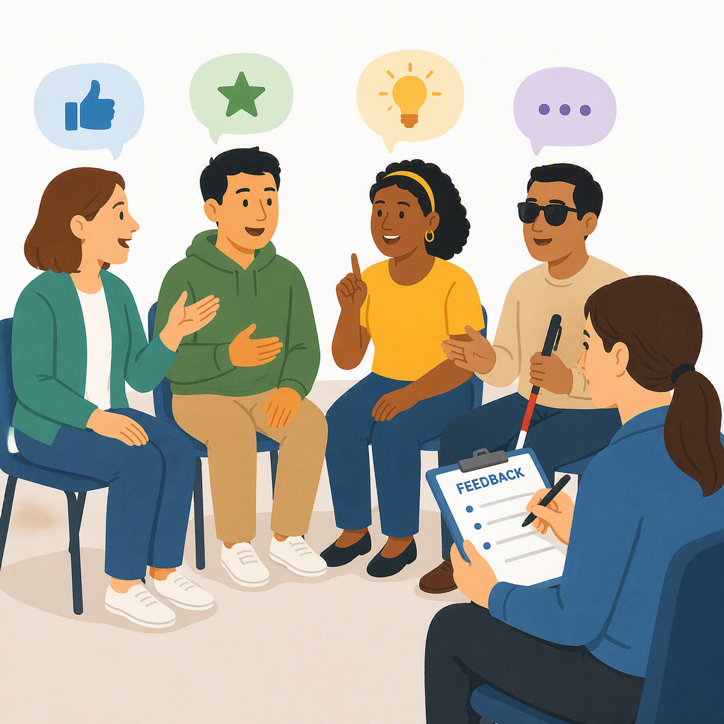 |  | The Government asked people what they thought about the Bill.
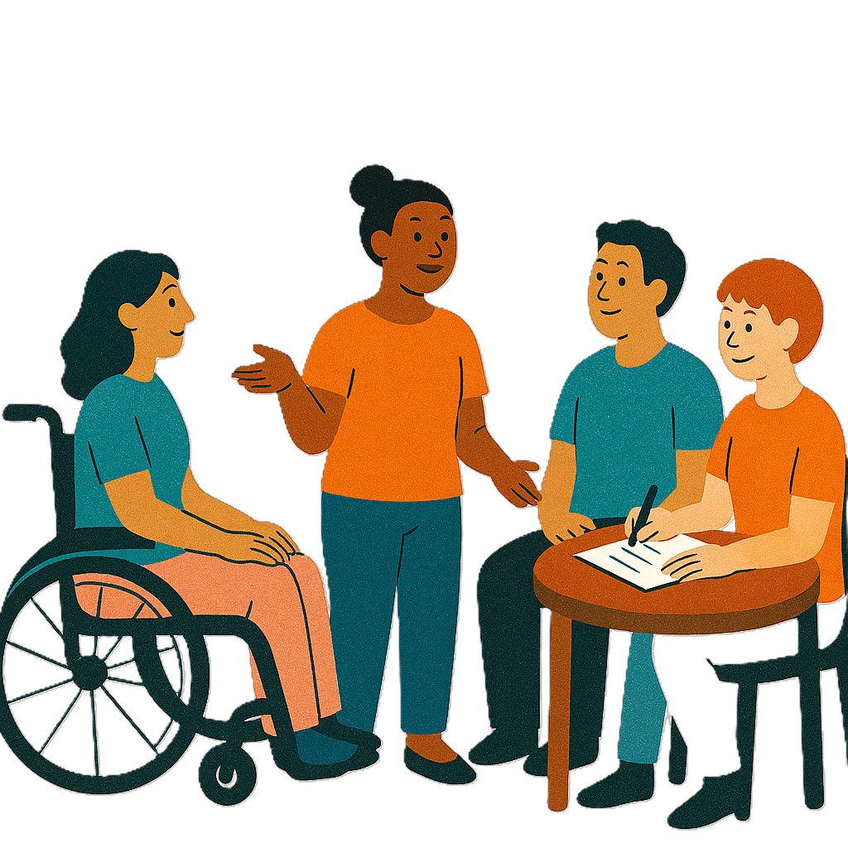 |  | We heard from  - People with disability
 |  | - Families
 |  | - Advocates  An advocate is someone who supports you to speak up for your rights.  It can also be called advocacy.
 |  | The Government made changes to the Bill from what we heard.
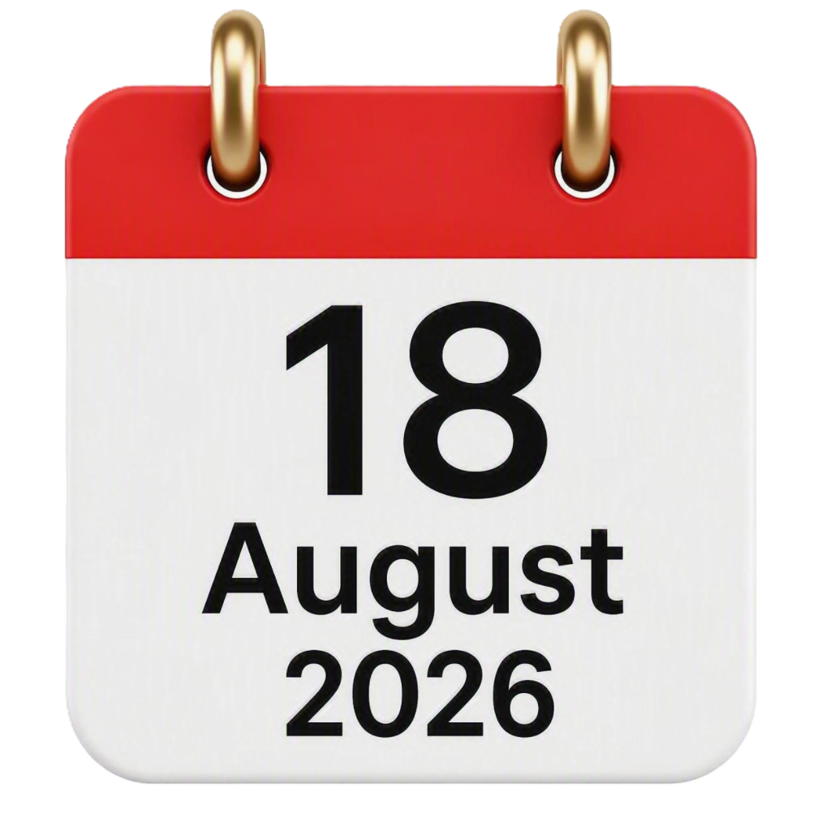 |  | The Bill changes were agreed to in Parliament on  - 18 August 2026.
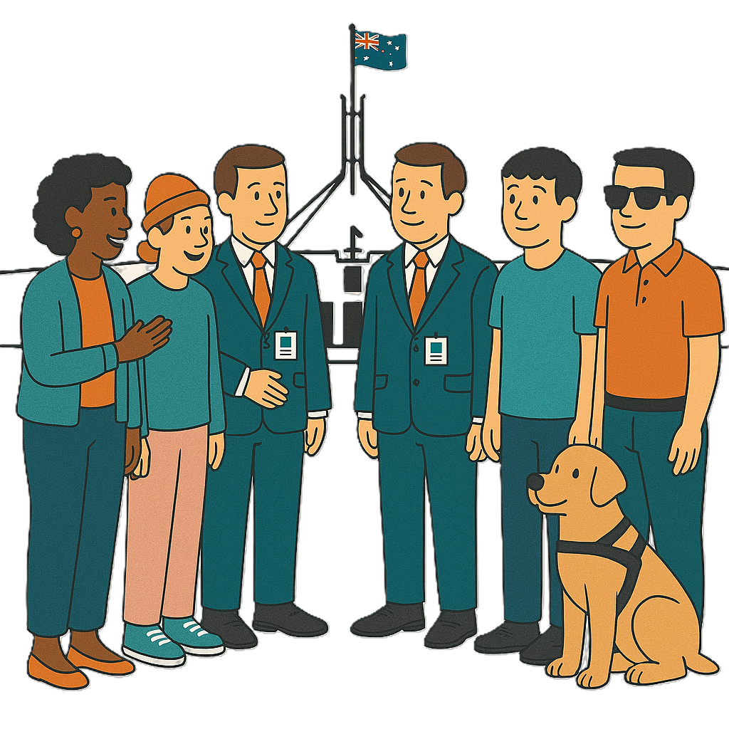 |  | Parliament is where politicians meet to make rules.  Politicians help run a country.
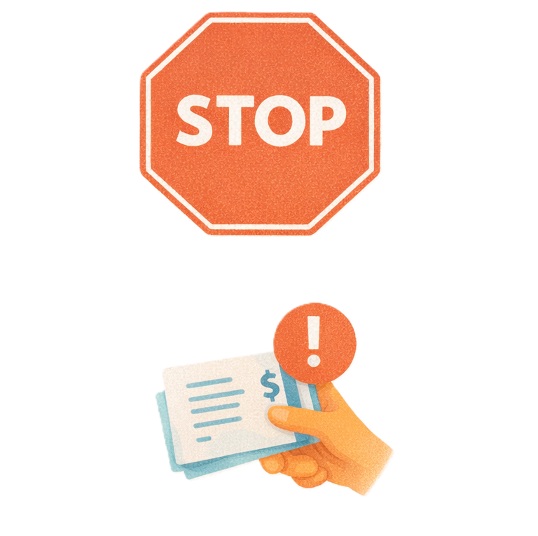 |  | The changes are to  - Stop fraud  Fraud is when someone tried to get something they should not get.  Like tricking someone to get their NDIS money.
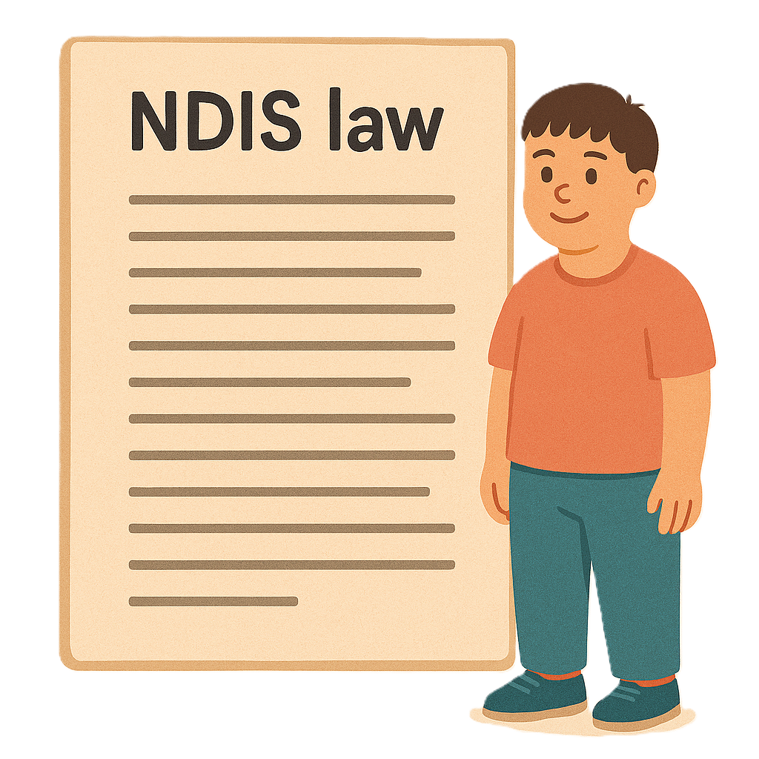 |  | - Make changes to the law clearer for people who get NDIS supports.

About this document

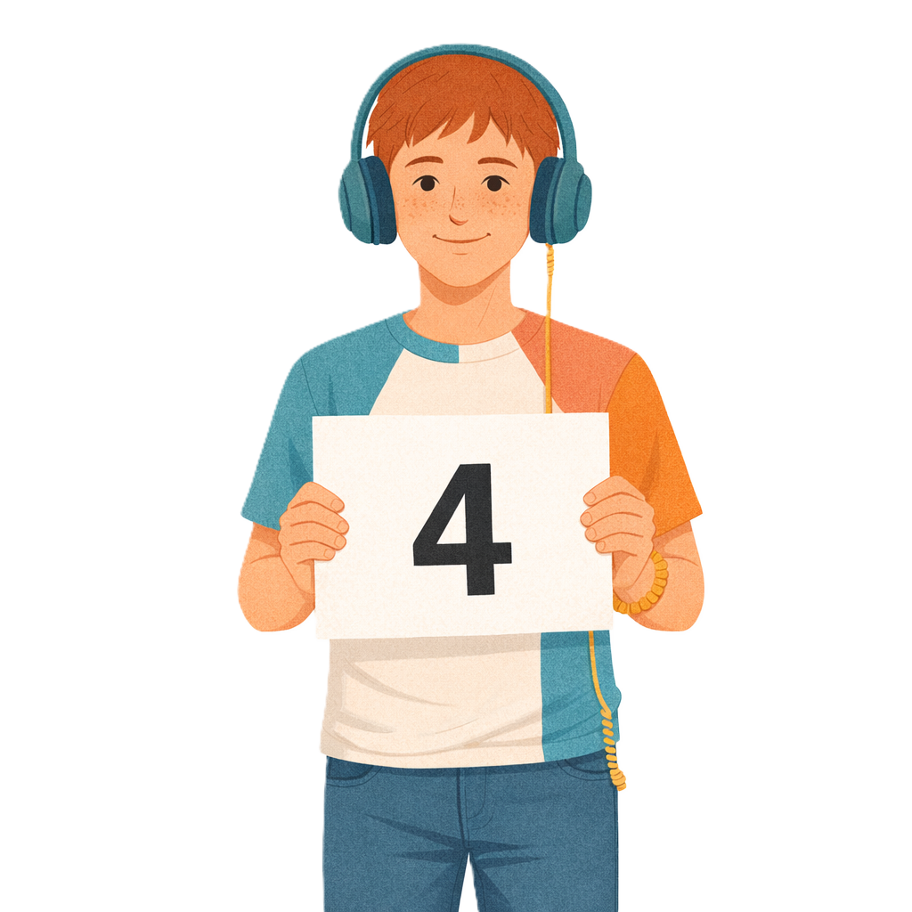 |  | This document is split into 4 parts.
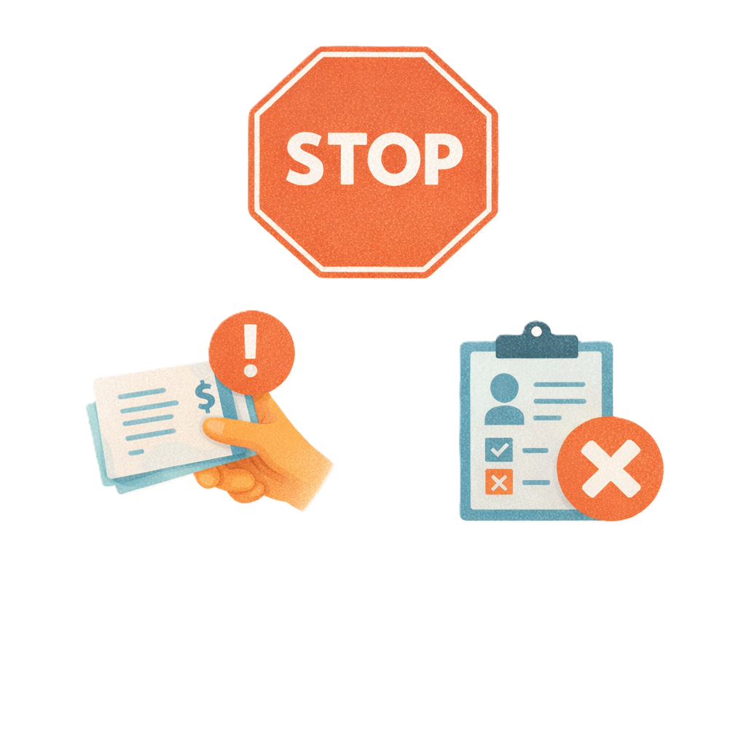 |  | Parts 1 and 2 are about changes to  - Stop fraud
Parts 3 and 4 are about changes to

- Make NDIS laws clearer for participants.
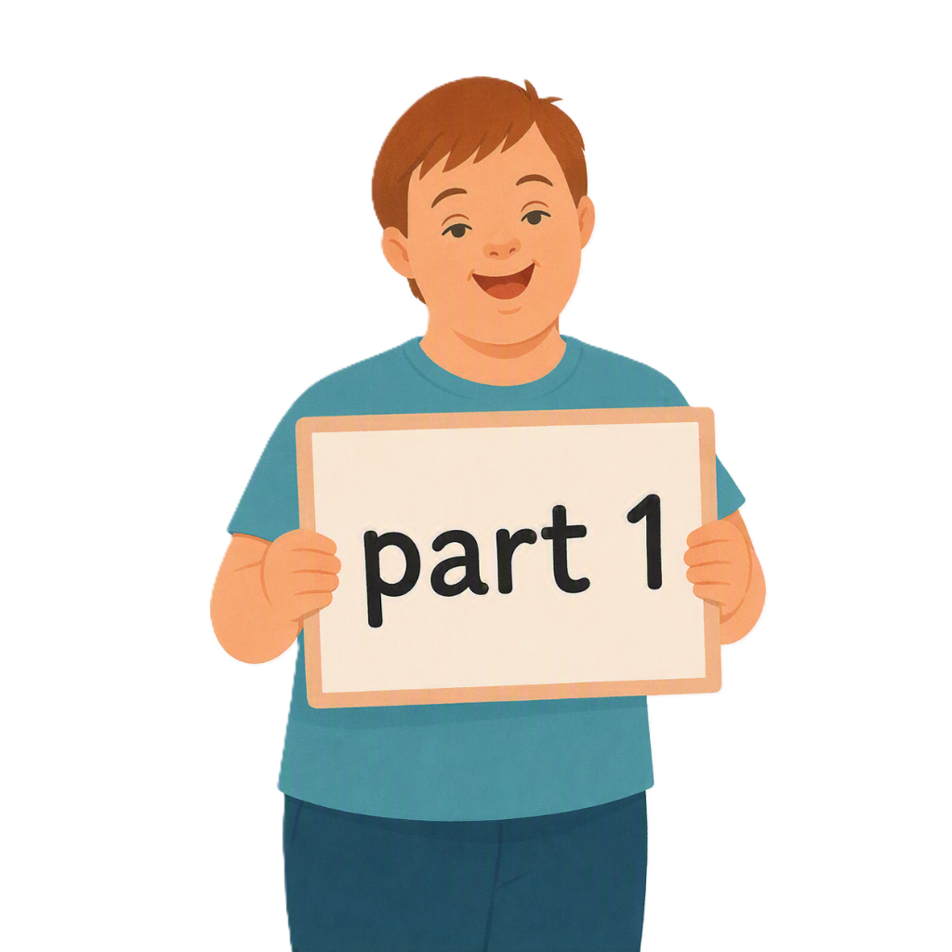 |  | This is part 1.

Banning kickbacks and inducements

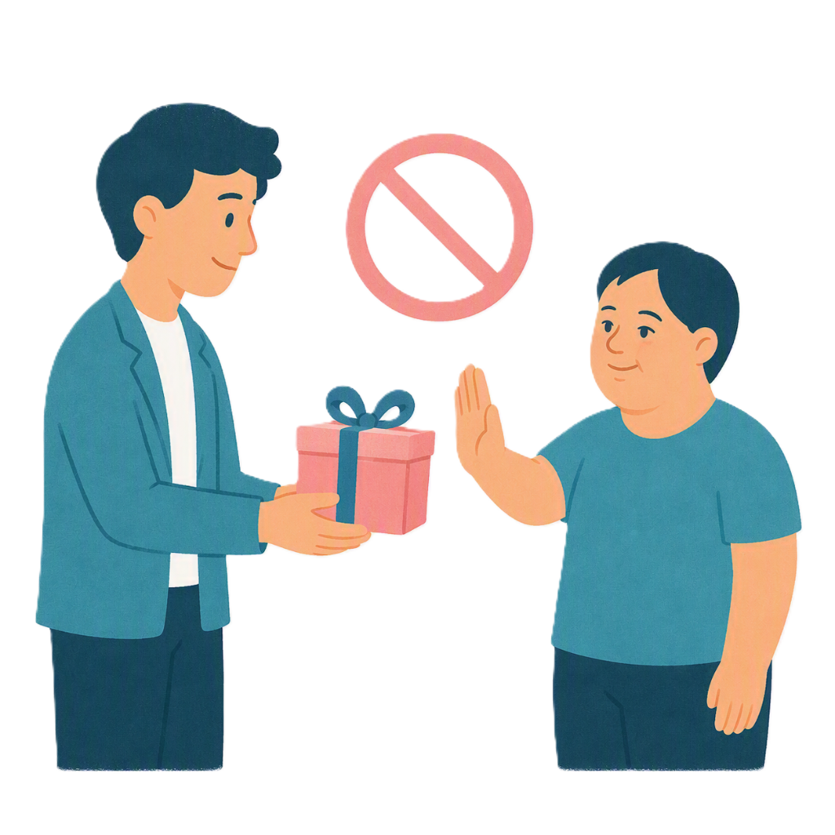 |  | This change is about banning kickbacks and inducements.  This means stopping  - Kickbacks  A kickback is giving something to people with disability so they pick a provider like  - Money  - Gifts.
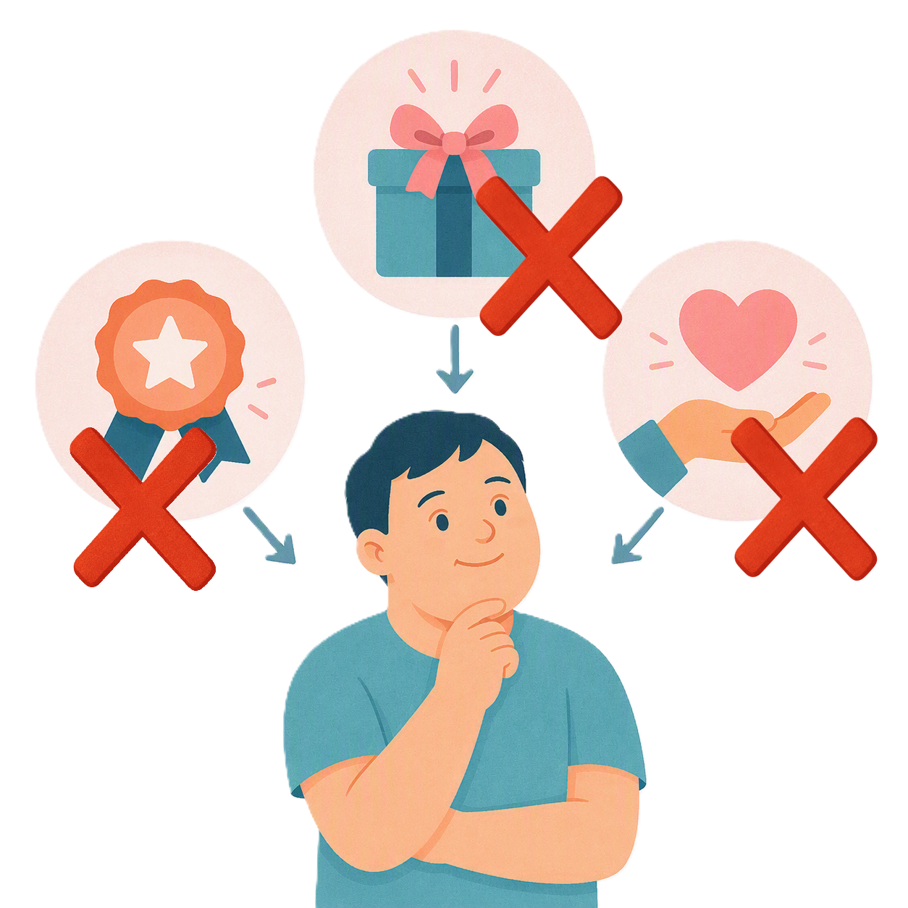 |  | - Inducements  An inducement is something to help change a persons decision like a  - Reward  - Benefit.
 |  | This change would stop NDIS providers from trying to get people with disability to  - Sign up for their service
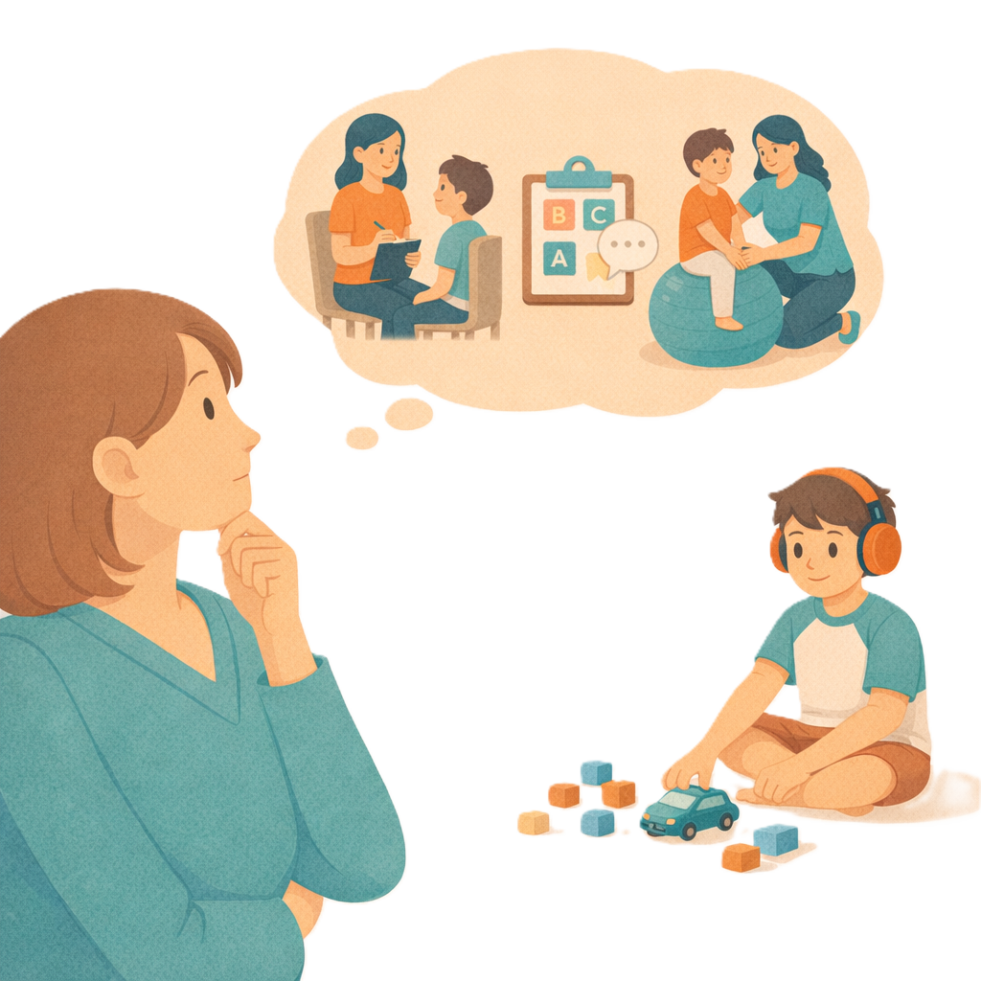 |  | - Keep going with their service
 |  | - Use more of their services.
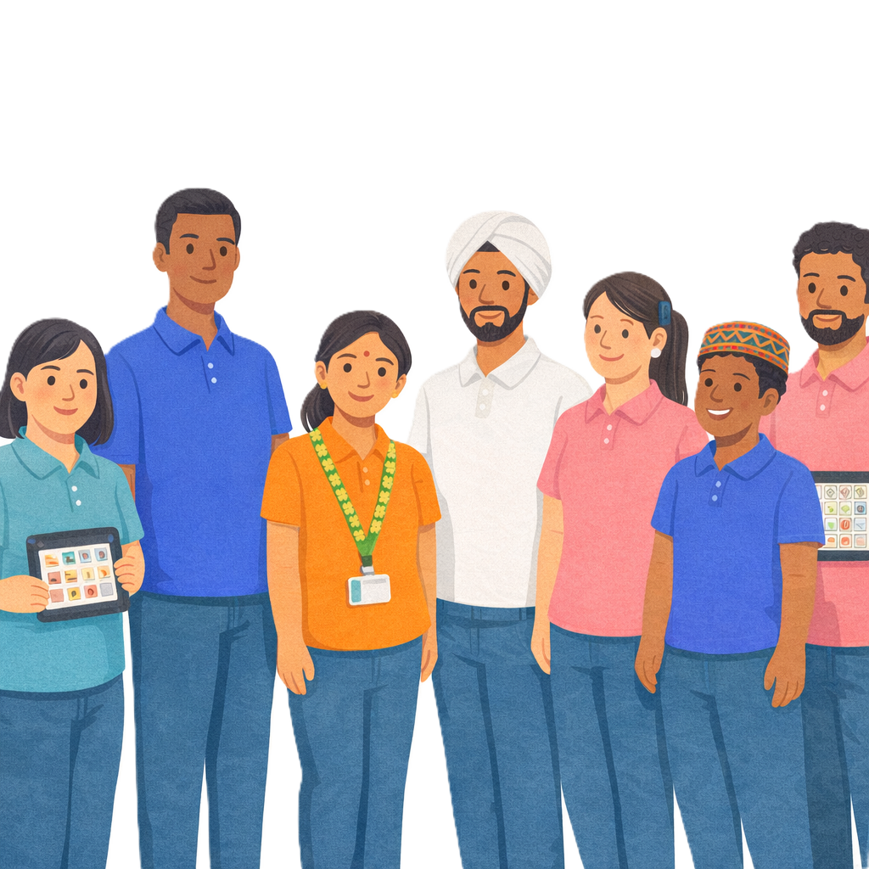 |  | NDIS providers get money from your NDIS plan to help support you.  We call them providers for short.
This will stop providers from offering

- Kickbacks

 |  | - Inducements
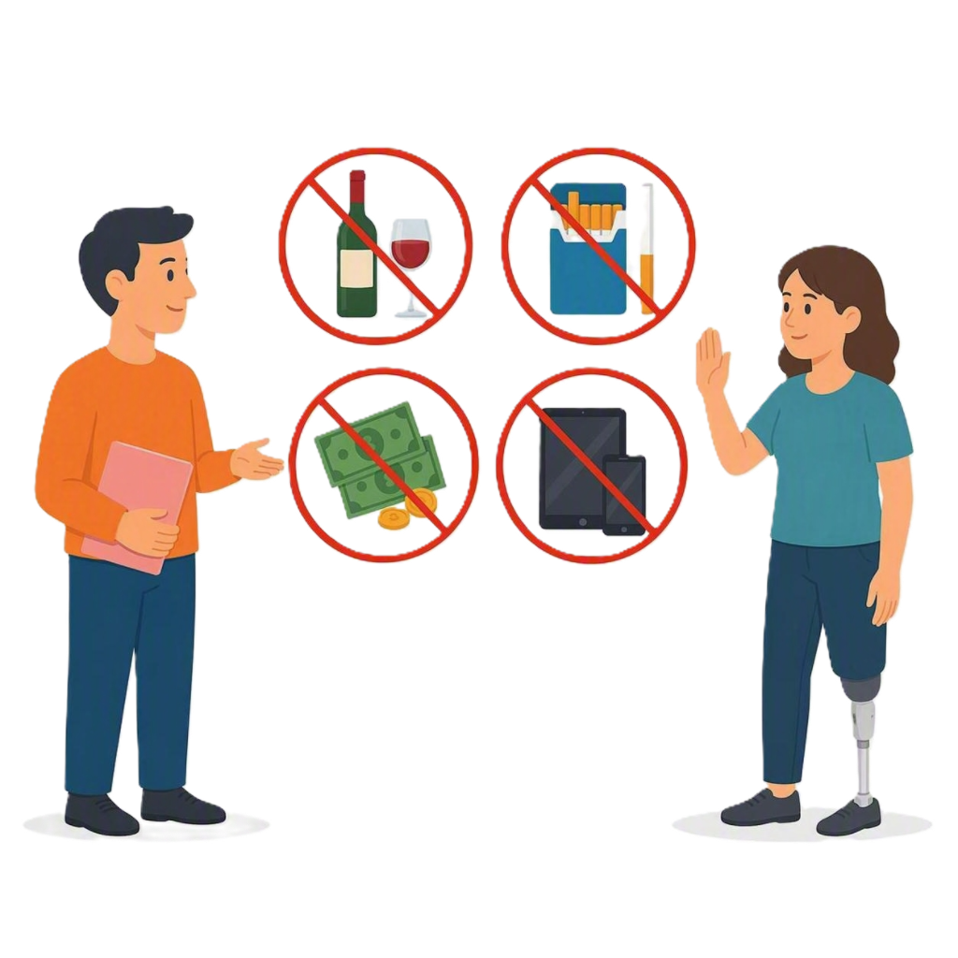 |  | Like  - Alcohol  - Tobacco  - Money  - Electronic devices.
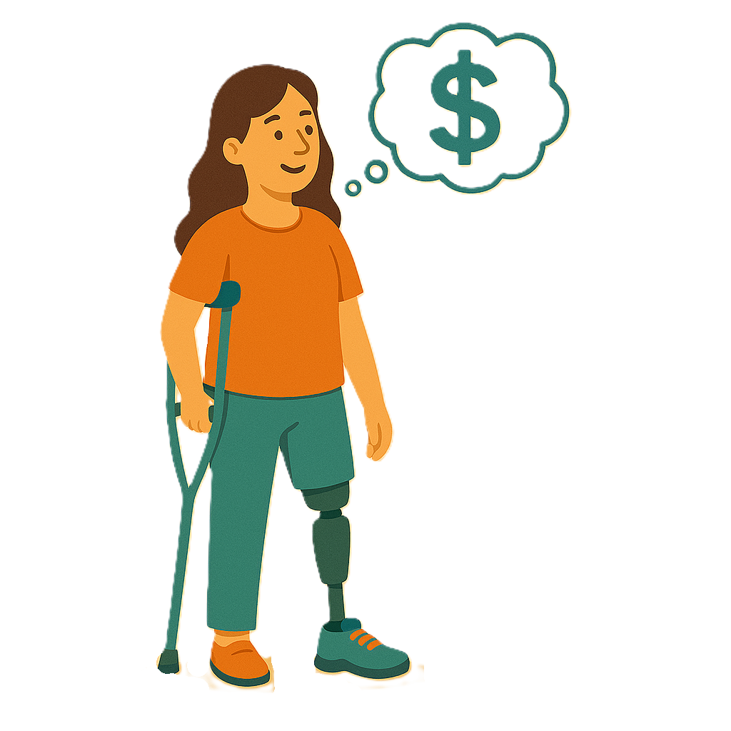 |  | Providers would still be able to  - Follow the regular way to decide a price for their service
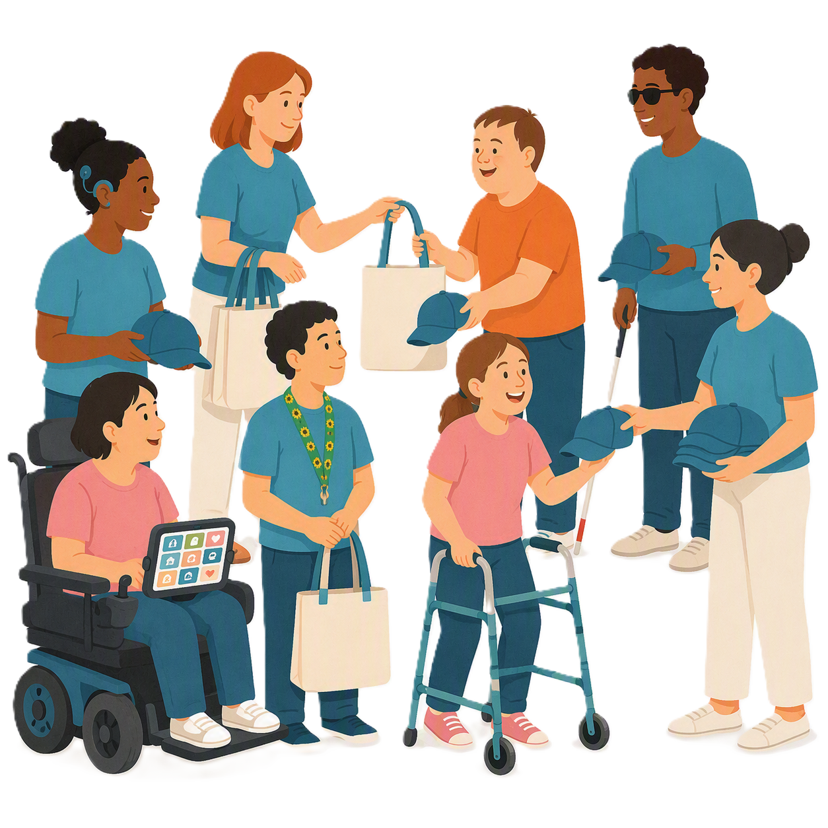 |  | - Give small items.  Like a bag or hat.

Providers not having to give documents for investigations

 |  | This change makes it clear that  - Providers can not refuse to give information in important investigations.
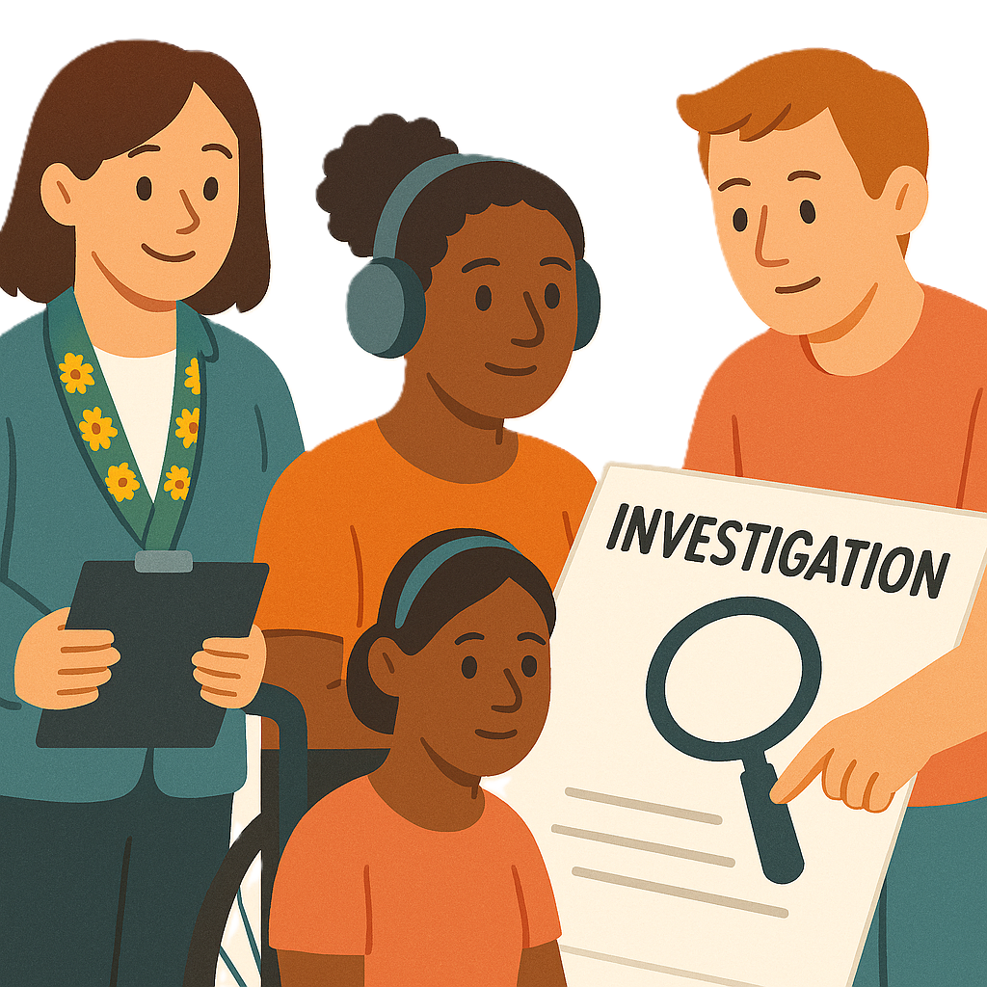 |  | An investigation is when someone looks at  - Facts  - What happened.  It can also be called to investigate.
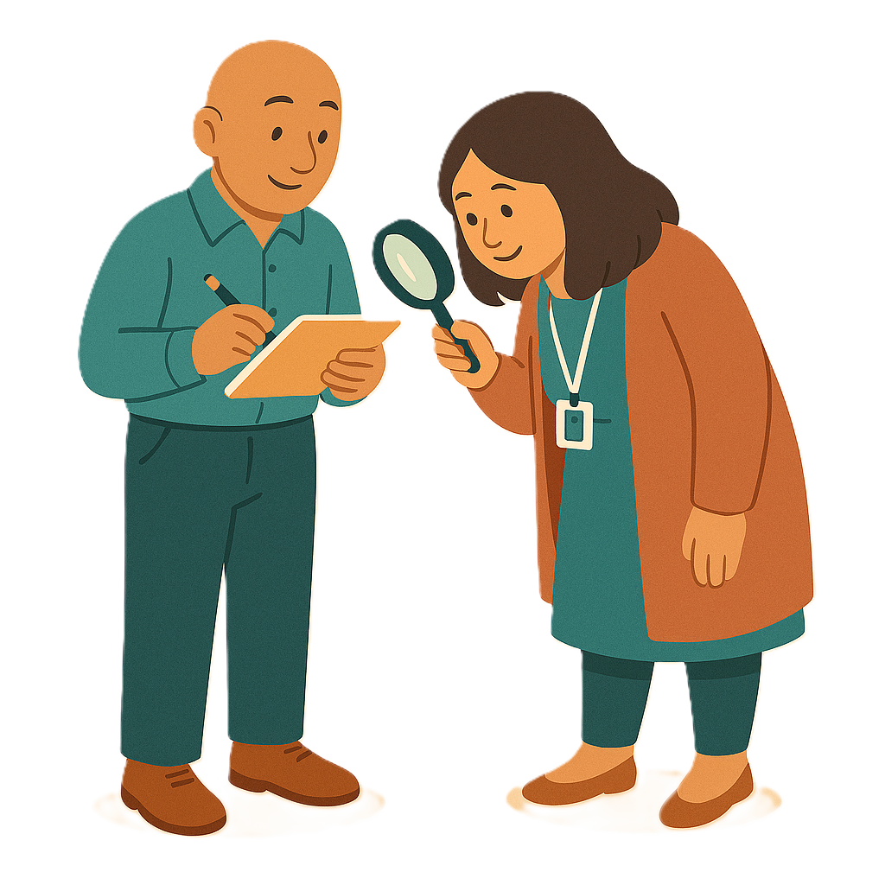 |  | They look more closely to understand  - What went wrong and  - How to keep people safe.
 |  | Providers can not say no to giving documents to
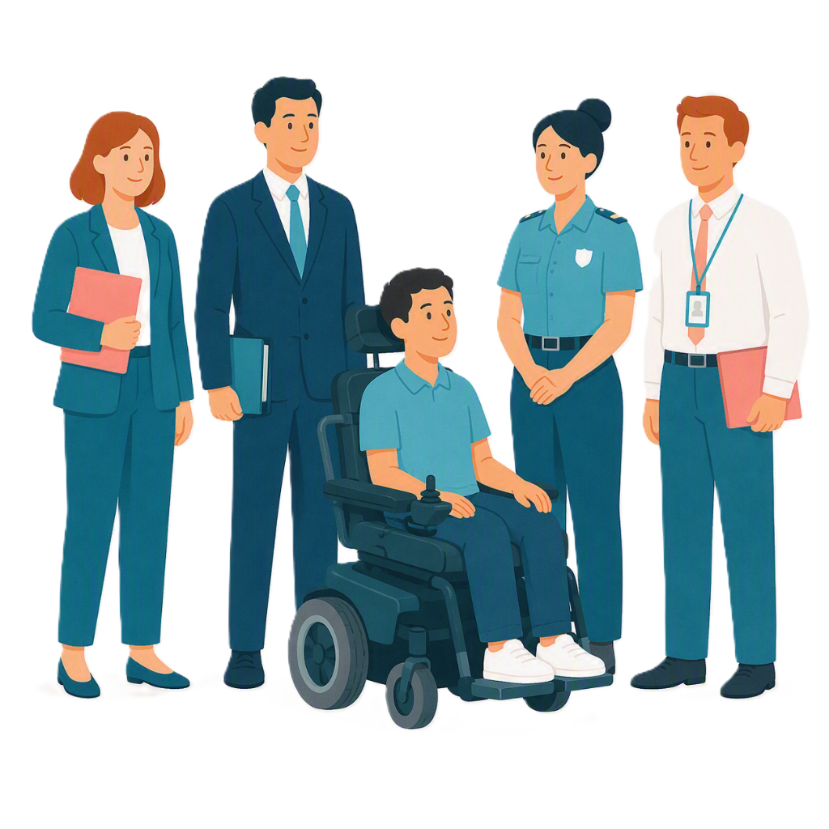 |  | - Authorities  Authorities are people who have power to make  - Decisions  - Rules  - Laws  About a certain areas.
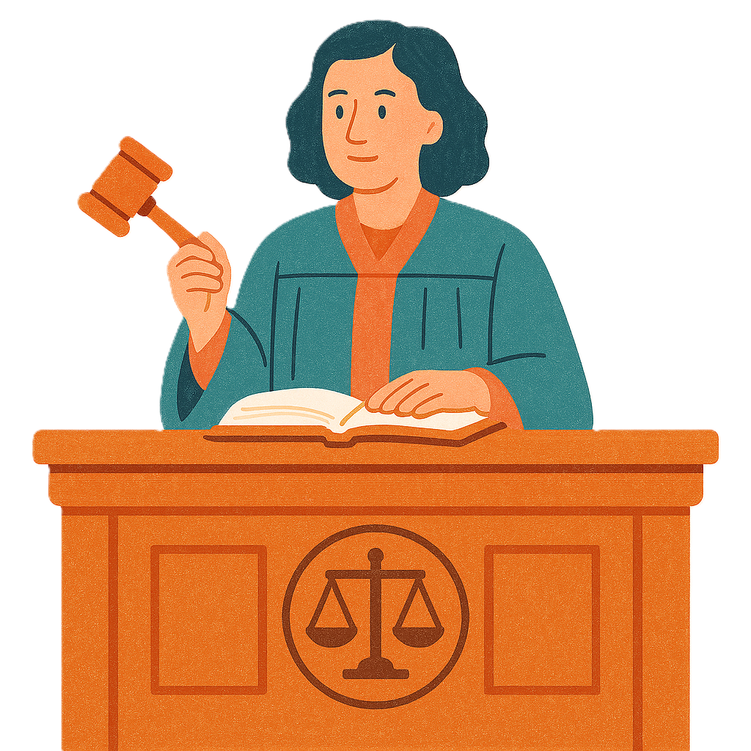 |  | - Courts  Courts are where you go when there is a problem with the law.
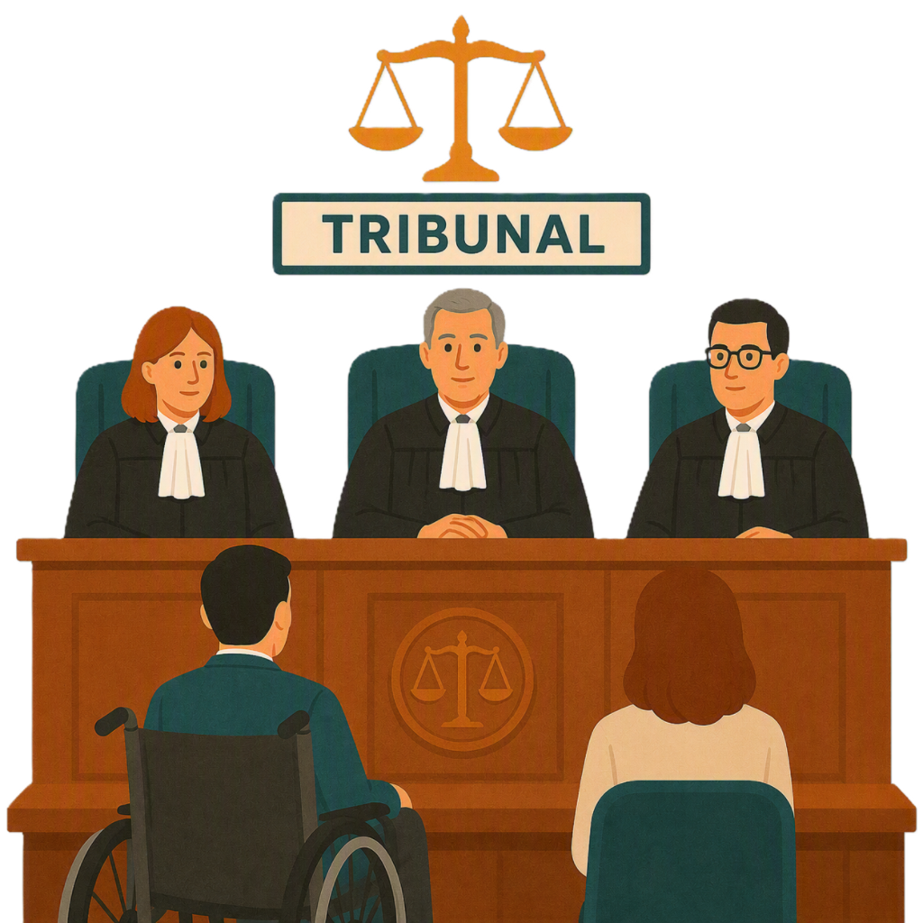 |  | - Tribunals  A tribunal is a place people can ask for a decision to be looked at again.
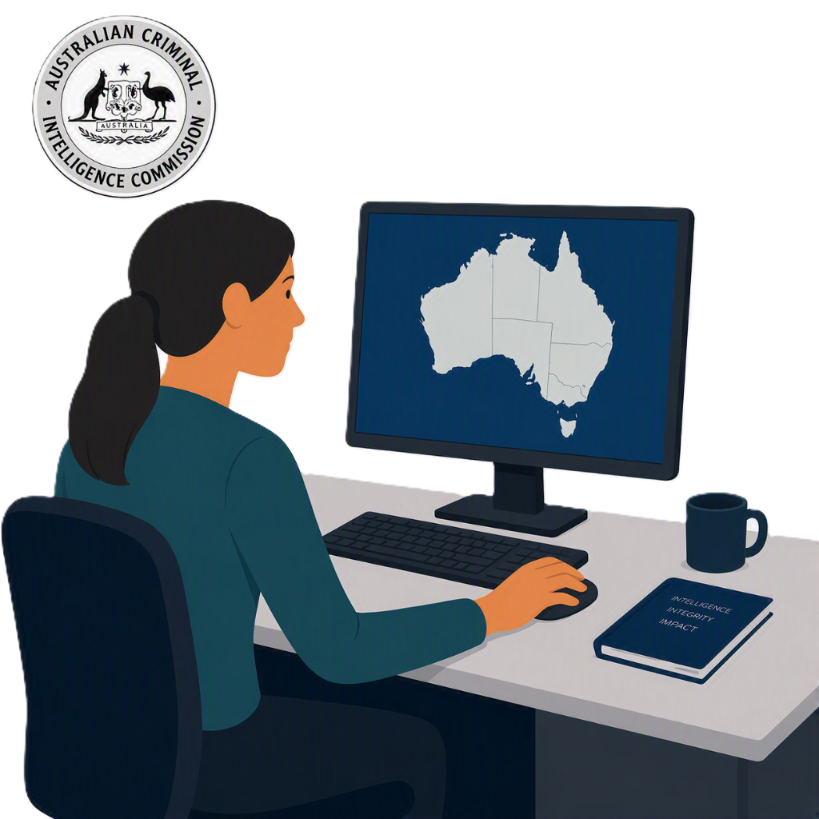 |  | - Australian Criminal Intelligence Commission  They work on serious and organised crimes.  Organised crimes are when groups of people work together to break the law.
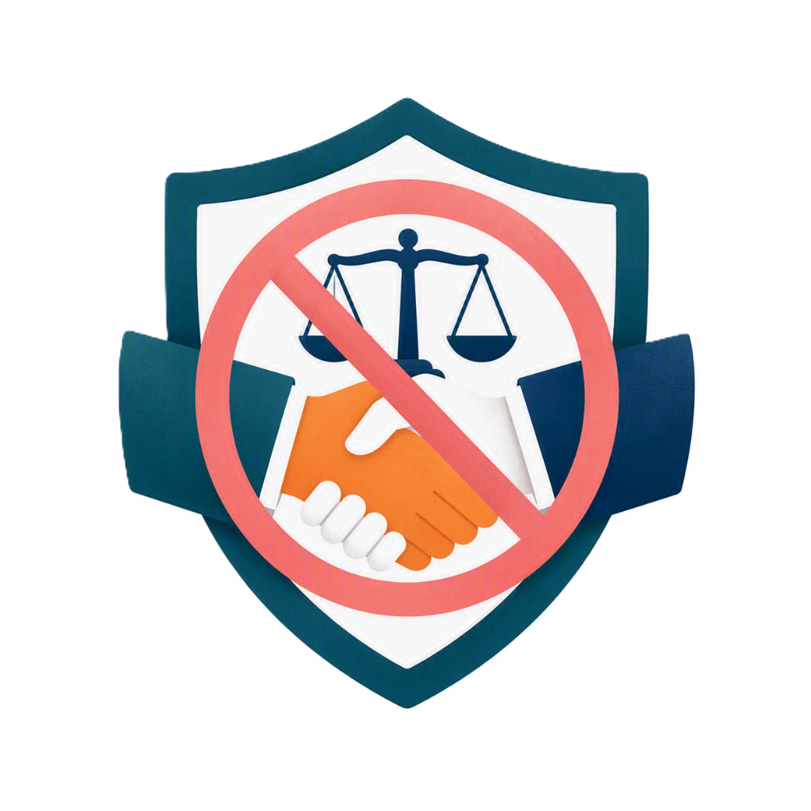 |  | - National Anti Corruption Commission  They help stop and investigate serious corruption in the Australian Government.
 |  | Corruption is when someone does the wrong thing to get something for themselves or someone else.  Like someone getting money for breaking the rules.
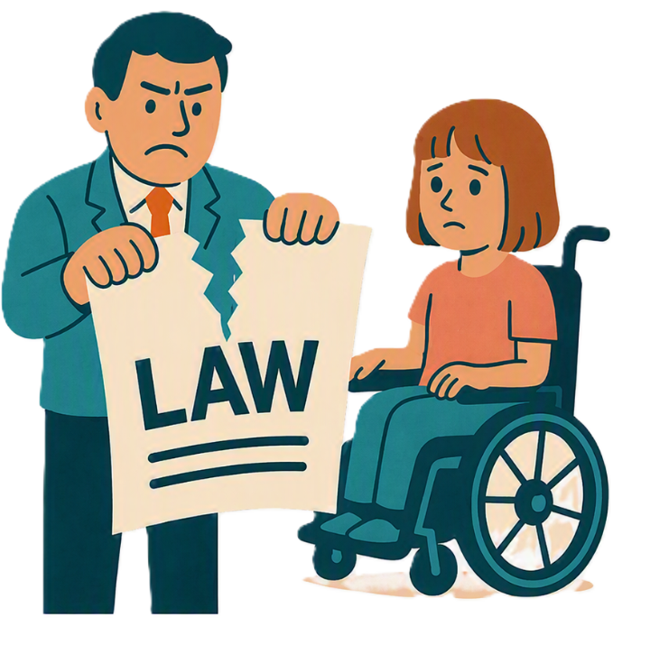 |  | This will help stop crime.  A crime is when you have not followed the law.

New punishments for fraud

This change introduces new punishments for not following the NDIS law.

This will help stop fraud.
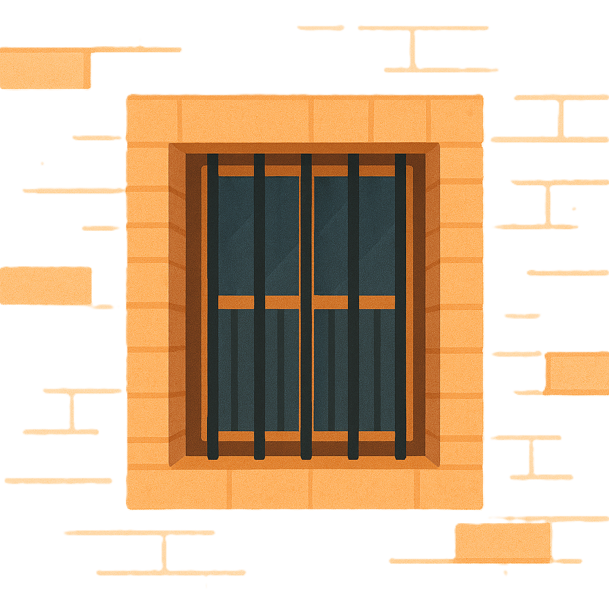 |  | The punishments can be  - Jail
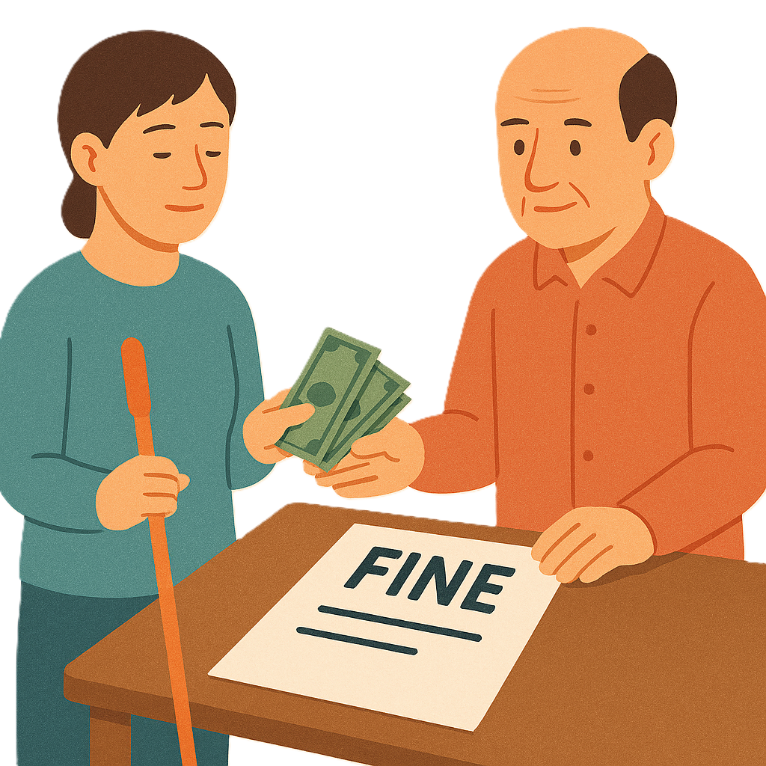 |  | - A fine  A fine is paying money to the government for breaking the law.
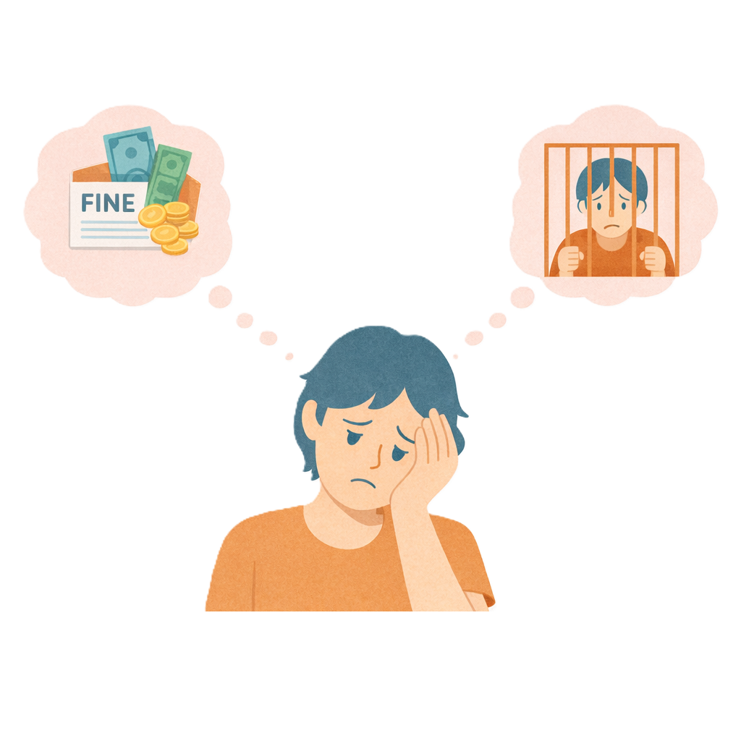 |  | - Both.
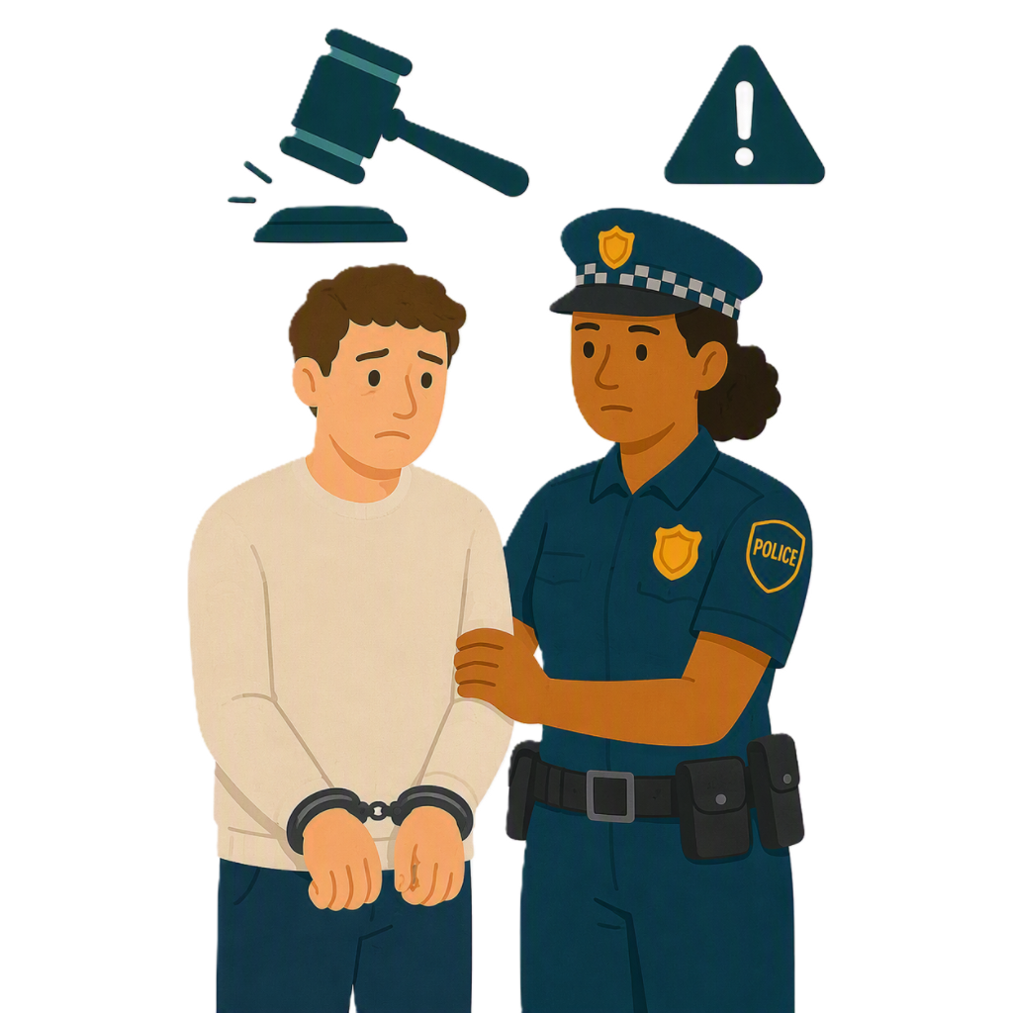 |  | Punishments will be stronger for people who break the law.
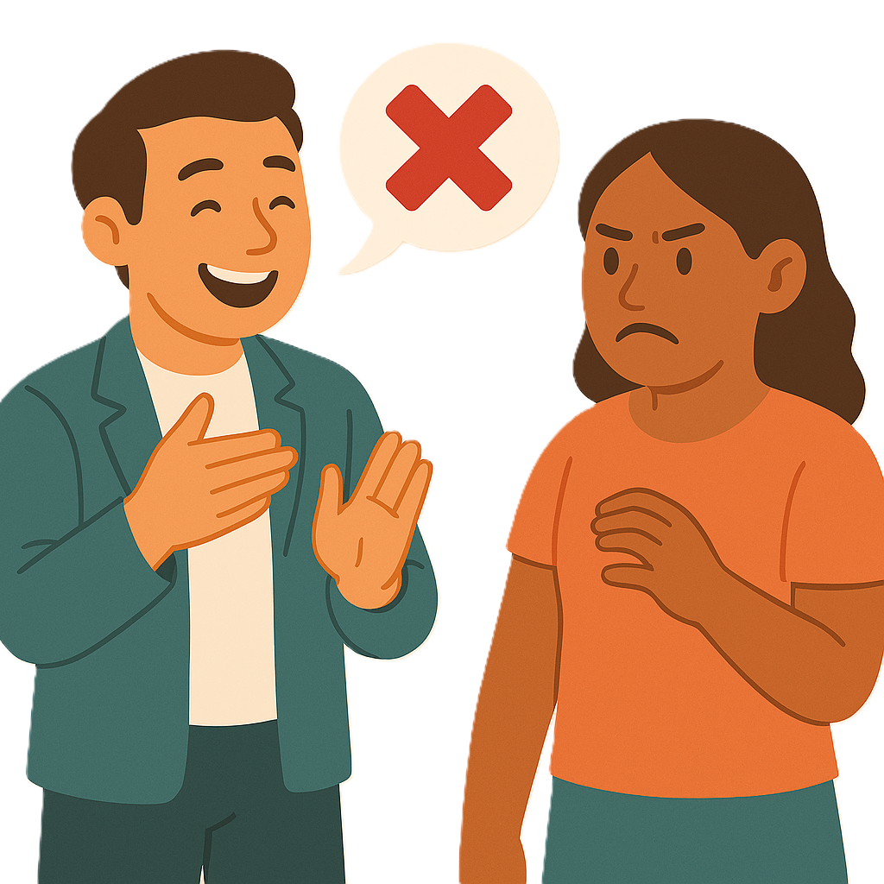 |  | The new punishments are for  - Giving wrong information on purpose to  - NDIS Commission  - NDIA.  This is called providing false or misleading information.
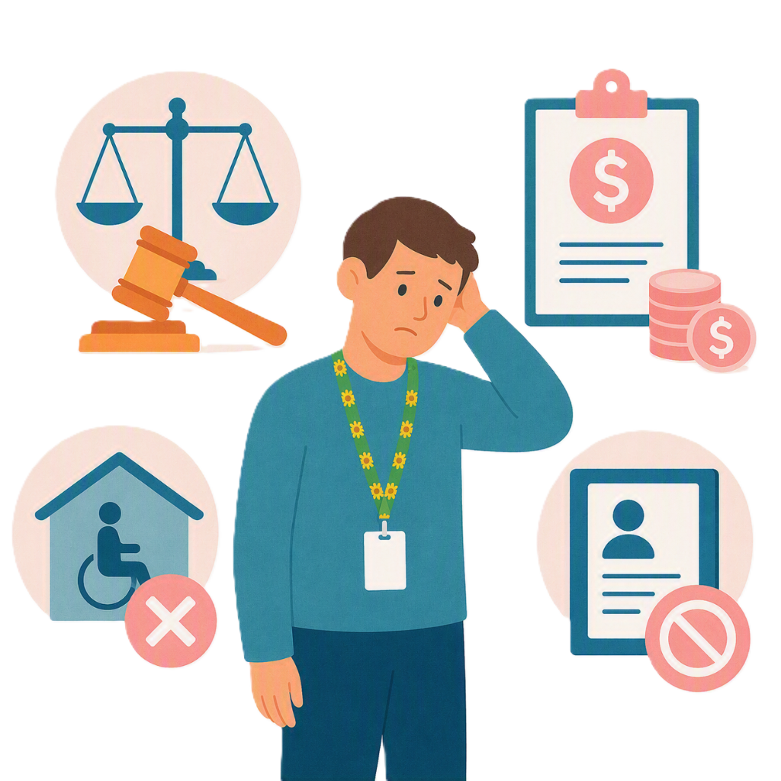 |  | This could be done  - To get NDIS supports  - For NDIS planning  - To get paid money from NDIS plans.
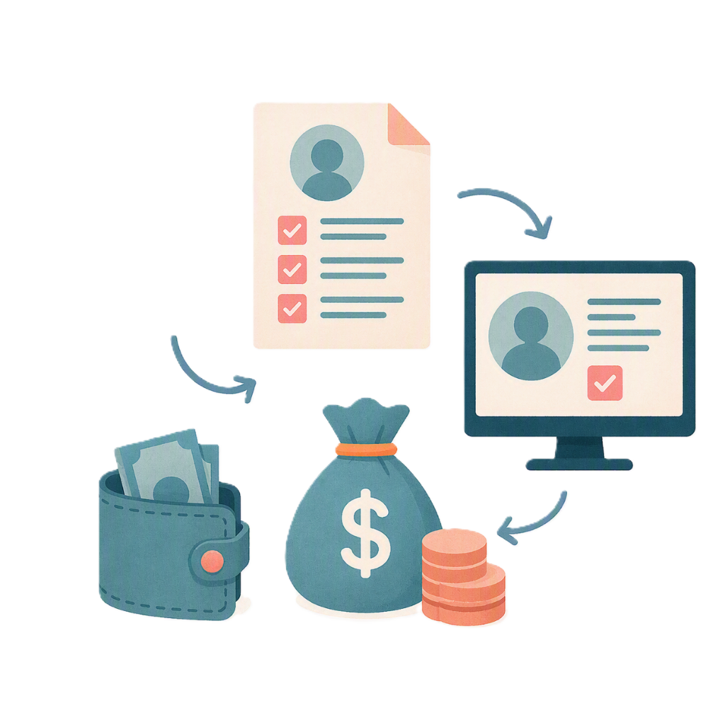 |  | - Getting NDIS money by deception.  Deception means tricking someone by telling them something that is not true.
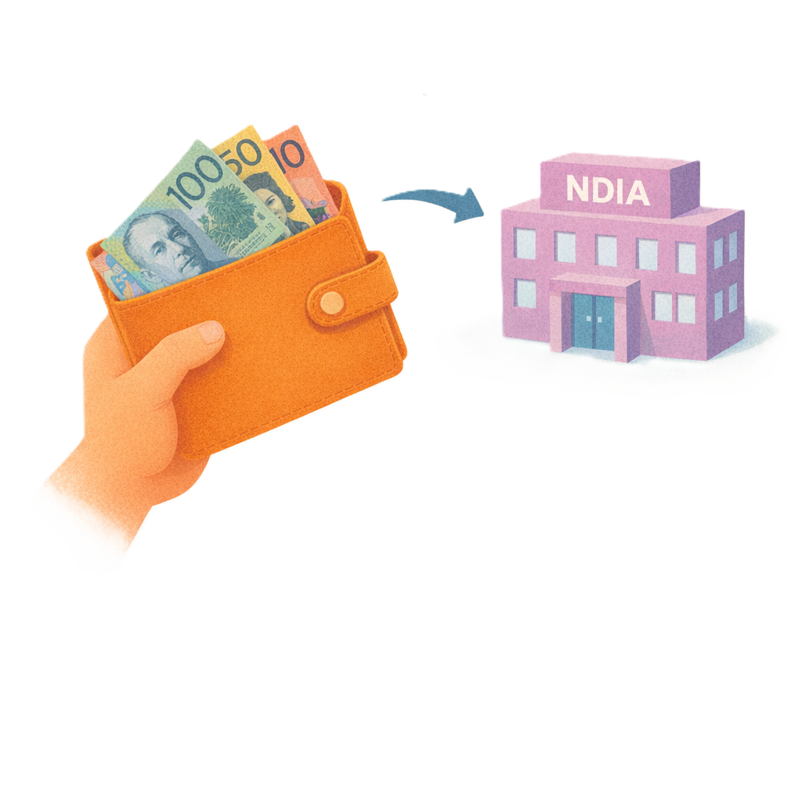 |  | People or providers might need to pay back the money they should not have got.
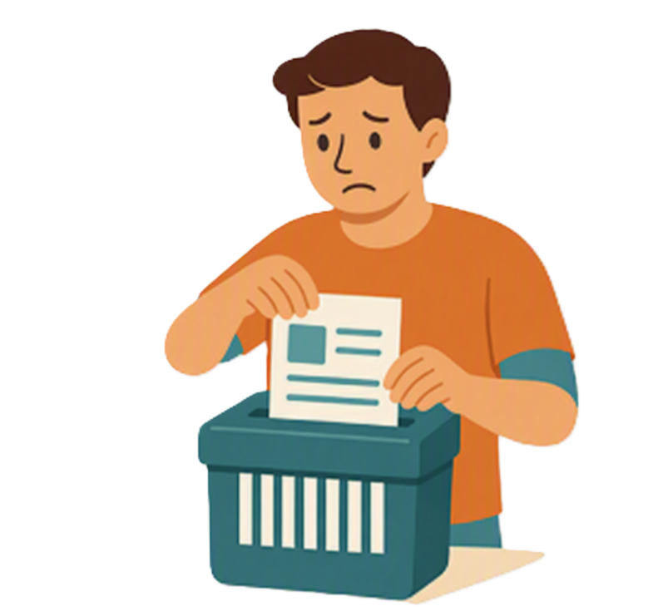 |  | - Destroying records on purpose.  This might be to  - Trick the NDIS  - Change an audit  - Change an investigation.
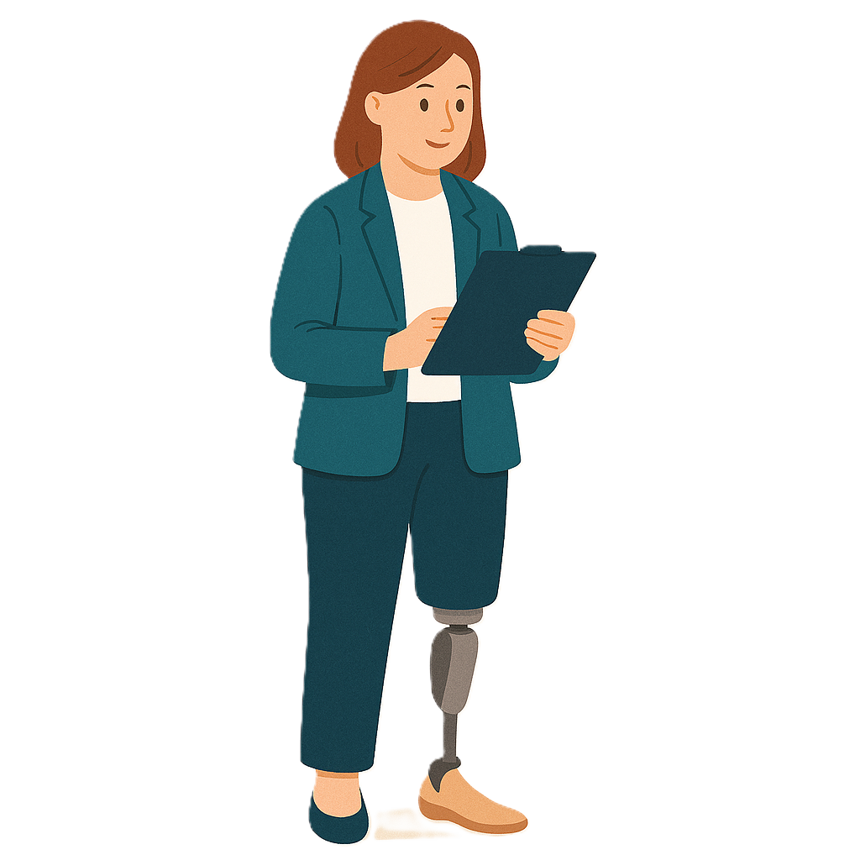 |  | Records could be paperwork or computer files about the services done.  An audit checks that everyone has followed the rules.
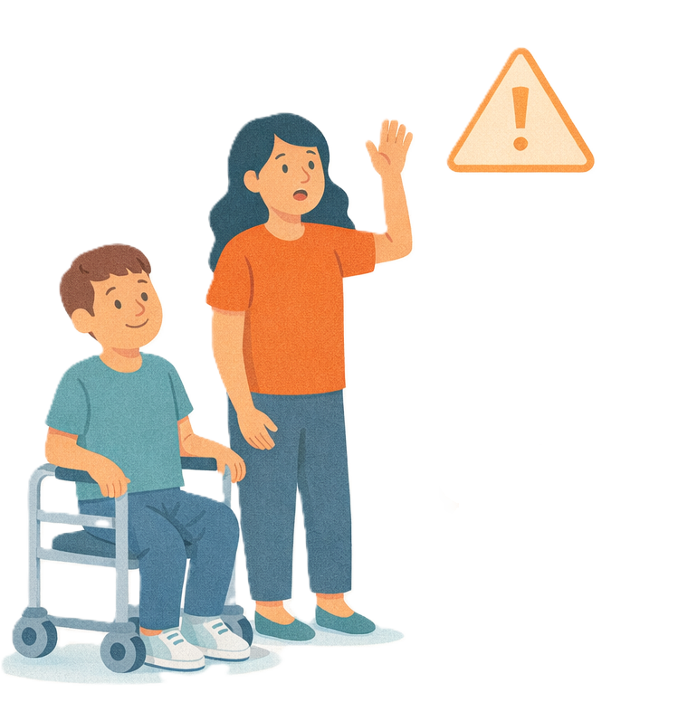 |  | - Nominees using their role in the wrong way.  This could be to  - Get something for themselves  - Hurt the person they support.
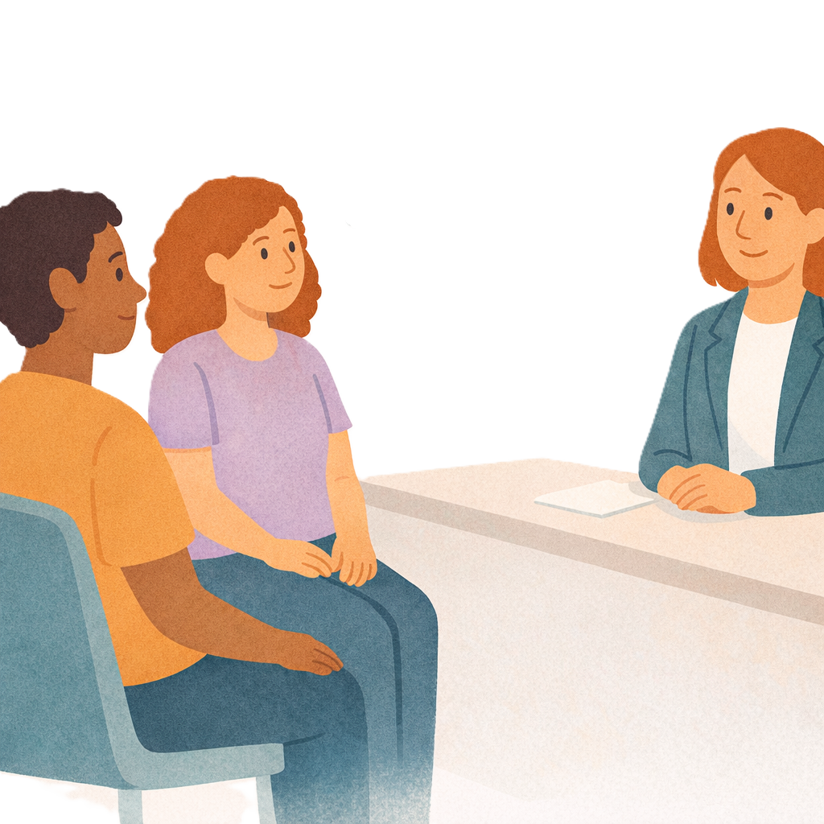 |  | A nominee is someone you choose to  - Make decisions for you  - Do things for you.

Whistleblower protection

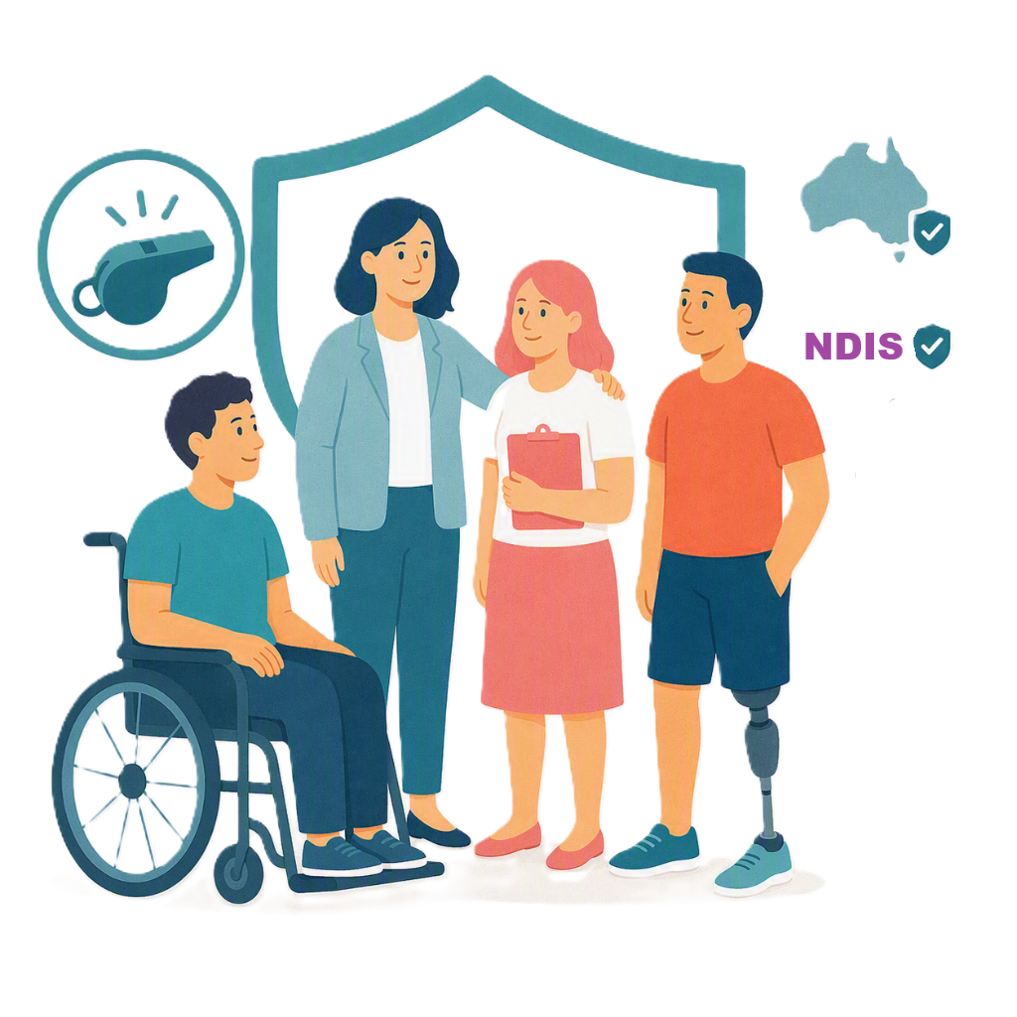 |  | This change improves protections for people who report wrongdoing in the NDIS.  Wrongdoing is when someone is not doing the job the right way.
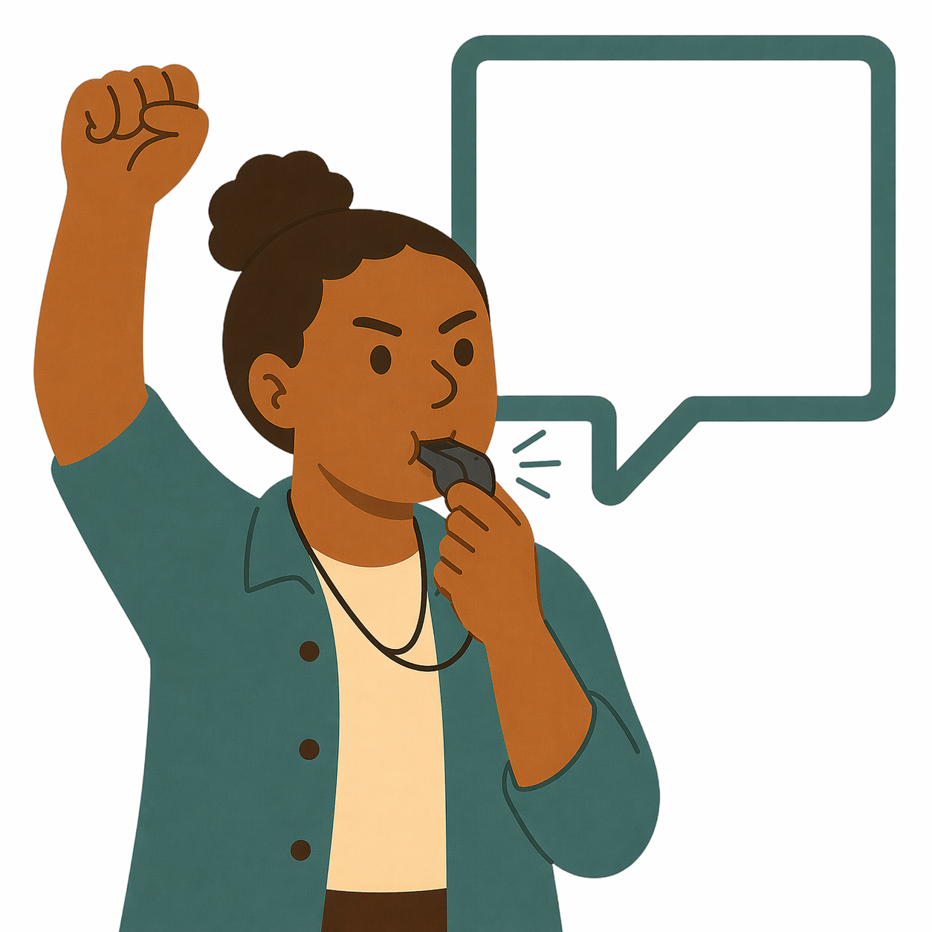 |  | People that report wrongdoing are called whistleblowers.
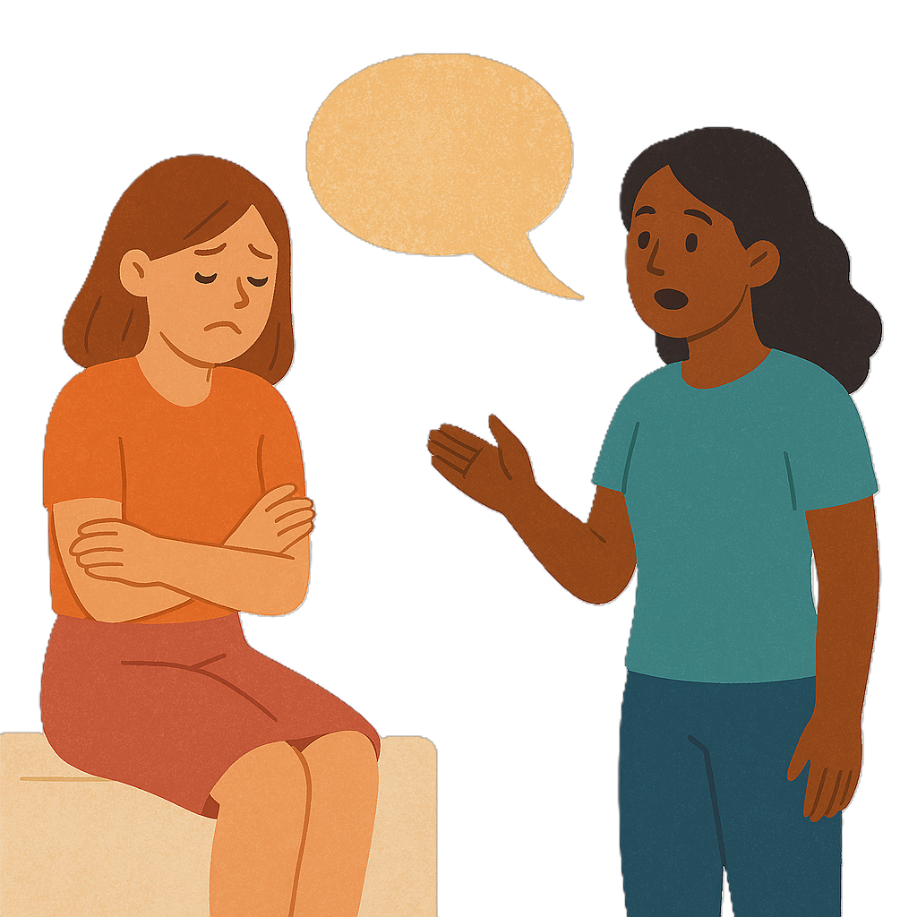 |  | This change helps to protect whistleblowers.
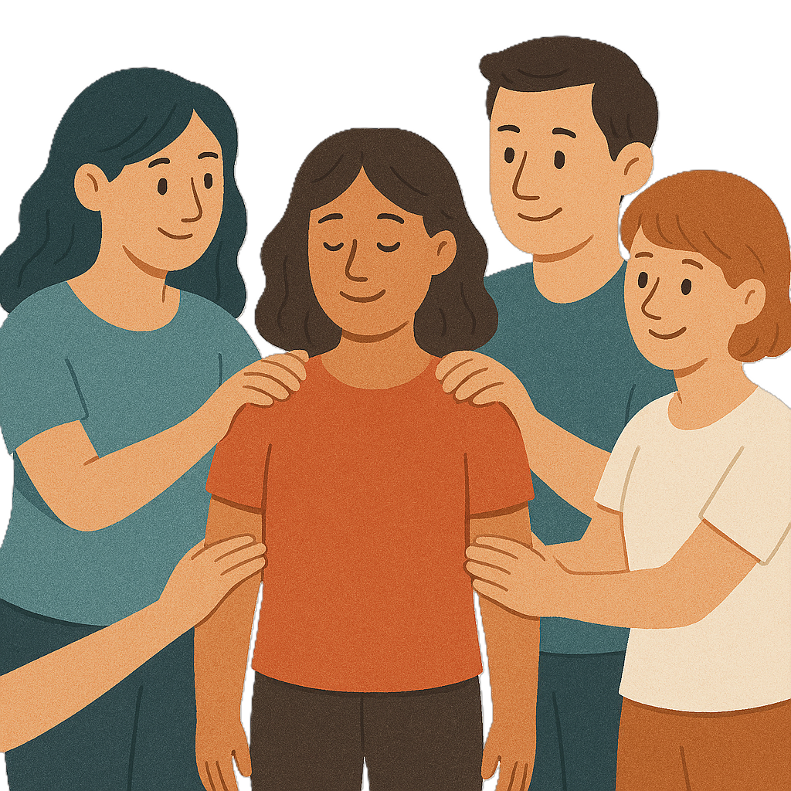 |  | It will help more people feel safe to speak up.  This will make the NDIS safer.

Some images in this Easy Read were made using AI.
You must not share or copy any of the images without permission.
August 2026.

