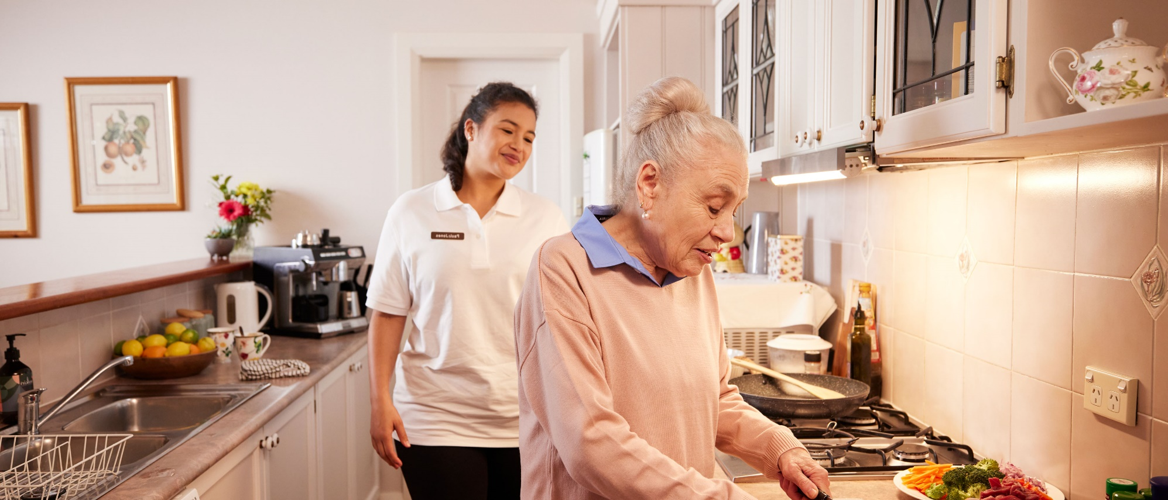


Disability Support for Older Australians Program and your aged care services

For clients

Reasons for an aged care assessment
An aged care assessment determines whether you are eligible to access aged care services, such as Support at Home services or residential aged care. Aged care assessments consider your physical, medical, mental, cultural, social, and wellness needs.
You should be made aware that undertaking an aged care assessment may have implications on your DSOA funding.

Contacting My Aged Care
When contacting My Aged Care, you or your DSOA Service Coordinator must clearly advise them that you are a DSOA client, and you must advise the aged care assessor which aged care services you would like to access. This is to prevent you from being found eligible for services that will impact your DSOA funding package.
My Aged Care assessors must be informed of:
- the services you are receiving under DSOA
- any unmet care needs
- and the sustainability of the current DSOA services provided to you.
Aged care assessors must also be informed of whether:
- you are wanting to access services that are not available under DSOA, or
- you want to access aged care services instead of DSOA.
You should only undertake an aged care assessment after considering the potential impact on your DSOA funding, or where you are considering a transition to aged care services instead of DSOA supports.
The DSOA Program cannot provide your DSOA Service Coordinator with information on your My Aged Care eligibility.
Your DSOA Service Coordinator must obtain your consent before contacting My Aged Care on your behalf.

Outcomes of an aged care assessment
If you are assessed as eligible for Support at Home services or residential aged care, your DSOA funding will be capped. DSOA clients with capped funding are not eligible to receive any new or additional supports or services through the DSOA Program, including through the Change of Needs process.
If you commence Support at Home services, or if you enter permanent residential aged care, you will be required to exit the DSOA Program from the date your aged care services commenced.

Accessing Aged Care services that commenced prior to 1 July 2021
If you commenced a Home Care Package or entered permanent residential aged care prior to 1 July 2021, you can continue to receive supports through the DSOA Program as a grandfathered service, however your DSOA funding will remain capped.
If at any time you commence Support at Home services that are at a higher level to your Home Care Package (that commenced prior to 1 July 2021), you will be required to exit the DSOA Program permanently.
If you commenced accessing Commonwealth Home Support Program (CHSP) services prior to 1 July 2021, you can continue to receive these CHSP services through a grandfathered arrangement, with no impact to your DSOA funding.

CHSP services DSOA clients CAN access
If you are found eligible for and access any of the below CHSP services, you can access these without it impacting your DSOA funding package:
- domestic assistance
- equipment and products
- hoarding and squalor assistance
- home adjustments
- home maintenance and repairs (including gardening)
- meals
- social support and community engagement
- therapeutic services for independent living
- transport
- Specialised Support Services (SSS).

CHSP services DSOA clients CANNOT access
As a DSOA client you cannot access any of the below CHSP services on or after 1 July 2021:
- allied health and therapy
- community cottage respite
- home or community general respite
- nursing care
- personal care.
If you are accessing any of the above CHSP services that commenced on or after 1 July 2021, you must relinquish these CHSP services through My Aged Care or exit the DSOA Program permanently.
If the relinquished services are still required to meet your disability support needs, you should discuss this with your DSOA Service Coordinator to determine if you are eligible to apply for additional funding through the DSOA Program.
If you are not eligible to apply for a Change of Need, they you will need to consider if you want to remain in the DSOA Program without these supports or receive all support through My Aged Care only.
In some instances, an Aged Care Assessment may recommend Residential Respite, the Restorative Care Pathway or Transition Care. You can access these services without it impacting your DSOA funding.


Phone 1800 200 422
(My Aged Care’s free call phone line)

Visit health.gov.au/aged-care-reforms
For translating and interpreting services, call 131 450 and ask for My Aged Care on 1800 200 422. To use the National Relay Service, visit nrschat.nrscall.gov.au/nrs or call 1800 555 660.

