
National evaluation of the Comprehensive Palliative Care in Aged Care Measure – Final Report
Australian Government, Department of Health, Disability and Ageing
21 April 2026

Nous Group acknowledges Aboriginal and Torres Strait Islander peoples as the First Australians and the Traditional Custodians
of Country throughout Australia. We pay our respect to Elders
past and present, who maintain their culture, Country and
spiritual connection to the land, sea and community.
This artwork was developed by Marcus Lee Design to reflect Nous Group’s Reconciliation Action Plan and our aspirations for respectful and productive engagement with Aboriginal and Torres Strait Islander peoples and communities

Disclaimer:
Nous Group (Nous) has prepared this report for the benefit of Australian Department of Health, Disability and Ageing (the Client).
The report should not be used or relied upon for any purpose other than as an expression of the conclusions and recommendations of Nous to the Client as to the matters within the scope of the report (Permitted Purpose). Nous and its officers and employees expressly disclaim any liability: (i) to any person other than the Client, and (ii) to the Client to the extent the report is used or relied upon for any purpose other than the Permitted Purpose.
© Nous Group
Nous has prepared the report with care and diligence. The conclusions and recommendations given by Nous in the report are given in good faith and in the reasonable belief that they are correct and not misleading. The report has been prepared by Nous based on information provided by the Client and by other persons. Nous has relied on that information and has not independently verified or audited that information.
Contents

Executive summary 1
Implementation of the measure 2
Models of Care 2
Outcomes: key findings against national outcomes and goals of the National Palliative Care Strategy 4
Interface issues 9
Funding mechanisms 10
Opportunities for the future 10
1 Introduction 12
1.1 Overview of the Measure 12
1.2 Purpose and scope of the national evaluation 12
1.3 Purpose of this report 13
2 Policy and operating context 14
2.1 Key reforms and initiatives in the aged care sector 14
2.2 Royal Commission into Aged Care Quality and Safety 16
2.3 Ongoing challenges in the aged care sector 17
3 Evaluation methodology 18
3.1 Evaluation approach 18
3.2 Methodology 18
3.3 Evaluation limitations 24
4 Evaluation findings 28
4.1 Implementation progress and lessons 29
4.2 Appropriateness of the Measure 41
4.3 Models of care implemented under the Measure 50
4.4 Assessment against national outcomes 61
4.5 Extent to which the Measure addresses interface issues 112
4.6 Effectiveness of joint funding and delivery arrangements 116
4.7 Observed changes in health service utilisation 128
5 Potential opportunities for future improvement 138
6 Glossary of key terms 151
Appendix A Key evaluation questions 155
Appendix B Detailed methodology 158
B.1 Evaluation methodology 158
B.2 Program theory 159
B.3 Data sources that informed this report 166
B.4 Consultation approach and sampling frame 171
B.5 Survey instrument and approach 173
B.6 Approach to estimate costs associated with impacts on health service utilisation 178
Appendix C Policy and operating context 183
Appendix D Total funding contributions for the Measure 190
Appendix E Assessment of delivery against responsibilities in the 2019-20 to 2023-24 Project Agreement 192
Appendix F National outcomes analysed in the Final Report 219
Appendix G Challenges and limitations of conducting a cost effectiveness analysis 225
G.1 Feasibility challenges of conducting a cost effectiveness analysis 225
G.2 Limiting factors relating to observed trends and associated costs and benefits 226
G.3 Lessons for future assessment of cost effectiveness 228

Executive summary
The Comprehensive Palliative Care in Aged Care (CPCiAC) Measure (the Measure) has been funded by a cost matched approach with the Australian Government and state and territory governments for eight years, through a National Partnership Agreement (NPA). The Measure involved a total commitment $147.2 million over an initial six-year investment and two-year extension, comprising of approximately $65.1 million from states and territories and $82.1 million committed from the Australian Government.
The Measure aims to help older Australians living in residential aged care who are nearing the end of their life. Its goals are to:
- improve palliative and end-of-life care for older people living in residential aged care
- further enable people to die where they want, supported by increased aged care services.
Nous Group (Nous) has conducted a mixed-methods, national evaluation of the Measure (from July 2020 to June 2025), drawing on state, territory and national datasets, and stakeholder input
The Evaluation Framework was designed with input from and approved by the Australian Government Department of Health, Disability and Ageing (the Department) and states and territories in 2021. The evaluation has a process, outcome and economic component, underpinned by eight key evaluation questions (KEQs) which guide data collection and synthesis, and inform the structure of this report. Ten national outcomes provide a consistent basis to assess the progress and impact of the Measure, grouped under goals of the National Palliative Care Strategy 2018.
This Final Report assesses the extent to which the Measure, as of May 2025, has achieved its aims and objectives. It outlines the activities implemented by states and territories, evidence related to the Measure’s successes, challenges, impacts on broader health service utilisation and future opportunities. The report draws on:
- Data specific to Measure-funded activities including quantitative and qualitative data collected directly from jurisdictions on their models of care, jurisdictional level evaluations and qualitative data collected through interviews with 116 stakeholders between September 2024 to May 2025, including jurisdictional health departments, specialist and generalist clinicians, Residential Aged Care Home (RACH) staff, pharmacists and peak bodies.
- Analysis of national data on health service utilisation and palliative care outcomes and resources – including a national survey of RACHs conducted by Nous (12 per cent response rate, N=337) (see Appendix B.5), and national data assets (including from the National Health Data Hub (NHDH), Palliative Care Outcomes Collaboration (PCOC), Medicare Benefits Schedule (MBS) and Pharmaceutical Benefits Scheme (PBS) data collections, data on compliance with the Aged Care Quality Standards and data on use of End of Life Directions for Aged Care (ELDAC) resources).

Implementation of the measure
Reach | Enablers | Barriers
- 1,652 RACHs impacted, representing 59 per cent of RACHs nationally.  - 55 projects funded and 69.2 additional full-time equivalent (FTEs) (as of 2025).  - Activities involved expanding existing models of care and piloting new projects. | - Collaboration across health and aged care sectors.  - Flexible funding to allow locally tailored approaches.  - Strong relationships between specialist services and RACHs.  - Central coordinating functions and effective governance. | - Staff shortages and high turnover continue to hinder service delivery, particularly in rural areas.  - Shorter than anticipated project timelines and funding delays have limited the effectiveness of service delivery.

Models of Care
Nous’s evaluation found the most effective models of care implemented under the Measure include:
- Specialist palliative care in-reach services: specialist palliative care services, implemented across all jurisdictions, have improved access to and the quality of palliative care for residents in RACHs through in-person and telehealth support. These services, involving medical specialists, clinical nurse consultants and nurse practitioners (NPs) providing in-reach care into RACHs, have enhanced end-of-life planning and collaboration among care teams, increased staff skills and confidence, and reduced hospital transfers and admissions.
- Palliative care needs rounds: needs rounds, implemented in the Australian Capital Territory (ACT), Tasmania, South Australia, Queensland, the Northern Territory and New South Wales (NSW), have effectively facilitated specialist palliative care support in RACHs. They enhance general practitioner (GP) engagement, improve coordination and relationships between RACH staff and specialists, lead to timely referrals, and bolster staff capability in identifying and responding to palliative care needs and enacting Advance Care Planning Documents (ACPDs).
- Culturally safe and appropriate models of care: culturally safe and appropriate models of care have been implemented in Victoria, Queensland, Western Australia and the Northern Territory. These models, when co-designed with community input and tailored to the local needs and communities, enhance engagement, improve the quality of care provided and lead to more culturally appropriate interventions.
- Education focused on palliative care: education focused on palliative care, implemented across all jurisdictions, has improved RACH staff confidence to recognise and respond to palliative care needs. Bedside and short-form education sessions have been found to be particularly effective, fostering greater engagement than long-form sessions and enabling staff to access specialist support more readily when needed.
- Multi-disciplinary teams: multidisciplinary teams (MDTs) implemented in Queensland, the ACT, Western Australia, the Northern Territory, NSW and Victoria, involved engaging or recruiting additional resources such as nurse liaisons, pharmacists and social workers, as well as nursing and primary care staff, GPs and specialists, to meet the holistic needs of residents. The use of NPs were consistently highlighted as useful due to their accessibility and prescribing ability.
- Care coordination resources: care coordination resources, implemented in Western Australia and Tasmania, have improved care integration, referral pathways and continuity of care by enhancing the connection between RACH residents, families and care teams. These roles, including nurse liaisons and care coordinators, streamline transitions between care settings, reduce hospital dependency, and support timely and appropriate palliative care delivery, ultimately facilitating better communication and care outcomes.
- Traineeships: traineeships in palliative care enhance workforce capacity and capability for high-quality palliative care delivery by accrediting clinical and non-clinical staff. Successful models include the GP registrar rotations in Tasmania and Eldercare traineeships in South Australia.
Success of these models were enabled by the following factors:
- Access to prescribers (for example, NPs or GPs)
- Adaptability to local contexts
- Staff capacity and availability
- Supportive leadership within RACHs
- A culture of education and collaboration within RACHs
- Strong relationships between specialists and RACH staff
- Open communication between families, carers and staff

Outcomes: key findings against national outcomes and goals of the National Palliative Care Strategy
National Palliative Care Strategy, Goal 1: Understanding – People understand the benefits of palliative care, know where and how to access services, and are involved in decisions about their own care.
Relevant outcomes | Key findings | Key statistics (among RACHs surveyed nationally in 2021 and 2025):
National outcome 1: More discussions focused on end-of-life care decision making between residents, families, carers, GPs  and specialist palliative care services including use of advance care planning.  National outcome 2: Improved access to information that informs end-of-life care decisions for residents and families. | - On a national level, advance care planning documents (ACPDs) are being completed earlier in RACHs and are being reviewed more frequently. In South Australia, end-of-life care planning has increased by 18 per cent and RACH staff have improved confidence to advocate for resident wishes and raise concerns.  - Measure-funded roles have enhanced communication and access to information for residents and families, supporting informed decisions in end-of-life care planning across various jurisdictions.  - Effective roles include liaison nurses in Western Australia, family support workers in Victoria, specialist NPs in the Northern Territory and specialist in-reach teams in the ACT and Tasmania. | - 66 per cent increase of number of residents with ACPDs on entry to the RACHs  - 20 per cent increase in the proportion of residents with ACPDs within three months of entry  - Eight per cent increase in ACPD reviews conducted every six months, between 2021 to 2025.  The above data points are presented in Figure 2 on page 61 and Figure 3 on page 62.

National Palliative Care Strategy, Goal 2: Capability – Knowledge and practice of palliative care is embedded in all care settings.
Relevant outcomes | Key findings | Key statistics (among RACHs surveyed nationally in 2021 and 2025):
National outcome 3: A higher proportion of clinical and non-clinical staff in RACHs have skills and confidence appropriate to their roles to recognise and respond to the holistic palliative care needs of residents, in a culturally safe way. | - There is evidence that RACH staff are completing training in palliative and end-of-life care more frequently. They have improved confidence due to better access to specialists, after-hours support and targeted education.  - Short-form or bedside education sessions engage RACH staff more consistently than longer, formal programs.  - App-based resources offer on-demand access to clinically relevant information, with a growing demand for palliative care education.  - The transient nature of the RACH workforce presents a challenge to workforce capability and the assessment of long-term outcomes.  - Education programs could be improved through enhanced navigability, tailored content and considering the diverse backgrounds of the workforce. | - 113 per cent increase in the proportion of RACHs where staff participate in palliative or end-of-life care training twice per year or more, between 2021 to 2025.  - 12 per cent decrease in the proportion of RACHs where staff participate in training once per year or less, between 2021 to 2025.  The above data points are presented in Figure 4 on page 72.

National Palliative Care Strategy, Goal 3: Access and choice – People affected by life-limiting illnesses receive care that matches their needs and preferences.
Relevant outcomes | Key findings | Key statistics (among RACHs surveyed nationally in 2021 and 2025):
National outcome 4: Improved access to quality palliative care in RACHs.  National outcome 5: Improved quality of palliative care provided in RACHs. | - Nationally, there has been an increase in the number of in-reach specialist palliative care providers reporting into PCOC. RACHs report significant increase in access to palliative care services, with particularly strong improvement in regional and remote areas.  - Based on analysis of national PBS data, there has been a significant increase in the prescription of palliative care medication in RACHs.  - Nationally, between 2018-19 to 2021-22, there were fewer emergency department (ED) presentations (2 percentage point decrease) and shorter hospital admissions for palliative care related hospital stays for RACH residents (1 percentage point decrease in palliative care overnight admissions).  - There is mixed evidence on improved symptom management, although, the ACT, Victoria and Tasmania highlighted examples of improved symptom management.  - Bereavement support for families and carers, access to specialist clinicians and GPs in certain regions, and workforce issues continue to be key gaps unaddressed by the Measure. | - 282 per cent increase in palliative care medication items dispensed under the PBS in RACHs, between 2018-19 to 2023-24.  - 47 per cent increase in the proportion of RACH residents accessing palliative care services between 2014-19 to 2017-22.  - 27 per cent increase in the proportion of RACHs in regional and remote areas that reported having access to specialist palliative care services, between 2021 to 2025.  The above data points are presented in Figure 6 on page 76 and Figure 8 on page 77.
National outcome 6: Greater resident choice in palliative care. | - RACHs reported better documentation of residents’ end-of-life wishes as a result of Measure-funded activities, with evidence this has led to an improved ability to fulfill the cultural and psychosocial needs of residents.  - RACHs are more frequently documenting residents' preferred place of death and a growing number of residents are dying in their chosen location. Evidence indicates that this preferred location is increasingly the RACH itself. | - 40 per cent increase in the proportion of RACHs that report they have recorded preferred place of death for residents, between 2018-19 to 2023-24.  The data points above are presented in Figure 15 on page 89.

National Palliative Care Strategy, Goal 4: Collaboration – Everyone works together to create a consistent experience of palliative care across care settings.
Relevant outcomes | Key findings | Key statistics (among RACHs surveyed nationally in 2021 and 2025):
National outcome 7: Improved care coordination with GPs/primary care, acute care services and specialist palliative care services.  National outcome 8: Improved integration between the health and aged care systems. | - Measure-funded roles with a care-coordination function have improved care integration, referral pathways and continuity of care.  - The Measure has facilitated stronger relationships between specialist providers and RACHs, with examples of good practice in Queensland, NSW, the Northern Territory and Tasmania. However, this can often be dependant on individual relationships.  - Remote areas report improved access to GPs and targeted efforts where GP engagement was a focus, such as in WA, have led to an increase in multidisciplinary case conferences.  - Nationally, despite increased prescriber activity, the number of GP-led multidisciplinary meetings and resident participation have declined, though analysis of MBS data does not capture all possible item codes for meetings.  - Clinician access to digital systems enables integration across health and aged care sectors. | - 114 per cent increase in the proportion of RACH residents accessing palliative care services through GPs based on RACH survey results between 2021 to 2025.  - 59 per cent increase in the proportion of RACH residents accessing palliative care within one month of attending a multi-disciplinary meeting, between 2021 to 2025.  The data points above are presented in Figure 18 on page 94 and Figure 20 on page 96.

National Palliative Care Strategy, Goal 6: Data and evidence – Robust national data and a strong research agenda strengthen and improve palliative care.
Relevant outcomes | Key findings | Key statistics (among RACHs surveyed nationally in 2021 and 2025):
National outcome 9: More palliative care services and health planners are informed by performance information on appropriateness, effectiveness, efficiency and outcomes.  National outcome 10: Improved clinical governance to identify and implement quality improvement initiatives and evaluation of outcomes within RACHs. | - Specialist palliative care services reporting to PCOC rose 32 per cent (from 57 in 2021 to 75 in 2024), showing growing commitment to outcome data collection.  - Use of performance tools like ELDAC’s after-death audits is increasing but remains inconsistent across RACHs; regular audit use rose from 33.1 per cent in 2021 to 38.9 per cent in 2025.  - Data on palliative care delivery and outcomes remains fragmented due to inconsistent practices and lack of centralised reporting.  - Dedicated roles, governance structures and communities of practice (CoPs) are improving knowledge sharing, clinical governance and quality improvement – particularly in Queensland, Western Australia and Tasmania.  - Opportunities exist to strengthen collaboration with PHNs and peak bodies to share best practices across health and aged care sectors.  - Compliance with governance related Aged Care Quality Standards remains weaker than for other standards. | - 84 per cent increase in the proportion RACHs surveyed that use a digital dashboard or tool to monitor palliative care, between 2021 to 2025.  - 17 per cent increase in the proportion of RACHs surveyed that “always” use an after-death audit such as ELDAC, between 2021 to 2025. Similarly, there was a 25 per cent decrease in the number of surveyed RACHs that “never” used an after-death audit.  The data points above are presented in Figure 21 and Figure 22 on page 101.

Interface issues
There is progress towards interface issues being addressed:
- Measure-funded activities are effectively addressing many health system interface issues, leading to improved access to generalist and specialist palliative care for RACH residents.
- Care coordination and navigation roles improve integration, referral pathways and continuity of care. GPs, specialist clinicians and RACH staff are collaborating effectively through needs rounds, improving coordination and navigation within the health and aged care system.
- There is some evidence from local evaluations that Measure-funded activities have led to reductions in unnecessary transfers to hospital in some states, particularly in Queensland and South Australia.
However, barriers continue to exist:
- GP involvement is valuable, but their availability remains variable – often affecting the timely prescription of medication.
- There is an opportunity to improve collaboration with Primary Health Networks (PHNs) in some jurisdictions.
- Culture and processes within RACHs do not reflect palliative care as a core business activity.

Funding mechanisms
- Despite implementation delays, due to initial agreement negotiations, program design timelines and the COVID-19 pandemic, cost-sharing approach between the Australian and state and territory governments has been an effective mechanism to facilitate joint investment and responsibility for palliative care in RACHs.
- All jurisdictions have financially contributed, allowing enhanced collaboration among health and aged care sectors, involving GPs, specialist clinicians and RACH staff to improve care delivery and integration.
- Flexible funding has allowed adaptation of models to local needs, such as in the devolved approaches taken in NSW and Queensland, with some regions establishing effective governance to support activities.
- Further improving the consistency of information captured and reported would provide a stronger evidence base for assessing the performance and outcomes of funded projects. Some potential comparable measures include avoidable ED visits, deaths in RACHs and ACPD completions.

Opportunities for the future
Domains | Focus
Funding and commissioning | Ensure funding is directed to embed palliative care in residential aged care, including options for more sustainable funding and consider lessons learned from the CPCiAC Measure.
Service delivery | Facilitate aged care residents’ improved access to quality generalist and specialist palliative care by strengthening collaboration across the health and aged care sectors, improving clinical governance arrangements and leveraging the successes of specific models of care.
Leadership and culture; workforce capacity | Embed palliative care into core business for RACHs across Australia by uplifting the baseline education and skills of the aged care workforce to be better equipped to deliver palliative and end-of-life care.
Data and evidence; Digital systems and information sharing | Increase visibility of palliative care provision in residential aged care through improved data collection, monitoring and evaluation to enable informed decision-making.

Introduction
This section describes the Measure and the purpose and scope of the national evaluation.

Overview of the Measure
The CPCiAC Measure has been funded by the Australian Government and the states and territories for eight years. The Measure is supported through 50:50 matched funding executed through National Partnership Agreements (NPAs) between the Australian Government and all states and territories.
The Measure aims to help older Australians living in residential aged care who are nearing the end of their life. Its goals are to:
- improve palliative and end-of-life care for older people living in residential aged care
- further enable people to die where they want, supported by increased aged care services.
States and territories design and implement initiatives suited to local needs, with a focus on:
- in-reach models of care, that include assessments to establish residents’ palliative care needs
- models that support end-of-life care decision making that aim to deliver quality, person-centred care to dying residents through the development of agreed goals of care
- education and training initiatives, that aim to build the capacity of the RACH workforce and other clinicians involved in the delivery of care to residents of RACHs.

Purpose and scope of the national evaluation
Nous was engaged by the Department to undertake a national evaluation of the Measure from July 2020 to June 2025. The evaluation sought to:
- determine the extent to which the aims of the Measure had been achieved
- contribute to the national evidence base and inform policy decisions about palliative care in aged care, including best practice models of care.
The evaluation objectives were to:
- assess implementation, appropriateness, effectiveness and cost-effectiveness of the Measure
- measure and analyse the impact of state and territory activities in relation to the Measure’s objectives
- identify the barriers and enablers to achieving the intended outcomes
- assess the effectiveness of the governance model of the Measure
- identify issues to inform future priorities, consider demographics, and health and aged care reforms
- analyse the achievements of the program in relation to the National Palliative Care Strategy
- develop recommendations to inform palliative care policy development.
An overview of the key evaluation questions for the evaluation are provided in Appendix A, and a detailed description of the evaluation methodology is provided in Section 3 and Appendix B.
The national evaluation did not:
- Rigorously evaluate individual models of care implemented by the states and territories or local health networks. Some jurisdictions are undertaking local evaluations of their activities, which the national evaluation has drawn on.
- Evaluate palliative care activities in residential aged care settings that are not funded under the Measure. For example, if an in-reach service is expanded under the Measure, then expansion activities only will be considered in this evaluation.
- Compare palliative care related outcomes across states and territories.

Purpose of this report
This Final Report provides the final assessment of implementation and effectiveness of the Measure to May 2025, since the Interim Report delivered in 2024, the Mid-point Report delivered in 2022 and the Baseline Report in 2021. All reports are available on the Department’s website: https://www.health.gov.au/our-work/comprehensive-palliative-care-in-aged-care-measure .
This Final Report intends to inform future policy and funding decisions relating to the Measure, currently funded until June 2026, and more generally, related to the delivery of palliative care services in residential aged care. This report structures findings against the KEQs summarised in section 2.2 and provided in detail in Appendix A. It provides:
- an assessment of the impact of policy and operating context on implementation of the Measure,
- updated evaluation findings on:
  - activities being delivered in each state and territory as of May 2025,
  - whether the Measure is being implemented as planned and lessons from implementation to date,
  - the extent to which it is appropriate to meeting the needs of residents, families and carers,
  - the effectiveness of the joint funding and delivery arrangements,
  - alignment to the National Palliative Care Strategy,
  - the emerging success of models of care (based on available data at this stage).

Policy and operating context

Key reforms and initiatives in the aged care sector
The Measure was introduced amongst significant reforms within the health and aged care sectors (Figure 1). Reforms have aimed to enhance access, quality and coordination of palliative care, ensure equitable funding for aged care services, and improve workforce capability and support. These reforms are summarised below and described in further detail in Appendix C.
Figure 1 | Timeline of reforms within the health and aged care sectors
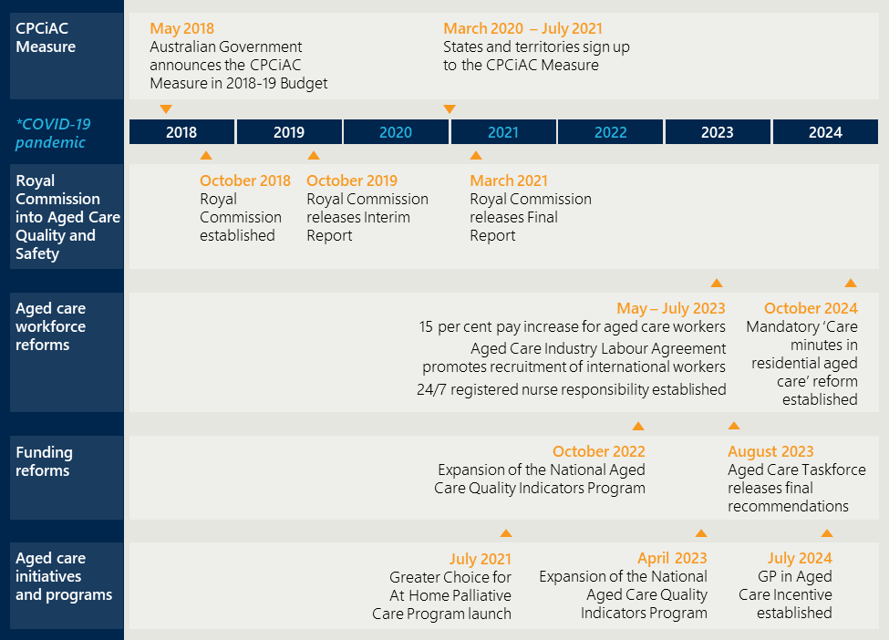
Reforms to enhance access, quality and coordination of palliative care include:
- Implementation of the Greater Choice for At Home Palliative Care (GCfAHPC) Program across all PHNs nationally, which aims to increase access to quality palliative care at home, and in the community, fostering early identification of care needs and improving service coordination.
- Expansion of the National Aged Care Mandatory Quality Indicators program (QI Program) which aims for continuous quality improvement and evidence-based decision-making.
- Strengthened Aged Care Quality Standards were developed and came into effect on 1st November 2025. These new Quality Standards include outcomes specific to palliative care and end-of-life care in aged care.
- The introduction of the new Support at Home Program to replace the Home Care Package Program and Short-term Restorative Care Program.
- Labour market reforms to address workforce shortages and improve care quality through migration pathways, wage increases, mandatory Registered Nurse (RN) presence and educational initiatives. These include:
  - the introduction of the Aged Care Industry Labour Agreement.
  - additional commitments to increase award wage increases for aged care workers.,
  - 24/7 RN responsibility requiring at least one RN on-site at all times.
  - the introduction of the ‘Care minutes in residential aged care’ reform which stipulates a minimum requirement for RACHs of 215 minutes of care to each resident daily, including time with an RN.
  - increased protections for aged care workers through expanded whistleblower protections.
Reforms to improve workforce capability and support include:
- Ongoing delivery of multiple education pathways aiming to attract, train and retain nurses in the aged care sector including the Aged Care Transition to Practice Program, the Aged Care Nursing Clinical Placement Program and the Aged Care Nursing Scholarships (ACNS).
- National education and training programs for the aged care workforce, including the Program of Experience in the Palliative Approach (PEPA)/Indigenous Program of Experience in the Palliative Approach and ELDAC.
- In May 2023, the Australian Government committed $53 million to continue funding for a suite of national palliative care projects with a focus on workforce education and training, building awareness of palliative care and end-of-life planning, quality improvement for care providers and increasing access to support in rural and regional areas.
Reforms to ensure equitable funding for aged care services include:
- Implementation of the Australian National Aged Care Classification (AN-ACC) funding model which seeks to ensure equitable funding based on individual resident needs, with considerations for regional and specialised requirements.
- Recommendations from the Aged Care Taskforce and the subsequent agreement by the Australian Government to remain the majority funder of aged care services (related to Recommendation two).

Royal Commission into Aged Care Quality and Safety
Recommended potential reforms identified through the Royal Commission into Aged Care Quality and Safety (the Royal Commission) are outlined in detail in the Aged Care Reform Roadmap. Many activities and outcomes delivered under the Measure respond to these reforms to varying degrees across each state and territory, which provide vital context to the evaluation findings in section 4.
Recommendations from the Royal Commission and the Measure
The recommendations from the Royal Commission address several key areas that intersect with the objectives of the Measure. These include:
- Quality of palliative care delivered in RACHs, including through staff capacity, processes and clinical governance (Recommendation 19). Addressed in section 4.4.
- Access to specialist palliative care including MDTs and a specific focus on specialist palliative care outreach services (Recommendations 58 and 70). Addressed in sections 4.3 and 4.4.
- Education and training for the RACH workforce and GPs (Recommendations 79, 80 and 114). Addressed in sections 4.3 and 4.4.
- Responsibilities across the Australian and state and territory governments for the delivery of specialist palliative care in aged care (Recommendation 69). Addressed in section 4.6.

Ongoing challenges in the aged care sector
Over the past decade, there has been an increase in Australians using residential and home care services, accompanied by a rise in the complexity of care required for aged care residents. The demand for palliative care is growing and expected to double by 2050. Workforce challenges in the aged care sector persist, exacerbated by high turnover, shortages and skill gaps, particularly in palliative care. The COVID-19 pandemic further stressed this sector, leading to increased burnout and workforce attrition. Despite recent government initiatives to bolster the nursing workforce, significant issues remain, especially given the ongoing occurrence of COVID-19 outbreaks in aged care homes.
Further detail on these challenges is provided in Appendix C.

Evaluation methodology
This section outlines the evaluation approach, the methodology and limitations of the evaluation.

Evaluation approach
The Evaluation Framework, developed with input from and approved by the Department and states and territories in 2021, outlines the methodology for the national evaluation. A program theory articulates how the Measure is intended to achieve its goals and underpins the evaluation. It is comprised of a theory of change and a program logic (provided in section 4).
The evaluation has three components:
- Process component. This examines the process of implementation and delivery of the Measure, including the effectiveness of joint funding and delivery arrangements between the Australian Government and states and territories. Updated findings for this component are provided in section 4.
- Outcome component. This examines the extent to which intended outcomes and goals were achieved. The Evaluation Framework identified ten national outcomes by which to assess progress towards goals. These are listed in Table 1 and an updated and final assessment against the national outcomes is provided in section 4.3.
- Economic component. This originally aimed to examine the cost-effectiveness of the Measure. Based on data limitations, a robust cost-effectiveness analysis was not possible. Section 4.7 provides a summary of observable trends in health service utilisation over the period of the Measure’s implementation, the cost changes associated with these and whether these trends align or conflict with what would be expected if the Measure has achieved its objectives.

Methodology
Eight KEQs structure the evaluation, which were addressed using a mixed-methods approach to collecting data and synthesising insights from a range of quantitative and qualitative data sources. Further information on detailed:
- research questions aligned to each KEQ are provided in Appendix A
- detailed methodology for the evaluation is described in Appendix B.
The KEQs described below were designed to address the three components of the evaluation: process, outcome and economic.
- Has the Measure been implemented as planned and what are the implementation lessons from the Measure?
- How appropriate is the Measure to meet the needs of residents, families and carers in the RACH setting?
- How effective have the joint funding and delivery arrangements been for implementing and achieving the aims of the Measure? How could governance arrangements be more effective?
- To what extent has the Measure achieved its intended outcomes?
- How cost-effective is the Measure?
- Is there a specific model of care that has been implemented that has proven to be more successful than others?
- How well does the Measure align and contribute to the National Palliative Care Strategy? Are there opportunities for improvement?
- Does the Measure and the models adopted in each jurisdiction help to address health system interface issues?
To address KEQ 4. To what extent has the Measure achieved its intended outcomes? ten national outcomes were developed to provide a consistent basis to measure the progress and impact of the Measure. Table 1 presents the national outcomes, grouped under goals of the National Palliative Care Strategy., Table 1 provides more detail on indicators to measure these outcomes. Section 4.4 provides a detailed assessment of findings against each outcome.

Table 1 | National outcomes for the Measure and alignment to the goals of the National Palliative Care Strategy (NPCS)
Relevant NPCS goal | Outcome description | Indicators
Goal 1: Understanding | Outcome 1: More discussions focused on end-of-life care decision making between residents, families, carers, GPs and specialist palliative care services including use of ACPDs. | - Increased proportion of RACH residents with ACPDs (for example, Advance Care Directives (ACDs)).  - Increased RACH compliance with the Aged Care Quality and Safety Standards (2b, 2c, 3c).  - Increased effectiveness and use of ACPDs (for example, ACDs) within RACHs.  - Increased frequency of ACPD review.
Goal 1: Understanding | Outcome 2: Improved access to information that informs end-of-life care decisions for residents and families. | - Increased RACH compliance with the Aged Care Quality and Safety Standards (1c).  - Increase in the proportion of RACH residents attending multidisciplinary case conferences.  - Increased resident, family and carer access to information on end-of-life care.  - Increased use of routine processes to record residents’ end-of-life wishes.
Goal 2: Capability | Outcome 3: A higher proportion of clinical and non-clinical staff in RACHs have skills and confidence appropriate to their roles to recognise and respond to the holistic palliative care needs of residents, in a culturally safe way. | - Increased number of RACHs that have a policy in place and monitored to ensure that all staff (including casuals) uptake available training/education opportunities to improve their understanding of palliative care.  - Increased completions of accredited courses related to palliative care.  - Increased proportion of staff that attend palliative care training.
Goal 3: Access and choice | Outcome 4: Improved access to quality palliative care in RACHs, including:  - increased use of assessments to establish residents’ palliative care needs  - decreased health service use related to futile or non-beneficial treatments and inpatient bed days  decreased healthcare expenditure arising from decreased service use. | - Increased number of RACH residents who receive palliative care through a service participating in the PCOC.  - Increased number of RACHs that access palliative care provided by state/territory specialist services.  - Increased number of RACH residents that access palliative care services.  - Increased number of RACH residents that are dispensed with medicines associated with palliative care.  - Increased number of Multidisciplinary Case Conferences by Medical Practitioners (Other Than Specialist or Consultant Physician) – (MBS items 735 to 758) in RACHs.  - A decrease in the number of RACH residents who presented to ED.  - A decrease in the number of RACH residents admitted to an acute care facility for palliative care.  - A decrease in the number of inpatient bed days related to palliative care.  - Increased number of providers/RACHs participating in the PCOC.
Goal 3: Access and choice | Outcome 5: Improved quality of palliative care provided in RACHs, including:  - reduced symptom burden  - improved quality of life for residents during the period they access palliative care  better experience of death and dying for residents, families/carers and staff, including meeting physical, psychosocial, cultural and spiritual needs. | - Increased number of providers/RACHs participating in the PCOC.  - Increased number of RACH residents who receive palliative care through a service participating in the PCOC.  - Improved resident experience of dying reported by family/carers.  - Increased proportion that met PCOC symptom benchmarks.  - Increased proportion of RACHs that have policies to ensure resident’s spiritual and cultural end-of-life wishes are met.  - Increased RACH compliance with the Aged Care Quality and Safety Standards 1(3)(a).  - Decreased number of complaints received by the Aged Care Quality and Safety Commission (ACQSC) from residents and families related to palliative care.
Goal 3: Access and choice | Outcome 6: Greater patient choice in palliative care, including:  - more people dying where they want  increased person-centred care informed by an individual’s choice. | - Increased proportion of RACH residents with ACPDs (for example, ACDs).  - Increased effectiveness and use of ACPDs (for example ACDs) within RACHs.  - Increased RACH compliance with the Aged Care Quality and Safety Standards (1c, 2b, 2c, 3c).  - Decreased number of RACH residents dying in an acute care setting (for example, hospital).  - Decreased number of RACH residents admitted to an acute care facility for palliative care.  - Increased number of RACHs that recorded place of death.  - Increased proportion of residents that died in RACH.
Goal 4: Collaboration | Outcome 7: Improved care coordination with GPs/primary care, acute care services and specialist palliative care services. | - Increase in the proportion of RACH residents attending multidisciplinary case conferences and number of multidisciplinary meetings run.  - Increase in access to specialist palliative care through GPs.
Goal 4: Collaboration | Outcome 8: Improved integration between the health and aged care systems. | - A decrease in the number of RACH residents who presented to EDs.  - A decrease in the number of RACH residents admitted to an acute care facility for palliative care.  - A decrease in the number of inpatient bed days related to palliative care.
Goal 6: Data and evidence | Outcome 9: More palliative care services and health planners are informed by performance information on appropriateness, effectiveness, efficiency and outcomes. | - Increase in RACHs that use an audit process to look at end-of-life care (for example, an after-death audit).  - Increased number of providers/RACHs participating in the PCOC.  - Increase in the RACHs that use a digital dashboard or monitoring tool.
 | Outcome 10: Improved clinical governance to identify and implement quality improvement initiatives and evaluation of outcomes within RACHs. | - Increased number of RACHs that implement quality improvement activities to improve palliative care.  - Decreased number of complaints received by the ACQSC from residents and families related to palliative care.  - Increased RACH compliance with the Aged Care Quality and Safety Standards (8c-e).  - Increased number of RACHs that have palliative care specific policies and procedures in place.

Overview of evaluation data sources
This report draws on a range of qualitative and quantitative inputs to provide a final assessment of the implementation and effectiveness of the Measure. It builds on the findings presented in the Interim Report, with the addition of updated national linked data to inform the quantitative assessment of outcomes (described in further detail in section 4.4). An overview of evaluation data sources is provided in Table 2. Further detail on individual data sources, their inclusions and limitations are detailed in Appendix B.3.
Table 2 | Overview of evaluation methods and data sources for the final report
Type of analysis | Data sources
Thematic analysis of qualitative insights | - Consultation with 116 stakeholders including state and territory policy leads (in September 2024) and RACH staff, specialist and generalist clinicians, PHNs, pharmacists and peak bodies between February and May 2025.  - Implementation updates and milestone reports from states and territories.
Quantitative analysis (including economic trends analysis) | - National linked data extracts from the NHDH formerly the National Integrated Health Services Information-Analysis Asset (NIHSI-AA), from 2018-19 and 2021-22.  - MBS and PBS data for palliative care-related items, covering the period 2013-14 to 2023-24.  - Comparative analysis of a national survey to RACHs conducted over March to April 2025 and a baseline survey conducted in 2021.  - National quantitative datasets related to palliative care, including from the ELDAC, PCOC and ACQSC.

Evaluation limitations
The findings presented in this report should be read with the following caveats in mind, given the differences in activities implemented across jurisdictions and broader operational and strategic context of the Measure. The key limitations to the evaluation are described below, with more detail specific to the limitations of each data source outlined in Appendix B.3.
Outcomes observed cannot be solely attributed to the activities delivered under the Measure
A causal link between Measure activities and observed outcomes cannot be established, given the variation in projects delivered under the Measure, and the extent to which individual RACHs or residents are ‘impacted’. Progress against evaluation outcomes likely reflects the cumulative impact of many initiatives within the Measure’s broader context (described in Appendix C in further detail).
This is particularly the case in jurisdictions where the Measure funding only partially supports certain roles or activities, supplemented by other funding sources. For instance, in the Top End of the Northern Territory, the Measure funded less than one FTE NP role (from 2020-21 to 2023-24), with additional funding from various streams, making it impossible to attribute outcomes to any single initiative.
The NHDH is limited in the timeliness and coverage of linked data
- Timeliness | The latest NHDH data available is from July 2021 to June 2022, leaving nearly three years of Measure implementation unobserved in the dataset. COVID-19 caused significant delays in Measure activities from 2020 to 2022. To address this lag, Nous supplemented NHDH data with MBS and PBS data up to June 2024. While this identifies numbers of RACH residents, it is not linked to hospital, aged care, or other relevant datasets.
- Coverage | NHDH data does not cover all hospital services. It includes public hospital data from NSW, Victoria, Queensland, SA, Tasmania and the ACT (2010-11 to 2021-22), and private hospital data (where available) from Victoria, Queensland and the ACT for the same period. The NHDH excludes data on community palliative care services and relevant MBS items that may relate to palliative care delivery. Available extracts included aggregate data for 2018-19 and 2021-22. Linked data for the years 2019-20 and 2020-21 was unavailable, limiting the number of data points by which to observe trends over time.
The data cannot be used to identify the RACHs or residents that were directly impacted by the Measure and those that were not (that is, as a “control” group). It can only indicate broad, system-level trends in the use of health services relating to palliative care.
The evaluation draws insights from a patchwork of qualitative and quantitative data sources as there is no one comprehensive data source available to the evaluation
Data available to the evaluation is imperfect and does not provide a complete picture of palliative care service delivery. Key challenges with the data available to the evaluation include:
- Data relating to community-based palliative care activity is not included in the NHDH.
- MBS data available to the evaluation does not include all possible items that may be billed relating to palliative care delivery (see above).
- PBS data captures prescription activity but cannot provide insight into the administration of prescribed medications relating to palliative care.
- PCOC data includes activity from a subset of palliative care services that provide in-reach care into RACHs, which does not provide a complete view of palliative care activity. As of 2023, 61 specialist in-reach services reported to PCOC.
- National quantitative datasets available to the evaluation (for example, MBS and PBS, ACQSC, ELDAC, PCOC), provide a holistic view of the broader palliative care landscape, education and service use but cannot be used to identify RACHs directly impacted by Measure activities.
- Responses to the RACH survey, initially designed to fill data gaps, do not represent all RACHs. Further, responses to the survey may be biased towards facilities who are more mature in their delivery of palliative care.
- There is a lack of nationally standardised data related to palliative care to monitor and assess palliative care services and outcomes. This has made it challenging to conduct a national, quantitative assessment of the effectiveness of Measure-funded activities. To address this, Nous introduced tailored quantitative and qualitative data collection methods across jurisdictions, but the comprehensiveness of responses was varied.
Stakeholder consultation, qualitative data collection from jurisdictions and jurisdictional level evaluations (where completed) were the only source of insights directly related to the Measure
Due to the inability to identify RACHs or individual residents impacted by the Measure through the national quantitative datasets, the evaluation relied on stakeholder engagement and qualitative data collection templates to understand the direct impacts of the Measure. In the 2024-25 reporting period to inform this Final Report, Nous consulted 116 stakeholders including RACH staff, specialist and generalist palliative care providers, PHNs, peak bodies, jurisdiction policy leads and pharmacists, with representation across all jurisdictions and remoteness levels (for RACH staff).
Stakeholder consultations explored the Measure’s impact on access to, and quality of, palliative care for residents and the extent to which they could be attributed to the Measure. Discussions covered access to quality care and end-of-life decision-making for residents, support for families, and education and clinical support for staff. Consultations also discussed the successes of models of care, ongoing operational barriers and future opportunities to further strengthen the delivery of palliative care in residential aged care.
Variation across states and territories creates challenges for understanding the national impact of the Measure
There is significant variation across states and territories that creates barriers to evaluating the impacts of the Measure and measuring success on a national level. Areas of variation include:
- Implementation activities and timelines | Implementation progress and impact varied across jurisdictions due to differences in the dates that each jurisdiction officially “signed up” to the Measure, the extent of COVID-19 disruptions over 2020 to 2022 and differences in approaches. Some jurisdictions focused on designing new programs with Measure funding, while others built on existing services.
- Models of care | Variation in the models of care implemented across jurisdictions and the degree of investment into each model results in different definitions for success.
- Data collection | Inconsistent data collection processes and definitions across jurisdictions, and the organisations delivering the activities under the Measure, means that the degree of coverage and understanding of the Measures impact in each jurisdiction is varied. Although some jurisdictions (Queensland, South Australia, Western Australia and the ACT) have completed formal evaluations, the focus and type of data reported in these is inconsistent. For example, Queensland is the only local evaluation that has explicitly provided a cost savings component, while Western Australia’s evaluation focuses on qualitative experiences of staff, residents and families.
- Engagement with the national evaluation | While the evaluation is taking a national view of the Measure’s impact, engagement with the evaluation varied across jurisdictions. Evidence presented in section 4 may reflect this variation.
The national evaluation uses secondary data to understand the input from families and carers
Families and carers of residents are unlikely to be able to comment on changes in palliative care in RACHs over time nor be aware of which of their interactions with facilities were activities funded by the Measure. The evaluation draws on local state or territory evaluations that may engage families and/or carers, for example, Western Australia’s deep dive evaluation. It also involves engagement with clinicians, practitioners and peak bodies who may be better placed to observe changes in palliative care due to the Measure over time and provide updated insights into the needs of residents, families and carers (detailed in Appendix B.4).

Evaluation findings
This section includes final evaluation findings relating to:
- progress in implementing the Measure and lessons from implementation (section 4.1)
- the appropriateness of the Measure in meeting the needs of residents, families, carers and staff (section 4.2)
- the success of models of care implemented across states and territories (section 4.3)
- final assessment against the national outcomes for the Measure (section 4.4)
- the extent to which the Measure addresses interface issues between health and aged care (section 4.5)
- the effectiveness of joint funding and delivery arrangements (section 4.6)
- broader changes in health service utilisation (section 4.7).
The findings in this section respond to each of the KEQs outlined in the Evaluation Framework and in Section 3 above.
Table 12 in Appendix B.2 maps the KEQs to different elements of the Measure (articulated in the program logic) and where each KEQ is addressed in this section of the report.

Implementation progress and lessons
Key findings:
This section relates to findings under KEQ 1: Has the Measure been implemented as planned and what are the implementation lessons from the Measure?
- The Measure has funded 55 projects and has reached over 1,652 RACHs, and funded an average of 75 FTE per year between 2022 and 2024.
- Implementation has been enabled by collaboration across the health and aged sectors, flexible funding and governance support.
- Devolved models work best when supported by a central coordinating function that ensures consistency and addresses variations in service delivery.
- Implementation plans have evolved in some jurisdictions largely in response to workforce restraints due to aged care workforce shortages, high turnover and difficulty with recruitment.
- Staff shortages and high turnover continue to hinder service delivery and sustainability, especially in remote areas.

Delivery against Project Agreement responsibilities
The Project Agreement outlined responsibilities for the Australian Government, states and territories
The 2019-20 Project Agreements were developed in consultation with state and territory governments, outlining the Measure aims, financial arrangements and responsibilities of governments. States and territories had unique funding arrangements, planned projects, and outputs and reporting milestones.
During the data collection period for this Final Report, the Project Agreements expired in June 2024 and new Project Agreements were re-negotiated and established with jurisdictions to extend the Measure’s funding until June 2026. At the time of reporting, six jurisdictions have signed the new Project Agreements, all jurisdictions had executed 2024-25 – 2025-26 Agreements in place by June 2025. Variations in the new Project Agreements are discussed in section 4.6.
All jurisdictions have been delivering on the Project Agreement responsibilities to date
The Australian Government and states and territories delivered on responsibilities in the original Project Agreement (2019-20 to 2023-24). A high-level assessment of the delivery against responsibilities by the Australian Government and states and territories is outlined in Table 22, Appendix E.
All states and territories are working towards delivering project outputs set out in the re-negotiated new Project Agreement Schedules (2024-25 to 2025-26). The new Schedules include more specificity on the Measure-funded activities set out as project outputs. These new activities build on the success of models and programs funded under the original Project Agreement (2019-20 to 2023-24). Due to the different models and programs being implemented in each jurisdiction, the project outputs, performance milestones and reporting commitments vary. Further detail is provided in section 4.6.
At this stage, the Measure has funded 55 projects and has reached over 1,652 RACHs
The number of RACHs reached by the Measure (1,652) represents 59 per cent of all RACHs in Australia (2,800 services at 30 June 2024). The extent to which a RACH is “reached” under Measure funded activities varies from light-touch access to educational resources through to more significant changes such as increased access to specialist palliative care in-reach services and/or implementing a new model of care. It is important to note that the Measure was not intended to reach all RACHs across all jurisdictions. This variation, and the fact the Measure has only reached 59 per cent of all RACHs, is important context in which to consider these evaluation findings and trends observed in data during the period of the Measure’s implementation.
As of July 2024 (the final data collection period of the evaluations), the Measure funded 69.2 FTE. As illustrated below, the number of FTE funded by the Measure has varied each year (Table 3). This is due to a range of factors including the activities funding, recruitment and staffing challenges or delays, and funding availability (for example, some activities were paused prior to the Measure funding extension due to uncertainty of funds).
Table 3 | Number of FTE funded by the Measure at the time of each evaluation report
Point in time | 2022  (as noted in Mid-point Evaluation Report) | 2023  (as noted in Interim Evaluation Report) | 2025  (as noted in Final Evaluation Report)
Total FTE funded through the Measure (nationally) | 57 FTE | 99 FTE | 69.2 FTE

Overview of state and territory implementation activities
All states and territories consulted in 2024 and 2025 reported ongoing implementation progress of CPCiAC activities. Detail on approaches being implemented in each jurisdiction is provided below.
Note that the ‘contributed’ funding figure for each jurisdiction refers to the total combined funding amount contributed by each state and territory and the Australian Government under the Measure from 2019-20 to 2025-26. A detailed breakdown of contributions by jurisdictions and the Australian government is provided in Appendix D.

Australian Capital Territory
Implementation | Models of care | Project count | Evaluation
- $3.2 million combined ($1.9 million contributed by the ACT Government)  - 28 RACHs reached, out of 28  - 5.5 FTE | - Needs rounds and incentivising shared care.  - Access to specialist palliative care support.  - Access to multidisciplinary support. | 1 (implemented in metropolitan areas) | Yes, complete.
Overview of activities:
One Palliative Care Needs Rounds (PCNR) model incorporating needs rounds, case conferences and specialist palliative care, delivered by the Palliative Aged Care Specialists (PEACE) team. The PEACE team is comprised of multidisciplinary expertise including a registrar, NPs, clinical nurse consultants (CNCs) and allied health who provide in-reach specialist palliative care into RACHs. A jurisdictional-level evaluation conducted in 2023 recommended the PCNRs be more adaptive to restraints, allowing for flexibility in attendees and preparation time.

Changes to implementation:
The PEACE team was designed to include five NPs but recruitment into all positions has been challenging. Due to limited capacity, the PEACE team evolved from conducting monthly PCNRs to providing palliative care via referrals.

New South Wales
Implementation | Models of care | Project count | Evaluation
- $34.1 million combined ($17.1 million contributed by the NSW Government)  - 537 RACHs reached, out of 899  - 20.7 FTE | - Needs rounds and incentivising shared care.  - Education and training.  - Access to multidisciplinary support. | 16 (implemented across metropolitan, regional and remote areas) | Yes, not focused on the Measure. Annual reporting.
Overview of activities:
Each of the 16 Local Health Districts (LHDs)/specialty health networks have been funded to design and implement their own projects to address local needs. A further 100 FTE multidisciplinary staff have been recruited through NSW funding, who partially provide support in aged care. Activities funded include:
- Training for RACH workers to provide end-of-life and palliative care (14 LHDs or specialty health networks (SHNs)).
- Meetings with GPs to train and increase collaboration with RACHs (11 LHDs or SHNs).
- Development or translation or dissemination of end-of-life and palliative care resources for services (ten LHDs or SHNs) or end-of-life and palliative care resources for residents and families (five LHDs or SHNs).
- Services or resources specific to Aboriginal and Torres Strait Islander people (eight LHDs or SHNs).
- Supporting RACH staff with advance care planning activities (eight LHDs or SHNs).
- Needs rounds at RACHs (seven LHDs or SHNs).
- Development of local models of care and supporting implementation with RACHs (seven LHDs or SHNs).
- Facilitating patient and family meetings to discuss goals of care (four LHDs or SHNs).
- Provision of support for families of RACH residents (three LHDs).

Changes to implementation:
Some LHDs (for example, Far West LHD) adapted their local approaches to address workforce shortages and staff turnover. This includes moving from a formalised needs rounds model to more consultative methods, such as bedside consultations on an as-needed basis.
Murrumbidgee LHD expanded from initially using the ELDAC model to tailoring resources for broader palliative care capacity improvement.

Northern Territory
Implementation | Models of care | Project count | Evaluation
- $1.3 million combined ($0.67 million contributed by the Northern Territory Government)  - 10 RACHs reached, out of 10, plus 4 residential services categorised as ‘National Aboriginal and Torres Strait Islander Program’.  - 0.4 FTE | - Needs rounds and incentivising shared care.  - Access to specialist palliative care support.  - Education and training. | 2 (implemented across regional and remote areas) | No. There is ongoing monitoring.

Overview of activities:
Two projects have been implemented, one in Central Australia focused on education and training for RACHs, including site visits and referrals, and one in the Top End providing regular needs rounds and education for RACHs.
To support CPCiAC objectives in the Top End, outreach visits will be delivered in partnership with the Advance Personal Planning facilitator and the PEPA facilitator. These programs share common goals with CPCiAC and will enable the team to provide coordinated, comprehensive care and support to the identified communities.

Changes to implementation:
In the Top End, resource constraints have led to screening visits being conducted on an as-needed basis rather than during scheduled bi-monthly trips. Telehealth is being utilised to maintain ongoing coordination of services in the region.

Queensland
Implementation | Models of care | Project count | Evaluation
- $28.7 million combined ($15.4 million contributed by the Queensland Government)  - 433 RACHs reached, out of 498  - 23.6 FTE | - Needs rounds and incentivising shared care.  - Access to specialist palliative care support.  - Education and training.  - Access to multidisciplinary support.  - Culturally safe and appropriate models of care. | 16 (implemented across metropolitan, regional and remote areas) | Yes, complete.

Overview of activities:
Each of the 16 Hospital and Health Service (HHS) has a Specialist Palliative Care in Aged Care (SPACE) project team, supported by a central SPACE project team within the Queensland Department of Health. The central SPACE team provide support, oversight and coordination at a statewide level while the local HHS SPACE teams developed and delivered locally appropriate service models.
The local SPACE team facilitates access to a Specialist Palliative Rural Telehealth Service (SPaRTa) in rural and remote RACHs which provides telehealth consultations to palliative residents, and clinical advice and education to local clinicians.

Changes to implementation:
Retaining staff is an ongoing challenge. Two HHSs stood down their SPACE services towards the end of the 2023-24 financial year due to Measure funding uncertainty. To address these challenges, Queensland has adopted a flexible approach in service delivery, transitioning from in-person needs rounds to a responsive service and focusing on developing targeted care plans. All HHSs are now delivering palliative care.

South Australia
Implementation | Models of care | Project count | Evaluation
- $11.3 million combined ($5.6 million contributed by the South Australian Government)  - 249 RACHs reached out of 257  - 4.8 FTE | - Needs rounds and incentivising shared care.  - Access to specialist palliative care support.  - Education and training.  - Traineeships.  - Access to multidisciplinary support. | 3 (implemented across metropolitan, regional and remote areas) | Yes, complete.
Overview of activities:
Three projects including Hospice in Aged Care (delivered by Rural Support Service (RSS)), Hospice in the RACH (provided by Eldercare) and GP Education and Engagement. Regional areas are a focus.
- The Hospice in Aged Care project aims to support rural and remote residents of state-funded RACHs with specialist care support to internally manage end-of-life care within the facilities.
- The Hospice in the RACH project aims to build capacity of hospice care in the RACH, to reduce ED transfers at end-of-life. This includes provision of hospice models of care coordinated by palliative care NPs.

Changes to implementation:
Due to the pilot’s success, several components of the Eldercare projects were adopted into business-as-usual for the organisation. Leftover funding from this was redirected to expand the needs rounds delivered by RSS in the Hospice in Aged Care project and the allocation of palliative care packages to residents supported by the Metropolitan Referral Unit (MRU), which mobilises community palliative care services to avoid hospitalisation. Limited capacity and resource constraints meant this program was not expanded to rural areas.

Tasmania
Implementation | Models of care | Project count | Evaluation
- $3.2 million combined ($1.6 million contributed by the Tasmanian Government)  - 70 RACHs reached out of 70  - 6.0 FTE | - Needs rounds and incentivising shared care.  - Access to specialist palliative care support.  - Traineeships.  - Access to multidisciplinary support.  - Care coordination. | 3 (implemented across regional and remote areas) | No. There is ongoing monitoring and evaluation.

Overview of activities:
Three workstreams including CNC-led in-reach into RACHs to conduct needs rounds, palliative care focused registrar training positions for GP registrars and funding brokerage for allied health on an as-needed basis. The workstreams are designed to provide case-based education through discussion at needs rounds, encourage GP involvement in palliative care and facilitate access to allied health support (that is, social worker).

Changes to implementation:
The delivery of GP registrar rotations were temporarily paused while the funding for the extension of the Measure was being finalised. However, the delivery of these rotations has since re-commenced, with these rotations being funded through supplementary contributions from the Tasmanian Government, separately to Tasmania’s co-contribution under the CPCiAC Measure.
The social worker role funded under Project 3 has since been employed through the Tasmania Health Service, not the Measure as was planned.

Victoria
Implementation | Models of care | Project count | Evaluation
- $30.9 million combined ($15.4 million contributed by the Victorian Government)  - 30 RACHs (2022) impacted out of 752 | - Access to specialist palliative care support.  - Education and training.  - Access to multidisciplinary support.  - Culturally safe and appropriate models of care. | 5 (implemented across metropolitan, regional and remote areas) | Yes, commenced.
Overview of activities:
Five workstreams are being implemented across Victoria, including:
- Capacity building. Building capacity in RACH staff to recognise residents’ clinical deterioration and establish processes and pathways to initiate, manage and where relevant escalate care to specialist palliative care providers.
- Aged care assessment tool. Reviewing assessment processes in residential aged care with the aim to enhance early recognition of decline, reduce unnecessary deterioration, functional decline, decrease unnecessary hospital admissions among residents and incorporate palliative care components to establish baseline data and benchmarking opportunities.
- Enhance RACH models of care. Exploring models to strengthen integration across multiple health service streams and providers, sustainability of palliative care pop-up clinics and rounding and admission profiling with palliative care and aged care clinicians, models to support joint appointments between palliative care providers and RACHs, and enhancement of outreach services.
- Goals of care resources. Partnering with health service providers to test, refine and implement resources to support families of residents without decision-making capacity to identify and record goals of care.
- Resident Elders. Partnering with Aboriginal and Torres Strait Islander organisations to develop and implement a model of care that supports Elders to access culturally safe and effective palliative and end-of-life care.

Changes to implementation:
Victoria experienced challenges in implementation of the Measure activities due to significant constraints on both the palliative care and aged care workforces. Several RACHs withdrew from the Measure citing workforce constraints and the sustained impact of the COVID-19 pandemic. Community palliative care providers increased enrolment of RACHs in 2023-24 despite these barriers.
The aged care assessment tool project attempted to engage with the Public Sector Residential Aged Care policy area to discuss adopting the University of Wollongong PACOP aged care assessment module in publicly funded RACHs in Victoria. This had limited uptake.
Palliative Care Victoria (PCV) identified implementation delays as a major barrier, contributing to the non-delivery of planned initiatives. PCV also reported that the limited guidance on how to spend Measure funds led to rushed project design and implementation, reducing the overall effectiveness of the care models delivered. When funding was released, there was limited guidance on how it should be applied.

Western Australia
Implementation | Models of care | Project count | Evaluation
- $15.4 million combined ($7.7 million contributed by the Western Australian Government)  - 287 RACHs impacted out of 287  - 17.9 FTE | - Access to specialist palliative care support.  - Education and training.  - Access to multidisciplinary support.  - Culturally safe and appropriate models of care.  - Care coordination. | 9 (implemented across metropolitan and regional areas). | Yes, complete.

Overview of activities:
Nine projects across three workstreams, including an expansion of specialist in-reach support for metropolitan RACHs, developing RACH workforce capability and capacity, and seven smaller projects including to improve the transition for residents between hospitals and RACHs.
The nine projects in Western Australia are:
- Metropolitan Palliative Care Consultancy Service (MPaCCS) expansion, Bethesda Health Care. The MPaCCS delivers a mobile multi-disciplinary specialist palliative care consultancy service to address the needs of patients, carers and families facing a life-limiting illness in facilities, including RACHs.
- Residential Aged Care Excellence in Palliative Care (RACEPC) Communicate, Cancer Council Western Australia. RACEPC provides online targeted education to RACH staff with a focus on communication and recognising and responding to the deteriorating resident.
- Transition Support Navigator pilot – North Metropolitan Health Service (NMHS). Established a pilot service to proactively facilitate integration of care at points of transition for inpatients 65+ years referred to Transition Care RACH at time of discharge from hospital.
- Care Coordinator pilot – South Metro Health Services (SMHS). Developed and implemented two pilots in two hospitals to support transition of patients admitted to hospital to RACH/Transitional Care Facility for the first time.
- Transition Support Officer pilot – East Metro Health Services (EMHS). Developed and implemented a pilot to support advance care planning documentation and transition of information between the RACH and hospital.
- GP Case-conferencing Coordinator pilot – Western Australia Primary Health Alliance (WAPHA). Pilot project for four dedicated Case-conferencing Coordinators located in metropolitan RACHs to support primary care coordination between GPs and RACHs, coordinate case conferencing aided by MBS items, and develop systems and processes to be sustainable for GPs and RACHs.
- Residential Care Line (RCL) expansion. Providing acute clinical support to RACHs including palliative-related care, symptom management, and identifying need for advance care planning and Goals of Care discussions.
- GP information resources. Develop a toolkit/business model to support GPs to access and deliver services in Western Australia’s RACHs and connect with existing RACH GPs and networks.
- Residential Goals of Care (RGoC) – Western Australia Country Health Service (WACHS). Adapt the Goals of Care document and process currently used in hospital settings to RACHs and pilot the form and process in WACHS RACHs.

Changes to implementation:
RACEPC Communicate project (Workstream 2) was delivered to develop RACH workforce capability and capacity to provide quality end-of-life and palliative care services to residents and families. The project pivoted to online delivery due to reduced accessibility to RACHs during the COVID-19 pandemic and changing RACH education needs identified through consultation with providers. The pivot allowed for greater accessibility for RACH staff to access small pieces of education and training. The underspent funds were reallocated to provide short-term extensions for four Measure-funded projects with successful models. Western Australia reported this as being crucial to maintain service continuity and staffing levels.

Lessons from implementation
The following evidence builds on the findings reported in the Interim Report, updated with evidence collected in the most recent data collection period.
Several jurisdictions adapted planned approaches to mitigate the impact of resource constraints and workforce challenges
- In the ACT, where the PCNR model was rolled out to all RACHs, the evaluation in 2023 recommended that needs rounds be more adaptive to restraints, allowing for flexibility in attendees and preparation time. Following this review, the PEACE team transitioned to providing specialist palliative care on an as-needed basis, in response to referrals, rather than implementing the needs rounds. The review found that needs rounds, when conducted by an RN or CNC were not as effective and that often staff were not prepared for the discussions, which was not an effective use of resources. Despite transitioning away from the PCNR model in 2024, the PEACE team advised the evaluation team that the needs rounds had served their purpose of generating good relationships between the aged care facilities and specialist palliative care services, and that the PEACE team were getting appropriate and timely referrals.
- Other jurisdictions implementing needs rounds also adapted their approaches to the local context to mitigate these challenges. In NSW and the Northern Territory (Top End), formal needs rounds or visits were adapted to more consultative methods, such as bedside consultations and in-reach services on an as-needed basis. Similarly, in Queensland the SPACE team transitioned from in-person needs rounds to a specialist in-reach service responding to referrals.
Devolved approaches are most effective when there is a central coordinating function to manage variations in effectiveness of service delivery
- As reported in the Interim Report, in Queensland, South Australia, Tasmania and Western Australia, the central Measure-focused staff within the state health departments have played a significant role in providing coordination support to Measure-funded teams. However, jurisdictions reported that funding these central roles has been a challenge due to the lack of designated funding for them in the Measure.
- In Queensland, decision-making authority has been delegated to each HHS to use funding to design and deliver individual models of care. A central team with the health department worked with each HHS to develop service profiles and appropriate models of care. This effectively enabled vastly different areas (for example, metropolitan Brisbane, Torres Cape and Central West) to tailor models of care to be best suited to their service needs.
- The model in Queensland, with a central and local HHS SPACE teams, has allowed the central SPACE team to be well-resourced to support HHS efforts, ensuring successful specialist support coordination across vast geographic areas. The central SPACE team has provided specialist support to complement the clinical and community knowledge from local leads.
The success of devolved projects has been reliant on individual commitment, central support and the presence of established palliative care prior to the Measure. HHS regions with proactive SPACE teams and those closely connected with SPaRTa achieved positive outcomes, whereas areas without dedicated SPACE teams reported difficulty and less successful implementation. Jurisdictional priorities led to some delays in implementation.
The success of devolved projects has been reliant on individual commitment, central support and the presence of established palliative care prior to the Measure
- Victoria reported that it took a significant amount of time to establish the steering group for The Resident Elders Project with PCV which shortened the project’s implementation time. PCV reported that the community-controlled steering committee developed the model of care but because of time constraints were not able to fully implement before the funding ended.
- Western Australia undertook extensive engagement processes to design their activities, which they indicated delayed implementation (reported in the Mid-point Report). RACH staff and policy leads in Western Australia reported in this data collection period that this extended consultation period allowed projects to be better fit-for-purpose to target the identified need but resulted in service delivery only being for two years. Despite the projects being better tailored, this is a short time to see any improvement in outcomes.
Staff shortages and workforce turnover remain significant, particularly in remote areas
- Workforce challenges continue to be a major issue, particularly in remote areas where recruitment and retention are affected by factors such as remuneration levels and community perceptions of aged care roles. Specialist providers in regional South Australia noted there is a lack of recognition that aged care is a complex setting that requires highly developed clinical and interpersonal skills, making it challenging to attract to the aged care workforce.
- All jurisdictions reported challenges with implementing the Measure due to ongoing high staff turnover in the aged care sector. South Australia, Tasmania, Queensland and the ACT in particular reported ongoing issues with turnover that impact the ability to retain an adequately and appropriately skilled workforce in those jurisdictions.
- Queensland reported the biggest challenge is maintaining a trained regional workforce, both in RACHs and in the local (SPACE) representatives. Each HHS in Queensland has at least one Measure-funded SPACE representative to support locally developed models of care for activities funded by the Measure.
- Staff shortages in Tasmania have impacted the ability of facilities to prepare for and attend needs rounds, prompting the model to adapt to ad hoc sessions.
- In the ACT, ongoing implementation is dependent on the recruitment to NP positions. The ACT reported barriers to recruitment being insufficient mentors to support NP candidates and a transition NP role not being covered by the ACT Public Sector Nursing and Midwifery Enterprise Agreement 2020-2022.
The uncertainty surrounding ongoing funding caused temporary disruptions to operating budgets prior to the Measure extension coming into effect
- A disruption occurred in the several months prior to the end of the initial Measure agreement (June 2024), the Federal Budget announcement of the Measure extension (May 2024) and the subsequent funding agreements made between the Australian and state and territory governments.
- During this period, state and territory health departments were unable to confirm ongoing employment for staff employed under temporary contracts funded by the Measure, including both clinical (for example, nursing) and non-clinical (for example, program/policy) roles, leading to some staff seeking alternate employment.
- During consultations in 2024 and 2025, most jurisdictions reported that short-term contracts (due to funding uncertainty) made some positions unattractive to potential applicants and existing employees.
- Several jurisdictions, including Queensland, Tasmania, Victoria and NSW, highlighted disruptions in staffing and subsequent service delivery in early 2024 caused by a period of uncertainty for the future of the Measure funding.
- Uncertainty and delays in funding affected projects across several states such as Queensland's SPACE services being paused due to funding issues. Similarly, Tasmania temporarily paused the delivery of GP registrar rotations while awaiting funding extension finalisation.

Appropriateness of the Measure
Key findings:
This section relates to findings under KEQ 2: How appropriate is the Measure to meet the needs of residents, families and carers in the RACH setting?
- All states and territories have funded activities focused on addressing residents’ clinical needs but there is a lack of consideration of cultural needs of residents.
- The Measure has improved access to palliative care specialists and strengthened referral pathways between RACH and specialist services.
- Measure activities have supported educational and psychosocial needs of families and carers, improving end-of-life care planning.
- Each jurisdiction has different activities based on their needs.
- Staff needs are met by providing access to additional specialist services to support the provision of appropriate palliative care and creating opportunities to learn through formal and informal training.
The Measure seeks to address the needs of residents, families, carers, staff and the system
As described in the Interim Report, there are three ways in which the design of the Measure is appropriate to meet the needs of residents, families, carers and staff:
- The design of the Project Agreement defined aims that matched evidence on needs by suggesting that funded initiatives focus on models of care that “include assessment to establish palliative care needs” and on education and training for “the RACH workforce and other clinicians”. Despite this, in practice this assessment could have been done better and could have better anticipated what was needed to achieve it.
- The funding mechanism facilitates greater collaboration at the health and aged care interface by providing funding and delivery support. Section 4.6 explores the effectiveness of the joint funding and delivery arrangements in further detail.
- The Measure allows for flexible approaches to meet local needs, allowing states and territories to design activities that respond to local contexts and flexibility to either implement new approaches to palliative care, or expand existing models of care.
Table 4 outlines the common palliative care needs for RACH residents, as well as common needs of families, carers, staff and the broader system. The extent to which the Measure addresses these needs is outlined in the following sections.
Table 4 | Summary of needs of residents, families, carers and staff
Resident needs | Across supports and services, evidence indicates that RACH residents need care that is culturally appropriate, coordinated and flexible to meet their individual needs and preferences.  - Nursing and medical support.  - Pain and symptom management.  - Multidisciplinary and specialist medical support to manage complex medical needs.  - Avoidance of unnecessary hospitalisations and procedures.  - Involvement in decision-making including advance care planning.  - Case conferencing and care coordination.  - Counselling and psychosocial support.  - Spiritual support.
Families/carer needs | - Education and access to information.  - Emotional, spiritual and psychological support.  - Respectful support and involvement including bereavement.
Staff needs | - Access to clinical staff when needed.  - Training, support and supervision to identify palliative care needs.  - Appropriate referral pathways.  - Education in symptom management.  - Time and resources to deliver care.  - Training to engage with residents and families.
System needs | - Ability to communicate with patients, carers and families about palliative care needs, death and dying.  - Appropriate facilities, workforce and funding to provide care.  - Communication channels across the health system, including with other RACH staff and hospitals.  - Appropriate education and training options underpinned by competency and capability frameworks.

Resident needs
In this data collection period, stakeholders including RACH staff, clinicians and PHN representatives reported that, as the population ages and health needs become more complex, care required in RACHs is shifting toward subacute care, leading to increased demands for clinical and non-clinical care. As discussed in section 4.2, the RACH population has increasingly complex care needs, is entering residential aged care at a time closer to dying and there is a growing demand for palliative care.
The following evidence was reported in the Interim Report, with minor updates arising in recent reporting to the national evaluation:
- All states and territories have funded activities focused on addressing residents’ clinical needs. The Measure has expanded access to specialist palliative care, improved RACH staff capability to provide palliative care and increased prescribing of palliative care-related medications. See section 4.4 for evidence of how Measure-funded activities have addressed residents' clinical needs (Outcomes 1 to 4). This includes through improved nursing and medical support, case conferencing and care coordination, and specialist medical support to manage complex medical needs through Measure-funded activities. More information on the specific projects funded under the Measure can be found in section 4.3.
- Three states have funded activities to meet cultural needs. Western Australia continues to use and promote the cultural education toolbox created by MPaCCS in July 2022 to guide caring and communicating with Aboriginal and Torres Strait Islander peoples. Queensland has had ongoing success with a community-informed model of care through consultation with Aboriginal and Torres Strait Islander communities in their Torres and Cape SPACE project (see Case study 1). Victoria’s Elder’s Program in partnership with Aboriginal and Torres Strait Islander organisations delivered by PCV has commenced service delivery after reporting delays in the Interim Report. Both projects have led to greater comfort and dignity at the end of life for Aboriginal and Torres Strait Islander people, and more meaningful support for both residents and their families.
- All states and territories have projects that seek to improve the quality of or discussions about ACPDs. Measure-funded teams are leading discussions on end-of-life care and decision making with residents, families and RACH staff. These conversations are reportedly taking place earlier and more often, frequently using ACDs and goals of care forms (see section 4.4 Outcome 1, for more details). The PEACE team in the ACT meet with residents and families to target ACPD completion, despite no longer conducting scheduled PCNRs. Clinicians and RACH staff in Western Australia reported that the ACPD education delivered under the MPaCCS and RACEPC programs increased confidence of staff to discuss ACPDs with residents and families. A focus on ACPD completeness in Tasmania has ensured RACH staff are fully aware of a resident’s wishes. The Northern Territory expressed challenges in completing ACPDs for residents who identify as Aboriginal and/or Torres Strait Islander as substantial input is often required from their community to make decisions. Where achieved, completing ACPDs allows residents to have their cultural wellbeing wishes honoured, such as being returned home to die on Country if they wish.
Case study 1: In Queensland, a community-informed and mobile model of care is providing holistic care to Aboriginal and Torres Strait Islander communities.
Project overview
Measure funds have enabled the extension of the SPACE project in the Torres and Cape HHS. The SPACE team have used Measure funding to establish a Pop-Up Palliative Care (PUP) team focused on community consultation in the Torres Strait and Cape Tribulation. The PUP team are mobile palliative care service that provides culturally sensitive support for people requiring end-of-life care in the Torres and Cape HHS. The team delivers holistic care through a multidisciplinary workforce comprising CNCs, Aboriginal Health Practitioners and grief counsellors.
Outcomes
The PUP team supports First Nations people who are medically evacuated to Cairns for tertiary care and facilitates their return to Country to die. To ensure continuity and quality of care, the team trains family carers, upskills the local health workforce and provides ongoing clinical support, enabling individuals to die on Country. The team also designates palliative care champions in remote RACHs and uses SPACE funding to support their travel for networking and education sessions.
For more information on how the Measure addresses the needs of residents, see Outcomes 1, 2, 3 and 4 in section 4.4.

Family and carer needs

Activities focused on meeting the educational and psychosocial needs of families and carers, improve end-of-life care planning and emotional well-being

Dedicated support:
- Some RACHs in Victoria have recruited a family support worker dedicated to bereavement support education. This role supports and advocates for families and their needs. Specialist clinicians found it effective for a family support worker to attend needs rounds, supporting bereavement care when RACH staff lacked confidence. Feedback from some families has been positive as they appreciate the time taken to listen and respond to their wishes.
- In Western Australia the Measure funds a social worker under MPaCCS to provide holistic support for residents and families. RACH staff and policy leads reported more social workers would be beneficial to assist more families in a timely manner.
Greater family or carer engagement and involvement in decision-making:
- The Northern Territory and ACT are including family members and carers in case conferences with residents, where appropriate, to increase their inclusion and understanding of the end-of-life planning process.
- The ACT reported that the PEACE team can spend more time with families during needs rounds than GPs and provide more holistic care. This impact has recently been inhibited by resource constraints. RACH staff in the Northern Territory reported that education teaches carers about the signs of deteriorations and empowers them to advocate for the resident for palliative care. In Queensland, the Metro North HHS SPACE team reported that there is a direct correlation between engaging with families and reducing avoidable hospital transfers of residents.
- More evidence for Measure-funded roles that provide dedicated support to residents and families surrounding end-of-life care decisions can be found in Detailed evidence: Outcome 2.
Some Measure-funded activities and roles have an indirect effect on families by supporting palliative care focused discussions and decision making
- In Tasmania, CNCs support families at needs rounds by providing clear explanations about their situations and the role RACHs can play in delivering palliative care. This approach mitigates the time constraints and confidence gaps of RACH staff and has been positively received by families. Jurisdictions implementing needs rounds (the ACT, South Australia, Queensland, Tasmania, NSW and the Northern Territory (Top End)), reported that they build staff confidence and capacity to communicate with families and carers about palliative care.
- RACH staff consulted in the Northern Territory, Queensland and South Australia reported that the specialist palliative care teams (particularly nurses and NPs) directly helped with discussions with families and residents, and building RACH staff confidence in these engagements.
- Queensland SPACE specialists reported that their engagement with families also helped reduce conflict with RACH staff and adverse reactions to medical care being provided to the residents, as their engagement helped improve family understanding.

Staff needs
The Measure has increased access to palliative care specialist clinicians to support RACH staff
- The Measure has funded in-reach specialist and generalist palliative care clinician roles in all jurisdictions.
- RACH staff reported increased staff confidence, improved access to palliative care for residents, improved access to medications and a reduction in avoidable hospital transfers.
- Access to specialist palliative care clinicians has especially improved where specialist in-reach has been expanded and/or a needs round model has been implemented and adapted:
  - The Queensland SPACE team provide specialist support to respond to local needs while the SPaRTa teams facilitate access to GPs and prescribers. The Queensland SPACE team reported that the model implemented in Metro North HHS, which provided pro-active responsive acute service focused on keeping residents at the RACH for care and led by an NP, was particularly effective at helping to manage residents and avoiding ED transfers.
  - The PEACE team deliver in-reach palliative care across the ACT on a referral basis and facilitates co-ordination across the RACH, GPs and specialist team. RACH staff described the PEACE team as “invaluable” as they can draw on them for support and advice. The PEACE team in the ACT also provide additional support and advice for junior RACH staff when more experienced staff are not available.
  - Specialist Palliative Care in-reach into RACHs in Tasmania is led by CNCs. The CNCs provide on-site clinical assessment, treatment and care coordination.
  - The MPaCCS expansion in Western Australia increased the accessibility of in-reach specialist support for residents and RACH staff.
  - The NPs in the Northern Territory (Top End) prescribes anticipatory medications, delivers education to staff and holds family discussions.
  - Additional clinical roles are funded into palliative care teams in the NSW LHDs.
  - In South Australia, specialist clinicians are funded through the Hospice in the RACH and RSS programs.
  - Community palliative care services in Victoria are funded to provide proactive in-reach support to aged care homes and build the capacity of aged care staff.
- As described in Detailed evidence: Outcome 4 in section 4.4, the quantitative data supports these findings:
  - The number of PCOC reporting specialist palliative care in-reach services across Australia increased significantly between 2021 and 2024, as did episodes of care.
  - Analysis of national PBS data also suggests there has been an increase in prescriber activity in RACHs, which can include NPs. The number of RACH residents that dispensed palliative care medication nationally increased significantly by 282 per cent from the period of 2019-20 to 2023-24.
Roles funded by the Measure strengthened referral pathways between RACHs and specialist services
Robust referral pathways are essential to ensure prompt and efficient specialist support.
- Specialist palliative care services offer round-the-clock and after-hours support when specialised assistance is needed. This service is particularly vital, as after-hours staff are often more junior and require additional guidance.
- In South Australia, the MRU has supported 145 RACHs with palliative care in-reach to residents through Measure funding.
- The MPaCCS team in Western Australia receives specialist in-reach referrals where appropriate. The expansion of the Western Australia RCL has enabled complex palliative care referrals to be made to the appropriate services when required.
- After hours telehealth support was reported as being particularly helpful for junior or inexperienced RACH staff (for example, the SPaRTa service in Queensland).
- Specialist clinicians in NSW and Western Australia reported that, over the duration of the Measure, they have received more appropriate palliative care referrals from RACHs as their staff have improved their ability to determine when specialist intervention is necessary.
The Measure has funded training, education and support for clinical and non-clinical RACH staff
- All states and territories are seeking to meet the capability building needs of clinical and non-clinical staff. At least three jurisdictions (Queensland, South Australia and Western Australia) have funded either formal (see Case study 2 for an example) or one-off education and training or more informal “case-based” education (for example, the Northern Territory) for clinical staff and personal care workers in RACHs.
- South Australia has developed resources to support staff to manage grief and bereavement informed by existing end-of-life resources adapted to suit the aged care context and through the engagement with a bereavement social worker. Western Australia delivered training for carers including grieving and counselling workshops through the MPaCCS program.
- The Western Australia RACEPC program aims to develop RACH workforce capability and capacity to provide quality end-of-life and palliative care services to residents and families. The program provides immersive simulation education focused on goal of care conversations and interpreting emotional cues, alongside dedicated advance care planning education and training sessions.
- Five jurisdictions are conducting needs rounds, which incorporate an education component for personal care workers, nurses and clinical staff. See Detailed evidence: Outcome 3 for more details.
Case study 2: In South Australia, Eldercare’s traineeship pilot program had notable success in upskilling aged care workers to identify palliative care needs.
Project overview
South Australia used part of its Measure funding to contract Eldercare to deliver the Hospice in the RACH project. A key component of this initiative was a 12-month traineeship program designed to upskill aged care workers and improve their ability to identify deterioration and palliative care needs in residents. Participants who completed the program earned a Certificate III in Individual Support (Aged Care), delivered through an external registered training organisation.
The pilot involved 27 participants across two cohorts, commencing in February and April 2022. Trainees undertook 120 hours of paid placement and received on-the-job training and mentorship throughout the program.
Outcomes
Of the 27 participants, 23 trainees completed the Certificate III (awarded after six months) and 16 completed the full 12-month traineeship. Those who finished the full program were offered ongoing employment at Eldercare facilities.
The program successfully strengthened the capability of personal care workers to deliver palliative care in RACHs. The strong uptake and positive outcomes prompted South Australia Health to redirect underspent Measure funds to extend palliative care training to additional Eldercare sites beyond the original pilot.
Recognising the value of the traineeship, Eldercare embedded the model into ongoing operations and funded an additional trainee cohort that commenced in April 2023. The program’s success was nationally recognised when Hospice in the RACH won the Innovation in Palliative Care award at the 2023 National Palliative Care Awards.

System needs
While the Measure funding is a valuable addition to the palliative and aged care systems, its impact is limited due to the scale of these sectors and the vast scope of needs. The Australian Government investment under the Measure to 2023-24 equated to $57.2 million with matched funding from states and territories. This is an effective start but has not been sufficient to meet the full demands of the system. To address this, Measure funded projects have worked in tandem with other initiatives and programs (discussed in section 3) to address the needs of the health and aged care systems.
Many RACH staff are not equipped with palliative care education prior to entering the workforce
- RACH staff, clinicians, and state and territory representatives across jurisdictions reported that formal education pathways (including university nursing degrees and vocational certificates for aged care) do not adequately equip RACH staff to be prepared for death and dying, and to provide palliative care. Upon initial hiring, staff often possess limited palliative care skills, requiring extensive in-house training to meet care standards. Junior staff require significant support to provide this level of care, placing additional strain on the existing workforce.
- Inadequate skills become particularly problematic during night shifts, as junior staff are reportedly often rostered overnight due to lower costs and likely lack the necessary experience. RACH staff and clinicians have reported anecdotally that patient deterioration frequently occurs overnight, exacerbating the demand for skilled palliative care.
- RACH staff and clinicians reported that the availability of afterhours palliative care telehealth support in some jurisdictions has mitigated these challenges. Access to specialist support and guidance for inexperienced staff limits unnecessary transfer of residents to hospital. However, there are opportunities to make these services more universally available.
Workforce turnover is an ongoing challenge to retaining skills acquired by staff through Measure-funded activities
- Stakeholders reported facing challenges in skill retention with high staff turnover. Most jurisdictions (for example, Tasmania, Queensland, Victoria, NSW and Western Australia) reported frustrations when considerable investment is spent in training and education for RACH staff only for high turnover patterns to cause the learned skills to leave.
- A Queensland PHN reported that workforce shortages is a persistent problem preventing positive outcomes. They reported that their local SPACE team encountered challenges in upskilling their workforce due to its transient nature, as investments made in training individuals often resulted in the person eventually leaving the job or sector entirely.
- In Queensland, services routinely re-engage with RACHs to maintain connections and try to minimise the knowledge loss due to staff attrition. There is a high level of cooperation with the other services (for example, PallConsult, SPaRTa) to minimise overlap and identify opportunities to coordinate care. Specialist clinicians in Queensland reported that it becomes more difficult to sustain education activities (for example, mentorship programs) in RACHs with significant staff turnover. The confidence and trust built through mentorship often leave with the departing staff, undermining continuity and effectiveness.
- Western Australia generalist providers reported it has been challenging to fully assess the impact of the RCLs focus on clinical deterioration training due to staff turnover.
- Specialist clinicians in NSW reflected that frequent management changes mean many RACHs remain unaware of specialist supports available due to a lack of continuity and communication. This “revolving door” of management turnover results in missed opportunities for residents to access specialist care.
The Measure does not address challenges related to system interoperability and information sharing
- RACH clinicians and specialist clinicians reported ongoing challenges in providing comprehensive care to residents due to the lack of access to and inconsistent transfer of patient information across different settings. This information is split across multiple systems that are not integrated.
- Pharmaceutical representatives noted that current PBS data shows prescriptions but not actual medication administration, making it hard to track usage patterns and adherence among residents.
- Generalist providers in NSW reported that there is no distinct dataset for palliative care and that community palliative care providers all operate on their own systems separate to the RACHs. It should be noted that NSW is currently undergoing data system reform, driven by several overlapping initiatives focused on improving data sharing, integration and governance to enhance health outcomes and system efficiency. These reforms include the NSW Data Reform Program, NSW Health Data Governance Reform, Lumos Program and Health System Reform Collaborations.,
- Victorian specialist clinicians noted that shared client records would streamline the referral process into community palliative care by accelerating information gathering from in-reach and health services.
In-reach teams may have access to resident records where they have strong relationships with the RACHs, however this is inconsistent and organisation-dependent.
- Some community palliative care providers in Victoria have arrangements with certain RACHs. These arrangements allow them access to specific information about particular residents, where relevant.
- In Tasmania, CNCs are employed by the Tasmanian Health Service. They have access to resident hospital information and aged care systems, provided the RACHs have granted them access. See Case study 3.
Case study 3: In Tasmania, specialist CNCs employed by the Tasmanian Department of Health can act as a conduit between digital records in RACHs and public HHSs.
Project overview
In Tasmania, the Measure funds a team of specialist palliative care CNCs to deliver dedicated and proactive specialist palliative care in-reach services in targeted RACHs. The CNC team is employed by the Tasmanian Department of Health, as such has access to state-wide public hospital and health records, while also being granted access to resident records within certain RACHs, with the appropriate permissions.
In one instance, a newly transferred resident was unresponsive to pain medication that had been administered in the RACH, with RACH staff unable to identify the reason, based on the information available to them.
Outcomes
The local specialist CNC to that region was able to access the resident’s medical history through the state’s digital health system and identified critical information missing from the resident’s transfer to the RACH from hospital. This enabled RACH staff to adjust the pain management plan and significantly improve the resident’s comfort.

Models of care implemented under the Measure
Key findings:
This section relates to findings under KEQ 6: Is there a specific model of care that has been implemented that has proven to be more successful than others?
- There is evidence of all models of care demonstrating success across jurisdictions.
- Needs rounds are effective at connecting specialists, staff and other multidisciplinary resources together, but should be utilised flexibly to mitigate resource and time constraints.
- Specialist clinicians are most valuable when they are drawn on to provide guidance in complex cases.
- The presence of a prescriber is crucial in the provision of palliative care to provide timely access to medications and to bolster the expertise and credibility of the care team.
All states and territories are implementing models of care that align to the evidence base
The literature review conducted in 2020 as part of this evaluation identified five frequently cited components of evidence-based palliative care models of care in RACHs. All states and territories are implementing activities that incorporate one or more of these components:
- Case management. A collaborative process of assessment, planning, facilitation and advocacy for options and services to meet a resident’s needs.
- Capability building. An approach to improving care provision that builds capabilities of residential aged care facility staff through education and professional development opportunities.
- Specialist in-reach or out-reach services. Care from specialist palliative care providers is provided either within or outside of the RACH.
- Shared care. Joint participation of GPs and specialists in the planned delivery of care for residents with palliative care needs, informed by an enhanced information exchange.
- Integrated care. Care that brings together inputs, delivery, management and organisation of services relating to diagnosis, treatment, care and health promotion.

Assessment of the success of models of care
All models of care are demonstrating success across jurisdictions
Section 5.3 in the Interim Report defines seven key models of care that have been identified through a literature review of best practice palliative care service delivery and consultation with states and territories. These models of care have been adopted to varying degrees across all jurisdictions using funding provided by the Measure. These are:
- access to specialist palliative care support
- needs rounds and incentivising shared care
- access to multidisciplinary support
- care coordination
- culturally safe and appropriate models of care
- education and training
- traineeships
The tables below provide updated progress and emerging findings related to these models of care across jurisdictions since the Interim Report (reporting conducted in 2024 and 2025).
The models of care outlined below are not mutually exclusive, as some have overlapping components. For example, needs rounds include access to specialist palliative care support, have education and training components and foster collaboration across MDTs.

Access to specialist palliative care support
Description
Specialist palliative care services are available to residents, their families and carers, and staff through proactive in-reach into RACHs (for example, the ACT, South Australia, Tasmania), telehealth support (for example, Queensland), or clear referral pathways to specialist palliative care services (for example, Western Australia, Victoria).
Implemented in
ACT, NSW, NT, QLD, SA, TAS, VIC, WA
Evidence of success and benefits
All jurisdictions reported general benefits including:
- Improved access to and quality of palliative care provided to residents. All jurisdictions reported that access to specialist palliative care support, either in-person or via telehealth, improved the access to and quality of palliative care provided to residents. NSW, Western Australia, the ACT, South Australia, Tasmania and the Northern Territory reported that specialist support equipped RACH staff to deliver palliative care and hold conversations with residents and their families (for example, the NP in West Moreton HHS in Queensland), and enabled improved communications with families and carers (for example, the PEACE team in the ACT and the CNC in Tasmania).
- Improved collaboration and understanding among care teams. The active involvement of specialist clinicians has strengthened end-of-life planning in residential aged care by fostering collaboration and understanding among care teams. Western Australia, the ACT, South Australia, Tasmania and the Northern Territory reported that specialist support equipped RACH staff to identify the palliative care needs of residents and address deterioration earlier (for example, MPaCCS phone line).
- Reduced hospital reliance. Clinicians and RACH staff reported a decrease in hospital transfers and admissions. In turn, this has reduced reliance on hospitals and acute care. NSW reported a significant reduction in the average patient’s length of stay in the specialist palliative care service, from 35.19 days to 17 days. NSW also reported that, by implementing a consult-liaison model to help transition the patients of hospital-based community palliative care teams to the RACH teams, there was a reduction in patients who were under the care of the palliative care service for more than 150 days (from 9 patients to 1 patient).
- Staff empowerment and upskilling. In some cases, such as in rural NSW and Western Australia, RACH staff reported that access to specialists supported upskilling of RACH staff to confidently deliver palliative care, resulting in the specialist clinicians only being called on when necessary.
More evidence for benefits of collaboration with specialist clinicians can be found in Detailed evidence: Outcome 1, Detailed evidence: Outcome 5 and Detailed evidence: Outcome 7.
Challenges in implementation
Some specialist providers in NSW and Queensland reported that there remains an overreliance on specialist clinicians to provide general palliative care support, that should be delivered by a generalist clinician or RACH staff.

Needs rounds and incentivising shared care
Description
Specialist palliative care practitioners collaborate with RACH staff and GPs to provide proactive assessment of residents’ palliative care needs and uplift staff capability through care planning discussions. In some models, practitioners may work together to provide case management support. Mechanisms that seek to remove barriers to participation in models of shared or integrated care for key practitioners, in particular GPs. For example, in SA’s Regional Hospice in RACHs model, GPs are remunerated to participate in needs rounds.
Implemented in
ACT, NSW, NT, QLD, SA, TAS
Evidence of success and benefits
All jurisdictions reported general benefits of needs rounds, including:
- Enhanced GP engagement and coordination in RACHs for palliative care, particularly when led by CNCs or NPs. In South Australia, specialist-led needs rounds were more effective than financial incentives for GP involvement and having a medical practitioner present during needs rounds reduced hospital transfers by enabling timely prescriptions. In Tasmania, needs rounds facilitated joint visits and information sharing between GP registrars and CNCs, improving care delivery and communication. A review of the needs round model in the ACT also found they were more effective when facilitated by an NP.
- Strong relationships established between specialist palliative care services and clinicians and RACH staff. Specialist clinicians in the ACT reported that needs rounds were instrumental in building strong relationships between specialist palliative care teams and RACHs. Once these relationships were established, RACH staff became more proactive in utilising in-reach services and gained confidence in reaching out for support. The positive outcomes were largely attributed to the strength of these professional relationships.
- Opportunity to provide training and improve skills of RACH staff. In Tasmania and South Australia, needs rounds offer bedside training opportunities, addressing knowledge gaps on a case-by-case basis outside formal programs.
- Improved ability of RACH staff to identify and respond to residents' palliative care needs. Stakeholders across jurisdictions indicated that funded activities have enhanced RACH staff's understanding and confidence in using palliative care services, with short-form education sessions yielding more engagement than longer programs (further evidence in Detailed evidence: Outcome 3, section 4.4).
- Increased awareness and enactment of residents’ ACPDs. In Tasmania, needs rounds often trigger discussions on ACPDs if absent. Best practices in Western Australia, South Australia and Queensland involve tools that improve residents' choice documentation, advocating for cultural and psychosocial needs at end-of-life (evidence in Detailed evidence: Outcome 6, section 4.4).
Challenges in implementation
As outlined in section 4.1, jurisdictions including the ACT, NSW, the Northern Territory and Queensland adapted their needs rounds models to address resource constraints, enabling continued service delivery. In South Australia, Tasmania and the ACT, needs rounds, though beneficial, were often halted when RACH workload increased.
In the ACT, the PEACE team shifted to a referral-based service, while Tasmania implemented "mini" needs rounds to manage workload issues. Despite their effectiveness, Tasmania reported inconsistent GP engagement, while Northern Territory RACH staff faced barriers to timely access to GPs to respond to CNC prescriptions, leading to hospital transfers for medication.
In the ACT, following a review of the PCNR model in 2023, the specialist palliative care team at Clare Holland House transitioned from the needs round model to a referral-based service. The review found that the needs rounds had served their purpose of generating good relationships between the aged care facilities and specialist palliative care service, and that the specialist palliative care service were now getting appropriate and timely referrals. The review also found that the needs rounds were less effective when not conducted by an NP (and there have been challenges recruiting for this NP role in the ACT). Stakeholders consulted in the ACT emphasised that the needs round model is an effective approach for building relationships between specialists and RACHs, and identifying and supporting residents who had palliative care needs. Needs rounds may be reinstated in the future in the ACT if, for example, a new facility comes online and there is a need to take a structured approach to build relationships.

Access to multidisciplinary support
Description
Additional resources such as nurse liaisons, pharmacists and social workers, are recruited or engaged to meet the holistic palliative care needs of residents in a timely manner. Multidisciplinary resources (MDTs) may also participate in case conferences as part of ongoing case management.
Implemented in
ACT, NSW, NT, QLD, SA, TAS, VIC, WA
Evidence of success and benefits
- Case conferencing and needs rounds across multiple jurisdictions has reportedly increased resident access to nursing and primary care staff, as well as GPs and specialist teams.
- NPs are a valuable multidisciplinary resource because they can prescribe medication for end-of-life care. An HHS in Queensland reported strong success of their local SPACE project led by two NPs and a CNC because the NPs mitigate the scarcity of GPs and allow timely prescription of medication. RACH staff in the ACT reported that the ability of the PEACE team to provide palliative care in a timely manner would be improved if there were more NPs to prescribe medication.
- Queensland, the ACT, Western Australia, the Northern Territory and NSW reported NP-led models of care as highly effective because NPs offer greater capacity for palliative care in RACHs. They are more cost-efficient than GPs and provide valuable clinical oversight within the RACH.
- RACH staff in the Northern Territory reported that the families and carers of residents respect the expertise of the NP and listen to their guidance on palliative care.
- Victoria reported success engaging non-clinical RACH staff (including cleaning and food service staff) through an early warning communication system. This tool helps all RACH staff members to identify deterioration and inform the relevant clinical staff of any observed changes.
Challenges in implementation
The presence of a prescriber is crucial in the provision of palliative care to provide timely access to medications, but workforce constraints mean access to a GP or NP can be challenging. RACH staff in Western Australia, NSW (Murrumbidgee), the Northern Territory (Top End) and clinicians in South Australia reported persistent challenges in accessing GPs, due to GP shortages in regional areas, limited financial incentives and a general reluctance among GPs to work in palliative care. These factors often hinder timely prescribing practices, and in some cases, result in patients experiencing avoidable pain at the end of life.
All jurisdictions reported workforce challenges both in recruiting and retaining staff in RACHs, as well as clinicians in the palliative care service system. Workforce turnover is an ongoing challenge to retaining skills acquired by staff through Measure funded activities. See section 4.2.4 for more information.

Culturally safe and appropriate models of care
Description
Focus on the delivery of holistic palliative care that addresses the specific needs and experiences of Aboriginal and Torres Strait Islander residents, their families and communities around death and dying.
Implemented in
NT, QLD, VIC, WA
Evidence of success and benefits
Models of care that are co-designed with and involve community members, and are tailored to the local needs are showing strong success.
- Victoria has established a self-determined First Nations reference group and co-designed a cultural safety framework and adaptable model of care. Victoria employed a Measure-funded cultural advisor as a core member of the PCV project team and reported that this fostered engagement with Aboriginal Community-Controlled Organisations (ACCOs), after having initial delays with engagement. PCV reported a subsequent increase in the quality of culturally safe care provided to First Nations communities.
- Queensland has had success developing a community-informed model of care in consultation with Aboriginal and Torres Strait Islander communities in their Torres and Cape SPACE project. They conduct a PUP service focused on liaising with local communities to develop their approach to palliative care. The PHN praised the program, speaking highly of the support provided to rural and remote Aboriginal and Torres Strait Islander communities (also see Case study 1).
- Western Australia has been delivering cultural education for RACH staff relating to communications for Aboriginal and Torres Strait Islander, and culturally and linguistically diverse (CALD) communities.
- RACH facilities in the Northern Territory reported that culturally safe care is delivered by incorporating First Nations-specific expertise. This collaborative approach allows staff to consider cultural nuances, leading to more culturally appropriate interventions. For example, an Aboriginal GP suggested mindfulness and breathing techniques over conventional medication, demonstrating a consideration of cultural preferences.
Challenges in implementation
Residential aged care staff in the Northern Territory highlighted some barriers to supporting First Nations residents to die on Country. In Central Australia, staff emphasised the need for funding to support travel and accommodation for residents wishing to return to Country at the end of life. In the Top End, staff raised similar concerns, noting that bed shortages often prevent them from accommodating families when residents cannot be transported home.

Care coordination
Description
Specific Measure-funded roles focused on coordinating care between RACH residents and care teams including internal and external health care providers.
Implemented in
TAS, WA
Evidence of success and benefits
Measure-funded roles with a dedicated care coordination function have significantly improved care integration, referral pathways and continuity of care. The care coordination efforts focus on enhancing the integration between RACH residents, their families and care teams, including acute care.
- The liaison nurse role funded through the MPaCCS expansion in Western Australia is designed to work with a range of stakeholders across the health and residential care systems to improve the interface between hospitals and RACHs. The role aims to smooth the transitions of individual residents between these settings and minimise the use of acute hospital resources. RACH staff in Western Australia reflected that the liaison nurse works with both hospitals and the families of residents to inform them of a resident’s deterioration and provide guidance on the necessary next steps. Staff also reported this role was effective at increasing ACPD uptake and completeness and increasing the numbers of deaths inside the RACH.
- The care coordination pilot program in Western Australia enabled the two RACHs to become less dependent on specialist support from MPaCCS, as the support was integrated into their in-house service delivery. Western Australia also implemented three pilot programs of transition support: a transition support navigator in NMHS, a care coordinator in South Metropolitan Health Service and a transition support officer in East Metropolitan Health Service. RACH staff reported that residents are transferred to hospital less because conversations took place internally and established the palliative care trajectory early, allowing for immediate palliative care that meets their preferences.
- The CNC in Tasmania plays a care coordination role alongside specialist palliative care providers. Clinicians in Tasmania reported the CNC role strengthened communication pathways between the RACH, the GP and other specialists to facilitate information sharing and enable timely and appropriate palliative care delivery.
More evidence for the success of care coordination models is detailed in Section 4.4 (Outcome 7).
Challenges in implementation
Despite involvement of specialist palliative care providers, access to GPs (especially in regional areas) was raised as limiting RACH’s ability to provide comprehensive care to their residents. In some cases, even if specialists had provided end-of-life medication recommendations, an inability to contact the GP or difficulties in accessing pharmacies meant this medication could not be administered in a timely manner.

Education and training
Description
- Specialist palliative care educators deliver formal education sessions to RACH staff and other practitioners involved in the delivery of palliative care in aged care (for example, GPs).
- Case-based education, such as during needs rounds and case conferencing models (for example, NSW, the Northern Territory) may also contribute to capability building.
- Embedded palliative care resources for RACH staff and GPs (for example, ELDAC) support ongoing capability development and compliance with policies and procedures related to palliative care.
Implemented in
NSW, NT, QLD, SA, VIC, WA
Evidence of success and benefits
- All jurisdictions reported that education and training they had received was beneficial, whether it was through formal education provision or ad-hoc knowledge sharing and upskilling.
- Specialist clinicians often provide education through bedside support to RACH staff, addressing workforce barriers to formal training. This was reported in the ACT, Victoria, the Northern Territory, South Australia, Western Australia and NSW.
- Queensland, Tasmania and Western Australia reported an increase in RACH staff confidence to recognise and respond to palliative care needs, including where to seek advice and specialist support if needed. This is discussed in further detail in section 4.2.3.
- Short-form or bedside education sessions achieve more consistent engagement from RACH staff than longer, formal education programs. Further detail is provided in Detailed evidence: Outcome 3.
Challenges in implementation
- While there is demand for education and training among jurisdictions, attendance to education sessions is often self-driven. This results in low uptake of palliative care training in RACHs that do not promote palliative care as core business and encourage or mandate staff to participate.
- South Australia policy leads reported issues where training is not delivered in a culturally tailored way that considers the cultural disparities in attitudes towards death and minimises uptake by RACH staff of these beliefs. Consequently, the staff that require training for delivering end-of-life care and communicating with residents and families are those who face barriers to access.
- Many jurisdictions (NSW, Tasmania, Victoria and Western Australia) commented that staff capacity and turnover is a challenge to building staff capability in the long-term.
- NSW teams implemented strategies to increase reach and accessibility of education with the use of recorded webinars to overcome staff shortages and high staff turnover in RACHs, helping to engage with RACHs and empower staff to support residents and families.

Traineeships
Description
Clinical and/or non-clinical staff complete an accreditation for advanced training in palliative medicine to expand the capacity and capability of both the health and aged care workforces in delivering quality palliative care (for example, South Australia, Tasmania).
Implemented in
SA, TAS
Evidence of success and benefits
Tasmania policy leads reported that the GP registrar traineeship program is integral to the model of care, as it enhances support for the CNCs and helps distribute their workload in delivering palliative care.
The Eldercare traineeships in South Australia are ongoing but are no longer funded under the Measure. As reported in the Interim Report, South Australia reported several benefits of their traineeship model, including:
- expanded workforce capacity
- improved confidence and palliative care specialist skillset among personal care workers through access to mentoring opportunities
- greater recognition and feeling valued among personal care attendants.
Tasmania has had two GP registrars complete rotations as Advanced Trainees, who are now palliative care specialists. An additional GP Registrar is currently undertaking training to become a palliative care specialist. Another four GP registrars have completed the Palliative Care Diploma while undertaking rotations enabled by the Measure. Overall, the program is showing success in building buy-in and interest in the palliative care specialty from GP trainees.
Challenges in implementation
Effective registrar traineeship programs depend heavily on palliative care services for supervision and training, which can limit progress, unless supported by strategic workforce planning and guaranteed funding to ensure alignment between candidate recruitment and available supervision capacity.
Common enablers of successful models of care
The evaluation identified several common factors that support ongoing success of models of care. These include factors reported in the Interim Report which were validated again in this reporting period.
- Adaptability to local contexts. Flexible models of care can be tailored to reflect local needs and capacity, enabling them to adapt to challenges as they arise, such as barriers to RACH staff attendance and preparation. For example, Tasmania adopted mini needs rounds while some SPACE teams in Queensland conduct informal handover discussions when formal needs rounds are not possible.
- Timely access to prescribers. Access to a prescribing professional, such as a GP or NP, as part of the care team enhances the ability of specialist teams and RACHs to deliver timely and appropriate palliative care.
- Environments that foster education and knowledge sharing while managing capacity limits. MDTs and needs rounds provide an effective setting for bedside education, allowing RACH staff to engage in case-by-case learning as they deliver care. Additionally, online short-form education offers RACH staff the flexibility to access clinically relevant training when they have capacity. For example, the South Australia Eldercare Hospice project facilitated education opportunities outside of needs rounds.
- The quality and capacity of the surrounding health system. In consultations, stakeholders emphasised the importance of effective primary and acute health system infrastructure in facilitating access to palliative care. For example, the effectiveness and ability to deliver needs rounds relies on the availability of NPs (or other specialist palliative care practitioners), local GPs and the capacity of RACH staff. In the Northern Territory and rural areas of Queensland, there is a lack of GPs and allied health staff which inhibits the success of multidisciplinary models of care.
- Open communication between families/carers and RACH staff. Families and carers need communication to understand their family member is being cared for. For example, the Northern Territory and South Australia developed resources for RACH staff to communicate with families and carers and encourage conversations relating to the end-of-life process for their loved ones.
- Mechanisms and processes to support and educate staff to identify residents needing palliative care. High workforce turnover limits the effectiveness of one-off education and training for RACH staff. An ongoing finding is the need to embed education policies and procedures into RACH settings, to ensure a more sustainable investment of education and training initiatives. Several jurisdictions highlighted the value of embedding small blocks of training into their existing procedures and struggled to get engagement for education programs that required more significant time commitments. Jurisdictions also emphasised the importance of ACPDs to support shared and integrated care for residents and their families and carers.
- Working collaboratively with stakeholders, including RACH leadership. Stakeholders reported that engagement with RACHs to ensure buy-in was essential to the implementation of new models of care. There is some evidence that leveraging existing relationships is an effective strategy. Western Australia reported that existing programs that had been expanded using the Measure funding, had more success due to their existing relationships with RACHs, compared to new programs that struggled to gain traction in the implementation stage.

Assessment against national outcomes
The following pages provide a final assessment against each of the ten national outcomes that the Measure set out to achieve (Table 1). They include:
- a summary of the final assessments for each national outcome, and
- updated insights on progress made against national outcomes, supported by evidence collected through quantitative and qualitative data analysis, consultation with stakeholders between June 2024 and May 2025, and national datasets where available.
Each outcome aligns to a component of the National Palliative Care Strategy, identified by the Strategy goals of: Understanding, Access and choice, Collaboration, and Data and evidence.
As outlined in section 4.1, the Measure has impacted 59 per cent of all RACHs in Australia (1,652 RACHs impacted out of 2,800 services as of 30 June 2024). Further, the extent to which a RACH is “impacted” under the Measure varies in intensity. The scale of the Measure’s impact (only half of all RACHs nationally), and the variation in that impact, is important context in which to consider evaluation findings. The data available for this evaluation is national data, covering all RACHs, not only those directly impacted by the Measure. It was not possible to isolate the RACHs impacted by the Measure within the national data. Therefore, the national trends here are likely to be significantly greater for the RACHs impacted by the Measure.
An overview of all national outcomes and associated indicators analysed in the final report is provided in Appendix F.
Understanding
Outcome 1: More discussions focused on end-of-life care decision making between residents, families, carers, GPs and specialist palliative care services including use of ACPDs.
Final assessment: While there has been a small increase in the number of residents with ACPDs in place (2 per cent since 2021), there has been a more significant increase in the number of ACPDs being in place on entry to the RACH (66 per cent since 2021) or within three months of entering RACHs (20 per cent since 2021). ACPDs are also being reviewed more frequently, with RACHs that review ACPDs every six months increasing by 8 per cent since 2021. In South Australia specifically, end-of-life care planning has increased by 18 per cent and RACH staff confidence to advocate for resident wishes and raise concerns earlier has improved.
There is evidence that end-of-life care planning discussions are enabled by the attendance of specialist CNCs or NPs to help facilitate discussions and improve staff confidence, and needs rounds also provide a platform for discussions.

Detailed evidence: Outcome 1
Increased discussions around end-of-life decision-making and ACPD completion supports the achievement of several national outcomes targeted in the Measure
These conversations increase RACH staff confidence (see Outcome 3), improve the likelihood that residents die in their preferred place (see Outcome 6) and ensure that residents’ end-of-life wishes are clearly documented and honoured – contributing to higher quality of care (see Outcome 5).
More ACPDs are in place for RACH residents – these are being completed sooner and reviewed more frequently
- In a national survey of RACHs conducted by Nous, responses indicate that more ACPDs are in place, and these are being completed sooner and reviewed more frequently. Since 2021, there has been modest growth in the number of residents with ACPDs in place (up 2 percentage points), but a notable increase in ACPDs being completed earlier, either upon RACH entry (21 percentage point increase) or within three months of entry (12 percentage point increase) (Figure 2). ACPDs are also now being reviewed more frequently, with an 8.4 per cent rise in RACHs conducting six-monthly reviews (Figure 3).
- In South Australia’s Hospice in Aged Care project, the proportion of deceased residents with an ACPD in place at death increased from 84 per cent at baseline (2021) to an average of 90.5 per cent in the 2024-25 financial year (July 2024 to March 2025).
- The Hospice in the Residential Aged Care Facility project (delivered by Eldercare) also showed signs of increased ACPD uptake with the proportion completed in one participating RACH increasing from 30 to 35 per cent to 40 to 45 per cent over the periods of June 2023 (baseline) to June 2024.
- An evaluation of South Australia’s Hospice in Aged Care (RSS) and Hospice in the RACH (Eldercare) program found an increase in commencement of end-of-life care pathways and plans for residents from 52 to 70 per cent. This indicates an improvement in the effectiveness of discussions focussed on end-of-life care planning. The evaluation notes that the percentage of residents with a formal ACD in place reduced slightly from 92 to 87 per cent over the study period; however, this change was not statistically significant. The evaluation also noted that this figure does not consider the high number of residents that no longer have decision-making capacity which inhibits the completion of ACDs. Additionally, the evaluation found a statistically significant increase in the number of case conferences held to discuss residents’ palliative care issues (from 25 to 52 per cent).
Figure 2 | RACH residents ACPD uptake in RACH survey respondents
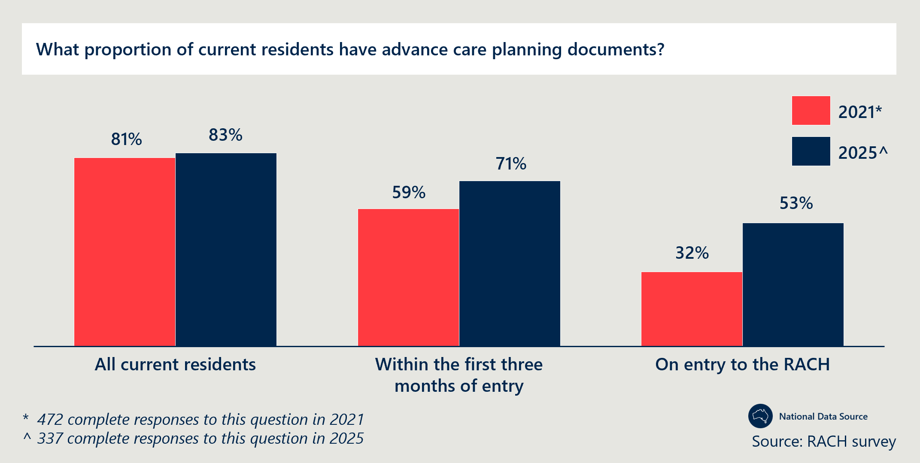
Figure 3 | Frequency of ACPD review for RACH residents
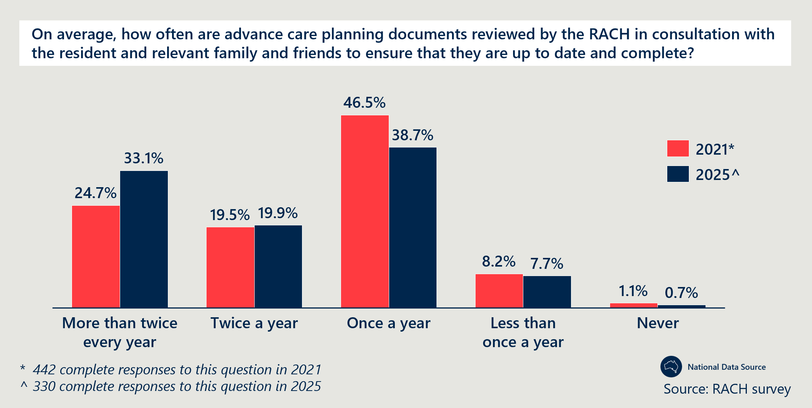
End-of-life care discussions generally are occurring more frequently and happening earlier
- In Tasmania, CNCs delivering the Specialist Palliative Care in-reach into RACHs project have seen earlier and more frequent conversations with residents and their families across all regions, crediting this involvement of the mentorship and shadowing opportunities provided by CNCs.
- In South Australia, RACH staff reported an improvement in conducting end-of-life care conversations earlier and more consistently since the implementation of the Measure. They reported RACH staff have been better able to advocate for residents’ wishes (see Outcome 6), proactively identify the need for anticipatory prescribing and improve their communication with GPs.
- Stakeholders in Tasmania, South Australia and the ACT identified needs rounds as an effective enabler of these conversations by providing a structured process to identify residents that required a discussion regarding their end-of-life care goals. An evaluation of South Australia’s Hospice in the RACH project (delivered by Eldercare) reported “Needs round meetings were also used to promote palliative care case conferences with a focus on advance care planning.” See section 4.3 for more detail on the effectiveness of the needs round model of care.
The active involvement of specialist clinicians has strengthened end-of-life planning in residential aged care by fostering collaboration and understanding among care teams
- Specialist CNCs and NPs in Queensland, the ACT and Tasmania, often attend end-of-life planning conversations alongside residents, their families and RACH staff.
- West Moreton HHS in Queensland emphasised the importance of having an NP in attendance to facilitate relationship building between GPs, residents’ families and RACH staff.
- In the ACT and Tasmania, advance care planning discussions are often led by the specialist CNC-led teams and have been well-received by residents, families and staff. CNCs in Tasmania reported that being involved in these conversations enabled the clinical teams to better understand and advocate for the resident’s wishes.
- In South Australia’s RSS programs, clinicians reported that GPs were more likely to attend discussions if a specialist palliative care medical consultant was to attend, reporting that this was often viewed as a professional development opportunity by the GPs and therefor incentive to attend.
- National quantitative data on the conduct of multidisciplinary case conferences (for example, from NHDH and MBS) does not show consistent trends in line with the qualitative findings above, however, the item numbers included in this sample does not include all possible items that may be used by GPs for palliative care. This is discussed in detail under Outcome 7.
The majority of RACHs continue to be compliant with Aged Care Standards relating to assessment and planning practices
- Between 2019 to 2024, the majority of RACHs met the Aged Care Quality Standards related to having adequate assessment and planning practices in place to identify and address consumer’s current needs, goals and preferences, including ACPDs. Of those assessed by the ACQSC, between 87 to 95 per cent met Aged Care Quality Standards 2b, 2c and 3c.
There are ongoing barriers to conducting end-of-life care discussions and ACPD uptake
- Many people entering residential aged care no longer have capacity to complete ACPDs. South Australia implemented community-based workshops to address the common issues of residents entering RACHs without decision making capacity (see Case study 4). While there was some success, South Australia highlighted the need for further work to target First Nations communities and support older people to have discussions around end-of-life care planning with their families. This was also reported in the Northern Territory (Top End), whereby the time the Measure-funded NP role was able to even visit a RACH, residents often had lost the capacity to complete an ACPD.
- Conflicting cultural approaches to death and dying for RACH staff. Western Australia, South Australia and NSW reported that the multicultural nature of the workforce presents a challenge to appropriate discussions with residents and families around end-of-life. Language barriers and differing cultural views around death mean conversations about end-of-life can be especially difficult for some staff.
- Facilitating family involvement in advance care planning discussions for First Nations residents. In the Northern Territory (Central and Top End), RACH staff reported the importance of involving families in end-of-life care planning for First Nations residents, however, are hindered by significant challenges with conducting these conversations in practice. This was particularly challenging where family members are living on Country in remote locations and the complex family hierarchies of within First Nations communities across the regions.
Case study 4: South Australia piloted community-based workshops to improve local awareness for end-of-life planning prior to entering a RACH.
Project overview
South Australia Health partnered with the Office for Ageing Well and local councils to deliver community workshops aimed at increasing awareness and completion of ACPDs among people aged 50 and over, before they enter residential aged care. This followed research showing many individuals already have reduced decision-making capacity upon entering a RACH, limiting their ability to complete ACPDs at that stage.
The pilot, led by the City of Onkaparinga, was funded through a mix of CPCiAC Measure funding, the Commonwealth Home Support Programme and state grants.
A survey revealed that 73 per cent of older South Australians, mostly aged 65 to 75, did not have an ACD. Respondents expressed a strong preference for in-person workshops. Two co-design sessions with 18 participants informed the final format and free supporting resources. Peer volunteers were trained to deliver workshops, which were promoted via council newsletters, databases and a dedicated website.
Outcomes
By November 2022, ten workshops had been delivered to over 125 attendees. Of these, 83 per cent said the session would help them complete an ACD and 96 per cent found the resources useful.
By targeting people before they enter RACHs, the program aims to increase ACD completion rates and enable individuals to better plan for end-of-life care. Community feedback indicates strong demand for continued delivery.
Since the pilot, six other local councils have adopted the community-based workshops to varying degrees.

Understanding
Outcome 2: Improved access to information that informs end-of-life care decisions for residents and families.
Final assessment: Measure-funded roles are improving communication and access to information to support better-informed decisions for residents and families in end-of-life care planning discussions.
- These roles include the MPaCCS liaison nurse in Western Australia, family support workers in Victoria, specialist NPs in the Northern Territory and specialist in-reach teams in the ACT and Tasmania.
- The Measure has funded the development of resources to support residents, families and carers through these conversations in Victoria, South Australia and Western Australia.
- In Western Australia, RACHs participating in the Measure reported significantly increased access to information on end-of-life planning (88 per cent compared to 56 per cent in RACHs not participating in the Measure).
- The majority of RACHs are compliant with the Aged Care Quality Standard relating to dignity and respect.

Detailed evidence: Outcome 2
Measure-funded roles provide dedicated support to residents and families surrounding end-of-life care decisions in Tasmania, Victoria, Western Australia, the ACT and the Northern Territory
- Clinicians in Western Australia reported that the MPaCCS liaison nurse role created time and space for direct family engagement, which RACH staff could not provide. This included informing families about signs of deterioration that were often missed by both families and hospitals and explaining the necessary next steps. RACH staff also reported that the liaison nurse role increased their confidence in having end-of-life and advance care planning conversations when residents and families first arrived at the RACH. Supporting this, data from the Western Australia Department of Health highlighted that projects like MPaCCS which actively collaborate with families and carers enhance RACHs’ capacity to advocate for residents. This data demonstrated that 91 per cent of those who accessed specialist palliative care report that families and carers received sufficient support, compared to only 71 per cent among those who did not.
- Clinical teams in the ACT and Tasmania delivering palliative care in-reach services reported that their roles allow them to spend more time supporting families by providing information and guidance that GPs and RACH staff often cannot do due to limited capacity. These conversations are frequently well received by both families and residents.
- In Victoria, policy leads reported that families have responded positively to the inclusion of a family support worker role. These workers offer a personal approach and the additional time needed to engage directly with families and collaboratively develop care plans.
- In the Northern Territory (Top End), the specialist NP facilitates family discussions in person and via video calls to enable attendance by family members living on Country and unable to attend in person. RACH staff noted that this title lends credibility, making families and residents more receptive to end-of-life advice. In one case, when a resident deteriorated and the family requested a transfer, the specialist NP led a case conference, explained why a transfer was not appropriate and arranged for the resident to remain in the RACH with the correct medication.
- In South Australia, RACHs and specialist clinicians reported benefits in hosting dedicated events that gave families direct access to staff, opportunities to ask questions and information about what to expect in care. These conference-style sessions, often featuring expert speakers, enabled multiple families to engage in meaningful conversations within limited timeframes.
Information and resources developed under the Measure are providing residents and families with information to support their cultural and emotional needs in Victoria and South Australia
- PCV used Measure funding to develop the Dignified and Respectful Decisions (DARD) resources to provide information and support for families assisting relatives in residential aged care. Website analytics for the resources indicate that they were accessed approximately 9,000 times by 3,750 unique users between July 2024 to May 2025. The resources were developed through an extensive consultation process, in partnership with ELDAC, are now publicly available and have been distributed to RACH networks in Victoria via PHNs.
- The DARD resources in Victoria have been made accessible to CALD residents and families, having been translated into ten different languages, developed through direct engagement with the respective communities. Language in these resources was also intentionally framed to be accessible to a wide audience, recognising differing cultural views on death and dying.
- The Victorian Resident Elders project undertook extensive research to develop a culturally informed model of care for First Nations aged care residents. This involved a focus on how RACHs can collaborate with residents to create individualised care plans.
- In South Australia, RACH staff noted a significant increase in available resources compared to previous years. They emphasised that future efforts should focus on tailoring existing materials rather than creating new ones. For example, South Australia Health’s Last Days of Life booklet and Bereavement Brochure adapt existing resources from Eldercare, Palliative Care Australia (PCA) and others to provide emotionally accessible and easy-to-understand information for families and carers.
- An evaluation of Western Australia’s implementation of the Measure indicated improved access to end-of-life planning resources. Specifically, 88 per cent of RACHs involved in the Measure were provided with information about end-of-life planning, options and services – compared to only 56 per cent of RACHs not participating in the Measure.
Improved access to information that informs end-of-life care is evidenced by majority compliance across relevant ACQSC standards and anecdotal accounts from RACH staff
- Analysis of quantitative data from ACQSC indicates that RACHs have improved compliance with the standards related to aged care residents’ choice and independence in decision-making surrounding their care, the way its delivered and when to include family and carers in their care (2019-2024).
- The national RACH survey found that 97.9 per cent of respondents used routine processes to discuss and record residents’ end-of-life care wishes. Despite the marginal drop (from 98.8 per cent in 2021 to 97.9 per cent in 2025), the vast majority continue to use approaches such as multidisciplinary case conferences to document these wishes. Further detail on the use of multi-disciplinary case conferences is provided under Outcome 7.
Projects under the Measure have implemented approaches to end-of-life planning where residents do not have capacity to complete formal ACPDs
- Goals of care documents are often used as an alternative format to capture residents’ wishes where a formal ACPD cannot be completed. RACHs in the Northern Territory use Goals of Care discussion flow charts to guide RACH staff in their conversations with families of residents regarding the palliative care approach in the Top End.
- The RGoC form developed by WACHS under the Measure has been widely used by RACHs and promoted by clinicians in regional areas of Western Australia. This has enabled the capture of resident choice where they lacked the decision-making capacity to complete a formal ACPD.
- South Australia partnered with local councils to conduct peer-led community-based ACPD workshops (see Case study 4).
Capability
Outcome 3: A higher proportion of clinical and non-clinical staff in RACHs have skills and confidence appropriate to their roles to recognise and respond to the holistic palliative care needs of residents, in a culturally safe way.
Final assessment: There is evidence that RACH staff have increased confidence to recognise and respond to palliative care needs due to improved access to specialist clinicians, after-hours support and education delivered by specialists. Short-form or bedside education sessions achieve more consistent engagement from RACH staff than longer, formal education programs. App-based resources provide on-demand access to clinically relevant information and there is ongoing and increasing demand for palliative care education. The transient nature of the RACH workforce continues to pose a challenge to maintaining workforce capability and observing long-term outcomes of education initiatives. There is opportunity for education programs to be improved through improved navigability, tailoring and more holistically considering the different backgrounds of the workforce.

Detailed evidence: Outcome 3
Education and capability building to deliver palliative care is a key focus of the recommendations from the Royal Commission (see section 2.1). Demonstrated improvements in RACH staff and GP capability because of education and training, indicating progress against the Royal Commission recommendations.
RACH staff have increased confidence to recognise and respond to palliative care needs due to improved access to specialist clinicians, after-hours support and education delivered by specialists
- Stakeholders from all jurisdictions reported that Measure-funded activities have helped to improve RACH staff understanding of palliative care services and confidence in utilising them. In particular, through access to specialist clinicians, after-hours support and education delivered by specialists. Analysis of the national RACH survey indicated that the vast majority of RACHs that responded in 2025 (95.8 per cent) continue to have palliative care specific policies or procedures that provide clear guidance to assist staff recognise signs of deterioration in 2025.
- Access to specialist clinicians. Clinicians in Tasmania (Southern region) identified the improved confidence and knowledge of RACH staff as one of the biggest impacts of the specialist palliative care in-reach team. Queensland’s SPACE evaluation reported an improvement in RACH staff confidence in 2023, when compared to a baseline established in 2021. Notably, the evaluation reported a 14 per cent increase in confidence when contacting services for advice, an 11 per cent increase in identifying quality information about end-of-life care and a 10 per cent increase in providing culturally appropriate care.
- After-hours support. The Northern Queensland PHN reported that SPaRTa and SPACE’s after-hours telehealth services boosted staff confidence, especially among agency nurses unfamiliar with individual patients. These services helped bridge this knowledge gap and reportedly contributed to reduced ED transfers, by providing RACH staff the information and advice required to deliver care in the RACH. SPACE clinicians noted that over time, RACH staff called their service less often for less complex issues, indicating increased confidence and integration of prior learnings into routine, generalist palliative care.
- Education delivered by specialists. Clinicians and RACH staff across NSW, Western Australia, the ACT, the Northern Territory, Victoria and South Australia championed training provided by specialist clinicians as achieving high engagement and responding to the immediate education needs of staff. Clinicians and RACH staff in Western Australia, reported that education sessions delivered by MPaCCs and RCL improved the confidence of nursing staff to have advance care planning and end-of-life conversations. This includes graduate nurses who have reported increased levels of confidence when working alongside doctors. Although attendance is largely nursing staff, learnings from these sessions were passed onto other care staff on a case-by-case basis. Data from the Western Australia evaluation supports this, with 88 per cent of surveyed residents in RACHs involved in the Measure perceiving staff as “very competent or competent” compared to 76 per cent of residents in RACHs not involved in the Measure.
- Short-form or bedside education sessions achieve more consistent engagement from RACH staff than longer, formal education programs. Clinicians and RACH staff across NSW, Western Australia, the ACT, the Northern Territory, Victoria and South Australia reported that educational sessions with specialists were delivered in a short and case-specific manner and were more practical than longer education programs. For example, “toolbox” sessions are brief, focused sessions designed to address specific concerns or clarify key topics raised by RACH staff.
- In Western Australia and South Australia, specialist clinicians employed “toolbox talks”. These sessions were often integrated into existing processes, such as needs rounds and debriefings, or delivered spontaneously at the point of need.
- Generalist clinicians in NSW highlighted that bedside training was embedded into routine practices, such as following advance care planning conversations. Specialist clinicians used note handovers as opportunities to provide real-time learning and reinforce key concepts. In the ACT, RACH staff reported that the PEACE teams provided bedside support to RACH staff, ultimately replacing formal education sessions. This bedside support was especially helpful for graduate and junior staff who are often unable to receive support from senior staff in the facility due to time constraints.
- In the Northern Territory the in-reach NP reported running bedside training to RACH staff on a case-by-case basis. This supplemented existing formal training provided by the head office of the RACH.
- A metropolitan LHD in NSW employed a combination of bedside and formal workshop sessions to target care staff, GPs and RACH management (see Case study 5).
- MPaCCS clinicians in Western Australia and SPACE clinicians in the Metro South HHS in Brisbane both recognised the critical role that mentorship models can play in increasing staff knowledge at the bedside. RACH staff in Western Australia particularly noted value of mentorship models in supporting recent graduate nurses, which constitute a large proportion the workforce.
- RACH staff in NSW and clinicians in Western Australia and South Australia suggested that formal training programs are likely to have lower uptake due to limited staff capacity to attend longer education sessions. Clinicians in South Australia specifically pointed to the lack of remuneration staff receive for partaking in professional development as playing a key role in this limited engagement. This is supported by findings from the national RACH survey, which identified that more than one in three RACHs do not have mandatory palliative care training for any staff group and only 8 per cent have mandatory training for all staff groups. This number has remained relatively unchanged over the course of the Measure, from 2021 to 2025. Despite generally low uptake in formal training, there are examples of good practice (see Case study 6).
Case study 5: A metropolitan LHD in NSW has implemented multi-disciplinary training, strengthening clinical care and awareness of referral pathways.
Project overview
A metropolitan LHD in NSW has delivered a series of targeted training programs to build the palliative care capability of RACH staff. Training was delivered both at the bedside and in formal group settings of up to 20 participants, covering topics such as syringe driver use and clinical management of palliative and end-of-life care. “Train the trainer” sessions supported ongoing capability building across the broader aged care workforce.
The LHD also maintained regular communication with RACHs and GPs through email, phone and in-person engagement. Patient review notes were routinely shared and case conferences were held to enhance collaboration and ensure consistent care.
Outcomes
GPs and care staff reported feeling more educated and supported, with improved adherence to care plans. RACH managers gained clearer understanding of referral pathways and were better equipped to provide accurate information for triage. Syringe driver training was implemented in 16 RACHs where this capability had previously been absent. Staff also reported a reduction in avoidable hospital admissions, indicating strengthened confidence and competence in managing palliative care needs within RACHs.

Case study 6: In NSW, Murrumbidgee LHD is working closely with ELDAC to deliver programs to improve the confidence and capability of RACH staff.
Project overview
Murrumbidgee LHD directed Measure funding toward education and capability building through the Murrumbidgee Mentor Model, delivered in partnership with ELDAC’s Linkages Program (formerly the “Working Together” program). The program aimed to strengthen the capacity of RACHs to deliver end-of-life care by improving staff confidence, skills and knowledge in palliative care and advance care planning, and by increasing access to palliative care advice and support.
The Linkages Program connected RACHs with an ELDAC facilitator who applied evidence-based strategies to build region-specific relationships between aged care providers, primary care and specialist palliative care services. The model also incorporated other external services relevant to end-of-life care to ensure a comprehensive and locally responsive support network.
Outcomes
The program was delivered to two cohorts of 13 RACHs over a six- to nine-month period. Each participating RACH completed five ELDAC audits before implementation and repeated these post-program to assess progress. The pre-implementation audits identified gaps in staff knowledge, skills and confidence. Linkage facilitators worked closely with each service to address these gaps through targeted education and support.
Personal Learning Assessments completed by aged care and clinical staff showed clear improvements. Aged care workers reported increased confidence across all assessment areas, including assessing palliative care needs, developing care plans, recognising deterioration, supporting care in the final week of life and addressing bereavement needs of families. Clinical RACH staff also reported increased confidence, though to a lesser extent, particularly in understanding advance care planning legislation, assessing end-of-life care needs and knowing when to initiate specialist palliative care involvement.
App-based resources provide on-demand access to clinically relevant information
- Western Australia reported strong engagement with virtually delivered RACEPC courses, after pivoting from in-person delivery which struggled to attract attendance. This enabled the cost savings to be redirected towards other Measure-funded projects in Western Australia.
- RACH staff in Queensland and NSW highlighted the usefulness of the PalliAGED app, developed by South Australia, in providing staff quick access to education they require in a particular situation, such as facilitating better conversations with the families of residents (see Case study 7).
- RACH staff in the Northern Territory and Western Australia found PEPA’s in-person training both effective and engaging. These in-person sessions, although helpful in mitigating attendance issues often encountered with virtual delivery, can be impractical to implement, as reported by RACH staff in Western Australia.
Case study 7: South Australia has leveraged partnerships to develop an app-based learning platform for aged care workers.
Project overview
South Australia Health used part of its Measure funding to contract GPEx, in partnership with Eldercare, to develop ten educational videos to support aged care workers in delivering palliative care. GPEx worked closely with Eldercare to identify relevant topics and provided support to screenwriters. Filming took place in June 2023.
The videos will be hosted on the PalliAGED App, operated by Flinders University. The app is designed as a mobile learning platform to help aged care workers recognise and respond to palliative care needs in residents.
Outcomes
The PalliAGED app is fully operational and includes ten educational videos that are accessed by RACH staff nationally. In consultation, stakeholders from Queensland, NSW and Victoria acknowledged an awareness and use of the PalliAGED app in supporting capability development for RACH staff.
There is ongoing and increasing demand for palliative care education
- Analysis of the national RACH survey suggests an increased demand for palliative and end-of-life training across RACH staff nationally. Between 2021 and 2025, the proportion of staff attending training more than once every six months grew by approximately 152 per cent, with a further 89 per cent increase among those attending once every six months (Figure 4). Over the same period, the proportion of RACHs with a preferred training provider or package rose by 62 per cent (34 per cent to 55 per cent). These responses possibly reflect the growing prioritisation of palliative and end-of-life training within RACHs.
- Since its launch in 2018, ELDAC’s Residential Aged Care Toolkit has seen user numbers rise, reaching 74,922 new users by 2024. In 2023, these users represented about 28 per cent of the 217,000 direct care RACH workers, an increase from 11 per cent in 2020 (Figure 5). Similarly, Australian Healthcare and Hospitals Association (AHHA’s) Palliative Care Online Training Portal experienced 27,049 new users in 2018, with 89 per cent reporting improved palliative care skills and 83 per cent feeling confident post-training (up from 37 per cent pre-training) (Figure 5). AHHA funding ended in 2023, limiting further tracking.
- Clinicians involved in Western Australia’s RACEPC project highlighted a large cohort of “self-starters” who had a genuine interest in upskilling on palliative and end-of-life care. Northern Territory (Top End) identified similar demand for formal training, highlighting the importance of a community-like supportive culture to encourage this demand.
Figure 4 | RACH survey results on frequency of staff participation on training
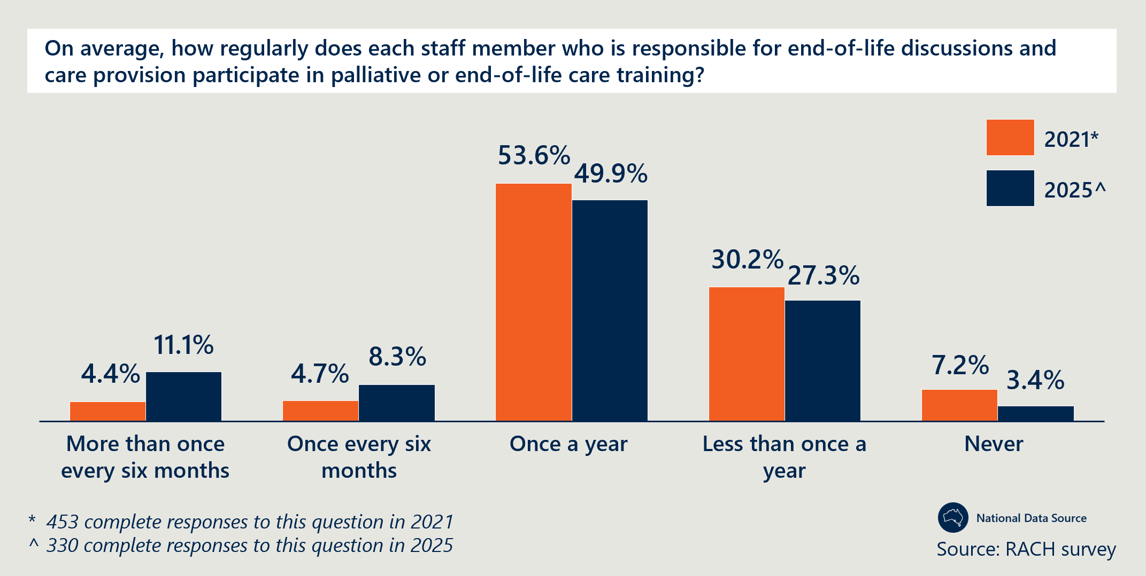
Figure 5 | Number of users for ELDAC and AHHA online resources from 2018 to 2024
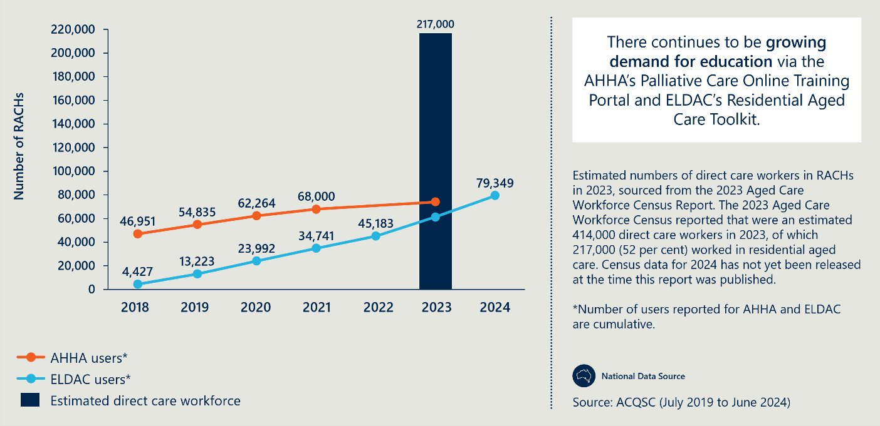
The transient nature of the RACH workforce poses a challenge to maintaining workforce capability and observing long-term outcomes of education initiatives
- Clinicians and PHNs in Victoria, PHNs in Queensland, and clinicians and RACH staff in Western Australia specifically reported that investments in training struggled to yield long-term benefits due to staff turnover, requiring RACHs to constantly restart training processes with new personnel. Additionally, clinicians and RACH staff in Western Australia highlighted staff turnover as a barrier to monitoring and assessing the impact of these training programs on staff skills and confidence over time.
- Clinicians from South Australia’s Regional Hospice program attributed the high turnover rates to insufficient financial and social incentives for entering and remaining in the aged care sector, citing lower wages and less recognition associated with working in the aged care sector, when compared to their counterparts in acute care. Specialist clinicians in NSW and Queensland also identified staff burnout, driven by a lack of psychological support, as a key contributor to this workforce instability.
There is opportunity for education programs to more holistically consider the different cultural and educational backgrounds of the aged care workforce to provide appropriate training
- As discussed in Outcome 1, stakeholders across jurisdictions consistently noted cultural barriers for RACH staff as hindering effective end-of-life communication. Both the NSW peak body and clinicians involved in Western Australia’s RACEPC program emphasised the importance of training that reflects diverse cultural approaches to death and dying).
- RACH staff in Western Australia and the Northern Territory emphasised that non-clinical staff play a key role in recognising deterioration and supporting palliative care but often lack appropriate training. This gap is further highlighted in the RACH survey results which indicate, that for those who responded to the survey, RNs are the only staff group for whom a majority (56 per cent) of RACHs reported mandatory palliative care training. Mandatory training for other staff groups in the survey also remained relatively unchanged from 2021 to 2025 for those who participated in the survey.
- The NSW South Eastern PHN (COORDINARE), Northern Queensland PHN, clinicians in Queensland’s Metro North HHS and clinicians involved in Western Australia’s MPaCCS program all highlighted the importance of upskilling GPs in palliative care – particularly to improve anticipatory prescribing practices. One example, provided by the Western Australia Department of Health, is the RACEPC program, which delivered targeted training to GPs and offered mentorship support from a palliative care physician. Tasmania also implemented the GP registrar program, strengthening GP speciality in palliative care (see Case study 8).
Case study 8: GP registrar rotations in Tasmania are contributing to capability building for GPs to better meet the complex needs of palliative residents in RACHs.
Project overview
Tasmania’s GP Registrar program is showing emerging success building interest and buy-in from training GPs in the palliative care specialty. The Registrar, under the direction of the Medical Specialist Palliative Care, provides high quality, evidence-based and complex care to palliative residents in RACHs. The Registrar provides comprehensive assessment of palliative residents with complex symptoms and end-of-life care needs and can provide advice and support to other treating GPs specific to palliative care. The program operates through six-monthly rotations and has recruited 2.5 FTE between November 2022 and May 2023.
Outcomes
Two previous registrars completed their advanced traineeships and are now palliative care specialists, with one working as a specialist in the region. One previous trainee who was involved in the program has continued study in palliative care and is now practicing as a specialist medical consultant in the region.
There is an opportunity to tailor and improve the navigability of educational resources
- RACH staff and PHNs in South Australia, Victoria and NSW highlighted the importance of tailoring and curating existing materials to specific audiences, rather than continuing to add to the pool of existing resources, risking duplication. Western Queensland’s PHN provided an example of this practice by tailoring existing Last Aid workshop materials for sessions in Mornington Island to better focus on First Nations people and their needs.
- A representative from one RACH in South Australia provided the example of how they leveraged ELDAC resources to develop a seven-step pathway which is currently used as an easy resource to help staff recognise deterioration and what to do at each step.
- Representatives from Western Australia’s Department of Health and PHN representatives in the Northern Territory and Tasmania raised that while there are many educational resources available to RACH staff, they can be challenging to navigate. They raised the opportunity to streamline and better promote existing materials, enabling remaining gaps to be identified and addressed.
Access and choice
Outcome 4: Improved access to quality palliative care in RACHs including:
- increased use of assessments to establish residents’ palliative care needs
- decreased health service use related to clinically futile or non-beneficial treatments and inpatient bed days
- decreased healthcare expenditure arising from decreased service use.
Final assessment: There is evidence of improved access to specialist palliative care in RACHs and in some contexts this has led to fewer unnecessary hospital transfers. There has been a significant increase in specialist palliative care in-reach services reporting to PCOC nationally between 2021 and 2024. Prescriptions of palliative care-specific medicines for RACH residents have also increased by 282 per cent for RACH residents from 2019 to 2024, indicating that there is increased prescriber activity in RACHs. There is also evidence of improved access to palliative care in certain regional and remote areas, with a 27 per cent increase since 2021 reported by RACHs surveyed nationally. However, barriers remain for many in regional and remote areas, particularly with regards to access to specialists and medications.

Detailed evidence: Outcome 4
Improving access to palliative care in residential aged care is a key focus of the recommendations from the Royal Commission (see section 3). Demonstrated improvements in resident access to MDTs, including specialist in-reach palliative care, aligns with progress against the Royal Commission recommendations.
The Measure has enabled residents to increasingly access specialist palliative care services
- Between the periods of 2014 to 2019 and 2017 to 2022, the total number of RACH residents accessing palliative care services reporting to PCOC increased by 47 per cent (62,000 to 91,000). This represents an increase from 7 per cent to 10 per cent of all RACH residents nationally receiving palliative care through these services, based on population estimates in AIHW’s GEN Aged Care Data (Figure 6) .
- Evidence from more recent data (from PCOC and a national survey of RACHs) also indicates that access to specialist palliative care services has increased in RACHs.
  - The volume of palliative care delivered proportional to the number of providers reporting to PCOC has increased significantly. There was a 32 per cent increase in the proportion of providers reporting specialist palliative care in-reach services into RACHs nationally (from 57 to 75 per cent between 2021 and 2024). Of these, the number of episodes of care delivered by specialist palliative care in-reach services into RACHs increased by 76 per cent (from 5,653 to 9,949 between 2021 and 2024). RACHs continue to be the most common referral pathway to specialist palliative care in-reach services reporting into PCOC, from 2021 to 2024 (Figure 7).
  - This specialist care is increasingly accessible in non-urban and regional areas as evidenced by a 123 per cent increase in the number of episodes of care delivered in “not a major city” (from 560 to 1,282 between 2021 and 2024).
- Qualitative data provided by ACT Health found that the strong relationships between the PEACE team and RACH staff led to more referrals to the PEACE team’s specialist palliative care services. As of 2023, 70 per cent of permanent residents who die in RACHs in the ACT receive specialist palliative care.
- Qualitative data provided by the Tasmanian Department of Health indicated that as a result of the CNC led model, over 2,000 residents who would otherwise not have had access to specialist palliative care have been supported by CPCiAC over the project duration.
- Policy leads in South Australia highlighted that the success of the Hospice in RACH pilot (Eldercare) enabled leftover funding to be reallocated to the MRU which would enable access by residents across multiple sites to specialist in-reach teams.
Access to specialist palliative care services has especially improved for RACHs in rural and remote areas
- The RACH survey results indicate similar improved access, with the majority of RACHs in both 2021 and 2025 (95 and 96 per cent, respectively) suggesting most residents were able to access specialist palliative care across the RACHs that completed the survey (Figure 8).
- RACH survey data also suggests that access to specialist palliative care in remote and very remote areas improved significantly (27 per cent increase) between 2021 to 2025. Improvements in access were also seen in outer and inner regional areas (Figure 8).
- This increased access in remote areas is likely to be facilitated by increased utilisation of videoconferencing in palliative care, by 14 per cent (Figure 9).
- South Australia’s RSS implemented 35 palliative care link (PC-Link) nurses across rural RACHs to deliver needs rounds and education to RACH staff (see Case study 9).
Case study 9: PC-Link nurses in rural South Australia facilitate access to improved palliative care and education.
Project overview
The PC-Link Nurse program, delivered by RSS, aims to build RACH nursing capacity to deliver palliative care for older people in rural and regional South Australia. RACHs used Measure funding to recruit 35 PC-Link nurses across rural RACHs and multi-purpose services.
The PC-Link nurse role involved using ELDAC’s After Death Audit tool to examine and improve local palliative care practices, liaising with RSS to coordinate referrals and needs rounds, and provide local mentorship to through ad hoc problem solving and handovers.
Outcomes
Needs rounds facilitated by the PC-Link nurse contributed to more proactive clinical care and fostered a safe, supportive environment for staff learning. Staff reported that the PC-Link nurse was more accessible than doctors for timely advice and support, which enhanced their confidence in managing palliative care needs.
PC-Link nurses often span across multiple facets of palliative care delivery. Compounded by workforce challenges in rural and remote areas, a key learning from this project was the need for local managerial support to ensure PC-Link nurses have the time to fulfill their required tasks.

Figure 6 | Number of RACH residents accessing palliative care services in 2014-19 and 2017-22
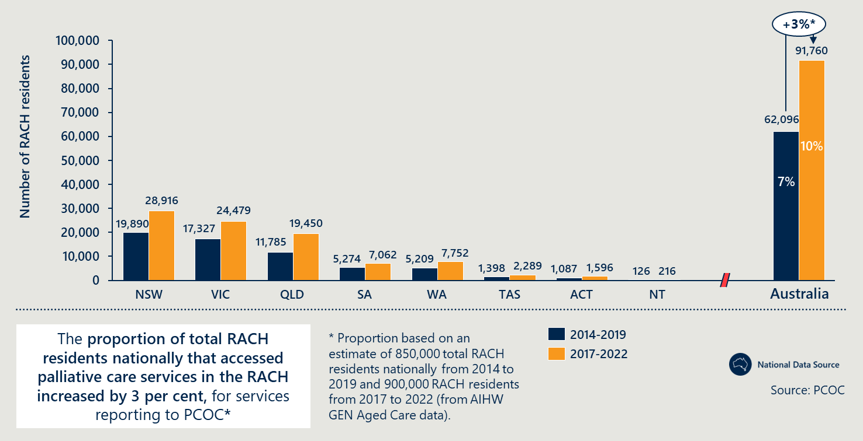
Figure 7 | RACH residents who accessed palliative care services reporting to PCOC while living at a RACH from 2014-2019 and 2017-2022
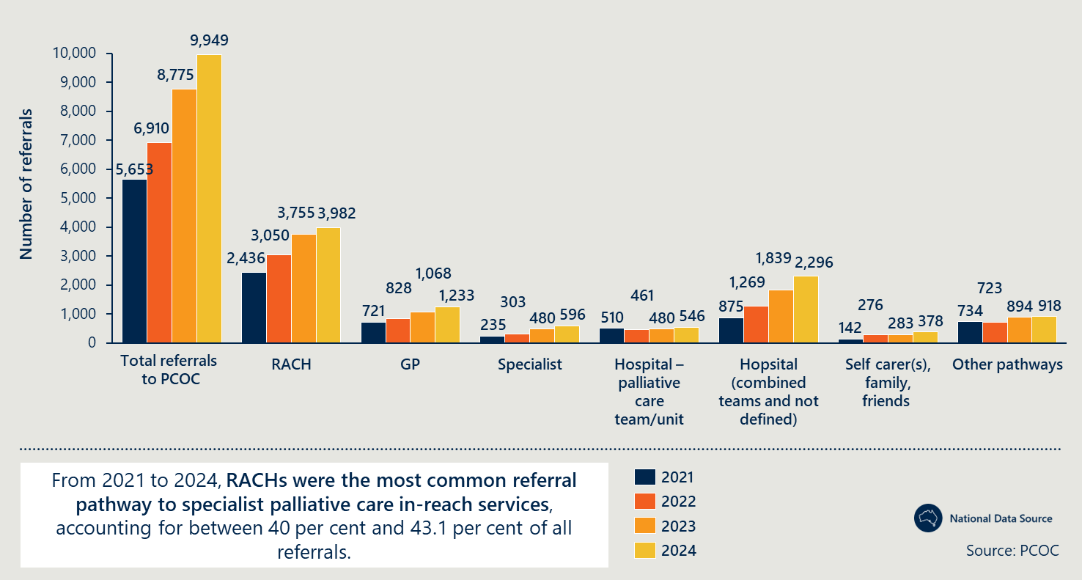

Figure 8 | RACH access to specialist palliative care by remoteness
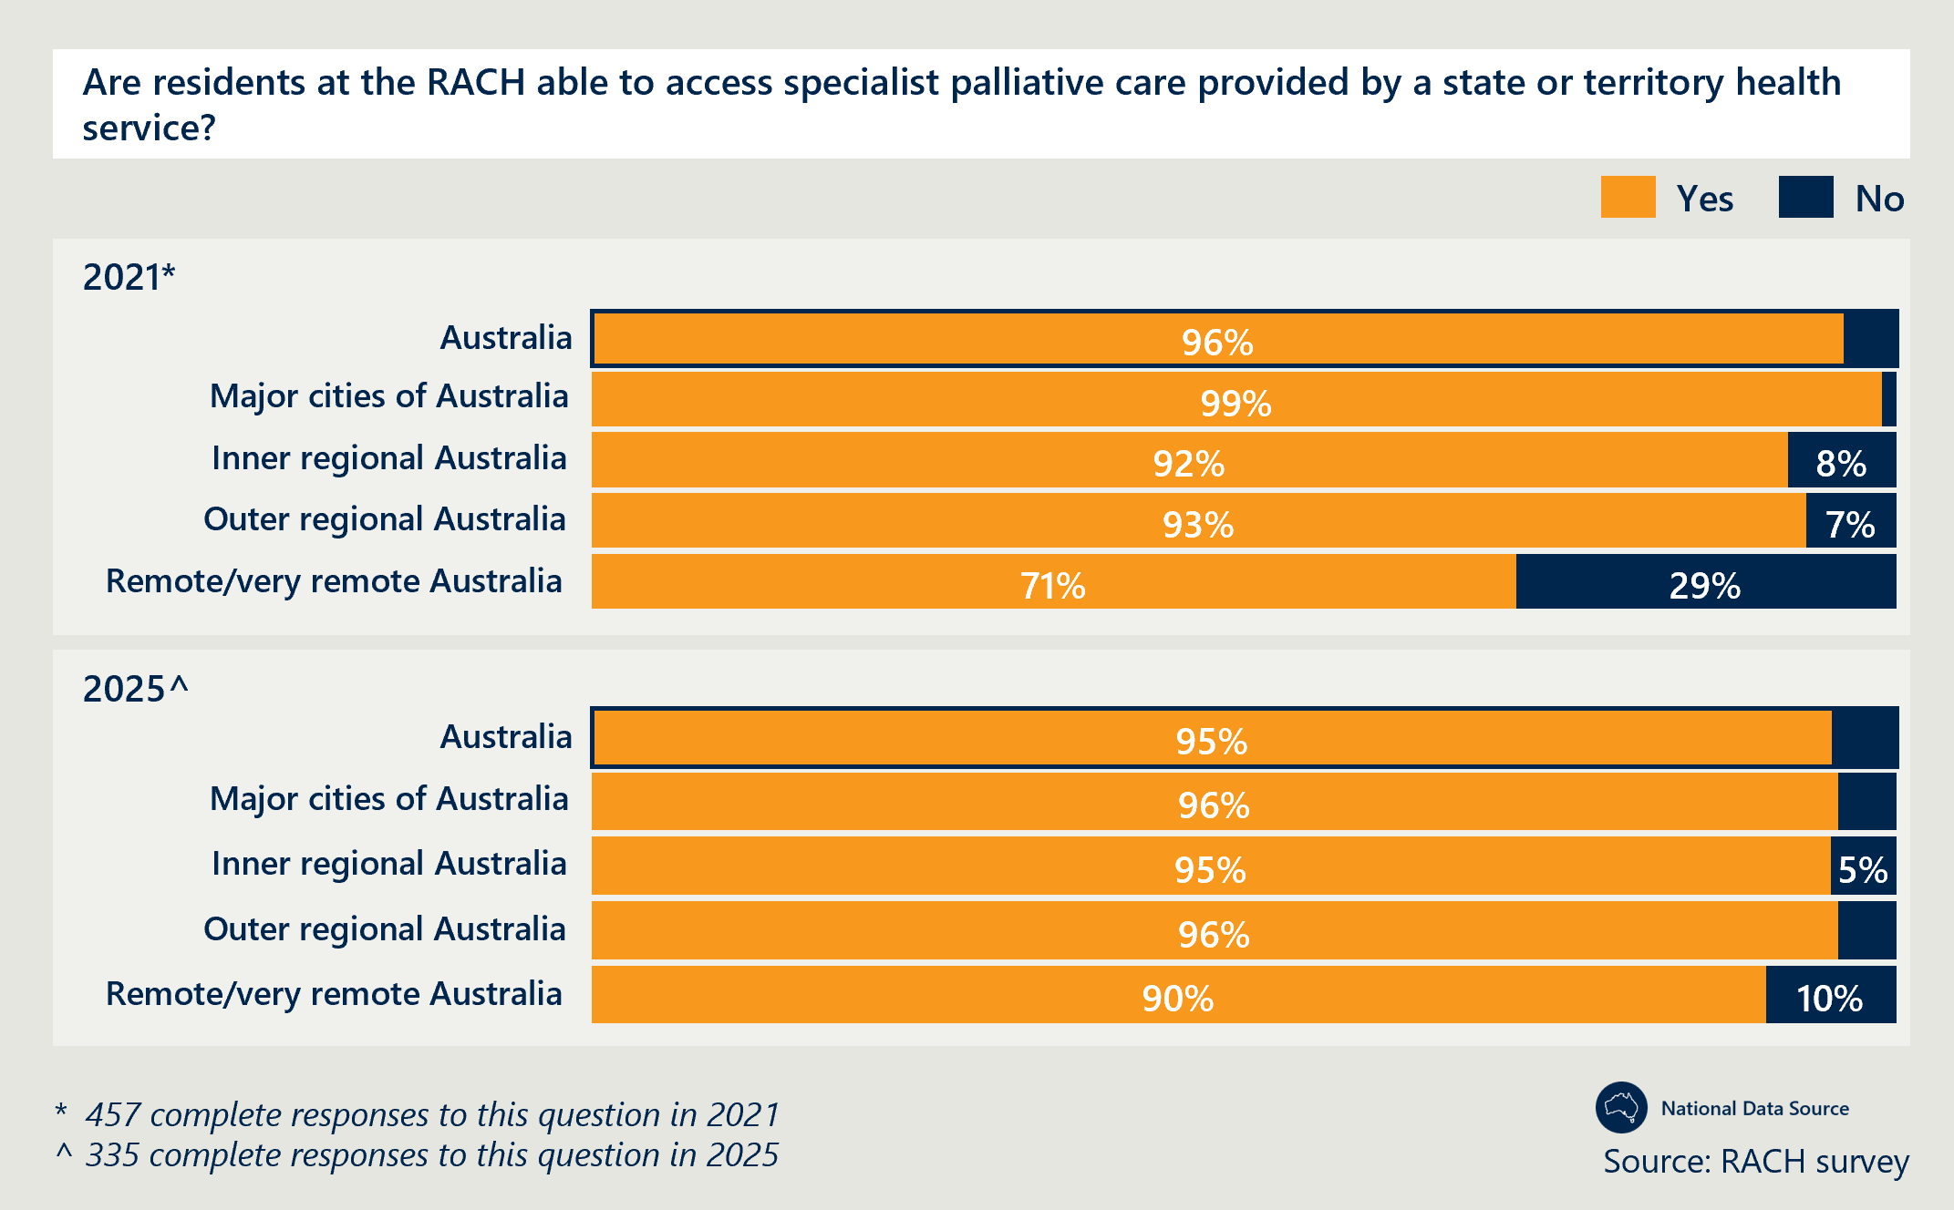
Figure 9 | RACH access to specialist palliative care by mode of delivery
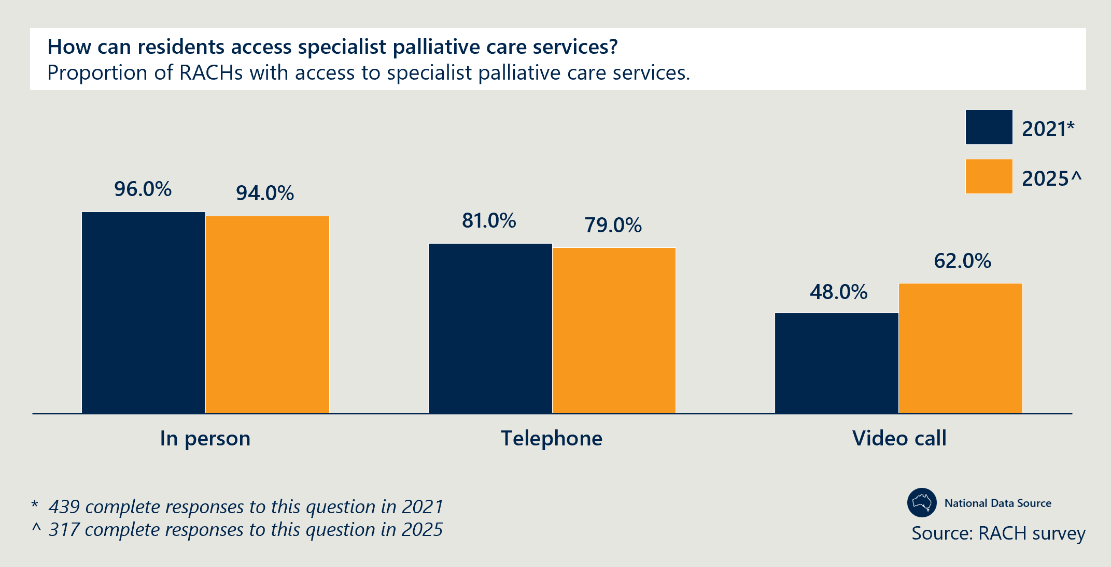
There is evidence that the timeliness of accessing specialist palliative care services has improved
- There is evidence that timely access to specialist palliative care providers is improving. The vast majority of PCOC episodes of care meet the benchmark for care commenced within two days of a person being ready. This proportion increased by 1.3 percentage points from 2021 to 2024 (92.3 per cent). This was a slight reduction from 2023 by 2.1 per cent (94.4 per cent).
- PCOC data also reveals that specialist palliative care is commencing in earlier stages of the end-of-life process. The condition in which a patient begins an episode of care may be a meaningful indicator of timeliness of specialist palliative care received and changes in symptom management. The proportion of care episodes that commenced when the resident was at “stable” phase increased from 2021 to 2024 by 2.5 percentage points and decreased by 1.5 percentage points for episodes of care that began when residents were “terminal” (Figure 10). This suggests that residents are being referred and beginning care earlier when they are more stable, possibly increasing the ability of specialists to mitigate symptoms of deterioration and provide a more comfortable end-of-life experience.
- RACH staff in Western Australia reported a substantial increase in access to MPaCCS, where waiting times improved from an average of two to three days to following-day or same-day responses. Despite this progress, clinicians noted that MPaCCS operates only from Monday to Friday due to funding limitations, leaving a gap in specialist support over weekends.
- In NSW, clinicians in South-West Sydney LHD reported enhanced access to their CNC services, with consultation response times reduced from up to three weeks to between 24 and 48 hours. Clinicians also reported that this accessibility of services relies on the awareness of RACHs to engage with the service and many RACHs remain unaware of these services. This is reportedly due to high turnover among facility managers, who are typically responsible for maintaining relationships with service providers.
Figure 10 | Resident condition during commencement of PCOC episode of care
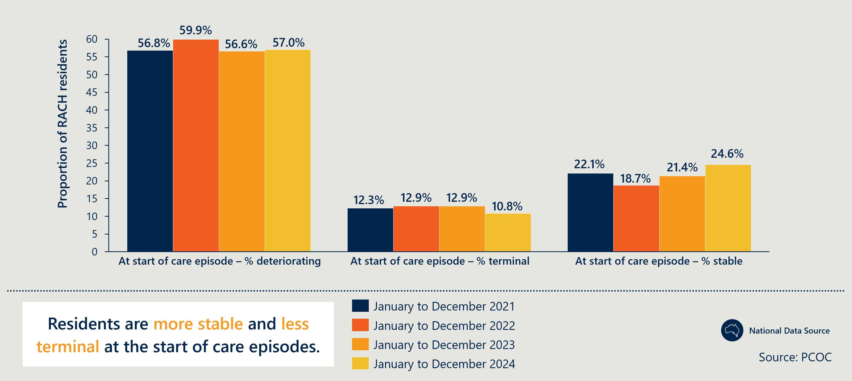
Increased access to palliative care in RACHs is leading to reductions in avoidable hospitalisations and ED presentations
- Stakeholders across all states and territories reported evidence of the Measure reducing avoidable ED transfers and admissions.
- The evaluation of Queensland’s SPACE project revealed a reduction in ED presentations and hospital admissions, resulting in a released capacity of 2,751 bed days annually and estimated cost savings of $6.438 million from released hospital capacity over the course of the Measure (October 2020 to March 2024). This outcome was attributed to the interventions delivered by the specialist teams. Specialist clinicians in Queensland’s West Moreton region also suggested the Hospital in Home program meant residents could receive much of the care they would normally receive in hospitals internally.
- Noting that the Measure did not reach all RACHs, NHDH data shows an overall national increase in palliative care bed days, both same-day and overnight (Figure 11). Defying this trend, the SPACE model demonstrates its effectiveness by reducing hospital admissions for participating residents, highlighting its impact despite broader system pressures.
- An evaluation of South Australia’s program attributed a reduction in hospital transfers to the Regional Hospice in Residential Aged Care project. Specifically, pre- and post-after death audits revealed reduction in hospital transfers in the last week of life from 16 per cent to 9 per cent of residents. The evaluation further highlighted that patients with ACPDs or were involved in case conferencing were less likely to be transferred.
- Specialist clinicians and RACH staff in Tasmania, NSW, the Northern Territory (Top End) and South Australia reported decreased reliance on hospital admissions and ED presentations, with Measure-funded roles enabling earlier detection of deterioration, increased staffing and improved goals of care documentation.
- RACH staff in South Australia and Western Australia highlighted the importance of this reduction in maintaining continuity and quality of care for residents, given their relationships with RACH staff.
- Analysis of national linked data in the NHDH indicates that the proportion of residents with at least one hospitalisation and proportion of residents with at least one ED presentation decreased by 2 percentage points from 2018-19 to 2021-22 (Figure 11).
Quantitative findings on reductions in ED presentations and hospital admissions do not distinguish between those that are avoidable and unavoidable. Therefore, they cannot be used as a definitive indicator of improved palliative care outcomes.
Figure 11 | Proportion of RACH residents with at least one hospitalisation or ED presentation
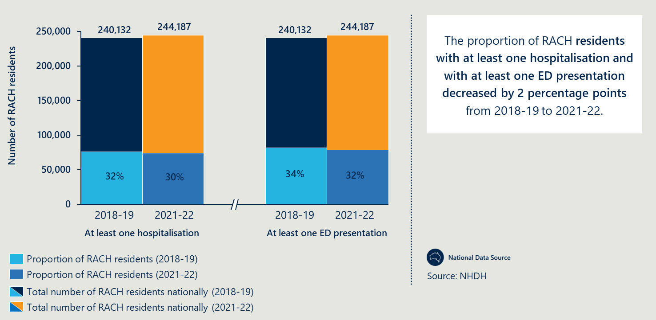
Prescribing activity for palliative care related medications for RACH residents nationally has increased
- PBS data revealed that the number of RACH residents dispensed palliative care medication nationally increased significantly, by 282 per cent from the period of 2018-19 to 2023-24 (Figure 12).
- Nationally linked data from NHDH revealed that from 2018-19 to 2021-22, the proportion of RACH residents receiving palliative care medication increased by an average of 8.25 per centage points across all jurisdictions (see Figure 13).
- Access to appropriate end-of-life medication is also supported by findings from the national RACH survey. The majority of survey respondents in 2025 (97.7 per cent) continue to have policies and procedures in place that outline clear steps to ensure residents can access appropriate medication if their condition deteriorates suddenly at their end of life.
- RACH staff in the Northern Territory (Top End), Tasmania, NSW, Queensland and South Australia reported improved prescribing practices, supported by greater involvement of specialist clinicians and better coordination with GPs.
- Staff in South Australia and NSW emphasised the benefits of the needs rounds model in identifying early signs of deterioration and ensuring anticipatory medications are appropriately charted and stocked.
- RACH staff in South Australia also noted that initiating discussions earlier enabled anticipatory prescribing to occur sooner and improved communication with GPs – an area they felt had significantly improved over the past five to six years.
- Despite these improvements, RACH staff in the Northern Territory (Top End) and Tasmania continued to report frustrations with anticipatory prescribing, primarily due to poor coordination with GPs, even where specialist in-reach teams were involved.
Figure 12 | Number of RACH residents dispensed palliative care medication in each jurisdiction from 2019 to 2024
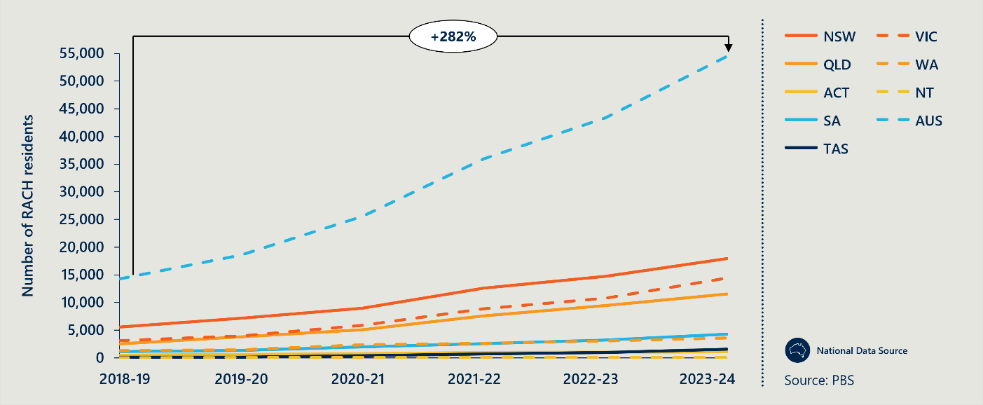
Figure 13 | RACH residents in total and who received medicines related to palliative care in 2018-19 and 2021-22
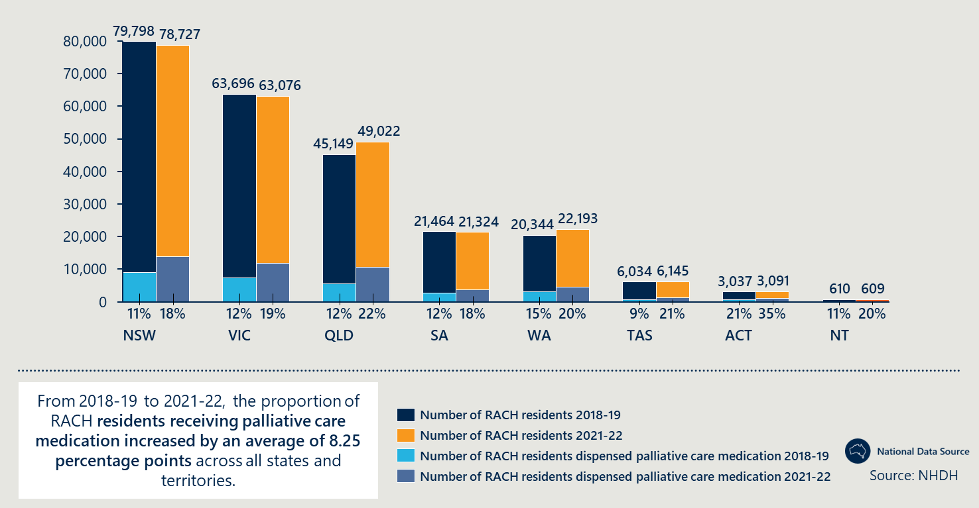
There is opportunity to strengthen generalist palliative care delivery in RACHs, reserving referrals to specialist providers for more complex cases
- Specialist providers in NSW’s Far West LHD, PCV and Palliative Care NSW, policy leads in Western Australia and clinicians in Queensland’s Metro North HHS highlighted that RACH staff are often unclear of the distinction between generalist and specialist palliative care. As a result, RACHs are often referring cases that could be managed at the generalist level, creating unnecessary demand for specialist providers. This places added pressure on specialist providers who should be focussing their efforts on more complex cases. In NSW’s Far West LHD, specialist clinicians reported that sustained pressure contributed to burnout and resignation of specialists.
- There is however some evidence of improvement:
  - Specialist clinicians in Victoria reportedly narrowed the eligibility criteria for specialist palliative care and established a telehealth service to provide advice on more general cases. They reported that this ensured they were able to provide more targeted access to specialist services for those with more complex needs.
  - One RACH in Queensland’s Metro North highlighted that the SPACE team has increased the confidence of RACH staff in delivering generalist palliative care.
  - Specialist providers in NSW’s Far West LHD highlighted that GPs were increasingly taking control of generalist palliative care, shifting pressure away from specialist providers. However, stakeholders caveated that this was not sustainable, as access to GPs is often a struggle and that RACHs should be taking greater control of this aspect of care.
Despite improvements, there are ongoing barriers to accessing specialist palliative care services and medications, particularly in regional and remote locations
- Despite quantitative data (Figure 8) suggesting that national-level improvements in access to quality palliative care in regional areas, PHN representatives from Tasmania and Country South Australia PHN highlighted that access to specialist palliative care services still remains particularly limited in their local regions. These regions increasingly rely on generalist practitioners, who are themselves often in short supply and difficult to access.
- Poor access to GPs and medication was also highlighted as a challenge by Western Victoria PHN, specialist clinicians involved in Queensland’s SPACE team, policy leads in Victoria, RACH staff in Western Australia and clinicians in Tasmania. RACH staff in Western Australia also highlighted significant challenges with anticipatory prescribing in regional and remote areas, where limited access to GPs and pharmacies – especially over weekends – hinders timely medication access when residents deteriorate rapidly.
- Specialist clinicians and PHN representatives in Tasmania, Queensland and NSW highlighted that even where there are GPs available, lack of education regarding anticipatory prescribing and palliative care medications remains a barrier with many reluctant to prescribe required medications. This can occur despite advice from specialist nurses, due to their clinical responsibility for residents and fear of unknown repercussions.
- Clinicians in NSW and South Australia highlighted that their ability to provide in-reach specialist palliative care to residents, relies on the awareness and willingness of RACHs to engage the services. In NSW, clinicians partially attributed this to high turnover among RACH managers, who are typically responsible for maintaining relationships with external providers. South Australia’s policy lead also raised this lack of awareness across RACHs as a barrier to expanding the MRU. For more detail see Outcome 8.

Access and choice
Outcome 5: Improved quality of palliative care provided in RACHs including:
- Reduced symptom burden
- Improved quality of life for residents during the period they access palliative care
- Better experience of death and dying for residents, families/carers and staff, including meeting physical, psychosocial, cultural and spiritual needs.
Final assessment: There is evidence that the Measure funded projects have led to improved quality of palliative care and symptom management, especially in the Northern Territory, the ACT, Victoria and Tasmania, and improved quality of life for RACH residents. The Measure has enabled RACHs and specialist clinicians to deliver more culturally specific support, and funded roles that provide holistic and bereavement support to residents and families.
However, there is mixed evidence from national data on improved symptom management. Bereavement support for families and carers could also be further improved. Access to specialist clinicians and GPs, and workforce issues continue to pose a challenge to delivering quality palliative care to all residents.

Detailed evidence: Outcome 5
Strengthening quality of palliative care in residential aged care is a key focus of the recommendations from the Royal Commission (see section 2.1). Demonstrated improvements aligns with progress against the Royal Commission recommendations.
There is evidence of improved quality of palliative care and symptom management as a result of the Measure funded projects, especially in the Northern Territory, the ACT, Victoria and Tasmania
- Qualitative evidence collected in 2025 suggests there has been improved quality of palliative care as a result of the Measure and better symptom management particularly where there is access to specialists and prescribers.
  - A national aged care peak body observed that, at a national level, the Measure has resulted in improved symptom management in RACHs.
  - The Northern Territory, ACT, Victoria and Tasmanian clinicians consulted with reported that they have helped improve RACH staff understanding of and management of resident symptoms.
  - In Tasmania, the needs rounds with CNCs has particularly helped improve communication on symptom management with GPs, despite GP access remaining a challenge.
  - In Victoria, specialist clinicians have implemented a flow chart resource to improve RACH staff understanding of palliative care symptoms and provides guidance on care pathways. Clear referral pathways reportedly help improve appropriate involvement of palliative care specialists, but there is still a need for further education on symptoms with specialists suggesting that this could be done through a “symptom clinic” to further improve RACH staff understanding of palliative care.
- As described in Outcome 4, the proportion of residents with at least one hospitalisation or ED presentation decreased from 2018-19 to 2021-22. However, national data on palliative care specific hospitalisations for RACH residents increased during this period, which may be driven by the impacts of the COVID-19 pandemic and the immaturity of Measure activities in 2021.
- Only a very small proportion (1 per cent) of complaints recorded by the ACQSC are related to palliative care, suggesting a generally high quality of palliative care in RACHs.
There is mixed evidence from national data on improved symptom management
- National PCOC data is inconclusive. As described in Outcome 4, from 2021 to 2024, the national PCOC data shows there has been a decrease in the proportion of RACH residents who are terminal when they commence an episode of specialist palliative care. This suggests improved symptom management as patients are receiving specialist palliative care earlier in their palliative care journey, as more patients are entering care in the stable phase.
- However, the proportion of episodes of care that met benchmarks for responsive care (BM3), reduced across almost all symptom types recorded in the PCOC dataset including Palliative Care Problem Severity Score (PCPSS) pain, Symptom Assessment Scale (SAS) fatigue and SAS pain from 2021 to 2024 (Figure 14). Similarly, the percentage of episodes of care that met the benchmark on having an unstable phase for three days or less (BM2) (Figure 14), decreased over the same period. This suggests residents are unstable for longer periods of time. The key factors driving these trends are likely to be the outbreak of the Omicron COVID-19 variant outbreaks in RACHs during this time and significant decreases in RACH workforce, reportedly as a result of slowing migration. PCOC data is also not specific to RACHs directly impacted by the Measure.
- The quality of care and end-of-life experiences for RACH residents is heavily influenced by their access to specialist palliative care (see Outcome 4), the confidence and ability of RACH staff to recognise and respond to general palliative care needs (see Outcome 3), and the extent to which their end-of-life decisions are supported, documented and informed (Outcomes 1 and 2).
Figure 14 | Proportion of PCOC episodes of care that met BM2 and BM3
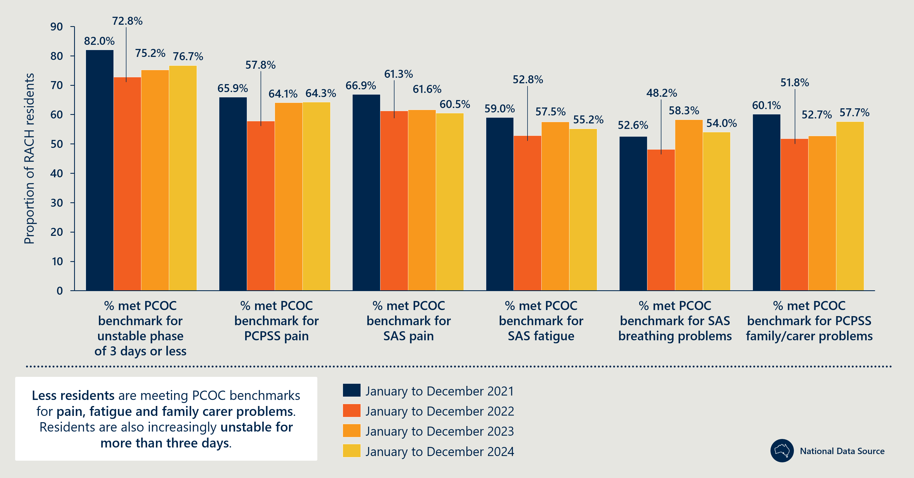
There is some evidence that the Measure has led to improved quality of life for RACH residents
- A national aged care peak body and representatives from NSW Health reported that, based on national and state-wide observations, the Measure funded projects have contributed to improved quality of life for residents in RACHs.
- Over the period of July 2019 to June 2024, the majority (90 per cent) of RACHs that were assessed against ACQSC standards were compliant with the standard relating to consumers being treated with dignity and respect, with their identity, culture and diversity valued.
The Measure has encouraged RACHs and specialist clinicians to deliver more culturally specific support
- Analysis of the RACH survey found that nationally, the vast majority of RACHs that provided a response have palliative care specific policies to ensure a resident’s spiritual and cultural end-of-life needs are met.
- During consultations with stakeholders in 2025, specific examples of good practice were captured across the Northern Territory, Victoria, Western Australia and Queensland:
  - RACH staff and specialist clinicians across the Northern Territory (Central Australia and Top End) actively work to support residents to die on Country when possible. One RACH adopted the practice of “bringing Country to the resident” when the resident could not be taken to Country for their death. This involved surrounding the resident with the music, people, smells and sights they would normally experience on Country. Funding constraints - such as travel costs - are often a limiting factor in this work.
  - Victoria has implemented the Resident Elders project to promote culturally safe palliative and end-of-life care for Aboriginal and Torres Strait Islander Elders, and a mentor program for aged care RNs across some metropolitan and regional areas. Victoria employed a Measure-funded cultural advisor as a core member of the PCV project team and reported that this fostered engagement with ACCOs, after having initial challenges with building trust.
  - The evaluation of Western Australia’s implementation of the Measure found that approximately 68 per cent of respondents in Measure impacted RACHs felt that resident’s cultural and spiritual background was respected, compared to RACHs not involved in the Measure where only 52 per cent felt resident’s cultural background was respected and 55 per cent felt spiritual beliefs were respected.
  - Improved internal symptom management and reduced hospital transfers enable residents to remain in the RACH during death. This allows staff, who understand the resident’s needs and end-of-life wishes, to provide high-quality, culturally appropriate care. For example, specialist clinicians in Western Australia described how staff ensured a Muslim resident’s bed faced Mecca, an important detail that may be missed in hospital.
  - The PUP team in Queensland ensure First Nations residents can die and receive quality palliative care support on Country.
Some Measure-funded roles provide holistic and bereavement support to residents and families
- RACH staff in Western Australia reported that while doctors and nurses managed symptoms effectively, MPaCCS social workers provided more effective support to families. Residents and families across regional and metropolitan areas gave positive feedback, highlighting the value of social workers. Unlike clinical staff, who often lack the time or skills to engage families meaningfully, social workers offer dedicated, compassionate support.
- The evaluation of Western Australia’s Measure funded projects found that RACH staff delivered high-quality care beyond clinical needs, with 84 per cent of residents recalling being treated with compassion, respect and dignity, and 79 per cent rating the overall care as excellent or good.
- Generalist providers in NSW’s South-Western LHD and in Tasmania suggested that the involvement of the CNC in-reach team not only boosted clinical aspects of care but also allowed for residents to receive better psychosocial and other holistic support.
- Specialist clinicians and policy leads in Tasmania reported using an MDT to delivery holistic, wraparound care. They have recruited a social worker in one region to build relationships with residents and families and provide information about the care that RACHs can provide. Other regions continue to support brokerage of allied health as needs are identified through RACH staff or CNC. A music therapist is also providing in-reach services into RACHs in the south.
Bereavement support for families and carers could be further improved
- The evaluation of Western Australia’s Measure funded projects found that bereavement support for families and carers was not adequate – only 50 per cent felt adequately supported at the time of the resident’s death and just 42 per cent received sufficient support afterwards.
- RACH staff and specialist clinicians in NSW described bereavement support as lacking in their locales, especially in regional facilities. One RACH specifically, expressed difficulty in engaging families for bereavement support after the resident had passed away.
- In the Northern Territory (Top End), limited access to holistic bereavement support can stem from the difficulties families living on Country face in visiting residents. Financial constraints hinder their ability to afford transport and accommodation, and despite RACHs’ efforts to provide lodging, bed shortages often prevent this.
Access to specialist clinicians and GPs, and other workforce challenges, continue to pose barriers to delivering quality palliative care to all residents
- Specialist providers in Victoria reported that delays in specialist clinicians responding to RACH referrals when residents deteriorate often result in residents dying before specialists arrive, leading to a poor end-of-life experience.
- RACH staff in the Northern Territory (Top End) also reported delays in accessing GPs resulting in poor anticipatory prescription practices that can result in residents having to undergo painful deaths. (More detail on the poor access to GPs and medication and its burden on resident experiences can be seen in Outcome 4).
- Other challenges such as the high proportion of CALD workers in the aged care workforce (see Outcome 3) and governance issues (see Outcome 10) have also inhibited the ability of the Measure to make meaningful improvements in the quality of care delivered in RACHs.

Access and choice
Outcome 6: Improved quality of palliative care provided in RACHs including:
- more people dying where they want
- increased person-centred care informed by an individual’s choice.
Final assessment: More people are dying in their preferred place of death and there is evidence from Western Australia, Victoria and South Australia that this is increasingly RACHs. National RACH survey results indicate a 40 per cent (8.8 percentage point) increase in the proportion of RACHs that have recorded the preferred place of death for all residents, for those that provided a response. There are examples of good practice in Western Australia, South Australia and Queensland where tools are improving documentation of resident choices and needs. This is better enabling RACHs to advocate for and fulfill residents’ cultural and psychosocial needs at the end-of-life. In Western Australia specifically, the Measure funded project has directly improved documentation of RACH residents’ preferred place of death.

Detailed evidence: Outcome 6
Resident choices are increasingly discussed and recorded through ACPDs and other processes
- As reported in Outcome 1, there is a general increase in end-of-life discussions and ACPD completion in RACHs, indicating that resident choice is being increasingly discussed and documented across all jurisdictions.
- Resident choices relating to preferred place of death is increasingly recorded in ACPDs and goals of care documents. National RACH survey results indicate an 40 per cent (8.8 percentage point) increase in the proportion of RACHs that have recorded the preferred place of death for all residents and a 21 per cent (1.3 percentage point) decrease in the proportion of RACHs that did not have a preferred place of death for any of their residents (Figure 15), between 2021 and 2025.
- Western Australia’s evaluation highlighted a 33 per cent increase in documentation of residents’ preferred place of death for RACHs participating in Measure-funded activities, compared to those that did not participate. The evaluation also found that participating RACHs had 28 per cent higher utilisation of this documentation than those not involved.
- The RGoC form developed by WACHS under the Measure has been widely used by RACHs and promoted by clinicians in regional areas of Western Australia. This has enabled the capture of resident choice where they did not have the capacity to complete a formal ACPD.
Figure 15 | RACH survey results on recording of resident's preferred place of death
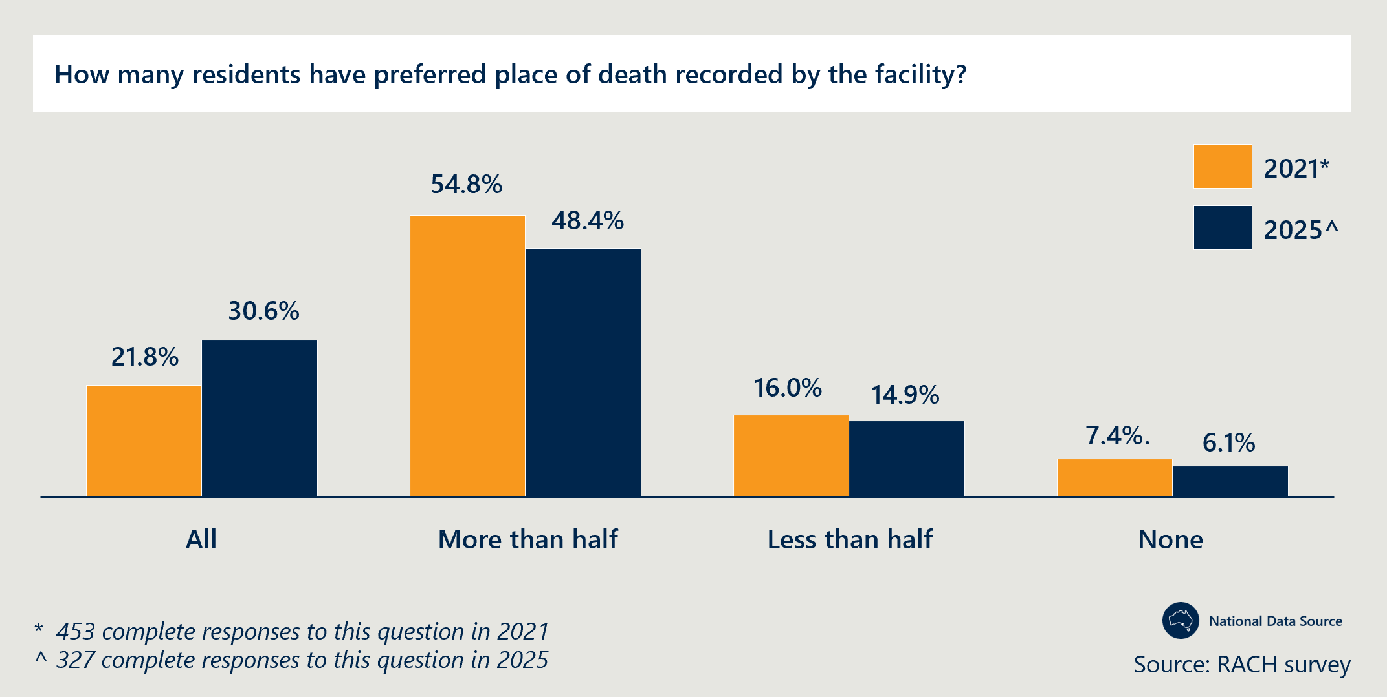
The Measure is enabling more people to die at home, in their RACH; this is the preferred place of death for most residents
- RACH staff in Western Australia, and clinicians in Victoria and South Australia, reported anecdotal evidence of an increase in the proportion of residents who had nominated the RACH as their preferred place of death and that, in most cases, this preference was fulfilled.
- There is also evidence from South Australia, Tasmania and the Northern Territory that the proportion of residents dying in their preferred place, and/or in the RACH, has increased:
  - An independent evaluation of South Australia’s Measure-funded activities found that, since the commencement of Measure activities, the proportion of residents who died in their preferred place of death increased from 66 per cent to 77 per cent and the percentage of residents who died in residential aged care increased from 85 per cent to 93 per cent.
  - The Tasmanian Department of Health reported that 99 per cent of residents that died from June 2023 to June 2024, died in their preferred place of death.
  - In October 2022, the Northern Territory reported that deaths within nursing homes in the Top End had increased by 175 per cent since the beginning of the CPCiAC project, indicating improved access to end-of-life care within the RACH.
- Analysis of national NHDH data from 2018-19 and 2021-22 indicates that the majority (approximately 81 per cent) of residents’ deaths occurred within the RACH (Figure 16). Although the proportion of resident deaths occurring within RACHs did not increase over the two time periods nationally, it did increase for the ACT, NSW and South Australia, with other jurisdictions either remaining the same or decreasing slightly (Figure 17). While a high proportion of deaths occurring in RACHs is generally a positive indicator of end-of-life wishes being fulfilled (with an estimated 96 per cent of residents wishing to remain in a RACH), it is important to note that not all residents elect RACHs as their preferred place of death and some hospital admissions or ED presentations are appropriate.
Figure 16 | RACH residents place of death in 2018-19 and 2021-22
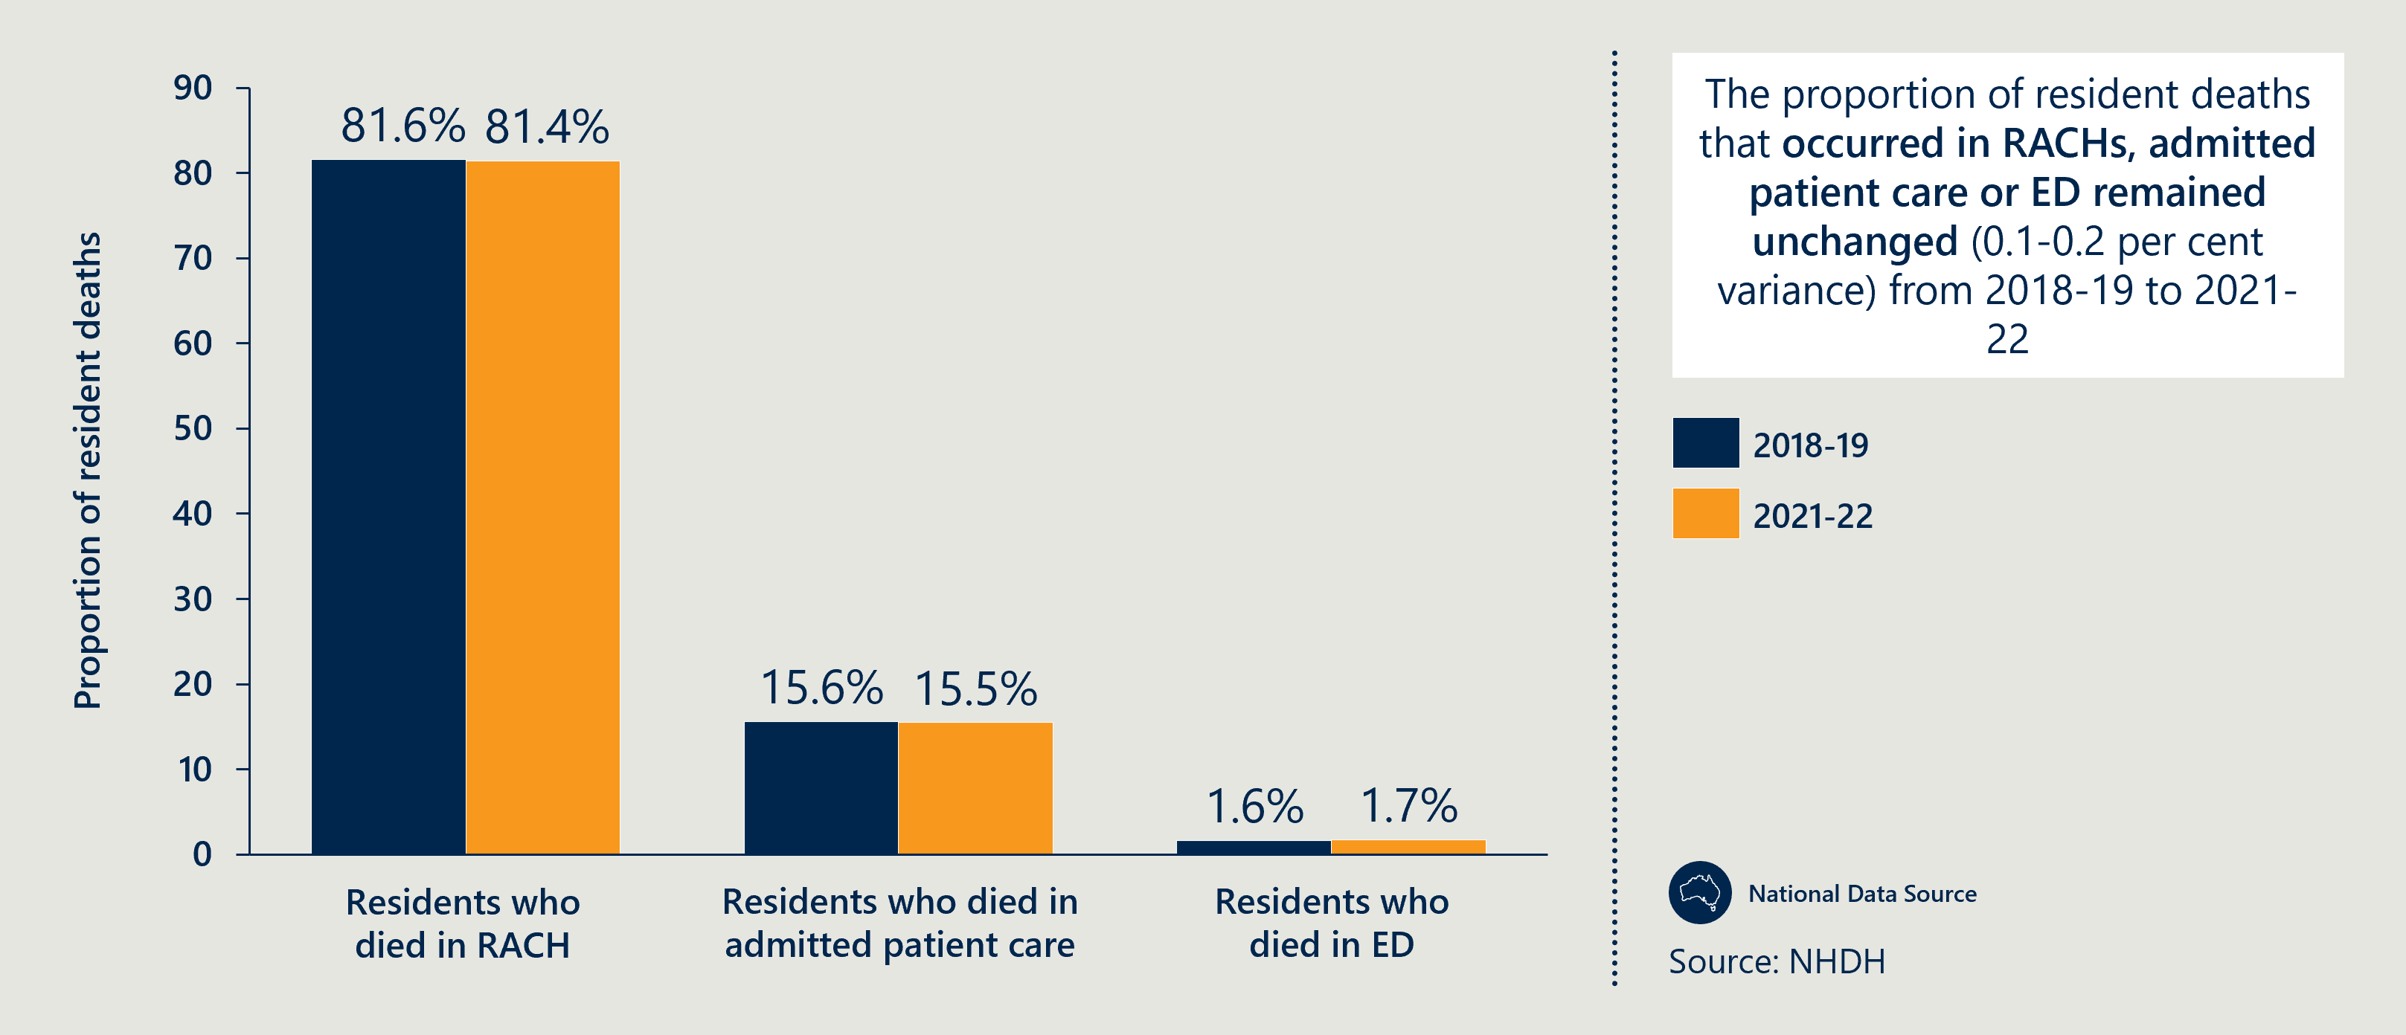
Figure 17 | Proportion of residents that died in RACHs, by state and territory
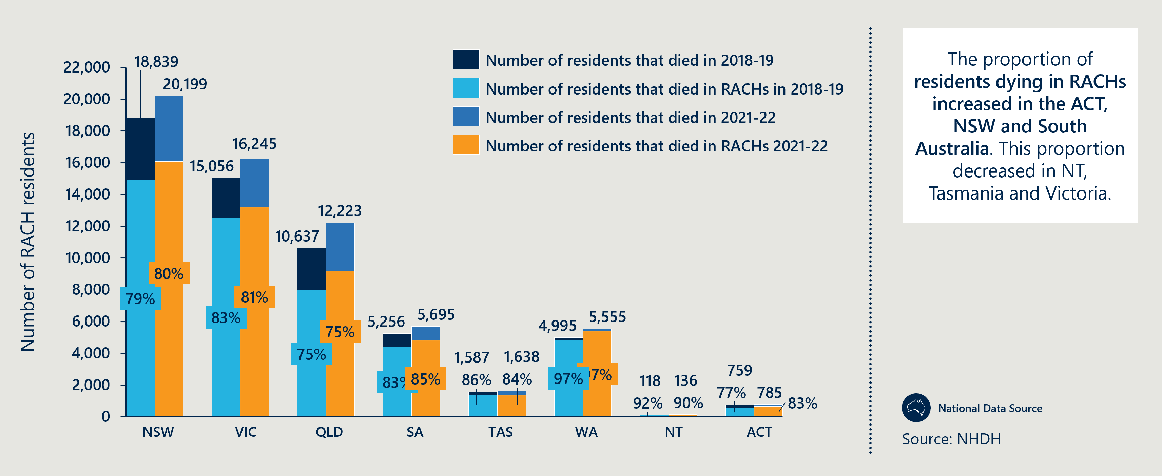
The documentation of resident choice is enabling RACHs to advocate for and fulfill residents’ cultural and psychosocial needs at the end-of-life
- In South Australia, RACH staff credited increased end-of-life planning conversations and ACPDs with an improved ability to meet the end-of-life care goals in almost all cases and provided explicit examples of where they were able to advocate for residents end-of-life preferences to return to the RACH (from hospital) to pass away with family.
- In Queensland’s Metro North HHS, RACH staff shared the example of a First Nations resident on a palliative care pathway who was supported to die in a hospice in Toowoomba, in accordance with her and her family’s wishes to be closer to her daughters.
- Additional detail on how the Measure has enabled RACH staff to provide culturally appropriate care, aligned with the end-of-life wishes of residents is detailed in Outcome 5 above.
Collaboration
Outcome 7: Improved care coordination with GPs/primary care, acute care services and specialist palliative care services.
Final assessment: Measure-funded roles with a dedicated care coordination function have significantly improved care integration, referral pathways and continuity of care, with specific examples of good practice in Western Australia, the ACT, Tasmania and Queensland. From 2018-19 to 2021-22, there was a 59 percent increase nationally in the number of residents that accessed palliative care within one month of attending an MDT meeting. This suggests an increasing focus on palliative care within multidisciplinary meetings, and that meetings help improve coordination and access to palliative care for residents.
There is mixed evidence on the extent to which GP involvement in RACHs has increased. There was a significant increase in remote and very remote RACHs surveyed reporting improved access to GPs. Further, where care coordination and GP involvement has been a focus (such as in Western Australia), RACHs reported an increase in multidisciplinary case conferences (77 per cent of participating RACHs held multidisciplinary case conferences, compared to only 56 per cent of RACHs not participating).
However, while prescriber activity in RACHs has increased nationally (as reported in Detailed evidence: Outcome 4), the number of multidisciplinary meetings run by GPs, and residents who attended at least one meeting, decreased from 2018-19 to 2021-22 and from 2019-20 to 2023-24, though this data has limitations.

Detailed evidence: Outcome 7
Measure-funded roles with a dedicated care coordination function have significantly improved care integration, referral pathways and continuity of care
- There is evidence from Western Australia, the ACT, Tasmania and Queensland that Measure-funded roles providing a coordinating function have led to several benefits. As described in section 4.3, care coordination efforts focus on enhancing the integration between RACH residents, their families and care teams and support the integration of acute care across aged care and health care settings.
  - In Western Australia, the Measure funded several coordination roles with the purpose of facilitating care coordination within health care teams and RACHs. These include the Care Coordinator pilot (SMHS), Transition Support Navigator pilot (NMHS) and Transition Support Officer pilot (EMHS). The RCL and MPaCCS services also work collaboratively to facilitate continuity of care, conducting handovers across services where required.
- Consultation with policy leads, specialist clinicians and RACH staff suggested these roles helped with coordinating referrals to relevant teams and supporting residents and families to understand their care pathways.
  - Data provided by the Western Australia Department of Health indicated that 63 per cent of RACHs involved in the Measure reported improved coordination of palliative care between GPs, hospitals and specialist palliative care teams – compared to only 24 per cent of RACHs not involved in the Measure.
  - Representatives from policy teams in the ACT highlighted the PEACE team’s key role in coordinating hospital transfers by working closely with North Canberra Hospital’s palliative care liaison team. The PEACE team account for 47 per cent of referrals to Clare Holland House’s in-patient unit and coordinate referrals to Palliative Care ACT volunteers when RACHs are unable to cater to resident’s psychosocial needs. See Case study 10 for an example of how the PEACE team coordinates multiple services to provide clinical, bereavement and culturally appropriate care to their residents.
  - In Tasmania, clinicians valued the CNC role for proactively coordinating with doctors, RACH staff and allied health providers such as social workers and dietitians.
  - SPACE teams in Queensland also supported coordination of care across different providers, reported by RACH staff and policy leads. Local SPACE clinicians play a key role in connecting RACHs in regional and rural areas to SPaRTa’s telehealth services, including ensuring the appropriate equipment is available for RACHs within and outside SPaRTa’s catchment area. The SPACE team Metro North HHS coordinate between other services, for example Residential Aged Care District Assessment and Referral, improving communication and referral pathways between the teams.
- NSW’s regional LHD implemented a model that supported the transfer of community-based residents into RACHs. This reduced the workload for community nurses and shortened the length of care episodes for specialist palliative care providers.
Case study 10: PEACE team in the ACT coordinate multiple services to provide holistic end-of-life care to residents.
Project overview
The PEACE team provided the following vignette to highlight a specific example of care coordination and resident outcomes.
Following a traumatic hospital experience involving unmanaged pain during care, a resident returned to their RACH fearful of dying and wanting to prioritise comfort. Upon return, their initial analgesic regime was ineffective and staff struggled to provide personal care. The PEACE team was engaged to improve the resident’s comfort and ensure their care aligned with their previously expressed wishes.
Outcomes
The PEACE team coordinated with the Home-Based Palliative Care service to reinstate spiritual care, helping the resident feel more emotionally settled as their condition worsened. They also connected the resident with volunteers from Palliative Care ACT, providing companionship and reassurance during their end-of-life experience. The PEACE team also supported the RACH’s nursing staff to communicate clearly with the GP as the resident’s condition worsened and collaborated directly with the GP to adjust the pain management approach as needed. Ultimately, collaboration between the GP, RACH staff and the GRACE team enabled appropriate weekend care planning, ensuring the resident received consistent, coordinated care during a critical period.
There is evidence that the Measure has strengthened collaboration between GPs and specialist palliative care teams
- Specialist clinicians in Western Australia and Queensland reported significant improvements in the prescribing practices of GPs because of the relationships and advice provided by specialist palliative care consultants.
- The Western Australia Department of Health note that relationships between GPs and specialist palliative care providers improved under the MPaCCS expansion.
- The proactive engagement of the specialist CNCs in Tasmania built trust among GPs who were initially reluctant to work alongside the CNC team and prescribe palliative care medication. In consultation, the CNCs and RACH staff reported that prior to this GPs were often not receptive to the recommendations of RACH staff who had received advice from the specialist CNC teams.
- Clinicians involved in South Australia’s RSS suggested that GPs felt more supported being accompanied by the Palliative Medicine Consultants in family meetings due to their specialist expertise.
More residents are accessing palliative care following multidisciplinary meetings, however there is mixed evidence on the extent to which multidisciplinary meetings involving GPs have increased
- From 2018-19 to 2021-22, there was a 59 percent increase in the number of residents nationally that accessed palliative care within one month of attending an MDT meeting (Figure 18). This suggests an increasing focus on palliative care within multidisciplinary meetings and that they are facilitating more coordination and access to palliative care for residents.
- While this suggests that multidisciplinary case conferences have become more effective at facilitating access to palliative care for RACH residents, there is mixed evidence on the prevalence of these meetings.
- Anecdotal accounts of increased multi-disciplinary case conferencing across jurisdictions suggest better care-coordination. Western Australia’s evaluation found that 77 per cent of RACHs impacted by the Measure held multi-disciplinary case conferences, compared to only 56 per cent of RACHs not involved in the Measure.
- Nationally, based on analysis of the NHDH and MBS data, the number of multidisciplinary meetings run by GPs, and residents who attended at least one meeting, decreased marginally from 2018-19 to 2021-22 and from 2019-20 to 2023-24 (Figure 19). However, it is important to note that this does not provide a complete picture of palliative care related GP activity in RACHs as the MBS items included in this analysis are not specific to palliative care and do not include all MBS items that GPs may bill for time spent in RACHs.
Figure 18 | Multidisciplinary case conferences that involve GPs and medical practitioners, 2018-19 and 2021-22
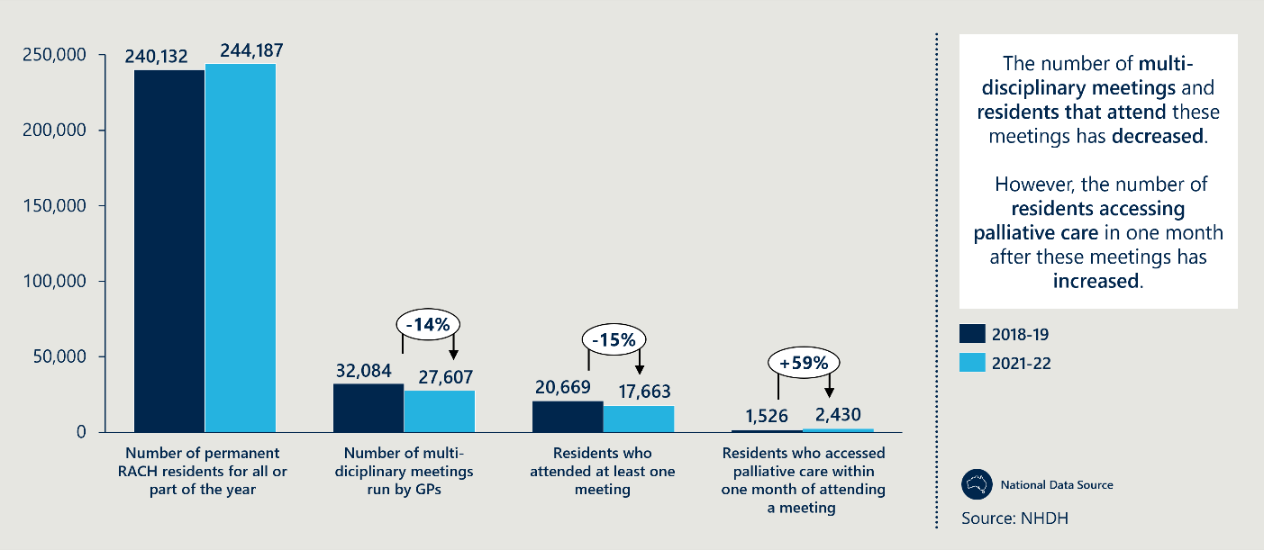
Figure 19 | RACH residents that attended at least one multi-disciplinary meeting from 2019 to 2024, by jurisdiction
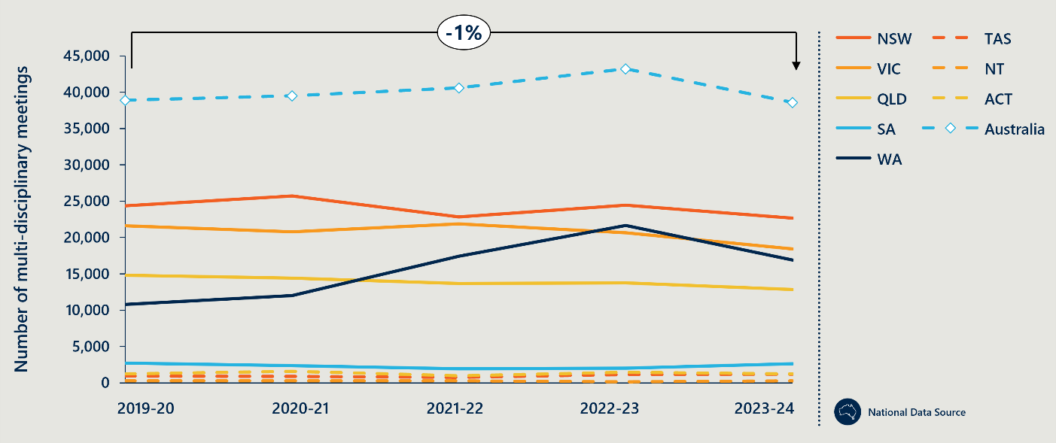
Access and coordination of GPs continues to be a challenge but is improving in some regions
- Poor coordination with GPs can have a significant impact on the quality of palliative care provided in RACHs, particularly in anticipatory prescriptions (see Outcome 4 for more detail) and in participation in needs rounds and other palliative or end-of-life related discussions.
- Nationally, the RACH survey results indicates that the majority of RACHs have access to palliative care through GPs and that access in remote areas has improved for those surveyed. The percentage of these RACHs in remote and very remote areas accessing palliative care services from GPs increased by 114 per cent (Figure 20).
- Western Australia’s GP Case-Conferencing Coordinator pilot aimed to increase GP time in RACHs but found significant barriers to changing GP behaviour. Instead, the pilot implemented structures to support RACHs to be able to assess residents and provide the right care at the right time.
- Several stakeholders raised ongoing challenges with GP access. RACH staff in Western Australia, NSW (Murrumbidgee), the Northern Territory (Top End) and clinicians in South Australia highlighted difficulties in accessing GPs, especially in regional areas stemming primarily from a shortage of GPs in the area often resulting in an excessive workload for those that are in reach.
- Clinicians involved in South Australia’s RSS and Eldercare programs developed a strategy to mitigate this issue by employing virtual needs rounds where GPs can dial in for just the residents they wanted to discuss.
- Clinicians in Tasmania, Queensland and PHNs in Victoria described similar challenges around access, however highlighted the lack of financial incentive GPs receive for engaging with RACHs as a potential cause.
- RACH staff in the Northern Territory (Top End) highlighted an example where inability to access the local GP resulted in staff having to call paramedics to prescribe necessary end-of-life medication for a deteriorating resident.
- CNCs in Tasmania also suggested that greater awareness is needed among GPs of the value of specialist palliative care services to support stronger engagement between GPs and specialist teams. They reported that, on commencement of the Measure, some GPs required education on the purpose and value of the specialist team, and how to work together to deliver comprehensive care to residents.
Figure 20 | RACHs accessing palliative care services from GPs, by remoteness
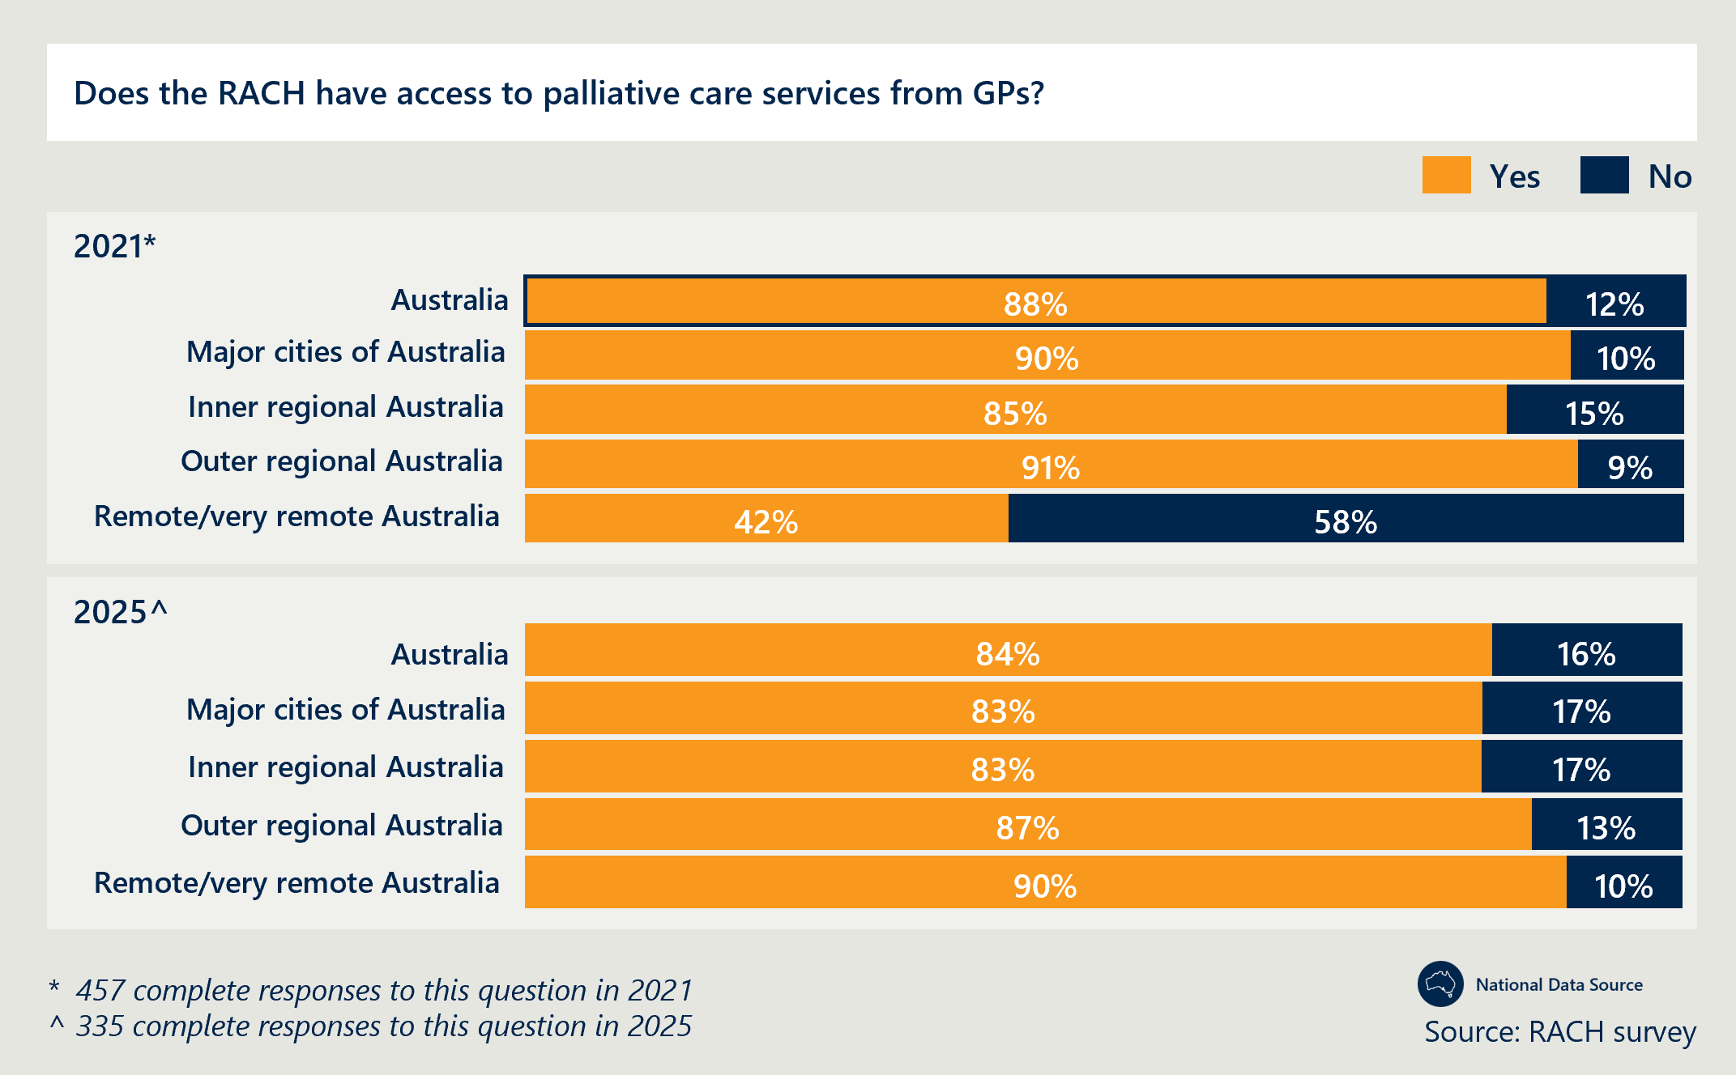
Collaboration
Outcome 8: Improved integration between the health and aged care systems.
Final assessment: The integration between health and aged care systems has been enhanced by increased access to specialist palliative care within RACHs (as outlined in Outcome 4). The Measure has facilitated stronger relationships between specialist providers and RACHs, with examples of good practice in Queensland, NSW, the Northern Territory and Tasmania. Care coordination roles help facilitate improved relationships, information sharing between clinicians and RACHs across care settings, as well as improve documentation, medication management and continuity of care. However, relationships are dependent on individual staff and therefore vulnerable to workforce turnover. Further, while clinician access to digital systems enables integration across health and aged care sectors and the delivery of comprehensive care, access remains ad hoc and role dependent. Overall, the Measure has fostered stronger links between specialist providers and RACHs, but palliative care is yet to be fully integrated within RACHs and remains largely reliant on external specialist providers.

Detailed evidence: Outcome 8
The Measure has facilitated stronger relationships between specialist providers and RACHs
- Integration between the health and aged care systems is evidenced by the increased access specialist palliative care providers have within RACHs. See more detail on this in Outcome 4.
- Specialist providers involved in Queensland’s central SPACE team reported that local HHS SPACE leads were successful in building relationships with RACHs in their regions, enabled by their local knowledge of their region.
- RACH staff in the Northern Territory (Top End) indicated that having the specialist NP able to physically attend RACHs participating in the Measure enabled relationship building between the NP and the RACHs. The NP also deeply understood the context and challenges of the region, aiding with trust-building.
- In Victoria, Measure funding was used to better integrate Melbourne City Mission’s Palliative Care (MCMPC) team into RACHs, delivering positive outcomes for residents, families, GPs and care staff (see Case study 11).
Case study 11: Melbourne City Mission in Victoria used the Measure’s funding to build stronger partnerships with the aged care sector.
Project overview
The MCMPC team received Measure funding to strengthen partnerships with aged care homes and improve palliative care outcomes across their catchment. By the end of the project, MCMPC was supporting 52 RACHs, by delivering in-reach specialist palliative care via an MDT. The MDT included CNCs and allied health professionals.
Outcomes
To evaluate its impact, Melbourne City Mission conducted interviews with 41 participating RACHs at the conclusion of the first year of operation. Of the RACHs interviewed, 26 stated they would refer all residents requiring palliative care to MCMPC. Staff reported that working with the MCMPC team enhanced their knowledge and reduced the burden of care – particularly in managing family discussions. Families also expressed greater understanding of palliative care following meetings involving MCMPC staff.
GP prescribing practices reportedly improved, with GPs increasingly relying on MCMPC’s clinical recommendations. In cases where RACHs expressed interest, MCMPC implemented a Calvary-based needs round model. All six RACHs that participated in this model reported positive outcomes.
Care coordination roles help facilitate information sharing between clinicians and RACHs across care settings, improving documentation, medication management and continuity of care
- Under the Measure, transition support navigator and care coordinator roles were funded across three metropolitan regions in Western Australia. These roles provide support to patients entering a RACH or transitional care facility for the first time or returning to their RACH after hospitalisation. They liaised between hospital clinical teams and RACH staff to ensure all necessary documentation and information were provided at the point of transition – facilitating continuity of care and, in some cases, resulting in referrals to specialist clinical teams. These roles also contributed to improvements in staff education and the completion of ACPDs and other end-of-life documentation.
- In Western Australia, the ACT and Queensland transition support functions were also embedded into other Measure funded roles such as for in-reach specialist palliative care clinicians. In Western Australia, for example, the MPaCCS liaison nurse coordinated transfers between hospitals and RACHs, ensuring referrals and medications were in place for the resident's ongoing care. See more detail on these roles in Outcome 7.
Relationships between RACHs and clinicians are dependent on individual staff and therefore vulnerable to workforce turnover
- Specialist providers involved in Queensland’s central SPACE team reported that frequent workforce turnover in these roles meant that when key personnel left, established relationships were often lost. This created challenges in re-identifying key RACH contacts and rebuilding trust, slowing implementation. One stakeholder highlighted that of 15 HHSs, at least four had these issues.
- Specialist providers in NSW’s Hunter New England LHD highlighted that high turnover of management positions in RACHs, especially for smaller facilities, meant that the relationships with GPs and specialist CNC teams were often lost. As a result, RACH’s access to these services would often be limited, simply due to a lack of awareness.
- A specialist clinician involved in South Australia’s Hospice in RACH pilot and RSS programs highlighted difficulties in engaging many RACHs to participate in the Measure’s initiatives despite repeated efforts at reaching out. Clinician access to digital systems enables integration across health and aged care sectors and the delivery of comprehensive care, however access remains ad hoc and role-dependent (see 4.2.4 for more details on the challenges on the interoperability of systems).
- RACH staff in Tasmania, highlighted the usefulness of the CNC role in its ability to act as a conduit between the RACH and the state-level hospital and community health records (see Case study 3).
- One RACH in Queensland’s Metro North HHS reported that their in-reach SPACE clinician was granted remote access to the facility’s records. Arrangements like these can reduce the need for on-site visits and enabled more efficient issue resolution through accessible, off-site support, however this arrangement is dependent on the RACH providing this permission.
- Specialist providers involved in Victoria’s Melbourne City Mission community palliative care team, highlighted better access to digital records as a key opportunity to strengthen their ability to provide comprehensive, in-reach care. One provider shared that they establish Memorandums of Understanding with RACHs, where they were willing, in which they agree on access to resident records, in addition to roles and responsibilities regarding needs rounds between the RACH and clinical team.
- In NSW Far West LHD, the CNC is uploading ACPDs into the EMR software, ensuring visibility of their end-of-life wishes even when transferred to hospital (see Case study 12).
Case study 12: In NSW’s Far West LHD, the Measure-funded CNC is uploading ACPDs into EMR software to streamline advance care planning across care settings.
Project overview
The Measure-funded Palliative and End-of-Life care team in Far West LHD has been providing an in-reach model of care to the residential aged care sector across the LHD. They have adapted the Calvary Needs Round model to address underutilisation of existing resources and the need for a standard approach to end-of-life planning and care delivery.
Outcomes
In 2021, a total of 29 needs rounds occurred across five RACHs. During the first year of needs rounds in the Far West LHD it was found that 17 of the 65 residents did not have ACPDs in place and a further 15 had plans that had not been reviewed for over three years. All but two of these were updated because of the needs rounds. Since July 2021 and the EMR Advance Care build, up to date ACPDs discussed at needs rounds have been uploaded in to EMR to ensure they are readily available even if the resident is transferred to hospital. This sharing of information enhances a streamlined approach to ACPD use across care settings.
Generalist palliative care is yet to be fully integrated within RACHs and remains largely reliant on external specialist providers
- Specialist providers in NSW’s Far West LHD, peak bodies in Victoria and NSW, policy leads in Western Australia and clinicians in Queensland’s Metro North HHS, emphasised that the distinction between generalist and specialist palliative care is not yet well understood. They advocated for the integration of generalist palliative care into routine care within RACHs, enabling care staff to manage these needs as part of their day-to-day responsibilities.
- PCV highlighted that people requiring specialist palliative care should represent only around one in five cases, thus these services should be reserved for those with more complex needs.
- There remains an opportunity for upskilling of GPs to better engage with and provide palliative care alongside specialist in-reach teams. SPACE Clinicians in Queensland (Metro North HHS), highlighted that further capability uplift for GPs with regard to generalist palliative care would reduce demand on already time-poor specialist in-reach teams, enabling them to focus on more complex cases.
Data and evidence
Outcome 9: More palliative care services and health planners are informed by performance information on appropriateness, effectiveness, efficiency and outcomes.
Final assessment: More specialist palliative care services providing in-reach to RACHs are reporting to PCOC, indicating a growing commitment to strengthening outcomes data collection for palliative care across the sector. The number of specialist palliative care services reporting to PCOC increased by 32 per cent, from 57 in 2021 to 75 providers in 2024. More RACHs are using tools to capture performance information, such as ELDAC’s after-death audits, but use is still inconsistent. While the proportion of RACHs surveyed nationally that “always” use an audit process has increased from 33.1 per cent in 2021 to 38.9 per cent in 2025, the majority of RACHs still do not regularly employ an audit process. Data relating to palliative care delivery and outcomes is inconsistent across the health and aged care sectors. This is exacerbated by the lack of centralised reporting systems. Jurisdictions are conducting local evaluations and data collection on Measure-funded activities, but they vary in focus and completeness.

Detailed evidence: Outcome 9
More specialist palliative care services are reporting to PCOC, indicating a growing commitment to strengthening outcomes data collection for palliative care across the sectors
- There was a 32 per cent increase in the proportion of providers reporting specialist palliative care in-reach services into RACHs (from 57 per cent to 75 per cent between 2021 and 2024). Of these, the number of episodes of care delivered by specialist palliative care in-reach services into RACHs increased by 76 per cent (from 5,653 to 9,949 between 2021 and 2024).
- The increasing uptake of PCOC by specialist in-reach palliative care services and PACOP for RACHs, demonstrates a growing commitment to strengthening outcomes data collection for palliative care across the sectors. The use of PCOC and PACOP is voluntary, data collected through these is not specific to RACHs or palliative care services directly impacted by the Measure.
- RACHs are showing commitment to data collection through increasing participation in PACOP, which captures outcomes data for palliating residents in residential aged care. The number of RACHs reporting into PACOP increased from 19 in the first half of 2023 to 94 in the second half of 2024 (290 per cent increase). Consultations with RACH staff in NSW, Western Australia and PCV and PCA also suggest that PACOP is being used increasingly across RACHs.
More RACHs are using tools to capture performance information, but use is still inconsistent
- There is evidence that the proportion of RACHs using after-death audits to review end-of-life care has increased. Of RACHs surveyed nationally, the proportion that “always” use an audit process increased by 17 per cent (from 33.1 per cent in 2021 to 38.9 per cent in 2025). The number of RACHs who reported to “never” use these processes decreased by 25 per cent (from 24.2 per cent to 18.2 per cent), over the same time period (Figure 21). However, the majority of RACHs surveyed reported that they do not regularly employ an audit process.
- Of RACHs surveyed nationally, the proportion of RACHs that use a digital dashboard or digital tool to monitor palliative care within the RACH increased by 84 per cent (from 16.9 per cent to 31.1 per cent). Despite this increase, the majority of RACHs do not implement a digital dashboard or tool to monitor palliative care within the RACH (Figure 22).
- Specialist clinicians supporting South Australia’s Hospice in RACH program and RSS program leveraged ELDAC’s after-death audits to track changes in key indicators between 2021 and 2025. Metrics include hospital transfers, ACPD completion, the proportion of residents nominating RACHs as their preferred place of death, the fulfilment of end-of-life wishes and the number of deaths occurring in RACHs. These metrics were consistently reported back to South Australia Health and used as part of the Flinders University evaluation of South Australia’s Measure activities.
Figure 21 | RACH use of audit processes to assess end-of-life care
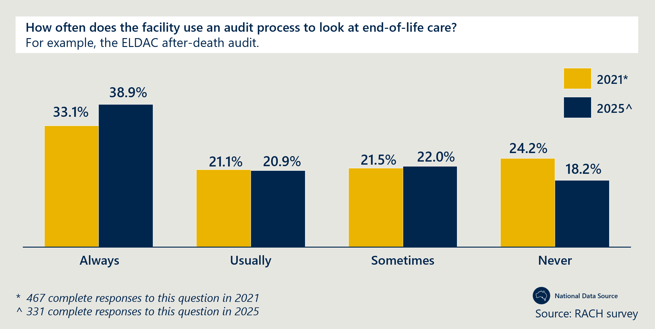
Figure 22 | RACH use of digital dashboards or other digital tools
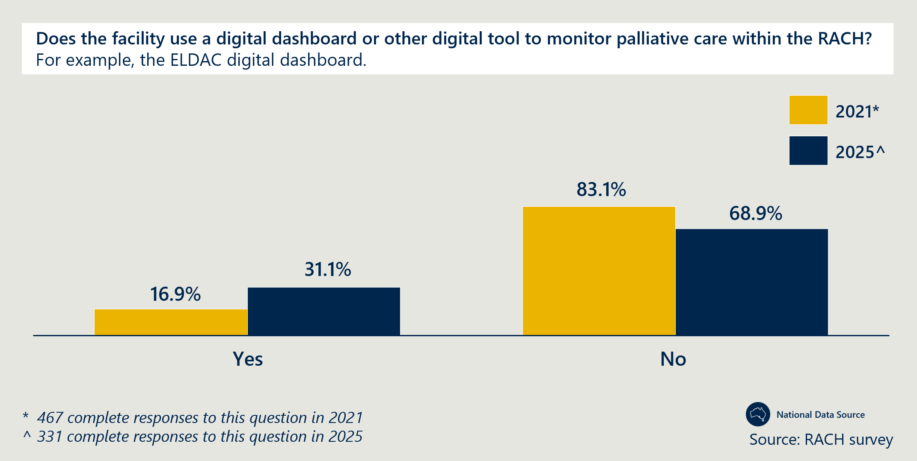
Data relating to palliative care delivery and outcomes is inconsistent across the health and aged care sectors; this is exacerbated by the lack of centralised reporting systems
- There is an absence of consistent data collection and centralised reporting systems, particularly in specialist palliative care services. This inconsistency affects the accuracy and comparability of data across regions and services. Further details on the limitations of data available to inform the evaluation is provided in sections 3.2.1 and 3.3.
- Infrastructure such as DHRs and My Health Record can enable better data collection and sharing. The ACT reported a focus on improved data governance and collection to assist with evaluating Measure activities.
- The ACT PHN (Capital Health Network) reported that improved systems, technology and infrastructure (as well as processes and individual capabilities) were needed to enable better communication and collection of data. This includes rolling out DHR and promoting better use of My Health Record. The Tasmanian PHN also reported that implementing My Health Records could improve data sharing and care transitions.
- Specialist clinicians in Victoria highlighted that their biggest challenge has been access to data, often resulting in a process of having to sort through large data sets to determine if their activities are producing improvements in outcomes.
- Specialist providers in a NSW’s Far West LHD indicated a lack a consistent data collection process or centralised reporting system for specialist palliative care services. While some internal quality control mechanisms exist, such as using scheduling records to estimate the number of consultations, these are informal, unstructured and not based on a standardised template. Specialist clinicians in NSW’s Far West LHD indicated that they collected data on the changes in ED presentations and referrals to their service coming from RACHs.
- Clinicians involved in Western Australia’s RACEPC project, reported that they conducted post-engagement surveys with RACH staff which returned a minimal response rate.
Jurisdictions are conducting local evaluations and data collection, although they vary in focus and completeness
- Statewide evaluations on the impact of the Measure have been completed in Queensland, Western Australia, South Australia and the ACT (see Table 22, Appendix E for more detail). The completed evaluations vary in terms of their focus, level of detail and indicators that are reported on. For example, Western Australia’s “deep dive” evaluation included a focus on qualitative input from RACH residents, families and carers. In contrast, the evaluation in the ACT focused heavily on the PCNR model and quantitative evidence to support this. Queensland’s is the only evaluation that includes an assessment of cost-effectiveness related to the activities funded under the Measure.
- Palliative Care Queensland highlighted the need for consistent key performance indicators (KPIs) across jurisdictions and local regions. Stakeholders suggested consistent KPIs would enable different place-based models of care to be evaluated against shared quality standards.
- As an input to this evaluation, a standardised qualitative data collection template was sent to state and policy leads to complete at regular intervals over the course of the evaluation. The rate of completion and level of detail provided in the responses was varied.
Data and evidence
Outcome 10: Improved clinical governance to identify and implement quality improvement initiatives and evaluation of outcomes within RACHs.
Final assessment: Dedicated roles and governance structures facilitate knowledge sharing on best practices and support quality improvement of Measure-funded activities, with good practice examples in Queensland, Western Australia and Tasmania. CoPs have enabled collaborative problem solving and sharing lessons learned from the Measure. There is evidence of improved clinical governance and quality improvement initiatives within individual RACHs since the implementation of the Measure. However, compliance with Aged Care Quality standards relating to governance remains lower than other standards. There are opportunities for enhanced collaboration with PHNs and peak bodies to share learnings across the health and aged care sectors.

Detailed evidence: Outcome 10
Dedicated roles and governance structures facilitate knowledge sharing on best practice and support quality improvement of Measure-funded activities
- The SPACE teams in Queensland use a hub-and-spoke model that combines effective statewide oversight and local clinical focus. PHNs and specialist clinicians reported the centralised hub and spoke model enables the central SPACE team to oversee project management and data monitoring, while local SPACE teams within each HHS can focus on clinical delivery.
  - Clinicians noted that local SPACE teams are required to report regularly on key indicators – such as reductions in hospital transfers – which allows the central team to assess the statewide impact.
  - The central SPACE team also holds regular meetings with local teams to troubleshoot operational issues, co-design new models of care and support funding applications. This structure enables local teams, often resource-constrained, to prioritise patient care while delegating administrative and project management responsibilities to the central unit.
- Clinicians in Tasmania highlighted the benefit of having a centralised CNC role that operates across multiple RACHs as they bring knowledge on best practices and clinical governance. The CNCs across all regions in Tasmania attend monthly meetings with the policy lead to discuss challenges and share lessons learned.
- Western Australia implemented a multi-layered governance structure that supports cross-sector collaboration, alignment of Measure-funded activities with policy objectives and information sharing. For example, decisions to re-allocate underspent funds were made with input from the required governance mechanisms to ensure the most appropriate use of funding. This structure includes:
  - an Implementation Group, which facilitates collaboration between palliative care providers
  - a Reference Group, which brings together peak bodies, RACH representatives and the Department of Health to ensure the alignment to the Royal Commission recommendations
  - a CoP, which promotes information sharing and operational improvement among service providers.
CoPs have enabled collaborative problem solving and sharing lessons learned from the Measure
- The Queensland Department of Health established a CoP to connect local HHS SPACE teams across the state with each other to share experiences and lessons learned. The CoP also included participation from services such as PallConsult, SPaRTa, PEPA and ELDAC, to provide education to SPACE teams across the state.
- Generalist providers involved in Western Australia’s RACEPC project reported the use of educational symposiums to bridge the gap between the specialist palliative care and aged care industries and to facilitate cross-sector learning, information sharing and collaboration.
- RACH staff in NSW highlighted the positive impact of ELDAC’s CoPs (now discontinued), highlighting a need for a CoP to support smaller RACHs in rural areas.
There is evidence of improved clinical governance and quality improvement initiatives within individual RACHs since the implementation of the Measure
- In the national RACH survey, approximately two in three RACHs reported to have implemented palliative care related quality improvement initiatives over the 12 months, with a 2.1 per cent increase in this proportion since 2021. The majority of RACHs surveyed nationally in 2021 and 2025 have specific policies and procedures related to palliative care. These results suggest that palliative care is now more formally and actively governed within RACHs.
- There is evidence of greater governance and quality improvement within RACHs (not specific to palliative care delivery), however there is opportunity for RACHs to improve governance systems, frameworks and risk management.
Compliance with Aged Care Quality standards relating to governance remains lower than other standards
- From July 2019 to June 2024, the majority (between 77 per cent to 81 per cent of all RACHs assessed against the Aged Care Standards (8c-e) were found to have met the standards relating to effective organisation wide governance systems, risk management systems and practices, and clinical governance frameworks. While this rate has decreased in 2024, the overall rate is still higher than the majority of other standards and suggests that there continues to be improvements required in the governance systems, frameworks and risk management approaches in RACHs.
- While compliance with these standards indicates positive outcomes in clinical governance, this ACQSC standard is not specific to palliative care and therefore compliance data cannot be used to draw definitive conclusions specific to palliative care governance. Note the ACQSC standards have been updated since the analysis that was undertaken for this evaluation. The data in this report related to the previous standards that were in effect until 31st October 2025, not the Strengthened Aged Care Standards that commenced on 1st November 2025.
Existing governance arrangements influence access to palliative care in RACHs
- Access to specialist palliative care teams often requires referral from a GP, relying on their individual awareness, trust and engagement with specialist palliative care services. GPs, as the primary care provider, are responsible for the medical care of RACH residents and are central to decision-making regarding a resident’s medical treatment and services. Consultation insights from SPACE clinicians in Queensland reported that GP engagement with specialists varied., Specialists suggested that this variation may be due to varied capacity or understanding of palliative care delivery amongst GPs, however this was not directly tested with GPs in the Evaluation.
There are opportunities for enhanced collaboration with PHNs and peak bodies to share learnings across the health and aged care sectors
- PHNs in Queensland, such as North Queensland and Gold Coast, reported proactive involvement with Measure-funded teams. This involvement included project management support, relationship building and the establishment of communities of practice.
- The Gold Coast PHN (GCPHN) used funding from the After-Hours program to provide funding to the SPACE team and establish a steering group that oversees the SPACE team’s Measure-funded activities. See Case study 13 for more detail.
- The Northern Queensland PHN reportedly provided funding to establish networking dinners between Measure-funded palliative care providers.
- Victoria’s Murray PHN suggested that the Measure could have benefitted from leveraging the collaborative practices and relationships built with peak bodies and RACHs as part of prior engagement such as the GCfAHPC Program. Victorian PHNs were generally not involved until late 2022 or 2023, with many unaware of the Measure in 2021 due to funding being withheld during the COVID-19 pandemic.

Extent to which the Measure addresses interface issues
Key findings:
This section relates to findings under KEQ 8: Does the Measure and the models adopted in each jurisdiction help to address health system interface issues?
- The Measure is effectively addressing many health system interface issues, resulting in improved access to both generalist and specialist palliative care for RACH residents.
- In some jurisdictions, specific coordination and navigation roles have improved care integration, referral pathways and continuity of care.
- There is some evidence that Measure-funded activities have led to reductions in unnecessary transfers to hospital, particularly in Queensland and South Australia.
- GPs, specialist clinicians and RACH staff are collaborating effectively through needs rounds, improving coordination and navigation within the health and aged care system. There is an opportunity to encourage greater collaboration with PHNs, given their increased role in the aged care sector.
- Despite improvements, challenges persist:
  - GP involvement is valuable but their availability remains variable.
  - Timely prescribing and dispensing of medications is inconsistent.
  - The culture and processes within RACHs are often misaligned with the delivery of palliative care as core business.
The literature review conducted by Nous in 2020 at the outset of the evaluation identified the key health interface issues that residential aged care, primary care and acute care sectors are seeking to address, outlined in Figure 23.
The Mid-point and Interim Reports outlined the emerging evidence that the Measure is an effective mechanism to address many of the health-aged care interface issues, though implementation was in its early stages for some states and territories.
Figure 23 | Key health interface issues identified in the literature review
Evidence collected in the literature review suggested that the following are key health interface issues that RACHs, primary care and acute care sectors are seeking to address:
- access to primary health care services
- access to secondary and tertiary health care services, such as specialists or allied health professionals
- avoiding unnecessary transfers to hospital EDs, which are often due to challenges accessing appropriate health services from within the RACH
- poor clinical handovers that occur when residents are required to transition between RACHs and the health system
- coordination of the various health and aged care services that a person is accessing
- continuity of care when transitioning into a RACH and communication between hospitals and RACHs when transitioning between health and aged care services, which includes poor clinical handovers that occur when residents are required to transition between RACHs and the health system
- a lack of support to navigate the complex health and aged care systems.
The Measure has increased access to generalist and specialist palliative care for residents in RACHs, enabled by improved capabilities and confidence
- The Measure has been used to increase access to specialist in-reach palliative care services in all jurisdictions. Evidence for this is detailed under section 4.3 and in Outcomes 4 and 5 (section 4.4).
- National data indicates that there is an increase in access to specialist palliative care, in-reach activity and an increase in prescriber activity. As reported in section 4.4:
- Between the periods of 2014-2019 to 2017-2022, the proportion of RACH residents accessing palliative care services within the RACH relative to Australia’s total RACH resident population increased from 7 per cent of RACH residents to 10 per cent of RACH residents in Australia (Figure 6).
- The number of episodes of care provided by specialist palliative care services reporting to PCOC increased by 76 per cent (from 5,653 to 9,949) between 2021 and 2024. Specialist palliative care services reporting to PCOC and providing in-reach services to RACHs, rose by 32 per cent, indicating a proportionally large increase in episodes of care provided per specialist palliative care in-reach provider.
- The patient count of RACH residents dispensed with PBS items related to palliative care by community pharmacies increased from 18,585 in 2019-20 to 54,421 in 2023-24 (193 per cent).
- Generalist palliative care delivery by RACH staff has been enabled by education and training initiatives, both formal and informal, which have increased the confidence and skills of staff to deliver palliative care to residents and reduce the need for acute care in hospital. Evidence for this is detailed under Outcome 3 (section 4.4).
Coordination and navigation of the health and aged care system has been addressed by Measure-funded roles in some jurisdictions
- Measure funded roles designed to support care coordination help to improve navigation of the health and aged care systems. These roles with a dedicated care coordination function have significantly improved care integration, referral pathways and continuity of care, as described in section 4.4, Outcome 7.
- The transition support officers and MPaCCS liaison nurse role in Western Australia have improved discharge processes from hospitals to RACHs, with more emphasis on holistic goals of care rather than medication and wound care. These roles facilitate care coordination to support residents' understanding of their care pathways and transitions from acute care to RACHs. This approach enhances integration among RACH residents, their families and care teams, including acute care providers, ensuring more efficient transitions. This broader focus allows hospital staff to discharge patients more appropriately into RACH settings, utilising comprehensive patient information facilitated by the liaison nurse. More evidence for this is detailed under Outcomes 7 and 8, section 4.4.
- While direct coordination support for GPs and other generalist clinicians from Measure funding has been limited, some models of care have created mechanisms for GPs to engage directly with RACH care teams and specialist clinicians. Needs rounds help ensure that residents transitioning into RACHs have complete ACPDs and prevent double handling of information. More evidence for this is detailed under section 4.3.
- Where care coordination and GP involvement has been a focus (such as in Western Australia), RACHs reported an increase in multidisciplinary case conferences (77 per cent of participating RACHs held multidisciplinary case conferences, compared to only 56 per cent of RACHs not participating).
Needs rounds facilitate collaboration between GPs, specialist clinicians and RACH staff in South Australia, the ACT and Tasmania
- Case conferencing and needs rounds across multiple jurisdictions has reportedly increased resident access to nursing and primary care staff, as well as GPs and specialist teams. Specialist clinicians in the north and south of Tasmania reported that having the resident’s GP involved in needs rounds allows the transfer of patient information to the RACH. More evidence is detailed under Outcome 3 (section 4.4).
- South Australia, the ACT and Tasmania reported that needs rounds improved GP engagement, confidence and coordination within RACHs to deliver palliative care and strengthened relationships between specialist palliative care services, clinicians and RACH staff. Evidence for this is detailed under section 4.3. A strong relationship between RACH staff and clinicians reportedly enables specialist teams to support RACH staff to contact GPs, for example to request specific medications.
There is some evidence that Measure-funded activities have led to reductions in unnecessary transfers to hospital.
- As reported in section 4.4 (Outcome 4), there have been some examples of Measure-funded projects leading to a reduction in avoidable hospital transfers.
- The evaluation of Queensland’s SPACE project revealed a reduction in ED presentations and hospital admissions, resulting in a released capacity of 2,751 bed days annually and cost savings of $6.438 million from released hospital capacity over the course of the Measure (October 2020 to March 2024).
- An evaluation of South Australia attributed a reduction in hospital transfers to the Regional Hospice in Residential Aged Care project. Specifically, pre- and post-After Death Audits revealed reduction in hospital transfers in the last week of life from 16 per cent to 9 per cent of residents. The evaluation further highlighted that patients with ACPDs or were involved in case conferencing were less likely to be transferred.
- Specialist clinicians and RACH staff in Tasmania, NSW, the Northern Territory (Top End) and South Australia reported decreased reliance on hospital admissions and ED presentations, with Measure-funded roles enabling earlier detection of deterioration, increased staffing and improved goals of care documentation.
This is an opportunity to work more effectively alongside PHNs, given their increased role in the aged care sector
- PHN representatives in NSW reflected that there is a significant opportunity for improved collaboration between PHNs and state-funded service providers to improve outcomes for RACH residents. This is especially true when there is a devolved approach to service delivery through state health service providers (such as in NSW and Queensland).
- A PHN in NSW reflected that because collaboration between LHDs (who received funding under the Measure) and PHNs is not mandatory, the involvement of LHDs in palliative care for RACH residents can be limited.
- In Queensland, PHNs have actively supported the Measure through initiatives like the SPACE team, where the GCPHN mandated data reporting to a steering group to facilitate discussion and continuous improvement, and the North Queensland PHN funded networking dinners, fostering collaboration and information sharing among providers involved in Measure initiatives. More evidence for this is detailed in section 4.4 (outcome 9). The GCPHN has been proactive in supporting the implementation of the Measure by leveraging other funding sources to address gaps for RACHs and the aged care workforce, identified through the SPACE project, as well as fund expanded access to the SPACE services for RACH staff (see Case study 13).
- Under the Measure currently, service providers are not required to report to or collaborate with PHNs, despite their relationships with RACHs and GPs, and involvement in external initiatives. PHNs also play a significant role in delivering information and education to GPs.
- Establishing strategic partnerships with defined joint goals and clear responsibilities would foster a more unified approach. By focusing on community needs and actively involving community perspectives, PHNs and state service provides could move away from siloed operations and work together more effectively.
- See section 5 for more detail on encouraging collaboration with key stakeholders, including PHNs, across the palliative care and aged care landscapes.
Despite progress in addressing the interface between the aged and health care systems, challenges remain
- Access to primary health care through GPs remains varied across all jurisdictions, depending heavily on the capacity and individual engagement of GPs to provide care in RACHs. For example, pharmaceutical representatives reported that GPs often lack confidence in prescribing palliative care medications, often defaulting to “comfort care” medication for non-terminal patients at low doses.
- Building relationships with GPs can be challenging and requires persistence but is proving valuable, particularly where GP shortages pose difficulties such as in Tasmania. In response to workforce restraints, some RACHs (such as in the ACT) use telehealth for needs rounds, although some GPs reportedly remain hesitant to participate – specialist clinicians in the ACT reported they feel GPs do not seek specialist support because they do not see the need.
- Timely prescribing and dispensing of medications is inconsistent. RACH staff reported challenges with accessing primary care after hours without in-house NPs to prescribe medication, particularly in regional and remote areas. Pharmacy representatives reported that community pharmacies that partner with RACHs are generally responsive during operating hours. Additionally, PHNs in South Australia, NSW and Tasmania reported RACHs struggle to dispense medication after hours when pharmacies are closed. The ACT avoids this issue by keeping a standard stock of subcutaneous medications in RACH storage for after-hours dispensing with a prescription if a resident deteriorates.
- The culture and processes within RACHs are often misaligned with the delivery of palliative care as core business. Despite the Royal Commission's emphasis on palliative care being central to aged care, the sector remains burdened by outdated approaches that hinder improvement efforts. Specialist clinicians in NSW reported that some RACH staff tend to avoid responsibility for delivering palliative care due to a fear of repercussions of a death in the RACH, which leads to an overreliance on emergency services. Clinicians reflected that often nurses can deliver palliative care but are constrained by processes that prevent decision-making, resulting in delays to care delivery, overreliance on specialist teams and unfulfilled goals of care. Addressing these issues requires a significant cultural shift to successfully integrate a collaborative model and align practices with modern palliative care needs.

Effectiveness of joint funding and delivery arrangements
Key findings:
This section relates to findings under KEQ 3: How effective have the joint funding and delivery arrangements been for implementing and achieving the aims of the Measure? How could governance arrangements be more effective?
- The cost sharing approach has enabled greater scale of investment and encouraged joint responsibility for expanding and improving palliative care in aged care. All jurisdictions have provided matched or exceeded contributions to the Measure, ensuring a shared financial responsibility in implementing palliative care improvements.
- The Measure has enabled jurisdictions to expand approaches to palliative care in aged care and enhanced collaboration between health and aged care sectors, involving GPs, specialist clinicians and RACH staff to improve care delivery and integration.
- The flexibility of the Measure enabled states and territories to implement projects that addressed local contexts and needs. Some jurisdictions have implemented effective governance structures that support Measure implementation, shape delivery of activities and maintain accountability.
- There is broad support across all jurisdictions for ongoing funding for specialist palliative care services.
- Performance reporting is improving but remains variable in its contents and structure, with new schedules under the NPA extension providing more specific data points and some common measures across jurisdictions. Jurisdictional evaluation activities varied in scope and timing, inhibiting efforts to understand the impact of the Measure.
- Further improving the consistency of information captured would provide a stronger evidence base for assessing the performance and outcomes of funded projects.
- Increased PHN involvement may support Measure-funded activities through enhanced governance, knowledge sharing and leveraging funding to address gaps in palliative care skills and service delivery.
As outlined in section 4.1 and Appendix E, all jurisdictions have been delivering on the Project Agreement responsibilities to date, specifically by:
- providing a matched financial contribution to support the implementation of this Agreement – as described below and in Appendix D, all jurisdictions either matched or over-matched funding from the Australian Government
- proposing and delivering projects aligned to the aims of the Measure, as described in section 4.1
- reporting on the delivery of outputs and evaluating their agreed projects – all states and territories have delivered annual performance milestone reports and most have delivered evaluations. The level of detail and focus of these varies, as described below.
The NPA has facilitated matched funding contributions between the Australian and state and territory governments, ensuring a shared financial responsibility in implementing palliative care related improvements
- The NPA, which outlined the CPCiAC Measure, facilitated joint investment in palliative care by the Australian and state and territory governments. As outlined in section 4.1 and Appendix D, all jurisdictions either matched or over-matched funding from the Australian Government and conducted annual reporting for the Department on the progress of their projects.
- The Measure has funded over $128 million worth of activities nationally that have impacted more than half of all RACHs in Australia. The combined total of the original (2019-202 to 2023-24 Agreement) equated to over $91 million across the Australian and state and territory governments. In 2024, the Measure was extended with an additional $19.77 million committed by state and territory governments and $17.26 million by the Australian Government to continue implementing projects under the Measure. A detailed table of the contributions of each state and territory and the Australian Government is provided in Table 21, Appendix D. Qualitative feedback from stakeholders across all jurisdictions has emphasised the importance of continued funding for these projects.
- Many jurisdictions invested in palliative care beyond their share of funding under the Measure. For example, the ACT and Queensland over-matched the funds contributed by the Australian Government. In their 2024/25 Performance Milestone Report, Tasmania indicated that they have funded Measure-related activities outside of the Measure and NSW have funded an additional 100 FTE staff (beyond the matched portion of funding) who provide support in aged care and support Measure activities. South Australia and the Northern Territory also combined funding from other streams to supplement the amount provided under the Measure to maximise the impact of their activities.
- Since the introduction of the Measure, there has been a significant increase in funding dedicated to palliative care in Australia, which reflects a broader focus on palliative care. In 2023, the Australian Government committed more than $68 million to palliative care projects focused on education and training, awareness raising, quality improvement, and increasing access and advance care planning. The introduction of the AN-ACC funding model in 2022 also had implications for how palliative care in aged care was funded.
The NPA has enabled jurisdictions to expand the reach of existing services and pilot innovative approaches to address palliative care needs in aged care
- The NPA signed by the Australian Government and all jurisdictions established, at a high level, how Measure funding could be used to expand existing models of care or support new approaches to the way care is delivered or commissioned by each state and territory for aged care residents. This aligns to best practice for similar agreements, identified in the Literature Review, which typically set aspirational objectives for the project to guide project activities to address service and systemic gaps.
- South Australia, Tasmania, Queensland and Western Australia all reported that the Measure funds have been used to explore and implement innovative approaches to palliative care not previously funded or that would not have occurred otherwise. This was re-emphasised in the most recent round of consultations.
The NPA has fostered enhanced collaboration between health and aged care sectors, involving GPs, specialist clinicians and RACH staff to improve care delivery and integration
- The Measure has effectively encouraged joint responsibility and improved collaboration at the interface of health and aged care. As outlined in section 4.5, the Measure has been used to increase access to specialist in-reach palliative care services in all jurisdictions. Evidence for this is provided in sections 4.3 and 4.4 (Outcomes 4 and 5). Measure funded projects with a dedicated care coordination function have especially improved care integration, referral pathways and continuity of care, as described in section 4.4 (Outcome 7). Needs rounds have also facilitated collaboration between GPs, specialist clinicians and RACH staff in South Australia, the ACT and Tasmania.
- As described in section 4.2, the Measure funded activities have sought to address the needs of residents, families, carers, staff and the system. All jurisdictions reported that Measure funded activities have led to improved outcomes for residents, through improved access to and quality of palliative care in RACHs.
The flexibility of the NPA enabled states and territories to implement and adapt projects to respond to local contexts and needs as they evolved
- Jurisdictions reported that the Measure enabled them to deliver projects tailored to local contexts and needs, particularly where devolved approaches were implemented such as in Queensland and NSW, or where adaptation was required due to workforce constraints.
- As outlined in section 4.1, several jurisdictions adapted their needs rounds model to mitigate resource constraints. This adaptation in the ACT, NSW, the Northern Territory and Queensland allowed services to continue despite constraints.
- In Western Australia, the initial design of the RACEPC education program to be face-to-face was found to be inaccessible for RACH staff, thus required a pivot to online delivery. This change resulted in underspent funds, which were able to be reallocated to further expand the MPaCCS in-reach service. The flexibility of the agreement enabled this reallocation as needed.
- Queensland specialist clinicians and the PHN reported that the funding enabled them to build on existing funding sources and services, and ensure the approach was specific to local needs. For example, the SPACE team in West Moreton expanded on existing services provided by Ipswich nurses to conduct consultations, establish goals of care and organise anticipatory prescribing. This contributed to the success of the model implemented in West Moreton through existing relationships between specialists and RACHs and existing specialist capabilities.
Effective governance structures support Measure implementation, shape delivery of activities and maintain accountability
- As reported in the Interim Report, Tasmania, Western Australia and Queensland established governance structures, including internal governance groups and communities of practice, to support the delivery of Measure activities and maintain accountability across devolved models of care.
- Tasmania implemented a three-level governance structure which has promoted knowledge transfer, strategic oversight and workload planning. The CPCiAC project in Tasmania is governed through a reference group chaired by the Department for Health with representatives from clinicians, the peak body, primary care and ambulance; a CNC CoP to share knowledge and learnings across CNCs; and the Palliative Care Clinical Network, the strategic body in Tasmania for matters relating to specialist, generalist and primary palliative, and end-of-life care service delivery at which CPCiAC Measure updates are a standing agenda item. This is supported by regular meetings to ensure CPCiAC CNC staff are integrated into the specialist palliative care services.
- In Queensland, the central SPACE team meets with local HHS SPACE teams monthly to discuss service profiles, quality improvement and governance in each health service. As of September 2024, the central SPACE team were also considering re-establishing the CoP which enabled clinicians to share learnings and challenges across sites. Victoria also reported that a “central body” with responsibility and visibility for all Measure funded projects (in Victoria, this is the peak body) helped prevent silos of practice.
- As described in Outcome 10 in section 4.4, Western Australia has implemented a multi-layered governance structure that supports cross-sector collaboration, alignment of Measure-funded activities with policy objectives and information sharing.
There is broad support for ongoing funding for specialist palliative care services, but concern that palliative care needs are greater than the Measure funding
- All stakeholders overwhelmingly supported the Measure funding, emphasising that funded services were addressing vital care needs and that funding should be ongoing to ensure that services can continue.
- Considering the Measure extension in 2024, concerns were raised about funding continuity, the impact this had on staff retention, and project continuation and expansion. Several jurisdictions, including Queensland, Tasmania, Victoria and NSW highlighted that this caused disruptions in staffing and subsequent service delivery, demonstrating their reliance on the Measure’s funding to meet local needs.
- The ACT and Northern Territory (Top End) reported that, despite being a significant investment, the funding provided under the Measure was still not sufficient to meet the needs of the population or adequately cover staffing costs. The ACT reported that the complex needs of an ageing population are increasing and funding amounts should reflect this.
- Similarly, PCA raised concerns about the sufficiency of the broader aged care funding system to address palliative care needs, citing the discrepancy between research indicating that 92 per cent of people who die in residential aged care had palliative care needs, but only a small proportion are formally assessed as needing palliative care under AN-ACC (which informs funding). As of June 2023, only 1.3 per cent of people in permanent residential aged care were admitted for palliative care (AN-ACC Class 1 – prognosis of less than three months to live). It is important to note that palliative care needs and services are not limited to residents in AN-ACC Class 1 (which is designed to facilitate fast-tracked admission into RACHs), so this is likely an underestimation of the proportion of RACH residents receiving palliative care. Based on analysis of NHDH data, approximately 10 per cent of RACH residents received palliative care services between 2017 to 2022 (see section 4.4, Outcome 4). Jurisdiction-level evaluation activities varied in scope and timing, despite being stipulated in the NPA. This has inhibited efforts to understand the impact of the Measure.
- The CPCiAC NPAs assigned responsibility to states and territories for evaluating their individual projects to inform the national evaluation, aligning with best practice principles on using data for performance and accountability however, neither the NPA nor the 2019-20 to 2023-24 schedules specified consistent measures or indicators. As a result, the collection of quantitative data and availability of findings has varied across jurisdiction-level evaluations. Queensland, Western Australia, South Australia and the ACT completed evaluations that were inputs to this report. Victoria and Tasmania evaluations are in progress, the Northern Territory is not planning to complete a separate evaluation, and NSW has conducted a broader end‑of‑life care evaluation which included but was not specifically focused on activities funded under the Measure. This variability, combined with the lack of specific reporting requirements, limits the extent to which consistent, quantitative information on the impact of the Measure is available to inform the national evaluation. The evaluation sought to address this, as outlined in section 2, but states and territories were limited in their ability to provide data retrospectively to inform the evaluation
There are opportunities to capture consistent data for measuring the outcomes of activities
- Under the new state and territory Schedules to the NPA for extended funding (up to June 2026), there is more specificity on quantitative information that jurisdictions will collect, though there is still significant variability. An overview of common data points captured in the 2024/25 Performance Milestone reports is provided in Table 5.
- Some jurisdictions have included specific targets, such as number of RACHs reached by funded activities (South Australia, Tasmania), percentage of RACHs reached (ACT, Queensland), and/or number of FTE to be funded (NSW, Queensland). Tasmania has additional detail on number of specialist in-reach services delivered by CNCs, number of ACPDs completed, number of linkages to allied health services and percentage of staff surveyed reporting increased confidence in providing palliative care.
- Table 5 highlights common measures that were captured by one or more jurisdictions, across different models of care in the 2024-25 Performance Milestone Reports under the NPA. This data highlights where there are opportunities for standardised measures to be collected across jurisdictions and where there is potential opportunity for jurisdictions to capture additional data that they are not already collecting or reporting. The evaluation notes that the projects implemented across jurisdictions differ based on local needs and not all data points will be relevant to all jurisdictions.
Table 5 | Common data points captured by jurisdictions in Performance Milestone Reports (2024-25)
Data points captured across 2024-25 Performance Milestone Reports | Number of jurisdictions that provided data (out of 8)
Number of RACHs impacted (total) | 7
Number of specialist palliative care in-reach episodes of care | 4
Number of ACPDs reviewed/updated/developed | 4
Number RACH staff attending education/training sessions | 4
Number of additional FTE funded (total) | 3
Number of education/training sessions delivered | 3
Number of referrals made to specialist palliative care | 3
Number of needs rounds completed | 2
Proportion of residents with ACPD in place at time of death | 2
Number of linkages of residents to allied health | 2
Residents impacted (total) | 1
Number of episodes of care by CPCiAC funded clinicians | 1
Number of residents discussed at needs rounds | 1
Number of ACPDs recorded | 1
Resident deaths in place of choice | 1
Number of case conferences completed | 1
Number of resources disseminated to the aged care sector | 1
Number of telehealth consults | 1

Improving the consistency of information captured would provide a stronger evidence base for assessing the performance and outcomes of funded projects
- Funding agreements could be further strengthened by including a standard reporting template and a standardised set of measures that capture palliative care related service delivery outcomes such as these, as well as other intended outcomes of the Measure.
- Standardised measures could include those listed in Table 5, in addition to measures that have been captured to varying degrees in state and territory evaluations, including number of:
  - avoided ED presentations (for residents, clinically futile)
  - avoided hospitalisations (for residents, clinically futile)
  - avoided hospital transfers (for residents, avoidable)
  - deaths in RACHs
  - residents who had a case conference within six months of their death
  - residents who were transferred to a hospital in their last week of life
  - residents whose needs and preferences were fully addressed in their last week of life
  - end-of-life care plans completed
  - telehealth consults.
- Improving the consistency of information captured would provide a stronger evidence base for assessing the performance and outcomes of funded projects, enabling outcomes and trends to be more confidently identified across the variety of service delivery models and local contexts. This would also strengthen future evaluation activities at the jurisdictional and national level, complementing and addressing gaps and time lags in national datasets.
- PHNs in Queensland and NSW supported enhanced reporting. Queensland PHNs suggested that while the NPA needs to allow for different requirements and implementation models across local health networks, consistent reporting requirements would allow for better evidence on efficacy of specific models of care. The PHN called for consistent KPIs to enable this assessment and inform evidence-based implementation going forward. NSW PHNs also supported enhanced reporting to improve transparency across LHDs on what outcomes have been achieved as a result of the investment.
There is opportunity for increased involvement of PHNs to support Measure-funded activities and governance by leveraging other funding streams and facilitating knowledge sharing
- Victorian PHNs noted that there is potential to leverage governance arrangements and relationships that have been built through the GCfAHPC program between PHNs, peak bodies and RACHs. In Queensland, this has been done by the GCPHN who have leveraged funding to advance outcomes of the CPCiAC Measure and have facilitated improved governance and information sharing in their region.
- As described in Case study 13, the GCPHN also facilitated a process for the local SPACE team to share learnings with the Palliative and Aged Care Leadership Group (within the PHN) to better support integration and coordination of activities and learnings across the PHN, from SPACE to other areas.
- NSW PHNs suggested that a national mechanism to provide visibility of how other local health networks, states and territories have used Measure funds could further enhance innovation and progress. This already exists at the national level for state and territory policy leads, however there is an opportunity to establish a platform for health planners and program owners at the local level where implementation occurs.
- Primary Health Tasmania (PHN) indicated that the use of Measure funds to recruit a core CPCiAC team in the Tasmanian Department of Health has improved the capacity for collaboration with the PHN, improved coordination in palliative care and reduced the risk of duplication (such as between the Measure activities and GCfAHPC program initiatives).
Case study 13: The GCPHN proactively leveraged other funding and activities to support and enhance the outcomes of the Measure-funded SPACE project in their region.
Project overview
GCPHN provided a collaborative brokerage function between stakeholders at the intersection of health and aged care services, to support the implementation of the Measure-funded activities. They did this by responding to needs or gaps for RACHs in the region (often identified by the SPACE team) and then working collaboratively to leverage funding or activities outside of the CPCiAC Measure, to further support the success of the Measure funded SPACE project. This resulted in increased training and capability uplift of RACH staff, GPs and nurses, increased access to palliative care services and to appropriate equipment within RACHs.
Need or gap | GCPHN support to CPCiAC Measure | Outcomes
RACH nurses’ clinical skills, capacity and confidence to deliver palliative and end-of-life care were not being fully addressed by the SPACE project, given resource constraints. | GCPHN funded PEPA/Centre for Palliative Care Research and Education (CPCRE) training and clinical attachments and scholarships for RACH nurses to complete a Graduate Certificate in Palliative Care. | PEPA/CPCRE training and clinical attachments completed or underway:  - eight GPs  - ten nurses completed and six nurses underway.  Graduate Certificate in Palliative Care completed:  - one GP  - one RACH nurse.  Training attendees report improved knowledge in palliative care.  Clinical attachments in the hospital palliative care units support improved relationships with Specialist Palliative Care team.
RACH nurses’ clinical skills, capacity and confidence to deliver palliative and end-of-life care were not being fully addressed by the SPACE project, given resource constraints. | GCPHN provided additional funding to provide RACH nurses with training on palliative and end-of-life care. The SPACE team supported the delivery of the one-day face-to-face education event. | The event provided education and training to 45 attendees on collaborative problem solving and action planning. Attendees reported high satisfaction and that the event met their learning.
Need for increased access to specialist palliative care in the event of sudden deteriorations. | Provided additional funding to expand the palliative care capacity of the SPACE team to all RACHs in the GCPHN region. | Implementation of a reactive service for sudden deterioration in addition to the proactive needs’ rounds, delivered by the SPACE team.
RACH nurses’ confidence to manage bereavement needs of their residents, families, carers and colleagues, especially following the COVID-19 pandemic identified by the SPACE team. | Leveraged the GCfAHPC (Bereavement Training) to provide additional training to RACH staff to normalise grief and provide strategies to improve support to staff, residents, and their family and carers. | A total of 370 RACH staff attended the 30 education and training sessions (from 30 RACHs). All staff reported satisfaction with the service.
Lack of appropriate telehealth equipment at RACHs for the SPACE team to deliver virtual consultations. | Provided grants for telehealth equipment to enable the SPACE team to provide telehealth during COVID-19 related lockdowns. | Delivered grants for telehealth to 44 (out of 57) RACHs in the PHN.
Lack of an expert advisory group to support integration and collaboration across the health and aged care sectors. | The SPACE project team reported to the Palliative and Aged Care Leadership Group quarterly to share successes and inform other activities across the region. | Provided integration and coordination of activities and shared lessons learned from the SPACE project to other areas.
Absence of palliative care clinical pathways to support primary care providers. This need was identified by the SPACE team. | The GCPHN and Gold Coast Hospital and Health Service (GCHHS) Specialist Palliative Care Service collaborated to develop 22 clinical pathways to address this gap. | This resulted in strong working relationships being developed between GCPHN and GCHHS Specialist Palliative Care Service.
Ongoing education for RACH workforce to provide holistic patient care, specifically through management of chronic wounds. | The GCPHN provided training on wound management, building on their Wound Pilot project that applied the SPACE needs round model. | Delivery of face-to-face events upskilling RACH workforce on chronic wound management, including palliative wounds, as a component of end-of-life care.

Observed changes in health service utilisation
This section provides an overview of expected changes in trends relating to outcomes achieved under the Measure and costs associated with these.

Key findings:
This section relates to findings under KEQ 5: How cost-effective is the Measure?
- There are significant constraints to conducting a true cost-effectiveness analysis of the CPCiAC Measure with the data that is currently available, nor is it possible to attribute any cost-related outcomes to the Measure. These issues are discussed in further detail in Appendix G.
- An estimated 59 per cent of RACHs in Australia were impacted by the Measure, but it is not possible to attribute outcomes or trends in the data to impacted RACHs. There are also significant confounding factors that may be influencing trends in the data, given the extent of concurrent reforms in RACHs.
- There are observable changes in broader health service utilisation that align with the objectives and timelines of the Measure, even though they cannot be attributed to the Measure itself. These include:
- increased usage of PBS items related to palliative care by residents
- increased specialist palliative care in-reach services, particularly outside of major cities
- fewer ED presentations by residents
- fewer hospital admissions, but longer hospital stays for residents
- a reduction in average length of hospital stays related to palliative care for residents
- increased multidisciplinary meetings run by GPs for RACH residents.
- No clear trends were observed regarding hospital admissions related to palliative care by residents and residents involved in multidisciplinary meetings run by GPs.
- A potential future approach to a more robust cost-effectiveness analysis of the Measure would entail resident-level analysis of the NHDH data. This is not possible within the scope of this evaluation.

Nous has observed broad trends related to the expected outcomes of the Measure and the estimated costs or cost savings associated with these
This section describes broad observable trends in available data during the implementation period of the Measure and estimated costs or cost savings associated with these changes. Where cost changes have been quantified, costs are expressed in real terms.
While it is not possible to attribute these trends directly to activities funded under the Measure, many of the trends observed are consistent with what we would expect to see if the Measure has been effective at achieving its objective.
Appendix G provides further detail on the feasibility and challenges of conducting a true cost-effectiveness assessment of the CPCiAC Measure, as was originally intended to address KEQ 5: How cost-effective is the Measure? Appendix G also captures lessons for any future assessment of cost effectiveness of the CPCiAC or similar measures.
Considerations for observing broad trends
Several considerations need to be taken into account for the trends discussed in this section. These are outlined at a high level below and described in further detail in Appendix G.2.
- It is not possible to attribute any observed trends in the data solely to the Measure.
- Aggregating and comparing the cost effectiveness of the different models being implemented is challenging given each jurisdiction is taking substantially different approaches to implement the Measure.
- Costs and cost savings associated with the Measure are spread over several health services including hospitals, ambulances, medication and other medical services (for example, GP visits). It is not possible to comprehensively collate costs across these services and attribute them to the Measure.
- Data available to quantify outcomes in monetary terms varies in timeliness and temporal coverage, which limits Nous’ ability to collate all costs observed into one net cost figure.
- Ultimately, the Measure seeks to improve the quality of death experienced by RACH residents. Nous does not believe it is possible to economically quantify the quality of life experienced by residents at end-of-life using standard health economics methods such as Quality-Adjusted Life Years (QALYs), which are not appropriate in this context.
It is possible to observe trends that broadly align with the objectives of the Measure, even though they cannot be attributed to the Measure itself. The following trends can be observed:
- Increased usage of PBS items related to palliative care by residents of residential aged care during the implementation of the Measure (section 4.7.1)
- Increased specialist palliative care in-reach services reported to PCOC from 2021 to 2024, particularly outside of major cities (section 4.7.2)
- A reduction in ED presentations by residents of residential aged care from 2018-19 to 2021-22 (section 4.7.3)
- A reduction in hospital admissions, but longer hospital stays, for residents of residential aged care from 2018-19 to 2021-22 (section 4.7.4)
- A reduction in average length of hospital stays related to palliative care for residents of residential aged care from 2018-19 to 2021-22 (section 4.7.5)
It is unclear from the data whether there was an increase in the number of multidisciplinary meetings observed during the implementation period:
- A small 3 per cent increase in the number of multidisciplinary meetings run by GPs for RACH residents was observed between 2019-20 to 2023-24 (from 35,393 to 36,544).
- However, there was a decrease of 1 per cent in the number of RACH residents who attended at least one multidisciplinary meeting run by GPs (from 27,514 in 2019-20 to 27,352 in 2023-24).
These observations are described in the tables below, including trends aligned with expected Measure objectives. Relevant context and limitations for each trend described below are detailed in Appendix G.2.

Summary of trends in PBS item usage related to palliative care
Trend that may be observed: an increase in PBS item usage related to palliative care for residents of residential aged care, given the intended Measure outcome to increase access to palliative care in RACHs.
Observation: there is an increased usage of PBS items related to palliative care by residents of residential aged care during implementation of the Measure.
An overview of trends in PBS item usage related to palliative care is outlined in Table 6.
Table 6 | Summary of trends in PBS item usage related to palliative care
Trend | Trends observed before measure (2013-14 to 2018-19) | Trends observed during Measure (2019-20 to 2023-24)
Patient count dispensed with PBS items related to palliative care | 14,234 increase (56,936% increase) | 35,836 increase (193% increase)
Permanent residential aged care population | 5% increase | 3% increase
Total benefits paid | $1.3m increase (90,958% increase) | $2.9m increase (183% increase)
Benefits paid per resident | $34.01 increase (60% increase) | $2.76 decrease (3% decrease)
PBS prescribing patterns during the Measure:
- Morphine increased by 5,520% (from 241 in 2019–20 to 13,542 in 2023–24). Largest increase by volume and percentage.
- Fentanyl increased by 1,711% (from 27 in 2019–20 to 489 in 2023–24). Second largest increase by percentage.
Decreases in benefits paid per resident can be attributed to the increase in the permanent residential aged care population relative to the increase in total benefits paid.

Summary of trends in specialist palliative care in reach service provision into RACHs and reporting to PCOC
Trend that may be observed: an increase in specialist palliative care in-reach service provision into residential aged care if the goals of the Measure have been achieved.
Observation: there has been an increase of specialist palliative care in-reach services reported to PCOC from 2021 to 2024, particularly outside of major cities.
Health service utilisation trends observed during implementation of the Measure (2021–2024):
- number of specialist palliative care in-reach services reporting in PCOC increased from 57 in 2021 to 75 in 2024.
- number of episodes of care reported by specialist palliative care in-reach services increased from 5,653 in 2021 to 9,949 in 2024.
- number of episodes per service reporting into PCOC increased from 99 in 2021 to 133 in 2024 (34% rise).
- specialist palliative care in-reach episodes of care not in major cities as a proportion of all episodes of care increased from 10% in 2021 to 13% in 2024.
- estimated cost changes associated with the increase in specialist palliative care in-reach service delivery range between an increase of $21 million and $45.7 million from 2021 to 2024.
- the number of episodes of care not in major cities increased from 560 in 2021 to 1,282 in 2024.
- as a proportion of the total residential aged care population, this equates to an estimated increase of between $106 and $230 per person on increased specialist palliative care in-reach service delivery.

Summary of trends in ED presentations
Trend that may be observed: a decrease in ED presentation for residents of residential aged care given the intended Measure outcome of decreased health service use, including less futile or non-beneficial treatment and inpatient bed days.
Observation: there has been a reduction in ED presentations by residents of residential aged care from 2018-19 to 2021-22.
Trends observed during Measure from 2018-19 to 2021-22 are outlined in Table 7.
Table 7 | Trends observed during Measure (2018-19 to 2021-22)
Trend | QLD | TAS | SA | NSW/ACT | VIC | Total
Total number of residents with at least one ED presentation | 10% increase | 10% increase | 6% decrease | 11% decrease | 7% decrease | 3,661 decrease (4% decrease)
Number of ED presentations | 7% increase | 10% increase | 10% decrease | 18% decrease | 12% decrease | 15,009 decrease (10% decrease)
ED presentations per resident | N/A | N/A | N/A | N/A | N/A | 6% decrease
Proportion of residents with at least one ED presentation | N/A | N/A | N/A | N/A | N/A | 2% decrease
Estimated cost changes from fewer ED presentations | N/A | N/A | N/A | N/A | N/A | $5.7 million decrease (expressed in 2025-26 pricing terms)

Case study 14: Queensland’s SPACE evaluation estimated potential statewide cost savings of $6.438 million from avoided ED presentations from October 2020 to March 2024.
Project overview
Clinical Excellence Queensland is leading implementation of the SPACE project across Queensland. The aim of the project is to improve equitable access to specialist palliative care for older people residing in residential aged care. Fifteen HHSs are being supported to develop and implement contextually appropriate models of care aligning with core service principles. Models include proactive PCNRs, mobile in-reach teams, telehealth consults, telephone support, interprofessional education and case-based learning.
Outcomes
Four HHSs measured hospital avoidance in their local evaluations. Their reported ranges ranged from 0.4 to 7.1 avoided ED presentations per day. Queensland took the lowest result of the estimated ED presentations avoided and extrapolated statewide, giving an estimated avoided presentations per year of 1,146. The estimated released capacity is 2,751 bed days annually, equating to cost savings of $6.438 million.

Summary of trends relating to all-cause hospital admission
Trend that may be observed: a decrease in hospital admissions and a decrease in length of hospital stays given the intended Measure outcome of decreased health service use, including less inpatient bed days.
Observation: there have been fewer hospital admissions, but longer hospital stays for residents of residential aged care from 2018–19 to 2021–22.
Health Service Utilisation Trends Observed During Implementation of the Measure (2018–19 to 2021–22):
- hospitalisations for residents of residential aged care captured in the NHDH linked dataset decreased from 186,034 in 2018–19 to 175,343 in 2021–22 (6%).
- proportion of the NHDH permanent residential aged care study population with at least one hospital stay decreased by 5% over the same period.
- Number of hospital stays per resident decreased from 0.85 in 2018–19 to 0.79 in 2021–22.
- Average number of hospital bed days per resident increased from 3.44 in 2018–19 to 3.49 in 2021–22.

Summary of trends in length of hospital stays relating to palliative care
Trends that may be observed: a decrease in the length of hospital stays related to palliative care given the intended Measure outcome of decreased health service use, including less inpatient bed days.
Observation: there has been a reduction in average length of hospitals stays related to palliative care for residents of residential aged care from 2018-19 to 2021-22.
Health service utilisation trends observed during implementation of the Measure (2018-19-2021-22):
- Average number of bed days related to palliative care for RACH residents captured in the NHDH linked dataset decreased from 5.5 days in 2019-20 to 5.13 days in 2021-22.
- Average number of bed days related to palliative care for RACH residents by jurisdiction:
  - Queensland: decreased by 20%
  - South Australia: decreased by 7%
  - Tasmania: decreased by 6%
  - NSW/ACT: decreased by 3%
  - Victoria: no change (5.56 days in 2018-19 to 5.57 days in 2021-22)
The cost change associated with the reduction in the average number of bed days related to palliative care is an estimated saving of $461 per hospitalisation.

Additional trends observed in the data
Trends have also been observed which may not align with the objectives of the Measure. These trends are likely to have been affected by the confounding factors discussed above. These trends are outlined below:
NHDH data indicates increased hospital admissions related to palliative care by residents of residential aged care from 2018-19 to 2021-22
- The total number of hospitalisations related to palliative care for RACH residents increased nationally by 22 per cent from 2018-19 to 2021-22 (from NHDH data).
- In this period, the number of same day hospitalisations related to palliative care for RACH residents increased by 45 per cent (from 346 to 503).
- Overnight hospitalisations related to palliative care for residents also increased by 21 per cent (from 6,798 to 8,194).
- The permanent residential aged care NHDH study population over the same period grew by 1 per cent, indicating greater health service utilisation for palliative care by residential aged care residents as a proportion of the residential aged care population.
- It is not possible to infer what the likely causes of increased hospitalisations are and whether this demonstrates the effectiveness of the Measure with the data currently available. Specialist palliative care clinicians in Queensland noted that these trends conflict with their observations during the implementation of the Measure-funded activities and may be driven by a range of factors, including: the COVID-19 pandemic impact on RACH resident health and workforce (causing additional constraints due to staff shortages), immaturity of the Measure funded projects at the time (many projects were only commencing in 2021), generic or subjective coding of ‘palliative’ patients within the hospital or appropriate hospital transfers due to care requirements. Further, trends are likely to vary depending on local health networks and the specific model of care being implemented (and whether there is a focus on hospital avoidance). The NHDH data does not allow this level of analysis.
Despite an overall increase in multidisciplinary meetings run by GPs, a smaller proportion of residents were attending meetings in 2023-24, compared to MBS data from 2019-20
- As noted above, the number of multidisciplinary meetings run by GPs for RACH residents increased by 3 per cent between 2019-20 to 2023-24 (from 35,393 to 36,544). However, there was a decrease of 1 per cent in the number of RACH residents who attended at least one multidisciplinary meeting run by GPs (from 27,514 in 2019-20 to 27,352 in 2023-24).
- As a result, the number of multidisciplinary meetings per resident increased from 1.29 in 2019-20 to 1.34 in 2024. This increase should be considered in the context of historical MBS services per resident, which has varied between 1.29 and 1.45 since 2013-14.
- The list of MBS items included in the trends described above is not an exhaustive list of MBS items related to palliative care and only includes MBS items related to multidisciplinary meetings run by GPs.

Potential opportunities for future improvement
This section outlines potential opportunities and considerations for future improvements to policy and program development.
As outlined in section 1, the Measure was a cost-shared program between the Australian and state and territory governments, aimed at expanding access to and quality of palliative care services for residents of RACHs. As members of the community, residents of RACHs require palliative and other health care services similar to other community members. The responsibility for palliative care is shared by the Australian and state and territory governments: the Australian Government provides national leadership and policy direction, supports research and other programs, and the state and territory governments provide quality palliative care services and policy development within their jurisdictions.
The evaluation findings presented in the sections above highlight:
- The Measure has been an effective mechanism for improved access to and quality of specialist and generalist palliative care in residential aged care. Measure funded projects have supported both generalist and specialist palliative care to RACH residents by extending access to specialist services, improving the standard and consistency of care, improving end-of-life care planning and attention to residents’ choices. In some cases, these improvements have led to tangible reductions in hospitalisations for residents, which has potentially reduced overall health system expenditure for states and territories.
- There is evidence that the Measure-funded activities have enhanced RACH staff capabilities and confidence, strengthened relationships and referrals between specialist and generalist staff, incentivised GP involvement in the management and delivery of palliative care for RACH residents and improved coordination between the health and aged care sectors.
- There is opportunity to further strengthen palliative care in residential aged care, through embedding effective models of specialist palliative care services into business as usual (BAU) and ensuring they are accessible by all RACHs where required. There is also an opportunity to strengthen the generalist palliative care skills in the health and aged care workforce, through targeted funding and program design, including education, care coordination and informed decision-making.
- Residents, families and carers would benefit from palliative care programs and services being reinforced and embedded into ongoing practice.
This section describes opportunities to further strengthen palliative care delivery in RACHs to address the needs of residents, families, staff and the system. These opportunities respond to the needs identified in the findings that address the KEQs (section 4).
Given the time-limited nature of the Measure funding (ending in June 2026), there is a need to transition the provision of palliative care in aged care as an embedded, ongoing service. The opportunities presented below (Table 8) reflect the joint role of the Australian and state and territory governments in the provision of palliative care to residents of aged care, where the Australian Government is responsible for the RACH and GP workforce, which provides generalist palliative care, while the states and territories are responsible for the specialist palliative care workforce in specialist in-reach services and acute care settings such as hospitals.
These opportunities are organised into four domains that cut across the palliative care and aged care systems, and which are essential to deliver high quality and safe palliative care into residential aged care (Figure 24):
- Funding and commissioning.
- Service delivery.
- Leadership, culture and workforce capacity.
- Data, evidence, digital systems and information sharing.
The opportunities and rationale build on concepts raised by stakeholders throughout consultation, or identified in review of literature, and draw on emerging evidence for success in current models of palliative care delivery. The opportunities are described in detail overleaf, with supporting rationale which refers to findings presented in section 4.
Figure 24 | Overview of the domains to focus future improvements
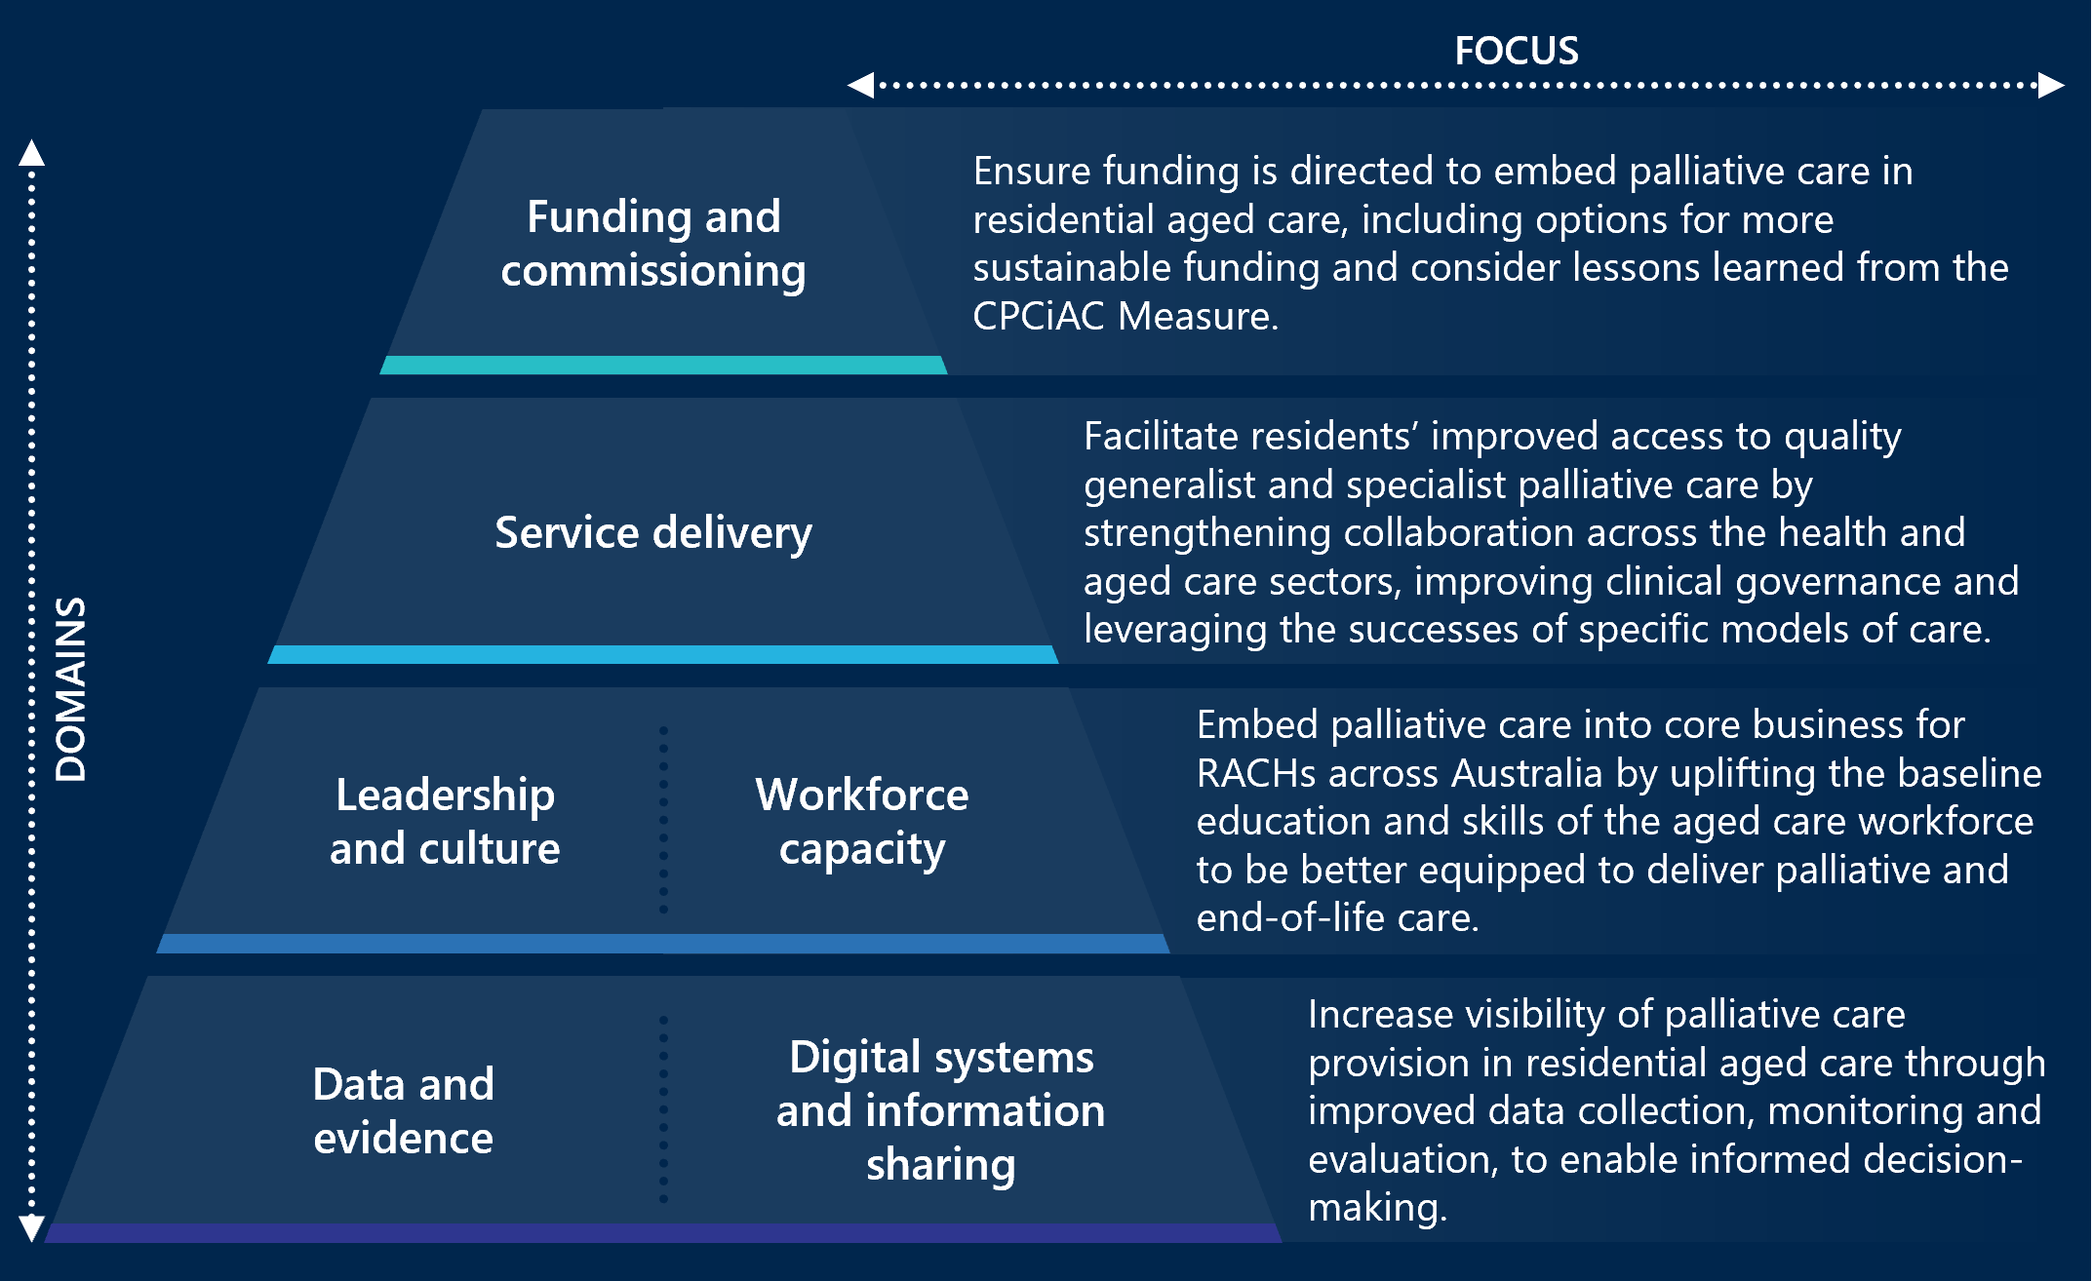

Table 8 | Future opportunities and supporting rationale across each domain
Funding and commissioning
Focus: Ensure funding is directed to embed palliative care in residential aged care, including options for more sustainable funding and consider lessons learned from the CPCiAC Measure.
Opportunities
State and territory governments could:
- Explore embedding effective Measure-funded projects to BAU activities within their jurisdictions, with a focus on securing ongoing funding, and maintaining continuity of service delivery and outcomes for residents, families and carers. Identifying specific activities to be embedded into BAU requires further consideration, however these could include those models of care found to be effective under the Measure, including specialist palliative care in-reach services, needs rounds, traineeships in palliative care, culturally safe and appropriate models of care, MDTs, education focused on palliative care and care coordination resources. Further details on these models are provided below in ‘rationale’ and in section 4.3. This could involve investigating options to secure ongoing, sustainable funding for palliative care in residential aged care and drawing on lessons from jurisdictions where activities have already been embedded into BAU, such as specialist palliative care in-reach and needs rounds in the ACT, palliative care traineeships through Eldercare in South Australia and several projects in NSW. Further work is required to identify the appropriate sustainable funding mechanisms for palliative care related activities.
The Australian and state and territory governments could:
- Explore stronger accountability mechanisms for ensuring high-quality generalist palliative care is delivered in RACHs. This may include making ongoing funding contingent on meeting relevant aged care standards that demonstrate ongoing efforts to strengthen palliative care delivery, or staff attendance at education relating to the provision of palliative care, and/or embedding a palliative care education standard into the aged care quality and safety standards. Separately, a quality indicator related to palliative care could be explored to monitor changes and further encourage accountability for the additional funds to be used towards improving palliative care for residents (see “Data, Evidence, Digital Systems and Information Sharing”, page 137.) Further work could be done to explore the feasibility of this being a composite indicator, to ensure that part of the assessment considers high quality specialist palliative care is being delivered in RACHs, by the state and territory services.
The Australian Government could:
- Review potential time-limited funding mechanisms, such as grants, to equip RACHs with the appropriate equipment and capacity to provide high-quality generalist palliative care. The needs and operations of RACHs could be further examined to understand where additional funding may be required to address barriers to the provision of quality generalist palliative care by RACH staff. The evaluation has found that some RACHs do not have adequate access to syringe drivers and telehealth equipment, for example. Consideration may also be given to whether the relevant clinical expertise is available within RACHs to support use of this equipment and ensuring there is adequate resourcing for staff to attend education programs as required. Further work is required to identify the exact mechanism(s) by which this occurs, but lessons could be drawn from other relevant programs to assess appropriate funding amounts, such as the Support at Home end-of-life pathway which includes an allocated “care management” allowance for individuals with a prognosis of three months or less to live, enabling access to a higher level of in-home aged care services specifically tailored to end-of-life needs.
- Explore ways to incentivise and encourage GP engagement in residential aged care to strengthen the delivery of general palliative care. Where there are evaluations being conducted on specific incentive programs or initiatives (for example, GPACI), explore whether there are lessons that can be leveraged to increase GP presence in RACHs. Some example incentives are explored under “Service Delivery”, page 138.
Rationale
- The Measure has been crucial in providing high-quality palliative care in RACHs and establishing a shared responsibility of funding across the Australian and state and territory governments.
- Overwhelmingly, clinicians, policy leads and RACHs reported that services funded under the Measure are critical to ensuring RACH residents have access to high-quality palliative care. Most claimed that without the services funded under the Measure, RACH residents would have much poorer palliative and end-of-life experiences and outcomes (Outcome 7, section 4.4).
- Specific models of care funded under the Measure have demonstrated success, as outlined in section 4.3.
- Inconsistent access to GPs in RACHs is an ongoing barrier to ensuring access to generalist palliative care and palliative care medications for residents (Outcome 4, section 4.4).
- Time-limited agreements pose workforce recruitment and retention challenges as well as a risk to resident outcomes (section 4.1.2).
- The additional time required for states and territories and the Department to plan for and negotiate NPAs, then design their programs under the Measure significantly reduced the implementation window (section 4.1). The Covid-19 pandemic also contributed to implementation delays.
State and territory policy leads highlighted an opportunity to strengthen the partnership relationship with the Department in the Measure’s design and delivery. This includes more proactive communications and transparency surrounding decision-making from the Department, both for the initial NPAs and the subsequent extensions (section 4.1.2).
Service delivery
Focus: Ensure that all aged care residents have improved access to quality generalist and specialist palliative care, enabled by strengthened collaboration across health and aged care sectors, clinical governance arrangements and leveraging the successes of specific models of care.
Opportunities
The Australian and state and territory governments could:
- Facilitate knowledge sharing across states and territories about models of care that have been found to be effective for improving access to and quality of palliative care, and the factors that enable their success. Effective models of care include specialist palliative care in-reach services, needs rounds, traineeships in palliative care, culturally safe and appropriate models of care, MDTs, education focused on palliative care and care coordination resources. Further details on these models are provided above and in section 4.3. Departments could also further examine and share findings relating to the enabling factors of successful models of care identified through their implementation under the Measure. For example, the role of NPs attending or leading needs rounds, dedicated care coordinator roles, specific resources that support transitions for residents between acute and aged care (for example, the WACHS RGoC form), community-based ACPD workshops, or where RACHs already meet with local services to discuss palliative care. Further detail is provided in section 4.3.
- Leverage and build on existing structures that provide a platform for services to collaboratively share learnings, resources and support quality improvement (for example, communities of practice, consortia). This could leverage existing forums at the Departmental level and consider how service delivery leads and staff could also be included to enable participation of different providers and care teams across the palliative care and aged care interface.
The Australian Government could:
- Consider how to increase access to basic clinical equipment in RACHs, required to deliver palliative care (for example, syringe drivers). This could examine the barriers to access for this equipment. These barriers include the cost of syringe drivers, reliance on loans, lack of RACH leadership buy-in, GP hesitation, or lack of capacity of RACH staff. This may require a review of funding mechanisms to ensure funding is sufficient for RACHs to cover the costs of equipment required to deliver palliative care per resident. Consideration should also be given to how capacity within RACHs to use this equipment will be addressed through recent reforms, such as 24/7 RN responsibility in RACHs, requiring at least one RN on-site at all times.
- Encourage proactive collaboration with key stakeholders across the palliative care and aged care landscapes in the design and delivery of activities funded under the Measure (or similar initiatives). This includes engaging PHNs, pharmacists and peak bodies to identify local needs to be addressed, build collaborative relationships to strengthen service delivery at the interface of health and aged care.
- Explore ways to encourage GP involvement in palliative care including participation in MDTs and working with specialist services. In addition to building on financial incentives described above, consider other incentives such as development opportunities for GPs, for example via access to specialist palliative care medical consultants leading in-reach teams. GPs may require additional education and awareness on the role and value of specialist teams to GPs to encourage collaboration, trust and advice seeking. This may help to reduce the hesitancy surrounding anticipatory prescribing and palliative care medications, common amongst GPs.
State and territory governments could:
- Investigate opportunities to promote provision and engagement with phone-based or videoconferencing services and address barriers to accessing telehealth where required to provide after-hours palliative care support and advice to RACH staff, supplementing specialist in-reach services. Further consideration is required to ensure timely identification and provision of relevant prescription medications, where after-hours support is utilised, given limitations in what relevant medications can be prescribed by some after-hours services.
- Explore opportunities to strengthen referral pathways and overall service integration across the aged care and palliative care service systems. This could involve coordination functions within or collaborating with specialist palliative care services to mitigate the variability access to services based on individual relationships, rather than genuinely integrated services between specialists, generalist clinicians and RACH staff.
Rationale
- RACHs have inconsistent access the basic tools and equipment to deliver palliative care. For example, clinicians, RACH staff, PHN staff and policy leads noted that RACHs across Western Australia, Tasmania, NSW and South Australia have issues with access to syringe drivers and the relevant clinical expertise required to support their use, and that this often led to resident transfers to hospital. Reasons for a lack of any or enough syringe drivers in RACHs include:
  - the cost of syringe drivers being prohibitive
  - RACHs relying on loans from the specialist palliative care teams or LHDs
  - lack of buy in on the utility of syringe drivers at RACH leadership level
  - GP hesitation for using syringe drivers
  - lack of capacity of rostered-on RACH staff to use syringe drivers (for example, some RACHs not having an RN on staff 24/7 due to being identified as a ‘low care’ facility).
Clinicians in Queensland reported access to teleconferencing equipment as a barrier for certain remote RACHs to be able to access support virtually.
- PHNs and peak bodies are key stakeholders in the palliative care and aged care sectors, however felt that there is opportunity to be more comprehensively consulted in the design and delivery of activities delivered under the Measure, both at the national and jurisdiction-level. In consultations, they raised concern of missed opportunities to work together to identify gaps and partner in service delivery (Outcome 10, section 4.4). For example, GCPHN in Queensland worked alongside the SPACE team to provide opportunities for RACHs and palliative care teams to share learnings and coordinate activities across the region, from SPACE to other areas (Case study 14).
- Specialist clinicians providing in-reach palliative care into RACHs in NSW highlighted that access to RACHs to provide care is dependent on individual relationships between specialists and RACH management staff. This meant that specialist access to RACHs to provide care to residents was limited to the strength of this relationship and was heavily impacted in some areas by high turnover of RACH management staff (section 4.2.4).
- GP engagement with RACHs and specialist teams is varied. As the key decision-maker for most of the medical care delivered to residents, GPs who do not engage with specialist palliative care teams can create immediate barriers to improving outcomes and experiences for residents. In Tasmania, the specialist CNC team reported the need to have targeted conversations with GPs to build understanding and trust in their in-reach service, with some success. Needs rounds in regional South Australia found more engagement from GPs when they were led by specialist palliative care consultants. The South Australia policy lead suggested that GPs viewed this as a beneficial learning opportunity and had more success with increasing engagement than financial incentives alone (Outcome 7, section 4.4).
- Telehealth and phone-based services are a highly useful tool for increasing accessibility of generalist care for regional and remote RACHs (for example, specialist teams in South Australia can conduct needs rounds across all regional South Australia via videoconferencing). Often RACH staff working after-hours are more junior and are benefited by access to additional supports where needed. Phone based advice services are an effective, time efficient method for RACH staff to seek timely advice and additional support after-hours. This benefit was reported by clinicians providing the RCL phone service in Western Australia and RACH staff accessing the SPACE team’s 24/7 phone line in West Moreton HHS in Queensland (section 4.4).
- Many RACHs do not have access to mechanisms by which they can share lessons on palliative care delivery and learn from others. This is done well in Victoria and Metro North HHS in Queensland, where there are local consortia are attended by RACHs, specialist palliative care providers and others, providing an opportunity to share lessons. While these meetings may be attended by Measure-funded roles, the mechanism itself is not funded under the Measure (Outcome 10, section 4.4).
- Specific models delivered under the Measure have components that have been consistently reported as core enablers of effective palliative care. The evidence for success for models of care implemented under the Measure are detailed in section 4.3. For example:
  - NPs as a key driver in the success of needs rounds, as they can provide specialist expertise, additional time to spend with residents and families, and have prescribing abilities.
  - Care coordination and transition support roles have reported benefits in RACHs and acute hospital settings. These roles were piloted extensively in Western Australia with much success in facilitating the transfer of residents from hospital into RACHs, coordinating essential documents and referrals, and providing information and support to residents and families.
  - Tools such as the RGoC developed by WACHS support collaboration and coordination across the health and aged care sector, enabling hospitals and RACHs to use common language to understand the residents needs preferences.
  - Community-based workshops aimed to increase advance care planning, such as those implemented in South Australia, are effective in raising awareness and uptake among the ageing community to complete ACPDs prior to entering RACHs. This reduces the risk of residents entering RACHs after they no longer have the decision-making capacity required to complete ACPDs.
Leadership, culture and workforce capacity
Focus: Embed palliative care into core business for RACHs across Australia by uplifting the baseline education and skills of the aged care workforce to be better equipped to deliver palliative and end-of-life care.
Opportunities
The Australian and state and territory governments could:
- Consider continued investment into early and ongoing education for RACH staff (clinical and non-clinical) to increase delivery of generalist palliative care and awareness of specialist palliative care needs, including preparatory education and training for people entering the residential aged care workforce.
  - Education content could include:
    - embedding general palliative care education into university or TAFE courses for nursing or care worker students
    - education for non-clinical staff (including cleaners, food service staff) to recognise signs of deterioration in residents
    - education for RACH staff of information on national aged care and palliative care standards, quality indicators and legislation, and the implications of this on palliative care delivery.
  - Delivery mechanisms for training RACH staff could consider:
    - a highly transient workforce which benefits from repeated, short-form delivery mechanisms that are case-based rather than training that requires significant investment of time
    - resourcing for RACH staff to attend longer-form, formal education sessions (for example, PEPA training)
    - who is delivering the training and the resourcing required to support them (that is, if it is to be delivered by specialist palliative care teams)
    - options to overcome workforce constraints (turnover, resourcing), for example, train-the-trainer or mentorship models.
- Collaborate with peak bodies such as PCA and Ageing Australia to further promote existing navigation tools and education resources for residents and families, RACH staff and clinicians. This includes the CareSearch navigation tool, to support navigation of information and resources, including PACOP and the National Palliative Care Projects.
  - Consider expanding this tool to also include tailored resources developed by PHNs or providers, where they have built on standardised tools to meet their local needs and contexts.
- Develop culturally tailored palliative care education for RACH staff who face cultural barriers to palliation and end-of-life care discussions. This education needs to address the ongoing challenge with diverse cultural approaches to death and dying that conflict with palliative care delivery, common amongst RACH staff. Education may include resources, events or programs that are designed in consultation with aged care staff, palliative care peak bodies and community and specialist organisations such as PICAC organisations.
- Explore opportunities to expand access to generalist and specialist palliative care for RACHs in regional and remote areas. This could include additional funding for services to deliver telehealth in these areas, and enhanced education and support for GPs and other prescribers.
Rationale
- Education and skills of staff is a significant barrier to ensuring ongoing access to palliative care. In particular:
  - The relatively low levels of generalist palliative care skills among RACH staff has led to increased reliance on specialist clinicians to provide generalist care, increasing demand on specialist services and decreasing the accessibility of specialist services for residents with more complex needs (section 4.3.1).
  - A large proportion of the RACH workforce are relatively junior and do not receive training specific to palliative care through their formal education pathways (that is, TAFE or university). As a result, staff are often unprepared to provide palliative care both in terms of clinical skills and the emotional impacts of working with palliating residents (section 4.2.4).
  - Longer-form education and training is valuable but difficult for RACH staff to practically engage with due to time constraints, some are required to attend unpaid on their non-working days (Outcome 3, section 4.4).
  - Clinical and non-clinical RACH have a role to play in identifying and supporting palliating residents and require education relevant to their role. For example, food service staff are likely to identify if a resident has stopped eating and could have the education to identify this as a potential indicator of clinical deterioration (section 4.3.1).
- There are significant cultural barriers to end-of-life and palliative care for many RACH staff. This was consistently raised by RACHs and clinicians nationally as a challenge with upskilling staff to have end-of-life planning conversations and delivering palliative care. There are very limited examples of where training for RACH staff has been tailored to consider these cultural barriers to engaging with education and delivering palliative care (Outcome 1, section 4.4).
  - Some examples of where there is work targeted to current or potential future residents and families, though not funded under the Measure, are death cafés held in Townsville Queensland, a health promotion officer in a NSW LHD who is co-leading work with Pasifika communities to promote advance care planning discussions and uptake. These examples, however, are not targeted towards RACH staff.
  - Other examples of educational resources outside of the Measure which may be leveraged, include Free diversity training and support for aged care providers and the Aged Care Diversity Framework.
- There are many education programs and resources that have been developed over recent years, however it can be difficult for RACH staff to navigate these resources to identify and access the information that they require, when that they need it. Peak bodies and PHNs raised that it is likely there are some gaps and duplication of resources, but given the volume of resources, it is difficult to know what they are.
- There are ongoing barriers to accessing specialist palliative care services and medications outside of metropolitan centres. RACH staff, PHN representatives, and specialist clinicians across regional and remote areas of South Australia, Victoria, Tasmania and Western Australia highlighted significant challenges with accessing medications, as a result of a common reluctance towards anticipatory prescribing from generalist practitioners. This can cause major barriers for providing care to residents who may deteriorate rapidly or unexpectedly at a time when access to GPs and pharmacies is limited (e.g. over weekends).
Data, evidence, digital systems and information sharing
Focus: Increase visibility of palliative care provision in residential aged care through improved data collection, monitoring and evaluation, to enable informed decision-making.
Opportunities
The Australian and state and territory governments could:
To better meet the needs of the system:
- Explore and promote mechanisms that support interoperability of systems and provider access to resident information across the health and aged care interface (for example, My Health Record). Explore opportunities to streamline digital patient record management, drawing on examples and lessons where this has been done such as the DHRs in the ACT.
- Investigate embedding a specific indicator into the Aged Care QI Program that captures palliative care related outcomes. Draw on international evidence and examples, such as those from Germany and Sweden that incorporate indicators relating to symptom management and end-of-life care planning into similar aged care quality programs.,
- Explore options to address gaps in available data to establish a comprehensive picture of national palliative care service provision in RACHs. This could include addressing gaps that exist in the NHDH, such as seeking to include community-based palliative care services (PCOC only covers a small number of services). This could also include promoting the use of palliative care-specific MBS items, where appropriate, to enhance capture of activity data. This may require input from AIHW, relevant Departmental data teams, peak bodies and service providers (including specialist teams).
- Consider ongoing investment into data linkage projects by the AIHW to improve recency and coverage of linked datasets. This includes:
  - Continue to expand existing efforts on data linkage such as the NHDH, to build expertise in using it, improve access and recency of the data to make it more relevant and informative for health/aged care system planners. Improved recency of linked national datasets will require participation across all jurisdictions and timely approvals for data sharing.
  - Explore other opportunities for data linkage, for example, linking PBS data with prescribing administration data to enable visibility of prescriptions that are filled, achieving a more accurate view of medication use. This may also include linkage with ACQSC data on compliance to aged care standards, to provide visibility over the impact on compliance with aged care standards and palliative care experiences for residents.
For potential future iterations of the Measure or similar investments:
- Future agreements and jurisdictional schedules could facilitate consistent data collection of comparable measures that capture palliative care service performance and outcomes. Measures commonly collected across jurisdictions are described in Table 5 (of section 4.6).
For future evaluations of similar programs and joint funding mechanisms:
- Consider the establishment of standardised performance indicators to enable national monitoring of the activities, to be designed with input from delivery partners (that is, states and territories) and with expert advice from the AIHW. NPAs could specify a standardised set of measures that capture palliative care related service delivery outcomes, as well as other intended outcomes of the Measure, are clearly defined and can be reported by all jurisdictions in a comparable way. Section 4.6 outlines potential indicators that could be collected to support ongoing monitoring and evaluation. The following should be considered when agreeing standardised performance indicators:
  - Enable identification of the services or individuals that receive the intervention/funding as much as possible, to enable attribution of findings.
  - Align to the intended outcomes of the Measure and cater to the variation across jurisdictions (for example, proportion of residents with completed ACPDs, proportion who died in preferred place of death, rate of transfers to hospital from RACHs).
  - Include cost data related to the Measure’s activities, to better understand the cost effectiveness of the Measure in each jurisdiction.
- Consider evaluation requirements in the design and prior to executing agreements, to support a strong evidence base and future decision-making. This includes:
  - Consider evaluation design early, alongside project design.
  - Establish comparable performance indicators for all jurisdictions (see point above).
  - Embed requirements for active involvement and data provision in national evaluation and conduct of local evaluation into the NPA, for example earmarking a portion of this funding specifically for evaluation activities, including data collection, reporting and participation in consultations.
  - Explore use of quasi-experimental methods to enable ethical and defensible ways of attributing outcomes and impacts to the Measure (for example, ensuring analysts can access unit record data and historical data).
Rationale
- Provider access and interoperability of systems across the health and aged care interface is an ongoing barrier to comprehensive care. Restrictions in clinicians having access to resident files and RACHs having limited visibility over resident health information that is not explicitly shared may leave some gaps in understanding resident needs and clinical concerns. In-reach teams may have access to resident records where they have strong relationships with the RACHs, however this is inconsistent and organisation-dependent (section 4.2.4).
- At the time of this report, there is no aged care quality indicator that is specific to the delivery of palliative or end-of-life care (section 3). While there are indicators that relate to hospital admission, consumer experience and quality of life, international examples such as Germany and Sweden implement quality indicators specific to symptom management and end-of-life care planning.,
- The current system-level data provides limited visibility over the delivery of palliative care in residential aged care, with many gaps across the different datasets that are available (section 2.3).
- The NHDH is the only national linked data sources that bridges the aged care and health care systems, however there are significant limitations in its coverage and timeliness (discussed in section 2.3). Analysts at the AIHW cannot access the unit record data that is required to be able to identify a treatment and control group for residents impacted by certain programs or services (including those funded under the Measure).
- The NPA, nor original (2019-20 to 2023-24) Schedules, did not specify standard measures or indicators to be reported on consistently by all states and territories (section 4.6).
- States and territories did not all deliver formal jurisdiction-level evaluations. The initial NPA articulated that the “States/territories will be responsible for evaluating their agreed projects, to contribute to the overarching evaluation of the Comprehensive Palliative Care in Aged Care Measure.” Some jurisdictions chose to conduct ongoing monitoring, in place of a formal evaluation, however the completeness of this monitoring data is varied (section 4.6). The variability of programs and initiatives across states and territories meant that data collection was inconsistent and definitions of “success” for different models meant that the impact of the Measure was challenging to assess nationally (section 2.3).
- Engagement with this evaluation has varied across states and territories, often a result of varied capacity across the policy leads and service providers within each jurisdiction to meet reporting requirements for the Measure and evaluation. For example, the allocated policy lead in the Northern Territory for the Measure ended in 2024, leaving the administrative burden of milestone reporting and engagement with the national evaluation to the specialist clinical teams delivering palliative care services, who have already limited capacity (section 4.6).

Glossary of key terms
Abbreviation | Description
ACCO | Aboriginal Community-Controlled Organisation
ACD | Advance Care Directive
ACPD(s) | Advance care planning document(s)
ACFI | Aged Care Funding Instrument
ACNS | Aged Care Nursing Scholarships
ACQSC | Aged Care Quality and Safety Commission
ACT | Australian Capital Territory
AHHA | Australian Healthcare and Hospitals Association
AIHW | Australian Institute of Health and Welfare
AN-ACC | Australian National Aged Care Classification
BAU | Business as usual
CALD | Culturally and linguistically diverse
CPCRE | Centre for Palliative Care Research and Education
CNC | Clinical nurse consultant
CoP | Community of Practice
COVID-19 | Coronavirus disease (COVID-19) is an infectious disease caused by the SARS-CoV-2 virus. The COVID-19 pandemic, also known as the coronavirus pandemic, is a global pandemic of coronavirus disease, commencing in 2019.
CPCiAC | Comprehensive Palliative Care in Aged Care (The Measure)
DARD | Dignified and Respectful Decisions – resources developed by Palliative Care Victoria
DHR | Digital Health Record
ED | Emergency Department
ELDAC | End of Life Directions for Aged Care
EMHS | East Metro Health Services
FTE | Full-time equivalent
GCfAHPC | Greater Choice for At Home Palliative Care
GCHHS | Gold Coast Hospital and Health Service
GCPHN | Gold Coast Primary Health Network
Generalist palliative care or generalist palliative care clinician | Palliative care provided by RACH staff, GPs, nurses, allied health or any service provider that does not have specialist palliative care qualifications
GP | General Practitioner
GPACI | General Practitioner in Aged Care Incentive
GRACE | Geriatric Rapid Acute Care Evaluation
HHS | Hospital and Health Service
IHACPA | Independent Health and Aged Care Pricing Authority
KEQs | Key evaluation questions
KPIs | Key performance indicators
LHD | Local Health District
MBS | Medicare benefits schedule
MCMPC | Melbourne City Mission’s Palliative Care
MPaCCS | Metropolitan Palliative Care Consultancy Service
MDTs | Multidisciplinary teams
MMM | Modified Monash Model
MRU | Metropolitan Referral Unit
NHDH | National Health Data Hub
NIHSI-AA | National Integrated Health Services Information (NIHSI) Analysis Asset (AA)
NMHS | North Metropolitan Health Service
NSW | New South Wales
NP | Nurse practitioner
NPA | National Partnership Agreement
NWAU | National Weighted Activity Units
PBS | Pharmaceutical Benefits Scheme
PCA | Palliative Care Australia
PCNR | Palliative Care Needs Rounds model implemented the PEACE team in the ACT, based on the INSPIRED trial in the ACT.
PACOP | Palliative Aged Care Outcomes Program
PCOC | Palliative Care Outcomes Collaboration
PCV | Palliative Care Victoria
PC-Link | Palliative Care Link
PEACE | Palliative Aged Care Specialists team at Clare Holland House in the ACT
PEPA | Program of Experience in the Palliative Approach
PHN | Primary Health Network
PICAC | Partners in Culturally Appropriate Care
PUP | Pop-Up Palliative Care
QALYs | Quality-Adjusted Life Years
QI Program | National Aged Care Mandatory Quality Indicators program
RACEPC | Residential Aged Care Excellence in Palliative Care
RACH/s | Residential Aged Care Home/s. Change in preferred language from Residential Aged Care Facilities (RACHs) per advice from the Department.
RCL | Residential Care Line
RGoC | Residential Goals of Care
RN | Registered Nurse
RSS | Rural Support Service
SHNs | Specialty health networks
SMHS | South Metro Health Services
SPACE | Specialist Palliative Care in Aged Care Project in Queensland.
SPaRTa | Specialist Palliative Rural Telehealth Service
Specialist palliative care | Palliative care provided by clinicians that specialise in palliative care, including nurses, doctors and specialist teams.
The Department | Australian Government Department of Health, Disability and Ageing.
The Measure | Comprehensive Palliative Care in Aged Care (CPCiAC) Measure
The Royal Commission | The Royal Commission into Aged Care Quality and Safety was established on 8 October 2018 to inquire into the quality and safety of aged care in Australia. Further information is available at https://agedcare.royalcommission.gov.au/.
VAD | Voluntary Assisted Dying
WACHS | Western Australia Country Health Service
WAPHA | Western Australia Primary Health Alliance
- Key evaluation questions
Table 9 outlines the KEQs and research questions, mapped to the three evaluation components (process, outcome and economic) described in section 2.2.
KEQs:
- Has the Measure been implemented as planned and what are the implementation lessons from the Measure?
- How appropriate is the Measure to meet the needs of residents, families and carers in the RACF setting?
- How effective have the joint funding and delivery arrangements been for implementing and achieving the aims of the Measure? How could governance arrangements be more effective?
- To what extent has the Measure achieved its intended outcomes?
- How cost-effective is the Measure?
- Is there a specific model of care that has been implemented that has proven to be more successful than others?
- How well does the Measure align and contribute to the National Palliative Care Strategy? Are there opportunities for improvement?
- Does the Measure and the models adopted in each jurisdiction help to address health system interface issues?
Table 9 | Data collection plan
KEQ | Research question | Evaluation component – Process | Evaluation component – Outcome | Evaluation component – Economic
1 | What is important to understand about the policy and operating contexts in which the Measure is delivered? | Yes
1 | What is the aim of the Measure? |  | Yes
1 | Has the Measure been implemented as planned? | Yes
1 | How could the implementation process have been improved? | Yes
2 | What are the palliative care needs of residents, families/carers and staff in RACH settings? |  | Yes
2 | How well did the Measure meet those needs? |  | Yes
3 | What evidence exists on best practice approaches to funding and delivery arrangements? | Yes
3 | To what extent do the joint funding and delivery arrangements enable the Measure to achieve its aims? | Yes
3 | How could the funding and delivery arrangements be improved? | Yes
4 | What are the intended outcomes? |  | Yes
4 | How can outcomes be measured? |  | Yes
4 | What is the baseline for the evaluation? |  | Yes
4 | How have outcomes changed over the life of the Measure? |  | Yes
5 | What are the changes in costs associated with trends in health service utilisation and related outcomes during the implementation of the Measure? |  |  | Yes
5 | What are the changes in costs associated with delivering palliative care compared to prior to implementation of the Measure? |  |  | n/a
5 | What activities undertaken through the Measure are the most cost efficient? |  |  | n/a
5 | What processes for implementing the Measure were the most cost efficient? |  |  | n/a
6 | Which models of care implemented under the Measure have been most successful? |  | Yes
6 | What models of care exist elsewhere that have proven successful? |  | Yes
7 | How do the Measure’s listed outcomes align with the goals and priorities of the National Palliative Care Strategy? | Yes
7 | How has the Measure contributed to the goals and priorities of the Strategy? |  | Yes
7 | How could the Measure be better aligned to the Strategy? |  | Yes
8 | What are the key interface issues? | Yes
8 | How have the models adopted within the Measure acted to address interface issues? |  | Yes
8 | How have other palliative care in RACH initiatives outside of the Measure sought to address health interface issues? |  | Yes

- Detailed methodology
This appendix provides the evaluation methodology, data sources that informed this report (including limitations) and methodology to quantify impacts on health service utilisation and associated costs.
- Evaluation methodology
The evaluation has been conducted over three stages:
- Stage one (April 2021 to August 2021): the purpose is to establish a national baseline. Some data sources were not available during stage one (for example, NHDH) but have been incorporated into stages two and three.
- Stage two (August 2021 to June 2023): the purpose is to undertake regular data collection and reporting to monitor implementation progress and outputs at the national level.
- Stage three (July 2023 to May 2025): the purpose is to measure outcomes from the Measure against the baseline, the costs associated with these changes and develop final findings and recommendations.
Table 10 summarises the evaluation methodology.
Table 10 | Process, outcome and economic evaluation components - guided by eight KEQs
Data collection and analysis | KEQs | To understand | Informed by
National outcomes | KEQ 4 | - Change in desired outcomes over time. | - Survey of sample of RACHs.  - Consultations with a sample of RACHs and states/territories.  - State/territory-provided info.  - National and other datasets.
Other national process | KEQ 1,3,7 | - National implementation.  - Effectiveness of joint funding and delivery mechanisms.  - Alignment to National Palliative Care Strategy. | - Consultations with states/territories, peak bodies, other experts and more.  - Desktop research.
Jurisdictional process and outcomes | KEQ 2,6,8 | - Extent the Measure met needs.  - Whether a model of care was more successful than others.  - Extent models helped to address health system interface issues. | - Jurisdictional data collection template.  - Other local monitoring/progress/evaluation reports.
Cost effectiveness analysis | KEQ 5 | - Changes in costs associated with trends of health service utilisation. | - Use of NHDH, MBS, PBS health service utilisation data and selected case studies.
These components will be informed by key elements to synthesise across:
- systematic analysis of each data source
- triangulation of data from multiple sources
- identify gaps, discrepancies or contradictions
- test and confirm findings with states, territories and the Department.
Upon synthesis, components will be reported via:
- Regular progress reporting
- Baseline Report
- Mid-point Report
- Interim Report
- Final Report
Out-of-scope: activities delivered prior to the Measure and jurisdictional-level evaluations
- Program theory
A program theory articulates how the Measure is intended to achieve its goals and underpins the evaluation. The program logic model for the evaluation is provided in Table 11. Outcomes in the program logic align to relevant outcomes from the National Palliative Care Strategy 2018.
The program logic for the CPCiAC Measure articulates the logical flow between the Measure and its outcomes. The program logic describes the causal pathways by showing how inputs (for example, Measure funding) and activities (for example, the implementation of in-reach care models, models that support end-of-life decision making, and training and education) lead to outputs (for example, recruitment of FTE, conversations with residents and families about advance care planning, staff undergoing training) and ultimately, the ten national outcomes.
The overall aim of the program logic is to:
- improve palliative and end-of-life care for older people living in residential aged care
- further enable people to die where they want, supported by increased aged care services
- contribute to achievement of the National Palliative Care Strategy.
The program logic is guided by the theory of change outlined below.
- Theory of change
Older Australians in residential aged care facilities (residents) need access to compassionate palliative care that meets their individual needs and preferences. The Measure aims to strengthen national and jurisdictional efforts to improve provision of quality palliative care for residents, through a 50:50 cost share funding model. Under the Measure, jurisdictions will deliver locally relevant projects that expand models of care or support new approaches to care provision to improve access to quality palliative care in RACHs and coordination with acute care facilities. Residents, their families and carers will have improved access to and experiences of compassionate and tailored palliative care, delivered by an appropriately skilled clinical and non-clinical workforce. This will improve the interface between acute and aged care and therefore support progress towards an integrated health-aged care system.
Table 11 | Program Logic (overleaf)
Context | Inputs | Activities | Outputs | Outcomes
Context  - The Royal Commission highlighted the need to strengthen access to high quality palliative and end-of-life care in aged care settings, including in RACHs.  - The National Palliative Care Strategy (2018) represents the significant commitment of the federal, state and territory governments to ensure the highest possible level of palliative care is available to all people.  - There are complex interface issues between the federally-funded aged care system and state/territory funded health care system, leading to challenges for people living in RACHs attempting to access health services (such as palliative care).  Client-level need  - 60,000 people die in RACHs each year.  - Individuals need personalised and responsive palliative care based on their unique needs and preferences. | Funding  - Up to $57.2 million from the Australian Government from 2018-19 to 2023-24.  - Matched (50:50) funding contributed by state and territory governments.  Governance  - Project manager oversees national implementation of the Measure at the federal level.  - Australian, state and territory governments provide staffing resources to support the negotiation and implementation of the Measure.  - Project Reference Group and Project Implementation Group advise on implementation and evaluation.  Evaluation  - The Department engages Nous as the national evaluator.  - States and territories conduct independent evaluation activities and provide data to support the national evaluation.  Providers  - Participating RACHs, health service providers and other key stakeholders coordinate with respective state and territory governments to implement the Measure. | National  - Establish Project Implementation Group.  - Negotiate and agree with states and territories on schedules that outline funding and in-scope activities.  - Initiate, manage and finalise a national evaluation of the Measure by 2023-24.  Jurisdictional  - Implement and evaluate in-scope activities as outlined in jurisdictional schedules.  - In-scope projects include in-reach models; models that support end-of-life decision making; and training, education and mentoring. Specifically, they are:  ACT: recruits two palliative care NPs; engage with hospitals to facilitate early assessment of palliative care needs of patients transitioning to RACHs; develop workforce succession planning process.  NSW: implements local initiatives by June 2023; adds 12 FTE palliative care nurses across NSW.  NT: screens residents for palliative care needs; supports RACHs to develop a plan for end-of-life preferences; develops routine educational activities; do targeted case reviews with GPs; monitors hospital ED admissions to identify preventable admissions.  QLD: develops model of service delivery in consultation with key stakeholders; establishes training, education and support programs.  SA: shares care between specialist palliative care services, GPs and residential aged care sector; provides education, training and assistance for the residential aged care workforce.  TAS: delivers specialist palliative care by CNCs; establishes GP registrar training positions; provides allied health services to meet holistic needs of residents.  VIC: enhances existing models of care across providers; builds capacity of residential aged care staff; reviews frailty assessment tools; partners with Aboriginal and Torres Strait Islander organisations to support Elders.  WA: boosts residential aged care consultancy to become in-reach service; expands training and mentorship within RACHs. | National  - Agreed Terms of Reference for Project Implementation Group.  - Commenced national evaluation in 2020.  - Published National Project Agreements and Schedules on the Council on Federal Financial Relations Website.  - Agreed Performance Milestone Reporting template.  Jurisdictional  - Implemented in-scope activities.  - Implemented jurisdictional governance arrangements.  - Reported outputs using the agreed Performance Milestone Reporting template.  - Specific outputs per jurisdiction:  ACT: recruited two palliative care NPs; engaged with hospitals to facilitate early assessment of palliative care needs of patients transitioning to RACHs; educated and trained RACH staff.  NSW: added 12 FTE palliative care nurses across NSW.  NT: screened residents for palliative care needs; supported RACHs to develop a plan for end-of-life preferences; developed educational activities; targeted case reviews with GPs; monitored hospital ED admissions to identify preventable admissions.  QLD: developed model of service delivery in consultation with key stakeholders; established training, education and support programs.  SA: shared care between specialist palliative care services, GPs and residential aged care sector; provided education, training and assistance for the RACH workforce.  TAS: recruited CNCs to the specialist palliative care service; recruited to GP registrar training posts; delivered brokered allied health services.  VIC: funded community palliative care services to provide in-reach support; rolled out education across metro area; delivered multifaceted resource for decision-making.  WA: expanded in-reach services in RACHs; expanded training and mentorship programs. | The outcomes align to relevant goals of the National Palliative Care Strategy. Note some outcomes may have more than one corresponding indicator.  Understanding  - Improved discussions focused on end-of-life care decision making between residents, families, carers, GPs and specialist palliative care services including use of ACPDs.  - Improved access to information that informs end-of-life care decisions for residents and families.  Capability  - A higher proportion of clinical and non-clinical staff in RACHs have appropriate skills and confidence to recognise and respond to the holistic palliative care needs of residents, in a culturally safe way.  Access and choice  - Improved access to quality palliative care in RACHs including:  - increased use of assessments to establish residents’ palliative care needs  - decreased use of inappropriate and clinically futile treatments  - decreased healthcare expenditure from fewer inpatient bed days.  - Improved quality of palliative care provided in RACHs including:  - reduced symptom burden  - improved quality of life for residents during the period they access palliative care  - better experience of death and dying for residents, families/carers and staff, including meeting physical, psychosocial and spiritual needs.  - Greater patient choice in palliative care including:  - more people dying where they want  - increased person-centred care informed by an individual’s choice.  Collaboration  - Improved care coordination with GPs/primary care, acute care services and specialist palliative care services.  - Improved integration between the health and aged care systems.  Data and evidence  - More palliative care services and health planners are informed by performance information on appropriateness, effectiveness, efficiency and outcomes.  - Improved clinical governance to identify and implement quality improvement initiatives and evaluation of outcomes within RACHs.

Table 12 | Map of KEQs to the stages of the program logic
Program logic stages | KEQs
Context | KEQ 1  - 4 Policy and operating context  - 5.1 Appropriateness of the Measure
Inputs | KEQ 1  - 4 Policy and operating context  - 5.1 Appropriateness of the Measure  - 5.2 Implementation progress and lessons  KEQ 3  - 5.6 Effectiveness of joint funding and delivery arrangements
Activities | KEQ 1  - 4 Policy and operating context  - 5.1 Appropriateness of the Measure  - 5.2 Implementation progress and lessons  KEQ 3  - 5.6 Effectiveness of joint funding and delivery arrangements
Outputs | KEQ 6  - 5.3 Models of care implemented under the Measure  KEQ 8  - 5.5 Extent to which the Measure addressed interface issues
Outcomes | KEQ 6  - 5.3 Models of care implemented under the Measure  KEQ 8  - 5.5 Extent to which the Measure addressed interface issues  KEQ 5  - 5.7 Cost effectiveness of the Measure  KEQ 4 & 7  - 5.4 Assessment against national outcomes
- Data sources that informed this report
Table 13 outlines the data sources used to inform the Final Evaluation Report, a description of each and the key limitations of this data.
Table 13 | Descriptions and limitations of data sources used to inform this report
Data source and time period | Description | Limitations
Consultations conducted in 2024-25 | Nous undertook targeted consultation with 116 stakeholders between September 2024 and May 2025, including:  - state and territory policy leads  - RACH staff  - specialist and generalist clinicians  - PHNs  - pharmacists  - peak bodies. | Achieving a nationally representative sample depended on voluntary participation of stakeholders in consultations. As a result, it was not possible to engage all stakeholder groups across all jurisdictions within the timelines for this evaluation. For example, RACH staff in Victoria did not participate in consultations. This approach is detailed in Appendix B.4.
Data collection tools in 2024 | States and territories provided an additional updated standard reporting template in July 2024 (previously completed every six months from April 2021 to July 2023). The tool collects information about implementation of the Measure activities in each jurisdiction, challenges and progress, and any relevant jurisdiction-level documentation useful to inform the national evaluation. | The rate of completion and level of detail in the data provided varied by jurisdiction. NSW did not provide a completed reporting template in 2024.
Desktop review conducted in 2024 and 2025 | This included review of:  - milestone reporting provided by states and territories to the Department in 2024  - the CPCiAC Measure NPA state-specific schedules, for the 2019-20 to 2023-24 Measure agreements and new agreements under the Measure’s extension  - publicly available information including peer reviewed and grey literature, including Investing to save: The economics of increased investment in palliative care (KPMG, 2020). | - Not all states and territories provided a jurisdiction-level evaluation.  - The NPA and Schedules do not specify the funding amounts per activity, making comparison between the effectiveness of different models of care or activities challenging.  - Given the limitations outlined in conducting a cost-effectiveness analysis, the funding amounts committed in NPA Schedules and Federal Funding Agreements should not be used to assign a cost per unit of effectiveness.  - There is no cost data available to estimate the average cost of one episode of specialist palliative care in-reach services. As an alternative, we have estimated cost ranges using KPMG’s estimate of the average cost per person of integrated home-based care in the last year of life. Dollar figures reported by KPMG have been indexed to 2024-25 Australian Dollars using the ABS annual Health CPI.
National Health Data Hub (NHDH) | Updated analysis of national linked data extracts from the NHDH, formerly the NIHSI-AA, to observe changes in data from 2018-19 (baseline) and 2021-22 (most recent). Analysis was conducted by AIHW. NHDH comprises Residential aged care Episodes data, APC data, ED data, MBS data, PBS data and National Death Index (NDI) data. | - NHDH data is limited to 2021-22 as the most recent linked dataset. This limits the time coverage of observed changes to hospital-based care for RACH residents.  - NHDH data does not include all states and territories. It includes NSW, Victoria, Queensland, South Australia, Tasmania and the ACT.  - Some indicators measured using NHDH are not available for certain states and territories, because of small numbers, confidentiality, or other concerns about the quality of the data. The analysis output in these situations was withheld by AIHW.  - It is not possible to determine whether an ED presentation is related to palliative care, due to the way that data is captured in ED systems (which differs from APC data).  - RACHs are not identified in NHDH and the implementation of interventions across and within states and territories. It is therefore challenging to evaluate the impact of Measure-funded activities on indicators using NHDH.  - NHDH data has only been provided for two points in time, 2018-19 and 2021-22.
Palliative Care Outcomes Collaboration (PCOC) | PCOC is a voluntary framework and protocol for routine clinical assessment and response by palliative care service providers. Nous received data from PCOC for the period of January to December for 2021, 2022, 2023 and 2024 to inform the evaluation. | - The data sample provided by PCOC does not include all service providers and may not be a representative sample. In 2024, 75 services reported specialist palliative care in-reach to PCOC.  - Given data reporting is voluntary, the limited sample may be biased towards those services that have more capacity to report.  - The data has not been verified by states and territories. PCOC is a voluntary clinical tool and states and territories do not have visibility over data collected prior to publication.
End of Life Directions for Aged Care (ELDAC) | ELDAC is a national specialist palliative care and advance care planning advisory service. Nous received reports with data on website and resource (for example, Residential Aged Care Toolkit) utilisation for the period of 2018 to 2024. | - Data on website and resource utilisation relates to all users, not only those who are employed in residential aged care.
Aged Care Quality Standards Commission (ACQSC) | The ACQSC manages the accreditation of residential aged care services across Australia and the quality review of home services. Nous received data on assessments and compliance with Standards 2(3)(b), (c) and 3(3)(c), the number of total complaints and the number of palliative care specific complaints. This data covered the period from January 2018 to July 2024. | - Complaints data from ACQSC is interpreted with caution because of the potential for a skewed sample.
Medicare Benefits Schedule (MBS) | Additional analysis of palliative care related service usage data from the MBS covering the period 2013-14 to 2023-24 to supplement the NHDH analysis given the time lag in available data from the NHDH. | - The list of MBS items provided by AIHW does not include all MBS item codes against which palliative care services can be billed against. AIHW identified MBS item numbers for two specific purposes:  - To identify multidisciplinary meetings run by GPs.  - To identify palliative medicine specialist services provided by a palliative medicine physician/specialist.  - AIHW has advised that additional MBS items related to palliative care refer to services provided by GPs, which are of a general nature. Although these may include services involved in palliative care, they are not specifically described as, or restricted to, palliative care, nor are they required for the two specific purposes described above. As a result, it is likely that MBS data presented in this report is an undercount.  - The usage of MBS items excludes service usage data which has been suppressed for resident confidentiality purposes.
Pharmaceutical Benefits Scheme (PBS) | Additional analysis of palliative care related service usage data from the PBS covering the period 2013-14 to 2023-24 to supplement the NHDH analysis given the time lag in available data from the NHDH. | - It is not possible to determine whether the residents that were dispensed with PBS items related to palliative care are residents of RACHs that have been impacted by the Measure. It is also not possible to determine whether the PBS items dispensed to RACH residents were specifically for palliative care. The PBS items dispensed to RACH residents are listed under Palliative Care (drug type code “PL”); however, these medicines are not exclusively for palliative care.  - Resident counts for some PBS items have been suppressed for patient numbers between one and five to prevent risk of patient identification.
RACH survey | A national survey to RACHs was conducted over March and April 2025. This survey was a follow-up from a comparable baseline survey conducted in 2021 (reported in the Baseline Report). Survey results were weighted by state or territory, organisation type and remoteness to generate estimates that are representative of all RACHs in Australia and enabled comparison to the baseline survey results. More detail is provided in Appendix B.5. | - The baseline survey was conducted in April 2021 which represents a snapshot of processes in place at a sample of RACHs across Australia at that point in time. The follow up survey conducted over March and April 2025 is used to understand changes in the delivery and quality of palliative care in RACHs that have occurred during the evaluation period.  - Survey responses are not restricted to RACHs directly impacted by the Measure.
Australian Healthcare and Hospitals Association (AHHA) | The AHHA is Australia’s national peak body for public and not-for-profit hospitals and healthcare providers. The Mid-point Report and Interim Report incorporated data from AHHA on participation in the Palliative Care Online Training Courses. Funding to the AHHA ceased since the Interim Report, so no new data has been included in this report. | - Data on website and resource utilisation relates to all users, not only those who are employed in residential aged care.  - The AHHA resources are not directly funded under the Measure and so the baseline assessment using this data provides an indication of training demand and use in the aged care workforce.
Independent Health and Aged Care Pricing Authority (IHACPA) | Inputs for estimating costs for ED presentations for RACH residents were taken from IHACPA’s National Benchmarking Portal and Nationally Efficient Price Determinations. | - Prices have been expressed in 2025-26 pricing terms using IHACPA’s indexation method from the Technical Specifications.
- Consultation approach and sampling frame
In the 2024-25 period, Nous consulted 116 stakeholders via virtual interviews and focus groups. Stakeholders include:
- state and territory policy leads (n = 11)
- RACH staff (n = 26)
- specialists and generalist clinicians (n = 42)
- pharmacists (n = 3)
- peak body representatives (n = 6)
- PHN representatives (n = 28).
Stakeholders were identified through contact lists provided by the Department (PHN representatives and peak bodies) and state and territory policy leads (RACH staff and clinicians). Additional contacts were identified through consultations, who were invited to interviews. All stakeholders received a discussion guide in advance, outlining the key lines of enquiry and providing an overview of how Measure funding was spent in their jurisdiction.
Nous established a range of criteria to ensure a representative sample of RACHs and PHN staff were included in consultations (Table 14).
Table 14 | Sampling criteria for consultation with RACHs and PHNs
Population size | RACHs were selected to represent varying facility sizes (assessed by number of beds) to capture differences in care delivery, staffing and resident demographics. At least one RACH will be selected from each of the categories below:  - small (0-60 beds)  - medium (61-100 beds)  - large (100+ beds) | PHNs were selected to represent varying population sizes. At least one PHN will be selected from each of the categories below:  - small (0-300,000 people)  - medium (300,001-800,000 people)  - large (800,001+ people)
State and territory representation | All states and territories were represented in the consultations across PHNs and RACHs. These contacts were sourced from a list provided to Nous by the Department. | All states and territories were represented in the consultations across PHNs and RACHs. These contacts were sourced from a list provided to Nous by the Department.
Remoteness index | RACHs were selected to represent a range of remoteness, as measured by the Modified Monash Model (MMM). At least one RACH will be selected from each of the following classifications:  - MM1 – metropolitan areas  - MM2-MM3 – regional centres and large rural towns  - MM4-MM5 – small/medium rural towns  - MM6-MM7 – remote/very remove communities. | It is not appropriate to assess a PHN's remoteness index using the MMM due to the varying geographical sizes of PHNs, which can encompass multiple remoteness indices. However, Nous will note during consultations the range of geographical locations that PHN staff have been involved in Measure activity implementation.
Ownership type (for RACHs only) | RACHs selected represented a range of ownership types, as this can influence the available resources and the operating models. Ownership types are grouped to reflect AIHW reporting, they include:  - government (state and territory or local)  - private organisations  - not-for-profit (religious, charitable and community). | Ownership type is not applicable to PHNs.
Adherence to the sampling approach described above depended on voluntary participation of stakeholders in consultations. As a result, Nous was unable to engage all stakeholder types across all jurisdictions within the timelines for the evaluation, the key gap being RACH staff in Victoria.
- Survey instrument and approach
Nous conducted a survey using the Qualtrics platform to collect data on palliative care delivery in RACHs, not available through other existing data sources. Questions were designed to focus on the national outcomes intended of the Measure.
A baseline survey was first distributed in 2021, which received 472 responses, representing 17 per cent of RACHs nationally. This follow-up survey, distributed in March and April 2025 was designed to assess changes in the delivery and quality of palliative care in RACHs over the course of the Measure’s implementation.
The survey was distributed via a shareable, anonymous link to RACHs across through:
- a list of over 2,200 RACH contacts provided by the Department
- distribution to RACH networks of 29 PHNs
- a ‘snowballing’ approach, by raising the survey during consultations with individual RACHs and encouraging promotion to other RACHs within the same organisation or region
- RACH newsletters from the Department and Ageing Australia’s membership list.
This process resulted in 337 responses from RACHs in 2025, including representation across all jurisdictions, remoteness levels and organisation types.
Analysis of the responses were conducted using the R statistical programming language. Only “complete” responses were included in this analysis. To ensure results of the survey was representative of the actual distribution of RACHs across the nation, weights for each response were developed using an iterative proportional fitting procedure that included the following variables:
- state/territory
- organisation type (for example, not-for-profit, state or territory government, private etc.)
- ABS regionality (for example, metropolitan, inner regional).
Table 15 provides an outline of the questions asked in the survey.
Table 15 | RACH survey questions
Questions | Response options
- Please enter the name of your specific RACH. | [Free text]
- Please enter the postcode of the facility. | [Free text]
- Please identify the service type of the facility. | - Residential  - Multi-purpose service  - Other (please specify)  Please enter the service type of the facility:  - [Free text]
- Which of the following best describes the organisation which provides residential aged care at your RACH? | - State or territory government  - Not-for-profit  - Religious  - Charitable  - Religious and charitable  - Community based  - Private incorporated body  - Local government  - Publicly listed company  - Please enter the organisation type  - Other (please specify): [Free text]
- Does the RACH use routine processes to discuss and record the end-of-life care wishes of each resident? For example, running multidisciplinary case conferences, or discussions between a resident and their family/informal carer, RACH staff, specialist care services and General Practitioner (GP). | - Yes  - No
- Does the RACH have palliative care specific policies or procedures? | - Yes  - No
- Do the palliative care specific policies or procedures have clear steps to: | Assist staff to recognise when a resident is close to end-of-life?*  - Yes  - No  Ensure residents' spiritual and cultural needs are met at end-of-life?  - Yes  - No  Ensure residents can access appropriate medication if their condition changes suddenly at end-of-life?  - Yes  - No
- How often does the facility use an audit process to look at end-of-life care? For example, the ELDAC digital dashboard? | - Never  - Sometimes  - Usually  - Always
- Does the RACH use a digital dashboard or other digital tool to monitor palliative care within the RACH? For example, the ELDAC digital dashboard? | - Yes  - No
- Has the RACH implemented quality improvement initiatives to improve palliative care outcomes over the past 12 months? | - Yes  - No  10.a. (If yes) Please provide a brief description of the quality improvement initiative(s):  - [Free text]
- Are residents at the RACH able to access specialist palliative care provided by a state or territory health service? This could be nurses, doctors, allied health or private services. | - Yes  - No  11.a. (If yes) Please select all modes through which specialist palliative care (from any provider) can be accessed.  - In person  - Video call  - Telephone
- Does the RACH have access to palliative care services from General Practitioners (GPs)? | - Yes  - No  Please describe access from GPs to the RACH:  - [Free text]
- What percentage of current residents have advance care planning documents? For example, an Advance Care Plan, Advance Health Directive or Advance Care Directive. | On entry to the RACH:  - [Free text]  Within the first 3 months of entry:  - [Free text]  All current residents:  - [Free text]
- Please describe any processes used within the RACH for residents, their families and carers to update the advance care planning documents? | [Free text]
- On average, how often are advance care planning documents reviewed by the RACH in consultation with the resident and relevant friends and family to ensure that they are up to date and complete? | - Never  - Less than one year  - Once a year  - Once every 6 months  - More than once every 6 months
- Are advance care planning documents able to be accessed on request by staff in: | The RACH:  - Yes/No  Specialist palliative care services  - Yes/No  Hospitals  - Yes/No  General practice  - Yes/No
- How many residents have preferred place of death recorded by the facility? | - None  - Less than half  - More than half  - All
- How many staff have completed a recognised course in palliative care work at the RACH? Please provide an estimate of full-time equivalent (FTE) staff. | [Free text]
- Is palliative care included as part of the mandatory training for each of these staff groups: | Registered Nurses:  - Yes/No  Team Leaders  - Yes/No  Enrolled Nurses  - Yes/No  Allied Health  - Yes/No  Direct care staff  - Yes/No  Pastoral care staff  - Yes/No  Other staff  - Yes/No
- Does the facility use a preferred training package or provider for palliative or end-of-life care? | - Yes  - No  Please identify the preferred training/education package:  - [Free text]
- On average, how regularly does each staff member who is responsible for end-of-life discussions and care provision participate in palliative or end-of-life care training? | - Never  - Less than once a year  - Once a year  - Once every 6 months  - More than once every 6 months
- Please provide any further comments or clarify any responses above. | [Free text]

- Approach to estimate costs associated with impacts on health service utilisation
Nous conducted descriptive analysis of changes in broad health service utilisation observed during the implementation of the Measure and the costs associated with these. Analysis has been conducted for the following costs associated with observed changes in health service utilisation:
- Cost changes associated with increased usage of PBS items related to palliative care.
- Cost changes associated with increased specialist palliative care in-reach.
- Cost changes associated with decreased ED presentations.
- Cost changes associated with reduced average length of hospitalisation related to palliative care.

Cost changes associated with increased usage of PBS items related to palliative care
Costs to government include benefits paid on PBS items related to palliative care. Table 16 outlines the cost changes to government associated with increased usage of PBS items related to palliative care by RACH residents over the period of the implementation of the Measure (2019-20 to 2023-24).
Table 16 | Cost changes to government associated with increased usage of PBS items related to palliative care by RACH residents (2019-20 to 2023-24)
State/territory | 2019-20 | 2023-24 | Change  (+ or – denotes an increase or decrease over the period)
ACT | $55,663 | $136,123 | + $80,460
NSW | $517,237 | $1,540,502 | + $1,023,265
Northern Territory | $4,954 | $5,335 | + $382
Queensland | $291,079 | $943,749 | + $652,670
South Australia | $95,959 | $331,124 | + $235,165
Tasmania | $14,230 | $142,600 | + $128,370
Victoria | $218,787 | $1,029,435 | + $810,648
Western Australia | $99,537 | $247,328 | + $147,791
Total | $1,297,444 | $4,376,196 | + $3,078,751

Costs to residents include patient contributions for PBS items related to palliative care. Table 17 outlines the cost changes to residents associated with increased usage of PBS items related to palliative care by RACH residents over the period of the implementation of the Measure (2019-20 to 2023-24).
Table 17 | Changes in costs to residents associated with increased usage of PBS items related to palliative care by RACH residents (2019-20 to 2023-24)
State/territory | 2019-20 | 2023-24 | Change  (+ or – denotes an increase or decrease over the period)
ACT | $17,037 | $39,630 | + $22,593
NSW | $136,918 | $382,768 | + $245,851
Northern Territory | $531 | $1,138 | + $608
Queensland | $48,333 | $188,703 | + $140,370
South Australia | $15,600 | $60,851 | + $45,251
Tasmania | $1,753 | $26,956 | + $25,204
Victoria | $52,029 | $252,109 | + $200,080
Western Australia | $15,394 | $49,680 | + $34,286
Total | $287,594 | $1,001,836 | + $714,242

B. Cost changes associated with increased specialist palliative care in-reach
Nous estimated cost changes associated with the increase in the number of episodes of care reported by specialist palliative care in-reach services (via PCOC). Nous used the following method to estimate the change in costs to government of specialist palliative care in-reach services for RACH residents:
- Multiply number of episodes of care reported by specialist palliative care in-reach services for RACH residents for each financial year by the cost per person of integrated home-based care (lower and upper range estimates), indexed to 2024-25 Australian Dollars using the ABS Health Annual CPI June Quarter to estimate the range of costs of specialist palliative care in-reach services.
- Calculate estimated changes by subtracting costs of specialist palliative care in-reach services (“cost per person of integrated home-based care”) from 2021 from 2024.
Table 18 outlines the inputs and results of this approach.
Table 18 | Estimated cost changes for specialist palliative care in-reach service delivery, 2021 to 2024
Period | Number of episodes of care reported by specialist palliative care in-reach services | Cost per person of integrated home-based care: Lower range cost estimate ($4,808) | Cost per person of integrated home-based care: Upper range cost estimate ($10,464)
2021 | 5,653 | $27.6 million | $60.2 million
2024 | 9,949 | $48.7 million | $105.9 million
Change in estimated costs  (+ or – denotes an increase or decrease over the period) |  | + $21 million | + $45.7 million

Cost changes associated with decreased ED presentations
Nous estimated cost changes associated with the observed trend of decreased ED presentations for RACH residents included in the NHDH data extract. Nous used the following method to estimate the change in costs to government of ED presentations for RACH residents:
- Estimate cost of ED presentations for each financial year using the formula outlined in Figure 25. Table 19 outlines the inputs used to estimate the costs associated with ED presentations for each financial year.
- Estimate changes in cost to government of ED presentations for RACH residents from 2018-19 to 2021-22.
Table 19 outlines the results of this approach.

Figure 25 | Estimated cost of ED presentations formula
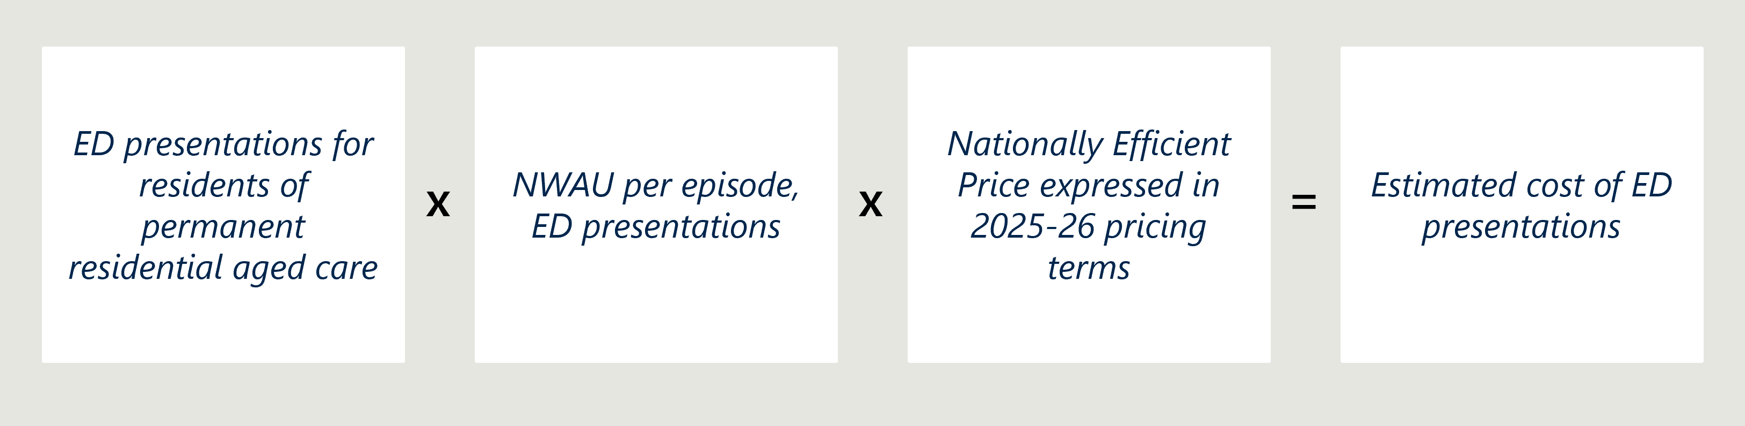
Table 19 | Cost changes associated with decreased ED presentations for RACH residents (2018-19 to 2021-22)
Indicator | 2018-19 | 2021-22
ED presentations for residents of permanent residential aged care | 152,535 | 137,526
NWAU per episode, ED presentations, | 0.13 | 0.14
Nationally Efficient Price expressed in 2025-26 pricing terms, | $7,325 | $7,249
Estimated cost of ED presentations, by RACH residents | $145,255,270 | $139,568,777
Change in estimated costs from 2018-19 to 2021-22  (+ or – denotes an increase or decrease over the period) |  | - $5,686,493

Cost changes associated with reduced average length of hospitalisation related to palliative care
The average length of hospitalisation (that is, the average number of hospital bed days) related to palliative care decreased from 5.5 days in 2018-19 to 5.13 days in 2021-22. The estimated cost savings in real terms is outlined in Table 20.
Table 20 | Inputs used to estimate costs associated with reduced average length of hospitalisations related to palliative care (2018-19 to 2021-22)
Input | 2018-19 | 2021-22 | Change  (+ or – denotes an increase or decrease over the period)
Average number of hospital bed days related to palliative care for RACH residents | 5.5 | 5.13 | - 0.37
Estimated cost of hospital bed days | $6,847 | $6,386 | - $461
- Policy and operating context
This Appendix outlines:
- key reforms and initiatives announced since the introduction of the Measure
- recent reforms and initiatives that have emerged since the Interim Report
- ongoing contextual challenges for the aged care sector.
As outlined in section 2, the Measure was introduced amongst significant reforms within the health and aged care sectors (Figure 1). This Appendix provides more detail on reforms that aim to enhance access, quality and coordination of palliative care, ensure equitable funding for aged care services, and improve workforce capability and support.
Reforms to enhance access, quality and coordination of palliative care:
- Implementation of the GCfAHPC program. The GCfAHPC Program launched as a pilot in 2017-18 with 11 PHNs and then rolled out nationally in 2020-21 to all 31 PHN regions, with the goal of improving access to quality palliative care at home and in the community. The Program supports primary care, aged care and the community. The overall aim is to enable people, who choose to, to remain at home whilst receiving palliative care, or end-of-life care. Under the GCfAHPC Program RACHs, and disability group homes, are included as a person’s permanent home address. The focus of the program is to enhance the capability and coordination of local health services, promote earlier identification of palliative care needs and enable care in the community. The program currently funds all 31 PHNs, who each undertook a regional palliative care needs assessment to provide a tailored and local response. There are many examples of activities delivered under the GCfAHPC Program that complement Measure-funded activities, such as in Adelaide PHN who worked to increase the uptake of advance care planning and deliver palliative care education to nurses and care staff in RACHs.
- Expansion of the QI Program. As of April 2023, in response to recommendations of the Royal Commission, the QI Program was expanded to include six new indicators related to daily living activities, incontinence care, hospitalisation, workforce, consumer experience and quality of life. At the time of this report, there are no quality indicators that explicitly capture the provision of palliative care. The QI Program imposes requirements for all RACHs to monitor against these indicators on a three monthly basis. The QI Program aims to facilitate continuous quality improvement amongst providers, provide transparent information to older Australians and support evidence-based decision making by the Australian Government. However, the regular data collection and reporting requirements of the QI Program may have also imposed greater administrative burden on RACHs.
- To address workforce shortages and improve care quality in RACHs, several measures were introduced in 2023. These include:
  - In May, the introduction of the Aged Care Industry Labour Agreement reflects the contemporary role that migration can play in investing in skills and training in the aged care sector. The Agreement promotes recruitment by allowing employers to sponsor direct care workers on skilled visas, including an expediated two-year pathway to permanent residency.
  - In July, the industry initiated a 15 per cent pay increase for aged care workers covered by certain awards. This includes personal care workers, nursing assistants, enrolled nurses, RNs, NPs working in aged care and home aged care workers.
  - The 24/7 RN responsibility was also established in July, requiring at least one RN on-site at all times. This is in response to recommendation 86 of the Royal Commission and aims to ensure qualified and experienced staff are available to identify potential risks for residents.
  - As of October 2024, the Australian Government introduced the ‘Care minutes in residential aged care’ reform which stipulates a minimum requirement for RACHs of 215 minutes of care to each resident daily, including 44 minutes of time with a RN. Activities eligible to be considered under ‘care minutes’ include daily operational activities such as emotional support, nursing services and recreational therapy. This reform comes in response to the Royal Commission’s findings that the routine care of older people in RACHs often did not meet expectations, including some examples of substandard care.
- Implementation of the General Practitioner in Aged Care Incentive (GPACI). In July 2024, under the GPACI, eligible GPs and practices delivering services to RACHs, can receive payments if they provide two care planning services in a one month period and conduct two visits every quarter. Eligible GPs that fulfill these service requirements can receive quarterly payments of $300 per patient and $130 per patient to the practice. The aim of this initiative is to incentivise delivery of care from GPs in aged care settings and ultimately improve care planning and continuity of care within the aged care sector. It seeks to allow for more anticipatory and proactive activities from GPs in aged care as opposed to the more time-based reactive approach taken in the past.
Reforms to improve workforce capability and support include:
- The ongoing delivery of multiple education pathways aiming to attract, train and retain nurses in the aged care sector by offering clinical experience, scholarships and transition pathways for both new nursing graduates and those considering a switch to aged care. Key initiatives in these reforms include the Aged Care Transition to Practice Program, the Aged Care Nursing Clinical Placement Program and the ACNS.
- National education and training programs for the aged care workforce. The Australian Government contributes funding to a large suite of formal education and training resources and programs to upskill the aged care workforce in the delivery of palliative care. Some leading examples of national education initiatives are the PEPA/Indigenous Program of Experience in the Palliative Approach and ELDAC which offer free, evidence-based, comprehensive training, resources and support to health and aged care professionals. The programs have a strong focus on building practical palliative care skills, advance care planning and supporting culturally responsive care. Other examples include the Improving Palliative Care Training and Outcomes in Aged Care budget measure which includes implementation of PACOP and PEPA Aged Care. In May 2023, the Australian Government committed a further $53 million to continue funding for the suite of national palliative care projects with a focus on workforce education and training, building awareness of palliative care and end-of-life planning, quality improvement for care providers and increasing access to support in rural and regional areas. A selection of universities, health services and palliative care organisations have received this funding to deliver projects aimed at strengthening palliative care across Australia, with an emphasis on inclusivity, quality and sustainability.
Reforms to ensure equitable funding for aged care services:
- Implementation of the AN-ACC funding model. The AN-ACC funding model is the primary funding model of residential aged care in Australia and was implemented in October 2022, replacing the Aged Care Funding Instrument (ACFI). The AN-ACC model includes a dedicated funding class (Class 1) to provide funding to RACHs for residents who are admitted into the RACH specifically to receive palliative care and residents who become palliative after admission to the RACH can be reclassed to reflect their additional needs. The AN-ACC model considers individual care needs of residents based on resident assessments and allocates funding accordingly using a mixture of fixed and variable payments/subsidies, enabling more appropriate and equitable funding for RACHs providing generalist palliative care to residents. The model also provides special consideration for RACHs with specific needs, for example those in regional and remote areas or are First Nations oriented. The new model separates funding assessments from care planning, enabling the RACHs to focus on understanding the residents’ needs, goals and preferences. Unlike ACFI, AN-ACC is not prescriptive in the specific care activities that are funded.
- Recommendations from the Aged Care Taskforce and the subsequent agreement by the Australian Government to remain the majority funder of aged care services. The Aged Care Taskforce released final recommendations in a report in March 2024. Seven funding principles guide the recommendations and articulate the need to support older people to age in place, ensure equitable and sustainable funding for aged care and invest in quality improvement, care innovation and transparency. In its response to the Aged Care Taskforce, the Australian Government has agreed to remain the majority funder of aged care services, in response to Recommendation 2, signalling that aged care reform is an ongoing priority.

There are challenges that persist across the aged care sector

The proportion of residents with complex care needs are increasing across residential aged care
Over the ten-year period from 2013 to 2023, the number of people accessing permanent residential aged care has increased by almost 10 per cent, with residents’ use of respite residential aged care increasing by 97 per cent over the same period. Over this period, the number of people choosing to receive home care has also increased four-fold (from 57,000 to 258,000 people).
Among the residential aged care population, the level of complexity of clinical and non-clinical care has increased substantially over the last decade. Published literature indicates that the proportion of residents classified as having high care needs has increased substantially over the period from 2009-2019, with the biggest increase of 29 per cent for care needs related to complex health care. More recently, between 2013 to 2023, the median length of stay for residential aged care has decreased by 3.7 months for people in permanent residential aged care, and death is recorded as the most common reason for leaving permanent residential aged care, accounting for 85-95 per cent of exits among residents both assessed as requiring palliative care and those not. These statistics highlight a RACH population with increasing complexity of care needs, entering residential aged care at a time closer to dying and a growing demand for palliative care, which is expected to double by 2050.

Aged care workforce issues continue to be a significant pain point in the sector
Despite recent reforms, Australia’s aged care workforce has historically struggled with significant shortages and high turnover rates. The Aged Care Worker Survey 2024 Report reveals that only 42.8 per cent of respondents have worked in the aged care sector for more than ten years. The industry has also voiced training gaps in palliative care and staff burnout as major challenges.
RNs play a vital role in delivering care in RACHs, offering technical expertise, leadership and skilled management of complex clinical issues. However, the number of RNs in aged care is limited, are often required to undertake less skilled tasks and are often paid less than their counterparts working in acute care. Since the COVID-19 pandemic, approximately 70 per cent of the aged care workforce is made up by Unregistered Health Care Workers. This proportion of the workforce often does not have the skills and training to manage the complexities of care required by older patients in residential aged care, particularly those with complex clinical, including palliative care, needs.
To address these challenges, the Australian Government has delivered a suite of programs to attract and retain a highly skilled aged care nursing workforce (described above).

COVID-19 disrupted aged care priorities, workforce capacity and care quality
The COVID-19 pandemic, which began in 2019, placed significant stress on residents and staff in RACHs. In December 2020 alone, RACHs experienced 218 COVID-19 outbreaks nationally. One study found that 33 per cent of RACH staff reported experiencing burnout during the pandemic. Consultation with jurisdictional policy leads in 2023 highlighted that many healthcare workers left the industry during COVID-19, suggesting that it was likely due to burnout.
Although the peak of the pandemic occurred over 2020-2022, there are ongoing impacts of this on the aged care sector. COVID-19 outbreaks within RACHs are an ongoing occurrence and require lockdowns within RACHs which prevents access of specialist care teams. On 1 May 2025, there were 61 active outbreaks in RACHs across Australia, infecting 357 individuals.
- Total funding contributions for the Measure
Table 21 | Combined funding contributions for all jurisdictions and the Australian Government, 2019-20 to 2025-26
Jurisdiction | Contributor | 2019-20 to 2023-24 Agreement | 2024-25 to 2025-26 Agreement | Total funds agreed to for Measure
ACT | ACT Government | $1,268,000 | $663, 000 | $1,931,000
ACT | Australian Government | $925,000 | $303,00 | $1,228,000
NSW | NSW Government | $10,000,000 | $7,056,000 | $17,056,000
NSW | Australian Government | $10,000,000 | $7,056,000 | $17,056,000
Northern Territory | Northern Territory Government | $521,000 | $152,000 | $673,000
Northern Territory | Australian Government | $521,000 | $152,000 | $673,000
Queensland | Queensland Government | $9,022,000 | $6,400,000 | $15,422,000
Queensland | Australian Government | $9,022,000 | $4,248,000 | 13,270,000
South Australia | South Australian Government | $3,825,000 | $1,821,000 | $5,646,000
South Australia | Australian Government | $3,825,000 | $1,821,000 | $5,646,000
Tasmania | Tasmanian Government | $1,162,000 | $455,000 | $1,617,000
Tasmania | Australian Government | $1,162,000 | $455,000 | $1,617,000
Victoria | Victorian Government | $14,187,000 | $1,250,000 | $15,437,000
Victoria | Australian Government | $14,187,000 | $1,250,000 | $15,437,000
Western Australia | Western Australian Government | $5,719,000 | $1,970,000 | $7,689,000
Western Australia | Australian Government | $5,719,000 | $1,970,000 | $7,689,000
Total | All state and territory governments | $45,704,000 | $19,767,000 | $65,471,000
Total | Australian Government | $45,361,000 | $17,255,000 | $62,616,000
Total | Total combined | $91,065,000 | $37,022,000 | $128,087,000

- Assessment of delivery against responsibilities in the 2019-20 to 2023-24 Project Agreement
Table 22 | Final assessment of delivery against responsibilities in the 2019-20 to 2023-24 Project Agreement
Stakeholder | Responsibilities | Delivery on responsibilities
Australian Government | - Monitoring and assessing achievement against milestones in the delivery of projects to ensure that outputs are delivered within the agreed timeframe.  - Providing a consequent financial contribution to states.  - Delivering a national evaluation by 2023-24. | The Australian Government continues to meet the responsibilities outlined in the Project Agreement to support the Measure’s implementation. The Australian Government has:  - been monitoring achievement against jurisdictional milestones through assessing specific performance reports, received April each year  - provided funds to jurisdictions on sign-up to the Measure  - commissioned an independent national evaluation which started in 2020  - conducted five Project Implementation Group meetings.  The national evaluation was extended to maximise coverage of the implementation period and mitigate data collection delays. The national evaluation will now cease in June 2025 with the submission of this Final Report.
States and territories | Financial contribution matched by the Australian Government, project proposal, delivering project outputs and reporting. | - All states and territories are providing financial contributions to support implementation of the Project Agreement to date. States and territories could choose to contribute additional funds above the matched funding amount to supplement the Australian Government’s contributions under the Measure.  - All states and territories submitted proposals and supporting evidence after signing up to the Measure.  - All states and territories are delivering on project outputs set out in the new Project Agreements.  As of May 2025, all states and territories have been reporting on the delivery of outputs set out in their agreements. All states and territories provided annual milestone performance reports to the Department in 2021, 2022, 2023 and 2024. All 2025 Performance Milestone reports were delivered by June 2025.
States and territories | Evaluating their agreed projects, to contribute to the overarching evaluation of the Measure. | The NPA outlines a responsibility for states and territories to evaluate their projects; however, jurisdictional evaluations vary in status:  - South Australia, Queensland, Western Australia and the ACT – completed, reports provided.  - Victoria – in progress. Victoria’s evaluation is anticipated to be completed in mid-2026.  - Tasmania – is not progressing a formal, point-in-time evaluation report at this stage but has established ongoing monitoring and evaluation of their CPCiAC activities, which informs internal reporting as well as reporting to the department. The approach has evolved to support practical data collection by CNCs.  - NSW – conducted an evaluation on broader end-of-life and palliative care activity, not Measure specific.  - The Northern Territory – is not conducting an evaluation but is conducting monitoring activities.  The impact of these variations on the national evaluation is described in section 4.6.  All states and territories have contributed to the national evaluation through input on the Evaluation Framework, completion of six-monthly data collection templates and participation in consultations with evaluators to inform the Baseline, Mid-point, Interim and Final evaluation reports.
- National outcomes analysed in the Final Report
This appendix includes updated information that was planned for the Final Report analysis, presented in the Mid-point Report. Table cells highlighted in blue are indicators that are new to the Final Report to contribute to the assessment against the outcome. Table cells highlighted in red are indicators that have been described in detail under a different outcome than initially planned. Indicators that are used to address multiple outcomes are cross-referenced throughout.

Outcome 1: More discussions focused on end-of-life care decision making between residents, families, carers, GPs and specialist palliative care services including use of ACPDs.
Evaluation indicator | Expected assessment of progress in the Final Report | Data source
Increased proportion of RACH residents with ACPDs (for example, ACDs). | Many RACHs facilitate residents having ACPDs and so there may be little change in this indicator. | RACH survey
Increased RACH compliance with the Aged Care Quality and Safety Standards (2b, 2c, 3c). | An increase in the proportion of compliant facilities could indicate that the Measure activities have led to improved use of ACDs. | ACQSC
Increased effectiveness and use of ACPDs (for example, ACDs) within RACHs. | An increase would likely indicate more discussions focused on end-of-life care. | Qualitative assessment
Increased frequency of ACPD review. | New to final report. | RACH survey

Outcome 2: Improved access to information that informs end-of-life care decisions for residents and families.
Evaluation indicator | Expected assessment of progress in the Final Report | Data source
Increased RACH compliance with the Aged Care Quality and Safety Standards (1c). | Improved compliance could indicate that more RACHs are involving residents in care planning and decisions, indicating that residents have improved access to information that informs end-of-life care decisions. | ACQSC
Increase in the proportion of RACH residents attending multidisciplinary case conferences. | Addressed under Outcome 7 | NHDH
Increased resident, family and carer access to information on end-of-life care. |  | Qualitative assessment
Increased use of routine processes to record residents’ end-of-life wishes. | New to final report | RACH survey

Outcome 3: A higher proportion of clinical and non-clinical staff in RACHs have skills and confidence appropriate to their roles to recognise and respond to the holistic palliative care needs of residents, in a culturally safe way.
Evaluation indicator | Expected assessment of progress in the Final Report | Data source
Increased number of RACHs that have a policy in place and monitored to ensure that all staff (including casuals) uptake available training/education opportunities to improve their understanding of palliative care. | In 2021, 63 per cent of RACHs had mandatory palliative care training for any staff group identified. An increase would indicate that more RACH staff are taking up training/education opportunities to improve their understanding of palliative care. | RACH survey
Increased completions of accredited courses related to palliative care. | An increase would indicate that more RACH staff have skills and confidence appropriate to their roles and related to palliative care. | AHHA, ELDAC
Increased proportion of staff that attend palliative care training. | New to final report | RACH survey

Outcome 4: Improved access to quality palliative care in RACHs including:
- increased use of assessments to establish residents’ palliative care needs
- decreased health service use related to clinically futile or non-beneficial treatments and inpatient bed days
- decreased healthcare expenditure arising from decreased service use.
Evaluation indicator | Expected assessment of progress in the Final Report | Data source
Increased number of RACH residents who receive palliative care through a service participating in the PCOC. |  | PCOC
Increased number of RACHs that access palliative care provided by states/territory specialist services. | In 2021, 93 per cent of Australian RACHs reported that residents could access specialist palliative care provided by a state or territory health service. An increase would indicate improved access to quality palliative care in RACHs. | RACH survey
Increased number of RACH residents that access palliative care services. |  | NHDH
Increased number of RACH residents that are dispensed with medicines associated with palliative care. |  | NHDH
Increased number of Multidisciplinary Case Conferences by Medical Practitioners (Other Than Specialist or Consultant Physician) – (MBS items 735 to 758) in RACHs. | Addressed under Outcome 7 | NHDH
A decrease in the number of RACH residents who presented to ED. |  | NHDH
A decrease in the number of RACH residents admitted to an acute care facility for palliative care. |  | NHDH
A decrease in the number of inpatient bed days related to palliative care. | New to section | NHDH
Increased number of providers/RACHs participating in the PCOC. | New to section | PCOC

Outcome 5: Improved quality of palliative care provided in RACHs including:
- reduced symptom burden
- improved quality of life for residents during the period they access palliative care
- better experience of death and dying for residents, families/carers and staff, including meeting physical, psychosocial, cultural and spiritual needs.
Evaluation indicator | Expected assessment of progress in the Final Report | Data source
Increased number of providers/RACHs participating in the PCOC. | Addressed under Outcomes 4 and 9 | PCOC
Increased number of RACH residents who receive palliative care through a service participating in the PCOC. | Addressed under Outcomes 4 | PCOC
Improved resident experience of dying reported by family/carers. |  | Qualitative assessment
Increased proportion that met PCOC symptom benchmarks. | New to final report | PCOC
Increased proportion of RACHs that have policies to ensure resident’s spiritual and cultural end-of-life wishes are met. | New to final report | RACH survey
Increased RACH compliance with the Aged Care Quality and Safety Standards 1(3)(a). | New to final report | ACQSC
Decreased number of complaints received by the ACQSC from residents and families related to palliative care. | New to section | ACQSC

Outcome 6: Greater resident choice in palliative care including:
- more people dying where they want
- increased person-centred care informed by an individual’s choice.
Evaluation indicator | Expected assessment of progress in the Final Report | Data source
Increased proportion of RACH residents with ACPDs (for example, ACDs). | Addressed under Outcome 1 | RACH survey
Increased effectiveness and use of ACPDs (for example, ACDs) within RACHs. | Addressed under Outcome 1 | Qualitative assessment
Increased RACH compliance with the Aged Care Quality and Safety Standard. | Addressed under Outcome 1 and 2 | ACQSC
Decreased number of RACH residents dying in an acute care setting (for example, hospital). | A decrease could suggest an improvement in the quality of palliative care provided in RACHs and in the experience of residents, families/carers and staff. | NHDH
Decreased number of RACH residents admitted to an acute care facility for palliative care. |  | NHDH
Increased number of RACHs that recorded place of death. | New to final report | RACH survey
Increased proportion of residents that died in RACH. | New to final report | NHDH

Outcome 7: Improved care coordination with GPs/primary care, acute care services and specialist palliative care services.
Evaluation indicator | Expected assessment of progress in the Final Report | Data source
Increase in the proportion of RACH residents attending multidisciplinary case conferences and number of multidisciplinary meetings run. | Given the multidisciplinary nature of these meetings, an increase in the number of these meetings occurring and in the proportion of RACH residents attending these, could indicate improved care coordination with GPs/primary care, acute care services and specialist palliative care services. | NHDH and MBS
Increase in access to specialist palliative care through GPs. | New to final report | RACH survey

Outcome 8: Improved integration between the health and aged care systems.
Evaluation indicator | Expected assessment of progress in the Final Report | Data source
A decrease in the number of RACH residents who presented to EDs. | Addressed under Outcome 4 | NHDH
A decrease in the number of RACH residents admitted to an acute care facility for palliative care. | Addressed under Outcome 4 | NHDH
A decrease in the number of inpatient bed days related to palliative care. | Addressed under Outcome 4 | NHDH

Outcome 9: More palliative care services and health planners are informed by performance information on appropriateness, effectiveness, efficiency and outcomes.
Evaluation indicator | Expected assessment of progress in the Final Report | Data source
Increase in RACHs that use an audit process to look at end-of-life care (for example, an after-death audit). |  | RACH survey
Increased number of providers/RACHs participating in the PCOC. |  | PCOC
Increase in the RACHs that use a digital dashboard or monitoring tool. | New to final report | RACH survey

Outcome 10: Improved clinical governance to identify and implement quality improvement initiatives and evaluation of outcomes within RACHs.
Evaluation indicator | Expected assessment of progress in the Final Report | Data source
Increased number of RACHs that implement quality improvement activities to improve palliative care. | A total of 65 per cent of RACHs have implemented quality improvement initiatives to improve palliative care outcomes over the past 12 months. | RACH survey
Decreased number of complaints received by the ACQSC from residents and families related to palliative care. | Addressed under Outcome 5 | ACQSC
Increased RACH compliance with the Aged Care Quality and Safety Standards (8c-e). | For the Final Report, Nous will request compliance with all Aged Care Standards, in particular Standard 8, 3(e) which requires aged care services to demonstrate the use of a clinical governance framework. | ACQSC
Increased number of RACHs that have palliative care specific policies and procedures in place. | New to final report | RACH survey

- Challenges and limitations of conducting a cost effectiveness analysis
- Feasibility challenges of conducting a cost effectiveness analysis
Nous explored the feasibility of conducting a cost-effectiveness analysis to assess the Measure’s impact, including its broader cost implications and potential effects on other parts of the health system. However, due to current data limitations, a true cost-effectiveness analysis is not possible.
Nous explored two approaches to assess the cost-effectiveness of the Measure:
- Case study quantification of the cost implications of outcomes achieved under the Measure. Jurisdictions did not consistently capture data related to cost savings under Measure-funded activities. Only one jurisdictional case study (conducted by Queensland) provided quantified cost savings. This been included in Case study 14.
- A comprehensive comparison of costs incurred under the Measure compared with a counterfactual (the scenario in which the Measure is or has not been implemented). This approach was ultimately not feasible. The reasons for this are outlined below.

A counterfactual comparison was not feasible due to limitations in data availability and data access, and the variability of the models being implemented
- There was no way to identify which RACHs or residents were or were not impacted by the Measure. Nous explored whether it would be possible to use quasi-experimental methods to establish a “treatment” and “control” group. While the NHDH (formerly NIHSI-AA) data has information on individual residents and RACHs, the Australian Institute of Health and Welfare (AIHW) analysts only have access to strictly de-identified data and so it is not possible to use this data to identify which individuals or RACHs were involved in the Measure (treatment group) and which were not (control group) without breaching confidentiality requirements at the AIHW.
- There are insufficient data points to establish a historical counterfactual using time series analysis to assess cost trends before and after Measure implementation. The lack of time points prohibits the use of any forecasting methods that could produce a potential predicted counterfactual against which to compare actuals. Nous explored the feasibility of this using a range of simple forecasting approaches including exponential smoothing, time-series linear models, drift models and trend models. All methods produced erroneously wide prediction intervals. Nous also considered applying an interrupted time series approach, however, given the data constraints and external confounding factors which could impact outcomes, Nous determined that this approach was also not feasible.
- Available data does not provide visibility on the extent of the “impact” across each individual RACH. For example, Measure funding may be used for direct specialist in-reach service provision, or for access to palliative care-related resources and information. The variability in implementation across states and territories and cost implications of different interventions makes assessment of the “impact” of the Measure challenging.
- There are no comparable programs or interventions to enable comparison. Given the variability of how the Measure has been implemented across states and territories, there is a lack of comparable programs or interventions against which the Measure could reasonably be compared.
- Limiting factors relating to observed trends and associated costs and benefits
Several confounding and limiting factors need to be considered for any observed trends.
- Given it is not possible to identify, in national datasets, which RACHs or residents were and were not impacted by the Measure, it is not possible to attribute any observed trends in the data solely to the Measure.
- Aggregating and comparing the cost effectiveness of the different models being implemented is challenging given each jurisdiction is taking substantially different approaches to implement the Measure. For example, South Australia is using funding in a limited set of RACHs while NSW is providing equal funding to all LHDs.
- Costs and cost savings associated with the Measure are spread over several health services including hospitals, ambulances, medication and other medical services (for example, GP visits). Given the available data, it is not possible to comprehensively collate costs across these services and attribute them to the Measure. This would require linking data from a variety of sources.
- Data available to quantify outcomes in monetary terms varies in timeliness and temporal coverage, which limits Nous’ ability to collate all costs observed into one net cost figure.
- Ultimately, the Measure seeks to improve the quality of death experienced by RACH residents. Nous does not believe it is possible to economically quantify the quality of life experienced by residents at end-of-life using standard health economics methods such as Quality-Adjusted Life Years (QALYs), which are not appropriate in this context. This is supported in the literature, which suggests that improving QALYs may not be the intended aim of end-of-life care interventions and may be inconsistent with patients’ wishes and preferences . This limits the ability to conduct analyses that account for the differential patient outcomes that are achieved under the Measure.
Trend | Corresponding section | Context and limitations
PBS item usage related to palliative care | Section 4.7.1 | - It is not possible to determine whether the residents that were dispensed with PBS items related to palliative care are residents of RACHs that have been impacted by the Measure.  - It is also not possible to determine whether the PBS items dispensed to RACH residents were specifically for palliative care. The PBS items dispensed to RACH residents are listed under Palliative Care (drug type code “PL”); however, these medicines are not exclusively for palliative care.  - Changes to PBS item usage may be driven by medicine availability, new drugs coming on to the market, patents being lifted, pre-emptive prescribing patterns, increased awareness of palliative care more generally, or changes in the nature of care provided in RACHs. This makes attribution of observed trends to the Measure challenging.
Specialist palliative care services | Section 4.7.2 | There is no cost data available to estimate the average cost of one episode of specialist palliative care in-reach services. As an alternative, we have estimated cost ranges using KPMG’s estimate of the average cost per person of integrated home-based care in the last year of life.
ED presentations | Section 4.7.3 | Cost changes associated with the decrease in the number of ED presentations have been estimated using National Weighted Activity Units (NWAUs) for ED hospital activity and the Nationally Efficient Price as reported by IHACPA (further detail on this method is outlined in Appendix B.6).
All-cause hospital admissions | Section 4.7.4 | - It is not possible to determine whether these are residents of RACHs that have been impacted by the Measure. It is also not possible to determine whether these hospitalisations are related to futile or non-beneficial hospital admissions, so it cannot be assumed that the reduction in general hospital admissions indicate reduced health service use for futile or non-beneficial treatments.  - Assuming all hospitalisations require an ambulance transfer, the decrease in hospitalisations is likely to achieve cost savings from reduced ambulance transfers.
Hospital stays relating to palliative care | Section 4.7.5 | - KPMG’s estimate of the cost of a hospital bed day, indexed to 2024-25 Australian dollars, is $1,245 per hospital bed day. This is the value used to estimate the cost changes associated with the reduction in the average number of bed days related to palliative care.
- Lessons for future assessment of cost effectiveness

A potential future approach to a more robust cost-effectiveness analysis of the Measure would entail resident-level analysis of the NHDH data
The variability in implementation approaches across jurisdictions makes understanding the overall cost effectiveness of the Measure challenging. A more robust approach to conducting cost effectiveness of the Measure would involve comparing the observed changes in expenditure for palliative care-related services to residents in RACHs that have been impacted by the Measure against residents in RACHs that have not.
This would require more detailed data from NHDH, MBS, PBS and PCOC data assets to identify which RACHs residents reside in and whether their RACH was involved in the Measure or not. A proposed, high-level method for conducting a more robust cost-effectiveness analysis could be:
- Obtain a list of RACHs directly involved in the Measure from each state and territory.
- Identify a treatment and control group of residents, based on resident-level data of residents at a RACH involved in the Measure (treatment) and residents at a RACH not involved in the Measure (control).
- Prepare linked data extract of resident/service counts for each year of the Measure implementation and the years prior to implementation, disaggregated by whether residents are in the treatment or control group and linked to NWAUs to assign costs.
- Analyse differences in costs incurred between the treatment and control groups, noting there would be several confounding factors.
- Conduct difference-in-difference analysis of longitudinal NHDH data to estimate the effect of the Measure on the treatment against the control group.

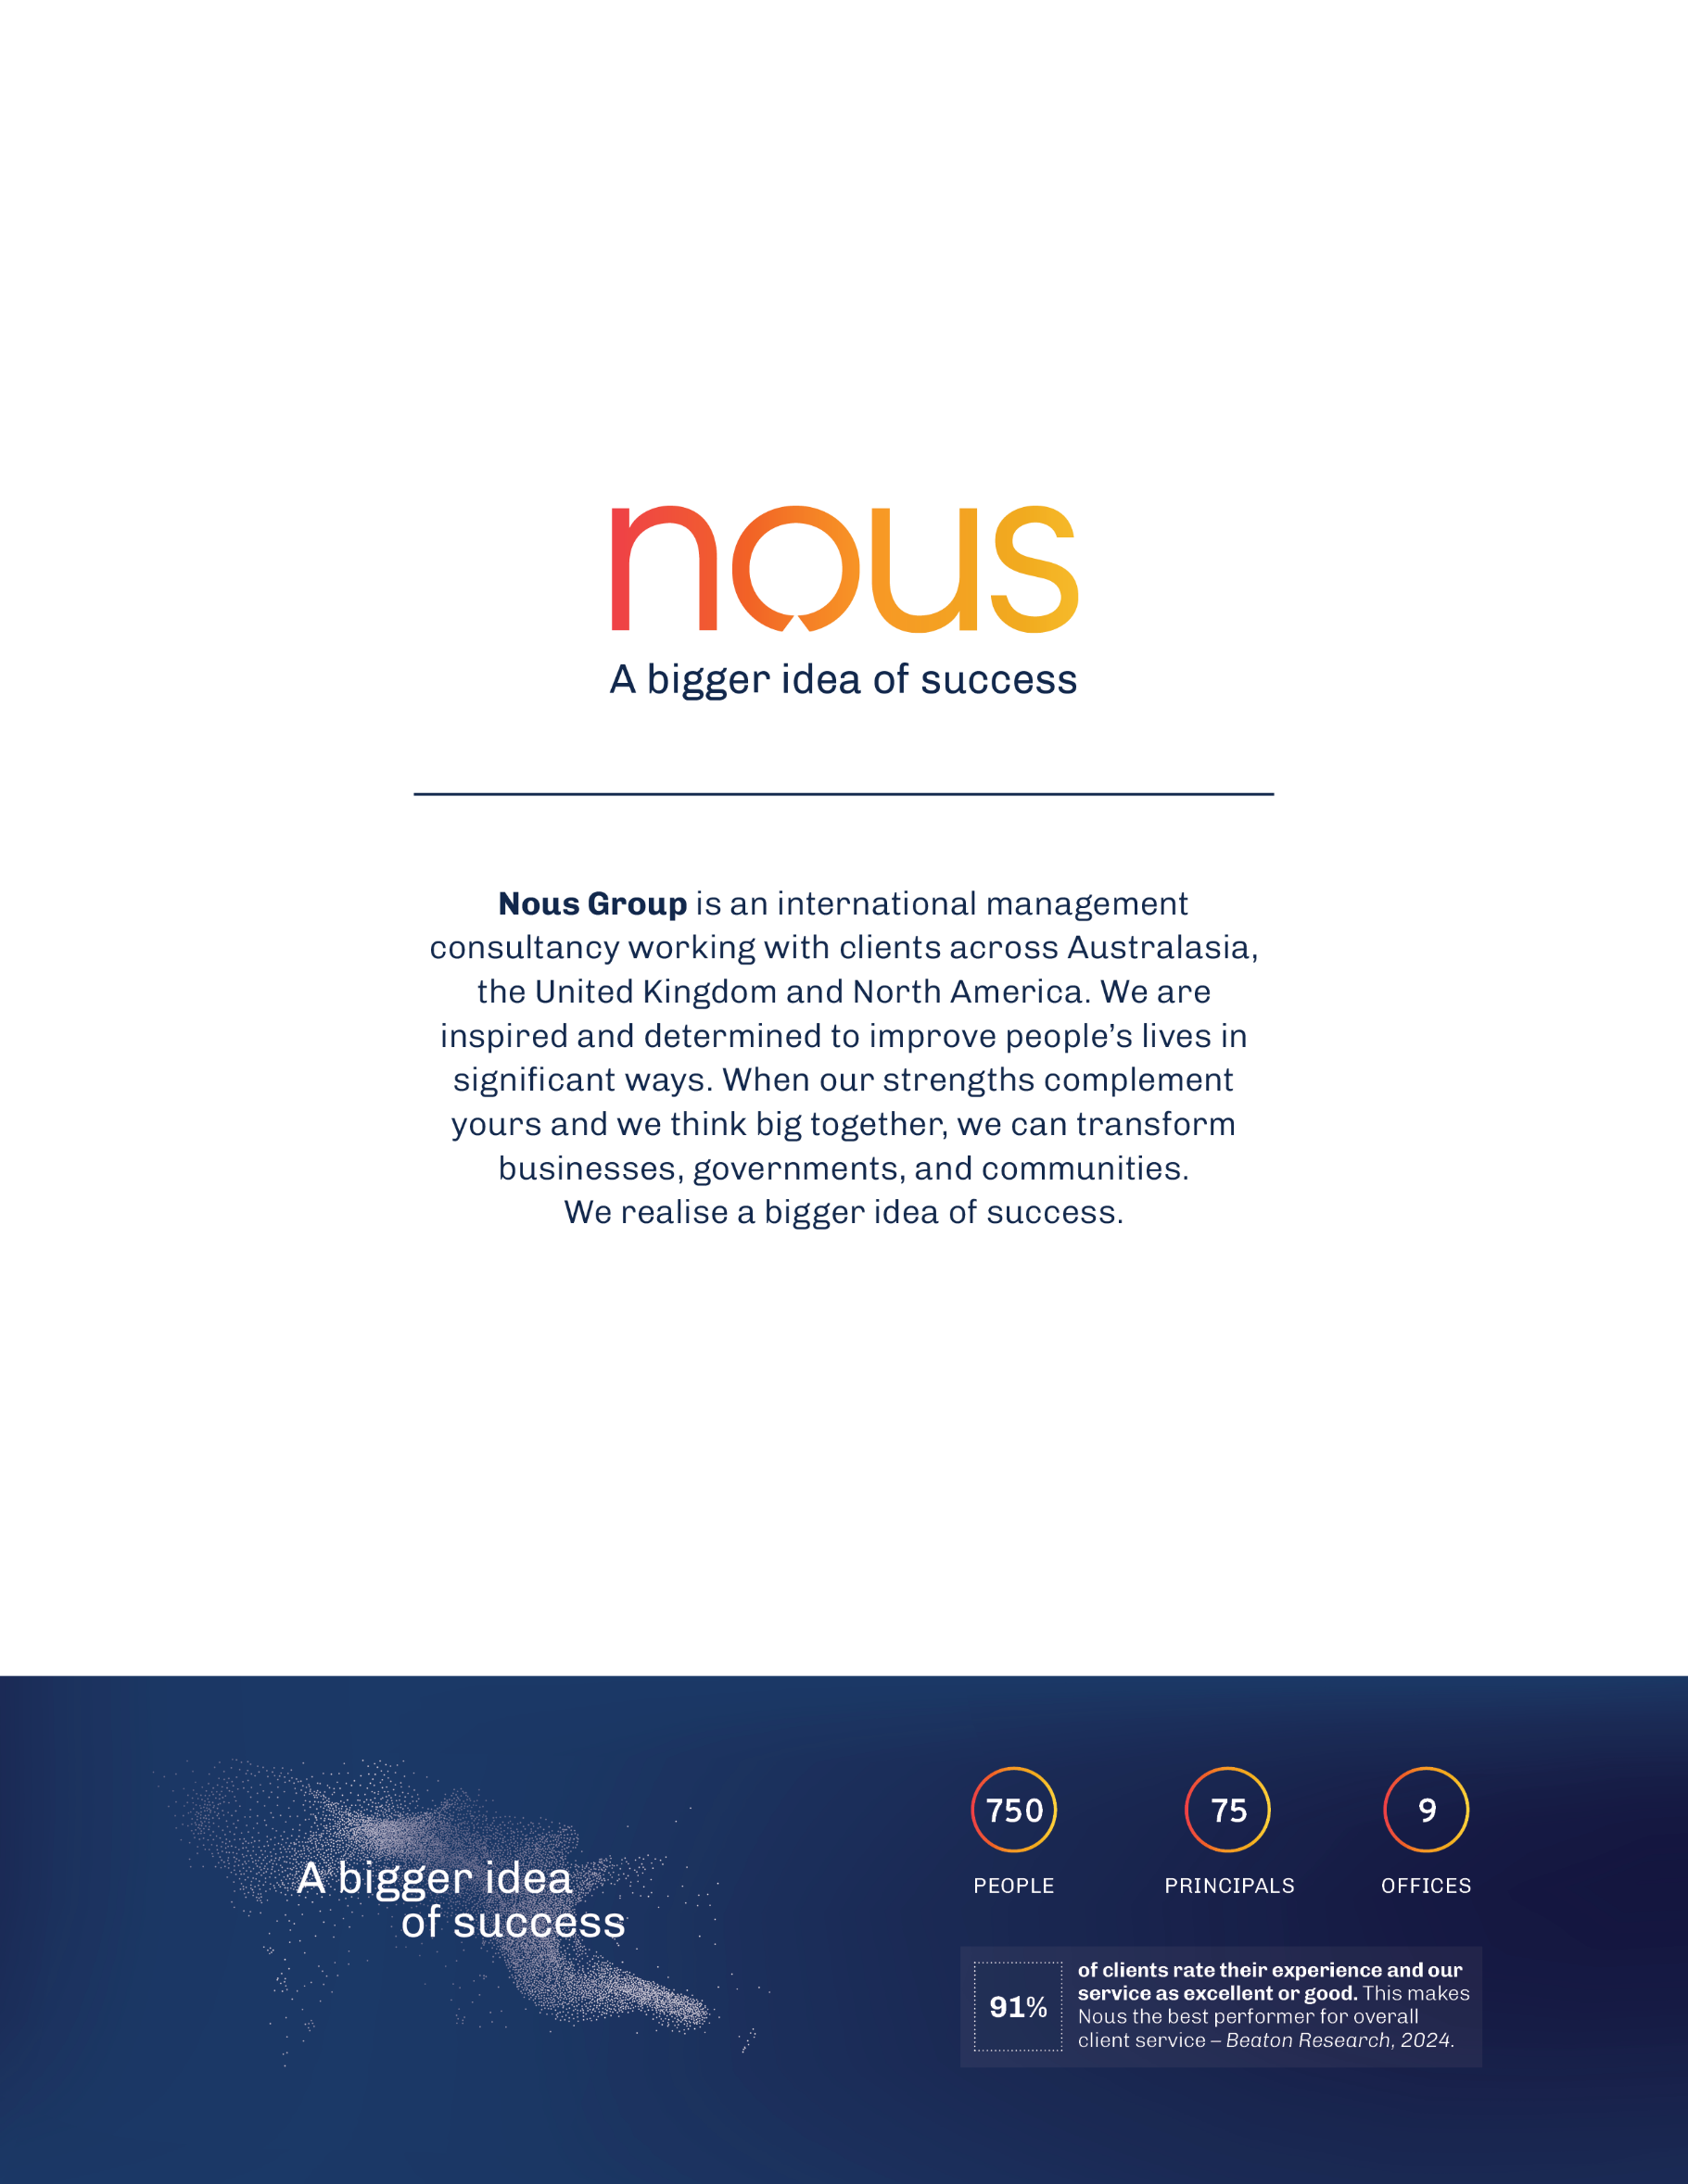

The total Commonwealth funding offered to jurisdictions from 2018-19 to 2025-26 was $76.7 million. However, some jurisdictions opted to contribute a reduced amount so in line with the principles of the measure, the Commonwealth funding contribution was reduced to match the jurisdictions, with a total of $62.6 million contributed. This included funding to jurisdictions as well as national evaluation and other activities.
The focus of the national evaluation was the six-year implementation period of the original investment under the Measure, however data collection for this Final Evaluation Report occurred during the extension period in 2024 and 2025, and so the report incorporates findings and data as recent as May 2025.
Calculated using Gen Aged Care Data on number of residential care services and multi-purpose services, collected 30 June 2024.
Of RACHs surveyed by Nous and who answered this question in 2025 (n = 337), compared to those surveyed in 2021 (n = 472).
Of RACHs surveyed by Nous and who answered this question in 2025 (n = 337), compared to those surveyed in 2021 (n = 472).
Of RACHs surveyed by Nous and who answered this question in 2025 (n = 330), compared to those surveyed in 2021 (n = 442).
Of the RACHs surveyed by Nous and who answered this question in 2025 (n=330) compared to those surveyed in 2021 (n= 453)
Of the RACHs surveyed by Nous and who answered this question in 2025 (n=330) compared to those surveyed in 2021 (n= 453)
NHDH data.
PBS data
NHDH data
Of the RACHs surveyed by Nous and who answered this question in 2025 (n=335) compared to those surveyed in 2021 (n= 457)
Of the RACHs surveyed by Nous and who answered this question in 2025 (n=327) compared to those surveyed in 2021 (n= 453)
Of the RACHs surveyed by Nous and who answered this question in 2025 (n=335) compared to those surveyed in 2021 (n= 457)
NHDH data
Of the RACHs surveyed by Nous and who answered this question in 2025 (n=331) compared to those surveyed in 2021 (n= 467)
Of the RACHs surveyed by Nous and who answered this question in 2025 (n=331) compared to those surveyed in 2021 (n= 467)
Of the RACHs surveyed by Nous and who answered this question in 2025 (n=331) compared to those surveyed in 2021 (n= 467)
Commonwealth of Australia. National Project Agreement for Comprehensive Palliative Care in Aged Care. 21 July 2020.
Australian Department of Health, Disability and Ageing, Greater Choice for At Home Palliative Care Program, 2021. Accessed at https://www.health.gov.au/our-work/greater-choice-for-at-home-palliative-care-program
Australian Department of Health, Disability and Ageing, New residential aged care quality indicators, 2022. Accessed at https://www.health.gov.au/news/new-residential-aged-care-quality-indicators
Aged Care Quality and Safety Commission. Outcome 5.7: Palliative care and end-of-life care. 2025. Accessed at https://www.agedcarequality.gov.au/strengthened-quality-standards/clinical-care/palliative-care-and-end-life-care
Palliative Care Australia, New Aged Care Act: What you need to know, 2025, Accessed at https://palliativecare.org.au/mediarelease/new-aged-care-act-what-you-need-to-know/
Australian Department of Health, Disability and Ageing. Skilled migration program, 2023. https://immi.homeaffairs.gov.au/what-we-do/skilled-migration-program/recent-changes/new-aged-care-industry-labour-agreement
Fair Work Ombudsman, 15% wage increase for aged care sector, 2023. Accessed at https://www.fairwork.gov.au/newsroom/news/15-per-cent-wage-increase-aged-care-sector
Australian Department of Health, Disability and Ageing, Working in aged care – A guide for workers about the new Aged Care Act. June 2024. Accessed at https://www.health.gov.au/sites/default/files/2025-06/working-in-aged-care-a-guide-for-workers-about-the-new-aged-care-act_0.pdf
Australian Department of Health, Disability and Ageing, 24/7 registered nurse responsibility, 2023. Accessed at https://www.health.gov.au/our-work/care-minutes-registered-nurses-aged-care/24-7-rns
Australian Department of Health, Disability and Ageing, Care minutes in residential aged care, 2024. Accessed at https://www.health.gov.au/our-work/care-minutes-registered-nurses-aged-care/care-minutes
Australian Department of Health, Disability and Ageing. What the new Aged Care Act means for you. October 2025. Accessed at What the new Aged Care Act means for you | Australian Government Department of Health, Disability and Ageing
Australian Department of Health, Disability and Ageing. Palliative care education and training. 2025. Accessed at https://www.health.gov.au/topics/palliative-care/education-and-training
Australian Department of Health, Disability and Ageing. New funding for palliative care projects. May 2023. Accessed at https://www.health.gov.au/ministers/the-hon-mark-butler-mp/media/new-funding-for-palliative-care-projects
Australian Department of Health, Disability and Ageing, Residential Aged Care Funding Reform, 2022. Accessed at https://www.health.gov.au/topics/aged-care/aged-care-reforms-and-reviews/residential-aged-care-funding-reform
Australian Department of Health, Disability and Ageing, Government Response to the Aged Care Taskforce, 2024. Accessed at https://www.health.gov.au/sites/default/files/2024-09/australian-government-response-to-the-aged-care-taskforce.pdf
Department of Health, Disability and Ageing. Aged care reform roadmap 2022-2025. Accessed at https://www.health.gov.au/our-work/aged-care-reforms/roadmap
Nous Group. Comprehensive Palliative Care in Aged Care Measure- Evaluation Framework. September 2021.
Australian Government Department of Health, National Palliative Care Strategy 2018.
Goal 5 (Investment) and Goal 7 (Accountability) of the National Palliative Care Strategy are not necessary to be included as national outcomes for this evaluation.
Nous Group. Comprehensive Palliative Care in Aged Care (CPCiAC) Measure- Interim Report. February 2024.
MBS items not included in the NHDH data extract that may be used for palliative care-related activity: 701, 703, 705, 707, 731, 03, 90051, 90054 (introduced in 2023).
National Project Agreement for Comprehensive Palliative Care in Aged Care. 21 July 2020. Commonwealth of Australia.
This number is derived from qualitative data collection tools collected by the evaluation team from states and territories.
AIHW. GEN Aged Care Data: Aged care data snapshot 2024- third release. November 2024.
Total funding, number of RACHs impacted by the Measure and FTE correct up to June 2024. Nous did not receive updated figures from Victoria or NSW in this data collection period.
An independent process evaluation commissioned by the NSW Ministry of Health and completed in June 2023, assessed implementation of funding enhancements under the End-of-Life Palliative Care (EOLPC) Framework 2018-2024. Further information on the evaluation can be found at: Snapshot findings: Evaluation of NSW End of Life and Palliative Care Framework.
AIHW. GEN Aged Care Data: Aged care service list, June 2025.
Updated number of RACHs impacted for Queensland was not provided in the milestone report. Number of RACHs impacted presented is from data provided in 2023-24 from the Queensland Department of Health.
Updated FTE for South Australia was not provided in the milestone report. FTE presented is from data provided in 2023-24 from the South Australian Department of Health.
3.0 of these FTE are currently employed using funding provided by the Tasmanian Government, in addition to Tasmania’s co-contribution obligations under the CPCiAC Schedule.
Nous Group, Literature review summary report – National Evaluation of the CPCiAC, 2020.
Commonwealth of Australia, National Project Agreement for Comprehensive Palliative Care in Aged Care. 21 July 2020.
Nous Group, Literature review summary report – National Evaluation of the CPCiAC, 2020.
NSW Government, NSW Data Reform, https://data.nsw.gov.au/nsw-government-data-strategy/nsw-data-reform, 11 July 2024
Correll P, et al. Lumos: a statewide linkage programme in Australia integrating general practice data to guide system redesign. Integr Healthc J. 2021 May 16;3(1). https://pmc.ncbi.nlm.nih.gov/articles/PMC10240716/
Nous Group (2020) Literature Review Summary Report – National Evaluation of the Comprehensive Palliative Care in Aged Care Measure.
Evidence has emerged in this data collection period that care coordination is a distinct model of care.
Needs rounds (outlined above) can also be considered a form of in-reach, however they focus on proactive screening and assessment, rather than reactive support and service delivery once residents’ needs are identified.
Of RACHs surveyed by Nous and who answered this question in 2025 (n = 337), compared to those surveyed in 2021 (n = 472).
Of RACHs surveyed by Nous and who answered this question in 2025 (n = 330), compared to those surveyed in 2021 (n = 442).
Nous conducted national surveys of RACHs as part of the evaluation, a baseline survey in 2021 (N=472) and another in 2025 (N=337)
Regional Hospice in the RACF project (Rural Support Service) Key Performance Indicators data provided by South Australia
Eldercare. Hospice in RACF- Final Report (internal). 2023
Collier, A. and North, A. PC-Link nurse evaluation. 2024
Eldercare. Hospice in RACF- Final Report (internal). 2023
Aged Care Quality and Safety Commission, Internal data provided on compliance with Aged Care Quality Standards. 2025.
Palliative Care Victoria, Dignified and Respectful Decisions., 2025, https://www.pallcarevic.asn.au/dard
Perron Institute. National Partnership Agreement: Comprehensive Palliative Care in Aged Care. WA Deep Dive Impact Evaluation. December, 2024
Recommendations 79, 80 and 114.
Clinical Excellence Commission (Queensland Health). SPACE Evaluation Report: Specialist Palliative Care in Aged Care Project. 2024
Perron Institute. National Partnership Agreement: Comprehensive Palliative Care in Aged Care. WA Deep Dive Impact Evaluation. December, 2024
“Clinically futile or non-beneficial treatments” cannot be identified, and therefore measured, within existing data that was available to the evaluation.
The PBS items dispensed to RACH residents are listed under Palliative Care (drug type code “PL”); however, these medicines are not exclusively for palliative care. PBS data captures prescription activity but cannot provide insight into the administration of prescribed medications relating to palliative care.
Recommendations 58 and 70.
PCOC Benchmark 1: Care commencing within two days of the resident being ready.
Clinical Excellence Commission (Queensland Health). SPACE Evaluation Report: Specialist Palliative Care in Aged Care Project. 2024
Recommendation 19.
This assumes the patients were assigned the correct phase. This also requires time and training, so could also be the result of the challenging staffing conditions.
PCOC Benchmark 3: Responsive care: symptoms or problems are in the moderate to severe range at phase start and end in absent/mild.
Metrics for symptom types included in BM3: PCPSS pain, SAS fatigue and SAS pain, PCPSS family/carer problems.
PCOC Benchmark 2: Percentage of unstable phases of three days or less.
Department of Health, Disability and Ageing, COVID-19 Outbreaks in Australian Residential Aged Care Homes, 2025, https://www.health.gov.au/sites/default/files/2025-05/covid-19-outbreaks-in-australian-residential-aged-care-homes-22-may-2025.pdf
CEDA, Duty of Care: Aged Care Sector in Crisis, 2022, https://www.ceda.com.au/getmedia/a7bc2f9e-4999-4c6b-9795-0eff89f0b94b/Duty-of-Care-Aged-Care-Sector-in-Crisis.pdf
Perron Institute. National Partnership Agreement: Comprehensive Palliative Care in Aged Care. WA Deep Dive Impact Evaluation. December, 2024
Perron Institute. National Partnership Agreement: Comprehensive Palliative Care in Aged Care. WA Deep Dive Impact Evaluation. December, 2024
Research Centre for Palliative Care, Death and Dying, Flinders University, Comprehensive Palliative Care in Aged Care (CPCiAC) Pilot Projects in South Australia: Final Evaluation Report. May, 2023.
Sarah M, Jacqui H, John A, Janean C, Joelle B, Christopher O, Zach H, Rachel H. Preferences and end of life care for residents of aged care facilities: a mixed methods study. BMC Palliative Care. 2023.
Perron Institute. National Partnership Agreement: Comprehensive Palliative Care in Aged Care. WA Deep Dive Impact Evaluation. December, 2024
MBS items not included in the NHDH data extract that may be used for palliative care-related activity, including MDT meetings or case conferencing: 701, 703, 705, 707, 731, 03, 90051, 90054 (introduced in 2023).
East Metropolitan Health Service, NMHS and South Metropolitan Health Service.
Royal Australian College of General Practitioners. Standards for general practice residential aged care. 1st edition. Victoria, 2023. Accessed via https://www.racgp.org.au/getmedia/8ecb20ea-a527-4a59-99e2-2ce7f4dd29a6/ID-4453-Standards-for-GPRAC-FINAL.pdf.aspx
Engagement with GPs was limited in the 2024-25 engagement period for this Evaluation due to little response. As a result, the Evaluation was unable to explore this further.
Collier, A. and North, A. PC-Link nurse evaluation. 2024
Australian Government. New funding for palliative care projects (media release). May 2023. https://www.health.gov.au/ministers/the-hon-mark-butler-mp/media/new-funding-for-palliative-care-projects
Visvanathan, R., Dowling, L. E., Crotty, M., Whitehead, C., & Inacio, M. (2024). Estimating potential palliative care needs for residential aged care: A population-based retrospective cohort study. Australasian Journal on Ageing, 43(2), 180–188. https://doi.org/10.1111/ajag.13282
Australian Institute of Health and Welfare. (2024). GEN fact sheet 2022–23: People’s care needs in aged care. AIHW. https://www.gen-agedcaredata.gov.au/getmedia/fb287dae-93b1-4faa-b9b0-ef0b7fc66c35/People-s-care-needs-in-aged-care-fact-sheet-2022-23.pdf
The Palliative and Aged Care Leadership Group is a group chaired/managed by GCPHN, but with external membership including HHS representatives across Palliative Care, Aged Care and Older Persons Mental Health, CALD and First Nations community organisations, GPs, Consumers, Community Aged Care and RACH representatives.
As outlined in Section 3.3, the CPCiAC Measure was implemented between March 2020 to July 2021 (whereas the NHDH data is from July 2021 to June 2022) therefore the ‘effect’ of the Measure activities on ED presentations is not likely to be fully observed in this data and nearly three years of Measure implementation (from 2021 onwards) are unobserved in the dataset. Further, the number of ED presentations in 2021-22 may be impacted by the COVID-19 pandemic.
Western Australia and Northern Territory are not included in the NHDH dataset.
Clinical Excellence Commission (Queensland Health). SPACE Evaluation Report: Specialist Palliative Care in Aged Care Project. 2024
Excluding the Northern Territory and Western Australia, as hospital admission data is not available for these jurisdictions in the NHDH dataset.
RACH residents have been identified by MBS as those that have received a RACH-specific MBS item within the year and a GP care plan within the same period.
Australian Commission on Safety and Quality in Health Care. (2018). National palliative care strategy 2018.
Department of Health, Disability and Ageing. Features of the new Support at Home program. February 2025. Accessed at https://www.health.gov.au/our-work/support-at-home/features
Australian Department of Health, Disability and Ageing, 24/7 registered nurse responsibility, 2023. Accessed at https://www.health.gov.au/our-work/care-minutes-registered-nurses-aged-care/24-7-rns
Accessible via https://www.caresearch.com.au/
van Baal K, Ernst A, Schade F, Stiel S. Implementation of quality indicators for palliative care for patients with incurable cancer at palliative care units in Germany (Quincie): a study protocol for a mixed-methods study. BMJ Open. June 2024. Accessed at https://pmc.ncbi.nlm.nih.gov/articles/PMC11202643/
South Australian Medical Research Institute. International and national quality and safety indicators for aged care: Research Paper 8. August 2020. Accessed at https://www.palliaged.com.au/Portals/5/Documents/Australian_Context/research_paper_8_-_international_and_national_quality_and_safety_indicators_for_aged_care.pdf
van Baal K, Ernst A, Schade F, Stiel S. Implementation of quality indicators for palliative care for patients with incurable cancer at palliative care units in Germany (Quincie): a study protocol for a mixed-methods study. BMJ Open. June 2024. Accessed at https://pmc.ncbi.nlm.nih.gov/articles/PMC11202643/
South Australian Medical Research Institute. International and national quality and safety indicators for aged care: Research Paper 8. August 2020. Accessed at https://www.palliaged.com.au/Portals/5/Documents/Australian_Context/research_paper_8_-_international_and_national_quality_and_safety_indicators_for_aged_care.pdf
This research question cannot be answered due to limitations in attributing cost changes to the Measure and data availability preventing comparison of cost changes. Appendix G for further detail on these limitations.
This research question cannot be answered with the data currently available. Cost data has not been collected across states and territories at the activity level so comparison between activities is not feasible.
This research question cannot be answered with the data currently available. Cost data has not been collected across states and territories at the process level so comparison between processes for implementing the Measure is not feasible.
Goal 5 (Investment) and Goal 7 (Accountability) of the National Palliative Care Strategy are not necessary to be included as national outcomes for this evaluation.
This report provided the following data points, which have been used to estimate costs associated with the observed trends in health service utilisation during the implementation of the Measure: Average annual cost per person of integrated home-based palliative care in the last year of life: $3,913 (lower bound estimate) to $8,516 (upper bound estimate) (2019 Australian dollars), and cost per hospital bed day: $1,005 (2019 Australian dollars).
Nous Group. National Evaluation of the Comprehensive Palliative Care in Aged Care Measure – Baseline Report and Progress Report 2. September 2021.
IHACPA (2025), National Benchmarking Portal. Accessed via https://www.ihacpa.gov.au/health-care/data/national-benchmarking-portal
IHACPA (2025), National Efficient Price Determination. Accessed via https://www.ihacpa.gov.au/health-care/pricing/national-efficient-price-determination
IHACPA (2025), National Pricing Model Technical Specifications. Accessed via https://www.ihacpa.gov.au/health-care/pricing/national-pricing-model-technical-specifications
RACH facility size based on AIHW Aged Care service lists and GEN Aged Care Data (AIHW). Accessed via https://www.gen-agedcaredata.gov.au/topics/providers,-services-and-places-in-aged-care
Data sourced from the Department of Health, Disability and Ageing via https://www.health.gov.au/our-work/phn/resources
The MMM measures remoteness and population size on a scale of categories MM-1 to MM-7, whereby MM-1 is a major city and MM-7 is very remote.
RACH geographical location data is sourced from AIHW Aged care service lists. Accessed via https://www.gen-agedcaredata.gov.au/resources/access-data/2024/september/aged-care-service-list-30-june-2024
RACH facility size based on AIHW Aged Care service lists and GEN Aged Care Data (AIHW). Accessed via https://www.gen-agedcaredata.gov.au/topics/providers,-services-and-places-in-aged-care
Australian Bureau of Statistics, Population Estimates: Concepts, Sources and Methods, 2009: Appendix 5 The Iterative Proportional Fitting Procedure, 2009, Canberra, ACT. [Internet] Available from: https://www.abs.gov.au/ausstats/abs@.nsf/Products/3228.0.55.001~2009~Appendix~The+iterative+proportional+fitting+procedure+(Appendix)?OpenDocument
There is no cost data available to estimate the average cost of one episode of specialist palliative care in-reach services. As a proxy, costs have been estimated based on KPMG’s estimated range of the average cost per person of integrated home-based care, via Investing to save: The economics of increased investment in palliative care (2020).
KPMG. Investing to save: The economics of increased investment in palliative care. 2020. Accessed via https://palliativecare.org.au/publication/kpmg-palliativecare-economic-report/
KPMG. Investing to save: The economics of increased investment in palliative care. 2020. Accessed via https://palliativecare.org.au/publication/kpmg-palliativecare-economic-report/
NHDH data extract, provided by AIHW.
IHACPA National Benchmarking Portal. Accessed via https://www.ihacpa.gov.au/health-care/data/national-benchmarking-portal
NWAU per episode for hospital activity using the following National Benchmarking Portal filters: Stream: Emergency department.
IHACPA Nationally Efficient Price Determination (2018-19 and 2021-22).
Nationally Efficient Price scaled using IHACPA’s scaling factors presented in the IHACPA National Pricing Model Technical Specifications 2025-26.
KPMG estimated the cost of a hospital bed day of $1,005 in 2019 Australian Dollars (via KPMG (2020), Investing to save: The economics of increased investment in palliative care). Indexed to 2024-25 Australian Dollars using the ABS annual Health CPI, the estimated cost of a hospital bed day used for this analysis is $1,245 per hospital bed day.
Australian Department of Health, Disability and Ageing, Greater Choice for At Home Palliative Care Program, 2021. Accessed at https://www.health.gov.au/our-work/greater-choice-for-at-home-palliative-care-program
Ibid.
Ibid.
Australian Department of Health, Disability and Ageing, Greater Choice for At Home Palliative Care Program – Adelaide PHN, 2021. Accessed at https://www.health.gov.au/resources/videos/greater-choice-for-at-home- palliative-care-program-adelaide-phn?language=en
Australian Department of Health, Disability and Ageing., New residential aged care quality indicators, 2022. Accessed at https://www.health.gov.au/news/new-residential-aged-care-quality-indicators
Australian Department of Health, Disability and Ageing. National Aged Care Quality Indicator Program (Qi Program) Manual 4.0 Part A. March 2025. Accessed at: https://www.health.gov.au/sites/default/files/2025-03/national-aged-care-mandatory-quality-indicator-program-manual-4-0-part-a.pdf
Australian Department of Health, Disability and Ageing., New residential aged care quality indicators, 2022. Accessed at https://www.health.gov.au/news/new-residential-aged-care-quality-indicators
Australian Department of Health, Disability and Ageing., New residential aged care quality indicators, 2022. Accessed at https://www.health.gov.au/news/new-residential-aged-care-quality-indicators
Australian Department of Health, Disability and Ageing, National Aged Care Mandatory Quality Indicator Program (Qi Program) Manual Part A – Version 3. 2022.
Australian Department of Health, Disability and Ageing. Skilled migration program, 2023. https://immi.homeaffairs.gov.au/what-we-do/skilled-migration-program/recent-changes/new-aged-care-industry-labour-agreement
Ibid.
Fair Work Ombudsman, 15% wage increase for aged care sector, 2023. Accessed at https://www.fairwork.gov.au/newsroom/news/15-per-cent-wage-increase-aged-care-sector
The Aged Care Award 2010, Nurses Award 2020 and Social, Community, Home Care and Disability Services Industry Award 2010.
Australian Department of Health, Disability and Ageing, 24/7 registered nurse responsibility, 2023. Accessed at https://www.health.gov.au/our-work/care-minutes-registered-nurses-aged-care/24-7-rns
Ibid.
Australian Department of Health, Disability and Ageing, Care minutes in residential aged care, 2024. Accessed at https://www.health.gov.au/our-work/care-minutes-registered-nurses-aged-care/care-minutes
Australian Department of Health, Disability and Ageing, Care minutes responsibility; Guide for residential aged care providers, 2025.
Ibid.
Australian Department of Health, Disability and Ageing, General Practice in Aged Care Incentive, 2024. Accessed at https://www.health.gov.au/our-work/gpaci
Ibid.
Australian Department of Health, Disability and Ageing, General Practice in Aged Care Incentive Guidelines, 2024.
Ibid.
Australian Department of Health, Disability and Ageing. Palliative care education and training. 2025. Accessed at https://www.health.gov.au/topics/palliative-care/education-and-training
Australian Department of Health, Disability and Ageing. New funding for palliative care projects. May 2023. Accessed at https://www.health.gov.au/ministers/the-hon-mark-butler-mp/media/new-funding-for-palliative-care-projects
Palliative Care Australia. National Palliative Care Projects Hub. 2025. Accessed at https://palliativecare.org.au/national-palliative-care-project-hub/
Australian Department of Health, Disability and Ageing, Residential Aged Care Funding Reform, 2022. Accessed at https://www.health.gov.au/topics/aged-care/aged-care-reforms-and-reviews/residential-aged-care-funding-reform
Australian Department of Health. What is AN-ACC Class 1 (Admit for Palliative Care)?. July 2022. Note: Residents can be re-classed but class 1 is only for admission. Many residents in other classes are likely to receive palliative care based on needs.
Australian Department of Health, Disability and Ageing, About the Australian National Aged Care Classification funding model, 2022. Accessed at https://www.health.gov.au/our-work/AN-ACC/about
Australian Department of Health, Disability and Ageing, About the Australian National Aged Care Classification funding model, 2022. Accessed at https://www.health.gov.au/our-work/AN-ACC/about
Australian Department of Health, Disability and Ageing, Residential Aged Care Funding Reform, 2022. Accessed at https://www.health.gov.au/topics/aged-care/aged-care-reforms-and-reviews/residential-aged-care-funding-reform
Australian Department of Health, Disability and Ageing, Government Response to the Aged Care Taskforce, 2024. Accessed at https://www.health.gov.au/sites/default/files/2024-09/australian-government-response-to-the-aged-care-taskforce.pdf
Australian Department of Health, Disability and Ageing, Government Response to the Aged Care Taskforce, 2024. Accessed at https://www.health.gov.au/sites/default/files/2024-09/australian-government-response-to-the-aged-care-taskforce.pdf
Ibid.
Ibid.
Australian Institute of Health and Welfare, GEN Aged Care Data – People using aged care, 2024. Accessed at https://www.gen-agedcaredata.gov.au/topics/people-using-aged-care#agedcareusebyageandsexovertime
Gibson, D. Who uses residential aged care now, how has it changed and what does it mean for the future? Australian Health Review. August 2020.
Australian Institute of Health and Welfare, Older Australians, 2023. Accessed at https://www.aihw.gov.au/reports/older-people/older-australians/contents/aged-care
Ibid.
Palliative Care Australia, Palliative Care Australia Roadmap 2022-2027, 2021.
Australian Department of Health, Disability and Ageing, Aged Care Worker Survey 2024 report, 2024.
Ibid.
Ibid.
Australian College of Nursing, Australian College of Nursing – 2022-23 Pre-Budget Submissions, 2022.
Ibid.
Australian College of Nursing, Investigation Into The Impact Of Covid-19 On Aged Care, 2020.
Ibid.
Australian Department of Health, Disability and Ageing. COVID-19 outbreaks in Australian residential aged care facilities, 2020.
Australian Journal of Advanced Nursing 38(3), Impact of the COVID-19 pandemic on the Australian residential aged care facility (RACH) workforce, 2021.
Australian Department of Health, Disability and Ageing. COVID-19 outbreaks in Australian residential aged care homes: 2 May 2025. 2025.
Based on Schedules under the CPCiAC National Project Agreement. Accessed via https://federalfinancialrelations.gov.au/agreements/comprehensive-palliative-care-aged-care
Based on executed Federal Funding Agreements with the ACT, NSW, the Northern Territory, Queensland, South Australia, Tasmania, Western Australia and Victoria.
KPMG, Investing to save: The economics of increased investment in palliative care (2020).
Confounding factors that would need to be considered include resident characteristics (for example, ACFI or AN-ACC profile); facility characteristics (for example, availability of allied health, palliative care, dementia-specific services); location (MMM category); socioeconomic factors (for example, Index of Relative Socio-Economic Disadvantage).

