Care minutes funding policy – April 2026 – fact sheet
The Australian Government introduced changes to the way it funds the delivery of care minutes for approved residential care homes in metropolitan areas in April 2026. This fact sheet explains how it works.
For more information, refer to the Frequently Asked Questions.

Key information
- Care funding is linked to the delivery of care minutes in residential care homes in metropolitan areas through the care minutes supplement.
- Residential care homes with specialised homeless funding status and those in regional, rural and remote areas are not impacted by this change.
- From the April – June 2026 quarter, the funding amount depends on the home’s care minutes performance from the October – December quarter of 2025 onwards.

Who does this funding policy apply to?
This funding policy applies to residential care homes in metropolitan areas that do not have specialised homeless funding status.
Metropolitan areas are defined by residential care homes operating in Modified Monash (MM) 1 areas.

What has changed?
This policy links care funding to the delivery of care minutes through the care minutes supplement.
The Australian National Aged Care Classification (AN-ACC) funding model is how the Government funds providers to deliver care, including delivering their care minutes.
Under this policy, the amount of Base Care Tariff (BCT) funding for MM1 non-specialised homes is reduced from 0.5 National Weighted Activity Unit (NWAU) to 0.387 NWAU.
The remainder of the 0.113 NWAU in BCT funding has been redirected into the care minutes supplement. This amount is equivalent to $34.26 per resident per day based on the AN-ACC price of $303.19 (applicable from 1 October 2026).

Why was this policy introduced?
This funding policy aims to increase MM1 residential care homes’ compliance with care minutes requirements and ensure the government’s substantial investment in residential aged care leads to more care for residents as intended. It ensures that the government is not providing funding for care minutes not being delivered.

Are there any funding impacts on allied health and lifestyle/recreational services?
No. The government continues to fund the delivery of required allied health and lifestyle/recreational services in full through AN-ACC funding.
Providers must ensure they continue to provide allied health and lifestyle/recreational services that meet their obligations under the relevant legislation.

Do I need to apply for the care minutes supplement?
No. You do not need to apply for the care minutes supplement for your residential care home. Services Australia automatically pays the relevant supplement amount each month over the payment quarter.

What are the supplement rates and how does it work?
The care minutes supplement rates work on a sliding scale (refer Table 1).
The rate payable for a payment quarter is based on the care minutes your residential care home reported for the relevant performance quarter.
The relevant performance quarter is the quarter that commenced 6 months prior to the payment quarter. For example, care time data for the October – December 2026 quarter (performance quarter) determines the supplement payable for April, May and June 2027 (payment quarter).
Your residential care home’s percentage of RN care minutes delivered includes care time from enrolled nurses (EN) of up to 10% of its RN target. This is in addition to actual care time delivered by RNs only.
There is no reduction from your home’s pre-April 2026 care funding if you continue to meet both care minute targets.
For example, if your residential care home meets 100% or more of both its total care minutes and registered nurse (RN) care minutes targets, the home will receive the maximum supplement of $34.26 per resident per day. This is the full value of the 0.113 NWAU for the care minutes supplement.
If your residential care home does not meet one or both of its targets, it will not get the maximum possible amount of care minutes supplement and therefore receive less overall funding.
Table 1 outlines the matrix for the supplement rates payable using current AN-ACC pricing, based on the percentage of care minutes delivered in the relevant period.
Table 1 – Care minutes supplement
 | % of RN care minutes delivered
% of total care minutes delivered | <85% | ≥85% - <87.5% | ≥87.5% - <90% | ≥90% - <92.5% | ≥92.5% - <95% | ≥95% - <97.5% | ≥97.5% - <100% | ≥100%
<85% | $0 | $0.61 | $1.21 | $1.82 | $2.43 | $2.73 | $3.03 | $3.03
≥85% - <87.5% | $5.76 | $6.37 | $6.97 | $7.28 | $7.88 | $8.49 | $8.49 | $8.79
≥87.5% - <90% | $11.22 | $11.82 | $12.43 | $13.04 | $13.64 | $14.25 | $14.25 | $14.55
≥90% - <92.5% | $16.98 | $17.59 | $18.19 | $18.80 | $19.40 | $20.01 | $20.01 | $20.31
≥92.5% - <95% | $22.74 | $23.35 | $23.95 | $24.56 | $24.86 | $25.47 | $25.47 | $25.77
≥95% - <97.5% | $28.50 | $28.80 | $29.41 | $30.02 | $30.62 | $31.23 | $31.23 | $31.53
≥97.5% - <100% | $29.11 | $29.71 | $30.32 | $30.62 | $31.23 | $31.53 | $31.83 | $32.14
≥100% | $31.23 | $31.83 | $32.44 | $33.05 | $33.35 | $33.65 | $33.96 | $34.26
$34.26
Rate for homes that open, transfer to another provider, return to operational, or changes BCT *
+ The rates in the table are based on the $303.19 AN-ACC price (from 1 October 2026)
* Rate applicable for up to 4 quarters (inclusive)

Example
Care minutes supplement applying to a residential care home
In this example, the residential care home has a target of 220 total care minutes per resident per day for the October – December 2026 quarter. This includes an RN specific target of 45 minutes per resident per day.
 | % of RN care minutes delivered
% of total care minutes delivered | <85% | ≥85% - <87.5% | ≥87.5% - <90% | ≥90% - <92.5% | ≥92.5% - <95% | ≥95% - <97.5% | ≥97.5% - <100% | ≥100%
<85% | $0 | $0.61 | $1.21 | $1.82 | $2.43 | $2.73 | $3.03 | $3.03
≥85% - <87.5% | $5.76 | $6.37 | $6.97 | $7.28 | $7.88 | $8.49 | $8.49 | $8.79
≥87.5% - <90% | $11.22 | $11.82 | $12.43 | $13.04 | $13.64 | $14.25 | $14.25 | $14.55
≥90% - <92.5% | $16.98 | $17.59 | $18.19 | $18.80 | $19.40 | $20.01 | $20.01 | $20.31
≥92.5% - <95% | $22.74 | $23.35 | $23.95 | $24.56 | $24.86 | $25.47 | $25.47 | $25.77
≥95% - <97.5% | $28.50 | $28.80 | $29.41 | $30.02 | $30.62 | $31.23 | $31.23 | $31.53
≥97.5% - <100% | $29.11 | $29.71 | $30.32 | $30.62 | $31.23 | $31.53 | $31.83 | $32.14
≥100% | $31.23 | $31.83 | $32.44 | $33.05 | $33.35 | $33.65 | $33.96 | $34.26
At the end of the quarter, the provider reported the RN, EN, personal care worker (PCW) or Assistant in Nursing (AIN) labour costs and hours in the relevant categories of the QFR.
Based on this, the residential care home:
- delivered an average of 218 total care minutes per resident per day, including an average of 43 RN care minutes during the quarter
- met 99.09% of its total care minutes target and 95.55%¹ of its RN care minutes target.
The residential care home receives a supplement of $31.53 per resident per day for the months of April, May and June 2027, based on their care minutes performance for the October – December 2026 quarter. This is in addition to BCT funding of $117.33 per resident per day that applies from 1 October 2026 (0.387 NWAU multiplied by the AN-ACC price of $303.19).

Online estimator
You can use the online care minutes supplement estimator to estimate how much care minutes supplement funding your residential care home could receive based on its care minutes performance data.

Are there exemptions for some residential care homes?
There are no exemptions from this funding arrangement, however the maximum rate payable ($34.26 per resident per day) applies in certain circumstances. This ensures providers are not financially disadvantaged and continue to receive their funding in full until the care minutes performance of their residential care homes can be assessed.
The maximum rate is paid to providers under the following circumstances:
- a new home becomes operational for the first time
- an existing home is transferred to another provider
- a home goes offline (0 operational beds) and is not operational for a certain period, before becoming operational again. This occurs when a home closes temporarily (exiting all residents from care), generally to undertake a renovation
- a home that had a change to its BCT category (specifically, a home that loses its specialised homeless status and becomes a standard MM1 home).

How long does the maximum rate apply for?
The maximum rate can apply for:
- 4 quarters (inclusive of the quarter when the event occurs) for new homes, homes that return to operational from being offline, and homes that had a BCT category change
- 3 quarters immediately after the quarter the event takes place for transferred residential care homes.
These durations are based on the amount of time it takes to ensure care minutes performance data is available.
See below scenarios of when the maximum rate applies and the duration for which it will remain in effect.

Scenario 1 – new residential care home becomes operational
If a residential care home becomes operational on 15 March 2027, the maximum rate will apply from Quarter 3 2026-27 (starting from 15 March 2027) through to end of Quarter 2 2027-28 (ending 31 December 2027). This covers 4 quarters, including the quarter the home was opened. From 1 January 2028, the rate of care minute supplement payable will be based on the total care minutes and RN care minutes delivered to residents in Quarter 1 2027-28 (see Illustration 1).
Illustration 1 – maximum rate scenario for a new home that becomes operational
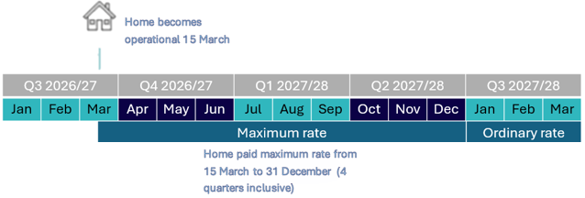

Scenario 2 – residential care home is transferred to a different provider
If a residential care home is transferred to a different provider on 15 March 2027, the home will continue to receive its current care minutes supplement rate until the end of Quarter 3 on 31 March 2027. The maximum rate will then apply for 3 quarters from Quarter 4 2026-27 (starting from 1 April 2027) through to end of Quarter 2 2027-28 (ending 31 December 2027). From 1 January 2028, the rate of care minute supplement will be based on the total care minutes and RN care minutes delivered to residents in Quarter 1 2027-28 (see Illustration 2).
Illustration 2 – maximum rate scenario for a transferred home
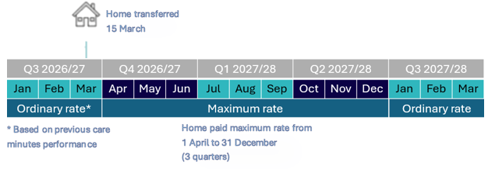

Scenario 3 – MM1 residential care home loses homeless specialised status
If a MM1 residential care home loses its homeless specialised BCT status on 1 January 2027, the maximum rate will apply for Quarter 3 2026-27 (starting from 1 January 2027) through to the end of Quarter 2 2027-28 (ending 31 December 2027). This covers 4 quarters, including the quarter it became a standard MM1 residential care home. From 1 January 2028, the care minute supplement will be paid based on the total care minutes and RN care minutes delivered in Quarter 1 2027-28 (see Illustration 3).
Illustration 3 – maximum rate scenario for a home that loses homeless specialised status
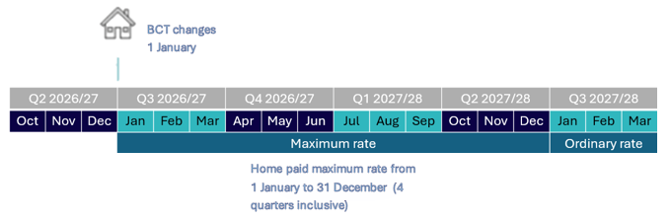

Changes to homes before 1 November 2025
The maximum rate does not apply to any homes that open, transfer or return from being offline before 1 November 2025, which is when the maximum rate rules take effect.
However, for residential care homes that opened, transferred or returned from being offline in September and October 2025 only, they would have a zero care minutes target for the October – December 2025 quarter (in line with current care minutes arrangements). This means the maximum rate of the supplement is payable to these residential care homes for the April – June 2026 quarter only.
Funding from July 2026 onwards is based on care minutes reported in the QFR from the January – March 2026 quarter.

Care Minutes Performance Statement
Starting as part of the 2025-26 Aged Care Financial Report (ACFR), all residential aged care providers will be required to prepare and submit a new Care Minutes Performance Statement.
The statement includes information about:
- direct care minutes delivered
- associated labour hours and costs
- RN coverage
- occupied bed days.
All providers must engage a registered company auditor to complete an audit of their Care Minutes Performance Statement. You will need to submit the audited statement in the ACFR.
To better understand new reporting requirements, refer to Care Minutes Performance Statement guidance.

Percentage truncated to 2 decimal places rather than rounded to the nearest 2 decimal places.

