BONDED RETURN OF SERVICE SYSTEM (BROSS)
Guide for University Users
September 2026

Contents

Introduction 3
The Bonded Return of Service System (BRoSS) 3
Important Information 3
This Guide 3
BRoSS Login 9
BRoSS Functionality 10
Guidance 13
Add an Applicant 13
View the Full Participant List 15
Expand Individual Records 15
Download Participant List 16
Add a Note 16
Remove Applicant 19
Search to Edit or View a Participant 20
Log Out 21
Additional information and assistance 21

Introduction
Implemented in 2020, the Bonded Medical Program (Program) helps address the shortage of medical professionals in regional, rural, and remote areas of Australia. The Program provides a Commonwealth Support Place (CSP) in a medical course at an Australian university in exchange for participants working in eligible locations after they graduate. On completion of their medical course the participant commits to working in an eligible location for up to 156 weeks as part of their ‘Return of Service Obligation’ (RoSO) under the Program.

The Bonded Return of Service System (BRoSS)
To support the Program, the Department of Health, Disability and Ageing (department) built BRoSS, a web portal, to assist Program participants, university staff, and Rural Workforce Agencies to manage their obligations. BRoSS allows a Program participant to self-manage their Return of Service Obligation (RoSO). The purpose of this manual is to aid the Universities in managing their firm offer applicant lists (Bonded CSPs) and review student status’ through their medical course in BRoSS.

University admission staff managing Program CSP applications will have secure BRoSS access to:
- enter applicant contact details
- review, monitor and update their firm offer list
- track applicant status for acceptance of the Program’s Terms and Conditions
- access resources to inform and support applicants

Important Information
To access BRoSS, you are required to have a myID login.
- myID – an app you can download to your smart device or access online to verify your identity when using government online services.
Please note: a myID is different to a myGov account (www.myid.gov.au). Access needs to be arranged via your university and regular logins are required to retain active access.
- Relationship Authorisation Manager (RAM) – an authorisation service that allows you to act on behalf of a business or entity online when linked with your myID. You'll use your myID to log in https://info.authorisationmanager.gov.au/
Further information is available at:
    - how to set up a Strong identity strength at www.myid.gov.au/setup
    - the new set up process for existing users at www.myid.gov.au/help-managing-your-myid
For additional details on these digital authentication services, please refer to the following website: https://www.abr.gov.au/auskey/your-auskey-replacement.

This Guide
This Guide will assist University admission staff to access and navigate BRoSS. The Guide comprises of three sections:
- Registration – This is the first step that allows the university user to register with the Health Data Portal and receive access to BRoSS.
- BRoSS login - steps for logging in to BRoSS for the first time.
- BRoSS Functionality:
  - Guidance
  - Add an applicant
  - View the full participant list
Each Section has a series of steps and screen shots to guide university admissions staff through the process.
Registration
- Ensure you have a valid myID and the relevant Relationship Authorisation Manager (RAM) authorisations set up. For additional details, please check the following websites:
  - For myID setup and usage: https://www.myid.gov.au/
  - For RAM information: https://info.authorisationmanager.gov.au/
- Access the Health Data Portal: https://dataportal.health.gov.au
- The first time you do this, you will need to select Register (once you have Registered, you will need to select Log in). Additional instructions on how to register above or under the Health Data Portal.
The Data Portal home screen will display. Select the ‘Register’ option.
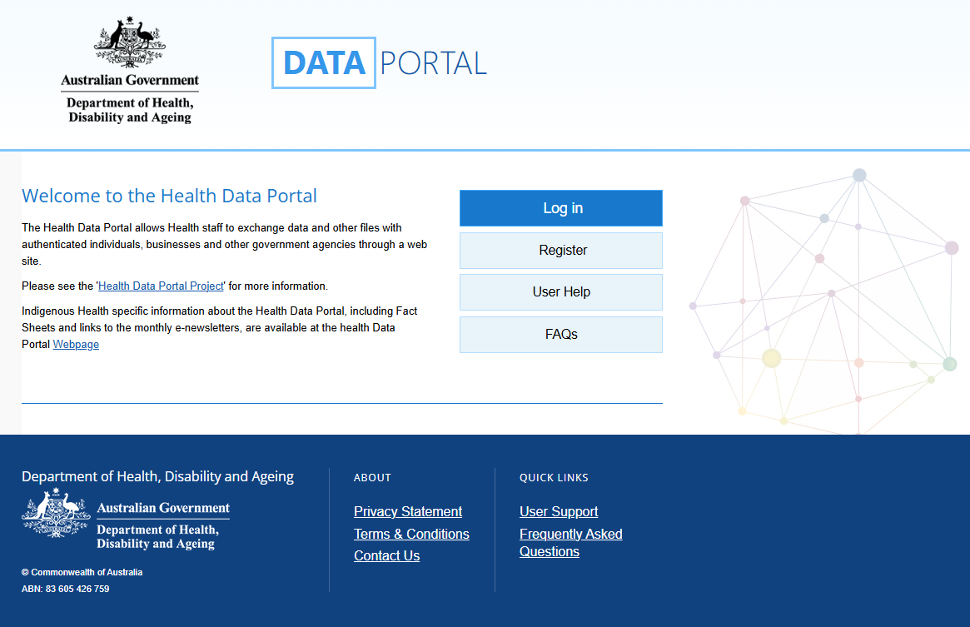

- The Health Data Portal (HDP) will prompt you for authentication to confirm you have a valid myID to be able to register for the HDP; read the instructions and then select ‘Next’.
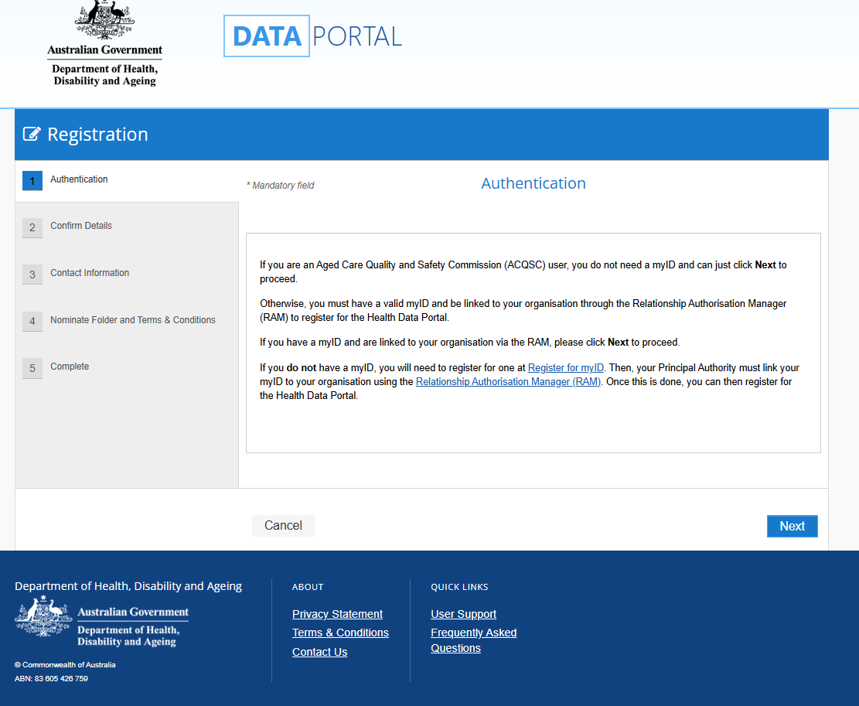

- The Health Authentication Gateway screen will be displayed. Click on ‘Continue with Digital ID’. (Do not select ‘Login with myGov’ as this will take you to the wrong screen).
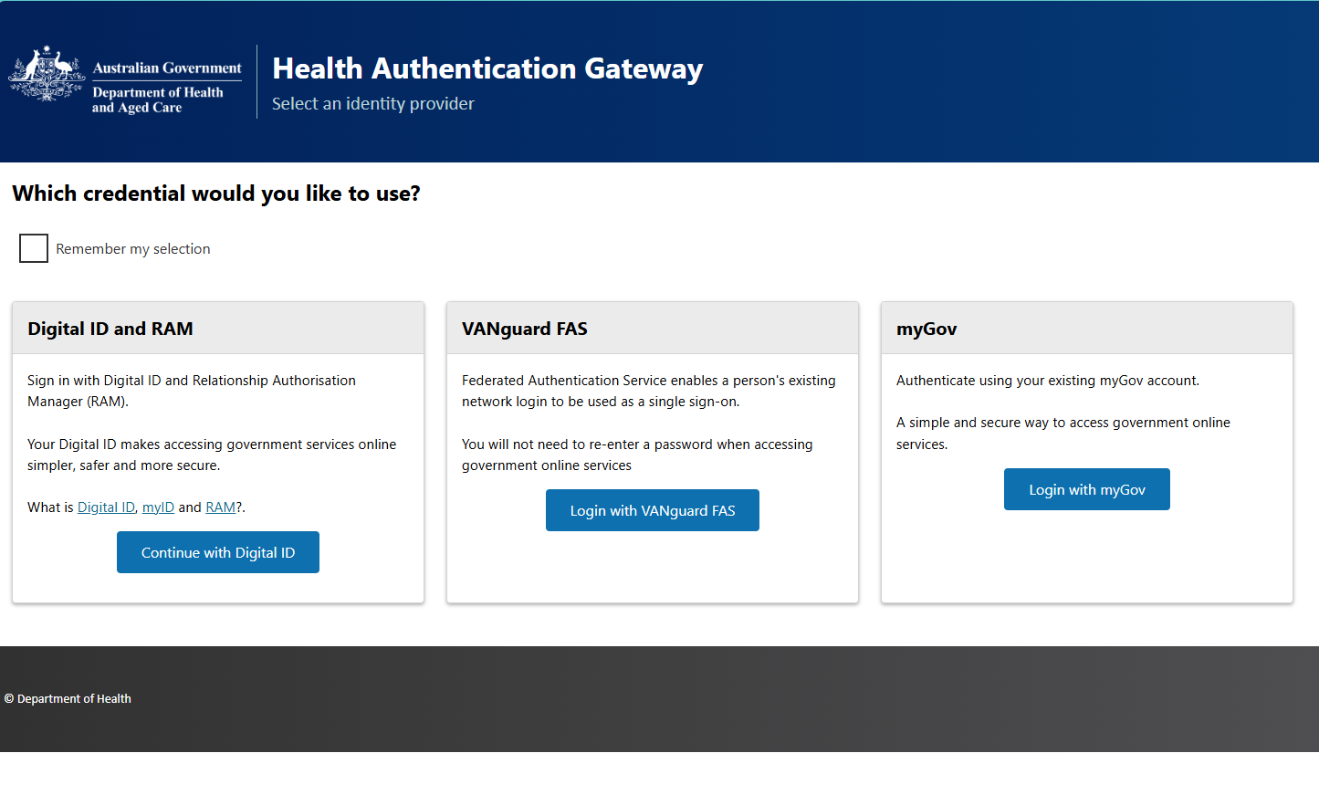
- The ‘Select your identity provider’ screen will display, click ‘Select myID’ to continue.
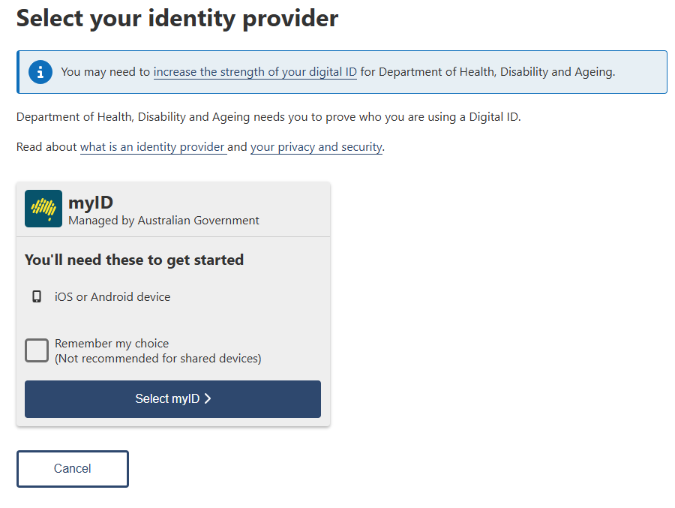

- The ‘myID’ screen will display, enter your ‘myID’ email address and then click ‘Get code’.
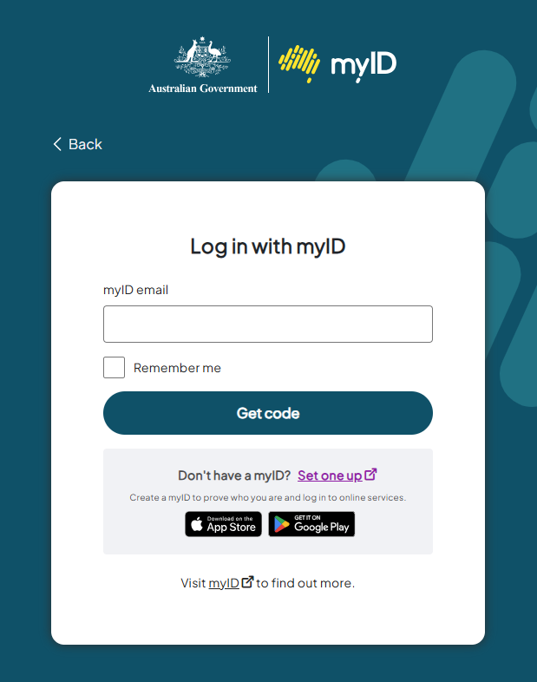
- Open the myID application on your phone and accept or enter your specific 4-digit code onto the screen, this will be updated every time you login.

- The ‘Registration - Confirm Details’ screen will display, confirm the onscreen details, then tick the certification box and click ‘Next’.
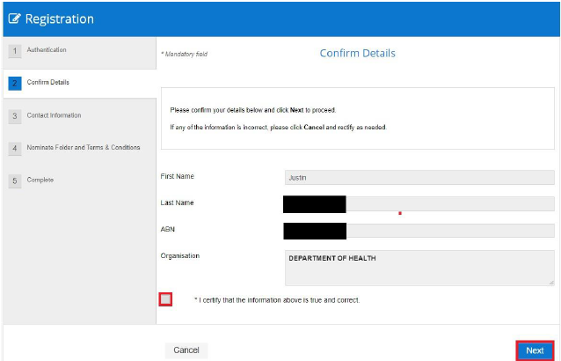
- The ‘Contact Information’ screen will display, enter your contact information and click ‘Next’.
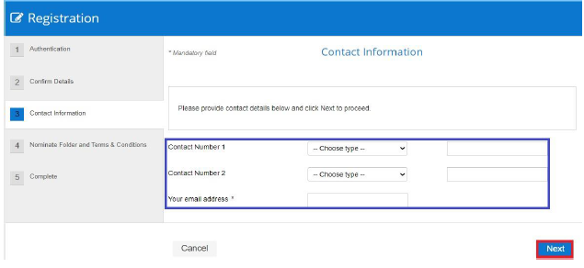
- The ‘Nominate Folder’ screen will display, select the ‘BRoSS’ folder from the drop-down list.
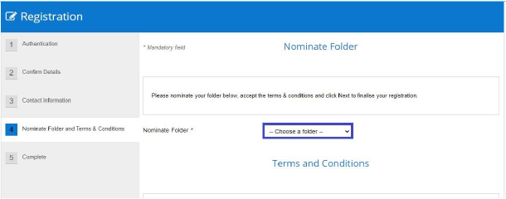
- Review and agree to the terms and conditions by clicking in the Agree box, then click Next’.
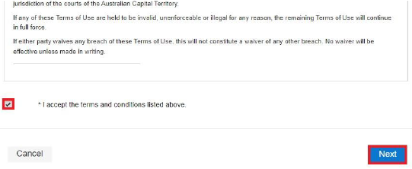
You have now successfully registered for the HDP.
An email is sent to the department advising that a new BRoSS user has been registered. Once the department has assigned all roles and associated privileges to your account, an email will be sent notifying you that your BRoSS login is now available.

BRoSS Login
To log in to BRoSS, the user needs to authenticate by following the steps below.
- Access the Health Data Porta (HDP): https://dataportal.health.gov.au.
- Select Log in.
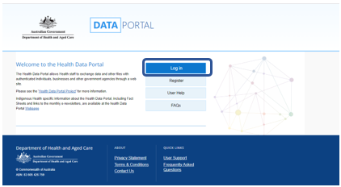

- Select ‘myID’ and authenticate.
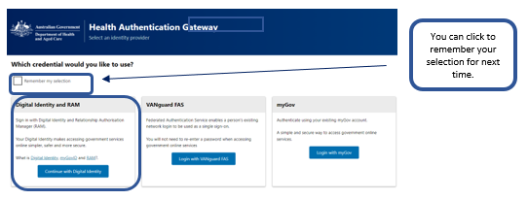
- Once authenticated, the HDP dashboard will open and you can select ‘BRoSS’ to open your BRoSS dashboard.
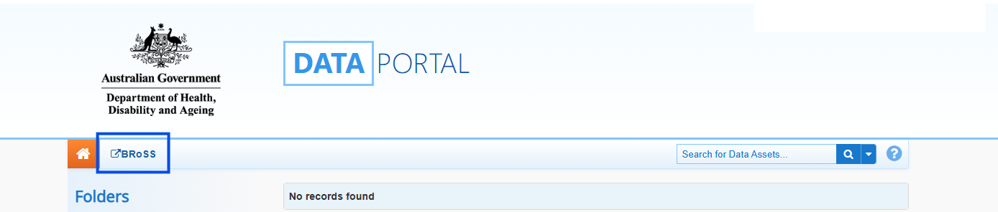

BRoSS Functionality
Once logged in, the following screen will display. This is your main dashboard.
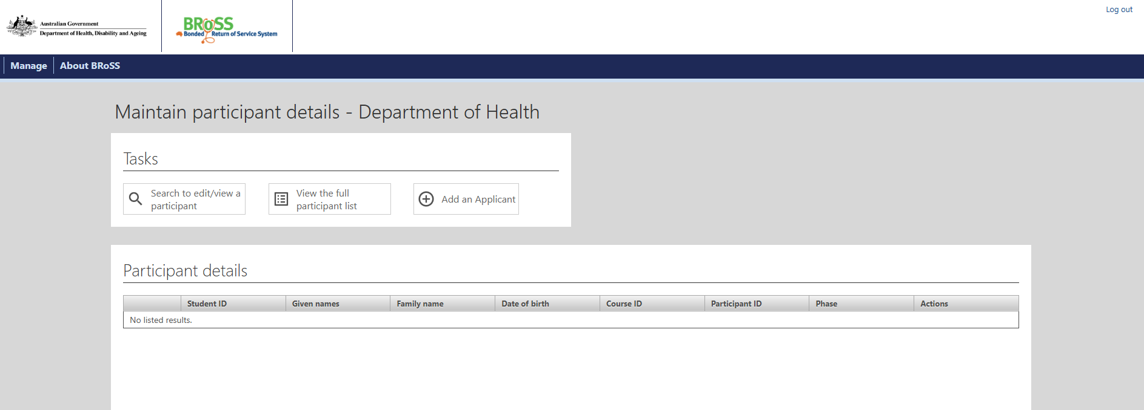
From any screen or activity window within BRoSS, you can return to your dashboard by hovering the mouse over the ‘Manage’ tab in the top left corner and clicking on ‘Maintain participant details’.
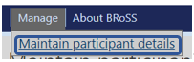
The ‘Maintain participant details’ screen includes the following ‘Tasks’:
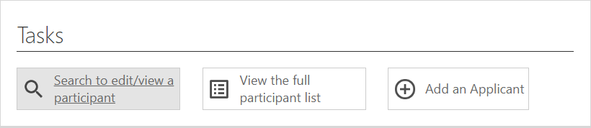
These ‘Tasks’ allow you to:
- Search to edit/view a participant;
  - search for a bonded applicant or student at your university
  - edit an applicant’s details
  - view a student’s details.
- View the full participants list;
  - export the list to excel.
- Add an applicant;
  - enter Bonded CSP applicants.
  - This function is only available between 1 January and 30 June. Outside of these dates the ‘Add an applicant’ button will be greyed out (If an applicant needs to be added outside of this period, contact us via bondedmedicalprogram@health.gov.au).

Under the ‘About BRoSS’ tab, there are external links to information about the Program:
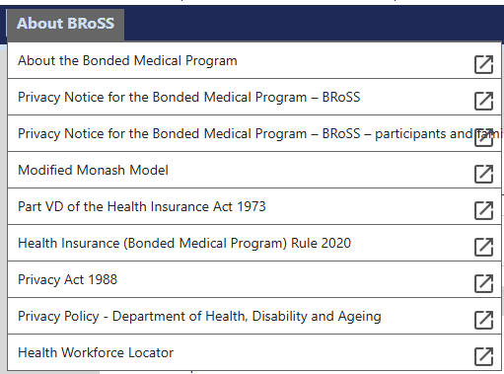
Here is a list of the links noted above for your reference:
About the Bonded Medical Program
https://www.health.gov.au/our-work/bonded-medical-program.
Privacy Notice for the Bonded Medical Program – BRoSS
https://www.health.gov.au/using-our-websites/website-privacy-policy/privacy-notice-for-the-bonded-medical-program-bross
Privacy Notice for the Bonded Medical Program – BRoSS – Participants and Family members
https://www.health.gov.au/using-our-websites/website-privacy-policy/privacy-notice-for-the-bonded-medical-program-bross-participants-and-family-members
Modified Monash Model
https://www.health.gov.au/topics/rural-health-workforce/classifications/mmm
Part VD of the Health Insurance Act 1973
https://www.legislation.gov.au/C2004A00101/latest/text
Health Insurance (Bonded Medical Program) Rule 2020 - https://www.legislation.gov.au/F2019L01513/latest/text
Privacy Act 1988
https://www.legislation.gov.au/C2004A03712/latest/text
Privacy Policy – Department of Health, Disability and Ageing https://www.health.gov.au/resources/publications/privacy-policy

Guidance
When performing ‘Tasks’ (‘Search to edit/view a participant’, ‘View full participant list’ or ‘Add an applicant’), each section includes a ‘Guidance’ tab on the right of screen. The ‘Guidance’ tab provides additional information and instructions to assist you to perform each task. Click on the arrow to expand the ‘Guidance’ tab and scroll down to view/access the information available. Click on the arrow again, to close the tab.
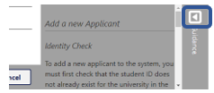

Add an Applicant
Before a new applicant can be added, BRoSS will use the ‘Student ID’ you enter and check for any existing records for that student to prevent the creation of duplicate student records.
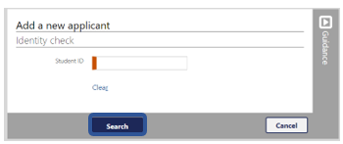
  - If the ‘Student ID’ already exists, the following notification will be displayed:
(Please contact us via BondedMedicalProgram@health.gov.au for assistance if this applicant needs to be used.)
- If the ‘Student ID’ does not exist, the notification below will be displayed, click ‘Proceed’ to continue.
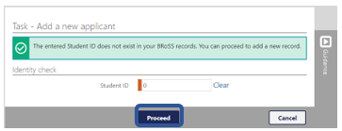

The ‘Add a new applicant’ screen will be displayed. Fill in the mandatory fields (marked orange) and click ‘Save’ to complete the task.
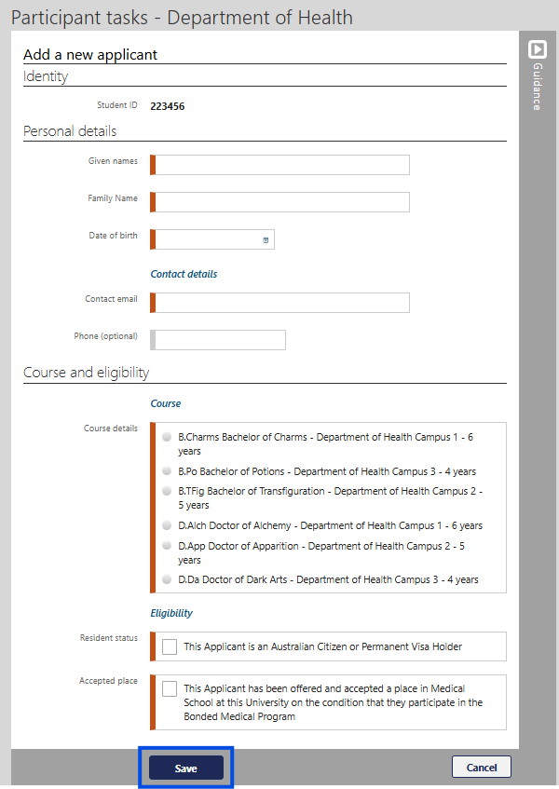
You will then be returned you to your dashboard.

View the Full Participant List
Upon clicking the ‘View the full participant list’ button, the system will display a notification showing the number of matches found and a list of participants in a table.
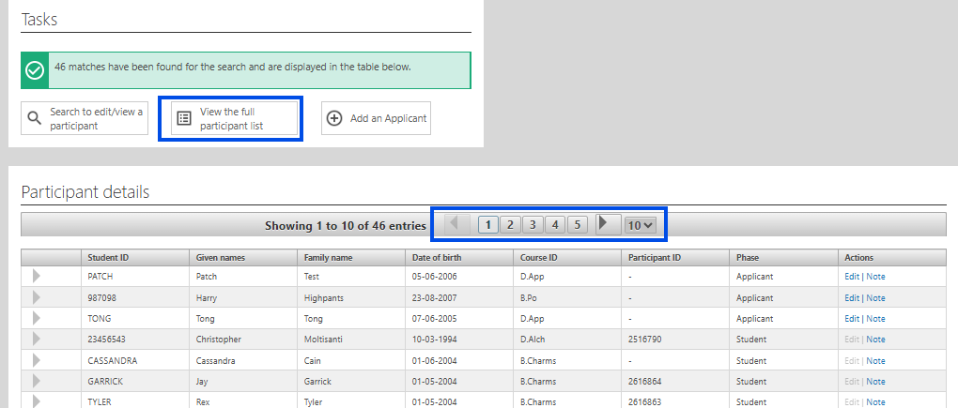
The default number of participants displayed on a page is 10, this can be changed to 25 or 50 by clicking the down arrow to the right of the number in this box. Alternatively, you can navigate directly to a specific page of records by clicking on the relevant page number, or; navigate forwards or backwards through the records one page at a time by clicking on the arrows on either side.
Under the column heading ‘Phase’ you can see each participant’s current status under the Program:
Applicant – offered a Bonded CSP but has not yet accepted the Program conditions to formally become a Program participant. University users can view both active and inactive applicants in this list.
Student – agreed to the conditions of the Program and has formally become a Program participant under the Health Insurance Act 1973. University users will only see active Students in this list, once the student has either completed their medical studies or withdrawn from the Program, they will be removed from the university view.

Expand Individual Records
To expand a search result so more information can be viewed about a participant, select the icon to the left side of the participant ID.
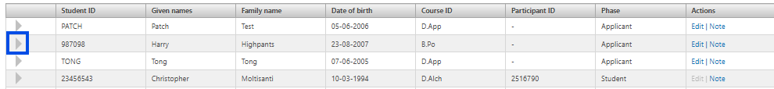

To minimise the record, select the icon.
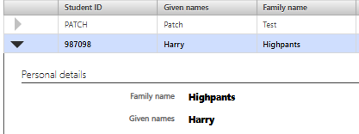

Download Participant List
At the base of each page of the search result list is an option to ‘Download participant list’.
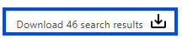
Participant ID | Given names | Family name | Contact email | Student ID | Scheme | Phase | Status | University | Year of enrolment
Clicking on this will download the entire list of participants as an excel spreadsheet to the user’s ‘Downloads’ folder with details for each participant as shown in the headings below.

Add a Note
Beside each displayed record, there are options to ‘Edit’ the record or update the information in ‘Note’.
Clicking on ‘Note’ enables the user to add a note for the participant. ‘Notes’ are date and time stamped and therefore cannot be edited once saved. Only your university users and health users can view the notes attached to each applicant/participant record.
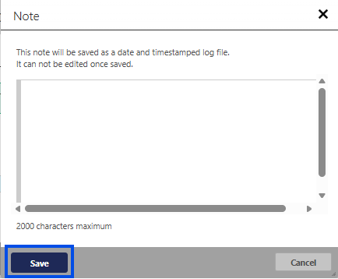

Once saved, the ‘Note’ will be displayed within an applicant/participant’s record.
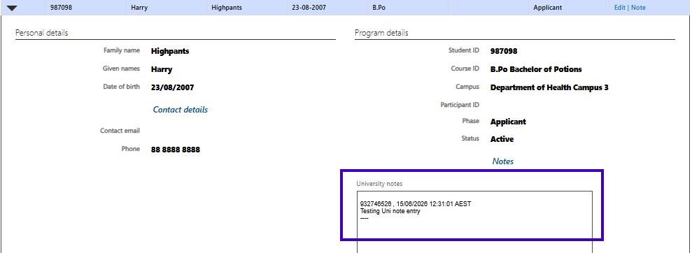
Edit Record
Clicking on ‘Edit’ enables the user to edit the applicant’s details.

You will have the capability to edit aspects of the applicant’s identity, personal details, course details and Program eligibility.
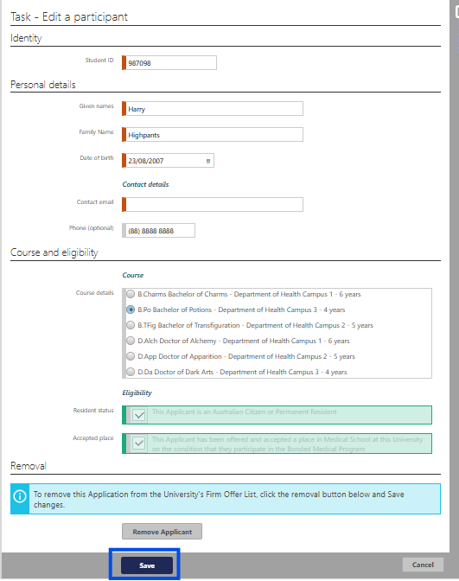
Note: university users are only able to ‘Edit’ a record that is at the ‘Applicant’ phase. Once an ‘Applicant’ becomes a Program participant their phase will change to ‘Student’, it is then the student’s responsibility to ensure that the details in their BRoSS record are kept up-to-date and accurate.

Remove Applicant
Below the participant’s details in the ‘Edit a participant’ screen, there is an option to ‘Remove Applicant’ from the University Firm Offer List.
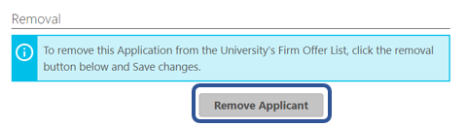
Clicking on this button will prompt the warning that the applicant will be withdrawn from the list and the button will change to read ‘Applicant has been removed’. Clicking on this button will reverse the removal. However, neither action will finalise or record the action until the ‘Save’ button is clicked.
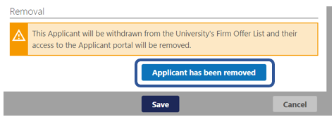
For applicants that have been removed, the option to restore the applicant will appear as an action against the applicant’s name in the participant details search screen. Upon clicking ‘Restore applicant’, a confirmation screen will appear. Click ‘Yes’ or ‘No’ as applicable.
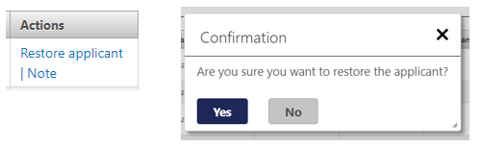

Search to Edit or View a Participant
Clicking on this option brings up the following screen.
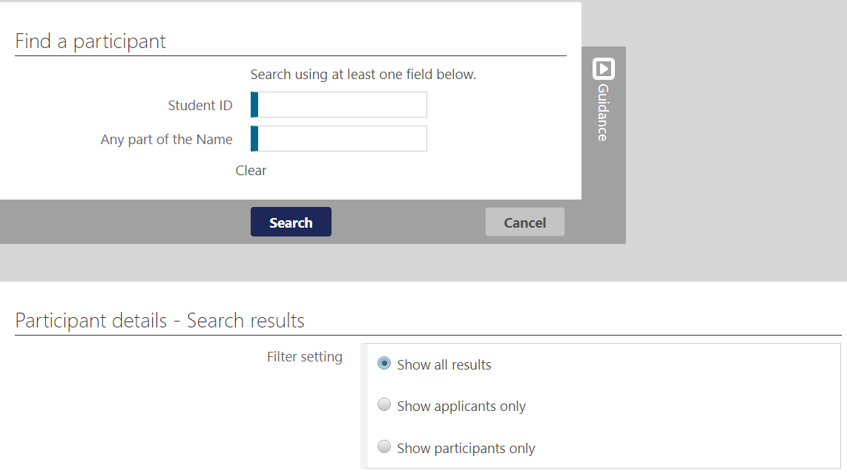
Results can be filtered to display all results, or only applicants or students (i.e., Program participants).
A search can be conducted using the student’s ID or name. Please note that the system will return results for partial matches of a Student ID or name.
For example, conducting a Student ID search using ‘123’ will return a list of students whose Student ID contains ‘123’ within their ID:
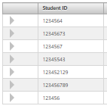
While a name search using letters ‘ha’ will return results for all students whose name contains ‘ha’ within their given of family name:
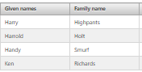
Providing more information for each field will better refine the search results. For example, if the exact name or Student ID is known, entering these details will result in an individual record rather than multiple search results.

Log Out
To log out of BRoSS, click the ‘Log out’ link at the top right of screen.
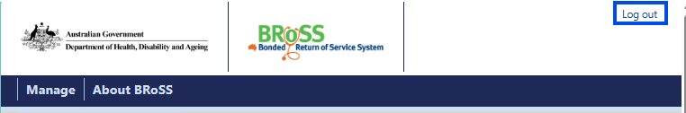
Then click ‘Name’ at the top right corner of the screen and select ‘Log off’.
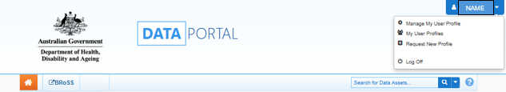

Additional information and assistance
University staff can find additional Program information on the university page of our website.
Students can find Program information and useful resources on the student page of our website.
For assistance, please contact us via BondedMedicalProgram@health.gov.au using the subject title format below. This will ensure your email is easily identifiable as a university query and triaged as a priority:
Bonded Medical Program – university name – request type

