BONDED RETURN OF SERVICE SYSTEM (BROSS)
Participant User Guide
Accepting your Bonded Offer
September 2026

Accepting your Bonded Offer

To be eligible, you must be:

an Australian citizen or Permanent Visa holder that resides in Australia, and

accepted into a course of study in medicine at an Australian university.

If you accept a Bonded CSP in a course of study in medicine at an Australian university, you must:

agree to participate in the Program by 30 June in your first year of study to maintain your enrolment in your medical course

comply with the Program conditions outlined at 124ZG of the Health Insurance Act 1973.

You should seek legal advice to make sure you understand your obligations before accepting a Bonded CSP at university.
Once your university’s Bonded CSP offer has been confirmed, you will receive an email titled - ‘BONDED MEDICAL PROGRAM – Agree to Participate’ which will contain your BRoSS Username and Temporary password to log in. If you do not receive this email, please contact your university or email the bondedmedicalprogram@health.gov.au.

To register your agreement, you will need to use BRoSS. Please refer to the BRoSS Participant User Guide – How to login about how to log in to BRoSS for the first time. You will need to have a myGov account to log in to BRoSS. Go to MyGov Home.
After logging in to your BRoSS record, your ‘My dashboard’ page will open.
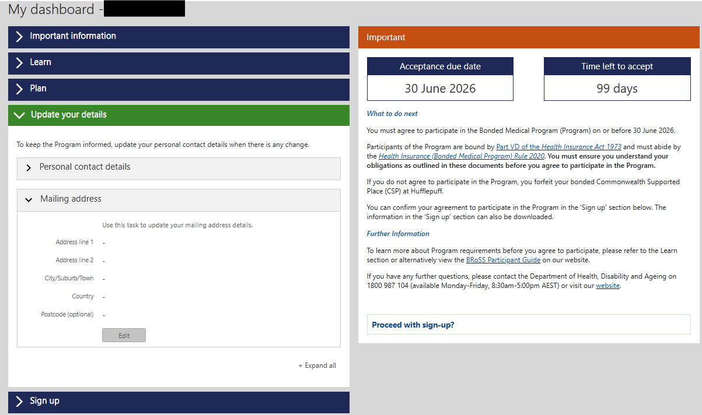

Review all the information on the left-hand side of the page by opening the accordions.
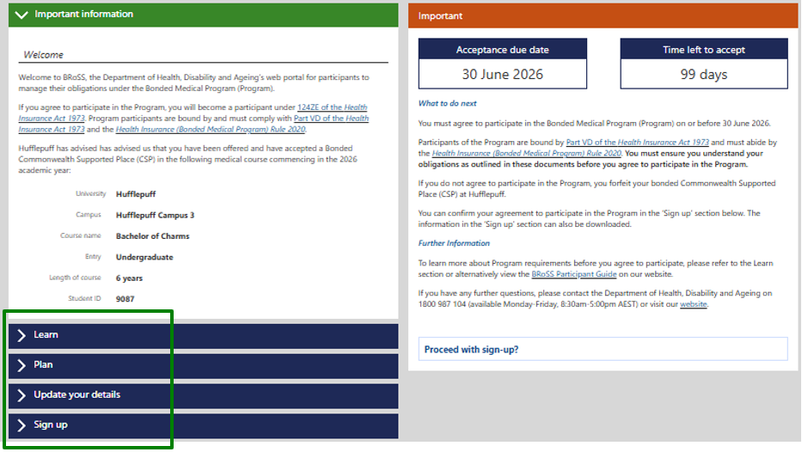
Under the ‘Update your details’ accordion, review the mandatory information required under ‘Personal contact details’ and update by clicking the ‘Edit’ button.
To ensure you receive important Program notifications and emails after you graduate, please ensure you add a non-university email address in the alternate email field.
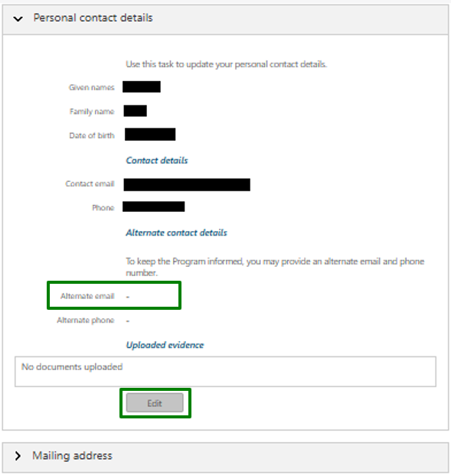
Ensure all mandatory fields (marked orange in the Edit pages) are correct and click ‘Save’.
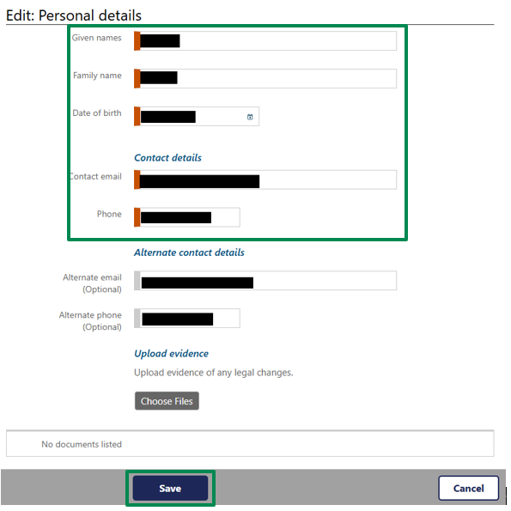

Once your details are updated either click on the ‘Proceed with sign-up’:
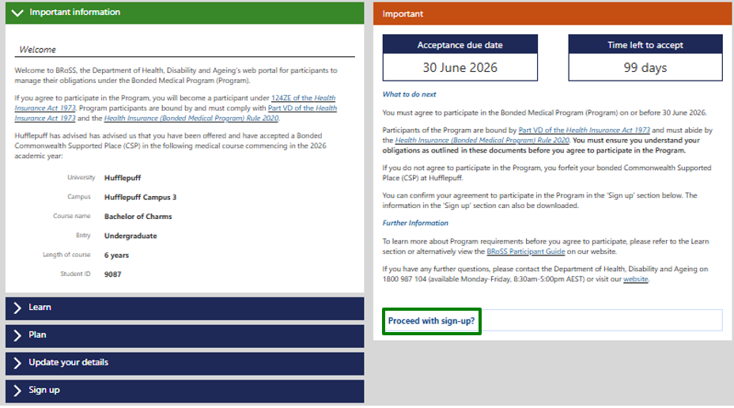
Or, open the ‘Sign up’ accordion to view your ‘Agreement to Participate’.
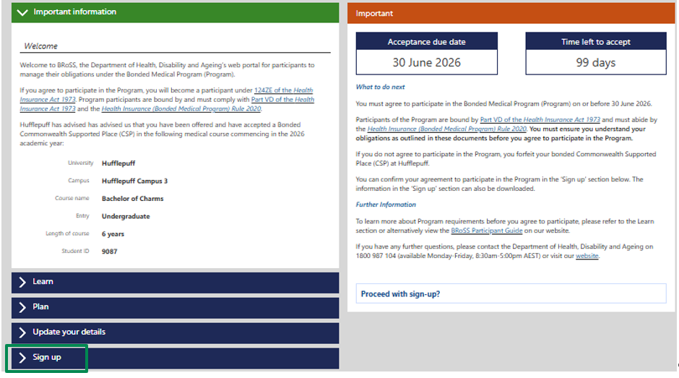

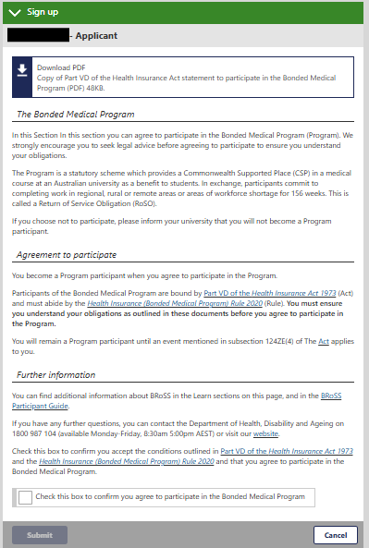

Read the information carefully, and if you agree to the legally binding Program conditions, tick (click) the ‘check box’ and click ‘submit’.
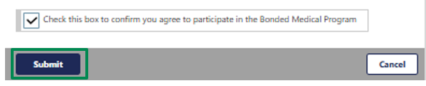
A pop-up page will confirm your acceptance into the Program. Click ‘Go’.
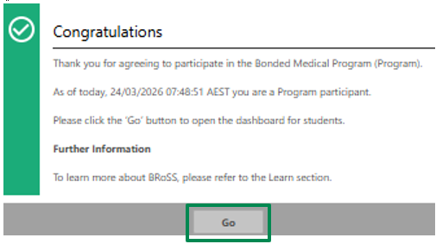
Once you click ‘Go’, you will be redirected to your BRoSS dashboard.
