Appendix F – CHSP Compliance Framework 2025-27 (Version 4)
Contents
1 About the CHSP Compliance Framework 2
2 CHSP and the Aged Care Act 2024 3
3 Data Exchange (DEX) oversight 4
3.1 Accuracy of Reporting 5
4 Fraud 6
5 Financial acquittals 6
5.1 Unspent funds 6
5.2 Financial viability 7
5.3 Exiting the program 7
6 Sector Support and Development 7
7 DEX performance reporting review 7
8 Flexibility provisions 8
9 My Aged Care 8
9.1 Enhanced monitoring of My Aged Care client ID reporting 9
10 Wellness and reablement reporting 9
11 Complaints and Feedback Management Report 10
12 Child Safety Compliance Statement 10

Publication date | Summary of changes
November 2025 | Version 1
November 2025 | Version 2 updates:  - New version control table  - New content under 3. DEX oversight, including exemption requests  - Inclusion of Data Exchange Toolkit (Stage 2) information under 9.1 Enhanced monitoring of MAC client ID reporting
June 2026 | Version 3 updates:  - 2. CHSP and the Aged Care Act 2024 – minor updates  - 3. DEX oversight – new content  - 4. Fraud – update to fraud and corruption plan  - 5. Financial acquittals – updated content  - 7. DEX performance reporting review – new content  - 9.1 Enhanced monitoring of My Aged Care client ID reporting – new content
September 2026 | Version 4 updates:  - 3 DEX oversight – new 3.1 accuracy of reporting section  - 9.1 – My Aged Care ID reporting information updated

About the CHSP Compliance Framework
The Commonwealth Home Support Program (CHSP) Compliance Framework (the Framework) outlines the performance and regulatory requirements for all CHSP registered providers. These include:
- performance against the grant agreement
- submitting financial and reporting information
- monitoring compliance against the Aged Care Quality Standards (the Standards) for relevant providers
- complying with obligations outlined in the CHSP Manual 2025-27 and in the Aged Care Act 2024 (the Act)
- escalation of fraud related issues for investigation
- meeting requirements to maintain current and accurate information on My Aged Care, with the Community Grants Hub and with the Aged Care Quality and Safety Commission.
The Framework also covers the receipt of deliverables outlined within the grant agreement upon the expected due date, including:
- Data Exchange (DEX) monthly reporting
- financial acquittals
- Sector support and development (SSD) performance reports
- wellness & reablement reports
- Child Safety Compliance Statement

The Department of Health, Disability and Ageing (the department) works with a number of other agencies, including:
- The Aged Care Quality and Safety Commission (ACQSC) regarding provider compliance against the Standards and conditions of registration.
- The Department of Social Services (DSS) Community Grants Hub (CGH) to manage the reporting of service delivery and expenditure against the grant agreement
- The National Indigenous Australians Agency (NIAA) for First Nation organisations.
The authority underpinning the monitoring and compliance activities in this Framework is the Act, the Aged Care Rules (the Rules) and the CHSP Grant Agreement, including the CHSP 2025-27 Manual.
Diagram 1: Compliance model
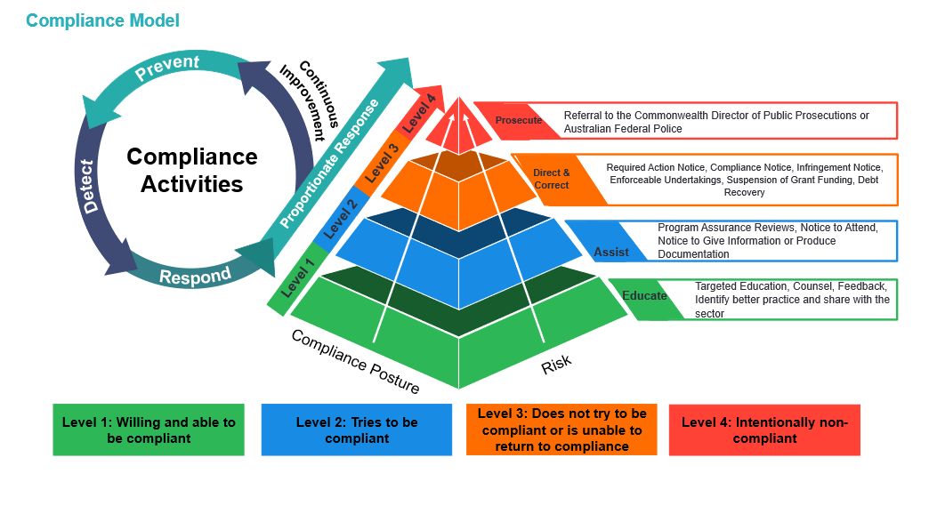
When responding to non-compliance, the department will take a risk-based approach. The department aims to adopt a tailored and flexible approach which considers the nature and severity of non-compliance.

CHSP and the Aged Care Act 2024
Since 1 November 2025, the Act provides a new framework for in-home aged care, including the CHSP.
CHSP registered providers need to remain registered to deliver Commonwealth funded aged care services, all existing providers were deemed into relevant registration categories from 1 November 2025. They need to comply with a set of obligations as set out at 9.3 of the CHSP manual. They need to do this even where they subcontract the delivery of services.
All CHSP registered providers need to comply with the Rules as they apply to the CHSP. The purpose of the Rules is to provide further detail on the requirements in the Act.
Compliance against the Act and Rules, which apply to the CHSP, are monitored as part of the Framework.

Data Exchange (DEX) oversight
Since 1 July 2022, CHSP registered providers are contractually required to submit monthly performance reports through DEX for services delivered in the previous calendar month. This replaced the 6 monthly performance report process. With the commencement of the Aged Care Act 2024, from 1 November 2025, CHSP registered providers are required to report on their service delivery in accordance with Rule 166-610.
- Section 166-610 of the Rules prescribes that a CHSP registered provider must give the System Governor a report about activity and performance data matters (the monthly performance report, submitted in DEX) each month.
- Section 166-610(2) states: The monthly performance report must be in an approved report form approved by the System Governor. The approved report form for DEX reporting is via input through the DSS Data Exchange (DEX) portal.
Contractually providers must submit data in DEX for the preceding month by the 14th of the following month. Providers can submit DEX reporting more frequently if they prefer, such as daily, weekly, or fortnightly.
Note:
- Providers who do not meet their performance reporting requirements by the due date will be in scope for compliance actions.
- Exemptions from compliance action will only be considered in extenuating circumstances.
Rule 166-627 covers the exemption process for the monthly performance report.
Please note: This is an exemption to providing a report, not an exemption to compliance action. Therefore, a registered provider who is requesting an exemption under subsection
166-610 must make this request at least 14 days before the due date for the report
(166-627(3)).
The System Governor (the department) may approve an exemption, if the provider submits evidence of the extenuating circumstance being experienced. If the exemption is approved, the registered provider will not have reminder emails sent or payments suspended.
The list of extenuating circumstances where an exemption from reporting may be approved with provided evidence is below:
Natural Disasters or Emergencies
- Bushfires, floods, or other natural events that disrupt service delivery.
- Pandemic-related restrictions or outbreaks (e.g., COVID-19 lockdowns).
Infrastructure or Technical Failures
- Facility damage or maintenance issues preventing service delivery reporting.
- Technical issues which are with DEX Helpdesk for resolution, including where XML validation error in the system are known to the helpdesk (evidence to be provided)
- Network outage with network provider that is out of the control of the provider (evidence to be required).
- If the department implements an IT system change that results in an unintended consequence and impacts providers reporting (evidence to be provided).
Any other registered provider that does not submit their DEX reporting will be in scope for compliance action. As stated above, the approved report format is the DEX portal, therefore manual data outside of the DEX portal cannot be accepted.
The CGH and the department review the services delivered by providers and engage with providers where performance is low or not in accordance with the Activity Work Plan. This engagement gives insights into provider capacity, sector strain, workforce issues, region specific challenges and cost increases related to service delivery.
My Aged Care IDs are required to be submitted though DEX. Providers have been required, since from 1 July 2025, to collect the My Aged Care IDs against services delivered in their client management software and provide this data into DEX since 1 January 2026. From 1 July 2026 the requirement for My Aged Care IDs became mandatory.
If there are concerns at any time that the provider will fail to meet their DEX data reporting obligations, the Compliance team will monitor DEX outputs and performance before a decision on funding reduction is appropriate.
Furthermore, the Compliance team may request a provider to submit a business case to further outline the steps that will be undertaken to return to compliance and improve outputs.

Accuracy of Reporting
We are aware of the need to ensure that providers have time to ensure accurate reporting.
The DEX portal hard closes for further data on 30 July and 30 January each year. Providers therefore have 7 months to ensure that all data for the preceding 6 month period is entered, accurate and reflects actual service delivery to clients eligible to receive aged care services.
To ensure that we have stable program data over time, the portal will not be re-opened for any corrections once the hard close date is reached.
The CGH Funding Arrangement Managers (FAMs) review DEX data periodically to identify any anomalies and actively engage with providers to address any associated issues. Providers should liaise with their FAMs about any reporting challenges or issues during the relevant reporting periods, to ensure they have accurate data entered into DEX by the dates the system hard closes.
DEX reporting is critical for both the management of individual funding agreements, and for the management of the program as a whole.

Fraud
Any suspected fraud within CHSP is escalated to the department’s fraud area for assessment and potential investigation in accordance with s264 of the Act and the Fraud and Corruption Control Plan 2025-27.
Further information is available on the department’s website under Report suspected fraud.

Financial acquittals
As specified in the CHSP Grant Agreement providers must spend the grant funding:
- only on carrying out the activity
- in accordance with the CHSP Grant Agreement
- on clients who have been assessed through My Aged Care as eligible for services as defined under the service list.
Section 166-605 of the Rules prescribes the CHSP registered provider must give the System Governor their annual financial declaration statement by 31 August after the end of the financial year, in a form approved by the System Governor. The financial declaration must also include a statement of compliance that the funding received under the grant was expended only on assessed clients and for services as defined under the service list.
The provider should, given robust accounting processes, be able to provide the financial acquittal within the required timeframe.
Note:
- The department requires a financial acquittal declaration, but not an audited financial statement. However, an audited financial statement may be requested should the department have concerns regarding the use of CHSP funds.
- Providers who do not meet their financial reporting requirements by the due date will be in scope for compliance actions.
- Providers must ensure that their outputs recorded in DEX align with the amount of unspent funding they are acquitting within a financial year.

Unspent funds
The department has advised providers that all unspent funds are recovered at the end of the financial year. Funds are provided annually against annual service provision and are reported in financial acquittal declaration as per s166-605.
Providers are not permitted to spend or retain unspent funds. Providers must return unspent funds identified through the acquittal process for a financial year. The department will issue the provider with a Debtor Tax Invoice to return any unspent funds. The repayment of these funds is monitored by the department.
Note: Providers who do not meet their financial obligations to repay unspent funds by the due date will be in scope for compliance actions.

Financial viability
Financial viability will be monitored for further compliance action to ensure CHSP registered providers are delivering services in accordance with their Activity Work Plan and identifying options to sustainably manage their grant funds and mitigate impacts to client service continuity.

Exiting the program
CHSP registered providers who have relinquished funds and/or novated their funding agreement are still required to provide a financial declaration statement (as per s166-605 of the Rules) for funds received before exiting the program.
Acquittal processes, including compliance actions, are managed by DSS, with processes in place for the management of inactive providers.

Sector Support and Development
The department has administrator responsibilities for daily operations for the Sector Support and Development (SSD) Community of Practice (CoP).
The administration of the CoP includes management of access, delegation of moderators, high level reporting and analytics and management of the SSD Network meetings.
The department tracks and monitors receipt of SSD Performance Reports and Activity Work Plan deliverables. The department will take compliance action, including monitoring of the mandatory requirements under the CoP.

DEX performance reporting review
The department monitors all CHSP service providers and undertakes a performance review against the entire agreement. The department undertakes regular audits of service delivery based on DEX data submitted by providers. The department works in consultation with CGH to identify providers where potential compliance action may be appropriate.
Providers will be assessed on all information they provide in DEX to determine if changes to the grant agreement are appropriate to meet local needs within the Aged Care Planning Regions (ACPR) that they are funded within.
The department will work with providers to understand historical performance issues and potential adjustment to agreements to align to performance delivery. If the department needs further information about under delivery and/or funding spent against the agreement, additional action and reporting may be required. This may result in a reduction of funding.

Flexibility provisions
The CHSP 2025-27 Manual outlines the flexibility provision for service providers.
CHSP registered providers cannot move funds out of or into these service types without written approval from the department:
- Equipment and products
- Home adjustments
- Specialised support services
- Sector support and development
- Hoarding and squalor assistance.
The aim is to provide a flexible approach to:
- ensure compliance with contractual performance reporting requirements under the CHSP grant agreement
- enable CHSP service providers to meet changes in the demand for services.
Service providers that use flexibility provisions to establish service types funded in their grant agreement in an ACPR must keep a footprint of a minimum of 50% for the relevant service type in the ACPR. This ensures those services remain in the ACPR and align in part to the grant agreement. This came into effect from 1 July 2023.
The department monitors compliance with this requirement.
More information about flexibility provisions is in the CHSP Manual.

My Aged Care
CHSP registered providers are required to use My Aged Care to accept client referrals and update client service information.
Providers are responsible for the ongoing management of their My Aged Care profile. Each service outlet, and services associated with the outlet, needs to be actively managed by CHSP registered providers to ensure a positive user experience and reduce misinformation for clients.
It is the responsibility for providers to maintain accurate service availability information and current information related to service descriptions is essential for an efficient aged care system. Aged care assessors, care finders, advocates, clients and the public rely on accurate information on the My Aged Care Service and Support Portal.
Providers should only appear available to deliver services against:
- CHSP services in areas where they are contractually funded to deliver services
- postcodes within the ACPR they can deliver services to.

To ensure compliance, the department:
- monitors CHSP registered provider availability on My Aged Care to ensure it aligns with their grant agreement and DEX reporting
- reviews analysis of provider behaviour on My Aged Care and reasons for rejecting referrals
- raise any ongoing and systemic trends with providers.
The CGH’s FAMs have access to information relating to service delivery against the agreement to guide discussions with providers where service levels are high or low. FAMs will also seek responses from providers if they are under delivering via DEX and are showing unavailability on My Aged Care.

Enhanced monitoring of My Aged Care client ID reporting
It is a statutory funding condition that CHSP providers deliver funded aged care services to clients who have been assessed and approved to access the services (section 267 of the Act).
Providers are required to include a My Aged Care ID, when reporting their monthly DEX data. The department monitors this data against other available data to ensure services are being accurately recorded. The data exchange was updated during 2025-26 to allow for My Aged Care IDs to be uploaded and reported in the data exchange.
Providers have been required to capture clients My Aged Care IDs since 1 July 2025 in their own client management systems and must upload this into DEX. The requirement for My Aged Care IDs is now mandatory. CHSP registered providers who are not reporting compliantly will be in scope for compliance action.
For more information and accessing guidance material, see the DEX reporting changes under CHSP Reforms.

Wellness and reablement reporting
Section 166-615 of the Rules prescribes that a CHSP registered provider must give the department a report about their progress in embedding wellness and reablement in its service delivery (the annual wellness and reablement report).
CHSP registered providers are required to submit the annual wellness and reablement report to the department by 31 July.
The department provides an online reporting template for this purpose. The report must include service level information regarding the application of wellness and reablement approaches to service delivery within their organisation.
The department will liaise with the CGH to action non-compliance in accordance with this Framework.
The outcomes of past reports are available on the department’s website.

Complaints and Feedback Management Report
In accordance with section 166-210 of the Rules, CHSP registered providers who are registered in category 4 (personal and care support in the home and community) and/or category 5 (nursing and transition care) are required to submit a report about the management of complaints and feedback to the Aged Care Quality and Safety Commission.
The complaints and feedback management report is required within 4 months after the end of the reporting period for the registered provider.

Child Safety Compliance Statement
Section 166-628 of the Rules prescribes that a CHSP registered provider must give a report (the child safety compliance statement) to the department each year.
CHSP registered providers are required to submit a Child Safety Compliance Statement to the department by 31 March each year. The statement of compliance reporting period is for the previous year.
The department will provide a template for this purpose through the FAM.
The Child Safety Compliance statement must include a declaration that the registered provider has delivered grant activities consistent with the Child Safety supplementary terms of the grant agreement. If a CHSP registered provider has not complied, they must provide a description of the non-compliance and the reasons for it.
The department will liaise with the CGH to action non-compliance in accordance with this activity.

