Maternal Respiratory syncytial virus (RSV) vaccination campaign
Information kit
June 2026
Contents
Introduction 2
Frequently asked questions 3
Communication resources 5
Translated resources 8
RSV vaccine consumer fact sheet 9
First Nations resources 11
Newsletter article 15

Introduction

About Respiratory syncytial virus (RSV)
RSV is a common respiratory virus that infects the nose, throat and lungs, and is a leading cause of childhood hospitalisation.
RSV spreads through small droplets produced when an infected person talks, coughs or sneezes.
The RSV vaccine is free under the National Immunisation Program for eligible pregnant women.
The RSV vaccine is recommended from 28 weeks of pregnancy and is the third maternal vaccine added to this program. Whooping cough and influenza (flu) vaccines are also available free during pregnancy, which help reduce the risk of severe disease and complications for both the mother and newborn child.

About this information kit
This kit includes information and resources you can share with your community to raise awareness about the risks of RSV in young children and the benefits of vaccination during pregnancy.
It includes:
- frequently asked questions
- communication resources, including printable posters and factsheets
- translated materials
- a case study (video and written)
- a newsletter article
- social media content.

How to use this kit
You can share information about RSV and vaccination with your community by:
- including an article in your newsletters and/or on your websites
- publishing social media posts
- displaying resources such as the poster or brochure
- encouraging people to access resources online.

Further information
For more information visit health.gov.au/maternalvaccinations
If you have questions or require further information, please email the Department of Health, Disability and Ageing at immunisationcomms@health.gov.au

Frequently asked questions
The following frequently asked questions and answers are provided as background and can be used in your communications.

How do vaccinations in pregnancy protect your baby?
Getting vaccinated against influenza, whooping cough and RSV during pregnancy allows protective antibodies to pass through the mother’s placenta to the baby. This helps protect the baby from birth and in their first few months of life when they are most vulnerable to serious illness.

What is Respiratory syncytial virus (RSV)?
RSV is a common, highly contagious virus that affects the airways and lungs and can cause serious illness such as bronchiolitis and pneumonia in babies and young children.
It spreads when an infected person coughs or sneezes.
The droplets can be inhaled by others or land on surfaces, where the virus can live for several hours.
Key points include:
- Almost all children will be infected with RSV in their first 2 years of life.
- RSV is a leading cause of hospitalisation for babies under 6 months in Australia.
- Even otherwise healthy children can develop severe RSV disease and require hospitalisation.
- Maternal vaccination reduces the risk of severe RSV disease.
- Getting vaccinated against RSV during pregnancy protects your newborn baby against severe RSV disease from birth and in their first few months of life.

What is the National Immunisation Program?
The National Immunisation Program (NIP) provides free vaccinations against certain diseases, to increase national immunisation rates and reduce vaccine preventable disease. Vaccinations take place from birth through to adulthood, including during pregnancy.

What vaccinations are recommended in pregnancy?
It is recommended that pregnant women receive influenza, whooping cough and RSV vaccines during their pregnancy. It is safe to receive all maternal vaccines at the same time. These vaccines can also be given with COVID-19 vaccines, if recommended by a health professional.

Who can receive vaccinations under the National Immunisation Program?
People who have, or are eligible for, a Medicare Card can receive free National Immunisation Program vaccines if they meet the eligibility criteria for the relevant vaccine.

Are vaccines safe during pregnancy?
There is extensive evidence demonstrating the safety of recommended vaccines in pregnancy. Studies of women vaccinated in pregnancy have found no evidence that the recommended vaccines harm their developing babies.
Before a vaccine is approved for use in Australia, it goes through extensive clinical trials and rigorous assessments by the Therapeutic Goods Administration (TGA).
Only vaccines that meet strict safety, quality and efficacy standards are approved.
This is part of the comprehensive process required before vaccines can be listed on the NIP.
Once a vaccine is available, its safety continues to be closely monitored and any concerns are taken seriously and investigated promptly.

What side effects can be expected?
Mild side effects following vaccination may be experienced. Most side effects last no more than 2 days and are part of the immune system’s natural response to the vaccine.
Common reactions can include:
- pain, swelling or redness at the injection site
- tiredness
- muscle aches
- mild fever.
Pregnant women are no more likely to experience these side effects than those who are not pregnant.
Serious reactions to vaccines are rare. Medical advice must be sought straight away if someone has a reaction that they think is severe or unexpected.

Where to get vaccinated?
Maternal vaccinations are available from:
- obstetricians or midwives
- general practitioners (GP)
- local council immunisation clinics (in some states and territories)
- community health centres
- Aboriginal health services
- participating pharmacies.
While vaccines are free, vaccination providers may charge a consultation or administration fee for the visit. This should be checked when the appointment is made. The Australian Government has increased support for bulk billed GP appointments through Medicare. To find a bulk billing GP near you, visit health.gov.au/bulkbilling

Where is more information on maternal vaccinations?
Find information about free vaccines in pregnancy to protect mothers and babies at health.gov.au/maternalvaccinations

Communication resources
The table below outlines the resources available to support your community engagement activities.
Resource library
Resource | Preview | Suggested use
Maternal vaccinations consumer brochure  This brochure provides information about recommended maternal vaccinations under the National Immunisation Program.  The brochure is available in DL (print) and A4 formats. | 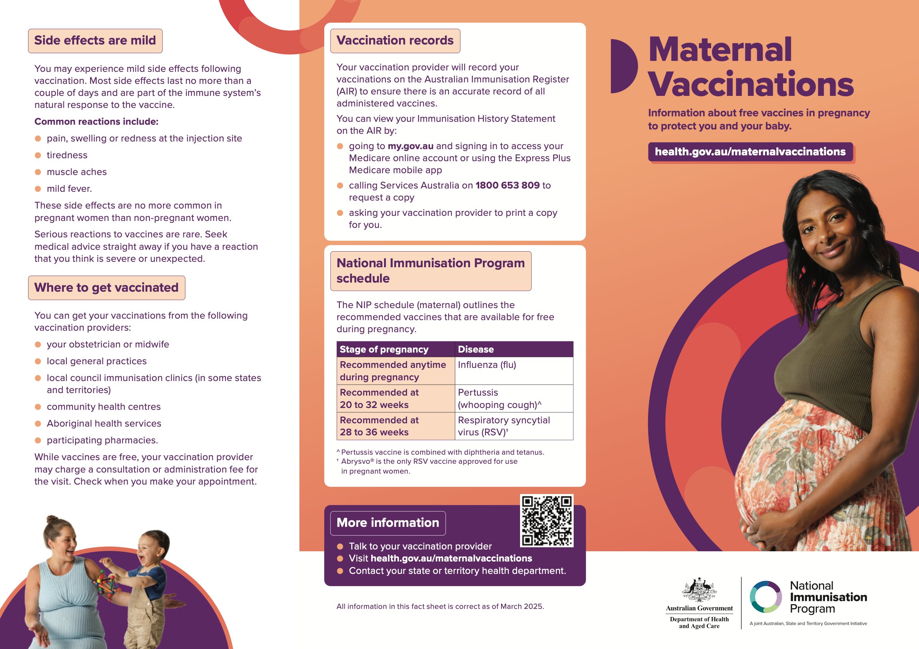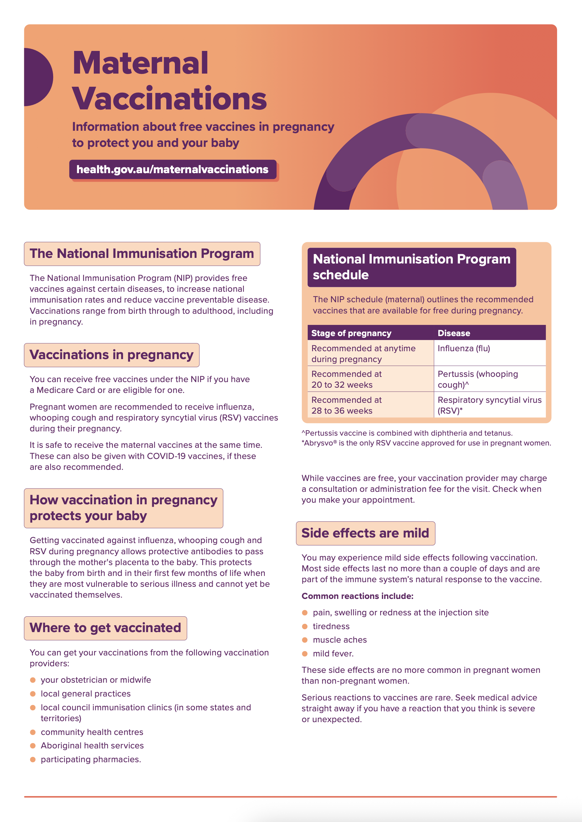 | This brochure is available for free through the National Mail and Marketing further details can be found here. Order and distribute this brochure in community waiting areas or public spaces.
Maternal vaccinations poster  This poster provides information about maternal vaccinations under the National Immunisation Program. | 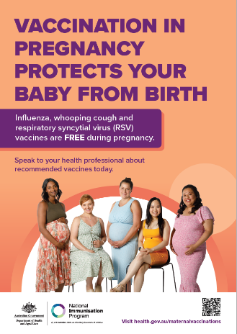  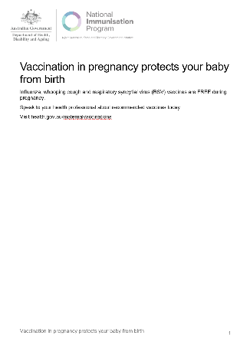 | Print and display this poster in community waiting areas or public spaces.
Maternal RSV vaccination video case study | 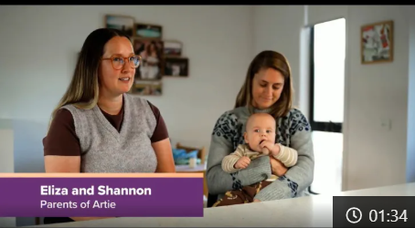 | Share through newsletters, websites and community channels to showcase the benefits of maternal RSV vaccination through a personal story.
Maternal RSV vaccination written case study | 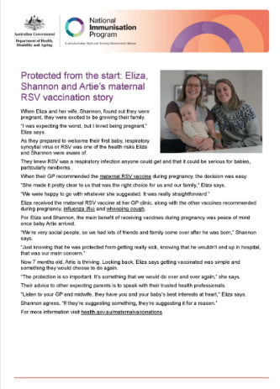
RSV protection - social tile  Social media tile about protecting babies from RSV with the maternal RSV vaccination. | 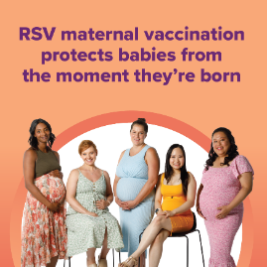 | Download social media tile about RSV protection  Publish on your preferred social media channels.
Free RSV vaccine - social tile  Social media tile about the free RSV vaccine in pregnancy. | 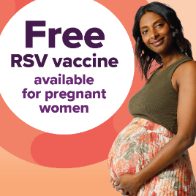 | Download social media tile about the free RSV vaccine  Publish on your preferred social media channels.
RSV vaccination during pregnancy - social tile  Social media tile about the RSV maternal vaccine. | 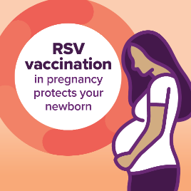 | Download social tile about RSV vaccination during pregnancy  Publish on your preferred social media channels.
Social media
Resource | Suggested post
Social post #1 | Respiratory syncytial virus (RSV) is a common, highly contagious virus that affects your baby’s airways and lungs.  You can protect your baby against severe RSV disease from birth by getting vaccinated during pregnancy. It’s free for eligible women and recommended from 28 weeks of pregnancy.  For more information on vaccines recommended in pregnancy, visit health.gov.au/maternalvaccinations
Social post #2 | Do you have questions about the maternal RSV vaccine?  You may want to know more about how the vaccine works, what other maternal vaccines are recommended and their safety or efficacy.  Talk to your doctor, nurse or other health professional about your upcoming maternal vaccinations.  For more information visit health.gov.au/maternalvaccinations

Translated resources

Help protect multicultural communities from RSV
There are translated resources available for multicultural communities. These are available in the following languages:
- Arabic
- Chinese Simplified
- Chinese Traditional
- Vietnamese.
Translated resources include:
- Respiratory syncytial virus (RSV) vaccine consumer fact sheet
- maternal vaccination poster
- maternal vaccinations consumer brochure
- health expert video
- social media content.
Find direct links to translated information and resources on the Maternal Vaccinations Translated Resources page.

How you can help
- Share: Forward the stakeholder pack email and download link to your network. Additionally, consider displaying posters and distributing fact sheets and brochures where relevant, to help extend the reach of the campaign.
- Post: Share the resources in this kit with your community by posting on social media platforms
or messaging apps such as WhatsApp, Viber, Telegram, WeChat, KakaoTalk or Facebook Messenger.
- Discuss: Start conversations about RSV vaccinations with community members at your place of work, or community and migrant centres.

Further information
- For translated resources, visit health.gov.au/maternal-vaccinations/translated-resources

Translated resource links

Resource library
Resource | Preview | In-language links
RSV vaccine consumer fact sheet  This fact sheet provides information to consumers on the maternal RSV vaccine and infant RSV immunisation products. | 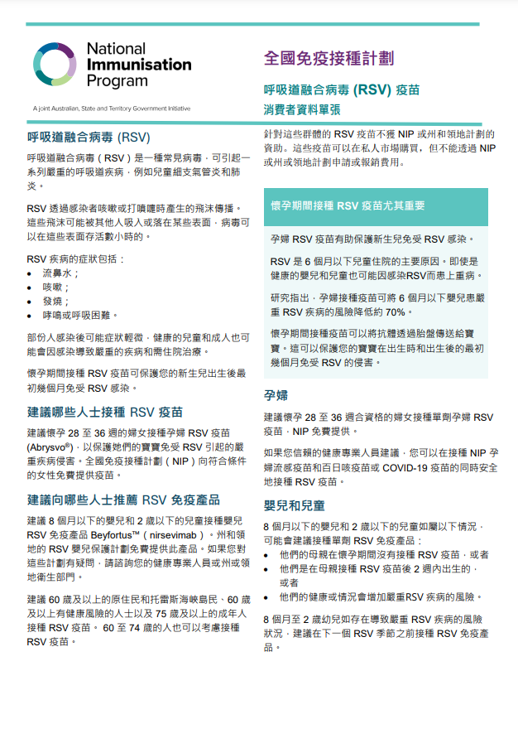 | - English
Maternal vaccinations consumer brochure  This brochure provides information about recommended maternal vaccinations under the National Immunisation Program.  The brochure is available in A4 format. | 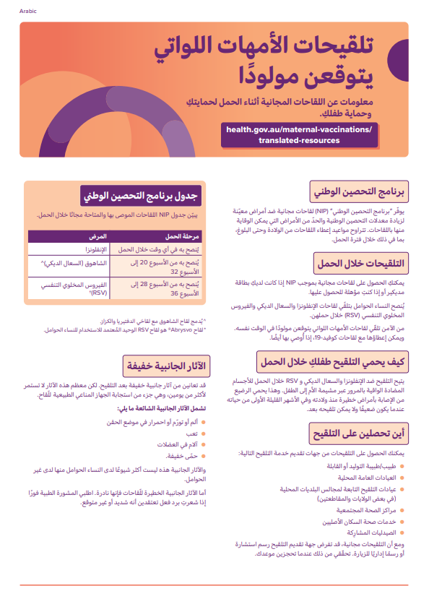 | - Arabic  - Chinese Simplified  - Chinese Traditional  - Vietnamese
Maternal vaccinations poster  This poster provides information about maternal vaccinations under the National Immunisation Program. | 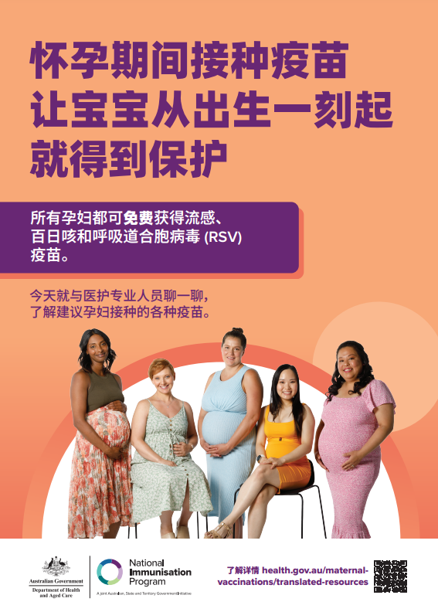 | - Arabic  - Chinese Simplified  - Chinese Traditional  - Vietnamese

Social media
Resource | Preview | Suggested use
RSV protection - social tile  Social media tile about protecting babies from RSV with the maternal vaccination. | 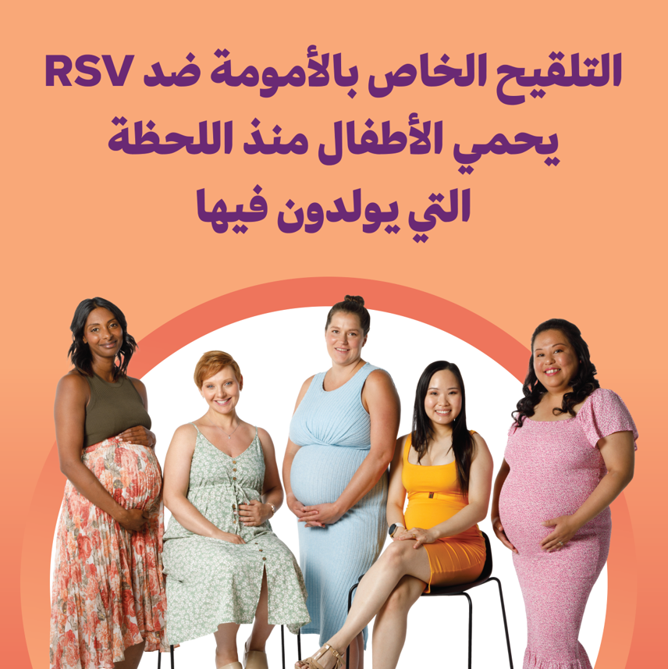 | Publish on your preferred social media channels.  Available in:  - Arabic  - Chinese Simplified  - Chinese Traditional  - Vietnamese
Free RSV vaccine - social tile  Social media tile about the free RSV vaccine in pregnancy. | 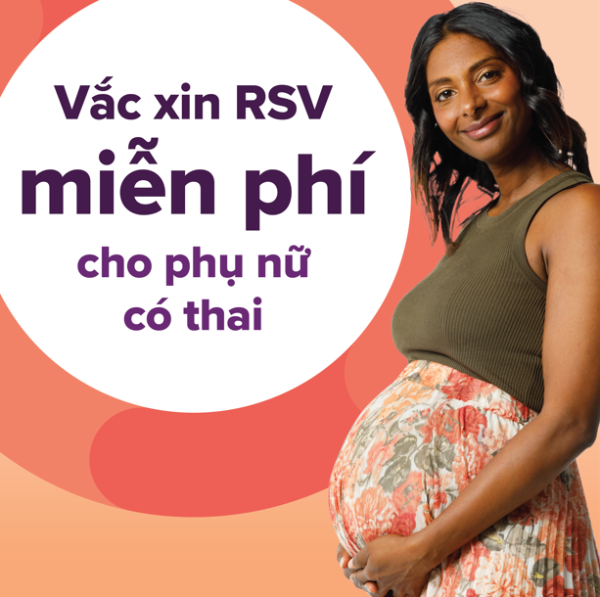 | Publish on your preferred social media channels.  Available in:  - Arabic  - Chinese Simplified  - Chinese Traditional  - Vietnamese
RSV vaccination during pregnancy - social tile  Social media tile about the RSV maternal vaccine. | 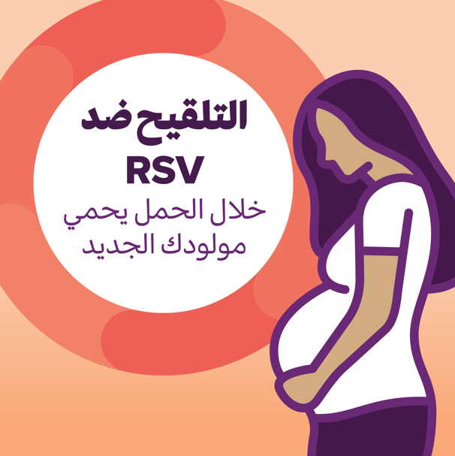 | Publish on your preferred social media channels.  Available in:  - Arabic  - Chinese Simplified  - Chinese Traditional  - Vietnamese

Resource | Suggested post
Social post #1 | 🦠 Respiratory syncytial virus (RSV) is a common and highly contagious virus that can make babies very sick.  👶 It’s a leading cause of hospitalisation for children.  🤰 If you’re at least 28 weeks pregnant, you could be eligible for a free RSV vaccine to help protect your baby from birth.  📘 Find trusted info in your language, visit:  https://www.health.gov.au/maternal-vaccinations/translated-resources
Social post #2 | 💬 Did you know most children before the age of 2 will get RSV? Babies under 6 months, especially those under 3 months, are most at risk of serious illness.  💛 Protect your baby in the first months of life with the free RSV vaccine during pregnancy. It’s safe and free for eligible pregnant women.  📢 Share this info with your community: https://www.health.gov.au/maternal-vaccinations/translated-resources

First Nations resources

It’s as easy as 1, 2, 3 to protect bub in pregnancy.
There are resources available for Aboriginal and Torres Strait Islander communities. Resources include:
- maternal vaccination poster
- maternal vaccinations and RSV fact sheet
- maternal RSV postcard
- health worker video content
- social media content.

Resource library
Resource | Preview | Link
Maternal vaccinations poster  This poster provides information about maternal vaccinations under the National Immunisation Program.  The poster is available in an A4 and A3 format. | 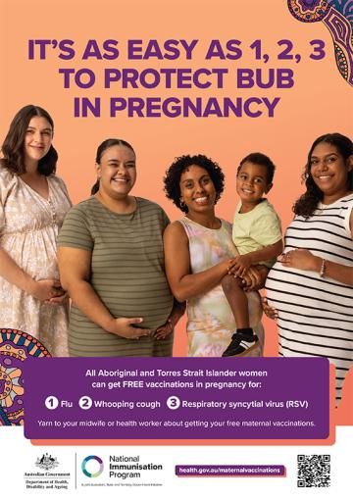 | - Download the Maternal vaccinations poster
Maternal vaccinations fact sheet  This fact sheet provides information about maternal vaccinations under the National Immunisation Program.  The fact sheet is available in an A4 PDF and A4 Word Document format. | 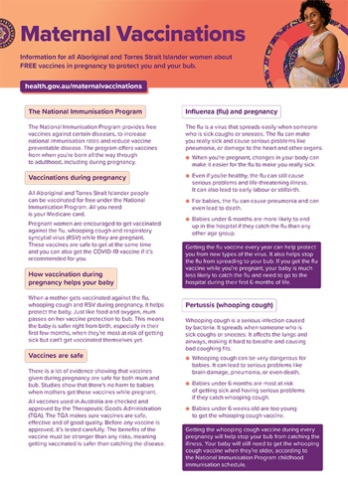 | - Download the Maternal vaccinations fact sheet
Maternal RSV postcard  This postcard provides information on what Respiratory syncytial virus (RSV) is and protecting baby from birth through maternal vaccination.  This postcard is available in PDF and Word Document format. | 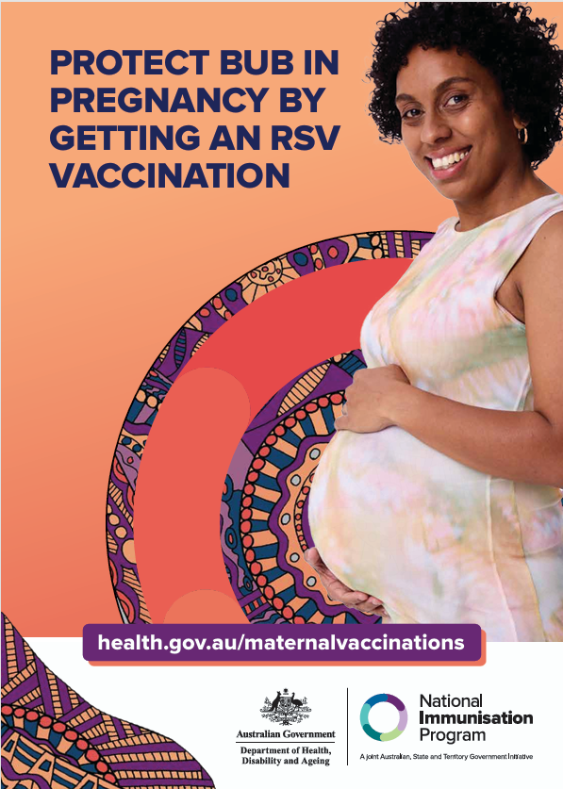 | - Download the maternal RSV postcard
Health worker video – Maternal vaccinations  This video explains how free maternal vaccinations help protect bub against influenza, whooping cough and RSV. | 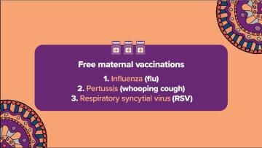 | - Watch the Health worker video – Maternal vaccinations
Health worker video – Influenza vaccine  This video explains what influenza is and why vaccination is important. | 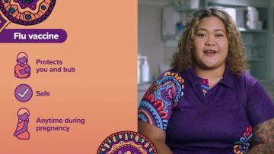 | - Watch Health worker video – Influenza vaccine
Health worker video – Whooping cough vaccine  This video explains what whooping cough is and why vaccination is important. | 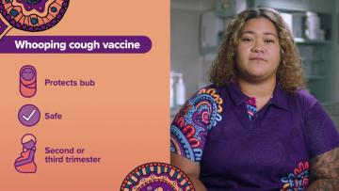 | - Watch Health worker video – Whooping cough vaccine
Health worker video – RSV vaccine  This video explains what RSV is and why vaccination is important. | 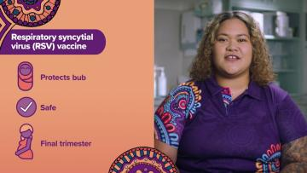 | - Watch Health worker video – RSV vaccine

Social media
Resource | Preview | Suggested use
Social video – Maternal vaccinations  Social media animation outlining each of the 3 maternal vaccinations.  Suggested post copy:  It’s as easy as 1, 2, 3 to protect bub in pregnancy, with free maternal vaccinations for flu, whooping cough and RSV. | 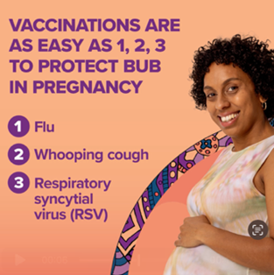 | - Download social media tile about maternal vaccinations  Publish on your preferred social media channels.
Social video – Influenza vaccine  Social media animation talking about how the influenza vaccine is safe at any time during pregnancy.  Suggested post copy:  The flu vaccine is safe at any time during pregnancy, and protects you and your bub for their first 6 months of life. | 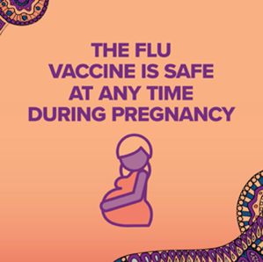 | - Download social video about influenza vaccine  Publish on your preferred social media channels.
Social video – Whooping cough vaccine  Social media animation outlining talking about why and when to get the whooping cough vaccine.  Suggested post copy:  Getting a safe and free whooping cough vaccine during pregnancy helps protect bubbas while they’re still too young to get vaccinated themselves. | 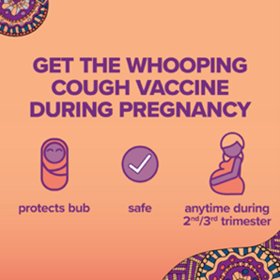 | - Download social video about whooping cough  Publish on your preferred social media channels.
Social video – RSV  Social media animation outlining talking about why and when to get the RSV vaccine.  Suggested copy:  RSV spreads really easily and affects bub’s airways and lungs. It can be very dangerous for littlies, so getting vaccinated really matters! | 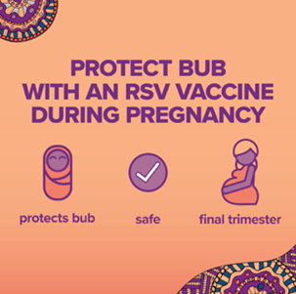 | - Download social video about RSV  Publish on your preferred social media channels.

Newsletter article
An article has been provided below that can be used on your website, in a newsletter or via email communication.

Free RSV vaccine available during pregnancy
A free vaccine to help protect babies against Respiratory syncytial virus (RSV) is available for eligible pregnant women in Australia.
RSV is a common virus that affects the airways and lungs and can lead to serious respiratory illnesses in newborns and infants, such as bronchiolitis and pneumonia.
The RSV vaccine is free under the National Immunisation Program (NIP) for women from 28 weeks of pregnancy.
This program provides free vaccines against certain diseases, to increase national immunisation rates and reduce vaccine preventable disease. Vaccinations take place from birth through to adulthood, including during pregnancy. Getting vaccinated during pregnancy helps protect babies from birth, with studies showing it can reduce the risk of severe RSV illness in babies aged under 6 months by 70%.
These immunisations will reduce hospitalisation rates and keep an estimated 10,000 infants out of hospital each year.
Pregnant women can safely receive the maternal RSV vaccine at the same time as the other recommended maternal vaccines, influenza and whooping cough, which are already available for free on the NIP for eligible pregnant women.
To learn more, speak with your healthcare provider or visit health.gov.au/maternalvaccinations

Source: Australian Government Department of Health, Disability and Ageing, Maternal RSV immunisation consumer fact sheet, May 2026. Available at health.gov.au.

