Online Compliance Platform
  - Introduction to using the OCP



Contents
Introduction 3
Using the OCP 3
How to get more help 3
Using the Online Compliance Platform 4
Activating the OCP 4
Logging in to the OCP 5
Reviewing your claim summary 5
Acknowledge all items as incorrectly claimed 6
Review a schedule of claimed items 7
Selecting responses for items on the schedule 7
Reviewing your progress 8
Exporting your schedule of claims 8
Voluntarily acknowledge additional services 9
Uploading supporting information 9
Reviewing your submission 9
Updating your contact details 10
Submitting your response to the compliance activity 11
Giving feedback about using the OCP 11
Downloading a copy of your submission 11
Saving your progress and logging out 12

Introduction
The Online Compliance Platform (OCP) is a secure digital portal for health providers. If we contact you about certain compliance activities, we may invite you to use the OCP. You can use it to self-review your Medicare claims schedule, look for potential errors, and respond to the compliance activity online.

Using the OCP
Using the Online Compliance Platform is voluntary. You can also choose to receive a paper schedule and respond to the compliance activity by mail or secure email if you prefer.
The OCP has many features that may help you complete the compliance activity online. For example, the OCP lets you review a schedule of Medicate claims and:
- search the schedule for a keyword
- sort the schedule by item number
- filter the schedule by item number, service location, response, and selection
- choose multiple items to include in a voluntary acknowledgment, if required
- write comments and upload supporting documents to include with your submission.
If you would like to use the OCP, we must confirm your email address and mobile phone number. This is to make sure your login and access code are private and secure. To confirm your contact information, we will call you by telephone

How to get more help
You can use our self-help resources at any time.
You can also contact us by email if you need more help.
You can find out more about how we protect your privacy in our privacy notice.
You can also refer to our terms of use for more information about using the OCP.

Using the Online Compliance Platform
You can use the OCP to review a schedule of Medicare claims online, voluntarily acknowledge any incorrect claims, and upload a supporting document. You can also confirm your claiming is compliant.

Activating the OCP
If you would like to use the OCP, we must confirm your email address and mobile phone number. This is to make sure your login and access code are private and secure. To confirm your contact information, we will call you by telephone.
Once we confirm your contact details, we will send you an email with a link to the OCP activation page. We will usually send this email one week after we call you.
On the activation page, you must agree to the OCP terms of use.
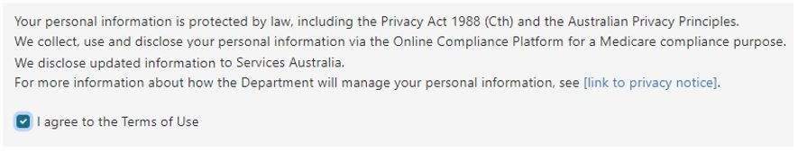
It is important to read the OCP terms of use before you agree to them. To read the OCP terms of use, click the link in the Using our website section in the footer of the OCP website.

Once you agree to the OCP terms of use, we will send you:
- an email with a link to the OCP login page
- an SMS with an access code to log in to the OCP.
If you do not agree to the OCP terms of use, you can contact us to arrange an alternative way to complete your compliance activity.

Logging in to the OCP
On the OCP login page, you can log in to the portal by entering your access code and clicking the Login button.
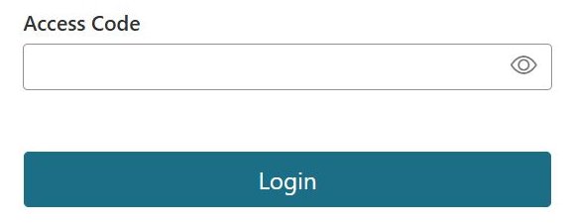
You can continue to use your access code to log in to the OCP until the due date for completing your compliance activity. We will give you this date in the email we send you.
Please contact us if you need more time to complete your compliance activity. You should also contact us if you are unable to login to the OCP with your access code.

Reviewing your claim summary
Once you log in to the OCP, you can review your claim summary. Your claim summary is a schedule of your Medicare claims applicable to the compliance activity. The summary shows the total number and amount of your claims for a period.
The total amount shown in this summary does not include any associated bulk bill incentive amounts. The OCP will give you details of bulk bill incentive items if you voluntarily acknowledge the associated services as incorrect claims
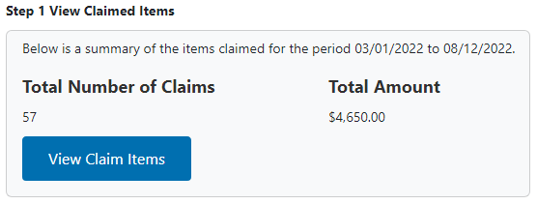
To view the item numbers for your claims, click the View Claim Items button.
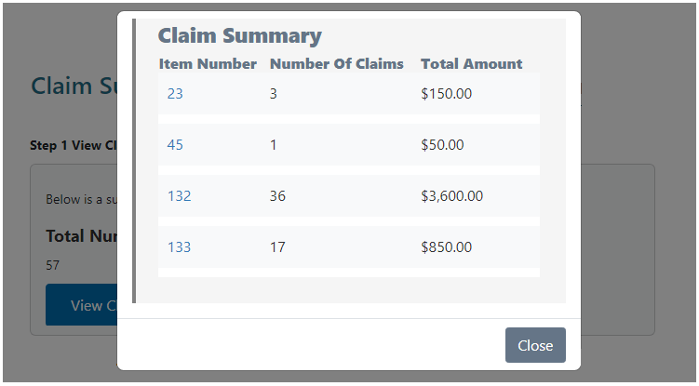
The item numbers shown in this window link to the MBS Online description of the item. Click the Item Number to open the MBS Online in a new browser tab.
The MBS Online description may have changed since you provided the services and lodged a Medicare claim.

Acknowledge all items as incorrectly claimed
If you have incorrectly claimed every item on your claim schedule, you can voluntarily acknowledge all items from the Claim Summary screen. To acknowledge all items, choose Acknowledge all items as incorrectly claimed at Step 2.
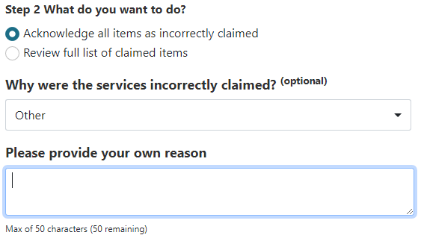
You can also choose to write a brief comment to explain the reason why you claimed the services incorrectly.
Before deciding to voluntarily acknowledge all items as incorrectly claimed from the claim summary screen, you should review your schedule of claims.

Review a schedule of claimed items
You can review a schedule of your Medicare claims applicable to the compliance activity. To review the schedule, choose Review full list of claimed items in Step 2.
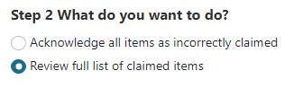
To review your schedule of claims, you can sort the list by item number. You can also filter the list by item number, service location, response, and selection or search for a keyword.
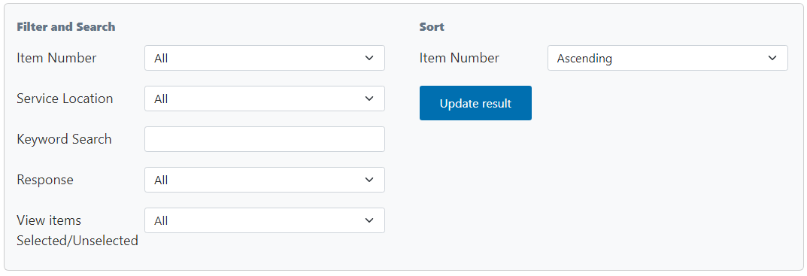
If you would like to review the schedule offline, you can export it as a Microsoft Excel spreadsheet. You cannot import this spreadsheet back into the OCP. You must use the OCP to respond to the items on the schedule and complete your compliance activity.

Selecting responses for items on the schedule
You can use your schedule of services to tell us which items are compliant and whether you claimed any items incorrectly. You can choose single line items on the schedule, or you can choose multiple items or all items in bulk.
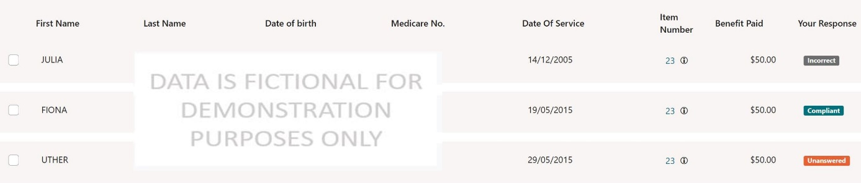
When selecting items on the schedule, you can also choose to write a brief comment to explain the reason for your response.

Reviewing your progress
There is a progress bar at the top of the page. It keeps track of how many Unanswered responses you must edit before you can submit a voluntary acknowledgement.
The first time you use the OCP to review your schedule of claims, all items on your schedule will show a default response of Unanswered.
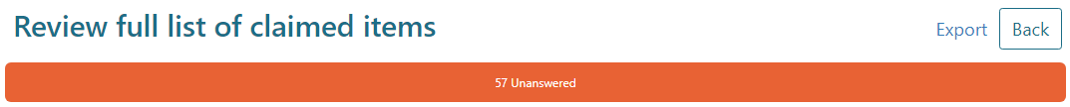
As you update your responses, the number of Compliant, Incorrect and Unanswered responses will change. Once you choose Compliant or Incorrect for each item, the progress bar will not display any Unanswered items.
You must choose a response of either Compliant or Incorrect for every item in the schedule before you can submit your voluntary acknowledgement.

Exporting your schedule of claims
You can export your schedule to review the items offline. To export the schedule, click the Export link in the top right corner of the page, above the progress bar.
When you export your schedule, you can save it as a Microsoft Excel spreadsheet. This spreadsheet will display the schedule in columns with the same headings as the online display. The spreadsheet will also show any comments you have chosen to write.
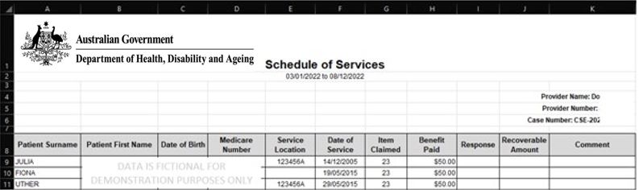
If you export the schedule as a Microsoft Excel spreadsheet, you cannot import this spreadsheet back into the OCP. You must use the OCP to record your responses to the items on the schedule and complete your compliance activity.

Voluntarily acknowledge additional services
Once you voluntarily acknowledge items from your schedule of claims, you can also voluntarily acknowledge up to 50 additional services using the OCP.
To voluntarily acknowledge more than 50 additional services, you can use the Voluntary acknowledgement of incorrect payments form. You can also use this form to acknowledge services outside the period applicable to the compliance activity.

Uploading supporting information
Before you complete your response, you can upload PDF file no larger than 10MB. You can also choose to write a brief comment to include with your submission.
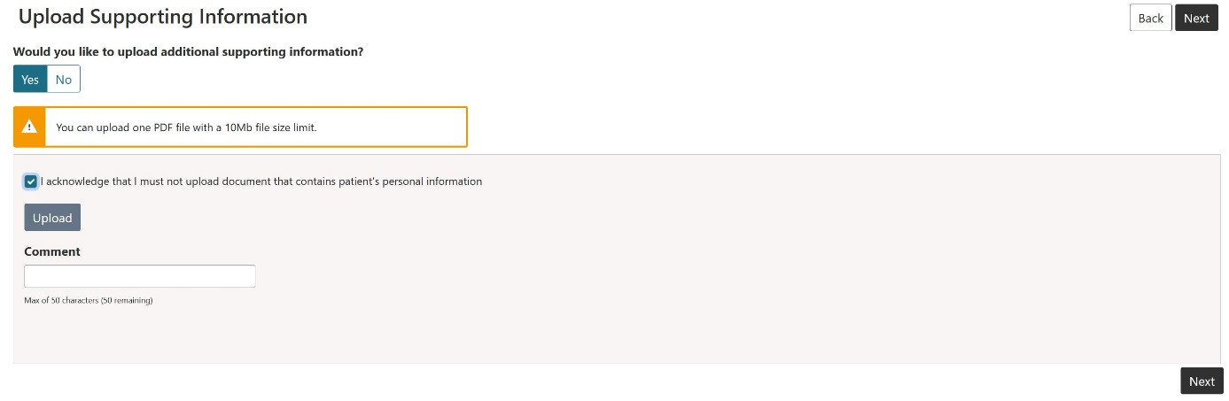
Before you can upload any supporting information, you must click the checkbox to acknowledge that you will not upload any patient personal information.

Reviewing your submission
You can review a summary of your voluntary acknowledgement before you submit it. The summary will include the total number of services and total recoverable amount. It also shows the amount of bulk bill incentive items for the services.
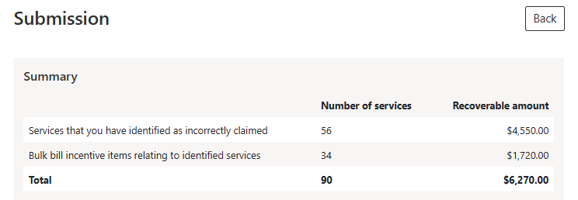

Once you submit your voluntary acknowledgement, we will confirm the recoverable amount of the services you have claimed incorrectly. We will then send you an email with a debt notification. We will also send you a tax invoice to tell you the repayment amount and payment options.

Updating your contact details
Before you submit your response, you can update your contact details. We will use this information to communicate with you about the compliance activity and send you a debt notification if you voluntarily acknowledge any services.
If you do not update your contact details, we will continue to use the existing details for the compliance activity and debt notices
The OCP will show the existing address, email address and mobile phone number we have for you. To update any of these, click the relevant field and type your updated contact details.
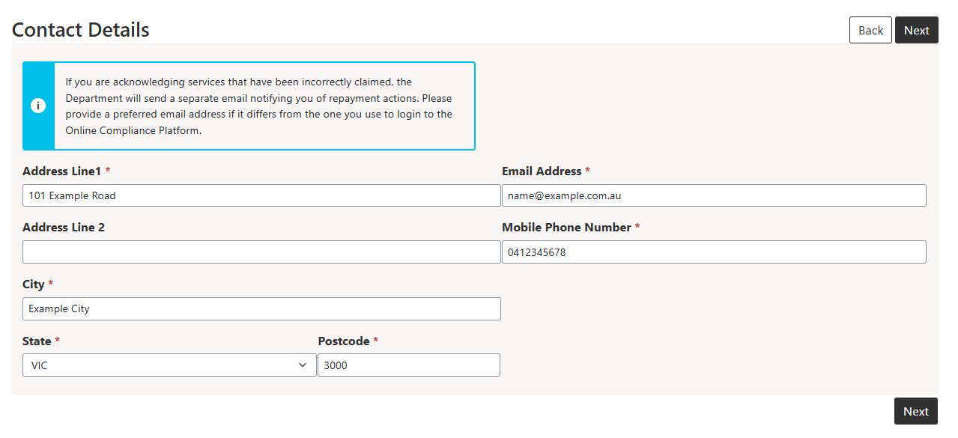
Updating your contact details using the OCP will only apply to communications we send you about the compliance activity, including any applicable debt notifications. If you would like to update your preferred mailing address for all Medicare activities, you must do this by contacting Services Australia.

Submitting your response to the compliance activity
You must complete a declaration before you submit your response to the compliance activity. To complete the declaration, click the checkbox in the declaration section.
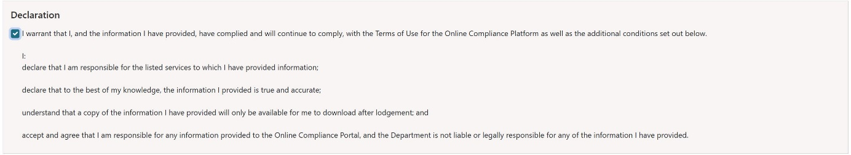

Giving feedback about using the OCP
When you submit your response, you can choose to write feedback about your experience using the OCP. You can type your feedback in the textbox.
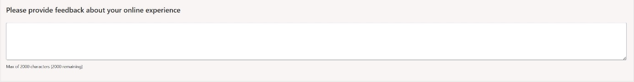

Downloading a copy of your submission
Once you submit your response, the OCP will redirect you to a page where you can download a copy of your submission. If you are acknowledging additional services, you can also download a schedule of these other items.
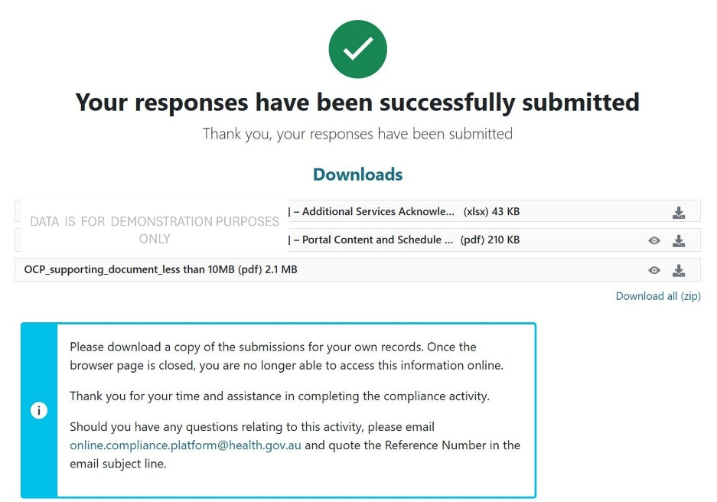
If you would like to download a copy of your submission, you must do it from this page before you close your browser. If you would like to change your responses or get a copy of your submission after leaving the OCP, please contact us.

Saving your progress and logging out
The OCP will save your changes automatically. To log out of the OCP, close your browser, including all open tabs and windows. For your security, the OCP will automatically log you out if you are inactive for 30 minutes.
If you have not submitted a response, you can log back into the OCP using the link we sent you via email. You will also need the access code we sent you via SMS. When you log back into the portal, you will resume from the screen you were using when you logged out.

Health.gov.au
All information in this publication is correct as of July 2026

