

National Nursing Workforce Strategy


Copyright
© 2026 Commonwealth of Australia as represented by the Department of Health, Disability and Ageing
Creative Commons Licence

This publication is licensed under the Creative Commons Attribution 4.0 International Public License (“Licence”) available under Creative Commons Attribution 4.0 Legal Code. You must read and understand the Licence before using any material from this publication.
Restrictions
The Licence may not give you all the permissions necessary for your intended use. For example, other rights (such as publicity, privacy and moral rights) may limit how you use the material found in this publication.
- The Licence does not cover, and there is no permission given for, use of any of the following material found in this publication:
- the Commonwealth Coat of Arms. (by way of information, the terms under which the Coat of Arms may be used can be found on the Department of the Prime Minister and Cabinet website);
- any logos and trademarks;
- any photographs and images;
- any signatures; and
- any material belonging to third parties identified in this publication.
Attribution
Without limiting your obligations under the Licence, the Department of Health, Disability and Ageing requests that you attribute this publication in your work. Any reasonable form of words may be used provided that you:
- include a reference to this publication and where practicable, the relevant page numbers;
- make it clear that you have permission to use the material under the Creative Commons Attribution 4.0 International Public License;
- make it clear whether or not you have changed the material used from this publication;
- include a copyright notice in relation to the material used. In the case of no change to the material, the words “© Commonwealth of Australia (Department of Health, Disability and Ageing) 2026” may be used. In the case where the material has been changed or adapted, the words: “Based on Commonwealth of Australia (Department of Health, Disability and Ageing) material” may be used; and
- do not suggest that the Department of Health, Disability and Ageing endorses you or your use of the material.
Enquiries
Enquiries regarding any other use of this publication should be addressed to the Branch Manager, Corporate Communication Branch, Department of Health, Disability and Ageing, GPO Box 9848, Canberra ACT 2601, or via e-mail to copyright@health.gov.au

Contents
Steering Committee Co-Chairs Foreword 3
Acknowledgement of Country 5
Glossary 6
Actions 10
Introduction 12
The value of nurses 12
Why is a strategy needed? 14
Nursing Supply and Demand Study 14
Overview of the strategy 15
Who is the strategy for? 16
Roles and responsibilities for implementation 16
Policy context and related strategies 18
The National Nursing Workforce Strategy 20
Vision 20
Priorities 20
Priority 1: Enhancing workforce planning, education and regulation 21
Objective 21
Rationale 21
Workforce planning 22
Career flexibility 23
Aboriginal and Torres Strait Islander nurses 24
Nursing education 25
Access to education 26
Student employment models 27
Regulation 27
Post graduate education 28
Priority 2: Enabling nursing innovation 29
Objective 29
Rationale 29
Emerging technologies 30
Funding models 31
Innovative models of care 32
Aboriginal and Torres Strait Islander co-design 33
Optimum scope of practice 34
Climate resilience and environmental sustainability 35
Priority 3: Elevating the nursing profession 36
Objective 36
Rationale 36
Leadership 37
Aboriginal and Torres Strait Islander leadership 38
Racism 39
Diversity, discrimination and cultural safety 40
Internationally qualified nurses 41
Identity of nursing 42
Priority 4: Delivering a sustainable nursing workforce 43
Objective 43
Rationale 43
Transition of practice 43
Career framework 44
Lifelong learning 44
Workplace environment 45
Research 46
Rural and remote workforce 47
Implementation and measuring success 49
Implementation 49
Governance 49
Monitoring and evaluation 49
Appendices 50
Appendix A – Australian health care system 50
Appendix B – Development of the strategy 51
Appendix C – Definition of nurses and nursing 58
References 60

Steering Committee Co-Chairs Foreword
We are pleased to present Australia’s first National Nursing Workforce Strategy (strategy). A significant milestone for the nursing profession in Australia. Developed through extensive collaboration and consultation, the strategy aims to address challenges and seize opportunities for the nursing profession.
The strategy presents a cohesive and proactive response to promote attraction, recruitment and retention, encourage innovative and multidisciplinary practice while fostering the nursing leaders of today and tomorrow. Considering the evidence of significant workforce shortages, delaying strategic workforce action risks further compromise of Australia’s population health, placing undue strain on the existing workforce. By prioritising a forward-thinking nursing workforce strategy, Australia can ensure its health and aged care system remains flexible and capable of meeting the needs of its population now and into the future.
The importance of this work cannot be overstated. Nurses are fundamental to the delivery of health care and services. They are key leaders, decision-makers, and innovators within and across the health and aged care system. Their ability to influence, lead, manage and operationalise change, alongside their commitment to providing scientific, evidence-based care, makes our profession indispensable.
These strengths ensure the profession continues to attract a diverse range of individuals and retains these committed, high-performing nurses – which is essential for system sustainability. Emphasising flexibility and promoting a healthy work-life balance are fundamental to these aims.
A collaborative effort is required to ensure the nursing workforce remains at the forefront of delivering person-centred services for all Australian communities. The strategy demonstrates the need for collective will, commitment, and action from governments, regulators, employers, education providers, professional bodies, and individual nurses, to drive effective implementation and sustainable change in the nursing workforce.
The strategy is the result of extensive collaboration and consultation with the sector. This includes input from more than 7,000 individuals who participated in various forms of consultation, including forums, online surveys, focus groups, yarning circles and one-on-one discussions. We extend our gratitude to the many organisations and individuals who contributed their time, expertise, and passion to this endeavour.
We would also like to thank the members of the Strategy Steering Committee and Strategy Advisory Group for their expertise, advice and oversight in development of the strategy. Their dedication to the future of nursing in Australia has been invaluable in shaping a comprehensive and purposeful strategy.
Thank you to Frances Rice RN, Allison Thomas, Karen Cook RN, Lucy Twigg RN, Samantha Lavender RN, Emma Saddington RN, Kristen Simpson, Anna Smith, Joanna Ubels, Victoria Wakefield RN, Jessica Ring, Kate Lehmensich, Karen Granton, Shreya Biswas RN, Danielle Ferguson, Brianna He, Lana Fligic, Rebecca Meynell, Alison McCluskey RN, Suzanne Michaelis, Suzanne Hughes RN, Tracey Thomson, Niluka De Silva and Cia Kay, the strategy project team, for your unwavering dedication and hard work to bring this strategy to fruition.
We look forward to the positive impact this strategy will have on the nursing workforce and health and wellbeing outcomes in Australia.
Adjunct Professor (Practice) Alison McMillan PSM
Commonwealth Chief Nursing and Midwifery Officer
Co-Chair Strategy Steering Committee
Co-Chair Strategy Advisory Group
Adjunct Professor Karrie Long
Chief Nurse and Midwifery Officer, Victoria
Co-Chair Strategy Steering Committee Co-Chair Strategy Advisory Group

Acknowledgement of Country
We acknowledge Aboriginal and Torres Strait Islander peoples as the Traditional Owners and Custodians of Country throughout Australia. We recognise and respect their continuing connection to land, sea, sky and community. We pay our respects to them and their cultures and to all Elders past, present and emerging.
We recognise the strength and resilience of Aboriginal and Torres Strait Islander peoples as we work towards a shared commitment of health equity.

Glossary
The strategy aims to use inclusive and respectful language and nationally accepted definitions - noting that on occasion there may be different definitions for some of the included terms in the strategy.
Table 1. Glossary for the National Nursing Workforce Strategy
Term | Definition
Aboriginal and Torres Strait Islander person | A person of Aboriginal or Torres Strait Islander descent who identifies as Aboriginal or Torres Strait Islander and is accepted as such by the community in which they live.
Accreditation | Refers to a formal process of approval for a program of study or training that ensures a person who successfully completes that program or training has the knowledge, skills and professional attributes needed to practise their health profession or undertake that activity.
Australian Nursing and Midwifery Accreditation Council | The Australian Nursing and Midwifery Accreditation Council (ANMAC) is responsible for:  - establishing education standards  - assessing and accrediting nursing, midwifery and other healthcare education programs, and  - assessing and validating the skills, qualifications and experience of overseas qualified nurses, midwives and health care workers.
Artificial intelligence | Computer systems able to perform tasks that normally require human intelligence, such as visual perception, speech recognition, decision-making, and translation between languages.
Climate resilience | Climate resilience is the ability to anticipate, prepare for, and respond to events, trends, or disturbances related to climate.
Co-design | Co-design is a process to combine lived experience and professional expertise to identify and create an outcome or product.
Cultural safety | Cultural safety represents a key philosophical shift from providing care regardless of difference, to care that takes account of people’s unique needs. It requires nurses to undertake an ongoing process of self-reflection and cultural self-awareness, and an acknowledgement of how a nurse’s personal culture impacts on care.
Culturally and linguistically diverse | Encompasses communities with diverse languages, ethnic backgrounds, nationalities, traditions, societal structures and religions.
Discrimination | Discrimination happens when a person, or a group of people, is treated less favourably than another person or group because of their background or certain personal characteristics.
Genomics | The study and mapping of genomes – the full set of genetic instructions for an organism. It includes both human and other genomes and how these interact with the environment.
Health and aged care | Reference to health and aged care in this strategy represents Australia’s multifaceted public and private health system: the providers, settings, specialties, participants and support mechanisms that deliver services to meet people’s physical, mental and social health needs across the life course.
HumanAbility | HumanAbility is the Jobs and Skills Council for the aged care and disability, children’s education and care, health, human services, and sport and recreation sectors.
Intersectionality | Intersectionality refers to the ways in which different aspects of a person’s identity can expose them to overlapping forms of discrimination and marginalisation.
Jobs and Skills Councils | Jobs and Skills Councils identify skills and workforce needs for their sectors, map career pathways across education sectors, develop contemporary VET training products, support collaboration between industry and training providers to improve training and assessment practice, and act as a source of intelligence on issues affecting their industries.
Leadership | Leadership has similarities in all industries although health is recognised for its complexity. Health leaders strive to improve clinical and quality of life indicators, and the wellbeing of the health system. Research shows the quality of health leadership directly and indirectly affects the quality of patient care and is an important factor supporting best practice.
LGBTIQA+ | People who have identified themselves as lesbian, gay, bisexual, transgender, intersex, queer, asexual or otherwise diverse in gender, sexual orientation and/or innate variations of sex characteristics.
Model of care | Model of care refers to the way in which a health service is delivered. It may refer to the process of care as well as which healthcare professionals or skills are required.
Multidisciplinary team | Multidisciplinary team care refers to collaborative care, which occurs when multiple health professionals from different professional backgrounds provide comprehensive services by working with each other, and with consumers, their families, carers and communities to deliver the highest quality of care across settings.
Nursing and Midwifery Board of Australia | The Nursing and Midwifery Board of Australia (NMBA) works to ensure that Australia’s nurses and midwives are suitably trained, qualified and safe to practise. The functions of the NMBA include:  - registering nursing and midwifery practitioners and students  - developing standards, codes and guidelines for the nursing and midwifery profession  - handling notifications, complaints, investigations and disciplinary hearings  - assessing overseas trained practitioners who wish to practise in Australia, and  - approving accreditation standards and accredited courses of study.
Nursing profession | The specialised field of nursing, characterised by the qualifications, skills, knowledge, standards, behaviours and values associated with delivering nursing care.
Nursing workforce | Individuals who are engaged or available to be engaged to deliver nursing care. This encompasses nursing students, assistants in nursing (or however named), enrolled nurses, registered nurses and nurse practitioners.
Person-centred care | A collaborative and respectful partnership with health professionals built on mutual trust and understanding through good communication. Each person is treated as an individual with the aim of respecting people’s ownership of their health information, rights and preferences while protecting their dignity and empowering choice. Person-centred care also recognises the role of family and community with respect to cultural and religious diversity.
Positive practice environment | A positive practice environment is one that supports excellence and decent work, ensures staff health and safety, supports the delivery of high-quality person-centred care, and fosters motivation and productivity.
Prejudice | A preconceived opinion toward another person or group formed in advance of any experience with that person or group. It is typically manifested behaviourally through discriminatory behaviour.
Pre-registration education | Includes education and training undertaken before becoming a registered nurse or an enrolled nurse.
Professional partnerships | Formal partnerships between organisations to support the outcomes sought with agreed joint decision-making roles and responsibilities.
Racism | Racism is the process by which systems and policies, actions and attitudes create inequitable opportunities and outcomes for people based on race. Racism is more than just prejudice in thought or action. It occurs when this prejudice – whether individual or institutional – is accompanied by the power to discriminate against, oppress or limit the rights of others.
Registered training organisations | Registered training organisations deliver nationally recognised training in the vocational education and training (VET) sector. To deliver this training, they need to be approved by the Australian Skills Quality Authority.
Registration | Applicants for registration must meet a range of standards to gain and retain their registration (licence) to practice as a nurse in Australia.
Scope of practice | The range of activities that a professional is educated, competent and authorised to perform. The scope of practice of individual practitioners is influenced by the settings in which they practise. This includes the level of competence and confidence of the nurse and the policy requirements of the service provider. As the nurse gains new skills and knowledge, their individual scope of practice changes.
Student employment model | An employment model where a person currently enrolled in an undergraduate nursing course, who is also registered with the NMBA as a student nurse, can undertake paid employment in a variety of health and aged care settings.

Actions
Table 2. Overview of National Nursing Workforce Strategy actions
Priority | Action
- Enhancing workforce planning, education and regulation | - Implement nationally coordinated nursing workforce data, modelling and planning  - Implement strategies that enhance nurses’ mobility and career flexibility  - Grow the Aboriginal and Torres Strait Islander nursing workforce  - Research and implement the most contemporary models of delivery of pre-registration education  - Facilitate students and nurses to access and complete nursing education  - Adapt student employment models for all health and aged care settings  - Increase transparency and improve timeliness and currency of regulatory processes and outcomes  - Develop and implement a nationally consistent accreditation process for post graduate nursing education
- Enabling nursing innovation | - Prepare and engage the nursing workforce to continue to drive the innovation and effective use of emerging technologies  - Create and embed funding models that drive evolution and enhancement of sustainable nursing practice  - Implement nurse-led innovative models of care  - Aboriginal and Torres Strait Islander nurses and communities design workforce initiatives that suit local conditions and community situations  - Enable nurses to work to their optimum scope of practice in all settings  - Mobilise and support the nursing workforce to lead and contribute to an environmentally sustainable and climate-resilient health and aged care system
- Elevating the nursing profession | - Advance nursing leadership  - Grow Aboriginal and Torres Strait Islander nurse leadership  - Adopt anti-racism initiatives in nursing  - Foster a diverse, inclusive and culturally safe nursing workforce  - Support internationally qualified nurses to transition into Australia’s health and aged care system  - Contemporise the identity of nursing
- Delivering a sustainable nursing workforce | - Develop a nationally consistent framework for transition of practice  - Develop a national nursing skills and capability framework and matrix  - Develop a national professional development framework  - Adopt positive practice environment standards in all settings  - Build and grow nurse clinical-academic/research career pathways  - Develop a rural and remote career pathway inclusive of transition of practice support  - Develop models of education to allow students to study closer to home including strengthening rural nursing clinical schools and professional experience placements  - Remove barriers to nurses working to their optimum scope of practice within multidisciplinary models of care in rural and remote locations

Introduction
As the world’s population grows, people need better access to safe, quality health care, as well as long-term employment. Investments that increase the overall productivity of the health sector and produce better health outcomes are a cornerstone for building strong health systems and stronger economies. Investing in the nursing workforce not only improves the well-being of populations, but also boosts economic growth by enhancing workforce productivity; strengthening health care systems; alleviating poverty; improving gender equality; and contributing to social cohesion, peace and prosperity.
Australia is the sixth largest country in the world by land area, serving a population of more than 27 million people. More than 70% of the population live in major cities and around 26% live in regional areas. The remainder of the population (2%) live in remote and very remote areas. Australia's population is diverse. People who identify as Aboriginal and/or Torres Strait Islander are estimated to represent 3.8% of the population. Almost 70% of the population was born in Australia, with 29.5% born overseas.
The Australian health and aged care system serving this population is one of the best in the world, providing safe and affordable universal health care, which is collaboratively managed by all levels of government – federal, state, territory and local. However, a range of factors are challenging the health and aged care system and how services are delivered. These include an ageing population, increasingly complex and chronic conditions, a large land mass with a geographically dispersed population, socioeconomic factors, the impacts of climate change, advancements in technology and the geopolitical landscape.
Additionally, the COVID-19 pandemic (the pandemic) exacerbated the demands being made on and for the nursing workforce in Australia. Globally, evidence shows there has been insufficient investment in policy and planning to ensure nations were training adequate numbers of nurses to meet their projected needs. In some countries nurse unemployment co-exists with significant nurse shortages. In Australia these factors are having and will continue to have significant impacts on demand for the nursing workforce now and into the future.

The value of nurses
The nursing workforce is critical to the health and aged care system and broader society.
Nursing represents more than 54% of the healthcare workforce nationally and is the single largest health profession in Australia. In 2023 there were 455,000 nurses with general and provisional registration in Australia and 88% identified as female. Of the total number of nurses, 389,787 were registered nurses and 65,213 were enrolled nurses. Comprehensive data on the nursing workforce is updated annually and published through the National Health Workforce Dataset.
There is recognition that economic growth and health system recovery and rebuild post COVID-19 is dependent on having an effective and sustainable health workforce. There is also a recognised need for urgent and effective policies and planning to support and sustain the nursing workforce.
Nurses have a broad scope of practice for both physical and mental health and across the lifespan. They deliver exceptional evidence-based, quality care and services across all health and aged care settings, in many speciality areas, in all communities and to all people throughout Australia. Pre-registration nursing education prepares students for generalist practice in a variety of health settings. Nurses may choose to undertake further study to develop knowledge and skills in a range of health and aged care settings, specialties, conditions and scopes of practice.
Nursing in Australia provides many opportunities to consolidate and develop either generalist or specialist knowledge and skillsets in unique geographic and cultural landscapes. With its vast land area and dispersed population, a career in nursing in Australia can range from working in a large metropolitan hospital to being the primary healthcare provider in a remote area. It can involve being an integral member of the local community, building connections with people from different cultural, linguistic, social backgrounds and intersectionalities. With the ability to work across a variety of practice contexts, nursing in Australia leads to diverse, interesting and rewarding careers.
Nurses have the highest rates of consumer contact of any health workforce within acute care, residential aged care and in remote settings. Nurses have an essential role in providing health services to meet the needs of people and promote health across the lifespan. Nurses collaborate with other health workers and work as part of multidisciplinary teams coordinating service delivery. They are key strategic and operational leaders across the entire health and aged care system. Nurses hold pivotal roles in areas outside the clinical environment. This includes leading research, teaching and education in the tertiary and vocational sectors, and leading regulation, policy development and implementation in government and non-government organisations.
Nurses are essential drivers of innovation and improvement. Through their leadership in research, education and policy development, nurses help create, disseminate and translate evidence-based knowledge, best practice and standards of care to drive continuous improvement in population health. Their role as collaborators, positively engaging and connecting with people, communities, organisations and multidisciplinary teams, is crucial to promoting health and wellbeing. Appendix A illustrates the integration of the nursing workforce in Australia’s health care system.
The societal and economic impact of nursing is profound. Investment in the nursing workforce has been shown to yield high returns, including in improved consumer outcomes, reduced hospitalisation and fewer patient safety errors. The value of nurses goes beyond the services they provide. Evidence shows that investment in healthcare improves health outcomes and quality of life. Healthy individuals are more likely to be employed and have higher productivity rates.,, Alongside delivering health outcomes, it is also important to recognise the considerable and broader value nurses generate. This is reflected in the economic growth and stimulatory effect of health spending – evidence shows a one Australian dollar investment in better health, results in a two-to-six-dollar return. The nursing profession continues to provide many Australians with stable and rewarding employment. As we advance into the future and the demand for health and aged care grows, the value and impact of nurses will become even greater.

Why is a strategy needed?
There is a critical need for effective and coordinated action and a shared vision for the nursing workforce. As well as the direct impact on health and wellbeing, reduced access and delays to health care can result in lost productivity for people and more broadly, increased cost of care and reduced health outcomes for the population. Targeted investment in health systems, including in the health workforce, promotes economic growth along other pathways: economic output, social protection and cohesion, innovation and health security. Investing in nursing ensures people receive cost effective and quality health care. This contributes to better health outcomes for the community and enables people to live full and productive lives. Investment in nursing is essential for optimising health outcomes and to generate broader societal and economic benefits.
Legislation, funding and policy settings show misalignment across the nation, which presents challenges that impede nurses working to their optimum scope of practice and in turn has negative consumer impacts. The COVID-19 pandemic placed additional stress on the nursing workforce, highlighting and exacerbating the issues the profession faces – including impacts on mental and physical health and wellbeing. The pandemic increased the immediate need for nurses, and without targeted action the existing workforce gap is likely to grow further. In contrast, the pandemic also created opportunities for the nursing workforce to diversify and innovate.
Nursing is a highly gendered workforce globally. Approximately 90% of the global nursing workforce is female, yet few leadership positions are held by nurses or women. Similarly, as a female dominated profession traditional views of care have perpetuated biases that limit workforce diversity, impact recruitment and retention and extend structural patriarchal issues such as pay inequity and power imbalance, undervaluing the profession. Perceptions of nursing need to shift to acknowledge the high level of scientific knowledge, education and skill demanded in and demonstrated by contemporary nursing practice. Removal of these barriers will establish a more inclusive and equitable workforce.,

Nursing Supply and Demand Study
This strategy was informed by the Nursing Supply and Demand Study 2023-2035 (PDF, 743 KB). The nursing supply and demand model was developed to provide a single, consistent, and integrated data evidence base for use in local, state and national workforce and service planning. The model starts from a point of equilibrium in 2022 and predicts what could happen if Australia does not address the demand for and supply of the nursing workforce. The demand for nurses is being driven by numerous factors including, an ageing population, increasingly complex and chronic conditions, a geographically dispersed population, the impacts of climate change and advancements in technology.
The national projections found that while both supply and demand of the workforce are estimated to increase during the projection period, without reform, supply is not expected to keep pace with demand.
Figure 1 shows baseline projections at a national level and across all sectors, with an undersupply of 70,707 full-time equivalent (FTE) nurses in 2035, which equates to around 79,473 nurses needed to fill the gap.
The National Aboriginal and Torres Strait Islander Health Workforce Strategic Framework and Implementation Plan 2021-2031 set a target of 3.43% of Aboriginal and Torres Strait Islander people being represented in the national health workforce by 2031.
The projected supply of employed nurses in 2035 is 470,859, which implies an estimated shortfall of around 9,088 Aboriginal and Torres Strait Islander nurses to meet the supply target of 3.43%.
Figure 1. National supply and demand of Full-Time Equivalent (FTE) Nurses 2023-2035
Note – for sector specific supply and demand projections see Nursing Supply and Demand Study 2023-2035 (PDF, 743 KB).
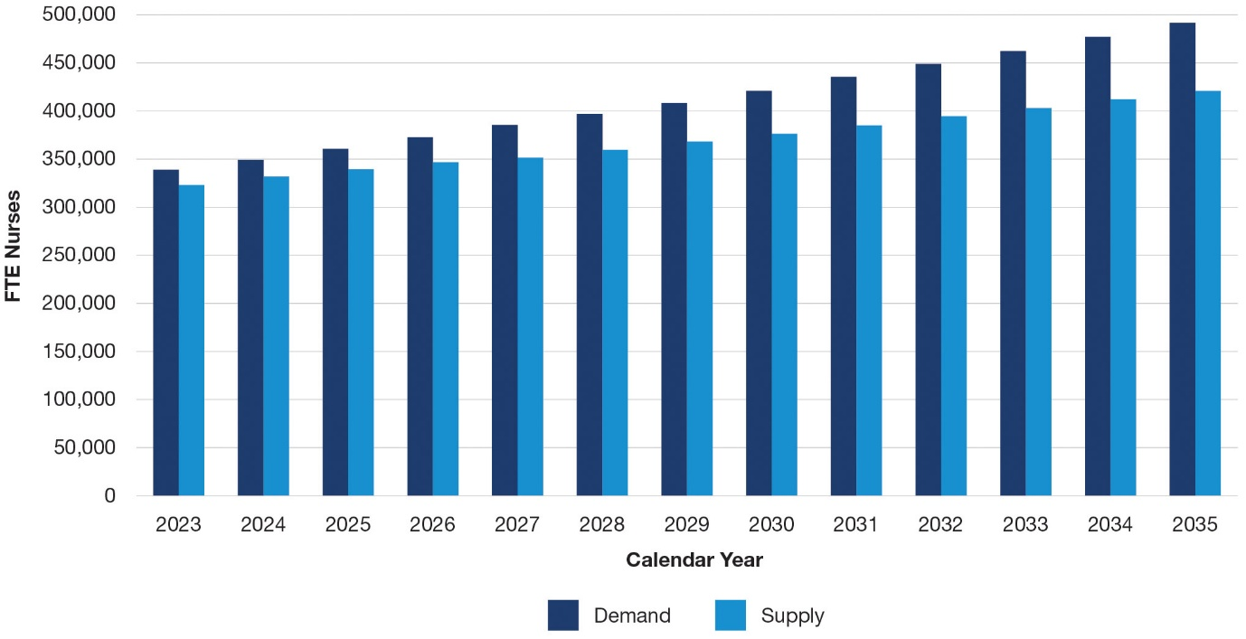
The nursing workforce projections indicate that if no strategic action is taken, supply of nurses will not keep pace with the needs of the population and increasing demand for care.
With this knowledge is the accountability and impetus for all stakeholders to act and intervene. Without action this undersupply of nurses in Australia will have a direct adverse impact on the health of the population in Australia and its prosperity as a nation.

Overview of the strategy
The strategy establishes priorities for strengthening the sustainability of the nursing workforce, aiming to bolster the delivery of health and aged care services to all Australian communities. It has been endorsed by all Health Ministers. It offers a comprehensive framework to foster collaboration and drive action among stakeholders in shaping the future of nursing workforce planning, investment and reform. The strategy highlights how investment in nursing can deliver considerable economic and societal benefits to all Australian communities and help to avoid the workforce supply and demand gap that will grow without reform.
A significant evidence base of research and consultation reports have informed development of the strategy, drawn from best practice and recognising the uniqueness of the Australian context. This includes understanding the challenges, issues and opportunities facing the nursing workforce in realising health outcomes for the population. The evidence base includes consultation with Aboriginal and Torres Strait Islander people, nurses, organisations and the public, as well as comprehensive consideration of international nursing workforce initiatives. More information on the process used to develop the strategy can be found at Appendix B.
The strategy acknowledges and commits to equity in representation and opportunities for Aboriginal and Torres Strait Islander people in the nursing workforce. It seeks to enable the entire nursing workforce to meet the health and cultural needs of Aboriginal and Torres Strait Islander people.
The strategy encompasses the breadth of nursing designations and includes nursing students, assistants in nursing (or however named), enrolled nurses, registered nurses and nurse practitioners. It applies to nurses in both clinical and non-clinical roles, in all specialities and across all settings. Appendix C provides a more detailed description of nurses and nursing. Midwives, as a separate and defined profession are not included in the strategy’s scope. However, it is recognised many nurses have dual registration as midwives and paramedics, so their perspective on nursing issues and the impact of the strategy on those professions has been considered.

Who is the strategy for?
It is intended for a wide range of audiences including governments, regulators, employers, education providers/registered training organisations, professional and industry bodies, and the nursing workforce. Through strategic direction, development and investment, over time, the strategy has the potential to involve and impact all nurses across all contexts and once implemented will improve access to quality care.

Roles and responsibilities for implementation
Governments, professional bodies, regulators, education providers, registered training organisations, and employers will support, fund and lead this work. Implementation will be in close collaboration with the nursing profession, consumers, carers and other implementation partners, including all organisations that affect the nursing workforce and other health professionals, operating at local, state, territory and national levels. Depending on the priority and action, partners may work collaboratively or in parallel. Collective will, commitment and action will drive effective and sustainable change and ensure the nursing workforce remains at the forefront of delivering health and aged care services for all Australian communities. This active participation and engagement will help to improve the systems in which nurses operate to make positive changes in their professional lives and careers.
Each action in the strategy lists key stakeholders responsible for, or having a role in, implementation. Table 3 describes key roles and responsibilities.
Table 3. Stakeholder roles and responsibilities
Stakeholder categories | Key role and responsibility
Governments | Commonwealth, state and territory, and local governments share responsibility for funding, operating and managing the health system. See Appendix A for more detail on government responsibilities. Other areas where government involvement is required include education, employment and workplace relations, home affairs, social services and veterans’ affairs.
Regulators | NMBA and ANMAC are responsible for regulating the profession including setting the standards and policies nurses must meet, including education standards. The Australian Commission on Safety and Quality in Health Care and Aged Care Quality and Safety Commission are responsible for regulating health and aged care services, which nurses deliver.
Education providers/registered training organisations | Responsible for developing, designing and delivering education and training programs, including co-design initiatives involving professional bodies and other relevant groups, to appropriately educate and train the nursing workforce.
Professional and industry bodies | Responsible for representing, supporting and communicating with members, industry and partners. This category includes HumanAbility, colleges, unions and other peak bodies.
Employers | Responsible for delivering health and aged care services, working environments, employment, supervision and support to attract and retain the nursing workforce. Includes governments where nurses are employed in public settings.
Nursing profession/workforce | Responsible for engaging and providing leadership to support achievement of the strategy objectives.
Consumer and carer organisations | Responsible for representing people with lived experience of the health and aged care system and ensuring the needs and preferences of consumers and carers are central to development and implementation of nursing policy.

Policy context and related strategies
Australia’s health and aged care system is complex, with nursing workforce accountabilities split between various stakeholders. The nature of a federated government means decision-making is distributed and reflects the different priorities of the Australian Government and individual state, territory and local governments.
The Australian Government is responsible for developing national health policies and funding population specific services, including health and medical research, National Disability Insurance Scheme (NDIS), Pharmaceutical Benefits Scheme (PBS), and Medicare Benefits Schedule (MBS). It contributes funds to the states and territories for public health and hospital services through the National Health Reform Agreement.
State and territories are the largest employers of the nursing workforce. They fund and manage public hospitals, deliver community, preventative and ambulance services, and regulate and license private hospitals.
Integrating workforce planning with overarching health system reforms and related policy changes across jurisdictions presents a critical challenge. The strategy acknowledges the diversity of the nursing workforce and its operation across a range of environments.
The strategy considers national, state, territory and international strategies and other relevant reforms that affect the nursing profession, including health, social, education, economic and employment policies. These considerations have also included key international documents such as the World Health Organization Global Strategic Directions for Nursing and Midwifery (2021–2025) and reports from the International Council of Nurses (ICN).
The intersection with other plans, policies, strategies and reviews are complex and changing, as demonstrated in Figure 2. This includes recognition that nurses work as part of multidisciplinary teams, and several related health workforce strategies are in place or in development. Implementation of the strategy will consider these related strategies, policies and review recommendations.
Figure 2. National nursing workforce policy context
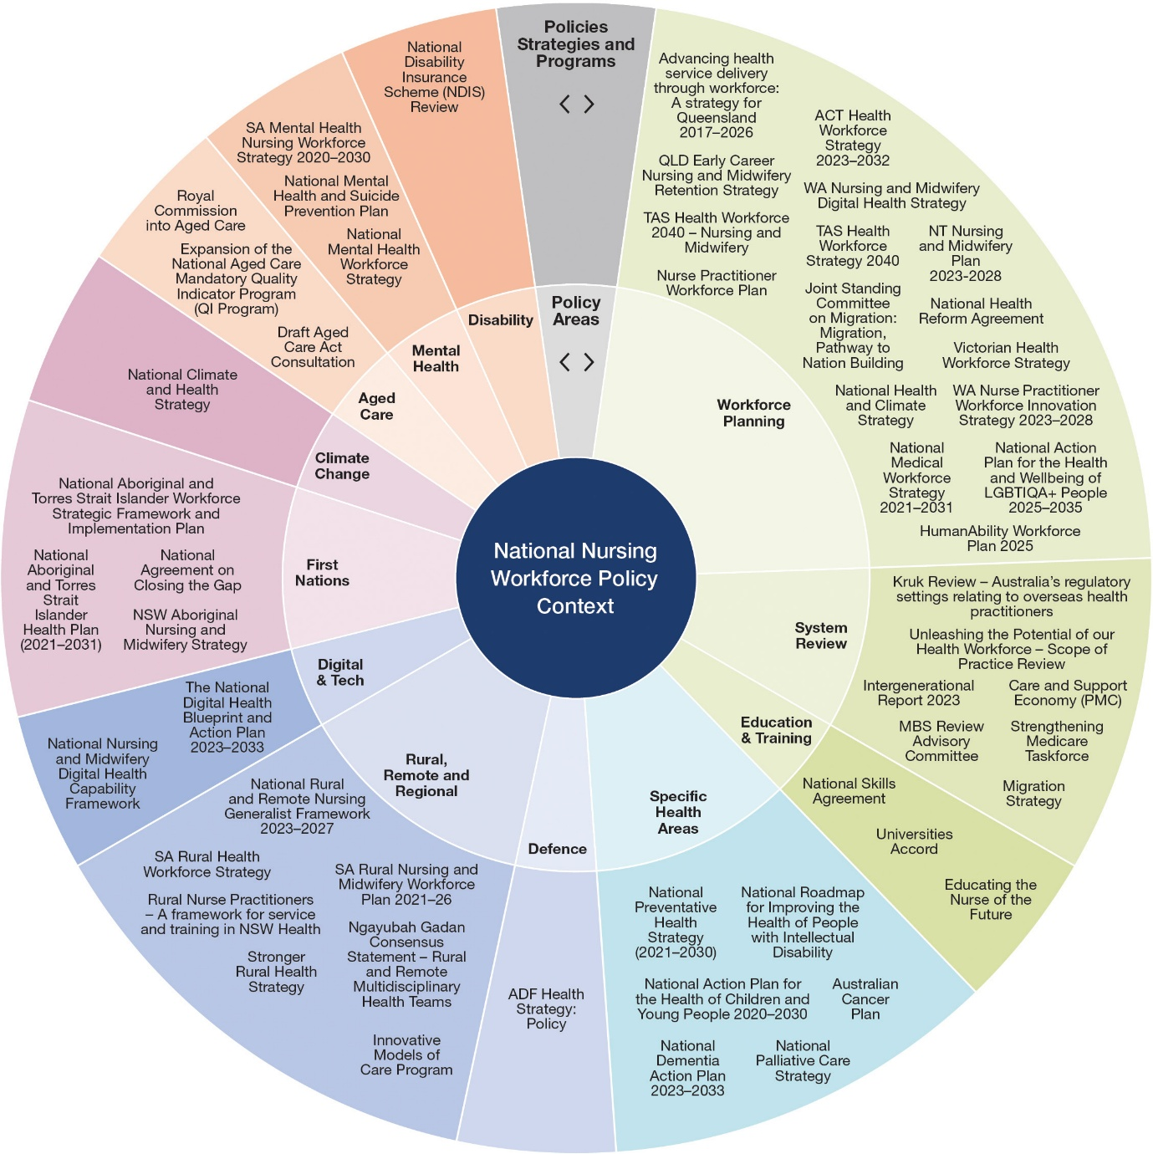

The National Nursing Workforce Strategy
This strategy sets out a long-term vision for the future of the nursing profession in Australia. Achievement of the vision is driven by four priorities with a ten-year time horizon for implementation.
The strategy recognises linkages and interdependencies between the priorities and their associated actions and objectives. The actions within the strategy can also be read through several lenses or grouped according to areas such as Aboriginal and Torres Strait Islander people, cultural and linguistic diversity, and rural and remote.
Figure 3. National Nursing Workforce Strategy architecture
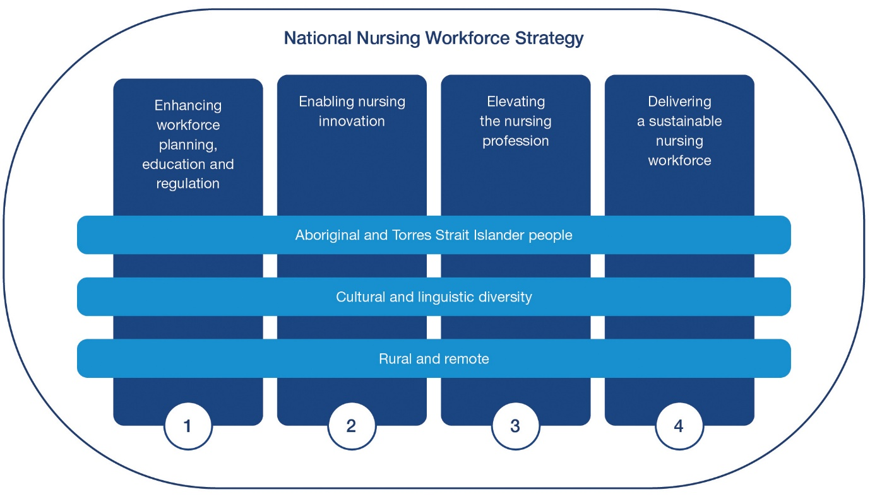

Vision
A sustainable nursing workforce that adapts, innovates and excels to deliver evidence-based health and wellbeing outcomes for all Australian communities

Priorities
1. Enhancing workforce planning, education and regulation
2. Enabling nursing innovation
3. Elevating the nursing profession
4. Delivering a sustainable nursing workforce
These are detailed in the following sections, with each priority providing:
- objectives that will be achieved where actions are successfully implemented
- a rationale for the significance of the priority and what it seeks to achieve
- actions designed to implement priority objectives
- aims to describe action intent; and
- responsibilities to identify the range of stakeholders who have responsibility for, or a role in, supporting implementation of actions.

Priority 1: Enhancing workforce planning, education and regulation

Objective
- Nursing workforce planning is data driven, collaborative, coordinated and effective.
- Nurses and nursing students are educated in a fit-for-purpose and contemporary education and career infrastructure.
- Nurses can progress their careers in the way they choose.

Rationale
Workforce planning, education and regulation are levers that enable a well prepared and effective nursing workforce. Workforce planning ensures supply and distribution of nurses meet the health and aged care needs of communities in Australia. Nursing education, training and career infrastructure must also evolve to meet the changing health and aged care landscape and the needs of the nursing workforce. Access to, and support for, completing nursing education will ensure a sustainable nursing pipeline. Clear development and advancement opportunities will enable nurses to pursue fulfilling careers and support retention.

Workforce planning

Reason for action
The National Health Workforce Dataset is informed by data from the annual registration process for nurses and the annual workforce survey voluntarily completed at the time of registration. This is used nationally for nursing workforce planning - in particular the modelling in the Nursing Supply and Demand Study 2023-2035 (PDF, 743 KB) . Workforce planning requires an evidence-based and coordinated approach to align with the overall goals of the health and aged care system. It considers system reforms, service delivery models and the potential impact of external factors such as future pandemics, climate-related events and political or economic shifts.
Access to additional data sources and development of a coordinated approach to the use of all health workforce data will improve the quality of nursing workforce planning in Australia. This, in turn supports delivery of person-centred health care, improves access to care, and enhances the quality, safety and sustainability of services.
Action | Intended outcomes | Responsibility
1.1 Implement nationally coordinated nursing workforce data, modelling and planning. | Governments collaborate on nursing workforce issues and develop solutions using robust data and evidence.  Improved approach to workforce data, modelling and planning.  Optimised distribution of the nursing workforce, particularly in rural and remote areas.  Priorities for Aboriginal and Torres Strait Islander data and data sovereignty are addressed. | Education providers/registered training organisations  Employers  Governments  Professional and industry bodies  Regulators

Career flexibility

Reason for action
Acknowledging the existing and expected pressures faced by the health workforce, the importance of attracting and retaining nurses into the future is critical. The lack of choice of roles and flexibility in work arrangements is driving nurses out of the system.
Increasing options to experience a range of roles, support career progression, recognise prior learning and increase flexibility will have a positive impact on staff retention and careers. This includes addressing inconsistent regulations, policies and practice requirements across jurisdictions. The inconsistencies result in administrative duplication, confusion and ultimately inhibit workforce movement, sustainability and consumer access to care.
Action | Intended outcomes | Responsibility
1.2 Implement strategies that enhance nurses’ mobility and career flexibility. | Nurses can easily choose to move between settings, services and jurisdictions. | Education providers/registered training organisations  Employers  Governments  Regulators

Aboriginal and Torres Strait Islander nurses

Reason for action
Evidence shows under-representation of Aboriginal and Torres Strait Islander people in the nursing workforce exacerbates health disparities faced by Aboriginal and Torres Strait Islander people, placing greater importance on recruitment strategies to increase the number of Aboriginal and Torres Strait Islander people in the nursing workforce.
Growing the workforce will require strategic partnerships, including with Aboriginal Community Controlled Health Organisations, and targeted recruitment and retention strategies. Co-designed, culturally safe, tailored, flexible and innovative approaches to nursing education and career pathways are needed. This should include deep community reach and connection promoting inclusive growth and employment in communities for Aboriginal and Torres Strait Islander people to become nurses.
Action | Intended outcomes | Responsibility
1.3 Grow the Aboriginal and Torres Strait Islander nursing workforce. | Aboriginal and Torres Strait Islander working age population parity is achieved within the nursing workforce.  Improved health and care outcomes for Aboriginal and Torres Strait Islander people. | Consumer and carer organisations  Education providers/registered training organisations  Employers  Governments  Nursing profession/workforce  Professional and industry bodies  Regulators

Nursing education

Reason for action
Pre-registration nursing education is designed to educate generalist nurses who can provide high-quality and evidence-based health care and perform key functions in a variety of settings. As the health needs of the population change and grow, nursing education must also continue to evolve, building the knowledge, skills and capability for nurses to deliver better health outcomes.
In this way nursing education is vital to Australia’s future so must be evidence-based and fit-for-purpose, embracing the full potential of new teaching and delivery methods and models including technologies to ensure students and nurses are receiving flexible and high-quality education.
Action | Intended outcomes | Responsibility
1.4 Research and implement the most contemporary models of delivery of pre-registration education. | Evidence-based changes to nursing education to better equip the future nursing workforce.  Improved student experience and outcomes.  Improved flexibility, quality and capacity to deliver professional experience placements. | Education providers/registered training organisations  Governments  Regulators

Access to education

Reason for action
The current structure of nursing education and training provides challenges to a smooth transition into the practice of nursing. Nursing students have cited key issues such as financial stress and poverty, professional experience placement issues, racism and bullying as negatively impacting their willingness to continue their nursing career.
A more flexible and inclusive approach and focus on the student nurse experience will have positive benefits. Continued work needs to be undertaken to ensure education pathways are available, including in rural and remote locations. Students must be supported to access, and safely and successfully complete their education in a way that meets their needs and supports their wellbeing.
Action | Intended outcomes | Responsibility
1.5 Facilitate students and nurses to access and complete nursing education. | The nursing workforce can access opportunities to grow and succeed in all education pathways, including in rural and remote areas.  Preceptors, supervisors and facilitators are supported in the provision of high quality and culturally safe professional experience placements for students. | Education providers/registered training organisations  Employers  Governments  Regulators

Student employment models

Reason for action
Many students have to undertake concurrent work and study. There is evidence that student poverty is increasing.
Student employment models provide opportunities for student nurses to undertake paid employment in health areas that use their skills and education while studying. Student employment models aim to improve workload management, support a productive work environment and provision of safe and quality care to meet the increasing demand for health and aged care services. These models do not substitute nursing education or professional experience placements, ensuring tertiary and vocational learning is maintained.
Action | Intended outcomes | Responsibility
1.6 Adapt student employment models for all health and aged care settings. | Nursing students have flexible and supportive undergraduate working opportunities that enhance their skills and confidence. | Employers  Governments

Regulation

Reason for action
The health and aged care system is highly regulated, whether it be assessing the use of new artificial intelligence technologies, optimising safety and quality of digital and clinical systems or ensuring that Australia’s nurses are suitably trained, qualified and safe to practice.
Contemporary, comprehensive and transparent regulation provides for public safety and accountability and informs policy development, direction and reform.
Action | Intended outcomes | Responsibility
1.7 Increase transparency and improve timeliness and currency of regulatory processes and outcomes. | Regulatory processes and outcomes are timely, visible and support quality and safety in nursing education and professional practice. | Regulators

Post graduate education

Reason for action
Education providers and accreditation authorities have an important role in ensuring undergraduate and post graduate education programs meet the needs of the community, align with service requirements and support innovation.
A nationally consistent postgraduate education and career progression process may increase the uptake of postgraduate education and better articulate pathways to progress. This will help remove barriers to transfer across practise settings and support retention of nurses.
Increasing quality and alignment will also support the continued development of professional skills and capability and support nurses to work to their optimum scope of practice.
Action | Intended outcomes | Responsibility
1.8 Develop and implement a nationally consistent accreditation process for post graduate nursing education. | Post graduate nursing qualifications are accredited and recognised, contributing to career progression and retention. | Education providers  Regulators

Priority 2: Enabling nursing innovation

Objective
- Nurses are enabled to work in innovative ways to meet the evolving needs of the community.
- Nurses work to their optimum scope of practice, improving access to and experience of person-centred care for consumers.
- Nurses engage in decision-making, policy, research and innovation at all levels and in all contexts.
- Nurses lead, influence and help shape the health and aged care system and consumer outcomes.

Rationale
Across the health and aged care system, nurses are continually advancing practices that enhance consumer health and wellbeing outcomes. The health and aged care system must acknowledge nurses as leaders in research and innovation, and enable nurses to work to their full potential, including to their optimum scope of practice. This will create a more adaptable and sustainable health and aged care system, retain nurses and improve consumer outcomes.

Emerging technologies

Reason for action
Technological advancements and consumer preferences are driving changes in how and where care is delivered, as well as expanding nurses’ roles and responsibilities and providing new opportunities for research and education.
The adoption of digital initiatives, including artificial intelligence, can address challenges and assist nurses to work to their optimum scope of practice and impact, having a positive effect on consumer health outcomes. Other technologies, such as genomics, have the potential to revolutionise healthcare by enabling more precise diagnoses, targeted treatments, and the prediction of disease susceptibility. Translating genomic evidence into nursing practice creates a genuine person-centred approach that delivers high quality personalised care to individuals.
Effective use of technology will enhance, not replace, the essential human elements of nursing care and relationships. Consistent and ongoing investment and training will be needed to equip all nurses with the knowledge and skills to ethically and effectively use digital technologies in their practice. Support for nurse-led research in designing, implementing, and evaluating emerging technologies is critical. Nurse co-design will improve usability and effectiveness of these technologies in providing care.
Action | Intended outcomes | Responsibility
2.1 Prepare and engage the nursing workforce to continue to drive the innovation and effective use of emerging technologies. | The nursing workforce leads and engages with research, innovation and the use of digital technologies and advocates for improvement and advancement in current technologies.  Consumers experience contemporary evidence-based nursing practice which evolves to meet their needs. | Consumer and carer organisations  Education providers/registered training organisations  Employers  Governments  Nursing profession/workforce  Professional and industry bodies  Regulators

Funding models

Reason for action
Current funding mechanisms do not provide the flexibility to adapt to changing healthcare needs and embrace innovation. Traditional funding approaches may lead to nurses being relegated to task-based roles rather than fully engaging in care planning and decision-making processes. A key enabler of increasing nurse-led models of care is through funding approaches which provide flexibility and focus on quality and delivery of care, when and where it is needed.
The need for flexible funding arrangements is reiterated in the Final Report of the Unleashing the Potential of our Health Workforce – Scope of Practice Review which states they are crucial in supporting health professionals to deliver multidisciplinary care and work to their full scope of practice.
Action | Intended outcomes | Responsibility
2.2 Create and embed funding models that drive evolution and enhancement of sustainable nursing practice. | Funding models enable nurses to design and implement models of care to meet consumer need.  Increased consumer access to person-centred care. | Consumer and carer organisations  Employers  Governments  Nursing profession/workforce  Professional and industry bodies

Innovative models of care

Reason for action
Nurses are key drivers of innovation in models of health care delivery. Working in diverse roles across the health and aged care system, nurses make connections across departments, professions, organisations, sectors and geographic areas to develop new care strategies and population health models. They are critical to driving the success of multidisciplinary teams, having a key role in linking consumers with different healthcare and community settings.
A system that supports research, development, implementation and the evaluation of new solutions in nursing is essential to effectively meet the needs of Australian communities. Innovative models of care can have considerable benefits including improved system efficiency and sustainability, improved use of health professionals’ skills and role satisfaction, improved consumer experience and satisfaction, enhanced quality of life and better health outcomes.
Action | Intended outcomes | Responsibility
2.3 Implement nurse-led innovative models of care. | Nurses initiate and deliver innovative models of care, enhancing consumer access to and experience of care. | Consumer and carer organisations  Employers  Governments  Nursing profession/ workforce  Professional and industry bodies

Aboriginal and Torres Strait Islander co-design

Reason for action
Aboriginal and Torres Strait Islander people experience unique health disparities and cultural considerations which necessitate a tailored approach to nursing and healthcare provision.
Supporting innovative, co-designed nursing initiatives allows for specific needs to be met as they can be tailored to suit local conditions and community situations.
Action | Intended outcomes | Responsibility
2.4 Aboriginal and Torres Strait Islander nurses and communities design workforce initiatives that suit local conditions and community situations. | Workforce initiatives meet community needs and outcomes for Aboriginal and Torres Strait Islander people.  Consumer representation is embedded through co-designed nursing initiatives that improve community outcomes. | Consumer and carer organisations  Education providers/registered training organisations  Employers  Governments  Nursing profession/ workforce  Professional and industry bodies

Optimum scope of practice

Reason for action
A nurse’s scope of practice is unique and influenced by the regulations and settings in which they work; the health needs of people; the level of competence and confidence of the nurse; and the policy requirements of the service provider. Evidence shows, when health professionals are supported to work at their optimum scope of practice there is improved access to care for consumers, equal or better health outcomes in some areas and cost savings.
Supporting Australia’s nursing workforce to use their full capabilities is critical in enhancing job satisfaction and wellbeing as well as supporting more efficient and effective care.
System integration, collaboration and learning with multidisciplinary teams all help nurses work to their optimum scope of practice. Legislative and regulatory harmonisation across jurisdictions, particularly in the context of prescribing rights, will also remove barriers. Collectively, this will drive improved retention and more responsive, person-centred care.
Action | Intended outcomes | Responsibility
2.5 Enable nurses to work to their optimum scope of practice in all settings. | Nurses contribute to safe, quality care delivery and improve consumer access to care by working to their optimum scope of practice.  Barriers to nurses working to their optimum scope of practice are removed. | Employers  Governments  Nursing profession/ workforce  Other health professionals  Professional and industry bodies

Climate resilience and environmental sustainability

Reason for action
Populations are already experiencing the impacts of climate change on their health and wellbeing. Being at the forefront of the health system, nurses can promote climate-ready healthcare and drive environmentally sustainable healthcare practices that meet current health needs, without impacting future generations’ health.
Nurses currently drive several sustainable healthcare initiatives designed to have a positive impact on healthcare sustainability, climate change and planetary health., Nurses have a shared responsibility to sustain and protect the natural environment from depletion, pollution, degradation and destruction. They are positioned to support individuals, families and communities to make healthy lifestyle choices and be advocates for initiatives that reduce environmentally harmful practices to promote health and wellbeing.
Action | Intended outcomes | Responsibility
2.6 Mobilise and support the nursing workforce to lead and contribute to an environmentally sustainable and climate-resilient health and aged care system. | The nursing workforce leads and supports sustainable and climate-resilient health and aged care. | Education providers/registered training organisations  Employers  Governments  Nursing profession/workforce  Regulators

Priority 3: Elevating the nursing profession

Objective
- Nurses are recognised and respected for their education, knowledge, skills and capabilities by other health practitioners, the health and aged care system and consumers.
- The nursing profession is valued for its leadership in driving health and aged care outcomes.
- Nurses cultivate an empowering and inclusive culture which is embedded into the identity of nursing.

Rationale
Nurses are highly skilled and qualified health professionals who undertake complex science-based work in dynamic and diverse environments. A career in nursing is rewarding, full of opportunities, development and advancement. Achieving more complete recognition of the complex, challenging and lived reality of nursing within and outside the profession will ensure nurses are empowered, valued and supported to fully use their expertise. This will support the retention of nurses and reinforce nursing as an attractive career choice into the future.

Leadership

Reason for action
Leadership in nursing cultivates relationships and healthy, respectful work environments which support workforce retention and growth. Strong and effective nursing leadership also results in improved quality of health care and better health outcomes for consumers. Developing leadership qualities is key to sustaining a nursing workforce to feel valued, safe and confident to work in their chosen profession.
Leadership is not management, it is not inherently linked to career advancement, nor is it solely the domain of senior nurses. Effective leadership is characterised by attributes such as integrity, empathy and resilience. It requires an understanding of the team and how to use their strengths and address weaknesses to drive collective success. Fostering inclusive, innovative and competent leaders who engage and practice with strategic intent will unlock the full potential of the nursing workforce. Actively advancing the diversity and profile of current and future leaders will result in a workforce that is highly valued not just for their presence, but for their skills and leadership qualities.
Action | Intended outcomes | Responsibility
3.1 Advance nursing leadership. | Nurses understand leadership principles and methods from the start of their careers.  Nurse leaders are diverse and cultivate positive practice environments and drive evidence-based practice, supporting optimal consumer outcomes.  Nurses are competitive in leadership roles across the spectrum of health.  Nursing retention is demonstrated through improved supply and demand data. | Education providers/registered training organisations  Employers  Governments  Nursing profession/workforce  Professional and industry bodies  Regulators

Aboriginal and Torres Strait Islander leadership

Reason for action
Evidence shows the Aboriginal and Torres Strait Islander health workforce delivers better health and care outcomes for Aboriginal and Torres Strait Islander consumers.
Accelerating the growth of the leadership pool of Aboriginal and Torres Strait Islander nurses will elevate the voices and positioning of Aboriginal and Torres Strait Islander nurses. It will also increase the visibility and elevate the influence and career potential of Aboriginal and Torres Strait Islander nurses.
Action | Intended outcomes | Responsibility
3.2 Grow Aboriginal and Torres Strait Islander nurse leadership. | Aboriginal and Torres Strait Islander nursing leaders are embedded and visible in senior leadership.  Increased representation of Aboriginal and Torres Strait Islander nurse leaders within the workforce. | Education providers/registered training organisations  Employers  Governments  Nursing profession/workforce  Professional and industry bodies  Regulators

Racism

Reason for action
Australia is one of the most culturally and linguistically diverse countries in the world. However, too many individuals and communities in Australia experience prejudice, discrimination and racism on a regular basis. Racism has profoundly detrimental effects on people’s lives, including leading to worse health outcomes. The ongoing harm to Aboriginal and Torres Strait Islander people, including Aboriginal and Torres Strait Islander students and nurses, from racism is recognised.
Racism and discrimination in the health and aged care system is an issue which must be addressed and ultimately removed, so nurses feel safe in their workplaces and consumers feel comfortable to access health and aged care which meets their cultural needs.
Action | Intended outcomes | Responsibility
3.3 Adopt anti-racism initiatives in nursing. | Elimination of racism in nursing (by nurses and towards nurses).  Progressively reducing the number of racism complaints. | Consumer and carer organisations  Education providers/registered training organisations  Employers  Governments  Nursing profession/workforce  Professional and industry bodies  Regulators

Diversity, discrimination and cultural safety

Reason for action
Cultural safety is a critical aspect of providing holistic and inclusive care to consumers from diverse backgrounds. Cultural safety goes beyond merely recognising cultural awareness and sensitivity. It involves recognising power imbalances inherent in healthcare settings and addressing them to ensure equitable and respectful treatment for all consumers. For nurses, cultural competence is fundamental to delivering culturally safe care. By fostering cultural competence, nurses can build trust and rapport, leading to better health outcomes and greater consumer satisfaction.,
The nursing profession has a key leadership role in fostering an inclusive health and aged care system that values and respects the contributions of all Australians. The diversity of the nursing workforce in Australia and recognition of the intersectionality within it, is crucial to achieve this.
Action | Intended outcomes | Responsibility
3.4 Foster a diverse, inclusive and culturally safe nursing workforce. | The nursing workforce is representative of the communities it is engaged with.  The nursing workforce leads culturally safe and competent workplaces that have inclusive policies and practices. | Consumer and carer organisations  Education providers/registered training organisations  Employers  Governments  Nursing profession/workforce  Professional and industry bodies  Regulators

Internationally qualified nurses

Reason for action
Internationally qualified nurses (IQNs) are an integral and valuable group within Australia’s nursing workforce and supplement the domestically educated workforce. Implementing the independent review of overseas health practitioner regulatory settings is improving regulatory frameworks to make it easier for appropriately qualified IQNs to register and work in Australia. This includes improving the applicant experience and expediting registration pathways to ensure the diverse skills, experiences and perspectives of IQNs help Australia’s nursing workforce to deliver and improve consumer care across the healthcare system.
Action | Intended outcomes | Responsibility
3.5 Support internationally qualified nurses to transition into Australia’s health and aged care system. | Increased representation of IQNs at all levels of the nursing profession and in diverse roles.  IQN workforce is embedded and accepted within the workforce. | Consumer and carer organisations  Education providers/registered training organisations  Employers  Governments  Nursing profession/workforce  Professional and industry bodies  Regulators

Identity of nursing

Reason for action
Nurses in Australia generally have a positive perception of themselves, their profession, and the work they undertake. They take pride in their chosen career and are aware of the critical role they have in healthcare delivery. However, sometimes they experience a lack of recognition, and they feel undervalued and underappreciated.
Redefining the identity of nursing in a modern, contemporary context will include defining the critical role and functions of nursing. This includes recognising the science and education streams required to deliver contemporary nursing care, deepening professional partnerships resulting in a better-informed understanding and greater acknowledgement of the value of nursing.
Action | Intended outcomes | Responsibility
3.6 Contemporise the identity of nursing. | The nursing profession is recognised and respected for its scientific knowledge, skills, capabilities and diversity.  Nurses are represented in the public domain as leaders, innovators and experts in health and aged care. | Consumer and carer organisations  Employers  Education providers /registered training organisations  Governments  Nursing profession/workforce  Professional and industry bodies  Regulators

Priority 4: Delivering a sustainable nursing workforce

Objective
- Improved attraction, recruitment and retention of nurses.
- Supply and distribution of nurses meet the needs of communities in Australia, including in rural and remote areas.
- Aboriginal and Torres Strait Islander working age population parity is achieved within the nursing workforce.
- Positive practice environments which foster diversity, cultural safety and wellbeing.

Rationale
A resilient and responsive health and aged care system relies on nurses. Addressing Australia’s nursing workforce shortage and maldistribution challenges is necessary to enable the continued delivery of quality care that meets the diverse health and aged care needs of consumers.

Transition of practice

Reason for action
Successful transition of practice of nurses into professional roles and between contexts of practice is necessary to build confidence and competence for the individual practitioner. This can be enabled by articulated support programs where experienced practitioners provide mentorship and guidance, and assist with system integration.
A nationally consistent transition of practice framework will ensure nurses are supported to move into the workforce and between settings, specialty areas and scopes of practice.
Action | Intended outcomes | Responsibility
4.1 Develop a nationally consistent framework for transition of practice. | A national framework is available and embedded to support and enable consistency of transition of practice for all nurses throughout their career journey. | Education providers/registered training organisations  Employers  Governments  Professional and industry bodies  Nursing profession/workforce  Regulators

Career framework

Reason for action
Australia lacks a nationally consistent nursing career framework with consistent terminology for roles, competencies and pathways.
A national career framework guided by workforce plans that identify the skills, knowledge, experiences and competencies the health care system requires from nurses will provide a structure in which a nurse can progress and develop their career. The career framework will provide opportunity to develop and maximise career opportunities in alignment with the care needs of Australia’s population.
Action | Intended outcomes | Responsibility
4.2 Develop a national nursing skills and capability framework and matrix. | A sustainable nursing workforce that attracts and retains diverse and high performing people.  Increased visibility and opportunity for career progression.  Workforce mobility across Australia is facilitated. | Employers  Governments  Nursing profession/workforce  Professional and industry bodies

Lifelong learning

Reason for action
A national professional development framework is a way to support nurses’ development in their role and across the continuum of clinical, research, administration, education and policy environments.
Development of a consistent national professional development framework will ensure key elements that influence a nurse’s decision to remain in the profession are accessible to all nurses, at every stage of their development. Expanding and building on existing programs will create a more supportive, engaging, and rewarding work environment for nurses.
Action | Intended outcomes | Responsibility
4.3 Develop a national professional development framework. | A framework which supports nurses across the career continuum.  Nurses can develop to their individual goals and requirements. | Education providers/registered training organisations  Employers  Governments  Nursing profession/workforce  Professional and industry bodies  Regulators

Workplace environment

Reason for action
Workplace environments which adhere to positive practice standards ensure the health, safety and personal wellbeing of all practitioners and support a nurse’s ability to deliver safe, high quality, person-centred care. The benefits of positive practice environments to nurses and consumer care outcomes are well documented.,, Occupational violence against nurses is widespread and is unacceptable. Consumers and families are frequently perpetrators of occupational violence. However, occupational violence also includes horizontal violence, bullying and psychologically unsafe working environments. All employers are legally required to provide a safe working environment. Employers should also adopt human resource practices that support and encourage a nurse’s willingness to stay in their role and profession.
Adopting positive practice standards in alignment with Safe Work Australia’s Model Code of Practice: Healthcare and Social Assistance Industry will give nurses the support and confidence to deliver the standard of care they are trained to provide and will increase retention.
Action | Intended outcomes | Responsibility
4.4 Adopt positive practice environment standards in all settings. | Education settings and workplaces are safe places for nurses and demonstrate commitment to student and worker wellbeing. | Education providers/registered training organisations  Employers  Nursing profession/workforce  Professional and industry bodies  Regulators

Research

Reason for action
Nurse-led research leads to improved workforce, consumer, population and health system outcomes and costs. Nurses who undertake clinical, academic and/or research career pathways are essential to the professional progression of nursing both through research and education. Nurses must have greater opportunities to pursue nurse-led research. Like other healthcare professions, there needs to be stronger links between the health and aged care system and the university sector.
Increasing nursing clinical academic research pathways therefore benefits all components of the sector.
Action | Intended outcomes | Responsibility
4.5 Build and grow nurse clinical-academic/research career pathways. | Clinical, academic and research pathways are visible, integrated, sustainable and accessible. | Education providers/registered training organisations  Employers  Governments

Rural and remote workforce
While the nursing profession is the most distributed health workforce in comparison to other health professions, more nurses are needed in rural and remote areas.
The following actions, along with developing strategies and programs such as the National Rural and Remote Nursing Generalist Framework 2023-2027 will help overcome the challenges of attracting and retaining nurses in rural and remote communities. They will contribute to a more attractive career package offering for the current and future nursing workforce.
Actions, strategies and programs should be considered in conjunction with broader government initiatives that attract health care workers to rural and remote areas which focus on core essentials such as availability of housing and childcare, and provision of technologies which support nurses to work to their optimum scope of practice.

Reason for action
Rural and remote nursing provides a unique range of opportunities, including exposure to a diverse range of clinical and leadership experiences, greater autonomy and the opportunity to build strong relationships with the community. It also requires care to be delivered to populations that have significantly higher burden of disease, lower life expectancies, and barriers to health service access not experienced in urban areas.
Developing a rural and remote career pathway with transition of practice support will ensure nurses working in rural and remote areas are well-prepared, supported and empowered to practice in this unique context.
Action | Intended outcomes | Responsibility
4.6 Develop a rural and remote career pathway inclusive of transition of practice support. | Increase in the size and distribution of the rural and remote nursing workforce commensurate with population need.  Increased recruitment and retention of nurses in rural and remote communities. | Education providers/registered training organisations  Employers  Governments  Professional and industry bodies

Reason for action
There is linkage between positive exposure to rural and remote clinical training with the intent to practice in these areas. Quality learning opportunities in rural and remote communities support the development of confidence and skills to work in these areas and foster strong local connections.
Action | Intended outcomes | Responsibility
4.7 Develop models of education to allow students to study closer to home including strengthening rural nursing clinical schools and professional experience placements. | Increased attraction of nurses into rural and remote nursing. | Education providers/registered training organisations  Governments

Reason for action
In remote and very remote communities, nurses are often the only place-based practitioner, supported by virtual or fly-in/ fly-out or drive-in/drive out multidisciplinary health professionals. Consequently, remote area nurses are responsible for providing continuous, coordinated and comprehensive primary health care to meet the diverse needs of their entire community, including after-hours emergency care. Where nurses in rural and remote areas can work to their optimum scope of practice, increased job satisfaction can lead to improved retention and communities can benefit from improved access to care.
Action | Intended outcomes | Responsibility
4.8 Remove barriers to nurses working to their optimum scope of practice within multidisciplinary models of care in rural and remote locations. | Increased retention of nurses in rural and remote communities.  Improved access to care for people living in rural and remote locations. | Employers  Governments

Implementation and measuring success

Implementation
Achieving the vision and outcomes of this strategy will require collaboration. The most effective and sustainable change will come about through collective will and action, and an ongoing commitment to progress. While action must be driven and owned by all stakeholders, successful implementation of the strategy outcomes will rely on collaboration and co-design.
These outcomes will be progressively reviewed under the oversight of a governance body.

Governance
A governance body will be established to ensure effective oversight of the strategy’s implementation, including monitoring and evaluation of the outcomes. The governance body will ensure representatives from governments, regulators, education providers, professional and industry bodies, employers and consumer and carer organisations are consulted. This will provide an avenue to coordinate, target and partner on initiatives, maximising the benefit of collective efforts and investment.

Monitoring and evaluation
A monitoring and evaluation framework will be established to measure the success of the strategy. The framework will allow the governance body overseeing the implementation of the strategy to effectively monitor its progress.
The framework will promote accountability across organisations and inform remedial strategies if the outcomes in the strategy are not being successfully achieved or having the desired effect. It will outline the methods and time periods at which data will be collected, collated and analysed. Conclusions about the success of the strategy can then be drawn and disseminated for wide learning among stakeholders.

Appendices

Appendix A – Australian health care system
Figure 4. Overview of the Australian health care system
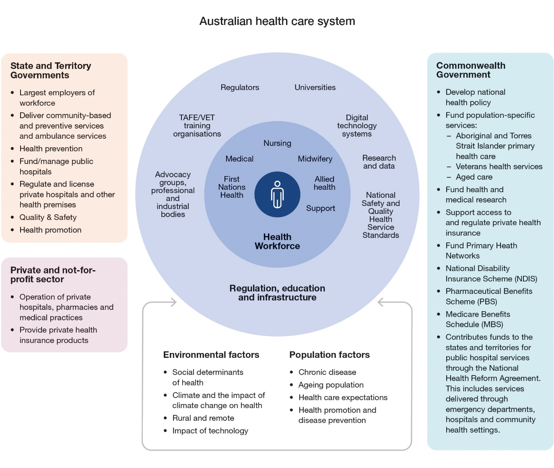

Appendix B – Development of the strategy
The strategy has been informed by extensive consultation and research, and its development has been guided by governance committees.
Figure 5. Overview of development of the National Nursing Workforce Strategy
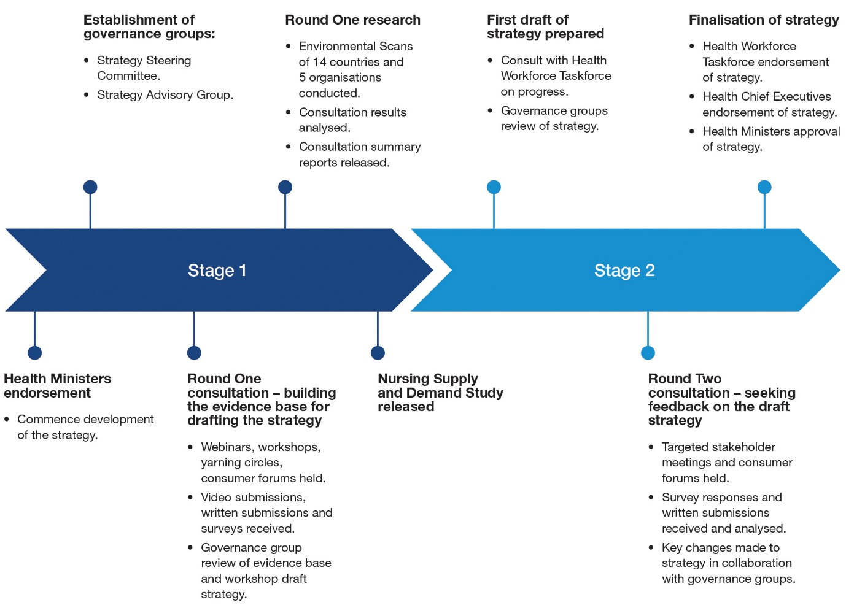

Stage One - Consultation and research
Extensive consultation was undertaken to understand current challenges facing the nursing workforce in Australia, what is working well and innovative solutions for the future. Stage One consultation included a range of virtual and in-person channels including webinars, workshops, yarning circles, video and written submissions, and surveys. A total of 5,995 stakeholders across the country participated and 1,169,336 data points were gathered. Additionally, 19 environmental scans and literature reviews were undertaken.
Figure 6. Breakdown of consultation activities.
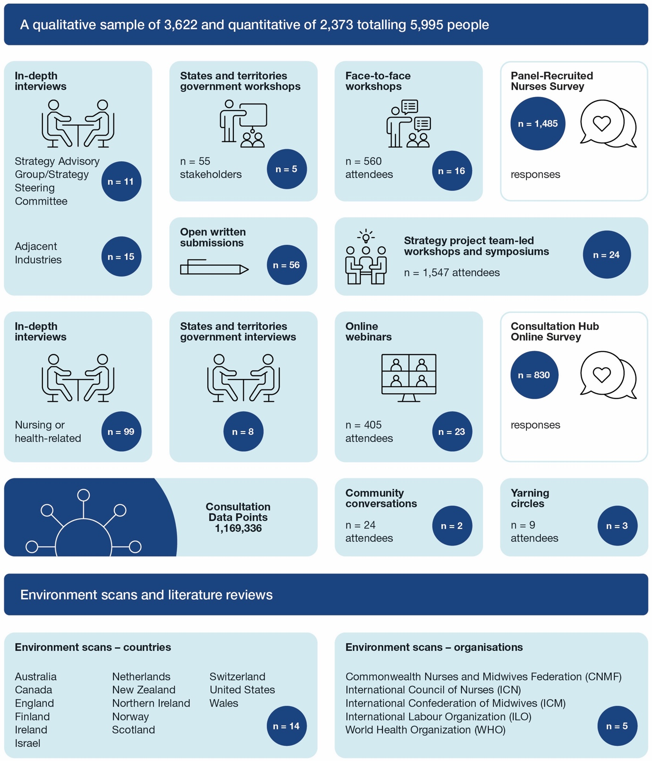
The outcomes from consultation as well as the evidence gathered through national and international environmental scans and literature reviews are available at: National Nursing Workforce Strategy webpage.

Key findings
- The findings from the public consultation are grouped into 13 key themes
(listed in no order):
- Planning for future workforce needs can be improved
- Perceptions about what nurses do are often outdated
- Continuing to recruit nurses is critical
- Retaining nurses is as important as attracting new ones
- Education and training can be improved
- Support during clinical placements needs to be bolstered
- Clear career progression is important for recruitment and retention
- Nurses’ roles and skills need to be optimised in line with changing community needs
- Supporting nurse leaders is important for positive workplaces
- Digital technologies will change the skills required of nurses
- Nurses in rural and remote areas face added challenges
- First Nations nurses face particular issues
- Supporting a diverse nursing workforce is important

Stage two – Drafting the strategy
The strategy was drafted using input from the extensive evidence base built in Stage One, and with guidance from the strategy governance groups.
Public consultation was held to seek feedback on the draft strategy. Stakeholders and interested members of the public were invited to provide feedback on the draft strategy via a survey or a written submission. 661 respondents engaged with the online survey and 62 written submissions were received.
Targeted meetings and webinars were held with 487 stakeholders. This included state and territory Chief Nursing and Midwifery Officers and their senior executives, professional bodies and organisations, government agencies and healthcare consumers. The feedback received informed key changes to the final strategy.

Strategy governance
A robust governance structure was developed to provide advice and strategic direction on the development of the strategy.
Table 4a. Overview of strategy governance – Commonwealth-State
Group | Membership | Accountabilities
Health Ministers Meeting (HMM) | Australian Government Minister for Health and Aged Care and state and territory government ministers responsible for health portfolios. | - Endorsement of strategy  - Determining governance arrangements
Health Chief Executives Forum (HCEF) | Chief executive officers from each Australian government health department. | - Consideration of strategy
Health Workforce Taskforce (HWT) | Officers from the Commonwealth, and all states and territories. | - Oversight of project
Strategy Steering Committee (SSC) | Chief Nursing and Midwifery Officer (CNMO)/Chief Nursing Officer from the Commonwealth and each Australian state and territory, as well as several specialists with expertise outside of nursing. | - Guiding the process towards a strategy that best meets the needs of the community, profession and service delivery providers
Table 4b. Overview of strategy governance – Other stakeholders/Non-Government
Group | Membership | Accountabilities
Strategy Advisory Group (SAG) | Co-Chairs: Commonwealth CNMO and Victorian CNMO; membership includes representatives from key stakeholder organisations with expertise in the nursing profession and nursing services. | - Providing advice to the SSC on key aspects of the nursing profession and nursing services
Table 5. Membership of the Strategy Steering Committee
Member | Role
Adjunct Professor (Practice) Alison McMillan PSM (co-chair) | Chief Nursing and Midwifery Officer, Australian Government Department of Health, Disability and Ageing
Adjunct Professor Karrie Long (co-chair) | Chief Nurse and Midwifery Officer, Victoria, Safer Care Victoria
Adjunct Associate Professor Jennifer Hurley | Chief Nurse and Midwifery Officer, South Australia
Ms Marina Buchanan-Grey (from 06/2024)  Mr Anthony Dombkins (05/2023 – 06/2024) | Chief Nursing and Midwifery Officer, Australian Capital Territory
Adjunct Professor Shelley Nowlan | Chief Nurse Officer, Queensland
Adjunct Associate Professor Kerrie Wilton (from 02/2025)  Ms Cheryl MacDonald (from 11/2024 – 02/2025)  Ms Mish Hill (05/2023 – 11/2024) | Chief Nursing and Midwifery Officer, Northern Territory
Dr Robina Redknap | Chief Nursing and Midwifery Officer, Western Australia
Ms Jacqui Cross PSM | Chief Nursing and Midwifery Officer, New South Wales
Associate Professor Francine Douce | Chief Nurse and Midwifery Officer, Tasmania
Professor Johanna Westbrook | Workforce Researcher
Professor James Buchan | Workforce Strategist
Professor Anthony Scott | Health Economist
Ms Miriam Spano | Systems Thinker
Table 6. Membership of the Strategy Advisory Group
Member | Organisation
Adjunct Professor (Practice) Alison McMillan PSM (co-chair) | Chief Nursing and Midwifery Officer, Australian Government Department of Health, Disability and Ageing
Adjunct Professor Karrie Long (co-chair) | Chief Nurse and Midwifery Officer, Victoria, Safer Care Victoria
Ms Kerri Gane (from 11/2023)  Ms Donna Bonney (05/2023 – 11/2023) | Catholic Health Australia
Dr Gabrielle Koutoukidis | National Enrolled Nurse Advisory Council
Ms Rebecca Badcock (from 07/2024)  Ms Jacqueline Nash (01/2024 – 07/2024)  Ms Wendy Zernike (06/2023 – 12/2023) | Aged and Community Care Providers Association
Professor Rhonda Wilson (from 02/2024)  Professor John Hurley (05/2023 – 02/2024) | Australian College of Mental Health Nurses
Ms Alison Weatherstone | Australian College of Midwives
Ms Leanne Boase | Australian College of Nurse Practitioners
Ms Karen Grace (from 06/2024)  Adjunct Professor Kylie Ward (05/2023 – 06/2024) | Australian College of Nursing
Ms Tanya Vogt (from 04/2024)  Adjunct Professor John Kelly (05/2023 – 04/2024) | Australian Nursing and Midwifery Accreditation Council
Ms Annie Butler | Australian Nursing and Midwifery Federation
Ms Mia Dhillon (from 10/2024)  Ms Karen Booth (05/2023 – 10/2024) | Australian Primary Health Care Nurses Association
Ms Jacquie Wiley | Australian Private Hospitals Association
Dr Ali Drummond | Congress of Aboriginal and Torres Strait Islander Nurses and Midwives
Ms Jo Root | Consumers Health Forum
Professor Karen Strickland | Council of Deans of Nursing and Midwifery
Captain John Kennedy (from 02/2025)  GRPCPT Kathryn Stein (06/2023 – 12/2024) | Defence Force Nursing
Ms Shannan Lewis (from 09/2024)  Dr Naomi Malouf (08/2023 – 09/2024)  Ms Katherine Isbister (05/2023 – 08/2023) | CRANAplus
Ms Carolyn Lees | Department of Veterans’ Affairs
Ms Alessandra Peck (from 02/2024)  Ms Annette Symes (07/2023 – 02/2024) | Nursing and Midwifery Board of Australia
Ms Deb Blow | Tafe Directors
Adjunct Professor Shelley Nowlan | Office of the National Rural Health Commissioner
Mr Paul Healey | Health Services Union

Appendix C – Definition of nurses and nursing
The Nursing and Midwifery Board of Australia (NMBA) regulates the practice of nursing in Australia by developing standards, codes and guidelines which together establish the requirements for the professional and safe practice of nurses. This includes students of nursing enrolled in a recognised nursing program.

Qualifications
The qualification to become an enrolled nurse (EN) is a Diploma of Nursing – minimum 18 months, gained in the vocational education sector such as TAFEs and private training organisations. To become a registered nurse (RN) requires a Bachelor of Nursing (degree) – three years, or Master of Nursing – two years, gained through higher education providers and registered training organisations at a university. To become a nurse practitioner (NP) requires registration as a RN and completion of a Master of Nurse Practitioner – minimum 18 months, gained at a university. The foundational education of a RN, EN and NP captures the breadth of the scope of the profession at graduate level.

Scope of practice
The scope of practice of individual nurses is influenced by the settings in which they practise and is not restricted to the provision of direct clinical care. Nursing practice extends to any paid or unpaid role where the nurse uses their nursing skills and knowledge. This includes working in a direct non-clinical relationship with clients, working in management, administration, education, research, advisory, regulatory, policy development roles or other roles that impact on safe, effective delivery of services in the profession and/or use of the nurse’s professional skills.

Registered nurse practice
RNs determine, coordinate and provide safe, quality nursing. This includes comprehensive assessment, development of a plan, implementation and evaluation of outcomes. As part of practice, RNs are responsible and accountable for supervision and the delegation of nursing activity to ENs and others.

Enrolled nurse practice
The EN works with the RN as part of the healthcare team. Core practice generally requires the EN to work under the direct or indirect supervision of the RN - which is critical for consumer safety. At all times, the EN retains responsibility for their actions and remains accountable in providing delegated nursing care.

Nurse practitioner practice
The NP scope of practice is built on the platform of the RN scope of practice. NPs can manage and are accountable for, complete episodes of care including wellness-focused care, as the primary provider of care or part of a care team. NPs can independently request and interpret any diagnostic and/or screening investigations within their scope of practice to facilitate diagnosis and/or screening processes. Care can include nursing interventions that involve initiation, titration or cessation of any medicines in their scope. NPs take responsibility for following up on any components of care initiated.

Assistant in nursing (AIN) practice
AINs have an important role in the delivery of nursing care. AINs work under the direction and supervision of ENs, RNs and NPs. AINs are part of the nursing career pathway as many go on to complete further study to become an EN or RN. These workers have various titles e.g. Personal Care Workers. NMBA regulation does not extend to AINs, however, those employed in aged care are subject to a Code of Conduct.

Sectors
Nurses work in many settings. For the supply and demand modelling completed by the Australian Government Department of Health, Disability and Ageing, nurses are assigned to a sector based on the individual respondents reported job role, job area and job setting in the annual survey at the time of renewal of annual registration. These sectors represent different healthcare settings. They are:
- Aged care nurses – provide care to older people in areas such as community settings, in-home settings, residential aged care facilities and hospitals.
- Acute care nurses – provide care to people with acute conditions predominantly in hospitals.
- Primary healthcare nurses – work in a variety of roles in non-hospital settings such as general practices, community health services and Aboriginal health services.
- Mental health nurses – provide care to people with mental ill health and disorders. They work in various settings including hospitals, community and residential health services, drug and alcohol services and correctional services.
- Other – includes all other nurses such as those working in education, government departments and professional associations.

References

World Health Organization (2016) Working for health and growth: investing in the health workforce. Report of the High-Level Commission on Health Employment and Economic Growth, World Health Organization, accessed 6 January 2025.
International Council of Nurses (ICN) (2024) International Nurses Day 2024, The economic power of care, International Council of Nurses, accessed 6 January 2025.
Britannica World Data Editors (2024) List of the world’s largest countries and dependencies by area, accessed 6 January 2025.
Australian Bureau of Statistics (June 2024) National, state and territory population, ABS website, accessed 6 January 2025.
Australian Institute of Health and Welfare (April 2024) Profile of Australia’s population, Australian Government, accessed 6 January 2025.
Australian Institute of Health and Welfare (April 2024) Profile of Australia’s population, Australian Government, accessed 6 January 2025.
Buchan J and Catton H (2023) Recover to rebuild. Investing in the nursing workforce for health system effectiveness, International Council of Nurses, accessed 6 January 2025.
Buchan J and Catton H (2023) Recover to rebuild. Investing in the nursing workforce for health system effectiveness, International Council of Nurses, accessed 6 January 2025.
Australian Institute of Health and Welfare (2024) Health workforce, Australian Government, accessed 6 January 2025.
Department of Health, Disability and Ageing (2025) Dashboard, Nursing and Midwifery Dashboards, Australian Government, accessed 6 January 2025.
Buchan J and Catton H (2023) Recover to rebuild. Investing in the nursing workforce for health system effectiveness, International Council of Nurses, accessed 6 January 2025.
Buchan J and Catton H (2023) Recover to rebuild. Investing in the nursing workforce for health system effectiveness, International Council of Nurses, accessed 6 January 2025.
International Council of Nurses (ICN) (2024) International Nurses Day 2024, The economic power of care, International Council of Nurses, accessed 6 January 2025.
Remes J, Linzer K, Singhal S, Dewhurst M, Dash P, Woetzel J, Smit S, Evers M, Wilson M, Rutter K and Ramdorai A (2020) Prioritizing health: A prescription for prosperity, McKinsey Global Institute, accessed 6 January 2025.
International Council of Nurses (ICN) (2024) International Nurses Day 2024, The economic power of care, International Council of Nurses, accessed 6 January 2025.
Cai L and Kalb G (2005) ‘Health status and labour force participation: evidence from Australia’, Health Economics 15(3), 241; DOI: 10.1002/hec.1053.
Remes J, Linzer K, Singhal S, Dewhurst M, Dash P, Woetzel J, Smit S, Evers M, Wilson M, Rutter K and Ramdorai A (2020) Prioritizing health: A prescription for prosperity, McKinsey Global Institute, accessed 6 January 2025.
Remes J, Linzer K, Singhal S, Dewhurst M, Dash P, Woetzel J, Smit S, Evers M, Wilson M, Rutter K and Ramdorai A (2020) Prioritizing health: A prescription for prosperity, McKinsey Global Institute, accessed 6 January 2025.
World Health Organization (2016) Working for health and growth: investing in the health workforce. Report of the High-Level Commission on Health Employment and Economic Growth, World Health Organization, accessed 6 January 2025.
Mannix, K (2021) The future of Australia’s nursing workforce: COVID-19 and burnout among nurses, The Future of Work Lab, University of Melbourne, accessed 6 January 2025.
Buchan J, Catton H, and Shaffer F (2022) Sustain and Retain in 2022 and Beyond. The global nursing workforce and the Covid-19 pandemic, International Council of Nurses, accessed 6 January 2025.
World Health Organization (WHO) (2020) State of the World’s Nursing 2020, World Health Organization, accessed 6 January 2025.
Department of Health, Disability and Ageing (2024) Dashboard, Nursing and Midwifery Dashboards, Australian Government, accessed 6 January 2025.
International Council of Nurses (ICN) (2024) International Nurses Day 2024, The economic power of care, International Council of Nurses, accessed 6 January 2025.
Royal College of Nursing (2020) Gender and Nursing as a Profession, Royal College of Nursing, accessed 6 January 2025.
Australian College of Nursing (ACN) (2021) Men in Nursing – Guiding Principles, Australian College of Nursing, accessed 6 January 2025.
Department of Health, Disability and Ageing (2024) Nursing Supply and Demand Study 2023-2035, Australian Government, accessed 6 January 2025.
Department of Health, Disability and Ageing (2024) Nursing Supply and Demand Study, Australian Government, accessed 6 January 2025.
Department of Health, Disability and Ageing (2024) 2020-2025 National Health Reform Agreement (NHRA), Australian Government, accessed 6 January 2025.
Australian Institute of Health and Welfare (2024) Health system overview, Australian Government, accessed 6 January 2025.
World Health Organization (WHO) (2021) The WHO Global Strategic Directions for Nursing and Midwifery (2021-2025), World Health Organization, accessed 6 January 2025.
International Council of Nurses (ICN) (2024) Publications and reports, International Council of Nurses, accessed 6 January 2025.
Department of the Prime Minister and Cabinet (2024) Covid-19 Response Inquiry Report, Australian Government, accessed 6 January 2025.
Department of Health, Disability and Ageing (2024) National Nursing Workforce Strategy Volume 1 Research Report, Australian Government, accessed 6 January 2025.
Department of Health, Disability and Ageing (2024) National Nursing Workforce Strategy Volume 1 Research Report, Australian Government, accessed 6 January 2025.
Department of Health, Disability and Ageing (2024) National Nursing Workforce Strategy Volume 2 Research Report, Australian Government, accessed 6 January 2025.
Schwartz, S (2019) Educating the Nurse of the Future—Report of the Independent Review into Nursing Education, accessed 6 January 2025.
Department of Health, Disability and Ageing (2024) National Nursing Workforce Strategy Volume 1 Research Report, Australian Government, accessed 6 January 2025.
Department of Education (2024) Australian Universities Accord Final Report, Australian Government, accessed 6 January 2025.
State of Victoria, Department of Health and Human Services (2020) Registered undergraduate student of nursing (RUSON) Employment and implementation guide, Victorian Government, accessed 6 January 2025.
Department of Health, Disability and Ageing (2024) National Nursing Workforce Strategy Volume 2 Research Report, Australian Government, accessed 6 January 2025.
Department of Health, Disability and Ageing (2024) Genetics and genomics, Australian Government, accessed 6 January 2025.
Australian College of Nursing (2020) Nurses, Genomics and Clinical Practice, accessed 6 January 2025.
Cormack M (2024), Unleashing the Potential of our Health Workforce - Scope of Practice Review - Final Report, accessed 6 January 2025.
Nursing and Midwifery Board of Australia (2016) Registered nurse standards for practice, Nursing and Midwifery Board of Australia, accessed 6 January 2025.
Cormack M (2024) Unleashing the Potential of our Health Workforce – Scope of Practice Review – Issues Paper 2, accessed 6 January 2025.
Department of Health, Disability and Ageing (2024) National Nursing Workforce Strategy Volume 2 Research Report, Australian Government, accessed 6 January 2025.
Cormack M (2024) Unleashing the Potential of our Health Workforce – Scope of Practice Review – Issues Paper 2, accessed 6 January 2025.
Department of Health, Disability and Ageing (2023) National Health and Climate Strategy, Australian Government, accessed 6 January 2025.
International Council of Nurses (2018) Nurses, climate change and health position statement, International Council of Nurses, accessed 6 January 2025.
Levett-Jones T., Bonnamy J, Cornish J, Correia Moll E, Fields L, Moroney T, Richards C, Tutticci N and Ward A (2024) ‘Celebrating Australian nurses who are pioneering the response to climate change: a compilation of case studies’, Contemporary Nurse, 60(3), 234–246; DOI: 10.1080/10376178.2024.2336230.
International Council of Nurses (2018) Nurses, climate change and health position statement, International Council of Nurses, accessed 6 January 2025.
International Council of Nurses (2021) The ICN Code of Ethics for Nurses, International Council of Nurses, accessed 6 January 2025.
Cummings G, Lee S, Tate K, Penconek T, Micaroni S, Paananen T and Chatterjee G (2021) ‘The essentials of nursing leadership: A systematic review of factors and educational interventions influencing nursing leadership’, International Journal of Nursing Studies, Volume 115, DOI: 10.1016/j.ijnurstu.2020.103842.
Department of Health, Disability and Ageing (2022) National Aboriginal and Torres Strait Islander Health Workforce Strategic Framework and Implementation Plan 2021-2031, Australian Government, accessed 6 January 2025.
Congress of Aboriginal and Torres Strait Islander Nurses and Midwives (2024) Submission to the Australian Government Department of Health and Aged Care National Nursing Workforce Strategy Consultation, Congress of Aboriginal and Torres Strait Islander Nurses and Midwives, accessed 6 January 2025.
Australian Institute of Health and Welfare (2025) Culturally and linguistically diverse Australians, Australian Government, accessed 6 January 2025.
Australian Human Rights Commission (2012) National Anti-Racism Strategy July 2012, Australian Human Rights Commission, accessed 6 January 2025.
Australian Human Rights Commission (2024) The National Anti-Racism Framework: A roadmap to eliminating racism in Australia, accessed 6 January 2025.
Curtis, E, Jones R, Tipene-Leach, D Walker C, Loring B, Paine S and Ried P (2019) ‘Why cultural safety rather than cultural competency is required to achieve health equity: a literature review and recommended definition’, International Journal for Equity in Health, 18(174); DOI: 10.1186/s12939-019-1082-3.
Laverty M, McDermott and Calma T (2017) ‘Embedding cultural safety in Australia’s main health care standards’, Medical Journal of Australia, 207(1), 15-16; DOI: 10.5694/mja17.00328.
Červený M, Kratochvílová I, Hellerová V and Tóthová V (2022) ‘Methods of increasing cultural competence in nurses working in clinical practice: A scoping review of literature 2011-2021’ Frontiers in Psychology, Volume 13; DOI: 10.3389/fpsyg.2022.936181.
Tang C, Tian B, Zhang X, Zhang K, Xiao X, Simoni JM and Wang H (2018) ‘The influence of cultural competence of nurses on patient satisfaction and the mediating effect of patient trust’, Journal of Advanced Nursing, 75(4):749-759; DOI: 10.1111/jan.13854.
Australian Institute of Health and Welfare (2015) Cultural competency in the delivery of health services for indigenous people, Australian Government, accessed 6 January 2025.
Kruk R (2023) Independent review of Australia’s regulatory settings relating to overseas health practitioners, accessed 6 January 2025.
Rasmussen P, Henderson A, McCallum J and Andrew N (2021) ‘Professional identity in nursing: A mixed method research study’, Nursing Education in Practice, Volume 52, March 2021; DOI: 10.1016/j.nepr.2021.103039.
Twigg D and McCullough K (2014) ‘Nurse retention: A review of strategies to create and enhance positive practice environments in clinical settings’, International journal of nursing studies, 51(1), 85-92; DOI: 10.1016/j.ijnurstu.2013.05.015.
Rodríguez-García M.C, Márquez-Hernández V.V, Belmonte-García T, Gutiérrez-Puertas L, and Granados-Gámez G (2020) ‘How magnet hospital status affects nurses, patients, and organizations: A systematic review’, AJN The American Journal of Nursing, 120(7), 28-38; DOI: 10.1097/01.naj.0000681648.48249.16.
Mihdawi M, Al-Amer R, Darwish R, Randall S and Afaneh T. (2020) ‘The influence of nursing work environment on patient safety’, Workplace health & safety, 68(8), 384-390; DOI: 10.1177/2165079920901533.
Pich J and Roche M (2020) ‘Violence on the job: the experiences of nurses and midwives with violence from patients and their friends and relatives’, Healthcare, 8(4), 522; DOI: 10.3390/healthcare8040522
World Health Organization (WHO) (2021) WHO guideline on health workforce development, attraction, recruitment and retention in rural and remote areas, World Health Organization, accessed 6 January 2025.
Department of Health, Disability and Ageing (2023) The National Rural and Remote Nursing Generalist Framework 2023–2027, Australian Government, accessed 6 January 2025.
Walsh S.M, Versace V.L, Thompson S.C, Browne L.J, Knight S, Lyle D.M, Argus G, Jones M (2023) ‘Supporting nursing and allied health student placements in rural and remote Australia: a narrative review of publications by university departments of rural health’, Medical Journal of Australia, 219(3 Suppl), s14-19; DOI: 10.5694/mja2.52032
Nursing and Midwifery Board of Australia (2024) Fact sheet: Scope of practice and capabilities of nurses, Nursing and Midwifery Board of Australia, accessed 6 January 2025.
Nursing and Midwifery Board of Australia (2016) Registered nurse standards for practice, Nursing and Midwifery Board of Australia, accessed 6 January 2025.
Nursing and Midwifery Board of Australia (2016) Enrolled nurse standards for practice, Nursing and Midwifery Board of Australia, accessed 6 January 2025.
Nursing and Midwifery Board of Australia (2021) Nurse practitioner standards for practice, Nursing and Midwifery Board of Australia, accessed 6 January 2025.
Department of Health, Disability and Ageing (2024) Nursing Supply and Demand Study 2023-2035, Australian Government, accessed 6 January 2025.

