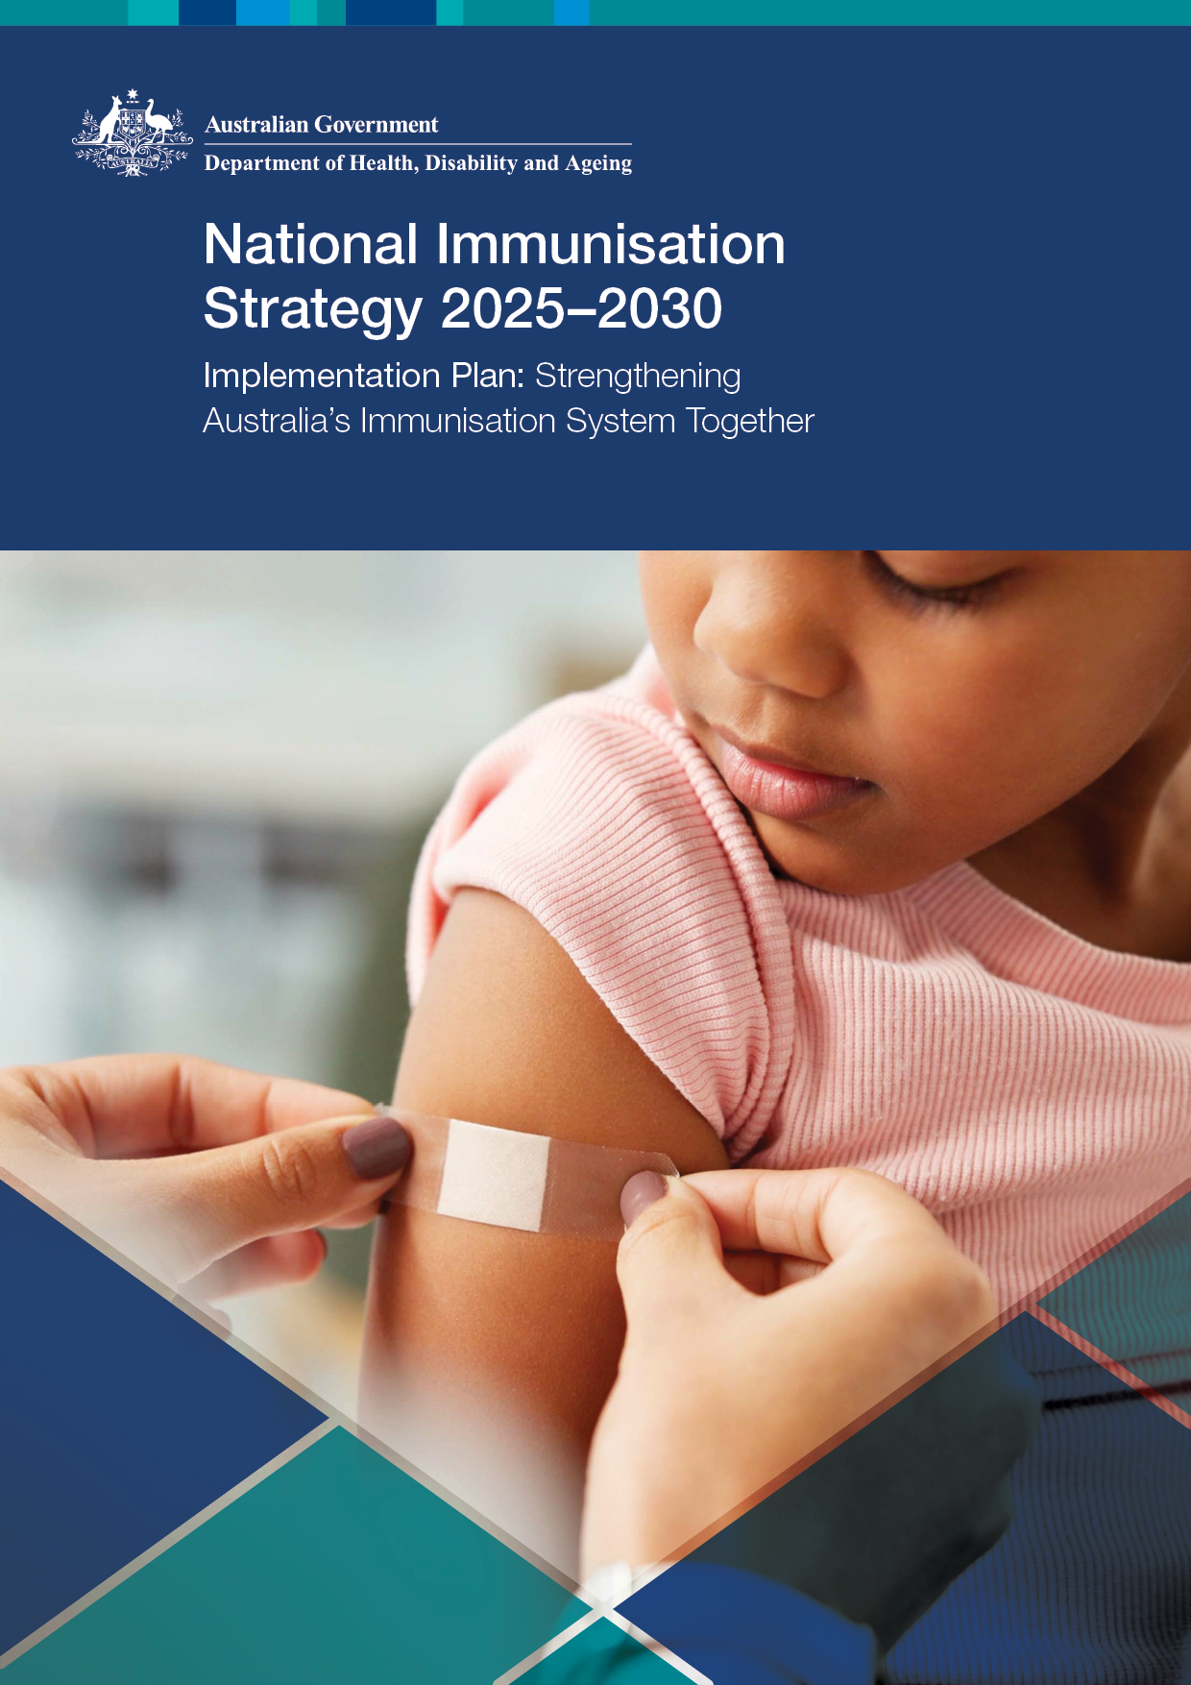
compen
Acknowledgement of Country
In the spirit of reconciliation, the Department of Health, Disability and Ageing acknowledges the Traditional Custodians of the Country throughout Australia and their connections to land, sea and community. We pay our respect to their Elders past and present and extend that respect to all Aboriginal and Torres Strait Islander peoples today.
Contents
01 Implementation Framework 5
A shared national commitment 6
The Implementation Plan 6
Vision, Mission, and Strategic Priorities 7
Vision 8
Mission 8
Strategic Priorities 8
Translating strategic intent into action 9
Purpose and scope of this plan 10
Foundational activities 10
Advanced activities 11
Strategic governance and advisory structures 12
Strategic governance 12
Advisory structures 13
National alignment through complementary planning 14
Roles and responsibilities 14
Commonwealth responsibilities 15
State and territory responsibilities 15
Shared responsibilities 16
Recognising the role of broader stakeholders 17
System implementation partners 17
Stakeholder engagement mechanisms 18
Monitoring, evaluation and learning 18
Maintaining momentum 19
02 Commonwealth and other Action Plans 20
National and jurisdictional action planning 21
Essential Vaccines Schedule NIS-aligned plans 21
State and territory immunisation strategies, action plans, and indicators 21
Commonwealth Action Plan: 2025-26 to 2026-27 and beyond 23
Commonwealth responsibilities 23
What is included in the Action Plan 23
Budget update 2026-27 24
Priority 1: Improve access to immunisation 25
Strategic focus 25
Context 25
Priority 2: Build trust, understanding and acceptance 29
Strategic focus 29
Context 29
Priority 3: Use data more effectively 33
Strategic focus 33
Context 33
Priority 4: Strengthen the immunisation workforce 36
Strategic focus 36
Context 36
Priority 5: Harness new technologies 38
Strategic focus 38
Context 38
Priority 6: Reform governance and delivery 40
Strategic focus 40
Context 40

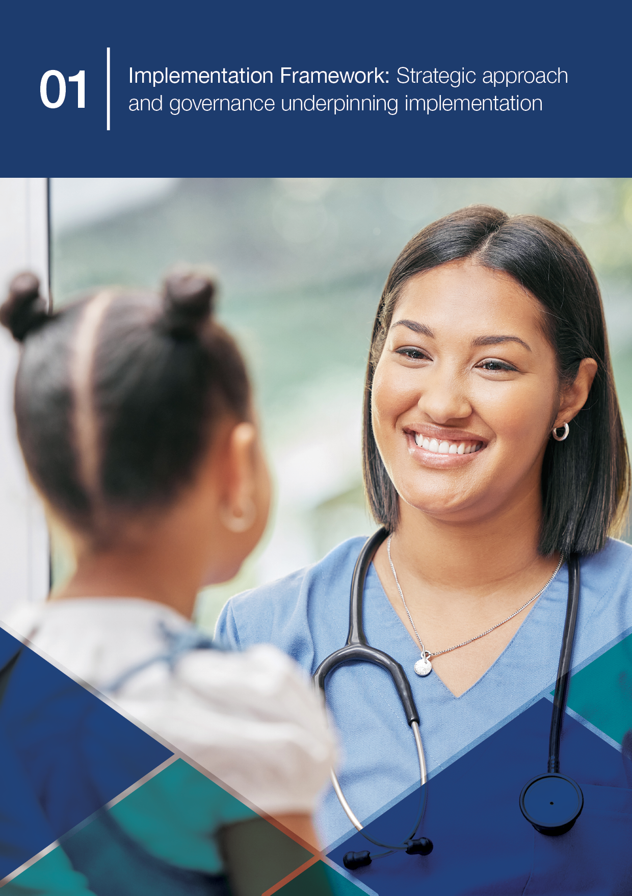

01 Implementation Framework

A shared national commitment
Immunisation protects people and communities from vaccine-preventable diseases and remains one of Australia’s most important public health interventions.
Sustaining and improving health protection through immunisation is reflected in Australia’s shared national commitment across governments, healthcare providers, communities and individuals. This collective effort is central to strengthening equity, maintaining confidence and ensuring our immunisation system can respond to current and future challenges.
The National Immunisation Strategy 2025–2030 (the Strategy) sets a bold vision for a healthier Australia through immunisation. Built around six Priority Areas, it provides a national framework for action and reflects the strengths, responsibilities and ambitions of all parts of the immunisation system.

The Implementation Plan
This Implementation Plan (the Plan) translates the Strategy’s vision into action. It comprises several components that guide implementation, monitoring, and reporting. It includes an Implementation Framework, an annual Commonwealth Action Plan, and links to monitoring and evaluation elements. These elements work together to operationalise strategic goals, track progress through defined indicators, and support annual public reporting.
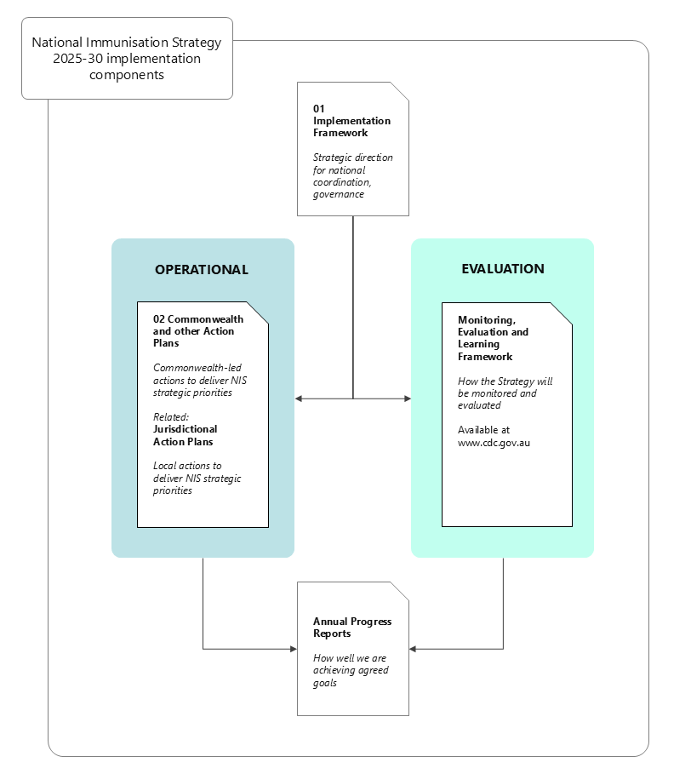
Figure 1. National Immunisation Strategy implementation components
The Plan focuses on current and evolving national activities led by the Commonwealth. It provides a foundation for coordinated progress toward achieving the priority areas and strategic goals of the Strategy. These include improving immunisation coverage, enhancing equity and access, strengthening system resilience, and supporting innovation and workforce capability.
In Part 2, the Plan provides an overview of key Commonwealth-led actions to support the Strategy. These actions are intended to contribute to long-term system improvement and shared accountability.

Vision, Mission, and Strategic Priorities
The Strategy is a forward-looking national framework developed through consultation with governments, expert bodies, healthcare providers, and community representatives. It acknowledges both the achievements and pressures facing our immunisation system.
Australia continues to maintain high immunisation coverage rates compared to other countries globally, reflecting strong programs and commitment within the sector. However, our system faces increasing complexity, persistent equity gaps, and the growing challenge of misinformation.

Vision
A healthier Australia through immunisation.

Mission
To reduce the impact of vaccine-preventable diseases through high uptake of safe, effective, and equitable immunisation across the lifespan.

Strategic Priorities
1 | Improve access and equity | Remove barriers and tailor approaches to ensure equitable access to vaccination, especially for those most at risk.
2 | Build trust and understanding | Foster public confidence and support informed decision-making through transparent communication and education.
3 | Use data more effectively | Strengthen data collection, analysis, and use to guide decisions and improve outcomes.
4 | Strengthen the immunisation workforce | Support and grow a skilled, diverse workforce to deliver high-quality immunisation services.
5 | Harness new technologies | Leverage innovation to improve vaccine delivery, monitoring, and engagement.
6 | Implement Sustainable Reform | Embed robust governance, delivery mechanisms, and accountability to ensure long-term success.
Implementation of our Strategy is aligned with the goals and priorities of a range of national and global strategies supporting improved health outcomes through increased vaccination coverage and disease control.
Domestically, our Strategy and Plan complement the objectives of the National Preventive Health Strategy 2021-2030 and the National Strategy for the Elimination of Cervical Cancer in Australia. These strategies prioritise immunisation as a key public health intervention.
Implementation activities also contribute to achievement of goals in the Fourth National Hepatitis B Strategy 2023-2030, the National Aboriginal and Torres Strait Islander Health Plan 2021-2031, and the National Agreement on Closing the Gap. They contribute by promoting equitable access to vaccines and strengthening culturally appropriate immunisation services.
Further, Australia’s Strategy aligns with broader global initiatives including the Immunization Agenda 2030 led by the World Health Organization, the UNICEF Immunization Roadmap to 2030, and disease-specific strategies such as the Polio Eradication Strategy 2022-2026.
These strategic linkages reinforce Australia’s commitment to a coordinated immunisation system grounded in evidence, equity, and continuous improvement that strengthens both national and global health security.

Translating strategic intent into action
The 2025-2030 Strategy marks a shift from broad strategic intent to operational delivery. Previous strategies, including the 2019-2024 framework, established important foundations by setting high-level goals to support providers, improve data systems, and promote equitable access. These principles remain central to Australia’s immunisation efforts and underpin this next phase of more targeted and accountable implementation.
The Plan is not a restatement of the Strategy’s Strategic Goals. It is a practical articulation of how those goals will be achieved, who will lead key activities, and what outcomes are expected. It reflects a system-wide commitment to:
- Action-oriented planning – supporting initiatives already funded, legislated, or in implementation, and identifying opportunities for new activities over time to address gaps.
- Clear accountability – through defined roles and measurable targets.
- Transparency and adaptability – enabling alignment across jurisdictions and responsiveness to future needs.
The Plan supports a coordinated national system that is practical, adaptive, and focused on long-term outcomes.

Purpose and scope of this plan

Foundational activities
Successful implementation of the Strategy will build upon foundational activities that ensure the continuity and effectiveness of Australia’s immunisation system. These functions are essential to maintaining the integrity of the National Immunisation Program (NIP) and provide the operational foundation for strategic reform and innovation.
Foundational activities include:
- Supporting vaccine registration and regulatory approvals through the Therapeutic Goods Administration (TGA), ensuring vaccines meet safety, quality, and efficacy standards before NIP consideration.
- Listing vaccines on the NIP following health technology assessment processes, ensuring publicly funded vaccines are clinically effective, safe, and cost-effective.
- Tendering for NIP vaccine supply to secure reliable, timely, and nationally equitable vaccine availability.
- Funding and purchasing vaccines for eligible populations, ensuring NIP vaccines are provided free for those who are eligible.
- Maintaining the Australian Immunisation Register (AIR), providing a comprehensive national record of vaccinations and supporting program implementation, monitoring, evaluation, and policy development.
- Facilitating Medicare Benefits Schedule (MBS) and other payments for General Practitioners (GPs), supporting GPs to deliver immunisation services in primary care settings.
- Monitoring vaccine safety through post-market surveillance, including analysis of adverse event reports and emerging safety signals by the TGA, to ensure ongoing safety and maintain public confidence.
- Providing routine clinical guidance and updates to immunisation providers to support consistent, evidence-based service delivery across the system.
- Maintaining and updating the NIP Schedule and eligibility criteria, to ensure consistent access and delivery across jurisdictions.
- Ensuring alignment with national health priorities and frameworks, by routinely integrating immunisation program activities with broader public health strategies to support cohesive and consistent national health delivery.
The Commonwealth Government leads these activities which are critical to the functioning of the Australian immunisation system. They ensure that vaccines are available, accessible, and administered safely, while enabling data-driven decision-making and continuous improvement.

Advanced activities
Foundational activities ensure the continuity and integrity of the NIP. Under Part 2 of this Plan, the Commonwealth Action Plan outlines strategic initiatives that extend beyond these core functions.
Examples include:
- NIP Vaccinations in Pharmacy (NIPVIP) Program to provide access to NIP vaccines through community pharmacies with no out-of-pocket costs.
- First Nations Vaccine Uptake Support Grant to increase antenatal, childhood and adult vaccination uptake for First Nations people attending Aboriginal Community Controlled Health Services (ACCHSs).
- Upgrading and modernising immunisation data systems to enhance the accuracy, accessibility, and integration of vaccination data across platforms.
These initiatives are designed to directly advance one or more goals and priority areas of the Strategy. Together, they build on the NIP’s established foundation to drive innovation, address emerging challenges, and realise the full ambition of the Strategy.
Foundational functions and the strategic initiatives outlined in the Commonwealth Action Plan represent a substantial investment in, and commitment to, Australia’s immunisation system. The estimated total Commonwealth funding allocated to support immunisation program activities is over $2.8 billion across four years from the commencement of the Strategy in 2025-26.
The Plan does not map all immunisation activities delivered across Australia. Instead, it complements jurisdictional efforts and provides a national mechanism for collaboration and shared accountability.
The Commonwealth Action Plan is a dynamic component of this Plan and will be reviewed and updated at least annually to reflect new Commonwealth investment and initiatives, progress, and completed actions. This may include any future co-designed activities, allowing the Plan to expand and evolve with implementation partners across the immunisation system.

Strategic governance and advisory structures
An integrated governance and advisory framework supports effective implementation of the Strategy, ensuring alignment, accountability, and responsiveness across all levels of the system. It connects decision-makers, experts, and stakeholders to guide strategic direction, monitor progress, and adapt to emerging needs.

Strategic governance
Established governance structures provide the leadership and coordination necessary to translate national immunisation priorities into action. These groups ensure that immunisation efforts are integrated with broader health objectives and that jurisdictions are supported in delivering locally tailored solutions.

Health Ministers’ Meeting (HMM)
The HMM provides high-level ministerial oversight of the Strategy, supporting national alignment, shared accountability and agreement on major policy directions.

Health Chief Executives Forum (HCEF)
The HCEF provides senior executive oversight of implementation, supporting intergovernmental coordination, alignment of effort across jurisdictions and shared accountability for progress.

Australian Health Protection Committee (AHPC)
The AHPC provides expert public health advice on communicable disease risks and health protection priorities relevant to the Strategy. Chaired by the Australian Government’s Chief Medical Officer and comprising Chief Health Officers from each jurisdiction, it supports clinically informed, nationally coordinated responses to emerging risks, and alignment with broader communicable disease control efforts.

Jurisdictions
State and territory governments lead local implementation of immunisation programs, tailoring service delivery, workforce support and community engagement to local needs while contributing to national alignment and shared accountability through established governance processes.

Advisory structures
Advisory structures provide expert advice and sector perspectives to shape implementation of the Strategy, strengthen collaboration and inform continuous improvement.

Strategic Reference Group (SRG)
The SRG provides independent strategic advice to support implementation of the Strategy and this Plan. Its role includes advising on planning priorities, alignment of immunisation activities with the Strategy’s six Priority Areas, stakeholder engagement, target setting, performance measurement, and monitoring and evaluation.
Membership includes:
- Commonwealth representatives, including from the Department of Health, Disability and Ageing and the Australian Centre for Disease Control (CDC)
- State and territory representatives
- Independent subject matter experts.
The SRG is an advisory body only and does not hold decision-making authority or operational responsibility. Its advice may inform Commonwealth and jurisdictional planning and investment decisions and positions progressed through formal intergovernmental processes.

NIS Implementation Forums
NIS Implementation Forums are periodic engagement mechanisms that bring together diverse stakeholders to identify barriers, emerging needs and opportunities to strengthen delivery. Their format and focus may evolve over the life of the Strategy to support implementation, respond to changing priorities and inform future planning.
The Department of Health, Disability and Ageing is responsible for leading implementation of the Strategy, including management of key advisory structures. The Australian CDC contributes through governance and advisory mechanisms, including the SRG, and leads the Strategy’s monitoring, learning and evaluation arrangements.

National alignment through complementary planning
The Strategy and implementation approach reflect Australia’s federated immunisation system, where each level of government develops Action Plans aligned to its roles and responsibilities. The Commonwealth leads national policy, funding, regulation, procurement and enabling systems, while states and territories lead local planning, service delivery, workforce support, community engagement and local public health responses. These roles are also reflected in the Essential Vaccines Schedule (EVS) to the Federation Funding Agreement – Health which supports the coordinated and effective delivery of the NIP and the Strategy.
This Plan outlines Commonwealth-led actions. State and territory action plans are developed independently to reflect local priorities, service delivery contexts, and population needs, while complementing the national approach. A version of jurisdictional action plans is submitted annually by states and territories as a Milestone under the EVS. Jurisdictions may choose to expand on EVS action plans in finalising annual implementation strategies and activities to support achievement of the Strategy’s goals.
Together, Commonwealth and jurisdictional action plans provide a practical mechanism for aligning effort across Australia’s immunisation system. They allow each government to focus on the activities most relevant to its role and local context, while contributing to shared national priorities and a coherent implementation approach.
This approach supports coordination without requiring uniform delivery. It recognises the distinct roles of governments, preserves flexibility for states and territories to respond to local needs, and provides a foundation for shared accountability over the life of the Strategy.

Roles and responsibilities
Australia’s immunisation system relies on clearly defined and complementary roles across Commonwealth, state and territory governments. Each level of government contributes distinct responsibilities, while working together to support nationally consistent, locally responsive immunisation outcomes.

Commonwealth responsibilities
Within the shared system, Commonwealth responsibilities centre on national settings, system stewardship and enabling functions, including:
- Developing national immunisation policy and managing the NIP to ensure consistency across jurisdictions.
- Leading Health Technology Assessment processes through the Australian Technical Advisory Group on Immunisation and the Pharmaceutical Benefits Advisory Committee to ensure access to safe, effective, and cost-effective vaccines on the NIP.
- Procuring and funding vaccines listed on the NIP, ensuring equitable access for all eligible populations.
- Providing MBS rebates to support immunisation service delivery by general practitioners and other authorised providers.
- Leading national consumer and health professional communication and education campaigns to promote public awareness and vaccine uptake.
- Driving research and innovation to strengthen immunisation systems, technologies, and practices.
- Monitoring vaccine safety through post-licensure surveillance by the TGA, including analysis of adverse event reports and emerging safety signals.
- Managing the AIR to maintain accurate and comprehensive national vaccination records.
- Monitoring immunisation coverage and performance to inform policy and program improvements.
The Commonwealth delivers these functions through a range of activities and improvement projects. Key system and program improvement actions are specifically detailed in Part 2 – Commonwealth and other Action Plans, which maps targeted activities to the Strategy’s priorities. The Commonwealth Action Plan is reviewed and updated regularly to reflect new or completed actions.

State and territory responsibilities
State and territory responsibilities focus on local planning, delivery and coordination within their jurisdictions, including:
- Delivering immunisation services through general practices, pharmacies, community clinics, and in-reach and outreach programs.
- Implementing school-based, state or territory, and other locally delivered immunisation initiatives tailored to community needs.
- Funding and managing additional immunisation programs beyond the NIP, including programs for specific populations or local priorities.
- Providing program updates and education to strengthen immunisation workforce capability.
- Ensuring local immunisation workforce compliance with reporting vaccination data to the AIR and local safety surveillance systems to support national monitoring.
- Engaging immunisation stakeholders and communities to promote culturally safe and accessible immunisation services.
- Leading outbreak responses and coordinating local public health actions in collaboration with national authorities.

Shared responsibilities
Shared responsibilities reflect areas where national consistency, local flexibility and coordinated action are needed to achieve the Strategy’s goals. These include:
- Jointly planning and setting priorities to align efforts across jurisdictions.
- Aligning and implementing any annual immunisation action plans that reflect both national and local contexts.
- Coordinating communication, public engagement, and education strategies to ensure consistent messaging and build public trust.
- Advancing Closing the Gap priorities by improving equitable access to immunisation for Aboriginal and Torres Strait Islander peoples and reducing the burden of vaccine-preventable disease.
- Facilitating equitable access for all priority populations, including culturally and linguistically diverse communities and people in rural and remote areas.
- Jointly developing and maintaining national standards and guidelines, including for vaccine storage and handling and cold chain management, to ensure safe and effective delivery across all settings.
- Collaborating on digital tools and innovations to improve immunisation delivery and monitoring.
- Building and maintaining shared monitoring and evaluation frameworks to assess performance and drive continuous improvement.

Recognising the role of broader stakeholders
Successful implementation of the Strategy depends on partners across the immunisation system, including healthcare providers, Primary Health Networks, community organisations, researchers, professional bodies and consumers. These stakeholders support delivery, strengthen community engagement, generate evidence and innovation, and help build public trust.

System implementation partners
- Healthcare professionals and providers, including general practitioners, nurses, pharmacists and Aboriginal and Torres Strait Islander Health Workers and Practitioners – promote and/or administer vaccines, engage with patients, their families and carers, and support data collection and reporting.
- Aboriginal Community Controlled Health Organisations and Aboriginal and Torres Strait Islander Health Services – deliver culturally safe immunisation services within comprehensive primary health care models, lead trusted community engagement, and inform culturally safe and effective immunisation policy and responses.
- Other service delivery organisations and settings, including general practices, community pharmacies, aged care providers and community clinics – support accessible immunisation services across primary care, community and residential settings.
- Community organisations – deliver culturally safe outreach, education, and support, especially for locally defined priority populations.
- Primary Health Networks – support local primary care engagement, provider communication, workforce capability and coordination between general practice, pharmacies, public health units and other immunisation stakeholders.
- Professional bodies, peak organisations, and training providers – support immunisation workforce development and training, standards, and advocacy.
- Consumers and community members (including consumer and priority population peak bodies) – share lived experience and insights to shape inclusive and responsive programs.
- Researchers, academic institutions and technical experts – provide evidence, evaluation, data insights, innovation and science communication expertise to strengthen immunisation systems and support clear, trusted information.

Stakeholder engagement mechanisms
Stakeholder engagement will inform implementation, review and continuous improvement through:
- NIS Implementation Forums – bringing together diverse perspectives, including lived experience, sector expertise and operational insights, to identify barriers, implementation priorities and opportunities for improvement.
- Consultation and co-design processes – including at the jurisdictional level, to support tailored approaches that reflect local contexts, community needs and the perspectives of priority populations.
- Review and learning processes – drawing on stakeholder feedback to understand what is working, identify emerging issues and inform future planning.
These mechanisms help ensure implementation remains grounded in community experience, informed by sector expertise and responsive to changing needs across the immunisation system.

Monitoring, evaluation and learning
Monitoring, evaluation and learning are essential to understanding whether national immunisation efforts are delivering meaningful, measurable and equitable outcomes. The Strategy is supported by a published Monitoring, Evaluation and Learning Framework, which provides guidance for how progress will be monitored, evaluated and shared over the life of the Strategy.
The framework sets out key evaluation questions, guiding principles, monitoring and evaluation activities, and arrangements for reporting and learning. It supports a nationally coordinated approach focused on system performance, equity, accountability and continuous improvement, while drawing on existing data sources and reporting processes where appropriate.
The Monitoring, Evaluation and Learning Framework for the National Immunisation Strategy for Australia 2025-2030 was developed by the Australian CDC in consultation with the Department of Health, Disability and Ageing, jurisdictions and immunisation experts, and endorsed through national immunisation governance processes.
Annual monitoring and learning processes will use the framework to track progress, identify emerging issues, inform future planning and support shared learning across governments, sectors and communities.

Maintaining momentum
This Plan establishes a practical platform for coordinated national action under the National Immunisation Strategy 2025-2030. It brings together current Commonwealth-led activities, governance arrangements, complementary planning processes and monitoring arrangements to support sustained progress over the life of the Strategy.
Implementation will continue to evolve as actions are delivered, new priorities emerge and evidence from monitoring, evaluation and stakeholder engagement is applied. The Commonwealth Action Plan is reviewed and updated regularly to reflect progress, completed activities and future investments, while annual monitoring and learning processes support transparency, shared accountability and continuous improvement.
Through sustained collaboration and a coordinated, adaptive and learning-focused approach, Australia can build on the strengths of its immunisation system while responding to changing community needs, persistent inequities, workforce and delivery pressures, and emerging public health challenges. This supports continued progress toward effective, equitable and trusted immunisation, and helps protect people and communities from vaccine-preventable diseases.

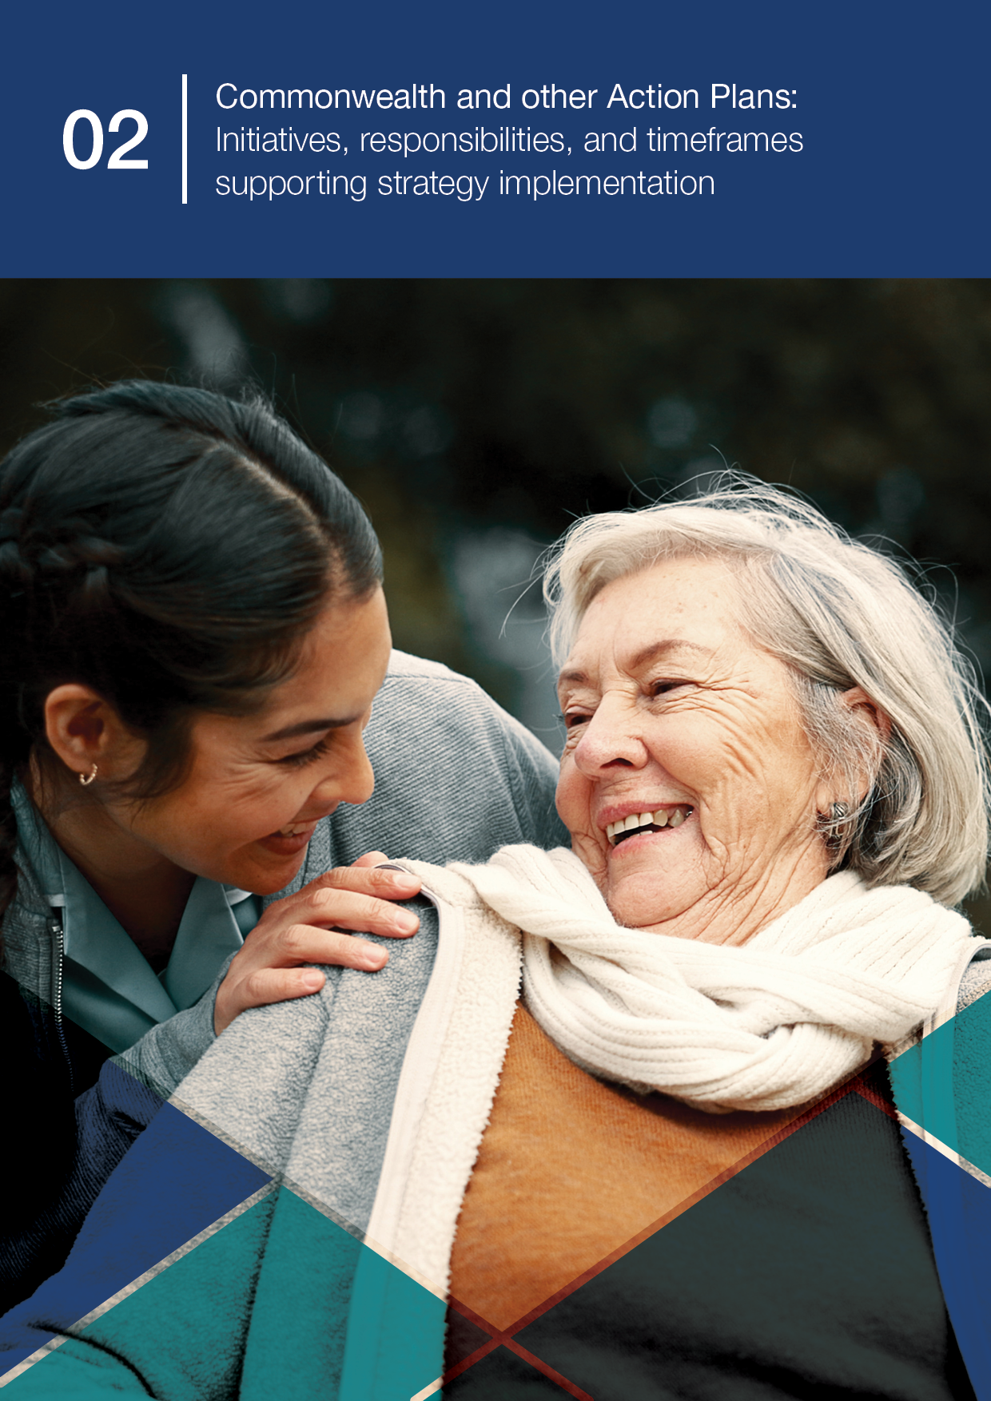
02 Commonwealth and other Action Plans

National and jurisdictional action planning
Part 2 of this Plan outlines Commonwealth-led actions that support implementation of the National Immunisation Strategy 2025–2030 (the Strategy). It should be read as one part of a broader national implementation approach in which all governments contribute to shared strategic priorities through actions aligned to their roles, responsibilities and local delivery contexts.
The Commonwealth Action Plan identifies current and planned activities led by the Australian Government, including national policy, funding, regulation, procurement, data systems, communication, program stewardship and other enabling functions.
State and territory governments lead local planning and delivery, including service models, workforce support, provider engagement, community partnerships, public health responses and initiatives tailored to local population needs. Jurisdictional planning occurs through a range of mechanisms.

Essential Vaccines Schedule NIS-aligned plans
Under the Essential Vaccines Schedule to the Federation Funding Agreement – Health, states and territories submit an annual NIS-aligned jurisdictional action plan as part of the agreed milestone process.
These submissions provide visibility of current and planned activities that contribute to the Strategy’s Priority Areas and Strategic Goals, and support intergovernmental alignment, monitoring and shared learning. They are designed as planning and accountability inputs within established government processes and are not required to be published.

State and territory immunisation strategies, action plans, and indicators
States and territories may also develop additional or adapted immunisation strategies, implementation plans, action plans, targets, indicators or progress reports. The form and timing of these products varies across jurisdictions, reflecting differences in local governance arrangements, existing strategies, population needs, service delivery models and planning cycles.
Some jurisdictions have published immunisation strategies or public-facing implementation material, while others use internal plans or EVS-aligned submissions to guide delivery and reporting.
This Plan does not reproduce jurisdictional action plans or provide a point-in-time catalogue of state and territory strategies. Jurisdictional plans are developed and maintained through separate state and territory processes and may change as priorities, funding, program settings and local circumstances evolve. Instead, this Plan describes the complementary planning approach that supports national alignment while preserving local flexibility.
Together, the Commonwealth Action Plan, jurisdictional EVS-aligned planning and any additional state and territory strategies or implementation/action plans provide a practical mechanism for coordinated action across Australia’s immunisation system.
This approach supports shared accountability for the Strategy’s goals without requiring uniform delivery. It enables each government to focus on the activities most relevant to its role and context, while contributing to national priorities, monitoring, evaluation and continuous improvement over the life of the Strategy.

Commonwealth Action Plan: 2025-26 to 2026-27 and beyond
The Commonwealth Action Plan sets out targeted Commonwealth-led initiatives that support implementation of the Strategy.
It focuses on activities that advance the Strategy’s Priority Areas and Strategic Goals, while recognising that these complement the Commonwealth’s ongoing responsibilities for national policy, program stewardship, vaccine procurement, safety monitoring, data management, health technology assessment and enabling systems.

Commonwealth responsibilities
Consistent with Part 1, the Commonwealth’s foundational responsibilities include:
- Developing national immunisation policy and managing the NIP
- Leading Health Technology Assessment processes
- Procuring and funding vaccines listed on the NIP
- Providing Medicare Benefits Schedule (MBS) rebates and other payment arrangements
- Leading national consumer and health professional communication and education campaigns
- Driving research and innovation
- Monitoring vaccine safety through post-licensure surveillance, including analysis of adverse event reports and emerging safety signals
- Managing the Australian Immunisation Register (AIR)
- Monitoring immunisation coverage and performance.
The initiatives that follow build on these foundational responsibilities.

What is included in the Action Plan
The Action Plan includes initiatives that are funded, legislated, in delivery, or sufficiently progressed to support implementation of the Strategy. Some are time-limited projects, while others are ongoing or recurrent activities that contribute to the Strategy over multiple years.
The tables in this section identify each initiative, its intended contribution to the Strategy, current timeframe and implementation status. Status updates are included at a high level to support transparency, monitoring and learning, not to duplicate detailed project reporting or existing program governance processes.
The Action Plan is cumulative and adaptive, and will be reviewed and updated at least annually to reflect progress, completed actions, continuing activities, new investments, emerging priorities and additional Commonwealth-led initiatives as they are agreed and funded or commence implementation.

Budget update 2026-27
The 2026-27 Budget included new investment of $41.2 million over four years under the measure Improving Access to and Uptake of Medicines and Vaccines for three National Immunisation Program measures that support implementation of the Strategy.
These measures include expansion of NIP Vaccination in Pharmacy Program payments for vaccinations given to children under 5 years, an enhanced childhood immunisation campaign, and Australian Immunisation Register SMS reminders for overdue childhood vaccinations.
These activities have been incorporated into the Commonwealth Action Plan under the relevant Priority Areas and will be updated as implementation progresses.

Priority 1: Improve access to immunisation

Strategic focus
Improve access to immunisation, with a focus on equity for Aboriginal and Torres Strait Islander people and other priority populations.

Context
Despite Australia’s high vaccination coverage overall, inequities remain. These include lower vaccination coverage rates among Aboriginal and Torres Strait Islander people, culturally and linguistically diverse (CALD) communities and people living in rural and remote areas.
National efforts must improve equity in immunisation access by supporting community-led approaches, improving data collection and use to identify and respond to inequities, and ensuring services are culturally safe and accessible for all.
Initiative | Description | Lead/ delivery partner(s) | Timeframe | Implementation status | Progress update | Intended outcome(s) | Related Strategic Goal(s)
1.1 National Vaccination Insights Project | Deliver the National Vaccination Insights project. This project will generate routine, systematic data and insights on vaccination barriers and drivers to inform strategies to improve vaccination uptake in different populations across Australia. | Lead: Department of Health, Disability and Ageing (DHDA)  Delivery partner (contract manager): Australian CDC | 2025-26 to 2026-27 | In progress | National findings on barriers and drivers of childhood, childhood influenza and adult influenza vaccination have been published and disseminated through research summaries, peer-reviewed publications and sector forums. The project is expanding to adolescent vaccination and provider-level barriers. Access the findings at ncirs.org.au. | Contemporary, nationally representative understanding of vaccination barriers and drivers across population groups, strengthening the evidence base for targeted strategies to improve uptake. | G1 – Partner with communities to understand barriers  G4 – Consider additional evidence-informed targets  G7 – Track community sentiment  G12 – Integrate/report timely data on diseases, coverage, safety, social/behavioural insights
1.2 NIP Vaccination in Pharmacy (NIPVIP) Program including expansion to children under 5 | Continuation of the NIP Vaccination in Pharmacy Program (NIPVIP), providing access to NIP vaccines for eligible people through community pharmacies with no out-of-pocket costs. This item includes expansion of eligibility to remove out-of-pocket costs for NIP vaccinations to children under 5 years, where permitted by state and territory legislation. | Lead: DHDA  Delivery partners:  - Pharmacy Programs Administrator (Australian Healthcare Associates)  - Pharmaceutical Society of Australia (PSA)  - Australian Pharmacy Council | Ongoing.  Expansion funded from 2026-27 to 2028-29. | Existing initiative in delivery.  Expansion planned to commence 1 January 2027. | 4,939 pharmacies registered in the program at 30 June 2026. NIPVIP pharmacies administered over 1.2 million NIP doses in the 12 months to 30 June 2026. Expansion to under 5s represents new activity added in the 2026-27 update. | Improved access to NIP vaccinations for eligible groups through expanded service delivery settings and removal of cost barriers. | G2 – Innovative service delivery to increase equitable immunisation access  G3 – Ensure vaccine access and uptake to reach national targets  G14 – Embed immunisation in preventive healthcare  G23 – Strengthen collaboration between governments to deliver NIP vaccines
1.3 Maintain, coordinate, and chair a National Aboriginal and Torres Strait Islander Immunisation Leadership Committee (formerly Advisory Group) | Establish and maintain a National Aboriginal and Torres Strait Islander cultural governance group. The Aboriginal and Torres Strait Islander Immunisation Leadership Committee will provide cultural and technical expertise, advice and advocacy at all stages of initiatives to inform current and future immunisation research, policy, programs and evaluation. This is a deliverable under Departmental current contract with the National Centre for Immunisation Research and Surveillance (NCIRS). | NCIRS | 2025-26 to 2026-27 | Ongoing | The NCIRS’ National Aboriginal and Torres Strait Islander Immunisation Leadership Committee meets bi-monthly with the inaugural face to face Group meeting held on 29 August 2025. Membership has grown to incorporate representation from jurisdictions, services, professional streams and community representatives. As of 31 December 2025, the Committee had 37 Aboriginal and/or Torres Strait Islander members and 4 non-Indigenous allies. Several members are contributing as investigators to various NCIRS projects. | Aboriginal and Torres Strait Islander cultural governance embedded into immunisation research and policy.  Improved trust, cultural safety, and vaccination uptake among Aboriginal and Torres Strait Islander peoples. | G1 – Partner with communities to understand barriers  G3 – Ensure vaccine access and uptake to reach national targets
1.4 First Nations Vaccination Uptake Support Grant | Deliver the First Nations Vaccine Uptake Support Grant to increase antenatal, childhood and adult vaccination uptake for First Nations people attending Aboriginal Community Controlled Health Services (ACCHSs).  Evaluate the Grant Program’s objectives and outcomes via an independent evaluation consultant. The evaluation is an opportunity to identify ongoing support opportunities to enhance policy and program design to address First Nations vaccination access and uptake rates. | Lead: DHDA  Delivery partner (grant): NACCHO  Delivery partner (evaluation): Nous Group | 2025-26 to 2026-27 | In delivery | 124 ACCHSs have commenced culturally safe, locally tailored vaccination initiatives, with training provided to local staff.  Additionally, the National Aboriginal Community Controlled Health Organisation (NACCHO) has strengthened immunisation capability and vaccination confidence across the sector through the delivery of targeted communications and activities to support Aboriginal Community Controlled Health Organisations with accessible, evidence-based information. | Increase vaccination rates in ACCHS that receive funding, resulting in lower vaccine preventable diseases.  Increase the number of staff in ACCHS trained to provide immunisation.  Increase the capacity of immunisation staff confident to deliver antenatal, childhood and adult immunisations.  Increase community-led and targeted immunisation messaging.  Increase ACCHS’ delivery of outreach services and targeted recall activities. | G1 – Partner with communities to understand barriers  G3 – Ensure vaccine access and uptake to reach national targets  G14 – Embed immunisation in preventive healthcare  G16 – Support First Nations health workforce contributions
1.5 Residential Aged Care Respiratory Vaccine Action Plan | Implement a Residential Aged Care Respiratory Vaccine Action Plan to support the sustained drive of respiratory vaccinations.  The Action Plan focuses on activities that enhance access, generate demand, and improve transparency to address key barriers. It includes key vaccinations COVID-19, Influenza, Shingles, Pneumococcal and RSV. | Lead: DHDA  Delivery partners:  Aged Care Safety & Quality Commission | Yearly | Ongoing | 2026 Residential Aged Care Respiratory Vaccine Action Plan agreed at the Ministerial level. Action Plan will continue to be reviewed through annual planning and monitoring processes, including the Action Plan’s specified activities. | Increased access, demand, uptake, and transparency of key respiratory vaccinations in aged care facilities. | G1 – Partner with communities to understand barriers  G2 – Innovative service delivery to increase equitable immunisation access  G4 – Consider additional evidence-informed targets
1.6 Identify barriers to vaccine consent in residential aged care settings | Conduct research into the structural, behavioural, and motivational barriers to vaccine consent and uptake in residential aged care settings. | DHDA | 2025-26 | Completed | Final report, including relevant findings and recommendations, delivered in 2025-26. Findings and recommendations have been disseminated to relevant stakeholder groups and are informing future planning and implementation of residential aged care vaccination activities. | Contemporary understanding of barriers to vaccine consent in residential aged care, with clear suggestions on activities to improve consent pathways. | G1 – Partner with communities to understand barriers  G5 – Engage to build trust/ combat misinformation

Priority 2: Build trust, understanding and acceptance

Strategic focus
Build trust, understanding and acceptance of immunisation in communities.

Context
Confidence in immunisation is high in Australia, but misinformation and disinformation can undermine trust. Communities and individuals may face different concerns depending on their experiences, cultural backgrounds, and information environments.
There is a need for clear, accurate, and respectful communication tailored to specific communities, and greater involvement of community voices in immunisation program design. The Strategy emphasises building relationships, supporting trusted messengers, and investing in research to understand drivers of trust and hesitancy.
Initiative | Description | Lead/ delivery partner(s) | Timeframe | Implementation status | Progress update | Intended outcome(s) | Related Strategic Goal(s)
2.1 Community-based outreach – Expos and networks | Deliver targeted, culturally appropriate communication and outreach initiatives, including through expos, multicultural networks, and community-led engagement. | DHDA | 2025-26 to 2026-27 | Ongoing | The childhood, maternal, and winter vaccination for older adults campaigns ran until 30 June 2026. CALD public relations experts were engaged to design and deliver culturally appropriate communications and activities. Materials were translated in up to 14 priority languages and disseminated across targeted communications channels including multicultural radio, TV and social media apps. Local engagement activities included attendance at multicultural events and facilitation of community-led information and education sessions. Campaign evaluation will take place in September 2026 and work is underway to plan new campaigns which will deliver ongoing activities. | Build trust, share accurate vaccine information, and improve immunisation uptake among CALD, hard-to-reach, and underserved populations. | G1 – Partner with communities to understand barriers  G5 – Engage to build trust/ combat misinformation  G6 – Strengthen community partnerships for tailored strategies  G7 – Track community sentiment
2.2 First Nations-led co-designed education initiatives | Partner with select communities to co-design culturally safe and tailored vaccine education initiatives and materials. This activity aims to support culturally safe education and vaccine acceptance, and improved uptake for Aboriginal and Torres Strait Islander communities.  Routinely engage with the National Aboriginal Community Controlled Health Organisation (NACCHO) seeking feedback on activities to increase vaccine access for Aboriginal and Torres Strait Islander communities. | DHDA  Delivery partner: NACCHO | 2025-26 to 2026-27 | In delivery | Initiative 1.4 refers. | Community-led education and improved acceptance, access, and uptake for Aboriginal and Torres Strait Islander people. | G1 – Partner with communities to understand barriers  G5 – Engage to build trust/ combat misinformation  G6 – Strengthen community partnerships for tailored strategies  G16 – Support First Nations health workforce contributions
2.3 SKAI for Consumers | Deliver and expand the Sharing Knowledge About Immunisation (SKAI) platform to provide accessible, evidence-based information and communication tools for consumers.  Access at skai.org.au. | Delivery partner (contract manager): Australian CDC  Delivery partner: NCIRS – Social Science Unit | 2025-26 to 2026-27 | In progress | The SKAI platform continues to provide accessible, evidence-based resources across pregnancy and newborn, childhood and adolescent vaccination. Adolescent resources are now available, including information for parents and carers and guidance on school-based vaccination. Adult resources are in development, with planning underway for an aged care expansion. | Informed vaccine decision-making through supportive, trusted conversations between consumers and healthcare professionals. | G1 – Partner with communities to understand barriers  G5 – Engage to build trust/ combat misinformation  G6 – Strengthen community partnerships for tailored strategies
2.4 Maternal Vaccination Schedule | Deliver a co-designed vaccination schedule and relevant resources to support understanding and acceptance of maternal vaccination.  The project will also deliver proposed implementation approaches to integrate the maternal vaccination schedule in the health sector and broader community, alongside an online web tool for consumers and providers to create customised schedules for pregnant women depending on their individual needs and circumstances. | Lead: Monash University | 2025-26 to 2027-28 | In progress | Initial work to undertake stakeholder mapping, stakeholder interviews and workshops has been completed. | Improved confidence of pregnant women and their families in the increasingly complex maternal vaccination landscape.  Health professionals equipped and confident to provide timely and appropriate vaccination guidance during pregnancy. | G1 – Partner with communities to understand barriers  G5 – Engage to build trust/ combat misinformation  G6 – Strengthen community partnerships for tailored strategies
2.5 Enhanced information strategies to counter misinformation | Build public trust and understanding of vaccination by improving the accessibility and clarity of immunisation information, addressing misinformation, and supporting health professionals with evidence-based resources.  This project consolidates multiple activities focused on content enhancement, stakeholder engagement, and strategic communication. | Lead: DHDA  Delivery partners: Australian Academy of Science and other academies, and technical science communication partners. | 2025-26 to 2026-27 | Ongoing | The childhood, maternal and winter vaccination for older adults campaigns ran until 30 June 2026. Campaigns aimed to promote and encourage uptake of vaccines through providing information, education and advice on immunisation to the public.  Current activities to improve immunisation information include review and update of the Questions About Vaccination resource, and enhancements to the department’s immunisation webpages. Future work links to planned expansion of the Sharing Knowledge About Immunisation (SKAI) website (initiative 2.3) and further research into barriers to uptake of vaccines (initiative 1.1). | Improved public access to clear, accurate, and culturally appropriate immunisation information. Strengthened public trust in vaccination.  Health professionals better equipped and more confident in addressing vaccine-related concerns.  Enhanced collaboration with scientific and research bodies to inform future strategies. | G5 – Engage to build trust/ combat misinformation  G6 – Strengthen community partnerships for tailored strategies  G8 – Strengthen skills of immunisation providers to support vaccination choices
2.6 Enhanced Childhood Immunisation Campaign | Deliver an enhanced childhood immunisation campaign targeting parents and carers of children aged 0-5 years. The campaign will include new materials and strategies to address barriers to timely childhood vaccination, build confidence and support informed decision-making. Tailored approaches will be developed for priority audiences, including First Nations families and culturally and linguistically diverse communities. | Lead: DHDA  Delivery partners may include creative, media, research and multicultural communication agencies, First Nations and community partners, clinical and behavioural science experts, and state and territory governments. | 2026-27 to 2029-30 | Planned | New activity announced in the 2026-27 Budget. | Increased awareness, confidence and motivation among parents and carers to vaccinate children on time according to NIP Schedule. Improved access to clear, trusted and tailored information about childhood vaccination. Support for improved childhood immunisation uptake, including among First Nations and multicultural communities. | G1 – Partner with communities to understand barriers.  G5 – Engage to build trust/ combat misinformation.  G6 – Strengthen community partnerships for tailored strategies.  G7 – Track community sentiment.

Priority 3: Use data more effectively

Strategic focus
Use data more effectively to target immunisation strategies and monitor performance.

Context
Data and evidence are essential for a responsive, equitable and high-performing immunisation system. However, data systems are fragmented, with variable capacity across jurisdictions and gaps in access to timely, linked, and actionable information.
Improving how immunisation data is collected, shared, and used will enable more effective service planning, delivery, and evaluation. This includes better integration of data across sectors and the use of linked data to identify under-immunised populations and areas of low coverage. The Strategy calls for nationally coordinated investment in data infrastructure, analytics, and equity monitoring.
Initiative | Description | Lead/ delivery partner(s) | Timeframe | Implementation status | Progress update | Intended outcome(s) | Related Strategic Goal(s)
3.1 Data Governance Review | Conduct a comprehensive review and update of policies and procedures governing immunisation data access, authorisation, and release. This activity aims to strengthen data governance frameworks to ensure secure, ethical, and efficient use of immunisation data. | DHDA | 2025-26 | Completed | The AIR Data Governance Review has been completed, identifying opportunities to strengthen data access, release and management processes. Governance documentation and procedures have been enhanced to support more transparent and consistent use of immunisation data. | Improved transparency, stakeholder confidence, and alignment with national privacy and data-sharing standards. | G9 – Improve completeness and transparency of AIR data for optimal quality and utility  G11 – Expand data linkage for better program monitoring  G12 – Integrate/report timely data on diseases, coverage, safety, social/behavioural insights  G25 – Standardise M&E of vaccine programs to improve outcomes
3.2 Data Modernisation Project | Upgrade and modernise immunisation data systems to enhance the accuracy, accessibility, and integration of vaccination data across platforms. | DHDA | Oct 25 – Feb 26 | Completed | The Immunisation Data Modernisation Program delivered a suite of public immunisation dashboards, improving access to AIR data and increasing transparency of immunisation information to support evidence-informed decision-making. Access the dashboards at: health.gov.au/topics/immunisation/immunisation-dashboards | Improved data quality and accessibility for more accurate targeting and monitoring of immunisation efforts. | G9 – Improve completeness and transparency of AIR data for optimal quality and utility  G10 – Creation of comprehensive dashboard of coverage data  G11 – Expand data linkage for better program monitoring  G12 – Integrate/report timely data on diseases, coverage, safety, social/behavioural insights
3.3 Integrated National Forecasting Model | Integrate a national forecasting model with current AIR data, digital tools (e.g. the VAS), and predictive analytics to support vaccine procurement, distribution, and program planning. | DHDA | 2025-26 to 2026-27 | In progress | Project build commenced in 2025-26, with testing and final integration into the VAS to continue in 2026-27. | Improved responsiveness to demand fluctuations, seasonal trends, and emergency scenarios. | G11 – Expand data linkage for better program monitoring  G19 – Strengthen program preparedness for new vaccines and technologies  G23 – Strengthen collaboration between governments to deliver immunisation programs
3.4 Public Health Data Network | The Public Health Data Network is the federated data ecosystem of linkage-ready datasets.  The Australian CDC is focused on stewardship of the foundational analytical architecture that enables the Australian CDC and partners to use linked data to evaluate priority vaccination projects. | Australian CDC  Australian Bureau of Statistics (ABS)  Australian Institute of Health and Welfare (AIHW) | Implementation of Data Network Phase 1: 2025-26  Phase 2 and Phase 3 delivered incrementally over the next 3-5 years. | In progress | The Australian Centre for Disease Control Act 2025 came into effect on 1 January 2026. This includes a range of authorisations to optimise the coherence and effectiveness of data for public health purposes.  A Public Health Data Network Pilot is underway in collaboration with the Australian Institute of Health and Welfare to progress linkage of notifiable disease case data to the National Health Data Hub. | Improved data accessibility and vaccine policy decision-making. | G11 – Expand data linkage for better program monitoring  G12 – Integrate/report timely data on diseases, coverage, safety, social/behavioural insights  G18 – Build expertise across the immunisation workforce in all areas, including communications.  G23 – Strengthen collaboration between governments to deliver immunisation programs
3.5 Systems for monitoring coverage and access – Aged Care and other groups | Establish systems to monitor coverage and access (including barriers) in Aged Care settings and for other priority groups, as required. This activity aims to improve vaccination program implementation in aged care settings and for vulnerable populations. | DHDA | 2025-26 to 2026-27 | In progress | A public dashboard is under development to monitor coverage and access to vaccinations in each residential aged care facility. Further exploration for monitoring other priority groups is also underway. | Improved program monitoring to support access for priority groups. | G3 – Ensure vaccine access and uptake to reach national targets  G9 – Improve AIR data to ensure quality and utility  G11 – Expand data analysis and reporting for program monitoring  G12 – Integrate/report timely data on diseases, coverage, safety, social/behavioural insights
3.6 AIR SMS reminders for childhood vaccinations | Implement AIR SMS reminders to parents and carers for childhood vaccinations. The measure will use AIR data to support nationally consistent, data-informed reminder activity and prompt timely follow-up for childhood immunisation. | Lead: DHDA  Delivery partner: Services Australia | 2026-27 to 2029-30 | Planned implementation from 1 March 2027. | New activity announced in the 2026-27 Budget. | Strengthened practical use of AIR data to support targeted reminder activity, reduce missed or delayed vaccinations, and contribute to improved childhood immunisation coverage. | G3 – Ensure vaccine access and uptake to reach national targets  G9 – Improve AIR data to ensure quality and utility

Priority 4: Strengthen the immunisation workforce

Strategic focus
Strengthen the immunisation workforce.

Context
Australia’s immunisation workforce includes nurses, general practitioners, Aboriginal and Torres Strait Islander Health Workers and Practitioners, pharmacists, public health professionals, and others. While established, the workforce faces increasing pressures due to complexity, demand, and evolving technologies.
The Strategy recognises the need to build workforce capacity, capability, and confidence to deliver safe, accessible, and culturally appropriate immunisation services. Investment in training, support, and innovative models of care is required to strengthen and sustain the immunisation workforce.
Initiative | Description | Lead/ delivery partner(s) | Timeframe | Implementation status | Progress update | Intended outcome(s) | Related Strategic Goal(s)
4.1 SKAI for Health Professionals | Deliver and enhance the SKAI platform for health professionals, including CPD-accredited eLearning modules. Access at skai.org.au/healthcare-professionals.  The platform aims to strengthen provider confidence, communication skills, and capacity to support informed vaccination decisions across diverse populations. | Lead: DHDA  Delivery partner (contract manager): Australian CDC  Delivery partner: NCIRS – Social Science Unit | 2025-26 to 2026-27 | In progress | SKAI continues to provide healthcare professionals with evidence-based communication tools, conversation guides, multilingual consumer resources and accredited eLearning to support respectful vaccination discussions across pregnancy, childhood and adolescence, including with Aboriginal and Torres Strait Islander families. New guidance on adolescent HPV vaccination has been published, adult vaccination resources are being developed, and planning is underway to support immunisers and staff in aged care settings. Training and promotion through professional and sector forums continue to strengthen awareness and use of the resources. | A confident immunisation workforce equipped with evidence-based communication tools and accredited training to support informed vaccine decisions and improve uptake. | G8 – Strengthen skills of immunisation providers to support vaccination choices  G15 – Enable providers full scope of practice and harmonise workforce requirements nationally  G16 – Support First Nations health workforce contributions  G18 – Build expertise across the immunisation workforce in all areas, including communications
4.2 First Nations primary health care service vaccination delivery | Train and support First Nations health sector staff to deliver vaccinations confidently. | DHDA  Delivery partner: NACCHO | 2025-26 | In delivery | Initiative 1.4 refers. | A confident immunisation workforce supporting First Nations communities to access vaccinations in culturally safe settings. | G14 – Embed immunisation in preventive healthcare  G16 – Support First Nations health workforce contributions
4.3 Primary Health Network (PHN) Immunisation Support Program (ISP) | Maintain and enhance the PHN-ISP, a community of practice enabling sharing of immunisation knowledge between PHNs and other key stakeholders including public health units. The program provides:  - access to an online platform of high-quality resources, education, news and updates, and network directories  - development of resources and education to address knowledge gaps  - networking opportunities. | DHDA  Delivery partner: NCIRS | 2025-26 to 2026-27 | In delivery | The PHN-ISP continues to deliver a national and coordinated approach to assist PHNs in delivering immunisation programs to support a range of immunisation providers, consistent with the NIP. An enhanced PHN-ISP online platform with more vaccination resources is available to registered immunisation providers. Virtual and in-person seminars and education sessions have been delivered for immunisation providers covering influenza and COVID-19 vaccination, and NIP program changes. Planning for further phases of the PHN-ISP are underway. | A confident and informed immunisation workforce enabling consistent practice and strengthened collaboration across PHNs and public health stakeholders. | G14 – Embed immunisation in preventive healthcare  G18 – Build expertise across the immunisation workforce in all areas, including communications

Priority 5: Harness new technologies

Strategic focus
Harness new technologies to respond to the evolving communicable disease and vaccine landscape.

Context
The COVID-19 pandemic demonstrated the critical role of vaccines and the importance of being able to rapidly develop, approve, procure, and deliver new vaccines. To remain responsive and resilient, Australia must be prepared to adopt and integrate new vaccine products and technologies as they emerge.
The Strategy aims to support rapid development, approval, and rollout of new vaccines; strengthen local manufacturing and supply chain resilience; use digital tools to enhance service delivery and data integration; leverage innovation to improve public engagement and combat misinformation; and systematically scan for new technologies and disease threats.
This priority ensures the immunisation system remains agile and responsive to evolving health challenges.
Initiative | Description | Lead/ delivery partner(s) | Timeframe | Implementation status | Progress update | Intended outcome(s) | Related Strategic Goal(s)
5.1 Vaccine Pipeline Planning Framework | Develop a proactive framework to support early planning for new vaccines entering the pipeline. This may include horizon scanning, procurement planning, and communication strategies to ensure readiness for future vaccine introductions. | DHDA | 2025-26 to 2026-27 | In progress | The Department has established regular horizon scanning meetings with vaccine sponsors. Information from these meetings is shared with ATAGI members to inform their work plan. A plan for connecting the NIP pipeline end-to-end is currently in development. | Improved preparedness for emerging vaccine technologies and delivery needs. | G19 – Strengthen program preparedness for new vaccines and technologies  G20 – Systematise horizon scanning for emerging and new VPDs and vaccines  G21 – Champion vaccine development and support commercialisation pathways
5.2 Update legislation for emerging technologies | Seek legislative amendments to expand the definition of ‘vaccine’ under the National Health Act 1953, enabling emerging technologies such as immunising monoclonal antibodies, and other novel products to be considered for National Immunisation Program (NIP) listing. | DHDA | 2025-26 | Completed | The National Health Amendment (passive immunological products) Bill 2026 received Royal Assent in April 2026, amending the definition of ‘vaccine’ under the National Health Act 1953 to allow both active and passive immunisation products (immunising agents) to be considered for listing on the NIP, subject to usual assessment, policy and implementation processes. | Legislative settings support the timely assessment and potential inclusion of emerging immunisation technologies on the NIP. | G19 – Strengthen program preparedness for new vaccines and technologies  G20 – Systematise horizon scanning for emerging and new VPDs and vaccines
5.3 Moderna onshore arrangements | Establish domestic mRNA vaccine manufacturing capability to support sovereign capability, pandemic preparedness and resilience, use of vaccines utilising mRNA technology, a technology which proved successful in responding to a novel pandemic for COVID-19, and enhancement of the mRNA research and manufacturing ecosystem and workforce in Australia. | DHDA | 2022-32 | In progress | The Australian Moderna mRNA Vaccine Manufacturing Facility was operationally completed in December 2024 and received a GMP licence to manufacture Therapeutic Goods in August 2025. Other regulatory milestones are currently underway to allow for supply of locally made Moderna vaccines in Australia. | Sovereign capability providing supply of Australian made mRNA respiratory vaccines in non-pandemic settings, pandemic preparedness and resilience including priority access and supply of mRNA vaccines in a global pandemic or national public health emergency, and enhancement of the mRNA research and manufacturing ecosystem and workforce in Australia. | G19 – Strengthen program preparedness for new vaccines and technologies  G21 – Champion vaccine development and support commercialisation pathways G23 – Strengthen collaboration between governments to deliver immunisation programs

Priority 6: Reform governance and delivery

Strategic focus
Implement sustainable reform in vaccine program governance, program delivery, and accountability.

Context
The Australian immunisation system is a shared responsibility across governments, providers, and communities. Reform is required to strengthen national coordination, ensure accountability, and support innovation. This includes more agile, transparent, and inclusive governance arrangements that reflect contemporary challenges and delivery models.
The Strategy calls for updated program architecture, shared accountability, and a culture of continuous improvement.
Initiative | Description | Lead/ delivery partner(s) | Timeframe | Implementation status | Progress update | Intended outcome(s) | Related Strategic Goal(s)
6.1 Develop and maintain a NIS Implementation Plan | Document and publish a clear, transparent plan outlining national-level immunisation actions funded, legislated, or in delivery. This plan will serve as a foundational tool for national coordination, accountability, and tracking progress against the Strategy. | DHDA | 2025-26 to 2029-30 | Ongoing | The NIS 2025-2030 Implementation Plan (this document) was finalised in late 2025, endorsed by the Health Chief Executives Forum, and published on 19 December 2025 at health.gov.au. Part 1, the Implementation Framework, is intended to remain relatively stable and will only be updated where needed to keep it accurate and current. Part 2, the Commonwealth Action Plan, is the dynamic section and will be reviewed and updated at least annually over the life of the Strategy. | Establishment of a transparent and coordinated national framework to support sustainable reform. | G23 – Strengthen collaboration between governments to deliver NIP vaccines  G25 – Standardise M&E of vaccine programs to improve outcomes  G26 – Strengthen Australia’s regional and global contributions to immunisation
6.2 Develop a NIS Monitoring, Evaluation and Learning Framework (MELF) including initial Indicators and Targets | Collaborate with jurisdictions, immunisation experts, and community stakeholders to design a MELF including measurable, evidence-informed immunisation indicators and targets. These metrics will align with the Strategy’s priorities, support equity in vaccine access and uptake, and guide program performance and evaluation across the lifespan. | Lead: Australian CDC | 2025-26 | Completed | The NIS Monitoring, Evaluation and Learning Framework was finalised in early 2026, endorsed by the Australian Health Protection Committee, and published on 20 April 2026 at cdc.gov.au. It will be updated over the life of the Strategy where required and will inform annual monitoring and reporting of progress. | A MELF for the Strategy that provides nationally consistent, evidence-informed immunisation targets that enhance program accountability, support equitable coverage, and guide strategic planning and evaluation. | G4 – Consider additional evidence-informed targets  G12 – Integrate and report timely surveillance data on diseases, vaccine coverage, safety and social and behavioural insights  G25 – Standardise M&E of vaccine programs to improve outcomes
6.3 Implement the NIS monitoring, evaluation, learning and reporting program | Implement the NIS Monitoring, Evaluation and Learning Framework (MELF) through annual monitoring, learning and reporting processes. These processes will draw on available data and stakeholder input against agreed indicators to support progress reporting and continuous improvement over the life of the Strategy. | Lead: Australian CDC | Annually from 2026-27 to 2029-30 | In progress | Initial implementation arrangements to support Year 1 (2025-26) progress reporting are underway following publication of the MELF in April 2026. | A structured annual monitoring, learning and reporting cycle that supports transparency, shared accountability, evidence-informed implementation and continuous improvement. | G4 – Consider additional evidence-informed targets  G12 – Integrate and report timely surveillance data on diseases, vaccine coverage, safety and social and behavioural insights  G25 – Standardise M&E of vaccine programs to improve outcomes
6.4 Essential Vaccines Schedule 2025-28 implementation, monitoring and performance arrangements | Administer the Essential Vaccines Schedule under the Federation Funding Agreement – Health as the primary intergovernmental mechanism supporting NIP implementation, funding arrangements, milestone reporting, and performance oversight. | Lead: DHDA  Delivery partners: State and territory governments | Annually from 2025-26 to 2027-28 | In progress | Annual NIS-aligned action plans and milestone reports received. Year 1 (2025-26) performance assessment underway. | Nationally consistent funding, planning and reporting arrangements support effective NIP stewardship, with improved visibility of jurisdictional priorities, performance and progress against the Strategy. | G3 – Ensure vaccine access and uptake to reach national targets  G9 – Improve completeness and transparency of AIR data for optimal quality and utility  G23 – Strengthen collaboration between governments to deliver NIP vaccines  G25 – Standardise M&E of vaccine programs to improve outcomes
6.5 NIP Value and Performance Project | Conduct a comprehensive review of the NIP to assess its value for investment. | Lead: DHDA  Partner: University of Technology Sydney | 2025-26 | Completed | The University of Technology Sydney has completed final deliverables for this project, evaluating the value proposition of nationally-funded vaccination access in Australia. | The NIP remains financially sustainable, evidence-based, and effectively governed to support equitable and responsive immunisation delivery. | G19 – Strengthen program preparedness for new vaccines and technologies  G21 – Champion vaccine development and support commercialisation pathways  G25 – Standardise M&E of vaccine programs to improve outcomes
6.6 Broaden vaccine assessment and refine ATAGI Pathways | Implement Health Technology Assessment (HTA) and NIP review recommendations to expand vaccine assessment criteria and streamline ATAGI processes. | DHDA | 2026-27 to 2027-28  Anticipated completion: end of 2027 | In progress | The Department has undertaken an administrative and functional review of ATAGI which has identified options for streamlining and improving the assessment process. Updates to the process, including a review of pre-submission guidelines, will occur over the next 12 months (2026-27). | More transparent, timely, and fit-for-purpose processes for programmatic vaccine decisions. | G19 – Strengthen program preparedness for new vaccines and technologies  G24 – Support policies that improve confidence in vaccine safety and accountability  G25 – Standardise M&E of vaccine programs to improve outcomes
6.7 Feasibility Study: No-Fault Vaccine Compensation for NIP vaccines | Undertake a feasibility study to assess the design, implementation, and viability of a Commonwealth no-fault vaccine injury compensation scheme for NIP vaccines. The study will explore international and potential national models, legal and administrative frameworks, and stakeholder perspectives. | DHDA | 2025-26 | Completed | Final report has been provided to Department. Advice on findings being prepared for Government | Report to inform government considerations regarding feasibility of a potential no-fault compensation scheme for NIP vaccines. | G24 – Support policies that improve confidence in vaccine safety and accountability (incl. scoping feasibility of no-fault compensation scheme)
6.8 Transition COVID-19 vaccine access to the National Immunisation Program | Transition COVID-19 vaccine access from emergency program arrangements to sustainable delivery through the National Immunisation Program, subject to positive PBAC recommendations and Government approvals for NIP listing. | DHDA | 2025-26 to 2026-27 | In progress | National COVID-19 Vaccination Program funding and authority ceases on 30 September 2026. COVID-19 vaccines will be available for eligible groups under the National Immunisation Program from 1 October 2026. | COVID-19 vaccination is embedded within routine national immunisation arrangements, supporting sustainable procurement, funding, delivery, monitoring and access for eligible populations. | G19 – Strengthen program preparedness for new vaccines and technologies  G21 – Champion vaccine development and support commercialisation pathways  G23 – Strengthen collaboration between governments to deliver NIP vaccines


National Immunisation Strategy for Australia 2025-2030 Implementation Plan
Last reviewed: July 2026
health.gov.au/immunisation

Available from the National Immunisation Strategy resources collection at www.cdc.gov.au
Updates against each initiative in the Commonwealth Action Plan provide a high-level indication of implementation progress at the time of publication. They are intended to support monitoring, evaluation and learning under the Strategy and do not replace detailed program, contract or governance reporting. Timeframes may be updated in future versions to reflect ongoing delivery, completed phases or new implementation periods.

