Government Provider Management System
User Guide: Provider Operations Reporting
April 2026
Version 3.0
This Government Provider Management System (GPMS) – Registered Provider Portal User Guide aims to support residential aged care and Support at Home providers in completing and submitting their annual provider operations reporting requirements via the GPMS portal.
Contents
1. Introduction 3
1.1 Purpose 4
1.2 Before proceeding 4
1.3 Log in to the GPMS portal 4
2. Further information and support 5
3. Access to the Provider Operations Collection Form 5
5. Provider Operations Reporting submission page 7
5.1 What’s new 8
5.2 Report due dates 9
5.3 Guides and FAQs 9
5.4 Active and Historical Submissions 10
5.4.1 Active Submissions 11
5.4.2 Historical Submissions 12
5.4.3 Download 12
6. Provider Operations Collection Form 12
6.1 Privacy Statement 13
6.2 Before you start 13
6.2.1 Collection Form banner 14
6.2.2 Side-bar navigation 14
6.2.3 Saving your data in the Collection Form 15
6.2.4 Information about completing the Collection Form 17
6.2.5 Reissuing the Collection Form 17
6.3 Key Personnel 18
6.4 Governing Body Membership 20
6.4.1 Governing body membership data fields 21
6.5 Governing Body Statement 22
6.5.1 Completing the Governing Body Statement 23
6.5.2 Signing the Governing Body Statement 24
6.5.3 Electronic e-Signature (DocuSign) 25
6.5.4 Hard copy signature 27
6.5.5 Non-compliance 29
6.5.6 Important to note 34
6.6 Diversity and Inclusion - Provider 36
6.7 Diversity and Inclusion - Service 38
6.8 Feedback, Complaints and Improvements 41
6.9 Declaration and Submission 45

Introduction
Since July 2023, the Department of Health, Disability and Ageing (the Department) has been been collecting information annually from registered providers about their operations, to enable publication of additional information about provider operations (and provider finances) on the My Aged Care website.
For residential care and Support at Home providers, the additional operations information being collected is:
- A statement signed by the governing body that the provider complied with its duties under the aged care legislation, and if not, why and what is being done to fix this.
- Diversity information about:
  - Whether the providers’ governing body includes representatives from Aboriginal and/or Torres Strait Islander, disability, gender diverse and cultural and linguistically diverse communities.
  - Initiatives to support a diverse and inclusive environment for care recipients and staff at each service.
- The kind of feedback and complaints received by each service, and key improvements made at the service in response.
- Information regarding the provider’s executive and membership of the governing body about:
  - whether the provider has a majority of independent members and a person with clinical experience on their governing body
  - has an exemption from this responsibility
  - any individual who holds an executive position in the organisation (such as the CEO) (optional).
Under the new Aged Care Act, Category 5 and 6 providers will be required to submit the Provider Operations Collection Form through the GPMS – Registered Provider Portal.
Important information
- Submission deadline: The Collection Form must be submitted by 31 October each year.
- Reporting period: The reporting period for the submitted information is the financial year period 1 July - 30 June.
- You will not be able to submit the Form unless all mandatory sections of the form are completed.
- If you need to access the Guides and FAQs, at any stage while completing the Form, be sure to first save your data (as these resources will take you outside the Form).

Purpose
This user guide will help explain how to complete the Form which includes:
- accessing the online Form in GPMS
- entering the data into the Form
- submitting the Form.

Before proceeding
Please be advised of the following:
The Department of Health, Ageing and Disability will retain records of your access to GPMS and when prompted, you must accept the GPMS Terms of Use to be able to access the system.
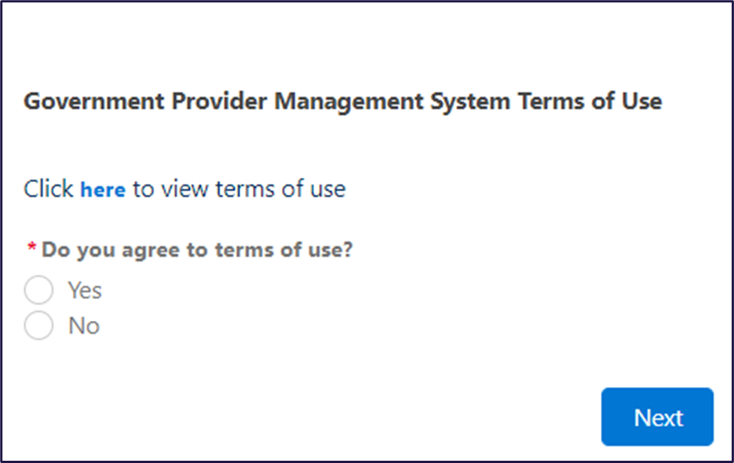

Log in to the GPMS portal
To log into the GPMS portal please visit Log In Using | Service Provider Portal.
If you require assistance logging into the GPMS portal, please refer to the Government Provider Management System – Troubleshooting Guide: Login support.

Further information and support
To view additional Provider Operations Reporting resources (including Frequently Asked Questions and a Quick Reference Guide), please go to the Resources section of this webpage.
For more information on GPMS please refer to the Government Provider Management System webpage.
Email the Department if you have provider operations reporting Collection Form completion enquiries (prior to submission) at ACFRQFRQueries@health.gov.au
If you require further assistance to login to GPMS please contact the My Aged Care service provider and assessor helpline on 1800 836 799, Monday to Friday (8am to 8pm) and Saturday (10am to 2pm) local time across Australia.
For translating and interpreting services, call 131 450 and ask for My Aged Care service provider and assessor helpline on 1800 836 799.
To use the National Relay Service, visit About the National Relay Service (NRS) | Access Hub or call 1800 555 660.
To access sign language interpreting and captioning services through Deaf Connect, call 1300 773 803 or email interpreting@deafconnect.org.au.

Access to the Provider Operations Collection Form
If you are a GPMS Organisation Administrator, you will need to make sure you correctly set up access and roles for people in your organisation who need to access the Form.
For more information on how to set up access and roles within GPMS please refer to the Government Provider Management System – User guide.
As Organisation Administrator:
- you should regularly review the users within your organisation that have access to provider operations reporting. If people leave or change positions, you may need to revoke or revise their GPMS user assess.
- you will only have access to provider operations reporting, if you are an assigned provider operations user.
If you are a general user in a residential care and/or Support at Home provider, please contact your Organisation Administrator if you have not yet been given access to the Form.
Once logged in, if you leave the system idle for some time the system will automatically log you out of GPMS for security reasons - see below notice. Simply log back in again with your GPMS Organisation Administrator credentials. Contact the My Aged Care service provider and assessor helpline on 1800 836 799 if you require further assistance.
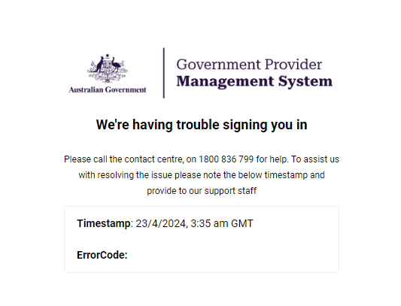

GPMS home page
When you log in to GPMS – Registered Provider portal, you will be taken to the GPMS Home Page.
You will only be able to see the tiles that you, as a user, have been given access to.
Select the Provider Operations Reporting tile to access the Form.
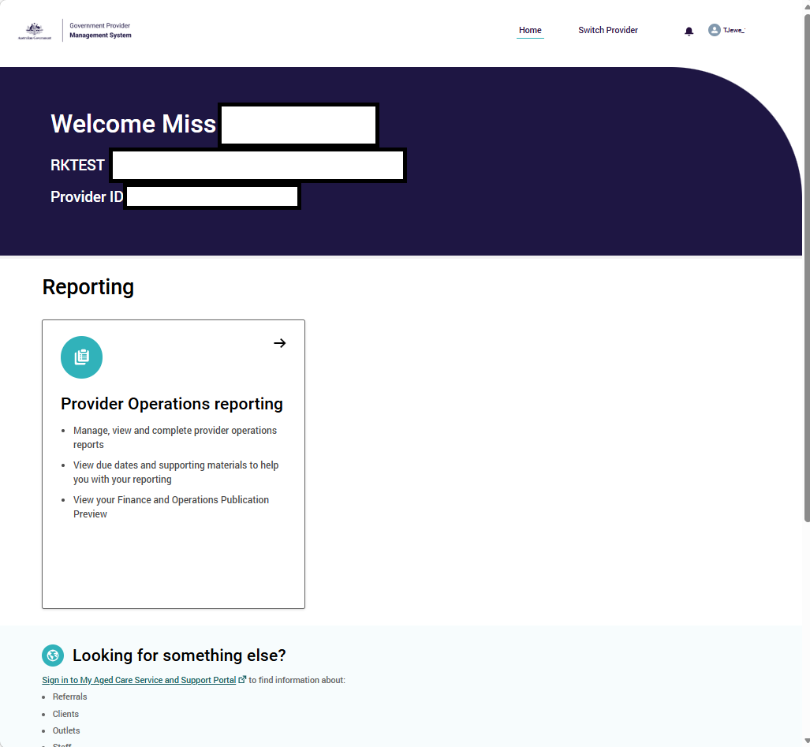
If you do not yet have access to GPMS, or cannot see the Provider Operations Reporting tile, visit the Accessing the Government Provider Management System webpage.

Provider Operations Reporting submission page
When you select the Provider Operations Reporting tile in GPMS, you will be taken to the home page of Provider Operations Reporting.
This page is called the Submission page (as it has your active and historical submissions).
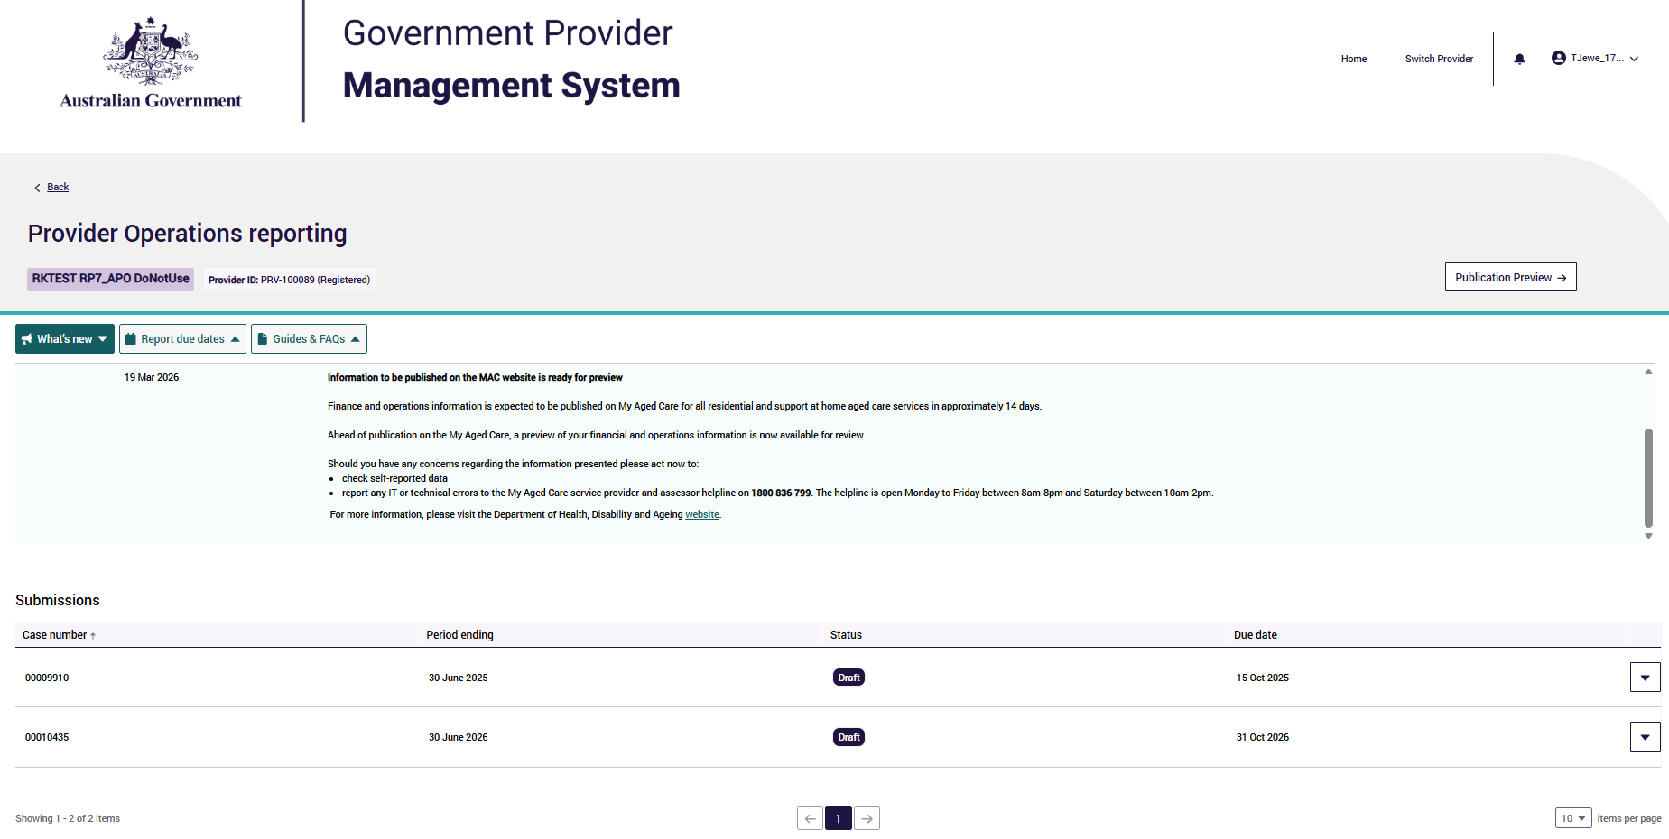
On the top half of the Submissions page, there are three tabs:
- What’s new
- Report due dates
- Guides and FAQs
On the lower half of each of these three tabs, there is a Submission section.

What’s new
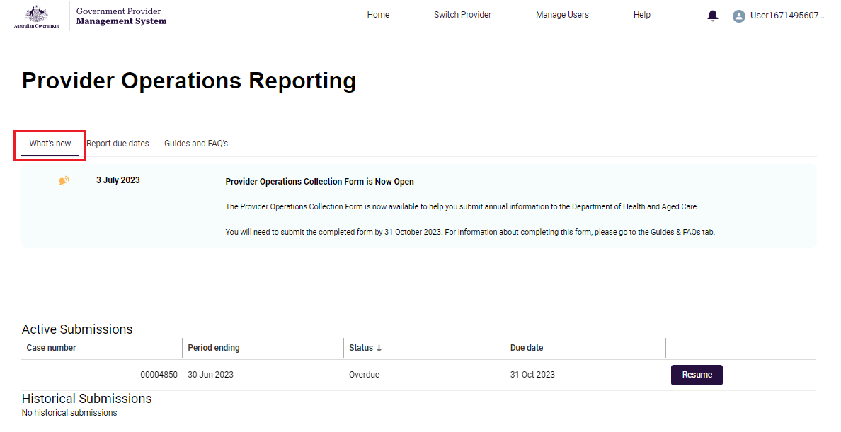
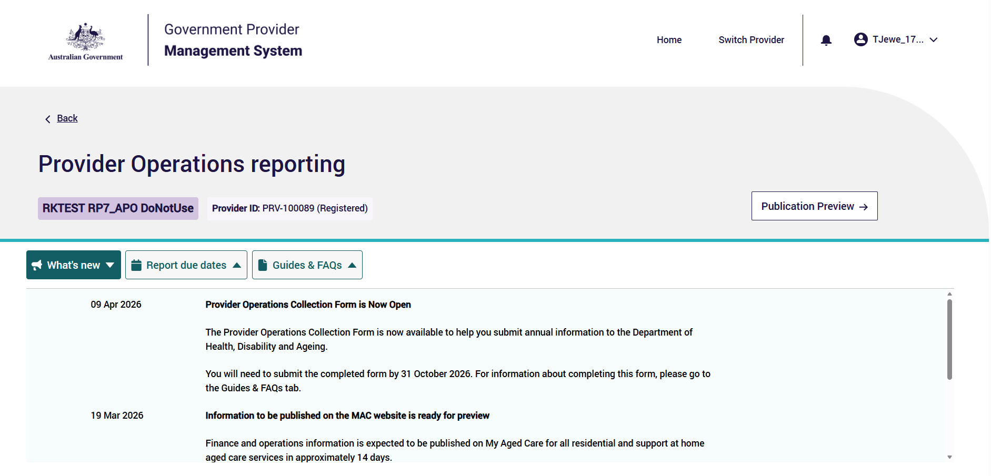
Selecting the What’s new tab will highlight key information and events.
For example, What’s new messages will let you know the date the Form is open from, when it closes, when information is available for preview, and when the data has been released to be published.
Organisation Administrators will also be advised via email once the information they have submitted during the reporting/ collection period is available for preview, prior to being published on the My Aged Care website.
This information will also be communicated through the Department’s newsletter.
New updates will be outlined in the light blue section, indicated with a bell icon and the date it takes effect. It is recommended that users check this section at least each quarter, as new updates will be published throughout the year.
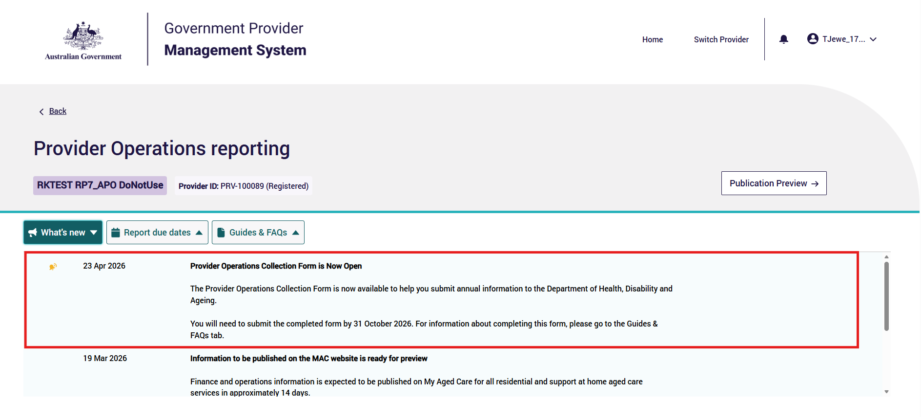

Report due dates
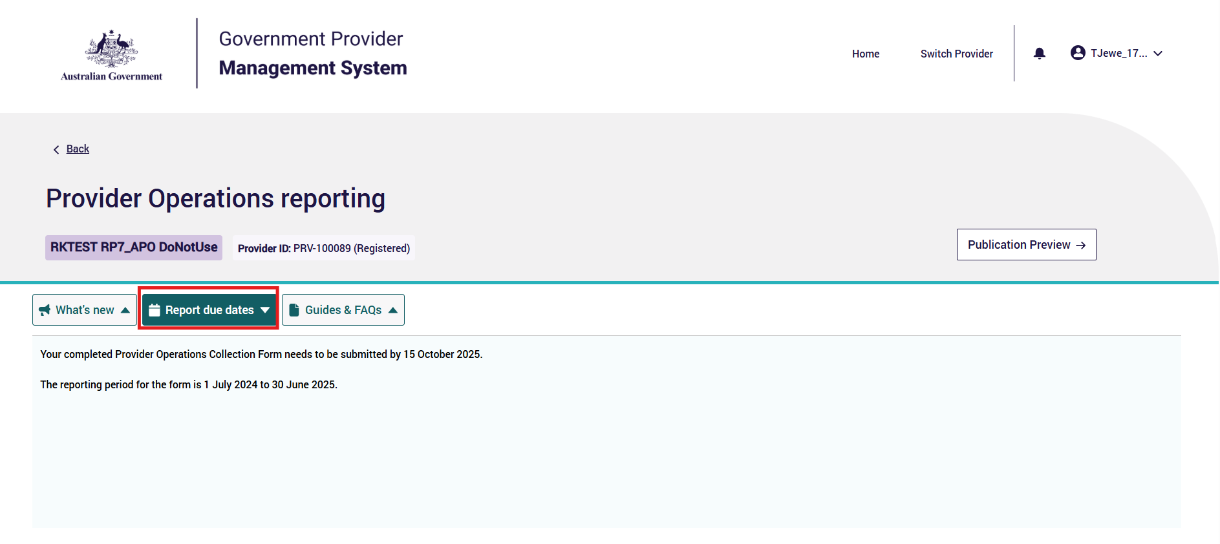
This Report due dates tab lists key dates when the Form must be submitted.
The reporting period is the period of 12 months starting on 1 July and ending on 30 June each year.
The Form should be open for data collection from 1 July each year and
must be submitted by 31 October each year (for the previous year’s reporting information).

Guides and FAQs
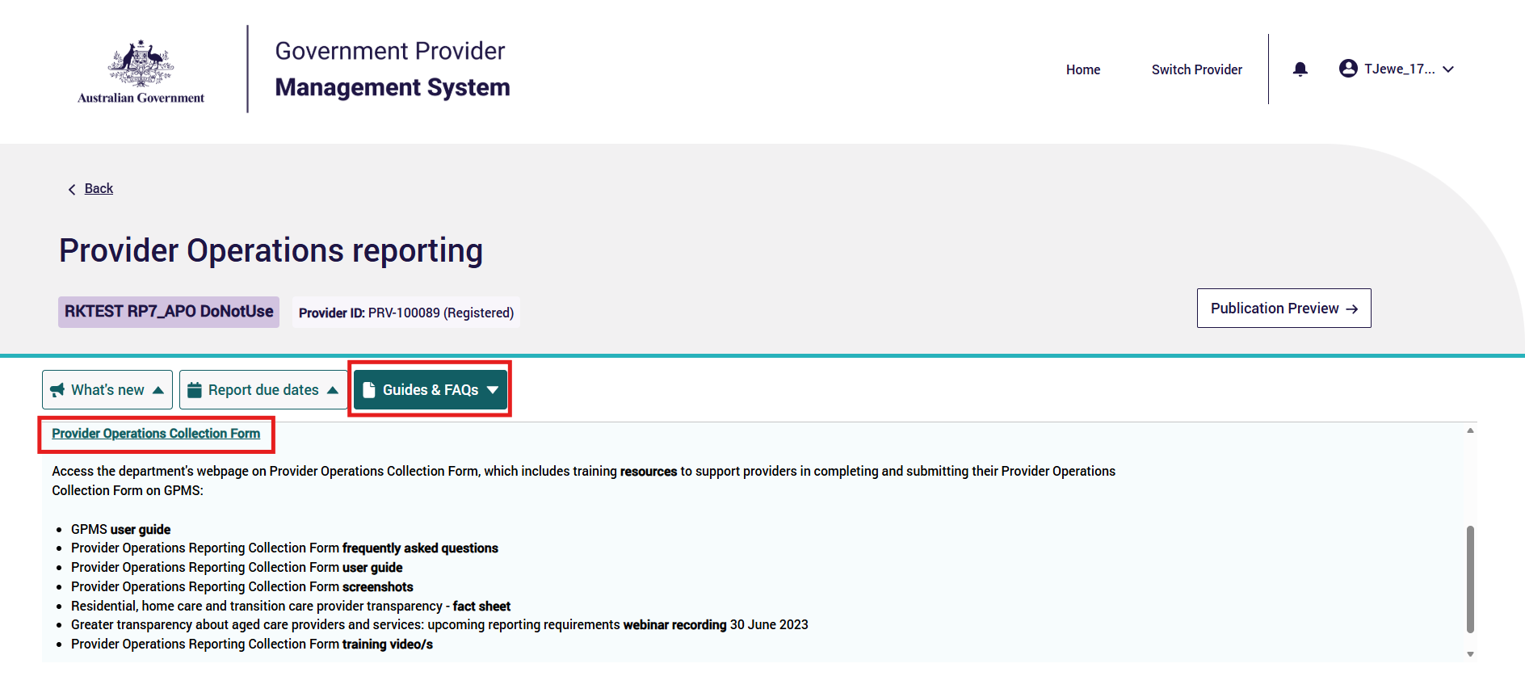
The Guides and FAQs tab contains links to various resources to help you complete the Form.
Resources include:
- Provider Operations Reporting – GPMS User Guide (this document)
- Provider Operations Reporting – Quick Reference Guide
- Provider Operations Reporting - Frequently Asked Questions (FAQs)
- Provider Operations Reporting - Privacy Statement
- GPMS - User Guide
The resources in this section will be updated.

Active Submissions
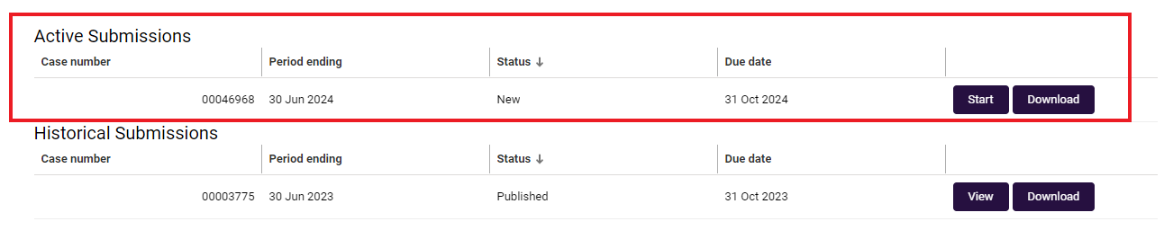
This area displays all current submissions. Each Submission will have a:
- Case number
- Period ending
- Status
- Due date
- Actions (e.g. Start/ Resume/ View and Download)
For New submissions, select Start – this will take you to start the Form for your organisation for the reporting period.
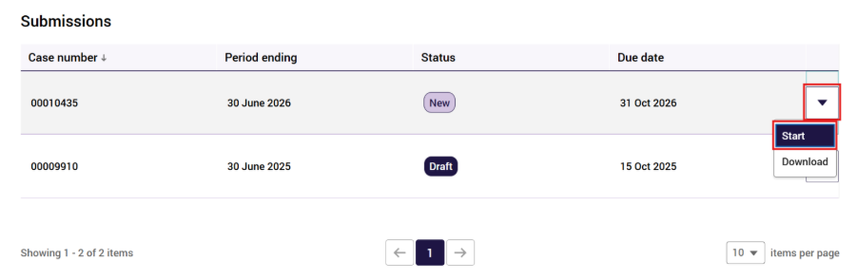
If an Active submission is in Draft, you will be able to continue completing the Form by selecting Resume.
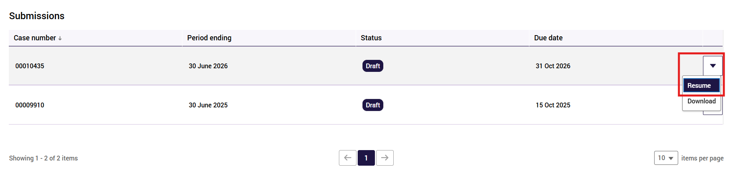

Download
You can download a PDF copy of a specific period’s Form at any stage in the annual reporting cycle. The Form can be downloaded in Draft, Overdue or Submitted status under Submissions, or in Published status under Historical Submissions. Note, historical submissions can only be accessed from the GPMS – Provider portal.
From there you can save the downloaded Collection Form to your preferred folder or print a copy for your records.
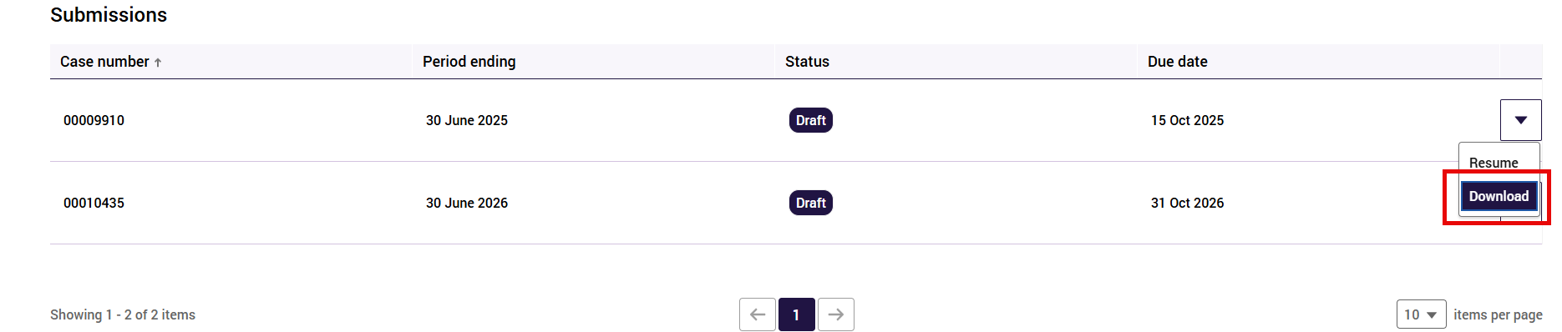

The Form
The following section explains how to enter data into the Form.

Privacy Statement
Whenever you enter the Form, you will be taken to a Privacy Statement.
Please read this statement carefully. If you accept the statement, select Agree to continue.
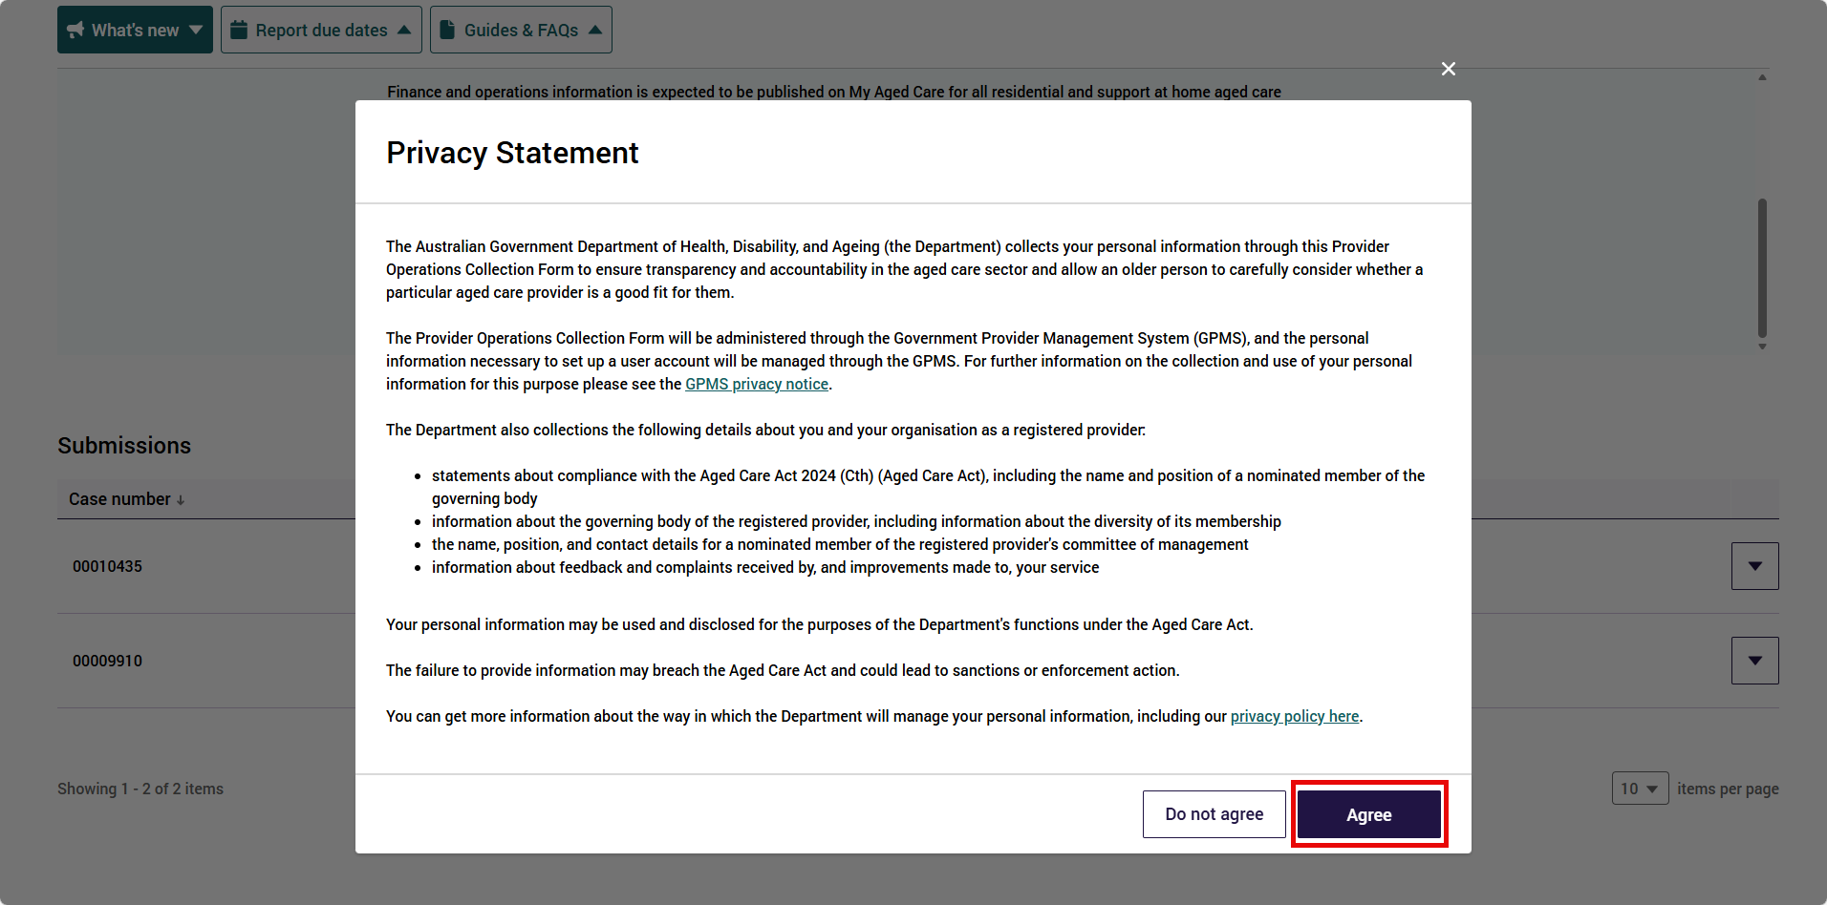
This Privacy Statement will appear each time you enter the Submission section, and you will need to select Agree to progress with the Form.
If you select Do not agree, you will not be able to continue with the Form.

Before you start
After agreeing to the Privacy Statement, the Before you start page will display.
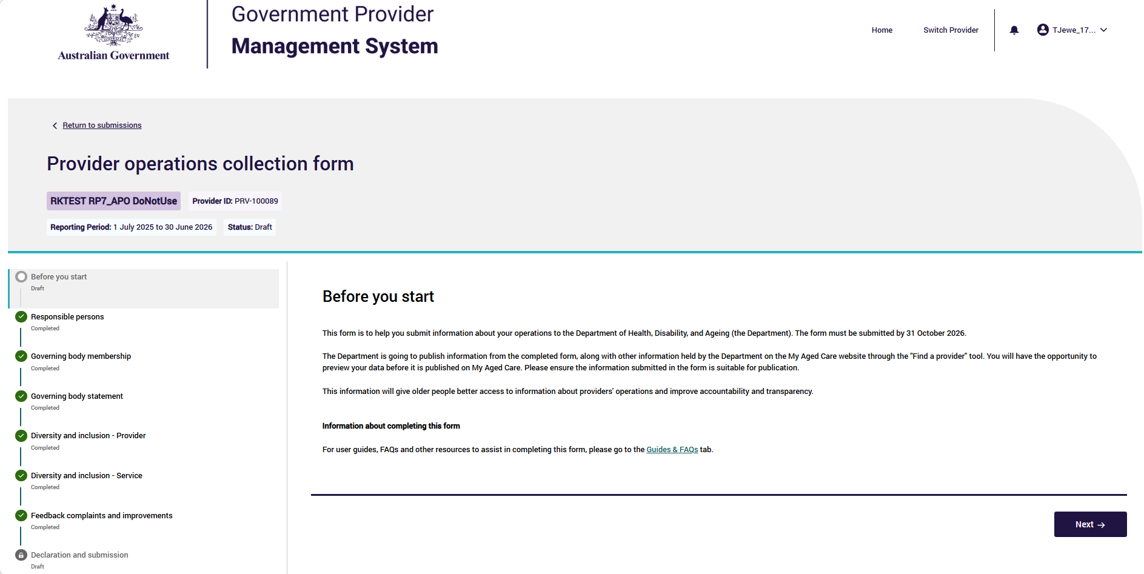
This page is the first page of the Form.
It provides you with introductory information to help you complete the Form.
This page also includes a link to the Guides and FAQs tab (which contain weblinks outside of the Form to GPMS-Registered Provider portal user guides, FAQs and other resources).
Please note:
- Be sure to save your progress in the Form when accessing these resources, as the links take you outside the Form.

Collection Form banner
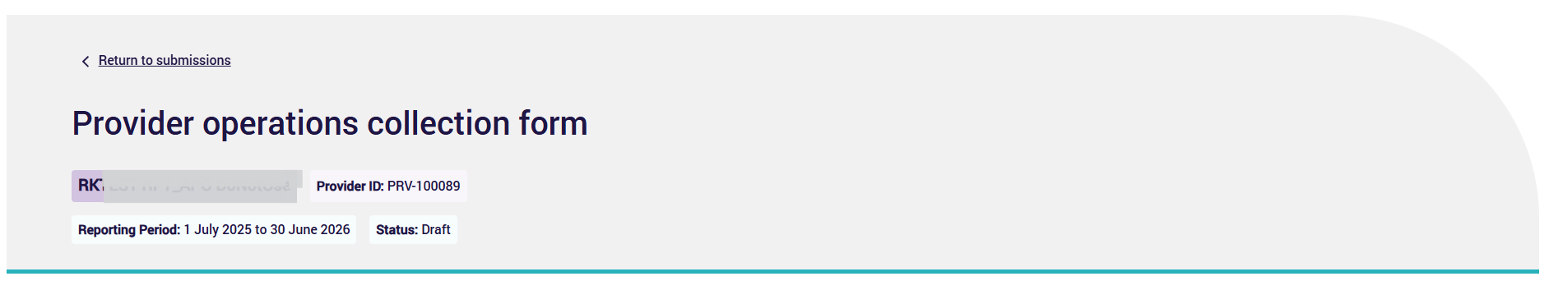
The banner that appears at the top of every page on the Form indicates:
- the name of the aged care provider/ your organisation (top left)
- that you are in the Provider Operations tile (GPMS application)
- the financial year reporting period
- the status of your Collection Report (e.g. Draft/ Submitted/ Reissued).
At the top right of the banner you can return to the Submissions page (Active and Historical Submissions information).
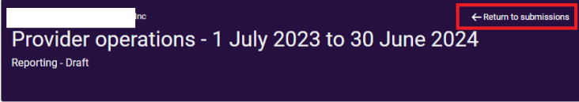
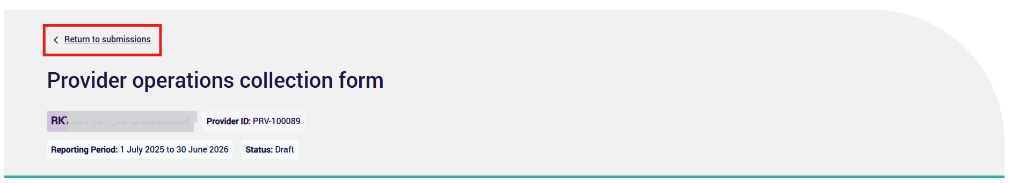

Side-bar navigation
On the left hand side is the navigation bar for the Form. The navigation bar provides links to each part of the Form.
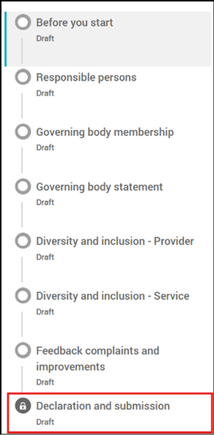
The navigation bar indicates your progress through the sections of the Form, from Before you start through to Declaration and submission.
You can move between sections in the navigation bar in any order, but you will not be able to submit your form (last step in Declaration and submission) until all sections are completed (indicated by green tick).
Status of pages in the navigation bar:
Icon | Meaning
Section you are currently in
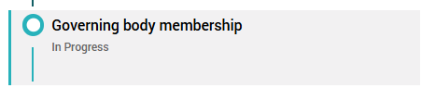
‘Section currently in’ shown as a blue bar and in greyed shade
Draft  In Progress | Section remains incomplete and needs completion
 | Section is complete
 | Section has errors and needs completion
 | Declaration and submission locked and greyed out until all sections are completed and have a green tick

Saving your data in the Collection Form
The Next and Back buttons and clicking on the side-bar navigation - will save the information entered providing there are no errors on the page.
These are located at the bottom right-hand corner of each page.
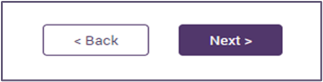
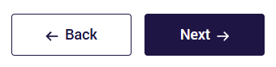
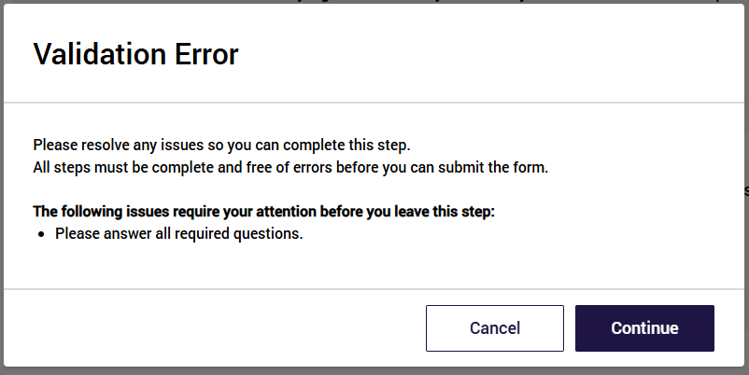
Please note:
- Not all sections in the Form have a Save button. If there is no save button click on Back, Next or the navigation bar to save.
On the sections with a Save at the bottom right (above Back and Next) you should save your work regularly and when moving away from the page.
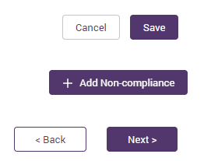
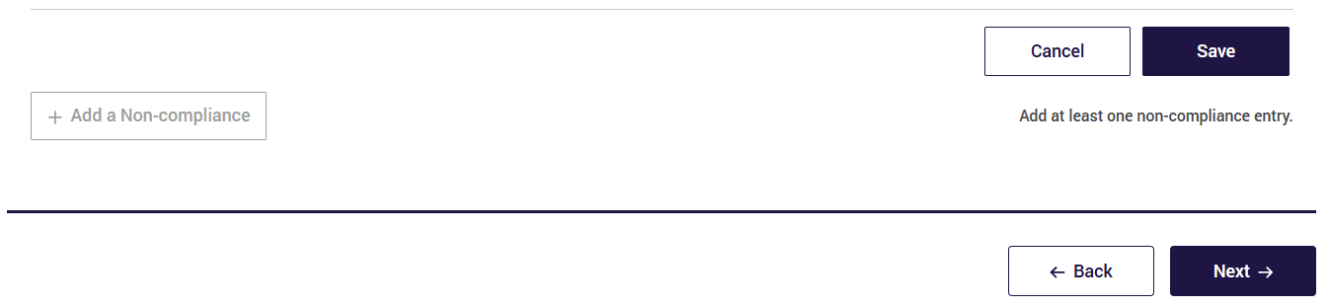
If you do not click Save, then you will lose the data entered when you move to other sections or pages.
A pop-up message will be displayed:
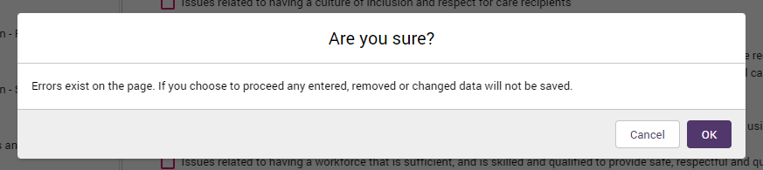
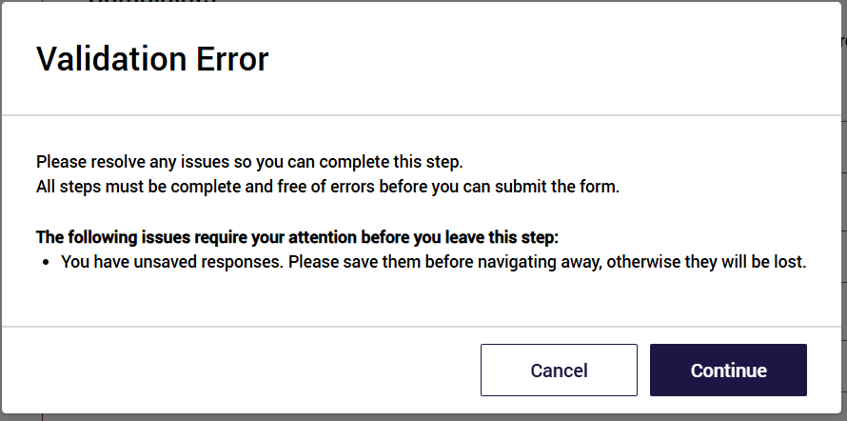
Selecting Return to submissions (top right of banner on each page) will not save your work and a pop up message will be displayed to warn you that your changes have not been saved.
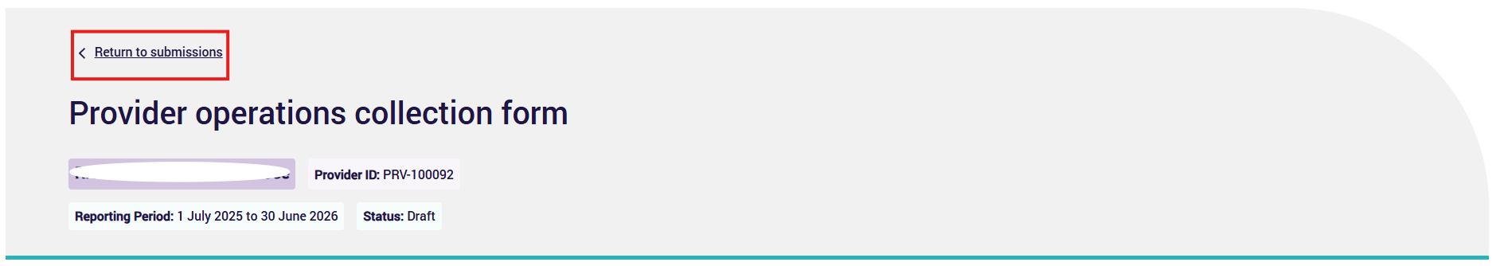
The return to submissions action does not support checking for any unsaved responses. Hence, it will not remind users to fix issues before leaving the Form.
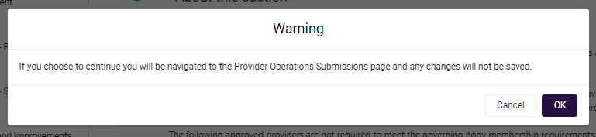

Information about completing the Form
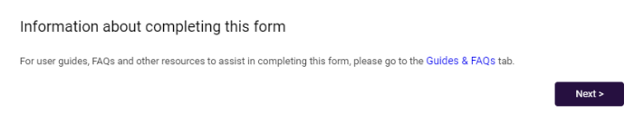
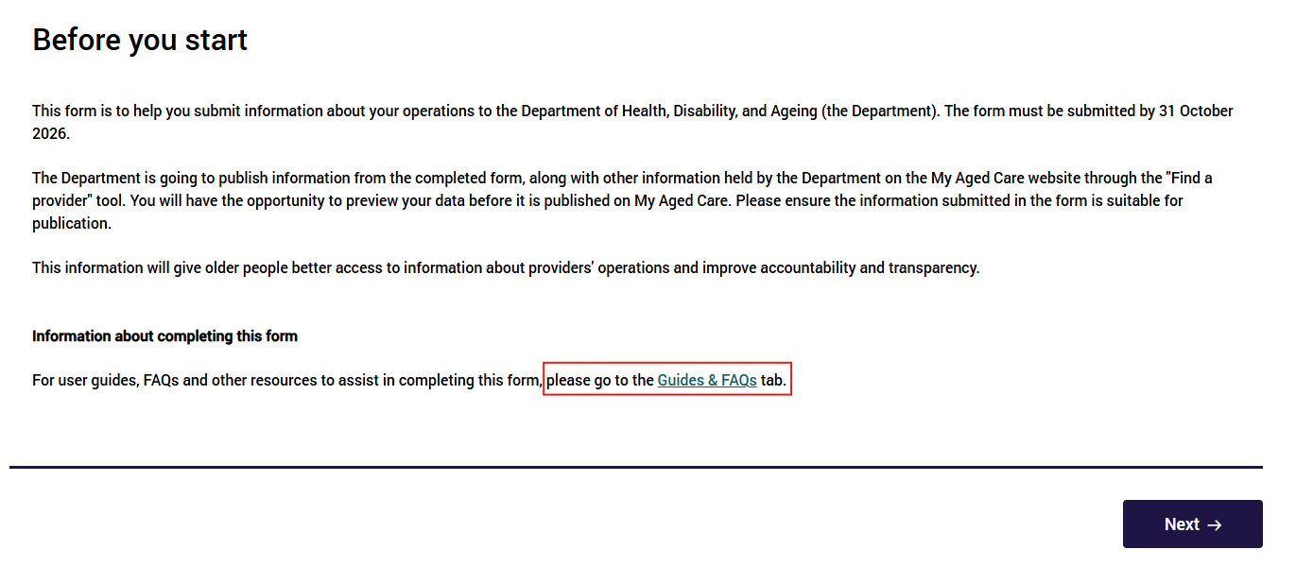
If you need to access the Guides and FAQs while completing the Form, be sure to first save your data. Accessing the Guides and FAQs from within the Before you start section of the Form opens the resources in another browser window protecting the user from accidentally navigating away from the form and losing unsaved responses.
Alternatively, you can visit the Department’s website to access provider information and resources to support you in completing the Form.

Reissuing the Collection Form
There are certain circumstances where a Form may be reissued, such as:
- You have submitted the Form and realised that you have provided a response that was not correct.
- You have submitted incorrect information for one or more sections of the Form.
- You have missed the deadline to report data and the form is locked and no longer able to be modified or submitted.
- A reissued form has reached the defined due date and is now overdue, it is locked, and you are no longer able to modify the Form.
In the rare event that you need to request that your Form be reissued after submitting, email the Department at ACFRQFRQueries@health.gov.au
When a Form is reissued, you will receive a notification in the GPMS portal, an email notification, and your submission will have the status of Reissued in the Submissions section of the Provider Operations Reporting submission page.

Responsible persons
This section is about providing the name and role of at least one (and up to three) responsible person at a senior executive level, who is responsible for executive decisions.
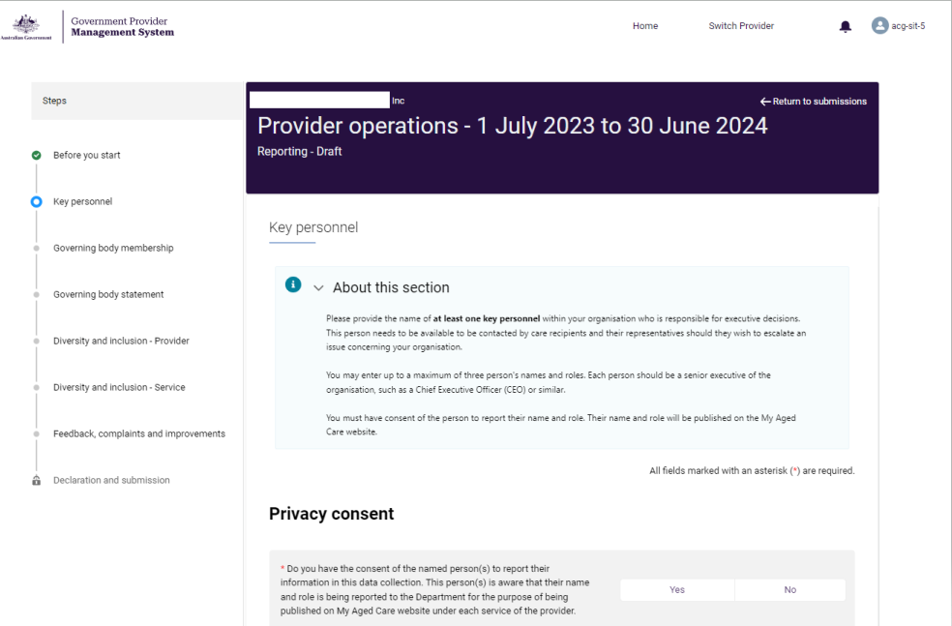
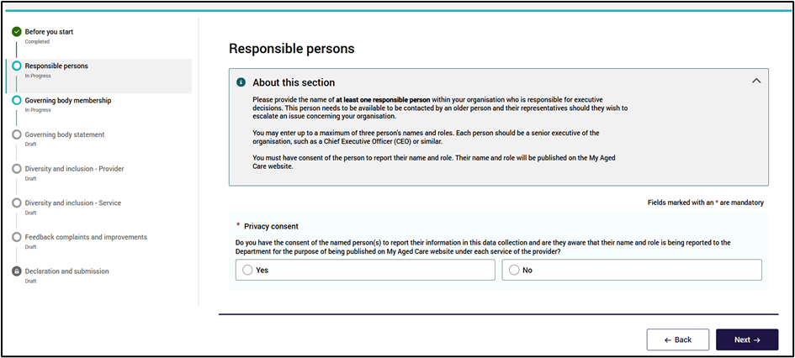
To begin completing the responsible person data fields:
- In response to the Privacy Consent question, select a Yes or No response.
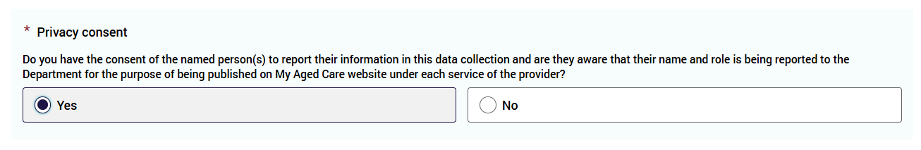
Only select Yes if you have the consent of all the named person/s. If you selected Yes to the Privacy Consent question, you will be able to enter the name and role of the executive.
You must select No if you have not yet obtained the person’s consent or they have not provided you with consent
You will be able to continue with the rest of the Form in the meantime. (You can move between sections in the Form).
Should you need to come back later and add consent details and agreement, select Yes, and enter the name and role of the nominated person.
Please note:
- You will be able to submit the Form even if you select No (to the Privacy consent question) and do not enter the name of a responsible person
- If you submit the Form with No selected (to the Privacy consent), no senior executive’s name will be displayed on the My Aged Care website for your provider.
- Each responsible person must be added separately and saved separately. Up to 3 responsible persons can be saved.
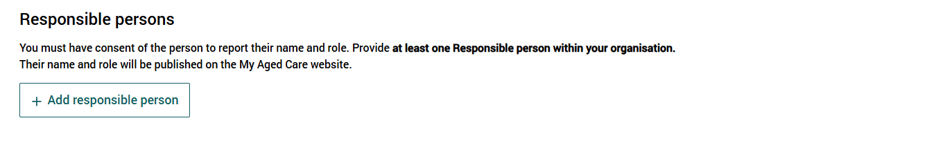
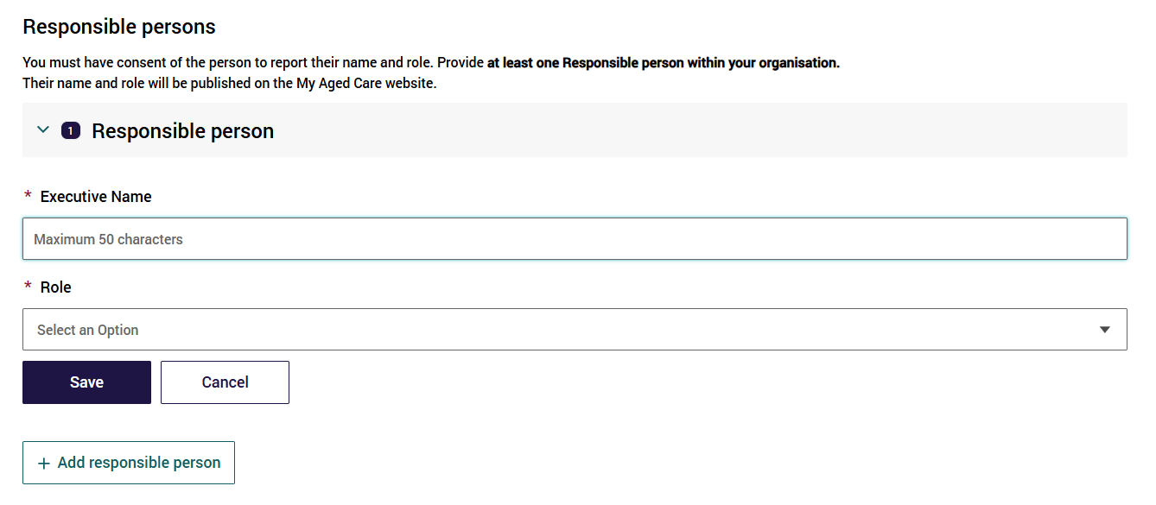
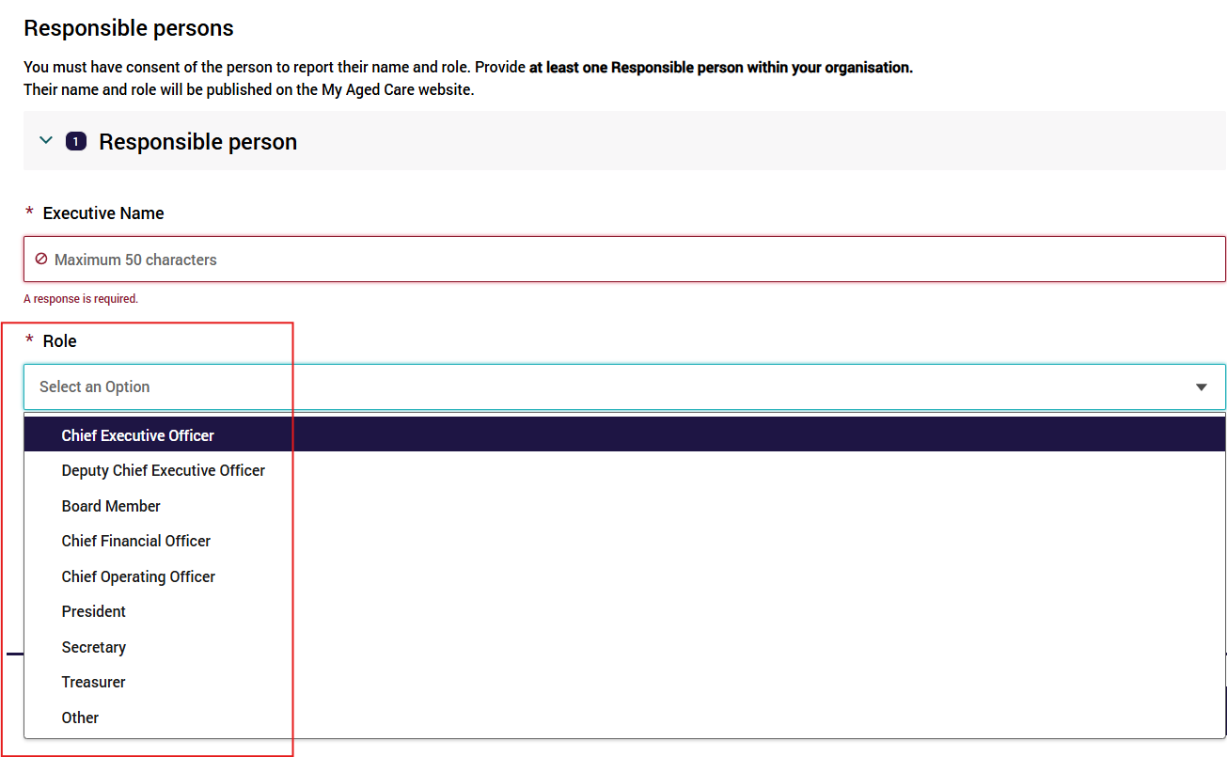
- Complete up to three executives’ names and roles. You do not need to enter all three names and roles.
- Executive name: Enter first and last name of executive . Please do not use nicknames, previous names or initials. Complete the name in the free text space provided in the form.
- Role: Select from the options provided.to enter the person’s role in the organisation (for example: CEO or similar. They should be a senior executive of the organisation). You can select Other is none of the options shown are suitable. Selecting Other will enable you to enter a free text response.
- Select Next to continue (noting you may also select Back to go back to update or edit the previous section).
Each individual Responsible person must be saved separately. Use the Add responsible person to open entry for another one. Up to three responsible persons can be saved.
Both Next and Back icons (and accessing the left Navigation Bar) will save the information that you have entered, provided there are no errors on the page.
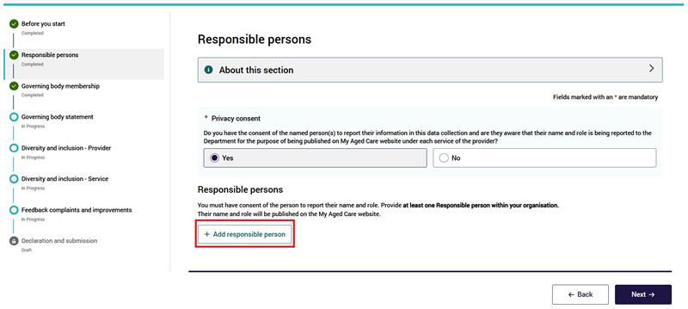
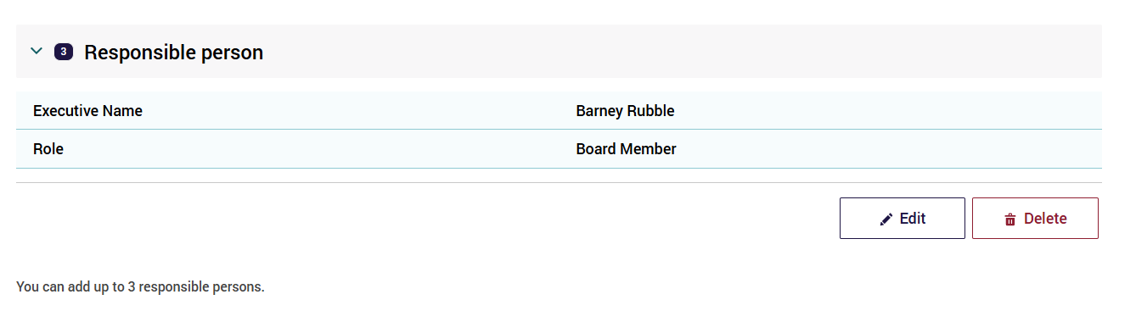
Each responsible person is numbered, each have Save and Cancel actions available before saving, and each have Edit and Delete actions available once saved. If one responsible person is deleted, then the remaining ones have their numbering corrected automatically

Governing Body Membership
This section is about the two governing body membership requirements (majority of independent non-executive members and at least one member with experience in providing clinical care).
It seeks information about whether your organisation meets these requirements, as well as some addition information, which may mean your your organisation is exempt from meeting the requirements.
All providers (except state, territory or local government authority providers) are required to complete all questions in this section of the Form, even if the governing body requirements do not apply to them. (State, territory or local government authority providers will be directed to the next part of the Form.)
Answer all questions in this section honestly and accurately and as it applies to your organisation at 30 June at the end of the reporting report (not at a possible future point in time).
We need to know where your organisation is currently at with this requirement.

Governing Body Membership data fields
- To complete the this section of the Form, select Yes or No to each question.
If you select Yes to the first question “Is your organisation a state and territory, a state or territory authority, or a local government authority?”, you will be directed to the next section. Select Next to continue to the next page.
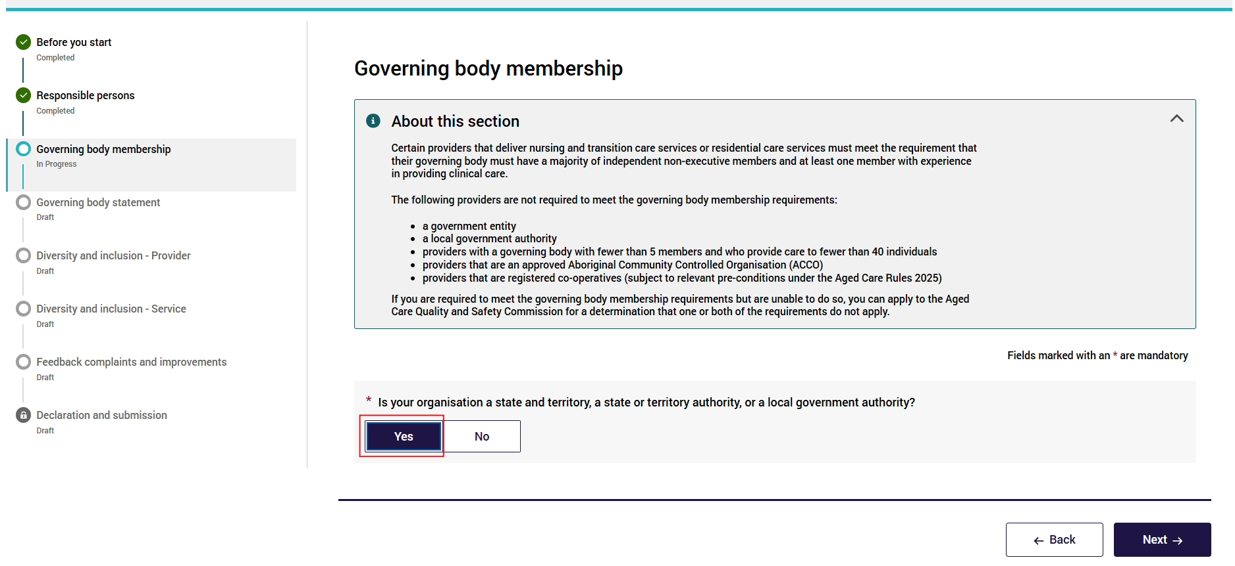
If you select No to the first question “Is your organisation a state and territory, a state or territory authority, or a local government authority?”, you will be directed to further questions in this section. Answer Yes or No as appropriate.
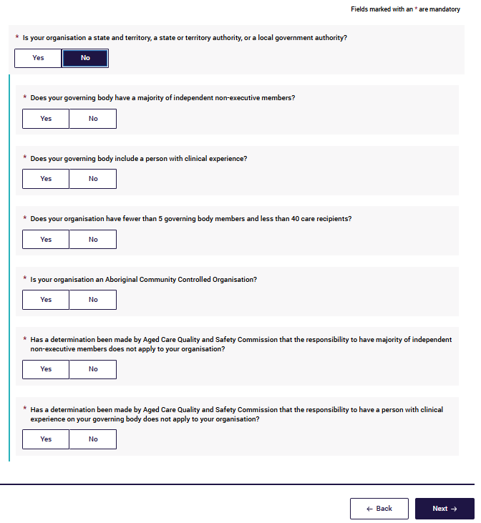
- Select Next to continue to the next page. This will save your data.
Select Back to go back to update or edit the previous page.
Select the navigation bar to go to any page of the Form.
Both Next and Back icons (and accessing the left navigation bar) will save the information that you have entered provided there are no errors on the page.

Governing Body Statement
This section is about the completion of a signed Governing Body Statement which allows providers’ governing bodies to demonstrate their understanding of, and accountability for, issues affecting the quality of care of aged care recipients.
The Governing Body Statement requires the governing body to provide details of any responsibility under Section 166-705 of the Aged Care Rules 2025, requires providers that deliver nursing and transition care services or residential care services to submit a statement about the provider's compliance with its conditions, obligations and requirements (responsibilities) under the Aged Care Act 2024.
This is beyond non-compliance identified by the Aged Care Quality and Safety Commission. This information is collected at the provider level.
Please read the instructions carefully, in particular: 6.5.1 Completing the Governing Body Statement.
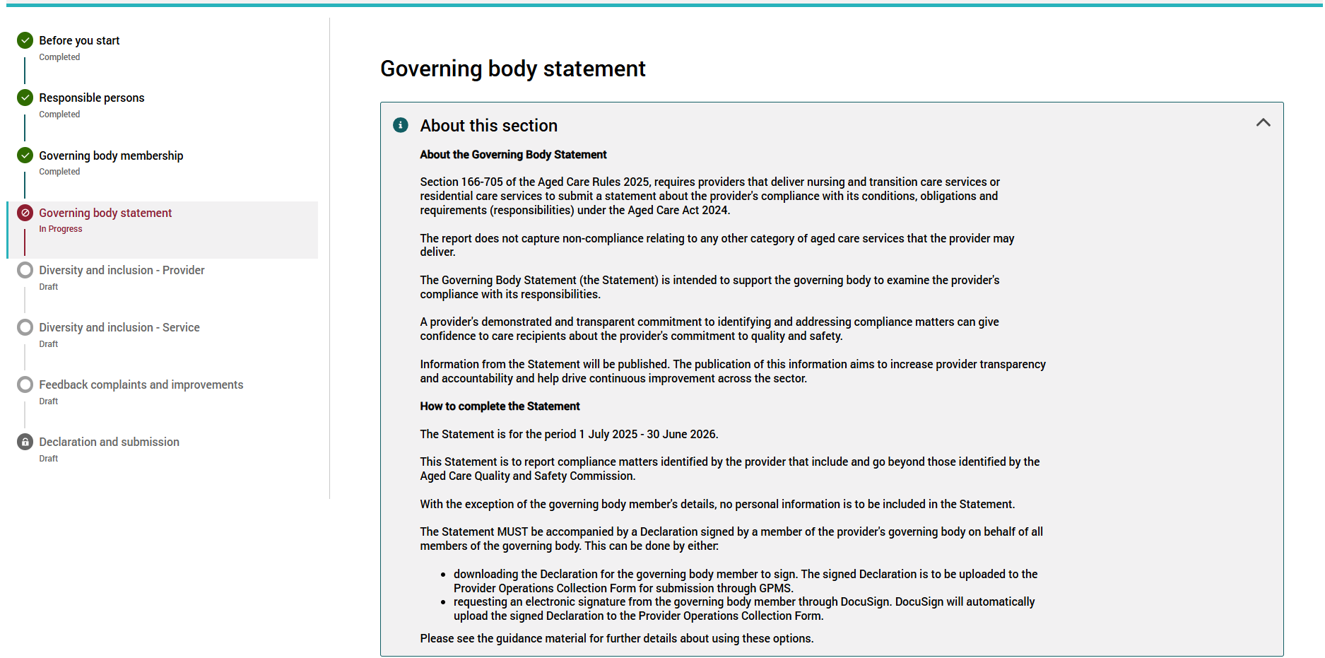
All parts in this initial section of the Statement need to be completed by all residential care and home care providers.
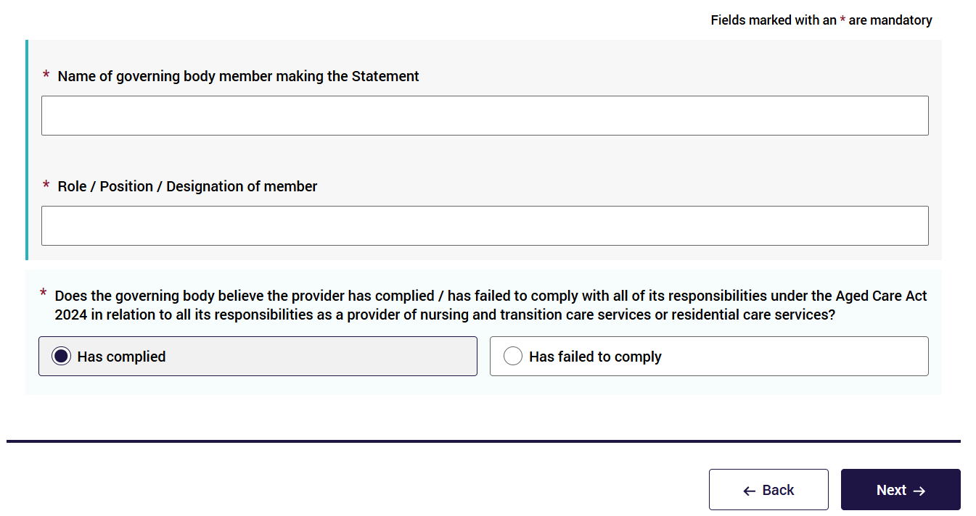

Completing the Governing Body Statement
To complete the Governing Body Statement:
- Provide the full name of governing body member making the statement.
- Enter the role, position, or designation of the governing body member who is making the statement and will sign the declaration. (Please check that this member will be available to sign the statement).
- Select Has complied or Has failed to comply.
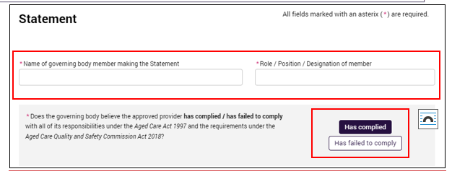
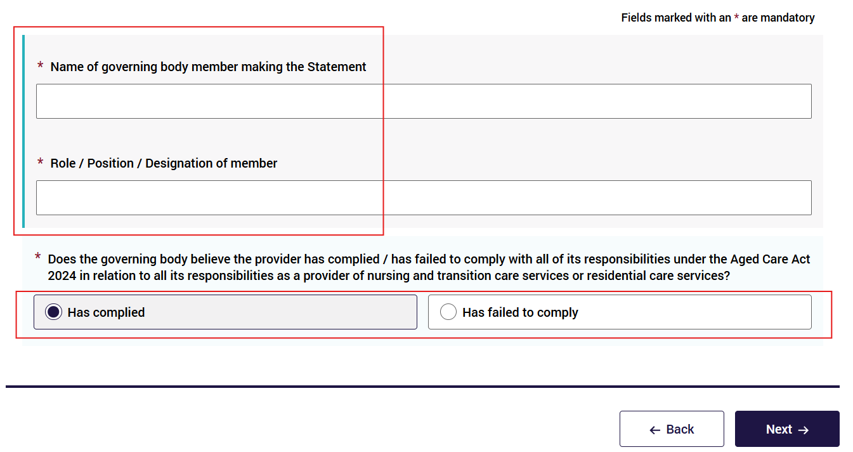
Please note:
- This Statement captures non-compliances beyond those identified by the Aged Care Quality and Safety Commission.
- It covers any non-compliance with the provider’s responsibilities under the Section 166-705 of the Aged Care Rules 2025, requires providers that deliver nursing and transition care services or residential care services to submit a statement about the provider's compliance with its conditions, obligations and requirements (responsibilities) under the Aged Care Act 2024.
If you select Has complied, a pop up message will ask if you want the Governing Body Statement to be signed electronically? Respond Yes or No:
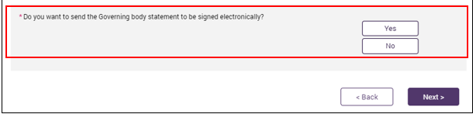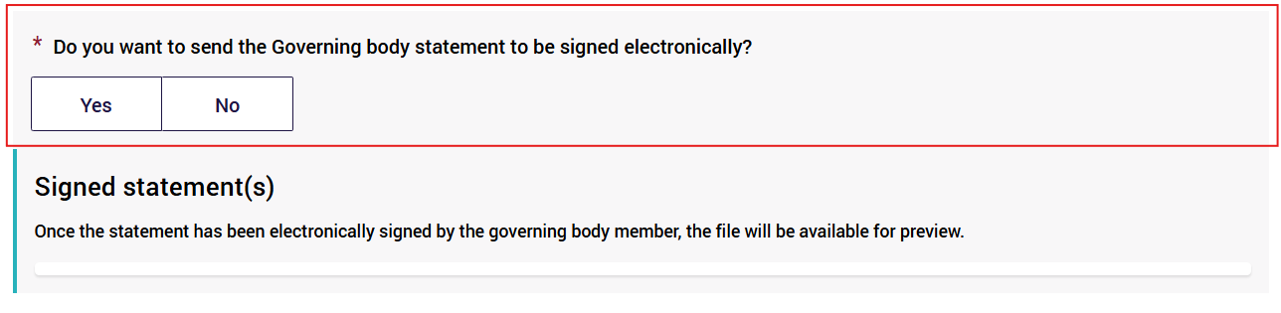
- If Yes, follow the electronic e-Signature process (see 6.5.2 below).
- If No, follow instructions for downloading the Declaration to allow the governing body member to sign a hard copy of the Declaration. The signed Statement will then need to be scanned and uploaded to the Form (see 6.5.3 below).
If you select Has failed to comply, go to the Non-Compliance section within this User Guide (section 6.5.4).
- Select Next to continue.

Signing the Governing Body Statement
The Governing Body Statement MUST be accompanied by a Declaration signed by a member of the provider’s Governing Body on behalf of all members of the Governing Body.
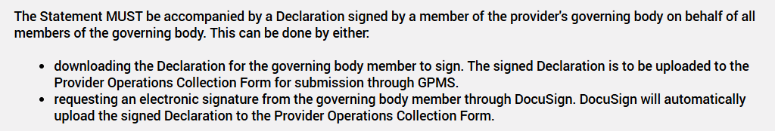
The Declaration can be signed either by – Electronic signature through DocuSign or by signing a hard copy of the Declaration.

Electronic e-Signature (DocuSign)
This option allows providers to request an electronic signature from a Governing Body Member through DocuSign. Send Document for e-Signature.
- Ensure you have selected the Yes option for the Governing Body Statement to be signed electronically.
Instructions appear when you choose to sign electronically. Proceed to click or press Send for e-signature.
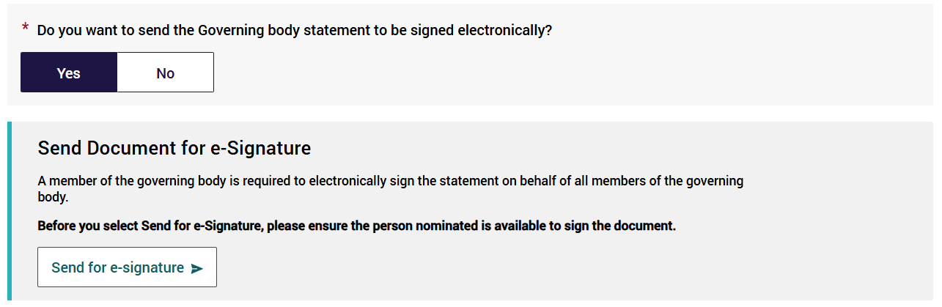
- In the pop up window enter the email address of the Governing Body Member who will be electronically signing the Statement.
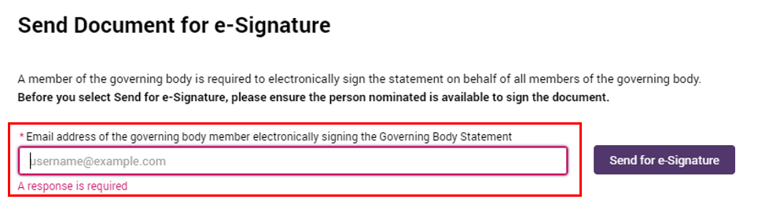
In the popup modal, enter both the email address and the mobile number of the governing body member who will be electronically signing the Statement.
Please note:
- Please check the Governing Body Member selected to electronically sign the Declaration is available before assigning the document to the member.
- Having to cancel an e-Signature request ACFRQFRQueries@health.gov.au will involve a delay in completing your Form.
- Then press Send for e-Signature.
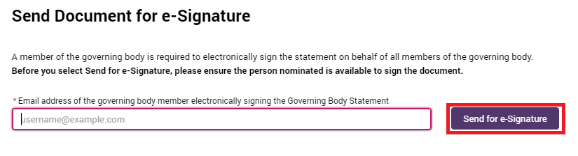
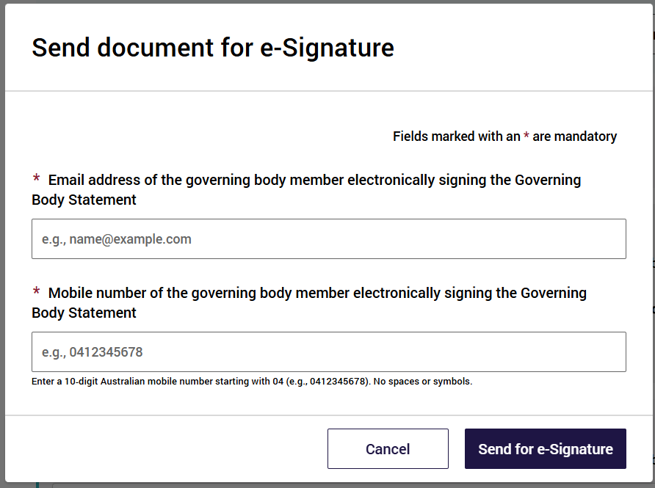
A green banner will then display at the top of the screen confirming the request and been successfully sent.
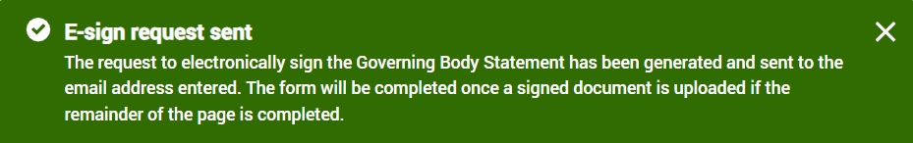
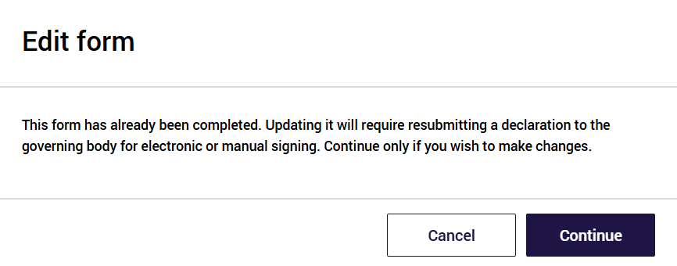
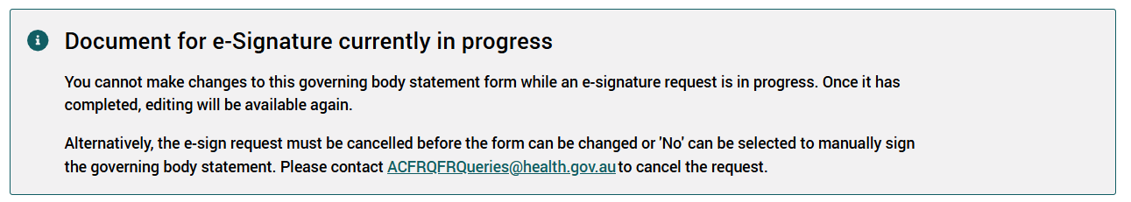
- Keep a look out for new notifications in GPMS (red light on the bell icon, at the top right of the page, next to your user name):
- You will be notified of a Fail/ Rejected/ Expired e-Signature request.
- You will be notified of the e-Signature success.
Once the statement has been electronically signed by the Governing Body Member, the file will be available for preview in the Signed statement section below:
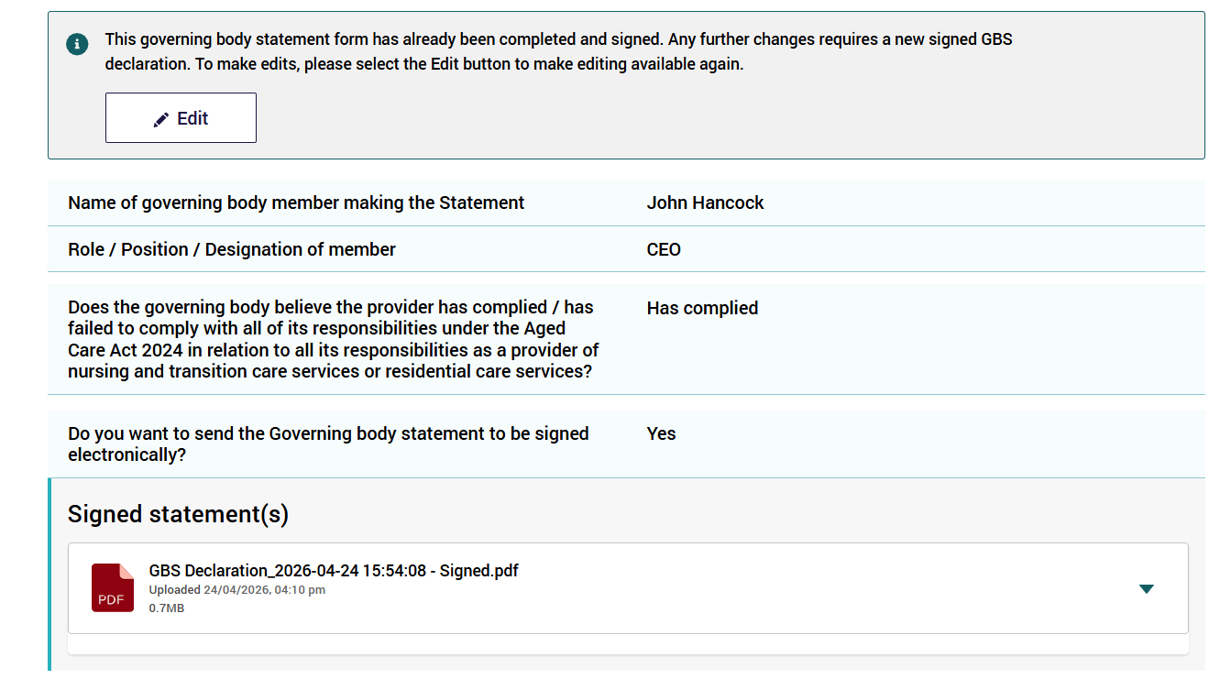
Cancelling a request for e-Signature
If you need to cancel the e-Signature request for any reason (e.g. change to manual download option or change the email address to request another e-Signature) you will first need to cancel the e-Signature request.
If you need to cancel the e-Signature request please email ACFRQFRQueries@health.gov.au
Once the e-Signature process has been cancelled, you can refollow the steps above to send another document for electronic e-Signature (e.g. with a new or correct email address) OR select the download process to sign the Governing Body Statement (download, print, scan and upload).
The form reverts to view only mode after a signature has been received to protect it from accidental changes. If any changes are made, a new signed GBS declaration must be provided. To intentionally make further changes to the GBS form, click the Edit button, which will revert the form back to entry mode.
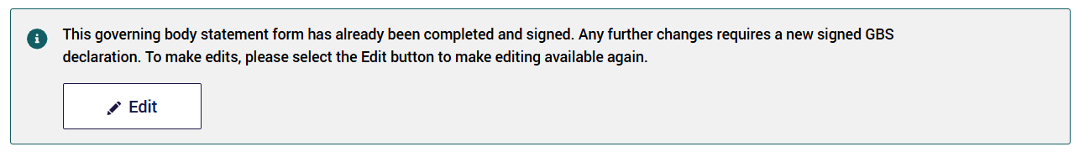

Hard copy signature
This is the other option for signing the Governing Body Statement.
- Once all compliance information has been entered into the Form, select Download Statement for signing.
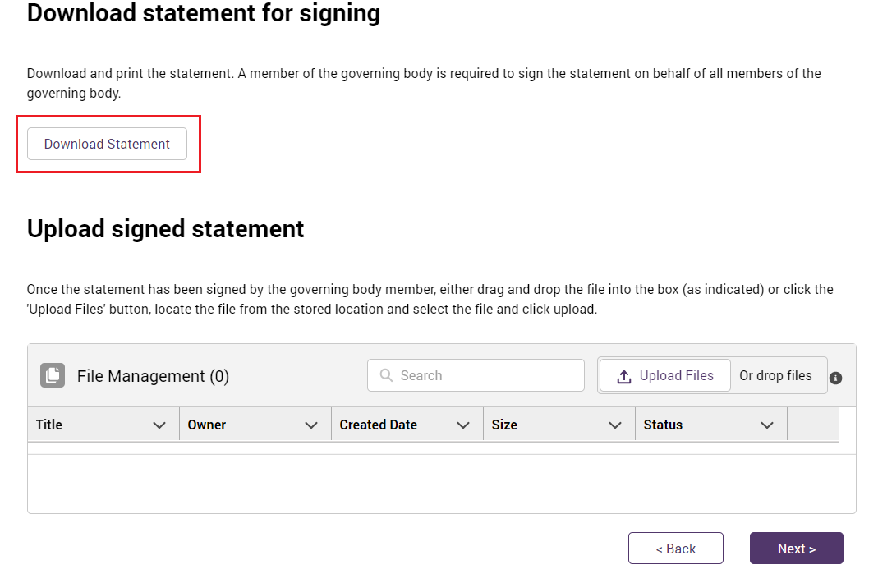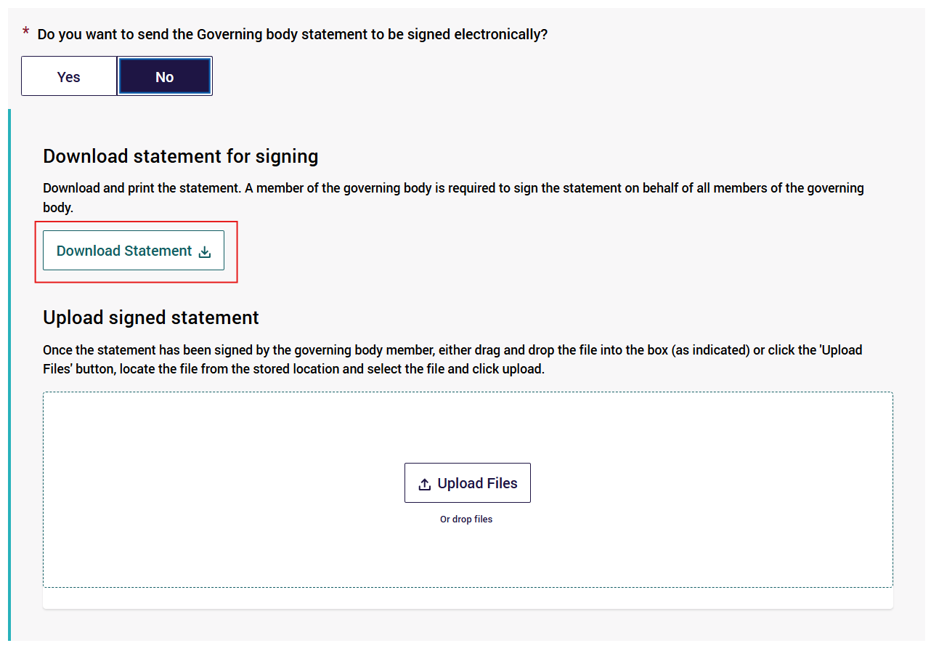
- Once the printed Statement has been signed by the Governing Body Member, scan the document and save it to a folder on your computer where you can locate it.
- Ensure you name and date the document so you can easily locate it, for example, ‘FY2023/24 Governing body statement signed statement’, to differentiate from a previously downloaded document (and from other financial years’ documents).
- Upload the latest document to GPMS using one of the two following methods:
- In the Form, select the Upload File button.
- When the file window appears locate the signed Statement saved on your computer and upload the document; OR
- Drag and drop the file into the box provided in the Form.
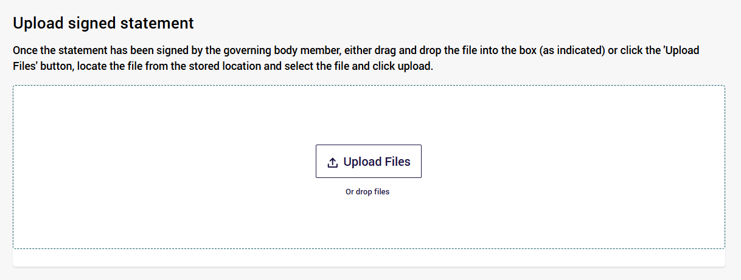
Make sure to upload the correct file from your folders.
Please ensure only PDF files of less than 30 megabytes in size are uploaded, or else the upload will fail.
Please note:
- For the downloading, signing, scanning and uploading option:
- When you upload your document, it will be scanned for viruses.
- This process may take up to 48 hours (two days). Please do not leave your submission to the last day for this reason (e.g. last few days of October).
- Your document will not be successfully uploaded until this virus scan has confirmed the uploaded document does not contain a virus.
- If a virus is detected, the document will not be uploaded and will be deleted – you will not be notified if this occurs.
- Please continue to check that your document has been successfully uploaded.
Once the document has been successfully uploaded, you will see a new notification (red light on the bell icon) indicating your scanned document has been successfully uploaded to the system.
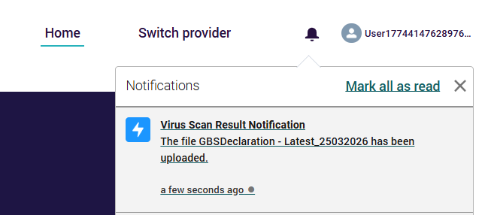
You will also now see it listed in the Uploaded document section.
- Select Next to save and continue.
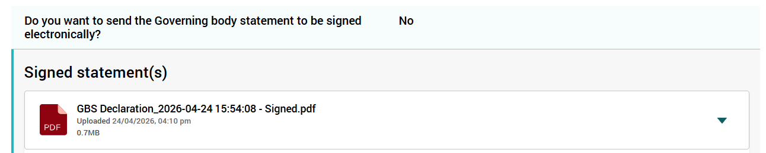
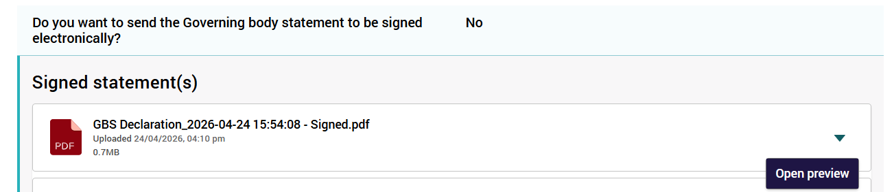
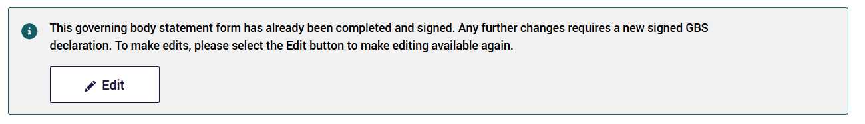
Please note:
- You can only select ONE option of signing the Governing Body Statement (electronic e-Signature OR downloaded/ uploaded hard copy signed Statement) - follow the required steps to complete the signing.
- Whether the Governing Body Statement is signed electronically or by hard copy, the person signing must be a member of the governing body and must sign the Statement on behalf of all Governing Body Members.

Non-compliance
If the governing body member selected Has failed to comply when completing the Governing Body Statement, you will be required to submit details of all non-compliance/s to the Department here in the Form.
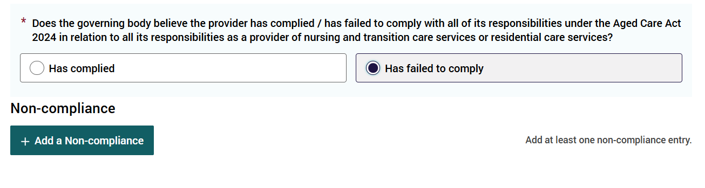
Non-compliance details required include:
- Non-compliance (type)
- Detail of non-compliance
- Services involved
- Cessation of non-compliance
- Reasons for non-compliance
- Actions taken to rectify non-compliance.
For each non-compliance selected, complete all fields for that non-compliance and save that entry, before entering details for another non-compliance.
You can enter multiple non-compliances.
You can link each non-compliance to one or more services, by selecting the Add Service button then choosing the checkbox next to the service/s.
Each entry will have the above series of questions to be completed (up to a maximum of 30 separate non-compliance entries). You are encouraged to group similar non-compliances together when reporting.
Please note:
- Please do not include any personal or private information about any individual in your responses.
- The responses will be published on the My Aged Care website exactly as you have submitted them.
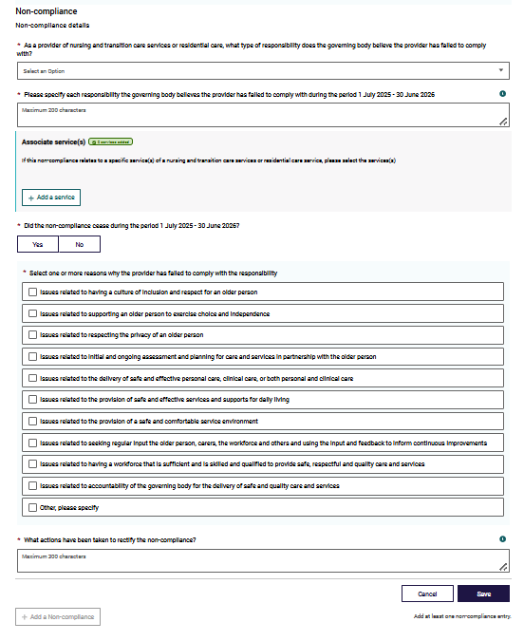
To complete the non-compliance section:
- Select non-compliance items (types of responsibilities) from the dropdown menu of options that best applies for your provider organisation.
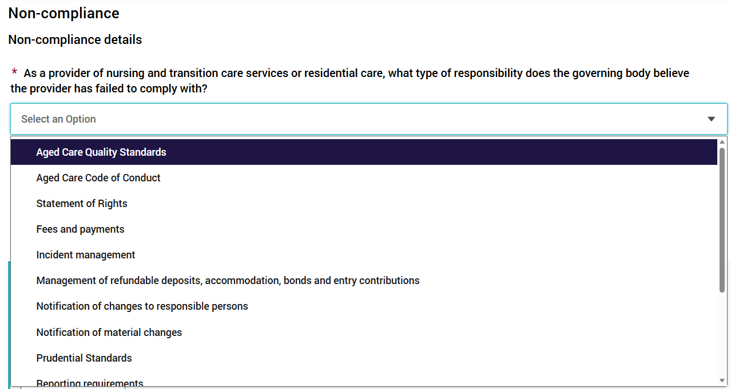
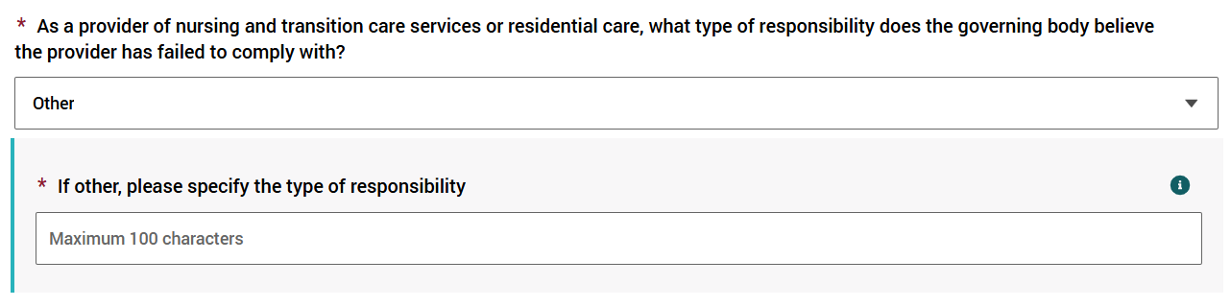
Select Other if a type of non-compliance is not listed in the drop down menu of options for your organisation, and complete the free text area for other types.
Please note:
- Do NOT include any personal information in this free text area due to privacy reasons.
- There is a 100 character limit on text entry, should you select Other.
For further information on this question (for example: explanations of the terms) please refer to the ‘Frequently Asked Questions’ document in the Guides and FAQs section.
Select the option/s that best fit your organisation.
Please note:
- Remember to save your responses after completing each non-compliance, as you progress through this section.
If a non-compliance relates to multiple types of non-compliance (e.g. the Aged Care Quality Standards and the Charter of User Rights), only list the non-compliance once, choosing the type that is most relevant to the circumstances.
- For each non-compliance type selected from the drop-down menu below, you will need to enter your response in free text.
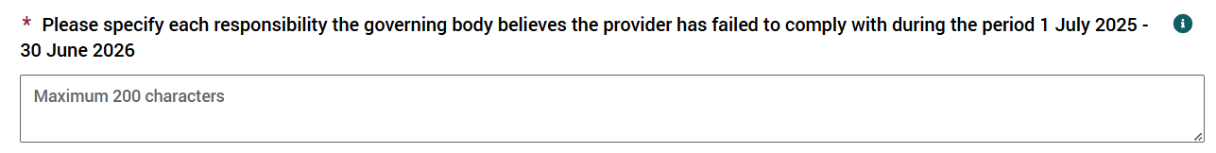
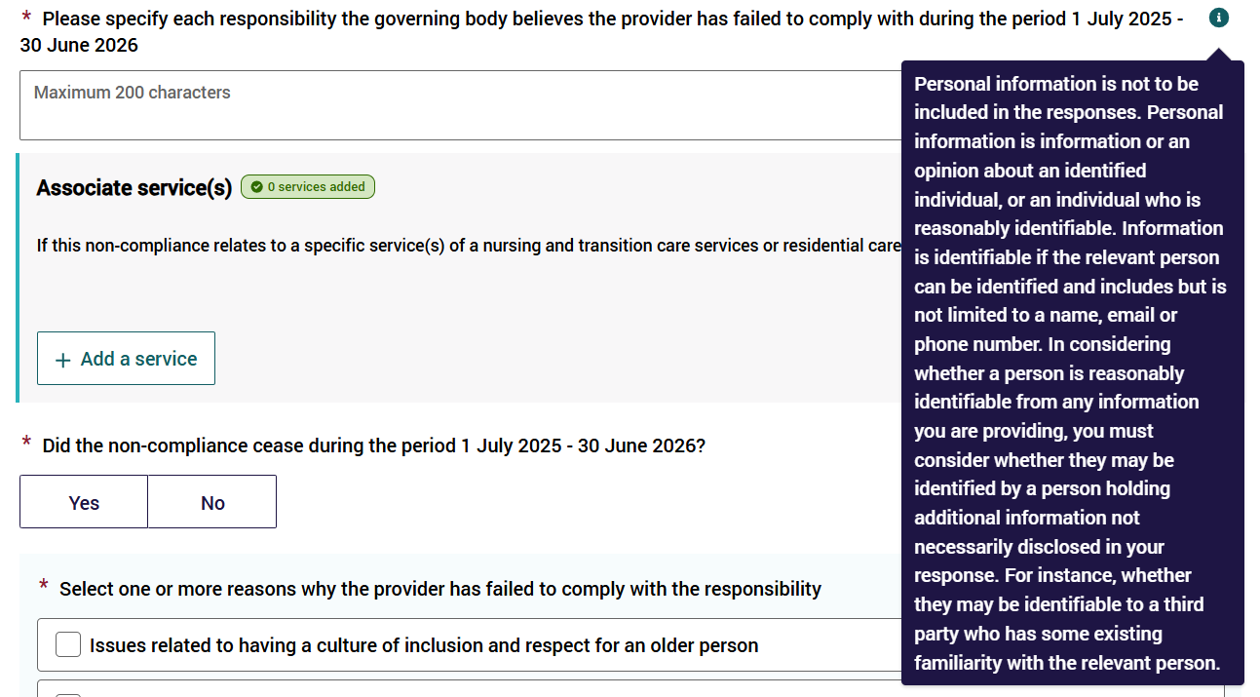
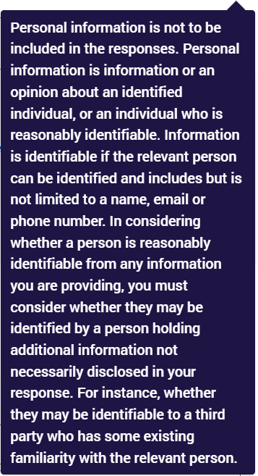
The information entered into the free text area must relate directly to the type of non-compliance selected.
Refer to the above question about type of non-compliance selected to assist you in determining the detail required for your response. Complete to the best of your ability and accuracy.
Please note:
- There is a 200 character limit on text entry in the free text area space.
- Do NOT include any personal information in this free text area due to privacy reasons.
- For each non-compliance type, if the non-compliance relates to a service, you will need to select one or more of the provider’s services.
To do this, select Add a service and select from the services listed for your organisation (check service name and service ID).
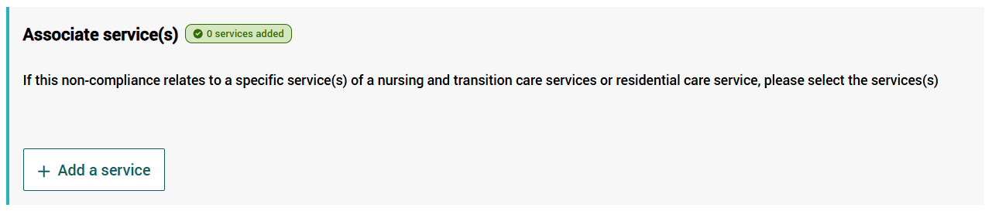
Only select your organisation’s services that were non-compliant with the specific requirement during the reporting period.
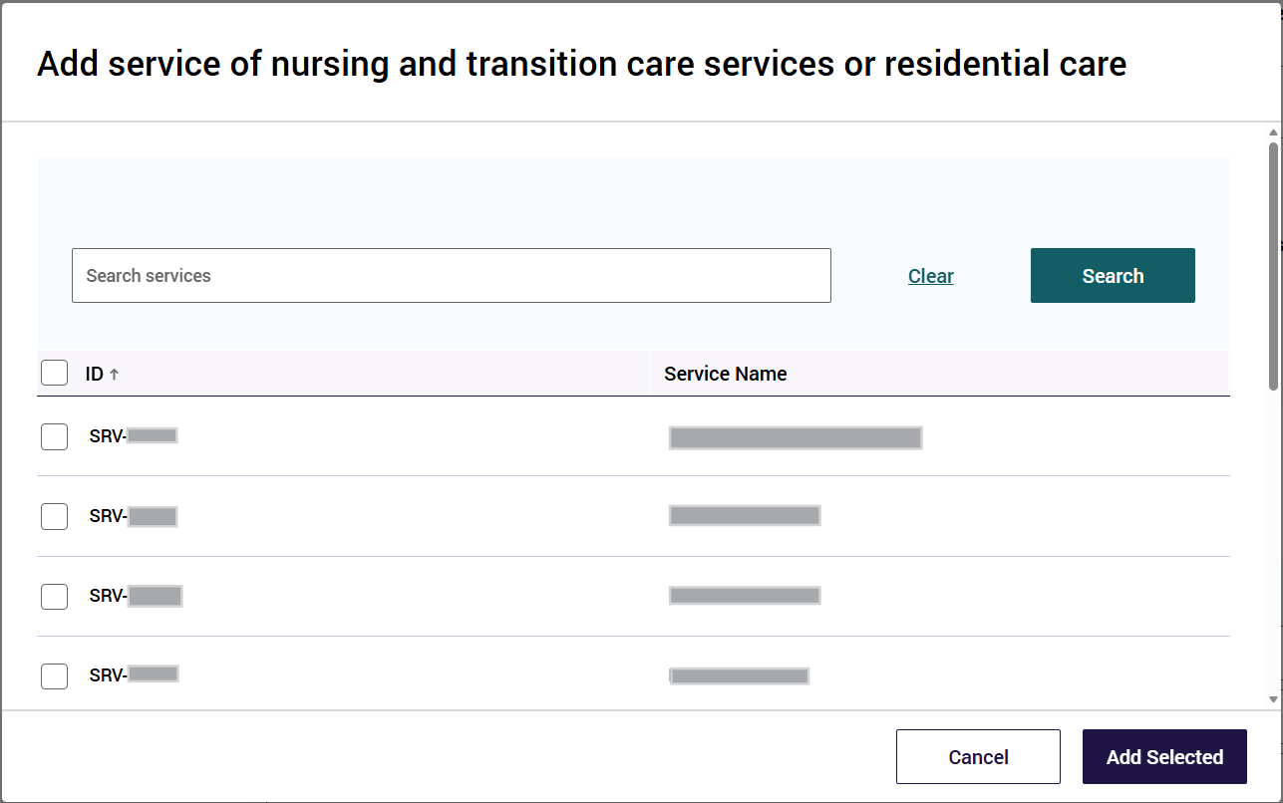
More than 1 service can be asociated. Add only selected services that have failed to comply with the non-compliance.
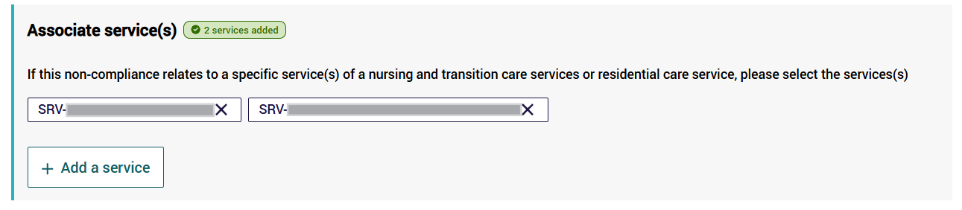Associating services is not mandatory.
In some cases the non-compliance may only relate to the provider (for example: governing body requirements).
In that situation, do not select any services as being non-compliant with that responsibility or requirement.
Complete the cessation of non-compliance question by selecting:
- Yes if the non-compliance ceased or ended during the reporting period; or
- No as best applies to your organisation.
- Select the reason/s for failing to comply with a responsibility or requirement from a list of options. The list of reasons aligns with expectations set out in the Aged Care Quality Standards.
Select Other if a reason for non-compliance is not listed here for your organisation and complete the free text area for other reasons.
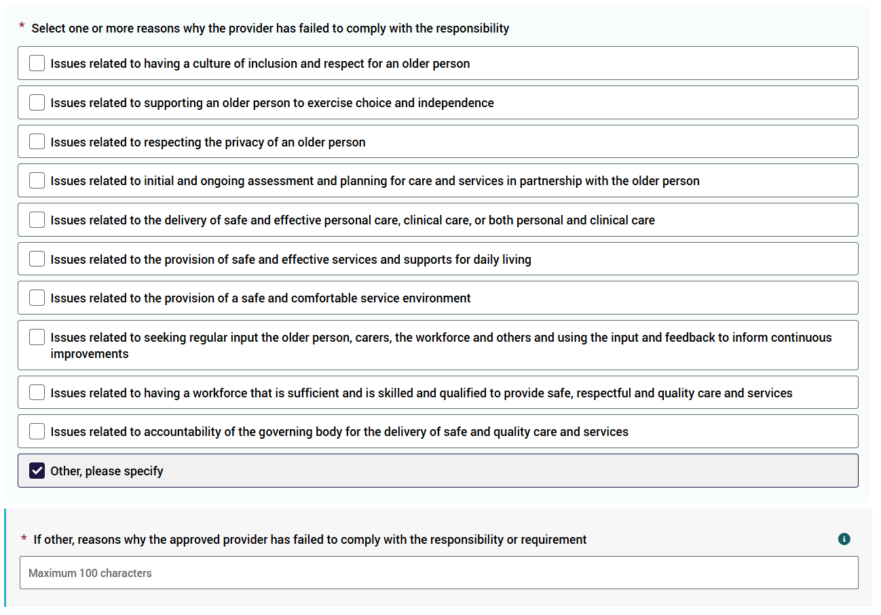
Please note:
- The information provided will be published on the My Aged Care website. Do NOT include any personal information in this free text area due to privacy reasons.
- There is a 100 character limit on text entry, should you select Other.
Providers are required to report the reason why the governing body believes the registeredprovider has failed to comply with a responsibility or requirement.
Non-compliances are often related to multiple reasons. Select as many reasons that apply for each non-compliance.
For supporting information on this question (for example: explanations of the terms), please refer to the ‘Frequently Asked Questions’ document in the Guides and FAQs section.
We have endeavoured to seek a wide range of possible reasons for non-compliance for providers.
- For the non-compliance, outline the actions that have been taken to rectify the non-compliance in the field displayed below.
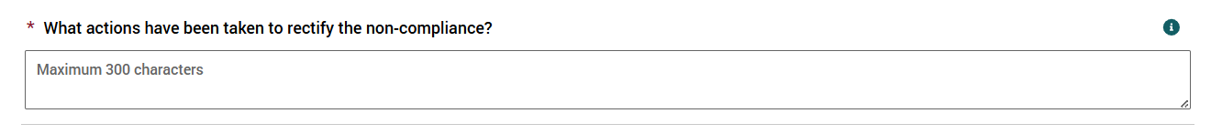
Please note:
- The information provided will be published on the My Aged Care website.
- Do NOT include any personal information in this free text area due to privacy reasons.
- There is a 300 character limit on text entry in the free text area.
- To select another type of non-compliance, select Add a Non-compliance - select from the drop down menu of options (of non-compliance types).
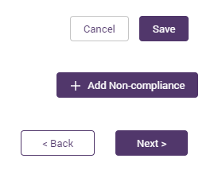
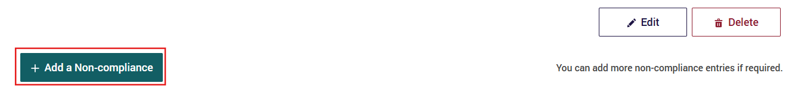
You will need to enter all the required information for each non-compliance and then Save, before adding another non-compliance.
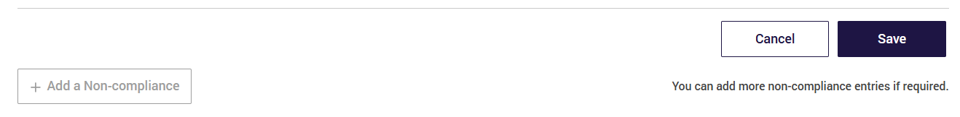
After you complete and save an entry for all questions related to a specific non-compliance, you can later edit the entry, or delete the non-compliance entry, if you need to do so.
Remember to Save your responses after entering the reasons for each non-compliance type, as you progress through this section.
Select Next to continue to the next section.

Important to note
The compliance data submitted in the Governing Body Statement is published on the My Aged Care website for your organisation under the Find a provider tool. Care recipients may use this data to make judgements about how informed the governing body is about the provider's performance.
This Governing Body Statement MUST NOT be changed after the Governing Body Member has signed and submitted their declaration.
After receiving a signed declaration, either via manual upload or via electronic signature, the GBS form remains in read-only mode to prevent accidental changes. The provider user CAN intentionally edit the GBS form to change non-compliance details, however that results in requiring attaining a new signed declaration for the GBS form to be considered completed.
Electronic signing process
- The person completing the Form includes the correct email address of the Governing Body Member, to view and digitally DocuSign the completed Statement.
Hard copy signing process
- Download and print a copy of the Statement for the Governing Body Member to sign - which you will then save and upload.
- Alternatively, Governing Body Members can be made a GPMS Provider Operations User (user access) by the Organisation Administrator to view the completed Statement online (before hard copy signing, scanning and uploading the document).
Below is an example of non-compliance information entered into this section - using the option ‘Statement of Rights’ as type of non-compliance:
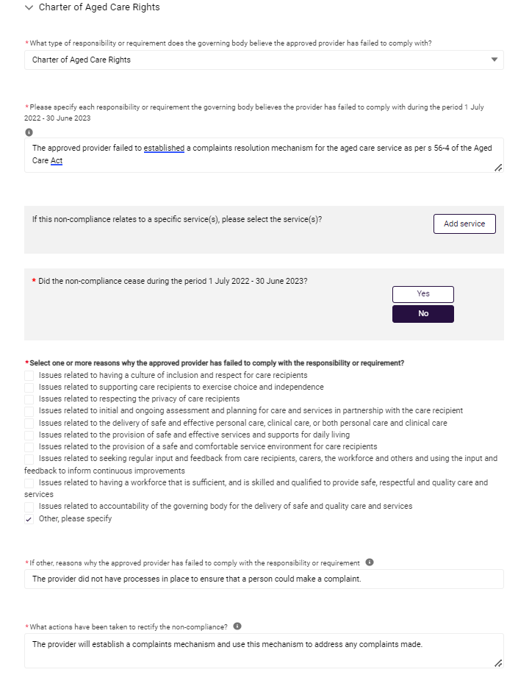
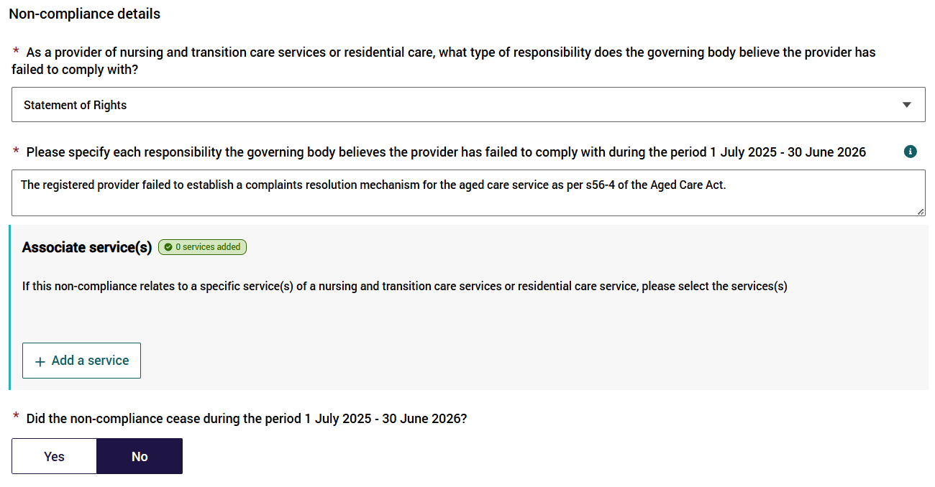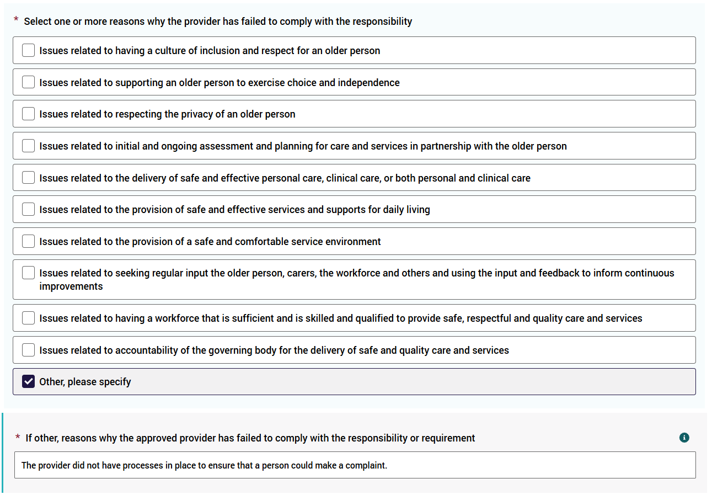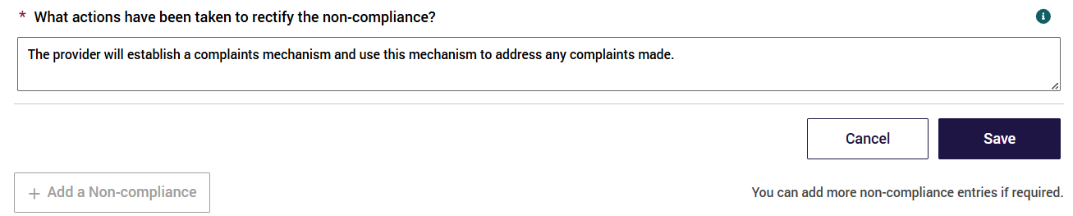
Once the non-compliance entry is saved, it is shown is view mode.
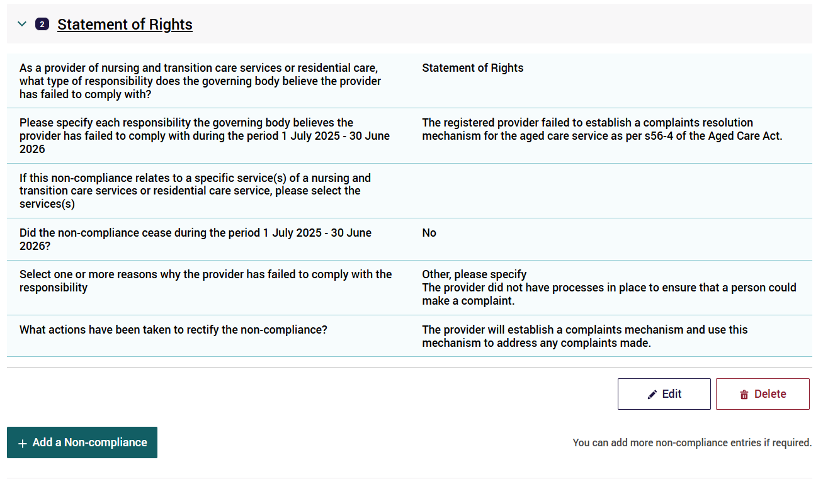

Diversity and Inclusion - Provider
This section is about the diversity of your organisation’s governing body.
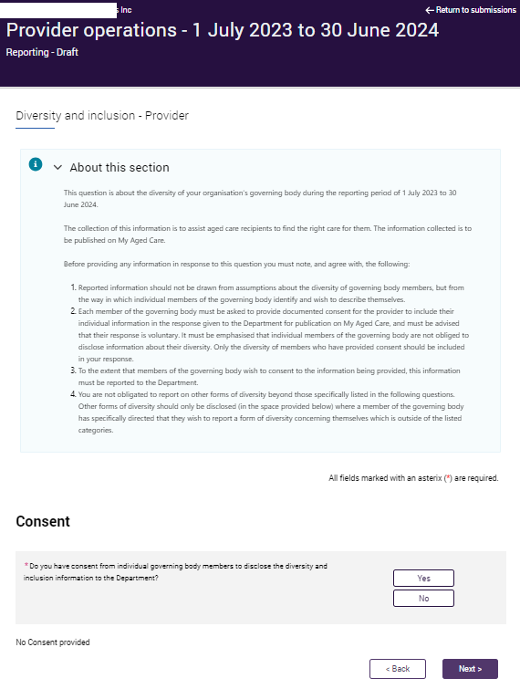
Please note, the above is a screenshot and the message is updated each year with accurate dates.
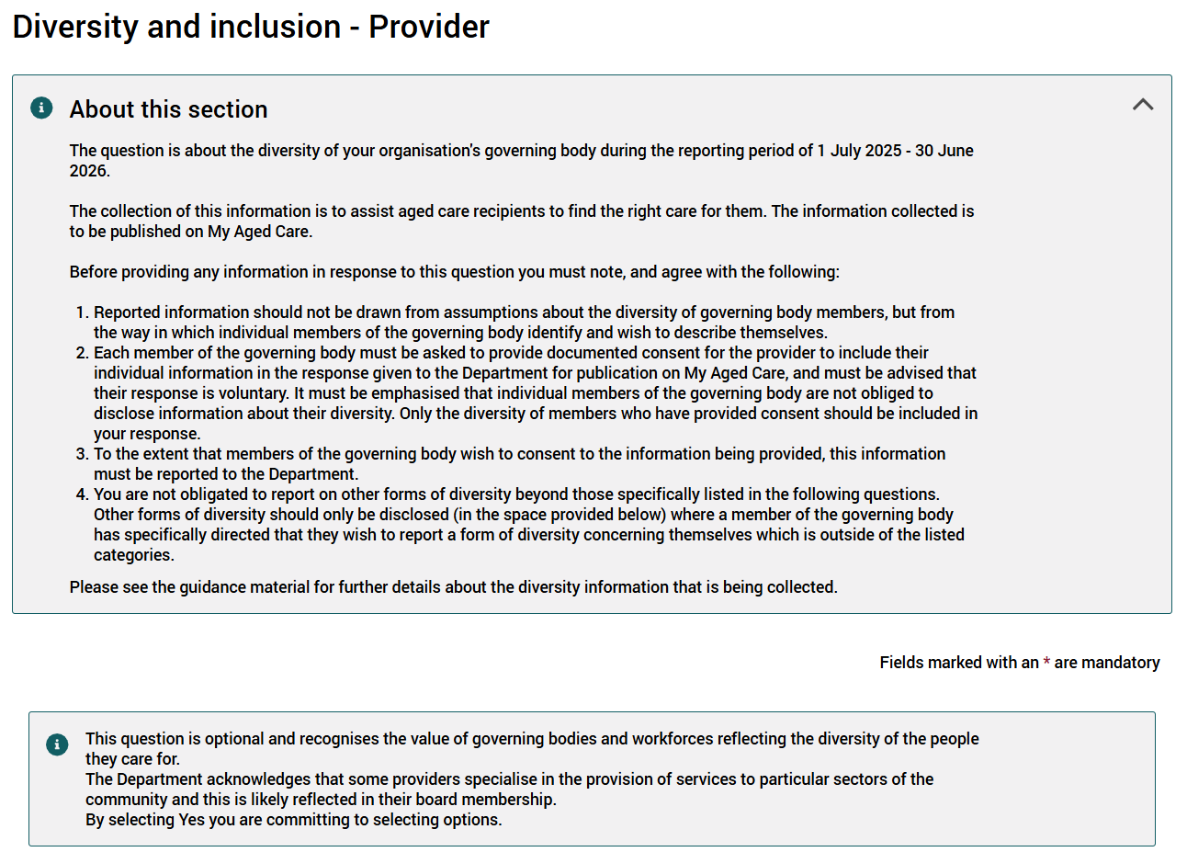
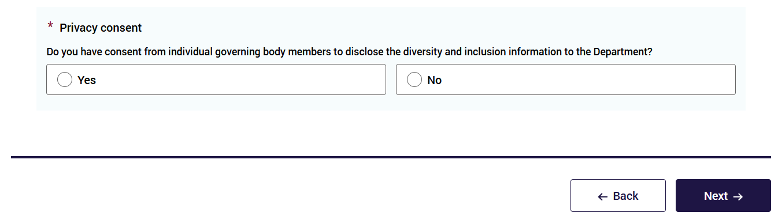
Select either Yes or No if one or more members of the governing body have consented to information about their diversity being reported in the Form.
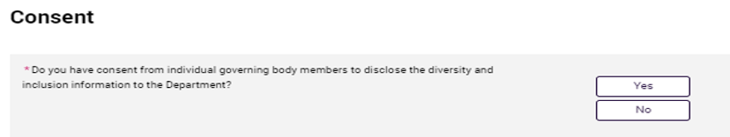
Select one, multiple, or none of the following responses as appropriate for your organisation:
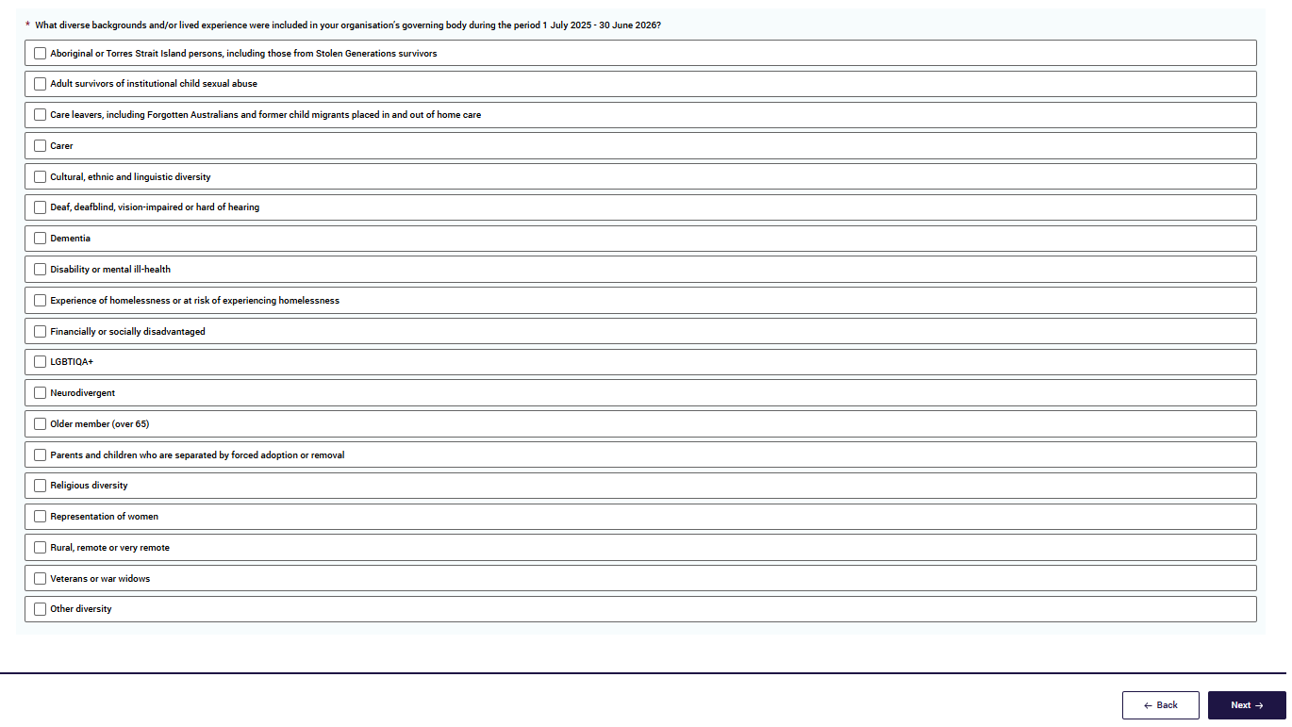
For supporting information on this question (such as definitions), please refer to the ‘Frequently Asked Questions’ document in the Guides and FAQs section.
If Other is selected you will be asked to specify the form/s of diversity represented within the provider’s governing body.
Only select Other if a member has specifically directed that they wish to report a form of diversity concerning themselves, outside of the above listed categories.
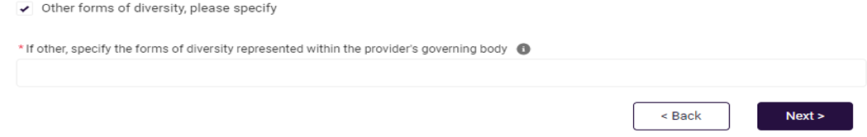
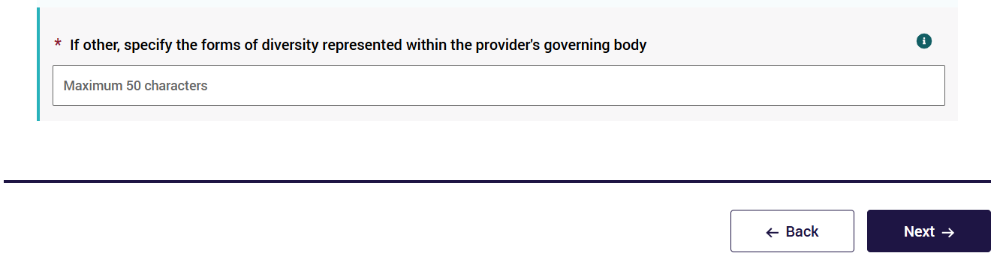
Please note:
- The free text area is limited to 50 characters.
Click Next to continue (noting you may also select Back to go back to update/ edit the previous section).
Both Next and Back icons (and accessing the left Navigation Bar) will save the information that you have entered provided there are no errors on the page.

Diversity and Inclusion - Service
This section is to collect information about initiatives implemented at each residential service and home care service to support a diverse and inclusive environment between 1 July and 30 June annually for each financial year reporting period.
All questions in this section are required for each service operated by the providers during the reporting period 1 July - 30 June.
The Form lists each service name and service ID that operated during the reporting period. All services under the provider that are operational for the reporting period will be displayed.
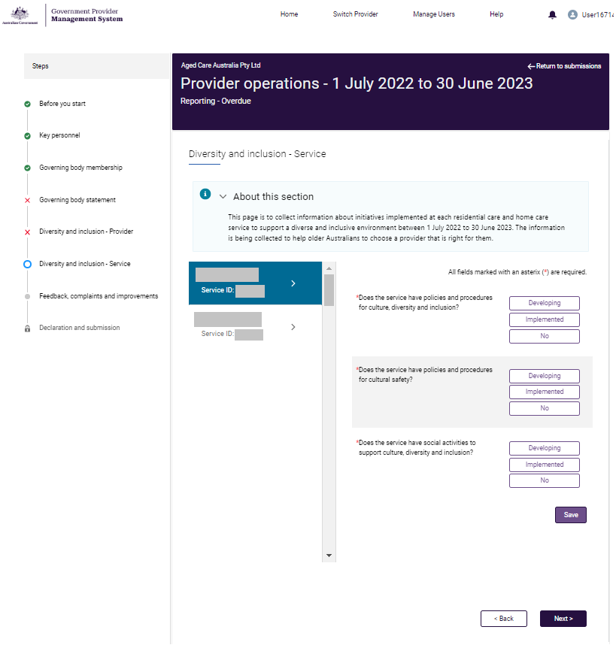
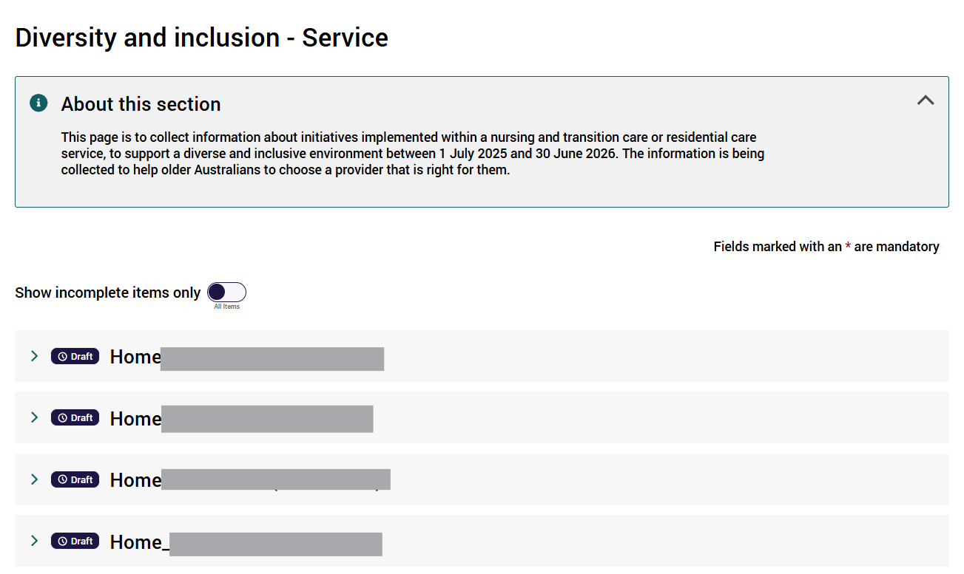
To complete this section of the Form, select a service from the displayed list of services to enter data about the initiatives at that service.
Please note:
- You do not need to select services in the order listed in the Form.
- When data has been entered for a service, a Completed stamp will be displayed against the service.
- This will allow you to track the services that have been completed and identify any services whose data has not yet been entered.
To assist you when there are many services listed, a Show incomplete items only toggle is shown at the top of the services listing.
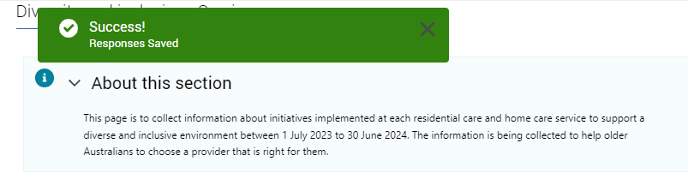
For each service you will need to select either Developing, Implemented or No for each of the following statements.
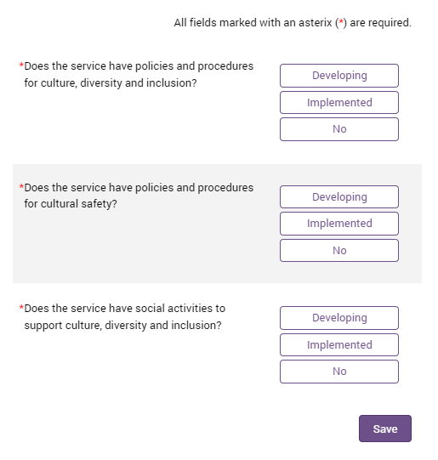
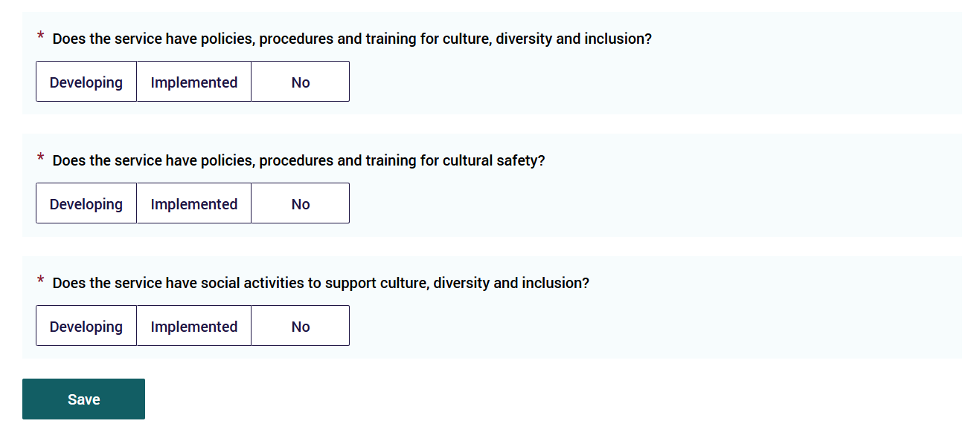
Respond as appropriate for your organisation for each of the three questions listed, for each service offered in the reporting period:
- Developing: work is underway, in progress, or has commenced in our organisation for this service.
- Implemented: this has been completed and we have policies and procedures in our organisation for this service.
- No: not yet started or completed or underway, no work has been done in this in our organsation for this service.
Remember to Save your responses for each service.
If you offer an additional service expand the next service applicable to your organisation.
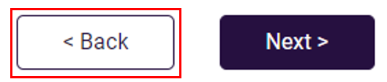
When you have completed entering the data for each service - this will be indicated by a tick Completed stamp.
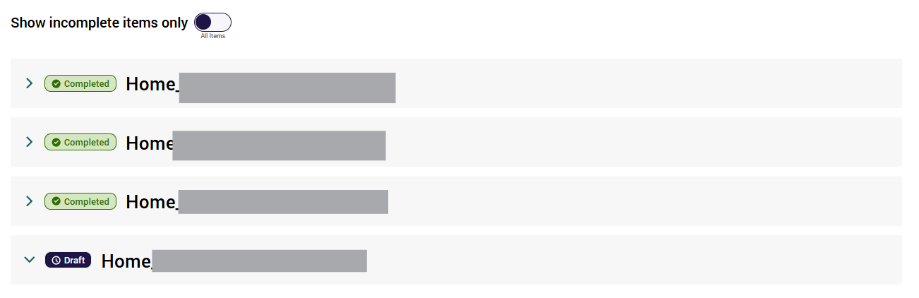
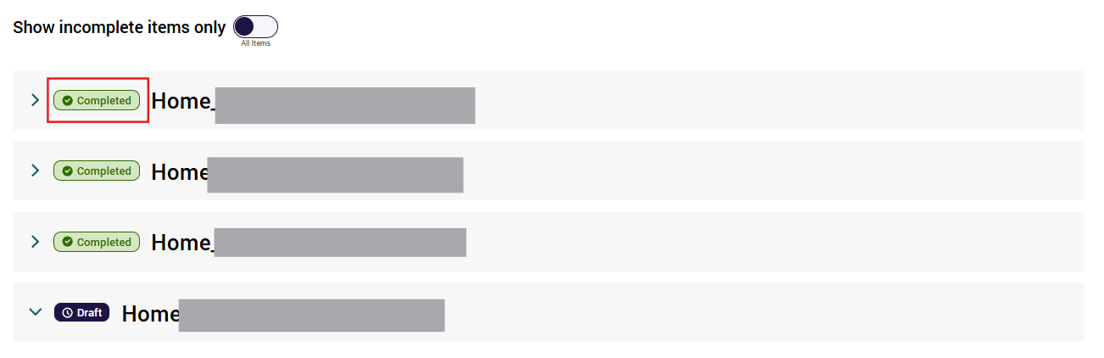
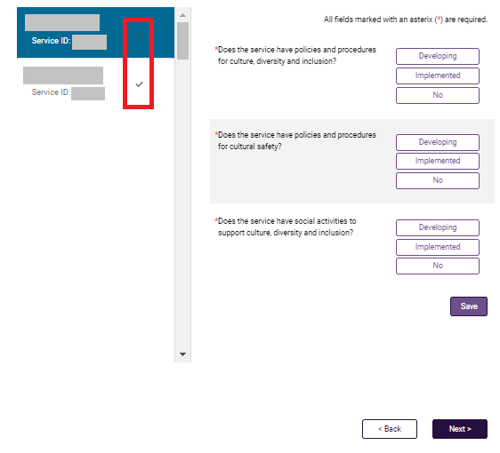
Continue until the three questions have been completed for every service operated in the reporting period.
Then click Next to progress to the next section of the Form.

Feedback, Complaints and Improvements
This section is to collect information about the most common kinds of positive feedback and complaints received about each residential care and home care service, as well as information about the key improvements made at each residential care and home care service between the reporting period 1 July and 30 June.
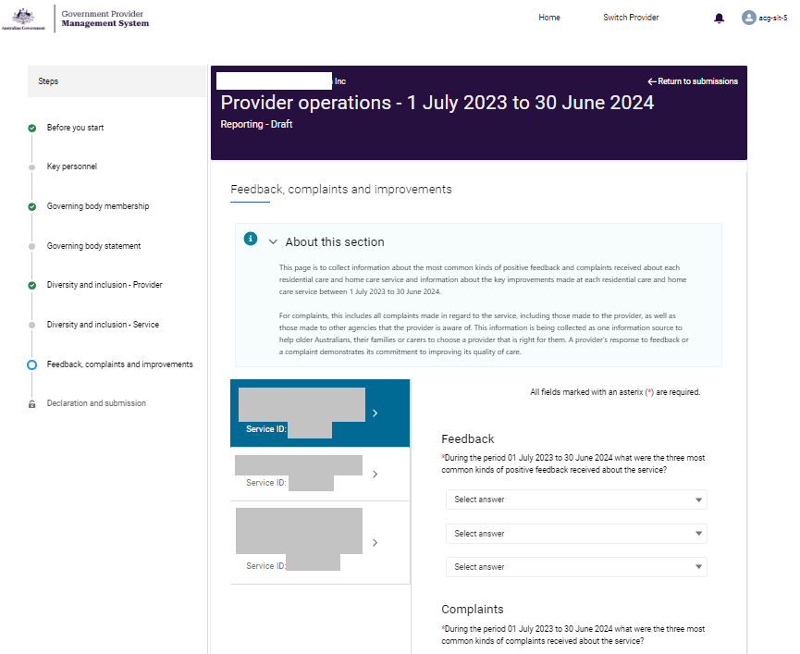
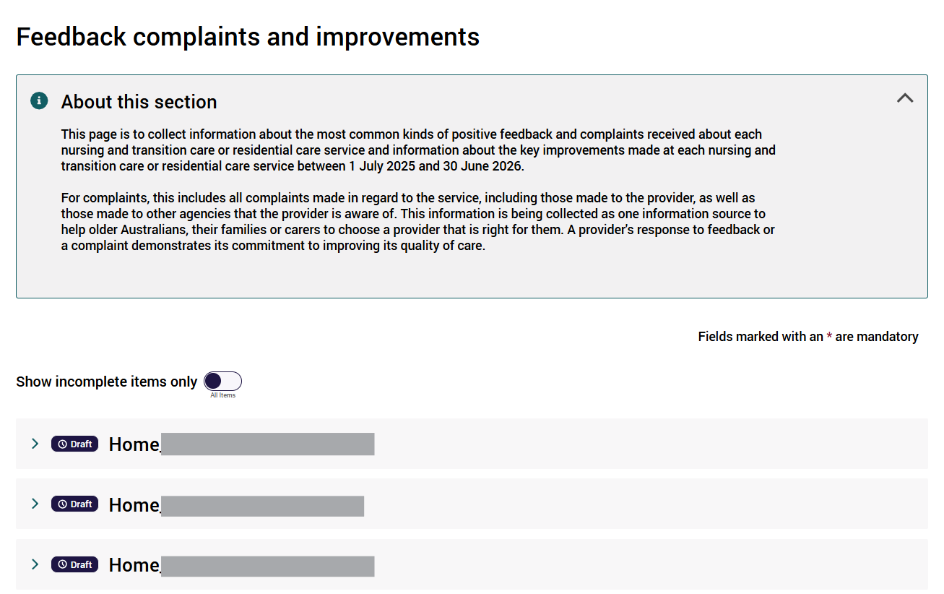
All questions in this section are required for each service operated by the providers during the reporting period 1 July - 30 June.
We have endeavoured to provide a wide range of categories for you to record positive feedback, complaints and improvements.
For supporting information on this question including explanations about each category, please refer to the ‘Frequently Asked Questions’ document in the Guides and FAQs section.
Select the categories that best fit the most common feedback, complaints and improvements for each residential care and home care service within your organisation. In selecting the most common kinds of feedback and complaints, providers should consider the frequency in which the kind of feedback and complaint is raised.
Select Other if the most common feedback, complaint, or improvement does not fit in with the provided menu of options.
When data has been entered for a service, a tick will be displayed against the service. This will allow you to track the services that have been completed and identify any services whose data has not yet been entered.
The Form lists each service name and service ID that operated during the reporting period.
- Select a service to enter information for feedback, complaints and key improvements each service.
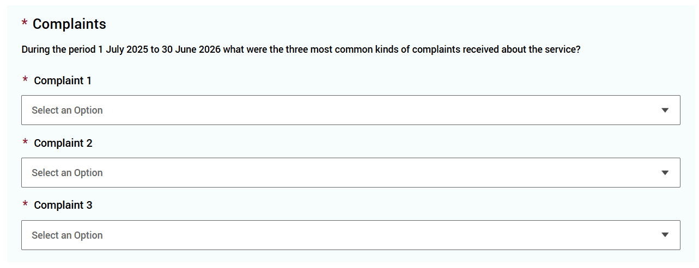
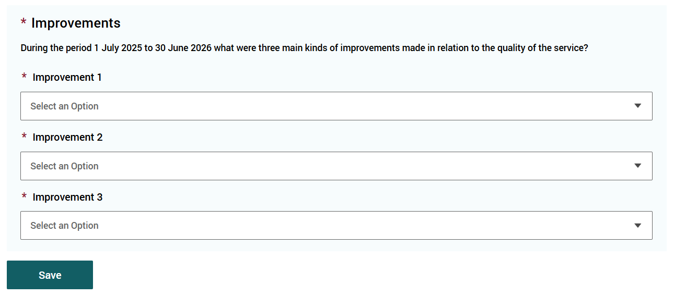
- Select the top three categories that best fit the positive feedback received on each service (not the whole organisation) during the reporting period.
Select Other if the most common kind of positive feedback received about the service does not fit in with the provided menu of options.
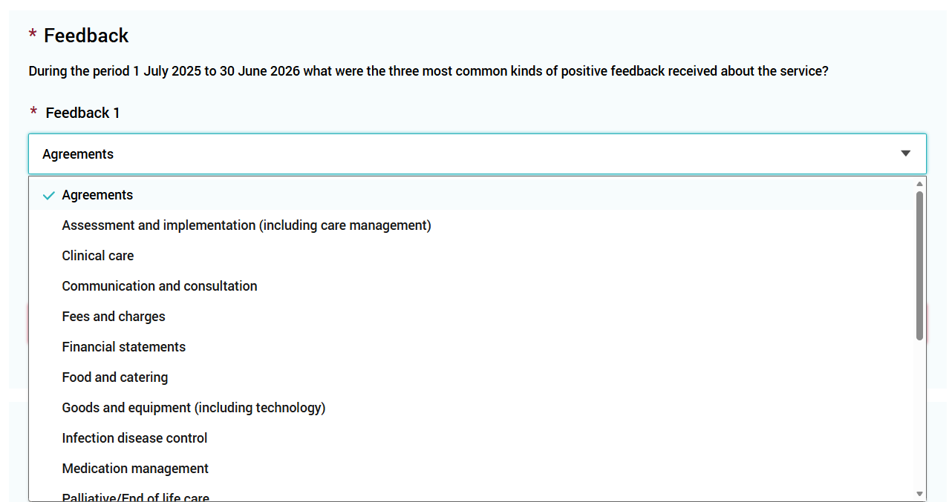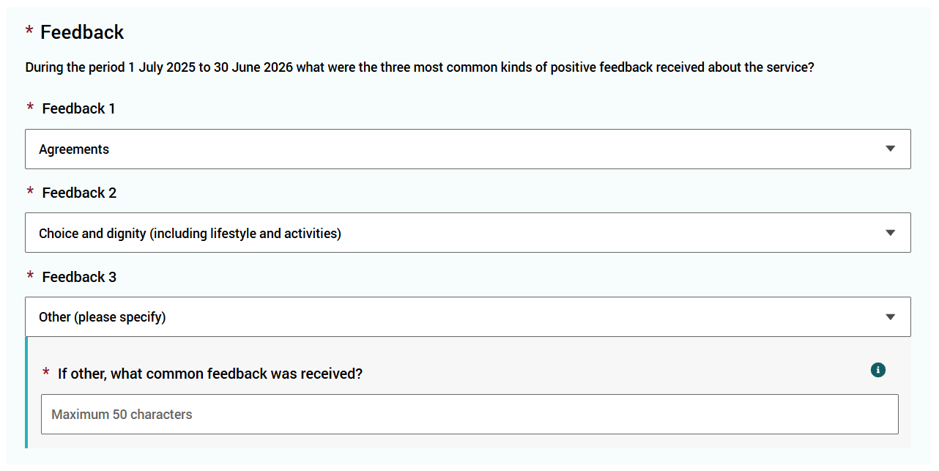
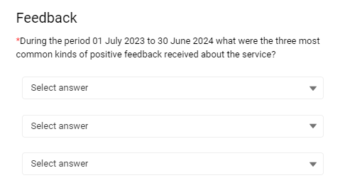
- Select the top three categories that best fit the most common kind of complaints received about your service (not the whole organisation) during the reporting period.
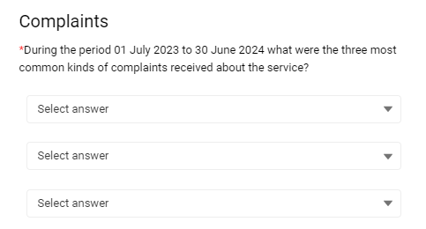
Select Other if the most common complaint/s made about the service does not fit in with the provided menu of options. You may select Other for each of the three responses.
Please note:
- The categories selected should capture include all complaints made during the reporting period in regard to the service, including those made to the provider, as well as those made to other agencies (such as the Aged Care Quality and Safety Commission) that the provider is aware of.
- If you select Other do not include personal information about any individual due to privacy reasons.
- Click Save often to regularly save your work as you progress.
- Select the top three kinds of improvements made in relation to the quality of the service (not the whole organisation) during the reporting period.
Select Other if the most common improvement made at the service does not fit in with the provided menu of options.
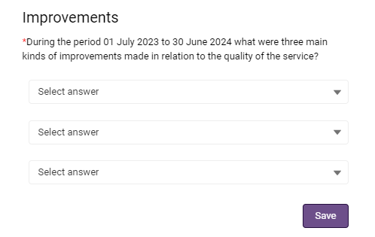
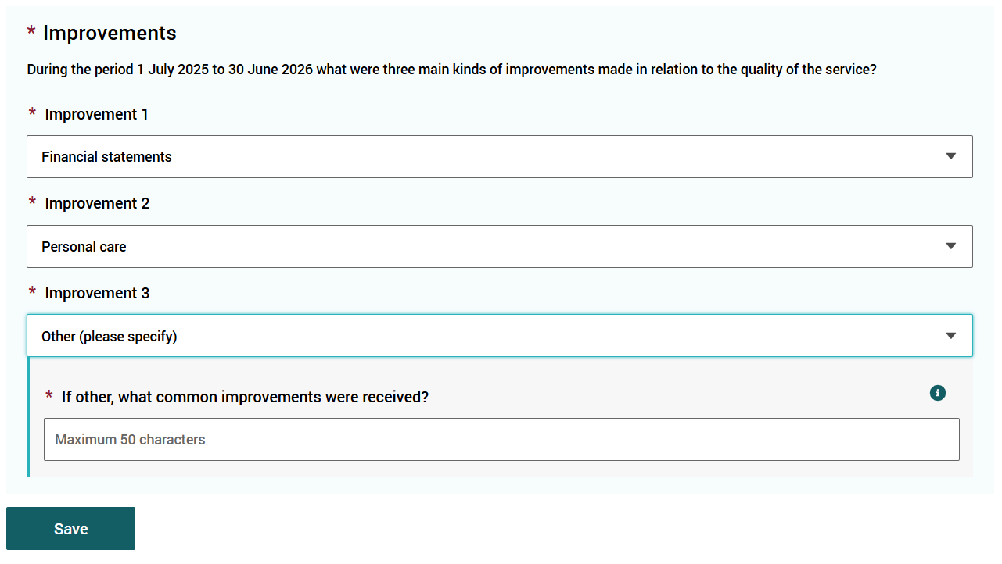
Please note:
- If you select Other do not include personal information about any individual due to privacy reasons.
- Click Save often to regularly save your work as you progress.
- Click Next to continue (noting you may also select Back to go back to update or edit the previous entry).
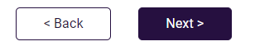

Declaration and Submission
This section is the final step in completing the Form and preparing for final submission via the GPMS portal.
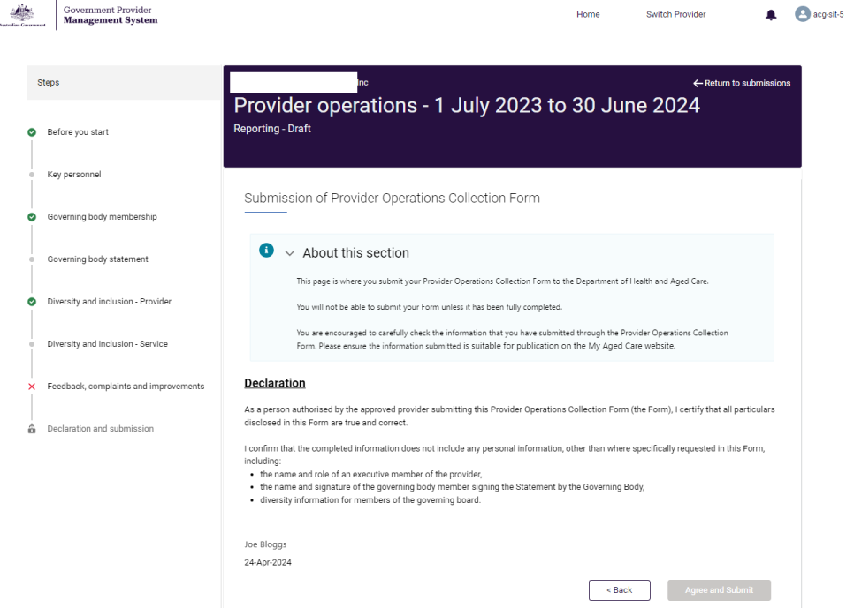
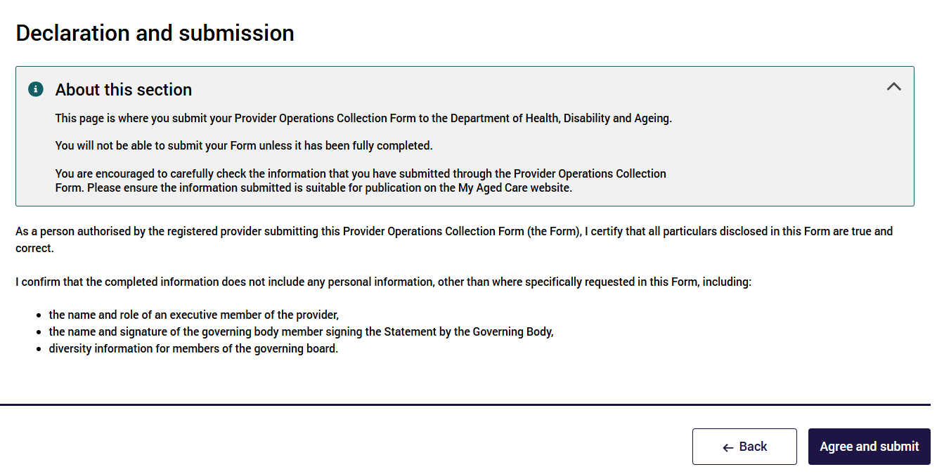
This final page (at the bottom of the left navigation bar) is where you submit your Form to the Department.
You will not be able to submit your Form unless it has been fully completed.
If you have not completed all sections in the Form, you will see those sections in the left-hand navigation bar marked with a red cross (): has errors, or grey dot (): not yet started – both these icons indicate these sections are incomplete.
Return to these sections in the Form and complete the ones marked with a red cross () or grey dot ().
You are encouraged to carefully check all the data that you have entered into the Form, prior to final submission. Please ensure the information submitted is suitable for publication on the My Aged Care website.
Please note:
- You must be the person authorised by the registered provider to submit the completed Form.
- Your name as a provider operations user will appear at the bottom of the Declaration Statement, above the date.
- Once submitted, you will not be able to go back and edit/ update/ review your responses within the Form.
If you have completed all sections in the Form (confirmed by green ticks in all sections in the left navigation bar (barring Declaration and submission, the last section)):
- Review the declaration
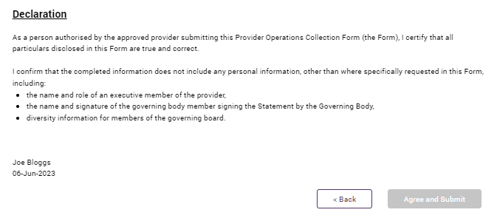
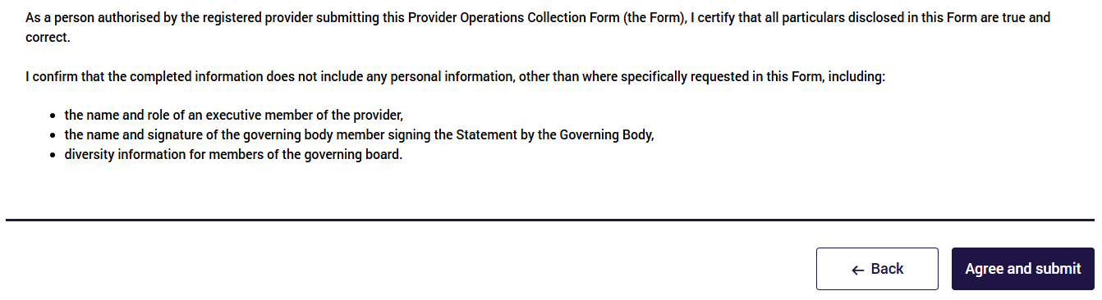
- If you are ready to make the declaration and submit the Form, select Agree and submit.
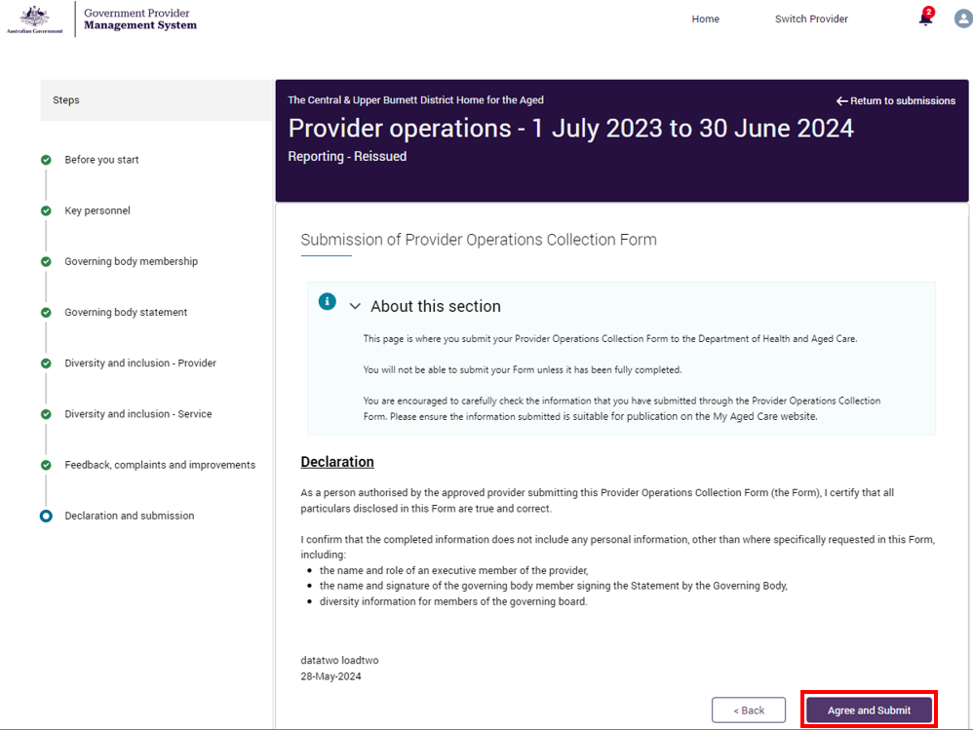
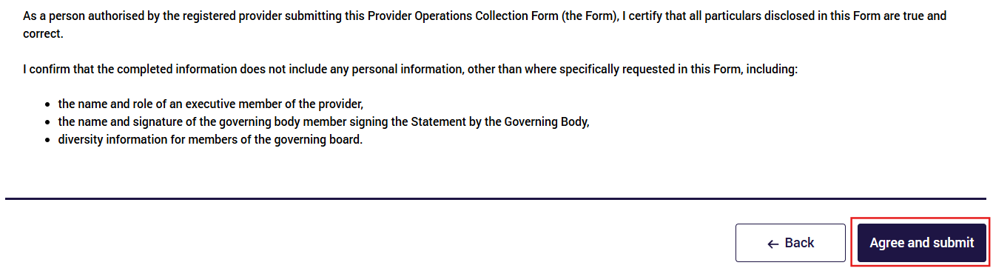
Once submitted, you will receive an acknowledgement There will be a record on the screen confirming the name of the person and the date submitted. This will also be recorded in the system records.
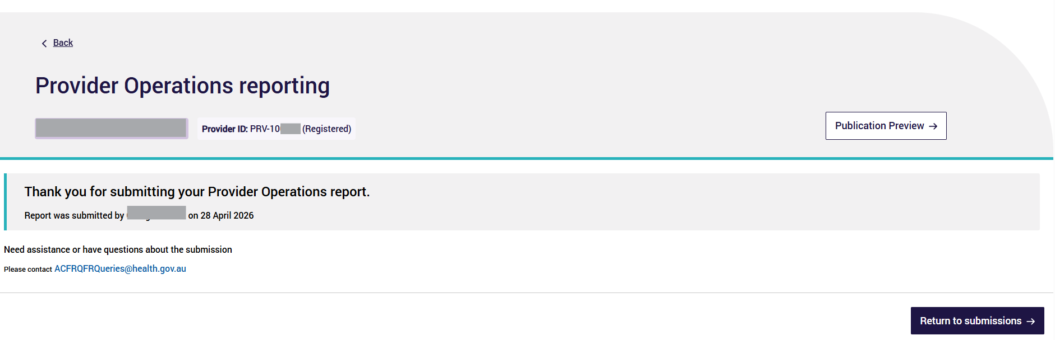
Report was submitted by <full name> on <date month year>.
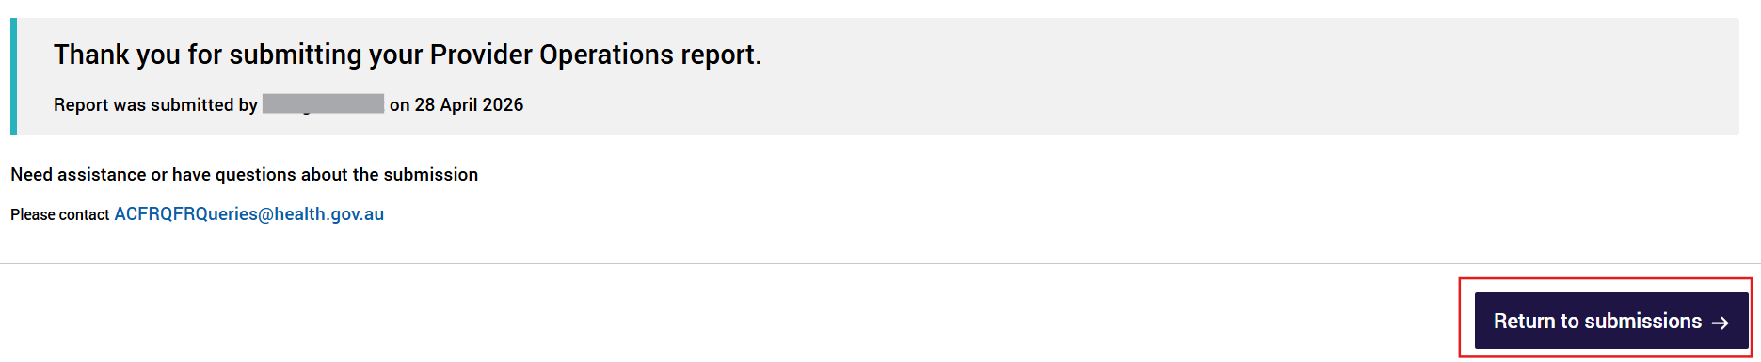
After submission, you will have access to a read-only view of yourForm and you will be able to download, save and print a copy of your Form.
