
Final Evaluation of the Prescribed List Reforms
Department of Health, Disability and Ageing
16 June 2026


Nous Group acknowledges Aboriginal and Torres Strait Islander
peoples as the First Australians and the Traditional Custodians of
country throughout Australia. We pay our respect to Elders past,
present and emerging, who maintain their culture, country and
spiritual connection to the land, sea and community.
This artwork was developed by Marcus Lee Design to reflect Nous Group’s Reconciliation Action Plan and our aspirations for respectful and productive engagement with Aboriginal and Torres Strait Islander peoples and communities.
Disclaimer:
Nous Group (Nous) has prepared this report for the benefit of the Department of Health, Disability and Ageing (the Client).
The report should not be used or relied upon for any purpose other than as an expression of the conclusions and recommendations of Nous to the Client as to the matters within the scope of the report. Nous and its officers and employees expressly disclaim any liability to any person other than the Client who relies or purports to rely on the report for any other purpose.
Nous has prepared the report with care and diligence. The conclusions and recommendations given by Nous in the report are given in good faith and in the reasonable belief that they are correct and not misleading. The report has been prepared by Nous based on information provided by the Client and by other persons. Nous has relied on that information and has not independently verified or audited that information.
© Nous Group

Contents
Glossary of commonly used terms and acronyms iii
Background on the Prescribed List iv
Executive summary 1
Final state of the reforms 8
1 About this Evaluation 12
2 Achievement of the reform objectives 14
2.1 Objective 1: Improve the alignment of the scheduled benefits of the PL with the prices paid in more competitive markets 14
2.2 Objective 2: Maintain no additional out-of-pocket costs associated with the PL devices for consumers 23
2.3 Objective 3: Maintain clinician choice of appropriate prostheses for their patients 26
2.4 Objective 4: Improve the affordability and value of PHI for privately insured Australians 29
2.5 Objective 5: Clarify the purpose, definition and scope of the PL in legislation 36
2.6 Objective 6: Implement new PL assessment pathways aligned to Health Technology Assessment principles and streamline the application process through simple and robust IT infrastructure 45
2.7 Objective 7: Develop and implement PL post-listing reviews and PL compliance frameworks to safeguard the PL Reforms 52
2.8 Objective 8: Ensure ongoing financial sustainability of PL administration through effective and efficient cost recovery arrangements that are compliant with the AGCF 64
Appendix A Methodology 68
A.1 Purpose of the evaluation 68
A.2 Evaluation plan and theory of change 68
A.3 Overall approach and KEQs 72
A.4 Approach to data collection and engagement 73
Appendix B List of stakeholders consulted 74
Appendix C Detail on evaluation indicators 75
C.1 Indicator 1: Reduction in benefits 75
C.2 Indicator 2: Change in the size of the gap between PL benefits and prices paid in more competitive markets 75
C.3 Indicator 3: Change in out-of-pocket expenses related to PL items 80
C.4 Indicator 6: Change in PHI premium increases 82
C.5 Indicator 7: Change in PHI coverage and for whom 83
C.6 Indicator 9: Implementation of PL regrouping 83

Glossary of commonly used terms and acronyms
AGCF | Australian Government Charging Framework
CIED | Cardiac implantable electronic device(s)
Consumers | Also alternatively referred to as patients
ECAG | Expert Clinical Advisory Committee
FY | Financial year
GUI | General use item
HIB | Health insurance business
HPP | Health Products Portal
HT | Hospital treatment
HTA | Health Technology Assessment
IHACPA | Independent Health and Aged Care Pricing Authority
IECT | Industry Employed Cardiac Technician
KEQ | Key evaluation question
LPP | Liste des Produits et Prestations
MDHTAC | Medical Device and Human Tissue Advisory Committee
Medical device sponsor | Also alternatively referred to as medical technology company or medical technology sponsor
MOU | Memorandum of Understanding
MSAC | Medical Services Advisory Committee
PHI | Private Health Insurance
PL | Prescribed List (previously known as the Prostheses List)
Private hospitals | Also alternatively referred to as private healthcare providers. Unless specified, hospitals refers to both private hospitals and day hospitals
Public benchmark | Benchmark pricing for PL items sold to Australian public hospitals – alternatively referred to as Weighted Average Price (WAP)
TSS | Technical Support Services (for CIEDs)

Background on the Prescribed List
The Prescribed List of Medical Devices and Human Tissue Products
The Prescribed List (PL) (previously known as the Prostheses List) is a schedule to the Private Health Insurance (Medical Devices and Human Tissue Products) Rules 2024 that sets the minimum price a private health insurer must pay a hospital for medical devices and human tissue products received by private patients in privately insured episodes of care. This is a legislative instrument made under the Private Health Insurance Act 2007.
The Minister of Health, Disability and Aged Care is responsible for administration of the PHI Act, including the PL. A range of stakeholders are involved in the provision, acquisition, funding and receipt of medical devices. These include the Department, private health insurers, private healthcare providers (i.e. private hospitals and day hospitals), medical technology companies, clinicians, and consumers. Their interactions in respect of the Prescribed List are summarised in Figure 1 below.
Since its introduction in 1985, the PL has undergone several reforms, reviews and changes. The PL is currently in four parts. For a device or product to be listed on the PL it must satisfy the criteria for listing for one of the four parts of the PL.
- Part A – consists of medical devices used for specific therapy (not general use) that must be either surgically implantable devices or be essential and specifically designed as an integral single-use aid for implanting a device or be critical to the continuing function of the surgically implanted device.
- Part B – consists of human tissue products.
- Part C – covers the specified groups of medical devices stated in the Rules that do not meet the listing criteria for Part A, but which the Minister considers suitable for benefit payments by private health insurers.
- Part D – consists of general use items (GUIs). GUIs include items not originally intended for the PL, including surgical consumables such as surgical glues.
The Department accepts applications on a continuous basis, and from 2019, the Prescribed List is typically published three times per year (effective 1 March, 1 July and 1 November).
Figure 1 | Mechanism of the Prescribed List
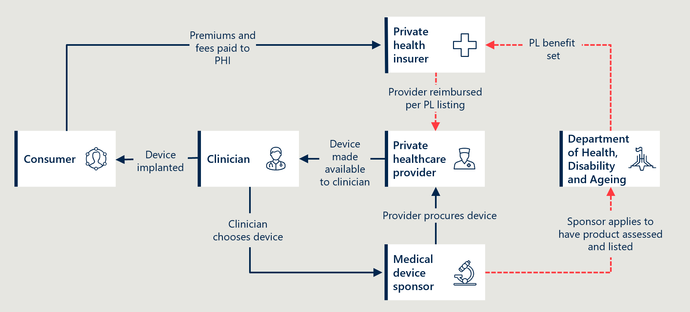


Executive summary
The Prescribed List of Medical Devices and Human Tissue Products (PL) reform program, introduced in the 2021-22 Australian Federal Budget, aimed to “reduce the cost of medical devices used in the private health sector and streamline access to new medical devices”. The reform program was implemented between 1 July 2021 and 30 June 2025.
Nous Group (Nous) was commissioned by the Department to conduct an independent evaluation of the reforms from September 2023 to June 2026. The evaluation sought to understand the extent to which reform activities delivered the eight stated reform objectives (listed in Figure 2) and to provide useful insights for the future of the PL.
This Final Evaluation report builds on a Baseline Evaluation report and two Interim Evaluation reports already published. The Interim Evaluation #1 report covered the implementation of the reforms until June 2024 and the Interim Evaluation #2 report covered the period from July 2024 to June 2025. This report builds on the Interim Evaluation #2 report, updating the analysis through revised figures and targeted amendments to findings and recommendations to reflect impacts realised following program completion.
Due to the benefit reductions achieved through the reforms, the Independent Health and Aged care Pricing Authority (IHACPA) estimated that significant savings of $540 million were generated for the Australian health system in the three years from July 2022 to June 2025. This includes $239 million in FY25, which reflects the reforms’ annualised impact now that benefit reductions have been fully implemented. Subject to future changes in device utilisation and benefit settings, savings of a similar annual order are expected to continue in future years. The cumulative effect of savings from the benefit reductions is estimated to reach $1 billion by June 2027.
These savings have put downward pressure on private health insurance (PHI) premiums. While increases in the volume of devices used and broader cost pressures mean premiums have continued to increase, it is reasonable to conclude that the reduction in PL benefits has moderated the size of these increases.
While these savings provide the headline impact of the reforms, the other planned objectives had mixed success. It is worth noting that perhaps the most striking reflection by the evaluation team across the reform years was the extent of mistrust between the private sector parties involved in the PL reform process – insurers, private hospitals and the MedTech companies. The potential for conflicts of interest was also extremely high. The process adopted by Government was deliberately consultative, which often resulted in open acrimony. The significant commercial interests involved meant that the reforms became highly contentious, with claims made by various stakeholders bordering on litigious. The interests of consumers were often lost in the process.
The Memorandum of Understanding for the policy parameters of the Prostheses List Reforms (the MOU), agreed early in the reform process between the then Minister for Health and Aged Care and the MTAA in 2022, had a significant impact on the realisation of the reform’s objectives. While the MOU established the process and parameters for reducing PL benefits, it also limited flexibility to achieve some of the other objectives. This was particularly in relation to the planned project to address the existing inequalities in the structure of the PL and simplify and streamline its 13 groupings (included under Objective 5 of the reforms). The MOU’s ban on the achievement of further savings was a significant factor in the failure to achieve regrouping.
Governance
The existence of disruptive disputation and potential conflicts of interest was to some extent improved at the outset by the changes to governance for the PL. The former Prostheses List Advisory Committee (PLAC) was replaced by the Medical Technology and Human Tissue Advisory Committee (MDHTAC), which removed representatives of the MedTech industry, the private health insurance industry and the private hospitals. The MDHTAC and its Expert Clinical Advisory Groups (ECAGs) included strong clinical representation and were able to transact business much more effectively, and in the interests of consumers. While some MDHTAC members felt the Committee would benefit from having better access to the voice of the hospitals (although not within the Committee), stakeholders generally supported the revised governance structures.
Maintaining the PL policies of no out-of-pocket fees for consumers and clinician choice of device
The evaluation found no substantive evidence that the reforms had impacted on the core policy of maintaining no additional out-of-pocket costs for consumers. Similarly, there was broad agreement that the ability for clinicians to have uninhibited choice of device had not been significantly impacted by the reforms.t While some concerns were expressed by some stakeholders that there had been some impact on both these policies, these were at the margin. The concerns that were raised related to the risk of cost-shifting behaviour on out-of-pocket fees and potential limitations on clinician choice related to some specific high cost/more advanced technologies.
Benefit reductions
A key component of the reforms was the planned series of reductions to PL benefits, which aimed to improve the alignment of PL benefits with prices paid in more competitive markets. The reductions, agreed in the 2022 MOU, were implemented as agreed in a staged way in July 2023, 2024 and 2025 to reduce the gap between PL benefits and prices in the Australian public health system. The private health insurance industry argued that use of public sector benchmark prices did not generate sufficient savings to materially reduce premiums, claiming benefit levels remain markedly higher than those observed in comparable international markets. While the evaluation considers the use of public sector benchmarking as an appropriate and effective method for the reforms, case studies undertaken by the evaluation indicate that there is still room to assess benefits against publicly available international benchmarks as a complement to existing application and review processes. International price benchmarks should be used selectively as a targeted evidence source in relevant BAU benefit setting decisions and post-listing reviews. For relevant applications or reviews, the Department, MDHTAC or contracted HTA providers could draw on publicly available international prices and, where appropriate, seek input from comparable overseas pricing or reimbursement bodies to help assess whether proposed or existing benefits remain reasonable. The 7% floor applied above public sector benchmarks during the reforms demonstrates that benchmarks can be used with an appropriate premium or buffer, recognising contextual differences without treating them as a barrier to practical comparison.
RECOMMENDATION 1: Use international price benchmarking selectively as a complementary input to relevant benefit-setting decisions and post-listing reviews.
CIEDs
With the exception of reductions to benefits for Cardiac Implantable Medical Device (CIED) items, the reductions were achieved within the original timeframes set out by Government, following the agreed methodology in the MOU. An agreement to defer reductions to CIEDs was made early in the reform program to consider treatment of the technical support services (TSS) funded by the CIED benefits. A TSS component of CIED benefits was determined to be excluded from reductions, and reductions were sought for the capital component of CIEDs only. The deferral by one year is estimated by IHACPA to have resulted in $94 million in forgone savings over the five-year period from July 2022 to June 2027. Given TSS effectively remains funded by the PL (despite not being a medical device or human tissue product), and the existence of ongoing cross-subsidisation of CIED services in public hospitals, further opportunities for reform remain in relation to CIEDs. Given the ongoing growth in the use of CIEDs, and their significant cost, there is a case for developing a more sustainable funding model for CIED TSSs in both private and public health services, to allow these costs to be unbundled from device costs. This would support greater transparency and allow each component to be priced/funded appropriately. Reform efforts could also include continued support for remote monitoring – in line with technological advances – and the potential development of a national CIED registry to improve oversight and service quality. Change is likely to be slow, given the lack of a current technical workforce within both private and public hospitals.
RECOMMENDATION 2: Use the work undertaken through the reforms to inform further cross-portfolio consideration of alternative service and funding models that allow the separation of CIED device and service costs in both the public and private sectors.
Regrouping
The original vision for a more tightly defined, clinically ordered, and manageable PL has not been fully realised. While the scope of the PL has been more tightly defined in legislation, the project to regroup the PL ‘along clinical lines’ to create a transparent and practical grouping structure was discontinued. The regrouping aimed to streamline the list, make it simpler to navigate for insurers and hospitals, and remove historical inconsistencies and pricing anomalies in the existing groupings.
Detailed work was undertaken with clinical input to regroup PL items by clinical use, but the proposed structure encountered significant opposition from some stakeholders. The challenges that arose resulted from the existence of mixed-benefit PL groupings and the MOU ban on achieving further savings. The regrouping work was ceased in May 2025 and the previous PL structure remains in place. The decision to cease work on this project was sound, given the constraints of the MOU, stakeholder pushback and the balance of potential benefits against implementation effort at the time. However, with the MOU no longer in effect, there remains an opportunity to use the extensive work undertaken to address the inconsistencies currently within the groupings and so to achieve benefits for users of the PL and for the consumer.
RECOMMENDATION 3: Build on the work undertaken during the reforms to identify and resolve historical inconsistencies and pricing anomalies in PL groupings. Rather than pursuing a wholesale restructure of the PL, this should be done in a targeted and ad hoc manner, as issues are identified.
Removal of GUIs
A further project that aimed to clarify the scope of the PL was the desire to remove general use items (GUIs) from the list. A significant amount of work was invested in consultation for and development of an alternative funding model for GUIs to facilitate their removal from the PL. The motivation for their removal was that they did not accord with the original intent of the PL – they are not implantable medical devices used for a specific therapy (which is the requirement to be listed in Part A) and are used in a broad range surgeries, not necessarily only surgeries involving prostheses. There was also a view that they represented a significant profit source, allowing a significant amount of GUI expenditure to be billed to insurance, and would be better funded through other means.
The GUI issue aroused passionate stakeholder views. Ultimately the parties could not reach consensus on proposed alternative arrangements, leading to the Government deciding in May 2024 to retain GUIs on the PL in an indefinite liminal state: existing categories of GUIs listed on a new Part D, with no additional categories to be added. Reasons cited for this decision included strong stakeholder feedback regarding unresolved implementation challenges that could lead to adverse impacts, current financial pressures on the private hospital sector, and the absence of an agreed alternative funding arrangement. Given the original commitment anticipated an alternative funding model, the main impact of retention of GUIs is the continuing administrivia and no progress made on clarifying the PL’s scope. It is estimated that between $228 million and $240 million in benefits for GUIs were funded through the PL in FY24.
Given the broader policy objective of streamlining the PL’s scope to reduce cost pressures on private health insurers, the work undertaken during the reform process to explore alternative funding approaches for GUIs should be leveraged in the post-reform context. There is an opportunity to build on this investment to develop a workable, clinically appropriate model that reduces system costs without adverse outcomes. This could include options that better align funding with the clinical context in which GUIs are appropriately used.
RECOMMENDATION 4: Use the work and lessons from the reforms to inform further Department consideration of sustainable funding options for GUIs outside the PL.
Revised pathways
A further project aimed at streamlining access involved the creation of revised assessment pathways. New pathways were implemented, with a new application tier (Tier 1) enabling appropriate applications to have more focused assessments and others to have more comprehensive assessments (Tiers 2 and 3). While these tiered pathways are operational (supported by the implementation of the Health Products Portal), the overall effectiveness of this reform project has been limited, in part due to resource constraints. There is also evidence that the quality and timeliness of applications for the PL is sub-standard and has required ongoing to-and-froing between Department officials and the device sponsors to clarify aspects of the applications. This in turn has impacted the required resourcing. Tailored training for sponsors as well as tighter control on submission requirements, including timeframes and minimum standards, will lift the quality of submissions and free up staff time and effort for more productive endeavours. In parallel with this tightening, the effectiveness of the application pathways would benefit from a review of resourcing requirements, including the level of technical expertise required and the staffing structure needed to meet those requirements.
RECOMMENDATION 5: Review staffing requirements against the nature and flow of application processing, matching work requirements with the technical and clinical expertise of the team.
RECOMMENDATION 6: Implement tailored training for sponsors and enforce tight requirements for quality, completeness and timeliness for sponsor submissions.
Further consideration of assessment requirements
Feedback from the MedTech industry during consultations suggested that Australia’s PL listing process has more stringent requirements around clinical effectiveness than international markets. Any device on the PL must already be assessed by the TGA and listed on the ARTG. There is an opportunity for the TGA and the Department to work together to find ways to streamline the clinical effectiveness assessment and reduce the administrative component of the listing process.
RECOMMENDATION 7: The Department and TGA should conduct a joint examination of the potential for some PL assessments to leverage the TGA assessment of device safety and quality or international assessments of clinical effectiveness and ensure there is no unnecessary duplication.
Post-listing reviews
The implementation of a more structured program for post-listing reviews was achieved through the development and testing of a post-listing review framework. While post-listing reviews are necessarily fairly lengthy processes, two of the four pilot post-listing reviews commenced during the reforms were excessively lengthy and are still ongoing in May 2026. Without stricter timeframes, the post-listing reviews run the risk of embedding uncertainty around the devices under consideration. The updating of the framework in early 2026 to clarify timeframes for stakeholder consultation and the announcement of the next program of reviews for 2025-26 will assist with transparency and certainty. Adequate resourcing within the Department, which will likely be assisted by the increase in the cost recovery fee, is also crucial to a successful post-listing review program.
RECOMMENDATION 8: More tightly manage stakeholder input and resourcing to achieve planned timeframes for post-listing reviews.
Compliance
The reforms struggled to introduce tighter compliance mechanisms to respond to the original aim of safeguarding the integrity of the PL. The Compliance Strategy promulgated following consultation in 2023 was followed by three further Consultation Papers, which received very limited support from stakeholders and were not proceeded with. Any legislative changes to introduce stronger compliance measures have been delayed and are unlikely to be a priority in the next few years. Instead, the Department published a final Compliance Strategy in July 2025, that set out an approach that uses existing regulatory mechanisms and more clearly articulates compliance expectations for all stakeholders, explicitly identifying behaviours that may constitute non-compliance. The updated Strategy adopts a lighter-touch, risk-based operational approach that prioritises education, monitoring and voluntary compliance over the introduction of new regulatory obligations.
Early in the reform process, private hospitals raised concerns about the lack of a compliance mechanism to enforce the PL price. They highlighted that the PL only regulates the benefit paid, rather than the prices at which medical devices are sold to hospitals by manufacturers. This can result in prices above the PL benefit being charged, with no mechanism to resolve the resultant dispute. One of the Consultation Papers (8b) took up this concern, proposing that sponsors be restricted from charging an amount higher than the PL benefit. This change was not agreed. Calls for establishment of a dispute resolution mechanism were also not agreed. It is noted that negotiating parties can (and sometimes do) agree to establish their own dispute resolution mechanism.
Concerns remain as to whether sufficient resources are available to effectively manage the approach outlined in the Strategy. A review of its effectiveness will be an important step to validate whether concerns and complaints have been managed appropriately.
RECOMMENDATION 9: Regularly document adherence to monitoring activities and undertake an evaluation of the impact of the 2025 Compliance Strategy after three years of operation.
Financial sustainability
PL cost recovery arrangements were successfully updated through the reform process to include tiered application fees that reflect the varying effort required to process and assess different types of applications. An annual levy payable for billing codes was also introduced to recover general PL costs, including administration, IT system maintenance, compliance and post-listing review activities.
A formal assessment of the financial sustainability of cost recovery arrangements was out of scope for the evaluation. Noting the intent of the changes are to bring cost recovery fees in line with the actual costs to administer the PL, it is concerning that all stakeholders, including Departmental staff, continued to express concern that the resources available to administer the PL are inadequate and do not represent efficient administration.
Conclusion
Overall, the reform program was implemented by the Department in a highly consultative and methodical way. Extensive investment in discussion papers, webinars, consultation documents, regular stakeholder meetings, and clinician-led reviews supported the rollout of the reforms. This consultative approach was resource-intensive and challenging in light of divergent stakeholder views and the financial impact of the decisions made on the different stakeholder groups who have a commercial interest in the PL arrangements. The over-riding imperative of the reforms – the reduction of benefits and consequent downwards pressure on health insurance premiums – was achieved but more remains to be done to realise all the potential benefits the reforms hoped to achieve.

Figure 2 | Reform objectives and associated reform projects
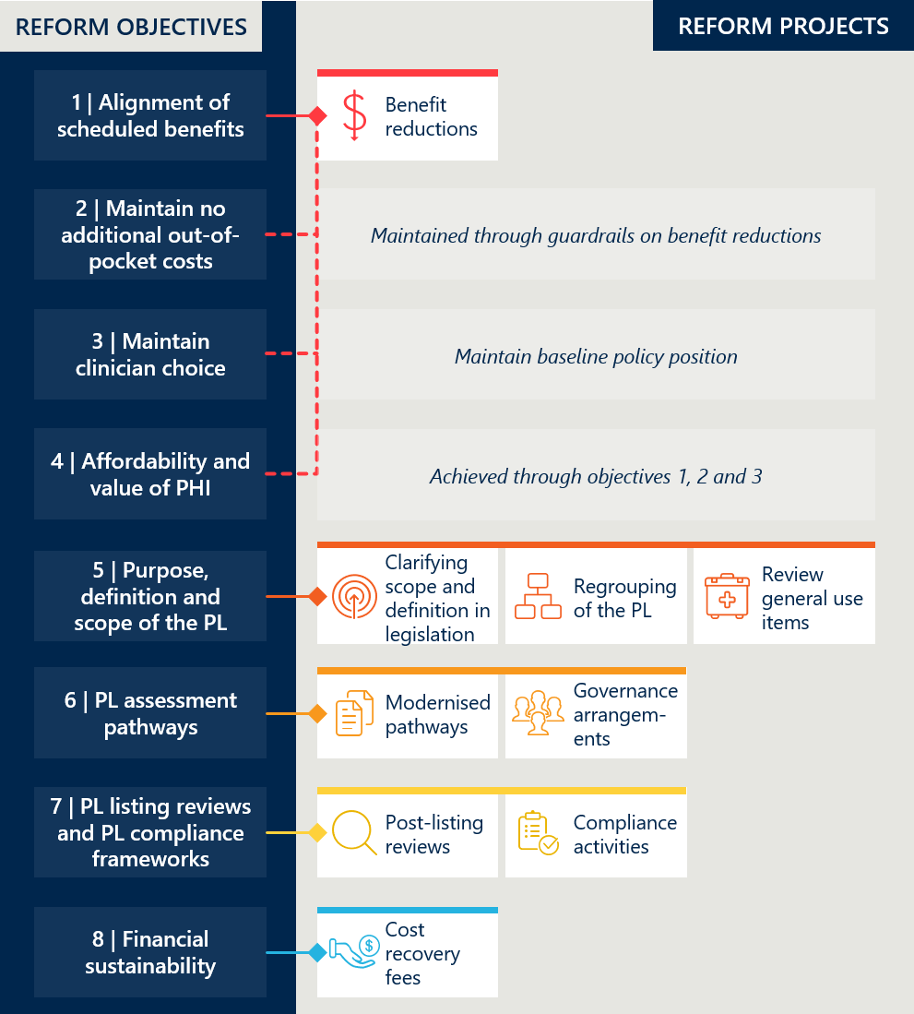

Final state of the reforms
Table 1 | Overview of reform objectives, their baseline position and the outcomes achieved
Reform objective | Baseline state | Rationale for objective | Reform project | Implementation of reform project | Outcomes achieved
1. Improve the alignment of the scheduled benefits of the PL with the prices paid in more competitive markets | PL benefits are significantly higher than prices in comparable markets. | High PL benefits contribute to PHI costs and issues of affordability. | PL benefits to be reduced incrementally over reform period in reference to IHACPA’s public benchmark prices (by 80% of the gap or within a 7% floor for most items). | - Benefits were successfully reduced across eligible sections of the PL.  - CIED reductions were completed for the device component only, with future funding arrangements for technical support services still unresolved. | - Benefit reductions materially improved alignment with Australian public hospital benchmark prices.  - For items subject to reductions, the median gap above public benchmark prices decreased from $177 to $35.  - Case studies comparing PL benefits with prices in New Zealand and France show an improvement in alignment with international markets, although material gaps remain for some products.
2. Maintain no additional out-of-pocket costs associated with the PL devices for consumers | Out-of-pocket costs for devices are charged in <1% of episodes. | Minimising out-of-pocket expenses is important for maintaining access to devices. | Maintaining minimal out-of-pocket costs establishes guardrails for the benefit reduction exercise and other policy decisions. | - The policy settings supporting minimal out-of-pocket costs associated with PL devices were maintained. | - Out-of-pocket costs for PL items remained rare at the conclusion of the reforms, with gap payments occurring in less than 1% of episodes across most PL categories.  - The evaluation did not identify clear aggregate evidence that the reforms increased consumer out-of-pocket costs.  - Some stakeholders reported isolated instances of financial pressure and potential cost-shifting, particularly where supplier prices exceed PL benefits.  - Overall, the PL continued to largely meet its objective of minimising consumer out-of-pocket costs for listed devices throughout the reforms.
3. Maintain clinician choice of appropriate prostheses for their patients | Clinicians have a choice of PL-listed items. | Ensuring clinician choice is a core principle of the PL design. | Maintain policy position enabling clinician choice of appropriate devices. | - The policy settings supporting clinician choice were maintained throughout the reforms. | - The reforms did not have a systematic impact on clinician choice of PL-listed devices.  - Some stakeholders reported isolated or emerging constraints, particularly for high-cost or more advanced technologies.  - Conditions placed on surgical guides and biomodels have raised specific concerns for some clinicians.
4. Improve the affordability and value of PHI for privately insured Australians | PHI affordability is an issue of concern with participation rates are decreasing for certain cohorts and risk profiles increasing. | Low PHI participation places strain on the rest of the health system. | Reduction in PL benefits while maintaining device availability and access. | - Benefit reductions generated $540 million in savings for the PHI system during the reforms, with cumulative savings projected to exceed $1 billion by the end of FY26. | - Savings from benefit reductions placed downward pressure on PHI premiums for consumers, although premiums have continued to rise in absolute terms due to factors unrelated to the reforms.  - The value of PHI in relation to PL access was maintained for consumers. Coverage was not affected by the reforms.
5. Clarify the purpose, definition and scope of the PL in legislation | Only high-level definition of PL in legislation. | Lack of clarity and complex structure leads to reduced effectiveness and unwanted outcomes. | Legislative changes | - The reforms established definitions for medical devices and human tissue products, renamed the Prostheses List as the Prescribed List, and introduced listing criteria for Parts A, B, C and D in the legislative instrument. | - Legislative changes contributed to clarifying the purpose, definition and scope of the PL.  - The impact of these changes was reduced by the retention of GUIs and the unresolved treatment of CIED technical support services.
 | PL structure has become complex and difficult to navigate. |  | A revised grouping structure of the PL that is aligned to clinical outcomes, independent of benefit, is transparent and practical to navigate | - A revised grouping structure aligned to clinical outcomes was not implemented.  - The regrouping project was discontinued due to the complexity of mixed-benefit groups, stakeholder concerns, and the MOU restriction on achieving further savings. | - The expected benefits of reduced grouping complexity, greater transparency and stronger alignment with clinical use were not achieved.
 | Expanding PL scope over time is seen as a major driver of costs. |  | Remove items that do not meet PL eligibility criteria such as the General Use Items (GUIs) | - GUIs were scheduled for removal from the PL but were retained indefinitely after agreement over an alternative funding model could not be reached. | - Existing GUI categories have been retained in Part D, with new listings limited to items that have a comparator already listed.  - GUI benefit reductions reduced expenditure, but the broader objective of clarifying the PL’s scope by removing GUIs was not achieved.
6. Implement new PL assessment pathways aligned to Health Technology Assessment principles and streamline the application process through simple and robust IT infrastructure | No distinct assessment pathways based on complexity.  Assessment process has mixed alignment with HTA principles. | Effective and efficient assessment is crucial to maintain integrity of the PL. | Multi-tiered application process to be established. | - Tiered assessment pathways were successful implemented alongside the newly introduced Health Products Portal (HPP). | - New tiered assessment pathways align assessment effort with application complexity.  - The expected efficiency gains were not realised by the conclusion of the reforms. Key constraints include Department resourcing and the quality and timeliness of sponsor submissions.
 | Governance mechanisms not optimal. |  | Changes to assessment governance arrangements. | - MDHTAC and Expert Clinical Advisory Groups (ECAGs) replaced former governance arrangements. | - The revised model improved efficiency and reduced conflicts of interest by removing direct representation from commercially interested parties.  - Some stakeholders raised concerns about transparency, communication and limited visibility of decision rationales.
7. Develop and implement PL listing reviews and PL compliance frameworks to safeguard the PL Reform | No formal compliance strategy. | Effective compliance crucial to safeguard the PL reform. | Development of formal compliance strategy and associated functions. | - A PL Compliance Strategy was developed and updated.  - Planned legislative changes to expand compliance powers were not enacted. | - The PL Compliance Strategy provides a clearer basis for monitoring, education and response to compliance risks.  - The approach relies on existing powers and a lighter-touch, risk-based model. The Department remains limited in its ability to compel information or enforce some proposed measures.  - Stakeholders have concerns about the Department’s capacity to effectively perform compliance and assurance activities.
 | No formal post-listing review framework. | Post-listing review mechanisms important to maintaining the integrity of the PL. | Development of post-listing review framework and completion of pilots. | - A formal post-listing review framework was developed, tested through pilot reviews, and updated to clarify processes and consultation timeframes. | - The framework strengthened the PL by creating a mechanism to reassess whether listed devices remain clinically appropriate, cost-effective and eligible for benefits.  - The pilot reviews demonstrated that post-listing reviews under the framework can be lengthy and resource-intensive, with two of the four reviews still ongoing at the conclusion of the reforms.
8. Ensure ongoing financial sustainability of PL administration through effective and efficient cost recovery arrangements that are compliant with the Australian Government Charging Framework | Historically established cost recovery arrangements are non-sustainable and misaligned with Australian Government Charging Framework. | PL administration should be cost-neutral to Government. | Revised cost recovery arrangements. | - The Department implemented revised cost recovery arrangements, including tiered application fees and an annual levy. | - The cost recovery arrangements better align PL administration with the Australian Government Charging Framework and the modernised PL operating model.  - Stakeholders and Department staff nevertheless continued to raise concerns about whether PL administration is adequately resourced.  - A formal assessment of financial sustainability was outside the evaluation scope.

About this Evaluation
The Prescribed List reforms were implemented by the Department of Health, Disability and Ageing (the Department) from 1 July 2021 to 30 June 2025, following their introduction in the 2021-22 Australian Federal Budget. The aim of the reforms was to “reduce the cost of medical devices used in the private health sector and streamline access to new medical devices”.
The Department commissioned Nous Group (Nous) to conduct an independent evaluation of the reforms from September 2023 to June 2026, using the Prostheses List Evaluation Framework (see Appendix A.2). The evaluation seeks to understand the extent to which reform activities have delivered the objectives of the Prescribed List reforms and to provide formative insights into implementation.
Evaluation methodology
Nous developed an evaluation plan that articulates the program theory of change, defines a set of Key Evaluation Questions (KEQs), and outlines indicators and measures to guide the evaluation.
The evaluation has four reports:
- Baseline Evaluation report
- Interim Evaluation #1 report, which covered the period from May 2021 to June 2024
- Interim Evaluation #2 report, which covered the period from July 2024 to the conclusions of the reforms in June 2025
- Final Evaluation report, which builds on the Interim Evaluation #2 report with revised figures and targeted amendments to findings and recommendations to reflect impacts realised following program completion.
Further detail on the evaluation methodology is provided in Appendix A.
Consultations
Stakeholder consultations were conducted for the Baseline Evaluation and two Interim Evaluation reports. Those consulted included:
- private health insurance representatives
- private hospital and day hospital representatives
- the medical technology sector
- clinician representatives, including relevant medical advisory committees and governance bodies
- consumer representatives
- Department staff involved in reform implementation and related policy areas.
Stakeholder views provided to this evaluation diverged on the pace, depth, rationale for and impact of reform activities. Views are summarised in this report for the purpose of clarity and brevity and are set out against each objective of the reforms.
Data analysis
Data analysis was undertaken for the Baseline Evaluation and both Interim Evaluations. For the Final Evaluation, selected figures and charts were updated to capture impacts following program completion.
The analyses draw on a range of data sources with different publication timelines. The date range used for each source is stated in the report.

Achievement of the reform objectives

Objective 1: Improve the alignment of the scheduled benefits of the PL with the prices paid in more competitive markets
This section considers the reduction of benefits and the resulting change in the size of the gap between PL benefits and prices paid in more competitive markets. The estimate of the overall savings associated with benefit reductions and related stakeholder perspectives is reported in Objective 4.
Figure 3 | Reform projects related to reform objective 1
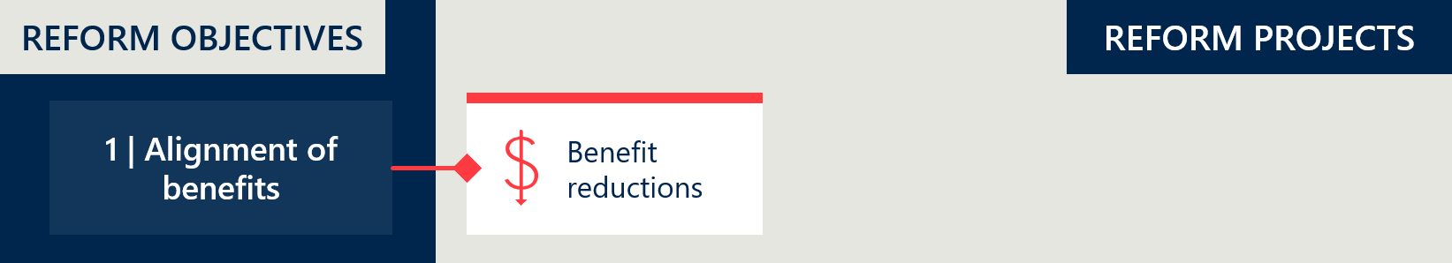

Reform project: benefit reductions
At baseline, there was a notable gap between PL benefits and prices in the Australian public health system (where compared to IHACPA’s Weighted Average Prices, public benchmarks of PL items) despite a series of benefit reductions between 2018 and 2020.
The Department reduced benefits to Part A of the list according to an agreed schedule of benefit reductions over three years documented in the 2022 Memorandum of Understanding (MOU) between the then Minister and the Medical Technology Association of Australia (MTAA). Figure 4 summarises the timeline of benefit reductions. The reductions methodology was discussed in Section 2.3.4 of the Interim Evaluation #1 report, which includes an overview of stakeholder perspectives at that time.
Three rounds of planned reductions of the gap between the current benefit and the public benchmark were implemented according to schedule in July 2022 (40%), July 2023 (20%) and July 2024 (20%). This resulted in all eligible benefits being reduced by 80% of the gap.
The following PL items were subject to an alternative schedule of reductions:
- General Use Items (GUIs) – In response to an initial delay to the proposal to remove GUIs from the PL, GUI benefits in Part 4 of the PL were reduced by 60% of the gap on 1 July 2022, followed by the remaining 40% of the gap in March 2023. In May 2024, the Minister announced GUIs would not be removed from the PL and would remain at the reduced benefit levels (see Figure 23). GUIs are considered in Objective 5.
- Cardiac Implantable Electronic Devices (CIEDs) – As agreed in the MOU, the Department deferred benefit reductions to CIEDs by one year to allow for further consultation on the value of technical support services. The final benefit reduction for CIEDs (20% of the gap on the device only amount) occurred on 1 July 2025. No benefit reductions on the technical support services component of CIEDs occurred during the reforms. CIEDs are considered separately in Section 2.1.4.
The estimated savings achieved from the reductions is discussed under Objective 4 in Section 2.4.

Figure 4 | Timeline of benefit reductions
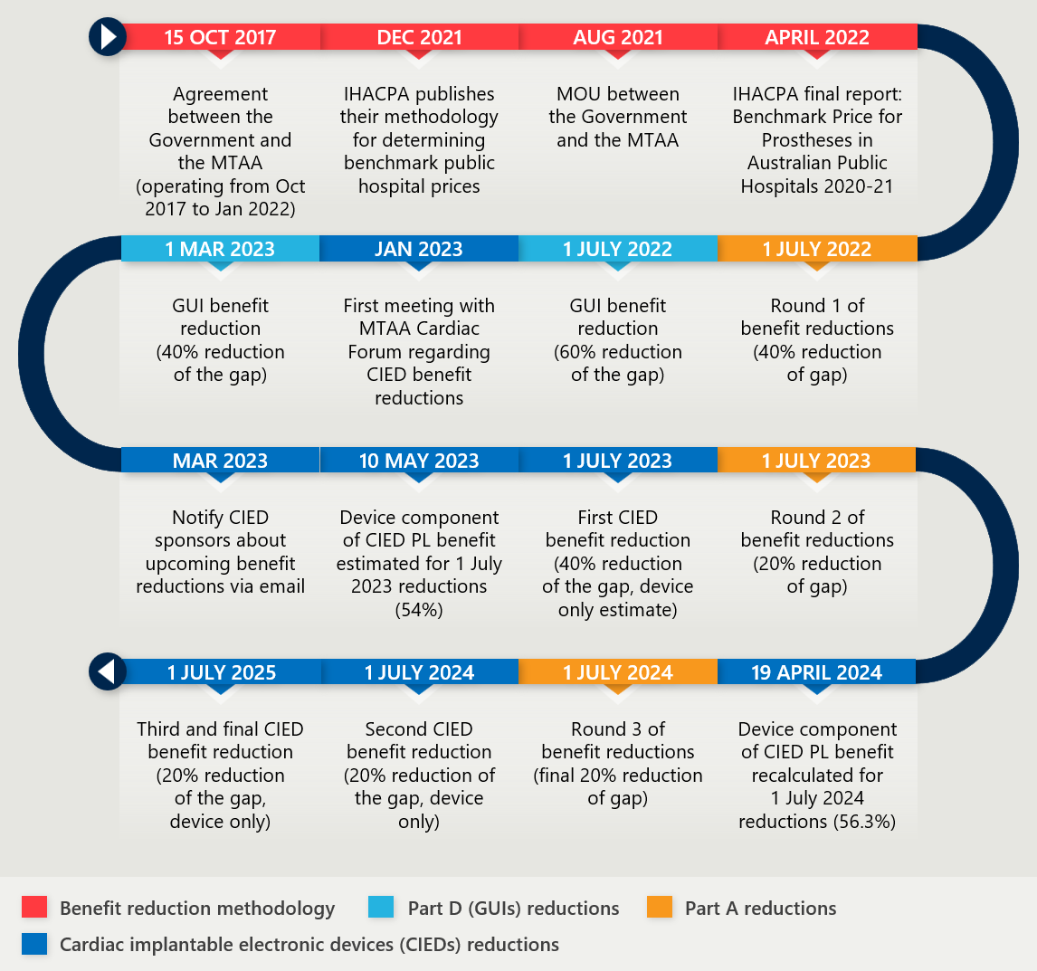

The reforms delivered benefit reductions to 51% of PL items
51% of items on the PL were subject to benefit reductions during the reforms. These 5006 items across 13 PL categories had benefits that were at least 7% higher than public sector benchmarks at the commencement of the reforms. The benefit reductions to these items represents a significant alignment in pricing.
Part C was out of scope for reductions (~1% of items), leaving ~48% of items already at or below the 7% price floor established by the MOU, and therefore not subject to reductions. Figure 5 below shows the breakdown of items subject to reductions by PL category.
Figure 5 | PL items subject to reform reductions (Parts A and D, excluding CIED items)
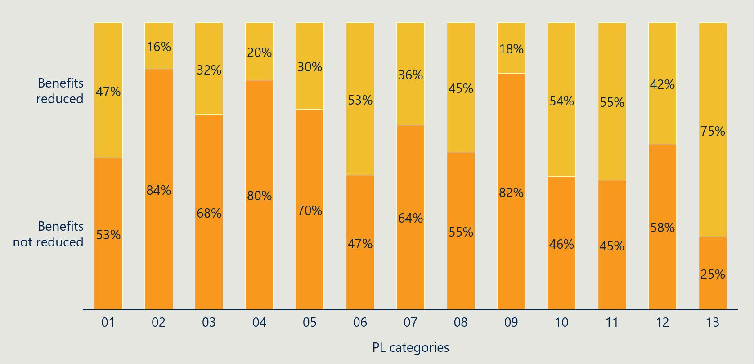
Table 9 in Appendix C.1 lists the benefit groups and items that were subject to reductions across the 13 PL categories. Over half of the 5006 items subject to reductions were in the Specialist Orthopaedic or Spinal categories.

The benefit reductions reduced the gap between PL benefits and comparable prices
Objective 1 of the reforms was to “Improve the alignment of the scheduled benefits of the PL with the prices paid in more competitive markets”. The evaluation assessed the median gap against Australian public sector benchmark prices as well as limited available international comparisons.

For items subject to reductions, the median gap above Australian public sector prices decreased from $177 to $35
The narrowing gap between PL benefits and public sector benchmarks (as reflected in IHACPA’s Weighted Average Prices) suggests that the reforms improved price alignment with more competitive markets. Figure 6 shows that, across all items, the median gap fell from $24 to $8 following the three rounds of reductions. Among the items specifically targeted for reductions – around half of the PL – the median gap decreased from $177 to $35.
Figure 6 | Median gap with public benchmark prices (Parts A and D, excluding CIEDs)
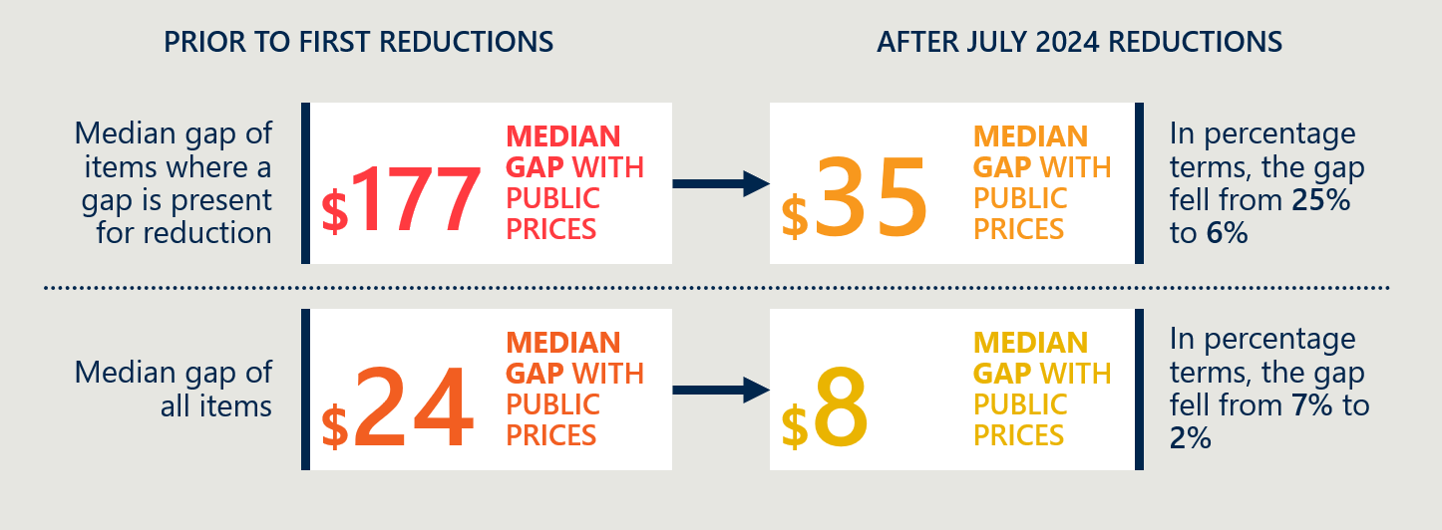
Table 12 in Appendix C.2 shows the median dollar and percentage gaps across PL categories before and after the reforms. All but one category now has a median gap of less than 12% above public benchmark prices. The exception is the Cardiac category (excluding CIEDs), which, although it had the largest percentage price reduction, still has a median gap of 42%.
Figure 7 shows the distribution of PL items according to their gap above public benchmarks – the orange bar represents the gaps following the July 2024 reductions and the dark blue bars represent the gaps at baseline. The number above each bar is the change in the number of items with that percentage gap. The absence of orange areas on the higher percentage gaps demonstrates there has been a significant reduction in items with large gaps. Since the baseline, 491 fewer PL items have a gap above 91%, and 2,360 additional items now have a reduced gap of less than 7%.
Figure 7 | Percentage gap between PL benefits and public benchmark prices (excluding CIED items)
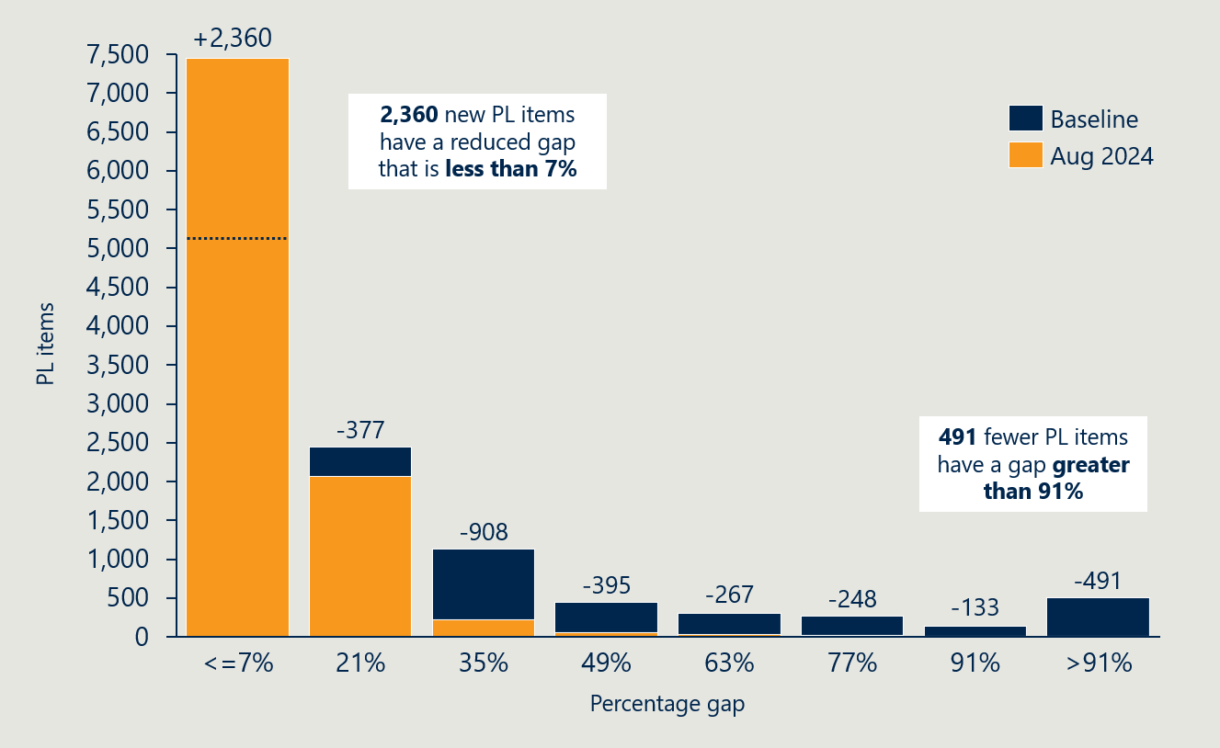

Feedback from stakeholders in the private health sector reflected the impact of the benefit reductions on their business

Private hospitals raised concerns that the reductions shifted financial pressure onto the hospital sector
Private hospitals raised concerns that the reductions shifted financial pressure onto the hospital sector. They questioned whether the estimated savings from the reforms adequately accounted for hospital provider costs and expressed doubt that savings arising from benefit reductions could be realised without adverse impacts on patient care. Hospital stakeholder identified inflation and the absence of mechanisms to adjust benefits over time as ongoing risk factors. In this context, they argued that the 7% margin above public benchmarks is insufficient to cover private sector costs, particularly for high-cost devices.

Inflation and the lack of mechanisms to increase benefits were seen by the MedTech industry as potentially risking innovation and access to new technology
Medical technology representatives acknowledged that benefit levels are now better aligned with public pricing but cautioned that cost inflation and the lack of mechanisms to increase benefits may undermine medical device innovation and Australian private health patient access to new technology.
These stakeholders reiterated their position that public markets often achieve lower prices through guaranteed volume unlike the private sector where clinician-led choice is critical, criticising the absence of accounting for this in the treatment of general use items.

Private health insurers argued that the reductions were too small and that the reforms delivered insufficient savings
Private health insurers argued that modest reductions in per-episode costs generated insufficient savings to materially reduce premiums. They criticised the reliance on public sector benchmarking, contending that the reduction calculations comprised of averages that do not represent the lowest prices encountered in the public sector, which continues to permit supra-economic gains for medical device companies to the detriment of consumers. They argued that additional savings opportunities were not fully realised, claiming device benefit levels remain markedly higher than those observed in comparable international markets.
The private health insurance representatives also raised concerns about what they perceived as ongoing gaming of the system.

Clinicians were broadly supportive of the benefit reduction methods used
Clinicians, primarily represented by the Australian Medical Association (AMA), considered it appropriate for PL benefits to be set somewhat above public hospital benchmarks with a 7% floor, noting differences between public and private settings. They viewed international pricing comparisons as of limited relevance to PL pricing.

Consumers were supportive of the reform process
Consumers have limited visibility over the PL and benefit reductions, as these transactions occur at arm’s length from them. Consumers’ primary concerns relate to the cost of private health insurance and the safety and quality of medical devices. Consumer representatives expressed broad support for the PL mechanism – which they believe contributes to these objectives – as well as for the overall reform process.

PL benefits are better aligned with some international markets but there remains a gap
An updated case study comparison with New Zealand and France, outlined in Appendix C.2, shows that prices in those markets have continued to remain stable throughout the reform period, while the Australian PL benefits have declined. This has narrowed the price gap, indicating that the reforms are achieving their goal of improving alignment with prices in more competitive markets.
As was discussed in Section 2.3.6 of the Interim Evaluation #1 report, the reforms have had mixed success in meaningfully reducing the absolute gap with the French market. While alignment has improved in some areas, the price differential with the French Liste des Produits et Prestation (LPP) remains substantial in others:
- A case study of knee implants (12.08.01 PL benefit group, see Figure 34) shows a noteworthy improvement in alignment. The gap between the French price and Australian benefit decreased from $300 (a 134% difference) in 2021 to $113 (50%) in 2025.
- In contrast, a case study of spinal fusion cages (13.10.01.02 PL benefit group, see Figure 36) shows limited change. The PL benefit remains over five times higher than the French LPP price at the end of reform period.,
As reform benefit reductions were calculated using public sector benchmark pricing, improved alignment with those benchmarks was expected. However, while market conditions vary between conditions, the limited international comparisons suggest that Australian prices remain among the highest globally.
The evaluation considers public sector benchmarking to have been a practical and appropriate basis for the reform benefit reductions. Stakeholders held mixed views on this approach. Many supported the use of a public sector price benchmark, reflecting the Australian context for purchasing and funding medical devices. Others, particularly the private health insurance industry, argued that there was scope for further reductions and that international prices could have been used. Although contextual differences can cloud direct comparisons, as outlined in Appendix F of the Baseline evaluation of the Prostheses List Reforms report, Australia’s largely international medical device supply chain means international benchmarking remains a useful complementary input to benefit setting decisions.
International price benchmarks should be used selectively as a targeted evidence source in relevant BAU benefit setting decisions and post-listing reviews. For relevant applications or reviews, the Department, MDHTAC or contracted HTA providers could draw on publicly available international prices and, where appropriate, seek input from comparable overseas pricing or reimbursement bodies to help assess whether proposed or existing benefits remain reasonable. The 7% floor applied above public sector benchmarks during the reforms demonstrates that benchmarks can be used with an appropriate premium or buffer, recognising contextual differences without treating them as a barrier to practical comparison.
RECOMMENDATION 1: Use international price benchmarking selectively as a complementary input to relevant benefit-setting decisions and post-listing reviews.

Reductions to cardiac implantable electronic devices proved complex
The funding model that has evolved in Australia for CIEDs includes both the cost of the device and the ongoing costs of the technical services that come with managing the devices after implantation, with these two components not separately identified on the PL. CIED benefits have enabled the MedTech industry to employ cardiac technicians (IECTs) to ensure CIEDs are functioning correctly – and the surplus benefit enables this workforce to review any alerts sent by CIEDs at no additional cost to the consumer.
Separation of the two components was further complicated by cross-sector subsidisation, with some public cardiac clinics and public hospitals also relying on technical support services (TSS) provided by privately employed IECTs. This means that funding via the PL intended for the private sector is also supporting some services in the public system. Industry sources estimated that up to 17% of all services provided by private cardiac technicians are performed in a public hospital. Medical device technicians are not reimbursed for providing CIED technical services in the public system and it was argued that some public hospitals rely heavily on this support, especially for out-of-hours and more complex cases. This meant that industry did not believe it was appropriate to benchmark CIED benefits to public prices, as these represent the public hospital market value for the CIED device only, and no associated technical services are reimbursable in the public system. Reliance on IECTs is reportedly more common in areas with service gaps such as rural and regional areas of Australia, and for services involving highly complex CIED patients.

A separate path was agreed and implemented for CIED benefit reductions
As a result, there was recognition early in the reform process that CIEDs would need a separate pathway for benefit reductions. The March 2022 MOU between the Minister and MTAA confirmed that CIEDs would follow an alternative schedule to allow Medical Services Advisory Committee (MSAC) to assess the value of associated technical support services. The first price reduction for CIEDs was deferred by 12 months and reductions were scheduled to take place on 1 July 2023 (40%), 1 July 2024 (20%) and 1 July 2025 (20%) respectively.
Consultation and an MSAC review confirmed that standard benefit reduction methods would not suit CIEDs. To avoid disrupting patient care, the Government took a cautious approach, adopting the key elements of MSAC’s short-term recommendation. The first benefit reduction of 40% of the gap on 1 July 2023 applied only to an estimate of the amount that corresponded to the actual device component of the benefit, which was estimated as 54%. The device component of CIEDs was later re-calculated as 56.3% of the total benefit and the updated figure was used to calculate the second reduction of 20% of the gap on 1 July 2024.

Despite consultation and review, no satisfactory resolution was reached
The MSAC advice in July 2023 was reported in a redacted public summary document published online on 16 April 2024. Their advice on the reasonable cost of cardiac technical support services noted it may be reasonable to include some services that are provided to public hospital patients until longer-term reform can address how these services are funded. MSAC stated that funding follow-up cardiac support services for public and private patients through the PL results in a lack of transparency in how these services are provided and funded. Their advice notes that preferably the benefit should be limited to the cost of the principal CIED and associated implantation costs only. MSAC also noted that further consideration of alternative models of care for patients with CIEDs and how funding of these services can be transitioned out of the PL benefit amount should be pursued. The Department subsequently conducted public consultation on how to implement the MSAC advice on the cost of TSS for CIEDs between July and September 2024. The Department released a high-level summary of submissions in January 2025; however, no further implementation was achieved.
Figure 8 | Reform timeline of CIED related activities
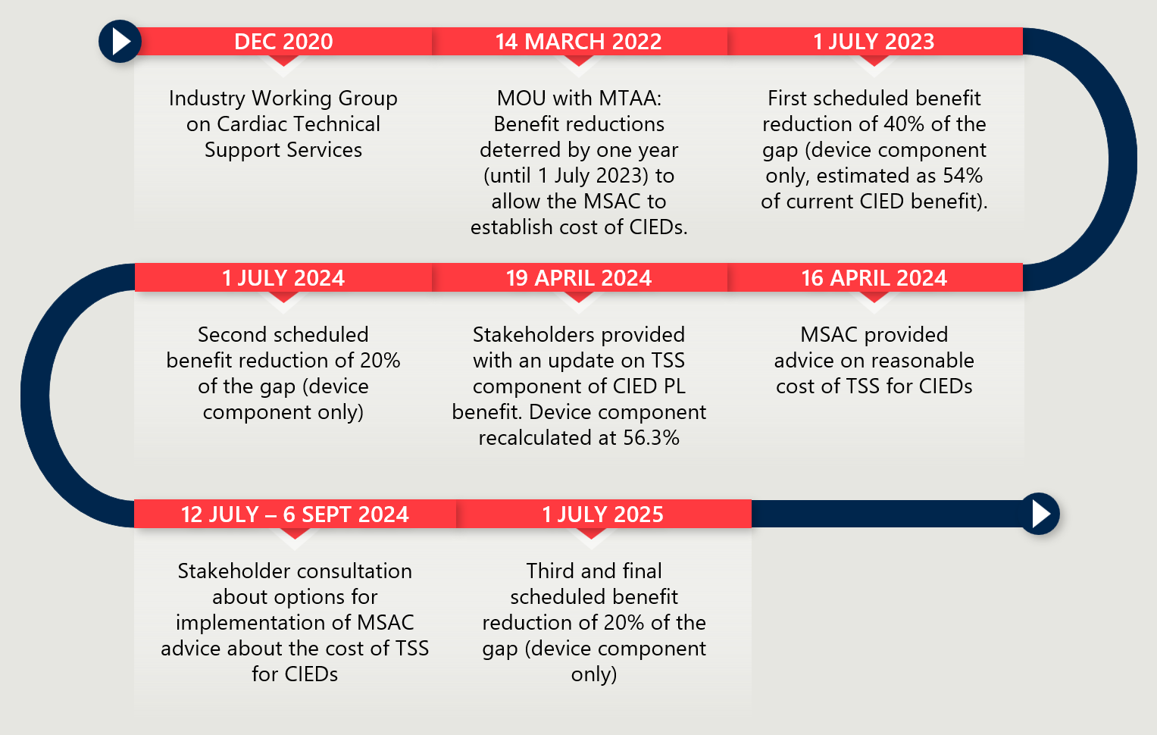

The current gap between CIED PL benefits and public prices was not available
The evaluation was not provided data showing the gap between PL benefits and public prices for CIED items. CIED items were additionally excluded from aggregated gap analysis provided to Nous for the evaluation (see Table 12). As a result, progress towards aligning CIED benefits with more competitive markets cannot be quantified.
However, as outlined in Section 2.3.5 of the Interim Evaluation #1 report, the evaluation estimated the median gap of the CIED items (device component only) to be approximately $19,600 (188% gap) and no less than $17,600 (144% gap) at the commencement of the reforms.

Feedback from stakeholders on the approach to CIED benefit reductions under the reforms was aligned with their commercial interests
MedTech Industry stakeholders supported the phased reduction approach, arguing that this was necessary given the scale of previous benefit cuts to CIEDs and the cumulative impact on staffing, service models and supply chains. They contended that that inclusion of CIEDs in the broader reduction model created unrealistic expectations of savings, as it failed to account for the embedded service component of CIED benefits.
While private hospitals generally described the decision to apply reductions only to the device component as a considered and pragmatic approach, some hospital representatives opposed any reduction to CIED benefits, citing risks that even modest percentage cuts would translate into large dollar losses per device, potentially making procurement unviable and threatening access, particularly for high-cost devices such as CRT-Ds and ICDs.
In contrast, private health insurers viewed the deferral and scale of reductions as overly conservative, arguing that it materially reduced anticipated savings and delayed benefits to consumers, given the well-documented gap between private and public CIED prices. They argued that the deferral materially reduced expected savings under the MOU and delayed consumer benefit. They consistently framed the phased approach as unnecessary, pointing to evidence from Senate inquiries and IHACPA data that CIED prices in the private system significantly exceeded public and international benchmarks. Insurers noted the deferral of reductions resulted in significant foregone savings and argued that each additional delay continued to impose costs on consumers and taxpayers.

There was similar disagreement on whether technical support services should remain bundled within CIED device benefits
The most significant divergence in views concerned whether to fund technical support services through the PL. Insurers argued these services should be excluded because costs lack transparency, service quality varies across patients, and available evidence suggests actual costs are materially lower than the amounts embedded in device benefits. They noted that bundling services within device prices is inconsistent with other implantable devices and obscures accountability for value and outcomes.
The MedTech sector opposed unbundling. They argued the current model reflects the specific care pathway for CIED patients and enables reliable service coverage, including in regional and remote areas. They challenged the cost estimates used to justify reform and warned that splitting funding streams could threaten service viability and increase patient costs.
Private hospitals and clinicians were primarily concerned about maintenance of a funding stream for the technical services. Some were opposed to unbundling without a replacement funding mechanism, citing risks to access, continuity of care and administrative burden. Others supported unbundling only if a clear and sustainable funding model-maintained access to technical support and avoided higher out-of-pocket costs.
Clinicians consistently emphasised that technical support services are integral to safe and effective CIED care at implantation and throughout device life. They advocated for continued funding through the PL until an alternative model is established.

Stakeholders identified the lack of a sustainable funding model for technical support services as a major risk
While the PL does not separately reimburse technical support services, there is a widely acknowledged need to maintain these services to ensure safe and timely care. Across stakeholder groups, there was strong agreement that the lack of a clearly defined and sustainable alternative funding model for technical support services presents a significant risk to further reform.
Private hospitals noted that removing embedded TSS funding without an agreed replacement mechanism would shift costs to hospitals or patients, undermine service planning, and place additional pressure on smaller and regional providers that rely heavily on external technical expertise. Similarly, clinicians emphasised that technical support services are essential to safe and effective CIED care across the life of the device. They argued that any transition away from the current model must be staged, adequately funded, and informed by improved data – including a national CIED register – to avoid disruptions to care or new out-of-pocket costs for patients.
Private health insurers acknowledged the importance of TSS but expressed frustration that reform has stalled without addressing long-standing concerns about transparency, accountability and cost control. They argued that the absence of a future funding model should not justify maintaining what they consider an inefficient status quo.
In contrast, medical device companies framed the lack of an alternative model as a reason to retain existing arrangements indefinitely. They emphasised the absence of a replacement workforce, long transition timelines, and risks to service continuity. Unlike other stakeholders, their position focused less on interim system design and more on preserving current commercial and service delivery models until a future solution is fully developed.

Concerns remain that CIED benefit reductions have had unintended consequences on patient care
The Cardiac Society of Australia and New Zealand (CSANZ) raised concerns about emerging service gaps, particularly in regional, rural and remote areas. They noted that while the public system does employ cardiac technicians, the workforce is limited and often relies on industry support for complex procedures and broad geographic coverage. Some device sponsors have reported reducing their IECT workforce or scaling back services in response to CIED benefit reductions, citing financial viability pressures.
These unintended consequences risk reducing access to essential CIED support services across both private and public settings. Given the growth in use of CIEDs, the impact on patient care is likely to be significant.

The model for funding CIEDs requires further reform
The compromise adopted during the reforms of temporarily shielding TSS from staged benefit reductions has helped protect patient care and avoided sudden out-of-pocket costs for people with CIEDs. However, it is not a sustainable way forward.
Clinicians consulted during the evaluation were considered in their approach to a future solution. Ideas included the establishment of a national CIED register as a first step to improve understanding of service delivery models and to inform more accurate costings of TSS currently provided by industry.
One clinician group advocated for developing a workforce of fully trained independent cardiac physiologists to deliver TSS currently performed by device companies. They stressed the need to design such a model in a way that ensures continuity of services for patients during any transition.
Remote monitoring was also identified as an area of technological change that may affect how CIED follow-up services are delivered and funded. Its increasing use may have implications for the volume and type of in-person follow-up required, as well as the mix of clinical, technical and administrative support involved in ongoing CIED care.
Further reform is required to ensure this growing area of medicine is efficiently managed and appropriately funded for the benefit of private and public patients into the future. It will be important to understand how TSS may have evolved since the issue was considered during the reforms. Any changes must be well considered, staged, data-informed and focused on preserving patient outcomes. Without this, further change could reduce access and increase costs for patients.
RECOMMENDATION 2: Use the work undertaken through the reforms to inform further cross-portfolio consideration of alternative service and funding models that allow the separation of CIED device and service costs in both the public and private sectors.

Objective 2: Maintain no additional out-of-pocket costs associated with the PL devices for consumers
This section considers any change in out-of-pocket costs related to PL items. It examines the prevalence of a gap payment for PL items and the average gap payment for PL-listed items.
Figure 9 | Reform projects related to reform objective 2
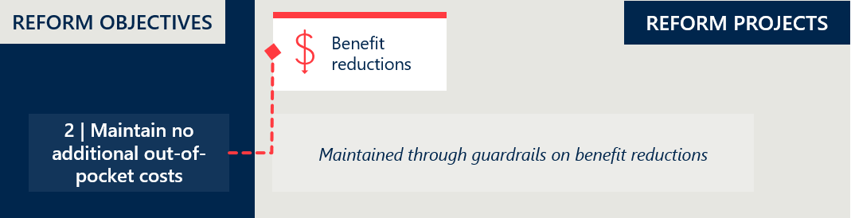

Reform project: out-of-pocket costs
There were no specific activities associated with the maintenance of out-of-pocket costs during the reforms. The findings remain similar to those in the Interim Evaluation #1 and Interim Evaluation #2 reports.

The reforms appear to have maintained minimal out-of-pocket costs for PL items
The evaluation did not find evidence that the PL reforms affected out-of-pocket costs for PL items at an aggregate level. Health Casemix Protocol (HCP) data from 2025 shows that direct gap payments for prostheses remain rare., However, stakeholders reported occasional cases where consumers were financially worse off overall, and there remains a risk of increased cost-shifting behaviour outside the PL item benefit.

Gap payments for PL items remain consistently rare
Figure 10 shows that gap payments are uncommon across the PL, with only 0.24% of PL items used in FY24 incurring a gap payment over $1. Table 13 (Appendix C.3) shows the prevalence of gap payments is around 1% or lower across all Part A categories, except for cardiothoracic items, which have a slightly higher rate of 2.63%. These consistently low rates – similar to pre-reform levels – suggest the reforms are largely meeting their goal of minimising consumer out-of-pocket costs.
Figure 10 | Prevalence of gap payments greater than $1
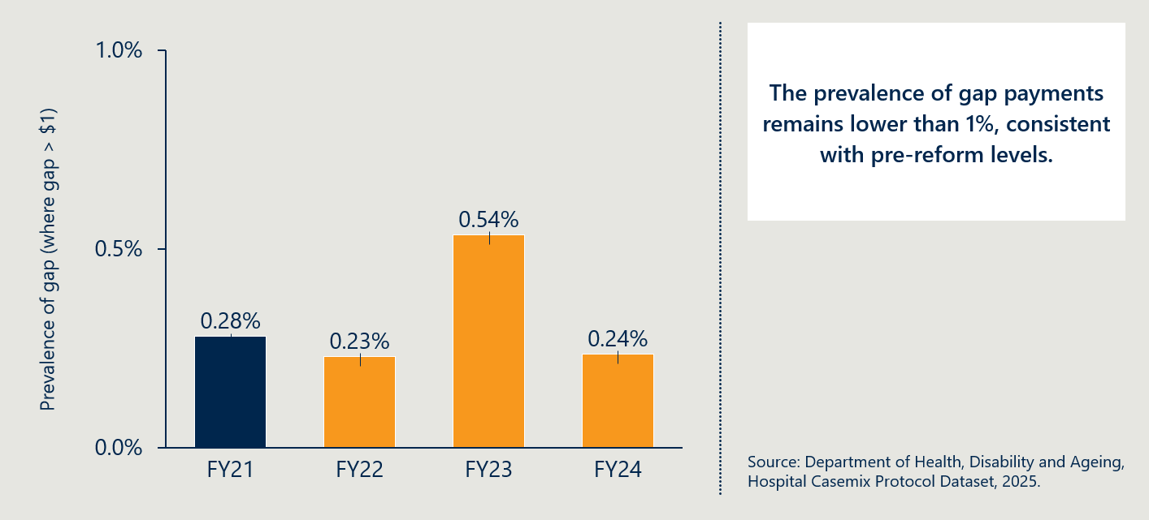
Feedback from consumer representatives and clinicians did not raise any concerns about increased out-of-pocket costs. The evaluation also sought input from the Office of the Commonwealth Ombudsman, who confirmed it had not observed any systemic trends of concern. Between July 2022 and May 2024, the Ombudsman received 35 complaints related to PL items – accounting for less than 1% of all PHI-related complaints received in this period. These complaints mostly involved unexpected costs incurred by private hospitals or privately insured consumers. Common issues included:
- Insulin pumps with manufacturer warranties (typically four years) shorter than the insurance replacement cycle (typically five years)
- Partial coverage of custom-made prostheses
- Claim rejections for items with newly introduced conditions on use (e.g. surgical guides or biomodels).

Gap payments average $212 when they occur
Figure 11 shows that while gap payments remain rare, they are significant in size when they do occur. In FY24, the average gap payment (where one is charged) was $212 – equivalent to around 33% of the item’s benefit. Table 14 (Appendix C.3) shows significant variability across Part A categories. For example, in the Plastic and Reconstructive category, the average gap payment exceeds 200% of the associated PL benefit.
The FY24 average represents a sharp increase from FY23, though it is lower than FY21 and FY22 and broadly in line with historical norms. Moreover, given the very low incidence of gap payments over $1, a high degree of year-to-year variability is expected. As outlined in Section 2.4.1 of the Interim Evaluation #1 report, there is no clear evidence that links these changes to the PL reforms.
Figure 11 | Average gap payment when gap payment is greater than $1
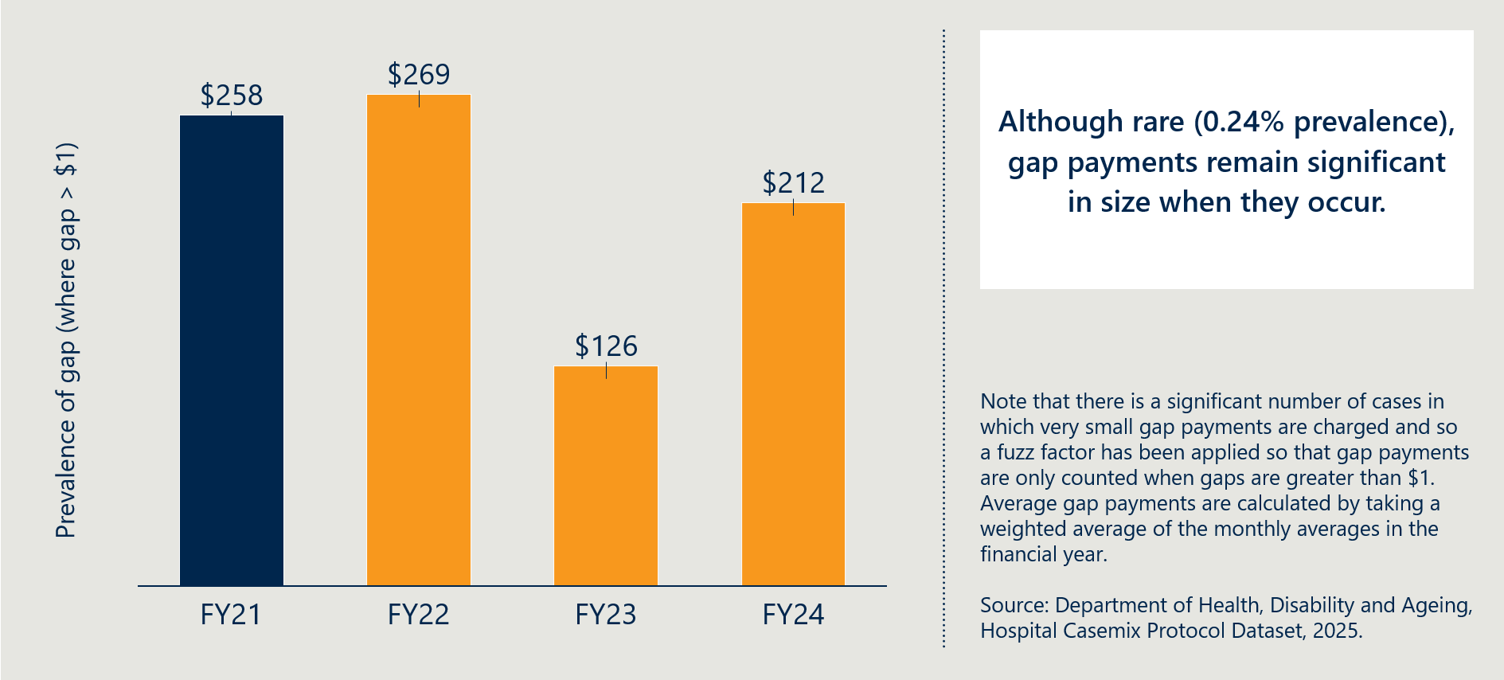

Feedback from stakeholders did not point to significant impact on patient out-of-pocket costs
There was a broad consensus among stakeholders that the reforms had not directly led to increased out-of-pocket costs to consumers. Clinicians generally reported no awareness of widespread increases in patient out-of-pocket costs or changes in clinical outcomes, although some observed reduced access to ancillary supports (e.g. free customised models). Some hospital stakeholders reported higher patient gap payments, particularly for high-cost devices such as cochlear implants and neurostimulators, which they viewed as undermining affordability.
MedTech representatives were of the view that benefit reductions alone did not have a material impact on out-of-pocket costs for existing products, and that there was no systematic evidence of increased consumer charges attributable directly to the reforms.

Some stakeholders expressed concerns that the reforms have inadvertently led, or may lead, to indirect out-of-pocket costs for consumers
Hospitals and some clinicians raised concerns that price ‘misalignment’ and emerging cost-shifting creates financial pressure and may indirectly lead to impacts on patients. Private hospital representatives reported instances where the prices charged by device suppliers exceeded PL benefits by approximately $2,000–$3,000, creating funding gaps not reimbursed by insurers. As noted in Objective 1, device suppliers are not mandated to charge the PL price. Hospitals argued that absorbing these gaps is financially unsustainable, while passing them on to patients risks higher gap payments and undermines affordability of private health insurance.
MedTech representatives stated that invoicing above the PL benefits ‘reflects a structural mismatch’ between the PL reimbursement and the genuine costs of supplying devices and associated services in the private sector, such as higher per-unit costs associated with lower and less predictable volumes than in the public sector. Hospital stakeholders cautioned that this ‘misalignment’ shifts financial risk onto health care providers and creates a downstream risk to patients where hospitals cannot continue to absorb the resulting funding gap.

Hospitals and clinicians have identified emerging cost-shifting behaviours
Hospital stakeholders reported that some device sponsors have begun unbundling services and consumables that were previously included with devices, resulting in additional charges to hospitals. Examples cited include separate fees for planning services, consumables, or customised items that were previously supplied at no cost. Hospitals and clinicians also noted reduced sponsor willingness to provide individualised items (e.g. 3D-printed models) free of charge, which they attributed to tighter margins following benefit reductions.
Medical technology representatives did not characterise these changes as cost shifting, instead describing them as commercial responses to sustained benefit reductions, increased costs of supply, and the absence of mechanisms to adjust benefits upward where costs rise.
Hospitals also raised concerns about delayed insurer payments and reimbursement disputes, which exacerbate cash-flow pressures and may increase incentives for providers to seek alternative cost recovery approaches. MedTech representatives generally argued that benefit reductions have not materially increased consumer costs for existing products, attributing pressures instead to broader system and insurer dynamics.
While the evaluation has not identified clear evidence of widespread hospital-driven cost shifting to patients, stakeholders across groups acknowledged that sustained margin pressure could present a future risk if unresolved.

Objective 3: Maintain clinician choice of appropriate prostheses for their patients
This section focuses on examining any change in clinicians’ experience of being able to choose the prostheses they wish to use. It also considers changes in the utilisation of PL items as a potential indicator for changes in clinician choice and consumer access.
Figure 12 | Reform projects related to reform objective 3
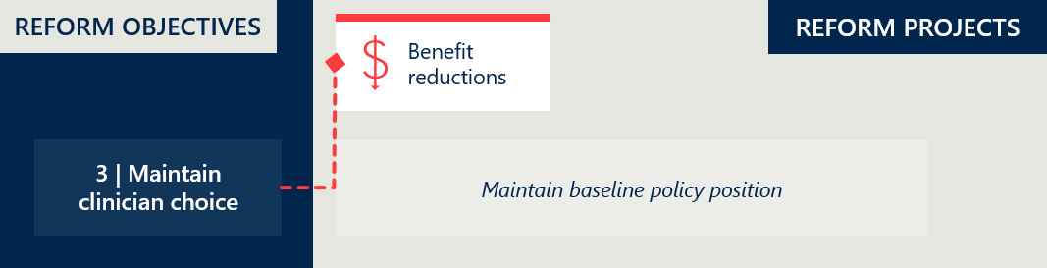

Reform project: clinician choice
No specific activities in relation to clinician choice were implemented during the reforms.
The PL was established to ensure that privately insured Australians can access the medical devices that are the most appropriate for their needs. For this to be effective, clinicians need reasonable freedom to select the device they consider clinically indicated. The PL provides clinicians with this freedom of choice by:
- listing devices that meet the relevant safety, efficacy and performance requirements, and
- requiring private health insurers to pay a minimum benefit for listed devices when they are provided as part of an insured episode of care.
Clinicians' selection of devices is also affected by other factors. Private hospitals, often in consultation with clinicians, enter supply arrangements with select device sponsors, effectively making a subset of PL items available for clinicians to choose from. Consignment arrangements are commonplace in private hospitals.
The PL is intended to support clinician choice by ensuring that patients are not directly exposed to the cost of PL-listed devices. However, financial considerations can still influence which devices are procured, stocked and made available for clinicians to choose from, including through negotiations between private hospitals and clinics, device suppliers and, in some cases, clinicians.

Clinicians continue to have choice of medical devices and human tissue products

The policy setting supporting clinician choice has remained constant
One of the principles underpinning the reforms was the maintenance of clinician choice. The ability for clinicians to have uninhibited choice of device is a key principle of the PL in providing privately insured Australians guaranteed access to appropriate medical devices and human tissue products. This principle is expressed in the application requirements for the PL where any item on the list is available for clinicians to access for a procedure in a private hospital, subject to it satisfying the tests outlined in the PL Guide.
Throughout the reforms, the policy setting supporting clinician choice has not changed. There is no strong evidence that the reforms significantly constrained device choice.

There has been a slight decrease in the number of items on the PL over time
The number of items listed on the PL has declined by 6.9% over the four years since baseline (see Figure 39 in Appendix C.6). Between August 2024 and July 2025, the reduction was a 1.3% reduction across Part A, C and D.
Industry stakeholders have suggested that reduced benefits have placed pressure on sponsors to maintain listings amid rising supply costs. Some removals may also be linked to the introduction of the cost recovery levy, with clinician stakeholders noting that sponsors may be rationalising less frequently used items – a trend they expect to continue.
While these factors may be contributing, the modest reduction in items does not appear to have materially affected clinician choice. Evaluation analysis of recently removed items showed a typical distribution of utilisation, with delisted items including both high- and low-use devices. Items are removed for various reasons, and the scale and pattern of removals do not raise concern.

Insurers and clinicians reported that clinician choice has generally been maintained
Private health insurers consistently stated that clinician choice has been maintained under the reforms, emphasising the breadth of devices still listed on the PL and the continued high volume of applications across each four-month cycle. They noted that most device categories on the PL continue to have wide representation and ongoing listing activity.
Clinician representatives (including medical and orthopaedic bodies) reported that, in their experience, the reforms have not materially affected device choice, and that appropriate access to devices has been maintained. Some clinicians observed rationalisation of low-volume or less commonly used items but did not consider this to have compromised overall clinical care or outcomes. Specific concerns arose with some high-cost devices – as discussed later in this section.

Hospitals and medical device companies perceived constraints on clinician choice due to pricing and reimbursement pressures
Private hospital representatives reported that benefit reductions have led hospitals to reconsider product selection, particularly where supplier prices exceed PL benefits, resulting in some devices being removed from preferred use lists based on reimbursement concerns rather than clinical considerations. Hospitals noted difficulty sourcing newer or advanced devices (e.g. CIEDs and some spinal implants), attributing this to pricing constraints following PL benefit reductions. One hospital reported that clinicians are increasingly cautious in device selection due to uncertainty about insurer reimbursement, even for PL-listed items, which may indirectly restrict clinical autonomy.

Some clinicians and private hospital representatives see a risk that clinician choice may be compromised for high-cost more advanced devices
Private hospital sector representatives reported that in their view clinician choice has been compromised in relation to certain advanced devices, particularly for CIED and spinal implants. Some clinicians were concerned that, in some cases, hospitals had limited access to these advanced devices due to reimbursement uncertainty and pricing constraints. While some private hospitals acknowledged that uncertainty was restricting clinician autonomy, others rejected any suggestion that private hospitals were restricting access.
They argue that while percentage reductions for CIEDs appear small, the absolute monetary reductions are significant enough to threaten procurement, leading to potential device shortages. They explained that if private hospitals are unable to procure devices at a viable price, leading suppliers may withdraw some products from the market thereby restricting clinician choice of device. While the evaluation has not cited any evidence that this has been occurring, the risk should continue to be monitored.

Particular concerns were raised by clinicians over access to surgical guides and biomodels due to the post-listing review process
Oral and maxillofacial surgeons expressed concern about the impact on patient care of the new conditions applied to surgical guides and biomodels following stage one of the post-listing review (see Section 2.7). While these devices remain on the PL, reimbursement was restricted following the review to use in certain procedures and capped at a maximum number of billing codes.
Clinicians reported that these restrictions have made it more difficult to perform major surgeries in a single session. Instead, they are sometimes required to stage procedures across multiple occasions to access the necessary surgical guides and biomodels. This has increased the treatment burden for patients and delayed recovery times.
Although the conditions apply to the private sector through the PL, some clinicians noted a flow-on effect in the public system. They reported that public hospitals – which had not previously imposed restrictions on these items and typically left decisions to clinician discretion – have become more cautious, with access now subject to additional scrutiny and high-level approvals.
These developments suggest that the conditions may have had unintended consequences for a subset of surgeons, potentially limiting clinician choice and access to necessary devices.

Industry raised concerns over the impact on clinician choice in the long term.
Medical technology stakeholders argued that reduced PL benefits may discourage sponsors from launching new or innovative products in Australia, particularly for high-cost, low-volume technologies, potentially leading to technologies being unavailable, thereby limiting choice for clinicians working in the private hospital system.
This risk was endorsed by consultation with the MTAA Cardiac Forum who stated that benefit reductions have, and in the event of more reductions will continue, to make it less attractive for cardiac device sponsors to bring new CIED technology available to the Australian market on the PL.
Other examples raised by medical device stakeholders included restrictions on adding new product groups (e.g. GUIs under Part D and new Part C products) limiting the ability of the PL to accommodate innovation, potentially leading to technologies being unavailable in the private system.
They warned that benefit reductions have placed pressure on the industry sponsors and that the cumulative effects could become more significant for patient access and clinical outcomes over time. They argued strongly that cumulative pricing pressures could lead to delisting of products, or withholding new product launches, especially for innovative or low-volume devices on the PL, narrowing the range of options available to clinicians over time.

Objective 4: Improve the affordability and value of PHI for privately insured Australians
This section examines the estimated savings from the reforms and considers changes in PHI premium increases to examine the affordability of PHI. It looks at premium price changes over time and any changes in PHI premiums that can be related to PL expenditure. This section also considers changes in PHI coverage and for whom to examine the value of PHI.
Figure 13 | Reform projects related to reform objective 4
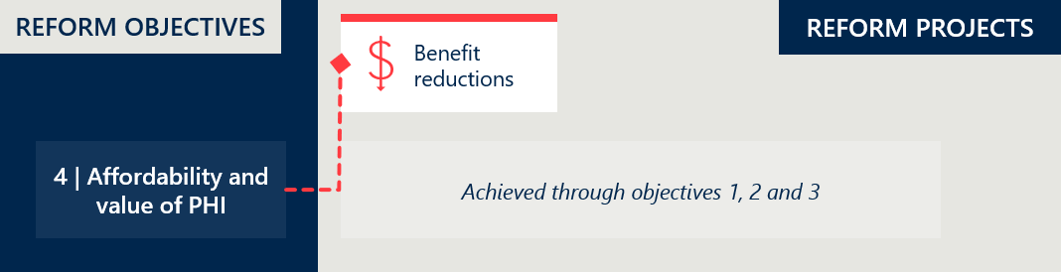

Reform project: affordability of PHI
The benefit reductions which aim to improve the affordability of private health insurance are outlined in Objective 1.

The reforms are expected to achieve $1 billion of savings resulting from benefit reductions by 2027
According to IHACPA estimates, the PL reforms generated $540 million in benefit reduction savings over the three years from July 2022 to June 2025. Savings increased each year over this period as benefit reductions were progressively implemented, reaching $239 million in FY25 once the reductions had been fully applied.
The FY25 saving provides the clearest indication of the reforms’ ongoing financial effect. Subject to future changes in device volumes, benefit settings and utilisation patterns, savings of a similar annual order are expected to continue in future years compared with the counterfactual where the reforms had not been implemented.
Based on projections made in November 2023, IHACPA estimates that the reforms will generate over $1 billion in total savings over the five years from July 2022 to June 2027.
This means the reforms are achieving their intended effect of sustaining lower benefit levels across the PL. These lower benefits reduce the insurance payments made for medical devices used in private hospitals, placing downward pressure on PHI premiums.

Savings have been limited by several factors
The extent of savings achieved through the PL reforms has been limited by structural and policy parameters. Notably, benefit reductions were determined under the MOU between the then Australian Government and the MTAA to reference public sector pricing only, rather than broader market benchmarks. Under these arrangements, benefit reductions were capped at a maximum of 80% of the gap between the PL benefit and public reference prices, with a 7% price floor above public prices applied.
Stakeholders have expressed varied perspectives about the validity of these parameters, as outlined in Section 2.3.3 (page 14) of the Interim Evaluation #1 report. In particular, some consider the 80% cap and 7% price floor to limit the extent of achievable savings, while others view these conditions as protections to account for differences between public and private hospital pricing.
In addition, the delayed implementation of benefit reductions for certain items has limited savings. IHACPA estimated that the decision to defer benefit reductions of CIEDs by one year would result in $94 million in foregone savings over the five-year period from July 2022 to June 2027. The implications of this delay, as well as other factors impacting the timing and scope of benefit reductions, are discussed further in Section 2.3.2 of the Interim Evaluation #1 report.

The benefit reduction savings have contributed to PHI affordability
All else being equal, lower PL benefit levels have undoubtedly resulted in reduced benefits paid out by insurers. Figure 14 illustrates the impact of these savings.
As 80-85% of premium revenue is typically returned to consumers in the form of insurance benefits, even modest reductions in benefit outlays can meaningfully improve insurer cost structures. This, in turn, supports downward pressure on premiums and improves PHI affordability, one of the key objectives of the reforms. The evaluation notes that some private hospital representatives expressed a strong view that the reforms should be less concerned with PHI costs and instead be targeting better equilibrium between providers and payers through an improved flow of funds to the hospital sector.
Figure 14 | Estimated insurer benefit outlays with and without reform savings ($M, based on 5% annual growth),
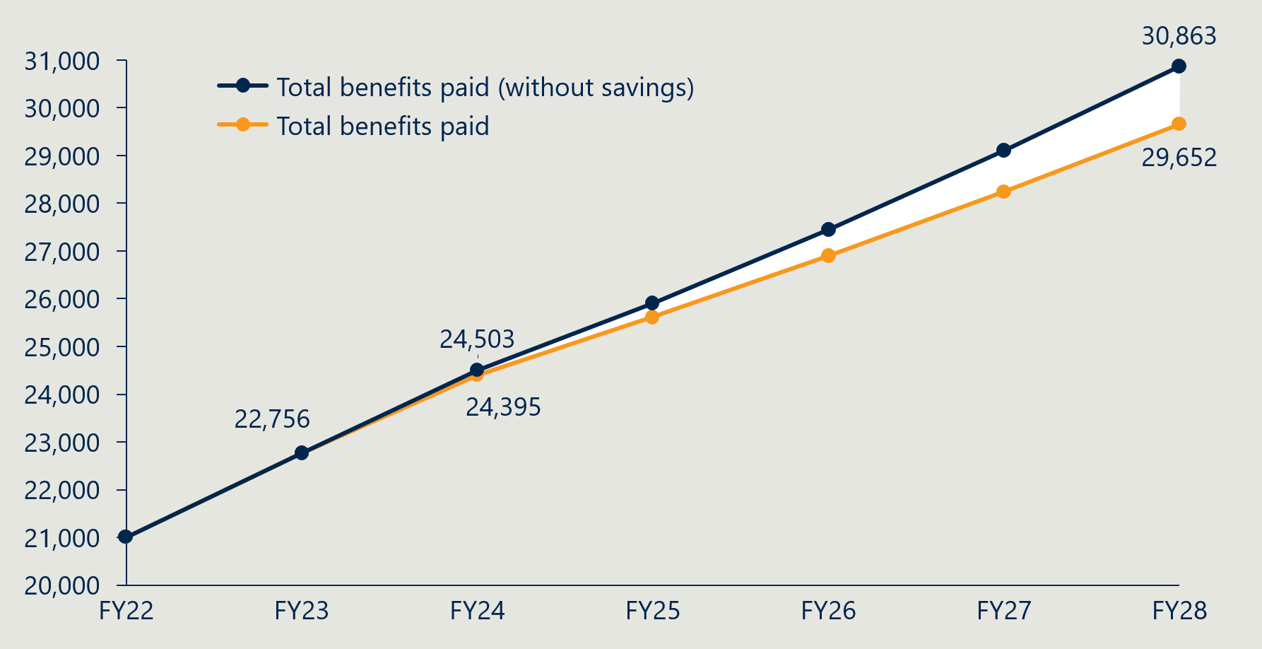

Growth in the use of devices clouds the direct impact of the benefit reductions on premiums
While the benefits paid for items on the PL have been reducing, prostheses utilisation has been increasing across PL categories (see Figure 15).
Figure 15 | Prostheses utilisation per 1000 HT PHI members by PL category
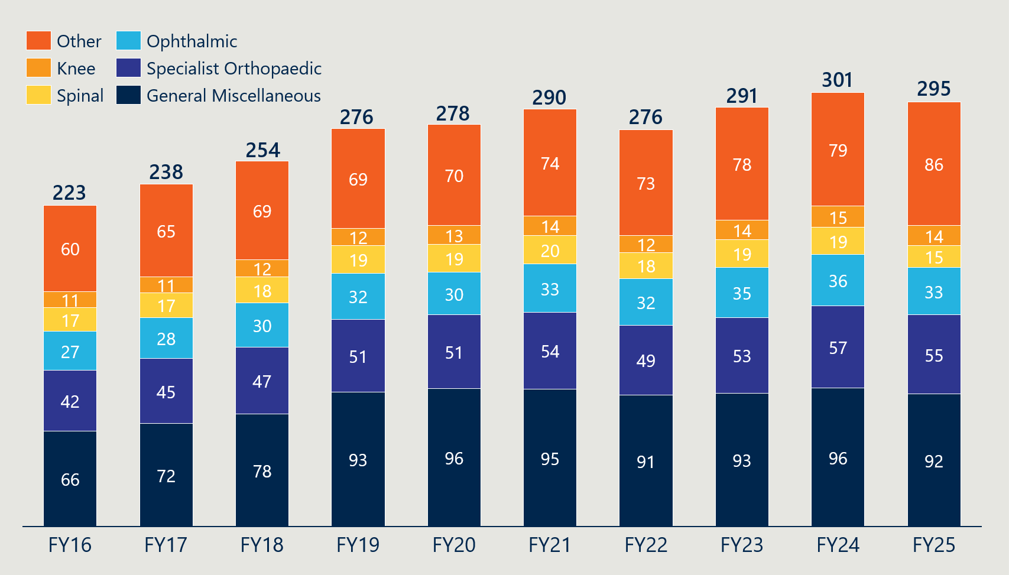
This growth in utilisation cannot be solely attributed to an ageing population. Figure 38 in Appendix C.5 shows that – except for 35-49-year-olds – all age groups are using prostheses more. Some of this growth is likely driven by advances in technology and a higher standard of care. However, this view is not shared by private health insurers, who hold a view that more items are being used than clinically necessary in hospitals. Given that clinicians select and use the items, this assertion cannot be substantiated.
This growth in utilisation partially offsets the savings achieved through lower PL benefits.
Figure 16 | Total prostheses benefits paid ($’000)
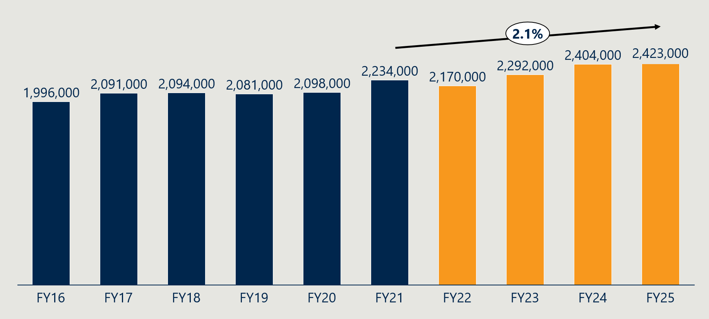
Figure 16 shows that total prostheses benefits paid grew by 8.5% from FY21 to FY25, at an average annual rate of 2.1%. However, over the same period, total HT benefits paid by insurers grew by 19.5%. In relative terms, prostheses benefit growth has been far more moderate than overall HT benefit growth.
Consistent with this, Figure 17 (below) shows that the share of total HT benefits accounted for by prostheses has declined modestly – from 14.1% in FY21 to 12.8% in FY25.
Figure 17 | Prostheses benefits paid as a percentage of total HT benefits
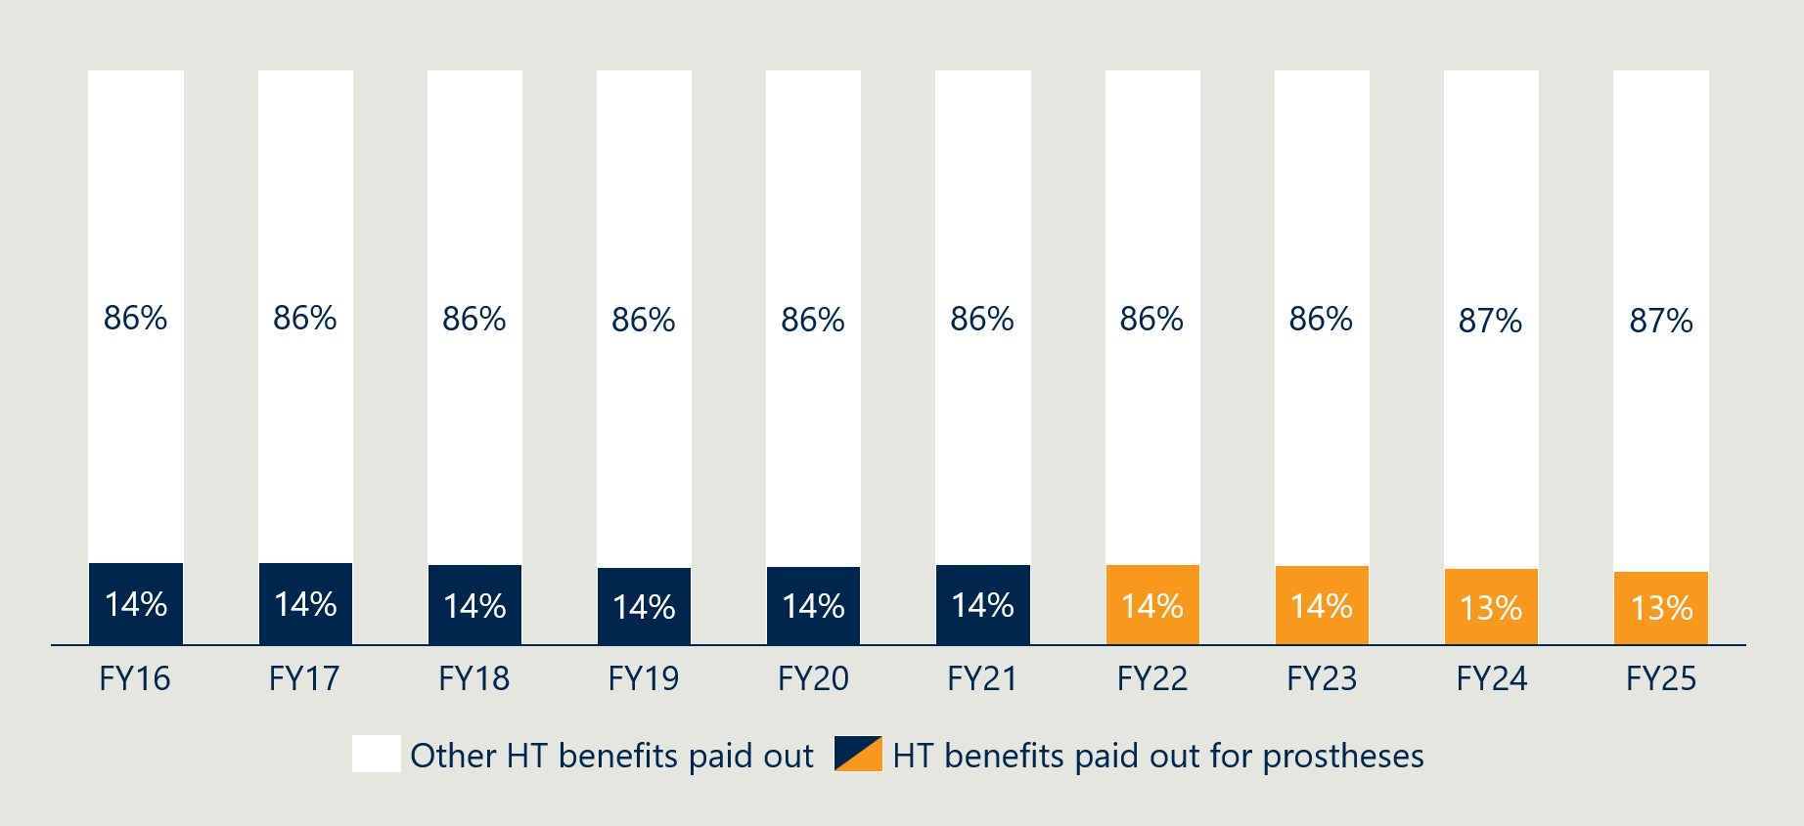

The PL reforms did not aim to address the volume of items used
While the PL reforms were deliberately designed to reduce benefit levels, they did not seek to limit the volume of items used.
Managing growth in utilisation would require strategies beyond pricing. Experience to date shows that even when restrictions are based on clear clinical or economic evidence, they can be contentious. For example, the introduction of conditions on surgical guides and biomodels prompted strong feedback from some clinicians, including reports of unintended impacts extending into the public system.

PHI premiums continue to rise
Despite efforts to contain costs through the PL reforms, PHI premiums have continued to increase. As shown in Figure 18 below, average premium growth declined in the years leading up to the reforms, reaching a low of 2.7% in FY21 and FY22. Since then, the rate of increase has edged upward – reaching 3.7% in FY25.
Figure 18 | Average year-on-year insurance premium price changes (as % of prior year premiums)
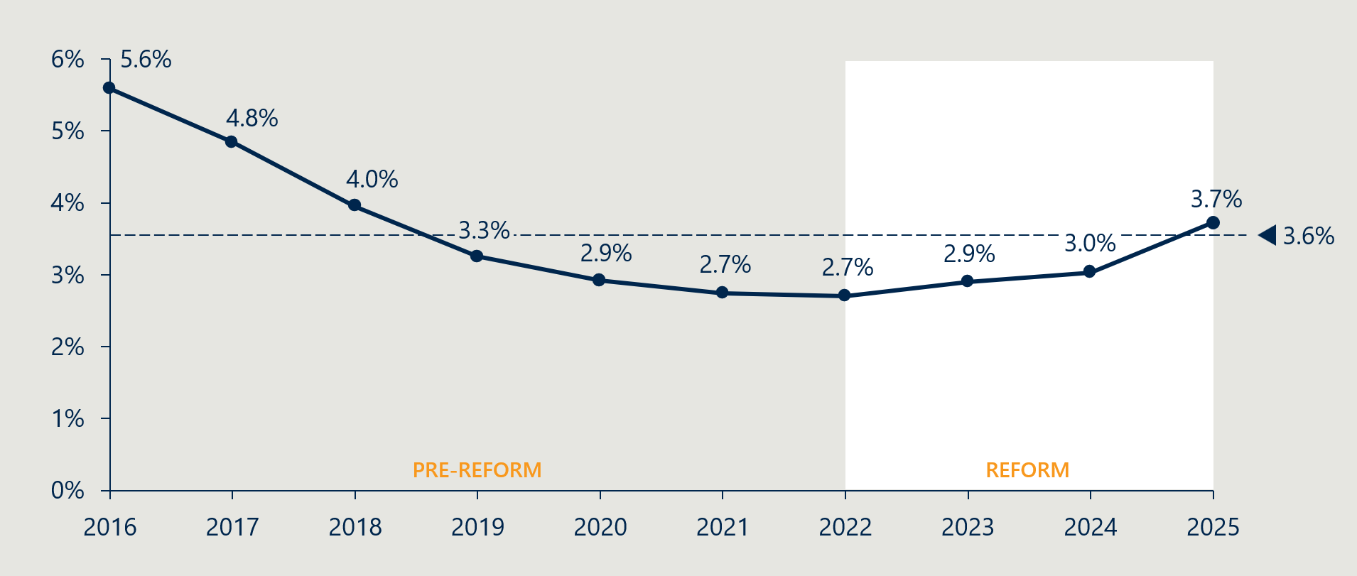
Stakeholders have pointed to several contributors to these upward pressures. Hospitals and medical device representatives have claimed that growing PHI management fees and profits are absorbing savings that could otherwise be passed on to consumers.
There is some evidence to support these claims. While PHI profits fluctuate year to year – and have decreased since FY21 – business expenses as a percentage of premium revenue have increased modestly over the past five years (Figure 19).
Figure 19 | Prostheses benefits as a % of premium revenue
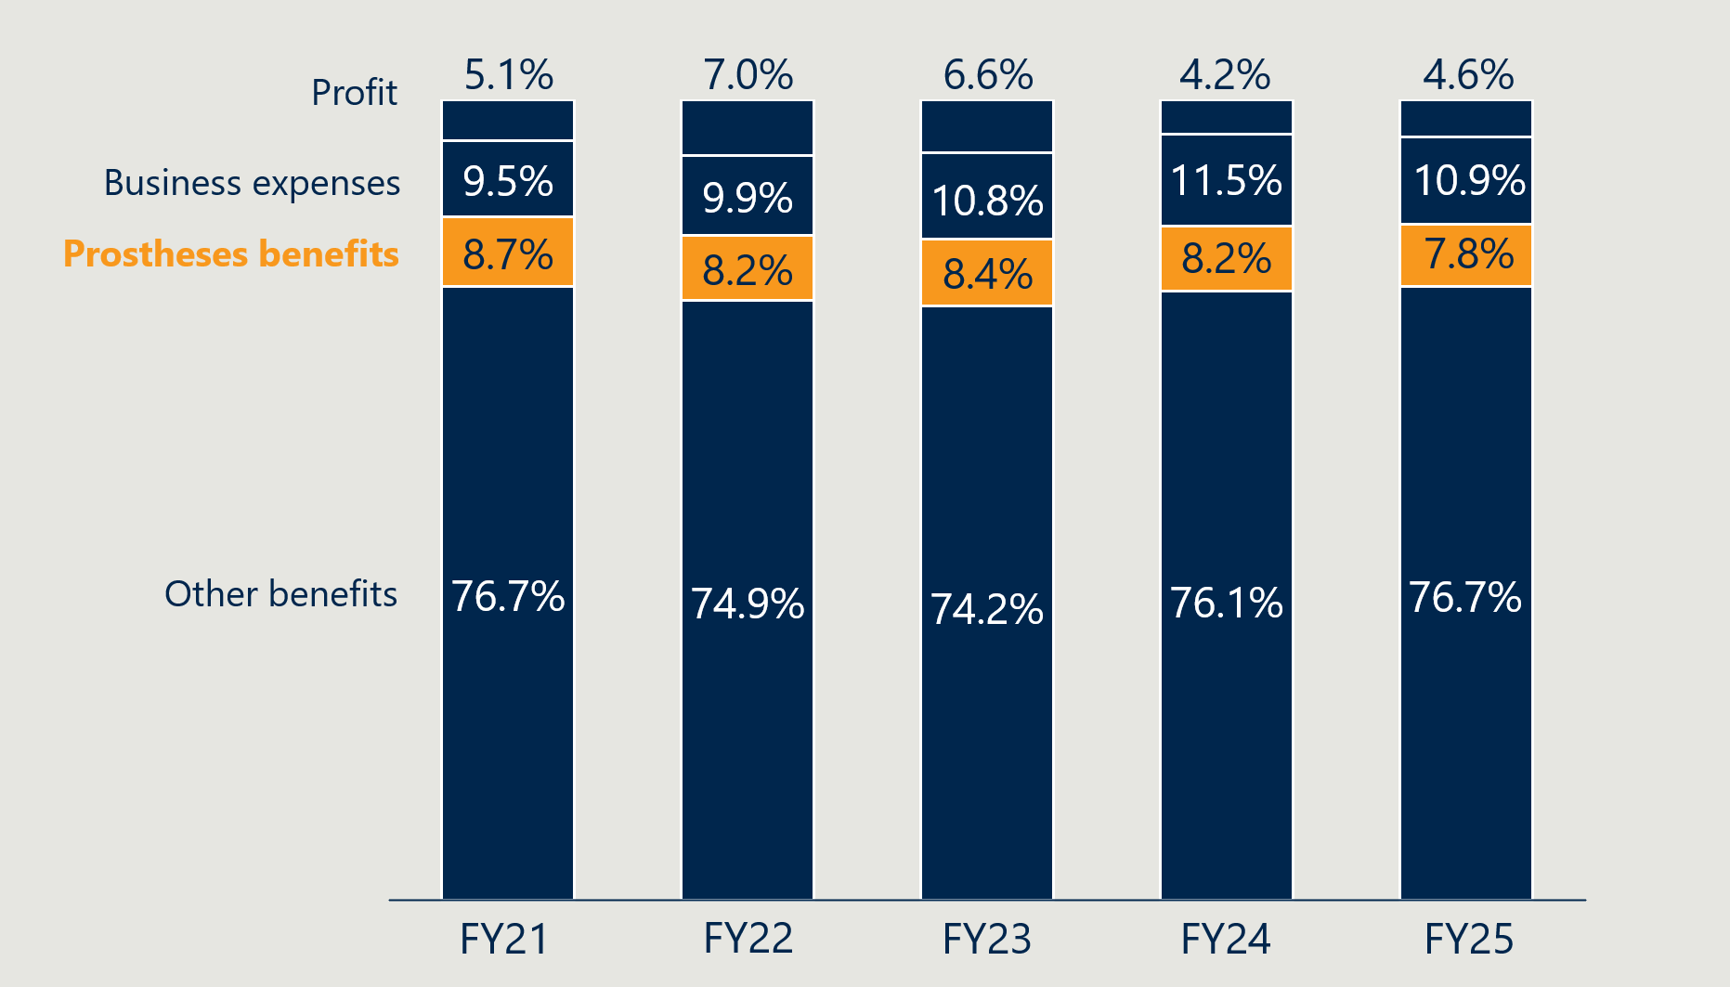
As shown in Figure 19, the share of premium revenue paid as prostheses benefits declined modestly from 8.7% in FY21 to 7.8% in FY25. Over the same period, business expenses for health insurance activities rose modestly, from 9.5% to 10.9%, while profits from insurance operations declined slightly from 5.1% to 4.6%.
Additionally, growth in hospital treatment benefits, as explored in Section 2.4.4, are a driver of rising premiums. This reinforces the broader point that while the PL reforms are moderating device-related benefits, further system-wide strategies may be needed to manage overall health insurance cost growth.

PHI coverage has remained stable despite rising premiums
Despite ongoing increases in premiums, PHI coverage for hospital treatment has increased slightly. As shown in Figure 20 below, the proportion of the Australian population with hospital treatment PHI increased from 44.6% in June 2021 to 45.8% in June 2025.
This suggests that recent cost pressures have not significantly affected overall participation in private health insurance. Stakeholders suggested that COVID-19 stabilised PHI coverage after years of decline – perhaps due to concern about public hospital access – and that in recent years, consumers are maintaining their cover.
Figure 20 | Percentage of Australian population with Hospital Treatment PHI
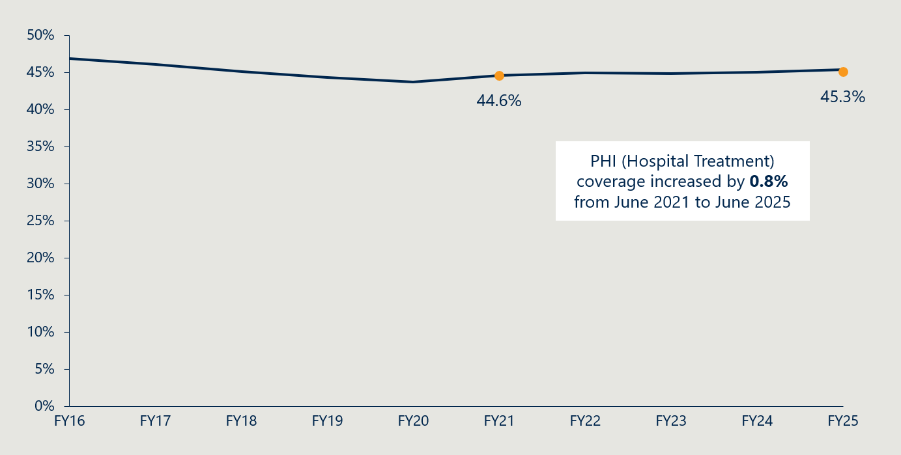

Stakeholders were broadly of the view that it is difficult to isolate the effects of the PL reforms on PHI premiums
Stakeholders expressed mixed views on whether the PL reforms have improved the affordability or value of private health insurance. There is broad agreement, however, that the impact of the reforms on premiums is hard to separate from other cost drivers.
Stakeholders were generally of the view that changes in PHI premiums cannot be clearly attributed to PL reforms alone, given concurrent drivers such as rising utilisation, insurer operating costs, and broader health system pressures. Private hospitals, clinicians, and medical technology representatives all point to continued year-on-year premium increases, suggesting that any PL-related savings have only marginally slowed, rather than reversed, premium growth.

Stakeholder groups had different perspectives on the relationship between the reforms and PHI premiums
Private hospitals and medical technology representatives question whether insurers have meaningfully passed PL savings on to consumers, citing ongoing premium increases and concerns about value for money. Clinicians reinforced this perspective, noting that although device costs per service have declined, these savings have not translated into visibly lower premiums for consumers.
Insurers argued that increased volumes of medical devices have offset unit price reductions, diluting any observable premium impact. They reported that some savings have been reflected in premium adjustments, though they acknowledge the scale is modest relative to total insurance costs. Insurers frame PL reforms as necessary but insufficient, emphasising that medical devices comprise a small share of total PHI expenditure and arguing for further reform to manage future cost pressures and reduce the risk of declining coverage.
Medical device representatives contend that PL benefit reductions have been one of the few sources of downward pressure on premiums in recent years, helping stabilise PHI participation during periods of broader affordability stress. Clinicians and medical device stakeholders generally attribute recent stabilisation or growth in PHI coverage more to consumer concerns about access to public hospitals than to improved affordability or perceived value arising from PL reforms.

Objective 5: Clarify the purpose, definition and scope of the PL in legislation
This section considers legislative changes in support of the PL’s defined purpose and scope, implementation of a new grouping structure and implementation of alternative funding arrangements for GUIs.
Figure 21 | Reform projects related to reform objective 5
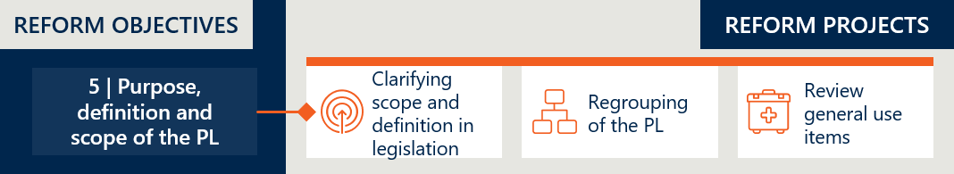

Reform project (a): clarifying scope and definition in legislation
At baseline, the PL lacked clear scope and a legislative definition of ‘prostheses’, allowing items that may be better suited to other funding mechanisms to be listed. As outlined in the Interim Evaluation #1 report, amendments were made to the PHI Act in 2023. This included renaming the list, replacing the use of ‘prostheses’ with ‘medical devices’, inserting definitions and revising the device listing criteria to clarify product eligibility.
The Private Health Insurance (Medical Devices and Human Tissue Products) Rules have since been updated to accommodate the retention of GUIs on the PL. The new rules, which came into effect on 1 November 2024 omitted the provision that would repeal Part D (GUIs) of the list and new listing criteria for devices in Part D were added with the intent of maintaining the existing scope of the Part D grouping scheme., Specifically:
- New listings for GUIs on the PL must have a comparative GUI already listed in Part D.
- No new categories, subcategories, groups, subgroups or suffixes will be added to Part D.
As discussed in the Interim Evaluation #1 report, the inclusion of definitions in the legislation further defined the scope of the PL. New definitions were inserted, and listing criteria was updated in the Act as parameters to provide better clarity around what products are eligible for inclusion on the PL. The updated legislation precluded items that were previously listed on the PL, such as GUIs and medicines, from being listed on the PL, however the removal of GUIs was reversed by the November 2024 rules, noted above. The GUI reform project is discussed further in Section 2.5.6.
Interim Evaluation #1 report also identified that some ambiguity on boundary products remained in the legislation. ‘Boundary products’ are defined as therapeutic goods with attributes that make it challenging to determine whether they belong to the category of medical device or medicine, or both.

Reform project (b): regrouping of the PL
The PL consists of 13 categories and multiple sub-categories and groupings that are grouped according to similar characteristics, functionality, clinical features and effectiveness. At baseline, PL groupings and benefit levels were based on device characteristics and clinical benefits. The PL reforms aimed to align groupings with clinical use, simplifying navigation for insurers and hospitals. An external consultant report (by Hereco) was delivered to the Department in 2022 however concerns arose with the multitude of products considered to comprise a “mixed benefit group” in the proposed new structure, which added significant complexity to regrouping. The requirement in the MOU with the MTAA which required that regrouping not result in additional savings was a complicating issue. As a result, the recommended regrouped PL structure was not finalised and as discussed in the Interim Evaluation #1 report, the regrouping project was paused. The regrouping project was subsequently discontinued: on 12 May 2025, the Department announced to stakeholders that the regrouping of Part A of the PL would not be continued as a reform measure.
Figure 22 | Timeline of PL regrouping reform project
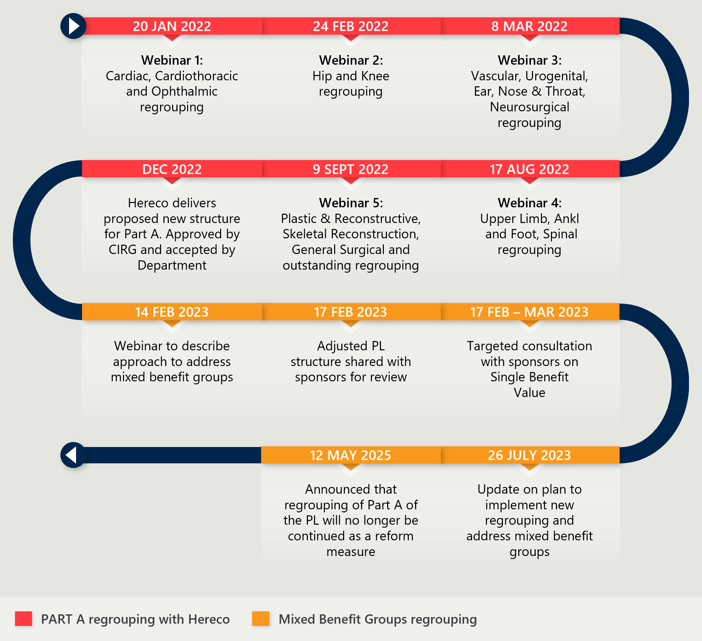

The regrouping aimed to provide transparency and simplicity
Regrouping of the PL was intended to provide transparency around PL items and increase the PL’s ease of use. This was in response to the PL being considered unwieldy, alongside a notion that this made the PL more difficult to administer, driving cost and unnecessary complexity. As of 2021, the PL contained 11,600 billing codes and 1,700 unique groupings. The regrouping aimed to align the structure of the PL directly with clinical use of the device groups, to streamline the list and make it simpler to navigate for insurers and hospitals.
The MOU between the Minister and the MTAA contained an important caveat to the process. It stipulated that the regrouping shall not be designed in a way that further reduces benefit levels for devices beyond the specific benefit reductions planned through other projects of the reforms.

There was also a view that regrouping would reduce inconsistencies and overpricing
Some stakeholders believe the current PL item groupings contribute to a variety of issues that result in some PL items being overpriced, such as:
- Inclusion of items in sections of the PL inconsistent with their actual or intended use.
- Differences in benefit amounts that are not explainable by clinically relevant product differences.
- The use of inappropriate comparator products, or reclassification of existing products into higher benefit subgroups or suffix groupings, which is viewed to be evidence of gaming.
Stakeholders who supported this change believed it would potentially reduce ‘gaming’ – whereby sponsors might list devices with minor changes to gain higher benefits without added clinical value.

Achieving a pure clinical use-based regrouping was challenging and the project was discontinued
The Department made the decision to cease work on the regrouping project when “it was evident that implementing the proposed PL grouping structure would require re-assessing all mixed benefit groups in line with a full health technology assessment”. The decision was made on the balance that the costs involved would outweigh any potential gains of efficiency and clarity.
The context that led to this decision was explored in the Interim Evaluation #1 report.

The prohibition in the MOU on using regrouping to make further reduction savings compounded the challenge
The 2022 MOU with the MTAA prohibited using regrouping to make further reduction savings on benefits beyond those already specified in the agreed reform benefit reduction schedule. The plan to implement the external consultant’s proposed grouping structure, based on clinical outcomes and independent of device benefits, resulted in some groupings containing a wide range of benefits. Regrouping those into single-benefit groups became unworkable in light of the MOU agreement on no further savings.

Regrouping was widely seen by stakeholders as conceptually sound but operationally complex and poorly executed
While there was broad conceptual support for simplifying and rationalising the PL, stakeholders disagreed on the feasibility, risks, governance, and intent of regrouping, particularly where it intersected with pricing, innovation, and reimbursement outcomes.
Hospital, medical device, and clinician stakeholders consistently highlighted poor governance, unrealistic timelines, and limited resourcing as contributing to the project stalling. Several stakeholders characterised the Department’s approach as “all-or-nothing”, particularly in its treatment of consultant recommendations, arguing that this rigidity prevented incremental progress even where consensus existed.
Medical device groups expressed frustration that alternative regrouping models – which they argued would have simplified the PL without breaching the MOU – were not progressed. Insurers and hospitals criticised what they perceived as opaque decision-making around the cancellation of the project, including limited transparency about why other practical options were not pursued.
Some stakeholders emphasised that written consultation alone was insufficient for such a complex reform, and that the lack of face-to-face dialogue with technical experts contributed to misunderstanding and mistrust.

Stakeholders highlighted the unresolved tension between the ambitions of the reforms
Stakeholders recognised that regrouping sat at the intersection of competing objectives: administrative simplification, transparency, and accountability, versus protection of clinical discretion, innovation, and commercial viability.
Medical technology, private hospitals, and some clinicians argued that proceeding without stronger governance, consultation, and pricing safeguards risked unintended consequences, including increased claims disputes, reduced access to devices, and weakened incentives to supply or innovate. For these stakeholders, the decision not to proceed was framed as a pragmatic risk‑management choice, given MOU constraints, fiscal limits, the cost and feasibility of undertaking multiple HTAs, and concerns that regrouping could be perceived as a proxy for price reduction.

The decision to discontinue work on regrouping left core structural issues unresolved
Stakeholders across groups acknowledged that stalling regrouping leaves core structural issues unresolved, including legacy groupings, ambiguous boundaries, and ongoing uncertainty around benefit eligibility when devices are used outside defined groups. Several stakeholders (including hospitals, insurers, and MDHTAC representatives) noted that, in the absence of regrouping, the PL continues to evolve incrementally, risking further entrenchment of inconsistencies and diminishing the value of work undertaken for the reform project.
Insurers and some MDHTAC advisory members viewed the lack of progress as a missed opportunity to resolve long‑standing inconsistencies in PL structure and strengthen alignment between device groupings, clinical use, and benefit settings.

The regrouping work remains a useful basis for targeted improvement to the PL
The original ambition to regroup the PL along clinical lines was not fully realised. While detailed work was undertaken with clinical input, the proposed structure encountered significant practical and stakeholder challenges. These challenges were largely driven by the existence of mixed-benefit PL groupings and the MOU ban on achieving further savings. This meant that options for a more flexible or clinically meaningful restructuring were constrained, particularly where regrouping would have required benefit changes or created perceived winners and losers. The decision to cease the regrouping work in May 2025 was sound in the context of these constraints.
However, the work undertaken remains valuable. It identified historical inconsistencies, pricing anomalies and areas where the grouping structure could be made more transparent and practical for users of the PL. The Department has indicated that this work will continue to inform post-listing reviews and assurance activities, providing a basis for future consideration of PL structure and category logic.
With the MOU having concluded on 30 June 2026, there is now greater scope to revisit these issues over time. Rather than recommencing a wholesale regrouping of the PL, the Department should use the previous regrouping work to inform targeted improvements to PL groupings where clear issues are identified.
RECOMMENDATION 3: Build on the work undertaken during the reforms to identify and resolve historical inconsistencies and pricing anomalies in PL groupings. Rather than pursuing a wholesale restructure of the PL, this should be done in a targeted and ad hoc manner, as issues are identified.

Reform project (c): review general use items
At baseline, the PL included general use items (GUIs), which are items used in a broad range of surgeries, not necessarily only surgeries involving prostheses. GUI items such as staples and sutures are procured in groups rather than individually for a specific operation and it was argued that these are not suitable for funding via a mechanism like the PL, which associates a benefit to be paid with a specific episode of care. An external review of the General Miscellaneous category on the PL was conducted in 2020, resulting in several recommendations, including tightening listing criteria and removing some miscellaneous items to be funded by an alternate mechanism.
Under the reforms, GUIs were originally set to be removed completely from 1 March 2022; however, this process was delayed to provide time for the Clinical Implementation Reference Group (CIRG) to review the potential impacts of the removal of these items. In the interim, a gradual reduction of the difference between the benefit and the public weighted average price was put in place (a reduction of 60% of the difference from 1 July 2022 and a further reduction of 40% of the difference from 1 March 2023). Removal of the items was delayed until March 2022, then on 1 May 2024 the Government confirmed that GUIs would remain on the PL after 1 July 2024. The announcement cited stakeholder concerns and increased financial pressures on private hospitals affecting their viability as key factors in this decision.
While GUIs have been retained in Part D of the PL, 26 specific billing codes were removed on 1 November 2024 as they are regulated by the Therapeutic Goods Administration as medicines and accessories to medicines and therefore do not meet the PL eligibility requirements.
Figure 23 | Timeline of general use items (GUIs) reform project
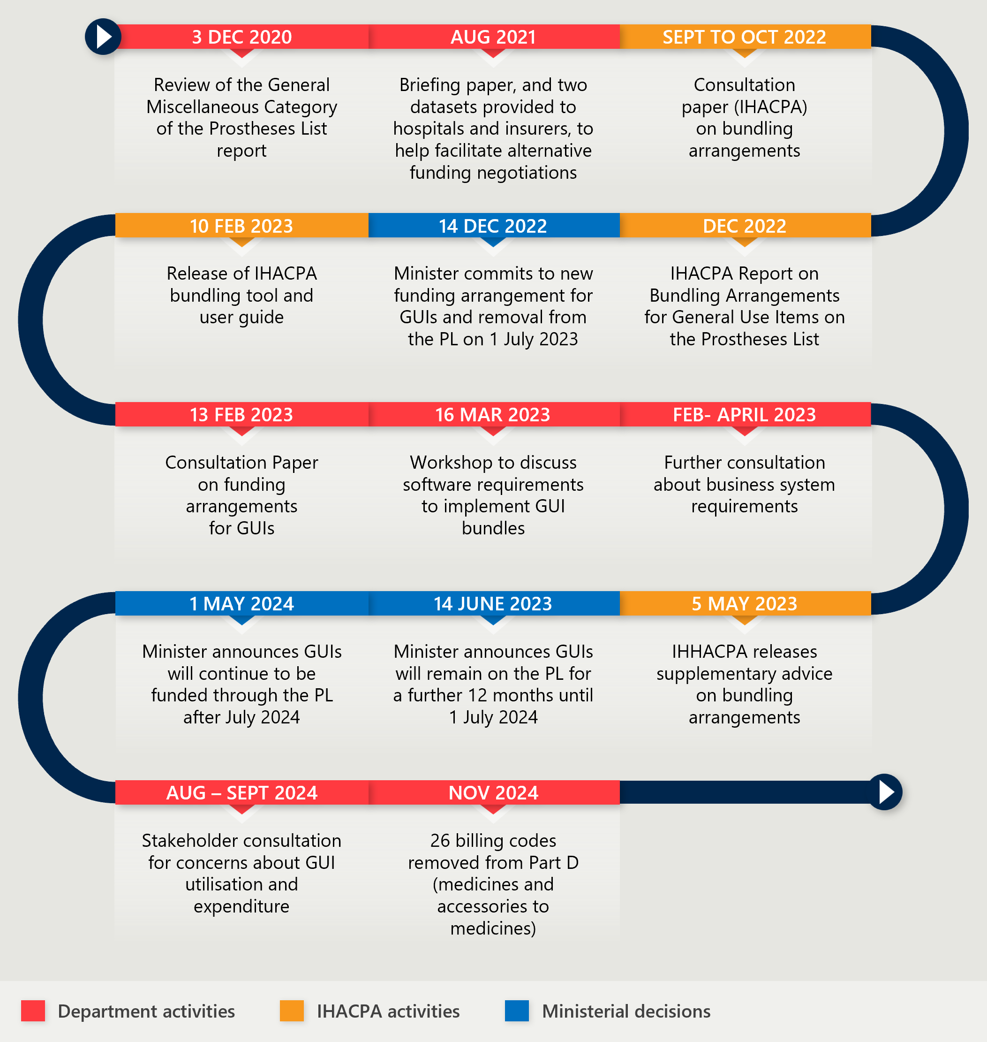

The objective to move GUIs to an alternative more appropriate funding mechanism was not realised
“The Government has listened to the concerns about the pressure removing general use items would have caused and decided that this achieves the best outcome for patients”
Minister Mark Butler, 1 May 2024

MTAA, 2017 Senate Submission

The original intention of removing GUIs from the PL by 1 March 2022, aimed to address ongoing concerns about the high utilisation of certain groups of products in the General Miscellaneous category of PL and elsewhere, and whether these items met the PL list criteria. It also aimed to reduce administration costs. However, its success was highly dependent on an alternative funding mechanism being put in place.
The Department identified a group of over 500 general use and consumable products that either failed to meet the pre-reform listing criteria or would not qualify under the new definitions agreed during the reform process. Their removal would have streamlined the PL’s scope and range of products and put further downward pressure on private health insurance by taking cost out of the system. Advice from the then Clinical Implementation Reference Group (CIRG) was that products could be removed from the PL with no clinical implications or adverse outcomes so long as the products were still available for use by clinicians under an alternative funding agreement.

The failure to remove GUIs resulted from unsuccessful attempts to negotiate a bundled funding arrangement between insurers and hospitals
Development of options for a bundled funding arrangement were aided by advice from IHACPA, with a consultation paper and final report on potential bunding arrangements delivered in late 2022. While private health insurers committed to the alternative funding arrangement, concerns were raised by private hospitals about potential negative clinical implications or adverse outcomes for patients as well as the compatibility of the proposed funding arrangements with existing data systems. Most stakeholders, except insurers, saw retention of GUIs as necessary in the absence of agreement on an alternative funding model. A fundamental concern remained that private hospitals might be financially worse off under the new arrangements. Interim Evaluation #1 report provides a full description of the failure of the negotiation process and the resultant decision, taken in May 2024, to no longer proceed with the removal of GUIs from the PL. In announcing the decision, the Minister stated that it was based on the need to balance patient safety and hospital viability with savings and reform commitments.

The extent of stakeholder angst about the removal of GUIs largely reflected their financial exposure to the decision
Stakeholders held strongly expressed views about the GUI issue. Private hospitals, clinicians, and medical technology representatives advocated strongly for retaining GUIs on the PL, emphasising that GUIs remain integral to contemporary surgical care. These stakeholders argued that, without a viable alternative funding mechanism, removal of GUIs would have substantially risked service disruption, reduced access, and increased financial instability for private hospitals. Clinicians and hospitals consistently noted that GUI reform is not feasible unless accompanied by broader PHI system reform or a replacement funding model that protects hospitals from financial harm.
Insurer opposition was driven by reported GUI misuse and cost containment
Private health insurers opposed the retention of GUIs on the PL, arguing that it results in weak quantity control, enabling overuse and hospital profit-taking. Insurers stated that removal of GUIs would allow prices and utilisation to be constrained through contract negotiations, delivering system savings. They advocated for a shift to case-based or DRG-style funding aligned with public sector models and characterised GUI retention as inconsistent with earlier reform advice, citing limited progress on consumer protection measures.

Stakeholders raised concerns over the moving of GUIs to Part D
Medical technology stakeholders criticised the effective “freezing” of GUI listings as narrowing the scope of the PL, arguing this undermines innovation. They highlighted that GUIs were subject to full price convergence between public and private systems, unlike Part A devices, and that the decision to contain Part D to “like-devices” does not reflect the PL’s original intent to support access to innovative technologies.
Hospitals similarly raised concerns about scope definitions creating uncertainty, particularly for ‘high-cost disposable items essential to modern care.’ Hospitals reported increased administrative burden due to the need to justify GUI use on a case-by-case basis.

Despite the failure to remove GUIs, benefit reductions resulted in reduced overall expenditure on GUIs
Although GUIs were not removed from the PL planned, benefit reductions to these items occurred during the reform period:
- From 1 July 2022: a 60% reduction of the gap between the PL benefit and the weighted average price.
- From 1 March 2023: a further 40% reduction of the remaining gap.
While GUI utilisation has remained constant throughout the reforms, benefit reductions have resulted in reduced expenditure on GUIs overall. This can be seen in Table 2 below.
Table 2 | Utilisation and value of GUIs between FY21 and FY24,
 | FY21 | FY22 | FY23 | FY24
Total utilisation | 1,020,932 | 990,720 | 1,023,011 | 1,019,798
Total value | $216,888,306 | $206,887,692 | $192,765,478 | $174,392,258
Weighted average benefit | $212 | $209 | $188 | $171
Annual utilisation of GUIs remained relatively stable between FY21 and FY24. Despite this, overall expenditure declined by 20% over the period, alongside a steady reduction in the weighted average benefit – from $212 in FY21 to $171 in FY24. This suggests that lower benefits were the primary driver of reduced total value.

The investment in GUI funding models underpins a future pathway for reform
Although the proposed removal of GUIs from the PL did not proceed, the reform process generated substantial design work and sector engagement that remains relevant. The Department, IHACPA and industry stakeholders invested time and resources into exploring alternative bundling models, with one insurer estimating over $250,000 in unrecoverable development costs.
GUIs remain an anomaly within the PL. They do not align neatly with the original purpose of the PL, as they are not implantable medical devices used for a specific therapy and are used across a broad range of procedures. Their retention means that the scope of the PL remains less clear than intended and that the administrative burden associated with listing, billing and managing these items continues.
The key barrier to removing GUIs from the PL is the absence of an agreed alternative funding mechanism. Private hospitals require a form of reimbursement or funding to support the purchase of these everyday items, and stakeholders raised concerns that poorly designed arrangements could create adverse impacts, particularly given financial pressures in the private hospital sector. The reform experience suggests that any future approach will need to be carefully designed, clinically appropriate and financially sustainable.
However, the objective of removing GUIs from the PL remains valid. The work undertaken during the reforms should be leveraged to support further consideration of sustainable funding options outside the PL, including options that better align funding with the clinical context in which GUIs are appropriately used. This would allow the Department to build on the investment already made, rather than recommencing design work from first principles, while continuing to pursue the broader policy objective of streamlining the PL’s scope and reducing unnecessary system costs.
RECOMMENDATION 4: Use the work and lessons from the reforms to inform further Department consideration of sustainable funding options for GUIs outside the PL.

Objective 6: Implement new PL assessment pathways aligned to Health Technology Assessment principles and streamline the application process through simple and robust IT infrastructure
This section considers the implementation of new applications pathways and the governance processes involved in their assessment. It documents the volume of PL application by tier and considers stakeholder perspectives on the assessment pathways and listing processes.
Figure 24 | Reform projects related to reform objective 6
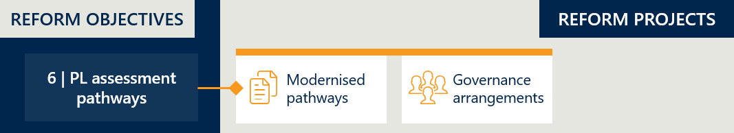

Reform project (a): modernised pathways
Prior to the reforms, applications for listing items on the PL followed a single assessment pathway. As outlined in Interim Evaluation #1 report, multiple assessment “tiers” for PL devices were established under the reforms (Tier 1, 2a, 2b and 3). The aim was to increase the efficiency of the assessment process by distributing resources across applications according to their relative complexity.

Assessment pathways were structured into three tiers, each with tailored evidence requirements
The Department introduced new assessment pathways on 1 July 2023. The three-tier system was designed to accommodate applications of varying complexity, ensuring that simpler and more complex submissions are processed through appropriate channels. The tiers apply to a range of application types, including new listings, amendments, compressions, and expansions.
The three tiers are set out in Table 3 below.
Table 3 | PL assessment pathways
Pathway | Description | Appropriate for the following applications:
Tier 1 | Department assessment pathway | - Part A applications that will be assessed only by the Department and are not expected to be presented to MDHTAC for consideration.  - Applications for devices that are classified by the TGA as Class IIb or lower, and devices with established technology (“relatively simple, well-understood and stable designs and limited variations, and with proven records of satisfactory safety and performance”).  - New applications to list a device within an existing PL grouping.  - Amendment applications that do not request a changed PL grouping.
Tier 2 | Clinical / focused HTA assessment pathways  (2a: clinical assessment only, 2b: clinical and economic assessment) | - Part A applications involving technology that is not well established; and/or have high variability in design and characteristics; and/or claims novel features, characteristics and functionality.  - Applications for devices classified by the TGA as Class III, or any Part C applications.  - Applications that require a new grouping.  - Amendment applications that request a changed grouping.
Tier 3 | Full HTA assessment pathway (MSAC assessment) | - Applications for devices that are novel or first-in-class technology; and/or there are no appropriate comparators on the PL.  - Applications where there is no relevant MBS item associated with the use of the device, requiring a new MBS item or an MBS descriptor to be modified.  - Applications where listing the device will cause significant financial impact on overall PL expenditure and therefore requires detailed financial assessment.

The proportion of Tier 2 applications has increased over time
Table 4 and Table 5 show the number of applications for Parts A and C and GUIs in each of the tiers since the modernised pathways were introduced. The data below includes four types of applications:
- New applications.
- Amendment applications: For changing the details of the existing billing code, including: deletion/addition of catalogue numbers, amending product name, description or size stated for billing code, addition or replacement of ARTG entries, changing the grouping the billing code is listed in. Amendment applications do not delete or create any existing billing codes.
- Expansion applications: For expanding the billing code covering multiple devices into two or more new billing codes.
- Compression applications: For compressing two or more billing codes into one billing code.
Other application types (applications to delist or transfer) have not been included in this analysis.
For Parts A and C of the list, 64% of applications are new applications to list. Tier 2 is the most utilised pathway for new applications, closely followed by Tier 1. Tier 3 is very rarely used. The makeup of Part D (GUIs) applications is broadly similar to the rest of the list.
Figure 25 shows the change in number of applications in each pathway over the same period.
Table 4 | Part A and C applications by tier and assessment pathway – September 2023 to April 2026
 | Tier 1 – Department pathway | Tier 2 – Clinical HTA pathway | Tier 3 – Full HTA pathway | All assessment pathways
New | 858 | 1,004 | 5 | 1,867
Amendment | 677 | 275 | 0 | 952
Expansion | 32 | 32 | 0 | 64
Compression | 1 | 8 | 0 | 9
All application types | 1,568 | 1,319 | 5 | 2,892
Table 5 | Part D (GUIs) applications by tier and assessment pathway – September 2023 to April 2026
 | Tier 1 – Department pathway | Tier 2 – Clinical HTA pathway | Tier 3 – Full HTA pathway | All assessment pathways
New | 37 | 39 | 0 | 76
Amendment | 28 | 12 | 0 | 40
Expansion | 9 | 2 | 0 | 11
Compression | 0 | 0 | 0 | 0
All application types | 74 | 53 | 0 | 127
Figure 25 | Number of PL applications between September 2023 and April 2026 (Part A, C and D)
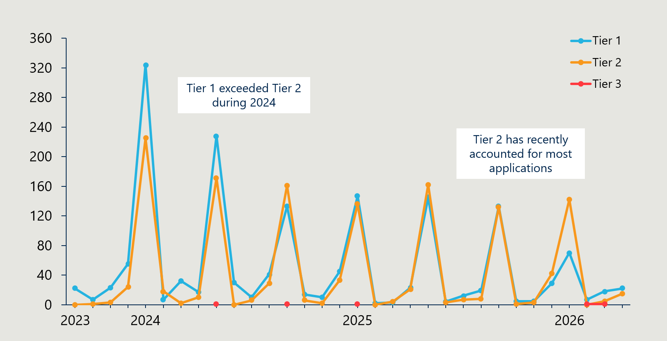
Figure 25 shows a spike in all application pathways in early 2024 followed by a declining trend over the remainder of 2024. This initial spike can be explained by implementation of the new Health Products Portal (HPP) enabling PL applications to be accepted again after applications were closed from May to September 2023. The volume of applications has settled to more consistent levels since then.
The pathway trend indicates that Tier 2 applications have increased over time while Tier 1 applications have trended downwards. This may be due in some part to sponsors gaining more familiarity with the tiers and their requirements. Notably, there was a marked drop in Tier 1 applications in early 2026.

The expected efficiency gains have been hampered by staffing challenges
Feedback from stakeholders both external to and within the Department indicated that resourcing constraints, including staff capacity and technical expertise, have limited the efficient administration of the tiered application pathways. This has affected the extent to which Tier 1 assessments by the Department have been completed consistently and at the intended level of technical competence.
Under the tiered model, Department staff assess Tier 1 applications and prepare Tier 2 applications for MDHTAC. These roles require staff to manage a high volume of technically complex submissions, triage applications appropriately and understand when clinical or technical input is required. The Department has noted that recruiting and retaining staff with the necessary skills and knowledge has been difficult. Limited resourcing has drawn criticism from stakeholders, including representatives of medical technology companies and MDHTAC members, who identified departmental capacity as a critical constraint on the effectiveness of the PL system. These issues were seen as contributing not only to slower assessment but potentially limiting timely access to new technologies in the private sector.
One consequence has been the reassignment of some Tier 1 applications to Tier 2, suggesting that the Department may not yet have the capacity, capability or support structures needed to assess all Tier 1 submissions as intended. This does not necessarily mean that all pathway challenges can be resolved through additional resourcing alone. Rather, it points to the need to review whether staffing levels, technical and clinical expertise, workflow design and escalation arrangements are well matched to the nature and flow of applications now being processed through each pathway.
Clinicians also raised concerns about the Department’s ability to attract and retain appropriately skilled clinical and technical staff to support the assessment of a high volume of complex device applications. They supported the Department’s gradual transition to full pathway implementation while capacity was built and sponsors adjusted to the new requirements.
RECOMMENDATION 5: Review staffing requirements against the nature and flow of application processing, matching work requirements with the technical and clinical expertise of the team.

The quality of sponsor submissions has not been optimal, adding to staff workload
Staff and members of the MDHTAC and ECAGs have faced challenges managing late, incomplete or poor quality responses from sponsors, further straining an already stretched system. The resulting to-and-fro to ensure information is complete and correct has added avoidable time and effort to the assessment process.
“MDHTAC Members are faced with additional requests to be assessed in real time or delay the application until the next round of ECAG meetings. A harder deadline and better resources for the department would be the obvious solution”
MDHTAC member, June 2025
In consultations, representatives of the MedTech industry were concerned that the absence of minimum response times and clear service standards impedes commercial planning. They also noted that tailored training offered to sponsors by the Department would likely lift the quality of responses. This indicates that both the Department and sponsors would benefit from clearer expectations around the application process, including the quality of information required, the timing of sponsor responses and the consequences of not meeting these requirements.
Better understanding of the process through training and the enforcement of a tighter set of requirements for sponsor submissions could materially improve administration of the pathways. This would require clear minimum standards for quality and completeness, defined response timeframes and a willingness to defer or close applications that do not meet requirements. A firmer approach would help lift the quality of submissions, reduce avoidable to-and-fro between sponsors and officials, and free up staff time for more productive assessment work.
RECOMMENDATION 6: Implement tailored training for sponsors and enforce tight requirements for quality, completeness and timeliness for sponsor submissions.

Potential further improvements to the pathways process could improve efficiency without risking safety and quality
Based on the experience of the pathways reforms, a question remains as to whether the revised pathways are optimal. While stakeholders broadly supported the new tiered model of PL device assessments, there were calls for clearer guidance and better transparency in addition to better-resourced implementation.
Some stakeholders commented that the PL application assessment pathways are not well aligned with some of the Health Technology Assessment (HTA) principles that define the way that assessment processes like the PL pathways should occur. They raised concerns about sustainability, transparency, administrative efficiency, accountability and consultative engagement. For example, while private hospitals and insurers do not submit PL applications, both had concerns about limited transparency of the assessment processes. Insurers expressed concern about the cumulative financial impact of certain device listings over time, reporting there is limited transparency on expected volumes or outcomes.
Medical technology representatives pointed to gaps in the available guidance as contributing to uncertainty. The draft PL Guide issued in December 2023 had not been finalised at the conclusion of the reforms and lacked detailed guidance on several elements, including the focused HTA process and the pathway for listing new technologies or updating existing listings on Part C of the PL. Because Part C applies to specified groups of devices that do not meet the Part A criteria but are considered suitable by the Minister for private health insurance benefit payments, clearer guidance is needed on the criteria and process used to support Ministerial recommendations. Stakeholders considered that these gaps reduced transparency and limited the PL’s ability to support timely access to emerging technologies.
There is an opportunity to examine whether PL evidence requirements can be streamlined
While medical technology representatives regarded Tier 1 as a step in a positive direction, they identified areas for refinement that they believed could reduce barriers and strengthen alignment with the evidence. In their view, the evidence requirements for some of the tiers are too stringent compared to overseas markets.
Medical technology stakeholders argued that the evidence requirements, particularly under Tier 2b and Tier 3, are not proportionate to the type and timing of evidence typically available for medical devices and are more stringent than comparable international settings. They also contrasted PL assessment timelines with pharmaceutical processes, calling for Tier 2b and Tier 3 applications to be completed within a single cycle.
These views should be considered in the context of the broader regulatory pathway for medical devices. Devices listed on the PL must already be included on the ARTG, meaning they have been assessed through TGA processes. This does not remove the need for the PL to consider whether a device should attract a private health insurance benefit, or the appropriate level of that benefit. However, it does raise a question about whether some elements of the PL assessment process could better leverage TGA assessments of safety and quality, or relevant international assessments of clinical effectiveness, without duplicating work unnecessarily.
A joint examination by the Department and TGA would help identify where the current process is appropriately distinct, where duplication may exist and where requirements could be streamlined while maintaining confidence in the clinical and financial basis for PL listing decisions.
RECOMMENDATION 7: The Department and TGA should conduct a joint examination of the potential for some PL assessments to leverage the TGA assessment of device safety and quality or international assessments of clinical effectiveness and ensure there is no unnecessary duplication.

Reform project (b): governance arrangements
As outlined in Interim Evaluation #1 report, the previous PL governance arrangements were replaced with the Medical Devices and Human Tissue Advisory Committee (MDHTAC) and five associated sub-committees known as Expert Clinical Advisory Groups (ECAGs) to encourage the right level of clinical expertise for the consideration of each application. Unlike the previous governance arrangement (the Prostheses List Advisory Committee (PLAC), representatives from private hospitals, the MTAA and health insurers were not included in the MDHTAC.
No major changes in implementation occurred since the revised arrangements commenced on 1 July 2023. This section primarily seeks to understand how these governance arrangements are operating and if they have increased the effectiveness of assessments.

Representation is appropriate and improved efficiency while removing conflicts of interest
Overall, governance arrangements appear to be operating as intended in terms of enabling clinically focused assessment. According to MDHTAC members, the discussions at the MDHTAC meetings are significantly more effective and efficient compared with those at PLAC. The range of clinical specialists on MDHTAC, coupled with consumer and other key advisers, generate quality outputs for both policy and day to day matters.
Representatives from MDHTAC noted that the removal of industry, hospital and insurer representatives from governance proceedings has improved efficiency, allowing clinicians to focus on clinical and health economic issues without distraction from commercially interested parties. This change has also minimised the potential for conflicts of interest in decision-making.
“PLAC meetings would often degenerate into long disagreements between hospitals, insurers and industry factions which did not allow the key clinical and health economic issues to be resolved satisfactorily”
MDHTAC member, June 2025

MTAA, 2017 Senate Submission

One potential drawback of the new arrangements noted by a MDHTAC member was that it limited the opportunity within MDHTAC discussions to understand how decisions affect hospital operational processes and, therefore, patient care. This view was echoed by some hospital stakeholders, who noted the value of better engagement on implementation and funding implications. The evaluation believes these concerns can be addressed within the current arrangements – particularly if clearer communication channels are established, as discussed below.

Applying appropriate clinical expertise in governance is key to sound decision-making
MDHTAC and ECAGs provide improved clinician coverage across specialty areas of device use compared to previous PL governance structures. Stakeholders generally agreed that the shift from PLAC has broadened specialist input into PL governance.
Opportunities for further improvement were identified by stakeholders. Some questioned whether some ECAGs include the right mix of professional representation. Some were of the view that professional organisations should provide the representation rather than particular individuals being appointed. Other clinicians suggested there may be value in further differentiating PL specialty governance groups, commenting on the decision to group knee and hip specialists within the same ECAG. They noted that combining disparate specialties can dilute relevant expertise and lead to advice and decisions that lack clinical nuance. A further concern was insufficient representation from vascular surgery. These concerns could be alleviated on an ad hoc basis depending on the devices for consideration. The key issue is that the best available expertise is applied to decision-making.

Not all stakeholders were happy with their exclusion from the governance body
The decision to remove industry representatives from governance was not supported by medical device industry representatives, who argued that it reduced the opportunity for dialogue and increased the possibility of misunderstandings. Some argued that it has reduced the quality and relevance of advice available to MDHTAC by reducing opportunities for dialogue, technical clarification and clinical input, particularly for complex or contested applications. In their view written submissions do not replace real-time clarification of technical or device-specific issues and restricted dialogue increases the risk of misunderstanding device functionality or clinical use. They argued that these factors diminish the value of advisory deliberations.

Limited visibility of MDHTAC advice is weakening confidence in assessment outcomes
Private hospitals and private health insurers did not seek direct reinstatement to PL governance committees. However, they reported that their limited engagement in governance arrangements now reduces their understanding of how MDHTAC advice is developed and how evidence is weighed, resulting in a lack of transparency surrounding the assessment pathways and subsequent decisions. They emphasised that they have a legitimate interest in understanding potential cost drivers prior to PL listings, as well as the rationale behind decision outcomes.
Hospitals noted that MDHTAC does not routinely publish the rationale for listing decisions. They argued that this reduces their ability to understand, interpret or contest outcomes. Some hospitals also suggested that an increased focus on value-based assessment places greater weight on economic considerations, which they believe may disadvantage high-cost or niche devices.
Private health insurers raised similar concerns about limited visibility of the inputs and assumptions behind MDHTAC decisions. They reported that unclear cost drivers and limited transparency about how evidence is weighed make it difficult to assess whether decisions align with health technology assessment principles.

Objective 7: Develop and implement PL post-listing reviews and PL compliance frameworks to safeguard the PL Reforms
This section considers developments related to post-listing reviews, including the implementation of a guiding framework and pilot reviews. This section also considers the implementation of a compliance strategy and associated compliance activities. It documents the types of compliance activities conducted and summarises stakeholder perspectives.
Figure 26 | Reform projects related to reform objective 7


Reform project (a): post-listing reviews
Prior to the reforms, post-listing reviews were conducted on an ad hoc basis to determine whether the product is still fit for purpose and has an appropriate benefit. Under the reforms the Government committed to establishing a review framework and to conduct four pilot reviews using a working version of the framework, with these pilots to then inform its further development.
A listing decision for the PL is made based on the available evidence and clinical context at the time of assessment. Over time, new information about a device may become available creating uncertainty about the eligibility or benefits payable for a device. Post-listing reviews may include:
- Reviewing and assessing reports of problems/concerns with the use of medical devices listed on the PL. For example, significant increases in volumes and expenditure.
- Checking evidence that medical devices continue to meet the requirements established at the point of listing – including a focus on comparative clinical effectiveness and cost effectiveness, out-of-pocket costs, approved usage, eligibility (scope and definition).
- Undertaking periodic reference pricing activities to maintain alignment between public prices and private benefits that underpins the PL settings.
The Department released a post-listing review framework on 1 July 2022. The intent of the framework was to improve post-listing processes and carry out post-market reviews. Of the four pilot reviews, two were completed during the reforms and two were ongoing at the conclusion of the reforms. An updated post-listing review framework was released in December 2024, to incorporate learnings, clarify processes and promote consistency of the reviews. In early 2026, the framework was updated to include expected timeframes for consultation.
Figure 27 | Reform timeline of post-listing reviews
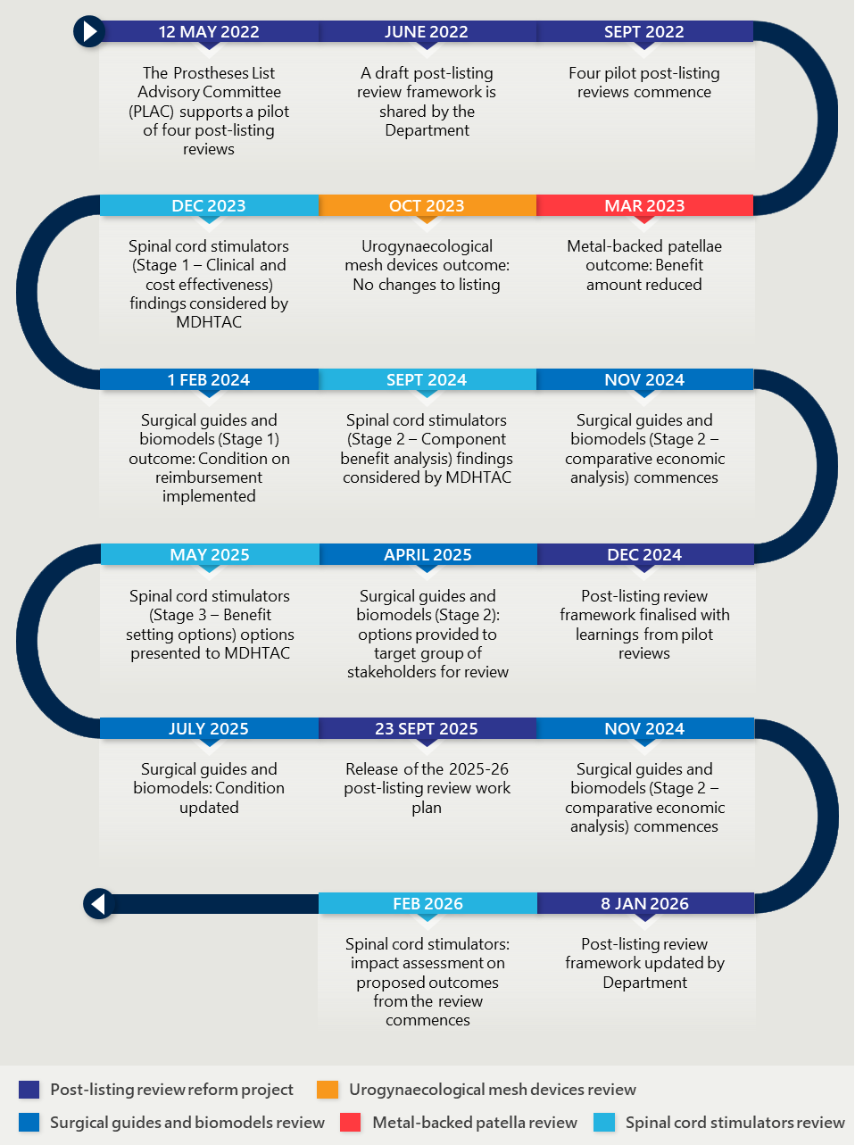
Table 6 | Summary of pilot post-listing reviews
PL review | Duration | Purpose | Review(s) | Key finding | Outcome
Metal-backed patellae (MBP) | Seven months  (August 2022 – March 2023) | To compare comparative clinical effectiveness and cost-effectiveness of MBP compared to all-polyethylene patellae (APP), as MBP attracted higher benefit amounts despite reported inferior safety and performance. | Internal department review with advice from former Knee Prostheses Clinical Advisory Group (KPCAG). | Based on available evidence, there should be no benefit difference between MBP and APP. | March 2023 – The PL benefit for MBP was reduced to the PL benefit assigned to APP.
Surgical guides and biomodels | Ongoing (September 2022 – Present) | To review rapid growth in use of surgical guides and biomodels, reports of overuse and inappropriate use, uncertainty about eligibility on the PL and comparative clinical effectiveness and cost effectiveness. | Stage 1: Health Technology Assessment (HTA) through an external provider  Stage 2: Comparative economic analysis | Stage 1: Surgical guides and biomodels are clinically effective when used for insertion of a medical device in complex craniomaxillofacial surgery, however there is insufficient evidence to support the listings for other types of surgeries. | November 2023 – Stage 1: A condition was applied to restrict PL reimbursement to use in craniomaxillofacial surgery procedures and limiting reimbursement to no more than six PL benefits per procedure. The condition took effect from 1 February 2024.  May 2026 – Stage 2: Draft report proposing no further changes to PL benefits for surgical guides and biomodels.
Spinal cord stimulators | Ongoing  (September 2022 – Present) | Assess the comparative clinical effectiveness and cost effectiveness of SCS as neurostimulation therapy for complex chronic pain management. | Focused HTA through an external provider | Stage 1: Uncertain comparative clinical effectiveness and insufficient evidence to inform alternative PL listing settings.  Stage 2: Assessed two components (implantable pulse generators and leads) of SCS systems that make up the majority of the benefit.  Stage 3: Reviewing benefit settings for the two components separately. | February 2026 – Proposed changes to SCS benefits and listings are undergoing impact assessment prior to final decision.
Mid urethral sling (MUS) – Urogynaecological mesh device | Eight months (February 2023 – October 2023) | Assess the comparative clinical effectiveness and cost effectiveness of MUS for the treatment of stress urinary incontinence (SUI) following the removal of two other types of urogynaecological mesh devices from being supplied in Australia. | Focused HTA through an external provider | MUS demonstrates comparable effectiveness and cost-effectiveness to alternative surgical interventions for the treatment of SUI. | October 2023 – Retained existing listings and benefits for urogynaecological mesh devices currently listed on the PL.

Post-listing reviews have been a valuable addition to the PL process
Overall, the addition of post-listing reviews has made a significant improvement to the administration of the list, as they provide the opportunity to test the decisions made. Previously, once devices were listed there was no opportunity to reconsider their effectiveness or value. Stakeholders generally supported post-listing reviews as a mechanism to safeguard the PL. They noted that the introduction of post-listing reviews under the reforms has the potential to support the integrity, value, and long-term sustainability of the PL. However, many emphasised that their effectiveness is contingent on how individual reviews are designed and implemented.
Insurers were of the view that post-listing reviews are an underused opportunity to deliver more value to consumers. They see the reviews as an effective means to address inefficiency, reset pricing benchmarks and return financial returns to consumers and taxpayers. They pointed to spinal cord stimulators and surgical guides and biomodels as devices they regard as low value or vulnerable to misuse, noting these have generated costs in the tens of millions of dollars without what they see as commensurate benefit.

Pilot reviews highlighted the need for stronger review management
The pilot post-listing reviews demonstrated both the value and difficulty of reviewing listed devices after initial approval. While stakeholders generally supported the intent of post-listing reviews, their experience with the pilot reviews highlighted several implementation challenges that need to be managed for future reviews to be effective. These included long review timeframes, resource constraints, short or unclear consultation processes, communication delays and concerns about the potential impact of review outcomes on clinical discretion and patient access.

Long review timeframes created uncertainty and constrained review volume
The anticipated duration of a post-listing review is between 3–12 months, depending on complexity. Two of the four pilot reviews were completed within this timeframe, taking seven and eight months respectively. However, the reviews into surgical guides and biomodels and spinal cord stimulators remained underway at the conclusion of the reforms. As at May 2026, both reviews had been ongoing for three years and eight months.
Some of this duration reflects the inherent complexity of post-listing reviews. Reviews may require input from sponsors, clinical committees and other stakeholders, and may draw on multiple evidence sources, including clinical evidence, guidelines, utilisation data, expert advice, compliance data, economic analysis, HTA reports and TGA reviews. Some stakeholders supported a deliberate and comprehensive review process, noting that this better reflects the complexity of assessing comparative clinical and cost effectiveness for medical technologies.
However, the length of the two ongoing pilot reviews appears to have exceeded what was necessary. The main contributors appear to have been changes in staffing, the need to upskill staff and the complexity of stakeholder engagement, particularly with clinical stakeholders. Departmental capacity was also constrained during the reform period because the efficient cost of post-listing reviews was not recovered from sponsors. From 1 July 2025, industry was charged for the cost of post-listing reviews, with the levy increasing from $150 to $355 per device to include compliance and post-listing review costs, as well as increased IT costs.
Extended reviews can create uncertainty for sponsors, hospitals, clinicians and private health insurers about future listing conditions, benefit levels and allowable use. Stakeholders reported that this uncertainty can disrupt clinical practice, particularly where hospitals and surgeons have adapted their systems, training and purchasing arrangements around listed devices. Long review timeframes also limit the number of reviews that can be undertaken at any one time, reducing the ability of post-listing reviews to address broader issues of value, utilisation and sustainability across the PL.
Stakeholders sought clearer, more predictable consultation and communication
Stakeholders raised concerns about the clarity, timing and consistency of consultation during the pilot reviews. Several stakeholders sought greater transparency about why reviews commence, how items are prioritised and how decisions are made. Medical device stakeholders also expressed concern that reviews may be initiated in response to unwarranted claims, particularly from private health insurers, without sufficient clarity about the evidence base or rationale for commencing a review.
Some stakeholders also criticised consultation timeframes as unrealistic given the complexity of the material being reviewed. For example, the Australian Medical Association (AMA) raised concerns about a two-week consultation period for a 92-page report on surgical guides and biomodels. Stakeholders argued that short consultation windows can limit the quality of input, particularly where reviews involve complex clinical evidence, proposed changes to benefit settings or potential restrictions on use.
Communication delays also contributed to uncertainty and reduced trust in the review process. The surgical guides and biomodels review was frequently cited as problematic, with stakeholders describing the review as unresolved, slow, disruptive and poorly communicated. Stakeholders suggested that clearer communication at the commencement of reviews, more regular status updates and clearer explanations of how submissions are used would improve confidence in the process.
These concerns do not indicate that consultation should be shortened or simplified indiscriminately. Rather, they indicate that consultation should be planned earlier, targeted to the relevant decision points and supported by clear expectations about the purpose, timing and use of stakeholder input.

Review decisions need to preserve appropriate clinical discretion
Clinicians, hospitals and medical device companies cautioned that post-listing reviews need to balance value and sustainability objectives with appropriate clinical discretion and patient access. Clinician representatives raised concerns that some reviews had proposed restrictions that they considered to exceed the review scope or create material limits on clinical choice. The AMA raised specific concerns about the perceived overreach of the surgical guides and biomodels review beyond its stated terms of reference.
Hospitals and clinicians also warned that rigid usage caps or delisting could undermine patient-specific decision making. They noted that removing clinically important items through review processes may shift costs to other parts of the health system or reduce patient access, rather than delivering genuine improvements in value or efficiency. Some stakeholders also cautioned that PL reforms should not have the unintended consequence of disadvantaging private hospitals relative to public hospitals.
Medical device companies raised related concerns about innovation. They noted that early-stage technologies may involve higher upfront costs before longer-term clinical and system benefits are realised, and cautioned that the limited or immature evidence base typical of many medical devices should not be interpreted as evidence of poor clinical performance.
These concerns reinforce the need for post-listing reviews to be tightly scoped and evidence-based. Review decisions should be sufficiently robust to address low-value use, inappropriate utilisation or outdated benefit settings, while avoiding unintended restrictions on clinically appropriate care.

The revised framework improves process clarity but not delivery assurance
A new version of the post-listing review framework was released in December 2024, updating the initial framework published in July 2022. The updated framework was developed in response to stakeholder feedback and the Department’s internal experience with the four pilot post-listing reviews. Figure 28 presents the revised process as outlined in the new framework.
Figure 28 | PL post-listing review process from new framework
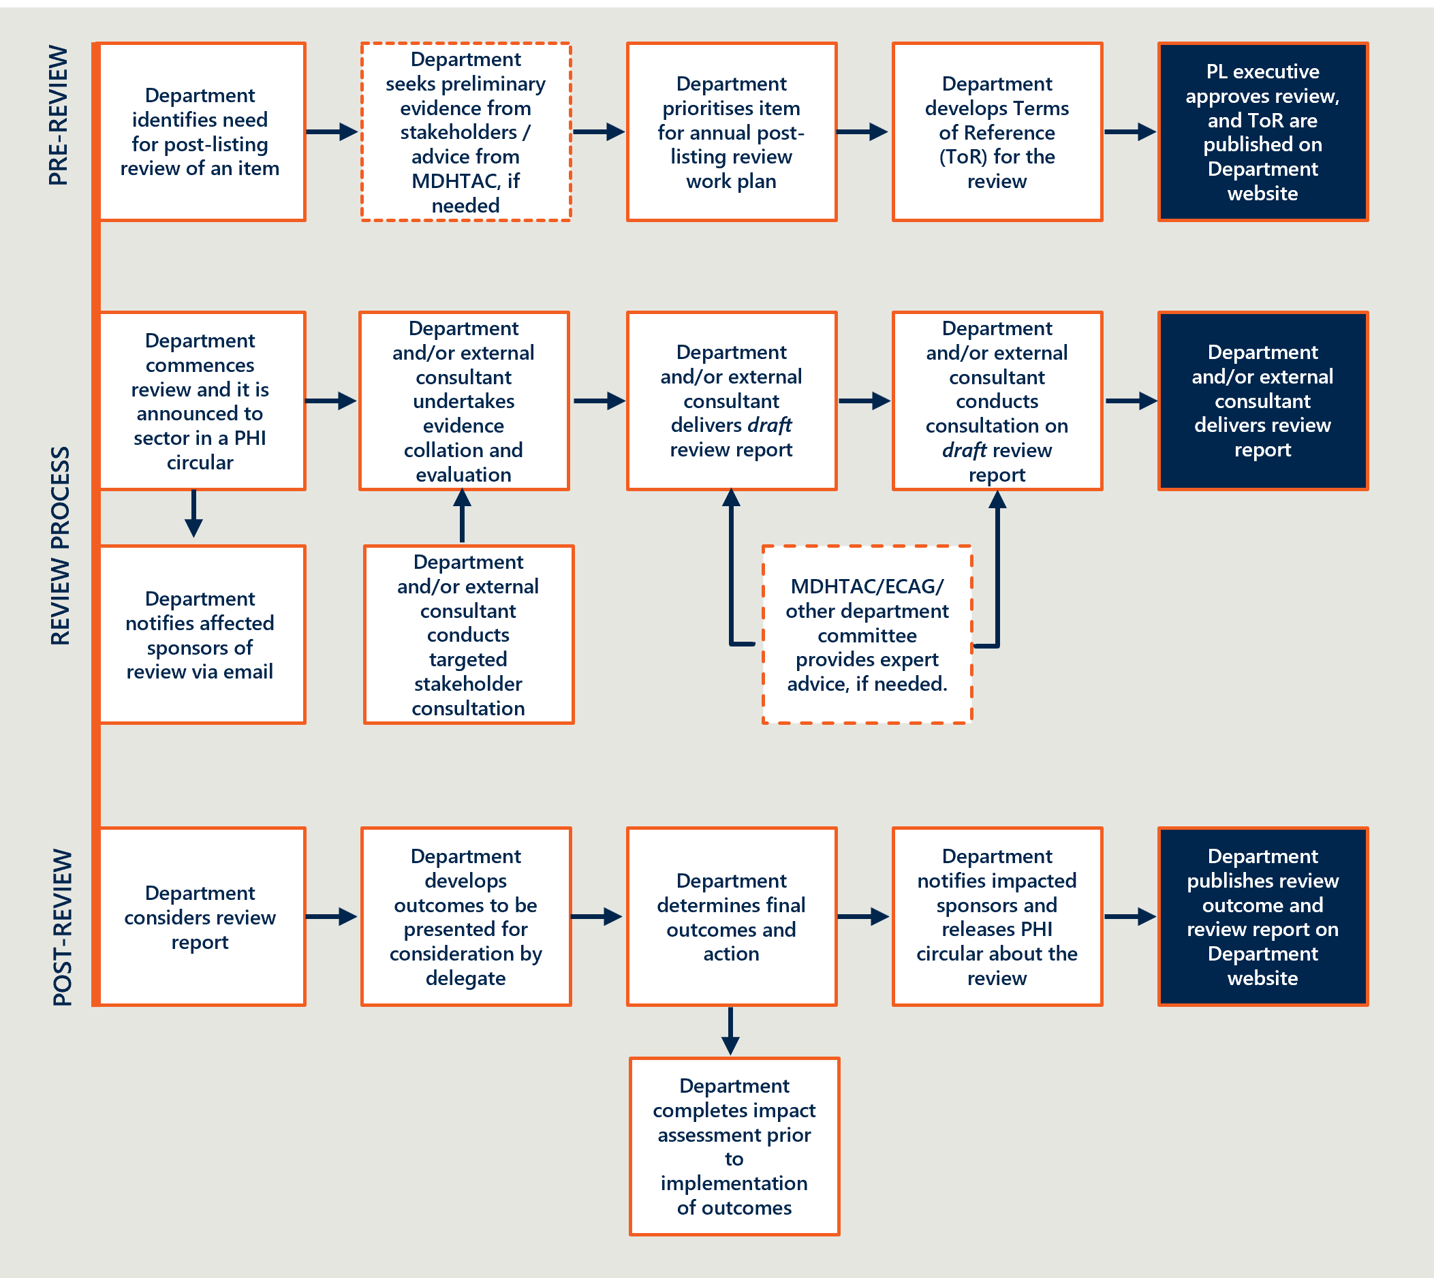
Advice from the Department suggests that the updated framework reflects several lessons from the pilot reviews. These included the need to communicate the scope of reviews more clearly, develop clear Terms of Reference, articulate research questions before collecting information and clarify the key points at which stakeholder input will be sought. These changes respond directly to stakeholder concerns that some pilot reviews lacked sufficient clarity about why reviews commenced, how items were prioritised and how decisions would be made.

The framework was further updated in January 2026 to improve transparency and predictability for stakeholders. The January 2026 version clarified when the Department will seek stakeholder input, including that the consultation approach will be determined for each review and that the standard submission period will be two to six weeks. The framework also states that the Department will publish an annual post-listing review workplan and timetable, providing stakeholders with advance notice of upcoming reviews. The 2025–26 annual workplan detailed five post-listing reviews the Department intended to complete.
The revised framework is a positive step towards improving transparency, consistency and predictability in post-listing reviews. However, the pilot reviews show that clearer processes will not, on their own, ensure reviews are completed within planned timeframes. Future reviews will need to be actively managed from commencement, including through clear decision points, realistic but bounded consultation windows and sufficient Departmental capacity to progress reviews without avoidable pauses.
Stakeholder input should also be managed deliberately. This does not mean consultation should be shortened indiscriminately. Rather, stakeholder input should be planned early, targeted to the relevant decision points and supported by clear expectations about the purpose, timing and use of submissions. This is particularly important for reviews involving complex clinical evidence or potential changes to benefit settings.
RECOMMENDATION 8: More tightly manage stakeholder input and resourcing to achieve planned timeframes for post-listing reviews.

Reform project (b): compliance activities
At the outset of the reforms, the establishment of a compliance program was identified as essential for safeguarding the integrity of the PL. The Department committed to developing a formal compliance strategy and associated compliance mechanisms to support robust administration of the PL, limit opportunities for gaming, enable compliance decisions and strengthen the Department’s ability to respond to non-compliance.
In May 2023, the Department released the Prescribed List Compliance Strategy, which incorporated stakeholder feedback on the draft strategy released for consultation in September and October 2022. The Strategy set out a responsive enforcement approach to managing risks to the integrity of the PL, including risks related to benefit price settings, artificial listing structures, fraudulent listing or utilisation and increased patient out-of-pocket costs.
Release of the Strategy was followed by further consultation on proposed compliance measures:
- Consultation Paper 7 (Proposed measures for compliance, assurance and information sharing) – proposed obligations for sponsors, hospitals and insurers, as well as potential legislative changes to support information gathering, enforcement and sanctions.
- Consultation Paper 8a (Gifts, benefits and discount reporting requirements) – proposed a compliance measure that would require hospitals or sponsors to maintain and report a register of gifts, benefits and discounts.
- Consultation Paper 8b (Alignment of amount charged for supply of a device with corresponding PL benefit) – proposed a compliance measure that would restrict sponsors from charging an amount higher than the PL benefit for the supply of medical devices on the PL.
In January 2025, the Department advised that there was insufficient evidence to justify legislating the measures proposed in Consultation Papers 8a and 8b. These measures were removed from the proposed Compliance, Assurance and Data Sharing Bill, although the Department advised it would continue to monitor and consult on evidence relevant to consumer protection measures.
The reforms ultimately landed on a more targeted compliance approach within existing powers. In July 2025, the Department published an updated Prescribed List Compliance Strategy, which outlines compliance obligations for PL stakeholders and the Australian Government. It focuses on four compliance priorities: proactive data analysis, appropriate benefit claiming, education and conditions on PL items.

Figure 29 | Reform timeline of compliance project
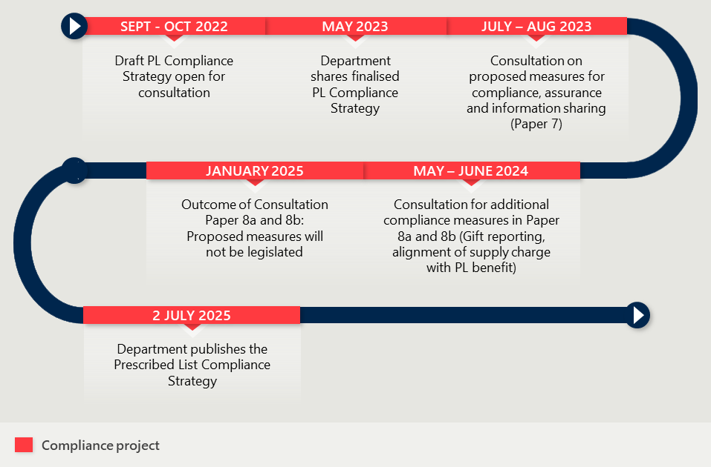

The reforms did not deliver the originally intended compliance powers
At the outset of the reforms, the establishment of a compliance program was considered essential for safeguarding the integrity of the PL. Without legal authority, the Department has limited power to compel stakeholders to answer questions or provide information. The compliance program was intended to support robust administration of the PL, limit opportunities for gaming, enable compliance decisions and strengthen the Department’s ability to respond to non-compliance.

The initial Strategy established the case for a compliance program
The Department released the first Prescribed List Compliance Strategy in May 2023. The Strategy set out a responsive enforcement approach to managing risks to the integrity of the PL, including inappropriate practices that could distort benefit price settings, encourage artificial listing structures, support fraudulent listing or utilisation, result in unfair listing arrangements or increase patient out-of-pocket expenses.
The initial Strategy provided the foundation for subsequent consultation on more detailed compliance, assurance and information sharing measures.

Proposed legislative powers were not implemented during the reforms
The Department consulted on proposed compliance, assurance and information sharing measures through Consultation Paper 7. The proposed measures set out obligations for sponsors, health providers and insurers, as well as legislative changes that would have supported information gathering, enforcement and sanctions. A summary of these proposed measures and the required legislative changes was set out in Table 15 of Interim Report #1.
These legislative powers were not implemented during the reforms. As a result, the Department did not obtain additional powers to compel stakeholders to comply with the majority of measures originally proposed through Consultation Paper 7. The proposed Compliance, Assurance and Data Sharing Bill did not commence the legislative process during the reforms.
Subsequent investigation by the Department found that some proposed measures may already be covered by existing legislation or reflected in existing industry practice. Compliance mechanisms available to the Department include PL device utilisation monitoring, post-listing reviews, communication and education. The Department also has the ability to place conditions on the use of PL-listed devices, as occurred following the post-listing review into surgical guides and biomodels. However, placing conditions on use has been a relatively uncommon action, with less than twenty devices on Part A having a condition restricting its reimbursement at the conclusion of the reforms.

Stakeholder disagreed on where compliance risks were concentrated
Stakeholders held different views on the most significant compliance risks affecting the PL. Hospitals and medical technology representatives criticised a perceived imbalance in the originally proposed compliance measures, arguing that the measures disproportionately targeted hospitals and industry without sufficiently responding to non-payment or partial payment by insurers.
Hospitals and medical technology representatives stated that insurers rejecting or delaying payment for PL-compliant items with limited scrutiny or consequence was a major compliance issue. They remained concerned about the limited range of enforceable actions available in cases of insurer non-payment, underpayment or delayed payment. Hospitals called for mandatory insurer reporting on instances of non-payment, underpayment and delayed payment.
Conversely, insurers argued that, without stronger legislative authority, compliance measures would be insufficient to deter PL fraud and gaming. Insurers reported identifying problematic PL items, which they stated had been raised with the Department but not addressed within a reasonable timeframe. Insurers also advocated for greater transparency of product codes, supported by a centralised and auditable register linking PL items to relevant billing codes.

Additional compliance measures were not supported
The Department also proposed two further compliance measures through Consultation Papers 8a and 8b. Consultation Paper 8a proposed a requirement for hospitals or sponsors to maintain and report a register of gifts, benefits and discounts. Hospital and medical technology representatives welcomed the decision not to proceed with this measure, viewing the original proposal as misdirected and overly burdensome.
Consultation Paper 8b proposed an amendment to the PHI Act to align the amount charged for the supply of a PL item with the corresponding PL benefit. Early in the reform process, private hospitals raised concerns about the lack of a compliance mechanism to enforce the PL benefit. The PHI Act does not restrict medical device sponsors from charging more than the PL benefit to supply an item, creating potential for an out-of-pocket cost to be borne by either the hospital or the patient.
In January 2025, the Department advised that there was insufficient evidence to justify legislating the measures proposed in Consultation Papers 8a and 8b. As a result, these measures were removed from the proposed Compliance, Assurance and Data Sharing Bill.

Stakeholders identified gaps in dispute resolution and enforcement capacity
Private hospital representatives raised concerns about the absence of a formal PL dispute resolution pathway between insurers and hospitals, identifying this as a gap the Department should consider addressing. Multiple hospital stakeholders called for a neutral, enforceable dispute resolution pathway for the PL to reduce reliance on costly mediation between parties. The evaluation notes that the PL does not govern contractual relationships between PL parties.
The evaluation consulted the Office of the Commonwealth Ombudsman, which confirmed it receives a small number of complaints related to PL items, some involving hospital-insurer disputes. In carrying out its role, the Ombudsman may make recommendations on individual cases, report on systemic issues or refer matters to the Department with a view to protecting the interests of private health insurance consumers. However, the Ombudsman’s office advised that it had not observed systemic trends of concern related to PL items. The evaluation was advised that some hospitals do not pursue disputes with insurers through the Ombudsman, perceiving the process to be ineffective or burdensome. This indicates that the number of Ombudsman cases likely underrepresents the extent of disputes between PL parties.
Multiple stakeholders also raised concerns that limited enforcement options and Departmental capacity constraints weakened compliance action. They noted that without adequate resourcing, clear legal authority and effective enforcement mechanisms, the compliance approaches introduced through the reforms may be perceived as largely symbolic. Several stakeholders also highlighted that the Department has historically been under-resourced in the PL area, constraining its capacity to effectively oversee and enforce responses to PL-related misconduct.

The updated Strategy provides a practical but lighter-touch compliance approach
The Prescribed List Compliance Strategy was updated in July 2025 following stakeholder feedback on the earlier approach and in the context of delays to legislative change. The updated Strategy outlines compliance obligations for PL stakeholders and the Australian Government, and applies to hospitals and day clinics, clinicians, sponsors of medical device and human tissue products, and private health insurers.
The updated Strategy provides a practical basis for compliance action within the Department’s existing powers. However, it represents a lighter-touch approach than the broader legislative model initially contemplated through the reforms.

The updated Strategy responded to concerns about imbalance
Stakeholder feedback through the reforms was particularly focused on a perceived imbalance in compliance expectations across PL stakeholders. The updated Strategy more clearly articulates compliance expectations for private health insurers, explicitly identifying behaviours that may constitute non-compliance, including rejecting or refusing legitimate benefit claims, reimbursing below the applicable PL benefit and undue delays in benefit payments.
This was an important change, as hospitals and medical technology representatives had raised concerns that earlier proposed compliance measures focused more heavily on hospitals and industry than on insurer conduct.

The updated Strategy prioritises proportionality over new obligations
Compared with the measures consulted on earlier in the reform process, the 2025 Strategy adopts a lighter-touch, risk-based operational approach that prioritises education, monitoring and voluntary compliance over the introduction of new regulatory obligations.
The Strategy identifies four areas of priority that seek to safeguard the integrity of the PL:
- Proactive data analysis – identifying anomalous claiming behaviour or suboptimal device utilisation patterns that may indicate compliance risks and non-complaint behaviour
- Appropriate benefit claiming – ensuring stakeholders accurately claim and reimburse benefits as required.
- Education – using education to clarify requirements and reiterate stakeholder responsibilities
- Conditions – identifying areas where conditions can assist in the correct usage of devices and minimise claiming anomalies.
The Strategy does not proceed with several of the stronger measures contemplated earlier in the reform process, such as new mandatory record-keeping requirements, expanded information-gathering powers or additional administrative sanctions. It instead reflects a stewardship approach designed to safeguard the integrity of the PL while minimising regulatory burden.
Existing powers remain the basis for compliance action
The updated Strategy continues to rely on existing legislative frameworks, including the PHI Act and the Criminal Code, and does not introduce new compulsory information-gathering or enforcement powers.
The Strategy identifies a range of existing activities that can support compliance, including monitoring, post-listing review processes, device utilisation reviews, HTA-style reviews, corrective actions, education and the use of legislative instruments. Where the Department identifies behaviours that suggest there are anti-competitive practices related to the use and application of the PL, it may make a referral to relevant regulators such as Australian Prudential Regulation Authority (APRA) and the Australian Competition and Consumer Commission (ACCC).
The Strategy also elevates the use of conditions on PL items as a compliance priority and intervention mechanism. Conditions may provide a targeted tool to address emerging risks to PL integrity where other compliance levers are limited. As noted above, this approach was used following the post-listing review into surgical guides and biomodels.

Ongoing monitoring is needed to test whether the Strategy is effective
While the updated Strategy provides a practical basis for managing compliance within existing powers, it relies on the Department consistently undertaking the monitoring, education and follow-up activities described in the Strategy. This is important because the updated Strategy adopts a lighter-touch approach than the measures originally proposed through the reform process, and because stakeholders raised concerns about the Department’s capacity to effectively oversee and enforce responses to PL-related misconduct.
The Department should regularly document whether the monitoring activities described in the Strategy are occurring, whether concerns identified through data analysis, tip-offs or stakeholder complaints are assessed, and whether issues are escalated or resolved. This would provide visibility over whether the Strategy is being implemented as intended.
An evaluation after three years of operation would also help assess whether the Strategy has improved compliance behaviour, strengthened confidence in the integrity of the PL and provided an effective basis for responding to stakeholder concerns.
RECOMMENDATION 9: Regularly document adherence to monitoring activities and undertake an evaluation of the impact of the 2025 Compliance Strategy after three years of operation.

Objective 8: Ensure ongoing financial sustainability of PL administration through effective and efficient cost recovery arrangements that are compliant with the AGCF
This section considers the implementation of cost recovery arrangements at a high level, noting a formal assessment of cost recovery is out of scope for the evaluation. This section also considers the financial sustainability of the PL’s administration, outlining any change in PL administrative effort and documenting stakeholders’ perspectives on its resulting financial sustainability.
Figure 30 | Reform projects related to reform objective 8


Reform project: cost recovery fees
PL cost recovery arrangements were updated through the reform process to support the financial sustainability of PL administration and improve alignment with the Australian Government Charging Framework (AGCF). The revised arrangements include application fees for relevant Part A, C and D applications, as well as an annual levy payable for each billing code listed on Parts A, C and D of the PL. Part B applications, applications to transfer a billing code to a different sponsor and applications to delete a billing code are not subject to cost recovery fees or charges.
The legislative basis for the revised cost recovery arrangements was established through amendments passed in March 2023. Following this, the revised cost recovery model commenced on 1 July 2024.
Under the revised model, sponsors pay a standard application fee for relevant PL applications. Additional fees are payable depending on the assessment pathway required for the product.
The reforms also introduced an annual levy to recover PL administration costs that cannot be assigned to a specific sponsor or application. The levy is payable once each year for each relevant billing code that a sponsor has listed on the PL. It recovers costs associated with list management, PL administration and IT systems, and from 2025–26 also includes costs associated with compliance activities and post-listing reviews.
The first annual cost recovery levy was charged to sponsors for 2024–25 on 15 March 2025, later than originally anticipated. For this first levy period, the levy was reduced to $150 per billing code because compliance and post-listing review costs for 2024–25 were funded through the reform process. The levy increased from 1 July 2025 to $355 per billing code, reflecting the inclusion of compliance activities, post-listing reviews and increased IT system costs in the levy base.
Figure 31 | Reform timeline of cost recovery
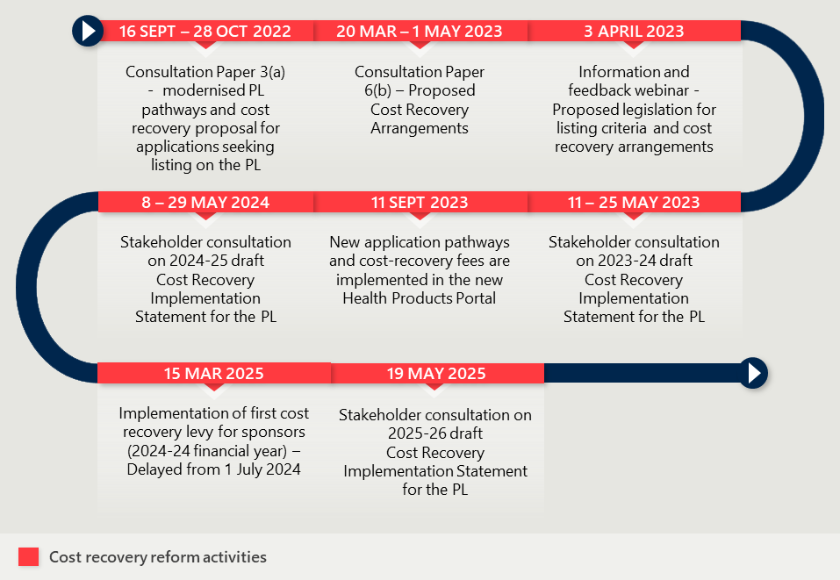

Balancing cost recovery and efficient PL administration remains challenging
The revised cost recovery arrangements have improved alignment between PL administration costs and the fees and levies charged to sponsors. As discussed in Interim Evaluation #1 report, PL cost recovery arrangements had not been substantially updated since 2009. The previous arrangements did not align with the AGCF because they did not adequately reflect the scale and complexity of the Department’s PL administration activities.
The updated arrangements are intended to better recover the cost of administering the PL and support the financial sustainability of PL administration. However, achieving this balance remains challenging. Stakeholders, including departmental staff, expressed concern that the resources available to administer the PL remain inadequate and do not yet reflect efficient administration. At the same time, medical technology stakeholders raised concerns about increased fees and levies, particularly where increases are perceived to add cost without corresponding improvements in timeliness, transparency or administrative performance.
For 2025–26, the Department reviewed and updated fees and charges in line with expected costs. This included indexation of staffing costs (3%), as well as increases to Tier 2 and Tier 2a application fees to reflect higher committee costs and externally contracted HTA costs for economic evaluations (between 6–33%). The annual levy also increased from $150 to $355 per billing code from 1 July 2025, reflecting the inclusion of compliance activities, post-listing reviews and increased IT system costs.
The cost recovery model will need to continue evolving as PL policy, activity levels and administrative costs change. The Department commissioned an independent review of the Prescribed List cost recovery arrangements in July 2025. The review had been completed by May 2026, with the Department considering the final report and its recommendations in the context of cost recovery arrangements from 2027–28 onwards.

Stakeholder emphasised that cost recovery should be balanced with access and administrative performance
Stakeholders provided feedback on the perceived risks and impacts of the revised cost recovery arrangements. While stakeholders generally recognised the need for the Department to recover the costs of administering the PL, they emphasised that cost recovery should be balanced against broader policy objectives, including maintaining access to current and emerging medical devices, supporting smaller sponsors and improving the quality and timeliness of PL administration.

Cost recovery could affect access to current and emerging devices
Private hospitals and medical technology representatives raised concerns that increased cost recovery may unintentionally reduce access to devices in the private sector. Medical technology representatives expressed this concern most strongly, cautioning that further rapid increases in fees or levies may discourage sponsors from listing new devices or making necessary amendments to existing listings.
Private hospitals also noted that where sponsors face higher costs, these may flow through to hospitals. This was viewed as a particular risk for niche devices where there are limited or no alternative suppliers, leaving hospitals with limited ability to manage additional costs.

Smaller sponsors may be more affected by higher fees
Medical technology representatives also highlighted that cost recovery may have uneven impacts across sponsors. They reported that increasing fees may place a disproportionate burden on smaller sponsors and Australian-based companies, particularly where sponsors have smaller portfolios or lower sales volumes.
These stakeholders warned that higher fees may discourage new listings, delay amendments to existing billing codes and limit local innovation. Some stakeholders supported more targeted fee settings or relief mechanisms that take account of sponsor size and capacity, although this was not supported by all industry representatives.

Higher charges have increased expectations for administrative performance
Stakeholders also emphasised that higher cost recovery charges should be matched by improvements in the quality, timeliness and reliability of PL administration. Private hospitals reported dissatisfaction with delays in publication of the list and errors that can disrupt claims processing and cash flow. They also suggested that the Department appears to remain under-resourced, particularly during critical periods in the PL cycle.
Medical technology representatives similarly argued that increased cost recovery should be accompanied by clearer service expectations and improved administrative performance. From their perspective, higher fees and levies are more difficult to accept where sponsors do not see corresponding improvements in timeliness, transparency or consistency.

Private health insurers questioned the long-term sustainability of the PL model
Private health insurers raised a broader concern that cost recovery does not address what they consider to be the underlying sustainability challenge of the PL. They argued that a shift away from the PL towards DRG-based or bundled payments would provide a more sustainable approach than maintaining a list-based system supported by cost recovery.
In their view, this would reduce the administrative burden associated with maintaining the PL and allow departmental resources to be redirected towards HTA and assessment of new technologies. This position was not shared by all stakeholders, and reflects a broader policy question about the future role and design of the PL rather than the cost recovery model alone.
- Methodology
- Purpose of the evaluation

The evaluation sought to understand the extent to which PL reform activities have delivered the objectives of the reform
The purpose of this evaluation was to understand the extent to which PL reform activities fulfilled their intended objectives and to provide formative insight into their delivery. This evaluation aimed to:
- Document the implementation of PL reform activities, including enabling and constraining factors, and assess the degree to which the PL reform was implemented as intended.
- Determine whether PL reform activities were achieving their intended objectives and, where possible, indicate the extent to which the desired outcomes had been achieved.
- Identify unintended consequences of reform activities and provide insight into how negative unintended consequences could be mitigated.
- Provide ongoing insight into additional activities to support the objectives of the program and findings to inform the future direction of PL management.
- Evaluation plan and theory of change

Nous planned the PL evaluation using the Department’s framework
The Department established the Prostheses List Evaluation Framework in 2021 to inform a consistent monitoring and evaluation approach that was applicable from the conceptualisation of the PL reforms through to their implementation and beyond. Nous was commissioned to evaluate the PL reforms using the evaluation framework. Nous independently reviewed the Department’s evaluation framework, and the evaluation team was satisfied that it outlined an appropriate structure by which the reforms should be evaluated.
Nous delivered its evaluation plan to the Department on 14 August 2023, detailing the evaluation context, objectives, approach, methodology, and project plan. This is summarised in the sub-sections below. The evaluation plan maintained the Framework’s overarching program logic and key evaluation questions (KEQs), while developing an explicit theory of change and including its own evaluation activities, sub-research questions, indicators, and measures.

The program logic and theory of change outline the reasoning between completion of evaluation activities and measurable changes in outcomes
The Federal Government allocated $22 million and provided additional resources, including the establishment of the Prescribed List Taskforce within the Department, to drive the successful implementation of the reform program. The reform utilised various inputs such as PL data, reference pricing, clinical data, technological systems, and existing research, which supported a series of targeted activities designed to refine documentation, engage stakeholders, enhance systems, and create a robust monitoring and evaluation framework.
Reform projects and activities were expected to lead to distinct outcomes in the short term (e.g. reduced pricing disparities, legislative clarity, streamlined processes), medium term (e.g. improved compliance activities, transparent administration), and long term (e.g. better access to cost-effective prostheses, more affordable private health insurance). The program logic diagram depicted in Figure 32 provides a summary of the reform program as described above
The theory of change posits that cost reduction in PL-listed items and PL administration will translate into better value for the public, with no adverse effects on patients' clinical outcomes, aligning spending on more valuable initiatives and improving value-for-money in private health cover.
The activities, outcomes, and long-term objectives of the reform were linked causally, with these relationships detailed in the causal logic diagram in Figure 33 and encapsulated within a broader theory of change:
If costs associated with the purchase of PL-listed items and with the administration of the PL are reduced, then this value will be passed to the public in the form of improved allocation of tax revenue to other valuable initiatives, reduced private health insurance premiums, or otherwise improved value-for-money in private health insurance. These cost reductions can be achieved without any negative impacts to consumers and their clinical outcomes.

Figure 32 | Prescribed List Reform Program Logic
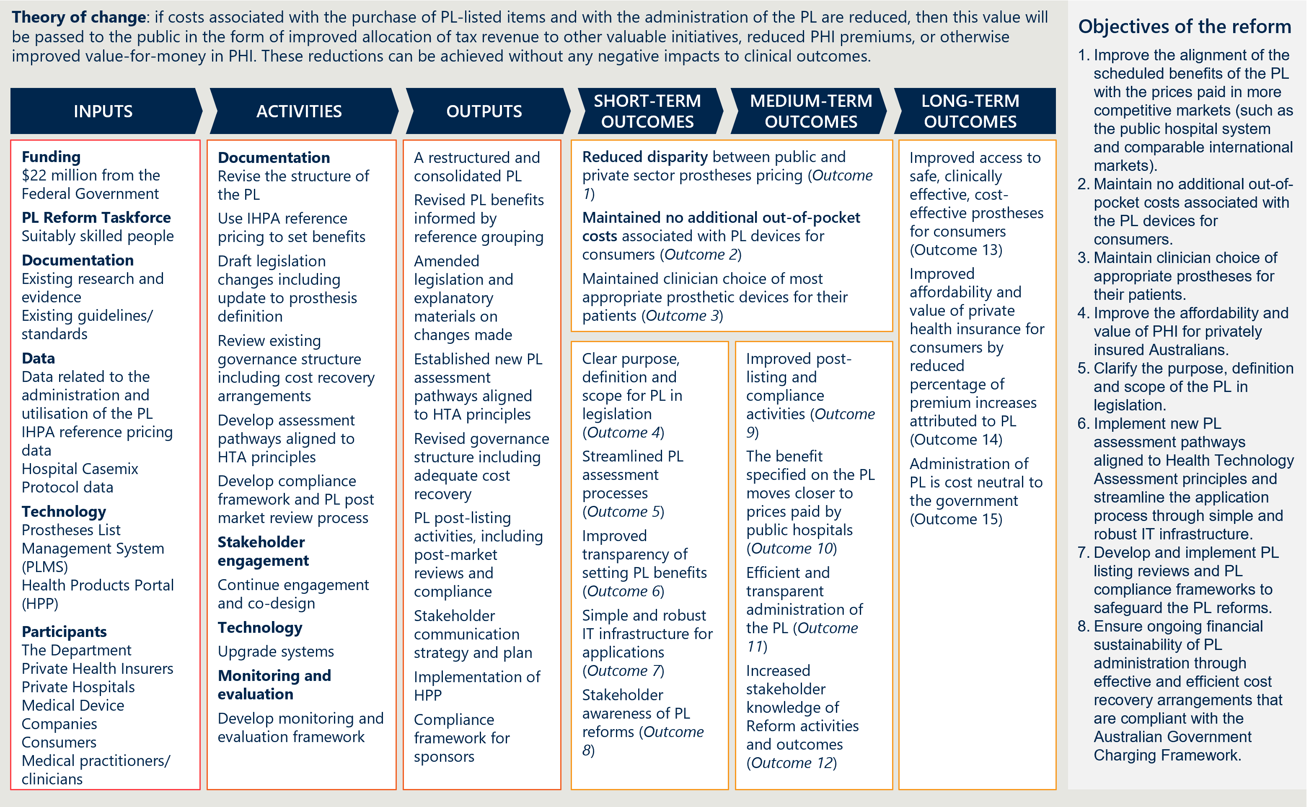
Figure 33 | Causal logic diagram
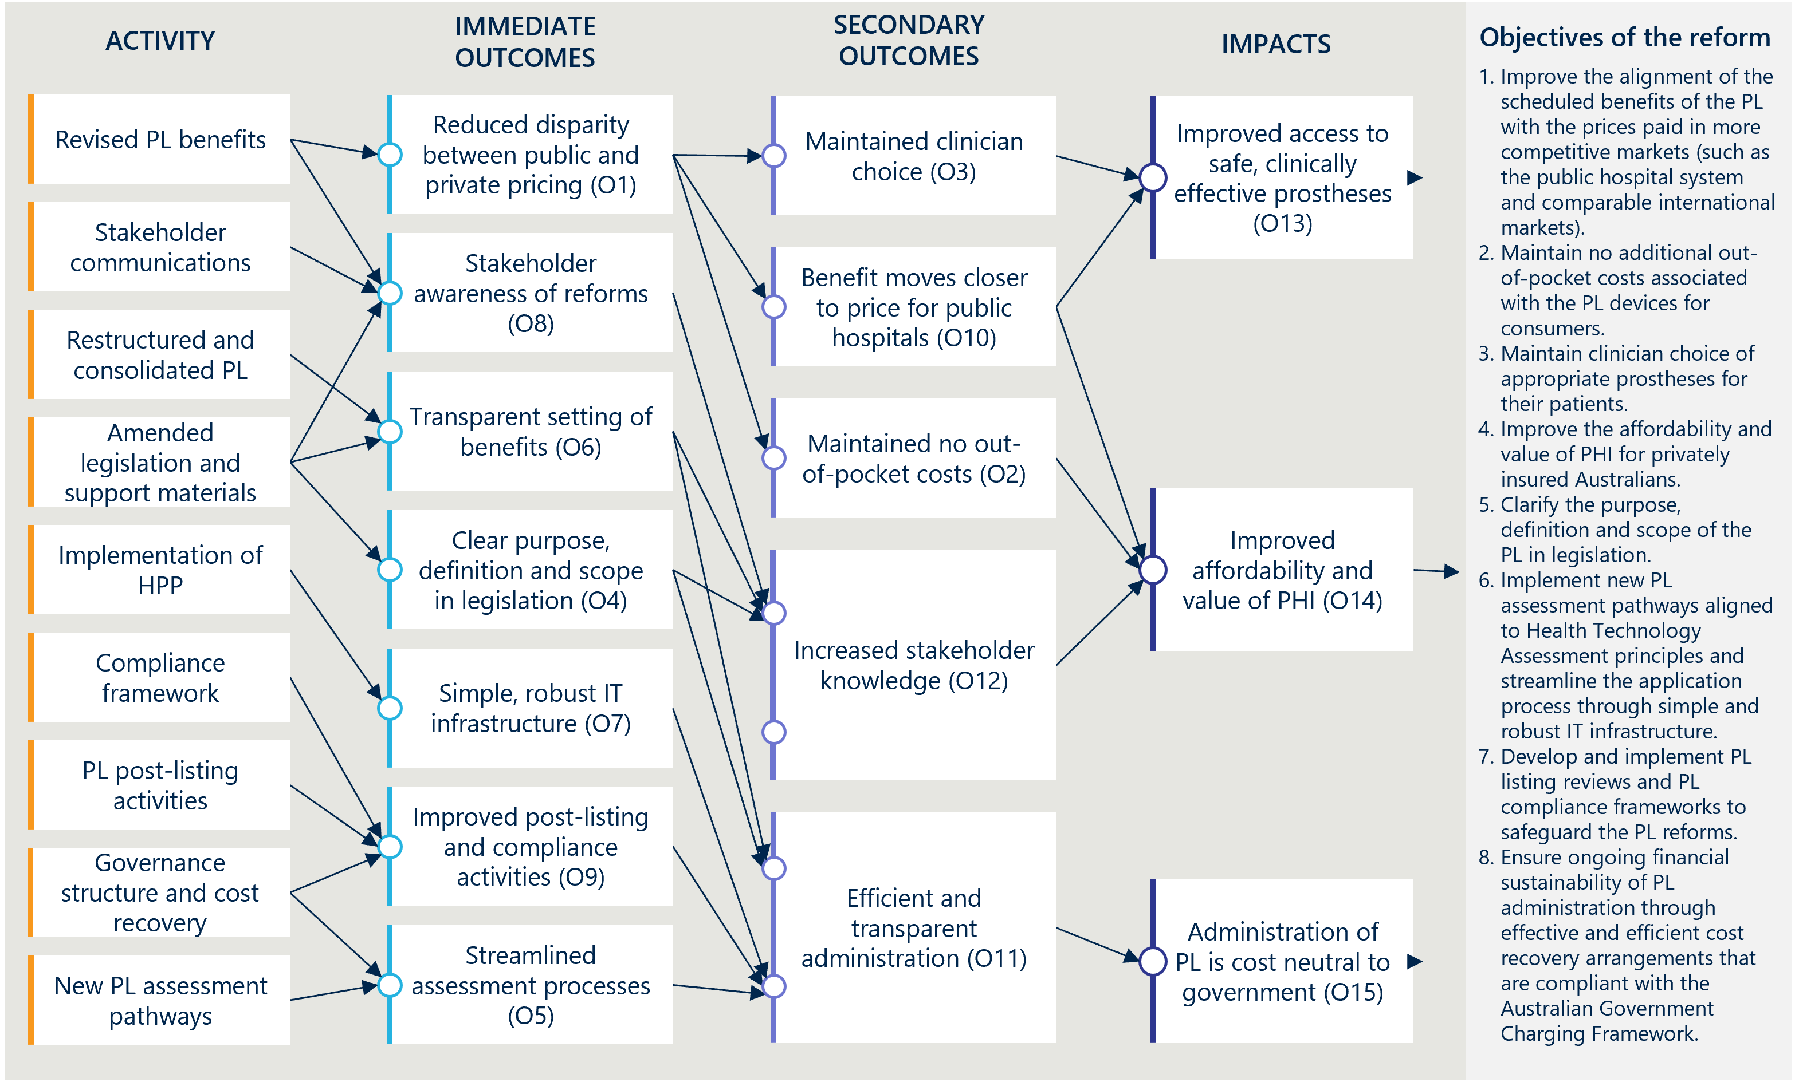

The scope of this evaluation was informed by both a formative and summative evaluation approach
The evaluation consisted of three components; a baseline report, interim reports, and a final report. Each of the reports that the evaluation produced had a distinct purpose:
- Baseline report: The baseline report established the foundation for evaluating the PL reforms by outlining the rationale and objectives of the reform program and providing qualitative and quantitative baseline information, including how progress and outcomes would be monitored over the evaluation period.
- Interim evaluation reports 1 and 2: These reports were key milestones in the monitoring stage of the evaluation. As the evaluation was conducted while PL reform activities were ongoing and some outcomes were yet to be realised, Nous shared emerging findings with the Department to support continuous improvement. The reports provided formative insights, early outcomes, and lessons learned to inform the ongoing delivery of the reforms and mitigate unintended negative consequences.
- Final evaluation report: This summative report built on the previous interim reports to conclude whether reform activities had been implemented as planned, assess outcomes, and make recommendations to inform the ongoing administration of the PL.
Key elements of the evaluation’s scope are outlined below in Table 7.
Table 7 | Scope of the evaluation
In-scope aspects of the evaluation | - PL reform implementation, effectiveness and impact (extent to which intended outcomes were achieved).  - Unintended positive or negative consequences beyond the expected outcomes.  - Experiences of consumers, private health insurers, private hospitals, public hospitals, medical device sponsors and clinicians.
Out-of-scope aspects of the evaluation | - Full cost-benefit analysis and/or economic evaluation, beyond that required to establish the suitability/sustainability of cost recovery efforts.  - Evaluation of the Department’s wider PHI reforms.  - Evaluation or analysis of PL components not impacted by the scope of the reforms.
Any context or related activities that need to be considered | - Understanding of the Government’s PHI reforms and policy agenda.  - Understanding of stakeholder consultations and input to the PL Reforms that have already taken place and how reform activities have changed as a result.
- Overall approach and KEQs

The evaluation was guided by three KEQs
There were three key evaluation questions (KEQs) used to guide the evaluation:
- Is the PL reform program being implemented as intended?
- Is the PL reform program achieving the expected outcomes?
- What are the ongoing and future directions, opportunities and priorities for the PL reforms?

Nous structured the evaluation by the eight objectives of the PL reforms
Nous structured the evaluation around the eight objectives of the PL reforms. The evaluation team developed a reporting structure for the ongoing delivery of the evaluation that was adapted to the evolving projects and priorities of the reform program, while remaining aligned with the key evaluation questions (KEQs) and the evaluation plan. The structure was centred on the eight PL reform objectives established by the Department’s PL Evaluation Framework and incorporated nine key projects that summarised the primary reform actions (Figure 2).

A set of indicators and measures guided the data collection, analysis and reporting
The evaluation team developed a set of indicators and measures that sit under each of the eight objectives of the PL reforms. The indicators and measures covered KEQ 1 and KEQ 2 resembled the key evaluation sub-questions introduced in the Department’s PL Evaluation Framework. Since the baseline report, the indicators and measures had guided the evaluation team’s data collection, analysis, and reporting.
- Approach to data collection and engagement

The evaluation used a ‘mixed methods’ approach
Evaluating the PL reforms involved a large and diverse group of stakeholders, a nuanced medical device market, intertwined reform initiatives, and several intangible outcomes. To address this complexity, the evaluation used a principles‑based approach with key evaluation questions (KEQs) and a program logic to focus the evaluation on the intentions of the reform.
The evaluation used a mixed‑methods approach, collecting both qualitative and quantitative data from interviews, focus groups, desktop research, surveys, and existing datasets. Data analysis involved thematic, descriptive, and inferential techniques, with triangulation of findings from multiple sources to validate the evidence.

Quantitative analysis informed the assessment of outcomes of the reforms
The performance of the PL reforms was assessed through analysis of a range of quantitative indicators. This involved compiling and assessing relevant descriptive statistics to develop hypotheses related to the sub-research questions, categorised under the indicators and measures. Where feasible, inferential methods, such as regression models, have been used to add rigour to the analysis and support efforts to attribute observed changes to the reforms. Graphs have been included to visualise, develop, and communicate key findings and analysis.

Qualitative analysis was critical to answering the evaluation’s research questions
On its own, quantitative analysis was not sufficient to answer all sub‑research questions. In many circumstances, quantitative data were missing or of inadequate quality, requiring a qualitative approach that enabled the evaluation team to hear directly from stakeholders. Where sufficient quantitative data were available, qualitative evidence strengthened the overall evidence base by enabling triangulation of insights from multiple sources.
Qualitative research methods such as surveys, interviews, and workshops, were used to explore stakeholder perspectives, experiences, and sensitivities in depth, particularly in relation to the “how” and “why” elements of the KEQs that could not be adequately addressed using quantitative data alone. This process also helped to build buy‑in for the evaluation’s findings and recommendations by providing forums for those affected by the reforms to have their perspectives heard.
The evaluation drew on multiple qualitative data sources, including Departmental and PL planning documentation, published stakeholder submissions and perspectives, stakeholder interviews, and stakeholder information requests.
- List of stakeholders consulted
External stakeholders consulted for this evaluation are detailed in Table 8. Their perspectives and input have been included in a summarised form throughout the report.
Table 8 | External stakeholders consulted for the evaluation
Stakeholder group | Organisation
Consumers representatives | - Consumer Health Forum (CHF)
Independent and advisory bodies | - The Office of the Commonwealth Ombudsman – Industry Investigations  - Medical Devices and Human Tissue Advisory Committee (MDHTAC)
Clinician representatives | - Australian and New Zealand Association of Oral and Maxillofacial Surgeons (ANZAOMS)  - Australian Medical Association (AMA)  - Australian Orthopaedic Association (AOA)  - Cardiac Society of Australia and New Zealand (CSANZ)
Private health insurer representatives | - Australian Health Service Alliance (AHSA)  - Private Healthcare Australia (PHA)
Hospital sector representatives | - Australian Private Hospitals Association (APHA)  - Catholic Hospitals Australia (CHA)
Medical device and technology industry representatives | - AusBiotech  - Medical Technology Association of Australia (MTAA)  - Medical Technology Association of Australia (MTAA) Cardiac Forum

- Detail on evaluation indicators
- Indicator 1: Reduction in benefits

Measure 1.1: Change in PL benefits
Table 9 | Benefit groups and items subject to reform reductions (Parts A and D, excluding CIED items)
Categories | Benefits groups subject to reductions | Items subject to reductions
01 – Ophthalmic | 26 | 170
02 – Ear, Nose & Throat | 6 | 25
03 – General Miscellaneous | 68 | 232
04 – Neurosurgical | 23 | 88
05 – Urogenital | 10 | 55
06 – Specialist Orthopaedic | 173 | 1,845
07 – Plastic and Reconstructive | 73 | 248
08 – Cardiac | 3 | 23
09 – Cardiothoracic | 8 | 17
10 – Vascular | 36 | 202
11 – Hip | 43 | 378
12 – Knee | 16 | 306
13 – Spinal | 51 | 1,417
Total | 536 | 5,006

- Indicator 2: Change in the size of the gap between PL benefits and prices paid in more competitive markets

Measure 2.1: Overall savings associated with benefit reductions
The evaluation relies on analyses conducted by IHACPA to report on estimates of overall savings associated with benefit reductions:
- Updated estimates of projected benefits and savings associated with Prescribed List reforms (13 December 2023) estimates projected savings from July 2022 to June 2027.
- Analysis on prescribed list benefit reductions for general use items (GUIs) and projected savings (20 January 2025) estimates savings from July 2022 to June 2024.
- Analysis on prescribed list benefit reductions (15 December 2025) estimates savings from July 2024 to June 2025.
The Department provided instructions and advice to IHACPA to conduct these analyses, including miscellaneous adjustments to account for additional factors. As discussed in Appendix B.2 of the Interim Evaluation #1 report, the Nous evaluation team has not been able to independently validate these estimates through analysis of the same data sources following only the policy parameters of the MOU.
Table 10 | Projected savings (based on IHACPA’s December 2023 analysis)
Scope of items | Savings period | Lower savings estimate  (0% annual growth) | Upper savings estimate  (5% annual growth)
All items | Savings to date  (July 2022 to June 2025) | $514 million | $547 million
All items | Five-year projected savings  (July 2022 to June 2027) | $1,042 million | $1,173 million
All items excluding CIEDs | Savings to date  (July 2022 to June 2025) | $431 million | $457 million
All items excluding CIEDs | Five-year projected savings  (July 2022 to June 2027) | $782 million | $873 million

Table 11 | Estimated savings for FY23, FY24 and FY25
FY23 savings | FY24 savings | FY25 savings
$106 million | $196 million | $239 million

Measure 2.2: Gap between PL benefits and prices in Australian public hospitals
Table 12 | Gap between PL benefits and public benchmark prices for items where a gap is present for reduction (Parts A and D, excluding CIEDs)
Categories | Median gap $ | Gap $ change | Median gap % | Gap % change
01 – Ophthalmic | $25 | -$33 | 11% | -16%
02 – Ear, Nose & Throat | $6 | -$38 | 6% | -12%
03 – General Miscellaneous | $4 | -$25 | 2% | -10%
04 – Neurosurgical | $49 | -$169 | 6% | -15%
05 – Urogenital | $17 | -$27 | 7% | -24%
06 – Specialist Orthopaedic | $28 | -$137 | 8% | -36%
07 – Plastic and Reconstructive | $24 | -$116 | 8% | -20%
08 – Cardiac (excluding CIEDs) | $323 | -$1,174 | 42% | -145%
09 – Cardiothoracic | $61 | -$595 | 3% | -20%
10 – Vascular | $64 | -$209 | 6% | -39%
11 – Hip | $69 | -$145 | 6% | -9%
12 – Knee | $78 | -$154 | 7% | -3%
13 – Spinal | $34 | -$205 | 4% | -14%
Total | $35 | -$142 | 6% | -19%
Table 12 shows that there is a closer alignment of benefits with public hospital prices across all PL categories. The median gap (for items where a gap is present for reduction) has fallen below 10% for all categories except for the ophthalmic category and the cardiac category (CIEDs excluded). For non-CIED cardiac items, there remains a median gap of 42% ($323) after all three rounds of reductions.

Measure 2.3: Gap between PL benefits and prices on the Liste des Produits et Prestations (LPP) and Pharmac Hospital Medical Devices Schedule
The evaluation uses three PL benefit groups as case studies to compare with the same products on the Liste des Produits et Prestations (LPP) and the Pharmac Hospital Medical Devices Schedule (Pharmac). The methodology for this measure is outlined in the Interim Evaluation #1 report.,
Figure 34 | International case study 1 (knee implant) – Benefit group comparison over time
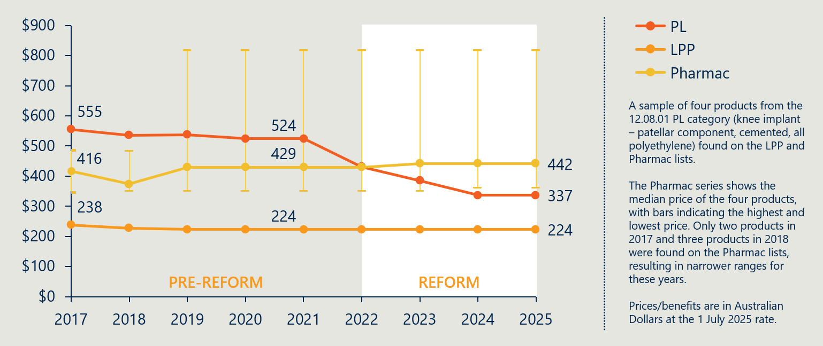
Case study 1 (Figure 34) shows the benefit and pricing history of four knee implants products from the 12.08.01 PL benefit group from 2017 to 2025. Prior to the reforms, the PL benefit was higher than the LPP and Pharmac prices on average. As a result of the benefit reductions, the PL benefit has fallen below the New Zealand median price and remains higher than the French price.
Figure 35 | International case study 2 (hip joint implant) – Benefit group comparison over time
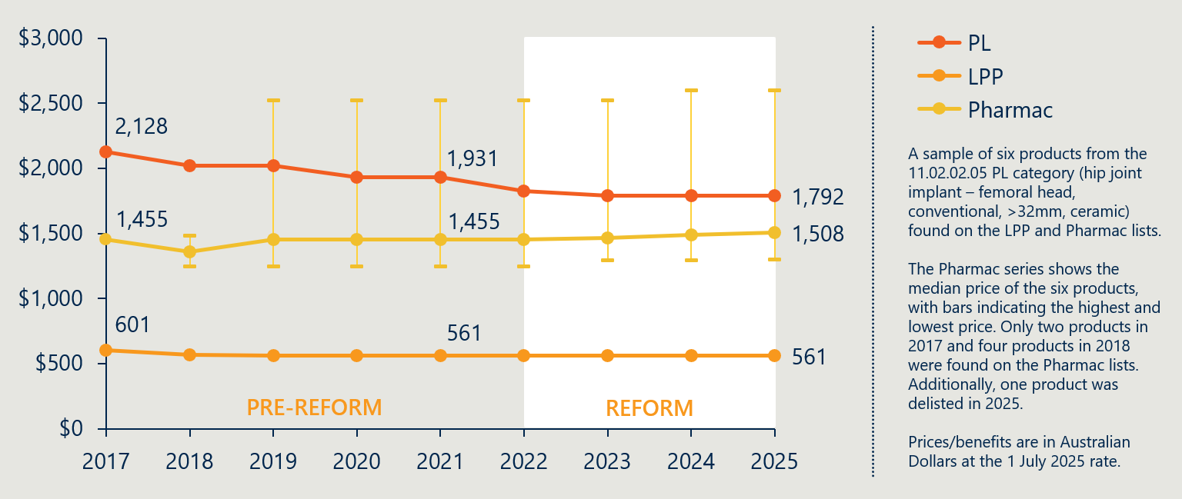
Case study 2 (Figure 35) compares the international benefits and prices of six hip joint implant products from the 11.02.02.05 PL benefit group. The reforms have resulted in a PL benefit that is more closely aligned with New Zealand and French pricing. However, the PL benefit remains $284 higher than the Pharmac median price (though lower than the highest priced product in the Pharmac category) and $1,231 higher than the LPP price.
Figure 36 | International case study 3 (spinal fusion cage) – Benefit group comparison over time
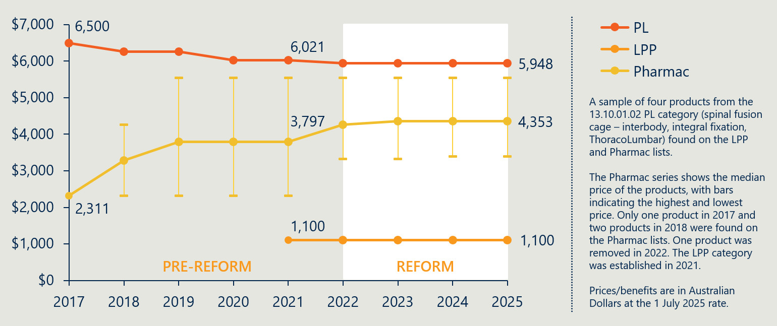
Case study 3 (Figure 36) compares the international benefits and prices of four spinal fusion cage products from the 13.10.01.02 PL category. The reforms have resulted in a marginal decrease in the PL benefit, while the median Pharmac price has increased and the LPP price has held steady. The PL benefit remains almost six times the LPP price for the same products.
- Indicator 3: Change in out-of-pocket expenses related to PL items

Measure 3.1: Prevalence of a gap payment for PL items
Table 13 | Prevalence of gap by PL category for items in Part A
 | FY23 |  |  | FY24
Categories | # of items | # of items with a gap | Rate of gap | # of items | # of items with a gap | Rate of gap | Change in rate of gap
01 – Ophthalmic | 377,388 | 3,797 | 1.01% | 393,400 | 2,488 | 0.63% | -0.37%
02 – Ear; Nose & Throat | 40,863 | 20 | 0.05% | 42,029 | 30 | 0.07% | 0.02%
03 – General Miscellaneous | 134,350 | 217 | 0.16% | 145,991 | 202 | 0.14% | -0.02%
04 – Neurosurgical | 24,182 | 85 | 0.35% | 25,263 | 22 | 0.09% | -0.26%
05 – Urogenital | 44,738 | 148 | 0.33% | 47,955 | 73 | 0.15% | -0.18%
06 – Specialist Orthopaedic | 654,345 | 2,505 | 0.38% | 679,617 | 1,346 | 0.20% | -0.18%
07 – Plastic and Reconstructive | 139,605 | 550 | 0.39% | 144,054 | 328 | 0.23% | -0.17%
08 – Cardiac | 77,932 | 824 | 1.06% | 81,282 | 961 | 1.18% | 0.12%
09 – Cardiothoracic | 9,098 | 185 | 2.03% | 9827 | 258 | 2.63% | 0.59%
10 – Vascular | 36,389 | 85 | 0.23% | 37,223 | 47 | 0.13% | -0.11%
11 – Hip | 150,559 | 296 | 0.20% | 154,886 | 124 | 0.08% | -0.12%
12 – Knee | 182,625 | 513 | 0.28% | 196,533 | 170 | 0.09% | -0.19%
13 – Spinal | 138,810 | 229 | 0.16% | 142,190 | 384 | 0.27% | 0.11%

Measure 3.2: Average gap payment for PL-listed items
Table 14 | Value of gap in Part A categories
 | FY23 |  |  | FY24
Categories | Avg benefit | Avg gap where gap was paid | Avg gap relative to avg benefit | Avg benefit | Avg gap where gap was paid | Avg gap relative to avg benefit | Change in avg gap to avg benefit
01 – Ophthalmic | $290 | $40 | 14% | $290 | $40 | 14% | 0%
02 – Ear; Nose & Throat | $680 | $10 | 1% | $650 | $300 | 46% | 45%
03 – General Miscellaneous | $310 | $30 | 10% | $300 | $20 | 7% | -3%
04 – Neurosurgical | $2,500 | $770 | 31% | $2,500 | $2,100 | 84% | 53%
05 – Urogenital | $770 | $130 | 17% | $880 | $130 | 15% | -2%
06 – Specialist Orthopaedic | $370 | $70 | 19% | $360 | $100 | 28% | 9%
07 – Plastic and Reconstructive | $370 | $410 | 111% | $360 | $790 | 219% | 109%
08 – Cardiac | $4,600 | $470 | 10% | $4,200 | $410 | 10% | 0%
09 – Cardiothoracic | $2,400 | $360 | 15% | $2,300 | $280 | 12% | -3%
10 – Vascular | $1,300 | $460 | 35% | $1,300 | $150 | 12% | -24%
11 – Hip | $1,600 | $270 | 17% | $1,600 | $400 | 25% | 8%
12 – Knee | $1,700 | $540 | 32% | $1,600 | $780 | 49% | 17%
13 – Spinal | $840 | $240 | 29% | $840 | $100 | 12% | -17%

- Indicator 6: Change in PHI premium increases

Measure 6.1: PHI premium price changes over time
Figure 37 | Average year-on-year premium revenue changes for HT PHI per policy and person (as % of prior year)
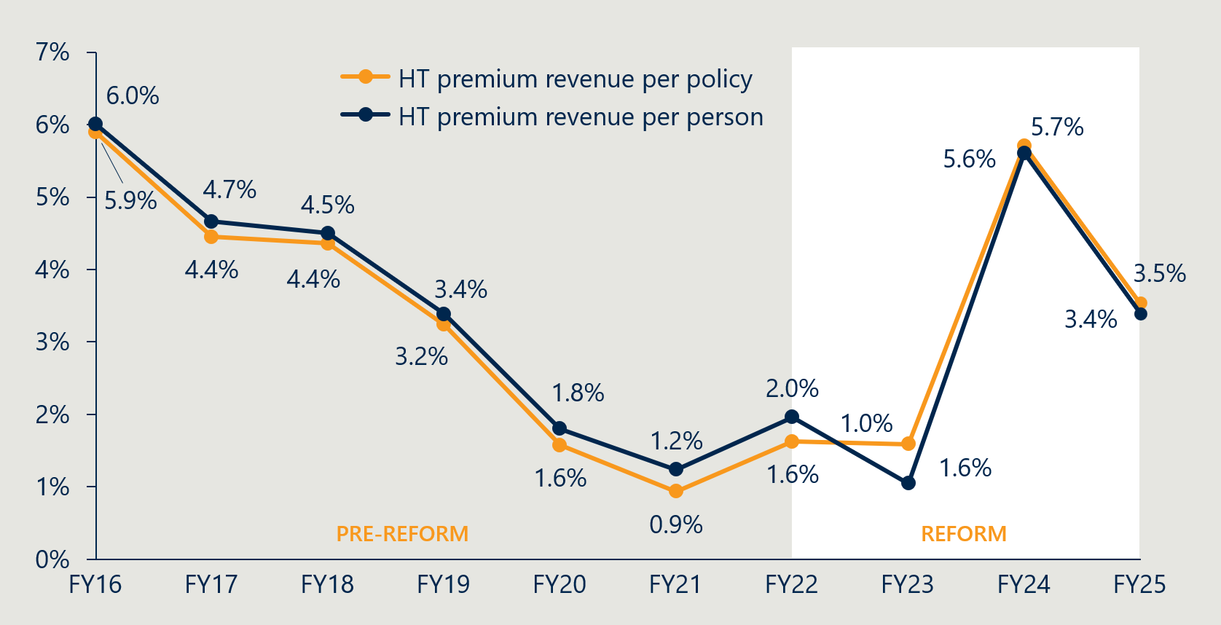
- Indicator 7: Change in PHI coverage and for whom

Measure 7.2: Utilisation of PL items by privately insured patients
Figure 38 | Average prostheses utilisation per 1000 HT PHI members by age,
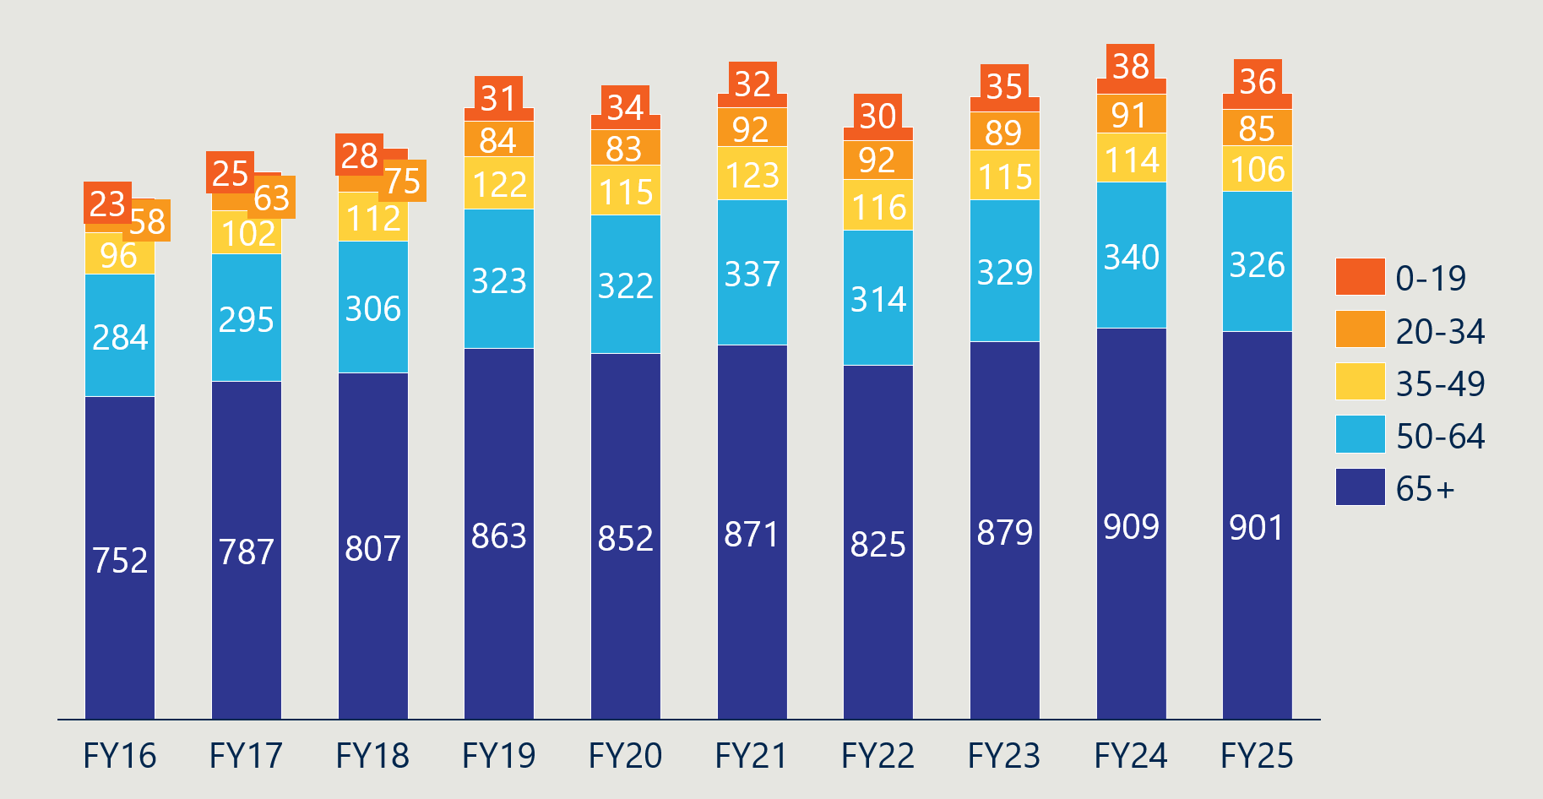
- Indicator 9: Implementation of PL regrouping

Measure 9.2: Number of PL items and benefit groups
Table 15 below summarises the number of items per category in the July 2025 PL. The overall number of items declined from the July 2021 PL (see Figure 39). Part C was the only part with an increase in the number of items, growing from 116 in July 2023 to 143 in July 2025.
Table 15 | Number of items per category in the July 2025 PL
 | Category | Part A | Part B | Part C | Part D | Total
Parts A, C and D | 01 – Ophthalmic | 369 | - | - | - | 369
Parts A, C and D | 02 – Ear, Nose & Throat | 162 | - | - | - | 162
Parts A, C and D | 03 – General Miscellaneous | 314 | - | 12 | 432 | 758
Parts A, C and D | 04 – Neurosurgical | 407 | - | - | 4 | 411
Parts A, C and D | 05 – Urogenital | 162 | - | 1 | - | 163
Parts A, C and D | 06 – Specialist Orthopaedic | 3459 | - | - | - | 3,459
Parts A, C and D | 07 – Plastic and Reconstructive | 712 | - | - | - | 712
Parts A, C and D | 08 – Cardiac | 319 | - | 106 | - | 425
Parts A, C and D | 09 – Cardiothoracic | 101 | - | 18 | - | 119
Parts A, C and D | 10 – Vascular | 306 | - | 6 | 69 | 381
Parts A, C and D | 11 – Hip | 668 | - | - | - | 668
Parts A, C and D | 12 – Knee | 720 | - | - | - | 720
Parts A, C and D | 13 – Spinal | 1,803 | - | - | - | 1,803
Part B | 01 – Cardio-thoracic | - | 11 | - | - | 11
Part B | 02 – Ophthalmic | - | 21 | - | - | 21
Part B | 03 – Orthopaedic | - | 552 | - | - | 552
Part B | 04 – Dermatologic | - | 18 | - | - | 18
 | Total | 9,502 | 602 | 143 | 505 | 10,752
Figure 39 | Number of PL items (Parts A, C and D)
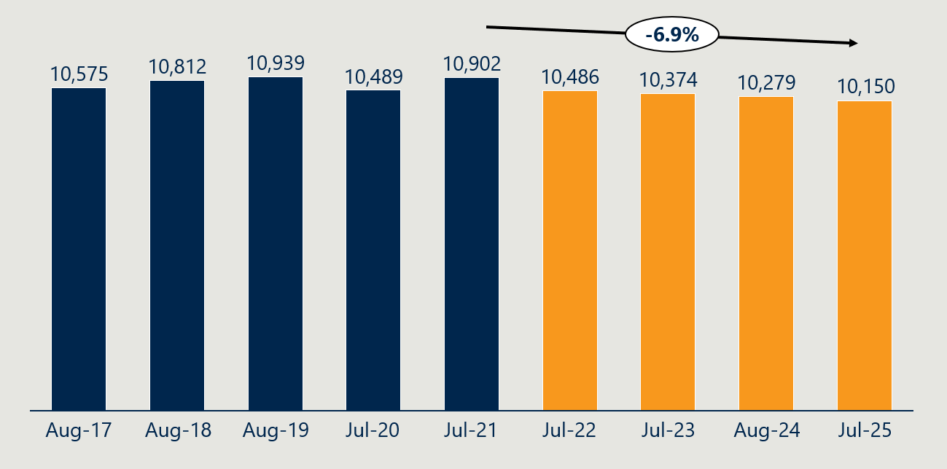
Figure 39 shows that the number of PL items in Parts A, C and D declined by 6.9% from the July 2021 PL to the July 2025 PL. This reflects a reversal of the trend in the 10 years preceding the July 2021 baseline, where the number of items increased by 1.1% per annum.
Figure 40 | Number of benefit groups (Parts A, C and D)
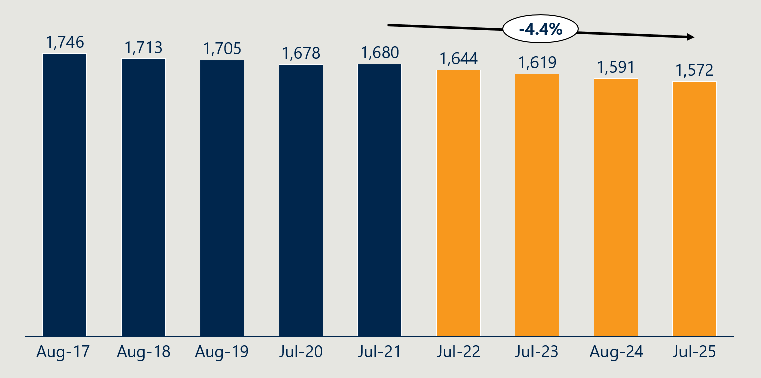
Likewise, Figure 40 shows that the number of benefit groups declined by 4.4% from the July 2021 PL to the July 2025 PL.
Figure 41 | Average items per benefit group (Parts A, C and D)
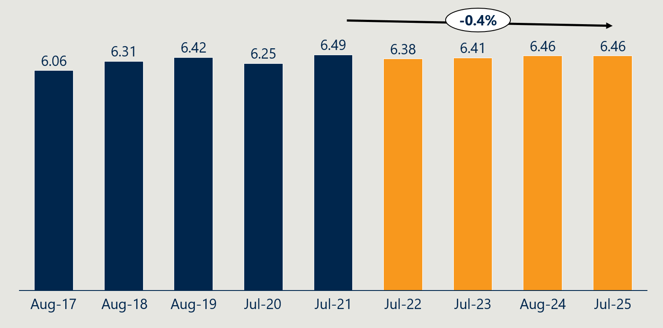
Figure 41 shows that the average items per benefit group has held relatively steady over the reform period. This reflects both the number of items and the number of benefit groups decreasing.

Department of Health and Aged Care, Historical background of the 2021-2025 Prostheses List Reform, 2022.
Department of Health, Disability and Ageing, Interim Evaluation #1 of the Prescribed List Reforms, 11 December 2024. https://www.health.gov.au/resources/publications/interim-evaluation-1-of-the-prescribed-list-reforms
Department of Health, Disability and Ageing, Interim Evaluation #2 of the Prescribed List Reforms, 8 October 2025. https://www.health.gov.au/resources/publications/interim-evaluation-2-of-the-prescribed-list-reforms
Independent Health and Aged Care Pricing Authority, Analysis on prescribed list benefit reductions for general use items (GUIs) and projected savings, 20 January 2025; Independent Health and Aged Care Pricing Authority (IHACPA) analysis on prescribed list benefit reductions, 15 December 2025.
Independent Health and Aged Care Pricing Authority, Updated estimates of projected benefits and savings associated with Prescribed List reforms, 13 December 2023.
Department of Health and Aged Care, Memorandum of Understanding for the policy parameters of the Prostheses List Reforms, 2022. https://www.health.gov.au/sites/default/files/documents/2022/03/memorandum-of-understanding-for-the-policy-parameters-of-the-prostheses-list-reforms.pdf
Independent Health and Aged Care Pricing Authority, Updated estimates of projected benefits and savings associated with Prescribed List reforms, 13 December 2023.
Ibid.
Department of Health, Disability and Ageing, Baseline evaluation of the Prostheses List reforms – Final report, 2024, https://www.health.gov.au/resources/publications/baseline-evaluation-of-the-prostheses-list-reforms-final-report
Department of Health, Disability and Ageing, Interim Evaluation #1 of the Prescribed List Reforms, 2024, https://www.health.gov.au/resources/publications/interim-evaluation-1-of-the-prescribed-list-reforms
Department of Health, Disability and Ageing, Interim Evaluation #2 of the Prescribed List Reforms, 2025, https://www.health.gov.au/resources/publications/interim-evaluation-2-of-the-prescribed-list-reforms
While efforts have been made to capture the essential content and key themes, the summaries in this report may not reflect all the nuances and particulars of the written feedback provided to the evaluation.
Independent Health and Aged Care Pricing Authority, Benchmark Price for Prostheses in Australian Public Hospitals 2020-21, 2022.
The Honourable Greg Hunt MP & the Medical Technology Association of Australia Limited, Memorandum of Understanding for the policy parameters of the Prostheses List Reforms, 2022.
Department of Health, Disability and Ageing, Interim Evaluation #1 of the Prescribed List Reforms, 2024, https://www.health.gov.au/resources/publications/interim-evaluation-1-of-the-prescribed-list-reforms?language=en.
Based on data provided by the Department on 31 July 2025 that excluded Part C and CIED items, comparing the benefits of the August 2024 PL to the benefits prior to the reforms. The evaluation supplemented this data with analysis of Part C and CIED items to calculate the total. Part B items are not included in the calculation.
While Nous is unable to verify whether every item with a benefit above 7% of its public benchmark was reduced (or above 0% for GUIs), the 51.1% figure aligns with other aggregate data provided to the evaluation by the Department of the prevalence of gaps between PL benefits and public benchmarks.
Data supplied by the Department, 31 July 2025.
Data supplied by the Department, 31 July 2025.
The Department omitted CIEDs from data and analysis shared with the evaluation.
Analysis of the gap between Weighted Average Prices and August 2024 PL benefits, supplied by the Department on 31 July 2025.
Ibid.
Department of Health, Disability and Ageing, Prescribed List of Medical Devices and Human Tissue Products Part A (Medical Devices), various editions; Pharmac, Hospital Medical Devices Schedule, various editions; l'Assurance Maladie, Liste des Produits et Prestations, http://www.codage.ext.cnamts.fr/codif/tips/index.php?p_site=AMELI. The earliest update after 1 July was used for each year.
Ibid.
French and NZ prices are slightly different to the same figures cited in the Interim Evaluation #1 and Interim Evaluation #2 reports due to a new exchange rate being used.
Indeed, the same set of IHACPA benchmarks the Department used to calculate the benefit reductions were then used to evaluate their success, with only a summary of the gap supplied to the evaluation for use in reporting.
Department of Health, Disability and Ageing, Baseline evaluation of the Prostheses List reforms – Final report, 2024, https://www.health.gov.au/resources/publications/baseline-evaluation-of-the-prostheses-list-reforms-final-report?language=en.
See Interim Evaluation #1 and Interim Evaluation #2 reports for a full discussion of the model and the exploration of alternatives.
Medical Services Advisory Committee (MSAC), Public Summary Document Application No. 1724 – Cardiac technical support services provided by industry employed technicians, 2023.
Stakeholder engagements, 2025.
The Honourable Greg Hunt MP & the Medical Technology Association of Australia Limited, Memorandum of Understanding for the policy parameters of the Prostheses List Reforms, 2022.
Department of Health and Aged Care, PHI Circular 21/22 Prostheses List Reform – Schedule of Prostheses List Price Reductions, 2022.
Department of Health and Aged Care, PHI Circular 29/23 Benefit reductions to Cardiac Implantable Electronic Devices, 2023.
Department of Health and Aged Care, PHI Circular 27/24 Benefit reductions to Cardiac Implantable Electronic Devices, 2024.
Communication with the Department, 2024.
This advice followed their assessment of the MTAA Cardiac Forum’s application No. 1724 – Cardiac technical support services provided by industry employed technicians.
Medical Services Advisory Committee (MSAC), Public Summary Document Application No. 1724 – Cardiac technical support services provided by industry employed technicians, 2023.
Ibid.
Department of Health and Aged Care, PHI Circular 27/24 Benefit reductions to Cardiac Implantable Electronic Devices, 2024.
Stakeholder engagements, 2025.
Department of Health, Disability and Ageing, Hospital Casemix Protocol Dataset, 2025.
Note that the incidence of gap payments cannot always be equated with out-of-pocket charges. In some instances, third parties, such as the Department of Veterans' Affairs, workers' compensation insurers, or motor vehicle insurance providers, cover the gap for consumers (therefore, not representing an ‘out-of-pocket’ cost). Conversely, there are out-of-pocket charges related to PL-listed items that are not included in these gap payments. As the HCP1 data set is from PHI reporting, it does not capture instances where consumers are charged out-of-pocket for PL-listed items as a result of a surgery or procedure not being uncovered under their policy.
Department of Health, Disability and Ageing, Hospital Casemix Protocol Dataset, 2025. Note that 33% is the FY24 weighted monthly average gap payment (where a gap was paid) relative to the FY24 weighted monthly average benefit.
Menzies Centre for Health Policy & University of Sydney, Options for a revised framework for setting and reviewing benefits for the Prostheses List, 2020.
Department of Health and Aged Care, The Prescribed List of Medical Devices and Human Tissue Products Guide (Draft), 2023.
Department of Health, Disability and Ageing, Prostheses List Part A (Prostheses), Part C (Other), and Part D (General Use Items), July 2025 edition.
Stakeholder submission, 2025.
Stakeholder consultation, 2025.
Department of Health, Disability and Ageing, Hospital Casemix Protocol Dataset, 2025.
Stakeholder consultations, 2025.
Independent Health and Aged Care Pricing Authority, Analysis on prescribed list benefit reductions for general use items (GUIs) and projected savings, 20 January 2025; Independent Health and Aged Care Pricing Authority (IHACPA) analysis on prescribed list benefit reductions, 15 December 2025.
Independent Health and Aged Care Pricing Authority, Updated estimates of projected benefits and savings associated with Prescribed List reforms, 13 December 2023. Note that these estimates are limited to insurer savings and do not reflect any offsetting costs that may have emerged elsewhere in the health system.
The Honourable Greg Hunt MP & the Medical Technology Association of Australia Limited, Memorandum of Understanding for the policy parameters of the Prostheses List Reforms, 2022.
Department of Health, Disability and Ageing, Interim Evaluation #1 of the Prescribed List Reforms, 2024, https://www.health.gov.au/resources/publications/interim-evaluation-1-of-the-prescribed-list-reforms?language=en.
Independent Health and Aged Care Pricing Authority, Updated estimates of projected benefits and savings associated with Prescribed List reforms, 13 December 2023.
Department of Health, Disability and Ageing, Interim Evaluation #1 of the Prescribed List Reforms, 2024, https://www.health.gov.au/resources/publications/interim-evaluation-1-of-the-prescribed-list-reforms?language=en.
Australian Prudential Regulation Authority, Annual private health insurance performance statistics database - 2023-24, December 2024.
Australian Prudential Regulation Authority, Annual private health insurance membership and benefit statistics, December 2024; Independent Health and Aged Care Pricing Authority, Updated estimates of projected benefits and savings associated with Prescribed List reforms, November 2023.
Benefit reduction savings are based on IHACPA’s Updated estimates of projected benefits and savings associated with Prescribed List reforms (Table 3 – 5% annual growth in utilisation). A 5% annual growth rate is also applied to benefit outlays in both the base and counterfactual scenarios.
Australian Prudential Regulation Authority, Annual private health insurance membership and benefit statistics, December 2025; Australian Prudential Regulation Authority, Quarterly Private Health Insurance Medical Device Or Human Tissue Products, December 2025.
Australian Prudential Regulation Authority, Annual private health insurance membership and benefit statistics, December 2025.
Australian Prudential Regulation Authority, Annual private health insurance membership and benefit statistics, December 2025.
Ibid.
Ibid.
Stakeholder consultation, 2025.
Department of Health, Disability and Ageing, List of historical premium price changes by insurer for 2025, 2025.
Stakeholder submissions, 2025.
Australian Prudential Regulation Authority, Annual private health insurance membership and benefit statistics, 2021–2025 editions (prostheses benefits data); Australian Prudential Regulation Authority, Annual private health insurance performance statistics database, 2024–2025 editions (FY24 and FY25 data); Australian Prudential Regulation Authority, Operations of Private Health Insurers Annual Report, 2021–2023 editions (FY21–23 data). Business expenses are limited to claims handling and other expenses related to health insurance business (HIB). Profit is before tax and excludes net investment income and non-HIB revenue.
Stakeholder submission, 2025.
Australian Prudential Regulation Authority, Annual private health insurance membership and benefit statistics, December 2025.
Department of Health, Disability and Ageing, PHI 77/24 – Private Health Insurance (Medical Devices and Human Tissue Products) Rules (No. 2) 2024, 24 October 2024. https://www.health.gov.au/news/phi-circulars/phi-circular-7724-private-health-insurance-medical-devices-and-human-tissue-products-rules-no-2-2024
Parliament of Australia, Private Health Insurance (Medical Devices and Human Tissue Products) Rules (No. 1) 2024 [replacement explanatory statement], 4 October 2024. https://www.aph.gov.au/Parliamentary_Business/Tabled_Documents/7627
Department of Health, Disability and Ageing, PHI 30/24 – General use items on the Prescribed List, 1 May 2024. https://www.health.gov.au/news/phi-circulars/phi-3024-general-use-items-on-the-prescribed-list
Therapeutic Goods Administration, Guidance on boundary and combination products, 2023.
Department of Health, Disability and Ageing, PHI 41/25 – Regrouping of Part A of the Prescribed List, 12 May 2025. https://www.health.gov.au/news/phi-circulars/phi-4125-regrouping-of-part-a-of-the-prescribed-list
Department of Health, Disability and Ageing, Prostheses List Compliance Strategy, 2022. https://consultations.health.gov.au/technology-assessment-access-division/prostheses-list-compliance-and-assurance-strategy.
House of Representatives, Explanatory Memorandum, Private Health Insurance Legislation Amendment (Medical Device And Human Tissue Product List And Cost Recovery) Bill 2022, 2022.
Department of Health, Prostheses List Reforms – Consultation Paper No 1, 2021.
Response to stakeholder information request for evaluation, 2024.
Department of Health, Disability and Ageing, PHI 41/25 – Regrouping of Part A of the Prescribed List, 12 May 2025, https://www.health.gov.au/news/phi-circulars/phi-4125-regrouping-of-part-a-of-the-prescribed-list.
The Honourable Greg Hunt MP & the Medical Technology Association of Australia Limited, Memorandum of Understanding for the policy parameters of the Prostheses List Reforms, 2022.
Department of Health, Disability and Ageing, PHI 51/23 – Regrouping of Part A of the Prescribed List, 26 July 2023, https://www.health.gov.au/news/phi-circulars/phi-5123-regrouping-of-part-a-of-the-prescribed-list
Department of Health, Disability and Ageing, PHI 41/25 – Regrouping of Part A of the Prescribed List, 12 May 2025. https://www.health.gov.au/news/phi-circulars/phi-4125-regrouping-of-part-a-of-the-prescribed-list
Stakeholder consultation, 2024.
Ernst & Young, Review of the General Miscellaneous Category of the Prostheses List, 2020.
We have taken a broader view of the baseline period for GUIs, noting their potential removal was the subject of consultations and reports prior to the announcement of the PL reforms in 11 May 2021, and these continued into 2022. Notwithstanding further changes that were to come, the MOU between the Minister and the MTAA in March 2022 formalised an agreed process for how GUIs were to be treated as part of the reform agenda.
The Hon Mark Butler MP, Ensuring lower surgery costs and continued access to healthcare through general use items, 1 May 2024. https://www.health.gov.au/ministers/the-hon-mark-butler-mp/media/ensuring-lower-surgery-costs-and-continued-access-to-healthcare-through-general-use-items
Department of Health, Disability and Ageing, PHI 71/24 – Removal of medicines and accessories to medicines from the Prescribed List, 11 October 2024. https://www.health.gov.au/news/phi-circulars/phi-7224-removal-of-medicines-and-accessories-to-medicines-from-the-prescribed-list
Department of Health, Disability and Ageing, Historical background of the 2021-2025 Prostheses List reform, 18 March 2022. https://www.health.gov.au/resources/publications/historical-background-of-the-prostheses-list-reform-2021-2025?language=en.
IHACPA, Consultation Paper on Bundling Arrangements for the General Use Items on the Prostheses List, 2022.
Department of Health, Disability and Ageing, Hospital Casemix Protocol Dataset, 2025.
GUI population is based on item codes listed in Part D on the August 2024 PL. Benefits used in calculations are from the PL update at the start of the period (e.g. July 2020 update for FY21). Items without all four years of benefit levels were removed from the analysis. Value is calculated as utilisation * PL benefit; weighted average benefit is calculated as total value / total utilisation.
Response to stakeholder information request for the evaluation, 2024.
Department of Health, Disability and Aged Care, Prostheses List Reforms - Consultation Paper 3 - A modernised fit-for-purpose listing process, 14 January 2022.
Department of Health, Disability and Ageing, Prescribed List of Medical Devices and Human Tissue Products Guide – Draft, 21 December 2023. https://www.health.gov.au/resources/publications/prescribed-list-of-medical-devices-and-human-tissue-products-guide-draft?language=en.
Department of Health, Disability and Ageing, Prescribed List Application Training, 27 November 2023. https://www.health.gov.au/resources/publications/prescribed-list-application-training?language=en.
HPP applications data. Applications to delist or transfer are not included.
Ibid.
Ibid.
Department of Health and Ageing, Review of health technology assessment in Australia, 2009.
Department of Health and Aged Care, The Prostheses List reforms, https://www.health.gov.au/topics/private-health-insurance/the-prostheses-list/the-prostheses-list-reforms, accessed 14 February 2024.
Department of Health, Disability and Ageing, Prescribed List post-listing review framework, 12 December 2024. https://www.health.gov.au/resources/publications/prescribed-list-post-listing-review-framework?language=en.
Department of Health, Disability and Ageing, Metal-backed patellae – Prescribed List post-listing review, 5 July 2024. https://www.health.gov.au/our-work/metal-backed-patellae-prescribed-list-post-listing-review
Department of Health, Disability and Ageing, Surgical guides and biomodels – Prescribed List post-listing review, 23 June 2025. https://www.health.gov.au/our-work/surgical-guides-and-biomodels-prescribed-list-post-listing-review
Department of Health, Disability and Ageing, PHI 74/23 – Prescribed List – Private Health Insurance (Medical Devices and Human Tissue Products) Amendment Rules (No. 2) 2023, 13 November 2023. https://www.health.gov.au/news/phi-circulars/phi-7423-prescribed-list-private-health-insurance-medical-devices-and-human-tissue-products-amendment-rules-no-2-2023
Department of Health, Disability and Ageing, Surgical guides and biomodels post listing review, Department report – DRAFT May 2026. Accessed 6 June 2026. https://www.health.gov.au/sites/default/files/2026-05/surgical-guides-and-biomodels-post-listing-review---draft-report.pdf
Department of Health, Disability and Ageing, Spinal cord stimulators – Prescribed List post-listing review, 14 March 2025. https://www.health.gov.au/our-work/spinal-cord-stimulators-prescribed-list-post-listing-review
Department of Health, Disability and Ageing, PHI 09/26 Spinal Cord Stimulator post-listing review impact assessment, 16 February 2026. https://www.health.gov.au/news/phi-circulars/phi-0926-spinal-cord-stimulator-post-listing-review-impact-assessment
Department of Health, Disability and Ageing, Urogynaecological mesh devices (mid-urethral slings) – Prescribed List post-listing review, 5 July 2024. https://www.health.gov.au/our-work/urogynaecological-mesh-devices-mid-urethral-slings-prescribed-list-post-listing-review
Department of Health and Aged Care, The Prescribed List of Medical Devices and Human Tissue Products Guide (Draft), 2023.
Department of Health, Disability and Ageing, PHI 12/24 – Updates to the 2024-35 Prescribed List CRIS and cost recovery levy, 10 February 2025. https://www.health.gov.au/news/phi-circulars/phi-1225-updates-to-the-2024-25-prescribed-list-cris-and-cost-recovery-levy.
Department of Health, Disability and Ageing, Cost Recovery Implementation Statement Administration of the Prescribed List of Medical Devices and Human Tissue Products 1 July 2025 to 30 June 2026 Version 1.1, 2025. https://www.health.gov.au/sites/default/files/2025-07/cost-recovery-implementation-statement-administration-of-the-prescribed-list-of-medical-devices-and-human-tissue-products.pdf
Australia Medical Association, AMA submission on the surgical guides and biomodels post-listing review Stage 2 draft report, 3 April 2025. https://www.ama.com.au/articles/ama-submission-surgical-guides-and-biomodels-post-listing-review-stage-2-draft-report
Ibid.
Department of Health, Disability and Ageing, Prescribed List post-listing review framework, 12 December 2024. https://www.health.gov.au/resources/publications/prescribed-list-post-listing-review-framework?language=en.
Department of Health, Disability and Ageing, The Prescribed List Post-listing Review Framework, January 2026. https://www.health.gov.au/sites/default/files/2026-01/prescribed-list-post-listing-review-framework.pdf
Department of Health and Aged Care, Prescribed List Compliance Strategy, 2023.
Department of Health, Disability and Ageing, Consultation Paper 7 – Proposed measures for compliance, assurance and information sharing, September 2024. https://www.health.gov.au/resources/publications/consultation-paper-7-proposed-measures-for-compliance-assurance-and-information-sharing
Department of Health, Disability and Ageing, Consultation Paper 8a – Gifts, benefits and discounts reporting requirement, September 2024. https://www.health.gov.au/resources/publications/consultation-paper-8a-gifts-benefits-and-discounts-reporting-requirement
Department of Health, Disability and Ageing, Consultation Paper 8b – Alignment of amount charged for supply of a device with corresponding PL benefit, September 2024. https://www.health.gov.au/resources/publications/consultation-paper-8b-alignment-of-amount-charged-for-supply-of-a-device-with-corresponding-pl-benefit
Department of Health, Disability and Ageing, PHI 05/25 – Outcome of Consultation Papers 8a and 8b, 9 January 2025. https://www.health.gov.au/news/phi-circulars/phi-0525-outcome-of-consultation-papers-8a-and-8b
Department of Health, Disability and Ageing, Prescribed List Compliance Strategy – Safeguarding the Prescribed List, 2 July 2025. https://www.health.gov.au/resources/publications/prescribed-list-compliance-strategy-safeguarding-the-prescribed-list
Department of Health, Disability and Ageing, Prescribed List Compliance Strategy – Safeguarding the Prescribed List, 18 May 2023. https://www.health.gov.au/resources/publications/prescribed-list-compliance-strategy-safeguarding-the-prescribed-list
Department of Health, Disability and Ageing, Consultation Paper 7 – Proposed measures for compliance, assurance and information sharing, September 2024. https://www.health.gov.au/resources/publications/consultation-paper-7-proposed-measures-for-compliance-assurance-and-information-sharing
Stakeholder input to the evaluation, 2025.
Department of Health, Disability and Ageing, Consultation Paper 8a – Gifts, benefits and discounts reporting requirement, September 2024. https://www.health.gov.au/resources/publications/consultation-paper-8a-gifts-benefits-and-discounts-reporting-requirement
Department of Health, Disability and Ageing, Consultation Paper 8b – Alignment of amount charged for supply of a device with corresponding PL benefit, September 2024. https://www.health.gov.au/resources/publications/consultation-paper-8b-alignment-of-amount-charged-for-supply-of-a-device-with-corresponding-pl-benefit
Department of Health, Disability and Ageing, PHI 05/25 – Outcome of Consultation Papers 8a and 8b, 9 January 2025. https://www.health.gov.au/news/phi-circulars/phi-0525-outcome-of-consultation-papers-8a-and-8b.
Stakeholder input to the evaluation, 2025.
Department of Health, Disability and Ageing, Prescribed List Compliance Strategy – Safeguarding the Prescribed List, 2 July 2025. https://www.health.gov.au/resources/publications/prescribed-list-compliance-strategy-safeguarding-the-prescribed-list
Department of Health, Disability and Ageing, Cost recovery fees and charges for the Prescribed List, 3 July 2025. https://www.health.gov.au/our-work/the-prescribed-list/cost-recovery.
Federal Register of Legislation. Private Health Insurance (Medical Devices and Human Tissue Products Levy) Rules 2025. https://www.legislation.gov.au/F2025L00284/asmade/text
Department of Health, Disability and Ageing, PHI 12/24 – Updates to the 2024-35 Prescribed List CRIS and cost recovery levy, 10 February 2025. https://www.health.gov.au/news/phi-circulars/phi-1225-updates-to-the-2024-25-prescribed-list-cris-and-cost-recovery-levy.
Ibid.
Department of Health, Disability and Ageing, Regulation Impact Statement (RIS): Improving the Private Health Insurance Prostheses List, 2021.
Department of Health, Disability and Ageing, Cost Recovery Implementation Statement: Administration of the Prescribed List of Medical Devices and Human Tissue Products 1 July 2025 to 30 June 2026, Version 1.1.
Department of Health, Disability and Ageing, PHI 33/26 – Consultation on draft Prescribed List Cost Recovery Implementation Statement (CRIS), 18 May 2026. https://www.health.gov.au/news/phi-circulars/phi-3326-consultation-on-draft-prescribed-list-cost-recovery-implementation-statement-cris
Data supplied by the Department, 31 July 2025. For indicators 1 and 2, the evaluation has used ‘benefit groups’ to refer to all items within a category, sub-category, group and sub-group that share the same benefit, within $2 (e.g. two items in A.01.01.01.01 with a benefit of $100 are considered as being in one benefit group, even if they have different suffix values). This is to align with IHACPA’s methodology for calculating the Weighted Average Prices and benefit reductions.
Evaluation team conversations with the Department, 2024. Additional factors included historical billing code changes, corrections to an error on the August 2022 PL update (~$1.6 million adjustment), and corrections to fix some date-related errors. The parameters and advice given to IHACPA has not been shared with the evaluation.
Department of Health, Disability and Ageing, Interim Evaluation #1 of the Prescribed List Reforms, 2024, https://www.health.gov.au/resources/publications/interim-evaluation-1-of-the-prescribed-list-reforms?language=en.
Independent Health and Aged Care Pricing Authority, Updated estimates of projected benefits and savings associated with Prescribed List reforms, 13 December 2023.
Independent Health and Aged Care Pricing Authority, Analysis on prescribed list benefit reductions for general use items (GUIs) and projected savings, 20 January 2025; Analysis on prescribed list benefit reductions, 15 December 2025.
Data supplied by the Department, 31 July 2025. Comparison made to baseline figures.
l'Assurance Maladie, Liste des Produits et Prestations, http://www.codage.ext.cnamts.fr/codif/tips/index.php?p_site=AMELI. The Liste des Produits et Prestations (LPP) is a list of medical device and human tissue products that guides reimbursement for the French national health insurance system. It has a comparable scope to the PL and it prices products at a higher level of grouping than the PL.
Pharmac, Hospital Medical Devices Schedule, multiple editions. The Pharmac Hospital Medical Devices Schedule (Pharmac) is a list of contracted medical devices products for New Zealand public hospitals. It has a narrower scope than the PL at baseline, and it prices products on an individual basis, not in concert with equivalent products within a group like the PL and LPP.
Department of Health, Disability and Ageing, Interim Evaluation #1 of the Prescribed List Reforms, 2024, https://www.health.gov.au/resources/publications/interim-evaluation-1-of-the-prescribed-list-reforms?language=en.
Past French and NZ prices are slightly different to the same charts in the Interim Evaluation #1 and Interim Evaluation #2 reports due to a new exchange rate being used.
Department of Health, Disability and Ageing, Prescribed List of Medical Devices and Human Tissue Products Part A (Medical Devices), various editions; Pharmac, Hospital Medical Devices Schedule, various editions; l'Assurance Maladie, Liste des Produits et Prestations, http://www.codage.ext.cnamts.fr/codif/tips/index.php?p_site=AMELI. The earliest update after 1 July was used for each year.
Ibid.
Ibid.
Department of Health, Disability and Ageing, Hospital Casemix Protocol Dataset, 2025.
Department of Health, Disability and Ageing, Hospital Casemix Protocol Dataset, 2025.
Australian Prudential Regulation Authority, Annual private health insurance membership and benefit statistics, December 2025; Australian Prudential Regulation Authority, Annual private health insurance performance statistics database - 2024-25, December 2025 (for FY24 and FY25 HT premium revenue); Australian Prudential Regulation Authority, Operations of Private Health Insurers Annual Report; 2014-15 to 2022-23 editions (for FY15-23 HT premium revenue).
Australian Prudential Regulation Authority, Annual private health insurance membership and benefit statistics, December 2024; Australian Prudential Regulation Authority, Quarterly Private Health Insurance Medical Device Or Human Tissue Products, March 2025.
Utilisation is calculated by dividing HT prostheses benefits for each category by the average prostheses benefit across all categories for the relevant financial year, as APRA does not publish prostheses utilisation by age. HT population coverage for each age bracket is then divided by the utilisation figure to obtain the average.
Department of Health, Disability and Ageing, Prostheses List Part A (Prostheses), Part B (Human Tissue), Part C (Other), and Part D (General Use Items), July 2025 edition.
Department of Health, Disability and Ageing, Prostheses List Part A (Prostheses), Part C (Other), and Part D (General Use Items), various editions.
Ibid. The evaluation has used ‘benefit groups’ here to refer to all items within a category, sub-category, group and sub-group that share the same benefit.
Ibid.

