Evaluation of the Medical Research Future Fund Research Missions theme
Health and Medical Research Office
Department of Health, Disability and Ageing
July 2026
This report is accompanied by an appendix document, which contains supporting material including detailed analysis and supplementary data.

Acknowledgements
The Department of Health, Disability and Ageing acknowledges the Traditional Owners and Custodians of Country throughout Australia, and their continuing connection to land, sea and community. We pay our respects to them and their cultures, and to Elders both past and present.
The department acknowledges all individuals and organisations who generously shared their invaluable insights and experiences to inform this evaluation.
The department also acknowledges the important contributions and guidance provided throughout the evaluation by the members of the Mission Evaluation Panel (outlined in Table 1).
Table 1 Members and experience of the Mission Evaluation Panel
Member | Background and experience
Professor Annemarei (Anna) Ranta (Chair) | Professor Ranta is an academic stroke neurologist and the head of the Department of Medicine at the University of Otago in Wellington, New Zealand.
Associate Professor Stephen Adelstein | Associate Professor Adelstein is a member of the Council of the National Health and Medical Research Council (NHMRC Council). He is head of the Department of Clinical Immunology and director of the Central Sydney Immunology Laboratory at Royal Prince Alfred Hospital. He is an Associate Professor of Medicine at the University of Sydney.
Ms Ainslie Cahill | Ms Cahill is a member of the NHMRC Council. She is chair of the NHMRC–Medical Research Future Fund (MRFF) Consumer Advisory Group, providing strategic advice on health and medical research from a consumer perspective.
Professor Raymond Chan | Professor Chan is an NHMRC Council member and the Deputy Vice-Chancellor (Research) at Flinders University.
Associate Professor Alwin Chong | Associate Professor Chong is a Wakamin descendent from Far North Queensland. He was director of the Yaitya Purruna Indigenous Health Unit at the University of Adelaide. He led the first Clinical Centre of Research Excellence in Aboriginal and Torres Strait Islander Health. Associate Professor Chong was program leader for the Healthy Communities Program for the Lowitja Institute Cooperative Research Centre.
Dr Tammy Clifford | Adjunct Professor Clifford is the Vice-President, Strategic Science and External Relations at the Canadian Institutes of Health Research. She is also an adjunct professor at the University of Ottawa’s School of Epidemiology and Public Health.
Ms Sue MacLeman | Ms MacLeman is the chair of Medicines Australia. She has more than 30 years’ experience as a pharmaceutical, biotechnology and medical technology executive. She has held senior roles in health administration, corporate, medical, commercial and business development.
Dr Shyamsundar Muthuramalingam | Dr Muthuramalingam is the Director of Research and Teletrials at Barossa Hills Fleurieu Local Health Network in South Australia. He is a member of the NHMRC–MRFF Consumer Advisory Group and the Australian Medical Council.
Ms Amelia Olsen-Boyd | Ms Olsen-Boyd is an executive manager at the Commonwealth Scientific and Industrial Research Organisation (CSIRO). She previously led the design of CSIRO’s Missions Program.
Dr Douglas Hilton (until March 2026) | Dr Hilton is a representative of the Australian Medical Research Advisory Board (AMRAB) and the current chief executive officer of CSIRO. He is immediate past director of the Walter and Eliza Hall Institute of Medical Research and former president of the Association of Australian Medical Research Institutes.
Professor Andrew Wilson (from  May 2026) | Professor Wilson is an AMRAB representative, Professor of Public Health in the Sydney School of Public Health, and the co-director of the Leeder Centre for Health Policy, Economics and Data (University of Sydney).

Shortened forms
ARC Australian Research Council
CIHR Canadian Institutes of Health Research
DALY disability-adjusted life years
ERA Excellence in Research Australia
MRFF Medical Research Future Fund
NHMRC National Health and Medical Research Council

Contents
1 Executive summary 1
1.1 Background 1
1.2 Research Missions program evaluation 2
1.3 Methodology 2
1.4 Position of Research Missions in the national and international funding landscape 2
1.4.1 National funders and priorities 2
1.4.2 Burden of disease 3
1.4.3 Characteristics of comparator Mission-style funders 3
1.5 Alignment and contribution of Research Missions–funded research 3
1.5.1 Contribution of Research Missions funding 3
1.5.2 Alignment of Research Missions funding 6
1.6 Progress and impact of Research Missions–funded research towards MRFF, program and Research Mission benchmarks 6
1.7 Opportunities to improve the impact of Research Missions 1
2 Background 3
2.1 The Medical Research Future Fund 3
2.2 The Research Missions theme 3
Box 1. Research Missions governance, priority setting, implementation and review 4
2.3 Research Missions program evaluation 6
2.3.1 Benchmarks 7
2.3.2 Scope 8
2.3.3 Governance 8
2.4 Limitations 9
3 Methodology 10
3.1 Data sources and analysis 10
3.1.1 Grantee survey 14
3.1.2 Public survey 14
3.1.3 Targeted consultations 16
3.1.4 Analysis of themes by stakeholder group 17
3.1.5 Document review 18
3.1.6 Performance indicator survey 18
3.1.7 MRFF administrative data 18
3.1.8 Publicly available and grey literature 18
4 Position of Research Missions in the national and international funding landscape 20
4.1 National landscape – priorities, research strengths, burden of disease and unmet need 21
Summary findings 21
4.1.1 National priorities 22
4.1.2 Australia’s research strengths 24
4.1.3 Burden of disease in Australia 25
4.1.4 Stakeholder views on unmet needs within the current Research Missions focus areas 26
4.2 Comparison to significant national funders 28
Summary findings 28
4.2.1 Brain cancer research 32
4.2.2 Cardiovascular health research 32
4.2.3 Dementia, ageing and aged care research 33
4.2.4 Genomics research 34
4.2.5 Aboriginal and Torres Strait Islander health research 34
4.2.6 Mental health research 35
4.2.7 Stem cell therapies research 36
4.2.8 Traumatic brain injury research 36
4.2.9 Innovative and creative approaches to implementing research priorities 37
4.3 Review of other Mission-style funding programs 41
Summary findings 41
4.3.1 Comparator Mission-style funders 42
4.3.2 Exemplar characteristics of comparator Mission-style funders 42
5 Alignment and contribution of Research Missions–funded research 47
5.1 Contribution of the MRFF to the research funding landscape 47
Summary findings 47
5.1.1 Applications, grants, funded rates and total funding 48
5.1.2 Funding by state and territory 49
5.1.3 Funding by regional, rural and remote status 50
5.1.4 Funding by broad research area 51
5.1.5 Funding by grant model 51
5.1.6 Grant duration 52
5.1.7 Grant size (funding awarded) 53
5.1.8 Stage of grants 56
5.2 Alignment of funded research by Research Missions focus area and Research Missions priorities 57
Summary findings 57
5.2.1 Funding by Research Missions focus area 57
5.2.2 Funding by Research Mission priority area 61
6 Progress and impact of Research Missions–funded research 62
6.1 Progress towards individual Research Mission aims 63
Summary findings 63
6.2 Progress towards Research Missions program aims 65
Summary findings 65
6.2.1 Stakeholder views on strengths 66
6.2.2 Stakeholder concerns and considerations 72
6.3 Progress towards MRFF measures of success 76
Summary findings 76
6.3.1 Measures of success being addressed by Research Mission grants 77
6.3.2 Progress towards measures of success 79
6.4 Considerations and barriers to translation and impact 91
Summary findings 92
6.4.1 Stakeholder concerns and considerations 92
6.5 Analysis of themes by stakeholder group 96
7 Opportunities to improve the Research Missions program 101
Summary findings 101
7.1 Opportunities to improve the impact of the Research Missions program 103
7.1.1 Fund large programs of work 103
7.1.2 Bring together key researchers, health professionals, stakeholders, industry partners and patients/consumers 104
7.1.3 Tackle big health challenges 104
7.1.4 Research translation and impact 105
7.1.5 Equity, diversity and inclusion 106
7.1.6 Administrative and governance processes 106
7.2 Conclusion 107
8 Glossary 110

Tables
Table 1 Members and experience of the Mission Evaluation Panel ii
Table 2 Opportunities to improve the Research Missions program, and their data sources 1
Table 3 Data sources used to inform the evaluation 11
Table 4 Contribution of data sources to the evaluation questions 12
Table 5 Survey response rate by Research Mission 14
Table 6 Public survey respondents by state or territory 15
Table 7 Percentage of total burden for the leading 10 disease groups in 2024 25
Table 8 Approaches used by Research Missions, MRFF and other national funders to implement their priorities 38
Table 9 Exemplar characteristics of comparator Mission-style funders 43
Table 10 Number of funded grants, total funding awarded and percentage of MRFF funding, by MRFF theme 48
Table 11 Number of funded grants, total funding awarded and funded rate by Research Mission 49
Table 12 Remoteness status of lead organisations of grants funded under each MRFF theme 50
Table 13 Remoteness status of lead organisations of grants funded under each Research Mission 50
Table 14 Number of Research Missions grant opportunities each year 56
Table 15 Contribution of MRFF Research Missions to Mission-related focus areas, in terms of funding disbursements to awarded grants 59
Table 16 Contribution of non-Mission MRFF initiatives to Mission-related focus areas, in terms of funding disbursements to awarded grants 60
Table 17 Average number of Chief Investigators, Associate Investigators, organisations and sectors per Research Missions grant 69
Table 18 MRFF measures of success being addressed by individual Research Missions and the Research Missions program 78
Table 19 Number of Research Missions–funded projects addressing MRFF priority populations 80
Table 20 Number of Research Missions–funded projects addressing Mission priority populations 81
Table 21 Number of people supported by grants funded under the Research Missions program 83
Table 22 Key themes by stakeholder group 97
Table 23 Frequency of responses from the public survey indicating a positive impact, by theme and research end user stakeholder group 98
Table 24 Frequency of responses from the public survey indicating a consideration or suggestion, by theme and research end user stakeholder group 99
Table 25 Frequency of responses from the public survey indicating a concern, by theme and research end user stakeholder group 100
Table 26 Opportunities to improve the Research Missions program 101

Figures
Figure 1 The 4 MRFF themes 3
Figure 2 MRFF monitoring, evaluation and learning conceptual framework 8
Figure 3 Familiarity with the Research Missions program, by respondent category 15
Figure 4 Public survey respondent involvement in applications and successful grants 16
Figure 5 Stakeholder interview participants by organisation category 17
Figure 6 Changes in age-standardised DALY rates for Mission-relevant diseases, 2003 to 2024 26
Figure 7 Median grant size, quanta of funding and indicative position in the research pipeline for the MRFF and significant national funders 30
Figure 8 Broad research area classification of Mission focus area–related grants funded by the Research Missions, MRFF (all related research, funded through the Missions and other MRFF initiatives) and NHMRC 31
Figure 9 Number of, funded rate and funding received for Research Missions grants by the state or territory of the lead organisation 49
Figure 10 Percentage of grants awarded for each broad research area, by MRFF theme 51
Figure 11 Number of grants awarded under each grant mode, by Research Mission 52
Figure 12 Grant duration for each MRFF theme 53
Figure 13 Grant duration for each Research Mission 53
Figure 14 Number of funded grants in each budget band, by MRFF theme 54
Figure 15 Number of funded grants in each budget band, by Research Mission 54
Figure 16 Number of Research Missions–funded grants in each budget band, by year 55
Figure 17 Completeness of grants funded under the Research Missions program 56
Figure 18 Funding disbursed or to be disbursed by the relevant Research Mission and through other MRFF initiatives, by Mission focus area 58
Figure 19 Progress towards individual Research Mission aims 64
Figure 20 Stakeholder views on how well the Research Missions program is meeting its aims 66
Figure 21 Consumer and end-user involvement in applications and research projects 68
Figure 22 Enablers for applications to Research Missions grant opportunities 70
Figure 23 Reasons stakeholders use Research Mission strategic documents 71
Figure 24 Next phase for Research Missions–funded research, as identified by grantees 72
Figure 25 Progress towards achieving MRFF measures of success for completed projects 79
Figure 26 Percentage of Research Missions program grantees that reported consumer involvement activities 85
Figure 27 Number of completed grants undertaking activities supporting health and healthcare change 87
Figure 28 Number of completed grants that resulted in outputs and outcomes supporting health and healthcare change 87
Figure 29 Number of clinical trials supported by each Research Mission, and the funding provided 90

1 Executive summary

1.1 Background
The Australian Government’s Medical Research Future Fund (MRFF) is a $25.4 billion long-term investment supporting Australian health and medical research. The MRFF operates as an endowment fund, in which the net earnings serve as a permanent revenue stream for investment in health and medical research and innovation, with the capital preserved in perpetuity. The MRFF aims to transform health and medical research and innovation to improve lives, build the economy and contribute to health system sustainability.
As outlined in the MRFF 3rd 10-year Investment Plan, MRFF funding is directed into 4 themes: Patients, Research Missions, Researchers, and Research Translation. This report focuses on the Research Missions theme, which aims to fund large programs of work that bring together key researchers, health professionals, stakeholders, industry partners and patients to tackle big, ambitious health challenges. The Research Missions theme will be referred to as ‘Research Missions program’ throughout this report.
Under the Research Missions program are 8 current Research Missions, 2 new Missions that will commence funding in the 2027–28 financial year, and a recently announced Arthritis and Musculoskeletal Conditions Research Mission (also see Section 2.2):
- Australian Brain Cancer Mission
- Cardiovascular Health Mission
- Dementia, Ageing and Aged Care Mission
- Genomics Health Futures Mission
- Indigenous Health Research Fund
- Million Minds Mental Health Research Mission
- Stem Cell Therapies Mission
- Traumatic Brain Injury Mission
- Low Survival Cancers Mission
- Reducing Health Inequities Mission.
A key feature of the Research Missions program is that funding is guided by a roadmap and implementation plan. These publicly available documents outline the strategic priorities and timing of investment over the duration of the Research Missions program, following national and international consultation. The roadmap and implementation plan are developed by expert advisory panels that are appointed by the Australian Government to provide advice to the Minister for Health and Ageing on Research Missions investments (see Box 1).

1.2 Research Missions program evaluation
The Department of Health, Disability and Ageing undertook this evaluation of the Research Missions program in accordance with the MRFF Monitoring, evaluation and learning strategy. The evaluation investigated:
- where Research Missions sit in the research funding landscape
- the contribution and progress of Research Missions at both the individual Mission and program levels
- opportunities to improve the impact of the Research Missions program.
The evaluation also provides evidence to support Government decision on whether to extend, cease or reshape individual Research Missions at completion of their initial tenure (generally 10 years).
The evaluation questions are:
- How do MRFF Research Missions sit in the national and international research funding landscape?
- What is the alignment and contribution of funded research across and between Missions?
- What progress and impact has Mission-funded research had towards MRFF, program and Research Mission benchmarks?
- What are the opportunities to improve the impact of MRFF Research Missions?
Within scope for this evaluation are all grants and grant opportunities funded under the Research Missions program as at 1 July 2025.

1.3 Methodology
Several data sources informed this evaluation, including:
- publicly available and grey literature
- the Australian Government’s National Health and Medical Research Strategy 2026–2036
- mid-term Research Missions reviews
- grantee progress and final reports
- Research Missions strategic documents (roadmaps and implementation plans)
- MRFF administrative data
- application and grants data collected through administration processes
- data from the 2024 performance indicator survey
- grantee and public survey
- targeted stakeholder consultations (interviews).

1.4 Position of Research Missions in the national and international funding landscape

1.4.1 National funders and priorities
The priorities of the MRFF Research Missions align with Australia’s National Science and Research Priorities 2 (supporting healthy and thriving communities) and 3 (elevating Aboriginal and Torres Strait Islander knowledge systems).
Most Research Missions priorities are consistent with significant national funders in the relevant area of research. Of the Research Missions, the priorities of the Australian Brain Cancer Mission, Stem Cell Therapies Mission and Traumatic Brain Injury Mission had the least overlap with other funders. The National Health and Medical Research Council (NHMRC) was identified as a significant national funder for all Research Missions focus areas. The MRFF generally funds research later in the research translation pipeline than the NHMRC and other significant national funders.
MRFF’s consumer involvement strategies have strengthened over the years and are more extensive than the significant national funders analysed.

1.4.2 Burden of disease
MRFF Research Missions collectively address aspects of 5 of the 6 leading burden-of-disease groups in Australia. Analysis of trends over time in the years before and after establishment of the Research Missions program shows increasing burden for mental and substance use disorders and dementia. Conversely, burden is decreasing for cardiovascular disease and some cancers including brain and central nervous system cancers.

1.4.3 Characteristics of comparator Mission-style funders
The MRFF Research Missions program shared some similarities with comparator Mission-style funders nationally and internationally in terms of:
- approaches to prioritisation, evaluation and learning
- focus on priority populations
- consumer involvement activities (including mandated involvement for some funding schemes)
- communication of research findings.
Learnings from comparator Mission-style funders included approaches to partnerships, collaboration, translation, commercialisation, funding priority populations and governance of funding programs.

1.5 Alignment and contribution of Research Missions–funded research

1.5.1 Contribution of Research Missions funding
From MRFF inception (2015) to 1 July 2025, the Research Missions program had funded more than 460 grants totalling over $960 million. Around one-third of the funded grants were complete, and one-fifth were less than halfway through their grant period. Almost one-quarter of applications submitted to the Research Missions program had been funded. Funded rates for individual Research Missions grants ranged from 11.9% (Million Minds Mental Health Research Mission) to 38.9% (Indigenous Health Research Fund).
Research Missions funding had reached all states and territories. Victorian lead organisations had received the most funding. Funded rates ranged from 20.5% for Western Australian lead organisations to 44.4% for Northern Territory lead organisations. Of the MRFF themes, the Research Missions program had the highest number of lead organisations from regional, rural or remote locations.
The broad research area with the highest percentage of funded Research Missions grants was ‘Clinical medicine and science’ (36%). Of the MRFF themes, Research Missions shared the highest percentage of grants classified as ‘Basic science’ research (12%) with the Researchers theme.
The median duration for Research Missions grants was 4 years, and the median grant size was $1.14 million. More than half of the grants funded under most Research Missions were less than $1 million, with a general shift over time towards awarding more open competitive grants, but less investment in larger-scale research projects.
A full breakdown of Research Missions funding is in Section 5 of this report.
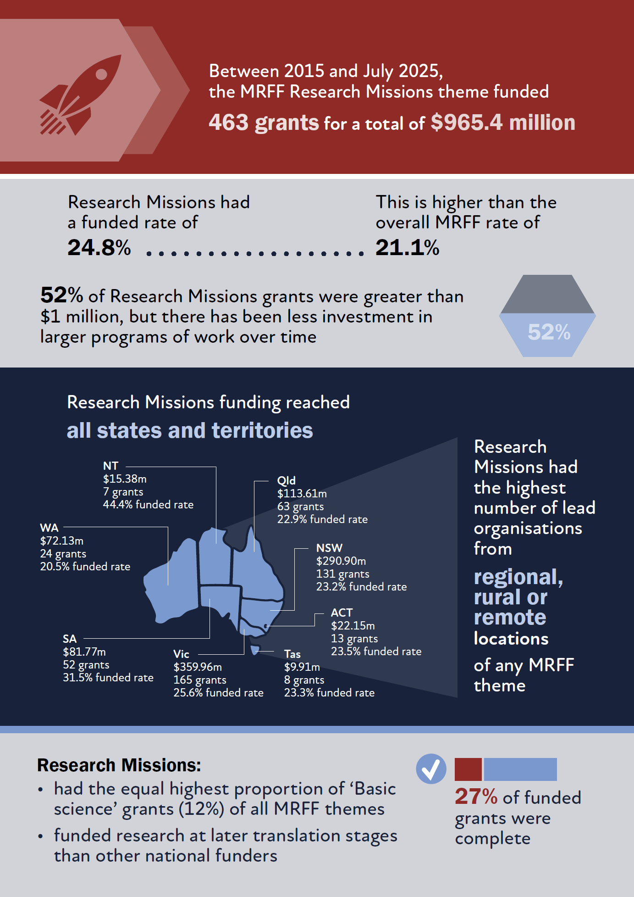

1.5.2 Alignment of Research Missions funding
All Research Missions disbursed funding for research relevant to their focus area. There was a significant degree of funding from other MRFF initiatives for cardiovascular health; dementia, ageing and aged care; Indigenous health; and mental health research. Stem cell therapies and traumatic brain injury have primarily received funding from their respective Research Missions. Of all the Research Missions focus areas, dementia, ageing and aged care have received contributions from the largest number of MRFF initiatives.

1.6 Progress and impact of Research Missions–funded research towards MRFF, program and Research Mission benchmarks
Significant or moderate progress has been made towards all Research Missions level aims. The Genomics Health Futures Mission, Million Minds Mental Health Research Mission and Traumatic Brain Injury Mission have made the most progress towards their respective aims.
Most stakeholders agreed that the Research Missions program was fulfilling, at least to some extent, its 3 aims of funding large programs; bringing together researchers, consumers and end users; and addressing significant health challenges. Most (69%) survey respondents who have been members of grant assessment committees thought that the overall aims of the Research Missions program were well considered as part of the assessment process.
Grant recipients received more than $124 million in cash and in-kind co-funding for research activities. Almost half of Research Missions grantees were working towards or had translated research outcomes into policy and practice, although challenges remain.
Regarding the MRFF measures of success (outlined in the MRFF Monitoring, evaluation and learning strategy), Research Missions grants most frequently focused on:
- areas of unmet need
- the community engaging with and adopting new technologies and treatments
- enabling researchers greater capacity to undertake translational research.
Research Missions grants least commonly focused on increased commercialisation of health research outcomes.
Most grants addressed at least one MRFF or Research Missions priority population. Most grants also included one or more consumer involvement activity. All research end users who responded to the public survey were actively involved in applications and research projects. Stakeholders recognised the role the MRFF has played in prioritising consumer participation via the MRFF principles for consumer involvement and application requirements and grant assessment criteria (updated October 2022). However, improvement is needed to ensure genuine consumer involvement throughout the research project. Funding has supported diverse research team members including medical professionals, early- and mid-career researchers, people from priority populations and industry-based researchers.
Nearly all grantees of Research Missions grants that were complete at the time of the 2024 performance indicator survey had undertaken activities supporting health and healthcare change. Most of those projects had resulted in outputs or outcomes supporting health and healthcare change, while more than a third had resulted in outputs or outcomes related to commercialisation.
A full breakdown of the progress and impact of the Research Missions program is in Section 6 of this report.
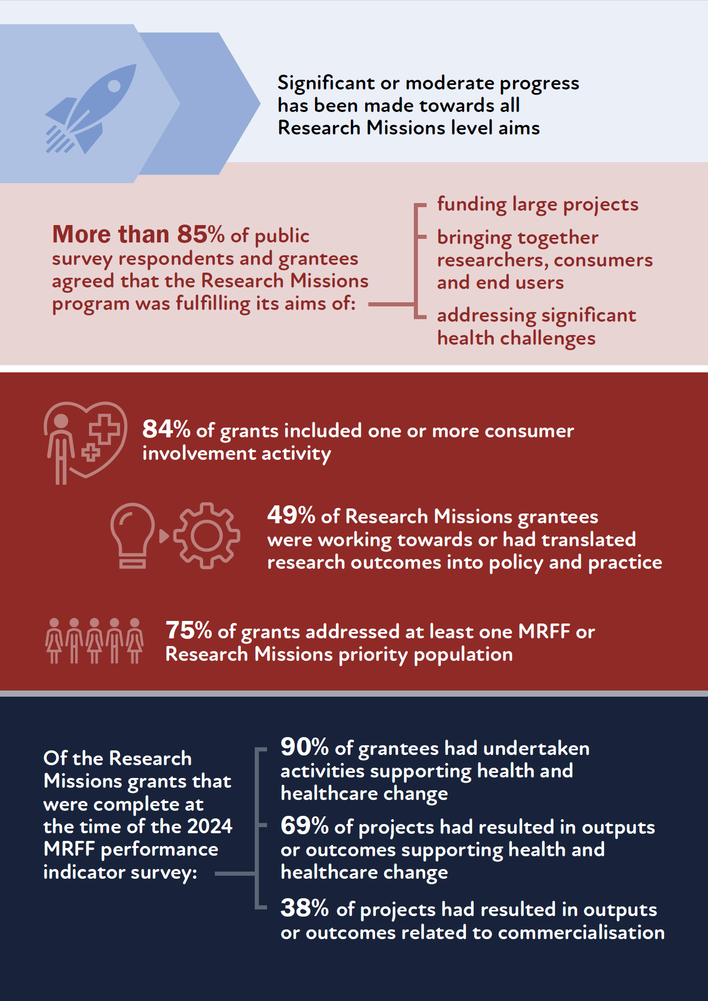

1.7 Opportunities to improve the impact of Research Missions
The evaluation identified several opportunities to improve the impact of the Research Missions program (Table 2). Some of these opportunities cannot be achieved by the MRFF alone and require broader collaboration across the health and medical research sector.
Table 2 Opportunities to improve the Research Missions program, and their data sources
Opportunity | Mid-term Research Mission reviews | Desktop analysis | Grantee survey | Consultations
Strategically shifting towards larger, longer-term grants and funding amounts to better facilitate Research Mission program aims
Strengthening research outcomes and translation through
application requirements
additional guidance and mechanisms
avenues for researchers to connect with research end users and relevant stakeholders (e.g. community, government, health systems, industry)
Providing better clarity on the evidence base to identify and prioritise Research Missions focus areas, and the priorities within each Research Mission | –
Strengthening mechanisms to ensure funding for priority populations, including funding across jurisdictions; for regional, rural and remote communities; and for Aboriginal and Torres Strait Islander communities |  |  | –
Developing mechanisms for better coordination to address shared priorities across Research Missions, MRFF initiatives, Government agencies and other research funders |  |  | –
Providing funding and supporting infrastructure for implementation of research findings |  | –
Strengthening communication of research successes and impact to consumers and end users, and of accountability of research progress and outcomes using meaningful evaluation metrics |  |  | –
Supporting more consistent and structured consumer and end-user involvement across the full Research Mission lifecycle |  | – | –
Streamlining and improving application, assessment and reporting processes | – | –
Having broader, less-prescriptive grant opportunity topics that are communicated early (e.g. via implementation plans) to allow researchers to plan early and collaborate | – | – | –
Although outside the scope of this evaluation, stakeholders also conveyed the need for increased funding to cover the full cost of research. This is a recognised issue for broader consideration across the health and medical research sector.
The findings and identified opportunities from this evaluation highlighted the features that make a priority area suitable for a Research Missions approach, and the considerations for determining Research Missions priorities. Specifying these will help inform future decision-making regarding the Research Missions program.
More details on these opportunities are in Section 7.1 of this report.
The features that make a priority area suitable for a Research Missions approach are:
- a clearly articulated, significant health challenge
- recognition of national strengths and capacity
- ambitious, long-term objectives that require structured, coordinated effort
- alignment with national priorities and gaps in the research landscape, and consideration of the international landscape
- emphasis on translation and real-world impact
- a distinct role within the broader funding system
- an impactful governance structure and evaluation.
The considerations for determining Research Missions priorities are:
- burden of disease and severity of impact
- unmet need, gaps and priority populations
- feasibility and potential for translation into policy, practice, system change or commercial outcome
- stakeholder and community input
- complementarity with other funding programs
- stage of the research pipeline and balance across stages
- emerging or future health challenges.

2 Background

2.1 The Medical Research Future Fund
The Australian Government’s Medical Research Future Fund (MRFF) is a $25.4 billion long-term investment supporting Australian health and medical research. The MRFF operates as an endowment fund, in which the net earnings serve as a permanent revenue stream for investment in health and medical research and innovation, with the capital preserved in perpetuity. The MRFF aims to transform health and medical research and innovation to improve lives, build the economy and contribute to health system sustainability.
MRFF funding is directed into 4 themes (Figure 1). There are 22 initiatives under these themes, as outlined in the MRFF 3rd 10-year Investment Plan (2024–25 to 2033–34).
Figure 1 The 4 MRFF themes
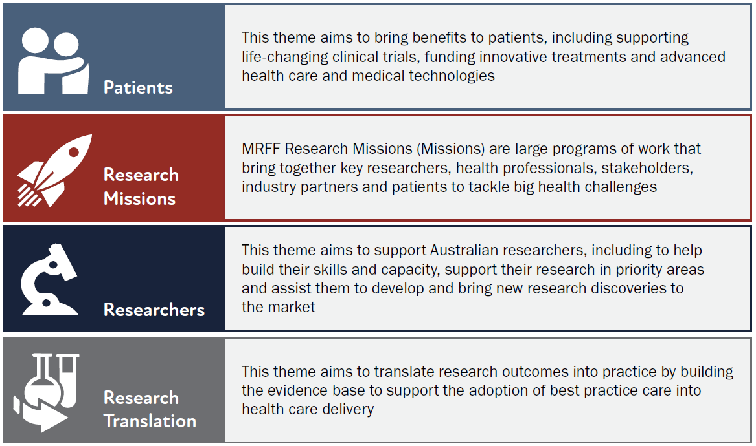
Source: MRFF 3rd 10-year Investment Plan (2024–25 to 2033–34).

2.2 The Research Missions theme
Research Missions are large programs of work that bring together key researchers, health professionals, stakeholders, industry partners and patients to tackle big health challenges.
The Research Missions theme will be referred to as ‘Research Missions program’ throughout this report.
There are 8 current Research Missions, 2 new Missions that will commence funding in the 2027–28 financial year, and a recently announced Arthritis and Musculoskeletal Conditions Research Mission:
- The Australian Brain Cancer Mission supports research into brain cancer treatments
- The Cardiovascular Health Mission brings together researchers, health professionals, industry and patients to make transformative improvements in heart and vascular health and stroke for all Australians
- The Dementia, Ageing and Aged Care Mission supports older Australians to maintain their health and quality of life as they age, live independently for longer and access quality care when they need it
- The Genomics Health Futures Mission will help improve testing and diagnosis for many diseases, help personalise treatment options to better target and improve health outcomes, and reduce unnecessary interventions and health costs
- The Indigenous Health Research Fund supports Indigenous-led research to tackle health issues facing Aboriginal and Torres Strait Islander people
- The Million Minds Mental Health Research Mission supports Australians with mental health issues by enabling access to new approaches to prevention, diagnosis, treatment and recovery
- The Stem Cell Therapies Mission is investing in the development of innovative, safe and effective treatments that improve health outcomes, in partnership with patients and carers
- The Traumatic Brain Injury Mission supports research to improve patient recovery after brain injury
- [New] The Low Survival Cancers Mission aims to improve care and health outcomes for people with cancers for which the average 5-year survival rate is less than 50%
- [New] The Reducing Health Inequities Mission supports research that improves access to high-quality health services for priority populations.
Each of these Missions is an MRFF initiative.
The Research Missions, like all MRFF initiatives, are determined by Government taking into consideration the MRFF Strategy and Priorities set by the Australian Medical Research Advisory Board, which are in turn based on public consultation with researchers and other stakeholders. All Research Missions differ from other MRFF themes in terms of governance structure and priority setting processes, even though this has evolved over time for the earlier Research Missions. Box 1 provides an overview of the Research Missions governance, priority setting, implementation and review processes.

Box 1. Research Missions governance, priority setting, implementation and review

Governance and priority setting
Research Missions are guided by expert advisory panels. These panels are appointed by Government to provide advice to the Minister for Health and Ageing. Their role is to define evidence, knowledge gaps and key research questions that should be addressed through Research Missions funding.
- Expert advisory panels develop roadmaps and implementation plans when Research Missions are established.
- Draft roadmaps and implementation plans undergo national public consultation before finalisation.
- For some Research Missions, expert advisory panels have also been involved in refreshing the roadmap and implementation plan near the midpoint of the Research Mission.
- The names and relevant interests of expert advisory panel members are published on the department’s website, and there are restrictions related to the funding that panel members can receive from the Research Missions they advise on.
- Consumers are included as full members of the expert advisory panels.
Research Missions roadmaps are short, high-level strategic documents that include:
- the aim, vision and goals for the Research Mission
- possible themes and priorities for investment.
Research Missions implementation plans support implementation of the roadmaps by outlining:
- questions/goals that
- describe how the Research Mission will benefit Australian patients
- guide investment priorities
- evaluate ongoing progress of the Mission
- priorities for investment, particularly defining research questions and outcomes for short-‍, medium- and long-term investment
- opportunities to leverage additional investment through philanthropy and other sectors, to support achievement of the Research Mission’s outcomes
- activities required to support the Research Mission’s outcomes and facilitate their longer-term implementation, including community and industry involvement.

Implementation
The department’s Health and Medical Research Office use the roadmaps and implementation plans to call for research proposals addressing the defined questions and expected outcomes.
Implementation plans are intended to provide certainty to researchers on topics for future funding calls. They are increasingly designed such that the identified priority topic, objectives, targeted years/timing of funding, and funding amounts directly feed into future grant opportunities under that Research Mission. The Australian Brain Cancer Mission, Genomics Health Futures Mission and Traumatic Brain Injury Mission are the most recently refreshed implementation plans that best exemplify this approach.
Researchers can then anticipate more-exact timing of funding calls via the MRFF grant opportunities forecast calendar.

Review
As outlined in the MRFF Monitoring, evaluation and learning strategy, Research Missions undergo review and evaluation activities proportionate to the size and nature of the program at the midpoint of the Mission. Mid-term review reports are available for the following Research Missions:
- Australian Brain Cancer Mission
- Cardiovascular Health Mission
- Dementia, Ageing and Aged Care Mission
- Genomics Futures Health Mission
- Million Minds Mental Health Research Mission
- Traumatic Brain Injury Mission.
Findings from these review activities have been incorporated into this evaluation.
The Indigenous Health Research Fund will undergo evaluation later in 2026, led by an Aboriginal and Torres Strait Islander Community-Controlled program.
The Stem Cell Therapies Mission has not undergone a dedicated mid-term review, due to the unique design of the implementation plan (in which funding priorities are repeated regularly) and the amount of funding remaining at the time of this present evaluation. Findings from this present evaluation will inform the future of the Stem Cells Therapies Mission.

2.3 Research Missions program evaluation
The department is undertaking an evaluation of the MRFF Research Missions program to:
- determine where Research Missions sit in the national and international research funding landscape
- determine contribution and progress at the individual Mission (initiative) level
- determine contribution and progress of the Research Missions program (theme)
- identify opportunities to improve the impact of the Research Missions
- provide evidence to support the Australian Government’s decision on whether to extend, cease or reshape individual Research Missions at the completion of the 10-year tenure.
The evaluation questions and lines of enquiry are:
- How do MRFF Research Missions sit in the national and international research funding landscape?
- How do Mission priorities sit against national priorities (including duplication with other MRFF initiatives and NHMRC), areas of national strengths or gaps, burden of disease, unmet and emerging needs?
- How does the MRFF Research Missions program compare with similar Mission-style programs funded by national and international funders?
- What is the alignment and contribution of funded research across and between Missions?
- What has been the contribution of the MRFF to the research funding landscape? By examining grant types, amounts and duration; priority population; organisation type and location; nature of research team and collaborations funded.
- How does the funded research align or compare across and between Missions and across the MRFF more broadly?
- What progress and impact has Mission-funded research had towards benchmarks?
- What has been the progress towards MRFF benchmarks (MRFF measures of success) for individual Missions and for the Missions program?
- What has been the progress towards Mission program benchmarks (program level aims)?
- What has been the progress towards individual Mission benchmarks (aims and priorities)?
- What are the opportunities to improve the impact of MRFF Research Missions?
- Are there improvements that could be made to Mission program delivery to better achieve its objectives?
- Are there improvements that could be made to Mission governance and evaluation processes?
- Are there other opportunities to improve the impact of the MRFF Research Missions?

2.3.1 Benchmarks
This evaluation assessed the progress of the Research Missions program in line with the aims and objectives articulated in each Research Mission implementation plan, the Government’s third 10-year MRFF investment plan, and the MRFF’s Monitoring, evaluation and learning strategy. The program logic for the assessment of research outcomes and impact is provided in Appendix A of the accompanying appendix document, with benchmarks reflecting the MRFF’s focus on supporting translational research.
Individual Research Mission benchmarks were based on the aims and objectives of individual Research Missions (outlined in Appendix B of the accompanying appendix document).
Research Missions program benchmarks were based on the aims of the Research Missions program:
- fund large programs of work
- bring together key researchers, health professionals, stakeholders, industry partners and patients/consumers
- tackle big health challenges.
MRFF benchmarks were based on the MRFF measures of success (Figure 2).
Figure 2 MRFF monitoring, evaluation and learning conceptual framework
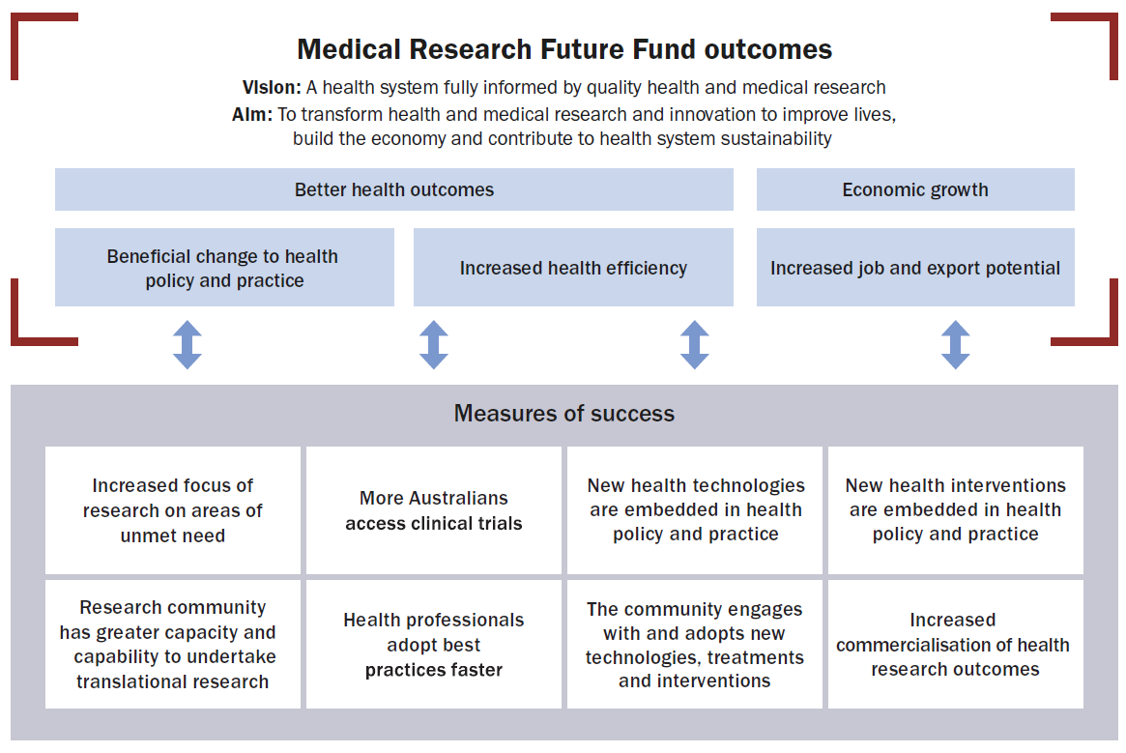

2.3.2 Scope
Within scope for this evaluation are all grants and grant opportunities funded under the Research Missions program as at 1 July 2025. This includes 463 grants totalling $965 million funded under 57 grant opportunities (see Section 5 for detailed analyses of Research Missions funding).
This evaluation did not assess the scientific quality, rigour or progress of individual grants. Rather, it assessed progress at the initiative (individual Research Mission) and program levels.
The 3 new Research Missions were not in scope for this evaluation as they had not yet disbursed funding (Reducing Health Inequities Mission and Low Survival Cancers Mission) or were announced after the evaluation was conducted (Arthritis and Musculoskeletal Conditions Research Mission). However, their aims and objectives were considered when identifying future opportunities for the Research Missions program.
This evaluation did not reassess key lines of enquiry from mid-term Mission reviews. If mid-term reviews had been completed by the time of the evaluation, this information was considered in the evaluation (see Section 3.1). The evaluation updated data arising from mid-term reviews when required.

2.3.3 Governance
This evaluation was undertaken by the Performance and Evaluation Section within the Health and Medical Research Office. This section is independent from the team that administers the Research Missions program (the Missions Strategy and Implementation Section).
The department established an independent Mission Evaluation Panel to guide and oversee the evaluation. Members have experience in research leadership, national and international Mission-style funding programs, health policy, consumer advocacy and First Nations health. The Mission Evaluation Panel supported the evaluation by:
- providing input into evaluation questions, lines of enquiry and the approach
- advising the department on the collection, analysis and interpretation of information supporting the evaluation
- providing expert advice and feedback on all deliverables.

2.4 Limitations
This evaluation had the following limitations:
- Grants in scope were determined when this evaluation commenced (1 July 2025). Grants awarded after this time were not in scope. Consequently, some analyses in this report may under-represent the contribution of MRFF-funded research to the funding landscape.
- Although every effort was made to ensure extensive stakeholder input into this evaluation, some invited stakeholders chose not to participate. Therefore, representation is not equal across stakeholder groups, and some views may not be captured.
- Some data used in this evaluation were captured before 1 July 2025 (as outlined in Section 3.1; for example, mid-term Mission reviews, MRFF performance indicators survey). Consequently, some analyses in this report may under-represent the impact of MRFF-funded research to the funding landscape.
- Using publicly available data to investigate other funders may have limited the extent of information obtained and coverage of research funders. For example, funders in the industry and philanthropy sectors do not usually provide details on research and development spending in public documents.
- Publication and citation metrics are recognised as commonly used research outputs. However, they have been less prioritised for reporting in this evaluation because
  - this reflects the emphasis on research translation in MRFF evaluation benchmarks (measures of success and impact measures) and assessment criteria
  - data collection is hampered by researchers not always attributing MRFF grant funding in their publications, and that most MRFF and Research Missions projects are incomplete at the time of this evaluation.

3 Methodology

3.1 Data sources and analysis
Table 3 provides an overview of the data sources used to inform this evaluation. Table 4 outlines how each data source contributed to the 4 evaluation questions.

Table 3 Data sources used to inform the evaluation
Data source | Focus | Date data collected | Number invited/in scope | Number of responses | Response rate
Publicly available and grey literature | National and international funding landscape | October 2025 | n/a | n/a | n/a
National Strategy for Health and Medical Research | National and international funding landscape | May 2026 | n/a | n/a | n/a
Australian Brain Cancer Mission mid-term review | Relevant Research Mission | December 2023 | n/a | n/a | n/a
Cardiovascular Health Mission mid-term review | Relevant Research Mission | February 2025 | n/a | n/a | n/a
Dementia, Ageing and Aged Care Mission mid-term review | Relevant Research Mission | August 2025 | n/a | n/a | n/a
Genomics Health Futures Mission mid-term review | Relevant Research Mission | September 2024 | n/a | n/a | n/a
Million Minds Mental Health Research Mission mid-term review | Relevant Research Mission | June 2022 | n/a | n/a | n/a
Traumatic Brain Injury Mission mid-term review | Relevant Research Mission | April 2025 | n/a | n/a | n/a
Grantee progress and final reports | Research Missions grantees | Date of final report or September 2025ª | Most recent report for 443 grants | n/a | 96%^{b}
Research Mission strategic documents (roadmaps and implementation plans) | Research Missions priorities | October 2025 | n/a | n/a | n/a
MRFF administrative data (application and grants data collected through administration processes) | Research Missions grants | Ongoing, analysed as at 1 July 2025 | 463 grants | n/a | n/a
MRFF performance indicator survey data | All MRFF grantees | May 2024 | 368 grantees | 295 | 80%
Grantee survey | Research Missions grantees | November to December 2025 | 463 grantees | 322 | 70%
Public survey | Open public forum | December 2025 to March 2026 | n/a | 189 | n/a
Targeted consultation (interviews) | Key stakeholders | January and February 2026 | 78 organisations | 44 organisations (79 individuals) | 56%^{c}
MRFF = Medical Research Future Fund; n/a = not applicable.
a If a final report or September 2025 progress report was not available, 2024 progress reports were used.
b Response rate is less than 100% because not all grantees had submitted their progress or final reports at the time of analysis.
c Several organisations chose to respond to the public survey rather than attend an interview.
Table 4 Contribution of data sources to the evaluation questions
Evaluation question | Line of enquiry | Public and grey literature | National Strategy | Research Mission reviews | Application and grants data | PI survey data | Grantee survey | Grantee progress reports | Public survey and interviews
1: How do MRFF Research Missions sit in the national and international research funding landscape? | How do Mission priorities sit against national priorities (including duplication with other MRFF initiatives and NHMRC), areas of national strengths or gaps, burden of disease, unmet and emerging needs? |  |  |  | – | – |  | –
1: How do MRFF Research Missions sit in the national and international research funding landscape? | How does the MRFF Research Missions Program compare with similar Mission-style programs funded by national and international funders? |  | – |  | – | – |  | –
2: What is the alignment and contribution of funded research across and between Missions? | What has been the contribution of the MRFF to the research funding landscape? | – | – |  |  | – | – | –
2: What is the alignment and contribution of funded research across and between Missions? | How does the funded research align or compare across and between Missions and across the MRFF more broadly? |  | – |  |  | – | – | – | –
3: What progress and impact has Mission-funded research had towards MRFF, program and Research Mission benchmarks? | What has been the progress towards MRFF benchmarks (MRFF measures of success) for individual Missions and for the Missions program? | – | – |  | – |  | –
3: What progress and impact has Mission-funded research had towards MRFF, program and Research Mission benchmarks? | What has been the progress towards Mission program benchmarks (program level aims)? | – | –
3: What progress and impact has Mission-funded research had towards MRFF, program and Research Mission benchmarks? | What has been the progress towards individual Mission benchmarks (aims and priorities)? | – | – |  |  |  |  | – | –
4: What are the opportunities to improve the impact of MRFF Research Missions? | Are there improvements that could be made to Mission program delivery to better achieve its objectives? |  | – |  |  | –
4: What are the opportunities to improve the impact of MRFF Research Missions? | Are there improvements that could be made to Mission governance and evaluation processes? |  | – |  |  | –
4: What are the opportunities to improve the impact of MRFF Research Missions? | Are there other opportunities to improve the impact of the MRFF Research Missions? |  |  |  | – | –
MRFF = Medical Research Future Fund; PI = performance indicator.

3.1.1 Grantee survey
The grantee survey was conducted using Microsoft Forms and was sent to the lead Chief Investigator for all grants in scope (n = 463). A copy of the survey is provided in Appendix C of the accompanying appendix document.
The survey was open from 10 November to 12 December 2025. Chief Investigators received advanced notification of the survey on 3 November 2025 and their unique survey link on 10 November 2025. Up to 2 reminder emails were sent to those who had not completed the survey. The survey was also communicated via the MRFF newsletter.
The overall survey response rate was 70% (322 responses for the 463 grants in scope). Table 5 provides a breakdown of responses by Research Mission. Most respondents were from universities or medical research institutes, reflecting the distribution of funding.
Table 5 Survey response rate by Research Mission
Research Mission | ABCM | CVHM | DAACM | GFHM | IHRF | MHRM | SCTM | TBIM | Total
Number of grants in scope | 12 | 102 | 63 | 96 | 69 | 43 | 64 | 14 | 463
Number of responses | 10 | 67 | 52 | 69 | 41 | 31 | 43 | 9 | 322
Response rate | 83% | 66% | 83% | 72% | 59% | 72% | 67% | 64% | 70%
ABCM = Australian Brain Cancer Mission; CVHM = Cardiovascular Health Mission; DAACM = Dementia, Ageing and Aged Care Mission; GFHM = Genomics Futures Health Mission; IHRF = Indigenous Health Research Fund; MHRM = Million Minds Mental Health Research Mission; SCTM = Stem Cell Therapies Mission; TBIM = Traumatic Brain Injury Mission.
Source: Grantee survey.
Quantitative data were analysed by response rate or frequency and are presented in figures throughout this report. Analysis was completed at Research Missions program level and for individual Research Missions where appropriate.
A structured, multistage approach was used to analyse qualitative survey responses, combining artificial intelligence (Microsoft 365 Copilot) with thorough human review and validation. Copilot was used to perform an initial thematic analysis, generating a list of key topics (‘thematic codes’). To ensure accuracy and relevance, an evaluator reviewed each theme in detail. All responses for a theme were examined to identify key points and recurring issues, and to assess prominence. Additional recoding was performed when needed for consistency and accuracy.

3.1.2 Public survey
The public survey was conducted using the department’s Consultation Hub. A copy of the survey is provided in Appendix D of the accompanying appendix document.
The public survey was open from 2 December 2025 to 2 March 2026. It was promoted via:
- the MRFF newsletter on 27 November and 18 December 2025, and on 2 February 2026
- multiple department social media posts
- a request to peak bodies and organisations to share the survey link with their members (n = 52 organisations).
The public survey received 189 responses. Approximately 10% of survey responses were consolidated responses on behalf of organisations (for example, medical research institutes, universities, advocacy organisations, peak bodies) rather than from individuals. Responses from medical research institutes and universities were combined with those from health and medical researchers to make up the ‘health and medical researcher or research organisation’ category. Individual and consolidated responses from advocacy organisations, peak bodies and associations were combined into the ‘advocacy organisation, peak body or association’ category. Four responses were categorised as ‘other’ because they did not fit into any other category.
The highest number of responses were from health and medical researchers or research organisations (92), followed by consumers, carers or community members (52) (Figure 3). Victoria had the highest number of respondents of any state or territory (58), followed by New South Wales (49) and Queensland (30) (Table 6).
Figure 3 Familiarity with the Research Missions program, by respondent category
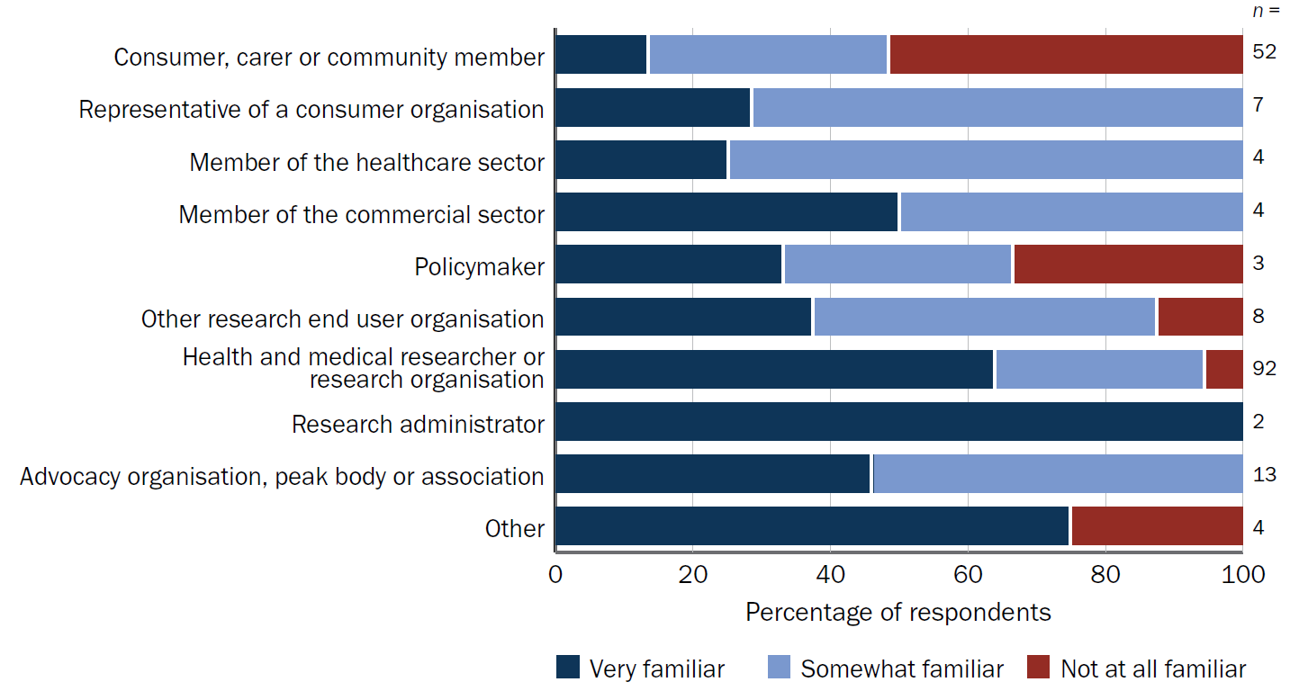
Source: Public survey.
Table 6 Public survey respondents by state or territory
State or territory | Number of responses | Percentage of responses
Australian Capital Territory | 13 | 6.9%
New South Wales | 49 | 25.9%
Northern Territory | 4 | 2.1%
Queensland | 30 | 15.9%
South Australia | 10 | 5.3%
Tasmania | 3 | 1.6%
Victoria | 58 | 30.7%
Western Australia | 22 | 11.6%
Total | 189 | 100.0%
Source: Public survey.
Most survey respondents (82%) were very or somewhat familiar with the Research Missions program. Respondents from the ‘consumer, carer or community member’ category were the least familiar with the program (52%) (Figure 3).
Approximately half (n = 94) of all survey respondents had been involved in at least one application to the Research Missions program, and 71% (n = 67) of these respondents had also been involved in at least one successful grant (Figure 4). Health and medical researchers or research organisations were involved in more applications (n = 71; 76% of all respondents involved in an application) and successful grants (n = 52; 78% of all respondents involved in a successful grant) than the total respondents from other categories (23 involved in applications and 15 in successful grants, collectively).
Figure 4 Public survey respondent involvement in applications and successful grants
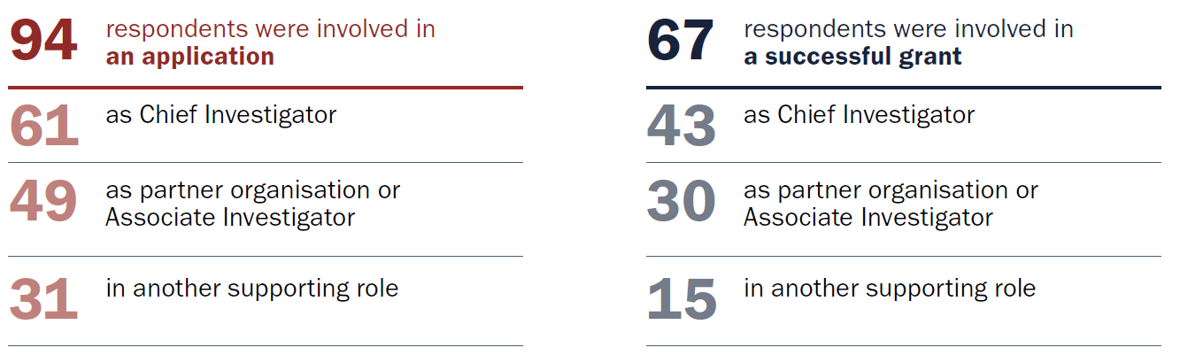
Note: Some respondents have multiple roles.
Source: Public survey.
Survey respondents were also asked about any additional involvement with the Research Missions program.
- Some respondents were involved in previous consultation activities including
  - on Research Mission strategic documents (11%)
  - to inform Research Mission review activities (10%).
- Some respondents were members of an expert advisory panel designing or refreshing the Research Missions strategic documents (10%).
- Some respondents participated in grant assessment committees (16%).
Quantitative data were analysed by response rate or frequency and are presented in figures throughout this report. Data are presented either by respondent category (see Figure 7) overall response or aggregated into 2 broad categories: ‘Health and medical researcher or research organisation’ and ‘Research end user’.

3.1.3 Targeted consultations
The department conducted virtual, semistructured group (n = 11) and individual (n = 6) interviews, involving a total of 79 individuals representing 44 organisations, in January and February 2026 (Figure 5; also see Appendix E of the accompanying appendix document). The department developed the list of stakeholders and finalised it in consultation with the Mission Evaluation Panel. Tailored interview topics were developed for each interview (see Appendix E of the accompanying appendix document).
Figure 5 Stakeholder interview participants by organisation category
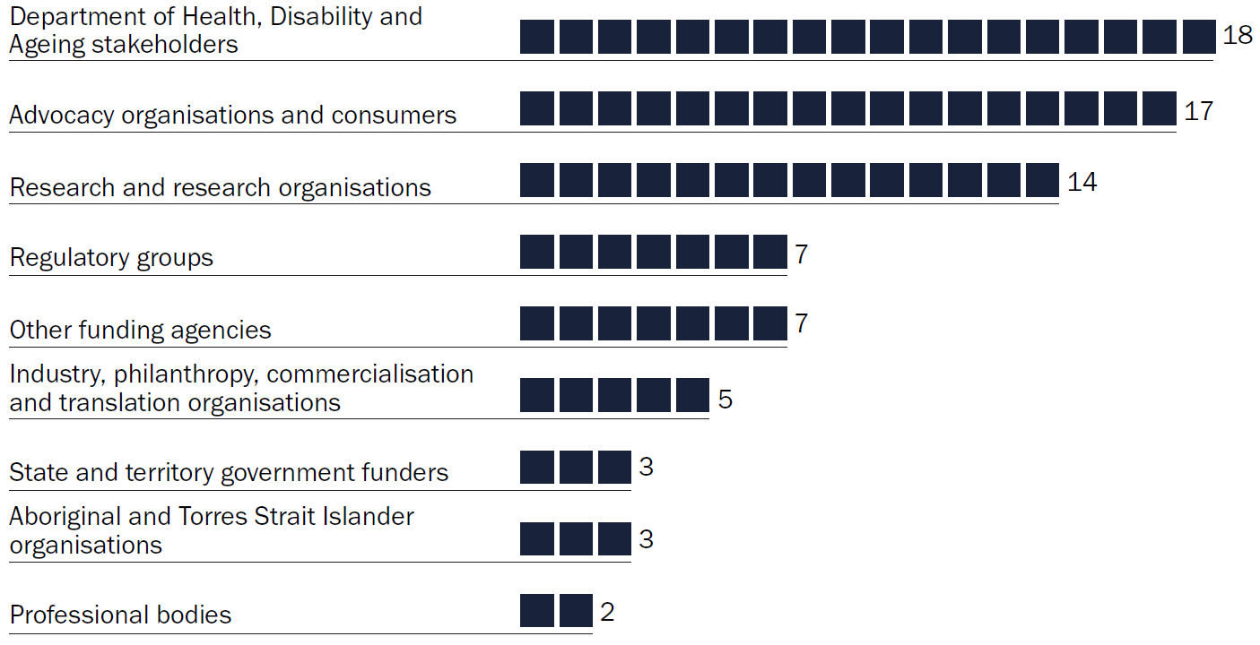
Source: See Appendix E of the accompanying appendix document.
As per the grantee survey, the department conducted all analyses of public survey and stakeholder consultation data. The thematic analysis was supported by artificial intelligence–based approaches within the department’s secure enterprise platform.
All interviews were automatically transcribed, and meeting summaries produced, using Microsoft 365 Teams and Copilot (with interviewee consent). A departmental attendee and the session facilitator reviewed the summaries to ensure they accurately captured the consultation session.
For stakeholder interviews, Copilot was used to create transcripts and summarise themes across all interview sessions. An evaluator manually analysed and coded the qualitative themes. Natural language processing techniques (Google Gemini) were then used to analyse text‑based consultation material from public survey data and stakeholder interviews. This analysis identified statements relating to concerns, suggestions, considerations and positive impacts, which were then categorised into one of 7 overarching themes and 19 sub‑themes based on the earlier identified themes. Where practical, a random sample of 10% of the categorised material was reviewed to provide assurance that the model was performing to a reasonable standard.
Although steps were taken to maximise accuracy, these models are inherently imperfect, and classification of this nature involves a degree of subjectivity. As such, outputs should be treated as indicative rather than definitive. Where needed, themes and quotes were manually verified against raw session transcripts.
Across all analyses involving natural language processing, results were used to complement evaluators’ assessment of the original consultation material, not replace their judgement.

3.1.4 Analysis of themes by stakeholder group
Stakeholder views were collected from several sources: the grantee survey, the public survey and targeted interviews. Where appropriate, quantitative data from different sources have been presented alongside one another in this report to provide additional insights.
The themes identified from qualitative assessment of the consultations were similar across the different data sources. They have been combined in Section 4.1, Section 6 and Section 7 of this report to capture broad perspectives. Section 6.5 outlines the themes identified from the grantee survey, public survey and targeted consultations.
Information from targeted interviews was used to complement public and grantee survey data. Interviews allowed the opportunity for more detailed discussion and greater nuance in responses.

3.1.5 Document review
Targeted review of program and project documentation was undertaken to complement other data sources used in this evaluation. The review included:
- the National Strategy for Health and Medical Research – the strategy and documents produced to support its development were reviewed, and relevant findings and recommendations have been incorporated in this report. The purpose of this review was to better understand the funding landscape, and to incorporate concerns and recommendations that were relevant to this evaluation.
- mid-term Research Mission reviews – as outlined in Box 1 (Section 2.2), 6 of the 8 Research Missions have undergone a mid-term review. Relevant findings from these reviews have been incorporated into this evaluation.
- Research Mission strategic documents – Research Mission aims and priorities, as outlined in their implementation plans and roadmaps, have been used as benchmarks for this evaluation.
- grantee progress and final reports – a total of 443 grantee reports (112 final reports and 331 progress reports) were reviewed and used to
  - assess the stage of grants (completed, in progress)
  - determine which MRFF measures of success had been addressed by the grants and what progress had been made towards achieving those measures of success
  - identify common barriers and enablers to implementation and translation of research outcomes.

3.1.6 Performance indicator survey
The MRFF performance indicators provide a framework for assessing the progress made towards the 8 MRFF measures of success and, in the longer term, the impact of the MRFF. In May 2024, the department captured performance indicator data via a survey of all (then) current and past grantees.
Data for 368 grants in scope for this evaluation (295 responses) were extracted from the MRFF performance indicator dataset, and have been analysed and presented in figures throughout this report. Analysis was completed at Research Missions program level and for individual Research Missions when appropriate.

3.1.7 MRFF administrative data
The department holds administrative data on applications and grants funded through the MRFF. This includes data such as funded rates, funded amounts, geographic location and alignment with Research Missions focus areas and priorities. This data was analysed to understand how the Research Missions program has contributed to the funding landscape, and its alignment with priorities and research areas.
Quantitative data are presented in figures throughout this report. Analysis was completed at Research Missions program level and for individual Research Missions when appropriate.

3.1.8 Publicly available and grey literature
Publicly available information and grey literature were reviewed to provide a high-level overview of Australia’s research priorities, strengths, burden of disease and significant national funders of Research Missions focus areas. This provides a better understanding of the context in which the Research Missions are operating. In addition, publicly available information about other Mission-style funders was reviewed to identify opportunities to increase the impact of the Research Missions program.
Significant national funders were defined as either:
- large-scale national funders that have demonstrated significant research investment in the Research Missions area of research
- priority-driven funders focused on understanding the Research Missions area of research.
A list of key words for each Research Missions area of interest (see Appendix F of the accompanying appendix document) was used to search the Dimensions AI database (Digital Science Solutions, London, UK) to identify Australian funders of the research area. Top funders were assessed using publicly available information to determine if they met the significant national funder criteria. Information on funders that did not meet the criteria (for example, state and territory health and medical research funding programs) have been noted in Section 4.2 where relevant.
Funders were then analysed in terms of quanta of research funding, research priorities and coverage along the research pipeline.

4 Position of Research Missions in the national and international funding landscape
This section addresses the following evaluation questions:
- How do MRFF Research Missions sit in the national and international research funding landscape?
- What is the alignment and contribution of funded research across and between Missions?
Section 4.1 addresses the national landscape – priorities, research strengths, burden of disease and unmet need.
Lines of enquiry addressed:
- How do Mission priorities sit against national priorities, areas of national strengths or gaps, burden of disease, unmet and emerging needs?
- What has been the contribution of the MRFF to the research funding landscape?
Data sources: Publicly available and grey literature, National Strategy for Health and Medical Research, targeted consultations, public survey
Section 4.2 compares MRFF Research Missions to other significant national funders.
Lines of enquiry addressed:
- How do Mission priorities sit against national priorities, areas of national strengths or gaps, burden of disease, unmet and emerging needs?
- What has been the contribution of the MRFF to the research funding landscape?
Data sources: Publicly available and grey literature, MRFF administrative data, previous MRFF review and evaluation activities
Section 4.3 reviews other Mission-style funding programs.
Lines of enquiry addressed:
- How does the MRFF Research Missions program compare with similar Mission-style programs funded by national and international funders?
Data sources: Publicly available and grey literature, targeted consultations, public survey, grantee survey

4.1 National landscape – priorities, research strengths, burden of disease and unmet need
A high-level overview of Australia’s research priorities, strengths and burden of disease was undertaken to better understand the context in which the MRFF Research Missions are operating.

Summary findings

National priorities
- Australia’s research priorities are guided by nationally agreed frameworks, including Australia’s National Science and Research Priorities.
- These priorities are broad and cross‑sectoral, providing context rather than disease‑specific direction for health and medical research investment.
- The MRFF Research Missions priorities align with National Science and Research Priorities 2 and 3 (‘Supporting healthy and thriving communities’ and ‘Elevating Aboriginal and Torres Strait Islander knowledge systems’).
- The National Health and Medical Research Strategy 2026–2036 sets out a 10-year vision for strengthening Australia’s health and medical research system. It includes a focus on national priority setting, collaborative platforms and networks, and coordinated horizon scanning, to which the Research Missions can contribute and leverage.

Australia’s research strengths
Collectively, Excellence in Research for Australia (2018), publications data and stakeholder views indicate that the following fields of research are strengths for Australian researchers:
- clinical sciences and clinical trials
- genetics
- human movement and sports science
- Indigenous health
- macromolecular and materials chemistry
- microbiology and medical microbiology
- neuroscience
- nursing
- nutrition and dietetics
- oncology and carcinogenesis
- psychology
- public health and health services.

Burden of disease
- Analysis of burden of disease trends over time shows increasing burden for mental and substance use disorders and dementia. Conversely, disease burden has been decreasing for cardiovascular disease and some cancers, including brain and central nervous system cancers.
- The Research Missions currently fund research directly addressing aspects of 5 of the 6 disease groups with the highest burden of disease, i.e. excluding musculoskeletal disorders (Table 7):
- cancer and other neoplasms though the Australian Brain Cancer Mission and Low Survival Cancers Mission (from 2027–28)
- mental and substance use disorders through the Million Minds Mental Health Research Mission
- cardiovascular diseases and stroke through the Cardiovascular Health Mission
- neurological conditions through the Dementia, Ageing and Aged Care Mission
- brain injury by external cause through the Traumatic Brain Injury Mission and suicide injury through the Million Minds Mental Health Research Mission.
- The Australian Government has recently announced the establishment of a new Arthritis and Musculoskeletal Conditions Research Mission.

Gaps and unmet need
Stakeholders proposed emerging or unmet needs within the Research Missions focus areas:
- research that could sit under the remit of an existing Research Mission but may not be a named priority
- health challenges that are broader in nature and could be within the remit of several existing Research Missions.

4.1.1 National priorities

National Science and Research Priorities
Australia’s National Science and Research Priorities, developed every 10 years in consultation with leaders from industry, research and government, are designed to guide Australian science and research efforts by the Australian Government, university and private sectors. Current priorities are:
- transitioning to a net zero future
- supporting healthy and thriving communities
- elevating Aboriginal and Torres Strait Islander knowledge systems
- protecting and restoring Australia’s environment
- building a secure and resilient nation.
This evaluation investigated the alignment of MRFF priorities with the National Science and Research Priorities to identify areas of overlap as well as differences. Given the purpose of the MRFF is to fund health and medical research, national priorities 1, 4 and 5 were excluded from analysis. The analysis found that:
- the critical research to achieve National Science and Research priority 2 overlaps significantly with the priorities of the MRFF, although for most MRFF Research Mission priorities, there is a focus on a specific disease or research area
- National Science and Research priority 3 is broader than health and medical research, and the critical research to achieve priority 3 overlaps partially with MRFF priorities; several Research Missions have priorities related to Aboriginal and Torres Strait Islander health
- the critical research area that overlaps the least with MRFF priorities is ‘Likely impacts of climate change on communities’ physical and mental health’ (as part of national priority 2) – this research area aligns with one priority of the Million Minds Mental Health Research Mission, as well as the Global Health initiative. The MRFF does not have a specific focus on climate change adaption approaches to support regional and remote Aboriginal and Torres Strait Islander communities (national priority 3).

Australian Medical Research and Innovation Strategy and Priorities
In accordance with the Medical Research Future Fund Act 2015 (the MRFF Act), the independent Australian Medical Research Advisory Board develops the Australian Medical Research and Innovation Strategy every 5 years and the Australian Medical Research and Innovation Priorities every 2 years following a national consultation process. The Australian Medical Research and Innovation Strategy and Priorities inform where Government directs MRFF investments in research. They also inform the basis for the MRFF’s 10-year investment plans, which set out the level of financial support for each of the MRFF’s initiatives including the Research Missions.

National Health and Medical Research Strategy
To provide an overarching direction for health and medical research in Australia, the National Health and Medical Research Strategy 2026–2036 was released in May 2026. The strategy sets out a 10-year vision for strengthening Australia’s health and medical research system.
The strategy lists 5 focus areas:
- Strengthen a vibrant research system that delivers for the nation
  - Discovery and basic science research
  - National priority setting and horizon scanning
  - Collaborative platforms and networks
  - National coordination, governance and evaluation
- Accelerate Indigenous-led research and its translation to improve Aboriginal and Torres Strait Islander peoples’ health and wellbeing
  - Aboriginal and Torres Strait Islander peoples’ ways of knowing, being and doing
  - Community partnership and implementation
  - Aboriginal and Torres Strait Islander leadership and workforce capacity and capability building
- Deliver high-value care through the timely translation and implementation of research findings into healthcare policy and practice
  - Translation into health systems policy and practice
  - Clinical trials, health services and public health research
  - Consumers and communities as research collaborators
  - Place-based regional, rural and remote research
- Drive impact through strengthened research development and commercialisation
  - Research-industry partnerships and integration
  - Sovereign capability and innovation
  - Access to capital and risk sharing
- Maximise the benefits of advanced technologies and be ready for future challenges
  - Global partnerships
  - Advanced therapeutics and technologies
  - Environmental sustainability and resilience.

4.1.2 Australia’s research strengths

Excellence in Research for Australia
Until recently, an important metric for assessing research excellence in Australia was Excellence in Research for Australia (ERA), administered by the Australian Research Council (ARC). ERA:
- assessed the quality of research conducted in each research discipline (field of research) in Australia’s higher education institutions using a suite of indicators
- compared the quality of Australian research to international benchmarks
- assigned the quality of research a rating between 1 and 5.
The 2023 ERA round was paused, and a new research evaluation approach is currently being considered in the context of the Government’s response to the Australian Universities Accord. Noting this limitation, historical results from the most recent ERA round (2018) are included in this report as one set of metrics to describe Australia’s research strengths, with nursing, psychology, human movement and sports science, and clinical sciences among the strongest fields (see Appendix G of the accompanying appendix document).

Publications involving Australian research organisations
Research excellence in terms of bibliometrics was determined by analysing the 4-digit field of research codes of publications from between 2016 and 2025 that involved at least one named author at an Australian research organisation.
The average field citation ratio (Digital Science, UK) varied among the fields of research. Publications from the ‘Medical microbiology’, ‘Clinical and health psychology’ and ‘Macromolecular and materials chemistry’ fields of research had the highest average field citation ratio of all fields of research. The ‘Clinical sciences’ and ‘Health services and systems’ fields of research had the greatest number of publications. Further detail is provided in Figure G2 of Appendix G in the accompanying appendix document.

Stakeholder views on Australia’s research strengths
Stakeholders invited for targeted consultation (see Appendix E of the accompanying appendix document) provided their views on Australia’s research strengths. The most common areas mentioned as strengths were clinical trials/research and Indigenous health.
Basic medical research, infectious diseases and medical device development were other strong research areas mentioned. Stakeholders also noted Australia’s strength in training high-calibre researchers, and the collaboration between researchers and organisations that is strengthened by well-established networks and collaborative funding systems.
In addition, previous reviews and evaluations identified aspects of Research Missions focus areas as national strengths. These are captured in Section 4.2.

4.1.3 Burden of disease in Australia
Burden of disease measures the impact of diseases and injuries on a population. The summary metric ‘disability-adjusted life years’ (DALY) measures the years of healthy life lost from death and illness. The Australian Burden of Disease Study 2024 includes estimates of disease burden for 220 diseases and injuries in Australia in 2024. The disease groups that caused the most burden in 2024 are outlined in Table 7.
Table 7 Percentage of total burden for the leading 10 disease groups in 2024
Percentage of total burden | Disease group | Specific diseases and their percentage of total burden
16.4% | Cancer and other neoplasms | Lung cancer (2.7%); bowel cancer (1.7%); breast cancer (1.3%); pancreatic cancer (1.1%); prostate cancer (1.0%)
14.8% | Mental and substance use disorders | Anxiety disorders (3.9%); depressive disorders (3.1%); autism spectrum disorders (1.8%); alcohol use disorders (1.3%); eating disorders (1.0%); drug use disorders, excluding alcohol (1.0%)
12.7% | Musculoskeletal disorders | Back pain and problems (4.3%); other musculoskeletal disorders (3.8%); osteoarthritis (2.5%); rheumatoid arthritis (2.0%)
11.8% | Cardiovascular diseases | Coronary heart disease (5.5%); stroke (2.2%); atrial fibrillation and flutter (1.2%); other cardiovascular diseases (0.9%); non-rheumatic valvular disease (0.6%)
8.4% | Neurological conditions | Dementia (4.5%); other neurological conditions (0.9%); Parkinsons disease (0.8%); migraine (0.8%); epilepsy (0.8%)
7.9% | Injury (external cause) | Suicide and self-inflicted injuries (2.8%); falls (1.6%); poisoning (1.2%); road traffic injuries – motor vehicle occupants (0.6%); other (0.5%)
7.2% | Respiratory diseases | Chronic obstructive pulmonary disease (3.7%); asthma (2.5%); interstitial lung disease (0.4%); upper respiratory conditions (0.4%); other (0.2%)
3.3% | Gastrointestinal disorders | Chronic liver disease (1.2%); inflammatory bowel disease (0.5%); functional gastrointestinal disorders (0.4%); gastro-oesophageal reflux disease (0.2%); intestinal obstruction (without hernia) (0.2%); other (0.2%)
2.7% | Endocrine disorders | Type 2 diabetes mellitus (2.2%); type one diabetes mellitus (0.3%); other (0.2%)
2.6% | Infectious diseases | Lower respiratory infections (0.8%); COVID-19 (0.8%); other gastrointestinal infections (0.3%); other infections (0.3%); urinary tract infections (0.2%)
Source: Australian Burden of Disease Study 2024.
The Australian Burden of Disease Study 2024 also reports on changes in burden over time. Changes can occur due to differences in population size or ageing, disease prevalence, or how causes are reported or coded in health data. Figure 6 shows changes in DALY rates over time for diseases relevant to the Research Missions (that have data available). The years of healthy life lost from death and illness have decreased for cardiovascular disease and brain and central nervous system cancers, but increased for dementia and mental and substance use disorders.
Figure 6 Changes in age-standardised DALY rates for Mission-relevant diseases, 2003 to 2024
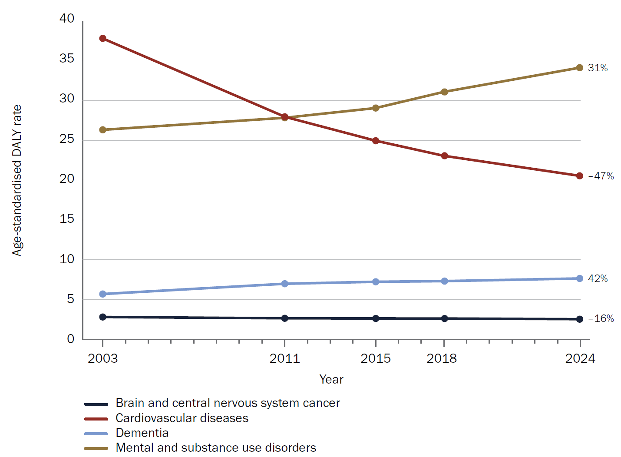
Source: Australian Burden of Disease Study 2024.

4.1.4 Stakeholder views on unmet needs within the current Research Missions focus areas
Through the public and grantee surveys and targeted consultations, stakeholders were asked to identify emerging or unmet needs within Research Missions focus areas, with consideration of the overall aims of the Research Missions program. Responses to this question fell into 3 main categories: areas of research within the broad remit of a current Research Mission, areas of research that cut across the Research Missions program, and new Research Missions topics.

Areas of research within the broad remit of a current Research Mission
Several stakeholders identified emerging or unmet needs that could fall under the remit of an existing Research Mission but may not be a named priority or remain an unmet need, including:
- research into the persistent health inequities experienced by Aboriginal and Torres Strait Islander peoples – participants highlighted the need to address the workload borne by Aboriginal and Torres Strait Islander researchers (for example, dedicated capacity building within grants)
- unmet or future needs within genomics research, including the transformative potential of genomics research (for example, personalised and precision-based health care), requirements for enhanced data infrastructure (for example, central repository for data sets, funding for long-term data storage and infrastructure), research into new models of care, and ensuring equitable access to genomic advances
- research to support the recommendations arising from the Royal Commission into Aged Care Quality and Safety, and research into falls prevention
- tailored suicide prevention strategies for LGBTQI+ communities.

Areas of research that cut across the Research Missions program
Stakeholders identified areas of unmet or emerging need that are broad and could be within the remit of several existing Research Missions. These included an increased focus on:
- priority populations, such as those with low socioeconomic status; gender diverse populations; LGBTIQ+ community members; regional, rural and remote populations; people with disabilities; women; and those experiencing intersectional disadvantage. The elderly population was also identified as a gap in much of the research evidence presented to regulatory areas
- prevention research
- rare conditions, including non-oncological rare diseases; conditions that are too rare to be included in effectiveness studies; and research into addressing the ‘diagnostic odyssey’ and access to existing therapies.
Additional suggestions included:
- population-level screening, and increased focus on chronic diseases and life expectancy
- embedding health services, implementation science and health economics research
- increased focus on allied health
- continuity of funding and support along the pipeline of research to translation or commercialisation, both from the MRFF (Missions program and other initiatives) and across the funding landscape
- increased support for translation activities
- digital innovation and the use of artificial intelligence in health care
- hospital reform and health system effectiveness
- repurposing of medicines, with a stronger emphasis on usage that is already occurring in community than on whether a drug can be repurposed.

New Research Missions topics
Stakeholders suggested new Research Missions topics, which the department will consider in the future. Given this is beyond the scope of this evaluation, the specific topics are not included in this report.

4.2 Comparison to significant national funders
This evaluation includes a high-level comparison of the MRFF with significant national funders of Research Missions focus areas. Specifically, it compares:
- quanta of research funding
- research priorities
- coverage along the research pipeline
- innovative and creative approaches to implementing research priorities.
The purpose of this comparison is to determine how MRFF Research Mission priorities and funding strategies align with or differ from national counterparts, and to identify opportunities to improve the impact of MRFF-funded research.

Summary findings
- The funder landscape relevant to each Research Mission is summarised in Figure 7, with supporting data in Appendix H of the accompanying appendix document.
- The National Health and Medical Research Council (NHMRC) was identified as a significant national funder for all Research Missions focus areas (Figure 7).
- The MRFF is the main funder of brain cancer and genomics research.
- The MRFF and NHMRC fund cardiovascular and Indigenous health research to a similar extent.
- The NHMRC is the main funder of dementia, ageing and aged care research; mental health research; stem cell therapies research; and traumatic brain injury research.
- Most Research Missions priorities are similar to those for significant national funders.
- The priorities of the Australian Brain Cancer Mission, Stem Cell Therapies Mission and Traumatic Brain Injury Mission had the least overlap with national funders.
- The MRFF generally funds research later in the research translation pipeline than the NHMRC and other significant national funders (Figure 7, Figure 8).
- This was especially apparent in brain cancer and genomics research.
- Indigenous health research is an exception, with the NHMRC and MRFF funding grants at a similar stage in the pipeline.
- Significant national funders have characteristics that differ from the approach used by the MRFF Research Missions. These characteristics include
- formal partnerships with other research funders and/or third-party organisations to support implementation of their priorities
- dedicated funding (fellowship schemes) to support early- to mid-career researchers and clinician researchers
- dedicated schemes to support translation and commercialisation of research outcomes.
- identification of women as a priority population
- a commitment to spend at least 5% of funding on Aboriginal and Torres Strait Islander health research each year.
- MRFF’s consumer involvement strategies have strengthened over the years and are more extensive than those for the significant national funders analysed.
Figure 7 Median grant size, quanta of funding and indicative position in the research translation pipeline for the MRFF and significant national funders
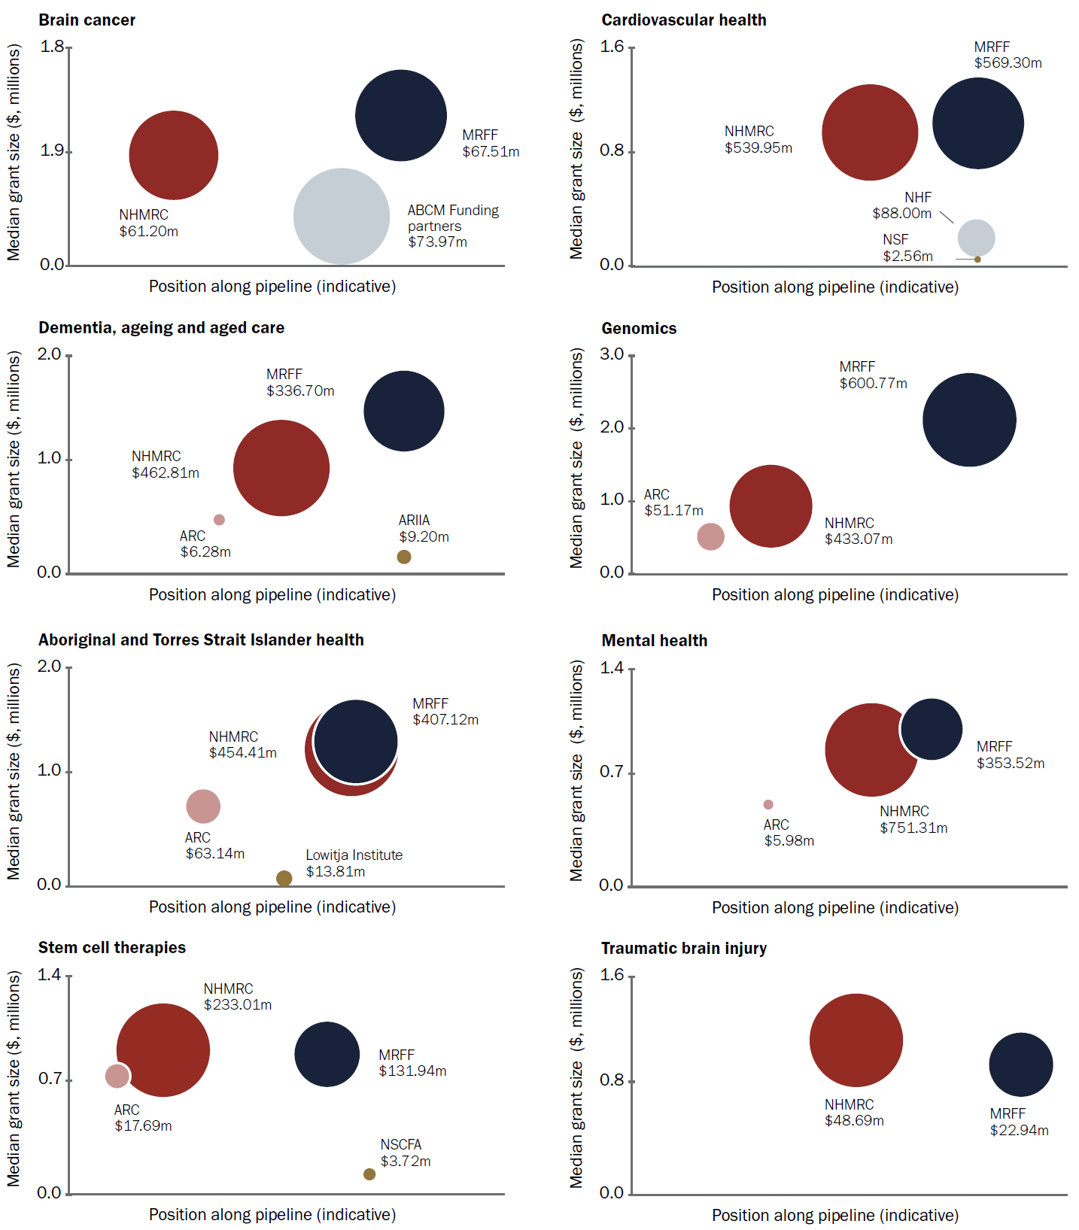
ABCM = Australian Brain Cancer Mission; ARC = Australian Research Council; ARIIA = Aged Care Research and Industry Innovation Australia; MRFF = Medical Research Future Fund; NHF = National Heart Foundation of Australia; NHMRC = National Health and Medical Research Council; NSF = National Stroke Foundation of Australia; NSCFA = National Stem Cell Foundation of Australia.
Notes: Median grant size for ABCM funding partners is approximate, as data were unavailable for some funders.
The median grant sizes for NHF and NSF are approximate averages based on expected funding per grant and number of grants awarded in 2024 (NHF) and 2025 (NSF).
The grant sizes for ARIIA, the Lowitja Institute and the NSCFA are averages, not medians, as there was insufficient information to determine the medians.
Source: Publicly available data, data from comparator funders, MRFF administrative data.
Figure 8 Broad research area classification of Mission focus area–related grants funded by the Research Missions, MRFF (all related research, funded through the Missions and other MRFF initiatives) and NHMRC
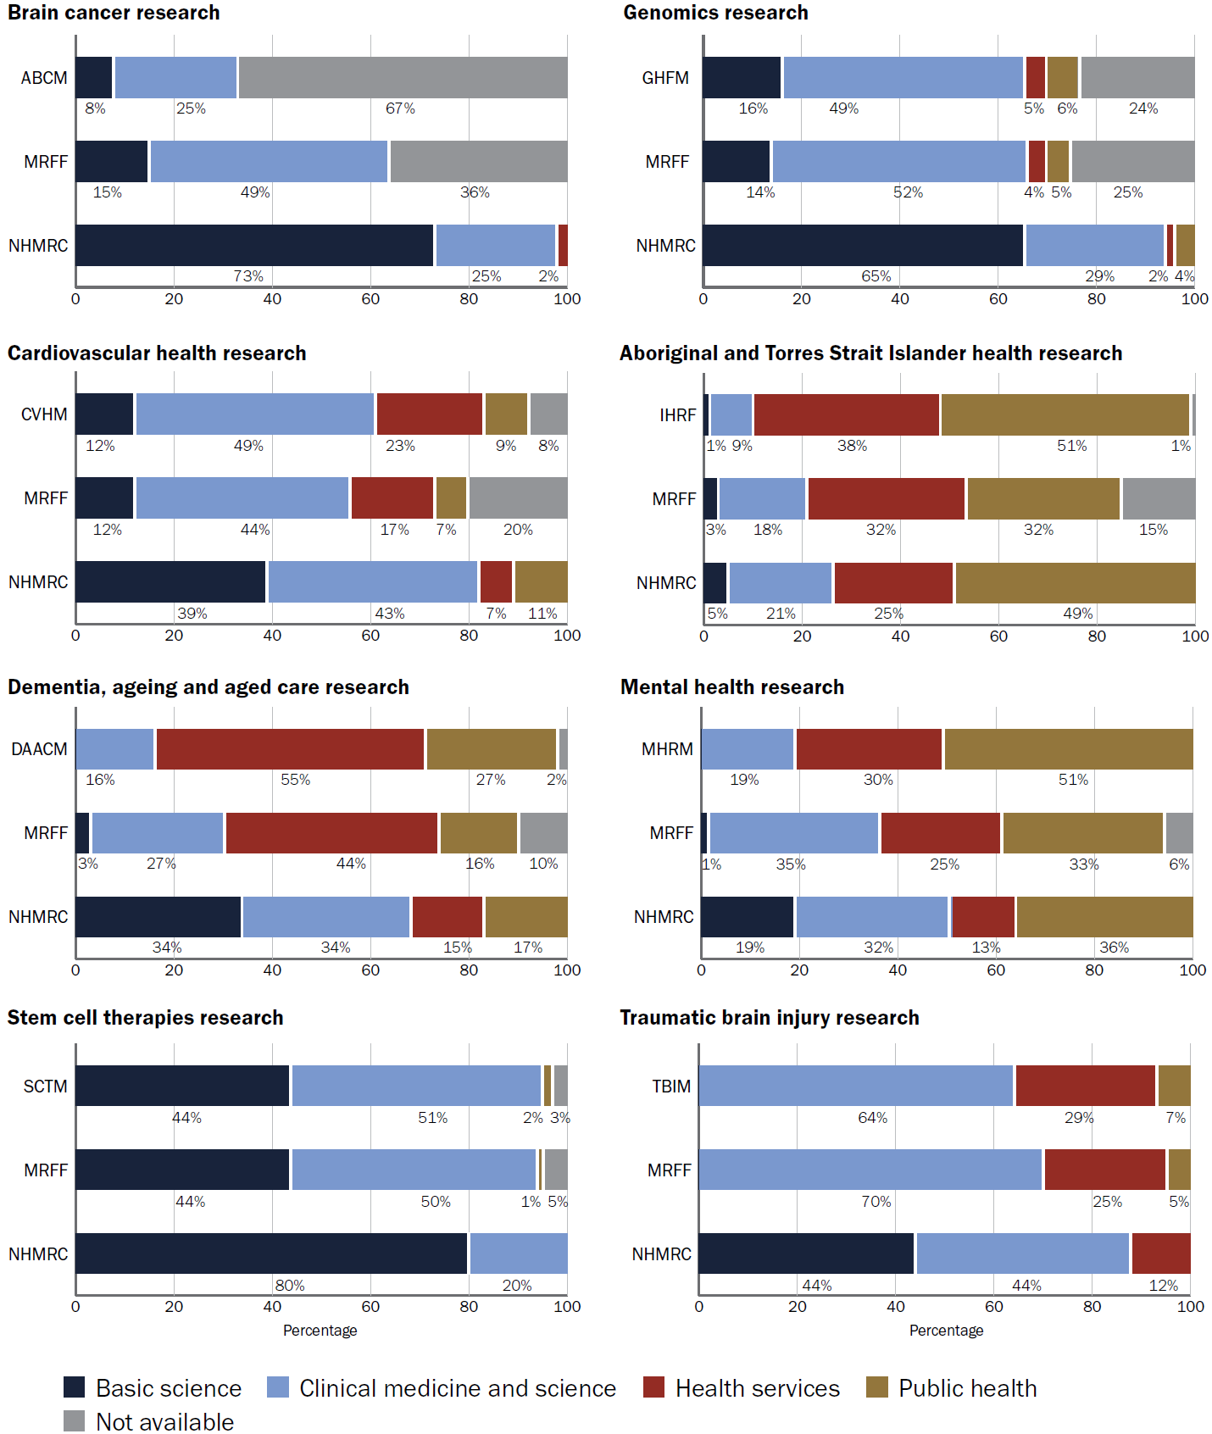
Source: MRFF administrative data.

4.2.1 Brain cancer research
The MRFF Australian Brain Cancer Mission is investing $126.4 million between 2018–19 and 2026–27 to support brain cancer research, with $50 million from the Australian Government via the MRFF and $76.4 million from funding partners.

Key national funders
The MRFF (together with philanthropic and state-based funding partners) and NHMRC are the major national funders of brain cancer research (Figure 7; also see Appendix H of the accompanying appendix document). Other key priority funders include Cancer Australia, Cancer Institute NSW and the Australian Cancer Research Foundation.

Alignment of priorities
The priorities of the Australian Brain Cancer Mission do not overlap with those of the NHMRC, although there is indirect alignment between the Mission objective to support equitable access to clinical trials and the NHMRC Aboriginal and Torres Strait Islander health priority.

Coverage along the research pipeline
Three-quarters (75%) of brain cancer research grants funded by the NHMRC and 15% of grants funded by the MRFF focus on basic science research (Figure 8).
MRFF-funded grants for brain cancer research were twice as likely to be classified as ‘Clinical medicine and science’ research (48% of funded grants) than grants funded by the NHMRC (24%).

Significant findings from mid-term Mission review
The review of the Australian Brain Cancer Mission identified Australia’s strengths in brain cancer detection, diagnosis, treatment and survivorship, much of which was driven by a combination of MRFF and non-profit and philanthropic co-funding. There was also evidence of this dedicated funding attracting cancer researchers from other disciplines within Australia to focus on brain cancer.

4.2.2 Cardiovascular health research
The MRFF Cardiovascular Health Mission is investing $220 million between 2019–20 and 2028–29 to improve cardiovascular health and stroke management for all Australians.

Key national funders
The MRFF is the largest funder of cardiovascular disease and stroke research nationally, followed by the NHMRC (Figure 7; also see Appendix H of the accompanying appendix document). Other key priority funders include the National Heart Foundation of Australia, National Stroke Foundation of Australia and the New South Wales Office for Health and Medical Research Cardiovascular Research Capacity Program.

Alignment of priorities
The priorities of the Cardiovascular Health Mission are consistent with national and international peak bodies (Australian National Heart Foundation and National Stroke Foundation of Australia) and overlap significantly with NHMRC health priorities.

Coverage along the research pipeline
More than a third (39%) of cardiovascular health research grants funded by the NHMRC and 12% of grants funded by the MRFF focus on basic science research (Figure 8).
The MRFF (17%) and the Mission specifically (23%) fund a higher proportion of cardiovascular health research grants classified as ‘Health services’ research than the NHMRC (7%).

Significant findings from mid-term Mission review
The review of the Cardiovascular Health Mission identified Australia’s leadership in cardiovascular disease and stroke research, with MRFF-funded research well placed both nationally and internationally.

4.2.3 Dementia, ageing and aged care research
The MRFF Dementia, Ageing and Aged Care Mission is investing $185 million between 2018–19 and 2028–29 to support older Australians to maintain their health and quality of life as they age, live independently for longer and access quality care when they need it.

Key national funders
The NHMRC is the largest funder of dementia, ageing and aged care research nationally, followed by the MRFF (Figure 7; also see Appendix H of the accompanying appendix document). Other key priority funders include Aged Care Research and Industry Innovation Australia.
The NHMRC has provided targeted initiatives for dementia, ageing and aged care research, specifically:
- the National Institute for Dementia Research Boosting Dementia Research Initiative
- 3 targeted calls for research into
  - cultural, ethnic and linguistic diversity in dementia research
  - end-of-life care
  - healthy ageing of Aboriginal and Torres Strait Islander peoples.

Alignment of priorities
The priorities of the Dementia, Ageing and Aged Care Mission have substantial overlap with significant national funders, noting that the priorities of the NHMRC National Institute for Dementia Research were included in the analysis.

Coverage along the research pipeline
Around a third (34%) of dementia, ageing and aged care research grants funded by the NHMRC and 3% of grants funded by the MRFF focus on basic science research (Figure 8).
The MRFF (44%) and the Mission specifically (56%) fund a higher proportion of dementia, ageing and aged care research grants classified as ‘Health services’ research than the NHMRC (15%).

Significant findings from mid-term Mission review
The review of the Dementia, Ageing and Aged Care Mission highlighted Australia’s strengths in:
- clinical, health services, implementation and public health research
- dementia prevention, biomarker discovery, neuroimaging, and stroke and vascular dementia research
- meaningful consumer involvement in research, with consumers, carers, and people with dementia co-designing research and serving as Chief Investigators.

4.2.4 Genomics research
The MRFF Genomics Health Futures Mission is investing $500.1 million between 2018–19 and 2027–28 to improve disease testing and diagnosis, help personalise treatment options to better target and improve health outcomes, and reduce unnecessary interventions and health costs.

Key national funders
The MRFF is the largest funder of genomics research nationally, followed by the NHMRC and ARC (Figure 7; also see Appendix H of the accompanying appendix document). Other government investments in genomics research and infrastructure include the Australian Government Department of Education’s National Collaborative Research Infrastructure Strategy, the Melbourne Genomics Health Alliance and Queensland Genomics.

Alignment of priorities
There is some overlap between the NHMRC and ARC health priorities and those of the Genomics Health Futures Mission. This reflects the NHMRC’s focus on broad health challenges and emerging issues, the ARC’s focus on healthy communities, and the Mission’s focus on genomics-related research.

Coverage along the research pipeline
Nearly two-thirds (65%) of genomics research grants funded by the NHMRC and 14% of grants funded by the MRFF focus on basic science research (Figure 8).
The MRFF (52%) and the Mission specifically (49%) fund a higher proportion of genomics research grants classified as ’Clinical medicine and science’ research than the NHMRC (29%).

Significant findings from mid-term Mission review
The review of the Genomics Health Futures Mission identified:
- examples of innovative strategies across Australia to involve consumers and under-represented groups in genomics research and investment decisions
- Australia’s strength in Indigenous genomics research, particularly with the introduction of the Aboriginal and Torres Strait Islander Genomic Advisory Group
- that Australia hosts a wealth of internationally renowned genomics researchers.

4.2.5 Aboriginal and Torres Strait Islander health research
The MRFF Indigenous Health Research Fund is investing $160 million between 2018–19 and 2028–29 to support Indigenous-led research to tackle health issues facing Aboriginal and Torres Strait Islander people.

Key national funders
The NHMRC is the largest funder of Aboriginal and Torres Strait Islander health research nationally, followed by the MRFF and ARC (Figure 7; also see Appendix H of the accompanying appendix document). Other key priority funders include the Lowitja Institute.
The NHMRC has provided 7 targeted calls for research addressing Aboriginal and Torres Strait Islander health, specifically:
- addressing violence for safer families and communities
- commercial determinants of Aboriginal and Torres Strait Islander health
- improving Indigenous maternal and child health in the early years
- a national network for Aboriginal and Torres Strait Islander health researchers
- healthy ageing of Aboriginal and Torres Strait Islander peoples
- nutrition in Aboriginal and Torres Strait Islander peoples
- social and emotional wellbeing and mental health for Indigenous peoples from early life.

Alignment of priorities
All significant national funders and the Indigenous Health Research Fund have the broad aim to improve the health of Aboriginal and Torres Strait Islander peoples. Therefore, the priorities of the Indigenous Health Research Fund were determined to have complete overlap with significant national funders, noting that the Fund’s priorities often have a specific disease or life stage focus.

Coverage along the research pipeline
A small percentage (1 to 5%) of Aboriginal and Torres Strait Islander health research grants funded by the MRFF and NHMRC focus on basic science research (Figure 8).
The Indigenous Health Research Fund had a greater focus on health services research (38% of funded grants) than the NHMRC (24% of funded grants).

4.2.6 Mental health research
The MRFF Million Minds Mental Health Research Mission is investing $125 million between 2018–19 and 2028–29 to support one million Australians with mental health issues through new approaches to prevention, diagnosis, treatment and recovery.

Key national funders
The NHMRC is the largest funder of mental health research nationally, followed by the MRFF and ARC (Figure 7; also see Appendix H of the accompanying appendix document). Other key priority funders include Beyond Blue.
The NHMRC provided a Special Initiative in Mental Health.

Alignment of priorities
There is broad overlap in priorities between significant national funders and the Million Minds Mental Health Research Mission. The NHMRC’s focus on critical and emerging challenges is less common in other funders analysed.

Coverage along the research pipeline
The Million Minds Mental Health Research Mission did not fund any mental health research grants classified as ‘Basic science’ research. This contrasts with 19% of grants funded through the NHMRC (Figure 8).
The Mission had a greater focus on health services (30% of funded grants) and public health research (51%) than the NHMRC (13% and 36%, respectively).

Significant findings from mid-term Mission review
The review of the Million Minds Mental Health Research Mission found that:
- the fragmentation of mental health services presents a challenge for effective collaboration
- major funding bodies, including the MRFF and NHMRC, specifically emphasise the involvement of individuals with lived experience, consumers and carers in their funded research. This involvement can happen through consumer advisory groups, the development of toolkits and other resources, and funding of dedicated grant programs.

4.2.7 Stem cell therapies research
The MRFF Stem Cell Therapies Mission is investing $150 million between 2019–20 and 2027–28 to develop innovative, safe and effective treatments to improve health outcomes in partnership with patients and carers.

Key national funders
The NHMRC is the largest funder of stem cell therapies research nationally, followed by the MRFF and ARC (Figure 7; also see Appendix H of the accompanying appendix document). Other priority funders include the National Stem Cell Foundation of Australia.

Alignment of priorities
The priorities of the Stem Cell Therapies Mission do not align with the NHMRC priorities, reflecting the NHMRC’s focus on broad health challenges and emerging issues. The priorities of the Mission align with those of the National Stem Cell Foundation of Australia and partially align with those of the ARC, noting that stem cell therapies research is not a focus for the ARC.

Coverage along the research pipeline
The NHMRC was almost twice as likely to fund stem cell therapies research classified as ‘Basic science’ research (80% of funded grants) than the Stem Cell Therapies Mission or MRFF (both 44% of funded grants) (Figure 8).
The Stem Cell Therapies Mission (52%) and MRFF (49%) funded a higher proportion of stem cell therapies grants classified as ‘Clinical medicine and science’ research than the NHMRC (20%).

4.2.8 Traumatic brain injury research
The MRFF Traumatic Brain Injury Mission is investing $50 million between 2019–20 and 2028–29 to support projects that predict recovery outcomes or identify the most effective care and treatments to improve patient recovery after brain injury.

Key national funders
The NHMRC is the largest funder of traumatic brain injury research nationally, followed by the MRFF (Figure 7; also see Appendix H of the accompanying appendix document). Other key priority funders include the Brain Foundation and the Transport Accident Commission.

Alignment of priorities
There is some alignment in priorities between the Traumatic Brain Injury Mission and the NHMRC. However, this alignment is broad and traumatic brain injury is not a focus for the NHMRC.

Coverage along the research pipeline
The MRFF did not fund any traumatic brain injury grants classified as ‘Basic science’ research. This contrasts with 44% of grants funded through the NHMRC (Figure 8).
The Traumatic Brain Injury Mission and MRFF were more likely to fund both clinical medicine and science research (64% and 70% of funded grants, respectively) and health services research (29% and 25% of funded grants, respectively) than the NHMRC (44% of funded grants for clinical medicine and science research and 12% for health services research).

Significant findings from mid-term Mission review
The international review of the Traumatic Brain Injury Mission noted that Australia was unique internationally in its approach to funding traumatic brain injury research. Unlike other countries, Australia recognises the complexity of the injury and need for multimodal approaches to treatment and rehabilitation. This is supported by how traumatic brain injury is managed in the Australian healthcare system.

4.2.9 Innovative and creative approaches to implementing research priorities
The Research Missions, MRFF and significant national funders all use a range of approaches to support implementation of their priorities (Table 8). This section aims to identify areas of strength for the Research Missions and MRFF, as well as gaps and opportunities.

Table 8 Approaches used by Research Missions, MRFF and other national funders to implement their priorities
Priority | Research Missions approach | MRFF approach | Other national funders approach
Partnerships and co-funding | At the grant scheme level, only the Australian Brain Cancer Mission has formal partnerships with other research funders. At the project level, the MRFF encourages partnership and co-funding across all initiatives (including Research Missions). | Some MRFF initiatives (e.g. the Medical Research Commercialisation initiative and the Targeted Translation Research Accelerator under the Preventive and Public Health initiative) involve partnerships with third-party organisations via a competitive process, to deliver funding programs and infrastructure to support research discoveries as they progress from proof of concept through to clinical implementation. At the project level, the MRFF encourages partnerships and co-funding across all initiatives. | National funders have established formal partnerships with other research funders and/or third-party organisations, e.g. NHMRC collaborative research projects with international researchers.
Support for early- to mid-career (EMCR) and clinician researchers | The Million Minds Mental Health Research Mission and Australian Brain Cancer Mission have embedded requirements for EMCRs in their implementation plans, to support career development and training. | The MRFF provides support through the Clinician Researchers and Early to Mid-Career Researchers initiatives.  Although these are project-based grants and not fellowships, funding for salary support can be requested. | National funders have dedicated funding for EMCRs and clinician researchers, including NHMRC Investigator grants and ARC funding schemes (Discovery Early Career Researcher Award, Future Fellowships, Early and Mid-Career Fellowships).
Translation and commercialisation | Aligned with the broader MRFF focus on translating research into practice, the Research Missions include priorities relating to implementation of interventions and improving health outcomes. | The MRFF supports translation and commercialisation of research findings into products or practice through the ‘Research translation’ theme and other initiatives (e.g. the Medical Research Commercialisation initiative and Frontier Health and Medical Research initiative). The Preventive and Public Health initiative also includes a health technology assessment stream that focuses on evidence gaps in the cost-effectiveness and comparative effectiveness of health care and strategies. | The NHMRC has developed a Research Translation Strategy with a mission to drive the translation of health and medical research.  Examples of dedicated schemes include the Cancer Institute of New South Wales translational research grants, NHMRC Development grants and numerous ARC schemes under the Linkage Program.
Priority populations | Many Research Missions have a focus on priority populations, including MRFF priority populations (see next column) and additional populations as relevant for the area of research. The Indigenous Health Research Fund has a specific focus on improving the health of Aboriginal and Torres Strait Islander peoples. | Research addressing priority populations is one of the Australian Medical Research and Innovation Priorities, to ensure equitable health outcomes for all people living in Australia. The MRFF runs grant opportunities that target specific priority populations, including people with intellectual disability, sexuality and gender diverse people and people with innate variations of sex characteristics, rural and remote communities, rare or currently untreatable diseases and conditions, culturally and linguistically diverse communities, and Aboriginal and/or Torres Strait Islander peoples. | Many significant national funders include priority populations in their strategic plans, with general alignment in populations between funders. Women are a priority population for many significant national funders, but not for the Research Missions or MRFF more broadly.  Both the NHMRC and ARC have priorities specific to Aboriginal and Torres Strait Islander health. They implement these priorities through various mechanisms: the NHMRC has a commitment (as part of its strategic framework) to spend at least 5% of funding on Aboriginal and Torres Strait Islander health research each year, while the ARC has targeted funding for Aboriginal and Torres Strait Islander researchers and research students through its Discovery Indigenous scheme.
Consumer involvement | Research Missions aim to bring together stakeholders, including consumers, to tackle big health challenges. MRFF policies and guidelines (see next column) guide consumer involvement with grants funded via the Research Missions program.  In addition, many expert advisory panels that advise Government on Mission research priorities include a consumer advocate or person with lived experience as a member. | The MRFF, guided by advisory committees, has developed principles for consumer involvement in MRFF-funded research, assessment criteria with explicit expectations for consumer involvement in MRFF applications, and statement and guidance on consumer involvement in MRFF-funded research. The MRFF also includes consumers on grant assessment committees, including as scoring and non-scoring members. | The NHMRC engages consumers and communities through numerous mechanisms, including:  - adopting a policy of public consultation in relation to individual and public health matters under NHMRC consideration  - appointing consumer and community representatives to NHMRC Council and committees  - establishing the NHMRC–MRFF Consumer and Community Advisory Group  - involving consumer and community reviewers in select peer reviews  - developing the NHMRC Statement on Consumer and Community Involvement in Health and Medical Research  - developing the NHMRC Toolkit for Consumer and Community Involvement in Health and Medical Research.

4.3 Review of other Mission-style funding programs
A high-level review of comparator Mission-style funders identified exemplar funding models that could increase the impact of research investments and improve processes and governance arrangements.

Summary findings
Characteristics of comparator Mission-style funders that differ from the approach used by the MRFF Research Missions include:
- partnerships and collaboration
- partnerships between government funders and other agencies to support research addressing shared priorities
- mandated co-funding and partnerships at the individual grant level
- structured activities to promote collaboration
- translation and commercialisation
- networks or councils that support communication, coordination, collaboration, translation and commercialisation
- establishment of multidisciplinary and interdisciplinary research networks to support collaboration
- dedicated funding streams for research scale-up and implementation
- representatives from the funder sitting on research program advisory boards and actively supporting translation activities
- priority populations
- funding schemes and mandated funding to support research that addresses priority populations, including Indigenous health
- governance of funding programs
- use of program managers and research experts to oversee and lead Research Missions
- portfolio approach to risk management, pilot funding and stage-gated funding
- structural mechanisms to support innovation and promote communication and collaboration across different initiatives within funding organisations
- updating programs or changing approaches to address known barriers.
Characteristics of comparator Mission-style funders that are similar to the approach used by the MRFF Research Missions include:
- prioritisation approaches
- consultation and frameworks to determine research focus
- priority populations
- initiatives focused on improving the health of priority populations
- consumer involvement
- engaging consumers in all stages of research, including as full research partners
- mandated consumer involvement as Chief Investigators for certain funding schemes
- communication
- websites, webinars, animations, reports and debates to communicate research findings to end users
- evaluation and learning
- commissioning of external organisations to undertake evaluation activities
- development of frameworks to understand Mission performance.

4.3.1 Comparator Mission-style funders
Comparator funders were identified from existing knowledge, consultation with the Mission Evaluation Panel and using the Organisation for Economic Co-operation and Development (OECD) Mission-Oriented Innovation Policy online toolkit.
Comparator funders were initially assessed to determine their similarity to the MRFF Research Missions program (see Appendix I of the accompanying appendix document). Funders were then investigated using publicly available information to identify innovative approaches, processes and governance arrangements. Targeted consultation with the NHMRC, Commonwealth Scientific and Industrial Research Organisation (CSIRO) and Canadian Institutes of Health Research (CIHR) supplemented publicly available information.

4.3.2 Exemplar characteristics of comparator Mission-style funders
Comparator Mission-style funders use a range of approaches to support implementation of their priorities. Table 9 outlines exemplar characteristics relevant to the MRFF Research Missions program.

Table 9 Exemplar characteristics of comparator Mission-style funders
Approach | Exemplars from Mission-style funders
Partnerships, collaboration and co-funding | The NHMRC Centres of Research Excellence program has used co-funding models; for example, co-funding by the Australian Government Department of Foreign Affairs and Trade to address shared priorities in One Health research.  Through the National Research Council Canada Challenge programs, the National Research Council Canada is partnering with private and public sector, academic and other research organisations, both in Canada and internationally, to advance research that addresses Canadian priorities. An example of how this was facilitated is provided in the Aging in Place Challenge program funding opportunity: Healthy aging community living labs, which includes mandatory cash or in-kind contributions and minimum requirements for team composition and level of involvement.  The CIHR encourages researcher collaboration by providing structured engagement activities for some of the schemes; for example, preapplication webinars, promoting collaboration between potential applicants.  The CIHR provides small grants (e.g. ‘Partnering for impact’) to support relationship building and readiness for larger projects.
Translation and commercialisation | The Moonshot Research and Development Program has established the Strategy Promotion Council – comprised of industry leaders, relevant ministries and academics – to support communication, coordination and collaboration to strategically promote research and development.  Each Mission in the Aalborg University Joint Mission Program has a Mission Partner Board comprising influential people from the Danish business community, the public and private sectors and non-government organisations. The board assists in the design of Missions and Mission projects, identifies potential collaboration opportunities with industry and other partners, and recommends ways to implement solutions into society.  The CIHR has funding streams for implementation and scale-up, particularly in the area of implementation science.  For larger research programs, a member of the CIHR sits on research program advisory boards (for example, to facilitate relationships between researchers and policymakers).
Priority populations | The CIHR National Women’s Health Research initiative is a priority initiative established through a working partnership between the CIHR’s Institute of Gender and Health, and Women and Gender Equality Canada. It addresses under-researched and high-priority areas of women’s health.  The NHMRC has committed (as part of its strategic framework) to spending at least 5% of its annual budget on Aboriginal and Torres Strait Islander health research. Similarly, the CIHR has a mandated percentage of funding dedicated to Indigenous health research.
Consumer involvement | The CIHR has a citizen engagement handbook that introduces best practices, approaches and methods that can be used to effectively engage citizens in research.  The Social Sciences and Humanities for Climate, Energy and Transport Research Excellence undertook stakeholder engagement to provide recommendations to policymakers and practitioners on methodologies for gathering citizen perspectives in the context of the Horizon Europe Missions.  The NHMRC Collaborations in Health Services Research program has mandated requirements for consumers to be members of the Chief Investigator team.  The NHMRC has recently released its Statement on Consumer and Community Involvement in Health and Medical Research, which was developed with consumers and community members and aims to guide consumer and community involvement in all aspects of health and medical research.
Prioritisation approaches | Wellcome Leap’s model of innovation uses Pasteur’s quadrant to determine program or research focus. Work in Pasteur’s quadrant is neither pure applied research nor pure basic research, is Mission-driven and designed to create a new capability or solve a specific problem. Projects are almost always multidisciplinary, multicommunity, multistage and dynamically adapting throughout the program.  Planning of a new program for the National Institutes of Health Common Fund occurs in 2 phases:  - In phase 1, broad research areas that address the biggest challenges and greatest opportunities in biomedical research are identified. These are prioritised against 5 criteria: high impact potential, achievability of high impact goals within a set timeframe, value to National Institutes of Health institutes and centres, cross-cutting nature and uniqueness.  - In phase 2, the broad areas are refined into well-defined initiatives.  Incorporating evaluative thinking into program design ensures that the right challenges are addressed, and that metrics for success are built into the design to assist in progress monitoring and evaluation.  CSIRO has developed ‘Convening missions: a playbook for collective implementation of mission-oriented innovation’, which outlines:  - the design features and definition of a Mission  - the design principles a Mission idea must satisfy  - classification of Mission types  - Mission design frameworks.
Governance of funding programs | The Moonshot Research and Development Program, Wellcome Leap and CIHR use scientific or program directors to oversee funding programs. Examples include:  - using the US Defence Advanced Research Projects Agency model of ‘program managers’. Program managers oversee multiple projects, develop an integrated implementation plan that can be revised according to project progress and problems encountered, and adopt a portfolio approach to manage risk of failure  - appointing scientific directors to lead institutes, as is done by the CIHR. These are leaders in their respective fields who champion and support health research and knowledge mobilisation, and establish national and international collaborations.  The National Institutes of Health comprises 23 institutes and centres, each with a unique focus. These institutes are coordinated by the Office of the Director and the Office of Strategic Coordination. The Common Fund sits within these bodies and designs cross-cutting, trans–National Institutes of Health programs.  Each European Commission EU Mission has a detailed implementation plan. In addition, the EU Missions Work Programme 2025 contains actions for all 5 EU Missions, as well as further actions to support the full implementation of EU Missions, including synergistic actions between the Missions and other Horizon Europe instruments.
Communication of research to end users | The National Institutes of Health Common Fund website includes:  - a ‘Science highlights’ page that reports on the real-world impacts of projects and project findings, as well as links to new publications and websites  - webinars, lectures and short animations explaining programs and outcomes to the public; accessible versions of many of the videos are published with audio description.  A recent evaluation of the Horizon Europe EU Missions scheme identified the need to enhance citizen and stakeholder awareness and engagement. Horizon Europe will address this by:  - engaging with communication professionals for a more citizen-based approach  - publishing a new report on the implementation of EU Missions  - organising a public debate on the implementation reports to draw lessons, discuss progress and communicate achievements of the EU Missions.
Review, refresh and evaluation of programs | The CSIRO Missions Program Office developed a framework for understanding Mission performance across 4 key areas: strategic impact, portfolio health, internal alignment and external collaboration.  - Individual Missions report progress against impact pathway indicators (defined environmental, social and economic outcomes), contributing to twice-yearly reporting on the progress of the whole portfolio.  - CSIRO is in the process of developing reporting to better capture the ‘additionality’ of Missions (for example, spillovers, which are the fortuitous scientific, technical, societal and organisational innovations that have emerged because of Mission implementation) and to understand how to improve Mission design.  The Moonshot Research and Development Program was designed specifically to avoid the pitfalls experienced by earlier programs (for example, ImPACT).  - The program retains multiyear funding, flexible design and core decision makers with delegated authority to assemble teams and manage ambitious projects.  - Changes to the program include openness to foreign researchers, the use of ‘inspiring, imaginative and credible’ missions (the 10 Moonshot goals), and the adoption of a portfolio approach and a stage-gate funding mechanism.
CIHR = Canadian Institutes of Health Research; CSIRO = Commonwealth Scientific and Industrial Research Organisation; NHMRC = National Health and Medical Research Council.

5 Alignment and contribution of Research Missions–funded research
This section addresses the following evaluation questions:
- What is the alignment and contribution of funded research across and between Missions?
Section 5.1 outlines the contribution of the MRFF to the research funding landscape.
Lines of enquiry addressed:
- What has been the contribution of the MRFF to the research funding landscape?
Data sources: MRFF administrative data
Section 5.2 explores how Research Missions–funded research aligns with its focus areas and priorities.
Lines of enquiry addressed:
- How does the funded research align or compare across and between Missions and across the MRFF more broadly?
Data sources: MRFF administrative data

5.1 Contribution of the MRFF to the research funding landscape
A review of MRFF-funded research was undertaken to determine the contribution of the MRFF Research Missions to the research funding landscape.

Summary findings
- From MRFF inception to 1 July 2025, the Research Missions program funded 463 grants totalling $965.4 million.
- The overall funded rate for applications submitted to the Research Missions program was 24.8%, compared with 21.1% for the MRFF overall.
- Research Missions funding reached all states and territories, though only the Cardiovascular Health Mission had an administrative (lead) organisation in every state and territory. Lead organisations from Victoria received the most Research Missions funding ($359.96 million) of any state or territory. Funded rates ranged from 20.5% for Western Australian lead organisations to 44.4% for Northern Territory lead organisations.
- Of the MRFF themes, the Research Missions program had the highest number of lead organisations located in regional, rural and remote locations.
- The highest percentage of grants funded under the Research Missions program were classified as ‘Clinical medicine and science’ (36%), followed by ‘Health services’ (23%) and ‘Public health’ (20%). Of all MRFF themes, Research Missions had the highest percentage of grants classified as ‘Basic science’ research (12%).
- Most grants funded under the Research Missions program were funded under a targeted Calls for Research grant model (68.3%). The median grant duration was 4 years and the median grant size was $1.14 million.
- The proportion of smaller projects funded through the Research Missions program increased over time, while there was less investment in larger-scale research projects.
- Approximately one-quarter (27%) of grants in scope were complete and 19% of grants were less than halfway through their grant period.

5.1.1 Applications, grants, funded rates and total funding
From MRFF inception to 1 July 2025, the MRFF invested $4.07 billion across the 4 MRFF themes. The Research Missions program funded 463 grants totalling $965.4 million (Table 10 and Table 11). The average funded rate for the Research Missions program was 24.8%, varying from 11.9% for the Million Minds Mental Health Research Mission to 38.9% for the Indigenous Health Research Fund.
Table 10 Number of funded grants, total funding awarded and percentage of MRFF funding, by MRFF theme
MRFF theme | Number of funded grants | Total funding awarded (millions) | Percentage of MRFF funding
Patients | 473 | $1,110.4 | 27.3%
Research Missions | 463 | $965.4 | 23.7%
Research Translation | 415 | $1,305.1 | 32.1%
Researchers | 296 | $690.1 | 16.9%
Total | 1,647 | $4,071.0 | 100.0%
Source: MRFF administrative data as at 1 July 2025.
Table 11 Number of funded grants, total funding awarded and funded rate by Research Mission
Research Mission | Number of funded grants (all types)ª | Total funding awarded (millions) (all types)ª | Funded rate (competitive grants)^{b}
Australian Brain Cancer | 12 | $33.2 | 19.4%
Cardiovascular Health | 102 | $160.1 | 26.1%
Dementia, Ageing and Aged Care | 63 | $111.2 | 22.2%
Genomics Health Futures | 96 | $300.3 | 35.3%
Indigenous Health Research Fund | 69 | $131.5 | 38.9%
Million Minds Mental Health Research | 43 | $106.2 | 11.9%
Stem Cell Therapies | 64 | $104.6 | 24.6%
Traumatic Brain Injury | 14 | $18.3 | 23.3%
Total / overall funded rate | 463 | $965.4 | 24.8%
a Includes all Research Mission grant opportunities in scope (competitive and non-competitive).
b Calculated using applications and outcomes from competitive grant opportunities only.
Source: MRFF administrative data as at 1 July 2025.

5.1.2 Funding by state and territory
Research Missions funding was awarded to lead organisations located in all Australian states and territories (Figure 9). However, only the Cardiovascular Health Mission had a lead organisation in every state and territory. It is worth noting that the amount of funding received across the states and territories was not commensurate with the funded rates – those with a high funded rate did not necessarily receive a high proportion of funding.
Figure 9 Number of, funded rate and funding received for Research Missions grants by the state or territory of the lead organisation
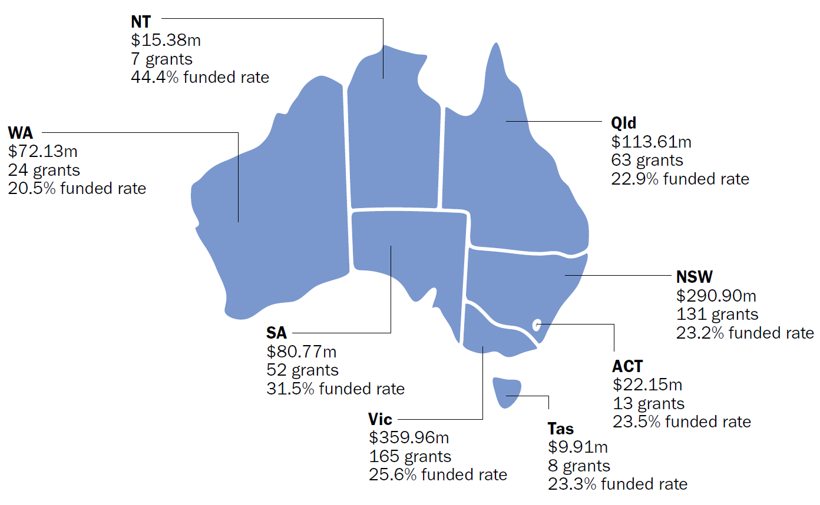
Note: Does not account for interstate or inter-territory collaborations.
Source: MRFF administrative data as at 1 July 2025.

5.1.3 Funding by regional, rural and remote status
Of the MRFF themes, Research Missions had the highest number of lead organisations categorised MM 2 to MM 7 (24). The theme with the next highest number was Research Translation (20), followed by Patients (15) and Researchers (10) (Table 12).
Five of the 8 Research Missions had grants administered by organisations located in MM 2 (regional) areas. The Australian Brain Cancer Mission and Stem Cell Therapies Mission had no grants administered by organisations in regional, rural or remote areas. Only the Million Minds Mental Health Research Mission had grants administered in areas classified above MM 2 (rural or remote) (Table 13).
Table 12 Remoteness status of lead organisations of grants funded under each MRFF theme
MRFF theme | MM 1 | MM 2 | MM 3–7 | Total
Patients | 457 | 13 | 2 | 473
Research Translation | 395 | 13 | 7 | 415
Researchers | 286 | 9 | 1 | 296
Research Missions | 439 | 22 | 2 | 463
MM = Modified Monash category; MRFF = Medical Research Future Fund.
Note: Remoteness status was determined using the Modified Monash Model. The MM Model defines whether a location is a city, rural, remote or very remote. The MM category of funded grants is based on the postcode of the lead organisation.
Source: MRFF administrative data as at 1 July 2025.
Table 13 Remoteness status of lead organisations of grants funded under each Research Mission
Research Mission | MM 1 | MM 2 | MM 3–7 | Total
Australian Brain Cancer | 12 | – | – | 12
Cardiovascular Health | 95 | 7 | – | 102
Dementia, Ageing and Aged Care | 61 | 2 | – | 63
Genomics Health Futures | 91 | 5 | – | 96
Indigenous Health Research Fund | 63 | 6 | – | 69
Million Minds Mental Health Research | 41 | – | 2 | 43
Stem Cell Therapies | 64 | – | – | 64
Traumatic Brain Injury | 12 | 2 | – | 14
MM = Modified Monash category.
Note: Remoteness status was determined using the Modified Monash Model. The MM Model defines whether a location is a city, rural, remote or very remote. The MM category of funded grants is based on the postcode of the lead organisation.
Source: MRFF administrative data as at 1 July 2025.

5.1.4 Funding by broad research area
The highest percentage of Research Missions grants fell under the broad research area ‘Clinical medicine and science’ (36%), followed by ‘Health services’ (23%) and ‘Public health’ (20%). Around one-tenth (12%) of Research Missions grants fell under ‘Basic science’, highlighting the program’s unique role in supporting foundational research in areas of need, as articulated in Research Mission implementation plans (Figure 10).
Figure 10 Percentage of grants awarded for each broad research area, by MRFF theme
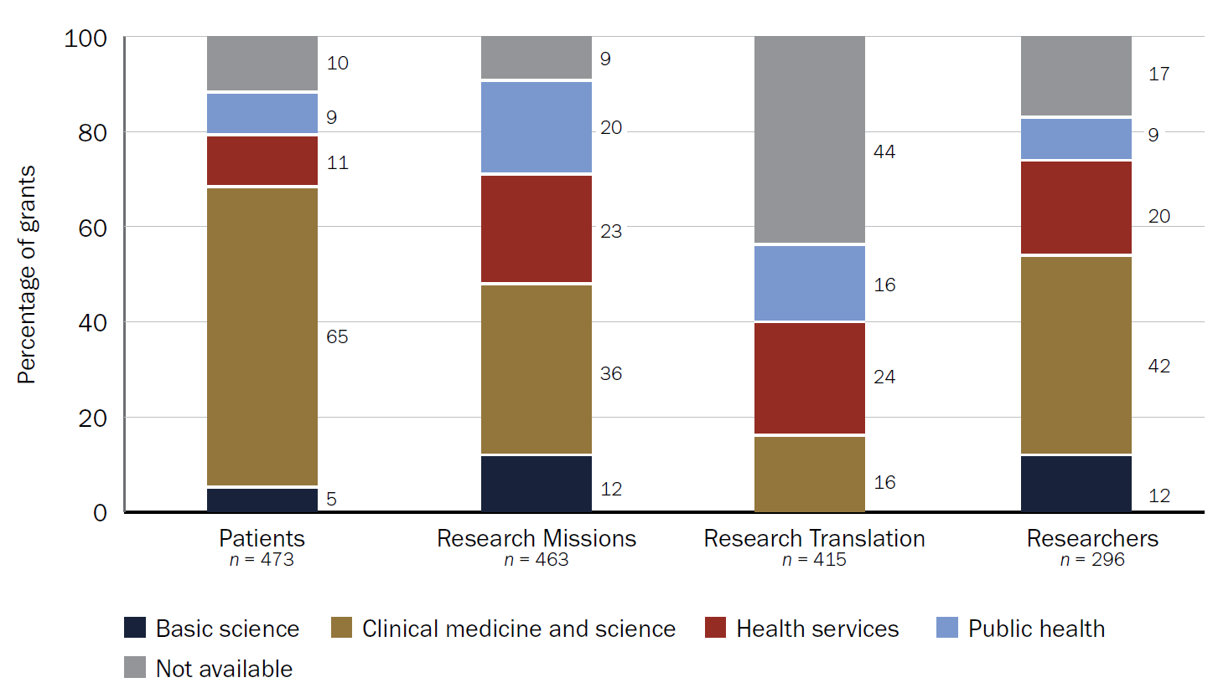
Source: MRFF administrative data as at 1 July 2025.
The breakdown of broad research area classification for each Research Mission is provided in Section 4.2.

5.1.5 Funding by grant model
Most Research Missions grants (68%) were awarded through the Targeted Call for Research grant model. Of the MRFF themes, Research Missions had the highest proportion of smaller-scale Incubator grants (26%). These were used to the greatest extent in the Indigenous Health Research Fund (58% of all grants) and Million Minds Mental Health Research Mission (49%). This reflects the priorities of these Research Missions to fund small-scale development projects and build research capacity. There was limited use of Accelerator grants across the Research Missions; this grant type was most common in the Stem Cells Therapies Mission and Cardiovascular Health Mission (Figure 11).
Figure 11 Number of grants awarded under each grant model, by Research Mission
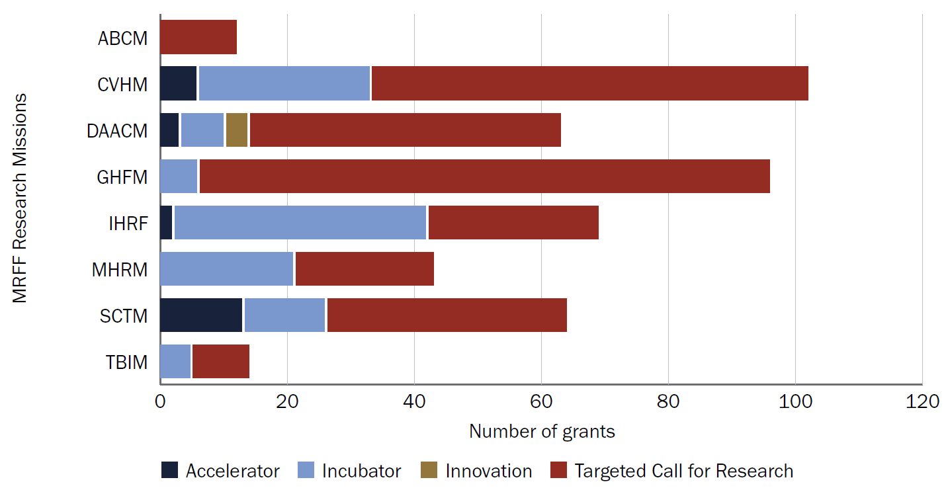
ABCM = Australian Brain Cancer Mission; CVHM = Cardiovascular Health Mission; DAACM = Dementia, Ageing and Aged Care Mission; GHFM = Genomics Health Futures Mission; IHRF = Indigenous Health Research Fund; MHRM = Million Minds Mental Health Research Mission; MRFF = Medical Research Future Fund; SCTM = Stem Cell Therapies Mission; TBIM = Traumatic Brain Injury Mission.
Source: MRFF administrative data as at 1 July 2025.

5.1.6 Grant duration
Most Research Missions grants had a duration of 3 to 5 years, with a median duration of approximately 4 years (Figure 12).
Figure 12 Grant duration for each MRFF theme
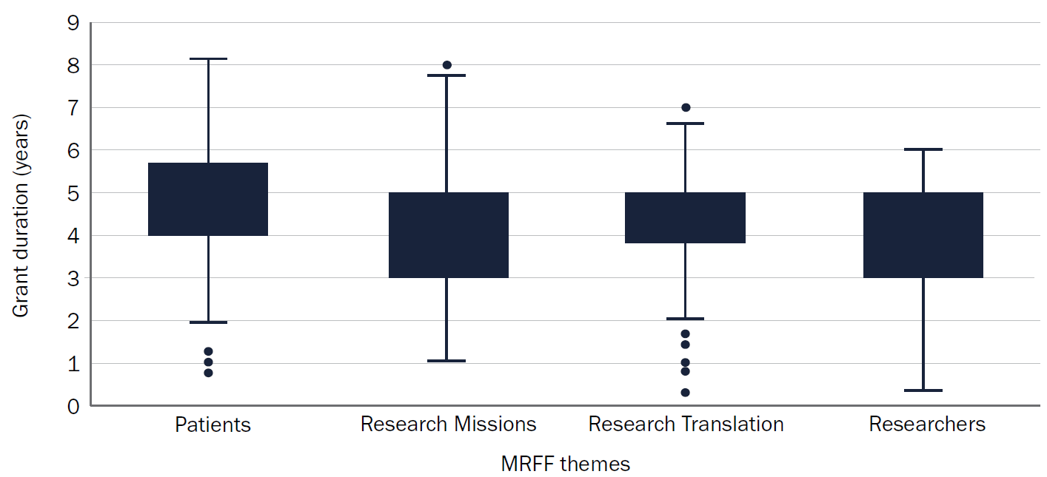
Source: MRFF administrative data as at 1 July 2025.
Of the Research Missions, the Australian Brain Cancer Mission had the longest median grant duration (5 years). The Million Minds Mental Health Research Mission, Indigenous Health Research Fund and Stem Cell Therapies Mission had the shortest median grant duration (around 3 years) (Figure 13).
Figure 13 Grant duration for each Research Mission
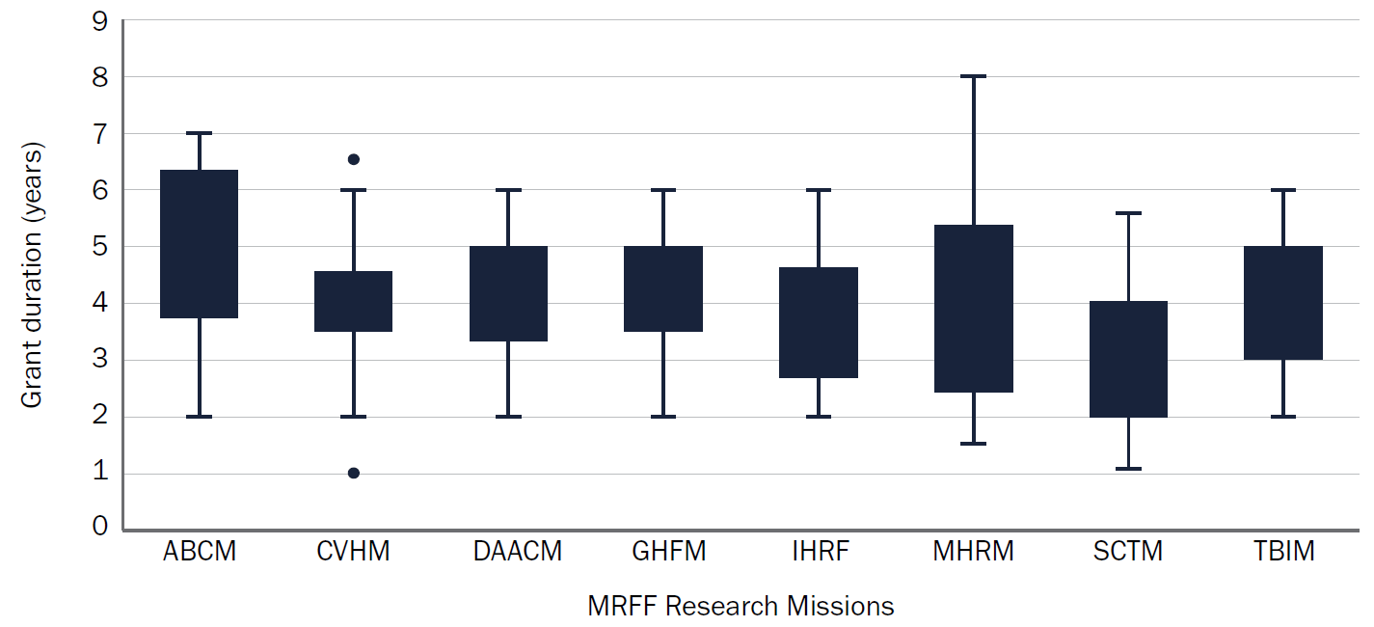
ABCM = Australian Brain Cancer Mission; CVHM = Cardiovascular Health Mission; DAACM = Dementia, Ageing and Aged Care Mission; GHFM = Genomics Health Futures Mission; IHRF = Indigenous Health Research Fund; MHRM = Million Minds Mental Health Research Mission; MRFF = Medical Research Future Fund; SCTM = Stem Cell Therapies Mission; TBIM = Traumatic Brain Injury Mission.
Source: MRFF administrative data as at 1 July 2025.

5.1.7 Grant size (funding awarded)
The Research Missions program had the lowest median grant size of the MRFF themes, with almost half of all awarded grants valued under $1 million (Figure 14).
For 5 of the 8 Research Missions, more than half of all grants awarded were valued under $1 million (Cardiovascular Health Mission, Indigenous Health Research Fund, Million Minds Mental Health Research Mission, Traumatic Brain Injury Mission and Stem Cell Therapies Mission) (Figure 15).
Figure 14 Number of funded grants in each budget band, by MRFF theme
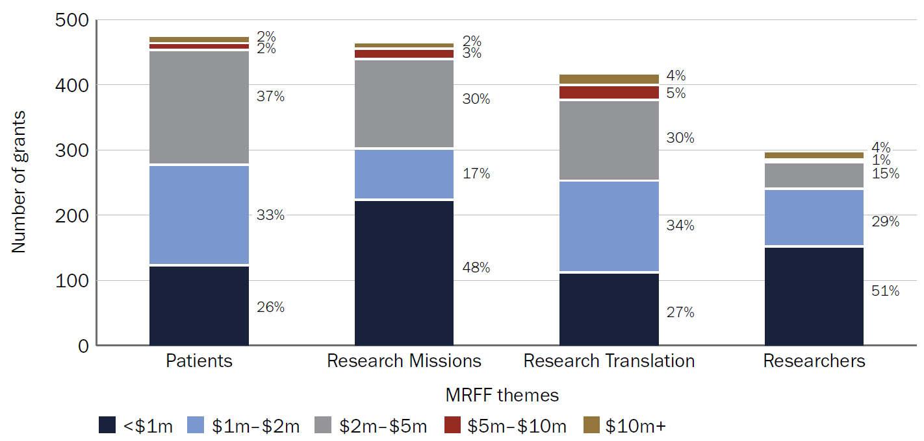
MRFF = Medical Research Future Fund.
Source: MRFF administrative data as at 1 July 2025.
Figure 15 Number of funded grants in each budget band, by Research Mission
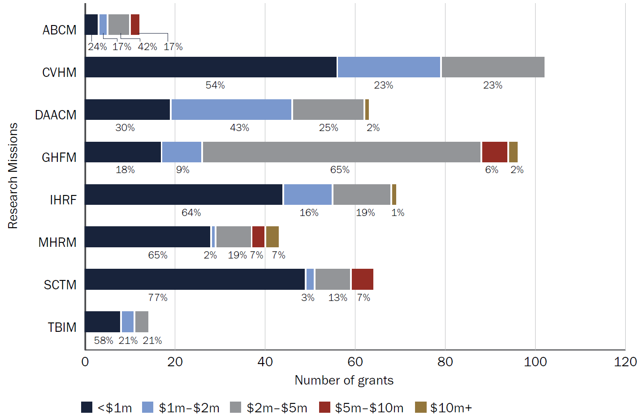
ABCM = Australian Brain Cancer Mission; CVHM = Cardiovascular Health Mission; DAACM = Dementia, Ageing and Aged Care Mission; GHFM = Genomics Health Futures Mission; IHRF = Indigenous Health Research Fund; MHRM = Million Minds Mental Health Research Mission; SCTM = Stem Cell Therapies Mission; TBIM = Traumatic Brain Injury Mission.
Source: MRFF administrative data as at 1 July 2025.
The funding size distribution of grants awarded under the Research Missions program shifted over time. Early funding was dominated by large-scale grants exceeding $2 million, most of these being ad hoc or one-off grants. This shifted towards a larger number of targeted and open competitive grants in recent years, most valued at less than $1 million (Figure 16).
Figure 16 Number of Research Missions–funded grants in each budget band, by year
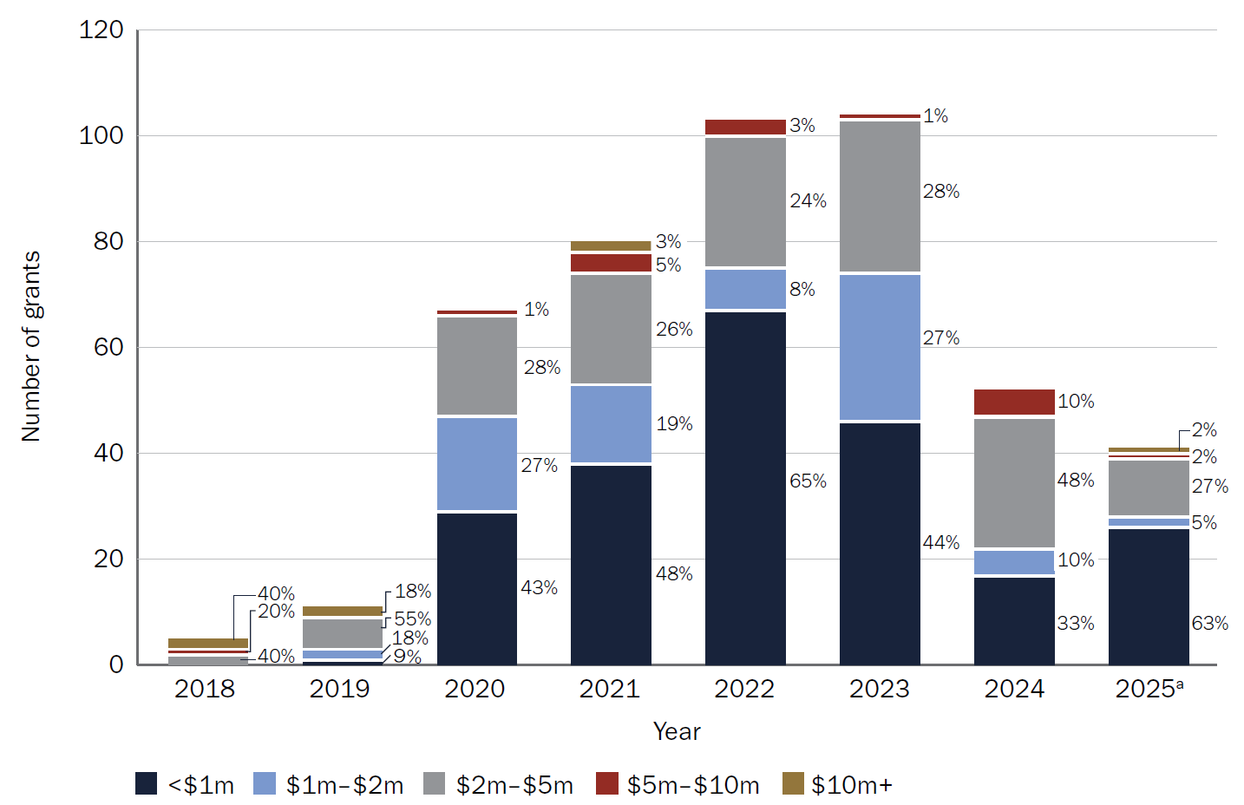
a Includes grants funded to 1 July 2025 only.
Note: Grants are shown in the year funding commenced, as determined by contract start date.
Source: MRFF administrative data as at 1 July 2025.
This shift suggests a change in how Research Missions funding has been deployed, with an increase in the proportion of smaller projects funded and less investment in larger-scale research projects. This trend should be interpreted with the following context:
- There has been a concurrent shift in MRFF funding as a whole. From 2021 onwards, 100% of funding for the Research Missions program has been allocated through competitive grant processes. In particular, data may be driven by large ad hoc grants (for example, those delivered via the Australian Brain Cancer Mission, Genomics Health Futures Mission and Indigenous Health Research Fund) in the early years, and a higher number of grants in subsequent years (particularly via the Cardiovascular Health Mission and Genomics Health Futures Mission).
- There was a higher number of grant opportunities in 2020 (corresponding with the MRFF’s Coronavirus Research Response), followed by a lower number of grant opportunities in 2021 (Table 14).
Table 14 Number of Research Missions grant opportunities each year
Number of Research Missions grant opportunities | 2018 | 2019 | 2020 | 2021 | 2022 | 2023 | 2024 | 2025ª
Non-competitive | 3 | 1 | 5 | 0 | 0 | 0 | 0 | 0
Competitive | 0 | 5 | 11 | 6 | 12 | 9 | 6 | 3
Total | 3 | 6 | 16 | 6 | 12 | 9 | 6 | 3
a 2025 data incomplete as at 1 July 2025.
Note: Based on the calendar year of the closing date of the grant opportunity.

5.1.8 Stage of grants
Grants in scope for this analysis ranged from very early–stage grants to completed grants. Approximately one-quarter of grants (27%) in scope were complete (n = 125), while 19% of grants (n = 98) were less than halfway (50%) through their grant period (Figure 17).
Figure 17 Completeness of grants funded under the Research Missions program
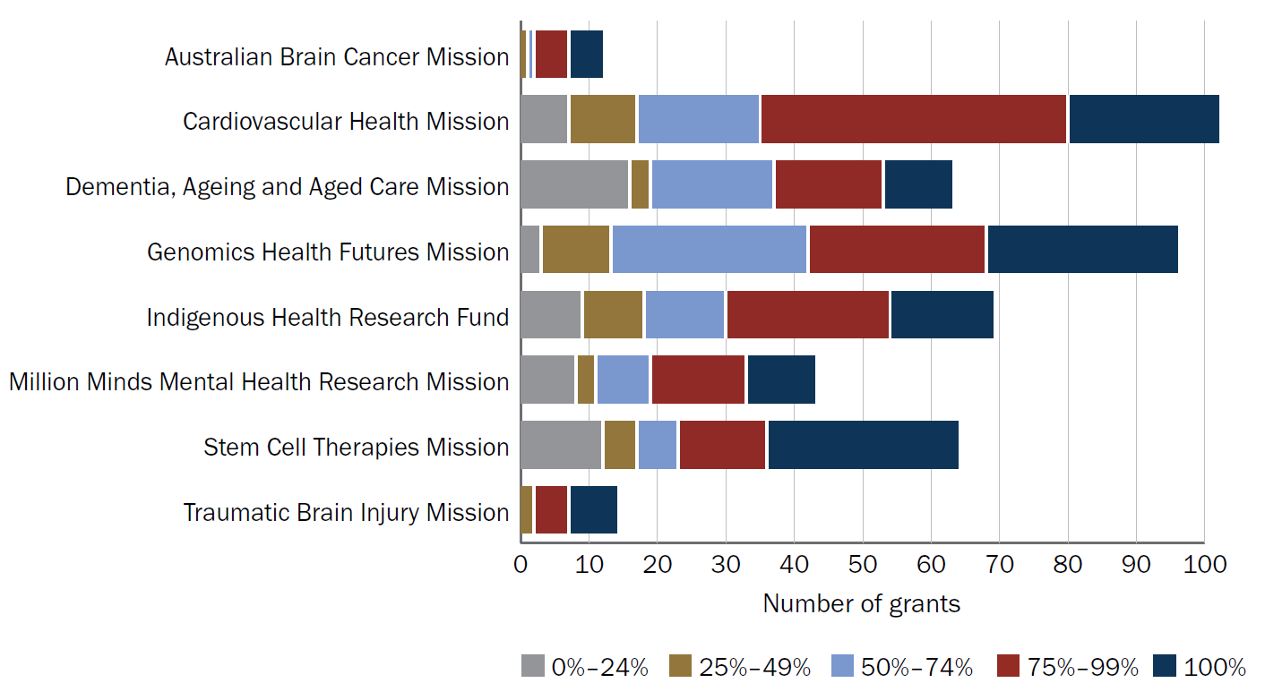
Note: Grant completeness was based on the grant activity start date and end date.
Source: MRFF administrative data as at 30 September 2025 (the most recent reporting period).

5.2 Alignment of funded research by Research Missions focus area and Research Missions priorities
A review of MRFF-funded research was undertaken to determine how it aligns with the Research Missions focus areas, aims and priorities.

Summary findings

Funding by Research Missions focus area
- All funding disbursed under each Research Mission was for research in the relevant focus area. For example, all funding under the Australian Brain Cancer Mission was for research related to brain cancer.
- Other MRFF initiatives provided a significant degree of funding for cardiovascular health; dementia, ageing and aged care; Indigenous health; and mental health research. Stem cell therapies and traumatic brain injury research have primarily received funding from their respective Research Missions.

Alignment with Research Missions priorities
Funding disbursed under each Research Mission has addressed some of the Mission priorities. As per the MRFF 3rd 10-year Investment Plan, all Research Missions have remaining funds to be disbursed, and not all priorities had been addressed at 1 July 2025.

5.2.1 Funding by Research Missions focus area
Each Research Mission provides funding for research relating to a specific focus area (for example, cardiovascular health). Other MRFF initiatives do not have a research focus area but may instead fund research for specific career stages (for example, the Early to Mid-Career Researchers initiative) or experimental approaches (for example, the Clinical Trials Activity initiative). Therefore, research that addresses a Research Missions focus area can be funded through the relevant Research Mission or through another MRFF initiative.
Half of the Research Missions focus areas have received more funding via initiatives outside the relevant Research Mission than through the Research Mission itself. These include cardiovascular health; dementia, ageing and aged care; Aboriginal and Torres Strait Islander health; and mental health research (Figure 18).
- Stem cell therapies research and traumatic brain injury research have received more funding through their respective Research Missions than through other MRFF initiatives.
- Brain cancer research and genomics research have received similar funding through their respective Research Missions and other MRFF initiatives.
There is a high degree of overlap in the total funding disbursed from other MRFF Research Missions or initiatives to mental health, Indigenous health, and dementia, ageing and aged care research. There is less overlap for brain cancer research and traumatic brain injury research (Table 15 and Table 16).
Figure 18 Funding disbursed or to be disbursed by the relevant Research Mission and through other MRFF initiatives, by Mission focus area
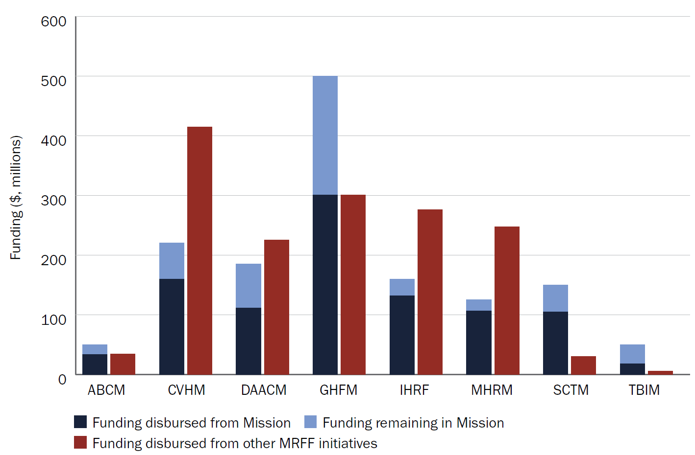
ABCM = Australian Brain Cancer Mission; CVHM = Cardiovascular Health Mission; DAACM = Dementia, Ageing and Aged Care Mission; GHFM = Genomics Health Futures Mission; IHRF = Indigenous Health Research Fund; MHRM = Million Minds Mental Health Research Mission; MRFF = Medical Research Future Fund; SCTM = Stem Cell Therapies Mission; TBIM = Traumatic Brain Injury Mission.
Source: MRFF administrative data as at 1 July 2025.
Table 15 Contribution of MRFF Research Missions to Mission-related focus areas, in terms of funding disbursements to awarded grants
Funding from Research Missions to Research Missions focus areas ($) | Brain cancer | Cardiovascular health | Dementia, ageing and aged care | Genomics health | Indigenous health | Mental health | Stem cell therapies | Traumatic brain injury | Total contribution of individual Research Missions to other Research Missions focus areasª
Australian Brain Cancer Mission | 33,244,938 | 0 | 0 | 5,002,023 | 0 | 0 | 329,489 | 0 | 5,331,512
Cardiovascular Health Mission | 0 | 160,065,218 | 4,473,930 | 7,088,291 | 25,605,490 | 1,586,502 | 958,504 | 0 | 39,712,717
Dementia, Ageing and Aged Care Mission | 0 | 506,834 | 111,158,920 | 0 | 4,964,132 | 4,622,432 | 0 | 0 | 10,093,398
Genomics Health Futures Mission | 0 | 3,548,599 | 0 | 300,285,751 | 14,741,275 | 3,721,823 | 0 | 0 | 22,011,697
Indigenous Health Research Fund | 0 | 38,375,952 | 951,004 | 995,406 | 131,451,312 | 32,433,595 | 0 | 0 | 72,755,957
Million Minds Mental Health Research Mission | 0 | 0 | 0 | 0 | 14,415,848 | 106,181,993 | 0 | 0 | 14,415,848
Stem Cells Therapies Mission | 0 | 19,739,891 | 1,906,624 | 3,395,513 | 0 | 1,425,156 | 104,598,510 | 0 | 26,467,184
Traumatic Brain Injury Mission | 0 | 0 | 5,322,418 | 0 | 5,822,234 | 3,448,008 | 0 | 18,267,342 | 14,592,660
Total contribution of Research Missions program to focus areaª | 0 | 62,171,276 | 12,653,976 | 16,481,233 | 65,548,979 | 47,237,516 | 1,287,993 | 0 | n/a
n/a = not applicable.
a Excludes funding provided through the Research Mission (that is, the funding in the blue cells).
Legend: Blue cells = Funding disbursed by the Research Mission to 1 July 2025. Red cells = Funding disbursed by other MRFF initiatives to Mission-related research areas (highest = dark red, lowest = light red). Grey cells = No funding disbursed by the MRFF initiative.
Source: MRFF administrative data as at 1 July 2025.

Table 16 Contribution of non-Mission MRFF initiatives to Mission-related focus areas, in terms of funding disbursements to awarded grants
Funding from non-Mission MRFF initiatives to Research Missions focus areas ($)ª | Brain cancer | Cardiovascular health | Dementia, ageing and aged care | Genomics health | Indigenous health | Mental health | Stem cell therapies | Traumatic brain injury | Total contribution of the initiative to Research Missions focus areas^{b}
Clinical Trials Activity | 9,113,753 | 56,183,471 | 24,959,963 | 33,841,275 | 15,783,982 | 45,938,444 | 7,888,512 | 1,084,852 | 194,794,252
Clinician Researchers | 0 | 15,391,609 | 13,587,568 | 4,139,323 | 6,235,124 | 22,573,774 | 1,562,250 | 989,466 | 64,479,114
Early to Mid-Career Researchers | 3,116,163 | 6,692,959 | 14,284,467 | 15,205,457 | 23,036,966 | 18,547,688 | 4,944,685 | 0 | 85,828,385
Emerging Priorities and Consumer Driven Research | 20,536,829 | 10,573,876 | 41,886,472 | 174,838,095 | 49,433,410 | 54,247,639 | 13,595,972 | 996,288 | 366,108,581
Frontier Health and Medical Research | 0 | 112,122,763 | 4,960,353 | 19,976,304 | 0 | 0 | 0 | 0 | 137,059,420
Global Health | 0 | 0 | 5,899,999 | 9,181,748 | 0 | 0 | 0 | 0 | 15,081,747
Medical Research Commercialisation | 0 | 0 | 50,000,000 | 0 | 0 | 0 | 0 | 0 | 50,000,000
National Critical Research Infrastructure | 1,499,900 | 13,487,286 | 2,999,924 | 11,312,634 | 5,853,333 | 19,951,382 | 0 | 0 | 55,104,459
Preventive and Public Health Research | 0 | 100,300,033 | 22,799,862 | 9,641,009 | 41,097,056 | 27,848,050 | 1,059,442 | 2,595,674 | 205,341,126
Primary Health Care Research | 0 | 5,847,926 | 9,379,785 | 0 | 13,546,668 | 1,599,056 | 0 | 0 | 30,373,435
Rapid Applied Research Translation | 0 | 24,577,146 | 18,212,300 | 5,868,917 | 44,656,554 | 9,391,042 | 0 | 0 | 102,705,959
Research Data Infrastructure | 0 | 7,480,930 | 3,915,588 | 0 | 10,475,878 | 0 | 0 | 0 | 21,872,396
Total contribution of all non–‍Research Mission initiatives to focus area | 34,266,645 | 352,657,999 | 212,886,281 | 284,004,762 | 210,118,971 | 200,097,075 | 29,050,861 | 5,666,280 | n/a
MRFF = Medical Research Future Fund; n/a = not applicable.
a Includes all MRFF initiatives that have funded Research Missions focus areas since the inception of the MRFF, consolidated under a current initiative.
b Grants funded under other MRFF initiatives may be relevant to more than one Research Missions focus area and may be counted more than once.
Legend: Red cells = Funding disbursed by other MRFF initiatives to Research Missions focus areas (highest = dark red, lowest = light red); Grey cells = No funding disbursed by other MRFF initiatives.
Source: MRFF administrative data as at 1 July 2025.

5.2.2 Funding by Research Mission priority area
Individual Research Mission aims and priorities are outlined in Research Mission implementation plans, and in Appendix B of the accompanying appendix document. Total funding and the number of grants awarded under each Research Mission priority as at 1 July 2025 are also included in Appendix B of the accompanying appendix document. More than half (n = 5) of the Research Missions had priorities that were still to be funded.
As per the MRFF 3rd 10-year Investment Plan, all Research Missions have remaining funds to be disbursed.
- Implementation plans generally indicate whether priority areas should be included in grant opportunities in the short, medium or long term, and some Research Missions are only now reaching the long-term timeframe (relative to the start date of the Research Mission).
- Where possible, all indicated priority areas would be included in grant opportunities over the life of the Research Mission. In some cases, an insufficient volume of fundable applications may be received for a particular stream or topic and, therefore, that priority area may not receive funding.

Progress and impact of Research Missions–funded research
This section addresses the following evaluation questions:
- What progress and impact has Mission-funded research had towards MRFF, program and Research Mission benchmarks?
- What are the opportunities to improve the impact of MRFF Research Missions?
Section 6.1 highlights the progress Research Missions have made towards their individual aims.
Lines of enquiry addressed:
- What has been the progress towards individual Mission benchmarks?
Data sources: Grantee survey, MRFF administrative data
Section 6.2 discusses the progress Research Missions have made towards the program aims.
Lines of enquiry addressed:
- What has been the progress towards Mission program benchmarks?
Data sources: Public survey, targeted consultations, grantee survey, MRFF administrative data, performance indicators survey
Section 6.3 outlines the progress Research Missions have made towards the MRFF measures of success.
Lines of enquiry addressed:
- What has been the progress towards MRFF benchmarks for individual Missions and for the Missions program?
Data sources: Document review (grantee progress and final reports), grantee survey, performance indicators survey, MRFF administrative data, case studies
Section 6.4 discusses the considerations and barriers to Mission research translation and impact.
Lines of enquiry addressed:
- What has been the progress towards MRFF benchmarks for individual Missions and for the Missions program?
- What has been the progress towards Mission program benchmarks?
- What has been the progress towards individual Mission benchmarks?
Data sources: Public survey, targeted consultations, grantee survey
Section 6.5 identifies and analyses the themes that arose from stakeholder consultations.

6.1 Progress towards individual Research Mission aims

Summary findings
Significant or moderate progress has been made towards all Mission-level aims. The Genomics Health Futures Mission, Million Minds Mental Health Research Mission and Traumatic Brain Injury Mission have made the most progress towards their aims.
Grantees were asked to rate the progress their individual projects have made towards the relevant Research Mission aims. Grantees indicated that significant or moderate progress has been made towards all Mission-level aims (Figure 19). This is despite no grants being awarded under Aim 1 of the Australian Brain Cancer Mission, only one grant being funded under Aim 1 of the Million Minds Mental Health Research Mission, and only one grant being funded under Aim 3 of the Traumatic Brain Injury Mission (see Appendix B of the accompanying appendix document). This likely reflects the interconnectedness of Research Mission aims.
- When considering significant and moderate progress, the Genomics Health Futures Mission, Million Minds Mental Health Research Mission and Traumatic Brain Injury Mission have made the most progress towards their aims.
- The most progress has been made in Aim 1 of the Traumatic Brain Injury Mission: ‘Personalising care after TBI [traumatic brain injury] to achieve the best possible outcomes’.
- The least progress has been made towards Aim 2 of the Dementia, Ageing and Aged Care Mission: ‘Achieve measurable improvements in healthy life expectancy among older Australians’.
These results likely reflect the nature and complexity of the aims. For example, it will take time to achieve measurable improvements in healthy life expectancy among older Australians. Comparatively, it will take a shorter time to make progress towards personalised care after traumatic brain injury.
Figure 19 Progress towards individual Research Mission aims
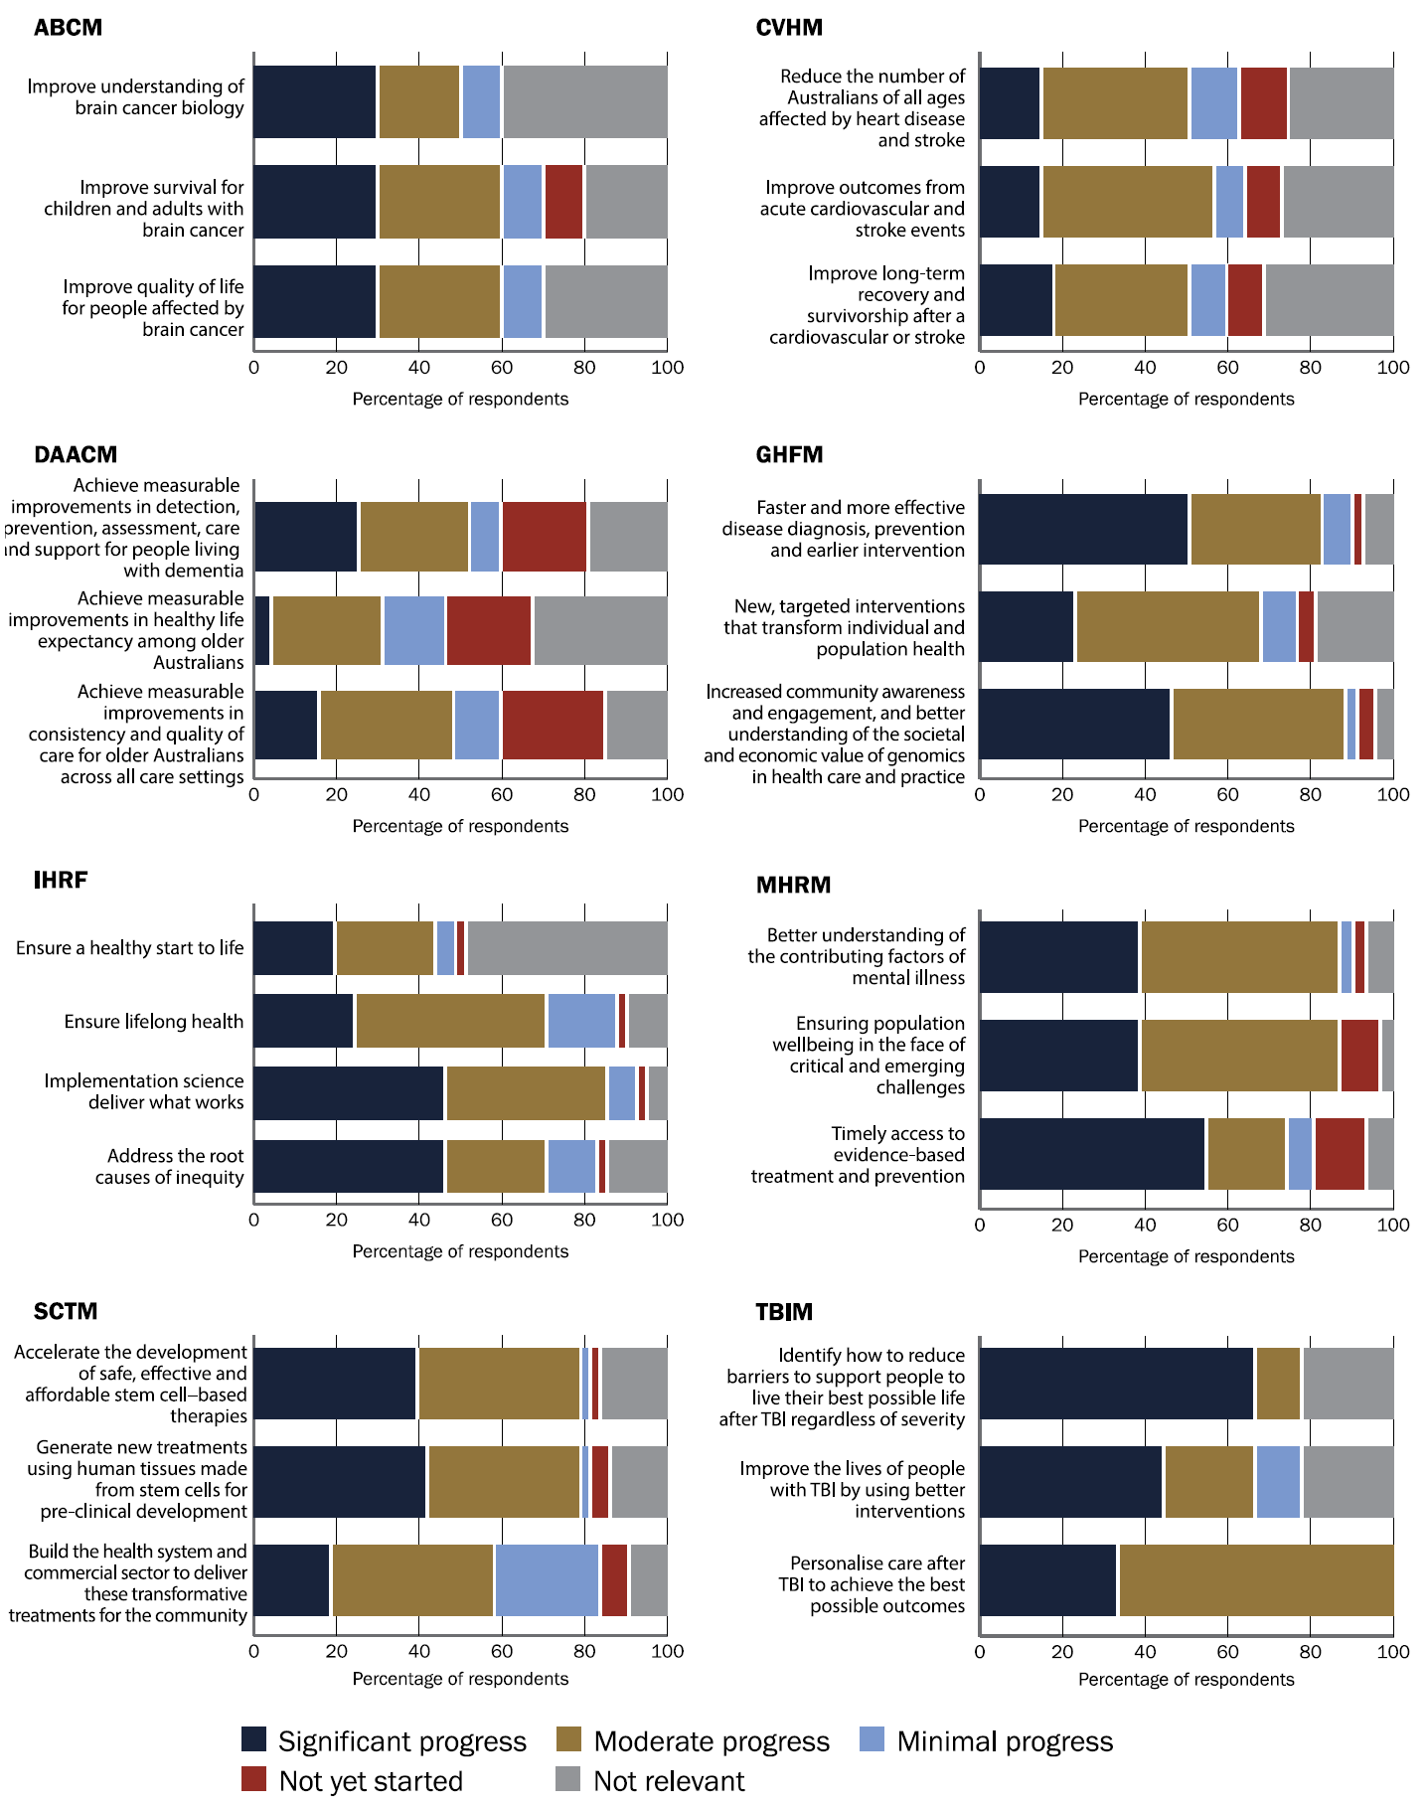
ABCM = Australian Brain Cancer Mission; CVHM = Cardiovascular Health Mission; DAACM = Dementia, Ageing and Aged Care Mission; GHFM = Genomics Health Futures Mission; IHRF = Indigenous Health Research Fund; MHRM = Million Minds Mental Health Research Mission; SCTM = Stem Cell Therapies Mission; TBI = traumatic brain injury; TBIM = Traumatic Brain Injury Mission.
Source: Grantee survey.

6.2 Progress towards Research Missions program aims
Stakeholders were asked for their views regarding progress towards the Research Missions program aims:
- fund large programs of work
- bring together key researchers, health professionals, stakeholders, industry partners and patients/consumers
- tackle big health challenges.

Summary findings

Stakeholder views on strengths
- More than 85% of grantee and public survey respondents agreed that the Research Missions program was fulfilling its aims to some extent. Research end users and grantees were more likely to describe the Research Missions program as fulfilling its aims ‘to a great extent’ than were health and medical researchers and research organisations.
- Most survey respondents who have been members of grant assessment committees (69%) thought that the overall aims of the Research Missions program were well considered as part of the assessment process.
- All research end users that completed the public survey were involved in applications and resulting research projects.
- Almost half of Research Missions grantees (49%) were working towards or had achieved translation of their research outcomes into policy and practice, although challenges remain.

Stakeholder concerns and considerations
Stakeholders identified concerns or considerations regarding progress towards Research Mission aims, including:
- program scope and structure – stakeholders currently view the program as too narrow in scope, involving project-based research rather than large, coordinated and sustainable programs of work
- funding scale and adequacy – stakeholders called for increased funding disbursement from the MRFF, and for grant funding to cover the true cost of research
- partnership and involvement challenges – challenges include timeframes to establish partnerships, eligibility to lead and administer grants, consumer and community involvement, and communication between research and policy
- prioritisation and selection processes – there is a lack of transparency and evidence-based rationale on how Research Missions are selected, and how Mission priorities are determined.

6.2.1 Stakeholder views on strengths

The Research Missions program is fulfilling its aims
Respondents were asked to rate the extent to which the Research Missions program is fulfilling its aims. Most respondents believed the program is fulfilling its aims to at least some extent. Grantees were more likely to indicate that the Research Missions program is fulfilling its aims ‘to a great extent’ than public survey respondents (Figure 20). Of the public survey respondents, research end users were more likely to describe the Research Missions program as fulfilling its aims ‘to a great extent’ than health and medical researchers and research organisations.
Figure 20 Stakeholder views on how well the Research Missions program is meeting its aims
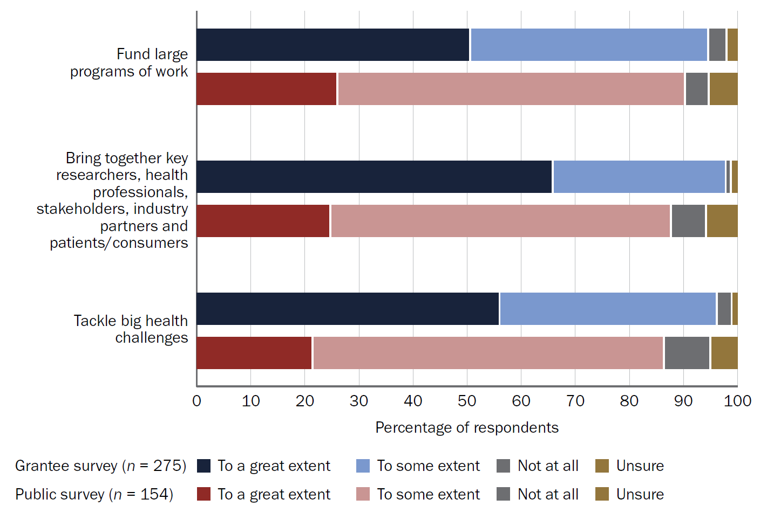
Source: Public and grantee surveys.
Quotes:
‘The MRFF Research Missions program plays an important role in addressing complex health challenges.’ – Public survey respondent, health and medical researcher
‘I think the program has been game changing for health and medical research in Australia and am keen for it to continue.’ – Grantee, Million Minds Mental Health Research Mission
‘I think, overall, it is an excellent program and achieving the intent.’ – Grantee, Indigenous Health Research Fund
‘It’s a vital contribution to the health research sector.’ – Grantee, Cardiovascular Health Mission

Strengths regarding progress towards Research Missions program aim 1: Fund large programs of work
Some stakeholders value the Research Missions program’s large-scale, long-term and mission-oriented structure, noting it fills a critical gap in the research funding landscape. This model is seen as uniquely enabling collaborative, nationally coordinated approaches to complex health challenges that are not feasible through traditional project-based grants. Some interview participants recognised that the provision of longer-term funding in specific research areas:
- enables the recruitment and retention of high-performing researchers
- is crucial to sustaining collaboration, workforce development, progress and sectoral improvement
- helps attract multiple forms of additional investment or co-investment.
Quote:
‘The MRFF Research Missions program has demonstrably fulfilled its core objectives. It has successfully funded large-scale, coordinated programs of work that would not have been feasible under traditional project-based funding schemes.’ – Public survey respondent, health and medical researcher

Strengths regarding progress towards Research Missions program aim 2: Bring together key researchers, health professionals, stakeholders, industry partners and patients/consumers
Some respondents praised the program for its success in fostering collaboration across disciplines and sectors. They believed that the program effectively assembles diverse teams including researchers, clinicians, industry partners and consumers to address major health challenges.
Participants specifically recognised the Million Minds Mental Health Research Mission and Indigenous Health Research Fund for providing opportunities for early-career researchers (specifically Aboriginal and Torres Strait Islander early-career researchers for the Indigenous Health Research Fund) to lead projects. Participants also identified the role of Australian Genomics (now superseded by the establishment of Genomics Australia) in coordinating activities and supporting applications under the Genomics Health Futures Mission as an exemplar of inter-Mission collaboration.
Stakeholders recognised the role the MRFF has played in encouraging consumer participation (see Section 4.2.9). Stakeholders considered the MRFF was effective in involving people with lived experience throughout the research lifecycle.
Allowing non-academic organisations to apply for MRFF funding has enabled researchers in community, industry and health systems to be involved, supported and recognised.
Quote:
‘I do think that awareness [of consumer involvement] is growing and I think that is down to some of the recent work of both NHMRC and MRFF in highlighting the importance of consumer involvement.’ – Interview participant, consumer and advocacy group

Strengths regarding progress towards Research Missions program aim 3: Tackle big health challenges
Some respondents strongly support the Mission selection process. They consider that the targeted approach and focus on nationally significant health challenges and translational research are effective ways to tackle major health challenges and areas of unmet need.
Respondents noted that the Indigenous Health Research Fund aligns well with the overall aims of the MRFF. They also considered that the Genomic Health Futures Mission strengthens Australia’s genomics sector, workforce and patient access to genomic screening, and is a key area for future health system transformation.
Quote:
‘The MRFF Research Missions program is a valuable national initiative that supports critical research across many of Australia’s most significant health challenges … None of these research challenges can be solved by any one sector alone, and the MRFF provides the essential support needed to bring together researchers, clinicians, industry partners, communities and other stakeholders to work collaboratively toward meaningful health improvements.’ – Grantee, Million Minds Mental Health Research Mission

The aims of the Research Missions program are well considered as part of the assessment process
Of the survey respondents who had been members of grant assessment committees (n = 31), 69% thought that the overall aims of the Research Missions program are well considered as part of the assessment process.
Many respondents indicated that the Grant Assessment Committee follows the required process. Some respondents indicated that this process does not always align with the Research Missions program aims – for example, grant opportunities requiring distribution of small funding amounts across many projects, or not requiring applicants to address a grand challenge.
Quote:
‘The program aims were well articulated but imperfectly embedded in assessment practice.’ – Public survey respondent, representative of a consumer organisation

Research end users have been actively involved in applications and successful grants
Research end users who had been involved in an application to the Research Missions program (n = 23) were asked about their role in the research. The most common roles were ‘priority setting and co-design’ (46%) and ‘dissemination of results’ (42%) (Figure 21).
Figure 21 Consumer and end-user involvement in applications and research projects
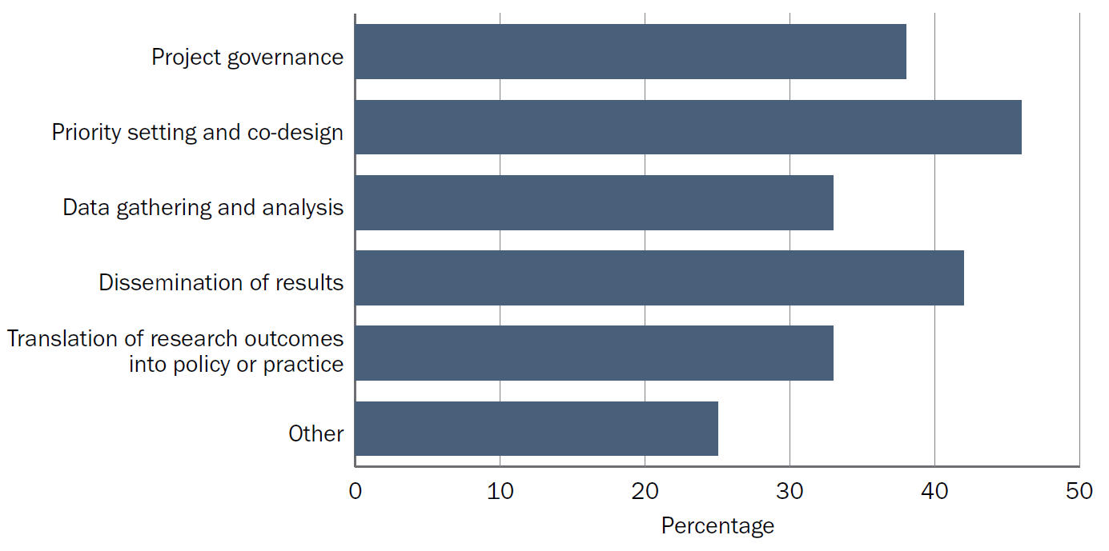
Source: Public survey.
Other ways that consumers and end users were involved include reviewing and providing guidance on applications, providing infrastructure and letters of support.
Some public survey respondents had suggestions for how the MRFF could improve involvement of consumers and research end users. These are outlined in Section 7.1.

Research Mission grants involve research teams across multiple organisations and sectors
To understand the collaborative breadth and diversity of sectors and institutions involved in Research Missions projects, an analysis was undertaken of the average number (per grant) of:
- named Chief Investigators
- named Associate Investigators
- participating organisations
- different sectors represented by investigators.
All Research Missions had an average of 3 to 4 different sectors per grant, reflecting cross-sector collaboration (Table 17).
Table 17 Average number of Chief Investigators, Associate Investigators, organisations and sectors per Research Missions grant
Research Mission | Number of CIs per grant, average (range) | Number of AIs per grant, average (range) | Number of organisations per grant, average (range) | Number of sectors per grant, average (range)
Australian Brain Cancer Mission | 20 (4–48) | 6 (1–10) | 13 (2–31) | 4 (2–6)
Cardiovascular Health Mission | 11 (2–47) | 6 (1–15) | 8 (1–25) | 3 (1–5)
Dementia, Ageing and Aged Care Mission | 11 (5–15) | 8 (1–15) | 9 (1–17) | 3 (1–6)
Genomics Health Futures Mission | 13 (1–47) | 7 (1–10) | 10 (2–30) | 3 (1–6)
Indigenous Health Research Fund | 10 (4–15) | 5 (1–12) | 7 (1–14) | 3 (1–5)
Million Minds Mental Health Research Mission | 11 (1–49) | 7 (1–34) | 8 (2–28) | 3 (1–7)
Stem Cell Therapies Mission | 8 (3–25) | 4 (1–15) | 6 (1–15) | 3 (1–6)
Traumatic Brain Injury Mission | 12 (1–50) | 13 (5–44) | 13 (5–26) | 3 (2–5)
AI = Associate Investigator; CI = Chief Investigator.
Source: MRFF administrative data as at 1 July 2025.

Applicants use Research Mission strategic documents, and other enablers of the Research Missions program
To better understand the strengths and enablers of the Research Missions program, grantees (n = 322) and public survey respondents who had been involved in an application to the Research Missions program (n = 95) were asked about enablers for applications, as well as their use of Research Mission strategic documentation (implementation plans and roadmaps).
As outlined in Figure 22, the most common enablers when applying for grant opportunities under the Research Missions program were ‘advanced notice of future grant opportunities’, ‘custom selection criteria’ and ‘priority population focus’.
Figure 22 Enablers for applications to Research Missions grant opportunities
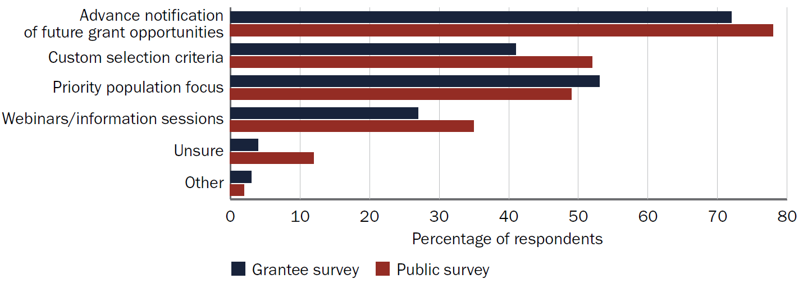
Source: Public and grantee surveys.
The key enablers of research that were listed in grantee progress and final reports were:
- strong partnerships and collaboration across clinical, community, industry and policy stakeholders
- co-design and sustained involvement of end users, including consumers, carers and clinicians
- access to shared data, digital platforms, and specialised research or clinical infrastructure
- clinician–researcher leadership embedded within service settings
- development of guidelines, standards and practical tools to support uptake of research outcomes.
Most public survey (85%) and grantee (74%) respondents were aware of Research Mission strategic documents. The most common reason for using strategic documents was to ‘identify topics for future funding opportunities as outlined in the implementation plan, before the grant opportunity was announced’. This was followed by ‘informing future research direction’ and ‘identifying evaluation measures’ (Figure 23).
Figure 23 Reasons stakeholders use Research Mission strategic documents
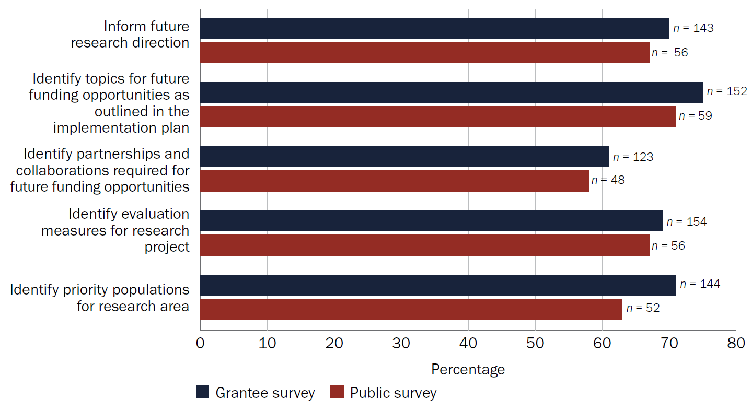
Source: Public and grantee surveys.
Some respondents also indicated that they use the documents:
- for strategic planning (for example, aligning industry priorities with national research direction)
- to draft their research funding application
- for communication (for example, dissemination to colleagues and potential partners)
- to inform dissemination strategies.
Quote:
‘The strategic documents informed our stakeholder engagement and dissemination strategy. They helped guide partnership development with health districts and aged care providers, ensuring that implementation planning and translation activities were consistent with MRFF’s long-term vision for sustainable system change.’ – Grantee, Dementia, Ageing and Aged Care Mission
A few respondents indicated that the documents have limited use because they are too broad or did not relate to their research area. Some respondents stated they had limited capacity to engage with the documents, or that success rates were too low to warrant them changing research direction. There is some variability between Missions in how specific the strategic documents are, depending on when they were produced and the views of the individual Expert Advisory Panel.

Grant recipients received co-funding to support research activities
Nearly three-quarters (71%) of grants funded through the Research Missions program received supplementary support from other funding sources. The total co-funding received by all grants in scope was approximately $124 million, comprising $68 million in in-kind contributions, $28.6 million in cash, and $27.7 million in combined in-kind and cash support. Co-funding came from various sectors, including philanthropy or not for profit, industry, and Commonwealth and state government departments.

Grant recipients have achieved or are working towards translating their research outcomes into policy and practice
Respondents were asked about the next phase of the research funded through the Research Missions program.
When ‘achieved’ and ‘in progress’ responses were considered together, 49% of grants had already translated, or were working towards translating, their research outcomes into policy and practice (Figure 24). This is consistent with the MRFF focus on supporting translational research to achieve better health outcomes, beneficial change to health practice and increased health efficiency.
Commercialisation of research outcomes was less of a focus for grants funded under the Research Missions program.
Many respondents indicated that their project either had recently commenced or was ongoing. This meant it was too early in the project to have achieved some or all of these next phase activities.
Figure 24 Next phase for Research Missions–funded research, as identified by grantees
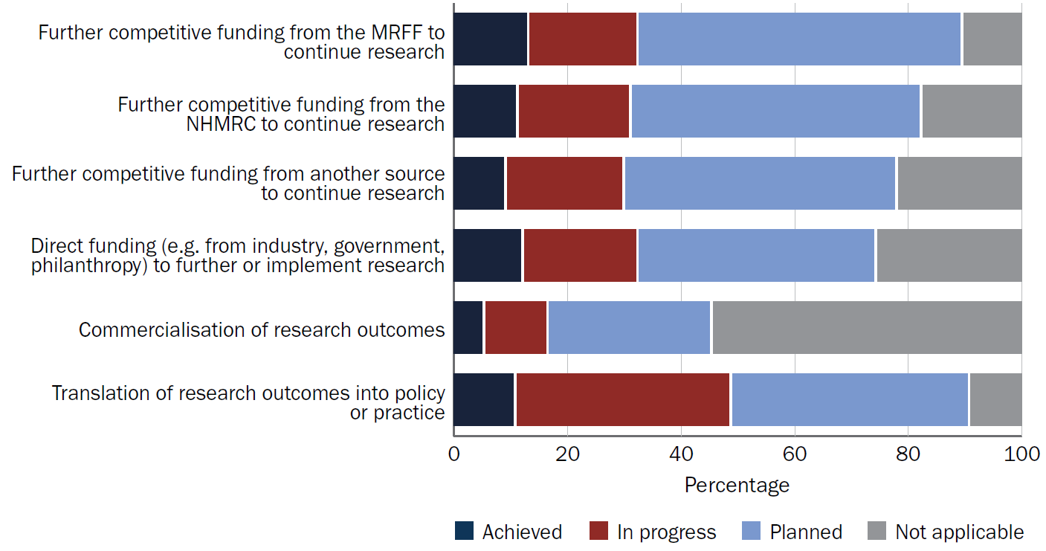
MRFF = Medical Research Future Fund; NHMRC = National Health and Medical Research Council.
Source: Grantee survey.

6.2.2 Stakeholder concerns and considerations
Stakeholders were asked to describe the main barriers to applying for, securing, conducting or translating research. Feedback relating to the 3 Research Mission aims are outlined below. Other barriers are outlined in Section 6.4.1.

Research Missions program aim 1: Fund large programs of work
This theme includes feedback on the program’s aim to fund large programs of work.
This theme was more likely to be raised by:
- industry, commercialisation and translation
- Mission-style funding agencies
- researchers and research organisations
- grantees
- advocacy organisations, peak bodies or associations.

Funding scale and adequacy
Consistent with ongoing sector sentiment, respondents strongly advocated for increasing the total funding disbursed from the MRFF by raising or removing the annual spending cap. This is deemed necessary to improve grant success rates and build research capacity.
More specific to the Research Missions program is the desire for increased funding amounts to enable larger, more ambitious programs of work that match the scale of national health challenges. Respondents considered that spreading funds too thin and keeping individual project grants small prevents research from achieving national scale. They also noted that programmatic and administrative support is important for large research funding programs – currently, impactful programs often rely on a mix of funding sources (for example, NHMRC, MRFF, state funding) to cover these costs.
Quote:
‘… with the current envelopes, it can be quite tricky to do anything of national scale with the amounts that are being allocated for the project.’ – Interview participant, departmental stakeholder

Program scope and structure
Respondents raised concerns that the current funding structure – which was viewed as having narrow scopes and short timelines – fosters fragmented, project-based research rather than the large, coordinated and sustainable programs of work needed for long-term impact. The current approach creates challenges for coordination, integration between projects and the transition of successful research into practice. A few stakeholders identified the Cardiovascular Health Mission as a Research Mission exemplifying this fragmented, project-based research approach.
Some respondents described each project funded under the Research Missions program as ‘starting from scratch’ and not building on previous research. Others felt that grant opportunities that ask applicants to build upon the work of existing grant holders favoured previously funded research teams.
Respondents emphasised the importance for funding calls to have clear, multiyear timelines, to allow teams to build collaborations and prepare high-quality proposals. Projects that address big health challenges require long-term planning. Respondents noted the ARC Centres of Excellence as an analogous example, with planning for these applications reportedly taking 2 to 3 years. Although the Research Mission implementation plans are meant to address this by providing early notice of future funding topics, stakeholder feedback indicated that not all applicants are aware of the implementation plans, or that the plans lack sufficient detail. (See also Section 6.2.1.)
Stakeholders considered the 3-year funding cycles to be too short for large, multidisciplinary and/or interdisciplinary projects due to legal, ethical, governance and project management requirements.
Quote:
‘Currently, Mission [sic] operate as collections of disconnected grants rather than strategic programs.’ – Public survey respondent, representative of an advocacy organisation, peak body or association

Financial and costing issues
Although this issue is broader than the Research Missions program and the MRFF, respondents reported that funding fails to cover the full cost of research. This creates a significant and often prohibitive financial burden on participating institutions. Key issues cited include the lack of provision for indirect or overhead costs, and salary packages that fall well below the actual cost of employing research staff. These issues can be exacerbated in health services, smaller partners, consumer organisations and regional, rural and remote settings, which are some of the collaborative players the Research Missions aims to engage.

Research Missions program aim 2: Bring together key researchers, health professionals, stakeholders, industry partners and patients/consumers
This theme includes feedback on the program’s aim to bring together diverse groups, including the effectiveness of collaborations and the challenges of engaging various stakeholders.
This theme was more likely to be raised by:
- advocacy organisations and consumers
- Department of Health, Disability and Ageing stakeholders
- Mission-style funding agencies
- health and medical researchers or research organisations.

Team composition and effectiveness
Short application timelines and administrative requirements are significant barriers to forming genuine cross-sector partnerships. These compressed timeframes conflict with the intensive work needed to build relationships, secure commitments and navigate partner governance. This is further complicated by limited capacity, time, resources and high staff turnover in stakeholder organisations.
Respondents noted that effective collaborative teams feature a diverse composition of academics, community members, consumers and other experts. Academic teams were seen as being potentially more successful in obtaining research funding, but less likely to be effective in translating research outcomes.
A few respondents noted that Chief Investigator application limits and eligibility requirements can inhibit collaboration. Respondents considered that application limits, including limitations on the number of applications a Chief Investigator can lead, are especially restrictive in highly specialised Research Mission areas. Restrictions on eligibility to lead and participate in research with a regional, rural and remote focus can have the unintended consequence of preventing metro-based researchers from partnering with researchers located in more regional areas, or can exclude people with the required expertise and partnerships from applying (for example, researchers who have previously but no longer live in rural or remote areas). It was noted that the regional, rural and remote workforce is relatively small and may not always have capacity or expertise to lead projects.
Quote:
‘The short windows for MRFF applications are often incompatible with the deep, time-intensive co-design required for Aboriginal and Torres Strait Islander health or complex service-level interventions. This forces “transactional” rather than “transformational” partnerships.’ – Public survey respondent, health and medical researcher

Consumer and community co-design
Despite advances made by the MRFF in relation to consumer and community involvement, stakeholders reported that consumer and community involvement can be tokenistic, under resourced and occur too late in the research process. Respondents considered that an appropriate consumer and community involvement approach is important for improving relevance, building trust and translating research into practical outcomes that address real-world health needs and equity gaps. Further, stakeholders cautioned that it is important to hear from a broad range of consumers and community members, as input from individuals or small groups may not represent the entire cohort.
Participants from Aboriginal and Torres Strait Islander representative organisations highlighted the ongoing need for culturally appropriate and meaningful partnerships with Aboriginal and Torres Strait Islander communities. It was noted that relationship building is an important form of impact but is often not recognised, captured or reported as such.
Quote:
‘Consumer and research end‑user involvement could be strengthened through more consistent and structured engagement across the full lifecycle of Research Missions, including priority setting, governance, implementation and evaluation. While consumer involvement is recognised within MRFF frameworks, its application can vary between Missions and funding opportunities. Earlier and more systematic involvement of consumer organisations in Mission design and prioritisation would help ensure alignment with real‑world need and disease burden. Clearer expectations and resourcing for meaningful consumer involvement within large, multi‑partner programs would also support more effective translation of research outcomes into policy and practice. Strengthening these mechanisms would enhance the relevance, impact and accountability of Mission‑funded research.’ – Public survey respondent, representative of a consumer organisation

Partnership and involvement challenges
Communication of government priorities, research activities and outcomes are not always accessible or coordinated. This makes it challenging for researchers to identify government priorities and for policymakers to engage with research and researchers.
Participants noted the challenges of differing timelines between the policy cycle and research and research funding. They also noted that the Research Missions’ focus is on disease-specific topics, while many policy challenges are systemic and cross-sectoral (for example, multimorbidity).
Participants noted that Aboriginal Community Controlled Health Organisations and many health services are currently ineligible to lead or administer MRFF funding. In addition, they often also lack the infrastructure to support research activities. Collectively, this limits their participation and recognition in health research. Respondents considered the infrastructure support for community-controlled organisations to be insufficient, limiting their ability to employ researchers and maintain research programs. Additionally, clinical researchers lack capacity and institutional support to apply for research funding – this is exacerbated for those with heavy clinical loads or who are based in rural areas. Appropriate incentives and reimbursement for both individuals and consumer organisations to participate in research activities are required, especially in rural contexts and in early-stage grant involvement (which is currently not funded).

Research Mission program aim 3: Tackle big health challenges
This theme relates to stakeholder views on the selection of research priorities and on project planning and grant duration.
This theme was more likely to be raised by:
- advocacy organisations and consumers
- Department of Health, Disability and Ageing stakeholders
- professional bodies
- researchers and research organisations
- grantees
- advocacy organisations, peak bodies or associations
- consumers or carers, community members or representatives of a consumer organisation.

Prioritisation and selection process
Respondents expressed significant concern about the lack of transparency and evidence-based rationale in how Research Missions are selected and how priorities for each Mission are determined. Many perceive the process as opaque and potentially influenced by political factors rather than population health needs, leading to misalignment between current funding, Australia’s largest health burdens and government priorities.
A few stakeholders specifically mentioned the Indigenous Health Research Fund; Reducing Health Inequities Mission; Dementia, Ageing and Aged Care Mission; and Million Minds Mental Health Research Mission as addressing big health challenges.
Although the Indigenous Health Research Fund was recognised as important in addressing Aboriginal and Torres Strait Islander health, participants called for greater recognition that topics relevant to Aboriginal and Torres Strait Islander peoples sit across all Research Missions, and increased alignment with community priorities.
Quote:
‘Currently, there is limited understanding of how Missions themes are selected, and their connection to the Australian health burden. We suggest that clearer reporting on the prioritisation process behind the selection of each Mission could improve this understanding among the scientific community.’ – Public survey respondent, health and medical research organisation

Gaps and neglected areas, and suggestions for new priorities
Respondents proposed gaps, unmet needs and new research priorities, including specific conditions, systemic challenges and the need to develop and adopt new research methodologies. These are further explored in Section 4.1.4.
Stakeholder suggestions to improve the progress of the Research Missions program towards its aims are outlined in Section 7.1.

6.3 Progress towards MRFF measures of success
Grantees were asked about their progress towards the MRFF measures of success (see Figure 25).

Summary findings

Measures of success being addressed by the Research Missions program
- Research Mission grants most frequently addressed the measure of success ‘Increased focus of research on areas of unmet need’, followed by ‘The community engages with and adopts new technologies and treatments’ and ‘Research community has greater capacity to undertake translational research’.
- ‘Increased commercialisation of health research outcomes’ is the least addressed measure of success.

Progress towards measures of success
- When considering completed projects, the measure of success most frequently reported as ‘fully achieved’ was ‘Increased focus of research on areas of unmet need’. This was followed by ‘Research community has greater capacity to undertake translational research’ and ‘New health interventions are embedded in health practice’.
- Most (75%) grants funded under the Research Missions program addressed at least one MRFF or Research Mission priority population.
- Around one-third (32%) of grants funded under the Research Missions program involved at least one clinical trial, with 138 trials supported overall.
- Most (84%) Research Missions grantees reported that their project involved one or more consumer involvement activities. All research end users who responded to the public survey were actively involved in applications and research projects.
- Grants funded under the Research Missions program have supported research team members across a broad range of categories, including medical professionals, early- and mid-career researchers, people from priority populations and industry-based researchers.
- Of the Research Missions grants that were complete at the time of the MRFF performance indicators survey, 90% of grantees had undertaken activities supporting health and healthcare change, 69% of projects had resulted in outputs or outcomes supporting health and healthcare change and 38% of projects had resulted in outputs or outcomes related to commercialisation.

6.3.1 Measures of success being addressed by Research Mission grants
Grantee progress and final reports were used to identify the measures of success being addressed by grants funded under the Research Missions program. Table 18 shows the number of times a measure of success was listed.
The most frequently addressed measure of success overall was ‘Increased focus of research on areas of unmet need’. It was the most frequently addressed measure of success for all Research Missions except the Traumatic Brain Injury Mission.
The least addressed measure of success was ‘Increased commercialisation of health research outcomes’. Grantees reported this measure of success most often for the Genomics Health Futures Mission and Stem Cell Therapies Mission – these Missions place more emphasis on technology development and translation than the other Missions.
Table 18 MRFF measures of success being addressed by individual Research Missions and the Research Missions program
Measure of success | ABCM, total mentions (distinct mentions) | CVHM, total mentions (distinct mentions) | DAACM, total mentions (distinct mentions) | GHFM, total mentions (distinct mentions) | IHRF, total mentions (distinct mentions) | MHRM, total mentions (distinct mentions) | SCTM, total mentions (distinct mentions) | TBIM, total mentions (distinct mentions) | Total for each measure, total mentions (distinct mentions)
Increased focus of research on areas of unmet need | 6 (4) | 93 (80) | 55 (49) | 72 (58) | 52 (48) | 26 (21) | 52 (48) | 8 (8) | 364 (316)
More Australians access clinical trials | 2 (2) | 33 (31) | 17 (17) | 41 (39) | 2 (2) | 6 (2) | 25 (24) | 1 (1) | 127 (118)
New health technologies are embedded in health policy and practice | 1 (1) | 55 (43) | 29 (24) | 69 (56) | 16 (14) | 8 (7) | 28 (27) | 7 (7) | 213 (179)
New health interventions are embedded in health policy and practice | 1 (1) | 33 (28) | 18 (18) | 20 (19) | 28 (25) | 13 (10) | 8 (8) | 5 (5) | 126 (114)
Research community has greater capacity to undertake translational research | 2 (2) | 63 (54) | 36 (33) | 54 (46) | 41 (40) | 19 (17) | 39 (35) | 7 (7) | 261 (234)
Health professionals adopt best practices faster | 4 (2) | 32 (30) | 34 (31) | 46 (43) | 23 (23) | 10 (8) | 8 (8) | 7 (7) | 164 (152)
The community engages with and adopts new technologies, treatments and interventions | 4 (3) | 54 (49) | 33 (30) | 55 (49) | 29 (28) | 19 (16) | 30 (29) | 11 (9) | 235 (213)
Increased commercialisation of health research outcomes | 3 (2) | 22 (21) | 9 (8) | 25 (25) | 0 (0) | 0 (0) | 37 (35) | 0 (0) | 96 (91)
ABCM = Australian Brain Cancer Mission; CVHM = Cardiovascular Health Mission; DAACM = Dementia, Ageing and Aged Care Mission; GHFM = Genomics Health Futures Mission; IHRF = Indigenous Health Research Fund; MHRM = Million Minds Mental Health Research Mission; SCTM = Stem Cell Therapies Mission; TBIM = Traumatic Brain Injury Mission.
Note: Shaded cells denote the most frequently reported measure of success for each Research Mission and overall.
Source: Grantee progress and final reports.

6.3.2 Progress towards measures of success
This analysis included projects that had been completed and for which a final report was available that captured progress towards measures of success (n = 44). Most measures of success were either partially or fully achieved by the end of the project. The measure of success most frequently reported as fully achieved was ‘Increased focus of research on areas of unmet need’ (Figure 25).
Figure 25 Progress towards achieving MRFF measures of success for completed projects
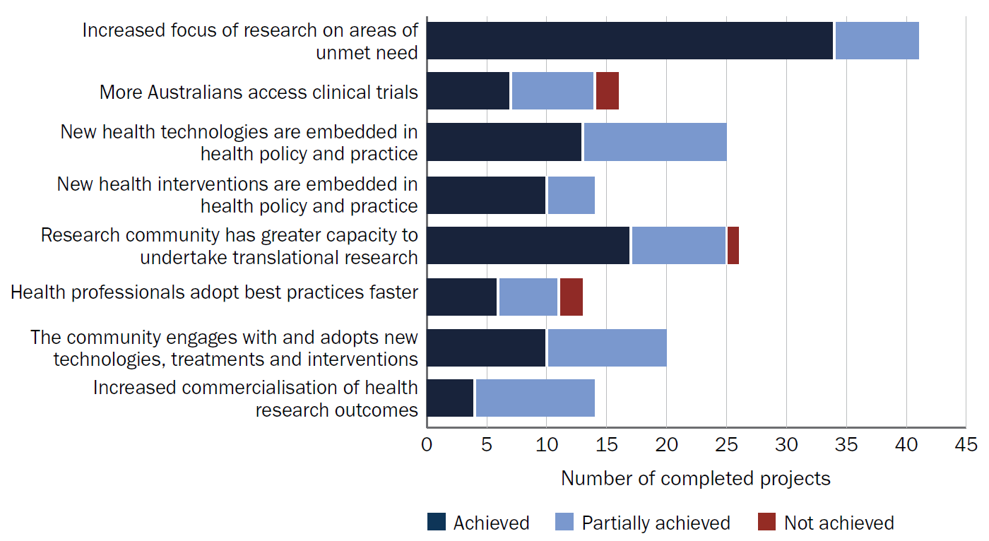
Source: Grantee final reports.

Measure of success: Increased focus of research on areas of unmet need
Based on the MRFF performance indicators survey and administrative data, 75% of grantees funded under the Research Missions program reported that their project addressed at least one MRFF priority population. The MRFF priority populations addressed are in Table 19. In addition, the grantee survey captured data on projects that address Research Mission-specific priority populations (that are not also MRFF priority populations). These are outlined in Table 20. Combined, this information provides an overall picture of the Research Missions program’s priority population focus.
Overall, the most common priority populations addressed were older people experiencing diseases of ageing, people with rare or currently untreatable diseases or conditions, and Aboriginal and/or Torres Strait Islander peoples. Only 4 grants funded under the Research Missions program had a focus on LGBTQIA people, while only 30 grants focused on individuals from culturally and linguistically diverse communities.

Table 19 Number of Research Missions–funded projects addressing MRFF priority populations
Priority population | ABCM | CVHM | DAACM | GHFM | IHRF | MHRM | SCTM | TBIM | Total
Aboriginal and/or Torres Strait Islander peoples | 0 | 14 | 2 | 11 | 54 | 8 | 1 | 2 | 92
Older people experiencing diseases of ageing | 0 | 25 | 54 | 8 | 4 | 0 | 9 | 2 | 102
People with rare or currently untreatable diseases or conditions | 7 | 12 | 2 | 36 | 2 | 1 | 31 | 1 | 92
People in remote or rural communities | 0 | 25 | 14 | 9 | 25 | 9 | 0 | 0 | 82
People with a disability (including people with intellectual disability) | 0 | 9 | 11 | 13 | 1 | 4 | 10 | 2 | 50
Individuals from culturally and linguistically diverse communities | 0 | 6 | 11 | 8 | 1 | 4 | 0 | 0 | 30
LGBTIQA people | 0 | 1 | 0 | 2 | 1 | 0 | 0 | 0 | 4
Youth | 3 | 6 | 0 | 7 | 12 | 15 | 12 | 3 | 58
ABCM = Australian Brain Cancer Mission; CVHM = Cardiovascular Health Mission; DAACM = Dementia, Ageing and Aged Care Mission; GHFM = Genomics Health Futures Mission; IHRF = Indigenous Health Research Fund; MHRM = Million Minds Mental Health Research Mission; SCTM = Stem Cell Therapies Mission; TBIM = Traumatic Brain Injury Mission.
Note: Projects supporting multiple priority populations are counted once for each group supported.
Source: MRFF performance indicator survey, MRFF administrative data as at 1 July 2025.
Table 20 Number of Research Missions–funded projects addressing Mission priority populations
Priority population | ABCM | CVHM | DAACM | GHFM | IHRF | MHRM | SCTM | TBIM
People who are financially or socially disadvantaged | n/a | n/a | 0 | n/a | n/a | 0 | n/a | n/a
People who are veterans of the Australian Defence Force or an allied defence force, including the spouse, widow or widower of a veteran | n/a | n/a | 0 | n/a | n/a | 0 | n/a | n/a
People who are homeless or at risk of becoming homeless | n/a | n/a | 0 | n/a | n/a | 3 | n/a | n/a
People who are care leavers (including Forgotten Australians, Former Child Migrants and Stolen Generations) | n/a | n/a | 1 | n/a | n/a | 1 | n/a | n/a
Parents separated from their children by forced adoption or removal | n/a | n/a | 0 | n/a | n/a | 0 | n/a | n/a
Prisoners and ex-prisoners | n/a | n/a | 0 | n/a | n/a | 2 | n/a | n/a
People affected by family, domestic and sexual violence | n/a | n/a | n/a | n/a | n/a | n/a | n/a | 1
Military and veteran populations | n/a | n/a | n/a | n/a | n/a | n/a | n/a | 0
People affected by repeated sports-related concussions | n/a | n/a | n/a | n/a | n/a | n/a | n/a | 1
ABCM = Australian Brain Cancer Mission; CVHM = Cardiovascular Health Mission; DAACM = Dementia, Ageing and Aged Care Mission; GHFM = Genomics Health Futures Mission; IHRF = Indigenous Health Research Fund; MHRM = Million Minds Mental Health Research Mission; n/a = not applicable; SCTM = Stem Cell Therapies Mission; TBIM = Traumatic Brain Injury Mission.
Note: Projects supporting multiple priority populations are counted once for each group supported.
Source: Grantee survey.

Case study: Population genomic screening of young adults to prevent cancer in Australia
Lead investigator: Professor Paul Lacaze, Head of Public Health Genomics, Monash University
Research Mission: Genomics Health Futures Mission
Grant Opportunity: 2020 Genomics Health Futures Mission
Project highlights
- Targeting population groups not routinely reached by existing diagnostic pathways
- Generating policy-relevant evidence on feasibility, cost-effectiveness and acceptability
- Enabling access to preventive interventions for participants and their families
- Informing future system design for population-level genomic screening
Measures of success
- Increased focus of research on areas of unmet need
- New health technologies are embedded in health policy and practice
- Research community has greater capacity to undertake translational research
- Health professionals adopt best practices faster
- The community engages with and adopts new technologies, treatments and interventions
The project
This project was a large-scale, nationwide population genomic screening pilot and feasibility study. Its aim was to improve the early identification and prevention of serious health conditions, including certain cancers and cardiovascular disease. The project focused on identifying individuals at elevated genetic risk of medically actionable conditions earlier in life – before disease onset – and enabling access to preventive care pathways.
Rather than concentrating on individuals already engaged with specialist genetics services, the project focused on population-based genomic screening of young adults, a group not routinely targeted by existing diagnostic pathways. This approach responded to a recognised gap in the health system, in which many people with clinically significant genetic risk remain unidentified until later stages, often after disease has developed or progressed.
The outcome
A major outcome of the grant was the successful testing and return of genomic screening results to more than 10,000 participants across Australia. This process identified 202 young adults at high genetic risk and supported them through structured genetic counselling and referral to clinical genetics services. This enabled participants to access tailored risk-management strategies through the public healthcare system, including enhanced surveillance, preventive interventions and cascade testing for family members.
The project has generated a robust evidence base to demonstrate the feasibility, acceptability and cost-effectiveness of population genomic screening as a preventive health strategy in Australia. Cost-effectiveness modelling conducted by the researchers also provided further supportive evidence. It showed that screening for high genomic risk of selected conditions could deliver health benefits while remaining economically viable within the Australian public health system, strengthening the case for further consideration of this approach in policy and planning contexts.
The main study findings were published in January 2026 in the inaugural issue of Nature Health.
Impact of MRFF funding
MRFF funding enabled this world-first nationwide pilot study of population genomic screening for high genomic risk of certain cancers and cardiovascular disease. In addition to demonstrating the feasibility, cost-effectiveness and acceptability of population genomic screening, the project directly impacted the lives of 202 participants identified with high-risk genomic variants, enabling them and their family members to access early screening and risk-reducing interventions through the public healthcare system. These interventions can be life-saving. Many of these participants have shared their personal stories, including in the media. The health outcomes achieved, and the evidence generated to inform future screening programs, have already delivered a substantial return on investment for this funding opportunity.

Measure of success: Research community has greater capacity to undertake translational research
Grants funded under the Research Missions program have supported research team members across a broad range of categories, including medical professionals, early- and mid-career researchers, people from priority populations and industry-based researchers (Table 21).
Table 21 Number of people supported by grants funded under the Research Missions program
Category | Number of people supported
General practitioners / medical doctors in primary care | 12
Medical doctors – specialists | 88
Nurses or midwives | 114
Dentists | 3
Allied health professionals | 342
Early-career researchers | 679
Mid-career researchers | 294
Higher degree research students (Masters, PhD) | 228
Women | 1,310
Aboriginal and Torres Strait Islander people | 183
People located in a regional, rural or remote area | 208
Culturally and linguistically diverse | 349
Researchers who are based in industry | 73
Source: MRFF performance indicator survey.

Case study: Healing the Past by Nurturing the Future: Trauma-integrated perinatal care to improve health outcomes for Indigenous parents and infants in a rural setting
Lead investigator: Professor Catherine Chamberlain, Melbourne School of Population and Global Health, The University of Melbourne
Research Mission: Indigenous Health Research Fund
Grant opportunity: 2020 Indigenous Health Research
Project highlights
- Building Indigenous research leadership through Indigenous-led governance and delivery
- Building research community capacity and capability by supporting Aboriginal community members to develop skills in implementation, evaluation and dissemination
- Focus on perinatal services in a large rural or regional health setting
- Developing and delivering scalable training and practical implementation resources to support translation into routine care
- Generating implementation knowledge about barriers and enablers in real-world service environments, informing future translational research and quality improvement
- Generating an additional $230,000 in in-kind funding from industry and state and territory governments
Measures of success
- Increased focus of research on areas of unmet need
- New health interventions are embedded in health policy and practice
- Research community has greater capacity to undertake translational research
- Health professionals adopt best practices faster
- The community engages with and adopts new technologies, treatments and interventions
The project
Indigenous communities are particularly affected by trauma stemming from violence and oppression associated with colonisation. The parenting transition is a critical life-course opportunity to ‘healing the past by nurturing the future’. This Indigenous-led demonstration study builds rigorous evidence for the rural healthcare setting and develops, implements and evaluates the acceptability, feasibility, costs and preliminary effectiveness of approaches to providing trauma-integrated perinatal care for rural Indigenous parents experiencing complex trauma to improve wellbeing.
The outcome
The project involved Indigenous-led translational research focused on improving the cultural safety and trauma-informed capability of perinatal services in a large rural/regional health setting. This included the development and delivery of co-designed training and implementation resources, including multilevel trauma-integrated training delivered at scale within the health service (more than 540 staff trained), and a suite of culturally safe, trauma-informed practice tools to support consistent uptake in day-to-day care. These outputs contribute to translational research capacity by providing tangible, service-ready resources and models that can be adapted and tested in other settings, supporting diffusion of innovation beyond the project site.
The project was designed to move beyond knowledge generation alone by co-designing practical strategies, resources and workforce development activities that could be implemented within routine maternity and family care.
Impact of MRFF funding
The MRFF funding was used to support staff at the regional health service, community-controlled organisation and the University of Melbourne. This enabled development of training to improve health service staff ‘awareness’ of trauma, as well as practical strategies for providing culturally safe trauma-informed care. A community advisory group and site implementation team led development of resources including a birthing trolley, parenting pack and other resources for parents. The funding also supported several community-based men’s workshops, a review of health service policies and scoping for a service directory.

Measure of success: The community engages with and adopts new technologies and treatments
In the performance indicators grantee survey (May 2024), 84% of Research Missions grantees reported that their project included one or more consumer involvement activities. The most reported activities were ‘Consumer organisations as project partners or advisory groups’ (60%), ‘Consumers in priority setting and co-design of study’ (54%) and ‘Consumers in project governance’ (45%) (Figure 26).
Figure 26 Percentage of Research Missions program grantees that reported consumer involvement activities
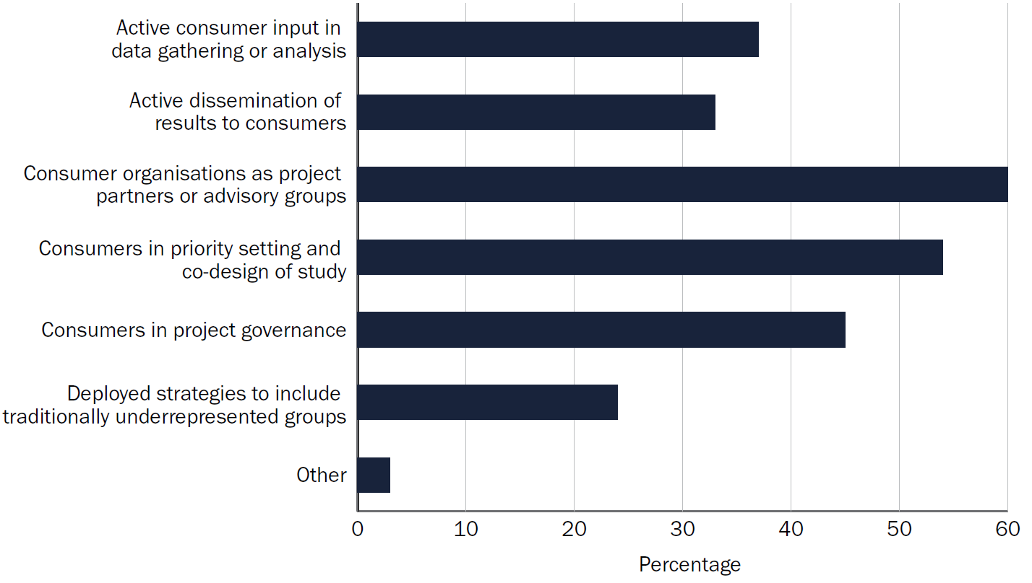
Source: MRFF performance indicator survey.
All research end users who completed the public survey (n = 23) indicated that they actively participated in an application or grant to the Research Missions program. The most common activities were ‘Priority setting and co-design’ (46%), ‘Dissemination of results’ (42%) and ‘Project governance’ (40%) (see Figure 21).
Some survey respondents also had suggestions for how the MRFF could improve involvement of consumers and research end users. These are outlined in Section 7.1.

Case study: Preventing suicide in boys and men
Lead investigator: Professor Jane Pirkis, Director of the Centre for Mental Health, The University of Melbourne
Research Mission: Million Minds Mental Health Research Mission
Grant opportunity: 2019 Suicide Prevention
Project highlights
- Collaborating across 5 universities and 14 community and industry organisations committed to male suicide prevention
- Testing the effectiveness of 7 suicide prevention programs designed for boys and men
- Modelling the impact of scaling up effective programs
- Receiving an additional $100,000 in funding from the philanthropic and not-for-profit sector
Measures of success
- Increased focus of research on areas of unmet need
- New health interventions are embedded in health policy and practice
- Health professionals adopt best practices faster
- The community engages with and adopts new technologies, treatments and interventions
The project
This project involved 7 randomised controlled trials. Five of these tested interventions designed to encourage men and boys to seek help by challenging certain dominant masculine norms such as stoicism and self-reliance. The other 2 trials tested interventions designed to ensure that, if men and boys do seek help, it meets their needs. The interventions were:
- ‘Breaking the Man Code’ – workshops for boys in years 10 to 12
- ‘Ahead of the Game’ – workshops for boys aged 12 to 17 years, their parents and sports club coaches
- ‘MATES in Manufacturing’ – training and support for men working in the manufacturing industry
- ‘Conversations about Suicide’ – specialist mental health first aid training for older men in men’s sheds
- ‘Boys Do Cry’ – media campaign targeting boys and men in the community
- ‘Men in Mind’ – training for psychologists and other mental health professionals designed to equip them to use therapies that work for male clients
- ‘Engaging Men in Crisis Support’ – training for Lifeline’s crisis supporters in working with male help-seekers.
The outcome
The trials demonstrated that these interventions show promise as tools for preventing male suicide. Highlights include:
- ‘Ahead of the Game’ participants reporting improvements in mental health literacy, and greater confidence in seeking help and offering support to others
- ‘Conversations about Suicide’ improving the suicide prevention skills of older men
- ‘Boys Do Cry’ having a positive effect on help-seeking intentions
- ‘Men in Mind’ effectively increasing mental health professionals’ self-reported efficacy in working with men.
Impact of MRFF funding
MRFF funding brought together national and international experts to test a suite of suicide prevention interventions that reach men and boys of different ages and in different settings. The project greatly contributed to knowledge about approaches that may be useful in decreasing the unacceptably high rate of male suicide.

Measures of success: Health professionals adopt best practices faster, New health technologies and interventions are embedded in health policy and practice
Of the Research Missions grants that were complete at the time of the MRFF performance indicators survey (n = 29), 90% of grantees had undertaken activities supporting health and healthcare change (Figure 27) and 69% of projects had resulted in outputs or outcomes that support health and healthcare change (Figure 28). The most common activities were ‘Engaged with relevant clinicians’, ‘Engaged with partners who can change practice’ and ‘Contributed to healthcare policy or clinical guidelines’.
Figure 27 Number of completed grants that had undertaken activities supporting health and healthcare change
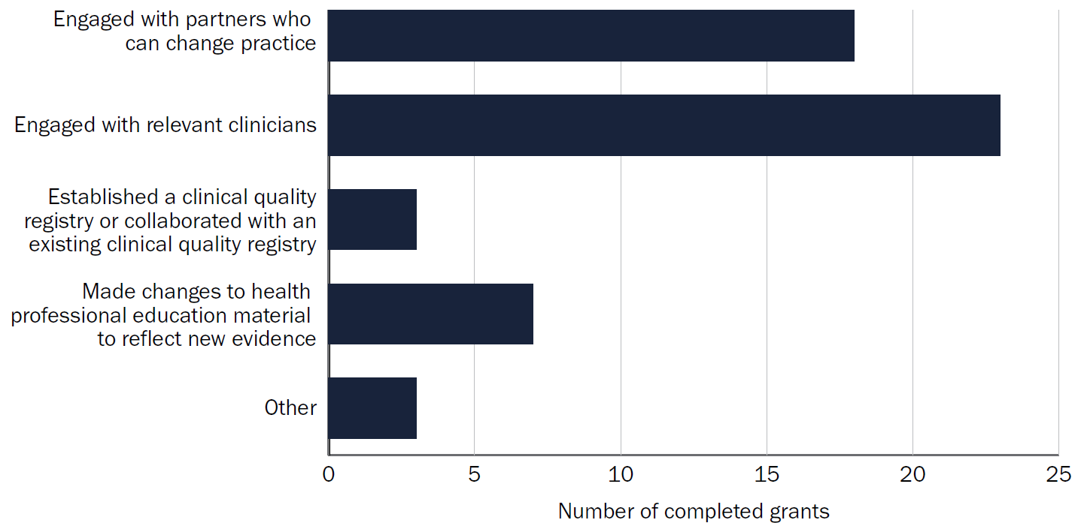
Source: MRFF performance indicator survey.
Figure 28 Number of completed grants that resulted in outputs and outcomes supporting health and healthcare change
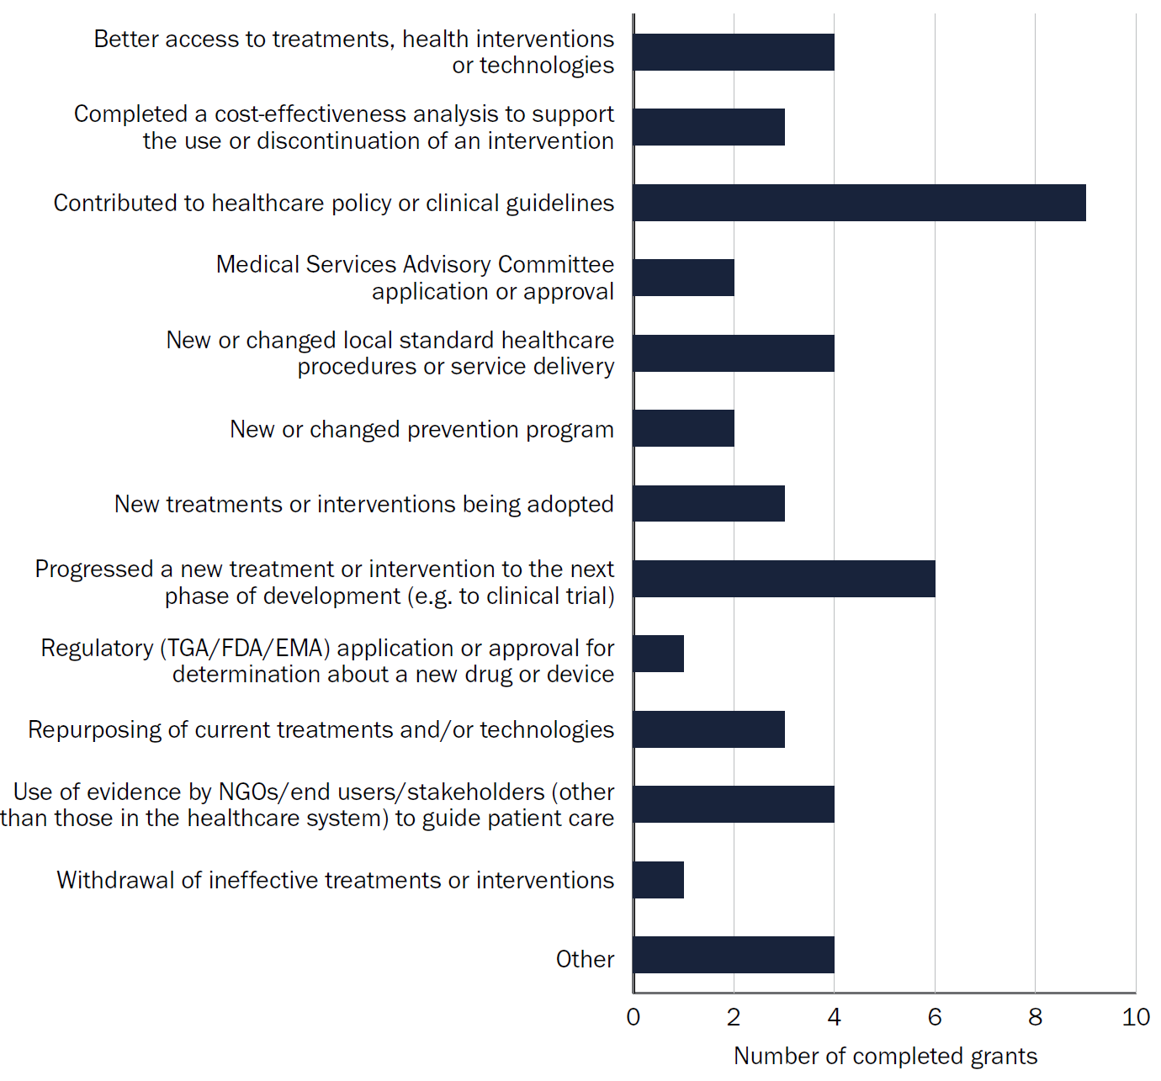
Source: MRFF performance indicator survey.

Case study: MAINSTREAM Centre for Health System Research and Translation in Eating Disorders: detection and intervention system-focused knowledge to drive better outcomes in mainstream care for eating disorders
Lead investigator: Professor Sarah Maguire, director of the InsideOut Institute for Eating Disorders, University of Sydney
Research Mission: Million Minds Mental Health Research Mission
Grant Opportunity: 2018 Million Minds Mission
Project highlights
- Developing the first national linked data asset in eating disorders
- Developing a lived experience lifetime survey (livED) co-designed platform for recording of experiences of an eating disorder
- Embedding at scale an early intervention screening tool and program for binge eating disorder and bulimia nervosa in service settings, including headspace centres and Medicare Mental Health Centres nationwide
- Establishing translation hubs in New South Wales, Victoria and Queensland, where researchers were placed directly within community-based organisations to support implementation, workforce training, evaluation and continuous improvement
- Training non-specialist clinicians to deliver evidence-based care, reducing dependence on specialist services
Measures of success
- Increased focus of research on areas of unmet need
- Research community has greater capacity to undertake translational research
- Health professionals adopt best practices faster
The project
This project enabled linked data and monitoring across the health system to drive earlier identification and intervention of mental health conditions. In doing so, it addressed a long-standing gap in Australia’s mental health system. The work addressed a critical challenge in eating disorder care: how to move from late, crisis-driven treatment to early detection and intervention – particularly in community and non-specialist settings where most people first seek help – and measure the outcomes. The project targeted nationally scalable solutions that could be embedded within existing primary care and youth mental health services.
The outcome
The major outcomes of the project were:
- a multistate analysis of 10 years of retrospective data covering 75% of Australia. This revealed sharp increases in eating disorder–related healthcare use – especially among adolescents – providing critical population-level insight into national service demand and access pathways. These analyses quantified mortality and the economic burden of eating disorders, revealing inequalities in access to care to inform more-equitable health system planning
- digital screening being embedded across primary care settings
- eTherapies for eating disorders coming more broadly available and ready for scaling nationally
- a livED survey, empowering people with eating disorders to share real-time lived experiences in diverse formats.
Impact of MRFF funding
MRFF funding enabled development of the program and for elements of it (for example, screening and eTherapy scaling) to receive ongoing funding from other sources.

Case study: Knowledge brokers for evidence translation to improve quality use of medicines in residential aged care
Lead investigator: Professor Simon Bell, director of the Centre for Medicine Use and Safety, Monash University
Mission: Dementia, Ageing and Aged Care Mission
Grant opportunity: 2020 Dementia, Ageing and Aged Care Mission
Project highlights
- Focusing on translating the NHMRC-approved Clinical Practice Guidelines for the Appropriate Use of Psychotropic Medications in People Living with Dementia and in Residential Aged Care into day-to-day organisational policies, procedures and routines
- Completing a 12-month counterbalanced randomised controlled trial involving 19 aged care facilities and 7 knowledge brokers in New South Wales, Queensland, Victoria and Western Australia
- Developing a suite of quality indicators to allow aged care provider organisations to monitor concordance with recommendations and good practice statements in the NHMRC guidelines
- Developing a medication safety toolkit comprising 12 microlearning videos for health and care staff and 9 one-page fact sheets. The toolkit also comprised a series of quality use of medicines, PowerPoint presentations, a 10-item adverse event monitoring checklist and a guideline companion guide in English, Greek, Italian, Vietnamese, and traditional and simplified Chinese
Measures of success
- Increased focus of research on areas of unmet need
- New health interventions are embedded in health policy and practice
- Health professionals adopt best practices faster
- The community engages with and adopts new technologies, treatments and interventions
The project
This project addresses findings from the Royal Commission into Aged Care Quality and Safety that over-reliance on psychotropic medications needs immediate action. The project trials the use of a ‘knowledge broker’ to implement new evidence-based recommendations to improve the safe and effective use of psychotropic medications in people living with dementia and in aged care.
The outcome
The project has tested a knowledge broker pharmacist model to actively translate guideline recommendations into routine practice in residential aged care. The project worked with aged care providers, peak bodies and a Stakeholder Advisory Committee to ensure implementation approaches are feasible and scalable.
The project developed a medication safety toolkit to support wider uptake of the knowledge broker role. To address time and resource constraints in aged care, the toolkit includes 12 short (5 to 7 minute) microlearning videos designed for on-the-job use. The work is also aligned with the Australian Government Aged Care On-site Pharmacist program, supporting practical pathways for implementation at scale.
Impact of MRFF funding
The project demonstrated a model whereby systems-level knowledge brokers can act as knowledge managers, linkage agents and capacity builders to implement new clinical practice guidelines. The project developed a series of resources that will enable aged care on-site pharmacists or other healthcare professionals to undertake this knowledge broker role.

Measure of success: More Australians access clinical trials
Around one-third (32%) of the grants funded under the Research Missions program involved at least one clinical trial (Figure 29).
Although the Cardiovascular Health Mission and Dementia, Ageing and Aged Care Mission supported the highest number of grants with clinical trials, other Research Missions funded a high percentage of clinical trials relative to the total number of grants awarded (for example, 4 of the 8 grants in scope under the Australian Brain Cancer Mission included clinical trials).
Figure 29 Number of clinical trials supported by each Research Mission, and the funding provided
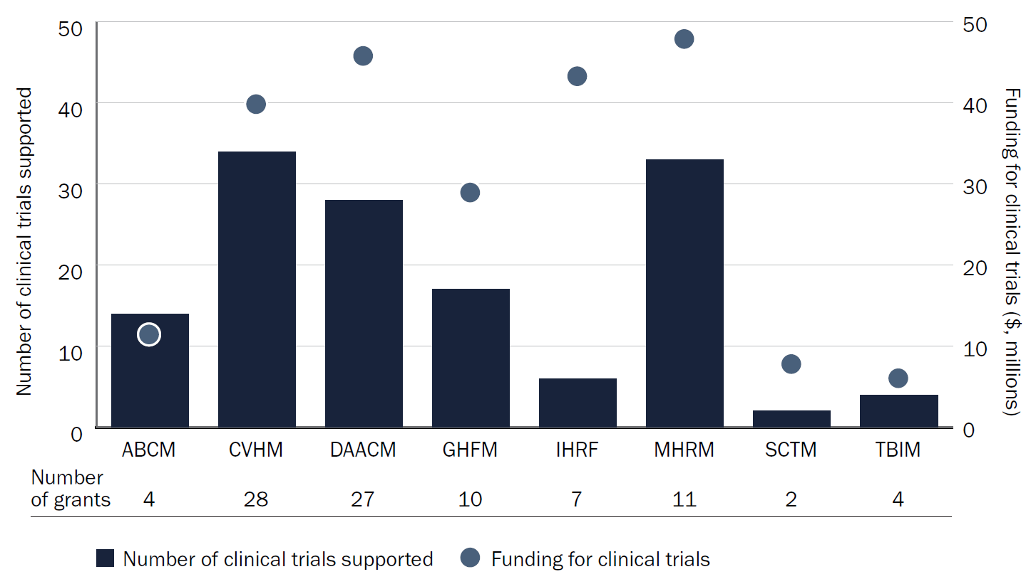
ABCM = Australian Brain Cancer Mission; CVHM = Cardiovascular Health Mission; DAACM = Dementia, Ageing and Aged Care Mission; GHFM = Genomics Health Futures Mission; IHRF = Indigenous Health Research Fund; MHRM = Million Minds Mental Health Research Mission; SCTM = Stem Cell Therapies Mission; TBIM = Traumatic Brain Injury Mission.
Note: A grant may fund more than one trial.
Source: MRFF performance indicator survey.

Measure of success: Increased commercialisation of health research outcomes
This measure of success was the least addressed by Research Mission grants (Table 18).
Several (38%) completed Research Missions grants (n = 29 at the time of the MRFF performance indicator survey) had resulted in outputs or outcomes related to commercialisation. The most common activities were:
- measurable improvement in the maturity of a technology (for example, improvement in technology readiness level) – 4 projects
- a commercial agreement with partners to commercialise project intellectual property – 2 projects
- job creation in industry research and development and commercialisation – 2 projects
- a product entering phase 3 or 4 clinical trials – 2 projects.

Case study: Cartilage-based stem cell therapies for joint deformity and facial disfigurement: a framework for point-of-care manufacturing and delivery (ARISTOCRAT)
Lead investigator: Professor Peter Choong, Hugh Devine Chair of Surgery, The University of Melbourne and orthopaedic surgeon at St Vincent’s Hospital
Research Mission: Stem Cell Therapies Mission
Grant opportunity: 2021 Stem Cell Therapies
Project highlights
- Establishing collaboration between multidisciplinary researchers, clinicians, industry and consumers
- Researching ways to change how osteoarthritis and microtia (an absent or poorly formed ear) are currently treated, minimising the number of operations and overall time spent in hospital
Measures of success
- New health technologies are embedded in health policy and practice
- New health interventions are embedded in health policy and practice
- Health professionals adopt best practices faster
- The community engages with and adopts new technologies, treatments and interventions
- Increased commercialisation of health research outcomes
The project
This project involves first of its kind research in Australia that allows live stem cells to be 3D printed and used as a material for treatments. The aim of this innovative solution is to repair cartilage loss, which can lead to painful joint deformity, and facial disfigurement from ear and nose absence or loss.
The outcome
The project is ongoing. To date:
- preclinical studies have been completed and the results are highly promising, with superior cartilage regeneration in treated versus untreated control groups
- consumer involvement activities for both knee and microtia are providing critical insights into patient, clinician and healthcare perspectives, ensuring the clinical pathway is responsive to end users’ needs
- the project is in the process of finalising the protocol and logistics of the first-in-human trial, due to commence in 2026.
Impact of MRFF funding
MRFF funding transformed a promising scientific concept into a clinically translatable regenerative medicine platform. It supported the development of novel biomaterials, surgical delivery systems, manufacturing capability and preclinical validation. This investment has enabled ARISTOCRAT’s work to progress to first-in-human studies while significantly de-risking future commercialisation. Beyond cartilage regeneration, the technologies and expertise generated through the program have already been used to establish new regenerative medicine applications, including microtia reconstruction, multiplying the impact and value created from the original MRFF investment.

6.4 Considerations and barriers to translation and impact
Stakeholders were asked about the main barriers to applying for and securing funding, and to conducting and translating research. Feedback relating to the 3 Research Missions aims are outlined in Section 6.2.2. Additional barriers to impact are outlined in this section.

Summary findings
- Research translation and impact – stakeholders identified a critical and systemic disconnect between research activities and health system and policy needs, as well as a gap between outcomes and their translation into health policy and practice.
- Accountability and impact evaluation – stakeholders raised concerns about the perceived lack of clear frameworks to evaluate and demonstrate real-world impact and return on investment of research funded under the Research Missions program.
- Population, geographic and workforce inequities – stakeholders raised concerns that research funding is underserving priority populations and current structures, creating workforce inequities.
- Application burden and timelines – stakeholders considered the application process to be a significant barrier, including the time and resource burden of preparing complex applications.

6.4.1 Stakeholder concerns and considerations

Research translation and impact
This theme relates to the program’s effectiveness in translating research into real-world practice, achieving systemic change and demonstrating measurable impact.
This theme was more likely to be raised by:
- Aboriginal and Torres Strait Islander organisations
- advocacy organisations, peak bodies and associations
- consumers
- Department of Health, Disability and Ageing stakeholders
- regulatory groups
- professional bodies
- industry, commercialisation and translation
- state and territory government funders
- Mission-style funding agencies
- researchers and research organisations
- grantees.

Implementation and ‘know-how’ gap
Respondents identified a critical and systemic gap between research outcomes and their translation into health policy and practice. This gap is attributed to:
- critical funding gaps between discovery and implementation
- lack of enabling infrastructure and support for translation activities
- a disconnect between research and the implementation environment (for example, policy, health care)
- a lack of clear pathways to and researcher expertise in clinical adoption, policy requirements or commercialisation.
Quote:
‘We have observed that a common barrier to translation has been that implementation of research findings often sits beyond the funded scope, timeframe and resourcing of projects.’ – Public survey respondent, representative of an organisation that is an end user of research outcomes

Health system integration
Respondents report a systemic disconnect between research activities and health system and policy needs. This includes misaligned priorities, siloed efforts and a lack of coordination between researchers, policymakers and health services. This gap hinders the translation of research into policy and practice, limiting the research’s potential impact and leading to inconsistent implementation across jurisdictions.
Respondents stated that projects led by researchers embedded in health systems were more likely to adapt to system constraints and achieve sustainable, scalable outcomes. Respondents also considered that health services research expertise was important for health system integration.
Respondents noted that researchers often lack a sufficient understanding of Australian health system funding pathways and the policy environment, which hinders the translation of their research.
Quotes:
‘And a lot of the MRFF funding does go into universities. And so then they may not have necessarily engaged with the health services at that time to then look at how that can get translated into practice as well.’ – Interview participant, state and territory government funder representative
‘Strengthening connections between the Missions and broader health policy initiatives, health system priorities, and service delivery frameworks would enhance research relevance and impact.’ – Public survey respondent, advocacy organisation, peak body or association

Accountability and impact evaluation
Respondents expressed concern about the perceived lack of clear frameworks to evaluate and demonstrate real-world impact and return on investment of research funded under the Research Missions program. Respondents also noted a lack of public information on project progress and outcomes. Collectively, these make it difficult to assess the program’s overall performance and value.
Respondents considered that systemic issues such as a lack of robust data collection and misaligned incentives (for example, within universities) hindered accountability for translating research into real-world benefits.
Respondents also highlighted the importance of impact assessment in rural areas, and appropriate evaluation approaches that recognise the unique goals, processes and impacts of community-led research in Aboriginal and Torres Strait Islander communities. This includes verifying whether grant commitments (for example, employing Aboriginal and Torres Strait Islander staff) are fulfilled in practice.

Equity, diversity and inclusion
This theme relates to stakeholder views on fairness and representation across different populations, geographic areas and researcher demographics.
This theme was more likely to be raised by:
- Aboriginal and Torres Strait Islander organisations
- advocacy organisations and consumers
- Department of Health, Disability and Ageing stakeholders
- state and territory government funders
- research and research organisations
- grantees.

Population and geographic equity
Respondents raised significant concerns that current research funding is inequitable, systematically underserving priority populations including:
- Aboriginal and Torres Strait Islander peoples
- older adults
- communities in regional, remote and smaller jurisdictions
- culturally diverse populations.
These inequities could more significantly impact intersectional populations. This population gap limits the evidence base required to design effective, culturally responsive health interventions and contributes to the persistence of avoidable health inequities. Respondents also highlighted the importance of these populations being represented in priority setting, assessment and within research teams.
Respondents identified the Indigenous Health Research Fund as an enabler of Aboriginal and Torres Strait Islander peoples’ participation in research and research that focuses on Aboriginal and Torres Strait Islander health.

Workforce and career stage equity
Respondents raised concerns that current funding structures and processes create significant workforce inequities. They noted that early- and mid-career researchers, clinicians and those in regional, rural, remote and non-academic settings are disadvantaged by intense competition, high administrative burden and processes that favour full-time university academics. Respondents reported that these challenges are driving talented individuals from the profession, leading to a critical loss of national research capacity.
Respondents also raised the inequity for those with caring responsibilities, especially when there are tight turnaround times for submissions or when applications are due over school holidays.
Respondents also noted that early (research) career clinicians and allied health professionals who do not hold a PhD do not qualify under early- or mid-career researcher definitions.

Administrative and governance processes
This theme relates to stakeholder views on the administrative and operational aspects of the program, from application and review to oversight and transparency.
This theme was more likely to be raised by:
- Aboriginal and Torres Strait Islander organisations
- advocacy organisations and consumers
- Department of Health, Disability and Ageing stakeholders
- regulatory groups
- state and territory government funders
- Mission-style funding agencies
- researchers and research organisations
- grantees.

Application burden and timelines
Respondents identified the application process as a significant barrier, citing the excessive time and resource burden of preparing complex applications. Respondents considered this especially relevant for the Research Missions program as applications often include multidisciplinary teams, clinical partners and consumer involvement. Burden can be especially impactful for early-career and clinical researchers, as well as community and consumer applicants.
Respondents also raised concerns about unpredictable timelines. These ranged from short notice of funding calls to multiyear intervals between outcomes and project commencement due to multi-institutional contractual delays, which hinder timely research.
Improving communication about funding eligibility and grant opportunities, especially to non-university organisations, could enhance participation in MRFF programs. Respondents also considered that grant opportunities are written for an academic audience, which can limit applications from other sectors such as Aboriginal and Torres Strait Islander organisations and industry, even when they are eligible to apply.
Quote:
‘We spend significant amounts of [resources] putting together [a] large team including consumers. The amount of time consumers spent on this to prepare for an application is extremely unfair given the low chances of success and not releasing full funds.’ – Public survey respondent, health and medical researcher

Review and success rates
Respondents expressed concern that low grant success rates create a significant application burden and an unfavourable cost-to-benefit ratio for the sector. Some respondents believe that it is difficult to be competitive for a grant unless you are part of a large research institution. Respondents considered that assessment processes favour academic metrics and established researchers.
Respondents broadly supported the current MRFF practice to involve consumers in grant assessment. Stakeholders had varying views on consumers scoring research funding applications, noting ongoing debate about the extent to which consumers should assess scientific merit. Some advocacy organisations considered that non-scoring results in more tokenistic involvement, and in underutilisation of consumer expertise in implementation and community perspectives. However, potential conflicts of interest – especially in small research fields in which community and consumer representatives may have ties to particular research groups – may need to be considered.
Quote:
‘They [consumers] are experts at being a consumer, an expert about implementation, and they’re an expert at sitting in their community and being able to translate some of the things that are actually being discussed and being researched.’ – Interview participant, national advocacy groups representative

Transparency and oversight
Respondents highlighted the need for better coordination within and across Research Missions, and to reduce potential duplication between the MRFF, NHMRC and other national funders of health and medical research.
Respondents called for greater transparency in priority setting and the grant assessment process, with concerns around perceived or apparent conflicts of interest.

6.5 Analysis of themes by stakeholder group
Table 22 maps the key themes that that were identified from the grantee survey and targeted consultations to each stakeholder group. Table 23, Table 24 and Table 25 do the same for the positive impacts, considerations or suggestions and concerns identified from the public survey.
In addition, wherever qualitative results involving themes are described in this report (Section 4.1, Section 6 and Section 7), a summary of the main stakeholder groups that raised the theme has been provided.

Table 22 Key themes by stakeholder group
Themes identified by stakeholder groups | Fund large programs of work | Bring together key stakeholders | Tackle big health challenges | Research translation and impact | Equity, diversity and inclusion | Administrative and governance processes
Aboriginal and Torres Strait Islander organisations | Less frequent | Less frequent | Less frequent | Most frequent | Most frequent | Most frequent
Advocacy organisations and consumers | Less frequent | Most frequent | Most frequent | Most frequent | Most frequent | Most frequent
Department of Health, Disability and Ageing stakeholders | Less frequent | Most frequent | Most frequent | Most frequent | Most frequent | Most frequent
Regulatory groups | Less frequent | Less frequent | Less frequent | Dark red | Less frequent | Most frequent
Professional bodiesª | Less frequent | Less frequent | Most frequent | Most frequent | Less frequent | Less frequent
Industry, commercialisation and translation^{b} | Most frequent | Less frequent | Less frequent | Most frequent | Less frequent | Less frequent
State and territory government funders | Less frequent | Less frequent | Less frequent | Most frequent | Most frequent | Most frequent
Mission-style funding agencies | Most frequent | Most frequent | Less frequent | Most frequent | Less frequent | Most frequent
Researchers and research organisations | Most frequent | Less frequent | Most frequent | Most frequent | Most frequent | Most frequent
Grantees | Most frequent | Less frequent | Most frequent | Most frequent | Most frequent | Most frequent
a Clinical service providers were invited for targeted consultation but did not attend.
b Philanthropic organisations were invited for targeted consultation but did not attend.
Legend: Dark red cells = themes most frequently identified (nominative). Light red cells = themes less frequently identified (nominative).
Source: Targeted consultations and grantee survey.
Table 23 Frequency of responses from the public survey indicating a positive impact, by theme and research end user stakeholder group
Themes identified by stakeholder groups | Fund large programs of work | Bring together key stakeholders | Tackle big health challenges
Health and medical researchers and research organisations | 26 | 32 | 19
Consumer, carer or community member | 1 | 5 | 2
Representative of a consumer organisation | 8 | 4 | 2
Member of the healthcare sector | 1 | 0 | 0
Member of the commercial sector | 1 | 0 | 0
Policymaker | 2 | 0 | 0
Other research end user organisation | 1 | 3 | 4
Advocacy organisation, peak body or association | 5 | 5 | 9
Other | 1 | 5 | 1
Note: Positive sentiment was only captured for themes relating to the Research Mission aims.
Legend: Red cells = themes identified (most frequent = dark red, least frequent = light red). Grey cells = no themes identified.
Source: Public survey.
Table 24 Frequency of responses from the public survey indicating a consideration or suggestion, by theme and research end user stakeholder group
Themes identified by stakeholder groups | Fund large programs of work | Bring together key stakeholders | Tackle big health challenges | Research translation and impact | Equity, diversity and inclusion | Administrative and governance processes
Health and medical researchers and research organisations | 140 | 33 | 90 | 132 | 39 | 69
Consumer, carer or community member | 5 | 14 | 19 | 8 | 6 | 7
Representative of a consumer organisation | 6 | 4 | 25 | 13 | 2 | 3
Member of the healthcare sector | 0 | 0 | 0 | 1 | 2 | 0
Member of the commercial sector | 9 | 0 | 8 | 5 | 1 | 3
Policymaker | 5 | 0 | 0 | 0 | 0 | 0
Other research end user organisation | 4 | 9 | 11 | 10 | 13 | 4
Advocacy organisation, peak body or association | 20 | 2 | 39 | 60 | 6 | 7
Other | 5 | 3 | 4 | 4 | 2 | 2
Legend: Red cells = themes identified (most frequent = dark red, least frequent = light red). Grey cells = no themes identified.
Source: Public survey.
Table 25 Frequency of responses from the public survey indicating a concern, by theme and research end user stakeholder group
Themes identified by stakeholder groups | Fund large programs of work | Bring together key stakeholders | Tackle big health challenges | Research translation and impact | Equity, diversity and inclusion | Administrative and governance processes
Health and medical researchers and research organisations | 167 | 48 | 66 | 102 | 54 | 125
Consumer, carer or community member | 2 | 12 | 23 | 10 | 6 | 4
Representative of a consumer organisation | 5 | 6 | 6 | 12 | 15 | 2
Member of the healthcare sector | 1 | 1 | 1 | 1 | 1 | 3
Member of the commercial sector | 1 | 0 | 1 | 1 | 1 | 3
Policymaker | 4 | 0 | 0 | 0 | 0 | 0
Other research end user organisation | 4 | 0 | 0 | 0 | 0 | 0
Advocacy organisation, peak body or association | 19 | 1 | 26 | 42 | 19 | 6
Other | 5 | 5 | 1 | 3 | 9 | 2
Legend: Red cells = themes identified (most frequent = dark red, least frequent = light red). Grey cells = no themes identified.
Source: Public survey.

7 Opportunities to improve the Research Missions program
This section addresses the following evaluation questions:
4. What are the opportunities to improve the impact of MRFF Research Missions?
Section 7.1 discusses in detail the identified opportunities to improve the impact of the Research Missions program.
Lines of enquiry addressed:
- Are there improvements that could be made to Mission program delivery to better achieve its objectives?
- Are there improvements that could be made to Mission governance and evaluation processes?
- Are there other opportunities to improve the impact of the MRFF Research Missions?
Data sources: Public survey, targeted consultations, grantee survey, mid-term Research Mission reviews

Summary findings
Table 26 summarises the opportunities to improve the Research Missions program that were identified by stakeholders and through analysis of other data sources. It should be noted that some of these opportunities cannot be achieved by the MRFF alone and will require broader collaboration across the health and medical research sector.
Table 26 Opportunities to improve the Research Missions program
Opportunity | Research Mission reviews | Desktop analysis | Grantee survey | Consultations
Strategically shifting towards larger, longer-term grants and funding amounts to better facilitate Research Missions program aimsª
Strengthening research outcomes and translation through
application requirements
additional guidance and mechanisms
avenues for researchers to connect with research end users and relevant stakeholders (e.g. community, government, health systems, industry)
Providing better clarity on the evidence base to identify and prioritise Research Missions focus areas, and the priorities within each Research Mission | –
Strengthening mechanisms to ensure funding for priority populations, including funding across jurisdictions; for regional, rural and remote communities; and for Aboriginal and Torres Strait Islander communities |  |  | –
Developing mechanisms for better coordination to address shared priorities across Research Missions, MRFF initiatives, Government agencies and other research funders |  |  | –
Providing funding and supporting infrastructure for implementation of research findings |  | –
Strengthening communication of research successes and impact to consumers and end users, and of accountability of research progress and outcomes using meaningful evaluation metrics |  |  | –
Supporting more consistent and structured consumer and end-user involvement across the full Research Mission lifecycle |  | – | –
Streamlining and improving application, assessment and reporting processes | – | –
Having broader, less-prescriptive grant opportunity topics that are communicated early (e.g. via implementation plans) to allow researchers to plan early and collaborate | – | – | –
Increasing funding to cover the cost of research (a broader opportunity beyond the MRFF) | – | –
a Implementation would need to consider the impact on funding distribution across jurisdictions, and capacity building in early- to mid-career researchers and priority populations such as regional, rural and remote communities; Aboriginal and Torres Strait Islander communities; and culturally and linguistically diverse communities.

7.1 Opportunities to improve the impact of the Research Missions program
Stakeholders were asked for suggestions on how to improve the Research Missions program. Opportunities identified from these suggestions have been categorised into 6 themes:
- fund large programs of work
- bring together key researchers, health professionals, stakeholders, industry partners and patients/consumers
- tackle big health challenges
- research translation and impact
- equity, diversity and inclusion
- administrative and governance processes.
It should be noted that some of these opportunities cannot be achieved by the MRFF alone. Their implementation will require broader collaboration across the health and medical research sector and balancing and staging against available resourcing.

7.1.1 Fund large programs of work
Respondents advocated for:
- a strategic shift towards fewer, larger and longer-term funding schemes with broader, less-prescriptive topics – this approach would enable more ambitious programs of work, for example
  - having these topics communicated early (as is currently done with some Missions via implementation plans) would encourage researchers and partners to plan to collaborate rather than compete for funding on fragmented projects
  - establishing clearer pathways for continuation or follow-on funding would reduce fragmentation and maintain momentum beyond the life of individual projects, enabling sustained impact at scale
- Research Missions including capacity-building components (data infrastructure, workforce development, fellowships, model of care development) for emerging health priorities for which the research area is still developing, alongside traditional research funding
- using co-funding or other coordination across multiple funders and jurisdictions – the Research Missions could consider
  - collaborating with international Mission-style programs (for example, EU Cancer Mission, UK National Institute for Health and Care Research Missions) to share methods, open calls for joint projects, and mutually recognise evaluation metrics and data standards
  - introducing structural incentives to encourage co-funding from states, territories and philanthropic funders
- although a broader issue, increasing the total funding disbursed from the MRFF to increase success rates, build Australia’s research capability and facilitate funding the full cost of research. Specific to the Research Missions, increasing funding amounts would better support larger programs of work that are of a scale matching national health challenges.
Quotes:
‘[A clear, long-term funding commitment] would then get some even higher quality proposals, and it would give the opportunity potentially, for the short-term competitors to become long-term collaborators.’ – Interview participant, researcher and research organisation representative
‘The actual costs of conducting large-scale, collaborative research often exceed what is eligible for reimbursement under MRFF guidelines. This can limit the scope or sustainability of projects and the organisations who host the research.’ – Grantee, Australian Brain Cancer Mission

7.1.2 Bring together key researchers, health professionals, stakeholders, industry partners and patients/consumers
Respondents advocated for:
- more consistent and structured consumer and end-user involvement across the full Research Mission lifecycle – priority setting, governance, co-design, research, assessment, implementation and evaluation – including
  - embedding clinicians, researchers, consumers, industry and implementation stakeholders as core partners from the outset, rather than involving them late or peripherally
  - increasing involvement opportunities and capacity building for those located in regional, rural and remote communities, including appropriate remuneration
  - further strengthening or mandating genuine consumer and research end-user involvement for all grants, including beyond the point of grant application
  - developing additional resources to support researchers with consumer and community involvement, guide assessors on appropriate budgeting for consumer and community involvement, support consumers to navigate the application process and support consumers to undertake grant assessment
  - allowing consumer and patient organisations; non-academic, medical research–focused not-for-profit organisations; and health services organisations to be lead applicants on Research Missions grants
- collaborations within and across Research Missions, including through
  - facilitating networking events such as biennial summits to bring together researchers within and across Research Missions
  - including greater recognition of new partnerships and collaborations in grant assessment processes.

7.1.3 Tackle big health challenges
Respondents called for:
- better clarity on the evidence base to identify and prioritise Research Missions focus areas, and the priorities within each Research Mission
- mechanisms for better alignment of the Research Missions program with consumer, community and Government priorities, including
  - structured opportunities for policymakers and researchers to come together to discuss and anticipate future policy challenges
  - inclusion of policymakers on grant assessment panels
  - regular opportunities for consumers and community to participate in priority setting.
Quote:
‘The impact of the MRFF Research Missions program could be strengthened through clearer and more transparent prioritisation processes that better reflect national disease burden, unmet need and economic impact.’ – Public survey respondent, representative of a consumer organisation

7.1.4 Research translation and impact
Respondents advocated for:
- a more structured and intentional approach to research translation, including clear implementation pathways, stronger alignment with health system priorities and dedicated infrastructure to ensure research delivers measurable, real-world impact – approaches could include
  - establishing structured mechanisms to facilitate input from health service providers, policymakers, states and territories, industry and investors, peak consumer organisations, and communities in the design, prioritisation, assessment and translation of the Research Missions program; for example, early involvement of Government regulators (for example, Therapeutic Goods Administration, health technology assessments) to support product alignment with regulatory requirements
  - improving communication of research outcomes through channels appropriate for the recipient (for example, newsletters, summary reports, ‘research libraries’) to inform research end users and community members about ongoing and completed research
  - enhancing requirements to engage directly with service providers at every stage (for example, co-design, data collection, interpretation, dissemination)
  - leveraging regulatory frameworks and partnerships with health service organisations to embed research in service delivery
  - funding implementation and sustainability phases to avoid the ‘translation cliff’; this could include specific funding calls for renewal of previously funded projects or programs to ensure continuity of infrastructure, expertise and data maintenance, and to better support research translation
  - providing translation support and/or training to researchers
- provision of clear metrics and evaluation plans at the beginning of Research Missions projects, and appropriate data capture – this should include consideration of appropriate evaluation measures that recognise the unique goals, processes and impacts of community-led research in Aboriginal and Torres Strait Islander communities. Respondents considered it less burdensome to embed impact measures across the entire research life cycle and use pre-populated forms.
Quotes:
‘Strengthening connections between the Missions and broader health policy initiatives, health system priorities, and service delivery frameworks would enhance research relevance and impact.’ – Public survey respondent, representative of an advocacy organisation, peak body or association
‘As with many research grant programs in Australia, I think that potential for impact is the area that needs most work. It is often the case that research grants fund the research program but fall short when it comes to translation. I think that funding programs could require more detail on translational pathways and ensure that adequate funds are available for this purpose. It is also important to recognise that many of these translational activities will be taking place after the research has been complete (and after the grant term has expired). Perhaps a separate period of time could be provided to researchers to engage in translational activities, after the research program has been completed.’ – Grantee, Genomics Health Futures Mission

7.1.5 Equity, diversity and inclusion
Respondents strongly advocated for:
- enhancing equity, diversity and inclusion through systemic changes, revised assessment criteria and targeted support mechanisms – suggestions include
  - increasing representation of priority populations in decision-making processes (for example, priority setting, grant assessment), taking into consideration adequate levels of representation and supporting more junior community members to participate (for example, appropriate mentoring)
  - embedding requirements for inclusion of early- to mid-career researchers across all Research Missions, and considerations for treating early-career clinician researchers the same as health and medical researchers with a PhD for eligibility purposes
  - ensuring assessment processes support equitable assessment of different research careers and non-traditional pathways for community-based researchers, research end users and consumers.
Quote:
‘If they [early- to mid-career researcher] then went into that assessment panel […] they might be the only Aboriginal voice on that panel. And if they’re very junior, that is a very uncomfortable, unsafe – potentially – position to be in.’ – Interview participant, state and territory government funder representative

7.1.6 Administrative and governance processes
Respondents suggested:
- streamlining the application process to reduce administrative burden – suggestions include
  - implementing an expression of interest or other 2-stage application process
  - streamlining the process for multi-institutional agreements
  - reviewing current administration processes to minimise delays
  - providing a standardised, multiyear grant calendar that includes early visibility of forecast rounds with indicative budgets
  - adopting longer application windows (for example, a minimum of 12 weeks)
- amending the assessment process to include shorter timeframes, provision of feedback for both successful and unsuccessful grants, and metrics data (for example, cut-off score)
- enhancing governance through greater transparency, more-diverse review panels and better alignment with other national funding schemes
- increasing alignment and coordination within and between Research Missions – this could involve
  - considering additional incentives for cross-Mission collaboration and engagement, including information-sharing and collaborative funding opportunities for existing grantees
  - ensuring that learnings and outputs from one Research Mission can more easily inform and strengthen other Research Missions, reducing duplication and improving national impact
- introducing measures to avoid duplication, such as a public repository of all Australian Government–funded research and consideration of previously funded grants when awarding new grants.

7.2 Conclusion
Overall, the MRFF Research Missions program has largely aligned with national priorities and burden of disease. Grantees and stakeholders consider that the program is fulfilling its intent and making progress towards predefined outcomes. Previous mid-term reviews have identified significant, impactful projects funded via the Research Missions, including:
- the Mental Health Australia General Clinical Trial Network (MAGNET) via the Million Minds Mental Health Research Mission
- support for the Australian and New Zealand Children’s Haematology/Oncology Group via the Australian Brain Cancer Mission
- Mackenzie’s Mission, the Genomic Screening Consortium for Australian Newborns (GenSCAN) via the Genomics Health Futures Mission.
Nevertheless, this evaluation has also identified several opportunities to realign and enhance the Research Missions’ focus on funding large programs; bringing together researchers, consumers and end users; and addressing significant health challenges. The identified opportunities broadly align with the focus areas identified in the National Health and Medical Research Strategy 2026–2036. They are also consistent with the 2025 Ambitious Australia report, which emphasises the importance of Mission-orientation approaches in supporting national coordination, outcomes and international impact. The findings from this evaluation will be considered alongside the strategy and Ambitious Australia report.
Based on the findings and opportunities identified in this evaluation, the following are presented to help inform future decision-making:
- Features that make a priority area suitable for a Research Missions approach that involves a structured, longer-term plan – this contrasts with non-Mission MRFF initiatives for which
  - support may be broader (for example, the Public and Preventive Health initiative and Primary Health Care initiative)
  - there is a need to adapt to rapidly changing needs (for example, the Global Health initiative and Research Data Infrastructure initiative)
  - there is a requirement for a highly specialised approach (for example, the Medical Research Commercialisation initiative and Frontier Health and Medical Research initiative)
- Considerations when determining the priorities within a Research Mission, with examples and lessons identified from past Mission reviews and evaluations.
Features that make a priority area suitable for a Research Missions approach:
- A clearly articulated, significant health challenge – Addresses a major health issue of national significance, areas of high or growing burden of disease, unmet need, or emerging health challenges that are not adequately addressed through existing funding mechanisms.
- National strengths and capacity – Areas for which Australia has existing research capability, infrastructure or leadership that can be leveraged; where targeted investment could build future national capacity and capability.
- Ambitious, long-term objectives that require structured, coordinated effort – Aims are only achievable through large programs of work, sustained and large-scale investment, leadership, collaboration and coordination over several years – they cannot be achieved through individual or shorter-term grants, or when the nature of the challenges are not rapidly changing (in which case, a non-Missions approach may be more appropriate).
- Alignment with national priorities and gaps in the research landscape, and consideration of the international landscape – Aligns with national health and medical research priorities while filling identified gaps or weaknesses in the existing funding landscape (including where research is underfunded or poorly coordinated), and considers clear opportunities to complement or capitalise on the international funding landscape.
- Emphasis on translation and real-world impact – Includes credible pathways for translating research into policy, practice, health system change or population-level benefit.
- Distinct role within the broader funding system – Occupies a key gap in the broader funding system that complements, rather than duplicates, investigator-driven funding (e.g. NHMRC, ARC) and other MRFF initiatives, particularly in targeting later-stage, applied, translational or system-focused research for which coordinated effort adds value.
- Impactful governance structure and evaluation – Need for a governance mechanism to allow input into priorities from experts, consumers, community and other key stakeholders; streamlined and efficient program delivery; continuous improvement; and mechanisms to refresh priorities when needed.
Considerations for determining Research Missions priorities:
- Burden of disease and severity of impact – The health condition or issue represents a significant or growing burden (including morbidity, mortality, disability or system impact), or outcomes are poor. An example is the importance of research into survivorship for brain cancer patients, as identified in the Australian Brain Cancer Mission Roadmap.
- Unmet need, gaps and priority populations – Areas for which there are clear gaps in existing knowledge, limited effective interventions, or populations or conditions that are under-researched or historically overlooked, particularly where inequities are persistent or worsening. An example is the Cardiovascular Health Mission, which aims to eliminate disparities in cardiovascular health care and outcomes between Indigenous and non-Indigenous Australians.
- Feasibility and potential for translation into policy, practice, system change or commercial outcome – Priority decisions should be informed by practical considerations (for example, ethical feasibility, workforce availability, infrastructure readiness, the ability to sustain outcomes beyond the grant period) and research areas with a credible pathway to implementation. An example is the Genomics Health Futures Mission, which refreshed its priorities to quarantine funding support for scalable adoption and implementation of genomics into clinical practice in the longer term.
- Stakeholder and community input – Consultation should be sought with researchers, clinicians, health services, consumers, communities, policymakers and other end users, particularly when lived experience or system insight can identify areas of greatest need or opportunity. An example is the Indigenous Health Research Fund, which has prioritised Indigenous leadership and self-determination, including the most recent grant opportunity that specifies that priority setting, distribution of funds and evaluation will be led by a community-controlled program.
- Complementarity with other funding programs – Consideration should be given to what is already funded by other MRFF initiatives, the NHMRC and other major funders. An example is the Dementia, Ageing and Aged Care Mission, which has a strong emphasis on interventions and care approaches, and less emphasis on basic science research that is typically funded by the NHMRC (which has also had dedicated funding support for dementia research).
- Stage of the research pipeline and balance across stages – The mix of research stages needed to achieve Mission goals (for example, discovery, clinical research, implementation), ensuring that earlier-stage research is appropriately connected to later-stage translation, including early involvement of policy, practice, and commercialisation or industry expertise. An example is the Stem Cell Therapies Mission Implementation Plan, which addresses key parts of the translation pipeline, from discovery through to early-phase clinical trials, to support commercialisation.
- Emerging or future health challenges – Emerging risks, technologies or trends (for example, demographic change, digital and AI-enabled health care) for which early investment could prevent future system pressures or inequities. An example is the Million Minds Mental Health Research Mission, which identified a role for capability building within the mental health research workforce via targeted support for early- to mid-career researchers and small-scale incubator or pilot grants.

8 Glossary
Abbreviation | Definition
Associate Investigator | An individual who provides intellectual input to the research and whose participation reasonably warrants recognition
Chief Investigator | Named researchers responsible for the scientific leadership, design, conduct and delivery of the research project
department | Department of Health, Disability and Ageing
Industry | Relates to any relevant industry; for example, biomedical technology, pharma and digital health
Lead Chief Investigator | The first named investigator on an application or grant. Takes the lead role in completing the application, conducting the research and reporting as required under the grant agreement. May also be referred to as Chief Investigator A (CIA)
Lead organisation | The organisation that entered into the grant agreement with the Commonwealth, often referred to as Administering or Eligible Organisation
Research end user | A person or organisation that uses research outcomes; for example, a consumer, carer, community member, member of the healthcare or commercial sector, policymaker or an advocacy organisation, peak body or association
Stakeholder | Any interested individual or party

Note that Dr Hilton’s AMRAB term concluded during the evaluation. Professor Wilson then took on the role of AMRAB representative on the Mission Evaluation Panel.
We acknowledge that the word ‘Mission’ may have negative connotations for some Aboriginal and Torres Strait Islander peoples. For this reason, the Indigenous Health Research Fund has intentionally been named to avoid the use of ‘Mission’.
‘Stakeholder’ encompasses any interested individual or party. We acknowledge that the word ‘stakeholder’ may have negative connotations for some Indigenous peoples, particularly in the global context, and that not all individuals feel represented by this term.
At the time of writing this report, the Australian Government announced the establishment of a new Arthritis and Musculoskeletal Conditions Research Mission; A Albanese and M Butler, $100 million to deliver more arthritis research [media release], Prime Minister of Australia, 11 June 2026, accessed 19 June 2026.
Noting that the NHMRC Statement on consumer and community involvement in health and medical research was published after this analysis was completed.
At the time of writing this report, the Australian Government announced the establishment of a new Arthritis and Musculoskeletal Conditions Research Mission; A Albanese and M Butler, $100 million to deliver more arthritis research [media release], Prime Minister of Australia, 11 June 2026, accessed 19 June 2026.
Department of Health, Disability and Ageing, Medical Research Future Fund Mission Governance, Department of Health, Disability and Ageing, 2025, accessed 22 June 2026.
This is relevant for the Australian Brain Cancer Mission, Million Minds Mental Health Research Mission, Genomics Health Futures Mission and Traumatic Brain Injury Mission.
Evaluation will be performed as part of the 2026 Empowering Community-Controlled Research Grant Opportunity, closing 11 November 2026.
Department of Health, Disability and Ageing, Results of the Medical Research Future Fund performance indicator survey – December 2024, Department of Health, Disability and Ageing, Australian Government, 2025, accessed 22 June 2026.
Both microbiology and medical microbiology are listed here as they have different 4-digit field of research (FoR) codes and were both identified as strengths.
Assessment included the MRFF Australian Medical Research and Innovation Priorities 2024–2026, as well as priorities of the Research Missions and other MRFF initiatives.
Department of Health, Disability and Ageing, MRFF Strategy and Priorities, Department of Health, Disability and Ageing website, 2024, accessed 22 June 2026.
FoR, the Australian and New Zealand Standard Research Classification (ANZSRC) code.
Australian Research Council (ARC), State of Australian University Research 2018-19: ERA National Report, ARC, Australian Government, 2019, accessed 22 June 2026.
Department of Education, Review of the Australian Research Council Act 2001, Department of Education, 2024, accessed 22 June 2026; the Review noted that, although early iterations of ERA have been effective in shifting the emphasis of Australian research from quantity of outputs to quality of outputs, ERA has had challenges including high administrative burden, gamification among universities and relevance outside the university sector. ERA was thought to have outlived its utility, and the time and resources involved may be better directed to other evaluation needs.
The field citation ratio (FCR) is a citation-based measure of scientific influence. For example, a publication with an FCR of 2.0 has received twice as many citations as the average for the Fields of Research code(s); Dimensions AI, What is the FCR? How is it calculated?, Dimensions Help Center website, 2026, accessed 22 June 2026.
Data on funding for Research Missions focus areas were provided by the ARC and NHMRC and are based on their respective agency methodologies. As the ARC does not fund direct medical research, areas such as brain cancer, traumatic brain injuries and dementia do not have relevant field of research codes and therefore cannot be directly mapped. For other significant national funders, websites and other publicly available information (for example, annual and financial reports) were used to determine quanta of research funding.
The summary provided in Figure 7 is informed by the NHMRC broad research area classification (where available; only applicable for MRFF and NHMRC funded grants, Figure 8), the strategic priorities of funders, and other relevant publicly available information.
The Australian Brain Cancer Mission is an exception as it involves co-funding from 12 funding partners comprising philanthropic organisations, charities, and state and territories.
Department of Health, Disability and Ageing, MRFF Australian Brain Cancer Mission strategic documents, Department of Health, Disability and Ageing, Australian Government, 2025, accessed 22 June 2026. The funding partners are: Cure Brain Cancer Foundation, Minderoo Foundation’s Eliminate Cancer Initiative, Carrie’s Beanies 4 Brain Cancer, the Mark Hughes Foundation, the Children’s Hospital Foundation Queensland, the State of Victoria, The Kids’ Cancer Project, the State of New South Wales, the Financial Markets Foundation for Children, the Robert Connor Dawes Foundation, ACT Health and Canberra Health Services, and the NeuroSurgical Research Foundation.
Department of Health, Disability and Ageing, Review of the Medical Research Future Fund Cardiovascular Health Mission, Department of Health, Disability and Ageing, Australian Government, 2025, accessed 22 June 2026.
Targeted calls for research that have been made since commencement of the Dementia, Ageing and Aged Care Mission up to 1 July 2025.
Targeted calls for research that have been made since commencement of the Indigenous Health Research Fund up to 1 July 2025.
Noting that the Indigenous Health Research Fund includes ‘promoting the health and wellbeing of Aboriginal and/or Torres Strait Islander mothers before, during and after their pregnancies’ as a priority area for investment.
This approach has been more consistently implemented since 2022.
Formally known as the Consumer Reference Panel; it has now been replaced by the NHMRC–MRFF Consumer Advisory Group.
The Australian Brain Cancer Mission is an exception as it involves co-funding from 12 funding partners comprising philanthropic organisations, charities, and state and territories.
The Organisation for Economic Co-operation and Development (OECD), The Moonshot Research and Development Programme, OECD website, 2024, accessed 22 June 2026; Japanese Cabinet Office, Moonshot Research and Development Program, Japanese Cabinet Office website, n.d., accessed 22 June 2026.
Olsen-Boyd A, Cooke A, Pring R, McBride C and Battaglia M, Convening missions - A playbook for collective implementation of mission-oriented innovation, Commonwealth Scientific and Industrial Research Organisation (CSIRO), Canberra, 2023, pp 25–26, https://doi.org/10.25919/v67x-b402.
Note that, in 2020, funding was redirected from the Dementia, Ageing and Aged Care Mission as part of an MRFF-wide investment to a Coronavirus Research Response, to serve the emergency need of the pandemic. The Coronavirus Research Response supported 15 grants totalling $13.2 million (out of the $185 million investment allocated to the Dementia, Ageing and Aged Care Mission). The resulting projects were not required to and do not align with the priorities of the Dementia, Ageing and Aged Care Mission, and are therefore not included in this analysis. Insights into the research, researchers and institutions funded under the MRFF Coronavirus Research Response can be found in the MRFF report on the Coronavirus Research Response.
The NHMRC uses several research classification systems, including ‘broad research area’, to categorise research applications. The classifications are ‘Basic science’, ‘Clinical medicine and science’, ‘Health services’ and ‘Public health’.
The MRFF uses 4 different grant models. Accelerator grants support large-scale interdisciplinary research to drive implementation of substantial improvements to health care and/or health system effectiveness. They provide large-scale (up to $5 million) and long-term (up to 5 years) funding. Incubator grants support early-stage research projects that test the potential and feasibility of new strategies and approaches for addressing critical or intractable health challenges. They provide small-scale (up to $1 million) and short-term (6 to 24 months) funding. Innovation grants fund smaller-scope research projects to allow grantees to build evidence of the feasibility of the project so that it can be more competitive in future funding opportunities. Targeted Call for Research grants are one-time requests for applications to address a specific health issue for which there is a significant research knowledge gap or unmet need.
Department of Health, Disability and Ageing, Financial assistance to support the Australian Medical Research and Innovation Priorities 2022–2024, Department of Health, Disability and Ageing, Australian Government, 2025, pp 41, accessed 22 June 2026.
Responses from the categories ‘Health and medical researcher or research organisation’ and ‘Research administrator’ were combined into one ’Health and medical researcher or research organisation’ category All other categories are combined into a broad research end user category.
Comprises responses from the categories ‘Consumer/carer or community member’, ‘Representative of a consumer organisation’, ‘Member of the healthcare sector’, ‘Member of the commercial sector’, ‘Policymaker’, ‘Advocacy organisation, peak body or association’ and all other representatives of research end user organisations.
Investigator data were captured through the NHMRC grants management platform, Sapphire. Investigator data from the Business Grants Hub were captured inconsistently so have been excluded from this analysis. Investigator data were unavailable for 5 of the 9 Australian Brain Cancer Mission NHMRC-administered grants, and 3 of the 70 Genomics Health Futures Mission grants. Due to insufficient data, 2 of the 62 Stem Cell Therapies Mission grants were excluded from participating organisation and sector analyses, but these were included in the investigator analysis.
Data from the MRFF performance indicator survey.
At the time of writing this report, the Australian Government announced provisioning for larger investment in health and medical research through the MRFF in the 2026–27 federal budget. This will grow each year from 2026–27 to reach up to $1 billion per year by 2030–31.
Note that current MRFF guidelines often allow up to 50 Chief Investigators and 50 Associate Investigators, and there are no limits on the number of partner organisations. It is worth additionally noting that respondents sometimes may not be aware of changes to the program, or they may have various levels of knowledge or understanding of the program.
The types of entities deemed eligible to receive MRFF funding, which are listed in Section 24 of the Medical Research Future Fund Act 2015 (MRFF Act), are medical research institutes, universities, corporate Commonwealth entities and corporations. As there is no definition for ‘corporation’ within the MRFF Act, the department has adopted the view that ‘corporation’ for the purposes of the MRFF Act means a corporation established under the Corporations Act 2001 (Corporations Act). This is the legislation that establishes the framework governing corporations in Australia. This definition excludes local health districts as a ‘state government other incorporated entity’ (Australian National Audit Office (ANAO), Department of Health’s Management of Financial Assistance under the Medical Research Future Fund, ANAO, 2021, section 3.23–3.24, accessed 22 June 2026). Recognising the importance of research conducted in conjunction with states and territories, a recent review of the MRFF Act has recommended an amendment to allow states and territories (including state and territory entities) to receive funding directly from the MRFF Health Special Account (recommendation 3).
The process for determining priorities for individual Research Missions includes public consultation. However, for some Research Missions, these consultations occurred a significant time ago.
Progress reports ask grant recipients to list the measures of success that are relevant to their project and the progress they have made towards them.
For each measure of success applicable to their project, grantees are asked to list each outcome/result and a description of progress towards achievement. Grantees may select the same measure of success for several outcomes/results. Not all grantees are required to report against the measure of success.
Grantees reported not achieving a few measures of success. Reasons for this were: the project scope was adjusted due to receiving less funding than requested, the measure of success related to a phase not funded under the current stream, and the goal was too ambitious within the scope of the MRFF-funded project but it remained a goal for future funding.
MRFF priority populations are outlined in the Australian Medical Research and Innovation Priorities 2024–2026.
This is likely an under-representation of the number of clinical trials as data are from the performance indicator survey, which only has data for 295 of the 463 grants in scope (see Table 2).
The MRFF has increased the opening period for grant opportunities in recent years, with forecast opening dates now available on the MRFF grant opportunities calendar.
Note that MRFF grant assessment criteria have been refined over time in consultation with diverse stakeholders (Department of Health, Disability and Ageing, Refresh of the Medical Research Future Fund Assessment Criteria – October 2022, Department of Health, Disability and Ageing, Australian Government, 2022, accessed 22 June 2026). The current criteria have more of an emphasis on impact and less on academic track record. Grant opportunity guidelines state that ‘[e]ach Chief Investigator should provide an example of how they have used their skills, knowledge and/or experience to contribute to meaningful advances in health outcomes, practice and/or policy relevant to the proposed research. Applicants should note that Chief Investigators may choose, but are not required, to provide elements of academic track record (e.g. publications, grants held, conference invitations) as evidence of impact at their own discretion’.
The MRFF Declaration of Interest Policy Statement contains guidance for MRFF advisory panels, committees, groups and other bodies (which includes grant assessment committees and expert advisory panels) on how to handle relevant interests.
At the time of writing this report, the Australian Government announced provisioning for larger investment in health and medical research through the MRFF in the 2026-27 federal budget. This will grow each year from 2026–27 to reach up to $1 billion per year by 2030–31.
As per current MRFF assessment criteria, applicants must ‘demonstrate how the views and values of consumers, the community, health providers and/or other end users have informed the proposed research, including how the needs and priorities of consumers (particularly those with lived experience and their carers) have informed the research question.’
Research Mission roadmaps and implementation plans are typically open to national consultation before finalisation by the Mission expert advisory panels. Furthermore, for the broader MRFF, the Australian Medical Research and Innovation Priorities are refreshed every 2 years and subject to public consultation, with the next consultation (at the time of writing) for the 2026–2028 Priorities expected in Q3 2026.
Current MRFF evaluation and data capture activities include a monitoring, evaluation and learning strategy that sets out the principles, framework and approach to monitoring and evaluating the MRFF; inclusion of evaluation measures in Research Mission implementation plans; and data capture of performance metrics for all funded grants.
Some Research Missions currently have dedicated funding for projects led by early- to mid-career researchers.
GrantConnect provides centralised publication of forecast and current Australian Government grant opportunities and grants awarded. However, this platform does not identify grants that may be duplicative.

