

Evaluation of the Greater Choice for At Home Palliative Care Program
Greater Choice Endpoint Report June 2026
June 2026

Disclaimer
We prepared this report for the Department of Health, Disability and Ageing (DHDA)’s use and benefit in accordance with and for the purpose set out in our engagement letter with the DHDA dated 2 September 2022.
The information, statements, statistics, and commentary contained in this report have been prepared by Scyne Advisory (Scyne) from the available information at the time. Scyne may, at its absolute discretion and without any obligation to do so, update, amend or supplement this document.
Scyne does not express an opinion as to the accuracy or completeness of the information provided, the assumptions made by the parties that provided the information or any conclusions reached by those parties. Scyne disclaims any and all liability arising from actions taken in response to this report. Any employees or persons associated with the preparation of the enclosed documents are in no way responsible for any errors or omissions in the enclosed document resulting from any inaccuracy, misdescription or incompleteness of information provided or from assumptions made or opinions reached by the parties that provided information.
Our engagement did not constitute an audit, review, or assurance engagement in accordance with Pronouncements or Standards issued by the Australian Auditing and Assurance Standards Board, and accordingly no such assurance will be provided in this report.
This disclaimer applies:
- to the maximum extent permitted by law and, without limitation, to liability arising in negligence or under statute; and
- even if we consent to anyone other than DHDA receiving or using this report.

Executive Summary
The Greater Choice for At Home Palliative Care (GCfAHPC) Program (the Program) has been established “to improve awareness of local palliative care options and to coordinate and facilitate access to palliative care services at home” and in the community, including in Residential Aged Care Homes (RACHs).
Through the Program, Primary Health Networks (PHNs) undertake activities which aim to enable people’s preference for palliative and end of life care (EOLC) at home and in the community, and to meet the following four objectives:
- Improve access to safe, quality palliative care at home and support EOLC systems and services in primary health care and community care.
- Enable the right care, at the right time and in the right place, and reduce preventable hospitalisations.
- Generate and use data to support continuous improvement of services across sectors.
- Use available technologies to provide flexible and responsive care, including care after usual business hours.
This report presents findings from an independent evaluation conducted by Scyne Advisory commissioned by the Australian Department of Health, Disability and Ageing (the department). It examines the design, implementation and outcomes of the Program across three data collection tranches (Baseline, Midpoint and Endpoint) from 2023 to 2025. It includes key evidence to support the evaluation findings and identifies how the insights might inform continuous improvement and the future direction of the Program.
While the evaluation finds that the Program has been implemented effectively across Primary Health Networks (PHNs), it also highlights that evidence of impact at the population health and health equity level remains inconclusive at this stage. This reflects both the scale of the Program and broader challenges in attributing system-level outcomes within the available timeframe and data environment.
This evaluation therefore distinguishes between strong progress in implementation and capability building, and more limited evidence of impact on longer-term outcomes such as reduced hospital activity and increased access to care at home.

Evaluation methodology
The evaluation was guided by domains and lines of enquiry which were co-designed in 2023 with the department and PHNs. There are 14 lines of enquiry which serve as key evaluation questions throughout this report and are outlined in Appendix B.
The key domains are:
- Program design and delivery: the extent to which the Program has been effectively implemented, governed and progressed as planned.
- Provider experience: the extent to which PHN activities provide awareness, confidence and knowledge of palliative care service options for healthcare professionals and providers who have engaged in activities.
- Patient experience: the extent to which people and their families, carers and loved ones, are aware of options and choices for palliative and end of life care.
- Population Health: the extent to which the Program has achieved population health outcomes including greater coordination and reduced hospitalisations.
- Health Equity: the extent to which PHN activities meet the needs for all people in their regions, including underserved populations.
- Lower cost of care: the extent to which the Program is cost-effective.
The evaluation analysed data relating to the activities undertaken by PHNs across the 3 years. This included data from peak bodies and other national institutions which measured population-level palliative care data, surveys distributed to PHNs and service providers, and consultations conducted with PHNs and external stakeholders involved in PHN activities.
The Endpoint report findings should be considered in the context of the following limitations:
- Program magnitude: Observable changes in population level data or aggregate measures are limited due to the program size and funding, the inability to observe systemic change, and variation in PHN activities.
- Data availability and causality: While it is possible to identify overall trends and associations in data, the limited strength in correlation (i.e. effect size) means the outcomes and findings are unlikely to be directly or causally related to the Program.
- Direct input from families, carers and individuals: The scope of the Endpoint evaluation did not include consultation or input from consumers and carers of palliative care services. However, consumer, carer and family feedback were at times captured by PHNs and where available, this has been analysed and included.
- Sources of bias: Survey responses and other datasets may be subject to selection bias, response bias or non-response bias, and may therefore not represent a representative or objective view of findings.
Notwithstanding these limitations, meaningful conclusions can be drawn from the analysis to inform the future of the Program.

Summary of PHN activities
The Program provides PHNs with flexibility to design activities in response to local needs and in alignment with Program guidelines and objectives.
In practice, this generates diversity across PHNs in the types and focus of their activities. To understand the breadth of activities across the Program, they have been grouped into five broad categories and relevant sub-categories. This is detailed further in Chapter 2.
Figure 1: Categories of PHN activities
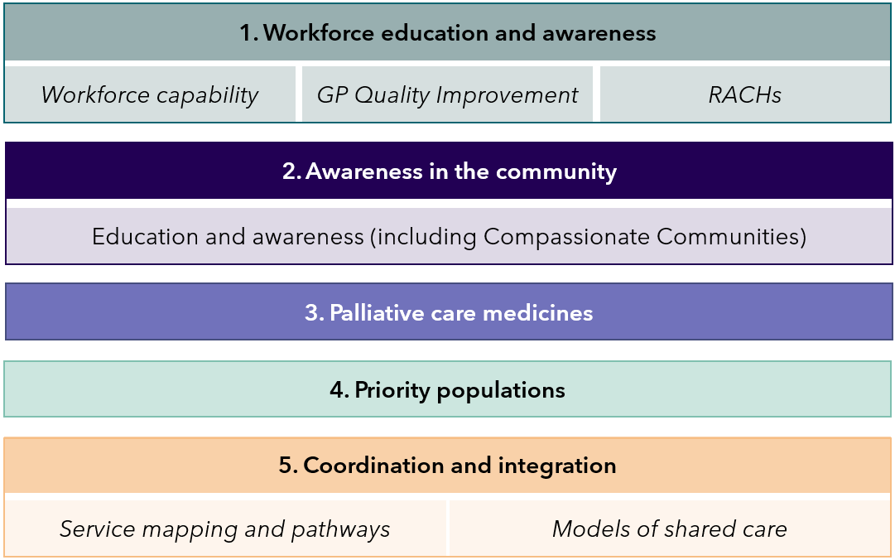
Based on this analysis of progress, key observations include:
- Half (52%) of overall activities can be categorised as workforce education and awareness. PHNs see workforce knowledge as a critical enabler of system change and were able to utilise existing relationships with service providers to implement these activities.
- 71% of coordination and integration activities were undertaken by PHNs who serve a rural or regional area. This aligns with feedback from rural and regional PHNs where limited palliative care services in these regions make it critical that services operate effectively and efficiently through better coordination.
- The least likely activities to be undertaken continue to be those related to priority populations (22% of overall activities) and palliative care medicines (0.08% of overall activities).

Opportunities
The evaluation finds that the Program is progressing well, with strong evidence of effective implementation and positive impact on workforce capability, service coordination, and awareness amongst providers, patients and communities.
However, evidence of impact at the population health and health equity level remains inconclusive. While many activities are expected to contribute to outcomes such as increased care at home and reduced hospital activity over time, current data does not enable a definitive assessment of system-level impact or attribution to the Program.
Detailed findings and domain-level assessments are presented in Chapters 3 to 9 and Appendix B.
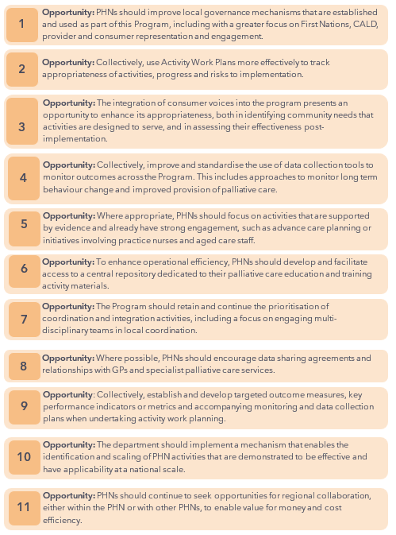

Conclusions and next steps
Overall, the Program has demonstrated progress against its stated objectives and is contributing to positive impact on consumers, carers and clinicians. This is detailed further in Chapter 9.
This report highlights several achievements where PHNs have improved access to, and coordination of palliative care, especially in areas with limited services and awareness. There are also several opportunities identified to further improve and measure the impact of the Program.
Next steps for the Program may include:
- Developing a plan for implementation of opportunities, prioritising these based on factors such as potential impact, feasibility, cost and timeliness.
- Ensuring that the next phase of funding for the Program appropriately explores the opportunities identified by the Evaluation.
Noting that while funding per PHN is modest on an annual basis, the cumulative national investment in the Program is significant. The evaluation highlights that, while this investment has supported substantial implementation activity and capability building across the system, there remains uncertainty regarding the extent to which it is translating into measurable system-level outcomes.
This reinforces the importance of strengthening outcome measurement, data collection and consistency at a national level to better understand impact and better inform future policy directions.

Table of Contents
Disclaimer 2
Executive Summary 3
1. Introduction 9
2. PHN Activity Summary 13
3. Program design and delivery 21
4. Provider Experience 32
5. Patient Experience 39
6. Population Health – Appropriate palliative care outcomes 46
7. Health Equity 54
8. Value for money 59
9. Conclusion and opportunities 63
Appendix A: Glossary 68
Appendix C: Case Studies 76



Introduction

Background and context
Palliative care is ‘person and family-centred care provided for a person with an active, progressive, advanced disease who has little or no prospect of cure and who is expected to die’. The aim of palliative care is to optimise quality of life. End-of-life care (EOLC) is care and services for people who are facing the end of their life, and their families. EOLC is an important part of palliative care and is provided for people of any age. The focus of EOLC is to help a person live out their life as comfortably as possible.
While 70% of Australians prefer to die at home, only 15% do so, with half of all deaths occurring in hospitals, and more than one third in residential aged care homes (RACHs). A 2024 report from the AIHW estimates that in 2019-20 there were 109,059 people aged 40 years or older who died from 10 selected underlying causes of death that would have required palliative care. Each of these individuals, their families, carers, and friends, would benefit from having knowledge and awareness of palliative care.

The Greater Choice for At Home Palliative Care Program
The Greater Choice for At Home Palliative Care (GCfAHPC) program (the Program) has been developed and funded ‘to improve awareness of local palliative care options and to coordinate and facilitate access to palliative care services at home’ and in the community.
Initially launched in May 2017, as a pilot across 11 Primary Health Networks (PHNs) by the Department of Health, Disability and Ageing (DHDA), the GCfAHPC program was introduced to drive coordination with respect to how palliative care is provided at home and in the community. The Program aims to enable people’s preferences for palliative and EOLC at home and in the community by empowering PHNs to undertake activities to meet the following four objectives:
- Improve access to safe, quality palliative care at home and support EOLC systems and services in primary health care and community care.
- Enable the right care, at the right time and in the right place, to reduce preventable hospitalisations.
- Generate and use data to support continuous improvement of services across sectors.
- Use available technologies to provide flexible and responsive care, including care after usual business hours.
The evaluation of the pilot program, from July 2018 to December 2020, found that there was merit to expand the Program, with recommendations to improve clarity and guidance on the flexible use of funding, greater flexibility on what funding can be used for, and shared learnings from existing activities to facilitate knowledge exchange. In 2021-22, the Australian Government committed further funds to expand the Program to all 31 PHNs, nationally, for four years to 2024-25. In 2024-25, the Australian Government committed to continue the funding of the Program for an additional four years, from 2025-26 to 2028-29.
As part of the Program, PHNs are funded to employ up to two full-time equivalent (FTE) staff members to implement activities. Funding may also be used to cover costs associated with implementing activities.
The Program is intended to achieve the following key outcomes:
- Improved capacity and responsiveness of services to meet local needs and priorities.
- Improved patient access to quality palliative care services at home.
- Improved coordination of care for patients, across health care providers and integration of palliative care services in their region.

The Evaluation of the GCfAHPC Program
With the expansion of the GCfAHPC Program to all 31 PHNs, a national evaluation was commissioned, with the aim to assess the impact of the Program on access to palliative care at home and in the community, and to inform the future direction of the Program.
The scope of the Evaluation includes three tranches of reporting:
- Baseline (2023) – to identify PHN activities, opportunities to better support implementation, and to establish a baseline of indicators that were used as a comparator to determine the impact of the Program.
- Midpoint (2024) – to understand PHN activity progress since Baseline and provide case studies demonstrating early indicators of value and/or outcomes.
- Endpoint (2025) – to focus on impacts of the Program in achieving intended outcomes and form insights to inform the future direction of the Program.
A more detailed summary of the evaluation methodology can be found in Appendix B.

Baseline and Midpoint evaluation findings

Baseline Evaluation
The Baseline evaluation, conducted in 2023, established indicators for comparison in future, data collection processes that could be used by PHNs throughout the Program and provide an initial checkpoint for PHN activity progress.
The Baseline report found that a range of different activities were being implemented by PHNs to meet the needs of their communities. These included five broad categories of PHN activities: workforce education and awareness; awareness in the community; palliative care medicines, priority populations; and coordination and integration of services. Further detail on PHN activities can be found in Chapter 2. The following was observed as part of the Baseline checkpoint:
- PHN progress against Activity Work Plans (AWP) was broadly on track. As expected, PHNs that participated in the pilot were more progressed in implementing activities.
- PHNs formed a range of partnerships with third-party organisations (including non-government organisations, local service providers, health professionals, peak industry bodies and community groups amongst others) to deliver activities.
- Activities focused on improving workforce capability were the most common activities undertaken (26 of 31 PHNs).
- Palliative care medicines and priority populations were the least likely types of activities to be undertaken.

Midpoint Evaluation
The Midpoint evaluation, concluding in 2024, served as a secondary checkpoint of PHN activities and to identify any early indicators of outcomes. It also explored the challenges to the implementation of PHN activities. The following was observed:
- Most PHN activities were meeting the needs of their PHN region and aligned to Population Health Needs or Palliative Care Needs Assessments and Healthy Ageing Strategies.
- There was increased uptake nationally of PHN-driven palliative care education and awareness workshops by health professionals.
- The importance of partnerships and collaboration to deliver successful Program activities continued to be highlighted.
- Projects with the potential for greater impact included longer-term planning, sustained efforts, pilots and trials, or PHNs working together towards shared goals.
- Targeting quality improvement in general practice continued to remain a challenge for PHNs, with only 8 activities occurring overall in this space. This was due to limited time available for GPs to engage, with competing priorities.

Purpose of this document
This document presents:
- An Endpoint assessment of PHN activity progress from 2023 to 2025.
- Findings identified from a range of mixed-methods data against the evaluation lines of enquiry.
- A comparative analysis, where possible, of changes in data observed between Baseline to Endpoint, and any insights this provides in terms of outcomes and impact.
- Potential next steps and considerations for the future of the GCfAHPC Program.

Limitations and considerations
Current limitations in data availability, attribution and timeframes constrain the ability to observe system-level outcomes, and should be considered when interpreting the findings, particularly in relation to population health and equity impacts. The analysis and findings of this evaluation should be considered in the context of the following limitations and considerations.

Program magnitude and effect size
While there is evidence of effective implementation, significant changes in population-level data or aggregate measures were infrequently observed. This is due to:
- The inability to observe systemic data changes within a 3-year timeframe.
- The scope of the overall program funding was intended and limited to PHN local system efforts, and therefore comparison to national palliative care data is also limited.
- Variation in PHN activities reduces the likelihood of consistent and uniform impact that can be detected within data.
- Limited strength in the correlation between population-level data and the Program (i.e. effect size).

Data availability and causality
There is limited nationally relevant data examining palliative care in Australia and PHNs described gathering data from local service providers as challenging.
Nationally relevant data on palliative care remains limited, and PHNs report challenges in sourcing information from local service providers. While broader trends may be observable through ongoing programs and policies, any outcomes are unlikely to be directly attributable to the program. To mitigate this, multiple data sources have been triangulated to strengthen insights.

Direct input from families, carers and individuals
Due to the absence of lived experience groups relating to activities, and the ethical considerations with engaging patients, families and carers, the scope of the evaluation did not include direct consultation or input from consumers and carers of palliative care services. However, consumer, carer and family feedback captured by PHNs where available and included in the analysis.

Sources of bias
Survey responses collected through the evaluation may be subject to selection bias, response bias or non-response bias. Where bias is present, insights may not represent an objective view of the subject. A range of data sources have been collected, synthesised and triangulated to mitigate this risk.

PHN Activity Summary

Summary of PHN activities
PHNs delivered diverse activities tailored to local palliative care needs, supported by funding for 2 FTE. These efforts aligned with each PHN’s Health or Palliative Care Needs Assessments or Healthy Ageing Strategies. Activity data included in this evaluation was current up to April 2025. The evaluation did not have access to the full 2024-25 annual reports, which would typically provide comprehensive data for the entire financial year.
To understand the breadth, activities have been grouped into five broad categories, and relevant sub-categories (Figure 2).A more detailed summary of PHN activities can be found in the companion document Greater Choice for At Home Palliative Care Program Activity and Partnerships Document (2025).
Figure 2: Categories of PHN activities
The key observations on the progress of PHN activities include:
- PHNs largely implemented activities as planned, based on Activity Work Plans and reporting.
- Half (52%) of overall activities can be categorised as workforce education and awareness. PHNs see workforce knowledge as critical enablers of system change and were able to utilise existing relationships with service providers to implement these activities.
- Coordination and integration activities are being undertaken by all PHNs and are consistently viewed as the ‘glue’ connecting service providers, industry bodies, and communities, actively bringing stakeholders together to implement initiatives. This aligns with feedback from rural and regional PHNs where limited palliative care services in these regions make it critical that services operate effectively and efficiently through better coordination.
- The least likely activities to be undertaken continue to be those related to priority populations (22% of overall activities) and palliative care medicines (0.08% of overall activities).

Workforce education and awareness
PHN efforts in workforce education and awareness activities are strategically designed to complement, rather than duplicate, existing national initiatives. These activities frequently involve linking with and leveraging resources from National Palliative Care Projects and similar programs or addressing specific regional gaps in education and awareness that are not comprehensively covered by broader national strategies. This approach ensures an efficient use of resources and avoids duplication of efforts and resources.
Workforce education and awareness activities can be further broken down into three sub-categories:
- Workforce capability – intended to improve capability in target workforces such as GPs, nurses, care professionals, allied health, paramedics and community services.
- GP quality improvement – intended to enable clinicians and practices to engage with Quality Improvement (QI) programs and processes related to palliative care.
- Residential aged care homes – intended to support RACHs through education and awareness of palliative care and advance care planning (ACP).
As of Endpoint, all 31 PHNs implemented a total of 106 activities in workforce education and awareness.
The following table provides a summary of where these activities are being implemented, whether this is more commonly seen in metro or rural areas, and whether pilot or non-pilot PHNs are more likely to undertake activities in this category.
Table 1: Workforce Education and Awareness activities, by sub-category and PHN characteristics
 | Workforce Capability (62 activities) |  | RACH (32 Activities) |  | GP QI (12 activities)
Rurality | # PHNs | # Activities | # PHNs | # Activities | # PHNs | # Activities
Metro PHNs (14 total) | 13 | 26 | 10 | 22 | 5 | 6
Rural PHNs (17 total) | 16 | 36 | 7 | 10 | 6 | 6
Pilot status
Pilot PHNs (13 total) | 11 | 20 | 7 | 12 | 5 | 5
Non-pilot PHNs (18 total) | 18 | 42 | 10 | 20 | 6 | 7
Jurisdiction
ACT (1 total) | 1 | 4 | 1 | 2 | 1 | 2
NSW (10 total) | 10 | 22 | 8 | 17 | 3 | 3
NT (1 total) | 1 | 3 | 1 | 1 | 0 | 0
QLD (7 total) | 7 | 15 | 4 | 8 | 1 | 1
SA (2 total) | 2 | 3 | 1 | 2 | 0 | 0
TAS (1 total) | 1 | 2 | 1 | 1 | 1 | 1
VIC (6 total) | 6 | 12 | 1 | 1 | 5 | 5
WA (3* total) | 1 | 1 | 0 | 0 | 0 | 0
*WA operates 1 organisation as an alliance of 3 PHN regions, the Western Australian Primary Health Alliance.
PHNs have used a range of approaches implementing activities in this category including:
- Education and awareness events: involving in-person and/or virtual events or sessions, often delivered in partnership with other organisations.
- Development of resources and toolkits: creating educational resources such as toolkits, frameworks, and modules for GPs, nurses, and the RACH workforce.
- Communities of Practice, connecting with experts, and QI champions for the purpose of continuous improvement: establishing networks for ongoing collaboration, and the sharing of ideas, resources, and knowledge to foster continuous improvement. This at times linked non-specialist healthcare professionals with experts to empower them to deliver best practice care.
Activity example:
Central and Eastern Sydney PHN – Nurse Education Program
CESPHN have developed a Nurse Education Program for nurses who are providing care in general practice settings, in patient homes and in residential aged care homes in their region.  The program was delivered by senior palliative care clinicians across academia, with a key objective being to increase the confidence, skills and knowledge of nurses in providing a palliative approach to care.  13 interactive education sessions were held between 2024-2025 and the program is now being evaluated by the University of Technology Sydney. | 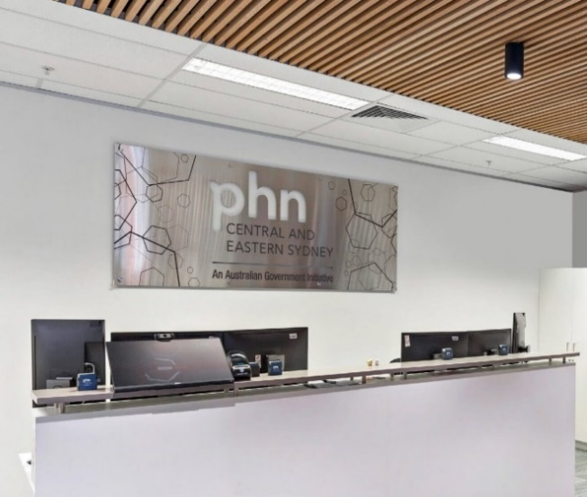

Awareness in the community
PHNs targeted several activities towards increasing awareness, knowledge and resources for their communities. This included activities to improve ACP knowledge, delivering workshops for those experiencing palliative care or their families, and normalising conversations around death literacy, grief, bereavement and dying. Some PHNs have focused specifically on the compassionate communities approach.
As of Endpoint, 24 PHNs have implemented a total of 65 activities that can be categorised as awareness in the community.
The following table provides a similar overall summary.
Table 2: Awareness in community activities, by sub-category and PHN characteristics
 | Awareness in the Community
Rurality | # PHNs (31 total) | # Activities (65 total)
Metro PHNs (14 total) | 9 | 22
Rural PHNs (17 total) | 15 | 43
Pilot status
Pilot PHNs (13 total) | 9 | 23
Non-pilot PHNs (18 total) | 15 | 42
Jurisdiction
ACT (1 total) | 0 | 0
NSW (10 total) | 10 | 39
NT (1 total) | 0 | 0
QLD (7 total) | 6 | 10
SA (2 total) | 2 | 3
TAS (1 total) | 1 | 3
VIC (6 total) | 4 | 8
WA (3* total) | 1 | 2
*WA operates 1 organisation as an alliance of 3 PHN regions, the Western Australian Primary Health Alliance.
Awareness in community activities most adopted included:
- Development of community palliative care resources – providing locally tailored information on what palliative care is, how it can be accessed, where it is provided, and different services available to the community. Resources include webpages, printed booklets, videos and information flyers.
- Partnering with organisations to deliver face-to-face and virtual workshops – including local service providers, peak bodies, non-government organisations, local government, community service providers and Local Heath Districts.
- Encouraging Compassionate Communities approaches or events – building holistic community capacity to provide wraparound informal support to a person wishing to remain at home whilst receiving palliative care, and wishing to die at home.
- Community Awareness events –increasing death literacy and improving the navigation of local services and resources. Examples of events include film screenings, guest speaker panel discussions, facilitating Death Café events and Dying to Know Day Events.
Activity example:
Country South Australia PHN – Nurturing Compassionate Communities in Country SA
CSAPHN have developed a ‘Nurturing Compassionate Communities in Country SA’ project for a coordinated and holistic approach to palliative care community awareness in their region.  The project was designed to deliver over 60 face-to-face and/or virtual sessions for community members including PalliLEARN workshops, Last Aid workshops, Health Professional Hot Topic webinars, and the publication of Palliative Care Plans for each Local Health Network.  The project monitors change in the community through the Death Literacy Index, palliative care surveys, evaluations and online project showcases. | 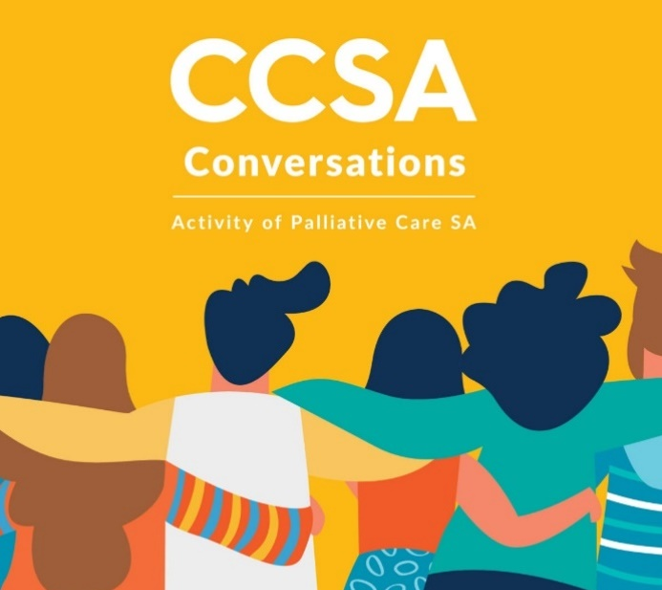

Palliative care medicines
Seven PHNs implemented palliative care medicines activities, often working together or partnering with state-based peak bodies and organisations.
This work aligned to broader national initiatives to establish a National Core Community Palliative Care Medicines List. Since PHNs activities began, a new national list identified four medicines for use by home-based palliative patients in the terminal phase who require urgent symptom relief.
As of Endpoint, 7 PHNs have implemented a total of 9 activities that can be categorised as palliative care medicines.
The following table provides an overall summary of these activities.
Table 3: Palliative Care Medicines activities, by sub-category and PHN characteristics
 | Palliative Care Medicines
Rurality | # PHNs (31 total) | # Activities (9 total)
Metro PHNs (14 total) | 5 | 6
Rural PHNs (17 total) | 2 | 3
Pilot status
Pilot PHNs (13 total) | 3 | 4
Non-pilot PHNs (18 total) | 4 | 5
Jurisdiction
ACT (1 total) | 0 | 0
NSW (10 total) | 2 | 3
NT (1 total) | 0 | 0
QLD (7 total) | 1 | 1
SA (2 total) | 0 | 0
TAS (1 total) | 0 | 0
VIC (6 total) | 4 | 5
WA (3* total) | 0 | 0
*WA operates 1 organisation as an alliance of 3 PHN regions, the Western Australian Primary Health Alliance.
Activities in this category focused on:
- Increasing the number of community pharmacies stocking palliative care medicines as part of the Core Medicines List (CML).
- Improving awareness and use of the CML and palliative care clinical capacity by prescribers, community palliative care providers and community pharmacists.
- Increasing awareness and understanding of anticipatory prescribing, which are medicines that are prescribed in advance to ensure treatment is timely to prevent unplanned hospital admissions.
- Increasing collaboration between providers to ensure coordinated medication and pain management.
- Working with RACHs to implement the IMPREST system (described below).
Activity example:
Gippsland PHN – Medication IMPREST system in RACHs
GPHN are supporting RACHs to implement IMPREST systems in their facilities. IMPREST allows RACHs to hold ‘ward stock’ of palliative care medications that have not been prescribed for a specific resident. This allows staff to have access to emergency and out-of-hours medication needed in the case of rapid deterioration.  GPHN have supplied small grants to RACHs for license fees for the IMPREST system and have commissioned the Gippsland Region Palliative Care Consortium to develop a guide and support implementation. | 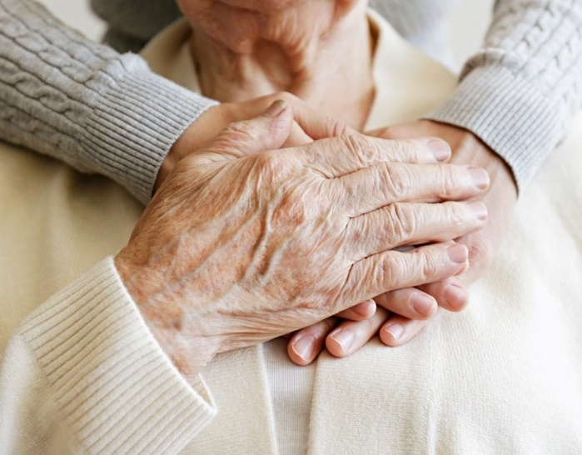

Priority populations
PHNs regularly undertake regional population Health Needs Assessments, through which certain underserved groups can be identified. As such, some PHN regions may have specific palliative care needs relating to their local population.
As of Endpoint, 14 PHNs had implemented a total of 23 activities targeted for priority populations.
The following table provides an overall summary of these activities.
Table 4: Priority population activities, by sub-category and PHN characteristics
 | Priority Populations
Rurality | # PHNs (31 total) | # Activities (23 total)
Metro PHNs (14 total) | 8 | 14
Rural PHNs (17 total) | 6 | 9
Pilot status
Pilot PHNs (13 total) | 6 | 11
Non-pilot PHNs (18 total) | 8 | 12
Jurisdiction
ACT (1 total) | 0 | 0
NSW (10 total) | 5 | 11
NT (1 total) | 1 | 1
QLD (7 total) | 2 | 2
SA (2 total) | 2 | 3
TAS (1 total) | 0 | 0
VIC (6 total) | 3 | 4
WA (3* total) | 1 | 2
*WA operates 1 organisation as an alliance of 3 PHN regions, the Western Australian Primary Health Alliance.
Activities in this category focused on:
- Increasing cultural competency and skills for health providers working with First Nation communities.
- Increasing ACP knowledge and self-empowerment for underserved communities in their region, for example First Nations, LGBTIQ+, CALD, or care leavers.
- Developing culturally appropriate, easy-to-read and translated palliative care resources for workforces and community.
- Increasing workforce capacity and awareness for dementia and dementia-related palliative care services.
- Improving services and resources available for people with disabilities, including deaf populations, those hard of hearing, and those with sensory impairments.

Activity example:
Brisbane North PHN – Disability Action Plan
BNPHN have developed and are implementing a Disability Action Plan to improve access to at home palliative care for people living with disability.  After a 10-month consultation process, key progress on this activity included developing a disability knowledge framework for health professionals to identify gaps in knowledge, share existing resources and information, and to build knowledge and networks. | 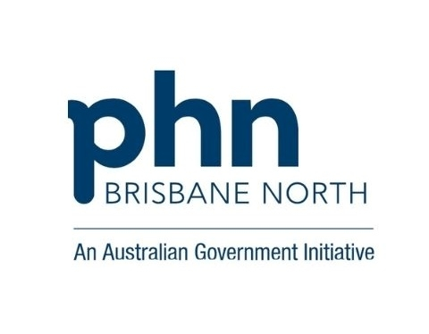

Coordination and integration
During consultations and focus groups, stakeholders indicated that PHNs play a critical role in the palliative care sector as being the ‘glue’ between service providers, industry bodies and communities. This view was shared amongst PHNs who had seen the impact of bringing service providers and champions of palliative care together to implement activities. This aligns to one of the objectives of PHNs, which is to work in collaboration to integrate and coordinate local health services. The summary below outlines formal activities of service mapping and developing models of shared care. However, it does not account for all the significant local channels of coordination and integration provided by all 31 PHNs as part of the core function of the 2 FTE. Rather, it focuses on specific activities which are best categorised under the term ‘coordination and integration’.
As of Endpoint, 24 PHNs had implemented a total of 42 activities that can be categorised as coordination and integration activities.
The following table provides an overall summary of these activities.
Table 5: Coordination and integration activities, by sub-category and PHN characteristics
 | Service mapping and pathways (26 activities) |  |  | Models of shared care (16 activities)
Rurality | # PHNs |  | # Activities | # PHNs |  | # Activities
Metro PHNs (14 total) | 7 | 8 |  | 4 | 4
Rural PHNs (17 total) | 13 | 18 |  | 6 | 12
Pilot status
Pilot PHNs (13 total) | 7 | 8 |  | 3 | 5
Non-pilot PHNs (18 total) | 13 | 18 |  | 7 | 11
Jurisdiction
ACT (1 total) | 1 | 1 |  | 1 | 1
NSW (10 total) | 9 | 12 |  | 5 | 7
NT (1 total) | 1 | 1 |  | 0 | 0
QLD (7 total) | 4 | 6 |  | 2 | 3
SA (2 total) | 1 | 1 |  | 1 | 4
TAS (1 total) | 1 | 1 |  | 0 | 0
VIC (6 total) | 3 | 4 |  | 1 | 1
WA (3 total) | 0 | 0 |  | 0 | 0
Coordination and integration activities ranged from:
- Bringing services providers and the community together through educational initiatives.
- Participating in and establishing collaborations, professional networks and consortiums for palliative care, including RACHs.
- Updating and reviewing HealthPathways for practitioners to better identify palliative care services to support a better continuum of care journey for individuals at home and in the community.
- Producing service and navigation directories, tools or webpages for the community and for health professionals.
- Establishing multi-disciplinary groups, partnerships and advisory committees across PHN regions with the intention of better coordinated palliative care journeys.
- Developing or implementing models of care for palliative care services to better support integration, joint services, shared documentation, referral systems, and palliative care capacity building.

Activity example:
South Eastern Melbourne PHN – Integrated Secure eReferral system
SEMPHN have supported the integration of secure eReferrals into GP and Specialist medical software. This is intended to improve the referral process to community palliative care providers in the region, improving efficiency for GPs and specialist palliative care practitioners, and to improve the accuracy and quality of referrals being received.  SEMPHN selected a vendor and commenced the integration and design phase in early 2025. They are supporting implementation through education and promotion of the feature, with the go-live intended for May 2025. | 

Program design and delivery

How effective have governance arrangements been for implementing and achieving the objectives of the GCfAHPC Program?
Key finding
Most PHNs have established or have utilised existing governance arrangements to support the design and implementation of activities. While there have been reported challenges to maintaining membership and attendance of governance mechanisms, they have proven effective in supporting a coordinated localised approach to palliative care. However, there are opportunities to ensure governance mechanisms include voices from underserved groups or priority populations.
Overall, evidence indicates strong progress in this area

Background
The guidelines PHNs received from the department to design and deliver their activities, specify that PHNs ‘have responsibility for… working with local communities, clinicians, service providers and state and local governments to identify and prioritise the health care needs of the population in their region.’ The Guidelines further state they will collaborate with networks and ensure linkage of their activities without causing duplication.¹⁰ An exploration of governance arrangements was conducted to determine whether these were effective in enabling PHNs to design and implement activities.

Findings
At Baseline 23 PHNs indicated through consultation that they had established governance groups or leveraged existing advisory bodies to govern program activities. In many cases, governance arrangements consisted of PHN Community or Clinical Councils, steering committees, advisory bodies, and regional representative groups.
These governance groups and advisory bodies incorporated membership of LHDs/LHNs, palliative care service providers, RACHs, cancer services, emergency services, and carer and consumer representatives.
At Endpoint, a survey of PHNs highlighted that the establishment of these governance structures helped to bolster relationships, collaboration, and opportunities for system level improvement, and created a strong foundation to achieve program outcomes within PHN regions. On an ongoing basis, survey responses from PHNs noted that governance arrangements assisted with:
- Developing and reinforcing referral pathways.
- Supporting continuous improvement.
- Providing opportunities for professional development.
- Improving knowledge and awareness.
- Providing opportunities for networking.
This was re-iterated in consultations, where it was identified that forums are used for the overarching governance and the inclusion of representative voices to implement PHN activities. For example, many of these forums are used for specific PHN activity categories such as improving coordination and integration, developing workforce education and awareness or developing shared outcomes for priority populations.
“Our active involvement in the [PHN] Aged Care Consortium, bringing together various community groups, alliances and people with lived experience enabled us to act as a central connector, bringing together diverse providers to address shared challenges and leverage collective expertise.”
- PHN Survey
PHNs also identified community involvement in governance arrangements as being key to successful initiatives aimed at improving death literacy in the community. Collaboration with local councils and other community-based organisations helped facilitate improved community engagement.
“Members work together at Palliative Care Advisory Committee meetings to solve issues raised during discussion e.g. RACH staff identified the use of syringe pump drivers in palliative care as a challenge. The LHD Nurse Practitioner now provides training to RNs in RACHs to upskill their staff.”
– PHN Survey
However, there were challenges in maintaining governance arrangements due to member availability and turnover, especially in regional and remote areas. PHNs indicated that GPs are invited to be part of governance mechanisms as part of this program but are not always involved or engaged or lack attendance continuity, leading to limitations in having a whole of system view on activities. In contrast, GPs shared that Program meetings did not always include information or activities that they felt was relevant to their delivery. As GPs are funded differently to other service providers, some felt that forums could have had a greater focus on exploring the role of GPs when working with palliative care services rather than symptom management or care itself. Similarly, observations from an understanding of existing governance mechanisms highlighted that there are limited community member representatives form underserved groups as part of membership and attendance.
Implications
- PHNs have an established role in developing local partnerships to create collective momentum in improving access of palliative care. Having governance mechanisms in place was an enabler to PHNs implementing and achieving the objectives of the Program. This was particularly beneficial when members were local stakeholders including service providers, community organisations, and local councils.
- Challenges with member availability and turnover in governance mechanisms can be mitigated by ensuring there are active incentives to participation, such as opportunities to network, exploring referral pathways and shared outcomes for program activities for all types of providers.
- Program governance arrangements that include members from community groups and providers, such as from First Nations and CALD communities, could better ensure the voices and needs of underserved groups are recognised in the design and implementation of activities.
- While many PHNs engaged with local stakeholders as part of their activities, there was limited information captured regarding the level of engagement and outcomes resulting from that engagement which could further strengthen the impact of the program.

To what extent do activities/initiatives implemented by PHNs align with Program objectives?
Key finding
PHN activities under all categories align to both the objectives and intended outcomes of the Program, as indicated by the Program guidelines. Similarly, PHN activities have aligned to priorities identified (explicitly and implicitly) in PHN Health Needs Assessments, Palliative Care Needs Assessments and other strategies and plans.
Overall, evidence indicates strong progress in this area

Background
Guidance provided to PHNs indicated that they were expected to identify, design, and implement activities that aligned with local needs identified as part of their own Health Needs Assessments (HNAs), Palliative Care Needs Assessments (PCNAs), and/or other local strategies and plans. For most PHNs, this included areas relating to ageing, chronic disease, workforce, local health and community infrastructure. However, it should be noted that the identification of local needs by PHNs was limited by a paucity of reliable palliative care data. Therefore, PHNs also relied on extensive stakeholder engagement to select and design their activities.
Alignment of activities to broader program objectives were assessed across the five categories of activities below.

Findings

Workforce Education and Awareness
PHNs (previously Medicare Locals and Divisions of General Practice) have historically had a role in the delivery of professional development to the primary care workforce. Aligned with this historical function, all 31 PHNs undertook activities aimed at raising capabilities in palliative care for primary health workforces.
In HNAs and PCNAs, 20 PHNs identified that increasing knowledge and skills about palliative care and improving workforce capability was a priority for their region. Where this was not explicitly stated as a priority for PHNs, it was noted to be intended as part of other identified priorities.
Similarly, workforce education and awareness activities implemented were aligned with the Program objectives as they were focused on areas of locally identified need in the population and targeted to workforces that could translate the education to clinical practice.

Awareness in the Community
Most PHNs (24 out of 31) implemented community awareness activities intended to increase knowledge of palliative care, services, and death literacy. PHNs were just as likely to have undertaken these activities whether they were from metropolitan or rural areas, pilot or non-pilot PHNs, or based on jurisdiction. However, the number of activities varied. Twice as many community awareness activities were implemented in rural areas than metropolitan (42 vs 23). This may reflect the strong social cohesion and self-reliance often found in rural communities, particularly where service gaps exist. In metropolitan areas, the lower number of activities may be due to the presence of multiple stakeholders already engaged in palliative care awareness, resulting in a more distributed approach.
PHNs in regional locations indicated in Endpoint surveys that coordination of community awareness activities was challenging due to logistics of distance and travel, however, it also inspired innovation and partnerships that resulted in increased community capacity.
In HNAs and PCNAs, 12 PHNs explicitly identified improved community education and awareness as a priority. PHNs that did not identify this, did examine broader workforce and population demographics which ultimately assisted in highlighting areas where targeted community awareness initiatives could be beneficial.

Palliative Care Medicines
PHNs in Victoria, New South Wales and Queensland (7 PHNs total) undertook Program activities focused on improving access to Palliative Care Medicines. Improving access to core palliative care medicines was identified at a national level as being key to improving access to palliative care supports at home and in the community and contributing to reduced preventable hospitalisations. As such, these activities are highly aligned to the Program objectives and evidenced through strong uptake in the community.
Several PHNs (10 in total) indicated that medication management and anticipatory prescribing were areas of identified need for health professional development and would enable health professional referrals to community pharmacy and core medicines in HNA or PCNAs.

Priority Populations
PHNs in 14 regions identified a broad range of priority populations who would benefit from improved access to knowledge, information and awareness of palliative care. 14 PHNs, evenly distributed between rural and metropolitan, also undertook activities for priority populations. These efforts focused on people who identified as First Nations (9 activities in 8 PHNs), from CALD backgrounds (5 activities in 4 PHNs), LGBTIQA+ (1 activity), and living with disability (7 activities in 7 PHNs). These activities aligned to the Program objectives of increasing access to palliative care in the community.
PHNs demonstrated effective engagement with priority populations, undertaking extensive consultation projects to identify unmet needs for priority populations and implementing targeted activities to address these needs. However, much of these efforts are only now (at the time of this endpoint report) being translated into new activities.

Coordination and Integration
Improving the coordination of care and integration of palliative care services for patients and carers is an identified outcome of the Program and key to enabling access. HNAs and PCNAs identified needs around improving care pathways, referral pathways, service navigation and system integration in 12 PHN regions.
24 PHNs undertook coordination and integration activities, with a majority relating to the use and update of HealthPathways to assist health professionals in identifying local referral networks and services. While these only account for formal models of coordinated palliative care, all PHNs reported working informally with providers and local groups to deliver activities. This informal work is a critical component of embedding palliative care into local systems. PHNs are actively connecting services, fostering relationships, and integrating palliative care into existing structures and agendas across health and community sectors.

Implications
- All categories of activities undertaken by PHNs align to both the objectives, and the intended outcomes of the Program. Similarly, PHN activities were aligned to priorities identified by PHNs as part of HNAs, PCNAs, and other strategies and plans.

How appropriate are PHN activities and initiatives in meeting the preferences and needs of individuals/carers/workforce?
Key finding
Program activities currently meet the needs of local workforces and communities, as identified by PHNs. However, significant effort has been required to identify these needs and there are still opportunities to improve monitoring of the appropriateness of activities. To identify these needs has been critical to the design and selection of activities, and there is still improvement that can be made to monitor the progress of this over time. The integration of consumer voices into the program presents an opportunity to enhance its appropriateness, both in identifying community needs that activities are designed to serve, and in assessing their effectiveness post-implementation. For example, this could be included as standard practice in HNA and PCNA methodologies.
Overall, evidence indicates moderate progress, with some areas for improvement

Background
Palliative Care NSW describes how ‘there continues to be a lack of awareness about the role of palliative care and the benefits it can provide to patients with life-limiting illnesses.’ This applies to both community and workforce. Similarly, research undertaken by PCA identified gaps in knowledge and understanding of palliative care and the need for better training and education of the workforce.
To achieve outcomes in line with local needs and preferences, awareness activities should be tailored to specific knowledge gaps, resource needs, preferred topics and preferred delivery methods of local individuals, carers and workforces. PHNs supplemented needs assessments with other planning activities such as consultation and co-design of activities, to further understand this.

Findings
As described in the previous chapter, analysis of PHN needs assessments (HNAs and PCNAs) indicates alignment between PHN needs assessments and the PHN activities that were undertaken as part of the Program.
This sentiment is shared by service providers. Results from the Endpoint service provider survey show that 69% (n=62/90) of respondents believed PHN activities either significantly or somewhat assisted with meeting needs and preferences of individuals (Figure 3).
Figure 3: Service providers beliefs about whether the Program activities assist with meeting individual needs and preferences.

However, to further ensure needs were part of activity design, implementation and continuous improvement, many PHNs undertook additional analysis and consultation. This enabled PHNs to identify needs and preferences that may not have been identified in needs assessments.
For example, through planning and consultation, CESPHN identified a need for education aimed at improving palliative care capabilities of home and community care nursing staff in the region. The Palliative Care Masterclass program was designed to increase confidence, skills, and knowledge of nurses to identify end-of-life symptoms and navigate sensitive conversations. Across 13 education sessions, 320 learning opportunities were delivered to 179 nurses working across RACHs, general practice and home/community care in the region. The nurses reported their needs were appropriately met through increased knowledge and confidence to provide a palliative approach to patients. In turn, they felt better equipped to meet the needs and preferences of individuals in their care.
SWSPHN consulted with RACHs and found a need to identify pain levels in residents to better meet their palliative care needs, to reduce the need for ambulance calls and hospitalisations. To address this, access to the PainChek digital tool was subsidised for 10 RACHs (representing 1,100 RACH beds) to better identify pain levels in residents with limited communication capacity e.g. late-stage dementia.
The Program’s flexibility was consistently identified as enabling PHNs to design activities that meet the needs of their communities and local workforces, and as an enduring Program strength.
Implications
- PHNs that conducted further consultation with stakeholders and communities in their local regions identified areas of need that would have otherwise not been determined by needs assessments. This shaped key program activities that had evidence of positive impact. However, some PHNs did not implement activities related to individual needs identified in their needs assessment and chose to focus on other areas of priority.
- PHNs supported both the workforce and individuals through their activities, despite implementation challenges. This included initiatives that allowed staff to feel more confident discussing death and dying and used innovative tools such as PainChek for earlier identification of pain levels.
- Evidence of whether PHN activities meet the needs and preferences of individuals, carers and the workforce relied on case study examples and consultation. There is an opportunity to include this level of qualitative analysis and engagement as standard practice in HNA and PCNA methodologies, through the inclusion of consumer voices.

Has the Program been implemented as planned (within PHNs, and nationally)?
Key finding
The Program overall has been implemented as planned and as indicated in PHN Activity Work Plans. However, there are still enduring challenges to implementation that have resulted in some PHN activities ceasing, pivoting or not progressing. The flexibility of the Program has allowed PHNs to effectively make changes to overcome barriers to implementation.

Background
PHNs were required to complete Activity Work Plans (AWPs) outlining their proposed activities, approach, and timelines to implementation from commencement in 2022. AWPs are updated annually and were analysed against PHN Annual Reports to examine whether activities had been implemented according to initial planning.

Findings
A total of 234 activities were planned to be implemented across the 31 PHNs. At Endpoint, 204 activities had been completed or were continuing. A small proportion (3.4%) ceased implementation, and 22 activities were still in planning stage. Results from the Endpoint survey also highlight that 90% of PHN respondents felt that Program outcomes had been achieved to either a moderate (45%) or significant extent (45%), indicating the Program overall, was implemented as planned.
At Baseline it was evident that pilot PHNs had been able to build from previous work and knowledge, accelerating their progress in implementing activities. At Endpoint, pilot PHNs demonstrated a higher likelihood of achieving outcomes to a moderate or significant extent, which is reflective of the longer timeframes to design and implement activities as compared to non-pilot PHNs.
89% of workforce education and awareness activities were completed as planned or were continuing activities. Of the 106 workforce education and awareness activities that were planned, 11 were ceased due to a change of approach or funding limitations. In addition, 1 remained in planned status with details not provided as to why this had not yet commenced.
Table 6: Activity completion status for Workforce Education and Awareness activities implemented by PHNs
Activity Status | Workforce Capability |  | RACH |  | General Practice Quality Improvement
Activity Status | # Activities | % Activities | # Activities | % Activities | # Activities | % Activities
Planning | 1 | 2% | 0 | 0% | 0 | 0%
Completed | 22 | 35% | 6 | 19% | 3 | 25%
Continuing | 35 | 56% | 20 | 63% | 8 | 67%
Ceased | 4 | 6% | 6 | 19% | 1 | 8%
TOTAL | 62 | 100% | 32 | 100% | 12 | 100%
Note: Planning = still in planning phase; Completed = activity fully implemented; Continuing = activity still being delivered; Ceased = activity commenced but stopped and will not be completed.
Endpoint surveys of PHNs identified that engagement with health professionals was a common challenge (reported by 12 PHNs) to implementation, and there were often difficulties gaining buy-in from GPs to participate due to competing priorities. PHNs also noted that some GPs they engaged with reported that they did not always find palliative care information relevant to them as compared to other primary care providers, as they did not always have palliative patients or were not clear on their role in palliative care provision.
Similarly, PHNs noted difficulties in engaging service providers who ordinarily view them as commissioners. More broadly speaking of PHNs, one of their core functions is to identify gaps within their region and commission services to address this need. However, in this Program, rather than only commissioning service providers, PHNs were given funding to coordinate local efforts and activities. Since this is different to how providers typically engage with PHNs, there were challenges in initially incentivising providers to participate.
65 community awareness activities were completed as planned or were continuing activities at Endpoint. 1 activity had ceased, and 1 activity was still in the planning phase. One community awareness activity had been postponed to late 2025 due to a severe weather event limiting travel for presenters.
Table 7: Activity completion status for Awareness in the Community activities implemented by PHNs
Activity Status | Awareness in the Community
 | # Activities | % Activities
Planning | 1 | 2%
Completed | 23 | 35%
Continuing | 40 | 62%
Ceased | 1 | 2%
TOTAL | 65 | 100%
Note: Planning = still in planning phase; Completed = activity fully implemented; Continuing = activity still being delivered; Ceased = activity commenced but stopped and will not be completed.
Few PHNs reported challenges with community awareness activities. Where challenges did arise, they were mostly related to establishing relationships with new stakeholders, travel and time constraints, and difficulties collecting data to measure impact. PHNs responded by adapting their approaches and often still made progress.
There were 7 PHNs who planned to undertake 9 palliative care medicines activities. At Endpoint, 2 activities were completed and 5 were continuing. There were 2 palliative care medicines activities that ceased enabling the PHN to pivot towards higher priority activities and needs.
Table 8: Activity completion status for Palliative Care Medicines activities implemented by PHNs
Activity Status | Palliative Care Medicines
 | # Activities | % Activities
Planning | 0 | 0%
Completed | 2 | 22%
Continuing | 5 | 56%
Ceased | 2 | 22%
TOTAL | 9 | 100%
Note: Planning = still in planning phase; Completed = activity fully implemented; Continuing = activity still being delivered; Ceased = activity commenced but stopped and will not be completed.
Several challenges were identified around implementation of palliative care medicines activities. This included difficulty with coordinating with RACHs to collect medication data, changes to pharmacy staff (and on occasion owners), inconsistencies in pharmacy contact details, and the need for ongoing upkeep of resources when provided to pharmacies.
There were 23 priority population activities that were planned by 14 PHNs. At Endpoint, 19 of these activities were completed or were continuing activities. 4 of these activities remained in the planning phase. Reasons as to why these activities did not progress were not provided by PHNs.
Table 9: Activity completion status for Priority Populations activities implemented by PHNs
Activity Status | Priority Populations
 | # Activities | % Activities
Planning | 4 | 17%
Completed | 8 | 35%
Continuing | 11 | 48%
Ceased | 0 | 0%
TOTAL | 23 | 100%
Note: Planning = still in planning phase; Completed = activity fully implemented; Continuing = activity still being delivered; Ceased = activity commenced but stopped and will not be completed.
Key challenges experienced by PHNs in implementing activities for priority populations included insufficient engagement from community groups and language and cultural barriers. PHNs responded to these challenges by adjusting their approaches to focus on strengthening partnerships with trusted representative groups to build greater rapport and trust.
A total of 24 PHNs planned 42 Coordination and integration activities over the duration of the Program. At Endpoint, 11 were completed, with a further 26 continuing. In addition, 5 activities ceased due to difficulties engaging partner organisations, who often had limited time available to support PHNs.
Table 10: Activity completion status for Coordination and Integration activities implemented by PHNs
Activity Status | Service mapping and pathways |  | Models of shared care
 | # Activities | % Activities | # Activities | % Activities
Planning | 0 | 0% | 0 | 0%
Completed | 1 | 6.25% | 10 | 38.46%
Continuing | 12 | 75% | 14 | 53.85%
Ceased | 3 | 18.75% | 2 | 7.69%
TOTAL | 16 | 100% | 26 | 100%
Note: Planning = still in planning phase; Completed = activity fully implemented; Continuing = activity still being delivered; Ceased = activity commenced but stopped and will not be completed.
Enduring challenges to implementation raised through all evaluation tranches, included: resourcing, availability of palliative care project officers and turnover (for both PHNs and health care providers), maintaining stakeholder relationships and engagement, and regional complexity. PHNs also indicated during consultations that changes to their organisation’s broader strategic direction, shifts in executive leadership and newly announced state-level activities duplicating their projects have all contributed to pivots and changes in program priorities. However, the flexibility of the Program has allowed them to do so relatively quickly.
“If we had anticipated a 7-year project/program we would have approached GCfAHPC differently, developing a staged approach over the time period to execute activities. Short funding cycles create a barrier to engagement. Being able to approach this work with a maturation model in mind over a 7-year period would have been fantastic.“
– PHN Survey Respondent
Implications
- PHN activities were predominantly implemented as planned across all activity categories. This indicates that needs assessments and particularly, additional local engagement have been effective in supporting the design and implementation of activities. These grant management processes, such as the use of Activity Work Plans, should be strengthened to support more detailed and strategic planning. This would reduce the need for PHNs to conduct additional engagement and pivot activity approaches mid-delivery.
- There have been enduring challenges to implementation, including workforce capacity, staff turnover, and difficulty building relationships with new stakeholders. These challenges are consistently observed across the primary care sector and are not unique to this Program.
- The program's flexibility has been instrumental, allowing PHNs to adapt their approaches to activities in response to evolving needs and emerging barriers. This unique adaptability, often distinct from other PHN programs, should be retained to continue fostering innovation, facilitating learning, and supporting continuous improvement.
- Activities that impact priority populations and improve coordination and integration were reported to be more challenging to implement and less likely to be adopted. The Grant Opportunity Guidelines could be updated to require PHNs to implement these types of activities, while leaving flexibility as to other activities that may be selected.

Provider Experience

To what extent has the Program increased workforce knowledge and awareness of palliative care options and services available for individuals?
Key finding
Data indicates that PHN activities have significantly contributed to increased workforce knowledge and awareness of palliative care options and services. However, there are still improvements to be made to capturing to what extent this is leading to changed behaviours and practices during clinical delivery.
Overall, evidence indicates strong progress in this area

Background
The palliative care workforce is diverse, comprising physicians, nurses, general practitioners, pharmacists, social workers, occupational therapists, physiotherapists, other allied health professionals, RACH staff, home care providers, disability carers, volunteers and the unpaid care workforce caring for people at home. The full scale of the palliative care workforce is difficult to quantify; however, as of 2022 there were approximately 300 full-time equivalent positions for Palliative Medicine Physicians (1.2 per 100,000 population), and around 3,700 palliative care nurses (13 per 100,000 population). While all members of this workforce have a role in helping individuals and carers understand their options around palliative and EOLC, the primary care workforce play a critical role as a point of entry. For example, GPs prescribed 90% of palliative care-related medications in 2023-24.
Education efforts by all PHNs have aimed to increase workforce knowledge of ACP, earlier identification of palliative patients, and reduce deterioration in health, before individuals require more intensive end of life care.

Findings
At Endpoint, a survey was distributed to providers involved in Program activities or events. 191 responses were received, though not all questions were answered. The survey showed that 56% (47/84) of providers had undertaken Program-related training or education. Additionally, 76% (72/84) agreed or strongly agreed they were aware of local palliative care service options, while 44% (60/137) reported limited understanding of the Program’s objectives and outcomes.
When asked what improvements had been made to services because of the Program, service providers remarked that working with PHNs had led to improved regional networks for palliative care. Similarly, knowledge of ACP and access to information and resources were noted to have been particularly helpful.²⁷
“… I have learned a great deal more about the use of medicines in palliative care and have a deeper understanding of the care and services/service providers available.- Community pharmacy
Several respondents to the Endpoint service provider survey conveyed that, while activities focused on building skills in primary care were useful in terms of knowledge development, this did not mean it would be applied in behaviour and practice.
PHNs also emphasised this in consultations, noting follow up was required to try to understand the impact of knowledge building activities, and there wasn’t always time or capacity to do this in the way they would have liked.
This is exacerbated by a lack of clarity around roles and responsibilities within palliative care. While service providers expressed interest and enthusiasm for learning about palliative care, consultations revealed confusion regarding the distinct roles and responsibilities of various provider types when delivering palliative care.
“Everyone thinks it’s someone else’s job, and assumes someone else will do that”
- Service Provider Consultations
Based on internal attendance data and evaluations provided by PHNs, it is estimated that PHN workforce education and awareness activities reached at least 5,540 health professionals. This included GPs, nurses, allied health, RACH staff, home care workers, and volunteer workforce. Post-event survey feedback from service providers indicated PHN education events were well received. Across all surveyed events, 74.5% said their understanding of death improved, and 63.8% reported better understanding of palliative care. Many also highlighted the value of face-to-face interactions in raising awareness and addressing challenges with ACP documentation, noting these sessions helped share knowledge and clarify gaps.
It is important to note that feedback forms were often tailored to specific events and did not always include explicit questions relating to improved understanding of palliative care. Similarly, not all feedback forms used at PHN events gave options to ‘disagree’ or ‘strongly disagree’ when asking for feedback.
Figure 4: Self-reported improvements in knowledge post workforce awareness and education activities. 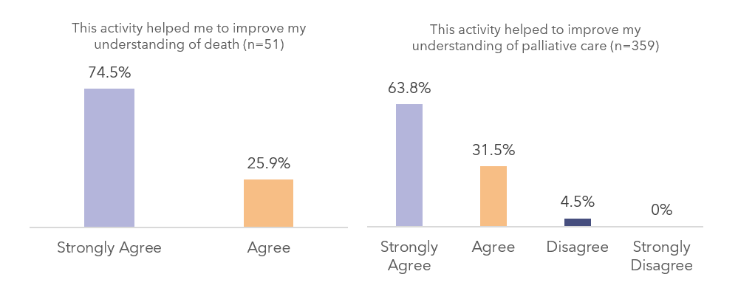
However, from service provider perspectives gained above, it is not possible to determine to what extent improved knowledge and awareness translates to changed behaviours and practice which could be better captured in future workforce surveys.
Education and awareness can also be influenced by the access service providers have to updated information and referral guidance. 17 PHNs have updated, promoted or added new HealthPathways relating to palliative care or EOLC which includes information on how to assess or manage common conditions, including referral and service information guidance. The average number of monthly views of palliative care HealthPathways increased from 475 to 1,795 (278% increase) since the start of the pilot Program, and from 616 to 1,795 (191% increase) since the Program was expanded to all 31 PHNs (Figure 5).
Figure 5: Average monthly views per year for palliative care HealthPathways

Some PHNs have also conducted their own activity assessments to understand the impact of their workforce education and awareness activities. For example, Murray PHN, Gippsland PHN and Western Victoria PHN have developed the Regional Victoria PHN Collaborative to support general practice quality improvement in their regions. They conducted an internal evaluation which found that they had fully or partially achieved all but one of their objectives, including improving awareness to identify early symptoms of palliative care, improved navigation of palliative care systems, increased utilisation of existing healthcare solutions, improved medical recording, and saw a positive cultural shift within practices. The Collaborative reported intentions to use the internal assessment to identify focus areas for the next funding cycle of the Program.
“Participation in the Program has led to significant improvements in our practice… [it has] encouraged a culture of continuous quality improvement within our clinic, prompting us to review and refine our processes to better align with best practices in early palliative care.”
- General Practice clinic from service provider survey
Implications
- Internal collaboration with other PHN teams and areas, such as aged care, HealthPathways, quality improvement, digital health and locally relevant programs, should be improved by PHNs to drive efficiency in reaching their target audience. Through collaborating internally, opportunities to identify where palliative and EOLC knowledge and awareness could be integrated into existing PHN work may amplify impact in PHN regions.
- Standardised tools should be co-designed and used across all 31 PHNs (pre, post, and follow up after education and training events) to better understand the long-term impact of PHN activities on workforce knowledge and awareness of palliative care. This could also explore to what extent knowledge and awareness is maintained, and whether it translates to changes in behaviours and practice.

To what extent has the Program increased workforce confidence and skills in providing palliative care services for individuals?
Key finding
Service providers report a high level of confidence and skills in providing palliative care after engaging in PHN activities, with PHN activities reaching 5,540 primary care health professionals. Workforces such as practice nurses, nurses and aged care staff have been particularly positively impacted by PHN activities.

Background
The Palliative Care Australia (PCA) National Workforce Survey (2024) found that 85% of respondents (n=1,400) were interested in receiving training on topics related to palliative care. The survey showed that 43% of respondents had less than 10 years’ experience. Members of the workforce revealed concerns about increasing demand for palliative care services placing additional strain on personal wellbeing and about the retention of skilled workers within the sector, noting that as the workforce itself is ageing, there is an associated loss of skilled workers and less experienced staff to provide mentoring, particularly in rural and remote areas. This is also in context of the workforce understanding they may require these skills when the Support at Home Program is launched in 2025, which is a dedicated End-of-Life pathway to help older Australians receive funding for services complementary to specialist care, such as meal delivery, personal care an assistive technology.
While PHNs work to improve workforce awareness of palliative care, they are also supporting workforces to build the necessary skills and confidence to provide palliative care services and have difficult conversations around death and dying. This includes targeted education on skills such as using syringe drivers, pain and deterioration management, medication management and anticipatory prescribing, breathlessness interventions, support with dementia or having earlier conversations around palliative care preferences.

Findings
There is a high level of confidence in service providers that have engaged in Program activities. The Endpoint service provider survey shows that 92% (n=78/84) respondents agree or strongly agree that they feel confident in initiating conversations about death and advance care planning with patients or families/carers. Similarly, 82% (n= 69/84) respondents agree or strongly agree that they feel confident in providing palliative care services to people. 70% of respondents (n=26/37) who completed training strongly agreed or agreed that the training was helpful in skill development for the provision of palliative care services. Similarly, post-event survey feedback shows that 65% (n=209) of attendees had felt more confident after engaging in an education event facilitated by the PHN.
This high level of confidence was also seen in After Death Audits (ADAs) collected from several PHNs, where multidisciplinary teams reflected on the palliative care service provided to individuals. 49% of ADAs reflected that the care team and providers were confident or very confident in providing input into the individual’s care (Figure 6). When non-applicable responses are removed, this increases to 89% (n=73).
Figure 6: Level of provider confidence, After Death Audits

This confidence translates to the level of care that people are receiving. 70% of ADAs report that patient deterioration was recognised early and managed, and 58% noted that pain was controlled very or extremely well (Figure 7). It is important to note that in ADAs providers are usually reflecting on their own provision of care, which may lead to bias.
Figure 7: Level of care provided to patients, After Death Audits
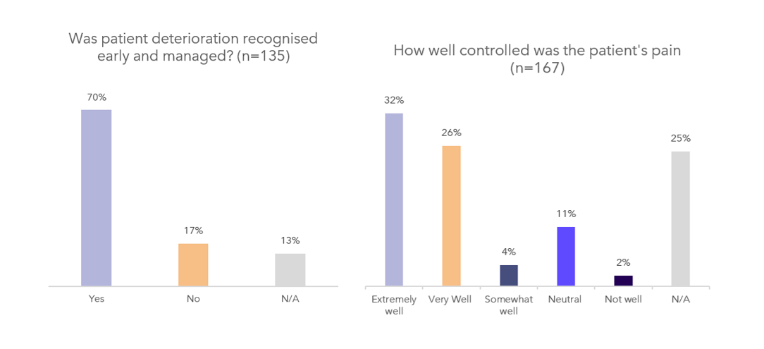
From the service provider survey, key barriers and challenges to participating in PHN activities also commonly included competing priorities, and absence of remuneration or other incentives to encourage participation. PHNs in 29 regions reported that Program activities were often linked to CPD points for GPs and nursing staff.
“When the Program works closely with the services on the ground, that’s positive, but it requires resources from the sector, which are often not renumerated.”
Member of PHN Consortium
PHNs are cognizant of the challenge related to workforce capacity and incentives to engage GPs in the Program. To overcome this and in lieu of no engagement, PHNs have focused on targeting training for different parts of the palliative care workforce, such as RACH staff, home care staff and palliative care volunteers. PHNs have also made considerable efforts to provide a range of delivery methods and options for education and training to maximise reach where possible.

Implications
- It is estimated that PHN activities focused on workforce education and awareness reached more than 5,540 primary care health professionals. Whilst this is a small proportion of the workforce nationally (as compared to a national total of 300 FTE palliative medicine physicians, and 3,300 FTE palliative care nurses employed in Australia) , it represents an average of 179 practitioners per PHN and positive impact towards awareness and confidence was reported.
- PHN activity progress and impact is being challenged by constraints in participant time and available funding for incentives, with consistent difficulties in engaging with GPs across PHNs.
- To better monitor and track reach and impact of PHN workforce education and awareness activities, a refined Post-event survey could be co-designed with PHNs, and its use mandated. A follow up survey to explore long term behaviours and practices of service providers could also be explored.
- Activities that have been successful in gaining reach and attendance should be identified for the purpose of sharing and implementing across other PHNs in the future.

Patient Experience

To what extent has awareness of palliative care in the community (including family and carers) increased?
Key finding
The Death Literacy Index has served as a vital tool for understanding and capturing levels of death literacy across PHN regions. While PHNs are conducting several community education activities such as Train the Trainer and Last Aid programs, improving the pre-post use of the Death Literacy Index and engaging in regular follow-up will enable greater understanding of the long-term impact of PHN activities and community-based initiatives.

Overall, evidence indicates moderate progress, with some areas for improvement

Background
A 2024 report from the AIHW estimates that in 2019-20 there were 109,059 people aged 40 years or older who died from 10 selected underlying causes of death that would have required palliative care. Each of these individuals, their families, carers, and friends, would benefit from having knowledge and awareness of palliative care.
PHNs have undertaken activities that aim to increase community awareness of palliative care in their regions, and encouraged conversations around death, dying, grief and end-of-life. PHN activities have also included implementing a ‘Compassionate Communities‘ model. This is a public health approach that brings together naturally occurring and regionally based support networks, communities, neighbourhood and citizenship to support end-of-life, loss, caregiving and bereavement.
Given that PHN engagement with communities was predominantly facilitated through established partnerships and existing key community groups, direct individual consumer recruitment that would necessitate ethics approval was not a component of this approach and ethics approval was not sought to collect their experiences or views. Future evaluations could consider ethically approved methods to explore consumer input.

Findings
The key measurement tool for community engagement events was the use of the Death Literacy Index (DLI). From 2023 to 2025 a total of 1,480 DLI responses were collected. DLI data was primarily collected from participants in community awareness activities, however, some PHNs incorporated the tool into workforce education and awareness and as part of priority populations activities. While the use of this tool by PHNs was optional, many found it useful to gauge death literacy levels in their region and assess impact of their activities and events.
The number of DLI responses only represents a small proportion of the overall reach of PHN events however the average DLI score across regions still offers a useful indicator of increased awareness resulting from PHN activities. The average DLI score recorded across all responses was 6.4, significantly higher than the national average of 4.7 (p < 0.0001), suggesting that individuals engaged through PHN initiatives have higher death literacy. However, because DLI scores were rarely collected before and after events, there is limited evidence to directly attribute these higher scores to the events themselves.
There was no notable difference in DLI scores that were collected closer to the beginning of the Program than those at the end of the evaluation period. However, responses collected from pilot PHNs and metro PHNs were above the national average of 6.4, while those from non-pilot PHNs and rural PHNs were below the national average (Table 11). There is limited evidence or reason to indicate why this may be the case; however, it could be attributed to the level of stigma and taboo surrounding death and dying or the lack of palliative care information and services in these regions, as highlighted by participants during consultations with PHNs.
Table 11: Average DLI scores by state, pilot status and rurality
 | Number of responses | Average DLI score | National average
State
NSW | 425 | 7.01 | 6.40
QLD | 226 | 5.74 | 6.40
SA | 289 | 6.93 | 6.40
VIC | 439 | 6.18 | 6.40
WA | 84 | 5.85 | 6.40
Pilot status
Pilot | 404 | 6.53 | 6.40
Non-pilot | 1,076 | 6.35 | 6.40
Rurality
Metro | 679 | 6.77 | 6.40
Rural | 801 | 6.09 | 6.40
Post-event surveys collected by PHNs at community events suggest that they are having an impact on improving attendees understanding of palliative care (Figure 8).
Figure 8: Post-event survey responses to improvements in understanding

“We are becoming better at making death part of life and things like this [event] confirm how society is changing. I am so relieved and embrace this.”
- Community participant survey
While this shows direct correlation to improved understanding, it is challenging to gauge the long-term impacts that community events are having on behaviour change.
PHNs noted anecdotally in consultations that they see the greatest impact for community activities which focus on earlier interventions and earlier conversations, rather than being reactive. This was seen to be successful when there are greater opportunities for consistent and regular group engagement with communities, so that support groups are mobilised quickly. This is seen in the example below.
Example: NQPHN’s Compassionate Communities Health Connectors ‘Train the Trainer’ model
NQPHN have developed an approach to Compassionate Communities in their region, which establishes longer term wraparound informal supports for people experiencing palliative care. The PHN trained over 350 community health connecters over 8 months, across 14 sites. They were trained to understand palliative care services and service gaps in their region, signpost vulnerable community members to access services, and conduct workshops themselves on key palliative care information. This could lead to a fully community-driven awareness campaign in the future. By leveraging community champions and existing networks, embedded behaviour change is more likely to be seen.
Similarly, several PHNs have conducted Last Aid / Last Days programs aimed to provide community education focused on end-of-life care. They equip community members with the knowledge and confidence to support others through death and bereavement proactively. For example, Country SA PHN attracted 40 participants at their courses. Of these 77.5% were primarily there to learn more about palliative care, death, dying and / or bereavement, while only 12.5% were currently caring for someone at the end-stage of life.
Figure 9: Country SA PHN Last Aid participants' reasons for attending

The Endpoint PHN survey indicates that many PHNs are continuing to engage with relevant state palliative care peak bodies to amplify the impact of their community awareness activities.

Implications
- To improve data quality and enable ongoing activity monitoring, the DLI should be completed pre and post community awareness events. However, this should be balanced with the risk of over-surveying community members, and those in vulnerable life stages.
- While it appears that community awareness is improving, it is difficult to gauge ongoing and long-term impacts on behaviour change. Post event surveys provide event-level data; without longer term follow up it is difficult to ascertain whether this translates to changes in service access or needs and preferences being met.

To what extent has the Program increased individual awareness of palliative care options and choices (including ACP)?
Key finding
There is a high level of interest, engagement and value gained from learning about advance care planning reported by both service providers and the community. This interest can serve as an opportunity for continued national momentum. While PHNs are currently undertaking activities which seek to support awareness of palliative care options and choices, there are opportunities for these or comparable activities to be completed by health professionals and community organisations.

Background
The concept of ‘good end-of-life care’ is associated with people having choice and control over where they receive their care, and what support and care is provided. Almost 90% of Australians believe it is important to talk about their wishes and preferences for care. Despite this, most Australians (56%) have not undertaken any action to talk about or record their end-of-life wishes.
To help improve this, some PHNs developed activities specifically aimed at improving awareness of palliative care services, options and choices, as well as supporting awareness and completion of Advance Care Planning (ACP).
ACP is the process of decision-making about end-of-life preferences in the case of sudden deterioration or an inability to communicate preferences at later stages of illness. Preferences can be formally documented in an Advance Care Directive (ACD) which ensures loved ones, carers and health professionals are aware of and respect an individual’s treatment preferences. In the Northern Territory, this is known as an Advance Personal Plan (APP).

Findings
One of the DLI sub-scales measures community knowledge through awareness of available services and support. Attendees at PHN events which focused on palliative care and advance care planning (ACP) scored an average DLI of 5.96, compared to the national average of 4.6. This difference is statistically significant (p < 0.0001), indicating higher death literacy among event participants. While national data on community engagement with palliative care resources was not standardised for this evaluation, some PHNs were able to demonstrate increased awareness, particularly through ACP-focused initiatives, as illustrated in the example below.
Example: Gold Coast PHN’s “Planning or your future care today” Advance Care Planning Booklet
Gold Coast PHN developed the ‘Planning for your future care today’ Advance Care Planning Booklet with the aim to raise awareness and support consumers to plan for their end of life. The booklet was made available online and in hard copy through ordering on the PHN website or in any City of Gold Coast libraries. As of 30 April 2025, 14,350 hard copies were distributed to the Gold Coast community.
This is supported by Post-event surveys, where 74% (n=54) of community respondents agreed or strongly agreed that a PHN activity had helped them improve their understanding of what ACP is (Figure 10).
Figure 10: Post-event survey responses to improvements ACP understanding

“[I learnt] …mainly about the integration of services in this region – finding one’s path through all that is available can be very difficult and it is heartening to see that there is acknowledgment of this, and steps being taken to make the processes more streamlined.”
- Community participant survey
This increase in awareness of ACP is also seen in service providers. From 2018-19 to 2023-24, a significant increase was seen in Statement of Choices (SoC) completions in RACH settings for all PHNs in Queensland except for Western Queensland. This is likely due to the limited number of ACP completion in Western Queensland as a whole. This increase was much greater than was observed for SoC completions in community or hospital. While not fully representative of all PHNs nationally, this is shown in Table 12 below.
Table 12: Queensland Office of Advance Care Planning SoC completions by sector
 | SoC completions (Queensland Office of Advance Care Planning)
 | Community |  | Hospital |  | RACH
 | 2018-19 | 2023-24 | 2018-19 | 2023-24 | 2018-19 | 2023-24
Brisbane North PHN | 363 | 291 | 212 | 221 | 198 | 661
Brisbane South PHN | 615 | 550 | 479 | 251 | 1,233 | 1,624
Country to Coast PHN | 203 | 324 | 68 | 137 | 239 | 1,095
Darling Downs West Moreton PHN | 346 | 231 | 135 | 107 | 295 | 489
Gold Coast PHN | 89 | 236 | 16 | 28 | 361 | 884
North Queensland PHN | 89 | 139 | 64 | 135 | 163 | 318
Western Queensland PHN | 43 | 32 | 41 | 18 | <5 | <5
Country to Coast PHN also saw an increase in completions of Advance Care Directives and Enduring Power of Attorney (EOPA) documents throughout the Program. 563 documents were completed in 2018-19 as compared to 5,403 completed in 2023-24 (860% increase). This could correlate to their ‘ACP in Community’ Project as part of this Program which aimed to increase the awareness and completion of these documents in their region.
Service providers indicated in Endpoint surveys that they felt education and awareness around ACP resulted in practice level improvements that aided in their ability to provide appropriate information to consumers. Services discussed ACP reviews, inclusion of ACP discussion in health assessments, improved access to resources to facilitate discussion around Voluntary Assisted Dying (VAD) and coordination of service-led consumer education on ACP.
In contrast, consultations revealed that there were still gaps in not knowing where to find opportunities for education, not having access to a national database of services and a fear of the subject observed in colleagues they work with.
From the Endpoint PHN survey, 48% (n=21/44) of respondents indicated that community education or awareness events had helped to raise awareness of palliative care options and choices for individuals in their region. However, 75% (n=33/ 44) of respondents stated that activities which had the greatest impact on awareness raising were education events, or the distribution of resources, by healthcare professionals (e.g. LHDs, local hospices, GPs, practice nurses, RACH staff, etc.). One PHN during consultations noted that they are “now doing more joint projects / low cost projects that are co-commissioned or with partners with shared goals.” This suggests that through strategic partnerships with health providers and other organisations, PHNs play a crucial role in enabling these entities to effectively undertake awareness-raising activities.

Implications
- There is a high level of engagement from individuals in events and resources related to ACP and APP documentation, completion and understanding.
- Service providers valued the education, training and resources developed by PHNs. This increase in knowledge and resources translated to increased service capability to discuss options and choices around palliative and EOLC with patients and carers. Service providers expressed a need for tools and resources that assist communication with people around choices and options at end-of-life, which could be further centralised via a repository for the purposes of collective sharing.
- While there was positive feedback about PHN activities and resources from community members, a more effective and efficient approach to raising awareness of palliative care options and choices may be via or with health professionals and community organisations as they are an existing point of entry to information for consumers. However, in practice there are still limited opportunities where this occurs so PHNs are currently filling this identified need effectively.

Population Health – Appropriate palliative care outcomes

To what extent has the Program generated and used data to support continuous improvement of services across sectors?
Key finding
The Program generated both locally tailored and standardised data through tools. To better understand how these tools are informing continuous improvement, PHNs should be required to indicate how data is driving decision-making and supporting continuous improvement as part of regular reporting to DHDA.
Overall evidence indicates moderate progress, with some areas for improvement
Background
As part of the Program, it was intended that PHNs would use data (both quantitative and qualitative) to inform the selection of activities as well to monitor impact for continuous improvement. A data collection approach and a suite of tools were co-designed with PHNs as part of the evaluation. PHNs had the flexibility to collect data based on the activities they were implementing. These tools included:
- The After Death Audit form
- The Death Literacy Index form
- Post Event Surveys
- HealthPathways and other Clinical Information Management Systems data
- Other PHN documentation (such as uptake of service directories, service maps and resources and potential web-based data such as clicks, views and unique users, etc.)

Findings
Our understanding of the activities undertaken by PHNs support us to identify the types of data collection tools that would reasonably be expected to be used by PHNs to monitor their activities It would also support us to assess whether the volume and type of data received for the evaluation is in line with these expectations. At Endpoint:
- 10 PHNs were undertaking activities that collected the After Death Audit (ADA) tool to collect data, and all 10 PHNs provided data. Nine PHNs incorporated ADA as a measure of GP Quality Improvement activities, and one PHN used the tool to supplement workforce capacity building data. In response to the Endpoint PHN survey, two respondents noted that the ADA ‘provided rich data both qualitative and quantitative identifying gaps and opportunities for improvement’.
- All 31 PHNs were undertaking activities that could have used the Death Literacy Index (DLI) to collect data relating to Workforce education and awareness and Awareness in the Community activities. DLI data was collected from 18 PHNs at Endpoint, with a total of 1,480 DLI survey responses. Respondents to the Endpoint PHN survey indicated that they used DLI data to inform the types of services and resources to include in community events, to identify areas for education and awareness, and to compare needs across different populations.⁵²
- All 31 PHNs could have used post-event surveys across activities such as workforce education, community awareness, priority populations, and palliative care medicines. At Endpoint, 19 PHNs submitted survey data. These surveys were the preferred tool for PHNs to assess activity uptake, understand health professional learning needs, and guide improvements. Several PHNs also found them valuable for identifying gaps in awareness and understanding of ACP.
- All 31 PHNs had access to HealthPathways data to support continuous improvement. At Endpoint, 17 PHNs provided this data. While page views and engagement can indicate increased awareness, they do not directly reflect changes in service access or care models.
- PHNs submitted a substantial amount of supplementary data, including internal analyses and evaluations of activities, to support and assess their implementation. Some PHNs who conducted quality improvement activities with general practices were able to access, analyse and apply practice-level data on completion rates of health assessments, General Practice Management Plans (GPMPs) and patients with completed ACP documentation. This information was provided back to general practices to support continuous improvement.
Endpoint survey results show 70% of PHNs used Program data to enhance service design, with many examples of locally driven evaluations and practice-level data use. Qualitative responses to PHN surveys also provided examples of PHNs using data collected to adapt and modify program activities. For example, one PHN planned activities to improve community access to end-of-life medication. Consultation with pharmacies in the region found that issues with access to core medicines were localised to one LGA and that these issues were occurring less frequently than perceived. In collaboration with local pharmacies, the decision was made to continue to monitor the situation and not pursue the planned activity.
Another example of how data was used for continuous improvement is highlighted below.
Example: Healthy North Coast RACH data
Healthy North Coast identified RACHs with high rates of emergency department presentations and provided support strategies and education tailored to the most common causes of hospital transfer. Data on RACHs registered with My Health Record (MHR) has supported targeted outreach around ACP and ACD documentation, including how to upload these documents to the MHR system. LHD admission data also revealed that very few residents from RACHs or the broader community are hospitalised with a documented ACD. Identification of this gap reinforced the ongoing need to raise awareness of ACP through community education efforts.

Implications
- Standardised tools should be reviewed, updated and co-designed with PHNs to support a more consistent approach to monitoring, nationally.
- Data collected as part of quality improvement activities with GPs (e.g. ADA, and practice-level data) provides rich insights that can be used to drive continuous improvement of services. However, few PHNs undertook activities that involved access to and use of this type of data. In future, the Program could require PHNs to deliver at least one activity relating to GP quality improvement to enable greater insight.
- To better encourage the use of data to inform continuous improvement, there could be a requirement for PHNs to indicate how they have or will use data collected in designing, implementing and refining their activities in regular status reporting and/or Activity Work Plans.

To what extent are services coordinated, integrated, and provide continuity of palliative care?
Key finding
Coordination and integration are core strengths of PHNs in this Program, as they develop informal channels that strengthen local relationships between providers, forums to discuss activities and priorities, and provide greater networking opportunities. However, there are limited opportunities to capture this level of impact of informal engagement.

Background
The palliative care service system in Australia comprises a range of service providers, health professionals and settings. Individuals often require different services and levels of service as their symptoms progress. Where there is an early identification of need, there is greater potential for services and supports to be coordinated to enable palliative care at home and in the community.
For example, leading practice suggests that, where possible, individuals should be referred to specialist palliative care at least 3 months prior to the end of life. Additionally, 94% of people who need palliative care will visit their GP in the last year of their life . Enabling appropriate palliative care in the home and community requires a multidisciplinary approach to care planning, including with primary care workforces such as GPs.
While Program guidelines do not permit PHNs to commission palliative care service provision, their core role in the Program, is facilitating and driving connections, partnerships to improve coordination and integration between services and sectors. This function is supported through the allocation of 2 FTE.

Findings
At Endpoint, 24 PHNs completed activities focused on Coordination and Integration however this encompasses only formal coordination and integration efforts such as establishing shared models of care and increasing service navigation pathways through HealthPathways.
More broadly, all PHNs have also adopted informal approaches that bring together different service providers within the local palliative care system to strengthen relationships, including primary care workforces, aged care workforces and allied health. Responses to the Endpoint PHN survey indicated that PHN activities that involved facilitating networks and relationships among service providers, contributed to strengthened awareness and relationships among providers that in turn has, or may, contribute to improved coordination and integration.
PHNs noted in consultations that it wasn’t always done well at the start due to a lack of understanding of the goals and objectives of what ‘good’ coordination looks like. However, as a result of continuous program leads, and greater program maturity, there has been an observed improvement in stakeholder understanding of palliative care due to collaborative forums and connections made by PHNs.
An example of this is SNPHN. As a member of the NSLHD Northern Sydney Community Palliative Care Working Group, SNPHN contributed to shared decision-making, consistent communication, and alignment of care pathways across providers. This collaboration has strengthened regional networks, facilitated knowledge exchange, and enhanced service integration to support holistic palliative care for patients and families.
Similarly, DDWMPHN have established a Care at the End of Life Collaborative (CAEOLC) to enable partnerships across government and non-government services to optimise systems, processes and outcomes for people in their region. This forum has a series of targets including the co-design of shared care pathways, service mapping and identifying gaps in patient journeys for vulnerable populations. They meet bi-monthly, including yearly forums and regular communication via email and newsletters.
While there are strong examples of impact, service providers noted that rural workforces, staffing arrangements and locum workforces that come in and out of regions with less commitment to continuous improvement are limiting seamless integration in palliative care delivery. One GP stated that even when they do refer patients, not just in palliative care but for all services, they are kept out of the loop of what occurs next. This led to them finding out their patient had died by checking-in via phone call with their daughter, after a point of referral.
Another service provider also stated that ‘it is hard to coordinate what doesn’t exist’ in relation to a lack of services and thin markets in areas such as the Northern Territory and Tasmania.
“There is now a better understanding of the available services and supports in the region, leading to more effective utilisation by healthcare professionals, service providers, and the community. There is increased awareness regarding early referrals and advance care planning among health professionals and community members.”
- PHN survey
To measure the formal impact of coordination and integration activities at the system level, the following were explored as indicators of coordination and integration from publicly available AIHW data:
- Palliative care episodes by referral sources and settings.
- Proportion of patients discharged to RACHs from public acute care facilities.
- MBS-subsidised palliative medicine attendances and case conferences provided by palliative medicine physicians/specialists.
However, recent national data does not yet reflect the impact of PHN activities on palliative care coordination and integration, as most indicators either predate the Program or show no significant change. This is likely due to the timing of data collection, as well as the relatively small scale of PHN activities.
In the future, data sources could include greater capture of coordination activities, including referral pathways, discharge rates and shared care arrangements.

Implications
- While there is limited evidence of impact of PHN activities to improving palliative care coordination and integration there are several qualitative examples that indicate that PHNs have strengthened relationships among local service providers through the Program.
- In future, coordination and integration could be better captured through smaller scale and localised measures such as conducting social network analyses. It could also include larger scale measures such as bi-directional data linkage projects between GPs and referrers (e.g. specialist palliative care, community services etc.) to understand how coordination is being translated to practice.
- PHN activities involving service mapping increased the knowledge of service providers about available palliative and EOLC services and referral pathways in their regions. The capacity to maintain these as up to date resources and continue to promote their use presents an ongoing challenge that is not unique to this Program.

To what extent has the Program enabled appropriate palliative care in the home and community, and reduced preventable hospitalisations?
Key finding
Current data limitations make it difficult to assess impact at the system-level to indicate reduced preventable hospitalisations. However, activity-level data and evidence illustrate that PHNs are conducting activities would enable greater palliative care at home and in the community.
Available evidence is limited and does not enable a definitive conclusion

Background
The Program, at its core, is designed to support individuals’ preferences for receiving palliative care at home and in the community. Therefore, impact is expected to be most visible in primary and community care settings, with potential downstream effects on hospital and acute care services. National datasets like AIHW and PCOC provide limited insights to support this assumption, and insights rely primarily on PHN-reported activity data and case studies.

Findings
The 2025 AIHW data release does not yet reflect the impact of PHN activities, as most indicators predate their implementation. Although there was a modest increase in palliative medicine prescriptions by GPs compared to specialists, this trend likely reflects broader variability over time rather than a direct result of the Program.
Datasets and indicators in the AIHW report that should be monitored when evaluating the Program in the future include:
- Number of prescriptions from GPs and palliative medicine specialists per 100,000 population by medication group.
- Patient outcomes (symptoms and problems in the absent to mild range at phase end).
- Palliative care-related hospitalisations per 10,000 population.
- Access to palliative care in RACHs.
PCOC data from 2016 to 2024 was also accessed. A customised request was submitted to obtain the following data to assess palliative outcomes in the home and the community:
- Duration between a patient’s first palliative care episode and their recorded date of death.
- Australia-modified Karnofsky Performance Status (AKPS) at first episode, by patient setting.
- Volume and duration of palliative care by referral source.
Similarly, there were no observable changes to these indicators that would suggest Program impact. It remains to be seen whether, as the Program continues, and more recent data becomes available, changes can be detected at a system level.
While it has not been possible to detect impact of PHN activities using system-level datasets, data collected by PHNs at the activity level demonstrates there has been, or is likely to be, impact.
The ADA used by PHNs undertaking quality improvement activities with GPs was analysed to determine if GP awareness and capability improved with respect to individuals eligible for palliative care. ADAs are conducted on a small sample of cases identified within a practice who would have been eligible for palliative care to assess whether they were identified and received palliative care that met their needs and preferences. Results from ADAs indicated that ACP preferences were taken into consideration during end-of-life care in 62% of cases (n=112/180) which was subsequently documented in an ACP for 55% of cases, or an enduring power of attorney for 43% of cases. For those who stated a preference, most preferred to die at home or in a RACH (Figure 11).
Figure 11: Patients documented preferred place of dying as assessed by After Death Audit.

The ADA data shows that 60% of people were referred to specialist palliative care. Of those who were referred, only 31% were referred early in their symptom progression (Figure 12). In some instances, progression may have been rapid (< 3months), however, the large proportion suggests that discussions with patients about care planning were not occurring early enough.
Figure 12: Timeliness of referral to Specialist Palliative Care as assessed by After Death Audit.

Further examples of how PHN level data indicates impact are described below.
EMPHN, NWMPHN and SEMPHN collaborated to produce an interactive online map of community pharmacies in the region that stock medications on the palliative Core Medicines List (CML). Access to these medications assists with symptoms commonly seen during terminal phase (pain, delirium, nausea, dyspnea, and noisy breathing). Timely access to medication on the CML reduces the likelihood of having to attend hospital for symptom control. Primary users of the list were community members, pharmacists and other health professionals. Since going ‘live’ there have been 17,500 views of the online interactive map with more than 1,500 of those views coming in the 6-month period from October 2024 to April 2025. Increased use of the interactive map and improved access to palliative care medicines should enable better palliative care at home and in the community and thus, in theory, reduce hospitalisations.
ACTPHN’s pilot study of the Breathlessness Intervention Service (ABIS) is another example. The number of ambulance call outs to people receiving the service indicated that most patients in the intervention cohort were being treated in the home, or where able to self-manage without subsequent transfer to hospital. This demonstrates a link between the ABIS approach and protocols resulting in patients being managed in the home or community without requiring hospital admission.
Similarly, HNECCPHN coordinated syringe drivers and training for nursing staff in RACHs. The training was well received by participants with over 95% of participants providing feedback that the use of the syringe driver in the end-of-life pathway resulted in improved overall symptom management and care of residents. 95% of participants also agreed that the use of the syringe driver at end-of-life had reduced the likelihood of hospitalisations for symptom management of residents.

Implications
- At the activity level, there is evidence of impact with PHNs undertaking activities that better enable appropriate care at home and in the community, and therefore likely to reduce preventable hospitalisations. This includes activities such as the syringe driver project, Breathlessness Intervention Service, and mapping community pharmacies that stock medications on the palliative Core Medicines List.
- Measuring impact of these activities, and demonstrating a causal link, remains a challenge. In future, there are other methods to accurately determine the level of reduced hospitalisations. This could be directly measured through sampling in GPs, where practice level data could allow us to observe differences between people identified for palliative care in practices engaging in the Program compared to those that have not. There could also be an opportunity to further explore whether PCOC data could enable greater tracking of patient access and journey from inpatient to community services. Data sharing agreements with GPs and specialist palliative care services could strengthen this in the first instance.
- It should be noted that limitations to observing system level changes include the limited time for PHN activities to have had a measurable impact and the size and scale of PHN activities to generate sufficient impact at a system, or even regional, level.

Health Equity

To what extent has the Program improved access to palliative care at home and in the community?
Key finding
Current data limitations make it difficult to assess whether there has been improved access to care at home and in the community, including for priority populations. While activity-level data and evidence show that some PHNs are conducting activities that would enable this outcome, this is only a small proportion of total PHNs.

Background
Significant barriers to accessing appropriate palliative care are especially exacerbated for people from underserved populations. This could be because of cultural stigma and comfort in discussing death and dying, limited awareness of palliative care services, cultural and language barriers, mistrust of health services, increased social isolation, and other financial or geographic constraints.
Providing culturally appropriate and equitable palliative care can include practices that are beyond the means, time and knowledge of service providers. In response, PHNs implemented a range of activities aimed at improving access to palliative care at home and in the community. These activities spanned all five program categories and were designed to support more equitable access. Many PHNs also undertook targeted initiatives to improve access for priority populations.

Findings
The set of indicators described previously from AIHW could be used to monitor to what extent access to palliative care at home and in the community is equitable. However, as discussed in Section 6.3, these indicators will require longer term monitoring and do not currently illustrate any change given the size and scale of PHN activities. In addition, several of these indicators may not be available by priority population groups.
There are indicators available as part of the PCOC dataset that could be used to assess equity of access to palliative care at home and in the community, including by socio-economic status, CALD status, by place of birth and first language, and by country of birth. While the PCOC data includes the period from 2016 to 2024 (i.e. at least one year of data post commencement of PHN activities) it is too early to determine if there are any changes that could be associated with PHN activities and there were no significant changes observed.
However, PHN examples at the activity level highlights a greater focus on making information more accessible for unserved populations and identified populations of need.
PHNs noted in consultations that they have been able to use this program as an opportunity to normalise conversations about death and dying and advance care planning with a range of people and communities. One PHN officer stated they find they can share what is available in their local area almost every time they talk to someone in their local community.
There is also evidence of impact as part of specific activities. WAPHA undertook a project focused on people with sensory loss to access palliative care. This included a professional development workshop for AUSLAN interpreters in Western Australia to explore advance care planning, palliative care documentation and decision making, and voluntary assisted dying.
Similarly, CSAPHN collated and shared culturally appropriate information bundles on ACP, palliative care and end of life care for First Nations communities and have made them freely available on the digital GoShare Plus platform. Four respected local South Australian First Nation community Elders led communication on these subjects by way of pre-recorded videos, and CSAPHN continued to engage local Elders to record video messages for the platform more broadly.
Additionally, SWSPHN have also launched a ‘Journey into Sorry Business’ booklet for First Nations peoples to understand preference for death, cultural practices and protocols associated with dying. This has been localised and tailored in other PHN regions, such as by Murray PHN to support First Nations communities in regional Victoria.
“Increasing education and awareness at community level through the Palliative Caring Booklets, Sensory Loss Project and Linkwest project improves access through the increased knowledge and demystification of palliative care services in the community. This has been specifically seen in the Deaf and Deafblind communities in the Sensory Loss Project where community members had limited understanding of what Palliative Care meant and how it can support them.”
- Service provider survey
In contrast, other PHNs noted that it is too early to prioritise meeting the needs of different community groups, as there are still challenges in the foundations of how palliative care is talked about and delivered generally and therefore would be exacerbated for underserved communities. In disability services, one provider agreed that palliative care is being done poorly. PHNs are aware and emphasise that work has to be done to find better metrics to see how things are changing for priority populations, and a key part of this is understanding progress and appropriateness in general practices.
Implications
- While there may be data from AIHW and PCOC that can be used as indicators to monitor impact of PHN activities on improving equitable access to palliative care for priority populations at a system level, it is too early to detect any changes. The small scale impact of PHN activities and the few activities undertaken by PHNs that focused on priority populations would mean these indicators may still not show observable changes in the future.
- At the activity level, there is evidence of impact in PHNs activities that improve access to palliative care at home and in the community for priority populations. This includes activities such as the Sensory Loss Project, GoShare communications and the Journey into Sorry Business Palliative Care booklet. There are also projects which are focusing on targeting early referrals to palliative care in general practice, including for underserved populations.
- However, the limited number of activities focused on improving access to palliative care at home and in the community for priority populations reflects challenges PHNs had in engaging with these hardly reached populations. To prioritise these activities in future, the Program could require PHNs to deliver at least one activity focused on priority populations.
- Given the constrained resourcing allocated to individual PHNs, establishing a shared learning model that leverages the proposed central repository could enhance efficiency and reach. This approach would enable the widespread adoption of high-quality, proven activities—such as the 'Sorry Business Booklet' or the 'Disability Framework' developed by Brisbane North—across multiple regions, preventing duplication of effort and maximising impact.

How appropriate is the Program at meeting needs and preferences of families, individuals, and carers?
Key finding
There are enduring challenges with engaging priority populations in PHN regions, not unique to this Program. This therefore meant that activities targeting these populations were the least likely category undertaken by the Program, apart from palliative care medicines. There are opportunities for PHNs to focus further on underserved populations identified in existing health needs assessments.
Overall, early progress is evident, with further development required

Background
It is well recognised that underserved populations experience inequitable access to culturally appropriate palliative care, and inequitable outcomes in terms of having their needs and preferences understood and met.
A key role of PHNs is to identify and address population health needs and gaps in service delivery and to improve access and equity. To identify the needs of their communities, PHNs were required to align their Program activities with needs assessments (HNAs, PCNAs, and other strategies and plans). As part of needs assessments conducted by PHNs, priority populations, and areas of health inequity amongst the community are often identified and highlighted as areas of focus.
As part of the Grant Opportunity Guidelines PHNs were eligible to undertake activities that address ‘specific population needs, such as people who are receiving Aged Care services, Aboriginal and Torres Strait Islanders, from Culturally and Linguistically Diverse (CALD) backgrounds or paediatric patients.’

Key Findings
Analysis of HNAs and PCNAs shows that 14 PHNs identified a need to address health inequities among priority populations or had demographic and health data suggesting such a need. Of these 14, 11 PHNs conducted an activity in this category while 3 did not, which may reflect resource constraints or time required for genuine co-design with underserved groups in these regions. However, an additional 3 PHNs who had not explicitly identified this need in their assessments did conduct activities for priority populations. (see Section 3.3).
Activities focused on priority populations were among the least commonly undertaken, except for those related to palliative care medicines. A total of 23 activities were delivered by the 14 PHNs, targeting First Nations peoples, CALD communities, LGBTIQA+ individuals, people experiencing homelessness, and those with hearing loss, disability, or accessibility needs. An example activity is described below.
Example: Murrumbidgee PHN “Planning your future care today” Advance Care Planning Booklet
Murrumbidgee PHN (MPHN) sought to understand the local barriers and enablers to First Nations people accessing the Murrumbidgee Local Health District (MLHD) palliative care service. Through consultation with 15 local First Nations organisations, MPHN explored the local needs of First Nations people requiring palliative care supports and services. The consultation findings have directed MPHN to support the provision of culturally appropriate and safe palliative care within primary care in the region.
Findings concluded that mainstream health services do not understand or accommodate the complex cultural practices surrounding Sorry Business (rituals and mourning) in First Nations communities. The unique end-of-life care needs and expectations within First Nations communities, such as the desire to pass away on Country and a distinct preference for home-based palliative care, present major challenges for mainstream health services. Logistical challenges and geographical limitations often prevent First Nations people from accessing care in their preferred location, resulting in stress and trauma during this critical time.
NSPHN and SWSPHNs produced resources in identified community languages and for people with English as a second language to address language barriers and ensure that people from CALD population groups were able to have a greater understanding of palliative care and communicate their needs and preferences. SWSPHN held a whole of community awareness event where they identified through post event surveys that 63% of those attending were from a Vietnamese background. In response, SWSPHN held a suite of community education events in a range of languages, including Vietnamese, which attracted high levels of attendance from CALD populations.
BSPHN held workshops for language interpreters to improve awareness on how they can support people to access information on ACP and palliative care. Feedback from these workshops indicated that interpreters had increased confidence and understanding of palliative care.
MPHN had existing palliative care community resources translated into AUSLAN to improve equity of access for people who were deaf or hard of hearing. Collateral produced included translation of videos into AUSLAN and booklets for people with low English levels.
While many PHNs have indicated that Priority populations activities were completed or continuing at Endpoint, there was limited data available for analysis to assess reach, acceptability, or impact.
Respondents to Endpoint service provider surveys reflect that there have been some perceived improvements to how services meet the needs of certain priority population groups. For example, one response highlighted that ACP discussions were added to over-75 health assessments which had resulted in increased capability of staff to identify patient palliative care preferences.
“These changes have enabled more residents to remain in familiar surroundings during end-of-life care while receiving high-quality, person-centred support. Additionally, structured family communication processes have been introduced, improving trust, emotional support, and satisfaction during critical times.”
Residential Aged Care Home Service – from service provider survey

Implications
- Despite several PHNs identifying a need to improve health inequities experienced by people from priority population groups (either in needs assessments, or Program planning and consultation), Priority Populations activities were the least likely category of activities to be undertaken by PHNs, except for Palliative care medicines. This likely reflects the challenges experienced by PHNs more broadly in engaging with priority populations.
- There was limited data available at Endpoint to assess the reach, acceptability and impact of PHN activities focused on Priority Populations. Data provided is limited to case studies and anecdotal feedback.
- If the Program is intended to address inequities experienced in palliative care for priority populations, then PHNs could be required to undertake at least one activity focused on Priority Populations. As part of this, a set of standardised tools could be co-designed with PHNs and other key stakeholders to collect and analyse data on reach and impact of future activities, and embedding direct consumer feedback and input.

Value for money

How cost-effective is the Program?
Key finding
The estimated cost per activity per PHN ranges from $3,530 - $200,000. Without access to the total number of participants per activity or reach of resources, it is difficult to determine if this estimate is representative of a cost-effective program. However, there are examples of PHNs demonstrating greater efficiencies via collaborations and shared activities. National expansion of successful activities, and national performance indicators could assist efficiencies further.
A key strength of the program lies in its strategic approach. Rather than investing in new programs or services, it utilises a modest investment to coordinate, strengthen, and amplify existing local expertise, activities, and infrastructure.
Available evidence is limited and does not enable a definitive conclusion

Background
A total of $37.3 million was committed to the Program across all 31 PHNs for four years to 2024-25. Under this funding, all PHNs received $300,000 per annum (pro-rata) to fund their activities. This funding is to ‘support the employment of up to two FTE staff members at each PHN and that funding could not be used for the direct delivery of palliative care services, duplication of existing programs or investments, major capital expenditure, retrospective costs, and general ongoing administration.
Health care effectiveness measures the degree to which outputs (treatments), produce improved outcomes for patients. In the case of this Program, cost-effectiveness relates to the extent to which the Program activities resulted in improved access to palliative care services at home and in the community.
Proactively delivered home-based palliative care for people with both malignant and non-malignant diagnosis has been shown to result in fewer people being hospitalised, lower number of days in hospital, and lower hospital costs. While it has been shown that additional investment in palliative care would be required to increase the number of people able to die at home, the reduced use of hospitals and RACHs would release funds to offset the cost of providing services at home.

Findings
PHN activities that improve access to palliative care, help identify patient needs and preferences and reduce barriers to home and community care can lead to cost savings by potentially lowering the use of emergency and acute services.
PHNs completed or were continuing 204 activities throughout the 4-year funding period. The estimated cost per activity per PHN was calculated to be around $3,530 - $200,000. This has been estimated based on the range of activities undertaken by each PHN with the lowest being 3 and the highest being 17. This range should be interpreted with a degree of caution and considered as a rough estimate only, which would vary depending on nature of the activity, geographic region and size, stakeholder involvement and intended objectives.
It has also considered the following assumptions:
- PHNs receive $300,000 per annum
- 2.0 FTE equates to roughly $180,000 per annum
- Administrative overheads
There are several factors that would influence this range such as:
- As discussed throughout the chapters above, some PHNs had trouble in recruiting and retention of staff throughout the Program period, which influences the consistent spend associated with FTE.
- PHNs with large catchments in rural areas had added financial challenges associated with travel.
- Activities such as stakeholder consultation and independent evaluation can be costly to deliver, and while they do not directly translate to outcomes, these activities have value in knowledge generation and provide direction for the future program activity that may be associated with potential outcomes.
Therefore, this estimate could represent good value for money for the level of training, reach and engagement that was achieved. However, for other activities, this may not be considered cost-effective, such as the development of resources that have had limited reach. Without access to the total number of participants per activity or reach of resources, it is difficult to determine if this estimate is representative of a cost-effective program.
Some PHNs used collaboration and pooling funding to increase the reach and impact of their activity. For example, collaboration between North Western Melbourne PHN, Eastern Melbourne PHN and South Eastern Melbourne PHN on the Palliative Care Access to Core Medicines (PCAM) Project. The interactive map produced as an output of this activity had 17,500 views (at Endpoint) and an associated evaluation by the Pharmaceutical Society of Australia provides useful learnings about the challenges associated with implementation. The collective impact of the three PHNs working together to reach a larger audience, positive engagement with the project and valuable learnings through effective evaluation is an example of program activity that demonstrates cost-effectiveness and efficiency. This scale of impact would likely not have been possible if the same activity had been conducted individually.
Healthy North Coast PHN is similarly pooling different funding sources to contribute to their Integrated Model of Support (IMoS) project for people living in residential aged care, supported by a regional collaborative and existing resources from across the local care ecosystem. The objective of IMoS is to reduce unnecessary hospitalisations, save on higher acuity costs, and deliver coordinated end-of-life processes for people in RACHs. This multi-sector approach to anticipatory practices and palliative care includes RACHs, the LHD, GPs, nurse practitioners, pharmacists, and university facilitators and will be implemented in the near future.
When asked about the opportunities for improvement within the current funding framework, the themes from qualitative responses to PHN Endpoint survey included:
- Appreciation of support in the Guidelines to be flexible and tailor activities to local needs.
- Desire for national consistency of activities to enable opportunities for assessing collective impact more effectively.
- Suggestions for increased collaboration between PHNs, national models and ‘scaling up’ of projects, and more prescriptive contracted deliverables. Examples of activities that would benefit from ‘scaling up’ include the development of whole-of-system end of life coordination models, identifying palliative care friendly community pharmacies, quality improvement activities being undertaken with GPs, and palliative care champions being trained in different service systems.
- Concerns about duplication of activities across PHNs being inefficient, and costs of producing hard-copy resources on a small scale.
- Desire for the Guidelines to be inclusive of flexible funding beyond FTE expenditure for Program activities, include needs-based funding allocations and allow the commissioning (or joint commissioning) of services.
PHNs appear to be conscious of the need to ensure that the program is both effective in improving access to palliative care at home and in the community as well as delivering value for money. Survey responses to the PHN survey indicate a strong willingness among PHNs to collaborate, share knowledge, and benchmark activities and outcomes across regions. This presents a significant opportunity for PHNs to proactively drive these collective improvements together in the future, aligning with the collaborative emphasis within the 2025-2029 Grant Opportunity Guidelines. Realising this enhanced, PHN-driven collaboration may, however, require additional resources and funding.
“Promoting a tailored program of activities is a priority, however, scaling up successful models developed during previous GCfAHPC years can enhance effectiveness and cost-efficiency. Establishing national models, with a lead PHN overseeing funding and program development…can drive greater population health impact and facilitate the achievement of outcomes.”
- PHN survey

Implications
- PHN activities, especially those relating to workforce education and community awareness cover subject areas that are similar across many PHN regions. PHNs and the Program as a whole may benefit from having consistency of activity areas and a baseline for the number of activities in each area. Activities such as workforce education may have performance indicators associated with measurement of outputs such as number of health professionals, health professional types for education and training activities. Measurement of cost efficiency is only possible if the reach is quantifiable.
- Activities with identifiable outcome measures relating to improved access to palliative care at home may be considered for expansion across trial sites in similar demographic settings. Allowing for a feasibility assessment of the activity in other regions. While some activities have proven effectiveness in one location, assessment of whether the same activity is successful in other regions is a more reliable measure of efficacy.
- Where possible, PHNs should ensure that their activities can demonstrate a link to upstream impacts on preventable hospitalisation and improved access to palliative care at home and in the community.
- The Program should continue to use existing PHN forums to communicate effectively and better identify where efforts can be combined, or built upon, to ensure better value for money.

Conclusion and opportunities
This chapter summarises and identifies a set of opportunities that could help support and improve the Program in the future. Opportunities have been captured by evaluation domain, described in further detail below.
This evaluation draws on a structured set of criteria to assess the progress across each domain. These criteria support consistent interpretation of findings and identification of areas for improvement.

Program design and delivery
Program design and delivery opportunities include actions that could strengthen the extent to which the Program has been effectively implemented, governed and progressed as planned (Table 13).
Table 13: Program design and delivery opportunities
# | Opportunity | Rationale | Considerations
1 | PHNs should improve local governance mechanisms that are established and used as part of this program, including with a greater focus on First Nations, CALD, provider and consumer representation and engagement. | There is varied use of governance arrangements and forums by PHNs to support activity implementation, leading to inconsistent inclusion of key representatives from consumer groups, general practices, or service providers that support underserved communities (i.e. First Nations communities or CALD communities). Establishing forums (or using existing forums) before activities are implemented is critical to successful project planning. | - This will be determined by the capacity and time that stakeholders have to contribute to Program activities.  - This will also depend on PHNs existing engagement and prior relationships with consumer and priority population groups.
2 | Collectively, use Activity Work Plans more effectively to track appropriateness of activities, progress and risks to implementation | AWPs should reflect needs assessment and outline measurable indicators/outputs to report against to help highlight outcomes being achieved/needs being addressed. Using these more effectively has the potential to identify common challenges, facilitate knowledge sharing, and enable the department to have greater oversight of the diversity of activities undertaken by PHNs. AWPs can be used by the department, but also PHNs, in tracking progress. | - This requires consistent progress updates by the PHN during reporting periods.
3 | Integrate consumer voice into the program | The integration of consumer voices into the program presents an opportunity to enhance its appropriateness, both in identifying community needs that activities are designed to serve, and in assessing their effectiveness post-implementation. | - This could be included as standard practice in HNA and PCNA methodologies

Provider experience
Opportunities on provider experience are those that would support the extent to which PHN activities provide awareness, confidence and knowledge of palliative care service options for healthcare professionals and providers who have engaged in activities (Table 14).
Table 14: Provider experience opportunities.
# | Opportunity | Rationale | Considerations
4 | Collectively, improve and standardise the use of data collection tools to monitor outcomes across the Program. This includes approaches to monitor long term behaviour change and improved provision of palliative care. | Standardised data collection as an input to the evaluation is lower than expected given the number of PHNs undertaking relevant activities. Much of the data provided did not include pre/post data or could not indicate whether it was being used for continuous improvement.  Similarly, PHN data is not currently able to ascertain whether this is leading to long-term changes in behaviour in the community. Moreover, data suggests that activities which had the greatest impact on awareness raising were those that involved healthcare providers (LHDs, local hospices, GPs, practice nurses and RACH staff etc.), indicating that there is a need to better understand the impact PHNs are contributing to.  Therefore, there is an opportunity to improve measurement practices of activities. This would be supported by a Program Outcomes Framework and Minimum Dataset. | - The use of data tools such as the DLI would have to be balanced with the risk of over-surveying community, and ensuring they are used with the right stakeholders.  - There may be existing data collection approaches that are embedded within community networks already.

Patient experience
There are several opportunities that could assist the extent to which PHN activities can better support people and their families, carers and loved ones for palliative and end of life care (Table 15).
Table 15: Patient experience opportunities
# | Opportunity | Rationale | Considerations
5 | Where appropriate, PHNs should proactively focus efforts on activities that are evidenced to be successful and which have existing momentum and engagement, such as advance care planning or with workforces such as practice nurses and aged care staff. | There is a high-level of sector engagement nationally on certain activities and resources (such as advance care planning), which are not being targeted by all PHNs.  Similarly, practice nurses and aged care staff play unique and critical roles in care for people in palliative and end of life care. Their knowledge, capability and confidence in delivering or administering care can directly influence avoidable hospitalisations. These staff are also often more accessible and able to participate in capability building activities, as compared to GPs.  There could be greater efficiencies and outcomes if these activities were prioritised by all PHNs nationally, where appropriate. | - The planning of activities may have already commenced for the future funding period of the Program.  - Due to general workforce shortage issues, the need to backfill and time constraints could still impede on engaging with nurses.
6 | To enhance operational efficiency, PHNs should develop and facilitate access to a central repository dedicated to their palliative care education and training activity materials | To reduce duplication of efforts, assist with knowledge sharing and contribute to consistent messaging to workforces, develop and share a central repository of information and collateral developed through individual PHN activities, where appropriate. This could take place through PHN specific SharePoint, or Teams Channel, and include communities of practice. | - This would have to be in line with PHN intellectual property and confidentiality policies.  - This may also require a voluntary ‘lead’ PHN to coordinate the repository

Population health
Population health opportunities relate to improvements that could be made to better understand the extent to which the Program has achieved greater coordination, data collection and enabled reduced hospitalisations (Table 16).
Table 16: Population health opportunities
# | Opportunity | Rationale | Considerations
7 | Where appropriate, PHNs should prioritise coordination and integration activities including those with a focus on engaging multi-disciplinary teams, supporting the unique position that PHNs have in local coordination. | PHNs are uniquely positioned to coordinate local services, resources and messaging across different types of workforces. While 20 PHNs undertook activities related to Coordination and Integration, much of this was unable to be captured effectively.  Multidisciplinary teams (MDT) play an important role in palliative and end of life care and lead to greater quality of care. MDTs are also a current focus on government policy and programs, including those delivered by PHNs. There is therefore an opportunity to leverage the growing prevalence of MDTs and networks across Australia, and the relationships and resources which PHNs have established, to improve coordination and integration of palliative care services. | - The role of PHNs in different workforce spaces may vary depending on local health system needs and external environmental factors.
8 | Where possible, PHNs should encourage data sharing agreements and relationships with GPs and specialist palliative care services. | PHNs that were able to implement data sharing agreements with service providers, LHDs or national projects have had better access to national palliative care data to inform their activities and allowed for greater continuous improvement on the way their activities were planned and conducted throughout the funding period. | - Access to national palliative care data may require support from the Department, where PHNs are unable to do so.

Health equity
This opportunity centres around embedded data collection to better understand health equity achievements, impact and the extent to which PHN activities meet the needs for all people in their regions, including underserved populations (Table 17).
Table 17: Health equity opportunities
# | Opportunity | Rationale | Considerations
9 | Collectively, establish and develop targeted outcomes, key performance indicators or metrics and accompanying monitoring and data collection plans when planning activities. | PHNs would benefit from defining target outcomes when planning their activities. For PHNs that have done this, and for those which have conducted internal evaluations, there is a greater understanding of the impact on reducing higher acuity burden, unnecessary hospitalisations and value for money. | - To do this effectively, PHNs will require a baseline understanding of evaluation, and outcomes measurement.

Value for money
The final opportunities centre around greater efficiencies that could be made to maximise the potential for impact, still within the funding envelope provided in the Program (Table 18).
Table 18: Lower cost of care opportunities
# | Opportunity | Rationale | Considerations
10 | The department should implement a mechanism that enables the identification and scaling of PHN activities that are demonstrated to be effective and have applicability at a national scale. | While tailoring activities to local needs is a critical enabler of the Program and should continue, PHNs noted there are opportunities for national scaling for activities that have proven to be effective. Examples include the development of whole-of-system end of life coordination models, identifying palliative care friendly community pharmacies, quality improvement activities being undertaken with GPs, and palliative care champions being trained in different service systems. This could extend to coordinating efforts engaging with key stakeholders where multiple PHNs are implementing similar activities that require input from external partners. This coordination could involve a representative 'lead' PHN engaging on behalf of a group of PHNs, avoiding duplication in effort and communication that may otherwise occur across PHNs. | - This is a long-term opportunity that requires high effort to implement.
11 | PHNs should continue to seek opportunities for regional collaboration, either within the PHN or with other PHNs, to enable value for money and cost efficiency. | PHNs that have collaborated with each other or with internal HealthPathways, Aged Care and data information teams are capturing and potentially achieving greater outcomes within the same funding envelope. This includes collaboratives and consortiums of PHNs working together to achieve greater outcomes and reach. | - This may be dependent on the geography and shared needs between PHNs.

Next steps
The purpose of the Endpoint Evaluation is to determine the progress and outcomes of PHN activities as part of the GCfAHPC Program. This report highlights progress made on activities and assesses the impact of these activities using available data.
An assessment of program performance based on the structured evaluation rubric mentioned above shows the Program has achieved a strengths rating of 21 out of 30 (70%). This suggests that, overall, the Program is demonstrated to be meeting the stated objectives and to have a positive impact on consumers, carers and clinicians.
Next steps for the Program may include:
- Developing a plan for implementation of opportunities, prioritising with consideration for such factors as impact, feasibility, cost and timeliness.
- Ensuring that the next phase of funding for the Program appropriately explores the opportunities identified by the Evaluation.

Appendix A: Glossary
Table 19: Glossary of terms
Abbreviation | Description
ACCHO | Aboriginal Controlled Community Health Organisation
ACP | Advance Care Plan
ACPA | Australian Community Pharmacy Authority
AIHW | Australian Institute of Health and Welfare
APHN | Adelaide PHN
AUSLAN | Australian Sign Language
AWP | Activity Work Plans
BNPHN | Brisbane North PHN
BSPHN | Brisbane South PHN
CAEOLC | Care at the End of Life Collaborative
CALD | Culturally and Linguistically Diverse
CCQPHN | Country to Coast, Queensland PHN
CESPHN | Central and Eastern Sydney PHN
CHNPHN | Capital Health Network PHN
CML | Core Medicines List
CoP | Community of Practice
CPD | Continuing Professional Development
CSAPHN | Country South Australia PHN
DDWMPHN | Darling Downs and West Moreton PHN
DLI | Death Literacy Index
DHDA | Department of Health, Disability and Ageing
ECHO | Extension for Community Healthcare Outcomes
ELDAC | End of Life Direction for Aged Care
EMPHN | Eastern Melbourne PHN
EOLC | End of Life Care
FTE | Full Time Equivalent
GCfAHPC | Greater Choice for At Home Palliative Care
GCPHN | Gold Coast PHN
GP | General Practitioner
GPHN | Gippsland PHN
GPMP | General Practitioner Management Plans
HELP | Healthy End of Life
HNCPHN | Health North Coast PHN
HNECCPHN | Hunter New England and Centre Coast PHN
INCA | Integrated Share Care Planning Platform
LGBTIQA+ | Lesbian, Gay, Bisexual, Transgender, Intersex, Queer/questioning, Asexual
LHD | Local Health District
LHN | Local Health Network
MBS | Medicare Benefits Schedule
NBMPHN | Nepean Blue Mountains PHN
NGO | Non Government Organisation
NQPHN | North Queensland PHN
NSPHN | Northern Sydney PHN
NTPHN | Northern Territory PHN
NWMPHN | North Western Melbourne PHN
OACP | Office of Advance Care Planning
PAG | Project Advisory Group
PCAM | Palliative Care Access to core Medicines
PCOC | Palliative Care Outcomes Collaboration
PEPA | Program of Experience in the Palliative Approach
PHN | Primary Health Network
PHT | Primary Health Tasmania
PSA | Pharmaceutical Society of Australia
QI | Quality Improvement
RACH | Residential Aged Care Home
SAPMEA | SA Postgraduate Medical Education Association
SDA | Specialist Disability Accommodation
SEMPHN | South Eastern Melbourne PHN
SESLHD | South Eastern Sydney Local Health District
SIL | Supported Independent Living
SWSPHN | South Western Sydney PHN
TCA | Team Care Arrangements
WAPHA | Western Australia Primary Health Alliance
WNSWPHN | Western New South Wales PHN
WQPHN | Western Queensland PHN
WVPHN | Western Victoria PHN

Appendix B: Evaluation methodology
With the expansion of the GCfAHPC Program to all 31 PHNs, a national evaluation of the measure was commissioned (the Evaluation). The aim of the Evaluation was to assess the impact of the Program on access to palliative care at home and in the community, and to inform the future direction of the Program and palliative care policies.
The scope of the Evaluation includes three tranches of data collection, analysis and reporting:
- Baseline (2023) – to identify progress of PHN activities as part of the Program, opportunities to better support implementation, and to establish a baseline of key indicators that will be used as a comparator at Midpoint, and Endpoint, to determine the impact of the Program in achieving outcomes.
- Midpoint (2024) – to understand the progress of PHN activities; analyse PHN activity progress since Baseline; and provide up to ten detailed case studies demonstrating earlier indicators of value and/or outcomes.
- Endpoint (2025) – to focus on impacts of the Program in achieving intended outcomes, and key insights to inform the future direction of the Program, and other palliative care policies and initiatives.
The following section outlines the data collection methodology used for the Endpoint evaluation, as well as the key evaluation artefacts (i.e Program Logic and Evaluation Lines of Enquiry).

Program Logic
A Program Logic was developed at the outset of the GCfAHPC Evaluation in partnership with DHDA and has been refined over the course of a series of workshops and consultations with all 31 PHNs. The Program Logic comprises four key elements:
- Objectives – what the program is intended to deliver and the outcomes it aims to achieve.
- Inputs and activities – the range of resources, investments, actions and processes needed to deliver the Program.
- Outputs – the tangible products and processes generated as a result of the Program.
- Outcomes – the changes to knowledge, beliefs, behaviours, and to the system because of the Program. Outcomes are grouped into short, medium and long term. Subject to data quality and scope, outcomes can potentially also be assessed by population groups (e.g., individuals from culturally and linguistically diverse background).

Figure 13: GCfAHPC Program Logic
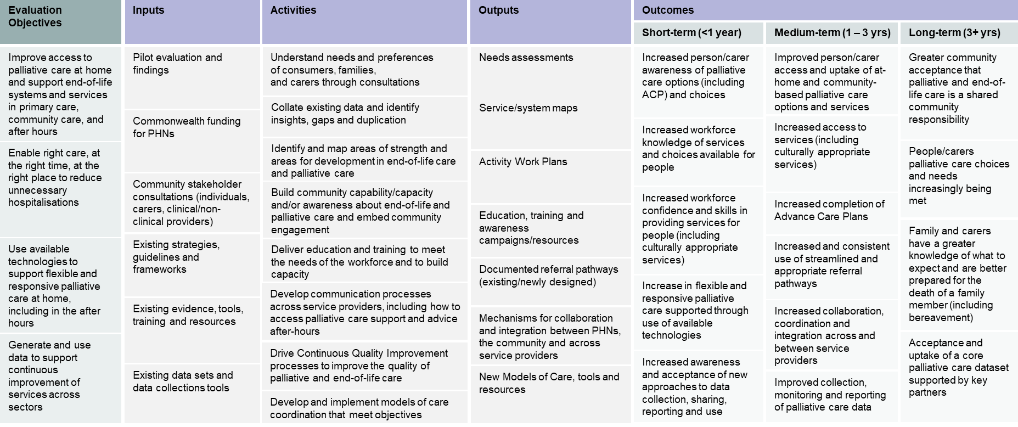

Endpoint evaluation Lines of Enquiry
An evaluation framework was also developed at the outset of the GCfAHPC Evaluation in partnership with DHDA and was similarly refined over the course of a series of workshops and consultations with all 31 PHNs.
For the purposes of the Endpoint evaluation, lines of enquiry that focused on program delivery and operations that were explored during Baseline and Midpoint were excluded. This allowed for a concise assessment based on impact and outcomes.
The Endpoint Evaluation was informed by 14 lines of enquiry (LoEs), as highlighted below.
Table 20: Lines of Enquiry for the Endpoint Evaluation
Evaluation Line of Enquiry
Program design and delivery
- How effective have governance arrangements been for implementing and achieving the objectives of the GCfAHPC Program?
- To what extent do activities/initiatives implemented by PHNs align with Program objectives?
- How appropriate are PHN activities and initiatives in meeting the preferences and needs of individuals/carers/workforce?
- Has the Program been implemented as planned (within PHNs, and nationally)?
Provider experience
- To what extent has the Program increased workforce knowledge and awareness of palliative care options and services available for individuals?
- To what extent has the Program increased workforce confidence and skills in providing palliative care services for individuals?
Patient experience
- To what extent has awareness of palliative care in the community (including family and carers) increased?
- To what extent has the Program increased individual awareness of palliative care options and choices (including ACP)?
Population Health
- To what extent has the Program generated and used data to support continuous improvement of services across sectors?
- To what extent are services coordinated, integrated, and provide continuity of palliative care?
- To what extent has the Program enabled appropriate palliative care in the home and community, and reduced preventable hospitalisations?
Health Equity
- To what extent has the Program improved access to palliative care at home and in the community?
- How appropriate is the Program at meeting needs and preferences of families, individuals, and carers?
Lower cost of care
- How cost-effective is the Program?

Endpoint Methodology
Active data collection for the Endpoint evaluation was conducted between June and September 2025 however this also included a cumulation of all data received from 2023 - 2025. The following data was collected and analysed:
- Materials submitted from PHNs including, but not limited to, program documentation, progress reports, post-event survey results, event attendance / participation data, etc., relating to activities.
- Data provided by the Statewide Office of Advance Care Planning (Queensland), AIHW and PCOC.
- Surveys distributed to PHNs and service providers.
- Four focus groups, each with 10 - 15 PHNs to discuss progress and outcomes.
- 14 focus groups, each with 1 – 5 service provider representatives who had engaged in PHN activities, to discuss on the ground impact and implementation.
Data collected from PHNs can be categorised into two types (Table 21):
- Core datasets and tools, i.e. those that apply and will be collected across all or a large proportion of PHNs.
- Supplementary datasets and tools, i.e. those that may apply or be collected by some PHNs, depending on activities and local context.

Table 21: Evaluation data collection approach overview
 | Data source | Description
Core | AIHW National Integrated Dataset | AIHW provides nationally aggregated data on palliative care that is of sufficient quality and is relatively easy to access in order to address certain Evaluation LoEs.
Core | Palliative Care Outcomes Collaboration (PCOC) | PCOC is a data source that is already in use or is of interest to many service providers.
Core | Death Literacy Index (DLI) | The DLI is an existing, validated tool on palliative care confidence and capability that is currently used.
Core | Scyne-proposed After Death Audit form | Scyne have developed a proposed After Death Audit Form using the most appropriate/relevant questions from existing Brisbane South (BSPHN) and Murrumbidgee PHN After Death Audit tools. It can be tailored to suit the needs of the Evaluation.
Core | PHN consultations | Consultations with PHNs will provide a point of comparison at all stages of the Evaluation.
Core | Scyne provided surveys to PHNs | PHN surveys will supplement consultation insights on Program design, governance, and activities.
Core | Scyne provided surveys to service providers | Service provider surveys will provide a clinician perspective on PHN led activities.
Supplementary | Post-event surveys | Post-event surveys collect feedback from participants on events conducted by PHNs.
Supplementary | The Program of Experience in the Palliative Approach (PEPA) surveys | PEPA collects pre and post survey data from education and training sessions to the healthcare workforce.
Supplementary | HealthPathways | HealthPathways is a web-based portal for health professions to access clinical management pathways, referral advice from specialist services, educational resources for patients, and treatment options.
Supplementary | Office of Advance Care Planning (QLD only) | Advance Care Planning data including values and preferences for persons with, and without decision-making capacity.
Supplementary | Use of webpages or resources (clicks, views, flyers etc.) | PHNs are tracking webpage or resource uptake through clicks, views of resources.
Supplementary | Other materials | May include collateral that captures further data inputs.

Appendix C: Case Studies
Appendix C showcases a selection of PHN activities designed and implemented as part of the Program. These were selected to showcase with the aim of highlighting the diversity of activity across regions, locations, rurality and demographics. These were also chosen based on the quality of PHN data available. Where required one-on-one consultations were held with PHNs to gather additional information.
A summary of the case studies is summarised on Table 22 below
Table 22: Glossary of PHN Activity Case Studies Included
# | PHN | Activity
1 | Country South Australia PHN | Palliative Medication Proficiency Education
2 | Western Australia Primary Health Alliance (Perth North PHN, Perth South PHN and Country Western Australia PHN) | Palliative Care Champion project in General Practice
3 | Australian Capital Territory PHN (Capital Health Network) | ACT Breathlessness Intervention Service (ABIS)
4 | Regional Victorian Collaborative (Murray PHN, Gippsland PHN and Western Victoria PHN) | Palliative Care Quality Improvement Project
5 | Central Queensland, Wide Bay and Sunshine Coast PHN (Country 2 Coast PHN) | Advance Care Planning (ACP) in Community
6 | Metropolitan Melbourne PHNs (Eastern Melbourne PHN, North Western Melbourne PHN and South Eastern Melbourne PHN) | Palliative Care Access to core Medicines (PCAM)
7 | Brisbane South PHN | Upskilling the interpreter workforce in palliative care settings
8 | Brisbane North PHN | Living and dying well for people with disability: palliative and end of life case knowledge framework
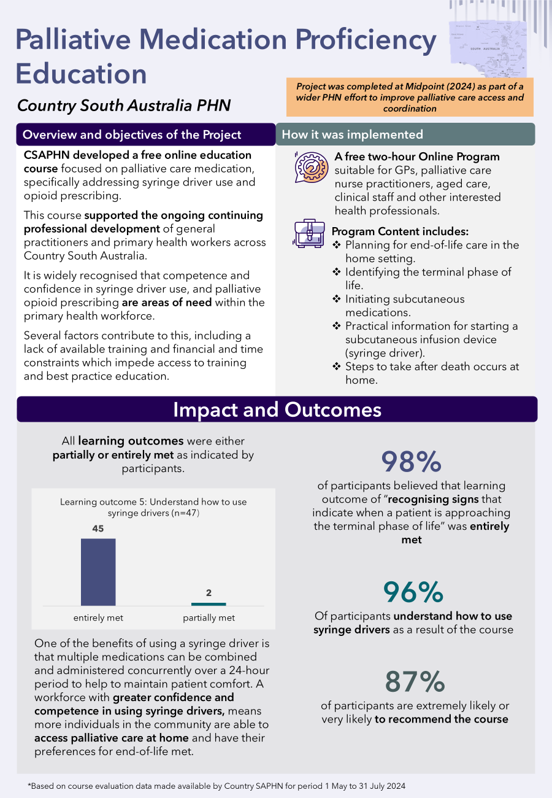
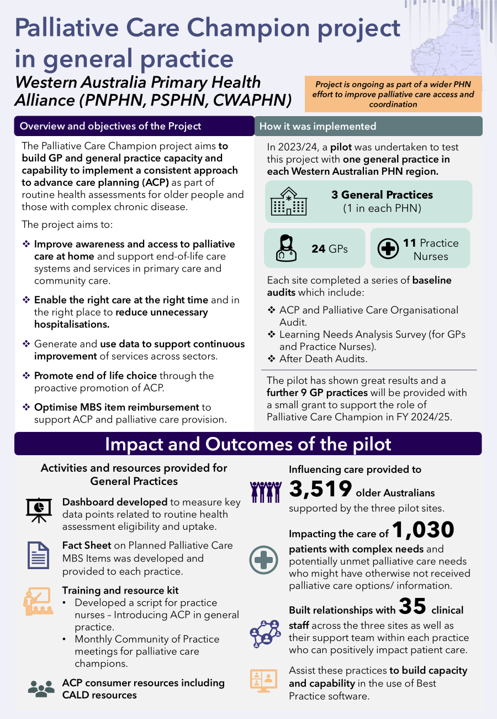
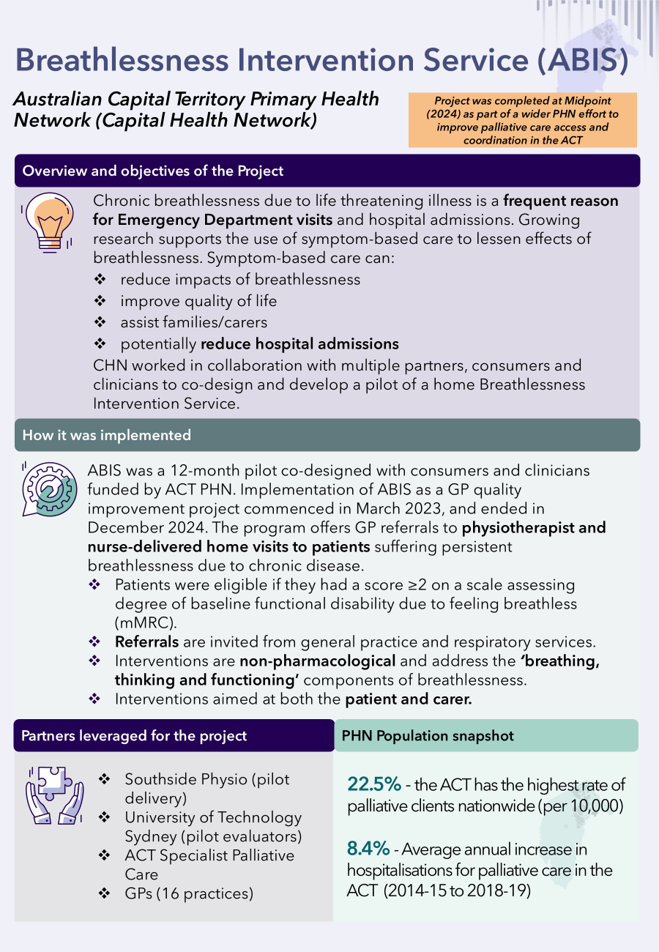
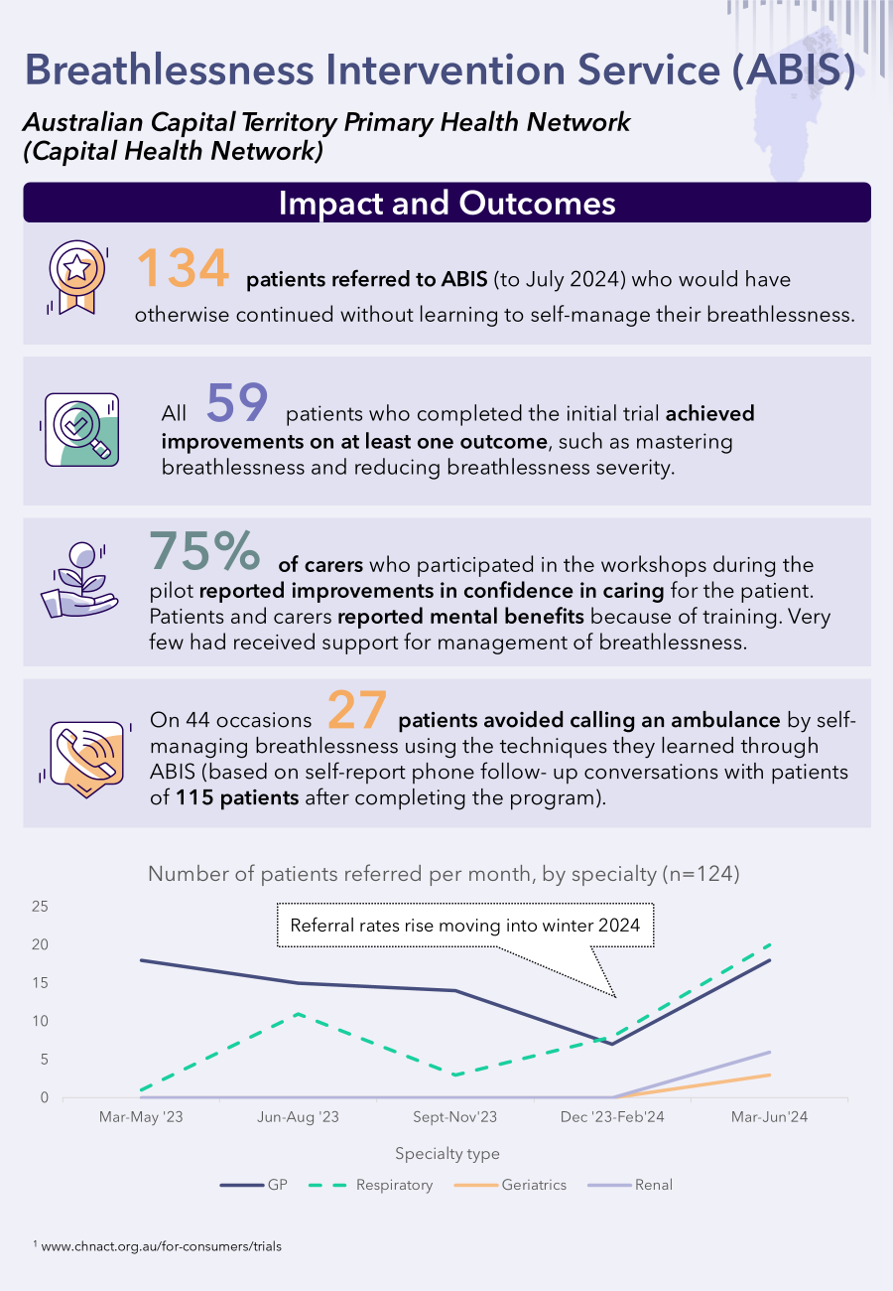
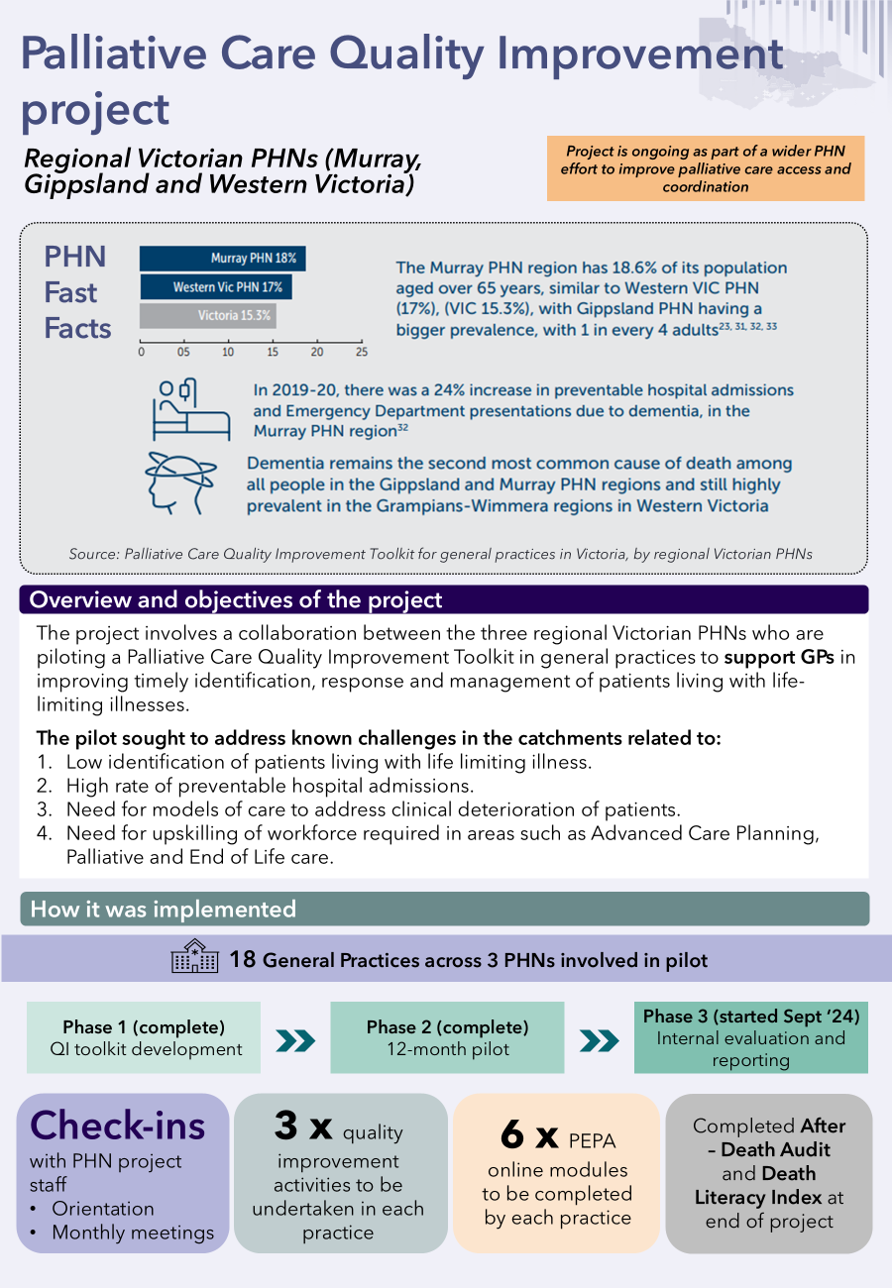
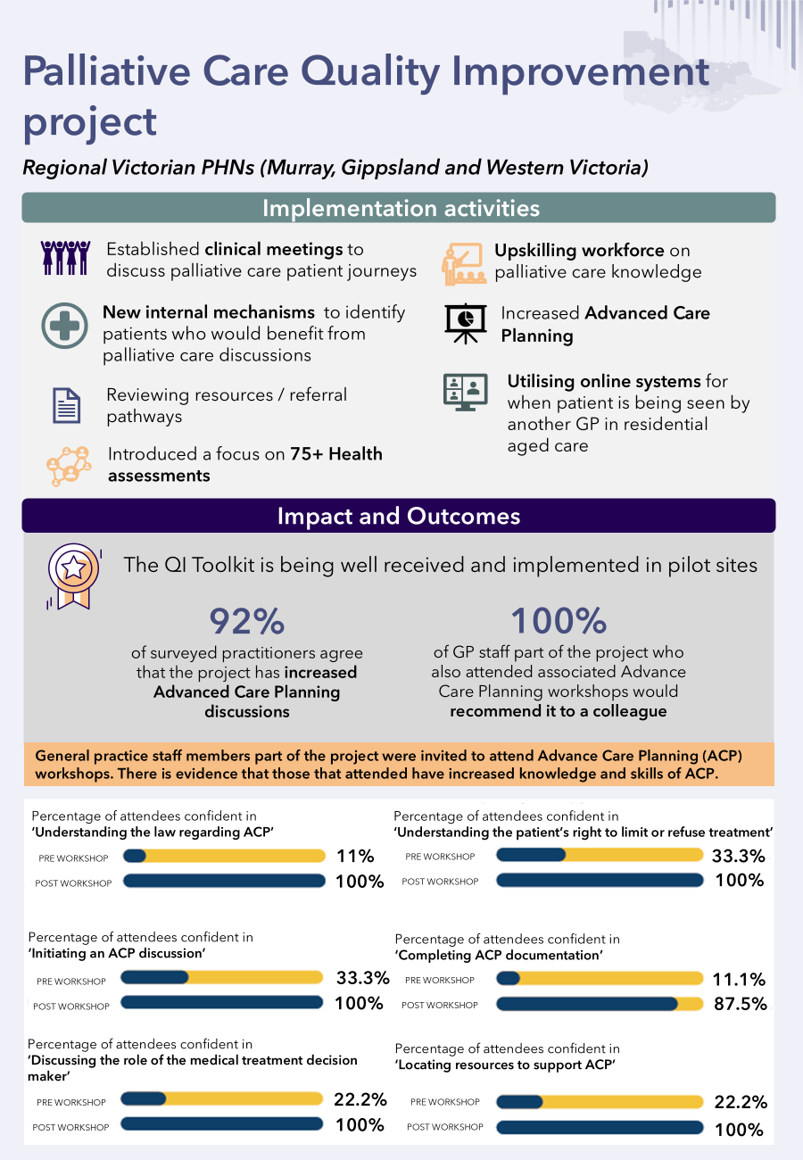
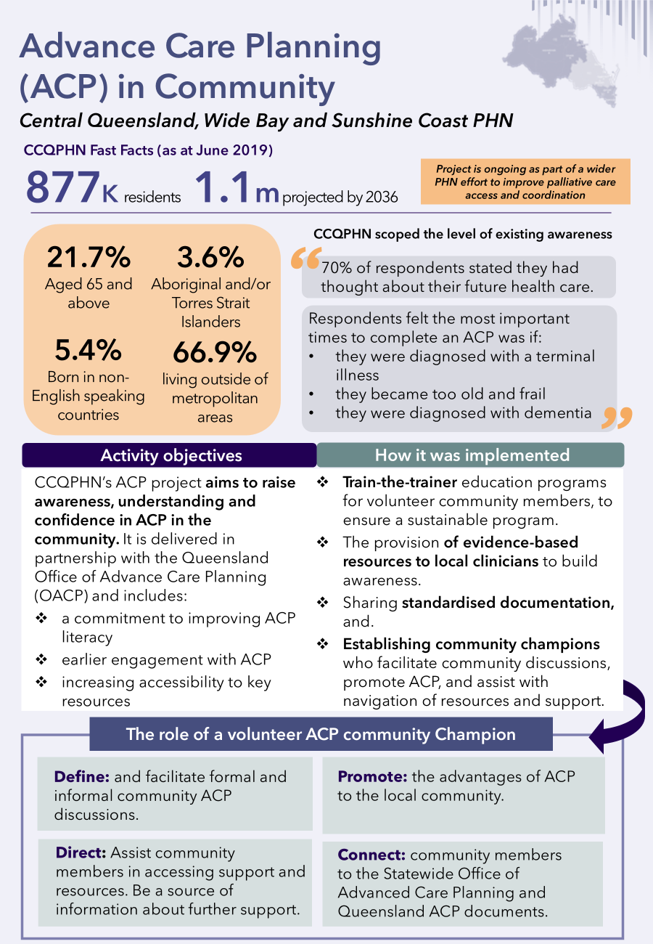
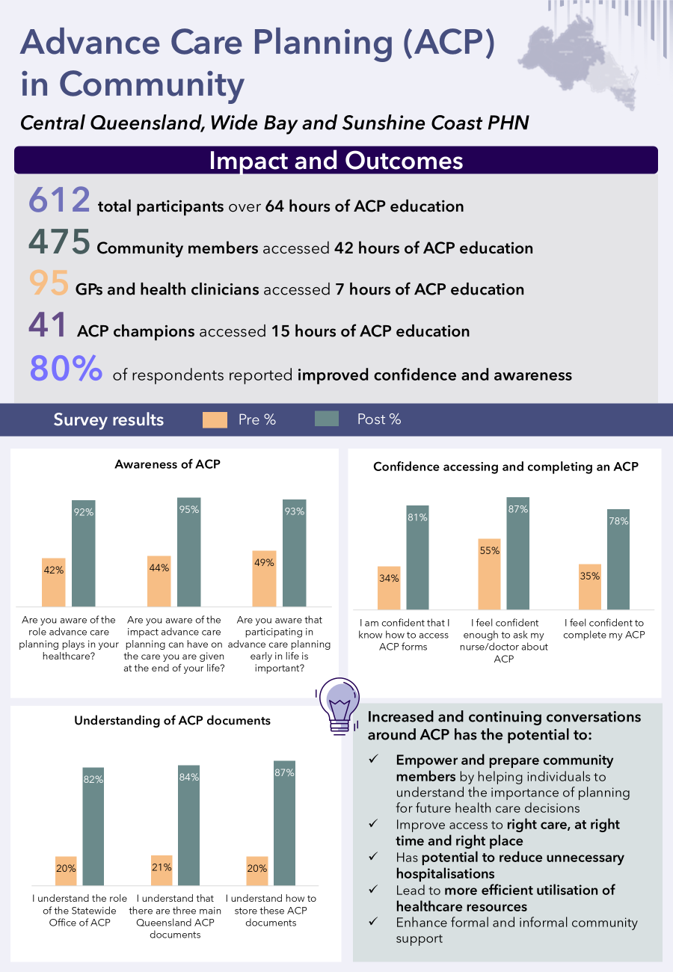
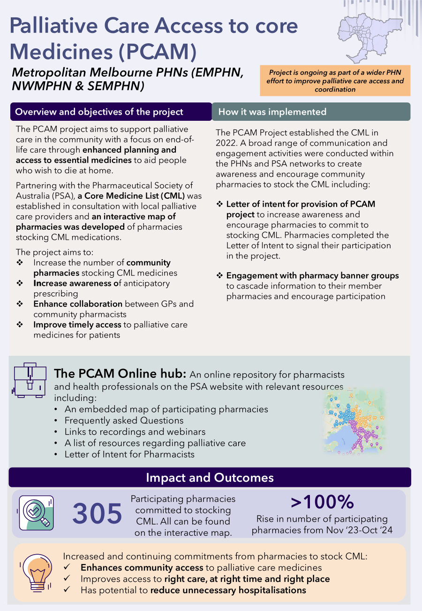
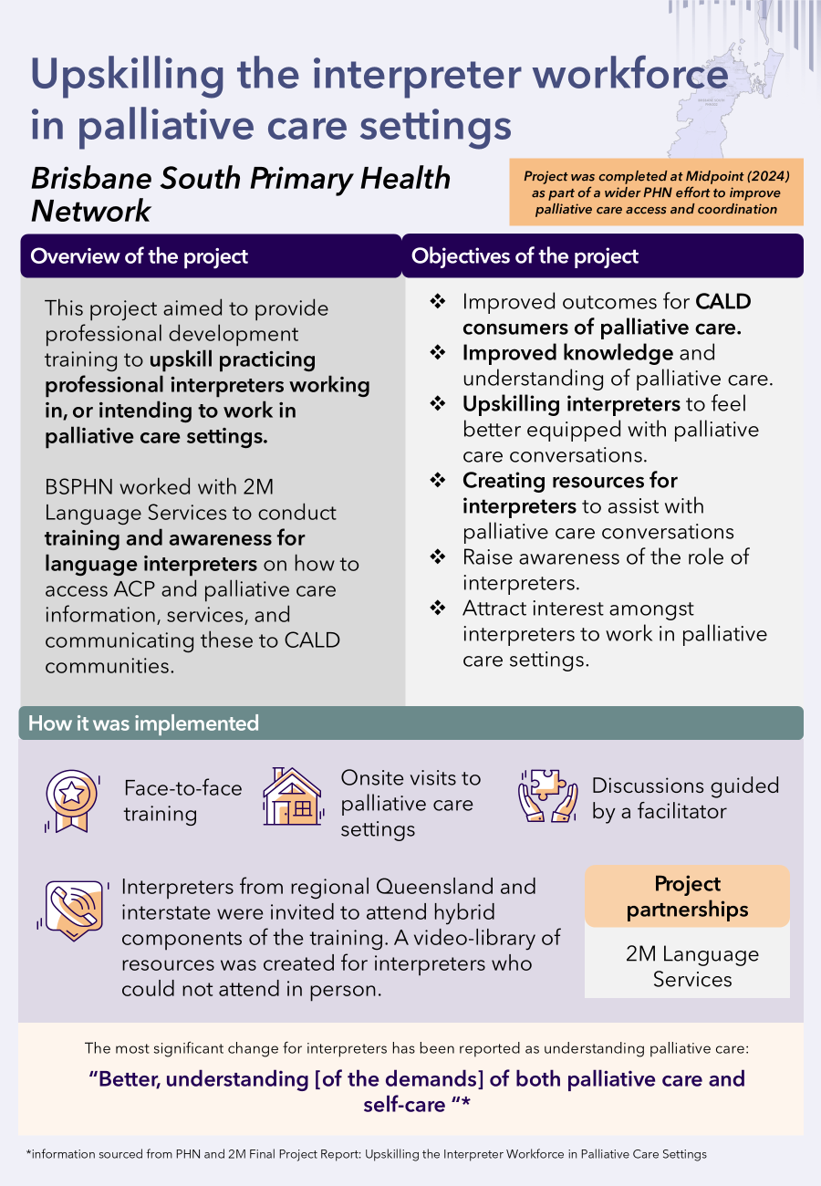
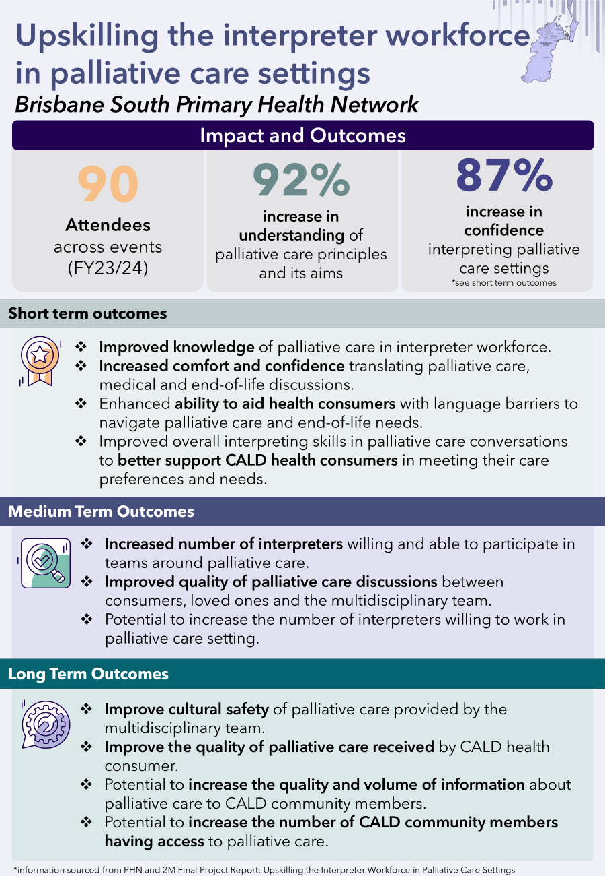
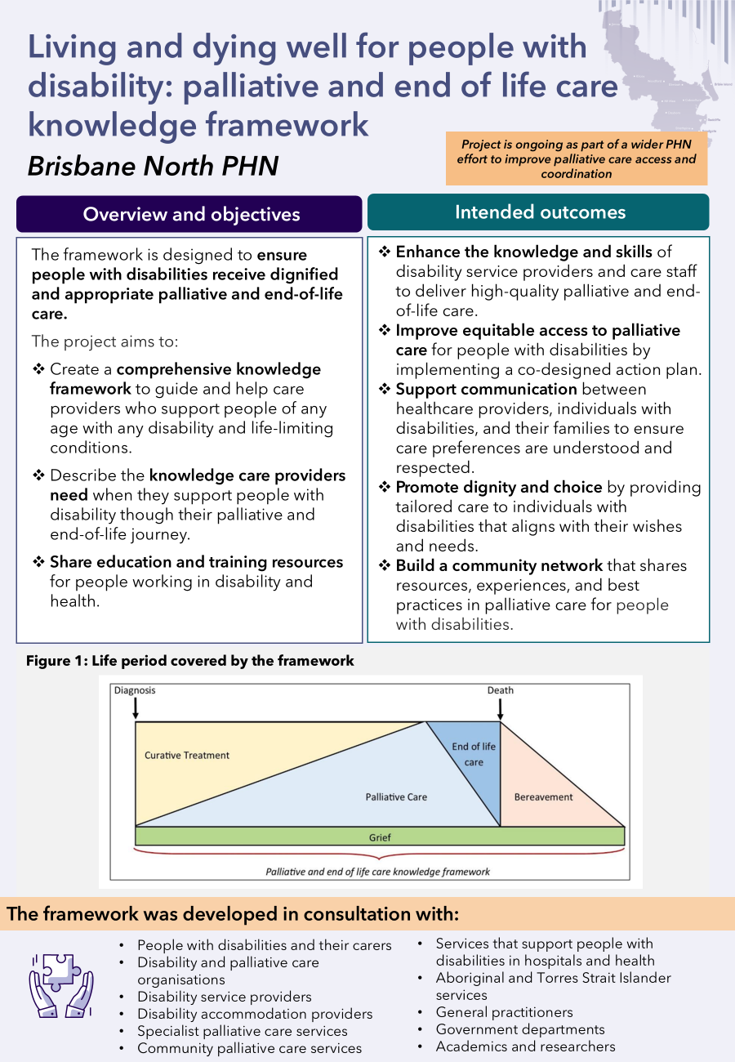
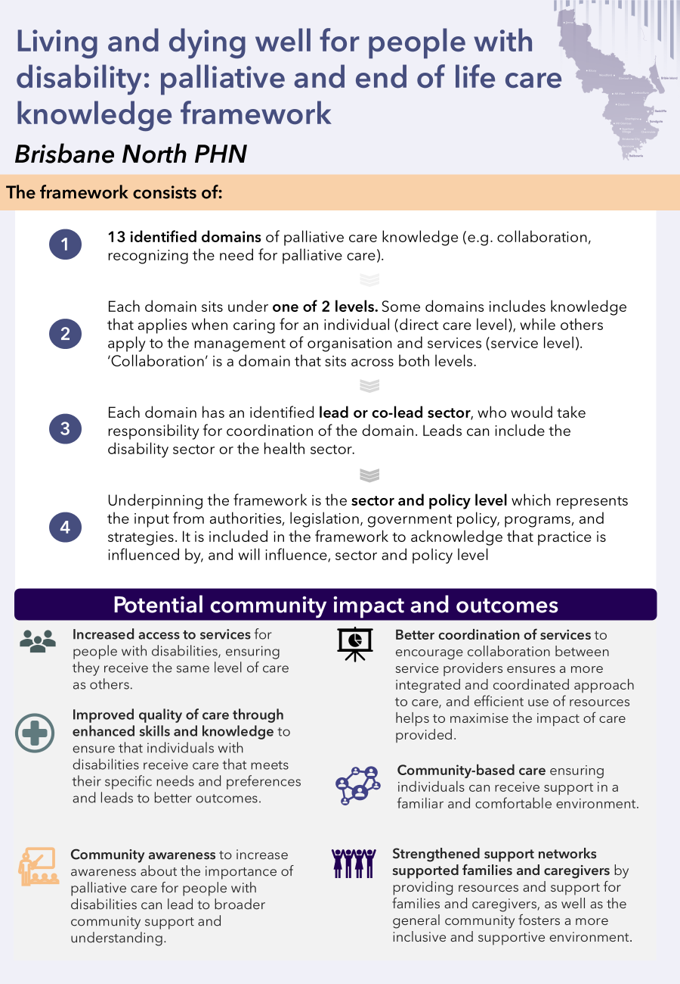


DHDA (2021). Primary Health Networks (PHN) Program Expansion of the Greater Choice for At Home Palliative Care (GCfAHPC) Measure Grant Opportunity Guidelines.
DHDA (2025). Greater Choice for At Home Palliative Care Program
Palliative Care Australia (2018). Background Report to the Palliative Care Service Development Guidelines. Available at: https://palliativecare.org.au/wp-content/uploads/dlm_uploads/2018/02/PalliativeCare-Background-to-Service-Delivery-2018_v3.pdf
DoHAC. (2019). What is Palliative Care? Available at: www.health.gov.au/topics/palliative-care/about-palliative-care/what-is-palliative-care#what-is-endoflife-care
DoHAC. (2019). What is Palliative Care? Available at: www.health.gov.au/topics/palliative-care/about-palliative-care/what-is-palliative-care#what-is-endoflife-care
Palliative Care Australia. (2017). The Economic Value of Palliative Care and End-of-Life Care. Available at: The Economic Value of Palliative Care and End-of-Life Care - Palliative Care Australia
Based on the Murtagh (2014) minimal estimate. Palliative care and health service use for people with life-limiting conditions, Overview of the population in need of palliative care - Australian Institute of Health and Welfare
DoHAC (2021). Primary Health Networks (PHN) Program Expansion of the Greater Choice for At Home Palliative Care (GCfAHPC) Measure Grant Opportunity Guidelines.
Deloitte (2021). Greater Choice for at Home Palliative Care Final Report.
DoHAC (2021). PHN Program Expansion of the GCfAHPC Measure Grant Opportunity Guidelines.
For the purposes of the GCfAHPC Evaluation Perth North, Perth South and Country Western Australia are co-operating as the Western Australia Primary Health Alliance (WAPHA). As a result, when counting the number of PHNs undertaking an activity, these three PHNs count as one entity (i.e. WAPHA). Otherwise, this report refers to 31 PHNs nationally.
DoHAC (2021). PHN Program Expansion of the GCfAHPC Measure Grant Opportunity Guidelines.
DoHAC (2025). National Evaluation of the GCfAHPC Program: Baseline Report.
PHN Endpoint survey – qualitative responses
PHN Endpoint survey – qualitative responses
PHN Consultations
PHN Endpoint survey – qualitative responses
PHN consultations
Service provider consultations
PHN Endpoint survey
National Core Community Palliative Care Medicines List identifies four medicines for use with home-based palliative patients in the terminal phase who require urgent symptom relief. Most common terminal symptoms in uncomplicated palliative care patients can be managed using medicines from the List. The List, developed by caring@home with key national stakeholders, supports quality palliative care by improving access to medicines in the community.
Palliative Care New South Wales (2023). Further evidence of the economic benefits of Palliative Care. Available at: https://palliativecarensw.org.au/further-evidence-of-the-economic-benefits-of-palliative-care/
Palliative Care Australia (2024). Wellbeing in palliative care workforces - National Workforce Survey Findings Report 1. Available at: https://palliativecare.org.au/statement/wellbeing-in-palliative-care-workforces-national-workforce-survey-findings-report-1/
CESPHN. Greater choice for at home palliative care nurse education final report (2025). University of Technology: Sydney.
PHN consultations
PHN Endpoint survey
GCfAHPC Baseline report
PHN Endpoint survey
PHN Endpoint survey – qualitative responses
PHN Endpoint survey – qualitative responses
PHN Endpoint survey
PHN consultations
Palliative Care Australia (2024). Wellbeing in palliative care workforces - National Workforce Survey Findings Report 1. Available at: https://palliativecare.org.au/statement/wellbeing-in-palliative-care-workforces-national-workforce-survey-findings-report-1/
AIHW (2025) Palliative Care Services in Australia. Available at: https://www.aihw.gov.au/reports/palliative-care-services/palliative-care-services-in-australia/contents/palliative-care-related-medications
Endpoint provider survey
PHN consultations
Palliative Care Australia (2024). Wellbeing in palliative care workforces - National Workforce Survey Findings Report 1. Available at: https://palliativecare.org.au/statement/wellbeing-in-palliative-care-workforces-national-workforce-survey-findings-report-1/
AIHW (2025) Palliative Care services in Australia: Palliative care in General Practice. Available at: https://www.aihw.gov.au/reports/palliative-care-services/palliative-care-services-in-australia/contents/palliative-care-in-general-practice
Based on the Murtagh (2014) minimal estimate. Palliative care and health service use for people with life-limiting conditions, Overview of the population in need of palliative care - Australian Institute of Health and Welfare
The DLI is an Australian validated tool developed by the Death Literacy Institute and used to measure the knowledge and skills people have about death and dying. Death Literacy Institute
DLI analysis
PHN Consultations
PHN consultations
Palliative Care Australia. Available at: https://palliativecare.org.au/resource/advance-care-planning
The Statement of Choices is a values-based document that records a person's wishes and preferences for their health care into the future. Its purpose is to guide or inform those who need to make health care decisions for a person who is unable to make those decisions for themselves.
An Advance Care Directive is a legally binding document that can be used in certain circumstances to provide directions about future health care and to appoint an attorney for health matters.
An EPOA is a legal document is used to appoint a person or people to make health/personal and/or financial decisions and sets out terms for how the power operates.
PHN Endpoint survey - service provider
Service provider consultations
PHN Endpoint survey
PHN consultations
PHN Endpoint Survey – qualitative responses
Jordan, R.I., Allsop, M.J., ElMokhallalati, Y. et al. Duration of palliative care before death in international routine practice: a systematic review and meta-analysis. BMC Med 18, 368 (2020). https://doi.org/10.1186/s12916-020-01829-x
Palliative Care Australia (2025). Recent developments in national palliative care data. https://palliativecare.org.au/statement/recent-developments-in-national-palliative-care-data/
PHN Endpoint survey
PHN consultations
Service provider consultations
Service provider consultations
https://www.health.gov.au/sites/default/files/documents/2020/01/exploratory-analysis-of-barriers-to-palliative-care-summary-policy-paper.pdf
PHN consultations
Service provider consultation
PHN consultations
Palliative Care Australia (2022). Palliative Care Australia Roadmap 2022-2027. https://palliativecare.org.au/publication/palliative-care-australia-roadmap-2022-2027/
DoHAC (2021). PHN Program Expansion of the GCfAHPC Measure Grant Opportunity Guidelines.
DoHAC (2021). PHN Program Expansion of the GCfAHPC Measure Grant Opportunity Guidelines.
Ibid.
Cassel BJ, Kerr KM, McClish DK et al. (2016). Effect of a Home-Based Palliative Care Program on Healthcare Use and Costs. J Am Geriatr Soc. 64(11):2288-2295
Swerissen H and Duckett S. (2014). Dying Well. Grattan Institute, Melbourne
PHN Endpoint Survey
BMC Nursing (2025) Enhancing nursing roles in community-based palliative care: closing gaps to improve patient outcomes, available at: https://bmcnurs.biomedcentral.com/articles/10.1186/s12912-025-02959-4
BMC Palliative Care (2023) The clinical effect evaluation of multidisciplinary collaborative team combined with palliative care model in patients with terminal cancer: a randomised controlled study, available at: https://bmcpalliatcare.biomedcentral.com/articles/10.1186/s12904-023-01192-7

