DISABILITY REFORM MINISTERIAL COUNCIL (DRMC)

Brisbane – 14 August 2026

COMMUNIQUÉ

Commonwealth, state and territory Disability Ministers met on 14 August 2026 in Brisbane and online for the third Disability Reform Ministerial Council (DRMC) meeting of the year.

Ministers were briefed on the design and testing of the NDIS support needs assessment for new framework planning, and discussed the architecture of budgeting and phasing. They discussed ongoing engagement and consultation on new framework planning, including forthcoming public consultation.

Ministers discussed the work of the recently established Technical Advisory Group for NDIS access, including the Group’s workplan and the proposed consultation activities to support the development of a robust, consistent and equitable framework for NDIS access and eligibility.

Ministers discussed the implementation of the reforms to secure the future of the NDIS, including public consultation activities and the approach to reform.

Mr Dougie Herd updated Ministers on the work the NDIS Reform Advisory Committee (RAC) has undertaken since June. Ministers approved an interim workplan which will see the RAC focus on three priority reform areas, including access and eligibility, new framework planning, and the broader ecosystem of support.
Ministers noted an update on the progress of work to develop a new Disability Support Quality and Safeguarding Framework. Ms Louise Glanville, Commissioner, and Ms Natalie Wade, Associate Commissioner, NDIS Quality and Safeguards Commission, provided an update on the Commission’s engagement with state and territory regulatory bodies on strengthening safeguarding through information sharing. Ms Emma King, CEO of HumanAbility, presented on the workforce planning being undertaken by HumanAbility as the Jobs and Skills Council for the care and support economy.
Ministers noted workforce measures that will support the implementation of Thriving Kids. Ministers provided an update on progress toward the implementation of Thriving Kids in their jurisdictions.
Ministers agreed a final two-year extension of in-kind arrangements for Specialist School Transport (SST) and Personal Care in Schools (PCIS) from 31 December 2026. Ministers noted the extension is subject to agreement of a long-term resolution, with options to be developed by senior officials.
Disability Ministers noted an update on the implementation of the National Autism Strategy 2025-31 and First Action Plan 2025-26, and discussed pricing governance.
Disability Ministers agreed that their next meeting would be held on 2 October in Darwin.

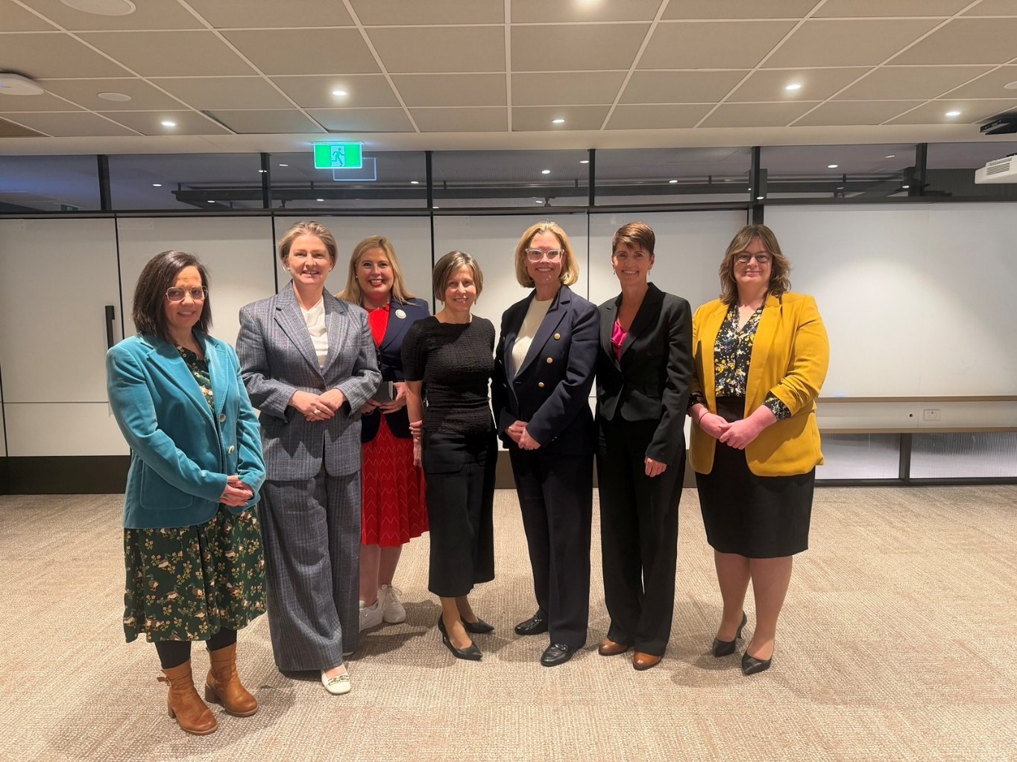
Minister Blandthorn (Vic), Minister Camm (Qld), Minister Hildyard (SA), Minister McAllister (Minister for the NDIS), Minister Beazley (WA), Minister Washington (NSW), Minister Orr (ACT)

Minister Palmer (Tas) and Minister Charls (NT) joined online.

