Consultation on NDIS Supports Rules (2025)

What we heard | August 2026

Acknowledgement of Country
The Department of Health, Disability and Ageing acknowledges the Traditional Owners of Country throughout Australia on which we gather, live and work. We acknowledge all Traditional Custodians, their Elders past, present and emerging and we pay our respects to their continuing connection to their culture, community, land, sea and water.

Contents
Acknowledgement of Country 2
Summary 4
About this consultation 4
What we heard 5
Main findings 6
Who we heard from 9
Profile of responses 9
Consultation findings 12
Current knowledge of what can and cannot be funded 12
Awareness of the NDIS Supports Rules and NDIS supports lists 12
Helpfulness of the NDIS supports lists 16
Appendix 1. List of organisations who made a submission 45

Summary
In 2024, the Australian Parliament made changes to the National Disability Insurance Scheme Act 2013. The changes give effect to key recommendations from the Independent Review of the NDIS and set the direction to build a stronger NDIS. This included inserting a definition of NDIS supports (section 10 of the Act).
In October 2024, the NDIS Supports Transitional Rules came into effect to support the effective operation and administration of the Act. The Transitional Rules identify what is and is not defined as an NDIS Support. The Rules aim to help NDIS participants to identify what can and cannot be purchased using NDIS funding.
The Transitional Rules were informed by a consultation process undertaken in 2024. More than 7,000 people provided their views on how the lists of NDIS supports should work.
The Transitional Rules created 3 types of NDIS supports lists. These are:
- A list for Supports that are NDIS supports
- A list for Supports that are not NDIS supports
- A Replacement supports list.
As further rules are developed to implement NDIS reforms, the NDIS Supports Rules now need to be updated.

About this consultation
To guide updates to the Rules, NDIS participants and the disability community were asked about their experience of the lists of NDIS supports since they came into place. Between 16 June and 27 July 2025, a total of 1,791 individuals and organisations provided their feedback about the NDIS supports. They responded to a survey or made a submission. There were 1,619 responses from individuals and 172 organisational responses or submissions.
Prior to and throughout the consultation period, the National Disability Insurance Agency (NDIA) and the Department of Health, Disability and Ageing (DHDA) also held workshops with Disability Representative Organisations (DRO) and key NDIS reference and advisory groups (including the NDIS Independent Advisory Council).
This report presents the information from the survey and submissions. Submissions are also listed on the DSS Engage website.
We have used the feedback from this consultation to make changes to the NDIS supports rules. We are seeking feedback on these changes through a public consultation during August-October 2026 via our Consultation Hub.

What we heard
Since the NDIS Supports Transitional Rules came into effect in October 2024, people have shared their views about the impacts of having prescribed ‘in and out’ lists. Responses provided throughout this consultation highlight that people are experiencing issues with how the NDIS supports lists are understood and used.
Feedback from respondents indicated that further work is needed to make the lists more helpful for NDIS participants, their families and carers. People suggested changes to how the Rules are implemented should aim to improve the clarity and ease of use of the lists.
The consultation feedback highlighted the following ways that the lists could work better in practice:
- More consistent information, advice and support. NDIS participants, families and carers reported people and organisations who support them interpret the lists and the items that are ‘in’ and ‘out’ in different ways.
- Clearer and more accessible guidance about how to use the lists
- Ensuring the lists still allow participants to get specific supports, products and services important to their lives. This includes things that help them to achieve their goals.
- Simplifying the process for the replacement supports so people have timely access to the support they need.
Feedback also suggested the lists need to be more inclusive and recognise cultural support. For example, for, people in regional, rural and remote areas, people who have multiple or co-occurring disabilities or intersecting factors, and/or who have complex needs.
Respondents reported that the lists need to be more accessible and easier to understand, with more nuance to apply meaningfully within a person’s life.

Main findings
The following section provides a summary of the main findings to the questions in this consultation. These are explored in more detail in the body of the report.

There is high awareness of the NDIS supports lists. But the lists need to be easier to use so people can know what they can use their NDIS funds on.
Awareness of the NDIS Supports Rules and lists is relatively high among most stakeholders.
- 72% of people knew about the NDIS Supports Rules and 76% knew about the NDIS supports lists.
- Just over half of people with disability (56%), and just over half of families and carers (54%), had used the NDIS supports lists to find out what NDIS funds can or cannot be spent on.
While the lists are helping some people to understand what can be purchased, feedback indicates a need to review the way the lists are structured.
- Among those who had used the lists to understand what can be purchased, only 15% said it is easy to understand what can be purchased and 68% said it is hard.
- There are differences in how helpful different groups find the lists to be. Providers are most likely to find the lists helpful (54% helpful), and people with disability the least likely to find them helpful (35%).
- People with disability are more likely to report the NDIS supports lists are unhelpful than helpful (46% compared to 35%) to find out what supports can be funded.
There are mixed perspectives from respondents about what would make the NDIS supports lists more helpful, easier to understand and apply. Some respondents suggested the lists should be clearer and more specific about what can be purchased, including providing examples and detailing the products and services included in each list.
Conversely, other respondents suggested less prescription, and broader definitions. They noted this would allow for the flexibility that they feel has been reduced since the introduction of the NDIS supports lists.
Despite the difference of views, a common theme was the lists should be simplified and communicated, in plain English, so they are easier to understand. This also included suggestions for more inclusive and accessible communication formats, such as Easy Read, and for multilingual, culturally responsive materials.

People understand the lists differently. This includes what the supports and items in the lists mean.
Respondents reported the NDIS supports lists are not interpreted in the same way when decisions are made about what NDIS funding can be spent on.
- 3 in 4 respondents had experienced or heard about situations where people understood the NDIS Supports Rules differently (77% of all respondents).
Responses highlighted the need for greater clarity between the ‘in’ and ‘out’ s, particularly in how they apply to different people. For example, respondents mentioned confusion when items appear in both lists. They also noted that despite the NDIS supports lists representing what is 'in' or 'out', there are differences in what can be approved depending on what’s in an individual’s plan.

The NDIS supports lists should be updated regularly to cover the different types of products and services people need now and in the future.
There was broad agreement that the NDIS supports lists should not be static. Respondents suggested they need to be regularly updated and improved, so they support the needs of participants.
- More than half of respondents (58%) said there are currently products that should be available but are not on the NDIS supports list.
- 41% of respondents said there are currently services that should be available but are not on the NDIS supports list.

The replacement supports process needs improving and simplifying.
Respondents identified many items they said should be included as part of the replacement supports process. Respondents said NDIS participants should have access to any of the things that:
- are recommended by professionals and experts to support their disability, including different types of therapies
- support people with disability to live a full life, including living independently.
Respondents noted that when something is funded as a replacement support it shouldn’t take away the funding, time or need for a support worker. For example, an iPad and relevant communication applications may be required to support a participant’s increased independence. However, the funding of this support does not necessarily replace the type of support that would be provided by a person.

Other key themes of feedback
Other feedback from stakeholders and some NDIS participants and their families and carers included the following:
- Preference for a principles-based approach to the lists. Stakeholders and some NDIS participants and families and carers mentioned prescribed lists of supports are not in line with the NDIS principles of choice and control. Some suggested a principles-based approach to the lists would give better guidance and set parameters for what is appropriate to spend NDIS funding on, while providing flexibility where required.
- Improving the way the lists are structured and communicated. This included better guidance, clarity and communication about the different categories and items in the NDIS supports lists, to improve consistency in the way they are interpreted. Stakeholders also suggested better training for NDIA staff and intermediaries to understand how to apply the lists.
- Implementing a rapid pre-clearance mechanism. It was suggested that this process would help participants confirm if a support is an NDIS support before purchase, reducing administrative burden and risk.
- Allowing everyday items when they serve disability-related need. This included items such as smart devices and household tools.
- More transparency and consistency in how decisions about the lists are made and communicated. This included when the NDIS supports lists are updated and how decisions by NDIA staff are made about NDIS supports.
- The need for co-design with people with disability, especially those from marginalised groups, to ensure the Rules reflect lived experience.
- The need for disability supports and services and other systems to work together. This included health, education and housing. For example, some stakeholders suggested:
- ensuring non-NDIS supports are reliably available through other systems
- the need for intergovernmental agreements and dispute resolution mechanisms to prevent gaps in support
- ensuring foundational and additional supports are in place before NDIS supports are removed or withdrawn.

Who we heard from
A six-week consultation process occurred between 16 June to 27 July 2025. Throughout the process, the department received:
- 1,703 responses to the online survey, 93 of which included a submission
- 88 separate submissions directly to the department mailbox.

Profile of responses
Almost all survey respondents answered on behalf of themselves (94%). Six per cent (6%) answered on behalf of organisations.
Most responses were either by a family member or carer of a person with disability (44%, 756 responses), or person with disability themselves (35%, 600 responses). Of those, a total of 1,045 respondents currently have (or the person they care for have) an NDIS plan. Most of this group held a plan before October 2024, a total of 997.
A large number of providers also responded (38%, 647 responses), then smaller numbers of disability advocates or advocacy organisations (7%, 119 responses), government employees (3%, 56 responses), legal professionals (1%, 16 responses), and others (5%, 82 responses).
The responses in the ‘other’ category came from a mix of peak bodies, other service providers, psychologists and mental health professionals, those in the public health space, teachers or students in related subjects, and friends of participants.
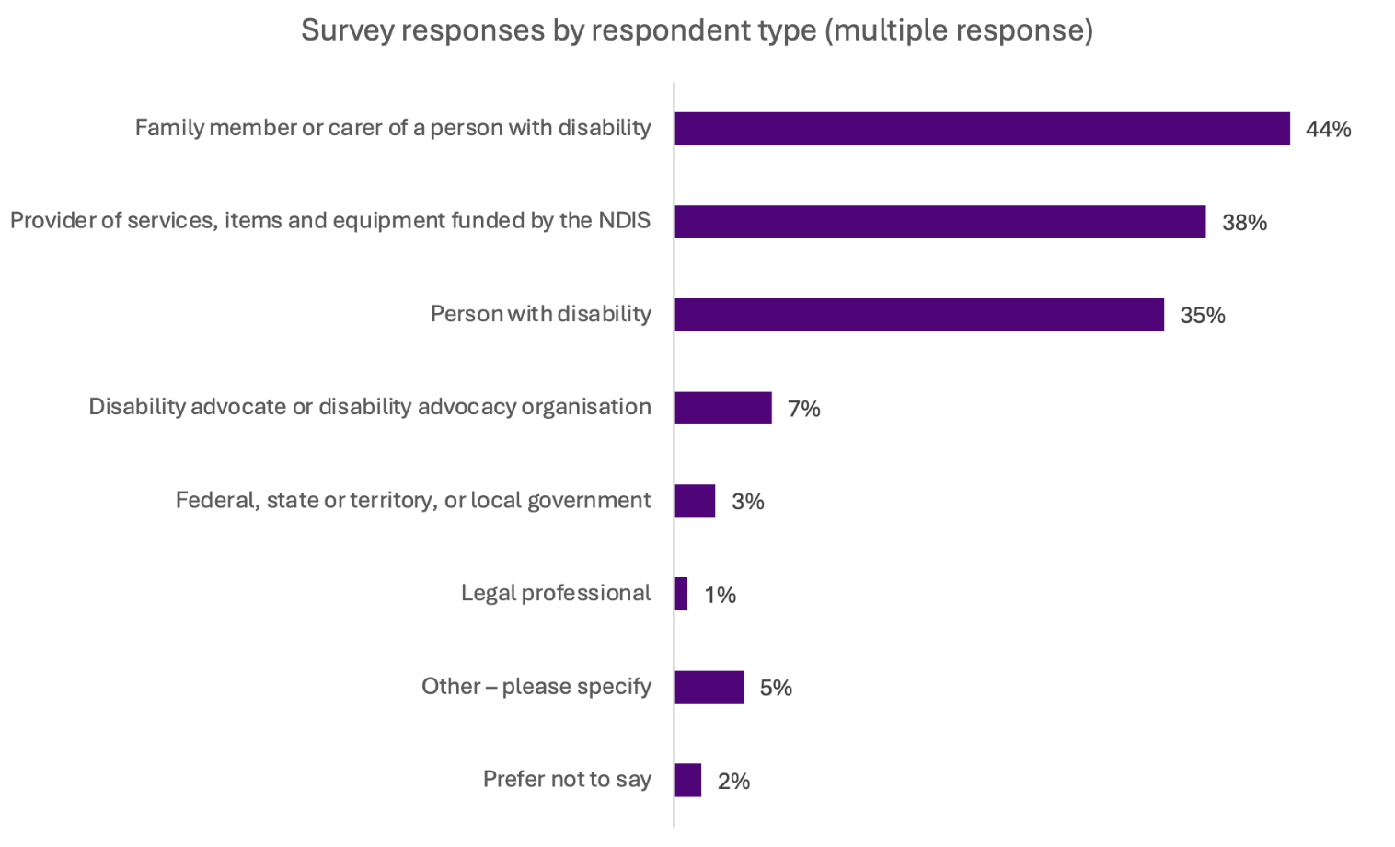
Figure 1 Base: All respondents (1,703)

Responses were received from across states and territories. This included from major cities, and from regional, rural and remote areas.
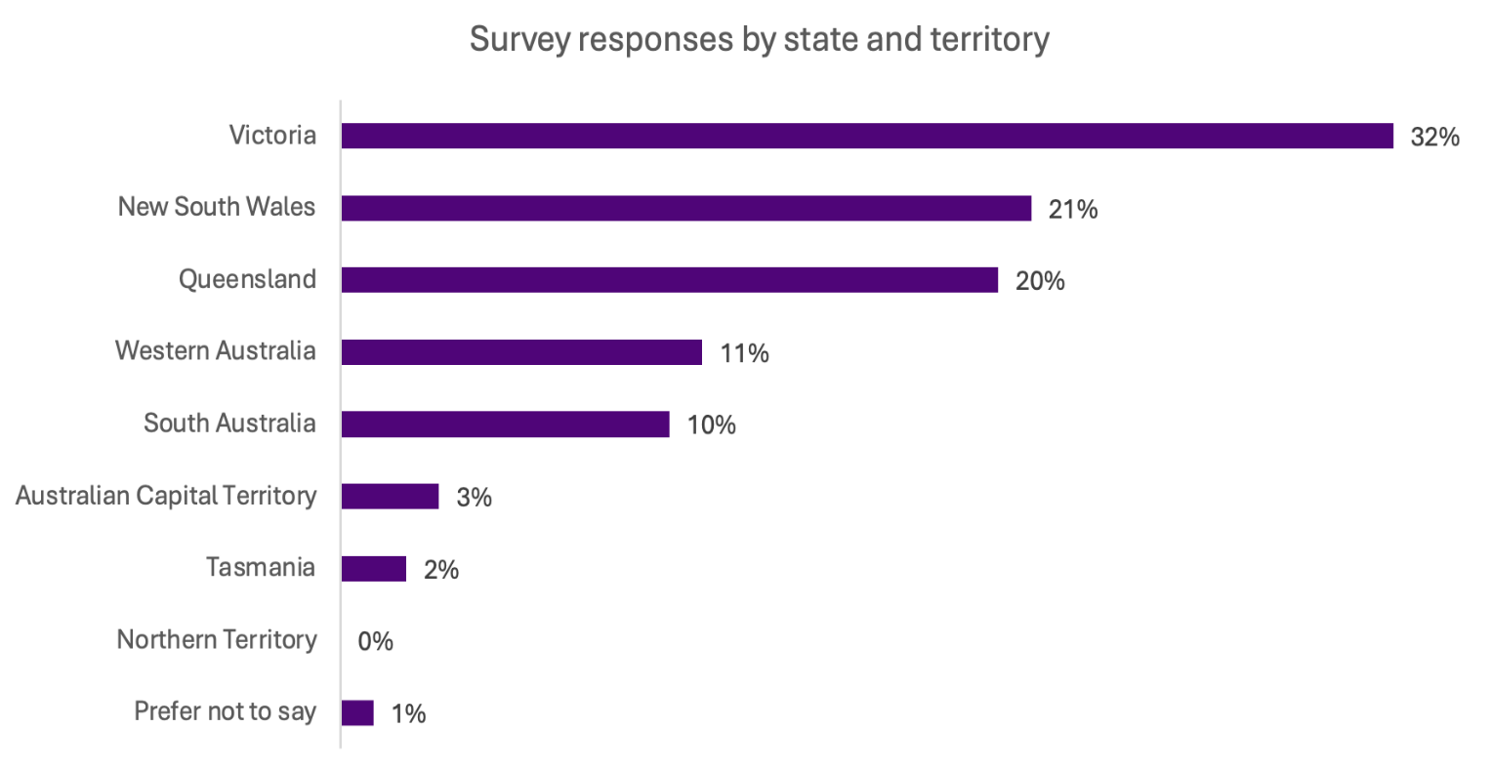
Figure 2 Base: All respondents (1,698)
From specific audience groups:
- a total of 67 responses were received from people identifying as Aboriginal and/or Torres Strait Islander
- 92 from those who speak a language other than English at home
- 190 from those identifying as LGBTIQA+SB.
Most respondents were women (79%).
The following chart shows the disability type of respondents with disability, and of the person with disability whose family members or carers responded. The most common reported disability type was Autism (54%). This was followed by physical disability (30%), psychosocial disability (27%) and intellectual disability (24%). Of the 13% who selected ‘other’, the most commonly mentioned disability types included:
- ADHD
- mental health conditions
- genetic conditions
- autoimmune conditions
- chronic pain.
Respondents were able to select multiple responses.

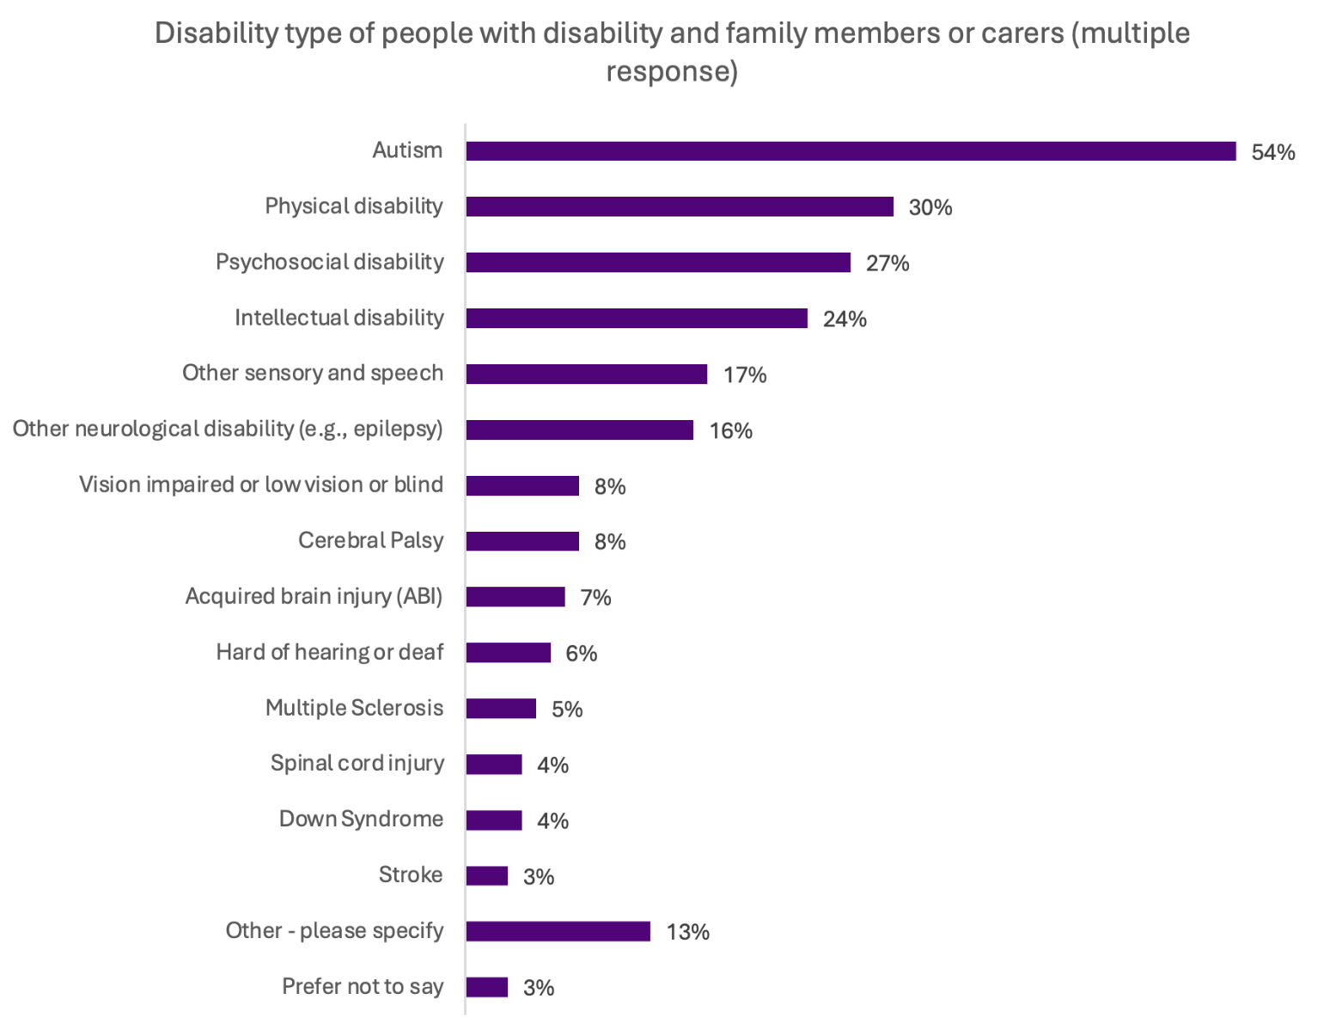
Figure 3 Base: All who answered, ‘I am a person with disability’ or ‘I am a family member or carer of a person with disability’ (1,147)

Consultation findings
The following sections provide the main findings and themes for the questions asked in the consultation survey. It includes data and charts from quantitative survey questions and themes from free-text questions. Input from survey responses was manually coded to determine relevant themes.

Current knowledge of what can and cannot be funded
Respondents were asked about whether they currently find it easy or hard to know what NDIS supports can be funded. In general, respondents reported finding it hard to know what could be funded by the NDIS.
- Respondents were six times more likely to say it was hard (71%) than easy (12%) to know what can be funded.
- Those with a disability and family or carers were most likely to find it very hard (43% and 36%, respectively) to know what could be funded.
- People and family members of people with autism (42%), hard of hearing or deaf (50%), physical disability (41%), psychosocial disability (48%), other neurological disability (42%) and other sensory and speech disability (40%) were more likely to find it very hard to know what can be funded by the NDIS.

Awareness of the NDIS Supports Rules and NDIS supports lists
Awareness of the NDIS Supports Rules and lists is relatively high. Just over half of people with disability (56%) and families and carers (54%) have used the NDIS supports lists to find out what supports can be purchased with NDIS funding.
Across all respondent groups, the NDIA website is the most commonly used source of information about what supports can be purchased using NDIS funding (56%). Responses indicated many NDIS participants also seek and receive information through their NDIS Support Coordinator (45%), Plan Manager or Local Area Coordinator (40%).

NDIS Supports Rules

Awareness of the NDIS Supports Rules was high.
- 7 in 10 respondents were aware of the NDIS Supports Rules in total (72%).
- People with disability and family members or carers were slightly less likely to know about the NDIS Supports Rules (68% of both groups were aware).
- People and family members of people with acquired brain injury (62%), autism (68%), multiple sclerosis (53%), psychosocial disability (64%), other sensory and speech (61%), and stroke (43%) were less likely than other disability groups to be aware of the NDIS Supports Rules.
- Awareness was higher for disability advocates (85%) and providers of NDIS services (84%).
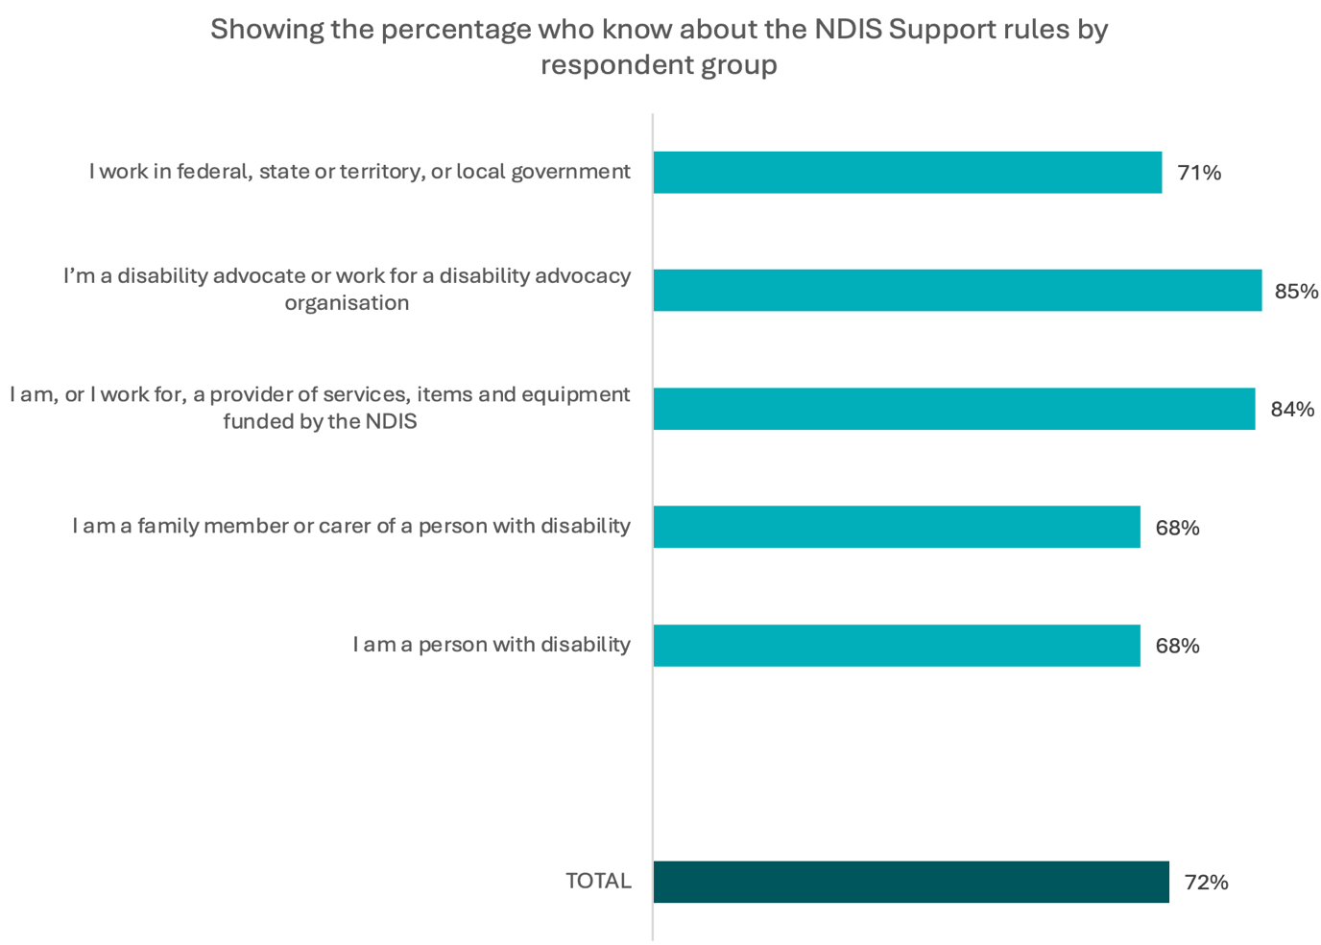
Figure 4 Base: All respondents (1,693), Person with a disability (596), Family member of a person with a disability (754), Provider or work for a provider (644), Disability advocate / advocacy organization (117), Government (56)

Most respondents felt they had some understanding of the Rules.
- Just over half of respondents indicated they had some understanding of the NDIS Supports Rules (56%). A further 38% said they had a good understanding.
- Only 1 in 20 respondents said they had no understanding of the Rules (5%).
- People with disability were slightly more likely to say they had no understanding of the Rules, with 1 in 10 reporting this (9%).
- People and family members of people with acquired brain injury (23%), autism (31%), and psychosocial disability (26%) were significantly less likely than other disability groups to indicate they had a good understanding of the Rules.
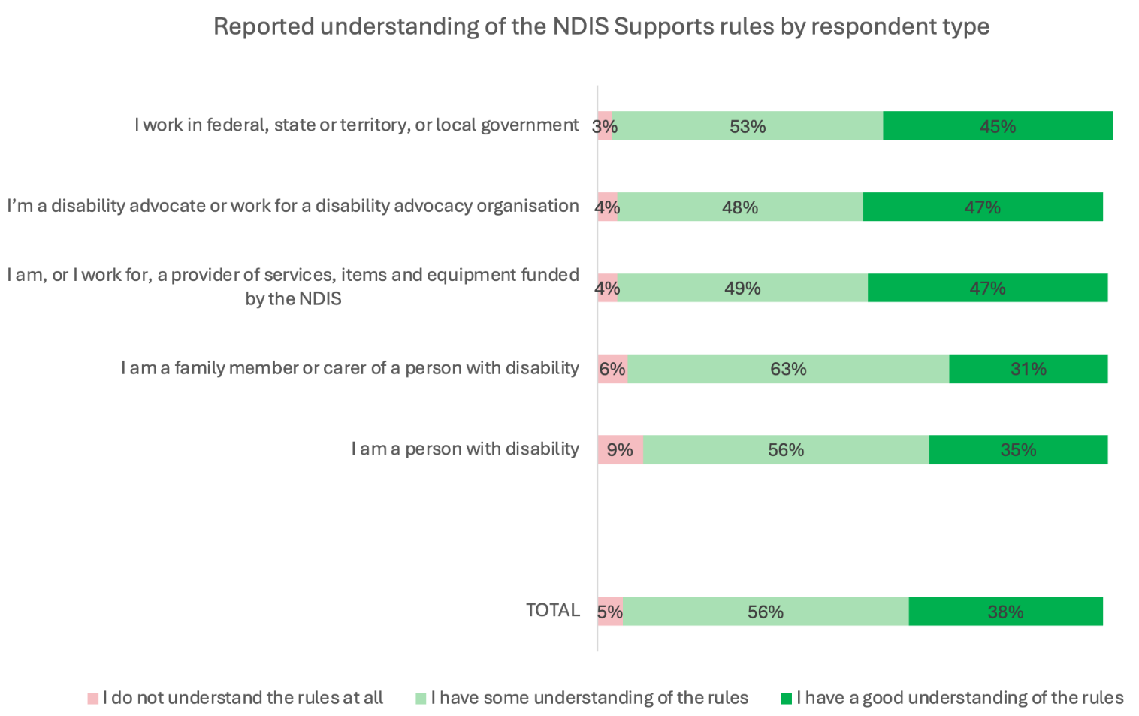
Figure 5 Base: All respondents (1,216), Person with a disability (404), Family member of a person with a disability (514), Provider or work for a provider (540), Disability advocate / advocacy organization (98), Government (40)

NDIS supports lists

Awareness of the lists was about the same as awareness of the NDIS Supports Rules.
- In total, 3 in 4 respondents were aware of the lists before doing the survey (76%).
- Awareness of the NDIS supports lists was lower among people with disability (75%) compared to disability advocates (88%) and providers (86%).
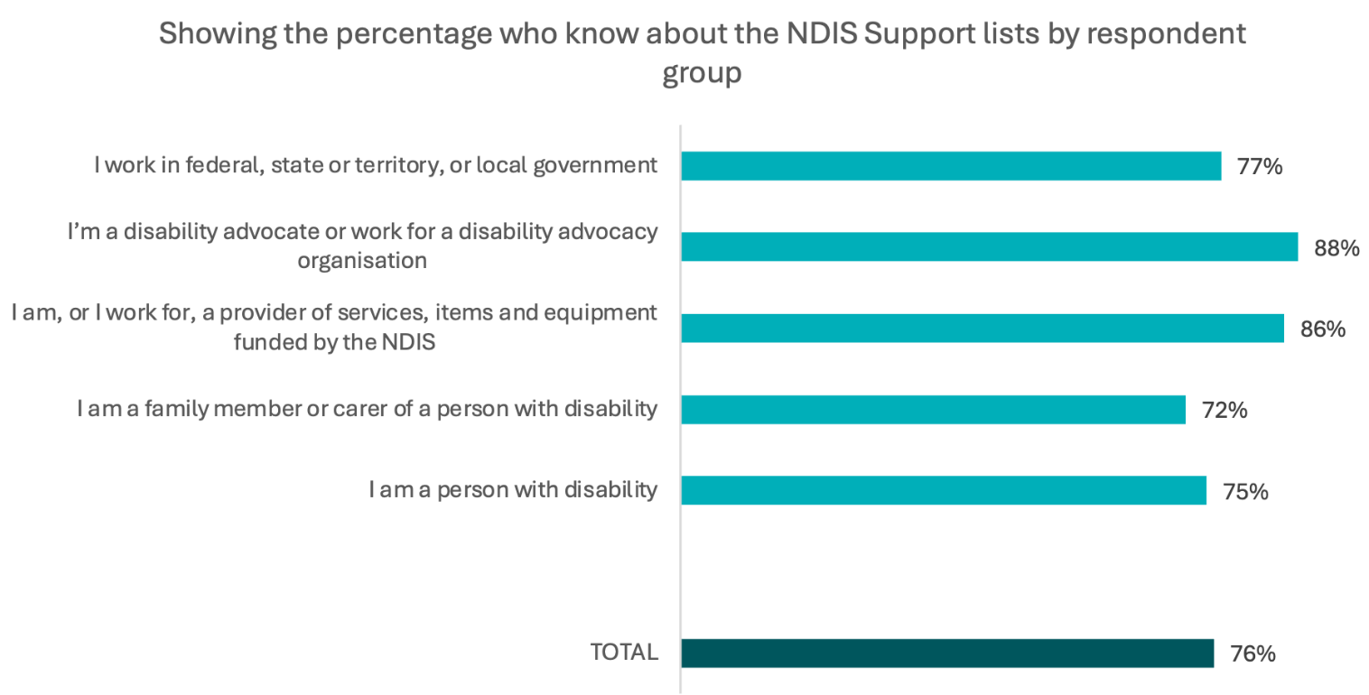
Figure 6 Base: All respondents (1,694), Person with a disability (597), Family member of a person with a disability (755), Provider or work for a provider (645), Disability advocate / advocacy organization (115), Government (56)

Finding information about what NDIS funding can be spent on
When it comes to finding information about what NDIS funding can be spent on:
- People with disability were most likely to use the NDIS website (49%) or ask their Support Coordinator (47%) or Plan Manager / Local Area Coordinator (39%).
- Providers were the most likely of any group to use the NDIS website, with 71% of providers selecting this option, compared to just under half of those with disability and family members or carers.
- There were some differences in preferred information sources between groups:
- Respondents who identified as Aboriginal and/or Torres Strait Islander were much less likely than average to say they would go to the NDIS website (39%, compared to 56% overall). They were also more likely than other groups to say they did not know where they would get help (7%, compared to 3% overall)
- Respondents who identified as LGBTIQA+SB were the most likely to say they would get information from disability advocacy organisations or peer networks (35%, compared to 25% overall).
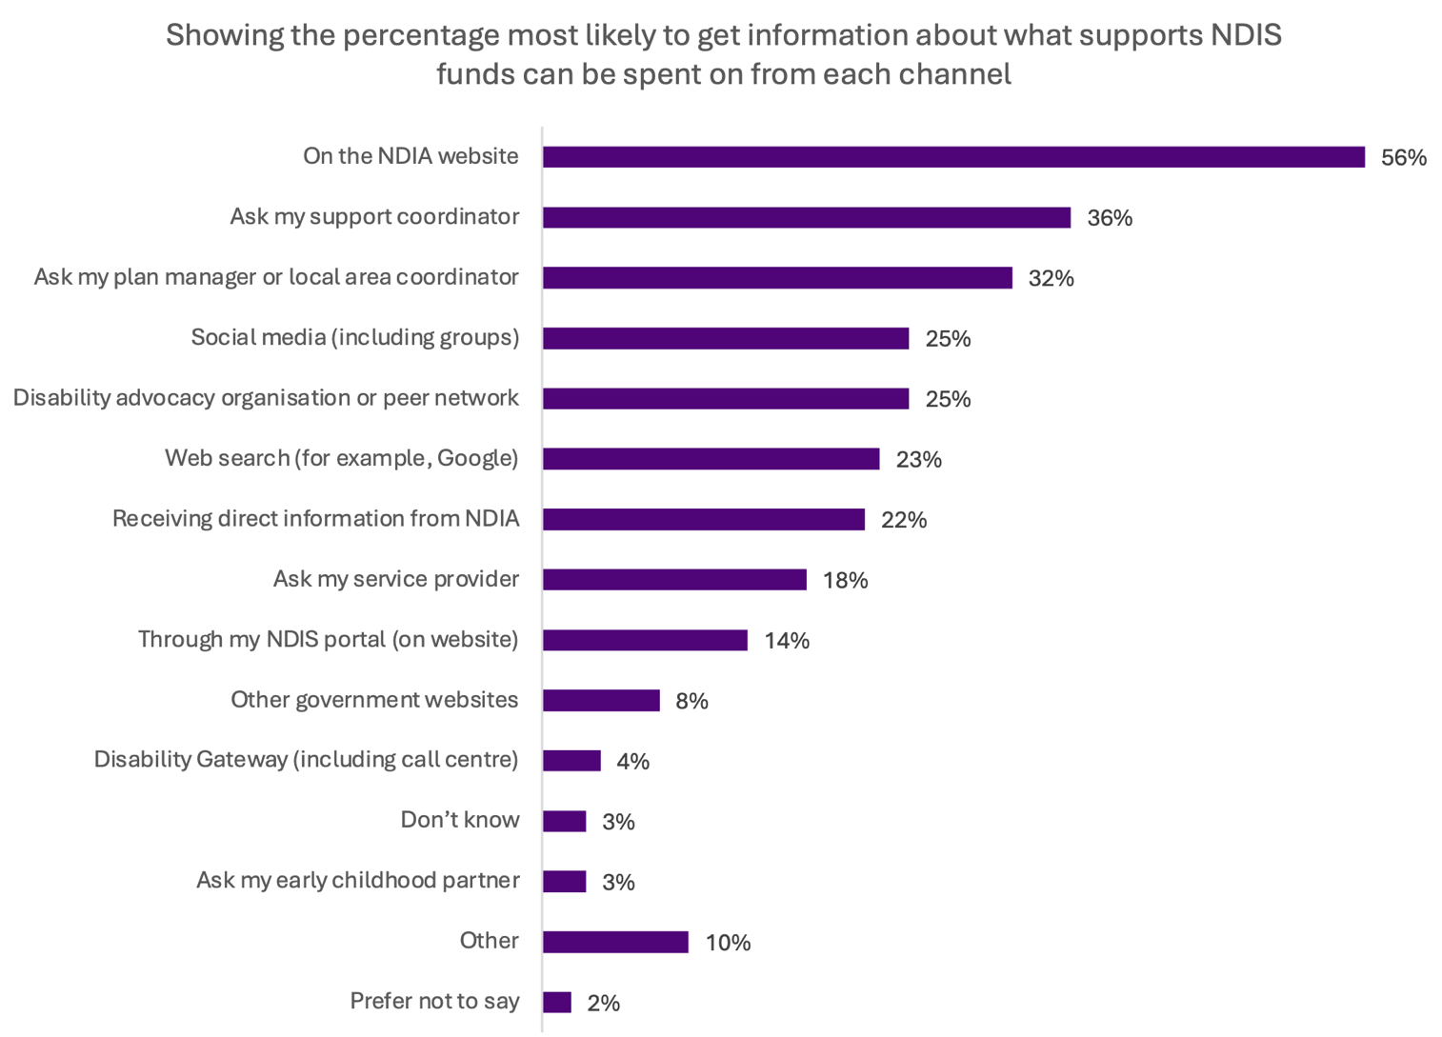
Figure 7 Base: All respondents (1,696)

Helpfulness of the NDIS supports lists
Despite high awareness of the NDIS supports lists, understanding about what can be funded by the NDIS could be improved. Amongst those who had used the lists to understand what can be funded, only 15% said it’s currently easy to understand what can be funded and 78% said it’s hard.
- There are also differences in how helpful different groups find the lists to be.
- Providers are most likely to find the lists helpful (54% helpful), and people with disability the least likely to find them helpful (35%).
- People with disability are more likely to report the NDIS supports lists are unhelpful than helpful (46% compared to 35%) to find out what supports can be funded.

Using the NDIS supports lists to know what can be funded
Just under 3 in 5 respondents had used the NDIS supports lists to understand what can be funded (58%) and half (50%) have used the lists to understand what can’t be funded.
- 1 in 5 respondents (19%) said they had used the replacement supports process. Noting the replacement supports process was designed to support exceptional circumstances, this response aligns with the original policy intent of the process.
- Overall, family members and carers were the least likely to have used the lists, though only a little less likely than people with disability. NDIS providers and disability advocates are more likely to have used the lists to find out what NDIS funding can and cannot be spent on.
- People and family members of people with acquired brain injury (45%), autism (53%), intellectual disability (51%), psychosocial disability (50%), and stroke (37%) were less likely than other disability groups to have used the lists to understand what can be funded.
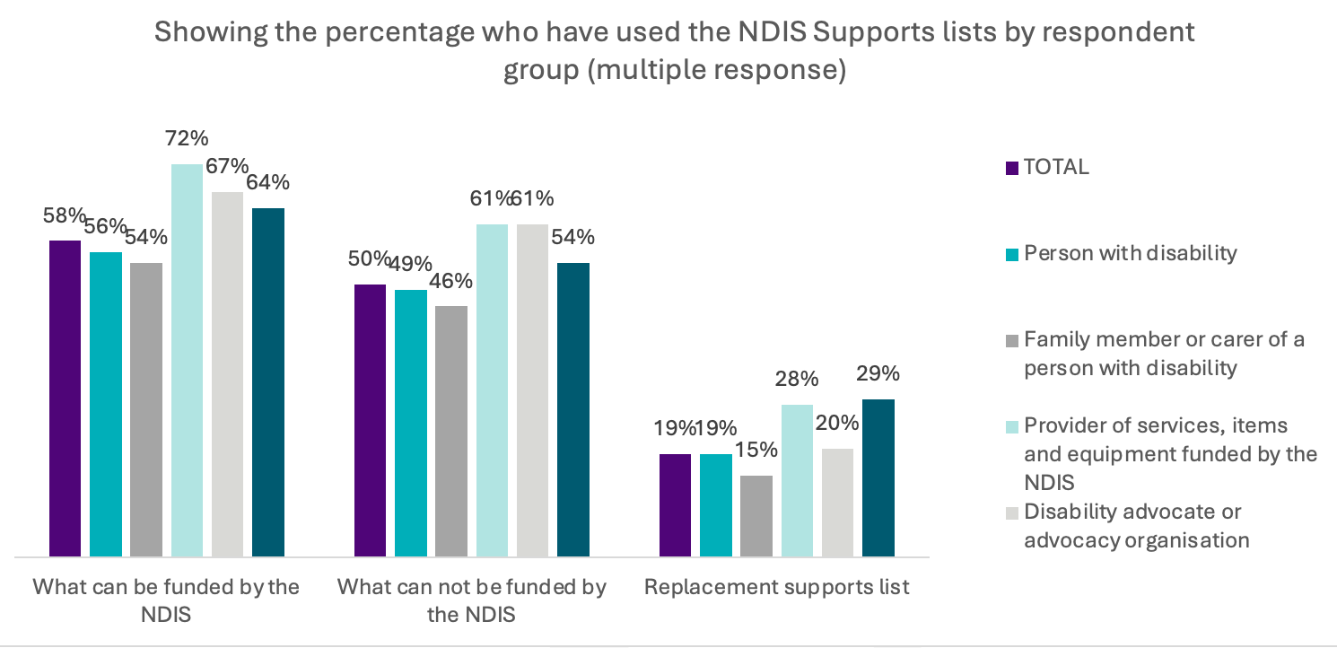
Figure 8 Base: All respondents (1,277), Person with a disability (448), Family member of a person with a disability (544), Provider or work for a provider (556), Disability advocate / advocacy organization (101), Government (43)
Across all respondent groups, 45% reported that the lists have been helpful to understand what supports can be funded by the NDIS. However, these results varied by group.
- People with disability were more likely to say the lists were unhelpful than helpful (46% compared to 35%).
- People who are hard of hearing or deaf were the least likely to find the lists helpful (27%).
- Family members and carers were around as likely to say the lists are helpful as unhelpful (41% compared to 38%).
- Advocates were also more likely to find them helpful than unhelpful (47% compared to 39%)
- Providers were most likely to say the lists were helpful (54%)
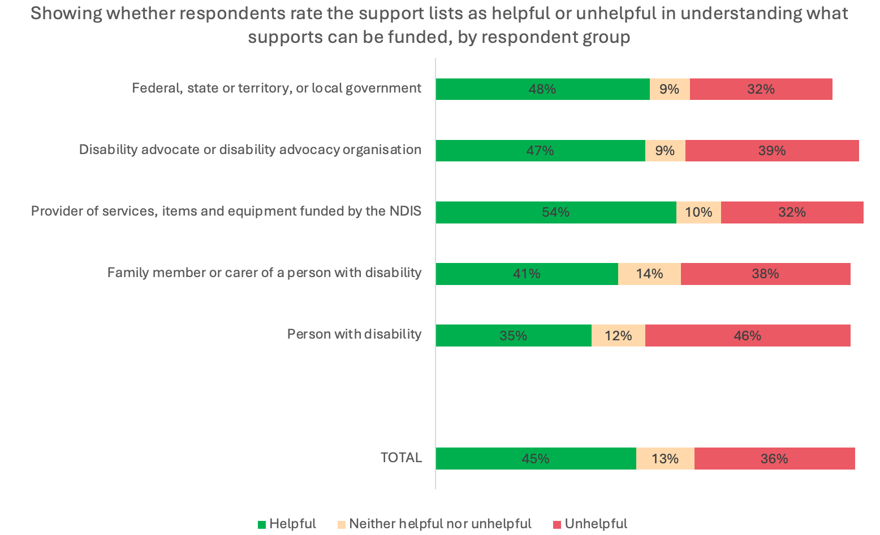
Figure 9 Base: All respondents (1,692), Person with a disability (597), Family member of a person with a disability (754), Provider or work for a provider (644), Disability advocate / advocacy organization (117), Government (56)
When combined with Figure 8 on the previous page, this shows that using the NDIS supports lists increases the understanding of what supports can be purchased using NDIS funding, but only for a small number of respondents. Of those who had used the lists, 15% said it’s easy to understand and 68% said it’s hard.

Effectiveness of supports lists
Survey responses suggested a range of improvements could be made to the current lists. Many respondents said the lists of NDIS supports need to:
- be clearer about what some categories or items cover
- be more flexible (to account for different circumstances)
- include things that some people need to be independent and live a full life.
We heard that more clarity about what’s allowed under these new Rules could improve people’s certainty in the funding decisions being made by Plan Managers and their confidence to make purchasing decisions.
Submissions highlighted that the current structure of the NDIS supports lists needs to be easier to interpret, more flexible and reflect the diversity and complexity of participants’ lives, particularly for people with intersectional identities, complex support needs and non-medicalised support preferences.
The joint submission from Disability Representative Organisations (DROs) highlighted the view the lists risk entrenching a narrow medical model of disability overlooking the value of lived experience, peer supports and culturally responsive practices. The submission noted concerns about the exclusion of supports for safety, autonomy and participation, with specific reference to supports such as assistive technologies, parenting supports and some gendered items such as sexual wellbeing aids. The submission recommended reframing the lists to allow for flexibility, co-design and recognition of functional benefit rather than relying on whether an item is standard or modified.
These concerns were echoed by other organisations including Occupational Therapy Australia, Women with Disabilities Victoria and the Australian Psychosocial Disability Collective. Concerns were raised that the current approach risks excluding low-cost, innovative, high impact supports tailored to individual needs and undermines person-centred planning.
Submissions noted a principles-based, person-centred framework could reduce the administrative burden on participants and providers.
JFA Purple Orange recommended replacing the current lists with a co-designed principles-framework, supported by user friendly guidance: ‘Participants consistently say they want clarity and flexibility… A principles-based rule can still offer clarity.’
The Australian Human Rights Commission (AHRC) raised concern the current approach risks regressing the NDIS away from its legislated human rights obligations. AHRC called for a co-designed, rights-based framework centring on personal autonomy, flexibility and inclusion, thereby ensuring no participant is worse off due to any rule changes.

Making the NDIS supports lists easier to use and understand
We asked participants what would make the NDIS Supports Rules or lists easier to use or understand, so people knew what supports could be purchased using NDIS funding. Over a thousand responses were given in total. Percentages are based on all who provided a response to this question.
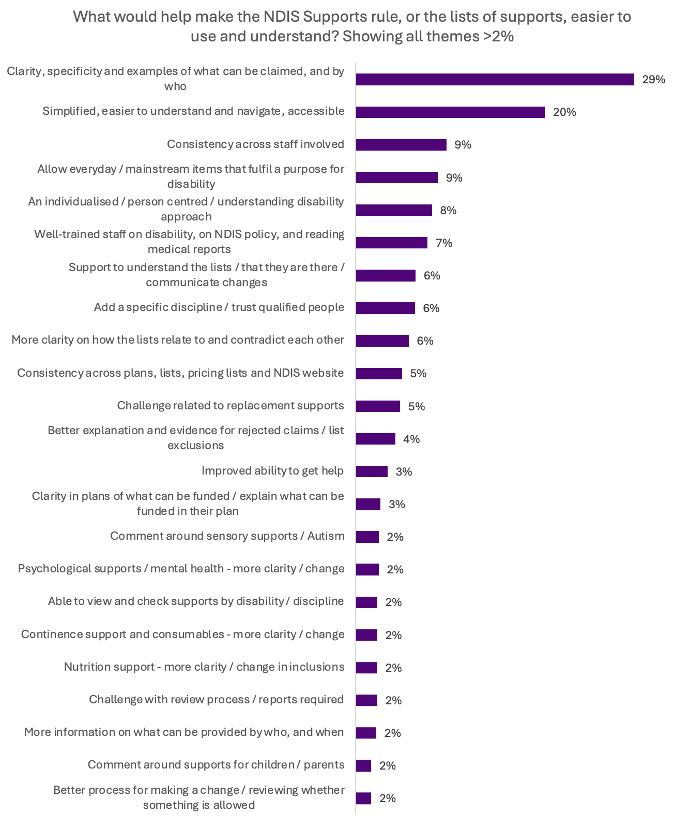
Figure 10 Base: All respondents who provided an answer (1,122)

Clarity and specificity
The most common suggestion respondents said would make the Rules or lists of supports more helpful was providing more clarity and specificity about what can be claimed and by who (29%). This included:
- More specific details of the products and services that can be claimed under each category of support
  - respondents want better alignment between list categories and items NDIS participants would purchase with funding, and an easy way to check whether something is included in a category.
- Inclusion of clear examples in the lists, based on broad categories, of what can be purchased with NDIS funding as opposed to using legislative language.
- More specificity and clarity about who can purchase particular kinds of NDIS supports for different things to ensure NDIS participants are clearer about the types of supports they can purchase
- More clarity on the products and services listed in the ‘in’ and ‘out’ lists and a review of the language used in these lists
  - ‘Wilderness Therapy’ was mentioned as an example where it is currently defined as not being an NDIS support, however a number of respondents suggested this is being interpreted to refer to other supports in the outdoor health industry that are evidence-based.
Respondents requested more information on what services can be provided (i.e. not just purchased), by who and under what conditions (an additional 2% of responses). This relates to clarity on the qualifications and professions that can be funded for providing a specific service. This might help to avoid a support request being declined.
‘I also think more examples could be included under each category. For example, one of the items in the 'in' list is 'Assistance in coordinating or managing life stages, transitions or supports'. The first paragraph says, 'Supports provided on a short-term basis that provide assistance to manage life transitions.' What kinds of supports are they referring to? What does it mean? Do they mean support workers? Service providers? Or something else? It's very vague.’ – survey response ID 44772, person with disability
‘Clear list of what is and isn’t a support and in what scenarios they may or may not be funded. E.G. an iPad may be a support for a hearing or speech impaired person to communicate, however is not allowed as a general support device outside of these circumstances.’ – survey response ID 45604, family member or carer of a person with disability

Simple, easy to navigate and accessible
The next most common suggestion respondents said would make the Rules or lists of supports more helpful was simplifying them, making them easier to navigate and improving accessibility (20% of responses).
Responses covered:
- Improving the language of the lists so they are easier to read. This includes making the categories within the lists clearer so people can better work out where supports fit and what can be purchased.
- Introducing features and formats that make the information in the lists easier to navigate. This included a search function that lets users filter supports, diagrams and visuals to support understanding, and putting all information in one place.
- Ensuring that the information in the lists is presented in different formats, making it accessible and available to those who need to use the lists. For example, having explainer documents and examples, and having the lists in Braille, Easy Read and visual presentation formats.
‘[…] There are no easy read lists, Braille lists, audio/video recordings, or other accessible formats; this is unacceptable. The description of most support is extremely pedantic/semantic and confusing; this is unacceptable. You have (supposedly) created a reference resource for disabled people, and you've made it actively hostile to disabled people.’ – survey response ID 44162, person with disability and a family member or carer of a person with disability, and a nominee and lifestyle guardian for an NDIS participant

Submissions from groups such as the Self Manager Hub, Consumers of Mental Health WA (CoMHWA), and Vision 20/20 Australia emphasised the need for accessible formats, including Easy Read, Braille and multilingual resources, and for co-designed communication tools reflective of the lived experience of people with disability.
The Institute for Urban Indigenous Health and Settlement Services International noted the current lists are not well understood in communities where English is not the first language.
People with Disability Australia (PWDA) and KIN Disability Advocacy for Diverse Communities also highlighted the need for community-led education, translated material and culturally responsive planning tools.
The Intellectual Disability Rights Service (IDRS) emphasised the current Rules are inaccessible for people with cognitive impairment. IDRS called for plain-English guidance and co-designed Rules to ensure people with intellectual disability can understand and confidently use their NDIS funding.
Additionally, South West Autism Network (SWAN) and Deaf Australia raised concerns about the lack of inclusive communication formats and the need for intersectional approaches considering gender, culture and language. There was strong support across these submissions for co-design with diverse communities to ensure lists are inclusive, usable and trusted by all participants.

Consistency
Respondents said that consistency in how the supports in the lists are understood by those who deliver or support NDIS participants would make purchasing decisions easier.
This included:
- consistency across professionals involved with NDIS supports (9%).
- consistency across different sources of information (5%).
Greater consistency would:
- reduce the need to involve many people before a purchase is made
- increase confidence to spend funds.
When it came to issues about advice and interpretation from disability and health professionals, respondents noted clearer language in the lists would:
- Streamline the approval process and promote confidence in decision-making for both participants and NDIS staff
- Promote greater consistency in how NDIA staff understand and apply the NDIS Supports Rules
‘I have confidentiality [sic] used self management guidelines for years to purchase low cost items that make a huge difference to my life. Now even my OT at cerebral palsy alliance tells me they cannot confidentiality advise me about simple supports. I am scared and anxious to make decisions and there is no one I can ask for advice. My LAC hasn’t responded to my questions. The call centre gives inconsistent advice. I truly believe even NDIA staff do not adequately understand the lists.’ – survey response ID 45674, person with disability
The chart below categorises the challenges respondents described where the Rules have not been understood or interpreted in a consistent way.
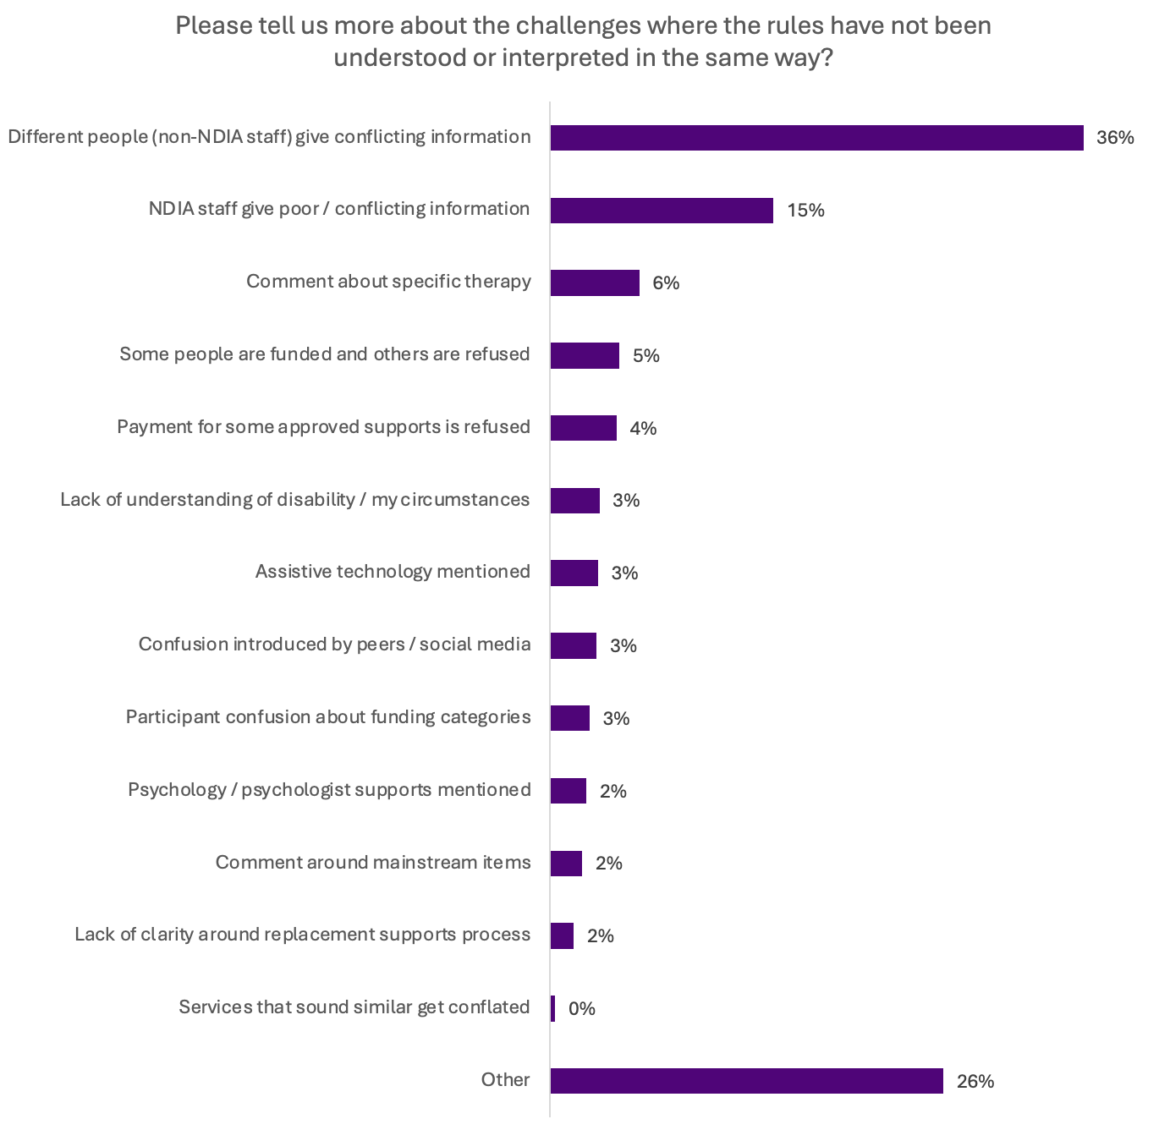
Figure 11 Base: All respondents who provided an answer (1,051)
The top response indicated the need for greater consistency when seeking clarification or asking questions of either the NDIA (15%) or from non-NDIA staff (36%), including intermediaries such as Plan Managers and Support Coordinators.
Respondents reported receiving conflicting information from different people in response to questions about whether specific supports are or are not allowed to be purchased under the NDIS Supports Rules.
‘When seeking advice or reconfirmation of lists of supports you may end up with 3 differing answers. There is a significant lack of communication between all parties where individuals seek information. Training of plan managers, LACs to follow the rules verbatim is paramount to consistency in messaging.’ – survey response ID 45148, provider or work for provider of services, items and equipment funded by the NDIS
‘I have personally called the 1800 800 110 number on 5 separate occasions to ask about changes to Supports and each and every time the rules have been interpreted differently.’ – survey response ID 45092, family member or carer of a person with disability
Respondents also provided some specific examples of challenges they have experienced with the Rules not being understood or interpretated in a consistent way, including:
- some people being able to purchase certain supports whilst others are not (5%)
- claims for supports being refused or rejected although they have approval (4%)
- supports being denied or challenged because of lack of understanding of disability and/or circumstances (3%)
- confusion introduced by social media/peers (3%)
- participant confusion about funding categories (3%)
- the need for funding for mainstream items (2%)
- lack of clarity around the replacement support process (2%)
Submissions reinforced comments from individuals about the need for consistent interpretation of the NDIS supports lists, suggesting this is an issue affecting both NDIS participants and providers which could in part be due to adjusting to the changes made by the NDIS support lists. There was also concern risk aversion is leading to more conservative decision-making about whether a support can be purchased, particularly for low-cost, high impact supports.
The joint submission from DROs and Every Australian Counts (EAC) emphasised unclear definitions and inconsistent application of the lists have led to conflicting advice and prolonged delays in receiving supports.
There was universal support for training and quality assurance for NDIA staff and intermediaries to improve consistency and reduce risk aversion in decision-making. The National Disability Services (NDS) reported NDIA staff sometimes lack training and tools to interpret the lists accurately, leading to conflicting advice, delays and denials of essential supports.
Others noted contradictions can create confusion for Plan Managers and NDIS participants alike. This included the NDIS Support lists, and the Pricing Arrangement and Price Limits (PAPL) are not consistent. Submissions called for greater consistency, clearer operational guidance, case-based examples to reduce ambiguity. Some submissions advocated for binding, Australian Tax Office-style guidance documents to promote clarity and consistency across the system.
People reported that published communication appeared to contradict other published information or contradict the advice of NDIA staff. Respondents gave some examples where web information, social media campaigns and other marketing materials had stories or examples that were not reflected in advice given, or in approvals of supports.
The submission from the Justice and Equity Centre (JEC) proposed a pre-clearance mechanism to help participants confirm support eligibility before purchase, reducing fear of debt recovery and improving trust in the system. JEC also highlighted how the dual-list structure encourages overly conservative interpretations and proposed a restructured list with clearer guidance.

Non-modified and standard every-day household items
1 in 10 respondents said that the lists would be more helpful if they allowed some non-modified, or standard every-day household items (9%). Some respondents highlighted that for people on low incomes, items the NDIS has listed as ‘household items’ may not be standard and may only be required because of a participant’s disability.
‘What the NDIA considers an everyday item, is often only valid for people who are on a good income and have a lot of discretionary money. But for people on an income just above the poverty line, a lot of those items are not considered an ‘everyday item’.’ - Submission Inbox_Ind_8
Responses on everyday and non-modified items are explored more in the later section of this report covering products and services that are missing from the lists.

A more individualised or tailored process
Respondents mentioned the need for the NDIS supports lists to take an approach that is individualised, or more understanding of a disability perspective (8%).
Comments under this theme said the lists need to acknowledge:
- not everyone with the same disability will want or need the same types of supports
- the approach may not work for those with complex disability
- NDIS participants having input into what is funded in their plan, based on their personal disability related needs and goals.
‘[…] Each disability is nuanced and specific to the individual and their need. This list ignores that foundation goal of the ndia, to tailor care to the participant and their goals. As a result when your disability is not cookie cutter and has some complexity these lists are too simple and don’t account for what actually meets the needs and goals of participant. Reads as though someone with little medical knowledge is attempting to streamline spending and deter use of funds despite spending resulting in greatest outcomes. Worded to cut budgets and push participants away. The list rarely clarifies confusion over funding.’ – survey response ID 44908, person with disability
‘By actually listening to what supports it is that the participant actually needs and funding those supports instead of going against professional advice and not even bothering to read the reports that are provided. Not to mention that the planners have absolutely no idea of what is considered reasonable and necessary and by that I mean that one planner can say "oh but that isn't considered a reasonable and necessary support" yet another can say "NDIS does consider that to be a reasonable and necessary support that can be funded".’ -survey response ID 45111, person with disability

Support to understand and use the lists
A number of themes emerged relating to receiving help and support to understand and use the lists. The main themes included:
- Better communication about the existence of the lists, including when changes occur, and support including videos and training on how to use the lists (6% of responses).
- Better ways to contact the NDIS for help (3%). This included a desire for a line of communication to the NDIA that guarantees a correct, definitive response to questions, and also for additional channels other than just the National Contact Centre.
‘[…] There need to be some videos (if they don't exist already), and there needs to be someone I can speak with that understands the lists. You can never reach a person at the NDIS who knows what's happening. The support coordinator who supports my family member hasn't received any professional development in understanding how the lists operate. Very poor communication continues to be a barrier to understanding the NDIS changes.’ – survey response ID 45280, person with disability, and a family member or carer of a person with disability
Submissions built on individual feedback by proposing practical reforms to make NDIS funding rules clearer, more consistent, and easier to apply in everyday contexts.
For example, JFA Purple Orange proposed the development of “Would we fund it?” style resources to help participants and planners apply the Rules consistently.
Every Australian Counts (EAC) recommended publishing ‘clear, plain-language guidance with practical examples’, providing consistent training for NDIA staff and intermediaries, and establishing a ‘central point of contact for clarification’. This suggestion was based on feedback in the EAC-run survey which highlighted confusion and inconsistent advice, with 75% of respondents to their survey reporting problems under the new Rules.

Clarity about how the different NDIS supports lists relate to one another
Responses highlighted the need for the NDIS supports lists to relate clearly to each other.
- While some comments outlined an understanding that the ‘in’ list is not exhaustive and must be broadly interpreted and the ‘out’ list is meant to be specific, there was some confusion among respondents about why certain supports appear to be included on both lists.
- Some comments questioned the purpose of having multiple lists, highlighting that not everything on the ‘in’ list is available to all participants (regardless of whether they have supporting reports), and conversely not everything on the ‘out’ list is unavailable to everybody (with the replacement supports process and review processes mentioned as the channels to access certain supports).
- Additionally, some comments flagged specifically that the ‘out’ list is too restrictive and does not account for the types of supports individuals may require.

Additional inclusions
Some respondents requested the inclusion of specific, evidence-based therapies, and that decisions should follow the recommendations of qualified professionals about what supports are required (6%).
Responses on this topic covered the following areas:
- Funding items when a qualified professional has recommended it
- Ensuring decisions about which services and therapies are included and excluded are evidence-based. This includes questions about how individual therapies are assessed, and how the government determined what should or should not feature in the lists
- Specific therapies and services respondents feel should be included, including, neurofeedback therapy, types of behaviour therapy, play therapy, family therapy, parenting programs, and outdoor and nature-based supports.
‘[…]1. Explicit Inclusion of Evidence-Based Parenting Programs
The current supports list does not clearly identify structured parenting programs as eligible supports. This omission creates confusion among families and providers about whether these services are fundable, despite their strong evidence base and alignment with NDIS objectives. Including parenting programs (e.g., Stepping Stones Triple P, Signposts, Parents Under Pressure) as clearly defined capacity-building supports—when delivered by qualified professionals—would improve transparency and promote consistency in funding decisions.[…]’ survey response ID 45696, disability advocate or work for a disability advocacy organisation
Submissions noted the exclusion of some therapies and support, even when recommended by qualified professionals such as parenting programs, and outdoor and nature-based supports. Organisations including Dietitians Australia, Speech Pathology Australia, Australian Physiotherapy Association and Australian Association of Psychologists highlighted some clinically endorsed items such as nutrition supplements, Augmentative and Alternative Communication (AAC) devices, neurofeedback and manual therapy care are being denied despite their proven benefits.
Osteopathy Australia (OA) specifically noted that osteopathy is often misclassified as an alternative therapy, despite being an AHPRA-registered, evidence-based allied health profession. They called for clearer definitions and guidance to ensure all AHPRA-registered professions are equally recognised and accepted within the NDIS framework.
Across these submissions, there was a call to update the lists to explicitly include all allied health services, and ensure professional recommendations are given greater weight in funding decisions. Many also advocated the removal of the replacement supports process for low-cost items and for allowing direct prescription by qualified professionals.

Replacement supports
The replacement supports process is covered in more detail in a later section of this report. However, replacement supports featured in some respondent comments relating to the ease of use and helpfulness of the lists related to this process (5%).
Comments noted:
- The replacement support process could be streamlined, especially when related to getting support for a limited amount of time or for a low-cost item.
- While a device may be required, it does not necessarily replace the support that would be provided by a person. However, in the current framework the replacement supports process may be the only way to access the device.
An example commonly given was that participants with dysphagia may require a Thermomix to prepare food, as a way to manage food consistency, however a Thermomix cannot be funded outside of the replacement supports process. When it is funded by the replacement supports process, it will generally reduce funding from support worker hours to prepare food, yet it does not replace the need for a person to continue to perform aspects of the meal preparation task.
‘The replacement supports rule/new process is unhelpful and appears to use up more of participant's time and funding on gaining allied health input for the required supporting documentation. [It] Is not a cost-effective process, and causes more delays (and often places people at more risk while waiting). Furthermore, participants require AT/supports that can enhance their independence or participation in aspects of a task, but that does not mean it is a full replacement for formal support workers or that it magically enables them to complete the whole task themself. They may also require support to build capacity to use it.’ – survey response ID 44371, provider or work for provider of services, items and equipment funded by the NDIS

Rejected claims and list exclusions
People raised the need for explanation when a requested support is refused. Respondents mentioned that the rationale for decisions is often not clearly explained (4%).
Respondents indicated when requests for replacement supports are declined, they have no recourse.
‘I would like it if NDIS would explain the reasoning and rationale behind their decisions especially what is helpful/beneficial or not their opinion especially when it differs from the opinion of the participant.’ – survey response ID 44441, family member or carer of a person with disability

Funding specifications for participant plans
Respondent comments highlighted instances where even when an NDIS participant has funding in their plan for a support, a claim for the support may not be paid (3%). Some comments indicated this is due to concerns from Plan Managers attempting to avoid incorrectly paying for a support which is not approved, because it is not always clear in plans what funding is for.

Review process / reports required
Respondents raised challenges in relation to the review process and the consideration of reports (2%).
This included:
- Ensuring NDIA staff read reports provided
- Reducing the need for reports so funding can be spent on direct supports
- Needing clarity around what is required in reports to ensure they are effective
- Ensuring NDIA staff are equipped to make appropriate decisions to avoid the need for additional reports and.
‘[…]Plan managers have got so scared they just decline, or ask for further evidence about everything. It is not good use of the NDIA budget if I’m getting further reports re every purchase, or appealing all decisions.[…]’ – survey response ID 45804, person with disability

Process for making a change to plans, appealing or reviewing decisions
Respondents want it to be easier to request a plan change or content decisions in the Administrative Review Tribunal when a request for a support to be added to a plan is declined, or when the circumstances of an NDIS participant change which results in different types of supports being required. One submission suggested the need for an ‘exception to the rule’ submission pathway, to account for the minority of participants who have complex and intersecting needs, and as such do not ‘fit into the box’.
‘[…]b) An 'Exception to the Rule' Submission Pathway:
I strongly advocate for the creation of a formal process for 'exception to the rule' submissions. While clear lists are helpful for the majority, they cannot account for the complex, intersecting needs of a minority of participants who do not "fit the box." These individuals often face compounding challenges such as language barriers, poverty, housing insecurity, and family violence, all of which are exacerbated by disability. Without the right, nuanced supports, we risk perpetuating cycles of disadvantage and developmental delay, leading to greater long-term costs for the scheme and society. An 'exception to the rule' pathway would allow a participant to make a case for a support that is not typically funded, by demonstrating how it is a direct and necessary response to their specific disability-related needs.[…]’ - Submission Inbox_Ind_14

Specific areas for review and clarification on inclusions
The following areas and types of support were mentioned frequently enough they emerged as themes in their own right.
- Sensory supports and Autism (2%) – Comments indicated issues relating to sensory processing are a challenge, however most sensory products are included on the ‘out’ list. Funding to attend an autism-specific group does not always allow for participants to attend the right groups for them (for example, an individual may not need an autism-specific group but may still benefit from an organised group).
‘Not funding sensory equipment, toys or exercise equipment isn’t appropriate when they are needed to support therapeutic goals directly relating to the individuals NDIS registered diagnosis.’ - survey response ID 44299, provider or work for provider of services, items and equipment funded by the NDIS
‘There is NOTHING in any of these lists about the very significant difficulties many clients have with day to day social awareness and understanding of the general community expectations’ – survey response ID 44150, family member or carer of a person with disability
- Psychological supports and mental health (2%) – There was a desire for more clarity about what can be funded in terms of mental health supports and psychological services. In addition to more clarity, respondents raised concerns about the removal of psychological supports resulting in NDIS participants being unable to access important supports, because they are not funded elsewhere. It should be noted psychology is an NDIS Support in the current lists, however, the NDIS was never intended to replace the role of mainstream service systems, including covering service gaps.
‘[…]NDIS having an understanding on what services are actually provided by primary and secondary services/ IE basic counselling is not provided in Mental Health services as such this needs to be sourced in the private sector and a MHCP does not cover the cost and there is a GAP payment required.’ – survey response ID 44553, work in federal, state or territory, or local government
- Continence supports (2%) – Respondents requested specific continence items be added to the lists. Currently, purchases of these commonly needed items from supermarkets are not allowed but are crucial for many people. Examples included personal protective equipment (such as gloves and wipes), creams, bedding protectors, washable underwear, and extra costs including laundry and cleaning. Other comments mentioned restrictions on the amount of continence aids funded via the NDIS, and the need for clarity on who is responsible for funding and providing continence assessments.
‘In relation to continence supplies and consumables it needs to be crystal clear that people with high physical support needs require wipes, gloves, hygiene products and in the case of spinal cord injury, suppositories, enemas etc. These items are directly related to the person's disability and should not be questioned / denied. They are not funded anywhere else. NDIA staff appear to need training in relation to disabilities [sic] requiring these supports - knowledge base is low in many instances, even with highly descriptive reports available.’ – survey response ID 45452. Support Coordinator with 35 years industry experience
- Supports for children and parents (2%) – The general sentiment of responses relating to supports for children and parents was a desire for supports which help children develop to be included. This included socialisation and play-based resources. Additionally, comments mentioned evidence-based parent support programs should be funded, as should supports which increase a child’s ability for participation, for example tutoring and school transport.
‘They are way too broad, this means so many things could be considered not fundable when they should be. The lists do not make it easy for anyone including plan managers or participants/carers to understand what’s considered as a NDIS support. Especially regarding children with disabilities. For example- play equipment and ‘toys’ are on the ‘out’ list. But many things that could be considered ‘toys’ are also used as therapy supports for children with disabilities. In order for children to get involved in and utilise equipment/activities for fine motor or gross motor skills etc they need to be engaged in the activity and therefore it is often needs to be a form of ‘toy’ when children are involved. So now the plan managers etc won’t pay for anything that can be viewed as a ‘toy’ because the NDIS simply listed all play equipment and toys to be on the Out list.’ – survey response ID 44405, family member or carer of a person with disability

Interpreting and understanding the NDIS Supports Rules
NDIS supports lists are helping to prescribe what supports participants can and cannot spend NDIS funding on, however people have different understandings of what the supports and items in the lists mean. Respondents highlighted the need for consistency in how the NDIS supports lists are interpreted when decisions are made about what NDIS funding can be spent on.
- 3 in 4 respondents had experienced or heard about situations where people understood the NDIS Supports Rules differently (77% of all respondents).

Ongoing need to review the NDIS supports lists
NDIS supports lists need to continue to be improved, tested and refined so they cover the extent of products and services people with disability need.
- More than half of respondents (58%) said there were products that should be available but are not on the NDIS supports list.
- 41% of respondents said there are services that should be available but are not on the NDIS supports list.

Products and services respondents want on the NDIS supports list
Products and services mentioned by respondents varied from general, such as mental health support, to highly specific, such as certain models of blenders (see chart below).
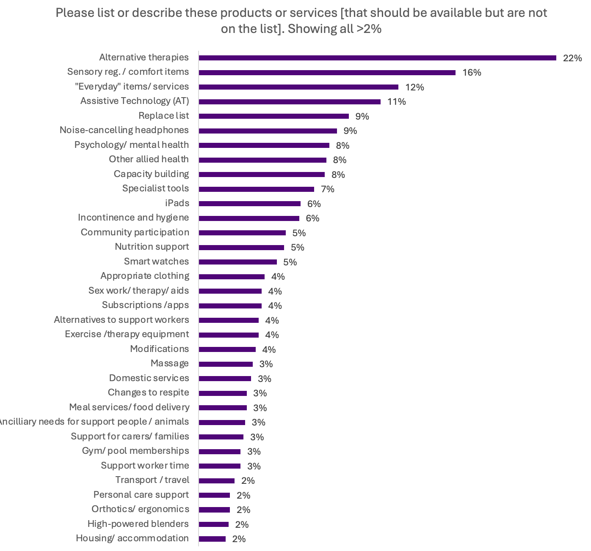
Figure 12 Base: All respondents who provided an answer (1,072)
NDIS participants, and/or their families and carers, from the following groups were the most likely to say there were products missing from the lists:
- autism (66%)
- physical disability (66%)
- psychosocial disability (63%)
- other neurological disability (72%)
- other sensory and speech (69%).
The following is an overview of comments about products and services respondents said should be available to be purchased using NDIS funding. As the list of items becomes very specific and individualised, the full list of items suggested is not included in this report but has been considered as part of the consultation process. Percentages are based on all who provided a response to this question.

Alternative therapies
Many responses (22%) mentioned access to alternative therapies. Common examples included, play therapy, animal therapy, neurofeedback therapy, nature-based therapy, yoga therapy, game therapy and hydrotherapy. Respondents often commented these therapies, delivered by professional experts, have been effective in improving function, capacity and/or comfort, and losing access to these supports has had negative impacts on NDIS participants.
‘My son thrived with this support and is emotional and social wellbeing has suffered since he can not access it. It was a crucial support for him.’ – survey response ID 44453, family member or carer of a person with disability
‘With out these options they will avoid seeking help altogether. I've seen that these therapies can lead to more engagement with boarder medical system as they are trained professionals, who have the trust of the people the treat and in my experience make recommendations to seek additional treatment.’ – survey response ID 44499, family member or carer of a person with disability
Some responses highlighted overlap between activities that may be used for therapeutic purposes or as a form of social participation, such as exercise classes. They reported that it can be a barrier to access if lists restrict these activities to being only therapeutic (or only social). Some responses also mentioned being able to purchase items that support alternative therapy, such as musical instruments.

Sensory regulation tools
A number of responses (16%) mentioned tools for sensory and emotional regulation, such as fidget devices, weighted blankets, crash mats and chewable items. They emphasised these are not the same as toys for children, as they perform a function which allows participants to self-regulate, build capacity and participate in social and community activities.
‘Furthermore, in regard to these regulation tools, my child uses minimal amounts of funds for low-cost Assistant Technology from her high funded plan to self-regulate and maintain regulation around others. Without, there is no other possible alternative but complete isolation. This is an incredibly restrictive practice. You must ask yourself, is that any way to live; completely isolated due to a disability that you have no control over?’ Submission Inbox_Ind_9
‘Not having access to these leads to emotional regulation issues. When you tell us to focus on emotional regulation instead, you’re asking to fix the problem often at crisis point, when it could have been minimised or even prevented with sensory equipment.’ – survey response ID 44782, family member or carer of a person with disability
‘The blanket rule of ‘sensory toys’ not being covered severely impacts clients who need sensory input replacement tools, such as chew tubes, to reduce hand biting or squishy balls to squeeze instead of pinching or squeezing people.’ – survey response ID 44579, provider or work for provider of services, items and equipment funded by the NDIS
There was feedback on the inclusion of noise cancelling headphones as they support some NDIS participants to be in the community by helping to cope with noise sensitivities and sensory overload.
‘Headphones are used more then others when your autistic, so it’s not normal usage. I currently use 3 different types of headphones to manage sensory input, it all depends on where I am, and having access to fund these mean that I can appear to fit in rather then stand out. Each has a specific purpose and I carry them all with me. I self funded one set, but not one of my non disabled friends have 3 sets for different situations.’ – survey response ID 44912, person with disability and family member or carer of a person with disability

Everyday products and services
A number of respondents suggested the inclusion of commonly available or everyday items in general (12%). Responses noted the current Rules (wording around ‘adapted or modified’) effectively require NDIS participants to purchase items from disability suppliers, rather than purchasing from more general suppliers, restricting the products that can be accessed. Respondents emphasised despite certain products and services being available to and used by the wider community, people with disability often need them specifically and exclusively because of their disability.
Respondents consistently reported accessing items through disability-specific suppliers is more expensive. This was often attributed to suppliers taking advantage of the lack of choice or to suppliers not having the same wholesale production or buying power as major retailers.
‘Disability specific equipment can actually be more costly than creative alternative options, and if there is a cheaper alternative to achieve therapeutic gains it should not be automatically ruled out because it hasn’t been modified.’ – survey response ID 44501, anonymous
‘just because anyone can buy something doesn't mean it can't be needed for my disability- anyone can buy slip in shoes but I HAVE to buy slip in shoes and all the extra cost that comes with it.’ – survey response ID 45119, anonymous
‘Now, I cannot get approved for new noise-cancelling headphones, but I can get funding for very expensive forced integration sensory therapy. This type of therapy very quickly drains the limited funding I have available. I do not understand why the NDIS would not be in favour of alternative pathways, such as having noise cancelling headphones, that have the same effect for me that the sensory therapy does. In fact, I would get more use out of noise cancelling headphones, as it can be used daily to help me navigate the world as an individual with sensory issues.’ Submission Ind_3
Respondents also reported everyday versions of products are often better quality and more fit-for-purpose than disability-specific versions, despite being cheaper, and indicated using the disability-specific versions can often feel othering.
‘I now have to buy ugly plastic deep sided plates from a disability supplier which are a lot more expensive and don’t work as well as the “everyday” plates that I’ve previously used. They are also very obviously a disability item and this makes me feel separate from the other members of my family and highlights that I am “disabled”. Whereas previously I could use a “normal” deep sided plate which is cheaper, does the job better, and doesn’t highlight that I have a difference from the rest of my family.’ – survey response ID 44350, person with disability
Some responses (4%) mentioned having access to everyday products, like household appliances, and services, such as hair and nail care in salons, would reduce the cost associated with completing tasks. They noted that the alternative is to pay for support workers to perform tasks (which can cost more overall). The inclusion of these services would allow participants more independence and autonomy, including not having people come into their homes.
‘Often getting a worker who specifically does the job at hand (ie hairdresser, handyman, nail salon, dog groomer, car detailer) results in a quicker outcome, safer practices, less harm, less fatigue to me and less funding being used for the same job.’ – survey response ID 44159, person with disability and a family member or carer of a person with disability
‘If a $600 watch saves having to pay for a support worker to be needed, makes financial sense! If someone needs to use reusable period underwear so they can use them independently rather than need a support worker go to the shops to purchase disposable and open and apply disposables, surely reusable undies are the better option?’ – survey response ID 44337, family member or carer of a person with disability and provider or work for provider of services, items and equipment funded by the NDIS

Assistive Technology (AT)
Responses mentioned devices and Assistive Technology (AT), particularly for Augmentative and Alternative Communication (AAC) and other communication needs (11%). Some responses mentioned tablets specifically, often saying that iPads are the most appropriate option for functionality and access to required apps (6%).
Responses also mentioned smart watches (5%), which are also required to monitor falls and be able to contact help.
Some individual submissions highlighted some of these products were developed initially to help meet the needs of those with disability, but they have now become mainstream. Their exclusion from the lists is perceived to be penalising participants because companies have now designed products that meet accessibility needs for a broader audience. Example products included electric toothbrushes, noise cancelling headphones and voice activated devices.
‘The NDIS hasn’t kept in step with the development of technologies to support communication. They are stuck in the assumption that a high-tech AAC support must mean a heavy, clunky, disability-specific adaption-resistant communication device costing $5,000. They don’t listen to the professionals who say a simple iPad for $500 plus a range of customisable apps for a few hundred extra will suit participants much more, being more socially-acceptable, customisable, much lighter and far cheaper.’ – survey response ID 44949, provider or work for provider of services, items and equipment funded by the NDIS
The submission from Assistive Technology Suppliers Australia (ATSA) emphasised the need for clearer nationally consistent guidance on assistive technology (AT). They recommended the NDIA ‘provide clear criteria for decisions on AT, without the need for extensive FAQs’ and ensure ‘all stakeholders…have access to the same guidance material and decision-making criteria on AT to reduce unnecessary frustrations and delays in access’. ATSA also called for ‘mandatory training on AT for all NDIA planner, plan managers and support coordinators’ to improve consistency and reduce delays in approvals.

Mental health supports
Some responses (8%) supported extending psychology and other mental health services to more or all participants.
- They noted that mental health can be impacted and/or complicated by challenges associated with disabilities.
- They also advocated for allowing NDIS funding to cover higher gap rates charged by psychologists who provide the most appropriate care.

Allied health
Numerous responses (8%) specified they had either not been able to access allied health services or commented more generally access to different allied health services are sometimes being restricted. Common services included dietitians, chiropractors, and osteopathy. These services are not excluded as NDIS supports.

Capacity building
Some responses (8%) suggested the inclusion of supports for capacity building. This included disability-specific and general courses and resources, skill building including swimming lessons, driving lessons and cooking classes, health and wellness coaching, sexuality and relationships education, peer support and support to facilitate greater day-to-day independence.

Personal care and hygiene
Some responses mentioned the need for products related to personal care and hygiene. In particular, responses often mentioned continence products and related items such as wipes, gloves and barrier creams (6%). Multiple responses (1%) suggested standard period underwear and menstrual products, explaining these can help with accessibility barriers such as low dexterity. These items are not excluded from NDIS supports where they are disability related.

Specialist products
Some responses (7%) mentioned specialist tools and equipment, such as prescription eyewear and household appliances with specific settings or design.
One submission noted that specifically prescription glasses are listed as not funded because they are funded by the health system, but there are instances where vision issues are the result of a disability, and the products required are not covered by the health system.
‘Specialised, non-standard prescriptions such as prism lenses, tinted, filtered, spectral coloured lenses are not available under any scheme in Australia and are specifically required to support the management (not treatment) of the neurological vision and cognitive processes of the participant with MS vision impairment-disability.’ Submission Inbox_Ind_16

Carers, support people and support animals
Responses also commonly mentioned supports not directly provided to NDIS participants but that are required to sustain the functioning of their support systems.
- This included costs incurred by support people, such as cost of plane tickets or to attend activities with participants, or for support animals, such as pet insurance and grooming (3%).
- It also included support services for family carers where a high care load keeps them from things like household cleaning (3%).
‘Products and [sic] services that allow those that provide unpaid care to be able to implement strategies to best support the person they care for without having to spend money on direct services.’ – survey response ID 45074, person with disability and family member or carer of a person with disability
‘there are a lot of families with two working parents who cannot keep up with household management due to the time and physical requirements of caring for their children, however they are offered no assistance to run the home where the child is expected to not only exist but thrive.’ – survey response ID 45630, person with disability and family member or carer of a person with disability

Community participation
Responses included a number of specific comments about products and services to support community participation (5%). As well as listing various types of community participation, such as events, sports, community classes, and employment, respondents also mentioned supports that enable access to community activities. This included being able to purchase:
- the price of admission or fees
- admission costs for support workers.
Some respondents also noted community activities can include ways to build on therapy-related skills, such as dance and exercise.

Nutrition support
Some responses (5%) mentioned nutrition support, including supplements and access to dietitians. They explained this is required by NDIS participants who need assisted or modified food and feeding, including tube feeding, and for participants whose diet is affected by food aversions. These supports are not excluded from NDIS supports where they are disability related.

Changes to respite
Several responses (3%) suggested the options listed for respite care or Short-Term Accommodation (STA) need to be less restrictive. They noted that respite care in group settings is inappropriate for some participants and their needs, however more appropriate alternatives have been excluded or have less options included than are available in group settings (such as meals).

Other responses
Other commonly mentioned goods and items included, but were not limited to:
- standard exercise and therapy equipment, especially to be able to use at home and between therapy sessions
- sex work and related supports
- some home and vehicle modifications, including for home security and independent household management
- back-up electricity generators for people dependent on electrical equipment
- compensation for disability-related property damage
- software, apps and subscriptions
- remedial and therapeutic massage
- gym and pool memberships
- meal services and food/grocery delivery.
Within the context of what should be included in the NDIS supports lists, many respondents suggested the use of finite lists is not appropriate to meet the diverse needs of different NDIS participants (9%). Some suggested changing the system to make lists more adaptable, and others were in favour of discarding the lists completely. They suggested NDIS participants should be able to use their NDIS funding for any support that is evidence-based to meet their needs and/or has been professionally prescribed or recommended.
‘In reality, what people need is not a rigid checklist — but a framework that respects human variation, supports sustainable care, and fosters dignity in daily life.’ – survey response ID 45048, family member or carer of a person with disability

Household items
1 in 3 respondents (37%) said there were household items they used to purchase with NDIS funding they can no longer easily access because of the introduction of the NDIS supports lists.
Percentages in the chart are based on all who provided a response to this question.
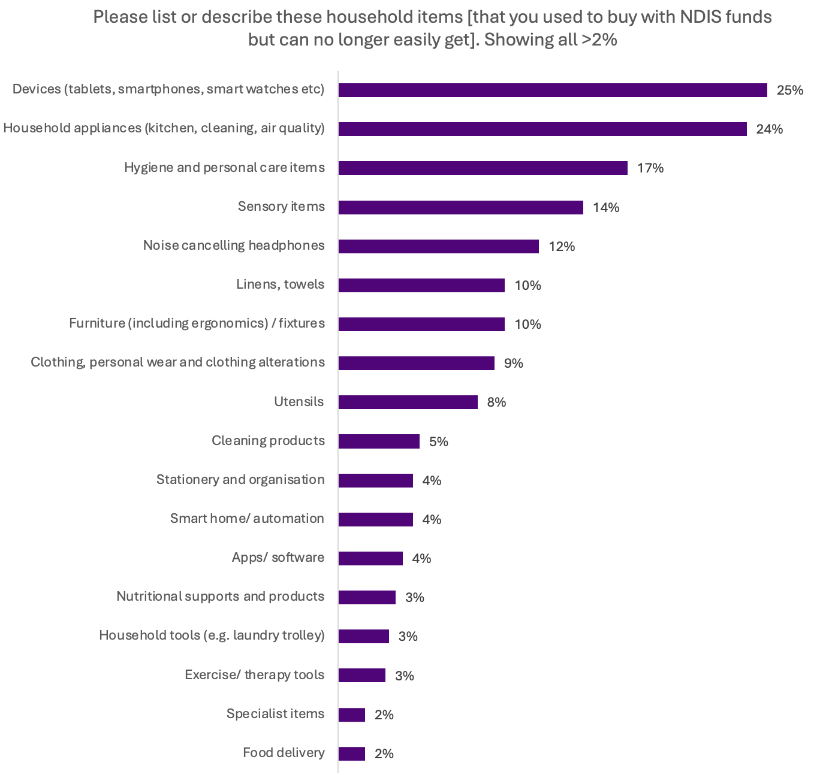
Figure 13 Base: All respondents who provided an answer (506)
Most responses mentioned previously being able to access everyday items through general retailers. Some of these included specialist items, such as industrial blenders and sheets for specialist beds. Responses often mirrored comments made in the previous question about products and services that respondents thought should be included in the list of NDIS supports but are not.
The most common items mentioned were:
- Smart devices - 1 in 4 responses (25%) mentioned smart devices (including tablets, phones and watches), computers, and other small devices such as timer displays, and including smart home and automation devices. They reported uses for devices included communication, supporting routine and regulation, and monitoring vitals and movement.
- Apps and software (4%), such as for communication and tracking diet and medication. A few also suggested internet and phone plans should be covered to allow for things like connecting to remote Auslan interpreters.
- Appliances - Responses often mentioned household appliances (24%). The appliances mentioned included:
  - kitchen appliances, such as dishwashers, induction hobs, Thermomix, and hot water dispensers
  - cleaning appliances, such as laundry machines and robot vacuums
  - appliances for air quality and temperature control, such as air purifiers and air conditioners.
‘Meal preparation items that would have managed falls risk, upper limb dysfunction and fatigue. For example a slow cooker or a food processor, to enable a person to cook for themselves without fear of standing at the stove and pulling things down, or losing digits.’ – survey response ID 44556, legal professional
- Hygiene and personal care products - Responses commonly mentioned hygiene and personal care products (17%). These included:
  - products needed specifically to address disability-related needs, such as incontinence products and wipes and personal protective equipment which are not excluded
  - particular versions of products such as soaps appropriate for sensory sensitivity
  - products needed in high volume because of disability, such as because of compulsive washing.
‘Continence aids never required a formal assessment before. I assure you that people aren't soiling themselves as a "rort".’ – survey response ID 44162, person with disability and family member or carer of a person with disability
- Sensory regulation tools - Responses continued to highlight the role of sensory regulation tools as disability supports (15%). This included noise cancelling headphones (12%).
‘Noise cancelling headphones can be an excellent low cost AT for someone with sensory sensitivities. Plan managers are reluctant to agree with their purchase.’ – survey response ID 44827, I am a family member or carer of a person with disability
- Furniture, fixtures and fittings - A number of responses (10%) mentioned home furnishings, such as chairs, beds and desks, fixtures, such as blinds and acoustic panelling, and fittings, such as adapted taps. This included ergonomic furniture and some specialist furniture. It also included sensory mats, bean bags and similar furnishings, exercise mats and non-slip mats.
‘Families have also been prevented from purchasing items used to set up a designated “calm corner” for emotional regulation, such as beanbags, sensory cushions, or low-arousal seating.’ – survey response ID 44283, family member or carer of a person with disability and a provider or work for a provider of services, items and equipment funded by the NDIS
- Linens and towels - A number of responses (10%) mentioned bedsheets and other linens and towels. This included:
  - specialised or customised products, such as waterproof bedding or sheets to fit specialist beds
  - appropriate products to meet sensory needs, including weighted blankets and sensory sheets
  - easy to use products for people with limited mobility or dexterity, such as towel hair wraps
  - products needed at higher volume, such as where frequent washing is required.
- Clothing and personal wear - Some responses (9%) mentioned access to appropriate clothing and other personal wear items such as shoes and hats. This included specialist items such as compression garments and orthotic shoes, as well as non-specialist items that are subject to especially high wear or damage or that meet sensory needs.
‘I have a client that rip staff clothing every day and they used to be able to pay for general clothing for the support workers (cheap k mart items) and replace these - but now it is meant to be the participants responsibility to pay for them every week - how is that fair and equitable’– survey response ID 44456, provider or work for provider of services, items and equipment funded by the NDIS
- Utensils - A number of responses (8%) brought up household utensils, particularly kitchen utensils. This included modified utensils such as cutlery, assistive items such as jar openers, tap turners and plastic straws, and specific types of utensils required by people with disability, such as electric can openers and lightweight items.
‘There are many low-cost kitchen gadgets that increase someone’s independence, safety and participation in cooking tasks. These get declined all the time saying they are everyday items.’ – survey response ID 44741, I am, or I work for, a provider of services, items and equipment funded by the NDIS
Other responses - Other items included, but were not limited to:
- stationary and other items used for personal organisation
- cleaning products
- household tools, especially where these support modified practice, such as clothes drying racks to use instead of clotheslines
- vitamins and supplements and non-prescription medications
- storage, such as for transporting specialist equipment or to provide security in shared living situations
- exercise equipment and other therapy-related equipment
- incidentals for support workers, such as toilet paper.
Submissions from both individuals and organisations also reflected the need to consider the inclusion of more household items. They specifically noted the exclusion of these items can impact independence, safety and participation of NDIS participants.
Organisations such as Australian Rehabilitation and Assistive Technology Association (ARATA), Deafblind Australia and Disability Council NSW called for a shift away from blanket exclusions of ‘mainstream’ items, recommending a functional benefit test and clearer guidance on what constitutes a disability-related household item.

Replacement supports process
The replacement supports process needs improving and simplifying. Respondents identified many items they said should be included on the replacement supports list. Many individuals and stakeholders also noted NDIS participants should have access to any of the things that:
- are recommended by professionals and experts to support their disability, including different types of therapies
- support people with disability to live a full life, including living independently.
Half of those who responded to the survey were aware of the replacement supports process (49%).
- 2 in 5 thought there were other types of supports that should be available as replacement supports (38%).
- Those with disability and disability advocates were the most likely to say there are other types of supports that should be available as replacement supports (49% and 51%, respectively).
Despite some awareness of the replacement supports process, the survey responses showed many participants find the replacement supports process needs simplifying—particularly for low-cost items.
Submissions from organisations also echoed this. They described the process as opaque, inaccessible and lacking review rights.
Organisations such as National Legal Aid, Illawarra Disability Alliance and Villamanta Disability Rights Legal Service suggested the documentation burden often exceeds the value of the item. The Justice and Equity Centre highlighted how the process penalises innovation and forces participants to give up existing supports even when replacements are inadequate.
Submissions consistently called for the process to be abolished or significantly reformed. Alternative proposals included having pre-clearance pathways, streamlined approvals for low-cost items, and greater trust in professional recommendations.

Replacement supports that should be available
Survey respondents were asked what supports that are not currently available as replacement supports should be available.
Almost 500 respondents provided a response for this question. There is a substantial amount of overlap between the supports suggested to be available as replacement supports and the supports that respondents say should be on the list of NDIS supports. The major difference is the most common responses to this question highlighted the need for the replacement supports process to allow more flexibility, so NDIS participants can access things which might be specific to their individual circumstances. This includes anything recommended by a qualified professional, anything which supports NDIS participants to live more independently, and anything that is a cost related to a participant’s disability.
The types of replacement supports respondents identified should be available included a wide array of supports, aids and equipment. The following categories recorded at least 5 responses:
- noise-cancelling headphones or earphones (10%)
- household appliances: (7%)
  - Robotic vacuums: n=12
- electronic communication devices:
- Smart phones or tablets: 6%
- Computers or laptops: 3%
- cooking appliances: (5%)
- Thermomix: n=8
- Blender: n=10
- Other cooking appliance (e.g. rice cooker): n=8
- assistive technology (AT) including smart devices:
- Smart watches or rings: 4%
- Smart home appliances or aids: 3%
- Low-cost AT/AT broadly: 3%
- Smart glasses or other glasses: 1%
- emotional regulation aids/tools (e.g. fidget aids) (4%)
- household aids including personal care items (e.g. grabbers, accessible toothbrushes, shavers) (4%)
- home security (2%)
- executive functioning support aids/tools (e.g. planner) (2%)
- sex or sexuality-related supports (1%)
- meal preparation (1%)
- massage or massage-related supports (1%).
There were also general categories for:
- anything recommended by a qualified professional (15%)
- anything related to a person’s disability (11%)
- anything that is an NDIS Support but is broken and requires replacement (1%).
Some of the items under ‘other’ included items that did not fit discretely into the identified categories. Instead, survey respondents identified that replacement supports could include:
- anything that requires an NDIS participant to pay significantly more than a person without disability
- anything related to individualised needs
- anything previously funded however now requires an upgrade
- anything previously funded by an NDIS plan.

Appendix 1. List of organisations who made a submission
- ALH Engineering Services
- Allied Health Professions Australia (AHPA)
- Amaze
- Anchorage Mentoring
- Animal Therapies
- Applied neuroscience society of Australia (ANSA)
- Assistive technology suppliers Australia (ATSA)
- Auslan Services
- Australian Association of Family Therapy
- Australian Association of Psychologists Inc (APPi)
- Australian Association of Social Workers (AASW)
- Australian community transport association (ACTA)
- Australian Human Rights Commission (AHRC)
- Australian music therapy association
- Australian Neurodivergent Parents Association (ANPA)
- Australian Physiotherapy Association (APA)
- Australian Psychological Society (APS)
- Australian Psychosocial Disability Collective (APDC)
- Australian Rehabilitation and Assistive Technology Association (ARATA)
- Australian Sign Language Interpreters and Translators Association (ASLITA)
- Autism Queensland
- Best Fit Disability Group
- Carers TAS
- Carers WA
- Cerebral palsy alliance
- Community Mental Health Australia
- Consumers of mental health WA (CoMHWA)
- Cri Du Chat support group Ltd
- Deafblind Australia
- Deafness forum Australia
- Dementia Australia
- Dietitians Australia
- Disability Advocacy Network Australia (DANA)
- Disability Council of NSW
- Disability Peoples Representative Organisations (DROs) joint submission
- Early Childhood Intervention Australia (ECIA) Victoria/Tasmania
- erma365
- Every Australian Counts (EAC)
- First 2 Care
- Health Coaches Australia and NZ Association (HCANZA)
- Hireup
- Illawarra Disability Alliance (IDA)
- Institute for Urban Indigenous Health (IUIH)
- Intellectual Disability Rights Service (IDRS)
- JFA Purple Orange
- Justice and Equity Centre (JEC)
- KIN Disability Advocacy for diverse communities
- M2M North Shore
- Massage & Myotherapy Australia/Australian Traditional-Medicine Society (ATMS)/Australian Natural Therapists Association (ANTA) joint response
- ME/CFS Australia
- Mental Health Australia
- National advocacy collective
- National Disability Service (NDS)
- National Legal Aid (NLA)
- National mental health consumer alliance
- NDIS Independent Advisory Council (IAC)
- Neurotherapy Clinic Victoria
- NT Public Guardian and Trustee
- Occupational Therapy Australia (OTA)
- Occupational Therapy Society for Invisible Disability (OTSi)
- Osteopathy Australia (OA)
- Outdoor Health Australia
- Parenting and Family Research Alliance (PAFRA)
- Parents of Deaf Children (PODC)
- People With Disability Australia (PWDA)
- Perth Brain Centre
- Physical Disability Council of NSW (PDCN)
- Pleasure Pixel
- Public Advocate SA
- Queensland advocacy for inclusion
- Queensland council of Social services
- Queenslanders with Disability Network (QDN)
- Rare Voices Australia
- Regional Autistic Engagement Network (RAEN)
- Sandtray Therapy Association of Australia
- Self Manager hub
- Service for the Treatment and Rehabilitation of Torture and Trauma Services – NSW (STARTTS)
- Settlement Services International (SSI)
- South West Autism Network (SWAN)
- Speak out advocacy
- Speech pathology Australia (SPA)
- Spinal cord injuries Australia
- Succeed Healthcare Solutions
- Summer Foundation
- Touching Base Inc
- Uniting Church (Vic and Tas)
- Verve OT
- Villamanta Disability Rights Legal Service
- Vision 20/20 Australia
- Vision Australia
- Western Australian Association for Mental Health (WAAMH)
- Whyalla Disability Peer Group
- Women with Disabilities Victoria (WDV)

Machinery of Government changes occurred during this time resulting in NDIS policy functions move from the Department of Social Services (DSS) to the Department of Health Disability and Ageing (DHDA). The public consultation was hosted on DSS platforms whilst transition and logistics were being finalised.
The list of what is an NDIS support is not exhaustive and is not intended to list everything that a participant may need.

