Consultation on NDIS Supports Rules (2025) – summary report
This is a summary of the consultation report.
The summary is available in Easy Read and Auslan versions.
More information on the consultation, including submissions is available on DSS Engage consultation page.
Acknowledgement of Country
The Department of Health, Disability and Ageing proudly acknowledge the Traditional Owners and Custodians of Country throughout Australia. We pay respect to those who have preserved and continue to care for the lands and waters on which we live and, work, and from which we benefit each day.
Introduction
In 2024, the Australian Parliament made changes to the National Disability Insurance Scheme Act 2013. These changes set the direction for how the NDIS will improve.
In October 2024, transitional rules were put in place for NDIS supports (section 10).
The Transitional Rules were informed by a consultation process in 2024 when more than 7,000 people provided their views on how the NDIS supports lists should work.
The transitional rules created 3 types of NDIS supports lists. These are:
- A list for Supports that are NDIS supports
- A list for Supports that are not NDIS supports
- A Replacement supports list.
These Rules now need to be updated. To update the Rules, we asked NDIS participants and the disability community about their experience of the lists of NDIS supports since they came into place.
This is a summary of the things people told us.
We have used the feedback from this consultation to make changes to the NDIS supports rules. We are seeking feedback on these changes through a public consultation during August-October 2026 via our Consultation Hub.

How we engaged
Between 16 June and 27 July 2025, a total of 1,791 individuals and organisations provided their feedback about the NDIS Supports Rules. They responded to a survey or made a submission. There were:
- 1,619 responses from individuals
- 172 organisational responses or submissions.
Before and during the consultation period, we also held workshops with disability representative organisations and disability advocates.
Who took part
People with disability made up about one-third (35%) of the responses we received in the survey.
Most other responses came from:
- a family member or carer of a person with disability (44%, 756 responses)
- providers of services, items and equipment funded by the NDIS (38%, 647 responses).
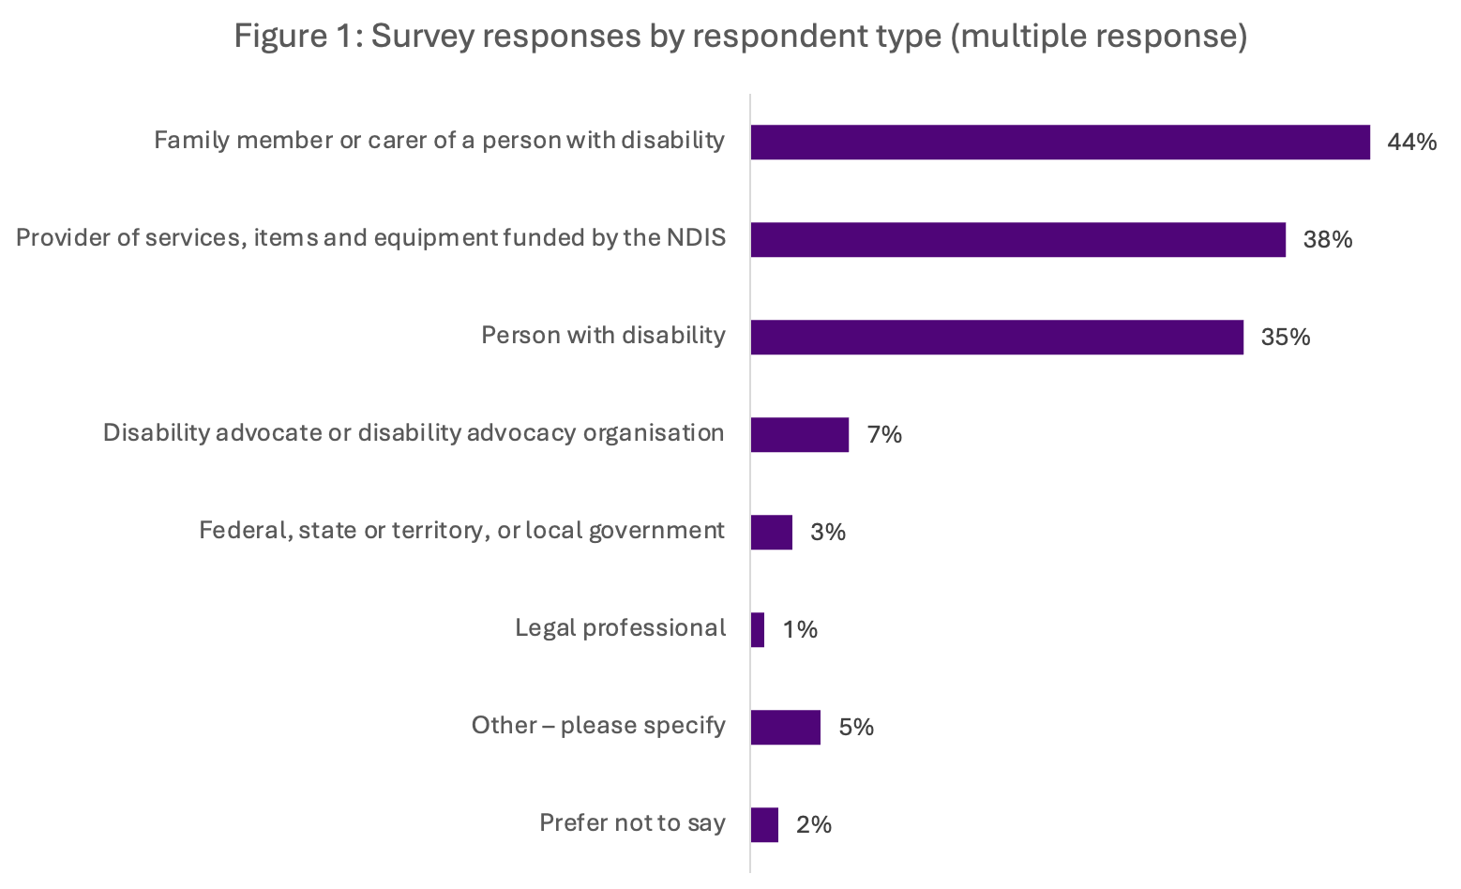
Figure 1 Base: All respondents (1,703)


What we heard
We heard that further work is needed to make the lists more helpful for NDIS participants, their families and carers. People suggested changes to how the Rules are implemented should aim to improve the clarity and ease of use of the lists.
The consultation feedback highlighted the following ways that the lists could work better in practice:
- More consistent information, advice and support. NDIS participants, families and carers reported people and organisations who support them interpret the lists and the items that are ‘in’ and ‘out’ in different ways.
- Clearer and more accessible guidance about how to use the lists
- Ensuring the lists still allow participants to get specific supports, products and services important to their lives. This includes things that help them to achieve their goals.
- Simplifying the process for the replacement supports so people have timely access to the support they need.
Some stakeholders suggested that the lists needed to be more inclusive and recognise cultural supports needs. For example, for people in regional, rural and remote areas, people who have multiple or co-occurring disabilities or intersecting factors, and/or who have complex needs.

Main findings
The following outlines the findings from the survey and things that people said might help to improve the NDIS Supports Rules.

There is high awareness of the NDIS supports lists. But the lists need to be easier to use so people can know what they can use their NDIS funds on.
Awareness of the NDIS Supports Rules, and the supports lists is high.
- 72% of people knew about the NDIS Supports Rules and 76% knew about the NDIS supports lists.
- Just over half of people with disability (56%), and just over half of families and carers (54%), had used the NDIS supports lists to find out what NDIS funds can or cannot be spent on.
But feedback also showed more could be done to make the lists helpful for people.
- Among those who had used the lists, only 15% said it’s easy to understand what can be funded and 68% said it’s hard.
  - People with disability are least likely to find the lists helpful. Only 35% said they are helpful and 46% said they are unhelpful.
To make the lists more helpful, people suggested the lists need to be:
- clearer guidance which is easier to understand
- more specific about what can be claimed, including giving examples of the products and services included in each list
- provided in plain English and more accessible formats.
Some people suggested the NDIS Supports Rules should allow for more flexibility so people can get different types of supports based on what they need to live a full life.

People understand the lists differently. This includes what the supports and items in the lists mean.
People said the NDIS supports lists are not always understood or interpreted in the same way.
- 3 in 4 respondents had experienced or heard about situations where people understood the NDIS Supports Rules differently (77% of all respondents).
We heard there is a need for greater clarity between the ‘in’ and ‘out’ lists. Some people said the lists seem to apply in different ways to different people.

The NDIS supports lists need to be updated regularly to cover the different types of evidence-based products and services people need now and in the future.
Lots of people agreed the lists should be updated regularly and be more flexible in what they cover. They said this would help make sure people with disability get the supports and items they need now and in the future.
- More than half of respondents (58%) said there are currently products that should be available but are not on the NDIS supports list.
- 41% of respondents said there are currently services that should be available but are not on the NDIS supports list.

The replacement supports process needs improving and simplifying.
People noted that when something is funded as a replacement support, it shouldn’t take away from having other support. For example, funding for a support worker. Participants often need to maintain this support to use a product, device or household item.
People identified many items they said should be included on the replacement supports list. They noted that people with disability should have access to any of the things that:
- professionals and experts recommend will support their disability, including different types of therapies
- support them to live a full life, including to live independently.


Other key themes of feedback

A principles-based approach to the lists
Some people, and organisations, said having prescribed lists is not in line with the NDIS principles of choice and control. Some suggested a principles-based approach to the lists would be better to guide and set out what is appropriate to spend NDIS funds on.

Improving the way the lists are structured and communicated
People want better guidance, clarity and communication about the different categories and items in the NDIS supports lists. This would improve consistency in the way they are interpreted. Stakeholders also suggested better training for NDIA staff and others to understand how to apply the lists.

Everyday items
We heard people want everyday items on the NDIS supports lists when they serve disability-related need. This included items such as smart devices and household tools.

Communication about NDIS supports list decisions
People said communication about decisions for what is approved and not needs to be clearer and more transparent. This included when the NDIS supports lists are updated and how decisions by NDIA staff are made about NDIS supports.

Co-designing with people with disability
We heard people want more co-design on the way the Rules are introduced, especially with people from marginalised groups, to ensure the Rules reflect lived experience.

The need for disability supports and services to work with other systems
People told us that we need to make sure disability supports and services work with other systems like health, education and housing.

