BONDED RETURN OF SERVICE SYSTEM (BROSS)
Participant User Guide Career Phases
August 2026

Reporting requirements
As a Program participant, you are responsible for keeping your BRoSS record up to date with certain career milestones, called Notifiable Events.

Notifiable Events
The career milestones you need to report on are detailed in section 15 of the Health Insurance (Bonded Medical Program) Rule 2020. You must meet the reporting requirements within a year of each Notifiable Event. We recommend you log into BRoSS annually to ensure that you are meeting your reporting requirements.

Updating your Student Phase
You must update BRoSS with any change which impacts on the completion time of your course of study in medicine. Evidence must be from the university confirming the change and include:
- your full name
- date of the evidence
- date on which the change takes effect
- confirmation of the medical course semesters you were enrolled in (regardless of pass/fail).
If you do not have a document from your university confirming this, you may provide a statutory declaration that includes this information.
You can update your ‘Student’ phase with your medical course completion information from your dashboard by clicking on the ‘Student’ button under the ‘Program timeline’.
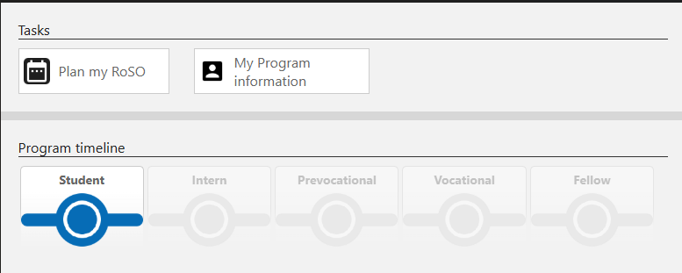
The ‘Student’ accordion will open. Click the ‘Advise’ link on the ‘Completion of medical course’ tile.
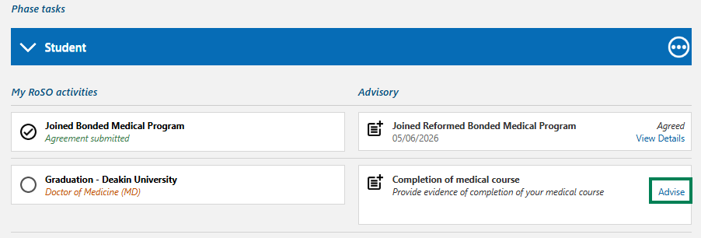
In the ‘Advisory: Completion of medical course’ complete the mandatory orange fields, upload your evidence and click ‘Submit’.
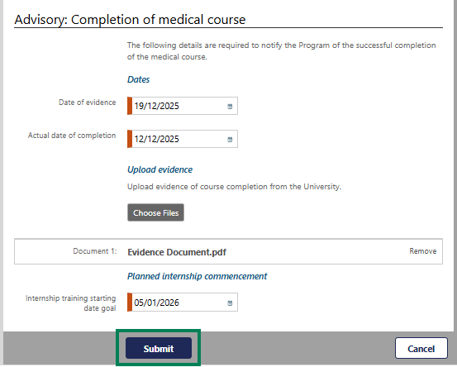
Your ‘Student’ accordion will change to green with a tick and the ‘Intern’ accordion will now be blue, indicating that this phase is now active.
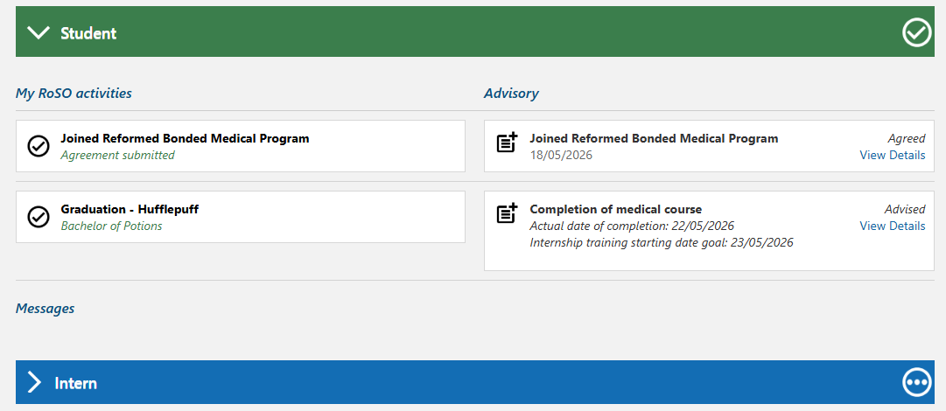

Entering your Internship Information
You can update your ‘Intern’ phase with your internship details from your dashboard by clicking on the ‘Intern’ button under ‘Program timeline’. Internship and vocational training sections also have planning dates set. If your plans change, review your record, and amend your planned start or finish date as required.
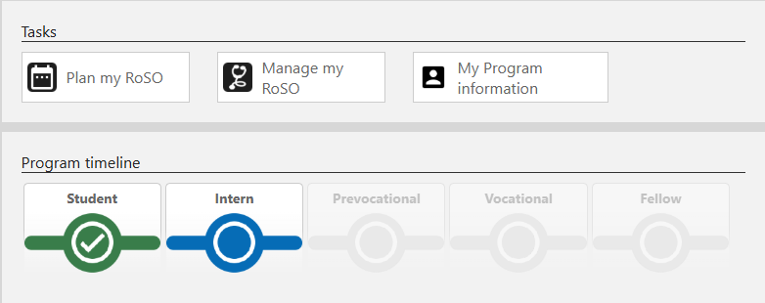
The ‘Intern’ accordion will open. Click the ‘Advise’ link on the ‘Commencement of internship’ tile.
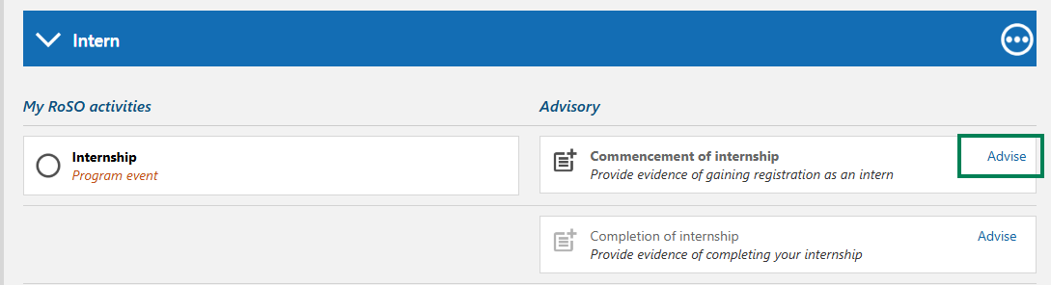
In the ‘Advisory: Commencement of internship’ complete the mandatory orange fields and click ‘Submit’.
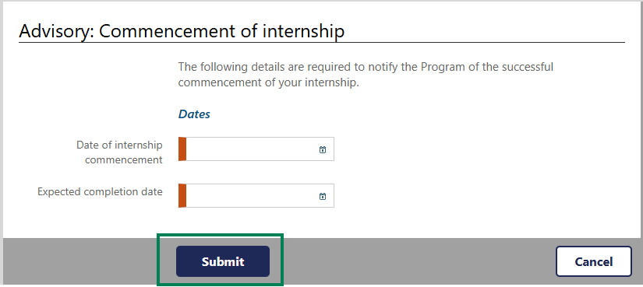

You will be taken back to the ‘Manage my RoSO’ page, there will now be three dots next to the event title that indicate your internship is activated.
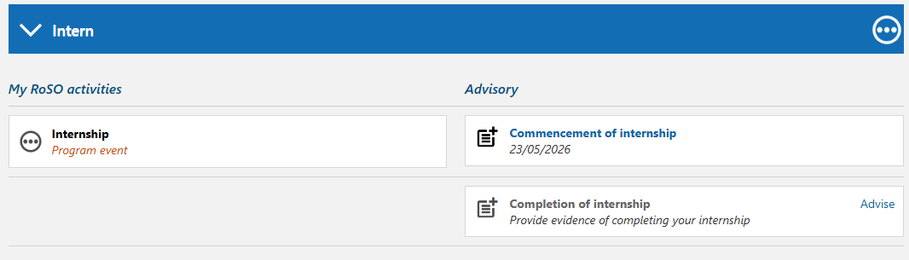

Completing your Internship Phase
On completion of your internship training, you will need to update the ‘Intern’ phase from your dashboard by clicking on the ‘Intern’ button under ‘Program timeline’.
Click the ‘Advise’ link on the ‘Completion of internship’ tile.
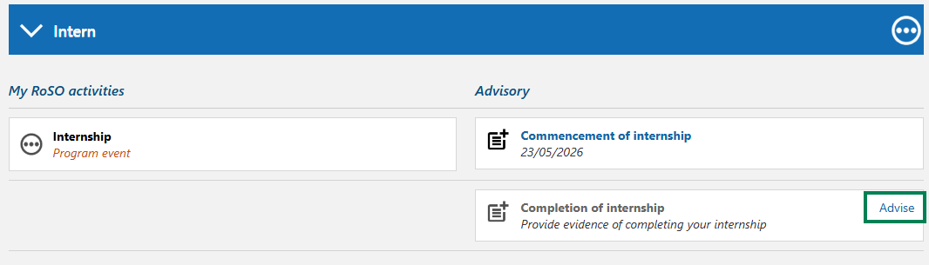

Enter your ‘Date of internship completion’ and then your ‘Vocational training starting date goal’, which is the date that you think you will commence training with your specialty college. This date can be updated at any time.
Please note, if you do not intend to undertake vocational training, enter a date that falls after your Program completion date to avoid receiving automated reminders.
Click ‘Submit’ once completed.
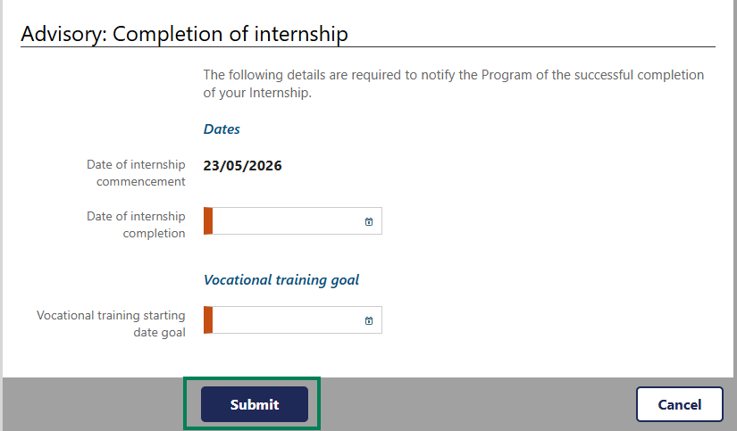
Your ‘Manage my RoSO’ page will now show your ‘Intern’ accordion as green with a tick and your ‘Prevocational’ accordion as blue to indicate this phase is now active.
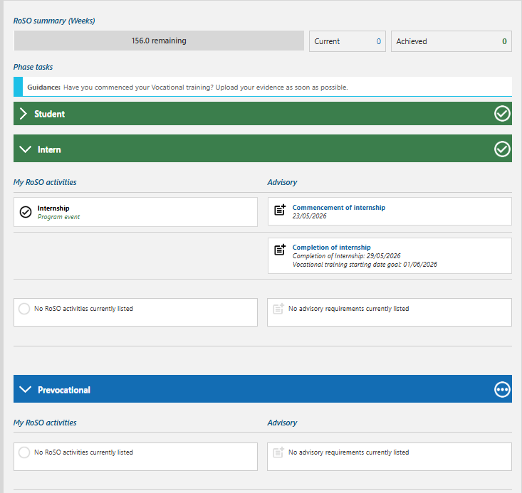

Updating your Prevocational training Phase
There are no notifiable event tiles under your ‘Prevocational’ phase, however, any RoSO you commence from your internship completion date will show under this accordion.
To view or update your Prevocational’ phase information, from your dashboard, click on the ‘Prevocational’ button under the Program timeline.
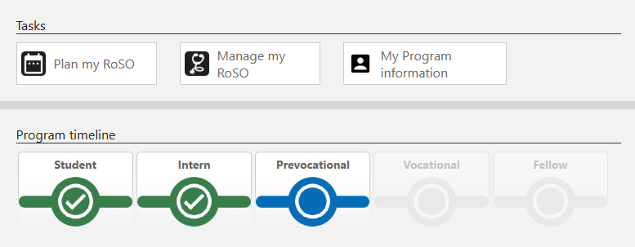

Commencing your Vocational Phase
To update your ‘Vocational’ phase with your training college details, from your dashboard, click on the ‘Vocational’ button under the Program timeline.
When you start vocational training, additional RoSO locations may become eligible for you. You need to enter your vocational training details so BRoSS can assess whether a location is eligible for you.
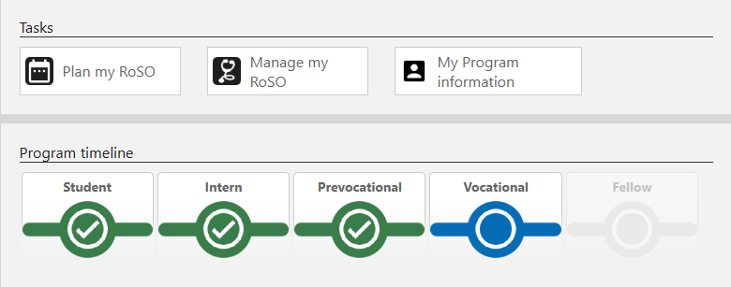
The ‘Vocational’ accordion will be greyed out until you ‘Advise’ of your ‘Commencement of vocational training’ by clicking on the ‘Advise’ link.
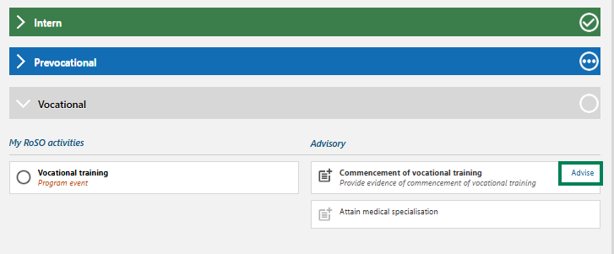
In the ‘Advisory: Commencement of vocational training’ page, complete all mandatory orange fields and upload evidence from the medical college that you have enrolled in to undertake vocational training. Evidence must include:
- date of commencement of vocational training
- anticipated date of completion
- name of the medical college
- type of specialisation.
If you are unable to provide a document with this information, you may provide it in a statutory declaration.
Click ‘Submit’.
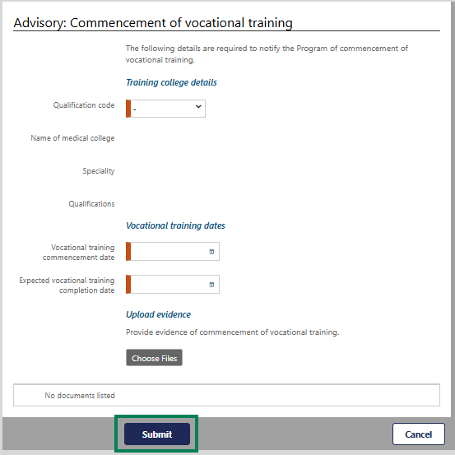

Once completed, the accordion will change to blue as it is now your current phase.
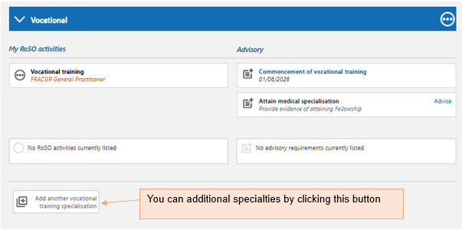

Attaining Fellowship – Completing your Vocational Phase
To update your ‘Vocational’ phase with your fellowship details, from your dashboard, click on the ‘Vocational’ button under the Program timeline.
Under the ‘Vocational’ accordion, click on the ‘Advise’ link on the ‘Attain medical specialisation’ tile.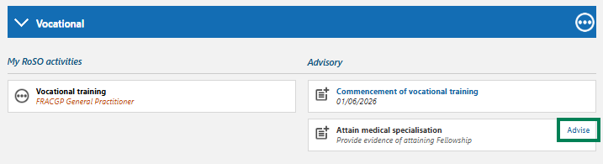

The ‘Advisory: Attain medical specialisation’ page will open. Enter the date you attained Fellowship and upload evidence from your medical college which must include:
- name of the bonded participant
- name of the medical college
- type of specialisation
- date the specialisation was attained.
If you are unable to provide a document with this information, you may provide a statutory declaration.
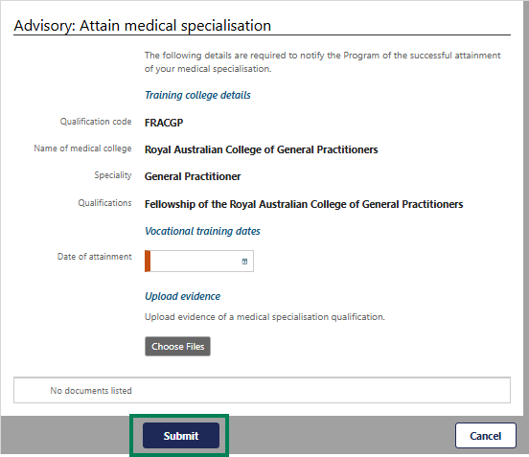
Click ‘Submit’.

Your ‘Manage my RoSO’ page will update so your ‘Vocational’ phase will now be green, and your ‘Fellow’ phase will be blue. If you are undertaking a dual specialty, you can add a second vocational training specialisation.
To do this, under your ‘Vocational’ or ‘Fellow’ phase accordion, select ‘Add another vocational training specialisation’.
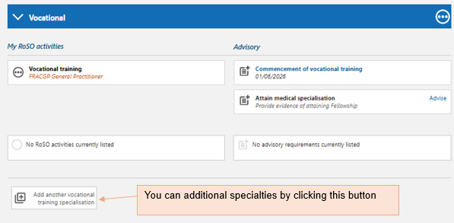
Once you begin training for your second specialty, you will need to ‘Advise’ your Commencement of vocational training as you did for your first specialty and click ‘Submit’. Both specialties will now appear on your record.
Locations that are eligible under your second specialty may require you to lodge a location override request. Refer to the BRoSS Participant User Guide – Return of Service Obligation (RoSO) for guidance.

RoSO scaling
A scaling discount may reduce your RoSO by up to 6 months if you meet the requirements set out under section 14 of the Rule.
For scaling to be applied you must have:
- attained fellowship
- completed 104 weeks (2 years) of your RoSO on a full-time basis in locations classified as MM 4-7 (this service does not need to be continuous and can include multiple RoSO events).
After completing the required 104 weeks, any further full-time RoSO in MM 4-7 locations will accrue a scaling discount equal to the time served (for example, one week worked = 2 weeks RoSO).
Please note, if you have opted into the Program from a legacy scheme, any RoSO credited as prior service will not contribute to the scaling benefit.

