BONDED RETURN OF SERVICE SYSTEM (BRoSS)
Participant User Guide
Exceptional Circumstances Requests
August 2026

Submitting a Request for Exceptional Circumstances
You, or your legal personal representative if you are unable to make an application, may apply to the Secretary for a determination that exceptional circumstances apply in relation to your Bonded Medical Program (Program) obligations.
Your application must:
- be made in writing,
- set out the exceptional circumstances that either:
  - prevented you from complying with the requirement to complete your RoSO within the period allowed under section 124ZG(1)(c) of the Health Insurance Act 1973 (Act),
  - caused you to breach the requirement to complete your RoSO within the period allowed under section 124ZG(1)(c) of the Act, or
  - resulted in you withdrawing from the Bonded Medical Program under section 124ZP of the Act; and
- be accompanied by sufficient evidence and documentation to enable the Secretary to make an informed decision.
Your application will be reviewed by the Secretary or their delegate, and you will receive written notice of the determination.
For more information about making an application for an exceptional circumstances determination, refer to Subsection 124ZEA of Part VD of the Health Insurance Act 1973.
To request an exceptional circumstances determination, expand the ‘Manage my agreement’ accordion on your BRoSS dashboard and click on the ‘Exceptional Circumstances’ button.
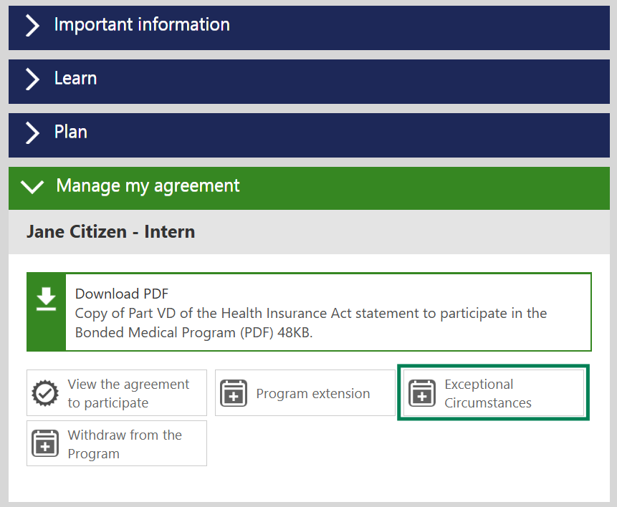
Click the ‘Request’ button in the ‘Exceptional Circumstances’ accordion.
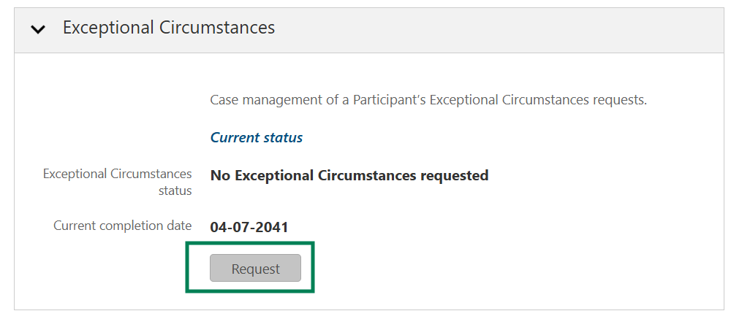

The ‘Request: Exceptional Circumstances’ page will open. To activate the ‘Submit Request’ button, you must first upload evidence to support your request.
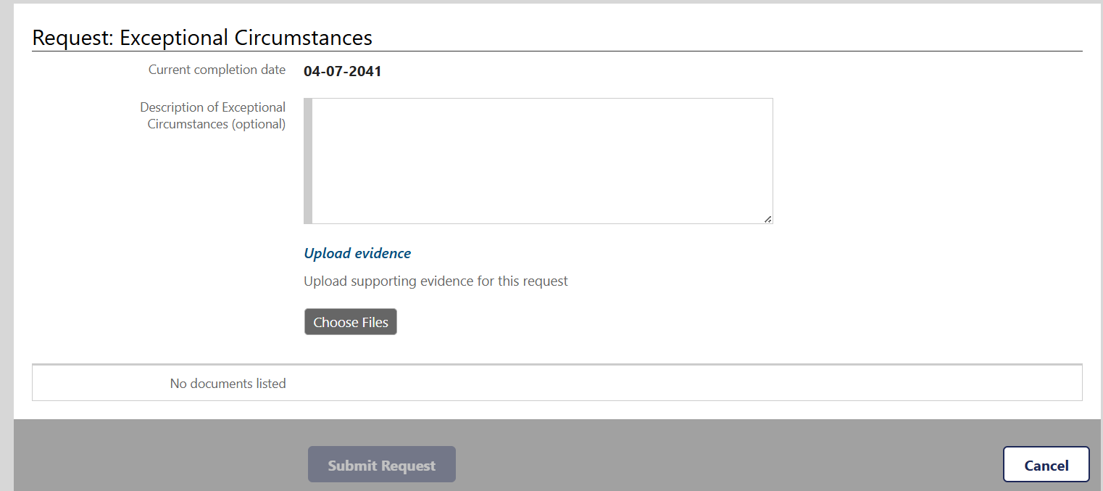
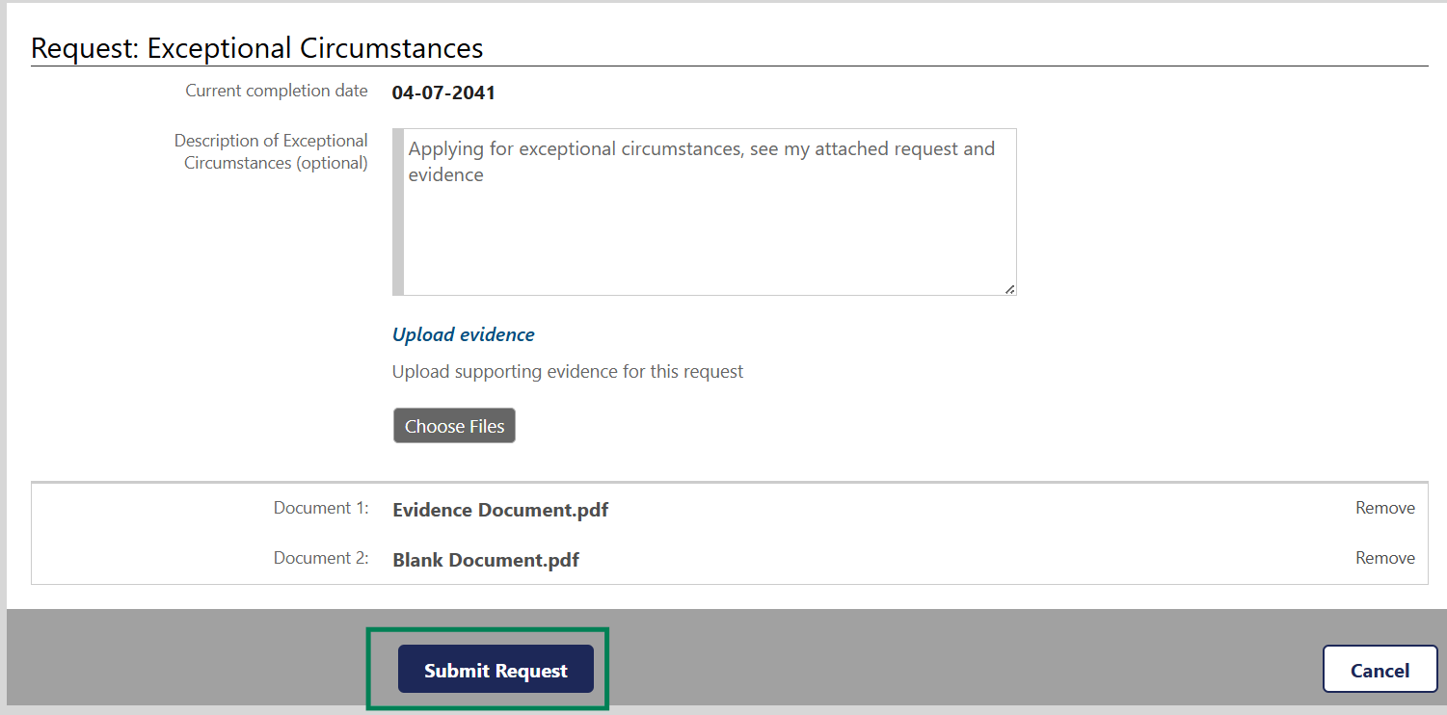
In addition to the documentation that evidences your exceptional circumstances, we recommend you include a statutory declaration outlining all work completed since graduation with your evidence.
Click the ‘Submit Request’ button.

Your ‘Exceptional Circumstances’ accordion will update to ‘Pending’ status.
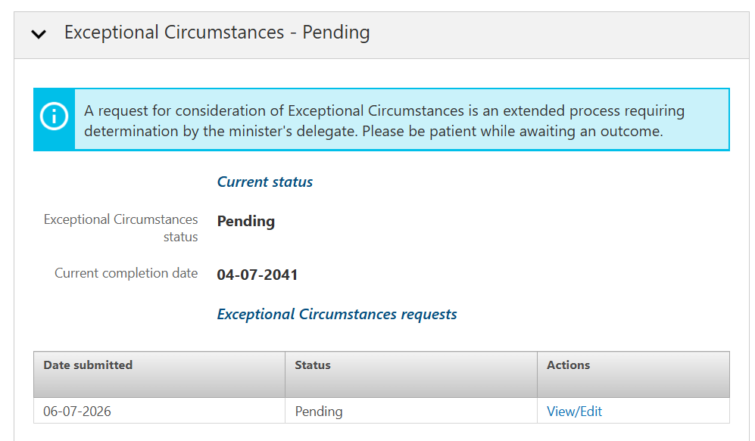
You can view or edit your request at any time from either your dashboard via the ‘Manage my agreement’ accordion or the ‘My Program information’ button. Clicking on the ‘View/Edit’ button will enable you to view or edit your request.
We will review your request, and you will be contacted by email if additional evidence is required, or when a determination has been made.

