BONDED RETURN OF SERVICE SYSTEM (BRoSS)
Participant User Guide
Withdrawing from the program (Intern – Fellow)
July 2026

Withdraw from the Program
Once you are a participant in the Bonded Medical Program (Program) you can withdraw at any time. If you have not yet graduated, see the ‘BRoSS Participant User Guide - Withdrawing from the Program - Student’.
If you are a former Medical Rural Bonded Scholarship (MRBS) Scheme participant, you will no longer face the 6-year Medicare ban if you withdraw from the Program or do not complete your Return of Service Obligation (RoSO) within 18 years of graduating from your medical course. However, you will still need to repay the cost of your scholarship.
The following withdrawal process is for all Program participants in the Intern to Fellow Phase.

Requesting a withdrawal repayment estimate
You can request a ‘Withdrawal Repayment estimate’ from the ‘My dashboard’ page by opening the ‘Manage my agreement’ accordion.
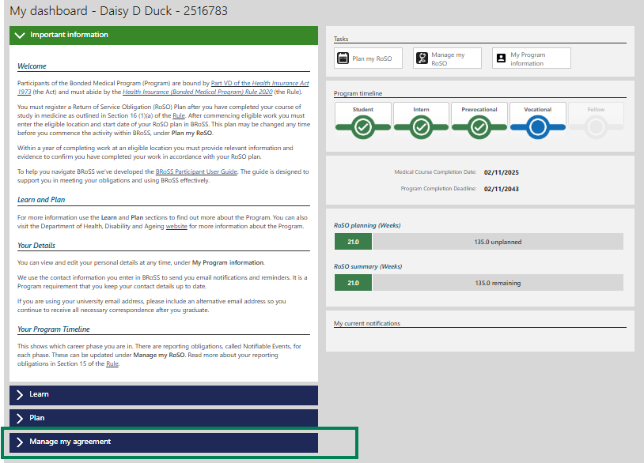

The ‘Manage my agreement’ accordion will open. Click on the ‘Withdraw from the Program’ button.
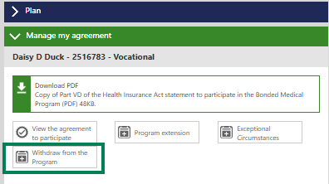
The ‘Estimate: Withdraw from the Program’ page will open. Enter the ‘Proposed withdrawal date’ and click ‘Next’.
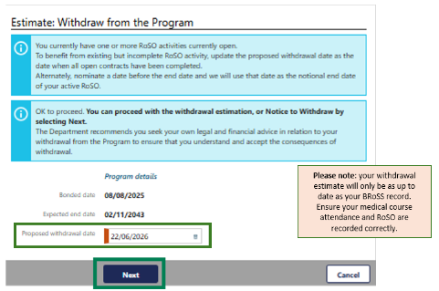

In the ‘Estimated: Withdraw from the Program’ page, you can download a ‘Repayment estimation report’ that contains information about your withdrawal. Once you have reviewed the report, click ‘Close’ to return to the ‘My dashboard’ page.
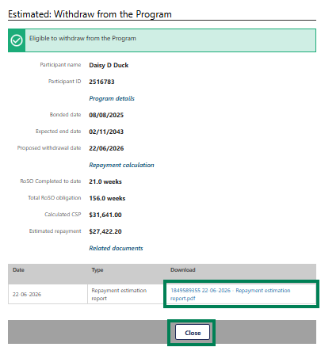
If you would like to continue with your withdrawal request or get an updated withdrawal repayment estimate, open the ‘Manage my agreement’ accordion from your dashboard and click on the ‘Withdraw from the Program’ button.

The ‘View: withdraw from the Program’ page will open. There are two options available on this page:
- click on the ‘Re-estimate’ button to get a new withdrawal repayment estimate, or
- click on the ‘Withdraw’ button to continue with your withdrawal, which will take you to the ‘View: Withdraw from the Program’ page.
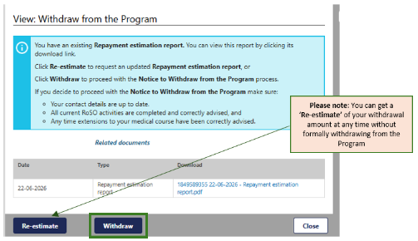
After clicking on the ‘Withdraw’ button, a pop-up ‘Warning’ will show. Click ‘OK’ to continue with your withdrawal.
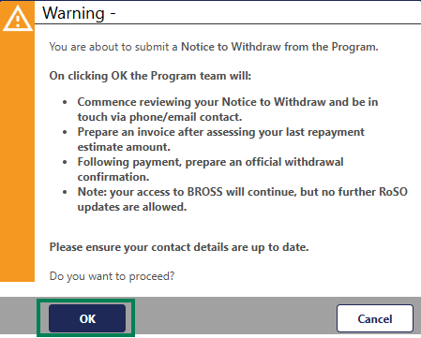

You will get an error message if any of your RoSO events have not been completed and you will not be able to submit your ‘Notice to Withdraw’ until the error reason has been managed.
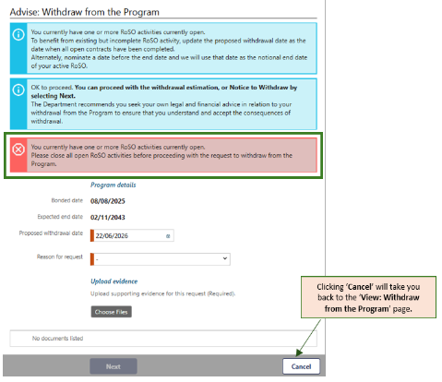
Once your RoSO activities are all completed, the ‘Next’ button will be activated allowing you to proceed with your withdrawal.
Select your ‘Reason for request’ and click ‘Choose files’ to upload your evidence, then click ‘Next’ to submit the request.
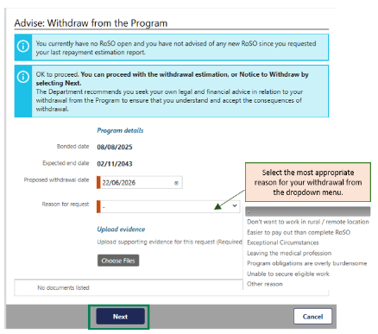
If you select ‘Other reason’ you will be required to provide additional information in the new field.
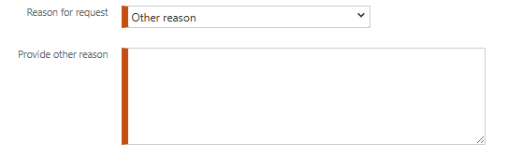
If applicable to your circumstances, you may also apply to the Secretary for a determination that exceptional circumstances apply and are preventing you from meeting your Program obligations. Section 124ZEA of the Health Insurance Act 1973 outlines the requirements for an Exceptional Circumstances Determination. To submit an Exceptional Circumstances request, refer to the BRoSS Participant User Guide – Exceptional Circumstances.

After clicking ‘Next’, the ‘Advised: Withdrawal from the Program’ page will show as ‘Eligible to withdraw from the Program’ which means your ‘Notice to Withdraw’ has been submitted to the department for assessment.
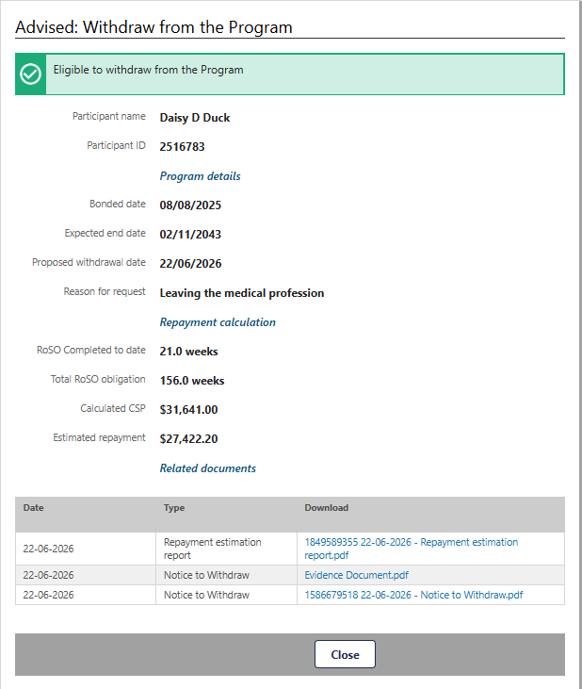
Your withdrawal request will be reviewed, including any RoSO events and evidence and you will be contacted if additional information or evidence is required. You will be provided with an invoice when your withdrawal request has been processed.
To cancel your withdrawal request, please email the BondedMedicalProgram@health.gov.au providing your details and the reason of cancellation.

