BreastScreen Australia Strategic Framework
All Australian governments have agreed to a national Strategic Framework to strengthen BreastScreen Australia (BSA). Built on the BSA Review findings, the Strategic Framework sets staged, actionable steps to deliver improved and modernised breast cancer screening services and better health outcomes.

Top Priorities
Two top priorities have been identified by all Australian governments to focus initial implementation, including:
- Increase participation and equity in access – particularly among under screened populations
- Progress toward risk-stratified screening through evidence-led, staged change

Enablers
Strong governance and a committed workforce will be critical to successful implementation. Future funding models, and increased funding transparency, will also be explored to support long-term sustainability and innovation. All Actions in the Strategic Framework require funding and resources, which all governments will consider as part of implementation.
Commitment
Endorsed by all governments; reforms will proceed using a learning health system model to ensure safe, equitable, and effective change.

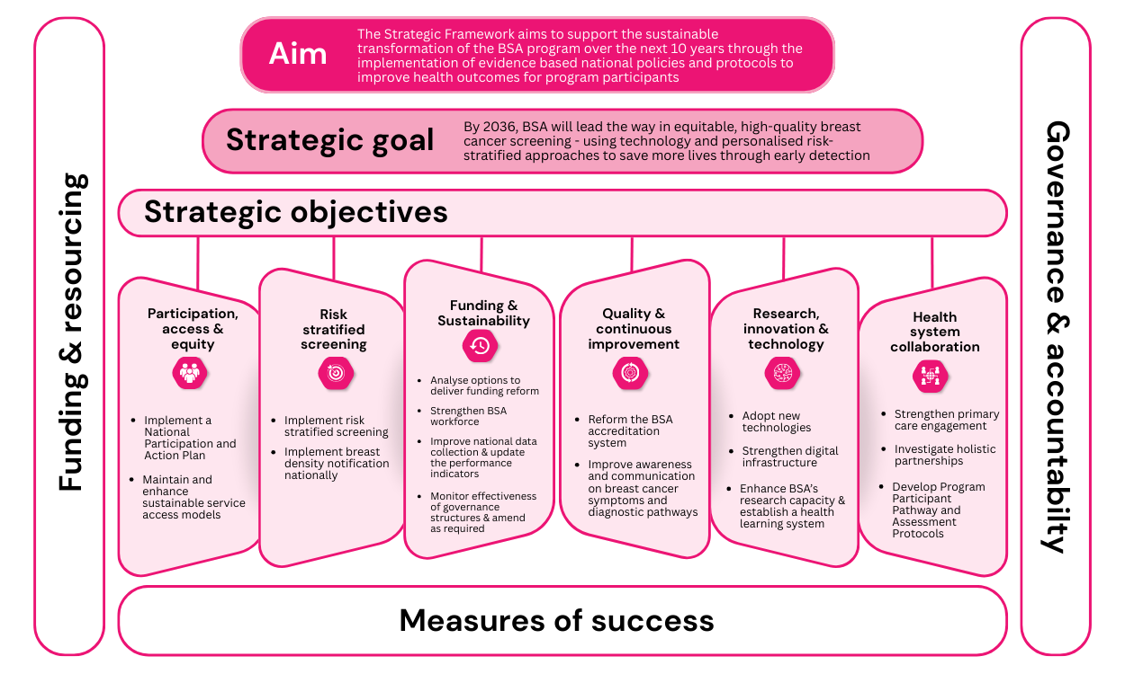

 | Actions | Timeframe
 | Actions | Short | Medium | Long
Participation, access & equity | Incrementally increase participation rates to ensure equity and sustainability | - Continue successful participation initiatives and share learnings.  - Develop national participation strategies | - Implement participation strategies, with a focus on under screened groups  - Pilot sustainable access models. | - Sustain and refine participation strategies.  - Evaluate strategy and implement access models.
Participation, access & equity | Improve accessibility through implementing more sustainable service access models
Risk stratified screening | Implement risk-stratified screening pathways | - Implement two-tiered risk pathways (average and high). | - Pilot a risk assessment tool and new screening pathways for different risk categories. | - Evaluate pilots and implement refined risk stratification pathways.
Funding and sustainability | All Australian governments agree to future cost-shared funding arrangements | - Develop cost-sharing principles and explore funding options.  - Update BSA Workforce Demand Report and invest in training.  - Expand national dataset and refine performance indicators.  - Clarify governance roles. | - Implement new funding options as needed.  - Update Workforce Demand Report and invest training.  - Enhance performance monitoring.  - Review governance. | - Monitor funding needs and adjust as required.  - Update Workforce Demand Report and invest training.  - Revise performance monitoring and governance as necessary.
Funding and sustainability | Build and sustain a skilled BreastScreen Australia workforce to meet current and future demand
Funding and sustainability | Expand the national data collection and update the performance indicators.
Funding and sustainability | Monitor the effectiveness of governance structures and amend as required.
Quality & continuous improvement | Redesign and implement a modernised BSA quality and safety system. | - Develop Quality and Safety Framework and National Standards.  - Consider outcomes from recent reviews to improve diagnostic access and pathways. | - Implement Quality and Safety Framework and Quality Improvement Program.  - Work with services to improve diagnostic access and pathways. | - Evaluate Quality and Safety Framework and Quality Improvement Program and refine as required.
Quality & continuous improvement | Improve diagnostic access for symptomatic women.
Research, innovation & technology | Invest in new technologies | - Undertake tomosynthesis feasibility analysis.  - National stocktake of digital systems.  - Invest in in-program research. | - Implement AI and tomosynthesis nationally.  - Invest in improved digital systems.  - Invest in in-program research. | - Ongoing review of evidence, in-program trials and implementation of new technologies, as evidence is available.
Research, innovation & technology | Build and optimise digital systems to support innovation, data sharing and future-ready screening services
Research, innovation & technology | Build and expand BSA’s research capability to drive innovation and evidence-based practice
Health system collaboration | Develop and implement stronger partnerships with GPs to improve participation and referral pathways. | - Enhance GP engagement initiatives.  - Develop national clinical assessment protocols. | - Embed GP engagement initiatives.  - Pilot partnership initiatives.  - Implement national clinical assessment protocols. | - Evaluate GP engagement initiatives.  - Embed partnership initiatives.  - Update national assessment protocols in line with current evidence.
Health system collaboration | Identify and establish integrated partnerships with other health services to improve overall consumer health outcomes.
Health system collaboration | Standardise and optimise participant pathways and assessment protocols across all jurisdictions.

