
Better thinking. Better advice. | healthconsult.com.au

Department of Health and Aged Care
  - BreastScreen Australia Review Workstram 4 - Final Report (Summary)

BreastScreen Australia Review Workstram 4 - Final Report (Summary)
29 April 2025

Disclaimer
HealthConsult has indicated within this report and all other deliverables the sources of the information provided. All reasonable precautions have been taken by HealthConsult to verify the information referenced in this report. However, the published material is being distributed without warranty of any kind, either expressed or implied.
This report has been prepared at the request of the Department of Health and Aged Care in accordance with the terms of our contract for this work.

Contents
Executive Summary 1
1. Introduction 4
2. Key findings 9
3. Recommendations 11
4. Next steps 13
Appendix A Acknowledgements 14
Appendix B Abbreviations and terminology 16

Executive Summary

The program
The BreastScreen Australia (BSA) Program aims to reduce morbidity and mortality from breast cancer through an organised, systematic approach to early detection using screening mammography. The program targets women aged 50 to 74 years, as evidence indicates this is the age group where mammography screening is most effective. Women aged 40 to 49 years and 75 years and older are also eligible for free mammograms but do not receive invitations as the evidence for effectiveness is less certain.
Since its inception in 1991, BSA has contributed to improved breast cancer outcomes including better detection, lower death rates, and improved 5-year survival rates from breast cancer.

The BSA review
From late 2023 to mid-2025, the Australian Government worked with states and territories to review BSA, aiming to shape the program's direction for the next decade. The recommendations focus on keeping the program evidence-based, consistent across Australia, and accessible to more people. They also seek to improve the screening experience, make services more efficient and effective, and ensure stable funding for the future.

What the review found
The review found that BSA provides free high quality breast cancer screening services, but fewer people take part than planned. About half of eligible women get screened, well below the 70% target. Some groups, including Aboriginal and Torres Strait Islander women, women who speak languages other than English, those in remote areas, and women from low-income backgrounds, are even less likely to take part. Mobile services help but some services face challenges with scheduling and equipment.
The review identified significant strengths of the BSA program worth preserving:
- its trusted national brand providing free, high-quality screening without referral requirements
- mobile screening vans creating vital connections in rural communities
- digital innovations improving accessibility through online booking and text message reminders
- culturally sensitive approaches including multilingual support and all-female service delivery
- high professional standards maintained by expertly trained radiographers and radiologists.
Figure 1 showcases innovative approaches from states and territories across Australia, demonstrating the program's commitment to continuous improvement.
Figure 1: Quality initiatives from across the country
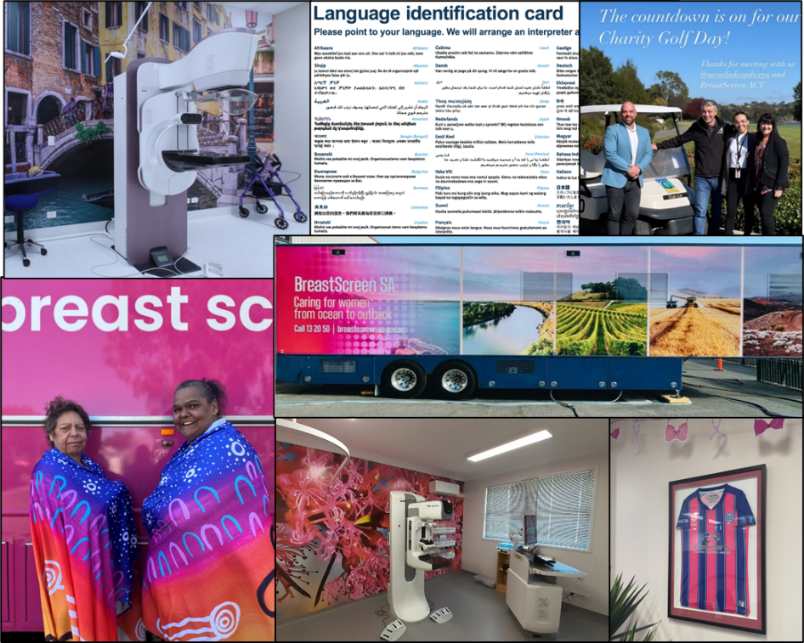
Source: Case study from Workstream 2 Quality and Safety report. Photos from BreastScreen ACT, NSW, NT, QLD, SA, VIC and WA. Bottom left image: L-R: Ann Lister, Gunditjmara & Louise Wackett, Gunditjmara, Djab Whurrung & Gilmory at the Kirrae Beautiful Shawl Project Visit. Artwork by Jess Chatfield, Gunditjmara, Djab Whurrung
However, there were also findings which identified areas for improvement, including:
- there are differences in how screening services are provided across Australia, causing inconsistencies in service delivery
- more is known about people's individual risk of breast cancer, which could inform personalised screening approaches
- clearer guidelines and better use of modern technology, such as 3D screening (tomosynthesis) and artificial intelligence (AI) are needed
- the need for BSA to work more closely with GPs and other health providers.
Finally, the review identified practical challenges such as cost-related barriers to participating (travel, childcare, lost work time), consumer expectations for faster results, more convenient appointment times, and services closer to home. Issues with funding constraints, staff shortages, outdated data systems, and resource intensive quality accreditation also limit BSA's ability to adapt. Addressing these will require clearer guidelines, sustainable funding, stronger leadership and improved research.

Summary of recommendations
Figure 2 proposes five key recommendations to address the review findings.
Figure 2: High level overview of BSA review’s recommendations
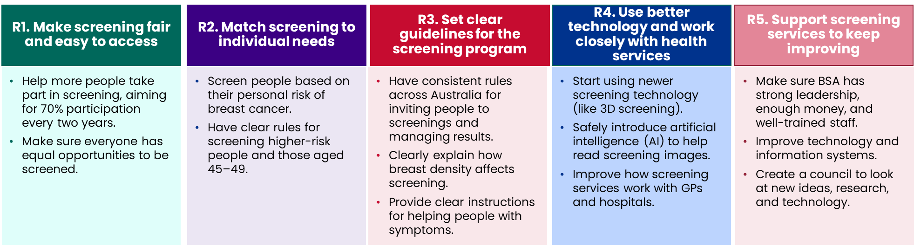

How will improvements and changes to the BSA program be made?
A draft BreastScreen Strategic Framework will be finalised to guide improvements to BreastScreen Australia over the next 10 years (2025–2035). The Framework outlines all recommendations and suggests when these changes could happen. Many of these recommendations are connected, so careful planning and collaboration are important.
To make change happen, clear leadership and ongoing consultation processes will be set up, including experts, consumers, and representatives from across Australia. This Framework will be approved by all Australian Governments through the Cancer and Population Screening Committee and Health Chief Executive Forum.

Introduction

Breast cancer
Breast cancer is the most diagnosed cancer other than skin cancer among females in Australia. Age represents the greatest risk factor, with over three-quarters of breast cancers occurring in women aged over 50.
The impact of BSA since its launch in 1991 has been substantial:
- improved detection of breast cancer cases in women 50-74 through screening
- reduction in the age-standardised mortality rate from 74 deaths per 100,000 in 1991 to 37 deaths per 100,000 in 2022
- improved 5-year survival rates: rising from 79% (1991-1995) to 92% (2016-2020).²
Despite these improvements, significant disparities persist:
- Aboriginal and Torres Strait Islander women experience 37% higher mortality rates despite 7% lower incidence, and lower 5-year breast cancer survival rates (85% compared with 91%)²
- Women in lower socioeconomic areas face higher breast cancer death rates (39.9 vs 34.7 deaths) per 100,000 age-standardised in 2018-2022.²

About BreastScreen Australia
Introduced in 1991, BSA is one of four population-based cancer screening initiatives in Australia. The program aims to decrease illness and death from breast cancer through early detection using screening mammography to identify unsuspected breast cancer before symptoms develop. Early detection allows for prompt treatment, potentially reducing illness and death associated with the disease. Figure 3 outlines the aims of the BSA program.
Figure 3: Aims of the BSA program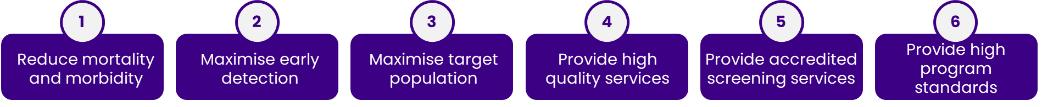
Source: BreastScreen Australia National Accreditation Standards
BSA is jointly funded by Commonwealth and state/territory governments. The Commonwealth Department of Health and Aged Care oversees policy, coordination, and national data collection, while states/territories are responsible for local program delivery.

How BSA works
The BSA program uses a two-step process to detect breast cancer:
Step 1: Screening: Two-view mammography of each breast, with radiologists examining images for suspicious characteristics. To ensure high quality services, BreastScreen uses two screen readers to examine the images separately. A third independent screen reader is used where the first two readers disagree on the findings.
Step 2: Assessment: If concerns are identified, consumers are recalled for further investigation, which may include clinical breast examination, additional mammography views, ultrasound imaging, and biopsy procedures if required.

Who participates
BSA targets women aged 50-74 years through active invitations, as evidence shows this is the age group where mammography screening is most effective. Women aged 40-49 and over 75 are eligible but not actively invited. Consumers from all backgrounds participate in the program as illustrated in Figure 4.
Figure 4: Illustrative representation of diverse participation

Source: BreastScreen Australia
These include Aboriginal and Torres Strait Islander people, culturally and linguistically diverse people, consumers with disabilities, transgender and gender diverse consumers, consumers with mental health conditions, consumers experiencing homelessness, and consumers in correctional facilities. The program must recognise and address many of its consumers belonging to multiple priority populations simultaneously and face compounded barriers that require tailored, multifaceted approaches to screening access and support.

Service delivery
Screening services are provided at over 750 locations across Australia, including mobile units serving regional areas. States and territories have either a single central service or multiple screening and assessment services overseen by a state coordination unit (SCU) depicted in Figure 5. Services are tailored to meet local geographic and demographic needs, varying in:
- size and coverage (from partial city coverage to vast geographical areas)
- delivery model (public sector, contracted private sector, or mixed arrangements)
- infrastructure (fixed locations, relocatable units, or mobile screening units).
Figure 5: Accredited BSA services by states and territories
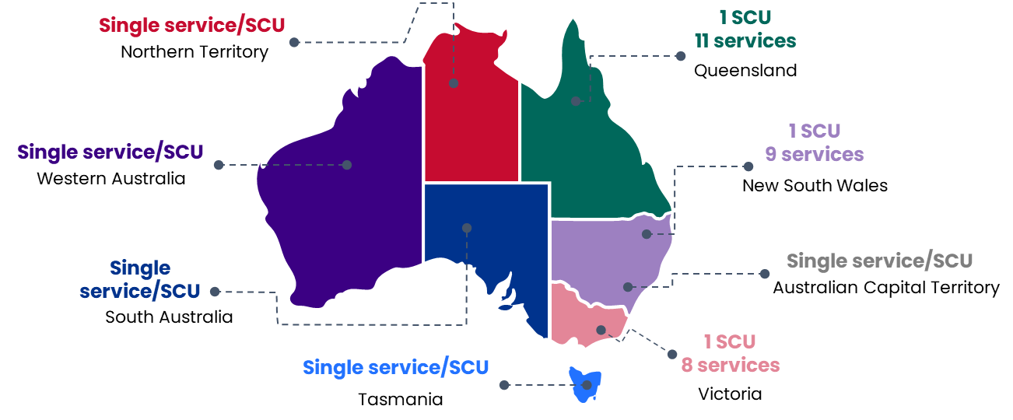
Source: HealthConsult based on review of program documentation
The various approaches to service delivery across Australia reflect BSA's commitment to addressing unique geographical and demographic challenges including the population size and structure of local health services. This adaptability is particularly evident in remote areas, where innovative solutions are essential to ensure equitable access to breast screening services.
The following case study from the Northern Territory illustrates how BSA services can be tailored to meet the complex needs of remote Indigenous communities while highlighting both successes and ongoing challenges in service provision.
Case study - Breast Screening in the remote communities  In the NT breast screening services are provided to three distinct, very remote communities: Desert, Top End and Island regions. These communities have over 20 dialects with seven main languages, with limited access to internet, regular phone service or mailboxes. Most services are provided via "Millie", the pink bus that travels on land or a barge for island communities. However, Millie faces significant challenges—she cannot travel on unsealed roads, lacks equipment protection from road vibrations, and has power requirements that not all communities can provide.  Access is coordinated through the local Aboriginal Medical Service (AMS), which provides population details and helps prioritise urgent follow-ups. The AMS organises and funds transport for consumers from outlying communities to attend screening. BreastScreen NT's Health Promotion team includes an Indigenous woman and a Territorian who understand cultural protocols, allowing time "for a yarn and a cup of tea" as part of the service. Staff respect local customs and understand the impact that "sorry business" and community dynamics have on attendance. Where possible, they collaborate with communities on promotional activities such as Women's Health Weeks run by Aboriginal Community Controlled Health Organisations. These events provide access to screening services while allowing consumers to familiarise themselves with the mobile unit. Local Territorians who have experienced breast cancer serve as BreastScreen Ambassadors, helping ease concerns for other consumers. Results are returned to the AMS, which recalls consumers to share results and manages future screening reminders.  Despite successes, resource limitations hinder service improvements. The service requires an off-road vehicle with air suspension, online booking, a website, promotional videos in local languages, funding for health promotion, a dedicated driver, and power access in remote communities. These gaps highlight the challenges in providing equitable screening services to remote Indigenous communities. | Millie parked at the front of the Harts Range Health Clinic  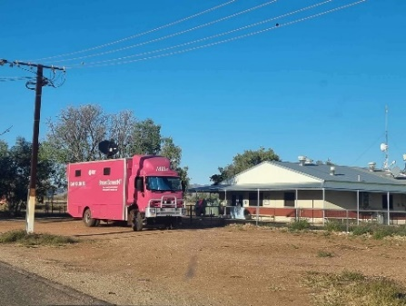  Millie on the barge coming into Maningrida  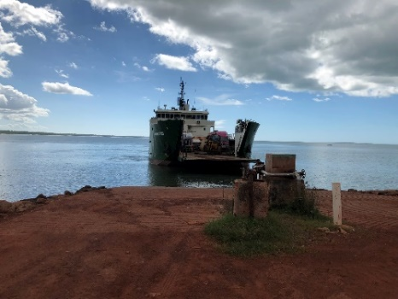  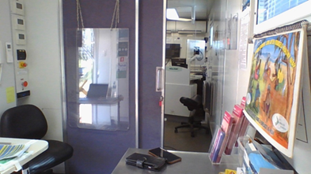  Waiting room/reception desk inside Millie  Radiographer desk looking at the mammography machine and waiting/reception room, Millie  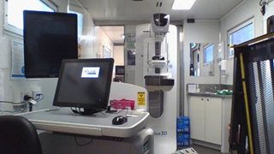  Source: Case study from Workstream 2 Priority Populations report. Photos from BreastScreen NT

The Review
In late 2023, the Commonwealth, in partnership with states and territories, initiated a review of BSA. The BreastScreen National Policy and Funding Review (the BSA Review) is supported by the BSA Review Steering Committee and overseen by the Expert Advisory Group (EAG).
Three concurrent workstreams were initially undertaken, each with a different focus. Figure 6 describes these workstreams and illustrates how they have been integrated to produce this Final Report and draft Strategic Framework of the BSA Review.
Figure 6: Overview of the four BSA workstreams
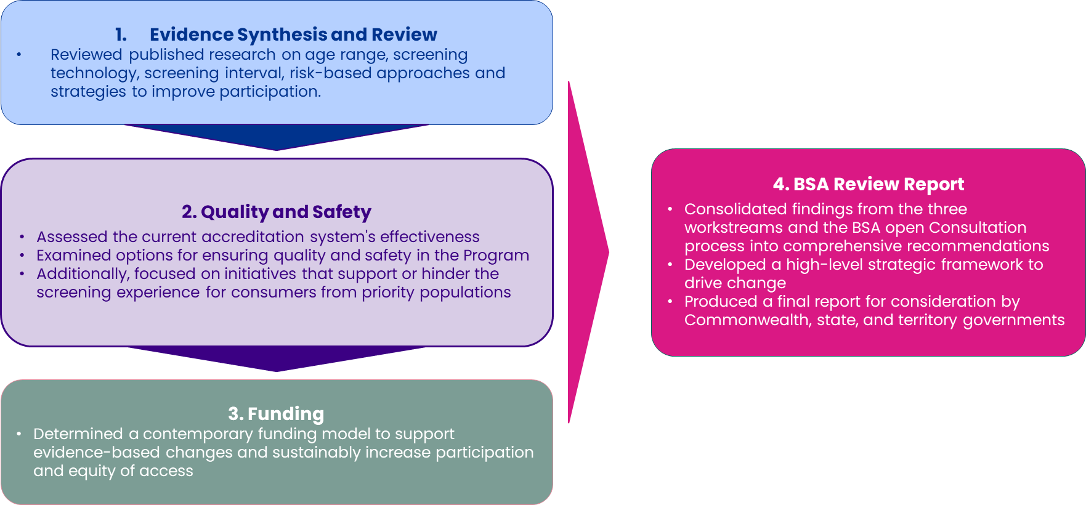

The BSA Review was undertaken to inform the future strategic direction of the BSA program for the next 10 years. The recommendations in this report aim to ensure that the program remains evidence-based, fosters national consistency, boosts participation rates and equity of access, improves user experience, increases service efficiency and effectiveness, and is backed by a sustainable funding model.

Key findings
The BSA Review findings are grouped under five core areas.

Participation, access and equity
Current state:
BSA screened 1.82 million people (50.1% of the eligible population) aged 50-74 in 2021-2022. Nearly all (99.8%) live within a one-hour drive of screening services, but many from priority groups still face barriers like travel costs, childcare, and lost income.
Challenges:
Participation in BSA remains around 51.7%, well below the 70% target. Significant gaps exist for priority groups, such as Aboriginal and Torres Strait Islander people, those who speak languages other than English, people in remote areas, and those experiencing socioeconomic disadvantage. Rural and remote communities also face limited access to fixed and mobile screening services. Additionally, there are too few partnerships between BSA and other health or screening programs.
Specific barriers identified for priority populations include:
While screening services are widely available, many people from priority groups still face barriers, including cultural differences, language issues, concerns about gender identity, disabilities, mental health, homelessness, and difficulties accessing rural or remote locations. Although mobile screening services help, they face practical issues like equipment maintenance and limited availability.

Person centred screening
Current state:
BSA currently screens women aged 50–74 every two years, based on age alone. This approach does not consider individual differences in breast cancer risk. Consumers increasingly expect personalised information about their risk and consistent, high-quality breast care, regardless of location.
Challenges:
Although evidence supports screening based on individual risk, implementing this approach without a validated risk assessment tool, is difficult. Management of high-risk consumers also varies across Australia, leading to potential care gaps, especially for those without access to specialist services. Additionally, approaches to screening women under 50 are inconsistent, and the benefits for this group remain unclear.

National consistency
Current state:
There are differences in service operations across each state and territory, leading to unequal care and consumer experiences. These differences can make consumers lose trust in the program and cause confusion, especially for those who move between regions.
Challenges:
Inconsistencies in assessment methods, breast density reporting, invitation and reminder systems, and management of symptomatic consumers.

Service enhancement
Current state:
BSA's technology and service model requires updating to meet modern standards and consumer expectations for holistic connected care.
Challenges:
Implementing advanced screening technologies such as 3D mammography (tomosynthesis) is challenging due to longer processing times, training requirements, and resources. Artificial intelligence (AI) for screen reading offers potential improvements but requires careful planning. Additionally, BSA operates separately from other health services, causing confusion and repeated tests, especially for consumers needing follow-up care.

Program enablers
Current state:
BSA's effectiveness is limited by challenges with governance structures, funding models, data systems, workforce shortages, quality frameworks, and research capacity.
Challenges:
Complex governance and unclear funding lead to inconsistent services and limit improvements across states and territories. Outdated data systems hinder effective monitoring and sharing of information between regions. Workforce shortages and lack of diversity threaten the program’s sustainability and its ability to meet diverse community needs. Additionally, quality standards and accreditation processes are outdated and complex. Finally, limited research coordination, makes it harder for BSA to innovate and roll out changes as evidence becomes available.

Recommendations
- Achieve equitable access and optimise participation across all population groups.
R1.1 Develop and implement a National Equity Framework.
R1.2 Develop and implement a National Participation Strategy and Action Plan with the aim of 70% biennial participation in line with WHO recommendation for optimal screening participation.
R1.3 Develop and implement sustainable service access models for screening and assessment services to maximise accessibility and participation.
R1.4 Develop and implement holistic partnership initiatives with other screening programs and healthcare providers.
This recommendation focuses on making screening equally available, working towards having 70% of eligible people screened every two years. It involves creating better ways for people to access screening services and building strong partnerships with community groups and other healthcare services to ensure broad coverage and participation.
- Transform BSA's screening model through the implementation of risk-stratified screening approaches.
R2.1 Develop and implement a national plan for transitioning to risk-stratified screening with a national approach to risk assessment using a validated and nationally adopted tool.
R2.2 Develop and implement a minimum nationally consistent criteria and protocols for annual screening for mammography.
R2.3 Develop and implement minimum protocols for the management of a high-risk and/or a very high-risk consumer.
R2.4 Develop and implement evidence-based guidelines for screening consumers aged 45-49 years.
This recommendation aims to provide screening approaches based on each person's individual breast cancer risk. It involves creating national guidelines for people at higher risk, ensuring that high-risk individuals receive consistent and appropriate care across all services, and establishing clear protocols for screening people between the ages of 45 and 49 years.
- Establish minimum national guidelines and protocols that reaffirm the aims and objectives of the program and maintain program integrity.
R3.1 Develop and implement protocols for screening invitation and reminder systems.
R3.2 Develop and implement minimum protocols and clinical guidelines that ensure cost-effective, high-quality assessment services.
R3.3 Develop and implement protocols to support the BSA position statement on breast density and screening.
R3.4 Develop and implement minimum protocols for the management of symptomatic consumers.
This recommendation is directed at establishing uniform approaches to breast screening across the country. It involves creating consistent methods for inviting and reminding consumers about screening appointments, ensuring assessment procedures are evidence-based and consistent nationwide, providing straightforward guidance on how breast density is reported and communicated to consumers, and developing clear protocols for managing consumers who present with breast symptoms.
- Enhance BSA's service delivery through strategic implementation of contemporary screening technologies and enhancing interactions with broader healthcare systems.
R4.1 Develop and implement an evidence-based plan for tomosynthesis as the primary screening modality.
R4.2 Develop and implement an AI governance framework with the initial focus on image reading.
R4.3 Develop and implement a primary care collaboration strategy.
R4.4 Develop and implement minimum protocols for interactions with diagnostic services for consumers with screen-detected cancer.
This recommendation centres on improving screening services through using modern technology and better healthcare coordination. It involves adopting modern 3D screening technology, carefully introducing AI to help with screening, working more closely with GPs and other health services and improving how screening connects to follow-up and treatment services.
- Strengthen the underlying systems and support structures that allow BSA to deliver high-quality breast screening services and enable improvements and innovation.
R5.1 Strengthen governance structures.
R5.2 Strengthen sustainable funding models.
R5.3 Strengthen digital and data infrastructure and data management and use.
R5.4 Strengthen and implement a sustainable workforce framework.
R5.5 Strengthen and implement a robust BSA Quality and Safety Framework and reforming the accreditation model.
R5.6 Strengthen innovation driving advancement by establishing the BSA Research and Technology Evaluation Council.
This recommendation prioritises building stronger foundations for the BSA’s systems, resources, and capacity to innovate. It involves improving how BSA is managed nationally, ensuring sustainable funding, upgrading computer and data systems, supporting and growing the workforce, improving quality and safety guidelines and supporting national coordination of research and technology.

Next steps
To help all Australian governments consider the recommendations, a draft Strategic Framework has been developed for BSA covering the next 10 years (2025-2035). The Framework will be finalised by government and will identify potential changes across three timeframes:
- Short-term (2025-2027)
- Medium-term (2028-2030)
- Long-term (2031-2035.
The Framework will also show who does what:
- The Australian Government will provide leadership and coordination of change
- States and Territories will deliver local change
- BreastScreen services will put changes into practice
- Everyone will work together in partnership on shared projects.
To make change happen, BSA will need to consult further with experts and community members. They will also learn from other health programs that have made similar changes.
Consultation will include people from across Australia, health experts, and service consumers, especially from priority groups. This helps make sure changes are safe and meet screening program and consumer needs.
BSA will develop an implementation plan with clear goals and timelines in line with the Strategic Framework. BSA will check how things are going through formal monitoring, regular reports, and independent reviews at 2 years and 5 years. This helps to see progress and respond to the changing environment.
The Strategic Framework shows the recommendations, how to make changes, and how different parts connect. It suggests when to make each change however as many of the recommendations depend on each other, change will be complex. Some projects will depend on available funding and the results of other projects. The Framework is just a starting point for all Australian governments to finalise and agree on the next steps.

Acknowledgements
This review was made possible through the contributions of numerous stakeholders, including the Expert Advisory Group, consumers, healthcare providers, researchers, and representatives from priority populations.
Special acknowledgment is given to Aboriginal and Torres Strait Islander organisations, consumer advocacy groups, and clinical experts who provided valuable insights throughout the consultation process.
The review was funded jointly by the Commonwealth and state and territory governments, with support from various consultants and the Department of Health and Aged Care Screening Policy and BSA Section project team.
This summary aims to close the feedback loop with stakeholders while providing a clear, accessible overview of the review findings and recommendations that will shape the future of BSA over the next decade.
Representatives from the following organisations have been consulted as part of this paper. While their views may have been personal, they have influenced the development of this paper:
- Aboriginal Health and Medical Research Council NSW
- ACON
- Australian Breast Density Consumer Advisory Council
- Australian Indigenous Doctors Association
- Australian Institute of Health and Welfare
- Australian Society of Medical Imaging and Radiation Therapy
- Breast Cancer Network Australia
- BreastScreen ACT, NSW, NT, QLD, SA, TAS, VIC, WA
- BreastScreen Victoria’s Consumer Advisory Group.
- Can at 40. Do at 45
- Cancer Council Australia
- Clinical Advisory Group
- Department of Health and Aged Care
- Greater Southern Consumer Advisory Committee
- Indigenous Allied Health Australia
- Medical Oncology Group of Australia
- Multicultural Centre for Women’s Health
- Multicultural Youth Advocacy Network
- National Aboriginal Community Controlled Health Organisation
- National Breast Cancer Foundation
- National Quality Management Committee
- National Rural Health Alliance
- Royal Australian College of General Practitioners
- Royal Australian and New Zealand College of Radiologists
- Royal College of Pathologists of Australasia
- Settlement Council of Australia
- So Brave Ltd
- Social Policy Group, Multicultural Youth Advocacy Network
- Townsville Aboriginal and Islanders Health Services
- University of Adelaide
- University of Melbourne
- University of NSW
- University of WA
- Victorian Aboriginal Community Controlled Health Organisation Inc.
- Women with Disability Australia

Abbreviations and terminology
The terminology in this document aligns with the Australian Institute of Health and Welfare (AIHW) including:
- ‘Consumer’ is used to refer to all individuals involved (or eligible to be involved) in BSA, regardless of sex or gender. Consumers include those with breast tissue suitable for screening, such as women, transgender men and women, non-binary, and gender-diverse people. State and territory BSA services provide guidance on screening for these groups.
- Where 'women' is specifically used it refers to 'female' based on sex assigned at birth, though not everyone may identify with this term. 'Breast' is used as a non-gendered term and is used non-medically to describe the tissue affected by breast cancer.
ACT Australian Capital Territory
AI Artificial Intelligence
AIHW Australian Institute of Health and Welfare
AMS Aboriginal Medical Services
BSA BreastScreen Australia
EAG Expert Advisory Group
NSW New South Wales
NT Northern Territory
QLD Queensland
SA South Australia
SCU State Coordination Unit
TAS Tasmania
VIC Victoria
WA Western Australia
WHO World Health Organization

AIHW (2024) BreastScreen Australia monitoring report 2024 accessed December 2024.
Australian Government Department of Health (2023). BreastScreen Australia National Accreditation standards, accessed February 2024
AIHW (2024) BreastScreen Australia monitoring report 2024 accessed December 2024.

