
Better thinking. Better advice. | healthconsult.com.au

Department of Health and Aged Care
  - BreastScreen Australia Review Workstream 2 Quality and Safety Review Final Report

BreastScreen Australia Review Workstream 2 Quality and Safety Review Final Report
28 August 2024

Contents
Executive Summary 1
1. Introduction 8
2. Current BSA quality and safety system 12
3. Best practice and emerging trends 19
4. Quality assurance effectiveness and efficiency 25
5. Opportunities 29
6. Conclusion and Suggestions 38
Appendix A Project Methodology 48

Abbreviations
ACHS Australian Council on Healthcare Standards
ACSQHC Australian Commission on Safety and Quality in Health Care
ACT Australian Capital Territory
ADR Annual Data Report
AI Artificial Intelligence
AIHW Australian Institute of Health and Welfare
BSA BreastScreen Australia
CAG Clinical Advisory Group
CMS Client Management System
EAG Expert Advisory Group
EQuIP Evaluation and Quality Improvement Program
EU European Union
IT Information Technology
KPI Key Performance Indicator
LHN Local Health Networks
MDT Multidisciplinary Team
NAR National Accreditation Requirement
NAS National Accreditation Standards
NATA National Association of Testing Authorities
NBCCEDP National Breast and Cervical Cancer Early Detection Program
NBCSP National Bowel Cancer Screening Program
NCSP National Cervical Screening Program
NPQS National Policy and Quality Standard
NQIP National Quality Improvement Plan
NQMC National Quality Management Committee
NSQHS National Safety and Quality Health Service
NSW New South Wales
NT Northern Territory
PACS Picture Archiving and Communications System
PBSF Population-Based Screening Framework
PM Project Management
QA Quality Assurance
QF Quality Framework
QI Quality Improvement
QIP Quality Innovation Performance
QLD Queensland
SA South Australia
SCU State Coordination Unit these are found both in single service jurisdictions and jurisdictions with multiple service
SMS Short Message Service
SQC State Quality Committees
TAS Tasmania
VIC Victoria
WA Western Australia

Executive Summary

Context
HealthConsult was engaged by the Department of Health and Aged Care (the ‘Department’) to undertake a review of the Quality and safety aspects of BreastScreen Australia (BSA) to inform the National Policy and Funding Review (BSA Review).
This review of BSA’s quality and safety aspects focused on assessing the efficiency and effectiveness of the current system and identifying alternative options with a view to ensuring the ongoing safety and quality of the BSA program. It is important to acknowledge that this review was conducted in the aftermath of the COVID-19 pandemic, during which a temporary accreditation management approach was implemented. This period emphasised quality assurance (QA) measures more heavily, while quality improvement (QI) initiatives were given lower priority, to ensure that services continued to be delivered safely.

BreastScreen Australia Program
Introduced in 1991, the BSA is a nationwide screening program aimed at reducing breast cancer morbidity and mortality through early detection. It offers free biennial mammograms for asymptomatic women aged 50-74, funded by the Commonwealth and state/territory governments. Women aged 40-49 or 75 and over are also eligible but do not receive invitations. BSA also provides assessment services following screening to diagnosis. Figure 1 describes BSA’s quality and safety management components.
Figure 1: The current quality and safety system of the BSA program
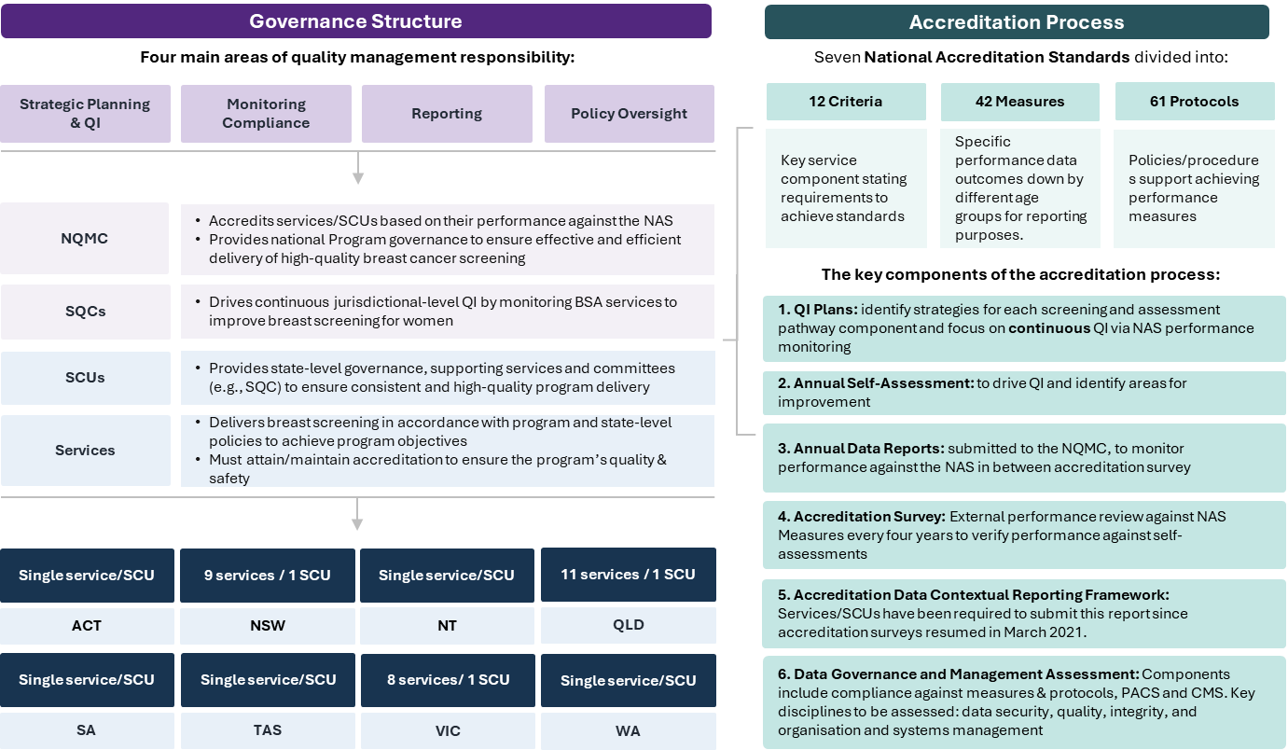
Source: HealthConsult based on review of BSA program documentation

Review methodology
The information and analysis presented in this report is based on a documentation and literature review, stakeholder consultations (n=38 individuals), case studies (n=7 BSA services, a survey (n=62 responses) and workshops with the Expert Advisory Group (refer to Appendix A). While all components focused on the program, the literature review also explored the broader quality and safety mechanisms used in cancer screening programs and the latest standard setting techniques nationally and internationally to inform the BSA Review. It is important to note that many of the findings in this report are derived from stakeholder perspectives, which may not always reflect factual information or be relevant to all services. However, these views have been faithfully recorded to represent the opinions of the stakeholders interviewed.

Alignment with best practice
QA and QI are interconnected concepts essential for maintaining and enhancing the quality of screening programs. QA ensures adherence to established standards through regular assessments, while QI focuses on continuous improvement by identifying areas for enhancement and implementing changes. QA and QI collaboratively enhance quality. QA detects problems, and QI devises solutions. As QI implements improvements, QA guarantees their retention. Both rely on data-driven decisions and strive to meet customer expectations. Together, they create a comprehensive approach to quality management, ensuring both compliance and ongoing improvement.

Quality Assurance
To assess if there is an alignment between Australian and international practices, breast cancer screening programs from England, the European Union (EU), Canada, the Netherlands, and New Zealand were analysed. Additionally, three models of Australian accreditation systems, based on a 2006 discussion paper on cancer service accreditation, were reviewed:
- Dual role models where organisations like the Australian Council on Healthcare Standards (ACHS) and the Evaluation and Quality Improvement Program (EQuIP) develop standards and conduct assessments every four years;
- Models where professionals and government-led standards are accredited by an external agency, like the Australian Commission on Safety and Quality in Health Care (ACSQHC); and
- Models where agencies are specifically established to accredit against specialised standards, such as the National Association of Testing Authorities (NATA).
Figure 2 summarises the features that BSA’s safety and quality system shares with other national or international best practices in breast cancer screening programs. It also highlights various practices that could be integrated into improvements to the current system.
Figure 2: Alignment between BSA quality and safety program and other similar programs
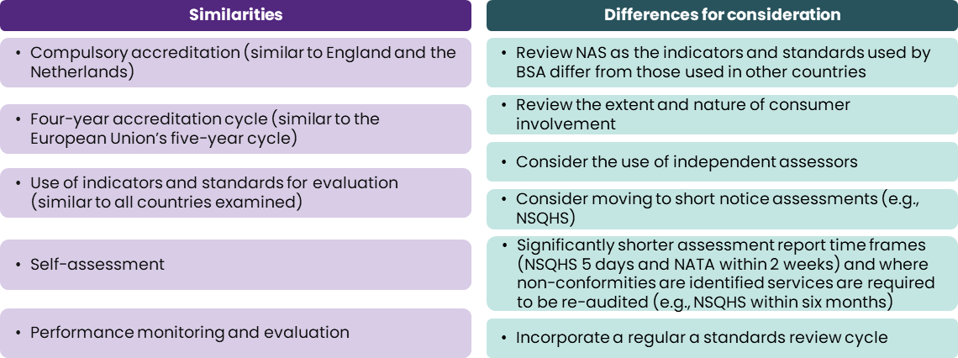
Source: HealthConsult based on literature review
Abbreviations: National Safety and Quality Health Service (NSQHS), National Association of Testing Authorities (NATA)
Figure 3 summarises emerging trends and models in QA identified from the literature review.
Figure 3: Emerging trends and models in QA identified from the literature
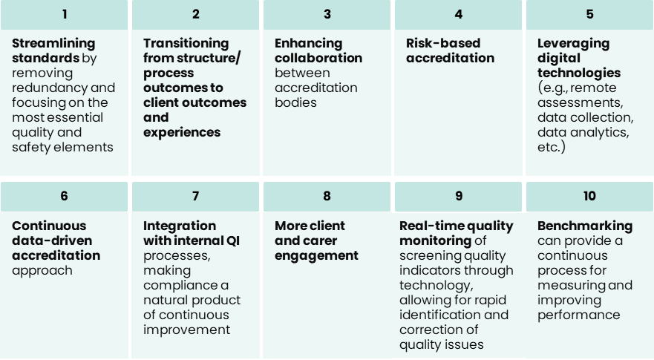
Source: HealthConsult based on literature review

Quality Improvement
QI processes are crucial in international breast screening programs and Australian programs like bowel and cervical cancer screenings. They ensure services meet high standards and adapt to client needs. Examples include New Zealand's National Screening Unit's Quality Framework (2015) and the Netherlands' 'Framework for the Execution of the Dutch Breast Cancer Screening Programme'.
Key features of QI processes include continuous monitoring, training, multidisciplinary collaboration, and knowledge exchange events. The United States' National Breast and Cervical Cancer Early Detection Program (NBCCEDP) exemplifies continuous monitoring and training by collecting performance data, benchmarking, and providing professional development. Italy's Group for Mammography Screening and the Italian College of Breast Radiologists demonstrate multidisciplinary collaboration with jointly developed guidelines. Canada's knowledge exchange events promote continuous learning and improvement.
BreastScreen Services/SCUs currently develop QI plans to identify, address, and learn from adverse events, mitigating recurrence risks. Additionally, QI plans are developed to improve performance where a NAS is not met. For every unmet NAS, a QI plan is required. Numerous QI initiatives, identified from case studies and surveys, were often one off funding sources (internal and external)- but rarely shared across services/jurisdictions. These initiatives cover screening, assessment, consumer experience, service promotion, workforce, continuity of care, and monitoring and evaluation. Examples include breast density reporting, mobile van assessments, bulk SMS recalls, consumer co-designed clinic areas, flexible work options for staff, and creating a Quality Manager position.

Effectiveness and efficiency
The BSA accreditation system is comprehensive but faces several challenges, including issues with the audit survey, Annual Data Report (ADR), National Accreditation Standards (NAS), peer review system and consumer input. The main challenges identified by stakeholders include:
- Accreditation heavy: The accreditation system is the core quality and safety mechanism utilised within the program.
- Resource utilisation: Effectively using resources for technology upgrades, securing funding, and maintaining a trained workforce to meet accreditation standards while supporting service quality and safety is a challenge when there are competing priorities.
- Impact on continuous QI: The accreditation system, including the NAS, has limited impact on continuous QI. Services have implemented various quality initiatives, often supported by one off funding sources (internal and external) or collaboration, to drive improvement, especially for priority populations.
- Quality and safety challenges: BreastScreen Services/SCUs are continually managing quality and safety matters, including outdated technology, lack of access to support services, interoperability challenges, and funding constraints.
- Workforce challenges: Workforce shortages, including the need for staff to provide quality care and conduct accreditation surveys, and constraints to staff training and competence (e.g. trauma informed care) exacerbate these challenges.
- Consumer experience: These include inconsistent service delivery, symptomatic women using screening services due to healthcare access delays and costs associated with private services, and assessment delays caused by resource constraints. Additionally, there is limited sharing of and ability to apply successful QI practices.
- Governance structure concerns:
  - Committee structure: There are too many committees and a lack of consumer representation, leading to a perception of lack of transparency and potential or risk of conflicts of interest.
  - Agility: The system lacks agility in addressing evolving healthcare challenges and adopting new technologies, as well as accommodating changing customer expectations.
  - Resource allocation: The National Quality Management Committee (NQMC) working to a tight accreditation schedule and with limited resources to implement quality initiatives
  - Standardisation: There is no standardised process for developing and updating standards.

Suggestions for improvement
Table 1 includes nine suggestions to ensure the ongoing safety and quality of the BSA program is informed by a review of best practices as well as stakeholder feedback and guided by core principles reflecting the program's values, priorities, and realities.
Table 1: Key suggestions for improvements
Quality Assurance
S1 | Review and update the NAS in consultation with stakeholders (including consumers) to align with contemporary best practices and allow for agility in evolving guidelines.
S2 | Initially modify the audit survey to reflect updated NAS and move towards multi-level QA mechanisms at service, jurisdictional, and national level with a coordinated short-notice accreditation survey process focused on a small core set of safety and quality standards with independent surveyors who understand the unique context of population screening.
S3 | Develop a national QA data and reporting framework for real-time monitoring, benchmarking, and performance feedback, exploring new technologies and tools for data collection, analysis, and visualisation.
Quality Improvement
S4 | Develop nationally agreed evidence-based guidelines for best practices across the screening pathway while allowing services to adapt and innovate to reflect local conditions where relevant, aiming to ensure high quality and similar screening, assessment and clinical experiences for each woman across Australia.
S5 | Develop and fund a national QI research and evaluation framework to evaluate the implementation of service improvements.
S6 | Develop and implement a national QI plan and roadmap driven by an overarching QI Framework providing strategic direction and outlining improvement priorities and initiatives.
S7 | Foster a culture of innovation and collaboration through QI networks, communities of practice, and knowledge-sharing platforms that can be adopted or adapted by services across the country to the local level.
S8 | Ensure a client-centred approach by involving consumers in QI activities and seeking their feedback and representation on QI committees.
S9 | Leverage digital health technologies and data analytics for sophisticated evaluation of QI approaches and their impact.
Governance
S 10 | Establish a national QA and QI governance structure and framework addressing the validated issues identified and new processes implemented with clear roles and responsibilities for all current national committees, including consumer, technical, clinical, and operational representation. This may also include changes to the governance structure. Note: Given that many concerns arise from stakeholder input, it is advisable to establish a process to validate these issues concerning governance before any changes are implemented.

Implementation Roadmap
Implementing the suggested revised model will require strong leadership, stakeholder engagement, and change management to overcome the potential challenges and risks. To mitigate these challenges, a phased approach to the implementation of changes to the system is recommended, as outlined in Figure 4. Additionally, this will require extensive consultation, piloting, and evaluation to refine the model and ensure it is feasible to implement. This should be accompanied by clear communication, training, and support for services to build capacity and confidence in the new system.
Figure 4: Staged Implementation of system changes Roadmap
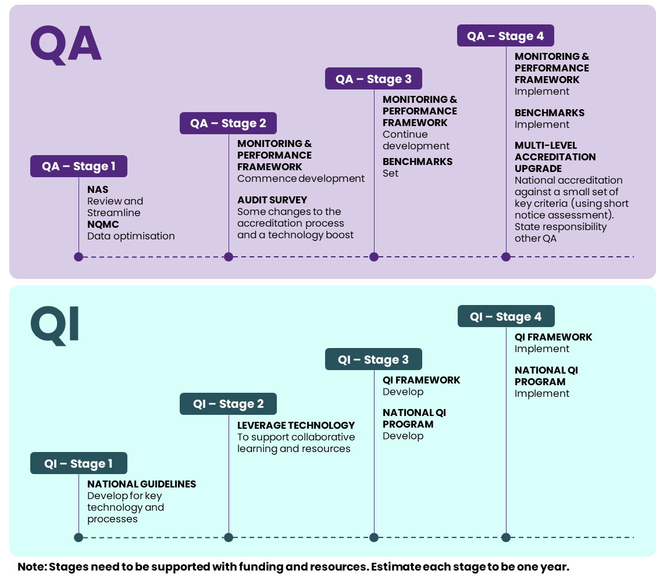
Source: HealthConsult (2024)

Introduction
This Chapter sets the context for the Quality and Safety Review of the BreastScreen Australia program (BSA program).

BreastScreen Australia
Introduced in 1991, BreastScreen Australia is a nationwide screening program that aims to reduce breast cancer morbidity and mortality through early detection (Figure 5). It is a joint initiative funded by the Commonwealth and state/territory governments. The Commonwealth oversees policy, coordination, national data collection, and evaluation, while the states/territories are responsible for local program delivery.
The program offers free biennial breast screening mammograms for asymptomatic women aged 50-74, who are actively encouraged to participate. Women aged 40-49 or 75 and over are also eligible for free mammograms but do not receive invitations. BSA also provides assessment services following screening to diagnosis.
Figure 5: Aims of the BSA program
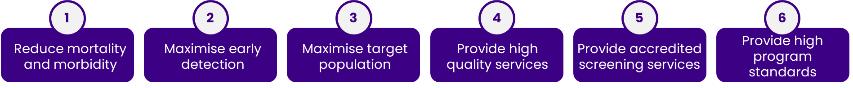
Source: BreastScreen Australia National Accreditation Standards
Screening services are provided at over 750 locations across Australia, including mobile units serving regional areas. Jurisdictions have either a single central service or multiple screening and assessment services overseen by a state coordination unit (SCU). All services and SCUs participate in accreditation (Figure 6).
Since the BSA Program’s inception and implementation of the National Accreditation Requirements (NARs) in 1991, the program and its accreditation system have undergone several reviews (refer to Appendix A of the Situation Analysis Report). Changes and modifications were driven by previous reviews and recommendations, with the most recent occurring in 2018 (refer to Appendix B of the Situation Analysis Report).
Figure 6: Accredited BSA services by jurisdictions
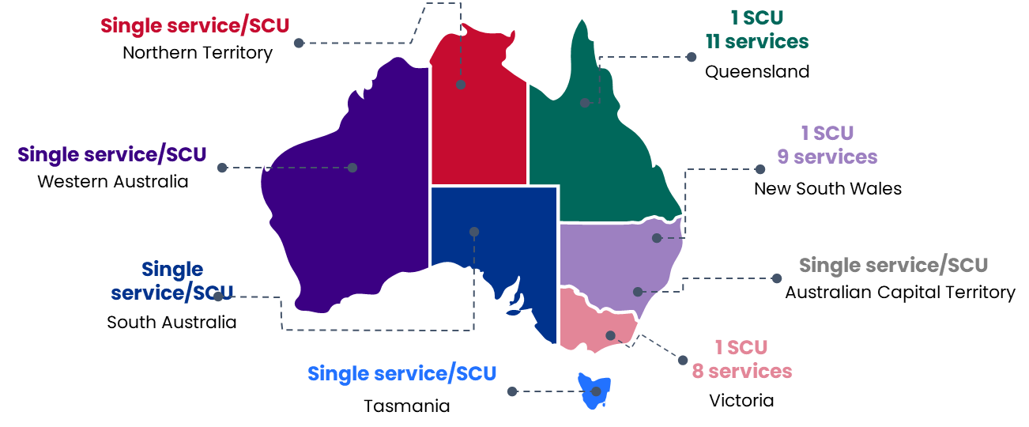
Source: HealthConsult based on review of program documentation

BreastScreen Australia National Policy and Funding Review (BSA Review)
BSA is undergoing a comprehensive review that will conclude by the end of 2024, being undertaken in partnership with the Commonwealth. states and territories and supported by the BSA Review Steering Committee and Expert Advisory Group (EAG). Through three concurrent workstreams, the BSA Review will assess research outcomes to inform the development of recommendations in the final workstream for evidence-based best practices in breast cancer screening in the Australian context. These recommendations will ensure that the program remains evidence-based, fosters national consistency, boosts participation rates, improves user experience, increases service efficiency and effectiveness, and is backed by a sustainable funding model.

Project scope and methodology
On 6 November 2023, the Department of Health and Aged Care (the Department) engaged HealthConsult to: “conduct the Quality and Safety Review.”
HealthConsult used the outcomes from previous reviews and undertook a process to compare the efficiency and effectiveness of the current accreditation system with alternative options for ensuring the safety and quality of the BSA program. The scope of this Quality and Safety review is presented in Figure 7.
Figure 7: Project scope and objectives
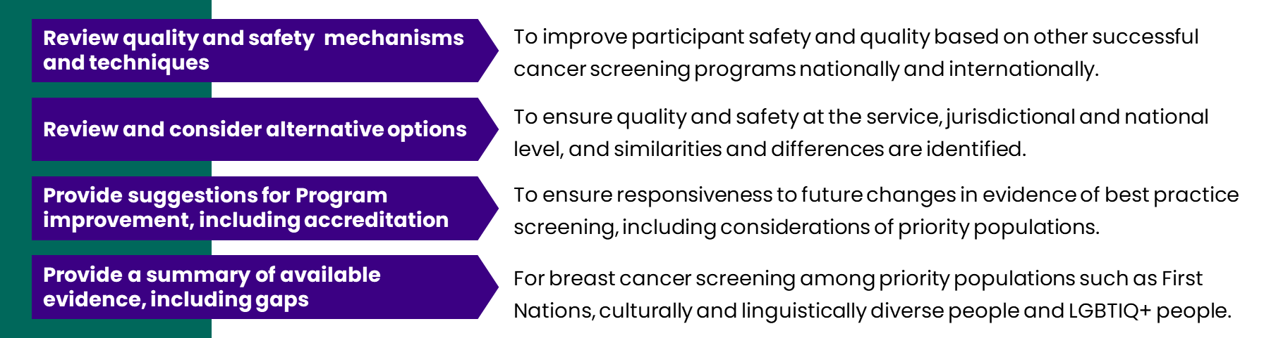
Source: HealthConsult (2024)
The project was undertaken using a mixed-method approach (Figure 8 and expanded in Appendix A). It is important to note that many of the findings in this report are derived from stakeholder perspectives, which may not always reflect factual information or be relevant to all services. However, these views have been faithfully recorded to represent the opinions of the stakeholders interviewed. The review was divided into two distinct parts:
A. Quality and safety systems assessed the current BSA accreditation system’s effectiveness and efficiency and identified quality and safety mechanisms used in cancer screening programs, including options for potential refinements to the current BSA models. A situation analysis document was delivered (on 15 January 2024) that summarised BSA's existing quality and safety mechanisms and identified emerging evidence related to breast screening accreditation.
B. Screening priority populations identified available evidence for breast cancer screening among priority populations such as First Nations women, culturally and linguistically diverse women, LGBTIQA+ people, women with disabilities and women with mental health/lived experience of mental health. A report addressing the Priority Populations was delivered on 23 April 2024.
Figure 8: Overview of the project’s mixed methods approach
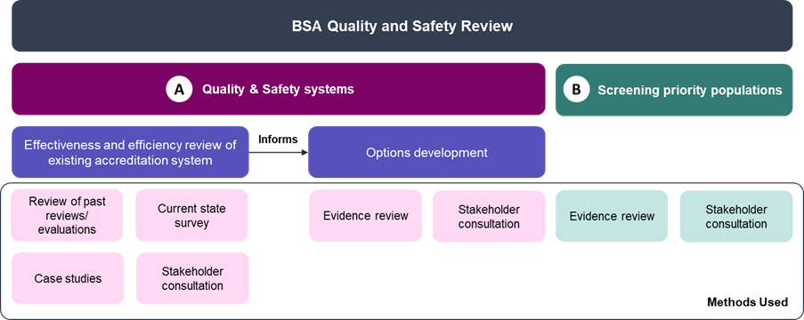
Source: HealthConsult (2024)

Structure of the document
The structure of the remainder of this Final Report is:
- Chapter 2 describes the main components of BSA screening quality and safety management, including the governance structure, quality assurance (QA), and quality improvement (QI), as they currently are.
- Chapter 3 presents global evidence on cancer screening quality and safety, summarises Australian methods, and compares them to international breast cancer screening models.
- Chapter 4 explores the effectiveness and efficiency of the current BSA’s QA system, drawing primarily from stakeholder input, case studies, and survey data.
- Chapter 5 presents potential strategies to enhance accreditation efficiency through governance reforms, alternative quality and safety mechanisms, and adaptability to emerging technologies.
- Chapter 6 provides suggestions to inform the BSA Review.

Current BSA quality and safety system
This Chapter describes the main components of BSA quality and safety management, including the governance structure, QA, and QI, as they currently are. Stakeholders also provided the key quality and safety issues and risks.

Quality and Safety Governance structure
BSA’s program governance structure has four main areas of responsibility for quality management. These include strategic planning and QI, monitoring compliance, reporting, and policy oversight. For consistent accreditation and QI, the Program’s quality management structure has adopted a governance model for each level (i.e., key players in accreditation), including:
- National Quality Management Committee (NQMC) accredits Services/SCUs by reviewing performance against the National Accreditation Standards (NAS) to identify national trends and address current and emerging issues. The NQMC provides national governance to ensure effective, efficient, and high-quality breast cancer screening. This includes developing and implementing the National QI Plan (NQIP) to support Services/SCUs in identifying performance issues. (Note: The NQIP expired in 2020 and has not been updated. Additionally, there is limited information about whether the NQIP was implemented nationally or used as intended.).
- State Quality Committees (SQCs) drive jurisdictional QI by monitoring BSA services, advising best practices, addressing risks, and recommending enhancements. They previously aligned State QI Plans with the NQIP (expired 2020) to ensure high-quality breast screening. (Note: SCQs have no formal reporting line to the NQMC).
- SCUs provide state-level governance, ensuring consistent, high-quality program delivery within a jurisdiction. They oversee policy planning, systems management, quality monitoring, workforce planning, and communication strategies while offering operational support and infrastructure management to achieve program objectives.
- Services deliver high-quality, accredited breast screening aligned with program and state policies to ensure safety and achieve objectives.
Accredited Services/SCUs conduct screening and assessment with key stakeholders involved in monitoring and management. This approach was developed to support effective governance and program management.
Within the Services/SCUs, certain roles are also responsible for quality management as part of breast cancer screening and assessment services. While this is not uniformly adopted in all areas (including the name of the role or the responsibilities), these roles may include the following:
- The Clinical/Service Director is responsible for overseeing high-quality clinical services in accordance with the NAS.
- Designated clinicians (radiologists, surgeons, pathologists, and radiographers) are responsible for all aspects of QA relevant to their respective disciplines:
  - Designated Radiologist oversees high-quality breast cancer screening and assessment services related to radiology in the Service/SCU, in accordance with the NAS. They also implement QI strategies outlined in the QI plan for radiologists/screen readers.
  - Designated Radiographer oversees high-quality breast cancer screening and assessment services related to radiography in the Service/SCU, in accordance with the NAS. They also implement QI strategies for radiographers and sonographers (where employed).
- Quality Manager who plays a crucial role in supporting QA processes, reporting and coordinating key QI activities. This also includes coordination of Quality Group meetings and incident reporting to the appropriate governance bodies.

Quality Assurance
QA involves a structured approach designed to ensure that services adhere to established standards, with an emphasis on preventing defects and ensuring uniformity. BSA's accreditation system aims to maintain high-quality breast screening services and provides the foundation for the accreditation program. To ensure women receive safe and high-quality breast screens, all screening services and SCUs must be surveyed every four years. The next four-year accreditation cycle will commence in 2025.
Pre-COVID-19, Services/SCUs were assessed against the NAS. The NAS consists of seven standards that relate to the screening and assessment pathway or the support functions and are further divided into 12 criteria, 42 measures, and 61 protocols. Accreditation surveys evaluate performance based on all NAS measures and protocols. In 2020, a group of crucial NAS measures was singled out for explicit use in decision-making. These included the benchmark measures and those unaffected by the number of women presenting, which had been influenced by COVID-19 mitigation strategies. Additionally, access and participation measures were continuously monitored to assess the impact of COVID mitigation efforts and to observe recovery once these measures were lifted. Additionally, in 2020, when in-person accreditations became impossible, a virtual accreditation process was developed.
Services/SCUs must also comply with key components of the accreditation process to receive accreditation, including:
- QI plan: Services/SCUs must develop, implement, monitor, and review QI plans that identify strategies for each screening and assessment pathway component, focusing on continuous improvement by tracking performance against the NAS. Additionally, QI plans are developed to improve performance where a NAS is not met. For every unmet NAS, a QI plan is required.
- Annual self-assessment: Services/SCUs must self-assess against the NAS to drive QI, identify improvement areas, and develop risk mitigation strategies. These strategies should be documented in QI plans, regularly monitored, and used to support accreditation applications.
- Annual Data Report (ADR): The purpose of the annual data report is to monitor performance against the NAS in between accreditation surveys. Services/SCUs must submit ADRs against the NAS to the NQMC. If reports show declining performance or concerns, the NQMC may request an interim survey and review accreditation status.
- Accreditation Survey: Every four years, services/SCUs undergo an accreditation survey. As defined in the BSA National Accreditation Handbook March 2021 this is “an external review of a Service and/or SCU performance against the national Program standards, based on the NAS Measures, and undertaken by a team of professional peers and the National Surveyor.” Additionally from 2023 the Deputy National Surveyor. The Handbook also noted the following survey types include full, interim, and pre-commencement for new services, although not all may be currently available.
- Accreditation Data Contextual Reporting Framework: Services/SCUs have been required to submit this report since accreditation surveys resumed in March 2021.
- Data Governance and Management Assessment: Every four years, services/SCUs participate in an accreditation survey assessment, with additional assessments at NQMC's discretion if performance concerns arise. The assessment covers compliance, Picture Archiving and Communications System (PACS), Client Management System (CMS) operation, management, and governance, focusing on data security, quality, integrity, and organisation and systems management across four key disciplines.
Current QA approaches vary among jurisdictions, with the main differences relating to the number of services in the jurisdiction and budgets:
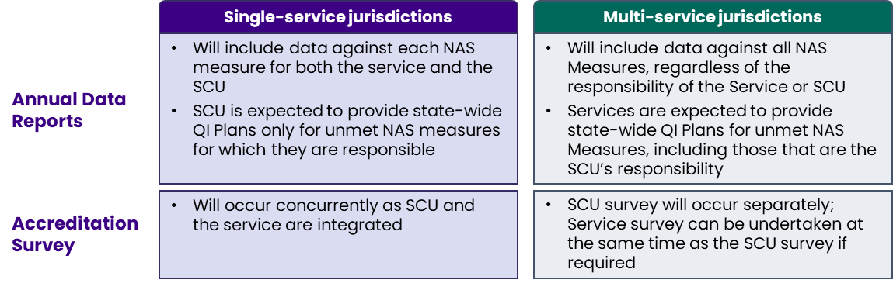
The consultations, case studies, and survey findings revealed a general lack of awareness among stakeholders regarding previous recommendations from BreastScreen Australia accreditation reviews and their implementation status. However, some positive changes identified include the appointment of the NQMC’s independent chair, the establishment of the National Surveyor, and the formation of SQCs. More recently a National Deputy Surveyor was also appointed. Some previous recommendations were considered too aspirational, given the lack of resourcing. A number of stakeholders noted that the NQMC is constrained by the accreditation bureaucracy (heavy administrative load) and that the overall system design as outlined in the Accreditation Handbook remains burdensome and reactive.

Quality Improvement
QI is a continuous initiative to improve the quality of products, services, or processes, with the goal of surpassing existing standards and increasing efficiency. QA and QI collaboratively enhance quality. QA detects problems, and QI devises solutions. As QI implements improvements, QA guarantees their retention. At the service level, QI involves developing QI plans and committing to ensuring adverse events are identified, addressed, and learned from to mitigate the risk of such events recurring in the future. Protocol 7.3, as part of the NAS, supports this by requiring Services/SCUs to implement and continually evaluate an incident management process that includes the identification, reporting, investigation, analysis, action, feedback and open disclosure of incidents in the service/SCU.
Each jurisdiction has a policy for managing adverse events that applies to all health services, including BreastScreen Services/SCUs. These policies outline a series of actions that must be taken for effective incident management. Although these actions may differ between jurisdictions, they generally involve the following steps: identification, initial action, notification, prioritisation, investigation, analysis, improvement action, and feedback.
From the case studies and the survey, a wide range of QI initiatives (Table 2) was identified, many implemented via alternative funding (e.g., one off funding source) but limited sharing of ideas outside services/jurisdictions.
Table 2: Examples of QI initiatives implemented in some services
Category | High-level description
Screening | - Breast Density Reporting  - Image quality improvement | - BreastScreen Plus for women with larger bodies
Assessment | - MDT review  - Use of Bilateral Tomosynthesis | - Mobile van assessment
Consumer Experience | - Bulk SMS for recall to screening  - Open Disclosure for Interval Cancer  - Modifications to clinic waiting areas and changerooms, in some cases through co-design with consumers | - Consumer feedback surveys and consultations on key decisions affecting client experience  - Strategies to help ease pain (e.g., pain trial) or anxiety (e.g., therapy dog) that some clients may experience at breast screening
Service promotion | - Health promotion teams actively engage with the community through events, SMS campaigns, and social media outreach
Workforce | - Flexible work options for existing staff (e.g., shorter days to accommodate those with children) | - Staff safety  - Radiographer Training Centre  - Creation of a Quality Manager position
Continuity of Care | - Mitigation strategy process re GP notification of diagnosis
Monitoring and Evaluation | - Data and Benchmarking  - Improving governance  - Service streamlining | - Technology review  - Routinely reviewing quality and safety mechanisms
Source: Stakeholder consultations, surveys and case studies
Abbreviations: MDT, Multidisciplinary Team

Quality and safety issues and risks
Through stakeholders' input in consultations, case studies, and the survey, the following key quality and safety issues and risks were identified:
- Technology infrastructure upgrades are required (across the board), e.g., to set up or continue facilitating online bookings, indicating that current resources may be insufficient to support the desired level of digital transformation.
  - Lack of access to critical support services, e.g., data or Information Technology (IT). Some stakeholders reported that their current PACS is outdated and struggles to handle new technologies like 3D tomosynthesis. Aligning with the statewide PACS has presented challenges, and limitations of the existing PACS continue to pose issues. Smaller services with combined SCUs depend on external government services to support data collection. This was considered inefficient, as these external teams often do not know about BSA services’ systems or processes.
  - Interoperability of results and images with other healthcare providers inside and outside BSA. Integration between public hospitals and breast screening software (especially image access) to improve data exchange and coordination, adding pressure on both staff and IT teams.
- Funding (commonwealth, state and territory) availability. Constraints are significant, with services relying on gradual funding and lacking sustainable resources for key roles, making it difficult to maintain consistent service levels. The focus on meeting budgets constrains some services’ ability to respond to community needs, suggesting that resource allocation may not always align with evolving screening and assessment requirements.
- Workforce and training constraints. These include:
  - Workforce shortages are an ongoing challenge. This includes staff necessary to deliver the desired quality of care and to undertake the accreditation surveys.
  - Staff training and competence (e.g. trauma-informed care) activities have to compete with other key quality and safety priorities.
  - QA processes may have gaps in comprehensively assessing all staff categories within the screening and assessment ecosystem. For instance, certain specialised professionals might not be fully evaluated for their suitability, safety practices, or up-to-date knowledge in their rapidly evolving fields. This oversight can lead to assumptions about expertise based on participation alone, without concrete verification. Ideally, national accreditation processes should include guidelines for acceptable levels of knowledge, skills and communication for all key personnel. They should also provide tools for Program Directors to identify and manage underperforming staff or those with outdated knowledge. Furthermore, implementing Key Performance Indicators for participation in critical meetings, multidisciplinary teams, and continuing education specific to the field would be beneficial. These measures would ensure that all staff, including highly specialised professionals, maintain current competencies and actively engage in ongoing professional development, ultimately enhancing the overall quality of care provided.
- Consumer experience including:
  - Consistency of service delivery. Most stakeholders felt BSA clients should expect the same service across Australia. This also incorporates a variation in equipment availability. NOTE: Some variation was considered acceptable due to location, remoteness, etc.
  - Symptomatic women are accessing breast screening services within jurisdictions due to not being able to access health care in a timely manner and the costs associated with private imaging services. There are inconsistencies across the country and within jurisdictions. Not all states and territories have high risk breast cancer services available.
  - Timeliness of assessment due to access or resource constraints
- Limited information sharing of QI practices that have proven successful.
In summary, stakeholders noted that effective resource utilisation is constrained by outdated technology, funding limitations, budget-driven decision-making, and, in some cases, reliance on external support. Stakeholders also reported on the insufficient size and challenges in maintaining the current workforce, which is also being experienced across the broader health sector.

Best practice and emerging trends
This Chapter presents information on cancer screening quality and safety from various settings and countries, summarises other Australian methods, and compares them to international quality and safety models in breast cancer screening. It then presents emerging approaches related to breast screening accreditation and QI.

Alignment with national best practice

Quality Assurance
An Australian discussion paper on accreditation of cancer services published in 2006 highlighted accreditation models implemented in Australia, including:
- Models with a dual role of standards development and assessment, such as the independent, not-for-profit organisation Australian Council on Healthcare Standards (ACHS) and the Evaluation and Quality Improvement Program (EQuIP). EQuIP provides optional accreditation involving self- and organisation-wide assessment, as well as periodic review to ensure providers meet necessary standards. Accredited providers are assessed every four years. ACHS also accredits organisations against other standards (e.g., National Safety and Quality Health Service (NSQHS)).
- Models whereby professional and government-led standards are accredited by an external accrediting agency, such as the Australian Commission on Safety and Quality in Health Care (ACSQHC). Together with federal and state/territory partners, the ACSQHC develops and oversees the NSQHS Standards against which public and private hospitals, day procedure services and public dental practices must be accredited. Trained external reviewers, usually from a non-profit accreditation agency, such as ACHS or Quality Innovation Performance (QIP), evaluate services’ compliance with the standards.
- Models where agencies are specifically established to accredit against specialised standards, such as the National Association of Testing Authorities (NATA), which accredits organisations for testing and inspection activities for their products and services. This includes accreditation of diagnostic imaging practices requiring accreditation through the Diagnostic Imaging Accreditation Scheme to access Medicare benefit payments. Other accrediting agencies, such as QIP, can also provide this service.
Table 3 compares these models based on their components, as outlined in the paper.
Table 3: National accreditation models comparison
Components | Dual role of standards development and assessment, e.g., EQuIP | Professional and government-led standards accredited by external agency, e.g., NSQHS | Agencies established to accredit against specialised standards, e.g., NATA
Assessment | Include self-assessment with external reviews | Mandatory short-notice assessments to NSQHS Standards will commence from July 2023. | Once NATA has established eligibility and the Standard relevant to your accreditation, a NATA Accreditation Specialist will conduct an advisory visit.
Assessment report time frame | Unknown | Within five business days. | Within two weeks of the initial assessment visit.
Major non-conformities | A continuous improvement cycle | Required to undertake a further assessment within six months of finalising the assessment. | NATA Accreditation Specialists will work closely with the organisation during this time to ensure its submission is reviewed efficiently.
Independent vs. peer reviewers | Independent assessors | Independent, trained assessors from approved accrediting agencies | NATA assessments are conducted by trained and qualified independent assessors who are experts in their respective fields
Compulsory vs Voluntary | Voluntary | Compulsory | Voluntary, but often required for access to government funding
Can be adapted to a specialised area | Standards for particular specialities can be developed based on the established framework. | Standards for particular specialities can be developed based on the established framework. | Currently focusing on specific areas such as diagnostic imaging
Source: The Cancer Council Australia, Australian Cancer Network and National Breast Cancer Centre. A core strategy for cancer care: accreditation of cancer services – a discussion paper. 2005 National Breast Cancer Centre, Camperdown, NSW and websites.
Abbreviations: EQuIP, Evaluation and Quality Improvement Program; NATA, National Association of Testing Authorities; NSQHS, National Safety and Quality Health Service; QIP, Quality Innovation Performance

Quality Improvement
In addition to accreditation models and standards, Australia has population screening programs with various quality and safety mechanisms, such as:
- The Australian Population-Based Screening Framework (PBSF) sets out principles and criteria to support the implementation and management of high-quality screening programs. It is underpinned by an evidence-based screening pathway that commences with recruitment and follows through testing to the point of diagnosis.
- The National Bowel Cancer Screening Program (NBCSP) Quality Framework and the National Cervical Screening Program (NCSP) Quality Framework define how these programs are measured, monitored, and evaluated.
While the structure of the two frameworks differs, they share common elements that contribute to ensuring high-quality screening programs. The key components of the frameworks included:
- Principles of Quality  - Quality and Safety in Practice  - Quality of Program Register Services and Data  - Quality Standards Measures and Benchmarks  - Safety Monitoring Parameters  - Screening Pathway Alignment | - Professional Standards and Guidelines  - Consumer Engagement  - Training, Credentialing, and Workforce Competency  - Information Management Systems  - Evaluation and Continuous Quality Improvement

Alignment with international best practice

Quality Assurance
An analysis of QA models for breast cancer screening programs in England, the European Union (EU), Canada, the Netherlands, and New Zealand, summarised in Table 4, found variations in accreditation cycles, compulsory or voluntary nature, standards and indicators used, and level of consumer involvement. Most QA models included standards development and guidance on topics such as audit process implementation and performance monitoring.
Table 4: Features of QA models for breast screening programs across countries
Component | Australia | NHS England | EU | Netherlands | Canada | New Zealand
Model | Internal QI plan with external accreditation | Internal process for managing service quality and participating in QA assessment and reviews | Quality cycle with monitoring system that collects and reports data to a screening program evaluation unit | Execution Framework outlining breast screening program delivery and QA, and program monitoring and evaluation | Must have a QA program; must implement acceptance testing of equipment and quality control monitoring program | QA is Lead Provider’s responsibility. Where shortcomings are identified, steps will be taken to meet required standards/ elements
Compulsory/ voluntary | Compulsory | Compulsory | Voluntary | Not stated | Voluntary | Not stated
Accreditation cycle duration | Every 4 years | Every 5 years | Every 5 years | Annual national evaluation report | Not stated | Not stated
Indicators/ standards program is accredited/ evaluated against | 7 NAS  (further divided into 12 criteria, 42 measures, and 61 protocols) | 17 standards, which incorporate KPIs | 13 KPIs | 11 key indicators presented* [complete set available only in Dutch language] | 13 evaluation indicators; quality determinants for each screening pathway step | 8 standards
Consumer involvement | Consumer advocate and Patient Safety and Quality Representative on the NQMC and consumer advocate on SQCs | Not stated | Guideline principle recommending client experience outcomes | Consumers are to participate in screening | Client opinions and satisfaction with screening services | Involved in developing revised NPQS (2008 and 2013)
Source: Based on a literature review conducted by HealthConsult
Abbreviations: EU, European Union; KPI, Key Performance Indicator; NAS, National Accreditation Standard; NHS, National Health Service; NPQS, National Policy and Quality Standard; NQMC, National Quality Management Committee; QA, quality assurance; QI, quality indicator; SQC, State Quality Committee
In addition to QA standards or indicators, the EU, Canada and New Zealand presented outcome or impact indicators for their breast screening programs. Governance reporting was not consistent across countries with variations in quality and safety responsibility at internal/local, national, and/or external levels. There was a notable focus on healthcare professionals' training and accreditation to ensure they meet professional and technical standards.

Quality Improvement
QI processes in international breast screening programs identified in the literature include:
- New Zealand: National Screening Unit, Quality Framework, 2015 defines key quality principles and requirements to ensure the best possible outcomes from screening programs and enhance the quality culture in screening.
- United States: The National Breast and Cervical Cancer Early Detection Program (NBCCEDP) collects performance data, compares it against benchmarks, and provides professional development to ensure providers follow evidence-based standards. This continuous monitoring and training have significantly improved service quality and patient outcomes.
- Netherlands: The ‘Framework for the Execution of the Dutch Breast Cancer Screening Programme' identifies options for programme improvement through the programme committee, working groups, expert groups, and monitoring and evaluation. It ensures these matters are coordinated and that improvements are implemented by the appointed parties. The framework defines QI as a set of planned and systematic actions aimed at increasing the possibilities of meeting the requirements.
- Italy: In 2016, the Italian Group for Mammography Screening and the Italian College of Breast Radiologists jointly developed breast cancer follow-up guidelines. This multidisciplinary group comprises radiologists, epidemiologists, pathologists, and surgeons. In 2017, the group also collaborated on digital breast tomosynthesis recommendations.
- Canada: A knowledge exchange event was held to bring together experts, partners, those with lived experiences, and stakeholders to discuss the current state of the science, including knowledge gaps, related to breast cancer screening.

Emerging trends and models
Emerging trends in accreditation, identified in the literature, include:
- Streamlining standards by removing redundancy and concentrating on the most essential elements related to quality and safety.
- Focusing on outcomes such as client outcomes and experiences allows more flexibility in how organisations achieve quality and safety objectives.
- Enhancing collaboration between accreditation bodies, organisations being accredited, payers, and regulators with the aim of reducing compliance burden and fostering a more unified approach.
- Leveraging digital technologies (e.g., online evidence submission, remote assessments, and data analytics) to make the accreditation process more efficient and less resource-intensive.
- Moving towards continuous, data-driven accreditation approaches for ongoing monitoring and improvement, making the process more dynamic and responsive.
- Encouraging organisations to integrate accreditation requirements into their internal QI processes, making compliance a natural product of continuous improvement rather than an additional burden.
- Increasing client and carer engagement in the accreditation process to ensure their perspectives and experiences are considered. This expands beyond women with lived experience of breast cancer.
- Implementing risk-based accreditation to prioritise areas of highest risk and allocate resources more efficiently.
- Using technology for real-time quality monitoring of screening quality indicators to rapidly identify and correct quality issues.
- Combining benchmarking and accreditation to drive QI efforts, with benchmarking providing a continuous process for measuring and improving performance and accreditation, offering a comprehensive quality and safety assessment and external validation.

Quality assurance effectiveness and efficiency
This Chapter explores the effectiveness and efficiency of the current BSA’s QA system. The analysis is predominantly informed by analysis of stakeholder consultations, case studies and surveys.

Governance structure
BSA’s quality and safety governance structure presents opportunities for enhancement to address key concerns raised by stakeholders. It needs to be noted that each service operates within a separate jurisdictional governance structure which includes differing requirements on managing quality and safety issues and risks.
Key concerns raised by consulted stakeholders include:
- The perceived excessive number of committees, insufficient consumer representation and engagement, and perceived lack of transparency and risk of conflicts of interest.
- Limited agility and responsiveness to rapidly evolving healthcare challenges and customer expectations, with room for improvement in clinical governance and leadership which may have impacted the time taken to adopt technological innovations like remote radiology.
- The need to clarify the Clinical Advisory Group's role and responsibilities to prevent overlap and ensure clinical insights directly shape policy and practice.
- The NQMC is working to a tight schedule and with limited resources to implement quality initiatives due to bureaucratic accreditation processes and limited digital support. Stakeholders commented that NQMC is “bogged down” in legacy bureaucratic processes around accreditation with many papers needing to be reviewed for each accreditation judgement as a contributing factor.
- The absence of a standardised process for developing and updating standards, leading to prolonged debates and procedural ambiguity.

Accreditation system
The current accreditation system is comprehensive but could be enhanced to optimise its effectiveness. Stakeholders also highlighted the issue of duplication efforts, where services are required to undergo additional accreditations mandated by hospitals, health services or Local Health Networks (LHNs). For example, it was noted that the current four-year accreditation cycle aligns with the NSQHS Standards cycle but does not coincide with the NSQHS surveys. It was also reported that hospital and health service management frequently do not give priority to the BSA's accreditation process, with other accreditation processes taking precedence over the BSA accreditation. An analysis mapping BSA NAS standards and protocols against the NSQHS Standards revealed minimal overlap between the two sets of standards. As a result, most of the NSQHS requirements continue to be applicable. Consequently, stakeholders may perceive this as duplication, but it is primarily an issue of the administrative burden linked to multiple QA processes.
Table 5 presents the accreditation system components, including benefits and limitations as reported by consulted stakeholders.

Continuous improvement and quality assurance
According to stakeholders, the accreditation system, including the NAS, has a limited impact on continuous QI. While the NAS and accreditation surveys highlight areas requiring improvement, merely complying with standards may not be sufficient to foster a true culture of continuous QI within services. Breast screening services strive to meet NAS targets, but stakeholders noted a lack of prompt action or support from state governments when services fail to meet these targets. To drive QI, services have implemented a range of quality initiatives (as previously discussed in Chapter 2.3; and case studies in Addendum 1), primarily supported by one off funding sources (internal and external) where possible or collaboration with other health organisations. Initiatives have also been created specifically to support priority populations (see case studies Addendum 1 and the BSA Quality and Safety Priority Population Report).

Table 5: Accreditation system components, including benefits and limitations
Components | Benefits | Limitations
Audit survey | - Valuable learning opportunities from peers  - Helpful process to identify gaps or areas for improvement on individual service level  - Instils a sense of pride when service receives accreditation  - Way to showcase the work and gain recognition for efforts  - Helps maintain and enhance process quality and integrity within the service  - Results can support business case for additional requirements | - Accreditation workload is overly burdensome, with preparation often taking months  - Lack of resources, particularly staff, to manage accreditation preparation effectively  - Duration between the survey and receipt of the accreditation report is too lengthy and can hinder timely implementation of improvements
ADR | - Helps maintain accountability  - Support self-assessment process monitoring performance  - Data gathered can facilitate internal benchmarking (currently only done with data reported to the Australian Institute of Health and Welfare (AIHW))  - Use of findings from monitoring and reporting internally  - Used to some extent to enhance quality and safety | - Wealth of data collected is not being strategically utilised at an aggregated level to drive national QI initiatives, although may be used within a jurisdiction or service  - Services find frequent ADR and data submission to AIHW onerous for data points unlikely to vary much over time  - The system is not a dynamic or responsive system  - The data is not used for National benchmarking which stakeholders identified as critical for transparency and performance comparison
NAS | - Impact on driving quality and safety  - Basis upon which BSA is governed, ensuring safe program delivery  - Provide a verification process that ensures services have systems in place, which builds trust in their quality and safety  - Impact on program outcomes  - The NAS aim to keep services aligned with best practice standards, ensuring they are safe, effective, and of high quality | - NAS are outdated and, in some instances, unattainable  - Lack of evidence base  - Not sufficiently dynamic to adapt to current technological and clinical advancements  - Not all standards reflect contemporary best practices, failing to account for societal changes such as the inability to book appointments more than 28 days in advance Incorporating consumer experience may enhance the program's outcomes  - Accuracy in reflecting overall quality and safety  - Require a process for regular reviews and updates to ensure alignment with contemporary clinical practices and technological developments
Peer Review System | - Involving professionals from within the program has benefits | - Involving program professionals risks conflicts of interest, compromising review objectivity and integrity  - Lack of resources and staff to be released so they can be peer reviewers
National and Deputy Surveyor and surveyors | - Integral to accreditation process, but stakeholders suggested enhancing the support for surveyors, | - The system does not adequately provide remuneration and incentives to effectively support and sustain the system
Consumer Input | - Strong focus on consumer engagement, including clients with lived experience, on a jurisdictional level | - Lack of emphasis on consumer experience within the NAS  - Lack of consumer input to make standards more relevant and reflective of service quality and safety
Source: Stakeholder consultations, survey and case studies
Abbreviations: BSA, BreastScreen Australia; NAS, National Accreditation Standards; AIHW, Australian Institute of Health and Welfare; ADR, Annual Data Report

Opportunities
This Chapter outlines potential improvements to make the accreditation process, including the NAS, survey, data collection, and reporting, more efficient and effective. It suggests changes to the governance structure, considering alternative or complementary quality and safety mechanisms to the current system. Additionally, it explores ways to future-proof the current quality and safety system, ensuring it can adapt to changing trends and technologies such as AI.

Enhancement of the current system
The following suggestions to enhance the current system were identified from stakeholder consultations, case studies, and the survey.

Governance
Moving forward, stakeholders noted several key initiatives that could be explored to modify current quality and safety governance:
- Streamline roles and responsibilities across committees and levels, and improve coordination and information sharing to reduce duplication of efforts and promote greater cohesion and alignment.
- Support the use of technology (e.g. to streamline the NQMC accreditation burden).
- It was noted during consultations that the governance structure, while responsive during COVID-19, could be enhanced to improve agility and preparedness for unforeseen challenges through more robust contingency planning and inbuilt flexibility.
- Improve linkages and information sharing between state and national committees through more structured and regular interactions to promote greater consistency and cohesiveness across the program. This specifically included:
  - NQMC with the Program Management Group and the State Quality Committees
  - the Clinical Advisory Group and the Clinical Directors (or equivalent, noting not all jurisdictions have a Clinical Director position) and Statewide Radiographers Group
- Measures to mitigate the risk of conflicts of interest, such as objective selection processes for committee membership, would be advantageous. While the NQMC fulfils vital responsibilities, there exists an opportunity to explore strategies that could further reinforce its independence, vitality and enhance its effectiveness. This consideration arises as the current composition includes members who are part of the system they are entrusted to govern, which may present potential challenges in maintaining objectivity and impartiality.
- The Program Management Group (PMG) could enhance its performance with a continued unified leadership approach and a clearer strategic vision to enable seamless implementation and effective coordination of quality and safety initiatives across various jurisdictions. Developing a unified strategic vision at this level could facilitate harmonised efforts and improved coordination in the implementation of key quality and safety measures across diverse jurisdictional landscapes. It is important for the PMG to effectively communicate with services and staff about its ongoing work, key priorities, and strategic workplan to counter any perceptions that it lacks cohesion.
- A clearly defined procedure for evaluating, updating, and retiring standards based on evidence is crucial to ensuring the NAS remains relevant and effective.

Quality Assurance
Stakeholders suggested the following opportunities for enhancement to the current QA processes:
- Streamline the accreditation and ADR processes. As the stakeholders highlighted, the accreditation processes can be resource-intensive, diverting attention from day-to-day operations.
- Adapt accreditation practices and procedures to local circumstances driven primarily by consumer demographics, regional and rural differences in workforce availability and equipment resources.
- Incorporating more consumer input and making the process more supportive of continuous improvement.
- Regular, proactive reviews of standards, criteria, and protocols should be conducted to ensure they remain aligned with contemporary views and evidence-based best practices. However, some stakeholders noted the NAS should be more agile and responsive to changing trends and technologies, and new standards should be introduced as needed rather than relying on a comprehensive review every five years. Some of the current criteria and standards may no longer be fully supported by the latest evidence, suggesting that the existing review period or cycle is insufficient to keep pace with the rapid expansion of knowledge in this field. Establishing a formal review cycle would enable timely updates to areas that require change. For example, the delay in updating the measures for the 50-74 age group has been a concern, and a more efficient process is needed to address such issues promptly. Stakeholders considered a review cycle of 4-5 years appropriate to reflect contemporary views. This was seen as efficient in ensuring that the NAS remain current and responsive to the evolving needs of the healthcare system.
- Optimise the use of technology for data collection, analysis, and visualisation.
- Optimise the use of data, including:
  - Strategically utilising at an aggregated level to drive national QI initiatives
  - Establishing national benchmarking
- Stakeholders suggested that to create a link between the NAS’ and QI, it is essential to regularly update the standards to reflect the evolving trends in breast screening. This would enable the NAS to remain relevant and effective in driving continuous improvements.

Quality Improvement
Stakeholders suggested the following opportunities for enhancement to current QI processes:
- Develop unified national evidence-based clinical guidelines for consistent technological integration and innovation across jurisdictions that should be flexible to accommodate evolving trends.
- Enable an adopt and adapt process for QI tools and processes
- Foster a culture of continuous QI.
- Facilitate and encourage peer and interstate networking among services can provide valuable support in implementing change and sharing best practices.
- Leverage the insights gained from accreditation processes can help enhance the overall quality and safety of breast screening services in Australia.
- Review of tools/ technologies that may impact quality and safety, including the type and consistency in practice. Regular funding to ensure services can accommodate change requirements. A national position on new technologies, treatment changes, and Artificial Intelligence (AI) would be beneficial, with one body determining this for all states. National implementation of AI, e.g., in mammography reading, is expected to become routine and, as part of the screening process, was considered essential by most stakeholders. AI adoption and collaboration across states were also seen as essential. Stakeholders noted that comprehensive analysis, including literature reviews, stakeholder engagement, evaluations, and peer consultation, should be undertaken when considering the adoption of AI or new technologies.
- Stop trial duplication if already performed, peer-reviewed, and research standards are met. Provide funding to support evidence-based research.
- More sustainable funding, rather than gradual or business case-reliant funding, was considered essential to ensure that the service could accommodate change requirements.
- More clinical input, especially from medical and allied health professional staff, to attract new clinicians into the program.

Future-proofing the system
Three preliminary options, identified through the situation analysis and evidence review, were further developed through feedback from stakeholder consultations, case studies, and the survey. These options included a range of components, some overlapping, across four dimensions of Governance, Accreditation system, Quality and Safety Review process and Quality framework (Figure 9).
Figure 9: Preliminary options considered for BSA quality and safety components
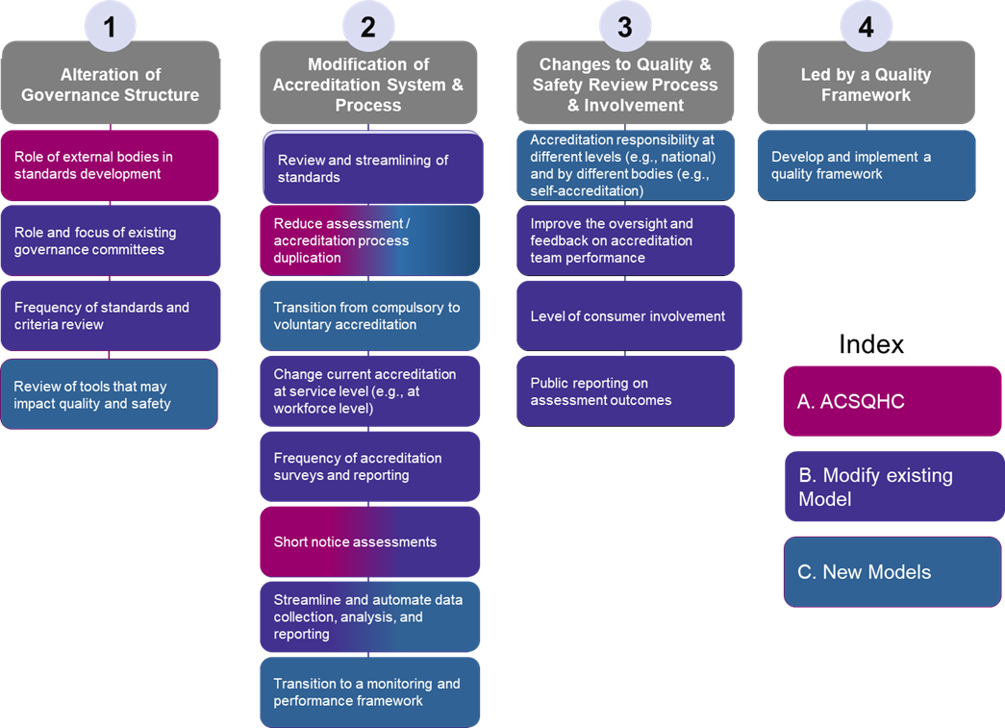
Source: HealthConsult (2024)
Abbreviations: ACSQHC, Australian Commission on Safety and Quality in Health
Table 6 displays an analysis of the options discussed with stakeholders for consideration to improve the BSA Program’s quality and safety and suggestions for enhancements from the previous section against the additional option of doing nothing based on the information detailed in Chapter 4.
There was no support for voluntary accreditation or workforce-level accreditation, so these have been excluded from Table 6.
Table 6: Options for consideration to improve the BSA Program’s quality and safety
A. Maintain the current system | B. Move to ACSQHC | C. Modify the existing model | D. Implement a new model
Limited support | Limited support | Medium to strong support | Medium to strong support
Governance and Standards
- No change to the current governance structure (limited support). The current limitations include:  - NQMC is overburdened with QA and limited time for QI  - SQCs do not interact with NQMC | - Move QA governance under ACSQHC (limited support). | - NQMC need more time/resources to focus on QI initiatives (medium support) | - Review the Role and focus of the Quality Management and safety governance committees (medium support)
- No change to NAS and approval process (No support) Current limitations include:  - NAS are outdated and, in some instances, not achievable  - Changes take long to approve, and there is no scheduled review cycle | - Standards To be developed by ACSQHC (limited support). Stakeholders noted Commission has limited expertise, although it may improve the review’s timeliness; some input would be beneficial | - NAS review and streamlining (strong support) of standards and reporting requirements  - Review NAS approval process (strong support)  - Establish review cycle of 4-5 years to reflect contemporary views (strong support)  - Increase consumer involvement, including input in NAS (strong support) | - Core set of NAS (strong support) suitable for short-notice assessments  - Review NAS approval process (strong support)  - Establish review cycle of 4-5 years to reflect contemporary views (strong support)  - Increase consumer involvement, including input in NAS (strong support)
Accreditation process
- No change to current accreditation (limited support). The current limitations include:  - Accreditation process is burdensome  - No additional focused surveys conducted for services that do not perform well at audit  - Limited oversight and feedback on accreditation team performance  - Accreditation responsibility (i.e., changing who conducts the accreditation process). Concerns about peer review  - Accreditation result. Concerns about the time taken to get results | - Reduce assessment process where services have been accredited by another system, e.g., NSQHS (medium support)  - Short notice assessments. Some stakeholders noted staff availability which would need to be addressed (medium to strong support)  - Accreditation responsibility independent reviewers (medium support) | - Short notice assessments (medium to strong support)  - Additional focused surveys were conducted for services that do not perform well at audit (medium support)  - Improve oversight and feedback on accreditation team performance (medium support)  - Accreditation responsibility (i.e., changing who conducts the accreditation process) (medium support)  - Concerns about peer review  - Reviewers need expertise  - Accreditation result - Public reporting on assessment outcomes to ensure community and consumers are better informed (strong support). Although it was noted posting negative reports may tarnish a reputation despite good work to resolve issues and years of positive performance; would need to be well-managed. | - Multi-level accreditation responsibilities; (medium support):  - Core national accreditation (using short notice) with the remaining QA activities as state-based activity  - Short notice assessments (medium to strong support) may be problematic with staff availability and would require a core set of standards  - Accreditation responsibility independent reviewers (medium support)
Data Collection
- No change to current data collection (No support). Process is burdensome, and data collected is not used strategically at national level |  | - Streamline processes, e.g., automating data capture and reporting (strong support) | - Monitoring and performance framework and benchmarking were seen as important, especially in combination with accreditation process changes (medium support)
Quality Improvement
- No change to current QI (Limited support). The current limitations include:  - No National Coordination  - Limited sharing of ideas  - No Quality Framework  - Quality Plan outdated |  | - Sharing of ideas on an adapt and adopt basis (strong support) | - Establish National Guidelines (strong support and high priority)  - Review of tools/ technologies that may impact quality and safety (strong support and high priority)  - Stop trial duplication if already performed, and peer-reviewed (strong support)  - Quality Framework was seen as important, especially in combination with accreditation process changes (medium support)
Benefits
- Uses existing strengths and expertise  - No disruption or change management required | - Builds on existing strengths and expertise  - Minimises disruption and change management  - Allows targeted improvements to address gaps  - Maintains focus and tailoring to breast screening  - Provides continuity and stability for services | - Builds on existing strengths and expertise  - Minimises disruption and change management  - Allows targeted improvements to address gaps  - Maintains focus and tailoring to breast screening  - Provides continuity and stability for services | - Provides a comprehensive approach to quality management  - Enables real-time, data-driven monitoring and benchmarking  - Encourages a culture of continuous improvement  - Aligns with international best practices  - Facilitates a more agile approach to quality management
Limitations
- The current limitations of the QA system would still exist  - QI would remain ad-hoc without national coordination | - May not be tailored to breast screening needs  - Services may face additional costs and administrative burdens associated with meeting new requirements  - There may be a loss of specific expertise and focus on breast screening quality under a more generalised accreditation system  - Services may resist/ struggle to adapt to changes, especially as it was not supported by stakeholders | - May not address fundamental limitations  - The model may be too inflexible for major changes  - Modifications may add complexity and confusion  - Resistance or fatigue among stakeholders  - Benefits may be limited or short-lived  - Previous recommendations only partially implemented | - Requires upfront investment in digital technologies  - This may create additional administrative burdens initially  - Relies on data quality and timeliness  - Requires careful selection of benchmarking metrics  - Relies on strong leadership and communication
Source: HealthConsult based on stakeholder consultations and a review of documentation provided. Abbreviations: ACSQHC, Australian Commission on Safety and Quality in Health Care; NSQHS, National Safety and Quality Health Service; QA, Quality Assurance; SQC, State Quality Committee

Based on the analysis of the pros and cons of each option, Option D ‘Implement a new model’ offers the greatest potential for long-term, sustainable improvements in the quality and safety of breast screening services in Australia. However, it involves the most significant change and upfront investment.
The key components of Option D emphasised by best practice and emerging trends include:
- Reducing the QA burden by:
  - Optimising the use of technology in data collection and reporting
  - Moving from solely focused on Accreditation surveys to including performance monitoring and benchmarking
  - Short notice assessments as currently being used by ACSQHC
  - Risk-based Assessment of core NAS.
- Addressing the variations of jurisdiction governance requirements by enabling a multilevel QA process where jurisdictions can implement additional QA processes (to the National Core QA process) that reflect local priorities and requirements.
- Increasing the focus on QI
  - Implementing a Quality Framework with a QI plan
  - Focusing on areas of concern, such as priority populations

Conclusion and Suggestions
This Chapter presents the key considerations, guiding principles and primary objectives that underpin the reviewers suggestions to ensure the ongoing safety and quality of the BSA program. A high-level roadmap for implementing these suggestions is included, emphasising the importance of a staged, collaborative, and adaptive approach to change management.
The report’s purpose has been to examine the current state of quality and safety in the Australian breast screening program and to provide suggestions for improvement. The findings and insights presented in this report underscore the need for a comprehensive and strategic approach to enhancing the QA and QI processes in the breast screening program. This approach must be grounded in a clear understanding of the unique considerations and principles that shape the program's operations and objectives and must be geared towards delivering meaningful, sustainable improvements in the safety, effectiveness, and efficiency of screening services.
The Australian breast screening program has a long history of delivering quality and safe services to women across the country. However, this has been achieved within certain constraints, including limitations in workforce and training, funding and the available technology.

Key Considerations
A range of factors that shape the current realities and future prospects of the breast screening program have been considered in developing suggestions and strategies for a more effective, efficient, and sustainable approach to QA and QI in the program. These key considerations include:
- Consistency of service delivery: Consideration was given to the strong consensus among stakeholders that breast screening participants should have the same expectation of service across Australia, regardless of their location. While some variation in service delivery may be acceptable due to factors such as priority populations and remoteness, the suggestions should aim to promote consistency in the quality of screening services nationwide.
- Focus mostly on QA: Quality activities in the breast screening program have mainly focused on assurance rather than improvement.
- Rapidly changing technology: Stakeholders highlighted that the NAS has not kept pace with technological evolutions, such as the emergence of digital mammography and, more recently, artificial intelligence tools. As the rate of technological change accelerates, there is a risk that the standards will become increasingly outdated and less relevant to contemporary best practices.
- Emerging trends and models of accreditation: Draw on insights from the latest developments and best practices in accreditation, both in Australia and internationally, to identify opportunities for alignment, harmonisation, and innovation in the breast screening program's accreditation processes while also recognising the unique features and requirements of population-based screening.
- Resource constraints: Many services report having insufficient resources, both human and financial, to fully achieve the NAS requirements. There are also insufficient resources to provide an adequate number of peer review surveyors to conduct accreditation assessments. QI has similar constraints with limited funding.
- Accreditation burden: Feedback from stakeholders (including services being accredited, the surveyors, and NQMC) that current accreditation processes and annual data reporting can be onerous and resource-intensive. Additionally, breast screening services are often required to undergo other accreditation processes as well as BreastScreen accreditation, depending on their jurisdiction and whether they are located within a hospital.
- Previous recommendations not implemented: While the reasons were not clear, they may not have been fully implemented due to a range of factors, including resource constraints, competing priorities, and the complexity of the changes required. Some recommendations may have been too ambitious or difficult to operationalise within the program's existing structures and processes, while others may have lacked sufficient buy-in or ownership from key stakeholders. Additionally, the absence of clear implementation plans, timelines, and accountability mechanisms may have hindered the translation of recommendations into action.
- Time required to implement: Consideration should be given to the time and effort required to design, test, and implement new QA and QI processes and develop a staged approach to change management that allows for gradual, incremental improvements over time.

Guiding Principles
The suggestions for improving QA and QI in the breast screening program have been guided by a set of core principles that reflect the values, priorities, and realities of the program. These guiding principles include:
- Consistency, equity, and continuous improvement: This means ensuring that all participants receive consistent, high-quality screening services regardless of location while allowing for acceptable variations due to factors such as priority populations and remoteness. The program should promote a proactive, continuous approach to QI alongside robust QA processes, fostering a culture of learning, innovation, and best practice sharing among services. Acknowledging that QI and QA are both essential components of a comprehensive quality management approach, the program should strive to strike a balance between compliance with established standards and continuously enhancing processes, outcomes, and experiences beyond the minimum requirements.
- Adaptability to technological change and alignment with best practices. QA and QI processes should be designed to be flexible and adaptable, accommodating rapid advancements in technology while incorporating rigorous evaluation and implementation strategies to enhance screening safety and effectiveness. Accreditation processes should align with the latest developments and best practices in Australia and internationally, identifying opportunities for harmonisation and innovation while recognising the unique requirements of population-based screening. Regular review and updating of standards, guidelines, and processes are necessary to keep pace with evolving evidence, technologies, and service delivery models, ensuring they remain relevant and fit for purpose.
- Focus on high-priority items and leveraging previous work. Suggestions and strategies should be prioritised based on their potential to address the most pressing challenges while delivering tangible benefits. This targeted approach helps to maximise the value of available resources and ensures that efforts are focused on areas where they can make the greatest difference. Additionally, the program should build on its existing strengths and successes by evaluating initiatives guided by national QI research and evaluation framework then adopting and adapting effective practices and tools from other jurisdictions, settings, or sectors. This allows the program to leverage proven solutions and avoid duplicating efforts, accelerating progress towards better QA and QI outcomes. By focusing on high-priority items and leveraging previous work, the breast screening program can drive continuous improvement and achieve better results within its current constraints.
- Streamlined accreditation and resource optimisation. The focus should be on optimising and streamlining accreditation processes to reduce the administrative burden on services, surveyors, and NQMC. Consideration could be given to aligning BreastScreen accreditation with other accreditation processes. Suggestions should be developed with the aim of being implementable within existing resource constraints or addressing these constraints directly, prioritising cost-effective and sustainable solutions that maximise value for money. Adopting a staged approach to change management allows for gradual, incremental improvements over time, balancing the need for progress with the reality of limited resources and competing priorities within the program.
- Feasibility, stakeholder engagement, and staged implementation. Strategies should be designed to be feasible, actionable, and well-supported by all stakeholders, with clear implementation plans, timelines, and accountability mechanisms developed to facilitate the translation of recommendations into action. By prioritising feasibility and adopting a staged approach to change management allows for gradual, incremental improvements over time, balancing the need for progress with the reality of limited resources and competing priorities within the program. This principle recognises the importance of stakeholder buy-in and the need to manage change in a way that minimises disruption and builds trust and confidence among all involved parties.
- Continuous evaluation and Iterative improvement to ensure that changes to QA and QI processes are effective, sustainable, and responsive to emerging needs and opportunities. The program should emphasise the importance of ongoing monitoring, evaluation, and feedback loops to assess the impact and effectiveness of changes over time. A staged approach to implementation, with clear milestones and review points, allows for progress to be assessed, challenges identified, and necessary adjustments made before proceeding to the next stage. This iterative, evidence-based approach ensures that improvements are delivering the intended benefits and that the program remains agile and adaptive in the face of evolving circumstances. By embracing continuous evaluation and iterative improvement, the breast screening program can foster a culture of learning, accountability, and excellence, driving better outcomes for all stakeholders.

Objectives
Based on the key considerations and guiding principles outlined above, two primary objectives for improving QA and QI in the breast screening program have been identified:
- Evolve QA processes towards a more focused, agile, evidence based and sustainable model: The first objective is to streamline and optimise the program's existing QA processes to ensure that they are fit-for-purpose, responsive to changing needs and technologies, and sustainable over time. This involves ensuring:
- NAS are contemporary and fit for purpose
- Audit survey is focused, sustainable and aligns with other accreditation surveys
- Annual Data Reporting is optimised is in what is collected and used and how data is collected
- Create a clear and effective pathway for QI initiatives from project to implementation: The second objective is to establish a more robust and systematic approach to QI in the breast screening program, to most importantly, improve national consistency and foster innovation, collaboration, and the spread of best practices.

Key suggestions
To achieve these objectives, the following key suggestions are recommended for consideration in three key areas:

Quality Assurance
The key suggestions for QA include:
S1. Conduct a comprehensive review and update of the NAS.
This should be done in consultation with key stakeholders (including consumers) to ensure that they are aligned with contemporary best practices, technologies, and service models. The revised NAS should be more streamlined, agile, outcome-focused, and achievable wherever possible. Once nationally agreed guidelines are available, the standards should reference these guidelines rather than duplicate them. This will allow the agility required to be able to evolve clinical guidelines as required e.g. additional information becomes available or new technology emerges.
S2. Initially modify the audit survey
To reflect the updated NAS with the aim of moving to multi-level QA mechanisms and controls at the individual service level, jurisdictional level and national level. Concurrently, review the governance of the SCUs and SQCs and revise the structure, reporting, operations and resourcing of SQCs in line with their role’ to enhance QA/QI across the three levels. This tiered approach recognises that quality is everyone's responsibility. The national and jurisdictional components may include:
    - A nationally coordinated short-notice accreditation survey process focused on a small core set of safety and quality standards. The key will be to use experienced independent surveyors who understand the unique context of population screening.
    - Jurisdictional responsibility and accountability for QA and meeting accreditation standards with QA mechanisms tailored to their specific structures, resources and populations. Standardised Jurisdictional QA could include activities like clinical audits, peer review and critical incident management.
S3. Develop a national QA data and reporting framework.
The framework should go beyond the current Annual Data reporting to enable real-time monitoring, benchmarking, and feedback on performance and supports continuous QI efforts. This framework should leverage existing data sources and systems while also exploring new technologies and tools for data collection, analysis, and visualisation.
    - Conduct a comprehensive review and update of the NAS, in consultation with key stakeholders, to ensure that they are aligned with contemporary best practices, technologies, and service models. The revised NAS should be more streamlined, agile, outcome-focused, and achievable wherever possible. Once nationally agreed guidelines are available, the standards should reference these guidelines rather than duplicate them. This will allow the agility required to be able to evolve clinical guidelines as required e.g. additional information becomes available or new technology emerges.
    - Initially modify the audit survey to reflect the updated NAS with the aim of moving to multi-level QA mechanisms and controls that are clearly defined for the individual service level, jurisdictional level and national level. This tiered approach recognises that quality is everyone's responsibility. The national and jurisdictional components include:
      - A nationally coordinated short-notice accreditation survey process focused on a small core set of safety and quality standards. The key will be to use experienced independent surveyors who understand the unique context of population screening.
      - Jurisdictional responsibility and accountability for QA and meeting accreditation standards tailored to their specific structures, resources and populations. Jurisdictional QA could include activities like clinical audits, peer review and critical incident management.
    - Develop a national QA data and reporting framework that goes beyond the current Annual Data reporting to enable real-time monitoring, benchmarking, and feedback on performance and supports continuous QI efforts. This framework would need to consider systems capability nationally and should leverage existing data sources and systems while also exploring new technologies and tools for data collection, analysis, and visualisation.

Quality Improvement
The key suggestions for QI include:
S4. Develop nationally agreed evidence-based guidelines
The guidelines should set out best practices across the screening pathway, from invitation and promotion through to assessment and diagnosis. Having common national guidelines ensures a consistent high-quality approach while allowing services to adapt and innovate to reflect local conditions where relevant. It was noted by stakeholders that some evidence-based clinical guidelines should be consistently applied and funded to ensure a high quality and similar screening, assessment and clinical experiences for each woman across Australia.
S5. Develop and fund a national QI research and evaluation framework to evaluate the implementation of service improvements.
This framework would enable review of effective practices and tools from other jurisdictions, settings, or sectors before they are adopted or adapted.
S6. Develop and implement a national QI plan and roadmap driven by an overarching QI Framework.
This will provide strategic direction and outline improvement priorities and initiatives.
S7. Foster a culture of innovation and collaboration.
This could include establishing QI networks, communities of practice, and knowledge-sharing platforms that enable services to learn from each other and scale up successful initiatives. This should include regular QI forums, webinars, and showcases, as well as online repositories of QI tools, templates, and case studies that can be adopted or adapted by services across the country to the local level.
S8. Ensure a client-centred approach.
Involve consumers in QI activities, including seeking feedback and representation on QI committees.
S9. Leverage the use of technology.
Utilise digital health technologies and data analytics to enable a more sophisticated evaluation of QI approaches and their impact on outcomes.

Governance
The key suggestion for Governance include:
S10. Establish a national QA and QI governance structure and framework.
Note: Given that many concerns arise from stakeholder input, it is advisable to establish a process to validate these issues concerning governance before any changes are implemented.
This should have clear roles and responsibilities for all current national committees. This may include ensuring that consumers, technical, clinical and operational expertise are embedded in quality governance, such as through representation on key committees and involvement in setting priorities. This may also include changes to the governance structure.
This should include a focus on:
    - Quality Assurance
      - A fast and efficient process to be able to adapt the NAS and provide oversight of accreditation outcomes.
      - Implement a regular evidence-based review and updating of quality standards and measures, cross-referenced to the national guidelines.
      - Oversight of the national performance monitoring and benchmarking dashboard
      - Adapt NAS based on QI insights once the new system has been implemented as outlined in Figure 10.
    - Quality Improvement
      - Oversight of the Quality Framework and the QI Plan.
      - A process to develop and endorse national guidelines.
      - Conduct periodic evaluations of the Quality Framework and supporting structures to assess their effectiveness in driving quality and safety outcomes.
      - Inform the NAS standards and QA process once systems have been successfully adopted as outlined in Figure 10.
Figure 10: QA and QI
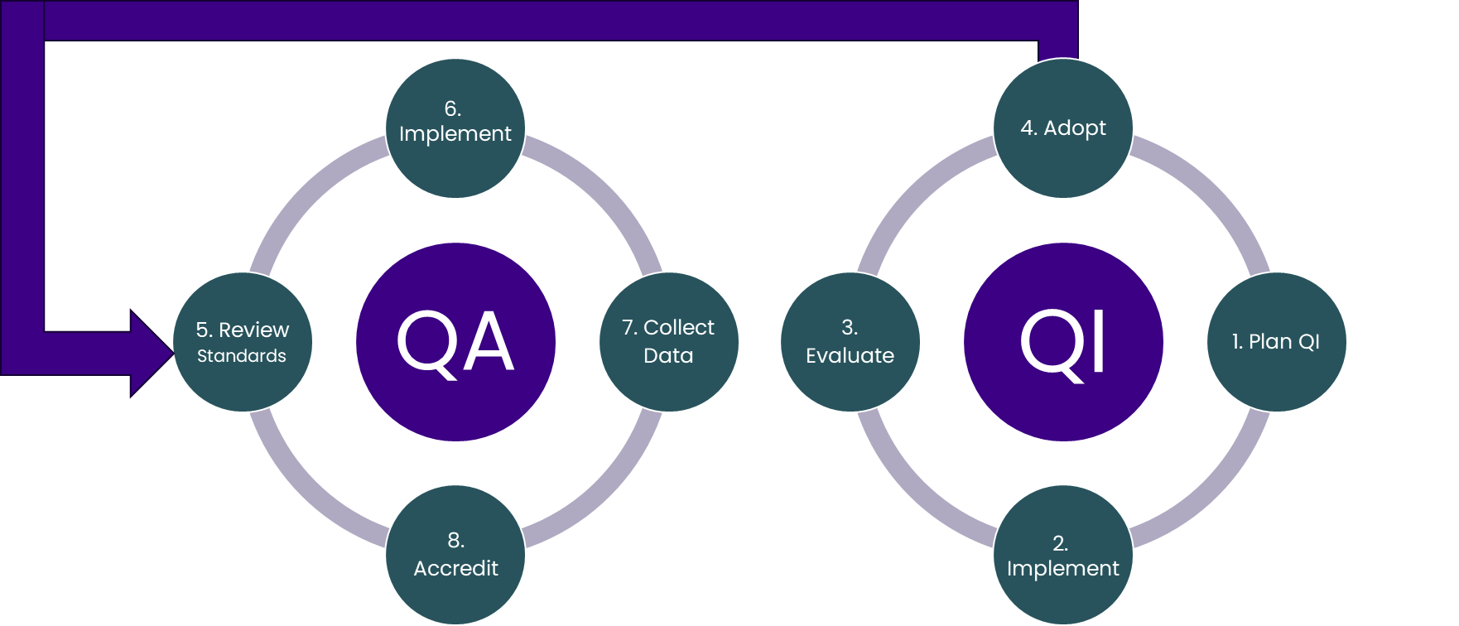
Source: HealthConsult (2024)

Goal State and Implementation Roadmap
The Goal State for Quality and Safety (Figure 11) is the desired outcome of implementing the proposed suggestions, leading to meaningful and sustainable improvements in the safety, effectiveness, and efficiency of screening services.
Figure 11: Key elements of the goal state for quality and safety
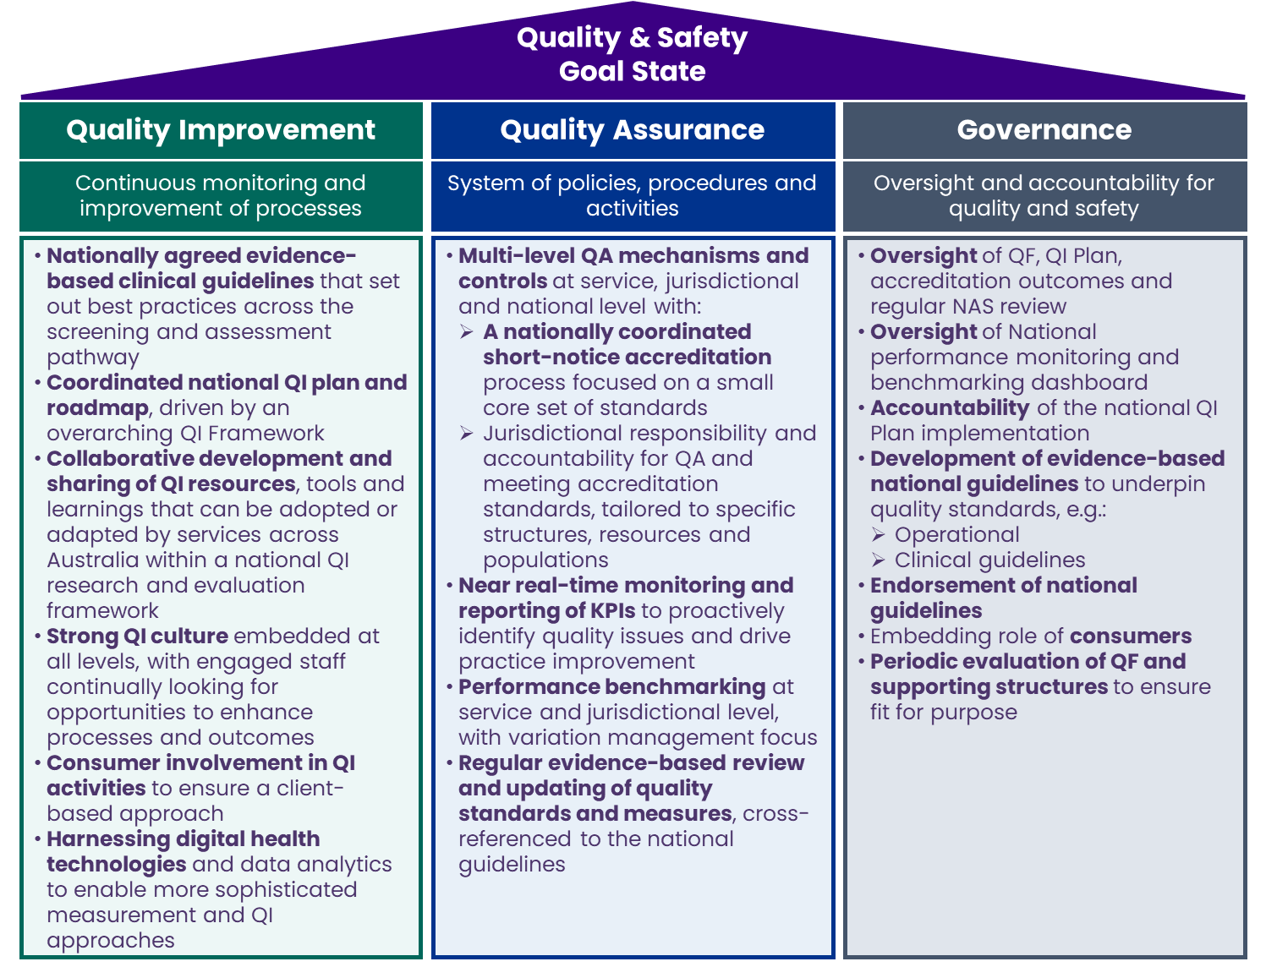
Source: HealthConsult based on review of BSA program documentation
Abbreviations: CAG; Clinical Advisory Group; NAS, National Accreditation Standards; NQMC, National Quality Management Committee; PM, Project Management; QA, Quality Assurance; QF, Quality Framework; QI, Quality Improvement
The key advantages of this model are:
- Comprehensiveness: By integrating multiple components and approaches, this model provides a holistic and robust framework for quality management, addressing both QA and QI.
- Alignment with best practices: The inclusion of benchmarking, quality frameworks, and regular review processes aligns with international best practices and standards for healthcare quality and accreditation.
- Data-driven insights: Optimising the process by keeping pace with efficiency gains possible with technology advancements not previously implemented in the QA process. The emphasis on monitoring and performance frameworks enables a more data-driven, evidence-based approach to quality management, facilitating timely identification of issues and opportunities for improvement.
- Flexibility and responsiveness: The multi-level accreditation responsibilities and regular review of tools allow for greater flexibility and responsiveness to the diverse needs and contexts of breast screening services across Australia.
- Continuous improvement culture: The integration of benchmarking and QI frameworks fosters a culture of learning, collaboration, and innovation across the breast screening sector.
However, implementing this model will require strong leadership, stakeholder engagement, improvements to system capability, capital funding and change management to overcome the potential challenges and risks, such as:
- Complexity and resource intensity: The development and implementation of this model may be complex, time-consuming, and resource-intensive, requiring significant upfront investments for the necessary technology upgrades.
- Stakeholder resistance: There may be resistance or fatigue among some stakeholders who are comfortable with the existing accreditation system and processes.
- Data and reporting burdens: The emphasis on data collection, monitoring, and benchmarking may create additional administrative burdens for services, particularly in the early stages of implementation.
To mitigate these challenges a phased approach to implementation is recommended, with extensive consultation, piloting, and evaluation to refine the model over time and ensure it is feasible to implement. This should be accompanied by clear communication, training, and support for services to build capacity and confidence in the new system.
To achieve the goal state, an Implementation Roadmap is proposed, which includes suggestions outlined in the previous section into practice. This roadmap is intended to provide a structured and staged approach to the breast screening program QA and QI reform while also allowing for flexibility and adaptation based on local needs and circumstances as outlined in Figure 4.
In the longer term, the benefits of this model – in terms of improved quality, safety, and outcomes for women participating in breast screening – are likely to outweigh the initial costs and challenges of implementation.

Project Methodology
Figure 12 provides a summary of the methods used in conducting this review.
Figure 12: Quality and Safety review methodology
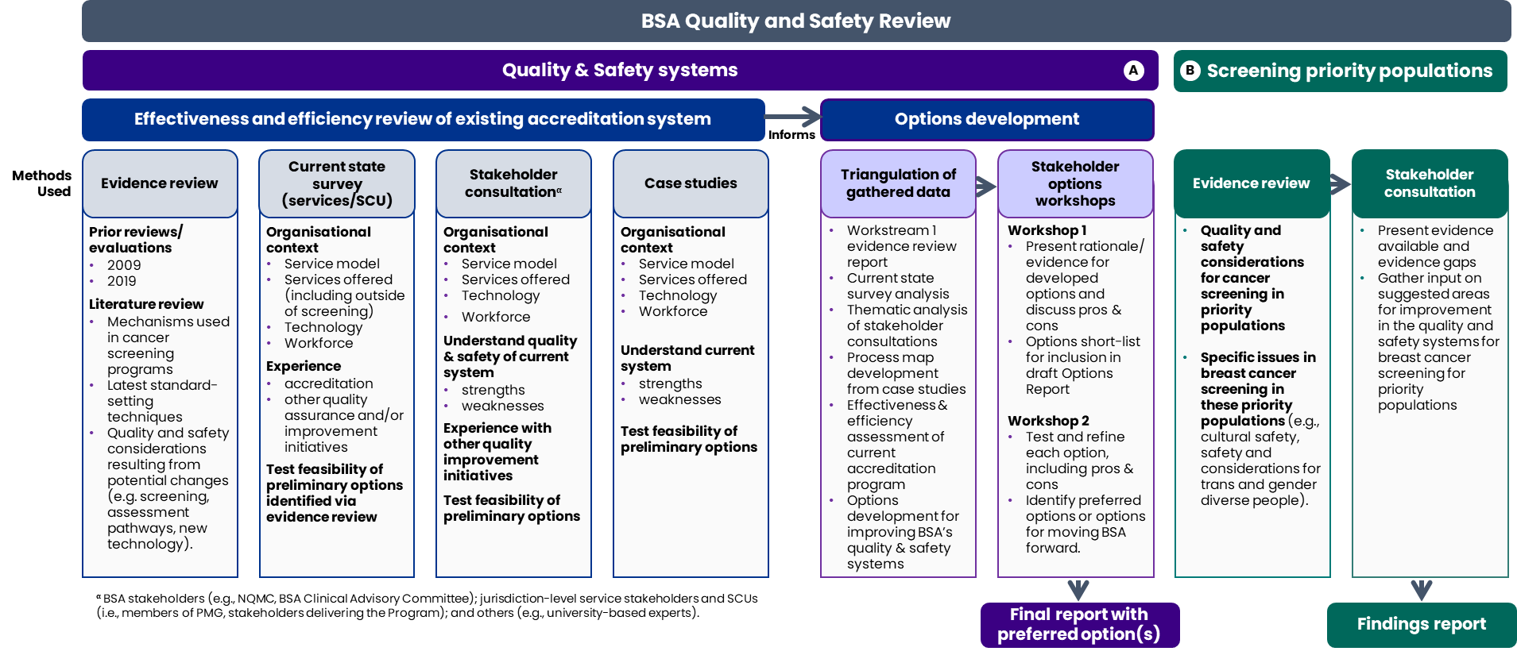
Source: HealthConsult (2024)

It should be noted that each service operates within separate jurisdictional governance structures with varying requirements for managing quality, safety issues, and risks.
Australian Government Department of Health and Aged Care (2018). Population Based Screening Framework, accessed from https://www.health.gov.au/sites/default/files/documents/2019/09/population-based-screening-framework_0.pdf
Australian Government Department of Health and Aged Care (2023). About the BreastScreen Australia Program, accessed from Australian Government Department of Health and Aged Care (2023). About the BreastScreen Australia Program, accessed from
Australian Government Department of Health (2023). BreastScreen Australia National Accreditation standards, accessed from https://www.health.gov.au/sites/default/files/2023-04/breastscreen-australia-national-accreditation-standards-nas.pdf
Australian Government Department of Health and Aged Care (2024). Accreditation Status Report (as at March 2024), accessed from https://www.health.gov.au/sites/default/files/2024-04/breastscreen-australia-accreditation-status-report.pdf
Note :this is not a standard position in every jurisdiction. Some have ‘service director/director/program director’ who would also be responsible for this in accordance with the NAS.
Note: we could not find evidence of this occurring but can occur at any time.
Australian Government Department of Health and Aged Care (2021). BreastScreen Australia National Accreditation Handbook, accessed from https://www.health.gov.au/sites/default/files/documents/2021/03/breastscreen-australia-national-accreditation-handbook.pdf
Australian Government Department of Health (2023). BreastScreen Australia National Accreditation standards, accessed from https://www.health.gov.au/sites/default/files/2023-04/breastscreen-australia-national-accreditation-standards-nas.pdf
Australian Government Department of Health and Aged Care (2021). BreastScreen Australia National Accreditation Handbook, accessed from https://www.health.gov.au/sites/default/files/documents/2021/03/breastscreen-australia-national-accreditation-handbook.pdf
The Cancer Council Australia, Australian Cancer Network and National Breast Cancer Centre. A core strategy for cancer care: accreditation of cancer services – a discussion paper. 2005 National Breast Cancer Centre, Camperdown, NSW.
Note a mapping of BSA NAS standards and protocols against the NSQHS Standards found little overlap between the two sets of standards so most of the NSQHS still apply.
The Australian Population Based Screening Framework (2018) The Australian Population Based Screening Framework (2018). Accessed 6 July 2024
National Bowel Cancer Screening Program – Quality Framework (2016) https://www.health.gov.au/resources/publications/national-bowel-cancer-screening-program-quality-framework. Accessed 6 July 2024
National Cervical Screening Program Quality Framework (2017), accessed from https://www.health.gov.au/sites/default/files/documents/2019/10/national-cervical-screening-program-quality-framework-national-cervical-screening-program-quality-framework.pdf
https://www.nsu.govt.nz/system/files/page/nsuqualityframework201514dec15.pdf
Siegl et al. (2014). Quality assurance through quality improvement and professional development in the National Breast and Cervical Cancer Early Detection Program. Cancer. 2014 Aug 15;120 Suppl 16(0 16):2584-90. doi: 10.1002/cncr.28822. PMID: 25099901; PMCID: PMC4459517.)
RIVM (2021). Framework for the execution of breast cancer screening, Accessed from https://www.rivm.nl/sites/default/files/2021-07/Framework%20execution%20Dutch%20Breast%20Cancer%20Screening%20%282021%29.pdf
Bucchi et al. (2016). Recommendations for breast imaging follow-up of women with a previous history of breast cancer: position paper from the Italian Group for Mammography Screening (GISMa) and the Italian College of Breast Radiologists (ICBR) by SIRM. Radiol Med. 2016 Dec;121(12):891-896. doi: 10.1007/s11547-016-0676-8
Bernardi et al. (2017). Digital breast tomosynthesis (DBT): recommendations from the Italian College of Breast Radiologists (ICBR) by the Italian Society of Medical Radiology (SIRM) and the Italian Group for Mammography Screening (GISMa). Radiol med 122, 723–730. https://doi.org/10.1007/s11547-017-0769-z
https://www.canada.ca/en/public-health/services/reports-publications/breast-cancer-screening-knowledge-exchange-virtual-event-what-we-heard-summary.html
This time is a maximum of 6 weeks including a 10 day review period for the service to correct any factual inaccuracies in the Survey report and a further 10 days to finalise the report after receiving corrections.
Note: Only the components of the models were discussed with stakeholders.
Short notice assessments in healthcare accreditation involve unannounced or minimally announced surveyor visits, giving organisations little advance warning. This method effectively evaluates a facility's daily operations without time for extensive preparation, reducing administrative burden and providing a more authentic view of routine practices.
The National Surveyor and Chair of NQMC have commenced a Community of Practice for BSA services. The first was held in July 2024. It is planned that up to three of these will be hosted each year.

