Approved PPB member category certificate examples
Program services must be delivered or supervised by qualified practitioners (QP). A QP is someone who has current membership of a recognised Practitioner Professional Body (PPB) in an approved membership category. To assist providers, images of the certificates for approved membership categories of each PPB are shown below. Further information about qualified practitioners is available on the program website. Practitioners who hold the following certificates with the identified PPB are entitled to hold a current and active QP number with the program and can deliver services to program clients.
Please check the membership categories on the certificate are correct before requesting a QP number through the portal.
Approved membership categories for Qualified Practitioners
PPB | Example PPB Approved Membership Certificates
Audiology Australia  (AudA)  Approved Member Categories  - Full Accredited  - Fellow Accredited  - Life Accredited  - Member Accredited Limited Scope Audiologist | 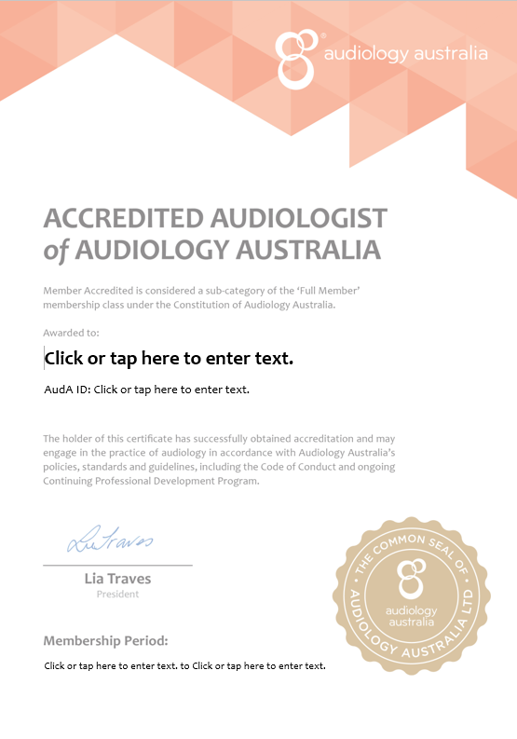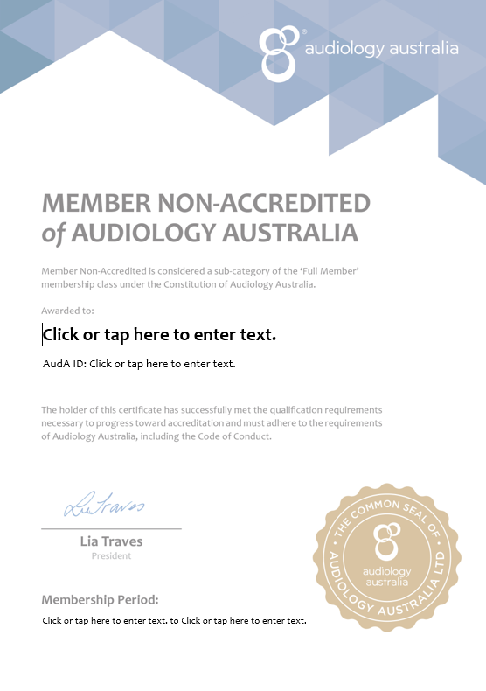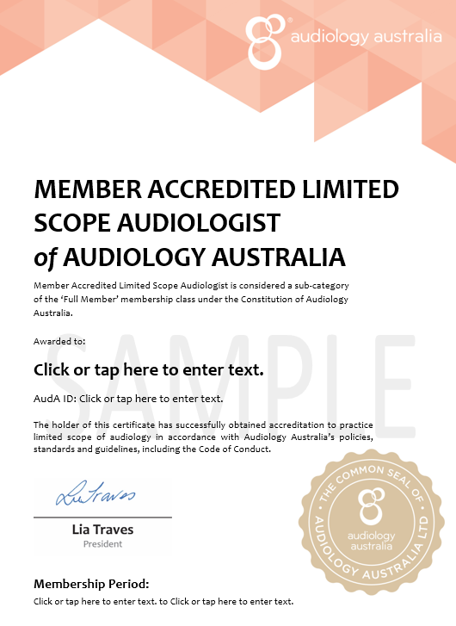
Australian College of Audiology incorporating Hearing Aid Audiology Society of Australia  (ACAud incorporating HAASA)  Approved Member Categories  - Full  - Fellow | 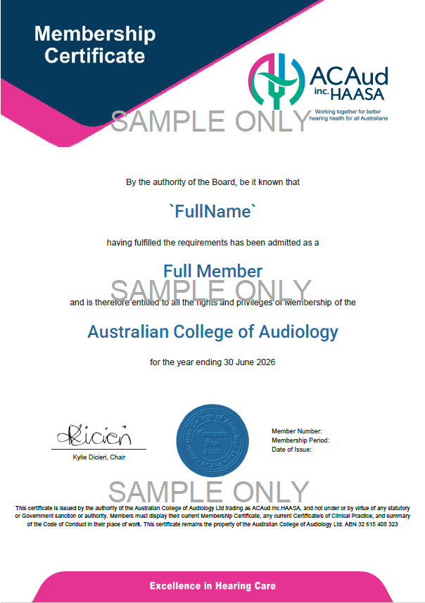 | 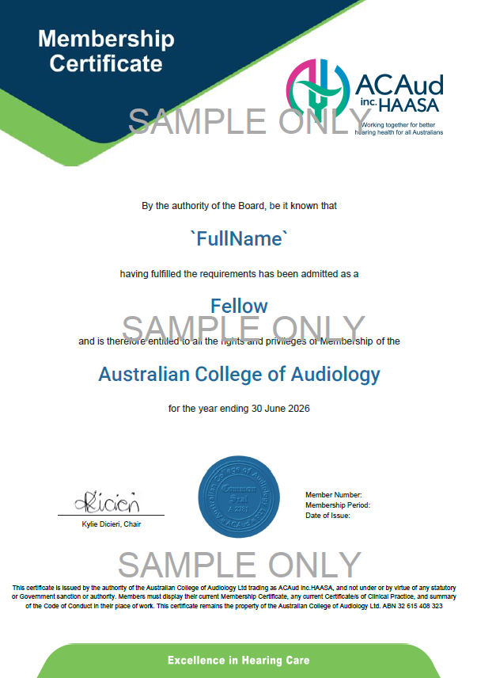
AND  ACAud incorporating HAASA Competency Certificate | Audiologist  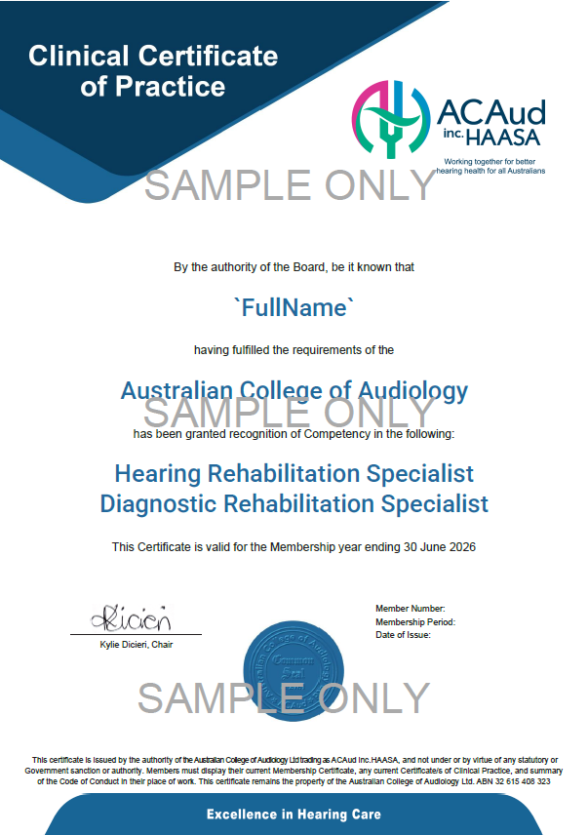 | Audiometrist  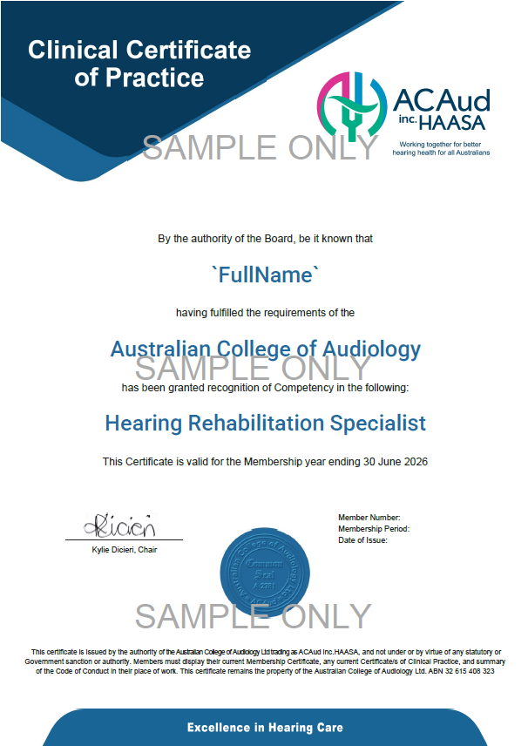
Restricted Scope Audiologist
