User Guide: Tobacco Reporting Service - View, manage and submit tobacco reports
20 July 2026

In this Guide:
- Before you start
- To submit reports on your organisation’s behalf
- To edit an existing draft submission
- To view a submission outcome

Before you start
To submit reports on your organisation’s behalf, you must:
- be a registered HBS portal user
- already be linked to the Tobacco Reporting Service.
- be linked to the organisation.
- have permission to upload and submit reports.
Tobacco Reporting Templates can be found here to download and complete for your organisation:
- Tobacco product ingredients report
- Tobacco product volumes report
- Tobacco product marketing and promotional expenditure report
- Tobacco product consolidated report.

To submit reports on your organisation’s behalf.
- On the Tobacco Reporting Service homepage, select your organisation from the drop-down menu.
- Once you have selected your organisation, select the Report submission card on the Tobacco Reporting Service homepage.
- Selecting the Report submission card will navigate you to the Report submissions page.
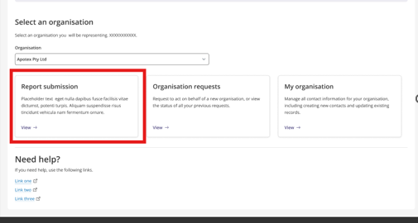
- On this page, select the Create new submission button.
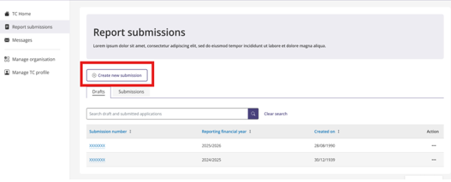
- After selecting Create new submission, you will be navigated to the Create New Submission page.
  - You will see a dropdown menu for “Which financial year is this report for?”.
  - Select the appropriate financial year.
  - Select the Start submission button.

Note:. The Start submission button will be enabled once the financial year has been selected

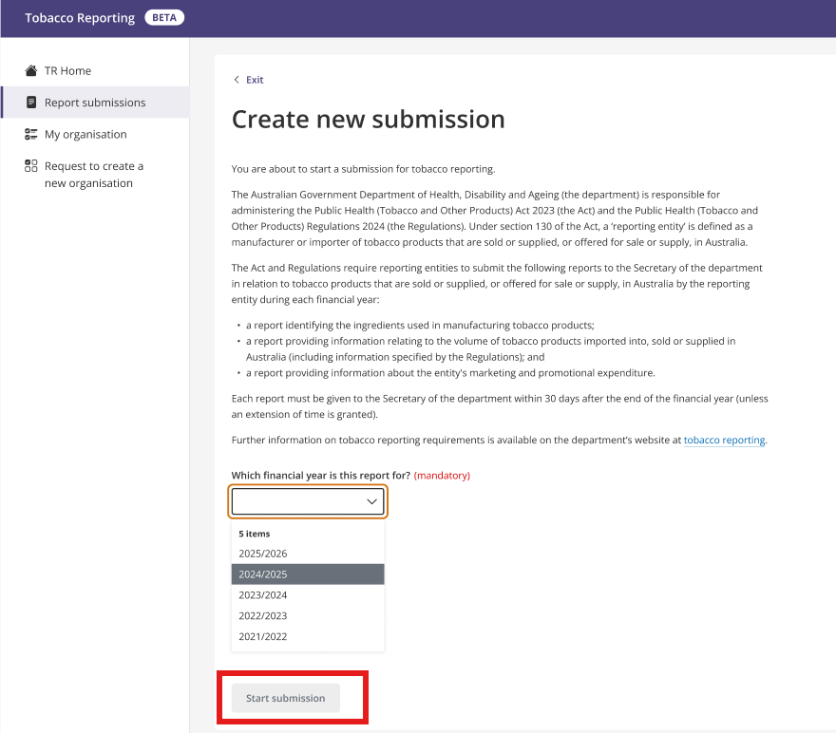
- After selecting Start submission, you will be directed to the Company Details page.
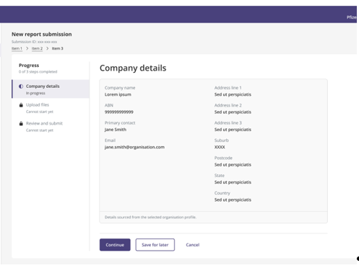

- Review the company details. This is a read-only section and no edits can be made to organisation details here.
- Choose one of the following:
  - Continue to progress to the next step, Upload files.
  - Save for later to save the draft submission and navigate back to the Report submissions page.
  - Cancel to navigate back to the Report submissions page without saving any changes.
- If you choose to continue you will be navigated to the Upload files page.
- Select the Add file button to upload files.
- Select the file or files you wish to upload.
- Uploaded files will be listed once you select the Continue or Save for later buttons.
Tobacco Reporting Templates can be found here on the department’s website:
- Tobacco product ingredients report
- Tobacco product volumes report
- Tobacco product marketing and promotional expenditure report
- Tobacco product consolidated report.

Note: You can upload a maximum of 3 files.

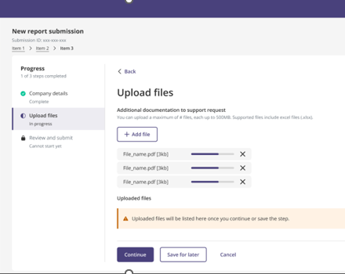

- If you choose to Continue you will be navigated to the Review and submit page.
- Review the proposed submission.
- Review the Declaration section and tick the declaration checkbox. You must tick this checkbox before submission is allowed.
- Select Submit or Save for later.

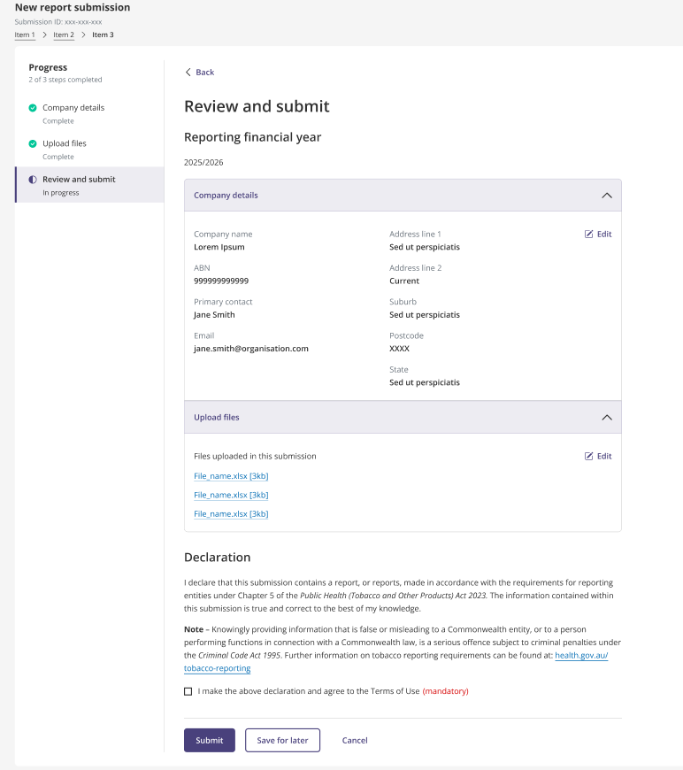

- If you choose Submit, a message will be displayed confirming that the form has been submitted successfully and providing information outlining the next steps.
- You will receive an email confirming the outcome of the submission.
- Processing may take several hours. Please wait for the response email before resubmitting.

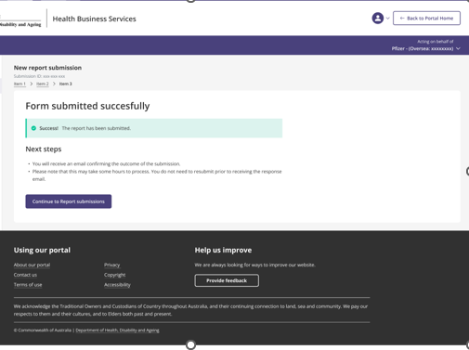

To edit an existing draft submission
- On the Report submissions page, select the Draft tab.
- Find the draft submission you want to continue.
- In the Actions column, select Edit.

To view a submission outcome
- On the Report submissions page, select the Submissions tab.
- Find the submitted report you want to view.
- In the Actions column, select View.
- The submission will open in view-only mode.

Note: Submitted reports are view only and cannot be edited or deleted.

