User Guide: Tobacco Reporting Service - Manage Organisation Requests
20 July 2026
This user guide explains how to manage Organisation Requests.
On the Tobacco Reporting Service homepage, you can see the Request to create a new organisation card.
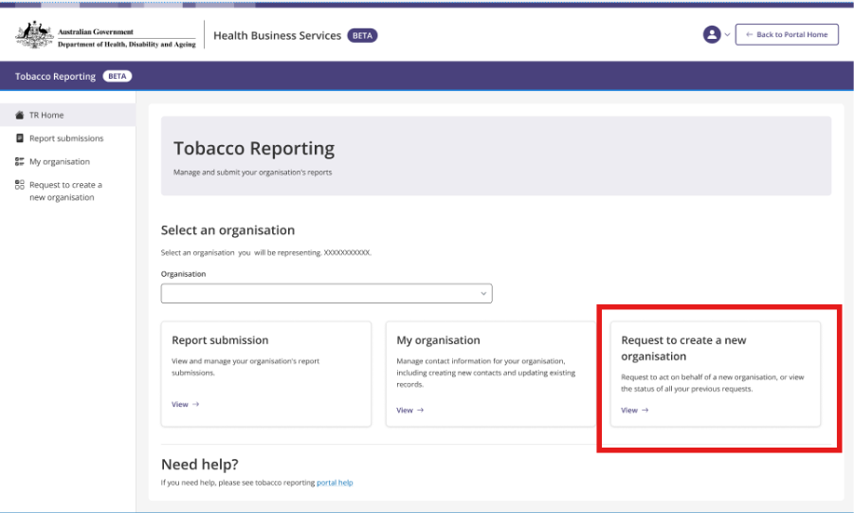
Selecting the card will navigate to the Request to create a new organisation page. This page allows you to:
  - Create an Organisation account
  - View submitted requests to create a new organisation
  - View, edit and delete draft requests.

Submission tab view:
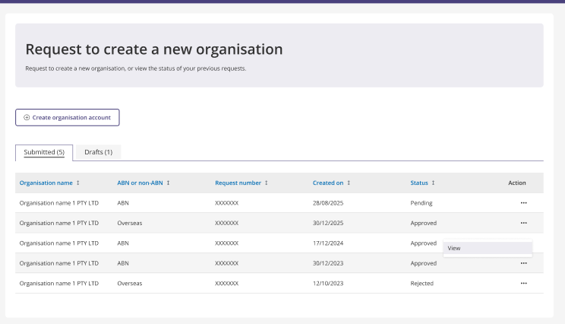
- To view the details of submitted requests from the Tobacco Reporting Service homepage navigate to the Request to create a new organisation page.
  - A list of both submitted and draft requests will be visible.
  - This includes columns with these details: organisation name, ABN or Non ABN request type, request number, date created, date modified and an Actions column option represented by 3 dots.
  - View your previous submissions in the Submissions tab on the Organisation requests page. Select Actions >> View.
  - Statuses include Pending, Approved, Rejected.

View 1: Request is Pending assessment
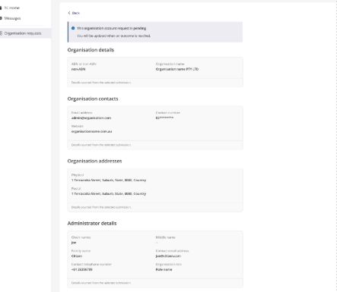

View 2: Request has been approved
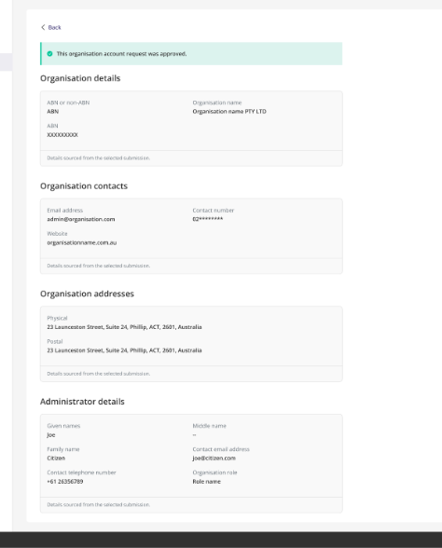

View 3: Request has been rejected
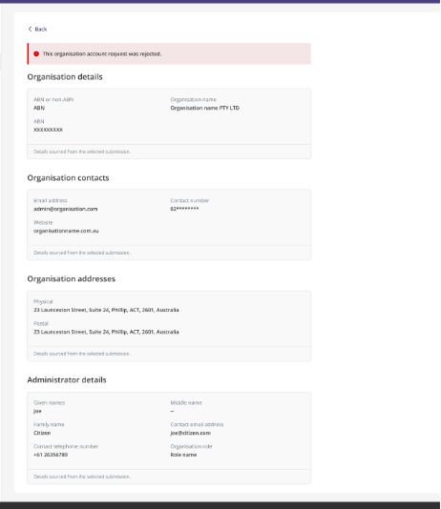
Note: Submissions are view only. Submissions cannot be edited or deleted.

- Delete the requests that are in draft.
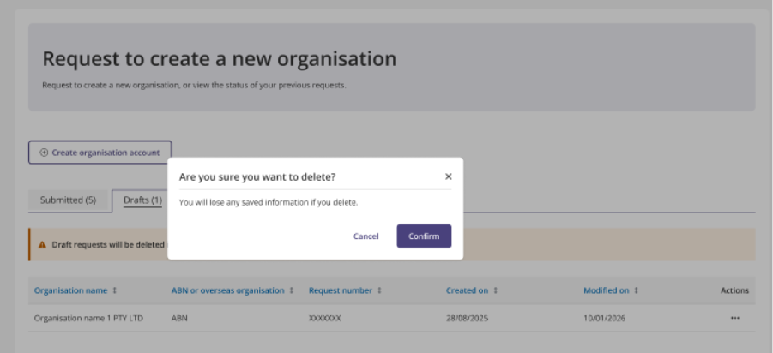

- In the Drafts tab move to the Actions column and select the three dots.
- You will have the choice of Edit or Delete.
- Select Delete.
- Selecting Confirm will remove the request from the list.
- Only Draft requests can be deleted.
- Drafts that are inactive for 7 days will be automatically removed from the list.

- Edit the requests that are in draft.

Submission draft view:
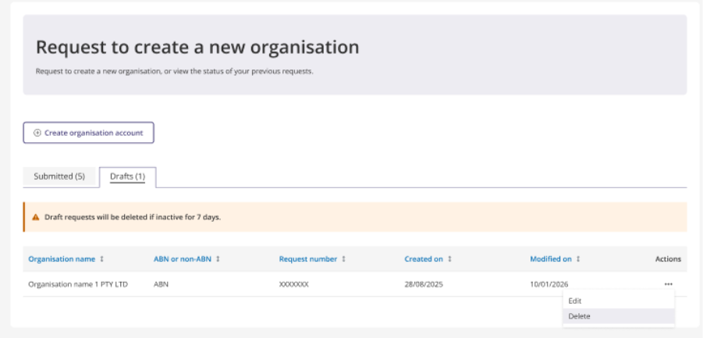
- In the Drafts tab move to the Actions column and select the 3 dots.
- You will have the choice of Edit or Delete.
- Select Edit or Delete.

