User Guide: Tobacco Reporting Service - Manage organisation invitations
20 July 2026
Invitations allow you to access the Tobacco Reporting Service through the Health Business Services (HBS) portal.

In this Guide:
- About invitations
- Before you can accept an invitation
- Accept an invitation
- Verify an invitation email address
- Decline an invitation
- Invitation errors
- Exit the invitation process
- New HBS portal users
- Existing HBS portal users not linked to the service

About invitations
Organisation Administrators can invite you to join their organisation in the Tobacco Reporting Service.
The invitation is sent by email. You action the invitation through the HBS portal within the Tobacco Reporting Service.
The invitation process links your HBS portal profile to the Tobacco Reporting Service. Once linked, you can access your organisation in the Tobacco Reporting Service.
This is separate from the initial invitation process to register for the HBS portal and create an Organisation account in the Tobacco Reporting Service. This guidance is when your organisation is already registered and inviting you to join.
For help accepting the initial invitation, refer to the HBS portal How to page on accepting an invitation.

Before you can accept an invitation
An Organisation Administrator must have invited you to join the organisation.
Before accepting an invitation, you must:
- receive an invitation email
- be registered for the HBS portal
- be signed in to the HBS portal
- have the invitation code from the email.

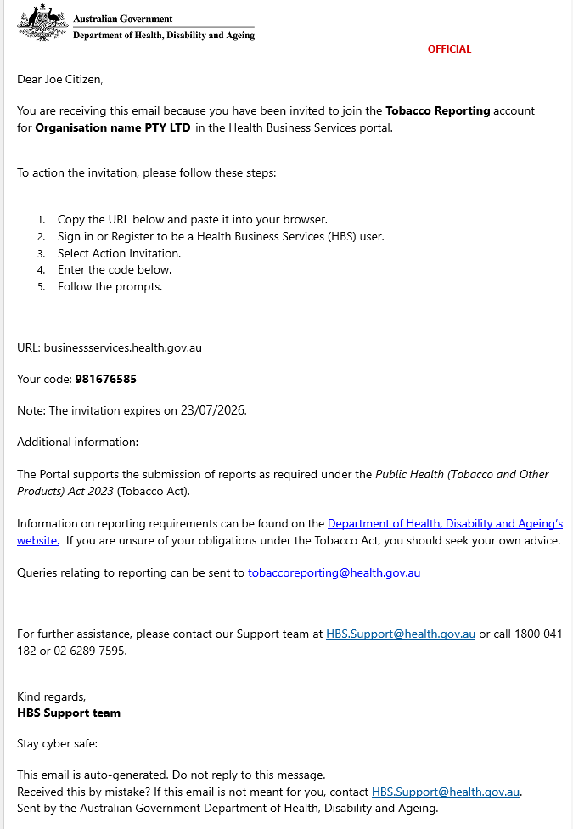

Accept an invitation
To accept an invitation:
- Sign in to the HBS portal.
- On the HBS home page, go to the Invitations section.
- Select Action invitation.
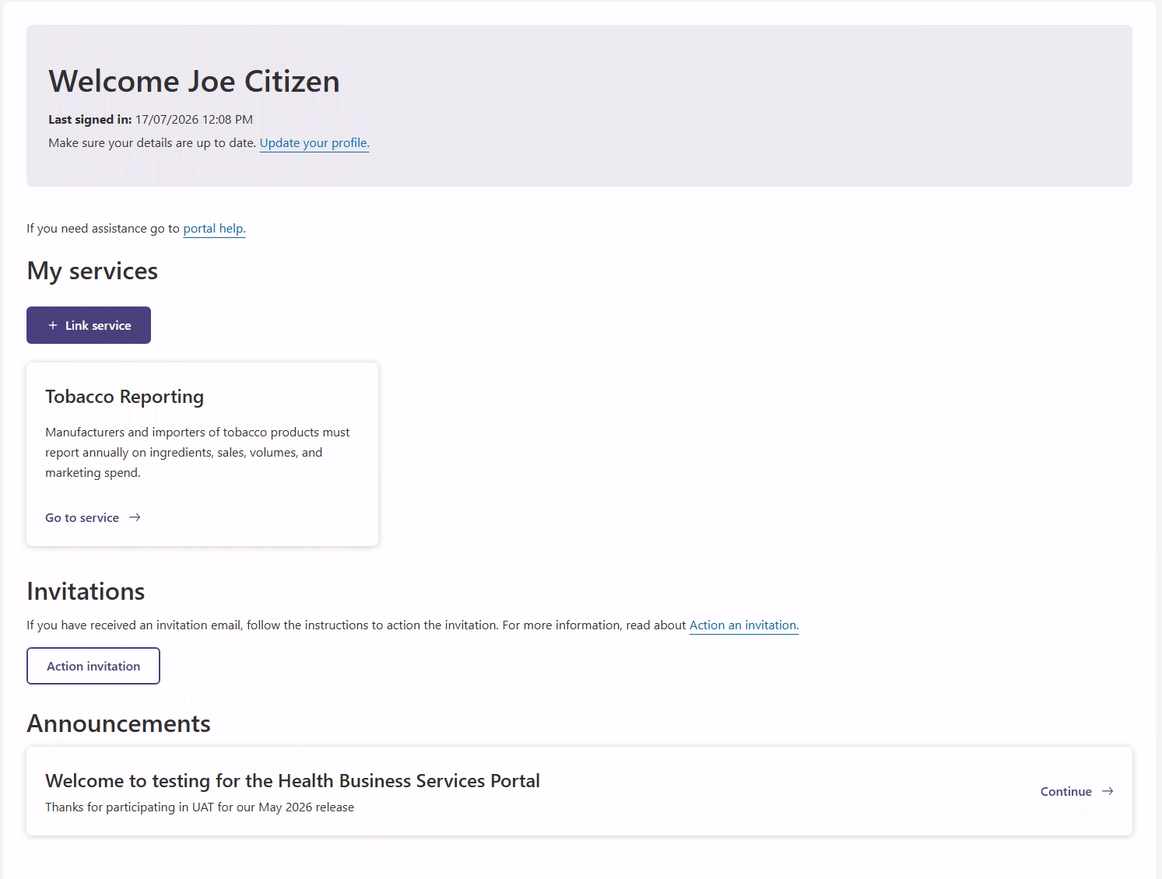
- On the Action an invitation page, enter the invitation code from the email.

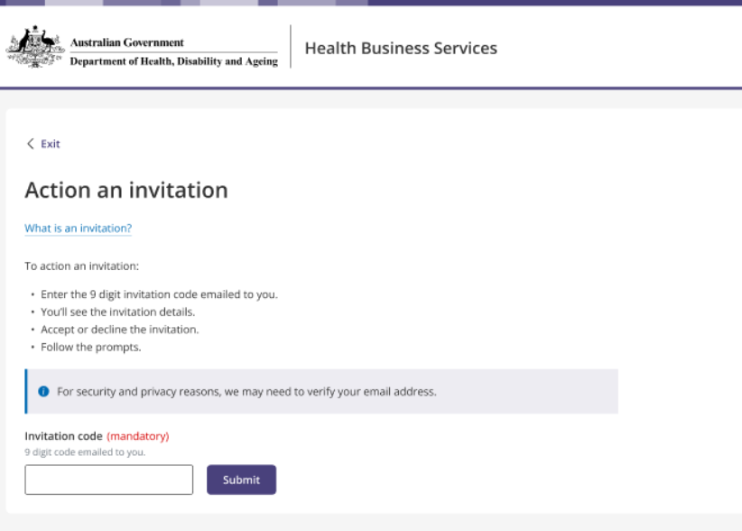
- Select the option to Continue.
- Review the invitation details.
- Acknowledge the declaration items.
- Select Accept.
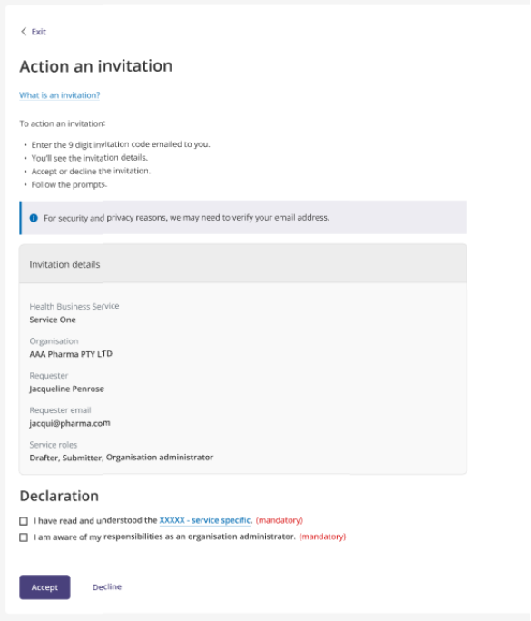

If the invitation email address matches the contact email or sign-in email in your HBS portal profile, you can accept the invitation.
When you accept the invitation, the acceptance is shared with the Tobacco Reporting Service.
You are redirected to the Tobacco Reporting Service homepage. You can then see the organisation you are associated with.
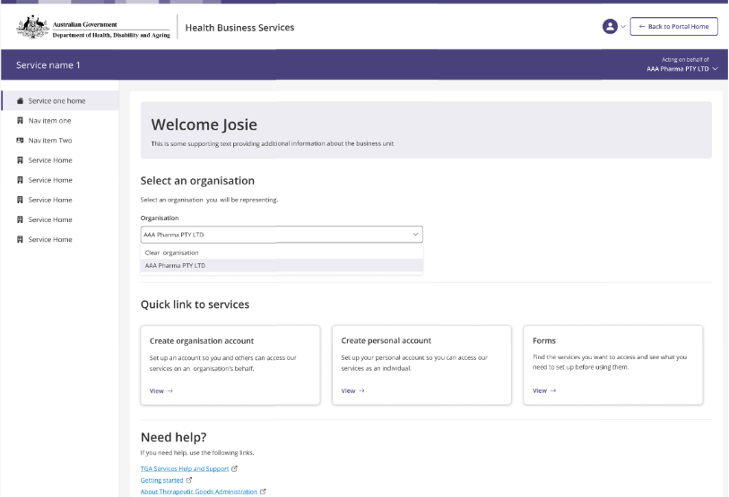

Verify an invitation email address
You may need to verify the invitation email address if it does not match the contact email or sign-in email in your profile.
You will be prompted to verify the email address.
The Action an invitation page shows the invitation email address.
The email address field is pre-filled and cannot be edited.
A verification code is sent to the invitation email address.
- Enter the verification code and select Verify code or
- You can also select Send new code to request another verification code.

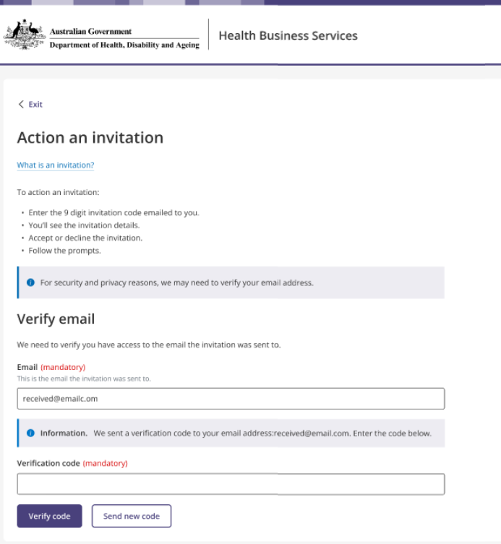
- Once the email address is verified, you can accept or decline the invitation.

Decline an invitation
You can decline an invitation after entering the invitation code and, if required, verifying the invitation email address.
To decline an invitation:
- On the invitation details page, select Decline.
- A confirmation message appears.
- Select Cancel to return to the Action an invitation page.
- Select Decline to confirm.
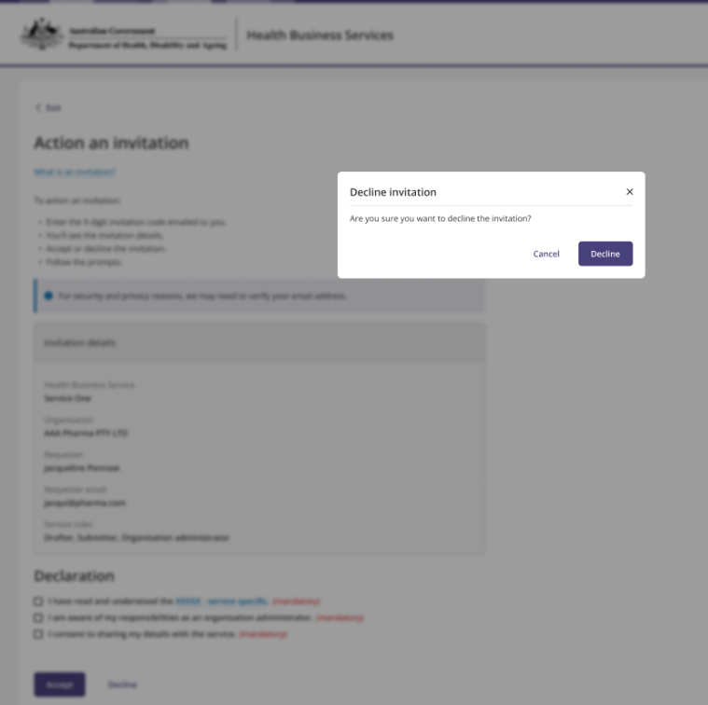
If you confirm that you want to decline the invitation:
- the Organisation Administrator is notified in the Tobacco Reporting Service
- you are returned to the HBS home page
- the one-time invitation code becomes invalid.

Invitation errors
You may see an error message if:
- the invitation code is invalid
- the invitation code has expired.
If the code is invalid or expired, check the invitation email and try again. If the issue continues, contact your Organisation Administrator.
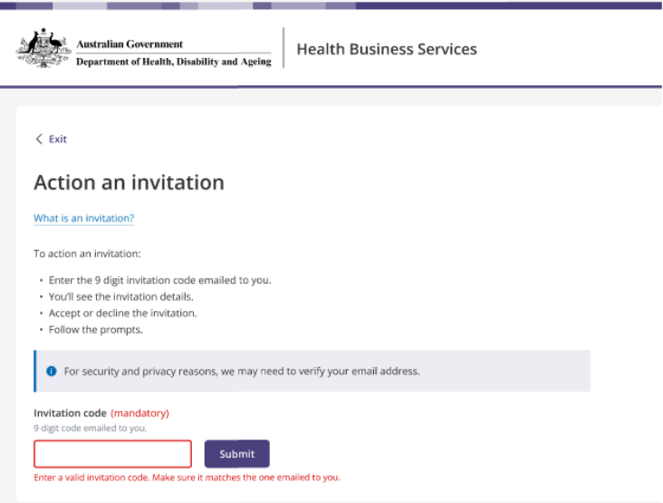
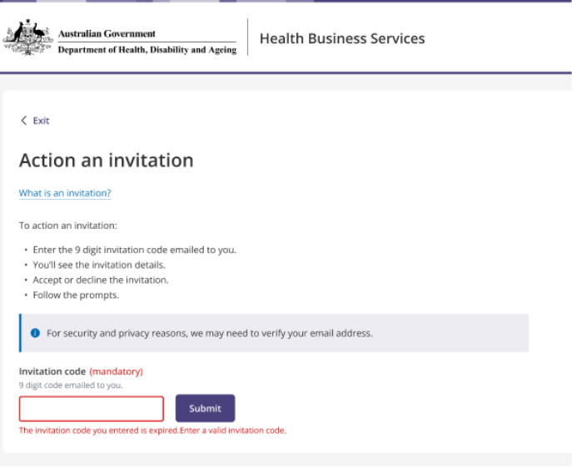

Exit the invitation process
The user can exit the invitation process from the Action an invitation page.
If the user selects Exit, a confirmation message appears.
The user can:
- select Leave to return to the HBS portal home page
- select Stay to remain on the Action an invitation page.
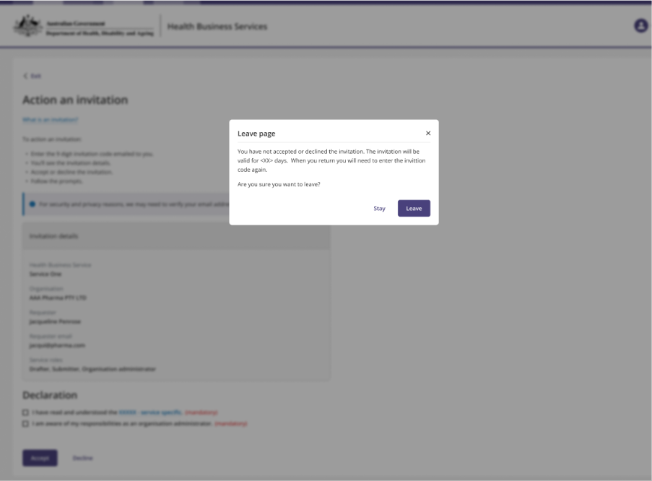

New HBS portal users
A new HBS portal user must register for the HBS portal before they can action an invitation.
After registration, the user can follow the same steps to action the invitation.
When a new HBS portal user accepts the invitation, their HBS portal profile is linked to the Tobacco Reporting Service.
The Action an invitation page may include an additional declaration asking the user to consent to sharing their details with the Tobacco Reporting Service.

Existing HBS portal users not linked to the service
An existing HBS portal user who is not linked to the Tobacco Reporting Service can still be invited to join an organisation.
The user follows the same steps to action the invitation.
When the user accepts the invitation, their HBS portal profile is linked to the Tobacco Reporting Service.

