User Guide: Tobacco Reporting Service - Manage organisation details
20 July 2026
This user guide explains how to manage organisation details.

Before you start
To manage your organisation you must:
- be a registered HBS portal user
- already be linked to the Tobacco Reporting Service
- already be linked to your Organisation.

Permissions
- You must have Organisation Administrator permission to edit organisation details and manage organisation addresses.

View your organisation details
- Go to the Tobacco Reporting homepage.
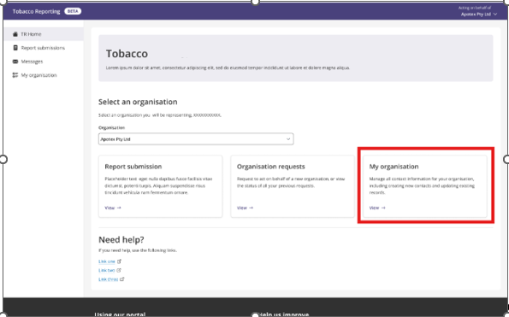
- Select your organisation from the dropdown menu.
- Once you select an organisation, the My organisation card will appear.
- Select the “My organisation” card.
- You will be directed to the “My organisation” page, where you can view your organisation details.
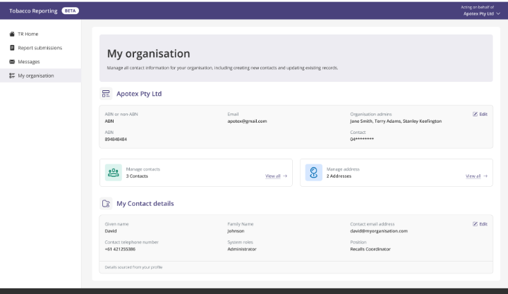

View your organisation details
- Go to the Tobacco Reporting Service homepage.
- Select your organisation from the dropdown menu.
- Once you select an organisation, the My organisation card will appear.
- Select the My organisation card.
- You will be directed to the My organisation page.

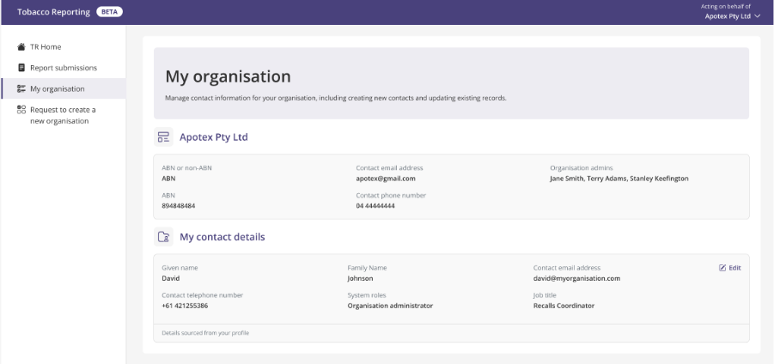
- Only Organisation Administrators can edit organisation details. If you do not have Organisation Administrator permission, the Edit option will not be visible.
- The only editable fields are Email address, Contact number and Website.
- Select Edit to open the Editing organisation details screen.
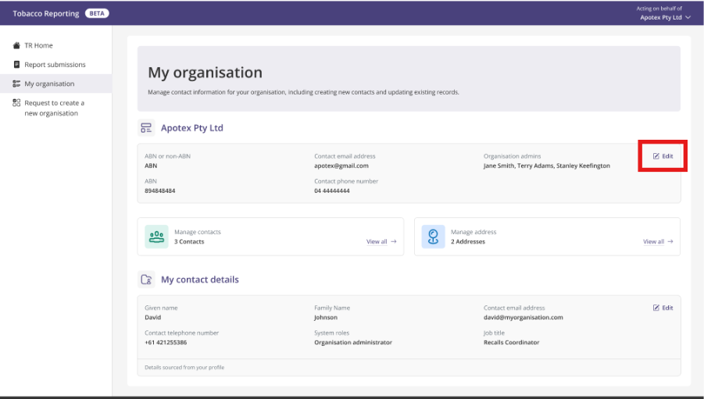
- Update the organisation details as needed and select Save.
- After you save, you will return to the My organisation page, and a success message will appear.

Manage organisation addresses
- Go to the My organisation page.
The Manage address card is visible to Organisation Administrators only.
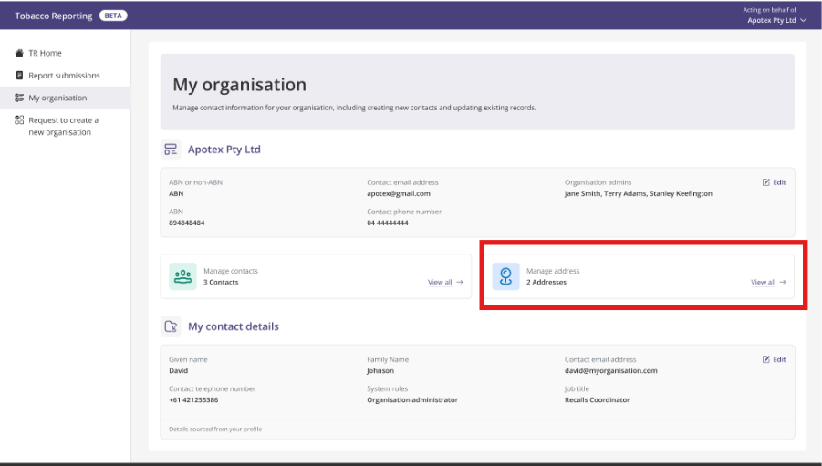

- Select View all to open the Manage address page.

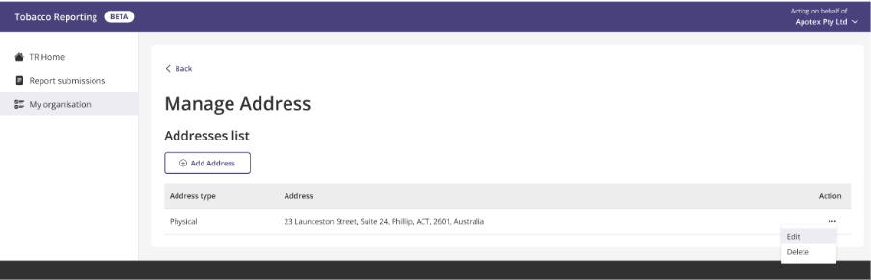
- Select Add Address to add an address to the organisation.
- Enter the address details and select Add.
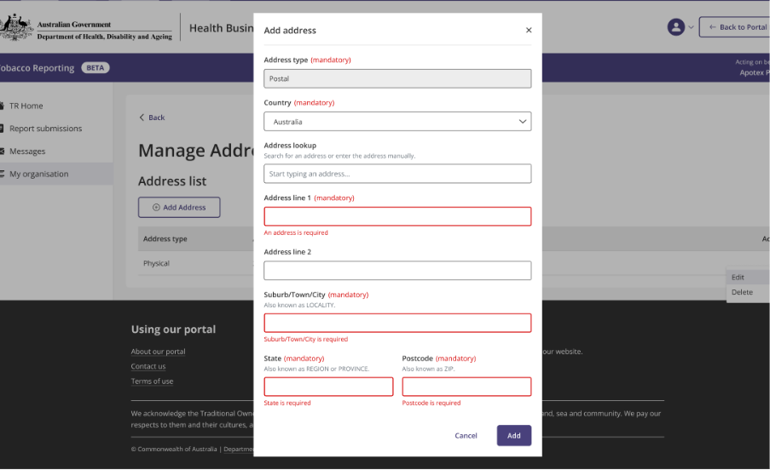
- You will return to the Manage address page and a success message will appear.
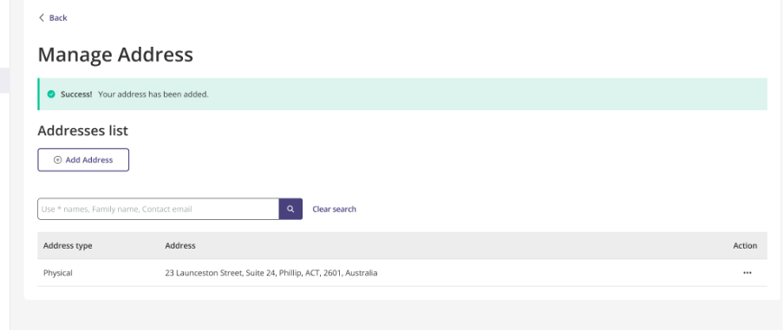
Note: An organisation can have only one physical address and one postal address. The Add Address button is greyed out when both address types are already recorded.

Edit an existing address
- On the Manage address page, go to the Actions column for the address you want to update.
- Select Edit and update the address details as needed.

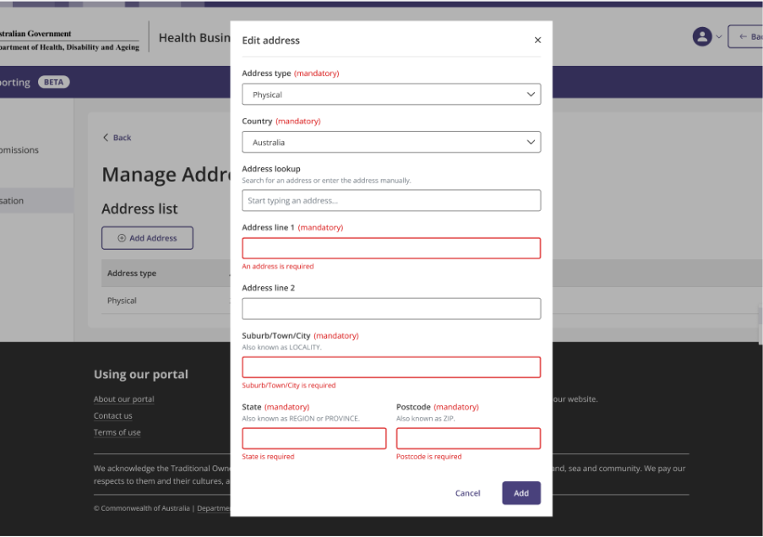

Delete an address
- On the Manage address page, go to the Actions column for the address you want to delete.
- Select Delete to remove the address from the list.
