User Guide: Tobacco Reporting Service - Manage organisation contacts
20 July 2026

In this Guide:
- Manage organisation contacts
You can manage the contact information for your organisation, including creating new contacts and updating existing records.

Before you start
To manage your organisation contacts you must:
- be a registered HBS portal user
- already be linked to the Tobacco Reporting Service
- be linked to the organisation.

To navigate to Manage your organisation contacts
- On the Tobacco Reporting Service homepage, select your organisation from the drop-down window.
- Once you have selected your organisation you will see the My organisation card.
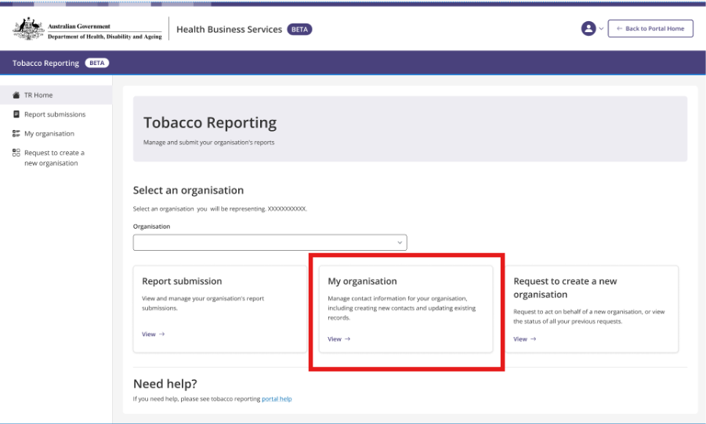
- Selecting the My organisation card will navigate to the My organisation page.

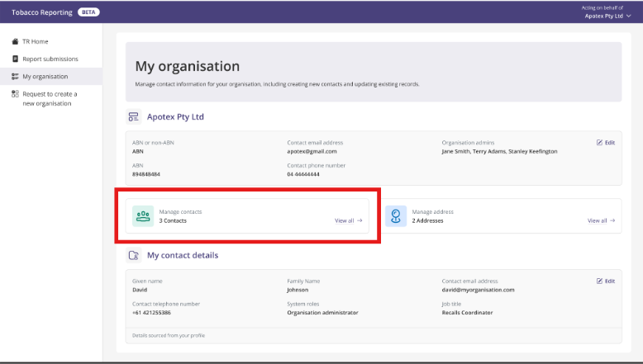

- On the My organisation page select the Manage contacts card.
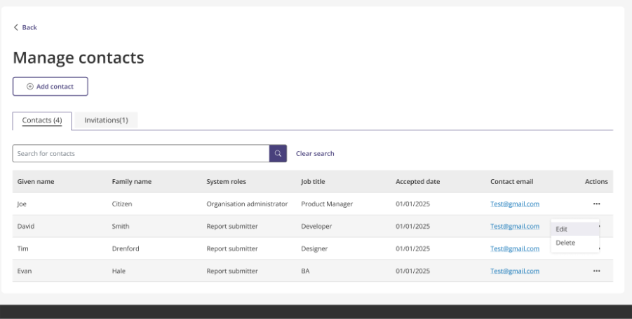

Note: the option to manage contacts is available only to the Administrator for your organisation. It will not be visible to you if you are not an Administrator.
Note: if you are assigned the role of Report Submitter you will have the following screen visible to you. You will not be able to update your system role.
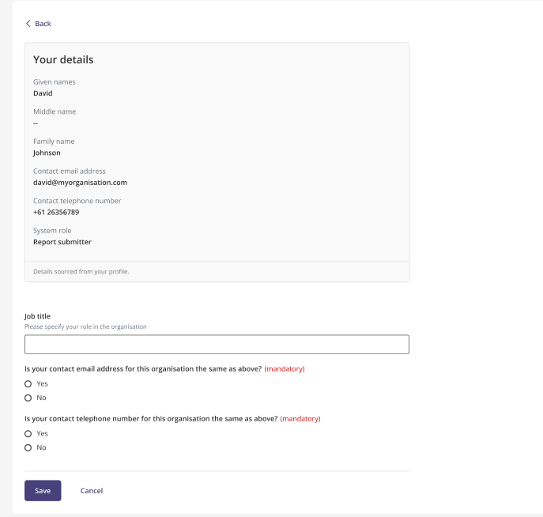
- As the Administrator for your organisation you can view both the contacts and invitations associated with your organisation. Each has their own tab.
  - By clicking the Contacts tab you can see all the contacts for your organisation.
  - By clicking the Invitations tab you can see all the invitations for your organisation.

- If you would like to edit an existing contact:
  - Select the Contacts tab.
  - Select Edit in the Actions column.
  - Edit the contact fields as required noting those fields marked as mandatory must be populated. This includes given name, family name, email address, and system roles.
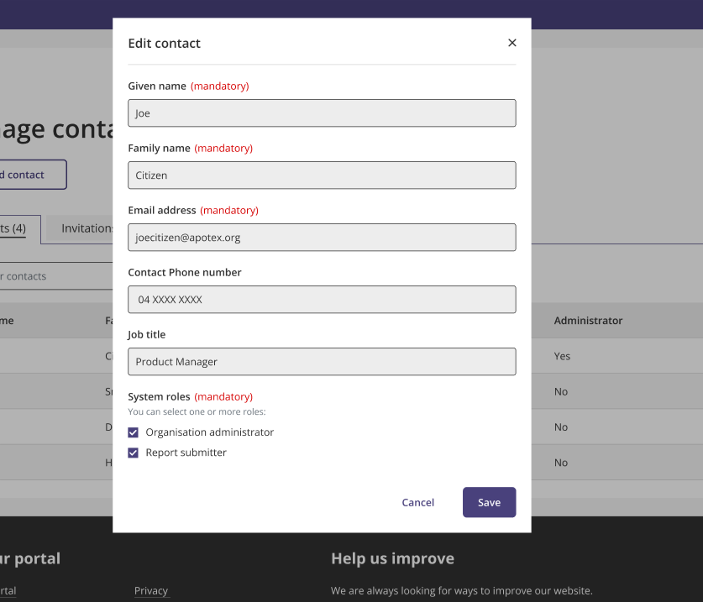
Note: only an Organisation Administrator can update the system roles of the organisation contacts.
Organisation contacts can hold the following roles: Organisation Administrator or Report Submitter.

- If you would like to delete an existing contact from the organisation:
  - Select the Contacts tab.
  - Select Delete in the Actions column.

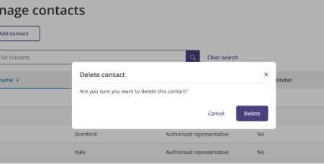

- If you would like to view and edit your contact details for the organisation:
- On the My organisation page, you can see the My contact details
section.
- By selecting the Edit button, you can update your own contact details.
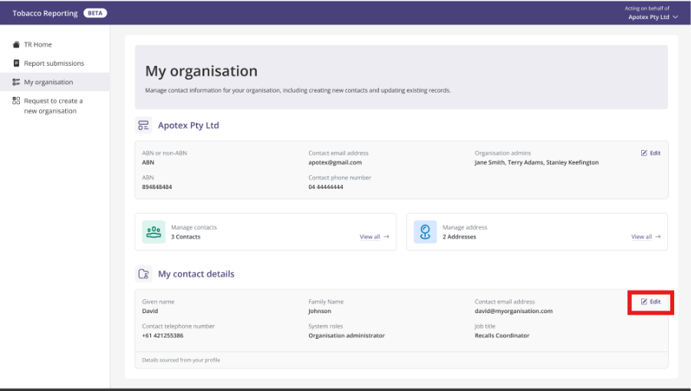
- If you are an Organisation Administrator when you select Edit you will be able to update your organisation role, email, contact number, and system roles.

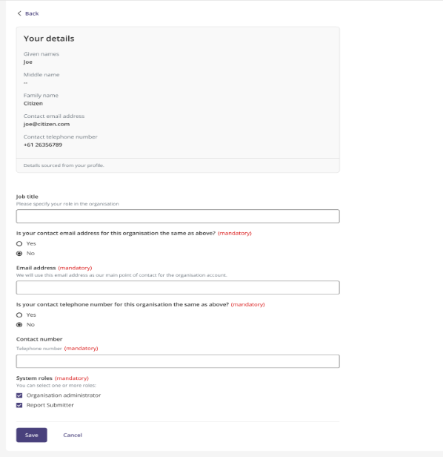

- If you would like to invite a new contact to act on the organisation’s behalf:
- On the My organisation page select the Manage contacts card.
- On the Manage contacts page select the Add contact button.
- Insert the contact’s details as required noting those fields marked as mandatory must be populated. This includes given name, family name, email address, confirmation of email and system roles.
- Select Add.
- Once you click Add this will send an invitation link to the contact using the email address provided.
- You will be navigated back to the Manage contacts screen, and a success message will show noting “Your invitation to act on behalf of the organisation has been sent to the contact.”

Note: The invitation status will show as pending in the Invitations tab until the invitation has been Accepted or Rejected by the contact.
The invitation link is valid for 7 days. If not actioned within the timeframe, the invitation status is updated to Expired.

