User Guide: Tobacco Reporting Service - Create a new Organisation Request
20 July 2026
For an organisation to submit tobacco industry reporting through the Tobacco Reporting Service you need an Organisation account. To do this you must use the new Organisation Request button.

In this Guide:
- Create a new organisation request
- Troubleshooting potential error messages

Before you start
To create a new organisation you must:
- be a registered HBS portal user
- already be linked to the Tobacco Reporting Service
- not yet be linked to the organisation

Create an Organisation account
- On the Tobacco Reporting Service homepage, you can see the “Request to create a new organisation” card.
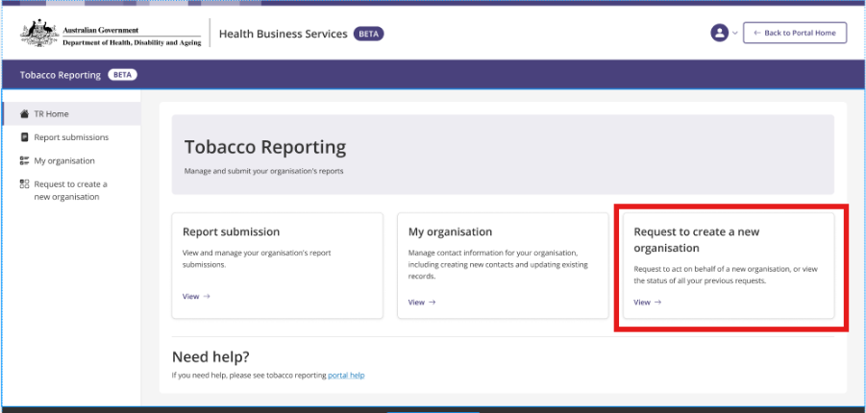
- Selecting the card will navigate to the “Request to create a new organisation page”.
- Select the “Create organisation account” button.
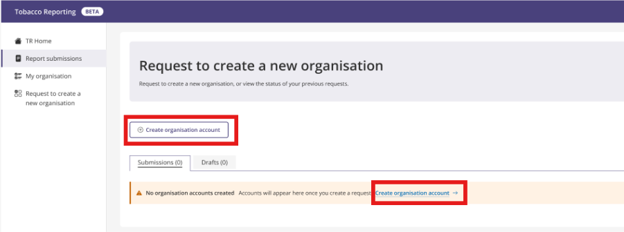
There are 2 ways you can create an Organisation account:
- Where your organisation is an Australian organisation, and has an ABN please make sure you:

  - use the ABN pathway. This will give you quick access to your new organisation
  - have registered to the portal using your myID Digital ID
  - refer to the ABN pathway guidance.

- Where the organisation is registered overseas and does not have an ABN:
  - use the Non ABN pathway.
  - refer to the Non ABN pathway guidance.

ABN Pathway
- If your organisation has an ABN select the “an organisation that DOES have an Australian Business Number (ABN)” option
  - and select Continue.

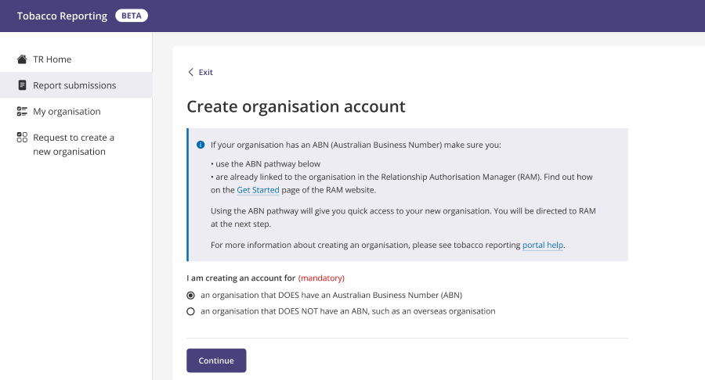
- Now you have selected the ABN pathway you will be redirected to the Relationship Authorisation Manager (RAM)
  - Search for and select your organisation.
  - Once you have selected your organisation, you will be redirected back to the Create Organisation account page.
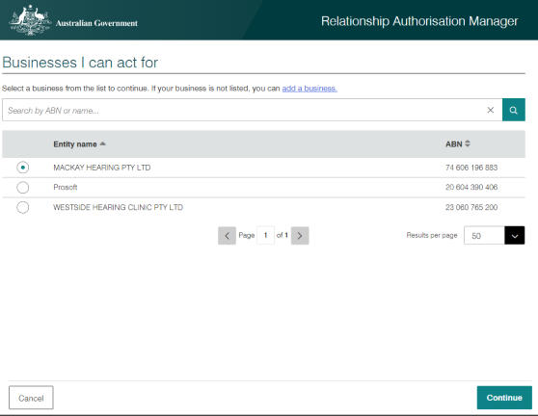

Note: if you select the ABN pathway but you have not logged in using your myID Digital ID you will receive an error message
- This message notes that “You must use your myID account to register your organisation using its ABN”.
- You will be asked to sign out and sign back in using your myID Digital ID. Information on using your Digital ID can be found here.
- If your organisation does not have an ABN, select the option to register an organisation that DOES NOT have an ABN.

- View and confirm your selected organisation before pressing “Continue” to progress your registration.
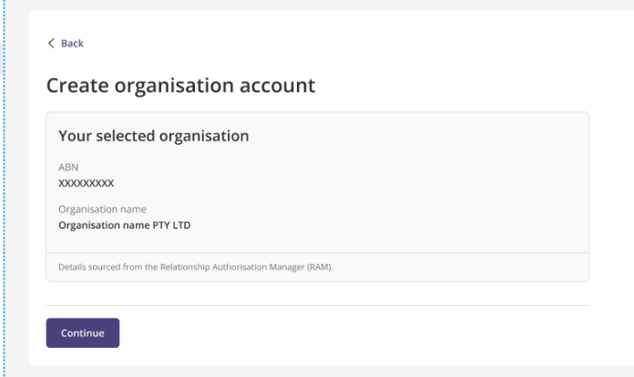

- Selecting Continue will take you to the What you will need page to start the organisation registration process.

What you will need:
- Your organisation email address
- Your organisation phone number
- A physical and postal address for your organisation

- Press the Start button once you have what you need. Now you will start the registration process on the Organisation details page.
- A read only screen will allow you check the organisation name and ABN details.
- Review and choose to either:
  - Continue on to the next step.
  - Save for later to save the draft request and navigate back to the Organisation requests page.
  - Cancel to navigate back to the Organisation requests page without saving any changes.
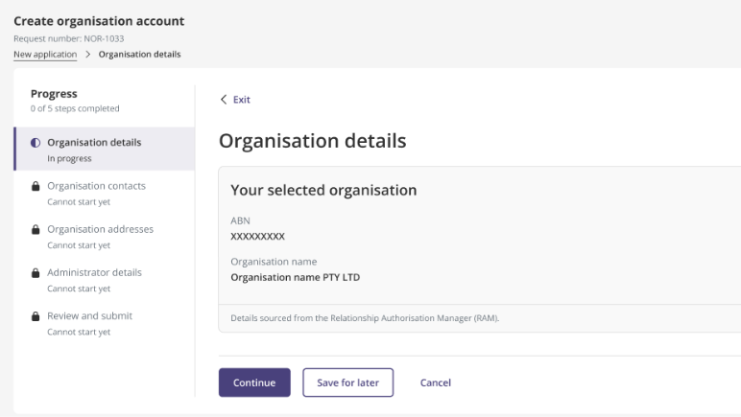
- If you Continue you will progress to the Organisation Contacts page.
  - Provide organisation email address (mandatory), contact number (mandatory) and website (optional).
  - Press “Continue” or “Save for later”.

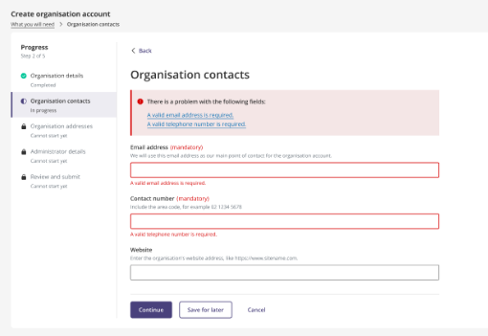

- If you Continue you will progress to the Organisation addresses page.
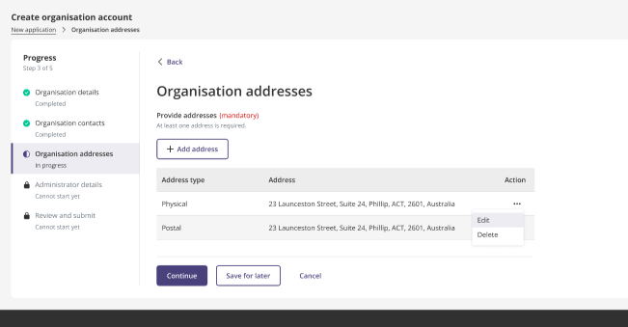

  - Provide your organisation address/es, i.e. physical and postal address by clicking the + Add Address button.
  - Note that at least one address must be provided. An error message will appear if no address is recorded.
  - Press Continue or Save for later.

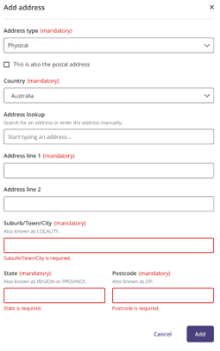

- If you Continue you will progress to the Administrator details page.
  - Provide the administrator details:
    - Organisation role (mandatory)
    - email (mandatory)
    - telephone number (mandatory).
  - Once you complete this section you will become the Organisation Administrator by default.
  - Press Continue or Save for later.
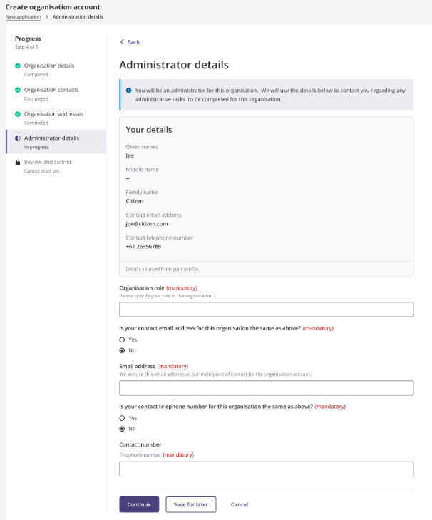

- If you Continue you will progress to the Review and submit page.
  - Review the organisation details.
  - Review the Declaration section and check all boxes. The submission will not be allowed unless all boxes are checked.
  - Press Submit or Save for later.
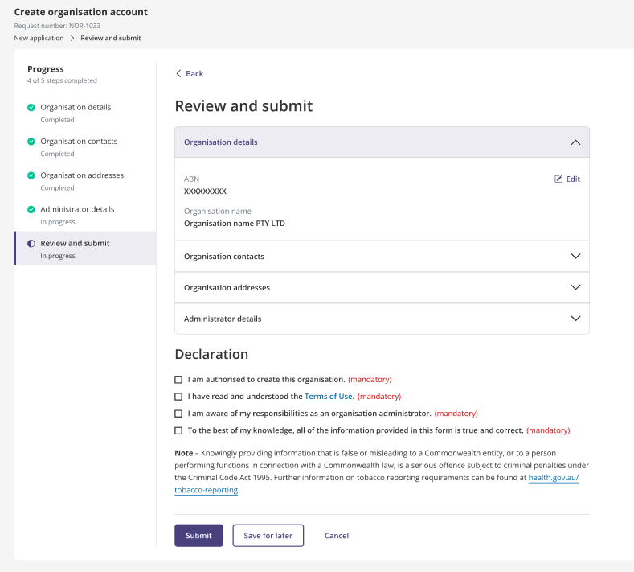
- Once your request has been successfully submitted, a message is displayed noting your organisation record request has been received.
  - You will receive a notification when registration has been approved.
  - Access to services will be provided when registration is approved.
  - Press the “Return to Tobacco Reporting homepage” button.

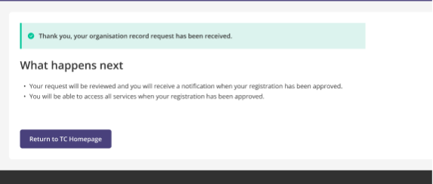
- When your registration is approved you will be able to see a dropdown menu on the Tobacco Reporting Service homepage.
This menu will allow you to select your organisation.

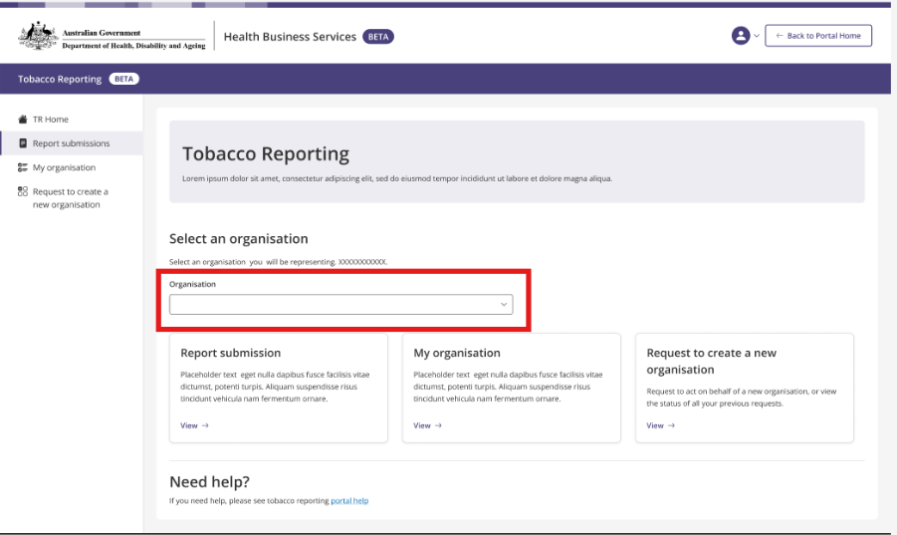

Pathway if you DO NOT have an ABN
- If your organisation does not have an ABN select “Where the organisation is registered overseas and DOES NOT have an ABN” and press Continue:
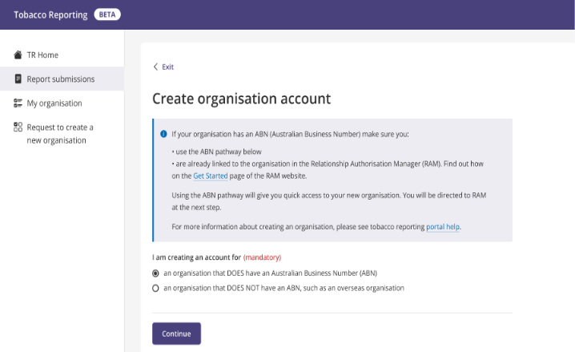

- Selecting Continue will take you to the What you will need page to Start the Organisation Registration process.

What you will need:
- Your organisation email address
- Your organisation phone number
- A physical and postal address for your organisation

- Review what you will need:
  - Note you will be identified as an administrator for this organisation

- Please press the Start button once you have what you need.

- Now you will start the registration process on the Organisation details page.
- Please enter the organisation name.
- Press Continue or Save for later.
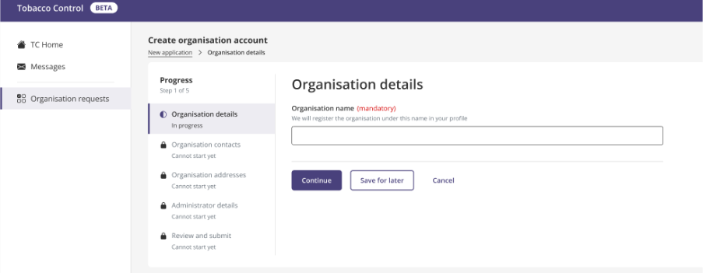

- If you Continue you will progress to the Organisation Contacts page.
  - Provide your organisation email address (mandatory), contact number (mandatory) and website (optional).
  - Press Continue or Save for later.

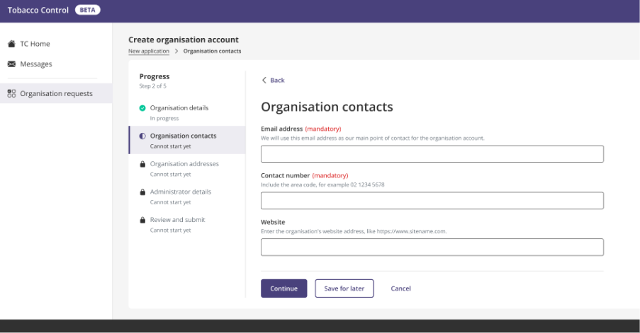

- If you Continue you will progress to the Organisation addresses page.
- Provide your organisation address/es, i.e. physical and postal address by clicking the + Add Address button.
- At least one address must be provided. An error message will appear if no address is recorded.
- Press Continue or Save for later.

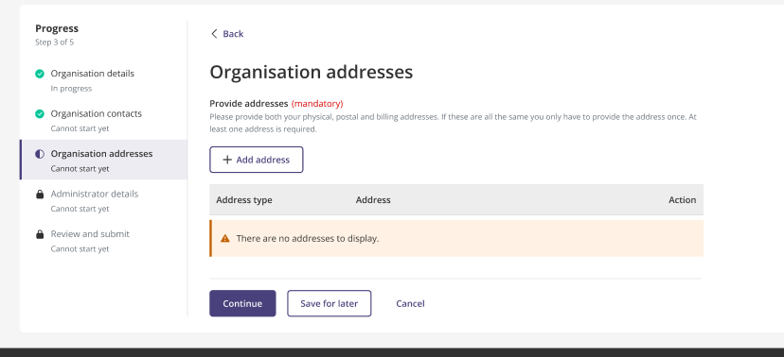

- If you Continue you will progress to the Administrator details page.
- Provide the administrator details
    - Organisation role (mandatory)
    - email (mandatory)
    - telephone number (mandatory)
- Once you complete this section you will become the Organisation Administrator by default.
- Press Continue or Save for later.

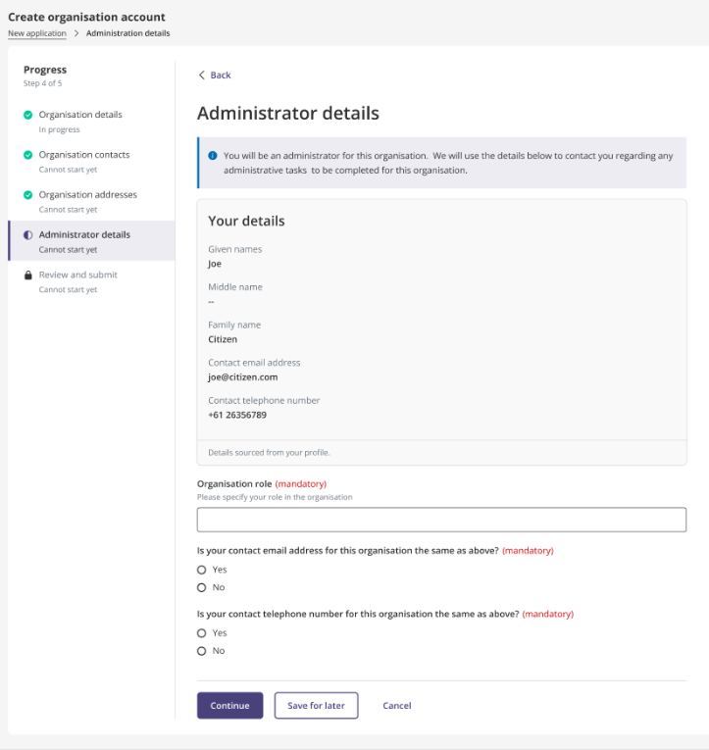

- If you Continue you will progress to the Review and submit page.
- Review the organisation details
- Review the Declaration section and check all boxes. The submission will not be allowed unless all boxes are checked.
- Press Submit or Save for later.
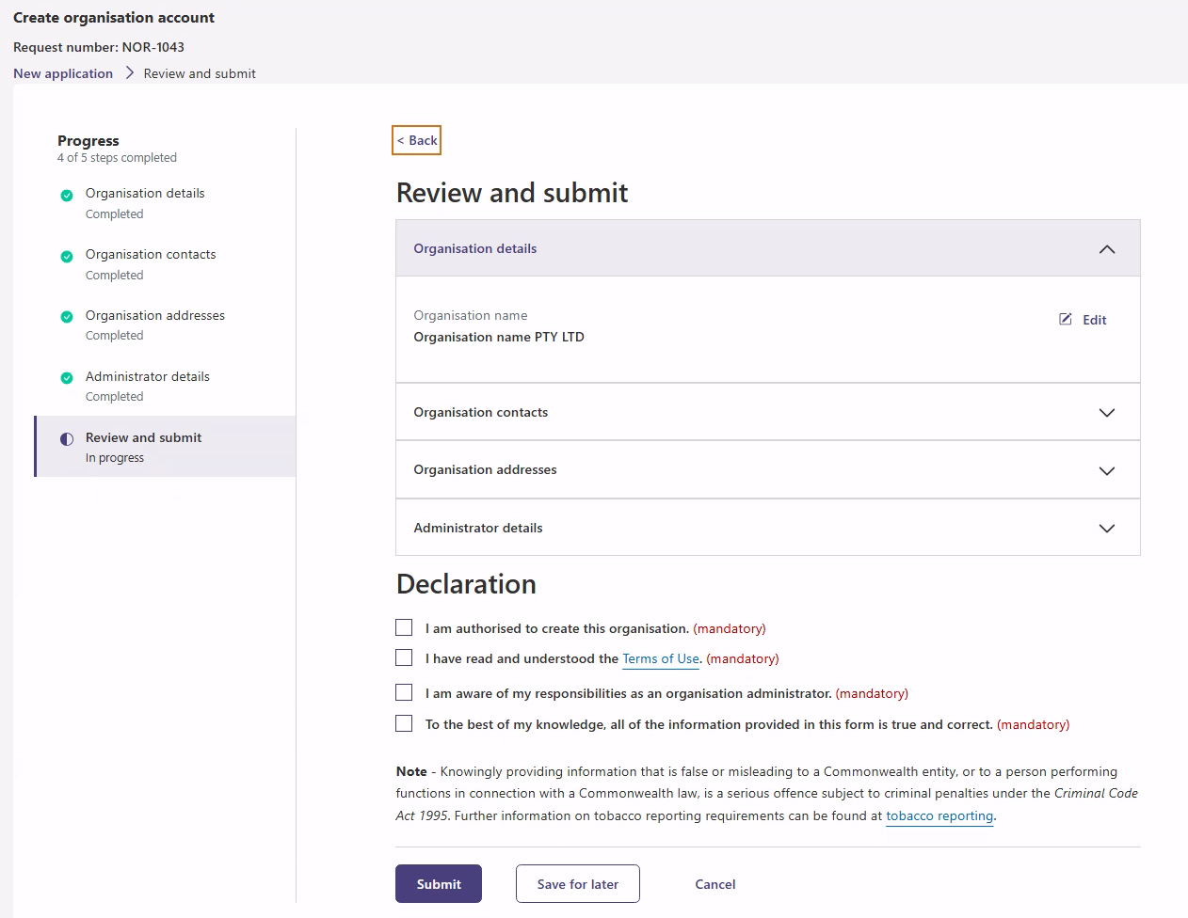
- Once your request has been successfully submitted, a message is displayed noting your organisation record request has been received.
- You will receive a notification when registration has been approved.
- Access to services will be provided when registration is approved.
- Press the Return to TR homepage button.

- Your request will appear as pending in the Organisation request page until it is approved.
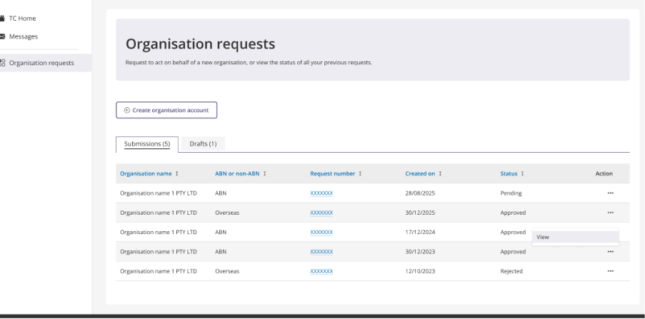
- When your registration is approved you will be able to see a dropdown menu on the Tobacco Reporting Service homepage. This dropdown menu will allow you to select your organisation.

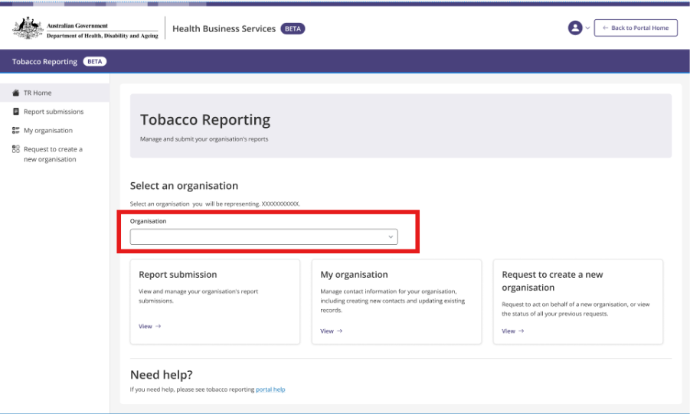

Troubleshooting potential error messages
The following messages may appear during the ABN pathway. If one of these messages appears, follow the guidance below before starting a new request.

The Organisation account that you selected in RAM (Relationship Authorisation Manager) already exists in the Tobacco Reporting Service.
- If you try to register an organisation that already exists in the Tobacco Reporting Service, you will receive this error message and the registration process will stop.
- This means your organisation will also have an identified existing Administrator within the Tobacco Reporting Service. Contact the Administrator for your organisation.
- If you are unable to contact the Tobacco Reporting Service Administrator for your organisation, contact the department at Tobaccoreporting@health.gov.au

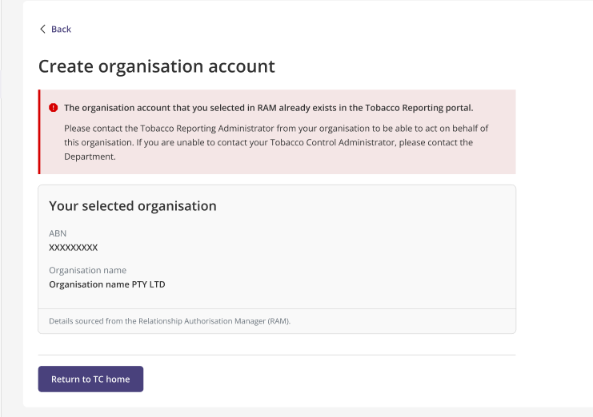

No organisation was selected in RAM (Relationship Authorisation Manager)
- If you attempt to create an Organisation account but do not select an organisation in Relationship Authorisation Manager, you will receive this error message and the registration process will stop.
- Go back to RAM and make sure you search for and select the organisation before returning to the portal.
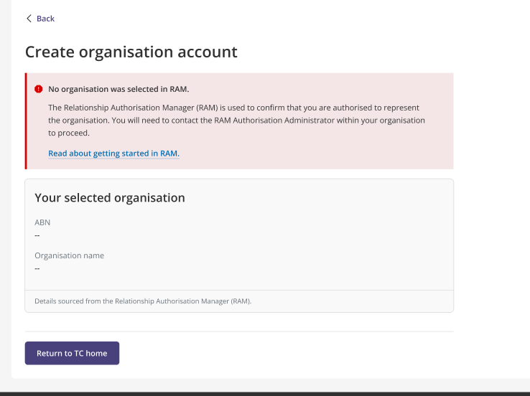

An application to register is already underway for this organisation.
- If you try to create an Organisation account where a request already exists, the registration process will stop.
- This means a draft application has already been started for this organisation.
- Select Continue to Draft to return to the existing application and complete it.

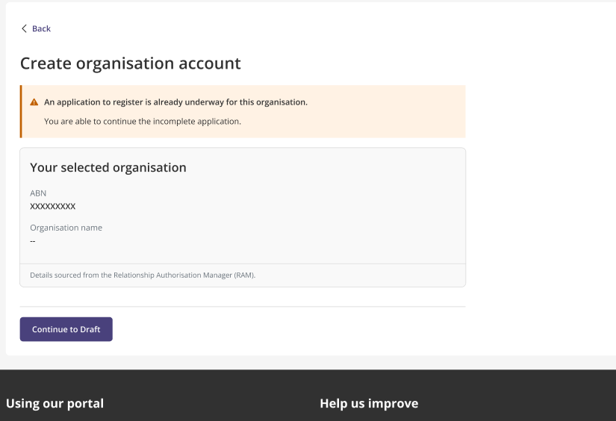

A request for this organisation is already being assessed.
- If you try to create an Organisation account where a request for the same organisation is already pending assessment, the registration process will stop.
- This means the department is already reviewing a request for this organisation.
- Wait for the department to finalise the existing request before starting a new request.

The organisation name is suppressed in the Australian Business Register.
- If the organisation name is suppressed in the Australian Business Register, a warning message will appear after you return from RAM.
- You can continue with the ABN pathway, but you must manually enter the organisation name during the Organisation details step.
- The ABN field will be read only.
- After entering the organisation name, continue through the organisation contacts, addresses, administrator details, review and submit steps.

