Practitioner Review Program – Key Statistics
Information on key statistics for case reviews and outcomes under the Practitioner Review Program, including case progression and an overview of requests made to the Director PSR.

Case progression and closures under the PRP
The graph below shows the progress of cases reviewed under the PRP and the point at which the case was closed during review:

PRP Cases Closed by Outcome (for Apr– Jun 2026)
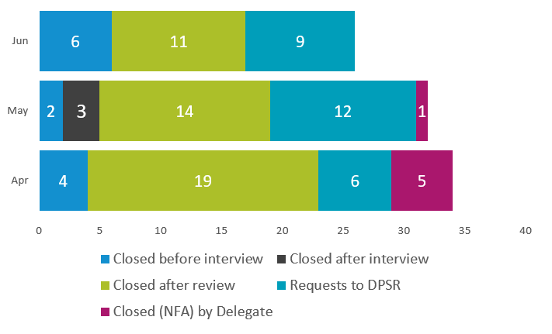
For reference, points of closure captured with descriptions are:
- Closed before interview: Case accepted for review under PRP after preliminary assessment by a Professional Adviser. Subsequently closed after further assessment (pre-interview work up) by a Professional Adviser and prior to any contact initiated – not/no longer suitable for PRP review.
- Closed after interview: Practitioner was interviewed and concerns were addressed after additional information was provided at interview. Case was closed with no further action.
- Closed after review: Practitioner was offered a 6-month period of review. A review of the practitioner’s data after this period resulted in the case being closed with no further action.
- Requests to DPSR: Request made to the Director PSR for review under s86 of the Health Insurance Act 1973 by a delegate of the Chief Executive Medicare.
- Closed (NFA) by Delegate: Case closed after delegate review as unsuitable for PSR referral. This may be because concerns are not considered sufficient to warrant PSR review or additional information is provided to reduce/remove concerns.

Requests to the Director PSR
The following tables include an overview of requests made to the Director PSR (DPSR).

Requests for review made to DPSR by specialty:
 | GPs, GP Trainees and OMPs |  | Non-GP Medical Specialists |  | Allied Health |  | Body Corporate |  | TOTAL
 | Cases | Percentage | Cases | Percentage | Cases | Percentage | Cases | Percentage | Cases
2025/26 | 93 | 75% | 18 | 15% | 11 | 8% | 2 | 2% | 124
2024/25 | 98 | 84% | 17 | 15% | 1 | 1% | 0 | 0% | 116
2023/24 | 80 | 73% | 24 | 22% | 5 | 5% | 0 | 0% | 109
Note: Dentists have been captured within allied health statistics.

Specialty breakdown of requests for 2025/26:
Practitioner/Case Type | Total | Percentage
General Practitioners/OMPs/GP Trainees | 93 | 75%
Body corporates | 2 | 2%
Gastroenterology and Hepatology | 2 | 2%
Cardiology | 2 | 2%
ENT | 1 | 1%
Haematology | 1 | 1%
Obstetrics and Gynaecology | 2 | 2%
Optometrist | 1 | 1%
Clinical Psychologist | 1 | 1%
Psychiatry | 2 | 2%
Paediatric Medicine | 2 | 2%
Nurse Practitioner | 8 | 6%
Podiatrist | 1 | 1%
Diagnostic Radiologist | 3 | 3%
Geriatric Medicine | 1 | 1%
Dentist | 1 | 1%
Midwife | 1 | 1%
TOTAL | 124 | 100%

Referrals for Prescribed Patterns of Service:
28 requests were sent to the DPSR for prescribed patterns of service during the period 1 July 2025 to 30 June 2026:
Prescribed Pattern of Service | No. prescribed pattern of services sent to DPSR for review
80/20 Breach | 3
30/20 Breach | 25

More information
PRP for practitioners
Prescribed pattern of services
Professional Services Review

Note that these numbers should be considered in the context of the number of practitioners in each provider group, the available number of MBS, PBS or CDBS items for each provider group, and the number of services provided under Medicare by provider group.

