NDIS Amendment Act
NDIA Measures Fact sheet
Part 3
NDIS plan variations

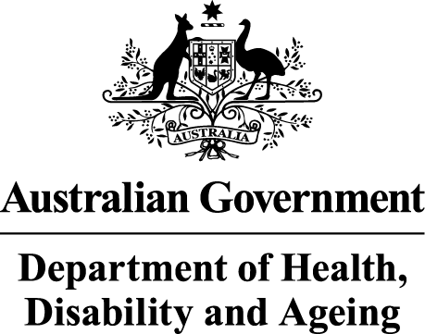 | The Australian Government Department of Health Disability and Ageing wrote this.  We say DHDA for short.  When you see the word we it means DHDA.
 | We wrote this in an easy to read way.  We use pictures to explain some ideas.
 | We have some words in bold.  This means the letters are thicker and darker.  These are important words.
 | This is an Easy Read summary of another document.  This means it has the most important ideas.
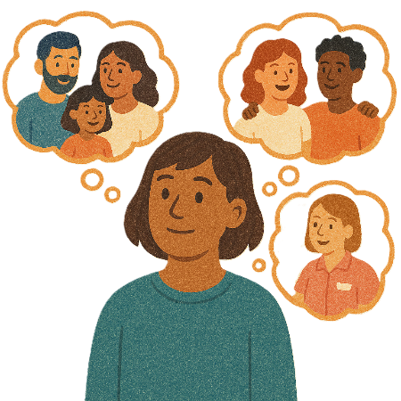 | You can ask for help to read this document.  You can ask  - A friend  - Family members  - A support person.
 | We recognise Aboriginal and Torres Strait Islander people as the Traditional Owners of the land we live on.
 | They were the first people to live on and use the  - Land  - Waters.

Contents
About this document 5
When NDIA can change your plan 9
Rules for plan variations 12
Making changes with you 14
More money for supports in your NDIS plan 16
Less money for supports in your NDIS plan 18
Working together to make changes 19
More information 21

About this document
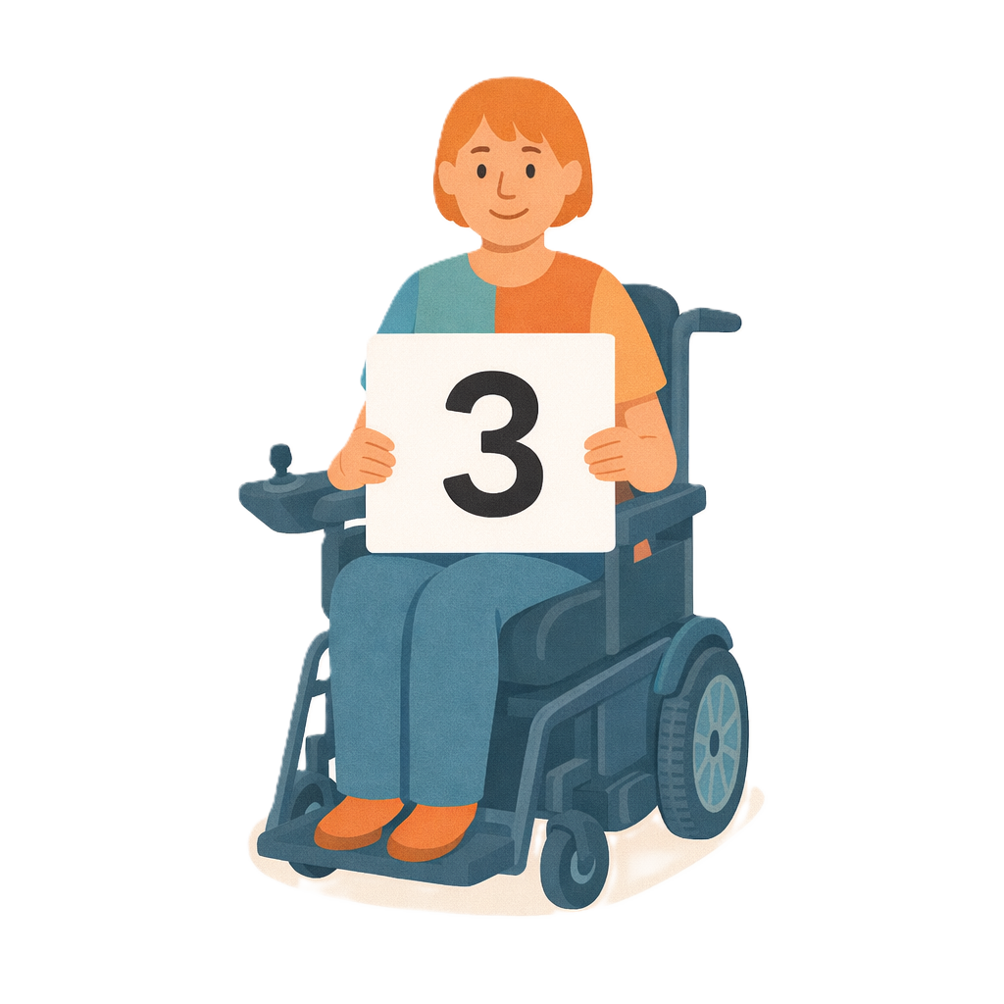 | This document has 3 parts.
 | This document talks about  - Changes the government wants to make to NDIS laws.  Laws are rules for how we live.  The changes are called the  - Integrity and Safeguarding Act.  We call it the Act for short.
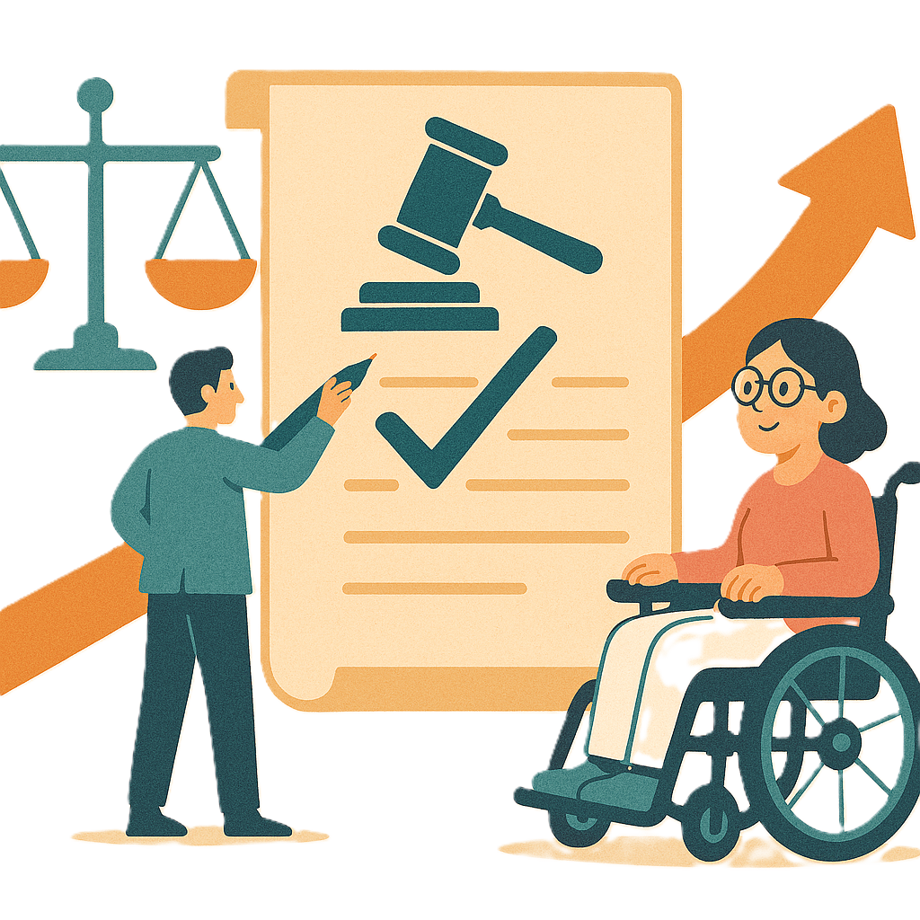 | Changes to laws are called amendments.  They help laws  - Change  - Be better.
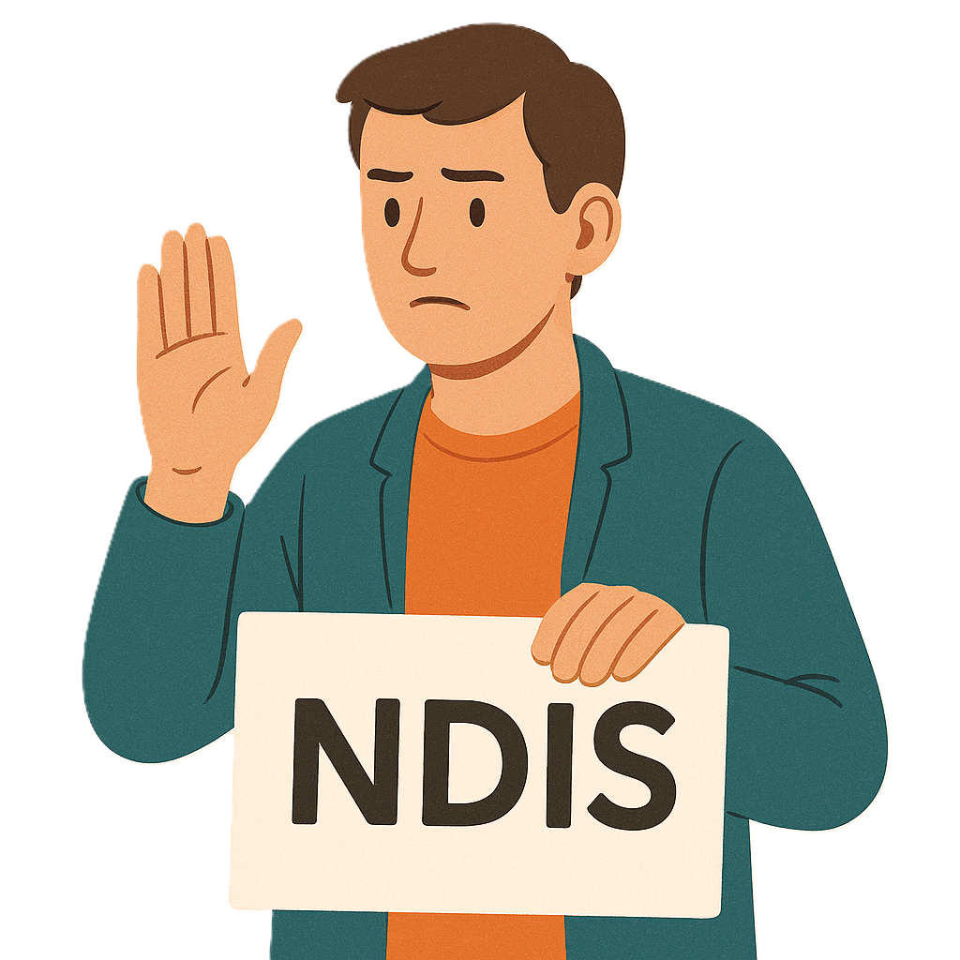 | Part 1 talks about  - Leaving the NDIS
 | Part 2 talks about  - Electronic forms  Electronic forms are filled in on a computer.
Part 3 talks about
- NDIS plan variations.
 | Plan variations are when the  - National Disability Insurance Agency changes things in your NDIS plan.  We call them NDIA for short.  NDIA can change  - Money  - Supports  In your NDIS plan.
 | This is part 3.

When NDIA can change your plan
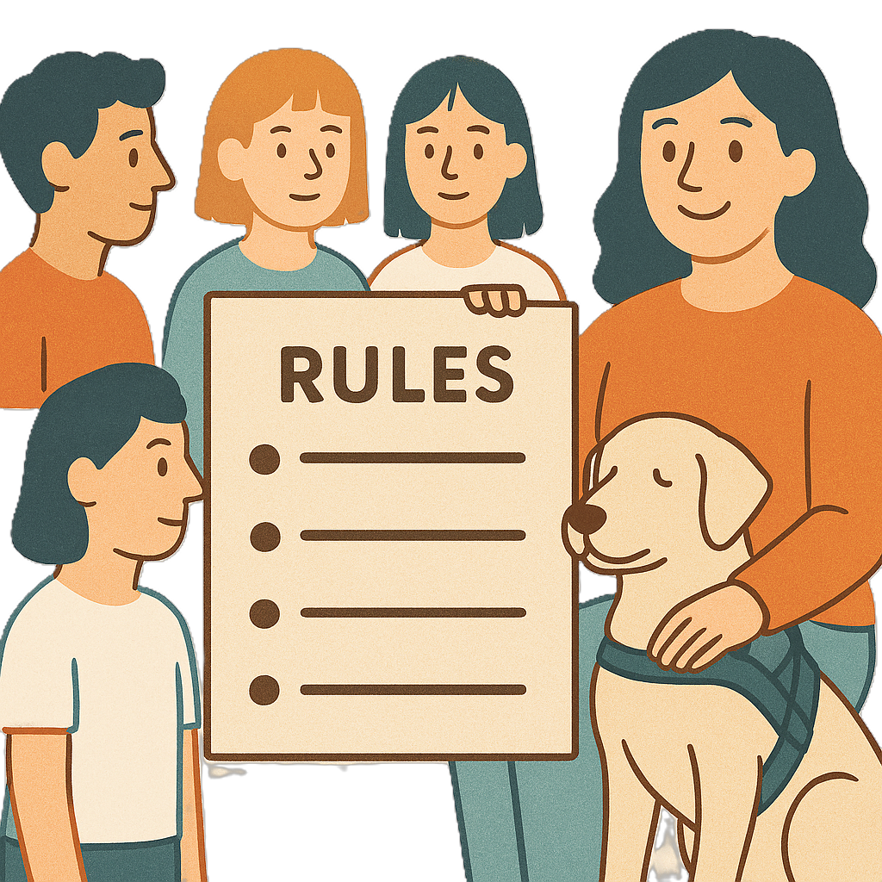 | NDIA have rules about when they can make changes to NDIS plans.
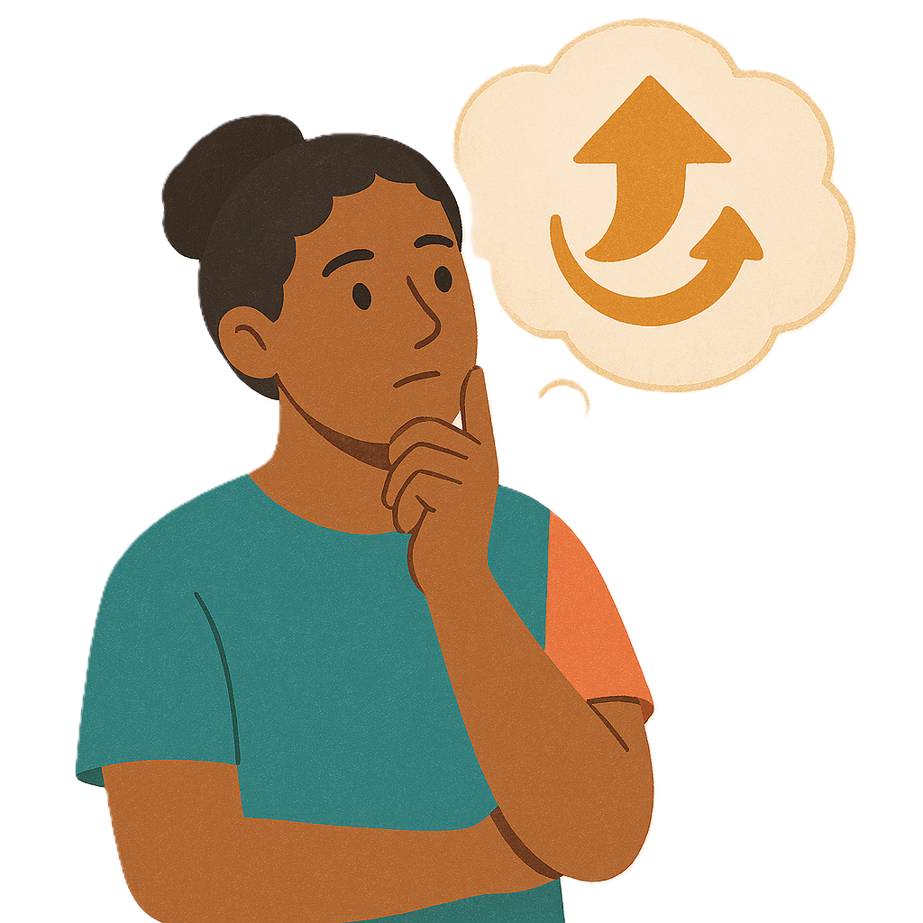 | They can make changes if the  - Person with the NDIS plan asks to make changes
 | - NDIA asks to make changes.
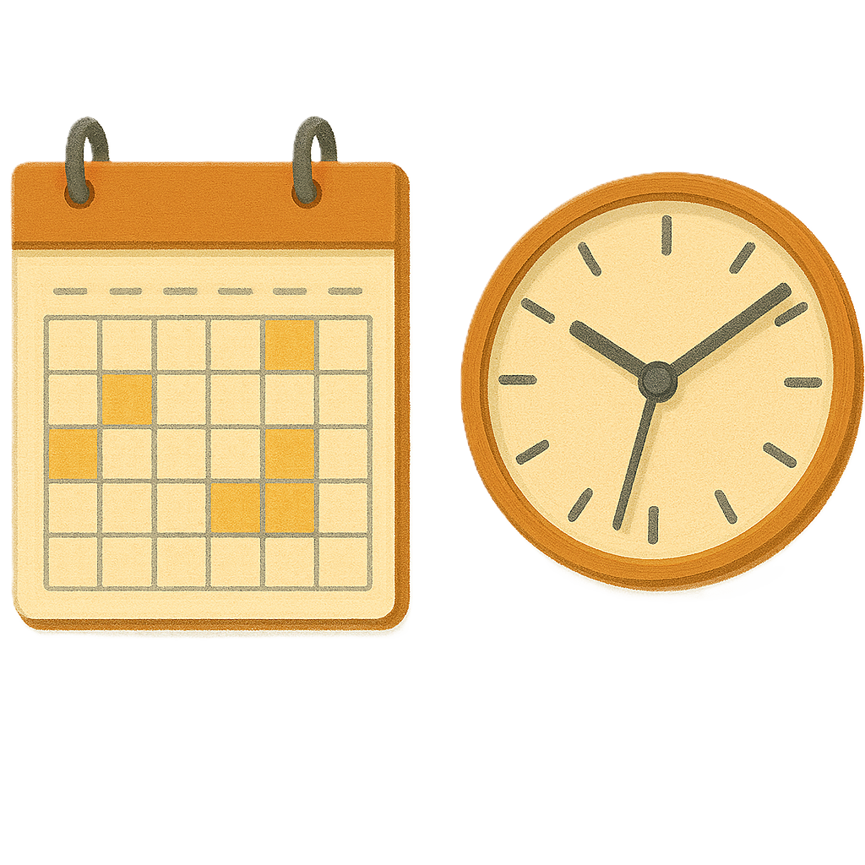 | The law says the changes can be  - Different amounts of time for your plan
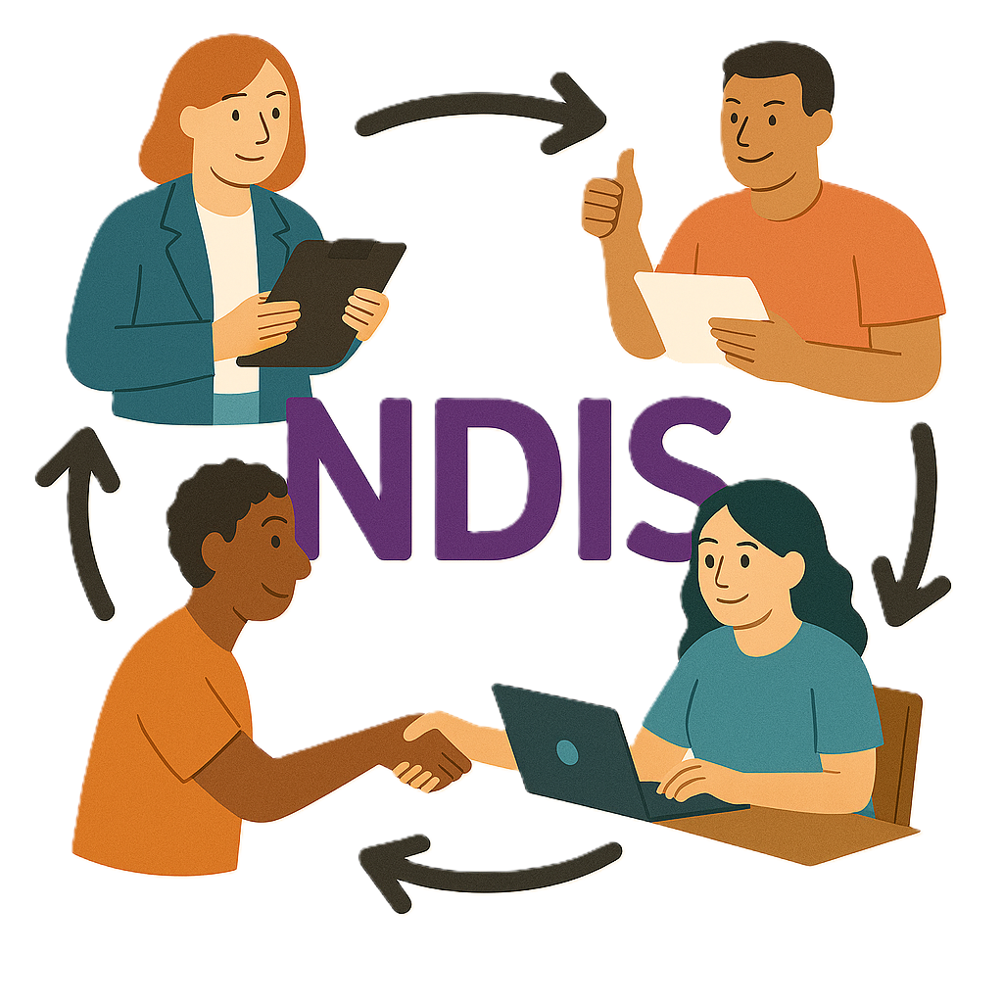 | - Who can look after your plan  This is called managing the plan.
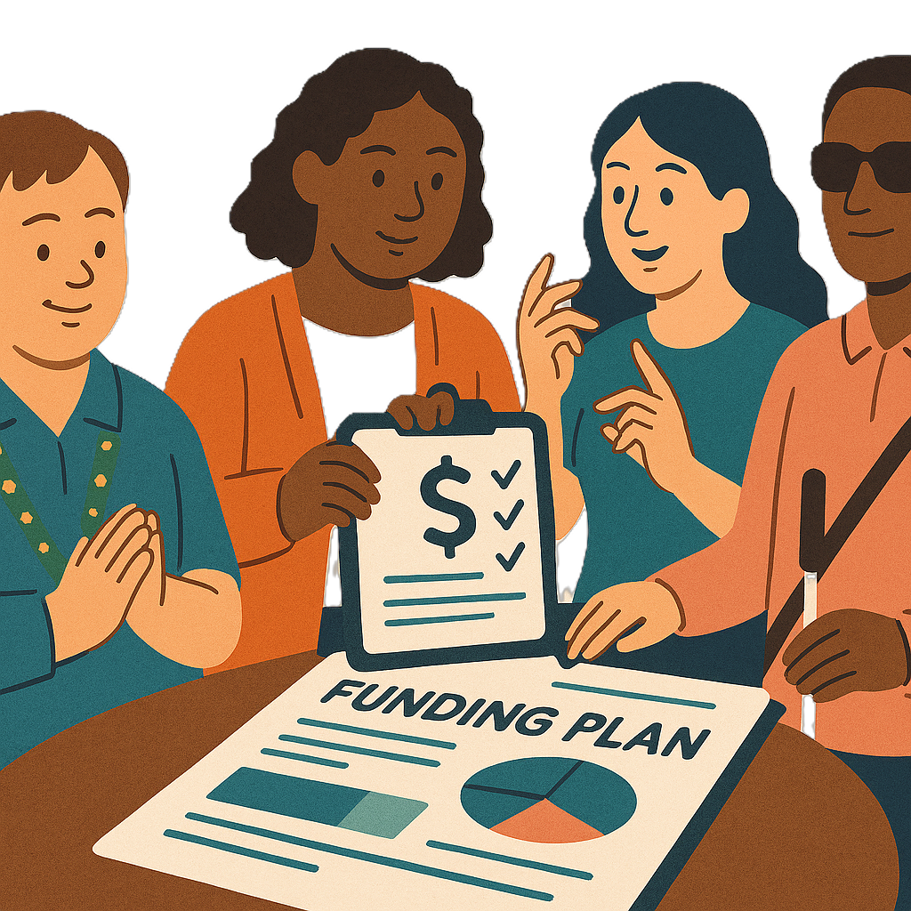 | - Amount of money in your plan
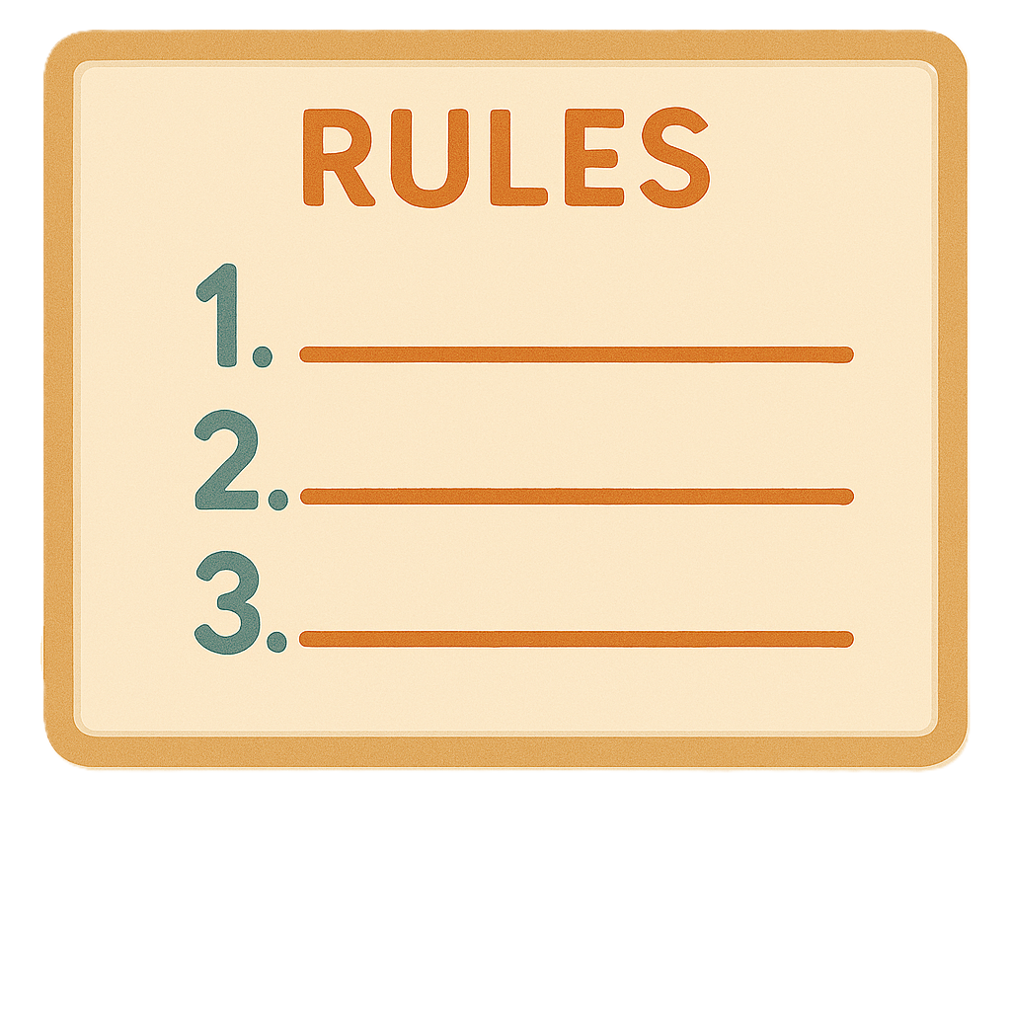 | - Rules for using your plan
 | - When they make a new plan.
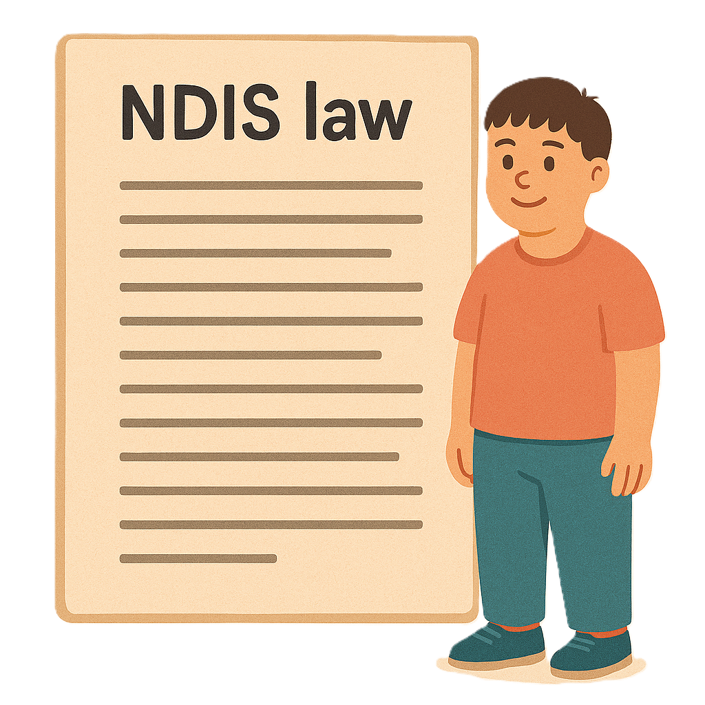 | We are not changing these laws.

Rules for plan variations
The changes will make it easier to understand when
- Funding in a NDIS plan can be changed.
Funding is money from the government to take part.
This is called plan variations.
 | It will make it easier to understand about what happens for plan variations.  For plan variations your funding can be  - More  - Less.
 | It will not change when you can ask for plan variations.

Making changes with you
 | The law says that NDIA must make changes to your NDIS plan with you.
 | NDIA need to listen to  - Your goals  Goals are things you want to do.
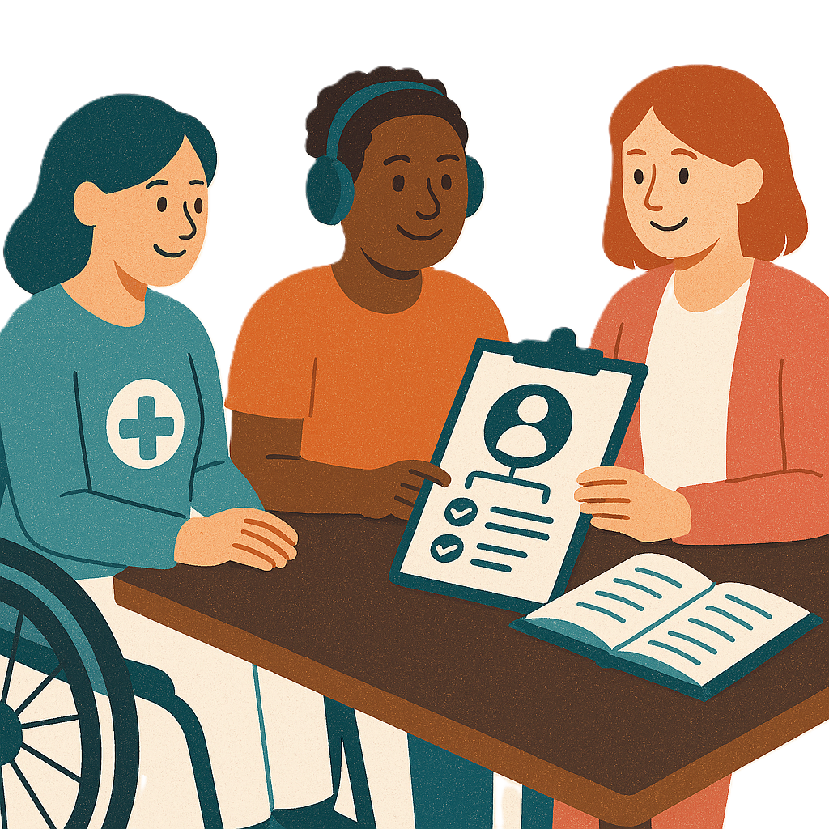 | - How you want to look after your plan  You can look after your NDIS plan if you want to.
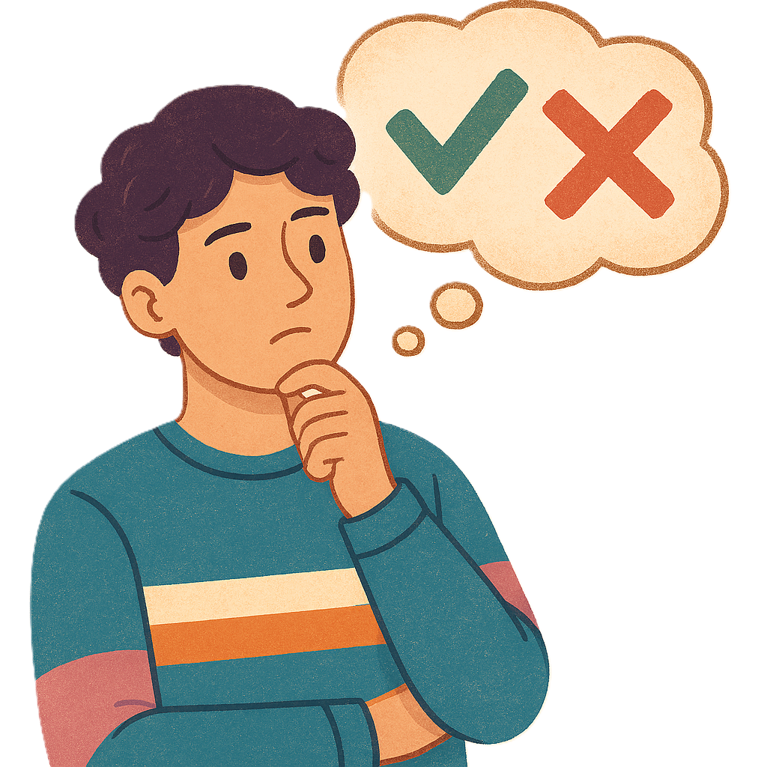 | - How well your plan has worked for you
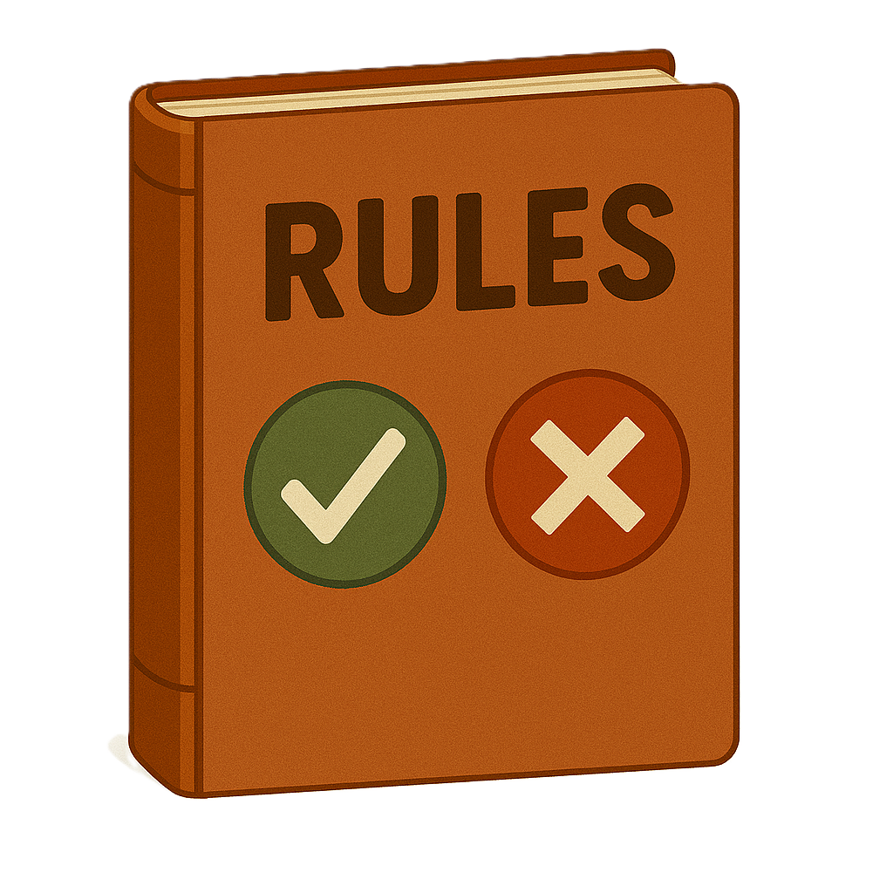 | - If your plan has been used following the rules.

More money for supports in your NDIS plan
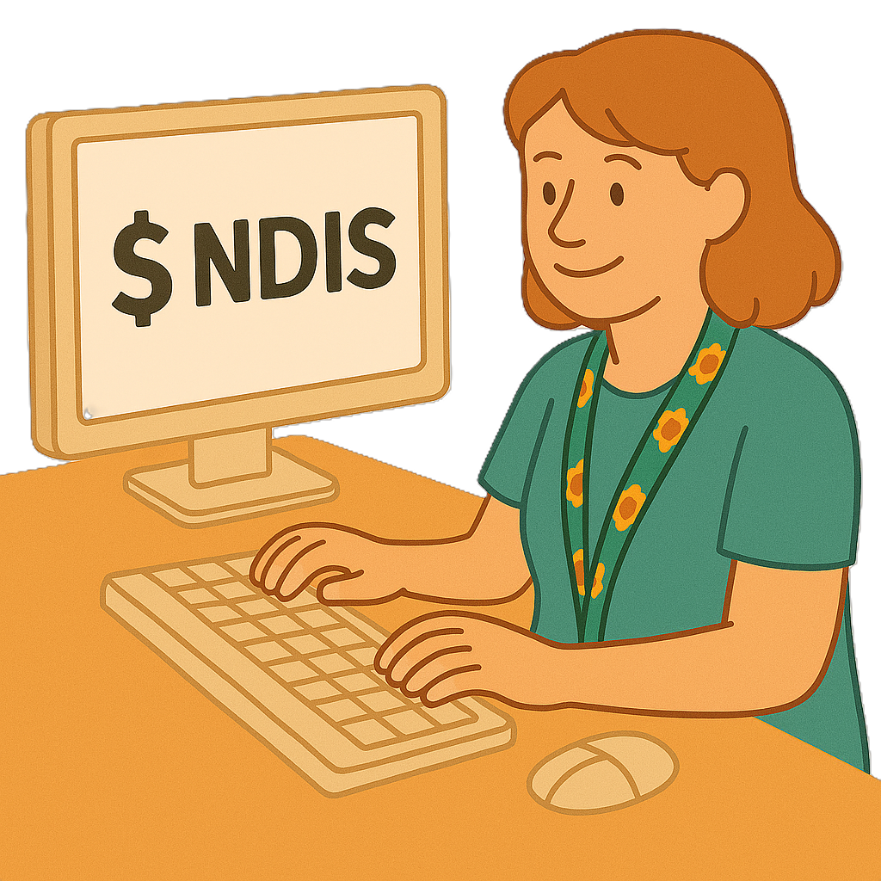 | Most changes to NDIS plans will have more money for supports.
Some of the changes could be
- Making the plan go for longer
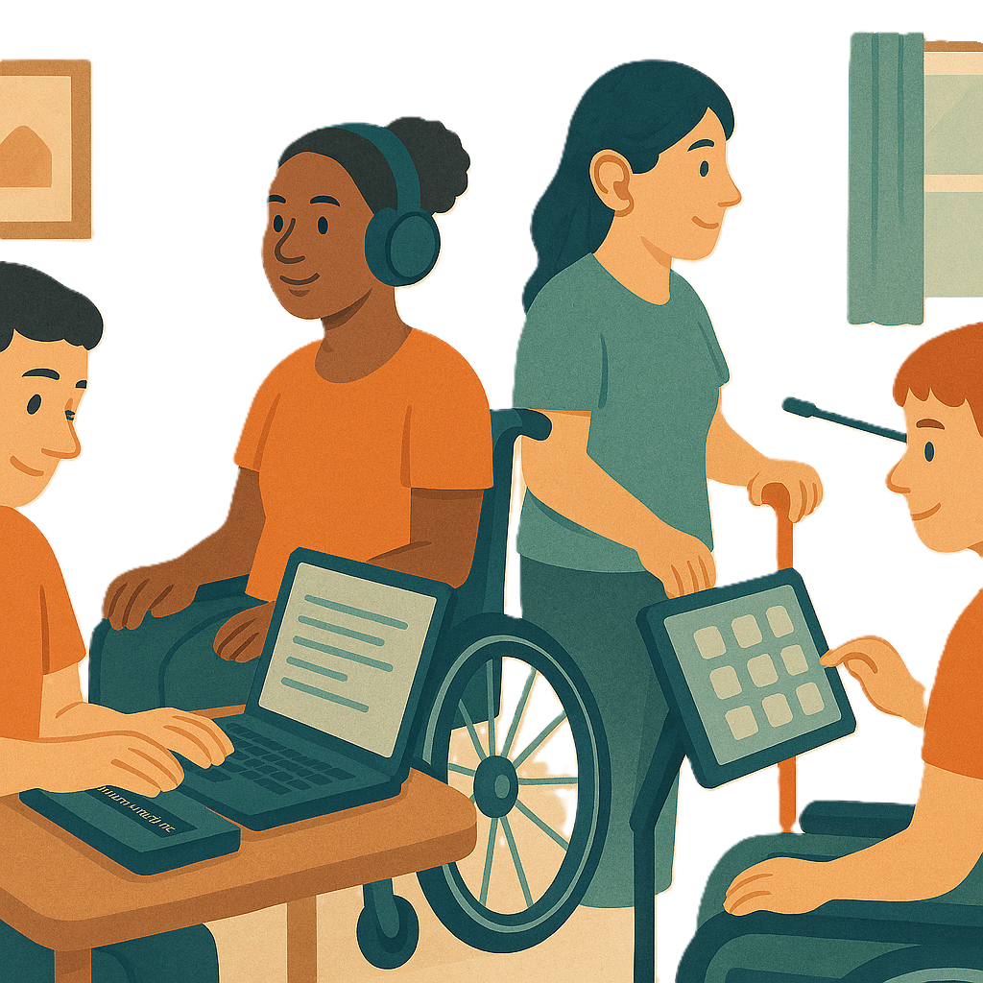 | Having money for assistive technology  Assistive technology can be things to help you:  - Speak  - Move  - See  - Hear.  This can also be changes to your home to help you be safe.
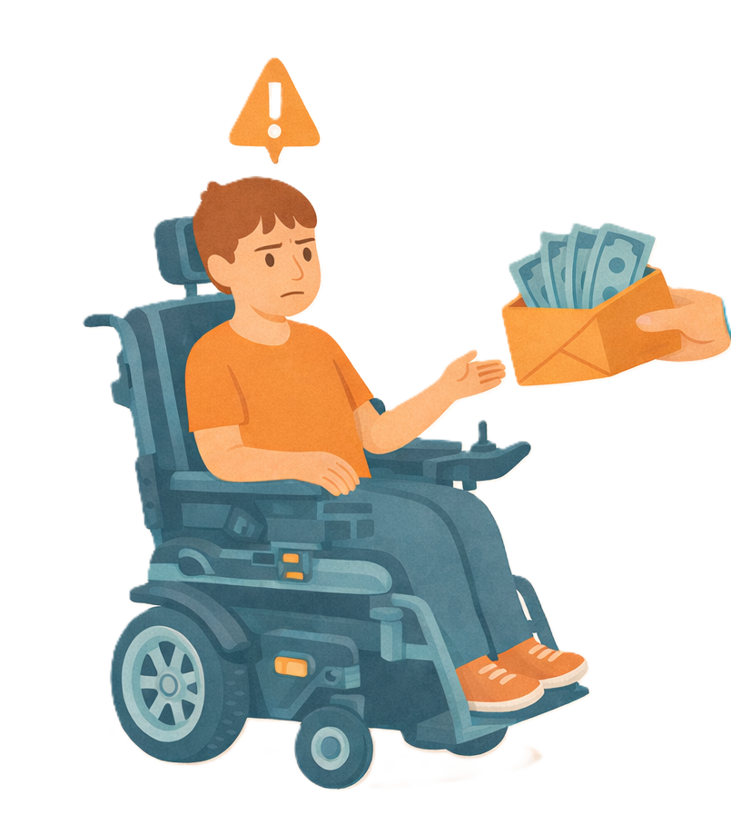 | - Having more money for supports quickly because your needs have changed  This can be called emergency funding.
 | - Money for supports to keep you  - Safe  - Healthy
 | - More money if you have experienced fraud  Fraud is when someone tries to get something they should not get.  Like tricking someone to get their NDIS money.

Less money for supports in your NDIS plan
 | Some changes to NDIS plans will have less money for supports.
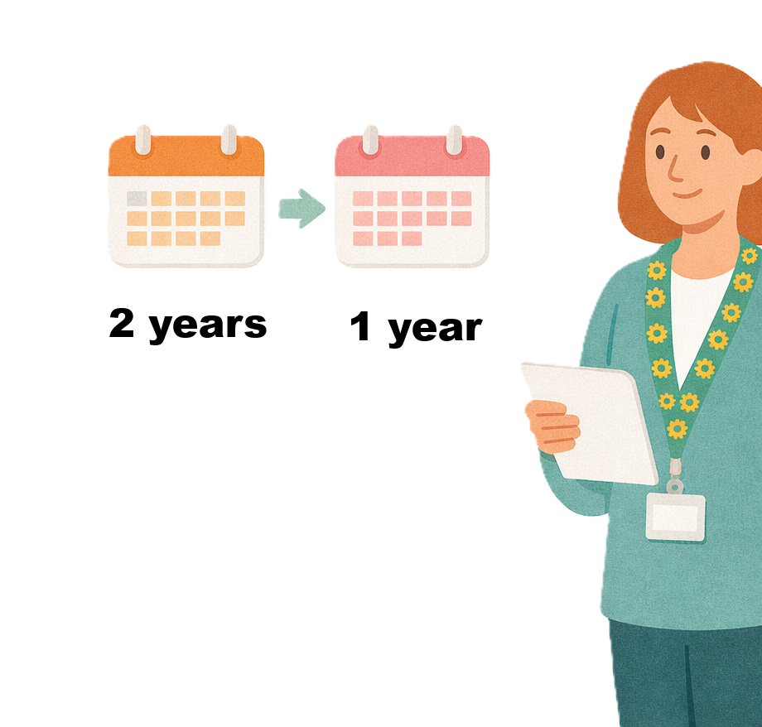 | They are  - Making a plan go over less time
 | - If someone has been given money after an accident  This means someone else pays for your disability supports not the NDIS.  This is called compensation.

Working together to make changes
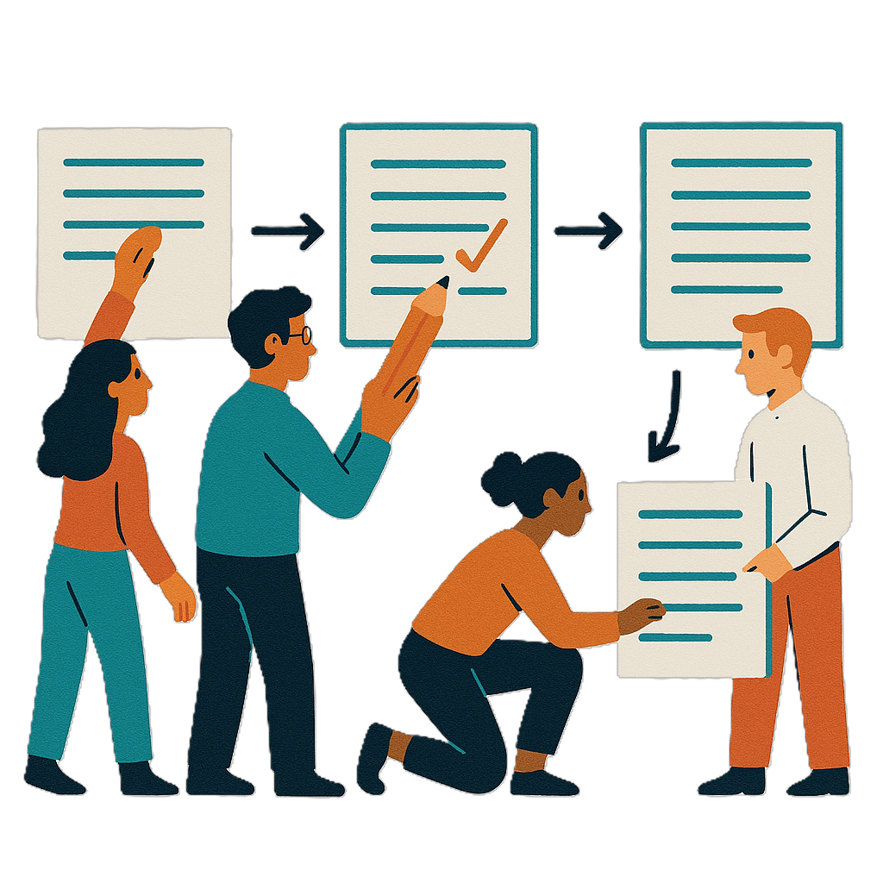 | NDIA must work with you to change your NDIS plan.  They do not have to make a whole new plan if your needs are the same.
 | Changes to plans will still be able to be reviewed if you do not agree.  This means you can ask for the decision to be checked again.
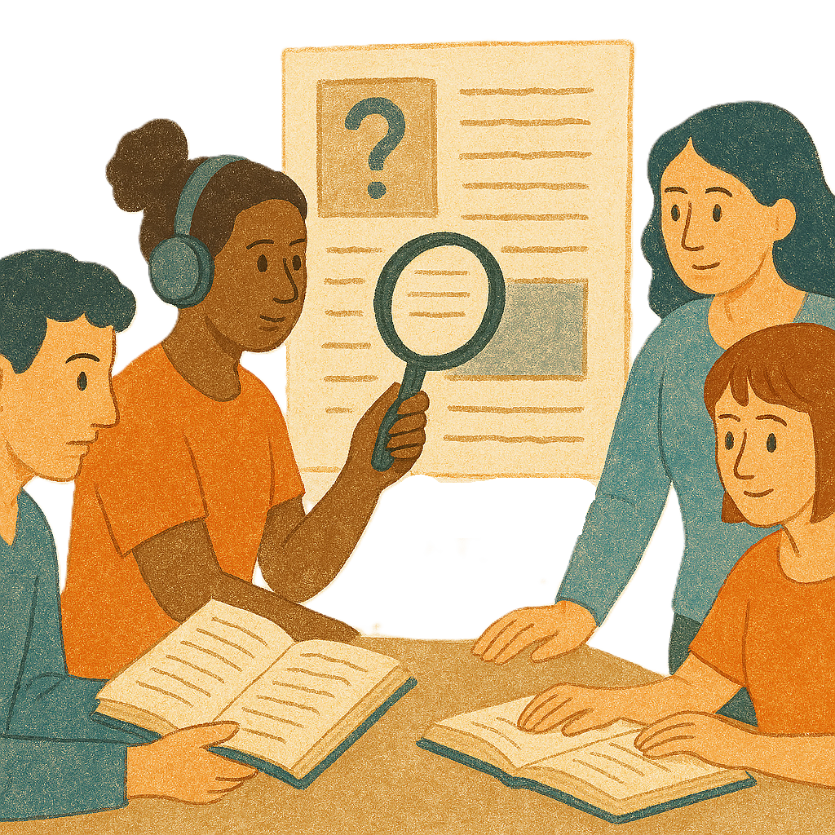 | If you do not agree with a change to your NDIS plan a  - Different person at NDIA can check the decision again.  They check if the right decision was made.  This is called an internal review.
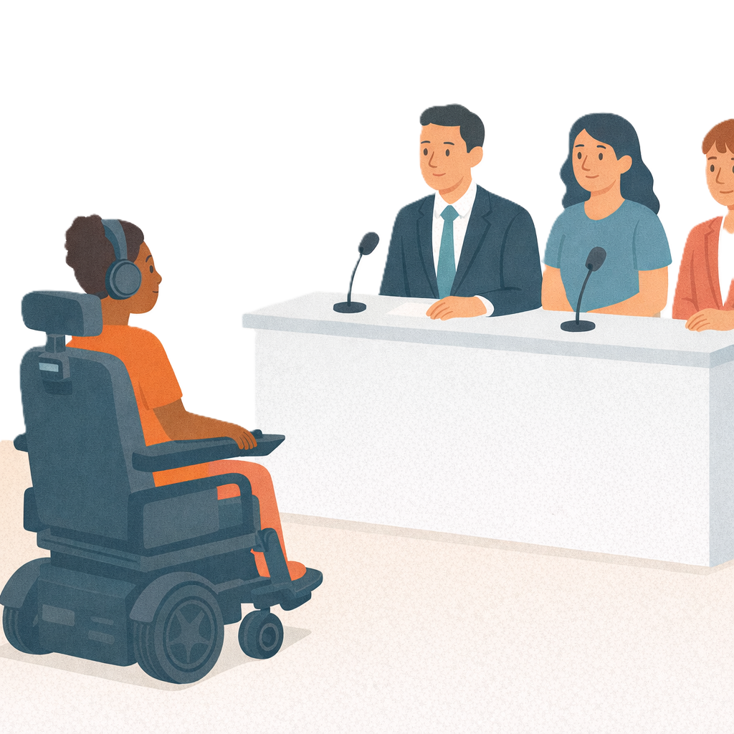 | If you still do not agree you can ask for an external review.  This is when someone outside NDIA checks the decision.  They check if the right decision was made.  An external review is done by the Administrative Review Tribunal.

More information
 | For more information you can look at our website.  www.health.gov.au/our-work/ndis-legislation-changes/amendments/2025
Some images in this Easy Read were made using AI.
You must not share or copy any of the images without permission.
July 2026.

