NDIS Amendment Act
NDIA Measures Fact sheet
Part 2
Electronic Forms
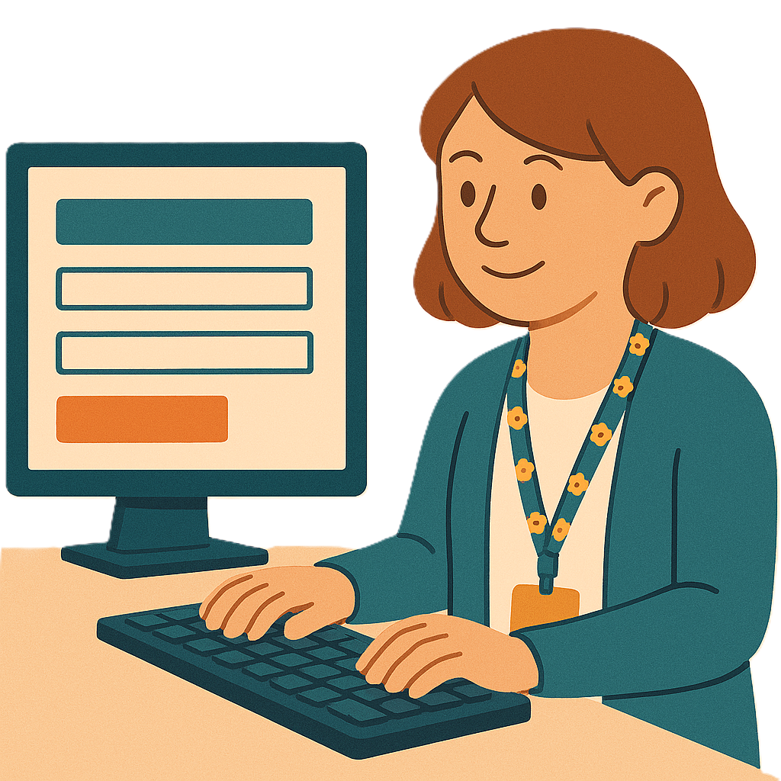
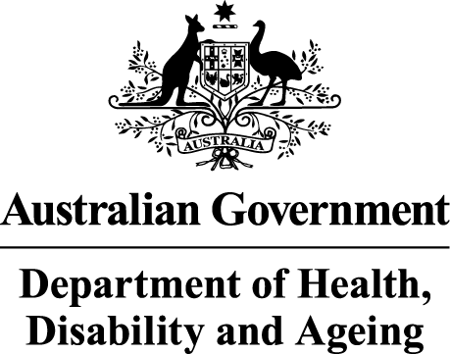 | The Australian Government Department of Health Disability and Ageing wrote this.  We say DHDA for short.  When you see the word we it means DHDA.
 | We wrote this in an easy to read way.  We use pictures to explain some ideas.
 | We have some words in bold.  This means the letters are thicker and darker.  These are important words.
 | This is an Easy Read summary of another document.  This means it has the most important ideas.
 | You can ask for help to read this document.  You can ask  - A friend  - Family members  - A support person.
 | We recognise Aboriginal and Torres Strait Islander people as the Traditional Owners of the land we live on.
 | They were the first people to live on and use the  - Land  - Waters.
Contents
About this document 5
Rules for providers making claims 8
Electronic form system 10
Proof for claims 12
Types of information to be shared 14
Keeping your information safe 18
If providers can not share information 20
More information 22

About this document
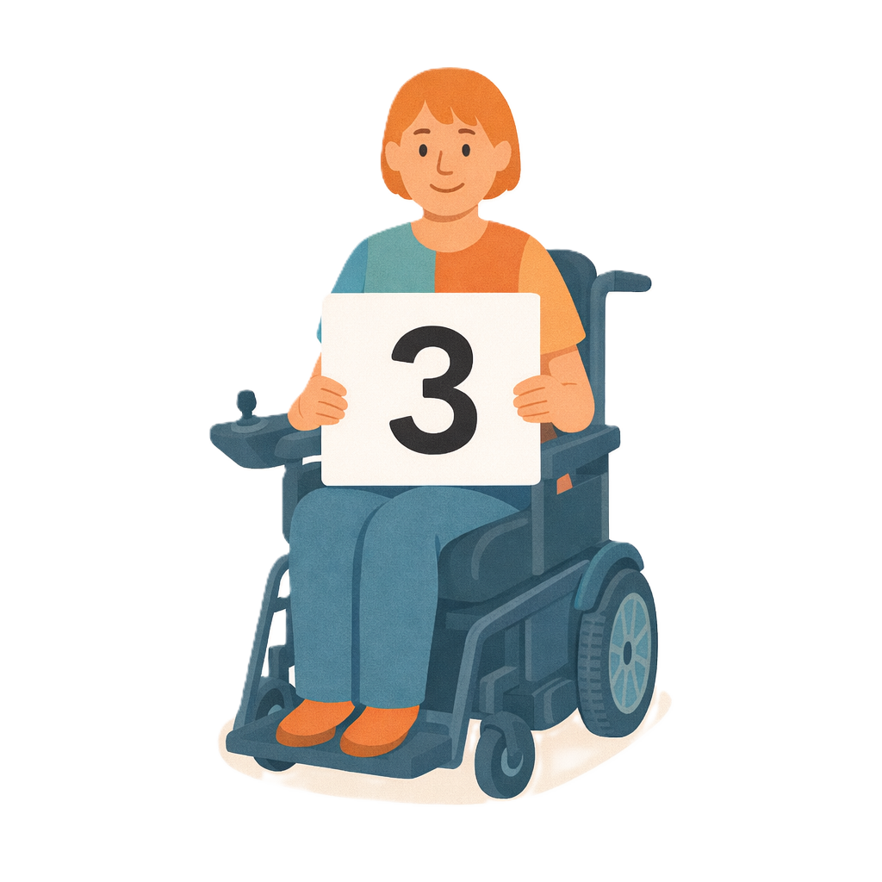 | This document has 3 parts.
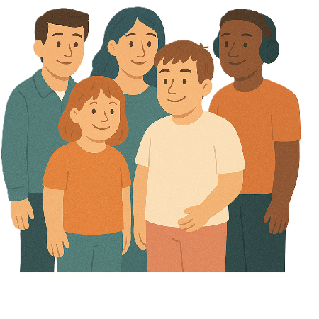 | This document talks about  - Changes the government wants to make to NDIS laws.  Laws are rules for how we live.  The changes are called the  - Integrity and Safeguarding Act.  We call it the Act for short.
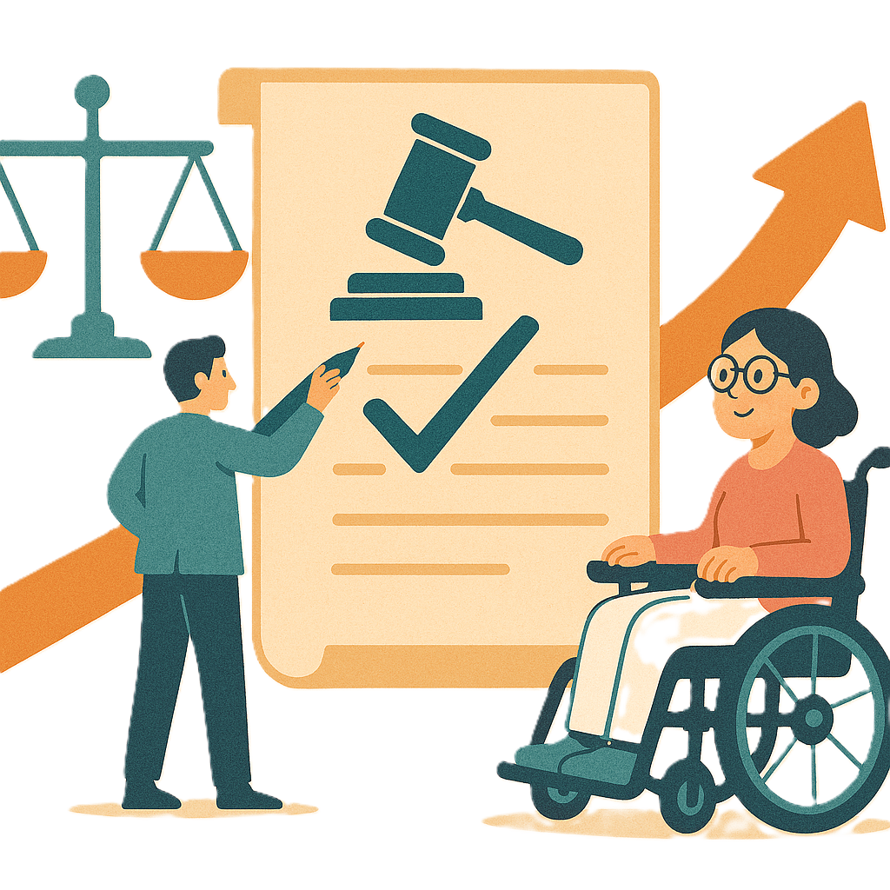 | Changes to laws are called amendments.  They help laws  - Change  - Be better.
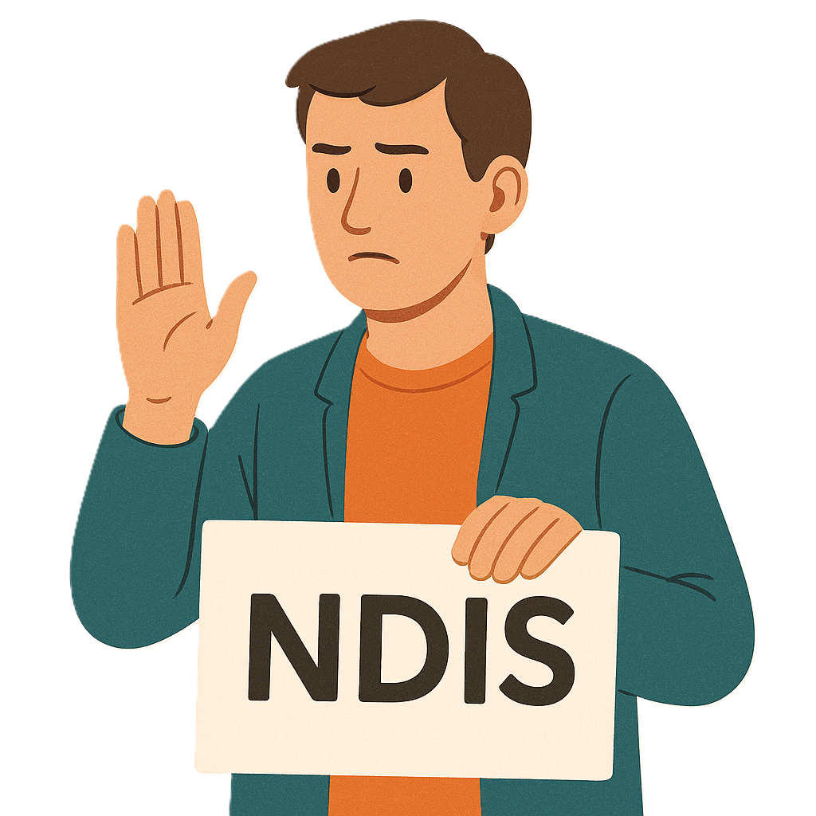 | Part 1 talks about  - Leaving the NDIS
Part 2 talks about
- Electronic forms
Electronic forms are filled in on a computer.
 | Part 3 talks about  - NDIS plan variations.
 | Plan variations are when the  - National Disability Insurance Agency changes things in your NDIS plan.  We call them NDIA for short.  NDIA can change  - Money  - Supports  In your NDIS plan.
 | This is part 2.

Rules for providers making claims
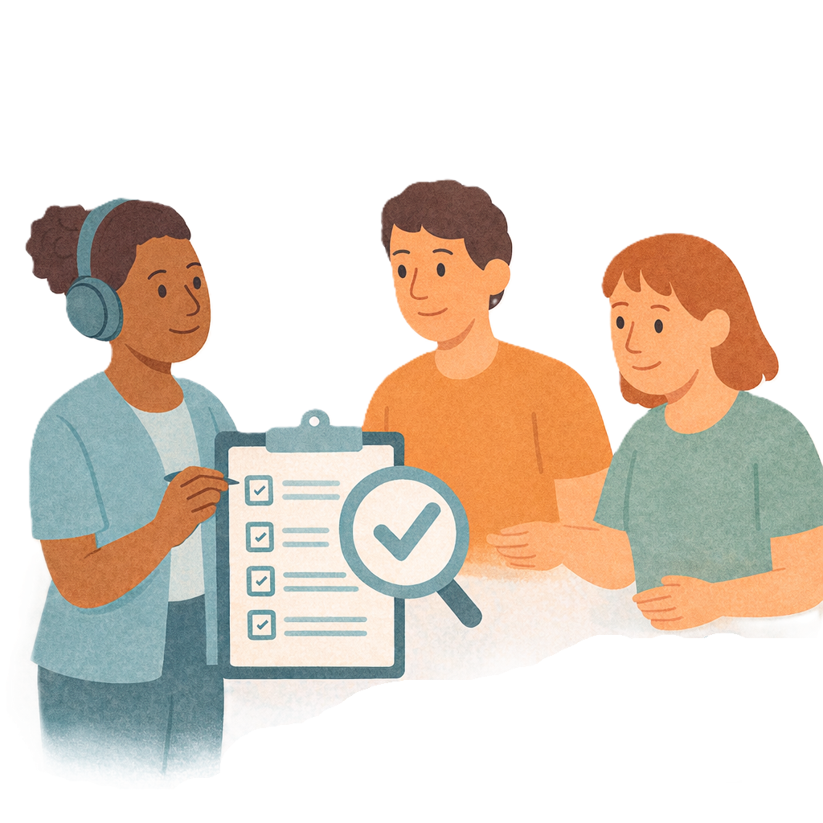 | This change wants to make it easier for  - NDIA to check providers are following the rules when they make claims.
 | Providers get money from your NDIS plan to support you.
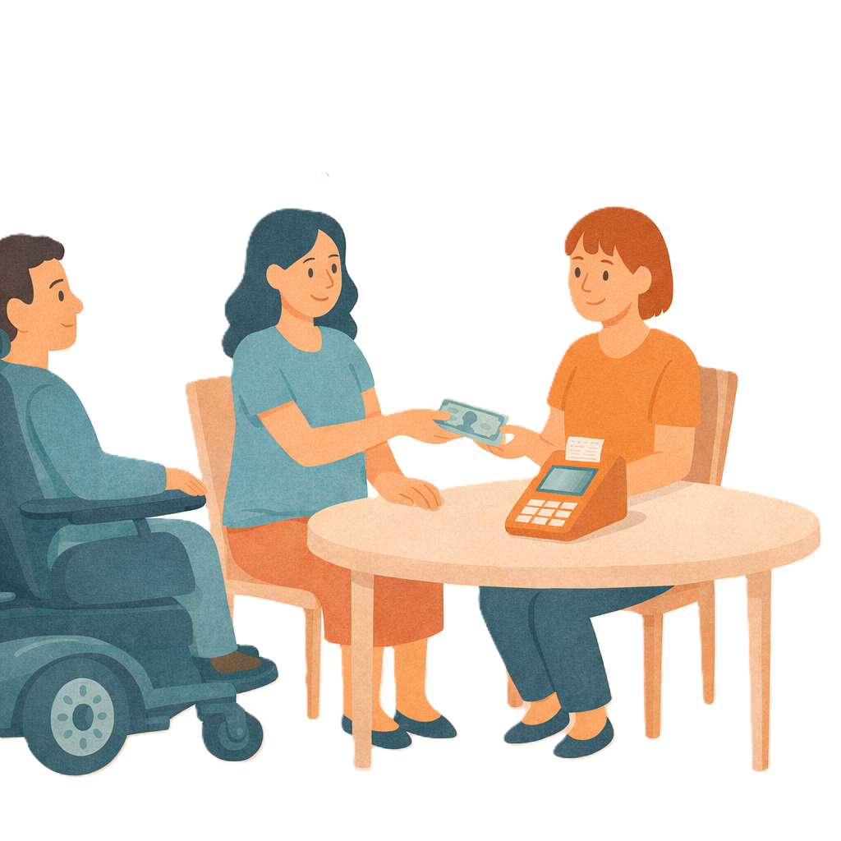 | Claims are when NDIS providers ask for money for doing a  - Service  - Support.
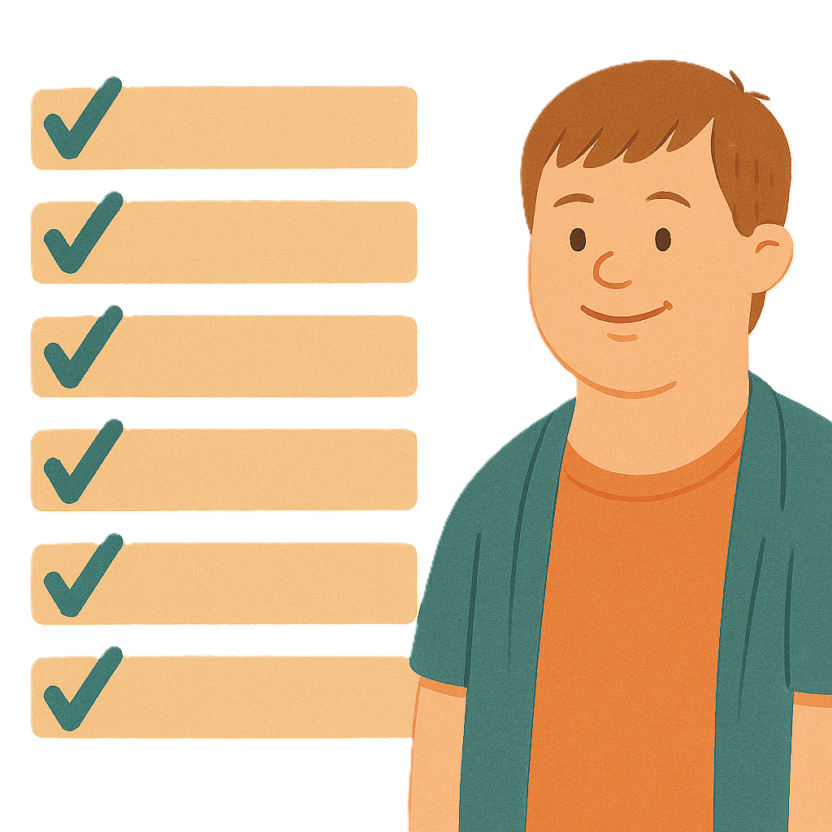 | This change will make sure  - Providers do the right thing
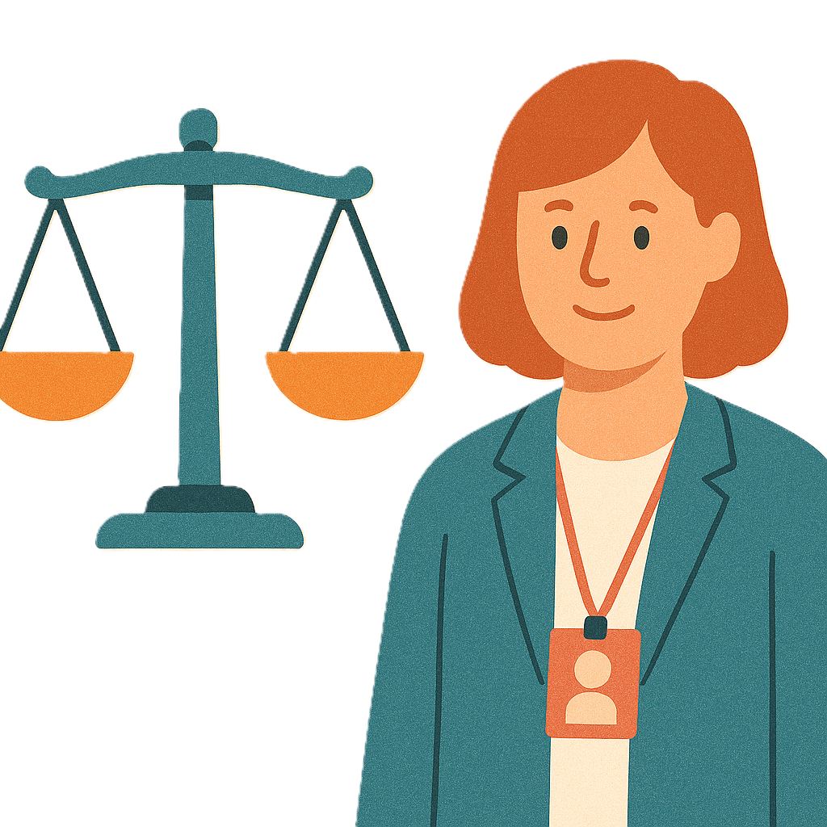 | - The NDIS is fair.

Electronic form system
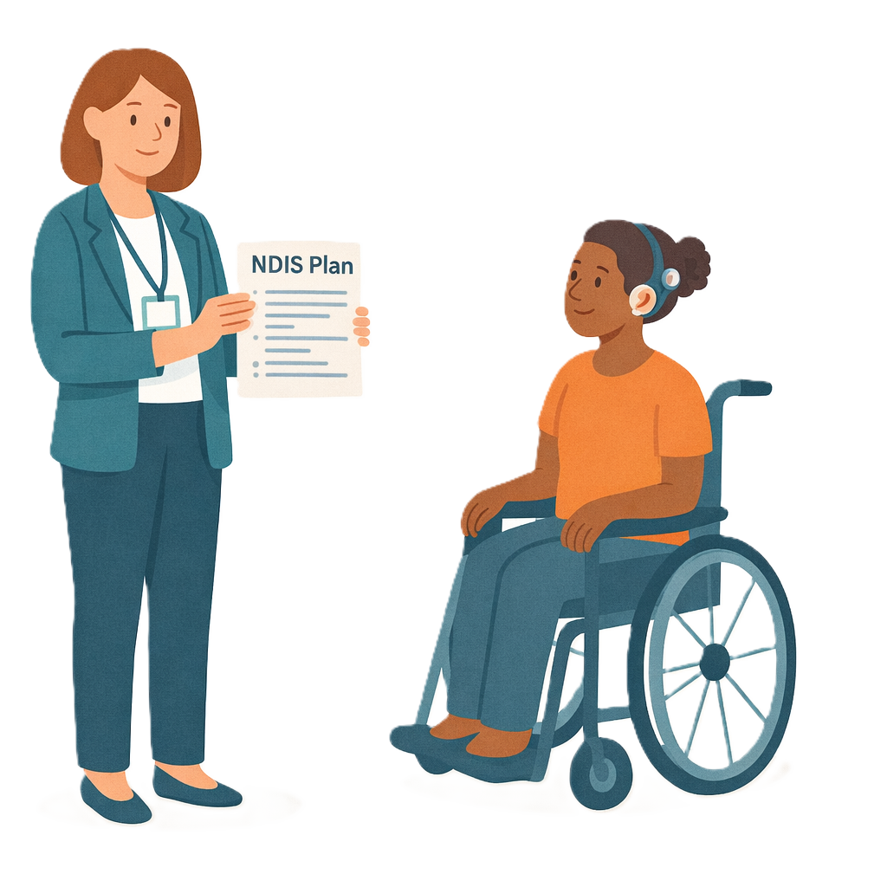 | We think registered providers should have to use the NDIA system to make claims for  - NDIA managed plans.  This is when the NDIA pays for supports from your NDIS plan.  This can also be called agency managed.
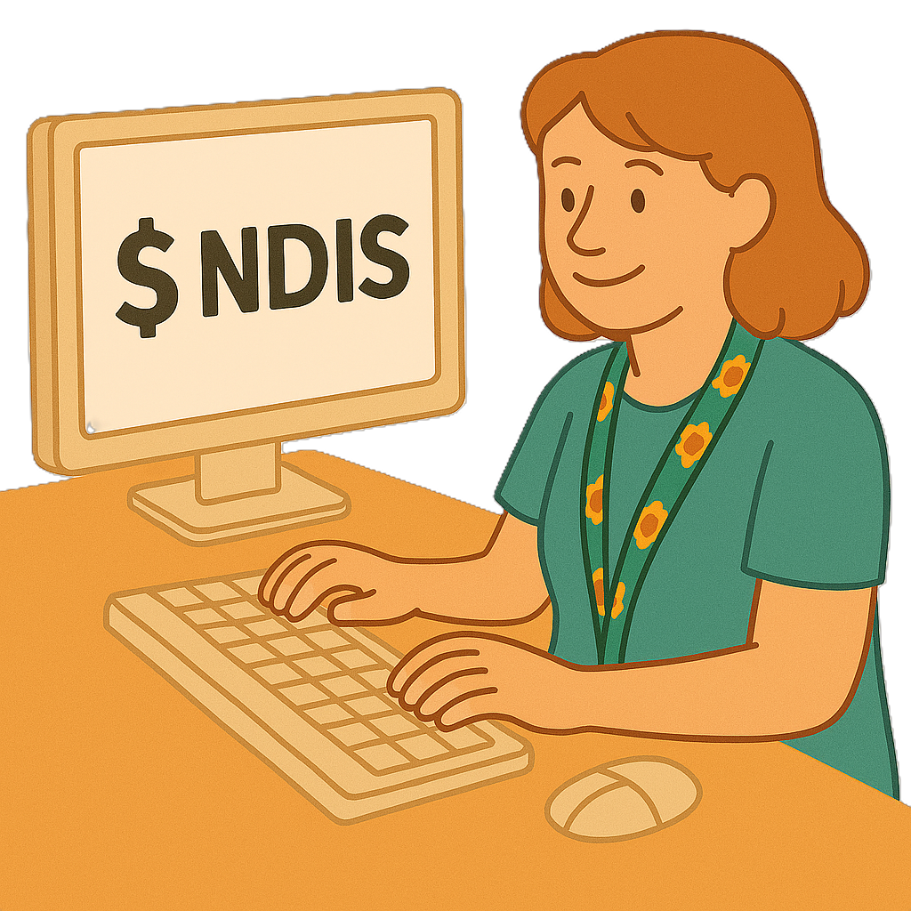 | Most providers use the NDIA system already.
 | People with disability who get NDIS support do not have to change how they put claims in.
 | A provider could ask for a different way if they can not use the electronic system.
 | NDIA have people who can help providers if they have questions about payments.

Proof for claims
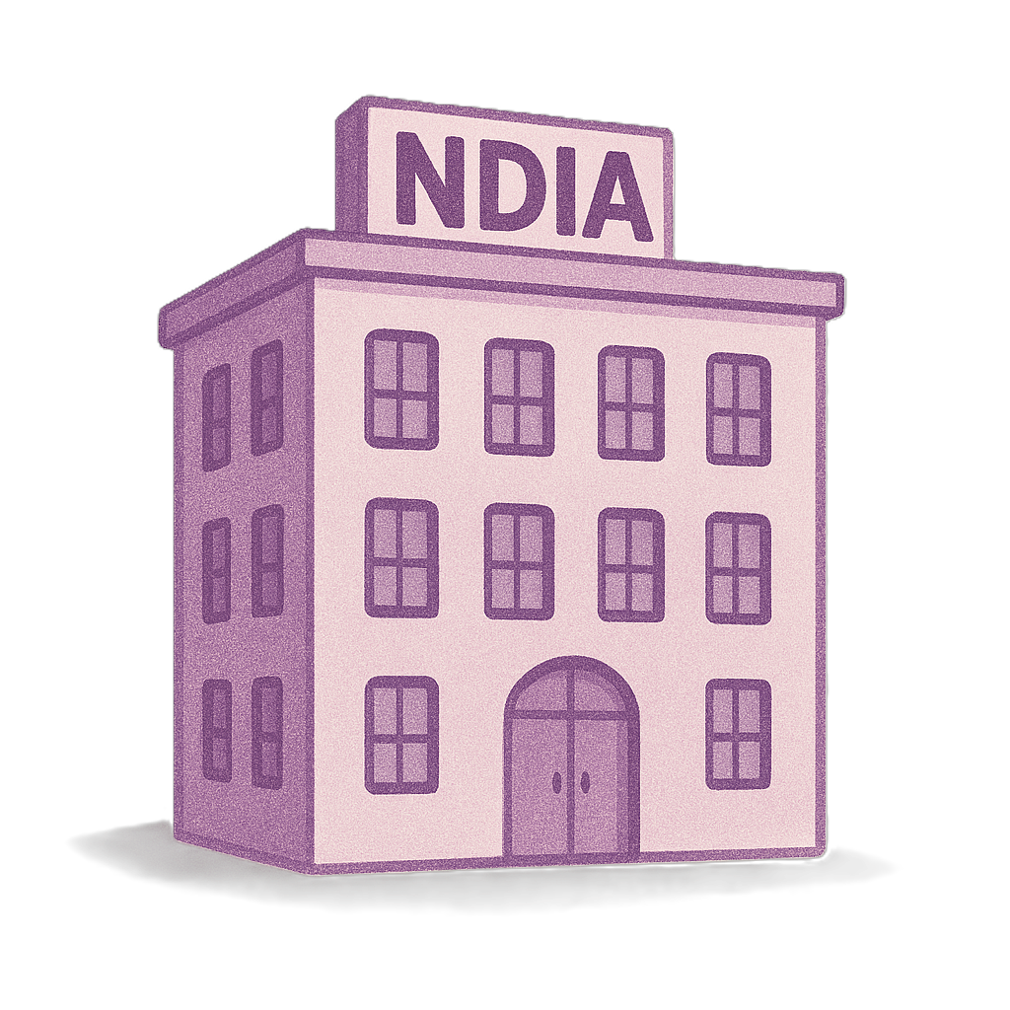 | The change will mean the Chief Executive Officer can ask for more information.  We call them CEO for short.  They run NDIA every day and make sure the work gets done.
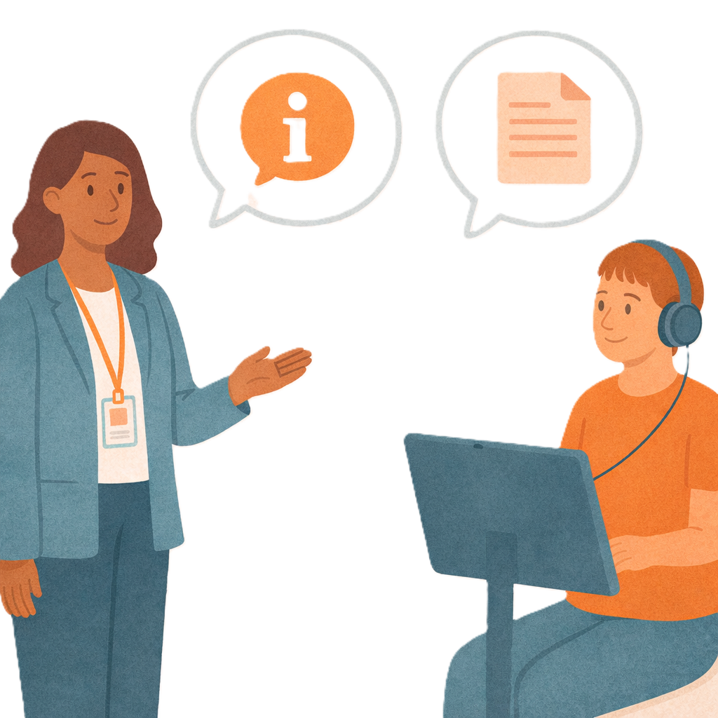 | The CEO can ask for  - Information  - Documents  About a claim.
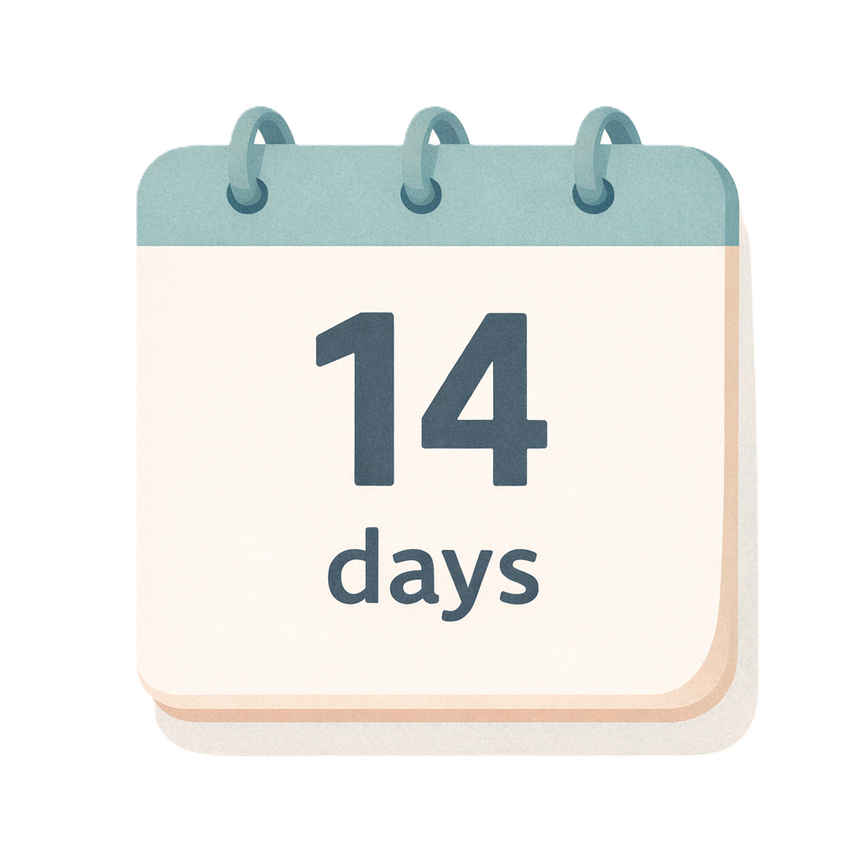 | Providers have 14 days to share this information.
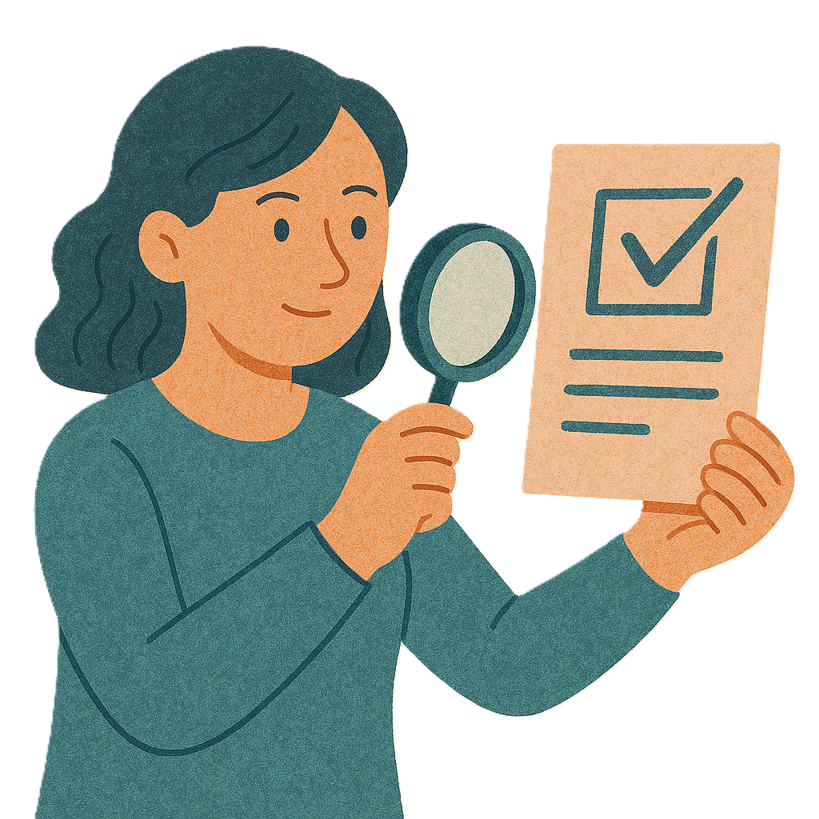 | This will help high risk claims be paid quickly.  High risk claims need extra checking.  This could be because  - Something does not look right  - More information is needed.
 | NDIA have lots of claims every day that are high risk.
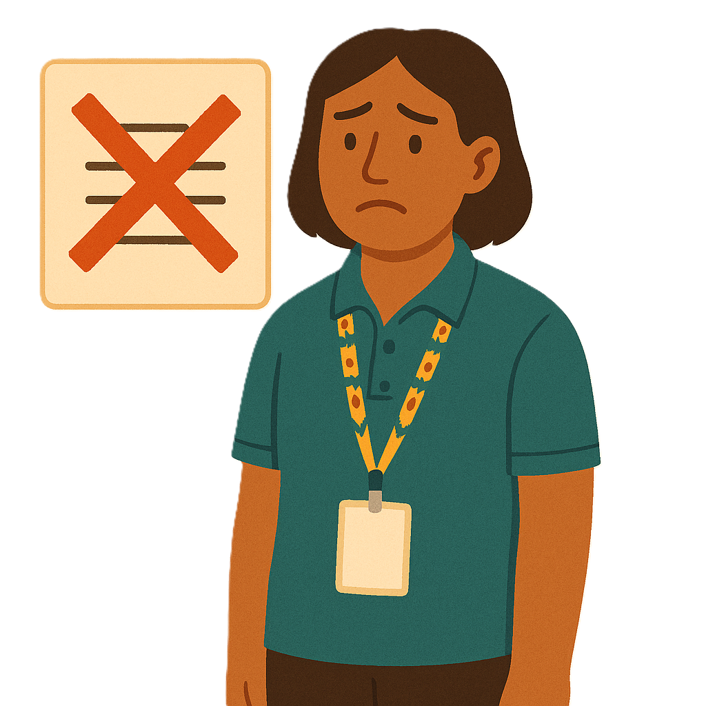 | Sometimes people putting in the claim can not give proof.  Proof means things to support the claim.  This change will say what they need to do.

Types of information to be shared
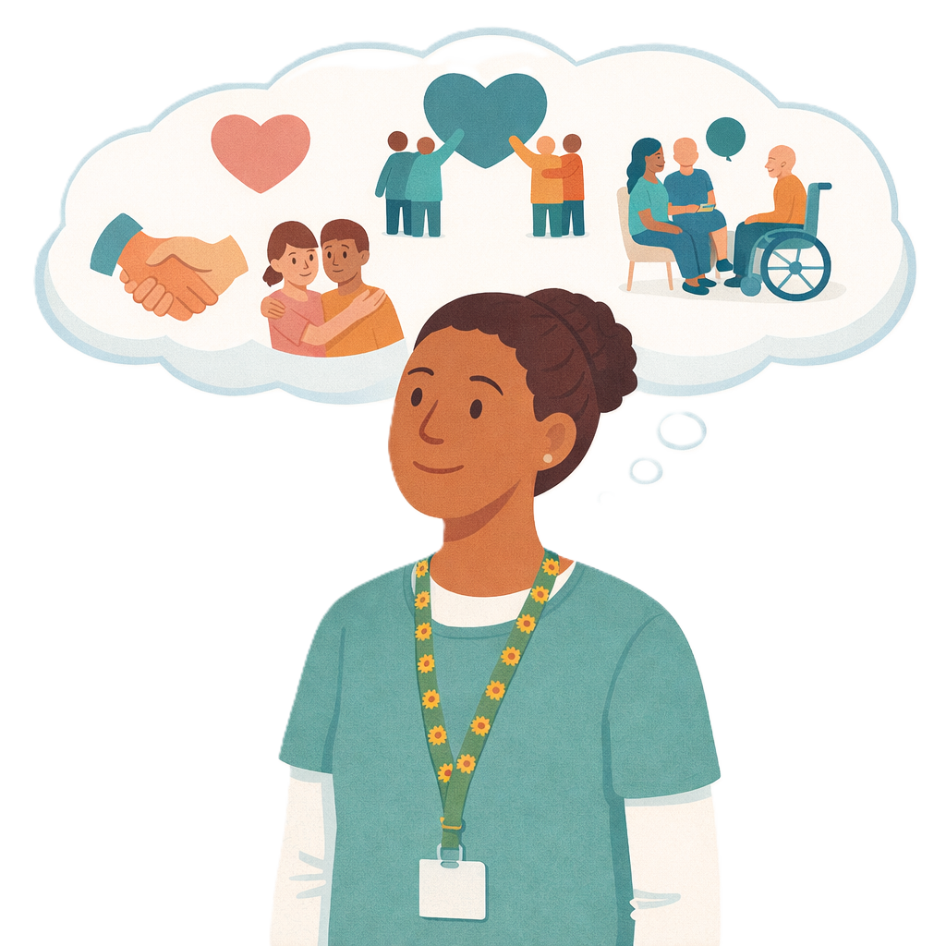 | Information about the claim that needs to be shared could be  - What the support is
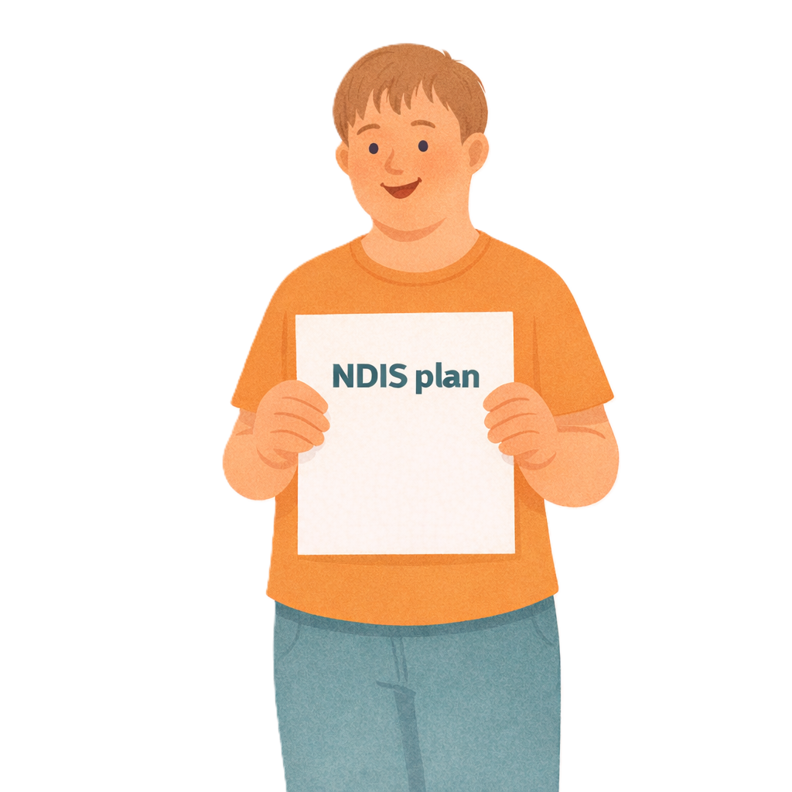 | - The support is part of a NDIS plan
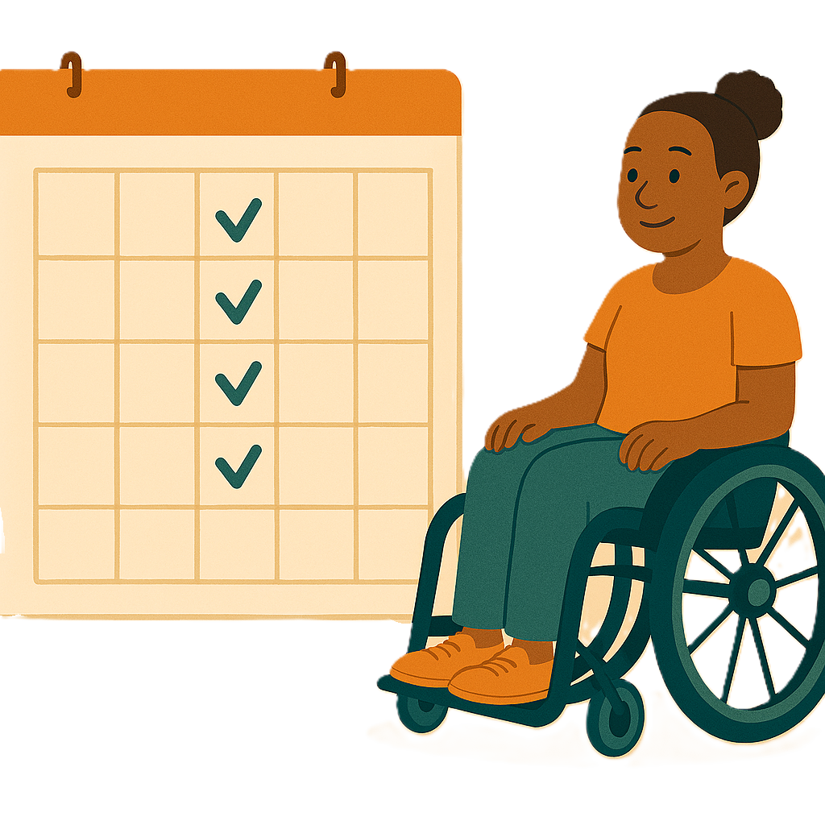 | - The support has been done
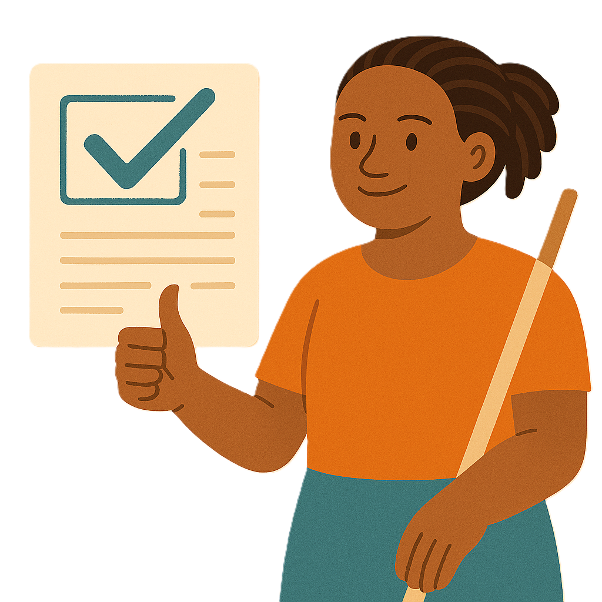 | - The claim is correct.
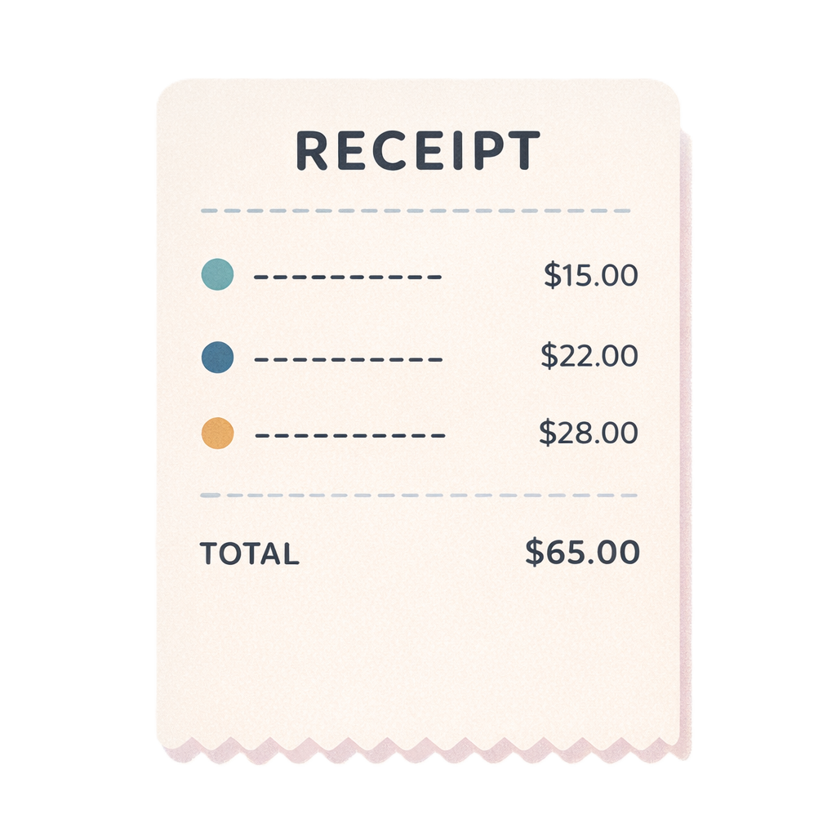 | NDIA will usually ask for  - Receipts
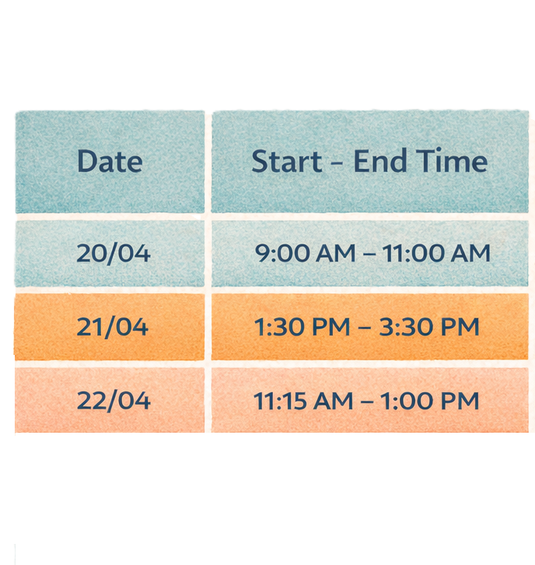 | - Something to prove how long the support took
 | - What type of support it is
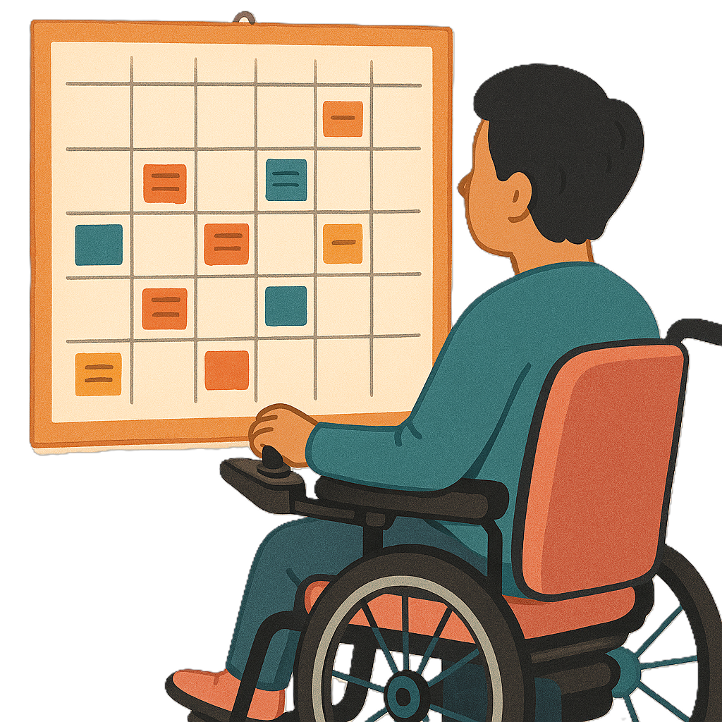 | - The day the support was done
 | - Information about what workers were working
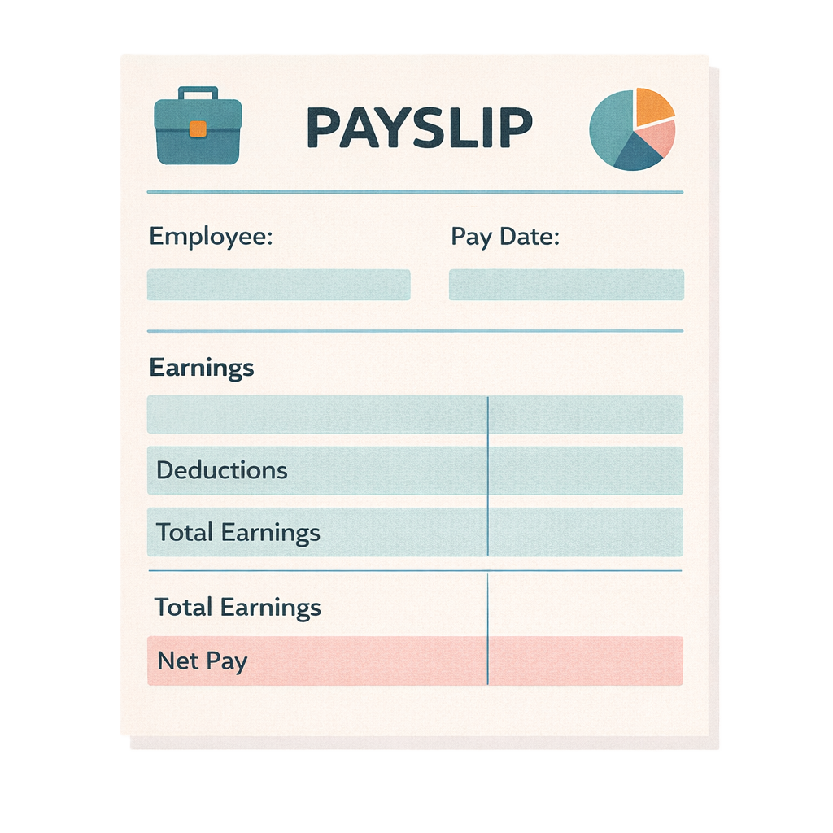 | This could be things like  - Payslips  Payslips say how much money the worker was paid for work.
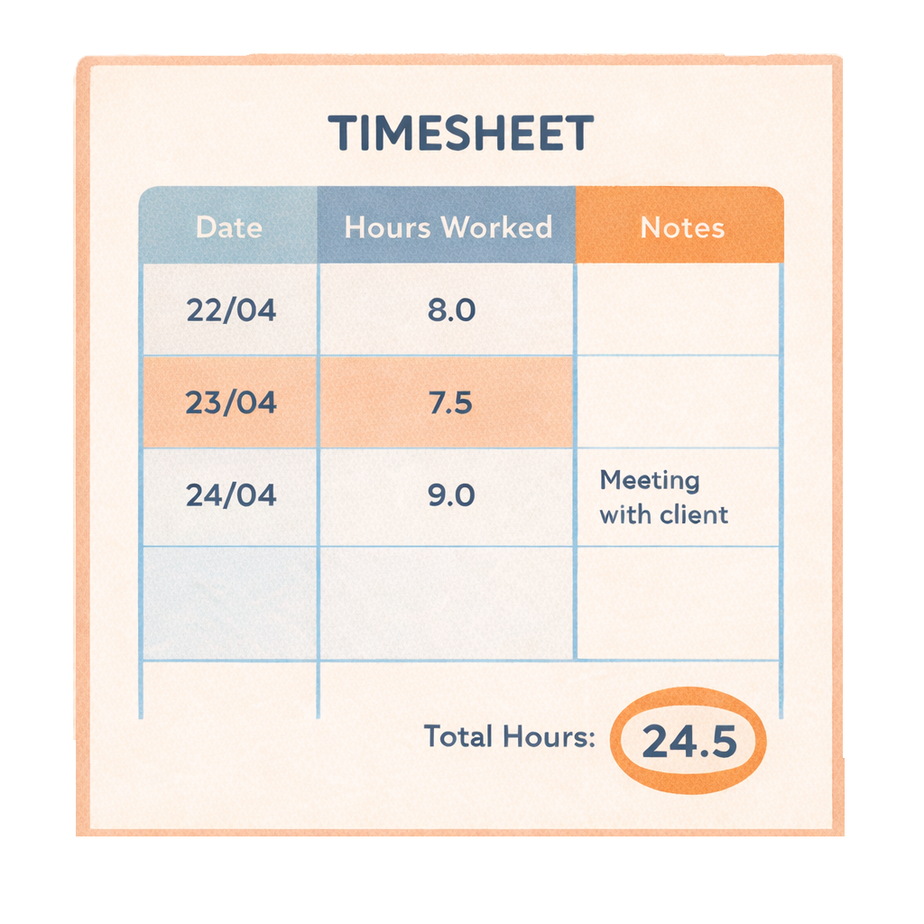 | - Timesheets  Timesheets say when someone worked.  They also say how many hours they worked.
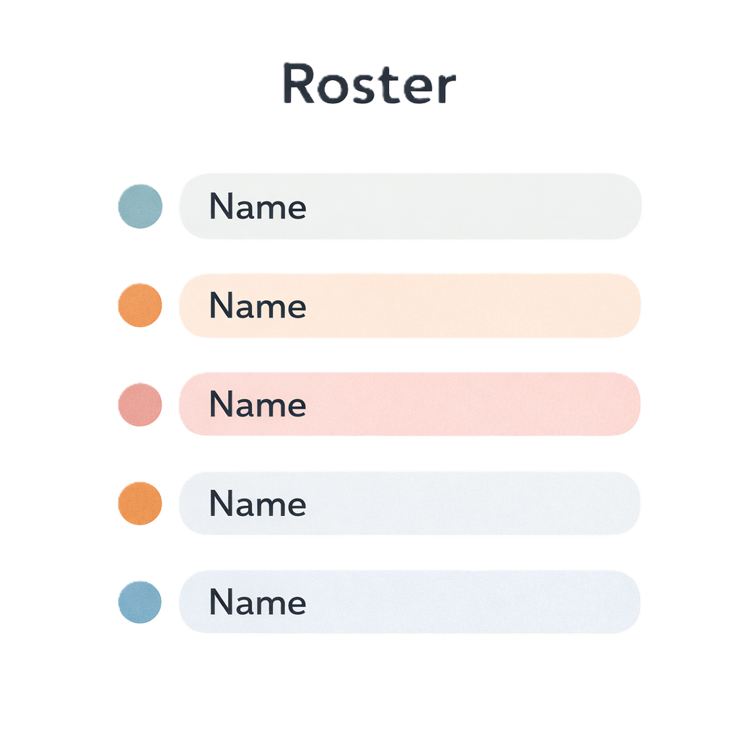 | - Rosters.  Rosters say the times and days people are working.

Keeping your information safe
The NDIA will only ask for
- Information that it needs to approve your claim.
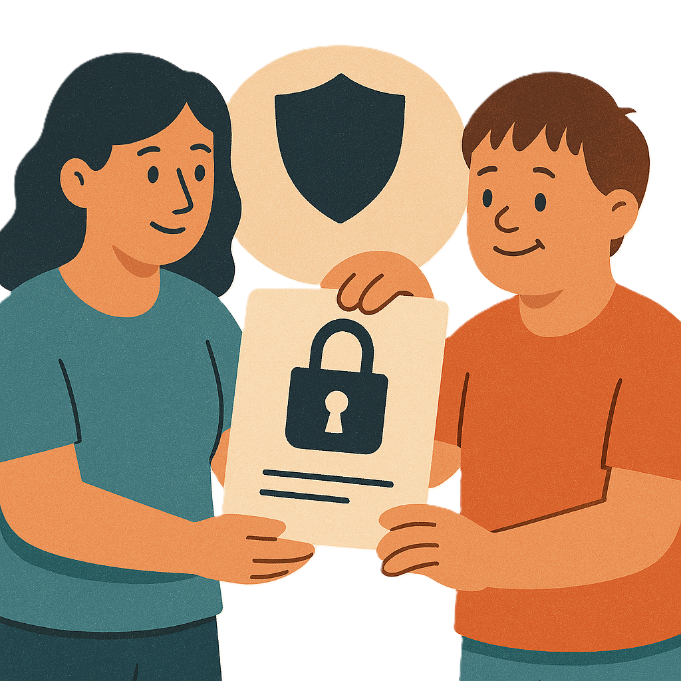 | - The NDIA keep your information safe.  - This helps to protect your privacy.  - This is called protected information.
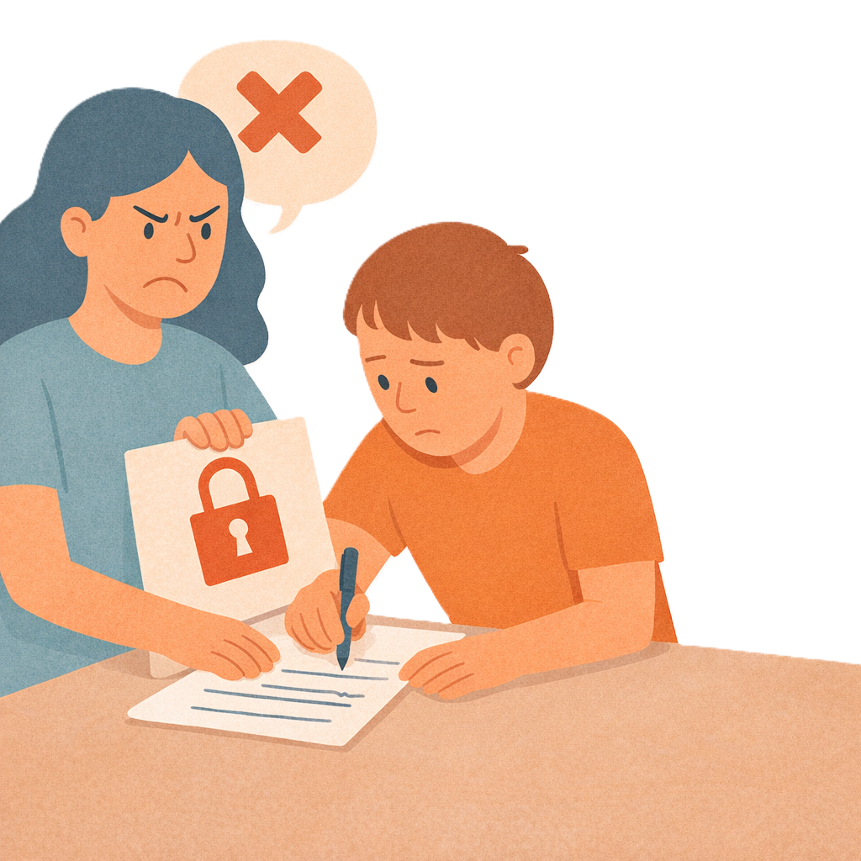 | No one can  - Record
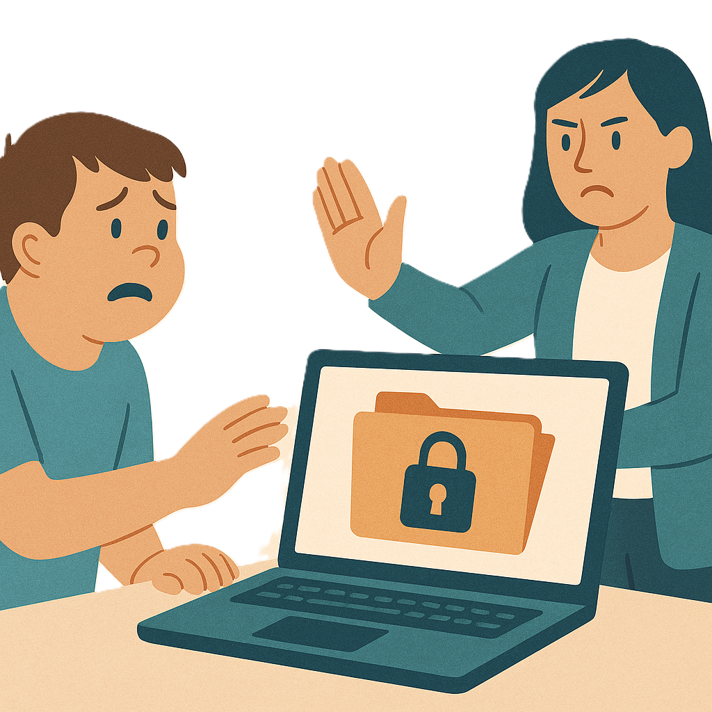 | - Use
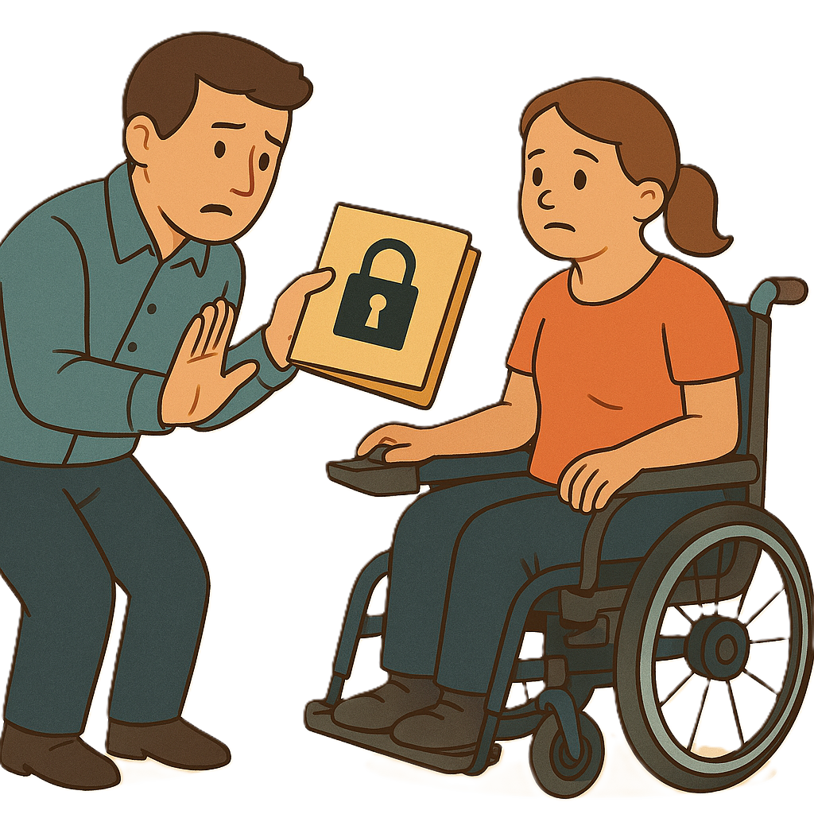 | - Share  Protected information.
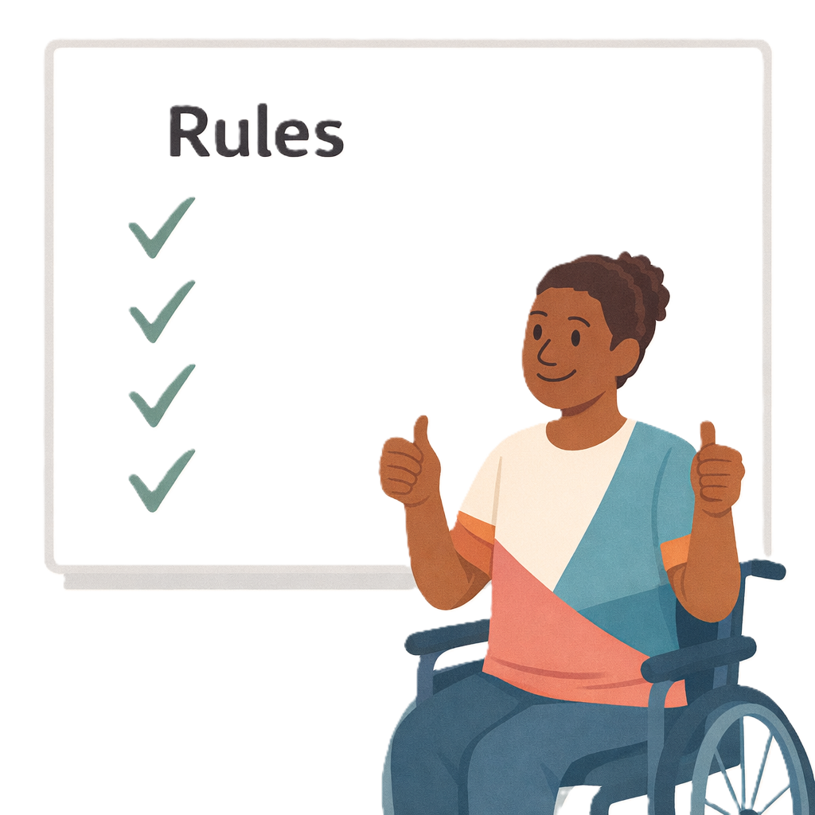 | There are rules that NDIA must follow when sharing protected information.  This helps keep information safe.

If providers cannot share information
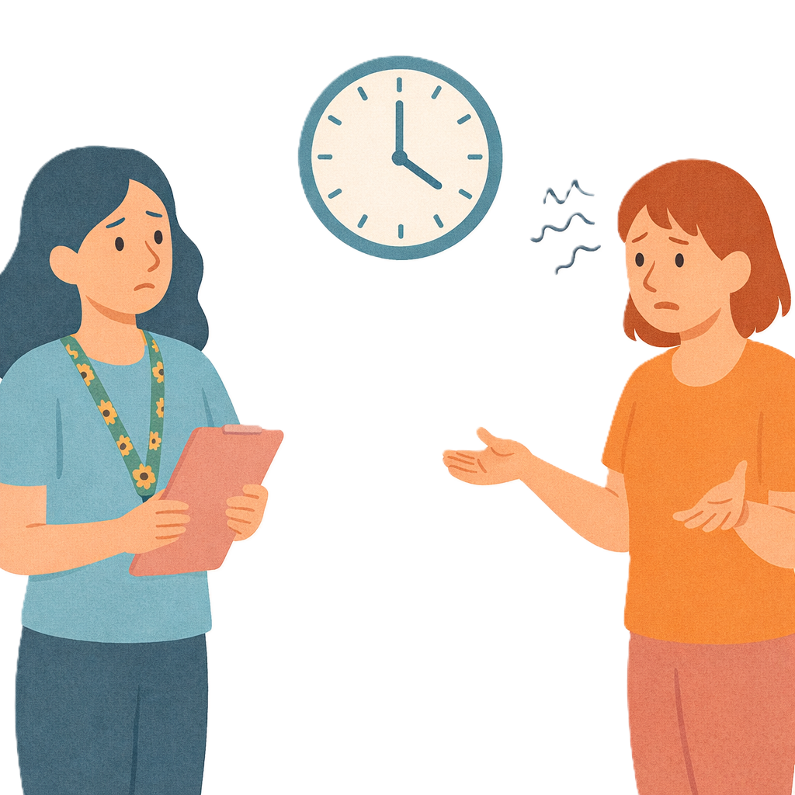 | Sometimes providers can not share information  - With NDIA  - In 14 days.
 | NDIA can give providers more time.
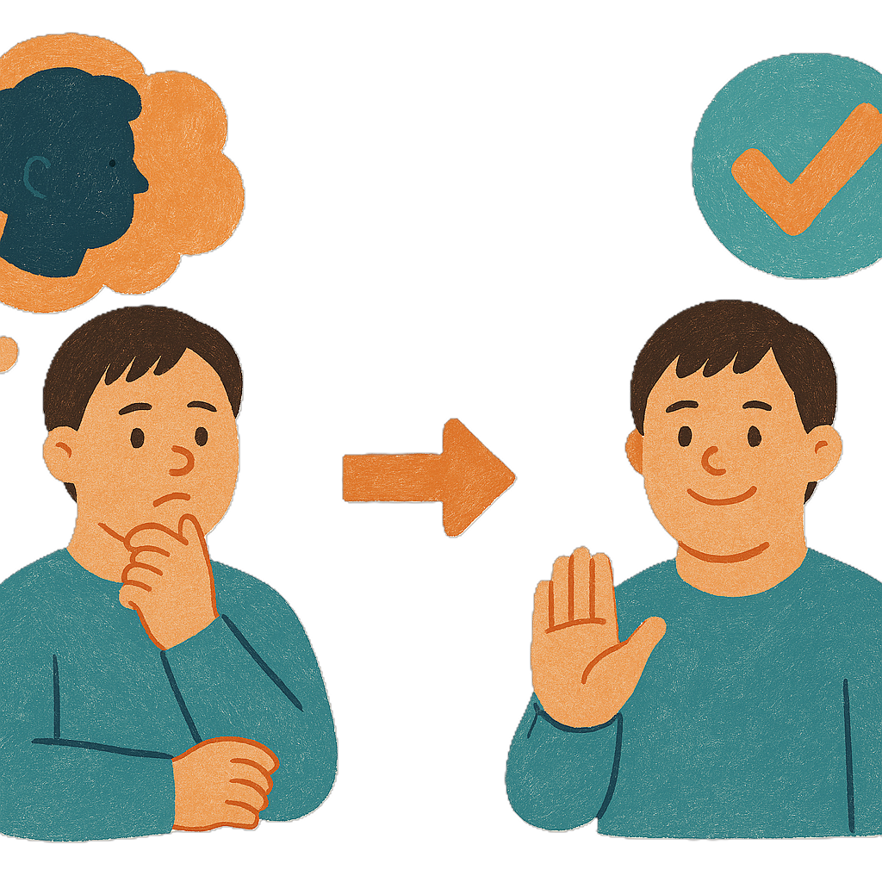 | NDIA can change their mind about needing more information.  They can do this if the information is lost.
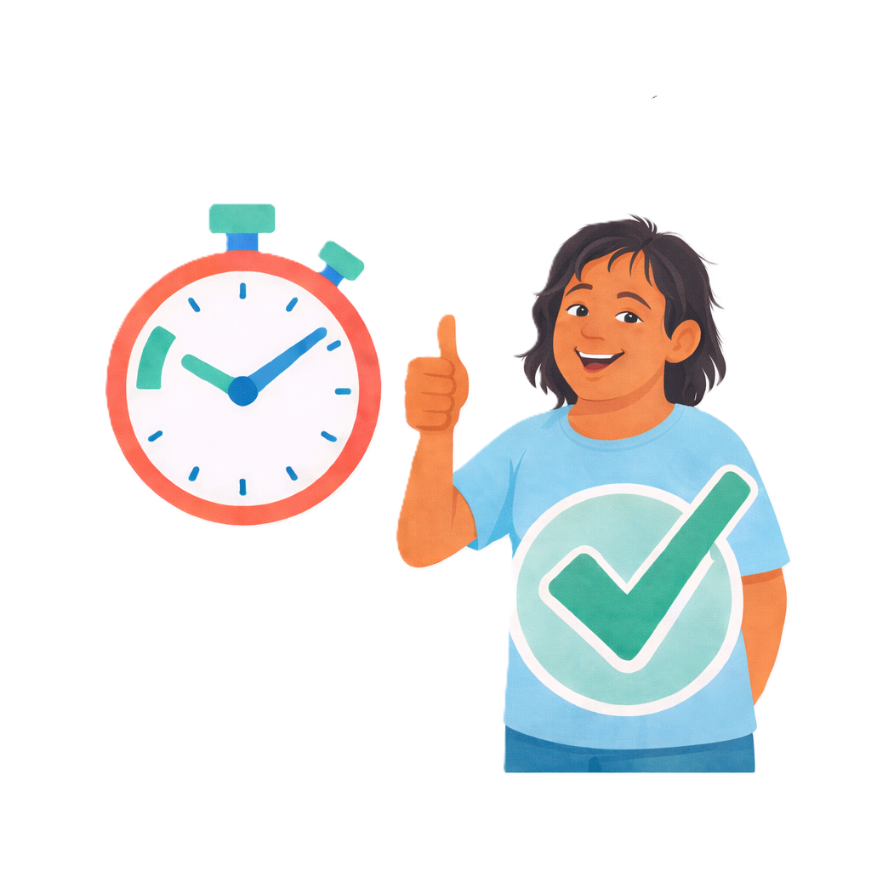 | Sharing information quickly with NDIA will make payments faster.
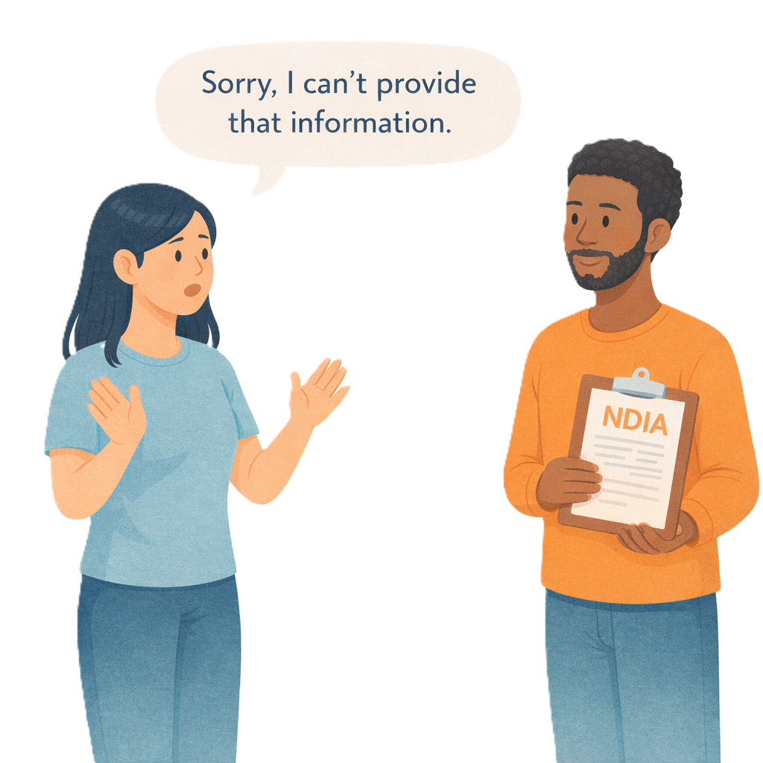 | If providers can not share information about a claim they can tell NDIA their reasons.
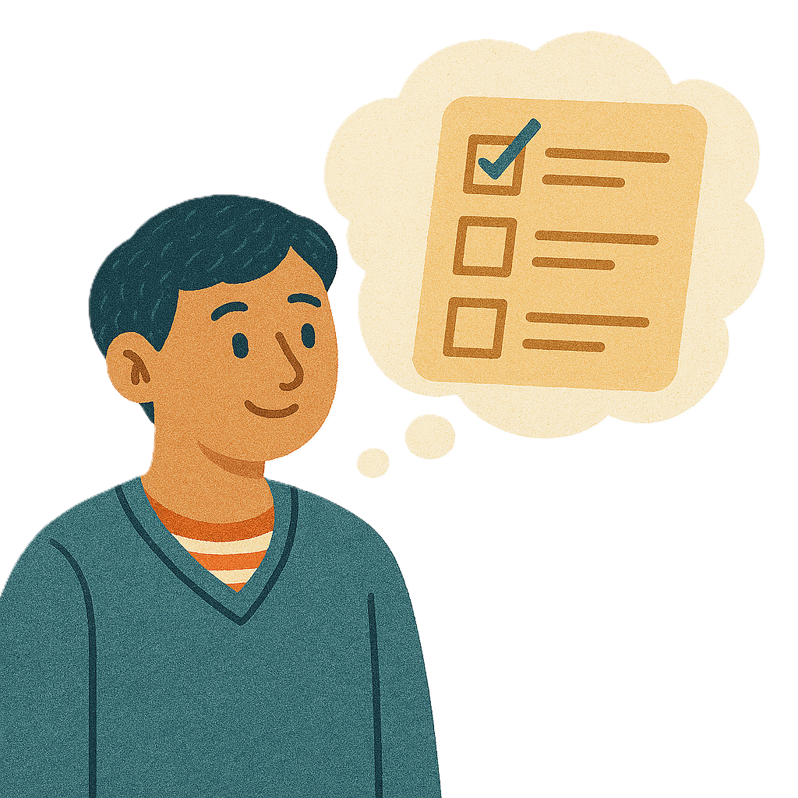 | If the CEO thinks the  - Reasons are fair  - Support was done  The provider will be paid.
 | This will help keep people with disability safe.

More information
 | For more information you can look at our website.  www.health.gov.au/our-work/ndis-legislation-changes/amendments/2025
Some images in this Easy Read were made using AI.
You must not share or copy any of the images without permission.
July 2026.

