NDIS Amendment Act
NDIA Measures Fact sheet
Part 1
Leaving NDIS
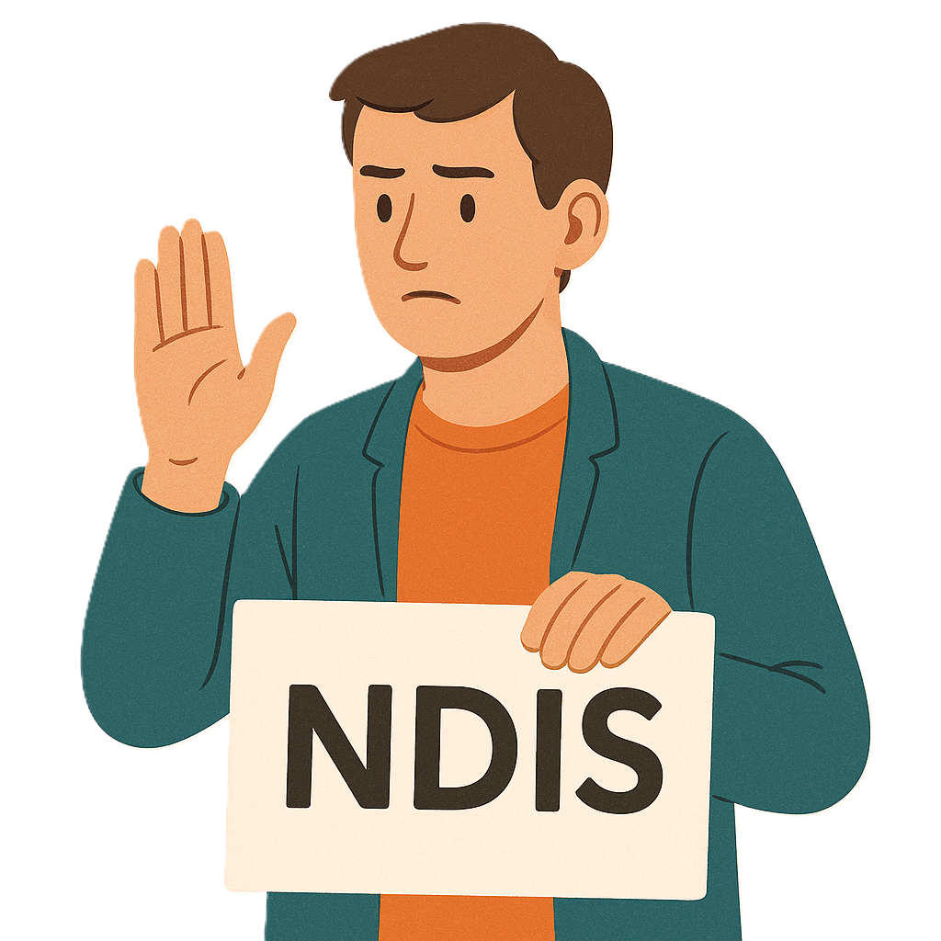
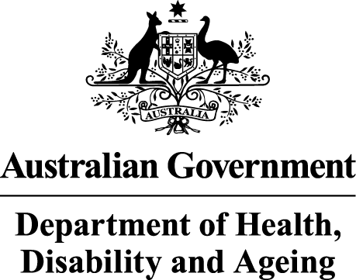 | The Australian Government Department of Health Disability and Ageing wrote this.  We say DHDA for short.  When you see the word we it means DHDA.
 | We wrote this in an easy to read way.  We use pictures to explain some ideas.
 | We have some words in bold.  This means the letters are thicker and darker.  These are important words.
 | This is an Easy Read summary of another document.  This means it has the most important ideas.
 | You can ask for help to read this document.  You can ask  - A friend  - Family members  - A support person.
 | We recognise Aboriginal and Torres Strait Islander people as the Traditional Owners of the land we live on.
 | They were the first people to live on and use the  - Land  - Waters.
Contents
About this document 5
Leaving the NDIS 8
Reasons you might want to leave 10
How to tell NDIA you want to leave NDIS 11
Cooling off period 14
More information 19

About this document
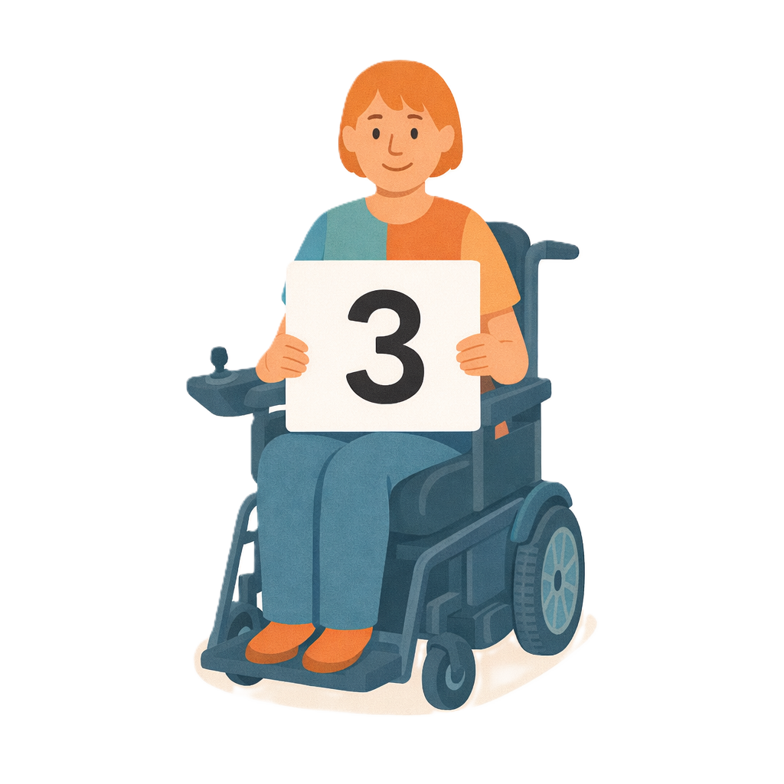 | This document has 3 parts.
 | This document talks about  - Changes the government wants to make to NDIS laws.  Laws are rules for how we live.  The changes are called the  - Integrity and Safeguarding Act.  We call it the Act for short.
 | Changes to laws are called amendments.  They help laws  - Change  - Be better.
Part 1 talks about
- Leaving the NDIS
 | Part 2 talks about  - Electronic forms  Electronic forms are filled in on a computer.
 | Part 3 talks about  - NDIS plan variations.
 | Plan variations are when the  - National Disability Insurance Agency changes things in your NDIS plan.  We call them NDIA for short.  NDIA can change  - Money  - Supports  In your NDIS plan.
 | This is part 1.

Leaving the NDIS
 | This change wants to make leaving the NDIS more  - Accessible  Accessible means everyone can use it.
 | - Safe.
 | It will respect your right to make your own choices.  Rights are rules about treating everyone  - Fair  - Equal.
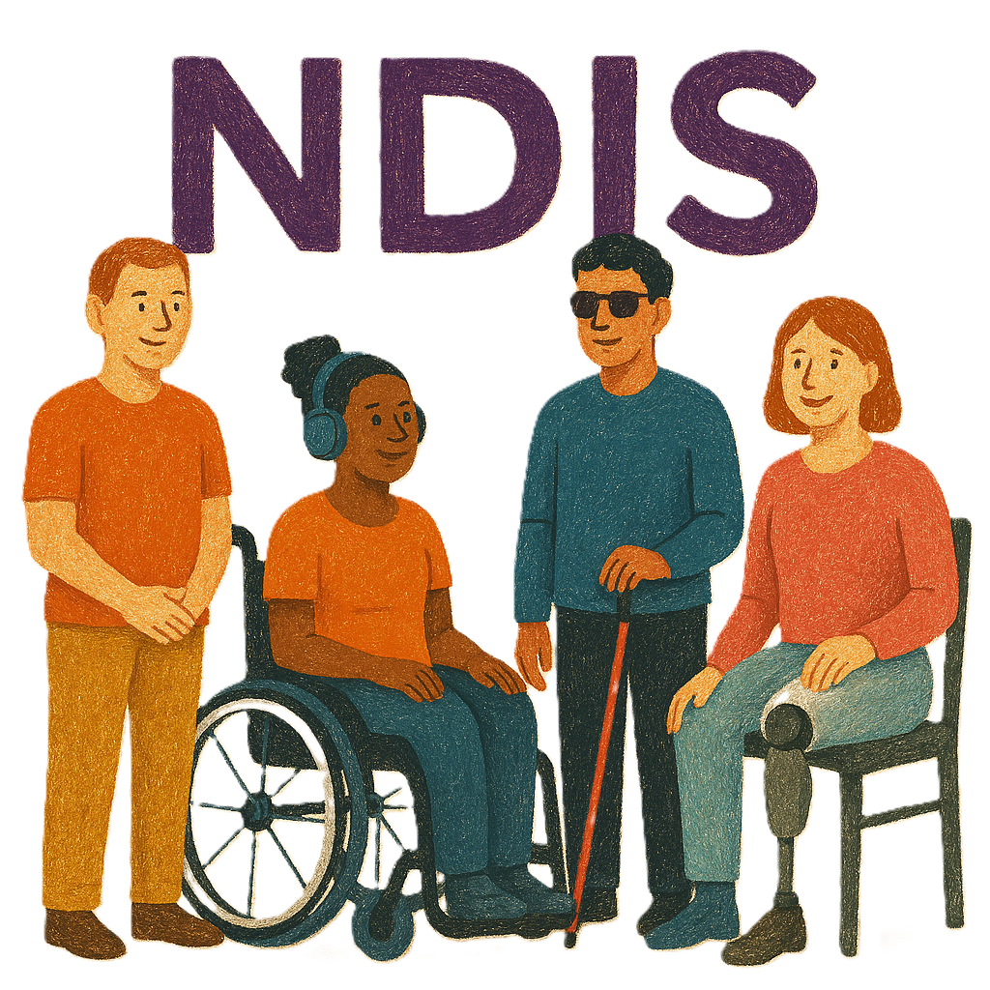 | This part is only for people with disability who  - Get NDIS supports  - Want to leave the NDIS.  They can be called NDIS participants.

Reasons you might want to leave
 | You do not have to say why you want to leave NDIS.
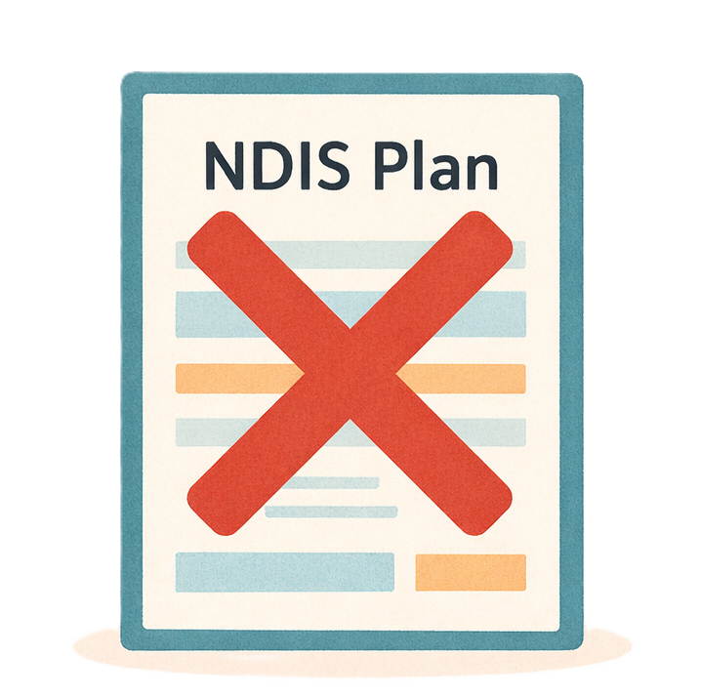 | Some reasons people want to leave NDIS are  - Not using their NDIS plan
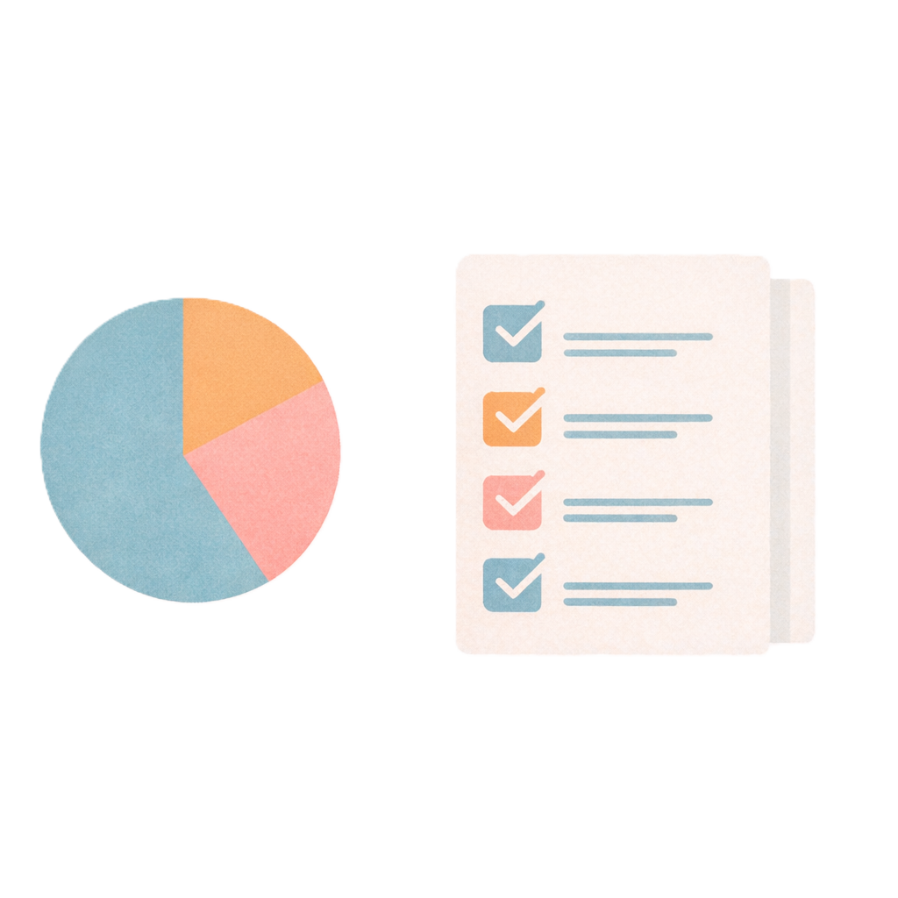 | - Using only a small part of their plan
 | - They are moving to a different country.

How to tell NDIA you want to leave NDIS
 | If you want to leave NDIS now you need to  - Write a letter to let NDIA know.
 | This means you stop being able to use your NDIS plan right away.
 | If you change your mind you need to  - Apply for NDIS again.  Apply means that you send information about your  - Disability  - Support needs.  This helps NDIA work out if you need NDIS.
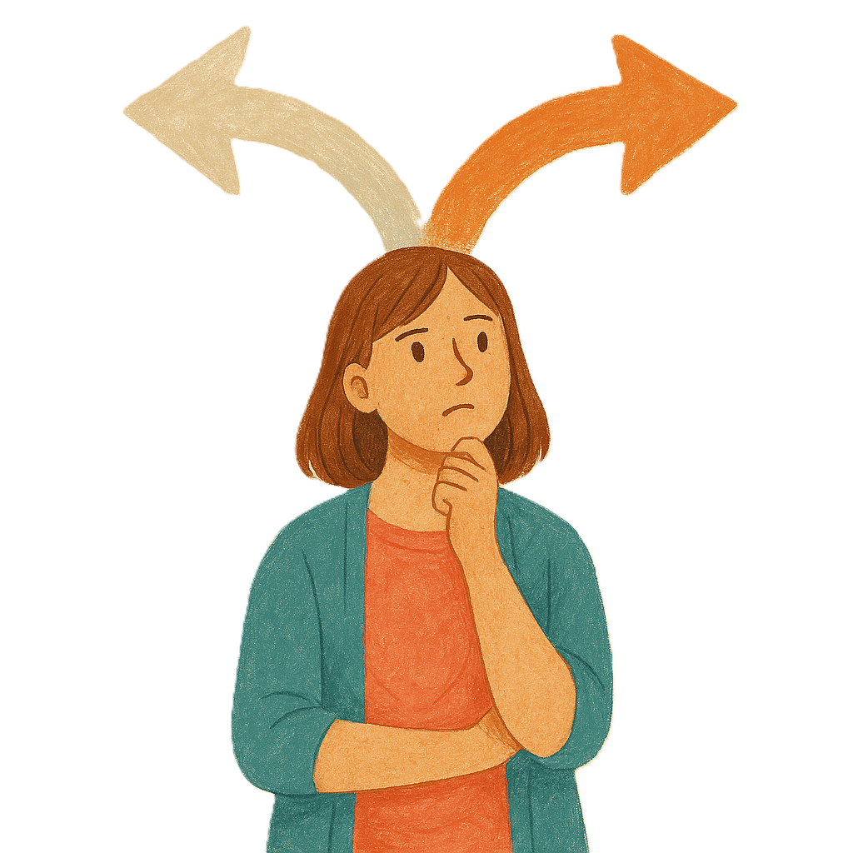 | We want people to have choices in the way they tell NDIA they want to leave NDIS.
 | We want people to be able to tell NDIA they want to leave NDIS by  - Sending an email
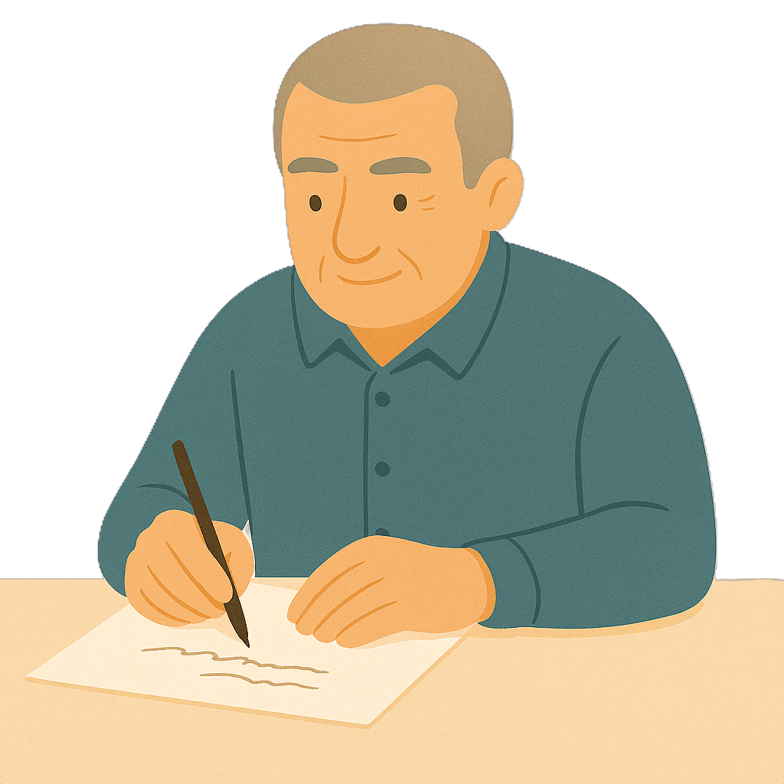 | - Sending a letter in the post
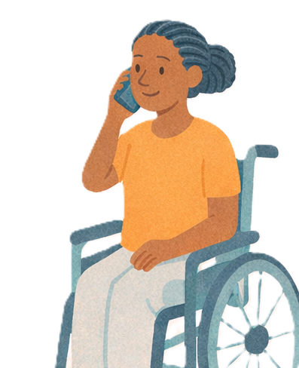 | - Talking to someone on the phone
 | - Talking to someone in person.

Cooling off period
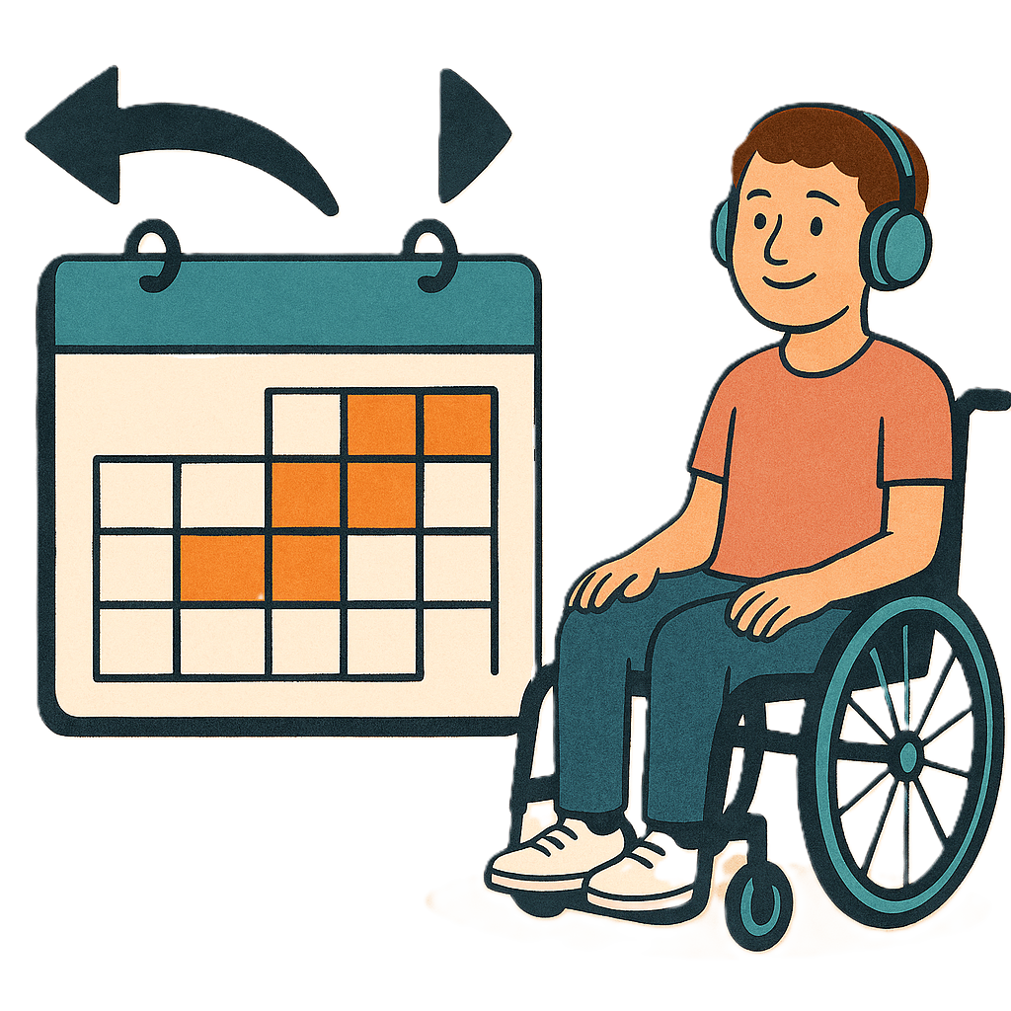 | The changes will add a cooling off period.  A cooling off period is the  - Amount of time you have to be able to change your mind.  The cooling off period is 90 days.  It gives you extra time to think about your decision before you stop getting NDIS.  It has nothing to do with being cold or cool.
 | You can change your mind anytime in the cooling off period.  Nothing bad will happen if you  - Change your mind  You will keep getting NDIS supports.
 | You will get a letter from the NDIA.
 | This will help you decide if it is the right choice for you.
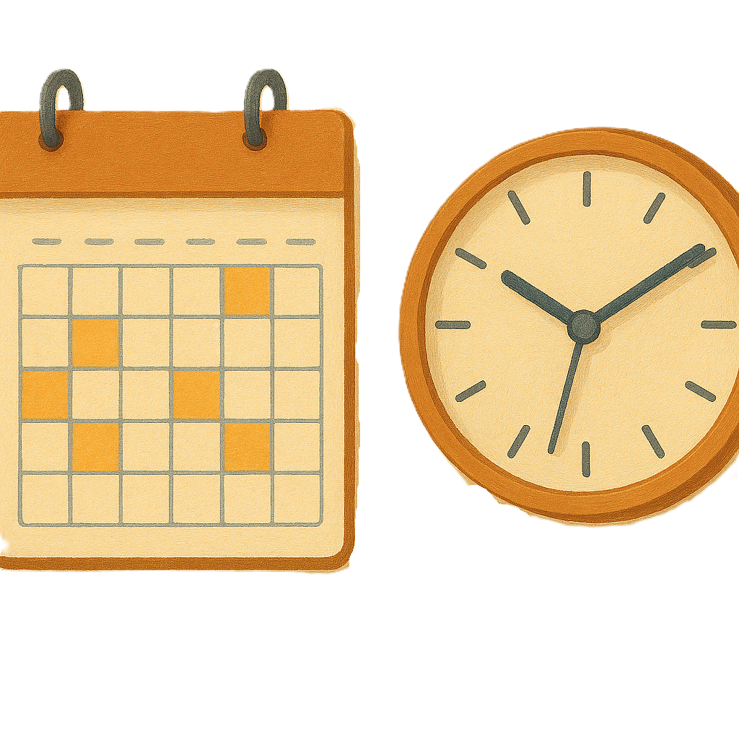 | The letter will say  - How much time you have to decide
 | - What to do if you change your mind
 | - What will happen if you leave the NDIS.
 | The NDIA can make the cooling off period longer as many times as they need.
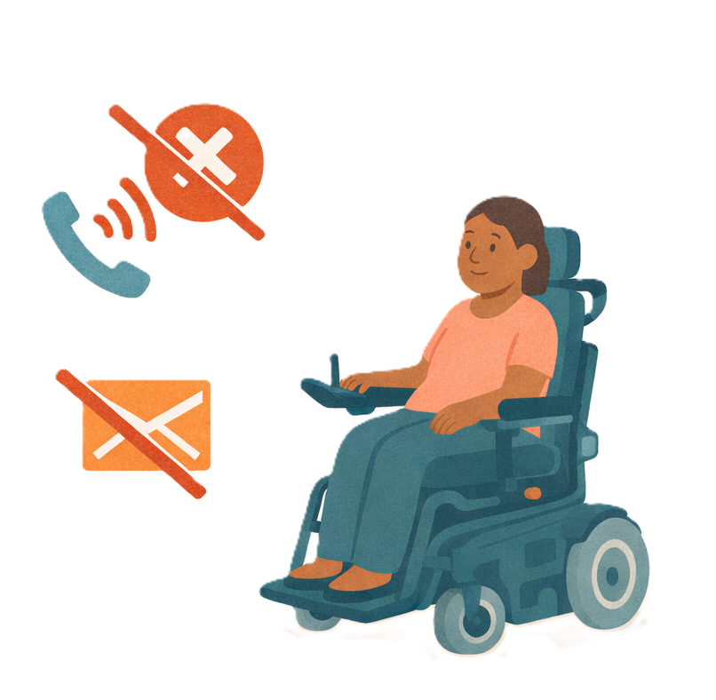 | They can make the cooling off period longer if they  - Can not contact you
 | Are worried about someone leaving the NDIS  They might think the person is vulnerable.
 | Vulnerable means a person needs extra  - Support  - Help to stay safe.
 | The NDIA will also write a letter to your plan nominee.  A plan nominee is someone you choose to  - Help make decisions about your NDIS plan  Some people do not have a plan nominee.
 | It is important to know that you will  - Stop getting NDIS supports if you do not contact NDIA before the time they say in the letter.

More information
 | For more information you can look at our website.  www.health.gov.au/our-work/ndis-legislation-changes/amendments/2025
Some images in this Easy Read were made using AI.
You must not share or copy any of the images without permission.
July 2026.

