


National Carer Strategy 2024-2034 Annual Report 2025
Title: National Carer Strategy 2024-2034 Annual Report 2025
Online ISBN: 978-1-76007-465-4
Copyright
© 2026 Commonwealth of Australia as represented by the Department of Health, Disability and Ageing
Creative Commons Licence

This publication is licensed under the Creative Commons Attribution 4.0 International Public License available from https://creativecommons.org/licenses/by/4.0/legalcode (“Licence”). You must read and understand the Licence before using any material from this publication.
Restrictions
The Licence may not give you all the permissions necessary for your intended use. For example, other rights (such as publicity, privacy and moral rights) may limit how you use the material found in this publication.
The Licence does not cover, and there is no permission given for, use of any of the following material found in this publication:
- the Commonwealth Coat of Arms. (by way of information, the terms under which the Coat of Arms may be used can be found on the Department of the Prime Minister and Cabinet website https://www.pmc.gov.au/resources/commonwealth-coat-arms-information-and-guidelines);
- any logos and trademarks;
- any photographs and images;
- any signatures; and
- any material belonging to third parties identified in this publication.
Attribution
Without limiting your obligations under the Licence, the Department of Health, Disability and Ageing requests that you attribute this publication in your work. Any reasonable form of words may be used provided that you:
- include a reference to this publication and where practicable, the relevant page numbers;
- make it clear that you have permission to use the material under the Creative Commons Attribution 4.0 International Public License;
- make it clear whether or not you have changed the material used from this publication;
- include a copyright notice in relation to the material used. In the case of no change to the material, the words “© Commonwealth of Australia (Department of Health, Disability and Ageing) 2026” may be used. In the case where the material has been changed or adapted, the words: “Based on Commonwealth of Australia (Department of Health, Disability and Ageing) material” may be used; and
- do not suggest that the Department of Health, Disability and Ageing endorses you or your use of the material.
Enquiries
Enquiries regarding any other use of this publication should be addressed to the Branch Manager, Corporate Communication Branch, Department of Health, Disability and Ageing, GPO Box 9848, Canberra ACT 2601, or via e-mail to copyright@health.gov.au

Sonny Green (Kamilaroi Nation, NSW, Australia) Caring for Mob, 2024. Commissioned for the National Carer Strategy. This artwork represents the often unseen but vital role of carers in First Nations families and communities, caring for loved ones experiencing chronic illness, disability, mental health challenges, or age-related conditions. It highlights the importance of a strong support system, tools and resources being available for carers. “The connections between the meeting circles are representative of these strong support systems. The digging sticks represent the tools to support carers to look after their loved ones. Being a carer is a role that is often ongoing for extended periods throughout one’s life, with ebbs and flows, ups and downs as shown through the depiction of the waterways. The florals throughout this design are there to symbolise care and nurture, something that we do well for our land, but also our people”

Acknowledgement of Country
We, the Department of Health, Disability and Ageing, proudly acknowledge the Traditional Owners and Custodians of Country throughout Australia, and pay respect to those who have preserved and continue to care for the lands and waters on which we live and work, and from which we benefit each day. We recognise the strengths and knowledge Aboriginal and Torres Strait Islander peoples provide to the health, disability and aged care systems and thank them for their ongoing contributions to those systems and the wider community. We extend this gratitude to all health, disability and aged care workers who contribute to improving health and wellbeing outcomes with, and for, First Nations peoples and communities.

Content warning
Aboriginal and Torres Strait Islander readers are advised this document may contain images of deceased persons.

Contents
Executive Summary 5
Key Achievements 6
Supporting Strategy implementation 7
Supporting the Strategy Vision 9
Groups supporting the National Carer Strategy Action Plan implementation 10
Status of commitments 11
Action Plan Progress 12
Impact of caring 13
Reporting roadmap 14
Appendices 15

Executive Summary
Australia’s National Carer Strategy 2024–2034 (the Strategy) was developed to better recognise, respect and support the 3 million unpaid carers who provide essential care to family members, friends and loved ones. The Strategy’s objectives are:
- Carers are identified, recognised, respected and valued.
- Carers are empowered to have fulfilling lives while engaging in their caring role.
- Carers’ physical and mental health, safety, wellbeing and financial security are supported.
Further information about these objectives is on page 30 of the National Carer Strategy 2024-2034. The Strategy will be achieved through action plans. The National Carer Strategy Action Plan 2024-2027 (the Action Plan) was launched to focus initial efforts and lay the foundation for future actions.
This is the first annual report for the Strategy. 2025 was focused on building the foundation for implementation of the Action Plan. This included prioritising commitments to enhance supports for carers delivered through Carer Gateway. The work undertaken during 2025 positions the Action Plan to be successfully implemented by the end of 2027. Future reports will focus on measuring the impact of these enhancements and track the success toward realising the Strategy’s objectives.
The voices of carers guided and informed projects throughout 2025. This was enabled by establishing a strong governance and stakeholder engagement model. This model included a lived experience carers and carer sector working group, 6 focus groups and the continued involvement of the National Carer Strategy Advisory Committee (the Committee). These engagements have informed work that is in progress on a range of Action Plan items.
The Government extends our sincere gratitude to the members of the Committee for their invaluable contributions throughout 2025. Their expertise, dedication, and commitment to ensuring the voices of carers were heard have been instrumental in guiding the implementation of the Strategy and Action Plan in its first year.
In 2026 we will focus our efforts on further exploring opportunities to improve data collection on unpaid carers and working across the Commonwealth and with our State and Territory colleagues to improve identification, recognition and support of unpaid carers across government systems.


Key Achievements

In the first year, the Strategy committed to:

Release an action plan
The National Carer Strategy Action Plan 2024-2027 launched in December 2024
An outcomes framework
An Outcomes Framework was delivered in May 2025 (developed by the Australian Institute of Family Studies)
Work with stakeholders to commence development and implementation of initial actions
The following groups were established:
- National Carer Strategy Advisory Committee
- National Strategy Action Plan Working Group
- 6 lived experience Carer Focus Groups

Implemented actions
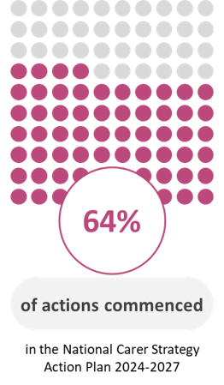
 Increased phone counselling access for carers through Carer Gateway with up to an additional 10,000 sessions funded per year.
 Carer Inclusive Workplace Initiative extended to 30 June 2026.
 Young Carer Bursary Program and Young Carer Network extended to 30 June 2027.
 Pre-employment supports available through Carer Gateway in metropolitan Queensland, South Australia and Tasmania.

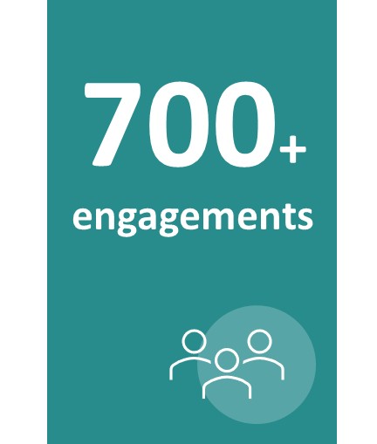
Stakeholder engagement
6 Carer Advisory Committee meetings
4 Action Plan Working Group meetings
27 Carer Focus Group sessions
28 Other stakeholder meetings/workshops
650+ survey responses* for “Improving counselling, mental health support and respite for Unpaid Carers”
(*part of current project work for Action Plan via Nous Group)

Supporting Strategy implementation
A range of activities have supported awareness raising and promoting recognition of carers during 2025. The annual Carer Wellbeing Survey (CSW), first launched in 2021, saw an increase in survey participation by carers, which contributes important data to strengthen our understanding of carers experience and well-being over time. Several complementary Government initiatives have launched that support the National Carer Strategy’s objectives and/or include the voices of carers.
National Carers Week
The theme for National Carers Week in 2025, delivered by Carers Australia, was ‘You are, know or will be one’ to highlight the widespread nature of caring, affecting all Australians at some point in their lives. Activities included:
  Launch event with 2025 Celebrity Ambassador Bronte Campbell |   Carers morning tea with Governor General Her Excellency the Honourable Ms Sam Mostyn AC at Government House Canberra |   events from across the country registered on the National Carers Week website |   Promoted through NDIS Newsletter and Primary Health Networks newsletter

Carer Gateway
  Carer Gateway information sessions delivered to Services Australia’s national network of over 240 Financial Information Service and Aged Care Specialist Officers in October 2025. | Carer Gateway service providers attended or hosted over 260 expos nationally to promote Carer Gateway services in their local communities, including carers, seniors and aged care, disability, end-of-life, diversity, first nations and reconciliation, CALD and multicultural, health services, career, school, youth, and veterans’ expos |   The Department updated 11 printed products promoting Carer Gateway including brochures, factsheets, flyers and posters

The Department promoted Carer Gateway twice in 2025 across it’s Instagram, Facebook and LinkedIn accounts. The first post, during National Carers Week, encouraged carers to prioritise their physical and mental health and seek support. The post highlighted the National Carer Strategy 2024-2034 and directed them to the Carer Gateway website and phone line. The second post on 24 October, featured an unpaid carer case study, highlighted the Strategy and Carer Gateway and provided Carer Gateway website and contact information.

Supporting Strategy implementation
Key stakeholder events*
  Carers Australia National Policy Forum – Recognising carers in health systems |   Re-invigorated the Parliamentary Friends of Carers group, with Carers Australia |     Carers Australia Young Carers Morning tea at Parliament House
*Not intended as a full list of sector activities in 2025.
Other key government actions supporting carers:
  For the 2025 academic year, 2967 Young Carer Bursaries were awarded. This included a one-off boost to meet additional demand. In addition, the Bursary amount was lifted from $3,768 to $4,000. |   Established a peak body for Mental Health Carers – Mental Health Carers Australia |  |   National Dementia Action Plan 2024-2034 released, which aims to improve the lives and care of people living with dementia, their carers and families.
  Carers voices are included in the development of Thriving Kids with lived experience parent representatives on the Advisory Committee.  Thriving Kids seeks to deliver supports for children outside the NDIS and their families, to support their development. |  |   Removing barriers to employment for Carer Payment recipients from March 2025 by:  - changes to the participation rule to better support carers’ workforce participation.  - education, volunteering and travel time removed from participation limits.  - temporary Cessation of Care arrangements were made more flexible, with payments able to be suspended (rather than cancelled) for up to six months.

Significant Surveys/Data 2025
Carer Wellbeing Survey (CWS) 2025
This national, annual survey tracks the wellbeing of carers aged 14 and over.
In 2025, 10,918 carers participated up by approximately 19% from 9,166 in 2024.
Findings highlight both the positive and challenging aspects of caring – further detail on survey findings about the impacts of caring is provided on page 13.
Dementia in Australia Report
This web report presents national dementia data, now Australia’s leading cause of death. Updated in December 2025, it highlights unpaid carers using ABS Survey of Disability, Ageing and Carers (SDAC) data, focusing on care intensity, impacts on health and wellbeing, and the gaps in carer data. Dementia in Australia, Australian Institute of Health and Welfare

Supporting the Strategy Vision
The National Carer Strategy vision is:
An Australian community in which all carers are recognised, valued and empowered with the support they need to participate fully in society and fulfil their caring role.
In 2025, implementation efforts were firmly driven by the Strategy’s vision and objectives, with activities that help to establish the building blocks needed for achieving long-term improvements in outcomes for carers. Each of these activities are associated with at least one of the 3 objectives of the Strategy as follows:
Carers are identified, recognised, respected and valued. | Carers are empowered to have fulfilling lives while engaging in their caring role. | Carers’ physical and mental health, safety, wellbeing and financial security are supported.
- Promotion of Carer Gateway across government, health and community systems.  - National Carers Week 2025 to raise awareness and normalise carer identity.  - Embedding carers lived experience in governance with the Advisory Committee, Action Plan Working Group and Focus Groups.  - Enhanced recognition and visibility of carers through stakeholder and parliamentary engagement activities.  - The 2025 Carer Wellbeing Survey. | - Pre-employment supports through Carer Gateway to assist carers to prepare for workforce participation.  - Extension of Young Carer Bursary Program and Young Carer Network.  - Engagement with carers through lived-experience groups and stakeholder consultations in projects to inform service design improvements.  - Projects commenced to expand peer support arrangements and deliver improved online and in-person training through Carer Gateway. | - Increased access to phone counselling through Carer Gateway.  - Review of Carer Gateway services to enhance accessibility, inclusivity and wellbeing outcomes for carers.  - Extension of the Carer Inclusive Workplace Initiative.  - Projects commenced to:  - identify improvements to counselling, mental health and respite supports,  - develop a culturally responsive practice framework to strengthen the cultural capability of Carer Gateway service providers.  - Pre-employment supports delivered through Carer Gateway.

Groups supporting the National Carer Strategy Action Plan implementation
Carers informed our work on the National Carer Strategy Action Plan through the National Carer Strategy Advisory Committee; an Action Plan Working Group and 6 carer Focus Groups. The carers in these groups have intersecting characteristics and identities, reflecting the diversity of our community.
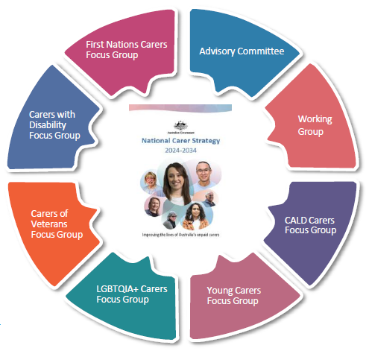

National Carer Strategy Advisory Committee
The Committee is made up of two co‑chairs and 12 members from the carer community and carer sector, reflecting diverse backgrounds, ages, identities and regions across Australia.

National Carer Strategy Action Plan Working Group
The Working Group has 10–15 members from the carer community and sector, reflecting the diversity of unpaid carers across Australia. Focus Group Chairs sit on the Working Group to ensure lived experience informs all advice.

Culturally and Linguistically Diverse (CALD) Carers Focus Group
Members bring diverse cultural and language backgrounds and advocate for fair, responsive support for CALD carers.

Young Carers Focus Group
Young carers aged 18–25 share insights on education, employment, mental health and the need for tailored support.

LGBTQIA+ Carers Focus Group
The LGBTQIA+ Carers Focus Group include carers with diverse lived experiences shaped by intersecting identities. Members highlight systemic barriers and advocate for equitable, inclusive and culturally safe carers support systems.

Carers of Veterans Focus Group
This group represents carers supporting veterans with physical and mental health needs, advocating for stronger recognition and support.

Carers with Disability Focus Group
Members are carers who provide care while also living with disability. They bring diverse lived experience, advocating for trauma-informed, peer-led supports to address isolation, build capacity and empower carers.

First Nations Carers Focus Group
The group comprises First Nations carers from across Australia, representing diverse communities and lived experiences. Members highlight the need for equity, recognition and culturally safe support for carers while navigating complex systems.

Status of commitments

Commitment | Achievements | Status
Support the well-being of carers by reviewing and improving  a. specific services offered through Carer Gateway  b. the accessibility and inclusivity of Carer Gateway. | All actions under commitment 1a and 1b are in progress. Action 1.1 has been fully implemented. | 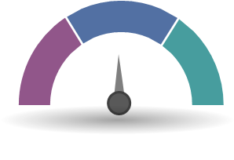
Improve identification and recognition of carers | Promotion of Carer Gateway throughout the community, government and medical/health systems | 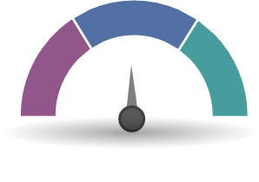
Contemporise the Carer Recognition Act 2010 | Government response to the House of Representatives Inquiry into the recognition of unpaid carers | 
Ensure the lived experience of carers guides continual improvement | Established the National Carer Strategy Advisory Committee to guide implementation of the first year of the Strategy and Action Plan  Established an Action Plan Working Group and 6 Focus Groups of lived experience carers representing the diversity of carers to support implementation of actions in the Action Plan | 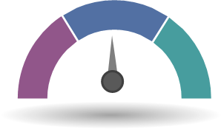
Support carers to achieve financial security | Extension of Carer Inclusive Workplace Initiative (CIWI), Young Carer Bursary and Young Carers Network  Support for carers to access training and prepare for employment offered through Your Caring Way transitioned to Carer Gateway | 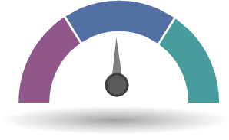
Understand the full carer landscape through improved data capture | Planning underway for development of a data strategy in partnership with key stakeholders including First Nations communities and organisations | 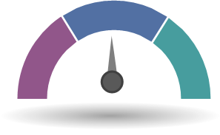

Action Plan Progress
During 2025, the department progressed actions across many of the commitments. This included actions that could be immediately implemented, such as delivery of Action 1.1 to increase phone counselling capacity for carers, and elements of Action 5.1 supporting the Carer Inclusive Workplaces Initiative, the Young Carer Bursary, the Young Carer Network and pre-employment support services delivered through Carer Gateway.
Several actions that require further research and scoping activities were also prioritised, to ensure delivery within the life of the current Action Plan. This included initial data mapping as part of action 6.1 under commitment 6 and work to support expansion in 2026 to a national model for pre-employment support through Carer Gateway.
Several projects were established to support delivery of Commitment 1:
- Review and improve specific services offered through Carer Gateway to support the wellbeing of carers.
- Review and improve the accessibility and inclusivity of Carer Gateway to support the wellbeing of carers.
These projects are still in progress, and outcomes will inform the 2026 Annual Report.

Action Plan projects in progress
Unpaid Carer Supports  Project Partner - Nous Group | Summary  Research for actions 1.3, 1.4 and 1.7 to identify counselling, mental health and respite improvements, as well as culturally responsive and inclusive supports.  Status  In progress, due for completion in July 2026.
Practice framework for unpaid carer support services  Project Partner - Nous Group | Summary  Deliver a framework for upskilling and enhancing the cultural capability of service providers through Carer Gateway focusing on 4 carer cohorts (action 1.8).  Status  In progress, due for completion in June 2026.
Carer Gateway Actions Project  Project Partner - KPMG | Summary  This project combines research for action 1.9 and 1.10, developing recommendations to improve navigation by Carer Gateway to better support carers interacting with different service systems and further opportunities to improve Carer Gateway.  Status  Completed November 2025. Recommendations are being considered.
Expand Peer Support and Improve Online Training provided via Carer Gateway & Extend Carer Gateway Operating Hours  Project Partner - Engagement process underway | Summary  This will expand peer support arrangements and deliver improved online and in-person training through Carer Gateway (actions 1.5 and 1.6). The department undertook stakeholder and feasibility research regarding Carer Gateway operating hours (action 1.2).  Status  In progress.

Impact of caring
Caring is a significant commitment that is rewarding and challenging for carers. Current data estimates there are 3 million carers in Australia (Australian Bureau of Statistics, 2022).
The 2025 Carer Wellbeing Survey shows a decline in carer wellbeing, with 38.9% of carers reporting healthy wellbeing levels compared with 66% of Australian adults. Mental health impacts, social isolation, access to respite, financial stress and reduced workforce participation remain significant challenges for many carers. The survey highlights the cumulative impact of caring:
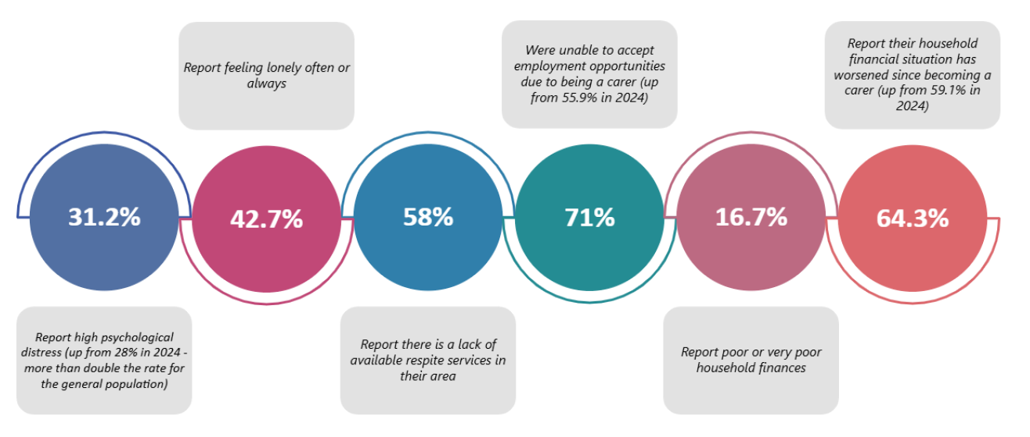
This shows why the Action Plan’s focus on mental health supports, respite and peer support is so important. This work, alongside actions already in place, is expected to deliver measurable improvements in carer wellbeing over time.
Lack of recognition by government, community, health and education systems is strongly linked to poorer wellbeing outcomes for carers. The 2025 Carer Wellbeing Survey found:
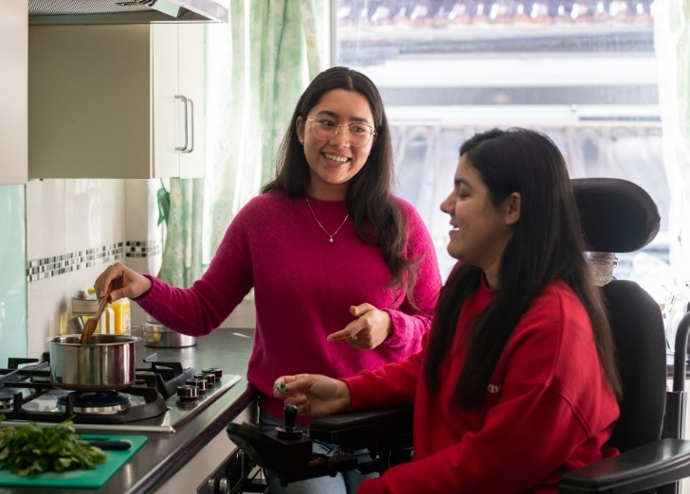
- more than 70% of carers do not feel recognised by government.
- almost one-third (30%) took more than a year to identify themselves as a carer.
Even after identification, 46% reported they were not provided with information about available support. Strengthening early identification pathways across health, education, government and community services, and improving recognition of carers will be a key focus during 2026 with Commitment 2 and 3 of the Action Plan.

Reporting roadmap
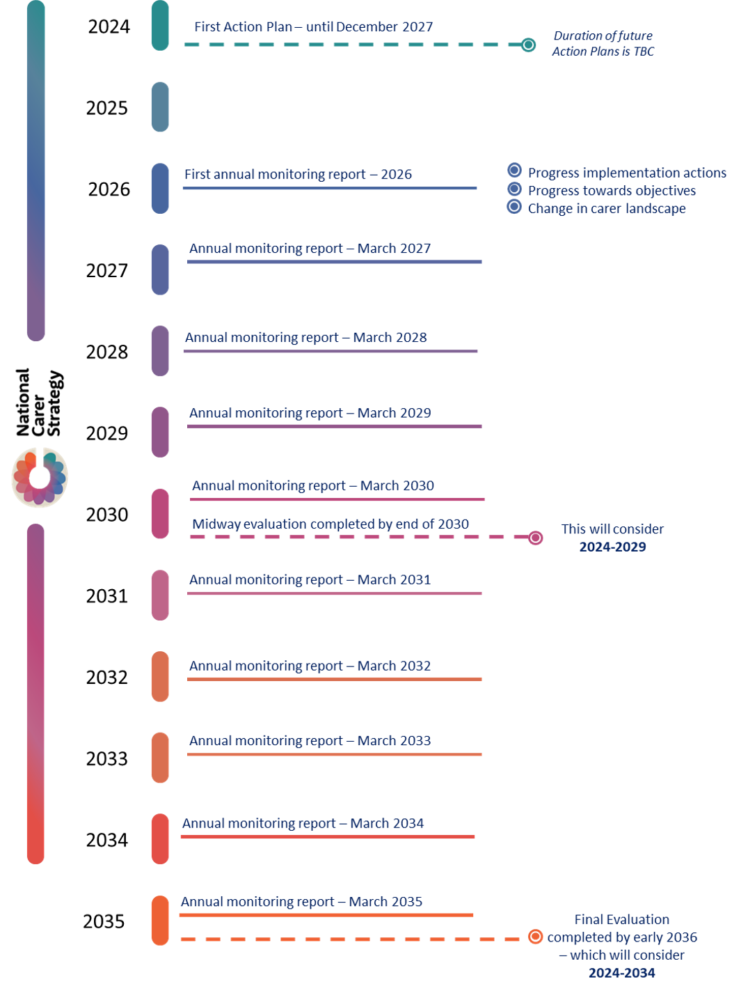

Appendices

Appendix 1: National Carer Strategy on a page
Vision
An Australian community in which all carers are recognised, valued and empowered with the support they need to participate fully in society and fulfil their caring role.
Principles
The co-designed principles should guide the coordination and delivery of carer-related and carer-impacting policies, programs and initiatives across Australian Government agencies.
Carer-centred: The lived experience of carers will be included in the co-design and co-production of policies, supports and services for carers. Carers lived experience will be included in evaluation processes.
Evidence-informed: Carer policies, supports and services will be informed by evidence, and innovation will be used to address challenges experienced by carers.
Accessible, equitable and inclusive: Carer policies, supports and services will be inclusive and tailored to respond to the needs of carers, at all stages of caring, recognising the diversity of carers, and the importance of cultural and psychological safety.
Supports personal agency: The design of policies, supports and services for carers will enable choices that suit them.
Transparent and accountable: Federal government departments will be accountable in delivering the Strategy and transparent in their processes to better recognise and value carers.
Objectives
The objectives are the results we want to achieve for carers.
Carers are identified, recognised, respected, and valued.
Carers are empowered to have fulfilling lives while engaging in their caring role.
Carers’ physical and mental health, safety, wellbeing, and financial security are supported.
Priority outcome areas
The priority outcome areas are where we will focus our efforts to achieve the Strategy’s vision and objectives.
Note: The priority outcome areas are not numbered in order of importance.
They are numbered for ease of reference.
Government, the community and services see and value carers, recognise their expertise and contribution, and create an environment that enables carers to identify at the earliest opportunity.
Carers can access supports, services and programs at the right time, right place and in the right way.
Ensure carers are able to develop knowledge and skills when needed to fulfill their caring role.
Carers can access, and participate in employment and education or training, including to improve their financial wellbeing.
Carers have access to supports that safeguard their psychological, physical and social wellbeing.
Build the evidence base about carers to better understand who carers are, including their diversity, what their experiences are, what works for them and why.

Appendix 2: Glossary of terms
For further information on the language used in this report, please refer to the language guide in the National Carer Strategy 2024-2034
Term | Description
Accessible | People from a diverse range of backgrounds, abilities, locations and demographics are afforded the opportunity to acquire the same information, engage in the same interactions, and enjoy the same services in an equally effective and equally integrated manner, with substantially equivalent ease of use.
Action Plan | The initial set of strategic actions to be implemented from 2024 to 2027 to support unpaid carers.
Awareness | Community and individual knowledge of the vital role carers play in the communities, the challenges they face and the importance of supporting them.
CALD | Culturally and Linguistically Diverse: refers to individuals and communities from various cultural backgrounds who speak different languages.
Carer-centred | A carer-centred approach means a policy or program emphasises individual care, ensuring that services are tailored to the specific needs and preferences of each person. It promotes dignity, autonomy, and holistic wellbeing, while supporting carers with the necessary resources and training to deliver respectful and effective care.
Carer Gateway | Carer Gateway is an Australian Government program providing free services and support for carers. It can help if family member or friend with disability, a medical condition, mental illness, or who is frail due to age.
Carer landscape | The overall environment and context in which carers operate, including policies, services, and support systems available to them.
Commitment | A promise or firm decision to do something.
Data capture | The process of collecting and recording information related to carers and their experiences, needs and services.
Empowered | Empowered means allowing carers to make decisions and take actions within specific guidelines to improve care and support, enhancing their ability to respond effectively.
Evidence base | Evidence base refers the collection of available data and research that guides decision making to shape and implement policies.
First Nations | Indigenous peoples of Australia, including Aboriginal and Torres Strait Islander communities.
Inclusive | Inclusive approach for all carers by ensuring equal access to resources, support, and opportunities. It outlines how to accommodate diverse needs and backgrounds, fostering an environment where every carer can thrive and contribute effectively.
Inquiry | This establishes guidelines for managing inquiries within the organisation. It defines the process for submitting, tracking, and responding to inquiries to ensure time and accurately handling. It specifies responsibilities, response times, and communication methods to maintain transparency and efficiency. A formal investigation or examination into a particular issue, in this case, the recognition of unpaid carers.
LGBTQIA+ | Refers to lesbian, gay, bisexual, transgender, queer, intersex, asexual, and other sexually or gender diverse people.
National Carer Strategy | A framework aimed at recognising, valuing and supporting unpaid carers in Australia.
National Carer Advisory Committee | A group of unpaid carers from diverse backgrounds who provide insights and guidance in the development of the Strategy.
Navigation | The process or activity of finding and accessing necessary services and resources effectively.
Outcomes Framework | A structured approach to measure the effectiveness and impact of actions taken under the Strategy.
Peer-led | An entity, program, or service is delivered or facilitated by a person with appropriate lived experience. In the context of the Strategy this refers to carer-led or demographic-led support. For example, an LGBTQIA+ support group led by a person who is a member of the LGBTQIA+ community. Another example is an advisory committee consisting of people with relevant lived experience.
Policy | A guideline or strategy aimed at addressing the needs and challenges faced by carers.
Program | A set of related measures or activities with a particular long-term aim.
Recognition | How the community acknowledges the contributions of carers, aiming to motivate and appreciate those who make this significant contribution to the community.
Respite Care | Respite care provides temporary relief, allowing carers a break to rest, manage stress, or attend to personal tasks.
Stakeholders | Individuals or organisations with an interest or investment in the outcomes of the Strategy, including carers, service providers, and advisory committees.
Thriving Kids | An Australian Government program to support children aged 8 and under with developmental delay and/or autism with low to moderate support needs, and their families, carers and kin.
Unpaid carer | A person who provides personal care, support and assistance to another person who needs it because that other person has a disability, a medical condition (including a terminal or chronic illness), a mental illness, or is frail and aged.  Carers receiving financial support such as the Carer payment or Carer allowance are included under this definition.
Wellbeing | To support physical, mental, and emotional wellbeing of carers. Helps carer maintain a healthy balance between their caregiving responsibilities and personal life, aiming to reduce stress and enhance overall quality of life.
Working group | A collaborative team formed to focus on specific tasks or projects.

Appendix 3: Data/Evidence Sources
Australian Bureau of Statistics (2022) Disability, Ageing and Carers, Australia: Summary of Findings, ABS Website, accessed 15 January 2026
Australian Institute of Health and Welfare (2025) Dementia in Australia, Web report 05 Dec 2025, AIHW Website, accessed 14 April 2026
Carers Australia (2024), Caring for others and yourself: Carer Wellbeing Survey 2024 Report – full report, Carers Australia website, accessed 22 January 2026
Carers Australia (2025), Caring for others and yourself: Carer Wellbeing Survey 2025 Report – full report, Carers Australia website, accessed 22 January 2026
Department of Health, Disability and Ageing (2024), National Dementia Action Plan 2024-2034, Department of Health, Disability and Ageing website, accessed 02 February 2026
Department of Health, Disability and Ageing (2026), Thriving Kids Advisory Group, Department of Health, Disability and Ageing website, accessed 02 February 2026
Department of Social Services (2024), Removing barriers to employment for Carer Payment recipients, Department of Social Services website, accessed 02 February 2026

