Service and Support Portal User Guide - Creating service delivery outlets and adding service information
This User Guide is for Administrators within the My Aged Care Service and Support Portal. It explains how to create and maintain information about service delivery outlets.
Information about aged care services provided by each service provider is publicly displayed in the service finder on the My Aged Care website.
This information is also used by My Aged Care contact centre staff and assessors to refer clients for service(s).
Table of contents
Notes 2
Viewing Outlets 2
Creating or adding a new outlet 3
Editing the Organisation philosophy 5
Verified Specialisations 7
Adding service items to an outlet 9
Adding and removing service sub-types 12
Activating or deactivating a service item 14
Adding and editing service attributes 16
Specialisations 19
Specialisation Verification 19
Specialised Services 20
Languages 21
Hours of operation (non-Support at Home) 22
Delivery Hours (Support at Home) 23
Staffing notes 24
Service specific delivery details 24
Pricing information (Support at Home) 24
Maintaining service and waitlist availability 36
Editing a service delivery area 37
Adding a room type to a residential facility 41
Activating an outlet 43
Deactivating an outlet 44
Removing an outlet from the Service and Support Portal 45
For more information or support 45

Notes
- Service information must be maintained by providers to ensure appropriate referrals are sent.
- Only Organisation Administrators in the Portal can create outlets. Staff can then be assigned to outlets and service delivery information can be added for each outlet.
- Only Organisation Administrators or Outlet Administrators can add or update service information.
- An outlet represents a point of client intake, which may be location-based. While it often reflects a physical site, it primarily functions as the entry point for service item delivery. You will need to set up one or more outlets in the Portal to add and maintain information about the services that your organisation delivers. To ensure that your services will be displayed on the service finders, you must set up an active outlet with an address and a service item under an operational outlet.
- Residential Care and Support at Home service providers will be required to complete pricing information.
- For detailed information on the process to transferring services between outlets and clients between services refer to the My Aged Care Service and Support Portal user guide – Advanced outlet and service management – Transferring clients and services.

Viewing Outlets
To view outlets, follow the procedure below.
- Select Outlet administration from the home page.
Team leaders and Staff members do not have access to the Outlet Administration tile.
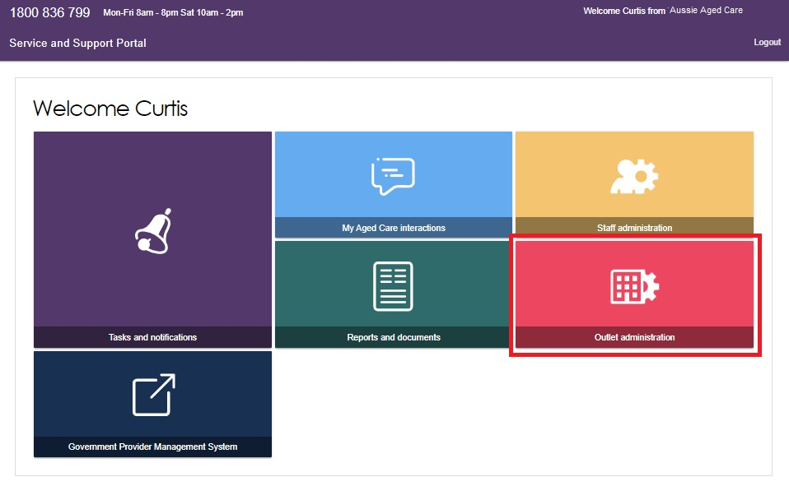
You can now view all of the outlets for your organisation.
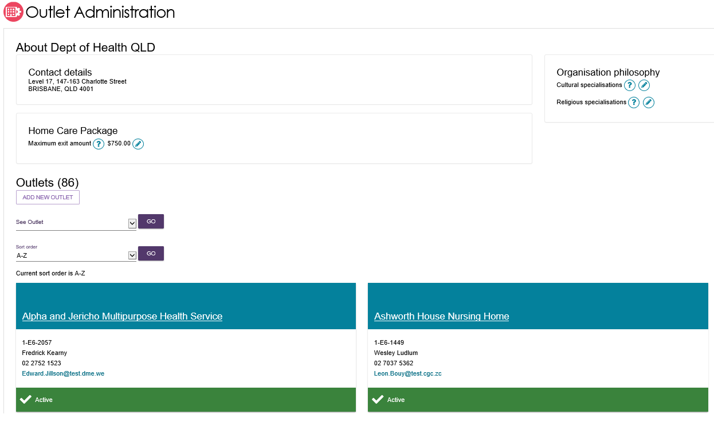

Creating or adding a new outlet
Administrators need to set up outlets in the Service and Support Portal before service information can be added.
When Administrators create an outlet, the status is set to ‘Inactive’ by default. You must activate the outlet and create service items in an outlet before it can be made operational. The process for activating an outlet is described later in this User Guide.
- Select Outlet administration from the home page.
From the Outlet administration page, select ADD NEW OUTLET.
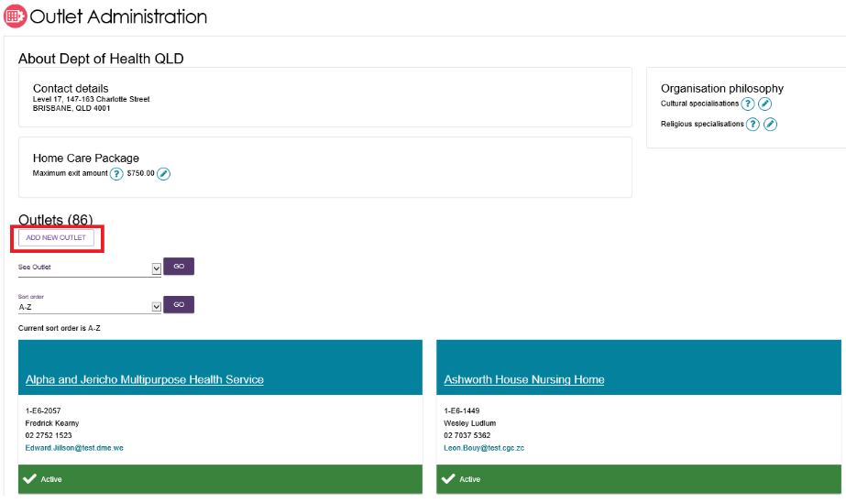
- Enter outlet details. To add an outlet address, select ADD OUTLET ADDRESS.
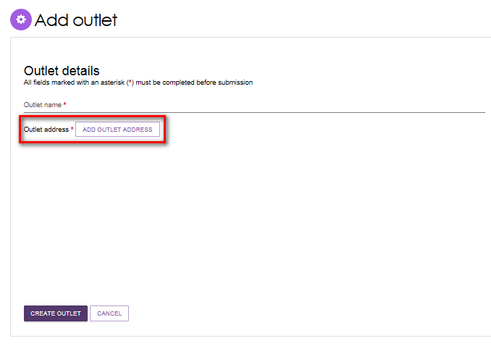
- Fill out your address details, then select VALIDATE THIS ADDRESS.
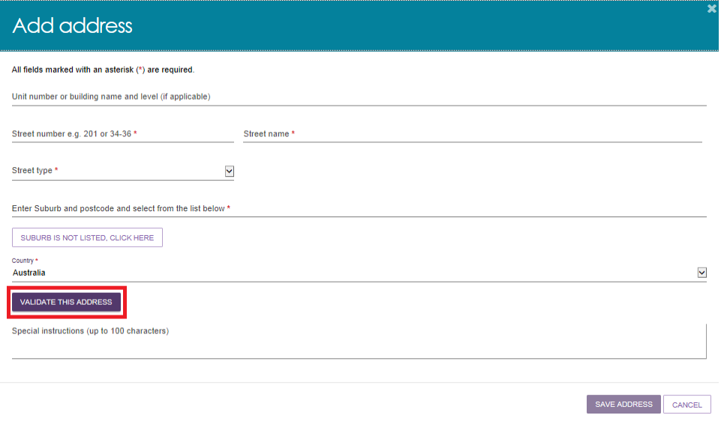
- Confirm that the address is displayed correctly, then select SAVE ADDRESS.
If the address has been entered correctly but is not returned as a result, select Not found use entered address anyway.
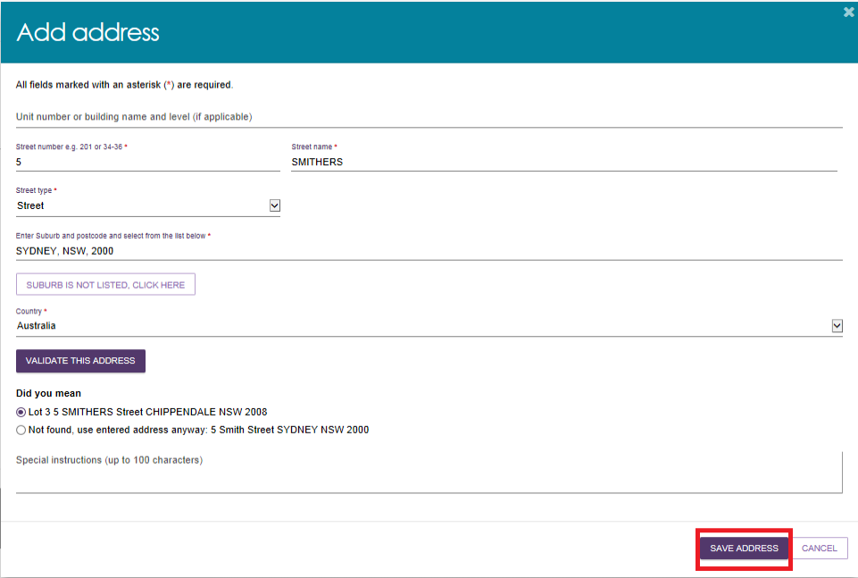
- Complete the remaining fields. Select CREATE OUTLET in order to save the record and create the outlet.
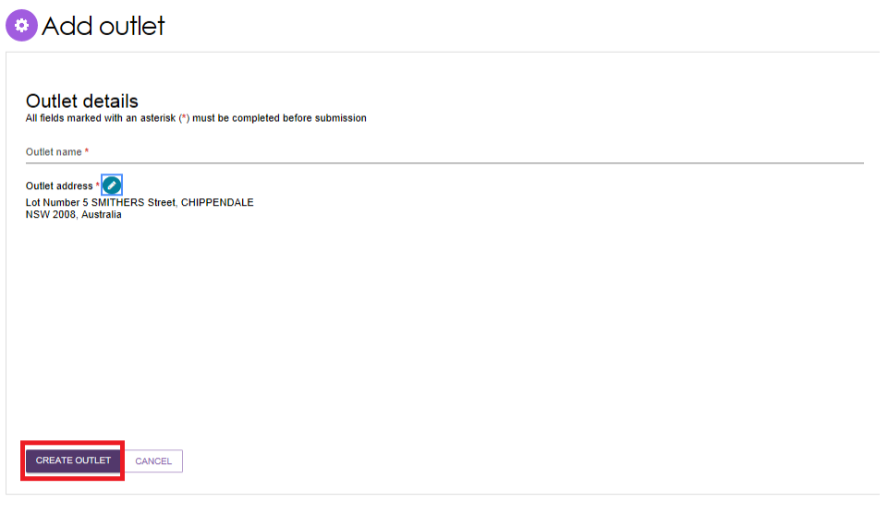
- The outlet has now been created and the details for the outlet have been saved. Repeat this process for remaining outlets, if required.

Editing the Organisation philosophy
- Add or edit cultural specialisations:
Select the Edit icon  next to Cultural specialisations to select those groups that you have a focus on providing culturally specific care to.
! | Cultural Specialisations are not the same as Verified Specialisations, and are not verified. Both types of specialisations are displayed in the service finder results.
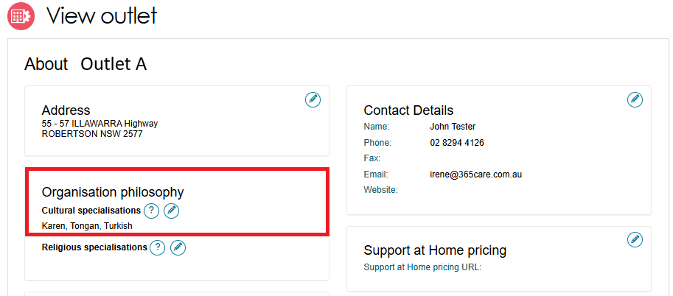
You can choose to apply this to all services in your organisation by using the SAVE AND APPLY TO ALL OUTLETS option or save as a default for all new services added by using the SAVE AND DON’T APPLY TO ALL OUTLETS option.
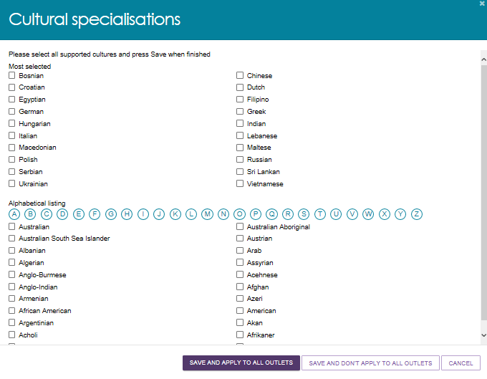
- Add or edit religious specialisations:
Select the Edit icon next to Religious specialisations to indicate if you have a focus on delivering care that aligns with particular religious needs or values.
You can choose to apply this to all current services in your organisation by using the SAVE AND APPLY TO ALL OUTLETS option, or save as a default for all new services added by using the SAVE AND DON’T APPLY TO ALL OUTLETS option.
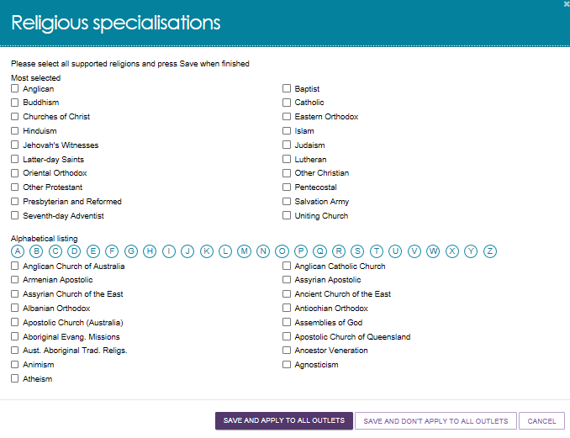

Verified Specialisations
All service providers must provide inclusive aged care services based on the needs of an individual, regardless of the individual’s location, background and life experiences. Some service providers can be recognised for offering tailored aged care services, verified through Specialisation. Verification
While all providers must demonstrate that they meet the Aged Care Quality Standards, providing specialisation for aged care services under Specialisation Verification is an optional and additional step.
When applying for Specialisation Verification, service providers must demonstrate their outlet meets the 2025 Specialisation Verification Framework criteria for a specific specialisation group or community by providing the required forms of evidence. Outlets can be verified in any of the nine specialisations to support:
- Aboriginal and Torres Strait Islander persons, including the Stolen Generations
- Veterans or war widows
- People from culturally, ethnically, and linguistically diverse (CALD) backgrounds
- People who are financially or socially disadvantaged
- People who are experiencing homelessness or at risk of experiencing homelessness
- Parents and children who are separated by forced adoption or removal
- Care leavers, including Forgotten Australians and former child migrants placed in out of home care
- Lesbian, gay, bisexual, trans/transgender or intersex or have other sexual orientations or are gender diverse or bodily diverse
- People who live in rural, remote, or very remote area
Outlets with verified specialisations are displayed in service finder and match and refer when searching for aged care services that meet the unique needs of older Australians. They are also published and searchable on the My Aged Care Website Find a Provider tool, to help older Australians make informed choices when selecting aged care services. Verification is valid for 3 years from the date the verification is issued unless removed.
Service providers who wish to be considered for Specialisation Verification for an outlet, will need to apply manually. For more general information on the verification process and details on how to apply refer to the Specialisation Verification for aged care services website.
! | Specialisation Verification may also be referred to as Diverse Needs in the Service and Support Portal.  Providers can only view and manage specialisations that were verified under the previous 2022 Specialisation Verification Framework in the Service and Support Portal.  From 1 November 2025, Specialisation Verification applications are assessed under the 2025 Specialisation Verification Framework.
The below image shows an outlet with no current verified diverse needs specialisations.
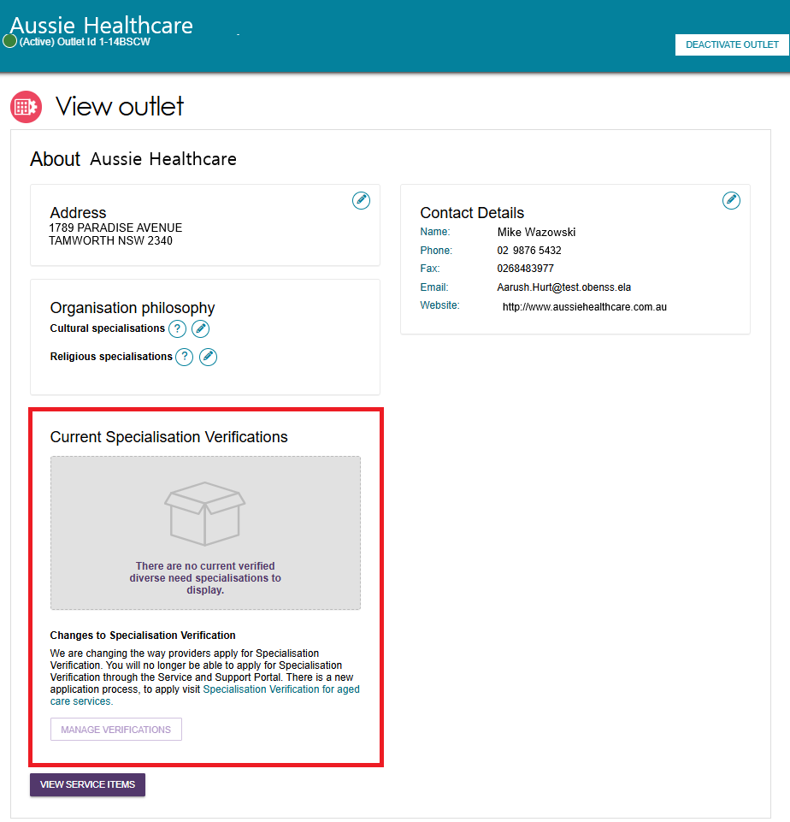
To manage current verified specialisations for service items of an outlet, refer to Specialisation Verification in the Adding and editing service attributes section.

Adding service items to an outlet
- From the Outlet Administration page, select the name of the outlet on the outlet card that you want to add a service item to.
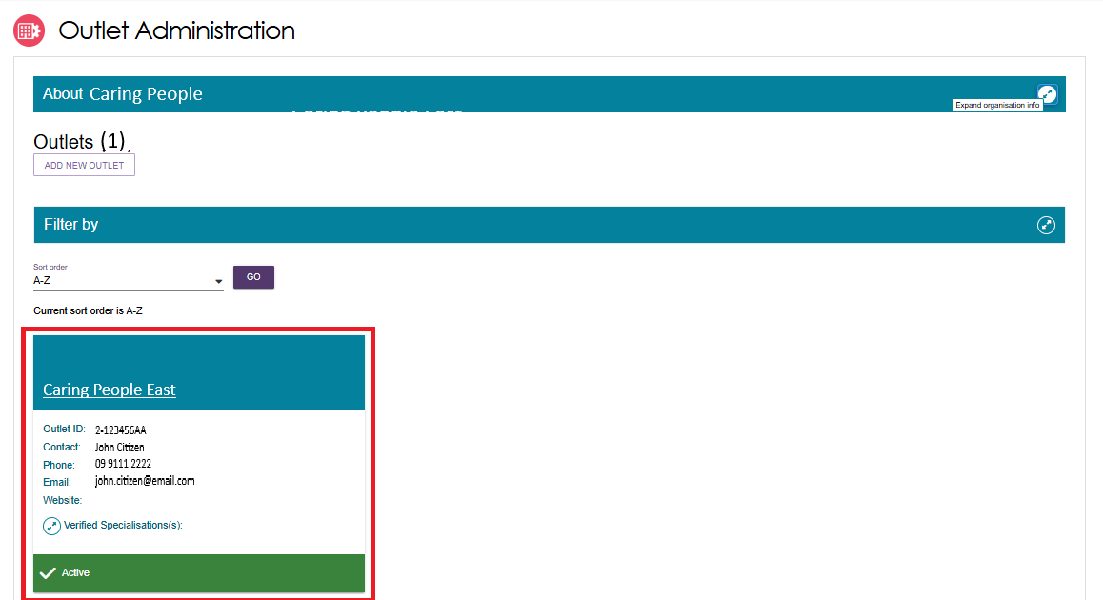
The View outlet page will be displayed.
- From the View outlet page, select VIEW SERVICE ITEMS.
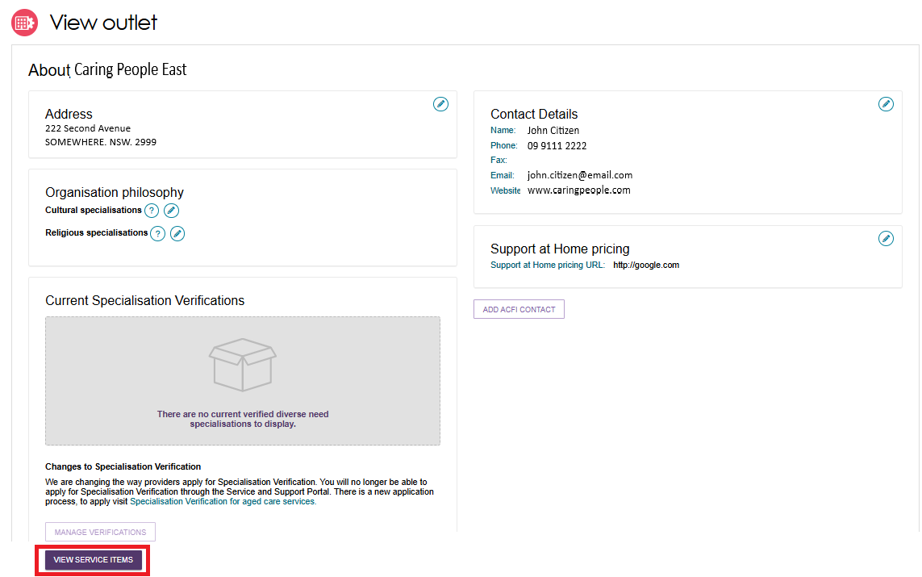
- From the View Service Items page, select the applicable Program tab.
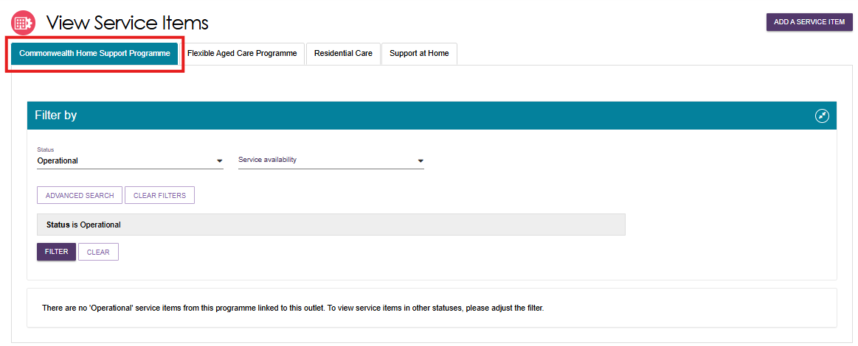
A list of the existing Service Items for that Program will be listed. The list will be filtered by the indicated criteria (e.g. Status of ‘Operational’ or ‘Offline’). Other filters are available.
- From the View Service Items page, select ADD A SERVICE ITEM.
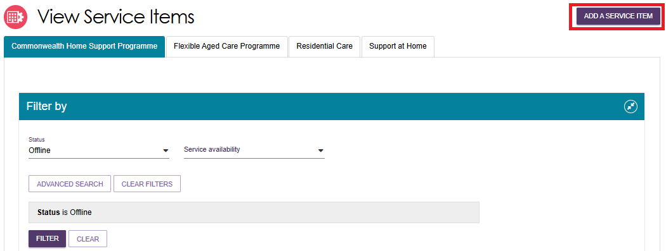
Select the program for the service that you wish to add.
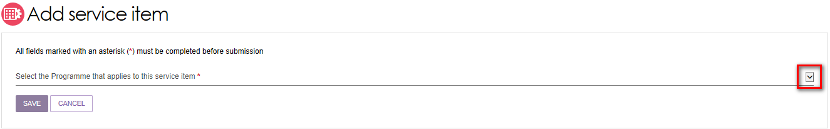
Once the program is selected, it will appear as Funded.
The option to change this selection is not available as all Commonwealth aged care program services must be approved and subsidised by the Australian government.
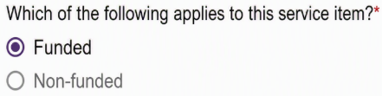
- Select the service you want to add to your outlet by selecting the relevant service item and then select SAVE. You can refine the list of service items by entering details and using the FILTER function.
If you are adding a new Support at Home service item, you will be required to enter a unique name in the Service Item Name field that is displayed.
Non-Support At Home Service Item Example
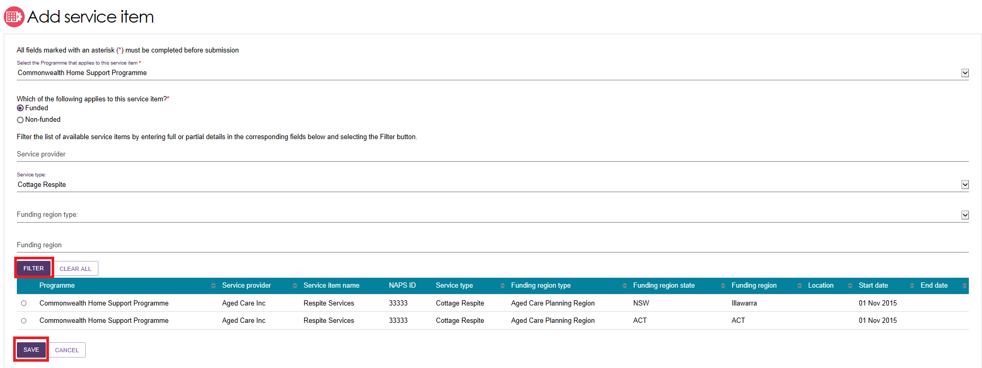
Support At Home Service Item Example
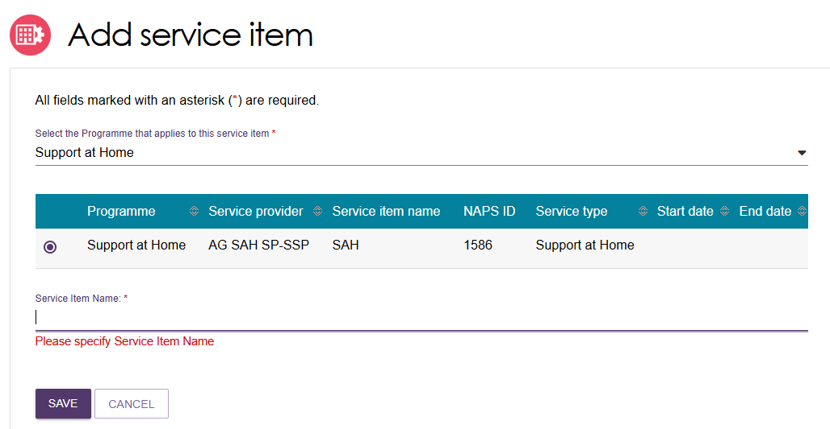
The service item will now display in the Outlet details page under Services. The service item will be defaulted to Offline and the status will need to be changed to Operational before it is displayed on the public service finder. The new service item will be listed with a status of Offline. A banner will also indicate that you have successfully added a service item to the outlet, and to remind you to Edit and Submit.
The process for activating a service item is described later in this guide.
Once services have been added to an outlet, you can filter the list of services that are listed under a specific program by status, service availability and waitlist availability.
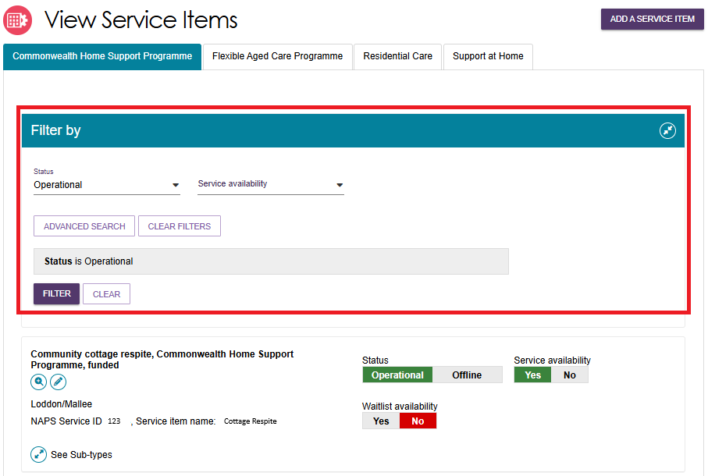

Adding and removing service sub-types
! | This function does not apply to Support at Home services, as each eligible outlet is automatically given all approved services based on the registration category.
For Commonwealth Home Support Programme service sub-types can be added or removed from the one single view screen.
- Navigate to the View Outlet details from the Outlet administration page for the outlet that you want to add a service sub-type to. Then select VIEW SERVICE ITEMS.
- Select See Sub-types below the service to see expanded service details.
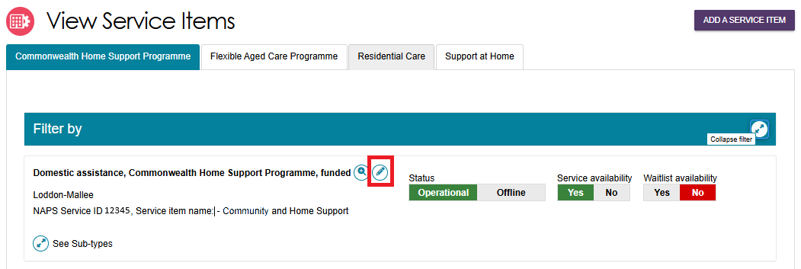
- Select ADD/REMOVE SUBTYPES.
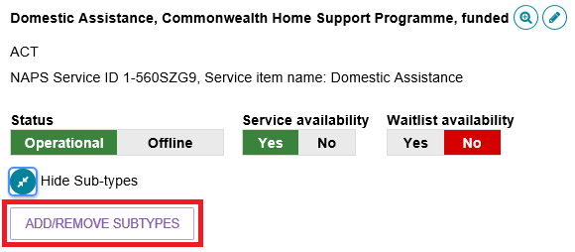
- The Add/Remove Subtypes screen will then be displayed where you can select or deselect the relevant sub types. Select SAVE.
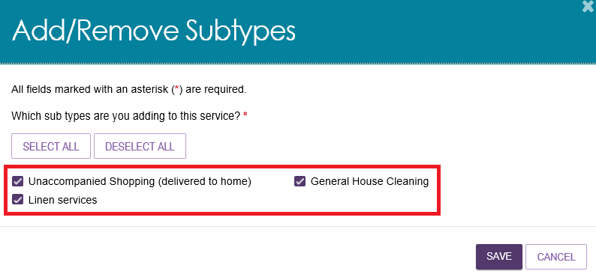

Activating or deactivating a service item
Navigate to the View Outlet details from the Outlet administration page for the outlet with the service item that you want to activate/deactivate and select VIEW SERVICE ITEMS.
For the services that have been added to the outlet, select Operational to activate the service item or Offline to deactivate the service item under the Status heading.
For non-Support at Home services the toggle is located at the right side of the screen next to the service name.
For Support at Home service items, the toggle is located at the top of the service item listing, and the toggle applies to all service types and services within the service item.
Non-Support At Home Example
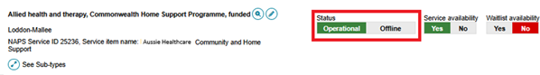
Support At Home Example
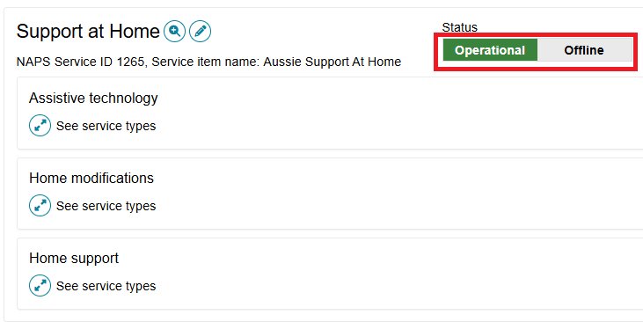
Only Operational services will display in the service finders.
The Offline status should be used to indicate where the service/s are not currently offered by the provider in that delivery area/region. For example, the service is at capacity.
Editing a service item
You can edit service item details by selecting the Edit (Pencil) icon to the right of the service item and/or service group name you wish to amend.
Non-Support At Home Example
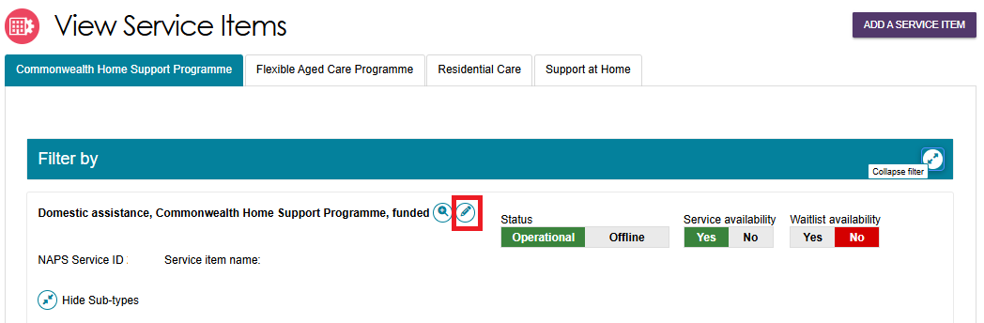
Support At Home Example
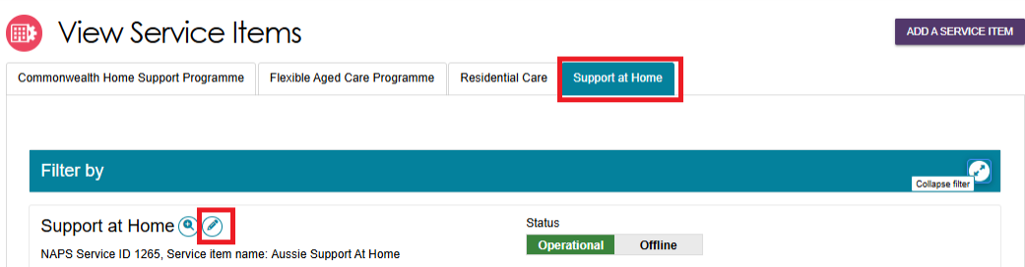

The details that can be edited include:
- Service item name
- Service delivery area
- If a service focuses on a specialised service area
- Upload promotional attachments (for residential facilities)
- Support at Home-specific attributes, e.g. service-based pricing
- Entering a detailed description for the service item.
! | For details about organisation philosophies and specialisations, refer to Editing the Organisation Philosophy, Specialisations and Verified Specialisations sections.
The service item details page will display.
Make the required changes and select SAVE. Read-only information is contractual information and cannot be edited via the Service and Support Portal. Any additional service information can be added in the Service description free text field. This information will be displayed in the public service finder on the My Aged Care website to assist clients in selecting a provider.
! | There are different options presented on a Support at Home service details page and a CHSP (Commonwealth Home Support Programme) service details page. Support at Home services are managed by delivery area. You can select multiple service types and items available within that area. CHSP providers will remain limited to a single service type and ACPR (Aged Care Planning Region), based on contractual information for each service item.

Adding and editing service attributes
Attributes for Support at Home, CHSP, and other programs are located in the Service Details (or Support at Home details) section of the Outlet Administration tile.
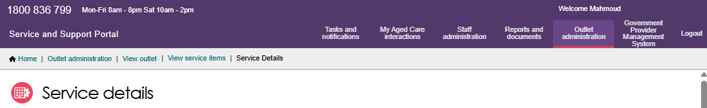
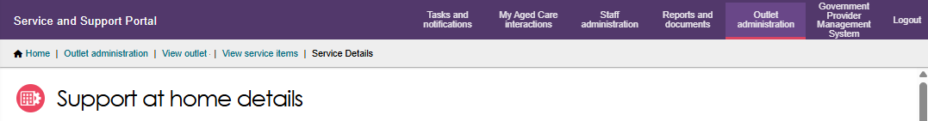
Attributes for individual services (or ‘service sub-types’) are located in the service itself.
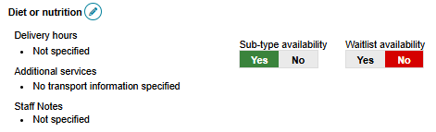
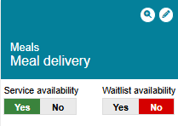
Some attributes are also displayed on the View Outlet page.
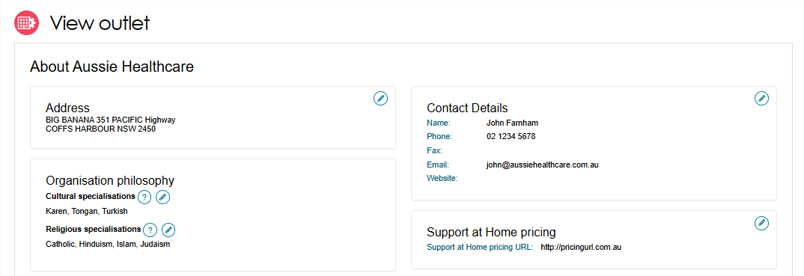
- To access any of the service attributes, select Outlet administration from the home page.

- From the Outlet Administration page, select the outlet.
Select VIEW SERVICE ITEMS.

- Select the CHSP, Flexible Aged Care Programme, Residential Care, or Support at Home using their corresponding tabs.
The Service Details tab includes key attributes such as contact details, service delivery, service area, specialisations, hours of operation, pricing (if applicable), and service descriptions.
The Specialisations attributes section is further divided into Specialisation Verification, Specialised Services and Languages. They are explained on the following page.

Specialisations
Specialisations is an umbrella term for 3 sub-groups: Specialisation Verification, specialised services, and languages. Service providers of all care types can identify their ability to provide aged care services that cater to these specialisations.
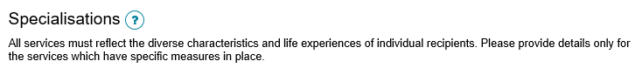
Outlet specialisations under the Organisation Philosophy heading are related to culture and language, refer to Editing the Organisation Philosophy for more details.

Specialisation Verification
Specialisation successfully verified under the previous 2022 Specialisation Verification Framework may have been applied as an attribute of a service item by default where it was nominated in the Specialisation Verification application completed via the Service and Support Portal.
Once a specialisation is successfully verified, a service provider can choose to manually update the verified specialisation attribute for an outlet service item. At any time during the verification period, a service provider can select or deselect current verified specialisation attributes to indicate if an outlet service item provides that specialisation.
Only selected specialisations verified under the 2022 Specialisation Verification Framework will be made available to search in the service finder and match and refer tools.
All current verified specialisations under the 2022 and 2025 Specialisation Verification Frameworks across all service items of the outlet (regardless of attribute selection) are provided to the My Aged Care Website Find a Provider tool for publication through a separate manual process.
! | In the Specialisations section, Specialisation Verification is displayed as Diverse Needs.  Only current specialisations verified under the previous 2022 Specialisation Verification Framework will be available to update in the Service and Support Portal.
The below image shows the ‘Aboriginal and/or Torres Strait Islander peoples and communities’ Specialisation Verification program specialisation that can be applied to a particular outlet’s service item. The other 8 specialisations are greyed out and thus not able to be applied.
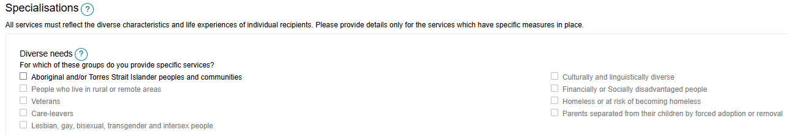
The below image shows the verified specialisation ‘Aboriginal and/or Torres Strait Islander peoples and communities’ selected.
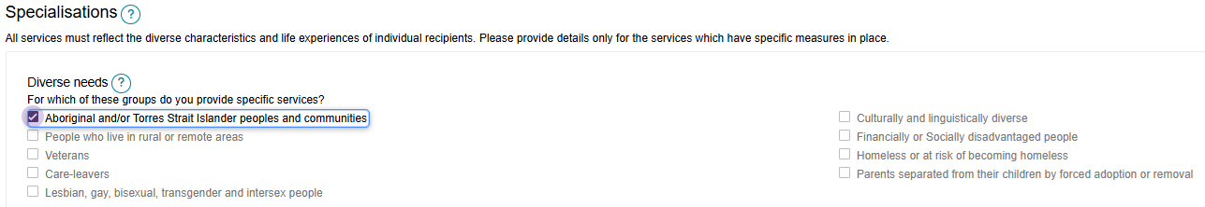

Specialised Services
There are other specialised services which you can indicate that an outlet service item offers. You should only select those with specific measures in place that demonstrate your specialised service offering, however they are not verified like the verified specialisations listed in Specialisation Verification.
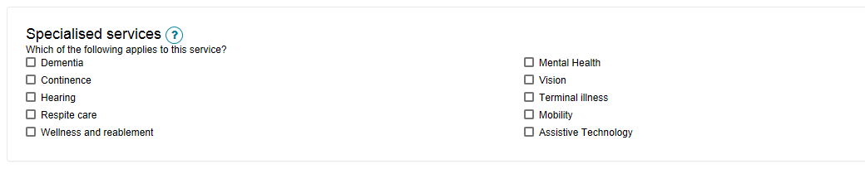

Languages
To indicate if this service caters for specific language requirements, select the languages in the Languages section.
Select SELECT LANGUAGES AVAILABLE to bring up the selection and select SAVE to save the configuration.
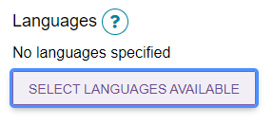
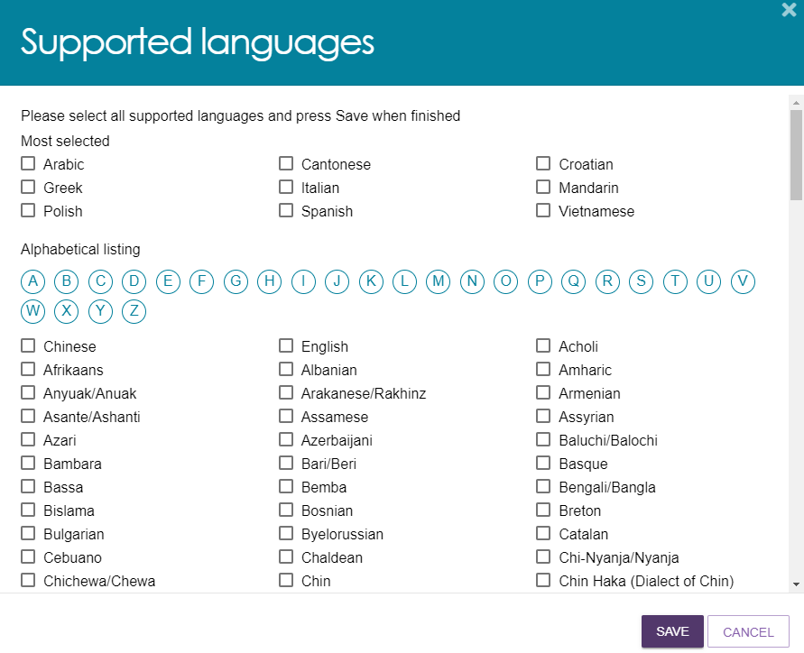
Once the language/s are selected and saved, they are shown under the List of languages.
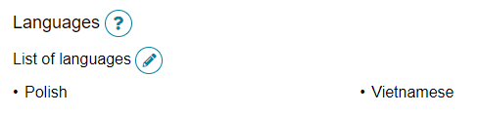

Hours of operation (non-Support at Home)
You can outline hours of operation for CHSP and other non-Support at Home services.
By default, you can enter standard Monday to Friday, Saturday, and Sunday hours. You can also specify individual working days by using the Customise option.
- Navigate to the service type to edit by following the steps in Editing a service item.
- Select the service you want to edit the hours of operation by selecting on the corresponding Pencil edit icon next to the service sub-type name.
Non-Support At Home Example
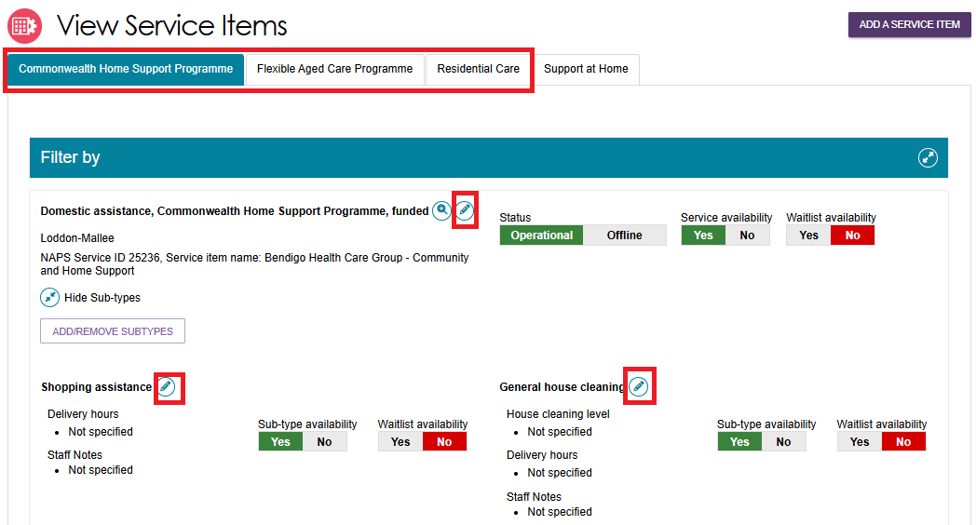
- Enter the start and end times for the applicable day.
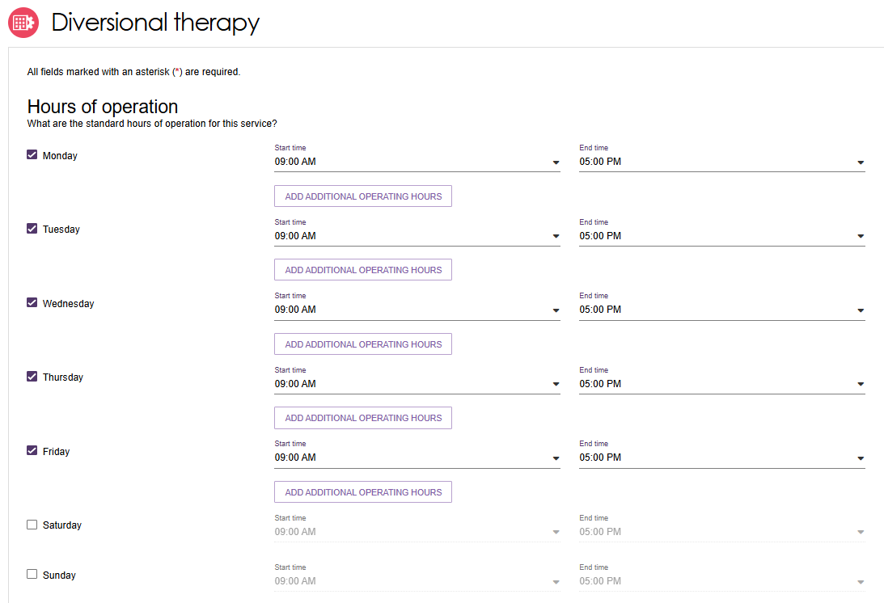

Delivery Hours (Support at Home)
Delivery Hours are specified for the Support at Home services and are not applicable to other programs (refer to Hours of Operation).
Support At Home Example
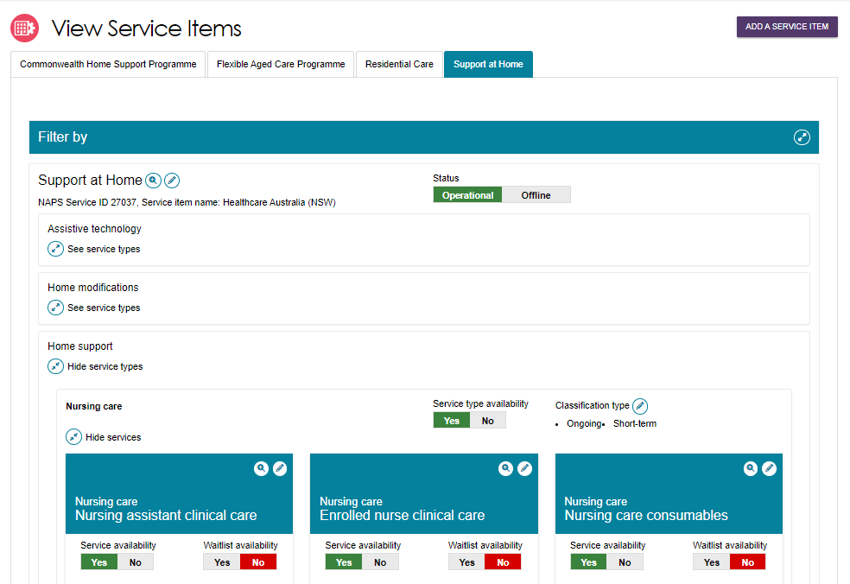
Select the Pencil (edit) icon on the service tile. This will open the service edit page. Standard hours are active by default and cannot be changed.
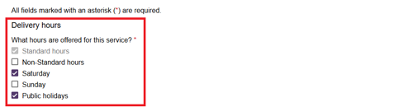
Select the applicable checkboxes for the delivery hours offered.
When you select a delivery hours checkbox the corresponding Common Price field will become active and you must have a price before saving the record.
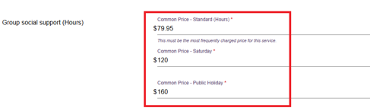
Select the SAVE CHANGES button at the bottom of the page.

Staffing notes
Staffing notes are able to be specified for each program.
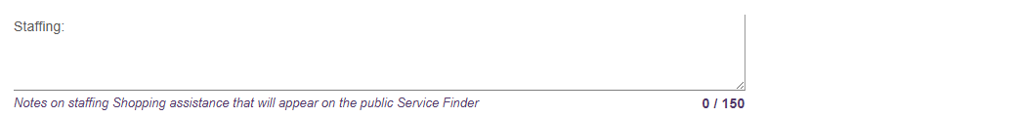

Service specific delivery details
Depending on the selected service, additional delivery details may be captured on this page. This information is used on the Assessor Portal to assist in finding a provider that can deliver services suitable for the client. Some services may only have some options available.
Transport service specific example
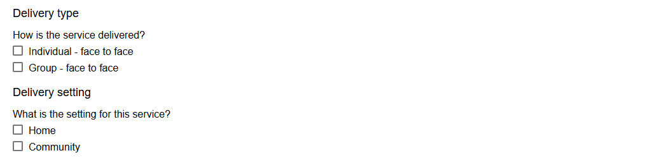
Service Description
You can input a description of your service and add any additional service information up to 1000 characters.
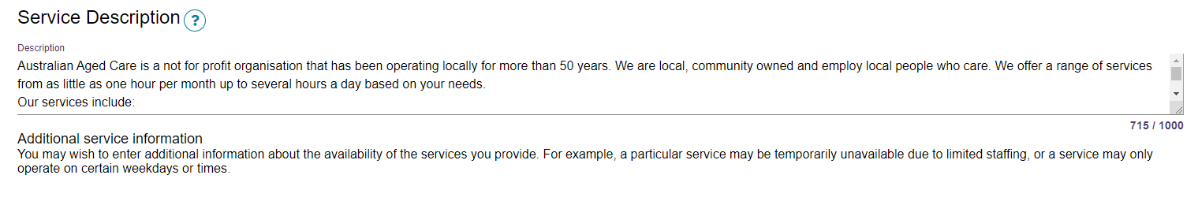

Pricing information (Support at Home)
This section covers pricing information for Support at Home only.
For room pricing for Residential Care please refer to Adding a room type to a residential facility.
Support at Home program outlets must provide:
- service level prices for all available Support at Home Services within each Outlet.
- It is also highly recommended to add a pricing website link (URL). This will be shared with My Aged Care Website to assist aged care participants find your published pricing.
If pricing is not entered for Support at Home services, you will not be able to:
- save a new service and make it Operational
- recommend adding a pricing website link (URL)
- save changes to partially complete existing pricing information
- confirm that pricing information has been reviewed, then pricing data will then not be supplied to My Aged Care to support tools such as the Fee Estimator.
!  ! | The Support at Home’s service item allows you to configure the services you deliver and their prices for a particular delivery area or region.  Pricing is entered at the service level for each service item within the outlet.

Updating Support at Home Pricing Information at the Organisation Level
!  ! | This functionality is available to Organisation Administrators only.  Organisational level pricing can be applied to every outlet service item that delivers Support at Home services. It will override existing pricing changes at the outlet service level if they already exist. Ensure that your Outlet Administrator/s are aware of your Organisational level pricing changes before you apply pricing to all Outlets.
- Go to the Outlet Administration page by following the steps in Viewing Outlets.
- Select the View (magnifying glass) button to the right of the Support at Home Organisation Pricing section.
If your organisation do not offer or deliver Support at Home program services, you do not need to complete this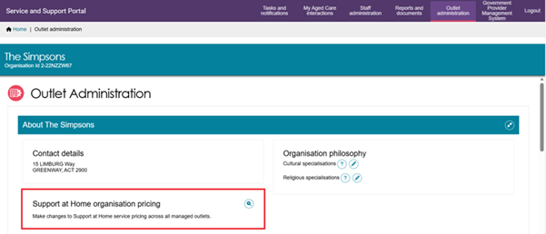
- A list of service groups and service types displays. This list will only show Service Groups and Service types associated with the your Organisation’s Registration Categories. Select the Edit (Pencil) button to the right of the service type/s that you would like to update.
The Last updated, Last updated to outlets, and Outlet update status columns are blank until you add pricing for services within the service type record.
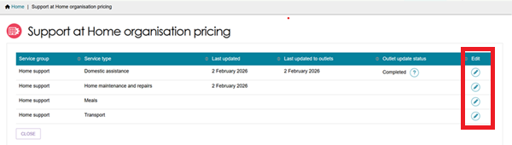

- For each service type that you selected Edit from the above step, the corresponding ‘Pricing for Service’ page appears.
All of your organisation’s available services within the service type and the common price fields for each delivery time period displays here. A domestic assistance page and a nursing care page example are shown below.
Domestic Assistance Pricing Page Example
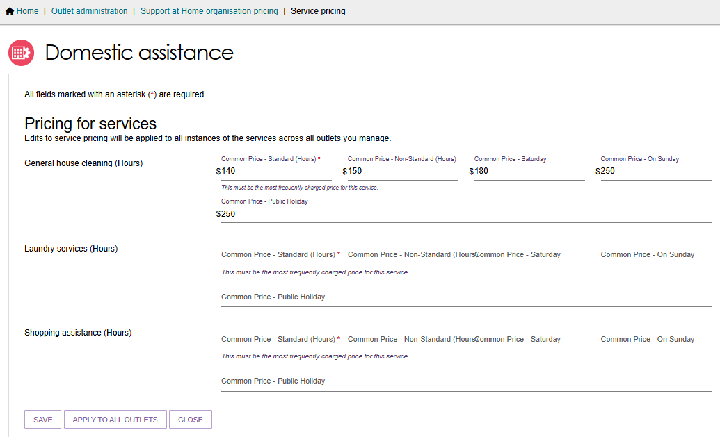
Nursing Care Pricing Page Example
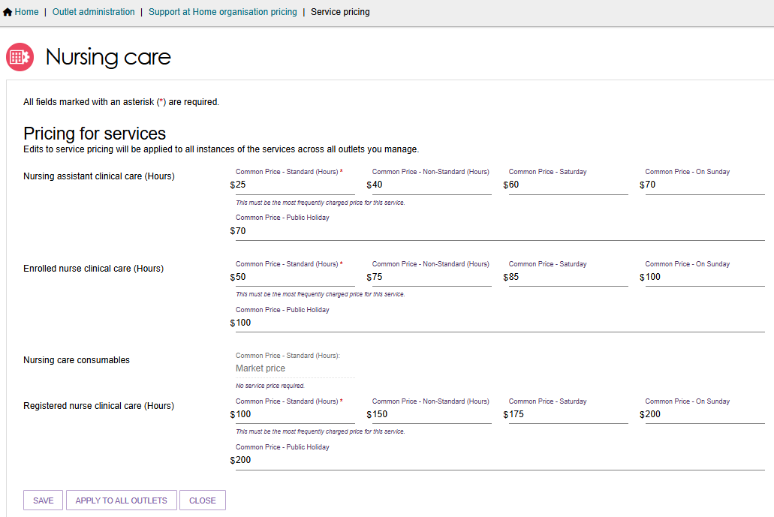

All mandatory fields (marked with a red asterisk) must be entered, for example ‘Common price – Standard (hours)’.
You must provide Common Price – Standard (Hours) for all Services that will be marked as available. You can enter a value from $0.00 to $999.99.
If you do not deliver a service within the service type, you can enter $0.00 if you need to enter a value in the mandatory field. You MUST then mark this service as not available on all the applicable Support at Home service items. For any service listed as ‘Market Price’ are you not required to enter a price value.
Select SAVE to save your progress and to be taken back to the Support at Home pricing page. This will only save the pricing on the Organisation level.
Select APPLY TO ALL OUTLETS to apply the pricing you have entered to all of the organisation’s outlets with a Support at Home service item. This is possible only after entering all mandatory Service pricing under a Service Type.
When applying pricing to all Outlets, only the prices will be copied down where that service delivery hours is selected. Standard hours are defaulted and will always be copied down.
For example, you enter all pricing at the organisation level. However, in some service items the additional service delivery hours selected is only Non-standard and Saturday, then only those prices will be copied to that service item.
Select CANCEL or CLOSE to go back to the Support at Home pricing page without any edits made or saved.
! | When applying organisational pricing to all outlets, the pricing will copy down to all Support at Home Service items, regardless of Operational or Offline status.
- When APPLY TO ALL OUTLETS is selected, an Information Banner appears: ‘We’re currently updating your selected pricing change across all outlets. This may take up to an hour or more to complete. You can continue working while this runs in the background and refresh this page to see if the update has completed. If any errors occur, information will be sent to the designated organisation email contact’.
The Outlet update status will be displayed. For more information select the Question Mark icon.
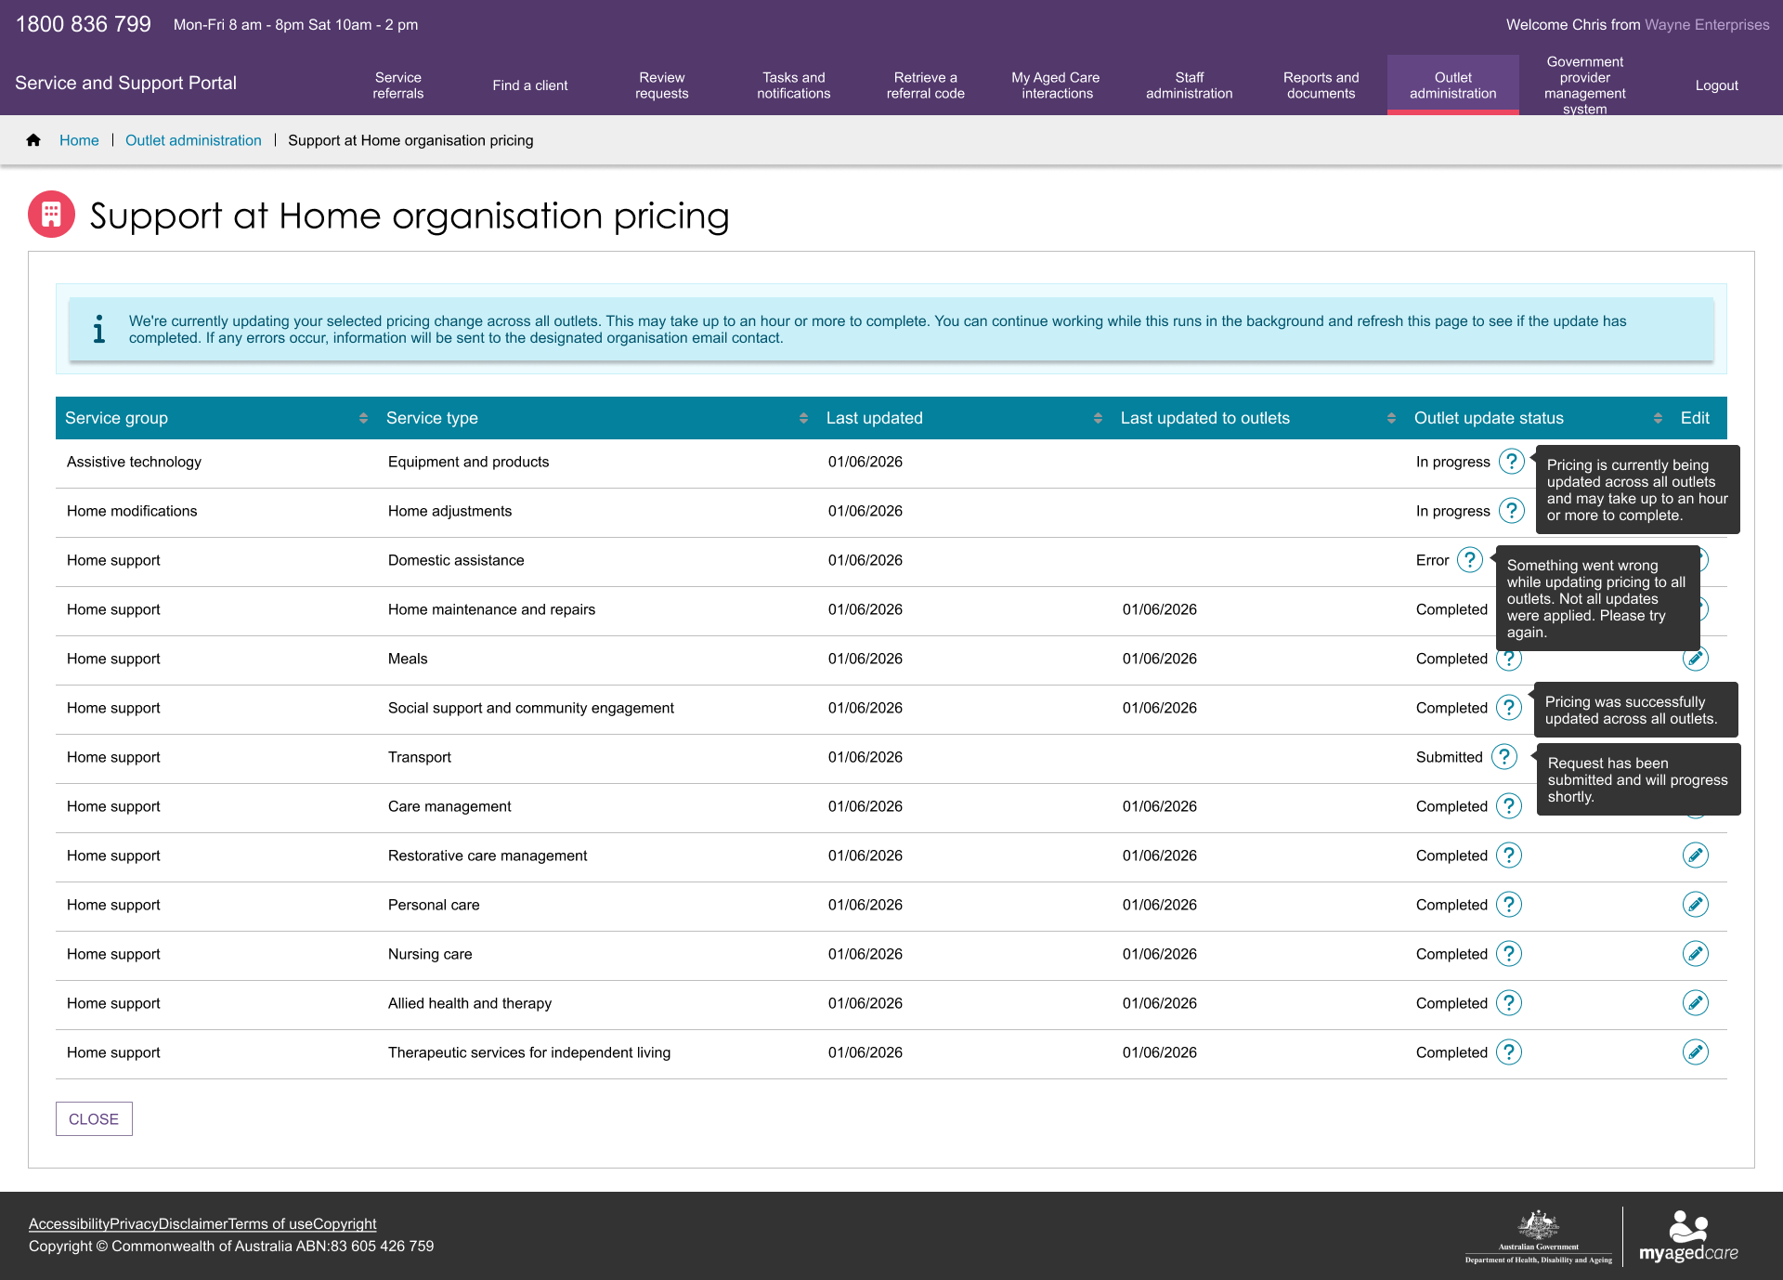

Updating Pricing Information at the Outlet Level
- Choose your outlet from the Outlet Administration page tiles.
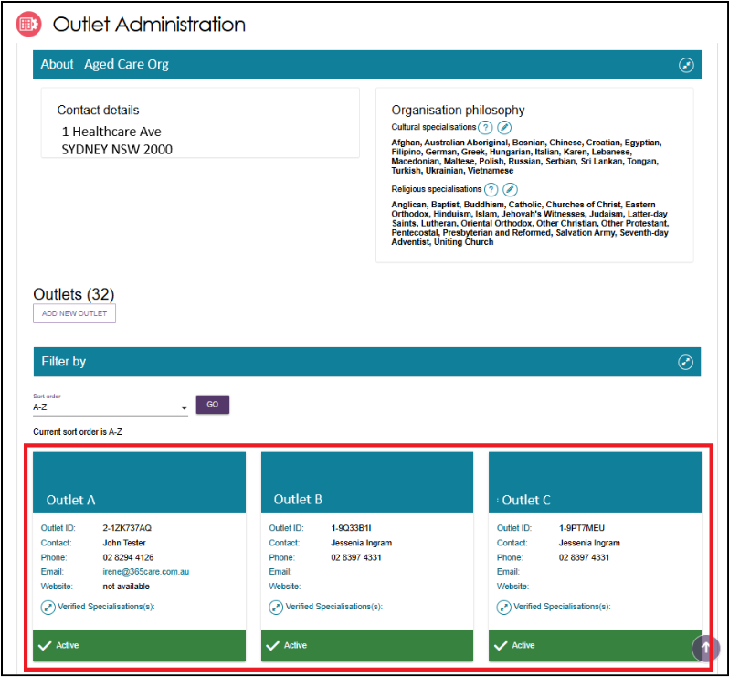
2. The outlet details page will be displayed. Select the Edit (pencil) icon to the right of the Support at Home pricing section.
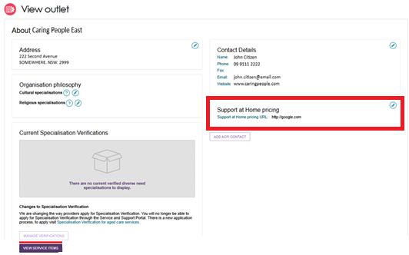

- The Support at Home pricing pop up appears.
Under the Full Price List section, a pricing schedule website link (URL) can be added.
To add a pricing schedule website link type in the URL in the Provide a website link section. Ensure that the website URL you enter is a valid website address. Use the URL Scheme field to select the if the URL is https:// or http://.
Finally, select whether you want to
- Apply to this outlet only, or
- Apply to this outlet and its Support at Home service items.
Then, select Save button.
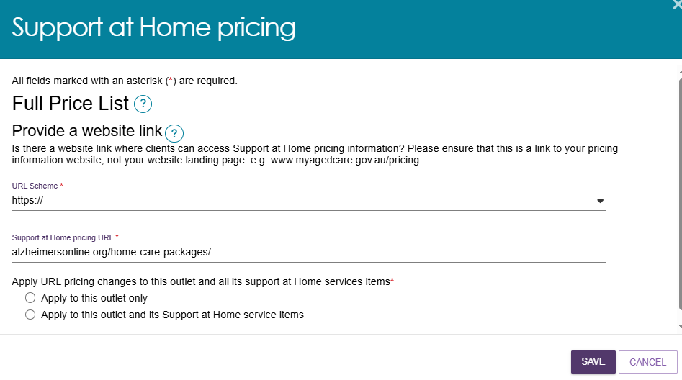
- The Pricing URL will now appear at the View Outlet page.
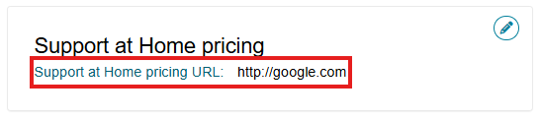

Updating Pricing Information at the Service Item Level
You can also update the service item pricing URL or supply a price schedule attachment specific to that delivery area/region.
- Choose your outlet from the Outlet Administration tile, then select View Service Items.
- From the View Service Items page, select the Support at Home tab, then the Edit (Pencil) icon to the right of the ‘Support at Home’ heading.
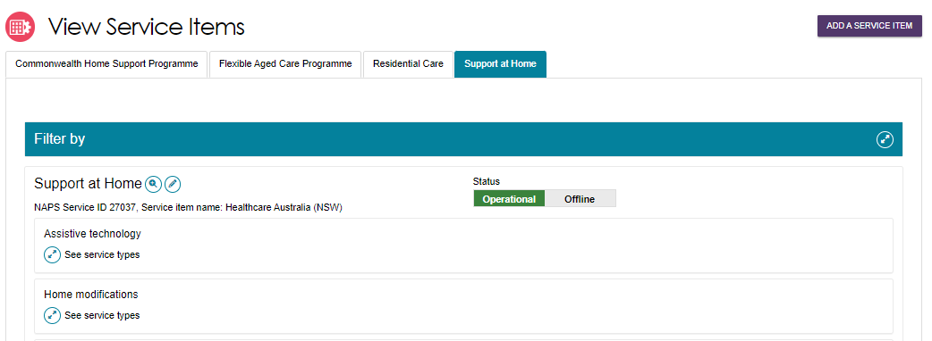
- The Support at Home details Page appears. This contains all configuration available for the service item.
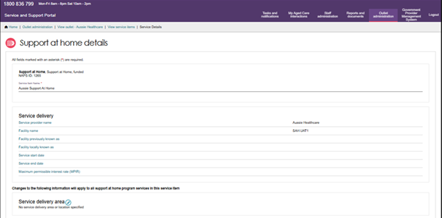
- Scroll to the bottom of the page to the Full Price List section.
In the URL Scheme section, select whether your website link is HTTP or HTTPS. Then, enter the website link in the URL section. The below screenshot shows an example website link.
You can also upload a pricing schedule here.
Finally, select Save.
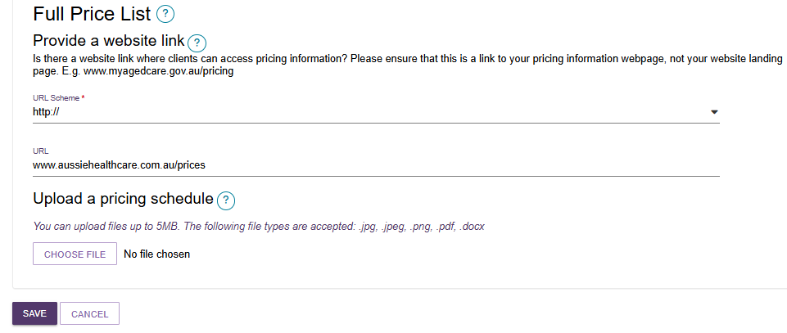

Updating Pricing Information at the Service level
! | Service pricing at the Organisational level will be automatically applied to all service level pricing.  Be aware of any Support at Home organisational pricing changes that the Organisational Administrator may do.
At the service level, you can update pricing based on the unit type such as per hour, trip or meal for individual services. If you have entered pricing at the Organisation level this information can now be used to autofill, if the service level price does not already exist.
- Choose your Support at Home outlet from the Outlet Administration tile, then select View Service Items.
- Select the Support at Home tab, then expand any service groups/service types, then select the Edit (Pencil) icon of the appropriate service card.
The below example shows the Home Support service group, Meals service type, and Meal Delivery service.
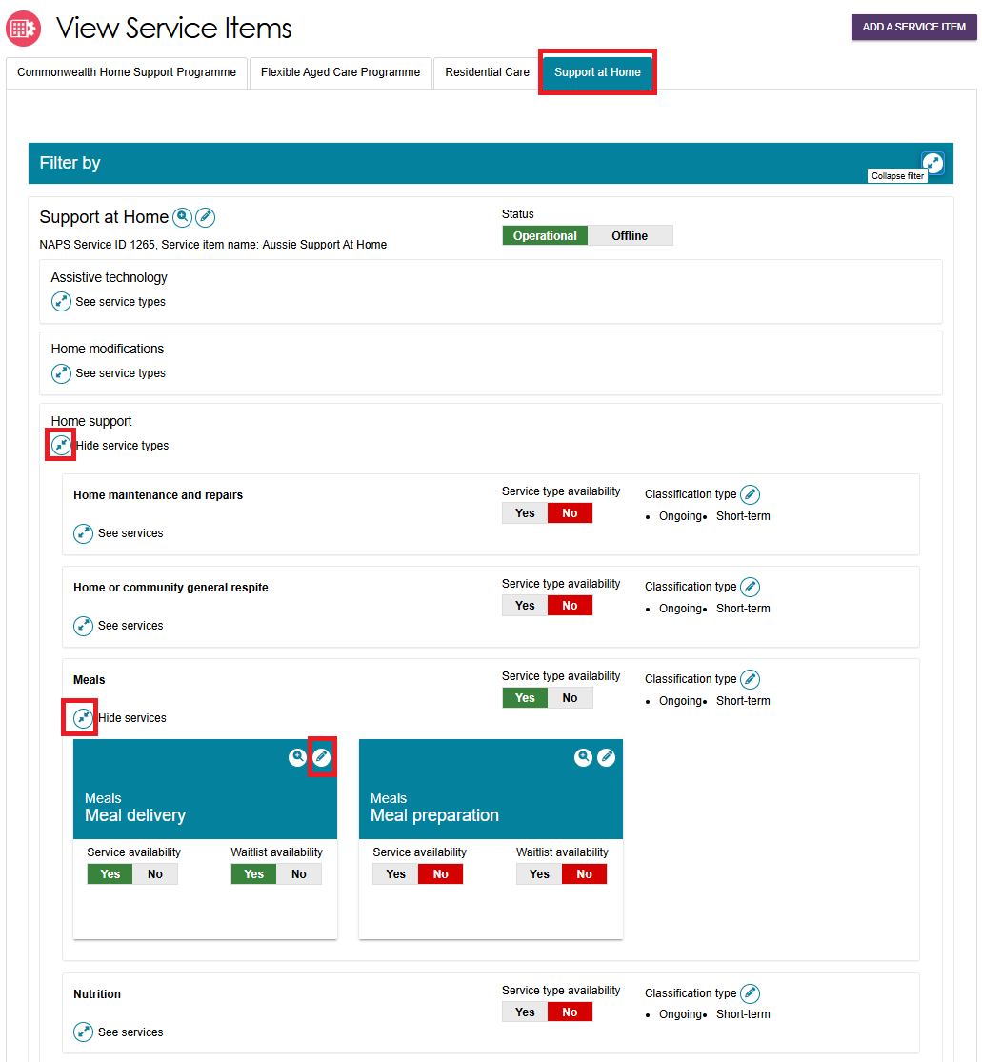
The Service Details page appears. The appearance of the page will vary depending on which service you have selected.
An example of a generic service’s page is shown below.
When you edit a Service’s pricing, the system will autofill the common prices from the Organisation level. This will only happen when:
- if there is price/s set at the Organisation level (also referred as reference price) and
- when you select the delivery hours option/s you offer for the service.
When the pricing is autofilled, an information banner also appears.
These prices is pre-filled for your convenience. You can keep this figure or apply a new price based on the delivery area, however you must ensure you save to apply the pricing data.
If you have not entered any pricing at the organisation level the fields will be blank and you must at minimum supply a service price for Common price – Standard hours. When you select additional delivery hours you must the enter the corresponding common price for that period.
Generic Service Details Page Example
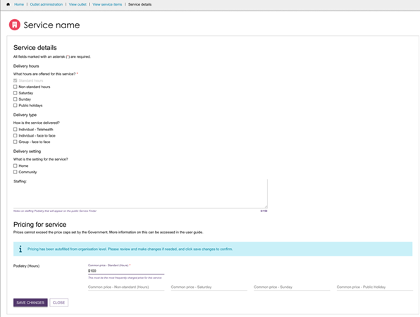
If service prices exist, and you adjust the availability setting (for example from No to Yes), the system will provide a message to review the pricing. It is encouraged to check the price details and complete any other prices for offered time periods and then save.
You can continue to add pricing in the other delivery hours offered e.g., Non-standard Hours, Saturday, Sunday, and Public Holiday. There is flexibility to have Service item specific pricing.
! | It is important to provide pricing at the service level to support My Aged Care website tools such as Find a Provider or Fee Estimator. There is flexibility to have service level availability and pricing by service delivery area (region).
This will be required to be completed for all services before changing the service item status to Operational.
For (Hours) services, enter the per hour price delivered during the time period.
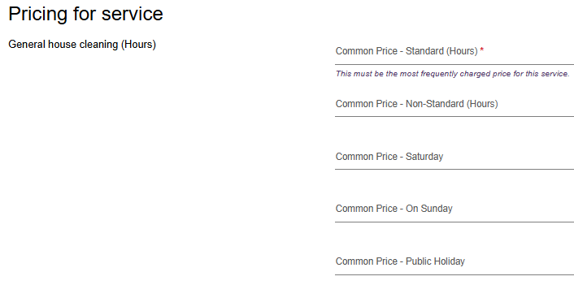
For meal delivery, enter the price per meal delivered during the time period. For example, in the Common price – standard (hours) section, enter the price for each meal delivered during standard hours.
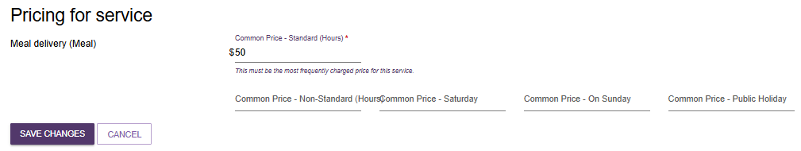
For transport services, enter the price per trip during the time period. For example, in the Common price – standard (hours) section, enter the price for each trip undertaken during standard hours.
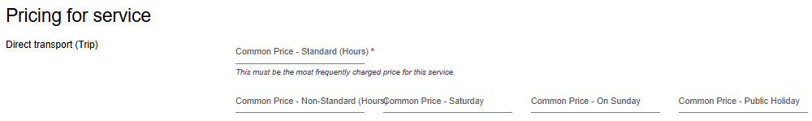
Some services such as consumables will default to ‘Market price’. No price is required to be entered.
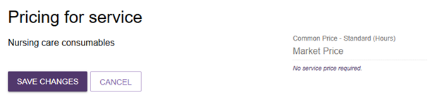
- If a service is on a waitlist, it is highly recommended to add service pricing to ensure this is visible on the Service Finder or Fee Estimator tools.
- All pricing information saved, including pricing schedule attachments, will appear by the next day on the Service Finder on the My Aged Care website, and do not require approval from the Department.
To view the pricing information entered, navigate back to the service where the pricing was updated, expand the service, and select the magnifier icon .
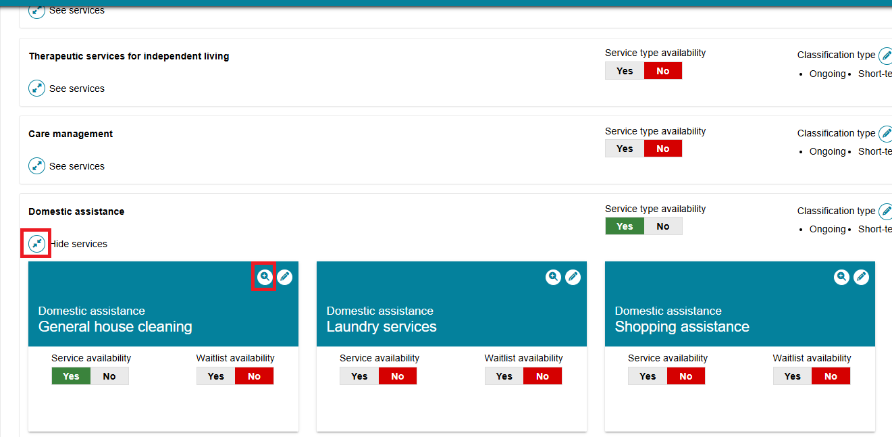
A pop-up window will appear with the pricing information for that service.
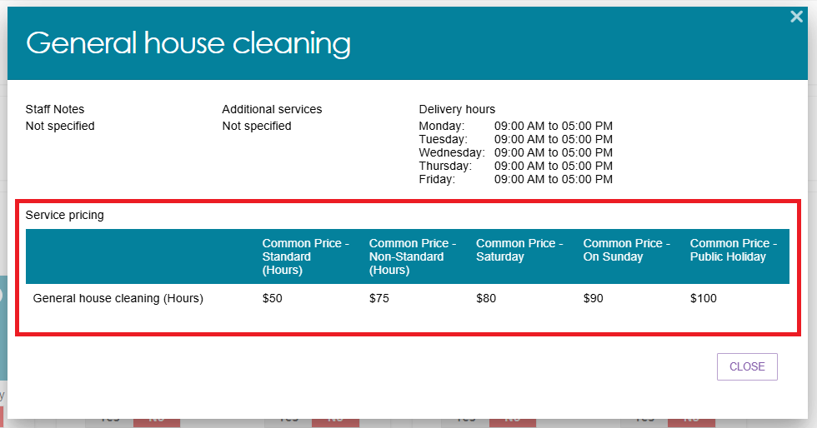

Reporting service pricing status
The Support at Home Pricing Status report enables Organisation Administrators and Outlet Administrators to view the service price status and identify which Services require pricing updates and when they were last updated.
The report will provide a full extract of all your Support at Home service pricing for all outlets, service items and price fields.
Go to Reports and Documents tile of the portal home page, then select the Support at Home Pricing Status link.
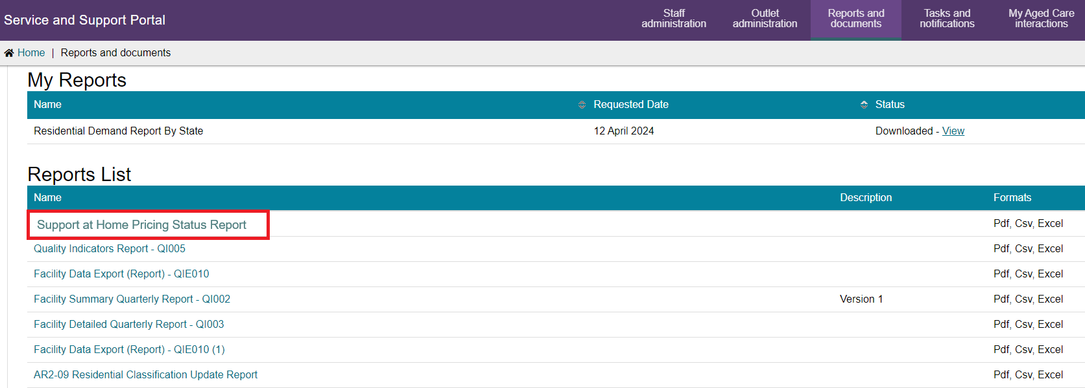
This will open a Report View page. Begin typing the Outlet name to select, you can add additional outlets. Then, Select the output type and then the Request Report button.
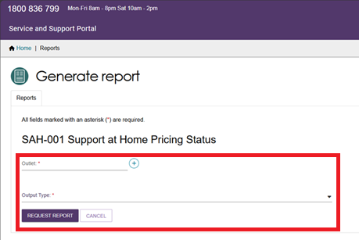
The report will run and be available to download in your My Report section once completed.
There is an estimated 24 hours delay in the data entry to being available in the report. For example, if you entered data into the portal yesterday, it should be available to view today.
Checking Pricing completion
Once you open the report, it will default to a sort order by Outlet and Operational service items and available services. This is intended to help you identify any missing pricing required to be entered.
A compliant Outlet is one where an Outlet is an active outlet with an operational Service item where a service/s availability = yes and common price – standard hours field contains a price value.
The following sample report shows compliance, non-compliance and where compliance rule is not applicable.
- Row 1 indicates compliance with the rule.
- Row 2 with the red highlighted cell (under ‘Common Price – Standard Hour’ column) indicates the non-compliant price for that service. Note that the report will NOT highlight any non-compliant cells.
- Row 3 is not required to be assessed against the rule as the Service is not available. Any service item that is Offline is also not assessed against the rule as well as Inactive Outlets.
Price review/maintenance
Pricing must be reviewed and updated quarterly. This report can assist in providing a review of all the pricing entered and the last updated date. The last updated date is when any one of the service price time periods has been updated.
You will be able to identify if a service price has not been updated based on the last updated date. For example, if prices for the services have not changed in 3 or 6 months. This may indicate that it needs a review against your common prices for that service.

Maintaining service and waitlist availability
You can maintain information about the availability of service items via the Service and Support Portal.
To maintain a waitlist, you must ensure that the waitlist availability status on the service item is set to Yes to turn on the waitlist, or No to turn off the waitlist. Service and waitlist availability information will be displayed on the service finder via the My Aged Care website. When you change availability information it will appear by the next day on the My Aged Care service finder on the My Aged Care website. You will still be required to add service pricing if you waitlist a service.
- Navigate to the View Outlet details from the Outlet administration page for the outlet that you want to edit service and waitlist information and select VIEW SERVICE ITEMS.
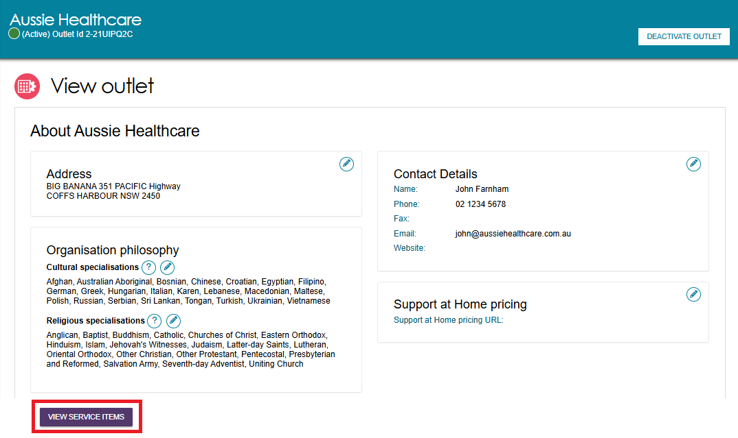
- Select the relevant service/waitlist availability status (Yes / No).by toggling the Yes | No switch. The location of the Yes | No switches will depend on the type of outlet and service chosen.
For non-Support at Home services such as CHSP or Residential Care: the toggles are to the right of each service heading, and at the sub-type level by expanding See sub-types.
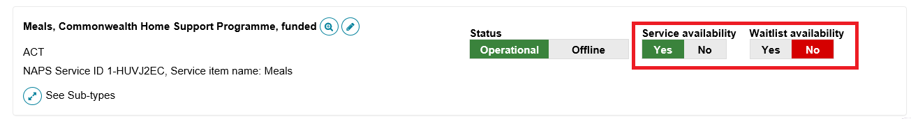
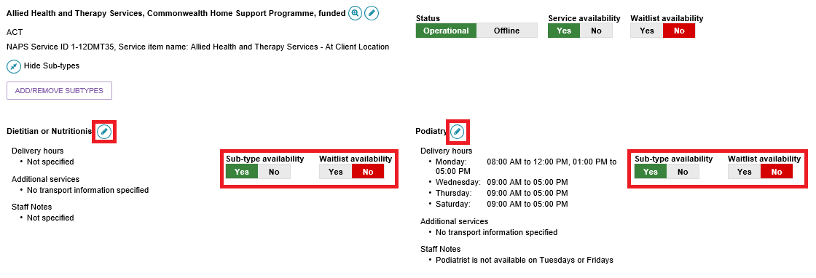
For Support at Home services, expand the service group, then expand the service type, and finally expand the service. There is a service availability toggle and a waitlist availability toggle in each service’s card. For the Service type to be available you must have at least one service with availability as Yes. To mark a service available you must provide the Common Price - Standard (Hours) at a minimum.
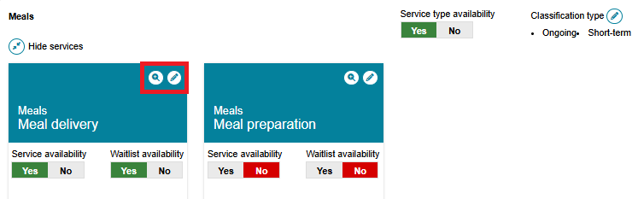

Editing a service delivery area
Information about the areas you deliver Commonwealth-funded services in (referred to as service delivery areas in the portal) are pre-filled, based on your contractual information. All providers (except Residential care) must review their service delivery area information and edit if required. It is important that you ensure the service delivery area(s) is accurate. This information is publicly displayed in the service finders and forms the basis of the referrals sent by contact centre staff and assessors.
For service items under the CHSP and Flexible Aged Care programs, select the at client location option. For Residential based services, select the at provider location option.
! | For Support at Home services, service delivery area details are defaulted to at client location. Any edits will apply for all service types and services underneath the Support at Home provider’s listing.
Follow these steps to edit a service delivery area:
- Navigate to the service item page from the Outlet Administration tile.
- On the View Service Items page, select Edit next to the relevant service item, or for the Support at Home program, the Edit icon next to the Support at Home heading.
NON-SUPPORT AT HOME EXAMPLE
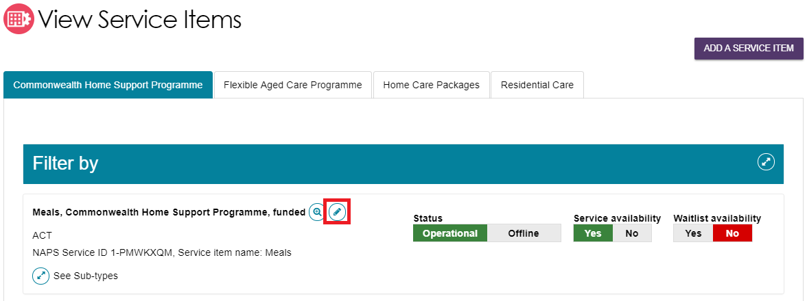
Support At Home Example
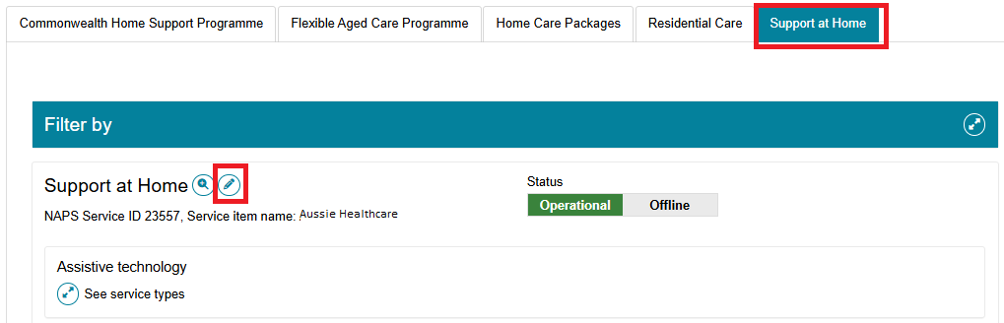
The Service details page will display.
- Select Edit (Pencil) next to the Service delivery area section.
Non-Support At Home Example
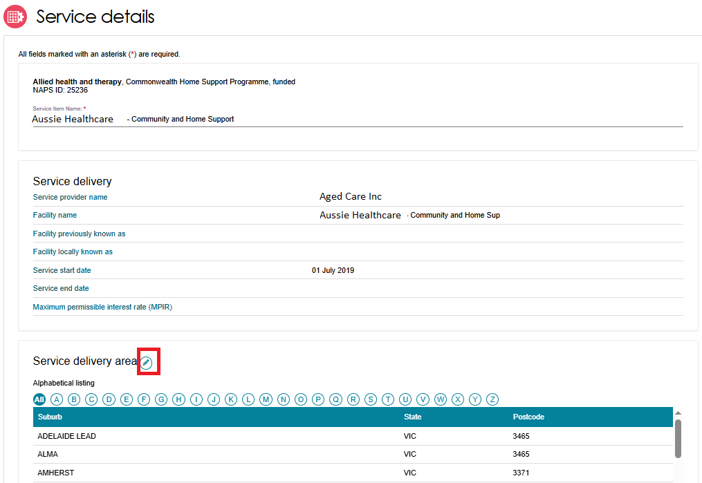
For Support At Home, there are no suburbs listed.
SUPPORT AT HOME EXAMPLE
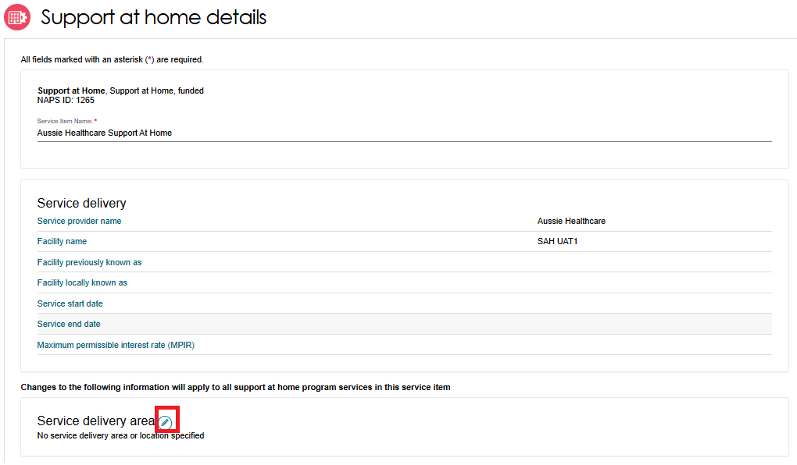
- The Edit Service Delivery Details page appears.
Select the service delivery type.
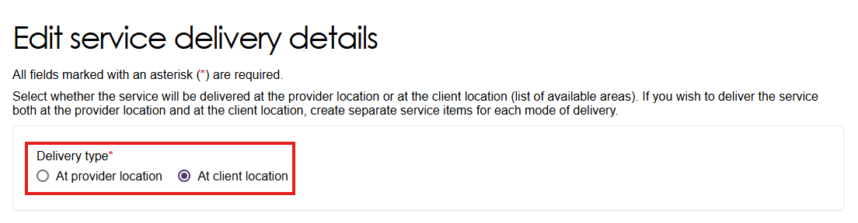
If prompted,
- Select ‘At provider location’ for residential services
- Select ‘At client location’ for non-residential services.
Note: For Support at Home, this choice is hidden. By default, ‘At client location’ is selected.
Once selected, the choice cannot be changed without assistance from the Contact Centre.
If you have selected At provider location, enter the address of the provider then select Validate This Address. Then select Save Changes.

- Search for and add suburbs
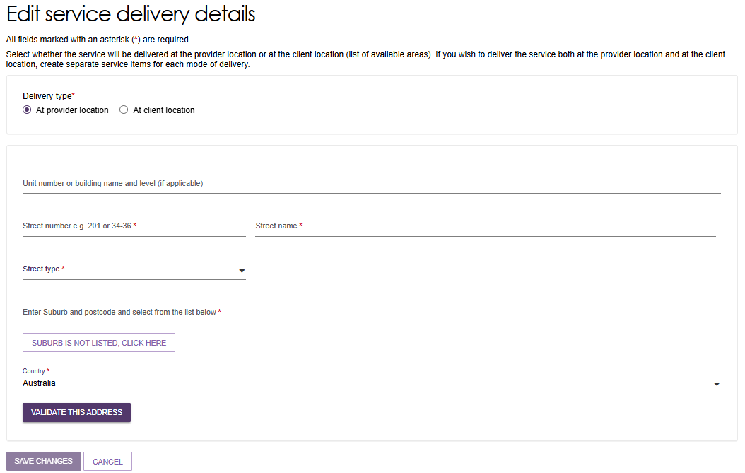
If you have selected At client location, you can choose the state or suburb(s) the service is delivered in. By default, the entire region, in which you are funded to provide service, is selected.
You can choose to search for a specific suburb to add, add all the suburbs in the selected state, or add all the suburbs in the selected region.
To remove suburbs from the list, select the suburbs you wish to remove using the checkbox and select REMOVE SELECTED, or use REMOVE ALL to start configuring your list of suburbs from the beginning.
Finally, select Save Changes to save the selected suburbs.
Select Cancel to go back to editing the service.
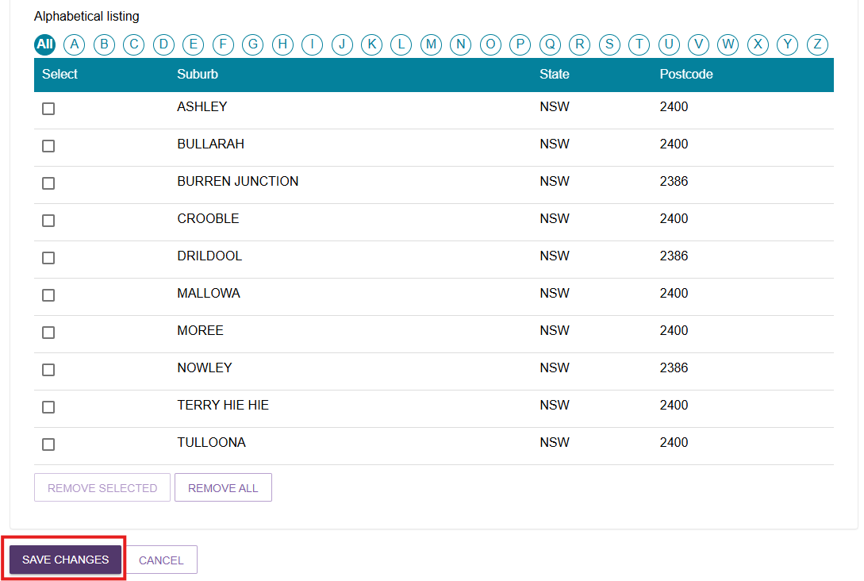

Adding a room type to a residential facility
- Choose your outlet from the Outlet Administration tile, then select View Service Items.
- At the View Service Items page, navigate to a Residential Care service then select See room types.
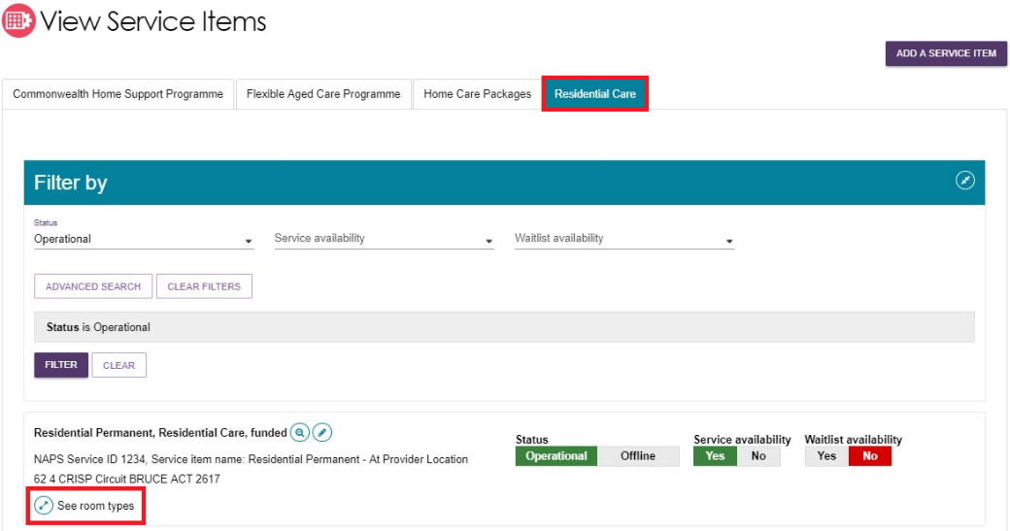
- Then select ADD ROOM TYPE.
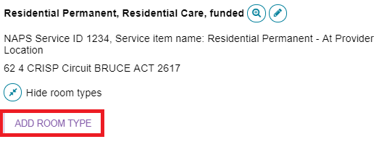
- The Room type page will be displayed. Enter the required information in the General room information and Pricing information sections.
Fields marked with a red asterisk (*) are mandatory.
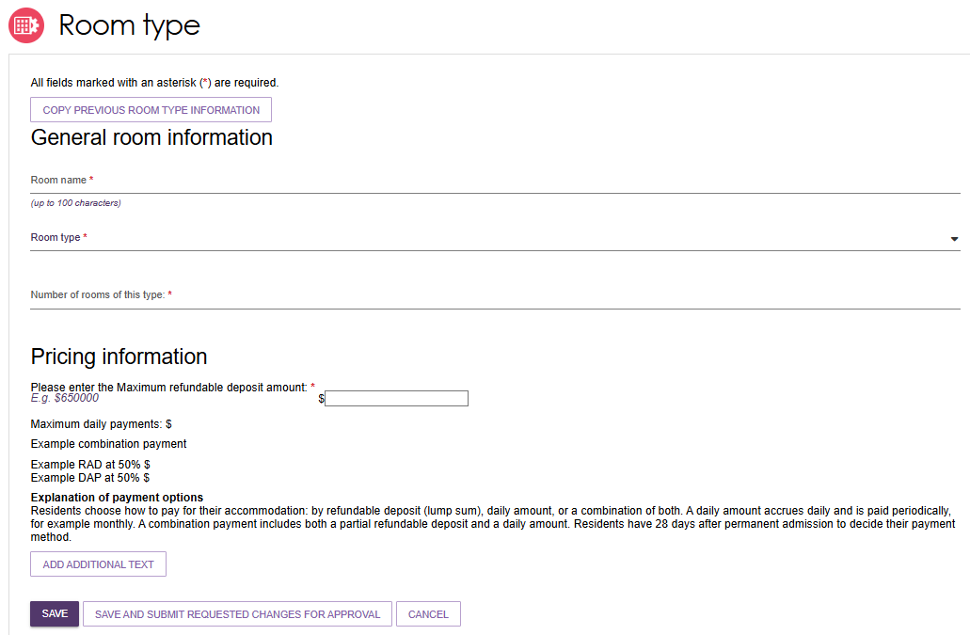
! | Accommodation prices above the maximum allowed Refundable Accommodation Deposit amount (or equivalent daily payment) must be approved by the Independent Health and Aged Care Pricing Authority (IHACPA).  If IHACPA have not approved this price, or you have not submitted an application for approval of this price, you cannot publish this price. You cannot charge this price until it is approved by IHACPA.  Please note that when an approval is granted IHACPA, the approved amount is not automatically updated on the My Aged Care website. Providers must update their own pricing information using the Aged Care Service and Support Portal.
- Enter the required information under Key feature statement. Select SAVE AND SUBMIT REQUESTED CHANGES FOR APPROVAL after all required information has been entered. This room information will display on the service finder once approved by the department (allow 3 business days).
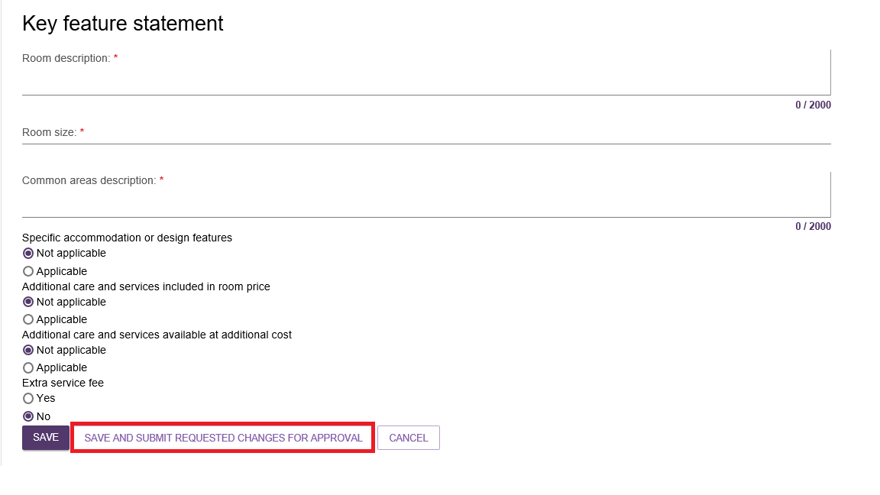
! | If you save the room type but do not select Submit, you will be notified that there are room types requiring approval by the department and be prompted to submit the room type to the department prior to displaying on the public service finder.

Activating an outlet
After service items are added, outlet(s) need to be made active so that the following occurs:
- The service items display in the service finder.
- Contact centre staff and assessors can send electronic referrals to the appropriate outlet.
- Assessors can match and refer to active services.
- Navigate to the View Outlet details from the Outlet administration page for the outlet that you want to activate and select ACTIVATE OUTLET.
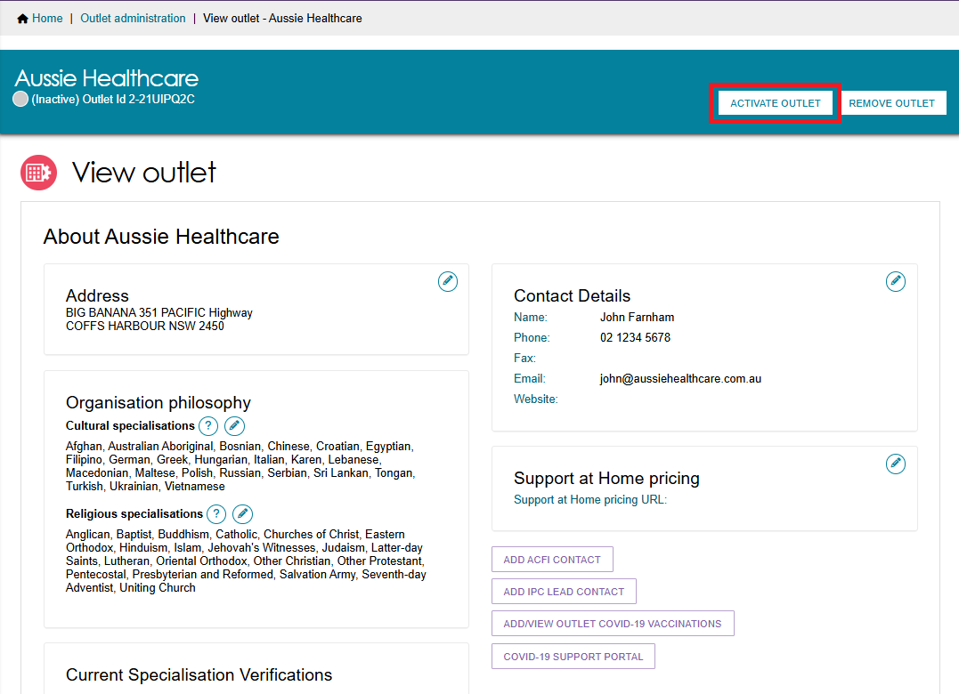
- Select ACTIVATE OUTLET at the bottom of the pop up, to confirm that you wish for this information to be displayed in the service finder. A warning message will display.
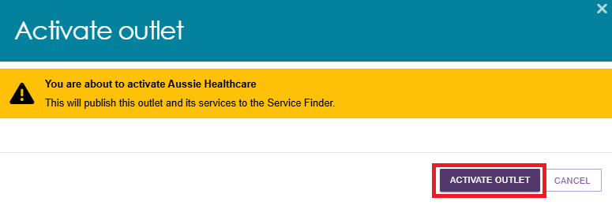
Your outlet is now active and operational service item information will display in the service finder, and will display as Active in the Service and Support Portal.
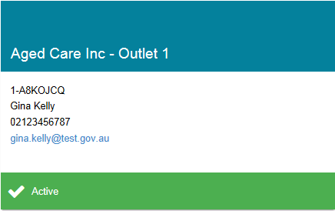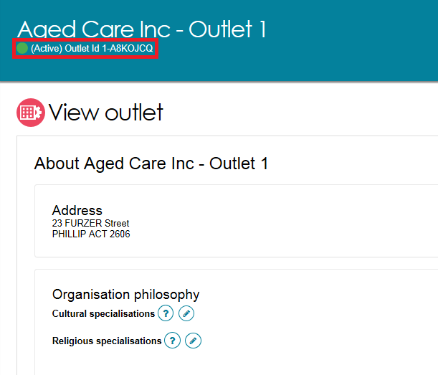

Deactivating an outlet
To remove an outlet from the service finders and stop referrals being sent to the outlet, it must be deactivated. An outlet cannot be made inactive if there are accepted and commenced services.
Navigate to the View Outlet details from the Outlet administration page for the outlet that you want to deactivate and select DEACTIVATE OUTLET.
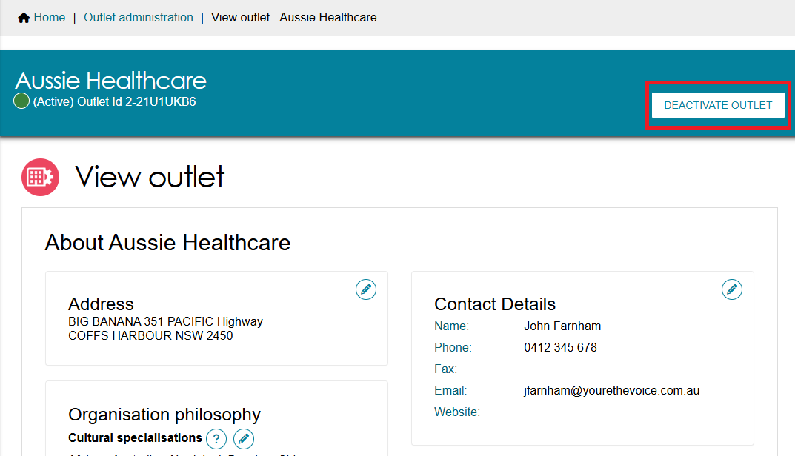
Select DEACTIVATE OUTLET again at the bottom of the pop up, to confirm that you wish to deactivate the outlet.
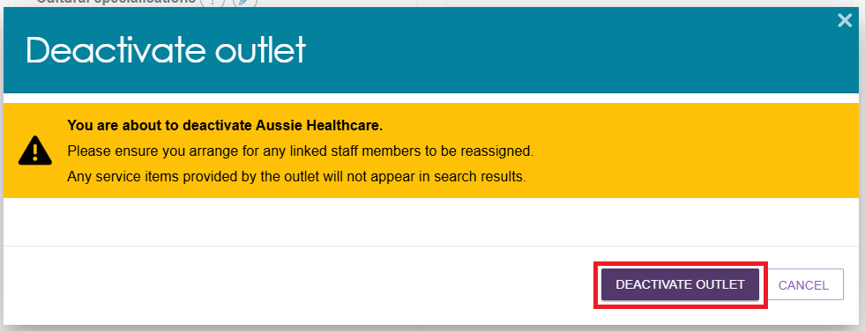
The outlet is now inactive, does not display on the relevant service finder or receive referrals, and displays as Inactive in the Service and Support portal.

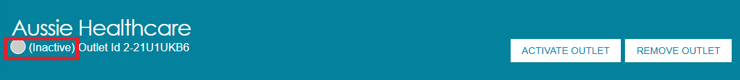

Removing an outlet from the Service and Support Portal
To remove an outlet from the Service and Support Portal, it must be in the status of ‘Inactive’.
- Navigate to the View Outlet details from the Outlet administration page for the inactive outlet you wish to remove and select REMOVE OUTLET.
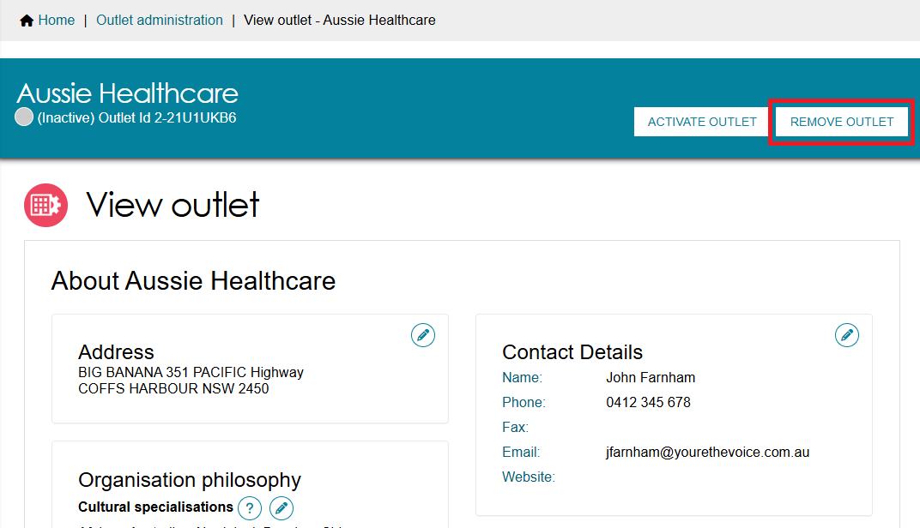
- Select REMOVE OUTLET at the bottom of the pop up, to confirm you wish to remove the outlet.
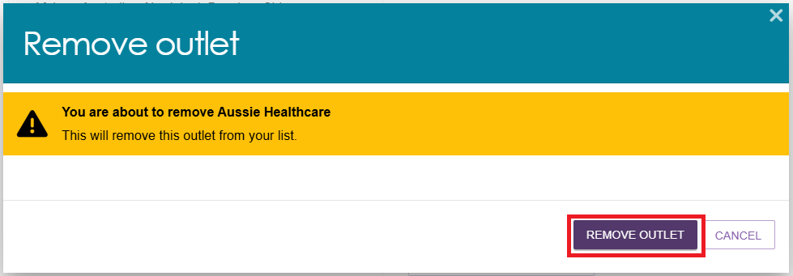
The outlet will no longer display in the Service and Support Portal.

! | If you want to create an outlet with the same name as the one you removed earlier, you will need to call the My Aged Care service provider and assessor helpline on 1800 836 799.

For more information or support
Further information is available from the Service and Support Portal Resources page.
The My Aged Care service provider and assessor helpline is available on 1800 836 799.

