LetterDate
HELLONAME_X SURNAME_X
304 Jackson Close
FREMANTLE WA 6160
Dear <first name>,

Support your health and reduce your dementia risk
Turning 50 is a good time to think about your future, and how you can stay healthier for longer. This includes your brain health and reducing your risk of dementia.
Dementia can affect memory, thinking and mood. Some cases can’t be avoided, but did you know that nearly half of all dementia cases could be prevented or delayed? There are things you can do that can make a real difference – you may already be doing some of them.
It's never too early, or too late, to reduce your dementia risk. Here are things you can do:
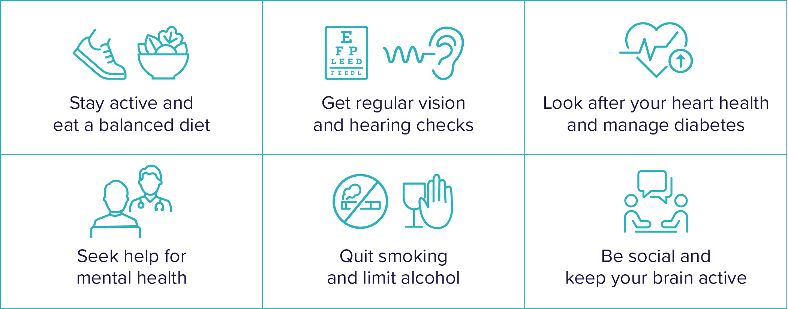

Learn how you can reduce your risk
Scan the QR code or visit health.gov.au/dementia to get your personalised dementia risk score and to learn more.
If you need more help - talk to your doctor or healthcare provider.

