Government Provider Management System
User Guide: Manage Your Organisation tile
June 2026
Version 0.3
This Government Provider Management System (GPMS) User Guide aims to provide registered providers an overview of how to manage their organisational details held by the Department of Health, Disability and Ageing in the GPMS Registered Provider portal.

Contents
1 Introduction 4
1.1 Purpose 4
1.2 Glossary 4
1.3 Login to the GPMS portal 4
1.4 Access Permission 5
1.5 Session time out 6
1.6 Further information and support 6
2 GPMS Registered Provider portal 6
2.1 Logging in 7
3 Provider Details 11
3.1 Provider details – Details tab 12
3.1.1 Edit provider details 13
3.1.2 Provider details – Registration tab 14
3.1.3 Provider details – Business contact tab 15
3.1.4 Provider details – Specialist aged care programs tab 16
4 Residential care homes 16
4.1 Search and Filter Residential Care Homes 17
4.2 Residential Care Home details – Details tab 18
4.3 Residential Care Home details – Aged care programs tab 19
4.3.1 Manage Offline Beds 20
4.4 Residential Care Home details – Contacts tab 25
4.5 View transferred Registered Residential Care Home 25
4.5.1 Recently acquired Residential Care Home 25
4.5.2 Residential Care Home change of ownership 26
5 Branches 26
5.1 Search and filter Branches 26
5.2 Branch Details – Details tab 27
5.3 Branch Details – Contacts tab 28
5.4 View transferred Branch 29
5.4.1 Recently acquired Branch 29
5.4.2 Branch change of ownership 30
6 Responsible persons and contacts 30
6.1 View Responsible Persons and Contacts 30
6.1.1 Responsible Persons and Contacts – All tab 33
6.1.2 Responsible Persons and Contacts – Residential Care Homes tab 35
6.1.3 Responsible Persons and Contacts – Branches tab 36
6.2 Point of Contact 36
6.2.1 What is a Point of Contact? 36
6.2.2 Add a new Point of Contact 36
6.2.3 Edit Personal details for a Point of Contact 42
6.2.4 Role details 47
6.2.5 Cease a Point of Contact 52
6.3 Responsible Persons 56
6.3.1 What is a Responsible Person? 56
6.3.2 Add Responsible Person to Residential Care Home 56
6.3.3 Edit Personal details for a Responsible Person 58
6.3.4 Updating Position details for a Responsible Person 59
6.3.5 Adding a Contact purpose 61
6.3.6 Ceasing a Contact Purpose 63
7 Associated Providers 65
7.1 View Associated provider Arrangements 65
7.1.1 Search and Filter 65
7.2 View Associated provider details 66

Introduction
The Government Provider Management System (GPMS) is a flexible Information Technology (IT) system which is a critical part of the Aged Care Digital Transformation Initiative underway to support aged care reform through better technology.
GPMS provides greater connectivity and data sharing between aged care providers and government.

Purpose
This User Guide has been designed to support registered providers to view and manage their:
- Provider organisation details
- Residential care homes
- Branches
- Responsible persons and contacts
- Associated providers

Glossary
A glossary is available on the departments website to help users to understand the terminology used in relation to GPMS functionality.

Login to the GPMS portal
To login to the GPMS Registered Provider portal please visit the GPMS portal log in page.
If users require assistance logging into the GPMS Portal, please refer to the Government Provider Management System – Quick Reference Guide: Logging into GPMS.

Please note:
The Department of Health, Disability and Ageing will retain records of users’ access to GPMS. When prompted upon login to GPMS, the user must accept the GPMS Terms of Use to be able to access the system.
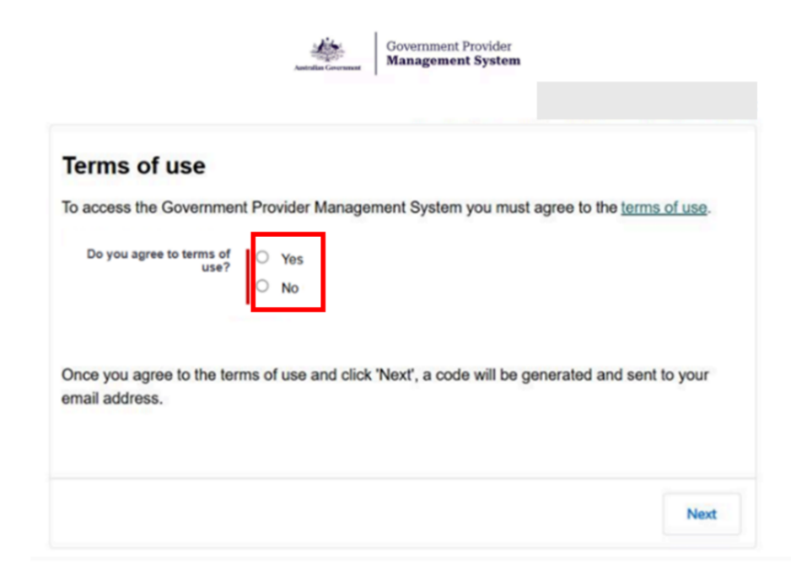

Access Permission
Organisation administrators can assign the following roles in GPMS via the Manage users function on the GPMS landing page:
Role | Tasks the user can perform
Provider staff (Registered Provider) | - View all details about their organisation and reported contacts  - Manage all contacts for their organisation
Provider staff (Home/Branch) | - View limited details about their organisation  - Access information regarding Homes and Branches they have been granted access to  - Manage contacts for Homes and Branches they have been granted access to
RN Submission - Service | - Submit 24/7 Registered Nursing reports on behalf of their organisation
Financial Reporting Submission | - Submit Quarterly Financial Reports on behalf of their organisation
QI Bench Marker | - Upload bulk Quarterly Indicator data.
QI Role - Org | - Submit Quarterly Indicator data on behalf of their organisation.
QI Role - Service | - Submit Quarterly Indicator data on behalf of their organisation.
Performance review (Org) | - View Star Ratings, Quality Standards, and regulatory decisions for their organisation.
Performance review (Home/Branch) | - View Star Ratings, Quality Standards and regulatory decisions for assigned residential care homes and branches.
SSP Provider Operations User | - Submit Provider Operations information and generate previews of provider report based on ACDW data.
In this document, the user role of Provider Staff (Registered Provider) will be referred to as provider-level user and Provider Staff (Home/Branch) as Home/Branch level user.

Session time out
Before making updates, the user should be aware of the “time-out” functions when a user is logged in to the GPMS portal.
GPMS has a time-out feature which automatically requires re-entry of username and password after 15 minutes of inactivity on the GPMS portal.
Information which is lost due to “time-out” cannot be recovered.

Further information and support
Please refer to the Government Provider Management System webpage and the Managing Your Organisation webpage for more information.
If users require further assistance to login to GPMS please contact the My Aged Care service provider and assessor helpline on 1800 836 799, Monday to Friday (8am to 8pm) and Saturday (10am to 2pm) local time across Australia.
For translating and interpreting services, call 131 450 and ask for My Aged Care on 1800 836 799.
To use the National Relay Service, visit About the National Relay Service (NRS) | Access Hub or call 1800 555 660.
To access sign language interpreting and captioning services through Deaf Connect, call 1300 773 803 or email interpreting@deafconnect.org.au.

GPMS Registered Provider portal
The Registered Provider portal acts as a central hub for registered providers to manage their organisational details. This includes viewing or modifying details about their:
- Organisation
- Responsible persons and contacts
- Branches
- Residential Care Homes, and
- Associated providers

Logging in
Users are required to log in to the Registered Provider portal by selecting the Log in to GPMS Registered Provider portal button.
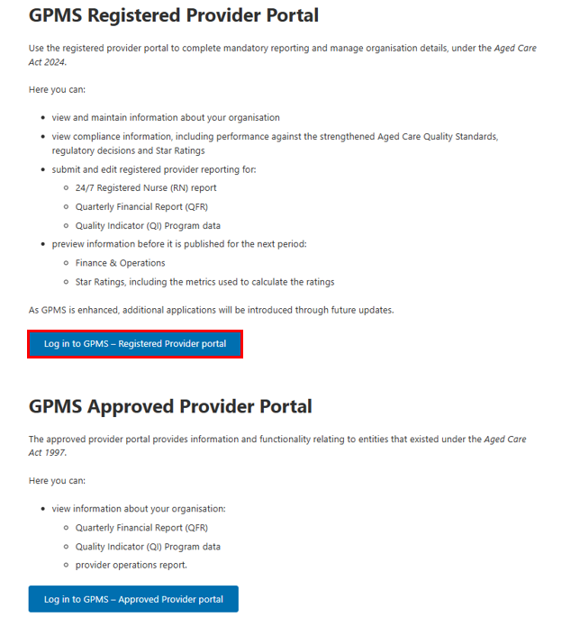
Upon selecting the Registered Provider button, users will be directed to the Log in using page where they will be required to select their login authentication method.
Information and guidance regarding logging in to GPMS can be found in the GPMS Quick Reference Guide: Logging in to GPMS.
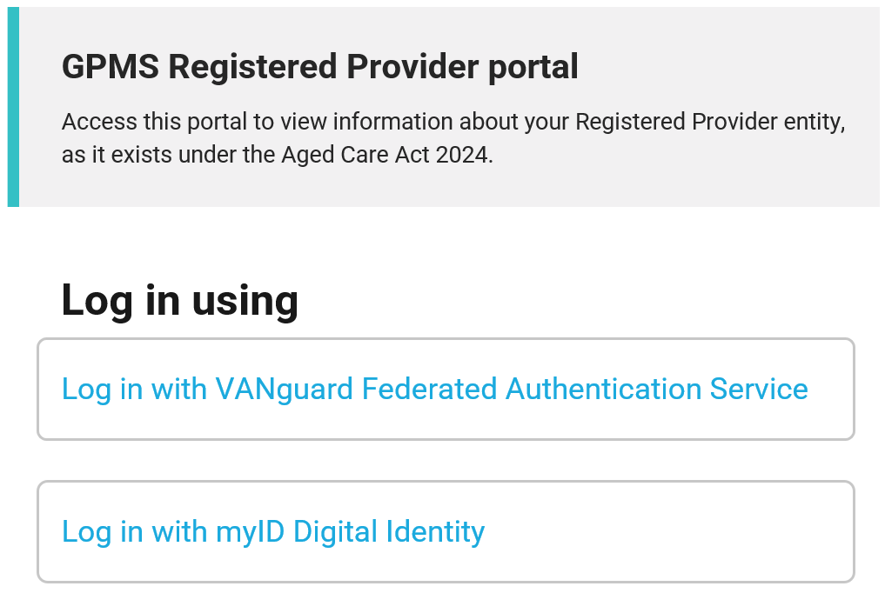
Once logged in, users will navigate to the GPMS Terms of use page and will be required to accept the Terms of Use to continue in the system.
The Registered Provider portal landing page will appear once the Terms of Use have been accepted.
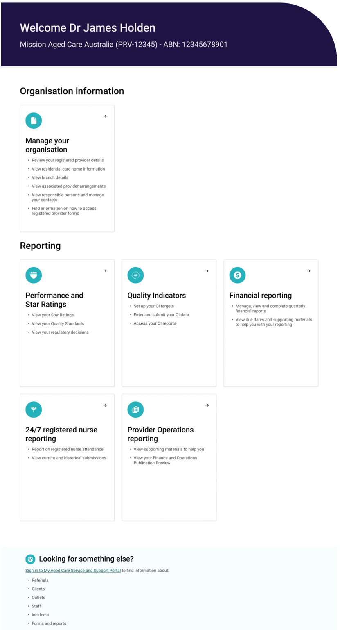
Depending on their access level, users may see the following tiles displayed on the Registered Provider portal landing page.
Menu tile | Description
Manage your organisation | - Review registered provider details  - View residential care home information  - View branch details  - View associated provider arrangements  - View Responsible Persons and manage contacts  - Find information on how to access registered provider forms
24/7 Registered Nurse Reporting | - Submit 24/7 Registered Nurse (RN) reporting
Financial Reporting | - Submit Quarterly Financial (QFR) reporting
Quarterly Indicators | - Submit Quarterly Indicator (QI) Program Reporting
Provider Operations Reporting | - View Finance and Operations Publication Preview
Performance and Star Ratings | - View Star Ratings  - View Quality Standards  - View regulatory decisions
Looking for something else? | Sign in to My Aged Care Service and Support Portal to find information about:  - Referrals  - Clients  - Outlets  - Staff  - Incidents  - Forms and reports
To manage your organisation, users must select the Manage your organisation tile. The following tiles are then displayed once Manage your organisation tile is selected:
Menu tile | Description
Provider details | - View registered provider details  - View registration details  - View and manage contact information  - View specialist aged care programs
Residential care homes | - View residential care homes  - View details of specialist aged care programs  - View and manage details about Responsible Persons and Points of Contact for specific residential care homes
Branches | - View branch details  - View the branch Points of Contact
Responsible persons and contacts | - View and manage details about Responsible Persons and contacts for the organisation  - View and manage details about Responsible Persons and contacts for specific residential care homes and branches
Associated providers | - View associated provider arrangements
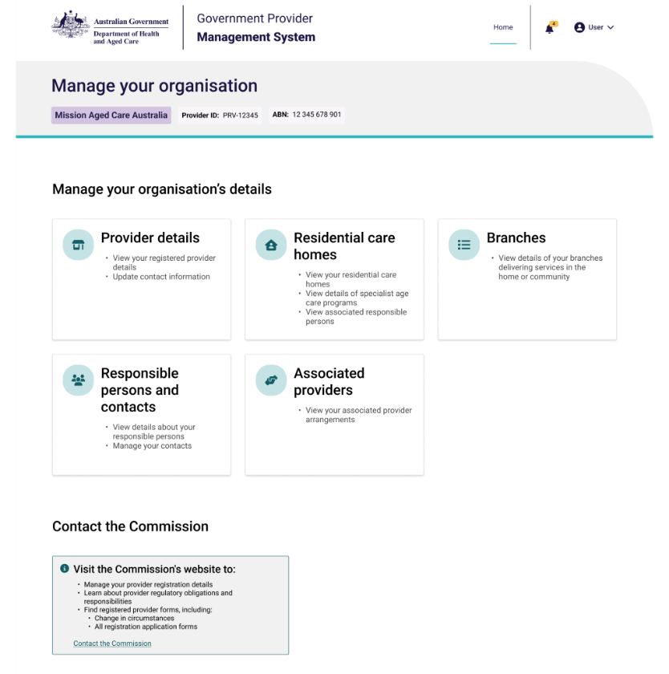

Provider Details
From the Manage your organisation landing page, users can select the Provider Details tile to view the Provider Details landing page.
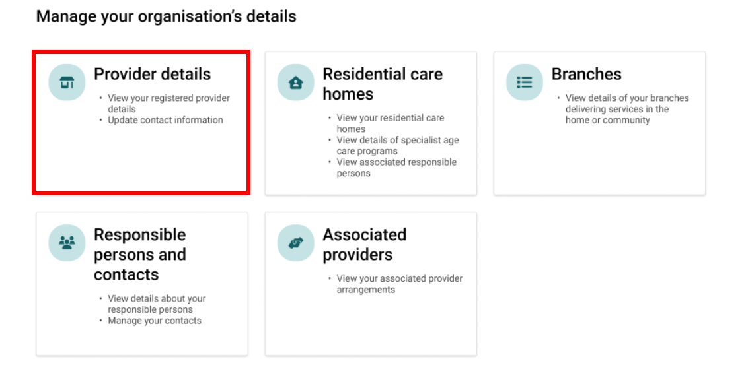
Four tabs are displayed at the top of the Provider Details landing page including:
- Details
- Registration
- Business contact
- Specialist aged care programs
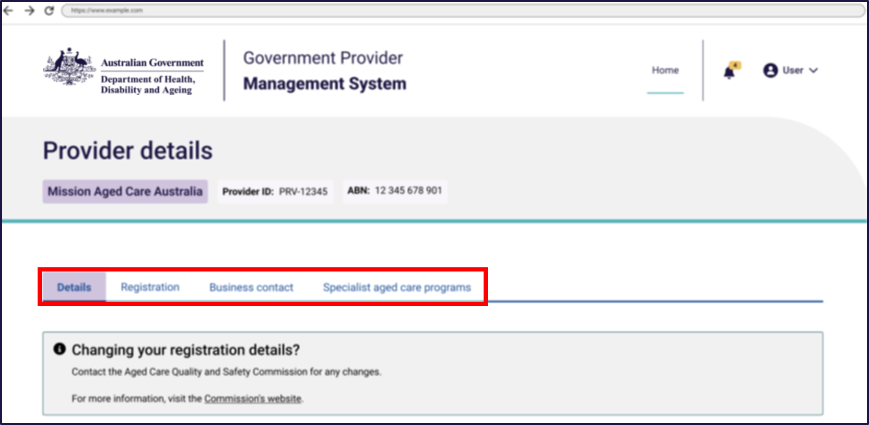

Provider details – Details tab
In the Details tab, users can view different sections for their organisation, including:
- Registered provider details
- Australian Business Number (ABN) details
- Incorporation details
- Parent / holding company details
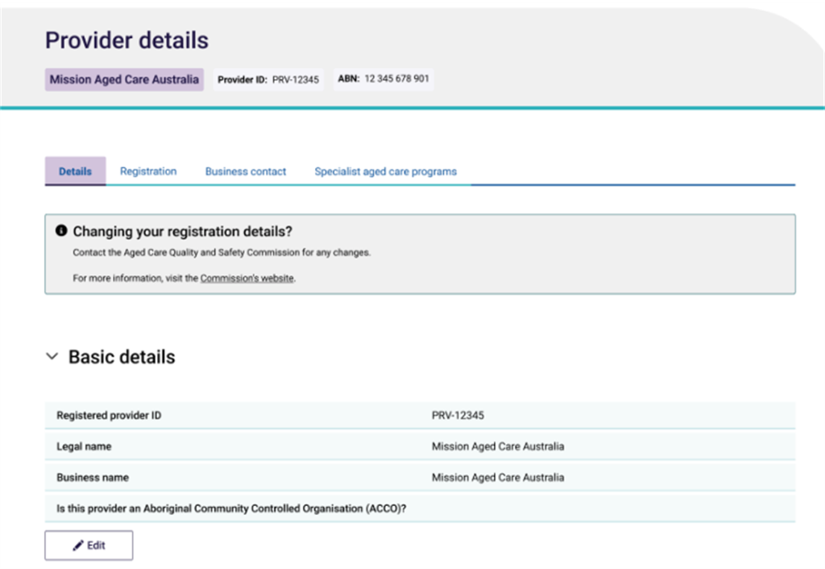
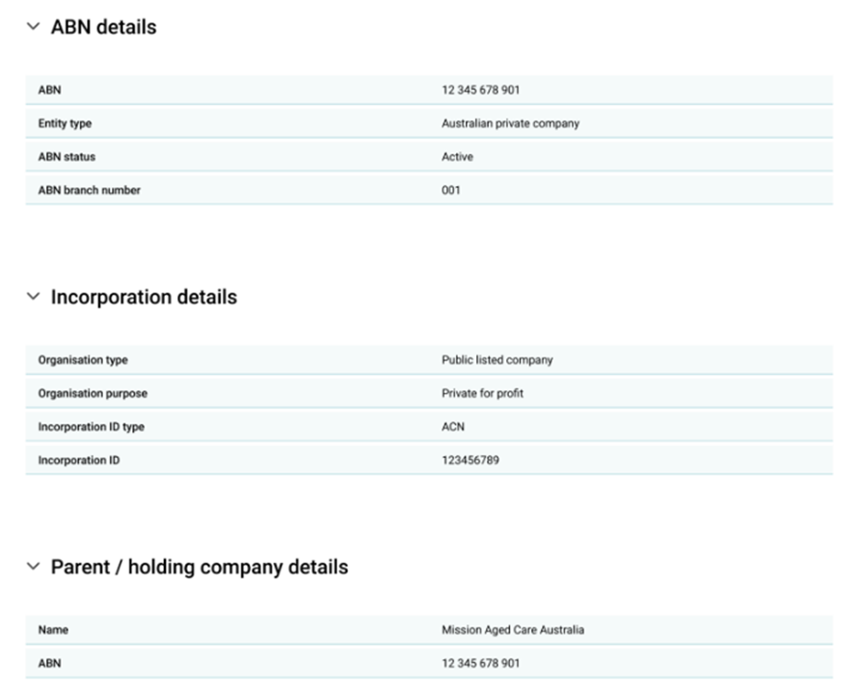

Edit provider details
Depending on their access level, users can edit information held for their Registered Provider in real-time.
There are two types of changes, as described in the sections below.

Non-notifiable change
These are changes that registered providers are not obligated by aged care legislation to notify the Aged Care Quality and Safety Commission (Commission) about. Information that is not notifiable and can be modified in GPMS will display an Edit option.
This information includes:
- Aboriginal Controlled Community Organisation details.
- This field may be blank upon initial review and if blank, the edit button will be visible to update.
If the Aboriginal Community Controlled Organisation field contains a Yes or No, then org-level users cannot edit the field, and the Edit button will not be visible to the user. This can only be changed using the Change in Circumstance form on the Commission’s website.
To update this field:
- Select Edit.
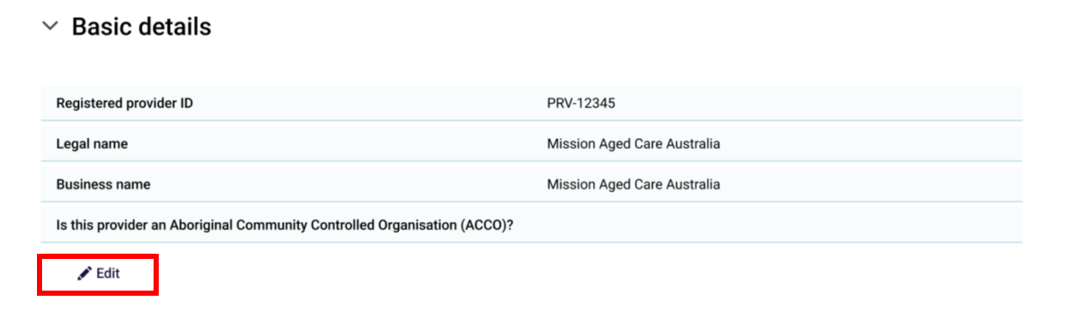
- Select Yes or No
- Select Save to confirm. Alternatively, the user can select the Cancel button to cancel the action and navigate back to the Provider Details page.
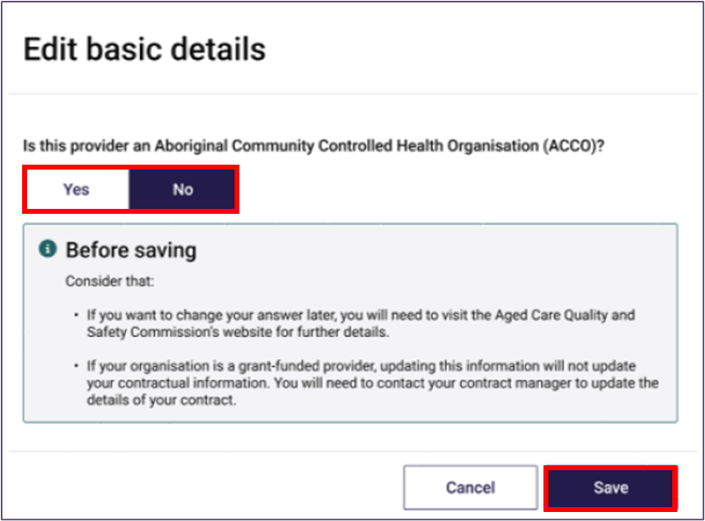

Changes that may impact suitability as a registered provider of aged care
Making any other changes to the information held in the Provider details tile can only be undertaken by notifying the Commission.
This is because it is possible that a change to this information could affect the organisation’s suitability as a Registered Provider of aged care. Information regarding this can be found on the Commission’s website or by clicking on the Contact the Commission hyperlink in the portal.

Provider details – Registration tab
In the registration tab, the user can view the Registration conditions and Registration categories sections.
To update the information shown in this tab, users are required to contact the Commission.
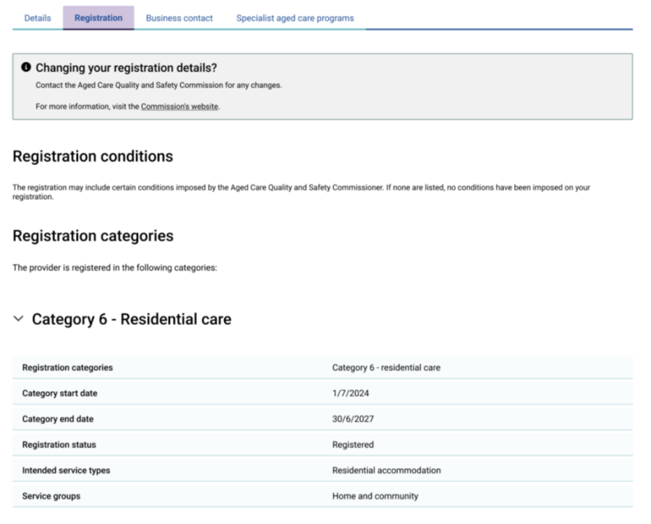

Provider details – Business contact tab
In the Business Contact tab, users can view Contact details and Address details for the organisation. Users can edit the following details by selecting the Edit button:
- Website
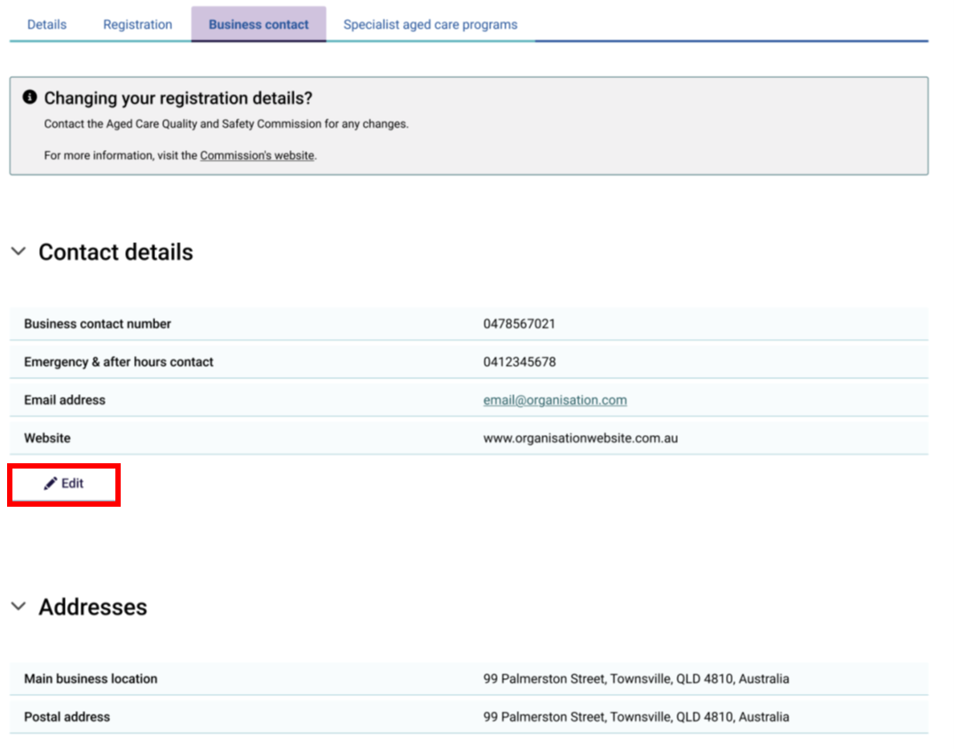

Provider details – Specialist aged care programs tab
The specialist aged care programs tab contains specific information about the organisation’s specialist aged care programs, including:
- Agreement ID
- Program type
- Status
- Program start date
- Program end date
To update the information shown in this tab, users are required to contact the Commission.
Note:
If there are no specialist aged care programs associated with this provider, this list will remain blank
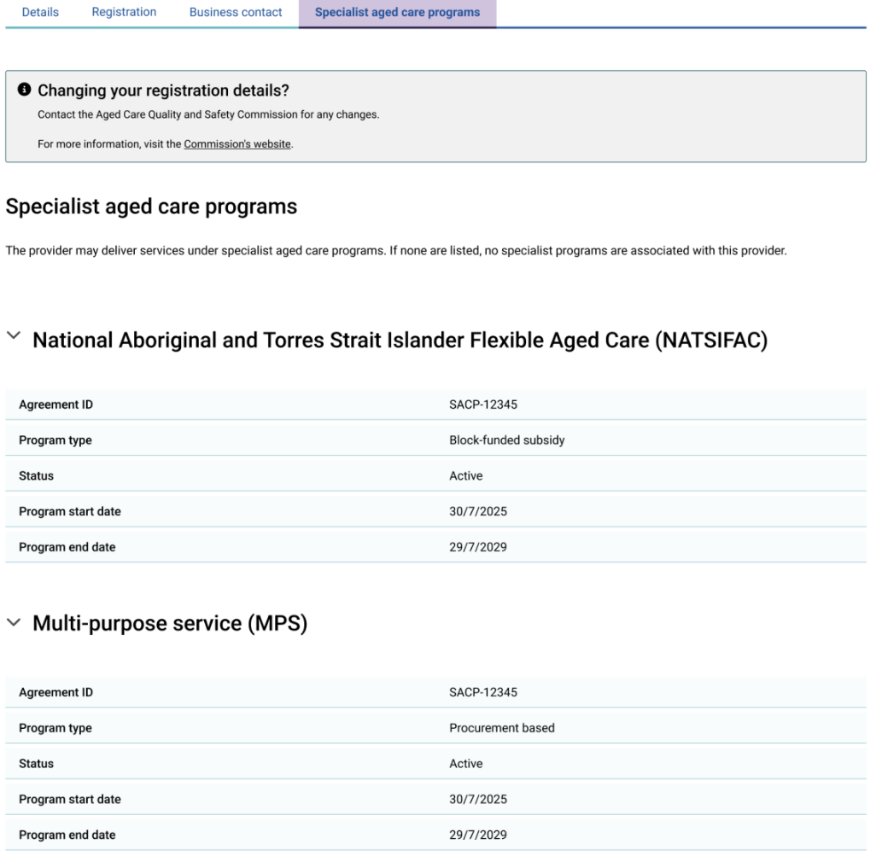

Residential care homes
From the Manage Your Organisation landing page, users can select the Residential care homes tile to view a list of homes they are authorised to access.

Search and Filter Residential Care Homes
Users can search for homes by their RCH ID, name, or program/payment ID, or filter the displayed list by Program type, State or by Status from the dropdown menu and select the Apply Filters button.
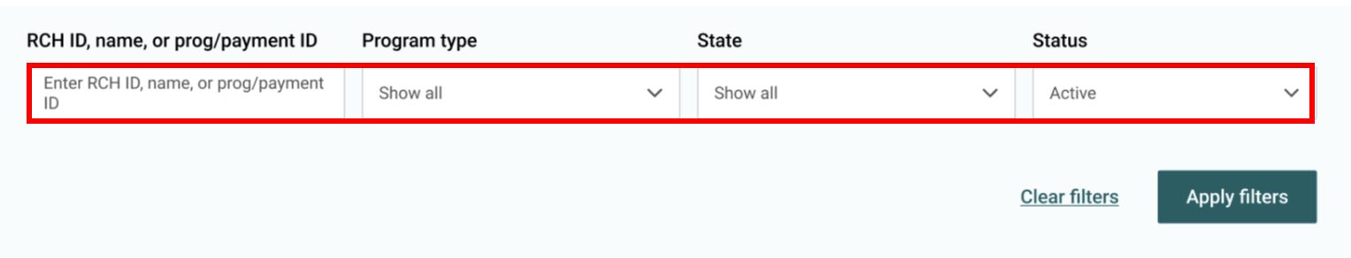
Users can sort this table alphabetically. The sort order is displayed when a user hovers over and selects the column headings.
The status of Active is selected by default.
- To view Inactive Homes
- Click the Status dropdown menu.
- Select Inactive.
- Click Apply Filter.
- The user can view all homes by the following statuses:
- Active
- Inactive
- Show all
- To revert to the default view, select Clear Filters.
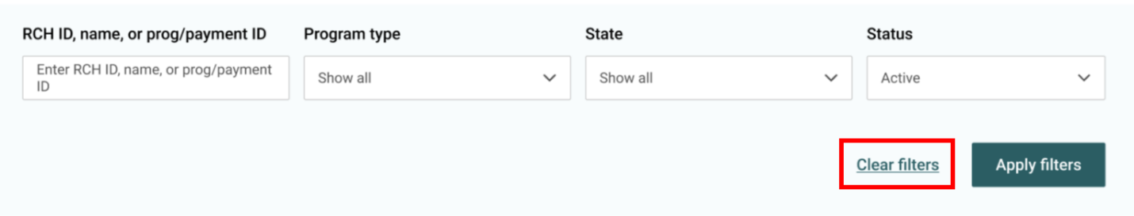
Users can select the View home details button to view more information about specific homes, which will take them to the selected home’s Details page.
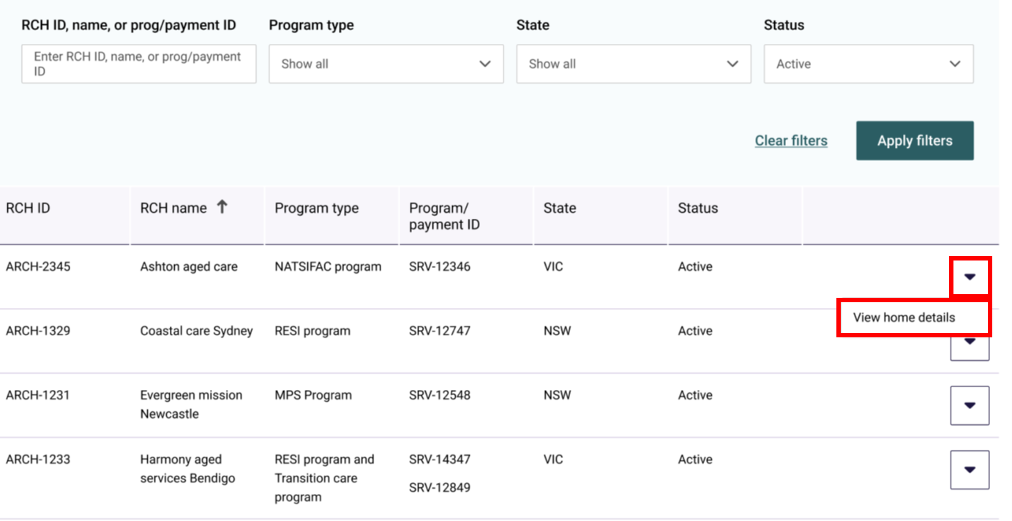
Once users navigate to the home details page, three tabs will display at the top of the page:
- Details
- Aged care programs
- Contacts
If the user would like to update the home’s details, they are required to notify the Commission via providernotifications@agedcarequality.gov.au or the Department via GPMS.Project@health.gov.au.

Residential Care Home details – Details tab
The details tab contains the following information about the selected home:
- Basic details
- Address
- Contact details
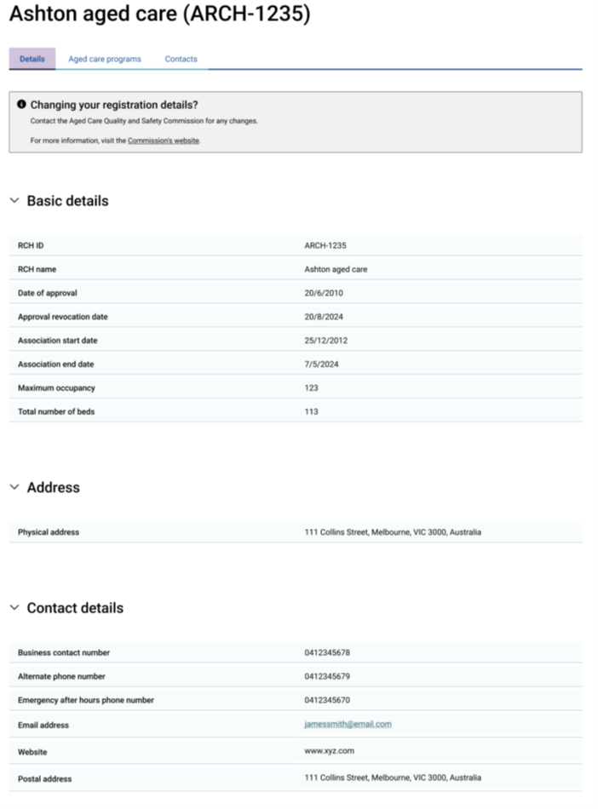

Residential Care Home details – Aged care programs tab
The Aged care programs tab contains information about the programs associated with the home and allows the user to view operational and offline beds and AN-ACC classification.
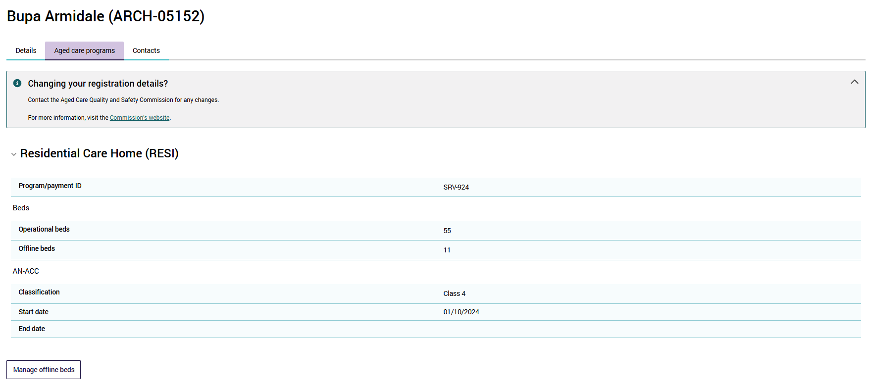

Manage Offline Beds
Within the Aged care programs tab, the manage offline beds button enables providers to:
- record beds at a RCH as offline
- make offline beds at a RCH available for use.
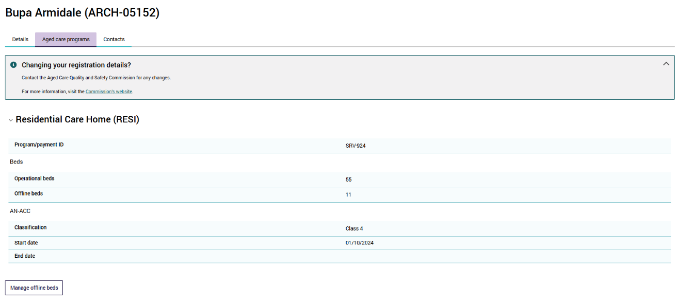
To record beds as offline click the ‘Manage Offline Beds’ button:
You will land on the Temporary offline beds page. Providers can record beds as offline for the following reasons:
- Lack of capacity to deliver care due to workforce or operational issues
- Delivering other Commonwealth funded aged care (e.g. TCP, MPS, NATSIFAC)
- Delivering other non-aged care or non-Commonwealth funded services (e.g. private residential care, NDIS, health services)
- Offline due to the redevelopment, refurbishment or extension of the whole or part of the building or site
- Opening of new residential care home in stages
- Offline pending permanent closure of whole or part of the residential care home
Note:
Some homes may have an additional category titled ‘Data migration – beds reported as offline prior to 1 November 2025’. This category was used to migrate existing offline bed data to the new GPMS. Offline beds in this category will be able to be moved to a different category or brought online as operational. Beds will not be able to be reported as offline for this category.
- Find the relevant reason beds are being taken offline and click Edit.
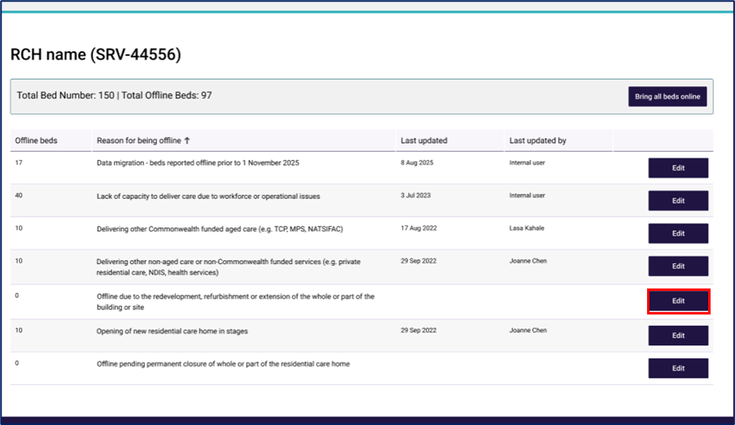
- Enter the number of beds you would like to be made offline and click Submit.
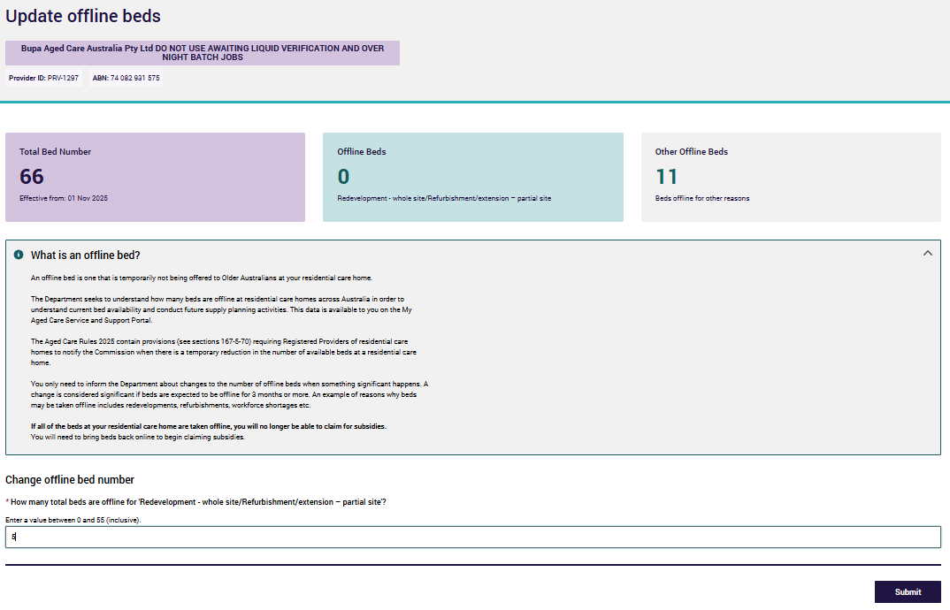
A confirmation box will appear to confirm the number of beds you are taking offline for your selected reason.
- click Ok
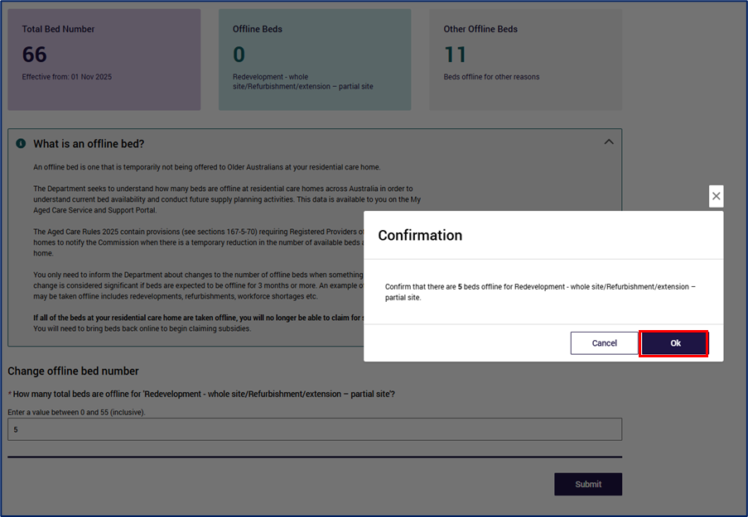
A confirmation email will be sent to your Responsible Person or Points of Contact. Please ensure your contact details are up to date, so you can receive this information.

To bring beds back online to operational:
- click Manage Offline Beds
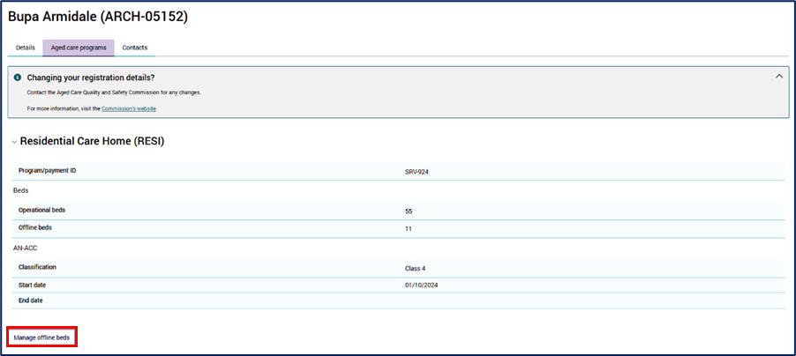
Find the relevant reason beds are being brought back online - for example, redevelopment works at your RCH may have been completed and all beds can be brought back online.
- click Edit
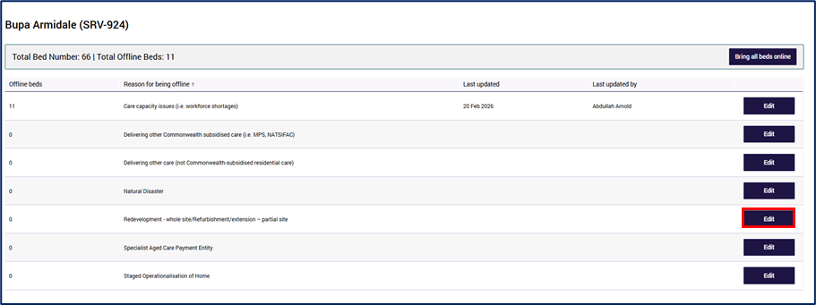
- Enter in the updated offline bed number and click Submit.
If you are wanting to bring all beds online, enter in 0.
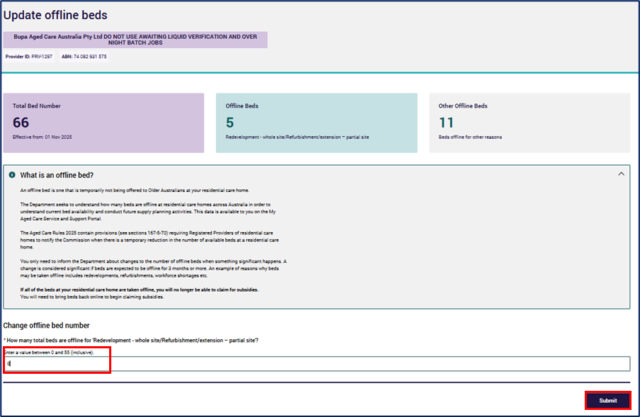
A confirmation box will appear to confirm you want to bring beds back to operational status.
- Click Ok
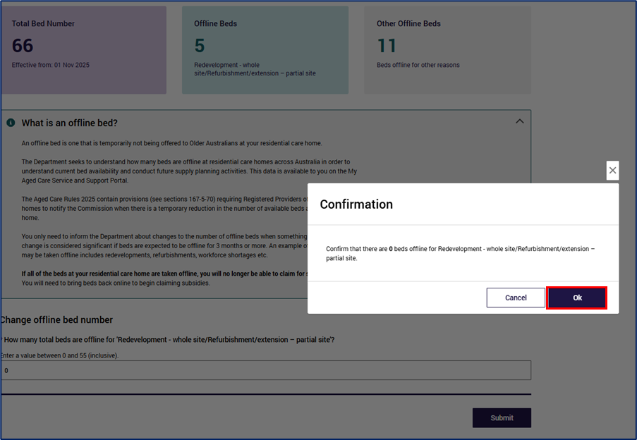
For further information on managing your offline beds, please visit Places to people – Embedding choice in residential aged care or Reporting offline beds.

Residential Care Home details – Contacts tab
The Contacts tab contains a list of Responsible Persons and a list of Points of Contact for the selected home.
The user can Add a new Point of Contact from this screen by selecting the + Add a Point of Contact button see section 6.2.2 Add a new Point of Contact.
Users can add an existing Responsible Person to a RCH from this screen by selecting the + Add a new responsible for button. See section 6.3.2 Add Responsible person to a residential care home.
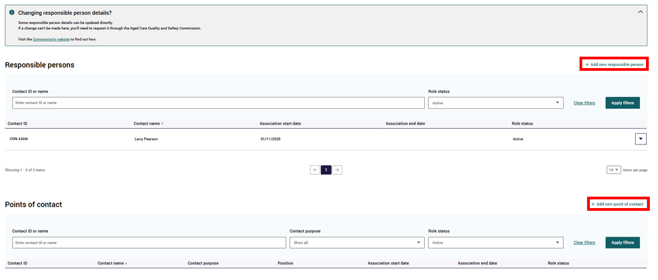

View transferred Registered Residential Care Home
On the Residential Care Home landing page, users can view information for homes that have recently been acquired or have had a change in ownership.
Information banners will display on the relevant homes’ page to alert users to the transfer status of the home.

Recently acquired Residential Care Home
A registered provider that has transferred one of its homes to another registered provider will see a status of Inactive. The new owner of the home will see a status of active within their residential care home table
A banner will display on the homes’ details page if the home has been acquired within the last 30 days.
Event | Banner display
Recently Acquired RCH | The ownership of this home was recently transferred to your organisation from [Previous Registered Provider’s name]. Review the details to ensure they are correct.

Residential Care Home change of ownership
A registered provider that has transferred one of its homes to another registered provider will see a status of Inactive for this transferred home.
Any updates to the home that occur after the change of ownership by the new registered provider, will not be visible to the previous registered provider. Registered providers are only able to see information relevant to transferred homes up until the date of home transfer.
The user will not be able to add any new contacts to a transferred home.
If searching for a transferred home in the Residential Care Homes landing page, select Inactive status and apply relevant filters.
A banner will display on the home’s details page if the home has been transferred within the last 30 days.
Event | Banner display
Change of ownership RCH | The ownership of this home was recently transferred from your organisation to [NEW Registered Provider's Name].

Branches
From the Manage Your Organisation landing page, users can select the Branches tile to view a list of branches they are authorised to access.
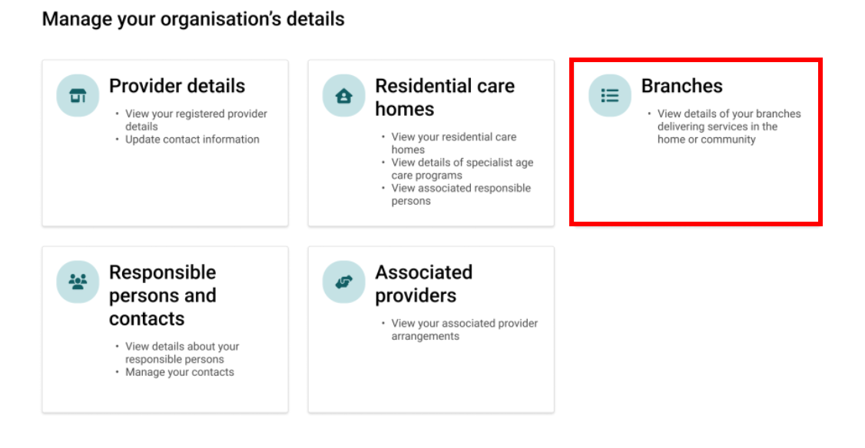

Search and filter Branches
Users can search for a specific branch by entering a Branch ID or name and can filter their search by Program type, State and Status and selecting Apply filters.
- The user can view all branches by the following statuses:
- Operational (selected by default)
- Non-operational
- Show all
Users can filter and sort this list based on their needs and use the View Branch details action to open the Branch details page and view details about a specific Branch.
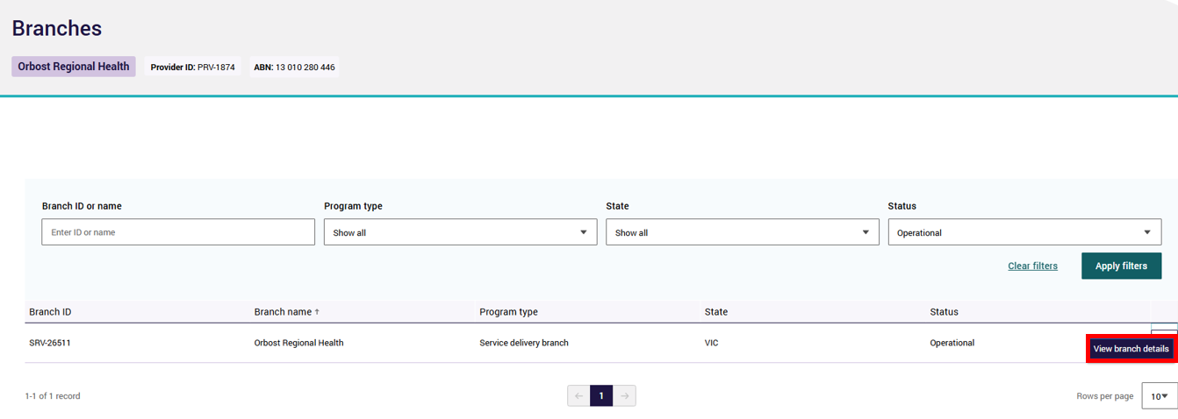
The Branch Details page contains two tabs:
- Details
- Contacts
If the user would like to update details, they are required to contact the Department's Local Network Office for aged care providers in their State or Territory. For more information, visit the Department’s website.

Branch Details – Details tab
The Details tab displays all information available for the branch including:
- Basic details (Branch ID, Branch name, Program type, Status and Start date)
- Address (Branch address)
- Contact details (Email address, Business contact number, Alternate phone number, Emergency after hours phone number and Postal address)
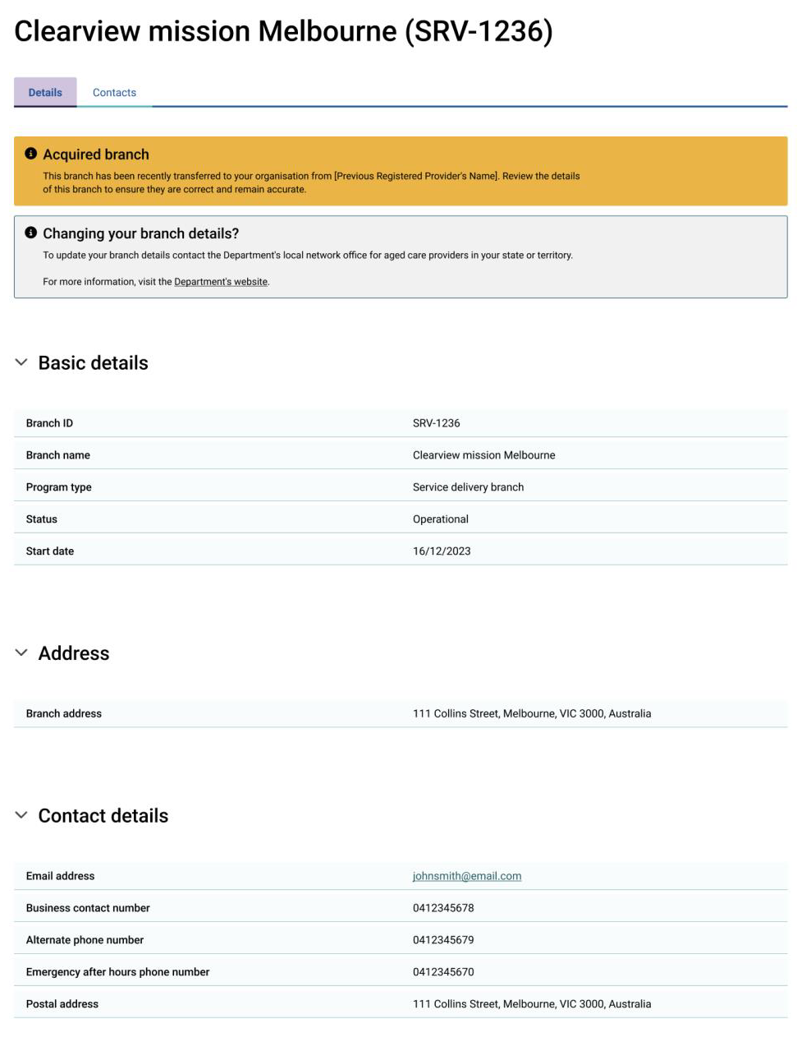

Branch Details – Contacts tab
By selecting the Contacts tab, users can view a list of Points of Contact relating to the selected Branch. The user can also Add a new Point of Contact from this screen by selecting the + Add a new Point of Contact button.
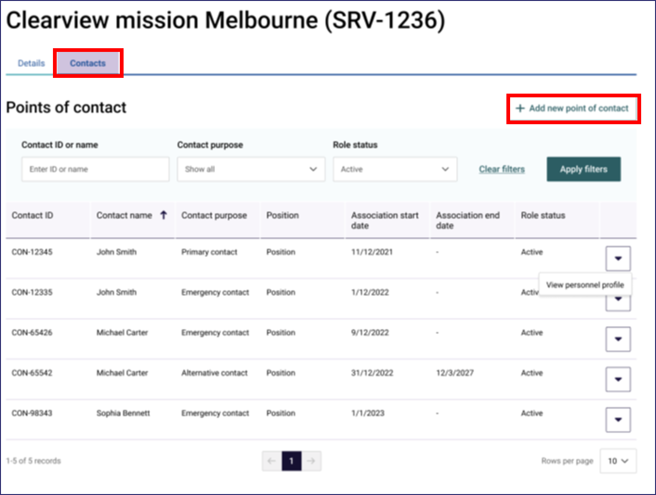

View transferred Branch
On the Branch Details page, users can view information for a Branch that has recently been acquired or had a change in ownership.
Information banners will display on the relevant Branches page to alert users to the transfer status of the Branch.

Recently acquired Branch
A registered provider that has transferred one of its Branches to another registered provider will see a status of Transferred. The new owner of the Branch will see a status of Operational within their Branch table.
A banner will display on the Branches’ details page if the Branch has been acquired within the last 30 days.
Event | Banner display
Recently Acquired Branch | The ownership of this branch was recently transferred to your organisation from [Previous Registered Provider’s name]. Review the details to ensure they are correct.

Branch change of ownership
A registered provider that has transferred one of its Branches to another registered provider will see a status of Transferred.
Any updates to the Branch that occur after the change of ownership by the new registered provider will not be visible to the previous registered provider. Registered providers are only able to see information relevant to transferred Branches up until the date of Branch transfer.
The user will not be able to add any new contacts to a transferred Branch.
When searching for a transferred Branch on the Branch landing page, select Non-operational status and apply relevant filters. Branches that have been transferred will display a status of Transferred.
A banner will display on the Branch details page if the Branch has been transferred within the last 30 days.
Event | Banner display
Change of ownership Branch | The ownership of this Branch was recently transferred from your organisation to [New Registered Provider’s name].

Responsible persons and contacts
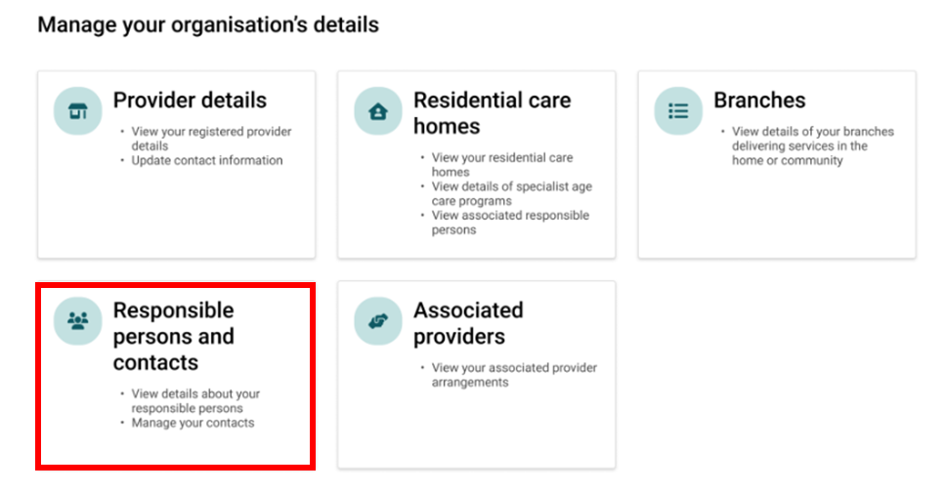

View Responsible Persons and Contacts
When selecting the Responsible Persons and Contacts tile or by selecting the Contact tab in either the Residential Care Homes or Branches tiles, the user will be presented with a table that displays the personnel the user is authorised to access. It will also display different information depending on the user profile, specifically:
- a Provider Staff (Registered Provider) user will see all Responsible Persons and contacts associated with the whole organisation.
- a Provider Staff (Home / Branch) user will only see those associated with the Residential Care Homes or Branches they have been given access to by the Organisation Administrator.
The table displays the following information:
- Contact ID
- Contact Name
- Responsible Person – tick indicates the person is currently assigned as a Responsible Person
- Point of Contact – tick indicates the person is currently a Point of Contact
- Role Status
- Active – this indicates that the personnel has at least one active role in the organisation, either as a Responsible Person or a Point of Contact.
- Inactive – This indicates that the personnel does not have any active Responsible Person or Point of Contact role, within the organisation.
The table can be sorted by last name or first name alphabetically. To sort, hover the mouse over the column headers and click to change the order of the displayed list.
Note:
The steps set out in this section are intended to cover all users with access to the GPMS Registered Provider portal. Users with limited access will not be able to perform all of these steps outlined in this document.
Note:
If the table displays duplicate records, meaning that the same individual is listed more than once, users are required to advise the Department by completing and submitting the GPMS - Reporting a Duplicate Contact form, available on the Department’s website. This will help to improve the information held about organisations in GPMS.
The table below contains information to guide the user in making changes to existing contact information:
Contacts role type | Steps to follow
Primary Contact | If the user is updating the current primary contact for a Home or Branch, a new Primary Contact must be added in order to cease the current primary contact.
Contact | To update the contact purpose of a Point of Contact with an incorrect contact purpose, the Contact’s role must be end-dated, and a new role with the correct contact purpose must be added.  To update the contact purpose for a Point of Contact that has changed roles within the organisation, resulting in a change to their contact purpose as a Point of Contact, the individual’s Point of Contact role must first be ceased, then a new role with a start date can be added that reflects when the Point of Contact commenced their new role.
Responsible persons | Users are only able to update the Preferred name and Position details (e.g. contact information and availability) of an existing Responsible Person displayed within GPMS. To add or cease a Responsible Person, providers are required to notify the Commission via a Change in Circumstance form.
Note:
Users can identify the Key Contact for their organisation in the All tab of the Responsible Persons and Contacts tile.
The Key Contact card will be displayed at the top of the page.
If no Key Contact is assigned, the card will display Not assigned instead of a name. To update the Key Contact, users should follow the steps outlined in section 6.3.5.
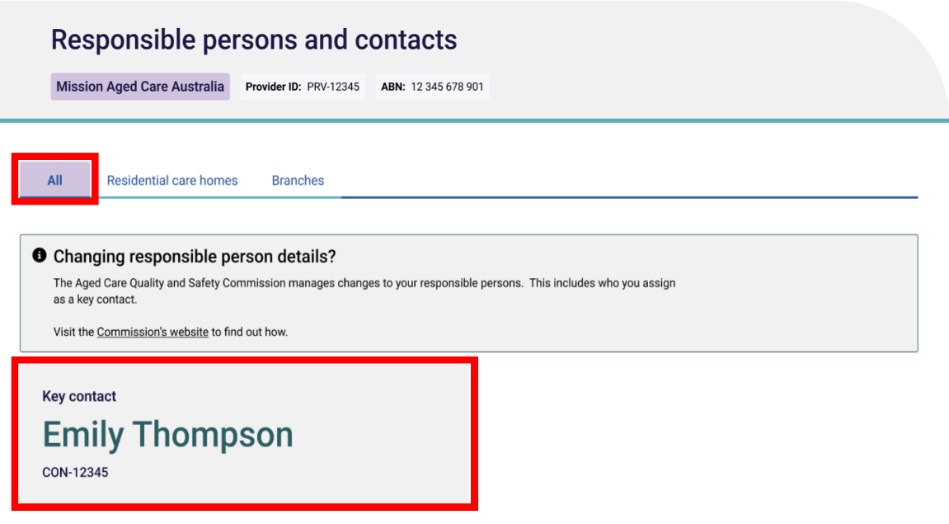

Responsible Persons and Contacts – All tab
There are three tabs within the Responsible Persons and Contacts tile with the All tab set as default.
The All tab allows users to view all Responsible Persons and Contacts the user is authorised to access.
To search contacts in the All tab, users can enter a Contact Id or Name in the input field and then click Apply Filters.
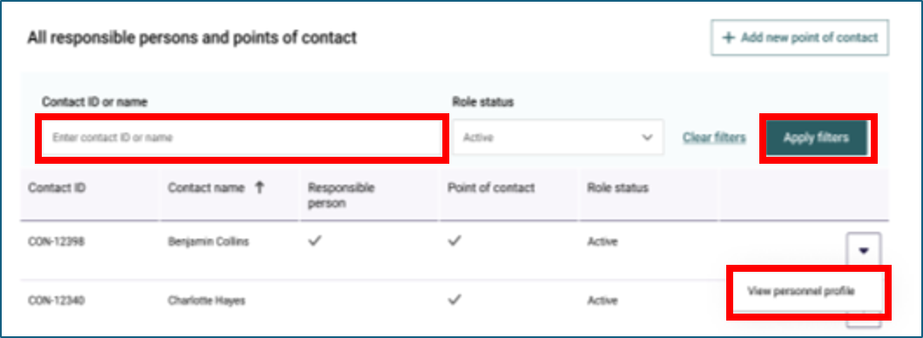
Users can then sort the results table alphabetically. The sort order is displayed when a user hovers over and clicks on the column headings.
Users can view profiles of contacts and responsible persons by clicking on the drop-down arrow in the row of the contact they wish to view and selecting View personnel profile. This action will navigate the user to the Personnel profile screen.
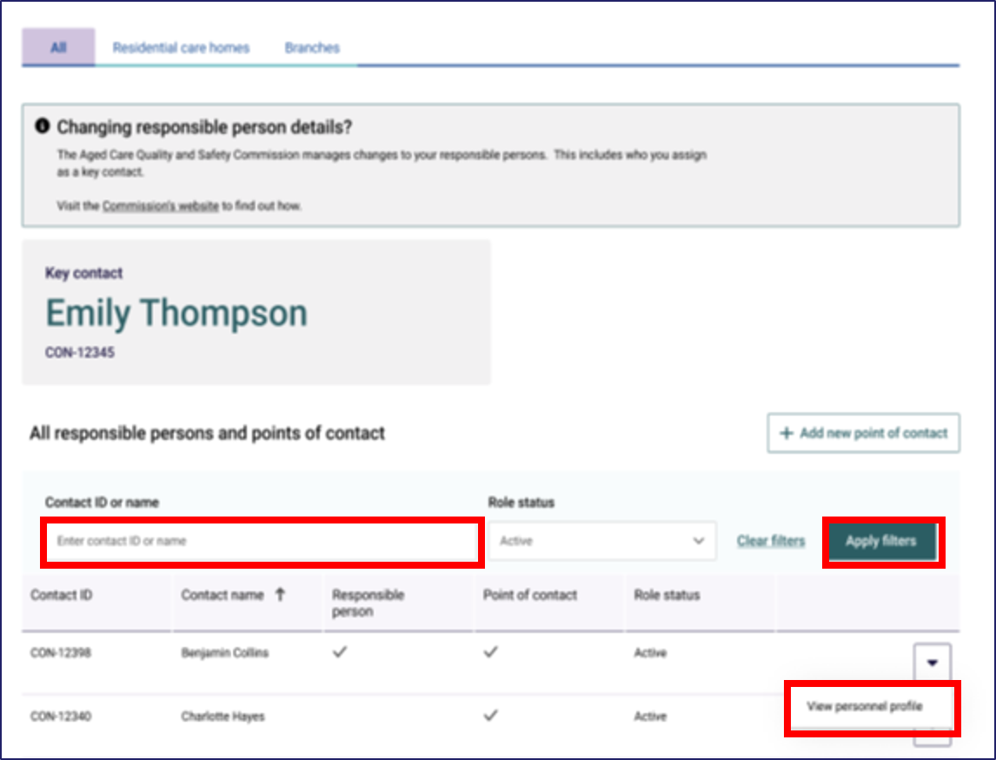
Note:
View section 6.2.3 for details on how to edit a Point of Contact.
View section 6.3.3 for details on how to update a Responsible Person.
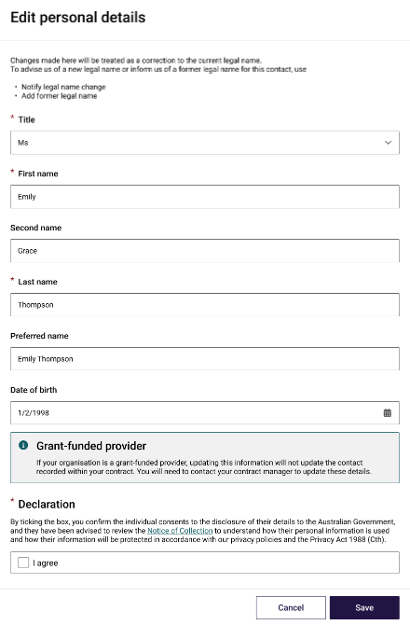
Users can also add a new Point of Contact by selecting the + Add a new Point of Contact button within the All tab. For more information on adding a new Point of Contact, see section 6.2.2 Add a new Point of Contact.
Note:
Some edits can only be made to those personnel that do not have an active Responsible Person role within the organisation. To change the suitability of a Responsible Person, providers should use the Responsible Person details update form available on the Commission’s website. To update position details for a Responsible Person, please see section 6.3.4.
Note:
The system will run a duplication check once the user selects Save. If potential duplicate contacts are flagged, a matching records found screen will appear and allow the user to check their updates against existing contact records in the system. The user will be required to select cancel if they believe the flagged contact records match or proceed with update if they believe the flagged contacts are not matching.

Responsible Persons and Contacts – Residential Care Homes tab
The Residential Care Homes tab in the Contacts screen allows all users to view and add Responsible Persons and contacts for Residential Care Homes (RCH).
Users can search and filter by RCH ID, RCH name, Contact ID, Contact name and Role status with the results table displaying key details such as RCH name, Contact name and assigned roles.
Users can add a new Point of Contact directly from this page by clicking on the + Add a new Point of Contact button. For more information regarding adding a new Point of Contact, see section 6.2.2 Add a new Point of Contact.
Users can also add a new contact responsible for RCHs directly from this page by clicking on the + Add a new responsible for button. For more information on adding Responsible Person to an RCH, see section 6.3.2 Add Responsible Person to Residential Care home.
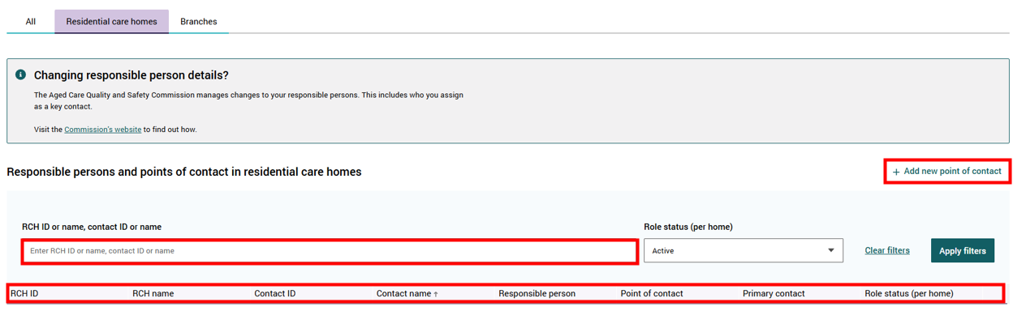

Responsible Persons and Contacts – Branches tab
The Branches tab allows users to view personnel for Branches they have access to.
Users can search and filter by Branch ID, Branch name, Contact ID, Contact name, and Role status, with a structured table displaying key details such as Branch ID, Branch name, Contact ID, Contact name, primary contact, and Role status (per branch).
Users can also add a new Point of Contact directly from this page by clicking on the + Add a new Point of Contact button. For information about adding new points of contact, see section 6.2.2 Add a new Point of Contact.
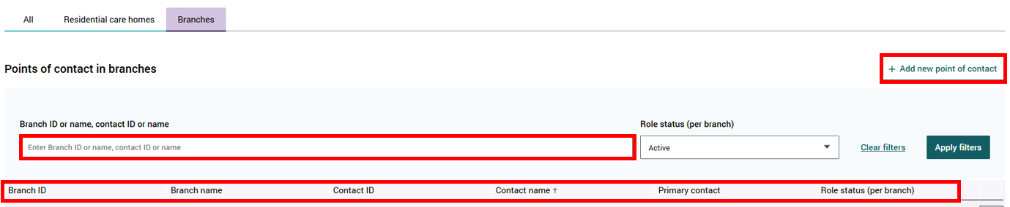

Point of Contact

What is a Point of Contact?
A Point of Contact is a person who is nominated as a contact for a specific purpose. For a Branch or Residential Care Home, this could be one or more people who have different Point of Contact roles.
There must be at least one person nominated as a primary contact for each Residential Care Home and Branch. Meaning they will be the first Point of Contact for either the Department or the Commission.
The nominated person must be able to engage with representatives of the Department or Commission in relation to that specific role.

Add a new Point of Contact
Users can access the + Add a new Point of Contact screen by following the below steps:
- Select + Add new Point of Contact, from the Responsible Persons and Contacts table page.
- Select the + Add new Point of Contact button via the Residential care homes or Branches pages to add a Point of Contact to a specific RCH or Branch.
Note:
A Point of Contact for a specific home or branch can only be created if the entity is in a status of Operational (Branch) or Active (Home).
- Before adding a new Point of Contact, users are required to perform a search for the individual to confirm whether they have an existing contact record. The user can search by the contact’s name or contact ID.
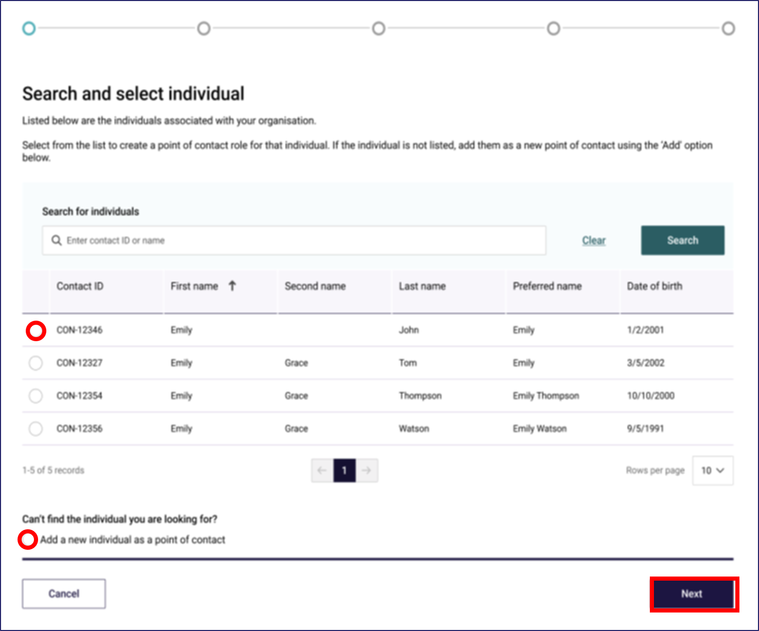
- If a contact record is found in the above search, users can select the checkbox in the correct contacts row in the display table and then select Next to continue with the contact’s existing details
Or:
- If no contact record is found for the individual they are searching for, users can select Add a new individual as a Point of Contact and select Next which will direct them to the Add personal details page
- When navigating to the review personal details page after selecting an existing contact in the search and select individual table, the fields in the review personal details page will be prepopulated with existing information. If the Add a new individual as a Point of Contact option was selected, the fields on the Add personal details page will remain blank.
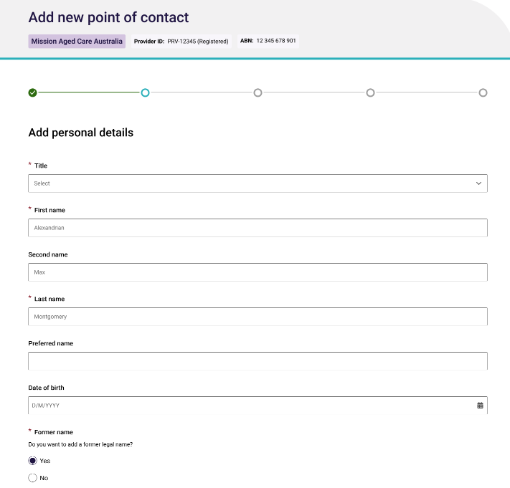
- Several fields on the Add personal details page are required fields and are marked with an asterisk, including:
- Title
- First Name
- Last Name
- Former name (Yes or No selection). If you select ‘Yes’ you will be required to enter the details below:
- Title
- First name
- Last name
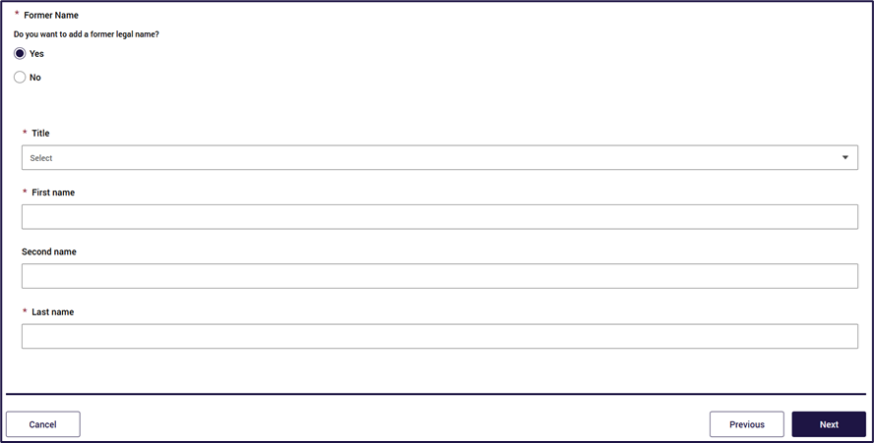
- Once all required fields have been completed, the user can select Next to proceed.
- By selecting Next on the Add personal details page, the system will run a duplication check for any existing contact records that match the information entered by the user. If matching records are found, the Matching records found pop up will display a list of matching contact records.
- Users will be required to review the matching records and identify if there is a match. They can then choose to:
- Proceed with the information provided, which means they are disregarding any duplicate records found or;
- Select matching contact record from the list displayed
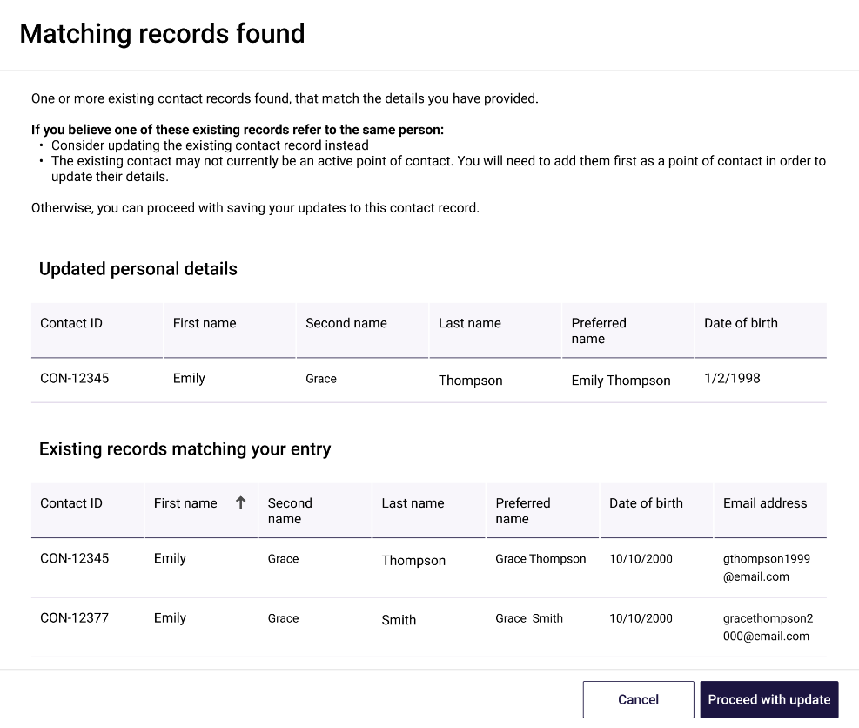
Note:
If an existing contact is selected and the individual is an active Responsible Person, the user will only be able to make updates to the contacts preferred name. To update other details for Responsible Persons, providers should use the Responsible Person details update form available on the Commission’s website. To update position details for a Responsible Person, please see section 6.3.4.
- Once the user selects Proceed with update, they will be directed to the Entity selection page where they will be required to assign the Point of Contact to an operational entity, which is either the Provider itself (therefore creating a Point of Contact for the organisation) or one or more of any of the Residential Care Homes and/or Branches.
- Users can search by entity name or ID or click anywhere in the search bar to view the dropdown list. The dropdown list displays entities in alphabetical order.
- The user will select the appropriate entities from the drop down list and select Next.
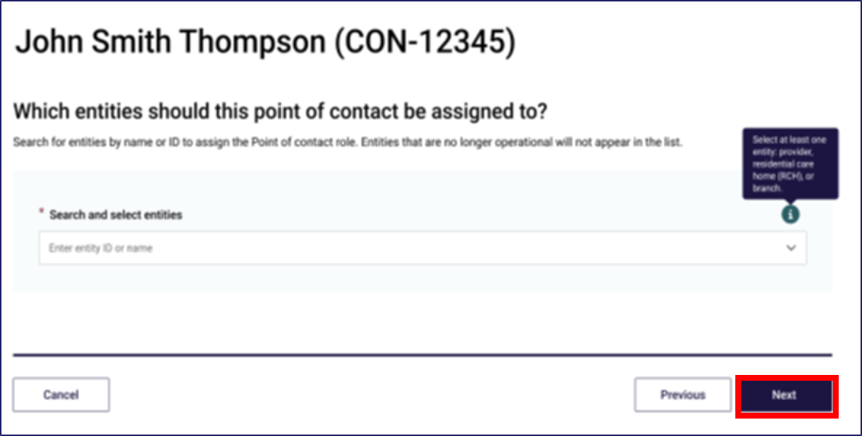
Once entities have been selected, the user will be directed to the Add role-specific contact and position details page.
There are some required fields on this page including:
Role-specific contact details
- Primary phone number
- Email address
Position details
- Position
- Contact purpose
- Primary Contact
- Alternative contact
- Emergency contact
- Start date
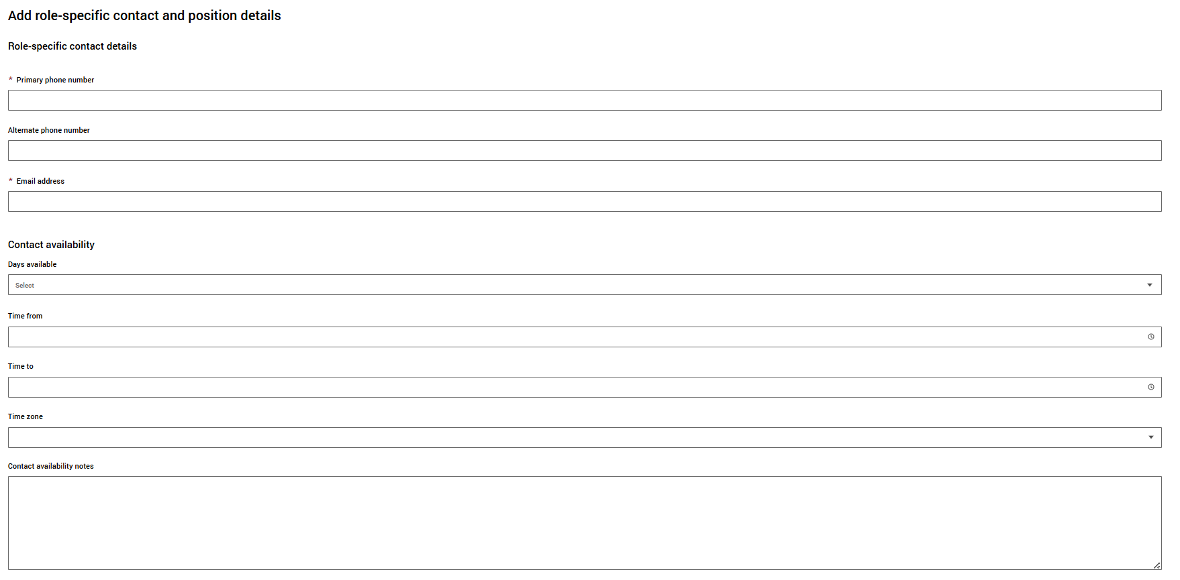
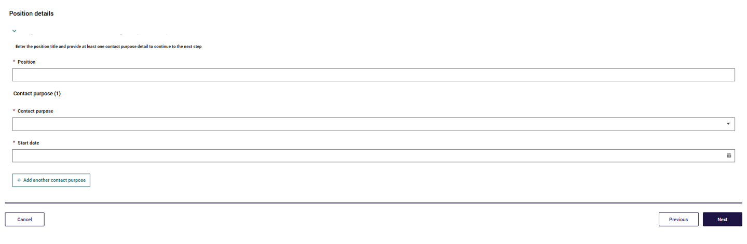
- Once all required fields are completed, select Next
Please note:
Multiple contact purposes can be assigned to each contact even if the home entity is not ‘active’. This can be done by selecting the + Add another contact purpose button. Users can remove the additional contact purpose field by selecting – Remove. This step can only be done before the saving the record, however.
A user cannot add a Point of Contact to an entity if the branch entity been transferred or is in the status of Closed
- The final step to creating a Point of Contact is to review the entered details and select the checkbox stating the contact agrees for their information to be disclosed to the Australian Government. Once the user ticks the I agree checkbox and selects Next, they will be displayed a success banner to confirm that the Point of Contact creation is complete.
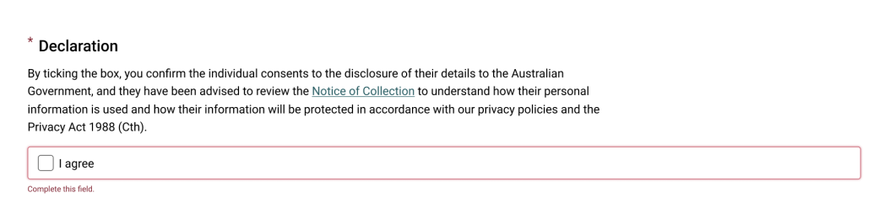

Users will be able to edit the Personal Details and Role Details tabs for personnel as permitted by their user access level.
Please note:
This does not apply if the personnel is a Point of Contact and an active Responsible person. To update a Responsible Persons personal details, providers should use the Responsible Person details update form available on the Commission’s website. To update position details for a Responsible Person, please see section 6.3.4.
Where a person is both an active Responsible Person and an active Point of Contact, only some of the position details for their role as a Point of Contact are editable.
Provider-level users will be able to update all personnel with a Point of Contact role however a Home/Branch level user will only have edit or update access for personnel assigned to Homes and Branches they have been granted access to. The following system limitations apply:
Users can only update the Point of Contact Name fields (Title/First Name/Second Name/Last Name) once per day. An update made on 1 July 2025 cannot be updated again until 2 July 2025.
A Point of Contact cannot be edited, and the edit button will not display, if the personnel is associated with:
the Point of Contact is historical, meaning their role as a Point of Contact has ceased.
A user cannot edit a Point of Contact if:
- the Branch has been transferred or is in the status of Inactive.
- the home is not active.

Edit Personal details for a Point of Contact
- Proceed to the Responsible persons and contacts table using one of the navigation steps set out in 6.1 View Responsible Persons and Contacts.
- Select View personnel profile on the relevant Point of Contact, this will navigate to the Personal details page of the selected contact.
- Select the Edit personal details button in the Personal details screen.
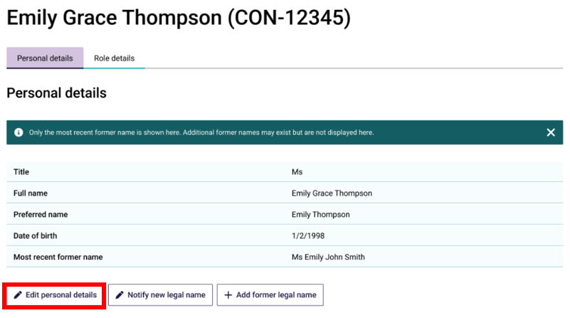
- A new window will display allowing users to update the required information.
Fields marked with a red asterisk are mandatory. The user may choose to include a Preferred name and Date of birth.
- Once changes have been made, review the Declaration to confirm via a tick box that the user has obtained the personnel's consent for their details to be disclosed to the Department.
- The user cannot proceed if they do not tick ‘I agree’ in the Declaration box.
- Select Save to complete the change. Alternatively, select Cancel to return to the Profile page.
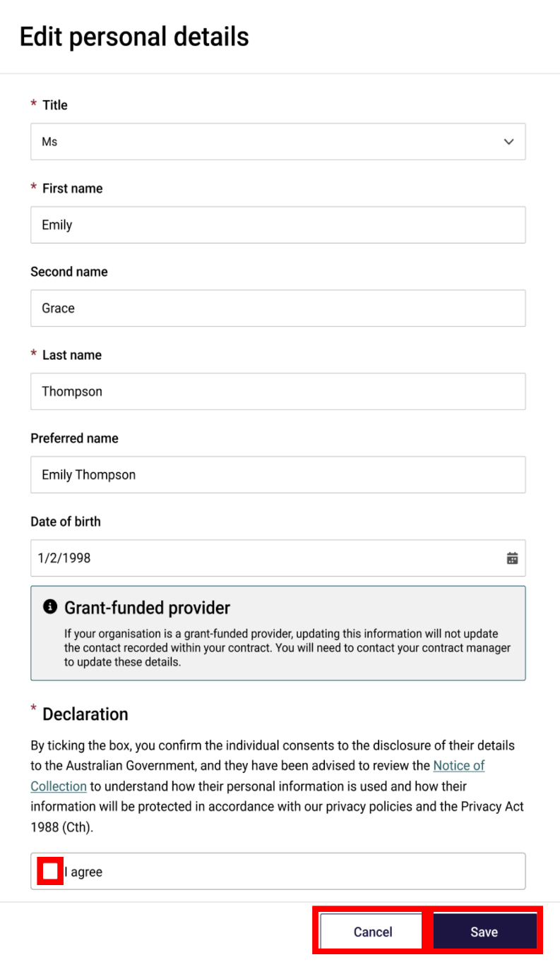
Please note:
The system will run a duplication check once the user selects Save. If potential duplicate contacts are flagged, a matching records found screen will appear and allow the user to check their updates against existing contact records in the system. The user will be required to select cancel if they believe the flagged contact records match or proceed with update if they believe the flagged contacts are not matching.

Notify of new legal name
- Go to the Responsible persons and contacts table using one of the navigation steps set out in 6.1 View Responsible Persons and Contacts.
- Select View personnel profile on the Point of Contact, this will navigate to the Personal details page of the selected contact.
- Select the Notify new legal name button in the Personal details screen.
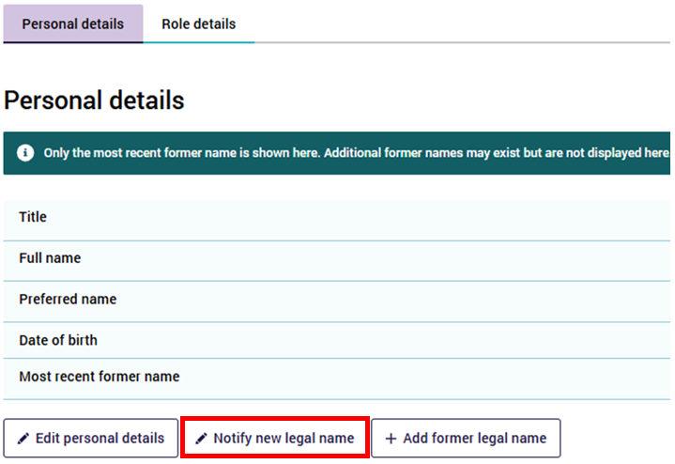
- A new window will display allowing users to update the required information.
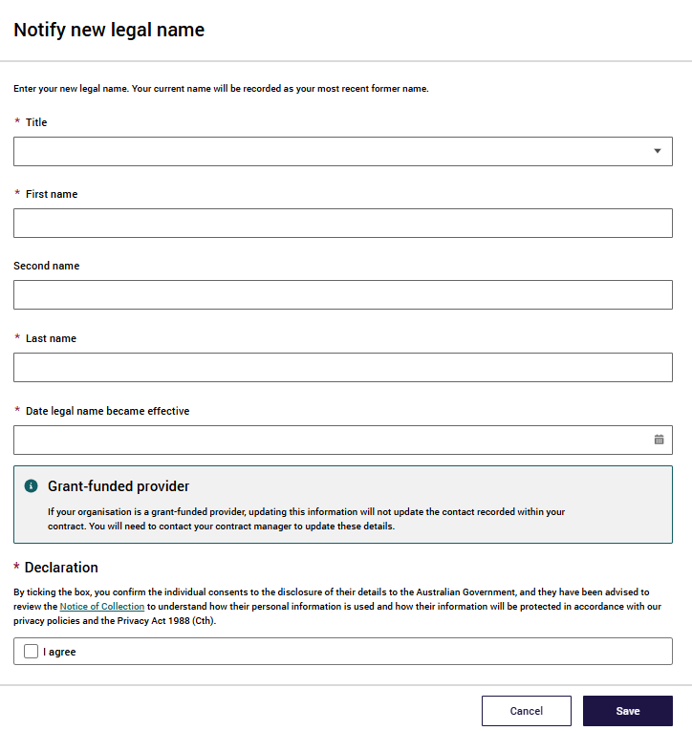
Note:
Fields marked with a red asterisk are mandatory. The user may also choose to include a Second name.
- Once changes have been made, review the Declaration to confirm via a tick box that the user has obtained the personnel's consent for their details to be disclosed to the Department.
The user cannot proceed if they do not tick ‘I agree’ in the Declaration box.
- Select Save to complete the change. Alternatively, select Cancel to return to the Profile page.
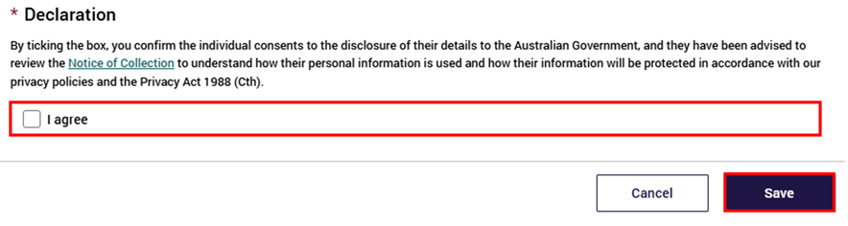
Please note:
The system will run a duplication check once the user selects Save. If potential duplicate contacts are flagged, a matching records found screen will appear and allow the user to check their updates against existing contact records in the system. The user will be required to select cancel if they believe the flagged contact records match or proceed with update if they believe the flagged contacts are not matching.

Add former legal name
- Go to the Responsible Persons and Contacts table using one of the navigation steps set out in 6.1 View Responsible Persons and Contacts.
- Select View personnel profile on the contact, this will navigate to the Personal details page of the selected contact.
- Select the Add former legal name button in the Personal details screen.
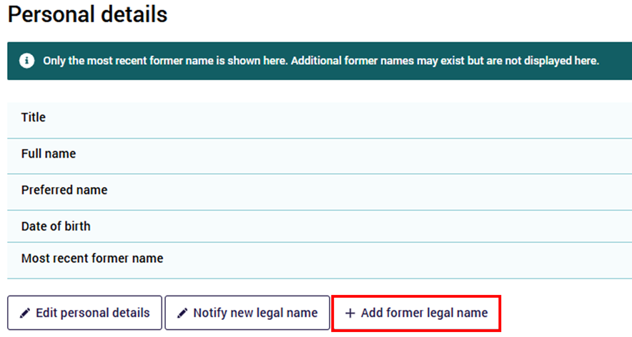
- A new window will display allowing users to update the required information.
Fields marked with a red asterisk are mandatory. The user may choose to include a Second name.
- Once changes have been made, review the Declaration to confirm via a tick box that the user has obtained the personnel's consent for their details to be disclosed to the Department.
- The user cannot proceed if they do not tick ‘I agree’ in the Declaration box.
- Select Save to complete the change. Alternatively, select Cancel to return to the Profile page.
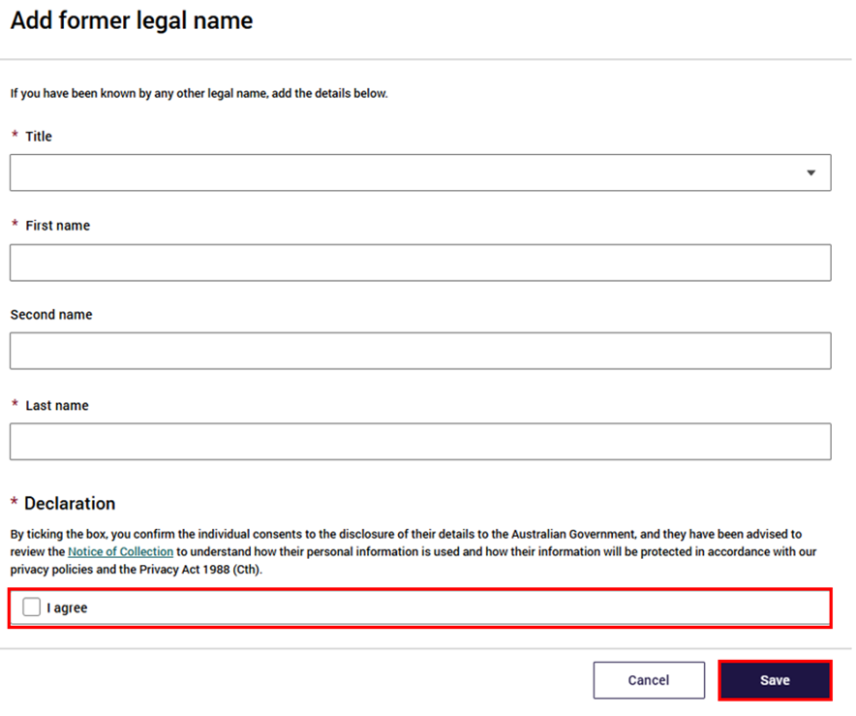

Role details
Select the Role details tab to view Role Details.
The Role details tab displays three tables including
- Responsible person role (Association ID, Position, Start date, End date, Role status) Users can click the drop-down arrow to view position details.
- Residential care homes this contact is responsible for (RCH ID, RCH name, Start date, End date, Role status) Users can click the drop-down arrow to cease.
- Point of Contact roles (Entity ID, Entity name, Position, Contact purpose, Start date, End date, Role status) Users can click on the dropdown arrow to view position details.
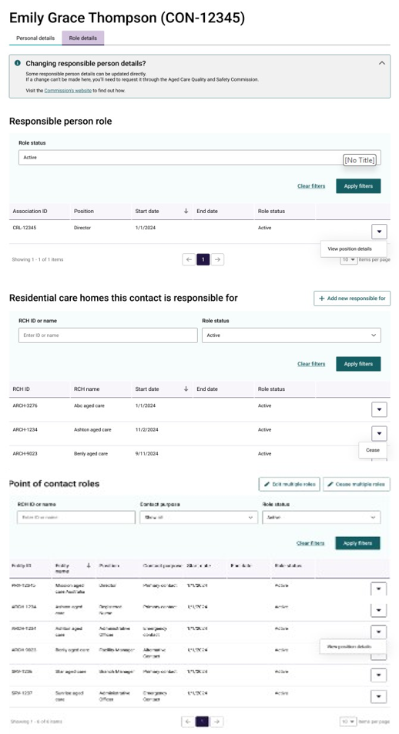
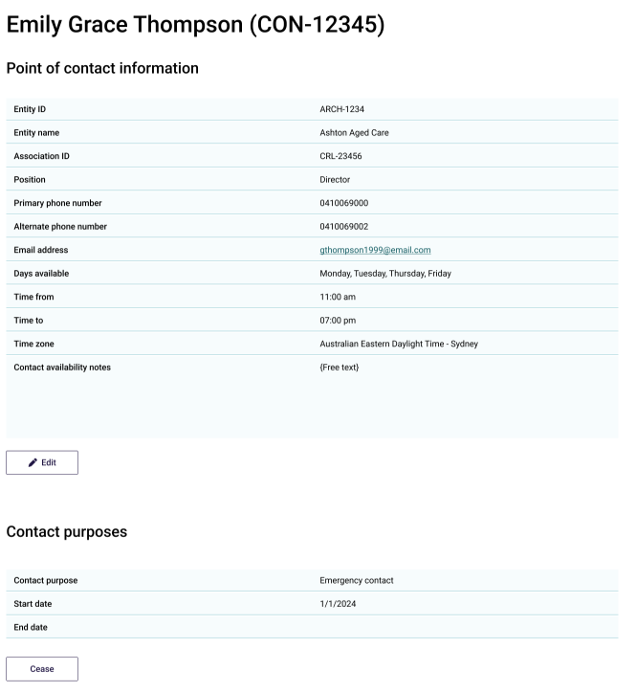

Updating multiple Point of Contact roles
Within the Role details tab, users with the appropriate permissions can update multiple Point of Contact roles at the same time.
- To do this, from the Personnel profile screen, Role details tab select the Edit multiple roles button
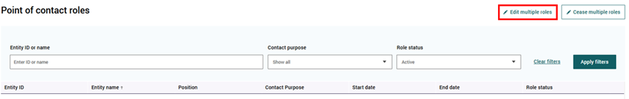
- Select the checkboxes for the relevant points of contact on the Point of Contact Roles screen and select Next.
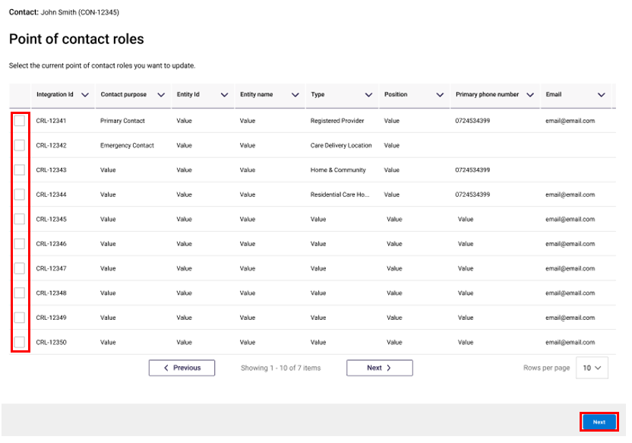
- Complete the fields you wish to update on the Position details screen and select Next.
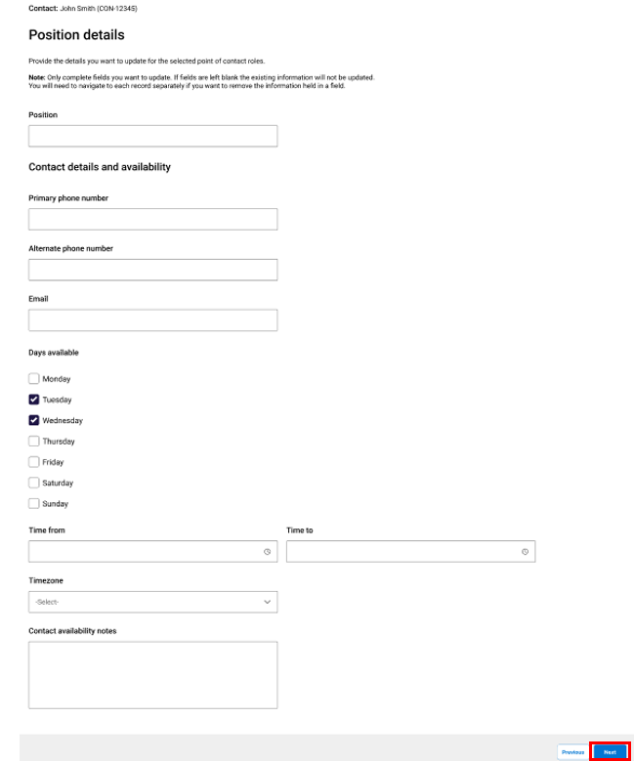
Note
If fields are left blank, this information will not be updated. Only complete the fields that require updating.
A Summary page will display, showing the updates that have been made.
- Select Submit.
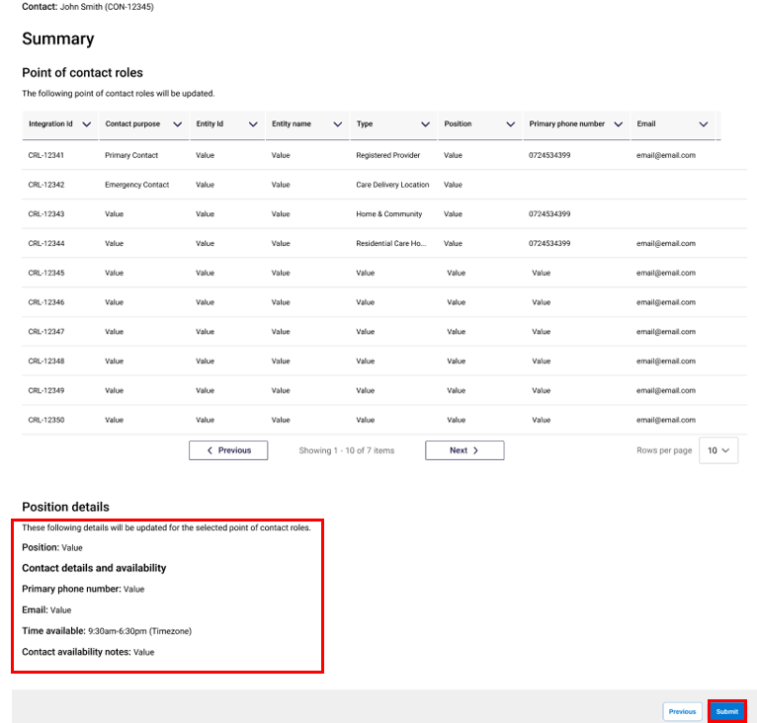
The user will see a confirmation message displayed on screen, confirming that the Point of Contact roles have been updated successfully.
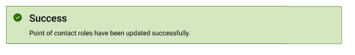

Updating Role details for a single Point of Contact
To update the Position details of a Point of Contact, users with appropriate access can this themselves via the Manage Your Organisation tile in GPMS using the below steps:
- Proceed to the Responsible Persons and Points of Contact table in the Responsible Persons and Points of Contact tile
- Select View personnel profile on the relevant contact, this will navigate to the Personal details page of the selected contact.
- Select the Role Details tab at the top of the Personal details page
- Scroll down until you reach the Point of Contact roles section of the table
- Select the drop down next to the Point of Contact role and select View position details
- Select Edit under the Point of Contact information table
- A new screen will display allowing the user to update the required fields
Several fields on the Add personal details page are required fields and are marked with an asterisk, including:
- Primary phone number
- Email address
- Days available
- Time from
- Time to
- Time zone
The user may also wish to include an Alternate phone number and Additional contact availability notes.
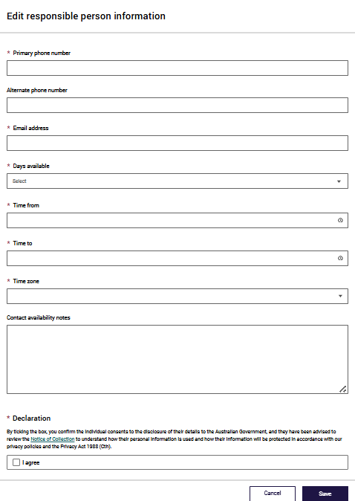
- Select the check box to accept the declaration
- Select Save

Cease a Point of Contact
User access roles will determine what Point of Contact records a user can cease.
If the contact role that the user wants to cease is the Primary Contact, the user must first follow the steps to add a new primary contact to that entity (i.e. Home or Branch). When a new Primary Contact is added to a Home or a Branch, the current primary contact will be automatically ceased/end dated.
Where the Point of Contact is located in a home or branch, the cease button will only be visible if the home or branch is in the following status:
Active (Home)
Operational (Branch)

Ceasing a single Point of Contact role
Below outlines the process for ceasing a single role of a Point of Contact:
- Go to the Responsible persons and contacts table using one of the navigation steps set out in the 6.1 View Responsible Persons and Contacts.
- Select View position details on the contact to cease the Point of Contact role. This will navigate to the Position details page of the contact.
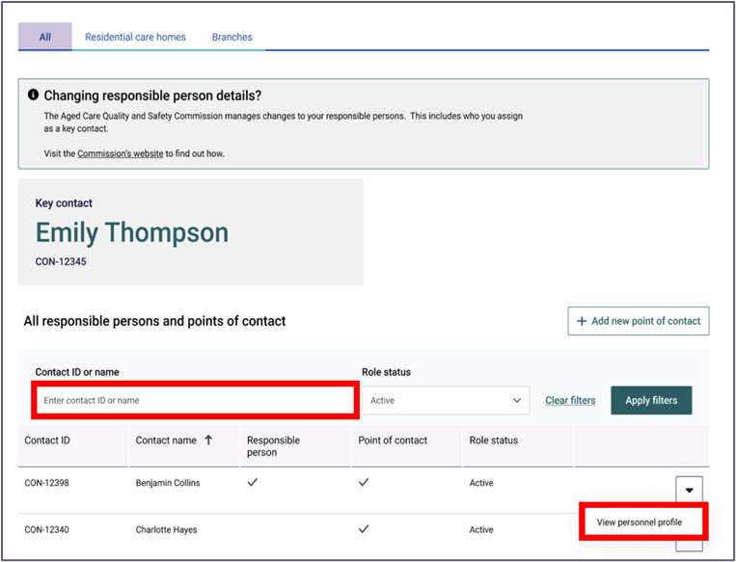
- Under the Contact purpose section of the person’s Position details page, select the Cease button.
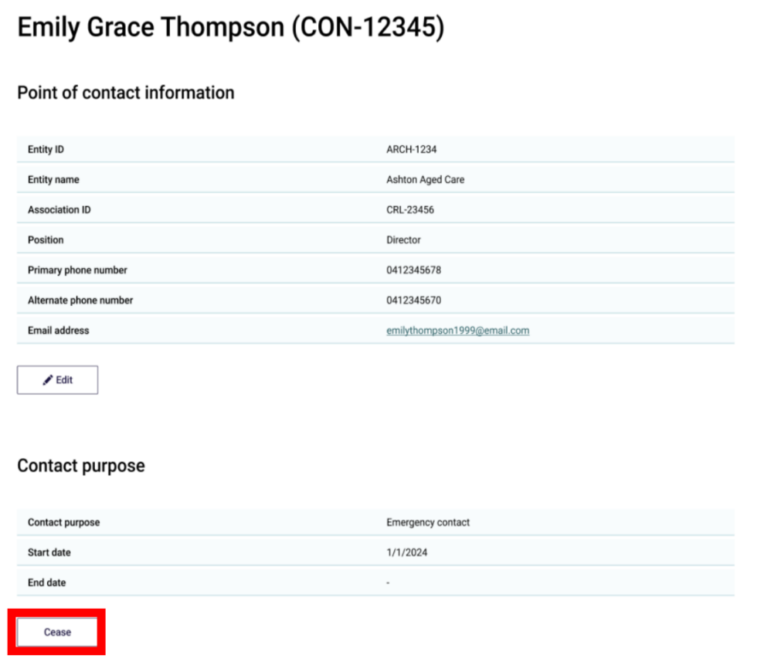
- A new window will display to allow the user to enter a cessation date for the selected role. The following system rules apply to this date field:
- The end date can be a past, present, or future date.
- The role end date cannot be prior to the role start date.
- The role end date can be the same as the role start date.
- The role end date must be entered in order to cease the role.
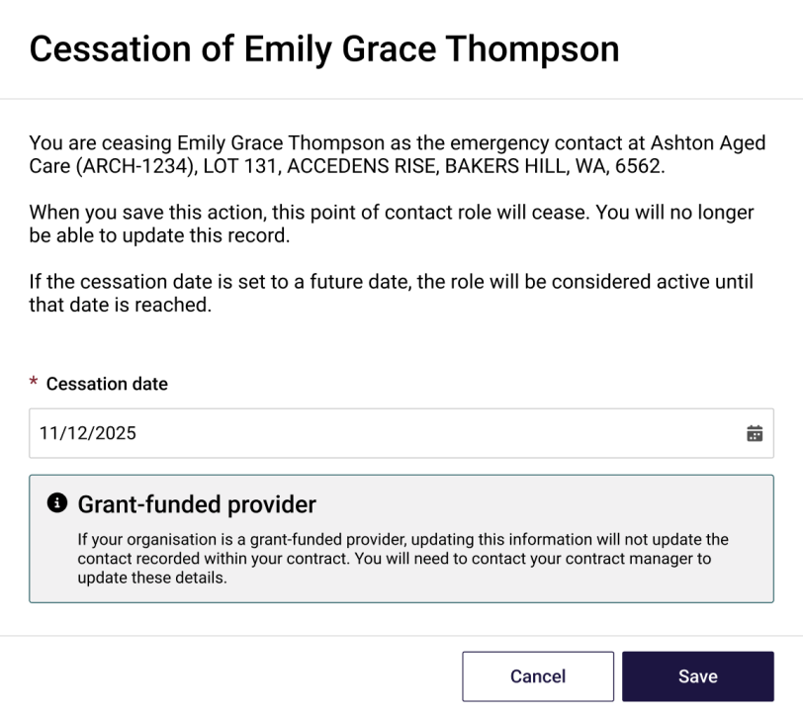
- Select Save to complete the change. Alternatively, select cancel to return to the Position details page.
The user will see a confirmation message displayed on screen when the cessation is successful, confirming that the Record saved successfully.
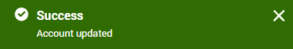

Ceasing multiple Point of Contact roles
Within the Personnel profile page, Role details tab, users with appropriate access can cease multiple Point of Contact records.
- Select the Cease multiple roles button to initiate the cessation
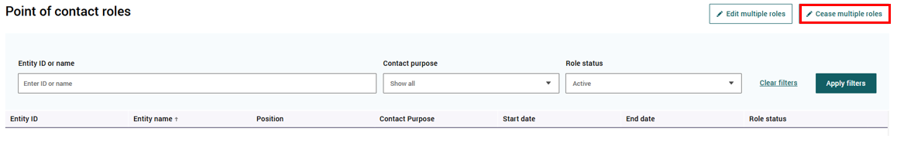
- Enter the End date in the field provided and select Next
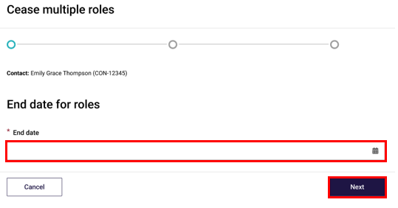
- Select the checkbox of the roles that require cessation and select Next
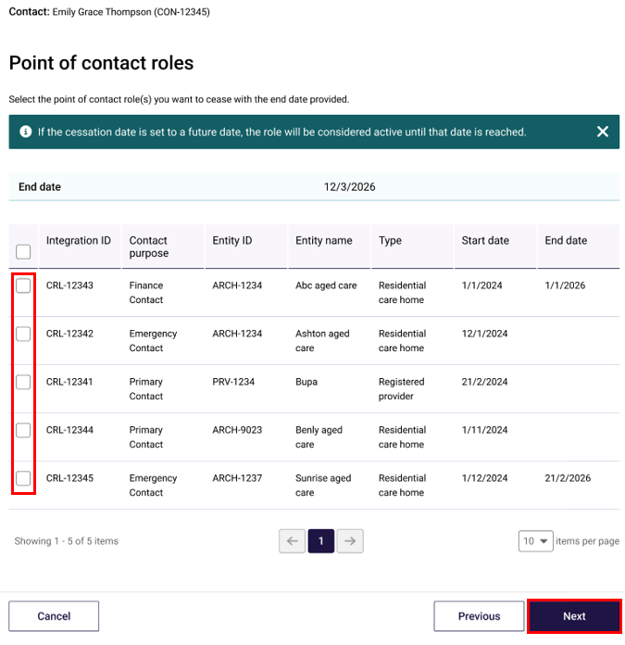
- Review the information on the Summary page and select Save
The user will see a confirmation message displayed on screen when the cessation is successful, confirming that the Point of Contact roles have been ceased successfully.


Responsible Persons

What is a Responsible Person?
A Responsible Person is someone who is in charge of or has a significant influence over the work of a provider. It also includes someone who has day-to-day responsibility for the provider’s operations.
To add/remove a Responsible Person, or to notify of a change in the suitability of a Responsible Person, users are required to notify the Aged Care Quality and Safety Commission. More information can be found on the Commissions website.

Add Responsible Person to Residential Care Home
Users can add Responsible Persons to Residential Care Homes from the Role details tab on the Personnel profile page or from the Contacts tab in the Residential Care Homes details page.
- Select the + Add new responsible for button
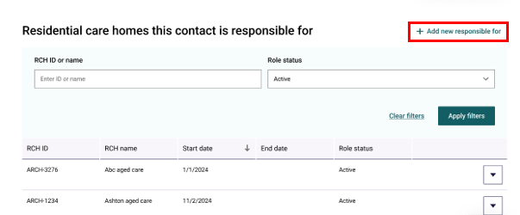
- On the Add new responsible for page, enter the name of the RCH/s the contact is responsible for in the search field
- From the drop down, select the appropriate RCHs
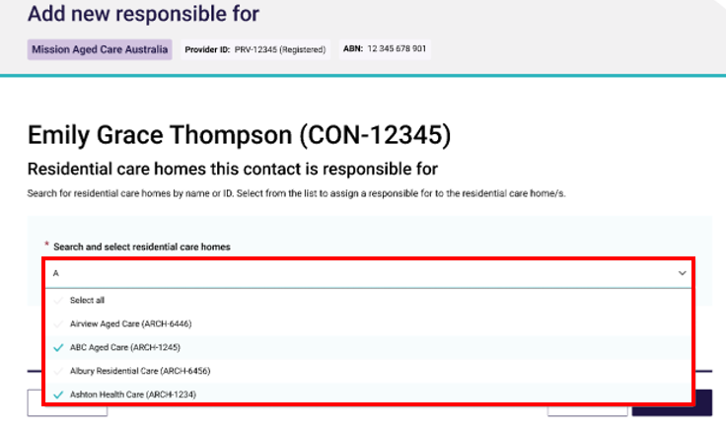
- Select Next.
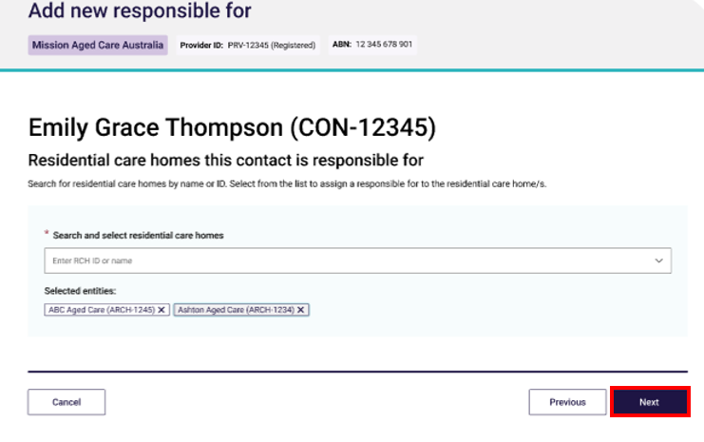
- Enter the date the contact became resposible for each RCH and select Next
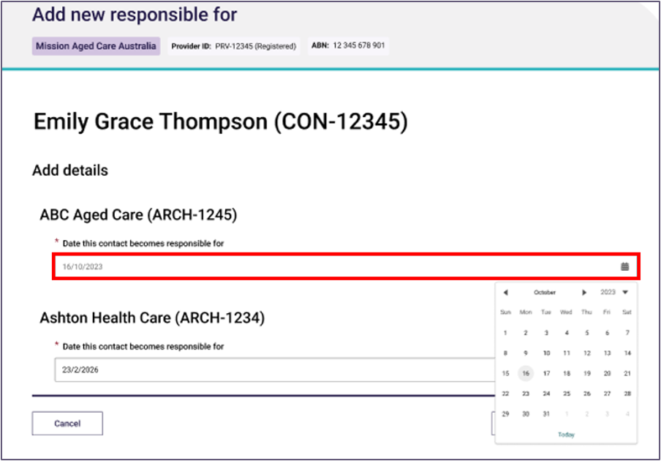
- Review the details and select Save
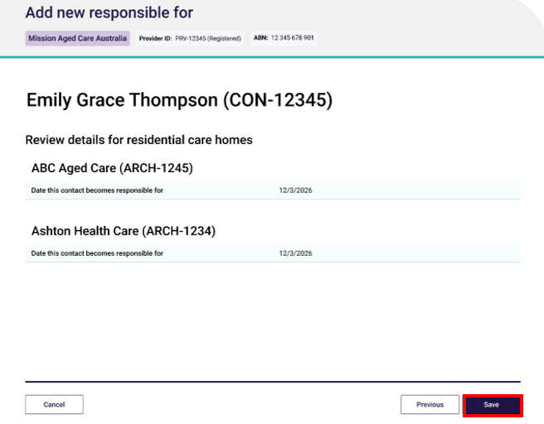
Once saved, a success banner will appear, notifying the user the Responsible for was added successfully.


Edit Personal details for a Responsible Person
- Proceed to the Responsible persons and contacts table using one of the navigation steps set out in 6.1 View Responsible Persons and Contacts.
- Select View personnel profile on the relevant Responsible Person, this will navigate to the Personal details page of the selected contact.
- Select the Edit personal details button in the Personal details screen.
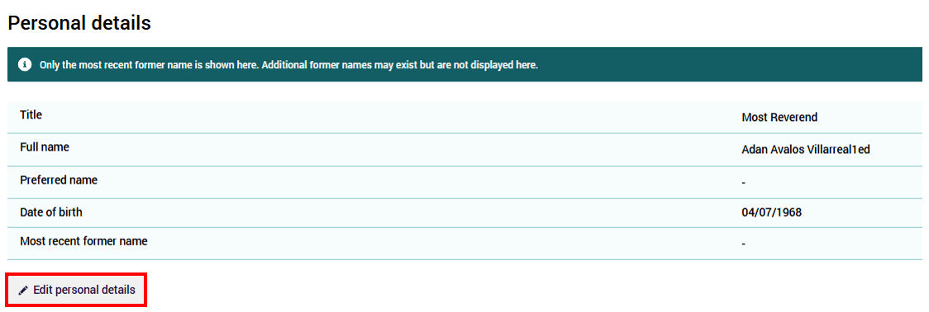
- A new window will display allowing users to update the required information.
The following fields can be edited for a Responsible Person
- Preferred name
- Once changes have been made, review the Declaration to confirm via a tick box that the user has obtained the personnel's consent for their details to be disclosed to the Department.
- The user cannot proceed if they do not tick ‘I agree’ in the Declaration box.
- Select Save to complete the change. Alternatively, select Cancel to return to the Profile page.
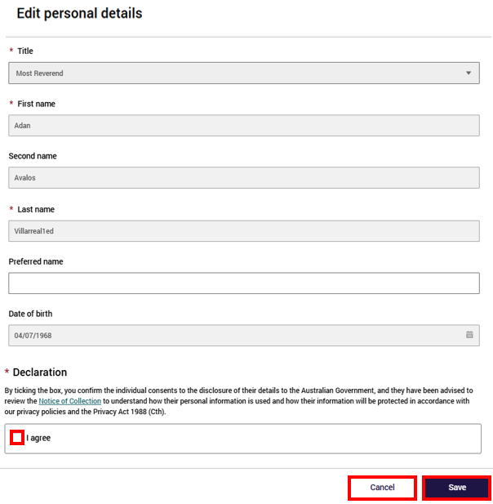

Updating Position details for a Responsible Person
To update the Position details of a Responsible Person, users with appropriate access can this themselves via the Manage Your Organisation tile in GPMS using the below steps:
- Proceed to the Responsible Persons and Points of Contact table in the Responsible Persons and Points of Contact tile
- Select View personnel profile on the relevant contact, this will navigate to the Personal details page of the selected contact.
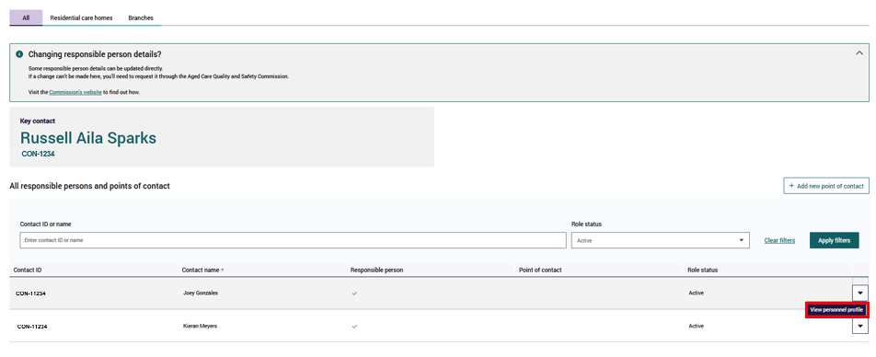
- Select the Role Details tab at the top of the personal details page
- Scroll down until you reach the Responsible person roles section of the table
- Select the drop down next to the Point of Contact role and select View position details
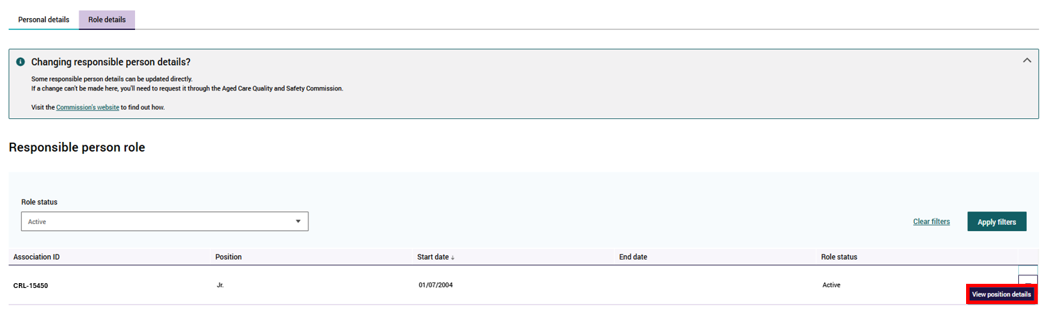
- Select Edit under the Responsible Person information table
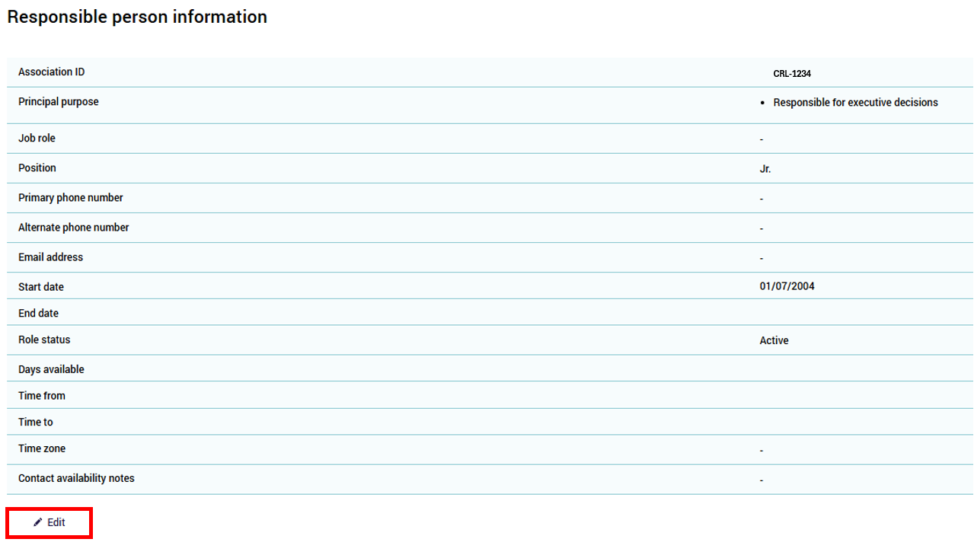
A new screen will display.
- Update the required fields
Several fields on the Add personal details page are required fields and are marked with an asterisk, including:
- Primary phone number
- Email address
- Days available
- Time from
- Time to
- Time zone
The user may also wish to include an alternate phone number and additional contact availability notes.
- Select the check box to accept the declaration
- Select Save
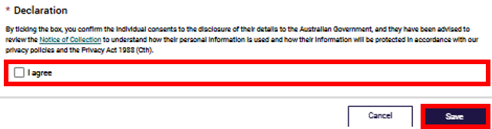
Note:
To update all other details relating to Responsible Persons, users are required to complete the Responsible Person details update form available on the Commissions website.

Adding a Contact purpose
From the Responsible Persons and Contacts tile, users can add contact purposes to an existing Responsible Person.
To do this:
- Proceed to the Responsible Persons and Contacts tile
- Select the drop down arrow on the relevant Responsible Person and select View personnel profile
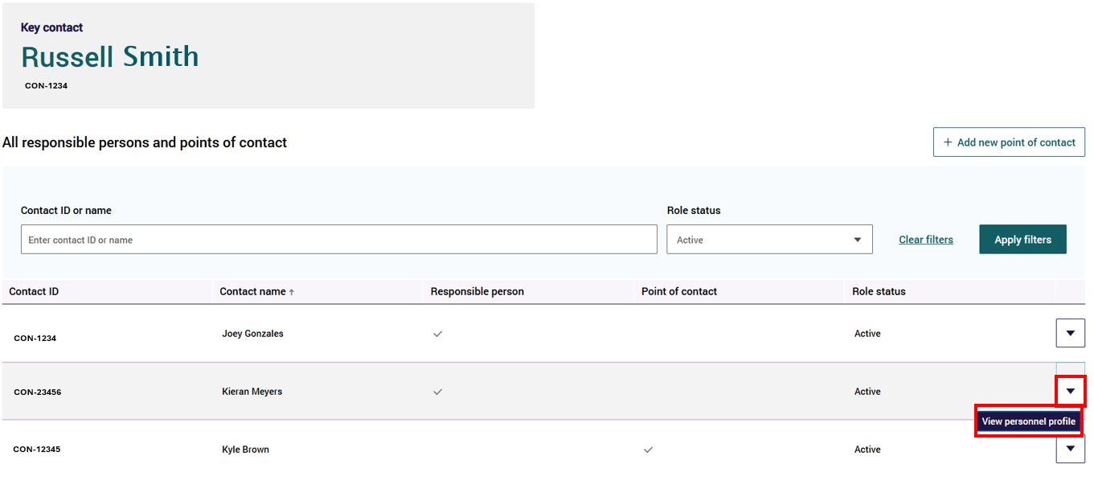
- On the Role details tab, select the drop down arrow on the relevant Responsible Person role and select View position details
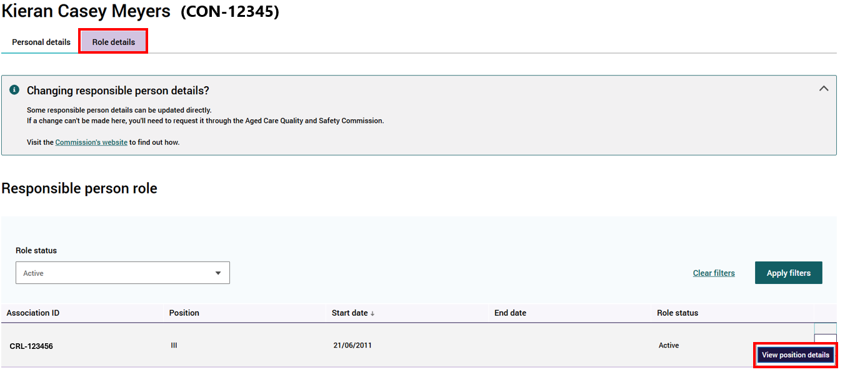
- Scroll down to the Contact Purpose section of the page and select +Add new contact purpose
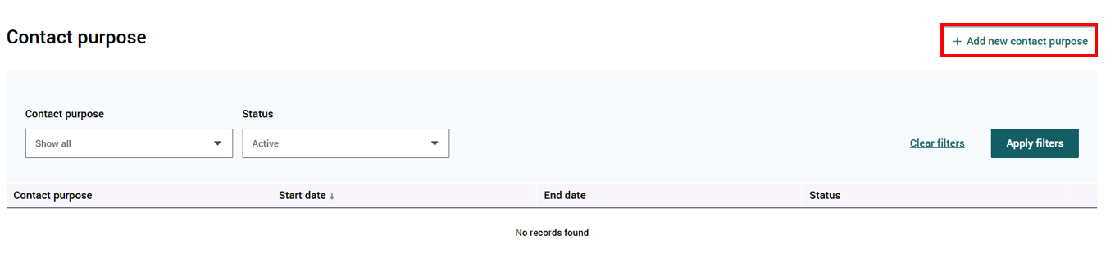
A pop up will display
- Select the arrow on the drop down box in the Contact Purpose field and select the appropriate contact purpose
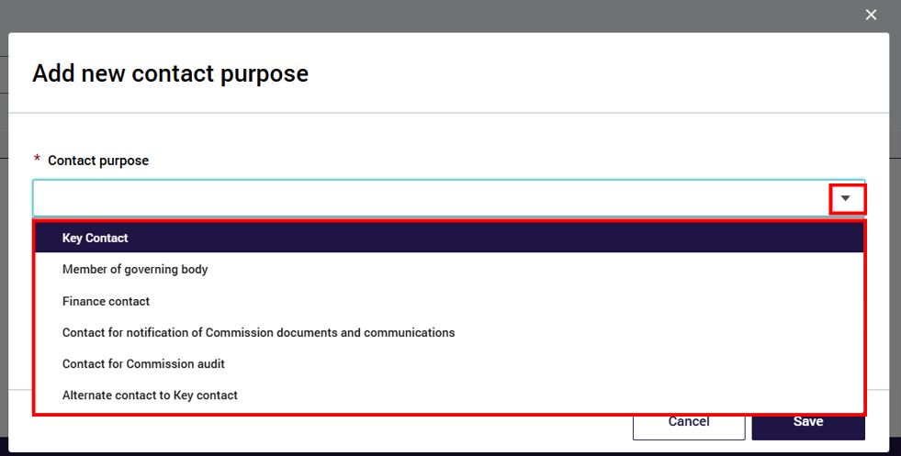
- Enter the start date that this contact purpose should commence
Note:
If updating the Key Contact, an additional check box will display. Check the box notifying the user that the current Key Contact will be automatically ceased
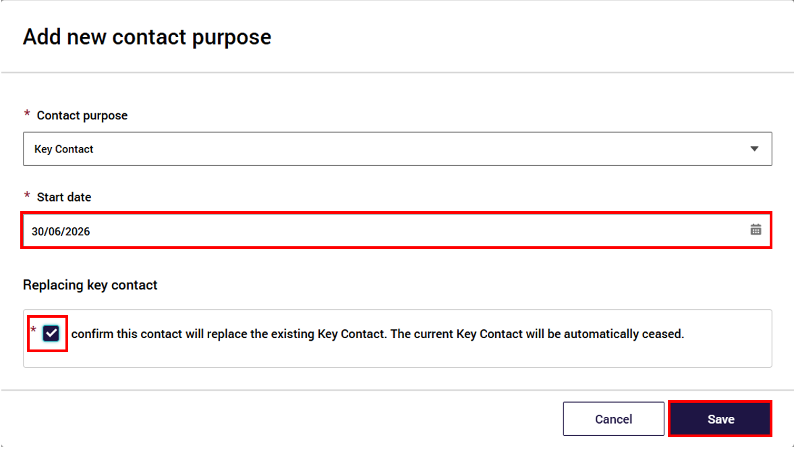
- select Save
The new contact purpose will appear in the Contact Purpose table.

Ceasing a Contact Purpose
From the Responsible Persons and Contacts tile, users can cease contact purposes of an existing Responsible Person.
To do this:
- Proceed to the Responsible Persons and Contacts tile
- Select the drop down arrow on the relevant Responsible Person and select View personnel profile
- On the Role details tab, select the drop down arrow on the relevant Responsible Person role and select View position details
- Scroll down to the Contact Purpose section of the page
- Click on the drop down arrow on the relevant Contact purpose and select Cease
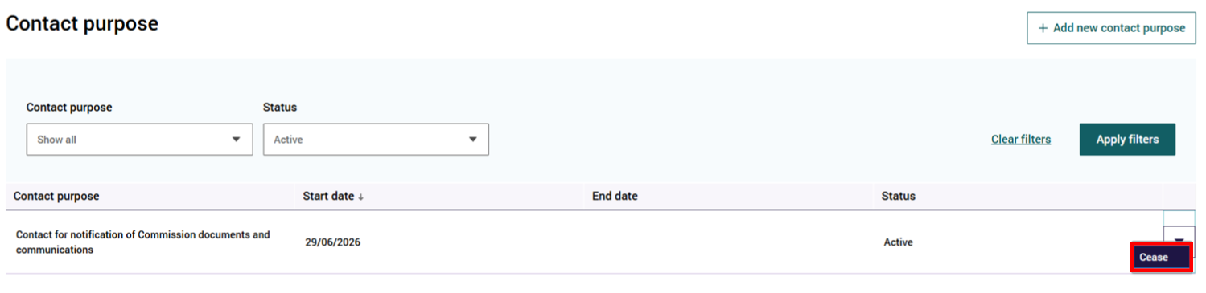
- Enter a cessation date
- Select Save
Note:
Some Contact Purposes require another contact to be given this purpose before you can cease. The system will display an error message notifying the user of this, if it is required.

Associated Providers
Authorised users can view a list of all associated providers associated to their registered provider via the Associated Provider tile.
Users can also view the details held on each associated provider via the Associated provider Details page.
Users with organisation level access can view and select the Associated Provider tile. Home or Branch level users will not see this tile on the Manage Your Organisation’s Details page.

View Associated provider Arrangements
From the Manage your organisation landing page, select the Associated Provider tile to view the associated provider arrangements associated with the organisation.
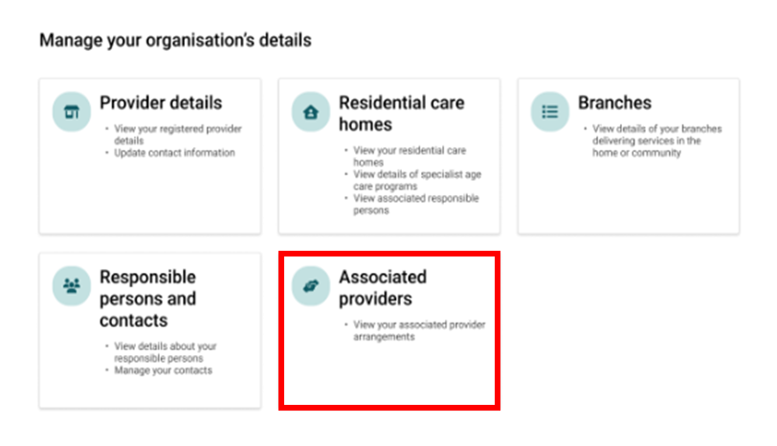

Search and Filter
- Users can search for an associated provider by Associated provider ID, Name or filter by Service types or Status and select Apply Filters button.
The table’s default view is active associated provider arrangements; however, a user can view inactive association by updating the status filter.
- Users can sort this table alphabetically by hovering the mouse pointer over the column headers.
- Clear filters can be selected to return to the default view of the list.
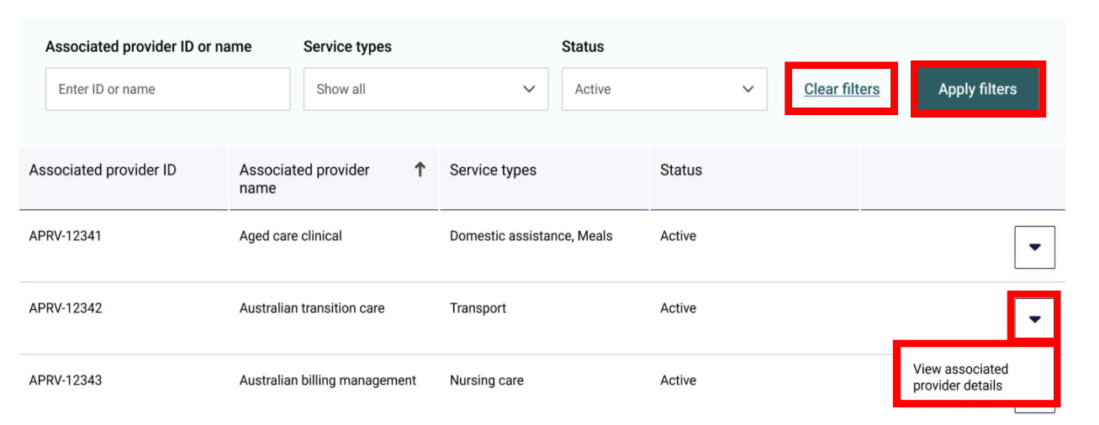

View Associated provider details
By selecting the View associated provider details drop down for a selected record in the table, users can view information regarding the selected associated provider, including:
- Basic details – this is information about the Associated provider arrangement including:
- Associated provider ID – this is their organisation’s record ID, assigned by the Department
- Associated provider name – this is their organisation’s name
ABN
- Registered to provide aged care – this indicates if the associated provider is also a Registered Provider in their own right. This will be Yes or No
- Information held about an associated provider arrangement is provided by the Registered Provider, when they notify the Commission about the arrangements they have in place.
- Association details – this is information about the arrangements that the Registered Provider has with the Associated provider including:
- Association ID
- Status
- Service types – these services align with the services provided under the Home Care Program
- Association start date – the date the arrangement commenced with the Registered Provider.
- Association end / review date – the date that the contract/agreement is to cease. If the contact/agreement has a renewal date rather than an end date, this will be the date the contract/agreement is intended to be renewed.
To edit any of the details displayed on this page, the user is required to notify the Commission formally. More information on this can be found on the Commission’s website.

