Framework for consumer engagement in HTA
  - Accessible version
Contents
1. Purpose 2
2. Key terms 2
3. Stakeholders 3
4. Guiding principles 4
4. Focus areas and stakeholder actions 4
4.1 Raise awareness 4
4.2 Build capability 4
4.3 Elevate engagement 5
4.4 Strengthen partnerships 5
4.5 Evaluate impact 5
5. Consumer engagement across the health technology lifecycle 5
Stage 1: Research & development 8
Stage 2: Regulatory decision 8
Stage 3: Health Technology Assessment (HTA) 8
Stage 4: Funding decision 9
Stage 5: Monitoring use 9

1. Purpose
Consumer engagement is central to health technology assessment (HTA). It helps ensure decisions reflect the needs, experiences and priorities of patients, their carers, families and communities.
This framework outlines shared principles, focus areas and actions to guide consumer engagement. It builds on previous work co-designed with consumers including the Conversations for Change report and recommendations from the Co-design Working Group for the Enhanced Consumer Engagement Process and the HTA Policy and Methods Review. Together, this work identified the need for more transparent and meaningful consumer engagement in HTA.

2. Key terms
Below are definitions of key terms used in the framework.
consumer
Patients, their carers, families, communities, and consumer organisations.
consumer ENGAGEMENT
Involving consumers so their views, lived experience and evidence inform processes and decisions that affect them.
consumer evidence
Systematically collected consumer experiences, needs, preferences and perspectives, generated using structured, research-based methods.
Consumer input
Information contributed by consumers and consumer organisations to inform HTA processes and decisions. This includes individual, collective or community-based experience.
Health technology
Something used to prevent, diagnose or treat a medical condition, or to improve quality of life. This includes medicines, vaccines, tests, imaging, surgeries, procedures and implants.
HEALTH TECHNOLOGY ASSESSMENT (HTA)
A process that helps the government decide if a health technology should be funded. For example, decisions about listing medicines on the Pharmaceutical Benefits Scheme (PBS) or services on the Medicare Benefits Schedule (MBS).

3. Stakeholders
This framework applies to everyone involved in HTA and recognises that consumer engagement is strengthened by the contributions of all stakeholders. While roles differ, everyone shares responsibility for transparent and meaningful consumer engagement. Contributions from each stakeholder may include:
- Consumers share their lived experience, needs, perspectives, preferences and outcomes that matter to them.
- Consumer organisations represent and communicate broader consumer experiences and priorities from their communities, and help support consumers to participate in HTA.
- Government enables consumer engagement by supporting processes and reducing barriers, so consumer input and evidence can meaningfully inform HTA.
- HTA advisory committees actively consider consumer input and consumer evidence alongside other evidence to inform HTA discussions and decisions.
- Health professionals share clinical knowledge and help identify how health technologies may affect care pathways, service delivery and consumer experience.
- Industry enables consumer engagement in research design and evidence generation so that consumer perspectives are reflected in evidence presented for funding decisions.
- Researchers engage consumers in planning and evidence generation to ensure studies reflect consumer priorities and outcomes that matter.

4. Guiding principles
These principles guide a shared approach to consumer engagement in HTA.
Transparency
HTA processes, engagement opportunities, how consumer input and evidence is considered and how decisions are made are clearly communicated.
Timeliness
Consumer engagement occurs early and continues throughout the health technology lifecycle.
Recognition
Consumer lived experience, values and preferences are recognised as essential to HTA.
Partnership
Stakeholders work in partnership to build trust, legitimacy and shared understanding of consumer engagement in HTA.
Inclusion
Consumer engagement is accessible, inclusive and culturally safe, supporting diverse consumers and communities, and those most affected by HTA decisions.

4. Focus areas and stakeholder actions

4.1 Raise awareness
- Provide centralised resources where information is accessible and easy to find
- Use plain language to explain HTA terms, processes, decisions and outcomes
- Share opportunities to contribute to HTA, including timelines and how information will be collected, used, stored and reported
- Broaden reach through digital and non-digital channels and networks

4.2 Build capability
- Provide support and guidance to strengthen stakeholders’ understanding of the role of consumer engagement in HTA
- Develop tailored resources and training to build knowledge and skills that meet the needs of different stakeholders
- Share practical examples of good consumer engagement across different stages of HTA
- Support continuous learning and reflection to strengthen engagement skills, confidence and ways of working

4.3 Elevate engagement
- Communicate the purpose of consumer engagement in HTA and why lived experience and consumer evidence matter
- Engage early and regularly in a proportionate manner so that consumer input informs evidence generation and HTA decisions, while avoiding unnecessary burden
- Set clear expectations about what and when consumers are asked to contribute and how input is used
- Support participation by offering flexible ways to engage, responsive to different needs, preferences and barriers

4.4 Strengthen partnerships
- Build and sustain relationships with consumers, consumer organisations, communities and other stakeholders through respectful and trust-based engagement
- Support equitable and culturally safe engagement by working with communities to tailor approaches, address barriers and support those most affected by HTA decisions
- Strengthen ongoing dialogue and collaboration through two-way communication and regular feedback
- Develop shared approaches to consumer engagement and clarify roles and responsibilities to support effective partnerships

4.5 Evaluate impact
- Monitor engagement to understand who is involved, when engagement occurs and whether it is accessible, inclusive and proportionate
- Document consumer input and evidence to tract use across the health technology lifecycle
- Provide feedback on how consumer input was considered and influenced HTA decisions
- Invite feedback and use data to continuously improve consumer engagement approaches, resources and support

5. Consumer engagement across the health technology lifecycle
Consumer engagement, consumer input and consumer evidence builds throughout the lifecycle of the health technology.
The health technology lifecycle consists of 5 main stages. Below is an overview of each stage, and opportunities for consumer engagement. Figure 1 provides a schematic representation of the lifecycle.
Boxed text represents opportunities for consumer engagement at each stage.

Figure 1. Consumer engagement across the health technology lifecycle
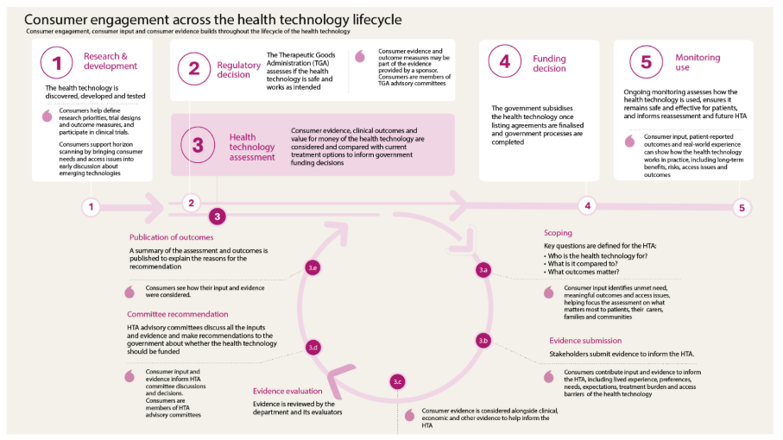

Stage 1: Research & development
The health technology is discovered, developed and tested.
Consumers help define research priorities, trial designs and outcome measures, and participate in clinical trials. Consumers support horizon scanning by bringing consumer needs and access issues into early discussion about emerging technologies.

Stage 2: Regulatory decision
Therapeutic Goods Administration (TGA) assesses if the health technology is safe and works as intended.
Consumer evidence and outcome measures may be part of the evidence provided by a sponsor. Consumers are members of TGA advisory committees.

Stage 3: Health Technology Assessment (HTA)
Consumer evidence, clinical outcomes and value for money of the health technology are considered and compared with current treatment options to inform government funding decisions. Since the focus of this framework is on HTA, below is an overview of the main steps in this stage, and opportunities for consumer engagement at each step.

3.a Scoping
Key questions are defined for the HTA, including:
- who the technology is for?
- what it is compared to?
- which outcomes matter?
Consumers input identifies unmet need, meaningful outcomes and access issues, helping focus the assessment on what matters most to patients, their carers, families and communities.

3.b Evidence submission
Stakeholders submit evidence to inform the HTA.
Consumers contribute input and evidence to inform the HTA, including lived experience, preferences, needs, expectations, treatment burden and access barriers of the health technology.

3.c Evidence evaluation
Evidence is reviewed by the department and its evaluators.
Consumers evidence is considered alongside clinical, economic and other evidence to help inform the HTA.

3.d Committee recommendation
HTA advisory committees discuss all the inputs and evidence and make recommendations to the government about whether the health technology should be funded.
Consumers input and evidence inform HTA committees discussions and decisions. Consumers are members of HTA advisory committees.

3.e Publication of outcomes
A summary of the assessment and outcomes is published to explain the reasons for the recommendation.
Consumers see how their input and evidence were considered.

Stage 4: Funding decision
The government subsidises the health technology once listing agreements are finalised and government processes are completed.

Stage 5: Monitoring use
Ongoing monitoring assesses how the health technology is used, ensures it remains safe and effective for patients, and informs reassessment and future HTA.
Consumer input, patient-reported outcomes and real-world experience can show how the health technology works in practice, including long-term benefits, risks, access issues and outcomes.

