Features of the Tobacco Reporting Service - quick reference guide
20 July 2026
Understand the look and layout of the Tobacco Reporting Service inside the Health Business Services (HBS) portal.

Getting started
You need to sign in to the Health Business Services (HBS) portal to access the Tobacco Reporting Service.
For help getting an account see: About Health Business Services.

Tobacco Reporting service system roles
Different system roles ensure users only have access to the features and actions required for their responsibilities within an organisation.
Every member will be given a service role which will determine their level of access. Service roles include either Organisation Administrator or Report Submitter.
The Organisation Administrator manages an Organisation account, including members and applications. Organisation accounts can have multiple Organisation Administrators.
Report Submitters are people who can act on behalf of an Organisation account and submit reports. To become a member of an Organisation account, you must be invited by an Organisation Administrator.

Common features found in the HBS portal
These are features commonly found in the HBS portal.

Side menu navigation
The side navigation menu helps you move between major sections of the HBS portal. It remains fixed while you scroll page content.
The menu is optimised to allow you to quickly switch tasks without losing your place. This is the fastest way to move between high-level pages without navigating back to the dashboard.
You can use it to:
- begin a new task, like starting a form
- return to an existing draft or submission
- manage report submission or organisation details.
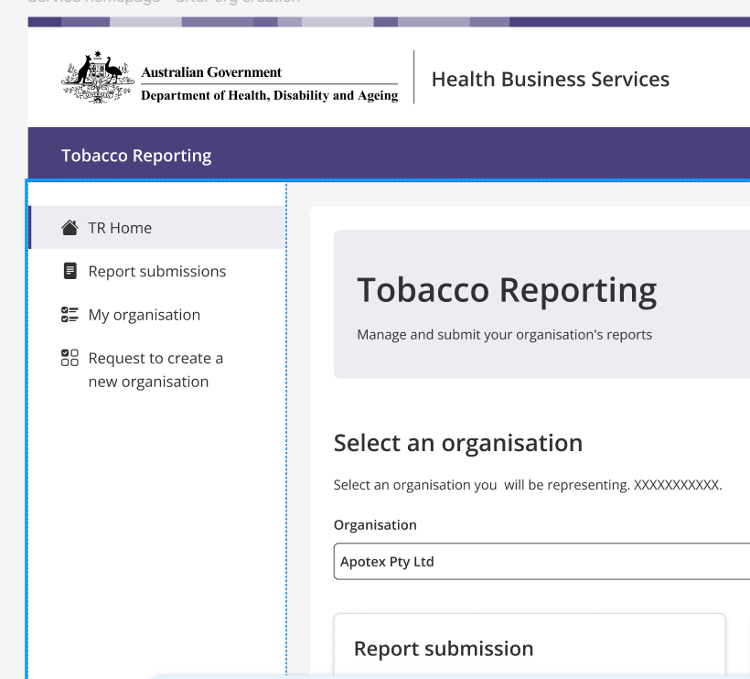

Features of the side menu
Each item in the side menu represents a key function in the HBS portal.
From the side menu you can navigate to:
- TR Home – the main landing page with tiles and shortcuts
- Report submissions – the page where you can submit tobacco industry reporting
- My organisation – organisation details and role-based information
- Request to create a new organisation – the page where you submit new organisation requests.
Click a menu item to visit the corresponding page.
An active page is highlighted with a light background and coloured selection.
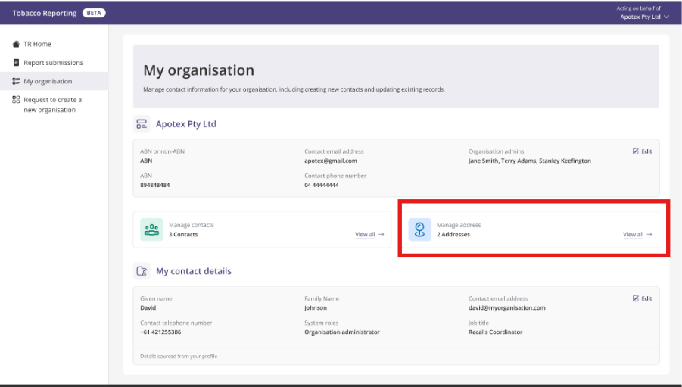

Cards (Tiles)
Cards provide quick access to the most used areas in the HBS portal.
Each card represents a page within the HBS portal.
Tiles are designed to support task-based navigation – letting you start work immediately without searching through menus.
Use cards to access:
- Report submission – this is where you can submit your tobacco reports
- Organisation requests - this is where you can request to create a new organisation
- My organisation – this is where you can manage your organisation details and role-based information.
__________________________________________________________________________________

Contact

Tobacco reporting
Contact us if you have questions or feedback about the tobacco reporting requirements.
tobaccoreporting@health.gov.au

