
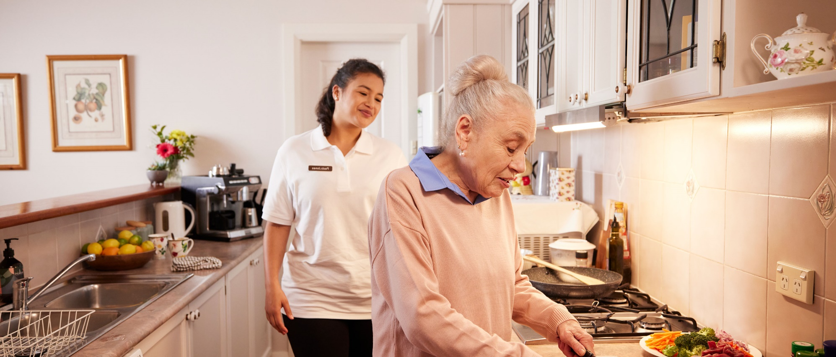

Disability Support for Older Australians Program and aged care services

For DSOA Service Coordinators
From 1 July 2021, clients accessing the Disability Support for Older Australians (DSOA) Program who are eligible or are already accessing some aged care services may have their DSOA funding capped or be required to transition to aged care and exit the DSOA Program.
Ensuring your clients are informed about changes to their DSOA funding before they are assessed as eligible for aged care services is important. For this reason, it is the DSOA Service Coordinator’s responsibility to inform all their DSOA client’s that an aged care assessment may impact their DSOA funding and provide each client with a copy of the department’s Disability Support for Older Australians Program and aged care services factsheet. This is to ensure that DSOA clients are aware of the implications surrounding eligibility for aged care services and how this affects their DSOA funding package.

Reasons for an aged care assessment
An aged care assessment determines whether a client is eligible to access aged care services, such as the Support at Home program or residential aged care. Aged care assessments consider the client’s physical, medical, mental, cultural, social, and wellness needs.
Clients should only undertake an aged care assessment after considering the potential impact on their DSOA funding, or where the client is considering a transition to aged care services instead of DSOA supports.

Assessment support
Once the DSOA Service Coordinator has informed the DSOA client about the impact an aged care assessment may have on their DSOA funding package, and the client has consented to proceed with an aged care assessment, the DSOA Service Coordinator must assist the client to contact My Aged Care on 1800 200 422 to request an assessment, or complete the referral form available on the My Aged Care website.
When contacting My Aged Care, the client or the DSOA Service Coordinator must clearly advise them that this referral is for a DSOA client, and which aged care services the client would like to access, this is to prevent the client from being found eligible for services that will impact their DSOA funding package.
My Aged Care assessors must be informed of:
- the services the client is receiving under DSOA
- any unmet care needs
- the sustainability of the current DSOA services provided to the client.
Aged care assessors must also be informed of weather:
- the client is wanting to access services that are not available under DSOA, or
- the client is wanting to access aged care services instead of DSOA.
Where a client is assessed as being at immediate risk, the department may consider the provision of interim funding while the outcome of the aged care assessment is pending.

Outcomes of an aged care assessment
If a client is assessed as eligible for Support at Home services or residential aged care, the client’s DSOA funding will be capped. DSOA clients with capped funding are not eligible to receive any new or additional supports or services through the DSOA Program, including through the Change of Needs process. However, annual price increases aligned to NDIS pricing changes will continue to be applied.
If a client commences Support at Home services or if they enter permanent residential aged care, they must exit the DSOA Program from the date these aged care services commenced. The commencement date will be verified through My Aged Care. Once a client exits the DSOA Program, this is a permanent exit and the client cannot re-enter.

Accessing Aged Care services that commenced prior to 1 July 2021
If a client commenced a Home Care Package or entered permanent residential aged care prior to 1 July 2021, the client can continue to receive supports through the DSOA Program as a grandfathered service, however their DSOA funding will remain capped.
If at any time the client commences Support at Home services that are at a higher level to their Home Care Package (that commenced prior to 1 July 2021), the client will be required to exit the DSOA Program permanently.
If a client commenced accessing Commonwealth Home Support Program (CHSP) services prior to 1 July 2021, the client can continue to receive these CHSP services through a grandfathered arrangement, with no impact to their DSOA funding.

CHSP services DSOA clients CAN access
If a client is found eligible for and access any of the below CHSP services, the client can access these without it impacting their DSOA funding package:
- domestic assistance
- equipment and products
- hoarding and squalor assistance
- home adjustments
- home maintenance and repairs (including gardening)
- meals
- social support and community engagement
- therapeutic services for independent living
- transport
- Specialised Support Services (SSS).

CHSP services DSOA clients CANNOT access
DSOA clients cannot access any of the below CHSP services of the commencement date is on or after 1 July 2021:
- allied health and therapy
- community cottage respite
- home or community general respite
- nursing care
- personal care.
If the client is accessing any of the above CHSP services that commenced on or after 1 July 2021, the client must relinquish these CHSP services through My Aged Care or exit the DSOA Program permanently.
If the relinquished services are still required to meet the client’s disability support needs and the client’s DSOA funding is not capped, the DSOA Service Coordinator should consider submitting a Change of Needs Application.
If a client is not eligible to apply for a Change of Need, they will need to consider if they want to remain in the DSOA Program without these supports or receive all support through My Aged Care only.
In some instances, an Aged Care Assessment may recommend a client for Residential Respite, the Restorative Care Pathway or Transition Care. DSOA clients can access these services without it impacting their DSOA funding.

Contacting My Aged Care
- The DSOA Program cannot provide a DSOA Service Coordinator with information on the clients My Aged Care eligibility.
- The DSOA Service Coordinator must obtain client consent before contacting My Aged Care on their behalf.
Phone 1800 200 422
(My Aged Care’s free call phone line)
Visit health.gov.au/aged-care-reforms
For translating and interpreting services, call 131 450 and ask for My Aged Care on 1800 200 422. To use the National Relay Service, visit nrschat.nrscall.gov.au/nrs or call 1800 555 660.
Phone 1800 200 422
(My Aged Care’s free call phone line)
Visit health.gov.au/aged-care-reforms
For translating and interpreting services, call 131 450 and ask for My Aged Care on 1800 200 422. To use the National Relay Service, visit nrschat.nrscall.gov.au/nrs or call 1800 555 660.

