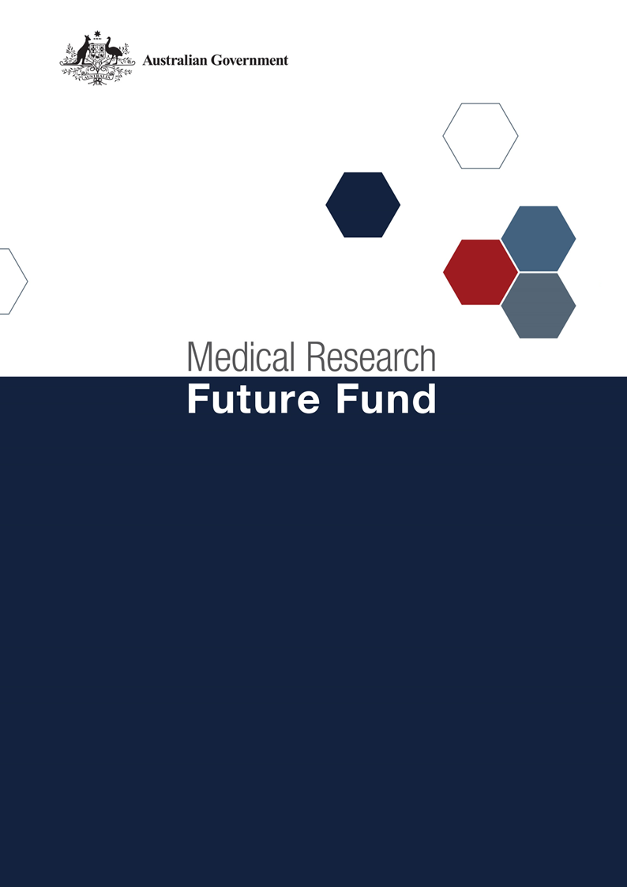

Consultation Guide – MRFF Australian Medical Research and Innovation Strategy 2026-2031 and Priorities 2026-2028

Contents
Consultation Purpose 3
Introduction 3
Australian Medical Research and Innovation Strategy 4
Australian Medical Research and Innovation Priorities 4
Recent MRFF Budget Commitments 4
Development of the Draft MRFF Strategy and Priorities 5
Consultation Process 6
Further Information 6
Key Contacts 6
Staying Informed 6
Related documents 6
Attachments 7

Consultation Purpose
The Australian Medical Research and Innovation Strategy and the Australian Medical Research and Innovation Priorities, often referred to as the MRFF Strategy and MRFF Priorities, guide how the Australian Government directs the Medical Research Future Fund (MRFF). Under the Medical Research Future Fund Act 2015 (MRFF Act), the Australian Medical Research Advisory Board (AMRAB) is responsible for setting the Strategy every five years and the Priorities every two years through a consultation process. The current 2021-2026 MRFF Strategy expires on 7 November 2026 and the 2024-2026 MRFF Priorities on 6 November 2026.
AMRAB is seeking feedback on the draft MRFF Strategy 2026-2031 and MRFF Priorities 2026-2028 to confirm whether they provide the right focus for the MRFF, identify any gaps, and ensure alignment with the intended outcomes of MRFF investment. The MRFF Strategy is distinct from the National Health and Medical Research Strategy (National Strategy), which sets broader directions for health and medical research across Australia. The development of the draft MRFF Strategy and Priorities has been informed by relevant evidence and insights from the National Strategy process, including the consultation led by Ms Rosemary Huxtable AO PSM. However, this consultation relates specifically to AMRAB's statutory role in developing the MRFF Strategy and Priorities and is not the government's response to the National Strategy.
This document provides background to support the consultation, covering the MRFF and its governing framework, the proposed Strategy and Priorities, key issues under consideration, and how to participate.

Introduction
The MRFF is an ongoing research fund set up by the Australian Government in 2015. Every year, the Government uses some of the net interest from this investment to pay for medical research initiatives. The MRFF is valued at $25.4 billion as at 31 March 2026.
The Government uses the MRFF to improve the health and wellbeing of Australians by funding health and medical research that addresses current, emerging and future health needs, burden of disease, and gaps in translation and health outcomes. The MRFF provides grants of financial assistance to support health and medical research and innovation. These grants support the translation of research towards impact and commercialisation to improve the health and wellbeing of all Australians.
The MRFF is managed by the Future Fund Board of Guardians, which invests the assets of the Fund. The Board of Guardians is required to maintain the nominal value of the credits made to the MRFF to enable a predictable and secure ongoing flow of funding for health and medical research and innovation.
The MRFF Act sets up the independent AMRAB and requires it to consult before determining the MRFF Strategy and Priorities. This ensures investment in research is flexible and meets the needs of the changing health and medical research landscape.
This is particularly timely, given the rapid pace of technological advancement, the growing influence of artificial intelligence on the research and funding environment, and a number of recent reviews and consultations across the research and health system. These include the Strategic Examination of Research and Development and the consultation process supporting the development of a National Strategy, both of which point to shifting national priorities and emerging expectations.
While AMRAB has taken these findings into account, the MRFF Strategy and Priorities provide an opportunity to translate these system-wide directions into a focused set of investment priorities. In doing so, they can ensure coherence with, and complementarity to, other national strategies, reforms, and funding mechanisms across the health and medical research landscape.

Australian Medical Research and Innovation Strategy
Section 32D of the Act specifies that:
AMRAB must determine a Strategy for ensuring that a coherent and consistent approach is adopted in providing financial assistance under the Act for medical research and innovation that is in force for 5 years.
In determining the Strategy, AMRAB takes into account the national strategy for medical research and public health research prepared by the National Health and Medical Research Council, as well as any other relevant matter.
The current MRFF Strategy (2021-2026) has provided a wide-ranging platform that has allowed MRFF to be responsive to current, emerging, and future health challenges, while continuing to fund projects that stimulate health and medical research across the entire research pipeline and achieve the MRFF’s strategic objectives.
Given the changing health and medical research landscape and the recent reviews noted above, it is timely to review and refresh the Strategy.

Australian Medical Research and Innovation Priorities
Section 32E of the Act specifies the matters in relation to the Priorities for providing financial assistance for medical research and medical innovation.
The Act requires AMRAB to take into account the following matters when determining the Priorities:
the burden of disease on the Australian community
how to deliver practical benefits from medical research and medical innovation to as many Australians as possible
how to ensure that financial assistance provided under the MRFF complements and enhances other financial assistance provided for medical research and innovation
any other relevant matters.
The current MRFF Priorities 2024-2026 align with the current MRFF Strategy (2021-2026), and are considered by the Minister for Health and Ageing before the Department of Health, Disability and Ageing (the Department) decides on the disbursement of funding from the MRFF.
The MRFF Priorities 2024-2026 are:
consumer-driven research
research infrastructure and capability
translation and commercialisation
effective and high value care
preventive and public health research
primary care research
health and medical researcher capacity and capability
Aboriginal and Torres Strait Islander health and wellbeing
priority populations
global health and health security
health impacts from environmental factors
artificial intelligence and digital health.

Recent MRFF Budget Commitments
The government announced in May 2026 that it will spend over half a billion dollars ($508.5 million) over the next 4 years to increase investment in medical research through the MRFF. The Budget commitment is groundbreaking for the sector, allowing MRFF grant funding to reach a record $1 billion a year by 2030-2031.
The additional funding for MRFF will improve health outcomes, encourage innovation, deliver advanced treatments, support the translation of research into medical care and make it easier for Australians to access clinical trials.
It includes $210 million to address national research priorities, including establishing:
the Australian Cancer Research Program to deliver coordinated research into cancers including brain cancer, low survival cancers, and childhood, adolescent and young adult cancers, and
the Precision Health Research Program, developing a grant program to boost genomic health care and research capability, improve genetic testing and treatment, and support earlier identification of people at risk of developing disease.
Research administration costs are inequitably supported across organisations that are awarded MRFF grants, so an additional $128 million will be invested to help address this imbalance.
This funding includes $127.6 million to bridge the gap between promising research and the delivery of new medical treatments and innovation. Going forward, projects will be selected competitively. The first two research projects to receive funding from this program include:
$30 million for the Australian Epilepsy Project to establish and implement a new standard of care for epilepsy across Australia.
$14.6 million for the Australian Centre for Accelerating Diabetes Innovation to help implement findings from research that will have a significant impact on diabetes research and care for Australian patients.

Development of the Draft MRFF Strategy and Priorities
A funding landscape review examined MRFF investment delivered under the 2021-2026 Strategy aligned to MRFF Priorities. MRFF funding was benchmarked against national (National Health and Medical Research Council (NHMRC)) and international comparators (the UK’s National Institute for Health and Care Research (NIHR) and Medical Research Council (MRC), and the Canadian Institutes of Health Research (CIHR)). The review included a thematic analysis of comparator funders to identify areas of alignment, innovation and opportunity.
Key learnings from the funding landscape review sought:
an outcomes-based approach to identifying Strategic Objectives and Priorities
more focused and targeted MRFF Priorities to better direct MRFF resources through:
fewer, more specific Priorities that directly addresses the Strategic Objectives
greater continuity and cohesive vision across proposed Priorities that build towards their overarching Strategic Objectives
improved complementarity with NHMRC to support the research ecosystem from discovery and capability-building (NHMRC) through to translation and implementation (MRFF).
Learnings from the National Strategy consultation have also informed this work. These findings reinforce that the MRFF Strategy and Priorities can translate the National Strategy’s system-wide direction into a focused set of investment priorities, while maintaining coherence with, and complementarity to, other national strategies, reforms and funding mechanisms across the health and medical research landscape.
At the conclusion of the landscape review, AMRAB supported a future-focused Strategy and Priorities with a stronger emphasis on fewer, more specific priorities that align directly with the Strategic Objectives. This represents a new Strategy and Priorities, reflecting the bold direction set by the refreshed and diverse Board.
The draft Strategy (Attachment 1) and Priorities (Attachment 2) are provided for public engagement and input, recognising that they are not intended to address the full breadth of health and medical research needs. Rather, they are designed to provide clarity and direction to the Minister within the two-year and five-year investment cycles.
AMRAB has elected to release a draft Strategy and Priorities to support targeted and constructive feedback, and to test and refine current perceptions of the priority landscape.

Consultation Process
AMRAB has agreed to a two-stage consultation process for the MRFF Strategy 2026-2031 and MRFF Priorities 2026-2028:
Open consultation will seek a wide range of views, make it easy for people from diverse backgrounds to contribute, understand support for the draft directions, and identify any important gaps.
An online consultation survey, open from 17 July 2026 to 16 August 2026, and
A webinar to explain the draft strategy and priorities, the advice being sought from the community and the sector and respond to questions.
Technical advice will be used to explore issues in depth and seek technical advice on issues raised through the open consultation. This will occur through appropriate expert and governance channels including:
Joint NHMRC-MRFF advisory committees.
Survey respondents will be asked to identify themselves and indicate if they are affiliated to an organisation. Respondents will have an opportunity to indicate consent to have their views made public on the MRFF website. All views will be reviewed by the Department to inform AMRAB’s considerations. The survey questions are available at Attachment 3 to help respondents to prepare their responses.
Consultation will be conducted primarily online, reflecting current operating and global risk conditions. It also reflects AMRAB’s recognition of, and appreciation for, the extensive time, effort, and constructive engagement contributed by the health and medical research sector over the past two to three years, including MRFF Priorities 2024-2026 and MRFF Act review, MRFF and MREA alignment, and draft National Strategy. This consultation is intended to be focused on confirming that the draft Strategy and Priorities appropriately reflect that feedback, confirm support for the proposed directions, and identify any important gaps.
The methodology also draws on lessons from recent national consultations, using a structured and staged process to balance breadth and depth of input, support efficient analysis, and integrate consultation into existing communication channels wherever possible.

Further Information

Key Contacts
For any questions relating to this consultation please contact the Department via MRFF@health.gov.au.

Staying Informed
Monitor the MRFF website as it will be regularly updated with notifications of opportunities to either engage with AMRAB or reflect on the ongoing national conversation.

Related documents
- Australian Medical Research and Innovation Strategy 2021-2026
- Australian Medical Research and Innovation Priorities 2024-2026
- Medical Research Future Fund Act 2015
- Statutory review of the Medical Research Future Fund Act 2015
- Investment Funds Legislation Amendment Bill 2021
- MRFF third 10-year Investment Plan
- MRFF Monitoring, Evaluation and Learning Strategy
- Financial Assistance to Support the Australian Medical Research and Innovation Priorities 2016-2018
- Report on financial support for medical research and innovation 2018-2020
- Financial Assistance to Support the Australian Medical Research and Innovation Priorities 2020-2022
- Financial assistance to support the Australian Medical Research and Innovation Priorities 2022-2024
- MRFF Investment Initiatives
- AMRAB membership background
- NHMRC Health Priorities
- Commonwealth Grants Rules and Principles 2024
- GrantConnect
- The National Health and Medical Research Council
- Business Grants Hub

Attachments
A.1 Draft Australian Medical Research and Innovation Strategy 2026-2031 – For Consultation
A.2 Draft Australian Medical Research and Innovation Priorities 2026-2028 – For Consultation
A.3 Consultation Survey Questions

