NDIS Amendment

Securing the NDIS for Future Generations
July 2026 Fact sheet
Part 1
Changes to areas
- When NDIS plans can be paused or cancelled.
- What a permanent disability means.

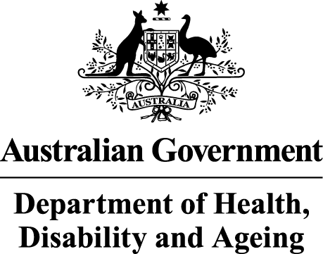 | The Australian Government Department of Health Disability and Ageing wrote this.  We say DHDA for short.  When you see the word we it means DHDA.
 | We wrote this in an easy to read way.  We use pictures to explain some ideas.
 | We have some words in bold.  This means the letters are thicker and darker.  These are important words.
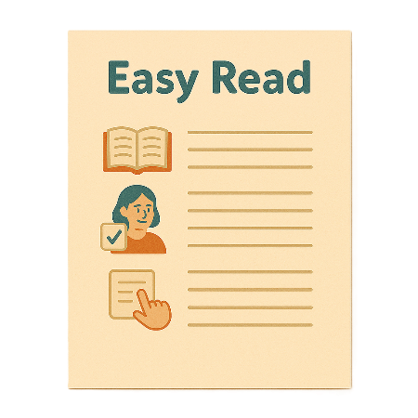 | This is an Easy Read summary of another document.  This means it has the most important ideas.
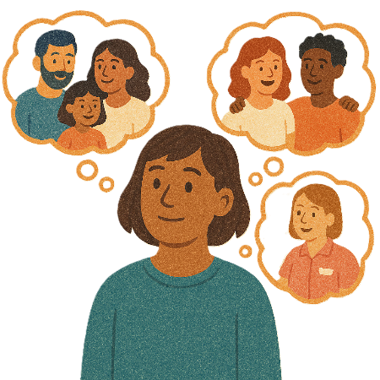 | You can ask for help to read this document.  You can ask  - A friend  - Family members  - A support person.
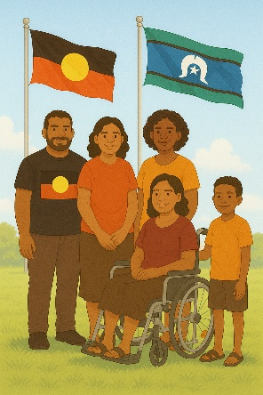 | We recognise Aboriginal and Torres Strait Islander people as the Traditional Owners of the land we live on.
 | They were the first people to live on and use the  - Land  - Waters.

Contents

Changes to NDIS laws | 5
Area 1 changes | 12
Area 2 changes | 16

Changes to NDIS laws

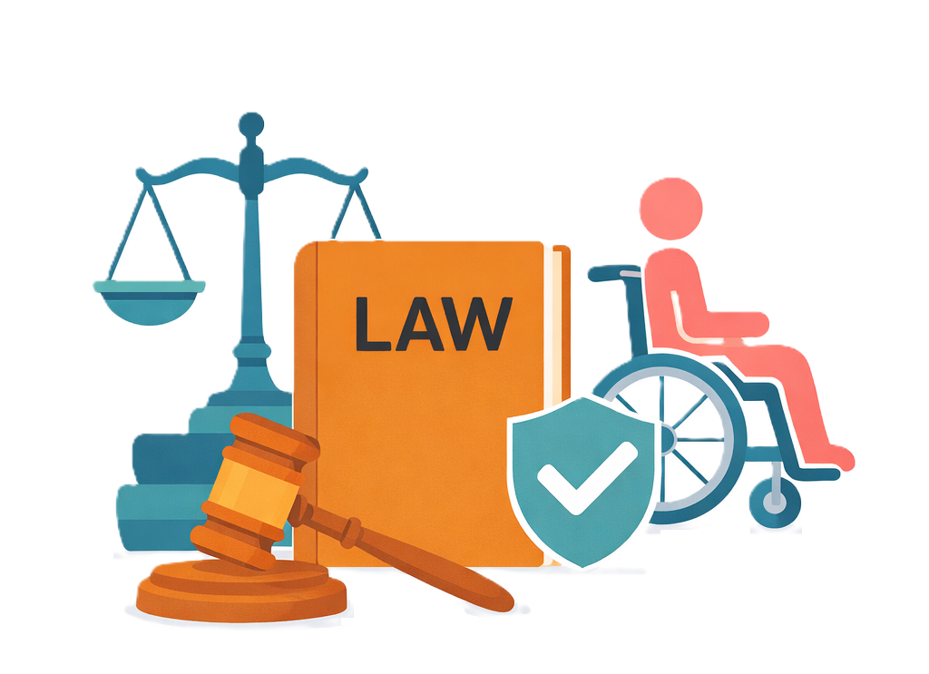 |  | The government wants to make changes to the NDIS laws.  Laws are rules for how we live.
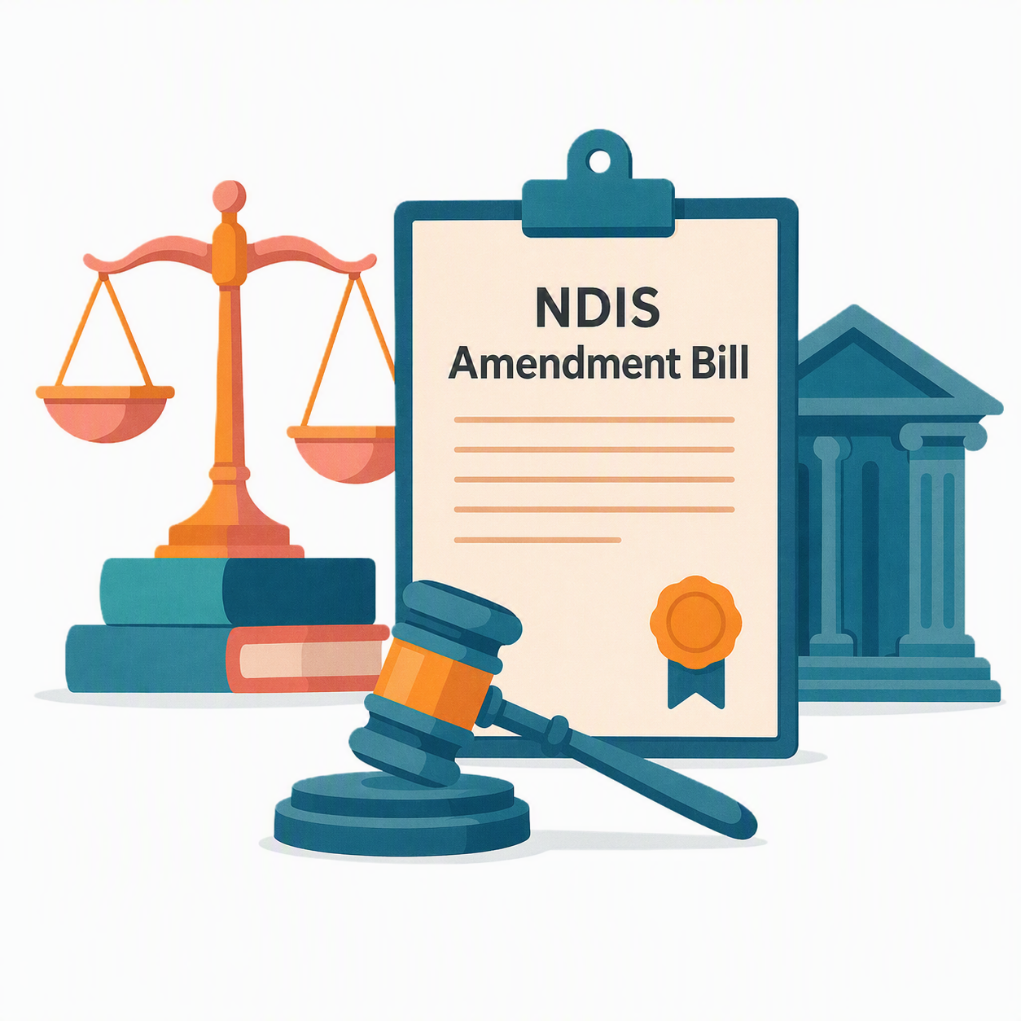 |  | To do this the Government  - Introduced the NDIS Amendment Bill 2026 in May 2026.  This Bill is a proposed change to the NDIS law.  It means it is not a law yet.
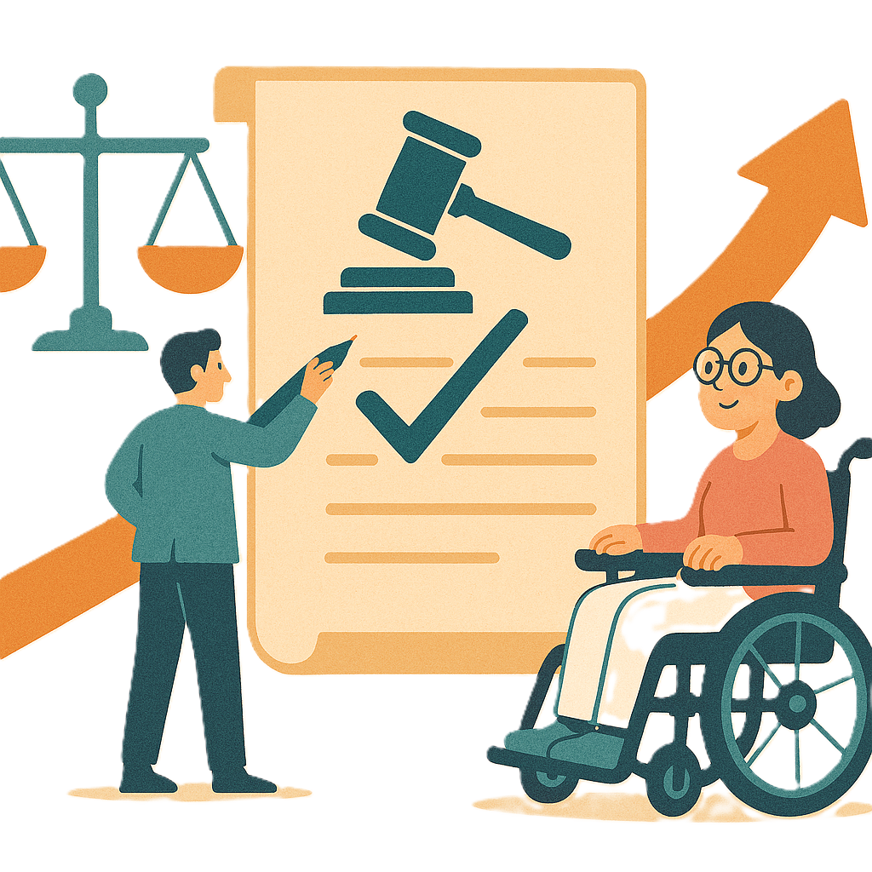 |  | Changes to the laws are called amendments.  They help laws  - Change  - Be better.
 |  | The Government asked people what they thought about the Bill.
 |  | We heard from  - People with disability
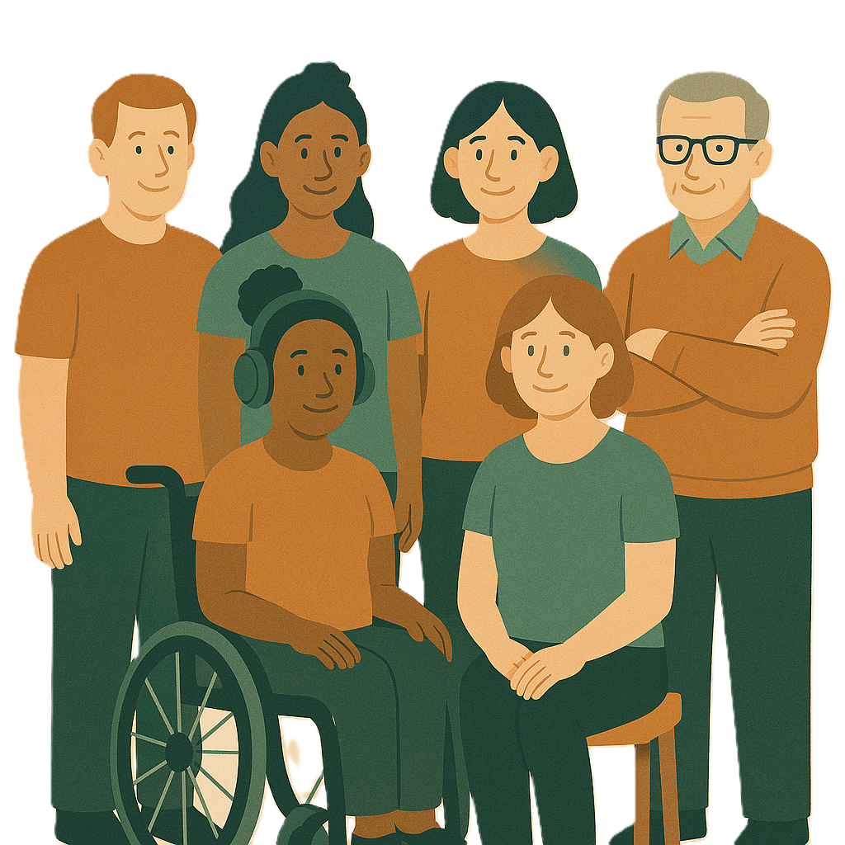 |  | - Families
 |  | - Advocates  An advocate is someone who supports you to speak up for your rights.  It can also be called advocacy.
 |  | Rights are rules about treating everyone  - Fair  - Equal.
 |  | - Organisations.
 |  | The Bill changes were agreed to in Parliament on  - 1 July 2026.
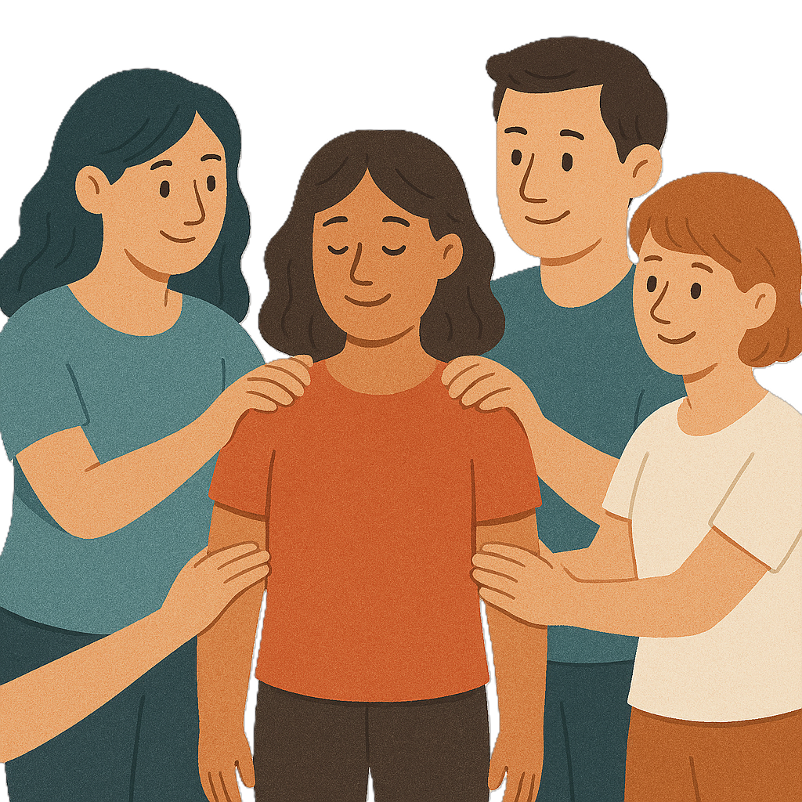 |  | The changes will  - Help keep people who get NDIS safe
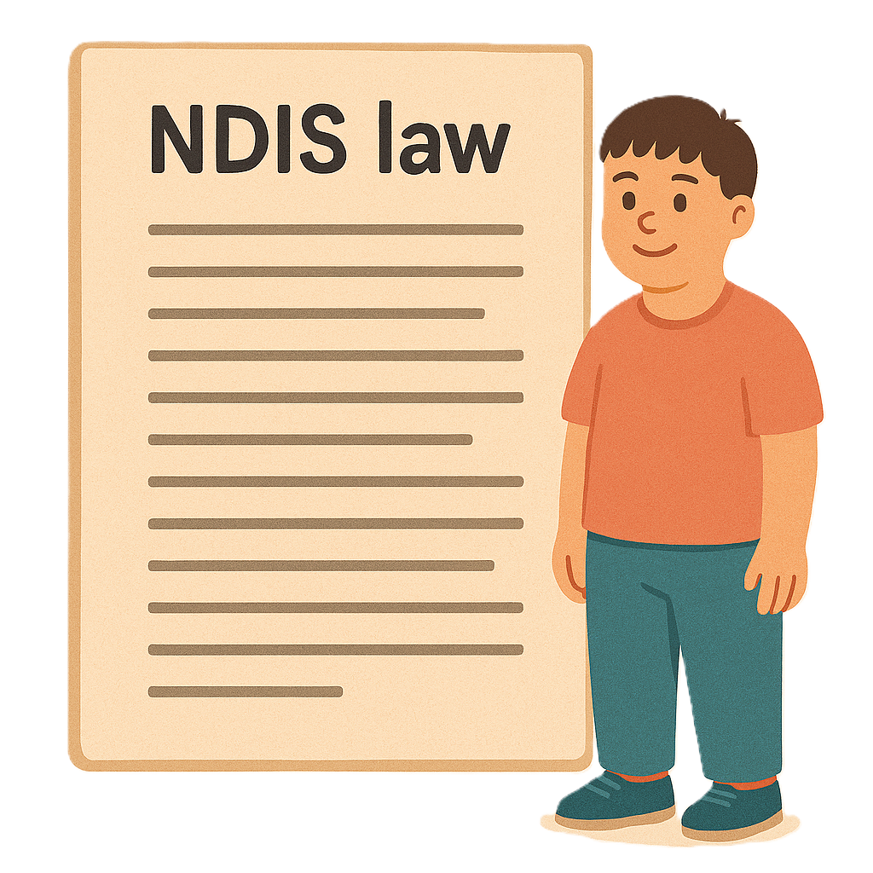 |  | - Make the laws clear
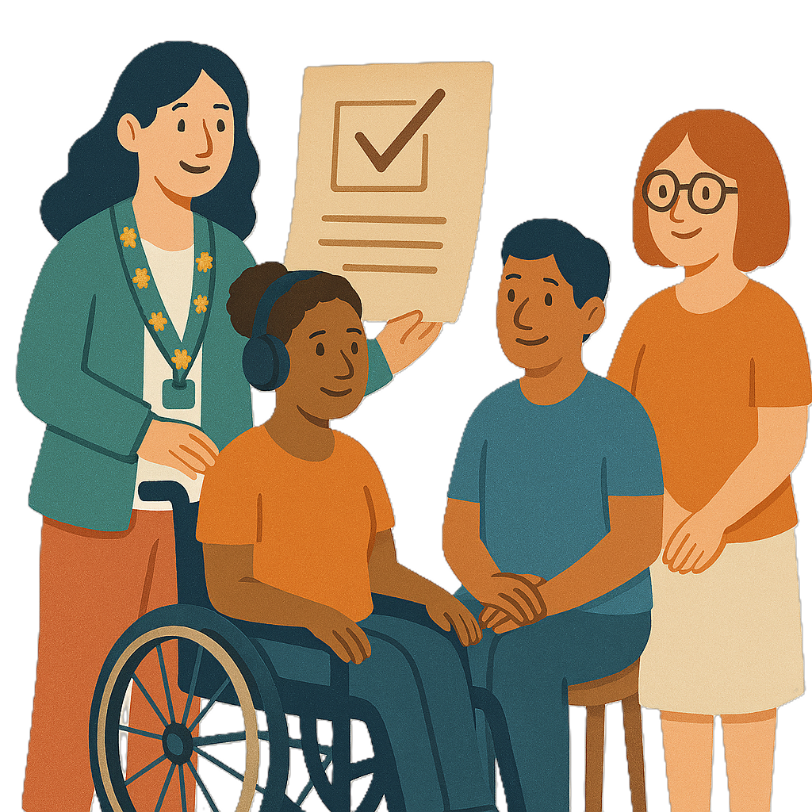 |  | - Make the laws easier to understand.
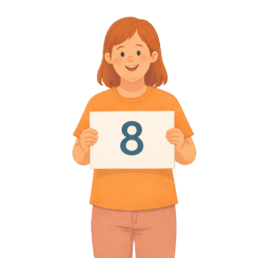 |  | The changes to the NDIS laws are in  - 8 different areas.  The changes are in 3 different Easy Reads.
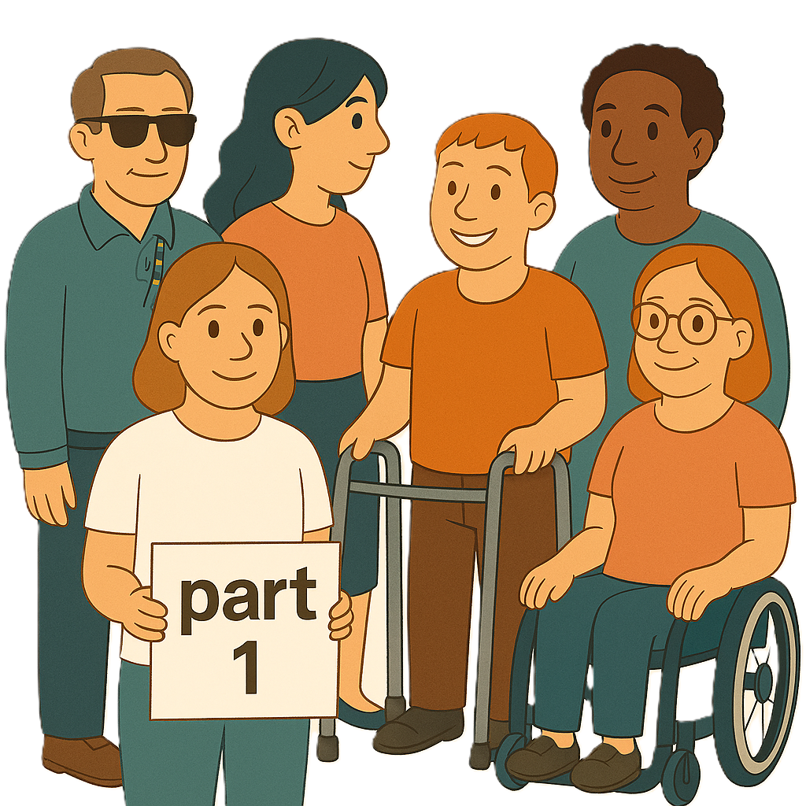 |  | This is part 1.  It has the changes in areas  - 1  - 2.
 | You can read the other parts on our website.  www.health.gov.au/resources/publications/changes-to-the-ndis-amendment-securing-the-ndis-for-future-generations-bill-2026-fact-sheet  They are in Easy Read.
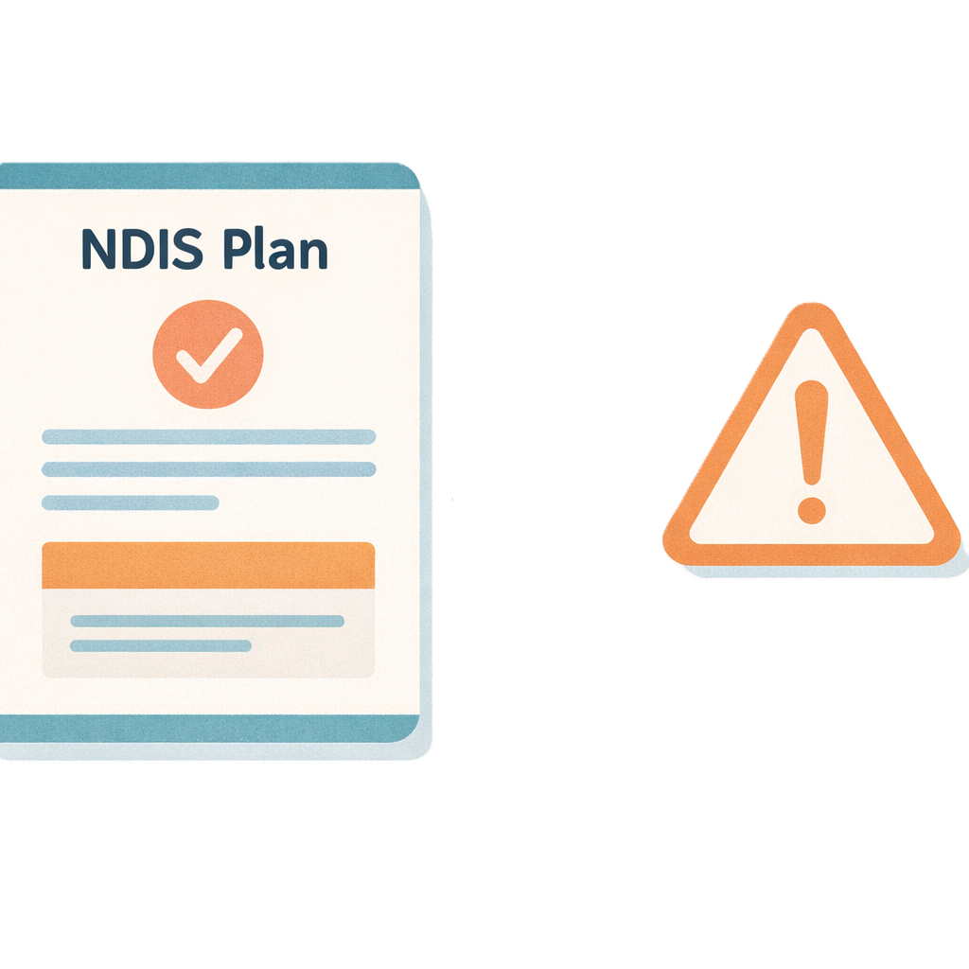 | The changes are  Area 1  - When NDIS plans can be paused or cancelled
 | Paused means you can not use your plan for a while.
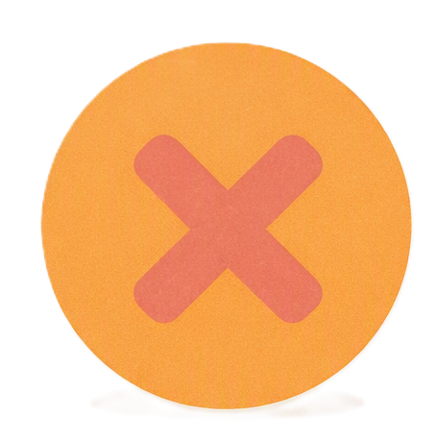 | Cancelled means you would not get any more money from NDIS.
 | Area 2  - What a permanent disability means.  A permanent disability does not go away.  It will likely last for the rest of their life.

Area 1 changes
When NDIS plans can be paused or cancelled

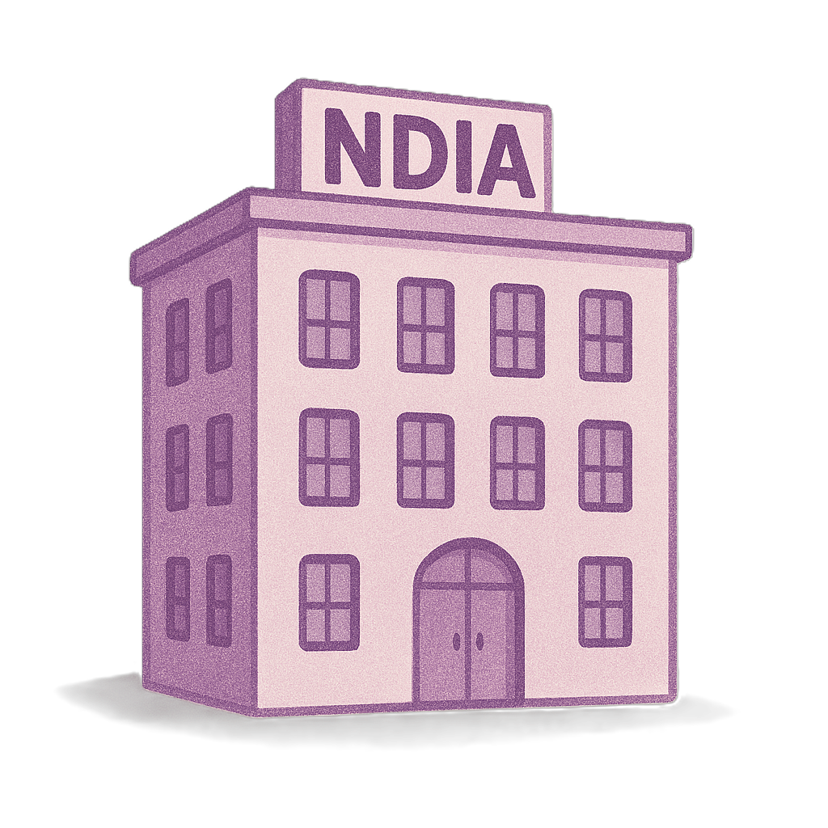 | This change is about National Disability Insurance Agency trying to contact someone who gets NDIS money.  We call it NDIA for short.  They look after the NDIS.
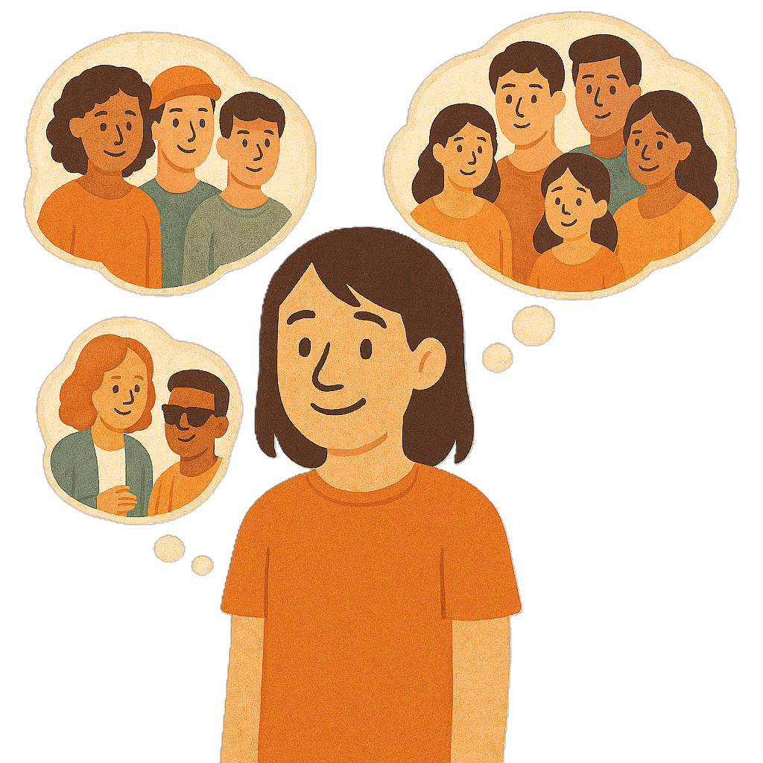 | NDIA need to contact  - The person who has a NDIS plan
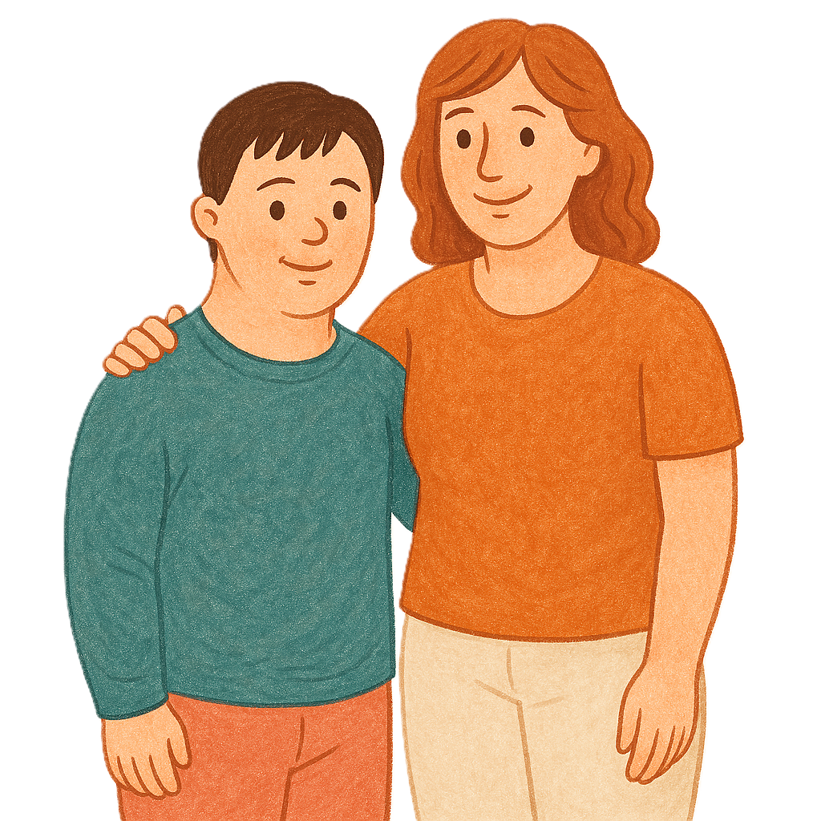 | - Their nominee  A nominee is someone you choose to  - Get letters from NDIA about your NDIS plan  - Write back to the letters if they need to.  Some people do not have a nominee.
 | - Someone else that you have said can talk to NDIA for you.  This is called an authorised person.
 | NDIA need to try at least 5 times.  NDIA need to contact the person in the way they like.  This could be by  - Phone  - Email  - Letter in the mail.
 | NDIA needs to try and contact you over 3 to 4 months.
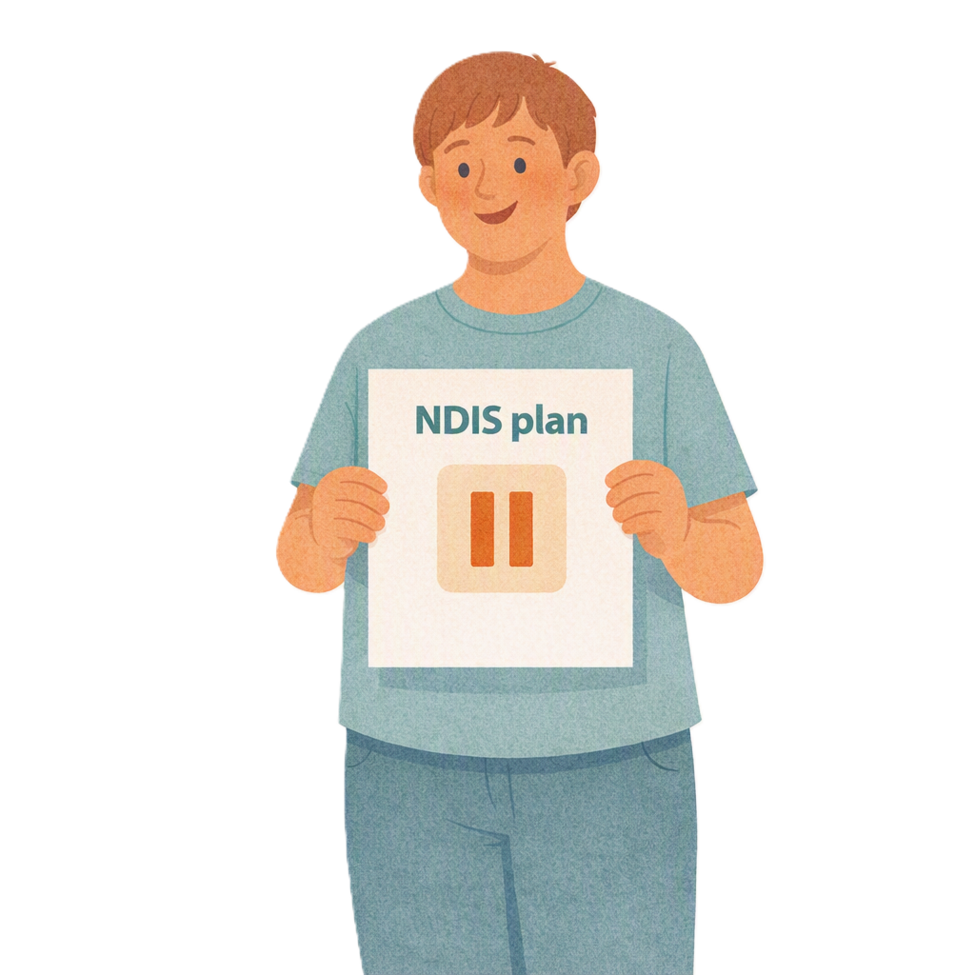 | NDIA can pause your NDIS plan if they contact you and you do not  - Answer them  - Give them the information they ask for.
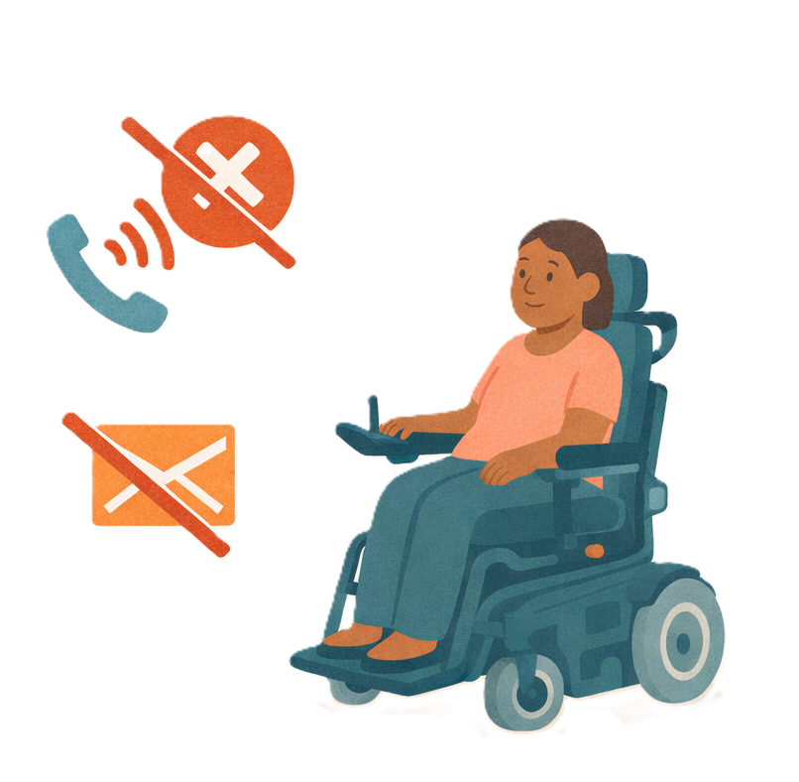 | NDIA can cancel your NDIS plan if  - Your plan has been paused for at least 90 days  - They can not contact you at all.
 | This rule is not for people who are in  - In hospital
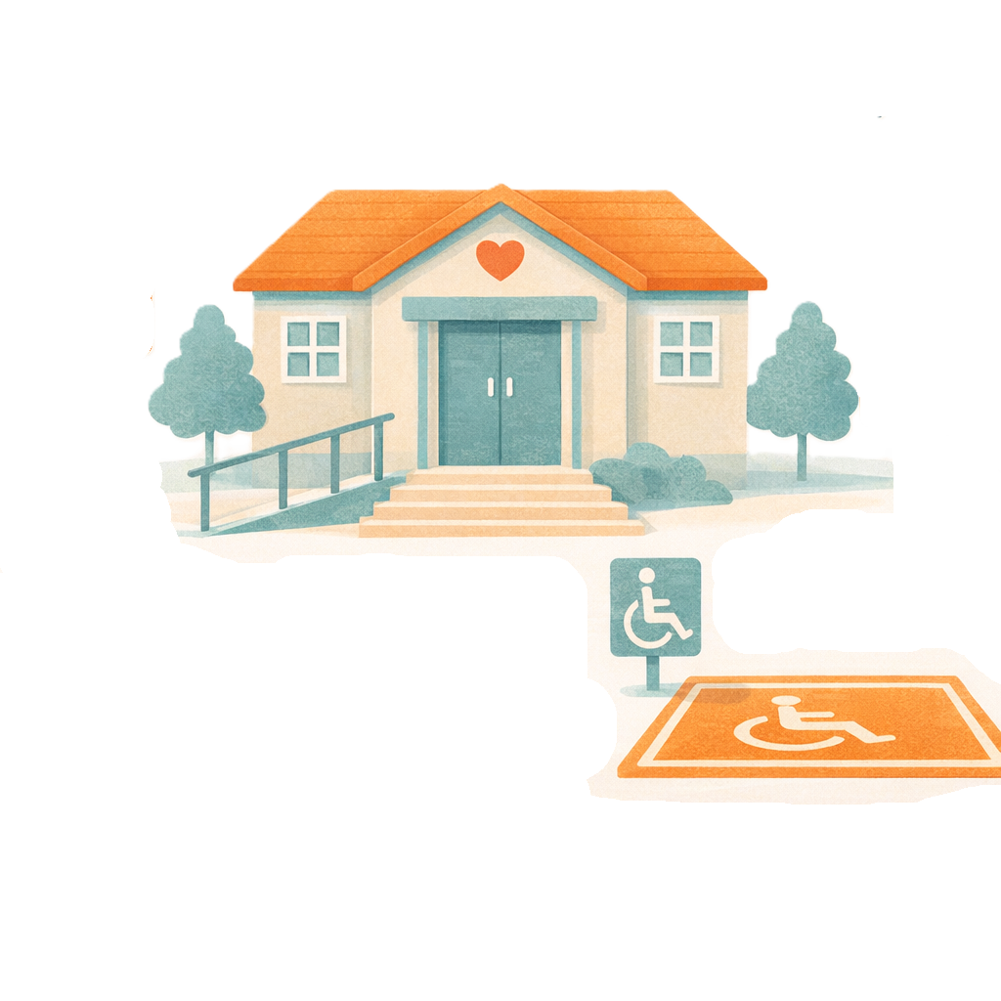 | - In an institution  Institutions are places that people with disability live together and get support.
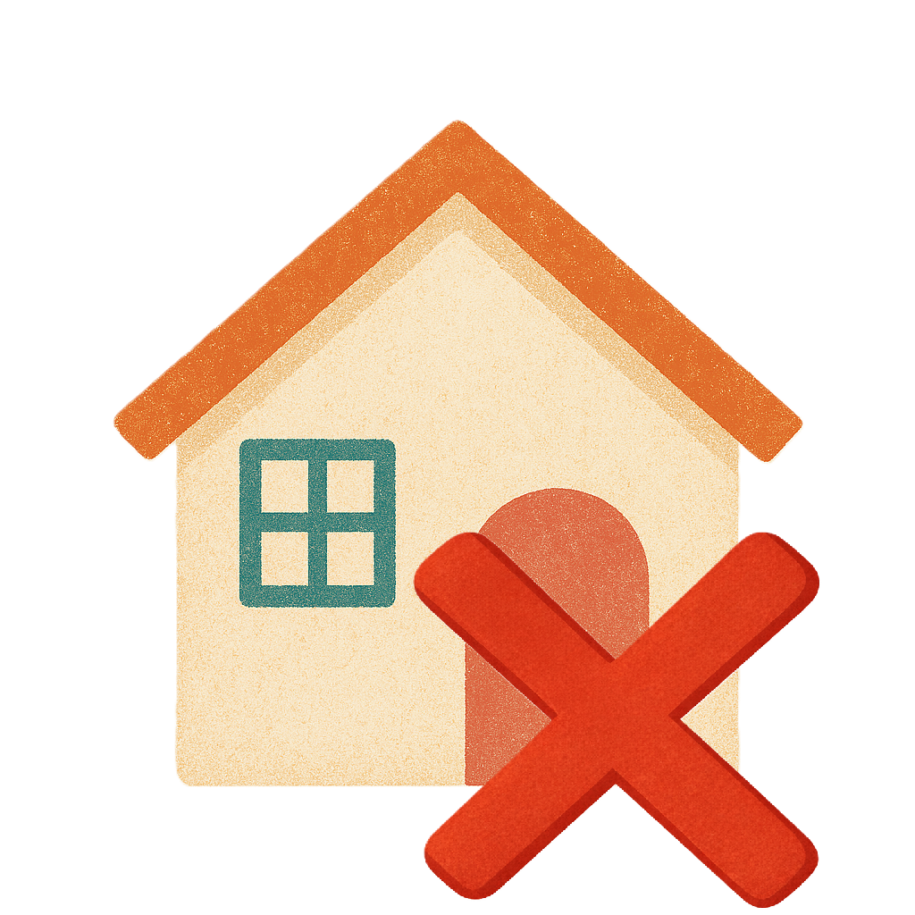 | - Are homeless.  Homeless means you do not have a home to live in.

Area 2 changes
Changes to what permanent disability means

This change is about who can get NDIS.

You now can only get NDIS if your disability

- Lasts a long time
- Will probably last a long time.
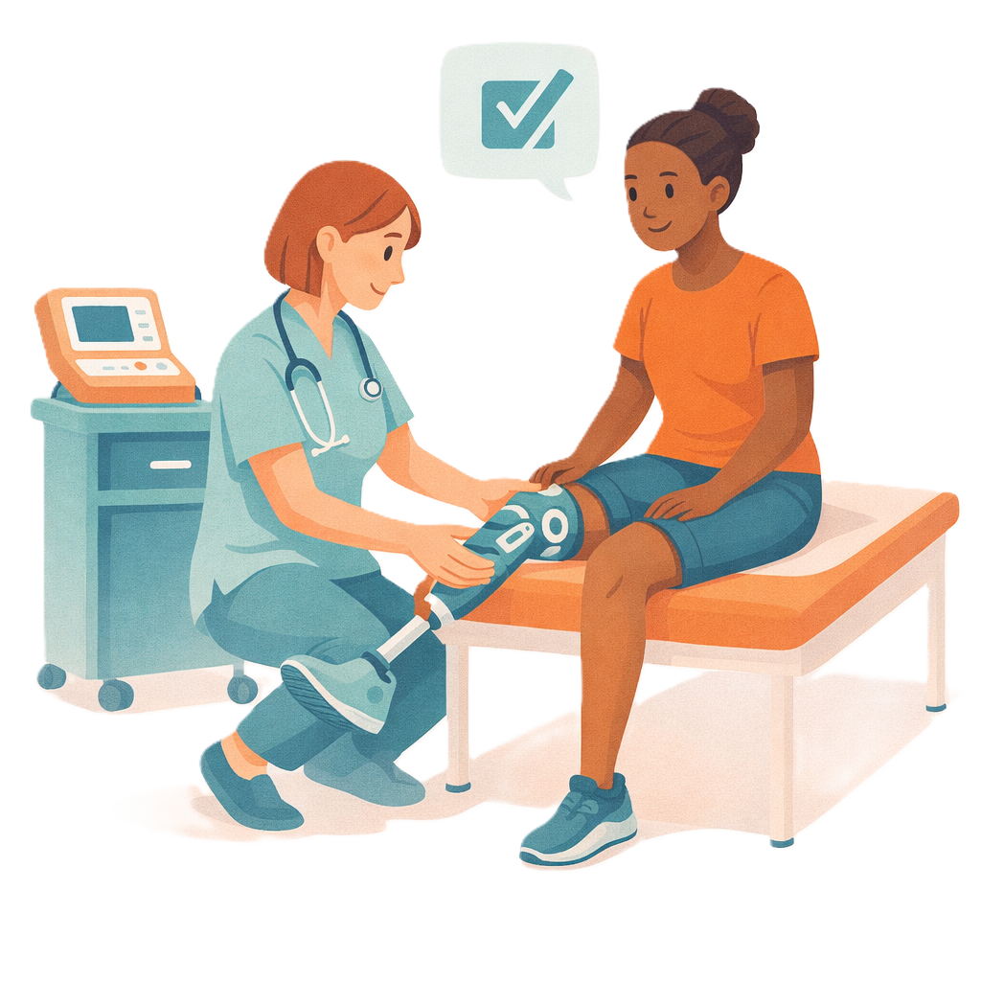 | This change will add another rule.  People will only be able to get NDIS if they have  - Tried all the treatment they can to help them
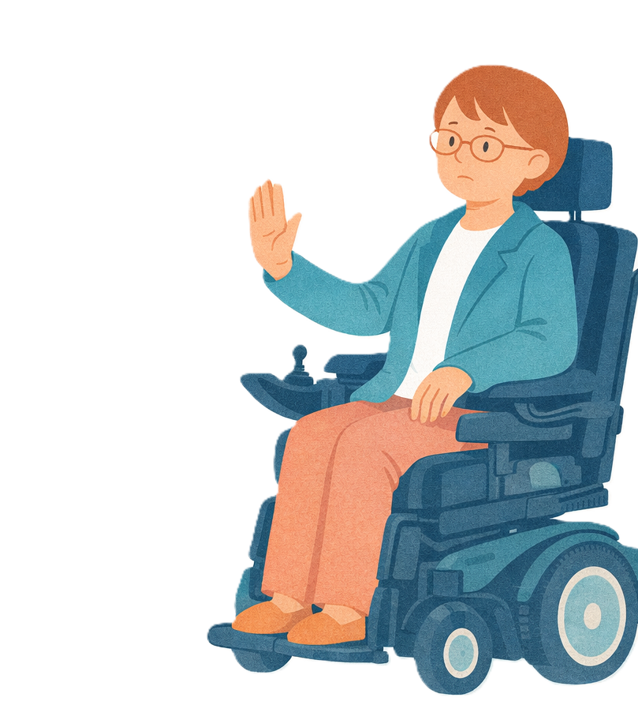 | - These treatments do not help them
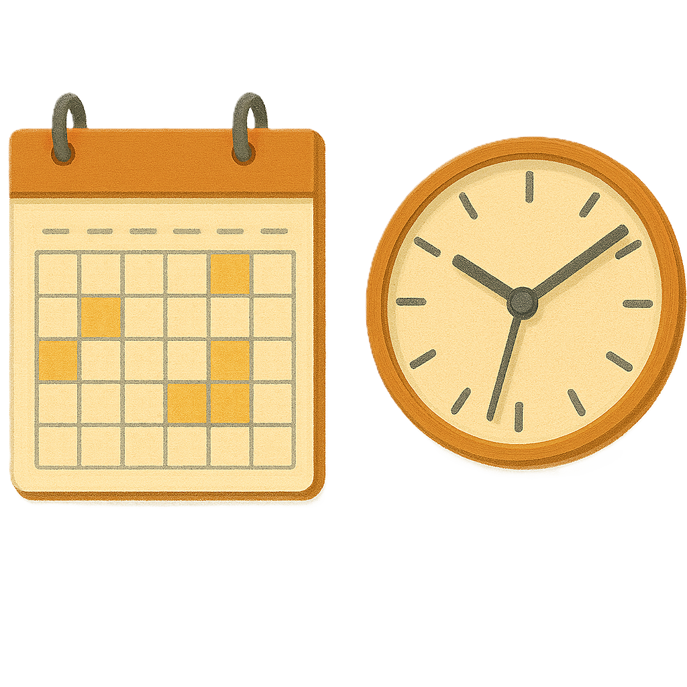 | - Their disability will last for the rest of their life.
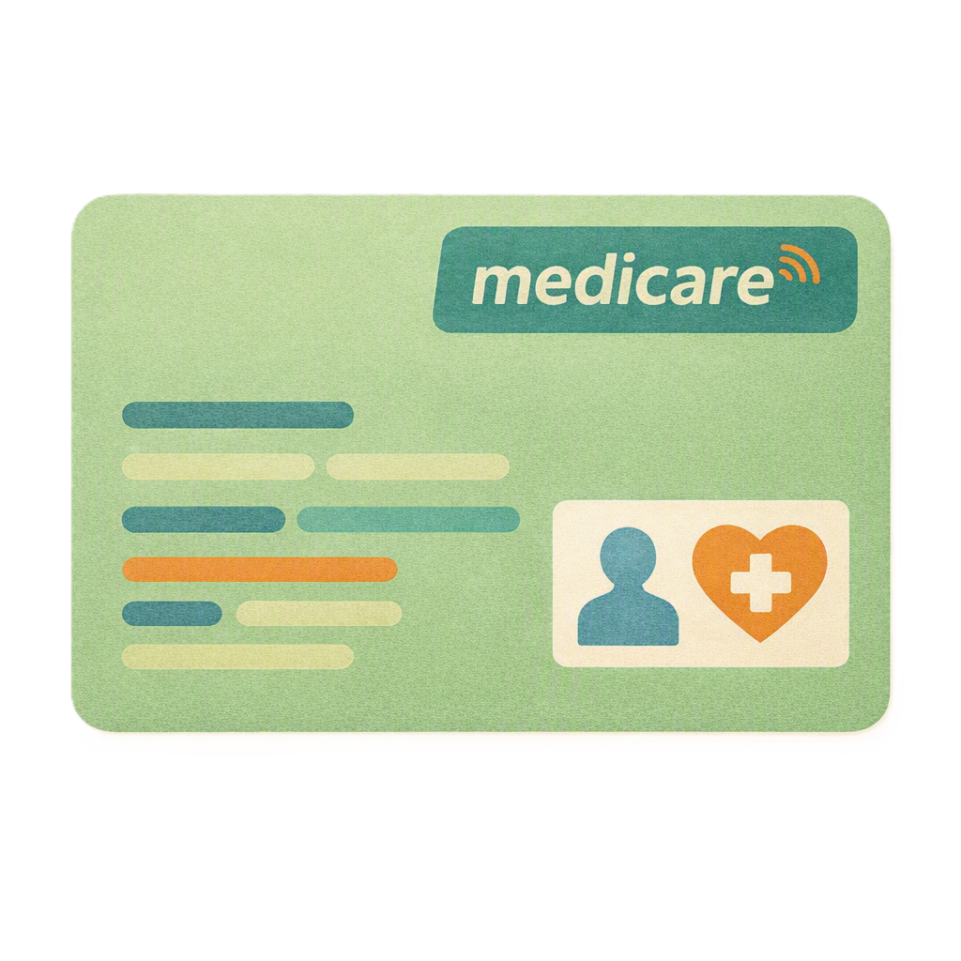 | The treatments can be paid for by  - Medicare
 | - Pharmaceuticals Benefits Scheme  It is called PBS for short.  PBS helps people pay less money for medicine.
 | - Public hospitals.
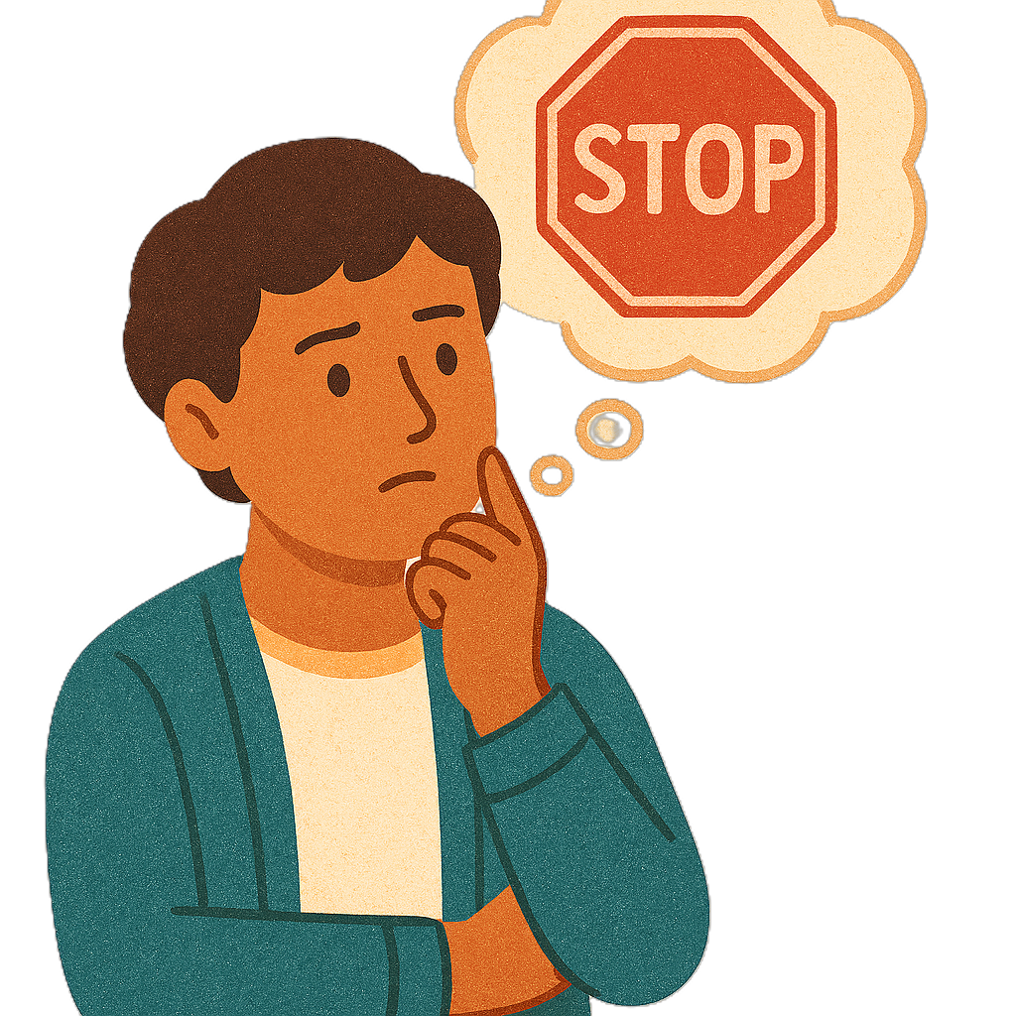 | Restrictive practices do not count as treatment.  Restrictive practices can take away your rights.  They stop you from  - Going places  - Doing what you want.
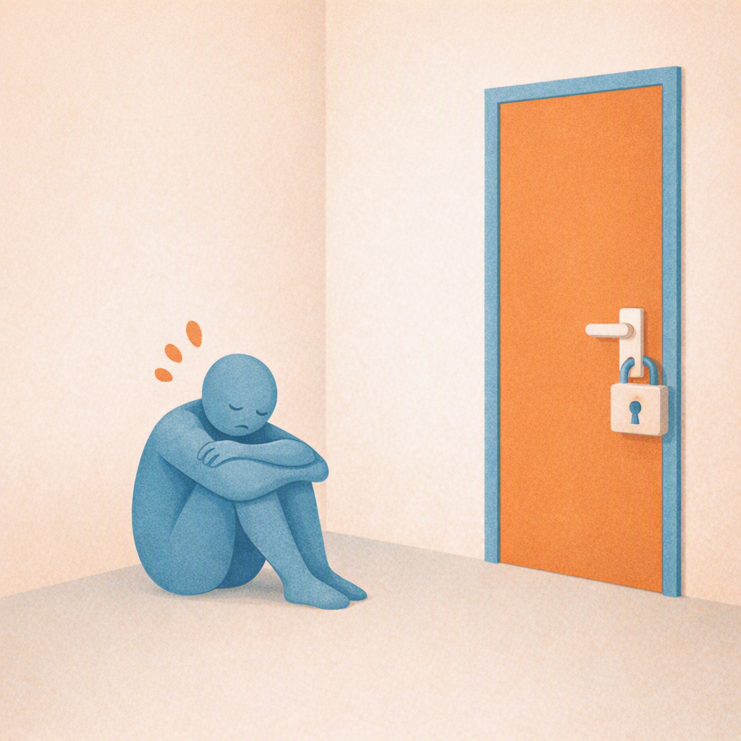 | Types of restrictive practices include  - Seclusion  This is when someone is kept alone in a  - Room  - Place.  They can not leave on their own.
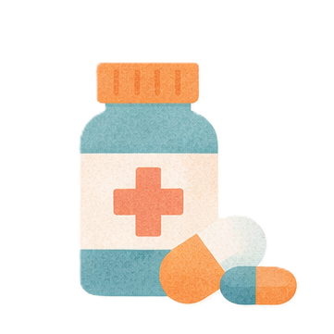 | - Chemical restraint  Chemical restraint is a medicine used to stop someone from  - Moving around  - Doing things.  The medicine is not used for a health condition.
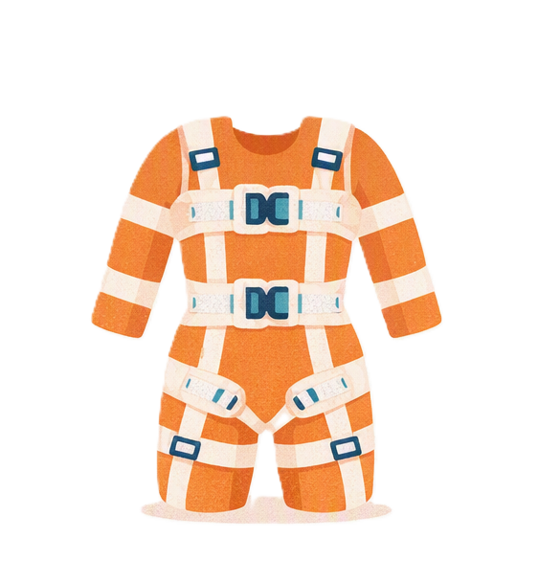 | - Mechanical restraint  Mechanical restraint is when something is used to stop people from moving around.  This could be  - Equipment  - Devices.  Like having special clothing to stop people from hurting themselves.
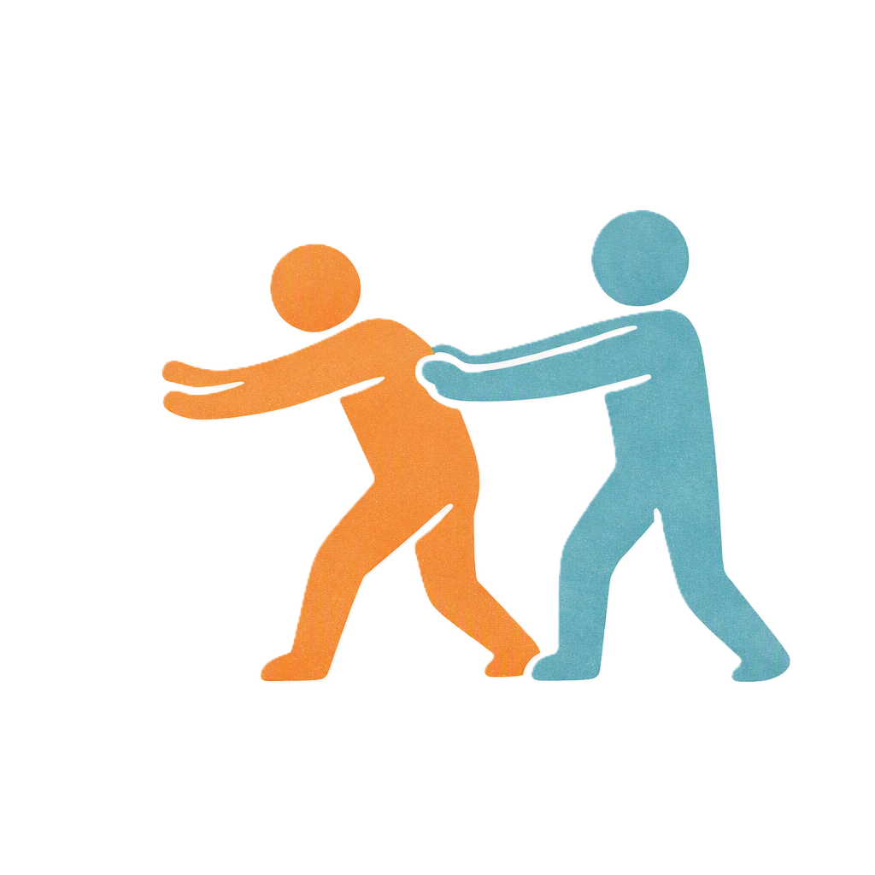 | - Physical restraint  Physical restraint is when someone uses their body to stop someone else moving around.
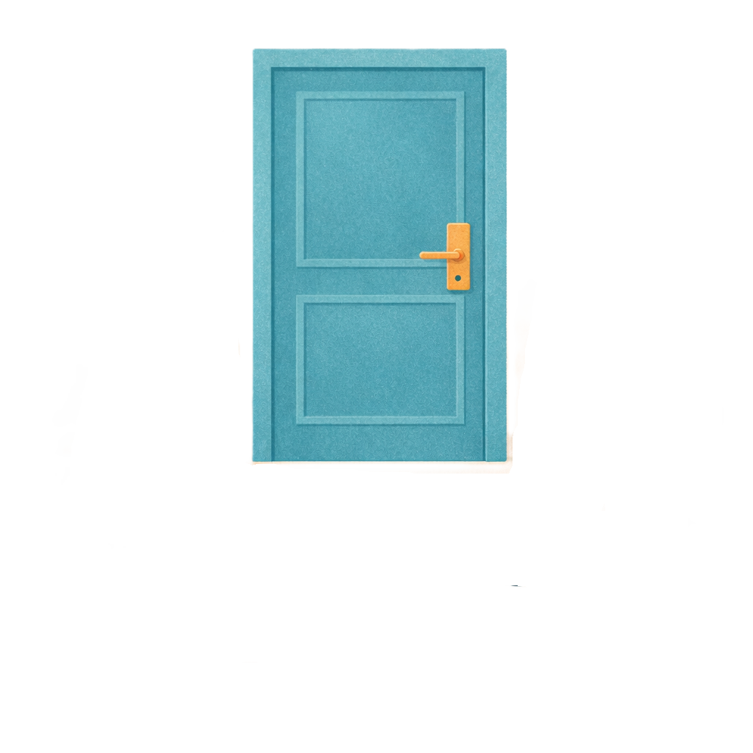 | - Environmental restraint  Environmental restraint is when someone is stopped from going where they want.  They might be blocked from going places.  Like the door is locked.
 | The wording has been changed to  - Make sure the Courts understand how to follow the law.  This is called clarifying legal interpretation.
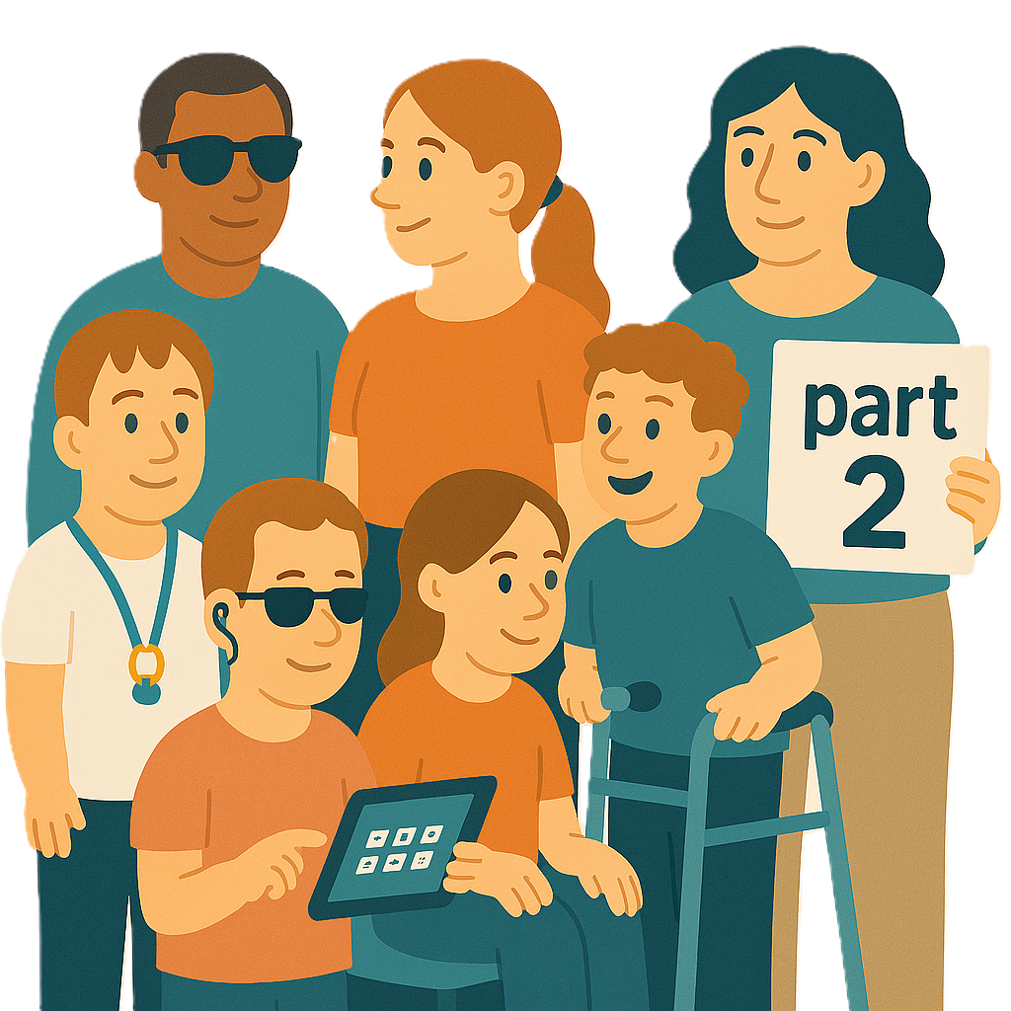 | You can now go to  - Part 2 to read about more changes.
Some images in this Easy Read were made using AI.
You must not share or copy any of the images without permission.
July 2026.

