BONDED RETURN OF SERVICE SYSTEM (BROSS)
Participant User Guide Updating your Personal Details
July 2026

Updating your Personal Details
To update your personal details, click on the ‘My Program Information’ button from your BRoSS dashboard.
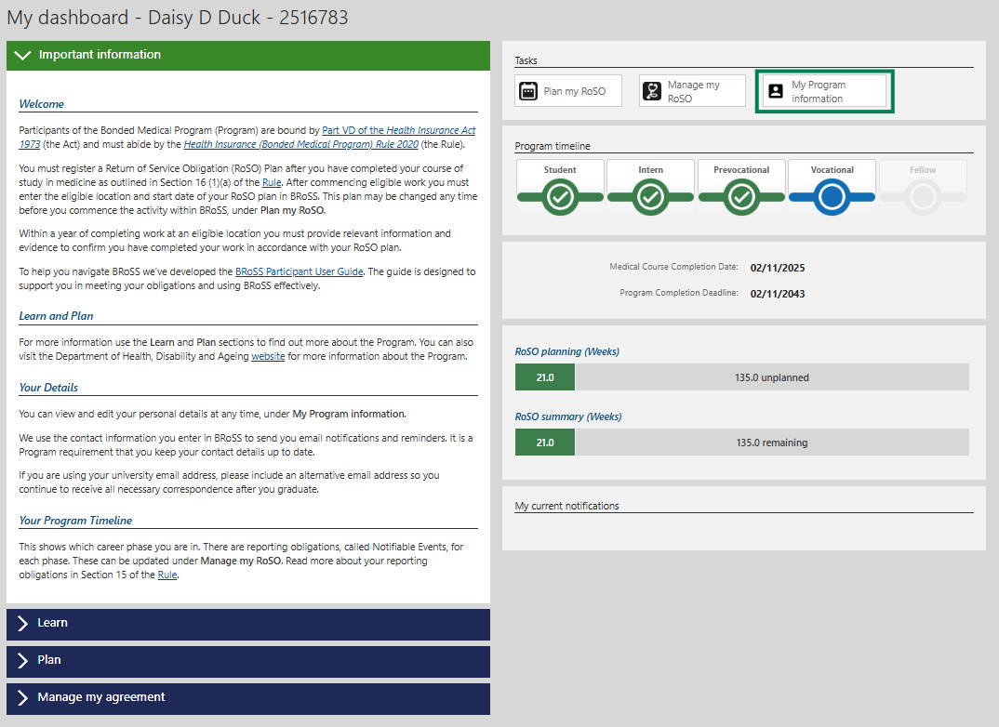
On this screen you can make changes to your personal details under the different accordions such as your name, date of birth, mailing address, email address/es and contact number.
Expand the ‘Personal contact details’ accordion by clicking on the arrow to confirm your details are correct.
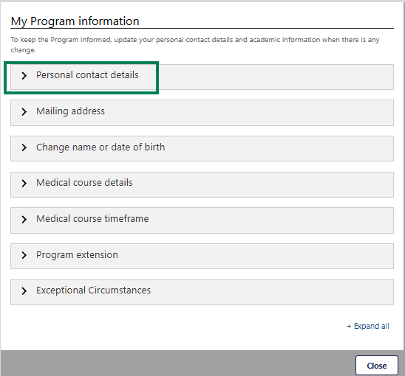
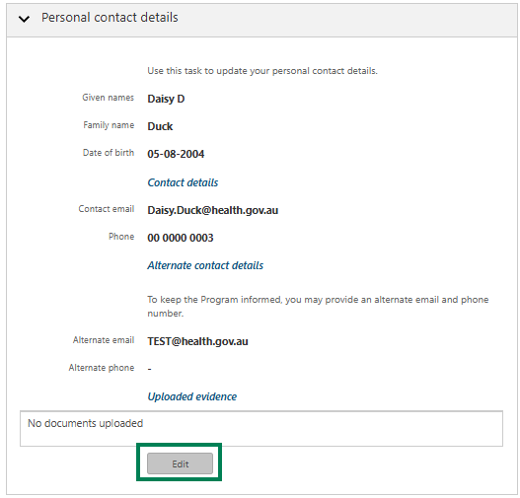
Click ‘Edit’ to update information as required. Please ensure you add an alternative email address to ensure you continue to receive Program notifications after you graduate or change employer. You can also add an alternative phone number if you wish.
Click ‘Save’ once the relevant information has been updated.
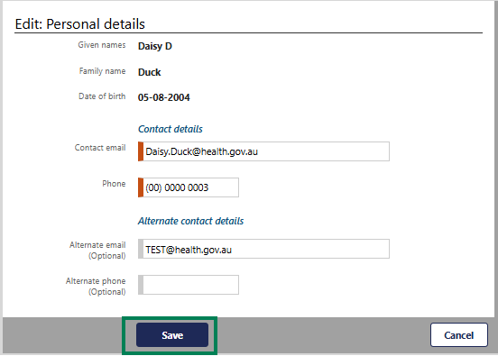
To review and update your mailing address click on the arrow to expand the ‘Mailing address’ accordion.
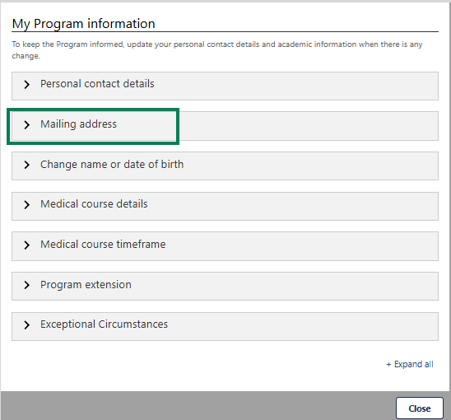
Click ‘Edit’ to update information as required.
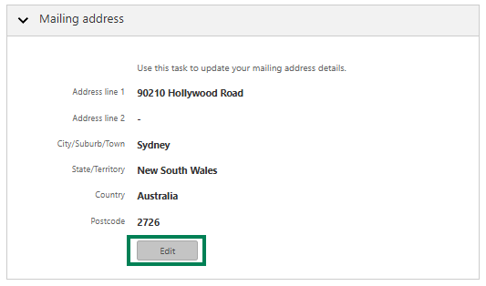
Click ‘Save’ once the relevant information has been updated.
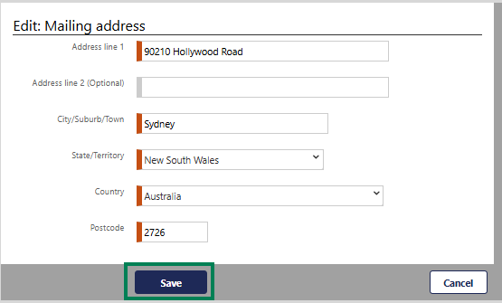
To update your name or date of birth, click on the arrow to expand the ‘Change name or date of birth’ accordion.
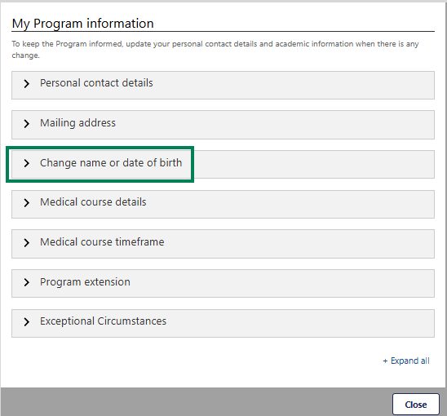
Click on the ‘Advise’ button.
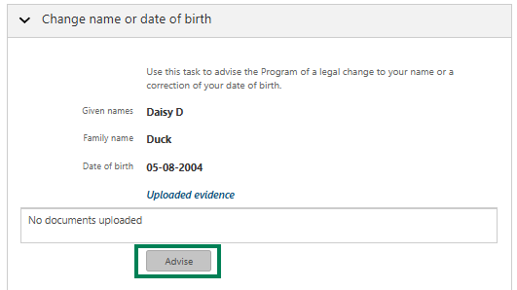

Click on the ‘Choose Files’ button to upload the required evidence of any legal changes and then click ‘Save’.
